# *Australian Jobs Act 2013*

# User Guide for Australian Industry Participation plans

**December 2020**

|  |
| --- |
| **This user guide is for project proponents and facility operators preparing their SmartForm Australian Industry Participation (AIP) plan under the *Australian Jobs Act 2013* (Jobs Act)*\**** |

AIP Plan

Compliance Reports

AIP Notification

I want to:

Get a quick overview of the Jobs Act AIP plan p.2

Understand the Jobs Act AIP plan submission process p.3

Navigate through the SmartForm Jobs Act AIP plan p.7

Find out how to answer each question in the AIP plan p.14

Get an answer to my query about Jobs Act AIP plans p.28

Preview the SmartForm Jobs Act AIP plan p.30

*Important note: this User Guide does not apply to Commonwealth procurements or Commonwealth funded projects under $500 million.

Overview of AIP plans

Australian Industry Participation (AIP) plans set out how proponents of eligible major projects ($500 million and above) will give full, fair and reasonable opportunity to Australian entities to bid for the supply of key goods and services ($1 million and more) for the project.

AIP plans are the key requirement of the *Australian Jobs Act 2013* (Jobs Act) which is Australian Government legislation administered by the Australian Industry Participation Authority. Separate arrangements apply to Commonwealth AIP policy plans. Contact the AIP Authority if you are unsure if your project has to comply with the Jobs Act.

AIP plans are specific to each major project and apply to the design, procurement and construction phase of the project. If the project establishes a new facility, the AIP plan also applies to the procurement for the operational phase of the new facility and the first two years of operations.

AIP plans do not mandate the award of contracts to Australian entities (defined as an entity with an ABN or ACN) but do require proponents to give equal consideration to capable Australian suppliers alongside any existing suppliers they may have.

AIP plans must be developed early enough in a project’s lifecycle to allow for the consideration and inclusion of Australian industry in the design and procurement phases. After approval, AIP plans can be updated or replaced if there are significant changes to the project or the AIP plan activities.

Australian Industry Participation Authority

The Australian Industry Participation Authority (AIP Authority) is responsible for ensuring project proponents and facility operators comply with the requirement to develop and effectively implement their AIP plans. The AIP Authority will assess draft AIP plans against the AIP plan rules to ensure they meet the required standard. Once the AIP Authority approves the AIP plan, proponents and operators must report six monthly to the AIP Authority on its implementation until the project is completed. Projects that establish new facilities must continue reporting for the first two years of operations.

The AIP Authority publishes a summary of each AIP plan on its website ([www.industry.gov.au/aip](http://www.industry.gov.au/aip)) for the duration of each project. There are penalties the AIP Authority may impose on proponents and operators for non-compliance with the Jobs Act, including non-compliance with their approved AIP plan.

SmartForm AIP plan

The SmartForm AIP plan allows proponents to develop and submit their draft AIP plan online. It has a number of features that make it easier for proponents to complete the plan. Proponent and project details will be pre-populated from the AIP Notification that proponents submit to notify the AIP Authority of their major project. Most of the questions in the plan have pre-populated responses that proponents can select and describe in more detail. The AIP plan summary is auto-generated from information entered into the plan. SmartForm must be used for all Jobs Act AIP plans.

The AIP plan should be completed by one person within the proponent but can be sent to other staff for review and approval. Proponents can also print a copy of the plan for distribution at any stage.

AIP plan submission

Proponents, operators and procurement entities

The AIP plan should be completed and submitted by the nominated proponent for the project. If there is only one proponent for the project, it will be the nominated proponent. Where there are multiple project proponents the responsibility for developing the AIP plan must be discharged to one of the proponents to act as the nominated project proponent. The nominated project proponent will be responsible for engaging with the AIP Authority during development of the draft AIP plan and for compliance reporting. There can only be one nominated project proponent for an AIP plan.

If a project establishes a new facility, it will be necessary to provide details in the AIP plan of the nominated operator and any other operators of the new facility. The nominated facility operator should be the entity principally responsible for the initial operational phase of the new facility (first two years of operations). The nominated facility operator will report on its compliance with the AIP plan in relation to procurement for the new facility’s operations. If the facility operator(s) is not determined at the time the AIP plan is developed, it is acceptable to insert the nominated project proponent’s details. These can be updated later.

An AIP plan describes a project proponent’s and operator’s (if applicable) actions to provide Australian entities with full, fair and reasonable opportunity to participate in a project and, in the case of a project to establish a new facility, the initial operations of the new facility.

In addition, the AIP plan details actions that the project proponent and/or operator will take to ensure that its procurement entities also provide Australian entities with full, fair and reasonable opportunity to participate in the project. Procurement entities are those entities responsible for acquiring key goods and services ($1 million and above) for the project or facility. They include entities engaged by the project proponent or facility operator to provide engineering, procurement and construction/management (EPC/M) services or tier one contractors for the project or facility.

Where a project proponent and/or operator is also a procurement entity for the project or facility, the actions relating to procurement entities in the AIP plan also apply to the proponent or operator.

Completing the AIP plan

If a project involves establishing a new facility the nominated project proponent must complete the following parts of the AIP plan:

Part A – Title, Part B – Project Phase and Part C – Initial Facility Operational Phase.

The nominated project proponent completes Part C on behalf of the facility operator(s).

If a project involves expanding, improving or upgrading an existing facility the nominated project proponent must complete the following parts of the AIP plan:

Part A – Title and Part B – Project Phase.

The nominated project proponent’s contact person must complete the SmartForm AIP plan by opening the link to the plan provided by the AIP Authority. The contact person should read all information and each question, select from the available options and provide more information where indicated. All required questions must be answered and the use of “TBA” or “TBC” is not acceptable. Do not provide attachments to the AIP plan or insert pictures, diagrams, excerpts or screen pages. If a required question has not been answered the SmartForm will prompt an answer before the plan can be completed. The plan should be saved regularly during completion. Refer to the SmartForm AIP Plan Navigation section for more information on SmartForm features.

At any stage of completion, the plan can be sent to another internal person for review and/or approval. This is optional and the AIP Authority does not require plans to be sent for internal review. Note that any person with access to the link will be able to open the plan and make changes to it. It is recommended therefore that only the contact person should complete and update the plan using feedback from others. Reviewers can enter feedback comments against each response by clicking on the comments icons. These comments will then be visible to the contact person when the plan is returned to them. Proponents can also print a PDF copy of the plan for distribution.

Submitting the AIP plan

Project proponents must submit the draft AIP plan to the AIP Authority at least 90 days before the trigger date for the project or if the AIP Authority specifies a later time, before that later time. Further information on trigger dates can be obtained from the AIP Authority website or by contacting the AIP Authority.

After completing the AIP plan, the declaration should be read and confirmed by the nominated project proponent contact person on behalf of any other project proponents and the nominated facility operator and any other operators if applicable. It is not necessary to provide separate confirmations of acceptance from other proponents or operators. The contact person should submit the draft plan from within the SmartForm to the AIP Authority for approval. Do not email the AIP plan to the AIP Authority. Proponents cannot retrieve or edit the plan after it has been submitted.

It is important that the nominated project proponent contact person’s details in Part A of the plan are correct as their email address will be the only notification point from the AIP Authority for the plan. Their details can be updated when the SmartForm plan is with the proponent for completion. If the email address changes after the plan is submitted contact the AIP Authority on (02) 6213 6404.

AIP plan assessment and approval

Upon receipt of a draft AIP plan, an AIP Authority Case Manager will review it and may return it in SmartForm to the nominated project proponent contact person with feedback or request additional information, usually within 10 business days. The proponent should consider the feedback, make any changes required to the plan and return it within 30 calendar days in SmartForm to the AIP Authority. If the plan is not returned by the case manager with further feedback it means it has been progressed to the AIP Authority for consideration. The AIP Authority has up to 30 calendar days to approve or refuse to approve the AIP plan.

A draft AIP plan will not be approved if it does not comply with the AIP plan rules specified in the Jobs Act. Adequately addressing all questions in the AIP plan will assist project proponents and operators with complying with the AIP plan rules.

When a draft AIP plan is approved by the AIP Authority the nominated project proponent contact person will receive a SmartForm email notification of approval and a copy of the approved AIP plan and summary. The AIP Authority will also provide a SmartForm link to enable proponents to re-do the AIP plan should it need to be replaced at a later stage.

If the draft AIP plan is not approved by the AIP Authority, the nominated project proponent contact person will be notified with the reasons and the AIP plan will be returned for updating. The proponent will be required to revise the draft AIP plan to ensure it complies with the AIP plan rules and re-submit it to the AIP Authority within 30 days of receiving notification. Upon receipt of a revised draft AIP plan the AIP Authority has 30 days to approve the AIP plan.

AIP plan summary

The AIP Authority is required to publish a summary of each draft AIP plan when it is first submitted for assessment. It is a Jobs Act requirement that summaries are published within one business day of receipt of the draft AIP plan. Summaries are published on the AIP Authority website [www.industry.gov.au/aip](http://www.industry.gov.au/aip) with the status of ‘Under Consideration’ while the AIP plan is undergoing assessment and approval. After approval, the status is updated to ‘Approved’. Summaries remain on the website until the project is completed or in the case of projects that establish new facilities, until the end of the first two years of operations.

SmartForm automatically generates the summary using information proponents enter into their draft AIP plans. The summary contains information on the project proponent(s) and any operators, the project and an outline of the AIP plan actions. Proponents can preview their AIP plan summary and print a copy if required from within the SmartForm before they submit the AIP plan. Proponents cannot modify the summary. If there is an error in the summary, proponents should update the relevant part of their AIP plan to correct it. Note the AIP Authority cannot modify the content of an AIP plan in SmartForm so the summary that is published will be the same as that seen by the proponent in the SmartForm.

An updated summary will be published after the AIP plan is approved. Intermediate changes to the plan before approval will not require an updated summary.

If there are subsequent changes required to the proponent/operator or project details in the summary after the AIP plan is approved, proponents or operators should download and update a Word version of the summary from the AIP Authority website and provide the updated version to the AIP Authority for publication. Changes to AIP actions will usually require a replacement AIP plan.

Privacy and confidentiality

Information collected by, or provided to, the AIP Authority in SmartForm AIP plans is “protected information” as defined under the Jobs Act. The use and disclosure by the AIP Authority of protected information is governed by Part 9 of the Jobs Act. The AIP Authority is also required to comply with the *Privacy Act 1988* and the Department of Industry, Science, Energy and Resources Privacy Policy.

Part 9 of the Jobs Act allows the AIP Authority to disclose AIP plan information to third parties such as the Minister with responsibility for AIP, certain government agencies and with the consent of the proponent, to any other party. Proponents acknowledge in the AIP plan declaration that these disclosures may occur and the AIP Authority will publish their AIP plan summaries.

The SmartForm service is hosted by an external provider Avoka, part of the Temenos Infinity group. Avoka does not have permission to access protected information but the AIP Authority may allow it to access data in the SmartForm for incident diagnosis only.

Proponents are responsible for ensuring the confidentiality of their SmartForm AIP plans during completion. Proponents should put in place arrangements to control internal access to the SmartForm to prevent unauthorised editing and printing of the plan. Note that if SmartForm emails are forwarded by their recipient, the next recipient will be able to use the link to access and edit the plan. It is recommended that only the nominated project proponent contact person be authorised to make changes to the plan. The AIP Authority can cancel an AIP plan if the proponent believes the plan’s confidentiality has been breached.

Duration of approved AIP plans

The AIP plan comes into force when the AIP Authority approves the AIP plan and continues throughout construction until project completion. For projects that establish new facilities, it continues until the end of the first two years of operations of the new facility.

Record keeping

The nominated project proponent and nominated facility operator must keep such records as are reasonably necessary to enable the AIP Authority to ascertain compliance at any time with Part B and/or Part C of the AIP plan, and retain those records for five years.

Changes to approved AIP plans

There may be changes to the information provided in an AIP plan after it is approved. This could include changes to the project proponent or operator details, project details, project contact person details or project website addresses. Proponents and operators should contact the AIP Authority when changes occur and seek advice on how to manage them. Minor changes will not require the AIP plan to be replaced. They may be reported in compliance reports and the AIP plan summary may be updated if required.

Where a project has not yet been completed, the nominated project proponent may submit another draft AIP plan with the intention of replacing the approved AIP plan. This may occur where the project has materially changed so that the approved AIP plan is no longer suitable or where there are changes to the AIP activities. The replacement AIP plan must be completed in SmartForm using the link sent by the AIP Authority when the original plan was approved. If the original AIP plan was done prior to SmartForm, contact the AIP Authority for the link.

For a project that establishes a new facility, the nominated operator of the new facility may submit another draft AIP plan in replacement of Part C of the AIP plan approved by the AIP Authority. Replacement of an approved AIP plan may be required if the operator has different procurement practices and is unable to fulfil the steps in Part C of the original AIP plan. The operator will need to obtain the SmartForm link held by the nominated project proponent contact person to start the replacement AIP plan or contact the AIP Authority for the link.

The link will open an editable version of the original AIP plan. Proponents and operators should amend the plan and submit it to the AIP Authority. A replacement AIP plan will undergo the same review and approval process as a draft AIP plan. Before replacing an approved AIP plan, proponents and operators should contact the AIP Authority to confirm that a replacement AIP plan is required.

Cancellation of projects

If a project is abandoned or cancelled, the nominated project proponent contact person must advise the AIP Authority of the cancellation within 60 days. The AIP Authority may ask for evidence of the cancellation such as media or ASX releases. Once cancellation is confirmed, the approved AIP plan ceases to be in force and the AIP plan summary will be removed from the AIP Authority website. Compliance reporting will be required until the date of cancellation.

If a project with an approved AIP plan is placed on hold or delayed the AIP plan will remain in force. Proponents should advise the AIP Authority of any significant delays to projects as it may be possible to extend compliance reporting periods.

SmartForm AIP Plan Navigation

The SmartForm AIP plan has been designed to streamline the completion process for proponents. It is important to start at the first tab and enter information progressively through the tabs in order. This will ensure you get the maximum benefit from the SmartForm features. Once you have completed all the tabs you can go back and make edits to earlier responses if required.

Projects that upgrade or improve existing eligible facilities will have to complete Parts A and B of the AIP plan. Projects that establish new facilities will have to complete Parts A, B and C. For these projects, the responses you provide in Part B will be carried over to Part C. You can then amend the Part C responses if required. Your project’s purpose (upgrade/new) will have been determined from your AIP Notification, so your SmartForm AIP plan will be set up accordingly. If you need to change your project purpose, contact the AIP Authority before you start completing the AIP plan.

Most questions are mandatory or require a minimum number of responses. The SmartForm will prompt you if a question is unanswered or you don’t select enough options. Text boxes allow you to provide more information on an AIP plan action. These have character limits and the counter at the bottom of the text box shows how many characters are remaining.

Each SmartForm AIP plan is assigned a reference code. This code is unique to your project’s AIP plan and can be used to access the plan up until it is approved. You should not share the code outside your organisation. If you think the confidentiality of the code has been breached you should contact the AIP Authority. Note if you print the AIP plan from the SmartForm the code will be included in the copy of the plan.

SmartForm allows you to send the completed plan to another person in your organisation for review and/or approval. However, the SmartForm does not support multiple users completing or editing the plan at the same time. The AIP Authority therefore strongly recommends that completion, editing and submission of the plan is carried out by one person only in the proponent’s organisation. This will avoid issues with multiple people trying to change the plan at the same time.

The nominated project proponent’s contact person should be the person to complete, edit and submit the plan. This person will have been sent the SmartForm AIP plan link by the AIP Authority. This person’s email address will also be the only form of communication from the AIP Authority on the submitted plan, including if there is feedback on the plan and when the plan is approved. If the person or their email address changes after submission, contact the AIP Authority.

Opening the SmartForm AIP plan

To open your SmartForm AIP plan for the first time you will need your specific project link sent by the AIP Authority. If you submitted the AIP Notification for your project the AIP Authority will initiate your SmartForm AIP plan and send the link to open it. If you did not submit an AIP Notification contact the AIP Authority. It is important not to use links for any other projects you may have. When the AIP Authority has initiated the plan, the proponent contact person will receive an email like this:

**Australian Industry Participation Plan**

You have been sent an AIP Plan for Major Project for completion.

Your reference code is 672KQXWD.

**This saved version will expire on: Thu Oct 22 19:20:34 AEDT 2020.** If it is not saved or submitted before this date and time it will be permanently deleted. The above reference code may be required to open your plan. Use the following url, https://forms.test.business.gov.au/smartforms/servlet/SmartForm.html?formCode=australianindustryp2&saveChallenge=true&referenceNumber=672KQXWD to open this plan.

Click on the link in the email you receive. The SmartForm AIP plan will open in your web browser and should look like this if your project’s purpose is to upgrade an existing facility (Parts A and B):

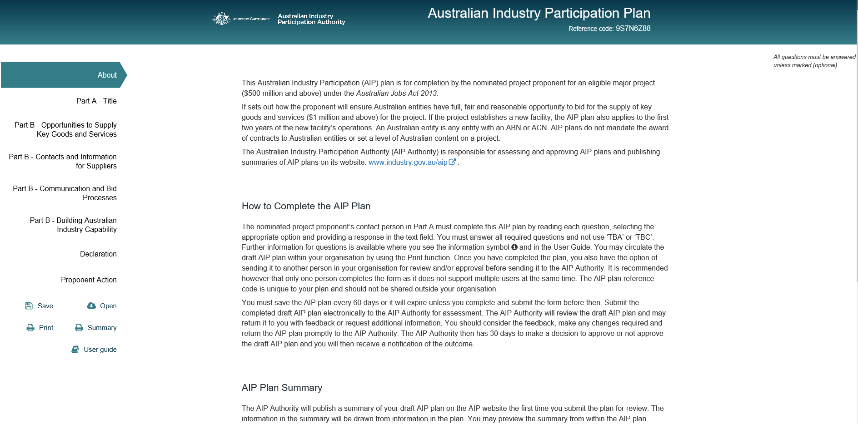

If your project’s purpose is to establish a new facility, the plan will look like this (Parts A, B and C):

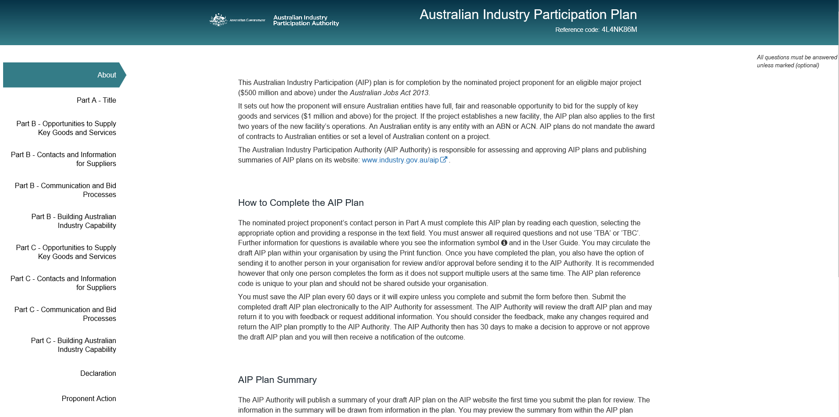

The About page has important information about the SmartForm AIP plan. The tabs on the left hand side represent each of the sections of the AIP plan that you need to complete. A tick next to each tab indicates it has been completed successfully. Important information about the AIP plan and explanations for some questions are available by hovering over the information symbols .

See the next section of this User Guide for information on how to respond to each of the questions.

Underneath the tabs are the SmartForm icons:

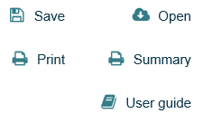

Save – whenever you have finished editing the plan save it by clicking on the Save icon. Note that if you do not access and save your plan within 60 calendar days of your last save, it will expire and the plan will be deleted. You will not be able to retrieve it and will need to start a new plan.

Open – this allows you to re-enter your plan using your reference code.

Print – this generates a PDF copy of your entire plan which you can print and distribute.

Summary – this generates the PDF summary of your plan using the information from your plan.

User guide – this opens the AIP plan User Guide which is this document.

In addition, there will be a comments icon when you hover to the right of fields as below:

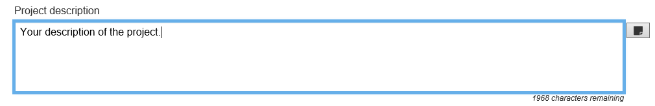

If you click on the icon it opens up a text box where you can add comments relating to the response:

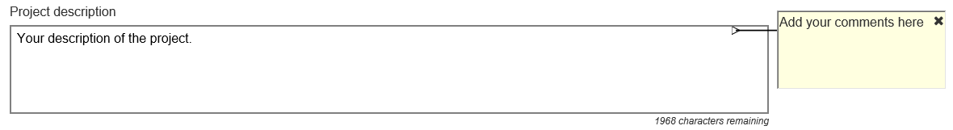

You can use it to leave reminders to yourself or make notes which can be read by other people that you send the plan to (see below). You can add to, edit or delete comments you or anyone else have made in the plan. If you send the plan to the AIP Authority the comments will be visible to the AIP Authority so make sure you delete any internal comments before sending it.

After completion of the AIP plan

The last tab is the Proponent Action tab which requires you to select one of the following options after you have completed the plan:

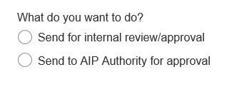

**Send for internal review/approval**

This option allows you to send the SmartForm AIP plan to another person in your organisation for review and/or approval. You will need to enter the person’s email address and include a message instructing them on what to do with the plan. You can only send the plan to one email address at a time:

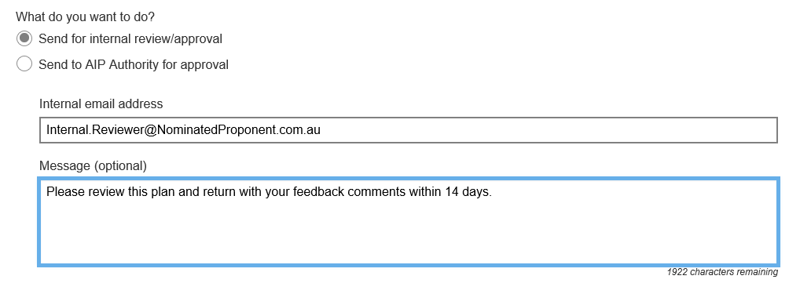

The reviewer will receive an email from SmartForm with the link to open the plan like this:

**Australian Industry Participation Plan**

You have been sent an AIP Plan for Major Project for review/approval.

<Your message>

Your reference code is **672KQXWD**.

**This saved version will expire on: Thu Oct 22 19:29:52 AEDT 2020.** If it is not saved or submitted before this date and time it will be permanently deleted. The above reference code may be required to open your plan. Use the following url, https://forms.test.business.gov.au/smartforms/servlet/SmartForm.html?formCode=australianindustryp2&saveChallenge=true&referenceNumber=672KQXWD to open this plan.

Note there is no email address checker in the SmartForm so ensure the email entered is correct. You will not receive bounce-back emails for incorrect email addresses or out-of-office messages. Check with the reviewer that they received the plan. If you send the plan to an incorrect or dormant email address you cannot recall the send. Anyone receiving the link will be able to open, edit and print the plan. You can, however, still access the plan from the original link sent by the AIP Authority or your last saved email and re-send it. This will not cancel the access to the plan for the original email address you sent it to. If you believe the incorrect address you sent the plan to will breach the confidentiality of the plan, contact the AIP Authority to have the plan cancelled.

Once you send the plan to the reviewer, they will be able to edit it. It is recommended, however, that only the nominated project proponent contact person makes changes to the plan responses. Any reviewers can provide their feedback against each response by clicking on the comments icons and entering their feedback in the comments text boxes. When they return the plan to you their feedback comments will be visible to you. Note they must return the plan to you from the Proponent Internal Review/Approval Action tab by clicking Send:

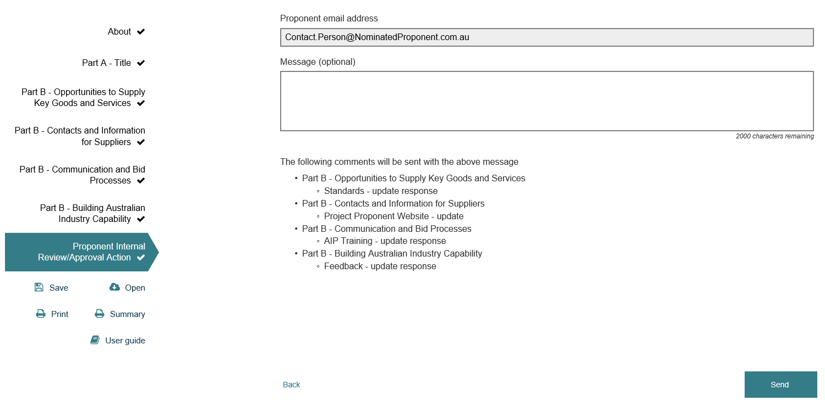

The SmartForm will always return the plan to the email address in Part A – Nominated Project Proponent Contact Person. The reviewer is not able to send the plan to a different person or to the AIP Authority. You will receive an email from SmartForm with the link to open the plan when it is returned by the reviewer. You may then send the plan to another person for review or approval.

While another person in your organisation can approve the plan, the Declaration page should only be confirmed by the nominated project proponent’s contact person. Their name appears at the start of the declaration and cannot be changed. The AIP Authority will take it that this person has confirmed the declaration and no other person has confirmed it as follows for a new facility plan:

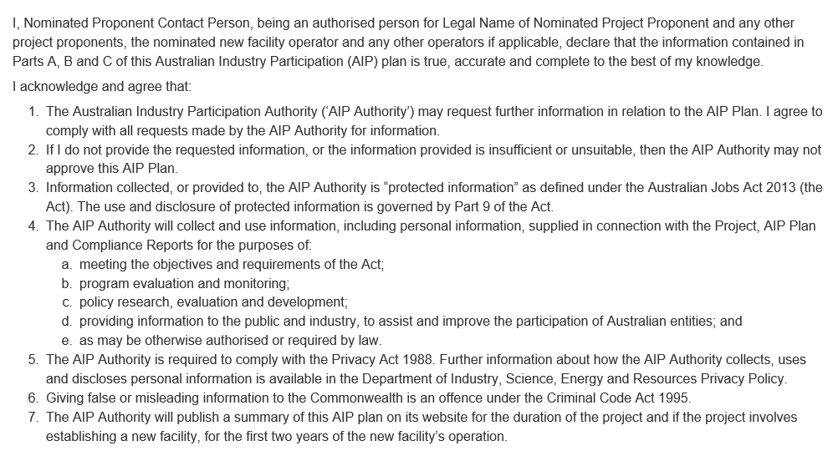

The additional confirmation is for proponents to consent to being included on the email distribution list for the AIP Newsletter.

Note the SmartForm AIP plan will expire if it is not accessed and saved within 60 days of you sending it to another person. Either the reviewer or yourself should save the plan regularly by clicking on the Save icon and then clicking Confirm in the pop-up box:

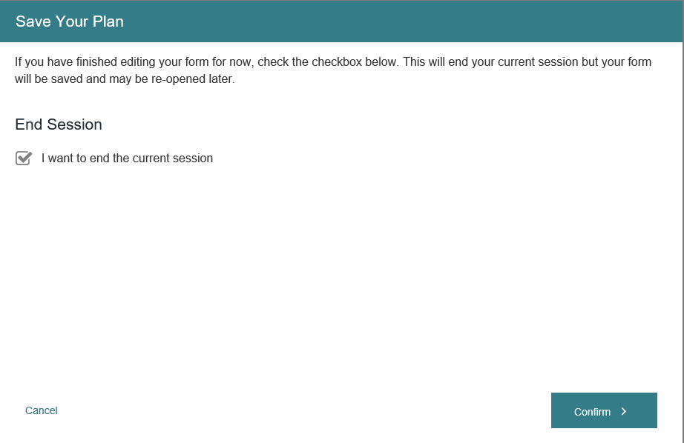

You will receive an email from SmartForm with the link to re-open your plan:

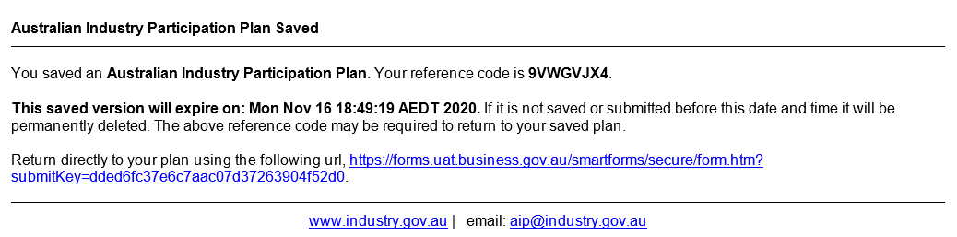

**Send to AIP Authority for approval**

This option is used to submit the AIP plan to the AIP Authority. All AIP plans must be sent to the AIP Authority for approval. The nominated proponent contact person will need to fully complete the plan and confirm the Declaration before they can submit it from within the SmartForm by clicking Send. If there is information missing in any part of the plan the SmartForm will advise you which questions require completion before you can submit it. Any comments left in the plan will be visible to the AIP Authority. Once you submit the plan you will not be able to retrieve it. From the Proponent Action tab, select ‘Send to AIP Authority for approval’ and click Send:

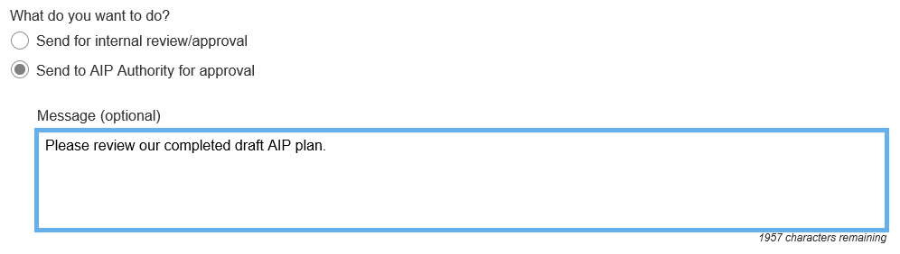

SmartForm will send an email to the AIP Authority ([aip@industry.gov.au](mailto:aip@industry.gov.au)) advising the plan has been submitted. You will receive a copy of the email from SmartForm as confirmation it has been sent.

Your AIP Authority Case Manager will assess the plan and may return it to you in SmartForm with feedback comments for updating. If the plan is returned you will receive an email from SmartForm like this:

**Australian Industry Participation Plan**

You have been sent an AIP Plan for Major Project for remediation with the following message.

<AIP Authority message>

Please note the following

* Part A - Title
  + <AIP Authority feedback>
* Part B – Project phase
  + <AIP Authority feedback>
* Part C – Initial operational phase
  + <AIP Authority feedback>

Your reference code is TJHSPJ5H.

**This saved version will expire on: Mon Oct 26 13:31:59 AEDT 2020.** If it is not saved or submitted before this date and time it will be permanently deleted. The above reference code may be required to open your plan. Use the following url, <https://forms.test.business.gov.au/smartforms/servlet/SmartForm.html?formCode=australianindustryp2&saveChallenge=true&referenceNumber=TJHSPJ5H> to open this plan.

You should consider any feedback, update the plan, send it for internal review or approval and return it within 30 calendar days to the AIP Authority in the SmartForm. Delays in returning the updated plan could result in non-compliance. If there is no further feedback from your case manager, they will forward your AIP plan to the AIP Authority for consideration.

If the plan is approved by the AIP Authority, you will receive an email from SmartForm confirming the approval with a copy of the approved AIP plan and summary and a link to re-do the plan if it needs to be changed later. This email is the formal notice of approval of the AIP plan from the AIP Authority.

If the plan is not approved by the AIP Authority, you will receive an email from SmartForm with the reasons and the plan will be returned to you in SmartForm for updating. You must update the plan and return it to the AIP Authority within 30 calendar days.

How to answer each question in the AIP plan

Each question in the AIP plan requiring project proponents or operators to provide or describe activities should be addressed as follows:

1. **What** is the action;
2. **How will the action be carried out; and**
3. **When** will the action be carried out.

Actions should be achievable and realistic. They should not however simply reflect business-as-usual procurement activities. Their intent should be to expand the organisation’s approach to identifying and considering potential suppliers and communicating opportunities. Actions that favour or preference existing supply chain partners over potential new suppliers are not acceptable. Actions should not preference suppliers in one location such as the project’s region over suppliers outside that region.

Actions should be distinct. Repeating the same action in response to different criteria is not acceptable. Actions should reflect intended future activity. Actions that have already been carried out should not be reported in the AIP plan. They can be included in the first compliance report.

Actions should be clearly expressed and accurately describe the three points above. Actions should be measurable such that their achievement can be assessed and reported on.

All actions in the AIP plan should be phrased in an active manner and should not include qualifying statements like as required, can, might or may (e.g.: “Project proponent will engage the services of industry associations to communicate opportunities” rather than “Project proponent may engage the services of industry associations to communicate opportunities”).

When drafting actions for an AIP plan the key consideration should be whether the action will provide full, fair and reasonable opportunity to Australian entities through assisting Australian entities to gain knowledge of, or access to, an opportunity.

A copy of the SmartForm Jobs Act AIP plan is at the end of this User Guide. The following provides more information on how to answer each question in the plan.

### **Part A – Title**

Part A of the AIP plan is required to be completed for all projects developing an AIP plan in accordance with the Jobs Act. If a proponent submitted an AIP Notification for the project and the AIP Authority initiated the AIP plan, some of the details in Part A will be pre-populated. Proponents must check and complete the details in Part A of the AIP plan as follows.

**Nominated Project Proponent Details**

Check the nominated project proponent details are correct. If not, enter the ABN, ACN or name of the nominated project proponent in the Search field. The SmartForm will search for the entity matching those details. Select the correct entity. Refer to the AIP Plan Submission section of this User Guide for information on determining the nominated project proponent. The name of the nominated project proponent will be published in the AIP plan summary.

Check the contact person details are correct. If not, enter the name, position title, phone number and email address of the nominated project proponent’s contact person for the AIP Authority. This person will be the point of contact between the nominated proponent and the AIP Authority, and will be responsible for completing the SmartForm AIP plan and submitting it to the AIP Authority. SmartForm will send all communications on the AIP plan from the AIP Authority to this person’s email address only. The details of this contact person will not be published and are for the AIP Authority’s use only. The nominated proponent’s contact person must be a director or employee of the nominated project proponent or its holding entity and not an external person or agent.

**Postal Address**

Check the postal address is correct. If not, enter the nominated project proponent’s postal address in the Search field. The SmartForm will search for the address. Select the correct address.

Check the proponent type is correct. If not, select the nominated project proponent’s proponent type from the available options: Single Company, Joint Venture, Public Private Partnership or Government Agency.

**Other Project Proponent Details**

Check the other project proponent details are correct. If not, provide details for all other project proponents involved in the project which have discharged their AIP plan development responsibilities to the nominated project proponent. Enter the details for each other project proponent(s) by selecting ‘Add project proponent’ and searching for the correct entity. Add each other proponent in another row. The names of any other project proponents will be published in the AIP plan summary.

**Project Details**

**Project name**

Check the project name is correct. If not, enter the name of the project.

**Project location**

Check the project location is correct. If not, enter the physical location of the project. This should be the street address (if applicable), suburb or other location and the state or territory. If there are multiple locations, enter the principal location.

**Project type**

Check the project type is correct. If not, select the type of facility being established/upgraded by the project from the available options:

|  |  |  |
| --- | --- | --- |
| Airport | Electricity facility | Factory |
| Land transport facility | Mine or quarry | Passenger terminal |
| Petroleum facility | Sewage or wastewater facility | Telecommunications network |
| Water supply facility | Wharf or other port facility | Other productive facility |

If more than one type of facility is being established/upgraded, select the principal type of facility for the project. If selecting ‘Other productive facility’ provide a description of the facility being established or upgraded.

**Project purpose**

The Project purpose describes the principal purpose of the project as either to upgrade an existing eligible facility or establish a new eligible facility. It will have been pre-populated from the AIP Notification or by the AIP Authority and cannot be amended by the proponent in SmartForm. If the Project Purpose needs to be changed contact the AIP Authority. Note if the Project Purpose is changed to ‘Establish new facility’, proponents will need to provide details of the facility operator(s) and complete Part C of the AIP plan.

**Project capital expenditure**

Provide an estimate of the total expenditure of a capital nature for the project in Australian dollars (AUD). Either enter the total estimated capital expenditure value, select from the range of estimated capital expenditure values or confirm the estimated capital expenditure value will be $500 million or more.

**Project description**

Enter a full description of the project including principal activities and components, timelines and procurement strategy. This description should provide enough information for Australian entities to determine if they are suitable to provide goods and services to the project.

**Project completion date**

Select the estimated date for completion of the construction phase of the project by clicking on the calendar icon. If the exact date is not determined, enter the last day of the month of completion.

All the project details will be published in the AIP plan summary that is generated from the plan.

**Nominated Facility Operator Details** (for projects that establish new facilities only)

Enter the ABN, ACN or name of the nominated operator of the new facility in the Search field. The SmartForm will search for the entity matching those details. Select the correct entity. The nominated facility operator will be responsible for implementing Part C of the AIP plan on behalf of any other operators of the new facility. The nominated facility operator may be the same entity as the nominated project proponent or a different entity. If the nominated facility operator is not determined when the AIP plan is developed, enter the details of the nominated project proponent. The name of the nominated facility operator will be published in the AIP plan summary.

Enter the name, position title, phone number and email address of the nominated facility operator’s contact person for the AIP Authority. This person will be the point of contact between the operator(s) and the AIP Authority. The details of this person will not be published and are for the AIP Authority’s use only. The person must be a director or employee of the nominated facility operator or its holding entity and not an external person or agent. If the contact person is not determined, enter the details of the nominated project proponent’s contact person.

**Postal Address**

Enter the nominated facility operator’s postal address in the Search field. The SmartForm will search for the address. Select the correct address.

Select the nominated facility operator’s operator type from the available options: Single Company, Joint Venture, Public Private Partnership or Government Agency.

**Other Facility Operator Details**

Enter the details of any other facility operators by selecting ‘Add operator’ and searching for the correct entity. Add each other operator in another row. The names of any other facility operators will be published in the AIP plan summary.

**Part B – Project Phase**

Part B of the AIP plan is required to be completed for all projects developing an AIP plan in accordance with the Jobs Act. It relates to the procurement of key goods and services ($1 million and above) by the proponent(s) and its procurement entities for the engineering and construction phase of the project.

Part B of the AIP plan binds the project proponent(s) for the project and if the proponent(s) for the project changes, the new proponent(s) will be bound by Part B of the AIP plan.

The key objective of Part B of the AIP plan is that Australian entities should have full, fair and reasonable opportunity to bid for the supply of key goods or services for the project.

Until the project is completed, the nominated project proponent must take all reasonable steps, including the steps it specifies in Part B of the AIP plan, to ensure that it and each procurement entity for the project achieve the objectives and obligations of Part B.

Evidence and records of the implementation of Part B of the AIP plan must be kept by the nominated project proponent for five years and provided as part of compliance reporting.

All references to “you” and ”your” in Part B refer to the nominated project proponent in Part A.

**Opportunities to supply key goods and services**

In this criterion proponents must detail the opportunities to supply key goods and services to the project, describe how procurement entities will keep up to date on Australian industry capability and the standards that will apply to the project.

**Indicative List of Key Goods and Services for the Project**

Proponents must provide an indicative list of all key goods or services (valued at $1 million or more) likely to be acquired for the project. Include any items already acquired for the project and any items for which procurement has commenced. Separate items into goods and services and only enter one item per field. Describe items in the way they are intended to be procured. If the proponent intends to procure a single head contractor for the project such as an Engineering, Procurement and Construction (EPC) contractor, it will be necessary to list the principal items the EPC contractor will acquire for the project.

For each item proponents should confirm if there will be opportunities for Australian and/or non-Australian entities to potentially supply the item. To supply an item includes manufacturing or supplying the goods or their components or providing the service. An Australian entity is defined as an entity with an ABN or ACN. Proponents should select ‘Opportunities for Australian entities’ for each item if potentially one or more Australian entities:

* can directly manufacture or supply the goods or services to the specifications or to the scale required for the project;
* can source or supply the item from another Australian or non-Australian entity;
* can supply the item but may not be competitive in terms of price or schedule with non-Australian entities;
* are partnered with a non-Australian entity to supply the item;
* can provide components of the item;
* can be involved in the transportation, modification, testing, installation and/or commissioning of the item;
* can manufacture or supply the item but are not yet pre-qualified or not the proponent, its engineering contractors or its procurement entities preferred or existing supplier; or
* could supply the item but further research is required to establish this.

The opportunities selected should be based on the market’s potential supply sources for each item, rather than confirm the proponent’s, their engineering contractors or procurement entities pre-determined sources of supply.

*Intent of the AIP plan*: Proponents and their engineering contractors and procurement entities should make themselves aware of and consider all potential Australian sources of supply for an item before making engineering and procurement decisions.

If there are potential Australian suppliers of an item, the AIP plan should be directed towards ensuring the engineering takes account of those Australian capabilities and those Australian suppliers are made aware of the supply opportunities and the processes to register interest and bid. This includes items for which there are only Australian sources of supply, in which cases proponents and their engineering contractors and procurement entities should consider potential new Australian suppliers alongside any of their existing Australian suppliers.

If an item has already been acquired or is already being procured, proponents should show the opportunities as they existed at the time the item was acquired or the procurement commenced.

If after consideration of all the potential Australian supply options, the proponent concludes there are no opportunities for Australian entities to supply an item or its components, an explanation must be provided. The explanation could be that no Australian entity can supply the item or supply it to the specifications or in the quantities or scale required for the project. The explanation should describe the recent research (i.e.: within the last six months) the proponent has done to reach this conclusion. The research should consider all the potential Australian supply opportunities for the item and not be limited to whether the item is manufactured in Australia. The AIP Authority may request evidence of how the conclusion was reached. The explanations will be published with the list of key goods and services in the AIP plan summary that is generated from the AIP plan.

If there are only opportunities for Australian entities to supply an item (i.e.: no opportunities for non-Australian entities) or opportunities for both Australian and non-Australian entities for an item, it is not necessary to provide an explanation.

After entering each item and confirming if it has opportunities for Australian and/or non-Australian entities, select ‘Add item’ to add it to the list. You can edit or remove each item from the list. Select ‘Summary’ from the SmartForm icons to view the list of your items in the summary.

**Maintain Understanding of Australian Industry Capability**

Proponents must select from the options how they will require their procurement entities stay up-to-date with the capability and capacity of Australian entities to manufacture and supply the key goods and services required for the project. If the proponent is the sole procurement entity for the project, select the actions the proponent will take. The options include requiring procurement entities to:

* consult with vendor identification agencies, such as the Industry Capability Network;
* research Australian industry capability and capacity;
* maintain a current database of Australian suppliers;
* directly contact potential Australian suppliers to determine their capability; and
* any other actions that will increase their awareness of Australian industry capability, such as consulting with industry associations.

For example, if the first option was selected, the proponent could engage the services of a vendor identification agency and then require its procurement entities to provide their $1 million and above procurement packages to the agency for a vendor search.

Proponents must select at least one option either from the list or by including other actions they will take. Proponents may enter up to five other actions. For each other action, enter the title of the action and then describe it in the text box underneath. Other actions should be distinct activities and not the same action described in different ways.

*Intent of the AIP plan*: Procurement entities must not solely rely on in‑house knowledge but should undertake market soundings and research to keep themselves regularly informed of Australian industry capability and capacity in relation to the key goods and services for the project. Particular attention should be given to researching the capability of Australian manufacturers for any manufactured goods required for the project.

*Best practice tip*: When selecting procurement entities, provide information about the AIP plan and require procurement entities to explain how they keep up to date with Australian industry capability and their process for registering Australian suppliers on their databases.

**Project Standards**

Proponents must select the design and engineering standards to be used on the project from the available options - Australian, International and/or Other. International standards means ISO standards or other recognised international standards in common use in the project’s industry sector. Proponents should select all the standards that will be used, for example: Australian, International and Other. If Other is selected proponents must provide a description of the Other standards to be used. The standards selected and the description of any Other standards will be published in the AIP plan summary that is generated from the AIP plan.

*Intent of the AIP plan*: The project’s design standards should not create a barrier to Australian entities participating in the project. Specifying Australian standards and recognised international standards will ensure Australian entities are not disadvantaged.

If proponents *only* select Other standards they will be presented with another question on the impact this will have on the ability of Australian entities to participate in the project. An explanation must be provided in the response box under that question. Proponents should explain if these Other standards can be met by Australian entities and what steps the proponent will take to ensure the Other standards are not a barrier to Australian entities participating in the project.

In addition, proponents that *only* select Other standards for the project will need to confirm that if their procurement entities only specify Other standards, the proponent will ensure each procurement entity publishes on its public website an explanation why neither Australian nor international standards are being used. The explanation must be published for the duration of the procurement entity’s procurement phase.

**Contacts and Information for Suppliers**

In this criterion proponents must detail the contacts and online information sources for Australian manufacturers and suppliers interested in participating in the project.

**Contact Person**

Proponents must provide the details of their employee who will be their contact person for supplier enquiries on the project. The person should be an employee of the nominated project proponent and not an agent or third party representative. Enter the person’s name, position title, phone number and email address. It is acceptable to use a generic email address provided the contact person has access to it. The contact person’s details will be published in the AIP plan summary and may be updated later if they change.

**Procurement Entity Contact Person**

Proponents must confirm they will ensure their procurement entities will at all times each have an employee who is designated as their procurement contact person for the project. This is in addition to the nominated project proponent’s contact person for supplier enquiries detailed in the question above unless the nominated project proponent is also the sole procurement entity for the project.

**Project Proponent Website**

Proponents must provide the address of their publicly accessible website which has general information about the project for potential suppliers. The website may also have a link to the project opportunities website (if different). The website address will be published in the AIP plan summary.

**Project Opportunities Website**

Proponents must provide the address of the publically accessible website(s) where the proponent(s) and its procurement entities will publish available opportunities to supply key goods and services ($1 million and above) as they arise and allow suppliers to register interest in those opportunities. This may be a third party’s website and/or the project proponent’s website. If using a third party website provide the specific project webpage address if possible. The website address will be published in the AIP plan summary.

The website(s) should be available from the commencement of the procurement phase of the project and continue to be available until all procurement is completed. The website(s) should be accessible by any potential supplier from any location and not require the payment of any fees or completion of a pre-qualification process before suppliers can use the site and register for opportunities. It is acceptable to use third party websites in common use in the project’s industry sector provided they meet the above accessibility criteria.

Available project opportunities should be published for a reasonable time period with sufficient information to allow all potential suppliers to register interest. All procurements of key goods and services ($1 million and above) should be published unless there is a substantive reason not to publish that can be justified to the AIP Authority if required.

*Intent of the AIP plan*: Proponents should ensure all the project’s opportunities are available to all potential capable suppliers to register interest and not limit it to opportunities for which they or their procurement entities do not already have an existing supply arrangement.

While it is acceptable to have general interest registrations during the early stages of a project, once procurement packages are determined they should be advertised on the website(s) as they arise and in sufficient time for registrations to be taken into account in the procurement decision making process. Procurement packages should be listed at the level they are intended to be procured and where applicable should include the ability for suppliers to register against the full or partial scopes of each package. Potential suppliers that register interest should be considered alongside and equally with any other suppliers already known to the proponent and its procurement entities.

*Best practice tip*: Upon completion of bidding and tendering processes, websites should include the contact details of successful bidders for procurement packages. This will enable lower tier suppliers to contact the successful bidders for sub-contracting opportunities.

**Procurement Entity Website**

Proponents must describe how they will ensure their procurement entities have a publicly accessible website on which their procurement entities will publish the:

* pre-qualification requirements potential bidders must meet at a reasonable time before they request bids;
* the standards for key goods and services; and
* the procurement entity procurement contact person’s details.

This website may be the project opportunities website or another publicly accessible website. Provide the addresses of any websites if known.

If the nominated project proponent is the sole procurement entity for the project, proponents should describe how and where they will publish this information.

*Best practice tip*: Establish a project opportunities webpage on a vendor identification agency website, such as ICN Gateway, and require procurement entities to publish on it their project opportunities, pre-qualification requirements, standards and procurement contact person’s details.

**Communication and Bid Processes**

In this criterion proponents must detail how they will engage and communicate with potential Australian manufacturers and suppliers to raise their awareness of the opportunities to supply key goods and services to the project and explain the pre-qualification requirements and bid processes. Information must also be provided on AIP training for procurement entities and ensuring equal bid timeframes.

**Engagement and Communication**

Proponents must select from the options how they will engage and communicate with potential Australian manufacturers and suppliers to raise their awareness of the project’s opportunities and explain the pre-qualification requirements and bid processes. Proponents must describe in more detail each action selected and include the timeframes for undertaking these activities in the response boxes. The proponent should conduct the activities which may be in collaboration with its procurement entities. It is not acceptable for a proponent to delegate these actions to its procurement entities.

The options with further explanations are:

* Promote project opportunities through industry associations
  + Promote project opportunities to potential Australian suppliers through their industry associations and networks, both national and regional. This could include arranging to brief industry association members on project opportunities, the pre-qualification requirements and bid processes at the start of the project’s procurement phase. Other activities include publishing project information in industry association newsletters or on their websites.
* Engage with vendor identification agencies on project opportunities and bid processes
  + Engage with vendor identification agencies to help advertise the project’s opportunities, pre-qualification requirements and bid processes to potential Australian suppliers. This could include the vendor identification agency alerting its supplier base to the project’s opportunities and creating a project webpage with information for suppliers. Project proponents should contact any vendor identification agencies before submitting the AIP plan to confirm that they are able to assist.
* Conduct supplier information briefings on project opportunities and bid processes
  + Hold industry briefings and/or workshops to communicate the project opportunities, pre-qualification requirements and bid processes to potential Australian suppliers. Briefings should be held at the start of the procurement phase in locations accessible to suppliers or online. Include information on how the briefings will be advertised and promoted for Australian entities to attend.
* Issue media releases or ASX announcements on project developments and opportunities
  + Publish media releases/statements through mainstream media (e.g. newspapers, industry magazines and/or business journals) or via ASX announcements on project developments and supply opportunities and how Australian entities can respond to them.
* Develop and distribute a supplier information guide for the project
  + Develop and distribute a Supplier Information Guide that details the project proponent’s expectations of Australian entities interested in supplying key goods and services for the project and the process for registering interest and bidding.
* Directly contact suppliers with information on project opportunities and bid processes
  + Direct contact with Australian entities (e.g. letter or email) informing them about project opportunities and how to register interest.

Proponents must select at least four options either from the list or by including other actions they will conduct. Proponents may enter up to five other actions. For each other action, enter the title of the action and then describe it in the box underneath. Ensure each other action is a distinct activity and not the same action described in different ways. The title of each action selected from the list or added in as another action will be published in the AIP plan summary.

*Intent of the AIP plan*: Proponents must actively engage and communicate with potential Australian suppliers to the project including suppliers outside their existing supply chains or arrangements. By raising their awareness, suppliers will be better placed to assess their suitability to participate in the project and understand the pre-qualification requirements and if necessary address them before the active procurement phase. It is important that proponents take a range of actions to communicate with suppliers. It is not acceptable for proponents to conduct all their communication through a project website.

*Best practice tip*: Develop a supplier communication strategy for the project that identifies the potential Australian supplier audience, the methods of communication, any facilitators such as industry associations and the timeframes for actions.

**AIP Training**

Proponents must describe how they will inform and train procurement entities about their AIP plan obligations for the project. Enter the description in the response box.

*Intent of the AIP plan*: It is important that procurement entities understand and implement the AIP plan’s actions to provide Australian entities with full, fair and reasonable opportunity on the project. Proponents must ensure they provide adequate training for procurement entity staff on the AIP plan and its requirements. This should be done before the active procurement phase begins with refresher training provided if required during procurement.

Examples of actions proponents can take:

* Hold workshops with procurement entity staff to detail the AIP plan obligations.
* Create, publish and distribute a policy detailing the project proponent’s commitment to maximising opportunities for Australian entities to participate in the project.
* Develop and distribute an information guide that details the project proponent’s expectations of procurement entities for the project.
* Include a requirement in tender documents and contracts that procurement entities implement the AIP plan activities.

*Best practice tip*: Make the AIP plan requirements an agenda item for kick-off meetings with procurement entities and develop and present an AIP training module to their procurement staff.

**Equal Bid Timeframes**

Proponents must confirm that they will ensure their procurement entities will not discriminate against Australian entities in relation to timeframes for responding to requests for bids to supply key goods and services for the project. Where the proponent is the sole procurement entity, it must confirm it will provide equal bid timeframes.

*Intent of the AIP plan*: Australian entities must be provided with the same and reasonable timeframes to bid for work on the project as non-Australian entities and entities already in the proponent’s and procurement entities’ supply chains. Proponents need to take steps to ensure their procurement entities adhere to this requirement.

*Best practice tip*: Require your procurement entities to list their key goods and services procurement packages ($1 million and above) on your project opportunities website with reasonable timeframes for responses and clearly state the closing dates for registrations of interest.

**Building Australian Industry Capability**

In this criterion proponents must describe how, through this project, they will encourage and facilitate Australian manufacturers and suppliers to build capability and integrate into global supply chains, including through the provision of feedback and recommendations for improvement.

**Capability Development**

Proponents must select from the options how they and their procurement entities will encourage and facilitate capability development for Australian manufacturers and suppliers to the project. Proponents must describe in more detail the actions selected in the response boxes.

The options with further explanations are:

* Recommend suppliers undertake training and/or accreditation to improve their capability, such as:
  + Providing advice and assistance to Australian entities in meeting pre‑qualification, accreditation and technical requirements.
  + Providing training and certification that enhances the ability of Australian entities to obtain additional business domestically and overseas.
  + Offering Australian entities access to internal training programs or provide training on improvements in technology or process management.
* Provide market intelligence to suppliers, including knowledge of international market and price trends, international and domestic market potential and sources of raw materials.
* Transfer new product and process technology to suppliers, to help them master new technologies.
* Encourage joint ventures and alliances between suppliers, such as between Australian and non-Australian entities to enable them to access new technology or larger markets.
* Support supplier development initiatives of industry associations or governments.
* Other activities such as:
  + Encourage Australian entities to undertake research and development and innovative activities.
  + Undertake a rigorous supplier audit and improvement initiative to benchmark and disseminate best practice.
  + Develop supplier scorecards to evaluate supplier performance and provide feedback to Australian entities in respect of performance against critical dimensions.
  + Introduce a development program for capable Australian entities that actively seeks out new local suppliers and provides training and technology transfer.

Proponents must select at least two options either from the list or by including other actions they will conduct. Proponents may enter up to five other actions. For each other action, enter the title of the action and then describe it in the box underneath. Ensure each other action is a distinct activity and not the same action described in different ways. The title of each action selected from the list or added in as another action will be published in the AIP plan summary.

*Intent of the AIP plan*: Australian entities engaged on the project should be provided with advice and opportunities to improve their capability to make them more competitive for future projects in Australia and internationally. Proponents and their procurement entities should encourage and facilitate these opportunities by drawing on their experience, technical knowledge and industry connections.

*Best practice tip*: Make your procurement entities aware that they will be expected to identify and facilitate opportunities to build capability of Australian manufacturers and suppliers to the project. Set targets for the numbers of Australian entities given opportunities to build their skills.

**Global Supply Chain Integration**

Proponents must select from the options how they and their procurement entities will facilitate the integration into global supply chains of Australian manufacturers and suppliers to the project. Proponents must describe in more detail the actions selected in the response boxes.

The options with further explanations are:

* Introduce suppliers to global supply chain partners including:
  + the appropriate technical and purchasing decision makers
  + visit project proponents’ and/or procurement entities’ overseas facilities
  + other global companies, including the project proponent’s customers and suppliers
  + international procurement office staff to increase their awareness of Australian industry.
* Support suppliers to register with the global supplier databases of the proponent, its procurement entities or global supply chain partners.
* Facilitate strategic partnering and joint ventures between Australian and international suppliers. This could be achieved by:
  + making introductions between possible partners
  + arranging seminars to raise awareness of the benefits to Australian entities of entering into strategic alliances and how to enter into and manage such arrangements
  + making referrals to vendor identification agencies.
* Recommend suppliers undertake export readiness training or international accreditation, to increase their capability to bid for work internationally.
* Support supplier export and global integration initiatives of industry associations or governments, through provision of resources or nomination of suitable suppliers.
* Provide references for high performing suppliers.
* Other activities including:
  + accredit Australian entities to work in other regions, thus opening new markets
  + assist participation by Australian entities in local, regional or national trade fairs and missions.

Proponents must select at least one option either from the list or by including other actions they will conduct. Proponents may enter up to five other actions. For each other action, enter the title of the action and then describe it in the box underneath. Ensure each other action is a distinct activity and not the same action described in different ways. The title of each action selected from the list or added in as another action will be published in the AIP plan summary.

*Intent of the AIP plan*: Australian entities engaged on the project should be provided with advice and opportunities to facilitate their integration into global supply chains that could lead to work on future projects in Australia and internationally. Proponents and their procurement entities should encourage and facilitate these opportunities by drawing on their experience and industry connections.

*Best practice tip*: Arrange presentations from your procurement entities to the project’s suppliers on how to register for their supplier databases and the requirements for working in other regions.

**Feedback**

Proponents must describe how they will ensure their procurement entities offer and provide feedback to Australian entities which were unsuccessful in their bids to supply to the project. Feedback must include recommendations of training and skills development activities to increase Australian entities’ capabilities and capacity to access future projects. Processes should be put in place to offer and provide feedback at each stage of the procurement, i.e.: after shortlisting of expressions of interest, after any subsequent pre-qualification and after award of contracts. Feedback may be written or verbal and should outline the reasons why the bid was not successful. The response to this question will be published in the AIP plan summary.

*Intent of the AIP plan*: Unsuccessful Australian entities should be offered feedback on their bids to help identify areas for improvement so they may be more competitive for future projects. Proponents and their procurement entities are well placed to provide recommendations of training and skills development that can assist Australian entities to build their capability.

*Best practice tip*: Make procurement entities aware of your requirements to offer and provide feedback and audit their compliance with the requirements. Arrange information seminars for procurement entities on supplier capability development agencies and programs to which they can refer unsuccessful Australian entities.

**Part C – Initial Facility Operational Phase**

Part C of the AIP plan is required to be completed for projects that establish new facilities only. It relates to the procurement of key goods and services ($1 million and above) by the operator(s) and its procurement entities for the initial operational phase (first two years) of the new facility.

Part C of the AIP plan binds the operator(s) for the new facility and if the operator(s) for the new facility changes, the new operator(s) will be bound by Part C of the AIP plan.

The key objective of Part C of the AIP plan is that Australian entities should have full, fair and reasonable opportunity to bid for the supply of key goods or services for the new facility’s initial operational phase.

Until the end of the first two years of operations of the new facility, the nominated facility operator must take all reasonable steps, including the steps specified in Part C of the AIP plan, to ensure that it and each procurement entity for the new facility achieve the objectives and obligations of Part C.

Evidence and records of the implementation of Part C of the AIP plan must be kept by the nominated facility operator for five years and provided as part of compliance reporting.

All references to “you” and ”your” in Part C refer to the nominated facility operator in Part A of the AIP plan.

The nominated project proponent will complete Part C on behalf of the nominated facility operator. If the nominated facility operator is not determined at the time the AIP plan is developed, it is acceptable to enter the nominated project proponent’s details and AIP actions from Part B. The nominated facility operator may submit a replacement AIP plan that updates the information and actions in Part C before the commencement of procurement for the operations phase.

Some new facilities may not intend to acquire any goods or services valued at $1 million and above. Part C must still be completed however and the actions would apply if there was any procurement of key goods and services.

The criteria and questions in Part C are the same as those in Part B. The SmartForm will pre-populate Part C with the responses from Part B of the plan. Proponents should review the responses and update them if required. Certain questions will not be pre-populated and will be required to be answered. There is only one declaration for each AIP plan which covers the responses in Part C. The AIP plan summary will include the Part C responses in the same format as Part B.

**Opportunities to Supply Key Goods and Services**

In this criterion, operators must detail the opportunities to supply key goods and services for the new facility, how procurement entities will keep up to date with Australian industry capability and the standards that will apply to the new facility. Further information on addressing the questions in this criterion is available in the equivalent criterion in Part B above.

**Contacts and Information for Suppliers**

In this criterion, operators must detail the contacts and online information sources for Australian manufacturers and suppliers interested in participating in the new facility. Further information on addressing the questions in this criterion is available in the equivalent criterion in Part B above.

**Communication and Bid Processes**

In this criterion, operators must detail how they will engaged and communicate with potential Australian manufacturers and suppliers to raise their awareness of the opportunities to supply key goods and services to the new facility and explain the pre-qualification requirements and bid processes. Information must also be provided on AIP training for procurement entities and ensuring equal bid timeframes. Further information on addressing the questions in this criterion is available in the equivalent criterion in Part B above.

**Building Australian Industry Capability**

In this criterion, operators must describe how, through this new facility, they will encourage and facilitate Australian manufacturers and suppliers to build capability and integrate into global supply chains, including through the provision of feedback and recommendations for improvement. Further information on addressing the questions in this criterion is available in the equivalent criterion in Part B above.

Answers to common queries about Jobs Act AIP plans

**Q: Can we defer completing the AIP plan until we are certain our project is going ahead?**

A: Once you have notified the AIP Authority of your major project you must submit the AIP plan 90 days before the agreed trigger date. Most projects are subject to various conditions such as government approvals and board sign-off, and for the purposes of the Jobs Act it is assumed these conditions will be met. Proponents must not defer submitting their AIP plan until they have all their project approvals.

**Q. Should we wait until we select our procurement entities before completing the AIP plan?**

A. There is no need to wait until you select your procurement entities. It will be important that potential procurement entities are aware of your AIP plan requirements when they tender for the project so they can factor them in. If you intend to engage a single procurement entity such as an Engineering, Procurement and Construction (EPC) contractor, there may be benefit in having its input into the development of the AIP plan. Contact the AIP Authority in such cases to discuss.

**Q. Are there any examples of good AIP plans the AIP Authority can share with us?**

A. There are many variations in plans due to project scope, size and sector so it is difficult to provide an example of a plan that would cover all these variations. Summaries of AIP plans are published on the AIP Authority website ([www.industry.gov.au/aip](http://www.industry.gov.au/aip)) and you are able to contact the proponents for advice. If you carefully review each question in your plan with reference to this User Guide (including the best practice tips) and get creative with ideas on how you can stretch your usual procurement practices to reach potential new Australian suppliers, you will be on the way to a good AIP plan.

**Q. Can we develop our AIP plan on our own template?**

A. Proponents must use the SmartForm AIP plan to develop their AIP plan. This ensures you address all the requirements of the Jobs Act AIP plan rules. The SmartForm has features to make it easier for you to complete and submit the plan. AIP plans submitted on different templates, including any previous paper based plan templates put out by the AIP Authority, will not be accepted.

**Q. Do we need to do an AIP plan if we are required to develop a state or territory industry plan?**

A. If you are required to develop a state or territory industry participation plan you may get an exception from doing the Jobs Act AIP plan. Your state or territory plan will need to meet a few conditions, however, including not preferencing suppliers in your state or territory over suppliers from elsewhere. You will need to notify the AIP Authority when you submit a state or territory industry participation plan, and provide the AIP Authority with a copy of the plan for review. Contact the AIP Authority for more details.

**Q. We already have a Jobs Act AIP plan for another project that we wish to use for this project.**

A. AIP plans are specific to each project you are developing. You may use the actions from your current plan in your new plan. If you are developing several projects at the same time that are interdependent (same location, objective and/or procurement approach) you may be able to combine them under one AIP plan. Contact the AIP Authority for advice.

**Q. Can we meet with the AIP Authority to discuss our project prior to submitting the AIP plan?**

A. If you would like to meet to discuss your project or get more information on preparing your AIP plan please send us an email ([aip@industry.gov.au](mailto:aip@industry.gov.au)) or phone (02) 6213 6404.

**Q. We don't have any information yet to fill in Part C as our operations team is not in place.**

A. At the time you need to submit the AIP plan, projects that establish new facilities may not have determined how they will conduct procurement for the operations phase. It is acceptable to repeat the information from Part B in Part C (the SmartForm will do this automatically) if you are yet to determine how operations procurement will be conducted. The nominated facility operator can submit a replacement of Part C of the plan closer to the commencement of operations procurement. If you don’t even know the details of your operator, just enter the nominated proponent’s details.

**Q. Can we submit the draft AIP plan without confirming the declaration in case there is feedback?**

A. The SmartForm requires you to confirm the declaration before you can send the plan to the AIP Authority. There may be no feedback required on your plan in which case the declaration needs to be confirmed before it progresses to the AIP Authority for a decision.

**Q. How can we get the other project proponent(s) and facility operator(s) to sign off the plan?**

A. You may circulate the PDF copy of the draft AIP plan to the other parties for their agreement prior to submission. The AIP Authority does not need to see confirmation from any other project proponents, the nominated facility operator or other operators that they agree to the plan. It is taken that the person confirming the declaration in the plan has the authority to do so on behalf of all parties and all parties have been made aware of and accept their obligations under the plan.

**Q. Will the AIP Authority acknowledge receipt of our AIP plan submission?**

A. SmartForm will cc you into the email we receive alerting us to your submission so you know it has reached us. We will not acknowledge receipt but if there is feedback on the plan your Case Manager will return the plan to you in SmartForm, usually within 10 business days. If you haven’t heard from us after 30 calendar days contact us on (02) 6213 6404.

**Q. Should we email a copy of the AIP plan to the AIP Authority?**

A. It is not necessary to email copies of the plan at any stage to the AIP Authority, including your early drafts for review. SmartForm is the platform for submitting and receiving approvals of plans. There are no attachments required for an AIP plan. If you have information about your AIP activities to date include it in your first compliance report.

**Q. Can the AIP Authority modify the content of our AIP plan after we submit it?**

A. The only fields the AIP Authority can modify in a submitted AIP plan are in Part A - Nominated Project Proponent details and the Project Purpose response. This allows the AIP Authority to update the email address so the plan can be returned to the correct person. Any other changes to the AIP plan can only be done by the proponent after the plan is returned to them by the AIP Authority.

**Q. Will the AIP Authority send a formal letter of approval for our AIP plan?**

A. SmartForm will send an email notification of approval to the nominated project proponent contact person when the plan is approved. This is the formal notification from the AIP Authority and letters will not be sent.

**Q. Can we make changes to our AIP plan after it has been approved?**

A. Projects will usually experience some changes that may mean the information in the AIP plan is out of date or incorrect. Minor changes to proponent, operator, project, personnel and contact details should be advised to the AIP Authority via email ([aip@industry.gov.au](mailto:aip@industry.gov.au)) or in your compliance reports. Your AIP plan summary may need to be updated. More significant changes to proponents, operators, the project or your AIP plan activities may require the submission of a replacement AIP plan. See the section in this User Guide on changes to AIP plans or contact the AIP Authority.

The SmartForm Jobs Act AIP Plan*



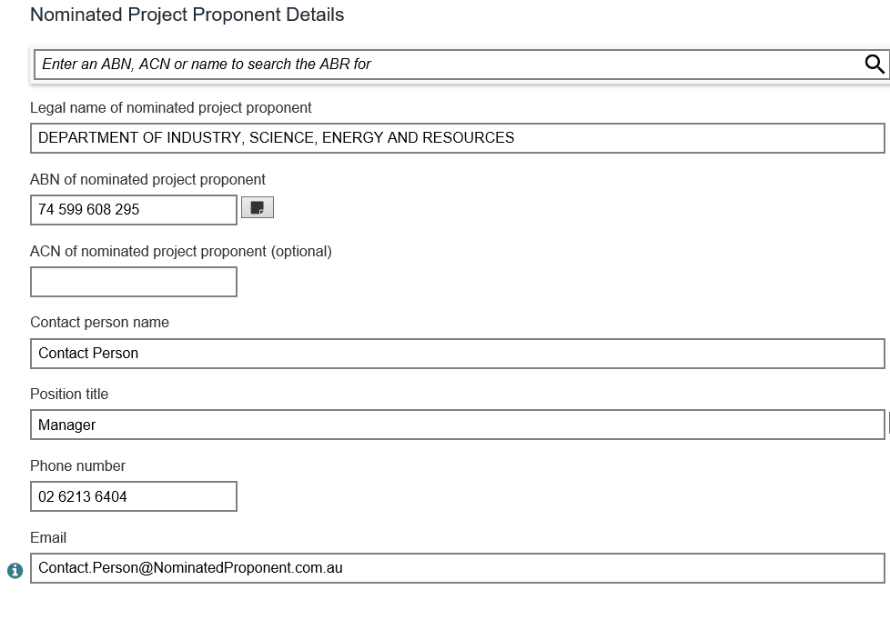

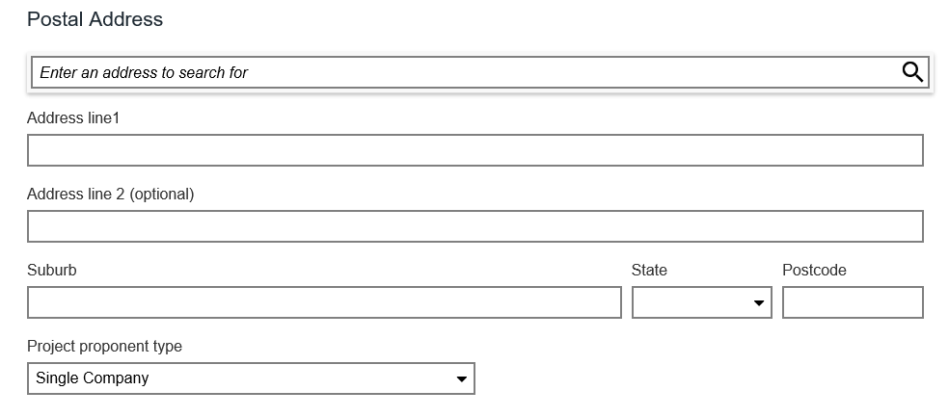

*Projects that establish new facilities complete Parts A, B and C. Projects that upgrade existing facilities complete Parts A and B and do not provide details of facility operators in Part A. This is a sample copy of the SmartForm that proponents complete online. Do not use this copy for your plan.

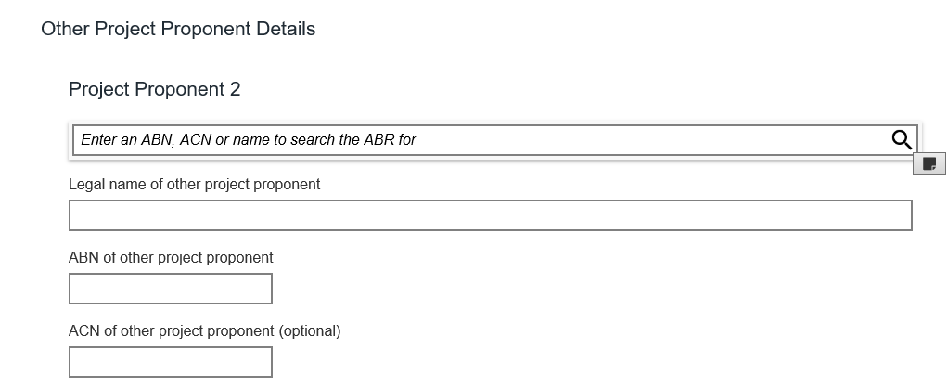

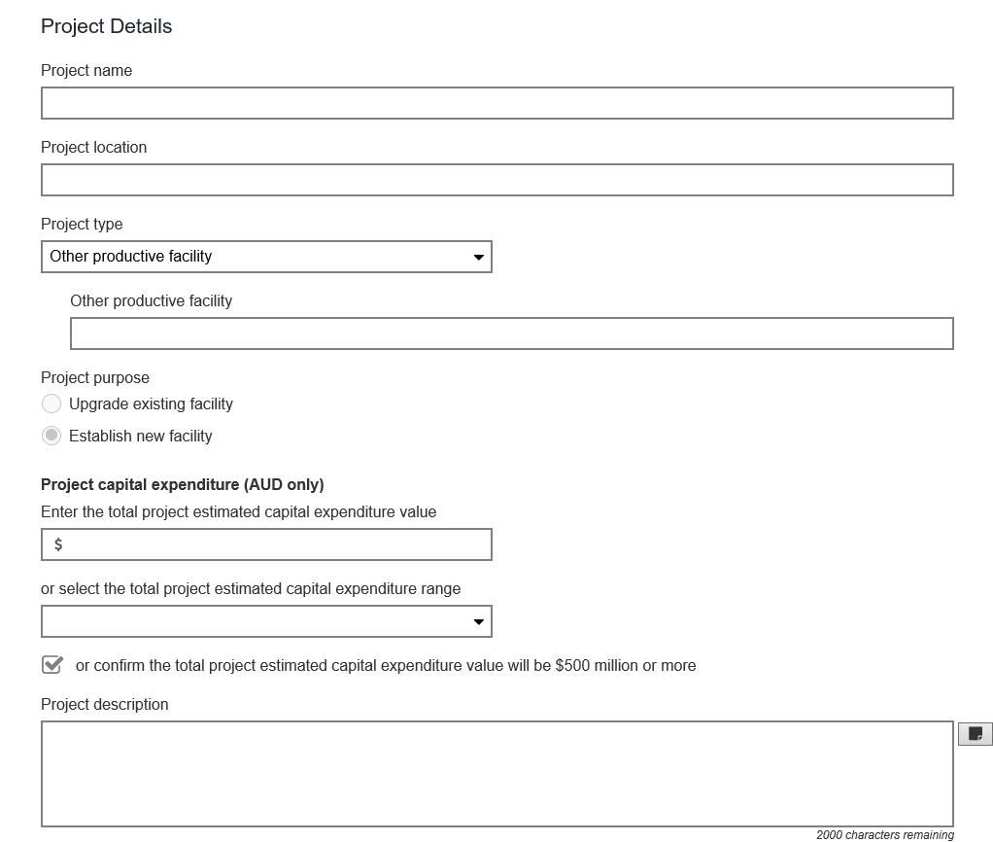

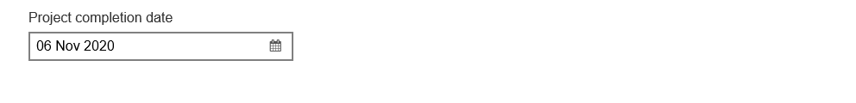

SAMPLE ONLY – DO NOT COMPLETE

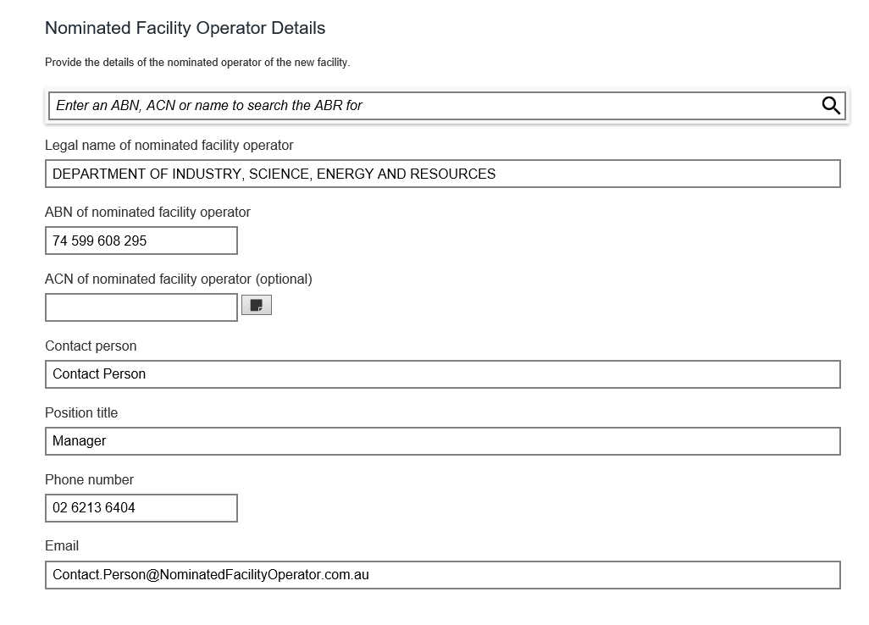

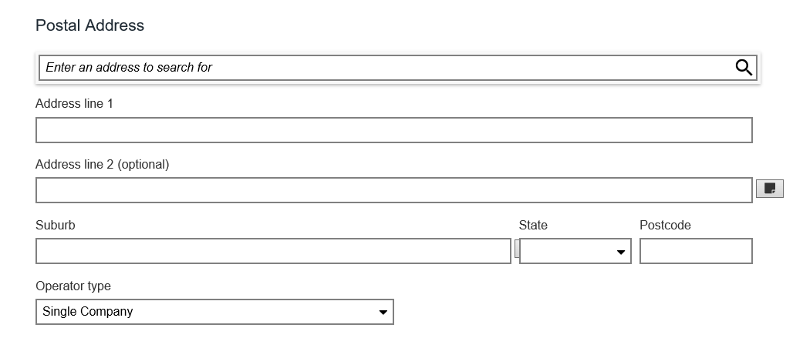



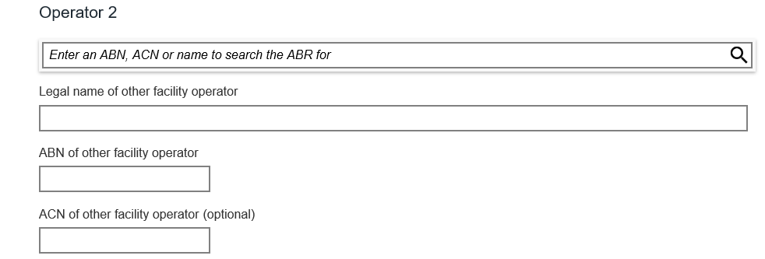



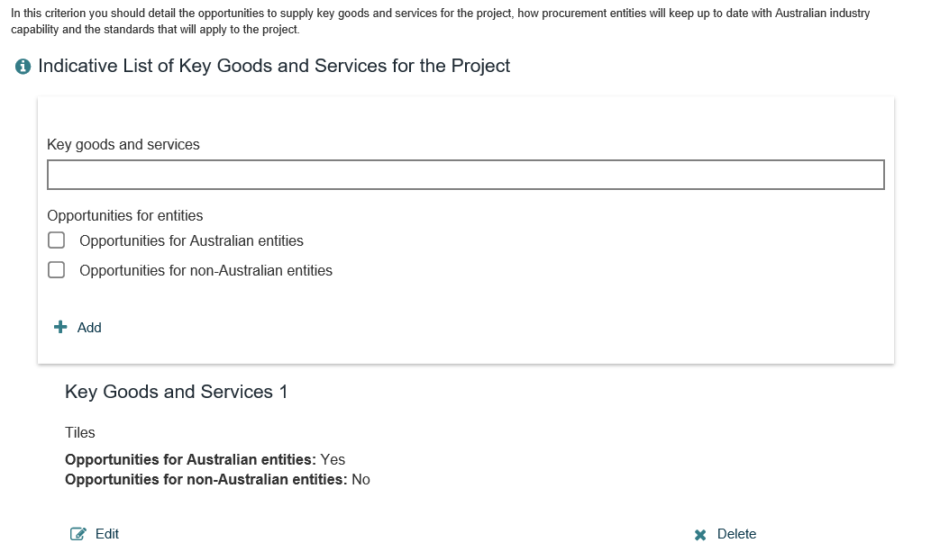

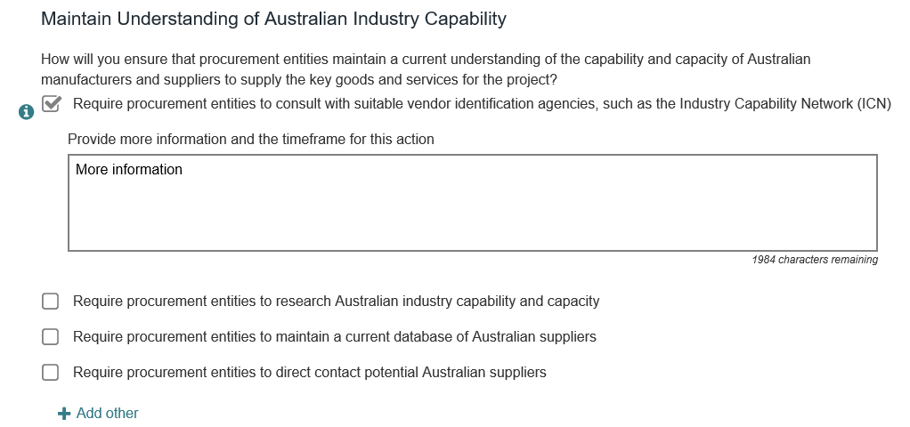

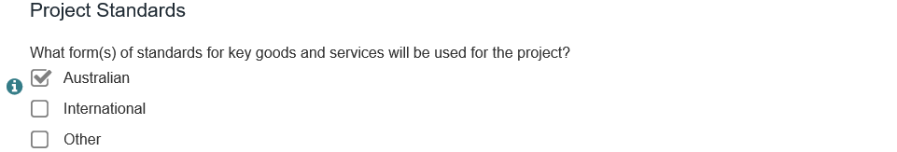

SAMPLE ONLY – DO NOT COMPLETE





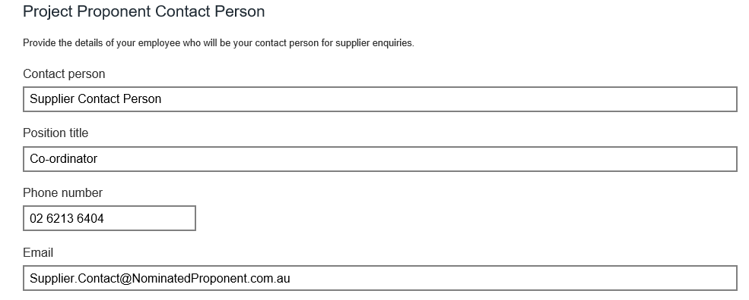



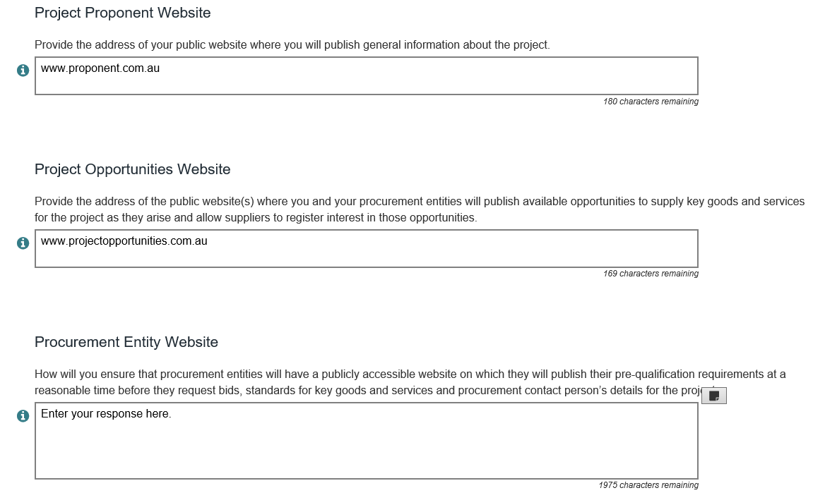

SAMPLE ONLY – DO NOT COMPLETE



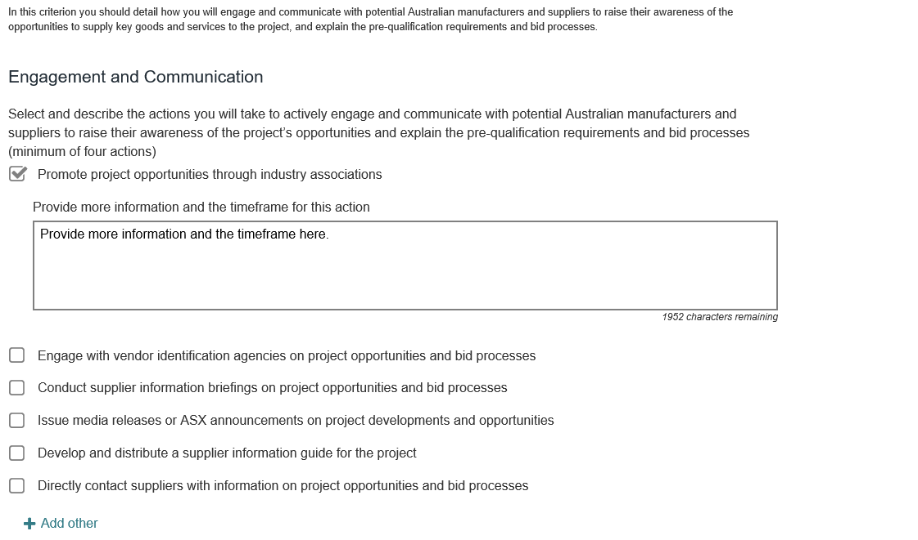

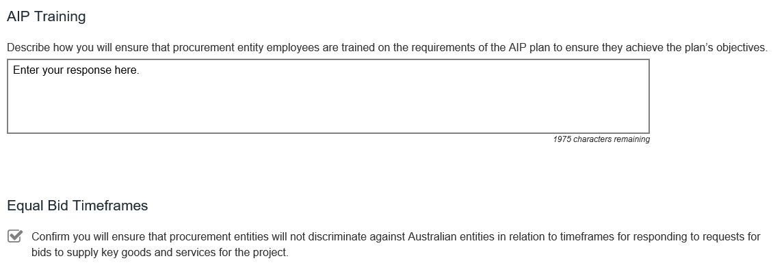

SAMPLE ONLY – DO NOT COMPLETE



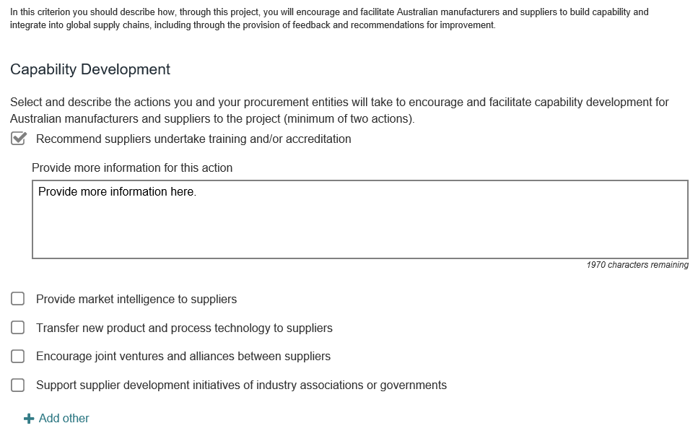

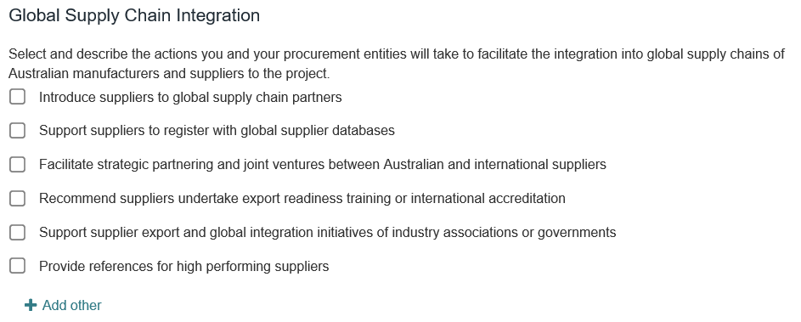

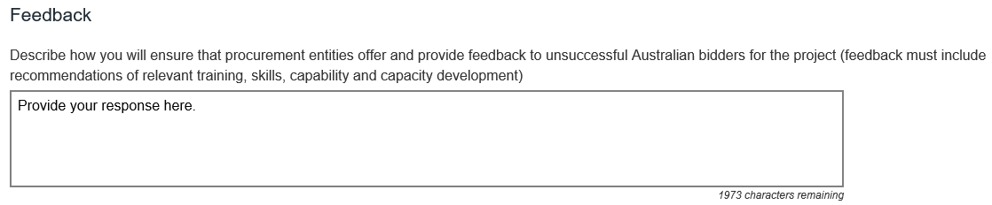

SAMPLE ONLY – DO NOT COMPLETE



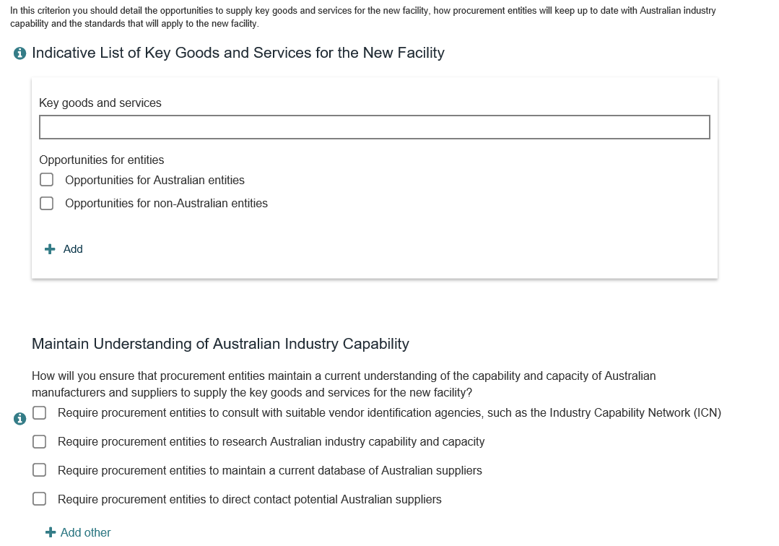

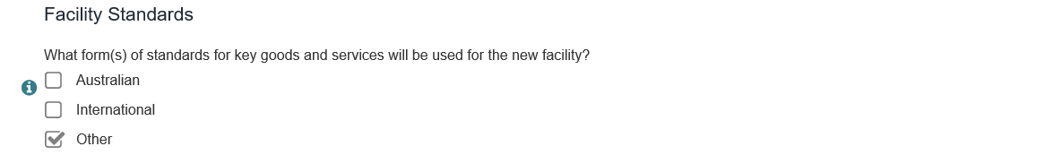



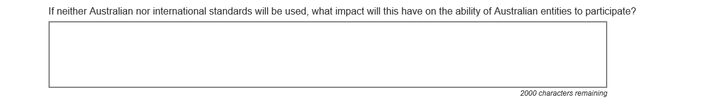



SAMPLE ONLY – DO NOT COMPLETE



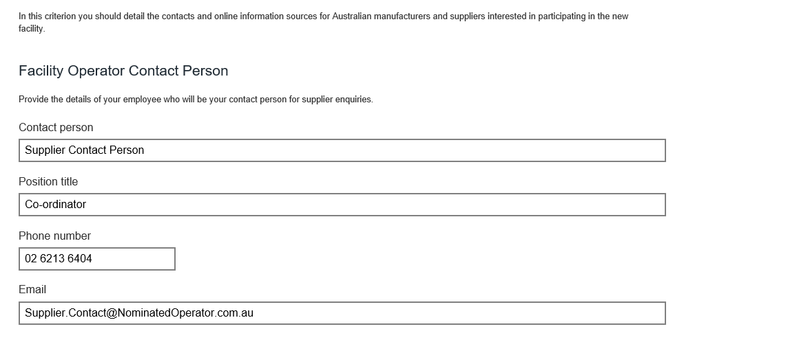



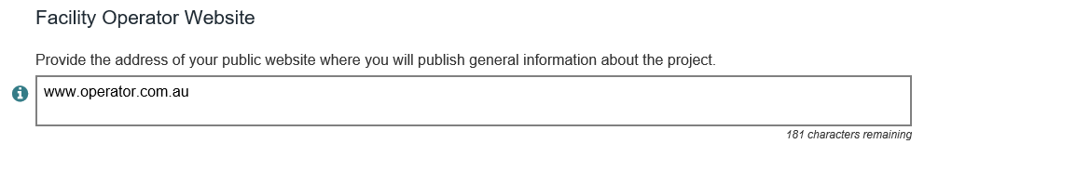

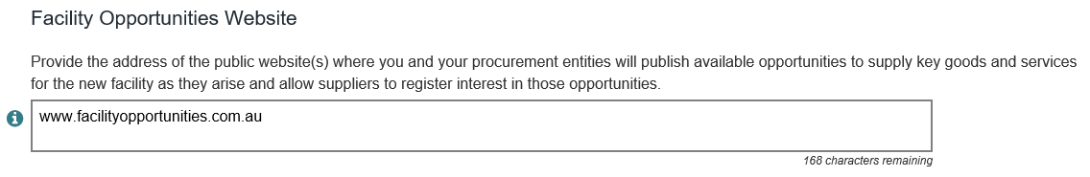

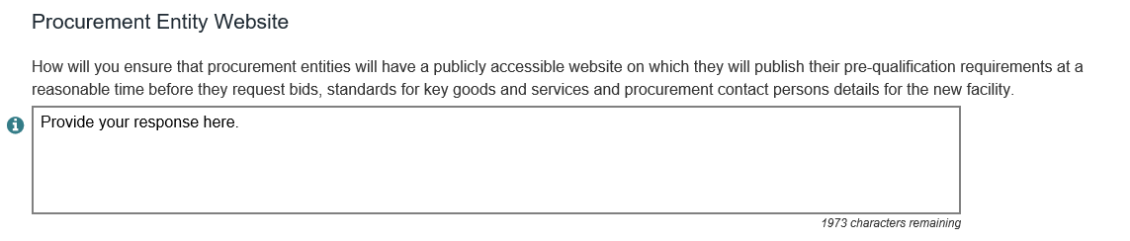

SAMPLE ONLY – DO NOT COMPLETE



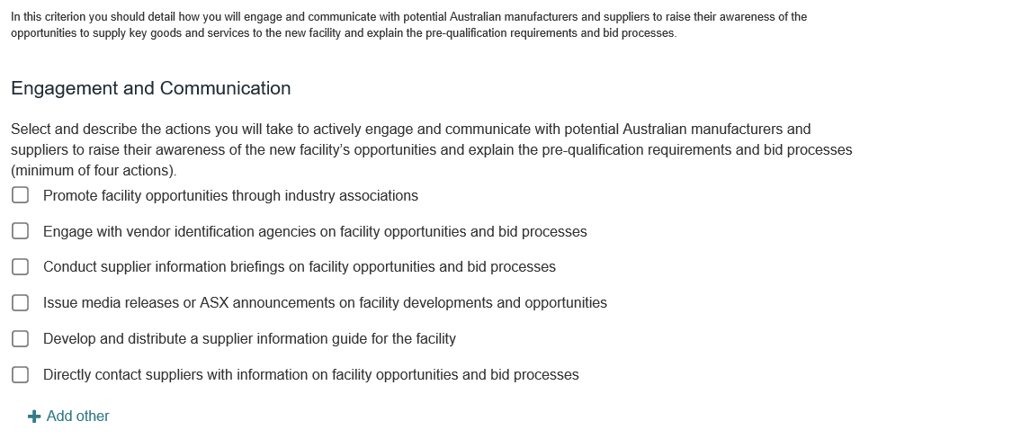

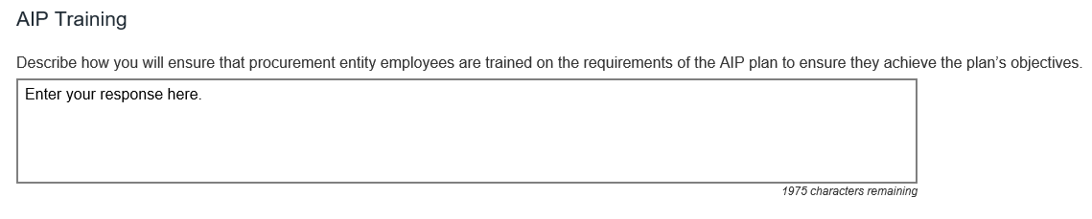

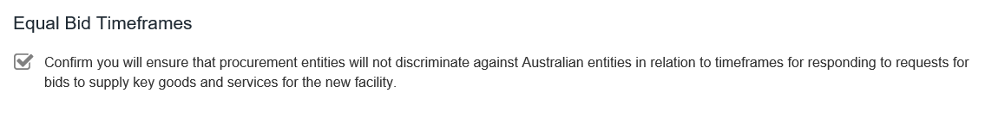

SAMPLE ONLY – DO NOT COMPLETE



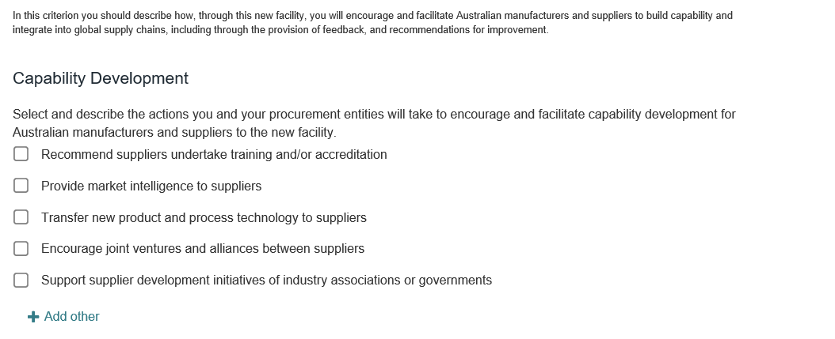

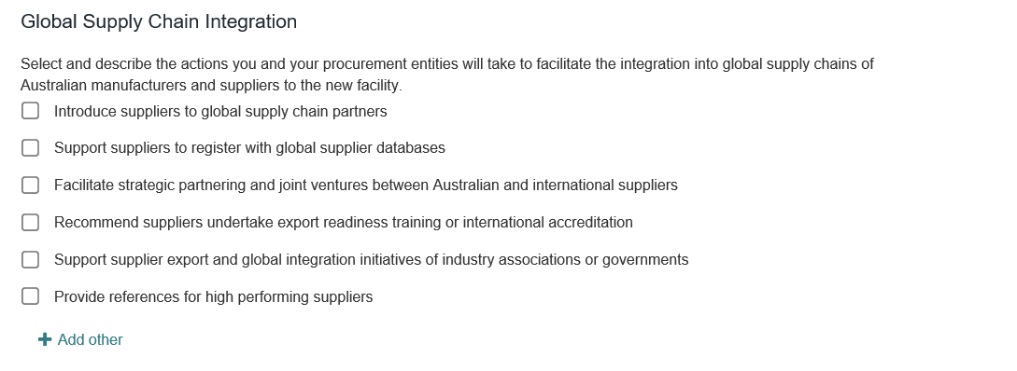

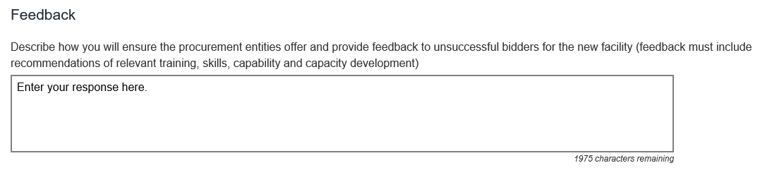

SAMPLE ONLY – DO NOT COMPLETE



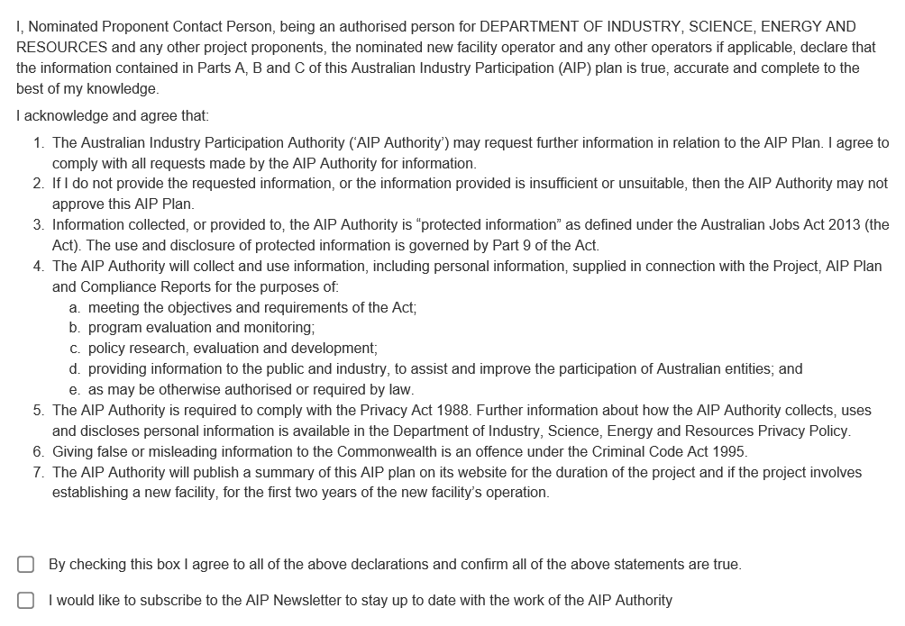

SAMPLE ONLY – DO NOT COMPLETE