

**“ISA’s 2030 strategic plan: How Company Directors can accelerate prosperity through innovation”**

**Bill Ferris AC, Chair of Innovation and Science Australia**

**Australian Institute of Company Directors - Directors’ breakfast**

**Thursday 12 April 2018**

**\*\*\*Check against delivery\*\*\***

Thank you for the invitation to speak at the AICD Directors’ breakfast this morning. And a special thank you also to Angus Armour for chairing the event.

I welcome the change to give you a brief outline of Innovation and Science Australia’s recent report to Government entitled “Australia 2030: Prosperity through Innovation”.

Importantly, I will also share with you my concern that we do not have the necessary mix of skills around our board tables to deliver the potential innovative future this nation deserves and needs. So later in my talk I will turn specifically to what it means for Australia’s company directors, and pose four governance challenges that I think we will need to work on together.

**ISA’s 2030 PLAN: OVERVIEW AND PRIORITIES**

Innovation and Science Australia is an independent statutory board, comprised primarily of private innovation practitioners, and tasked with advising Government on how to lift Australia’s innovation performance out to 2030. So what would success look like in 2030? The ambition and vision for our plan is for Australia to be an international leader in innovation by 2030, known and respected for the excellence of its research, science and commercialisation, with plentiful and meaningful jobs in a fair, inclusive and healthy economy and society. The economy will be one less dependent on the performance of our commodities exports and historically favourable terms of trade, and more widely driven by the development and commercialisation of our own ideas and inventiveness.

To get there by 2030, ISA has developed a report entitled “Australia 2030: Prosperity through Innovation”. This strategic plan calls out 5 imperatives to be tackled if Australia is to close the present considerable gap in innovation performance between it and key competitor nations.

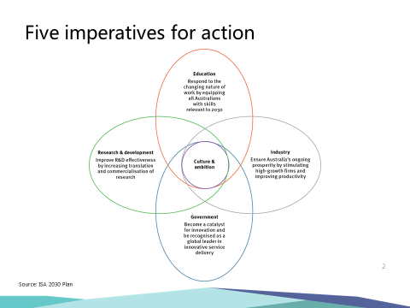

We make 30 recommendations to deal with these imperatives, some of which I will describe in the time available today.

**IMPERATIVE 1: EDUCATION**

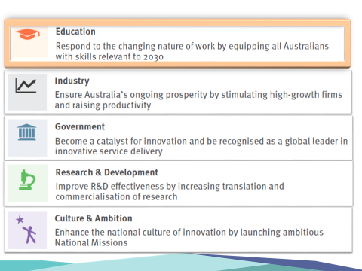

The nation will only achieve the potential economic and social prosperity envisaged in the Plan if we are able **to equip our kids with skills relevant to the jobs of 2030.**

In our conversations around the ISA board table we refer to education as setting the “speed limit” for our economy. Yet just at the time when Australia needs to accelerate its innovation performance, and raise its economic speed limit, we are falling behind our global peers, particularly in student performance in science, mathematics and literacy.

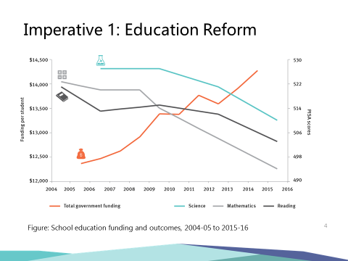

The data shows that while Australia has pockets of excellence in our education system, overall results in science, maths and literacy have declined in the last decade, despite increases in funding. **This must be reversed.**

Therefore ISA’s recommendations focus on changes necessary in secondary school curricula, quality of teaching, and student performance. We focus on increasing teacher quality and training, noting for example that 40 percent of maths teachers are teaching “out of field” i.e. without any formal maths knowledge or training.

And given that digital literacy will be just as important in future work as basic literacy and numeracy, we support increased emphasis on STEM subjects with an expanding role for the STEM Partnerships Forum, bringing industry and education leaders together to lift student understanding and awareness of the relevance of STEM skills to a wide range of careers.

The changing nature of work in the future means that reskilling and life-long training and learning will be essential to establish a competitive workforce and to maintain a fair and inclusive society out to 2030 and beyond. The Plan therefore recognises and recommends the urgent need to restore and enhance the reputation and capability of the vocational education training (VET) sector.

**IMPERATIVE 2: INDUSTRY**

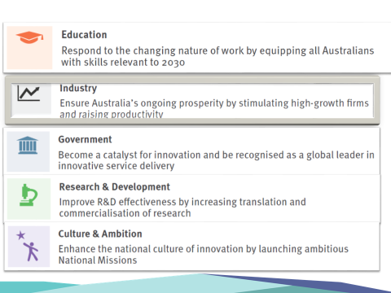

**We need to ensure Australia’s ongoing prosperity by stimulating high-growth firms and raising productivity.**

Australian business simply isn’t investing in innovation at the rate seen in the business communities of our competitor nations. And, more alarmingly, the trend in this investment has been falling since the GFC.

BERD – the acronym for Business Expenditure on Research & Development – reached a highpoint of 1.3 percent of GDP in 2008, but fell to 1 percent in 2015-16. In the same year, BERD was at 3.6 percent of GDP in Israel, and around 2 percent of GDP in both Germany and the USA. The reversal of this downward trend in R&D spending by business is a top priority in the Plan. We need BERD to expand significantly, with something closer to 1.7% of GDP being, a reasonable aim by 2030.

To achieve this goal, our Plan includes a number of recommendations aimed at encouraging start-ups and scale-ups. This includes improved design of existing research and development incentives (tax based, grants based and co-investments) …… incentives to drive a greater bang for the government’s buck and to make sure they are readily accessible to growth oriented companies, big and small.

The ISA Board notes that Australia’s reliance on indirect tax based incentives is out of step with other more innovative nations. E.g. Australia has only 13 percent of its business incentives in direct measures compared to Sweden, Germany and Israel at 100 percent, US 73 percent and the UK at 50 percent.

One key area where direct support should be expanded is in facilitating exports by Australian firms. Exports are a strong proxy for innovative and competitive performance and our plan therefore calls for an expansion of Austrade’s EMDG program. Indeed, approximately 50 percent of the SME’s in the EMDG program are achieving better than 20 percent per annum compound growth in employees and sales. With consumer households in Asia expected to double from 600 million today to 1.2 billion by 2030, we believe there is a large multiplier opportunity to be supported by this recommendation.

A further key recommendation relates to the fact that competing in the global innovation economy also requires access to the best talent available. As a small part of the global community, Australia can’t expect to find all of this talent within its own shores. It is therefore vital we have an immigration policy that can attract and retain world class talent for our innovation system.

**IMPERATIVE 3: GOVERNMENT**

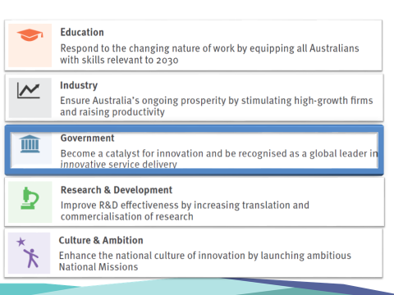

**Government must become a catalyst for innovation and be recognised as a global leader in innovative service delivery.**

ISA believes Australian governments can and should make greater strategic use of their role in the economy to stimulate innovation amongst SMEs and high growth firms. The plan recommends that 33 percent of government procurement contracts should be awarded to SMEs by 2022 (measured in dollar value) and it recommends Governments should accelerate the trial of innovative new approaches to supporting SMEs and high growth firms, such as a “government as a first customer” program.

Australian governments are also sitting on a stockpile of rich data assets. We need to get better and faster at making high value data available, so that third party users can harness it to create new insights and services.

High quality curated data is also an essential ingredient for AI and the efficiency of its algorithms. This carries implications and opportunities for almost all industries, from transport to healthcare and education. And so we have recommended that the Government’s forthcoming Digital Economy Strategy paper should prioritise development of an advanced capability in AI and machine learning to ensure Australia remains globally competitive.

All too often the focus in the public debate on innovation is only on how Governments **invest** in supporting innovation, rather than how they themselves **innovate**.

Therefore, the Plan calls for a review of the Australian Government Public Service to enable a greater role and capability for innovation in policy development, implementation and service delivery. (Recommendation No 18).

**IMPERATIVE 4: RESEARCH AND DEVELOPMENT**

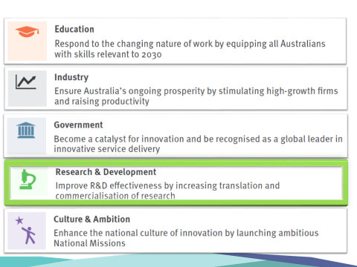

**We need a significant improvement in collaboration for commercialisation.**

Australian researchers produce world class knowledge and ideas. But we badly lag our competitor nations in commercialising this intellectual property. The level of collaboration between business and researchers is also lagging our competitors, e.g. the contribution of Australian industry to higher education R&D is just 5%, and below the OECD average. We need to quickly reduce the intellectual and physical gulfs between industry and research institutions**, and drive collaboration that leads to commercialisation**. The single largest Government incentive for business R&D, the RDTI, neither encourages nor requires any collaboration. Our recommendations include a new incentive to be included in the RDTI; a special collaboration premium tax offset for incremental expenditure undertaken by business with universities and PFRA’s in technology and product development.

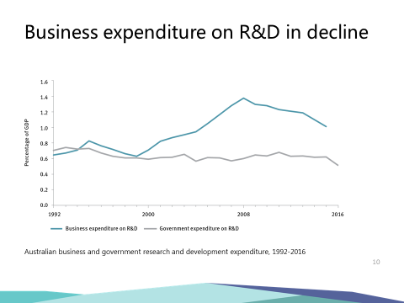

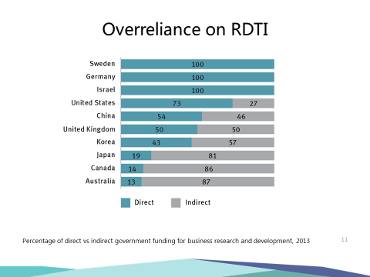

The fantastic talent we have in PhD students is not being taken up by Australian business to the extent that is seen in our competitor nations. For example, recent data shows that for business researchers per thousand employed by industry we sit 21st out of 36 comparable nations. We need more businesses to reach out to our universities and other publicly funded research organisations including CSIRO and the MRI’s. We need a ramp up in the exchange among universities and businesses and we believe a collaboration premium will provide an additional boost to this.

We also have some great programs that we recommend the government could build on – a good example being the **CRC Programme**; which is a merit-based grants programme that brings together industry, universities and research organisations to conduct and commercialise leading-edge research. The recent creation of the CRC-Projects scheme has brought additional vigour to the program and is already supporting many impressive industry lead projects.

Before I leave the topic of R&D, I want to note that we have reaffirmed the need for Government to establish secure, long-term funding for national research infrastructure, which is a key foundation for our innovation system. This is in accordance with the recommendations of the 2016 National Research Infrastructure Roadmap, which was developed under the expert guidance of my colleague and ISA Deputy Chair, Chief Scientist Dr Alan Finkel.

**IMPERATIVE 5: CULTURE & AMBITION**

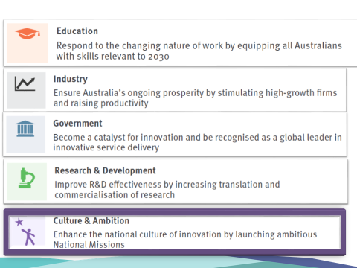

To help build a culture that inspires Australians to take on some of the really big challenges and to proudly celebrate our own outstanding science and innovation, the Plan recommends a program of National Missions - large scale ambitions catalysed by governments that address audacious challenges. Such a program would invigorate the public’s excitement and imagination for science and innovation, and inspire our best thinkers and entrepreneurs to solve our greatest challenges.

We are recommending that the first such National Mission should be to use genomics and precision medicine to assist Australia becoming the healthiest nation on Earth. This will entail the expansion and integration of genomics and precision medicine capability into our national health and medical system. It is a grand project. This mission would sequence the genomes of selected patient groups, including families with a history of cancer, children with rare diseases, and people with chronic disease. It would lead to better health outcomes, new and earlier diagnosis, improved prevention and more targeted and personalised care. In doing so, we can be a world leader in intelligent, efficient and cost effective health delivery.

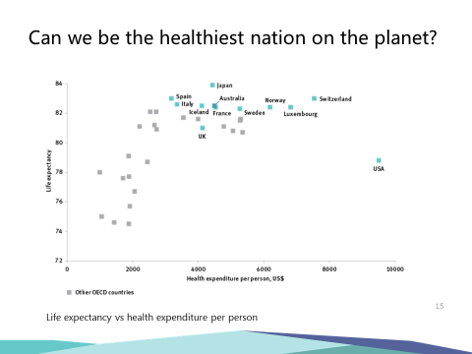

We are already in the top half dozen of OECD nations in terms of life expectancy, and at reasonable cost per capita. But why not aim to be great, rather than good? Why not have a crack at becoming number 1? ………… to become the healthiest nation on the planet. I’d call that a challenge worth taking on, with benefits to all Australians.

There is much more I could add to this overview of the 2030 Plan, and I commend the full version to you as, in the words of the RBA Governor, “worth a read”.

But in the time remaining, I now want to turn to what does all this mean for company directors? What is being done, and what still needs to be done, to ensure our company directors are playing their part in delivering our innovative future?

It is very pleasing to note that the AICD has been active in this space. On the topic of cybersecurity, it has developed a “Cyber for Directors” program, which I understand is being expanded in partnership with Adrian Turner and his colleagues at Data 61. Indeed, I understand that Adrian’s webinar on a data driven future has been AICD’s most popular webinar in that series.

AICD has also recently established its Technology Governance and Innovation Panel, under the leadership of Kee Wong. This will be an important group, and ISA is represented on the panel by ISA board member Dr Bronte Adams as well as our CEO, Dr Charlie Day.

But whilst these are recent positive developments, Australia’s company directors have plenty more to do before we can say that they are fully supporting innovation activity. So let me throw out some ideas where I think you, as directors, can contribute more. I’ll frame these as four “governance challenges”.

**Governance Challenge 1: Prioritise operating performance as number one item for risk management**

The demographer Bernard Salt recently noted in The Australian “that our corporate sector, as measured by its creation of market value, is notable for its lack of dynamism”. Let me explain. I started my career in venture capital in Australia in 1970. In the intervening 48 years, we have seen booms and busts, as have other nations. But if you look at the top 10 most valuable companies on the ASX, all of them were already going concerns when I was getting started in 1970. By contrast, a look at the top ten most valuable firms in the US is notable for the fact that half of them did not exist in 1970. It’s a stunning comparison. And when you look across the Australian corporate sector, it is apparent that our capacity to produce firms that show sustained periods of high growth and wealth creation is not where it needs to be.

David Thodey recently said in an interview with AFR that “So often our board agendas are full of so many things to get done, often around compliance, but you’ve got to put time on the agenda to think about what might be, or what is possible.”

Well, how about we put “innovation and change” on every Board Meeting Agenda with discussion items to include:

• How can we better service our customers? What is the company’s NPD pipeline, and what new behaviours should we try (e.g.) creating in-house incubators with the money and the licence to experiment and fail.

• Could our business model be disrupted by others?

**Governance Challenge 2: Include more Engineers, Scientists, digital savvy people in your Boardroom mix**

Industry expertise is perhaps one of the most important qualifications that Directors can bring to the boardroom because it offers deeper understanding of industry characteristics, competitive threats and strategic opportunities. Diversity of skills from industry and the research sectors around the Board table can encourage a trickle-down effect and boost a culture of collaboration.

One study recently caught my eye. U.S Corporations commonly elect professors to their boards. For instance, during the 1998-2011 period around 40% of Standard and Poor’s 1,500 firms had at least **one** professor in their boardrooms.

A 2015 research paper by Grant Thornton looked at the impact of professors in the boardroom and found that firms with academic directors is associated with higher firm performance. Inter alia, the paper found these firms have lower cash-based CEO compensation, more patent and citation numbers, higher acquisition performance, and greater earnings quality and stock price informativeness. How many boards in Australia would boast professors? I wonder how many professors in Australia would actually be interested?

Directors with literacy in and passion for embracing digital technology, and other directors with deep, engineering and other domain strengths relevant to the company’s sustainable future will offer significant strategic advantage to firms navigating the 21st century digitising economy. Such skills are no longer nice to haves – they are core to the ability to operate effectively. Prioritising seats around the table for people who can offer these insights is a key challenge facing Australian boards.

**Governance Challenge 3: Move on from diversity being just about gender balance**

Gender diversity on boards is obviously a very important topic. The research and statistics speak for themselves. For example, research conducted by Grant Thornton in 2015 found that companies with gender diverse executive boards offer higher returns on investment compared with peers run by all-male boards. The study covered listed companies in India, UK and US and estimates the opportunity cost for companies with male-only executive boards at a staggering US$655 billion in 2014.

It is incumbent of the AICD membership to dramatically change the diversity of talent in its boardrooms. While gender balance is an urgent and laudable priority, with no better champion than AICD’s own Chairman Elizabeth Proust, I actually think it is time to move beyond this gender pursuit …. In addition to the digital technology skills requirements I’ve just discussed, there are 2 other equally important, probably more important, priorities for boards to include:

* Age: directors young enough for imagination not to be compromised by experience. How many directors do you have on your boards under the age of 30? Any under 21?
* Ethnicity: there are an estimated 500 million consumer households in Asia today rising to > 1.2 billion by2030. These markets dwarf the domestic market, and it is absolutely the case that successful innovation starts with knowing your customers well ….. And yet our boards include very few of the Aussie diaspora in key Asian cities or members of our own Asian communities in Australia.

I could make the argument that unless boards could tick these extra governance boxes of boardroom diversity they would be non-compliant; they would be seen as not fit for purpose in managing risk or opportunity for shareholders.

**Governance Challenge 4: Move quickly to understand and deploy AI and ML**

My colleagues around the ISA board table would admonish me if I did not mention the transformative technologies of artificial intelligence and machine learning, which are upending many of the assumptions underpinning long-standing business models. At the moment there is something akin to a new arms race between China and the USA underway, as they seek technological superiority in this rapidly evolving field. Whatever happens at that level, it is clear that if Australia wants to remain at the forefront of economic development we need to develop our own capability in what Adrian Turner of Data 61 likes to call the “cyber-physical economy” (where digital and physical co-exist). ISA hasn’t yet seen compelling quantitative data on this, but our conversations with directors in the development of our 2030 Report suggest to us that this is an area where Australian boards are at risk of falling behind.

AI and Machine Learning will be key enabling technologies of the next wave of industry transformation – my view is that directors would not be fulfilling their duties if they didn’t have a clear-eyed view of how their companies can benefit from these technologies, not being victims. In a nutshell, we need to be as focused on the cyber **opportunity** as we are on cyber **security**.

**CONCLUSION**

Our Report is a report to Government; but its recommendations address all sectors of the economy and all of our citizenry. Ultimately it is a plan for the sort of society and economy all Australians can aspire to by 2030. It is a plan to create more and better jobs, noting that fast-growing companies that innovate, export and scale are responsible for virtually all new net jobs in the economy.

Company Directors have a key role to play in bringing this future to fruition. The four governance challenges I have highlighted above will hopefully provide food for thought, and help inspire complementary actions that can support the Government’s response to our plan. This response we expect to see soon.

AICD’s ability to provide governance and guidanceto navigate the future challenges outlined in our 2030 strategic plan will be crucial to ensuring Australia thrives in the global innovation race.

**Thank you.**