

**“Intellectual Property and the Business of Innovation”**

**Bill Ferris AC, Chair of Innovation and Science Australia**

**10th Francis Gurry lecture on Intellectual Property 2018**

**28 August 2018 - Melbourne**

**30 August 2018 - Sydney**

**\*\*\*Check against delivery\*\*\***

{Acknowledgment of Country}

Thank you to Professor Megan Richardson, Director, Intellectual Property Research Institute of Australia at the Melbourne Law School for the introduction and coordinating this prestigious event. I’d also like to acknowledge The Institute of Patent and Trade Mark Attorneys of Australia (IPTA) and the University of Melbourne for also organising the Francis Gurry lecture series.

Ladies and gentlemen, patent and trade mark attorneys, industry practitioners, students, and all others in the room or watching the live stream, I am honoured to deliver the 10th Francis Gurry lecture on Intellectual Property.

It is a privilege to be following global heavyweights like Pippa Hall, Chief Economist, UK Intellectual Property Office (2016); The Honourable Mr Justice Birss, Judge of the High Court of England and Wales (2015); and the lecture’s namesake and distinguished Melbourne Law School alumnus, Dr Francis Gurry (2013).

Given my background in venture capital and private equity, and my current role as Chair of Innovation and Science Australia (ISA) my talk today will take a business-focused approach to innovation and IP rights.



So I begin by sharing a brief personal story. As a young teenager, my late father, Chum Ferris, tinkered with and repaired all manner of domestic devices powered by that amazing disruptor of his time, electricity. By 1932 at the age of 18 he had scraped together enough pocket money to fund a start-up business in Sydney, repairing and manufacturing home radio receivers. He went on to design and introduce Australia’s first portable car radio, able to run on its own 6V battery, the car’s 12V system, and the home’s 240 volt system. The Ferris Portable Car Radio was a new-to-market, high quality product which tapped into the expansionary boom of car ownership and lifestyle wishes in a post war industrialising Australia. In 1960 the Ferris “Gutter Grip” car radio antenna was patented in Australia[1] and New Zealand[2]. In 1963, the Ferris Brothers company was granted a patent for a Coaxial Connector[3] and by the late 60s the company employed more than 700 workers nationally.

Dad’s patenting of the Gutter Grip and Coaxial Connector also taught me a valuable lesson about the special relationship between IP and innovation, specifically how a robust IP rights system can be a key facilitator of successful innovation. Dad’s innovation and entrepreneurship inspired my own start-up in 1970; Australia’s first venture capital company set up to back entrepreneurs like Chum.

Innovation is the key to a sustainable Australian prosperity, one less dependent upon the performance of our commodities exports and historically favourable terms of trade, and more widely driven by the development and commercialisation of our own ideas and inventiveness. History shows us that in the long term the places and people that practice innovation – new and better ways of making things and delivering services at home and abroad – are the ones that keep creating sustainable jobs and prosperity.

Innovation drives productivity, which drives GDP growth which drives living standards. And fast-growing companies that innovate, export and scale are responsible for virtually all new net jobs in the economy. We have many notable innovative Australian companies that have made their mark on the world stage and demonstrated our ability to punch above our weight; what we need is many more of the success stories like Atlassian, CSL, Cochlear, Macquarie Bank and BHP.

**AUSSIES MAKING IT BIG ON THE WORLD STAGE**

Another Aussie who certainly made it on the world stage is, of course, Dr Francis Gurry. Following his graduation with a Bachelor of Laws from the University of Melbourne, Francis Gurry started out as a barrister and solicitor at the Supreme Court of Victoria in 1975. After obtaining a PhD from the University of Cambridge in 1980, he joined the World Intellectual Property Organisation (WIPO) in 1985. Between 1988 and 1999, Dr Gurry held positions in numerous areas of WIPO, including in the Industrial Property Law Section, the Office of the Director General, and the Legal Counsel Office before becoming Director General of WIPO in May 2008. Francis Gurry’s current work as head of WIPO is critical in ensuring that the IP system serves its fundamental purpose of encouraging creativity and innovation in all countries. I commend Dr Gurry’s work and contributions.

And I also take this opportunity to acknowledge the contributions of IP Australia’s former Director General, Patricia Kelly who retired earlier this month. IP Australia has come a long way from when clerks filled large leather-bound ledgers with painstaking descriptions of inventions in perfect copperplate script. Today, over 99% of the 850,000 annual customer transactions handled by IP Australia, worth over AUD $200 million in revenue, are digital[4]. To achieve this IP Australia has radically transformed digital customer engagement, positioning IP Australia as the first Australian Government service delivery agency to be fully digitized.

Australia’s IP rights system is a key component of the innovation system and the improvements Patricia implemented at IP Australia have been to the benefit of the researchers and entrepreneurs to whom we look to power Australia’s 21st century knowledge economy.

Having a strong national IP agency is important because Australians are an inventive lot. Australian inventions surround us in our everyday lives and form important parts of the Australian lifestyle and national character. From the stump-jump plough enabling broad acre farming, to penicillin, to atomic absorption spectroscopy, to the black box flight recorder, polymer bank notes, xerography and X-ray crystallography, the pacemaker, cochlear implant, sleep apnoea therapy, from novel plants and seeds to Wi-Fi from CSIRO, the vaccine for cervical cancer, spray-on skin repair, the identification of helicobacter as cause of ulcers, and much more.

And this inventiveness continues at the cutting edge of science and research. In June this year, Walter+Eliza Hall Institute of Medical Research’s (WEHI) Professor David Huang and an amazing team of researchers won the prestigious 2018 Australian Academy of Technology and Engineering (ATSE) Clunies Ross Award for knowledge commercialisation of anti-cancer drug, Venetoclax. This drug has proved effective in treating chronic lymphocytic leukemia and is being explored for potential application to other types of cancers. Especially innovative was WEHI’s sale of a portion of its royalty rights to a Canadian pension fund in a deal worth over $400 million. Such an advance on royalties would never have been possible absent a thoroughly protected family of patents. And this in turn has enabled WEHI to expand their cutting edge research and commercialisation activities and, we hope ultimately, improved health outcomes for Australians and patients around the world.

**STATE OF AUSTRALIAN INNOVATION**

However, as hugely impressive as all of these examples are, the evidence confirms that in recent years our innovation system has increasingly been falling behind our OECD trading partners and others including Israel, Singapore, South Korea and Taiwan, and China. Disruptive technologies, especially digital technologies, are a pervasive force for change in all parts of the Australian economy.

Indeed, ISA’s perspective is that in the past decade Australia has moved from a once-in-a-century mining boom into a global innovation race, where IP is at least as valuable a resource as iron ore and oil. Access to and creation of knowledge, and hence IP, will become increasingly important as Australia moves further into the digital age. While our 26 years plus of unbroken economic growth is literally a world record, we will need to lift our innovation game across the whole economy if we are to extend that run for another 26 years, as we would all hope for.

I mentioned before that Francis Gurry is currently the head of WIPO, so we are in a sense indebted to him for helping us to understand how we place in this global innovation race. WIPO’s annual publication of the Global Innovation Index (GII) provides a series of metrics for the innovation performance of 126 countries representing approximately 91% of the world’s population and 96% of global GDP[5]. The current data - which is broadly in accordance with ISA’s 2016 *Performance Review of the Innovation, Science and Research System* – suggests that while we have a proud history of invention, there is much more to be done to extract the commercial benefits we could be experiencing were our innovation system performing more efficiently and ambitiously.

The 2018 Global Innovation Index was released on 10 July and indicated some mixed results for Australia’s innovation performance, just briefly:

* Overall Australia ranked 20th out of 126 countries. This is an improvement from 2017, when Australia ranked 23rd, although it is worth noting that since 2013 Australia’s ranking has bounced around a little in the range 17th-23rd.
* Australia ranks 19th out of 47 high-income countries
* Australia ranks 6th among the 15 countries in South East Asia and Oceania
* **Strengths**: 1st in tertiary enrolments; 2nd in Government’s online services; 7th in ease of starting a business; 16th in venture capital deals[6]
* **Weaknesses**: Australia’s patent profiles are both considered a weakness relative to the other top 25[7]. Australia also ranked: 69th in STEM graduates; 84th in percentage of Gross Expenditure on R&D (GERD) financed from abroad

While these types of indices will always draw criticism for the accuracy and composition of their metrics, the broad findings made in the latest GII accord with ISA’s research suggesting that Australians are not innovating at the levels we need to fulfil our ambitions in the global knowledge economy.

**AUSTRALIAN BUSINESSES ARE NOT INNOVATIVE ENOUGH**

The ownership of ideas and activities is the lifeblood of any innovation system. The use of patents, trademarks, copyright and trade secrets, along with other IP rights, are important tools to ensure that the value from new ideas can be optimised commercially and socially.

A recent example illustrates this symbiosis, Byron Bay father-son duo Stuart and Cedar Anderson are the inventors behind ‘the Flow Hive’, Australia’s most successful crowdfunding campaign to date launched via Indiegogo’s crowd platform. FlowHive reached their funding target of $72,000 USD in just eight minutes; The Flow Hive is the most significant beekeeping invention since the ‘Langstroth bee hive’, patented in 1852. Reverend Langstroth from Philadelphia in the USA was the first to discover the ‘bee space’ measurement; dimensions that informed the industrialisation of modern beekeeping. He observed that if the space that bees inhabited was too small, the bees couldn’t build comb. Rev Langstroth’s book ‘*Langstroth's Hive and the Honey-Bee: The Classic Beekeeper's Manual’* is still available to purchase and is a common reference point for beekeepers even now! In anticipation of the commercial value of their method which built on the knowledge of Langstroth, the Flow Hive’s inventors registered for a provisional patent before launching their crowdfunding campaign. It was granted due to their invention’s unique split cell technology; a plastic ‘honeycomb matrix’ which the bees complete with their own wax. Since its launch, The Flow Hive has been recognised for not only its innovative method, but also for its unique design. In 2016, The Flow Hive won Australia’s most prestigious prize for design, the Good Design Award, and to date, the company has sent out 50,000-plus beehives to more than 100 countries.

But one success story, or many dozens more that this audience could tell if time allowed doesn’t mean that all is OK in our national innovation system. On the contrary, the economy-wide evidence strongly indicates that Australian businesses are ***not*** innovating enough, and this is true whether you look at spending on R&D, or development of new-to-world products, or Australia’s patent filing record. Take IP Australia’s 2018 report[8] which highlighted that while patent applications grew overall in 2017, applications for standard patents by **Australian residents** decreased by about 5%.

Taking a longer term view, over the decade to 2016 resident patent filings by Australian firms at IP Australia declined by 8%, while resident filings at the European Patent Office grew by 16%, and at the United States Patent and Trademark Office (USPTO) by 33%. And I probably don’t need to remind this audience that over the same period resident filings at the Chinese patent office grew by 885%!

I also note, not without a sense of irony, that the most prolific domestic filer in our nation of gamblers in 2017 was Aristocrat Technologies Australia with 157 applications. This was followed by our national science agency CSIRO with 45 applications. Many of you will be aware that CSIRO scientists developed some of the key technologies underpinning Wi-Fi – and only after engagement in a long court battle did they secure returns from the related intellectual property. Indeed the irony continues when you note the second-largest *foreign* filer at IP Australia last year was US-based Qualcomm[9], with 264 applications – around six times CSIRO’s total. And the equipment to deliver Wi-Fi and other wireless communications technologies are key to Qualcomm’s product portfolio. In something of an understatement, CSIRO Chief Executive Larry Marshall reflected on these patent statistics “Australia needs to lift its game”[10].

**ISA’S 2030 PLAN: OVERVIEW AND PRIORITIES**

Recognising Australia’s innovation imperative, the Australian Government launched the National Innovation and Science Agenda (NISA) in 2015. It provided an immediate boost to Australia’s innovation capabilities by committing $1.1 billion over four years to 24 measures. NISA also created Innovation and Science Australia (ISA) as an independent statutory advisory Board tasked with undertaking a performance review of Australia’s innovation system, and developing a strategic plan to 2030 advising the government on how to enhance Australia’s innovation performance. I chair the board comprised mainly of private sector innovation practitioners. The deputy chair is Chief Scientist Alan Finkel AO and our CEO is Dr Charlie Day (present here today).

ISA’s strategic report to Government entitled: “*Australia 2030 Prosperity through Innovation*” was publicly released in January this year. It is a plan to realise the vision that by 2030 Australia will be counted within the top tier of innovative nations.

Our strategic plan calls out five imperatives to be tackled if Australia is to close the present considerable gap in innovation performance between it and key competitor nations. We make 30 recommendations to deal with these imperatives, some of which I will highlight now.

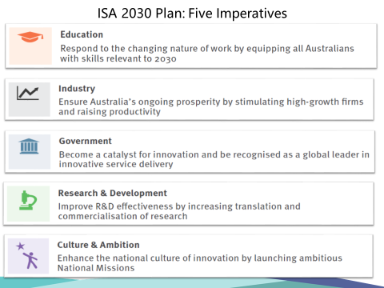

**The first imperative is about Education:** The nation will only achieve the potential economic and social prosperity envisaged in the Plan if we are able to equip our kids with skills relevant to the jobs of 2030. Our recommendations for this imperative focused on strengthening teacher training, reviewing and strengthening the Vocational Education and Training (VET) system, and better preparing students for post-school science, technology, engineering and mathematics (STEM) occupations.

**Industry:** We need to ensure Australia’s ongoing prosperity by stimulating high-growth firms and raising productivity. Australian business simply isn’t investing in innovation at the rate seen in the business communities of our competitor nations. And, more alarmingly, the trend in this investment has been falling since the GFC. The reversal of this downward trend is a top priority in the Plan and our recommendations included changes to the balance of indirect tax and other direct incentives to propel business investment in R&D and innovation. **I will talk more about BERD and how it relates to IP and patent filing later in my speech today.**

**Government:** Government must become a catalyst for innovation and be recognised as a global leader in innovative service delivery. In this third imperative our 2030 report identified the big opportunities for government in its own activities to adopt innovative approaches to policy development, service delivery, procurement, and the management and curation of their data. A big win for this imperative was the Government’s announcement on 4 May 2018 of an independent review of the Australian Public Service. This responds to ISA’s recommendation to “conduct a review of the Australian Government Public Service with the aim of enabling a greater role and capability for innovation in policy development, implementation and service delivery.”

In this imperative we also identified a strategic opportunity for government to embrace a flexible regulatory environment that supports innovation. There is significant work underway to improve Australia’s legal and regulatory framework to enhance innovative activity, including the passage of legislation implementing the NISA measures to amend insolvency laws and following the Productivity Commission’s 2016 review of Australia’s IP laws.

**The fourth imperative is Research & Development (R&D):** We need a step-change improvement in collaboration for commercialisation.

In GII metrix we badly lag our competitor nations in translating and commercialising our intellectual property. The level of collaboration between business and researchers is also lagging our competitors, e.g. the contribution of Australian industry to higher education R&D is just 5%, and below the OECD average. We need to quickly reduce the intellectual and physical gulfs between industry and research institutions and drive collaboration that leads to commercialisation.

An excellent example of cross sector collaboration that is boosting Australia’s innovation performance and transfer of technology is Brisbane-based UniQuest, Australia’s leading university commercialising entity which manages the intellectual property of The University of Queensland (UQ). UniQuest has an impressive track record[11]; it benchmarks in the top 10% globally for university-based technology transfer offices. Technologies licensed by UniQuest include UQ’s cervical cancer vaccine, Gardasil, the technology used in most of the world's magnetic resonance imaging (MRI) medical diagnostics, and the IP behind the cash and milestones $1 billion Novartis acquisition of Spinifex Pharmaceuticals - one of Australia’s largest biotechnology company acquisitions. These technological developments have gone on to make more than $16 billion USD in combined gross product sales globally for the companies involved. To date UniQuest has more than 87 granted US patents and has spun out more than 100 start-up companies. Together with these companies, UniQuest has raised more than $625 million to take UQ technologies to market and UniQuest has returned $465 million in revenue to the university since 2002.

Collaboration for commercialisation is possible; we need heaps more of it!

**Culture and ambition:** I have made a career of investing in talented Australians, both in the NFP world and in the corporate world; people who have gone on to achieve incredible things. So I know ability is not the barrier to Australians succeeding globally. Where I see a big gap between Australia and the world’s leading innovation nations is in the level of our aspiration, and our willingness to tackle very big problems, at a global scale. The fifth imperative we identified for national attention was the absence of an embedded innovation culture in Australia. *Inter* *alia*, we called for adoption of large scale national missions to address major challenges and opportunities now faced by the Australian economy and society. Missions of scale and significance which if achieved would demonstrate to all Australians the excellence of our own science and implementation skills. Missions which if tackled by the collaboration of our best and brightest scientists, entrepreneurs and innovators, would over time help stimulate a culture of innovation, a love of and respect for making and doing things better and smarter.

We therefore welcomed the Government’s announcement in May 2018 of the Australian Genomics Futures Health Mission with $500 million over ten years funded by the Medical Research Future Fund (MRFF). This was one of the National Missions our plan recommended to enable **Australia to one day become the healthiest nation on earth.**

**WORK TO BE DONE: INCREASING BUSINESS INVESTMENT IN INNOVATION**

As I mentioned earlier in my speech, the decline in business investment in R&D and innovation is an issue that needs to be tackled by government, business and other key stakeholders if Australia is to become a top tier innovative nation. The ambitions outlined in our 2030 Plan can only be achieved if there is a dramatic improvement in business investment in innovation.

The key internationally-used measure of innovative business activity is Business Expenditure on R&D (BERD). This is the single largest component of a nation’s total expenditure on R&D (GERD). In the following graph you will observe the decline in Australia’s GERD as a percentage of GDP at a time when it is rising in the OECD.

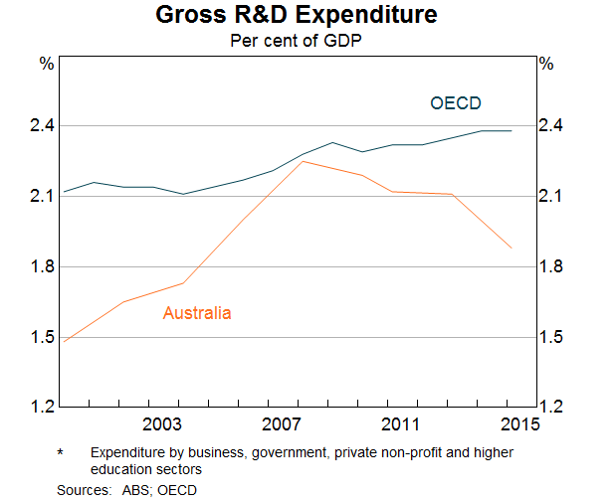

The major cause of this decline in Australia is BERD which has been steadily tracking downward from 1.4% to just 1% since 2008. During the same period, BERD in our leading competitor nations has been increasing. The size of this divergence is even starker when you compare Australia with the top 5 OECD countries now averaging a 3.7% GDP expenditure on R&D……….. double what we are investing! This is a situation that warrants significant national attention.

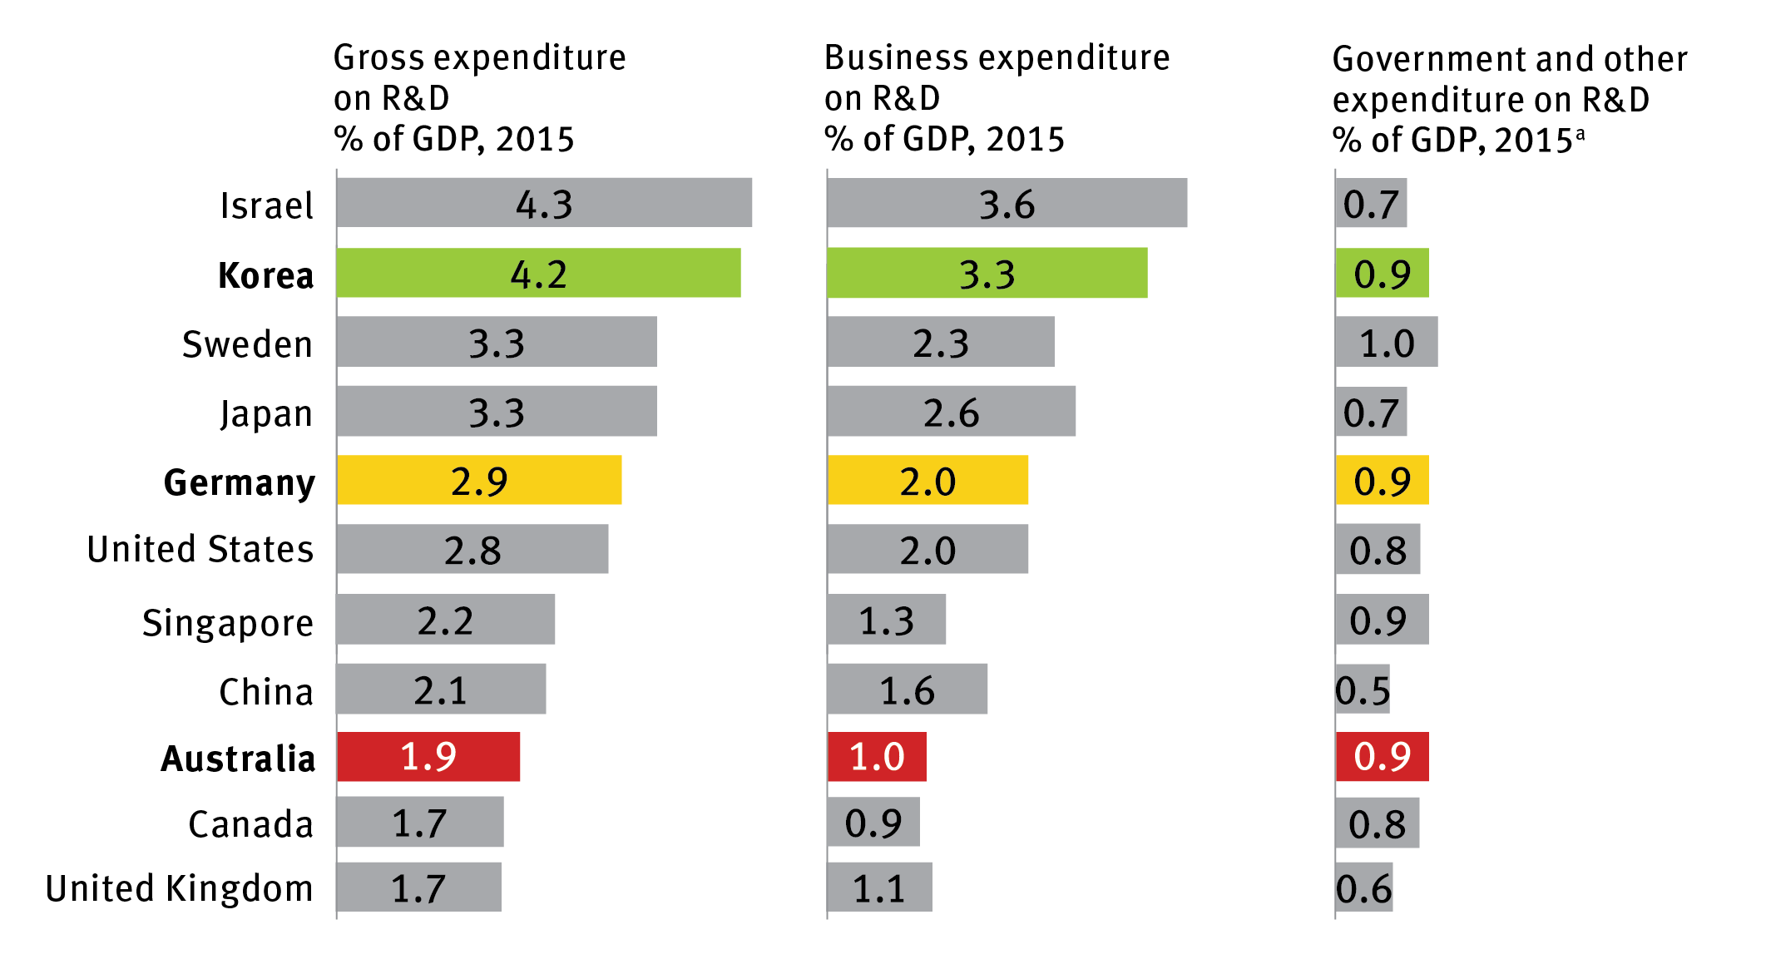

*Australia’s expenditure on research and development compared with peers, 2015 (Source ISA 2030 Plan)*

Consider the international comparisons in this next slide. Take three countries – Australia, Germany and South Korea. As the third column on the slide shows, in all three the expenditures by Government are the same, at 0.9% of GDP. But look at the very different investments by business: 1% in Australia, 2% in Germany and 3.3% of GDP in South Korea. Putting it another way, the leverage on public sector investment is only 1.1 times in Australia, but 2.2 times in Germany, and 3.7 times in South Korea. In Israel the leverage is 5 times.

So why the massive difference? Is it cultural? Is it the quality of currently available government support programs? Our hypothesis is that a key path to address these disparities should be through re-thinking the form, and not just the amount, that government support for business R&D takes in Australia compared with the leading innovation nations.

As this next slide shows, in most of our competitor countries, the majority of incentives are direct not indirect ……. Indeed some like Germany, Sweden and Israel have zero indirects and only utilise direct measures to drive their BERDs. We believe a smarter rebalancing of our direct and indirect support mechanisms is overdue and will be essential to reversing Australia’s decreasing levels of business investment in innovation.

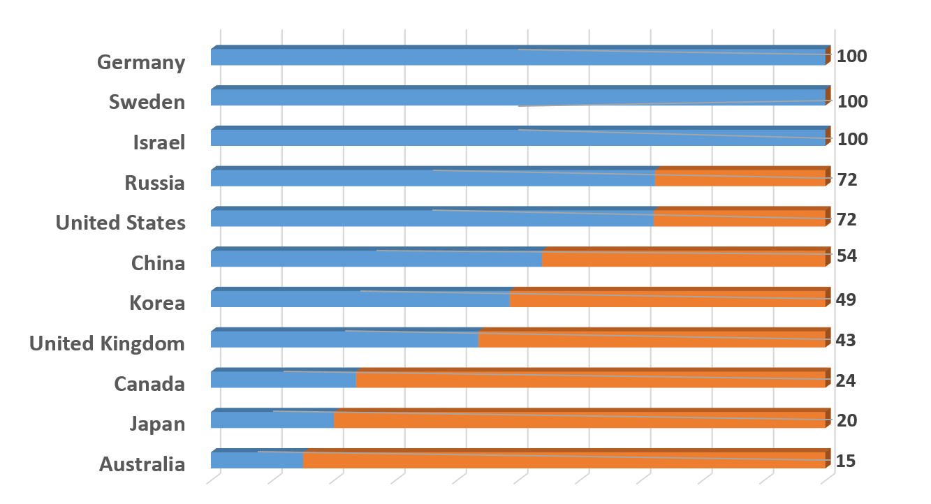

*Percentage of direct vs indirect government funding for business research and development, 2015 (Source OECD 2017 report).*

So what do I mean by “Direct” instead of “Indirect” incentives?

Unlike the indirect RDTI, agnostic as to sector, self-assessed and continually available regardless of performance outcomes, direct incentives seek to powerfully leverage Government investment in innovation and have the following characteristics and objectives:

1. Expand availability of risk capital

2. Expand access and size of markets

3. Leverage collaboration for commercialisation

A few examples of these 3 sorts of direct incentives:

**1. Expansion of Available Risk Capital via Government Co-Investment** Where scale and/or risk otherwise intimidates and holds back activity in the small domestic market economy of Australia, Government co-investment can leverage private sector action. Think the recently established Biomedical Translation Fund (BTF), a $500 million VC fund, established with ISA’s recommendation and guidance, with 50/50 sharing of equity funding by the Government and private sector investors. The rationale for this fund was to ensure we don’t continue to squander the fantastic health and medical research breakthroughs achieved by our researchers. The $500m of VC, managed by three private life sciences management companies, is now available for development of new drugs and devices through clinical trials into the market place.

Since getting up and running in 2017, the BTF has already provided venture capital of almost $80 million to 12 young companies commercialising a range of exciting innovations including a breakthrough kidney disease treatment, novel treatments for peanut allergies in kids, and wearable medical technology that helps Parkinson’s sufferers self-manage their disease.

Without the availability of the BTF risk capital and expertise these breakthrough products and IP would continue to drift offshore or simply die in the laboratories. This leverage which Government co-investment delivers is exemplified by the way it has attracted and enabled some of the nation’s leading superfunds to match the Government’s $250 million with the long term and patient risk capital previously eschewed. So there is private sector dollar for dollar skin in the game and the individual projects are selected by experienced private life sciences fund managers. The BTF demonstrates the power of targeted co-investment by Government.

**2. Expansion of market size and access via Government as a large and innovative customer**

Government can choose to foster innovation through its procurement processes. In 2015-16, Australia ranked only 70th out of 144 countries on how government procurement fosters innovation. Leveraging government procurement (federal government spend was $47.3 billion across 64,092 contracts in 2016-17) to drive innovation is a complex challenge. But the success of international initiatives suggest that we should try harder.

Following its NISA announcement in December 2015, the Government launched the Business Research Innovation Initiative (BRII). This was based on other nations’ established procurement experiences with challenge grants; in particular the US, Small Business Innovation Research Program (SBIR). ISA assisted the design and roll-out of a pilot BRII program which included two main objectives:

* To solve problems and opportunities identified by government departments by funding SME’s able and willing to create, prototype and test innovative solutions.
* To enable scale up and commercialisation of such solutions to a wider customer base.

A contemporary US example is Illumina: a global leader in genome sequencing equipment which at the most fundamental level enables the ability to read and understand genetic variation. It received its first SBIR award in 1999. In January 2014, Illumina announced a milestone in life sciences by introducing a system that researchers can use to sequence the genetic code of a human for approximately $1,000. Today the company has grown to over 5,000 employees globally and generating multi billions in annual revenues.

**3. Expansion of market size and access via export development grants**

This is not about “picking winners” per se; but it is unashamedly about supporting demonstrated high performance sectors. Our 2030 plan calls for an expansion of Austrade’s EMDG program. Given exports are a strong proxy for innovative and competitive performance, we view this as a very effective direct program.

Consumer households in Asia are expected to double from 600 million today to 1.2 billion by 2030. While this will offer fantastic opportunities, our distance from key Asian export markets is an issue, and the distinct cultural, linguistic, business and regulatory environments within these markets are significant barriers to entry. If this does not present a market failure per se it certainly signals a market challenge for Australian SME’s, perhaps a uniquely Australian market challenge that we need to deal with. We believe there is a very large multiplier opportunity via a significant expansion in targeted EMDG programs.

**4. Grants which leverage Collaboration for Commercialisation**

One such existing direct measure is the successful Co-operative Research Centre Program (CRC). Since 1990 this program has achieved a leverage of 4 times the Government investment by support from academia and industry. Given its success, it is a program that has been largely copied by others offshore (e.g) the Catapault Program in the UK. The success of CRCs is captured in the story of the Capital Markets CRC. Twenty years ago Professor Michael Aitken, CEO of the CRC and 2016 winner of the Prime Minister’s Prize for Innovation, developed software that could define and test fairness and efficiency of financial markets. Capital Markets CRC also spun off SMARTS, a real-time surveillance software that services regulators, exchanges, and brokers in capital markets. In Europe, this surveillance solution has helped to reduce instances of insider trading by 26%. SMARTS has been adopted by more than 40 national exchanges and regulators and 150 brokers across 50 countries.

The CRC-P program is a recent iteration emphasising a greater role for industry and focusing on shorter terms (up to 3 years) for achieving market tested commercialisation of new products and services. The CRC-P program has backed an incredible range of technologies enabling tangible improvements to people’s lives; from driver monitoring systems that help tackle fatigue in truckies, to new technologies for rocket propulsion systems, through to using Artificial Intelligence to improve cancer diagnosis. In just its first five rounds of funding the program has supported 63 Projects with $133m, which has leveraged an additional $320m of partner cash and in-kind support. I am happy to say that demand remains very strong.

So these are some of the significant direct measures available to correct the imbalance in our business incentives and to reverse the decline in BERD.

Importantly, this is not just about Government; to be clear we believe that an appropriate re-allocation by Government of its current “indirect” incentive expenditures of $3 billion per annum can fund most of the “direct” measures referred to above.

**CONCLUSION**

In conclusion I can assure you that I and ISA intend to continue the important conversation with government and other stakeholders around getting a better and smarter balance into our support measures for business R&D…………….. And to compete internationally on the basis of our knowledge and innovation.

We need the IP professionals in this room tonight, and colleagues across the nation to join us in relentlessly prosecuting the case for innovation. If you will excuse the pun it should be patently obvious that the prosperity of our children and grandchildren depends on it.

**Thank you.**

1. Patent number 242531
2. Patent number 128497
3. Patent number 258935
4. <https://www.industry.gov.au/about-us/what-we-do/annual-report/annual-report-2016-17/part-c-ip-australia>
5. <https://www.globalinnovationindex.org/Home>
6. Number of deals per purchasing power parity $GDP
7. GII: 6.1.1:Patents by origin/bn PPP$ GDP: 2.2 (score/value) **44** (rank); GLII 6.1.2: PCT patents by origin/bn PPP$ GDP 1.5 (score/value) **22** (rank)
8. <https://www.ipaustralia.gov.au/ip-report-2018>
9. Qualcomm is an American multinational semiconductor and telecommunications equipment company that designs and markets wireless telecommunications products and services.
10. <https://www.innovationaus.webtactics.net.au/2018/04/CSIRO-is-on-a-patent-patrol>
11. <https://uniquest.com.au/our-track-record>