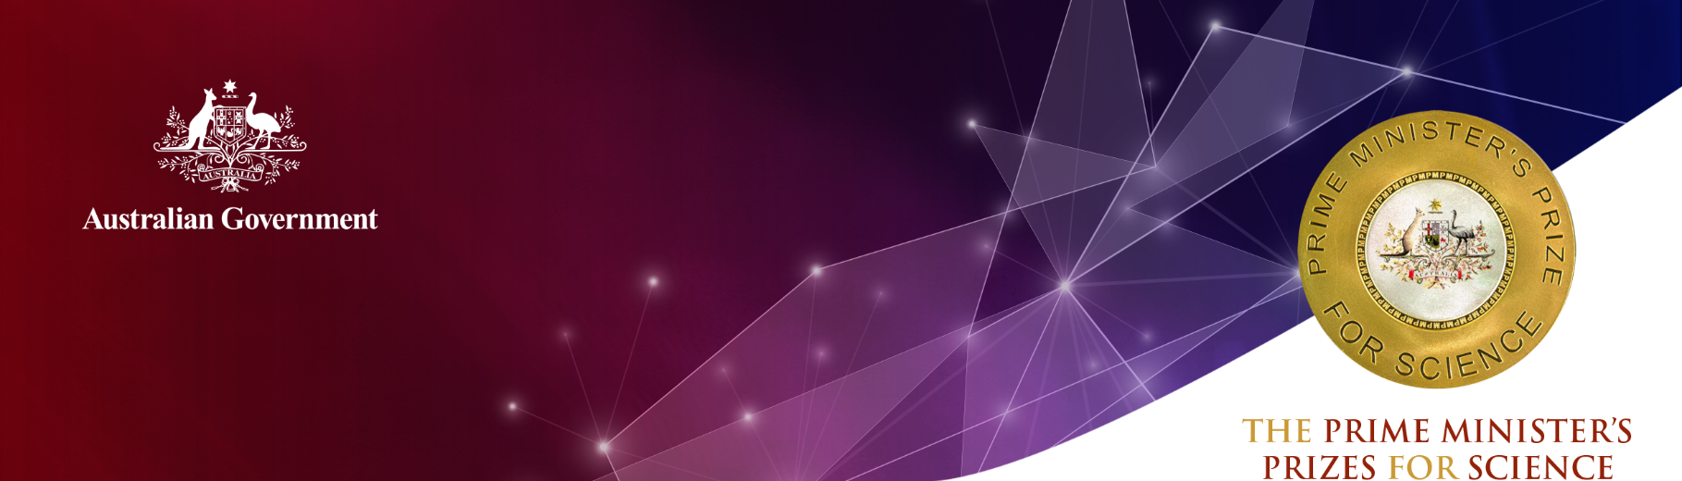
Associate Professor Justin Chalker
Flinders University

2020 Prize for New Innovators
Associate Professor Justin Chalker has invented a novel class of polymers synthesised directly from elemental sulphur (a waste by-product of the petrochemical industry), and renewable plant oils.
The vast majority of polymers (such as conventional plastic and rubber) are made from unrenewable building blocks and many of these materials are non-recyclable. Associate Professor Chalker’s ground-breaking research shows that low-cost and renewable molecules (such as limonene and canola oil) can react with sulphur to make a new class of sustainable and recyclable plastic and rubber.
Associate Professor Chalker has demonstrated a range of real-world applications for his new sulphur-polymer materials, addressing critical issues facing humanity such as ensuring clean air, water and sustainable food production. These are outlined below.

Mercury remediation
Environmental contamination caused by mercury is a serious global issue. Associate Professor Chalker’s polymers are excellent agents for mercury capture. They work to remove contamination from the air, water and soil at a rate and volume competitive with current commercial sorbents.

Oil-spill clean-up
Associate Professor Chalker’s polymer has a high affinity for crude oil and diesel fuel, so can be useful in cleaning up oil spills. When the polymer is applied to an oil spill, it gathers the oil into a gel upon contact for easier retrieval.

Slow-release fertilisers
Associate Professor Chalker has shown that fertiliser nutrients can be embedded in his sulphur-based polymer. This allows the slow release of nutrients, with the polymer acting as a source of the micronutrient sulphur. Since more than 50 per cent of all fertiliser applied globally is lost to run-off, Associate Professor Chalker’s fertiliser formulation is a breakthrough in crop production.

Mercury- and cyanide-free gold mining
Artisanal and small-scale gold mining is the largest source of mercury pollution on Earth, with nearly 20 million subsistence miners using mercury to extract gold from ore. In formal and large-scale gold mining, it is common to use highly toxic cyanide to leach gold. Associate Professor Chalker has recently patented a gold mining process that eliminates the use of toxic mercury and cyanide. The process features a novel and safe way to rapidly leach the gold in high yield. The sulphur polymer is then used to recover the gold. This process is being developed commercially for both gold mining and e-waste recycling.
Associate Professor Chalker’s technologies have been patented and assigned to Perth-based Clean Earth Technologies (CET), an organisation driving more environmentally sustainable approaches to mining.
CET has invested heavily in Australian infrastructure on the back of the success of Associate Professor Chalker’s patents, including a new production plant in Adelaide, South Australia. CET expects to invest more than $2 million over the next five years into the operation, with CET CEO Kevin Fell reporting that Associate Professor Chalker’s innovations have helped attract $15 million in investment.

Qualifications
PhD. Organic Chemistry, University of Oxford (2011)
B.S., Chemistry, University of Pittsburgh (2006)
B.A., History and Philosophy of Science, University of Pittsburgh (2006)

Career highlights
2018 Royal Australian Chemical Institute (RACI) Youth Chemistry Lecturer, Tasmania
2018 AMP Tomorrow Maker
2018 South Australia Science Excellence Awards STEM Educator of the Year
2018 Eureka Prize Finalist for Outstanding Early Career Researcher (one of three in Australia)
2018 Organic and Biomolecular Chemistry New Talent Award
2017 Dream Chemistry Award finalist (one of five globally)
2017 Green Chemistry Emerging Investigator Award
2017 ChemSocRev Emerging Investigator Award
2017 David Solomon Award for commercialising research, Royal Australian Chemical Institute (RACI) Academic Sharp Brain Competition
2016 Visiting Lecturer, Marie Curie Training Network in Protein Conjugates, Institute of Molecular Medicine, Lisbon
2016 Tasmanian Alkaloid Visiting Lectureship, University of Tasmania
2016 South Australian Tall Poppy of the Year
2015 Australian Research Council, Discovery Early Career Researcher Award (DECRA)
2015 Vice-Chancellor’s Award for Early Career Researchers, Flinders University
2014 Visiting Lecturer, Inaugural Summer School in Chemical Biology, University of Leiden
2013 F1000 Faculty Member of the Year, Chemical Biology Division
2012 Tulsa Undergraduate Research Challenge Mentor of the Year
2008 National Science Foundation Graduate Research Fellowship
2007 Eli Lilly Prize for Excellence in Organic Chemistry Research
2006 Rhodes Scholarship

