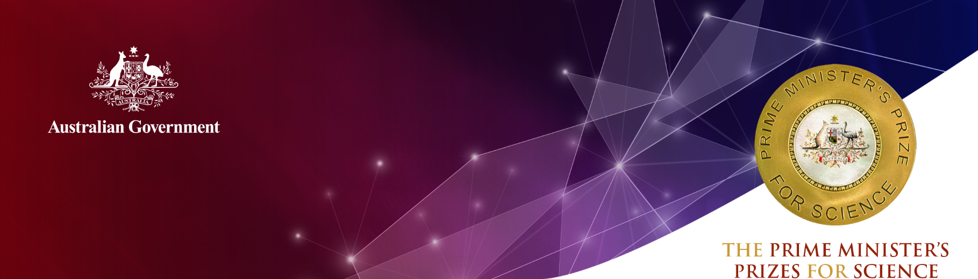
Mr Darren Hamley
Willetton Senior High School, Western Australia

2020 Prime Minister’s Prize for Excellence in
Science Teaching in Secondary Schools
Mr Darren Hamley has taught at Willetton Senior High School for 28 years. It is one of Western Australia’s largest schools, with more than 2,500 students. He teaches science to Years 7 to 12 students and has coordinated the school’s Gifted and Talented Education Program for 20 years.
Mr Hamley’s extensive knowledge and infectious enthusiasm gives him an innate ability to engage and inspire students. This cultivates students’ love of science and lifelong skills in science inquiry.
He develops innovative approaches to teaching and learning, helping young people understand how to apply science to the real world. He has established science-based extracurricular clubs for solar cars, chess, Rubik’s Cube solving, dolphin and ocean conservation and astronomy.
Mr Hamley was instrumental in including an observatory in the school’s new science building. Willetton Senior High School is now the only public school in Western Australia with a fully robotic, 36-centimetre telescope.
He also leads the school’s solar car project, where students design and construct a full-size solar-powered car. Willetton Senior High School is one of only a few schools to have entered the World Solar Challenge (a 3,000km race from Darwin to Adelaide), and drive a 1,000km section of the Nullarbor on two occasions.
Mr Hamley also fosters a passion for science among students who participate in the world-recognised Duke of Edinburgh’s Award program. He takes students to Shark Bay (900km north of Perth) to produce wildlife-spotting brochures, which are designed to help tourists appreciate and conserve the environment.
Mr Hamley has received multiple awards for increasing students’ awareness and exploration of the environment, and for encouraging conservation through scientific efforts. His awards include the 2019 Murdoch University’s Ocean Challenge for raising awareness of ocean pollution, and the 2015 Department of Parks and Wildlife (DPaW) Environmental Award for restoration of the Western School Prawn population in the Swan River.
He has also led student research into the effect of dorsal fin damage on dolphin’s swimming performance, following the death of a number of Swan River dolphins due to entanglement. Students used 3D printers to make accurate scale models and research hydrodynamic drag. As a result of this work, the students were invited to speak at an environmental conference, and they formed a conservation club called Trash4Splash to raise awareness of river pollution.
Mr Hamley is an active member of the school’s Aboriginal Education Committee, and works to promote a greater understanding and appreciation of Aboriginal culture in the community. He is an enthusiastic promoter of girls in STEM, and presented his ’Designing Projects to Encourage the Participation of Girls in STEM’ at a Perth learning conference.

Mr Hamley has made significant contributions to the science education community outside of Willetton Senior High School. He is always looking to promote and improve science education – from professional development sessions about Gifted and Talented Education, to contributing to Australian Geographic and presenting at science conferences.

Qualifications
Graduate Certificate, Harvard University (2019)
Dip.Ed, Murdoch University (1984)
B.Sci (Biology), Murdoch University (1983)

Career highlights
2019 Winner of the Department of Biodiversity, Conservation and Attractions (DBCA) Monkey Mia Inspirational Volunteer Award for work on student-based dolphin echolocation research
2019 Winner of the Murdoch University’s Ocean Challenge (Students) for promoting the awareness of ocean pollution
2018 Invited to join the Council of the Royal Society of Western Australia
2018 Winner of the Doug Clarke Medal awarded by the Royal Society of Western Australia (Science education award Primary, Secondary or Tertiary)
2017 ‘Cockatoos of Australia’ published online by Australian Geographic; student-based project to photograph every species of cockatoo in Australia
2017 Nominated for the City of Cockburn’s Inspirational Volunteer Awards (Category: Environmental and Animal Protection) for work on kangaroo rehabilitation
2016 Finalist in the United Nations Association of Australia’s World Environment Day Awards; for student-based research on restoration of coral in the Ningaloo Reef
2015 Winner of Department of Parks and Wildlife (DPaW) Environmental Award for restoration of the Western School Prawn population in the Swan River
2015 Awarded Highly Commended for the Prime Minister’s Prize for Excellence in Science Teaching (Secondary Schools)
2015 Finalist in the Murdoch University Distinguished Alumni Awards
2015 Winner of the Engineers Australia award for student-based work on solar-powered cars

