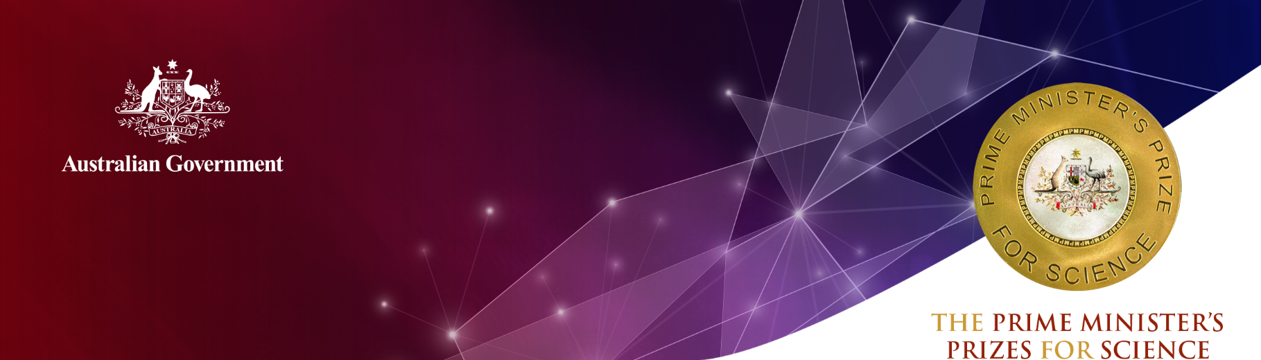
Mrs Sarah Fletcher
Bonython Primary School, Australian Capital Territory

2020 Prime Minister’s Prize for Excellence in
Science Teaching in Primary Schools
Mrs Sarah Fletcher is a primary school teacher in the Australian Capital Territory. She has worked as both a classroom and STEM specialist teacher in several schools since 2003.
She is renowned for using her deep knowledge of the curriculum, pedagogical skills and understanding of her students to develop flexible, engaging and quality education programs.
Mrs Fletcher is innovative and imaginative, and seeks to maximise the resources at her disposal to inspire even the most reluctant learners. She believes that real learning happens when students have an emotional attachment to what is being taught.
She teaches skills and content that link with real-life experiences, and accentuates her lessons by inviting working scientists into the classroom. For example, she connected a class of Year 1/2 students who were interested in snakes with the ACT Herpetological Association.
Visits from working scientists generate excitement among students and propel them forward in their learning development.
As a STEM specialist teacher, Mrs Fletcher works closely with classroom teachers to support the individual needs of each child, including those in Bonython Primary School’s two Learning Support Unit-Autism (LSUA) classes.
Mrs Fletcher also seeks opportunities for students to engage in science beyond the classroom. She encourages entries in Origin Energy’s Big Little Idea initiative, the Science Educators’ Association of the Australian Capital Territory’s (SEAACT) Science Fair and a design challenge with the Australian National University's World Solar Challenge Team.
She also plays a significant role in the operation of the SEEACT Science Fair.
She has also facilitated after-school engineering workshops with the Australian National University (ANU) College of Engineering and Computing Science.
Mrs Fletcher has been a member of the SEEACT council for 15 years and works with the wider education community to promote and improve the quality of science teaching.
Mrs Fletcher leads professional learning sessions related to Primary Science education, including the annual Primary Science Teachers Workshop. She also coordinates ANU’s Science Enrichment Event, to promote science in the Tuggeranong region.
Mrs Fletcher also created the STEM Specialist Primary Teacher Network, which aims to help STEM teachers connect with one another in the ACT region.

Mrs Fletcher is a respected voice in the education sector and is often approached to trial new science education resources.
She also develops strong relationships with local schools and colleges to harness the power of cross-age mentoring and collaboration in the ACT community.
Mrs Fletcher is passionate about building the confidence and capacity of her students, to ensure that every child views themselves as a scientist capable of analysing and solving problems.

Qualifications
B.Ed, University of Canberra (2002)
B.A, Australian National University (2000)
B.Sci, Australian National University (2000)

Career highlights
2020 Developed and leads the STEM Specialist Primary Teacher Network to share resources and provide mentorship and a support network (12 teachers participating in program)
2019 Co-Presented ‘Computational Thinking and Robotics in the Primary Classroom’, STEMEd Conference
2019 Facilitated Australian National University College of Engineering and Computer Science Workshop
2019 Trialled and reviewed Science and Technology Education Leveraging Relevance’s (STELR) ‘A Day in the Life of a 7-Year-Old’
2019 Involved in review of new ‘Primary Connections’ website
2019 Participated in CSIRO’s ‘STEM in Schools’ event
2018 Awarded Highly Commended for the Prime Minister’s Prize for Excellence in Science Teaching (Primary Schools)
2016-2017 Science Educators' Association of the ACT (SEAACT) Science Fair Co-Coordinator and Host School Contact
2016 Published in Teaching Science (article about the Australian National University Enrichment Event)
2015-Current Australian National University Science Extension Event Creator and Coordinator
2015-2017 Australian National University Junior Extension Day (Tuggeranong Network) Science Year 2 Coordinator
2014-Current Developer and Manager of Inspiring Our Future in Science page on Facebook (linking primary teachers and primary science resource providers)
2013-Current Facilitator/Coordinator System Annual Primary Science Workshops
2009-Current Science Educators' Association of the ACT (SEEACT) Council – Primary Contact Officer
2009 Recipient Ruth Dirks Scholarship, Australian Science Teachers Association (ASTA)
2009 Facilitator Primary Standards Consultation Meetings on behalf of Australian Science Teachers Association (ASTA)
2009 Coordinated Australian Academy of Science’s Primary Connections (Professional learning program delivered to primary science teachers in the ACT)
2007 Sat on a School Validation Panel
2006 Presented Curriculum Renewal to Turner School staff; presented Waste Wise environmental management professional learning to staff

