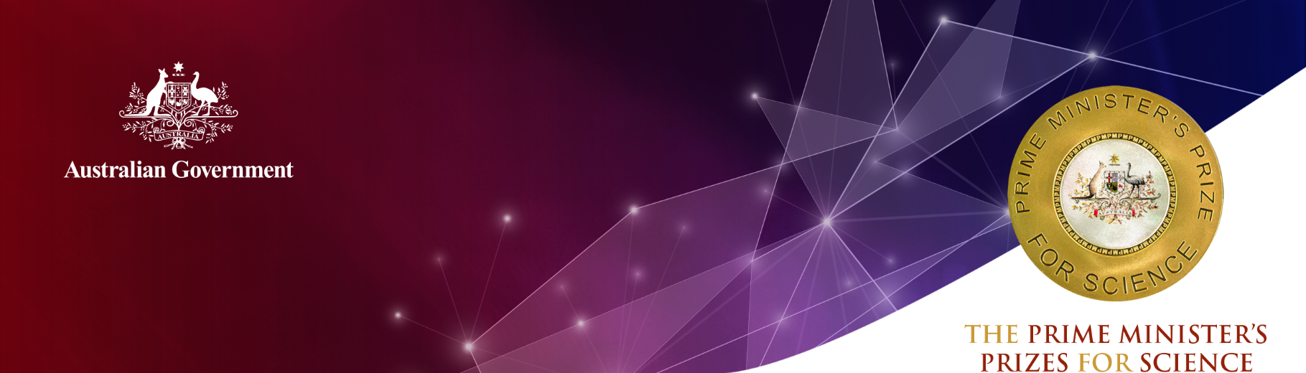
Emeritus Professor David Blair,
Professor David McClelland,
Professor Susan Scott and Professor Peter Veitch
ARC Centre of Excellence for Gravitational Wave Discovery (OzGrav)

2020 Prime Minister’s Prize for Science
Emeritus Professor David Blair, Professor David McClelland, Professor Susan Scott and Professor Peter Veitch are pioneering Australian physicists recognised for their critical contributions to the first direct detection of gravitational waves, thereby opening a new window into the Universe with gravitational wave astronomy. This is a groundbreaking discovery in the field of physics, which has been 100 years in the making.
Albert Einstein first predicted the existence of gravitational waves in 1916. Gravitational waves are minute distortions in the fabric of space-time that are non-electromagnetic in nature and spread from their source at the speed of light. However, he believed they would never be detectable.
In 1994, 78 years after Einstein’s hypothesis, the world took a significant step towards gravitational wave detection with the construction of two four-kilometre, arm-length gravitational wave detectors in the United States, which formed the Laser Interferometer Gravitational-wave Observatory (LIGO). One year later, the Australian Consortium for Interferometric Gravitational-wave Astronomy (ACIGA) was formed, focusing on gravitational wave detection research and development.
In 1997, ACIGA members, Emeritus Professor Blair and Professors McClelland, Scott and Veitch joined the LIGO Scientific Collaboration (LSC) to broaden their activities to cover all areas of LIGO research.
In the decades following, this team has led critical work to develop our understanding of the existence of gravitational waves. This culminated in the first direct gravitational wave detection in 2015 – the signal coming from the collision of two substantial black holes 1.3 billion years ago.
This was followed by a further detection in 2017, from the collision of two neutron stars. The first detection of its kind, this event solved a 50-year-old mystery confirming that these mergers are the source of previously observed high-energy gamma ray bursts, and of heavy metals such as gold, platinum and uranium in the Universe.
The impact of their discovery has been immense; opening up previously unknown parts of the Universe such as hidden black holes, understanding the origin of gamma ray bursts (and with the potential to discover how supernovae explode), and to even peer back to the beginning of time at the Big Bang.
For this ’discovery of the century’, the 2017 Nobel Prize in Physics was awarded to the three American founders of the LIGO project. It was featured by the Australian Academy of Science as one of the top five international science breakthroughs of the last decade.

Emeritus Professor David Blair
Emeritus Professor Blair created a large-scale high optical power research facility on a remote site at Gingin, Western Australia, to mimic Advanced LIGO interferometers and investigate the subtle interactions between light, sound and heat that would occur in full-scale detectors.
His pioneering work predicted that laser light would scatter from sound in the mirrors, causing parametric instability at power levels far below that needed to obtain detector sensitivity.
When this theory was validated during LIGO commissioning, Emeritus Professor Blair sent team members to help implement stabilisation methods that allowed the detectors to achieve sufficient power levels to make the first detection of gravitational waves.

Professor David McClelland
Professor McClelland has led Australia’s partnership in Advanced LIGO since its commencement in 2009.
He chaired the LIGO Scientific Collaboration’s (LSC’s) Instrument Science/Advanced Detector program from 2013 to 2017.
He is the Principal Investigator for OzGrav in the LSC and represents OzGrav on the Gravitational Wave International Committee (GWIC).
Professor McClelland led The Australian National University team that played a crucial role in designing, installing and commissioning Advanced LIGO’s lock acquisition system, and in the construction and installation of Australian hardware for precision routing of the laser beam.
His pioneering quantum ‘squeezing’ technology (now installed in all detectors) is essential for boosting interferometer sensitivity to the current level where signals are detected weekly when in operation.

Professor Susan Scott
Australia’s leading general relativity theorist, Professor Scott initiated the Australian effort in gravitational wave data analysis in 1998, and led Australian research in digging gravitational wave signals out of detector noise.
Her Australian National University team contributed key components to the LIGO Data Analysis System through which the detection signal was processed in 2015; designing and conducting the first gravitational wave search to be carried out under Australian leadership.
When LIGO made the first observation of a neutron star merger, the ANU SkyMapper telescope imaged the newly-born kilonova and determined its temperature profile.

Professor Peter Veitch
Professor Veitch’s University of Adelaide team invented and installed critical instrumentation for the Advanced LIGO detectors, namely their Hartman sensors. These sensors provide a solution to a major technological problem – the distortion of the laser beam within the detector – by measuring them simply and with a sensitivity that is 30-times better than any other sensor.
The Hartman sensors are used at all stages of the detection process: commissioning, measurement and adaptive correction of the distortions, and optimising the detector sensitivity and stability.

Emeritus Professor David Blair

Qualifications
PhD., East Anglia (1972)
B.Sc., Physics (First Class Hons), University of Western Australia (1967)

Career Highlights
2018 West Australian Scientists Hall of Fame
2017 Royal Astronomical Society Group Achievement Award ‘A’
2017 Australian Academy of Science Bruno Rossi Prize awarded to the LIGO Scientific Collaboration
2016 Gruber Cosmology Prize awarded by The Gruber Foundation
2016 Special Breakthrough Prize for Fundamental Physics
2007 Western Australian Scientist of the Year 2007-8
2006 Western Australian Champion Award
2005 Australia-New Zealand Association for the Advancement of Science Medal
2005 Australian Government Eureka Prize for Promoting the Understanding of Science
2003 Clunies Ross National Science and Technology Medal
2003 National Medal for Community Service
2003 Centenary Medal for Service to Science
2000 Citation: Most Outstanding Review Paper, Reports on the Progress of Physics
1995 Australian Institute of Physics Walter Boas Medal
1993 75th Anniversary Award, The University of Western Australia
1992 NASA Group Achievement Award
1988 Marcel Grossmann Institutional Award for Research in Gravitation and Astrophysics

Professor David McClelland

Qualifications
PhD., University of Otago (1987)
M.Sc., University of Western Australia (1981)
B.Sc. (First Class Hons), University of Western Australia (1978)

Career Highlights
2019 Fellow of Australian Academy of Science
2018 International Organisation for Quantum Communication, Measurement and Computing Award for Outstanding Achievements in Quantum Experimentation
2017 Walter Boas Medal, Australian Institute of Physics
2017 Vice Chancellor’s Award for Excellence
2017 Royal Astronomical Society Group Achievement Award ‘A’
2017 Einstein Medal, Einstein Society, Switzerland
2017 AAS Bruno Rossi Prize awarded to the LIGO Scientific Collaboration
2017 Princess of Asturias Award for Technical and Scientific Research
2016 The Australian National University (ANU) Impact Award for Reach and Influence
2016 Gruber Cosmology Prize awarded by The Gruber Foundation
2016 Special Breakthrough Prize for Fundamental Physics
2016 Ecole Normale Superieure Visiting Fellow, Paris, France
2013 Elected Fellow, Optical Society of America
2013 Joseph F. Keithley Award, American Physical Society
2010 Elected Fellow, American Physical Society
1997 Associateship, California Institute of Technology
1992 French National Centre for Scientific Research (CNRS) Research Fellowship

Professor Susan Scott

Qualifications
PhD. Mathematical Physics, The University of Adelaide (1991)
B.Sc. Pure Mathematics (Hons), Monash University (1979)

Career Highlights
2020 Fellow of American Physical Society
2017 American Astronomical Society Bruno Rossi Prize
2017 Einstein Medal, Einstein Society, Switzerland
2017 Royal Astronomical Society Group Achievement Award in Astronomy
2017 Princess of Asturias Award for Technical and Scientific Research
2017 The Australian National University (ANU) Award “Vice-Chancellor's Award for Excellence”
2016 Gruber Cosmology Prize awarded by The Gruber Foundation
2016 Special Breakthrough Prize for Fundamental Physics
2016 ANU Award “Impact Award for Reach and Influence”
2016 Fellow of Australian Academy of Science
2016 Fellow of Australian Mathematical Society
2004 Fellow of European Academy of Sciences
2004 Fellow of Australian Institute of Physics
1999 Fellow of Institute of Physics (UK)
1992-98 ARC Australian Research Fellow
1986-89 Rhodes Fellowship, Oxford (worked with Roger Penrose – 2020 Nobel Laureate in Physics)
1985 Amelia Earhart Fellowship (USA)

Professor Peter Veitch

Qualifications
PhD., University of Western Australia (1987)
B.Sc. (Hons), University of Western Australia (1978)

Career Highlights
2017 Royal Astronomical Society Group Achievement Award ‘A’
2017 Australian Academy of Science Bruno Rossi Prize awarded to the LIGO Scientific Collaboration
2016 Gruber Cosmology Prize awarded by The Gruber Foundation
2016 Special Breakthrough Prize for Fundamental Physics
2016 Elected Fellow, Optical Society of America
1991 Max Planck Research Award

