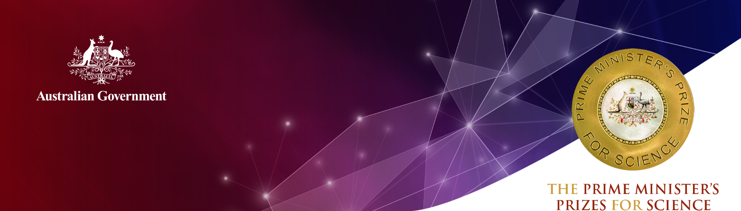
Professor Thomas Maschmeyer
The University of Sydney

2020 Prime Minister’s Prize for Innovation
Professor Thomas Maschmeyer is a Professor of Chemistry at the University of Sydney, where he serves as Founding Director of the Laboratory of Advanced Catalysis for Sustainability (School of Chemistry). He is also the Founding Executive Chairman of Gelion Technologies and Co-Founder as well as Principle Technology Consultant of Licella Holdings.
He is being recognised for translating his outstanding fundamental research into two pioneering technologies: the Catalytic Hydrothermal Reactor (Cat-HTR™), and zinc-bromide energy storage design. These achievements greatly enhance Australia’s reputation for leadership in science, and its application to solving sustainability problems.
The Catalytic Hydrothermal Reactor (Cat-HTR™)
Cat-HTR™ enables the transformation of residues and wastes into valuable (petro)chemical feedstocks.
The technology can process inputs that include pulp and paper processing waste, woody construction waste, mixed end-of-life plastics, used lubrication oil, shredded tyres and much more.
The underlying fundamental research began at the Technical University of Delft, and continued at the University of Sydney. From here, it was brought to commercial demonstration at Licella Holdings (the company Professor Maschmeyer co-founded with its CEO Dr Len Humphreys in 2007).
Professor Maschmeyer – together with large and varied teams – not only improved the understanding of their fundamental discoveries, but translated them into a process with global implications. An Australian plant to deliver this technology is now being designed with Licella’s joint venture, IQRenew.
Cat-HTR™ has attracted $100 million of international investment for its development ($85 million of this in Australia). Licella has created near 50 full- and part-time jobs in Australia, and another 15 overseas.
The Cat-HTR™ development is enormously important for Australia. It addresses the sustainability of liquid fuel and chemical supplies by using renewable waste or end-of-life plastic inputs to support a circular economy. This reduces carbon dioxide emissions and plastic waste in the environment.
In Prime Minister Scott Morrison’s address to the United Nations General Assembly in 2019, Cat-HTR™ was specifically named as a technology that “…shows us a truly circular economy is not only possible, but is achievable”.
Zinc-bromide energy storage design
Professor Maschmeyer’s zinc-bromide gel battery design is unlocking the potential of renewable energy and a low-carbon society by facilitating safe, low-cost, high-efficiency energy storage.
This innovation launched Gelion Technologies, a company that has raised $21 million over five years in local and overseas financial markets and employs 25 staff (two-thirds of whom are directly engaged in either research or technology development).
Gelion’s Endure Zinc-Bromide batteries are optimised for stationary energy storage, and to power off-grid and micro-grid installations for a range of industrial, agricultural (e.g. irrigation or desalination) and residential purposes. The Endure batteries are especially suited to hot and remote environments due to their high temperature capability, low fade and tolerance of any state of charge, including complete discharge.

Qualifications
D. Phil. (Science), The University of Sydney (1995)
B. Sci. (Hons. I), The University of Sydney (1991)
German Abitur, Hamburg (1986)

Career highlights
2019 Federation of Asian Chemical Societies’ Contribution to Economic Development Award
2019 Honorary Doctorate of Science, Universities of Ca’Foscari Venice and Trieste
2018 CSIRO Eureka Prize for Leadership in Innovation and Science
2018 Royal Australian Chemical Institute (RACI) R.K. Murphy Medal for Industrial Chemistry
2015 Founding Executive Chairman of Gelion Technologies
2015 Honorary Distinguished Professor, University of Cardiff
2014 Founding Director of University of Sydney’s A$150 million Australian Institute of Nanoscale Science and Technology (AINST, now ‘Sydney Nano’)
2014 Fellow, Royal Society of New South Wales
2013 New South Wales Science and Engineering Award for Renewable Energy Innovation
2012 Royal Australian Chemical Institute (RACI) Weickhardt Medal for Economic Contributions through Chemistry
2011 Royal Australian Chemical Institute (RACI) Applied Research Award
2011 Foreign Member, Academia Europea
2011 Fellow, Australian Academy of Science (AAS)
2011 Fellow, Australian Academy of Technological Sciences and Engineering (ATSE)
2011 Fellow, Royal Australian Chemical Institute (RACI)
2007 Le Fèvre Prize of the Australian Academy of Science for Outstanding Basic Research in Chemistry by a Scientist under 40
2007 Co-Founder, Licella Holdings
2006 Co-Founder, Ignite Energy Resources
2001 Founding Professor, Avantium

