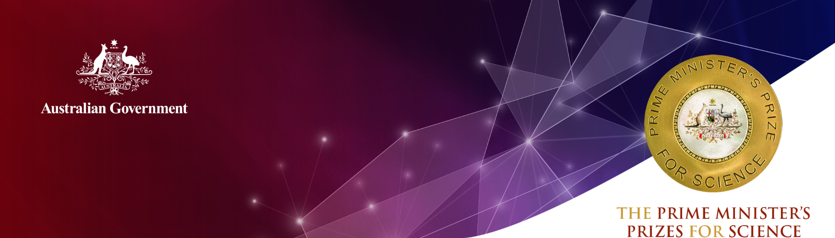
Scientia Associate Professor Xiaojing Hao
University of New South Wales (UNSW)

2020 Malcolm McIntosh Prize
for Physical Scientist of the Year
Scientia Associate Professor Xiaojing Hao is a world-leading researcher in the field of thin-film solar photovoltaics (PV) at the University of New South Wales (UNSW). This work relates to the direct conversion of sunlight into electric power.
Associate Professor Hao initiated a new line of research after completing her PhD in photovoltaics at UNSW, using emerging, earth-abundant and non-toxic thin-film material known as ‘sulphide kesterite’ (or Copper Tin Zinc Sulphide) to form solar cells.
This compound material acts much like the traditional solar panels we see today. However, it does not use any of the toxic or scarce elements found in non-silicon thin-film solar offerings currently seen in commercial environments.
While silicon is an almost ideal material for PV, there is a need for similar environmentally-friendly thin-film materials such as kesterite. These ‘green’ materials can be used in applications that are not well-suited to silicon solar cells (e.g. coatings on buildings or on the bodywork of solar vehicles), or can be stacked on top of standard silicon cells to boost their power output.
Associate Professor Hao’s mission is to create ‘green’ solar cells with abundant and environmentally-friendly materials, so that they can be deployed on a large scale and applied across all aspects of modern life.
Associate Professor Hao and her team intended to prove that kesterite solar cells could function at a sufficient rate of energy conversion, and in the process, set four world records for pure sulphide kesterite solar cell efficiency. In March 2017, the team reached an energy conversion efficiency of 11 per cent – the first time that the 10 per cent efficiency threshold was broken for this type of solar cell. In late 2019, Associate Professor Hao and her team set another world record for a low bandgap kesterite solar cell, reaching an energy conversion efficiency of 12.5 per cent.
These breakthroughs represent major advances in the development of solar cells because they are flexible, low-cost and environmentally-friendly. Her achievements could lead to ‘green’, low-cost industrial tandem solar cells with efficiencies of well above 30 per cent. Such high-power ‘green’ solar cells would speed up the global deployment of PV systems, a positive step given the threat of climate change.
Associate Professor Hao’s achievements has piqued the commercial interest of industry, and established her as the international leader in the development of thin-film solar cells. Her work is driven by a keen awareness that our current and future renewable energy demands will only be met with a wide-scale and significant increase in the use of PV. The technology must also be cost-effective and must not create new environmental problems via the use of toxic elements.

Associate Professor Hao has also made significant contributions to the development of other top cell thin-film materials for the next generation of silicon-based tandem cell stacks. In these cell stacks, thin-film top cell candidates are stacked on the silicon to achieve dramatic increases in performance.
The significance and commercial potential of Associate Professor Hao’s pioneering technology is reflected in the $23 million plus in competitive research grants that her work at UNSW has attracted since 2011.

Qualifications
PhD. Photovoltaic Engineering, University of New South Wales (2010)
M.Eng., Northeastern University, Shenyang, China (2003)
B.Eng., Northeastern University, Shenyang, China (2001)

Career highlights
2020 Australian Research Council College of Experts
2019 Australian Research Council Future Fellowship
2019 Australian’s Most Innovative Engineers 2019
2018 New South Wales Premier’s Prize for Science and Engineering (Energy Innovation in New South Wales)
2018 University of New South Wales Research Staff Excellence Award (Faculty of Engineering)
2018 Best Poster Award, 7th World Conference on Photovoltaic Energy Conversion (combining the most two prestigious world PV conferences)
2017 Finalist (Top 3) of University of New South Wales Women in Engineering Awards of ‘Professor Judy Raper Award for Leadership in Engineering’
2017 University of New South Wales Scientia Fellowship (Inaugural)
2015 Australian Research Council Discovery Early Career Researcher Award (DECRA)
2015 Named as one of UNSW’s ‘20 rising stars who will change our world’
2011 Australian Renewable Energy Agency (ARENA) Postdoctoral Fellowship
2009 Australian Academy of Technological Science and Engineering-Early Career Symposium Fellowship (ATSE-ECSF)
2008 Chinese Government Award for Outstanding Overseas Student
2007 Best Poster Award, 17th International Photovoltaic Science and Engineering Conference, Fukuoka, Japan
2006 Endeavour International Postgraduate Research Scholarship (EIPRS) PhD scholarship

