# Tilte page features Office of the Chief Economist logo, report logo and the words 'Australian Innovation System Report, 2016, www.industry.gov.au/innovation report.' Image is a tessalation of hexagons. Representing the variation and interconnectedness of the innovation system.

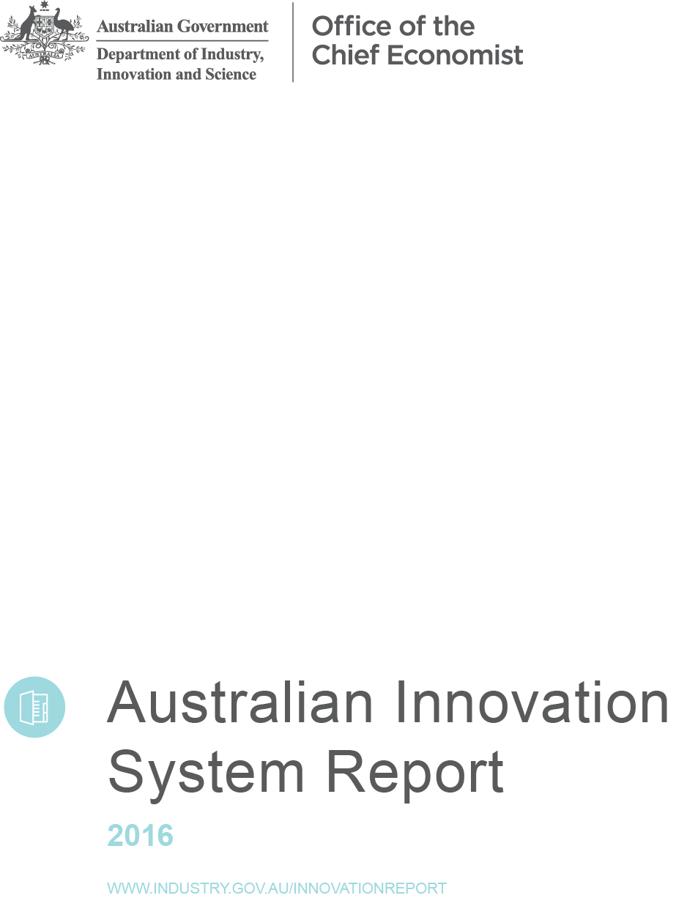



Includes contact details, project team list, acknowledgements, ISSN 2207-0680 and images provided by shutterstock. 

Report is copyrighted by Commonwealth of Australia 2016 and is licenced under Creative Commons Attribution 3.0.



Foreword

With the winding up of the once-in-a-generation mining boom, innovation has once again become a major focal point for policy, as decision makers across the country scan the horizon to identify new sources of growth. To assist with that task, this report provides crucial information on the state and performance of Australia’s innovation system. It is worth pausing for a moment to reflect on the remarkable technological and social achievements made possible by human ingenuity.

For much of human history, economic progress was virtually non-existent. The oft quoted words of Thomas Hobbes describing humankind’s natural condition as ‘nasty, brutish, and short’ can serve as a lucid reminder of the human value of economic and social progress.

It is only in the last 200 years or so that living conditions improved dramatically, resulting in the doubling of life expectancy. A great deal of this improvement is underpinned by innovations across a whole spectrum of human endeavours.

A key insight from economic literature is that sustained economic growth depends on continuous technological progress, which is underpinned by the accumulation and application of knowledge. A handful of major ground-breaking discoveries — followed by a vast array of subsequent applications, refinements and modifications — have led to the kind of economic growth that has transformed the agrarian societies of a few centuries ago into today’s high-tech service-based economies.

We have come a long way on the road of discovery but the journey has not been without cost. Mistakes have been made, policies have failed and resources have been wasted. Indeed, it is fair to say that the road to our success is littered with failure. Yet, failure is something from which we can learn, without needing to dwell on it. As we continue on his road, here in the lucky country, we should remind ourselves that Australian living standards are now among the highest in the world.

In terms of what we can measure, we cracked GDP in the 1930s. We know now that knowledge is the basis for what drives growth in our living standards and wellbeing, and that innovation systems transmit and diffuse new knowledge. But production is becoming increasingly knowledge-intensive, networked and digitally-enabled. Businesses invest significant resources in building their knowledge capital and using it as a source of competitive advantage. In some OECD countries, business investment in various intangible assets significantly exceeds the investment in machinery, equipment and buildings.

Obviously, it is hard to measure the transmission and diffusion of something weightless — or as Alfred Marshall famously put it ‘in the air’ — like knowledge and ideas. We attempt to do this by observing what goes on within businesses, based on asking business owners and managers about their innovation activities. And we extend this by using business performance records to examine the association between what business owners say they do, and their subsequent performance.

Going forward, as more information becomes available, it offers the potential for new insights about the society in which we live, and the opportunities and challenges we face. The value of this information comes not only from a better understanding of the world around us but also from its relevance to making important decisions about the future. This year’s report features a number of novel indicators based on data that were previously unavailable.

A well-functioning innovation system requires the participation of a range of actors across the spectrum of business, government, academia and other parts of the community. By continuing to take a systemic view, the report follows in the tradition established in the previous reports as it tries to shed light on a whole range of different aspects of innovation in Australia and our relative standing compared to our peers. It provides high quality, up-to-date information to support policy decisions and stimulate the ongoing national dialogue about Australia’s economic future.



Mark Cully  
Chief Economist  
Department of Industry, Innovation and Science  
November 2016

Contents

Foreword 5

Contents 6

List of figures 8

Executive summary 11

Introduction: the evolution of innovation indicators 15

1. Key innovation concepts 18

1.1 Defining innovation 18

1.2 Defining the innovation system 18

1.3 The evolution of innovation indicators 20

New innovation data 21

Feature article: Innovating the innovation indicators 23

Feature article: theSPACE 25

2. Why is innovation important? 28

2.1 Innovation is a key factor for competitiveness 28

2.2 Measuring the outcomes of the innovation system 28

2.3 The economic contribution of innovative businesses 29

2.4 The economic contribution of high-growth businesses 30

Start-ups and growth 31

2.5 The benefits of innovation 34

2.6 The relationship between innovation and firm growth 35

2.7 A new indicator for the impact of innovation 38

Income from goods and services innovation 40

A new measure of innovation system efficiency 40

2.8 Feature article: CSIRO Futures 41

3. Activities in the innovation system 43

3.1 Trends in entrepreneurship and innovation 43

Innovation rates are improving slowly 43

Technological vs non-technological innovation 44

3.2 Innovation novelty 45

3.3 A new measure of innovation frequency 47

3.4 Improving our measurement of innovation investment 48

3.5 Research and development in Australia 50

The impact of R&D on innovation activity 50

Trends in R&D activity 52

Investment in R&D 52

3.6 Trends in business expenditure on experimental development 55

3.7 Innovation activity is clustered in cities 56

Refining the map 56

Enablis: A case study of an innovative, high-growth firm 59

4. Networks and collaboration 61

4.1 The state of business collaboration in Australia 61

Collaboration and the frequency of innovation 62

4.2 Business-research sector collaboration 62

How Australia compares 62

Collaboration within research organisations 63

4.3 Absorptive capacity 64

Source of ideas and information for innovation 64

Researchers in business 67

5. Framework conditions 70

5.1 Broad indicators of framework conditions in Australia 70

5.2 Intellectual property protection trends in Australia 70

5.3 Venture capital trends in Australia 71

5.4 Product market regulation 73

5.5 Australian Employee Share Schemes 74

5.6 Australia’s skills base is growing 77

5.7 Academic research trends 79

Outputs: academic publications 79

Outputs: graduating students 79

Appen: A case study of an innovative, high-growth firm 80

5.8 The role of government in the innovation system 82

The Australian Government’s role in supporting R&D 83

Tax incentives and subsidies 84

Appendix A Data tables 85

Glossary of terms 112

References 119

List of figures

Figure 1.1: The innovation cycle 19

Figure 1.2: Total expenditures on external activities for innovation, 2014 24

Figure 1.3: Person-months required to develop most important innovation in 2014 24

Figure 2.1: Total estimated number of employing businesses that are innovation-active, and their contribution to employment, income and capital expenditure, 2014–15 30

Figure 2.2: The net contribution of businesses to economic growth, by business age and average annualised growth class, 2004–05 to 2010–11 32

Figure 2.3: The net contribution of businesses to employment growth, by business age and average annualised growth class, 2004–05 to 2010-11 32

Figure 2.4: Contribution of businesses of different ages to growth relative to their share of employment, total sales, export sales or value added in Australia, 2004–05 to 2010–11 33

Figure 2.5: Increases in business performance and activities compared to the previous year, by innovation status, 2014–15 34

Figure 2.6: Median growth of annual sales (panel A), value added (panel B), gross operating profit (panel C) and employment growth (panel D), by innovation persistence, 2008–09 to 2010–11 36

Figure 2.7: Total business income derived from sales of new goods and/or services, by size, 2014–15 38

Figure 2.8: Total estimated business sales from innovation goods and services, by sector, 2014–15 39

Figure 2.9: Share of income from new or significantly improved goods and services, by country, 2012 40

Figure 3.1: Innovation activity in Australia, 2006–15 43

Figure 3.2: International ranking on innovation-activity, 2010-2012 44

Figure 3.3: Degree of innovation novelty in Australian goods and services innovation, 2001–03 to 2014–15 47

Figure 3.4: International ranking on new to market innovation, 2010-12 47

Figure 3.5: The relationship between innovation frequency and innovation novelty, by number of innovations, 2014–15 48

Figure 3.6: Percentage of innovation-active businesses investing in innovation, by range of investment and employment size, 2014–15 49

Figure 3.7: Proportion of businesses receiving 25 per cent or more of their income from new goods and services, by investment in machinery, equipment or technology, 2014–15 49

Figure 3.8: Innovation-active businesses, as a percentage of total R&D-active businesses, 2010–12 50

Figure 3.9: Innovation-active businesses, as a percentage of total businesses with no R&D, 2010–12 51

Figure 3.10: Product/process innovators that are R&D active, 2010–12 51

Figure 3.11: R&D-active businesses operating in international markets, 2010–12 52

Figure 3.12: Businesses with no R&D operating in international markets, 2010–12 52

Figure 3.13: Australia’s GERD and BERD intensity, 1990–2013 53

Figure 3.14: Major flows of R&D investment, 2013–14 54

Figure 3.15: Business experimental development as a percentage of GDP, 2013. 55

Figure 3.16: Business expenditure on experimental development as a percentage of GDP, 1996–2013. 55

Figure 3.17: Mean annual expenditure in R&D per 10 000 inhabitants by SA3 region, 2008–2014 57

Figure 3.18: Mean patent application counts per 10 000 inhabitants by SA3 region, 2008–2015 58

Figure 3.19: Enablis’ growth, indexed, 2005–06 to 2015–16 60

Figure 4.1: Businesses collaborating on innovation activities (as a percentage of innovation-active businesses undertaking product and/or process innovation), 2010–12 61

Figure 4.2: Percentage of businesses undertaking collaboration, by frequency of innovation, 2014–15 62

Figure 4.3: Businesses collaborating on innovation with higher education or research institutions, by size, 2010–12 63

Figure 4.4: Self-reported business performance and innovation, by business absorptive capacity, 2013 65

Figure 4.5: Sources of ideas or information for innovation, 2006–07 and 2014-15 66

Figure 4.6: Businesses citing market sources as highly important for innovation, 2010–12 66

Figure 4.7: Businesses citing external institutional sources as highly important for innovation, 2010–12 67

Figure 4.8: Proportion of total researchers in business enterprise (panel A), government (panel B), higher education (panel C) and private non-profit (panel D), 2013. 68

Figure 5.1: Intellectual property protection activity, by innovation frequency, 2014-15 71

Figure 5.2: Barriers to entrepreneurship (panel A), administrative burdens on start-ups (panel B), complexity of regulatory procedures (panel C) and regulatory protection of incumbents (panel D), 2013 74

Figure 5.3: Total share based employee share payments by business size and age class, 2006-07 to 2014-15 76

Figure 5.4: Mean difference of value added per employee between ESS and Non-ESS businesses, by size and age class, 2006-07 to 2014-15 76

Figure 5.5: Skill shortages or deficiencies reported by all businesses, by skill type, by innovation status, 2014-15 78

Figure 5.6: Appen’s turnover growth, indexed, 2011–12 to 2015–16 81

Figure 5.7: International ranking on public support for innovation, 2010–12 82

Figure 5.8: The innovation cycle and the role of government 83

Figure 5.9: Government-financed GERD as a percentage of GDP, 2011 or latest year 84

Figure 5.10: Indirect funding, R&D tax incentives, 2011 84

Executive summary

Innovation is a key driver of business competitiveness, economic growth, and ultimately improved living standards. According to estimates by the Organisation for Economic Co-operation and Development (OECD), as much as 50 per cent of long-term economic growth in its member countries can be attributed to innovation, and this contribution is expected to grow. The annual *Australian Innovation System Report* brings together a body of evidence on the structure and performance of Australia’s innovation system, based on a range of key indicators from new and existing sources.

The theme of this year’s report is the evolution of Australia’s innovation indicators. During the last year, the Department of Industry, Innovation and Science collaborated with the Australian Bureau of Statistics (ABS) to develop new questions to be included in the *Business Characteristics Survey*. Throughout the report we present new insights from this work.

The report also extends the existing evidence by incorporating novel indicators derived from the recently created Business Longitudinal Analysis Data Environment (BLADE). Following in the tradition of previous reports, the 2016 edition is supplemented by a number of case studies and feature articles to highlight specific aspects of Australia’s innovation system.

The new indicators expand evidence of the economic value of innovation. The consistent finding is that innovation-active businesses outperform non-innovation-active businesses on a range of measures. Innovation-active businesses in Australia make up 45 per cent of all employing businesses but contribute to over 60 per cent of sales and employment. Compared to non-innovation-active businesses they are 40 per cent more likely to increase income and profitability, twice as likely to export, and two-to-three times more likely to report increased productivity, employment and training.

New analysis using BLADE shows that the frequency of innovation matters, as the positive impact of innovation gets stronger when businesses innovate more frequently. Persistent innovators significantly outgrow other businesses in terms of sales, value added, employment and profit growth. The data shows that in the period 2008–09 to   
2010–11, persistent innovators generated:

* 18 times the value added growth of intermittent innovators
* four times the employment growth of regular innovators
* five times the sales growth of regular innovators

Australia ranks fifth out of 30 OECD countries in terms of its overall proportion of innovation-active businesses, reflecting the strong contribution of our innovative small- and medium-sized enterprises (SMEs; Australian large businesses rank relatively poorly on this measure, coming in 18th out of 29 countries). In terms of investment, total expenditure on innovation by Australian businesses in 2014–15 was between $26 billion and $30 billion. In terms of innovation novelty, new-to-business innovation—the adoption of innovations developed by others—is the most common type of innovation in Australian business.

Just as innovation can be a source of competitive advantage for businesses, a high-performing innovation system can underpin the overall competitiveness of an economy. It is worth noting that Australia earns only a relatively modest proportion of its total income from the sale of innovative goods and services compared to other OECD countries. In 2014–15, income from new or significantly improved goods and services was only around 7.2 per cent of total sales. With this estimate, Australia ranks 20th out of 23 countries in the OECD. The average of the top five OECD countries is   
19.1 per cent. The discrepancy between Australia’s poor performance on this measure, but its high proportion of innovation-active businesses may be explained by two factors: the size of the businesses innovating and the type of innovations being undertaken. Firstly, as the proportion of large Australian businesses that are innovation-active is relatively small, this means that it is less likely that their sales will result from innovative goods or services. Secondly, many Australian businesses are process innovators. This means their innovations may reduce their operating costs or improve efficiency instead of producing a new product for market.

An important innovation activity is research and development (R&D). Literature suggests that R&D-related activities can explain up to 75 per cent of total factor productivity growth, once externalities are considered. The literature also shows that R&D has a significant rate of return, at 10–30 per cent for private return and more than 40 per cent for social return. Australia’s gross domestic expenditure on R&D (GERD) to GDP ratio was 2.1 per cent in   
2013–14, which is slightly above the OECD average of 2.0 per cent, but significantly lower than the top five OECD performers on this indicator. Following a period of strong growth, Australia’s GERD as a percentage of GDP has been declining since   
2008–09, driven by a steep reduction in business R&D as a percentage of GDP. This is related to the reduction in mining R&D expenditure, which declined from $4.3 billion in 2008–09 to $2.8 billion in 2013–14.

Despite having a high proportion of innovation-active businesses, Australia has a relatively low proportion of businesses that are R&D-active. Manufacturing is the largest contributor to R&D in terms of net expenditure, although its share in R&D spending declined from 36 per cent in 2005–06 to 26 per cent in 2013–14. Notwithstanding its declining share of economic activity, R&D intensity of manufacturing increased from 3.5 per cent in 2005–2006 to 4.8 per cent in 2013–14, which represented an increase of $1.1 billion over the period. In addition Professional, Scientific and Technical Services has become the second largest spender on R&D after Manufacturing, totalling $3.75 billion in 2013–14, a 45 per cent increase over the last five years. R&D expenditure in this sector has been driven by SMEs.

The capacity of an economy to innovate relies on its stock of human capital—the skills, knowledge and expertise embedded in its workforce. Australian businesses report a lack of access to skilled personnel as a barrier to innovation, and this pertains to all kinds of skills—not just scientific, engineering or technical.

Academic research contributes to the generation and diffusion of new knowledge, and supports the development of human capital and knowledge. Australia ranks well internationally on measures relating to academic research, and Australian universities have risen in global rankings over the past decade. According to the Academic Ranking of World Universities, since 2003 Australia has increased the number of its universities in the top 500 worldwide from 13 to 23. The number of students completing higher degrees by research has grown slowly but consistently, almost doubling between 2000 and 2014.

Networking and collaboration are essential to a high-performing innovation system. Collaboration with research organisations such as the Commonwealth Scientific and Industrial Research Organisation (CSIRO) and universities has been found to more than triple the likelihood of businesses reporting annual productivity growth. However, except in the resources sector, the data suggests that Australia’s innovation system is weakly networked. Australia ranks poorly against OECD comparators in most business to research and business to business collaboration indicators. Australian businesses also have comparatively low levels of international engagement with respect to intellectual property, joint R&D, and trade in goods and services.

In contrast, collaboration within Australia’s research and university sectors is strong. Australia was ranked 7th in the OECD across all disciplines in terms of its share of the world's top 1 per cent of highly cited publications attributed to international collaboration. Australian academic publications accounted for 3.9 per cent of the global market share in 2015. This proportion has increased steadily over the past decade, and Australia now ranks 9th in the OECD on this measure. Australian research publications comprise over 7 per cent of the world’s top 1 per cent most highly cited publications across all disciplines.

Framework conditions influence the capacity of an economy to create and sustain an environment conducive to innovation. Framework conditions in Australia are strong overall. One of the many framework conditions that are relevant to innovation activity is intellectual property (IP) protection, as several types of IP protection are significantly associated with greater levels of innovation novelty.

Due to the nature of innovation and large spillover effects associated with knowledge, governments around the world play an active role in fostering and shaping framework conditions that support innovation activity. The Australian Government’s most significant influences on the innovation system are indirect—its policy and regulatory settings and its investments in infrastructure, health care, education and research. Governments can also play a major role in stimulating private R&D. Most of the direct investments made by government are in research and education. The focus of public R&D investment is primarily on areas that are high risk, for basic research, or where private investment is relatively limited, for example, in defence, health and environmental protection.

**Infographic describing Australian Innovation System and important statistical findings. 
•On average, every $1 invested in innovation returns $2 in sales
•Innovation activity accounts for 50% of economic growth in OECD
•R&D spending: 
o$7billion basic research
o$13 billion applied research
o$13 billion in experimental development
o$33 billion in total spending
oEquivalent to about the GDP of Estonia
•Top barriers to innovation are (1) access to additional funds (18%), (2) lack of skilled persons (16%) and (3) cost of development or introduction. Implementation (13%)
•Chart featuring average gross operating profit, by innovation status and degree of novelty
•Clients, customers or buyers have the strongest collaboration share (37%). 
**

**Infographic. Depicts the ratio of innovation-active businesses that reported increases in performance compared to non-innovation-active businesses. 
1.4 time higher for income from sales of goods or services. 
4 times higher for range of goods or services offered
2 times higher for productivity
1.4 times higher for profitability
3 times higher for total number of jobs or positions
5 times higher for export markets targeted
3 times higher for contracting or outsourcing
3 times higher for structured/ formal training for employees
3 time higher for expenditure on information technologu
5 times higher for social contributions**

Introduction: the evolution of innovation indicators

Every year, the *Australian Innovation System (AIS) Report* has three main objectives:

1. to demonstrate the importance of innovation to the Australian economy
2. to provide a reference document for key innovation indicators
3. to highlight the relative strengths and weaknesses of the Australian innovation system.

The 2016 report focuses on the evolution of Australia’s innovation indicators. In order to provide the reader with robust and up-to-date information, we need to choose concepts, definitions and methods that together satisfy the above stated objectives of the AIS Report series.

In order to enable international comparisons and maintain stability of indicators,we generally adopt internationally recognised and negotiated concepts and definitions of innovation. However, these concepts and definitions need to be reviewed regularly and treated with caution.

We see two main drivers of change. The private sector changes the way it innovates, while government develops and revises policy, raising new measurement challenges. In both cases, we need to fill gaps in our understanding of how the innovation system functions and develop new indicators of innovation system performance to address these gaps.

This is why the Department of Industry, Innovation and Science has embarked on a series of collaborative projects to evolve our innovation data. This year’s report:

* presents some of the results from these projects
* highlights new projects that are still in the pipeline, such as the development of a national management capability survey
* makes recommendations for future improvements to innovation system indicators.

The report is structured as follows:

* Chapter 1 outlines the concepts, definitions and methodological basis for measuring the performance of the innovation system.
* Chapter 2 presents new and revised analysis of the impact of innovation on Australian businesses and their contribution to the economy.
* Chapter 3 highlights some of the important activities in the innovation system.
* Chapter 4 assesses the extent to which the innovation system is connected.
* Chapter 5 discusses in detail some important framework conditions that support the innovation system.

The appendix to the report contains a series of tables of innovation statistics, which are referred to throughout the report. Monthly updates to these tables are published online on the Office of the Chief Economist [website](http://www.industry.gov.au/innovationreport).[1]

Despite the numerous systemic weaknesses identified in past reports, Australia’s economic performance to date has proven remarkably resilient, especially when global economic recovery in the wake of the global financial crisis remains fragile. This performance reflects well on Australia’s institutions, our economic conditions, and our culture of entrepreneurship. Australia has benefited significantly from the mining boom, its geographical proximity to Asia and a business-friendly environment—all of which contributed to low unemployment, low inflation and Australia’s 25 years of uninterrupted economic growth.

Australia’s future output and employment performance will be determined by our ability to find new sources of growth. Without another resources boom, growth is likely to rely on a greater use of knowledge, innovation and entrepreneurship.

Innovation and Science Australia and the innovation system audit

| In December 2015, the government launched the National Innovation and Science Agenda (NISA) aimed at developing a more entrepreneurial and innovative Australian economy. To give effect to the agenda, Innovation and Science Australia (ISA) has been established as an independent body responsible to provide whole-of-government strategic advice on all innovation, science and research policies, programmes and regulatory settings.  To assist the ISA Board in implementing the strategic vision of ISA, the government has established the Office of Innovation and Science Australia (OISA). The Board has commenced a comprehensive audit of the performance of Australia’s innovation system. The audit, which is being conducted by OISA, is critical for ensuring that the Board has a detailed picture of the state of Australia’s innovation system and the policy, regulatory and cultural environment in which it operates. The audit report is due to be completed by the end of 2016 and will inform the strategic direction to transform Australia into a leading innovation country by 2030. |
| --- |

A brief history of the Australian Innovation System Reports

| 2010: A Compendium of Indicators  When the first AIS Report was published in 2010, it set out to provide a compendium of indicators that would enable comparison of Australia’s innovation performance against other Organisation for Economic Co-operation and Development (OECD) countries. Initially, these indicators were also used for tracking progress against a set of government priorities and innovation targets. Fast forward six years, the six reports to date embody a comprehensive repository of information on the patterns and trends that characterise Australia’s innovation system.  2011: Underpinnings of Innovation  The 2011 report articulated in detail the intellectual foundations for understanding innovation as a system, emphasising the importance of open collaboration, networking and trade in changing industry and society for the better. It concluded that the most prevalent mode of innovation in Australia was the adoption and modification of existing innovations, and that poor networking and collaboration was perhaps the most significant weakness in the Australian innovation system.  2012: Innovation and Productivity  The 2012 report described the connection between innovation and productivity growth. It specifically highlighted the role of intangible capital, and identified Australia as a ‘fast follower’ country with regard to adopting and using new knowledge. It noted the relatively weak innovation performance of Australian businesses by international standards, despite considerable growth in research and development (R&D) investment and the stock of intellectual property. In addition to comparatively low rates of collaboration, insufficient management capability and a comparably weak innovation culture were suggested as possible factors contributing to the slowdown in Australia's measured productivity growth.  2013: The Asian Century  Having outlined the broad patterns of Australia's national innovation activity, the 2013 report focused on the role of innovation in capturing the opportunities presented by the rapid rise of Asian economies. It found that while Australian industry had been successful at seizing opportunities in Asia, the activity was concentrated primarily in the mining, agriculture and education sectors, and mostly involved large multinational businesses. Accordingly, the report argued that opportunities existed for a more broad-based engagement in global value chains by Australian businesses large and small, across a wider spectrum of industries and particularly in niche growth areas such as eco-innovation.  2014: Innovation Driven Competitiveness  The 2014 report examined the role of innovation as a driver of Australia’s competitiveness. The report found that while Australian small- and medium-sized enterprises (SMEs) appeared to be innovative by OECD standards, large businesses were lagging behind global innovation leaders. Australian businesses of all sizes performed poorly on new-to-market innovation compared to other OECD countries. The report argued that these factors reduced Australia’s export competitiveness and Australia’s diversity of exports.  2015: Innovative Entrepreneurship  The 2015 report focused on innovative entrepreneurship as a force of ‘creative destruction’, whereby new entrants drive a competitive reallocation of resources to alternative uses. It found that the level of business start-up activity in Australia was high by world standards, reflecting a relative abundance of business opportunities. Drawing on newly available evidence, the report found that start-up activity was at the heart of employment growth in Australia, and that the bulk of this growth was driven by a relatively small number of high-growth businesses that could be found across all sectors of the economy. |
| --- |

# Key innovation concepts

## Defining innovation

The term **innovation** conjures up different images, associations and meanings, depending on your background or experience.

Business innovation is a new idea or path that is applied practically to create or capture value in a market. Innovation could start with ‘How do I increase my market share?’, ‘How can my business model be more cost effective?’ or ‘How can I reduce my environmental footprint?’ Innovation can be either proactive or reactive.

Innovation is about market experimentation. It involves the acceptance, or at least tolerance, of uncertainty and the risk of failure, on the basis that valuable learning will also come from failure. The collective effect of each individual innovation activity and project is progress itself, the pace of which is determined by how well these innovative activities help find practical solutions to real world problems.

In a market economy like Australia’s, once solutions are discovered or invented they find applications across a range of new or improved goods and services. In economic terms, this application manifests in expanded aggregate production and consumption opportunities.

To systematically compare Australia with other countries, we have adopted an internationally recognised and widely adopted business-level definition of business innovation (Definition 1.1)from the OECD/Eurostat Oslo Manual (Methodology 1.1).

Definition .: Oslo Manual definition of innovation

| Innovation is the implementation of a new or significantly improved product (good or service), process, new marketing method or a new organisational method in business practices, workplace organisation or external relations.[2] |
| --- |

Given this definition, innovation is more than just generating novel ideas or disseminating knowledge. This aspect of innovation, implementation, is crucial, as only those novel ideas that are implemented can lead to economic and social progress. It is implementation that separates knowledge and invention from innovation.

Figure 1.1 gives a stylised visual guide to the innovation cycle. Often innovation is described as a process where ideas are translated into a commercial opportunity through investment and market experimentation. Some of the profits are then re-invested into idea generation. These ideas can come from many places, not just from within the business itself. Competitors, customers, suppliers, researchers and others can all trigger innovation.

When measuring innovation activity in the business enterprise sector, the focus is on the proportion of businesses that are innovation-active. Innovation-active businesses are those that undertook any innovative activity (Definition 1.3) during the reference period, including any type of innovation introduced to the market and/or any innovation projects that were either still in development or abandoned.

## Defining the innovation system

Most definitions of innovation systems include three fundamental elements: (1) networks of people and organisations; undertaking (2) innovation-related activities; within (3) an institutional and cultural environment.[3] Reflecting this practice, this report adopts the following definition:

Definition .: The innovation system

| An innovation system is an open network of organisations that interact with each other and operate within framework conditions that regulate their activities and interactions.  These three components of the innovation system—innovation activities, networks and framework conditions—collectively function to produce and diffuse innovations that have, in aggregate, economic, social and/or environmental value. |
| --- |

**Innovation activities** are the discrete activities that lead to discoveries that have commercial potential, such as R&D, entrepreneurial activity, innovation funding (e.g. venture capital), or the training of scientists and engineers in tertiary education. Because innovation activities are performed across all sectors of the economy (public, private and not-for-profit), the focus on activities emphasises what is done in an innovation system, rather than who does it.

**Networks** refer to formal or informal linkages between people and organisations in the innovation system, including communities of practice (such as medical professionals and software developers), joint research arrangements, industry-research collaboration and public procurement of private sector research outputs. The strength and quality of these linkages enable coordination of resources and activities between parts of the innovation system.

Figure .: The innovation cycle

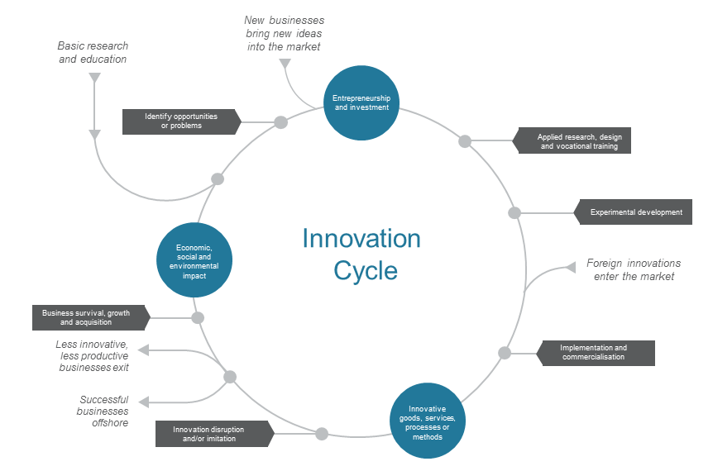

Methodology .: The Oslo Manual

| The Oslo Manual is an international source of guidelines for collecting and using data on innovation activities in industry. The first version of the Oslo Manual, issued in 1992, and the surveys undertaken using it, demonstrated the viability of collecting data on innovation.  Successive editions of the manual updated the original framework of concepts, definitions and methodologies to incorporate survey experience and improved understanding of the innovation process, and also to take in a wider range of industries such as services.  The third edition, published in 2005, expanded on the innovation measurement framework in three important ways. First, greater emphasis was given to the role of linkages with other businesses and institutions in the innovation process. Second, it recognised that innovation is important in less R&D-intensive industries, such as services and low-technology manufacturing. Third, the definition of innovation was expanded to include two additional types of innovations—organisational innovation and marketing innovation.  The Oslo Manual is currently being updated and revised by the OECD. The Department of Industry, Innovation and Science and the Australian Bureau of Statistics (ABS) have been advocating for the OECD to improve international comparability, include new forms of business model innovation, improve the measurement of environmental and social innovation, and develop new methods for harmonising measures of management capability.  The third edition of the Oslo Manual can be found [here](http://www.oecd.org/innovation/inno/oslomanualguidelinesforcollectingandinterpretinginnovationdata3rdedition.htm).[4] |
| --- |

**Framework conditions** refer to the institutional environment and general conditions for innovation activities, networks and collaboration. These conditions comprise the practices, rules and conventions that collectively regulate the behaviour of actors in the system and encourage or discourage innovation activity. Examples of framework conditions include the tax treatment of research and development (R&D), trade tariffs and industry technology standards, entrepreneurship culture, and attitudes towards risk.

Framework conditions reflect the history of an innovation system in action, and their state at a particular point in time can either impede the momentum of the innovation cycle or accelerate it.

The literature emphasises that innovation systems are a product of history, and are embedded in a particular industrial structure and institutional environment. Since each sectoral, regional or national innovation system evolves independently with its own set of rules, practices and cultures, no two systems are identical, and therefore there is no optimal or ideal system to be compared to. Each innovation system is like an experiment. The only way of knowing if Australia is performing well or not is to compare Australia’s performance with other countries on each indicator (Methodology 1.2).

## The evolution of innovation indicators

Historically, there have been two main sources of innovation indicators: the OECD’s Frascati and Oslo Manuals. The Frascati Manual[5] provides guidelines for collecting and interpreting R&D data, and the Oslo Manual does the same for innovation data.

The OECD has been the leading organisation promoting development of the innovation indicators. Through its key publications and research projects, the OECD has made international comparisons of hundreds of indicators publicly available and helped member countries build the necessary data infrastructure.

One important example of this is the development of the Business Longitudinal Analytical Data Environment (BLADE; section 2.6). The development of the BLADE by the ABS and the Department of Industry, Innovation and Science was necessary for Australia to participate in the OECD’s project, Dynamics of Employment and Micro Drivers of Productivity.

Methodology .: A systems approach to innovation indicators

| Defining, measuring and comparing innovation systems present conceptual challenges, as there is no ideal or optimal innovation system model.  We use a mix of quantitative (indicator based) and qualitative (case study based) methods to present a picture of the system and its impact. Each concept (for example, collaboration) will have a range of indicators that show Australia’s relative strengths and weaknesses. We focus on the most robust, trusted data (usually from the ABS or OECD) for policy purposes. We also use complementary indicators that either reinforce or challenge our more robust datasets.  International comparisons for each indicator are presented as part of a systems approach to measuring innovation. There are some challenges with making these comparisons. Unlike Australia, many other OECD countries’ national survey instruments for measuring business innovation are not mandatory, leading to variable coverage and low response rates.[6] This may have the effect of skewing other country data towards the most innovative businesses that are motivated to report their innovative activities.  Most Australian innovation data is compiled according to fiscal years, while OECD data is compiled according to calendar years. In this report, the performance of the Australian innovation system in a fiscal or calendar year is compared with the previous corresponding period unless stated otherwise.  It also not possible to adjust for industrial structure for every indicator and every sector (Methodology 3.1). Further analysis is required to consider how differences in innovation between Australia and other OECD countries might be explained by differences in industrial structure. |
| --- |

New innovation data

To continue meaningful and timely analyses of the Australian innovation system, the Office of the Chief Economist (OCE) at the Department of Industry, Innovation and Science collaborated with the ABS and the Australian Innovation Research Centre at the University of Tasmania to develop a suite of new innovation questions (Methodology 1.3 and feature article, Innovating the innovation indicators). Three of these questions were taken up by the ABS in the Business Characteristics Survey (BCS; see Methodology 1.3 and 1.4). Throughout the report we present results from this ‘new generation’ of innovation indicators.

We have also created and published an Innovation Insights Database*,* which collects input, output and outcome indicators of Australia's innovation system using a wide range of publicly available sources.

We are able to combine existing data to create new insights or new indicators (Methodology 1.4). The BLADE provides the data environment that enables new indicators that integrate innovation characteristics and administrative data on business performance. A number of these new indicators are cited throughout the report.

Methodology .: Three new or significantly improved questions in the Business Characteristics Survey

| 1. Innovation frequency  * The number of new or significantly improved goods or services introduced * The number of new or significantly improved operational processes introduced * The number of new or significantly improved organisational/managerial processes introduced * The number of new or significantly improved marketing methods introduced  1. Innovation investment  * Greater innovation expenditure ranges and a new percentage allocation against different types of expenditure. * Additional innovation expenditure options:   + Re-organisation of existing business models, work practices and decision-making processes   + Other labour costs related to the development or introduction of new goods, services, processes or methods  1. Innovation impact  * The percentage of income that resulted from new or significantly improved goods or services introduced |
| --- |

Definition .: Types of innovation

| ***Product innovation*** is the introduction of a good or service that is new or significantly improved with respect to its characteristics or intended uses. This includes significant improvements in technical specifications, components and materials, incorporated software, user friendliness, or other functional characteristics.  ***Process innovation*** is the implementation of a new or significantly improved production or delivery method. This includes significant changes in techniques, equipment and/or software.  ***Marketing innovation*** is the implementation of a new marketing method involving significant changes in product design or packaging, product placement, product promotion, or pricing.  ***Organisational innovation*** is the implementation of a new organisational method in the business’ business practices, workplace organisation*,* or external relations.  Source: OECD (2005) *Glossary of statistical terms* |
| --- |

Methodology .: Creating novel innovation indicators using the Business Characteristics Survey

| The AIS Reports rely on the Business Characteristics Survey (BCS), an annual survey administered by the ABS. The BCS is financially supported each year by the Department of Industry, Innovation and Science. The OCE collaborates with the ABS on the ongoing improvement of the BCS. Several new approaches and indicators discussed in this year’s report flow from this collaboration.  The BCS is the vehicle for the ABS’ Integrated Business Characteristics Strategy, which integrates the collection and quality assurance of data required for input into the ABS’ Business Longitudinal Database. The BCS also produces point-in-time estimates for the use of information technology, innovation, and a broad range of other non-financial characteristics.  Approximately 7000 businesses are randomly sampled using an online questionnaire, which is stratified by industry and employment. The sampling methodologies for the BCS are standard statistical practice and in line with other economic surveys in Australia and the OECD. All businesses on the Australian Business Register identified as having 300 or more employees are included in the sample. The ABS then uses the sample to estimate the activity of the entire employing business population.  A key part of the BCS is a detailed set of questions on business innovation, which are asked every second year. This is why some business innovation data presented in this report is only available every second year. The detailed survey includes questions on drivers, sources of ideas, and collaboration for innovation.  These detailed questions on innovation, and the broader BCS questions on markets and business performance, have allowed the department to undertake detailed analysis of the impact and nature of innovation in Australia, as well as constructing novel, customised innovation indicators. For example, by cross-tabulating business financial indicators with innovation questions, we get Figure 2.8. Any chart in this report that cites ‘ABS customised data’ is an example of this.  The BCS is a relatively small sample of businesses in Australia. It is not a census. This means that when we try to evaluate the performance of small sectors of the economy, the quality of the insights can be poor because of sampling errors or unavailable data due to confidentiality restrictions. This has historically limited our ability to accurately measure the contribution of innovation to economic or productivity growth—a perennial question for policy makers. To develop robust economic policies, at some point Australia needs to measure innovation across all economically active businesses. We suggest that this be done through business income tax collection once every five to ten years. |
| --- |

Feature article: Innovating the innovation indicators

|  |
| --- |
| Kieran O’Brien and Anthony Arundel |

In 2015, the Australian Innovation Research Centre (AIRC) at the University of Tasmania undertook a pilot survey of Australian businesses to gather new data on the frequency, cost and impacts of different types of business innovation activity in Australia. The project was a collaboration between the AIRC; the Department of Industry, Innovation and Science; and the Australian Bureau of Statistics. The objectives of the study were to:

1. determine if useful, high-quality data could be collected from Australian businesses on the frequency, costs and impacts of their innovative activities
2. determine if new survey questions on these topics could provide useful data for businesses, governments and researchers.

In the pilot survey, mailed and online questionnaires were sent to a random sample of 1600 Australian businesses in all industries except for Public administration and safety, Education and training, and Financial asset investing and superannuation. Survey questions covered business innovation activities in the 2014 calendar year (ended 31 December 2014). Of the 1600 businesses in the study sample, 359 completed the questionnaire, giving a response rate of 22.4 per cent. The distribution of businesses by industry is very similar for both the 359 participating businesses and the full sample of 1600 businesses. Consequently, the industries in scope are well represented in the results.

Our report assesses 20 new indicators and analyses the results of a pilot survey using these questions. The full report can be found [here](http://www.utas.edu.au/australian-innovation-research-centre/research/business-sector-innovation/innovation-impacts).[7]

Results from these questions offer improved understanding of the frequency, costs and impacts of innovation in Australian businesses.

Innovation investments

Investment in innovation can be measured by the expenditures that businesses make to develop and implement any innovations. Innovation investment can include external expenditures on ‘tangible’ items such as new equipment, machinery or technology; or purchases of ‘intangible’ items such research, consulting or design services, technology licences or patents.

Alternatively, internal innovation investments include expenses on development activities within the business, such as for staff training or in-house software development.

For the majority of businesses (52 per cent), their expenditures on external activities for innovation were greater than their internal expenditures. In the survey, total reported expenditure on all external activities for innovation was approximately $1.8 billion in 2014. The vast majority of total external expenditure (88 per cent) was for purchasing new machinery, equipment or technology for innovation (Figure 1.2). This was followed by purchases of design, marketing or training services from other organisations (10 per cent of total external investment). Purchases of licenses and external research services accounted for only 2 per cent of the total.

*Innovation management planning*

The survey asked businesses whether they had an innovation management plan or policy in 2014, and what the contents of that plan covered. Of all responding businesses (including innovators and non-innovators), 33 per cent reported having an innovation management plan/policy in 2014. However, only 10 per cent reported that their plan was documented in a written format. Relatively few business innovation plans (36 per cent) included a method for rewarding individuals or teams involved in successful innovations.

Though not shown here, more detailed analysis of these results showed that businesses with a written innovation management plan were more likely than those without a plan to have higher reported innovation sales.

An active innovation management plan is one way to help shape the direction and success of different innovation activities and strategies, and the results suggest potential for further formal innovation management in Australian businesses.

Figure .: Total expenditures on external activities for innovation, 2014

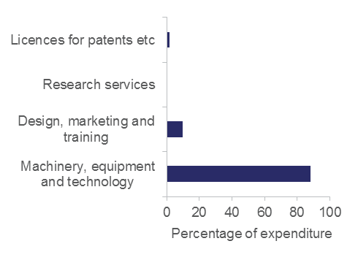

Source: O'Brien K, Arundel A and Butchart DB (2015) *New evidence on the frequency, impacts and costs of activities to develop innovations in Australian businesses: Results from a 2015 pilot survey*, Hobart, University of Tasmania and Australian Innovation Research Centre

*Most important innovations for Australian businesses*

Innovative businesses were asked to identify the single innovation introduced in 2014 that was most important for the financial position of the business. This question provides a new measure of the impact of different types of innovation on business performance.

For 47 per cent of respondents, the most important innovation in 2014 was an operational process innovation, while 31 per cent cited an organisational or managerial process innovation as most important. Innovative goods were the least common, cited by only 14 per cent of respondents. Of note, innovative services were cited more than twice as often (28 per cent) as innovative goods. This is because considerably more respondent businesses are in services than in manufacturing, which reflects the structure of the Australian economy.

The high frequency of process innovations (operational or organisational) indicates that many Australian businesses obtain greater financial benefits from efficiency and quality improvements than from product (goods and services) innovations.

The survey also asked innovative businesses to estimate the number of person-months required to develop and implement their single most important innovation in 2014.[8] The results provide an indication of the scale of innovation projects, the speed of implementation, and the costs associated with those innovations that had the most impact in Australian businesses.

Figure 1.3 shows that 66 per cent of innovative businesses report a development time of less than 6 person-months. Furthermore, 29 per cent of businesses report a development time of less than 1 person-month. These results partly reflect the small number of employees in many respondent businesses, but also demonstrate that small, incremental innovations have important outcomes for many businesses in Australia.

Figure .: Person-months required to develop most important innovation in 2014

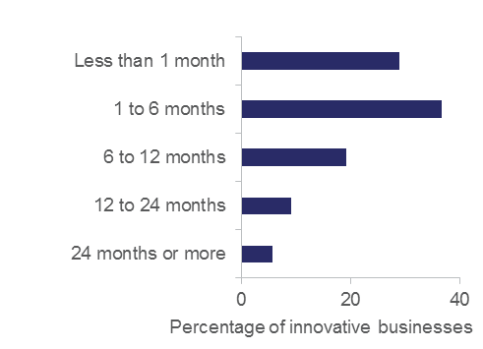

Source: O'Brien K, Arundel A and Butchart DB (2015) *New evidence on the frequency, impacts and costs of activities to develop innovations in Australian businesses: Results from a 2015 pilot survey*, Hobart, University of Tasmania and Australian Innovation Research Centre

Methodology .: The Management Capability Survey

| The role of management and leadership in driving innovation, investment, performance, collaboration and the building of business capability is increasingly recognised. Recent empirical work on US businesses suggests that one quarter of cross-country and within-country total factor productivity gaps can be attributed to management practices.[9]  The Management Capability Survey (MCS) is an ambitious project that aims to expand understanding of Australia’s business management performance. The MCS is a collaboration between the OCE, the ABS, the University of Technology Sydney (UTS) and Stanford University (USA).  The MCS will sample over 15 000 businesses from all sectors of the economy and all classes of business size. The MCS will develop a comprehensive management dataset, covering all sectors of the Australian economy. The survey will include questions on performance monitoring, target setting, incentives/people management and strategic planning and management. The survey is targeted at CEOs and business owners rather than a range of managers within a business.  The project aims to:   * provide improved capability and understanding of organisational and strategic management capability in businesses across the Australian economy * deliver rigorous analysis of management capability and its importance to productivity and economic growth. * provide data that allows for rigorous evaluation of industry programmes that focus on management capability, such as the Industry Growth Centres and the Entrepreneurs Programme * benchmark Australia’s business management capability against other countries.   Results from the MCS will be released by the ABS in mid-2017. The OCE will be linking the management capability results to the BLADE to determine the impact of management capability on business financial performance and broader economic and productivity growth. Results are expected in mid-2017, and will be published on the ABS and OCE websites (www.industry.gov.au/innovationreport). |
| --- |

Feature article: theSPACE

|  |
| --- |
| Author Troy Haines  CEO, theSPACE, Australasia |

| CEO, theSPACE, Australasia |
| --- |

| Logo says 'Turning ideas into reality'' |
| --- |
|  |

In regions such as Cairns, Queensland, we experience similar challenges to other regional areas in Australia. The challenges of high unemployment, fading traditional industries, a lack of economic diversity, and a ‘brain drain’ of talent to urban centres all highlight the need for novel economic development strategies. Innovation and entrepreneurship are highlighted as potential solutions, but both require knowledge and support to be successful.

TheSPACE is Far North Queensland’s innovation and start-up hub. By studying models developed abroad, such as in Boulder and Silicon Valley, and through our own experiences and assessments of regional entrepreneurs, we identified the following key ingredients of a start-up and innovation ecosystem:

1. Culture: It is essential to develop an entrepreneurial culture among all stakeholders within a region.[10] Small businesses differ from start-ups and stakeholders need to understand the ‘scalability’ and ‘innovation’ required for a start-up to deliver the growth required for economic development.
2. Champion(s): An ecosystem needs a champion or a team of champions to provide a driving force, and to keep stakeholders focused and moving forward on an ongoing basis. Ideally, champions benefit from the ecosystem as entrepreneurs, but also develop it for the benefit of the broader community.
3. Stakeholder engagement: In a regional context, the saying ‘it takes a village to raise a start-up’ is particularly relevant. Key stakeholders in a region include local, state, and federal governments; service providers (e.g. accountants, lawyers and consultants); educational and research institutions; mentors; investors; media; and, most importantly, entrepreneurs.
4. Process: To build capacity in a region, there must be a clear process (or runway) that will lead entrepreneurs from idea to commercialisation to exit, and provide the necessary support services along the way.[11]
5. Physical space and events: Entrepreneurs benefit from the availability of co-working spaces, which become a means of sharing information and knowledge, building a community, and fostering the necessary culture.

Some recommendations for others wishing to build a sustainable regional start-up and innovation ecosystem are:

1. Recognise that building an ecosystem takes more than just funding an accelerator or incubator: Ecosystem building requires a cultural shift where failure is celebrated, tall poppies are encouraged, and global entrepreneurship becomes common. An ecosystem requires bringing together diverse components—especially people—and developing a process to turn ideas into reality. The goal is to bring long-term capability and sustainability to the region from which companies will emerge, not just in the short term, but long into the future.
2. Take a lean approach to space: A physical space provides a place to run events and programmes, gives entrepreneurs a place to work, and helps provide a focus to the ecosystem. We have found that, in the early stages of building an ecosystem, growing the community and soft infrastructure (i.e. the ecosystem and culture) is far more important than a physical space. We encourage a lean mentality to growing the co-working space in step with the needs of the growing community.
3. Reflect the region: It is important for the ecosystem to reflect and embrace the uniqueness of its own region.
4. View technology as only part of the solution: A start-up and innovation ecosystem is not just about developers ‘building apps’. For example, in our experience some of the most innovative people in the regions are tradespeople. The opportunity is to bring technology to what regions already do well, and educate our entrepreneurs on an effective commercialisation process.
5. Reduce volunteer burnout: Having a trained start-up and innovation coach helps to overcome volunteer burnout, builds capacity in the region, and provides sustainable revenue.
6. Focus on sustainability: Initial funding from high net worth individuals or government agencies to start an ecosystem certainly can be helpful, but building a sustainable business model (which is not solely reliant on funding) is critical. Our model has allowed us to grow to five staff over the past four years.
7. Entrepreneurs are at the heart of any ecosystem: In an ecosystem, stakeholders may make or take particular roles that might do more harm than good, even when their intentions are good. For example, we’ve learned that it’s not the governments’ or the investors’ role to lead the ecosystem. These stakeholders play key roles in ecosystem development, but entrepreneurs need to be the ones to drive the development of the ecosystem, as it creates a culture of entrepreneurship.
8. Build from the grassroots up: Having a trained start-up and innovation coach provides high levels of support for early-stage entrepreneurs who require significant amounts of time for development and nurturing. This approach fosters a grassroots approach to ideation in the communities, and helps build the ecosystem organically.

Although it is still early days, we are seeing positive activity in other regions and finding champions inspired to do the work in building the ecosystems. Our regions are beginning to understand that building ecosystems for economic growth is far more than a short-term goal of establishing an incubator or accelerator. Building an ecosystem is about creating a cultural shift that will allow a community to be strategically agile long into the future. It requires working with students in schools and universities and teaching them the fundamentals of entrepreneurship, particularly how to turn an idea into a scalable business.

The future of a region's economic development will depend on a widespread culture shift to entrepreneurship that is educated around risk, and views strategic failure as a learning opportunity. To remain relevant in the modern global economy, it is critical that regions in Australia (and around the world) embrace building ecosystems and adopt processes that help entrepreneurs turn good ideas into high-growth, scalable businesses. That is the path we’re taking in Cairns, and in supporting other regions throughout Australia we hope our model and experiences will encourage many other regions to do the same.

For more information visit theSPACE [website](https://thespacecairns.com/).[12]

# Why is innovation important?

Decades of economic research demonstrate that innovation is a key driver of competitiveness and growth for both businesses and societies.[13] We have introduced new indicators and new analysis that show a significant causal impact of innovation on business performance. All else being equal, the impact of innovation on business growth is significant and positive, and this effect gets stronger as businesses innovate more regularly. High-growth businesses drive the majority of employment, sales, exports and economic growth in Australia. In particular, start-up businesses that are less than three years old make a disproportionate contribution to growth on every indicator examined.

Consistent with the literature, this chapter introduces new indicators and new analysis to provide compelling evidence of the impact of innovation on Australian society.

## Innovation is a key factor for competitiveness

Innovation is a key factor for competitiveness and growth in developed economies like Australia’s.[14] The OECD estimates that as much as 50 per cent of economic growth in its member countries can be accounted for by innovation activity, and that this contribution will grow.[15] Innovation has been demonstrated to drive productivity growth and the competitive advantage of businesses.[16]

Market disruption comes from new goods or services and business model innovation. Businesses that deliver highly novel, new-to-market goods and services create temporary monopolies that drive up profits and market share for their business. A competitive edge requires the production and marketing of new goods and services that are unique, not easily reproduced, and that create value to the customer or capture value for the business.

For incremental process and organisational innovation, the business gets a cost advantage over its competitors by using resource inputs more productively. This allows a business to gain a higher mark-up at the prevailing market price, or to use a combination of lower price and higher mark-up than its competitors to gain market share and higher profit margins.[17]

A healthy innovation system is therefore vital to Australia if we are to maintain and improve our economic position in the face of increasing global competition, climate change and an ageing workforce.

Just as effective innovation can be a source of competitive advantage to a business, a high-performing innovation system can deliver competitive advantage to the Australian economy.[18] Research shows that in competitive markets, innovative businesses out-compete other businesses by achieving higher rates of business survival and growth in employment and profits.[19] Uncompetitive businesses fail and their resources are reallocated to these more productive and profitable business, resulting in allocative efficiency and increasing aggregate productivity growth across the economy.[20] Businesses with exposure to international competition have more than double the rate of productivity growth, better management quality, and greater and more novel innovation than their domestic counterparts.[21]

## Measuring the outcomes of the innovation system

One way to indirectly measure the performance of the innovation system is to review how Australia performs on broad outcome indicators. Economic, health, employment, social inclusion, social equity and environmental sustainability outcomes (Tables [A1](http://www.industry.gov.au/innovationreport) and [A2](http://www.industry.gov.au/innovationreport)) will in part reflect past performance of the innovation system, and identify areas requiring further development.

There has been a steady increase in real GDP. Australia is currently ranked 12th of 36 OECD+[22] countries for the index of GDP per capita relative to the USA. Australia’s score dropped in 2015 for the second consecutive year since its highest level in 2013.

Australia’s GDP per capita was previously assisted by the boom in commodity markets. The commodity boom resulted in favourable terms of trade, so the recent decline can be correlated with the decreasing demand and lower prices for Australia’s resources. In the wake of the mining boom, productivity gains have been weak.

Australia is currently ranked last of 35 OECD+ countries on economic complexity.[23] Given the relationship between market diversification and innovation presented in Sections 2.5 and 3.2, this may reflect the fact that Australia is a resource rich country and a significant share of its exports is made up of commodities.[24]

GDP per hour worked is above the OECD+ average, but well behind the OECD+ top five country average. Only the Australian mining sector appears to have productivity levels above the OECD average and amongst leading businesses worldwide. This is consistent with a high R&D intensity and revealed technological advantage in that sector.[25]

The OECD has found that productivity growth at the global frontier has remained relatively robust in the 21st century, despite the slowdown in average productivity growth for most OECD countries. For example, labour productivity at the global frontier (the global top 100 most productive businesses) increased at an average annual rate of 3.5 per cent in the manufacturing sector over the 2000s, compared to an average growth in labour productivity of just 0.5 per cent for non-frontier businesses. This gap is even greater in the services sector. The OECD has raised concerns that this rising gap in productivity growth between the global frontier and other businesses represents:

* a poor ability of the most advanced businesses nationally to adopt new technologies and knowledge developed at the global frontier
* limited diffusion of existing technologies and knowledge from national frontier businesses to laggards
* a rise of tacit knowledge as a source of competitive advantage for global frontier businesses.[26]

## The economic contribution of innovative businesses

Another way of looking at the contribution of innovative businesses to the economy is to estimate whether their share of total economic activity is more than you would expect from their total share of all businesses.

Figure 2.1 illustrates the disproportionate share of the Australian economy’s total income, net income and employment held by innovation-active businesses. Although innovation-active businesses were only 45 per cent of all employing businesses in 2014–15, they accounted for over 60 per cent of sales and employment. Businesses introducing new-to-market innovation (Chapter 3) have an even greater disproportionate share of sales and employment (up to three times what one would expect from their share of businesses). These findings reinforce international studies that show that innovative businesses can disproportionately drive job creation and income growth.[27]

Figure .: Total estimated number of employing businesses that are innovation-active, and their contribution to employment, income and capital expenditure, 2014–15

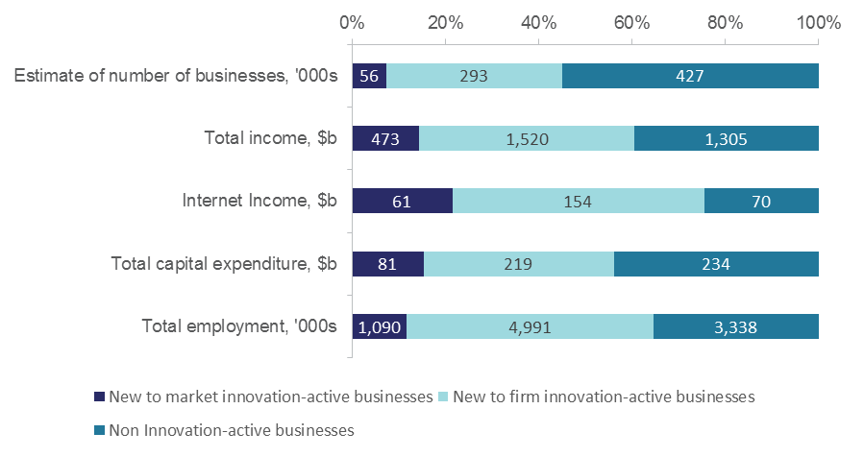

Notes: Estimates of the number of businesses operating in Australia can be derived from a number of sources within the ABS. Variations will occur because of differing data sources, differing scope and coverage definitions between surveys, as well as variations due to sampling and non-sampling error.

Source: Customised ABS data commissioned by the Department of Industry, Innovation and Science

## The economic contribution of high-growth businesses

High-growth businesses are a small fraction of total businesses in an economy, yet generate most of the jobs and sales turnover. They are most likely to be young, most likely to be innovative, and are found across all sectors of the economy. Most international studies also indicate that these businesses seldom remain as high-growth businesses, to the extent that the emergence of high-growth businesses is often likened to a random process, meaning high-growth businesses cannot be identified ex ante.[28]

Earlier analysis undertaken by the OCE shows that, compared with their low- and medium-growth counterparts, Australian high employment growth micro start-ups exhibit superior financial performance, higher innovation activity (particularly operational process and organisational/managerial innovation) and a greater demand for external equity finance.[29]

From a management perspective, medium and high employment growth start-ups were also significantly more likely to monitor and assess their performance across a wider range of performance indicators. These data are consistent with other evidence that suggests that sustained innovation and high growth comes from superior strategic management.[30]

Definition .: OECD relative measures of growth

| High*-*growth businesses are businesses with average annualised growth in sales or employment greater than 20 per cent a year over a three-year period.  Gazelles form a subset of high-growth businesses that have been employers for a period of up to five years.  Medium*-*growth businesses are businesses with average annualised growth in sales or employment between 10 and 20 per cent a year over a three-year period.  Low*-*growth businesses are businesses with average annualised growth in sales or employment between 1 and 10 per cent a year over a three-year period.  Nil*-* or negative*-*growth businesses are businesses with average annualised growth in sales or employment equal to or less than zero per cent a year over a three-year period. |
| --- |

Definition .: Business age classes

| We adopt the business age class definitions set out by the OECD. Young businesses are defined as businesses aged between zero and five years of age. Start-ups are a specific subset of young businesses within the first three years of operation (0–2 years old).  Mature businesses are defined as those businesses aged six years and older. Old businesses are a specific subset of mature businesses that are ten or more years old.  The diagram above provides a schematic definition of firms by their age as set out by the OECD standards. Using arrows from left to right to show the increasing firm age, the diagram divides firms into two broad categories of ‘young’ and ‘mature’ firms. The young firms are defined as firms aged in the range of 0-5; and the mature firms as those aged 6 years and older. Under this broad categorisation, the diagram subdivides each category based on two age ranges. Young firms are subdivided into ‘start-ups’ that are firms in the age range of 0-2 years, and other young firms that are in the age range of 3-5 years. Mature firms are also subdivided into two sub-categories: firms in the age range of 6-9 and old firms in the age range of more than 10 years. |
| --- |

Using the BLADE and relative definitions of sales growth and age (Definitions 2.1 and 2.2), we were able to show that, unsurprisingly, high sales growth businesses make a disproportionate contribution to growth in Australia (Figure 2.2 and Figure 2.3; Methodology 2.1). Over the seven-year period from 2004–05 to 2010–11 there were over 800 000 new jobs created, total sales grew by $1.4 trillion, export sales grew by $0.22 trillion, and $0.44 trillion of value was added to the economy. High sales growth businesses generated the majority of this growth, accounting for 66 per cent of net positive employment growth, 67 per cent of net positive sales growth, 84 per cent of net positive export growth and 70 per cent of net positive economic growth. High sales growth businesses accounted for around 30 per cent of all businesses in Australia. The results are similar when using employment as the growth indicator.*Start-ups and growth*

Figure 2.3 shows that start-ups (0-2 years) are the largest contributor to job creation, accounting for 1.2 million new jobs over the period 2004–05 to 2010–11. This represented 90 per cent of net positive job creation. The contribution of start-ups is not directly comparable with the number stated in the 2015 report. The latest analysis includes an additional financial year and data from financial corporations was excluded based on advice from the ABS. While start-ups accounted for the majority of net job creation, their net contribution to sales, exports and economic growth is not as great as mature businesses. Our latest research finds that over the seven-year period, high sales growth start-ups generated the majority of start-ups jobs (780 000 out of 1.2 million jobs). In addition, high sales growth start-ups created $360 billion in sales, $100 billion in value added and $15 billion in exports over the same period.

Although the absolute impact of start-ups might be lower, they make a disproportionate contribution to growth in all indicators observed: employment, total sales, export sales and value added (Figure 2.4). For example, start-ups make a high economy-wide contribution to net employment creation. This is because they tend to add more than they subtract overall, but also more than double what one would expect from their share of total employment (Figure 2.4). As businesses age they make a lower contribution to growth in every indicator examined, such that by the time they are six or more years old they contribute less than their total aggregate share (of the relevant indicator).

This sort of micro-aggregate analysis is complex. While the results show that start-ups contribute disproportionately to employment creation in Australia, mature medium and large businesses are still significant net contributors to sales and value-added growth, and are the major net contributors to export growth. With the exception of employment, mature small businesses tend to generate net losses in the Australian economy. This is why the cumulative effect of mature businesses can often appear as a net negative (Figure 2.3).

Figure .: The net contribution of businesses to economic growth, by business age and average annualised growth class, 2004–05 to 2010–11

| Figure 2.2 shows the net contribution of businesses to economic growth, using value added, in constant prices. It shows that high growth businesses added $586 billion (constant prices) to the economy while nil or negative growth businesses took $397 billion from the economy. It shows that over the period (2004–05 to 2010–11) $440 billion was added to the economy, of which start-ups accounted for $164 billion. |
| --- |

Notes: Averages incorporate all industry classes except [Standard Institutional Sector Classification of Australia](http://www.abs.gov.au/ausstats/abs@.nsf/Lookup/40F31FE6397B8AA3CA257BDD001163AC?opendocument) 2 (SISCA2) businesses. Average annualised growth rates are calculated on a total sales basis over a rolling three-year period.[31]

Source: ABS (2016) Business Longitudinal Analysis Data Environment. Customised data report commissioned by the Department of Industry, Innovation and Science

Figure .: The net contribution of businesses to employment growth, by business age and average annualised growth class, 2004–05 to 2010-11

| Figure 2.3 shows the net contribution of businesses to employment growth. It shows that high-growth businesses created two million jobs, while nil or negative growth businesses lost 2.4 million jobs. Over the period (2004–05 to 2010–11), there were (net) 820,000 new jobs created. Start-ups accounted for 1.2 million new jobs) |
| --- |

Notes: Averages incorporate all industry classes except SISCA2 businesses. Average annualised growth rates are calculated on a total employment basis over a rolling three-year period.

Source: Customised ABS data commissioned by the Department of Industry, Innovation and Science

Figure .: Contribution of businesses of different ages to growth relative to their share of employment, total sales, export sales or value added in Australia, 2004–05 to 2010–11

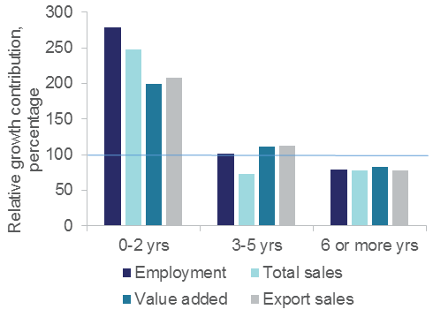

Notes: Averages incorporate all industry classes except SISCA2 businesses. Relative growth contribution is calculated as the percentage contribution to total aggregate growth (e.g. employment) divided by that sector’s total share of employment (i.e. relative to 100 per cent).

Source: Customised ABS data commissioned by the Department of Industry, Innovation and Science

Methodology .: Calculating the contribution of businesses to national aggregates

| We use the ABS’ BLADE to calculate the contribution of businesses of different ages, sizes and growth classes to aggregate growth in total sales, export sales, employment, labour productivity and value added.  We use total sales growth as the basis for defining the growth classes. The three-year annualised growth rate and business age definition restricts the length of the period we can analyse to 2004–05 to 2010–11. We have done similar work using a one-year growth rate and found similar results over the longer period 2002–03 to 2013–14.  Growth ranges for the first year of a unit's existence are calculated based on their rate of change for sales and/or full-time equivalent (FTE) employees in their first consecutive year.  SISCA2 businesses (Finance & Insurance sector) and a handful of businesses with extreme and unlikely values have been excluded.  Value Added has been calculated as: Sales income (BAS Turnover less GST payable) minus Intermediate Usage (BAS Other (i.e. current expenses) less GST credits). Capital expenses and wages/salaries are not part of VA calculation. Labour productivity is the ratio of Value Added per full-time equivalent (FTE) employee.  Businesses contribute where they are classified each cycle, so a business can contribute to different age, size and growth classes over time.  Firms that exit during the period are included in the results where their growth could be determined. |
| --- |

## The benefits of innovation

The link between innovation and broader business performance in Australia is demonstrated in Figure 2.5. The data shows that in 2014–15, innovation was significantly correlated with higher business productivity growth, employment growth, market diversification and a range of other performance outcomes.[32] These results are consistent across all industry sectors and over time.[33] Compared with businesses that don’t innovate, innovation-active Australian businesses are:

* 40 per cent more likely to increase income and profitability
* twice as likely to export, and five times more likely to increase the number of export markets targeted
* two to three times more likely to report increased productivity, employment and training
* three times more likely to increase investment in IT
* almost five times more likely to increase the range of goods and services offered, and make social contributions such as donations.

These results are consistent with research that demonstrates a positive relationship between innovation, competitiveness and, in particular, exporting and productivity growth.[34] Recent research shows that salary, employment and productivity benefits can persist for years after an innovation is introduced.[35]

Figure .: Increases in business performance and activities compared to the previous year, by innovation status, 2014–15

Figure 2.5 shows the changes in business performance and activities compared to the previous year, by innovation status. It is a horizontal clustered bar chart that shows that:
• 43.1 per cent of innovation-active businesses had an increase in income from sales of goods or services, compared to 30.7 per cent of non-innovation-active businesses
• 32.6 per cent of innovation-active businesses had an increase in profitability, compared to 23.5 per cent of non-innovation-active businesses
• 31.5 per cent of innovation-active businesses had an increase in productivity, compared to 15.4 per cent of non-innovation-active businesses
• 26.5 per cent of innovation-active businesses had an increase in the range of goods or services offered, compared to 5.7 per cent of non-innovation-active businesses
• 25.8 per cent of innovation-active businesses had an increase in expenditure on information technology, compared to 8.3 per cent of non-innovation-active businesses
• 21.3 per cent of innovation-active businesses had an increase in total number of jobs or positions, compared to 7.8 per cent of non-innovation-active businesses
• 13.5 per cent of innovation-active businesses had an increase in structured or formal training for employees, compared to 3.3 per cent of non-innovation-active businesses
• 13.2 per cent of innovation-active businesses had an increase in social contributions, compared to 2.8 per cent of non-innovation-active businesses
• 12.7 per cent of innovation-active businesses had an increase in contracting out work or outsourcing, compared to 3.8 per cent of non-innovation active businesses
• 2.6 per cent of innovation-active businesses had an increase in export markets targeted compared to non-innovation-active businesses.


Source: ABS (2016) *Selected characteristics of Australian business, 2014–15*, cat. no. 8167.0

## The relationship between innovation and firm growth

A common criticism of measures of the impact of innovation is the problem of causation. Since there are numerous ways in which a business could gain competitive advantage, a strong correlation between business performance and innovation may simply reflect some other aspects of the business that do not relate to innovation. Moreover, the results presented in Figure 2.5 rely on self-reported data collected in the BCS, which can suffer from a selection bias.

To address these issues, we worked with the ABS to develop a new metric to measure the impact of innovation on business performance in a more reliable fashion (Methodology 2.2). Figure 2.6 shows a significant positive association between innovation and business performance. In particular, we show that businesses that persistently innovate (see Definition 2.3) significantly outgrow other businesses in sales, value added, employment and profit.

New analysis using BLADE shows that the frequency of innovation matters, as the positive impact of innovation gets stronger when businesses innovate more frequently. Persistent innovators significantly outgrow other businesses in terms of sales, value added, employment and profit growth. The data shows that between the period 2008–09 and 2010–11, persistent innovators generated:

* 18 times the value added growth of intermittent innovators
* four times the employment growth of regular innovators
* five times the sales growth of regular innovators.

We applied a propensity score matching model and regression to BLADE data to simulate a randomised controlled experiment. The results show that the relationship between innovation and business growth is significant, positive and direct (Table 2.1). Regressions using innovation persistence group dummy variables show positive and significant coefficients for gross output growth and value-added growth (data not shown).

By addressing causal uncertainty over the three year period in the study, we show a strong modelling evidence of a causal relationship between innovation and business performance.

Definition .: Innovation persistence

| ‘Persistent innovators’ are businesses that reported introducing any innovation every year over a three*-*year period.  ‘Regular innovators’ are businesses that reported introducing any innovation in two years out of a three*-*year period.  ‘Intermittent innovators’ are businesses that reported introducing any innovation in one year out of a three*-*year period.  ‘Non-innovators’ are businesses that did not report introducing any innovation within a three*-* year period. |
| --- |

Figure .: Median growth of annual sales (panel A), value added (panel B), gross operating profit (panel C) and employment growth (panel D), by innovation persistence, 2008–09 to 2010–11

Figure 2.6 has four panels, each with a column graph showing business performance by innovation persistence for the period 2008–09 to 2010–11. 
• Panel A shows median growth of annual sales. Persistent innovators had $63,205 sales growth, regular innovators had $13,368 sales growth, and intermittent innovators had $1,068, while non-innovators had -$935.

Figure 2.6 has four panels, each with a column graph showing business performance by innovation persistence for the period 2008–09 to 2010–11. 
• Panel B shows median growth of value added. Persistent innovators had $20,999 value added growth, regular innovators had $11,631 value added growth, and intermittent innovators had $1,156 value added growth, while non-innovators had -$154 value added growth

Figure 2.6 has four panels, each with a column graph showing business performance by innovation persistence for the period 2008–09 to 2010–11. 
• Panel C shows median profit growth. Persistent innovators had $54,944 profit growth, regular innovators had $1,393 profit growth, $326 profit growth, while non-innovators had $0 profit growth

Figure 2.6 has four panels, each with a column graph showing business performance by innovation persistence for the period 2008–09 to 2010–11. 
• Panel D shows median employment growth (FTE). Persistent innovators had 0.42 employment growth, regular innovators had 0.1 employment growth, while intermittent and non-innovators had 0 employment growth. 


Note: This chart includes both simple and complex firms, and therefore differs from Table 2.1. They also report on different time periods. Analysis of Variance shows a significant effect of innovation persistence on these four growth indicators (p<0.05) for both SMEs and large firms.  
Source: ABS (2016) Business Longitudinal Analysis Data Environment. Customised data report commissioned by the Department of Industry, Innovation and Science

Methodology .: Measuring the impact of innovation persistence

| In this study we examined the performance of Australian businesses that reported persistence of innovation over the three*-*year period, 2011–12 to 2013–14.  We generated a balanced panel sample distribution of 6000 businesses from the BLADE. We determined the impact of the persistence of innovation on 2013 outcomes, using business characteristics from 2011 as covariates and non-innovators as the control group. We looked at simple business (where these have simple structures and a single ABN) and complex business (large, diverse and complex structure) models.  We investigated the causal relationship between business innovation and performance using propensity score matching (kernel method). This technique is designed to minimise selection bias by matching each innovating business with a non-innovating business that has the same or similar observed characteristics. This has the effect of minimising the effect of other characteristics that might influence a business’s performance. We controlled for business age, size, sector, information and communication technology (ICT) intensity, collaboration, competition, foreign ownership, government assistance, flexible working arrangements, skills base, skills shortages, export status and debt or equity finance seeking behaviour.  Histogram and kernel density of propensity scores mapping show that the distribution of propensity scores becomes more similar between the treated and control groups after matching. Plots reveal a clear overlapping of the distributions. This is consistent across all models used. There is also a large reduction in bias.  Regressions using persistence group dummy variables for gross output and value added were carried out to confirm the presence of cumulative effects from innovation persistence. |
| --- |

Table .: Average treatment effect on treatment differences between simple-structured innovators and non-innovators (control), by innovation persistence, 2010–11 to 2012–13.

|  |  |  |  |  |
| --- | --- | --- | --- | --- |
| *Outcomes* | *Persistent innovators* | *Regular innovators* | *Intermittent innovators* | |
| Value Added output ($) | **1 440 056 | 628 687 | | 738 327 | |
| Gross Output (Business income tax) ($) | ***2 689 158 | ***3 278 584 | | **1 988 192 | |
| Turnover ($) | ***3 951 768 | **2 804 453 | | **2 521 148 | |
| Gross output growth (2011–2013) ($) | ***1 807 495 | 382 008 | | 107 598 | |
| FTE (numbers) | ***14 | 5 | | **11 | |
| Total salaries & wages ($) | **376 375 | **312 009 | | *489 113 | |
| Export sales ($) | *323 118 | 87 164 | | 161 867 | |
| Value added growth (2011–2013) ($) | *860 695 | -458 367 | | -215 256 | |
|  |  |  | |  | |
| Treated observations(a) | 849 | 806 | | 835 | |
| Total observations(a) | 1994 | 1951 | | 1980 | |

Notes: Values are the difference from the non-innovator control group. Analysis of simple structured businesses using a derived balanced panel. * p<0.1; ** p<0.05; *** p<0.01; (a) Sample size for most outcome variables except productivity and growth where there are missing values.

Source: ABS (2016) Business Longitudinal Analysis Data Environment. Customised data report commissioned by the Department of Industry, Innovation and Science

## A new indicator for the impact of innovation

One of the criticisms of Figure 2.5 is that it is based on a survey of respondent’s opinions of their own business’s performance. To address this, we collaborated with the ABS and the University of Tasmania to introduce an Australian-first method for measuring the impact of innovation on the economy (Methodology 2.3; Feature article in Chapter 1).

The total proportion of innovation-active businesses in Australia earning a quarter or more of their income from innovative[36] goods and services was 16 per cent in 2014–15. As businesses increase in size, the proportion of income earned from innovative goods and services declines significantly (Figure 2.7).

In 2014–15 the total proportion of businesses in Australia earning a quarter or more of their income from innovative goods and services were:

* 21 per cent for micro-sized businesses
* 11 per cent for small-sized businesses
* 11 per cent for medium-sized businesses
* 3 per cent for large-sized businesses.

Figure .: Total business income derived from sales of new goods and/or services, by size, 2014–15

| Figure 2.7 is a horizontal stacked bar chart showing the percentage of total business sales income generated from the sale of new goods and/or services by employment size in 2014–15. It shows that for large businesses (200 or more persons), 12.8 per cent generated no income, 51.4 per cent generated between 0 to less than 5 per cent income, 27.3 per cent generated between 5 to less than 10 per cent income, 5.8 per cent generated between 10 and less than 25 per cent income and 2.7 per cent generated 25 per cent or more income from the sale of new goods and/or services. It shows that for medium-sized businesses (20 to fewer than 200 persons), 13.3 per cent generated no income, 34.3 per cent generated between 0 to less than 5 per cent income, 25.3 per cent generated between 5 to less than 10 per cent income, 16.6 per cent generated between 10 and less than 25 per cent income and 10.5 per cent generated 25 per cent or more income from the sale of new goods and/or services. It shows that for small businesses (between 5 and 19 persons), 9.0 per cent generated no income, 35.8 per cent generated between 0 to less than 5 per cent income, 30.5 per cent generated between 5 to less than 10 per cent income, 13.9 per cent generated between 10 and less than 25 per cent income and 10.7 per cent generated 25 per cent or more income from the sale of new goods and/or services. It shows that for micro businesses (fewer than 5 persons), 16.8 per cent generated no income, 28.3 per cent generated between 0 to less than 5 per cent income, 17.4 per cent generated between 5 to less than 10 per cent income, 16.8 per cent generated between 10 and less than 25 per cent income and 20.8 per cent generated 25 per cent or more income from the sale of new goods and/or services. |
| --- |

Source: ABS (2016) *Innovation in Australian Business 2014–15*, cat. no. 8158.0

Based on this data, and using Methodology 2.3, we estimate that Australian businesses earned $60 billion from the sale of innovative goods and services introduced in 2014–15. This was approximately two per cent of total sales in that same year. Half of this income was generated by SMEs ($28 billion).

There is significant variation by sector in the income earned from innovative goods and services (Figure 2.8). *Wholesale Trade* ($11 billion), *Manufacturing* ($10 billion), *Finance and Insurance Services* ($10 billion) and *Professional, Scientific and Technical Services* ($6 billion) were the four largest earners from 2014–15 goods and services innovations. These sectors also tended to earn a higher proportion of their total income from the sale of innovative goods compared to the national average of two per cent. *Information, Media and Telecommunication Services* earned $3 billion from innovative goods and services introduced in 2014–15, which was close to 4 per cent of its total income for that year. Sectors with a smaller share of GDP (for example *Agriculture, Forestry and Fishing*), or that were more likely to undertake process and/or organisational innovations than goods and services innovation (for example *Mining*), did not earn significant income from their new goods and service innovations in 2014–15.

Figure .: Total estimated business sales from innovation goods and services, by sector, 2014–15

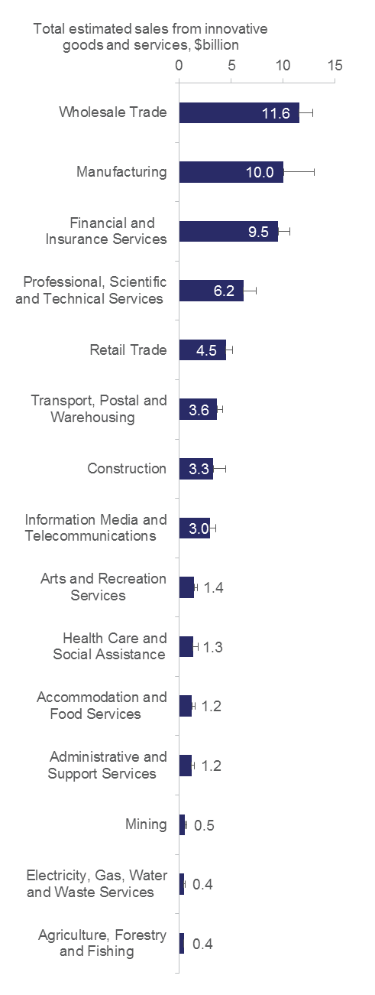

Notes: Bars are standard errors. Data is unavailable for Rental, Hiring and Real Estate Services; Arts and Recreation Services; and Other Services.

Source: Customised ABS data commissioned by the Department of Industry, Innovation and Science.

Methodology .: Measuring the impact of innovation

| For the first time in Australia, businesses were asked the following question in the 2014–15 Business Characteristics Survey:  ‘What percentage of the income reported in [Q3a: Total Income from Sales from Goods or Services] resulted from new or significantly improved goods or services introduced during the year ended 30 June 2015?’  Businesses were then asked to tick a percentage range.  This question related specifically to the returns from goods or services innovation in the year of introduction. This question is also asked across European Union businesses, allowing us to make international comparisons.  This question does not ask what proportion of total income from goods and services comes from innovations introduced earlier than the reference year.  This question will also not capture some of the financial benefits from other types of innovation.  Since the survey is designed to provide a representative sample of the Australian business population, the ABS is able to estimate the national expenditure using mid-points from ranges for each business that answered the question. This is likely to be an underestimate, given that businesses that ticked the range ‘Greater than or equal to 25 per cent’ was assigned a 25 per cent value in this estimation. |
| --- |

Income from goods and services innovation

Australia appears to earn a relatively low proportion of its total income from innovative goods and services compared with other countries (Figure 2.9). When we match Australian data to the EU Community Innovation Survey industry scope and business size classes, Australia’s estimate of the income from new or significantly improved good and services is 7.2 per cent of total sales in 2014-15. With this value Australia ranks 20th out of 23 countries in the OECD, with the OECD top five average being 19 per cent.

Figure .: Share of income from new or significantly improved goods and services, by country, 2012

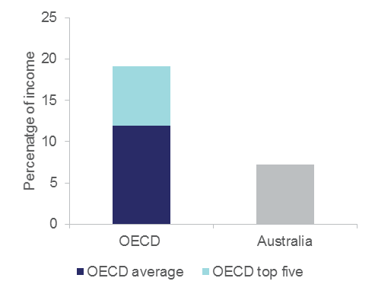

Notes: Australian business data is matched to the EU Community Innovation Survey industry and size scope. Community Innovation Survey data relates to total sales in 2012. More recent EU data is not yet available. Australian data is for 2014-15. The OECD top five countries are Turkey, Slovakia, Spain, United Kingdom and Denmark.

Source: Customised ABS data commissioned by the Department of Industry, Innovation and Science; Eurostat

A new measure of innovation system efficiency

The ABS estimates total expenditure on innovation by Australian businesses in 2014–15 was between $26 billion and $30 billion. To calculate these figures, innovation-active businesses were asked to estimate their expenditure (using ranges) on the development or introduction of all new goods, services, processes or methods during the reference period. To estimate the innovation expenditure by all Australian businesses, the ABS assigned a random value to each innovation-active business that reported expenditure within the bounded ranges, combined them with any actual dollar values reported, and weighted the results to derive an innovation expenditure total. This operation was performed multiple times, and the average provides an approximate value of innovation expenditure.

As noted earlier in this section, Australian businesses were estimated to have earned $60 billion in 2014–15 from innovative goods and services. This level of income, combined with the expenditure estimated above, suggests that for every dollar put into innovation by the market two dollars are returned (without making any assumptions about lag effects, additional public sector investment, or trying to model what types of innovations were actually invested in).

This indicates that innovation investment contributes significantly to sales in the private sector. The contribution of innovation is likely to be higher than our estimate, given that:

* the financial benefits of other types of innovation, such as process innovation, are not captured in this indicator and are known to be higher than goods and services innovation
* sales from innovative goods and services introduced in previous years are not measured.

## Feature article: CSIRO Futures

|  |  |  |
| --- | --- | --- |
| Author James Deverell  Director, CSIRO Futures   | Director, CSIRO Futures | | --- | | CSIRO logo | |

*After decades of economic growth enabled by market-oriented reforms and driven by strong demand for mineral resources, Australia is now facing an uncertain economic future. The investment phase of the mining boom is over. The world is changing rapidly as unprecedented wealth creation shifts the balance of economic power towards Asia. Global demand for exports is expected to treble by 2050.[37] This will create enormous opportunities for Australia. However, at the same time new business models and disruptive technologies are threatening established industries faster than ever before.*

*Faced with these changes, how will Australia maintain its competitiveness in existing industries and build comparative advantage in new and emerging industries? While this is a complex and multi-faceted question, one of the most important factors will be innovation, particularly in science and technology. The OECD estimates that technological innovation, driven by R&D investment, contributes around 50 percent of GDP growth in developed countries.[38]*

*Innovation will be important on two fronts. First, it will be key to increasing productivity in existing industries through the application of new technologies, such as automation, data analytics and genetics. This matters because Australia’s multi-factor productivity has been in decline for the past decade, and productivity is one of the key drivers of economic growth.[39]*

*Second, innovation will be a necessary ingredient for developing new industries and new companies through the commercialisation of emerging science and technology. With many of these innovations disrupting existing industries, it will be important to use these breakthroughs to generate new sources of comparative advantage internationally.*

*However, Australia has a limited window to seize these new opportunities. If we don’t, others will. This is the ‘innovation imperative’; in a rapidly changing world, Australia risks being left behind if it fails to innovate.*

*But how do we plan today’s innovation investments to meet these future opportunities and challenges? High-growth businesses and governments alike will need to make intelligent, informed decisions about where to invest to get the best outcomes, whether that is return on capital (at a corporate level) or new sources of economic growth and sustainability (at a national level).*

*In a recent report,* Australia 2030: Navigating our Uncertain Future*, CSIRO developed a framework to guide strategic planning and innovation investment decisions under uncertain conditions such as those currently facing Australia. The framework is based on CSIRO’s ‘global megatrends’, the long-term social, economic, environmental and technological patterns of change that CSIRO has been tracking since 2009.* Australia 2030 *presents the most recent iteration of these megatrends, crowdsourced across CSIRO’s 5000 research professionals, and uses them to develop four divergent scenarios for the future of Australia.*

*The report also outlines key growth opportunities for five core growth sectors across each of the scenarios. By using a scenarios-based approach, these opportunities span a range of future outlooks. CSIRO is now expanding on these opportunities to develop industry and technology roadmaps that identify how science, technology and innovation can enable these opportunities, and where investments are most likely to accelerate technology adoption.*

*The framework presented in Australia 2030 can also be applied within high-growth companies to align corporate strategy and innovation investments. The four steps of this framework are summarised below.*

*The first step of the framework (‘Explore’) identifies relevant trends and emerging technologies, and uses these to develop a view of the future landscape through a set of custom scenarios. For each of these scenarios, significant opportunities and risks are identified. There is a deliberate focus on identifying long-term opportunities that challenge the status quo and provide sustainable value, rather than ‘quick wins’.*

*The second step (‘Choose’) assesses and prioritises these opportunities, and uses them to develop an innovation strategy that aligns with corporate strategy. One of the key purposes of an innovation strategy is to guide innovation investment decisions at all levels of the organisation. At a corporate level, it should inform decisions about where the company will be an innovation leader, where it will be a ‘fast-follower’ and, importantly, where it will deprioritise investment. Within individual business units and projects, the strategy should guide decisions about where to maintain capability in-house and where to partner or outsource.*

*The third step (‘Plan’) translates this strategy into a portfolio of technology projects, and identifies the skills, capabilities and resources that will be necessary to deliver against this portfolio. Taking a portfolio approach to innovation allows a company to diversify its investments across a spectrum of innovation activities, ranging from short-term incremental improvements to longer-term breakthrough and disruptive innovations.*

*The final step (‘Create’) is about executing against this portfolio of projects by developing the necessary skills, culture and partnerships to create sustainable value from technology. A key component in this step is identifying the right collaboration model and partners that align with the time horizon and intellectual property (IP) outlook of individual projects. An example of this is using exploratory development, such as corporate venturing or start-up accelerator programs, to collaborate on ideas and concepts. This can provide a low-risk and low-cost option to continually test ideas in unproven areas, and to trial relationships with new innovation partners.*

*These four steps provide a framework for developing an innovation strategy and technology portfolio based on a top-down view of long-term trends and emerging technologies, and a bottom-up view of existing comparative advantage. This approach can be applied at both a national level and within individual companies to identify new opportunities, align innovation investments with long-term strategy, and harness technology to create sustainable growth for the years ahead.*

*Find out more about* [*CSIRO Futures here*](https://www.csiro.au/en/Do-business/Futures)*.[40]*

# Activities in the innovation system

This chapter examines some of the key activities in the innovation system: innovation, entrepreneurship, and R&D.

Australia ranks relatively highly on general entrepreneurship and innovation measures, but poorly on new-to-market innovation.

Businesses that undertake R&D are almost always innovation-active businesses, and are significantly more likely to be new-to-market innovators. Australia’s gross domestic expenditure on R&D (GERD) to GDP ratio was 2.1 per cent in 2013–14, which is slightly above the OECD average of 2.0 per cent, but significantly lower the top five OECD performers on this indicator.

Australia fares better on experimental development. In 2013, Australia was ranked 10th out of 29 OECD countries on business expenditure on experimental development as a percentage of GDP. The majority of R&D expenditure is undertaken by large businesses.

The Australian Government supports R&D in a number of ways, both directly and indirectly. The government is expected to spend $10.1 billion on R&D in 2015–16, including $3.2 billion through the R&D Tax Incentive.[41]

## Trends in entrepreneurship and innovation

Australia’s rates of entrepreneurship and attitudes towards entrepreneurship are high relative to other countries, even though the rate of business creation appears to be slowing in Australia and across the OECD. Australia has a range of indicators that measure business R&D, innovation, invention and entrepreneurship performance (Table A2).

Innovation rates are improving slowly

The key measure of ‘innovativeness’ of the private sector in Australia is the percentage of innovation-active businesses. The latest results show that 45 per cent of all Australian businesses were innovation-active in 2014-15, down from 48 per cent in 2013–14. The proportion of innovation-active businesses has shown a slightly upward trend with yearly fluctuations over the past decade (Figure 3.1).[42]

Figure .: Innovation activity in Australia, 2006–15

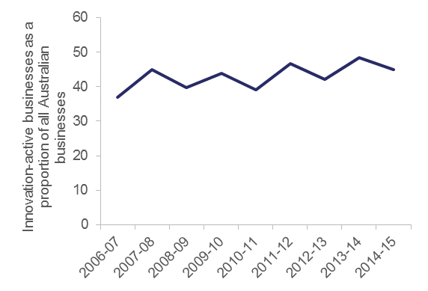

Source: ABS (various) *Innovation in Australian Business*, cat. no. 8158.0; ABS (various) *Summary of IT Use and Innovation in Australian Business*, cat. no. 8166.0

The most recent international comparisons for the year 2012–13 show that Australia ranks in the top five of 30 OECD countries in terms of the proportion of innovation-active businesses to total businesses (Figure 3.2). Australia’s score appears higher in this chart than in [Table A2](http://www.industry.gov.au/innovationreport) because the data are matched to other OECD countries (see note in Figure 3.2). This high ranking may reflect relatively high innovation activity by SMEs. Large businesses have a low rank, 18th place. Australia’s manufacturing and service sectors are relatively highly ranked.

Figure .: International ranking on innovation-activity, 2010-2012

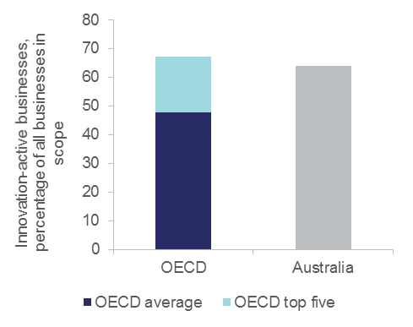

Notes: OECD comparisons exclude businesses with less than ten employees. Industry core coverage includes ISIC Rev. 4 Sections and Divisions B, C, D, E, G46, H, J, K, M71-72 and 73. Australian data is for 2012-13. The OECD top five are Switzerland, Germany, Luxembourg, Australia and Ireland.

Source: OECD (2015) *Innovation Indicators Database,* [www.oecd.org/innovation/inno/inno-stats.htm](http://www.oecd.org/innovation/inno/inno-stats.htm)

Methodology .: Making international comparisons with innovation data

| Given we use an internationally agreed definition of innovation, we are able to make comparisons with other countries (mostly in the OECD) that use the same definition. Country scores are typically presented as a percentage of all businesses, or as a percentage of all innovation-active businesses.  The ABS transforms the Business Characteristics Survey unit record data to produce national business innovation and collaboration indicators that match businesses in other OECD countries. OECD specifications include:   1. Using the same OECD employment size ranges.   SMEs are 10–249 employees, and large businesses are 250+ employees. Excluding the very small businesses typically makes Australia’s OECD matched innovation rate higher than it appears in ABS publications because micro-sized businesses are significantly less likely to innovate in any given year.   1. Using the same International Standard Industrial Classification (ISIC) of All Economic Activities developed by the United Nations.   OECD Industry core coverage usually includes ISIC Rev. 4 Sections and Divisions B, C, D, E, G46, H, J, K, M71-72 and 73. This typically makes Australia’s OECD matched innovation rate higher than it appears in ABS publications because sectors like Agriculture are less likely to innovate in any given year.  Due to the considerable time and resources it takes to collect, coordinate and match the data from over 35 countries, the OECD’s international comparisons are typically three to five years old when they are released. |
| --- |

Technological vs non-technological innovation

The OECD describes goods, services, and process innovation as predominantly technological innovation, and marketing/organisational innovation as mostly non-technological innovation (Definition 1.3).

Data for Australia and other OECD countries shows that most businesses adopt a mixed-mode approach to innovation, where different types of innovation are used in complementary ways. For example, goods and services innovation is often accompanied by a new marketing method, or the introduction of a new operational process might demand a new way of managing a business’ supply chain (organisational innovation).

Table 3.1 provides international comparisons of the different modes of innovation. Australia ranks highly for product or process innovation only, with large businesses ranked 3rd in the OECD and SMEs ranked 8th.

By contrast, for innovation in marketing or organisational methods only, Australia ranks poorly at 30th for large businesses and 31st for SMEs out of 33 OECD countries. In this mode of innovation, there was little variability in Australia’s OECD rank between manufacturing (28th) and services (29th).

Australian SMEs ranked first in the OECD (at 43 per cent) for product or process and marketing or organisational innovation. Even though a higher proportion (50 per cent) of large businesses in Australia innovated in this way, they ranked 13th in the OECD.

Table .: Mixed modes of innovation, Australia versus the OECD and OECD top five averages, 2010-2013

|  |  |  |  |  |  |
| --- | --- | --- | --- | --- | --- |
|  |  | ***Business size*** | | ***Economic sector*** | |
|  | ***All businesses*** | ***SMEs*** | ***Large businesses*** | ***Manufacturing*** | ***Services*** |
|  | *as a percentage of all businesses* | *as a percentage of all SMEs* | *as a percentage of all large businesses* | *as a percentage of all manufacturing businesses* | *as a percentage of all service businesses* |
| **Product and/or process innovative businesses, including abandoned or ongoing innovation activities (regardless of organisational or marketing innovation)** | | | | | |
| OECD average | 35.7 | 34.6 | 64.3 | 41.0 | 33.5 |
| OECD top 5 average | 54.0 | 53.0 | 79.2 | 59.5 | 50.8 |
| Australia | 55.8 | 55.4 | 70.5 | 53.0 | 55.9 |
| **Organisation or marketing innovative businesses only** | | | | | |
| OECD average | 13.7 | 13.7 | 11.5 | 11.7 | 15.3 |
| OECD Top 5 average | 21.5 | 21.7 | 19.0 | 20.0 | 22.8 |
| Australia | 6.8 | 6.8 | 7.5 | 5.3 | 8.4 |
| **Product or Process AND Marketing or Organisational innovations only** | | | | | |
| OECD average | 24.9 | 23.9 | 50.4 | 27.4 | 23.4 |
| OECD Top 5 average | 39.4 | 38.4 | 66.6 | 42.4 | 38.1 |
| Australia | 42.9 | 42.7 | 50.7 | 39.5 | 42.5 |

Notes: SMEs are businesses with 10-249 employees. Large businesses have 250+ employees. Manufacturing and service sectors are defined according to ISIC Rev. 4. The All businesses comparison is for firms with ten or more employees and ISIC (Rev. 4) Sections and Divisions B, C, D, E, G46, H, J, K, M71-72 and 73. Australian data is for 2012-13. According to the OECD ‘Products’ includes both goods and services.

Source: OECD (2015), "Mixed modes of innovation", in *OECD* *Science, Technology and Industry Scoreboard 2015: Innovation for growth and society*.

## Innovation novelty

At a minimum, an innovation must be new to the business. Higher degrees of novelty can be broadly categorised as **‘new-to-market’** (Definition 3.1), where the market is defined as the business and its competitors and can include a geographic region or product line. Within this category, an innovation can be ‘**new-to-industry**’, ‘**new-to-country**’ or ‘**new-to-world**’ innovation. An innovation is new to world when the business is the first to introduce the innovation for all markets and industries— domestic and international.

Businesses that are the first in their market to develop innovations can represent the technology or innovation frontier. Previous AIS Reports have shown that this degree of novelty can have a big impact on the competitiveness of industry, and may be more important for breaking into new export markets than for increasing export sales.[43] New-to-market innovation is significantly and positively associated with export activity, market share and average annual sales.[44] This association is strongest for large businesses, which account for the majority of exports.

The average gross operating profit for Australian business is generally higher for innovators, particularly new to market innovators, as shown by Table 3.2.

Table .: Average gross operating profit, by innovation status and degree of novelty, 2014–15.

|  |  |  |
| --- | --- | --- |
|  | *Average gross operating profit per business, $000* | *Average gross operating profit per employee, $000* |
| New-to-market innovators | 550 | 28 |
|  | (103) | (5) |
| New-to-business innovators | 297 | 17 |
|  | (33) | (2) |
| Non-innovators | 110 | 14 |
|  | (26) | (3) |

Notes: Gross operating profit is defined as Total income – (Total operating expenditure + Capital expenditure) according to the ABS. Figures in parentheses are standard errors.

Source: Customised ABS data commissioned by the Department of Industry, Innovation and Science

Definition .: Defining innovation novelty

| In order to assess innovation novelty, businesses that introduced an innovation (i.e. innovating businesses) were asked in the Business Characteristics Survey to report whether they thought their new or significantly improved goods, services, processes or methods introduced were new to the world, new to Australia, new to the industry, or new to the business only (these categories are mutually exclusive).  Newto*-*market innovation is where the innovation is either new to the world, new to Australia *or* new to the industry. $$New to Market =\left(New to World+New to Australia +New to Industry\right)$$ |
| --- |

Innovation that is only new to the business was the most common type across innovating Australian businesses in 2014–15. The percentage of surveyed businesses that reported introducing new goods and services innovations was 19 per cent in 2014–15. Most of these businesses are doing new-to-business innovation, adopting goods and services developed by others. Only 5.5 per cent of surveyed businesses reported delivering new-to-market goods and services in 2014–15.

The rate of new-to-market innovation appears to have declined since the pre-global financial crisis period (Figure 3.3). This may reflect growing aversion to invest in high-risk business ventures or internal innovation projects, or an outright loss of highly innovative businesses across Australia.

In contrast to the international comparisons on innovation activity (that include all types of novelty), Australian new-to-market innovation is ranked relatively poorly against other countries (Figure 3.4). After matching to OECD definitions of business size and sector, the data suggests that Australia is not an innovation leader but an innovation follower. Compared to 31 other OECD countries, Australia, at nine per cent, ranked 23rd for the year 2012–13.

This ranking largely reflects the activity of SMEs (with 10–249 employees) at nine per cent. Large businesses (with 250+ employees), also at 9 per cent, rank even lower at 29th out of 30 OECD countries.

Although Australia’s new-to-market innovation ranks poorly against many of our OECD counterparts, several of our sectors perform well above the national average on new-to-market innovation. In particular, the *Manufacturing* and *Wholesale Trade* sectors perform well above the national average in both relative and absolute terms.[45]

Figure .: Degree of innovation novelty in Australian goods and services innovation, 2001–03 to 2014–15

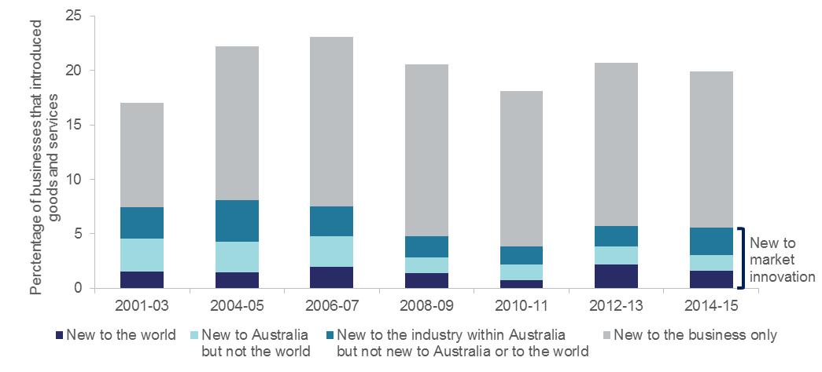

Notes: New to market innovation is the sum of New to world, New to Australia and New to industry innovation.

Source: ABS (various) *Innovation in Australian business*, cat. no. 8158.0

Figure .: International ranking on new to market innovation, 2010-12

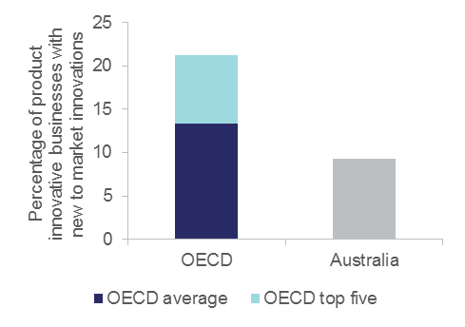

Notes: OECD comparisons exclude businesses with fewer than ten employees. Industry core coverage includes ISIC Rev. 4 Sections and Divisions B, C, D, E, G46, H, J, K, M71-72 and 73. Australian data is for 2012-13. The OECD top five countries are Canada, Belgium, Netherlands, Finland and Austria.

Source: OECD (2015) *Innovation Indicators Database,* [www.oecd.org/innovation/inno/inno-stats.htm](http://www.oecd.org/innovation/inno/inno-stats.htm)

## A new measure of innovation frequency

One of the criticisms of the Business Characteristics Survey is that its measure of innovation has historically been a YES/NO response for a particular reference year. This meant that there was no way to tell if one innovative business had introduced several innovations or only one. The new indicators developed with the University of Tasmania and the ABS provide insight to innovation frequency (Chapter 1).

Across all four types of innovation, businesses most commonly reported introducing one to two new goods, services, processes or methods. For example, of those businesses reporting new goods and/or services:

* 66 per cent introduced one to two new goods and/or services during the year ended 30 June 2015
* only 7 per cent introduced 10 or more new goods and/or services.

More frequent innovators are also more likely to be new to market innovators, as shown by Figure 3.5. This is also the case for more persistent innovators (data not shown; Chapter 2).

Figure .: The relationship between innovation frequency and innovation novelty, by number of innovations, 2014–15

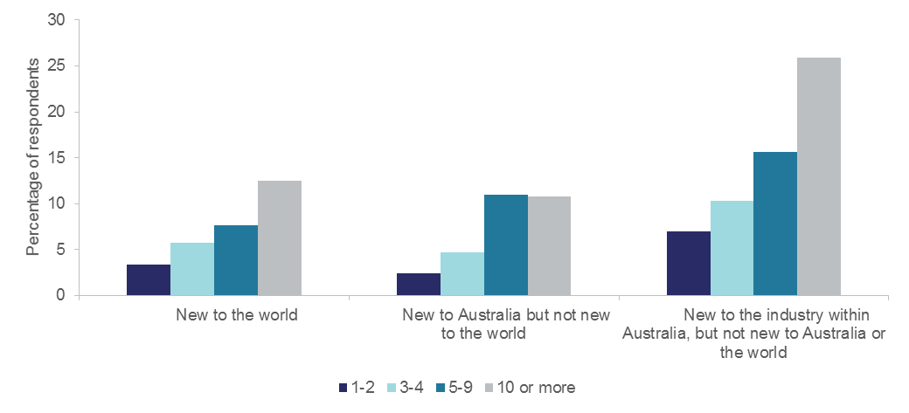

Source: Customised ABS data commissioned by the Department of Industry, Innovation and Science

## Improving our measurement of innovation investment

While there is an accounting definition of R&D and intellectual property, there is no such definition of innovation expenditure. For this reason, obtaining accurate estimates of innovation expenditure is difficult. The 2014-15 BCS included a revised question on business innovation expenditure that allows a business to allocate a percentage of total investment towards specific innovation-related activities. This includes estimates of the percentage of expenditure on physical assets for the development of innovation and intangible items (e.g. training and marketing; Definition 3.2).

Two new response options were added to the survey:

1. Reorganisation of existing business models, work practices and decision making processes.
2. Training relevant to the development or introduction of new goods, services, processes or methods.

Definition .: Innovation investment

| Investment on innovation comprises all expenditure incurred by businesses on developing or introducing all new or significantly improved goods, services, processes or methods over a financial year period.  The types of activities covered in the survey are:   * acquisition of machinery, equipment or technology (including hardware and software) * re-organisation of existing business models, work practices and decision-making processes * training relevant to the development or introduction of new goods, services, processes or methods * marketing activities undertaken to introduce new goods and/or services to the market * research and experimental development for the purposes of developing or introducing innovation * design, planning or testing * acquisition of licences, rights, patents or other intellectual property * other labour costs related to the development or introduction of new goods, services, processes or methods * other activities related to the development or introduction of new goods, services, processes or methods |
| --- |

Using these revised definitions, the ABS estimated total expenditure by Australian businesses on innovation-related activities to be between $26 and $30 billion in 2014–15.

The proportion of innovation-active businesses that reported no expenditure on innovation was 28 per cent. Nearly half of all businesses (46 per cent) reported innovation expenditure of $1 to less than $25 000. Not surprisingly, as business size increased, the likelihood of spending more on innovation also increased (Figure 3.6). The majority of SMEs invested between $1 and $100 000 in innovation-related activities. Less than one per cent of all innovation active businesses reported innovation expenditure of $5 million or more. These were mostly large businesses.

Figure .: Percentage of innovation-active businesses investing in innovation, by range of investment and employment size, 2014–15

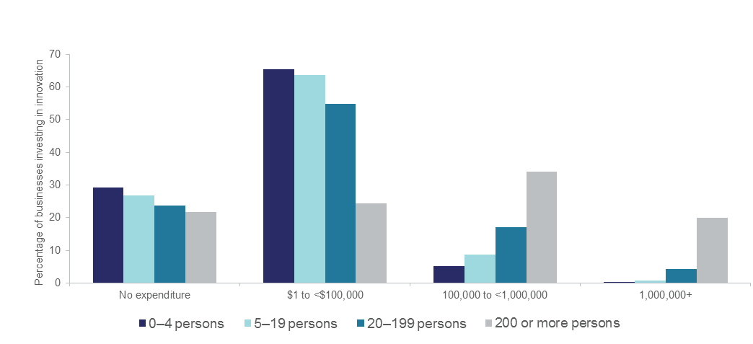 Source: ABS (2016) *Innovation in Australian Businesses, 2014-15*: *Innovation Expenditure, Table 1* cat. no. 8158.0 (data cube: Excel spreadsheet) <http://www.abs.gov.au/ausstats/abs@.nsf/mf/8158.0>

Businesses investing a high proportion of capital in acquiring physical assets including machinery received less income from the sale of new goods and services than those who invested a low proportion of expenditure in machinery. This is illustrated through the U-shaped relationship between the proportion of businesses receiving 25 per cent or more of their income from new goods and services, and acquiring machinery (Figure 3.7). This relationship may result from businesses prioritising investment on physical assets and thereby reducing investment on intangible items such as training, marketing and R&D. These intangible items seem to be high contributors to income from the sale of innovative new goods and services.

Figure .: Proportion of businesses receiving 25 per cent or more of their income from new goods and services, by investment in machinery, equipment or technology, 2014–15

Figure 3.7 shows the proportion of businesses receiving 25 per cent or more of their income from new goods and services by their investment in machinery, equipment or technology, for 2014–15. 
19% of businesses that spent 0–25% of their investment on machinery, equipment or technology received 25% or more of their income from innovative sales. 
12% of businesses that spent 26–50% of their investment on machinery, equipment or technology received 25% or more of their income from innovative sales. 
7% of businesses that spent 51–75% of their investment on machinery, equipment or technology received 25% or more of their income from innovative sales. 
10% of businesses that spent 76–100% of their investment on machinery, equipment or technology received 25% or more of their income from innovative sales. 

Notes: ‘Tangibles’ means machinery, equipment and technology.

Source: Customised ABS data commissioned by the Department of Industry, Innovation and Science

## Research and development in Australia

R&D plays a crucial role in the technological development and competitiveness of a country. The benefits of R&D come primarily in the form of skills development, the generation of new knowledge and technologies, and the creation of new goods and services. The literature has shown that R&D-related activities can explain up to 75 per cent of total factor productivity growth, once externalities are considered.[46] The private returns to R&D are generally found to be positive, and higher than those for physical capital. International research shows a statistically significant relationship between a business’ investment in intellectual property (IP) and its performance. In particular, investment in IP and other forms of intangible capital have been shown to facilitate business growth,[47] and spur productivity improvements.[48] This suggests that innovative businesses conducting R&D may reap greater rewards than innovative businesses that don’t perform R&D.[49]

The impact of R&D on innovation activity

Businesses that undertake R&D in Australia are almost always innovation-active (Figure 3.8 and Figure 3.9). Across the OECD, 94 per cent of businesses doing R&D are innovation-active, compared to only 35 per cent of businesses that don’t perform R&D (on average).

Figure .: Innovation-active businesses, as a percentage of total R&D-active businesses, 2010–12

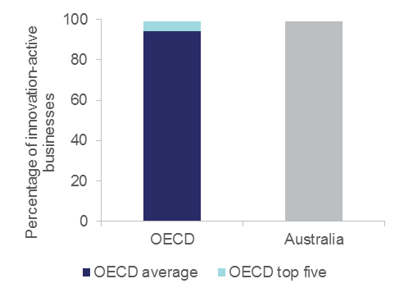

Notes: OECD comparisons exclude businesses with fewer than ten employees. Industry core coverage includes ISIC Rev. 4 Sections and Divisions B, C, D, E, G46, H, J, K, M71-72 and 73. Australian data is for 2012-13. The OECD top five countries are Japan, Slovakia, Australia, Switzerland and Austria.

Source: OECD (2015) *Innovation indicators database,* [www.oecd.org/innovation/inno/inno-stats.htm](http://www.oecd.org/innovation/inno/inno-stats.htm)

Definition .: R&D and R&D Intensity

| R&D comprises creative and systematic work to increase the stock of knowledge—including knowledge of humankind, culture and society—and to devise new applications of available knowledge.  The term R&D includes three types of activity: basic research, applied research and experimental development.  Basic research is experimental or theoretical work undertaken to acquire new knowledge of the underlying foundations of phenomena and observable facts, without any particular application or use in view.  Applied research is original investigation to acquire new knowledge. It is, however, directed primarily towards a specific, practical aim or objective.  Experimental development is systematic work, drawing on knowledge gained from research and practical experience and producing additional knowledge, which is directed to producing new products or processes*,* or to improving existing products or processes.  R&D intensity is commonly defined as the ratio of R&D expenditure to an output measure, usually gross value added (GVA) or gross output (GO)*,* and occasionally employment. This indicator is commonly used at the level of an economy to measure its relative R&D effort (gross expenditure on research and development (GERD) divided by GDP) or its sector (business expenditure on R&D (BERD) over GDP or a more closely aligned measure of GVA for the industry sector).  Source: Frascati Manual (2015)[50]; Galindo-Rueda and Verger (2016).[51] |
| --- |

Figure .: Innovation-active businesses, as a percentage of total businesses with no R&D, 2010–12

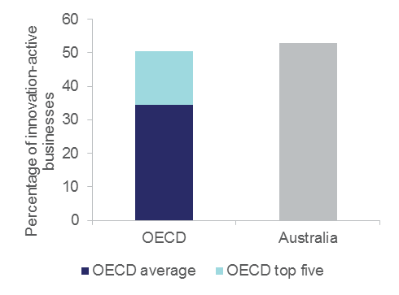

Notes: OECD comparisons exclude businesses with fewer than ten employees. Industry core coverage includes ISIC Rev. 4 Sections and Divisions B, C, D, E, G46, H, J, K, M71-72 and 73. Australian data is for 2012-13. The OECD top five countries are Switzerland, Australia, Germany, Italy and Greece.

Source: OECD (2015) *Innovation statistics and indicators*, [www.oecd.org/innovation/inno/inno-stats.htm](http://www.oecd.org/innovation/inno/inno-stats.htm)

R&D-active Australian businesses are three times more likely to introduce new-to-market goods and service innovations (24 per cent) than non-R&D-active businesses (seven per cent). Australia has a relatively low proportion of businesses introducing product or process innovations that are R&D active (Figure 3.10). Australia ranks last on this measure relative to 28 OECD countries.

Figure .: Product/process innovators that are R&D active, 2010–12

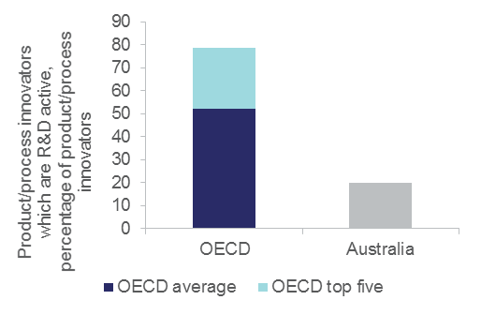

Notes: OECD comparisons exclude businesses with fewer than ten employees. Industry core coverage includes ISIC Rev. 4 Sections and Divisions B, C, D, E, G46, H, J, K, M71-72 and 73. Australian data is from 2012-13. The OECD top five countries are Sweden, Korea, Finland, Netherlands and Norway.

Source: OECD (2015) *Innovation statistics and indicators*, [www.oecd.org/innovation/inno/inno-stats.htm](http://www.oecd.org/innovation/inno/inno-stats.htm)

A greater share of R&D-active businesses operate in international markets compared to businesses that don’t do R&D (Figure 3.11 and Figure 3.12). This is consistent with the relationship between new-to-market innovation and R&D.

Figure .: R&D-active businesses operating in international markets, 2010–12

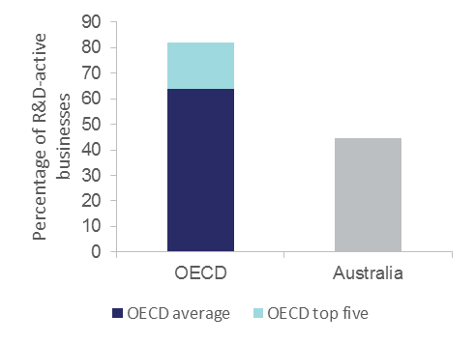Notes: OECD comparisons exclude businesses with fewer than ten employees. Industry core coverage includes ISIC Rev. 4 Sections and Divisions B, C, D, E, G46, H, J, K, M71-72 and 73. Australian data is for 2012-13. The OECD top five are Austria, Latvia, Slovenia, Hungary and Slovakia.

Source: OECD (2015) *Innovation statistics and indicators*, [www.oecd.org/innovation/inno/inno-stats.htm](http://www.oecd.org/innovation/inno/inno-stats.htm)

Figure .: Businesses with no R&D operating in international markets, 2010–12

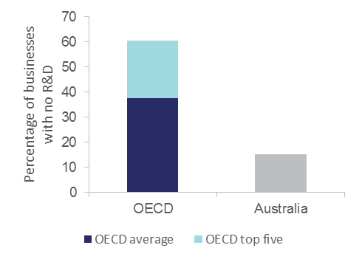Notes: OECD comparisons exclude businesses with fewer than ten employees. Industry core coverage includes ISIC Rev. 4 Sections and Divisions B, C, D, E, G46, H, J, K, M71-72 and 73. Australian data is for 2012-13. The OECD top five are Latvia, Slovakia, Slovenia, Hungary and the Netherlands.

Source: OECD (2015) *Innovation statistics and indicators*, [www.oecd.org/innovation/inno/inno-stats.htm](http://www.oecd.org/innovation/inno/inno-stats.htm)

Trends in R&D activity

Australia’s GERD to GDP ratio was 2.11 per cent in 2013–14 ([Table A7](http://www.industry.gov.au/innovationreport)), which is slightly above the OECD+ average of 2.01 per cent. Australia was ranked 14th out of 36 OECD+ countries in 2013–14, and also behind one non-OECD country (Taiwan) for which data was available. GERD as a percentage of GDP (see Definition 3.3) has been in decline in Australia since 2008–09, after a period of strong growth (Figure 3.13). This decline has been driven by a significant decrease in business R&D as a percentage of GDP over this period (Figure 3.13).

Australia’s BERD/GDP ratio increased steadily between 1995 and 2008, from 0.82 to 1.37. The BERD/GDP ratio then declined to 1.19 by 2013 ([Table A2](http://www.industry.gov.au/innovationreport)). This is considerably lower than the average BERD/GDP ratio of 2.78 for the top five OECD+ countries. In 2013, Australia was ranked 15th out of 35 OECD+ countries by BERD/GDP ratio.

Manufacturing continues to be the largest contributor to R&D in terms of net investment, although the relative proportion has decreased from 36 per cent in 2005–06 to 26 per cent in 2013–14. Despite manufacturing’s declining share of economic activity, manufacturing’s R&D intensity has increased from 3.5 per cent in 2005–2006 to 4.8 per cent in 2013–14. Since 2011–12, mining investment in R&D has declined from $4.1 billion to $2.83 billion in 2013–14. This has been partially offset by a boom in the financial and insurance services sector R&D, where investment tripled between 2005–06 and 2013–14.

Figure 3.14 shows the major flows of R&D throughout the innovation system. The private sector is the biggest investor in R&D in Australia, and performs mostly applied research and experimental development. A small proportion of the $19 billion spent on R&D by businesses in 2013–14 went to other sectors for collaborative R&D. For example, the industry sector spent $430 million on higher education sector R&D, approximately 2.3 per cent of its total investment in R&D.

Investment in R&D

The Australian Government is the second largest source of funds for R&D expenditure. In 2014–15, the industry sector received around $2.8 billion in tax concessions (Figure 3.14). While the industry sector receives support in the form of tax concessions, the higher education sector and the Australian government research agencies rely on direct government support in the form of grants. In   
2014–15, the higher education sector and Australian government research agencies received $3.4 billion and $1.9 billion respectively. The higher education sector spent $10.1 billion on R&D, over half of which came from general university funds.

Figure .: Australia’s GERD and BERD intensity, 1990–2013

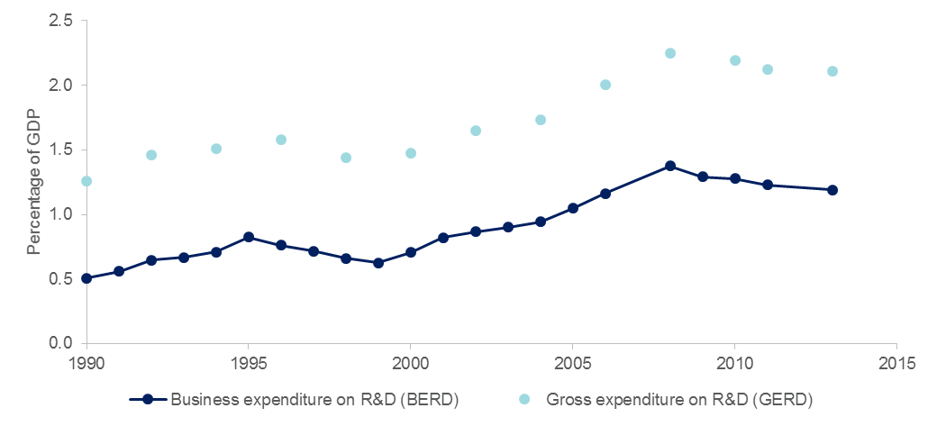

Notes: GERD/GDP is only available for the marked years; the line is a fitted trend.

Source: OECD (2016) Structural Analysis Database, <http://stats.oecd.org/>

Figure .: Major flows of R&D investment, 2013–14

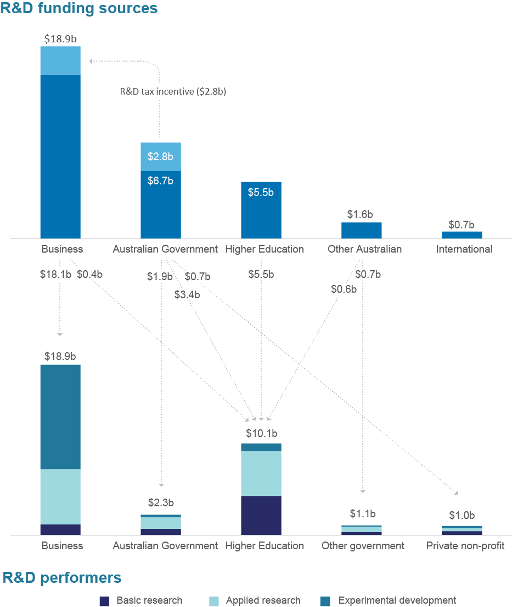

Notes: Flows of less than $400 million are not included in this figure for visual clarity.

Source: ABS (2015*) Research and Experimental Development, Business, 2013–14*, cat no. 8104.0; ABS (2016) *Government and Private Non-Profit Organisations, 2014–15*, cat no. 8109; ABS (2016) *Higher Education Organisations, 2014*, cat no. 8111.0; Department of Industry, Innovation and Science (2016) *Science, Research and Innovation Budget tables 2016–17*

## Trends in business expenditure on experimental development

As experimental development is dedicated towards producing new materials, products or processes, it is most closely linked with creating innovation within businesses and across the economy.

Business expenditure on experimental development increased from 0.57 to 0.75 per cent of GDP between 1996 and 2013. Compared to other OECD countries, Australia was ranked 10th in terms of business expenditure on experimental development as a percentage of GDP in 2013.

The Australian industry sector spent $11.5 billion on experimental development in 2013. Following the Global Financial Crisis of 2008-09, the ratio of business experimental development expenditure to GDP declined marginally. In comparison, the top five OECD countries experienced a significant increase in experimental development expenditure for businesses, increasing from 1.2 to 2.2 per cent of GDP over the same period.

On average, businesses in OECD countries spent 0.85 per cent of GDP on experimental development, compared to 0.76 per cent for Australia (Figure 3.15 and Figure 3.16).

Figure .: Business experimental development as a percentage of GDP, 2013.

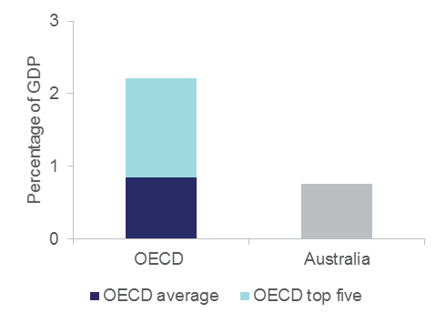

Notes: The OECD top five countries are Israel, Korea, Japan, Sweden and Finland.

Source: United Nations Educational, Scientific and Cultural Organization and World Development Indicators from the World Bank.

Figure .: Business expenditure on experimental development as a percentage of GDP, 1996–2013.

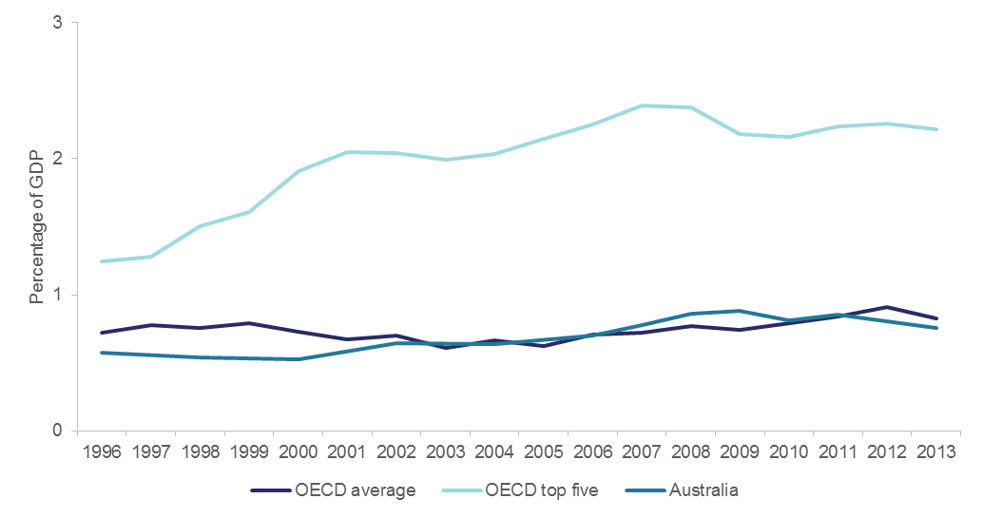

Source: United Nations Educational, Scientific and Cultural Organization and World Development Indicators from the World Bank.

Notes: Prior to 2006, data for Australia is only available every two years. Data not available for all OECD countries.

## Innovation activity is clustered in cities

Framework conditions are often national, reflecting the specific path of technological, economic and social development of a country. At a regional level, the innovation system is often described as an ecosystem so as to highlight the interdependency of its components and the evolutionary processes that drive regional development. This ecosystem view is increasingly used to frame policy problems in terms of the health of a regional innovation system, and to identify the gaps by referencing best practices in other regions. We recently introduced the *National Innovation Map* to reveal the geography of innovation in Australia and improve our understanding of the innovation ecosystem.

This map is an online visualisation tool that highlights differences in innovation and entrepreneurial performance between regions at the SA3 level (Definition 3.4).

Research on the geography of innovation activity has highlighted clusters as an important factor contributing to national competitiveness. Close proximity to areas of dense economic activity can induce stronger competition between businesses. This in turn encourages innovation and resource efficiency. Businesses cluster to share resources, including knowledge. Close proximity also reduces transport and communication costs and increases the scope for differentiation and market experimentation in the pursuit of innovation-driven comparative advantage.

Definition .: What is SA3?

| Statistical Area level 3 (SA3) is a standardised regional breakup of Australia. There are 333 SA3 spatial units. In aggregate, they cover the whole of Australia without gaps or overlaps. In general, the SA3s are designed to have populations between 30 000 and 130 000 persons, however these boundaries can be varied to contain more significant and meaningful regional areas. As a result, there are a number of SA3s with populations above 130 000 or below 30 000. SA3s do not cross state and territory borders.  Since the National Innovation Map was published, the ABS has since released an updated Statistical Geography Standard for SA3*.* |
| --- |

Source: ABS (2010) Australian Statistical Geography Standard. Cat. No. 1270.0

The map uses administrative data to plot patents, trademarks, business entries/exits and business expenditure on R&D (BERD) to provide a picture of the level and location of innovative entrepreneurship in Australia. All indicators of innovation activity have some degree of skewness towards major cities, in part attributable to the location of companies’ head offices or the location of offices where the IP or R&D is being registered.

Section 3.5 shows that in most countries, almost 100 per cent of R&D active businesses are also innovative businesses. Together with patent and trademark data, the map gives a strong signal of business innovation by region.

The map shows that the majority of innovation activity occurs in Australia’s capital cities. This is not surprising, considering 70 per cent of Australia’s population is concentrated within five major cities. However, close analysis of the map and associated data show that there are pockets of strong regional innovation activity.

High levels of BERD have occurred in regional areas despite their lower population density (Figure 3.17). This may be partly explained by the mining sector, which during the 2008–12 period had a high share of BERD. However, the latest data for 2013–14 shows that mining R&D is decreasing, with some evidence that regional R&D is also declining.

Patents and trademarks demonstrate the likely arrival of new technologies and products in the marketplace, and are intermediate output measures of innovation activity.

Figure 3.18 shows the distribution of patent applications per 10 000 inhabitants, and confirms the expected hypothesis that patents are concentrated in more populous regions or cities.

The online map also shows entrepreneurship churn (the sum of business entries and exits), which has been positively associated with innovation activity as innovative businesses enter markets and compete with incumbents, forcing out less productive businesses.

Our research using the maps has found that:

* The presence of industry-facing research organisations like CSIRO or Cooperative Research Centres have a positive influence on regional innovation.
* There are no regions in Australia where high IP generation does not occur in tandem with high entrepreneurship.
* For every one per cent increase in R&D expenditure, a 0.35 per cent increase was observed in patent applicant counts and a 0.40 per cent increase in trademark applicant counts.

Refining the map

Since the initial release of the map, we have continued to work towards improving the measures in it. For example, we have increased our use of geocoding within the dataset, as previously all of the datasets had been matched using postcodes. IP Australia has since released some geocoding information for their patents and trademarks data, which has enabled us to increase the use of geocoding and thus provide greater precision in locating data within their correct SA3.

The National Innovation Map will continue to be updated and improved. You can explore the map [here](http://www.industry.gov.au/Office-of-the-Chief-Economist/Publications/Pages/Nat-Innovation-Map.aspx).[52]

Figure .: Mean annual expenditure in R&D per 10 000 inhabitants by SA3 region, 2008–2014

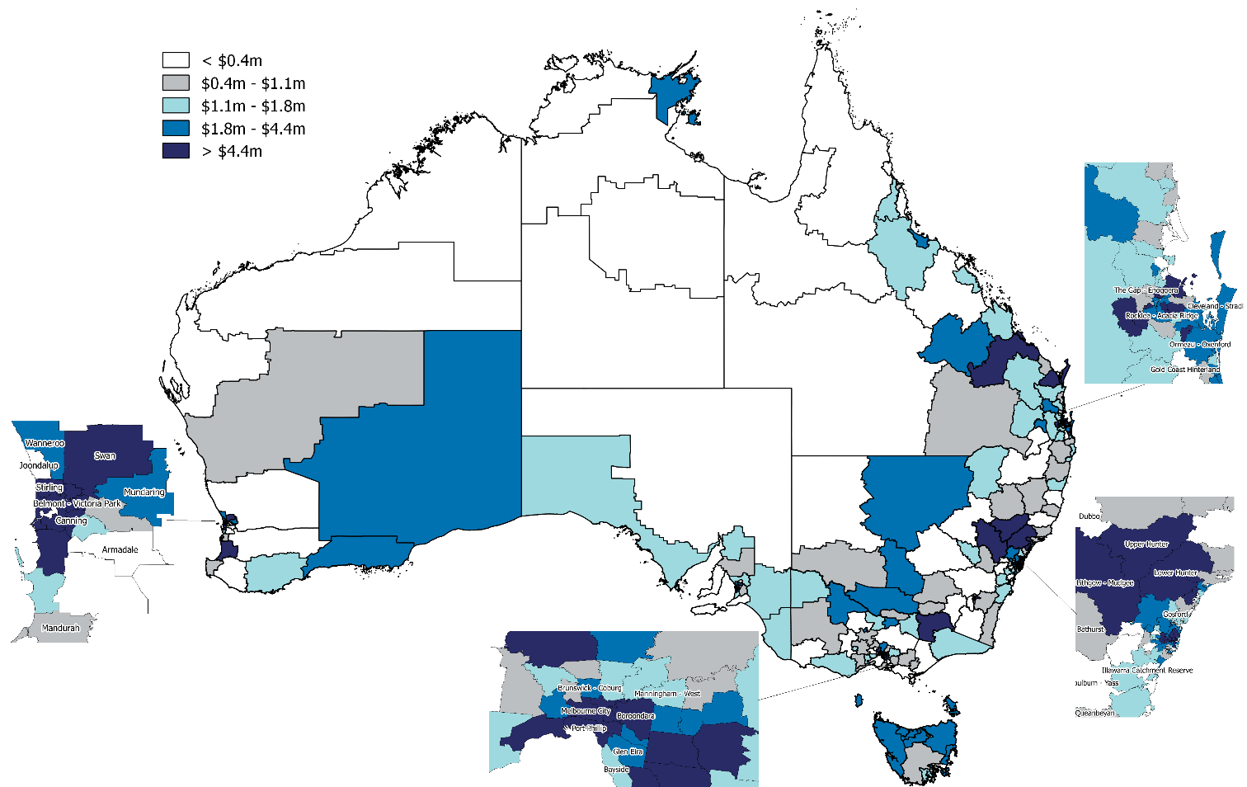

Note: Map shows five quintiles with 66–67 SA3 regions each.

Source: Australian Government R&D Tax Incentive (formerly R&D Tax Concession) programme, viewed 22nd June 2015 and Department of Industry, Innovation and Science (2016), *National Innovation Map*, http://industry.gov.au/Office-of-the-Chief-Economist/Publications/Pages/Nat-Innovation-Map.aspx

Figure .: Mean patent application counts per 10 000 inhabitants by SA3 region, 2008–2015

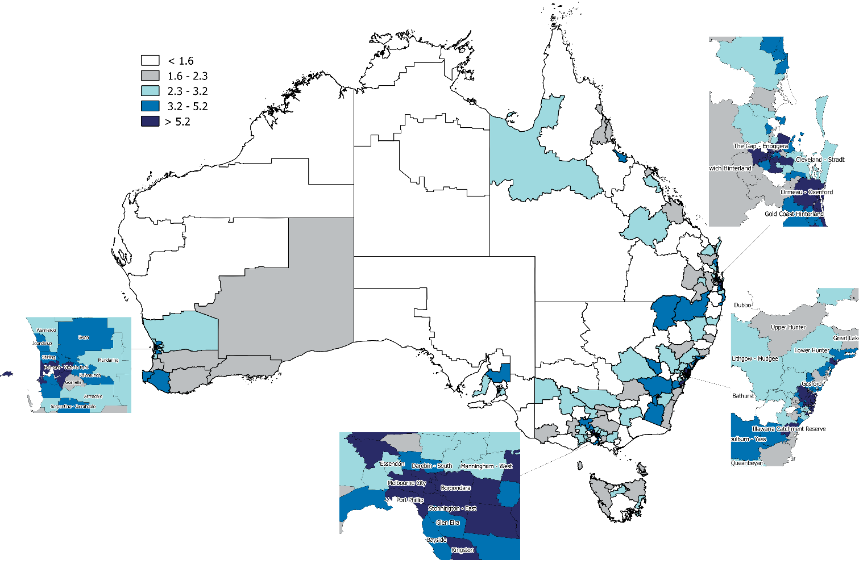

Note: Map shows five quintiles with 65–66 SA3 regions each.

Source: Intellectual Property Government Open Data 2016 (IP Australia) and Department of Industry, Innovation and Science (2016) *National Innovation Map*, http://industry.gov.au/Office-of-the-Chief-Economist/Publications/Pages/Nat-Innovation-Map.aspx

Enablis: A case study of an innovative, high-growth firm

| Enablis CEO |
| --- |

John Evans, Enablis CEO

| Logo says 'your communication partner' |
| --- |

Based in the Sydney CBD, and with a new office opening in Melbourne, Enablis provides data and voice connectivity for highly distributed organisations. Their customers typically have between 10 and 200 or more sites (for example travel agencies and large aged-care providers). As information and communication technologies become central to operations and management, businesses with multiple sites need reliable, secure and efficient data and voice communications. This leads to a strong demand for support ranging from the design to the installation of communications technologies. The constant change in technologies, including VoIP (Voice over Internet Protocol) telephony and the growth in cloud-based services, coupled with the increasing importance of security, is leading more businesses to outsource these services. Enablis offers its target market fully managed communication services across data, voice and security. The CEO and Enablis founder, Jon Evans, comments that ‘there is at least a perception among organisations in our target market that the major telecommunications service providers are unable to provide the level of customer support that is needed’. With this market focus, Enablis has achieved strong and consistent growth over the past seven years (Figure 3.19), delivering revenue growth averaging over 35 per cent year-on-year, reaching $13 million by 2015.

Jon first arrived in Australia as a backpacker, and then returned to the UK to establish the Australian operations for a small IT communications business, Sirocom. While still young, Sirocom was bought out by another UK business, Azzurri. One of Azzurri’s major clients was STA Travel, who had many sites in the Australasian region. Azzurri needed a local capability to service this client, and formed an Australian subsidiary. In 2009 Jon bought out the shareholding of this Australian operation and in early 2015 rebranded the business as Enablis.

Jon developed an extensive knowledge of the market by working in sales roles in several IT communications businesses in the UK, and later as a partner-manager for Verizon in Australia.

‘Enablis is a “sales-fronted” business with a clear strategy aiming at 30 per cent annual growth’, says Jon. ‘I have been determined to keep a focus on the value proposition for customers and a build a culture that supports and motivates staff.’ With a knowledge of the potential of available technologies, and an understanding of customer needs, Enablis aims to help customers be more efficient in their use of communications. The capability to provide advice that can enable a customer to see opportunities to transform their business model is becoming increasingly important.

Enablis inherited its strategic focus, business model, and to some extent core staff from its one-time owner, Azzurri. Finding this to be a valuable resource they built on this skillset and over time increased focus on their key market. As a keen yacht racer, Jon’s analogy of the current situation is ‘we have a full spinnaker up, the sky is blue, and there are no clouds on the horizon… the boat is cranking so let’s enjoy the ride’. In the business’ early days there was a tendency to pursue growth by ‘shooting at everything that moved’, but the focus on the central value proposition has increased over time, along with the company’s reputation in its target market.

Capable and motivated staff are vital for a small, fast-growing business, and while high growth attracts staff, Enablis finds that the local labour market is limited. Jon comments: ‘we recruit most of our technology specialists through word of mouth. Among our 35 employees today we have 19 nationalities. We find that many of these more recent arrivals in Australia have a can-do attitude and are keen to learn and develop’. Fast growth provides increasing opportunities for talented staff, which has contributed to high retention levels. Enablis invests in developing staff and deepening its skillset to support its strategic market focus.

Although Enablis has grown to 35 employees, it retains a flat structure and a strong internal culture. For Jon this is vital for success. ‘We have an open culture that avoids internal politics’. Growth brings new challenges for recruitment and the management of incentives, while complexity increases and there is less direct contact between staff and the senior management team. Enablis recently begun drawing on advice from a specialist human resource management consultancy.

Innovation at Enablis has been incremental, and largely involves integrating newly available hardware and software to provide better solutions for clients. ‘We must keep an eye on the horizon and see what is out there, but must keep focused on the commercial application and the customer need for that application—that is a key for innovation for us’, says Jon. In-house engineering competence and relationships with technology developers provide the capability for the assessment and effective application of new technologies. Enablis’ technology-related links are largely with overseas networks and technology providers; there are no significant innovation-related links to local organisations.

As flexibility and agility are important, Jon considers Enablis is small enough to maintain fast decision making, even for major strategic decisions. ‘We have robust processes so that doubling in size would not be a problem’.

Jon and his senior management team think that the next phase of growth will likely require a step-change in the company. ‘We are now clarifying the direction for growth, developing a five-year business plan, reviewing the organisational structure, more clearly defining roles and expectations, and formalising some management processes’.

Any growing market segment is likely to attract new entrants, and technological change can lower the barriers to entry. Jon considers that Enablis’ relationship with customers and its reputation in the target market limit the risk of turbulence. The company continues to invest in strengthening capability in newer technology areas, such as the cloud, through recruitment and possibly in the future through a partnership or acquisition. Continued growth is likely to involve developing new clients—they aim for ten new clients each year—including in other geographical markets such as other Australian cities or New Zealand. Jon commented: ‘We have looked at the government market, and while we are confident we have an attractive value proposition for that market, the complex procurement processes have been a disincentive’.

Reflecting on his experience, Jon emphasises ‘self-development and continuous learning’. He acknowledges the value of the mentoring he has had from the owner of Sirocom, Simon Rogan, in creating Enablis through a management buyout, and then leading a period of rapid growth. Simon has been an adviser over the life of the business, sits on the Board of Enablis, and usually spends a week in the company every six to 12 months. Jon also found that participating in The Executive Connection (TEC) has been a very valuable source of mentoring, peer-peer learning and support. ‘I wouldn’t be where I am without the support I have found through TEC’.

Figure .: Enablis’ growth, indexed, 2005–06 to   
2015–16

| Figure 3.19 shows Enablis’ indexed growth in turnover and staff from 2005–06 to 2015–16, with the values in 2011–12 set at 100. Turnover went from an index of 0.2 in 2005–06, to 100 in 2011–12, to 811 in 2015-16. Staff went from an index of 8 in 2005–06, to 100 in 2011–12, to 292 in 2015-16. |
| --- |

Notes: Turnover and staff are indexed from 2005–06. The value in 2011–12 is 100.

Authors: UTS Business School MCS Research Team and Abasi Latcham.

# Networks and collaboration

Networking and collaboration activity is essential to a high-performing innovation system. Highly networked innovation systems enable businesses to efficiently share resources, risk and ideas for innovation.[53] Collaborative innovation is associated with more novel innovations that can capture global market shares.[54] Businesses that pursue a culture of both innovation and collaboration experience compounding benefits across a range of business performance measures.[55]

This chapter discusses Australia’s performance on (1) general indicators of business collaboration, (2) indicators of business-to-research collaboration, and (3) measures of business absorptive capacity.

## The state of business collaboration in Australia

We use the collaboration definition from the ABS BCS which is consistent with the OECD’s Oslo Manual (Definition 4.1). International comparisons on business collaboration are, like the innovation data, matched to OECD business size and industry sector classifications. The biggest issue with these comparisons is that the Australian data has a single reference year such as 2012–13 while most other OECD countries have a three year reference period such as 2010–12. We are currently working with the ABS to estimate a three-year rate of innovation and collaboration to improve international comparisons.

Definition .: Collaboration

| Collaboration describes arrangements where partners work together for mutual benefit, including some sharing of technical and commercial risk. It is not necessary for each participant in a collaboration to benefit commercially.  This definition used in the ABS BCS conforms to the OECD’s Oslo Manual and includes informal collaboration arrangements. |
| --- |

Measures of Australia’s business collaboration activity, including international engagement, are shown in [Tables A3 and A4](http://www.industry.gov.au/Office-of-the-Chief-Economist/Publications/Pages/Australian-Innovation-System.aspx). With the exception of the resources sector, the data suggests that Australia has a weakly networked innovation system. Innovation-active Australian businesses have below average likelihood of collaboration on innovation. Australian industry has low levels of international engagement with respect to trade in goods, services, intellectual property and joint R&D. Australia performs relatively well on raw commodity trade and foreign direct investment,[56] consistent with our technological leadership in the resources sector.

Figure 4.1 shows the proportion of innovation-active product and process innovators that collaborated on innovation. In this generic measure of collaboration, the percentage of Australian businesses collaborating on innovation activities is lower than the OECD average and more than 20 percentage points below the OECD top five average.

Figure .: Businesses collaborating on innovation activities (as a percentage of innovation-active businesses undertaking product and/or process innovation), 2010–12

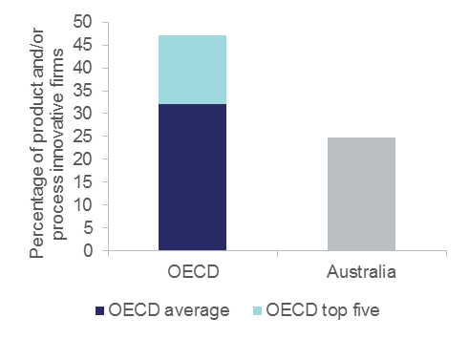

Notes: OECD comparisons exclude businesses with fewer than ten employees. Industry core coverage includes ISIC Rev. 4 Sections and Divisions B, C, D, E, G46, H, J, K, M71-72 and 73. Australian data is for 2012-13. The OECD top five countries are Belgium, Slovenia, Denmark, Estonia and Austria.

Source: OECD (2015) *Innovation Indicators Database*, [www.oecd.org/innovation/inno/inno-stats.htm](http://www.oecd.org/innovation/inno/inno-stats.htm)

Looking at the percentage of businesses cooperating on innovation activities with suppliers, Australia also ranks poorly (25th out of 30 OECD countries). Only 12 per cent of innovation-active businesses undertake this type of collaboration, compared with an OECD average of 21 per cent (for 30 countries), with the top five countries averaging 34 per cent. The rankings and the gap from the frontier (the OECD top five average) is even worse when comparing large Australian businesses with their OECD counterparts. Australia also ranks below the OECD average, at 20th out of 30 countries, for collaboration with customers.

Collaboration and the frequency of innovation

Figure 4.2 suggests that collaboration on innovation and the number of innovations introduced per business per year is correlated. For example, businesses that collaborated on innovation were twice as likely to develop ten or more innovations in 2014–15.

When the data is disaggregated by business size there are notable differences between SMEs and large businesses. While large businesses tend to develop a higher number of innovations, collaboration activity did not have a significant effect on the frequency of innovation. For example, 32 per cent of non-collaborators and 28 per cent of the collaborators (on innovation) undertook 10 or more innovations respectively.

By contrast, 19 per cent of innovative SME collaborators introduced 10 or more innovations in 2014–15, almost double their non-collaborative counterparts (10 per cent). This positive relationship may reflect a general lack of resources (and risk appetite) in SMEs for undertaking a high number of innovation projects. Collaboration would allow resource-constrained SMEs to share resources and spread risks further.

Figure .: Percentage of businesses undertaking collaboration, by frequency of innovation, 2014–15

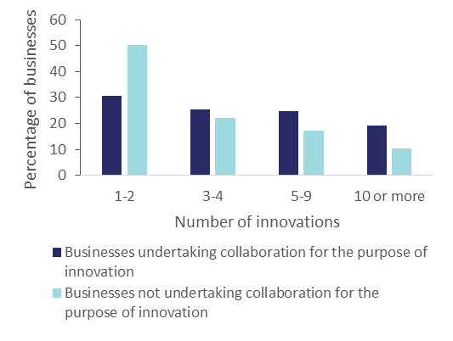

Source: Customised ABS data commissioned by the Department of Industry, Innovation and Science

## Business-research sector collaboration

Research institutions are a source of expert knowledge that businesses can leverage in order to innovate more effectively, both in outcomes and cost. Collaboration with research organisations such as CSIRO and universities has been found to more than triple the likelihood of businesses reporting annual productivity growth and increases in other performance measures.[57]

How Australia compares

Australia fares poorly on collaboration with research institutions. Australian industry’s collaboration with higher education and research institutions ranked the lowest of 27 countries in the OECD, both for large businesses and for SMEs, as shown by Figure 4.3.

For Figure 4.3, the ABS data on collaboration is matched to the OECD definition (Methodology 3.1). The surveys from which the data are derived are designed to measure the likelihood of collaborating on innovation for the entire population of businesses. They are not directed at R&D-intensive businesses, or at highly collaborative businesses. If the collaboration rates of R&D-active businesses were made the target indicator, this would not necessarily improve Australia’s ranking, as all other countries would have to make a similar definitional change.

In 2012–13, the proportion of Australian non-R&D-active product- or process-innovating businesses collaborating on innovation was 23 per cent, ranked 11th out of 30 OECD countries. The equivalent collaboration score for R&D-active businesses was higher at 32 per cent, but Australia’s ranking was 25th out of 31 countries. Many other OECD countries have a higher proportion of their business population undertaking R&D than Australia, which has only about 12 000 R&D-active businesses.

The randomised, stratified sample of 7,000 businesses returns a very low proportion of businesses that are collaborating on innovation with research and higher education institutions. This means that any further breakdown by industry is not possible. Despite the volatility in the national collaboration rate, international comparisons have consistently shown relatively low rates of collaboration. Even if we crudely accounted for the difference in reference periods by tripling the rate of collaboration, Australia would still rank well below the OECD average.

A low level of collaboration using BCS data is consistent with other recorded data. In 2013–14, Australian businesses invested $18.8 billion on R&D, but only $426 million (2.3 per cent) was directed to higher education and $185 million (1.0 per cent) to government in 2014–15 (Section 3.5). Much of a country’s research is performed by the higher education and government sectors. Industry financing of R&D in higher education and government in Australia is average by OECD standards. Australia was ranked 16th out of 33 countries in 2012 for share in total HERD, and 12th out of 34 countries for GOVERD financing. In 2014–15, only three per cent of Australian businesses reported sourcing their ideas for innovation from higher education institutions. This suggests that the majority of Australian businesses are largely disconnected from the publicly funded research sector.

Collaboration within research organisations

Research organisations across Australia have a highly collaborative culture. In the share of the world's top one per cent of highly cited publications attributed to international collaboration, Australia was ranked 7th out of 37 OECD+ countries across all disciplines, 5th in social sciences and humanities, and 8th in natural sciences and engineering ([Table A9](http://www.industry.gov.au/innovationreport)). The rate of domestic and international research-to-research collaboration is growing.

Figure .: Businesses collaborating on innovation with higher education or research institutions, by size,   
2010–12

SMEs

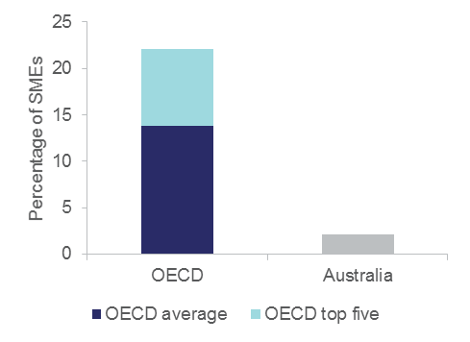

Large businesses

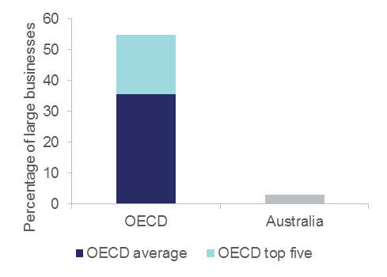

Notes: Collaboration as a percentage of product and/or process-innovating businesses in each size category. OECD comparisons exclude businesses with fewer than ten employees. Industry core coverage includes ISIC Rev. 4 Sections and Divisions B, C, D, E, G46, H, J, K, M71-72 and 73. Australian data is for 2012-13. The OECD top five for SMEs are Slovenia, Finland, Austria, Greece and Belgium. The OECD top five for large businesses are Finland, Greece, Austria, Slovenia and Sweden.

Sources: OECD (2015) *Science, Technology and Industry Scoreboard 2015*; Customised ABS report commissioned by the Department of Industry, Innovation and Science

Data from the National Survey of Research Commercialisation[58] shows collaboration by publicly funded research organisations (PFROs) is increasing in value terms, but is a small share of PFROs’ commercialisation income ([Table A10](http://www.industry.gov.au/innovationreport)). However, other types of income such as contracts and consultancies, while not fitting the formal definition of collaboration, can involve PFROs in work with client businesses that is collaborative in nature. In 2014, PFROs earned $1.8 billion from research contracts, consultancies and collaborations, of which $0.3 billion (16.8 per cent) was on collaboration projects.

## Absorptive capacity

Absorptive capacity (see Definition 4.2) influences innovation, business performance, and the transfer of knowledge within and between businesses.[59]

Over the past several decades a business’ capacity to manage knowledge has increasingly been recognised as being important for competitiveness. The intensity of global competition requires businesses to build their absorptive capacity to stay at the global innovation frontier. Absorptive capacity has also been described as central in facilitating high levels of entrepreneurship, which is in turn linked to growth and competitiveness.[60]

Definition .: Absorptive Capacity

| Absorptive capacity is a business’ ability to identify, acquire, transform and exploit knowledge, external to the business.[61] |
| --- |

In 2013 we collaborated with the Melbourne Institute of Applied Economic and Social Research to survey around 1,050 businesses on the relationship between absorptive capacity, innovation and business performance. The survey results indicated that businesses reporting a high-absorptive capacity tended to rate their innovation and financial performance very highly compared with low-absorptive capacity businesses (Figure 4.4).

Activities such as co-patenting and joint R&D are commonly used as imperfect proxy indicators for absorptive capacity (Chapter 3). This section provides two other indicators of absorptive capacity: the *Source of ideas and information for innovation* (based on the Oslo Manual) and the proportion of *Researchers in Business* (based on the Frascati Manual).

Source of ideas and information for innovation

The BCS asks all innovation-active businesses the question: “*During the [reference] year, from where did this business source ideas and information for the development or introduction of new goods, services, processes or methods?*” Businesses are then asked to tick a range of market (e.g. customers and suppliers) and institutional sources (e.g. universities and governments).

Figure 4.4: Self-reported business performance and innovation, by business absorptive capacity, 2013

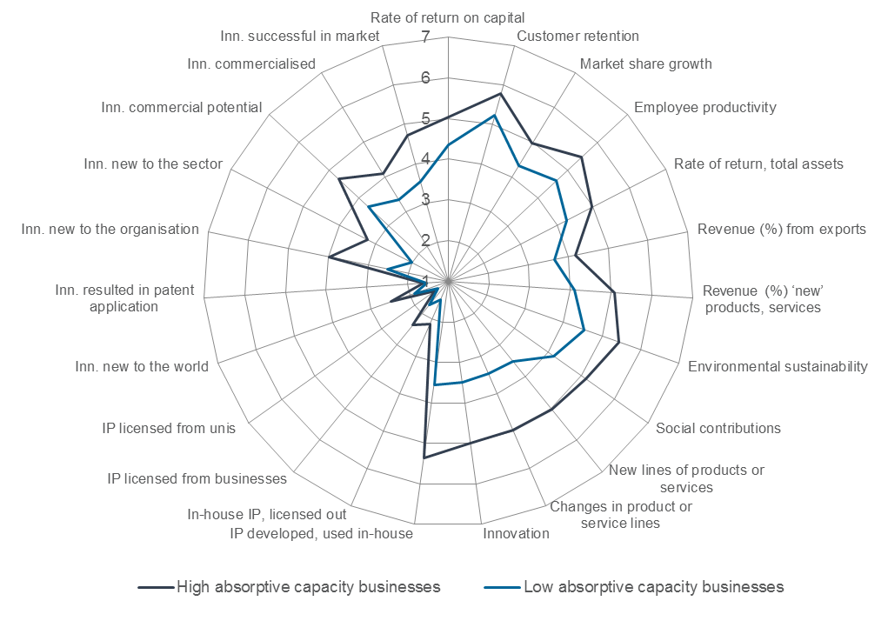

Notes: Based on a customised survey of absorptive capacity. *High absorptive capacity* businesses are the top 20 per cent of businesses reporting on their capacity to identify, acquire, transform and exploit knowledge external to their organisation. *Low absorptive capacity* businesses are the bottom 20 per cent. Scores are based on seven point Likert scale responses. *Inn.* = Innovation. IP = Intellectual property.

Source: Department of Industry and Melbourne Institute of Applied Economic and Social Research, 2013, commissioned by the Department of Industry, Innovation and Science

Figure .: Sources of ideas or information for innovation, 2006–07 and 2014-15

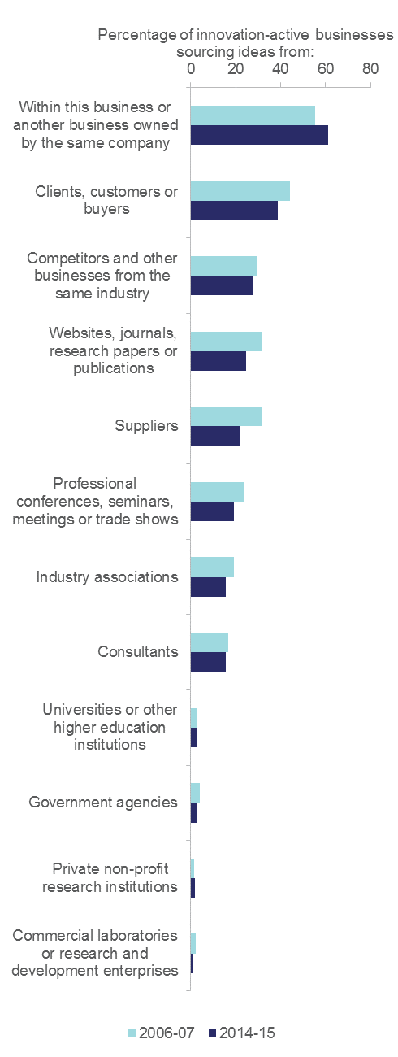

Source: ABS (various) *Innovation in Australian Business*, cat. no. 8158.0

Previous research shows that the more diverse the sources of information and ideas, the stronger the innovation performance of a business.[62] Figure 4.5 shows that this measure of absorptive capacity in Australian businesses has changed marginally over the past decade.

The majority of OECD country data on sourcing ideas is collected via the Community Innovation Survey (CIS). In this survey, businesses are asked to rate the importance of a variety of sources to their business’ innovation activities. By contrast, the ABS does not ask Australian businesses to rate the importance of each source. Because the CIS ratings are qualitative and subjective, the following two international comparison figures may be subject to risks of bias and misinterpretation. Despite this issue, both figures are generally consistent with other data on networks and collaboration.

For all countries in the OECD, market sources are considered more important than institutional sources, and are more likely used as sources of ideas or information for innovation. Australian businesses, at 68 per cent, rank reasonably highly in networking with external market sources such as customers and suppliers (4th out of 24 OECD countries; Figure 4.6).[63] Australian businesses, at 6 per cent, ranks reasonably poorly in networking with external institutional sources such as universities (19th out of 26 OECD countries; Figure 4.7).

Figure .: Businesses citing market sources as highly important for innovation, 2010–12

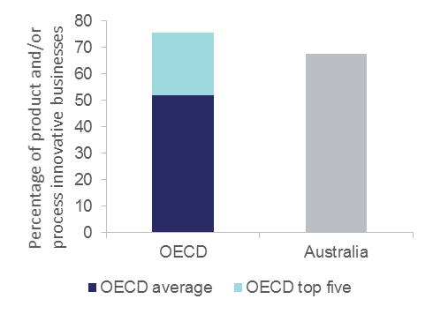

Notes: The OECD top five are Turkey, Israel, Switzerland, Australia and Slovenia. OECD comparisons exclude businesses with fewer than ten employees. Industry core coverage includes ISIC Rev. 4 Sections and Divisions B, C, D, E, G46, H, J, K, M71-72 and 73. Australian data is for 2012-13.

Source: OECD (2015) *Innovation statistics and indicators*, [www.oecd.org/innovation/inno/inno-stats.htm](http://www.oecd.org/innovation/inno/inno-stats.htm)

Figure .: Businesses citing external institutional sources as highly important for innovation, 2010–12

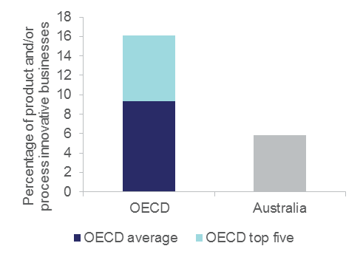

Notes: OECD comparisons exclude businesses with fewer than ten employees. Industry core coverage includes ISIC Rev. 4 Sections and Divisions B, C, D, E, G46, H, J, K, M71-72 and 73. Australian data is for 2012-13. The OECD top five are Switzerland, Israel, Hungary, Austria and the United Kingdom.

Source: OECD (2015) *Innovation statistics and indicators*, [www.oecd.org/innovation/inno/inno-stats.htm](http://www.oecd.org/innovation/inno/inno-stats.htm)

Researchers in business

The more a business invests in R&D activities, the better it will be at adopting innovations and deriving profit from these activities. Using the proportion of researchers in business as a rough proxy for private sector absorptive capacity shows that Australia has low absorptive capacity by OECD standards. The total number of business R&D FTE personnel per thousand employment in industry was 9.4 in 2013.[64] Australia ranks 19th out of 33 countries on this measure. The Australian figure is below the OECD average of 9.8, and well behind the top five OECD countries’ 19.2. However, there are signs of improvement. Australia has grown at an average annual compound growth rate of 6.0 per cent since 1981, from a low base of 1.6 business R&D FTE personnel per thousand employees.

The total number of business researchers (FTE) per thousand employment in industry was 4.7 in 2013.[65] Australia ranks 18th out of 33 countries on this measure. The Australian figure is below the OECD average of 6.3, and well behind the top five OECD countries’ average of 14.7.

Figure 4.8 also shows that Australia has a below-average proportion of its total researchers in the industry sector (43 per cent) by OECD standards. The OECD average is 48 per cent, with proportions ranging between 14 and 84 per cent. Most Australian researchers work in the higher education sector (44 per cent), although researchers in business have almost reached parity. In 2008, only 31 per cent of researchers worked in the business enterprise sector in Australia. The share of researchers working in Australian businesses, although still below the OECD average, has increased in recent years.

As the increased share has come at the expense of the higher education sector, it may suggest that business demand for researchers is increasing. This may indicate an increasing appreciation of the benefits of collaboration within the business sector. Historically in Australia, it has appeared as though businesses have undervalued collaboration because they do not have the capacity to understand what economically useful knowledge is outside of the business, particularly knowledge found in universities and other research organisations. This would be the case for the majority of businesses in Australia, as R&D investment is unevenly distributed.

The share of researchers working in government has remained relatively stable. In 2008, government researchers accounted for nine per cent of the total, whereas in 2012–13 it had only increased to 10 per cent.

The absorptive capacity of Australian businesses may be further limited by a highly uneven distribution of researchers within the private sector. Data from the 2011 *Census of Population and Housing* show that engineering and PhD graduates were highly concentrated within a few sectors of the economy. Many industries in the private sector employ very low percentages of PhD graduates, with the majority of them filling management or technical roles in their sector of employment.

Figure .: Proportion of total researchers in business enterprise (panel A), government (panel B), higher education (panel C) and private non-profit (panel D), 2013.

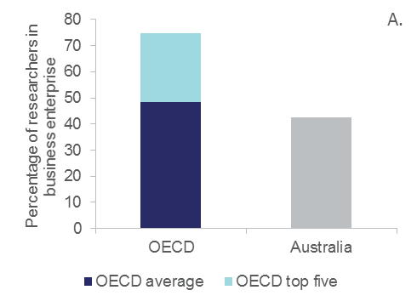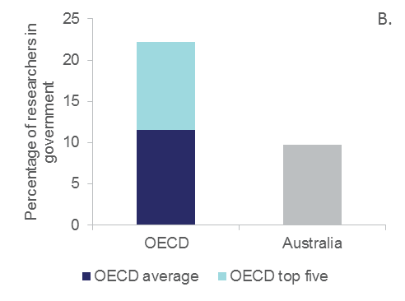

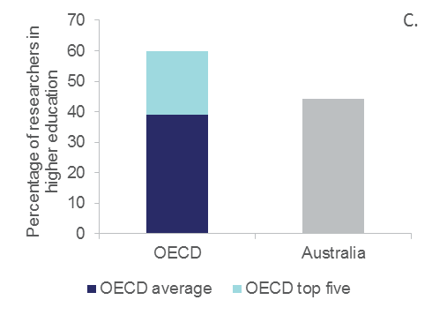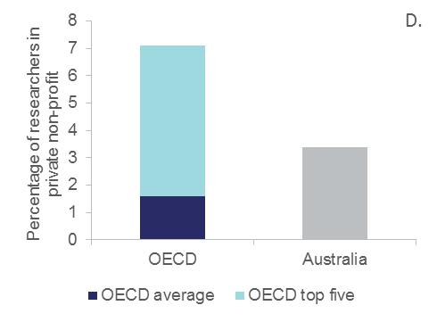

Notes: Data are shown as full-time equivalent. For a number of countries, methodological improvements were adopted over the period 2003–13, which may hinder data comparisons over time. In the USA 31.3 per cent of researchers are classified as ‘not elsewhere classified, estimates’ which hinder data comparisons. The top five countries are: (A) Israel (2012), Korea, Japan, Sweden and United States (2012); (B) Luxembourg, Mexico (2011), Slovenia, Greece and Hungary; (C) Slovak Republic, Greece, United Kingdom, Portugal and Chile; (D) Chile, Portugal, Mexico (2011), Australia (2012-13) and Italy.

Source: OECD (2015) Research and Development Statistics Database

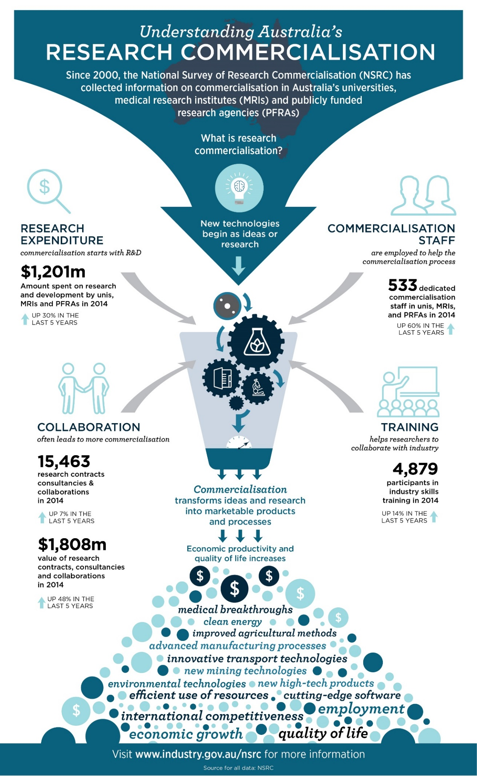

Source: National Survey of Research Commercialisation (2016)

# Framework conditions

This chapter discusses a range of innovation system framework conditions, including the availability of human capital (e.g. skills), organisational capital (e.g. employee share schemes), and financial capital (e.g. venture capital and later-stage private equity).

## Broad indicators of framework conditions in Australia

A range of indicators for framework conditions is presented in [Table A5](http://www.industry.gov.au/innovationreport). Overall, framework conditions in Australia are strong: the economy is growing, entrepreneurial intentions are at their highest to date, and there is sufficient financing available for business activity. In 2015, the unemployment rate returned to its 2012 level, a decrease of around 0.4 percentage points from 2014 ([Table A5](http://www.industry.gov.au/innovationreport)).

A side effect of capital intensification and innovation—especially disruptive innovation—can be the temporary displacement of employees. When compared to other OECD countries, Australia has been successful at providing new jobs relatively quickly to these workers, as on average over the period 2002–13 almost 70 per cent of displaced employees became re-employed within one year, and almost 80 per cent found a new job within two years.[66] Re-employment rates are higher in Australia than in most other OECD countries. Notwithstanding, a significant minority of those re-employed do not gain a high-quality job, and finding a new job is more difficult for older, casual or part-time employees.

While employment conditions may be relatively stable, the NAB Business Confidence Survey shows a drop in confidence, with the index falling from 7.0 in 2014 down to 5.4 in 2015 ([Table A5](http://www.industry.gov.au/innovationreport)). While business conditions are strong, supported by record low interest rates and a slightly more favourable Australian dollar, business confidence is not as resilient due to the prevailing uncertainty in the global economy and financial markets. Businesses have indicated that government policy and regulatory compliance costs are becoming an increasingly important factor affecting confidence in the future.[67]

Nonetheless, in the 2015–16 Global Entrepreneurship Monitor, Australia recorded its highest level of entrepreneurial intentions (the proportion of 18- to 64-year-olds expecting to start a new businesses within the next three years), at 14.4 per cent (up from 10 per cent in 2014). This puts Australia above the USA (12.4 per cent) and the UK (8.2 per cent).[68] This level was below developing regions (Asia and Oceania average 21.6 per cent; Africa 39.3 per cent) where entrepreneurship is more likely to be driven by necessity rather than opportunity. When countries become wealthier and real wages rise, there is a natural decline in entrepreneurship rates as the opportunity cost of starting a new business (as opposed to being a wage earner) increases, particularly if the primary motive for starting a business is economic necessity.[69]

## Intellectual property protection trends in Australia

Intellectual property (IP) protection is an intermediate output measure of innovation, signalling the creation of more novel innovations (see glossary). Innovative exporters[70] are almost twice as likely to invest in IP as non-innovative domestic exporters, and there is generally a high correlation between patenting and trademarking strengths, and the international competitiveness of a sector.

Between 2005 and 2008, Australian businesses that used complexity of design to protect the IP of their innovation were 204 per cent more likely to be introducing new-to-world innovations. Businesses that registered designs or used secrecy/confidentiality agreements were 129 per cent and 92 per cent more likely to be introducing new-to-world innovations respectively.[71] Interestingly, neither patents nor trademarks appeared to have a significant association with innovation novelty; however this economy-wide study did not disaggregate results by industry. Manufacturing uses patents, but many service sectors do not.

Well-developed and strong IP regimes promote trade as a channel of technology transfer, particularly for industries that are R&D intensive.[72] Research undertaken by IP Australia found that improving IP protection and enforcement regimes in destination countries would increase Australia’s exports of elaborately transformed manufactures to those same countries.[73] This finding is consistent with the idea that higher value-added sectors tend to be more R&D intensive, and hence more reliant on IP rights both domestically and internationally. There is a significant correlation between IP protection, R&D, and new-to-market innovation around the world (Chapter 3).

In absolute terms, Australia has seen a significant increase in IP-related applications for 2015.[74] Trademark applications, patents, designs and plant breeder’s rights all increased in 2015. However, over the past decade Australia’s share of global IP relative to its population has declined ([Table A2](http://www.industry.gov.au/innovationreport)). This trend is consistent with a decline in new-to-market innovation, but consistent with a large increase in IP application in China as part of the increasing legal convention.

Around 10 per cent of innovation-active Australian businesses applied for patents (ranked at 23 out of 26 countries),[75] nine per cent registered a design (ranked at 21 out of 23 countries), 29 per cent registered a trademark (ranked at 15 out of 24 countries) and 31 per cent indicated that they were using trade secrets (ranked at 18 out of 22 countries).

Businesses that innovate ten or more times per year are almost twice as likely to use some type of IP protection, compared to businesses that innovate less than three times a year (Figure 5.1). This effect is particularly true for SMEs, and is consistent with the positive relationship between innovation frequency and new-to-market innovation. Larger businesses also see a positive correlation between frequency of innovation and IP protection, however the increase in the use of IP is less dramatic.

Figure .: Intellectual property protection activity, by innovation frequency, 2014-15

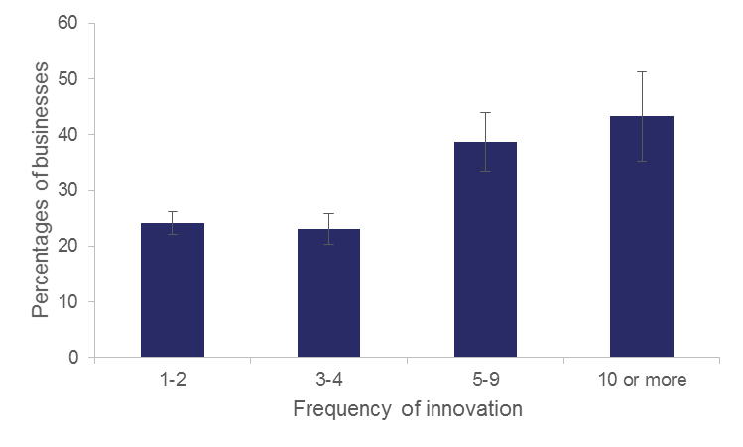

Notes: The error bands show a 95 per cent confidence interval.

Source: Customised ABS data commissioned by the Department of Industry, Innovation and Science

## Venture capital trends in Australia

Young innovative businesses often encounter obstacles in obtaining seed and early-stage financing because of uncertain profit and growth expectations and a general lack of collateral or track record.

In a recent inquiry into business creation in Australia, the Productivity Commission reviewed access to finance for new businesses.[76] The report showed that many new businesses do not require external financing, that innovation-active businesses are more likely to identify access to finance as a barrier to innovation, and that personal finance is the dominant source of finance for micro and small start-up businesses. Drawing on a limited body of conflicting evidence, the Productivity Commission concluded that equity finance, on average, was not an issue for Australian entrepreneurship.

The Treasury’s recent financial inquiry (Murray inquiry) found that new SMEs have more difficulty than large businesses accessing bank loans. This is because banks’ business models and expertise are more suited to providing debt finance to established businesses, with venture capital more suited to start-up businesses in emerging industries.[77] Often the business concepts and technologies of innovative start-ups that are not yet generating revenue, and that have predominantly intangible assets, are judged by financial institutions as unviable investments.[78]

As a specialised form of private equity finance, venture capital can stimulate innovation, spur entrepreneurship, and enhance productivity growth. Venture capital is a form of private equity used to fund costly, high-risk, high-return technology-based innovative businesses at the pre-seed, seed, start-up, and early-expansion stages of commercialisation.

In real terms, Australian venture capital and later-stage private equity investment in 2014–15 is 82.5 per cent of what it was in 2005–06.[79] Over that period there was a substantial decrease in the amount of venture capital and later-stage private equity being invested in new companies, with capital instead being channelled into follow-on investments in existing companies.

The value of new investments was three times that of follow-on investments in 2014–15. Before the Global Financial Crisis, this ratio was around four to five times. Australian data[80] indicate that investment commitments have also fallen almost as sharply as actual investment values over the same period. Over the past decade:

* The number of new investments per year declined from 259 to 76 between 2005–06 and 2012–13. However, during 2013–14 and 2014–15 the number of new investments increased to 151.
* The value of total investments (new and follow-on) decreased from $3.0 billion to $1.1 billion in real terms between 2007–08 and 2012–13. Total investments recovered somewhat over the period 2013–2015, with a value of $1.7 billion in 2014–2015.
* *Information media and telecommunications* and *Health care and social assistance* sectors had the highest number of total investments in 2014–15. The *Information media and telecommunication* sector had the highest number of new investments at 49, while the *Health care and social assistance* sector had the highest number of follow-on investments at 34.
* Both the number and value of venture capital and later-stage private equity investments show signs of recovery in 2014–15. The leveraged buyout and initial public offer saw the biggest recovery in real terms, increasing from $16 million to $938 million between 2010–11 and 2014–15.

As expected, the frequency of venture capital investments declines as investment amounts increase (see Table 5.1). This decline is especially visible for the pre-seed/seed/start-up category. Early- and later-stage expansion stages also see a significant decline as investment range increases. This decline may reflect either a decrease in demand or a shortage of funding supply.

Currently, there are no accurate and robust measures of demand for venture capital in Australia. The Department is working with the ABS to further develop the BCS to better estimate demand for debt and equity finance in Australia.

While Australia is performing slightly above the OECD median for later-stage investment as a percentage of GDP, early-stage investment as a percentage of GDP (at 0.007 per cent) is just half the OECD median (0.015 per cent of GDP).[81] Unlike the US, Israel and many other countries in the OECD, Australian venture capital investment is experiencing a delayed return to pre-GFC levels ([Table A5](http://www.industry.gov.au/Office-of-the-Chief-Economist/Publications/Pages/Australian-Innovation-System.aspx)).

The rate of venture backing per thousand businesses is on the low side compared with other OECD countries.[82] Although the average investment per business is moderately ranked at US$1.5 million, Australia has the lowest investment in high-risk, early-stage venture capital (i.e. seed, start-up and other early-stage investment) compared with other OECD countries. This is the case both in terms of the number of businesses invested in and the proportion of money invested.

In 2013–14 a major venture capital fund, valued at $250 million, was created by AirTree Ventures. This surpasses the $200 million venture capital fund created last year by Blackbird Ventures. The AirTree fund represents a major increase in venture capital in Australia, accounting for around 21 per cent of new and follow-on investment in 2013‑14.

Table .: Number of investee businesses receiving venture capital and later-stage private equity, by investee stage, by investment range, 2014-15

|  |  |  |  |
| --- | --- | --- | --- |
|  | **Stage of Investee Company** | | |
| Investment range | Pre-seed / Seed / Start-up | Early expansion / Late expansion | Turnaround/LBO/IPO |
| Less than $2 million | 126 | 65 | 17 |
| $2 million to less than $5 million | 9 | 22 | 9 |
| $5 million to less than $10 million | 4 | 4 | 7 |
| $10 million to less than $20 million | - | 8 | 6 |
| $20 million or more | - | 12 | 9 |
| Total | 142 | 111 | 48 |

Notes: Missing cells have been confidentialised due to low counts.

Source: Customised ABS data commissioned by the Department of Industry, Innovation and Science

## Product market regulation

Product Market Regulation (PMR; see glossary) can influence the process of creative destruction by reducing competitive pressures on incumbent businesses and making it harder for new challengers to establish themselves in a market. Research suggests that there are large differences across the OECD in the growth performance of new businesses after they enter the market.[83] These differences may partly reflect the influence of product market regulation.

The OECD measures barriers to entrepreneurship using its Product Market Regulation Database (Methodology 5.1).

Barriers to entrepreneurship include the administrative burdens on start-ups (costs of creating a new business), the regulatory protection of incumbents, and the complexity of regulatory procedures.

In 2013, Australia was ranked 17th out of 34 OECD countries in the overall barriers to entrepreneurship indicator (see Figure 5.2, Panel A). Notwithstanding, the decomposition of the barriers to entrepreneurship reveals that Australia had the lowest burdens on start-ups in the OECD (1st out of 34 countries, Panel B), high complexity of regulatory protection (23rd out of 34 countries, Panel C), and very high regulatory protection of incumbents (32nd out of 34 countries, Panel D). Hence, in Australia there are low initial costs associated with creating a new business, but once created, businesses then have to negotiate higher levels of business regulation, which can become costly. High regulatory protection can favour incumbents, and can make it hard for new businesses to establish themselves in the market.[84]

Figure .: Barriers to entrepreneurship (panel A), administrative burdens on start-ups (panel B), complexity of regulatory procedures (panel C) and regulatory protection of incumbents (panel D), 2013

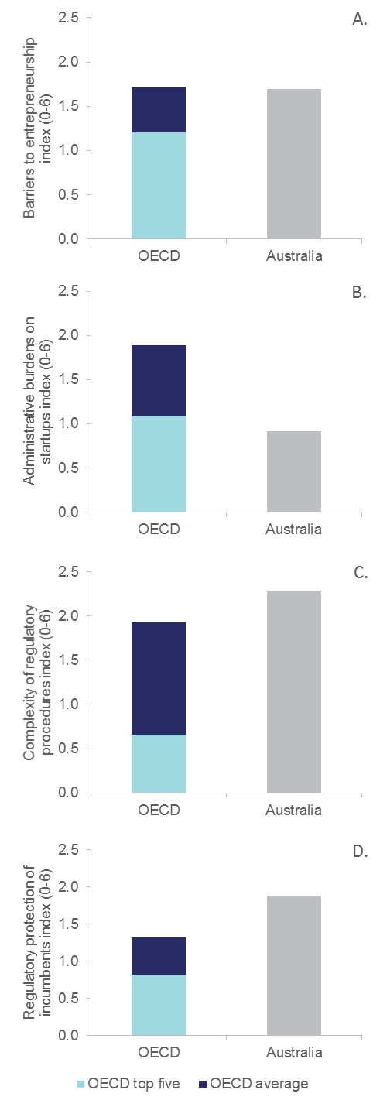

Notes: Indices range from 0 to 6, where the lower the score, the less of an impediment is the regulatory barrier. The top five countries are thus those with the lowest scores, and are (A) Slovak Republic, New Zealand, Netherlands, Italy and Denmark; (B) Australia, New Zealand, Chile, Switzerland and Netherlands; (C) Portugal, Slovak Republic, Italy, Hungary and Austria; (D) United Kingdom, Estonia, Czech Republic, Austria and Slovak Republic.

Source: OECD (2016) Product Market Regulation Database

Methodology .: The OECD’s product market regulation database

| Since the late 1990s, the OECD has been constructing a system of indicators to measure ongoing developments in PMR. These indicators have been condensed over time to form a new integrated PMR indicator. The PMR indicator is constructed from 18 base indicators that are grouped into three main components: state control, barriers to entrepreneurship, and barriers to trade and investment.  The disaggregation of the PMR indicator into these three components suggests regulations that inhibit competition are higher in state control (OECD average 2.2) and barriers to entrepreneurship (OECD average 1.7) than in barriers to trade and investment (OECD average 0.5). High scores on barriers to entrepreneurship are usually driven by complex regulations and high administrative burdens on new entrants. |
| --- |

## Australian Employee Share Schemes

Attracting skilled employees is extremely important to enable businesses to innovate and grow. Survey data indicates that the top reason for businesses to introduce an Employee Share Scheme (ESS; Definition 5.1) in Australia is to motivate, attract and retain competitive and valuable employees,[85] so an ESS is a form of organisational capital building. There is also evidence that an ESS programme indirectly encourages risk taking, entrepreneurship and investment — all important factors in fostering innovation.[86]

Over the past twenty years there have been two federal parliamentary inquiries[87] into ESS that found, executive remuneration aside, ‘very little of a substantive nature is known about employee share plans in Australia at all’.[88] We recently undertook an Australian first research project using cross-sectional and panel analysis of ABS Economic Activity Survey data and Australian Tax Office data (Methodology 5.2) to identify some of the characteristics and performance of businesses engaged in ESS over the period 2006–07 to 2014–15.

ESS activity has been steadily rising in Australia, albeit from a very low base. ESS payments grew to just over $2 billion in 2014-15, and accounted for approximately 0.4 per cent of total wages and salaries in Australia (Figure 5.3). The majority of ESS spending is by mature businesses (86 per cent in 2014-15), particularly large, mature businesses (65 per cent in 2014-15). More specifically, the use of ESS is most common in large, mature businesses in the mining, professional, scientific and technical services, or finance and insurance services industries.

Despite being much less likely to use an ESS, when small businesses do, they have a greater percentage of employees receiving ESS and it represents a significantly higher share of their annual total labour costs. For every dollar spent on wages by SMEs, approximately 25–53 cents were paid as share-based payments, when compared to only three cents for every dollar in large organisations.

Definition .: Employee Share Schemes

| An employee share scheme (ESS), also referred to as an employee share option plan, employee share ownership scheme, or an employee equity scheme, is a remuneration scheme under which businesses offer to their employees shares, stapled securities, or rights to acquire them (options). |
| --- |

Methodology .: Measuring the incidence and impact of ESS in Australia

| Our study used two main data sources: the BLADE (see glossary) from the ABS, and Australian Tax Office (ATO) data, including Business Activity Statements and Pay-As-You-Go information.  The Economic Activity Survey (EAS) is contained within the BLADE. The relevant survey question of the EAS form asks for employee share-based payments and stock options (analogous to an ESS), expensed to the business or organisation remunerating employees, and accrued during the current period. As such this information does not discriminate between narrow- or broad-based ESS.  Demographic information such as business age, size or industry classification, are derived by a combination of data from the ABS Business Register and historical ATO reporting patterns.  EAS uses stratified random sampling to produce population estimates of economic activity in Australia as published by the ABS in Australian Industry (ABS cat no. 8155.0). EAS data is collected annually for the fiscal year ending June 30 and each iteration contains approximately 20 000 businesses.  Our study contrasts ESS and non-ESS businesses of the same age, size class and sector, recognising that these businesses are likely to use the same labour market and have similar human resource management practices. Most international studies examining the effects of ESS on productivity use cross-sectional data. |
| --- |

ESS schemes are seen as a way for business owners to attract and retain valuable employees, and enhance employee innovation and productivity. Our research showed that businesses with ESS payments had on average a lower level of employee churn, higher wages per employee, and higher labour productivity, compared to other businesses of a similar size or age (Figure 5.4). This productivity difference was strongest for SMEs.

Figure .: Total share based employee share payments by business size and age class, 2006-07 to 2014-15

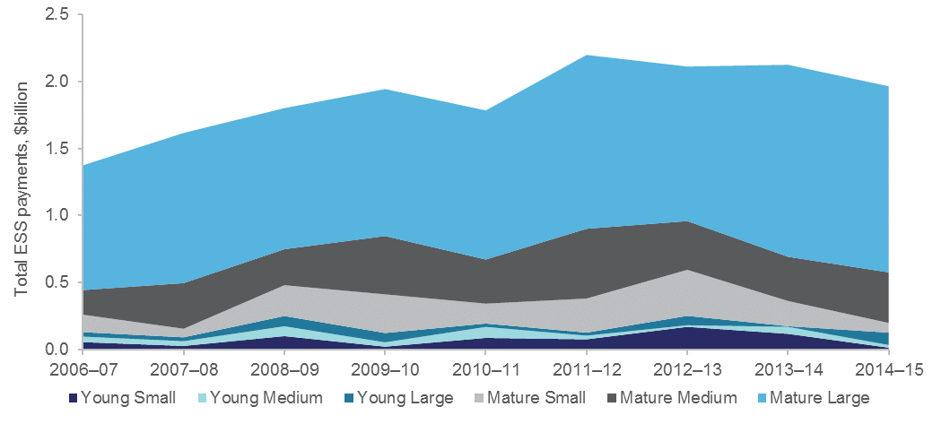

Notes: Data is the weighted sum of employee share-based payments and stock options, expensed to businesses/organisations for remunerating employees accrued over each financial year. Small businesses have 1-19 employees, medium businesses have 20-199 employees and large businesses have 200+ businesses. Young businesses are less than six years old. Mature businesses are 6+ years old. Averages incorporate all industry classes.

Source: ABS (2016) Economic Activity Survey, 2006–07 to 2014-15

Figure .: Mean difference of value added per employee between ESS and Non-ESS businesses, by size and age class, 2006-07 to 2014-15

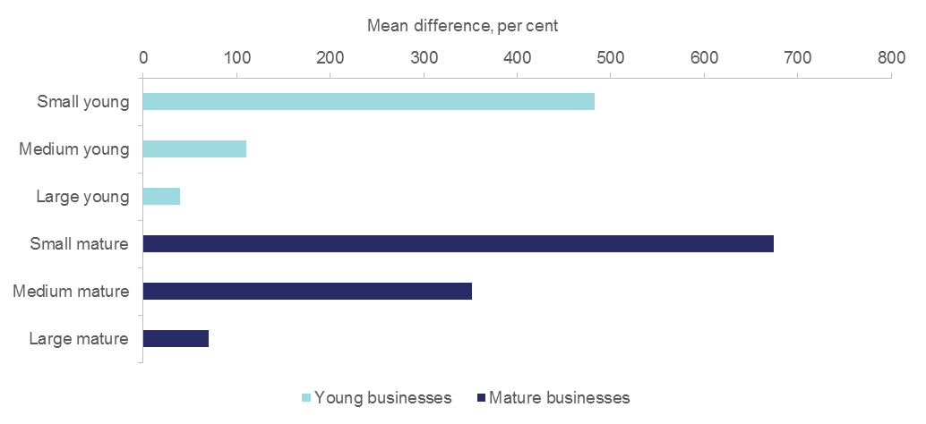

Notes: This figure shows the differences between means (ESS minus non-ESS) in percentage terms. For example small, young businesses with ESS had almost five times greater labour productivity than their non-ESS counterparts. Small businesses have 1-19 employees, medium businesses have 20-199 employees and large businesses have 200+ businesses. Young businesses are less than six years old. Mature businesses are 6+ years old. Averages incorporate all industry classes.

Source: ABS (2016) Economic Activity Survey 2006–07 to 2014-15

ESS programmes can be either narrow-based (e.g. targeting the CEO and executives) or broad-based (targeting most or all employees). The international evidence is mounting that broad-based ESSs generate greater benefits to business performance if regularly offered to employees than narrow-based schemes do. Our data suggests that the greatest impact of ESS is seen in Australian SMEs. The data may suggest that ESS tax policy in Australia should generally exclude narrow-based ESS schemes (executive remuneration) for large businesses where any productivity dividend from public support would be expected to be the lowest.

Future work could examine the impact of broad-based versus narrow-based ESS schemes on financial performance of SMEs and large businesses in Australia. Such analysis would be possible if the ABS and the ATO collaborate to clean and connect ATO ESS data to the BLADE. The Economic Activity Survey could also be refined to differentiate between narrow- and broad-based schemes using a dummy variable.[89]

To find out more about this research, click [here](http://www.industry.gov.au/innovationreport).[90]

## Australia’s skills base is growing

Innovation-active businesses report high usage and shortages/deficiencies in all skill types, not just science, engineering and technology skills (Figure 5.5).[91] Lack of access to skills was the second-highest barrier to innovation in 2014-15, but this percentage has been steadily declining over the past decade.

[Table A6](http://www.industry.gov.au/innovationreport) shows a range of indicators that measure the performance of Australia’s skills and education system. Australia’s adult literacy rates and problem-solving skills rank relatively highly in the OECD, and Australians are highly educated overall, with the proportion of the adult population (aged 25–64) attaining tertiary education reaching 43 per cent in 2015. The number of qualifications completed in the vocational education and training sector has almost doubled over the past decade. However, it is worth noting that Australia is ranked 7th out of 22 OECD countries on skills mismatch, which is consistent with business sentiment reflected in business surveys regarding access to skills.

The proportion of the population aged 25–34 with a bachelor degree or higher was 37 per cent in 2015, so university graduates make up the bulk of the 48 per cent of this particular age cohort who attained some form of tertiary education ([Table A6](http://www.industry.gov.au/innovationreport)). The rapid rise in university qualifications has been remarkable: a greater percentage of people aged 25–34 graduated with a bachelor degree or higher in 2015 than with any form of tertiary qualification in 2000.

Australia competes globally on attracting skilled migration to the country. In 2013, Australia had a net inflow of around 75,710 permanent migrants, of which 41 per cent were skilled migrants. DHL’s Global Connectedness Index ranked Australia 26thof 37 OECD+ countries on its global connectedness of people flows index, due to a combination of migration and international student numbers ([Table A3](http://www.industry.gov.au/innovationreport)). Australia also has a high share (22 per cent) of university students in Australia coming from abroad,[92] and was ranked 3rd out of 36 OECD+ countries on its share of the international education market.

Figure .: Skill shortages or deficiencies reported by all businesses, by skill type, by innovation status, 2014-15

Figure 5.5 is a clustered bar chart that shows the skills shortage or deficiency in undertaking core business activity by innovation status in 2014–15. Innovation-active businesses reported higher levels of skills shortages or deficiencies than non-innovative-active businesses. Innovation-active businesses report the following percentages of skills shortages or deficiencies from highest to lowest: trades (12.7 per cent); marketing (9 per cent); financial (7.2 per cent); business management (5.3 per cent); IT technical support (5.2 per cent); IT professionals (4.9 per cent); Transport, plant and machinery operation (3.7 per cent); project management (2.7 per cent); engineering (2.6 per cent); and scientific and research (1.5 per cent). 
Non-innovation-active businesses report the following percentages of skills shortages or deficiencies from highest to lowest: trades (6.7 per cent); financial (2.5 per cent); marketing (1.7 per cent); business management; transport, plant and machinery operation; engineering (all 1.3 per cent); IT technical support (1.2 per cent); It professional (0.8 per cent); project management (0.5 per cent); and scientific and research (0.3 per cent). 

Source: ABS (2015) *Selected Characteristics of Australian Business, 2013-14*, cat. no. 8167.0

Methodology . Employee Earnings and Jobs (EEJ) Dataset

| The ABS has developed an experimental Employee Earnings and Jobs (EEJ) dataset containing Personal Income Tax and Business Tax data from the Australian Tax Office for 2011-12. This dataset can provide detailed and accurate information on employees such as earnings and its components, occupation levels, and the dynamics of jobs in regions and by industries. It also contains limited business financial information. The dataset is part of the ABS’ move towards developing a longitudinal Linked Employer-Employee Database (LEED).  Without a longitudinal dimension, the potential for the EEJ dataset to contribute to business dynamics research is currently limited.  With a longitudinal aspect, the LEED would assist industry policy development by helping us understand the impact of organic versus acquisitive entrepreneurship on aggregate employment and economic growth. Further integrating the LEED with the BLADE will provide rich data about employers as well as employees.  With an expanded data coverage and integration with the BLADE, the LEED would allow us to more accurately measure the contribution of different skills or occupations to business innovation and growth. |
| --- |

## Academic research trends

Tables [A8](http://www.industry.gov.au/innovationreport) to [A10](http://www.industry.gov.au/innovationreport) provide performance indicators of Australia’s research system. While R&D expenditure can be volatile, Australia’s research workforce and research outputs (measured by publications) have been steadily rising. Overall, research in Australia is relatively strong, and Australian universities have risen in global rankings over the past decade. According to the Academic Ranking of World Universities, Australia has increased the number of its top 500 universities from 13 to 23 since 2003.[93]

Outputs: academic publications

The volume of academic publications serves as a proxy measure for the stock of knowledge being generated and diffused, with the number of associated citations demonstrating their value. Australian academic publications accounted for 3.9 per cent of global market share in 2015 ([Table A9).](http://www.industry.gov.au/innovationreport) This proportion has increased steadily over the past decade, and Australia now ranks 9th out of 37 OECD+ countries. However, in terms of relative citation impact, which measures the impact of national research compared to the impact of global research, Australia’s rank is lower but still above the OECD+ average at 14 out of 37 OECD+ countries.

The different ranking between publication volume and citation impact may reflect the different topics and subjects being published across countries, or that Australian universities value (and are rewarded for) publication volumes rather than necessarily their quality or commercial application.

Nonetheless, Australian research publications comprise over seven per cent of the world’s top one per cent highly cited publications across all disciplines ([Table A9).](http://www.industry.gov.au/innovationreport) Of Australia’s most highly cited publications, three-quarters were attributed to international collaboration. Australia’s engineering and natural science publications take a greater share of the top one per cent of highly cited publications than the OECD+ average. They account for less than those related to social sciences and humanities.

Outputs: graduating students

The number of students completing higher degrees by research in Australia has grown slowly but consistently in recent years, almost doubling between 2000 and 2014 ([Table A8](http://www.industry.gov.au/innovationreport)). International students have been responsible for much of the observed growth in the completion of research degrees. Indeed, from 2010 to 2014 the number of international students increased at an average rate of 1.74 per cent per annum, compared to an average of only 0.34 per cent for domestic students.

Appen: A case study of an innovative, high-growth firm

| Appen sound booth |
| --- |

| Logo says 'A global leader in language, search and social technologies' |
| --- |
| How do people and machines ‘talk’ to one another? For example, search engines, e-commerce sites and navigation systems all need to be able to communicate accurately in an increasingly wide range of natural languages. Appen is a world-leading provider of high-end speech, text and language technology services. Using its expertise in speech, search and linguistics, Appen assists clients with applications in devices and technology that interact with humans across the globe.  Many innovative companies start with a specific customer demand that leads to a custom ‘solution’, which in turn offers a glimpse at a wider opportunity. The starting point here happened in the 1990s, when US technology company Nuance approached Dr Julie Vonwiller. As a linguistic expert at the University of Sydney, her assistance was required to improve the voice recognition functionality of Nuance’s systems. Appen’s co-founder and current Chair, Chris Vonwiller, who had been an engineer and senior manager in Telstra, brought corporate experience and an awareness of the opportunity of the increasing role of natural language in the human-machine interface. Their combined expertise, and the dual market-technology insight that it shaped, led to the formation of Appen. Through periods of fast and slow growth, Appen’s turnover grew to over $82 million. From the outset Appen was managed by executives with extensive prior industry experience. It listed in 2015.  Appen had to develop a unique business model for a rapidly evolving business. The combination of linguistic and technological expertise is its key asset, but in the early years it was difficult to find skilled human resources to keep up with growth. Appen used networks among academic and professional linguists, and tried different forms of contracting before developing its global network.  While Appen now has a core staff of over 230, it has built a global network of over 350 000 individuals to whom it can outsource specific language tasks—its selective ‘crowd’. It has also developed the capability to grow, select and manage this diffuse asset, combining competition among suppliers with strong internal quality control. The capacity to recruit individuals with language skills and then mobilise its crowd enables Appen to respond rapidly and flexibly to customer demand. Australia’s multicultural and multilinguistic population is a strong locational asset for Appen.  Appen’s founders saw the market was clearly global, and at an early stage looked for entry to the US economy. Finding a US customer was the first step to establishing a US presence. Although the US is still the major market, Appen has customers in Europe and supports its international network of independent contractors from an operation in the Philippines.  In 2009 the private equity group Anacacia invested in Appen and began facilitating international acquisitions. In 2011, Appen acquired a complementary US business, Butler Hill, which focused on the application of linguistics to internet-based search and text analytics. In 2012 Appen acquired the business Wilkman Remer. Butler Hill, and its major client Microsoft, strengthened Appen’s position in the US market, although it also led to a high level of dependence on a single customer.  ‘We have very little revenue derived locally,’ CEO Mark Brayan says. ‘A third of our resources are local and the other two-thirds are around the world. The success of Australian tech businesses often depends on how effectively and quickly they can go offshore to reach bigger markets’. Even for web-based businesses, proximity to customers is important, particularly to generate sales.  Mark sees three foundations for sustained high growth at Appen:   1. High demand: ‘Our services have been in high demand due to the growth in interaction between people and technology, and the need to extend accurate language interpretation to include more and more languages’. 2. Capability and flexibility: ‘We have built, and continue to strengthen, a capability base that provides both a high level of expertise across all relevant languages—and the application of our linguistic capability to information technology applications—and a high level of flexibility, through the use of “managed crowd-sourcing”’. 3. Scale: ‘And our business model is scalable’.   Growth, particularly the transformation into a public company, led to the need to formalise corporate management. In 2015 Mark Brayan was appointed CEO, bringing extensive experience in leading IT businesses. Mark notes: ‘more recently a CFO, Head of HR and Recruiting and Head of IT were recruited. Since listing, our culture is very results oriented’. Nevertheless, for an organisation dependent on the specialist expertise of its staff, Appen consciously seeks to maintain a ‘happy ship’: staff engagement is assessed, individuals have performance plans and management incentives in the form of shares.  Appen aims to maintain its high growth by entering and increasing its position in more international markets, finding markets in other applications in the IT industry, expanding into government markets, and making further acquisitions. However, Appen faces competition in its two main markets. In the ‘speech’ market, its competitors are either university consortia or smaller, regional businesses that focus on a specific language or group of languages. In the ‘search’ market, the main competitors are the large localisation businesses. Nevertheless, Mark is confident that Appen’s strong technical capabilities and global network are up to the challenge: ‘Our breadth of linguistic capability and our high level of quality assurance are critical to maintaining our competitiveness’. Disruption is always possible, if not inevitable, in the IT sector, and in the longer run improvements in machine learning may impact the market. |

Figure .: Appen’s turnover growth, indexed, 2011–12 to 2015–16

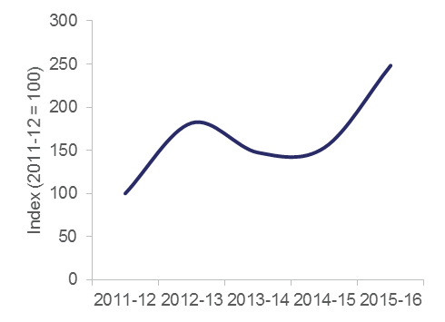

Notes: Turnover is indexed from 2011–­12. 2011–12 is 100. The line has been smoothed.

Source: Appen Ltd (2015) *Annual Report 2015*, Appen Ltd; Appen Ltd (2014) *Prospectus*, Appen Ltd.

Authors: UTS Business School MCS Research Team and Abasi Latcham.

## The role of government in the innovation system

Governments across Australia play an important role in supporting innovation (Figure 5.8). People typically think of innovation policy as direct grant support for R&D or commercialisation projects, but this is a simplistic view.

Governments’ abilities to influence rates of innovation through direct financing of innovation projects is limited. The percentage of Australian businesses receiving public support for innovation is low and, at seven per cent, is currently the lowest in the OECD (Figure 5.7).[94]

Innovation policy encompasses many elements of research, industry, social inclusion, education, competition, and trade policy that have an impact on the innovation system. The Australian Government’s recently announced NISA is an example of broader, co-ordinated innovation system policy.[95]

Currently, the Australian Government’s most significant influence on the innovation system is indirect, through policy and regulatory settings or through investments in infrastructure, health, education and research. Most of the direct investments made by the government are in research and education. Historically, the government has directly supported innovation activity in cases where the private or community sectors do not have sufficient economic incentives to invest, for example through the provision of early-stage venture capital and tax incentives for R&D. Other aspects of the innovation system have increasingly been supported, for example by building SME management capability and through the procurement of innovative goods and services.

The government sets an example of innovative entrepreneurship by investing in high-risk, high-reward research and transformative approaches. The government creates a stream of new insights and technological breakthroughs through its R&D investment, many of which will be commercialised by the private or community sectors. Education policy creates a skilled workforce, crucial for innovation, and government-built physical and digital infrastructure is not only fundamental to economic activity but also enables new goods, services and business models to develop.

Previous AIS reports have shown that businesses are the major investors in innovation for economic development by using R&D expenditure as an imperfect proxy for investment in innovation (see further below). Nonetheless, governments make complementary R&D investments in areas that are high risk, for basic research, or where business R&D investment is relatively limited, for example, in defence, health and environmental protection.[96]

Figure .: International ranking on public support for innovation, 2010–12

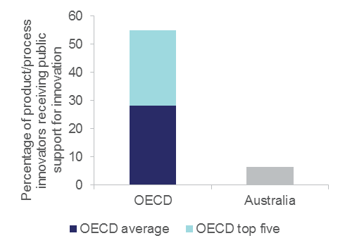

Notes: OECD comparisons exclude businesses with fewer than ten employees. Industry core coverage includes ISIC Rev. 4 Sections and Divisions B, C, D, E, G46, H, J, K, M71-72 and 73. Only enterprises with 10 or more employees are covered. The OECD top five countries are Canada, Korea, France, Netherlands and Hungary.

Source: OECD (2015) *OECD Innovation Indicators Database,* [www.oecd.org/innovation/inno/inno-stats.htm](http://www.oecd.org/innovation/inno/inno-stats.htm)

Figure .: The innovation cycle and the role of government

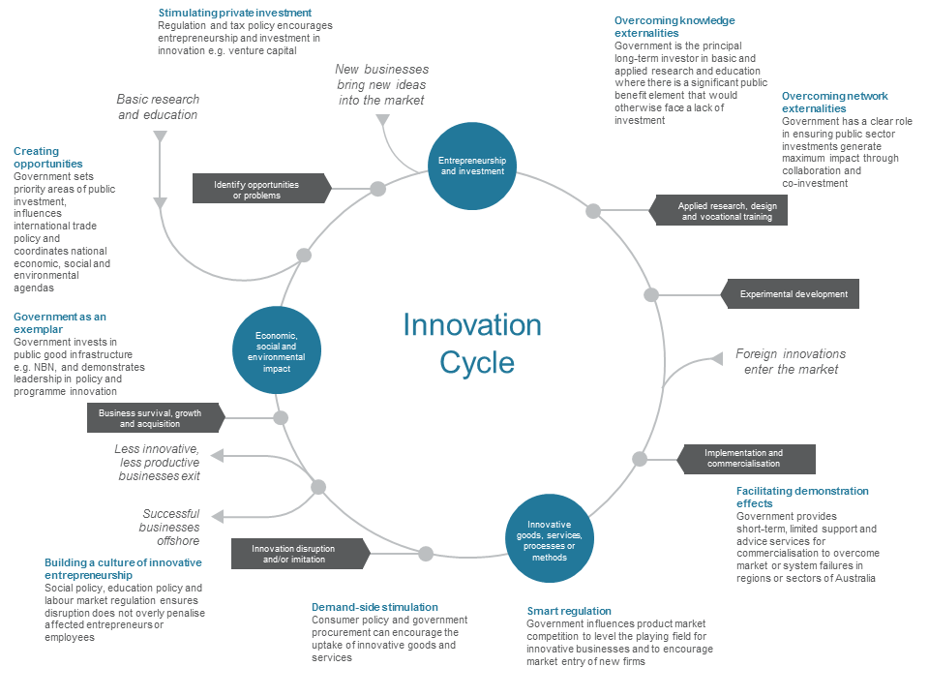

The Australian Government’s role in supporting R&D

The Australian Government supports R&D in a number of ways, both directly and indirectly. The government expects to spend $10.1 billion on R&D in 2015–16, including $3.2 billion through the R&D Tax Incentive. This is spread across multiple sectors of the economy and multiple policy portfolios. Australia is ranked 11th out of 33 OECD countries on its government funding of R&D (Figure 5.9).

Historically, publicly-funded research has been essential to a range of significant innovations that turned out to have large economic returns. Notable examples include aviation, nuclear energy, the internet, pharmaceuticals, GPS navigation, biotechnology, artificial intelligence and robotics. In recognition of the crucial role of public funding, the OECD emphasises that a long-term and stable approach to public research funding is essential to future innovation.

The main rationale for government support of R&D is the large gap between private and social returns to R&D investment. Private returns to R&D refers to benefits generated by R&D that are fully captured by the business undertaking the R&D. Social returns happen when the R&D performed by the business spill over to individuals and other businesses (Definition 5.2).

Research has found a statistically significant and positive association between government assistance and business innovation.[97] The challenge for public policy is to support private R&D investments that would not otherwise have been made, and that generate total private and social returns that sufficiently exceed the costs.

Definition .: Identifying R&D spillovers

| R&D activities of private businesses generate widespread benefits enjoyed by competitors, suppliers, consumers and society at large. As a result, the overall economic value to society often exceeds the economic benefits that innovating businesses enjoy as a result of their R&D activities. The difference between the social rate of return that the society enjoys and the private rate of return captured by R&D performing businesses is described by economists as a positive externality or spillover of R&D. These spillovers imply that private businesses will invest less than is socially desirable in research, with the result that some desirable research projects will not be undertaken, and others will be undertaken on a smaller scale than the socially optimal level.  Studies of US, French and Japanese businesses have found private returns on R&D investment may be as high as 30 per cent and social returns are higher than 70 per cent. [98] |
| --- |

For public R&D, the social returns appear to be highest in basic research.[99] Public R&D spending includes higher education R&D (HERD) and government agencies R&D (GOVERD) as a proportion of GDP, and remained stable for a decade until 2004. Since then it has increased, driven by HERD, to reach 0.87[100] per cent of GDP in 2013 ([Table A7](http://www.industry.gov.au/innovationreport)). However, private R&D spending (including business BERD and non-profit R&D) as a percentage of GDP has decreased since 2008 to reach a value of 1.25 per cent of GDP in 2013 after sustained growth for 15 years.

Tax incentives and subsidies

The public sector can play a major role in stimulating R&D. Tax credits and direct subsidies for R&D have been found to have positive effects on business’ R&D investment. However, care should be taken in using tax credits and R&D subsidies because they can sometimes introduce risks of crowding-out and can disproportionately support incumbent businesses.[101] Australia has a relatively high share of indirect funding in terms of tax incentives compared to other countries. For 2011, Australia was ranked 3rd out of 31 OECD countries in terms of tax incentives given to the industry sector as a percentage of GDP (Figure 5.10).

Many developed countries have set, or are considering, ambitious GERD over GDP ratio targets as national goals. However, evidence to date shows that only a few countries have successfully achieved their self-imposed GERD targets.[102] Australia currently does not have a R&D target.

Figure .: Government-financed GERD as a percentage of GDP, 2011 or latest year

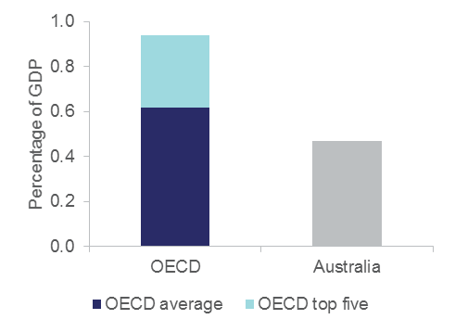

Notes: The OECD top five countries are Iceland, Austria, Korea, Finland and Sweden.

Source: OECD Main Science and Technology Indicators 2015

Figure .: Indirect funding, R&D tax incentives, 2011

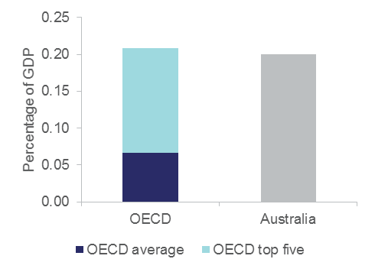

Notes: The OECD top five countries are France, Canada, Australia, Korea and Belgium.

Source: OECD Main Science and Technology Indicators 2015

# Appendix A Data tables

| *Table A1(a): Outcome indicators* | | | | | | | | | | | | | | |
| --- | --- | --- | --- | --- | --- | --- | --- | --- | --- | --- | --- | --- | --- | --- |
| *Australian Trend Data (i)* | | | | | | | | | | | | | | |
| ***Indicators*** | ***1995*** | ***2000*** | ***2005*** | ***2006*** | ***2007*** | ***2008*** | ***2009*** | ***2010*** | ***2011*** | ***2012*** | ***2013*** | ***2014*** | ***2015*** | ***2016*** |
| GDP per capita relative to the USA (USA = 100), index¹ | 78 | 77 | 80 | 81 | 82 | 82 | 88 | 87 | 88 | 84 | 89 | 85 | 82 | – |
| GDP per hour worked (USA = 100), index¹ | 81 | 83 | 79 | 80 | 80 | 79 | 81 | 79 | 80 | 79 | 85 | 83 | – | – |
| Real Gross Domestic Product (GDP) (chain volume measures), billions A$² ¹⁸ | 890 | 1,074 | 1,273 | 1,320 | 1,369 | 1,394 | 1,422 | 1,456 | 1,509 | 1,546 | 1,585 | 1,620 | – | – |
| Real Gross Domestic Product (GDP) growth from previous  year, %² | 3.9 | 1.9 | 3.0 | 3.8 | 3.7 | 1.8 | 2.0 | 2.4 | 3.6 | 2.4 | 2.5 | 2.3 | – | – |
| Gross national income, US$ per capita³ | 21,516 | 27,319 | 33,931 | 35,739 | 37,557 | 38,132 | 39,471 | 40,522 | 42,371 | 41,996 | 45,575 | 45,324 | – | – |
| Multifactor productivity annual growth/change, %⁴ | 1.212 | 0.633 | -0.065 | 0.193 | -0.144 | -0.463 | 0.529 | -0.874 | 0.809 | 1.514 | 0.693 | 0.583 | – | – |
| Index of Economic Freedom⁵ | 74 | 77 | 79 | 80 | 81 | 82 | 83 | 83 | 83 | 83 | 83 | 82 | 81 | 80 |
| Resilience of the economy, score⁶ | – | – | 7.6 | 7.4 | 6.4 | 6.8 | 5.8 | 7.0 | 7.7 | 7.3 | 6.5 | 6.8 | 5.3 | 6.2 |
| Economic Complexity Index⁷ | – | -0.17 | -0.24 | -0.22 | -0.30 | -0.48 | -0.57 | -0.46 | -0.55 | -0.57 | -0.52 | -0.63 | – | – |
| Hannah-Kay index of industrial specialisation⁸ | – | – | – | – | – | – | – | 0.55 | – | – | – | – | – | – |
| Global Competitiveness Index, score ranges from 1-7 (best)⁹ | – | – | – | 5.2 | 5.2 | 5.2 | 5.2 | 5.1 | 5.1 | 5.1 | 5.1 | 5.1 | 5.1 | 5.2 |
| Global Innovation Index¹⁰ | – | – | – | – | – | – | – | – | 49.9 | 51.9 | 53.1 | 55.0 | 55.2 | 53.1 |
| Non-energy material productivity, GDP per unit of domestic material consumption (DMC), US$/kg¹¹ ¹⁹ | 0.97 | 1.02 | 1.15 | 1.23 | 1.20 | 1.11 | 1.05 | 1.30 | 1.32 | – | – | – | – | – |
| Renewable electricity, % total electricity generation¹¹ | 9.6 | 8.4 | 8.8 | 9.3 | 8.6 | 8.1 | 7.5 | 8.6 | 10.3 | 10.0 | 12.6 | 14.9 | – | – |
| Water productivity, total (constant 2010 US$ GDP per cubic meter of total freshwater withdrawal)¹² ²⁰ ²¹ | 33.5 | 41.3 | – | – | 56.5 | – | – | – | 36.1 | 75.7 | 38.4 | 64.4 | – | – |
| UNDP Human Development Index¹³ ¹⁴ ²² ²³ | 0.87 | 0.90 | 0.91 | – | – | 0.92 | – | 0.93 | 0.93 | 0.93 | 0.93 | 0.94 | – | – |
| Environmental Performance Index¹⁵ ²¹ | – | 80.5 | 81.2 | 81.2 | 81.5 | 81.7 | 81.9 | 82.2 | 82.4 | 82.4 | – | – | – | 87.2 |
| Social Progress Index¹⁶ | – | – | – | – | – | – | – | – | – | – | – | 86.1 | 86.4 | 89.1 |
| Gini coefficient, score ranges from 0 (perfect equality) to 1 (perfect inequality)¹⁷ ²⁴ ²⁵ ²⁶ | – | – | – | – | – | – | – | – | – | 0.326 | – | 0.337 | – | – |

|  |  |  |  |  |  |  |  |
| --- | --- | --- | --- | --- | --- | --- | --- |
| *Table A1(b): Outcome indicators* | | | | | | | |
| *OECD+ Comparisons (ii)* |  |  | | | | | | |
| *Indicators* | *Australia's score (iii)* | | *OECD+ Average (iv)* | *OECD+ top 5 average (vi)* | *Gap from the top 5 OECD+ performers*  *(per cent) (vii)* | *Ranking against OECD+ countries*  *(viii)* | *Year of OECD+ comparison* | |
| GDP per capita relative to the USA (USA = 100), index¹ | 82 | | 70 | 120 | 32 | 12th of 36 | 2015 | |
| GDP per hour worked (USA = 100), index¹ | 83 | | 73 | 113 | 27 | 13th of 35 | 2014 | |
| Gross national income, US$ per capita³ | 45,324 | | 37,198 | 57,095 | 21 | 9th of 33 | 2014 | |
| Multifactor productivity annual growth/change, %⁴ | 0.583 | | 0.147 | 0.779 | 25 | 3rd of 15 | 2014 | |
| Index of Economic Freedom⁵ | 80 | | 71 | 82 | 2 | 4th of 38 | 2016 | |
| Resilience of the economy, score⁶ | 6.2 | | 5.3 | 6.7 | 8 | 8th of 38 | 2016 | |
| Economic Complexity Index⁷ | -0.63 | | 1.09 | 1.91 | 133 | 35th of 35 | 2014 | |
| Hannah-Kay index of industrial specialisation⁸ | 0.55 | | 0.56 | 0.67 | 17 | 20th of 31 | 2010 | |
| Global Competitiveness Index, score ranges from 1-7 (best)⁹ | 5.2 | | 5 | 5.7 | 9 | 19th of 38 | 2016 | |
| Global Innovation Index¹⁰ | 53.1 | | 50.7 | 62.6 | 15 | 18th of 38 | 2016 | |
| Non-energy material productivity, GDP per unit of domestic material consumption (DMC), US$/kg¹¹ ¹⁹ | 1.32 | | 2.61 | 4.09 | 68 | 13th of 15 | 2011 | |
| Renewable electricity, % total electricity generation¹¹ | 14.9 | | 34.1 | 84.0 | 82 | 25th of 34 | 2014 | |
| Water productivity, total (constant 2010 US$ GDP per cubic meter of total freshwater withdrawal)¹² ²⁰ ²¹ | 64.4 | | 129.5 | 530.8 | 88 | 19th of 36 | 2014 | |
| UNDP Human Development Index¹³ ¹⁴ ²² ²³ | 0.93 | | 0.88 | 0.93 | no gap | 2nd of 37 | 2014 | |
| Environmental Performance Index¹⁵ ²¹ | 87.2 | | 83.8 | 90.0 | 3 | 12th of 38 | 2016 | |
| Social Progress Index¹⁶ | 89.1 | | 83.2 | 89.4 | 0 | 4th of 35 | 2016 | |
| Gini coefficient, score ranges from 0 (perfect equality) to 1 perfect inequality)¹⁷ ²⁴ ²⁵ ²⁶ | 0.326 | | 0.311 | 0.252 | 30 | 21st of 34 | 2012 | |

– = data not available

***Table notes*:** **(i)** Data are presented in calendar year format. Where the data are in financial years, it is expressed in terms of the year where the financial year begins e.g. 2010–11 is shown as 2010. **(ii)** OECD+ includes all countries in the OECD, as well as China, Taiwan and Singapore (where data is available). **(iii)** The ‘Australia’s score’ field presents the Australian values used in the OECD+ comparisons. **(iv)** This is the arithmetic (simple) average of the OECD+ country scores. **(v)** This is the median of the OECD+ country scores **(vi)** This is the arithmetic (simple) average of the top five OECD+ countries in a ranked list. **(vii)** This represents Australia’s distance from the frontier as defined by the average of the top five ranked OECD+ countries. It is calculated as 100*(Top five average - Australia’s score)/ Top 5 average. Where the solution is a negative value or zero, ‘no gap’ is shown in the cell. **(viii)** OECD+ rankings are performed on those OECD+ countries for which data are available. Individual data availability may vary between indicators.

***Sources* (1 - 17)**: **[1]** OECD (2016) GDP per capita and productivity levels, OECD Productivity Statistics (database), 1/06/2016, URL: http://stats.oecd.org/; **[2]** ABS (2015) Australian System of National Accounts, cat. no. 5204.0, 2014–15, Expenditure on Gross Domestic Product (GDP), URL: http://www.abs.gov.au/; **[3]** OECD (2016) National Income, 2016, Gross national income, DOI: 10.1787/2fe06aca-en; **[4]** OECD (2016) Productivity, 2016, Growth in GDP per capita, productivity and ULC, URL: http://stats.oecd.org/; **[5]** The Heritage Foundation (2014-2016) Index of Economic Freedom, 2014 – 2016, URL: http://www.heritage.org/; **[6]** IMD (2014–2016) World Competitiveness Online, 2014 – 2016, URL: https://www.worldcompetitiveness.com; **[7]** Center for International Development at Harvard University (2016) Atlas of Economic Complexity, 2016, URL: http://atlas.cid.harvard.edu/; **[8]** OECD (2014) Structural Analysis (STAN), 2014, URL: http://stats.oecd.org/; **[9]** World Economic Forum (2014–2016) Global Competitiveness Index, 2014–15 - 2016–17, URL: http://www.weforum.org/; **[10]** Cornell University, INSEAD, WIPO (2011–2016) Global Innovation Index, GII 2011–2016, URL: http://www.globalinnovationindex.org; **[11]** OECD (2016) Green growth indicators, 2016–2, URL: http://www.oecd.org/; **[12]** World Bank (2014-2016) World Development Indicators, 2014–2016, URL: http://data.worldbank.org/; **[13]** United Nations Development Programme (2014) Human Development Index, 2014, Table 2: Human Development Index trends, 1980–2013, URL: http://hdr.undp.org/; **[14]** United Nations Development Programme (2015) Human Development Index, 2015, URL: http://hdr.undp.org/; **[15]** Yale University and Columbia University (2014–2016) Environmental Performance Index, 2014–2016, URL: http://epi.yale.edu; **[16]** Social Progress Imperative (2015–2016) Social Progress Index, 2014–2017, URL: http://www.socialprogressimperative.org/; **[17]** OECD (2015-2016) Income Distribution and Poverty, 2014–16

***Indicator notes* (18 - 26)**: **[18]** Series ID A2420912W; series type original; data type derived; collection month is June; **[19]** Reference year is 2010; **[20]** 1997 data used in place of 1995 data.; **[21]** 2002 data used in place of 2000 data.; **[22]** 1990 data used in place of 1995 data.; **[23]** See Technical note 1 (http://hdr.undp.org/en) for details on how the HDI is calculated; **[24]** A lower score is better, gap from the top 5 performers represents absolute gap; **[25]** Gini (disposable income, post taxes and transfers); **[26]** New income definition since 2012

| *Table A2(a): Indicators of Australia’s innovation and entrepreneurship activity* | | | | | | | | | | | | | | |
| --- | --- | --- | --- | --- | --- | --- | --- | --- | --- | --- | --- | --- | --- | --- |
| *Australian Trend Data (i)* | | | | | | | | | | | | | | |
| ***Indicators*** | ***1995*** | ***2000*** | ***2005*** | ***2006*** | ***2007*** | ***2008*** | ***2009*** | ***2010*** | ***2011*** | ***2012*** | ***2013*** | ***2014*** | ***2015*** | ***2016*** |
| Business expenditure on R&D (BERD), % of GDP¹ | 0.82 | 0.71 | 1.05 | 1.16 | 1.28 | 1.37 | 1.29 | 1.28 | 1.23 | – | 1.19 | – | – | – |
| Percentage of Business expenditure on R&D (BERD) financed by government, %¹ | 2.4 | 3.8 | 4.0 | 3.9 | 2.8 | 2.0 | 2.0 | 1.7 | 1.9 | – | 2.1 | – | – | – |
| Percentage of innovation-active firms, %² ³ ²⁷ | – | – | – | 37.1 | 44.9 | 39.8 | 43.8 | 39.1 | 46.6 | 42.2 | 48.3 | 45.0 | – | – |
| Percentage of innovation-active SME firms, %⁴ ²⁸ | – | – | 36.7 | – | – | 39.7 | 43.7 | 38.9 | 46.6 | 42.0 | 48.1 | – | – | – |
| Percentage of innovation-active large firms, %² ³ ⁴ ⁵ ⁶ ²⁹ | – | – | – | 66.2 | 70.8 | 66.7 | 74.3 | 65.9 | 76.0 | 74.3 | 79.5 | 73.3 | – | – |
| Proportion of businesses introducing goods or services innovation, %³ ⁷ ⁸ ³⁰ ³¹ | – | – | 19.3 | 18.4 | 21.9 | 18.2 | 19.8 | 17.3 | 20.4 | 20.0 | 24.1 | 19.3 | – | – |
| Proportion of businesses introducing operational/ process innovation, %³ ⁷ ⁹ ³⁰ ³¹ | – | – | 20.8 | 16.9 | 17.6 | 16.3 | 16.9 | 16.4 | 19.1 | 16.9 | 17.9 | 15.6 | – | – |
| Proportion of businesses introducing organisational/managerial process innovation, %³ ⁷ ¹⁰ ³⁰ ³¹ | – | – | 20.7 | 16.4 | 19.0 | 19.4 | 20.7 | 18.9 | 23.0 | 20.2 | 21.7 | 17.4 | – | – |
| Proportion of businesses introducing marketing  innovation, %³ ⁷ ¹¹ ³⁰ ³¹ | – | – | 14.3 | 12.7 | 14.6 | 17.2 | 16.7 | 16.8 | 19.9 | 18.8 | 20.3 | 16.5 | – | – |
| Proportion of innovation-active businesses innovating to reduce environmental impacts, %¹² ¹³ | – | – | – | 12.1 | – | 11.4 | – | 12.9 | – | 11.7 | – | 7.4 | – | – |
| Share of high and medium technology manufacturing as a percentage of GDP¹⁴ ¹⁵ ¹⁶ | – | – | – | – | – | – | – | 1.85 | 1.86 | 1.70 | 1.63 | 1.57 | – | – |
| Rate of high-growth enterprises in the construction sector, measured by employment growth (%)⁵ ¹⁷ ³² | – | – | – | – | 4.6 | 4.2 | 3.6 | 3.4 | 3.7 | 3.6 | 3.1 | – | – | – |
| Rate of high-growth enterprises in the industry sector, measured by employment growth (%)⁵ ¹⁷ ³² | – | – | – | – | 1.4 | 1.1 | 0.9 | 0.9 | 1.0 | 1.0 | 0.8 | – | – | – |
| Rate of high-growth enterprises in the services sector, measured by employment growth (%)⁵ ¹⁷ ³² | – | – | – | – | 1.2 | 1.1 | 0.9 | 0.8 | 1.0 | 1.0 | 0.9 | – | – | – |
| Rate of high-growth enterprises in the construction sector, measured by turnover growth (%)⁵ ¹⁷ ³³ | – | – | – | – | 9.3 | 7.8 | 6.3 | 5.7 | 6.0 | 6.0 | 5.6 | – | – | – |
| Rate of high-growth enterprises in the industry sector, measured by turnover growth (%)⁵ ¹⁷ ³³ | – | – | – | – | 2.9 | 2.5 | 1.7 | 1.6 | 1.6 | 1.6 | 1.5 | – | – | – |
| Rate of high-growth enterprises in the services sector, measured by turnover growth (%)⁵ ¹⁷ ³³ | – | – | – | – | 2.7 | 2.3 | 1.7 | 1.6 | 1.7 | 1.7 | 1.5 | – | – | – |
| Employer Enterprise Birth Rate, %¹⁸ ¹⁹ ²⁰ | – | – | 16.3 | 17.1 | 15.3 | 14.4 | 16.7 | 13.9 | 13.5 | 11.2 | 13.7 | 13.4 | – | – |
| Total early-stage entrepreneurship activity (TEA), %²¹ ²² ³⁴ | – | 14.7 | 10.5 | 11.9 | – | – | – | 7.8 | 10.5 | – | – | 13.1 | 12.8 | – |
| Employer Enterprise Death Rate, %¹⁸ ¹⁹ ²⁰ ³⁵ | – | – | 15.0 | 14.6 | 15.3 | 15.4 | 13.1 | 13.5 | 13.1 | 14.0 | 12.7 | 12.4 | – | – |
| Churn Rate, %¹⁸ ¹⁹ ²⁰ | – | – | – | – | 21.4 | 20.9 | 21.1 | 20.2 | 19.9 | 18.7 | – | – | – | – |
| 1-year survival rate (employer enterprises), %¹⁸ ¹⁹ ²⁰ | – | – | 85.0 | 85.4 | 84.7 | 84.6 | 86.9 | 86.5 | 86.9 | 86.0 | 87.3 | 87.6 | – | – |
| Patents granted by IP Australia, for Australian residents²³ ²⁴ ³⁶ | – | – | – | 924 | 1,086 | 925 | 926 | 1,178 | 1,262 | 1,311 | 1,110 | 1,199 | 1,199 | 1,614 |
| Innovation Patents by AU residents²³ ³⁷ | – | – | 926 | 918 | 1,034 | 1,028 | 1,109 | 1,127 | 1,204 | 1,205 | 1,131 | 1,021 | – | – |
| Industrial designs certified by IP Australia, for Australian  residents²³ ³⁸ | – | – | 115 | 151 | 238 | 342 | 274 | 327 | 265 | 318 | 217 | 569 | – | – |
| Triadic patent families per million population¹ | 13.1 | 26.9 | 23.6 | 17.6 | 16.4 | 14.6 | 16.0 | 13.8 | 13.9 | 13.7 | 13.6 | – | – | – |
| Patent applications filed by AU residents under PCT per million population²³ ³⁹ | – | – | – | 96 | 97 | 90 | 79 | 79 | 77 | 75 | 69 | 73 | – | – |
| Share of world triadic patent families¹ | 0.7 | 0.9 | 0.8 | 0.6 | 0.7 | 0.6 | 0.7 | 0.6 | 0.6 | 0.6 | 0.6 | – | – | – |
| Patent applications filed under PCT per million population¹ | 46 | 91 | 103 | 99 | 96 | 85 | 84 | 78 | 79 | 76 | 77 | – | – | – |
| Development of environment-related technologies, % all technologies²⁵ | 9.63 | 7.77 | 6.16 | 6.24 | 8.60 | 8.95 | 10.52 | 10.70 | 9.97 | 8.63 | – | – | – | – |
| Development of environment-related technologies, inventions per capita²⁵ | 5.18 | 7.27 | 1.40 | 1.37 | 2.05 | 1.74 | 1.77 | 1.85 | 1.97 | 1.58 | – | – | – | – |
| Diffusion of environment-related technologies, % all  technologies²⁵ | 6.9 | 5.8 | 7.0 | 7.5 | 8.9 | 10.4 | 11.1 | 12.1 | 10.8 | 9.3 | – | – | – | – |
| Environmentally related government R&D budget, % of total government R&D²⁵ | 1.2 | 3.0 | 1.8 | 2.3 | 2.8 | 2.7 | 4.1 | 3.8 | 3.3 | 3.9 | 3.8 | 4.0 | – | – |
| Renewable energy public research, development and demonstration (RD&D) budget, % of total energy public RD&D²⁵ ³⁴ | 4.6 | 9.9 | 12.4 | 14.6 | 16.0 | 13.8 | 19.3 | 20.2 | 33.6 | 33.4 | 53.9 | 25.5 | – | – |
| Energy public research, development and demonstration (RD&D) budget, % of GDP²⁵ ³⁴ | 0.02 | 0.02 | 0.02 | 0.03 | 0.03 | 0.03 | 0.04 | 0.03 | 0.04 | 0.05 | 0.06 | 0.02 | – | – |
| Madrid system trademark registrations by country of origin²⁶ | – | – | – | – | – | – | – | – | – | – | 16.3 | – | – | – |
| Patent Cooperation Treaty resident applications, per billion PPP$ GDP²⁶ | – | – | – | – | – | – | – | – | 27.8 | 80.5 | 31.5 | 31.4 | 19.2 | 21.5 |
| Industrial design registrations (AU resident) per million  population²³ ⁴⁰ | 121 | 98 | 136 | 168 | 110 | 113 | 119 | 111 | 111 | 107 | 125 | 111 | – | – |
| Trade Mark applications from Australian residents²³ ²⁴ | 19,036 | 27,175 | 38,193 | 40,246 | 39,754 | 38,211 | 38,308 | 39,554 | 40,066 | 41,106 | 39,682 | 41,686 | 47,081 | – |
| Trademark registrations (AU resident) per million population²³ ⁴⁰ | 429 | 504 | 1,091 | 1,120 | 1,221 | 1,245 | 1,123 | 1,077 | 1,062 | 1,063 | 1,069 | 994 | – | – |
| National office resident trademark registrations, per bn PPP$ GDP²⁶ | – | – | – | – | – | – | – | – | – | – | 26 | – | – | – |
| Plant breeder’s rights applications from Australian residents²⁴ | – | – | – | 171 | 174 | 192 | 186 | 176 | 179 | 138 | 134 | 137 | 156 | – |

| *Table A2(b): Indicators of Australia’s innovation and entrepreneurship activity* | | | | | | | |
| --- | --- | --- | --- | --- | --- | --- | --- |
| *OECD+ Comparisons (ii)* |  |  | | | | | | |
| *Indicators* | *Australia's score (iii)* | | *OECD+ Average (iv)* | *OECD+ top 5 average (vi)* | *Gap from the top 5 OECD+ performers*  *(per cent) (vii)* | *Ranking against OECD+ countries*  *(viii)* | *Year of OECD+ comparison* | |
| Business expenditure on R&D (BERD), % of GDP¹ | 1.19 | | 1.34 | 2.78 | 57 | 15th of 35 | 2013 | |
| Percentage of Business expenditure on R&D (BERD) financed by government, %¹ | 2.1 | | 7.4 | 13.6 | 84 | 31st of 34 | 2013 | |
| Percentage of innovation-active SME firms, %⁴ ²⁸ | 62.2 | | 48.1 | 67.4 | 8 | 5th of 31 | 2011 | |
| Percentage of innovation-active large firms, %² ³ ⁴ ⁵ ⁶ ²⁹ | 77.9 | | 75 | 55.8 | 40 | 14th of 31 | 2011 | |
| Rate of high-growth enterprises in the construction sector, measured by employment growth (%)⁵ ¹⁷ ³² | 3.6 | | 4.0 | 7.9 | 55 | 8th of 19 | 2012 | |
| Rate of high-growth enterprises in the industry sector, measured by employment  growth (%)⁵ ¹⁷ ³² | 1.0 | | 3.9 | 6.8 | 85 | 19th of 19 | 2012 | |
| Rate of high-growth enterprises in the services sector, measured by employment growth (%)⁵ ¹⁷ ³² | 1.0 | | 4.4 | 8.0 | 87 | 18th of 18 | 2012 | |
| Rate of high-growth enterprises in the construction sector, measured by turnover  growth (%)⁵ ¹⁷ ³³ | 6.0 | | 10.6 | 19.6 | 69 | 12th of 15 | 2012 | |
| Rate of high-growth enterprises in the industry sector, measured by turnover  growth (%)⁵ ¹⁷ ³³ | 1.6 | | 10.2 | 18.3 | 91 | 15th of 15 | 2012 | |
| Rate of high-growth enterprises in the services sector, measured by turnover  growth (%)⁵ ¹⁷ ³³ | 1.7 | | 8.7 | 15.1 | 89 | 15th of 15 | 2012 | |
| Employer Enterprise Birth Rate, %¹⁸ ¹⁹ ²⁰ | 9.3 | | 10.1 | 13.4 | 31 | 17th of 25 | 2012 | |
| Total early-stage entrepreneurship activity (TEA), %²¹ ²² ³⁴ | 12.8 | | 9.8 | 17.8 | 28 | 7th of 29 | 2015 | |
| Employer Enterprise Death Rate, %¹⁸ ¹⁹ ²⁰ ³⁵ | 9.4 | | 10.4 | 17.3 | 46 | 15th of 24 | 2012 | |
| Churn Rate, %¹⁸ ¹⁹ ²⁰ | 18.7 | | 20.5 | 29.9 | 37 | 15th of 24 | 2012 | |
| 1-year survival rate (employer enterprises), %¹⁸ ¹⁹ ²⁰ | 87.3 | | 78.9 | 90.5 | 4 | 4th of 21 | 2013 | |
| Triadic patent families per million population¹ | 13.6 | | 30.2 | 94 | 86 | 22nd of 37 | 2013 | |
| Share of world triadic patent families¹ | 0.6 | | 2.6 | 15.4 | 96 | 18th of 37 | 2013 | |
| Patent applications filed under PCT per million population¹ | 77 | | 112 | 290 | 74 | 22nd of 37 | 2013 | |
| Development of environment-related technologies, % all technologies²⁵ | 8.63 | | 11.15 | 21.31 | 60 | 25th of 37 | 2012 | |
| Development of environment-related technologies, inventions per capita²⁵ | 1.58 | | 10.71 | 35.21 | 96 | 28th of 37 | 2012 | |
| Diffusion of environment-related technologies, % all technologies²⁵ | 9.3 | | 11.9 | 20.8 | 55 | 27th of 36 | 2012 | |
| Environmentally related government R&D budget, % of total government R&D²⁵ | 4.0 | | 2.6 | 4.9 | 17 | 2nd of 20 | 2014 | |
| Renewable energy public research, development and demonstration (RD&D)  budget, % of total energy public RD&D²⁵ ³⁴ | 25.5 | | 29.3 | 50.6 | 50 | 8th of 16 | 2014 | |
| Energy public research, development and demonstration (RD&D) budget,  % of GDP²⁵ ³⁴ | 0.02 | | 0.04 | 0.07 | 78 | 12th of 16 | 2014 | |
| Madrid system trademark registrations by country of origin²⁶ | 16.3 | | 27 | 72.2 | 77 | 19th of 33 | 2013 | |
| Patent Cooperation Treaty resident applications, per billion PPP$ GDP²⁶ | 21.5 | | 38.9 | 100 | 78 | 22nd of 37 | 2016 | |
| National office resident trademark registrations, per bn PPP$ GDP²⁶ | 26 | | 27 | 56 | 54 | 19th of 37 | 2013 | |

– = data not available

***Table notes*: (i)** Data are presented in calendar year format. Where the data are in financial years, it is expressed in terms of the year where the financial year begins e.g. 2010–11 is shown as 2010. **(ii)** OECD+ includes all countries in the OECD, as well as China, Taiwan and Singapore (where data is available). **(iii)** The ‘Australia’s score’ field presents the Australian values used in the OECD+ comparisons. **(iv)** This is the arithmetic (simple) average of the OECD+ country scores. **(v)** This is the median of the OECD+ country scores **(vi)** This is the arithmetic (simple) average of the top five OECD+ countries in a ranked list. **(vii)** This represents Australia’s distance from the frontier as defined by the average of the top five ranked OECD+ countries. It is calculated as 100*(Top five average - Australia’s score)/ Top 5 average. Where the solution is a negative value or zero, ‘no gap’ is shown in the cell. **(viii)** OECD+ rankings are performed on those OECD+ countries for which data are available. Individual data availability may vary between indicators.

***Sources* (1 - 26): [1]** OECD (2016) Main Science and Technology Indicators, 2016-1, URL: http://stats.oecd.org/; **[2]** ABS (2008–2014) Summary of IT Use and Innovation in Australian Business, cat. no. 8166.0, 2006–07 - 2012–13, Summary of Innovation in Australian Business, URL: http://www.abs.gov.au/; **[3]** ABS (2014–2016) Summary of IT Use and Innovation in Australian Business, cat. no. 8166.0, 2012–13 - 2014–15, Summary of Innovation in Australian Business, by employment size, by industry, URL: http://www.abs.gov.au/; **[4]** OECD (2015) Science, Technology and Industry Scoreboard, 2015, DOI: 10.1787/20725345; **[5]** ABS (2015–2016) Special request, 2015-1 - 2016-1; **[6]** OECD (2013) Science, Technology and Industry Scoreboard, 2013, DOI: 10.1787/sti_scoreboard-2013-en; **[7]** ABS (2008–2013) Selected Characteristics of Australian Business, cat. no. 8167.0, 2005–06 - 2011–12, Business innovation, URL: http://www.abs.gov.au/; **[8]** ABS (2016) Innovation in Australian Business, cat. no. 8158.0, 2014–15, Good and services innovation, URL: http://www.abs.gov.au/; **[9]** ABS (2016) Innovation in Australian Business, cat. no. 8158.0, 2014–15, Operational Processes by Innovation, URL: http://www.abs.gov.au/; **[10]** ABS (2016) Innovation in Australian Business, cat. no. 8158.0, 2014–15, Organisational/managerial processes, URL: http://www.abs.gov.au/; **[11]** ABS (2016) Innovation in Australian Business, cat. no. 8158.0, 2014–15, Marketing methods innovation., URL: http://www.abs.gov.au/; **[12]** ABS (2008–2014) Innovation in Australian Business, cat. no. 8158.0, 2008–13, Drivers of Innovation, URL: http://www.abs.gov.au/; **[13]** ABS (2016) Innovation in Australian Business, cat. no. 8158.0, 2014–15, Drivers of Innovation , URL: http://www.abs.gov.au/; **[14]** ABS (2014) Australian Industry, cat. no. 8155.0, 2012–13, Manufacturing Industry by ANZSIC Class; **[15]** ABS (2015–2016) Australian Industry, cat. no. 8155.0, 2013–14 - 2014–15, Manufacturing industry; **[16]** ABS (2016) Australian National Accounts: National Income, Expenditure and Product, cat. no. 5206.0, June 2016, Income from GDP and Changes in Inventories, Annual; **[17]** OECD (2015) Entrepreneurship at a Glance , 2015, URL: http://www.oecd.org/; **[18]** ABS (2007–2015) Counts of Australian Businesses, including Entries and Exits, cat. no. 8165.0, 2007–2014, Businesses by Industry Division, URL: http://www.abs.gov.au/; **[19]** ABS (2016) Counts of Australian Businesses, including Entries and Exits, cat. no. 8165.0, 2015, URL: http://www.abs.gov.au/; **[20]** OECD (2016) Structural and Demographic Business Statistics (SDBS) Database, 2016, Business Demography Indicators ISIC 4, URL: http://dx.doi.org/; **[21]** Global Entrepreneurship Research Association (GERA) (2015) Global Entrepreneurship Monitor (GEM), 2014, URL: http://www.gemconsortium.org/; **[22]** Global Entrepreneurship Research Association (GERA) (2016) Global Entrepreneurship Monitor (GEM), 2015–16, Adult Population Survey, URL: http://www.gemconsortium.org/; **[23]** Australian Government (2014–2015) Special data request from IP Australia, 2014–2015, **[24]** Australian Government (2016) Australian Intellectual Property Report, 2016, URL: https://www.ipaustralia.gov.au; **[25]** OECD (2016) Green growth indicators, 2016-2, URL: http://www.oecd.org/; **[26]** Cornell University, INSEAD, WIPO (2011–2016) Global Innovation Index, GII 2011–2016, URL: http://www.globalinnovationindex.org

***Indicator notes* (27 - 40): [27]** 0+ employees; **[28]** 0-199 employees for Australia-only data points; 10-249 employees OECD Comparison; **[29]** 200+ employees for Australia-only data points; 250+ employees OECD Comparison; **[30]** Businesses may be counted in more than one category; **[31]** Proportions are of all businesses in each output category; **[32]** High growth enterprises rate, measured by employment growth, by main sector, average annualised changes (over 3 year period), for total business ecomony (OECD definition basis), firms with 10 or more employees in first time period; **[33]** High growth enterprises rate, measured by sales growth, by main sector, greater than 20% average annualised increase (over 3 year period), for total business ecomony (OECD definition basis), firms with 10 or more employees in first time period; **[34]** 2001 data used in place of 2000 data.; **[35]** A lower score is better, gap from the top 5 performers represents absolute gap; **[36]** IP Australia's databases country codes are not complete for mainframe applications. As a result, the number of Australian grants may be understated prior to 2008; **[37]** The innovation patent regime was established in November 2000, and as such the first full year of data available is 2001; **[38]** Design certificate was introduced with the 2003 act, so no observations before then; **[39]** PCT data is not currently available prior to 2006; Population has been sourced from ABS Cat. No. 3101.0; **[40]** Population has been sourced from ABS Cat. No. 3101.0

| *Table A3(a): Main indicators of Australia’s international engagement* | | | | | | | | | | | | | | |
| --- | --- | --- | --- | --- | --- | --- | --- | --- | --- | --- | --- | --- | --- | --- |
| *Australian Trend Data (i)* | | | | | | | | | | | | | | |
| ***Indicators*** | ***1995*** | ***2000*** | ***2005*** | ***2006*** | ***2007*** | ***2008*** | ***2009*** | ***2010*** | ***2011*** | ***2012*** | ***2013*** | ***2014*** | ***2015*** | ***2016*** |
| DHL Global Connectedness Index¹ | – | – | 54 | 55 | 55 | 58 | 59 | 59 | 58 | 58 | 57 | – | – | – |
| Trade, % of GDP² | 38 | 41 | 39 | 41 | 41 | 42 | 45 | 40 | 41 | 43 | 41 | 42 | 41 | – |
| Exports of goods, % of GDP³ ⁴ | 13.5 | 15.6 | 13.9 | 15.1 | 14.3 | 17.6 | 15.3 | 16.4 | 17.5 | 16.2 | 16.5 | 16.6 | 15.3 | – |
| Exports of services, % of GDP⁴ ⁵ | 4.3 | 4.9 | 4.0 | 4.0 | 4.1 | 4.1 | 3.9 | 3.6 | 3.4 | 3.4 | 3.5 | 3.7 | 4.0 | – |
| Exports in raw commodities, % of GDP⁴ ⁶ | – | – | – | – | 5.9 | 9.5 | 8.1 | 9.6 | 10.8 | 9.6 | 10.0 | 10.0 | 8.2 | – |
| Net Foreign Direct Investment Inflows, % of GDP⁷ ⁸ ⁹ | 1.3 | 1.7 | -3.7 | 3.2 | 4.2 | 4.4 | 3.1 | 2.8 | 3.8 | 3.7 | 3.7 | 2.7 | 1.8 | – |
| FDI and technology transfer, score ranges from 1-7 (best)¹⁰ | – | – | – | 5.2 | 5.4 | 5.5 | 5.4 | 5.2 | 5.1 | 5.0 | 5.2 | 5.1 | 4.8 | 4.8 |
| Business impact of rules on FDI, score ranges from 1-7 (best)¹⁰ | – | – | – | 5.4 | 5.3 | 5.4 | 5.1 | 4.9 | 4.9 | 5.0 | 4.9 | 4.6 | 4.8 | 4.9 |
| Technology balance of payments - (receipts minus payments), % of GDP⁹ ²¹ | -0.049 | -0.167 | -0.093 | -0.023 | -0.134 | -0.194 | -0.182 | -0.211 | -0.245 | -0.264 | -0.326 | -0.306 | – | – |
| Intellectual property balance of payments, million A$¹¹ ¹² | – | -1,319 | -1,832 | -2,001 | -2,492 | -2,656 | -2,588 | -2,659 | -3,065 | -3,213 | -3,280 | -3,476 | -3,589 | – |
| Percentage of Gross Expenditure on R&D (GERD) financed by abroad, %⁹ ²¹ ²² | 2.1 | 3.5 | 2.9 | 2.4 | – | 1.6 | – | – | – | – | – | – | – | – |
| Percentage of Business expenditure on R&D (BERD) financed by abroad, %⁹ | 3.0 | 4.7 | 1.6 | 1.9 | 1.2 | 1.0 | 1.0 | 0.9 | 1.2 | – | 1.6 | – | – | – |
| Proportion of patents with foreign co-inventors, %¹³ | 9.3 | 13.2 | 15.3 | 16.7 | 16.1 | 16.1 | 17.3 | 18.6 | 18.5 | 17.4 | 16.2 | – | – | – |
| R&D expenditure of foreign affiliates, % of R&D expenditure of the enterprise¹⁴ ¹⁵ ¹⁶ ¹⁷ | – | – | – | 36.5 | 36.5 | 35.5 | 32.1 | 29.5 | 30.5 | – | 27.2 | – | – | – |
| Net gains of skilled people through migration, '000s¹⁸ ¹⁹ ²³ | – | – | 29.0 | 36.0 | 40.4 | 44.2 | 41.1 | 32.2 | 25.2 | 33.6 | 30.8 | 30.4 | 30.4 | – |
| Short term education trips churn, '000s²⁰ ²⁴ | 156 | 249 | 328 | 346 | 371 | 400 | 429 | 442 | 438 | 465 | 465 | 465 | 516 | – |
| Short term convention and conferences trips churn, '000s²⁰ ²⁴ | 205 | 292 | 357 | 378 | 394 | 353 | 355 | 393 | 415 | 444 | 450 | 450 | 485 | – |
| Short term employment trip churn, '000s²⁰ ²⁴ | 99 | 144 | 247 | 284 | 302 | 300 | 297 | 317 | 338 | 374 | 371 | 371 | 490 | – |
| Short term business trips churn, '000s²⁰ ²⁴ | 850 | 1,043 | 1,315 | 1,394 | 1,438 | 1,294 | 1,353 | 1,472 | 1,501 | 1,453 | 1,478 | 1,478 | 1,485 | – |

| *Table A3(b): Main indicators of Australia’s international engagement* | | | | | | | |
| --- | --- | --- | --- | --- | --- | --- | --- |
| *OECD+ Comparisons (ii)* |  |  | | | | | | |
| *Indicators* | *Australia's score (iii)* | | *OECD+ Average (iv)* | *OECD+ top 5 average (vi)* | *Gap from the top 5 OECD+ performers*  *(per cent) (vii)* | *Ranking against OECD+ countries*  *(viii)* | *Year of OECD+ comparison* | |
| DHL Global Connectedness Index¹ | 57 | | 64 | 83 | 32 | 26th of 38 | 2013 | |
| Trade, % of GDP² | 41 | | 108 | 258 | 84 | 33rd of 35 | 2015 | |
| Exports of goods, % of GDP³ ⁴ | 15.3 | | 37.1 | 84.1 | 82 | 32nd of 36 | 2015 | |
| Exports of services, % of GDP⁴ ⁵ | 4.0 | | 17.5 | 57.9 | 93 | 33rd of 35 | 2015 | |
| Exports in raw commodities, % of GDP⁴ ⁶ | 8.2 | | 3.1 | 9.7 | 15 | 3rd of 34 | 2015 | |
| Net Foreign Direct Investment Inflows, % of GDP⁷ ⁸ ⁹ | 1.8 | | 4.4 | 24.1 | 93 | 13th of 35 | 2015 | |
| FDI and technology transfer, score ranges from 1-7 (best)¹⁰ | 4.8 | | 4.9 | 5.7 | 17 | 25th of 38 | 2016 | |
| Business impact of rules on FDI, score ranges from 1-7 (best)¹⁰ | 4.8 | | 5.1 | 6.1 | 21 | 27th of 38 | 2016 | |
| Technology balance of payments - (receipts minus payments), % of GDP⁹ ²¹ | -0.306 | | 0.566 | 2.412 | 113 | 21st of 24 | 2014 | |
| Percentage of Gross Expenditure on R&D (GERD) financed by abroad, %⁹ ²¹ ²² | 1.6 | | 7.4 | 18.6 | 91 | 25th of 30 | 2008 | |
| Percentage of Business expenditure on R&D (BERD) financed by abroad, %⁹ | 1.6 | | 11.1 | 29.2 | 95 | 28th of 34 | 2013 | |
| Proportion of patents with foreign co-inventors, %¹³ | 16.2 | | 24.5 | 45.3 | 64 | 28th of 38 | 2013 | |

– = data not available

***Table notes****:* **(i)** Data are presented in calendar year format. Where the data are in financial years, it is expressed in terms of the year where the financial year begins e.g. 2010–11 is shown as 2010. **(ii)** OECD+ includes all countries in the OECD, as well as China, Taiwan and Singapore (where data is available). **(iii)** The ‘Australia’s score’ field presents the Australian values used in the OECD+ comparisons. **(iv)** This is the arithmetic (simple) average of the OECD+ country scores. **(v)** This is the median of the OECD+ country scores **(vi)** This is the arithmetic (simple) average of the top five OECD+ countries in a ranked list. **(vii)** This represents Australia’s distance from the frontier as defined by the average of the top five ranked OECD+ countries. It is calculated as 100*(Top five average - Australia’s score)/ Top 5 average. Where the solution is a negative value or zero, ‘no gap’ is shown in the cell. **(viii)** OECD+ rankings are performed on those OECD+ countries for which data are available. Individual data availability may vary between indicators.

***Sources* (1 - 20):** **[1]** DHL (2014) DHL Global Connectedness Index, 2014, URL: http://www.dhl.com/; **[2]** World Bank (2016) World Development Indicators, 2016, URL: http://data.worldbank.org/; **[3]** OECD (2016) International Trade and Balance of Payments, 2016, International Trade (MEI), URL: http://stats.oecd.org/; **[4]** OECD (2016) National Accounts, 2016, 1. Gross domestic product (GDP), URL: http://stats.oecd.org/; **[5]** OECD (2016) Balance of Payments (MEI), 2016, URL: http://stats.oecd.org/; **[6]** OECD (2016) International Trade by Commodity Statistics, 2016-1, Harmonised system 2007, URL: http://www.oecd.org/; **[7]** OECD (2014) Foreign Direct Investment Statistics, 2013, URL: http://stats.oecd.org/; **[8]** OECD (2016) Foreign Direct Investment Statistics, April 2016, FDI financial flows, main aggregates BMD4, URL: http://stats.oecd.org/; **[9]** OECD (2016) Main Science and Technology Indicators, 2016-1, URL: http://stats.oecd.org/; **[10]** World Economic Forum (2014–2016) Global Competitiveness Index, 2014–15 - 2016–17, URL: http://www.weforum.org/; **[11]** ABS (2014–2016) International Trade in Services by Country, by State and by Detailed Services Category, Calendar Year, cat. no. 5368.0.55.004, 2013–2015, International Trade in Services, Credits, Calendar Year by Country & Service, URL: http://www.abs.gov.au/; **[12]** ABS (2014–2016) International Trade in Services by Country, by State and by Detailed Services Category, Calendar Year, cat. no. 5368.0.55.004, 2013–2015, International Trade in Services, Debits, Calendar Year by Country & Service, URL: http://www.abs.gov.au/; **[13]** OECD (2015–2016) Indicators of international co-operation in patents, 2015–2016, URL: http://stats.oecd.org/; **[14]** ABS (2013) Research and Experimental Development, Businesses, Australia, cat. no. 8104.0, 2013, Business expenditure of R&D, summary statistics, URL: http://www.abs.gov.au/; **[15]** ABS (2013) Research and Experimental Development, Businesses, Australia, cat. no. 8104.0, 2013, Business resources devoted to R&D, by level of foreign ownership, URL: http://www.abs.gov.au/; **[16]** ABS (2015) Research and Experimental Development, Businesses, Australia, cat. no. 8104.0, 2013–14, Business expenditure on R&D, summary statistics, URL: http://www.abs.gov.au/; **[17]** ABS (2015) Research and Experimental Development, Businesses, Australia, cat. no. 8104.0, 2013–14, Business resources devoted to R&D, by level of foreign ownership - summary statistics, URL: http://www.abs.gov.au/; **[18]** Australian Government (2014) Special data request from Department of Immigration, 2014 **[19]** Australian Government (2015) Special data request from Department of Immigration, 2015, Outlook for Net Overseas Migration **[20]** ABS (2010–2016) Overseas Arrivals and Departures, Australia, June 2010 - June 2016, Overseas Arrivals and Departures Tables, URL: http://www.abs.gov.au/

***Indicator notes* (21 - 24): [21]** 1996 data used in place of 1995 data.; **[22]** 2004 data used in place of 2005 data.; **[23]** A new method of categorising visas was introduced in May 2014. The new method assigns visas previously categorised as 'Other' to more appropriate categories, resulting in more visas being included in the category "Skilled". As a result, the data has been historically revised, and is not comparable to the data presented in the 2013 Australian Innovation System Report; **[24]** Churn is calculated as Arrivals + Departures

| *Table A4(a): Indicators of Australia’s business collaboration activity by innovation-active businesses* | | | | | | | | | | | | |
| --- | --- | --- | --- | --- | --- | --- | --- | --- | --- | --- | --- | --- |
| *Australian Trend Data (i)* | | | | | | | | | | | | |
| ***Indicators*** | ***1995*** | ***2000*** | ***2005*** | ***2006*** | ***2007*** | ***2008*** | ***2009*** | ***2010*** | ***2011*** | ***2012*** | ***2013*** | ***2014*** |
| Percentage of innovation-active total businesses collaborating on  innovation, %¹ ² ³ ¹⁰ ¹¹ | – | – | – | 17.0 | – | 16.9 | – | 23.6 | – | 20.3 | – | 20.1 |
| Percentage of innovation-active SMEs collaborating on innovation, %² ⁴ ¹² | – | – | – | 17.0 | – | 16.8 | – | 23.6 | – | 20.1 | 19.7 | – |
| Percentage of innovation-active large firms collaborating on innovation, %¹ ² ³ ⁴ ¹³ | – | – | – | 22.4 | – | 23.2 | – | 24.4 | – | 32.3 | 25.2 | 25.6 |
| Proportion of innovation-active businesses collaborating for any reason, % of respondents⁵ ⁶ ⁷ | – | – | 16.7 | 15.9 | 20.7 | 22.5 | 22.2 | 22.4 | 21.3 | 14.0 | 14.8 | 14.8 |
| Proportion of non-innovation active businesses collaborating for any reason, % of respondents⁵ ⁶ ⁷ | – | – | 6.0 | 6.4 | 6.5 | 7.6 | 6.7 | 7.4 | 6.8 | 4.6 | 3.8 | 3.8 |
| Percentage of innovation-active total businesses with international collaboration on innovation, %² ⁴ ¹⁴ | – | – | – | – | – | 2.4 | – | 4.0 | – | 6.1 | – | – |
| Percentage of innovation-active total businesses collaborating with universities or other research institutions (excluding commercial), as a percentage of collaborative innovation-active businesses² ¹⁵ | – | – | – | 12.1 | – | 9.5 | – | 9.6 | – | 12.6 | – | 8.8 |
| Percentage of innovation-active SMEs collaborating with universities or other research institutions (excluding commercial), as a percentage of collaborative innovation-active businesses² ⁸ ¹² | – | – | – | 12.1 | – | 9.5 | – | 9.6 | – | 12.6 | – | 8.7 |
| Percentage of innovation-active large businesses collaborating with universities or other research institutions (excluding commercial), as a percentage of collaborative innovation-active businesses² ⁸ ¹³ | – | – | – | 12.7 | – | 15.8 | – | 13.7 | – | 10.7 | – | 11.2 |
| International collaboration in development of environment-related technologies, % collaboration in all technologies⁹ | 4.2 | 3.2 | 3.4 | 3.9 | 6.2 | 4.7 | 5.9 | 8.0 | 6.2 | 6.6 | – | – |

| *Table A4(b): Indicators of Australia’s business collaboration activity by innovation-active businesses* | | | | | | | |
| --- | --- | --- | --- | --- | --- | --- | --- |
| *OECD+ Comparisons (ii)* |  |  | | | | | | |
| *Indicators* | *Australia's score (iii)* | | *OECD+ Average (iv)* | *OECD+ top 5 average (vi)* | *Gap from the top 5 OECD+ performers*  *(per cent) (vii)* | *Ranking against OECD+ countries*  *(viii)* | *Year of OECD+ comparison* | |
| Percentage of innovation-active SMEs collaborating on innovation, %² ⁴ ¹² | 24.0 | | 31.7 | 48.0 | 50 | 24th of 31 | 2009 | |
| Percentage of innovation-active large firms collaborating on innovation, %¹ ² ³ ⁴ ¹³ | 33.1 | | 55.5 | 75.4 | 56 | 29th of 31 | 2009 | |
| Percentage of innovation-active total businesses with international collaboration on innovation, %² ⁴ ¹⁴ | 6.1 | | 18.3 | 31.6 | 81 | 24th of 27 | 2009 | |
| Percentage of innovation-active SMEs collaborating with universities or other research institutions (excluding commercial),%² ⁸ ¹² | 2.1 | | 14.2 | 22.6 | 91 | 27th of 27 | 2011 | |
| Percentage of innovation-active large businesses collaborating with universities or other research institutions (excluding commercial), %² ⁸ ¹³ | 3.0 | | 36.0 | 55.3 | 95 | 27th of 27 | 2011 | |
| International collaboration in development of environment-related technologies, % collaboration in all technologies⁹ | 6.6 | | 9.5 | 15.1 | 57 | 32nd of 37 | 2012 | |

– = data not available

***Table notes:* (i)** Data are presented in calendar year format. Where the data are in financial years, it is expressed in terms of the year where the financial year begins e.g. 2010–11 is shown as 2010. **(ii)** OECD+ includes all countries in the OECD, as well as China, Taiwan and Singapore (where data is available). **(iii)** The ‘Australia’s score’ field presents the Australian values used in the OECD+ comparisons. **(iv)** This is the arithmetic (simple) average of the OECD+ country scores. **(v)** This is the median of the OECD+ country scores **(vi)** This is the arithmetic (simple) average of the top five OECD+ countries in a ranked list. **(vii)** This represents Australia’s distance from the frontier as defined by the average of the top five ranked OECD+ countries. It is calculated as 100*(Top five average - Australia’s score)/ Top 5 average. Where the solution is a negative value or zero, ‘no gap’ is shown in the cell. **(viii)** OECD+ rankings are performed on those OECD+ countries for which data are available. Individual data availability may vary between indicators.

***Sources* (1 - 9): [1]** ABS (2008–2012) Innovation in Australian Business, cat. no. 8158.0, 2006–07 - 2010–11, Innovation-active Businesses and Collaboration, URL: http://www.abs.gov.au/; **[2]** ABS (2012–2015) Special request, 2012–2015; **[3]** ABS (2016) Innovation in Australian Business, cat. no. 8158.0, 2014–15, Innovation-active Businesses and Collaboration , URL: http://www.abs.gov.au/; **[4]** OECD (2013) Science, Technology and Industry Scoreboard, 2013, DOI: 10.1787/sti_scoreboard-2013-en; **[5]** ABS (2008) Selected Characteristics of Australian Business, cat. no. 8167.0, 2005–06, URL: http://www.abs.gov.au/; **[6]** ABS (2008–2013) Selected Characteristics of Australian Business, cat. no. 8167.0, 2006–07 - 2011–12, Collaborative arrangements by innovation status, employment size, and industry, URL: http://www.abs.gov.au/; **[7]** ABS (2014–2016) Selected Characteristics of Australian Business, cat. no. 8167.0, 2012–13 - 2014–15, Business Structure and Arrangements, URL: http://www.abs.gov.au/; **[8]** OECD (2015) Science, Technology and Industry Scoreboard, 2015, DOI: 10.1787/20725345; **[9]** OECD (2016) Green growth indicators, 2016-2, URL: http://www.oecd.org/

***Indicator notes* (10 - 15): [10]** 0+ employees for Australia-only data points; 10+ employees for OECD Comparison; **[11]** OECD measures this as a percentage of product and/or process innovative firms; **[12]** 0-199 employees for Australia-only data points; 10-249 employees for OECD Comparison; **[13]** 200+ employees for Australia-only data points; 250+ employees for OECD Comparison; **[14]** 10+ employees; **[15]** 0+ employees

| *Table A5(a): Indicators of framework conditions in Australia* | | | | | | | | | | | | | | |
| --- | --- | --- | --- | --- | --- | --- | --- | --- | --- | --- | --- | --- | --- | --- |
| *Australian Trend Data (i)* | | | | | | | | | | | | | | |
| ***Indicators*** | ***1995*** | ***2000*** | ***2005*** | ***2006*** | ***2007*** | ***2008*** | ***2009*** | ***2010*** | ***2011*** | ***2012*** | ***2013*** | ***2014*** | ***2015*** | ***2016*** |
| Operating surplus, % of GDP¹ | 22.7 | 22.7 | 24.0 | 24.7 | 23.9 | 26.1 | 24.8 | 25.5 | 25.3 | 24.0 | 24.3 | 23.2 | 22.5 | – |
| Index of Industrial Production² | 68.2 | 77.2 | 81.6 | 85.2 | 87.7 | 87.3 | 90.1 | 91.3 | 94.5 | 96.7 | 100.0 | 102.7 | 105.8 | – |
| NAB Index of capacity utilisation³ ²⁶ ²⁷ ²⁸ | 79.9 | 79.3 | 82.7 | 83.2 | 82.9 | 79.3 | 81.9 | 81.4 | 80.7 | 79.6 | 79.4 | 81.8 | 81.2 | – |
| Industry Gross Value Added (chain volume measures),  billions A$⁴ ²⁹ | 820 | 993 | 1,176 | 1,222 | 1,269 | 1,295 | 1,323 | 1,354 | 1,405 | 1,441 | 1,479 | 1,516 | 1,562 | – |
| Unemployment rate (ABS), %⁵ | 8.5 | 6.9 | 4.8 | 4.3 | 4.2 | 5.8 | 5.2 | 5.0 | 5.2 | 5.7 | 6.0 | 6.1 | 5.7 | – |
| Inflation Rate (CPI), %⁶ ⁷ | 3.1 | 6.1 | 4.0 | 2.1 | 4.4 | 1.4 | 3.1 | 3.5 | 1.2 | 2.4 | 3.0 | 1.5 | 1.0 | – |
| Trade Weighted Index (TWI)⁸ ³⁰ | 58.1 | 49.7 | 62.2 | 68.9 | 73.4 | 64.7 | 67.3 | 77.8 | 76.5 | 71.4 | 72.0 | 63.8 | 62.5 | – |
| NAB Business Confidence Survey, score⁹ ²⁶ ²⁸ ³¹ | 14.2 | 18.9 | 7.7 | 13.5 | -8.8 | 5.1 | 7.1 | 2.5 | -2.3 | -0.6 | 6.2 | 7.0 | 5.4 | – |
| Barrier to innovation: Lack of access to additional funds, % of respondents¹⁰ ¹¹ ¹² ³² | – | – | – | 15.9 | 16.0 | 19.5 | 18.4 | 21.1 | 19.9 | 20.3 | 18.4 | 18.4 | – | – |
| —Government regulations or compliance, % of  respondents¹⁰ ¹¹ ¹² ³² | – | – | – | 10.3 | 10.6 | 11.9 | 14.5 | 13.0 | 13.9 | 12.7 | 11.9 | 10.7 | – | – |
| —Adherence to standards, % of respondents¹⁰ ¹¹ ¹² ³² | – | – | – | – | – | 4.1 | 5.2 | 4.1 | 4.3 | 4.5 | 3.8 | 3.8 | – | – |
| —Cost of development or introduction/implementation, % of respondents¹⁰ ¹¹ ¹² ³² | – | – | 11.1 | 10.9 | 10.8 | 12.5 | 13.1 | 15.0 | 14.4 | 14.6 | 14.1 | 12.7 | – | – |
| —Lack of access to knowledge or technology, % of  respondents¹⁰ ¹¹ ¹² ³² | – | – | 3.4 | 3.4 | 3.2 | 3.0 | 3.8 | 3.6 | 4.2 | 3.3 | 3.3 | 3.6 | – | – |
| —Lack of skilled persons in any location, % of  respondents¹⁰ ¹¹ ¹² ³² | – | – | 22.8 | 25.7 | 23.0 | 19.4 | 20.4 | 20.0 | 17.8 | 17.2 | 16.4 | 16.4 | – | – |
| —Lack of skilled persons within the business, % of  respondents¹⁰ ¹¹ ¹² ³² | – | – | 14.3 | 16.1 | 14.8 | 13.2 | 13.6 | 13.1 | 11.8 | 12.4 | 11.7 | 10.9 | – | – |
| —Lack of skilled persons within the labour market, % of respondents¹⁰ ¹¹ ¹² ³² | – | – | 17.3 | 18.7 | 16.6 | 12.8 | 13.2 | 12.5 | 11.4 | 9.9 | 9.4 | 9.3 | – | – |
| —Uncertain demand for new goods or services, % of  respondents¹⁰ ¹¹ ¹² ³² | – | – | 9.4 | 8.8 | 11.2 | 13.0 | 13.4 | 12.8 | 15.9 | 14.7 | 13.1 | 11.8 | – | – |
| —Any of the listed barriers to innovation, % of  respondents¹⁰ ¹¹ ¹² ³² | – | – | 38.1 | 46.3 | 43.7 | 43.2 | 44.6 | 44.9 | 45.1 | 44.1 | – | 40.3 | – | – |
| —None of the listed barriers to innovation, % of  respondents¹⁰ ¹¹ ³² | – | – | – | – | – | 56.8 | 55.4 | 55.1 | 54.9 | 55.9 | – | 59.7 | – | – |
| Proportion of businesses seeking debt or equity finance for innovation, % of respondents¹³ ¹⁴ | – | – | 12.7 | 13.6 | 15.4 | 12.7 | 11.1 | 8.2 | 12.6 | 14.4 | 9.8 | 10.5 | – | – |
| Financing through local equity market, score ranges from  1-7 (best)¹⁵ | – | – | – | 6.31 | 5.89 | 5.34 | 4.60 | 4.59 | 4.66 | 4.72 | 4.97 | 4.81 | 4.98 | 5.06 |
| Ease of access to loans, score ranges from 1-7 (best)¹⁵ | – | – | – | 4.83 | 4.88 | 4.95 | 4.41 | 3.92 | 3.68 | 3.68 | 3.51 | 3.32 | 3.32 | 5.08 |
| Venture capital availability, score ranges from 1-7 (best)¹⁵ | – | – | – | 4.83 | 4.66 | 4.43 | 3.97 | 3.83 | 3.54 | 3.34 | 3.56 | 3.40 | 3.13 | 3.16 |
| Venture Capital Investment, million A$¹⁶ ³³ | – | – | 606 | 813 | 901 | 683 | 401 | 239 | 320 | 262 | 295 | 384 | – | – |
| Venture capital investments, % of GDP¹⁷ ¹⁸ | – | – | – | – | – | – | – | – | – | 0.021 | 0.017 | 0.018 | 0.023 | – |
| Early stage venture capital investment, % of GDP¹⁷ ¹⁸ | – | – | – | – | – | – | – | – | – | 0.009 | 0.009 | 0.007 | 0.010 | – |
| Later Stage Private Equity investment, % of GDP¹⁷ ¹⁸ | – | – | – | – | – | – | – | – | – | 0.012 | 0.007 | 0.011 | 0.014 | – |
| Market capitalization of listed companies, % of GDP¹⁹ | 66.6 | 89.8 | 116.0 | 147.0 | 152.0 | 64.8 | 136.0 | 127.0 | 86.2 | 90.2 | 87.3 | 88.6 | 88.6 | – |
| Stocks traded, total value, billion, current US$¹⁹ | 98 | 213 | 613 | 859 | 1,370 | 840 | 841 | 1,130 | 1,130 | 906 | 788 | 703 | 751 | – |
| Stocks traded, total value, % of GDP¹⁹ | 26.7 | 51.4 | 88.4 | 115.0 | 161.0 | 79.6 | 90.8 | 99.0 | 81.2 | 58.9 | 50.4 | 48.4 | 56.0 | – |
| Stocks traded, turnover ratio, %¹⁹ | 40.0 | 57.2 | 76.2 | 78.4 | 106.0 | 123.0 | 66.7 | 77.8 | 94.2 | 65.3 | 57.7 | 54.6 | 63.2 | – |
| Government procurement of advanced tech products, score ranges from 1-7 (best)¹⁵ | – | – | – | 4.0 | 4.2 | 4.1 | 4.0 | 4.1 | 3.9 | 3.7 | 3.6 | 3.4 | 3.3 | 3.3 |
| Firm-level technology absorption, score ranges from 1-7 (best)¹⁵ | – | – | – | 5.5 | 5.7 | 5.8 | 5.9 | 5.9 | 5.8 | 5.9 | 5.8 | 5.6 | 5.6 | 5.4 |
| Entrepreneurial intentions, %²⁰ ²¹ ³⁴ | – | 7.8 | 12.0 | 10.6 | – | – | – | 8.7 | 12.3 | – | – | 10.0 | 14.4 | – |
| Buyer sophistication, score ranges from 1-7 (best)¹⁵ | – | – | – | 5.8 | 5.3 | 4.8 | 4.7 | 4.4 | 4.2 | 4.1 | 3.8 | 3.7 | 3.8 | 3.8 |
| Percentage of final household consumption expenditure on Health, Communications and Education, %²² | 9.6 | 10.6 | 11.8 | 11.8 | 11.7 | 12.0 | 12.2 | 12.3 | 12.4 | 13.0 | 13.1 | 13.3 | – | – |
| Statutory corporate income tax rates, %²³ | – | – | – | 30 | 30 | 30 | 30 | 30 | 30 | 30 | 30 | 30 | 30 | 30 |
| Start-up procedures to register a business, count¹⁹ ³² | – | – | 3 | 3 | 3 | 3 | 3 | 3 | 3 | 3 | 3 | 3 | 3 | – |
| Cost of business start-up procedures, % of GNI per capita¹⁹ ³² | – | – | 1.9 | 1.8 | 0.8 | 0.8 | 0.8 | 0.7 | 0.7 | 0.7 | 0.7 | 0.7 | 0.7 | – |
| ISO 14001 environmental certificates, per billion PPP$ GDP²⁴ | – | – | – | – | – | – | – | – | – | 12.7 | 15.6 | 14.0 | 24.8 | 37.9 |
| Total environment related taxes, % of GDP²⁵ | 2.57 | 2.41 | 2.20 | 1.96 | 1.94 | 1.81 | 1.83 | 1.77 | 1.77 | 2.00 | – | – | – | – |

| *Table A5(b): Indicators of framework conditions in Australia* | | | | | | | |
| --- | --- | --- | --- | --- | --- | --- | --- |
| *OECD+ Comparisons (ii)* |  |  | | | | | | |
| *Indicators* | *Australia's score (iii)* | | *OECD+ Average (iv)* | *OECD+ top 5 average (vi)* | *Gap from the top 5 OECD+ performers*  *(per cent) (vii)* | *Ranking against OECD+ countries*  *(viii)* | *Year of OECD+ comparison* | |
| Financing through local equity market, score ranges from 1-7 (best)¹⁵ | 5.06 | | 4.43 | 5.60 | 10 | 12th of 38 | 2016 | |
| Ease of access to loans, score ranges from 1-7 (best)¹⁵ | 5.08 | | 4.46 | 5.46 | 7 | 11th of 38 | 2016 | |
| Venture capital availability, score ranges from 1-7 (best)¹⁵ | 3.16 | | 3.50 | 4.66 | 32 | 25th of 38 | 2016 | |
| Venture capital investments, % of GDP¹⁷ ¹⁸ | 0.023 | | 0.049 | 0.192 | 88 | 18th of 30 | 2015 | |
| Early stage venture capital investment, % of GDP¹⁷ ¹⁸ | 0.010 | | 0.029 | 0.107 | 91 | 20th of 28 | 2015 | |
| Later Stage Private Equity investment, % of GDP¹⁷ ¹⁸ | 0.014 | | 0.02 | 0.082 | 83 | 10th of 28 | 2015 | |
| Market capitalization of listed companies, % of GDP¹⁹ | 88.6 | | 75.6 | 162.0 | 45 | 9th of 27 | 2015 | |
| Stocks traded, total value, billion, current US$¹⁹ | 751 | | 4,100 | 17,910 | 96 | 9th of 23 | 2015 | |
| Stocks traded, total value, % of GDP¹⁹ | 56.0 | | 64.5 | 201.2 | 72 | 9th of 23 | 2015 | |
| Stocks traded, turnover ratio, %¹⁹ | 63.2 | | 79.5 | 220.8 | 71 | 9th of 23 | 2015 | |
| Government procurement of advanced tech products, score ranges from 1-7 (best)¹⁵ | 3.3 | | 3.6 | 4.6 | 27 | 26th of 38 | 2016 | |
| Firm-level technology absorption, score ranges from 1-7 (best)¹⁵ | 5.4 | | 5.3 | 6.0 | 10 | 20th of 38 | 2016 | |
| Entrepreneurial intentions, %²⁰ ²¹ ³⁴ | 14.4 | | 14.0 | 28.0 | 49 | 12th of 29 | 2015 | |
| Buyer sophistication, score ranges from 1-7 (best)¹⁵ | 3.8 | | 4.0 | 4.9 | 22 | 23rd of 38 | 2016 | |
| Percentage of final household consumption expenditure on Health, Communications and Education, %²² | 13.3 | | 8.9 | 15.8 | 16 | 4th of 33 | 2014 | |
| Statutory corporate income tax rates, %²³ | 30 | | 25 | 32 | 7 | 5th of 22 | 2016 | |
| Start-up procedures to register a business, count¹⁹ ³² | 3 | | 5 | 2 | 36 | 4th of 37 | 2015 | |
| Cost of business start-up procedures, % of GNI per capita¹⁹ ³² | 0.7 | | 3.8 | 0.2 | 337 | 10th of 37 | 2015 | |
| ISO 14001 environmental certificates, per billion PPP$ GDP²⁴ | 37.9 | | 36.4 | 88.8 | 57 | 14th of 37 | 2016 | |
| Total environment related taxes, % of GDP²⁵ | 2.00 | | 2.28 | 3.69 | 46 | 24th of 35 | 2012 | |

– = data not available

***Table notes:* (i)** Data are presented in calendar year format. Where the data are in financial years, it is expressed in terms of the year where the financial year begins e.g. 2010–11 is shown as 2010. **(ii)** OECD+ includes all countries in the OECD, as well as China, Taiwan and Singapore (where data is available). **(iii)** The ‘Australia’s score’ field presents the Australian values used in the OECD+ comparisons. **(iv)** This is the arithmetic (simple) average of the OECD+ country scores. **(v)** This is the median of the OECD+ country scores **(vi)** This is the arithmetic (simple) average of the top five OECD+ countries in a ranked list. **(vii)** This represents Australia’s distance from the frontier as defined by the average of the top five ranked OECD+ countries. It is calculated as 100*(Top five average - Australia’s score)/ Top 5 average. Where the solution is a negative value or zero, ‘no gap’ is shown in the cell. **(viii)** OECD+ rankings are performed on those OECD+ countries for which data are available. Individual data availability may vary between indicators.

***Sources* (1 - 25): [1]** ABS (2016) Australian National Accounts: National Income, Expenditure and Product, cat. no. 5206.0, June 2016, Income from GDP and Changes in Inventories, Annual; **[2]** ABS (2016) Australian National Accounts: National Income, Expenditure and Product, cat. no. 5206.0, June 2016, Indexes of Industrial Production, Annual; **[3]** National Australia Bank (NAB) (2016) NAB Index of capacity utilisation, 2017, Ref: Thomson Reuters Subscription database; **[4]** ABS (2015) Australian National Accounts: National Income, Expenditure and Product, cat. no. 5206.0, June 2015, Industry Gross Value Added, Chain volume measures, Annual; **[5]** ABS (2016) Labour Force, Australia, cat. no. 6202.0, June 2016, URL: http://www.abs.gov.au/; **[6]** ABS (2014–2015) Consumer Price Index, Australia, cat. no. 6401.0, 2014–2015, CPI: All Groups, Index Numbers and Percentage Changes, URL: http://www.abs.gov.au/; **[7]** ABS (2016) Consumer Price Index, Australia, cat. no. 6401.0, June 2016, Tables 1 and 2: CPI: All Groups, Index Numbers and Percentage Changes , URL: http://www.abs.gov.au/; **[8]** RBA (2010-2016) Trade Weighted Index (TWI), December 2009 - July 2016, URL: http://www.rba.gov.au/; **[9]** National Australia Bank (NAB) (2016) NAB Business Confidence Survey, 2017, Ref: Thomson Reuters Subscription database; **[10]** ABS (2008–2013) Selected Characteristics of Australian Business, cat. no. 8167.0, 2005–06 - 2011–12, Barriers to innovation - by innovation status, employment size, and industry, URL: http://www.abs.gov.au/; **[11]** ABS (2014–2015) Selected Characteristics of Australian Business, cat. no. 8167.0, 2012–13 - 2013–14, Barriers, URL: http://www.abs.gov.au/; **[12]** ABS (2016) Innovation in Australian Business, cat. no. 8158.0, 2014–15, Barriers to innovation, URL: http://www.abs.gov.au/; **[13]** ABS (2008–2013) Selected Characteristics of Australian Business, cat. no. 8167.0, 2005–06 - 2011–12, Reasons for seeking debt or equity finance, by innovation status, by employment size, by industry, URL: http://www.abs.gov.au/; **[14]** ABS (2014–2016) Selected Characteristics of Australian Business, cat. no. 8167.0, 2012–13 - 2014–15, Business finance, URL: http://www.abs.gov.au/; **[15]** World Economic Forum (2014–2016) Global Competitiveness Index, 2014–15 - 2016–17, URL: http://www.weforum.org/; **[16]** ABS (2016) Venture Capital and Later Stage Private Equity, Australia, cat. No. 5678.0, 2014–15, Ref: www.abs.gov.au/ausstats/abs@.nsf/mf/5678.0; **[17]** OECD (2013) Entrepreneurship at a Glance , 2013, DOI: 10.1787/data-00283-en; **[18]** OECD (2014-2016) Entrepreneurship at a Glance , 2014 –2016, URL: http://www.oecd.org/; **[19]** World Bank (2016) World Development Indicators, 2016, URL: http://data.worldbank.org/; **[20]** Global Entrepreneurship Research Association (GERA) (2015) Global Entrepreneurship Monitor (GEM), 2014, URL: http://www.gemconsortium.org/; **[21]** Global Entrepreneurship Research Association (GERA) (2016) Global Entrepreneurship Monitor (GEM), 2015–16, Adult Population Survey, URL: http://www.gemconsortium.org/; **[22]** OECD (2016) National Accounts, 2016, 5. Final consumption expenditure of households, URL: http://stats.oecd.org/; **[23]** KPMG (2016) Corporate tax rates by country, 2016, URL: http://www.kpmg.com/; **[24]** Cornell University, INSEAD, WIPO (2012–2016) Global Innovation Index, GII 2012–2016, URL: http://www.globalinnovationindex.org; **[25]** OECD (2014) Green growth indicators, 2014, DOI: 10.1787/data-00686-en

***Indicator notes* (26 - 34):** **[26]** 1996 data used in place of 1995 data.; **[27]** Index is value taken at end June. June 2014 refers to 2013 year. Data code in Thomson Reuters is AUCAPUTLQ; **[28]** NULL; **[29]** Series ID A2304757K; series type original; data type derived; collection month is June; **[30]** May 1970 = 100; values are for June month; **[31]** Index is value taken at end June. June 2014 refers to 2013 year. Data code in Thomson Reuters is AUNAB…Q (use monthly records); **[32]** A lower score is better, gap from the top 5 performers represents absolute gap; **[33]** Venture capital from the ABS data is defined as: pre-seed; seed; start-up; and early expansion; **[34]** 2002 data used in place of 2000 data.

| *Table A6(a): Australia’s education and skills base* | | | | | | | | | | | | | |
| --- | --- | --- | --- | --- | --- | --- | --- | --- | --- | --- | --- | --- | --- |
| *Australian Trend Data (i)* | | | | | | | | | | | | | |
| ***Indicators*** | ***1995*** | ***2000*** | ***2005*** | ***2006*** | ***2007*** | ***2008*** | ***2009*** | ***2010*** | ***2011*** | ***2012*** | ***2013*** | ***2014*** | ***2015*** |
| Total expenditure on educational institutions, % of GDP¹ ² ³ ⁴ | 5.05 | 5.09 | 5.19 | 5.71 | 5.18 | 5.21 | 5.95 | 5.94 | 5.68 | 5.58 | 5.61 | – | – |
| Public expenditure on education, % of GDP¹ ⁵ ⁶ ⁷ | 4.81 | 4.49 | 4.46 | 4.60 | 4.28 | 4.26 | 4.94 | 5.01 | 4.76 | 4.57 | 4.75 | – | – |
| Expenditure on tertiary education institutions, % of GDP¹ ² ³ ⁴ | 1.57 | 1.45 | 1.46 | 1.63 | 1.55 | 1.49 | 1.60 | 1.62 | 1.60 | 1.59 | 1.67 | – | – |
| Public expenditure on tertiary education, % of GDP¹ ⁵ ⁶ ⁷ | – | 1.16 | 1.14 | 1.13 | 1.00 | 0.97 | 1.10 | 1.15 | 1.12 | 1.14 | 1.32 | – | – |
| Expenditure on primary, secondary and post-secondary (non-tertiary educational) institutions, % of GDP¹ ² ³ ⁴ | 3.40 | 3.64 | 3.72 | 3.99 | 3.51 | 3.73 | 4.19 | 4.32 | 4.09 | 3.98 | 3.94 | – | – |
| Percentage of 25-34 year olds with bachelor degree or higher, %⁸ ⁹ ¹⁰ | 14.3 | 22.2 | 29.2 | 29.2 | 30.6 | 31.9 | 34.6 | 34.0 | 35.0 | 36.8 | 35.2 | 36.9 | 37.3 |
| Proportion of population aged 25-64 attaining tertiary education, %¹⁰ ¹¹ ¹² | – | 27.5 | 31.7 | 33.0 | 33.7 | 36.2 | 36.9 | 37.6 | 38.3 | 41.3 | 39.5 | 41.9 | 42.9 |
| Proportion of population aged 25-34 with tertiary education, %¹⁰ ¹¹ ¹² | – | 31.4 | 38.1 | 38.8 | 40.7 | 42.0 | 44.8 | 44.4 | 44.6 | 47.2 | 45.7 | 48.1 | 48.5 |
| Proportion of population aged 25-64 attaining upper secondary or post-secondary non-tertiary education, %¹⁰ ¹¹ ¹² | – | 31.3 | 33.3 | 33.7 | 34.4 | 33.8 | 34.1 | 35.6 | 35.7 | 35.2 | 36.2 | 35.2 | 36.1 |
| Proportion of population aged 25-64 attaining below upper secondary school education, %¹⁰ ¹¹ ¹² ³³ | – | 41.2 | 35.0 | 33.3 | 31.8 | 30.1 | 29.0 | 26.8 | 25.9 | 23.6 | 24.3 | 22.9 | 21.0 |
| Share of international tertiary education market, %¹ ¹³ ¹⁴ | – | 5.1 | 6.5 | 6.3 | 7.0 | 6.9 | 7.0 | 6.6 | 6.1 | 5.5 | 6.2 | – | – |
| Percentage of adults scoring at proficiency level 3 or above in literacy, %¹⁵ | – | – | – | – | – | – | – | – | – | – | 56.4 | – | – |
| Percentage of adults scoring at proficiency level 3 or above in numeracy, %¹⁵ | – | – | – | – | – | – | – | – | – | – | 45.9 | – | – |
| Percentage of adults scoring at proficiency level 2 or above in problem solving in technology-rich environments, %¹⁵ | – | – | – | – | – | – | – | – | – | – | 38.0 | – | – |
| VET system Government recurrent expenditure (per adjusted full year equivalent (FYTEs)), A$¹⁶ ³⁴ | – | – | – | – | 11,402 | 11,009 | 10,671 | 10,031 | 9,922 | 9,501 | 9,697 | – | – |
| Participation rate of Australians aged 15 years and older in VET, %¹⁷ ¹⁸ ¹⁹ | – | – | 11.4 | 11.4 | 11.3 | 11.3 | 11.3 | 11.6 | 12.1 | 12.4 | 11.8 | 11.2 | 10.0 |
| Number of qualifications completed by students in VET, '000s¹⁷ ²⁰ | – | – | 296 | 292 | 319 | 352 | 394 | 441 | 519 | 583 | 562 | 577 | – |
| Number of qualification equivalents completed by students in VET (Management and commerce), '000s¹⁶ ²¹ | – | – | 127 | 128 | 142 | 153 | 153 | 168 | 194 | 203 | 167 | 169 | 110 |
| Businesses reporting some or a lot of difficulty in recruiting staff, % of all employers²² ²³ | – | – | 40.6 | – | 44.4 | – | 33.7 | – | 34.1 | – | 36.4 | – | 36.4 |
| Employers who use new product releases to determine training needs, % of all employers²² | – | – | 7.1 | – | 3.2 | – | 3.0 | – | 3.5 | – | – | – | – |
| Barrier to innovation: Lack of skilled persons in any location, % of respondents²⁴ ²⁵ ²⁶ ³³ | – | – | 22.8 | 25.7 | 23.0 | 19.4 | 20.4 | 20.0 | 17.8 | 17.2 | 16.4 | 16.4 | – |
| Proportion of graduates employed in labour force after completing VET, % of respondents²⁷ ²⁸ | – | – | 81 | 82 | 83 | 82 | 80 | 78 | 79 | 78 | 78 | 78 | 74 |
| VET graduates satisfied with overall quality of training, % of respondents²⁷ ²⁸ | – | – | 87 | 87 | 88 | 88 | 89 | 88 | 89 | 89 | 87 | 88 | 87 |
| Labour force participation rate²⁹ | 63.5 | 63.4 | 64.8 | 65.1 | 65.5 | 65.4 | 65.2 | 65.4 | 65.1 | 65.0 | 64.7 | 64.9 | 64.8 |
| Percentage of employers recruiting international students, %³⁰ ³¹ | – | – | 15.7 | 20.7 | 24.1 | 35.3 | 20.5 | 19.0 | 30.8 | 23.2 | 18.5 | 13.3 | – |
| Employer difficulty sourcing/recruiting graduates, %³⁰ ³² | – | – | 49.3 | 56.5 | 62.4 | 53.5 | 30.7 | 36.3 | 42.1 | 34.3 | 32.6 | 41.0 | – |
| Employer overall satisfaction with VET system, %¹⁶ | – | – | 70.7 | – | 74.0 | – | 77.8 | – | 77.8 | – | 73.1 | – | 72.9 |

| *Table A6(b): Australia’s education and skills base* | | | | | | | |
| --- | --- | --- | --- | --- | --- | --- | --- |
| *OECD+ Comparisons (ii)* |  |  | | | | | | |
| *Indicators* | *Australia's score (iii)* | | *OECD+ Average (iv)* | *OECD+ top 5 average (vi)* | *Gap from the top 5 OECD+ performers*  *(per cent) (vii)* | *Ranking against OECD+ countries*  *(viii)* | *Year of OECD+ comparison* | |
| Total expenditure on educational institutions, % of GDP¹ ² ³ ⁴ | 5.61 | | 5.21 | 6.39 | 12 | 13th of 33 | 2013 | |
| Public expenditure on education, % of GDP¹ ⁵ ⁶ ⁷ | 4.75 | | 4.79 | 6.48 | 27 | 16th of 32 | 2013 | |
| Expenditure on tertiary education institutions, % of GDP¹ ² ³ ⁴ | 1.67 | | 1.54 | 2.24 | 25 | 13th of 33 | 2013 | |
| Public expenditure on tertiary education, % of GDP¹ ⁵ ⁶ ⁷ | 1.32 | | 1.33 | 2.1 | 37 | 15th of 33 | 2013 | |
| Expenditure on primary, secondary and post-secondary (non-tertiary educational) institutions, % of GDP¹ ² ³ ⁴ | 3.94 | | 3.67 | 4.71 | 16 | 10th of 33 | 2013 | |
| Percentage of 25-34 year olds with bachelor degree or higher, %⁸ ⁹ ¹⁰ | 35.2 | | 32.0 | 42.3 | 17 | 12th of 34 | 2013 | |
| Proportion of population aged 25-64 attaining tertiary education, %¹⁰ ¹¹ ¹² | 42.9 | | 34.5 | 48.7 | 12 | 7th of 35 | 2015 | |
| Proportion of population aged 25-34 with tertiary education, %¹⁰ ¹¹ ¹² | 48.5 | | 41.8 | 58.0 | 16 | 8th of 35 | 2015 | |
| Proportion of population aged 25-64 attaining upper secondary or post-secondary  non-tertiary education, %¹⁰ ¹¹ ¹² | 36.1 | | 43.1 | 64.5 | 44 | 26th of 34 | 2015 | |
| Proportion of population aged 25-64 attaining below upper secondary school  education, %¹⁰ ¹¹ ¹² ³³ | 21.0 | | 22.8 | 8.7 | 142 | 21st of 34 | 2015 | |
| Share of international tertiary education market, %¹ ¹³ ¹⁴ | 6.2 | | 2.1 | 9.3 | 33 | 3rd of 36 | 2013 | |
| Percentage of adults scoring at proficiency level 3 or above in literacy, %¹⁵ | 56.4 | | 50.0 | 61.5 | 8 | 5th of 22 | 2013 | |
| Percentage of adults scoring at proficiency level 3 or above in numeracy, %¹⁵ | 45.9 | | 46.8 | 57.6 | 20 | 13th of 22 | 2013 | |
| Percentage of adults scoring at proficiency level 2 or above in problem solving in technology-rich environments, %¹⁵ | 38.0 | | 29.4 | 41.3 | 8 | 6th of 22 | 2013 | |

– = data not available

***Table notes:*** **(i)** Data are presented in calendar year format. Where the data are in financial years, it is expressed in terms of the year where the financial year begins e.g. 2010–11 is shown as 2010. **(ii)** OECD+ includes all countries in the OECD, as well as China, Taiwan and Singapore (where data is available). **(iii)** The ‘Australia’s score’ field presents the Australian values used in the OECD+ comparisons. **(iv)** This is the arithmetic (simple) average of the OECD+ country scores. **(v)** This is the median of the OECD+ country scores **(vi)** This is the arithmetic (simple) average of the top five OECD+ countries in a ranked list. **(vii)** This represents Australia’s distance from the frontier as defined by the average of the top five ranked OECD+ countries. It is calculated as 100*(Top five average - Australia’s score)/ Top 5 average. Where the solution is a negative value or zero, ‘no gap’ is shown in the cell. **(viii)** OECD+ rankings are performed on those OECD+ countries for which data are available. Individual data availability may vary between indicators.

***Sources* (1 - 32): [1]** OECD (2003–2013) Education at a Glance, 2003–2013, DOI: 10.1787/19991487; **[2]** OECD (2014) Education at a Glance, 2014, Indicator B2: What proportion of national wealth is spent on education, URL: http://www.oecd.org/; **[3]** OECD (2015) Education at a Glance, 2015, Indicator B2: What proportion of national wealth is spent on education?, DOI: 10.1787/19991487; **[4]** OECD (2016) Education at a Glance, 2016, Indicator B2. What proportion of national wealth is spent on education?, URL: http://www.oecd.org/; **[5]** OECD (2014) Education at a Glance, 2014, Indicator B4: What is the total public spending on education?, URL: http://www.oecd.org/; **[6]** OECD (2015) Education at a Glance, 2015, Indicator B4: What is the total public spending on education?, DOI: 10.1787/19991487; **[7] O**ECD (2016) Education at a Glance, 2016, Indicator B4. What is the total public spending on education?, URL: http://www.oecd.org/; **[8]** ABS (2005–2008) Education and Work, Australia, cat. no. 6227.0, 2005–2008, Persons aged 15–64 years, Level of highest non-school qualification and age, URL: http://www.abs.gov.au/; **[9]** ABS (2015) Education and Work, Australia, cat. no. 6227.0, 2015, Non-school qualification at Bachelor Degree level or above, persons aged 20–64 years , URL: http://www.abs.gov.au/; **[10]** OECD (2015) Education at a Glance, 2015 Interim report, Indicator A1: To what level have adults studied?, URL: http://www.oecd.org/; **[11]** OECD (2015) Education at a Glance, 2015, Indicator A1: To what level have adults studied?, DOI: 10.1787/19991487; **[12]** OECD (2016) Education at a Glance, 2016, Indicator A1. To what level have adults studied?, URL: http://www.oecd.org/; **[13]** OECD (2014) Education at a Glance, 2014, Indicator C4: Who studies abroad and where?, URL: http://www.oecd.org/; **[14]** OECD (2015) Education at a Glance, 2015, Indicator C4: Who studies abroad and where?, DOI: 10.1787/19991487; **[15]** OECD (2013) Skills Outlook (PIAAC), 2013, URL: http://skills.oecd.org/; **[16]** NCVER (2015–2016) Special data request from NCVER, 2015–2016; **[17]** NCVER (2009–2014) Students and Courses, 2009– 2013, URL: http://www.ncver.edu.au/; **[18]** NCVER (2015) Students and Courses, 2014, Government-funded students and courses, URL: http://www.ncver.edu.au/; **[19]** NCVER (2016) Students and Courses, 2015, Government-funded students and courses: Australia, URL: http://www.ncver.edu.au/; **[20]** NCVER (2015–2016) Students and Courses, 2014–2015, Australian vocational education and training statistics: Government-funded students and courses, URL: http://www.ncver.edu.au/; **[21]** NCVER (2014) Special data request from NCVER, 9-Sep-14, Table 1; **[22]** NCVER (2011-2013) Employer's Use and Views of the VET System, 2011–2013, URL: http://www.ncver.edu.au/; **[23]** NCVER (2015) Employer's Use and Views of the VET System, 2015, Index 1: Publication tables, URL: http://www.ncver.edu.au/; **[24]** ABS (2008-2013) Selected Characteristics of Australian Business, cat. no. 8167.0, 2005–06 - 2011–12, Barriers to innovation - by innovation status, employment size, and industry, URL: http://www.abs.gov.au/; **[25]** ABS (2014–2015) Selected Characteristics of Australian Business, cat. no. 8167.0, 2012–13 - 2013–14, Barriers, URL: http://www.abs.gov.au/; **[26]** ABS (2016) Innovation in Australian Business, cat. no. 8158.0, 2014–15, Barriers to innovation, URL: http://www.abs.gov.au/; **[27]** NCVER (2014) Student Outcomes, 2014, Table 1, URL: http://www.ncver.edu.au/; **[28]** NCVER (2015) Student Outcomes, 2015, Times series of key findings, URL: http://www.ncver.edu.au/; **[29]** ABS (2016) Labour Force, Australia, cat. no. 6202.0, June 2016, URL: http://www.abs.gov.au/; **[30]** Graduate Careers Australia (2014) Graduate Outlook Survey, 2013, URL: http://www.graduatecareers.com.au/; **[31]** Graduate Careers Australia (2015) Graduate Outlook Survey, 2014, Figure 6: Proportion of employers who recruited international graduates, URL: http://www.graduatecareers.com.au/; **[32]** Graduate Careers Australia (2015) Graduate Outlook Survey, 2014, Figure 4: Proportion of employers who had difficulty sourcing graduate, URL: http://www.graduatecareers.com.au/

***Indicator notes* (33 - 34): [33]** A lower score is better, gap from the top 5 performers represents absolute gap; **[34]** 2015 prices

|  |  |  |  |  |  |  |  |  |  |  |  |  |  |
| --- | --- | --- | --- | --- | --- | --- | --- | --- | --- | --- | --- | --- | --- |
| *Table A7(a): Australia’s investment in research* | | | | | | | | | | | | | |
| *Australian Trend Data (i)* | | | | | | | | | | | | | |
| ***Indicators*** | ***1995*** | ***2000*** | ***2005*** | ***2006*** | ***2007*** | ***2008*** | ***2009*** | ***2010*** | ***2011*** | ***2012*** | ***2013*** | ***2014*** | ***2015*** |
| Gross Expenditure on R&D (GERD), % of GDP¹ ¹⁰ ¹¹ | 1.58 | 1.48 | 1.73 | 2.00 | – | 2.25 | – | 2.19 | 2.12 | – | 2.11 | – | – |
| Gross Expenditure on R&D (GERD), billion A$² ³ ⁴ ¹⁰ ¹¹ | 8.8 | 10.4 | 16.0 | 21.8 | – | 28.3 | – | 30.9 | 31.7 | – | 33.5 | – | – |
| Gross Expenditure on R&D (GERD) per capita population,  current PPP $¹ ¹⁰ ¹¹ | 366 | 415 | 582 | 750 | – | 889 | – | 926 | 928 | – | 989 | – | – |
| Business expenditure on R&D (BERD), billion A$⁵ ⁶ | 4.4 | 5.0 | 10.4 | 12.6 | 15.0 | 17.3 | 16.8 | 18.0 | 18.3 | – | 18.8 | – | – |
| Higher education expenditure on R&D (HERD), % of GDP¹ ¹¹ | 0.39 | 0.40 | 0.47 | 0.50 | – | 0.54 | – | 0.58 | 0.60 | 0.63 | 0.63 | – | – |
| Higher education expenditure on R&D (HERD), billion A$³ ¹⁰ ¹¹ | 2.3 | 2.8 | 4.3 | 5.4 | – | 6.8 | – | 8.2 | – | 9.6 | – | 10.1 | – |
| Higher education expenditure on R&D (HERD) financed abroad, %³ ¹⁰ ¹¹ | 1.07 | 2.17 | 2.96 | 2.89 | – | 2.03 | – | 2.20 | – | 2.40 | – | 2.37 | – |
| Percentage of Higher education expenditure on R&D (HERD) financed by industry, %¹ ¹¹ | 4.66 | 5.32 | 6.20 | 6.76 | – | 5.85 | – | 4.91 | – | 4.73 | – | – | – |
| Government expenditure on R&D (GOVERD), % of GDP¹ ¹⁰ ¹¹ | 0.37 | 0.33 | 0.27 | 0.29 | – | 0.27 | – | 0.27 | 0.24 | 0.24 | 0.24 | – | – |
| Government expenditure on R&D (GOVERD), billion A$⁷ ¹⁰ ¹¹ | 2.06 | 2.36 | 2.49 | 3.10 | – | 3.42 | – | – | 3.55 | 3.73 | – | 3.33 | – |
| Percentage of Government expenditure on R&D (GOVERD) financed by industry, %¹ ¹⁰ ¹¹ | 12.0 | 12.3 | 13.6 | 11.5 | – | 9.9 | – | – | 7.1 | 7.7 | – | – | – |
| Public spending in environment-related R&D, % total public spending on R&D⁸ | 1.19 | 2.95 | 3.18 | 3.29 | 3.81 | 3.57 | 5.47 | 5.01 | 4.86 | – | – | – | – |
| Percentage of Gross Expenditure on R&D (GERD) performed by the Private Non-Profit sector, %¹ ¹⁰ ¹¹ | 2.11 | 2.77 | 3.00 | 2.80 | – | 2.63 | – | 2.96 | 2.98 | – | 2.84 | – | – |
| Private non-profit R&D, million A$⁷ ⁹ ¹⁰ ¹¹ | 186 | 289 | 479 | 609 | – | 744 | – | – | 944 | 961 | – | 1,007 | – |
| Government Budget Appropriations or Outlays for R&D (GBAORD), % of GDP¹ | 0.57 | 0.53 | 0.52 | 0.52 | 0.47 | 0.46 | 0.52 | 0.50 | 0.48 | 0.45 | 0.45 | 0.44 | 0.42 |
| Government-financed Gross Expenditure on R&D (GERD), % of GDP¹ ¹⁰ ¹¹ | 0.72 | 0.67 | 0.70 | 0.75 | – | 0.78 | – | – | – | – | – | – | – |

| *Table A7(b): Australia’s investment in research* | | | | | | | |
| --- | --- | --- | --- | --- | --- | --- | --- |
| *OECD+ Comparisons (ii)* |  |  | | | | | | |
| *Indicators* | *Australia's score (iii)* | | *OECD+ Average (iv)* | *OECD+ top 5 average (vi)* | *Gap from the top 5 OECD+ performers*  *(per cent) (vii)* | *Ranking against OECD+ countries*  *(viii)* | *Year of OECD+ comparison* | |
| Gross Expenditure on R&D (GERD), % of GDP¹ ¹⁰ ¹¹ | 2.11 | | 2.01 | 3.66 | 42 | 14th of 36 | 2013 | |
| Gross Expenditure on R&D (GERD) per capita population, current PPP $¹ ¹⁰ ¹¹ | 989 | | 819 | 1,470 | 33 | 15th of 36 | 2013 | |
| Higher education expenditure on R&D (HERD), % of GDP¹ ¹¹ | 0.63 | | 0.47 | 0.81 | 23 | 9th of 35 | 2013 | |
| Percentage of Higher education expenditure on R&D (HERD) financed by  industry, %¹ ¹¹ | 4.73 | | 6.85 | 16.77 | 72 | 17th of 31 | 2012 | |
| Government expenditure on R&D (GOVERD), % of GDP¹ ¹⁰ ¹¹ | 0.24 | | 0.22 | 0.40 | 41 | 15th of 35 | 2013 | |
| Percentage of Government expenditure on R&D (GOVERD) financed by  industry, %¹ ¹⁰ ¹¹ | 7.7 | | 5.4 | 12.8 | 40 | 10th of 32 | 2012 | |
| Public spending in environment-related R&D, % total public spending on R&D⁸ | 4.86 | | 2.41 | 4.50 | no gap | 2nd of 28 | 2011 | |
| Percentage of Gross Expenditure on R&D (GERD) performed by the Private Non-Profit sector, %¹ ¹⁰ ¹¹ | 2.84 | | 1.73 | 5.80 | 51 | 4th of 25 | 2013 | |
| Government Budget Appropriations or Outlays for R&D (GBAORD), % of GDP¹ | 0.42 | | 0.63 | 0.95 | 56 | 16th of 22 | 2015 | |
| Government-financed Gross Expenditure on R&D (GERD), % of GDP¹ ¹⁰ ¹¹ | 0.78 | | 0.57 | 0.88 | 11 | 7th of 31 | 2008 | |

– = data not available

***Table notes:* (i)** Data are presented in calendar year format. Where the data are in financial years, it is expressed in terms of the year where the financial year begins e.g. 2010–11 is shown as 2010. **(ii)** OECD+ includes all countries in the OECD, as well as China, Taiwan and Singapore (where data is available). (iii)The ‘Australia’s score’ field presents the Australian values used in the OECD+ comparisons. **(iv)** This is the arithmetic (simple) average of the OECD+ country scores. **(v)** This is the median of the OECD+ country scores **(vi)** This is the arithmetic (simple) average of the top five OECD+ countries in a ranked list. **(vii)** This represents Australia’s distance from the frontier as defined by the average of the top five ranked OECD+ countries. It is calculated as 100*(Top five average - Australia’s score)/ Top 5 average. Where the solution is a negative value or zero, ‘no gap’ is shown in the cell. **(viii)** OECD+ rankings are performed on those OECD+ countries for which data are available. Individual data availability may vary between indicators.

***Sources* (1 - 9):** **[1]** OECD (2016) Main Science and Technology Indicators, 2016-1, URL: http://stats.oecd.org/; **[2]** ABS (2010) Research and Experimental Development, All Sector Summary, Australia, cat. no. 8112.0, 2010, Gross resources devoted to R&D, summary statistics, URL: http://www.abs.gov.au/; **[3]** ABS (2014–2016) Research and Experimental Development, Higher Education Organisations, Australia, cat. no. 8111.0, 2012–2014, Higher education resources devoted to R&D, summary statistics, URL: http://www.abs.gov.au/; **[4]** ABS (2015) Research and Experimental Development, Businesses, Australia, cat. no. 8104.0, 2013–14, Summary, URL: http://www.abs.gov.au/; **[5]** ABS (2013) Research and Experimental Development, Businesses, Australia, cat. no. 8104.0, 2013, Business expenditure of R&D, summary statistics, URL: http://www.abs.gov.au/; **[6]** ABS (2015) Research and Experimental Development, Businesses, Australia, cat. no. 8104.0, 2013–14, Business expenditure on R&D, summary statistics, URL: http://www.abs.gov.au/; **[7]** ABS (2014–2016) Research and Experimental Development, Government and Private Non-Profit Organisations, Australia, cat. no. 8109.0, 2012–13 - 2014–15, Government expenditure on R&D, summary statistics, URL: http://www.abs.gov.au/; **[8]** OECD (2014) Green growth indicators, 2014, DOI: 10.1787/data-00686-en; **[9]** ABS (2014) Research and Experimental Development, Government and Private Non-Profit Organisations, Australia, cat. no. 8109.0, 2012–13, Private non-profit expenditure on R&D, summary statistics, URL: http://www.abs.gov.au/

***Indicator notes* (10 - 11):** **[10]** 1996 data used in place of 1995 data.; **[11]** 2004 data used in place of 2005 data.

| *Table A8(a): Indicators of Australia’s research workforce* | | | | | | | | | | | | | | |
| --- | --- | --- | --- | --- | --- | --- | --- | --- | --- | --- | --- | --- | --- | --- |
| *Australian Trend Data (i)* | | | | | | | | | | | | | | |
| ***Indicators*** | ***1995*** | ***2000*** | ***2005*** | ***2006*** | ***2007*** | ***2008*** | ***2009*** | ***2010*** | ***2011*** | ***2012*** | ***2013*** | ***2014*** | ***2015*** | ***2016*** |
| Share of professionals and technicians in total  employment, %¹ ² ³ ⁴ | – | – | – | 37.6 | – | 35.8 | – | 36.1 | – | 31.8 | – | – | – | – |
| Number of students completing higher degree by research in Australia⁵ ⁶ | – | 5,434 | 6,820 | 7,103 | 7,141 | 7,178 | 7,092 | 7,403 | 7,961 | 8,230 | 9,209 | 9,579 | – | – |
| Number of domestic students completing higher degree by research in Australia⁵ ⁶ | – | 4,557 | 5,510 | 5,566 | 5,506 | 5,556 | 5,382 | 5,460 | 5,647 | 5,601 | 6,165 | 6,238 | – | – |
| Number of international students completing higher degree by research in Australia⁵ ⁶ | – | 877 | 1,310 | 1,537 | 1,635 | 1,622 | 1,710 | 1,943 | 2,314 | 2,629 | 3,044 | 3,341 | – | – |
| PhD graduation rate, %⁷ ⁸ | – | 1.29 | 1.71 | 1.89 | 1.91 | 1.89 | 1.85 | 2.05 | 2.16 | 2.21 | 2.46 | 2.50 | – | – |
| Proportion of international students enrolled in advanced research programs, %⁹ ¹⁰ | – | – | 17.8 | 19.1 | 20.8 | 23.3 | 26.3 | 28.7 | 30.7 | 32.5 | – | – | – | – |
| Researchers, % of total labour force¹¹ ¹³ ¹⁴ | 0.67 | 0.69 | 0.80 | 0.82 | – | 0.82 | – | 0.86 | – | – | – | – | – | – |
| R&D personnel, % of total employment¹¹ ¹³ ¹⁴ | 1.09 | 1.06 | 1.19 | 1.23 | – | 1.27 | – | 1.32 | – | – | – | – | – | – |
| Availability of research and training services, score ranges  from 1-7 (best)¹² | – | – | – | 5.31 | 5.20 | 5.27 | 5.28 | 5.26 | 5.39 | 5.32 | 5.07 | 5.21 | 5.65 | 5.78 |

| *Table A8(b): Indicators of Australia’s research workforce* | | | | | | | |
| --- | --- | --- | --- | --- | --- | --- | --- |
| *OECD+ Comparisons (ii)* |  |  | | | | | | |
| *Indicators* | *Australia's score (iii)* | | *OECD+ Average (iv)* | *OECD+ top 5 average (vi)* | *Gap from the top 5 OECD+ performers*  *(per cent) (vii)* | *Ranking against OECD+ countries*  *(viii)* | *Year of OECD+ comparison* | |
| Share of professionals and technicians in total employment, %¹ ² ³ ⁴ | 31.8 | | 33.7 | 44.6 | 29 | 21st of 31 | 2012 | |
| PhD graduation rate, %⁷ ⁸ | 2.50 | | 1.70 | 3.06 | 18 | 8th of 30 | 2014 | |
| Proportion of international students enrolled in advanced research programs, %⁹ ¹⁰ | 32.5 | | 19.9 | 51.5 | 37 | 8th of 33 | 2012 | |
| Researchers, % of total labour force¹¹ ¹³ ¹⁴ | 0.86 | | 0.73 | 1.21 | 29 | 11th of 32 | 2010 | |
| R&D personnel, % of total employment¹¹ ¹³ ¹⁴ | 1.32 | | 1.19 | 1.90 | 31 | 15th of 30 | 2010 | |
| Availability of research and training services, score ranges from 1-7 (best)¹² | 5.77 | | 5.24 | 6.19 | 7 | 14th of 38 | 2016 | |

– = data not available

***Table notes*:** **(i)** Data are presented in calendar year format. Where the data are in financial years, it is expressed in terms of the year where the financial year begins e.g. 2010–11 is shown as 2010. **(ii)** OECD+ includes all countries in the OECD, as well as China, Taiwan and Singapore (where data is available). **(iii)** The ‘Australia’s score’ field presents the Australian values used in the OECD+ comparisons. **(iv)** This is the arithmetic (simple) average of the OECD+ country scores. **(v)** This is the median of the OECD+ country scores **(vi)** This is the arithmetic (simple) average of the top five OECD+ countries in a ranked list. **(vii)** This represents Australia’s distance from the frontier as defined by the average of the top five ranked OECD+ countries. It is calculated as 100*(Top five average - Australia’s score)/ Top 5 average. Where the solution is a negative value or zero, ‘no gap’ is shown in the cell. **(viii)** OECD+ rankings are performed on those OECD+ countries for which data are available. Individual data availability may vary between indicators.

***Sources* (1 - 12):** **[1]** OECD (2007) Science, Technology and Industry Scoreboard, 2007, DOI: 10.1787/sti_scoreboard-2007-en; **[2]** OECD (2009) Science, Technology and Industry Scoreboard, 2009, DOI: 10.1787/sti_scoreboard-2009-en; **[3]** OECD (2011) Science, Technology and Industry Scoreboard, 2011, DOI: 10.1787/sti_scoreboard-2011-en; **[4]** OECD (2013) Science, Technology and Industry Scoreboard, 2013, DOI: 10.1787/sti_scoreboard-2013-en; **[5]** Australian Government (2014) Special data request from Department of Education, 2014; **[6]** Australian Government (2015) Higher Education Research Data Collection (HERDC), 2014-1, Award Course Completions, URL: http://education.gov.au/; **[7]** OECD (2014) Education at a Glance, 2014, Indicator A3: How many students are expected to complete tertiary education?, URL: http://www.oecd.org/; **[8]** OECD (2016) Education at a Glance, 2016, OECD.Stat, URL: http://www.oecd.org/; **[9]** OECD (2007–2013) Education at a Glance, 2007–2013, DOI: 10.1787/19991487; **[10]** OECD (2014) Education at a Glance, 2014, Indicator C4: Who studies abroad and where?, URL: http://www.oecd.org/; **[11]** OECD (2016) Main Science and Technology Indicators, 2016-1, URL: http://stats.oecd.org/; **[12]** World Economic Forum (2014-2016) Global Competitiveness Index, 2014–15 - 2016–17, URL: http://www.weforum.org/

***Indicator notes* (13 - 14): [13]** 1996 data used in place of 1995 data.; **[14]** 2004 data used in place of 2005 data.

|  |  |  |  |  |  |  |  |  |  |  |  |  |
| --- | --- | --- | --- | --- | --- | --- | --- | --- | --- | --- | --- | --- |
| *Table A9(a): Quality measures of Australia’s research publications* | | | | | | | | | | | | |
| *Australian Trend Data (i)* | | | | | | | | | | | | |
| ***Indicators*** | ***1995*** | ***2000*** | ***2005*** | ***2007*** | ***2008*** | ***2009*** | ***2010*** | ***2011*** | ***2012*** | ***2013*** | ***2014*** | ***2015*** |
| Share of world publications, %¹ ² | 2.45 | 2.77 | 2.90 | 3.01 | 3.09 | 3.19 | 3.29 | 3.38 | 3.49 | 3.61 | 3.73 | 3.85 |
| Number of fields with higher than world average citation rate by field (out of 22)¹ | 11 | 15 | 19 | 20 | 21 | 21 | 21 | 21 | 21 | 21 | 21 | 22 |
| Relative citation impact¹ ² ³ | 1.05 | 1.08 | 1.14 | 1.16 | 1.18 | 1.20 | 1.23 | 1.27 | 1.30 | 1.32 | 1.34 | 1.37 |
| Share of world's top 1% highly cited publications, all disciplines ¹ | 2.5 | 3.1 | 3.5 | 3.9 | 4.4 | 5.0 | 5.4 | 5.7 | 6.2 | 6.5 | 7.1 | 7.3 |
| Share of world's top 1% highly cited publications, natural sciences and engineering¹ | 2.31 | 3.07 | 3.28 | 3.89 | 4.38 | 4.74 | 5.06 | 5.41 | 5.90 | 6.26 | 6.70 | 6.93 |
| Share of world's top 1% highly cited publications, Social Sciences and Humanities¹ ⁴ | 2.31 | 2.84 | 2.80 | 3.25 | 3.86 | 4.48 | 5.03 | 5.22 | 5.76 | 6.27 | 7.66 | 8.32 |
| Share of world's top 1% highly cited publications attributed to international collaboration, All disciplines¹ | 1.02 | 1.66 | 2.23 | 2.57 | 2.94 | 3.37 | 3.74 | 4.08 | 4.50 | 4.88 | 5.46 | 5.68 |
| Share of world's top 1% highly cited publications attributed to international collaboration, Natural Sciences and Engineering¹ | 1.06 | 1.81 | 2.26 | 2.77 | 3.16 | 3.49 | 3.82 | 4.16 | 4.61 | 4.98 | 5.44 | 5.65 |
| Share of world's top 1% highly cited publications attributed to international collaboration, Social Science and Humanities¹ | 0.80 | 1.17 | 1.53 | 1.77 | 1.92 | 2.36 | 2.73 | 2.98 | 3.32 | 3.70 | 4.75 | 5.11 |
| Top 1% publications per Bn PPP GERD Offset¹ | 119.7 | 132.7 | 126.0 | 131.7 | 143.1 | 151.9 | 152.5 | 153.1 | 158.0 | 165.0 | – | – |
| Top 1% publications per Bn PPP GERD (excluding BERD)¹ ⁴ | 226.1 | 261.6 | 255.9 | 282.5 | 312.9 | 346.3 | 365.3 | 383.9 | 396.5 | 405.2 | – | – |
| Proportion of publications in top 1%¹ | 1.0 | 1.1 | 1.2 | 1.2 | 1.4 | 1.5 | 1.6 | 1.6 | 1.7 | 1.8 | 1.8 | 1.8 |
| Proportion of publications in top 10%¹ | 10.5 | 11.2 | 11.8 | 12.2 | 12.9 | 13.4 | 13.6 | 14.0 | 14.1 | 14.2 | 14.4 | 14.2 |

| *Table A9(b): Quality measures of Australia’s research publications* | | | | | | | |
| --- | --- | --- | --- | --- | --- | --- | --- |
| *OECD+ Comparisons (ii)* |  |  | | | | | | |
| *Indicators* | *Australia's score (iii)* | | *OECD+ Average (iv)* | *OECD+ top 5 average (vi)* | *Gap from the top 5 OECD+ performers*  *(per cent) (vii)* | *Ranking against OECD+ countries*  *(viii)* | *Year of OECD+ comparison* | |
| Share of world publications, %¹ ² | 3.85 | | 3.04 | 12.57 | 69 | 9th of 37 | 2015 | |
| Relative citation impact¹ ² ³ | 1.37 | | 1.25 | 1.66 | 18 | 14th of 37 | 2015 | |
| Share of world's top 1% highly cited publications, all disciplines¹ | 7.3 | | 4.9 | 20.3 | 64 | 7th of 37 | 2015 | |
| Share of world's top 1% highly cited publications, natural sciences and engineering¹ | 6.93 | | 5.01 | 21.03 | 67 | 8th of 37 | 2015 | |
| Share of world's top 1% highly cited publications, Social Sciences and Humanities¹ ⁴ | 8.32 | | 3.94 | 19.01 | 56 | 4th of 37 | 2015 | |
| Share of world's top 1% highly cited publications attributed to international collaboration, All disciplines¹ | 5.68 | | 3.34 | 12.06 | 53 | 7th of 37 | 2015 | |
| Share of world's top 1% highly cited publications attributed to international collaboration, Natural Sciences and Engineering¹ | 5.65 | | 3.54 | 12.89 | 56 | 8th of 37 | 2015 | |
| Share of world's top 1% highly cited publications attributed to international collaboration, Social Science and Humanities¹ | 5.11 | | 2.17 | 8.99 | 43 | 5th of 37 | 2015 | |
| Top 1% publications per Bn PPP GERD Offset¹ | 165.0 | | 144.5 | 300.3 | 45 | 12th of 35 | 2013 | |
| Top 1% publications per Bn PPP GERD (excluding BERD)¹ ⁴ | 405.2 | | 347.3 | 623.1 | 35 | 11th of 35 | 2013 | |
| Proportion of publications in top 1%¹ | 1.8 | | 1.7 | 2.7 | 33 | 14th of 37 | 2015 | |
| Proportion of publications in top 10%¹ | 14.2 | | 12.8 | 17.0 | 16 | 14th of 37 | 2015 | |

– = data not available

***Table notes:*****(i)** Data are presented in calendar year format. Where the data are in financial years, it is expressed in terms of the year where the financial year begins e.g. 2010–11 is shown as 2010. **(ii)** OECD+ includes all countries in the OECD, as well as China, Taiwan and Singapore (where data is available). **(iii)** The ‘Australia’s score’ field presents the Australian values used in the OECD+ comparisons. **(iv)** This is the arithmetic (simple) average of the OECD+ country scores. **(v)** This is the median of the OECD+ country scores **(vi)** This is the arithmetic (simple) average of the top five OECD+ countries in a ranked list. **(vii)** This represents Australia’s distance from the frontier as defined by the average of the top five ranked OECD+ countries. It is calculated as 100*(Top five average - Australia’s score)/ Top 5 average. Where the solution is a negative value or zero, ‘no gap’ is shown in the cell. **(viii)** OECD+ rankings are performed on those OECD+ countries for which data are available. Individual data availability may vary between indicators.

***Sources* (1): [1]** InCites (2016) InCites, 2016, Ref: Thomson Reuters subscription database

***Indicator notes* (2 - 4):** **[2]** Data cover a five year period e.g. 2013 data covers 2009–2013 inclusive; **[3]** A value of 1.33 indicates Australian publications received, on average, a citation rate 33% higher than the world average for publications in their discipline and year; **[4]** Data covers a three year period e.g. 2013 data covers 2011–2013 inclusive. Per cent of world top publications produced by Australian authors. Top publications means papers (articles and reviews) that rank in the top 1% by citations for field and year

|  |  |  |  |  |  |  |  |  |  |  |  |
| --- | --- | --- | --- | --- | --- | --- | --- | --- | --- | --- | --- |
| *Table A10: Research Commercialisation Outcomes* | | | | | | | | | | | |
| *Australian Trend Data (i)* | | | | | | | | | | | |
| ***Indicators*** | ***2000*** | ***2005*** | ***2006*** | ***2007*** | ***2008*** | ***2009*** | ***2010*** | ***2011*** | ***2012*** | ***2013*** | ***2014*** |
| Number of formal agreements on academic/research collaboration between Australian universities and overseas institutions¹ ⁶ | – | 3,054 | – | 3,419 | – | 3,886 | – | – | 5,086 | – | 5,559 |
| Adjusted gross income from Licenses, Options and Assignments by major publicly funded research agencies, universities and medical research institutes million A$² ⁷ ⁸ | 152 | 81 | 141 | 260 | 106 | 332 | 160 | 107 | 350 | 120 | 99 |
| Number of Licenses, Options and Assignments yielding income from major publicly funded research agencies, universities and medical research institutes² ⁸ | 487 | 652 | 703 | 738 | 629 | 692 | 798 | 777 | 759 | 947 | 632 |
| Number of patents granted worldwide from publicly funded research agencies, universities, and medical research institutes (MRIs) ³ ⁹ | 324 | 381 | 423 | 426 | 403 | 380 | 345 | 374 | 400 | 418 | 419 |
| Value of equity holdings by major publicly funded research agencies, universities and medical research institutes, million A$² ⁷ ⁸ | 186 | 213 | 235 | 236 | 205 | 256 | 159 | 143 | 92 | 136 | 95 |
| Number of start-up companies in which major publicly funded research agencies, universities and medical research institutes have an equity holding² ⁸ | 69 | 172 | 194 | 197 | 186 | 187 | 175 | 173 | 124 | 180 | 77 |
| University income from Cooperative Research Centre (CRC) Research (million A$)⁴ ⁵ | 81 | 130 | 131 | 126 | 124 | 123 | 119 | 108 | 117 | 104 | 108 |
| University income from industry and other funding sources for research (million A$)⁴ ⁵ | 331 | 492 | 627 | 672 | 773 | 666 | 797 | 832 | 830 | 925 | 981 |

– = data not available

***Table notes*:** **(i)** Data are presented in calendar year format. Where the data are in financial years, it is expressed in terms of the year where the financial year begins e.g. 2010–11 is shown as 2010.

***Sources* (1 - 5): [1]** Universities Australia (2014) International Links of Australian Universities, October 2014, Type of Agreement, URL: https://www.universitiesaustralia.edu.au/; **[2]** Australian Government (2016) National Survey of Research Commercialisation (NSRC), 2014–15, URL: http://www.innovation.gov.au/; **[3]** Australian Government (2016) Special request from NSRC, 2016, Data Extracted from IP Australia Analytics Hub, Research Organisation Time Series; **[4]** Australian Government (2013–2014) Higher Education Research Data Collection (HERDC), 2012–2013, URL: http://education.gov.au/; **[5]** Australian Government (2015) Higher Education Research Data Collection (HERDC), 2014, Research Block Grants, URL: http://education.gov.au/

***Indicator notes* (6 - 9): [6]** 2003 data used in place of 2005 data.; **[7]** Constant 2014 prices; **[8]** The data is drawn from the current time series of 55 organisations; **[9]** The data is based on 2000-2014 time series cohort of 53 organisations

Glossary of terms

Absorptive capacity (AC)

Absorptive capacity is a business’ ability to identify, acquire, transform and exploit knowledge that is external to the business. Measures such as R&D expenditure, number of researchers in the business and survey methods are used to measure absorptive capacity.

Backward participation

Backward participation measures the value of imported inputs in the overall exports of a country (the remainder being the domestic content of exports). This indicator provides an indication of the contribution of foreign industries to the exports of a country by looking at the foreign value added embodied in the gross exports.

Business Characteristics Survey (BCS)

The BCS is an annual survey and it is the vehicle for the ABS' Integrated Business Characteristics Strategy. The strategy is designed to integrate the collection and quality assurance of data required for input into both the ABS' Business Longitudinal Database and the production of point in time estimates for: Use of information technology; innovation; and a broad range of other non-financial characteristics.

A key part of the BCS is a detailed set of questions on business innovation asked every second year. This is why some business innovation data presented in this report is only available every second year. The detailed survey includes questions on drivers, sources of ideas, and collaboration for innovation.

Business expenditure on R&D (BERD)

R&D expenditure undertaken by the industry sector only.

[Business Longitudinal Analysis Data Environment (BLADE)](http://www.industry.gov.au/Office-of-the-Chief-Economist/Data/Pages/Business-Longitudinal-Analytical-Data-Environment.aspxhttp:/www.industry.gov.au/Office-of-the-Chief-Economist/Data/Pages/Business-Longitudinal-Analytical-Data-Environment.aspx)[103]

The ABS' BLADE is a series of integrated, linked longitudinal datasets over the period 2001–02 to 2013–14. It is based on retrospectively reconciling the different reporting structures in ATO and ABS data to facilitate linking survey and administrative data for businesses.

The survey data used here is from two sources: the Business Characteristics Survey, and the Business Expenditure on Research and Development. The administrative data is sourced from the ATO and includes Business Activity Statements and Pay-As-You-Go. In addition, demographic information, such as business age or industry classification, are derived by a combination of data from the ABS Business Register and historical ATO reporting patterns.

Business size

According to the Australian Bureau of Statistics:

* large businesses are considered those employing 200 or more persons
* medium-sized enterprises are those employing 20 to fewer than 200 persons
* small businesses are those employing between five and 19 persons
* micro-businesses are those employing fewer than five people
* non-employing businesses are those run by their owners.
* small- to medium-sized enterprises (SMEs) are defined as businesses that employ one to fewer than 200 persons.

The OECD defines SMEs as businesses that employ fewer than 250 employees, while the United States considers SMEs to include businesses with fewer than 500 employees. When performing international comparisons, we use the OECD definitions of SME and large business.

Capital expenditure

Capital expenditure, or Capex, are funds used by a company to acquire or upgrade physical assets such as property, industrial buildings or equipment. It is often used to undertake new projects or investments by the business.

Collaboration

Collaboration amounts to interactions both among organisations and between organisations and their surroundings. Systems approaches often highlight linkages as the most vital area for promoting innovation activity. These interactions can consist of informal contacts and information flows, or more formal collaboration on innovation projects. They include adjustments in the value chain, such as closer relationships with suppliers or users, or research on market demand or on the potential uses for technologies. Businesses may have close relationships with other businesses within an industry cluster, global supply or production chain, or be part of looser networks. They may draw on published work from public research institutions, or work directly with them on collaborative projects. The lowest level of links between businesses is when a business draws on information belonging to another business that is openly available and that does not require the purchase of technology or intellectual property rights, or interaction with the source. Linkage may also involve acquisition of knowledge and technology through procurement of external knowledge and/or purchase of capital goods and services (machinery, equipment and software) which have knowledge and technology embodied in them. The benefits of linkages will depend on how well knowledge is shared throughout the enterprise and channelled into the development of new products, processes and other innovations.

Competitive advantage

Competitive advantage is the value a business is able to create for its buyers that exceeds the business' cost of creating it. Value is what buyers are willing to pay, and superior value stems from offering either lower prices than competitors for equivalent benefits or providing unique benefits that more than offset a higher price.

Competitiveness

The competitiveness of trade-exposed businesses is defined as their ability to succeed in international competition against leading international competitors. For businesses that are non-trade exposed, competitiveness is defined by their ability to be as efficient and effective as global leaders in their industry.

Economic complexity

Economic complexity is expressed in the composition of a country’s productive output, and reflects the structures that emerge to hold and combine knowledge. Ultimately, the complexity of an economy is related to the multiplicity of useful knowledge embedded in it. For a complex society to exist, and to sustain itself, people who know about design, sales and marketing, finance, technology, human resource management, operations and trade law must be able to interact and combine their knowledge to make products. These same products cannot be made in societies that are missing parts of this capability set. Increased economic complexity is necessary for a society to be able to hold and use a larger amount of productive knowledge.

Economic complexity index

The economic complexity index (ECI) is a holistic measure of the production characteristics of large economic systems, usually whole countries. As with most of the measurements used in complexity economics, the goal of this index is to explain an economic system as a whole rather than the sum of its parts. The ECI looks to explain the knowledge accumulated in a country's population, and that is expressed in the country's industrial composition. To achieve this goal, the ECI combines metrics of the diversity of countries and the ubiquity of products to create measures of the relative complexity of a country's exports. The product equivalent of the Economic Complexity Index is the Product Complexity Index or PCI.

Employee Share Schemes

An employee share scheme (ESS), also referred to as an employee share option plan, employee share ownership scheme, or an employee equity scheme, is a remuneration scheme under which businesses offer to their employees shares, stapled securities, or rights to acquire them (options).

Entrepreneurship

Entrepreneurship has been typically referred to as a creative, risky and innovative idea, activity or process that is converted into new products, processes and organisational forms that enhance economic development and growth. Despite definitional differences, it is generally agreed that entrepreneurship is both a driving force of, and a challenge for, young start-ups that lack funds, human capital and relevant experience.

Export and import of goods and services

Exports of goods and services consist of sales, barter, or gifts or grants, of goods and services from resident to non-residents, while imports consist of purchases, barter, or receipts of gifts or grants, of goods and services by residents from non-residents. International transactions in services differ in many respects from those in goods. The production and the delivery of a service is usually a single operation carried out by mutual agreement between producer and consumer, which requires some kind of prior contact between them.

Goods covers general merchandise, goods for processing, repairs on goods, goods procured in ports by carriers, and non-monetary gold. In accordance with general balance of payments principles, change of ownership is the principle determining the coverage and time of recording of international transactions in goods. Exports and imports of goods are recorded at market values at points of uniform valuation; that is, the customs frontiers of exporting economies.

Forward participation

Forward participation is the share of exported goods and services used as imported inputs to produce other countries' exports. This indicator gives an indication of the contribution of domestically produced intermediates to exports in third countries.

Framework conditions

The efficacy of an innovation system often hinges upon the quality of framework conditions, namely the capacity to ensure an innovation-friendly environment. This is shaped not only by R&D, but also by the interplay of factors that enable knowledge to be converted into new products, processes and organisational forms, which in turn enhances economic development and growth. Framework conditions encompass the quality and reach of governance in a country, an effective banking and financial system, an honest and functioning judiciary, and working educational and health systems.

Full-time equivalent (FTE)

A measure of the total level of staff resources used. The FTE of a full-time staff member is equal to 1.0. The calculation of FTE for part-time staff is based on the proportion of time worked compared to that worked by full-time staff performing similar duties.

Global Financial Crisis (GFC)

The economic downturn of 2007-08. It was a global phenomenon of economic difficulty experienced by markets and consumers. The downturn was cause by a multitude of complex economic factors including unnecessary risk taking by the financial sector, macroeconomic conditions and speculative behaviour.

Global Value Chains (GVC)

Global Value Chains are the embodiment of global collaboration on innovation fuelled by growing international trade, global competition, and greater fragmentation of production processes.

Gross Domestic Product (GDP)

GDP can be defined according to three different methods:

* Output-based definition: Gross domestic product is an aggregate measure of production equal to the sum of the gross values added of all resident institutional units engaged in production (plus any taxes, and minus any subsidies, on products not included in the value of their outputs). The sum of the final uses of goods and services (all uses except intermediate consumption) measured in purchasers’ prices, less the value of imports of goods and services, or the sum of primary incomes distributed by resident producer units.
* Expenditure-based definition: Expenditure-based gross domestic product is total final expenditures at purchasers’ prices (including the f.o.b. value of exports of goods and services), less the f.o.b. value of imports of goods and services.
* Income-based definition: Income-based gross domestic product is compensation of employees, plus taxes less subsidies on production and imports, plus gross mixed income, plus gross operating surplus.

Gross expenditure on R&D (GERD)

Gross expenditure of R&D represents the total expenditure devoted to R&D by the business, government, private non-profit and higher education sectors.

Gross output (GO)

Gross output is an economic concept used to measure total economic activity in the production of new goods and services in an accounting period. It is a much broader measure of the economy than GDP. It is equal to the value GDP plus intermediate consumption.

Gross value added (GVA)

GVA is a measure in economics of the value of goods and services produced in an area, industry or sector of an economy. In national accounts GVA is output minus intermediate consumption; it is a balancing item of the national accounts' production account

GVA = GDP + subsidies - (direct sales taxes)

High-growth businesses (HGFs)

For the purpose of this document, we have followed the OECD definition of high-growth businesses. The OECD defines HGFs as those with more than 20 per cent annualised growth over a three-year period, with at least 10 employees, where growth can be measured by the number of employees or by turnover.

Higher education expenditure on R&D (HERD)

R&D undertaken by universities and other research institutions.

**Industry sector definitions**

For indicators for which internationally comparable data exists, the industry sectors have been defined in accordance with the International Standard Industrial Classification of All Economic Activities (ISIC), Rev.3.

For national data, industry sectors are defined according to the 2006 Australian and New Zealand Standard Industrial Classification (ANZSIC).

Innovation

An innovation is the implementation of a new or significantly improved product (good or service), or process, a new marketing method, or a new organisational method in business practices, workplace organisation or external relations.

Four types of innovation are distinguished: product innovations, process innovations, marketing innovations and organisational innovations.

* + Product innovation

A product innovation is the introduction of a good or service that is new or significantly improved with respect to its characteristics or intended uses. This includes significant improvements in technical specifications, components and materials, incorporated software, user friendliness or other functional characteristics.

* + Process innovation

A process innovation is the implementation of a new or significantly improved production or delivery method. This includes significant changes in techniques, equipment and/or software.

* + Marketing innovation

A marketing innovation is the implementation of a new marketing method involving significant changes in product design or packaging, product placement, product promotion or pricing.

* + Organisational innovation

An organisational innovation is the implementation of a new organisational method in the business’ business practices, workplace organisation or external relations.

Innovation activity

Innovation activities are all scientific, technological, organisational, financial and commercial steps that actually, or are intended to, lead to the implementation of innovations. Some innovation activities are themselves innovative; others are not novel activities but are necessary for the implementation of innovations. Innovation activities also include R&D that is not directly related to the development of a specific innovation.

Innovation system

In this document, innovation system is defined as an open network of organisations both interacting with each other and operating within framework conditions that regulate their activities and interactions. Three components of the innovation system (networks, innovation activities and framework conditions) collectively function to produce and diffuse innovations that have, in aggregate, economic, social and/or environmental value.

Innovation-active businesses

An innovation-active business is one that has undertaken any innovative activity irrespective of whether the innovation was introduced, still in development or abandoned during the reference period.

Innovative businesses (also innovating businesses)

This category includes businesses that introduced at least one type of innovation during the reference period.

Intangible capital

Intangible capital includes assets such as data, software, designs, new organisational processes, management quality, R&D, patented technology, reputation (brand equity) and business-specific skills.

Intellectual property rights

Clear intellectual property rights are vital for improving incentives to innovate in some industries, particularly high-technology sectors where R&D plays a central role in innovation. Laws and regulations are part of the framework in which businesses operate. Well-designed regulations and standards can provide a strong signal to support and guide innovative activities. They affect access to information, property rights, tax and administrative burdens (particularly for small businesses). Some enterprises may even avoid some types of highly complex links if they have concerns about the loss of intellectual property. A number of methods are used for protection of intellectual property:

* patents
* registration of design
* trademarks
* copyrights
* confidentiality agreements and trade secrecy
* secrecy that is not covered by legal agreements
* complexity of product design
* lead time advantage over competitors.

Knowledge diffusion

The flow of knowledge and technology is at the core of what is often referred to as knowledge diffusion. Knowledge diffusion is relevant both for identifying the economic effects of innovation, and for establishing the shape of an enterprise’s network. As with highly interactive linkages, knowledge diffusion is influenced by concerns over knowledge leakages and the methods enterprises use to protect their intellectual property.

Knowledge management

Knowledge management involves practices for gaining external knowledge and interacting with other organisations, and for sharing and utilising knowledge within the enterprise.

Knowledge networks

Knowledge networks facilitate the exchange of technology and commercial information. Informal networks tend to be based on personal contacts or “communities of practice”, or simply arise in the normal course of business. Formal or managed networks can be organised by business organisations such as chambers of commerce, research associations, technology services companies, consultants, universities or public research organisations, or sponsored by local, regional or central governments.

Large Business

See *Business size.*

Linked Employee Employer Data (LEED)

The ABS has developed an experimental Employee Earnings and Jobs (EEJ) dataset containing personal income tax and business tax data from the Australian Tax Office for 2011–12. This dataset can provide detailed and accurate information on employees such as earnings and its components, occupation levels, and the dynamics of jobs in regions and by industries. It also contains limited business financial information. The dataset is part of the ABS’ move towards developing a longitudinal Linked Employer-Employee Database (LEED).

With a longitudinal aspect, the LEED would assist industry policy development by helping us understand the impact of organic versus acquisitive entrepreneurship on aggregate employment and economic growth. Further integrating the LEED with the BLADE will provide rich data about employers as well as employees.

MCS

The Management Capability Survey is an ambitious project that aims to expand understanding of Australia’s business management performance. The MCS is a collaboration between the OCE, the ABS, UTS and Stanford University (USA).

New-to-market innovation

New to the market innovations include innovations that were any of the following:

* new to the world
* new to Australia but not new to the world
* new to the industry within Australia, but not new to Australia or the world.

For more information, see novelty.

Non-technological innovation

Non-technological innovation covers all innovation activities that are excluded from technological innovation. This means it includes all the innovation activities of businesses that do not relate to the introduction of a technologically new or substantially changed good or service, or to the use of a technologically new or substantially changed process.

Novelty

All innovations must contain a degree of novelty. Three concepts of the degree of novelty of innovations are: new to the business, new to the market and new to the world.

* New-to-the-business innovation

The minimum entry level for an innovation is that it must be new to the business. A product, process, marketing or organisational method may already have been implemented by other businesses, but if it is new to a given business, then it is an innovation to that business.

* New-to-market innovation

Innovations are new to the market when the business is the first to introduce the innovation to its market. The market is simply defined as the business and its competitors, and it can include a geographic region or product line.

* New-to-the-world innovation

An innovation is new to the world when the business is the first to introduce the innovation for all markets and industries, domestic and international. New to the world therefore implies a qualitatively greater degree of novelty than new to the market.

OECD +

OECD plus includes China, Taiwan and Singapore in addition to the 35 OECD member countries.

Opportunity cost

An opportunity cost refers to a benefit that a person could have received, but gave up, to take another course of action.

Organisation for Economic Co-operation and Development (OECD)

A group of countries working towards common problems of increasing economic growth, welfare and social problems. The list is comprised of Australia, Austria, Belgium, Canada, Chile, Czech Republic, Denmark, Estonia, Finland, France, Germany, Greece, Hungary, Iceland, Ireland, Israel, Italy, Japan, Korea, Latvia, Luxembourg, Mexico, Netherlands, New Zealand, Norway, Poland, Portugal, Slovak Republic, Slovenia, Spain, Sweden, Switzerland, Turkey, United Kingdom and United States.

Product market regulation (PMR)

PMR is the degree to which policies promote or inhibit competition in areas of the product market where competition is viable.

Productivity

Productivity is the ratio of a business’ sector’s, or economy’s outputs to inputs. There are a number of ways to measure productivity. Labour productivity is where the only input being considered is labour costs. Multifactor productivity uses labour and capital costs, and Total factor productivity uses capital, labour, energy, material and services costs as inputs. Productivity growth occurs when growth in industry outputs exceeds growth in inputs.

Real value

Real values are also known as constant values. The real value is a nominal value adjusted for inflation. Real values are obtained by removing the effect of price-level changes from the nominal value of time-series data

Values that are adjusted for inflation enable comparison of quantities over time.

Relative citation impact

Relative citation impact is defined as the number of citations for Australian research in a specific field of research as a ratio to the world average citations in that field of research.

Research and Development (R&D)

Research and development (R&D) comprises creative work undertaken on a systematic basis in order to increase the stock of knowledge (including knowledge of man, culture and society), and the use of this stock of knowledge to devise new applications.

The term R&D covers three activities: basic research, applied research and experimental development. Basic research is experimental or theoretical work undertaken primarily to acquire new knowledge of the underlying foundation of phenomena and observable facts, without any particular application or use in view. Applied research is also original investigation undertaken in order to acquire new knowledge. It is, however, directed primarily towards a specific practical aim or objective. Experimental development is systematic work, drawing on existing knowledge gained from research and/or practical experience, which is directed to producing new materials, products or devices; to installing new processes, systems and services; or to improving substantially those already produced or installed.

Research specialisation

Research specialisation is the ratio of the proportion of a country’s research publications that are in a particular field to the proportion of the world’s research publications that are in that field. A specialisation value of 1.00 would indicate that the field comprises the same proportion of that country’s output as it does of world output, while 2.00 would indicate that it comprises twice as high a proportion in the country as in the world. It is important to note that it is quite possible - and even common - to have high specialisations in fields that are only a small proportion of publications.

Researchers

Researchers are defined as professionals engaged in the conception or creation of new knowledge, products, processes, methods and systems, as well as in the management of these projects.

Revealed comparative advantage

Revealed comparative advantage (RCA) is an index calculated using exports, providing a measure of relative specialisation of a country’s export activities in an industry. The RCA is calculated as the proportion of a country's exports in that industry divided by the proportion of world exports in that industry. If the RCA is greater than one, a comparative advantage is “revealed”. If the RCA is less than one, the country has a comparative disadvantage in that industry.

Schumpeterian growth

Schumpeterian growth theory features quality-improving innovations that displace previous technologies, and are motivated by prospective monopoly rents. It predicts that a higher rate of growth should be associated with a higher rate of business entry and exit, and that exit can enhance productivity growth.

Science and engineering degrees

Science degrees include: life sciences; physical sciences; mathematics and statistics; and computing. Engineering degrees comprise: engineering and engineering trades; manufacturing and processing; and architecture and building.

SMEs (Small- and Medium-Sized Enterprises)

See *Business size*.

Spillover

The situation in which the costs of producing or the benefits of consuming a good spill over onto those who are not producing or consuming it. Spillover effects are also known as externalities.

Statistical Area Level 3

Statistical Areas Level 3 (SA3s) are geographical areas that are used for the output of regional data, including census data. The aim of SA3s is to create a standard framework for the analysis of ABS data at the regional level. SA3s are designed to provide a regional breakdown of Australia. They generally have a population of between 30 000 and 130 000 people. In the major cities, they represent the area serviced by a major transport and commercial hub. They often closely align to large urban local government areas (e.g. Parramatta, Geelong). In regional areas, they represent the area serviced by regional cities with a population of over 20 000 people. In outer regional and remote areas, they represent areas that are widely recognised as having a distinct identity and have similar social and economic characteristics.

Trade in Value-Added

Traded-exposed goods and services are composed of inputs from various countries around the world. However, the flows of goods and services within global production chains are not always reflected in conventional measures of international trade. The joint OECD–WTO Trade in Value-Added initiative addresses this issue by considering the value added by each country in the production of goods and services that are consumed worldwide.

Trademarks

Trademarks are the outcome of establishing recognisable designations and symbols for goods and services, as well as business’ identities. They play a crucial role in the process of marketing innovations, being instrumental in differentiating the attributes of goods and services in the marketplace. Trademark data is considered a useful complementary measure of innovation activity in business compared with patents because of its broader applicability to service industries.

UTS

University of Technology Sydney

Value added

The amount by which the value of an article is increased at each stage of its production, exclusive of initial costs. In national accounts, value added is often obtained by deducting intermediate consumption from gross output.

Venture capital

Venture capital is defined as high-risk private equity capital for typically new, innovative or fast-growing unlisted companies. A venture capital investment is usually a short- to medium-term investment with a divestment strategy, with the intended return on investment mainly in the form of capital gains (rather than long-term investment involving regular income streams).

The following describes various stages at which a venture capital vehicle may make investments:

* Earlier stages (includes pre-seed, seed, start-up or early): products are in development, testing or pilot production. Investee companies may not be fully operational, and may not yet be generating revenue.
* Expansion (includes early expansion, expansion or late expansion): developed products are in the market, and the investee company has significant revenue growth and may be approaching, or at, profitable operating levels.
* Later stages (includes turnaround, late, buyout or sale): a mature investee company that may require financing for turnarounds (because of flat or declining revenue), consolidation and selling of the business.

References

1. Introduction

   Australian Government (2016) *Australian Innovation System Report*, Office of the Chief Economist, viewed 28 October 2016, [www.industry.gov.au/innovationreport](http://www.industry.gov.au/innovationreport)
2. OECD (2005) Oslo manual: guidelines for collecting and interpreting innovation data, 3rd edition, OECD and European Commission.
3. See a review of innovation systems definitions in Deloitte Access Economics and Business Council of Australia (2014) *Australia’s innovation imperative*, pp. 7–8 and the appendix.

   Chapter 1
4. OECD (2016) Oslo Manual: Guidelines for Collecting and Interpreting Innovation Data, 3rd Edition, *OECD*, viewed 14 September 2016, <http://www.oecd.org/innovation/inno/oslomanualguidelinesforcollectingandinterpretinginnovationdata3rdedition.htm>
5. OECD (2015) *Frascati Manual 2015: Guidelines for Collecting and Reporting Data on Research and Experimental Development*, OECD Publishing
6. OECD (2009) *Innovation in Firms: A Microeconomic Perspective*, OECD Publishing
7. University of Tasmania (2016) New Evidence on the Frequency, Impacts and Costs of Activities to Develop Innovations in Australian Businesses, *Australian Innovation Research Centre*, viewed 14 September 2016, <http://www.utas.edu.au/australian-innovation-research-centre/research/business-sector-innovation/innovation-impacts>
8. A person-month is the share of a full-time employee’s time spent on development or introduction activities. For example, two employees working half-time for one month would equal one person-month.
9. Bloom, N. et al. (2014) *The new empirical economics of management*, NBER Working Paper 20102
10. Mason C & Brown R (2014) Entrepreneurial Ecosystems and Growth Oriented Entrepreneurship. OECD & LEED Publishing; World Economic Forum (2013) Entrepreneurial Ecosystems around the Globe and Company Growth Dynamics, World Economic Forum
11. Markley DM, Lyons TS & Macke DW (2015) Creating Entrepreneurial Communities: Building Community Capacity for Ecosystem Development, *Community Development*, 46(5), pp. 580–598
12. theSPACE (2016) theSPACE is Far North Queensland’s Innovation & Startup Hub, *theSPACE*, viewed 14 September 2016, <https://thespacecairns.com/>
13. Fagerberg J (2013) *Innovation: a new guide*, [Working Papers on Innovation Studies](http://ideas.repec.org/s/tik/inowpp.html) 20131119, Centre for Technology, Innovation and Culture, University of Oslo
14. Chapter 2

    UN Economic Commission for Europe (2007) *Creating a conducive environment for higher competitiveness and effective national innovation systems: lessons learned from the experiences of UNECE countries*, United Nations, New York & Geneva, pp. 9–37; Urbancová H (2013) Competitive advantage achievement through innovation and knowledge, *Journal of Competitiveness* 5(1), pp. 82–96; and OECD (2015) *Science, technology and industry scoreboard 2015*, OECD Publishing; Solow RM (1957) Technical change and the aggregate production function, *Review of Economics and Statistics* 39(3), pp. 312–320; McCloskey D (2012) Bourgeois Dignity: Some Schumpeterian Themes, keynote speech at 14th Joseph Schumpeter Conference, Brisbane, July 2012; Rosenberg N et al. (1992) *Technology and the wealth of nations*, Stanford University Press; and Verspagen B 2005, Innovation and economic growth, In Fagerberg J, Mowery DC & Nelson RR (eds.), *The Oxford handbook of innovation*, Oxford University Press
15. **OECD (2015) *The OECD Innovation Strategy 2015*, OECD Publishing**
16. Hall BH (2011) *Innovation and productivity*, Nordic Economic Policy Conference on Productivity and Competitiveness; Soames L et al. (2011) *Competition, innovation and productivity in Australian businesses*, Productivity Commission and Australian Bureau of Statistics Research Paper, ABS catalogue no. 1351.0.55.035, Canberra; and Hashi I & Stojčić N (2013) The impact of innovation activities on business performance using a multi-stage model: evidence from the Community Innovation Survey 4, *Research Policy* 42, pp. 353–366; Fagerberg J (2013) *Innovation: a new guide*, Working Papers on Innovation Studies 20131119, Centre for Technology, Innovation and Culture, University of Oslo.
17. Depending on the elasticity of demand.
18. Business Council of Australia (2014) *Building Australia’s innovation system*, submission to the Senate Economics Committee Inquiry into the Australia Innovation System
19. Bloom N, Draca M & Van Reenen J (2012) *Trade-induced technological change? The impact of Chinese imports on innovation, diffusion of IT and productivity*, National Bureau of Economic Research working paper 16717
20. This argument is based on many evolutionary economics studies. Nelson R & Winter S (1982) *An evolutionary theory of economic change*, Belknap Press, Cambridge, MA; and the works of Joseph Schumpeter (1934, 1942). Australian evidence comes from Parham D (2002) *The role of exit and entry in Australian productivity growth*, OECD Science, Technology and Industry Working Papers 2002/06, OECD Publishing; Fosteret al.(2005) *Reallocation, business turnover and efficiency: selection on productivity or profitability?* NBER Working Papers 11555; and, Hendrickson L, Bucifal S, Balaguer A and Hansell D (2015) *The employment dynamics of Australian entrepreneurship*, Office of the Chief Economist Research Paper, Department of Industry and Science
21. Lydon J et al. (2014) *Compete to prosper: improving Australia’s global competitiveness*, McKinsey Australia.
22. OECD+ includes all countries in the OECD, as well as China, Taiwan and Singapore (where data is available).
23. Center for International Development at Harvard University (2016) Atlas of Economic Complexity, 2016, URL: http://atlas.cid.harvard.edu/
24. See Chapter 3 for a detailed discussion of new to market innovation.
25. Department of Industry (2014) *Australian Innovation System Report - 2014*
26. OECD (2015) *The Future of Productivity*, 2015, OECD Publishing
27. van Reenen J (1996) The creation and capture of rents: Wages and innovation in a panel of UK companies, *Quarterly Journal of Economics,* 11, pp. 195–226
28. Moreno F and Coad A (2015) High-growth firms: Stylized facts and conflicting results, *Entrepreneurship Growth: Individual, Firm, and Region*, pp 187-230
29. Hendrickson L, Bucifal S, Balaguer A, et al. (2016) Employment Dynamics of Australian Entrepreneurship: A Management Perspective, *Technology Innovation Management Review,* 6(6) pp. 33–40
30. Hendrickson L, Bucifal S, Balaguer A, et al. (2016) Employment Dynamics of Australian Entrepreneurship: A Management Perspective, *Technology Innovation Management Review,* 6(6) pp. 33–40
31. ABS (2013) 1218.0 - Standard Economic Sector Classifications of Australia (SESCA), 2008 (Version 1.1), *Australian Bureau of Statistics*, 11 September 2013, viewed 16 September 2016, <http://www.abs.gov.au/ausstats/abs@.nsf/Lookup/40F31FE6397B8AA3CA257BDD001163AC?opendocument>
32. ABS (2014) *Customised report based on the Business Characteristics Survey data commissioned by the Australian Government Department of Industry*. These relationships are statistically significant. Analysis of variance tests show the correlation between innovation and jobs growth, innovation and productivity growth, and innovation and growth in the range of goods and services being offered is highly significant (*P* < 0.0001).
33. Department of Industry (2013) *Australian Innovation System Report - 2013*, pp. 4–56
34. Hall BH (2011) *Innovation and productivity*, Nordic Economic Policy Conference on productivity and competitiveness; Hashi I & Stojčić N (2013) The impact of innovation activities on business performance using a multi-stage model: evidence from the Community Innovation Survey 4, *Research Policy,* 42, pp. 353–366
35. Balasubramanian N & Sivadasan J (2011) What happens when businesses patent? New evidence from US manufacturing census data, *Review of Economics and Statistics,* 93, pp. 126–46
36. The source data defines ’innovative’ as ‘new or significantly improved’.
37. CSIRO (2015) *Australian National Outlook 2015: Living standards, resource use, environmental performance and economic activity, 1970–2050,* CSIRO
38. OECD (2015) *OECD Innovation Strategy 2015 – An agenda for policy action*, Meeting of the OECD Council at Ministerial Level Paris, 3-4 June 2015
39. The Conference Board (2016) *The Conference Board Total Economy Database™*, May 2016, viewed September 2016, <http://www.conference-board.org/data/economydatabase/>

    Chapter 3
40. CISRO (2016) CSIRO Futures, *CSIRO*, viewed 14 September 2016, <https://www.csiro.au/en/Do-business/Futures>
41. Department of Industry, Innovation and Science (2016) *Science, Research and Innovation Budget Tables 2016–17*, http://www.industry.gov.au/innovation/reportsandstudies/Pages/SRIBudget.aspx
42. We are currently working with the ABS to investigate the source of this sawtooth wave pattern.
43. Department of Industry (2014) *Australian Innovation System Report - 2014*
44. Department of Industry (2014) *Australian Innovation System Report - 2014*; Soames L, Brunker D and Talgaswatta T (2011) *Competition, Innovation and Productivity in Australian Businesses*, Productivity Commission Australian Bureau of Statistics, Research Paper, cat. no. 1351.0.55.035, ABS
45. Australian Bureau of Statistics (ABS) (2016) *Innovation in Australian Businesses, 2014-15*, cat. no. 8158.0 <http://www.abs.gov.au/ausstats/abs@.nsf/mf/8158.0>
46. Griliches Z (1995) R&D and Productivity: Econometric Results and Measurement Issues, In Stoneman P (ed.) *Handbook of the Economics of Innovation and Technological Change*, Blackwell
47. Audretsch DB (2012) *Determinants of high-growth entrepreneurship*, OECD Publishing
48. OECD (2013) *New Sources of Growth: Knowledge-Based Capital - Key Analyses and Policy Conclusions*, OECD Publishing
49. Businesses that undertook R&D but did not introduce any innovation are not classified as innovative.
50. OECD (2015) *Frascati Manual 2015: Guidelines for Collecting and Reporting Data on Research and Experimental Development*, OECD Publishing
51. Galindo-Rueda F and Verger F (2016) *OECD Taxonomy of Economic Activities Based on R&D Intensity*, OECD Science, Technology and Industry Working Papers, 2016/04, OECD Publishing
52. Department of Industry, Innovation and Science, (2016) National Innovation Map, *Australian Government*, viewed 14 September 2016, <http://www.industry.gov.au/Office-of-the-Chief-Economist/Publications/Pages/Nat-Innovation-Map.aspx>

    Chapter 4
53. OECD (2010) *The OECD innovation strategy: getting a head start on tomorrow*, OECD Publishing; ACOLA (2014) *The role of science, research and technology in lifting Australian productivity*, Securing Australia’s future Project 4 final report, [www.acola.org.au](http://www.acola.org.au/); Microsoft Australia (2014) *Joined-up innovation*, discussion paper, [www.microsoft.com/enterprise/en-au/business-leaders/joined-up-innovation/default.aspx](http://www.microsoft.com/enterprise/en-au/business-leaders/joined-up-innovation/default.aspx).
54. Department of Industry (2014*) Australian Innovation System Report - 2014*, p.126
55. Vinding AL (2006) Absorptive capacity and innovative performance: a human capital approach, *Economics of Innovation and New Technology* 15, pp. 507–517
56. This investment is mostly in the Mining and Quarrying sector.
57. Lane PJ, Salk JE and Lyles MA (2001) Absorptive capacity, learning, and performance in international joint ventures, *Strategic management journal,* 22(12), pp 1139-1161
58. Australian Government (2016) National Science and Research commercialisation, viewed 28 October 2016, <http://www.industry.gov.au/innovation/NSRC/Pages/default.aspx>
59. Lane P, & Lubatkin M (1998) Relative absorptive capacity and interorganizational learning*. Strategic Management Journal*, 19(5), pp. 461–477; Lane PJ, Salk JE and Lyles MA (2001) Absorptive capacity, learning, and performance in international joint ventures, *Strategic management journal,* 22(12), pp 1139-1161
60. Yiu D & Lau CM (2008). Corporate entrepreneurship as resource capital configuration in emerging market firms, *Entrepreneurship Theory and Practice*, 32, pp. 37–58; Zahra S (2007) Contextualizing theory building in entrepreneurship research. *Journal of Business Venturing*, 22(3), pp. 433–452
61. Zahra SA & George G (2002) Absorptive capacity: a review, reconceptualization, and extension, *Academy of Management Review* 27(2), pp. 185–203; Cohen WM, Levinthal DA. Absorptive capacity: a new perspective on learning and innovation, *Administrative Science Quarterly,* 35, pp. 128–152
62. Vinding AL (2006) Absorptive capacity and innovative performance: a human capital approach, *Economics of Innovation and New Technology* 15, pp. 507–517; Department of Industry (2013) *Australian Innovation System Report - 2013*, DoI, pp. 54–55
63. OECD (2015) *OECD Science, Technology and Industry Scoreboard 2015*, OECD Publishing, pp. 142.
64. OECD (2014) *Main science and technology indicators*, OECD Publishing
65. OECD (2014) *Main science and technology indicators*, OECD Publishing

    Chapter 5
66. OECD (2016) *Back to Work: Australia: Improving the Re-employment Prospects of Displaced Workers*, OECD Publishing
67. NAB Group Economics (2016) *NAB* *Quarterly Business Survey – June Quarter 2016*, National Australia Bank
68. Singer S, Amorós JE, Arreola DM and Global Entrepreneurship Research Association (2015) *Global Entrepreneurship Monitor 2014 Global Report*, Babson College, Universidad del Desarrollo, Universiti Tun Abdul Razak, Tecnológico de Monterrey, p. 80
69. Shane S (2009) Why encouraging more people to become entrepreneurs is bad public policy, *Small business economics,* 33(2), pp 141-149, 143
70. Department of Industry (2014) *Australian Innovation System Report - 2014*, DoI
71. Soames L, Brunker D and Talgaswatta T (2011) Competition, innovation and productivity in Australian businesses, *Productivity Commission and Australian Bureau of Statistics joint research paper*
72. Falvey R, Foster N and Greenaway D (2006) Trade, imitative ability and intellectual property rights, research paper, *Nottingham: The University of Nottingham*
73. McDaniel C (2014) *The relationship between international trade and patent rights: evidence for Australia’s exports*, Office of the Chief Economist, IP Australia.
74. IP Australia (2016) *Australian Intellectual Property Report 2016*, Australian Government
75. Rankings are based on OECD+ countries.
76. Productivity Commission (2015) *Business Set-up, Transfer and Closure*, Australian Government
77. The Treasury (2014), *Financial System Inquiry Final Report*, Australian Government
78. OECD (2015) *New Approaches to SME and entrepreneurship finance: Broadening the range of instruments-Final Synthesis Report*, Working Party on SMEs and Entrepreneurship (WPSMEE)
79. ABS (2016), *Venture Capital and Later Stage Private Equity, Australia, 2014-15*, cat. no. 5678.0
80. Based on customised ABS data commissioned by the Department of Industry, Innovation and Science.
81. The ABS reports that Australia’s venture capital investment is 0.11 per cent of GDP in Venture Capital and Later Stage Private Equity, Australia, 2013–14, catalogue 5678.0. This is different from the 0.0071 per cent of GDP reported by the OECD in Entrepreneurship at a Glance 2014. The difference between these two figures is due to differences in their respective definitions and terminologies. The ABS definition of venture capital includes pre-seed, seed, start-up and early expansion investments. The OECD includes as venture capital investment pre-launch, launch and early-stage development.
82. OECD (2015) *Entrepreneurship at a Glance 2015*, OECD Publishing
83. Koske I *et al.* (2015) The 2013 update of the OECD's database on product market regulation: Policy insights for OECD and non-OECD countries, *OECD Economics Department Working Papers*, No. 1200, OECD Publishing
84. Department of Industry, Innovation and Science (2015) Australian Industry Report - 2015
85. Landau I, O’Connell A and Ramsay I (2013), *Incentivising Employees: The theory, policy and practice of employee share ownership plans in Australia*, Melbourne University Press
86. Sesil JC, Kroumova MK & Kruse DL; Blasi J (2004) *Broad-based Employee Stock Options in the US: Company Performance and Characteristics*; Sesil JC & Lin YP (2011) The Impact of Employee Stock Option Adoption and Incidence on Productivity: Evidence from U.S. Panel Data, *Industrial Relations: A Journal of Economy and Society* 50(3), pp. 514–534; [Chang](http://www.sciencedirect.com/science/article/pii/S0304405X1400186X) X, Fu K, [Low](http://www.sciencedirect.com/science/article/pii/S0304405X1400186X) A, [Zhang](http://www.sciencedirect.com/science/article/pii/S0304405X1400186X) W (2015) Non-executive employee stock options and corporate innovation, *Journal of Financial Economics* 115(1), pp. 168–188
87. Senate Standing Committees on Economics (2009) *Inquiry into the Employee Share Schemes*, Parliament of Australia; House of Representatives Standing Committee on Employment, Education and Workplace Relations (2000) S*hared Endeavours: Employee share ownership in Australia*, Parliament of Australia
88. House of Representatives Standing Committee on Employment, Education and Workplace Relations (2000) S*hared Endeavours: Employee share ownership in Australia*, Parliament of Australia
89. Landau I, O’Connell A and Ramsay I (2013), *Incentivising Employees: The theory, policy and practice of employee share ownership plans in Australia*, Melbourne University Press
90. Australian Government (2016) *Australian Innovation System Report*, Office of the Chief Economist, viewed 14 September 2016, <http://www.industry.gov.au/Office-of-the-Chief-Economist/Publications/Pages/Australian-Innovation-System.aspx>
91. McGowan MA & Andrews D (2015) Skills Labour Market mismatch and labour productivity: Evidence from PIAAC data, *OECD Economics Department Working Papers* No. 1209, OECD Publishing
92. Ghemawat P & Altman SA (2014), *DHL Global Connectedness Index 2014*, DHL, p. 12
93. Munro K (2016) Investment in research driving improvements in Australian universities' QS World University Rankings, *The Canberra Times*, 6 September 2016, viewed 7 September 2016, <http://www.canberratimes.com.au/national/education/investment-in-research-driving-improvements-in-australian-universities-global-rankings-20160902-gr7hbd.html>
94. OECD (2015) *Science, Technology and Industry Scoreboard 2015*, OECD Publishing
95. Australian Government (2016) Welcome to the ideas boom, *National Innovation and Science Agenda*, viewed 13 September 2016, <http://www.innovation.gov.au/>
96. Department of Innovation, Industry, Science and Research (2011) *Australian Innovation System Report – 2011*, DIISR; Department of Industry, Innovation, Science, Research and Tertiary Education (2012) *Australian Innovation System Report – 2012*
97. Soriano F, Rotaru C & Dzhumasheva, S (2012) *Propensity Score Matching: An Application Using the ABS Business Characteristics Survey*, ABS
98. Griliches Z (1984) *Introduction to R&D, Patents, and Productivity*, University of Chicago Press; Goto A and Suzuki K (1989) R&D capital, rate of return on R&D investment and spillover of R&D in Japanese manufacturing industries, *The Review of Economics and Statistics*, pp 555–564; Terleckyj NE (1980) What Do R&D Numbers Tell Us about Technological Change?, *The American Economic Review,* 70(2), pp 55–61; Scherer FM (1982) Inter-industry technology flows and productivity growth, *The Review of Economics and Statistics*, pp 627–634; Griliches Z and Lichtenberg F (1984) Inter-industry technology flows and productivity growth: A re-examination, *The Review of Economics and Statistics*, pp 324–329
99. Elnasri A and K. Fox (2014) *The Contribution of Research and Innovation to Productivity and Economic Growth,* UNSW Australian School of Business Research Paper No 8, 2014.
100. This figure of public expenditure as a percentage of GDP is a calculation of HERD as a percentage of GDP plus GOVERD as a percentage of GDP
101. Bloom N, Griffith R and Van Reenen J (2002) Do R&D tax credits work? Evidence from a panel of countries 1979–1997, *Journal of Public Economics,* 85(1), pp 1–31
102. Alvarez R, Bravo-Ortega C & Poniachik D (2015) *Empirical Evidence on R&D Targeting and Transitions*, Faculty of Business and Economics Working Paper Series SDT 402, University of Chile
103. Department of Industry, Innovation and Science (2016) Business Longitudinal Analysis Data Environment (BLADE), Department of Industry, Innovation and Science, viewed 16 September 2016, <http://www.industry.gov.au/Office-ofthe-Chief-Economist/Data/Pages/Business-Longitudinal-Analytical-Data-Environment.aspx>