



**Further Information**

For more information on other department initiatives please see the department’s website at: [www.industry.gov.au](http://www.industry.gov.au/)

For more information or to comment on the report, please contact: Manager

Industry and Firm Analysis

Department of Industry, Innovation and Science GPO Box 9839

CANBERRA ACT 2601

Telephone: +61 2 6213 6000

Email: [AustralianIndustryReport@industry.gov.au](mailto:AustralianIndustryReport@industry.gov.au)

**Project Team** Sasan Bakhtiari Tim Bradley Heather Cotching Sophie Couch Niko Drahos Mark Gibbons

Katya Golobokova Mathew Horne Laura Jones Kevin Leong

Ana Porta Cubas Kristel Robertson Abrie Swanepoel Razib Tuhin Chris Turnbull

**Acknowledgements**

The authors would like to acknowledge the contributions of Francesca Beddie (Make Your Point), Robert Breunig (Australian National University), John Campbell (JGC Maintenance Services Pty Ltd), Rene Chaustowski, Jason Collins (PricewaterhouseCoopers), Jane Dorrian, Melissa Eaton, Mayela Garcia (ACIL Allen Consulting), James Glenn (National Australia Bank), Guy Jakeman (ACIL Allen Consulting), Matthew Johnson, Sarah Kosciuk, Shari Lapthorne, Nick McClintock (Bureau of Communications Research), David Mitchell (Bureau of Infrastructure, Transport and Regional Economics), Ben Mitra-Khan, Eshan Motwani (PricewaterhouseCoopers), Kate Penney, Bilal Rafi, Angus Rolph, Sandra Ryan, Ross Slater (Department of Infrastructure and Regional Development), Colin Scott (University College Dublin), Peace Segarajasekeran (Bureau of Communications Research), Sadia Sheikh, Martin Stokie (PricewaterhouseCoopers), Nina Verdon, Carl Windhorst and Ben Witteveen. The report also benefitted from valuable comments by various other staff members. The views expressed in this report are those of the authors and do not necessarily reflect those of the Australian Government or the Department of Industry, Innovation and Science.

© Commonwealth of Australia 2015 ISBN: 978-1-925092-60-8

**Ownership of intellectual property rights in this publication**

Unless otherwise noted, copyright (and any other intellectual property rights, if any) in this publication is owned by the Commonwealth of Australia (referred to below as the Commonwealth).

**Creative Commons licence**

With the exception of the Coat of Arms, this publication is licensed under a Creative Commons Attribution 3.0 Australia Licence. Creative Commons Attribution 3.0 Australia Licence is a standard form license agreement that allows you to copy, distribute, transmit and adapt this publication provided that you attribute the work. A summary of the licence terms is available from [http://creativecommons.org/licenses/by/3.0/au/deed.en.](http://creativecommons.org/licenses/by/3.0/au/deed.en) The full licence terms are available from <http://creativecommons.org/> licenses/by/3.0/au/legalcode

The Commonwealth’s preference is that you attribute this publication (and any material sourced from it) using the following wording:

Source: Licensed from the Commonwealth of Australia under a Creative Commons Attribution 3.0 Australia Licence. The Commonwealth of Australia does not necessarily endorse the content of this publication.

# Foreword

The sources of Australia’s economic growth are changing. We can no longer rely on investments in the resources sector to drive economic activity. It is clear that Australia’s future economic growth will need to draw from a broader base.

A smooth transition from one set of growth drivers to another is not guaranteed.

The ability for firms to grow is both constrained and facilitated by regulatory frameworks. Well-designed regulations can overcome market failure, improve productivity and lead to an improved allocation of resources. Poorly-designed regulations, however, burden business with red tape, and hinder innovation and entrepreneurship.

In order to cement our nation’s long-term economic prosperity it is critical that we get our policy settings right. We need to support an environment that allows competitive businesses to thrive.

Key to this environment are the enabling services. Enabling services, which include Professional & Support Services, ICT & the Digital Economy, Trade, Transport & Logistics, and Utilities Services, produced nearly half a trillion dollars of output last year and employed more than a quarter of our workforce. They provide support to firms at all stages of production and have been instrumental to job creation and in ensuring Australia remains a modern dynamic economy.

How can Australia’s future economic prosperity be sustained? The answer is not by sitting on our hands. Rather, as a nation we need to act now to examine new sources of economic growth, adjust to the various changes that are taking place and address any impediments to adjustment and growth via appropriate policy frameworks.



**Mark Cully**

Chief Economist

Department of Industry, Innovation and Science

# Executive summary

The *Australian Industry Report 2015* is the second report in this series to be released by the Department of Industry, Innovation and Science’s Office of the Chief Economist.

Last year, the *Australian Industry Report 2014* told the story of how the economy was responding to structural change — particularly as the mining investment boom was coming to an end — and where the economy was heading in the future.

This year’s report continues that narrative. The mining investment boom, which buoyed the economy throughout most of this millennium, has all but passed and the resources sector is shifting its focus to production.

The economy is in a state of transition, and how this transition will unfold is unclear.

While 2014–15 marks the 24th year of consecutive economic growth, growth is slowing and is now a full percentage point below its long-run average. Productivity remains a concern. Global market, demographic and technological forces continue to challenge Australia’s competitiveness.

Australia’s future economic prosperity requires an environment that supports resilience and adaptiveness and facilitates innovation and entrepreneurship. The *Australian Industry Report 2015* takes a look at some core facets of that environment. Specifically, the report examines:

* the role and importance of enabling services
* how regulatory settings impact on firm performance
* the role of research and development (R&D) in securing long-run economic growth

The Australian economy will benefit from a greater diversification in the drivers of growth. An effective and competitive enabling services sector, appropriate regulation and increased R&D are all key contributors to realising that objective.

## Australia faces challenges in establishing new drivers of economic growth

Chapter 1 of the *Australian Industry Report 2015* provides a snapshot of the international, domestic and sectoral developments affecting the Australian economy over the past year.

The international economy is gradually expanding, supported by record low interest rates and lower oil prices. However, global growth remains uneven. Instability in the euro area and economic volatility in China pose risks for the Australian economy. Falls in the Australian dollar over the last year will assist Australian industries to increase their competitiveness in export markets in this uncertain environment.

Gross Domestic Product (GDP) grew by 2.3 per cent in 2014–15 — a result largely driven by the retreat from record levels of mining investment.

Domestically, all sectors saw an increase in output with the exception of Manufacturing and Construction. The biggest change occurred in Mining, where output grew by 7.6 per cent, but employment contracted by over 15 per cent (see Chart ES.1). Within the services sector, growth was strongest in Information, Media & Telecommunications, Accommodation

& Food Services, Financial & Insurance Services and Health Care & Social Assistance. Chart ES.1: Growth in output and employment by industry, 2014–15

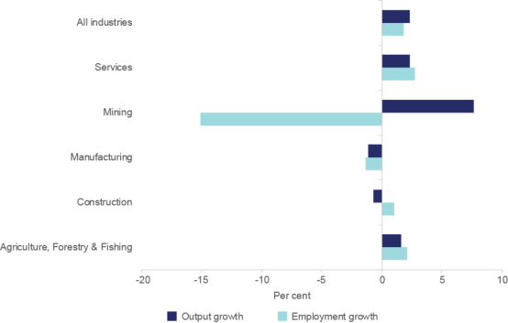

*Source*: ABS cat. no. 5204.0, table 5; ABS cat. no. 6291.0.55.003, table 4

*Notes*: Original data and chain volume measures for growth in industry value added (i.e. output). Original data and a four-quarter average are used for employment growth.

Australia needs reforms that improve productivity and reduce business costs to remain competitive. The immediate challenge is to successfully manage the transition from the commodity price boom to new and broader drivers of economic growth. While a lower Australian dollar is supporting this adjustment, business confidence and investment remain weak. Australian industry must act on opportunities, such as expanding into new areas and capitalising on the potential of emerging markets in Asia. The service sectors in particular will play an important role in ensuring that Australia remains a modern dynamic economy.

### Enabling services provide vital intermediary business services

In 2014–15, the Australian economy produced services worth around $970 billion, representing approximately 60 per cent of GDP.

Only about a third of services produced in 2012–13 were sold to households. Indeed, the majority of services produced are intermediates — provided to support other businesses in the production of final products.

The enabling services are a vital part of the economy, a key requirement for businesses to get their products to market. It is highly important that this sector is competitive and productive.

Whereas conventional methods of industry analysis typically focus on *what* is being produced, the analysis in Chapter 2 focuses on *who* the production is for. Shifting the focus to the who provides an alternative approach to examining the services sector. Chapter 2 of this report looks at services in terms of the function they offer other businesses. It shows how enabling services are used by a range of other industries and how they help those industries create their final products.

This analytical approach identified four enabling services groups:

* Professional & Support Services
* Information & Communications Technology (ICT) & the Digital Economy
* Trade, Transport & Logistics
* Utilities Services

In 2014–15, these enabling services produced approximately $465 billion of output (29 per cent of GDP) and employed approximately 3.1 million workers (27 per cent of total employed). Professional & Support Services are the largest of the four enabling services groups, employing the most people and making up around 20 per cent of GDP in 2014–15. The other three groups are much smaller, collectively producing around 9 per cent of GDP. Chart ES.2 presents some key information about each of the enabling services groups.

Chart ES.2: Enabling services groups and key statistics, 2014–15

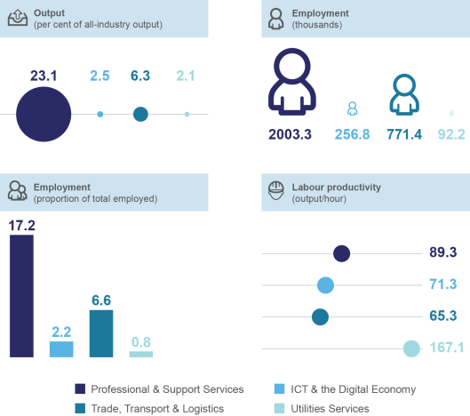

*Source*: ABS cat. no. 5204.0, table 5; ABS cat. no. 5209.0.55.001, table 5; ABS cat. no. 6202.0, table 21; *ABS Census of Population and Housing 2011*; ABS Special Data Request from Labour Force Survey; and Department of Industry, Innovation and Science (2015) calculations

*Note*: Employment (thousands) infographic is not to scale

### Appropriate regulation facilitates and supports sustainable economic growth

Well-designed regulation can serve to improve productivity and competitiveness within the economy, while also meeting broader social objectives. It is the role of government to ensure that these benefits are not outweighed by the costs.

Chapter 3 shows that while the benefits of regulation are widespread, it is the costs that receive a disproportionate amount of attention. Multiple business surveys indicate that the business community perceives Australia’s regulatory burden as high. These perceptions do not align with the favourable rankings Australia receives on international benchmarks such as the *World Bank Doing Business Indicators* and the *OECD Product Market Regulation Index*. Nor do the surveys give us data about the economic and financial impact of regulation or isolate this impact from other effects on business activity or firm performance.

Looking past these measurement difficulties, a key finding based on the Australian Bureau of Statistics’ *Business Characteristics Survey* is that regulation is only a moderate concern for firms when viewed in the context of other barriers to performance (see chart ES.3). Barriers that are cited to a greater extent include lower profit margins to remain competitive and lack of access to additional funds. The small size of Australia’s underground economy provides further evidence that Australian businesses are not overly regulated.

Chart ES.3: Regulatory and other barriers to general business activities or performance, 2006–07 to 2013–14

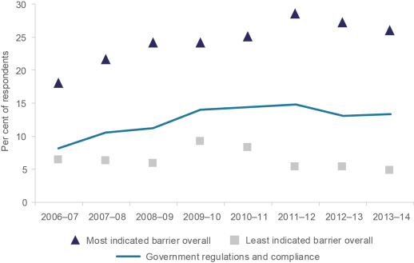

*Source*: ABS cat. no. 8167.0

*Notes*: The least and most indicated barrier overall does not relate to government regulation and compliance.

Additional insight can be obtained from stocktake measures, such as the analysis of the Australian Business Licensing and Information Service that was conducted for this report. The findings show varying quantities of regulation across industries, though stocktakes are limited given that levels of complexity and impact are ignored.

Well-designed regulatory frameworks can have a positive impact on both the behaviour and performance of firms. While it is often argued that improvements in economic outcomes depend on deregulation, the evidence suggests there is a limit to what regulatory reform can achieve for highly deregulated economies with quality institutional frameworks.

### R&D activity among firms is essential for long-run growth

One of the purposes of the *Australian Industry Report* is to show how administrative data can be used to build a robust evidence base for policy development. Results based on an analysis of the department’s R&D Tax Concession programme data are presented in Chapter 4. The data provide evidence of significant knowledge spillover benefits for Australian firms engaged in R&D activity.

R&D tax incentives aim to address the market failure of under-investment in R&D; the inability of private entities to capture the full benefit of their R&D efforts (particularly for smaller firms); and insufficient access to external finance. The findings presented in this report suggest that government institutions can play a potent role in stimulating private R&D by shifting focus to basic types of research. This aligns with research undertaken in institutes of higher education and research centres.

# CHAPTER 1

Economic and business conditions

In 2014–15, the Australian economy produced goods and services valued at $1.6 trillion, was home to more than 2.1 million actively trading businesses and employed over

11.7 million people.**1** This chapter of the *Australian Industry Report 2015* tells the story of the Australian economy over the last year and the challenges and opportunities that await.

Australia’s economy is in transition. The investment phase of the commodity boom has all but passed and the mining sector has shifted its focus to production. The question now is how this transition will unfold. Will economic activity and employment opportunities flow smoothly to the non-resource sectors of the economy? Or is Australia in for a period where real living standards stall, or even decline?

The chapter begins with a look at **international developments**: their impact on the Australian economy and their implications for the future. Global economic growth has picked up slowly over the last year, although with notable divergence between countries. An economic recovery in the United States and falling oil prices have supported growth, while the threat of a Greek exit from the euro area appears to have subsided. Developments in China remain a key risk to Australia’s economic outlook, a fact which the June 2015 Chinese stock market downturn brought into sharp focus.

The chapter then outlines **developments in the domestic economy** over the last year. The transition through the resources boom has continued to present challenges for Australia. As yet, there are few signs that the pick-up in non-mining investment will fill the investment gap left by the mining industry. GDP growth remained below its long-run trend in 2014–15 at 2.3 per cent.**2** While resources projects are beginning to pay dividends in terms of output, Australia’s productivity growth remains below the level required to sustain the recent rate of improvement in living standards.**3** Business and consumer confidence remain relatively low.

**1** In this chapter all data is current as at 6 November 2015.

**2** Original data. ABS cat. no. 5204.0, table 1

**3** Productivity is the ratio of output produced to inputs used in the production process.

Employment, however, has grown at a relatively strong rate of 2.0 per cent over the past year.**4** The participation rate — the proportion of the working age population in the labour force — has also risen over the same period. Labour cost pressures remain relatively moderate as wages growth eased through 2015. Australia’s unemployment rate may have stabilised, with expectations that it will fall below 6 per cent in 2017.**5**

Furthermore, some pre-conditions for a successful transition towards a more diverse economy have been met. Key among these has been the depreciation of the Australian dollar, which this year fell below the US70 cents level for the first time since 2009.**6** The Reserve Bank of Australia (RBA) decision to reduce the cash rate to a historical low is also important. Lower interest rates should continue to provide cheap access to capital and stimulate economic activity by encouraging greater spending by households.

The final section of this chapter applies a **sectoral lens to economic developments** over the last year.**7** Mining output has grown solidly as the industry has moved deeper into the production phase of the resources boom. The services sector has experienced solid growth while outcomes for the manufacturing sector have been more modest.**8** Construction output has fallen over the past year. The increase in residential construction activity, in part driven by low interest rates, has not been sufficient to offset the decline in engineering construction.

**4** Trend data. ABS cat. no. 6202.0, table 1

**5** Bloomberg economic forecasts; Reserve Bank of Australia (2015) *Statement of Monetary Policy August 2015*, Sydney, p. 67

**6** RBA Statistical Tables, table F11

**7** This report uses the Australian and New Zealand Standard Industrial Classification (ANZSIC), which disaggregates the economy into nineteen industries. See Appendix A for details. The ANSZIC industry division of Electricity, Gas, Water & Waste Services is referred to as Utilities throughout the chapter.

**8** Services are considered to be all ANZSIC industry divisions except for Mining, Manufacturing, Construction and Agriculture, Forestry & Fishing. This is based on the definition of services industries from ABS cat. no.

1301.0 *Year Book Australia 2012*

Developments over the past year must be understood in the context of structural change, a theme explored in the *Australian Industry Report 2014*. Chart 1.1 compares industry shares of employment in 2004–05 with 2014–15. The majority of people in Australia (around 80 per cent) are employed in the services industries, with the largest employing industries being Social Services and Distribution Services. The services industries’ share of employment has risen by around 2.5 per cent over the past decade, driven by Social Services and Business Services. At the same time, Manufacturing and Agriculture, Forestry & Fishing’s shares of employment have contracted. Mining employment has edged up over the same period, but remains relatively low.

Chart 1.1: Industry shares of employment (per cent), 2004–05 versus 2014–15

Chart 1.1 shows the shares of industry employment in 2004–05 and 2014–15. The services industries’ share of employment has increased solidly over the past decade to around 80 per cent of total employment, with the largest increase recorded by Social Services. Manufacturing’s share of employment has declined from 10.7 per cent to 7.8 per cent. Mining’s share of employment has edged up from 1.1 per cent to 1.9 per cent. Agriculture, Forestry & Fishing’s share of employment has declined from 3.7 per cent to 2.7 per cent.



*Source*: ABS cat. no. 6291.0.55.003, table 4

*Notes*: Original data. Shares are calculated using a four-quarter average.

Changes in industry shares of GDP over time also tell a story of structural change. Chart

1.2 compares each industry’s share of GDP in 2004–05 with 2014–15. The services industries account for the majority of production (around 60 per cent). However, the rise in services’ share of employment has not been mirrored on the production side, with services’ share of GDP remaining relatively stable over the past decade. Mining’s share of GDP has risen rapidly over the last decade as a result of the resources boom, which also supported growth in construction output. Manufacturing’s share of GDP has fallen the most sharply of any industry. Manufacturing is the only sector which has seen its actual production (not just its share of production) fall over the past decade.

Chart 1.2: Industry shares of GDP (per cent), 2004–05 versus 2014–15

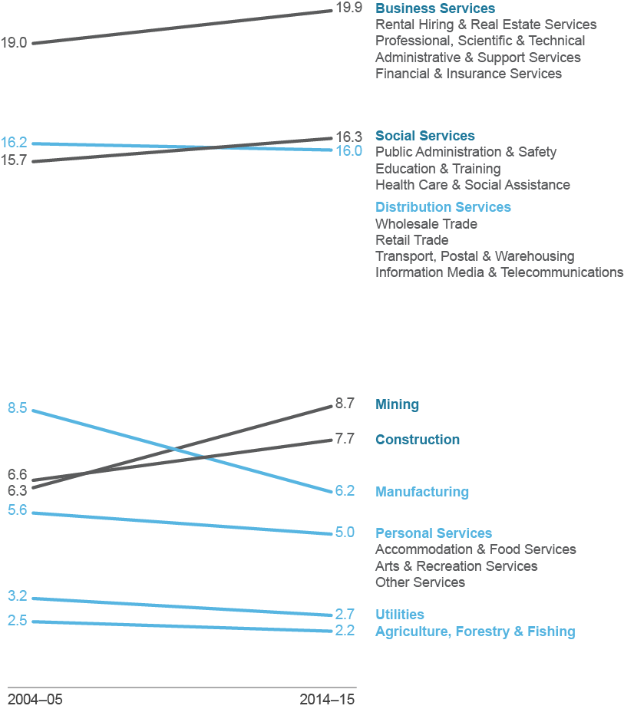

*Source*: ABS cat. no. 5204.0, table 5

*Notes*: Original data, chain volume measures. Shares of GDP do not sum to 100 per cent. GDP also includes ownership of dwellings, taxes less subsidies on products and the statistical discrepancy.

## International economic conditions

As a small open economy, Australia can be significantly affected by international events. Changes in financial conditions and confidence spread easily through an integrated global economy. Even small interest rate movements in other countries can shift significant capital and affect the value of currencies around the world.

Similarly, economic changes among our trading partners directly affect demand for Australia’s exports and the prospects of exporting industries. Chart 1.3 shows Australia’s largest trading partners using trade in value added. This measure traces products through the production process to their final destination, revealing which countries account for what proportion of final demand for Australian exports and where Australian imports are sourced. It provides important context for how economic developments overseas might affect Australia.**9**

Chart 1.3: Australia’s largest trading partners measured by trade in value added by destination of final demand, 2011

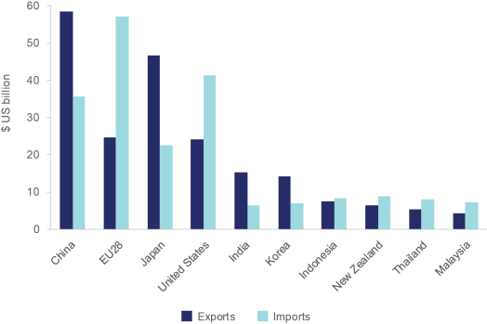

*Source:* OECD Statistics *International Trade and Balance of Payments*, Trade in Value Added

*Notes*: Domestic value added embodied in foreign final demand. 2011 is the latest data available. EU28 comprises the following countries: Austria, Belgium, Bulgaria, Croatia, Cyprus, Czech Republic, Denmark, Estonia, Finland, France, Germany, Greece, Hungary, Ireland, Italy, Latvia, Lithuania, Luxembourg, Malta, Netherlands, Poland, Portugal, Romania, Slovak Republic, Spain, Sweden, and United Kingdom.

Over the past year, the global economy has continued to recover, supported by stimulus from deficit spending, the injection of new money into economies by central banks, low interest rates, and low oil prices. However, within this broadly positive picture there are notable downside risks, many of which affect Australia’s major trading partners. China — Australia’s largest trading partner (see Chart 1.3) — has faced some significant challenges over the past year. The country’s transition towards a stronger consumer base has been complicated by slowing economic growth and the bursting of a stock market bubble.

**9** The value added trade estimates suggest that the United States and Europe are more important for export demand than what conventional trade statistics suggest. See Kelly G and La Cava G (2014) *International Trade Costs, Global Supply Chains and Value-added Trade in Australia*, Reserve Bank of Australia, Sydney, p. i

2015 has also been a year of difficulty for the euro area — our second largest trading partner. Economies within the euro area continue to face slow growth, subdued confidence, and low consumer demand. The euro area has also faced economic ‘shockwaves’ as the Greek debt crisis continues to unfold.

The following section describes in greater detail the global economic currents which Australia faces.

###### Global growth is gradually, but unevenly, picking up

Global economic growth reached 3.4 per cent in 2014, a marginal improvement from the 2013 growth rate of 3.3 per cent.**10** The headline figure masks a widening divergence in growth rates among major economies. This divergence is not new. China had the fastest GDP growth rate between 2005 and 2015, followed by India, the United States, Japan and the euro area. This order has recently changed, with India exhibiting the fastest economic growth in 2015. Chart 1.4 shows annual GDP growth in China, India, Japan, the United States and the euro area over the past decade.

Chart 1.4: Annual GDP growth in key economies, 2005–2015

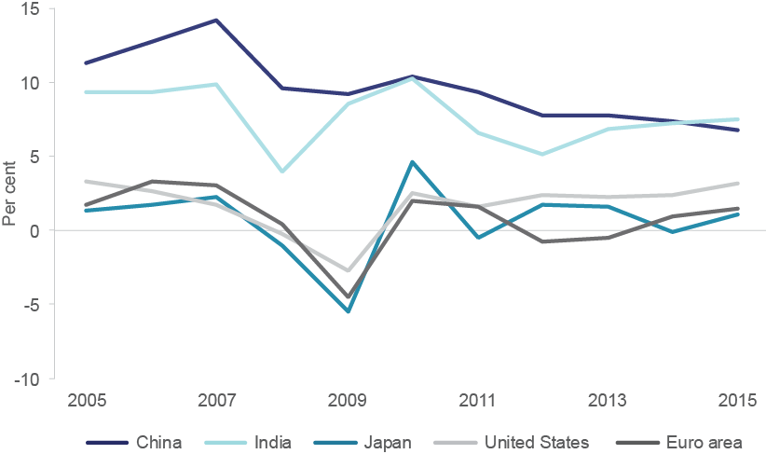

*Source*: International Monetary Fund *World Economic Outlook*; Thomson Reuters DataStream

*Notes*: Year-on-year change, constant price data

The Chinese economy is still growing at a robust pace, although a gradual deceleration is evident and risks are emerging in the real estate and share market, which have both shown signs of volatility.

Economic growth in the United States, meanwhile, is picking up. Labour market conditions have been improving and authorities have signalled the likelihood of a lift in interest rates after a period of record lows, suggesting a greater confidence in growth prospects.

**10** International Monetary Fund (2015) *World Economic Outlook: Adjusting to Lower Commodity Prices*, October 2015, p. 3

The economic outlook for the euro area has improved over the past year. Wage growth is rising, unemployment rates are falling and GDP growth is above where it has been for most of the past few years. However, the region continues to be burdened with low confidence and persistent economic shockwaves related to problems in some member economies, notably Greece.

The performance of Japan’s economy has been mixed, with solid GDP growth in the first quarter of 2015 followed by a contraction in the second quarter. Soft domestic consumption continues and export growth is showing signs of temporary weakness. The Japanese economy retains key strengths including a competitive export industry and a strong labour market. But recent weakness will trouble policymakers given the magnitude of monetary and fiscal stimulus into the Japanese economy.

India is currently a standout economy both in terms of its size and its growth. With economic growth of over 7 per cent recorded in 2014–15, India has become one of the fastest growing economies in the world, albeit starting from a low per-capita base.**11** Although its unemployment rate remains hard to measure, most estimates point to a downward trend. India is engaged in significant economic and regulatory reforms and is widely seen as an important driver of future global growth.

### Economic conditions in Australia’s largest trading partner, China, are in flux

Domestic conditions in China have the potential to significantly affect demand for Australian exports. After three decades of rapid expansion, China’s growth is showing signs of moderation, easing to a level below 7 per cent in 2015 as China struggles to transition to a consumer-led economic growth model.**12**

The slowdown in growth partly reflects policy measures adopted by the Chinese Government to contain financial vulnerabilities. Total Chinese debt (including government, household and corporate) has increased from 100 per cent of GDP in 2007 to more than 200 per cent of GDP in 2014.**13** The high debt stems in part from efforts to encourage investment, following the sharp decline in growth in the aftermath of the Global Financial Crisis.

The slowdown in growth has been exacerbated by two important factors. First, overdevelopment in China’s real estate market has created volatility and led to fears of significant losses among developers and homeowners. Second, excessive growth in China’s stock market led to a sharp correction in mid-2015, when equity values fell by around one-third. The resulting uncertainty led to downgraded GDP growth forecasts of 6.8 per cent in 2015 and 6.3 per cent in 2016, and there is considerable ongoing doubt about the direction of the Chinese economy.**14** The falling growth outlook and ongoing volatility represent distinct risks for the global economy.

**11** International Monetary Fund (2015) *World Economic Outlook: Adjusting to Lower Commodity Prices*, October 2015, p. 2

**12** Ibid.

**13** China Briefing (2014) *China Debt Rises to 226 Percent of Annual GDP,* <http://www.china-briefing.com/> news/2014/05/12/china-debt-rises-226-percent-annual-gdp.html, viewed 5 November 2015

**14** International Monetary Fund (2015) *World Economic Outlook: Adjusting to Lower Commodity Prices*, October 2015, p. 2

### The euro area remains vulnerable to shockwaves from Greece

The euro area comprises 19 separate economies, which together make up the largest economic entity in the world. It operates using a single currency, which helps countries with relatively strong economies by constraining currency growth, improving their export competitiveness. However it has the opposite effect on countries with weaker economies, which lose the ability to devalue their currency and increase competitiveness. Significant economic diversity among the 19 members has continued to challenge its operation over the last year. In particular, ongoing difficulties in Greece present a significant risk of destabilising the euro.

Greece ran up unsustainable debt levels following its admission to the euro area. In the years since the Global Financial Crisis, Greece has experienced repeated crises, with unemployment spiking and GDP collapsing. The economic linkage of the euro area has resulted in ‘contagion’, meaning that Greece’s problems have assumed an importance beyond what the country’s size would normally suggest.

The International Monetary Fund, the European Central Bank and the European Commission have provided Greece with two financial bailouts in exchange for efforts by Greece to restore a budget surplus. Previous cuts in Greek government spending have had greater-than-expected impacts on the Greek economy, with collapses in confidence, spikes in unemployment, falls in investment and multi-year recessions. Following the election of the anti-austerity Syriza party, Greece effectively defaulted on its loans, and strict controls were imposed on the movement of money. Although bailout terms have subsequently been reached, the issue has been fraught and continues to present risk.

The euro area is Australia’s second largest trading partner after China. Further destabilisation among European countries could see Australia buffeted by flow-on effects. These impacts could also affect China. Chinese exports to the euro area make up around 16 per cent of its total exports.**15**

**15** World Trade Organisation (2015) *China Trade Profile*, [http://stat.wto.org/CountryProfile/WSDBCountryPFView.](http://stat.wto.org/CountryProfile/WSDBCountryPFView) aspx?Language=E&Country=CN, viewed 5 November 2015

### The United States and United Kingdom may be changing course on monetary policy

Central banks set interest rates as a means to manage employment growth and inflation. As seen in Chart 1.5, key economies have experienced historically low interest rates post Global Financial Crisis.

Chart 1.5: Official interest rates in key economies, 1985–2015

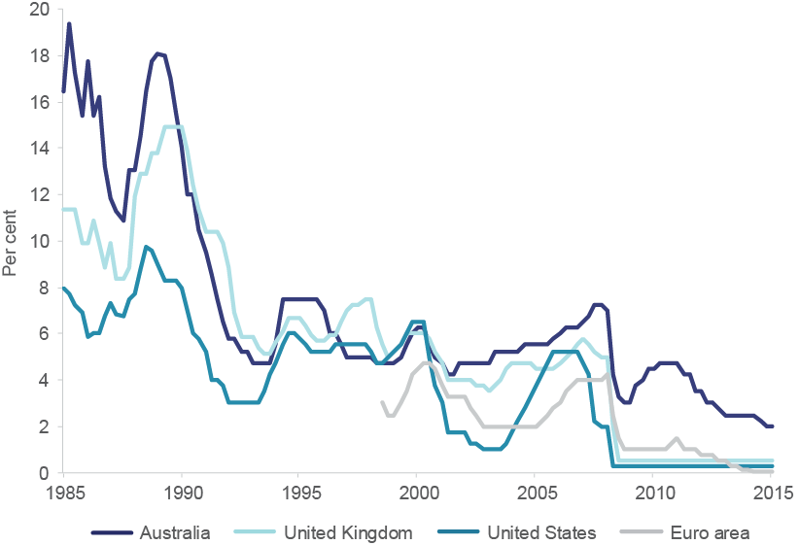

*Source:* RBA Statistical Tables, table F13; Thomson Reuters DataStream

*Notes*: Japan excluded from this analysis due to breaks in the time series.

Low interest rates have encouraged higher borrowing and spending in many OECD countries, reflecting large (and partially successful) efforts to provide economic stimulus. However, the sheer magnitude of monetary stimulus has also been cited as a potential source of increased inflation and financial bubbles.

Interest rates in the United States did not rise for nine years after 2006 and were at historical lows for five years following the Global Financial Crisis. However, there are signs that the tide may be turning due to strong improvements in the labour market. The unemployment rate in the United States has fallen to around 5 per cent. At the same time, the unemployment duration has fallen from a median 13.5 weeks in October 2014 to 11.2 weeks in October 2015.**16** The United Kingdom is also facing better economic conditions and a lift in official interest rates may be on the agenda in coming months.**17**

**16** United States Department of Labor (2015) *Unemployed persons by duration of unemployment*, October 2015, Bureau of Labor Statistics, [http://www.bls.gov/news.release/empsit.t12.htm,](http://www.bls.gov/news.release/empsit.t12.htm) viewed 4 November 2015

**17** Australia and New Zealand refer to the rate that the central bank charges on overnight loans to commercial banks as the official cash rate. In the United States this is called the federal funds rate and in England it is called the official bank rate.

Rising interest rates will increase the attractiveness of the United Kingdom and United States to new capital, potentially reducing capital deployment elsewhere, including Australia. As interest-bearing assets in the United States increase their returns, the movement of money from Australia to the United States will depreciate the Australian dollar.

### A lower Australian dollar is helping Australian exporters

A lower Australian dollar improves export competitiveness by allowing exports to be sold for less in foreign currencies. As Chart 1.6 shows, the value of the Australian dollar rose sharply during the commodity boom and is now declining.

Chart 1.6: Australia’s real and nominal trade weighted exchange rate, 1995–2015

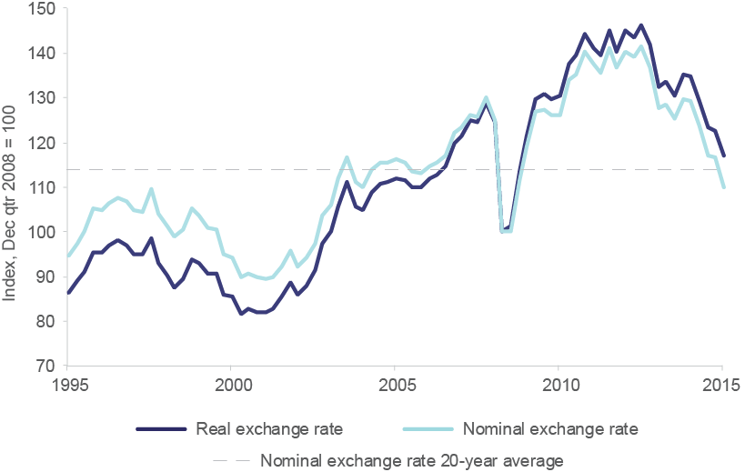

*Source*: RBA Statistical Tables, table F11 and F15; Thomson Reuters DataStream

*Notes*: The nominal trade-weighted exchange rate is the average value of the Australian dollar in relation to currencies of Australia’s trading partners (based on a weighted geometric average). The real trade-weighted exchange rate is the average value of the Australian dollar in relation to the currencies of Australia’s trading partners adjusted for relative price levels.

Over the past 12 months, the Australia dollar has been subject to a gradual, steady decline. This is taking significant pressure off some exporting industries and aiding the transition to new export sources. Industries likely to benefit from the lower Australian dollar include trade-exposed manufacturing, international education, and tourism.

### Changes in global commodity prices are affecting Australia’s export profile

Economic growth in China triggered a 10-year commodity boom from the early 2000s. However, with supply growth now outstripping growth in demand, prices for most commodities declined during 2015. Between January and August 2015, oil prices declined by 4 per cent, iron ore prices fell by 23 per cent and thermal coal prices decreased by 9 per cent.**18**

The rise in commodity prices and consequent investment surge was an unprecedented event, for which a correction was inevitable. The recent fall in prices has curtailed the flow of capital into new investment projects and resulted in falling exploration as companies cut costs.

Declining commodity prices will benefit non-mining industries by lowering input costs, even as they reduce revenue for the resource sector. In this way, falling commodity prices are likely to magnify existing trends towards rebalancing of the economy. Australia is likely to face a shift of its exports away from commodities and into other areas such as services.

Although global GDP growth is likely to remain solid, this is not expected to drive a further significant increase in commodity prices. Chart 1.7 shows the commodity price boom between 2000 and 2011 and the more recent downturn. Australia’s terms of trade — the price Australia receives for its exports relative to what it pays for its imports — has fallen sharply since the peak in early 2013.

Chart 1.7: RBA Index of Commodity Prices, 1995–2015

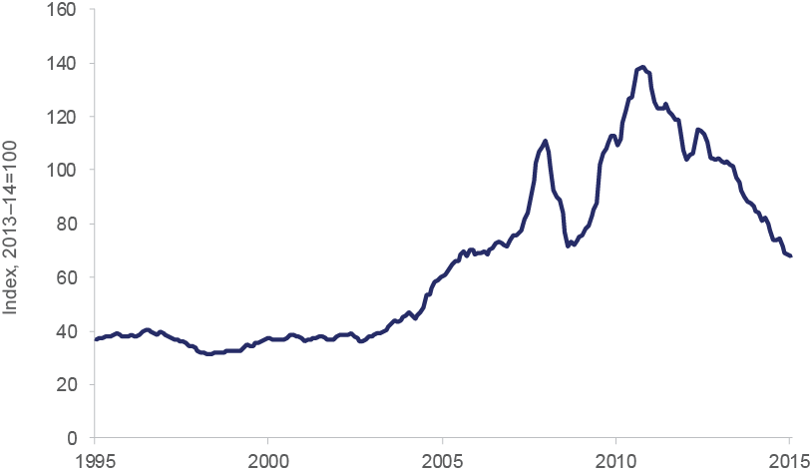

*Source:* RBA Statistical Tables, table I2

*Notes*: Data represents the index of commodity prices using the special drawing right measure (SDR). The price measures for the commodities used in the index are calculated using average export values in 2013–14.

Movements in oil prices have also had a significant global impact. The price of oil halved over the last six months of 2014 before stabilising and eventually increasing in the first half of 2015. The fall has been attributed to a boom in unconventional petroleum operations (such as shale oil) in the United States and solid supply from the Organization of the

**18** Iron ore prices are Freight on Board. Department of Industry, Innovation and Science (2015) *Resources and Energy Quarterly,* September quarter 2015, Canberra p. 2

Petroleum Exporting Countries (OPEC). At the same time, demand was dampened by soft global growth, increased energy efficiency measures, and substitution away from oil towards renewables and lower carbon-intensity fossil fuels.

Most nations are net importers of oil and stand to benefit from lower oil prices. The International Monetary Fund predicts this will provide a substantial stimulus to global growth over the medium term to 2020.**19** It estimates a potential impact of between 0.5 and

1.0 per cent extra real global GDP growth in 2016. The effects of lower oil prices on any one specific economy will vary with the intensity of oil use and the country’s balance of trade in oil and related goods.

In Australia, oil accounts for 38 per cent of total energy end use, dominated by the use of oil products for combustion engines. This includes unleaded petroleum, LPG, diesel and aviation fuel, which account for a large majority of total Australian petroleum product sales.**20** Lower prices will reduce domestic transportation costs and will also help to bring down the costs of imports from trading partners which use oil intensively in production, notably China.

As a net oil importer, Australia benefits from low oil prices. However, the effect is clouded by the fact that Australia is a net energy exporter — falls in oil prices exert downward pressure on substitutes such as gas and coal, which are consequently facing declining revenue.

### Australia has entered into a range of new free trade agreements

Slow progress in multilateral initiatives in the World Trade Organization has led Australian governments to pursue trade negotiations at the regional (multi-country) and bilateral levels.

Bilateral trade agreements with three of Australia’s largest trading partners have recently concluded. The China-Australia Free Trade Agreement will allow over 85 per cent of Australia’s goods exported to China to enter duty free when the agreement enters into force, rising to 95 per cent once fully implemented.**21** The Japan-Australia Economic Partnership Agreement, which entered into force in 2015, provides duty-free entry for almost all of Australia’s resources, energy and manufacturing exports to Japan.**22** Once fully implemented, this agreement will allow more than 97 per cent of Australia’s merchandise exports to receive preferential access or to enter Japan duty-free.**23** The Korea–Australia Free Trade Agreement, which entered into force in 2014, provides duty-free entry for 88 per cent of Australia’s exported resources, energy and manufacturing products into Korea. Under this agreement, all remaining tariffs on these goods will be eliminated by 2023.**24**

**19** Husain A, Arezki R, Breuer B, Haksar V, Helbling T, Medas P and Sommer M (2015) *Global Implications of Lower Oil Prices*, International Monetary Fund, p. 16–21

**20** Department of Industry, Innovation and Science (2015) *Australian Energy Update*, <http://www.industry.gov.au/> Office-of-the-Chief-Economist/Publications/Documents/aes/2015-australian-energy-statistics.pdf,

viewed 11 November 2015

**21** Department of Foreign Affairs and Trade (2015) *China-Australia Free Trade Agreement,* <http://dfat.gov.au/> trade/agreements/chafta/fact-sheets/Pages/key-outcomes.aspx, viewed 6 November 2015

**22** Department of Foreign Affairs and Trade (2015) *Japan-Australia Economic Partnership Agreement,* [http://dfat.](http://dfat/) gov.au/trade/agreements/jaepa/fact-sheets/Pages/fact-sheet-outcomes-at-a-glance.aspx, viewed 6 November 2015

**23** Department of Foreign Affairs and Trade (2015) *Japan-Australia Economic Partnership Agreement,* [http://dfat.](http://dfat/) gov.au/trade/agreements/jaepa/fact-sheets/Pages/fact-sheet-outcomes-at-a-glance.aspx, viewed 6 November 2015

**24** Department of Foreign Affairs and Trade (2015) *Korea-Australia Free Trade Agreement*, <http://dfat.gov.au/> trade/agreements/kafta/fact-sheets/Pages/outcomes-at-a-glance.aspx, viewed 6 November 2015

In addition, Australia has successfully concluded negotiations on Trans-Pacific Partnership (TPP). The TPP encompasses 12 countries which represent around 40 per cent of global GDP and 25 per cent of world trade.**25** It aims to create seamless trade and investment and eliminate 98 per cent of all tariffs across a range of agricultural, manufacturing, and resource goods.**26** Key Australian minerals, petroleum and LNG exports will have zero tariffs into TPP countries.**27**

Australia is currently negotiating several other free trade agreements, including the India–Australia Comprehensive Economic Cooperation Agreement and the Regional Comprehensive Economic Partnership Agreement that includes ten Association of South East Asian Nation (ASEAN) countries; India, China, Korea, Japan and New Zealand.

### The domestic economy

Commodity prices have retreated and capital investment in mining has passed its peak, so Australia must now look to other sources of growth. A lower terms of trade is placing pressure on national income. Labour productivity growth has remained solid over the past two years, but there is room for improvement given the degree of capital investment undertaken during the commodity boom.

Uncertainty among businesses could undermine the ability of firms to adjust. Most surveys point to volatile and mixed conditions and confidence over the last year, with businesses claiming a need for improved cost competitiveness and a lower exchange rate.

Wage growth has slowed considerably, reducing cost pressures across a range of industries. Moderation in wage growth appears to be supporting employment — the unemployment rate reached just over 6 per cent in 2015, but subsequently appears to have stabilised. There has been an improvement in labour force participation (persons in or seeking employment as a share of the total working age population) which may be explained by jobs growth in relatively high employing services industries.

### Current economic growth is below trend

While Australia has now recorded its 24th consecutive year of GDP growth, in recent years the growth rate has fallen below the long-term average. Australia’s economy is growing at around 2.0 to 2.5 per cent per year — about a percentage point below the average of the past 20 years. Speculation about a ‘new normal’ has begun, with some wondering whether a lower rate of growth may be here to stay.**28**

At the same time, growth in income per capita has slowed. As a general rule, GDP and income growth rates move together. However, in the last few years, there has been a decoupling of the two. GDP growth has slowed but remained positive, while income growth has turned negative. Real incomes, in other words, have declined. Chart 1.8 shows the relationship between GDP and income growth over the past two decades, and the more recent decoupling of the two.

**25** Department of Foreign Affairs and Trade (2015) *Trans-Pacific Partnership Agreement,* <http://dfat.gov.au/trade/> agreements/tpp/outcomes-documents/Pages/outcomes-at-a-glance.aspx, viewed 6 November 2015

**26** Andrew Robb MP (2015) *Trans-Pacific Partnership (TPP) pact to drive jobs, growth and innovation for Australia,*

[http://trademinister.gov.au/releases/Pages/2015/ar_mr_151006.aspx,](http://trademinister.gov.au/releases/Pages/2015/ar_mr_151006.aspx) viewed 6 November 2015

**27** Department of Foreign Affairs and Trade (2015) *Trans-Pacific Partnership Agreement,* [http://dfat.gov.au/trade/agreements/tpp/outcomes-documents/Pages/outcomes-resources-and-energy.aspx,](http://dfat.gov.au/trade/agreements/tpp/outcomes-documents/Pages/outcomes-resources-and-energy.aspx) viewed 6 November 2015

**28** Reserve Bank of Australia (2015) *Issues in economic policy*, speech by Governor Glenn Stevens, 22 July 2015, viewed 1 November 2015, [http://www.rba.gov.au/speeches/2015/sp-gov-2015-07-22.html;](http://www.rba.gov.au/speeches/2015/sp-gov-2015-07-22.html%3B) Mitchell A (2015) Tony Abbott likely to pass on the IMF’s advice, *afr.com.au*, 24 July 2015, viewed 1 November 2015, [http://www.](http://www/) afr.com/opinion/columnists/alan-mitchell/tony-abbott-likely-to-pass-on-the-imfs-advice-20150624-ghwm71

Chart 1.8: Annual growth in GDP and income per capita, 1994–95 to 2014–15

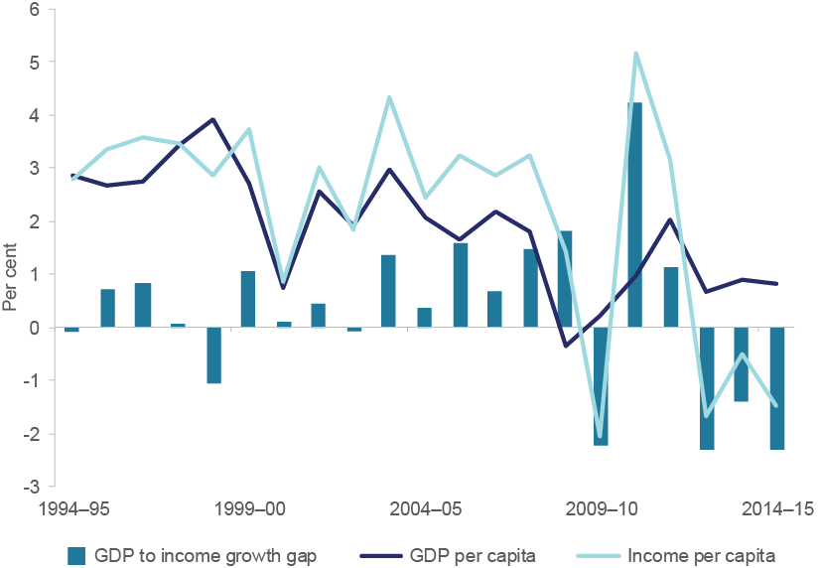

*Source:* ABS cat. no. 5204.0, table 1

*Notes*: Original data, chain volume measures. Income per capita is Real Net National Disposable Income Per Capita (RNNDI). The blue bars represent the difference between GDP and income per capita. Where

income per capita is greater than GDP per capita, the blue bars are on the positive side of the horizontal axis, suggesting a positive GDP to income growth gap.

The composition of Australia’s growth is also changing as Australia shifts away from the investment phase of the resources boom. Major components of GDP include household consumption, business investment, government expenditure and trade. Chart 1.9 shows the contributions of each sector to GDP growth over the past 10 years.

Chart 1.9: Annual growth in GDP, contributions by key components, 2004–05 to 2014–15

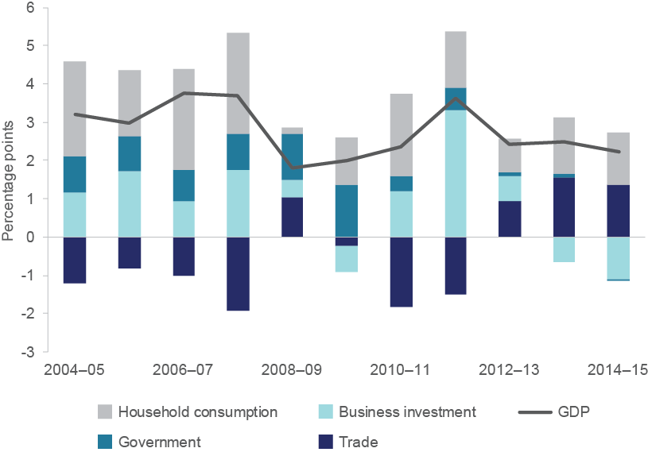

*Source*: ABS cat. no. 5204.0, table 2

*Notes*: Original data, chain volume measures. ‘Government’ includes government consumption and government gross fixed capital. A GDP component below the horizontal axis indicates that the component experienced negative growth, bringing down GDP.

Business investment was a reliable contributor to GDP growth up until 2012–13, but has detracted from growth over the past two years. At the same time, government spending has been constrained by a tough fiscal environment, resulting in a lower contribution. In contrast, trade has made a positive contribution to growth over the last three years.

Exports remain an important part of economic transition for Australia, and the recent improvement follows decades of relative stagnation in export volumes. The export share of Australia’s economy grew strongly in the immediate aftermath of 1980s reforms, but subsequently tailed off, and has remained at around 20 per cent for the past 15 years. Encouragingly, some positive signs for exports were evident in 2014 and 2015. The falling Australian dollar has supported a range of trade-exposed industries including manufacturing, agriculture and tourism. Globally, however, Australia’s share of world merchandise exports has declined from around 1.5 per cent in 2011 to around 1.3 per cent at present.**29**

### Low productivity and high business costs are constraining growth

Productivity has been the most significant driver of Australia’s income growth over the past 40 years.**30** Sustained reform efforts lifted labour productivity significantly during the 1990s, but growth rates subsequently dropped off again during the commodity boom. This was partially a result of a run-up of mining investment, which increased inputs without immediately increasing outputs.

As mining capacity comes online, output (and productivity) has been expected to rise sharply. So far Australia’s productivity performance has remained moderate but not exceptional. Labour productivity grew by 2.5 per cent in 2013–14 — marginally above the

**29** Department of Industry, Innovation and Science (2015) *Industry Monitor*, Canberra

**30** Treasury (2015) *Intergenerational Report: Australia in 2055*, Canberra p. x

long-term average. Multifactor productivity (which includes capital) grew by 0.4 per cent — around half the long-term average. The Productivity Commission has noted these rates are not sufficient to sustain ongoing growth in living standards.**31**

Chart 1.10 shows Australia’s productivity as a percentage of the United States’ productivity since 1995. As can be seen in the chart, Australia’s productivity was relatively close to the United States in the 1990s. This was widely understood to be the result of sustained reform efforts in Australia which worked to curb wage inflation and improve the functioning of the economy. However, since 2001 the ratio has worsened, with a further widening following the Global Financial Crisis when the United States experienced massive job shedding and increased capitalisation. Australian GDP per-hour worked is now less than 80 per cent of the level of the United States.

Chart 1.10: Ratio of productivity, Australia and United States, 1995–2013

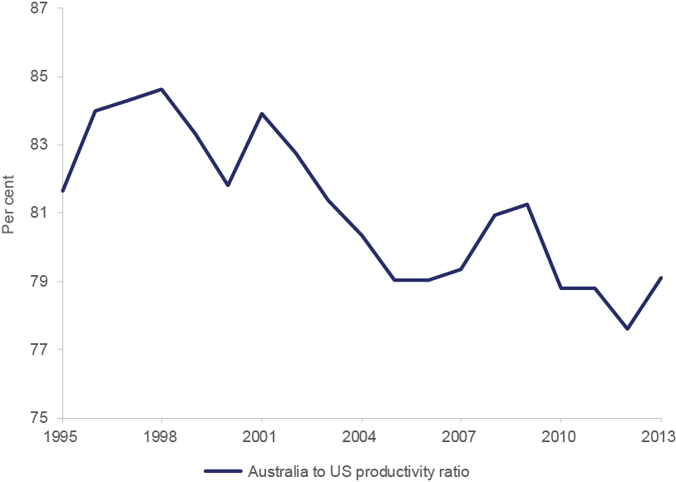

*Source:* Conference Board *Total Economy Database,* Output, Labor, and Labor Productivity, 1950-2015

*Notes*: Australia to United States productivity ratio is GDP per hour worked in Australia divided by GDP per hour worked in the United States.

Australia’s productivity is notably divergent across industries. Investment in mining has expanded extraction capacity significantly, creating a long-term productivity benefit. However, this is offset to some degree by an increasing reliance on depleted and inaccessible mines, which require significantly greater input relative to expected output. The Utilities sector has also experienced low productivity as a result of large investments which have focused on improving reliability rather than increasing output. This has led to a sharp fall in actual output relative to input costs.

Australian cost structures remain relatively high, despite the softening in wage growth. This puts exporters at a relative disadvantage, since it increases their cost relative to overseas competitors. High costs exist for a range of reasons. Labour costs in Australia remain elevated — a result of our wage settings, which grew strongly during the commodity boom. Energy costs in Australia have also been driven up as a consequence of large investments in grid upgrades. High costs for transportation reflect Australia’s large geographic area, the distance between its cities, and its relatively small population base.

**31** Productivity Commission (2015) *PC Productivity Update*, July 2015, Melbourne, p. 1

A recent lack of progress in tariff removal has meant Australia retains tariff barriers on more than 50 per cent of imported goods.**32** A range of other nations including the United Kingdom, United States, and Japan have reduced tariff barriers sharply, and are closing the gap on Australia.**33** Tariff cuts will play an important role in reducing business input costs.

The rise in the Australian dollar during the commodities boom exacerbated the cost issue for Australian businesses, although the subsequent fall has taken some pressure off. Effective regulatory and tax reform will provide a long-term reduction in cost structures and a stimulus for productivity. Chart 1.11 shows unit labour costs faced by Australian businesses. Labour costs increased in relative terms during the commodity boom, but faced even more sharp rises as a result of other nations slashing labour and increasing capitalisation during the Global Financial Crisis. The increase in the value of the Australian dollar (also shown in the chart) added further upward pressure to cost structures, although there are positive signs evident in the most recent years, with costs appearing to ease.

Chart 1.11: Cost pressures faced by Australian business, 2005–2015

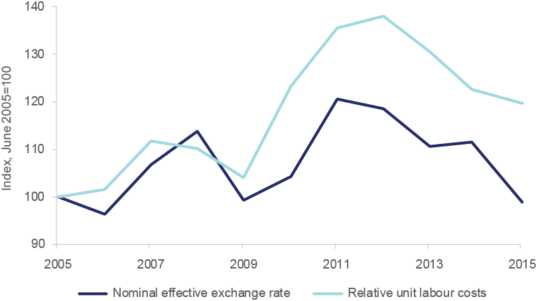

*Source*: RBA Statistical Tables, table F15; OECD *Economic Outlook*; Thomson Reuters DataStream

*Notes*: Relative unit labour costs are seasonally adjusted.

### Broader investment and confidence remain soft

A key question for the Australian economy is whether investment in non-mining sectors will pick up sufficiently to cushion the impact of decreasing mining investment.**34** Chart 1.12 shows how mining investment has declined over the past few years from the historically high levels seen during the resources boom. Meanwhile, the pick-up in non-mining investment remains relatively subdued, despite the RBA reducing the official cash rate to record lows in early 2015. Construction and services industries’ investment has only risen modestly while manufacturing investment has continued on a downward trajectory.

**32** Productivity Commission (2015) *Trade and Assistance Review 2013–14*, July 2015, Melbourne, p. 22

**33** Based on domestic market access subindex. World Economic Forum (2014) *The Global Enabling Trade Report 2014*, p. 11

**34** Investment refers to private capital expenditure in this discussion.

Chart 1.12: Capital investment by industry, 2005–2015

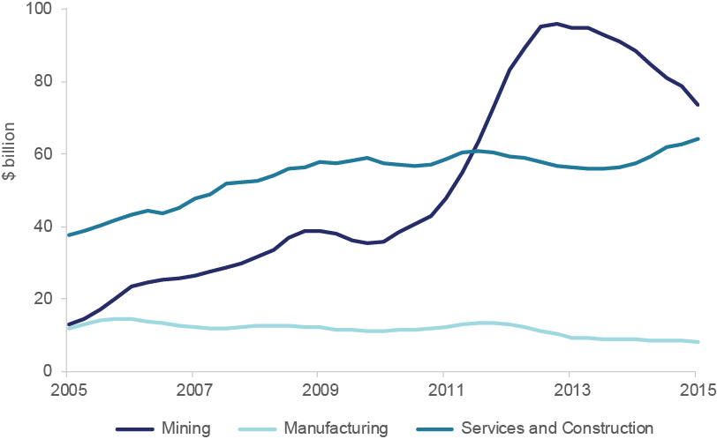

*Source:* ABS cat. no. 5625.0, table 3b

*Notes*: Actual expenditure, original data, chain volume measures, year-ended quarterly estimates. Services includes most services industries. Exceptions include Public Administration & Safety, Education & Training and Health Care & Social Assistance.

Treasury forecasts that these trends will continue. Mining investment is projected to fall by over 25 per cent in 2015–16 and over 30 per cent in 2016–17.**35** Non-mining investment, on the other hand, is expected to increase by just 4 per cent in 2015–16 and 7.5 per cent in 2016–17.

Research by the RBA on firm ‘hurdle rates’ helps to explain the subdued nature of non- mining investment, despite the low interest rate environment in which firms are operating.**36** Hurdle rates are the minimum return firms require to move forward with an investment decision. Reductions in interest rates may fail to affect firm investment decisions if broad approval within firms is required to change their hurdle rates. Other firms may leave hurdle rates constant despite falling interest rates as a way of managing the risks associated with a weaker economic environment.

A variety of other reasons have been identified for the ongoing weakness in business investment. Firms may be experiencing elevated risk aversion post Global Financial Crisis, despite the effects of the crisis being relatively minor in Australia. Relatively low productivity growth, the high exchange rate (until more recently), and difficulties accessing finance have also been cited as explanations.

**35** Australian Government (2015) *Budget Strategy and Outlook: Budget Paper No.1*, Budget 2014–15, Statement 2: Economic outlook, p. 2–5

**36** Reserve Bank of Australia (2015) *Firms’ Investment Decisions and Interest Rates*, June quarter 2015, [http://www.rba.gov.au/publications/bulletin/2015/jun/pdf/bu-0615-1.pdf,](http://www.rba.gov.au/publications/bulletin/2015/jun/pdf/bu-0615-1.pdf) viewed 4 November 2015

Low business confidence may also be hampering business investment. Chart 1.13 shows that the National Australia Bank business confidence index has been largely trending down since 2013, although business conditions have picked up, with improvements in trading conditions, profitability, and employment.

Chart 1.13: National Australia Bank business confidence and conditions, 2005–2015

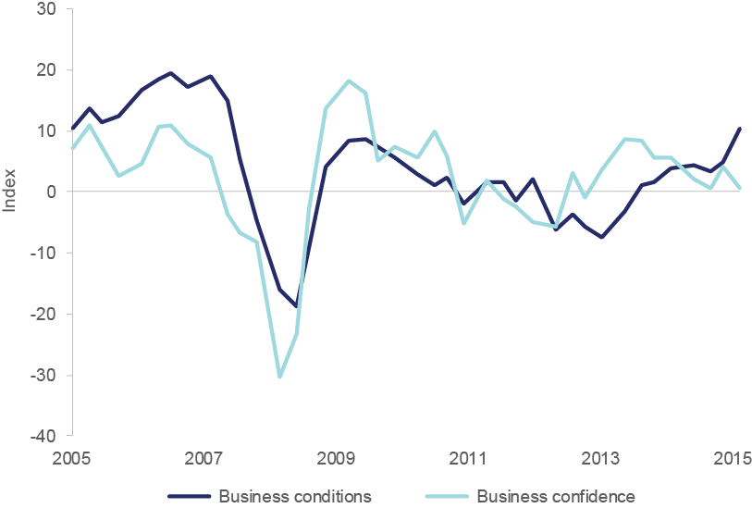

*Source*: National Australia Bank *Quarterly Business Survey*; Thomson Reuters DataStream

*Notes*: Business confidence measures respondents’ expectations of overall business conditions in their industry for the next month. Business conditions is a simple average of trading, profitability and employment indices reported by respondents.

Low levels of business confidence have (until more recently) dovetailed with relatively low levels of consumer confidence. Consumer confidence picked up in early 2015 as interest rates fell, but subsequently dipped back below 100 (indicating consumers are once again pessimistic on balance). Westpac noted, ‘sentiment has reverted back to a level more reflective of broader concerns about the outlook for the Australian economy’.**37**

**37** Westpac-Melbourne Institute (2015) *Consumer Sentiment Index*, June 2015

Businesses have retained most of the profitability gains recorded post Global Financial Crisis but have not been able to achieve a sustained improvement in profit levels (see Chart 1.14). Nominal wages and salaries have increased relative to profits in recent years, averaging around 50 per cent of gross operating profits over the last 12 months.

Chart 1.14: Business profits and ratio of profits to wages, 2005–2015

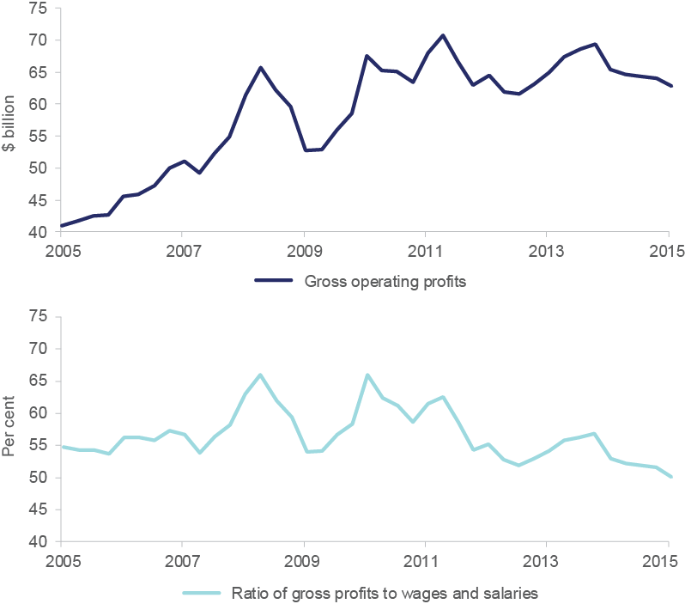

*Source:* ABS cat. no. 5676.0, table 1

*Notes*: Current prices, seasonally adjusted data

### After several soft years, labour market conditions may be firming

The unemployment rate has stabilised at just over 6 per cent after several years of gradual increase. The plateau in unemployment is a result of solid employment growth (around 2 per cent through the year). This is a stronger result than might be expected given the relative moderation in GDP growth. Solid outcomes in employment appear to reflect a combination of wage restraint (which has reduced potential job losses) and a concentration of economic growth in labour-intensive industries such as Healthcare & Social Assistance, Accommodation & Food Services, Transport, Postal & Warehousing, and Retail Trade.**38**

Reflecting the same trend, the participation rate is growing at a stronger pace than would ordinarily be implied by broader economic conditions. After falling post Global Financial Crisis, labour force participation has recently risen again to around 65 per cent. Chart 1.15 shows Australia’s unemployment and participation rates between 1995 and 2015.

Chart 1.15: Unemployment and participation rates, 1995–2015

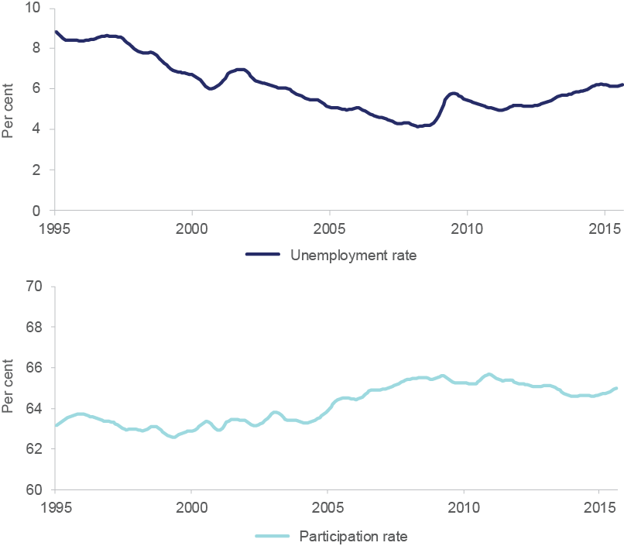

*Source*: ABS cat. no. 6202.0, table 1

*Notes*: Trend data, August 1995 to August 2015

**38** Labour intensive industries are industries that require higher than average quantities of labour, in relation to capital, to produce their goods or services.

Although recent outcomes have been solid, youth unemployment continues to be an issue. The employment-to-population ratio for persons aged 15–24 has fallen from 65 per cent in 2008 to 58 per cent, though there are modest signs of a turnaround in the latest data.

Australia is also recording sluggish wage growth. Wages grew by 0.6 per cent in the June quarter 2015, and 2.3 per cent through the year — effectively a flat result in real terms.**39** This is a distinct drop on the average of the last 10 years, and some industries are seeing wages fall in real terms. Mining recorded the largest decline, as unusually high wages continued to unwind. Budget forecasts suggest wage growth of only 2.5 per cent in 2015–16, and

* 1. per cent for 2016–2017 — close to zero growth in real terms.**40**

Skilled migration continues to be a major component of labour market growth in Australia. In 2013–14, 128,550 visas were granted to permanent migrants under the skills stream of Australia’s migration program.**41** According to the latest information from the Continuous Survey of Australian Migrants, the employment outcomes for these migrants were strong. In particular, the labour force participation rate for such migrants over the survey period was around 96 per cent — much higher than the national rate of 65 per cent.**42** Box 1.1 explores these figures in greater detail and highlights the continuing contribution that migration makes to Australia’s economic performance.

**39** ABS cat. no. 6345.0, table 1

**40** Australian Government (2015) *Budget Strategy and Outlook: Budget Paper No.1*, Budget 2014–15, Statement 2: Economic outlook, p. 2–5

**41** The programme targets migrants that have the skills, proven entrepreneurial ability or outstanding capabilities that will contribute to the Australian economy. Visas granted include dependent family members.

**42** Department of Immigration and Border Protection (2014) *Australia’s Migration Trends*, Canberra p. 5

**Box 1.1: Migration makes a significant**

**contribution to the economy**

Australia’s migration policy has increasingly targeted skilled immigration in recent decades. Skilled immigration generates a more skilled labour force and allows industries to quickly source labour in the event of skill shortages. Skilled migration increased from 51.5 per cent of net overseas migration in 1997–98 to 67.7 per cent in 2013–14.**43**

Consideration of the role of skilled migration through the lens of population, participation and productivity suggests that migration is an increasingly important factor underlying Australia’s economic growth. An ageing population and increasing demands for skilled labour mean this is likely to continue.

##### Population: Net overseas migration has made a large contribution

##### to population growth

The 2015 *Intergenerational Report* notes the influence of the size and structure of Australia’s population on the pace of economic and income growth. Net overseas migration has exceeded the net natural increase in the population (i.e. births minus deaths) over the past decade (see Chart 1.16). Strong growth in skilled migration has been a key contributor to the overall rise in net overseas migration during this period.**44** However, the past two years have seen a decline, with net overseas migration falling to 173,000 persons in the year to the March quarter 2015.**45**

Chart 1.16: Population growth by components, 1995–2015

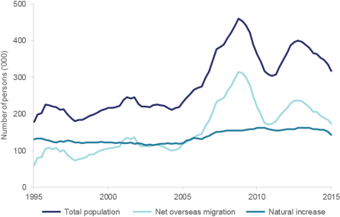

*Source*: ABS cat. no. 3101.0, table 1

*Notes*: Year-ended population flows

**43** Department of Immigration and Border Protection (2014) Australia’s Migration Trends 2013–14, Canberra p. 22

**44** Department of Immigration and Border Protection (2014) Australia’s Migration Trends 2013–14, Canberra p. 23

**45** ABS cat. no. 3101.0, Australian Demographic Statistics, March 2015, table 1

##### Participation: Immigration is the key contributor to labour supply

##### in Australia

Historically, migration has been an important source of labour supply for Australia. The age distribution of migrants is generally younger than the age distribution of resident Australians, meaning migration contributes more to the working-age population and overall labour force participation rates.**46** Immigration is now the principal contributor to labour supply. Over the last five years, migrants have accounted for:

* + - 52.5 per cent of labour force growth
    - 57.3 per cent of employment growth**47**

At least half of persons employed in occupations such as Clothing Trades Workers (57.9 per cent), Generalist Medical Practitioners (56.4 per cent), Dental Practitioners (55.6 per cent) and Software & Applications Programmers (55.2 per cent) were born overseas. The industries employing the most overseas born persons are Professional, Scientific & Technical Services (15 per cent), Health Care & Social Assistance (14 per cent) and Manufacturing (11 per cent). Chart

1.17 highlights employment growth among migrants and persons born in Australia.

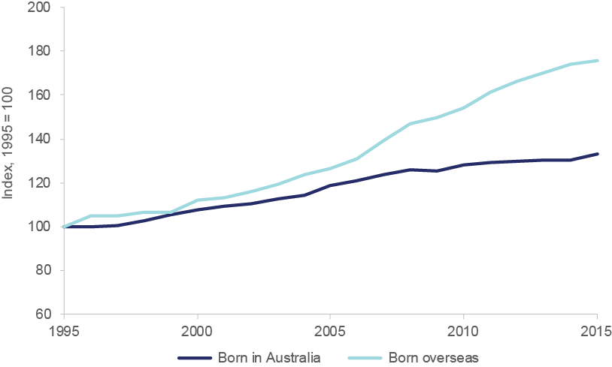Chart 1.17: Employment growth for persons born in Australia versus overseas, 1995–2015

Source: ABS cat. no. 6291.0.55.001, table LM5

##### Productivity: Access to skilled labour assists industries to remain

##### productive and competitive

Migrants contribute to human capital development and technological progress by upskilling and raising the capabilities of Australian workers through a transfer of skills and knowledge. Migrants possess varying levels of skills across a range of fields. Large proportions are employed in highly skilled occupations, increasing the

**46** Almost a third (30.8 per cent) of Australia’s working-age civilian population was born overseas in 2014–15. This is up from 27.4 per cent a decade ago and 25.7 per cent two decades ago. Treasury (2015) *Intergenerational Report*: Australia in 2055, Canberra p.19; ABS cat. no. 6291.0.55.001, August 2015, table LM5

**47** ABS cat. no. 6291.0.55.001, August 2015, table LM5

average skill level of the domestic workforce, and in turn increasing productivity.

The 2015 *Intergenerational Report* notes ‘there is some evidence that high levels of net overseas migration might increase productivity, as … migrants may, on average, be better educated than the average Australian’.

Migrants have relatively high levels of education, with 26.5 per cent of the overseas born population holding tertiary qualifications. This compares to 17 per cent of the Australian born population. Among the overseas born population, about half of those aged 25 to 34 and a third of those aged 35 to 44 are tertiary educated. Management and Commerce and Engineering and Related Technologies are the highest ranking field of education for migrants and Australian born persons.**48**

Skilled migrants also make up a large proportion of those employed in highly paid occupations in Australia. The greatest concentrations of skilled migrants are found in the highest income brackets: 16.2 per cent of skilled migrants report income over $104,000, while 14.4 per cent are in the $78,000 to $103,999 income bracket. In comparison, the highest concentration of Australian born workers are found in the $20,800 to $31,199 income bracket (12.5 per cent) and the $31,200 to $41,599 income bracket (11.5 per cent).**49**

**48** Tertiary qualifications have been defined as bachelor degree or above. Only the population aged 15 years and above has been included in these estimates. ABS 2011 Census of Population and Housing

**49** ABS 2011 *Census of Population and Housing*

### Developments in Australian industry

This section examines economic developments at the industry level over the last year. Growth in output across all industries was 2.3 per cent in 2014–15 while employment growth was 1.8 per cent. Chart 1.18 shows growth in output and employment in 2014–15 for the five key industry sectors.

Chart 1.18: Growth in output and employment by industry, 2014–15

All industries

Services

Mining

Manufacturing

Construction

Agriculture, Forestry & Fishing

-20 -15 -10 -5 0 5 10

Per cent

Output growth Employment growth

*Source:* ABS cat. no. 5204.0, table 5; ABS cat. no. 6291.0.55.003, table 4

*Notes*: Original data and chain volume measures for growth in industry value added (i.e. output). Original data and a four-quarter average are used for employment growth.

As the production stage of the mining boom requires less labour than the investment phase, mining employment has declined over the past year. Mining output, however, has increased solidly as the production phase of the resources boom gets underway.

The services sector continues to experience solid growth, both in terms of employment and output. Both manufacturing output and employment contracted in 2014–15.

Output in the construction industry has fallen over the past year. The increase in residential construction activity, in part driven by low interest rates, has not been sufficient to offset the decline in engineering construction. Employment in Agriculture, Forestry & Fishing, a relatively low employing industry, has risen, as has the sector’s output.

Analysis of the performance of the Industry Growth sectors also shows mixed results. More information is contained in Box 1.2.

##### Box 1.2: Insights into five industry growth sectors

The Industry Growth Centres Initiative is the centrepiece of the Australian Government’s *Industry Innovation and Competitiveness Agenda: An action plan for a stronger Australia*. Selection is based on sectors of the economy where Australia has the potential for international competitive advantage. The Initiative will enable national action on key issues by identifying opportunities to:

* reduce regulatory burden
* increase collaboration and commercialisation
* improve capabilities to engage with international markets and global supply chains
* enhance management and workforce skills

Chapter 3 of the *Australian Industry Report 2014* examined output (GVA), employment and labour productivity for the following five industry growth sectors:

* Food & Agribusiness
* Mining Equipment, Technology & Services
* Oil, Gas & Energy Resources
* Advanced Manufacturing
* Medical Technologies & Pharmaceuticals**50**

This analysis informed the establishment of the Initiative.

Table 1.1 below updates the data for each sector. The composition of the growth sectors has been updated since last year’s report to better reflect economic activity (see Appendix B for the revised composition of the growth sectors).

Recent developments affecting the sectors, such as the transition in mining, are more readily seen in changes in GVA and employment growth. Over the past year, GVA increased in Oil, Gas & Energy Resources (up 4.9 per cent) and Medical Technologies & Pharmaceuticals (up 1.4 per cent) and declined in Advanced Manufacturing (down 3.4 per cent) and Mining Equipment, Technology & Services (down 10.3 per cent). GVA was stable in Food & Agribusiness (down just 0.1 per cent).

At the same time, employment grew in Food & Agribusiness (up 2.2 per cent), was stable in Medical Technologies & Pharmaceuticals (down just 0.1 per cent) and fell in Advanced Manufacturing (down 1.1 per cent), Mining Equipment & Services (down 9.7 per cent) and Oil Gas & Energy Resources (down 12.8 per cent).

**50** Note that the Growth Sectors form the basis of two major programmes run by the Department of Industry, Innovation and Science: the Industry Growth Centres Initiative, and the Entrepreneurs’ Infrastructure Programme. For more information on the Industry Growth Centres Initiative see: [http://www.business.gov.au/advice-and-support/IndustryGrowthCentres/Pages/default.aspx.](http://www.business.gov.au/advice-and-support/IndustryGrowthCentres/Pages/default.aspx)

For more information on the Entrepreneurs’ Infrastructure Programme see: http://www.business. gov.au/advice-and-support/EIP/Pages/default.aspx

Table 1.1 Growth sectors key economic indicators, 2014–15

|  |  |  |  |  |
| --- | --- | --- | --- | --- |
| **Growth sector** | **Employment**  **(‘000)** | **Annual employment**  **growth (per cent)** | **Gross value**  **added ($ billion)** | **Annual gross value added**  **growth (per cent)** |
| Food & Agribusiness | 525.9 | 2.2 | 53.9 | –0.1 |
| Mining Equipment, Technology & Services | 77.7 | –9.7 | 10.9 | –10.3 |
| Oil, Gas, & Energy Resources | 111.0 | –12.8 | 54.9 | 4.9 |
| Advanced Manufacturing | 259.7 | –1.1 | 29.7 | –3.4 |
| Medical Technologies  & Pharmaceuticals | 70.9 | –0.1 | 10.5 | 1.4 |
| **Australian Industry** | **11,658.9** | **1.8** | **1,367.6** | **2.3** |

*Source:* Department of Industry, Innovation and Science estimates; ABS cat. no. 6291.0.55.003, data cube EQ096; ABS cat. no. 5204.0, table 5

The department has funded an additional sample of 6,000 firms in the *Business Characteristics Survey (BCS)* conducted by the Australian Bureau of Statistics. This allows the department to better understand the business characteristics of firms in the growth sectors. This survey collects data on a broad range of topics including business ownership, collaborative arrangements, performance measures, barriers, innovation, and business use of information technology, skills and markets.

The first release provides a baseline for measuring future performance, with further data to be released in coming years. The full report and associated data is available at: [http://abs.gov.au/ausstats/abs@.nsf/mf/8170.0.](http://abs.gov.au/ausstats/abs%40.nsf/mf/8170.0) This data may identify opportunities to develop policies that will enable industry to maximise productivity and international competitiveness. Medical Technologies & Pharmaceuticals is the only growth sector that is above average on all indicators of business performance (see Chart 1.19). All other growth sectors are below average on at least one indicator of business performance. This data shows that Advanced Manufacturing, Medical Technologies & Pharmaceuticals and Food & Agribusiness all report higher rates of productivity than the all-industry average.

The main factors cited as barriers to general business activities or performance were lack of customer demand and higher rates of government regulation and compliance. Chapter 3 of this year’s *Australian Industry Report* provides more perspectives on regulation in the five key sectors. Chart 1.19 shows the percentage of businesses in each growth sector which reported increased performance relative to 2013–14.

Chart 1.19: Measures of business performance, 2013–14 to 2014–15

35

30

25

Per cent of businesses

20

15

10

5

0

Export markets targeted

Total number of jobs or positions

Productivity Profitability

All industries Advanced Manufacturing

Mining Equipment, Technology & Services Oil, Gas & Energy Resources Medical Technologies & Pharmaceuticals Food & Agribusiness

*Source*: ABS (2015) *Business Characteristics Survey*

### The services sector has been a reliable source of growth

The diverse set of industries classified as ‘services’ account for around 80 per cent of employment and around 60 per cent of GDP. The services sector grew solidly in 2014–15 at 2.3 per cent, in line with all-industry growth. Within this headline figure, there was wide disparity across the sector. Chart 1.20 shows the growth rates of Australia’s key services industries in 2014–15.

Chart 1.20: Growth in industry value added by services industry, 2013–14

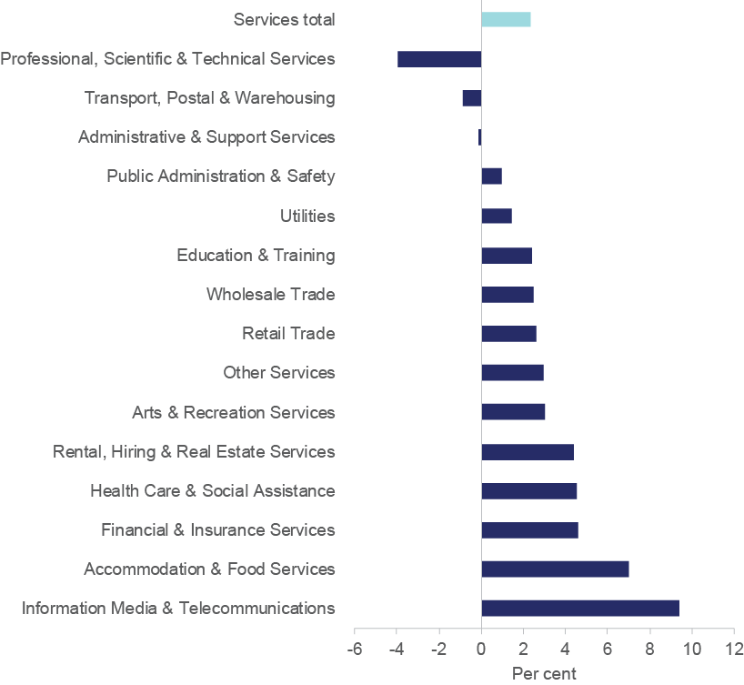

*Source*: ABS cat. no. 5204.0, table 5

*Notes*: Original data, chain volume measures

### Strong growth was evident in Information Media & Telecommunications and Accommodation & Food Services

Information Media & Telecommunications recorded the most rapid growth of any services industry in 2014–15, with industry output increasing by 9.4 per cent. The sector includes much of the Information & Communications Technology (ICT) industry, but also includes media elements such as TV, radio, print and libraries. The sector’s strong recent performance has been attributed to businesses’ increasing use of ICT services to compete effectively.**51** The industry has also benefited from rapid technological change and a shift to new business models.

Strong growth has also been recorded in Accommodation & Food Services, which captures the activities of hotels, restaurants, cafes and bars. Accommodation & Food Services

**51** Deloitte Access Economics (2015) *Business Outlook: Global challenge*, September quarter 2015, p. 45

expanded by around 7 per cent in 2014–15, while the profits of firms in the industry were up around 20 per cent on the previous year.**52** The sector is likely benefiting from a lower Australian dollar, which encourages Australian tourists to remain at home while promoting tourism from abroad.**53**

Growth in Financial & Insurance Services remained robust. This is a continuation of a longer-term trend (the industry is one of the fastest growing over the last 10 years), with record low interest rates facilitating strong growth in lending activity. Health Care & Social Assistance continued to expand strongly, in line with demographic change including the ageing population.

### Softer growth occurred in Retail Trade and Professional, Scientific & Technical Services

Retail Trade is confronting a constraint on demand for its products in the form of soft wages growth, currently at its lowest level on record. On the other hand, strong house price growth is promoting residential building and renovations, which in turn has generated retail demand.**54**

Output of the Utilities sector grew slowly in 2014–15, increasing by just 1.4 per cent. Factors ranging from the rise in electricity prices to the closure of key manufacturing facilities have constrained demand for the sector’s production.**55**

A small number of services sectors have contracted over the past year. Professional, Scientific & Support Services output declined in 2014–15. The sector’s output has been trending down since late 2013. Similarly, Transport, Postal & Warehousing contracted in 2014–15. This moderate contraction, however, represented a marked improvement in the sector’s performance over the last few years. Lower fuel prices and linkages to a booming residential construction sector are amongst the reasons for the partial recovery.**56**

**52** Trend data. ABS cat. no. 5676.0, table 11

**53** Department of Employment (2014) *Industry Outlook: Accommodation and Food Services*, Canberra, p. 2

**54** Deloitte Access Economics (2015) *Business Outlook: Global challenge*, September quarter 2015, p. 37

**55** Deloitte Access Economics (2015) *Business Outlook: Global challenge*, September quarter 2015, p. 43

**56** Deloitte Access Economics (2015) *Business Outlook: Global challenge*, September quarter 2015, p. 45

##### Box 1.3: Service exports continue to increase

The rise of the middle class in Asia and the rebalancing of the Chinese economy towards consumption are expected to increase global demand for services. Global service exports have been growing at an average annual rate of 8 per cent for the last 10 years. With the costs of airfares declining and information technology improving, services have become less expensive to produce and deliver. As the services industry accounts for two thirds of total Australian industry output, Australia is well positioned to capitalise on this increase to demand.

Recent improvements in global conditions and falls in the Australian dollar are expected to further benefit exporting services industries. Currently, service exports make up around 20 per cent of Australia’s total exports. After low or negative growth post Global Financial Crisis, service exports have made a full recovery, now reaching annual growth not seen since mid-2007. Australian service exports increased by 5.8 per cent through the year to September 2015 (see Chart 1.21).

Chart 1.21: Growth in goods and service exports, 2005–2015

80

60

40

20

Per cent

0

-20

-40

2005 2007 2009 2011 2013 2015

Service exports Goods exports

Source: ABS cat. no. 5368.0, table 1

*Notes*: Seasonally adjusted, current price data, through-the-year growth. Service export figures do not capture activities of foreign-based subsidiaries or of individuals temporarily travelling abroad to provide a service. They also do not take into account domestic services that contribute to the value of an exported good, such as design services for goods to be shipped overseas.

Travel is the largest component of service exports, contributing $37 billion to the Australian economy in 2014–15. Export growth across key services industries is shown in Chart 1.22. Business & Personal Travel and Education Travel are the biggest contributors to service exports. Service provision to people travelling for personal and educational reasons is a globally contested industry, as countries compete to attract tourists and students from critical markets such as China. Recent falls in the exchange rate have allowed the tourism and education industries to capitalise on rising global demand, with the number of short-term arrivals into

Australia increasing by 6.6 per cent in 2014–15.**57** Exports for Telecommunications, Computer & Information Services and Financial Services have also significantly increased from last year.

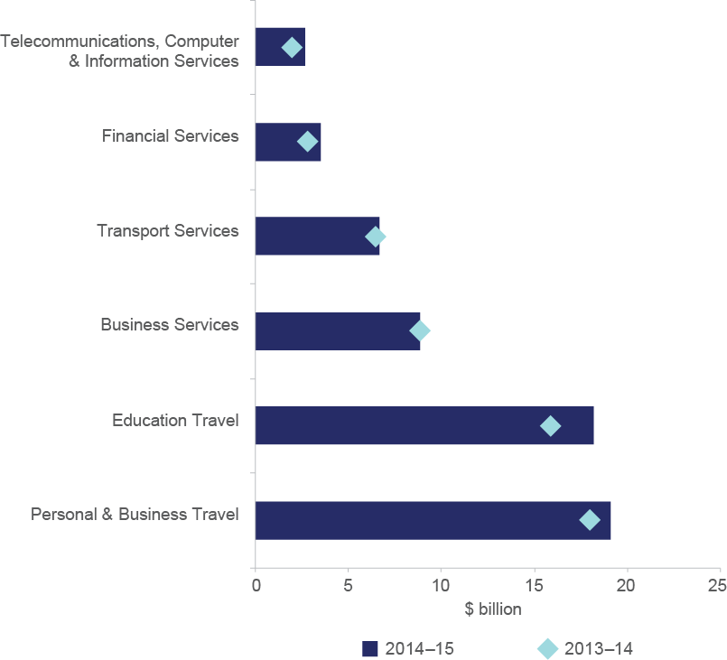Chart 1.22: Key components of service exports, 2013–14 and 20

*Source*: ABS cat. no. 5368.0, table 11a

*Notes*: Original data, current prices

##### Services industries face relatively low import competition

On the whole, the Australian services sector is relatively unexposed to import competition. Chart 1.23 shows the share of domestic demand for each service which is met by imports. As Australia has a relatively low import share of domestic sales, fluctuations in the Australian dollar generally have a relatively minor impact.

Chart 1.23 also shows the extent to which each service industry uses imported inputs in its production processes. A fall in the Australian dollar will cause the price of imported inputs to increase. Industries importing a large amount of inputs may be adversely affected, partially offsetting the benefit of a lower Australian dollar.

**57** ABS cat. no. 3401.0, table 5

Chart 1.23: Import characteristics of the services industries, 2012–13

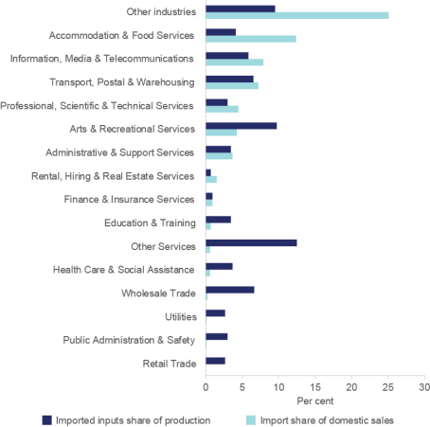

*Source*: ABS cat. no. 5209.0.55.001, table 5 and table 8

*Notes*: Latest available data is for 2012–13. Import share of domestic sales is calculated as

the proportion of imports within domestic sales. Domestic sales equal domestic production plus imports minus exports. Other services includes automotive, machinery and equipment repair and maintenance, personal care services, funeral, crematorium and cemetery services, religious services, civic, professional and other interest group services, private household employing staff and undifferentiated goods.

In August 2015, the Productivity Commission released their draft paper into barriers to growth in Australian services exports. This paper examined restrictions on access to Australian airports for foreign airlines and withholding taxes imposed on Australian payments of interest, dividends, royalties and payments from managed funds to foreign investors. The Commission noted that lack of uniform rates of withholding tax can create distortions in the market for investors. They also noted that inconsistencies with Foreign Investment Review Board screening thresholds for investment proposals could be restricting services exports.

Over the next few decades, global consumption will shift more towards services. At the same time, Australia is beginning a structural transformation to broader-based growth. Service exports could play an important role in strengthening Australia’s growth prospects. To maximise these opportunities, Australia needs to ensure there are no unnecessary restrictions on service exports.

### Mining continues to transition into the production phase

Over the past year, the Australian resources sector has continued to transition from the investment phase to the production phase of the resources boom.

Lower commodity prices have affected the profitability of Australian producers. The June quarter 2015 was the sixth consecutive quarter of lower profits in the mining sector.**58** This has curtailed the flow of capital into new projects and reduced capital expenditure on existing projects. Reflecting this, mining investment declined by 21.2 per cent through the year to the June quarter 2015.**59** In addition, exploration expenditure has declined as companies seek opportunities to cut costs and increase productivity.

In contrast, mining exports have increased rapidly as the high volume of investment over the past decade has begun to translate into new production capacity. Mining output increased by 7.6 per cent in 2014–15 and the industry was the largest contributor to GDP growth, adding 0.6 percentage points.**60** Chart 1.24 illustrates the increase in exports of key resource commodities — iron ore, thermal coal and metallurgical coal — over the past decade. Although exports of all three commodities increased over this period, iron ore exports exhibited the strongest growth. The department projects that the value of Australia’s resources and energy exports will increase by around 50 per cent by 2019–20.**61**

Chart 1.24: Volume and value of mining commodity exports, 2004–05 to 2014–2015

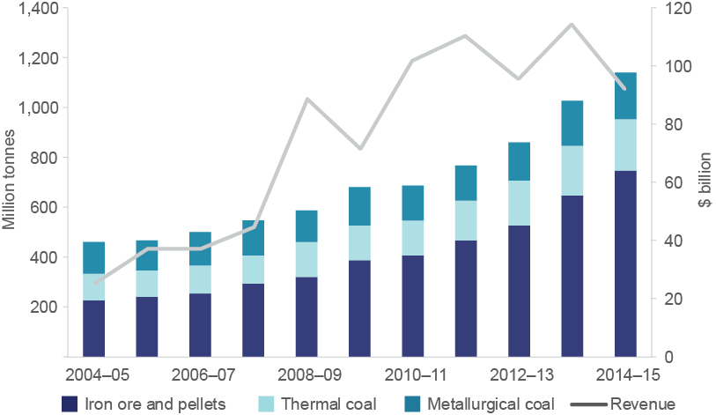

*Source*: Department of Industry, Innovation and Science, *Resources and Energy Quarterly*, September 2015 and September 2011 (Historical)

*Notes*: Revenue is the total for all three commodities, expressed in nominal terms.

One of the more substantial transitions is occurring in the LNG sector, with seven large LNG projects scheduled for completion over the next five years. These projects are projected to triple Australia’s LNG exports by 2019–20, making Australia the world’s largest LNG exporter.**62**

**58** Trend data. ABS cat. no. 5676.0, table 11

**59** Trend data. ABS cat. no. 5625.0, table 3b

**60** Original data. ABS cat. no. 5204.0, table 5

**61** Estimate is calculated in nominal terms. Department of Industry, Innovation and Science (2015) *Resources and Energy Quarterly*, September quarter 2015, Canberra p. 17

**62** Department of Industry, Innovation and Science (2015) *Resources and Energy Quarterly*, September quarter 2015, Canberra p. 2

Despite the largely positive outlook, Australia’s LNG sector faces increasing uncertainty. The trajectory for demand is uncertain beyond the medium term, particularly given falling prices for oil and strong competition from domestic and pipeline substitutes in the growing markets of China and Europe. This may be compounded by the sustainability of LNG imports into Japan in the event of nuclear restarts.

As a result, consumers require more flexible supply arrangements and have been less willing to sign long-term supply contracts. This has contributed to the growth in spot trading which is now around 30 per cent of the market. In addition, excess capacity is emerging following a period of tight supply. Global liquefaction capacity is projected to expand by 65 per cent over the next five years to around 170 million tonnes, as projects in Australia and the United States are completed (see Chart 1.25). The combination of excess supply and a vigorous spot market will put pressure on prices and slow investment in new projects.

Chart 1.25: Global existing and new liquification capacity

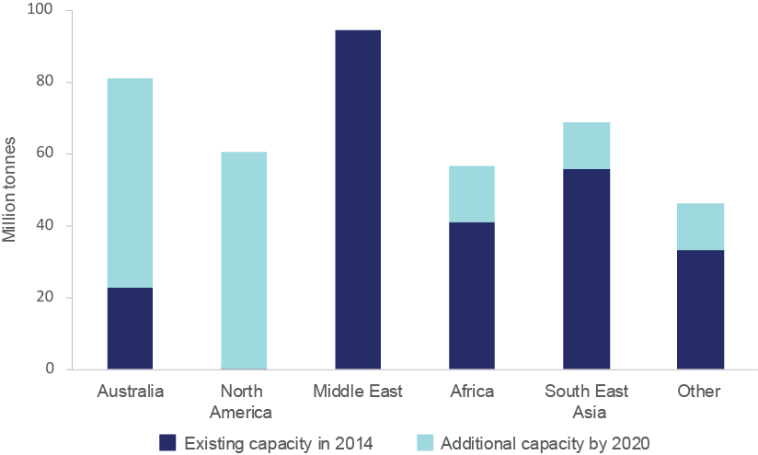

*Source*: Department of Industry, Innovation and Science, *Resources and Energy Quarterly*, September 2015

*Notes*: Includes allowances for plant downtime and maintenance.

### Manufacturing challenges remain, but the lower Australian dollar is helping

The manufacturing sector contracted in 2014–15, with output declining by 1.2 per cent.**63** Output fell in five out of eight manufacturing subsectors, with the sharpest falls occurring in Printing & Recorded Media, Machinery & Equipment, and Metal Products. Non-Metallic Mineral Products and Wood & Paper Products recorded strong rises in output in 2014–15. Employment in the manufacturing industry declined by 12,600 persons over the same period.**64**

**63** ABS cat. no. 5204.0, table 5

**64** Original data, four-quarter average. ABS cat. no. 6291.0.55.003, table 4

On the positive side, gross operating profits in Manufacturing increased by 2.0 per cent in 2014–15, driven by strong results in the first half of the year.**65** There are also increasing signs that manufacturers are benefiting from the fall in the Australian dollar. As Chart 1.26 shows, manufacturing exports have risen since the decline in Australia’s exchange rate from its peak in early 2013. The chart tracks movements in Australia’s exchange rate using the Trade Weighted Index, a measure of the value of the Australian dollar against the currencies of Australia’s major trading partners.

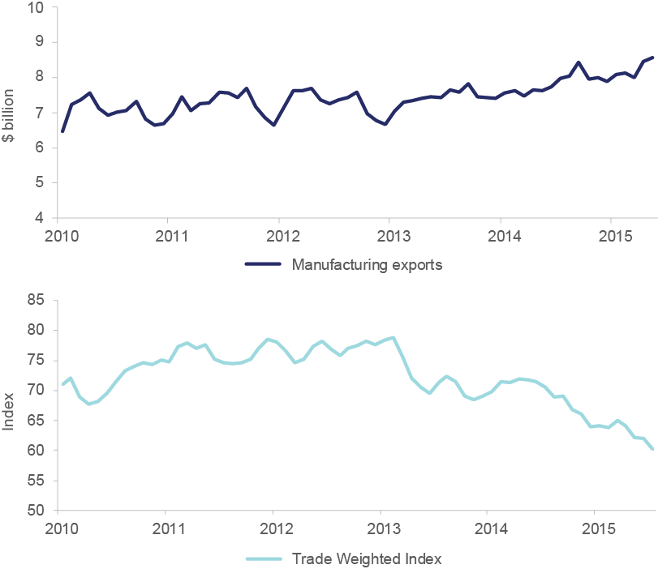Chart 1.26: Manufacturing exports and the exchange rate, 2010–2015

*Source:* Thomson Reuters DataStream; RBA Statistical Tables; ABS cat. no. 5368.0, table 32a

*Notes*: Export data is a three month moving average, original and in current prices.

The decline in the exchange rate has also benefited manufacturers by driving up the price of imports that compete with manufacturing sales in Australia. These benefits, however, have been partially offset in manufacturing sub-sectors that use a large amount of imported inputs (these are more expensive under a lower Australian dollar). Evidence from business surveys confirms that a lower Australian dollar can be a double-edged sword, with some manufacturers reporting that rising costs of imported inputs are squeezing their margins.**66**

**65** Original data. ABS cat. no. 5676.0, table 11

**66** Australian Industry Group (2015) *Performance of Manufacturing Index*, September 2015

### Construction activity is tapering off, but is supported by low interest rates

Activity in the construction sector can be divided into three broad areas: engineering construction, residential building, and non-residential building.67 Chart 1.27 shows the contributions of each type of construction work to total construction work over the past decade.

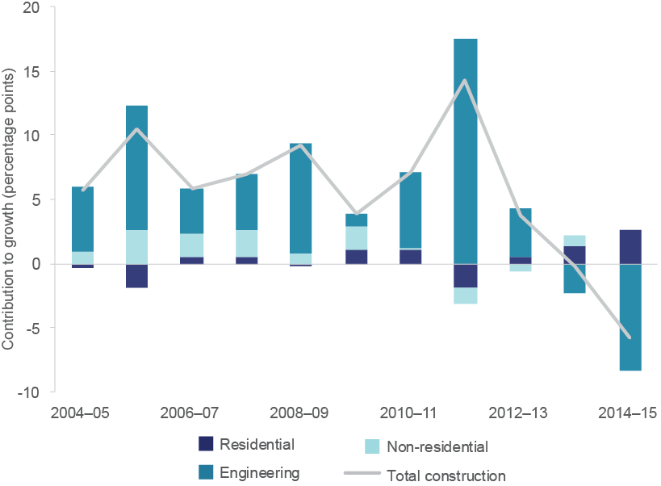Chart 1.27: Contributions to growth in total construction work 2004–05 to 2014–15

*Source*: Thomson Reuters DataStream; ABS cat. no. 8755.0, table 1; ABS cat. no. 8762.0, table 1

*Notes*: Seasonally adjusted data, constant prices

Engineering construction activity generated by the resources boom has driven much of the growth in the sector over the last 10 years. However, as the investment phase of the resources boom has wound down, so has engineering construction activity. Engineering construction activity fell by 14.2 per cent in 2014–15, the largest decline since the start of the statistical series.

Meanwhile, residential building activity has been on the rise. Residential building work increased by 10.6 per cent in 2014–15. The upswing in residential building activity is being supported by record low interest rates and high property prices. Nationally, residential property price growth is at 9.8 per cent in through-the-year terms, supported by price inflation in Sydney and, to a lesser extent, Melbourne.**68** Non-residential building has remained stable but is expected to improve, with Deloitte Access Economics stating that high asset prices, low interest rates and a lower Australian dollar are providing strong fundamentals for growth.**69**

**67** Examples of engineering construction projects include mines, highways, pipelines, harbours, railways and bridges.

**68** Original data. ABS cat. no. 6416.0, table 1

**69** Deloitte Access Economics (2015) *Business Outlook: Global Challenge*, September quarter 2015, p. 21

The contraction in engineering construction activity has affected some States more heavily, as can be seen in Chart 1.28. Engineering construction activity in Queensland fell by almost 50 per cent in 2014–15. Deloitte Access Economics is forecasting that $45 billion of the total $48 billion invested in current engineering projects in Queensland will come to a close this year.**70**

The fall in engineering construction activity in Western Australia has been more gradual. After five consecutive periods of negative growth, Western Australia recorded a temporary rebound in engineering construction in early 2015 as several large projects, including the Gorgon gas project, were completed. Levels of engineering construction in New South Wales have declined, but the development of hospitals, schools and roads are expected to support the sector over the next few years. The level of engineering construction in Victoria is forecast to be above the national average as a result of strong population growth.**71**

Chart 1.28: Value of engineering construction by State, 2005–2015

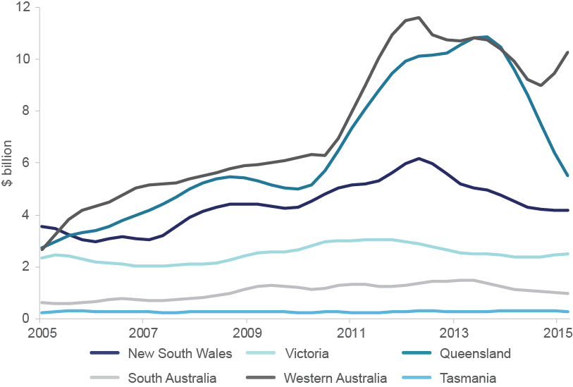

*Source*: ABS cat. no. 8762, table 2

*Notes*: Trend data, chain volume measures. Australian Capital Territory and Northern Territory are excluded.

**70** Deloitte Access Economics (2015) *Business Outlook: Global Challenge*, September quarter 2015, p. 105

**71** Deloitte Access Economics (2015) *Investment Monitor: Investment fragile as LNG projects wrap up*, September quarter 2015, p. 18–19

### Agriculture, Forestry & Fishing is well placed despite lingering vulnerabilities



Agriculture, Forestry, & Fishing accounts for around 2.2 per cent of the Australian economy. While its share has shrunk over time, output from the sector has continued to grow, and total industry value added for the sector rose by 1.5 per cent in real terms in 2014–15.**72** Some areas of the industry are recording particularly high export growth, as Chart 1.29 shows. Rises in exports of meat and meat preparations and other rural products are linked to the growth in demand for high-value food in Asia.

Chart 1.29: Export values for agricultural produce, 2005–2015

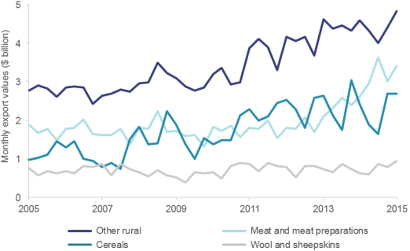

*Source:* ABS cat. no. 5302.0, table 7

*Notes*: Original data

In terms of overall production, several industries stand out. Nut growing, a traditionally modest crop, is rising rapidly and has become increasingly important as a source of domestic supply and exports. Nut production is expected to expand from around 139,000 tonnes in 2014 to 170,000 tonnes in 2020.**73** There has been a mixed performance with meat products — outputs of mutton and pork are picking up, but outputs of beef and lamb have decreased through the year to September 2015.**74** Fruit and vegetables exports are growing rapidly, with the value of vegetable production increasing by around one-third since 2006–07.**75**

Forecasts by the Department of Agriculture and Water Resources are mixed for agricultural products in 2015–16, but strong, long-term growth is expected for high-value food, driven by rising incomes in China.**76** The Department of Agriculture and Water Resources expects that Chinese demand for dairy products will more than double by 2050, and almost double for sugar and beef.**77**

**72** ABS cat. no. 5204.0, table 1, table 5

**73** Australian Nut Industry Council (2014) *Australia’s Tree Nut Industry: Growing for success*, p. 7

**74** ABS cat. no. 7218.0.55.001, datacube

**75** Department of Agriculture and Water Resources (2015) *Horticulture Fact Sheet: Production statistics*, [http://www.agriculture.gov.au/ag-farm-food/food/publications/hort-fact-sheet,](http://www.agriculture.gov.au/ag-farm-food/food/publications/hort-fact-sheet) viewed 4 November 2015

**76** Department of Agriculture and Water Resources (2015) *Agricultural commodities*, September quarter 2015, ABARES, Canberra

**77** Department of Agriculture and Water Resources (2013) *What Asia Wants: Long term food consumption trends in Asia*, ABARES, Canberra, p. xiii

### Summary

The transition away from the mining investment boom towards more diverse sources of growth has continued to unfold over the past year. It is not yet clear what the future has in store. On the one hand, GDP growth remains below its long-term average. There is talk of a ‘new normal’, with the possibility that lower rates of growth are here to stay.

Challenges from the global economic environment are expected to continue. China’s recent growth rate has softened as weakness emerges in its domestic economy. Declining commodity prices are reducing revenue for the resource sector even as a lower Australian dollar appears to be assisting trade-exposed industries. Falling commodity prices and a lower terms of trade are placing pressure on national income.

Productivity growth remains below the level required to sustain recent improvements in living standards. Australia is losing ground to comparable countries such as the United States and further reforms are needed to boost Australia’s productivity levels. In addition, the pick-up in non-mining investment is unlikely to cushion the impact of the fall in mining investment on economic growth. Greater business confidence could help to spark non- mining investment, but confidence remains relatively low.

On the other hand, there are signs of a successful adjustment. Employment growth has been relatively strong over the past year and participation in the labour market has increased. Australia’s unemployment rate has been relatively stable in recent months and there are expectations that it will remain stable over 2016, before improving in 2017. The lower Australian dollar should also help underwrite the transition to more diverse sources of growth, boosting the competitiveness of trade-exposed sectors. Australia has faced more difficult adjustments in the past when the terms of trade have trended down, and its recent performance suggests improved economic resilience.

At the sectoral level there have been positive signs over the past year. Mining output has ramped up as the production phase of the boom has taken hold. Residential construction activity has partially offset the effect of declining engineering construction. Overall, services industries have continued to grow solidly. Manufacturing exports have picked up in response to the lower Australian dollar, although the sector has continued to contract.

Looking forward, a lower Australian dollar should continue to exert a positive influence on exporting industries and bolster tourism. Solid employment outcomes will provide greater confidence in the economy and support growth. The challenge will be to ensure productivity growth continues to drive improvements in living standards.

# CHAPTER 2

Enabling services and their role

in the economy

In 2014–15, the Australian economy produced services worth around $970 billion — equivalent to about 60 per cent of GDP.**78**

Only about a third of these services, however, were sold directly to households. The majority (45 per cent) of services produced each year are sold to other businesses.**79**

These intermediary services enable businesses to thrive, to grow and develop. They do this by providing access to technologies, economies of scale, and to specialist and technical expertise. Most importantly, these services allow a business to concentrate on their core activities.

Identified in this chapter are four broad groups of enabling services:

* Professional & Support Services
* ICT & the Digital Economy
* Trade, Transport & Logistics
* Utilities Services

Whereas conventional methods of industry analysis typically focus on *what* is being produced, the analysis in this chapter focusses on *who* the production is for. Reflecting this, the analysis presented here excludes sectors that produce goods and those that primarily produce final services. This allows for a focus on sectors which provide intermediary services to other industries.

In 2014–15, enabling services produced approximately $465 billion of output (29 per cent of GDP) and employed 3.1 million workers (27 per cent of total employed).**80** As a whole,

**78** Based on ABS cat. no. 5204.0 and the definition of services industries from ABS cat. no. 1301.0 (Year Book Australia, 2012). Services industries are defined as all industries except for goods-producing industries: Agriculture, Forestry and Fishing; Mining; Manufacturing; and Construction. Note that all data in this chapter is current to 6 November 2015.

**79** Approximately 45 per cent of services sold in 2012–13 were intermediary services, based on ABS cat. no. 5209.0.55.001, table 5. 15 per cent of services were sold to the government sector, and 4 per cent were exported.

**80** Appendix C outlines the methodology that has been used to identify the industry classes which offer enabling services and estimate their output, employment and other activity.

**CHAPTER 2** Enabling services and their role in the economy **51**

enabling services have high levels of labour productivity (19 per cent above the industry average in 2014–15). Overall, research intensity in the enabling services is roughly 2.4 times greater than the average for all other industries in 2013–14.

This chapter examines each of the enabling services groups in turn, providing insight into their makeup and value. It also examines a range of factors which may affect enabling services in the future.

Productive enabling services contribute to Australia’s overall economic performance and competitiveness. This is an area of critical study and one in which greater understanding could improve our knowledge of how businesses enable other businesses in the Australian economy.

### What are enabling services?

Enabling services are the intermediary business-generated services provided to support the production, sale and delivery of final products. These intermediary services are required for businesses to get their products to market.

While the specific services provided will differ across industries, businesses providing enabling services fulfil a number of broad functions. These include:

* + the provision of technical advice and know how
  + access to specialist skills and services
  + access to vital infrastructure (both physical and digital)
  + access and communication with a businesses’ customers and other businesses
  + access to economies of scale

Nearly all businesses rely on enabling services to some extent. Consider for example, a business producing bottled fruit juice. The production and delivery of bottled fruit juice will require many inputs of both goods and services.

Obviously, that business will require the ingredients that comprise the juice, as well as the bottles and packaging that contain it. Perhaps less obvious to the production process, are the marketing services, the financial and legal advice, the logistical support and the utilities services that have contributed along the way. These enabling services are intermediary inputs to production. The use of these enabling services allows the business to concentrate on its core activity of producing bottled fruit juice.

In examining how best to classify enabling services, the department considered a range of possible methods. For the purposes of achieving a broad definition which captured all business-to-business services, the department selected a straightforward approach which captured a wide range of enabling functions.

This approach used information contained in Australian Bureau of Statistics ANZSIC classes and Input-Output Industry Groups. The department assessed the descriptions of over 500 ANZSIC classes in order to exclude those industries that produced goods, and those that produced services for final consumption. For each industry which was not excluded, the proportion of enabling services provided by that industry was then calculated using the percentage of ‘business’ product sales from the relevant Input-Output tables (as distinct from product sales to household, government or export sectors).

Chart 2.1 reports the distribution of services sold between businesses, households, governments and exports for the Input-Output Industry Groups used in enabling services calculations in this chapter.

Chart 2.1: Distribution of services sold to businesses, households, government and exports, by selected Input-Output Industry Groups, 2012–13

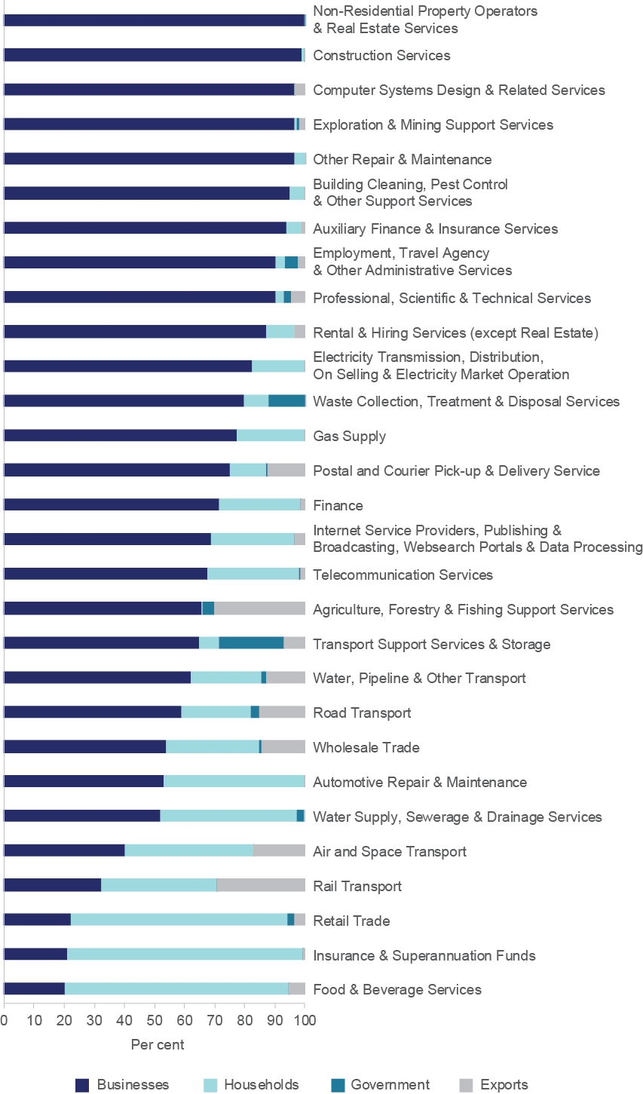

*Source*: ABS cat. no. 5209.0.55.001, table 5; and Department of Industry, Innovation and Science (2015) calculations

These proportions were then used to create estimates for enabling services as a whole. The industries were also further defined into four enabling services groups, based on common themes. These groups are as follows:

* + **Professional & Support Services** are a wide range of industry classes ranging from professional services such as legal and accounting and scientific research services, to support services such as repair and maintenance. They are made up of fee-for-service businesses that provide business operations and optimisation services.
  + **ICT & the Digital Economy** includes telecommunications, internet based data processing, storage and transmission, data processing and web hosting services, and computer system design and related services such as software development and installation. These businesses enable other businesses by providing a communications platform that allows business-to-business and business-to-customer interaction, as well as advanced data processing and hosting services.
  + **Trade, Transport & Logistics** features the range of businesses involved in logistics supply chains. They are businesses that move and sell products created by Australian businesses to final users (households, governments, or to international customers). This group features wholesalers, retailers, transport and logistics businesses, and the support services to these businesses. Support services include postal services and warehousing, as well as specialised support services such as stevedoring for the water freight industry.
  + **Utilities Services** deliver vital services necessary for the functioning of Australian businesses such as electricity, gas through mains systems, water, and drainage and sewage services. This group includes businesses engaged in the collection, treatment and disposal of waste materials; remediation of contaminated materials; and recycling activities.

Appendix C contains further information on the methodology used to identify the composition of the enabling services groups. The full list of sub-industries included within each group can be found in Appendix D. Note that each of these groups is quite broad and includes a number of sub-industries. Focusing on who the production is for, rather than what is being produced, these groups do not fall neatly within the standard ANZSIC industry classifications.

This methodology can also be extended to examine the specific enabling services that are relevant for one or more specific industry groups. Box 2.1 examines an extension of the methodology as it applies to the five growth sectors that form part of the Australian Government’s *Industry Innovation and Competitiveness Agenda*.

##### Box 2.1 Extension of the method for identifying enabling services — application for industry growth sectors

The department applied the method used for identifying enabling services and extended it to examine which industries provide enabling services to the five industry growth sectors.

The growth sectors are an important part of the Australian Government’s *Industry Innovation and Competitiveness Agenda*. The agenda includes the Industry Growth Centres Initiative (the Initiative), which will establish Industry Growth Centres for each growth sector. The Initiative is the centrepiece of the Government’s new industry policy direction. It has been designed to lift competitiveness and productivity and assist Australia’s transition into smart, high value and export focused industries. Chapter 1 of this report (see Box 1.2) provides updated information on output, employment and labour productivity on each of the five industry growth sectors, namely:

* Food & Agribusiness
* Mining Equipment, Technology & Services
* Oil, Gas & Energy Resources
* Advanced Manufacturing
* Medical Technologies & Pharmaceuticals**81**

Extending the application of the methodology for the five industry growth sectors involved:

1. Taking the four digit ANZSIC classes for each of the growth sectors (see Appendix B for the full list of ANZSIC classes) and matching them with the relevant proportion of each Input–Output Industry Group (industry groups)**82**
2. Calculating the proportion of inter-industry product sold by an industry group to growth sector industry groups identified above
3. Examining, for each industry group, how many growth sector industry groups they supplied

Chart 2.2 shows a scatter plot of the results of this analysis for the 114 industry groups. The vertical axis plots the results of step 2 above. The horizontal axis plots the results of step 3 above.

At one end of the spectrum, there are five industry groups that provide no input to the growth sectors (i.e. zero proportion of growth sectors supplied and output supplied). As an example, one of these five groups is Library & Other Information

**81** Note that the Growth Sectors form the basis of two major programmes run by the Department of Industry, Innovation and Science: the Industry Growth Centres Initiative, and the Entrepreneurs’ Programme. For more information on the Industry Growth Centres Initiative see: [http://www.business.gov.au/advice-and-support/IndustryGrowthCentres/Pages/default.aspx.](http://www.business.gov.au/advice-and-support/IndustryGrowthCentres/Pages/default.aspx)

For more information on the Entrepreneurs’ Programme see: <http://www.business.gov.au/advice-and-support/EIP/Pages/default.aspx>

**82** If the growth sectors are only partially defined within an industry group, a proportional approach based on the total number of employed persons in growth sector classes relative to the total number employed in the industry group overall, as reported in the 2011 Census, is taken.

Services — which makes intuitive sense as this group does not appear to be closely related to any of the five growth sectors.

At the other end of the spectrum, there are 10 industry groups that supply all of the growth sectors, including, for example, Wholesale Trade. There are also four industry groups that supply the majority of their output to the growth sectors, including, for example, Agriculture, Forestry & Fishing Support Services (although most supply less than 15 per cent of their output to industry groups).

Chart 2.2: Scatter plot of proportions of growth sectors supplied by Input–Output Industry Groups

Chart 2.2 shows a scatter plot of growth sectors supplied by Input-Output Industry Groups in 2012–13. The x-axis shows the proportion of an Input-Output Industry Group’s output that is supplied to growth sector Input-Output Industry Groups. The y-axis shows the proportion of growth sector Input-Output Industry Groups supplied by an Input-Output Industry Group. 
Of all the points in the scatter plot, five Input-Output Industry Groups provide no input to the growth sectors, they are: Ownership of Dwellings; Residential Care and Social Assistance Services; Primary and Secondary Education Services (including Pre-Schools and Special Schools); Defence and Library and Other Information Services. 
Ten Input-Output Industry Groups supply all five of the growth sectors: Polymer Product Manufacturing; Construction Services; Retail Trade; Electricity Transmission, Distribution, On Selling and Electricity Market Operation; Finance; Employment, Travel Agency and Other Administrative Services; Petroleum and Coal Product Manufacturing; Professional, Scientific and Technical Services; Wholesale Trade and Road Transport. 
Four Input-Output Industry Groups supply the majority of their output to the growth sectors: Poultry and Other Livestock; Agriculture, Forestry and Fishing Support Services; Sheep, Grains, Beef and Dairy Cattle and Gas Supply.


*Source*: ABS 5209.0.55.001, Table 5; Department of Industry, Innovation and Science (2015)

Chart 2.2 shows a wide distribution of growth sectors supplied and output supplied to growth sectors by industry groups. Given this distribution, it may be appropriate to impose thresholds to identify a particular number of enabling services’ industry groups for the five growth sectors. The department elected to look for natural clusters in the results above. For example, natural cluster thresholds were identified where an industry group was supplying to at least 70 per cent of growth sectors and/or had at least 15 per cent of its output to growth sectors. These thresholds of 70/15 produced a total of 27 industry groups.

Depending on the purpose of the analysis, identifying relevant thresholds may assist in identifying relationships between different sectors, commonalities across sectors and potential policy responses. Note that a range of other thresholds may also be appropriate depending on the objective of the analysis.

### Key characteristics of enabling services

In 2014–15, enabling services produced approximately $465 billion of output (29 per cent of GDP) and employed approximately 3.1 million workers (27 per cent of total employment). Professional & Support Services are the largest of the four enabling services groups, employing the most people and making up around 20 per cent of GDP in 2014–15. The other three groups are much smaller, collectively producing around 9 per cent of GDP.

Labour productivity in enabling services is around 19 per cent higher than the industry average. Utilities Services have the highest labour productivity of the four groups, reflecting their capital intensive nature.

Research intensity in enabling services is roughly 2.4 times greater than the average for all other industries in 2013–14. This is mostly due to the stand out performance in the ICT & the Digital Economy group. ICT & the Digital Economy has the highest research intensity of any enabling services group, with 4.2 per cent business expenditure on research and development (BERD) to output in 2013–14. This compares with 2.0 per cent for the enabling services as a whole, and 0.6 per cent for all other industries.

Chart 2.3 shows key statistics of the four enabling services groups for 2014–15.

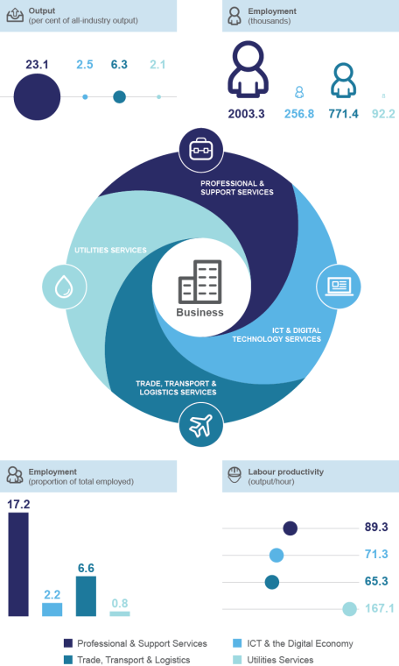Chart 2.3: Enabling services groups and key statistics, 2014–15

*Source*: ABS cat. no. 5204.0, table 5; ABS cat. no. 5209.0.55.001, table 5; ABS cat. no. 6202.0, table 21; ABS *Census of Population and Housing 2011;* ABS *Special Data Request from Labour Force Survey;* and Department of Industry, Innovation and Science (2015) calculations.

*Note*: Employment (thousands) infographic is not to scale

Enabling services are increasing as a proportion of the economy. As can be seen in Chart 2.4, the share of services that are enabling services has increased over the last decade. In 2004–05, enabling services accounted for 45.1 per cent of services production. By 2014– 15 this had increased to 47.9 per cent. Growth in enabling services accounted for, on average, 56.0 per cent of the growth in the services sector between 2004–05 and 2014–15.

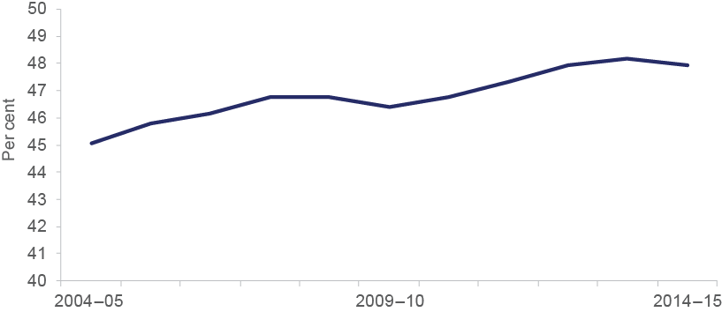Chart 2.4: Enabling services as a share of the services sector, 2004–05 to 2014–15

*Source*: ABS cat. no. 5204.0, table 5; ABS cat. no. 5209.0.55.001, table 5; ABS cat. no. 6202.0, table 21; ABS *Census of Population and Housing 2011;* ABS *Special Data Request from Labour Force Survey;* and Department of Industry, Innovation and Science (2015) calculations.

Strong increases are also reflected in output and employment. Chart 2.5 shows that output in three of the four enabling services groups has grown faster than the total for all other industries combined.

Chart 2.5: Output for enabling services groups, 2004–05 to 2014–15

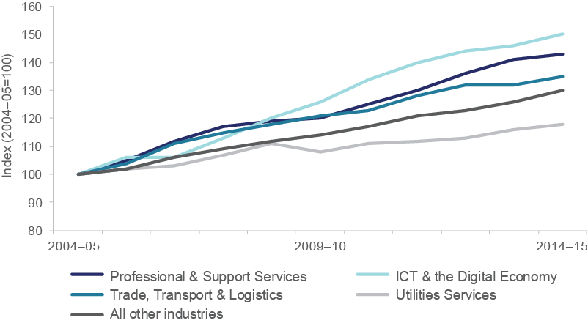

*Source*: ABS cat. no. 5204.0, table 5; ABS cat. no. 5209.0.55.001, table 5; ABS cat. no. 6202.0, table 21; ABS *Census of Population and Housing 2011;* ABS *Special Data Request from Labour Force Survey;* and Department of Industry, Innovation and Science (2015) calculations.

Similarly, Chart 2.6 shows that three of the four enabling services groups have seen faster employment growth over the last ten years, except for Trade, Transport & Logistics which has grown in line with all other industries from 2010–11 onwards.

Chart 2.6: Employment for enabling services groups, 2004–05 to 2014–15

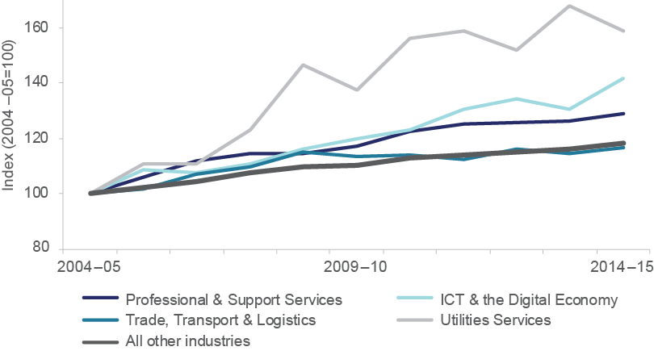

*Source*: ABS cat. no. 5204.0, table 5; ABS cat. no. 5209.0.55.001, table 5; ABS cat. no. 6202.0, table 21; ABS *Census of Population and Housing 2011;* ABS *Special Data Request from Labour Force Survey;* and Department of Industry, Innovation and Science (2015) calculations.

Labour productivity levels (output per hour worked) vary somewhat across the four groups, as shown in Chart 2.7. Three of the four appear similar when compared to Utilities Services, which shows much higher labour productivity as a result of higher capital intensity.

Chart 2.7: Labour productivity for enabling services groups, 2004–05 to 2014–15

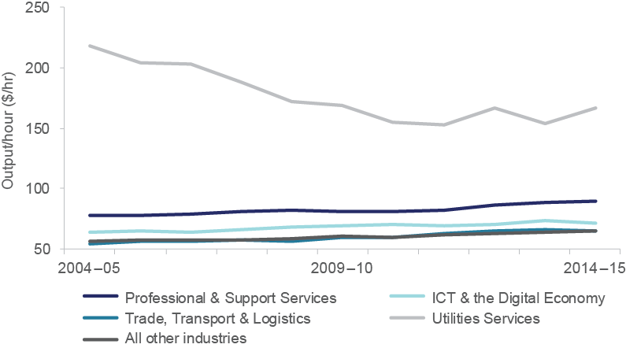

*Source*: ABS cat. no. 5204.0, table 5; ABS cat. no. 5209.0.55.001, table 5; ABS cat. no. 6202.0, table 21; ABS *Census of Population and Housing 2011;* ABS *Special Data Request from Labour Force Survey;* and Department of Industry, Innovation and Science (2015) calculations.

The above data shows that enabling services are a large, high-employing, and research intensive part of the economy. These metrics, however, are unlikely to fully capture the importance of enabling services. Box 2.2 explores use of modelling to measure the indirect contribution of enabling services.

**Box 2.2: Modelling the contribution of enabling**

**services for industry growth sectors**

One way to measure the economic impact of enabling services is to estimate the spill over benefits from improving their productivity. Greater productivity in enabling services should allow businesses to provide more competitive offerings to the market — in effect creating a ‘rising tide’ where all businesses benefit from these improvements.

The effects of a productivity increase can be illustrated by using a Computable General Equilibrium (CGE) model. CGE models use historical data and economic theory to map the structure of an economy and its components, such as households, businesses, governments, and the international sector. Variables in the model can be modified or ‘shocked’ to estimate alternate values, based on how economic actors would be expected to respond.

A CGE model can for example be used to measure the impact of a 1 per cent increase in the labour productivity of enabling services. In this example, modelling was undertaken to estimate the impact across the five growth sectors, building on the analysis outlined in Box 2.1.

Individual results of the modelling for the five growth sectors are presented in Chart 2.8. Each of the five growth sectors clearly benefits from the improved labour productivity of enabling services. Differences in impacts are likely to be as a result of a number of factors including market scale and structure, cost bases and how the enabling services are used in each sector. As per Chart 2.8, Advanced Manufacturing benefits the most, showing an increase in production of $553 million.

Chart 2.8: Change in growth sector output from a 1 per cent increase in enabling services labour productivity

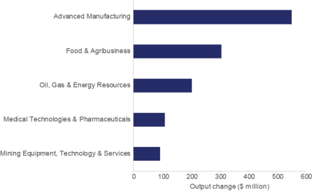

*Source*: ACIL Allen Consulting (2015)

The modelling results confirm that improvements in the productivity of enabling services can lead to significant impacts in multiple sectors in the economy. It reflects the extent to which enabling services are integrated into the broader economy. Similar results are expected across a wide range of sectors.

This chapter now turns to describing the individual characteristics of each enabling services group — Professional & Support Services; ICT & the Digital Economy; Trade, Transport

& Logistics; and Utilities Services.

### Professional & Support Services provide access to specialist skills in a cost-effective manner

Professional & Support Services represent an important and highly varied set of service industries. These industries provide specialist skills and technical knowhow that would be expensive for other businesses to generate in-house. Many of these skills are used only intermittently, or can be provided only by experts in limited supply.

The activities described above are often brought under the collective term of ‘outsourcing’ of business practices. There are two major types of outsourcing activities associated with Professional & Support Services:

* process outsourcing by businesses seeking operational efficiency
* business optimisation outsourcing by businesses seeking specialised, high-value services that are cheaper to procure externally

Both types of outsourcing are important. Business process outsourcing can lead to operational efficiency, which has become crucial for competing in a globalised economy. To remain competitive and reduce overhead costs, many businesses have increasingly outsourced non-core processes, despite the logistics chain risks that can be created. The types of activities that are outsourced by businesses and captured in Professional

& Support Services include:

* office administration, book-keeping and accountancy services
* employment and recruiting services
* marketing and advertising
* maintenance of buildings, equipment

Operating on the same principles as business process services, business optimisation services give advice on management or practices or provide specialist services that are difficult for a business to generate in-house. These include:

* scientific research
* management consulting
* banking, finance and insurance
* legal services
* market research services
* particular industry services such as petroleum and mineral exploration services, mining support services, and agriculture and fishing support services

The decision to procure these services externally is dependent on their cost relative to internal production. The existence and growth of these industries indicates the benefits of increasing specialisation and markets for cross-industry and for-industry services.**83** The department estimates that in 2014–15 approximately $317 billion dollars’ worth of Professional & Support Services was purchased by Australian industries (see Table 2.1). This is the largest of the enabling services groups, accounting for 19.6 per cent of Australia’s GDP for 2014–15.

**83** This phenomenon relates to Ronald Coase’s celebrated theory of the firm, whereby the existence of businesses is based on the extent to which they minimise transaction costs between individuals operating in a marketplace: Coase R H (1937) The Nature of the Firm, *Economica,* 4(16), pp. 386–405. Where it is cheaper for individuals to transact between each other, they will do so. Where it is not cheaper, they will create organisations such as businesses to reduce the costs of transactions between themselves. In the same way, businesses will choose to procure services externally from themselves where it is cheaper for them to do so.

A snapshot of key data is presented in Table 2.1 and Chart 2.9. Historical data is provided over the last ten financial years to give a snapshot of current trends. To show growth trends the data for output, employment and labour productivity are provided in index form, with 2004–05 forming the base year. The data for labour productivity is reported as output per hour worked. Other data, such as BERD intensity, Intellectual Property (IP) intensity and the distribution of worker skill levels, are provided for the latest available year.

Table 2.1: Professional & Support Services, key data, various years

|  |  |  |
| --- | --- | --- |
| **Key statistics** | **Value** | **Share of all-industry**  **(per cent)** |
| Output, 2014–15 ($ billions) | 317.0 | 23.1 |
| Employment, 2014–15 (millions employed) | 2.0 | 17.2 |
| **Productivity and innovation statistics** | **Value** | **Difference vs**  **all-industry (units)** |
| Labour productivity, 2014–15 ($ output/hr worked) | 89.3 | +18.3 |
| BERD intensity, 2013–14 (BERD/output; per cent) | 2.3 | +0.9 |
| IP intensity, 2013  (patent applications per 1,000 businesses) | 1.2 | –0.1 |

*Source*: ABS cat. no. 5204.0, table 5; ABS cat. no. 5209.0.55.001, table 5; ABS cat. no. 8165.0; ABS *Census of Population and Housing 2011;* ABS *Special Data Request from Labour Force Survey;* Department of Industry, Innovation and Science (2015) *R&D Tax Offset and R&D Tax Concession programme data;* IP Australia (2015) *Special Data Request — Patent applications, 1990–2013;* and Department of Industry, Innovation and Science (2015) calculations.

*Notes*: BERD data is business reported BERD to the Australian Taxation Office and the Department of Industry, Innovation and Science as part of business applications for the R&D Tax Incentive programme.

Chart 2.9: Professional & Support Services, key data, various years

Chart 2.9 shows growth trends for output, employment and labour productivity for Professional & Support Services from 2004–05 to 2014–15, in index form, with 2004–05 forming the base year. The chart also shows the distribution of worker skill levels in Professional & Support Services for 2014.
Over the last ten years, output and employment growth for Professional & Support Services have increased faster than for the economy at large. Labour productivity is also performing well in the Professional & Support Services relative to all industries. Workers’ skill levels in Professional & Support Services are similar to all industries, reflecting the varied nature of services provided by this group.


*Source*: ABS cat. no. 5204.0, table 5; ABS cat. no. 5209.0.55.001, table 5; ABS cat. no. 8165.0; ABS *Census of Population and Housing 2011;* ABS *Special Data Request from Labour Force Survey;* and Department of Industry, Innovation and Science (2015) calculations.

*Notes*: Skill levels refer to the five skill levels from the ABS’s Australian and New Zealand Standard Classification of Occupations (2006). The higher the skill level, the more training or education is required for that particular occupation.

Business process and business optimisation outsourcing services appear to have increased over the last ten years, while employment growth has also increased faster than for the economy at large. Labour productivity is also performing well in the Professional & Support Services relative to all industries.

Workers’ skill levels in Professional & Support Services are similar to all industries, reflecting the varied nature of services provided by this group. The top occupations range from skill level 1 occupations, such as Accountants, to the lowest skilled occupations (skill level 5), such as Commercial Cleaners.**84** BERD intensity (measured as industry BERD as a percentage of industry output) for Professional & Support Services is relatively high. Professional & Support Services averaged a 2.1 per cent ratio of BERD spending to output over 2008–09 to 2013–14, compared to 1.5 per cent for all industries. IP patent activity for Professional & Support Services is on par with that of other industries.

### ICT & the Digital Economy provide services which allow businesses to communicate and leverage computer systems

ICT & the Digital Economy businesses provide digital and internet-based communication services to other businesses, and technical assistance through IT consulting services. The importance of these sorts of services are such that ICT technology has been called the ‘enabling utility’ of the modern age.**85** The ABS’s *Business Characteristics Survey* shows internet access, internet-based commercial transactions and internet-derived income have increased for each year of the survey. In 2013–14:

* + 94.7 per cent of businesses had internet access
  + 56.0 per cent placed orders via the internet
  + 33.2 per cent received orders via the internet
  + internet income for businesses was estimated at $266.8 billion dollars**86**

Australian businesses have increased their web presence, with:

* + 47.1 per cent having a web site in 2013–14
  + 30.8 per cent having a separate social media presence online**87**

These activities are expected to increase with the roll out of the National Broadband Network (NBN). The NBN is currently available to one in every ten Australian households, and NBN Co expects that the network will double its footprint each year to achieve the goal of reaching eight million households and businesses by 2020.**88** In addition, well-designed and fit-for-purpose IT systems are becoming increasingly valuable for businesses; however, the design, build and implementation of these systems can be difficult for non-specialised workforces to complete.

ICT & the Digital Economy business services are growing rapidly in size and importance. Of the four enabling services groups considered in this chapter, ICT & the Digital Economy has grown the fastest, with an annualised average growth rate of 4.1 per cent per year between 2004–05 and 2014–15. A summary of key indicators and trend data for this group is provided in Table 2.2 and Chart 2.10.

**84** Skill levels for each occupation are as defined in the ABS’s Australian and New Zealand Standard Classification of Occupations (2006)

**85** See for example Phil Ruthven (2015) ‘Where the jobs are’, *Australia’s future workforce?* Committee for Economic Development of Australia, p. 196

**86** ABS cat. no. 8166.0

**87** Ibid.

**88** NBN Co Limited (2015) *Corporate Plan 2016*, p. 10

Table 2.2: ICT & the Digital Economy, key data, various years

|  |  |  |
| --- | --- | --- |
| **Key statistics** | **Value** | **Share of all-industry**  **(per cent)** |
| Output, 2014–15 ($ billions) | 34.1 | 2.5 |
| Employment, 2014–15 (thousands employed) | 256.8 | 2.2 |
| **Productivity and innovation statistics** | **Value** | **Difference to**  **all-industry (units)** |
| Labour productivity, 2014–15 ($ output/hr worked) | 71.3 | +0.3 |
| BERD intensity, 2013–14 (BERD/output; per cent) | 4.2 | +2.8 |
| IP intensity, 2013  (patent applications per 1,000 businesses) | 2.3 | +1.0 |

*Source*: ABS cat. no. 5204.0, table 5; ABS cat. no. 5209.0.55.001, table 5; ABS cat. no. 8165.0; ABS *Census of Population and Housing 2011;* ABS *Special Data Request from Labour Force Survey;* Department of Industry, Innovation and Science (2015) *R&D Tax Offset and R&D Tax Concession programme data;* IP Australia (2015) *Special Data Request — Patent applications, 1990–2013;* and Department of Industry, Innovation and Science (2015) calculations.

*Notes*: BERD data is business reported BERD to the Australian Taxation Office and the Department of Industry, Innovation and Science as part of business applications for the R&D Tax Incentive programme.

Chart 2.10: ICT & the Digital Economy, key data, various years

Chart 2.10 shows growth trends for output, employment and labour productivity for ICT & the Digital Economy from 2004–05 to 2014–15, in index form, with 2004–05 forming the base year. The chart also shows the distribution of worker skill levels in ICT & the Digital Economy for 2014.
Over the last ten years, output and employment growth for ICT & the Digital Economy have outpaced all industries, while labour productivity has remained on-par with the all industries’ average. Skill levels data shows that 70 per cent of workers in ICT & the Digital Economy have occupations associated with the highest skill level (skill level 1). This compares to 30 per cent for all industries.


*Source*: ABS cat. no. 5204.0, table 5; ABS cat. no. 5209.0.55.001, table 5; ABS cat. no. 8165.0; ABS *Census of Population and Housing 2011;* ABS *Special Data Request from Labour Force Survey;* and Department of Industry, Innovation and Science (2015) calculations.

*Notes*: Skill levels refer to the five skill levels from the ABS’s Australian and New Zealand Standard

Classification of Occupations (2006). The higher the skill level, the more training or education is required for that particular occupation.

Output and employment data for ICT & the Digital Economy show similar patterns to those for Professional & Support Services, with use of these services increasing rapidly. Over the last ten years, output and employment growth have outpaced all industries. Labour productivity has remained on-par with the all-industries’ average, but services provided by this group may be improving the productivity of industries purchasing their services.

Skill levels data shows that 70 per cent of workers in ICT & the Digital Economy have occupations associated with the highest skill level (skill level 1). This compares to 31 per cent for all industries. Some of the top five occupations in the group include Software and Applications Programmers, ICT Support Technicians and ICT Business and Systems Analysts.

BERD intensity for ICT & the Digital Economy is relatively high. ICT & the Digital Economy spent, on average, 4.3 per cent of output on BERD between 2008–09 and 2013–14, compared to 1.5 per cent, on average, for all industries. IP patent activity was also high, with

* 1. patent applications per 1,000 businesses in 2012 and 2.3 patent applications per 1,000 businesses in 2013, compared to the all-industries’ figures of 1.1 and 1.3, respectively.

### Trade, Transport & Logistics underpin the functioning of the physical goods market and support broader services

The Trade, Transport & Logistics group covers businesses that provide logistics management services for businesses that produce and trade in physical goods. These services include a range of wholesaling, retailing, transport, delivery and storage services used by these businesses to get their products to customers. Services-producing businesses also use parts of this group — notably postal, transport or freight services — to support their activities.

This group has been separated from the Professional & Support Services because of its fundamental and long-standing importance for the operation of the physical goods market. The Bureau of Infrastructure, Transport and Regional Economics (BITRE) reports that Australian domestic freight activity has increased eight-fold since 1961.89 In 1961, freight movements were approximately 62 billion tonne kilometres; in 2011–12, that figure had risen to approximately 600 billion tonne kilometres.**90** The same report shows that domestic rail freight is vital for iron ore and coal transportation, with the transportation of these two minerals comprising over 80 per cent of all Australian rail freight in 2011–12. Chart 2.11 shows major freight flows in Australia, 2011–12.

Chart 2.11: Australian freight movements, 2011–12

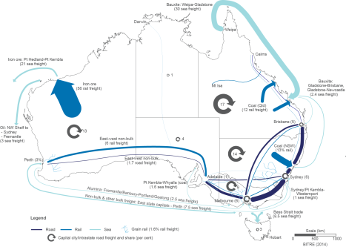

*Source*: BITRE (2014) *Freightline I — Australian freight transport overview*, p. 3

**89** Bureau of Infrastructure, Transport and Regional Economics (2011) *Truck productivity: sources, trends and future prospects*, Research Report 123, p. 2

**90** Ibid.; Bureau of Infrastructure, Transport and Regional Economics (2014) *Freightline I — Australian freight transport overview*, p. 1

Without Trade, Transport & Logistics, the physical goods market could not operate beyond a localised, place-based format without imposing significant costs on isolated and remote locations. A loss of Trade, Transport & Logistics services would also constrain the opportunities for mutually beneficial market transactions between producers and consumers, both across the nation and internationally.

Overall, Trade, Transport & Logistics forms a significant portion of the Australian economy, with output of $86.2 billion (5.3 per cent of GDP) in 2014–15. A snapshot of the group’s performance is provided in Table 2.3 and Chart 2.12.

Table 2.3: Trade, Transport & Logistics, key data, various years

|  |  |  |
| --- | --- | --- |
| **Key statistics** | **Value** | **Share of all-industry**  **(per cent)** |
| Output, 2014–15 ($ billions) | 86.2 | 6.3 |
| Employment, 2014–15 (thousands employed) | 771.4 | 6.6 |
| **Productivity and innovation statistics** | **Value** | **Difference vs**  **all-industry (units)** |
| Labour productivity, 2014–15 ($ output/hr worked) | 65.3 | –5.7 |
| BERD intensity, 2013–14 (BERD/output; per cent) | 0.9 | –0.5 |
| IP intensity, 2013  (patent applications per 1,000 businesses) | 1.3 | 0.0 |

*Source*: ABS cat. no. 5204.0, table 5; ABS cat. no. 5209.0.55.001, table 5; ABS cat. no. 8165.0; ABS *Census*

*of Population and Housing 2011;* ABS *Special Data Request from Labour Force Survey;* Department of Industry, Innovation and Science (2015) *R&D Tax Offset and R&D Tax Concession programme data;* IP Australia (2015) *Special Data Request — Patent applications, 1990–2013;* and Department of Industry, Innovation and Science (2015) calculations.

*Notes*: BERD data is business reported BERD to the Australian Taxation Office and the Department of Industry, Innovation and Science as part of business applications for the R&D Tax Incentive programme.

Chart 2.12 shows growth trends for output, employment and labour productivity for Trade, Transport & Logistics from 2004–05 to 2014–15, in index form, with 2004–05 forming the base year. The chart also shows the distribution of worker skill levels in Trade, Transport & Logistics for 2014.
Over the last ten years, output growth and labour productivity for Trade, Transport & Logistics have outpaced all industries, while employment growth has remained on-par with the all industries’ average. Workers in Trade, Transport & Logistics have a relatively lower skills profile compared to all industries. The majority of workers have skill level 4 occupations followed by skill level 5 occupations.
Chart 2.12: Trade, Transport & Logistics, key data, various years

*Source*: ABS cat. no. 5204.0, table 5; ABS cat. no. 5209.0.55.001, table 5; ABS cat. no. 8165.0; ABS *Census of Population and Housing 2011;* ABS *Special Data Request from Labour Force Survey;* and Department

of Industry, Innovation and Science (2015) calculations.

*Notes*: Skill levels refer to the five skill levels from the ABS’s Australian and New Zealand Standard Classification of Occupations (2006). The higher the skill level, the more training or education is required for that particular occupation.

Output and labour productivity data for Trade, Transport & Logistics show that over the last ten years, output growth and labour productivity have outpaced all industries. Employment growth has remained on-par with the all-industries’ average.

Workers in Trade, Transport & Logistics have a relatively lower skills profile compared

to all industries. The majority of workers have skill level 4 occupations (commensurate with Certificate I/II or one year’s work experience) followed by skill level 5 occupations (commensurate with Certificate I qualification or no formal training). In addition, the majority of Trade, Transport & Logistics’ occupations are either in the retail industry or provide services to it. Retail is an area where the majority of the highest employing occupations require no formal education.

BERD intensity for Trade, Transport & Logistics was also below the all-industries’ average. Trade, Transport & Logistics invested, on average, 0.9 per cent of their output in BERD between 2008–09 and 2013–14, compared to the all-industries’ average of 1.5 per cent. IP patent application performance was in line with the all-industries’ benchmark.

### Utilities Services are fundamental in allowing other businesses to function

Utilities Services are comprised of businesses that provide services for the physical functioning of Australian businesses.**91** These functions include:

* + - * electricity transmission and distribution services to electricity generators
      * electricity retail and wholesaling to customers
      * gas and water supply through storage and distribution systems
      * sewerage and drainage services
      * waste collection and waste treatment
      * pipeline transport of natural gas, oil or other materials

Of the four enabling services groups considered in this chapter, Utilities Services is the smallest. It has output of $28.2 billion in 2014–15, equal to approximately 1.7 per cent of GDP. A snapshot of Utilities Services’ performance over the last decade is provided in Table

2.4 and Chart 2.13.

Table 2.4: Utilities Services, key data, various years

|  |  |  |
| --- | --- | --- |
| **Key statistics** | **Value** | **Share of all-industry**  **(per cent)** |
| Output, 2014–15 ($ billions) | 28.2 | 2.1 |
| Employment, 2014–15 (thousands employed) | 92.2 | 0.8 |
| **Productivity and innovation statistics** | **Value** | **Difference vs**  **all-industry (units)** |
| Labour productivity, 2014–15 ($ output/hr worked) | 167.1 | +96.1 |
| BERD intensity, 2013–14 (BERD/output; per cent) | 0.6 | –0.8 |
| IP intensity, 2013  (patent applications per 1,000 businesses) | 3.4 | +2.1 |

*Source*: ABS cat. no. 5204.0, table 5; ABS cat. no. 5209.0.55.001, table 5; ABS cat. no. 8165.0; ABS *Census*

*of Population and Housing 2011;* ABS *Special Data Request from Labour Force Survey;* Department of Industry, Innovation and Science (2015) *R&D Tax Offset and R&D Tax Concession programme data;* IP Australia (2015) *Special Data Request — Patent applications, 1990–2013;* and Department of Industry, Innovation and Science (2015) calculations.

*Notes*: BERD data is business reported BERD to the Australian Taxation Office and the Department of Industry, Innovation and Science as part of business applications for the R&D Tax Incentive.

**91** Note that telecommunications and internet utilities are included in the ICT & the Digital Economy group.

Chart 2.13 shows growth trends for output, employment and labour productivity for Utilities Services from 2004–05 to 2014–15, in index form, with 2004–05 forming the base year. The chart also shows the distribution of worker skill levels in Utilities Services for 2014.
Over the last ten years, output growth for Utilities Services has been below that for all industries, while employment growth has exceeded the average. Labour productivity growth for Utilities Services has lagged significantly behind the all industries average. Workers’ skill levels in Utilities Services are in line with that for all industries.    
Chart 2.13: Utilities Services, key data, various years

*Source*: ABS cat. no. 5204.0, table 5; ABS cat. no. 5209.0.55.001, table 5; ABS cat. no. 8165.0; ABS *Census of Population and Housing 2011;* ABS *Special Data Request from Labour Force Survey;* and Department of Industry, Innovation and Science (2015) calculations.

*Notes*: Skill levels refer to the five skill levels from the ABS’s Australian and New Zealand Standard Classification of Occupations (2006). The higher the skill level, the more training or education is required for that particular occupation.

Falling growth rates of output for Utilities Services have coincided with rising rates of employment. Over the last ten years, output growth has been below that for all industries, while employment growth has exceeded the average. This partially reflects significant investment in the resilience of electricity grids in Queensland and other states, and has meant labour productivity growth for Utilities Services has lagged significantly behind the all-industries’ average.

Workers’ skill levels in Utilities Services are in line with that for all industries. BERD intensity for Utilities Services is lower than all industries, however IP intensity is higher. Utilities Services had 2.2 applications per 1,000 businesses in 2012 and 3.4 applications per 1,000 businesses in 2013, compared to all industries with 1.1 and 1.3 respectively.

### What does the future hold for enabling services?

The previous analysis considers the current context of the enabling services. As enabling services may play an even more pivotal role in the future, this chapter concludes by examining trends that may affect enabling services going forward. The following four themes are examined:

* + - * international competition
      * the impact of technological advancements
      * the impact of automation technology
      * the role of regulation

Chart 2.14 provides a snapshot of some of the key activities within these trends and which enabling services groups are most likely to be affected.

Chart 2.14: Future trends that may affect the enabling services groups

International competition /

Globalisation Cloud computing

3D printing Energy storage improvements

Open data initiatives Wireless sensor tags Space technologies Online outsourcing

Automation

Professional & Support Services Trade, Transport & Logistics

ICT & the Digital Economy Utilities Services

*Source*: Department of Industry, Innovation and Science (2015)

### International competition could be disruptive, but will drive productivity enhancements

Competition supports productivity growth by weeding out unproductive businesses and expanding available markets for those at the frontier. International competition brought about by globalisation will increase the use of offshore services for many industries within Professional & Support Services and ICT & the Digital Economy.

In the past, ‘offshoring’ has typically been aimed at lower skilled occupations. Front office business processes such as call centres and administrative services are being outsourced to countries with lower labour costs.**92** This trend could also extend to higher skilled occupations in the future. IBISWorld expects that offshoring will spread into more specialised areas due to the increasing technological sophistication of countries such as India and the Philippines.**93** Susceptible jobs include Accounting, Market Research and Statistical Services, Advertising, Data Processing and Web Hosting Services.

In comparison, Utilities Services and the Trade, Transport & Logistics are likely to be less exposed since many such services require an ‘on the ground’ presence or manual manipulation. Examples of non-trade exposed services include Plumbing Services, Air Conditioning Services, Courier and Delivery services, and Sewerage and Drainage Services.

###### Information technology is evolving with great speed, creating new possibilities

A range of new technologies offer Australian businesses the potential to expand the services they provide and improve their productivity.

Table 2.5 provides a snapshot of selected technological advancements that may affect enabling services groups, with overviews of what impacts these advancements may have.

Table 2.5: Technological advancements that may affect enabling services **94, 95, 96, 97, 98**

|  |  |
| --- | --- |
| **Technology** | **Potential impact** |
| Cloud computing | Cloud computing allows computer processing power to operate over a network instead of within local software and hardware.  ICT & the Digital Economy businesses should benefit from cloud computing’s expansion and find ways to improve their productivity. McKinsey and Company estimates that by 2025 the vast majority of web applications and services could be cloud delivered.**94** |
| 3D printing 3D printing will affect the manufacturing industry, but due to interconnectivity, many other industries may also be significantly disrupted. As products will be able to be printed on site and on- demand, logistics requirements may change, with less need for final products but more need for transit of raw printing materials. This technology has the potential to create new manufacturers in Australia, who in turn will rely on Trade, Transport & Logistics services to deliver products to customers.  **92** Lin R (2015) *IBISWorld Industry Report OD5515 Business Process Outsourcing in Australia,* IBISWorld, p. 6  **93** Ibid.  **94** McKinsey Global Institute (2013), *Disruptive technologies: Advances that will transform life, business and the global economy*.  **95** Ibid  **96** Lateral Economics (2014) Open for Business: How Open Data Can Help Achieve the G20 Growth Target, p. 12  **97** Motorola (2011) Advantages of RFID in transportation and logistics, Motorola White Paper  **98** Kumho (2013) Kumho leads the way in radiowave technology, <http://www.kumho.com.au/blog/2013/08/20/> | |

kumho-leads-the-way-in-radiowave-technology/

|  |  |
| --- | --- |
| **Technology** | **Potential impact** |
| Energy storage improvements | Energy storage improvements are expected to affect Utilities Services. Currently only around 3–4 per cent of electricity produced is stored for use in a later period.**95** Improvements in electricity storage would increase this proportion, allowing for more efficient electricity transmission and distribution, particularly in peak periods. Improved battery storage would allow remote communities that are off the grid to access electricity when required. Better storage may also increase the use of alternative energy sources such as wind and solar, which generate electricity intermittently. |
| Open data initiatives | Open data initiatives, such as those that release government data to the public, are also expected to increase in popularity. They are expected to reduce the costs of providing existing services by government and improve the quality of existing services.**96** ICT &  the Digital Economy businesses will be at the forefront of enabling businesses to utilise the potential of open data initiatives. |
| Wireless sensor tags | Wireless sensor tags attached to objects are expected to significantly improve Trade, Transport & Logistics productivity. Current examples include Radio Frequency Identification tags. The benefits of Radio Frequency Identification tags over barcodes are that significantly more information can be stored, the tag does not need to be within line of sight of the reader, and tags can be more easily housed within the tracked object itself. Since a lack  of product traceability is a major cost in the transport and logistic service industries, the widespread use of wireless sensor tags are expected to increase cost savings.**97** For example, Kumho Australia is expected to save $10 million a year with RFID technology.**98** |
| Space technologies | Space technologies can bring about greater efficiencies and encourage innovation. Satellite communications can facilitate universal access to faster internet services, allowing people and business to take advantage of new communication tools and next generation technologies. Global navigation satellites can improve transport, farming and logistics systems and enable new  locationbased services. They have the potential to assist all of the enabling services groups. |
| Online outsourcing | Business-to-business online marketplaces are making it simple and efficient for businesses to outsource jobs online. Online platforms such as AirTasker and Freelance can help businesses connect  and get the right person for the job. These platforms make it faster, easier and more efficient for businesses to outsource, which should be of benefit for the Professional & Support Services and ICT & the Digital Economy groups. |

*Source*: Department of Industry, Innovation and Science (2015)

### Automation will lead to changes in enabling services

The enabling services groups will need to adapt to advances in automation. The department’s research into occupational automation indicates that Professional & Support Services will see extensive automation in several of its occupations.**99** These include Telemarketers, Bank Workers, Bookkeepers and Accounting Clerks.

Trade, Transport & Logistics are expected to face operational and workforce disruptions from innovations including autonomous vehicles, which can run 24 hours a day without human error. Daimler has also recently tested the world’s first self-driving truck in the United States.**100** Automation is also expected to transform warehousing: Kiva Systems, purchased by Amazon in 2012, has already developed a robot-based software program which allows robots to perform shelving and loading tasks.**101**

Autor’s research indicates that automation trends are likely to be beneficial on balance. Automation can assist workers to perform additional tasks — the introduction of automated teller machines, for example, led to bank tellers being freed to pursue relationship building and value-adding sales tasks.**102**

### Regulatory changes will need to be well designed

Well-designed regulation should support the needs of the Australian community, businesses, the environment and the economy, without impeding growth. It should not impede or prevent businesses from making optimal decisions to manage their operations.

Trade, Transport & Logistics in particular are likely to benefit from effective regulation. An accommodative regulatory environment in Canada has allowed Amazon to test its drone delivery service there, leading to technology transfer from the United States.**103** Australia needs to adopt world-leading regulatory practices which do not stymie value-creating activities. Regulatory frameworks need instead to support innovation and new technology.

Chapter 3 of this report explores regulation and its role more fully in the context of the Australian economy as a whole.

**99** Edmonds E and Bradley T (2015) *Mechanical boon: will automation advance Australia?* Research Paper 7/2015, Office of the Chief Economist, Department of Industry, Innovation and Science; Frey, C.B., and Osborne, M.A. (2013) The Future of Employment: How susceptible are jobs to computerisation?

**100** ABC News (2015), *German carmaker Daimler unveils world’s first self-driving truck,* <http://www.abc.net.au/> news/2015-05-07/germanys-daimler-unveils-worlds-first-self-driving-truck/6451254

**101** Autor D (2015) ‘Why are there still so many jobs?’ 29(3) *Journal of Economic Perspectives* 3–30, p. 24

**102** Ibid., p. 7

**103** Pilkington E (2015) ‘Amazon tests delivery drones at secret Canada site after US frustration’, *The Guardian,*

<http://www.theguardian.com/technology/2015/mar/30/amazon-tests-drones-secret-site-canada-us-faa>

### Summary

As identified in Chapter 1 of this report, services have been growing as a share of employment and GDP over the last 10 years. Areas like healthcare, education and personal services are being increasingly demanded by Australian consumers. Examining who these services are being produced for can provide a better understanding of what is happening in the sector.

Each year, the *Australian Industry Report* undertakes research and analysis on an industry specific issue. This year the report examines the role and importance of ‘enabling services’. Enabling services allow a business to focus on its core activities. They provide an efficient way to employ specialist and technical capacity without having to create these functions in-house.

These business-to-business transactions play an important role in the economy. From the analysis, it is clear that many services sectors are highly integrated across the economy, with many almost solely focused on providing services to other businesses.

Enabling services are both large and growing. They account for almost half of total services and employ more than 3 million workers. The four enabling services groups identified in this chapter — Professional & Support Services; ICT & the Digital Economy; Trade, Transport

& Logistics; and Utilities Services are distinct in function, structure, and performance. However, all form a vital part of the Australian economy.

Economic modelling commissioned by the department indicates that improvements in the productivity of enabling services will yield significant and widespread economic benefits. This modelling approach could also be extended to learn more about enablers for different parts of the economy. More generally, the analysis can be applied to a single industry or sector to understand its specific enabling services. Further work on applying the concept of enabling services may provide new information about the structure and relationships for a range of sectors across the economy.

Enabling services stand at the threshold of significant technological change. This chapter touches on issues that may affect enabling services in the future, including globalisation, technological disruption and insufficient or outdated regulation.

Rather than examining services from the perspective of the industry supplying them, this chapter examined services from the perspective of who is demanding them. It provides a different way to examine the services sector in the Australian economy. This approach canvasses both emerging sectors, such as the digital economy, and traditional sectors, such as utilities and transport, which can allow for deeper and more insightful analysis.

# CHAPTER 3

Regulation and its impact

on Australian businesses

Well-designed regulation can serve to improve productivity and competitiveness within the economy, while also taking account of the concerns of businesses and consumers alike. On the other hand, poorly-designed regulation imposes unnecessary burden, particularly through high compliance costs. This can stifle innovation and competitiveness.**104**

The daily business activities of firms are both constrained and facilitated by regulation. This interaction and the associated impacts depend on a firm’s size, location, stage of development and the industry it operates in. The economic impact of regulation relates directly to the business life cycle, affecting decisions about start-up, expansion, business as usual and closure. At each step firms need to ensure that they are complying with set requirements. This process can be costly, which is why it is important that unnecessary regulation is removed and needlessly complex regulation is simplified.

Most international indicators provide a favourable comparison of Australia’s regulatory framework. However, various domestic business surveys suggest that Australia’s regulatory burden is high. The misalignment amongst available indicators and measurement techniques hints at the difficulty in determining the impact of regulation. This chapter seeks to improve understanding about Australia’s regulatory landscape by exploring the following questions:

* What is regulation and its rationale?
* What is the impact of government regulation on Australian businesses and how can this be measured?
* How does Australia’s regulatory environment compare with other countries?
* What are governments doing to improve the existing regulatory framework in Australia?

The chapter also provides perspectives on the stock of business licensing requirements in Australia, and how regulation impacts on firm decisions and aggregate economic activity. Finally, observations are provided about how regulation might vary among industries as well as the key challenges facing policy makers.

**104** Productivity Commission (2008) *Annual Review of Regulatory Burdens on Business: Manufacturing and Distributive Trades*, Research Report, Canberra, p. 1

### What is regulation?

In a broad sense, the term ‘regulation’ includes all mechanisms used to influence social and economic behaviour where there is an expectation of compliance. Regulation can be implemented and enforced by governments, through various legal and non-legal mechanisms, or self-imposed in the form of codes of conduct and other internal policies. It can even be thought of in terms of implicit societal norms and customs.

For the purposes of this chapter ‘regulation is state intervention in the private domain, which is a by-product of our imperfect reality and human limitations**105**’. Such intervention is imprecise in how it seeks to remedy these imperfections. Indeed some aspects of regulation turn out to be undesirable, creating waste rather than benefit. Recognising this can assist decision makers to streamline regulation.

State intervention typically occurs by way of explicit government processes. Regulatory regimes can be instituted by way of a specific Act of Parliament or alternatively, originated by a government agency with legislative authority. For instance, many tax rules are directly implemented by the Australian Taxation Office (ATO) rather than by Parliament. There are also quasi-regulations which are not necessarily backed by explicit legislation (many take effect as ‘soft law’). These include guidance notes and codes of practice that outline appropriate procedures and behaviour.

### Why regulate?

The primary economic justification for regulation is market failure. This rationale covers issues such as market power, windfall profits, externalities**106** and information asymmetries. Examples of these are set out in Table 3.1. Regulatory intervention in such circumstances can promote competition within markets with the flow-on effect of increased productivity and innovation which, in turn, drive economic growth.

Regulation also plays a large part in achieving desirable outcomes in areas such as public health and safety, the environment and industrial relations. Here, it is aimed at promoting important social objectives as well as intergenerational objectives relating to our future prosperity.**107**

Non-economic rationales typically involve the protection of human rights and the promotion of social solidarity.**108** This is underpinned by the idea that market-based solutions are not necessarily ideal in relation to these issues.

Well-designed regulation provides an essential platform upon which all markets operate. Fundamental rules — like those protecting property rights — provide the necessary conditions in which markets can be established. More targeted regulation — such as that which promotes competition — ensures that markets operate effectively and efficiently.

Rationales for regulation continue to evolve. In recent decades, the National Competition Policy Review Committee, established in 1992, has been influential in shifting the focus to addressing market failure and promoting outcomes that benefit the wider public.**109** This contrasts with Australia during the post-World War II era where protectionist policies defined the regulatory landscape.**110**

**105** The Yale Journal on Regulation (2015) *What is Regulation?,* viewed 19 April 2015,<http://jreg.commons.yale.edu/what-is-regulation/>

**106** Externalities are the consequences of economic activity experienced by third parties.

**107** The Treasury (2015), *Intergenerational Report: Australia in 2055*

**108** Prosser T (2010), *The Regulatory Enterprise: Government Regulation and Legitimacy*, Oxford

**109** Hilmer F et al. (1993) *The National Competition Policy: Report by the Independent Committee of inquiry,*

Australian Government Publishing Service

**110** Douglas J (2014) Deregulation in Australia, Staff Working Paper, Australian Government Department of the Treasury, *Economic Roundup Issue 2*, 2014, p. 54

Table 3.1: Regulatory rationale

|  |  |  |
| --- | --- | --- |
| **Rationale** | **Aims** | **Example** |
| Monopolies | Counter tendency to raise prices and lower output | Utilities |
| Externalities | Seek to account for the true cost of production | Pollution |
| Information asymmetry | Inform the uninformed | Food and drinks labelling |
| Continuity | Ensure essential service | Telecom for remote areas |
| Anti-competitive behaviour | Prevent distortionary tactics | Below cost pricing in travel |
| Public goods and moral hazard | Share costs where free- rider problems exist | Defence |
| Scarcity and rationing | Protect public interest | Fuel shortages |
| Planning | Protect interests of future generations | Environment |
| Human rights | Protection of weaker citizens | Discrimination |

*Source*: Baldwin R, Cave M & Lodge M (2012), *Understanding Regulation: Theory, Strategy, and Practice (2nd)*, Oxford University Press

### Optimal regulatory settings

Many theorists have explored the interaction of state and market-based activity. However, there is no consensus on what constitutes an ‘optimal’ mix of regulation. At one extreme the efficient markets hypothesis argues for no regulation, though only the staunchest of free market thinkers would advocate for this: our world does not readily mirror theoretical economic models. Others argue that greater levels of regulation are required to facilitate such things as a more equitable society, or to appropriately account for externalities. These perspectives are often incompatible. Instead of optimal settings, regulators have to make normative judgements about what is appropriate given the circumstances.

A vast body of research investigates various outcomes or impacts of regulatory frameworks.**111** Much of the regulatory process attempts to find a balance for competing economic and social interests, rather than promising an optimal equilibrium between state and market roles. This balancing act was recently highlighted in the Productivity Commission’s draft inquiry report into Australia’s workplace relations framework.**112**

**111** See for example, Djankov et al. (2006), Gorgens et al. (2003), Haidar (2012), Stankov (2009) as detailed in Appendix E

**112** Productivity Commission (2015) *Workplace Relations Framework*, draft report

### Regulatory burden

The characterisation of the costs of regulation as a ‘burden’ can skew the debate. While eliminating excessive regulation is a worthwhile initiative, removing all regulatory burdens would be detrimental to the economy. Instead of burden, the concept of proportionality is more objective. This refers to the pursuit of policy objectives using instruments that are proportionate to the objective being sought.

The government is committed to reducing excessive regulatory burden. Initiatives such as the *red tape reduction target* are an important part of this process.**113** In addition, the Office of Deregulation and the Office of Best Practice Regulation (OBPR) within the Department of Prime Minister and Cabinet has been tasked with ensuring that any new and significant policy proposals are accompanied by a Regulatory Impact Statement (RIS). This involves risk analysis; cost-benefit analysis (CBA); assessment of compliance costs; assessment of competition effects; and appropriate consultation with relevant parties.**114** Such requirements ensure that new regulations are underpinned by sound analysis of the pros and cons of intervention.

While removing ineffective and inefficient regulation is important from a business perspective, it is also important to understand the reasons for regulations being implemented in the first place. In many cases, removing burdensome regulation may not provide a net benefit for the economy or society. Making improvements in the design and implementation of existing regulations, or the introduction of other non-regulatory interventions may be more beneficial than eliminating regulation altogether.**115** The suitability of existing regulations and the impact of reform will depend on various factors, including the cost of adjusting to new regulations, evolving social preferences and the emergence of new technologies.

### Regulatory strategy

Numerous regulatory strategies can be used to tackle the complexities of market failures and to address social and rights-based issues. Different strategies can achieve similar outcomes, though each has unique benefits and drawbacks. Common strategies include command and control, market harnessing controls or incentive-based regulation, as detailed in Table 3.2. Other regulatory strategies include information disclosure requirements, direct intervention, rights and liabilities laws, and public compensation.

Command and control regulations are the most restrictive, relying on strict legal authority to deliver desired outcomes. Within this category, licensing is arguably the most restrictive because it can deny entry to, or remove players from, the market. This restrictive nature requires substantial administration and reporting — both for governments to enforce and businesses to comply with. Command and control legislation can also become complex, especially where regulatory objectives overlap or where multiple jurisdictions are involved. Certain measures may also act as a barrier to competition and against the public interest through increased prices and reduced quality and innovation. Still, command and control regulation is one of the most effective strategies to achieve an objective.

**113** Commencing in 2014 the Australian Government has committed to reduce the ‘burden of red and green tape’ by $1 billion annually.

**114** Department of the Prime Minister and Cabinet (2014) *The Australian Government Guide to Regulation*

**115** OECD (2010) *Regulatory Policy and the Road to Sustainable Growth*, draft report, OECD publishing, p. 23

Table 3.2: Regulatory strategies

Strategy Example

Command & Control Health and Safety at work

Incentives Differential tax on leaded and unleaded petrol

Market harnessing controls

* + Competition laws Airline industry
  + Franchising Rail, television, radio
  + Contracting Local authority refuse services
  + Tradeable permits Sulphur dioxide emissions

Disclosure Mandatory disclosure in food/drink sector Direct action and design solutions

* + Direct interventions State-supplied work premises
  + Nudge strategies Consent to organ donation is assumed

Rights and liabilities laws Rules of tort law

Public compensation / social insurance Workplace safety schemes

*Source*: Baldwin R, Cave M & Lodge M (2012), *Understanding Regulation: Theory, Strategy, and Practice (2nd)*, Oxford University Press

In contrast, incentives or competitive market principles can influence behaviour without the need for strict rules. This approach is often referred to as objective-based regulation. For instance, grants or subsidies can be provided to businesses for delivering desirable outcomes. Similarly, taxes can be imposed on those delivering undesirable outcomes, for example a tax on carbon emissions. Governments can also harness market forces by way of laws designed to reduce anti-competitive behaviour, increase consumer choice and improve economic efficiency.

Another interesting regulatory strategy involves ‘nudging’. This incorporates principles that underlie behavioural economics and which have long been used by firms. They are relatively new in the regulatory environment and are a comparatively ‘light touch’ government action.**116** The Australian Taxation Office’s Behavioural Insights Team has experimented with these techniques. Randomised controlled trials (RCTs) have shown that incorporating public goods messages within tax payment reminder letters have been able to increase the likelihood of payment.**117** However, there are detractors who argue that civil liberties are being impinged.**118** Box 3.1 provides insight into behavioural economics and includes a case study of a recent application for the Department of Industry, Innovation and Science.

**116** Department of Finance and Deregulation (2012) *OBPR Research Paper — Influencing Consumer Behaviour: Improving Regulatory Design*, December 2012

**117** Better communication to improve payment compliance, Australian Taxation Office, viewed 7 July 2015 [https://www](http://www.ato.gov.au/About-ATO/Access%2C-accountability-and-reporting/Informing-the-community/Our-).ato.gov[.au/About-ATO/Access,-accountability-and-reporting/Informing-the-community/Our-](http://www.ato.gov.au/About-ATO/Access%2C-accountability-and-reporting/Informing-the-community/Our-) effectiveness/Fostering-willing-participation/Better-communication-to-improve-payment-compliance/

**118** See for example, *There’s a backlash against nudging — but it was never meant to solve every problem,* Cass Sunstein, Comment is free, The Guardian

**Box 3.1: Behavioural economics and its application to the Commercialisation Australia (CA) programme**

**PricewaterhouseCoopers (PwC)**

##### An introduction to behavioural economics

You have received a letter saying you have not yet paid your vehicle tax. The instructions are in the middle of the letter, the consequences are not clear and the language is technical. The likelihood of you taking action is relatively low. Now, consider that you received a different letter with the headline ‘Pay your tax or lose your car’. Research shows that you are now twice as likely to take action; three times more likely to pay if a photo of your vehicle was included in the letter.**119**

This is an example of behavioural economics (or behavioural science) in practice. Behavioural economics is a challenge to the assumption that individuals are rational decision makers who logically assess and carry out the options that will maximise their welfare. With rational decision makers, incentives, greater choice and more information are the main tools to change behaviour in this framework.

Fifty years of behavioural research has found many weaknesses with the rational framework. People do not have unlimited cognitive ability. They heavily discount the future. They are affected by the way choices are framed and by cues in the environment. They apply heuristics (decision shortcuts) when making choices. These factors can lead people to make poor decisions (biases) and often lead to a gap between people’s intentions and their actions.

Public policy and programmes are often developed under the implicit assumption that people are rational decision makers. However, given the heuristics and biases of human decision makers, policy levers like incentives or further information may not be effective in generating behaviour change. Behavioural economics provides policy makers or regulators with a suite of new tools to change behaviour and help people make better decisions.

As an example, consider the regulatory requirement to disclose product information at the point of purchase. Behavioural scientists have found that disclosure requirements are most effective when designed for ‘homo sapiens’ and not for the perfectly rational, self-interested individuals described in economics text books (or, ‘homo economicus’). Disclosure should be timely, simple and salient to have the desired effect. An RCT can be used to determine whether alternative forms of disclosure inspired by behavioural economics will work.

##### Behavioural economics in action

In mid-2015, PwC provided behavioural economics advice to the Department of Industry, Innovation and Science on how it could increase compliance with programme requirements. PwC analysed post-completion reporting requirements for the Commercialisation Australia (CA) programme as a case study in this area.

As a first step, PwC analysed the ‘decision environment’ in which CA participants

**119** Cabinet Office UK (2012) *Applying behavioural insights to reduce fraud, error and debt*, February 2012, Cabinet Office Behavioural Insights Team, viewed 12 October 2015, [https://www](http://www.gov.uk/).gov.uk/ government/publications/fraud-error-and-debt-behavioural-insights-team-paper

make decisions. If we can understand how biases arise in different decision moments, we can work to reduce, harness or counter them. This analysis identified themes including frictions and complexity in communications, participant procrastination and a lack of feedback upon completion of the report. For instance, CA participants often overlooked or ignored the department’s email notification that the post-completion data collection form was due, as the email lacked salience.

PwC used these findings to redesign the email notification and proposed additional forms of reminders. Among other things:

* + - Email content was re-ordered. The most important information, including the simple steps that participants needed to take, was placed at the top.
    - Unnecessary material was deleted from the email to reduce frictions and complexities. Behavioural economics has found that small frictions and complexities can easily derail good intentions. As people stick to the *status quo*, procrastinate and try to avoid present-day costs, unnecessary frictions and complexities further increase the tendency toward inaction.
    - A clear due date was provided to give the deadline salience and additional reminders were proposed (such as pre-notification emails and text messages). People pay attention to what is salient — the novel, attractive and what is relevant to us.
    - The email highlighted the reciprocal relationship between grant recipients and the department, with recipients having received substantial grant sums from the department. People tend to respond to positive actions with another positive action. As they have been given a grant by the department, a positive act, this should be leveraged to generate a positive act in return.

The simpler communication with CA participants also reduced the burden on participants by allowing them to immediately and easily meet the grant requirements.

[Martin.Stokie@au.pwc.com](mailto:Martin.Stokie@au.pwc.com) — Partner [Jason.Collins@au.pwc.com](mailto:Jason.Collins@au.pwc.com) — Senior Manager [Eshan.Motwani@au.pwc.com](mailto:Eshan.Motwani@au.pwc.com) — Senior Associate

### Challenges associated with regulation

Measuring the impacts of regulation is one of the key challenges for government and other interested parties. There are various options in terms of measurement, though each has limitations. For instance, survey responses are impacted by factors such as the business cycle and survey design, including sample size; perceptions do not necessarily align with reality. Quantitative measurements are available, though these often rely on assumptions that attempt to quantify the unquantifiable. This is particularly true for costs associated with social and environmental outcomes.**120** Other quantitative measures use a stocktake though these fail to account for complexity or impact.

Despite these hurdles, governments continue to evaluate their regulatory activity and introduce reform based on their findings. Economic-based reforms can be split into two main categories: those aimed at improving economic efficiency and those aimed at reducing compliance costs. The former aims to improve economic efficiency by reducing ‘restrictions’ imposed by regulations**121**; while the latter focuses on reducing the cost of complying with existing regulations. Efficiency and compliance-based reforms are discussed in more detail later in the chapter.

Discouraging or controlling for rent-seeking behaviour is another consideration for governments and regulators. Rent-seeking is prevalent when regulatory frameworks act as a barrier to entry, thereby discouraging competition and protecting incumbents. There is a balancing act in being able to meet desired objectives while not imposing upon the efficient operation of markets.

The disproportionate impact of regulation on small and medium enterprises (SMEs) is also an important issue.**122** These enterprises typically have fewer resources and often lack the skills and expertise required to comply with government regulations.**123** The digital world presents a further set of challenges with examples of these discussed in Box 3.2.

**120** The requirement for a cost-benefit analysis, as well as its associated depth, is determined by the Commonwealth Government’s Office of Best Practice Regulation.

**121** Here ‘restrictions’ are considered in the context of impeding free market forces. It should be noted, however, that some restrictions are necessary in delivering important social outcomes.

**122** The Treasury (2014) *Federal Treasury Economic Roundup Issue 2, 2014, ‘Deregulation in Australia’,* p. 71

**123** A survey of Australian CEOs conducted by the Australian Industry Group (AiG) reported that the majority of respondents perceived SMEs to be subject to greater compliance costs when compared to their larger counterparts.

The Australian Industry Group (2014) *National CEO Survey: Burden of Government Regulation*, p. 13

##### Box 3.2: Regulation of the digital economy

##### Technology neutrality

A key role for government is to ensure that regulatory frameworks are able to keep pace with the rapid pace of technological change. In order to do so, the concept of technology neutrality provides some key guiding principles. First, regulations should focus on objectives rather than methods (or technology). Second, regulatory principles should be the same regardless of the technology being used. And third, regulation should not influence choice of technology.**124**

Technology neutral outcomes rely on a market focus rather than a service or product focus.**125** Without this, regulatory frameworks require constant updates to reflect the nature of new technology. This is inefficient and exerts undue influence on the actual technologies being used.

Technology neutrality was first considered during the liberalisation of telecommunication markets in the 1990s.**126** Since then the principles have been adopted by other industries spurred on by the influence of the internet. A recent example involves the way in which Uber has disrupted the market for taxis in Australia and across the world.

Uber is a smart phone application which matches people with a network of drivers.**127** The system circumvents existing taxi regulatory frameworks, with this aspect leading many jurisdictions to ban Uber.**128** This calls into question whether or not current frameworks are appropriate, and specifically, whether they are unfairly favouring incumbents in the industry. Debate continues as to how best to allow for the benefits of this new technology, with implications for other industries being impacted by rapid technological change.

##### The sharing economy

The sharing economy involves using underutilised resources. This is being primarily driven by increasing levels of connectedness brought about by the internet. Multibillion dollar valuations of companies such as Airbnb, an accommodation service, and Uber, as mentioned above, hint at the value of the sharing economy. The speed at which these companies have come into being is remarkable, though this rapid rise is bringing unique challenges for regulators. Concern is highest for consumer safety and protection, public amenity, taxation, and the treatment of incumbents.**129**

**124** Hogan Lovells (2014) *Technology Neutrality in Internet, Telecoms and Data Protection Regulation*, Hogan Lovells Global Media and Communications Quarterly 2014 <http://www.hoganlovells.com/files/Uploads/Documents/8percent20Technologypercent> 20neutralityper cent20inper cent20Internet.pdf

**125** Alexiadis P & Cole M (2004) *The Concept of Technology Neutrality*, viewed 28 May 2015 <http://www.gibsondunn.com/fstore/documents/pubs/Alexiadis-ECTA_Review_2004.pdf>

**126** Reed C (2007) Taking Sides on Technology Neutrality, *SCRIPT-ed, 4(3*), pp. 263–284

**127** Uber (2015), *The Company*, viewed 28 May 2015 [https://www](http://www.uber.com/about).uber[.com/about](http://www.uber.com/about)

**128** Certain jurisdictions, such as the ACT, have legalised ride-sharing services.

**129** Productivity Commission (2015) *Business Set-up, Transfer and Closure*, draft report, May 2015

Despite these challenges, these companies are still in the business of providing goods and services; the largest part of Uber’s value is derived from being a very effective taxi service. Regulations relating to insurance, safety, driver certification, etc. are all still relevant. This means that the current regulatory frameworks only require amendments rather than a complete rethink. Principles of technology neutrality would certainly assist with this type of change.

Companies operating in the sharing economy are demonstrably valuable in an economic, environmental, and social context. The challenge for government is to encourage the type of innovation that has facilitated their success, while managing any apparent risks. The recent Productivity Commission draft report on *Business Set-up, Transfer and Closure* emphasises a couple of key points concerning these challenges.**130**

First, regulators should be flexible. The nature of new types of business models means that consumers and/or businesses may be subject to unforeseen outcomes. For example, existing regulations may be acting as a barrier to entry, or may not adequately deal with public health and safety. This requires regulators to be able to quickly deal with these unique instances.

Second, governments need to assess the current regulatory framework on an ongoing basis. This relates directly to the first point. However, instituting a formal review process helps to ensure that regulatory methods are efficient and effective in the context of evolving markets.

**130** Ibid.

The remainder of this chapter explores the channels through which regulation impacts businesses; the stock of business licensing requirements in Australia; perceptions and comparisons of Australia’s regulatory framework; empirical evidence on the impacts of regulatory reform; and some industry-specific perspectives on regulation. The chapter concludes with a discussion of current government initiatives and considers the scope for further regulatory reform.

### The impact of regulation on businesses

A world without regulation is likely to be one with significant adverse outcomes for businesses and society at large. Regulation will always impose some level of cost on businesses, though this cost is not synonymous with unnecessary burden. The challenge for governments is to develop regulation that delivers beneficial social and economic outcomes without unnecessarily restricting business activity.

### How do businesses benefit from regulation?

Businesses benefit from regulations that support effective and efficient markets, reduce anti-competitive behaviour and promote a level playing field. Examples of these regulations include property rights, standards and competition laws. Well-designed regulation also promotes consumer confidence, which increases the quantum of market activity.

Businesses are likely to benefit from regulation through the following key channels:

* provision of fair trading conditions
* creation of new business opportunities
* access to best-practice processes, via standards for example
* discouragement of illegal activity such as fraud and industrial espionage
* protection of intellectual property (IP)

Regulation, particularly in the form of voluntary and mandatory standards, can also benefit businesses by providing them with access to best-practice processes. By facilitating the transfer of knowledge and information among businesses, standards help to promote competition, productivity and innovation for Australian businesses operating in both domestic and international markets.**131** Standards also assist Australian businesses to participate in global value chains (GVCs). Mutual recognition of standards enables imported inputs to be used in domestic production and allows Australian businesses to export components used in foreign production.**132** This has the additional benefit of lowering costs for regulators.**133**

Businesses also benefit from IP laws, which encourage innovation. An effective IP framework rewards businesses and individuals for innovation, while ensuring that the broader economy can benefit from advances in technology. Proposals to streamline Australia’s IP system are presented in Box 3.5 later in the chapter. Certain other regulatory regimes have also been found to encourage innovation, such as those related to the environment. In this instance firms are incentivised to innovate in order to remain competitive and to maintain social licence to operate.**134**

**131** Standards Australia (2013) *The Economic Benefits of Standardisation*, Research Paper, viewed 28 May 2015, <http://www.standards.org.au/OurOrganisation/News/Documents/Economicper> cent20Benefitsper cent20ofper cent20Standardisation.pdf and Blind K & Jungmittag A (2007) The Impact of Patents and Standards on Macroeconomic Growth: A Panel Approach Covering Four Countries and 12 Sectors, *Journal of Productivity Analysis*, 29, pp. 51–60

**132** Mutual recognition of standards is also an important part of Australia’s obligation to reduce non-tariff barriers to trade.

**133** Productivity Commission (2015) *Mutual Recognition Schemes*, Research Report, Canberra

**134** Ford, J A et al. (2014) How environmental regulations affect innovation in the Australian oil and gas industry: going beyond the Porter Hypothesis*, Journal of Cleaner Production* (2014), [http://dx.doi.org/10.1016/j.](http://dx.doi.org/10.1016/j) jclepro.2013.12.062

Another benefit to business involves the way regulatory frameworks can protect incumbents. Examples include taxi licensing as mentioned in Box 3.3 or the telecommunication sector in Australia before deregulation occurred in the early 1990s.**135** In such cases, the regulatory framework allows businesses that are already operating in the industry to extract excess profit, at the expense of the economy at large.

### Regulatory costs for businesses

Although the precise impact of regulation is difficult to measure, the costs borne by businesses can be broadly grouped into direct and indirect costs of compliance, as indicated in Chart 3.1.**136**

Chart 3.1: The cost of complying with government regulations

Direct compliance costs

* + Financial costs
  + Altered production processes
  + Restrictions on goods and services

Indirect compliance costs

* + Opportunity costs
  + Costs incurred by external parties

*Source:* Department of Industry, Innovation and Science (2015)

Direct compliance costs include those incurred as a result of devoting resources to compliance, reporting information to regulators, altering processes and changing the types of goods and services produced.**137** Businesses also have to deal with indirect compliance costs, which include the opportunity costs associated with devoting resources to regulatory compliance, as well as regulatory costs that affect competitors, suppliers, customers and other external agents.

The impact of compliance depends largely on business size, competitive pressures, and current economic and business conditions. Large businesses can devote entire sections of their organisation to regulatory compliance due to scale efficiencies not available to SMEs. Regulatory costs are not only confined to government regulations. An interesting finding by Deloitte Access Economics is that self-imposed rules of the private sector (which are outside the scope of this chapter) are costing businesses almost twice as much as government regulation.**138**

Direct compliance costs such as altered production processes or changes to products may act as an unnecessary burden if they are not appropriately justified. The opportunity cost of compliance can be similarly burdensome if the requirements are not well-designed; every hour spent meeting regulatory requirements being an hour that could be otherwise spent in a different manner.

**135** Robers J H (2005) *Defensive Marketing: How a Strong Incumbent Can Protect Its Position,* Harvard BusinessReview, viewed 8 July 2015, https://hbr.org/2005/11/defensive-marketing-how-a-strong-incumbent- can-protect-its-position

**136** Productivity Commission (2008) *Annual Review of Regulatory Burdens on Business: Manufacturing and Distributive Trades,* research report, Canberra, pp. xvi–xvii

**137** den Butter F, Graaf M & Nijsen A (2009) *The Transaction Costs Perspective on Costs And Benefits of Government Regulation: Extending the Standard Cost Model*, discussion paper, Tinbergen Institute, Amsterdam, p. 3

**138** Deloitte Access Economics (2014) *Get out of your own way; Unleashing productivity BTLC #4*, report

### Taking a closer look at certain types of business regulation

### using the ABLIS

For this chapter, data held within the Australian Business Licence and Information Service (ABLIS) was used as a proxy for regulation applicable to businesses and industry. The ABLIS is a national system designed to help businesses and business intenders identify and manage business licensing and information requirements.**139**

It is not a definitive database on regulation; mainly providing users a streamlined level of information that is most relevant for starting and operating a business. Quasi-regulations and regulations implemented by government agencies are not captured, nor are overarching legislature such as Awards. Despite these omissions, the ABLIS is still useful to provide an indication of the level of regulation applicable to industries by level of government.

The ABLIS provides information about licences, permits, approvals, registrations, codes of practice, standards and guidelines. From this, the end user can create a personalised report containing:

* a summary of State, Territory, Local and Australian government licensing requirements relevant to their business
* information about licence fees, how to apply, periods of cover and renewals
* how to access application and renewal forms
* where to go for more help and information

Box 3.3 demonstrates how an entrepreneur might use the ABLIS to identify the core regulatory obligations faced by a business that they’re looking to initiate. For the purpose of this hypothetical case study, the business is a construction firm operating in New South Wales. This example is chosen as it reflects the most common Australian business in terms of industry type and geographic location.**140**

**139** The ABLIS allows for search results to be saved to an *Australian Business Account (ABA)* for later action. Over one million searches have been conducted through the ABLIS since its launch in August 2012.

**140** Analysis based on ABS cat. no. 8165.0

###### Box 3.3: Regulatory obligations: a construction firm start-up perspective

Entrepreneurs face considerable requirements when starting a new business. Take, for example, an entrepreneur establishing a construction business in Sydney.**141** According to the ABLIS, this entrepreneur faces upwards of 60 business licensing obligations. This includes compliance with advisory material, codes of practice, licences and other legal obligations in starting and operating their business. Below are just some of the questions an entrepreneur must consider before going into business.

**What are my taxation obligations?**

**Will I employ staff?**

**What type of building work will my business perform?**

**Will my business use public space?**

**Will my business impact the environment?**

Even though the ABLIS underestimates the total number of regulatory obligations, it still provides a useful indication of the regulatory considerations that must be taken into account by an entrepreneur.

Questions relating to business registration, taxation obligations and employment are relevant for all new and existing businesses. In most cases, an entrepreneur would initially be required to register their business name, apply for both an Australian Business Number (ABN) and Tax File Number (TFN), and register for Goods and Services Tax (GST).

**141** For the purpose of this case study, the business is assumed to perform carpentry work on construction projects.

If the construction business employs staff, additional measures must also be taken. Many of these relate to industrial relations and work health and safety, including compliance with: the National Employment Standards (NES); National Standard for Licensing Persons Performing High Risk Work; National Standard for Manual Tasks; the Superannuation Guarantee; and minimum standards for workplace gender equality. The business may also be required to: register for Fringe Benefits Tax (FBT); register as a PAYG withholder; register for payroll tax in New South Wales (NSW); and provide all new employees with a Fair Work Information Statement.

Occupation-specific regulations may also be applicable for some businesses. For example, this business would likely be required to comply with: Approved Occupational Clothing Guidelines; the Building Code of Australia; the National Code of Practice for the Construction Industry (1997); and the National Standard for Construction Work [NOHSC:1016 (2005)]. The business would also have an obligation imposed by the NSW Government to obtain relevant contractor licences and ensure employees obtain a Construction Induction Card and Qualified Supervisor Certificate — Building and Tradework.

The typical Sydney-based construction business also faces around 20 State and Local government regulations related to planning and building. Approval is required to: connect or work on a water meter; connect to a public drain or sewer; manage trees and vegetation; and gain access to neighbouring land. Further regulations govern plant and equipment used by the business, including the requirement to obtain a Licence to Carry out High Risk Work and register plant items. Additionally, the business may be required to comply with regulations governing the use of public space, which includes gaining approval to: lease an unused public road; place a skip bin in a public place; hoist an item on or near a public road; and undertake works on or near roads.

At least 10 environmental regulations, at both the State and Local Government levels, may also apply to the business. For example, approval is required to: carry out development in the NSW Coastal Zone; dispose of trade waste into a public sewer; place commercial waste in a public place; and to conduct works adjacent to a levee or on a floodplain.

It is evident that the Australian business in this example faces a large number of regulations in order to set up and operate. However, the number of regulatory requirements faced by a business does not provide an adequate assessment of Australia’s regulatory framework. Regulations need to be weighed up in terms of their benefits and costs for the community at large.

### Business licensing count in the ABLIS

The ABLIS data was also used to compare business licensing requirements experienced by different industries, including by type of regulation and level of government (i.e. Commonwealth, State/Territory or Local Government). This preliminary analysis gives an impression of the regulatory stock associated with setting up and running a business, though is not definitive.

For instance, a total stock of regulation was recently undertaken by all Commonwealth Government agencies. From this, 84 per cent of regulations were found to be quasi- regulations, with none of these accounted for by the ABLIS.**142** This highlights the limitations of the ABLIS in providing a picture of all regulatory requirements relevant to businesses.

To conduct the analysis, duplication matters were addressed. The first such duplication relates to Local and State Governments having regulations addressing the same issue. If each were counted individually then the level of regulation would be skewed towards the most granular jurisdiction.

The second form of duplication occurs when counting the number of regulations for broadly defined industry categories. If ignored, regulations that are applicable to multiple industry subcategories will be counted for each and every industry subcategory that they apply to. This makes it appear that the number of regulations is larger than is actually the case.

The following assessment removes duplication at the Local Government Area (LGA) and industry level where appropriate. Duplication at the State level was more difficult to address within the ABLIS and so an average has been provided to allow for a worthwhile comparison.

At this point it is important to reiterate that regulatory stock does not equate with regulatory burden or complexity. Further analysis is required to determine the impact or related burden of regulation.

Chart 3.2 categorises regulations captured in the ABLIS into types. The ABLIS captures regulations as either advisory materials, codes of practices, licences, regulatory obligations or support services. Licences constitute the majority of regulations within the ABLIS, with these being instituted by Local Government more so than by the States or Commonwealth. In fact, all Local Government regulations within ABLIS are licences. Typical examples include occupational licences and building permits.

**142** Cutting Red Tape, *Stage One: Counting and assessing regulation,* viewed 28 August 2015, [http://cuttingredtape.](http://cuttingredtape/) gov.au/annual-reports/annual-deregulation-report-2014/stage-one-counting-and-assessing-regulation

Chart 3.2 shows the count of business license regulations within the Australian Business Licensing and Information Service (ABLIS) for the three levels of government (Commonwealth, State/Territory, and Local) in June 2015. The count is disaggregated into Codes of Practice, Licenses and Other. 
In order to provide an accurate comparison, industry and jurisdiction duplication has been removed for Local Government. For State/Territory government, industry duplication has been removed and an average is provided to account for the issue of jurisdictional duplication. The range of counts for each of the states/territories is provided to illustrate that there is considerable variability in the count of regulation across different states. 
The counts for each level of government are similar once duplication issues have been addressed. This suggests that these types of regulation are administered in similar levels across all levels of government. Commonwealth regulations within the ABLIS are either codes of practices or licences. State/Territory regulation within the ABLIS is mostly licenses, followed by codes of practice, with a small count of other types. Local Government regulations within the ABLIS are all licences. 
Chart 3.2: Type of regulation within the ABLIS by level of government as at June 2015

*Source*: ABLIS

*Notes*: The candlestick indicates the count range of business licences among each of the States and Territories

Codes of practices are the next most frequent type of regulation captured in the ABLIS. The remaining advisory materials, regulatory obligations and support services are all State-based regulations and are far less prominent (captured as ‘Other’ in Chart 3.2). As mentioned above, the count for State/Territory is captured by an average. The candlestick indicates the count range of business licensing regulation across the eight individual State and Territory jurisdictions of Australia.

Moving to an industry breakdown in Chart 3.3, it is evident that the business licensing regulatory stock varies by industry and level of government. For example, Commonwealth business licence regulations are highest for Manufacturing and Transport, Postal & Warehousing. While Local Government regulations dominate for industries such as Construction, Retail Trade, and Arts & Recreation Services. Finally, the average level of State/Territory business licence regulations is highest for Agriculture, Forestry & Fishing and Manufacturing.

The industry with the lowest stock of these types of regulation is Financial & Insurance Services, with this being almost entirely made up of Commonwealth regulations. This is noteworthy given that the 2013–14 *Business Characteristics Survey (BCS)* found that members of this industry were the most likely to perceive regulation and compliance costs as a barrier to business and firm performance.**143** This misalignment reinforces the point that stock does not necessarily equate with burden, or perceptions thereof.

**143** ABS cat. no. 8167.0

Chart 3.3 show an industry breakdown of the count of regulations captured within the Australian Business Licensing Information Service (ABLIS) for the three levels of government (Commonwealth, State/Territory, and Local) in June 2015. 
The variability is considerable between industries and for the extent that each level of government contributes to the business licensing regulatory landscape. 
Commonwealth business licensing regulations are highest for Transport, Postal & Warehousing, and Manufacturing. The average level of State business licensing regulations is highest for Agriculture, Forestry & Fishing and Manufacturing. Whereas the highest amount of Local Government regulations within the ABLIS are for Arts & Recreation Services and Retail Trade. 
Chart 3.3: The ABLIS business licensing count by industry as at June 2015

*Source*: ABLIS

*Notes*: The State/Territory average is a count of the total number of state business licensing regulations divided by eight

### National surveys on the impacts of regulation

A number of business surveys have been conducted to explore the regulatory burden in Australia. Notable among these are studies conducted by the Australian Industry Group (AiG) and Australian Chamber of Commerce and Industry (ACCI). The Australian Bureau of Statistics (ABS) also offers insight into the impact of regulation on Australian businesses through its *Business Characteristics Survey (BCS)* and *Business Longitudinal Database (BLD)*. These surveys are useful, though they only provide perceptions rather than quantifiable and objective impacts.

AiG’s annual survey of Australian CEOs assesses the impact of regulation on business.**144** In 2014, respondents were asked to indicate the top three factors expected to impede business growth over the coming year. The ‘burden of government regulations’ and ‘flexibility of industrial relations’ were each cited among the top three impediments to growth by 11 per cent of respondents. A large majority (83 per cent) of CEOs considered regulation

* particularly that which relates to industrial relations and work health and safety — to impose a medium to high cost on their business.

Like AiG, ACCI conducts an annual *National Red Tape Survey* to assess its members’ perceptions of the regulatory burden.**145** The 2015 edition of the survey argued that the regulatory burden had increased over the preceding 12 months, with work health and safety, industrial relations and industry specific regulations considered the most burdensome among respondents. ACCI’s report also indicates that respondents perceive regulations to be overly complex, causing them to spend more time than necessary on compliance and less time focussing on the core functions of their business.

Respondents to ACCI’s survey also suggested that businesses absorbed most of the burden of regulation, with around 55 per cent indicating they were unable to pass on any regulatory costs to consumers. This assertion suggests that the absorption of regulatory costs impede business performance and growth. However, the empirical evidence is lacking to authoritatively test this sentiment.

The following feature article explores business perceptions of regulation and the channels through which regulation impacts business as judged by the National Australia Bank’s (NAB) Quarterly Business Survey (QBS) and Small to Medium Enterprise (SME) survey.

**144** Australian Industry Group (2014) *National CEO Survey: Burden of Government Regulation*, viewed 16 February 2015,

<http://www.aigroup.com.au/portal/binary/com.epicentric.contentmanagement.servlet.ContentDeliveryServlet/> LIVE_CONTENT/Publications/Reports/2014/Burden_of_Government_Regulation_Mar_2014.pdf

**145** Australian Chamber of Commerce and Industry (2015) *National Red Tape Survey*, viewed 18 May 2015 http:// [www.acci.asn.au/Research-and-Publications/Research/National-Red-Tape-Survey](http://www.acci.asn.au/Research-and-Publications/Research/National-Red-Tape-Survey)

**Feature article: Using the NAB business survey**

**to assess perceptions of regulatory reform**

**National Australia Bank**

With the final stages of a once-in-a-generation mining boom upon us, it is important for Australia to remain competitive in an ever more difficult global economic environment. Strong productivity growth is crucial to Australia’s long- term competitiveness and economic prosperity in this regard. While reform in Australia has gone a long way to reducing regulatory barriers to productivity, firms continue to point to industrial relations and taxation as areas where more progress needs to be made.

##### Greater productivity needed to drive stronger growth and maintain living standards

During the 1980s and 90s, Australia undertook economic reforms that paved the way for decades of mostly uninterrupted economic growth and prosperity. While these largely ‘stuck to the script’ of removing policy-related distortions and impediments to economic growth, they also made significant inroads to freeing up markets and increasing competition. Consequently, Australia’s labour cost competitiveness improved notably between the mid-1970s and early 2000s. In more recent years, however, much of the improvement in competitiveness has been unwound — despite some recent improvement. The concern therefore is whether any stalling of productivity gains relative to competitors going forward could hinder Australia’s transition through the end of the mining boom?

Firstly, exchange rate flexibility is one important mechanism to assist Australia’s competitiveness and manage the impact of a declining terms of trade on income growth. The Australian dollar (AUD) has already depreciated notably against the US dollar (USD). This does appear to be helping, at least in terms of services trade which increased, and has stabilised unit labour costs in foreign currency terms. But, in a sluggish global demand environment any additional competitive edge will be crucial, and faster productivity growth is the way to do it.

Australia’s productivity growth since the mid-2000s has been disappointing with the slowdown reasonably broad-based across industries. However, equating this with a ‘productivity crisis’ is often an overstatement. The productivity slowdown is particularly pronounced in areas such as Mining where long development times for investments can temporarily have negative productivity effects. Elsewhere, (outside of Utilities) productivity has generally increased, but to varying degrees and generally at lower rates than what we have seen in previous years.

In its recent Article IV concluding statement**146**, the IMF singled out the distribution sector (including retail, wholesale and transport), as having the biggest scope for productivity improvement — indicating that previous reforms have seen a number of other sectors move to (or near) the global productivity frontier. This suggests that there is still scope to improve productivity, despite the fact that much of the ‘low hanging fruit’ on the reform front have already been plucked. The challenge is finding what the right reforms are, and like the IMF have said; there is ‘no silver bullet, just many targets’. Australia could also face challenges in terms of

**146** International Monetary Fund (2015) *Australia: Concluding Statement of the 2015 Article IV Mission*, June 24, 2015

compositional shifts in the economy. Do the emerging industries (namely services) have the most potential for productivity growth? This may be an issue that cannot be addressed by government reform.

##### The NAB Business Survey points to industrial relations and tax compliance as the clear front runners in terms of reform priorities.

To shed some light on this issue, the NAB Quarterly Business Survey (QBS) for the June quarter 2015 asked firms a series of questions on what they perceive to be the biggest regulatory burdens facing their business. These questions were included in both the regular business survey (the QBS covering more than 900 firms), as well as NAB’s SME survey (including more than 700 firms) — making for fairly comprehensive coverage. In response to the question on their major regulatory constraints, by far the most common response for larger business was labour/industrial relations regulations (Chart 3.4). While SMEs also list labour regulations as a significant constraint (second highest), it is not surprising that larger firms perceive this as their primary constraint given that the absolute size of their workforce is likely to add significantly to their regulatory compliance and cost.

Chart 3.4: Major regulatory constraints

Chart 3.4 shows responses  from the National Australia Bank (NAB) Quarterly Business Survey (QBS) and Small Medium Enterprise (SME) Survey for the question that asks firms about perceived regulatory constraints.
Labour/Industrial relations is the largest perceived constraint for QBS respondents, with 32 per cent of respondents citing it, compared to 20 per cent of SME respondents.  Finance/tax legislations is the largest perceived constraint for SME respondents with 26  per cent citing it as a constraint compared to only 16 per cent for the total number of QBS respondents.
All other constraints were cited by 11 per cent or less of respondents from either survey, with only slight variation for each perceived constraint. They include OH&S, other, none (as in no constraints), competition and consumer laws, environmental constraints, transport and vehicle legislation, building regulation, product standards, and privacy laws.  

*Source:* National Australia Bank

This is a fairly consistent story when considering the responses of larger firms across industries. Unsurprisingly, industries such as Retail, which tend to have a high employment content but generally lower wages, are the most sensitive to labour regulations. While industries in the Utilities sector where the employment inputs are lower (in terms of head count), are a little less sensitive (Chart 3.5).

Chart 3.5: Labour regulations are a major constraint (QBS)

Chart 3.5 shows the percentage of respondents from the National Australia Bank (NAB) Quarterly Business Survey (QBS) which cited labour regulations as a major constraint by industry breakdown. 
The Retail industry perceives labour regulations as a major constraint more than other industries (42 per cent of respondents). This is followed by Recreational & Personal Services and Manufacturing each with 38 per cent of respondents that share this perception. Mining follows with 29 per cent of respondents, Construction (26 per cent), Wholesale (26 per cent), Transport/Utilities (24 per cent), and Financial/Property/Business (19 per cent).

*Source:* National Australia Bank

While the regulatory constraints highlighted by SMEs are broadly similar to that provided by big business, the primary constraint is a notable point of difference. SMEs are reporting a heavy burden from finance/tax legislation requirements (rather than labour regulations). This is most likely a reflection of the significant capacity constraints facing smaller firms, which make it more difficult to comply with complex tax regulation and legislation, and highlights the need for a more simplified taxation system in Australia. Nonetheless, it is interesting to note the variation in sensitivities to taxation/financial regulation constraints across industries (Chart 3.6). Professional services (especially finance and business services) is perceived by far to be the most constrained by these regulations, although most industries still include it in their top two — Construction is the only exception, where building regulations, Occupational Health & Safety (OH&S) and labour laws are a bigger concern.

Chart 3.6: Burden from finance/tax regulation (SME Survey)

Chart 3.6 shows the percentage of respondents from the National Australia Bank (NAB) Small Medium Enterprise (SME) Survey citing finance/tax regulation as a constraint by industry breakdown.
The Finance industry overwhelmingly perceives these regulations as a constraint with 73 per cent of SME firms indicating this. Business Services followed with 46 per cent of respondents and then Property Services (26 per cent), Retail (24 per cent), Wholesale (21 per cent), Manufacturing (20 per cent), Health (12 per cent), Transport (11 per cent), Hospitality (10 per cent), and Construction (10 per cent). 


*Source:* National Australia Bank

Firms were then asked how these regulatory burdens actually impacted their business (Chart 3.7). It appears as though the most direct impacts — higher business and compliance costs — were also the most widely cited by firms (for both SMEs and larger businesses). However, added uncertainty and investment delays are also significant. Given large drops in mining investment of late, much stronger non-mining investment is needed to help drive growth and productivity in Australia going forward. In this respect, any regulatory constraints that add to investment costs and uncertainty need to be addressed. While any number of factors besides regulatory burdens could be contributing to added uncertainty (e.g. weak demand), an uncertain outlook along with higher business and compliance costs are likely contributing to high ‘hurdle rates’ (the required rate of return before business will invest) reported by firms in the June 2015 *NAB Monthly Business Survey*. The average of around 13 per cent is very high in the current low interest rate environment, and partly explains the extremely low business investment intentions (as reported in the *ABS Capital Expenditure Survey*).

Chart 3.7: How regulation constrains business

Chart 3.7 shows responses  from the National Australia Bank (NAB) Quarterly Business Survey (QBS) and Small Medium Enterprise (SME) Survey for the question that asks firms about how regulation constrains business.
Higher business costs is cited as the main way that regulation constrains business by the QBS (31 per cent) and SME survey (30 per cent).
This is followed by compliance costs, added uncertainty, time wasted, and investment delays (cited between 9 and 28 per cent depending on the survey). Impact on demand, other, none (as in regulation doesn't constrain business), and lower productivity were all cited to an even smaller amount (between 0 and 2 per cent).


*Source:* National Australia Bank

##### How does compliance with regulatory requirements impact business

##### confidence and employment decisions?

While it may come as no surprise to some that businesses (both large and small) feel bogged down by industrial relations, taxation and OH&S compliance requirements, the next aspect to consider is how these things stack up against other factors impeding business confidence and employment decisions (Chart 3.8).

Interestingly, the response from firms is that while government regulations do play a role in their hiring decisions, it actually ranks quite low relative to more fundamental factors such as weak demand, low business confidence, and the lack of suitably qualified labour — although it could be argued that government policy and regulation can affect the availability of suitable labour (i.e., by impinging on labour flexibility) and wage outcomes.

Chart 3.8: Main constraint on hiring workers

Chart 3.8 shows responses  from the National Australia Bank (NAB) Quarterly Business Survey (QBS) and Small Medium Enterprise (SME) Survey related to the main constraints to hiring workers. 
Weak Demand is the main constraint with 39 per cent of respondents citing this from the QBS and 28 per cent of respondents from the SME survey. This is followed by lack of suitable labour, poor confidence, wage pressures, spare capacity and uncertain cashflows which range from 6 to 14 per cent of respondents for the QBS and between 9 and 17 per cent for the SME survey. Government policy and regulation follows with 5 per cent of respondents for the QBS and 8 per cent for the SME survey. This suggest that when regulation is considered in the context of other factors it ranks lowly as a barrier, at least for hiring workers. 


*Source:* National Australia Bank

Responses were a little less equivocal when it came to business confidence (Chart 3.9). When asked what they see as the major hurdle to higher business confidence going forward, firms listed government policy & regulation and compliance costs as the second and third highest hurdles respectively, behind sluggish customer demand — noting that ‘government policy’ could potentially include contractionary fiscal policy. It is particularly interesting to see that a significantly higher proportion of firms’ responses have government policy and compliance costs as a major hurdle to confidence than interest rates, and perhaps more importantly, the AUD.

Until very recently, the Reserve Bank of Australia (RBA) has touted the importance of a lower AUD to aiding the ‘transition’ of economic growth in Australia, but recent depreciation seems to have already made the AUD less of a constraining factor. Monetary policy appears to be losing some potency as well, and even the RBA Governor has noted ‘it is increasingly clear to people that the kind of sustained growth in mind here won’t be the result of the manipulation of interest rates or year-to-year government fiscal settings. Demand management policies play an important role, but they have their limitations.’**147**

Chart 3.9: Hurdles to higher business confidence

Chart 3.9 shows responses  from the National Australia Bank (NAB) Quarterly Business Survey (QBS) and Small Medium Enterprise (SME) Survey related to hurdles to higher business confidence. 
Customer demand is cited the most with 23 per cent of QBS and SME respondents perceiving this as a hurdle. This is followed by government policy, compliance cost, wage cost and suitable labour, cited by between 10 and 17 per cent of respondents from both the QBS and SME survey. 
Access to funding, interest rates, lower AUD and higher AUD are all cited by an even smaller amount of firms (between 3 and 6 per cent). Confidence already positive was cited by less than 2 per cent of respondents for both surveys. 


*Source:* National Australia Bank

These responses therefore highlight how crucial reforms and a reduced regulatory burden are to future economic prosperity. Higher confidence leads to greater risk taking, which if done within reason, is the cornerstone of productivity growth. So then, what is holding back the reforms business need? This is the final and perhaps the most difficult question asked of firms in the Survey (Chart 3.10).

**147** Glenn Stevens, RBA Governor, Address to the Anika Foundation Luncheon supported by Australian Business Economists and Macquarie Bank, Sydney, 22 July 2015

Chart 3.10: Factors holding back reforms

Chart 3.10 shows responses from the National Australia Bank (NAB) Quarterly Business Survey (QBS) and Small Medium Enterprise (SME) Survey on the question that relates to factors holding back reforms.
Low political priority is cited by respondents from both surveys far more than any other factor (50 per cent of QBS respondents and 47 per cent of SME survey respondents). This is followed by interest groups/public interest and complexity with between 16 and 21 per cent of respondents from both surveys citing these factors. Implementation costs, environmental/safety concerns, government understanding and other are all cited by a small minority of respondents (7 per cent or less for both surveys).


*Source:* National Australia Bank

There are a number of potential reasons that can hold back reform. In the case of taxation or technology, it can simply be the pure complexity (or dynamic nature) of the issues involved that can make the process a drawn out one. Unfortunately however, responses from firms tend to suggest a high degree of disillusionment in our leadership. Both small and larger firms see ‘low political priority’ as the primary factor holding back needed reforms in their industry. Larger firms also believe interest groups are the next biggest road block to change. While the realities of this could be up for debate, it is the perceptions of firms that have real implications for confidence and this needs to be addressed.

[James.Glenn@nab.com.au](mailto:James.Glenn@nab.com.au) — Senior Economist (Australia)

Regulatory concerns are not exclusively a domestic issue, as shown by the *Australian International Business Survey*.**148** One of the key findings in 2015 was that nine per cent of internationally active Australian firms saw international regulation acting as a barrier to their international operations. In addition, eight per cent of these firms cited difficulties in understanding the requirements of regulatory regimes in markets where they were operating overseas.

The ABS is able to offer a further perspective into the perceptions of regulation via their annual *BCS*. Part of this survey asks businesses to indicate, from a list of options, perceived barriers to their general business activities or performance. One such option is ‘government regulations and compliance’.

In the most recent 2013–14 survey (see Chart 3.11), 13.3 per cent of businesses selected government regulations and compliance as a barrier to their general business activities or performance. To provide context, the barrier (from available options) that was chosen the least was ‘environmental factors’ at 4.7 per cent; whereas the option selected the most was ‘lower profit margins to remain competitive’ at 26.1 per cent.

Chart 3.11: Businesses identifying regulation as a barrier to general business activities or performance by firm size, 2006–07 to 2013–14

Chart 3.11 shows the proportion of firms part of the Australian Bureau of Statistics (ABS) Business Characteristics Survey (BCS) that cite regulation and compliance costs as a barrier to general business activities and performance. The chart provides results from 2006–07 to 2013–14 and provides a breakdown by firm size. The firm size categories are 0-4 persons, 5-19 persons, 20-199 persons and 200 or more persons. 
For this period there is a slight trend increase in the number of firms that cite regulation and compliance costs as a barrier. In 2006–07 the overall percentage of firms making this selection was 8.2 per cent of firms, whereas in 2013–14 the overall number of firms was 13.3 per cent. This was slightly smaller than the peak in 2011–12 of 14.8 per cent. Firms from 5 to 199 persons consistently showed more concern than the smallest and largest firms. However, in 2012–13, largest firms showed the most concern. 
To provide context, indicators were provided for the least and most indicated barrier overall. These show that regulation is not the greatest concern for business, nor is it the lowest concern for general business activities and performance. 


*Source*: ABS cat. no. 8167.0

*Notes*: The least and most indicated barrier overall does not relate to regulation and compliance

For the period 2006–07 to 2013–14, regulation and compliance is of greatest concern to small (5–19 employees) and medium (20–199 employees) firms. Firms with 0–4 employees consistently reported a smaller share for regulation and compliance as a barrier compared to larger firms. This is likely to be explained by the presence of non-employing firms where industrial relations laws and regulations are less applicable.**149**

Another important finding based on the *BCS* data is that the likelihood of choosing government regulation and compliance as a barrier correlates with the likelihood of selecting some other barriers to general business activities such as lower profit margins, lack of customer demand and lack of access to additional funds. This might be explained by the business cycle; when the economy is booming, businesses are less likely to cite regulatory barriers and vice versa.

**148** Export Council of Australia (ECA) (2015) *Australian International Business Survey: 2015 Report*

**149** BLD data over the period 2006–07 to 2010–11 was used to investigate responses of non-employing firms vs. firms with 1–4 employees, with the latter being only slightly below that of firms with 5–19 employees.

Turning to an industry breakdown of the *BCS* results in Chart 3.12, the Financial & Insurance Services industry indicated regulatory barriers the most frequently, at 30.7 per cent. Mining, and Electricity, Gas, Water & Waste Services followed with 23.9 per cent and 21.5 per cent of respondents, respectively.

Chart 3.12: Businesses identifying regulation as a barrier to general business activities or performance by industry, 2013–14

Chart 3.12 shows an industry breakdown of firms that cited regulation and compliance costs as a barrier to general business activities and performance from the Australian Bureau of Statistics (ABS) Business Characteristics Survey (BCS) for the year 2013–14.
The chart also provides error bars that indicate the least and most indicated barrier overall by industry. 
Financial & Insurance Services is the industry with the most respondents who selected regulation and compliance costs as a barrier, at 30.7 per cent. This is followed by Mining (23.9 per cent), Electricity, Gas, Water & Waste Services (21.5 per cent), and Agriculture, Forestry & Fishing (16.5 per cent).
The industry that cited regulation and compliance costs the least is Arts & Recreation Services (7.4 per cent of respondents). 


*Source:* ABS cat. no. 8167.0

*Notes*: The error bars indicate the maximum and minimum selected barrier to general business activities or performance. In the majority of cases they do not specifically relate to regulation and compliance.

Interestingly, the Financial & Insurance Services industry was one of the industries least likely to select a barrier.**150** This is peculiar given that they show the most concern with regards to regulation. However, the effect aligns with the increased scrutiny placed on financial services in the aftermath of the Global Financial Crisis.**151**

In highlighting these trends, it must be noted that the *BCS* data (along with other surveys) provides an imperfect assessment of whether regulatory frameworks are appropriate. This

**150** The average proportion of Financial & Insurance Service businesses to select each of the ten available barriers was 9.9 per cent compared to 13.8 per cent for all industries.

**151** Lowe P (2015) *The Transformation in Maturity Transformation*, Address to Thomson Reuters’ 3rd Australian Regulatory Summit, Reserve Bank of Australia, Sydney, 27 May,

<http://www.rba.gov.au/speeches/2015/sp-dg-2015-05-27.html>

is because the nexus of where perceptions meet reality is not well defined. In other words, where actual barriers exist, businesses may fail to perceive them, and vice versa. Thus, the analysis can only ever act as a proxy for whether or not Australia’s regulatory frameworks are appropriate.**152**

The *BCS* is also able to provide an indication of the geographic markets where Australian businesses sell goods and services (Chart 3.13). This is relevant because firms are exposed to additional regulations in each jurisdiction where they operate. Thirty-eight per cent of firms operate in multiple markets beyond their local area, with 23 per cent of firms active in multiple states and territories and 8 per cent selling goods and services to overseas markets. This added layer of complexity is particularly relevant for assessing regulatory frameworks when certain industries or firms are more likely to operate in multiple markets.**153**

Chart 3.13: Geographic markets in which Australian businesses sell goods and services, 2013–14

Chart 3.13 provides a representation of the geographic markets in which businesses sold goods or services as per the Australian Bureau of Statistics (ABS) Business Characteristics Survey (BCS) for 2013–14.
81.9 per cent of firms surveyed sold goods or services in local markets. 37.9 per cent sold goods or services outside their local area but within their state/territory. 22.8 per cent sold goods or services outside of their state/territory but within Australia. 7.9 per cent of firms sold goods or services in overseas markets.
These groups are not mutually exclusive. Nor are they necessarily subsets; cross-over will exist. For example some firms may sell goods and services locally and overseas though not in regions defined by the other two categories. 


*Source*: ABS cat. no. 8167.0

Global comparisons of regulation and competitiveness

Many international organisations, including the World Bank and Organisation for Economic Co-operation and Development (OECD), have constructed indices to compare regulatory frameworks between nations. Most of these suggest that Australia’s regulatory burden is at the lower end of the international spectrum, though some suggest otherwise.

In terms of favourable rankings, the World Bank ranked Australia as the 13th best economy for its ease of doing business in 2014 (Chart 3.14). They cite business start-up, access to credit, contract enforcement and dealing with construction permits as strengths of our regulatory system. On the other hand, access to electricity, property registration, protection of minority investors, taxation and international trade were highlighted as areas for improvement.

**152** An analysis of the *Business Longitudinal Database (BLD)* survey, which tracks the same firms over a five year period, found similar results to those obtained in the *BCS*.

**153** Medium and large businesses and industries such as Information Media & Telecommunications and Wholesale Trade are most likely to be operate in multiple geographic markets.

Among developed countries, the OECD gauged Australia’s product market regulatory regimes to be similar to, but slightly more restrictive than, those of the United Kingdom and New Zealand, while being less restrictive than those experienced by businesses in Japan and Canada, among other nations.

In contrast, the Fraser Institute and World Economic Forum (WEF) ranked Australia poorly. For instance, Australia came in at 37th for overall regulation, 62nd for labour market regulation, 44th for business regulation and 30th for credit market regulation according to the Fraser Institute. And this was despite a ranking of 12th for ‘Economic Freedom’.**154** According to the WEF’s *Global Competitiveness Report* 2014–15 Australia’s was 124th out of 144 with respect to the burden of government regulation. In their report, WEF identified restrictive labour market regulations as the chief impediment for Australian businesses.

Global indices and rankings can be helpful in comparing the regulatory burden across countries. However, caution needs to be taken. Global rankings suffer from the same measurement uncertainty as discussed above, including being susceptible to subjective biases.

Rankings for regulation are sensitive to both the type of data and methodology used in its construction. In most cases, this sensitivity owes to the inherent difficulty in quantifying the impacts of regulation.**155** In other cases, indices are disproportionately weighted with subjective measures of regulation, including results from surveys of business owners and executives. The index compiled by the WEF, for example, relies more heavily on survey data than it does on empirical evidence. Considering multiple indices to form an opinion is a way around this problem.

**154** Out of a total of 157 countries assessed in 2015.

**155** Hoyland B, Moene K & Willumsen F (2012) The Tyranny of International Index Rankings, *Journal of Development Economics*, 97, pp. 1–14

Chart 3.14: Australia’s performance in global regulation and competitiveness rankings**156**

Chart 3.14 shows Australia's performance in selected global regulation and competitiveness rankings. The chart provides results for the latest available year as per each publication. It shows that Australia ranks 13th out of 189 based on the World Bank Doing Business Indicators (2015), 12th out of 157 based on the Fraser Institute's Economic Freedom of the World index (2015), 22nd out of 144 based on the World Economic Forum's Global Competitiveness Index (2015), 8th out of 45 based on the OECD Product Market Regulation index (2013) and 18th out of 60 based on the IMD's Wold Competitiveness Index (2015). Most international indicators suggest that Australia's regulatory burden is at the lower end of the international spectrum. However, there are a few instances where Australia ranks poorly such as the Fraser Institute's labour market regulation, business regulation and credit market regulation indices and the World Economic Forum's index on the burden of government regulation. It should be noted that global indices and rankings can be helpful in comparing the regulatory burden over time and across countries, but they are sensitive to both the type of data and methodology used in its construction. 


Improved performance in global regulation indices does not necessarily equate with an improvement in Australia’s regulatory framework or burden.**157** Moreover, policies aimed at improving our ranking may not necessarily lead to desirable outcomes for Australian businesses and consumers. This is because evaluation techniques are imperfect and do not provide a definitive assessment.

**156** See Gwartney J, Lawson R & Hall J (2014), *Economic Freedom of the World*, Annual Report, Fraser Institute World Bank (2014) *Doing Business 2015: Going Beyond Efficiency*, Washington, DC.

World Economic Forum (2014) *The Global Competitiveness Report 2014–2015*, Insight Report, Geneva Koske I, Wanner I, Bitetti R & Barbiero O (2015) *The 2013 Update of the OECD Product Market Regulation Indicators: Policy Insights for OECD and non-OECD Countries*, OECD Economics Department Working Papers, 1200/2015

IMD (2015) *IMD World Competitiveness Yearbook 2015*, viewed 29 May 2015, <http://www.imd.org/uupload/> imd.website/wcc/scoreboard.pdf

**157** Ibid.

### The underground economy as a proxy for regulatory burden

Tax obligations, labour market regulations and business licensing requirements are some of the main reasons why a firm might participate in the underground economy. The relative size of the underground economy can therefore be viewed as a useful proxy for regulatory burden.

The OECD describes the underground economy as ‘those activities that are productive and legal but are deliberately concealed from the public authorities to avoid payment of taxes or complying with regulations’.**158**

Many factors explain the size of the underground economy: a burdensome tax system, rigid labour market, low institutional quality, excessive regulation in financial and product markets, the level of economic development, and social and cultural influences.**159**

Non-compliance with administrative rules tends to occur in areas where there is a low level of regulation and a high proportion of cash transactions. According to the ABS, in Australia underground production is concentrated in industries such as Construction, Accommodation, Cafes & Restaurants, Personal & Other services, and Retail Trade.**160**

The measurement of the underground economy is a difficult task given that these activities cannot be directly measured. There are generally three approaches to measuring the underground economy: direct methods (such as surveys), indirect methods (indicator approaches) and model-based approaches.**161** To explore the relationship between the size of the underground economy and the regulatory burden using cross-country data, a simple measure based on the self-employment rate was used for this chapter. Data on self- employment is available from the OECD for a large list of countries and this measure also aligns well with other international measures of the size of the underground economy such as those produced by Schneider et al. (2010).**162**

Chart 3.15 illustrates a positive relationship between the size of the underground economy and administrative burdens on start-ups (also sourced from the OECD). Countries with a higher regulatory burden are associated with a larger underground economy. A similar result can be found by using OECD employment protection legislation data, particularly the indicator on the strictness of regulation on temporary forms of employment.

**158** OECD (2002) *Measuring the Non-Observed Economy: A Handbook*, OECD Publishing

**159** See Abdih Y & Medina L (2013) *Measuring the Informal Economy in the Caucasus and Central Asia*, IMF Working Paper no. 137; OECD (2002) *Measuring the Non-Observed Economy: A Handbook*; and Fialová K & Schneider O (2011) *Labour Institutions and their Impact on Shadow Economies in Europe*, World Bank Policy Research Working Paper no. 5913

**160** Australian Bureau of Statistics (2012*) The Non-observed Economy and Australia’s GDP*, ABS cat. no.

5204.0.55.008, Information paper

**161** Fialová K & Schneider O (2011) *Labour Institutions and Their Impact on Shadow Economies in Europe*, World Bank Policy Research Working Paper no. 5913

**162** Schneider F, Buehn A & Montenegro C E (2010), *Shadow economies all over the world: New estimates for 162 countries from 1999 to 2007*, World Bank Policy Research Working Paper no. 5356

Chart 3.15 is a scatterplot with each dot representing a specific country. The x-axis variable is an index that is representative of administrative burden to business start-ups.  The index acts as a proxy for regulatory burden with higher values representing higher levels of burden.
The y-axis represents the per cent of people who are self employed. Again, it is a proxy for the underground economy, with higher levels of self employment associated with a larger underground economy. 
The relationship between the two variables is positive implying that countries that have more regulatory  burden are more likely to have a larger underground economy and vice versa. The R squared value is 0.4289 for the 30 countries used in the analysis. 
Australia appears at the lower end of the self employment spectrum and has the equal lowest administrative burden score.
Chart 3.15: Regulation and the size of the underground economy

*Source*: OECD

*Notes*: Higher values of administrative burden imply higher levels of regulation.

The size of Australia’s underground economy is small by international standards. According to the OECD’s self-employment rate measure, Australia was ranked 7th smallest from a list of 32 countries for which data were available in 2013, while Australia ranked 9th out of 25 countries as estimated by Schneider et al. (2010).

The ABS’s view is that it is highly unlikely that underground transactions in Australia would account for more than around 2 per cent of GDP. ABS estimates are much more conservative than other estimates for Australia that are based on unreported income measures such as currency holdings (see Bajada,1999).**163** Nevertheless, this relatively small measure of the underground economy suggests that regulation in Australia is not overly burdensome.

### Empirical evidence on the impact of regulation on economic aggregates

A summary of empirical evidence exploring the impact of regulation on firm performance, business dynamism, productivity, and direct impacts on economic growth is presented in Appendix E. Some of the more notable findings are documented below.

#### Firm performance

From a business perspective, regulation is typically seen as a barrier to firm performance. A common belief is that ‘red tape’ impedes firm growth. Such a view is supported by business surveys examining the impact of government regulation on business (discussed above). This section will evaluate the existing evidence-base to see whether perceptions reflect reality.

While some regulations control for disproportionate impacts on SMEs, it is important to acknowledge that special exemptions for SMEs can also have undesirable side-effects. Specifically, businesses operating close to the threshold for exemptions may choose to forego opportunities for expansion in order to remain eligible for regulatory exemptions.

**163** Bajada (1999) Estimates of the underground economy in Australia, *The Economic Record*, 75(4), pp. 369–384

By remaining small, businesses miss out on scale efficiencies, reduce employment opportunities, and inhibit allocative efficiency of the broader economy.**164**

Most empirical evidence supports the assertion that the regulatory burden is felt more heavily by SMEs. However, evidence relating to other aspects of firm performance is mixed. One notable study exploring the impact of business constraints among transition economies found no evidence of a robust relationship between regulation and firm performance.**165**

Another study which reviews the empirical evidence in this field argues that regulation can have both positive and negative impacts on firm performance. This impact is uncertain and dependent upon the specific regulation or reform in question.**166**

Although evidence on this issue in an Australian context is limited, some international studies are able to shed light on the links between regulatory reform and firm performance. One study conducted in the United Kingdom (UK) explored the link between business’ perceptions and experiences of regulation.**167** The study found that businesses in the UK had broadly negative perceptions of employment regulation, although few could cite specific instances where regulation had adversely impacted their business. Moreover, the study suggested that business owners’ and managers’ perceptions of regulation typically worsened over time.

#### Business dynamism

Regulations affect macroeconomic outcomes through their influence on the dynamics of firm renewal and resource reallocation across firms and sectors. Business dynamism refers to the process by which firms are continually born, expand/contract and fail. The existence of a positive link between business dynamism and outcomes such as productivity and economic growth is well established in the empirical literature.

A business environment conducive to dynamism assists entrepreneurs to enter the market and does not impede inefficient businesses from closing; Andrews et al. (2015) find less stringent regulations tend to be associated with higher allocative efficiency.**168**

The impact of regulation on entrepreneurship has received some attention in the empirical literature, with the majority of this work taking a cross-country perspective. These studies agree that certain forms of regulation can be detrimental to entrepreneurial activity. Minimum capital requirements and the total number of processes required to start a business can also deter entrepreneurial activity.**169**

Evidence for developed economies indicates that reform that reduces the size of government, strengthens legal processes, provides greater access to finance, and greater flexibility for credit, labour and business can lead to greater entrepreneurial activity.**170** Empirical results produced by Ciriaci (2014) confirm that higher levels of red tape barriers are associated with lower entry dynamics in 17 European member countries.**171** The author also found that firm birth rates in Portugal, Spain and Italy have positively and robustly reacted to reforms

**164** Calcagno P & Sobel R (2014) Regulatory Costs on Entrepreneurship and Establishment Employment Size,

*Small Business Economics*, 42(3), p. 544

**165** Commander S & Svejnar J (2011) Business Environment, Exports, Ownership, and Firm Performance, *The Review of Economics and Statistics*, 93(1), pp. 309–337

**166** Kitching J (2006) A Burden on Business? Reviewing the Evidence Base on Regulation and Small-Business Performance, *Environment and Planning C: Government and Policy*, 24(6), pp. 799–814

**167** Carter S, Mason C & Tagg S (2009) Perceptions and Experience of Employment Regulation in UK Small firms,

*Environment and Planning C: Government and Policy*, 27, pp. 263–278

**168** Andrews D, Criscuolo C & Menon C (2015) Firm Dynamics and Public Policy: Evidence from OECD Countries,

*Small Business Conditions and Finance Conference*, Reserve Bank of Australia , 19–20 March

**169** See for example Dreher A & Gassebner M (2013) Greasing the Wheels? The Impact of Regulations and Corruption on Firm Entry, *Public Choice*, 155, pp. 413–432; and van Stel A, Storey D & Thurik A (2007) The Effect of Business Regulations on Nascent and Young Business Entrepreneurship, *Small Business Economics*, 28(2/3), pp. 171–186

**170** Nystrom K (2008) The Institutions of Economic Freedom and Entrepreneurship: Evidence from Panel Data,

*Public Choice*, 136(3/4), pp. 269–282

**171** Ciriaci D (2014) *Business dynamics and red tape barriers*, European Economy Economic Paper no. 532, September

aimed at fostering entry dynamics.

In Australia, the Productivity Commission has investigated business set-up, transfer and closure. It concludes in its draft report that regulatory barriers to business dynamism are low in Australia compared to international benchmarks. Box 3.4 summarises the key findings from the Productivity Commission’s draft report.

**Box 3.4: Productivity Commission inquiry into business set-up, transfer and closure**

In May 2015, the Productivity Commission (PC) released its draft inquiry report on Business Set-up, Transfer and Closure. The main objectives of this PC inquiry are to examine barriers to business dynamism and how these barriers affect the economy more generally. The inquiry compares barriers to firm entry, exit and transfer in different industries, geographic locations and for different firm sizes. It also evaluates existing regulations governing business dynamism, and makes several recommendations for improvement. Notably, the inquiry did not explore the impact of regulations on continuing firms.

The overarching finding is that regulatory barriers to business dynamism are low in Australia compared to international benchmarks. However, there are some areas in which regulatory reform could serve to improve business dynamism and economic efficiency more broadly. The PC’s main recommendations relate to the responsiveness of existing regulations to new business models, the appropriateness of government assistance to entrepreneurs, and the suitability of existing regulations regarding corporate insolvency.

The PC recommends that government assistance to entrepreneurs should not depend on the business model employed, or differences in technology, industry or geographic location. Rather, assistance should focus on deliverable outcomes and should only be provided where economy-wide benefits are likely to be achieved.

As an alternative to financial assistance for entrepreneurs, the inquiry recommends that start-ups be temporarily exempt from certain regulatory obligations that impose a barrier to entry. Though such exemptions should not adversely impact community safety and wellbeing or have adverse environmental outcomes.

While the PC evaluates policies predominantly in an economic efficiency context, the report appropriately recognises that economic efficiency is not always a priority. On the contrary, there are a number of scenarios in which social outcomes are valued more highly than economic efficiency. Examples highlighted in the inquiry include the Northern Territory Government’s Indigenous Business Development Program and the Australian Government’s New Enterprise Incentive Scheme.

Finally, the inquiry examines financial regulation of business start-up, transfer and closure in significant detail. For the most part, these regulations are found not to impose any significant impediment to business dynamism. The inquiry finds no evidence of regulation impeding access to credit, suggests that it is simple and inexpensive to close a business, and reports that existing insolvency arrangements are functioning well. However, the inquiry suggests that some alterations to insolvency regulations are necessary in improving business dynamism and economic efficiency.

The PC’s complete inquiry into Business Set-up, Transfer and Closure can be accessed from: <http://www.pc.gov.au/inquiries/current/business>

#### Productivity

The impact of regulatory reform on productivity is highly connected to competition, business dynamism, resource allocation and innovation. In essence, any reform that enhances these factors can be expected to improve productivity.**172** One famous and notable economic theory, Schumpeter’s concept of ‘creative destruction’, promotes these as central factors behind productivity. The theory argues that new innovations can render existing products and processes redundant, causing resources to flow to innovative and relatively productive firms.

Firms’ incentives to innovate and introduce new products and/or processes are another channel through which regulation may affect productivity. While Schumpeterian theory suggests that regulatory reform could be beneficial for productivity, the magnitude of any improvement is likely to depend on an industry’s relative proximity to the technological frontier. In other words, an industry or nation lagging far behind the technological frontier has greater potential to achieve productivity improvements than one positioned on or close to the frontier.

The impact of regulatory reform on productivity has received only modest attention in the literature. This owes to difficulties in both measuring the burden of regulation and obtaining appropriate firm-level data. Notwithstanding these difficulties, a small number of studies have attempted to measure the impact of regulatory reform on productivity by conducting cross-country comparisons.

The evidence presented in these studies provides some level of support for regulatory reform improving productivity. An empirical analysis presented in the IMF’s *World Economic Outlook* concluded that deregulation of product markets had a positive and statistically significant impact on total factor productivity (TFP).**173** While this impact is experienced across all industries within an economy, the study suggests that the services sector typically experiences the greatest benefits of product market reform.

Notably, the IMF’s study fails to find a statistically significant link between labour market deregulation and TFP, though this may owe to difficulties in comparing labour market flexibility. Impacts of regulatory reform are also explored, with the finding being that reform typically leads to improved TFP over both the short and medium terms. They also find that a short-run decline in TFP is likely attributable to adjustment costs.

While there are few studies examining the direct link between regulation and productivity in the Australian context, a number of studies have explored the impact of competition on productivity. In this sense, it may be possible to assess the relationship between regulatory reform and productivity in Australia via the impact of competition-enhancing reforms.

Recent evidence based on data collected from Australian businesses suggests that heightened competition has led to improvements in aggregate productivity.**174** The study suggests that competition improves productivity by assisting resources to reallocate to relatively more productive firms. Regulations governing firm entry and exit therefore have an important role to play in facilitating efficient resource allocation.

Another area of interest is the impact of patent protection on innovation, technology transfer and productivity growth. There are many benefits associated with a well-functioning intellectual property (IP) system. Some initiatives in streamlining Australia’s IP system are discussed in Box 3.5 below.

**172** Results based on an analysis of cross-country data, for example, reflect a positive relationship between average employer enterprise birth rates and labour productivity growth, i.e. in countries where firm turnover is more active, productivity growth is higher.

**173** See IMF (2015) *World Economic Outlook 2015*, Box 3.5, International Monetary Fund, viewed 6 April, <http://www.imf.org/external/pubs/ft/weo/2015/01/index.htm>

**174** Nguyen T & Hansell D (2014) *Firm Dynamics and Productivity Growth in Australian Manufacturing and Business Services,* Research Paper, Australian Bureau of Statistics, Canberra

##### Box 3.5: Streamlining Australia’s IP system

##### IP Australia

IP rights have a long and rich history, with the first known use of the term ‘intellectual property’ dating back to 1769.**175** IP rights, however, are hardly archaic, with the system continually evolving and adapting to a modernising world.

Today IP rights exist to provide an incentive to invest in innovation. They provide a right to exclude others from using an innovation in exchange for the full public disclosure of the invention, brand name, design or new plant species. A well- functioning IP system can foster innovation and encourage the flow of ideas. It can benefit innovators, investors, and consumers alike, as well as the broader community by incentivising investment in innovation while also facilitating the public dissemination of new ideas.

As the IP system becomes increasingly important to business, and the demand for IP rights continues to grow, so too does the importance of having a well-functioning IP system that strikes the right balance between incentivising future innovation and maximising the benefits of innovation across the whole community. To this end, the Productivity Commission has recently commenced a 12-month public inquiry into Australia’s intellectual property system that is due for release in August 2016.

##### The global stage

Australia is an active participant in the international IP system and is a party to many international IP treaties and agreements.**176** Some of these agreements set guidelines and standards to be met for IP rights protection in signatory countries and others unify procedures for the filing of IP rights applications. By participating in international IP treaties and agreements Australia has aligned its interaction with international IP systems to a high degree, thereby reducing the regulatory burden on Australian IP right applicants and increasing assurance of a globally consistent outcome.**177**

IP rights are also a prominent feature in Australia’s multilateral and Free Trade Agreements (FTAs). Australian trade policy seeks to reduce costs to Australian businesses through streamlining and harmonising international processes, while also providing greater certainty of the outcomes of IP rights claims for exporters and investors.

**175** *Oxford English Dictionary* (3rd Ed.), Oxford University Press, September 2005 (citing *Monthly Review*, vol. 41. p. 290 (1769))

**176** Such treaties include the Paris Convention, the World Trade Organization (WTO) Agreement on Trade Related Aspects of Intellectual Property (TRIPS Agreement), the Patent Cooperation Treaty (PCT), the Patent Law Treaty, the Singapore Treaty on the Law of Trade marks, the Madrid Protocol, the Nice Agreement, and the International Convention for the Protection of New Varieties of Plants (UPOV).

**177** For example, an Australian applicant may file an international patent application through the PCT, making it easier for them to apply for a patent in multiple overseas jurisdictions. Another example is an Australian plant breeder who can be assured that other UPOV signatory countries will offer them similar protection for Plant Breeder’s Rights.

In addition to being a signatory to IP treaties and agreements, IP Australia (the Australian IP office) works collaboratively with IP offices across the globe to improve the efficiency of its operations and ultimately reduce costs to Australian businesses. These initiatives include:

* **The Global Patent Prosecution Highway** — an initiative allowing patent applicants to request accelerated examination in one office based on the same application being granted in another office.
* **The Vancouver Group** — an initiative that includes the Australian, UK and Canadian IP offices and facilitates sharing of information and experiences on common issues to inform best practice behaviour and improve the efficiency of office operations.
* **WIPO CASE** — a global system spearheaded by IP Australia that enables patent offices to securely share documentation related to the search and examination of patent applications in order to improve the efficiency of the examination process.
* **The Single Economic Market agenda** — the New Zealand and Australian Governments are working to remove regulatory barriers to firms operating in both markets. The aim is to create a more seamless trans-Tasman business environment through introducing new processes, such as a single regulatory framework for patent attorneys and a single application and examination process for patents.
* **Global trade mark database** — IP Australia is currently engaged in a multinational project to develop a global database for trade mark recognition and linking, to make it easier to compare and evaluate policy impacts across countries.
* **Regional Patent Examination Training** — IP Australia has developed a comprehensive distance learning capability for patent examination training for overseas IP offices. This allows for in depth training and knowledge transfer necessary to examine patents to international standards.

##### Streamlining Australia’s IP system

At present, some of the processes for obtaining, maintaining and challenging the four IP rights administered by IP Australia are complex and may create additional regulatory effort for some parties. This can create costs for businesses dealing with the IP system, particularly smaller businesses that face compliance costs disproportionate to their size. Businesses may incur significant costs due to lost opportunities and having to adopt alternative strategies. Some of the causes of this complexity include:

* Different administrative processes and rules exist between the IP rights
* Administrative procedures may be more burdensome than they need to be
* Delays in the examination and granting of IP rights that can lead to prolonged periods of uncertainty over the freedom to operate in a particular market

To address these issues, IP Australia is placing a high priority on aligning and streamlining processes, improving service delivery and reducing unnecessary delays. This will make administration of the system more efficient for IP Australia and for applicants.

In February 2015, IP Australia released a consultation paper on proposals to streamline IP processes and support small business. This consultation paper helps Government understand the costs and benefits of policy options to address a range of issues.

The Government received 20 submissions and is currently drafting the legislative changes in light of the issues raised. IP Australia intends to release an exposure draft of the legislative changes for public comment before introducing the bill to Parliament in early 2016, subject to Government priorities.

The consultation paper includes over twenty proposals to streamline IP processes and support small business. This is grouped into three main themes: (i) Aligning and simplifying; (ii) Assisting small business; and (iii) Technical fixes. Table 3.3 summarises the aim of each proposal and provides a few examples.

Table 3.3: Proposals to streamline IP processes and support to small business

|  |  |  |
| --- | --- | --- |
| **Theme** | **Aim** | **Examples** |
| Aligning and simplifying | Align, improve and simplify processes and practices across the four IP rights administered by IP Australia to reduce the complexity  of the IP system and better balance the interests of IP owners and third parties. | Better aligning extensions  of time procedures to provide customers with a simpler, streamlined process for obtaining short extensions.  Allowing customers to make administrative amendments to their applications online, like changes to name and address details. |
| Assisting small business | Assist Australian SMEs navigate the IP rights systems. | Allow courts to award additional damages for making unjustified threats of infringement. |
| Technical fixes | Address errors and inconsistencies in IP legislation. | Ensuring that the Professional Standards Board has the authority to publish the personal information of attorneys.  Aligning the prosecution timeframes for incorporated attorney firms with individual attorneys. |

*Source*: IP Australia (2015), *Public Consultation: Proposals to streamline IP processes and support small business*, <http://www.ipaustralia.gov.au/pdfs/streamline-IP-process-consultation-PDF>

##### Modernising IP Australia

In a constantly changing environment it is critical that IP Australia maintains an effective and contemporary operation and identifies and adopts best practice to harness new efficiencies and to provide greater value to Australian businesses and research organisations. This has led to a number of recent reforms to ensure Australia’s IP system remains modern and flexible.

The reforms being implemented by IP Australia include:

* **Rights in One (RIO)** will allow the harmonisation of IP Australia business processes across all four IP Rights groups, realising efficiencies for both internal and external users.
* **The Patent Analytics Hub** — the Hub has been introduced to assist the Australian innovation community capitalise on its knowledge and ideas. This is achieved by providing analysis of IP issues to Australian Government agencies and Australian research organisations that informs research priorities and the efficacy of IP decision making.
* **IP Government Open Data** — a publicly available set of IP Australia’s administrative data dating back to the early 1900s. It contains information on each aspect of the application process from application through to the granting of IP rights, matched to firm data from the Australian Business Register. The data is of value to IP researchers and professionals, and supports the development and implementation of policies associated with intellectual property in Australia.
* **The IP Toolkit** — together, the Department of Industry, Innovation and Science and IP Australia released an educational resource and information package on *business.gov.au* in September 2015. The toolkit is designed to assist stakeholders, especially small businesses, in managing IP in research collaboration.
* **The Source IP digital marketplace** — a one-stop-shop for information sharing, licensing preferences and facilitating contact for IP generated by the public research sector in Australia. This initiative will seek to address a current barrier to collaboration and commercialisation through making information about available public sector IP more accessible.

##### Economic growth

Regulatory reform is likely to have an indirect effect on economic growth, arising from the cumulative impact of reform on factors such as firm performance, innovation, productivity and resource allocation — discussed above.

The direct impact of regulatory reform on economic growth has received little empirical attention in the Australian context, due mainly to the unavailability of suitable data. Nevertheless, valuable insight can be gained from studies taking a cross-country and international perspective.

The great majority of empirical evidence is supportive of the claim that regulatory reform can have a positive effect on a country’s economic growth.**178** Studies conducted on a global scale suggest that countries which improve government regulation — measured by performance in the World Bank’s *Doing Business Indicators* — will, on average, experience improvements in economic growth.**179** However, the magnitude of this affect has been subject to some debate and is likely to depend on a large number of country-specific factors.

One of the most important factors in the relationship between regulatory reform and economic growth is the degree to which a country is initially regulated, or indeed, deregulated. For example, there is some evidence to suggest that deregulation provides statistically significant benefits for countries that are initially highly regulated, but no such benefits for countries that begin with a moderate to low-level of regulation.**180** In other words, there must be some optimal level of regulation, at least from an economic growth point-of-view.

The study by Gorgens et al. (2003) suggests that countries with a score above six on the Fraser Institute’s *Economic Freedom of the World* index are unlikely to experience a measurable increase in economic growth as a result of regulatory reform.**181** Such a result indicates that further regulatory reform in Australia would not necessarily have any significant impact on economic growth (Australia scored 7.83 on the index for 2013). Of course, this study is not without limitations and its results should be interpreted carefully.

Similar to the study by Gorgens et al., a departmental study suggests that there are diminishing returns to reforms beyond a certain threshold. This implies that advanced economies such as Australia have less to gain from further reform when compared to less advanced economies. The study analysed the relationship between labour market regulation and unemployment outcomes in OECD economies.**182** The results show that, using the estimated average effect, a one per cent improvement in the flexibility of labour market regulation has the potential to create employment opportunities for around 5,000 Australian workers.**183** The research also revealed that improvements in government bureaucratic effectiveness and regulatory reform complement each other’s effects in reducing the unemployment rate.

**178** Evidence to the contrary is presented in Stankov P (2009) *Deregulation and Economic Growth: Did Reformers Underperform?,* CERGE-EI Working Paper no. 424, viewed 1 April 2015, [http://papers.ssrn.com/sol3/papers.](http://papers.ssrn.com/sol3/papers) cfm?abstract_id=1699197

**179** See for example, Djankov S, McLiesh C & Ramalho R (2006) Regulation and Growth, *Economic Letters*, 92, pp. 395–401; and Haidar J (2012) The Impact of Business Regulatory Reforms on Economic Growth, *J. Japanese Int. Economies*, 26, pp. 285–307

**180** Gorgens T, Paldam M & Wurtz A (2003) *How Does Public Regulation Affect Growth?,* University of Aarhus Economics Working Paper No. 2003–14, viewed 1 April 2015, [http://papers.ssrn.com/sol3/papers.](http://papers.ssrn.com/sol3/papers) cfm?abstract_id=442861

**181** Australia performed well above this level in 2012, with a score of 7.68 for regulation.

**182** Rafi, B (2015) *The impact of labour market regulation on the unemployment rate: Evidence from OECD economies*, Department of Industry, Innovation and Science Research paper (forthcoming)

**183** Labour market flexibility scores were calculated using the Fraser Institute’s Economic Freedom of the World index as a proxy.

### Some industry specific perspectives

Many industries include a subset of regulations that are industry-specific. For instance, certain high-risk work or environmental impacts will necessitate unique regulatory frameworks not applicable for other industries.

The following section discusses some industry-specific impacts of regulation for selected industries which are of interest to the department’s portfolio. These include the five key growth sectors within the Industry, Innovation and Science portfolio and how regulation impacts on the mineral and energy resources sector.

### Key growth sectors

Regulation and how this is impacting on the five key growth sectors is one of the key themes of the Industry Growth Centres (IGCs) initiative. Each IGC will deliver a *Regulation Reform Agenda* to the Government within twelve months of its commencement.

With this in mind, ABLIS is able to provide insight into how the stock of business licensing requirements relate to the growth sectors. This is a useful indication, though further analysis will be required to determine if the current regulatory framework is appropriate for each of the growth sectors.**184**

Chart 3.16 shows that this type of regulation differs considerably, in terms of count, from growth sector to growth sector. For instance, Advanced Manufacturing (AM) faces the greatest portion of business licences (and the like) from the Commonwealth. In contrast, Medical Technologies & Pharmaceuticals (MTP) face the greatest level of these obligations from Local Government. Different again is the fact that Food & Agribusiness (FA), and Oil, Gas & Energy Resources (OGER) face a similar level from all three levels of government. The difference in counts is largely due to the inherent difference in the types of industries that constitute each of the growth sectors.

Chart 3.16: Count of regulation within the ABLIS by key growth sector as at June 2015

Chart 3.16 shows the counts of regulation within the Australian Business Licensing Information Service (ABLIS) for key growth sectors and disaggregated by level of government (Local, State/Territory, Commonwealth). The State/territory count is an average to account for issues of duplication as described in the body text (the candlestick indicates the range of ABLIS regulation count for each individual State/Territory).
The five growth sectors are Advanced Manufacturing (AM), Food & Agribusiness (FA), Mining Equipment, Technology & Services (METS), Medical Technologies & Pharmaceuticals (MTP), and Oil, Gas & Energy Resources (OGER).
The counts of ABLIS regulations vary between the five growth sectors. AM has the highest count of Commonwealth ABLIS regulation though a relatively low count of State/Territory and Local Government ABLIS regulations. FA has a consistent level of ABLIS regulation across all three levels of government. METS has a relatively high amount of ABLIS regulation from Local Government, and a comparatively low level of State/Territory ABLIS regulation, and an even smaller amount of Commonwealth ABLIS regulations.
MTPs count of Commonwealth ABLIS regulation is higher than exists for State/Territory and then Local government. Whereas OGER has a relatively consistent count of ABLIS regulations. In an overall sense, OGER has a relatively lower count of these types of regulation when compared to FA, for example. 


*Source*: ABLIS

*Notes*: The candlestick indicates the count range of business licences among each of the States and Territories.

**184** See previous Chapter 3 ‘Business licensing count in the ABLIS’ section for a more complete discussion of the limits of the ABLIS analysis.

The 2013–14 *BCS* is able to provide information on whether or not firms within the key growth sectors perceive regulation and compliance costs as a barrier to their general business activities or performance. Chart 3.17 shows that four of the five sectors perceive regulation as more of a barrier than the average perception across all firms.

FA indicates regulation and compliance as being a barrier the most (19.4 per cent of respondents) which aligns with the strict health and safety rules that these businesses have to comply with. OGER indicate regulation and compliance costs the least (12.7 per cent of respondents), though this is only slightly less than the all-firm average of 13.3 per cent.

Chart 3.17: Key growth sector businesses identifying regulation and compliance costs as a barrier to general business activities or performance, 2013–14

Chart 3.17 shows the percentage of firms from the Australian Bureau of Statistics (ABS) Business Characteristics Survey (BCS) from the five key growth sectors that cited regulation and compliance costs as a barrier to general business activities and performance. 
The five growth sectors are Advanced Manufacturing (AM), Food & Agribusiness (FA), Mining Equipment, Technology & Services (METS), Medical Technologies & Pharmaceuticals (MTP), and Oil, Gas & Energy Resources (OGER).
Error bars provide the most and least indicated barrier to general business activities and performance for each growth sector. 
The all industry average of firms that cite regulation and compliance costs as a barrier to general business performance and activities is 13.3 per cent. Four of the five growth sectors cite this barrier more than the average. FA firms cite regulation and compliance costs 19.4 per cent, followed by METS (18.9 per cent), MTP (17.0 per cent), AM (16.8 per cent) and OGER (12.7 per cent).
OGER followed by METS are the least likely to cite other options as a barrier to business performance and activities; FA followed by AM are the most likely.  


*Source:* ABS cat. no. 8170.0

*Notes*: The error bars indicate the maximum and minimum selected barrier to general business activities or performance (i.e. barriers other than government regulations and compliance).

Given the impact that regulation can have on business activity within the key growth sectors, the Growth Centres’ Regulation Reform Agendas will be a means to recommend to government what can be done differently. The Department of Industry, Innovation and Science has developed the *Regulation Reform Agendas: Guide for Growth Centres* to assist with development of their reform blueprints.

### Mineral and energy resources sectors

The mineral and energy resources sectors are a key component of Australia’s economy, with direct relevance to Mining Equipment, Technology and Services (METS) and OGER growth sectors. The *Industry Innovation and Competitiveness Agenda (IICA)***185** highlights that these industries are subject to significant regulatory delay costs when compared to the rest of the world. This suggests that ongoing regulatory reform is justified.

The Commonwealth Government and the State and Territory Governments have separate roles and responsibilities with regard to mineral and energy resource exploration and development.

**185** Department of the Prime Minister and Cabinet (2014) *Industry and Innovation Competitiveness Agenda Report: An action plan for a stronger Australia,* p. 16, report

The States and Territories are responsible for regulating mineral and energy resources onshore (inside the first three nautical miles of the territorial sea). Whereas the Commonwealth Government has responsibility for the management of mineral and energy resources offshore (outside the first three nautical miles of the territorial sea).

The Commonwealth Government also has a significant regulatory role in relation to environmental assessments under the *Environmental Protection and Biodiversity Conservation Act 1999* (EPBC Act). This includes activities that are deemed likely to have a significant impact on matters of national environmental significance.

A detailed look at regulatory initiatives relevant to the mineral and energy resources sector is provided in Box 3.6.

**Box 3.6: Regulatory initiatives relevant to the**

**mineral and energy resources sector**

##### The 2015 Energy White Paper

The Commonwealth Government released its *Energy White Paper* on 8 April 2015. It sets out a framework for delivering competitively priced and reliable energy supply to households, business and international markets through:

* competition in energy markets to improve consumer choices and exert downward pressure on energy costs
* more productive use of energy to improve energy use, promote economic growth and competitiveness and reduce emissions
* investment to encourage innovation, energy resources development and grow exports

Underpinning the Energy White Paper framework is a market-based approach to foster flexible and adaptive regulatory and market arrangements and measures.

##### One-Stop-Shop for Environmental Approvals

The Commonwealth Government has committed to delivering a One-Stop-Shop for environmental approvals. This will lead to a simplified approvals process, swifter decisions and an improved investment climate in Australia, while maintaining high environmental standards.

Implementation is progressing well, with new or revised bilateral agreements completed with all State and Territory governments. Progress includes implementation of measures to streamline assessment procedures in advance of the *EPBC Act* legislative amendments passing the Senate.

In addition, in February 2014, the National Offshore Petroleum Safety and Environmental ManagementAuthority (NOPSEMA) became the sole environmental assessor for offshore oil and gas projects in Commonwealth waters.

The Commonwealth Government is now working with the States and the Northern Territory to further streamline approval processes for offshore petroleum activities occurring wholly or partly in a State or Territory’s coastal waters.

These reforms are expected to result in regulatory savings to business, including the onshore minerals and energy resources sector, of around $426 million per year

by reducing costs associated with delays to project approvals and administration. Offshore, the streamlining process in Commonwealth waters is estimated to save the industry and the community approximately $120 million per year.

##### Mineral and Energy Resources Exploration

Mineral and energy resources exploration is a vital prerequisite for the discovery and extraction of mineral and energy resources, which accounts for around eight per cent of GDP.

Since 2012, there has been a marked decline in exploration, particularly greenfield exploration, as the mining boom moved to the production phase. In light of this, the Productivity Commission was tasked to undertake an inquiry into non-financial barriers to exploration.

The resultant *Minerals and Energy Resources Exploration* report was released in 2014. The Report’s 22 recommendations focus on opportunities to improve regulation of exploration onshore and offshore across mineral title, environmental and Indigenous heritage approval regimes by:

* + increasing transparency and accountability in the licencing approvals process
  + improving access to environmental and Indigenous heritage information
  + eliminating State, Territory and Commonwealth Government environmental approval processes that are duplicative and disproportionate to the level of risk
  + making land access decisions that balance the benefits of exploration to the wider community with an appropriate level of evidence-based risk management

##### Sustainable Development

Good mining practices are tied to activities that are environmentally sound, socially responsible and economically viable. As new challenges emerge and new solutions are developed, mining practices must be flexible and innovative to match site-specific requirements and community expectations.

The Commonwealth Government has developed an approach to promote industry self-regulation through proactive adoption of leading practice sustainable development principles in collaboration with industry and academia.

The Department of Industry, Innovation and Science’s Leading Practice for Sustainable Development Programme (LPSDP) for the Mining industry provides practical guidance through handbooks and workshops. The objective of the programme is to encourage a shift in approaches, attitudes, practices and technologies used by the Mining industry.

##### Land Use

Access to land is integral to the international competitiveness of Australia’s mineral and energy resources sector.

To this end the Australian Government, in partnership with relevant State and Territory Governments, developed the Multiple Land Use Framework (MLUF) through the COAG Energy Council.

The MLUF supports the delivery of multiple and sequential land use outcomes that are merit based, thereby providing improved investment certainty for the minerals and petroleum sectors and community confidence in land use decisions.

##### Onshore Gas Developments

The *Domestic Gas Strategy* was released on 14 April 2015 to support the responsible development of unconventional gas. This strategy recognises that understanding and communicating the science is essential for building community confidence in the industry and for enabling smart regulation. It also stresses the importance of carefully considering the social and environmental issues associated with the onshore gas industry.

The Implementation of the *Domestic Gas Strategy* is progressing well with a number of key milestones already met and others on track to be delivered. The Australian Government is also working through the COAG Energy Council on a range of considered measures to improve the function of our domestic gas markets consistent with the Council’s gas market vision.

To ensure our domestic market is operating efficiently the Australian Government has tasked our competition watch-dog, the Australian Competition and Consumer Commission (ACCC), to undertake an inquiry into upstream gas market structure and competition issues. The ACCC inquiry into Eastern and Southern Australian wholesale gas prices is underway, with the final report to be submitted to the Government by April 2016.

The 2009 blowout at the Montara Wellhead Platform off the Western Australian coast demonstrates the need for the effective regulation of the offshore petroleum and greenhouse gas storage industries. The *Report of the Montara Commission of Inquiry*, which was prepared by the Montara Commission of Inquiry following the Montara incident, made several recommendations proposing amendments to strengthen the offshore petroleum regulatory regime.

To give effect to those recommendations, the Australian Government undertook a review of the effectiveness of Commonwealth legislation applicable to offshore petroleum activities and the marine environment, including the *Offshore Petroleum and Greenhouse Gas Storage Act 2006* (OPGGS Act), and has made several amendments to improve the offshore petroleum regulatory scheme to implement the findings of the review. These initiatives are explored in Box 3.7

##### Box 3.7: Regulatory changes — Offshore Petroleum and Greenhouse Gas Storage Act 2006

##### Establishment of National Regulator

The *Offshore Petroleum and Greenhouse Gas Storage Amendment (National Regulator) Act 2011* made key amendments to the OPGGSAct. These amendments established two new national bodies to administer and regulate petroleum and greenhouse gas storage operations in Commonwealth offshore areas. These bodies are known as the NOPSEMA and the National Offshore Petroleum Titles Administrator (NOPTA). The new bodies replaced the former State and Northern Territory (NT) Designated Authorities.

The Productivity Commission *Review of Regulatory Burden on the Upstream Petroleum (Oil and Gas) Sector* (April 2009) identified significant unnecessary regulatory burden on the sector and made 30 recommendations including the establishment of a national offshore petroleum regulator in Commonwealth waters. The Montara Commission recommended that a single, independent regulatory body should be created, looking after safety as a primary objective, along with well integrity and environmental approvals.

NOPSEMA operates as an expanded version of the previous National Offshore Petroleum Safety Authority (NOPSA). The principal functions of NOPSEMA include regulation of:

* + occupational health and safety
  + structural integrity of offshore facilities, wells and well-related equipment
  + environmental management
  + day-to-day petroleum operations

NOPTA’s principal functions include:

* + providing information, assessments, analysis, reports, advice and recommendations to members of the Joint Authorities and the ‘responsible Commonwealth Minister’
  + collecting, managing and releasing relevant data
  + titles administration
  + approving and registering title transfers and dealings
  + retaining the registers of petroleum and greenhouse gas titles

##### Introduction of Polluter Pays Scheme

It is appropriate that, where there is a serious petroleum spill, it is the polluter who should bear responsibility for ensuring that any damage is minimised, as well as pay the costs associated with cleaning up the spill and remediating the environment. The Legislative Review determined that although the ‘polluter pays’ principle was given effect to varying degrees in the OPGGS Act, there was scope to clarify its application.

As a result of this finding, the Australian Government amended the OPGGS Act by the *Offshore Petroleum and Greenhouse Gas Storage Amendment (Compliance Measures No. 2) Act 2013*. This Act included amendments that introduced a specific statutory duty on a petroleum titleholder, in the event of a petroleum spill arising as a result of activities in the titleholder’s title area, to stop, contain,

control and clean up the spill, and to remediate the environment and carry out environmental monitoring. These amendments also empowered NOPSEMA or the responsible Commonwealth Minister to recover from the titleholder any costs incurred.

##### Implementation of Environmental Streamlining

Under previous regulatory arrangements, offshore petroleum and greenhouse gas activities which were likely to have an impact on one or more matters of national environmental significance would be subject to regulation under both the OPGGS Act and the EPBC Act. This resulted in unnecessary duplication of environmental approval processes, without providing any additional environmental protection benefits.

In October 2013, the then Minister for Industry, the Minister for the Environment and the CEO of NOPSEMA agreed to conduct a strategic assessment of NOPSEMA’s environmental management authorisation processes, in accordance with Part 10 of the EPBC Act. This authorisation process is described in a key document, ‘the Program’.

The Minister for the Environment endorsed the Program and approved a class of actions undertaken in accordance with the Program in February 2014. This was supported by amendments to the *Offshore Petroleum and Greenhouse Gas Storage (Environment) Regulations 2009*, which commenced on 28 February 2014. This led to the creation of a single environmental approval process for petroleum activities in Commonwealth offshore areas, replacing the requirement for approval under both the OPGGS Act and EPBC Act. As a result, where titleholders engage in large scale petroleum operations, compliance with NOPSEMA’s approval process under the OPGGS Act and Environment Regulations is assumed to satisfy the requirements of the EPBC Act, without requiring the applicant to obtain further approval from another Commonwealth regulator.

Streamlining the regulatory processes for environmental management of offshore activities will provide greater certainty for business, accelerate approval times and support investment decisions. It also helps to promote Australia as an attractive investment destination while maintaining strong environmental safeguards.

### Types of reform, regulatory initiatives and future directions for Australia

Regulatory reform can take place through a focus on improving economic efficiency, reducing compliance and administrative costs (‘cutting red tape’), or a combination of these approaches. Reform targeted at increasing economic efficiency, including the trade liberalisation and microeconomic reforms of recent decades, are typically more effective in achieving beneficial economic outcomes.**186** Reducing compliance costs, such as streamlining administrative processes, can also make a useful contribution.**187**

### Efficiency-based reform

In a perfectly competitive market, resources are free to flow between firms and industries to their most efficient use. Under this ideal scenario, capital, labour and other inputs flow to the most productive firms, while relatively unproductive firms are forced to exit the market. This process is often referred to as improving ‘allocative efficiency’.

The aim of efficiency-based reform is to facilitate improvements in allocative efficiency by removing unnecessary impediments to competition. Although it is widely acknowledged that competition can improve allocative efficiency, its impact on technical efficiency — commonly referred to as ‘productivity’ — is more difficult to measure. Most empirical evidence suggests that the impact of competition-enhancing reform on productivity is positive, and much greater than its impact on allocative efficiency. However, such benefits can take considerable time to manifest and may not necessarily be distributed equitably.**188**

Although efficiency-based reforms can have significant benefits in the medium and long term, they will almost certainly result in short-term adjustment costs.**189** As the name suggests, these are costs associated with the adjustment of businesses and workers to new market conditions resulting from regulatory change. For example, when heightened competition results in the closure of inefficient firms, it will take time for workers employed in these firms to find new jobs. Thus, a short-term burden is likely to result from efficiency- based reforms.

### Compliance-based reform

Compliance-based reforms aim to reduce the administrative burden faced by businesses in adhering to regulations. Such reforms can benefit businesses and the broader economy where they target unnecessary, over prescriptive and overlapping regulations.

These benefits are difficult to quantify, though the Australian Government’s Regulatory Burden Measurement (RBM) framework and standard cost models (SCMs) attempt to do so. Such methods measure the administrative costs associated with regulation, but do not attempt to measure the benefits, nor the indirect costs. In this regard, cost-benefit analyses provide a more thorough assessment; though some of the impacts remain unquantifiable.

Despite measurement difficulties, the indirect or flow-on benefits of reduced compliance costs are likely to be larger than the financial savings experienced by businesses. The main justification for this hypothesis is that resources previously devoted to regulatory compliance are able to be reallocated to the core activities of the business, including production and

**186** Douglas J (2014) *Deregulation in Australia*, Staff Working Paper, Australian Government Department of the Treasury, Economic Roundup Issue 2, 2014, p. 72

**187** See for example, Djankov S, McLiesh C & Ramalho R (2006) Regulation and Growth, *Economic Letters*, 92

**188** A comprehensive review of the empirical evidence is presented in Ahn S (2002) *Competition, Innovation and Productivity Growth: A Review of Theory and Evidence*, OECD working paper

**189** Borland J (2001) *Microeconomic Reform in Australia: An Introduction*, p. 8 <http://cf.fbe.unimelb.edu.au/staff/jib/> documents/micref.pdf

the development of innovative practices and processes.**190** By reducing barriers to new firm entry, compliance-based reforms can also open the door to entrepreneurship and heightened competition. Where such activities boost productivity, the benefits of reduced compliance costs are likely to flow throughout the economy.

While compliance-based reform has become an important objective for recent governments, the stock of regulations has continued to rise. Some sources have found that the number of regulatory requirements imposed on businesses has grown by as much as one third over the previous decade.**191** As mentioned though, stock does not necessarily equate with burden.

Compliance-based reforms can reduce business costs, but such benefits are relatively minor compared to those achieved through efficiency-based reforms. This is not surprising since compliance-based reforms focus on the cost of meeting regulatory obligations rather than addressing the restrictions imposed by regulation itself. Still, reducing unnecessary compliance costs can lead to positive outcomes for businesses, individuals and the broader economy.

The success and extent of efficiency-based reforms means that there are now fewer opportunities to engage this type of agenda. As a result, there has been a shift in focus to compliance-based reform in recent years. This is of key importance to business and industry groups such as the Australian Chamber of Commerce and Industry (ACCI) and the Australian Industry Group (AiG).

While promoting regular review of regulatory frameworks aligns with principles of good regulatory practice, the economic impact that comes with reducing red tape can be over stated.**192** In addition, perceptions of regulatory burden do not necessarily match the reality of regulatory burden.

A centrepiece for much of the current agenda has been the federal government’s *red tape reduction target*. This has brought compliance-based reform to the fore, with a flow on impact regarding perceptions of regulation, and what a desirable regulatory framework should look like. Still, it’s important to recognise that Australia’s regulatory framework compares favourably to other countries.**193**

An example of current Department of Industry, Innovation and Science initiatives in this space is provided in Box 3.8. Details of additional programmes not covered in this chapter are provided in Appendix F.

**190** Banks G (2003) *The Good, the Bad and the Ugly: Economic Perspectives on Regulation in Australia*, Address to the Conference of Economists 2003, Business Symposium, Canberra, 2 October, <http://www.pc.gov.au/> news-media/speeches/cs20031002/cs20031002.pdf

**191** Douglas J (2014) *Deregulation in Australia*, Staff Working Paper, Australian Government Department of the Treasury, Economic Roundup Issue 2, 2014, p. 60

**192** OECD (2014) OECD Framework for Regulatory Policy Evaluation, OECD Publishing, viewed 28 May 2015,<http://dx.doi.org/10.1787/9789264214453-en>

**193** A global comparison of Australia’s regulatory framework is provided in Chart 3.14.

**Box 3.8: Single business service**

Through the Australian Government’s single business service initiative, AusIndustry is putting the needs of businesses first by simplifying and streamlining access to information and advice.

Announced in the 2014–15 Budget, single business service streamlines assistance for Australia’s 2.1 million businesses through a single website (*business.gov.au*), a **13 28 46** contact centre and a national outreach services network.

Statistics for 2014–15 show:

* + over 11 million unique page views of *business.gov.au* (26 per cent increase on 2013–14)
  + 76,266 contacts comprising web chats, emails and phone calls to **13 28 46** (40 per cent increase on 2013–14)
  + around 60 million online business transactions processed through VANguard, a whole of government programme delivering reliable, affordable authentication services for business to government (B2G) and government to government (G2G) online transactions
  + more than 66,000 followers on *business.gov.au* Facebook and Twitter accounts which provide regular updates on the latest business news.

Through the single business service and in line with the Government’s Digital Transformation Agenda, AusIndustry is providing better user experiences for businesses by linking them to government programmes such as the Entrepreneurs’ Programme and the Industry Skills Fund, reducing red tape and streamlining government service delivery.

##### business.gov.au

*business.gov.au* offers simple and convenient access to government information, forms and services. It provides an easy way for businesses of all sizes to find essential information on planning, starting and running a business, and insights into business improvement strategies.

It has a wide range of free tools and useful resources to assist businesses to take an idea from conception to the market, including business planning templates and marketing plans.

*business.gov.au* offers a broad range of licensing and registration services including the ability to register for an Australian Business Number (ABN), links to register for a Tax File Number and the ABLIS which helps business owners identify their needs for licences, permits, registrations and certificates.

##### business.gov.au contact centre

Operating from 8am to 8pm Australian Eastern Standard Time (AEST) Monday to Friday, *business.gov.au* **13 28 46** responds to business enquiries through a choice of phone, web chat or email.

The team of agents has extensive experience in the business sector — including small business and independent contracting — and will tailor advice to individual business needs.

They have diverse knowledge on a range of topics including business start- up information, banking, finance, accounting and marketing, advertising, small business counselling and information technology.

##### AusIndustry national facilitation network

AusIndustry has a large national footprint, with an extensive reach into regional Australia and more than 20 offices across the country.

The AusIndustry national network of State, Territory and Regional Managers and Customer Service Managers provide businesses with specific information and referrals based on their circumstances and needs.

Business Advisers and Facilitators with extensive private sector management experience in a range of industries can offer comprehensive advice to eligible businesses.

##### Case study:

**Easy access to business information and advice**

A Wodonga-based company that provides technical assistance to the food and mining industries could potentially double its turnover after receiving tailored skills advice through AusIndustry.

Owner of **JGC Maintenance Services Pty Ltd**, John Campbell, already knew that additional training was needed for his business to expand, particularly to certify employees to service modern high-speed food packaging equipment platforms. However, Mr Campbell was unable to find the appropriate assistance.

Mr Campbell turned to *business.gov.au* and immediately located the web chat function where he had a brief conversation explaining his company’s training needs with a customer service operator. The operator asked questions about Mr Campbell’s individual circumstances, and using their expert knowledge of available programmes and experience with small business, quickly identified that the Industry Skills Fund was suitable.

The initial conversation resulted in a phone conference with Industry Skills Fund representatives and a skills adviser who offered tailored and simplified advice and started the grant eligibility process.

‘Accessing information was straight-forward and painless which was convenient for someone who is extremely busy and isn’t able to spend much time in the office such as myself,’ Mr Campbell said.

‘It took less than 10 minutes to explain my situation and register my details through the web chat function.

‘All the advice and information I received from the skills adviser and AusIndustry has been relevant and transparent.’

**JGC Maintenance Services Pty Ltd** provides technical servicing to high speed packaging equipment across Australia and New Zealand and has four employees, while also utilising several subcontractors.

‘The assistance will help us expand, particularly as the training will allow us to provide technical assistance on modern equipment, meaning we are able to pick up new fixed-term contracts,’ he said.

‘Potentially, we could double our turnover with the correct training.

‘I know this is quite a big statement, but there is great promise for the business.

‘I would recommend going to *business.gov.au* to other businesses. It was a really simple process that gave me the exact information I was looking for.’

### State and Territory government initiatives

The three levels of government in Australia each legislate and maintain their own sets of rules and regulations. The result is a complex web of regulatory interaction, not only between, but within jurisdictions. This can create an added layer of complexity for businesses operating in more than one State, for example.

A significant proportion of businesses sell goods or services outside their State or Territory (see Chart 3.13), particularly medium and large businesses and certain industries such as Information Media & Telecommunications and Wholesale Trade. Firms have to deal with multiple layers of regulation as illustrated earlier through the analysis of the ABLIS data (see Chart 3.3). The benefits of reducing the regulatory burden on business can therefore only be maximised if there is a coherent effort across all layers of government.

Each of the State and Territory governments has implemented their own reform program to tackle unnecessary regulations. For the most part, these reforms focus on reducing and simplifying administrative requirements faced by businesses, including the use of online forms, simplification of licensing requirements, and changes to planning and development processes.

The Council of Australian Governments (COAG) is playing an important role in coordinating regulatory reform across the different layers of government in Australia. A full description of this role, including key achievements to date, is presented in Appendix F.

### Scope for further reform

The success and scope of efficiency-based reforms of past decades means that there are now fewer opportunities to pursue this type of change. However, this does not mean that past reforms cannot be improved, updated, reconsidered, or even scrapped altogether. Certain reforms that may have been difficult to pursue in the past may now be seen favourably, and vice versa.

It is important that any reform agenda is backed by objective evidence and not unduly influenced by interest groups. This is a difficult undertaking given that a considerable amount of the assessment relies on subjective measures. Nevertheless, assessing costs and benefits using the RBM framework helps any assessment to be as objective as possible.

A particular area for potential reform concerns Australia’s tax system, and offshoring of profits. This involves corporations conducting business in Australia, and then recording significant portions of their revenue in other international jurisdictions. These arrangements are legal. However, there is a sentiment that Australia’s taxation system is being exploited. This issue is complex and is certainly not unique to Australia. With appropriate assessment and cooperation there is potential for beneficial change.

Further scope for change involves the labour market, and specifically, the potential for microeconomic and efficiency-based reform that has been successful in other industries. Many competing interests and opinions exist regarding labour market reform. Despite strong evidence for economic benefit, there is considerable concern over what impact that this type of reform will have on social and economic equity. The PC’s draft report into Australia’s workplace relations framework has found that Australia’s system is not systematically dysfunctional and needs repair, not replacement.**194**

Other areas of reform include a further reduction in compliance costs, in line with current policies. Evidence for the economic benefits of these types of reform is not as clear as for efficiency-based reforms. However, they are typically viewed as favourable and are consistent with principles of sound regulatory practice.

**194** Productivity Commission (2015) *Workplace Relations Framework*, draft report

### Summary

Regulation is a necessary and unavoidable component of a prosperous business environment. In its purest form, regulation facilitates the creation of markets, promotes competition and delivers desirable social outcomes. Such outcomes are justified provided that the benefits exceed the costs that are imposed on individuals, businesses and the economy. If regulation is poorly designed or inadequately enforced, it results in an unnecessary burden on businesses and society at large.

The effect of regulation on firms depends on where they are trading, their size, their stage of development and the industry they belong to. In addition to the direct costs of regulation, businesses also face significant indirect costs or opportunity costs. These direct and indirect costs, in concert with other factors, influence decisions to spend and invest, hire workers, expand, export and innovate.

Analysis conducted using the ABLIS indicates that all levels of government impact on the business licensing regulatory landscape. However, there are differences in this count of regulation across the Australian States and Territories. There is also variation across industries, though it is difficult to assess whether these differences constitute excessive burden. This is because regulatory stock does not necessarily equate with impacts. Measuring regulatory burden and the associated impacts remains difficult. A comprehensive evaluation framework is required and should include credible indicators and robust research methods to support any inferences concerning regulatory impacts.

Various business surveys suggest that Australia’s existing regulatory framework is overly prescriptive; businesses are of the opinion that they are devoting too much time and money towards regulatory compliance. While these perceptions are genuine, Australia’s regulatory framework compares favourably with its international counterparts as judged by global indicators. The small size of Australia’s underground economy also suggests that regulation in Australia is not overly burdensome. Still, there is scope for streamlining regulatory frameworks.

The NAB business surveys provide additional context concerning businesses perceptions of regulation. Business and compliance costs as well as the uncertainty that regulatory frameworks impose were cited as aspects of concern. However, the surveys show that regulation is of lesser importance when considered in the context of other factors that impact upon business confidence and general operating decisions.

At present, the Australian Government has a strong focus on reducing unnecessary regulatory compliance costs through its *red tape reduction target*. Other government initiatives focus on establishing one-stop-shops for compliance, including the Department of Industry, Innovation and Science’s delivery of single business service *SmartForms*, *business.gov.au* and the *Australian Business Account*. Compliance-based reforms such as these are certainly beneficial though efficiency-based reform provide the greatest economic benefit.

Empirical evidence highlighted in this chapter explores the impacts of regulation as related to firm performance, business dynamism, innovation, productivity, resource allocation, as well as the direct impacts on economic growth. This supports the argument that a lower- cost business environment remains an important objective to boost competitiveness and for placing growth on a stronger and more sustainable footing. Another important finding is that the impact of deregulation on economic growth is non-linear. This implies that there is a limit to the economic benefits that regulatory reform can achieve in a highly deregulated economy.

# CHAPTER 4

Evidence-based analysis:

Business research and development

One of the aims of the *Australian Industry Report* is to showcase recent empirical research conducted by the department using its administrative data**195** holdings. Rigorous analyses of administrative data can generate a robust evidence base to inform the policy debate.

Last year’s report presented the findings of a department-commissioned research project using the former Enterprise Connect programme data. The research compared the post-programme performance of participants against that of similar non-participants. Encouragingly, it was found that programme participants performed significantly better than non-participants on a range of measures, such as revenue and employment growth.

Building on this tradition, this year the department used the former Research and development (R&D) Tax Concession programme data to investigate the channels of knowledge spillovers for Australian businesses engaged in R&D activity.**196** Knowledge spillovers, specifically R&D spillovers, refer to the involuntary leakage, as well as, the voluntary exchange of useful technological information that occurs between businesses.**197**

At the heart of this chapter is a feature article based on this research conducted in collaboration with the Australian National University’s Crawford School of Public Policy.**198** The research finds that geographic proximity and the clustering of industries play an important role in facilitating knowledge spillover and turning it into an effective innovation tool. It also sheds new light on the role of suppliers in the network of knowledge spillover, finding that this is not driven by geographic proximity.

R&D is the main vehicle for innovation. This chapter, therefore, begins with a brief discussion about the role and importance of R&D, and reviews the key arguments for the role of government in supporting innovation-related activities. In this context, the chapter also reviews international empirical literature on the impact of tax incentives on business R&D investment.

**195** Government departments collect a variety of qualitative and quantitative information to fulfil their administrative, reporting, policy, advisory and accountability functions. This is known as administrative data, which is collected in accordance with regulatory requirements for the delivery of departmental programmes.

**196** The Australian Government’s R&D tax programme helps businesses to offset some of the costs of their R&D activity. It is the most significant programme administered by the department, and is the primary mechanism by which the government seeks to encourage firms to undertake R&D.

**197** Steurs, G (1994) *Spillovers and cooperation in research and development*, Doctoral Dissertation, Leuven: Katholieke Universiteit, p. 2

**198** Bakhtiari, S and Breunig, R (2015) Channels of knowledge spillovers: An Australian perspective, *Department of Industry, Innovation and Science research paper*, forthcoming

### The role of R&D in economic growth and productivity

R&D activities comprise creative work undertaken on a systematic basis in order to increase the stock of knowledge, including knowledge of man, culture and society, and the use of this stock of knowledge to devise new applications.**199**

One of the main drivers of long-run economic growth is productivity growth, which in turn is largely determined by technological progress and innovation. For example, technical change has been identified as the major source of aggregate US productivity growth in the 20th century.**200** Moreover, the creation and diffusion of new products or processes provide the foundation for new industries, businesses and jobs. Therefore, the role of innovation in sustained economic growth cannot be overemphasised.

R&D activities, being critical to both technological progress and innovation, are a major contributor to productivity growth.**201** Investment in R&D produces knowledge capital, which is then used as an input in the production process. Evidence suggests that investment in R&D is comparable to investment in physical capital.**202**

Besides the creation of new knowledge, products or processes, R&D activity within the business also increases absorptive capacity, which is defined as the rate of adoption of existing technologies and ideas. The concept of absorptive capacity is related to the benefits of knowledge spillovers (discussed more thoroughly in the feature article in this chapter). In this view, knowledge spillovers induce complementarities in firms’ R&D efforts.

### The importance of R&D to firm performance

R&D activity can result in value creation for firms; new or significantly improved products or processes increase the value of firm output. As such, investment in R&D is a matter of deliberate strategy in order to boost profits and firm competitiveness.**203**

R&D-led innovation can increase firm competitiveness. New or significantly improved products and services can be sources of increased profits for innovating firms, while process innovation can lead to productivity and efficiency improvements. R&D therefore supports the underlying firm objective of profit maximisation while enabling firms to increase their market shares.

**199** OECD (2002) *Frascati Manual: Proposed Standard Practice for Surveys on Research and Experimental Development*, Organisation for Economic Co-operation and Development

**200** Kendrick J (1956) Productivity Trends: Capital and Labor, *NBER Occasional Paper*, no. 53, <http://www.nber.org/chapters/c5596>

**201** Guellec D & Potterie B (2001) R&D and Productivity Growth: Panel Data Analysis of 16 OECD Countries, *OECD Science, Technology and Industry Working Papers*, no. 2001/03, <http://dx.doi.org/10.1787/652870318341>

**202** See for example, Griliches Z (1995) *R&D and Productivity*, in Stoneman P (ed.), *Handbook of the Economics of Innovation and Technological Change*, Blackwell, Oxford ; and Morbey G & Reithner R (1990) How R&D Affects Sales Growth, Productivity and Profitability, *Research Technology Management*, 3393), pp.11–14

**203** For more information on how investment in intangible capital (a broad proxy measure for investment in innovationrelated activities) such as R&D supports the competitiveness of Australian industries, see *Australian Innovation System Report (2014)*. Using a combination of R&D, patent and trademark data, the report shows that there is generally a very strong alignment between a sector’s innovation capabilities and its international competitiveness.

Although bigger and more profitable firms are better able to invest in R&D, there is ample empirical evidence suggesting that firms investing in R&D are generally more profitable and more productive.**204** Moreover, there is evidence that new or small firms that conduct R&D also experience superior growth performance than non-R&D firms of the same cohort.**205**

### The role of government in supporting innovation-related activities

The return on investment in R&D cannot be fully appropriated by private entities making the investment. This is because knowledge produced through R&D has the characteristics of a public good**206**. Therefore, the social benefit of R&D is higher than its private benefit. Moreover, the process of knowledge production is inherently uncertain. Hence, investment in R&D activity is riskier than other forms of investment. For these two reasons — incomplete appropriability and greater risk — private investment in R&D remains below the socially desirable level. Public support for R&D attempts to reduce the adverse impact of market failures resulting from this private underinvestment in innovation activities.

Even if the problem of incomplete appropriation did not exist or was remedied by government intervention, investment in R&D would still suffer from another market failure: the gap between the private return to the innovator and the cost of capital from external sources.**207** Arrow **208** associated this problem with high, uninsurable risk and large minimum scale required for the development of major innovations. Hall **209** approached it from the point of view of investment theory and argued that some innovations will fail to be provided purely because the cost of external capital is too high.

Although the socially optimal level of R&D has not been specifically quantified, government intervention can increase the realised level of R&D activity so that it contributes further to the public good, including by at least partially compensating firms for the gap between the private and social returns to R&D expenditure. Indirect support, through tax incentives and direct support, such as funding through grants and loans, are two policy options currently used in many countries to stimulate business R&D. Indirect support is especially relevant for Australia as recent evidence from the OECD**210** indicates that Australia is more reliant on indirect funding to support R&D compared to the OECD median. Box 4.1 provides a brief overview of the Australian Government’s current R&D Tax Incentive programme, while the following section provides a review of empirical research examining how the level of private sector R&D may be expected to respond to public support in the form of tax incentives.

**204** Ehie I & Olibe K (2010) The Effect of R&D Investment on Firm Value: An Examination of US Manufacturing and Service Industries, *International Journal of Production Economics*, 128(1), pp. 127–135

**205** Stam E & Wennberg K (2009) The roles of R&D in new firm growth, *Small Business Economics*, 33(1), pp. 77–89

**206** A public good is a good that is both non-excludable and non-rivalrous in that individuals cannot be effectively excluded from using a particular good and where use by one individual does not reduce its availability for another individual. A textbook example is a lighthouse.

**207** External capital refers to financing arrangements that are external to the firm. For example, sources such as equity (shares); bond and commercial paper issues, and bank financing.

**208** Arrow K (1962) Economic Welfare and the Allocation of Resources for Invention, in Nelson R (ed) *The Rate and Direction of Inventive Activity: Economic and Social Factors*, Princeton University Press, New Jersey

**209** Hall B (2002) The financing of research and development, *Oxford Review of Economic Policy*, 18(1), pp. 35–51 **210** OECD (2015) Overview of national innovation policy mix, Percentage of public spending for R&D and innovation, Organisation for Economic Cooperation and Development <http://innovationpolicyplatform.org/>

STICharting/IPM_FUND.htm?iso=AU

##### Box 4.1: The Australian Government’s

**R&D Tax Incentive programme**

The R&D Tax Incentive is a broad-based, market-driven programme accessible to all industry sectors. It provides targeted tax offsets to lower the cost of eligible R&D activities, thereby encouraging companies to conduct R&D. Sectors that have particularly benefitted from the R&D Tax Incentive include information technology, communications, biotechnology, energy and food processing.

In 2011–12, the R&D Tax Incentive replaced the R&D Tax Concession to overcome concerns that the R&D Tax Concession offered insufficient inducement for firms to increase their R&D expenditure and extended support beyond the scope of genuine R&D activities. The R&D Tax Incentive intentionally redistributes support in favour of small and medium businesses, which are more financially constrained compared to large businesses and hence are more likely to respond to incentives to increase their R&D investment.

The R&D Tax Incentive programme aims to improve competitiveness and productivity across the Australian economy by:

* encouraging industry to conduct additional R&D (by providing higher rates of benefit)
* providing business with more predictable and less complex support mechanisms
* improving the incentives for smaller firms to engage in R&D, which international evidence suggests are more responsive to fiscal incentives only accepting claims based on genuine R&D activities (through a targeted definition of eligible R&D activities)

Companies are required to have R&D expenditure of at least $20,000 in a financial year to be eligible for the R&D Tax Incentive in that year. This requirement does not apply for firms that engage with the programme’s Research Service Providers**211** or in Cooperative Research Centres.

The R&D Tax Incentive currently provides:

* a 45 per cent refundable tax offset for eligible entities with an annual aggregated turnover of less than $20 million (and which are not controlled by income-tax exempt entities) for expenditure on eligible R&D activities in Australia
* a 40 per cent non-refundable tax offset for all other eligible entities for eligible R&D expenditure
* a non-refundable tax offset at the prevailing corporate tax rate for R&D expenditure in excess of $100 million

**211** A research service provider (RSP) is an organisation that is registered under section 29A of the Industry Research and Development Act 1986 by Innovation Australia as having the appropriate scientific and or technical expertise and resources to perform R&D on behalf of other businesses. For further details on RSPs refer to [www.business.gov.au](http://www.business.gov.au/)

### International evidence on the impact of R&D tax incentives on business R&D investment

While economists generally agree that the market will fail to provide sufficient quantities of R&D, the central question in the literature is the effectiveness of governmental market intervention in increasing the supply of private sector R&D. To establish this, researchers have employed various methods including: surveying firms, cross-country econometric analysis, estimating firm-level R&D investment demand equations with a policy shift dummy, using a constructed user cost of R&D and benefit–cost analyses.

Hall and van Reenen**212** survey the econometric evidence on the effectiveness of fiscal incentives in the form of tax credits for R&D investment. Acknowledging that knowledge on this issue is far from perfect, the authors report substantial evidence to suggest that a dollar in tax credit for R&D stimulates a dollar of additional R&D. This is also the conclusion of an econometric study**213** into the effectiveness of the Canadian R&D tax credit programme, which finds that a 1 per cent increase in the federal tax credit generates an average of 98 cents of additional private R&D expenditure per dollar of tax revenues forgone.

Bloom et al.**214** examine the impact of fiscal incentives on the level of R&D investment. They use an econometric model of R&D investment using a panel dataset on tax changes and R&D spending in nine OECD countries including Australia. The authors find evidence that tax incentives are effective in increasing both R&D investment and R&D intensity (R&D expenditure as share of total output). They estimate that a 10 per cent fall in the cost of R&D stimulates just over a 1 per cent rise in the level of R&D in the short run, and just under a 10 per cent rise in R&D in the long run.

A more recent 2014 examination by the European Commission of international best practice in R&D tax incentive design found that the impact of incentives may be highly sensitive to their design and organisation, but empirical studies on the effects of design and organisational features are scarce.**215**

Turning to Australian studies, a survey of 116 R&D Tax Concession registrants — of which 96 claimed the tax concession in 2002–03 — found that around 80 firms made the decision to claim the tax concession before proceeding with R&D projects, and would have proceeded with their current portfolio of R&D projects without the R&D Tax Concession. A similar number of firms also reported that their decision to proceed with a particular R&D project was not contingent on their ability to claim tax concession.**216** In contrast, another survey of around 200 participants in various Australian Government R&D assistance programmes during the mid-2000s found that, without government assistance for R&D, over 80 per cent of respondents would have had a smaller R&D budget and a slower rate of R&D project completion.**217**

**212** Hall B & van Reenen J (2000) How effective are fiscal incentives for R&D? A review of the evidence, *Research Policy*, 29(4), pp. 449–469

**213** Dagenais M, Mohnen P & Therrien P (1997) Do Canadian firms respond to fiscal incentives to R&D?, *CIRANO Discussion Paper*, 97s–34, Montreal

**214** Bloom N, Griffith R & van Reenen J (2002) Do R&D tax credits work? Evidence from a panel of countries 1979–1997, *Journal of Public Economics*, 85(1), pp. 1–31

**215** A Study on R&D Tax Incentives (Final Report), European Commission Directorate-General for Taxation and Customs Union, The Hague

**216** DITR (2005) *The R&D Tax Concession — Impact on the Firm*, Department of Industry, Tourism and Resources, Canberra, pp. 23–24 <http://www.industry.gov.au/innovation/reportsandstudies/Documents/> RandDTaxConcessionImpactontheFirm.pdf

**217** DITR (2007) *How R&D Assistance Influences Company Behaviour*, Department of Industry, Tourism and Resources, Canberra <http://www.industry.gov.au/innovation/reportsandstudies/Documents/> HowRandDAssistanceInfluencesCompanyBehavior.pdf

An earlier 1993 econometric study by the former Bureau of Industry Economics (BIE)**218** found that R&D investment grew faster for R&D tax concession registrants than for non- registrants. This study also reported that R&D tax concession induced additional R&D investment by consistent registrants (i.e. firms that conducted R&D before and after the introduction of R&D tax concession in 1985–86).**219** The contradictory and dated findings of the existing Australian studies on the subject serve as a further motivation for the feature article which utilises the department’s administrative data to examine how Australian businesses may be benefitting from R&D tax concessions.

Some studies**220** have considered the effect of tax policy on private sector R&D using cross- country data. Cross-country analysis exploits variation in policy between countries and, as such, aims to disentangle contemporaneous macroeconomic events. However, if countries are inclined to introduce R&D tax incentives in response to poor innovative performance, the approach may suffer from simultaneity bias. Additionally, results based on cross- country data are sensitive to the inclusion of outliers. It should also be remembered that the coefficients of cross-sectional regression are simply averages for the countries covered.

Table 4.1 summarises the results of a wide range of international and domestic empirical studies on the impact of R&D tax incentives.**221** While most studies report evidence of a positive impact of tax incentives on business R&D investment, there is a paucity of Australian studies with robust empirical evidence.

Box 4.2 highlights some of the key challenges faced by researchers in general when conducting impact evaluations of business support programmes.

Table 4.1: Selected empirical studies on the effectiveness of R&D tax incentives222

Author (year)

**Country of focus**

**Data and methodology Results**

Bureau

of Industry Economics (1993)

Thomson (2010)

Australia >1,000 firms; period of credit: 1984–94; examines the impact

of tax credit availability (dummy variable) on R&D investment and its price responsiveness,

controlling for unobserved firm heterogeneity

Australia An unbalanced panel data

set of 500 large firms for the period of 1990–2005

R&D tax concession induced higher R&D investment by R&D tax concession registrants

Lack of robust evidence to suggest that the

user cost of R&D is a statistically significant determinant of firm R&D investment decisions

**218** Bureau of Industry Economics (1993) R&D, Innovation and Competitiveness: An Evaluation of the R&D Tax Concession, *Research Report 50*, Australian Government Publishing Service, Canberra, Australia

**219** Limitations of this study are discussed, for example, in OECD (1997) and Thomson (2010).

**220** Falk M (2006) What drives business R&D intensity across OECD countries?, *Applied Economics*, 38(5), pp. 533–547

**221** The list of studies mentioned in Table 4.1 is not exhaustive. Generally, advanced economy studies on tax incentives rather than grants have been mentioned in the table. These studies are closer in relevance to Australia’s current tax policy debate than others.

**222** See Appendix G for full details.

|  |  |  |  |
| --- | --- | --- | --- |
| **Author (year)** | **Country of focus** | **Data and methodology** | **Results** |
| McFetridge  & Warda (1983) | Canada | Aggregate data; period of credit: 1962–82; measures the price responsiveness of R&D investment | A 1 per cent decrease in the user cost  of R&D increases R&D investment by  0.6 per cent |
| Mansfield  & Switzer (1985) | Canada | 55 firms; period of credit: 1980–83; measures the price responsiveness  of R&D investment, controlling for unobserved firm heterogeneity | A 1 per cent decrease in the user cost  of R&D increases R&D investment by 0.04–0.18 per cent |
| Bernstein (1986) | Canada | Firm-level data; period of credit: 1981–88; measures the price responsiveness of R&D investment | A 1 per cent decrease in the user cost  of R&D increases R&D investment by  0.13 per cent |
| Dagenais  et al. (1997) | Canada | 434 firms; period of credit: 1975–92; examines  the impact of tax credit availability (dummy variable) on R&D investment | A 1 per cent decrease in the user cost  of R&D increases R&D investment by  0.4 per cent |
| Asmussen  & Berriot (1993) | France | 339 firms; period of credit: 1985–89; examines  the impact of tax credit availability (dummy variable) on R&D investment | A 1 per cent decrease in the user cost  of R&D increases R&D investment by  0.26 per cent |
| Duguet (2012) | France | A panel dataset of around 1,500 firms for the period of 1993–2003 | An extra euro ‘saved’ by the firm in the form of tax generates more than one euro of R&D expenditure |
| Bloom et al. (1998) | G7 and Australia | Panel data on 9 countries; period of credit: 1979–94; measures the price responsiveness of R&D investment | A 1 per cent decrease in the user cost  of R&D increases R&D investment by 0.16–1.1 per cent |
| McKenzie and Sershun (2010) | G7, Australia and Spain | Panel data from the OECD ANBERD and  STAN databases 1979–97 | A 1 per cent decrease in the user cost of R&D increases R&D  investment by 0.12–0.22 per cent in the short run and by 0.46–0.83 per cent in the long run |

|  |  |  |  |
| --- | --- | --- | --- |
| **Author (year)** | **Country of focus** | **Data and methodology** | **Results** |
| Kasahara et al. (2014) | Japan | >6,000 firms; estimates the effect of a change in tax credit rate on R&D investment | A positive effect on R&D investment of an increase in R&D tax credit rate is reported, especially for firms with high-debt to asset ratio |
| Bloom et al. (2002) | OECD | Panel data on 9 countries; period of credit: 1979–97; measures the price responsiveness of R&D investment, controlling  for unobserved country heterogeneity | A 1 per cent decrease in the user cost  of R&D increases R&D investment by 0.1–1 per cent |
| Mansfield (1986) | Sweden | 40 firms; period of credit: 1981–83; measures the price responsiveness  of R&D investment, controlling for unobserved firm heterogeneity | Tax policy had only a minimal effect on the price responsiveness of R&D investment |
| Fowkes, Sousa, & Duncan (2015) | UK | Firm level data for SMEs and large companies compiled from company tax returns data and National Statistics on R&D tax credits: 2003–04 to 2012–13 | Between £1.53 and £2.35 of R&D investment is stimulated for every £1  of tax forgone |
| Collins (1983) | US | 99 firms; period of credit: 1981–82; measures the price responsiveness of R&D capital stock | Price responsiveness of R&D capital stock is statistically insignificant |
| Eisner et al. (1984) | US | 600 firms for R&D, 3  4-digit industries for tax; period of credit: 1981–82; examines the impact  of tax credit availability (dummy variable) on R&D investment | Impact of tax credit availability on R&D investment is statistically insignificant |
| Mansfield (1986) | US | 110 firms; period of credit: 1981–83; measures the price responsiveness  of R&D investment, controlling for unobserved firm heterogeneity | A 1 per cent decrease in the user cost  of R&D increases R&D investment by  0.35 per cent |

|  |  |  |  |
| --- | --- | --- | --- |
| **Author (year)** | **Country of focus** | **Data and methodology** | **Results** |
| Baily & | US | 12 2-digit industries; | A 1 per cent decrease |
| Lawrence |  | period of credit: 1981–89; | in the user cost |
| (1992) |  | examines the impact | of R&D increases |
|  |  | of tax credit availability | R&D investment by |
|  |  | (dummy variable) on R&D | 0.75 per cent |
|  |  | investment and its price |  |
|  |  | responsiveness |  |
| Berger | US | 263 firms; period of credit: | A 1 per cent decrease |
| (1993) |  | 1981–88; examines | in the user cost |
|  |  | the impact of tax credit | of R&D increases |
|  |  | availability (dummy | R&D investment by |
|  |  | variable) on R&D | 1–1.5 per cent |
|  |  | investment and measures |  |
|  |  | the price responsiveness |  |
|  |  | of R&D capital stock |  |
| Hall (1993) | US | 800 firms; period of credit: | A 1 per cent decrease |
|  |  | 1981–91; measures the | in the user cost |
|  |  | price responsiveness of | of R&D increases |
|  |  | R&D investment | R&D investment by |
|  |  |  | 1–1.5 per cent |
| McCutchen | US | 20 large firms; period | A 1 per cent decrease |
| (1993) |  | of credit: 1982–85; | in the user cost |
|  |  | examines the impact | of R&D increases |
|  |  | of tax credit availability | R&D investment by |
|  |  | (dummy variable) on R&D | 0.28–10 per cent |
|  |  | investment |  |
| Hines (1993) | US | 116 multinationals; period | A 1 per cent decrease |
|  |  | of credit: 1984–89; | in the user cost |
|  |  | measures the price | of R&D increases |
|  |  | responsiveness of R&D | R&D investment by |
|  |  | investment | 1.2–1.6 per cent |

**Box 4.2: Methodological challenges related to the** **evaluation of government programmes**

The evaluation of the impact of government programmes poses a unique set of challenges. Most government programmes impact not only on participating businesses but also on the wider economy. Moreover, all businesses are impacted, albeit differently, by a range of domestic and international factors. Hence, it is necessary to establish control groups (non-participants that are similar to participants prior to programme participation) against which the outcomes of treatment groups (programme participants) can be compared. In other words, there is a need for establishing a counterfactual223 against which policy or programme outcomes can be assessed. However, issues such as scarcity of resources, ethical constraints and privacy concerns sometimes hinder the compilation of the data required to perform such analysis.224

Even in the presence of a counterfactual, robust evaluation demands due consideration to another common problem called selection bias. Programme participation is not a random phenomenon, but an outcome of a rational and informed decision made by participants. Systematic differences between participants and non-participants, including past activity and performance, influence this decision. Moreover, since participants select into programmes, they do not constitute a random sample. Therefore, an attempt to estimate policy impact without regard for the influence of pre-existing characteristics on the decision to participate leads to biased estimates. Some researchers overcome possible selection bias by using an econometric technique called matching which directly addresses the question ‘What would a treated firm with given characteristics have done if it had not been treated?’

Establishing the criteria for what constitutes success is another challenge. This is because different internal and external stakeholders often have different, and divergent, expectations regarding desirable programme outcomes. Effective impact evaluation aims to reconcile and address heterogeneous expectations. However, this can sometimes result in the impact evaluation process becoming too broad and unstructured in its scope.225

Beyond these key issues, policy time lag (the time difference between the implementation of a policy and its impact on targeted activity), determining and accounting for policy distributional effects and externalities are other important factors that need to be sufficiently addressed for the purpose of robust and insightful programme evaluation.

This discussion illustrates that robust impact evaluation exercises are as much art as they are science. Skilled analysts with deep knowledge and specialised training in statistics, econometrics, policy design and implementation as well as evaluation expertise are needed in order to undertake this process to a high standard.

**223** The situation a participating firm would have experienced had it not been exposed to a business assistance programme.

**224** For a discussion of experimental and quasi-experimental approaches to establishing counterfactuals, see *Randomised controlled trials and industry program evaluations*, Melbourne Institute of Applied Economic and Social Research and Department of Industry, Innovation and Science report. <http://www.industry.gov.au/Office-of-the-Chief-Economist/Publications/Documents/randomised-> controlled-trials/Randomised-controlled-trials-and-industry-program-evaluations.pdf

**225** For a discussion on determining what constitutes success, see Rogers, P et al. (forthcoming) *Choosing appropriate designs and methods for impact evaluation*, Department of Industry, Innovation and Science report, Canberra.

The existence of knowledge spillovers from R&D activities forms one of the main arguments in support of government policies and assistance that facilitate and encourage R&D. Because the mechanisms and channels of knowledge spillover are not well understood, particularly in Australia, the department collaborated with the ANU’s Crawford School of Public Policy to examine R&D tax programme data to get a better picture of knowledge spillover among Australian businesses.

##### Feature article: R&D and knowledge spillover

**among Australian businesses**

An important feature of a vibrant and progressive economy is its rate of innovation and entrepreneurship. Both forces are tied to the national welfare and growth but also to the ability of domestic firms to compete with foreign firms at home and in the export markets. Acceleration in the rate of innovation can be the key not only to prosperity but also to survival for many Australian businesses facing competition in an increasingly globalised world.

The latest report from the IMD World Competitiveness Center indicates that in 2015 Australia fell to rank 18 out of 61 countries (down from 17 in 2014) in the competitivenessofitsenterprises,stayingbehindcountriessuchasCanada,Norway, and New Zealand.This trend is compounded by a recent slump in productivity growth. Putting priority on policies that stimulate innovation is one way to reverse these trends. Designing the most effective policy, however, hinges on a thorough understanding of how innovation takes place, which factors are the most important in its success, and what are the barriers to undertaking R&D and innovating.

One can draw analogies between the production of output and the production of innovation. For instance, the production of a car requires various inputs such as the engine, body parts, windshield that are sourced from different suppliers and assembled into a new car. One can think of a similar process for innovation in which some input, mainly knowledge, feeds the production of innovations and patents. However, there is a main point of difference: in the production of output a firm has to rely solely on its own internal resources. On the other hand, in the production of innovation, knowledge does not have to originate internally but could be available from various external sources and duly adapted and customised to the firm’s needs. In a recent study, Bloom, Shankerman & Van Reenen226 theorise that where firms are located in the vicinity of each other (e.g. in clusters), the R&D staff from those firms will meet randomly but frequently and will inevitably discuss their work with like-minded colleagues in the other company, and this despite their company’s desire to keep its private knowledge secret. Such interactions lead to unwanted leakage of knowledge across firms.

This knowledge spillover has both positive and negative consequences. Sharing of knowledge accelerates the pace of innovation by giving firms access to a larger pool of knowledge. On the other hand, the inability of firms to protect their own private knowledge generates a sense of free-riding and loss. The business attitude towards undertaking R&D depends on how they see the balance between these consequences. To the extent that businesses believe the free-riding aspect of spillovers is a major issue leaving them with the expenditure bill for R&D but

**226** Bloom N, Schankerman M & van Reenen J (2013) Identifying Technology Spillovers and Product Market Rivalry, *Econometrica*, 81(4), pp. 1347−1393

no advantage over their competitors, they will cut back on R&D to disadvantage their competitors. In a non-cooperative environment, where each firm acts in self- interest with conflicting interests among firms, all firms will under-invest, leaving the whole economy underinvesting in R&D despite widespread social benefits.

For this reason many governments have initiatives to fill the incentive gap by providing various forms of protection such as licenses and patents and/or direct assistance in terms R&D incentives or grants. Australia is no exception: since 1985, the Australian Government has been offering businesses a tax concession payable on eligible R&D expenditures incurred during the preceding financial year as an incentive for firms to increase R&D activities.

The extent to which such programmes can generate social benefits is, however, in dispute not least because there is still no consensus among researchers about how to detect and measure the size of knowledge spillover. A growing body of economic work uses various proxies to represent spillovers and detect their size and significance; for instance, see Bloom et al. for evidence on the US and Belderbose et al. for evidence on Japan. A salient fact present in these studies is that the spilling over of knowledge is geographically highly localised and mainly takes place between very proximate firms. In other words, there are added social benefits in the form of more accelerated innovation rate where industries are clustered and population is dense. The possibility of knowledge spillover can actually be the reason why some industries are clustered in the first place. Nonetheless, there is very little consensus on the geographic size of the region where spillovers are most effective; estimates range between one to tens of kilometres in radius.

Despite the growing interest in this area, there is still a dearth of evidence in Australia, especially at firm-level. This is mostly due to data availability or accessibility problems. Having access to the R&D Tax Concession registration data held by the Department of Industry and Science, we have attempted to fill the niche by investigating the role of various external sources of private and public knowledge in instigating R&D activity in Australian businesses above and beyond their normal course. We further test the proximity hypothesis. In doing so, we are bringing the available evidence in Australia mostly on par with that of the other countries. In what follows, we briefly describe the composition of the data and then discuss our findings.

##### Composition of the data

For consistency, this project uses data available under the R&D Tax Concession programme. The R&D Tax Concession was available to all companies with R&D expenditure of $20,000 or more in a financial year, where the R&D costs were mostly incurred in Australia. The dataset, therefore, covers nearly all R&D active firms in Australia as long as their R&D expenditures remained above the threshold.

From its inception, the programme went through many regulatory changes to make it both more efficient and effective. In order to focus on our goal of studying spillovers with the least amount of disruption from other changes including those in policy, we use the 2001–2011 extract of the data because it is the most stable period of the programme with the fewest major regulatory and policy changes. Especially, in 2012 the program changed to the Tax Incentive Program with a new set of provisions, therefore, we restrict ourselves to the earlier years to avoid any discontinuity in results. Chart 4.1 shows the level of participation over this period.

Chart 4.1: Count of firms and entries and exits in the R&D Tax Concession data

Chart 4.1 shows the count of participating firms in the R&D tax concession programme, as well as entries and exits from 2001 to 2011.
There is a steady increase in the number of participating firms, growing from 3,732 firms in 2001 to 9,281 firms in 2011. 
Annual entries tracks higher than annual exits though exits almost equal entries for 2011. Entries were typically between one thousand and two thousand firms with exits a few hundred less than this, on average. 


*Source*: Department of Industry, Innovation and Science (2015)

The number of participating firms in the concession programme constantly grew during this period, increasing from 3,732 firms in 2001 to 9,281 firms in 2011. The chart also shows a constant movement of firms into and out of the programme, with the inflow overtaking the outflow in every year and leading to a constant increase in the numbers. Interestingly, we find that that some firms only exit the data to reappear in a later year. These firms are typically identified by their small size, suggesting that they concluded one research project and were thus excluded (as a result of R&D expenditures falling below the $20,000 cut off), then reappeared when they started another project. The pattern differs from that of larger firms that tend to run a dedicated research division and are more likely to be observed in every year of the data.

The reach of the R&D Tax Concession is universal and, as Chart 4.2 shows, businesses from very diverse industries have been participating over the years. However, close to 90 per cent of the participating firms belong to four specific industries: Manufacturing, Professional, Scientific & Technical Services, Mining and Information Media & Telecommunications. Between 2001 and 2011, there were some observable changes to the distribution. Mainly, the proportion of Manufacturing firms decreased while the proportion of firms in Mining and Information Media & Telecommunications industries rose. We note that an increase in the latter group of firms was mostly associated with an increase in the number of registered firms active in the fields of ICT technology. The general pattern of change reflects the structural shift in the Australian economy from Manufacturing towards Mining and Services that has been a hallmark of the past decade — as discussed in the *Australian Industry Report 2014*.

Another notable change in the distributions was an increased diversity in the industry of participating firms from 2001 to 2011. In 2001, service industries such as Rental, Hiring & Real Estate Services and Education & Training were practically missing from this programme. By 2011, these industries were represented in the programme by a few firms.

Chart 4.2: Distribution of participating firms by major ANZSIC groups

Chart 4.2 shows the distribution of participating firms in the R&D tax concession programme by industry type for two snapshots in time (2001 and 2011).
Manufacturing firms are the most represented industry for both time periods, though the proportion drops from 51 per cent in 2001 to 39 per cent in 2011. Professional, Scientific & Technical Services are the next most prominent with  a proportion of 15 per cent in 2001 and 18 per cent in 2011. The proportion of Mining firms stays relatively unchanged (from 9 per cent in 2001 to 10 per cent in 2011). While  Information Media & Telecommunications increases from 5 per cent in 2001 to 14 per cent in 2011. The remaining industries make up significantly less of a proportion of participating firms in the R&D tax concession programme. 


*Source*: Department of Industry, Innovation and Science (2015)

In terms of geography, as would be expected, the distribution of participating firms had very strong correlations with the distribution of population across states and territories. About 85 per cent of the participating firms were located in the three most populated states: New South Wales, Victoria and Queensland. Again, from 2001 to 2011 there was a shift in the distribution of firms by state, most notably away from New South Wales and Victoria and towards Western Australia and Queensland. This shift epitomises the period of resources boom in Australia where business activity dropped in Manufacturing (New South Wales and Victoria are major manufacturing hubs) and increased in Mining and Resources (Western Australia and Queensland are major mining hubs). Having said that, the actual number of firms in each sector, including manufacturing, has been growing over the years. The shift in distribution, however, suggests that growth in the number of manufacturing firms has been slower than that in many other sectors.

Chart 4.3: Distribution of participating firms by jurisdiction

Chart 4.3 shows the distribution of participating firms in the R&D tax concession programme by state/territory for two snapshots in time (2001 and 2011).
The ordering remains unchanged for the two time periods though the proportions change slightly. From highest to lowest proportion, the ordering is NSW, Vic., Qld, WA, SA, Tas., ACT, NT.
The proportions for NSW in 2001 and 2011 are 37.2 per cent and 33.9 per cent respectively. Vic., 27.0 and 25.3 per cent; Qld, 15.9 and 19.7 per cent; WA, 10.7 and 12.7 per cent; SA, 5.9 and 5.6 per cent; Tas., 1.6 and 1.4 per cent; ACT, 1.2 and 1.0 per cent; NT, 0.5 and 0.4 per cent.


*Source*: Department of Industry, Innovation and Science (2015)

##### Channels of spillover

The R&D Tax Concession registration data reports the R&D expenditures and the number of R&D staff engaged by the firm (reported as full-time equivalent). Given this information, we build proxies for spillovers in the same vein as in Bloom et al. and by aggregating the stock of R&D staff in external firms. In contrast, the internal R&D staff of a firm is treated as its **absorptive capacity** or the ability of the firm to absorb and adapt the knowledge generated by the aggregated external R&D staffs for its own specific usage.

We are particularly interested in detecting the impact of knowledge sourced from different sources; therefore, we further apply the following decomposition in our aggregations:

1. **Peers (Horizontal Spillover):** this is the knowledge generated by firms in the same industry as the firm in question. The absorption and adoption of knowledge among these firms is somewhat effortless as they most likely have similar technologies and innovate for similar or competing products. For the same reason, spillovers in this area could be the source of highest tensions as these firms are also likely to be competing in the same market. The incentive problem amongst these firms then becomes the largest as the availability of knowledge makes their job of coming up with innovation easy but also gives their competitor the same advantage.
2. **Suppliers (Vertical Forward Spillovers):** this is the knowledge that originates from R&D and innovation carried out by suppliers. The forwardness of the channel refers to the fact that knowledge and the supply of goods or services flow in the same direction from a supplier to the firm. In principal, the availability of supplier’s knowledge to a firm adds to firm’s overall stock of knowledge in developing its own ideas and innovations. Furthermore, a firm might have to keep its product in line with the supplier’s technology of the input or service it receives to make the maximum use from it. All of this is despite the difference between the technology of suppliers and their clients which makes some adaption necessary.
3. **Clients (Vertical Backward Spillovers):** backward knowledge in this context refers to the knowledge originating from client firms that moves in the opposite direction to the flow of goods or services. This type of spillover accounts for the fact that innovative clients/customers could demand their suppliers to stay in pace with their technological advancement. Moreover, suppliers can equally be inspired and tempted to adapt an innovation by their client to improve their own operation.

Chart 4.4 illustrates the flow of knowledge from each of these channels. Building a proxy for spillover across peers is rather straightforward: one needs only to include firms that are in the same industry (specified by matching ANZSIC classification). The data does not specify whether two firms are in a supplier–client relationship, therefore, we use Input−Output tables from the Australian Bureau of Statistics to assign a weight to a firm either as a supplier or client in accordance to the share of input supplied by the industry of first firm to the other’s or vice versa.

Chart 4.4: Various channels of knowledge spillover to a firm

Chart 4.4 is a flow chart defining the various channels of knowledge spillovers with reference to a target firm.
Suppliers bring vertical forward knowledge spillovers to a target firm.
Clients bring vertical backward knowledge spillovers to a target firm.
Peers bring horizontal knowledge spillovers to a target firm.
Universities and Government are also a source of knowledge spillovers.


*Source*: Department of Industry, Innovation and Science (2015)

In addition to the sources above, we also study the importance of public knowledge in driving private R&D. We account for three sources of public knowledge: institutes of higher education, Commonwealth government, and State governments. Each source is represented by its total annual R&D expenditure in each state, which is obtained from the relevant ABS reports.These channels are also illustrated in Chart 4.4. It must be noted that R&D expenditures by government institutions do not include R&D tax concessions or any other form of business assistance and are exclusively intramural spending by government agencies.

##### Geography of spillovers

The current literature is salient that geographic proximity is integral to the process of knowledge spillover. As firms get farther apart the potential for knowledge leaking between them depreciates rapidly. We implement the geographic aspect into our analysis by further splitting each of the spillover terms into three geographic

components: local, regional and remote. Using the physical distance between two firms, we define the locality of a firm by a radius of 10 km around that firm and the region as a radius of 250 km around that firm. Any firm farther than 250 km is considered remote. This classification is illustrated in Chart 4.5.

Chart 4.5: Geographic classification defining the locality and the region around a firm

Chart 4.5 shows a conceptual map of geographic classification defining the locality and region around a specific/singular firm.
Local to a firm are all firms within a circle of 10km radius with the reference firm at the centre.
Regional to a firm are all firms within a circle of 250km radius with the reference firm at the centre.
Remote to a firm are all firms outside a circle of 250km radius with the reference firm at the centre.


*Source*: Department of Industry, Innovation and Science (2015)

Chart 4.6 exhibits an example of what is covered under our definition of local and regional areas around two metropolitan areas, Sydney and Melbourne. In the case of Sydney, for instance, the regional area includes the neighbouring cities, Newcastle and Wollongong, but also cities as far as Canberra.

Chart 4.6: Coverage of local and regional areas around Sydney and Melbourne metropolitans

Chart 4.6 shows a map of Sydney and a separate map of Melbourne, with each city being the centre of a circle with a radius of 250 kilometres.
For Sydney: Newcastle, Wollongong and Canberra fall within the 250km radius circle.
For Melbourne: Geelong, Ballarat, and Albury fall within the 250km radius circle.


*Source*: Department of Industry, Innovation and Science (2015)

##### Methodological framework

In our specifications we use the aggregate R&D staff of external firms as a measure of newly generated knowledge by other firms with the potential to spill over. Take firm A in industry I. For peer effect, we do the aggregation over all firms that are in the same 3-digit ANZSIC as that of firm A and repeat this for all other firms separately to get a series. For suppliers and clients we use a weighted aggregation of R&D staff in firms that are not in the same ANZSIC with firm A, where the weights are the share of industrial output that travels to and from industry I and the industry of other relevant firms. These shares are found using the ABS Input-Output tables.

Each of the aggregations for peers, suppliers and clients are further broken down into three sub-aggregations pertaining to local, regional or remote firms to firm A. Owing to the availability of geographic coordinates, we measure distance between two firms in their great arc distance using the Haversine formula. We then group peer firms by their distance to firm A, and do the same with suppliers and clients.

For each of the peers, suppliers, and clients we estimate an average impact and then the premiums for firms being local or regional to firm A. What we report in the tables are those regions with positive premium, that is, where spillovers are present and active.

##### Key findings

Our research question asks what role each of the factors above play in pushing a firm to spend on R&D above and beyond its normal course of expenditures. For a more accurate test, we also account for the fact that R&D expenditures could additionally be impacted by a firm’s past R&D expenditures (e.g. by an on-going project), past sales, and also the tax concessions that is received by the firms in our sample.

For an overview of the spillover landscape, the main findings of this research are summarised in Table 4.2. The left-most column mentions the sources of knowledge spillovers for the firms that participated in the R&D Tax Concession programme. The other columns show where those sources were located — local, regional or remote areas. A ‘**+**’ sign indicates positive and statistically significant knowledge spillovers, e.g. from peer firms of the same local area. In our sample, a ‘typical’ programme participant is one who gains knowledge from R&D conducted by its peers and customers within 10 kms of its own location (local) and from its suppliers located more than 250 kms away (remote). There would also be positive spillovers from tertiary institutions located within the same state as the participant. On the other hand, the table shows that R&D conducted by Commonwealth and State Governments within the local area has a statistically significant negative (denoted by a ‘**–**’ sign) impact on firm R&D expenditure.

Table 4.2: Summary of significant knowledge spillover channels in Australia

|  |  |  |  |
| --- | --- | --- | --- |
| **Source of Spillover** | **Sign of local spillovers if present** | **Sign of regional spillovers**  **if present** | **Sign of remote spillovers**  **if present** |
| Peer Firms | + |  |  |
| Supplying Firms |  |  | + |
| Client Firms | + |  |  |
| Institutes of Higher Education | + |  |  |
| Commonwealth Government | – |  |  |
| State Government | – |  |  |

*Source*: Department of Industry, Innovation and Science (2015)

As part of the estimation process, we look at a variety of factors that could have a role in prompting higher R&D expenditures. Our results indicate a degree of persistence in R&D activity: businesses conducting R&D in one year are more likely to carry out R&D in the next year. This persistence was expected as research projects can take a while before bearing fruit. However, our results also show that R&D is not persistent enough to be sustained over the long term without strong turnover or external stimulants such as spillovers and tax incentives, and it would rapidly fall to zero if not supported by other means such as strong sales or government assistance.

We examine the size of R&D staff to determine a firm’s capacity to absorb and convert outside knowledge into firm-specific applications. In our findings, the size of R&D staff does impact a firm’s future R&D expenditures positively. That said, a few firms in our data do not report having any staff engaged in the R&D despite reporting expenditure on R&D. In the latter case, we believe these firms are commissioning a third party to conduct their R&D projects. In our specification, these firms drop out of the analysis as we cannot properly measure their absorptive capacity.

Coming back to spillovers, we assess the effect of the previously mentioned countervailing forces among the peer firms: one that encourages firms to do more R&D to benefit from the freely available pool of knowledge; and the other which discourages firms from doing R&D for the fear of giving their competitors free advantage. The final direction depends on which force dominates. We find that the spillovers from firms operating in the same industry in general have a negative average effect. This discourages firms from investing in future R&D but the discouragement only comes from firms that are located in remote or regional distances in Chart 4.5. The impact of the spillover among similar (peer) firms in the locality of each other is in fact positive and a significant driver of R&D as is indicated in Table 4.2. In other words, in Australia similar firms located within a proximately local area, such as a metropolis, find the presence of knowledge spillovers empowering and not much of a disincentive.

We find a similar relationship when it comes to client firms. A larger R&D activity by clients in the locality of a firm generates a positive drive to increase future R&D

activity. We do not detect any such impact from clients located in the region or farther. The overall picture suggests that firms are better capable of assimilating knowledge from their local clients.

We indicated in Table 4.2 that R&D activity by suppliers in the proximity of a firm or within the regional radius does not contribute to the R&D activity of the firm. Instead, it is the R&D activity by suppliers in very far distances — in our modelling suppliers farther than a 250 km radius — that are the main contributors. Given that this result is in contrast to the hypothesis about the localisation of spillovers, we conducted a few extra robustness tests to confirm that our results are general and not just driven by a certain group of firms.

In our first attempt, we follow our analysis by first restricting our sample to all firms that are located within a 100 km radius of the city centres in Sydney, Melbourne, and Brisbane. In doing so, we hypothesise that the pattern for suppliers could be caused by firms in remote or sparsely populated areas where firms have to rely on any source of knowledge regardless of the distance. Focusing on densely populated areas eliminates that potential problem. However, our findings are robust to this sample restriction.

We also hypothesise that the pattern could be caused by one or two industries that have substantial presence in the data and at the same time can effectively network and conduct business over the internet, hence, making physical distances irrelevant. Two industries matching such a description are Professional, Scientific

& Technical Services and Information Media & Telecommunications. But excluding each one from the analysis had no qualitative impact on the findings. We also restricted our sample to Manufacturing only to make sure that the findings are not a matter of Manufacturing versus Services, and again we can confirm that the robustness of our findings extends to this segmentation.

As per this evidence, we conclude that, in-line with Bloom et al. (2013)**227**, knowledge spillover from competitors and client firms in Australia mostly occurs through face-to-face contacts between the R&D staff of the two firms. For that reason geographic proximity plays a crucial part. On the other hand, the transfer of knowledge from a supplier to a firm in Australia is most likely happening through the delivery of the product or service itself. The possibility of learning by reverse engineering the delivered product eliminates the need for geographic proximity in this case. While this explanation warrants further investigation, it is out of the scope of this research.

As mentioned in the beginning, the R&D expenditures by institutes of higher education do stimulate R&D activity in private firms, but R&D by Commonwealth and State Government agencies have the opposite effect and discourage R&D by private companies. This can be explained by the fact that at least 50 per cent of research expenditure among academic institutions is on the basic type**228**. This type of research can be broadly applied to various applications, with some adaptation, and hence nourishes the applied type of research that is commonly undertaken among private companies. On the other hand, State and Federal Governments have traditionally dedicated more than 60 per cent of their R&D expenditures to

**227** Bloom N, Schankerman M & van Reenen J (2013) Identifying Technology Spillovers and Product Market Rivalry, *Econometrica*, 81(4), pp. 1347−1393

**228** ABS cat. no. 8111.0

applied research**229**. This type of research competes with research in the private sector and could crowd out private investment.

##### Conclusion

As is the case with other countries, the R&D landscape in the Australian private sector is characterised by knowledge spilling over from firms that are in various types of relationship to a firm. Similarly, geographic proximity and the clustering of industries play important parts in facilitating knowledge spillover and turning it into an effective innovation tool. What is different from previous findings is the role of suppliers in the network of knowledge spillover, which appears not to be driven by geographic proximity. There are some interesting policy implications for this latter finding. For instance, since the supplier’s knowledge seems to be able to travel far, then enabling R&D among industries that are major suppliers could have far reaching implications for the broader economy.

Our findings also imply that the most effective form of public knowledge to stimulate private R&D is basic research. Government agencies and institutes of higher education can play a potent role in stimulating private R&D by shifting more focus to basic types of research in line with the institutes of higher education and research centres Then firms will be able to base their applied research on the outcomes of the research conducted by the government, as well as that conducted by universities, in generating their own line of innovations.

[Sasan.Bakhtiari@industry.gov.au](mailto:Sasan.Bakhtiari@industry.gov.au) — Senior Economist [Robert.Breunig@anu.edu.au](mailto:Robert.Breunig@anu.edu.au) — Professor

**229** ABS cat. no. 8109.0

### Summary

Building on last year’s *Australian Industry Report*, this chapter provides another example of how administrative data can be used for the purpose of policy-relevant microeconomic research that helps to build a robust evidence base. The empirical evidence we offer on the role and importance of R&D incentives can contribute to current consideration of reform in Australia’s taxation system.

The feature article, based on a rigorous analysis of the department’s R&D Tax Concession programme data, provides evidence of the existence of significant knowledge spillover for Australian firms engaged in R&D activity. Geographic proximity and supplier-client relationship across industries play an important role in the facilitation of knowledge spillover and the stimulation of R&D activity among firms.

The R&D tax incentive has become an important policy instrument in several major economies to encourage firm investment in R&D. The chapter briefly discusses the rationale for providing fiscal incentives to businesses in order to increase private R&D investment. It presents estimates of the impact of a 1 per cent decrease in the user cost of R&D on increased R&D investment, with these ranging between 0.04 per cent and 1.6 per cent depending on a range of issues including methodology, country of study and the time period under study.

These incentives aim to address the market failure of underinvestment in R&D due to the riskiness and lumpiness of R&D investment, the inability of private entities to capture the full benefit of their R&D efforts and (particularly for smaller firms) insufficient access to external finance. An increase in private investment in R&D, in turn, is expected to lead to more innovation, higher productivity level and ultimately higher living standards.

# Appendix A

Industry and sector classifications

The Australian and New Zealand Standard Industrial Classification (ANZSIC) is the industry classification system used by the ABS and the industry classification system used in this publication. The ANZSIC is a hierarchical classification with four levels: Divisions (the broadest level), Subdivisions, Groups and Classes (the finest level). There are 19 ANZSIC industry divisions. At various stages, this report groups these 19 ANZSIC industry divisions using either a 5-sector model or a 9-sector model as detailed in Table A.1. Further information is available from the ABS in their Australian and New Zealand Industrial Classification 2006 publication (cat. no. 1292.0).

Table A.1: ANZSIC sector models

|  |  |  |
| --- | --- | --- |
| **ANZSIC industry division** | **5-sector model** | **9-sector model** |
| Agriculture, Forestry & Fishing | Agriculture, Forestry  & Fishing | Agriculture, Forestry  & Fishing |
| Mining | Mining | Mining |
| Manufacturing | Manufacturing | Manufacturing |
| Construction | Construction | Construction |
| Electricity, Gas, Water & Waste Services | Services | Utilities |
| Wholesale Trade | Services | Distribution Services |
| Retail Trade | Services | Distribution Services |
| Transport, Postal & Warehousing | Services | Distribution Services |
| Information, Media & Telecommunications | Services | Distribution Services |
| Rental, Hiring & Real Estate Services | Services | Business Services |
| Professional, Scientific & Technical Services | Services | Business Services |
| Administrative & Support Services | Services | Business Services |
| Financial & Insurance Services | Services | Business Services |
| Public Administration & Safety | Services | Social Services |
| Education & Training | Services | Social Services |
| Health Care & Social Assistance | Services | Social Services |
| Accommodation & Food Services | Services | Personal Services |
| Arts & Recreation Services | Services | Personal Services |
| Other Services | Services | Personal Services |

# Appendix B

Definition of industry growth sectors

Appendix B revises last year’s list of Growth Sectors. The revised list was developed in conjunction with the ABS following input from line areas of the department and better reflects the relationship between ANZSIC classes and the Growth Sectors.

### ANZSIC classes for five Industry Growth Sectors

#### Food & Agribusiness

0121 Mushroom Growing

0122 Vegetable Growing (Under Cover) 0123 Vegetable Growing (Outdoors) 0131 Grape Growing

0132 Kiwifruit Growing 0133 Berry Fruit Growing

0134 Apple and Pear Growing 0135 Stone Fruit Growing 0136 Citrus Fruit Growing 0137 Olive Growing

0139 Other Fruit and Tree Nut Growing 0141 Sheep Farming (Specialised) 0142 Beef Cattle Farming (Specialised) 0143 Beef Cattle Feedlots (Specialised) 0144 Sheep-Beef Cattle Farming

0145 Grain-Sheep or Grain-Beef Cattle Farming 0146 Rice Growing

0149 Other Grain Growing 0151 Sugar Cane Growing 0159 Other Crop Growing n.e.c. 0160 Dairy Cattle Farming 0171 Poultry Farming (Meat) 0172 Poultry Farming (Eggs) 0180 Deer Farming

0192 Pig Farming

0193 Beekeeping

0199 Other Livestock Farming n.e.c.

0201 Offshore Longline and Rack Aquaculture 0202 Offshore Caged Aquaculture

0203 Onshore Aquaculture

0411 Rock Lobster and Crab Potting 0412 Prawn Fishing

0413 Line Fishing

0414 Fish Trawling, Seining and Netting 0419 Other Fishing

0529 Other Agriculture and Fishing Support Services 1111 Meat Processing

1112 Poultry Processing

1113 Cured Meat and Smallgoods Manufacturing 1120 Seafood Processing

1131 Milk and Cream Processing 1132 Ice Cream Manufacturing

1133 Cheese and Other Dairy Product Manufacturing 1140 Fruit and Vegetable Processing

1150 Oil and Fat Manufacturing

1161 Grain Mill Product Manufacturing

1162 Cereal, Pasta and Baking Mix Manufacturing 1171 Bread Manufacturing (Factory based)

1172 Cake and Pastry Manufacturing (Factory based) 1173 Biscuit Manufacturing (Factory based)

1174 Bakery Product Manufacturing (Non-factory based) 1181 Sugar Manufacturing

1182 Confectionery Manufacturing

1191 Potato, Corn and Other Crisp Manufacturing 1192 Prepared Animal and Bird Feed Manufacturing 1199 Other Food Product Manufacturing n.e.c.

1211 Soft Drink, Cordial and Syrup Manufacturing 1212 Beer Manufacturing

1213 Spirit Manufacturing

1214 Wine and Other Alcoholic Beverage Manufacturing 2461 Agricultural Machinery and Equipment Manufacturing 6620 Farm Animal and Bloodstock Leasing

#### Mining Equipment, Technology & Services

1012 Mineral Exploration

1090 Other Mining Support Services

2491 Lifting and material handling manufacturing

2462 Mining and Construction Machinery Manufacturing

#### Oil, Gas & Energy Resources

0600 Coal Mining

0700 Oil and Gas Extraction 1011 Petroleum Exploration

1701 Petroleum Refining and Petroleum Fuel Manufacturing 1709 Other Petroleum and Coal Product Manufacturing 2700 Gas Supply

5021 Pipeline Transport

#### Medical Technologies & Pharmaceuticals

1841 Human Pharmaceutical and Medicinal Product Manufacturing 1842 Veterinary Pharmaceutical and Medicinal Product Manufacturing 2411 Photographic, Optical and Ophthalmic Equipment Manufacturing 2412 Medical and Surgical Equipment Manufacturing

3491 Professional and Scientific Goods Wholesaling 3720 Pharmaceutical and Toiletry Goods Wholesaling

#### Advanced Manufacturing

1811 Industrial Gas Manufacturing

1812 Basic Organic Chemical Manufacturing 1813 Basic Inorganic Chemical Manufacturing

1821 Synthetic Resin and Synthetic Rubber Manufacturing 1829 Other Basic Polymer Manufacturing

1831 Fertiliser Manufacturing

1832 Pesticide Manufacturing

1841 Human Pharmaceutical and Medicinal Product Manufacturing 1842 Veterinary Pharmaceutical and Medicinal Product Manufacturing

1851 Cleaning Compound Manufacturing

1852 Cosmetic and Toiletry Preparation Manufacturing 1891 Photographic Chemical Product Manufacturing 1892 Explosive Manufacturing

1899 Other Basic Chemical Product Manufacturing n.e.c. 2311 Motor Vehicle Manufacturing

2312 Motor Vehicle Body and Trailer Manufacturing 2313 Automotive Electrical Component Manufacturing 2319 Other Motor Vehicle Parts Manufacturing

2391 Shipbuilding and Repair Services 2392 Boatbuilding and Repair Services

2393 Railway Rolling Stock Manufacturing and Repair Services 2394 Aircraft Manufacturing and Repair Services

2399 Other Transport Equipment Manufacturing n.e.c.

2411 Photographic, Optical and Ophthalmic Equipment Manufacturing 2412 Medical and Surgical Equipment Manufacturing

2419 Other Professional and Scientific Equipment Manufacturing 2421 Computer and Electronic Office Equipment Manufacturing 2422 Communication Equipment Manufacturing

2429 Other Electronic Equipment Manufacturing 2431 Electric Cable and Wire Manufacturing 2432 Electric Lighting Equipment Manufacturing 2439 Other Electrical Equipment Manufacturing 2441 Whiteware Appliance Manufacturing

2449 Other Domestic Appliance Manufacturing 2451 Pump and Compressor Manufacturing

2452 Fixed Space Heating, Cooling and Ventilation Equipment Manufacturing 2461 Agricultural Machinery and Equipment Manufacturing

2462 Mining and Construction Machinery Manufacturing 2463 Machine tool parts and parts manufacturing

2469 Other specialised machinery and equipment manufacturing 2491 Lifting and handling equipment manufacturing

2499 Other machinery and equipment manufacturing

# Appendix C

Methodology used to identify enabling services’ ANZSIC classes and estimate enabling services’ data

In order to identify the enabling services’ ANZSIC classes, the department had to first define what comprises enabling services. The following definitions were considered:

* A definition of Enabling Technologies and Services used for eligibility for the Entrepreneurs’ Programme, an Australian Government flagship initiative to support business competitiveness and productivity at the firm level.**230** Enabling Technologies and Services, however, are targeted at supporting the Australian Government’s five growth sectors, whereas enabling services in this chapter are aimed at capturing business services provided to all businesses in Australia.
* An academic definition of enabling sectors, that comes from Pol, Carroll and Robertson (2001).**231** They define an enabling sector as one that produces innovative products which are taken up and used by a recipient sector to increase its efficiency. This definition limits enabling sectors to those that produce innovative products, however, this chapter wishes to capture all enabling services that help a business, whether that product is innovative or not.
* A definition of enabling industries that comes from McKinsey and Company.**232** They use a strictly export market lens to identify the enabling elements of the economy. After dividing the Australian economy into five segments, they define one of these segments as ‘Enabling Industries’, based on their provision of inputs to trade exposed businesses. These industries are construction, finance, real estate, professional services, logistics and utilities and they are conceived as the ‘backline to Australia’s frontline exporters’.**233** This definition falls short, however, since this chapter is interested in identifying enabling services that assist all firms in the Australian economy.
* Examining Input–Output Table data from the ABS’ Australian National Accounts to identify industries that are particularly important to other industries or the economy as a whole. I–O Table 5 provides detailed information about the supply (production) and use (purchase) of goods and services in dollar terms, between Input–Output Industry Groups (industry groups) and final uses such as households.**234** The analysis of these results proved difficult at the economy-wide level because nearly all of the service industries display strong connectedness. However this approach is likely to be more promising in identifying enablers for particular sectors or classes of sectors. An example of how the approach can be applied to identify enablers for a class of sectors — the five Industry Growth Sectors**235** — is outlined in Box 2.1.

**230** [http://www.business.gov.au/advice-and-support/EIP/Pages/default.aspx.](http://www.business.gov.au/advice-and-support/EIP/Pages/default.aspx) Note that the definition of enabling services in this chapter has no bearing whatsoever on the eligibility or guidelines of the Entrepreneurs’ Programme

**231** Pol, E., Carroll, P., Robertson, P (2001), *A new taxonomy of economic sectors with a view to policy implications,*

Working Paper 01-01, Department of Economics, University of Wollongong.

**232** McKinsey and Company (2014) *Compete to Prosper: Improving Australia’s global competitiveness.*

**233** Ibid.

**234** The basic sectoral unit for industry data in the ABS’s I–O Tables are Input-Output Industry Groups (IOIGs). IOIGs are based on the ANZSIC 2006 classification system. Most IOIGs are made up of multiple ANZSIC classes that group similar economic activities. The ABS notes that these groupings were formed to enable I–O tables ‘to present a balanced picture of the structure of the economy while maintaining comparability between the latest published tables and earlier ones’: ABS cat. no. 5216.0, p. 72

**235** The Australian Government’s 2014 *Industry Innovation and Competitiveness Agenda*: *An action plan for a stronger Australia.* For more information on the Industry Growth Centres Initiative see: http://www.business. gov.au/advice-and-support/IndustryGrowthCentres/Pages/default.aspx

Because of the challenges with each of the above approaches, the department used the following approach to identify ‘enabling services’ ANZSIC classes and estimate enabling services’ data.

### Step 1

The ANZSIC system has detailed descriptions of 506 different ANZSIC classes.236 These descriptions contain an outline of what types of activities are undertaken by businesses in that class, including their primary activities and excluded activities. For example, Class 0111 Nursery Production (Under Cover) has the following description:

‘0111 Nursery Production (Under Cover)

This class consists of units mainly engaged in propagating and/or growing plants (or parts of plants) under cover. ‘Under cover’ is generally defined as greenhouses, cold frames, cloth houses and lath houses. Also included are units mainly engaged in propagating and/or growing plant nursery products (except nursery stock for forests), bulbs, corms, or tubers undercover.

Primary activities

* Bedding plant growing (under cover)
* Bulb propagating (under cover)
* Fruit tree nursery operation (under cover)
* Nursery production n.e.c. (under cover)
* Ornamental plant growing (under cover)
* Perennial growing (under cover)
* Seedling growing (under cover)
* Vine stock nursery operation (under cover)

Exclusions/References Units mainly engaged in

* propagating and/or growing plants (or parts of plants) outdoors are included in Class 0112 Nursery Production (Outdoors);
* growing turf for transplanting are included in Class 0113 Turf Growing;
* growing cut flowers or foliage for display or growing flowers for seed collection under
* cover are included in Class 0114 Floriculture Production (Under Cover); and
* growing nursery stock for forests are included in Class 0510 Forestry Support Services.’

Each class description was examined to determine whether businesses in that class provided intermediary, business-generated services.

For example, Class 0111 above was assessed as not providing enabling services, because the units within it created plants. The creation of plants was considered the production of a good, rather than the production of a business service.

Using the same logic, all goods-producing classes were excluded on a case-by-case basis. This meant that classes such as 2611 Fossil Fuel Electricity Generation, 2612 Hydro-Electricity Generation and 2619 Other Electricity Generation were excluded, as they produced electricity, which was considered a “good” rather than a service. Other excluded classes included those that provided:

* Governmental or regulatory type services by bodies that were not businesses, such as 7600 Defence.

**236** Descriptions are in ABS cat. no. 1292.0

* + Education and training services. While there are businesses that may pay for the training of staff within 8101 Technical and Vocational Education and Training and 8102 Higher Education, it was argued that these services only tentatively assisted a business to produce, sell or transport a final product through improving workforce skills. This is different from in-house, business-specific training that directly improved the production, selling or transport functions of an enabling services’ business.
  + Health care and social assistance services, since these services were provided for the purpose of assisting the health of people, rather than in assisting businesses.
  + Arts and recreation services, which are again the provision of final services (such as museums, sports facilities, gambling activities).
  + Other services that were assessed as going to persons as final services, or if purchased by businesses would be so minor as to be negligible. This led to the exclusion of 9421 Domestic Appliance Repair and Maintenance, 9491 Clothing and Footwear Repair, and 9499 Other Repair and Maintenance not elsewhere classified.
  + Personal services, since these are provided to persons as final services or if purchased by businesses were judged to be so minor as to be negligible (such as 9531 Laundry and Dry-Cleaning Services or 9533 Parking Services).

Based on this analysis, 175 classes have been identified as providing enabling services (see Appendix D for full listing).

### Step 2

After identifying these classes, the department had to estimate what proportion of each class’s activity was linked to enabling services to businesses, as opposed to activity for households, governments or the export market.

To do this, estimates of business activity were made from Input–Output Table 5. Table 5 of the 2012–13 tables has data on industry group product sales to other industry groups, to households, to government, and to the export market. This data was used to estimate the percentage of an industry group’s product sold to other industry groups. A concordance table between ANZSIC classes and industry groups was then used to apply the industry group percentage of supply to other industry groups to ANZSIC classes that formed the enabling services groups.**237**

These percentages were applied to the output, hours worked, employment, firm count, business expenditure on research and development (BERD) and patent data received from IP Australia to estimate the enabling services proportions of these series.**238** That is:

*ANZSIC class data * concorded industry group proportion of product sold to businesses*

*= enabling services proportion on ANZSIC class data*

For example, 6932 Accounting Services is made up of businesses that providing accounting and auditing services to businesses, households, governments, or to export markets. Accounting Services fall within industry group 6901 Professional, Scientific and Technical Services. Professional, Scientific and Technical Services are estimated to sell 90 per cent of their total product to businesses, and so 90 per cent of the data of Accounting Services is attributed to the enabling services function of Accounting Services.

Table C.1 below contains industry groups that contain enabling services classes and the percentage of industry group supply to other industries.

**237** ABS cat. no. 5209.0.55.001, Table 40. Industry and Product Concordances, IOIG(2015) TO ANZSIC06

**238** BERD data comes from the Department of Industry, Innovation and Science’s internal administrative database. This data has reported BERD expenditure by businesses that participate in the R&D Tax Incentive programme, and its predecessor R&D Tax Concession programme. While this data reflects only these participating businesses, the programme is open to all Australian businesses that undertake R&D activity. It also contains the entire population of these businesses and contains more detail than the ABS’s cat. no. 8104.0 publication, which is a sample-based survey.

Table C.1: Industry groups that contain enabling services classes and the percentage of industry group supply to other industries, 2012–13

|  |  |
| --- | --- |
| **Input–Output Industry Group** | **Percentage supply to other industry groups,**  **2012–13** |
| Non-Residential Property Operators and Real Estate Services | 100 |
| Construction Services | 99 |
| Exploration and Mining Support Services | 97 |
| Computer Systems Design and Related Services | 97 |
| Other Repair and Maintenance | 96 |
| Building Cleaning, Pest Control and Other Support Services | 95 |
| Auxiliary Finance and Insurance Services | 94 |
| Professional, Scientific and Technical Services | 90 |
| Employment, Travel Agency and Other Administrative Services | 90 |
| Rental and Hiring Services (except Real Estate) | 87 |
| Electricity Transmission, Distribution, On Selling and Electricity Market Operation | 82 |
| Waste Collection, Treatment and Disposal Services | 80 |
| Gas Supply | 77 |
| Postal and Courier Pick-up and Delivery Service | 75 |
| Finance | 71 |
| Internet Service Providers, Internet Publishing and Broadcasting, Websearch Portals and Data Processing | 69 |
| Telecommunication Services | 68 |
| Agriculture, Forestry and Fishing Support Services | 66 |
| Transport Support Services and Storage | 65 |
| Water, Pipeline and Other Transport | 62 |
| Road Transport | 59 |
| Wholesale Trade | 54 |
| Automotive Repair and Maintenance | 53 |
| Water Supply, Sewerage and Drainage Services | 52 |
| Air and Space Transport | 40 |
| Rail Transport | 32 |
| Retail Trade | 22 |
| Insurance and Superannuation Funds | 21 |
| Food and Beverage Services | 20 |

Source: ABS cat. no. 1292.0; ABS cat. no. 5209.0.55.001, table 5; and Department of Industry, Innovation and Science (2015) calculations.

### Step 3

Classes were then examined for common themes, with four such themes identified. This process produced four enabling services groups:

* + **Professional & Support Services** are a wide range of industry classes ranging from professional services such as legal and accounting and scientific research services, to support services such as repair and maintenance. They are made up of fee-for-service businesses that provide business operations and optimisation services.
  + **ICT & the Digital Economy** includes telecommunications; internet based data processing, storage and transmission; data processing and web hosting services; and computer system design and related services such as software development and installation. These businesses enable other businesses by providing a communications platform that allows firm-to-firm and firm-to-customer interaction, as well as advanced data processing and hosting services.
  + **Trade, Transport & Logistics** feature the range of businesses involved in logistics supply chains. They are businesses that move and sell products created by Australian businesses to final users (households, governments, or are exported). This group features wholesalers, retailers, transport and logistics businesses, and the support services to these businesses. Support services include postal services and warehousing, as well as specialised support services such as stevedoring for the water freight industry.
  + **Utilities Services** deliver vital services necessary for the functioning of Australian businesses such as electricity, gas through mains systems, water, and drainage and sewage services. This group includes businesses engaged in the collection, treatment and disposal of waste materials; remediation of contaminated materials; and recycling activities.

### Step 4

All the data in Step 2 was summed to create estimates of the enabling services as a whole, and for each of the four enabling services groups.

# Appendix D

Component ANZSIC classes for the  
enabling services groups

This Appendix details a list of 4-digit ANZSIC classes that comprise the four enabling services groups identified in Chapter 2.

|  |  |
| --- | --- |
| **ICT & the Digital Economy** | **ANZSIC class** |
| Wired Telecommunications Network Operation | 5801 |
| Other Telecommunications Network Operation | 5802 |
| Other Telecommunications Services | 5809 |
| Internet Service Providers and Web Search Portals | 5910 |
| Data Processing and Web Hosting Services | 5921 |
| Electronic Information Storage Services | 5922 |
| Computer System Design and Related Services | 7000 |
| **Professional & Support Services** | **ANZSIC class** |
| Forestry Support Services | 510 |
| Cotton Ginning | 521 |
| Shearing Services | 522 |
| Other Agriculture and Fishing Support Services | 529 |
| Petroleum Exploration | 1011 |
| Mineral Exploration | 1012 |
| Other Mining Support Services | 1090 |
| Printing Support Services | 1612 |
| Land Development and Subdivision | 3211 |
| Site Preparation Services | 3212 |
| Plumbing Services | 3231 |
| Electrical Services | 3232 |
| Air Conditioning and Heating Services | 3233 |
| Fire and Security Alarm Installation Services | 3234 |
| Other Building Installation Services | 3239 |
| Hire of Construction Machinery with Operator | 3292 |
| Catering Services | 4513 |
| Post-production Services and Other Motion Picture and Video Activities | 5514 |
| Other Information Services | 6020 |
| Banking | 6221 |
| Building Society Operation | 6222 |

Credit Union Operation 6223

Other Depository Financial Intermediation 6229

Non-Depository Financing 6230

Financial Asset Investing 6240

General Insurance 6322

Financial Asset Broking Services 6411

Other Auxiliary Finance and Investment Services 6419

Auxiliary Insurance Services 6420

Passenger Car Rental and Hiring 6611

Other Motor Vehicle and Transport Equipment Rental and Hiring 6619

Farm Animal and Bloodstock Leasing 6620

Heavy Machinery and Scaffolding Rental and Hiring 6631

Other Goods and Equipment Rental and Hiring n.e.c. 6639

Non-Financial Intangible Assets (Except Copyrights) Leasing 6640

Non-Residential Property Operators 6712

Real Estate Services 6720

Scientific Research Services 6910

Architectural Services 6921

Surveying and Mapping Services 6922

Engineering Design and Engineering Consulting Services 6923

Other Specialised Design Services 6924

Scientific Testing and Analysis Services 6925

Legal Services 6931

Accounting Services 6932

Advertising Services 6940

Market Research and Statistical Services 6950

Corporate Head Office Management Services 6961

Management Advice and Related Consulting Services 6962

Veterinary Services 6970

Professional Photographic Services 6991

Other Professional, Scientific and Technical Services n.e.c. 6999

Employment Placement and Recruitment Services 7211

Labour Supply Services 7212

Travel Agency and Tour Arrangement Services 7220

Office Administrative Services 7291

Document Preparation Services 7292

Credit Reporting and Debt Collection Services 7293

Call Centre Operation 7294

Other Administrative Services n.e.c. 7299

Building and Other Industrial Cleaning Services 7311

Building Pest Control Services 7312

Packaging Services 7320

Investigation and Security Services 7712

Automotive Electrical Services 9411

Automotive Body, Paint and Interior Repair 9412

Other Automotive Repair and Maintenance 9419 Electronic (except Domestic Appliance) and Precision Equipment

Repair

9422

Other Machinery and Equipment Repair and Maintenance 9429

**Transport, Trade & Logistics ANZSIC class**

Wool Wholesaling 3311

Cereal Grain Wholesaling 3312

Other Agricultural Product Wholesaling 3319

Petroleum Product Wholesaling 3321

Metal and Mineral Wholesaling 3322

Industrial and Agricultural Chemical Product Wholesaling 3323

Timber Wholesaling 3331

Plumbing Goods Wholesaling 3332

Other Hardware Goods Wholesaling 3339

Agricultural and Construction Machinery Wholesaling 3411

Other Specialised Industrial Machinery and Equipment Wholesaling 3419

Professional and Scientific Goods Wholesaling 3491

Computer and Computer Peripheral Wholesaling 3492

Telecommunication Goods Wholesaling 3493

Other Electrical and Electronic Goods Wholesaling 3494

Other Machinery and Equipment Wholesaling n.e.c. 3499

Car Wholesaling 3501

Commercial Vehicle Wholesaling 3502

Trailer and Other Motor Vehicle Wholesaling 3503

Motor Vehicle New Parts Wholesaling 3504

Motor Vehicle Dismantling and Used Parts Wholesaling 3505

General Line Grocery Wholesaling 3601

Meat, Poultry and Smallgoods Wholesaling 3602

Dairy Produce Wholesaling 3603

Fish and Seafood Wholesaling 3604

Fruit and Vegetable Wholesaling 3605

Liquor and Tobacco Product Wholesaling 3606

Other Grocery Wholesaling 3609

Textile Product Wholesaling 3711

Clothing and Footwear Wholesaling 3712

Pharmaceutical and Toiletry Goods Wholesaling 3720

Furniture and Floor Covering Wholesaling 3731

Jewellery and Watch Wholesaling 3732

Kitchen and Diningware Wholesaling 3733

Toy and Sporting Goods Wholesaling 3734

Book and Magazine Wholesaling 3735

Paper Product Wholesaling 3736

Other Goods Wholesaling n.e.c. 3739

Commission-Based Wholesaling 3800

Car Retailing 3911

Motor Cycle Retailing 3912

Trailer and Other Motor Vehicle Retailing 3913

Motor Vehicle Parts Retailing 3921

Tyre Retailing 3922

Fuel Retailing 4000

Supermarket and Grocery Stores 4110

Fresh Meat, Fish and Poultry Retailing 4121

Fruit and Vegetable Retailing 4122

Liquor Retailing 4123

Other Specialised Food Retailing 4129

Furniture Retailing 4211

Floor Coverings Retailing 4212

Houseware Retailing 4213

Manchester and Other Textile Goods Retailing 4214

Electrical, Electronic and Gas Appliance Retailing 4221

Computer and Computer Peripheral Retailing 4222

Other Electrical and Electronic Goods Retailing 4229

Hardware and Building Supplies Retailing 4231

Garden Supplies Retailing 4232

Sport and Camping Equipment Retailing 4241

Entertainment Media Retailing 4242

Toy and Game Retailing 4243

Newspaper and Book Retailing 4244

Marine Equipment Retailing 4245

Clothing Retailing 4251

Footwear Retailing 4252

Watch and Jewellery Retailing 4253

|  |  |
| --- | --- |
| Other Personal Accessory Retailing | 4259 |
| Department Stores | 4260 |
| Pharmaceutical, Cosmetic and Toiletry Goods Retailing | 4271 |
| Stationery Goods Retailing | 4272 |
| Antique and Used Goods Retailing | 4273 |
| Flower Retailing | 4274 |
| Other Store-Based Retailing n.e.c. | 4279 |
| Non-Store Retailing | 4310 |
| Retail Commission-Based Buying and/or Selling | 4320 |
| Road Freight Transport | 4610 |
| Rail Freight Transport | 4710 |
| Water Freight Transport | 4810 |
| Air and Space Transport | 4900 |
| Postal Services | 5101 |
| Courier Pick-up and Delivery Services | 5102 |
| Stevedoring Services | 5211 |
| Port and Water Transport Terminal Operations | 5212 |
| Other Water Transport Support Services | 5219 |
| Airport Operations and Other Air Transport Support Services | 5220 |
| Customs Agency Services | 5291 |
| Freight Forwarding Services | 5292 |
| Other Transport Support Services n.e.c. | 5299 |
| Grain Storage Services | 5301 |
| Other Warehousing and Storage Services | 5309 |
| **Utilities** | **ANZSIC class** |
| Electricity Transmission | 2620 |
| Electricity Distribution | 2630 |
| On Selling Electricity And Electricity Market Operation | 2640 |
| Gas Supply | 2700 |
| Water Supply | 2811 |
| Sewerage And Drainage Services | 2812 |
| Solid Waste Collection Services | 2911 |
| Other Waste Collection Services | 2919 |
| Waste Treatment and Disposal Services | 2921 |
| Waste Remediation and Materials Recovery Services | 2922 |
| Pipeline Transport | 5021 |

***Source:*** Department of Industry, Innovation and Science (2015) Note: n.e.c is not elsewhere classified

# Appendix E

Empirical evidence on the impacts  
of regulation

### Firm performance

|  |  |  |
| --- | --- | --- |
| **Publication** | **Country/ Region focus** | **Quantification of impacts/summary of findings** |
| Carter et al. (2009) | United Kingdom | Regulations are perceived by businesses to be particularly burdensome. Business owners’ and managers’ perceptions worsen the longer they are involved with the business. The burden of employment regulations increases with firm size. |
| Chittenden et al. (2003) | USA, UK, AUS  & NZ | Taxation compliance costs are regressive, with small businesses bearing as much as 90 per cent of total business compliance costs. |
| Commander & Svenjar (2011) | Cross-country | Few business constraints affect firm performance. Specifically, no evidence is found to suggest a robust relationship between the level of regulation and firm performance. |
| Garicano et al. (2013) | France | Regulations related to firing costs imposed on firms of 50 or more employees impacts on the distribution of firm size and productivity. |
| Tran-nam et al. (2000) | Australia | Average taxation compliance costs per  $1,000 of turnover are $25 for small businesses, under $1 for medium-sized businesses and become negative for large businesses. |

### Business dynamism

|  |  |  |
| --- | --- | --- |
| **Publication** | **Country/ Region focus** | **Quantification of impacts/summary of findings** |
| Andrews et al. (2015; RBA conference) | Cross-country | Less stringent regulations affecting product markets tend to be associated with higher static allocative efficiency in manufacturing sectors. |

|  |  |  |
| --- | --- | --- |
| **Publication** | **Country/ Region focus** | **Quantification of impacts/summary of findings** |
| Ardagna & Lusardi (2008) | Cross-country | Moving from the lowest score to the highest score on the constructed regulation index reduces the probability of becoming an entrepreneur from 6 per cent to 1.8 per cent. |
| Bjørnskov & Foss (2008) | Cross-country | No significant link is found between measures of regulation (including enforcement of property rights, public regulation and openness to international trade) and entrepreneurship. However, government intervention (including government consumption and  taxation) is negatively correlated with entrepreneurship. |
| Branstetter et al. (2014) | Portugal | By moving up 80 positions in the World Bank’s Doing Business Indicators, Portugal experienced a 17 per cent increase in monthly start-ups (among eligible industries). |
| Ciccone & Papaioannou (2007) | Cross-country | A nation around the 75th percentile in terms of the time to start a business will, on average, experience about 0.4 per cent lower entry growth than a country around the 25th percentile. |
| Dreher & Gassebner (2013) | Cross-country | Both number of procedures and minimum capital requirements have a negative and statistically significant  impact of entrepreneurial activity. Neither the number of days nor out-of-pocket costs required to start a business have a robust relationship with entrepreneurial activity. |
| Klapper et al. (2006) | Europe | Costly regulations have a negative impact on start-ups, force entrants to be larger, and inhibit firm growth rates within high-entry industries. |
| Nystrom (2008) | Cross-country | Less restrictive regulation of labour, credit and business, on average, increases entrepreneurship. |
| van Stel et al. (2007) | Cross-country | Both minimum capital requirements and labour market regulations reduce entrepreneurship rates. Administrative processes are not found to have a significant impact on firm formation. |

### Productivity

|  |  |  |
| --- | --- | --- |
| **Publication** | **Country/ Region focus** | **Quantification of impacts/summary of findings** |
| Barcenilla-Visus (2013) | Cross-country | Deregulation of telecommunications sectors, namely reductions in entry barriers and public ownership, improves technical change but inhibits efficiency change. |
| Breunig & Wong (2007) | Australia | Firm entry and exit had a positive and statistically significant impact on aggregate productivity of Australian industry throughout the 1990s. While entering and exiting firms both exhibit below-average productivity, firm exit  contributed more strongly to productivity improvements. |
| Kent & Simon (2007) | Cross-country | Lower levels of both labour and product market regulation lead to higher levels of total factor productivity (TFP) growth. The greatest improvements in TFP growth are experience when labour and product market deregulation is pursued simultaneously. Moreover, product market deregulation appears to have  a greater impact on TFP growth the further a nation is from the global leader (technological frontier). |
| Nguyen & Hansell (2014) | Australia | Increased competition leads to increased aggregate productivity by facilitating  the reallocation of resources from less competitive to more competitive firms. Firms that exit the market are found to have below-average productivity in the years leading up to their exit. |
| Nickell (1996) | United Kingdom | Heightened competition, measured through number of competitors and economic rents, leads to improved TFP growth. |
| Olley & Pakes (1996) | United States | Deregulation led to improvements in aggregate productivity growth in the US telecommunications equipment industry. Such improvements were realised through improved resource allocation as opposed to an increase in average firm productivity. |
| D’Este et al. (2011) | United Kingdom | This paper highlights the importance of distinguishing between two different effects of the obstacles that firms face in undertaking innovation activity. Part  of the finding is that firms that cite more innovation barriers (including regulation) tend to be more innovative. |

### Economic growth

|  |  |  |
| --- | --- | --- |
| **Publication** | **Country/ Region focus** | **Quantification of impacts/summary of findings** |
| Barseghyan (2008) | Cross-country | High business entry costs have a negative impact on output per worker.  This negative impact on output is a  by-product of the productivity impeding nature of high entry costs. |
| Djankov et al. (2006) | Cross-country | Moving from the worst quartile to the best quartile in the World Bank’s Doing Business Indicators leads to a 2.3 per  cent increase in annual economic growth. |
| Gorgens et al. (2003) | Cross-country | Countries with high regulation (a score below 5 on the Fraser Institute’s  Economic Freedom of the World index) are likely to experience improvements in economic growth as a result of regulatory reform, while those countries with a moderate to low level of regulation (a score above 5) are unlikely to achieve such benefits. |
| Haidar (2012) | Cross-country | The average business regulatory reform leads to a 0.15 per cent increase in annual GDP growth. |
| Stankov (2009) | Cross-country | Laggards experienced, on average, 1 per cent higher annual GDP growth  than those countries actively pursuing regulatory reform. |

### Full references to studies on the impacts of regulation

Andrews D, Criscuolo C & Menon C (2015) *Firm Dynamics and Public Policy: Evidence from OECD Countries*, Small Business Conditions and Finance Conference, Reserve Bank of Australia, 19–20 March

Ardagna S and Lusardi A (2008) *Explaining international differences in entrepreneurship: The role of individual characteristics and regulatory constraints*, National Bureau of Economic Research

Barcenilla Visús S, Gómez Sancho JM, López Pueyo C, et al. (2013) Technical Change, Efficiency Change and Institutions: Empirical Evidence for a Sample of OECD Countries, *Economic Record*, 89(285), pp. 207–227

Barseghyan L (2008) Entry costs and cross-country differences in productivity and output,

*Journal of Economic Growth*, 13(2), pp. 145–167

Bjørnskov C and Foss NJ (2008) Economic freedom and entrepreneurial activity: Some cross-country evidence, Public Choice, 134(3–4), pp. 307-328

Branstetter L, Lima F, Taylor LJ, et al. (2014) Do entry regulations deter entrepreneurship and job creation? Evidence from recent reforms in Portugal, *The Economic Journal*, 124(577), pp. 805–832

Breunig R and Wong MH (2007) The Role of Firm Dynamics in Australia’s Productivity Growth, *Australian Economic Review*, 40(1), pp. 90–96

Carter S, Mason C & Tagg S (2009) Perceptions and Experience of Employment Regulation in UK Small firms, *Environment and Planning C: Government and Policy*, 27, pp. 263–278

Chittenden F, Kauser S and Poutziouris P (2003) Tax regulation and small business in the USA, UK, Australia and New Zealand, *International Small Business Journal*, 21(1), pp. 93–115

Ciccone A and Papaioannou E (2007) Red tape and delayed entry, *Journal of the European Economic Association*, 5(2 3), pp. 444–458

Commander S & Svejnar J (2011) Business Environment, Exports, Ownership, and Firm Performance, *The Review of Economics and Statistics*, 93(1), pp. 309–337

Djankov S, McLiesh C & Ramalho R (2006) Regulation and Growth, *Economic Letters*, 92, pp. 395–401

D’Este P, Iammarino S, Savona M, et al. (2012) What hampers innovation? Revealed barriers versus deterring barriers, *Research Policy*, 41(2), pp. 482–488

Dreher A & Gassebner M (2013) Greasing the Wheels? The Impact of Regulations and Corruption on Firm Entry, *Public Choice*, 155, pp. 413–432

Garicano L, Lelarge C and Van Reenen J (2013) *Firm size distortions and the productivity distribution: Evidence from France*, National Bureau of Economic Research

Gorgens T, Paldam M & Wurtz A (2003) *How Does Public Regulation Affect Growth?*, University of Aarhus Economics Working Paper No. 2003–14, viewed 1 April 2015, http:// papers.ssrn.com/sol3/papers.cfm?abstract_id=442861

Haidar J (2012) The Impact of Business Regulatory Reforms on Economic Growth, J.

*Japanese Int. Economies*, 26, pp. 285–307

Kent C, Simon J and Smith K (2007) *Productivity growth: The effect of market regulations*, Reserve Bank of Australia

Klapper L, Laeven L and Rajan R (2006) Entry regulation as a barrier to entrepreneurship,

*Journal of Financial Economics*, 82(3), pp. 591–629

Nguyen T & Hansell D (2014) *Firm Dynamics and Productivity Growth in Australian Manufacturing and Business Services*, Research Paper, Australian Bureau of Statistics, Canberra

Nickell SJ (1996) Competition and corporate performance, *Journal of political economy*, pp. 724–746

Nystrom K (2008) The Institutions of Economic Freedom and Entrepreneurship: Evidence from Panel Data, *Public Choice*, 136(3/4), pp. 269–282

Olley GS and Pakes A (1992) *The dynamics of productivity in the telecommunications equipment industry*, National Bureau of Economic Research

Stankov P (2009) *Deregulation and Economic Growth: Did Reformers Underperform?*, CERGE-EI Working Paper no. 424, viewed 1 April 2015, <http://papers.ssrn.com/sol3/> papers.cfm?abstract_id=1699197

van Stel A, Storey D & Thurik A (2007) The Effect of Business Regulations on Nascent and Young Business Entrepreneurship, *Small Business Economics*, 28(2/3), pp. 171–186

Tran-Nam B, Evans C, Walpole M, et al. (2000) Tax compliance costs: Research methodology and empirical evidence from Australia, *National Tax Journal*, pp. 229–252

# Appendix F

Additional regulatory initiatives

### Australian Government initiatives

The Australian Government has committed to reducing regulatory compliance costs by

$1 billion annually through a *red tape reduction target*. As part of this commitment, two parliamentary sitting days each year were dedicated to repealing unnecessary, overlapping and over-prescriptive regulations.

From a financial perspective, the programme is achieving its objective. As of 12 November 2015, the government estimates that $4.5 billion in red tape has been removed from the regulatory framework for the previous two years.**239** This is being achieved through the establishment of deregulation unit’s within each portfolio department, tasked with pursuing appropriate measures of change.

In addition to the *red tape reduction target*, the government also commissioned a formal *review of Australia’s National Competition Policy (NCP)* in December 2013. The original policy was drafted more than 20 years ago, and so the review was initiated to provide an assessment of the challenges facing contemporary Australia.

Of particular note is recommendation 8 — regulation review — which states that ‘all Australian governments should review regulations […] in their jurisdictions to ensure that unnecessary restrictions on competition are removed.’**240** This is in keeping with principles of well-designed regulatory frameworks. Importantly, it does not stipulate levels of regulation. Instead, the review calls for rigorous, transparent and independent assessments of whether regulation is in the public interest. This will remain as a clear missive for the reform agenda in future years.

The *red tape reduction target* and competition policy review are overarching initiatives that guide the direction of reform. Specific programmes designed at changing the regulatory landscape are explored below.

It is an Australian Government requirement that the costs of proposed changes to federal regulation — including the introduction of new regulations and changes to existing regulations — be assessed in accordance with the *Regulatory Burden Measurement (RBM)* framework prior to implementation. The principle of this requirement is that the burden imposed by any new or altered regulation must be fully offset by reductions in existing regulations. The RBM framework is part of the broader requirement for Regulation Impact Statements (RISs) to accompany any proposals for new or altered regulations.

It attempts to quantify the burden that regulations impose on businesses, including direct compliance costs and delay costs.**241** The former encompasses both administrative costs of compliance and substantive costs arising from enforced changes to the business’ processes. Delay costs, on the other hand, relate to expenses incurred by businesses as a result of delays in the application and approval of licences and permits.

**239** According to the Australian Government’s Regulatory Burden Measurement framework.

**240** *Competition Policy Review* (2015) Final Report, p. 5

**241** Direct financial costs, such as actual tax liabilities and permit costs, are not considered within the scope of framework.

The RBM framework makes no attempt to measure the benefits achieved through regulation, nor does it attempt to measure the indirect impacts (both positive and negative) likely to be experienced throughout the broader economy. This limitation owes largely to practicality and the absence of any concrete and reliable methods for evaluating the broader impacts of regulation.

The *Industry Innovation and Competitiveness Agenda (IICA)* also engages with regulatory reform. There are a range of issues not limited to encouraging employee share ownership and reforming the vocational education and training sector.

### Department of Industry, Innovation and Science initiatives

Forms and paperwork are an essential part of regulation and compliance activities. However, paper-based forms are not conducive to efficient administrative practice. Recognising this, the department have developed *SmartForms*. This service helps to significantly reduce the costs and administrative overhead associated with compliance.

Government agencies are able to utilise the service by creating, publishing and maintaining their online transactions. The aim is that consumers and businesses need only consult this one service in order to satisfy any of their compliance obligations. At the time of writing, the service is still in a preliminary/development phase. However, it currently hosts in excess of 580 *SmartForms* across 130 Commonwealth, State/Territory, and Local Government agencies and programmes. Estimates for the number of *SmartForms* submissions for 2014–15 are 120,000, with continued strong growth expected for subsequent years.

The *Australian Business Account (ABA)* is a national service delivered by a partnership of Commonwealth, State/Territory and Local governments. The *ABA* provides users with the ability to create an Account to assist them in managing their government interactions through an existing business, or a business they may be intending to start. The *ABA* provides businesses and business intenders with a method of managing and tracking applications and transactions with various levels of government Australia-wide, and a way of creating ‘to do’ lists relating to their business. The *ABA* also serves as an additional communication channel for government to keep registered users informed on changes to regulatory requirements as well as business development information. Currently, the *ABA* has over 36,000 registered account holders.

The *Tasmanian Major Projects Approval Agency (TMPAA)* was launched on 23 July 2014 as part of the Commonwealth Government’s commitment to growing the Tasmanian economy. The *TMPAA* works with businesses to identify all their regulatory and compliance obligations when undertaking a major project in Tasmania. The *TMPAA* provides a single- entry-point for Commonwealth regulations and approvals. In consultation with regulators, it maps the critical approvals pathways for major investment projects in Tasmania; it monitors Tasmanian major project milestones, and provides *ad hoc* advice on regulatory issues. The *TMPAA* also identifies potential regulatory improvements for policy makers to consider; and provides *ad hoc* policy input to the Department of Industry, Innovation and Science on Tasmanian economic and industry issues. The Government’s *Developing Northern Australia White Paper*, which was released on 18 June 2015, has proposed a similar service for Northern Australia. The *TMPAA* will be rebranded to the Major Projects Approval Agency (MPAA), with offices in Tasmania and the Northern Territory. The Northern Territory office will open in January 2016 and will be located in Darwin.

### The role of COAG

The Council of Australian Governments (COAG) aims to deliver policy reforms that require coordinated action by all Australian governments. COAG has embarked on a range of reforms in recent times in an attempt to simplify and unify regulation and cut overlapping or conflicting red tape. In addition, the Australian Government will be releasing the Federation White Paper this year, which aims to clarify the roles of the three levels of government and to promote the efficient and effective functioning of the Federation.**242**

The members of COAG are the Prime Minister, State and Territory Premiers and Chief Ministers, and the President of the Australian Local Government Association (ALGA).

In 2008, COAG agreed to implement a number of reforms under the National Partnership Agreement to Deliver a Seamless National Economy (SNE NP). The SNE NP included 36 reforms aimed at reducing the regulatory burden on firms operating in multiple jurisdictions including 27 deregulatory reforms, eight competition reforms and one reform aimed at regulation making and review processes.

In December 2012, the members of COAG signed a National Compact on Regulatory and Competition Reform.**243** The Compact was designed to recommit the States and Territories to prioritising growth and productivity enhancing reforms, ensuring best practise regulation and reducing the regulatory burden for businesses, as well as completing the remaining SNE NP reforms. The priority reform areas under the Compact are:**244**

* streamline environmental approvals
* improve development assessment processes and major project approvals
* rationalise carbon reduction and energy efficiency measures
* accelerate energy market reform to reduce pressure on electricity prices
* lifting regulatory performance
* simplify business to government reporting and reduce reporting costs for business

Since 2012, all State and Territory governments have been pushing ahead with this reform agenda.

**242** Department of the Prime Minister and Cabinet (2015), *Reform of the Federation White Paper*, https://federation.dpmc.gov.au/

**243** COAG (2012), *National Compact on Regulatory and Competition Reform*, [https://www.coag.gov.au/node/486](http://www.coag.gov.au/node/486)

**244** COAG (2012), *Annexes to the National Compact on Regulatory and Competition Reform*, https://[www.coag.gov.au/sites/default/files/Annex-A-and-B-and-C-to-the-Compact.pdf](http://www.coag.gov.au/sites/default/files/Annex-A-and-B-and-C-to-the-Compact.pdf)

# Appendix G

Full references to studies on the effectiveness of R&D tax incentives

Asmussen E & Berriot C (1993) Le credit d-impot recherche, cout et effet incitatif, Ministere de l’Economie et des Finances, Paris, France.

Baily M & Lawrence R (1992) Tax Incentives for R&D: What Do the Data Tell Us?, Study commissioned by the Council on Research and Technology, Washington, DC.

Berger P (1993) Explicit and implicit effects of the R&D tax credit, *Journal of Accounting Research*, 31(2), pp. 131–171.

Bernstein J (1986) The effect of direct and indirect tax incentives on Canadian industrial R&D expenditures, *Canadian Public Policy*, 12(3), pp. 438–448.

Bloom N, Griffith R & van Reenen J (1998) Do R&D tax credits work? Evidence from an international panel of countries 1979–1994, Working Paper No. W99/8, Institute for Fiscal Studies, UK.

Bloom N, Griffith R & van Reenen J (2002) Do R&D tax credits work? Evidence from a panel of countries 1979–1997, *Journal of Public Economics*, 85(1), pp. 1–31.

Bureau of Industry Economics (1993) R&D, Innovation and Competitiveness: An Evaluation of the R&D Tax Concession, Research Report 50, Australian Government Publishing Service, Canberra, Australia.

Collins E (1983) An early assessment of three R&D tax incentives provided by the Economic Recovery Tax Act of 1981, PRA Report 83-7, National Science Foundation, Washington, DC.

Dagenais M, Mohnen P & Thierrien P (1997) Do Canadian Firms Respond to Fiscal Incentives to Research and Development?, Tilburg University mimeo.

Duguet E (2012) The effect of the incremental R&D tax credit on the private funding of R&D an econometric evaluation on French firm-level data, *Revue d’Economie Politique*, 122(3), pp. 405-435.

Fowkes RK, Sousa J, Duncan N (2015) Evaluation of research and development tax credit, HMRC working paper 17, Her Majesty’s Revenue and Customs Department, United Kindom.

Hall B (1993) R&D tax policy during the 1980s: Success or failure?, *Tax Policy and the Economy*, 7, pp. 1–36.

Hines J (1993) On the sensitivity of R&D to delicate tax changes: the behavior of U.S. multinationals in the 1980s, in Giovannini A, Hubbard R & Slemrod J (eds), *Studies in International Taxation*, University of Chicago Press, Chicago.

Kasahara H, Shimotsu K & Suzuki M (2014) Does an R&D tax credit affect R&D expenditure? The Japanese R&D tax credit reform in 2003, *Journal of Japanese and International Economies*, 31, pp. 72–97.

Mansfield E (1986) The R&D tax credit and other technology policy issues, *American*

*Economic Review*, 76(2), pp. 190–194.

Mansfield E & Switzer L (1985) The effects of R&D tax credits and allowances in Canada,

*Research Policy*, 14(2), pp. 97–107.

McCutchen W (1993) Estimating the impact of the R&D tax credit on strategic groups in the pharmaceutical industry, *Research Policy*, 22(4), pp. 337–351.

McFetridge D & Warda J (1983) Canadian R&D incentives: their adequacy and impact, Canadian Tax Paper No. 70, Canadian Tax Foundation, Toronto.

McKinzie K, Sershun N (2010) Taxation and R&D: An investigation of the push pull effects,

*Canadian Public Policy*, 36(3), pp. 307-324.

Thomson R (2010) Tax Policy and R&D Investment by Australian Firms, *The Economic Record*, 86(273), pp. 260–280.

OECD (1997) Research and Development Fiscal Incentives in Australia: Impacts and Policy Lessons, <http://www.oecd.org/sti/inno/1822639.pdf>

# Glossary

**Absorptive capacity** — The ability of a firm to evaluate, assimilate and apply new knowledge. One motivation that has been claimed for a firm to undertake research and development is to increase its absorptive capacity.

**Administrative data** — Data that is collected to fulfil administrative, reporting and accountability functions.

**Allocative efficiency** — Where production is representative of consumer preferences.

**Australian and New Zealand Standard Industrial Classification (ANZSIC)** — The industry classification system used by the Australian Bureau of Statistics (see Appendix A for details).

**Australian Business License and Information Service (ABLIS)** — A free online national service providing information about regulatory obligations and licensing requirements for businesses.

**Barriers to trade** — Government imposed restraints on the flow of international goods or services. Examples include tariffs (taxes on imports), quotas (restrictions on the number of total value of a particular good that can be imported) and embargoes (the partial or complete prohibition of trade with a particular nation or group of nations).

**Basic research** — Research whose primary intent is to create new knowledge or develop new theoretical insights, without necessarily having immediate commercial or practical applications.

**Behavioural economics** — The study of psychology as it relates to the economic decision making processes of individuals and institutions.

**Business confidence** — A measure of business expectations regarding business conditions.

**Business dynamism** — The process by which firms are continually born, expand/contract and fail.

**Capital** — Tangible and intangible assets that provide valuable services over their life. They include machinery and buildings, or such things as brand image and goodwill. Collectively, they are one of the factors of production, along with labour and land.

**Consumer confidence** — A measure of consumer expectations regarding economic conditions.

**Counterfactual** — What would have happened under a different scenario to that which was observed.

**Creative destruction** — The relentless process of innovation by which new production units replace outdated ones.

**Economic bubble** — The economic concept to describe a surge in trading which leads to an asset that is priced above its true value. The conclusion, or burst, of a bubble is economically destabilising and results in prices sharply plummeting until equilibrium is established at a much lower price point.

**Economic growth** — An increase in the market value of the goods and services produced by an economy. Usually measured by changes in Gross Domestic Product (GDP).

**Efficient markets hypothesis** — Asset prices fully reflect all available information.

**Endogenous variable** — A variable is endogenous to a model if it is determined within that model.

**Exchange rate flexibility** — This is determined by whether or not a country operates under a fixed or flexible exchange rate system.

**Exogenous variable** — A variable that is determined independently or outside of the model.

**Exports** — Goods or services produced domestically and sold in overseas markets.

**Externality** — A cost or benefit that affects a party who had no say in incurring that cost or benefit.

**Fiscal stimulus** — A rise in public spending, or a cut in taxation enacted by a government in order to support economic growth.

**Free Trade Agreement (FTA)** — Involves the cooperation by two or more countries to reduce trade barriers and to increase trade with each other.

**Global Financial Crisis (GFC)** — The global recession which began in mid-2008 and was triggered by financial market upheaval in the United States.

**Global value chains (GVCs)** — Networks of production located across multiple countries.

**Globalisation** — The increasing interconnectivity of economies and markets.

**Gross Domestic Product (GDP)** — The total market value of goods and services produced in a national economy within a given period less the cost of goods and services used in the production process, but before deducting allowances for the consumption of fixed capital. GDP is the sum of total industry GVA (see Gross Value Added), ownership of dwellings, taxes less subsidies and the statistical discrepancy.

**Gross Value Added (GVA)** — The total value of goods and services produced by an industry, sector or area less the cost of the goods and services used in the production process. The sum of total industry GVA can be thought of as total industry output. The terms GVA and output are often used interchangeably in this report, but it should be noted that at the industry or sector level, GVA is net output, not gross output, i.e. total output less the value of intermediate goods used in production.

**Imports** — Goods or services produced in overseas markets and sold domestically.

**Inflation** — A measure of the change (increase) in the general level of prices.

**Information asymmetry** — Where one party has more or better information than the other.

**Intermediate inputs** — Goods or services that are used as inputs in the production process of other products. Equivalent to intermediate goods and intermediate services.

**Intermediate goods** — Goods that are used as inputs in the production process of other products.

**Intermediate services** — Services that are used as inputs in the production process of other products.

**Knowledge spillovers** — Involuntary leakage and voluntary exchange of useful technological information between businesses.

**Labour productivity** — The ratio of output to labour inputs (hours worked) used in the production process.

**Market failure** — Where the allocation of resources is inefficient due to reasons including externalities, information asymmetries and monopolies.

**Monetary stimulus** — Measures by central banks which make borrowing cheaper in order to encourage investment and spending. Such measures may include reductions in interest rates and/or dictating the supply of money.

**Nudging** — A behavioural economics concept, which argues that positive reinforcement and indirect suggestions can influence the motives, incentives and decision making of groups and individuals.

**Offshoring** — The relocation of a business process from one country to another — typically an operational process, such as manufacturing, or supporting processes, such as accounting.

**Open economy** — An economy in which there are economic activities between the domestic community and those outside it. Trade and capital can flow across the border, into and out of the domestic economy.

**Organisation for Economic Co-operation and Development (OECD)** — An international economic organisation comprising 34 countries. Member countries are typically those with advanced economies, although some less advanced countries such as Mexico, Chile and Turkey are also members. As a result, the OECD is often used as a point of comparison for advanced countries for a wide variety of statistics.

**Output** — See Gross Value Added (GVA).

**Outsourcing** — The contracting out of a business process to another party or firm.

**Participation rate** — The number of persons employed and unemployed (the labour force), expressed as a percentage of the population.

**Per capita** — Per person.

**Production** — see Gross Domestic Product.

**Productivity** — The ratio of output produced to inputs used in the production process.

**Quasi-regulation** — Rules developed by administrative agencies or bodies that help to achieve the overarching principles set out in legislation.

**R&D intensity** — The ratio of company spending on research and development to its sales revenue.

**Randomised controlled trials** — A type of scientific experiment where people or groups are randomly allocated the treatment that is being studied.

**Real exchange rate** — The purchasing power of a currency relative to another at current exchange rates and prices. It is the ratio of the number of units of a given country’s currency necessary to buy a basket of goods in the other country, after acquiring the other country’s currency, to the number of units of the given country’s currency that would be necessary to buy that basket directly in the given country.

**Real Net National Disposable Income (RNNDI)** — A measure of the real purchasing power of income.

**Real output** — Nominal output adjusted for changes in prices. Can be thought of as the quantity of output rather than the value of output (nominal output), because the impact of relative price changes has been removed.

**Red tape** — Bureaucratic rules and formalities, especially in the public domain.

**Regulation** — Legal restrictions imposed by governmental authorities to influence social and economic behaviour.

**Regulatory burden** — Indirect and direct costs imposed on business by regulatory obligations.

**Selection bias** — Where individuals or groups that are analysed are fundamentally different to individuals or groups that are randomly selected.

**Simultaneity bias** — Where two or more variables within a model are reliant on the internal processes of that model. It is a form of the endogeneity problem in econometrics.

**Structural change** — Long-term shifts in the sectoral composition of an economy. A constant and natural part of the economic development process that occurs as output, investment and employment shifts between industries, sectors or regions. This concept can be broadened to include changes within industries and within firms.

**Technology neutrality** — This is a principle of regulatory framework design which requires a market focus rather than a service or product focus. Preference for delivery methods is not stipulated.

**Terms of trade** — Refers to the relative price of exports in terms of imports and is defined as the ratio of export prices to import prices.

**The sharing economy** — A socio-economic ecosystem built around the sharing of human and physical resources.

**Total Factor Productivity (TFP)** — The portion of output not explained by the amount of inputs used in production.

**Trade-Weighted Index (Australia)** — A measure of the Australian dollar weighted against the currencies of Australia’s major trading partners.

**Underground economy** — Those activities that are productive and legal but are deliberately concealed from the public authorities to avoid payment of taxes or complying with regulations.

**Unit labour costs** — The average cost of labour per unit of output.

**Unit record data** — Firm-level or individual-level data.