# Australia 2030: Prosperity through innovation

## A plan for Australia to thrive in the global innovation race

**Innovation enriches our lives**

*Australians now live much longer, healthier, and more fulfilling lives, and Australia has some of the highest standards of living in the world thanks in large part to technological progress.*

The benefits that innovation has brought to our lives are all around us in the quality of life that Australians enjoy and the meaningful work we undertake. This is why innovation continues to be critical for Australia’s future, and why this plan is ultimately a plan for the sort of society and economy all Australians can aspire to create for themselves and their children by 2030.

In a world that continues to become more interconnected and complex, innovation is becoming more and more critical to national economic performance, job creation and standards of living. As the historical drivers of our productivity growth wane, we need to strengthen our capacity to generate value from our ideas and our inventiveness. Rather than being fearful of the disruption and change that technology will inevitably bring to all countries, Australians should see in these transformations the seeds of renewed growth that can sustain our enviable prosperity and quality of life. We are well placed to take advantage of these opportunities, and we can therefore be confident, but not complacent.

ISA has developed a strategy looking out to 2030 to advise the Australian Government on how to generate and capture more of the benefits of innovation for Australians. The strategy makes 30 recommendations which are framed in the context of five strategic imperatives:

* **Education**: Respond to the changing nature of work by equipping all Australians with skills relevant to 2030
* **Industry**: Ensure Australia ‘s ongoing prosperity by stimulating high-growth firms and raising productivity
* **Government**: Become a catalyst for innovation and be recognised as a global leader in innovative service delivery
* **Research & Development:** Improve R&D effectiveness by increasing translation and commercialisation of research
* **Culture & Ambition:** Enhance the national culture of innovation by launching ambitious National Missions.

As an enterprising and ambitious country, standing still is not an option. By putting our energies into creating a world-class Australian innovation system, we are giving our children the best chance at thriving in an Australia that successfully navigates a dynamic future.

ISA’s report to the Australian Government – *Australia 2030: Prosperity through innovation* (the 2030 Plan) sets out the path to a more innovative Australia in 2030. However, innovation is not solely driven by government, so it’s up to all Australians to make our innovative future a reality. For further information on the 2030 Plan see ISA’s website: [www.industry.gov.au/ISA](http://www.industry.gov.au/ISA).

## Australia’s Opportunities and Challenges in the journey to 2030

*Innovation and Science Australia’s vision for 2030 is that Australia will be counted within the top tier of innovation nations. We will take pride in our global reputation for excellence in science, research and commercialisation.*

*Our world-leading strengths in innovation, science and research will benefit all Australians through:*

* *strong economic growth*
* *competitive industries and companies, and collaborative education and knowledge institutions*
* *plentiful jobs that are meaningful and productive*
* *a fair and inclusive society with a high quality of life.*

The 2030 Plan highlights a number of themes that will shape the future landscape that our innovators will help us to create and to navigate:

### Productivity will determine our future prosperity

In recent decades Australia has benefited from a favourable move in its terms of trade during an expansionary period in its exports of commodities. However, this contribution to national income growth is now forecast to be -0.5 per cent through to 2025. Australia must offset the impact of this expected decline in the terms of trade by developing new sources of income and improving domestic productivity and growth, to improve GDP per capita by 2025. Innovation drives productivity and in the long run, productivity growth is the key to increasing the living standards of all Australians.

Because improving employment growth and labour productivity alone will not be enough to close the growth gap, Australia will also need to improve capital and multifactor productivity. How well we use digital technology will be critical in this challenge. Digital technology increases the productivity of existing practices and creates new domestic and export markets and services that expand growth. Greater adoption of digital technology could increase Australia’s annual GDP growth rate by 0.7–1.2 per cent.

### Many jobs will get better, but we will need different skills to do them

Over the past 70 years, the nature of work in Australia has transformed. The first major shift was a gradual transition in the industries Australians worked in: jobs in construction, manufacturing, mining and agricultural decreased while service sector jobs increased and now employ 80 per cent of Australians. A second shift is now underway involving an increase in interaction jobs (involving more complex human interactions and judgements) and a decrease in production and transaction jobs.

The skills needed to perform jobs are also changing. Digital skills and skills relating to science, technology, engineering and mathematics (STEM) are increasing in importance, and occupations currently requiring STEM skills are outstripping overall employment growth. At the same time, jobs across the board will require employees to spend more time using 21st century skills, including interpersonal, creative, problem-solving and entrepreneurial skills. These trends mean our education system needs to develop and support both STEM skills and humanities, arts and social sciences (HASS) skills that nurture interpersonal skills such as empathy and creativity.

Given the mix of future occupations is uncertain, but the skills needed to perform them are clear, it is important that Australia’s education system provides the right foundation of skills to give every child the best chance in life, and provides the lifelong opportunity to retrain throughout their working life.

### Our companies face greater opportunities, but fiercer competition

Australian companies operate in a fundamentally different business environment to the one they knew at the start of the century. They have a greater ability to seize global market opportunities, enabled by digital technology and the rise of emerging country economies. They also face stiffer competition.

Australian firms are operating in an environment where companies that can solve a global need using technology can scale fast and generate significant financial value. The countries that generate globally successful firms benefit disproportionately in the global economy because the firms create most jobs in their local market. However, Australia’s business R&D investment is low relative to our peer competitor countries, highlighting that Australian companies will need to increase their efforts to scale, innovate and become more productive to thrive.

### Technology will continue to transform our world

Opportunities in the next decade will be amplified and accelerated by the ubiquity of technology in our lives, the pace of innovation, and the scale of adoption. Digital technologies will combine with asset-intensive domains like healthcare and agriculture to create more value for consumers, and new methods for competing. A suite of new digital technologies, such as machine learning, optimisation, artificial intelligence, sensing, robotics, visualisation and distributed ledgers, are opening new opportunities for innovation.

Although Australian companies have generally been ready adopters of digital technology, there is still room for growth. Around 15 per cent of global goods and services are now traded on e-commerce platforms, such as Alibaba and Amazon. These platforms are also serving as the launch pads for thousands of small-sized and medium-sized enterprises, giving them the reach to challenge larger companies. Although there are significant benefits for businesses who can scale and adapt quickly, there are also risks for incumbents as new business models disrupt traditional markets and services. The key for Australia to capitalise on these opportunities is to combine our core strengths on asset-intensive physical domains with emerging digital technologies and economic structures.

### We need to use a new toolkit to solve our biggest social challenges

Science, technology and innovation are instrumental in meeting Australia’s rising demand for public services, and tackling Australia’s biggest social and environmental challenges, including improving health outcomes, increasing public safety, and decarbonising the economy. Tackling our national challenges is not the job of governments alone. Australia has a world-class pool of researchers, and an increasingly powerful technological toolkit, created by concurrent improvements in the performance and cost of complementary technologies such as genome sequencing, low-carbon energy, machine learning, AI, optimisation, visualisation, sensors and robotics.

The strength of Australia’s local talent – and advances in technology and science – mean we need to raise our aspirations as a nation about what we can achieve. One example is the opportunity to integrate genomics and precision medicine into our healthcare system to ensure that Australia continues to be one of the healthiest countries on Earth. Genomics is the study of genomes, our complete DNA, and it will play an important role in improving health outcomes through early diagnosis, preventative health, and safer and more personalised treatments. Australian researchers can use genomics to build on advances in precision medicine to tackle key causes of death and disability, and to accelerate access to breakthrough treatments to deliver better and more affordable health outcomes.

## Imperative 1 Education

* Respond to the changing nature of work by equipping all Australians with skills relevant to 2030

**ISA’s vision** is that Australia has a world-leading education system that equips all Australians with the skills and knowledge relevant to 2030. Realising this vision is the first imperative of this plan because providing a world-class education is fundamental to Australia being an innovative and fair country. Education determines the capability of workers and entrepreneurs, and therefore the economy’s productivity and innovation capacity. Education also shapes Australians’ life opportunities.

### Strategic Opportunities

* Teaching of science, technology, engineering and mathematics and 21st-century skills can be improved through development for teachers and school leaders, and education inequality can be reduced through targeted interventions
* Australia’s vocational education and training system can be made responsive to the new priorities presented by innovation

**Figure: School education funding and outcomes, 2004–05 to 2015–16**

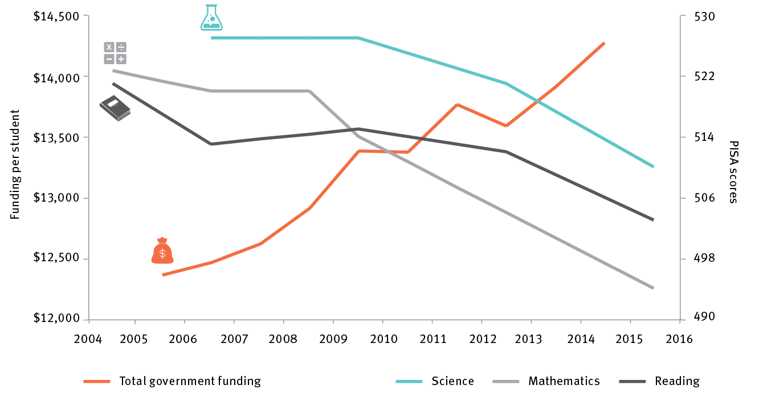

PISA = Programme for International Student Assessment

Note: The left-hand axis refers to total public funding per student, which in constant dollars has increased by 15% over the period. The righthand axis refers to average PISA scores, which from 2006–07 to 2015–16 have declined by 3% in scientific literacy; and from 2004–05 to 2015–16 have declined by 5% in mathematical literacy and 3.5% in reading.

Source: OECD Programme for International Student Assessments 2015, *Results by country*, <<http://www.oecd.org/pisa/>>; Productivity Commission 2017, *Report on government services*, Chapter 4 School education attachment tables, <<http://www.pc.gov.au/research/ongoing/report-on-government-services/2017/child-care-education-and-training/school-education>>.

One of the key challenges for this imperative is that Australian school system performance has declined in the last decade, both relative to other countries and in real terms, even as funding per student has grown. The decline is particularly acute in core STEM subjects, such as science and mathematics

### **Recommendations** require the following actions:

1. Strengthen training for pre-service and in-service teachers

2. Better prepare students for post-school science, technology, engineering and mathematics (STEM) occupations

3. Raise student ambition and achievement in literacy and numeracy

4. Review the Vocational Education and Training system

5. Continue and strengthen reforms to the Vocational Education and Training system

## Imperative 2 Industry

* Ensure Australia’s ongoing prosperity by stimulating high-growth firms and improving productivity

**ISA’s vision** is that by 2030 Australia will accelerate growth and exports of Australian businesses by strengthening a competitive and productive business environment.

### Strategic Opportunities

* Business R&D investment can be increased by better targeting the Research and Development Tax Incentive (R&DTI) program, and increasing support for direct grant programs that target national priorities
* The growth of exporting firms, particularly young high-growth firms, can be encouraged by increasing Export Market Development Grants funding, and expanding and making better use of trade agreements
* The opportunities presented by the ‘fourth wave’ of the internet can be captured by strengthening Australia’s digital economy including capability in Artificial Intelligence (AI) and machine learning
* Business productivity in all sectors can be facilitated by healthy levels of competition
* Australia’s innovation investment and talent can be strengthened by improving access to global talent pools and fostering greater diversity

**Figure: Australian business and government research and development expenditure, 1992–2016**

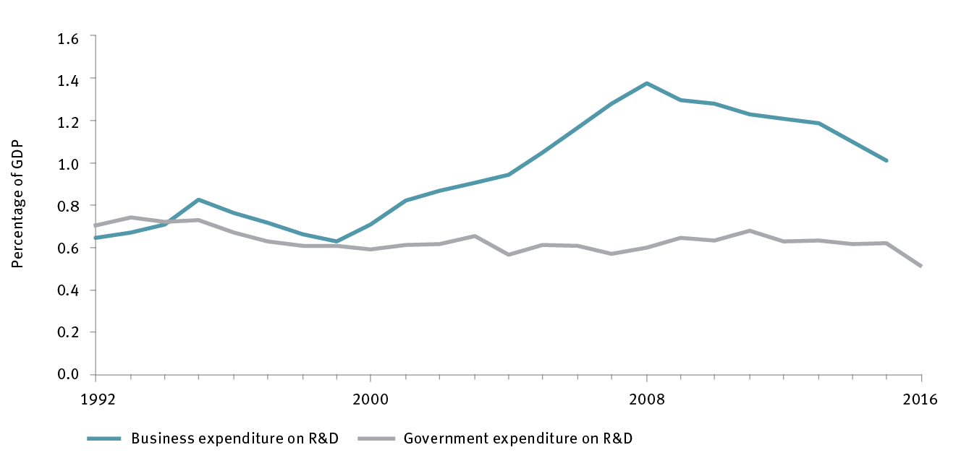

BERD = business expenditure on research and development; R&D = research and development

Note: BERD has only been reported biannually since 2011. Data for missing years are an average of each adjacent year (e.g. BERD for 2012 is the average of 2011 and 2013).

Source: Australian Bureau of Statistics 2017, *Research and experimental development, businesses, Australia*, 2015–16, cat. no. 8104, ABS, Canberra, <<http://www.abs.gov.au/ausstats/abs@.nsf/mf/8104.0>>; Australian Government Department of Industry, Innovation and Science 2017, *Science, research and innovation budget tables*, DIIS, Canberra, <<https://industry.gov.au/innovation/reportsandstudies/Pages/SRIBudget.aspx>>.

One of the key challenges for this imperative is that innovation in Australia’s firms, as measured by R&D expenditure by business, is lagging behind global peers, and has in fact been declining since 2008 (figure 12). ISA recommends that government should make it the top priority of innovation policy to reverse this decline.

### **Recommendations** require the following actions:

6. Reverse the current decline in business expenditure on R&D by improved targeting of government support.

7. Enhance efforts to help young firms access export markets

8. Prioritise investment in artificial intelligence and machine learning

9. Ensure healthy competition in knowledge intensive industry sectors

10. Strengthen efforts in talent attraction and skilled immigration

## Imperative 3 Government

* Become a catalyst for innovation and be recognised as a global leader in innovative service delivery

**ISA’s vision** is that by 2030, Australian governments will facilitate innovation through the regulatory and policy environment; procurement and major programs and projects; and through role modelling innovation through service delivery.

### Strategic Opportunities

* A flexible regulatory environment that supports innovation could be achieved through collaboration among Australian governments
* Investors can be encouraged to pursue opportunities that generate both financial and social returns
* The use of open data would be accelerated by improving access and usefulness
* National innovation can be stimulated by using government procurement as a strategic lever
* Government service delivery can be improved through process redesign and digital technology

**Figure: Australian Government procurement contract expenditure, 2008–16**

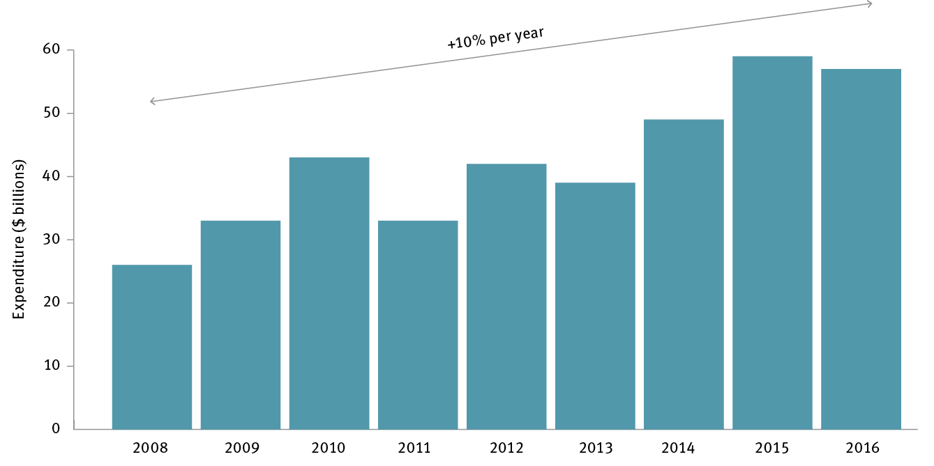

Note: The values reflect the aggregate of all contract values reported in AusTender in each financial year ending in the year indicated.

Source: Australian Government Department of Finance 2016, *Statistics on Australian Government procurement contracts*, Department of Finance, Canberra, <http://www.finance.gov.au/procurement/statistics-on-commonwealth-purchasing-contracts>.

Key roles of Government are to (1) provide a flexible regulatory environment that assists technological change, (2) leverage government data as a catalyst for data-driven innovation, and (3) incorporate innovation opportunities explicitly into procurement decisions. Government spending on procurement is a significant economic driver in Australia.

### **Recommendations** require the following actions:

11. Create a more flexible regulatory environment that fosters innovation

12. Encourage social innovation investment across Australia

13. Improve provision and use of open government data

14. Grow Government procurement from SMEs to 33% by 2022

15. Increase the use of innovative procurement strategies

16. Maximise the spillover benefits of major government programs

17. Deliver greater government savings from digitising service delivery

18. Review the Public Service emphasising improved capability to innovate

## Imperative 4 Research & development

* Improve research and development effectiveness by increasing translation and commercialisation of research

**ISA’s vision** for Australia’s R&D sector is to maintain the excellence that has become its hallmark, while increasing the incentives for collaboration and commercialisation. Despite significant and positive policy changes that have been made in this area in recent years, ISA believes more can be done to break down barriers between the research sector and industry, and to build stronger connections between the two

### Strategic Opportunities

* Industry-research sector collaboration could be increased by introducing a collaboration premium in the Research and Development Tax Incentive program
* Institutional support for commercialisation could be increased by establishing a dedicated stream of funding for translational activities
* Maintaining Australia’s high-quality research will require continued investment in national research infrastructure, commencing with the nation’s high-performance computing facilities
* Making the most of available research talent would be facilitated by promoting greater diversity in the research and innovation workforce
* The growing momentum in Australian venture capital would be supported by taking measured and consultative approaches to any intervention

**Figure: Australian R&D Expenditure as % GDP: 1992 – 2014**

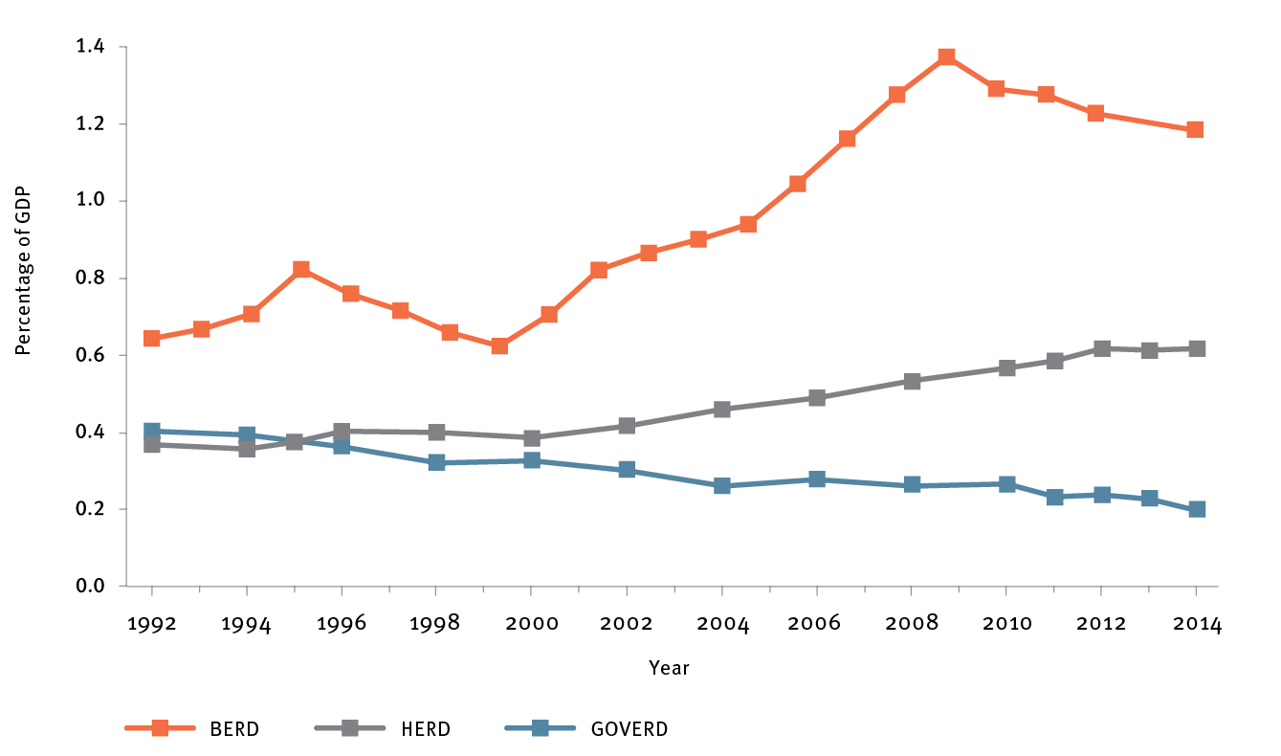

BERD = business expenditure on research and development

HERD = higher education expenditure on research and development

GOVERD = government expenditure on research and development

Universities, publicly funded research agencies (such as CSIRO), research institutions, and industry generate high-quality research outputs, train new research talent, actively find new opportunities to collaborate, and investing financially in R&D activity. However, whilst recent signs of progress are encouraging, more needs to be done to improve our rates of collaboration and commercialisation.

### **Recommendations** require the following actions:

19. Introduce a collaboration premium on tax offset to incentivise collaboration

20. Evaluate scaling-up industry higher degree by research placement programs

21. Evaluate the impact of recent changes to incentivise collaboration in 2022

22. Increase commercialisation capability in research organisations

23. Develop and release an Australian Innovation Precincts Statement

24. Establish secure, long-term funding for national research infrastructure

25. Maintain a long-term policy commitment to greater gender diversity

26. ISA to monitor availability of risk capital to high-growth businesses

## Imperative 5 Culture & ambition

* Enhance the national culture of innovation by launching ambitious National Missions

**ISA’s vision** is that Australia seizes the opportunity to add a more ambitious chapter on innovation to our evolving national stories. We see a future as an innovation-strong nation that is also innovation proud. We believe the Australian Government has a strategic opportunity to use “National Missions” – large-scale initiatives catalysed by governments that are designed to address audacious challenges – to accelerate Australian innovation and encourage more collaboration across the innovation system.

### Strategic Opportunities

* A Genomics and Precision Medicine National Mission will be an ideal first mission, delivering health and innovation benefits for all Australians
* Ensuring Australia’s National Missions are effective can be achieved through the development of a robust framework to identify and implement missions

**Figure: Life expectancy vs health expenditure per person**

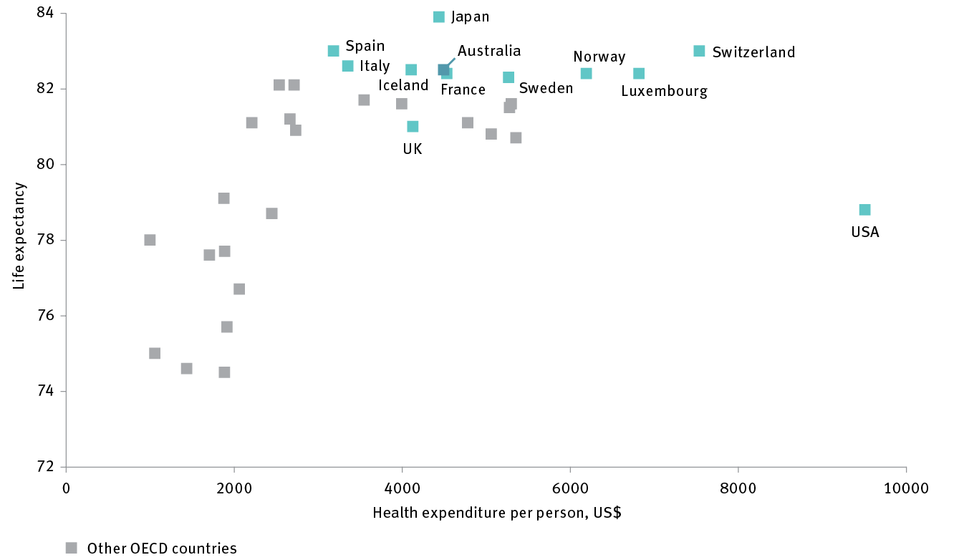

OECD = Organisation for Economic Co-operation and Development

Source: Organisation for Economic Co-operation and Development 2017, *Better life index*, OECD, Paris, <http://stats.oecd.org/Index.aspx?DataSetCode=BLI>; Organisation for Economic Co-operation and Development *Health expenditure and financing data, per capita (current prices)*, OECD, Paris, <https://data.oecd.org/health.htm>.

While aspiring to be the healthiest country on Earth sounds ambitious, Australia currently achieves an average life expectancy of 82.5 years – the 6th-highest in the world – through health expenditure per person of only US$4493, the 14th-highest in the world.

### **Recommendations** require the following actions:

27. Establish a National Mission to help make Australia the healthiest nation on Earth

28. Adopt a framework to continue to identify and implement additional National Missions

## Roadmap for Action

* The recommendations in the 2030 Plan focus on how governments can contribute to the effective functioning of Australia’s innovation system. This includes actions to regulate and shape the system more effectively, actions to be a stronger customer and catalyst for innovation in the system, and investments that support critical enabling activities that would not occur at all, or as effectively, without government support.
* The aim of the 2030 Plan is to use strategic activity and investment by governments to trigger significant increases in funding for R&D from other sources. Government investment in R&D is projected to rise modestly from 0.62% to approximately 0.69% of GDP by 2030, whilst Business investment is projected to rise from 1% to approximately 1.7% of GDP.
* Successful implementation of the plan will require focused attention from Government, and an effective mechanism for coordination across the whole of the Australian Government.

### **Recommendations** require the following actions:

29. Invest in developing a more effective framework to evaluate the performance of Australia’s innovation programs

30. Develop a suite of innovation metrics and methodologies to fully capture innovation and link it to economic, social and environmental benefits

*Australia is in a $1.6 trillion global innovation race, where the prize at stake is a bigger share of global wealth, better jobs, and the best access to the products of innovation for addressing societal challenges.*

*Yet we are falling behind our global peers, particularly in student performance in science and mathematics, and in business investment in research and development.* ***This is more than a canary chirp in our economic mineshaft: it is a clarion call for national action.***

Bill Ferris AC

Chair, Innovation and Science Australia

November 2017