

# Australian Innovation System Report 2016

The *Australian Innovation System Report* 2016 brings together evidence on the structure and performance of Australia’s innovation system, based on a range of key indicators from new and existing sources.

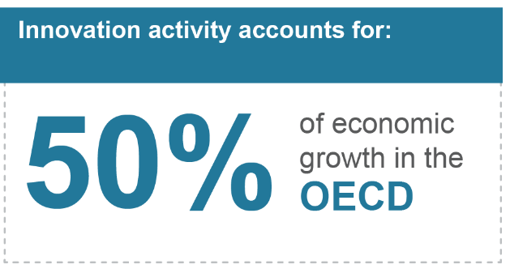

Innovation is a key driver of business competitiveness, economic growth, and improved living standards. The Organisation for Economic Co-operation and Development (OECD) estimates that as much as 50 per cent of long-term economic growth in its member countries can be attributed to innovation, and this contribution is expected to grow.

The theme of this year’s report is the evolution of Australia’s innovation indicators. During the last year, the Department of Industry, Innovation and Science collaborated with the Australian Bureau of Statistics (ABS) to develop new questions in the Business Characteristics Survey. Throughout the Australian Innovation System Report 2016 we present new insights from this work.

The report also extends existing evidence by incorporating novel indicators derived from the new Business Longitudinal Analysis Data Environment (BLADE). Following in the tradition of previous reports, the 2016 edition is supplemented by a number of case studies and feature articles to highlight specific aspects of Australia’s innovation system.

The new indicators expand evidence of the economic value of innovation. The consistent finding is that innovation-active businesses outperform non-innovation-active businesses on a range of measures. Innovation-active businesses in Australia make up 45 per cent of all employing businesses, but contribute to over 60 per cent of sales and employment. Compared to non-innovation-active businesses they are 40 per cent more likely to increase income and profitability, twice as likely to export, and two-to-three times more likely to report increased productivity, employment and training.

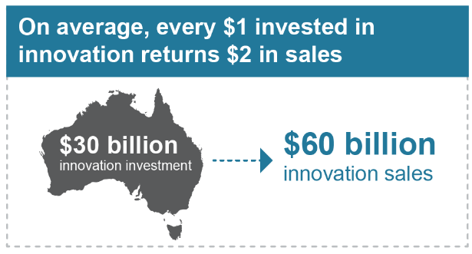

## The benefits of persistent innovation

New analysis using BLADE shows that the frequency of innovation matters. The positive impact of innovation increases when businesses innovate more frequently. Persistent innovators (businesses that report introducing any innovation every year over a three-year period) significantly outperform other businesses in terms of sales, value added, employment and profit growth. In the period 2008–09 to 2010–11, persistent innovators generated:

 18 times the growth of value added of intermittent innovators

 four times the employment growth of regular innovators

 five times the sales growth of regular innovators.

Australia ranks fifth of 30 OECD countries in terms of its overall proportion of innovation-active businesses, reflecting the strong contribution of innovative small- and medium-sized enterprises (SMEs). Large businesses rank relatively poorly on this measure, 18th out of 29 countries.

Total investment expenditure on innovation by Australian businesses in 2014–15 was between $26 billion and $30 billion.

New-to-business innovations (the adoption or modification of innovations developed by others), were the most common type of innovation in Australian business.

Chart depicting gross operating profit by innovation status and degree of novelty. 

New-to-market innovators score the highest

$7billion spent on basic research
$13billion spent on applied research
$13billion spent on experimental development
Equating to $33billion in total spending
Which is about the GDP of Estonia

## Income from goods and service innovation

Just as innovation can be a source of competitive advantage for businesses, a high-performing innovation system can underpin the overall competitiveness of an economy. Australia earns only 7.2 per cent of total income from the sale of innovative goods and services, in comparison to 19.1 per cent for the top five OECD countries (on average). Consequently, Australia ranks 20th out of 23 countries in the OECD on this measure.

The discrepancy between Australia’s poor performance on this measure, but its high proportion of innovation-active businesses may be explained by two factors: the size of the businesses innovating and the type of innovations being undertaken. Firstly, as the proportion of large Australian businesses that are innovation-active is relatively small, this means that it is less likely that their sales will result from innovative goods or services. Secondly, many Australian businesses are process innovators. This means their innovations may reduce their operating costs or improve efficiency instead of producing a new product for market.

## Research and development (R&D) in Australia

R&D is an important innovation activity. Research suggests that R&D-related activities can explain up to 75 per cent of total factor productivity growth, once externalities are considered. Moreover, R&D has a significant rate of return, at 10–30 per cent for private return and more than 40 per cent for social return.

Australia’s gross domestic expenditure on R&D (GERD) to GDP ratio was 2.1 per cent in 2013–14, slightly above the OECD average of 2.0 per cent, but significantly lower than the top five OECD performers. Following a period of strong growth, Australia’s GERD as a percentage of GDP has been declining since 2008–09, driven by a steep reduction in business R&D as a percentage of GDP. This is related to the reduction in Mining R&D expenditure, which declined from $4.3 billion in 2008–09 to $2.8 billion in 2013–14.

Despite having a high proportion of innovation-active businesses, Australia has a relatively low proportion of businesses that are R&D-active. Manufacturing is the largest contributor to net expenditure on R&D, although its share in R&D spending declined from 36 per cent in 2005–06 to 26 per cent in 2013–14. Notwithstanding its declining share of economic activity, R&D intensity (that is, R&D expenditure divided by gross value added) in the Manufacturing sector increased from 3.5 per cent in 2005–06 to 4.8 per cent in 2013–14.

In addition, Professional, Scientific and Technical Services has become the second largest spender on R&D after Manufacturing, totalling $3.75 billion in 2013–14, a 45 per cent increase over the last five years. R&D expenditure in this sector has been driven by SMEs.

## Skills for innovation

The capacity of an economy to innovate relies on its stock of human capital — the skills, knowledge and expertise embedded in its workforce. Australian businesses report a lack of access to skilled personnel as a barrier to innovation.

Academic research contributes to the generation and diffusion of new knowledge, and supports the development of human capital and knowledge. Australia ranks well internationally on measures relating to academic research, and Australian universities have risen in global rankings over the past decade. The number of students completing higher degrees by research has grown slowly but consistently, almost doubling between 2000 and 2014.

1st Access to addtional funds 18%
2nd Lack of skilled persons 16%
3rd Cost of development or introduction/implementation 13%

## Framework conditions

Framework conditions influence the capacity of an economy to create and sustain an environment conducive to innovation. Framework conditions in Australia, including intellectual property protection, are strong overall.

Governments around the world play an active role in fostering and shaping framework conditions that support innovation activity. The Australian Government’s most significant influences on the innovation system are indirect: policy and regulatory settings and investments in infrastructure, health care, education and research. Governments can also play a major role in stimulating private R&D.

Most of the direct investments made by government are in research and education. The focus of public R&D investment is primarily on areas that are high risk, for basic research, or where private investment is relatively limited, for example, in defence, health and environmental protection.

Networks and collaboration

Networking and collaboration are essential to a high-performing innovation system. Collaboration with research organisations such as the Commonwealth Scientific and Industrial Research Organisation (CSIRO) and universities has been found to more than triple the likelihood of businesses reporting annual productivity growth.

However, except in the resources sector, the data suggest that Australia’s innovation system is weakly networked. Australia ranks poorly against OECD comparators in most business-to-research and business-to-business collaboration indicators. Australian businesses also have comparatively low levels of international engagement with respect to intellectual property, joint R&D, and trade in goods and services.

In contrast, collaboration within Australia’s research and university sectors is strong. Australia was ranked 7th in the OECD across all disciplines in terms of its share of the world’s top 1 per cent of highly cited publications attributed to international collaboration. Australian academic publications accounted for 3.9 per cent of the global market share in 2015. This proportion has increased steadily over the past decade, and Australia now ranks 9th in the OECD. Australian research publications comprise over 7 per cent of the world’s top 1 per cent most highly cited publications across all disciplines.

Infographic. Depicts the ratio of innovation-active businesses that reported increases in performance compared to non-innovation-active businesses. 
1.4 time higher for income from sales of goods or services. 
4 times higher for range of goods or services offered
2 times higher for productivity
1.4 times higher for profitability
3 times higher for total number of jobs or positions
5 times higher for export markets targeted
3 times higher for contracting or outsourcing
3 times higher for structured/ formal training for employees
3 time higher for expenditure on information technologu
5 times higher for social contributions