|  |
| --- |
| Australian Government Department of Industry and Science. Office of the Chief Economist |
| Research Paper 4/2015 |
| The employment dynamics of Australian entrepreneurship |
| Luke Hendricksona, Stan Bucifala, Antonio Balaguera and David Hansellb  Department of Industry and Sciencea and Australian Bureau of Statisticsb |
| September 2015 |
| Abstract |
| This research paper is the first in a series to explore the dynamics of employment and productivity growth in Australian firms using the newly created Expanded Analytical Business Longitudinal Database. This paper examines the contribution of young firms, particularly start-ups, to net job creation in the Australian economy between 2001–2011. The results show that young SMEs contribute disproportionately to job creation. Young SMEs (firms aged 0–5 years) made the highest contribution to net job creation in Australia (40 per cent) and start-up activity (firms aged 0–2 years) is responsible for most of this growth. Australia’s start-up activity is high but they tend to reach smaller sizes relative to other OECD countries examined to date. A very small fraction (3 per cent) of start-ups drive the majority (77 per cent) of their post-entry job creation. These high growth start-ups also show superior sales and profit performance but lower labour productivity performance compared to other surviving start-ups. |
| JEL Codes: J21, L26, M13, O31, O57  Keywords: Australia, creative destruction, DynEmp, entrepreneurship, employment, innovation, OECD, productivity, start-up |

For further information on this research paper please contact:

Manager

Innovation Research

Department of Industry and Science

GPO Box 9839

Canberra ACT 2601

Phone : +61 2 6213 6000

Email: [innovationreport@industry.gov.au](mailto:innovationreport@industry.gov.au)

Have you read the Australian Innovation System report? [www.industry.gov.au/innovationreport](http://www.industry.gov.au/innovationreport)

Disclaimer

The views expressed in this report are those of the author(s) and do not necessarily reflect those of the Australian Government or the Department of Industry and Science.

© Commonwealth of Australia 2015.

This work is copyright. Apart from use under Copyright Act 1968, no part may be reproduced or altered by any process without prior written permission from the Australian Government. Requests and inquiries concerning reproduction and rights should be addressed to [chiefeconomist@industry.gov.au](mailto:chiefeconomist@industry.gov.au). For more information on Office of the Chief Economist research papers please access the Department’s website at: [www.industry.gov.au/OCE](http://www.industry.gov.au/OCE)

Creative Commons Licence

With the exception of the Coat of Arms, this publication is licensed under a Creative Commons Attribution 3.0 Australia Licence.

Creative Commons Attribution 3.0 Australia Licence is a standard form license agreement that allows you to copy, distribute, transmit and adapt this publication provided that you attribute the work. A summary of the licence terms is available from http://creativecommons.org/licenses/by/3.0/au/deed.en. The full licence terms are available from http://creativecommons.org/licenses/by/3.0/au/legalcode.

The Commonwealth’s preference is that you attribute this publication (and any material sourced from it) using the following wording:

Source: Licensed from the Commonwealth of Australia under a Creative Commons Attribution 3.0 Australia Licence. The Commonwealth of Australia does not necessarily endorse the content of this publication.

Acknowledgements

We thank the following colleagues for their comments on the paper: Chiara Criscuolo, Andrew Lalor, Mark Cully, Per Davidsson, Diane Braskic, Nick Yazidjoglou, Tony Wiskich, Jennifer Poehl and Abrie Swanepoel.

|  |
| --- |
| Key points   * This research paper investigates the employment dynamics of Australian entrepreneurship using the new Australian Bureau of Statistics’ Expanded Analytical Business Longitudinal Database 2001–02 to 2012–13, funded by the Department of Industry and Science. * As firms age they contribute less to job creation and more to job destruction. Young firms in Australia contribute disproportionately to net job creation. Although employing a small fraction of the Australian workforce (15 per cent), young SMEs generated the largest share of total job creation (40 per cent) in the economy. * For every 100 existing jobs in Australia in any given year, start-ups will, on average, add 5 jobs within the following three years. * Over the period 2006–2011 we estimate that 1.04 million full time equivalent (FTE) jobs were added to the economy. Start-ups (firms aged 0–2 years) added 1.44 million FTE jobs to the economy whereas older firms (3+ years) shed around 400,000 FTE jobs over the same period. * Most micro-start-ups (new firms with 0–9 employees) either exit or grow very little (96.8 per cent). A very small fraction (3.2 per cent) of these micro-start-ups grow dramatically over five years post-entry and these firms account for the majority (77 per cent) of total post-entry job creation of all micro-start-ups in their cohort. These high growth start-ups are found in all sectors of the economy. * As expected the sales and profit performance of these high growth firms is superior to those that remain stable or only grow marginally after five years. However their labour productivity is lower during that period of dramatic employment growth and investment. * Australia has relatively high start-up activity but this activity has been declining. The employment generated per start-up is low compared with other OECD countries. |

# Introduction

There are large, persistent productivity differences between firms within industries and productivity affects firm survival and growth.[1] Considerable international evidence suggests that entry, exit, expansion, and contraction of firms are closely related to measures of productivity and profitability (for surveys and summaries, see Syverson 2011, Foster *et al*. 2001, Bartelsman & Doms 2000). Creative-destruction is a restructuring process within an economy where new more innovative, more productive firms replace less innovative, less productive ones.[2] The efficient reallocation of resources between these growing and shrinking firms is critical to aggregate employment and productivity growth. Lentz & Mortensen (2008), working with a Danish firm panel from 1992–1997 found that 74 per cent of aggregate productivity growth came from reallocation of employment to innovating firms through both entry/exit dynamics (21 per cent) and growth through capture of market share (53 per cent). The growth orientation of a firm is ultimately related to the decisions of firm owners and managers to invest in competitive or productive advantages such as acquisition, innovation and skilled employees.[3] Understanding the motivations, entrepreneurial activities and framework conditions that drive these dynamics would therefore be expected to lead to better policy outcomes.[4]

Until now our capacity to understand these firm dynamics and its impact has been limited by a lack of data that would enable researchers to link firm level change in employment and production to national trends. Aggregate data, such as the national accounts, provide a glimpse into which industries drive these trends, but by default measure net change only hiding within-sector differences.

The Organisation for Economic Cooperation and Development (OECD) has recently created two new cross-country projects using firm-level data to understand these dynamics: DynEmp (see Box 1.1), which focusses on employment dynamics, and MultiProd,[5] which sheds light on the micro-drivers of aggregate productivity performance. The first iteration of DynEmp included results from 18 countries over the period, 2001–2011. The data showed that young, small firms create a disproportionate amount of jobs and that there are significant differences between countries in the capacity of these firms to survive and grow.[6]

The Department of Industry and Science partnered with the Australian Bureau of Statistics (ABS) to create the *Expanded Analytical Business Longitudinal Database* (see Box 1.2) so that Australia could contribute to the two OECD projects. Our ultimate objective, however, was to create a robust longitudinal census of firm activity that we can all use to understand firm dynamics and develop better, more evidence-based industry policy in Australia.

The EABLD is a census of firms over the period 2001 to 2012. Any firm with an ABN or ACN is included in the database. In 2001 there were 1.70 million firms in the database accounting for 7.12 million full time equivalent jobs, $570 billion value added, $2.39 trillion total sales output of which $173 billion came from exports. In 2012 there were 2.83 million firms in the database accounting for 8.96 million FTE jobs, $1.3 trillion value added, $4.48 trillion total sales output of which $352 billion came from exports.[7]

This paper compares Australian results for DynEmp with those already published by the OECD and then burrows deeper into the data in order to provide a more comprehensive understanding of the drivers of employment creation and destruction in Australia. Growth is defined here as employment growth. We find that Australian results support the main conclusions of the OECD DynEmp report. We also describe the growth of young, small Australian firms, particularly start-ups.

Box 1.1: DynEmp: The OECD dynamics of employment project

| The OECD Directorate for Science, Technology and Innovation has initiated a cross-country project focusing on employment dynamics. The OECD provides guidance and STATA® routines for distributed micro-data analysis of business dynamics. By aggregating confidential firm-level data from national business registers, DynEmp provides new comparative, empirical evidence on the role of creative destruction, start-ups and young firms to participating country performance. A range of OECD countries including Australia, as well as other non-OECD countries such as Brazil and Puerto Rico are currently participating. More detail on the DynEmp project can be found [here](http://www.oecd.org/sti/dynemp.htm). Throughout this paper ‘participating’ countries is defined as OECD and other countries currently in the DynEmp database. |
| --- |

Box 1.2: The Expanded Analytical Business Longitudinal Database 2001–02 to  
2012–13

| The Expanded Analytical Business Longitudinal Database (EABLD) is a statistical data integration project with the ABS as the Integrating Authority. The development of the EABLD was funded by the Department of Industry and Science.  The EABLD is the term used to describe a series of integrated, linked longitudinal datasets that cover the period 2001–02 to 2012–13; it contains a range of firm level information.  The EABLD is based on the Business Register and includes the population of firms for each year. It uses the ABS statistical unit as the firm level unit and large/complex firms are included.  It includes business-level data from administrative sources (predominantly ATO) and a range of ABS surveys (including the Business Characteristics Survey, the Business R&D survey and the Economic Activity Survey).  The use of Business Activity Statement data (sourced from the ATO) provides a basic set of financial information for all businesses.  As it has been created retrospectively and not all information about firm entries, exits and restructures is available, various methods have been developed to ensure that there is a longitudinal perspective.  Solutions have also been developed in respect of the complexities of mapping the various tax reporting structures to the ABS units model.  This is essential to facilitate the linking of directly collected ABS data into the EABLD.  Using the ABS statistical unit structure enables the EABLD to reflect the industry composition which forms part of ABS economic statistics. The EABLD allows for policy evaluation, research and analysis, and the production of statistical outputs for a variety of firm performance measures.  As primary linking is undertaken using the ABN, other administrative data also containing ABN can be linked to the EABLD.  More information on the EABLD and how to access it can be found [here](http://www.abs.gov.au/ausstats/abs@.nsf/mf/8171.0?OpenDocument).[8] |
| --- |

# Results

The following results from the EABLD refer to the period 2001–02 to 2011–12 unless otherwise stated. Due to data restrictions, all OECD comparisons are limited to manufacturing, construction, and non-financial business services and use OECD firm size definitions. All other analyses reflect the full complement of industry sectors where possible, excluding government. For detailed information on methodology see Box 1.2 and Appendix A. Supplementary data is provided at Attachment B.

Box 2.1: Defining firms by age and size

| We adopt the firm age definitions set out by the OECD. *Young firms* are defined as firms aged between 0 and 5 years of age. Start-ups are a specific subset of young firms within the first three years of operation (0–2 years old).  *Mature firms* are defined as those firms aged 6 years and older. Old firms are a specific subset of mature firms that are ten or more years old.  The diagram above provides a schematic definition of firms by their age as set out by the OECD standards. Using arrows from left to right to show the increasing firm age, the diagram divides firms into two broad categories of ‘young’ and ‘mature’ firms. The young firms are defined as firms aged in the range of 0-5; and the mature firms as those aged 6 years and older. Under this broad categorisation, the diagram subdivides each category based on two age ranges. Young firms are subdivided into ‘start-ups’ that are firms in the age range of 0-2 years, and other young firms that are in the age range of 3-5 years. Mature firms are also subdivided into two sub-categories: firms in the age range of 6-9 and old firms in the age range of more than 10 years.  Firm size classes are defined in Table 2.1 below depending on the analysis. |
| --- |

Table 2.1: Defining firms by age

|  |  |
| --- | --- |
| Standard Australian firm employment sizes (ABS definition) | Australian firm employment sizes used for OECD comparisons |
| Micro (0–4 employees) | Micro (0–9 employees) |
| Small (5–19 employees) | Small (10–49 employees) |
| Medium (20–199 employees) | Medium (50–249 employees) |
| Large (200+ employees) | Large (250+ employees) |

Source: ABS (2001) *Small Business in Australian*, Cat. No. 1321.0 Criscuolo C, Gal PN &  
Menon C (2014) *The dynamics of employment growth: New evidence from 18 countries*, OECD Science, Technology and Industry Policy Papers no. 14, OECD Publishing, <http://dx.doi.org/10.1787/5jz417hj6hg6-en>

## Australia has a high and declining share of young firms, particularly start-ups

The structure of Australian industry is characterised by a high proportion of small firms. In terms of business counts, nearly all Australian firms could be considered small to medium enterprises (SMEs; 99.7 per cent). Micro and small firms (with less than 50 employees) made up some 98 per cent of Australian firms and accounted for 41 per cent of total employment over the ten years 2001–02 to 2011–12. Australia also has a relatively high share of micro businesses in the total firm population compared to other OECD countries.[9] Micro firms accounted for 87 per cent of all firms in the business population but only around 16 per cent of total employment. The OECD median share of micro-firms was 80.6 per cent.[10] Sole-proprietor firms (with no employees) account for a high share of firms in manufacturing (25 per cent) and services (42 per cent) but account for a very small percentage of total employment (0.4 per cent and 0.9 per cent of manufacturing and services, respectively).

The lion’s share of Australian employment can be attributed to a relatively small number of large firms. Large firms represent only 0.3 per cent of all Australian firms but they account for some 40 per cent of employment, which is broadly comparable to countries like France, UK, USA and Canada. This general pattern is similar across many other OECD countries, in that most firms are small but most employees work for medium and large firms.

Looking at firm age structure, the differences are more pronounced. Table B1 provides firm age and size data for the Australian Business population between 2006 and 2011. Earlier years in the database cannot be included in this table because mature firms (6+ years) cannot be identified. Figure 2.1 summarises the age profile of Australian employing SMEs (firms with 1–199 employees) over the same period. The proportion of firms that are young  
(0–5 years of age) declined from 42.5 per cent (~337,000 firms) to 35.6 per cent (~288,000 firms) over the period examined. Start-ups, according to the OECD definition are firms 0–2 years of age. The proportion of SMEs that were start-ups declined from 19.2 per cent (~152,000 firms) to 16.3 per cent (~132,000 firms) between 2006 to 2011 (Figure 2.1). Most large firms are mature (6+ years old) and stable at around 90 per cent of all large firms (Table B1).

Unlike the Australian data presented in this report, OECD comparisons are limited to manufacturing, construction and non-financial service sectors. By international standards, Australia has a relatively high proportion of small firms that are start-ups. Some 33 per cent of firms with less than 50 employees were aged less than 3 years in Australia. Within the sample, this is second only to Brazil, where the fraction of start-ups in SMEs was 40 per cent (Figure B1). The relatively high share of start-ups among Australian firms can also be seen in the manufacturing and services sectors (Figure B2). The share of manufacturing firms aged less than 3 years was around 24 per cent, which is relatively high compared to most other countries over the 10–year period. Similarly, the services sector also exhibits a relatively high share of young firms, where some 33 per cent of firms could be classified as start-ups (Figure B1).

There is considerable diversity among countries in the average number of people employed by manufacturing start-ups (Figure B2). Australian manufacturing start-ups tended to employ fewer staff during the period compared to other countries. The average number of staff employed in Australian manufacturing start-ups was 5.5 employees. The size of Australian services start-ups was closer to the middle of the country range. The average number of staff employed in Australian services start-ups was 4.3 employees.

Notwithstanding the relatively high proportion of start-ups in Australia there has been a decline in Australia (Figure 2.1), and indeed in many other OECD countries. Figure B3 compares start-up rates by countries (i.e. the fraction of start-ups among all firms), averaged across the indicated 3-year periods. The share of Australian start-ups against all firms has been declining since the three-year period 2004–2006.[11] This ageing trend is apparent across many other countries in the OECD. In parallel with the decline in the start-up rate, Australia’s start-up share of total employment has been falling and the share of start-ups in gross job creation has fallen in recent years, from around 32 per cent to less than 15 per cent.

Figure 2.1: Age composition of small to medium sized firms, 2006–2011

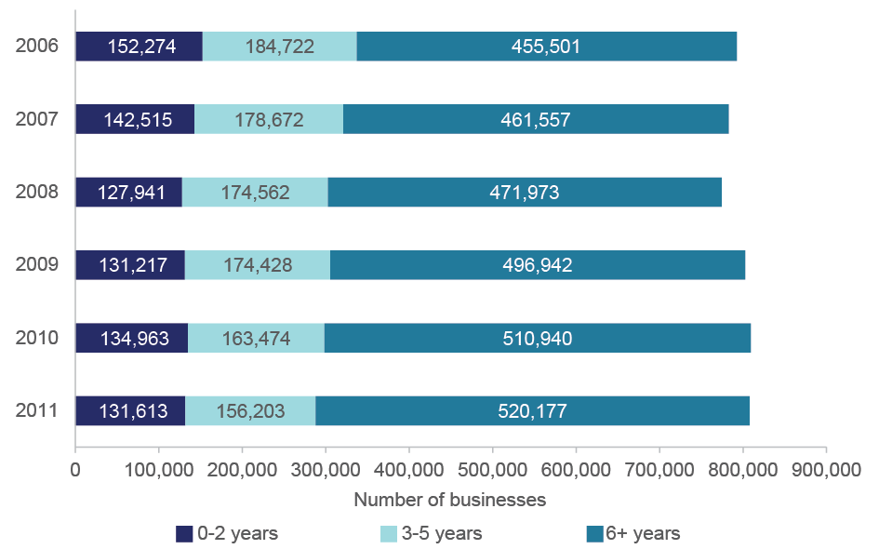

Notes: The graph shows the number of firms by different age groups in the total number of small and medium firms (1–199 employees) in Australia. The units in the bars are the total number of businesses in each age category. Young firms are 0–5 years and mature firms are 6+ years. Start-ups are defined as a subset of young firms that are 0–2 years of age. Data is for all sectors of the economy excluding government and non-employing firms.

Source: ABS (2015) Expanded Analytical Business Longitudinal Database 2001–02 to 2012–13

The majority of employment is concentrated in mature businesses, both in Australia (Table B1) and in other countries in the OECD DynEmp database. In Australia, in 2011, mature employing businesses accounted for almost 6 million Full Time Equivalent (FTE) jobs or 84.2 per cent of all employment. This is for all sectors of the economy.

Across all countries examined to date, around 63 per cent of manufacturing, construction and non-financial sector firms were mature (aged 6 years or more), and these accounted for nearly 80 per cent of total employment for those sectors (Figure B4). Australian mature firms (aged 6+ years) showed relatively smaller shares of overall firms (48 per cent) and employment  
(71 per cent) than other countries, respectively, but the pattern is broadly consistent with other participating countries (Figure B4).

The share of young firms (0–5 years old) in the total number of all firms was lower, compared to mature firms, as was their share of employment. This pattern is similar both in Australia and across other countries examined by the OECD (Figure B4). However, differences between countries do exist in the relative magnitudes. Australian start-ups (firms aged 0–2 years) accounted for 34 per cent of all firms in the subpopulation over the period, which is relatively higher than the average of other countries in the OECD DynEmp database (20 per cent).

## Young SMEs contribute disproportionately to job creation

Over the period 2006 to 2011 we estimate that 1.04 million full time equivalent jobs were added to the economy. Young SMEs are responsible for the majority of this net growth having added 1.12 million jobs in that period (Figure 2.2).

Figure 2.3 shows net job creation by age over the same period 2006–2011. Most of the job creation was undertaken by start-ups of any size. Start-ups (firms aged 0–2 years) added approximately 1.44 million jobs to the economy whereas older firms (3+ years) shed just over 400,000 jobs over the same period (Figure 2.3; Table B1). Figure B5 shows that firm entry and immediate post-entry growth dominate gross job creation. For example, in 2011, young firms added ~275,000 jobs to the economy. Firm entry added ~154,000 jobs in 2011, just over half of all young SME firm employment creation. Mature firms by contrast added ~53,000 jobs to the economy.

Figure 2.2: Net employment creation, gross employment creation and gross employment destruction by firm age and size, 2006–2011

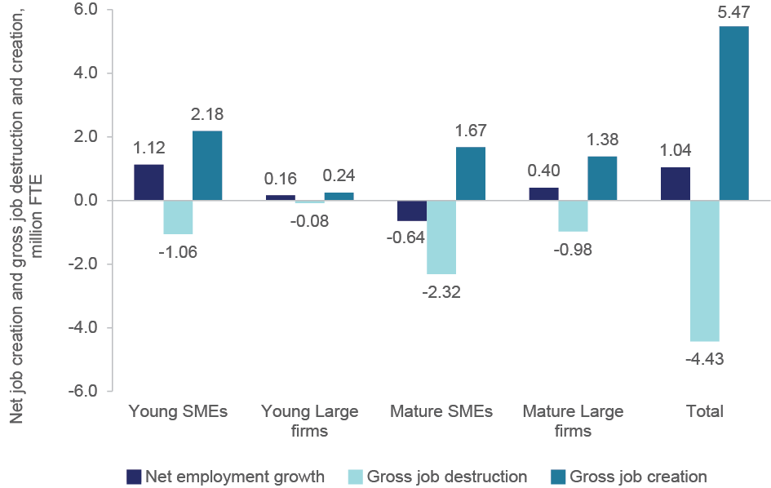

Notes: Employment is measured in Full Time Equivalents (See Appendix A). Results are for all non-government sectors and exclude non-employing firms. Young firms are 0–5 years and mature firms are 6+ years.

Source: ABS (2015) Expanded Analytical Business Longitudinal Database 2001–02 to 2012–13

The 2006–2011 period examined is unusual in that it covers a significant economic downturn when a lot of jobs were lost (Figure 2.3). The data shows that through the global financial crisis start-ups maintained net positive employment growth whereas older firms became net job destroyers (Figure 2.3). Net employment loss during this period was driven by downsizing rather than exit of firms (Figure B5).

Despite having a relatively lower share in total employment, younger firms — and especially smaller ones — contribute disproportionately to job creation (Figure 2.4). Over the period 2006–2011, the largest contribution to job creation in Australia (40 per cent) came from young SMEs: firms aged 0–5 years that had 1–199 employees and accounted for only 15 per cent of total employment. By contrast, mature Australian SMEs showed the highest rate of job destruction (52 per cent) but their share of employment (41 per cent) was also higher than young SMEs. Large Australian firms (with 200+ employees) tended to have lower rates of both job creation and job destruction, compared to smaller firms. Large, mature firms aged 6+ years accounted for 42 per cent of total employment but only 25 per cent of gross job creation (Figure 2.4).

Figure 2.3: Net employment growth by firm age, 2006–2011

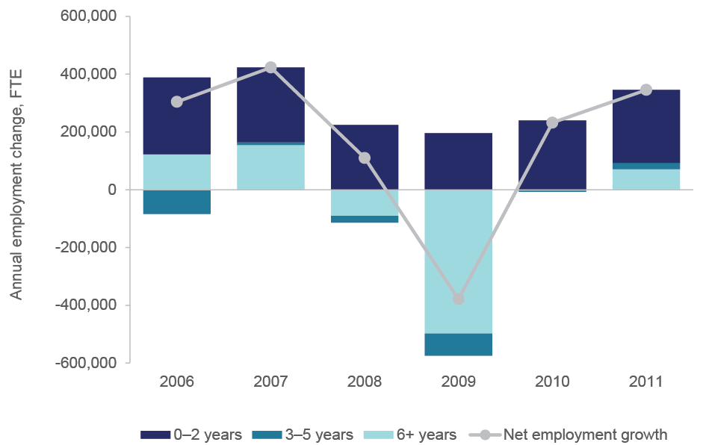

Notes: Employment is measured in Full Time Equivalents (See Appendix A). Results are for all non-government sectors and exclude non-employing firms. Young firms are 0–5 years and mature firms are 6+ years. Start-ups are defined as a subset of young firms that are 0–2 years of age.

Source: ABS (2015) Expanded Analytical Business Longitudinal Database 2001–02 to 2012–13

When we compare Australia to other countries (using restricted sectors and different size classes) we find that Australia’s employment dynamics are consistent with other countries examined to date over the ten year period 2001–2011 (Figure B6). If anything, Australia is more extreme in its reliance on young SMEs for gross job creation. Young SMEs contribution to gross job creation in Australia was 50 per cent compared to the OECD average of  
41 per cent.

To summarise differences in job creation, destruction and net employment growth, we repeated the regression analysis from Criscuolo *et al.* (2014; See Appendix A). Table B2 shows that all groups of firms have higher gross job creation rates than mature-large firms (the reference group). Generally as firms age they contribute less to job creation. Young SMEs show the greatest effect on gross job creation confirming the descriptive analysis above. Young SMEs have a high churn in terms of job creation and destruction. Despite this high rate of destruction, their average net growth rates are significantly higher than other firm-age categories (Table B2). As SMEs age their contribution to net job creation declines significantly. These results are remarkably similar to other countries in the DynEmp database and stable irrespective of whether industry dummies were used. In Australia, it appears that mature-small firms have a significantly higher gross job destruction rate than young-medium sized firms. These rates were similar for other countries.

Figure 2.4: Employment, job creation and job destruction for SME and Large firms by firm age, 2006–2011

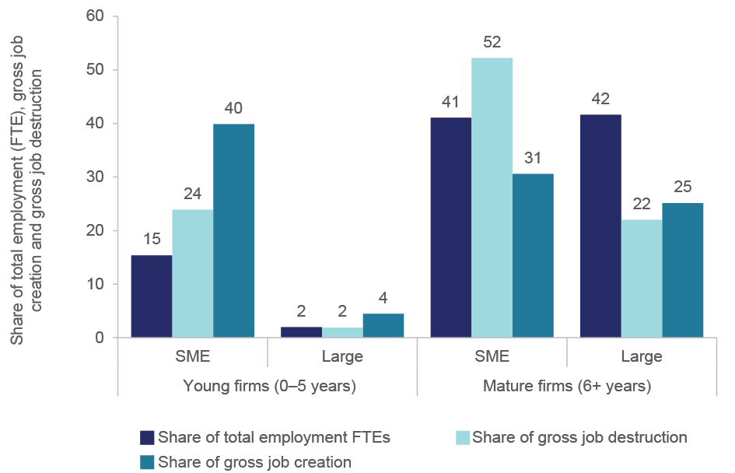

Notes: Results are for all non-government sectors and excludes non-employing firms. SMEs are firms between 1–199 employees. Large firms are 200+ employees. Age classes are Young (0–5 years old) and Mature (6+ years old).

Source: ABS (2015) Expanded Analytical Business Longitudinal Database 2001–02 to 2012–13

Figure 2.5 contrasts the contribution of young and mature firms to net employment growth over the period 2001–2011 for all countries in the OECD DynEmp database. Figure 2.5 reinforces the finding that young firms’ contribution to net employment growth is significantly larger and net positive compared with mature firms that make a net negative contribution. This is a common phenomenon for the other countries in the DynEmp database. For the three sectors (manufacturing, construction and non-financial services) used to compare with other countries in the DynEmp database,[12] young firms (0–5 years) had a net employment growth contribution of 2.8 per cent over the period 2001–2011 (Figure 2.5). Much of this was driven by start-up activity (3.5 per cent) since the contribution to job creation and job destruction by incumbent young firms were 0.6 per cent and -1.4 per cent, respectively. By contrast, mature firms aged 6+ years drag down net employment growth by -4.1 per cent and this was driven primarily by downsizing of incumbent mature firms. This pattern is broadly consistent across the other countries in the DynEmp database (Figure 2.5). Australia had one of the highest annual average employment growth rates (at 2.9 per cent) in the OECD between 2001 and 2008. Disaggregating this rate by firm age shows that the unweighted net employment growth rate of surviving young firms (aged 0–5 years) was 12.2 per cent between 2001 and 2011. By contrast the unweighted net employment growth rate of mature firms (6+ years) was significantly lower at 1.4 per cent over the same period. The net growth gap between these young, surviving and mature firms is one of the highest among the countries in the DynEmp database (data not shown).

Figure 2.5: Net employment growth contributions by incumbent and entry/exit activity and by firm age, as a percentage of aggregate non-financial sector employment, 2001–2011

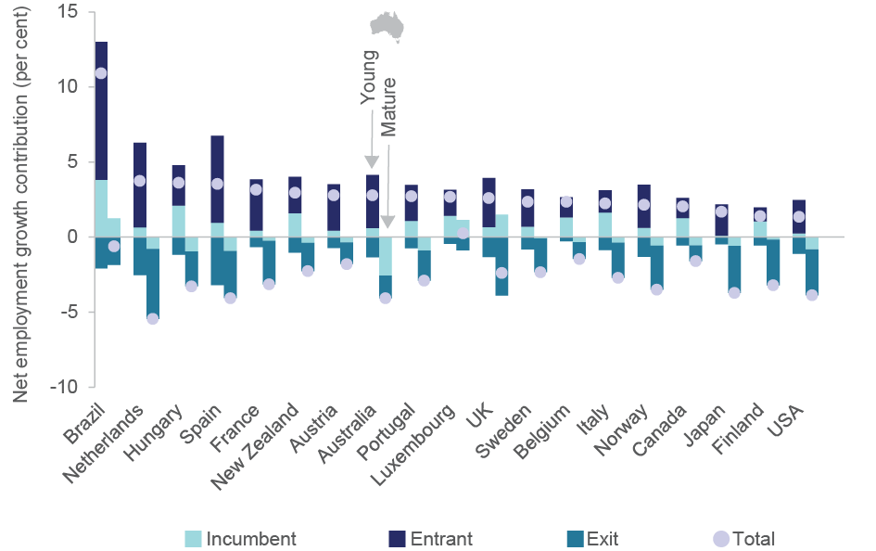

Notes: Contributions are calculated as the net job creation by the group over total employment in manufacturing, non-financial business services and construction averaged across all available years. Young firms are aged 0–5 years old, mature firms are 6+ years old. For the purposes of OECD comparisons headcount measures are used rather than Full Time Equivalents. The period covered is 2001–2011 for Australia, Belgium, Canada, Finland, Hungary, the Netherlands, the United Kingdom and the United States; 2001–2010 for Austria, Brazil, Spain, Italy, Luxembourg, Norway and Sweden; 2001–2009 for Japan and New Zealand; 2001–2007 for France; and 2006–2011 for Portugal. Owing to methodological differences, figures may deviate from officially published national statistics. For Japan data are at the establishment level, for other countries at the firm level. Data for Canada refer only to organic employment changes and exclude merger and acquisition activity.

Source: Criscuolo *et al.* (2014) and ABS (2015) Expanded Analytical Business Longitudinal Database 2001–02 to 2012–13

## Start-up activity and performance in Australia

At this point the definition of *start-up* moves away from the static definition (*firms aged 0–2 years*) to firm entry: *any firm that is newly created in any given year*. In this section we track the performance of start-ups over time from birth to three years of age. In this section we are looking at start-ups of all sizes.

*Normalised net job creation by surviving entrants* shows the average number of jobs created by surviving start-ups over a three year period. This is normalised by dividing this number by the total employment in Australia at the beginning of the three year period. The analytical approach used by the OECD[13] to identify cross-country differences in the dynamics of firm survival and growth consists of decomposing normalised net job creation from surviving start-ups into four main components (See Appendix A).

1. *Start-up ratio*, the number of entrants relative to the country’s total employment. This can be considered a measure of entrepreneurship in the economy.
2. *Survival share*, the number of businesses that survive until or beyond the third year of life over the total number of starting businesses. This measure captures the extent to which the selection process is affecting the survival probability of entrants.
3. *Average size at entry*, the average number of employees for entrants that survive until or beyond the third year of life. This measure might reflect, *inter alia*, low entry barriers.
4. *Average post-entry growth*, measured as the final over initial employment ratio of surviving entrants. This measure reflects the growth performance of surviving start-ups.

In order to make international comparisons, Table 2.1 only provides start-up data for the three macro-sectors Manufacturing, Construction and Non-financial business services as defined by the OECD. We have expanded this analysis to include much more detailed sectoral comparisons for all Australia industries (See Table B3).

In Australia, net job creation by entrants that survive at least three years represent 4.9 per cent of overall employment. In other words for every 100 jobs in Australia in any given year start-ups will, on average, add 5 jobs within the following three years. This value varies by sector from as low as 0.5 per cent to as high as 8.2 per cent (Table B3). This value also changes over time and had a notable dip during the global financial crisis (Table 2.1). Australia has relatively high normalised net job creation compared to other OECD countries, which range between 1 per cent and 5 per cent.

Net job creation by surviving micro (0–9 employee) start-ups (at 144 per cent) is large enough to more than compensate for the job destruction of those start-ups that exit within five years, despite only representing 45 per cent of the total start-up cohort that entered the economy (Table B3).

Table 2.1 shows that the start-up rate was close to 20 start-ups per 1,000 employees in the working population in 2003. Around the global financial crisis the start-up rate fell to 12 and bounced back in 2010 to 15 (Table 2.1). The latest year 2012 showed a fall in the start-up rate to 11.5 start-ups per 1,000 employees consistent with Figure 1. Australia has a relatively high average start-up ratio compared with other OECD countries which range between 3 and 23 start-ups per 1,000 employees.[14] Of the sectors covered in the analysis the data shows that start-up rates are low in manufacturing and high in selected service sectors of the economy. Sectors with very high start-up rates (>35 start-ups per 1,000 employees) were *Fishing, Hunting and Trapping*, *Building construction* and *Construction services*, *Non-store retailing and Retail commission-based buying and/or selling*, *Internet publishing and broadcasting, Insurance and Superannuation funds,* *Property operators and real estate services* and *Creative and performing arts* (Table B3). *Metal ore mining*, *Pulp & paper manufacturing* and some health and education sectors show low start-up rates (Table B3).

Table 2.2: Decomposition of normalised net job creation in Australia, 2001–2011

| Entry cohort | Net job creation by surviving entrants relative to total employment | Start-ups per thousand employees | Start-up survival rate, Share of surviving firms after three years (per cent) | Average start-up employment size at entry | Average post-entry growth, Final over initial employment ratio, (per cent) |
| --- | --- | --- | --- | --- | --- |
| 2003 | 5.82 | 18.9 | 59.2 | 2.7 | 141.1 |
| 2004 | 6.32 | 18.8 | 59.4 | 3.3 | 129.3 |
| 2005 | 5.54 | 16.4 | 60.1 | 3.6 | 118.3 |
| 2006 | 5.26 | 15.7 | 59.5 | 3.6 | 118.3 |
| 2007 | 4.05 | 15.4 | 59.8 | 3.6 | 98.0 |
| 2008 | 3.56 | 13.7 | 59.4 | 3.8 | 89.5 |
| 2009 | 3.93 | 12.2 | 55.7 | 3.9 | 107.4 |
| 2010 |  | 15.6 | - | - | - |
| 2011 |  | 15.2 | - | - | - |
| 2012 |  | 11.5 | - | - | - |
| *Mean* | 4.93  (0.40) | 15.3  (0.8) | 59.0  (0.6) | 3.5  (0.2) | 114.6  (6.7) |

Notes: These data are for manufacturing, construction, and non-financial business services. For the purposes of OECD comparisons headcount measures are used rather than Full Time Equivalents. Some indicators are not available beyond 2009 because the third year survival and growth data is not yet available in the database. Numbers in brackets are standard errors.

Source: ABS (2015) Expanded Analytical Business Longitudinal Database 2001–02 to 2012–13

The start-up survival share was steady between 2003 and 2009 at around 60 per cent (Table 2.1). There is some evidence of a decline in survival in the 2009 cohort. Three year survival of Australian start-ups is moderate to low compared with other OECD countries which range from about 55 per cent to over 70 per cent. Cross-sectoral variation in start-up survival is high, ranging between 42 per cent and 74 per cent for the sectors covered in the analysis (Table B3). Sectors with lower survival rates include *Forestry and logging* (42 per cent), *Internet publishing and broadcasting* (45 per cent) and *Creative and performing arts activities* (45 per cent). Sectors with high survival rates were *Accommodation services* (71 per cent), *Beverage and Tobacco manufacturing* (70 per cent) and a number of health and education subdivisions (Table B3).

Of the start-ups that do survive to three years, their average size at entry was 3.5 employees (Table 2.1). This figure steadily increased between 2003 and 2009 to almost 4 employees. Average size at entry is relatively moderate compared with other OECD countries that range between 1.8 and 7 employees. The Australian average size data hides significant sectoral variation over time (Table B3). Sectors where start-up rates are high typically have low average entry sizes and *vice versa*.

Average post-entry growth of start-ups was 114.6 per cent (Table 2.1). This figure represents a final over initial employment ratio for firms that survive to three years. A score higher than 100 per cent shows post-entry growth. Australia’s average post-entry growth rate is low compared to most other OECD countries examined to date (ranging from 110 per cent to 240 per cent). Australia’s average post-entry growth has been declining over the period measured, with a notable fall during the global financial crisis, and a return to moderate net employment growth for firms entering the economy in 2009.

Most firms that survive three years either grow marginally or retain their staff numbers at entry levels (~100 per cent). In some sectors, if they manage to survive, the reduction in employment is significant. For example, *Motion picture and sound recording activities* (34 per cent), *Creative and performing arts activities* (75 per cent) and *Insurance and Superannuation Funds* (73 per cent) shed employees (Table B3). Contingent on survival, mining sector firms show high relative employment growth as do *Air and Space Transport* and *Warehousing and Storage Services*. This indicator is more variable than other sub-components. The growth prospects of start-ups varied significantly by cohort birth date. For example, *Metal ore mining* start-ups showed a high average post-entry growth (432 per cent) but varied dramatically between 1,682 per cent and 127 per cent for the seven cohorts studied.

## Micro-start-up performance

This section takes a closer look at micro-sized start-ups (new firms created with 0–9 employees). We followed a number of cohorts of micro-sized start-ups over five years post-entry. After five years we compare the performance of those surviving firms in the start-up cohort that stayed in the same size range (0–9 employees) with those in the cohort that grew in employment into 10–19 and 20+ employee categories. We call these latter firms high growth micro-start-ups for the purposes of this paper (See Appendix A for more detail).

Most micro-start-ups do not survive and even fewer grow. So where does the employment growth come from? We analysed micro-start-ups as a more accurate representation of organic or *de novo* entrepreneurship and avoid the influence of mergers/acquisitions by large firms influencing the result. As shown earlier in the paper, micro-sized start-ups, like other start-ups are net job creators at the intensive margin. This is a consistent result across almost all two-digit industries observed in Australia (Table B3). Across almost all industries in Australia, net job creation by surviving start-ups is large enough to more than compensate for the job destruction that comes from exiting start-ups. This result is consistent with other OECD countries studied to date where job creation rates range between 95 per cent and 190 per cent.[15] However, hidden under the aggregate data is high sectoral variation in the extent to which they contribute to job creation. In *Mining* sectors for example, the jobs created by surviving micro-start-ups (intensive margin) can be up to six times that of initial micro-start-up employment (extensive margin; Table B3).[16]

Figure 2.6A shows that a very small fraction of the surviving micro-sized start-ups are responsible for most of the job creation by all micro-start-ups over a five year period. Although representing only 3.2 per cent of all micro-start-ups they accounted for 77 per cent of gross job creation by surviving micro-start-ups over five years. This result is very similar to results for other OECD countries (generally less than 5 per cent). For most sectors of the economy, these firms grow dramatically after five years to more than compensate for the job destruction of exiting micro-start-ups.

Figure 2.6B shows that the disproportionate contribution of high growth micro-start-ups varies by industry (62.5 to 93.6 per cent; Figure 2.6B; See also Table B3). For example, micro-sized mining firms that both survived and grew into a higher size class totalled 8.3 per cent of all micro-entrants in that sector and also accounted for 93.6 per cent of micro-firms’ contribution to total employment growth for that sector. The construction sector is at the other end of the spectrum with a lower percentage of high growth micro-start-ups and, perhaps not surprisingly, a lower contribution to employment growth for the sector. Figure 2.6B also shows that the average employment contribution per high-growth micro-start-up varies by sector. *Mining* and *Public administration & safety* have double the employment growth per firm that *Retail* *trade* and *Wholesale trade* have.[17]

When we further analysed the performance of these high growth micro-start-ups created in 2006 we found that, not surprisingly, these firms exhibited superior sales, gross operating profit, employment, value added and capital expenditure performance compared with surviving micro-start-ups firms that were stable or grew marginally over the same period (Figure 2.7A; Tables B4 to B6).[18] While the lower ranges on these performance measures were often similar the upper ranges were significantly different. These results were common to all industry divisions in Australia and across earlier cohorts studied (data not shown).

Labour productivity of surviving micro-start-ups was higher after five years consistent with the trends noted by Nyugen & Hansell (2014). Despite high performance in every other measure, high growth micro-start-ups typically had lower or at best equal labour productivity performance compared to the surviving start-ups that did not grow much (Figure 2.7B; Table B5). Additionally the productivity dispersion was higher in the low growth start-up cohort compared to the high growth cohort after five years. While the absolute labour productivity values varied by industry, the relative differences were similar across all industries and micro-start-up cohorts observed.

Figure 2.6: Five year post-entry dynamics of micro-sized start-ups by share of firms (all sector, panel A) and by industry (panel B), 2002–2011

Based on data from the ABS Expanded Analytical Business Longitudinal Database, figure 6 (panels A and B) displays five year post-entry dynamics of micro-entrants (0-4 employees) by share of firms from 2001 to 2011. Panel A is a bar chart incorporating all sectors and showing the contribution to job creation as well as exits. It shows that a very small percentage of the surviving micro-sized start-ups are responsible for most of the job creation by all micro-start-ups over five years. Although representing only 3.2% of all micro-start-ups they accounted for 77% of total net job creation by surviving micro-start-ups over five years. For most sectors of the economy, these firms grow dramatically after five years to more than compensate for the job destruction of exiting micro-start-ups. 
Panel B is a bubble chart comparing industry sectors. It plots the contribution to total micro-start up job creation versus the share of total micro-start-up businesses. It shows that the disproportionate contribution of high growth micro-start-ups varies by industry from 62.5per cent to 93.6per cent. This is evident in micro-sized mining firms that accounted for 93.6per cent of micro-firms contribution to total employment growth for that sector.


Based on data from the ABS Expanded Analytical Business Longitudinal Database, figure 6 (panels A and B) displays five year post-entry dynamics of micro-entrants (0-4 employees) by share of firms from 2001 to 2011. Panel A is a bar chart incorporating all sectors and showing the contribution to job creation as well as exits. It shows that a very small percentage of the surviving micro-sized start-ups are responsible for most of the job creation by all micro-start-ups over five years. Although representing only 3.2% of all micro-start-ups they accounted for 77% of total net job creation by surviving micro-start-ups over five years. For most sectors of the economy, these firms grow dramatically after five years to more than compensate for the job destruction of exiting micro-start-ups. 
Panel B is a bubble chart comparing industry sectors. It plots the contribution to total micro-start up job creation versus the share of total micro-start-up businesses. It shows that the disproportionate contribution of high growth micro-start-ups varies by industry from 62.5per cent to 93.6per cent. This is evident in micro-sized mining firms that accounted for 93.6per cent of micro-firms contribution to total employment growth for that sector.


Notes: Share of firms by size class reached after five years and the contribution to net job creation by that group. Results for panel A are the results of all industry sectors and the five-year cohorts starting in 2002, 2003, 2004, 2005 and 2006. Size of the bubbles in panel B represents the number of employees created per high growth firm over five years. All data is calculated using a headcount measure. FTE measures show similar relative results.

Source: ABS (2015) Expanded Analytical Business Longitudinal Database 2001–02 to 2012–13

Figure 2.7: Mean sales (panel A) and labour productivity (panel B) at micro-start-up stage and size class achieved after five years, by selected industry, 2006–2011 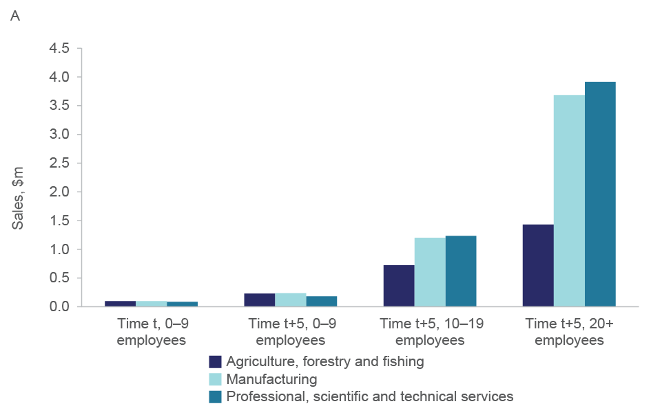 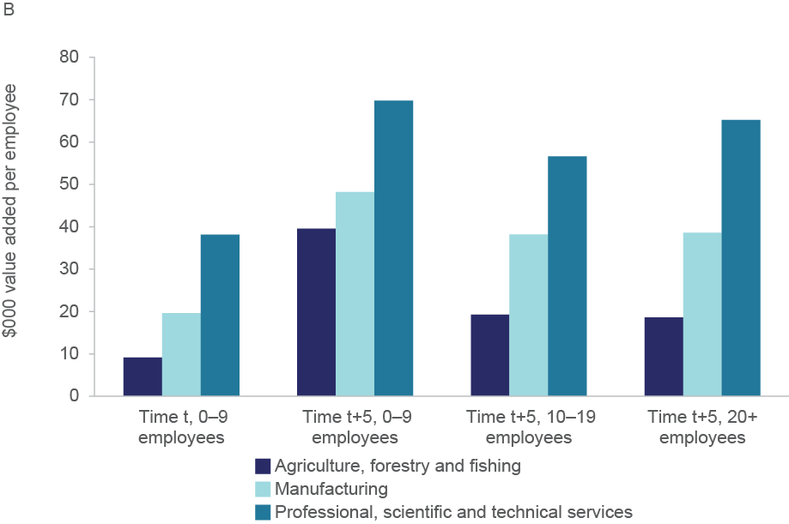

Notes: All micro-sized start-ups in 2006 were tracked over five years between 2006 and 2011. All surviving firms after five years are classified into the 0–9 employees, 10–19 employees or 20+ employees size class achieved. Dollar values are nominal. Employment data and size classes are calculated using a headcount measure. FTE measures show similar relative results. Source: ABS (2015) Expanded Analytical Business Longitudinal Database 2001–02 to 2012–13

# Discussion

This paper shows that young SMEs contribute disproportionately to net employment creation in Australia. Jobs growth in Australia is generated by firms of all ages and sizes but it is young firms, particularly high growth start-ups that are the engine of employment growth.

Over the ten year reference period, young SMEs made the highest contribution to net job creation in Australia (50 per cent) and start-up activity is responsible for approximately half of this growth. It is a very small fraction (3 per cent) of surviving start-ups that go on to generate most (77 per cent) of the employment growth in young firms. Job creation by these high growth micro-start-ups is more than enough to compensate for gross job destruction by exiting start-ups and downsizing mature firms. Start-up activity is therefore critical for employment growth in Australia. The data shows that an ‘up or out’ dynamic generally holds true for job growth in Australian firms, consistent with the findings of all other countries studied to date.[19],[20] However, the start-up data (See section 2.3) for Australia suggests that we are more likely to go ‘out’ than we are to go ‘up’ compared to the OECD median. More countries in the OECD DynEmp database will confirm this result. Observing all sectors shows that key information on the performance of a resource-driven country like Australia can be missed by a narrow focus on manufacturing and services. The data on employment dynamics shows the high impact that the mining boom had on firm creation, survival and growth in that sector.

Australia has relatively healthy entrepreneurship and creative-destruction compared with other OECD countries. Start-ups occupy a relatively high share of total firms, implying that Australia’s firm environment is more dynamic compared to a number of other OECD countries. These results are consistent with other reports that show Australia has relatively high entrepreneurial intentions, a high rate of firm creation and low regulatory barriers to entrepreneurship.[21]

This paper highlights the significance of start-up firms to net job creation in Australia. However the importance of start-ups to the Australian economy has been declining over the decade examined: The share of start-ups in the economy, their share of employment and their contribution to gross job creation, while still high compared to other OECD countries fell significantly. One explanation worth further research is whether industry composition is changing over the ten year period such that some sectors of the economy explain the slowing start-up activity.

The declining rate of entrepreneurship is also observed across all OECD countries examined to date, suggesting a global phenomenon rather than a specifically Australian issue. It has been argued that firm ageing/consolidation represents a slowing in the rate of creative-destruction and re-allocation dynamics.[22] The global financial crisis will have influenced the downward trend to some extent across all OECD countries examined to date. However, Hathaway & Litan (2014) show declining start-up activity in the USA since the late 1970s with little evidence that business consolidation is responsible for the decline. The unemployment rate in Australia generally fell during the period we examined. Swanepoel & Harrison (2015) show that the unemployment rate has a positive and statistically significant impact on self-employment in Australia. The start-up rate data shown in this paper does mimic aggregate unemployment trends over the same period as it does in other OECD countries. Start-up activity is buffering against unemployment during economic downturns.

High growth firms are found in all sectors of the economy. If net job creation is a policy aim then being able to identify these high growth start-ups early is critical. Understanding the internal capabilities of these high-growth firms and how they grow is therefore a fruitful area of future research.

Australia’s national average post-survival growth prospects are relatively low compared with other OECD countries. The efficiency of resource reallocation may be relatively low in Australia or competition may be particularly high. This needs further testing and validation. Criscuolo *et al*. (2014) highlight the importance of exogenous (outside-firm) factors such as bankruptcy laws and the availability of finance that may be a constraint to this growth. In Australia, most venture capital is poured into technology-driven ICT and life science firms (ABS 2015) rather than the full range of sectors that exhibit high-growth start-up dynamics. Venture capital and other formal sources of finance for start-ups might be more supportive of other sectors if funds and deal flow was higher and high information asymmetries were addressed in those sectors.

Other North American and European countries studied by the OECD may have certain market scale or access advantages. The OECD (2007) has estimated that lower market access relative to the OECD average could contribute negatively to GDP per capita by as much as 10 per cent in Australia. A critical aspect of our future research will be to determine how early, and the extent to which, these high-growth micro-start-ups access international markets for either capital injections or export sales. Australia is a relatively open economy. However, given our relatively younger and smaller firms resource constraints factors may be locking up the growth potential of Australian start-ups. The Export Council of Australia[23] note that the highest barriers to exporting firms are access to information relating to local culture, firm practices and language; information about local regulations and customer payment issues. Helping Australian born global start-ups overcome these barriers may ease Australia’s growth constraint relative to other countries.

There is a wealth of research that shows that persistent and large variation in firm productivity exists within all industries and that firm productivity affects firm profitability, survival and growth.[24] The data we have presented here is not entirely consistent with the OECD’s conceptual model of resource reallocation and creative destruction: *more innovative,* *more productive firms capture resources from less innovative, less productive firms*.

We demonstrate that after five years the high growth start-ups often have lower labour productivity than the surviving start-ups that don’t grow. The use of headcount measure rather than full time equivalents or hours worked does not change this result.[25] Revenue-based productivity measures often understate true productivity differences, especially for newer firms where more productive firms often have lower prices and are larger).[26] Unfortunately we are not able to observe plant-specific output prices across all industries over such a long timeframe at this stage. Capital expenditures and intermediate costs suggest that total factor productivity may exhibit the same response as labour productivity. Future research will investigate whether these observations hold for total factor productivity and whether there is a trade-off between productivity and employment growth amongst firms of different age and size classes within Australia.

We suggest the observed productivity differences may also be explained by strategic decisions of start-up management and leadership. An important management-related dimension is the role of learning, innovation investment and risk-taking in differentiating start-up growth performance before economies of scale diverge. Consistent with innovation and growth literature we argue that high growth start-ups are able to develop a sustained and unique market advantage early, which by definition, would come from the introduction of new or significantly improved goods, services and methods for organising production.[27] If Syverson’s (2011) argument is correct then these innovative firms are able to leverage productivity advantages faster and displace less productive competitors quicker. Empirical evidence suggests this is the case for Australian firms: innovation drives firm growth in profitability, employment, economies of scope and productivity (see Balasubramanian & Sivadasan 2011, Department of Industry 2014, Andrews *et al*. 2014). Innovators are significantly more likely to invest in physical capital, indicating in part the building of new productive capabilities through technology adoption such as ICT (Department of Industry 2014). The data presented in this paper shows high growth start-ups dramatically increase their capital expenditure, indicating in part the building of new productive capabilities through technology adoption such as ICT (see OECD 2015).

Among innovative firms, young and small firms can have higher innovation intensities than mature firms as measured by the ratio of research and development spending to sales.[28] Our own ongoing research gives compelling evidence that innovation capability underpins the observed firm-employment dynamics thereby influencing productivity and employment outcomes in the Australian economy. Our preliminary analysis shows that the likelihood of innovation, employment, productivity growth and economies of scope falls significantly as Australian firms’ age. R&D expenditure per employee is significantly higher for young Australian firms ($50,000 per employee) than mature firms (less than $30,000 per employee) across all years in the period 2006–07 to 2011–12. Innovative firms are twice as likely to generate employment growth as non-innovative firms (see Department of Industry and Science 2014a). Our research shows over the period 2005–06 to 2010–11 that R&D performing micro-firms (0–9 employees) were 26 per cent more likely than non-R&D performing micro-firms to increase annual sales by 20 per cent or more. If innovation is so important for firm survival and growth it may be logical to think that the high growth micro-start-ups invest more in innovation or innovate more frequently. However, this assumption needs to be tested empirically. We have observed that innovation is a useful proxy indicator for the overall quality of a firm but innovative firms differ in just how innovative they are. Looking at the productivity dispersion for both low and high growth micro-start-ups we will likely find that the presence of innovation is not exclusive to one particular cohort. Rather, more detailed investigation is required into the extent to which new to market innovation is occurring in each cohort and, as noted above, the extent to which each cohort competes in international markets.

The second strategy dimension to consider is growth-orientation. Our data is consistent with the majority of owners and managers of Australian start-ups being self-employed or lifestyle entrepreneurs, i.e. opportunity based entrepreneurs, opting for work-life balance versus ongoing wealth creation.[29] Most surviving start-ups still double their sales in five years but do not to grow much in employment. They keep their costs and re-investment low and focus on being efficient and profitable. This is a viable and successful strategy for many start-ups.

By contrast the high growth start-ups grow dramatically in all aspects of production, implying high growth in market share. However, their output growth does not keep pace with employment growth to the extent that any inherent labour productivity advantage may be hidden compared with low growth micro-startups. We suggest that these high growth firms are still in their ascendancy even after five years (see Nyugen & Hansell 2014). Owner/managers are hiring new staff and investing in physical and intangible capital with the expectation of future returns thereby temporarily suppressing revenue-based labour productivity. This may explain the inconsistency with the prevailing economic argument and suggests that revenue-based labour productivity may not always be the best indicator of performance when young firms are in a rapid growth phase. Future research needs to track these firms over their full lifecycle to assess if and when these firms achieve their ‘maximum’ productivity performance (See Coad *et al*. 2015). This data suggests that labour productivity should always be considered with other indicators of firm growth such as sales or employment when considering key performance indicators for industry policies.

This paper explores a rich dataset from the perspective of employment dynamics. This paper demonstrates how the Expanded Analytical Business Longitudinal Database (EABLD) has unlocked an unprecedented level of analytical capacity within the ABS, the Department of Industry and Science and the research community more broadly. The EABLD is essentially a longitudinal census of the business population with basic information such as sales, value added, employment and has the capacity to be further developed with additional datasets being added. These additional datasets could be administrative enabling counterfactual evaluation of industry policies at any level of government. The Department of Industry and Science, in collaboration with the Australian Bureau of Statistics, is now participating in two major OECD firm dynamics projects and is undertaking a series of research projects asking policy questions on the importance of R&D, intellectual property, employee share schemes, innovation and entrepreneurship to aggregate employment and productivity growth in Australia.

###### Methodological notes

The results presented here are based, in part, on tax data supplied by the ATO to the ABS under the Taxation Administration Act 1953, which requires that such data is only used for the purpose of administering the Census and Statistics Act 1905. Any discussion of data limitations or weaknesses is in the context of using the data for statistical purposes, and is not related to the ability of the data to support the ATO's core operational requirements. Legislative requirements to ensure privacy and secrecy of this data have been adhered to. In accordance with the Census and Statistics Act 1905, results have been confidentialised to ensure that they are not likely to enable identification of a particular person or organisation.

Employment

We use an estimate of a full-time equivalent (FTE) employment measure based on individual wages and the employer’s industry of origin. These estimates are better aligned with the ABS Labour Force Series (cat no 6202.0) for employee hours worked and hours worked for individuals using five waves of the Survey of Employee Earnings and Hours (cat no. 6306.0) than the headcount measure.

For the purposes of OECD comparisons employment is a headcount measure based on the number of unique ABN-Employee links in ATO annual payment summaries. These data are then linked to the EABLD to align the ABS units model and the ATO data structures. A consequence of this definition is that employment totals will differ with official ABS measures of employment in the Labour Force Survey as multiple job holders (either concurrent or sequential in one year) will receive a payment summary from each employer each year.

Scope

This paper provides data for the 2001–02 to 2011–12 years from the EABLD. The 2012–13 data was not included in the analysis at this stage because of the need to quality check the robustness of the data from the 2012–13 year.

For the purposes of cross-country comparisons, the data is limited to manufacturing, construction and service sectors excluding financial and insurance services using the International Standard Industrial Classification.[30] We also use OECD size class definitions to ensure comparability. International comparisons are made on manufacturing, construction and non-financial business services only. All other sectors are excluded from international comparisons.

Where internal cross-sectoral comparisons are made, all ANZSIC6 sub-divisions are used except 6, 7, 17, 26, 27, 47, 56, 60, 75, 76, and 96 due to the small number of observations. These sectors are included in national average analysis but excluded from descriptive statistics in order to maintain confidentiality of information.

For the purposes of static comparisons start-ups are defined as firms that are 0–2 years old (Results sections1 and 2). For all other longitudinal or temporal analyses start-ups are defined as firm entry.

Where the performance of growth and micro-sized start-ups are analysed in Results section 4, we define micro-sized start-ups as business entries that have 0–9 employees at time t. Medium and high growth micro-sized start-ups are defined as micro-sized start-ups that at time t+5 have grown their employment into the 10–19 employee and 20+ employee range, respectively.

Decomposition Analysis

The analytical approach used by the OECD[31] to identify cross-country differences in the dynamics of start-up survival and growth consists of decomposing normalised net job creation by surviving entrants into four main components.

1. *Start-up ratio*, $\frac{{NrUnit}_{at}\left(t+j\right)}{{EMP}_{t}\left(t\right)}$, measured as the number of entrants relative to the country’s total employment. This can be considered a measure of the role of entrepreneurship in the economy.
2. *Survival share*, $\frac{{NrUnits}_{at}^{surv}\left(t\right)}{{NrUnit}_{at}\left(t\right)}$, measured as the number of businesses that survive until or beyond the third year of life over the total number of starting businesses. This measure captures the extent to which the selection process is affecting the survival probability of entrants.
3. *Average size at entry*, $\frac{{EMP}_{at}^{surv}\left(t\right)}{{NrUnits}_{at}^{surv}\left(t\right)}$, calculated as the average number of employees for entrants. This measure might reflect, inter alia, low entry barriers.
4. *Average post-entry growth*, $\frac{{EMP}_{at}^{surv}(t+j)}{{EMP}_{at}(t)}$, measured as the final over initial employment ratio of surviving entrants. This measure reflects the growth performance of surviving start-ups.

The following equation decomposes normalise net job creation into the above components:

$\frac{{EMP}_{at}^{surv}(t+j)}{{EMP}_{t}(t)}=\frac{{EMP}_{at}^{surv}(t+j)}{{EMP}_{at}(t)}*\frac{{EMP}_{at}^{surv}\left(t\right)}{{NrUnits}_{at}^{surv}\left(t\right)}*\frac{{NrUnits}_{at}^{surv}\left(t\right)}{{NrUnit}_{at}\left(t\right)}*\frac{{NrUnit}_{at}\left(t+j\right)}{{EMP}_{t}\left(t\right)}$ (1)

Regression Model

OLS regression analysis was used to determine the role of firm age within size classes and *vice versa* using the following equation adapted from Criscuolo *et al.* (2014):

$y_{ijsct} = ∝ + \sum_{ij}{δ_{ij}{Ageclass}_{i}*}{Sizeclass}_{j}+ I_{s}+μ_{ijsct}$ (2)

where *i* indexes age classes, *j* size classes, *s* macro sectors and *t* years. *I*s is a macro-sector fixed effect. The dependent variable could be either the ratio of gross job creation over average total employment, the ratio of gross job destruction over average total employment or the ratio of net job creation of average total employment across the periods studied. Two age classes and three size classes were used across the macro-sectors studied according to the following table.

Table A1: OECD definitions of age and size classes

|  |  |
| --- | --- |
| Age classes | Size classes |
| Young (<6 years of age) | Small (<50 employees) |
| Old (6+ years) | Medium (50–249 employees) |
|  | Large (250+ employees) |

Source: Criscuolo C, Gal P N & Menon C (2014) *The dynamics of employment growth: New evidence from 18 countries*, OECD Science, Technology and Industry Policy Papers no. 14, OECD Publishing,

The split between young and mature firms at age five years was chosen in part to make international comparisons possible. However, Nguyen & Hansell (2014) also observe that, contingent on survival, most firms reach their industry’s productivity frontier or get close to it at around 5 years of age.

Entry and Exit

It is important to note that a business entry or exit may not equate to a business start-up or closure in the Australian Business Register. There may be a number of reasons why a business entry or exit event has occurred, including events relating to selling a business and changes in a business' structure due to merger or takeover activities. Further, businesses may transition into and out of the profiled population based on the guidelines used by the ABS, such as a medium sized enterprise growing in size and complexity. Incumbent firms are simply defined as firms that are not entering or exiting the economy. Their employment activity is basically recruitment and downsizing.

While the methodology of linking the administrative and survey data in the EABLD tries to accommodate these known issues, further analytical work is necessary to evaluate its efficacy. In particular future work needs to analyse worker clusters over time to identify true entry and exit as international evidence suggests that relabelling of firms with new identifiers can introduce bias (Hethey-Maier & Schmieder 2013).

For these reasons we focus on micro-start-ups as they are more representative of de novo entrepreneurship. However, the evidence cited by Criscuolo *et al*. (2014) suggests that this issue doesn’t affect the overall result or trend.

###### Supplementary data

Table B1: Number of firms, total employment and net employment growth by firm age and firm size, 2006–2011

| *Firm age* | *0–2 years* | | | *3–5 years* | | | *6+ years* | | | *All firms* |
| --- | --- | --- | --- | --- | --- | --- | --- | --- | --- | --- |
| *Firm size* | *Small (1–19 employees)* | *Medium (20–199 employees)* | *Large (200+ employees)* | *Small firms (1–19 employees)* | *Medium firms (20–199 employees)* | *Large firms (200+ employees)* | *Small firms (1–19 employees)* | *Medium firms (20–199 employees)* | *Large firms (200+ employees)* |  |
| Total number of firms | | | |  | | |  | | |  |
| 2006 | 149,643 | 2,631 | 69 | 179,704 | 5,018 | 178 | 429,528 | 25,973 | 2,532 | 795,276 |
| 2007 | 139,731 | 2,784 | 70 | 173,297 | 5,375 | 187 | 434,037 | 27,520 | 2,689 | 785,690 |
| 2008 | 125,403 | 2,538 | 63 | 169,240 | 5,322 | 169 | 443,822 | 28,151 | 2,756 | 777,464 |
| 2009 | 129,167 | 2,050 | 61 | 169,851 | 4,577 | 125 | 470,373 | 26,569 | 2,650 | 805,423 |
| 2010 | 132,784 | 2,179 | 86 | 158,966 | 4,508 | 126 | 483,184 | 27,756 | 2,750 | 812,339 |
| 2011 | 129,069 | 2,544 | 106 | 151,584 | 4,619 | 160 | 490,684 | 29,493 | 2,892 | 811,151 |
| Total employment (FTE) | | | |  | | |  | | |  |
| 2006 | 315,608 | 108,758 | 43,929 | 480,226 | 208,009 | 123,430 | 1,366,960 | 1,239,591 | 2,671,885 | 6,558,396 |
| 2007 | 313,641 | 115,861 | 31,717 | 494,420 | 224,420 | 123,541 | 1,427,851 | 1,318,897 | 2,865,600 | 6,915,950 |
| 2008 | 280,855 | 103,993 | 31,108 | 488,317 | 223,094 | 89,768 | 1,466,359 | 1,348,839 | 2,928,300 | 6,960,632 |
| 2009 | 246,980 | 85,853 | 32,372 | 456,172 | 191,954 | 64,589 | 1,485,599 | 1,265,961 | 2,727,128 | 6,556,607 |
| 2010 | 255,420 | 93,545 | 52,125 | 426,507 | 191,488 | 56,049 | 1,523,508 | 1,328,061 | 2,836,713 | 6,763,414 |
| 2011 | 257,034 | 113,564 | 51,895 | 409,854 | 197,862 | 86,253 | 1,568,846 | 1,423,130 | 2,975,631 | 7,084,067 |
| Net employment (FTE) growth | | | |  | | |  | | |  |
| 2006 | 177,380 | 61,675 | 26,892 | -70,340 | 2,063 | -15,880 | -77,634 | 70,144 | 129,710 | 304,011 |
| 2007 | 173,665 | 68,896 | 16,220 | -21,018 | 27,227 | 3,485 | -87,858 | 64,210 | 178,228 | 423,055 |
| 2008 | 147,737 | 56,040 | 19,845 | -42,225 | 13,383 | 6,009 | -139,789 | 12,114 | 36,789 | 109,903 |
| 2009 | 130,092 | 49,592 | 16,036 | -76,173 | -1,291 | 1,203 | -242,409 | -100,601 | -155,245 | -378,795 |
| 2010 | 144,810 | 57,843 | 36,791 | -29,397 | 22,126 | 3,717 | -125,758 | 33,555 | 88,456 | 232,144 |
| 2011 | 147,249 | 73,922 | 31,499 | -19,730 | 28,762 | 13,410 | -110,771 | 60,607 | 120,603 | 345,552 |

Notes: Non-employing firms are excluded from this analysis. All figures are for private sector businesses (government businesses are excluded) with a valid ANZSIC code. Australian standard size classes are used in this table.

Source: ABS (2015) Expanded Analytical Business Longitudinal Database 2001–02 to 2012–13

Figure B1: Age composition of small businesses, by country, 2001–2011

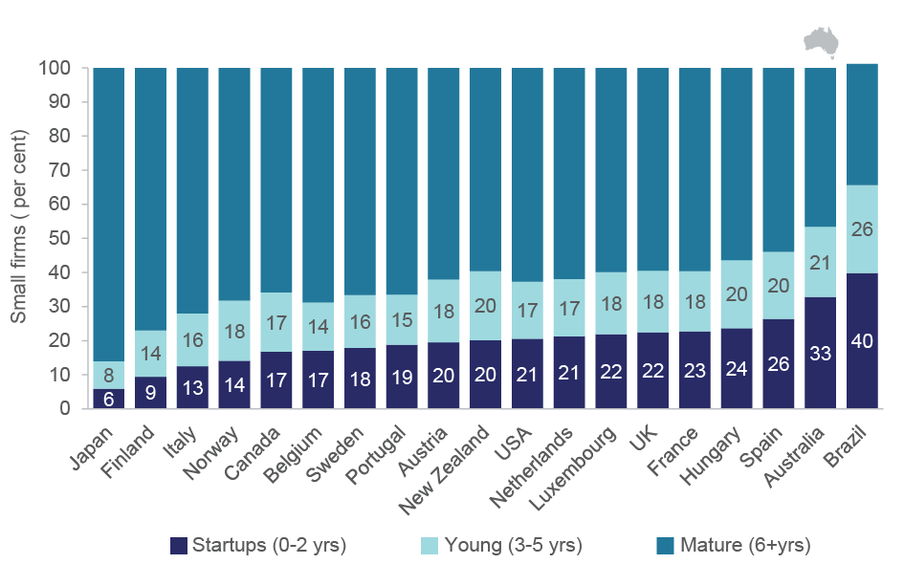

Notes: The graph shows the share of firms by different age groups in the total number of micro and small firms (below 50 employees) in each economy on average over the available years. The period covered is 2001–2011 for Australia, Belgium, Canada, Finland, Hungary, the Netherlands, the United Kingdom and the United States; 2001–2010 for Austria, Brazil, Spain, Italy, Luxembourg, Norway and Sweden; 2001–2009 for Japan and New Zealand; 2001–2007 for France; and 2006–2011 for Portugal. Sectors covered are: manufacturing, construction, and non-financial business services. Owing to methodological differences, figures may deviate from officially published national statistics. For Japan data are at the establishment level, for other countries at the firm level. Data for Canada refer only to organic employment changes and exclude merger and acquisition activity.

Source: Criscuolo *et al.* (2014) and ABS (2015) Expanded Analytical Business Longitudinal Database 2001–02 to 2012–13

Figure B2: Size of start-up manufacturing (panel A) and services (panel B) firms and their share of total firms by country, 2001–2011

Based on the OECD and ABS data, figure B2 (panels A and B) shows the size of start-up firms in the manufacturing (panel A) and services (panel B) sectors by the number of employees in Australia and 18 other OECD countries in the 10-year period 2001-2011. The figure also shows the share of start-up manufacturing (panel A) and services (panel B) firms in Australia as a percentage of total firms compared with 18 other OECD countries. The 18 OECD countries studied are Brazil, Netherlands, Hungary, Spain, France, New Zealand, Austria, Portugal, Luxembourg, UK, Sweden, Belgium, Italy, Norway, Canada, Japan, Finland and the USA.
Panel A is a bar chart showing a relatively high share of start-ups among Australian firms in both the manufacturing and services sectors (second only to Brazil). The share of manufacturing firms aged 0-2 years was around 24 per cent, which is relatively high compared to most other countries over the 10-year period.  Similarly, the services sector exhibits a relatively high share of start-ups, where some 33 per cent of firms could be classified as start-ups, aged 0-2 years.
Panel B indicates a considerable diversity among countries in terms of the average number of people employed by manufacturing start-ups, with Australian manufacturing start-ups tending to employ fewer staff during the 10-year period compared to other countries. The average number of staff employed in Australian manufacturing start-ups was 5.5 employees. The size of Australian services start-ups was closer to the middle of the country range. The average number of staff employed in Australian services start-ups was 4.3 employees.


Notes: The graph reports the average size of start-up firms (from 0 to 2 years old) and the share of start-up firms in the total number of firms by sector. For the purposes of OECD comparisons headcount measures are used rather than Full Time Equivalents. The period covered is 2001–2011 for Australia, Belgium, Canada, Finland, Hungary, the Netherlands, the United Kingdom and the United States; 2001–2010 for Austria, Brazil, Spain, Italy, Luxembourg, Norway and Sweden; 2001–2009 for Japan and New Zealand; 2001–2007 for France; and 2006–2011 for Portugal. Services exclude the financial business sector. Owing to methodological differences, figures may deviate from officially published national statistics. For Japan data are at the establishment level, for other countries at the firm level. Data for Canada refer only to organic employment changes and don’t include merger and acquisition activity.

Source: Criscuolo *et al.* (2014) and ABS (2015) Expanded Analytical Business Longitudinal Database 2001–02 to 2012–13

Figure B3: Share of start-ups in the business population, 2001–03 to 2010–11

Based on the OECD and ABS data, figure B3 shows the share of start-ups as a percentage of all firms in Australia and 18 other OECD countries over the 10-year period 2001-2011 in selected sectors. The 18 OECD countries under consideration are Brazil, Netherlands, Hungary, Spain, France, New Zealand, Austria, Portugal, Luxembourg, UK, Sweden, Belgium, Italy, Norway, Canada, Japan, Finland and the USA. The sectors covered are manufacturing, construction; and non-financial services. 
Figure B3 is a bar chart compares start-up rates (i.e. the fraction of start-ups among all firms) by country, averaged across four episodes: 2001-03, 2004-06, 2007-09 and 2010-11. The figure indicates that the share of start-ups have declined in most countries over time. Notwithstanding the relatively high proportion of start-ups in Australia there has been a decline in Australia, too. The share of Australian start-ups against all firms has been declining since the three-year period 2004-2006. 


Notes: The graph reports start-up rates (defined as the fraction of start-ups among all firms) by countries, averaged across the indicated three-year periods. Start-up firms are those firms which are from 0 to 2 years old. The period covered is 2001–2011 for Australia, Belgium, Canada, Finland, Hungary, the Netherlands, the United Kingdom and the United States; 2001–2010 for Austria, Brazil, Italy, Luxembourg, Norway, Spain and Sweden; 2001–2009 for Japan and New Zealand; 2001–2007 for France; and 2006–2011 for Portugal. Sectors covered are: manufacturing, construction, and non-financial business services. Owing to methodological differences, figures may deviate from officially published national statistics. For Japan data are at the establishment level, for other countries at the firm level. Data for Canada refer only to organic employment changes and don’t include merger and acquisition activity.

Source: Criscuolo *et al.* (2014) and ABS (2015) Expanded Analytical Business Longitudinal Database 2001–02 to 2012–13

Figure B4: Employment share by firm age, OECD vs. Australia, 2001–2011

Based on the OECD and ABS data, figure B4 shows (in the form of a bar chart) employment share, by firm age, in selected sectors in Australia as against the average of 18 other OECD countries in the 10-year period 2001-2011. The 18 OECD countries under consideration are Brazil, Netherlands, Hungary, Spain, France, New Zealand, Austria, Portugal, Luxembourg, UK, Sweden, Belgium, Italy, Norway, Canada, Japan, Finland and the USA. The sectors covered are manufacturing, construction and non-financial services. 
Figure C4 shows that across all countries examined, around 63 per cent of firms in the sectors considered were mature (aged 6 years or more), and these accounted for nearly 80 per cent of total employment for those sectors. Based on this figure, Australian mature firms (aged 6 years or more) show relatively smaller shares of overall firms (48 per cent) and employment (71 per cent) than other countries, respectively, but the pattern is broadly consistent with other participating countries. The share of young firms (0-5 years old) in the total number of all firms was lower, compared to mature firms, as was their share of employment. This pattern is similar both in Australia and across other countries examined by the OECD. However, differences between countries do exist in the relative magnitudes. Australian start-ups (firms aged 0-2 years) accounted for 34 per cent of all firms in the subpopulation over the period under consideration, which is relatively higher than the average of other 18 countries in the OECD database (20 per cent).


Notes: The graph reports the share of firms and employment, respectively, by firms of different age classes in average across all available years and countries. For the purposes of OECD comparisons headcount measures are used rather than Full Time Equivalents. Start-ups are split into firm births and 1–2 year old firms. The period covered is 2001–2011 for Australia, Belgium, Finland, Hungary, the Netherlands, the United Kingdom and the United States; 2001–2010 for Austria, Brazil, Spain, Italy, Luxembourg, Norway and Sweden; 2001–2009 for Japan and New Zealand; 2001–2007 for France; and 2006–2011 for Portugal. Sectors covered are: manufacturing, construction, and non-financial business services. Owing to methodological differences, figures may deviate from officially published national statistics. For Japan data are at the establishment level, for other countries at the firm level.

Source: Criscuolo *et al.* (2014) and ABS (2015) Expanded Analytical Business Longitudinal Database 2001–02 to 2012–13

Figure B5: Gross employment creation and destruction by firm age, 2007–2011

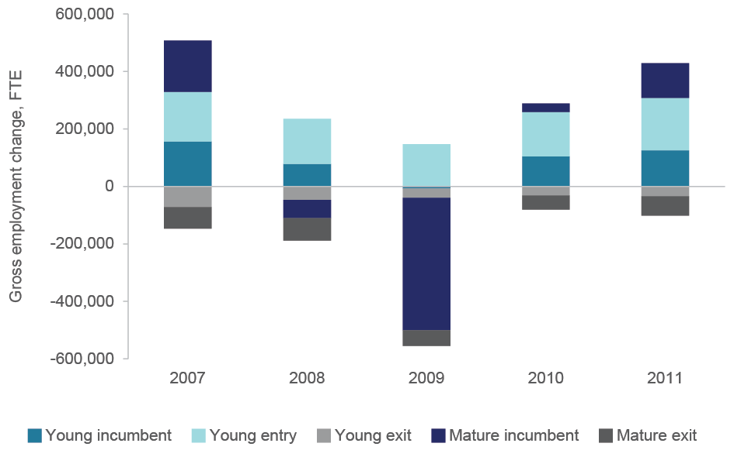

Notes: Mature firms are those that are 6+ years, young firms are 0–5 years old. Start-ups that enter and exit in the same year are excluded from the analysis. Employee numbers are by Full Time Equivalent measures. Contributions are from all sectors of the economy.

Source: ABS (2015) Expanded Analytical Business Longitudinal Database 2001–02 to 2012–13

Figure B6: Employment, job creation and job destruction for SME (panel A) and Large firms (panel B) by firm age, OECD *vs*. Australia, 2001–2011

Based on the OECD and ABS data, figure B6 (panels A and B) shows (in the forms of two bar charts) employment, job creation and job destruction for SMEs (panel A) and large firms (panel B) in selected sectors in Australia compared to 18 other OECD countries in the 10-year period 2001-2011. The 18 OECD countries under consideration are Brazil, Netherlands, Hungary, Spain, France, New Zealand, Austria, Portugal, Luxembourg, UK, Sweden, Belgium, Italy, Norway, Canada, Japan, Finland and the USA. The sectors covered are manufacturing, construction and non-financial services. 
Comparing Australia to other countries - using different size classes: SMEs (1-249 employees) and large firms (250+ employees) - figure B6 (panels A and B) shows that while Australia’s employment dynamics are consistent with other countries examined over the ten year period, Australia is comparatively more reliant on young SMEs for gross job creation than the average of the other 18 OECD countries. Young SMEs contribution to gross job creation in Australia was 50 per cent compared to the OECD average of 41 per cent.


Notes: The graph reports the contribution to total employment, gross job creation and job destruction by firms in the reported age-size groups on average across all available years and countries. For the purposes of OECD comparisons headcount measures are used rather than Full Time Equivalents. Size classes are Small to Medium (1–249 employees) and Large (250+ employees). Age classes are Young (1–5 years old) and Mature (6+ years old). The period covered is 2001–2011 for Australia, Belgium, Finland, Hungary, the Netherlands, the United Kingdom and the United States; 2001–2010 for Austria, Brazil, Spain, Italy, Luxembourg, Norway and Sweden; 2001–2009 for Canada, Japan and New Zealand; 2001–2007 for France; and 2006–2011 for Portugal. Sectors covered are: manufacturing, construction, and non-financial business services. Owing to methodological differences, figures may deviate from officially published national statistics. For Japan data are at the establishment level, for other countries at the firm level. Data for Canada refer only to organic employment changes and exclude merger and acquisition activity.

Source: Criscuolo *et al.* (2014) and ABS (2015) Expanded Analytical Business Longitudinal Database 2001–02 to 2012–13

Table B2: OLS regressions of gross job creation and destruction and net growth rate of firms by firm size and age group fixed effects

| Dependent variable | Gross job creation ratio | Gross job destruction ratio | Net growth rate |
| --- | --- | --- | --- |
| Young-small | 0.246*** | 0.106*** | 0.140*** |
|  | (0.00585) | (0.00523) | (0.00772) |
|  |  |  |  |
| Young-medium | 0.232*** | 0.0747*** | 0.157*** |
|  | (0.00585) | (0.00523) | (0.00772) |
|  |  |  |  |
| Mature-small | 0.0369*** | 0.118*** | -0.0811*** |
|  | (0.00585) | (0.00523) | (0.00772) |
|  |  |  |  |
| Mature-medium | 0.0204*** | 0.0501*** | -0.0297*** |
|  | (0.00585) | (0.00523) | (0.00772) |
|  |  |  |  |
| Constant | 0.120*** | 0.128*** | -0.00753 |
|  | (0.00961) | (0.00859) | (0.0127) |
|  |  |  |  |
| Observations | 595 | 595 | 595 |
| R-squared | 0.882 | 0.736 | 0.835 |

Notes: The reference category is mature-large firms (age 6+; size 250+). Young-large firms are excluded from the analysis. General divisional dummies were used. Robust standard errors in parentheses *** p<0.01, ** p<0.05, * p<0.1

Source: ABS (2015) Expanded Analytical Business Longitudinal Database 2001–02 to 2012–13

Table B3: Start-up activity by ANZSIC Sub-division, 2001–2011

|  | ***Start-ups of all sizes*** | | | | | | | | ***Micro-start-ups*** | |
| --- | --- | --- | --- | --- | --- | --- | --- | --- | --- | --- |
| *Subdivision* | *Start-up share of total employment, per cent* | | *Start-up share of gross job creation, per cent* | *Net job creation by surviving start-ups relative to total employment, per cent* | *Start-up ratio (start-ups per 1,000 employees)* | *Start-up survival rate after three years, per cent* | *Average start-up size, employees* | *Average three-year post-entry growth,*  *per cent* | *Micro-start-up survival rate after five years, per cent* | *Job creation by micro-start-ups after five years, per cent* |
| *AGRICULTURE, FORESTRY AND FISHING* |  | |  |  |  |  |  |  |  |  |
| Agriculture | 3.54 | | 16.4 | 3.99 | 20.08 | 59.7 | 2.69 | 102.6 | 49.0 | 114.6 |
| Aquaculture | 2.22 | | 15.4 | 2.78 | 10.68 | 53.4 | 2.86 | 109.8 | 43.7 | 134.9 |
| Forestry and Logging | 3.74 | | 22.3 | 5.98 | 25.20 | 41.6 | 3.22 | 144.5 | 32.3 | 152.7 |
| Fishing, Hunting and Trapping | 3.38 | | 15.7 | 3.41 | 45.73 | 47.0 | 1.17 | 92.5 | 35.2 | 88.0 |
| Agriculture, Forestry and Fishing Support Services | 7.73 | | 30.8 | 8.20 | 18.86 | 57.4 | 5.45 | 107.5 | 44.8 | 168.8 |
| *MINING* |  | |  |  |  |  |  |  |  |  |
| Metal Ore Mining | 0.74 | | 5.5 | 1.99 | 1.55 | 59.7 | 6.23 | 432.1 | 47.8 | 436.4 |
| Non-Metallic Mineral Mining and Quarrying | 1.90 | | 13.1 | 3.46 | 8.73 | 53.7 | 3.43 | 178.6 | 41.7 | 254.5 |
| Exploration and Other Mining Support Services | 3.14 | | 16.3 | 7.63 | 8.85 | 62.8 | 5.07 | 296.9 | 51.8 | 599.9 |
| *MANUFACTURING* |  | |  |  |  |  |  |  |  |  |
| Food Product Manufacturing | 2.73 | | 21.5 | 3.20 | 3.73 | 66.7 | 9.10 | 112.6 | 47.9 | 157.1 |
| Beverage and Tobacco Product Manufacturing | 1.75 | | 15.7 | 2.13 | 3.67 | 70.4 | 6.15 | 118.5 | 57.6 | 179.0 |
| Textile, Leather, Clothing and Footwear Manufacturing | 2.66 | | 19.8 | 2.75 | 10.97 | 56.6 | 3.29 | 90.7 | 40.9 | 106.0 |
| Wood Product Manufacturing | 2.90 | | 21.6 | 3.47 | 7.90 | 65.0 | 4.60 | 112.5 | 48.7 | 137.1 |
| Pulp, Paper and Converted Paper Product Manufacturing | 1.50 | | 19.2 | 1.41 | 1.92 | 63.7 | 7.00 | 140.9 | 48.9 | 311.5 |
| Printing (including the Reproduction of Recorded Media) | 2.72 | | 22.4 | 3.18 | 8.36 | 64.6 | 4.05 | 110.0 | 49.0 | 137.7 |
| Basic Chemical and Chemical Product Manufacturing | 1.28 | | 13.7 | 1.61 | 2.71 | 64.1 | 5.70 | 139.1 | 49.5 | 183.4 |
| Polymer Product and Rubber Product Manufacturing | 1.93 | | 17.1 | 2.49 | 3.42 | 66.2 | 7.43 | 122.6 | 50.9 | 164.0 |
| Non-Metallic Mineral Product Manufacturing | 2.02 | | 18.4 | 2.53 | 5.34 | 60.0 | 5.69 | 116.0 | 46.5 | 162.3 |
| Primary Metal and Metal Product Manufacturing | 1.05 | | 12.2 | 1.66 | 2.23 | 66.0 | 5.78 | 156.4 | 53.0 | 219.0 |
| Fabricated Metal Product Manufacturing | 2.89 | | 20.3 | 3.95 | 9.52 | 62.6 | 4.17 | 129.2 | 48.4 | 163.8 |
| Transport Equipment Manufacturing | 1.86 | | 16.4 | 2.30 | 5.28 | 59.1 | 4.97 | 120.6 | 43.9 | 154.9 |
| Machinery and Equipment Manufacturing | 2.15 | | 16.3 | 3.39 | 5.11 | 68.5 | 5.80 | 137.7 | 54.8 | 172.7 |
| Furniture and Other Manufacturing | 3.64 | | 23.6 | 4.10 | 14.14 | 63.0 | 3.33 | 100.6 | 48.3 | 112.6 |
| *ELECTRICITY, GAS, WATER AND WASTE SERVICES* | |  |  |  |  |  |  |  |  |  |
| Water Supply, Sewerage and Drainage Services | 3.21 | | 22.2 | 2.97 | 3.16 | 57.7 | 13.52 | 186.6 | 42.3 | 210.5 |
| Waste Collection, Treatment and Disposal Services | 3.04 | | 20.4 | 3.43 | 12.16 | 65.1 | 2.52 | 123.5 | 50.9 | 160.6 |
| *CONSTRUCTION* |  | |  |  |  |  |  |  |  |  |
| Building Construction | 4.37 | | 21.2 | 5.87 | 37.60 | 52.7 | 1.74 | 128.6 | 41.2 | 150.2 |
| Heavy and Civil Engineering Construction | 2.89 | | 15.8 | 4.56 | 9.37 | 55.1 | 4.55 | 144.5 | 41.4 | 194.7 |
| Construction Services | 5.66 | | 24.8 | 7.43 | 49.60 | 57.4 | 1.48 | 124.1 | 43.9 | 138.9 |
| *WHOLESALE TRADE* |  | |  |  |  |  |  |  |  |  |
| Basic Material Wholesaling | 2.29 | | 17.3 | 3.19 | 9.60 | 62.5 | 3.08 | 133.4 | 49.1 | 168.4 |
| Machinery and Equipment Wholesaling | 2.04 | | 15.7 | 3.07 | 7.08 | 66.4 | 3.73 | 141.9 | 53.0 | 184.1 |
| Motor Vehicle and Motor Vehicle Parts Wholesaling | 3.43 | | 23.7 | 3.60 | 8.87 | 62.0 | 5.07 | 117.4 | 47.7 | 144.6 |
| Grocery, Liquor and Tobacco Product Wholesaling | 3.51 | | 21.1 | 4.98 | 11.24 | 62.8 | 4.40 | 134.3 | 47.7 | 192.2 |
| Other Goods Wholesaling | 2.47 | | 17.7 | 3.54 | 11.40 | 60.7 | 3.03 | 130.9 | 45.5 | 171.1 |
| Commission-Based Wholesaling | 3.54 | | 22.6 | 3.92 | 22.49 | 59.4 | 2.13 | 131.3 | 44.6 | 134.4 |
| *RETAIL TRADE* |  | |  |  |  |  |  |  |  |  |
| Motor Vehicle and Motor Vehicle Parts Retailing | 3.27 | | 25.6 | 4.55 | 6.76 | 66.2 | 7.01 | 123.4 | 48.9 | 139.0 |
| Fuel Retailing | 5.40 | | 28.2 | 6.79 | 7.55 | 65.9 | 9.68 | 126.1 | 47.1 | 99.0 |
| Food Retailing | 2.75 | | 26.9 | 3.22 | 6.52 | 62.3 | 5.73 | 108.3 | 44.0 | 125.2 |
| Other Store-Based Retailing | 3.48 | | 25.2 | 4.20 | 9.95 | 63.6 | 4.33 | 117.0 | 46.6 | 129.5 |
| Non-Store Retailing and Retail Commission-Based Buying and/or Selling | 8.45 | | 29.6 | 7.87 | 65.78 | 49.8 | 1.38 | 118.1 | 34.7 | 166.3 |
| *ACCOMMODATION AND FOOD SERVICES* |  | |  |  |  |  |  |  |  |  |
| Accommodation | 4.79 | | 28.9 | 5.82 | 7.03 | 70.6 | 7.80 | 116.3 | 53.3 | 175.0 |
| Food and Beverage Services | 7.35 | | 37.1 | 7.43 | 11.17 | 55.8 | 9.21 | 95.5 | 34.3 | 101.2 |
| *TRANSPORT POSTAL AND WAREHOUSING* |  | |  |  |  |  |  |  |  |  |
| Road Transport | 3.80 | | 21.4 | 4.82 | 25.39 | 61.9 | 1.85 | 116.9 | 47.6 | 127.1 |
| Water Transport | 3.42 | | 22.7 | 6.11 | 7.28 | 58.8 | 7.68 | 136.4 | 43.8 | 647.5 |
| Air and Space Transport | 0.58 | | 9.1 | 1.13 | 2.00 | 55.5 | 4.17 | 210.7 | 43.9 | 556.2 |
| Other Transport | 3.06 | | 17.6 | 3.63 | 16.05 | 57.5 | 2.65 | 122.0 | 43.7 | 197.0 |
| Postal and Courier Pick-up and Delivery Services | 3.11 | | 31.3 | 3.43 | 30.24 | 56.5 | 1.37 | 101.5 | 41.3 | 93.0 |
| Transport Support Services | 3.62 | | 23.9 | 3.23 | 20.09 | 51.9 | 3.16 | 117.4 | 40.0 | 159.3 |
| Warehousing and Storage Services | 2.84 | | 17.1 | 5.08 | 4.77 | 67.0 | 9.08 | 170.8 | 54.1 | 372.1 |
| *INFORMATION MEDIA AND TELECOMMUNICATIONS* | |  |  |  |  |  |  |  |  |  |
| Publishing (except Internet and Music Publishing) | 2.39 | | 21.6 | 3.06 | 4.12 | 58.3 | 13.66 | 100.4 | 44.4 | 123.4 |
| Motion Picture and Sound Recording Activities | 12.40 | | 39.3 | 3.61 | 10.84 | 50.3 | 7.37 | 34.0 | 39.1 | 165.0 |
| Internet Publishing and Broadcasting | 6.31 | | 31.6 | 8.53 | 59.13 | 45.2 | 1.82 | 133.6 | 31.5 | 171.6 |
| Telecommunications Services | 0.62 | | 15.8 | 0.75 | 1.75 | 63.1 | 4.12 | 140.5 | 49.0 | 201.0 |
| Internet Service Providers, Web Search Portals and Data Processing Services | 2.92 | | 19.0 | 3.72 | 11.95 | 55.8 | 3.44 | 120.3 | 40.8 | 139.9 |
| *FINANCIAL AND INSURANCE SERVICES* |  | |  |  |  |  |  |  |  |  |
| Finance | 2.25 | | 20.5 | 2.00 | 11.01 | 54.1 | 2.52 | 96.9 | 42.2 | 114.5 |
| Insurance and Superannuation Funds | 2.90 | | 19.9 | 2.10 | 36.28 | 51.1 | 0.73 | 72.9 | 22.0 | 27.2 |
| Auxiliary Finance and Insurance Services | 4.36 | | 23.7 | 5.03 | 23.59 | 58.7 | 2.38 | 105.1 | 46.3 | 124.6 |
| *RENTAL, HIRING AND REAL ESTATE SERVICES* |  | |  |  |  |  |  |  |  |  |
| Rental and Hiring Services (except Real Estate) | 5.16 | | 25.2 | 6.49 | 21.62 | 62.0 | 2.87 | 121.5 | 48.7 | 176.1 |
| Property Operators and Real Estate Services | 5.93 | | 29.6 | 7.17 | 63.33 | 62.1 | 1.17 | 116.3 | 51.7 | 136.5 |
| *PROFESSIONAL, SCIENTIFIC AND TECHNICAL SERVICES* | |  |  |  |  |  |  |  |  |  |
| Professional, Scientific and Technical Services (Except Computer System Design and Related Services) | 4.32 | | 23.4 | 5.77 | 22.49 | 58.7 | 2.80 | 121.4 | 45.5 | 146.9 |
| Computer System Design and Related Services | 5.33 | | 26.8 | 6.89 | 26.25 | 54.8 | 3.44 | 125.2 | 41.2 | 153.5 |
| *ADMINISTRATIVE AND SUPPORT SERVICES* |  | |  |  |  |  |  |  |  |  |
| Administrative Services | 3.93 | | 21.5 | 4.97 | 3.78 | 59.6 | 13.69 | 123.9 | 45.4 | 267.2 |
| Building Cleaning, Pest Control and Other Support Services | 4.81 | | 25.4 | 5.13 | 23.01 | 52.9 | 2.84 | 106.1 | 39.1 | 118.7 |
| *EDUCATION AND TRAINING* |  | |  |  |  |  |  |  |  |  |
| Preschool and School Education | 0.91 | | 11.3 | 0.88 | 0.38 | 71.9 | 19.00 | 143.8 | 56.3 | 251.1 |
| Tertiary Education | 6.05 | | 29.5 | 8.12 | 9.46 | 58.9 | 9.81 | 133.6 | 45.2 | 225.2 |
| Adult, Community and Other Education | 4.44 | | 24.4 | 5.61 | 18.97 | 58.0 | 3.25 | 121.8 | 43.0 | 157.9 |
| *HEALTH CARE AND SOCIAL ASSISTANCE* |  | |  |  |  |  |  |  |  |  |
| Hospitals | 0.38 | | 5.7 | 0.49 | 0.94 | 61.3 | 6.00 | 151.5 | 47.4 | 247.3 |
| Medical and Other Health Care Services | 4.02 | | 23.2 | 5.59 | 22.66 | 74.2 | 2.14 | 135.6 | 63.7 | 155.6 |
| Residential Care Services | 1.06 | | 9.7 | 1.73 | 0.54 | 73.6 | 24.20 | 148.3 | 54.1 | 471.5 |
| Social Assistance Services | 2.94 | | 19.1 | 4.56 | 3.43 | 65.8 | 11.76 | 151.9 | 48.6 | 289.9 |
| ARTS AND RECREATION SERVICES |  | |  |  |  |  |  |  |  |  |
| Heritage Activities | 1.41 | | 11.7 | 2.08 | 5.84 | 61.5 | 3.38 | 155.3 | 45.0 | 137.2 |
| Creative and Performing Arts Activities | 4.71 | | 25.8 | 3.60 | 40.15 | 45.0 | 1.71 | 75.4 | 33.6 | 94.6 |
| Sport and Recreation Activities | 3.35 | | 21.3 | 3.88 | 7.54 | 61.7 | 5.76 | 113.9 | 45.5 | 156.6 |
| Gambling Activities | 0.99 | | 11.8 | 1.30 | 3.05 | 65.5 | 4.28 | 125.1 | 48.2 | 135.0 |
| *OTHER SERVICES* |  | |  |  |  |  |  |  |  |  |
| Repair and Maintenance | 5.54 | | 28.9 | 6.20 | 29.16 | 64.8 | 2.34 | 108.9 | 51.2 | 119.0 |
| Personal and Other Services | 4.49 | | 25.9 | 4.59 | 17.74 | 60.0 | 3.50 | 100.1 | 44.8 | 106.0 |

Notes: Subdivisions 6, 7, 17, 26, 27, 47, 56, 60, 75, 76, and 96 are excluded due to the small number of observations. Data points are averages of multiple cohorts within the time period. See methodology notes for start-ups of all sizes. For the purposes of OECD comparisons headcount measures are used rather than Full Time Equivalents. The net job creation by micro-start-ups shows the ratio of final employment by survivors at time t+5 over total employment of entrants at time t.

Source: ABS (2015) Expanded Analytical Business Longitudinal Database 2001–02 to 2012–13

Table B4: Median micro-start-up sales, profit and expenditure on intermediates by age, five year employment growth performance and industry, 2006–2011

|  |  |  |  |  |  |  |  |  |  |  |  |  |
| --- | --- | --- | --- | --- | --- | --- | --- | --- | --- | --- | --- | --- |
|  | ***Sales, $m*** | | | | ***Gross operating profit, $000s*** | | | | ***Intermediate expenditure, $m*** | | | |
|  | *Employment at birth* | *Employment after five years* | | | *Employment at birth* | *Employment after five years* | | | *Employment at birth* | *Employment after five years* | | |
| *Industry division* | *0–9* | *0–9* | *10–19* | *20+* | *0–9* | *0–9* | *10–19* | *20+* | *0–9* | *0–9* | *10–19* | *20+* |
| Agriculture, Forestry and fishing | 0.10 | 0.23 | 0.72 | 1.43 | 33 | 59 | 135 | 118 | 0.06 | 0.15 | 0.46 | 0.74 |
| Mining | 0.09 | 0.19 | - | 10.74 | 27 | -4 | - | 452 | 0.07 | 0.41 | - | 7.97 |
| Manufacturing | 0.10 | 0.23 | 1.20 | 3.69 | 31 | 57 | 152 | 253 | 0.06 | 0.12 | 0.72 | 2.13 |
| Construction | 0.09 | 0.17 | 1.66 | 4.07 | 46 | 63 | 197 | 363 | 0.04 | 0.08 | 0.88 | 2.28 |
| Wholesale trade | 0.13 | 0.36 | 2.93 | 7.30 | 16 | 52 | 240 | 505 | 0.11 | 0.22 | 1.82 | 4.90 |
| Retail trade | 0.14 | 0.34 | 1.88 | 3.64 | 9 | 45 | 134 | 170 | 0.12 | 0.23 | 1.36 | 2.67 |
| Accommodation and food services | 0.10 | 0.22 | 0.68 | 1.40 | 7 | 48 | 97 | 134 | 0.07 | 0.12 | 0.36 | 0.76 |
| Transport, postal and warehousing | 0.08 | 0.13 | 1.30 | 3.92 | 35 | 51 | 168 | 412 | 0.03 | 0.06 | 0.66 | 1.91 |
| Financial and insurance services | 0.07 | 0.15 | 1.22 | 4.02 | 25 | 78 | 211 | 565 | 0.01 | 0.03 | 0.50 | 1.54 |
| Rental, hiring and real estate services | 0.10 | 0.15 | 1.12 | 3.34 | 59 | 85 | 178 | 514 | 0.02 | 0.04 | 0.43 | 1.39 |
| Professional, scientific and technical services | 0.09 | 0.18 | 1.24 | 3.91 | 47 | 66 | 207 | 617 | 0.02 | 0.05 | 0.44 | 1.41 |
| Administrative and support services | 0.08 | 0.14 | 0.78 | 2.88 | 36 | 53 | 129 | 320 | 0.03 | 0.05 | 0.27 | 0.82 |
| Education and Training | 0.07 | 0.15 | 0.78 | 2.10 | 32 | 51 | 78 | 226 | 0.03 | 0.06 | 0.37 | 0.81 |
| Health care and social assistance | 0.10 | 0.27 | 0.86 | 1.48 | 50 | 107 | 152 | 284 | 0.03 | 0.08 | 0.34 | 0.53 |
| Arts and recreation services | 0.08 | 0.15 | 0.58 | - | 32 | 46 | 83 | - | 0.04 | 0.07 | 0.31 | - |
| Other services | 0.08 | 0.17 | 0.81 | 3.42 | 26 | 46 | 89 | 375 | 0.05 | 0.08 | 0.45 | 1.38 |

Notes: Electricity, gas, water and waste services and Information, media and telecommunications ANZSIC industry divisions are excluded due to the small number of observations. Size of firm is by employee headcount.

Source: ABS (2015) Expanded Analytical Business Longitudinal Database 2001–02 to 2012–13

Table B5: Median micro-start-up industry value added, employees and labour productivity by age, five year employment growth performance and industry, 2006–2011

|  |  |  |  |  |  |  |  |  |  |  |  |  |  |  |
| --- | --- | --- | --- | --- | --- | --- | --- | --- | --- | --- | --- | --- | --- | --- |
|  | ***Industry value added, $m*** | | | | | ***Number of employees*** | | | | ***Labour productivity, $’000 per employee*** | | | | |
|  | *Employment at birth* | *Employment after five years* | | | | *Employment at birth* | *Employment after five years* | | | *Employment at birth* | *Employment after five years* | | | |
| *Industry division* | *0–9* | *0–9* | *10–19* | | *20+* | *0–9* | *0–9* | *10–19* | *20+* | *0–9* | *0–9* | *10–19* | | *20+* |
| Agriculture, Forestry and fishing | | 0.04 | 0.07 | | 0.24 | 0.64 | 0 | 0 | 12 | 28 | 9 | 40 | | 19 | 19 |
| Mining | | 0.04 | 0.02 | |  | 2.99 | 0 | 2 | - | 44 | -76 | -86 | | - | 60 |
| Manufacturing | | 0.04 | 0.09 | | 0.48 | 1.26 | 0 | 1 | 12 | 28 | 20 | 48 | | 38 | 39 |
| Construction | | 0.05 | 0.08 | | 0.65 | 1.45 | 0 | 1 | 13 | 28 | 31 | 59 | | 51 | 50 |
| Wholesale trade | | 0.03 | 0.09 | | 0.70 | 1.52 | 0 | 1 | 13 | 28 | 14 | 56 | | 54 | 48 |
| Retail trade | | 0.02 | 0.08 | | 0.42 | 0.76 | 0 | 1 | 12 | 27 | 10 | 40 | | 34 | 27 |
| Accommodation and food services | | 0.02 | 0.08 | | 0.30 | 0.57 | 1 | 2 | 13 | 30 | 6 | 34 | | 23 | 19 |
| Transport, postal and warehousing | | 0.04 | 0.07 | | 0.55 | 1.41 | 0 | 1 | 12 | 32 | 31 | 53 | | 43 | 42 |
| Financial and insurance services | | 0.04 | 0.10 | | 0.66 | 2.00 | 1 | 0 | 13 | 25 | 0 | 51 | | 54 | 53 |
| Rental, hiring and real estate services | | 0.06 | 0.09 | | 0.59 | 1.62 | 0 | 0 | 13 | 30 | 18 | 53 | | 45 | 52 |
| Professional, scientific and technical services | | 0.06 | 0.11 | | 0.71 | 2.16 | 0 | 1 | 12 | 29 | 38 | 70 | | 57 | 65 |
| Administrative and support services | | 0.04 | 0.08 | | 0.44 | 1.60 | 0 | 1 | 12 | 36 | 20 | 44 | | 36 | 31 |
| Education and Training | | 0.04 | 0.08 | | 0.37 | 1.04 | 0 | 1 | 14 | 31 | 12 | 40 | | 26 | 27 |
| Health care and social assistance | | 0.06 | 0.16 | | 0.50 | 1.00 | 0 | 1 | 12 | 28 | 31 | 82 | | 39 | 34 |
| Arts and recreation services | | 0.04 | 0.06 | | 0.28 | - | 0 | 0 | 14 | - | 8 | 32 | | 22 | - |
| Other services | | 0.04 | 0.08 | | 0.40 | 1.61 | 0 | 1 | 12 | 30 | 17 | 40 | | 34 | 41 |

Notes: Electricity, gas, water and waste services and Information, media and telecommunications ANZSIC industry divisions are excluded due to the small number of observations. Size of firm is by employee headcount. Labour productivity was estimated as Industry value added per employee.

Source: ABS (2015) Expanded Analytical Business Longitudinal Database 2001–02 to 2012–13

Table B6: Median micro-start-up capital expenditure by age, five year employment growth performance and industry, 2006–2011

|  |  |  |  |  |
| --- | --- | --- | --- | --- |
|  | **Capital expenditure, $m** | | | |
|  | Employment at birth | Employment after five years | | |
| Industry division | 0–9 | 0–9 | 10–19 | 20+ |
| Agriculture, Forestry and fishing | 2,832 | 5,424 | 17,438 | 46,994 |
| Mining | 3,011 | 1,855 | - | 921,435 |
| Manufacturing | 864 | 0 | 6,005 | 27,561 |
| Construction | 0 | 0 | 11,035 | 41,620 |
| Wholesale trade | 0 | 0 | 13,404 | 55,725 |
| Retail trade | 949 | 0 | 1,176 | 10,770 |
| Accommodation and food services | 1,795 | 0 | 0 | 3,605 |
| Transport, postal and warehousing | 191 | 0 | 24,214 | 20,000 |
| Financial and insurance services | 0 | 0 | 3,988 | 25,660 |
| Rental, hiring and real estate services | 0 | 0 | 8,082 | 28,021 |
| Professional, scientific and technical services | 0 | 0 | 5,143 | 23,692 |
| Administrative and support services | 0 | 0 | 1,909 | 5,061 |
| Education and Training | 0 | 0 | 4,968 | 48,529 |
| Health care and social assistance | 0 | 0 | 3,698 | 10,044 |
| Arts and recreation services | 0 | 0 | 0 | - |
| Other services | 461 | 0 | 2,100 | 53,140 |

Notes: Electricity, gas, water and waste services and Information, media and telecommunications ANZSIC industry divisions are excluded due to the small number of observations. Size of firm is by employee headcount.

Source: ABS (2015) Expanded Analytical Business Longitudinal Database 2001–02 to 2012–13

References

Alinejad M, Balaguer A & Hendrickson L (2015) *Financing innovation and entrepreneurship in Australia,* Department of Industry and Science, Office of the Chief Economist (forthcoming)

Australian Bureau of Statistics (ABS; 2013a) *Australian National Accounts: National Income, Expenditure and Product, December 2013,* Cat. No. 5206.0

ABS (2001) *Small Business in Australian*, Cat. No. 1321.0

ABS (2013b) *Microdata: Australian Census Longitudinal Dataset, 2006–2011*, Cat. No. 2080.0

ABS (2015) *Venture Capital and Later Stage Private Equity*, Australia, 2013–14, Cat. No. 5678.0

Acemoglu D, Akcigit U, Bloom N & Kerr WR (2013) Innovation, reallocation, and growth. *NBER Working Paper* 18993.

Balaguer A, Pachernegg T & Hendrickson L (2015) *The influence of R&D on firm performance in Australia*, Department of Industry and Science, Office of the Chief Economist (forthcoming)

Balasubramanian N & Sivadasan J (2011) What happens when firms patent? New evidence from US economic census data. *Review of Economics and Statistics* 93(1): 126–46

Bartelsman EJ & Doms M (2000) Understanding productivity: Lessons from longitudinal microdata, *Journal of Economic Literature* 38(3): 569–94

Coad A, Daunfeldt S–O & Halvarsson D (2015) *Bursting into life: Firm growth and growth persistence by age,* Social Science Research Network (June 10, 2015).

Criscuolo C, Gal PN & Menon C (2014) *The dynamics of employment growth: New evidence from 18 countries*, OECD Science, Technology and Industry Policy Papers no. 14, OECD Publishing, <http://dx.doi.org/10.1787/5jz417hj6hg6-en>

Davidsson P & Wiklund P (2013) Introduction, In, *New perspectives on firm growth* (Davidsson P & Wiklund P, Eds) Edward Elgar, Cheltenham, UK

Davidsson P, Steffens P & Fitzsimmons J (2013) Growing profitable or growing from profits: putting the horse in front of the cart? In, *New perspectives on firm growth* (Davidsson P & Wiklund P, Eds) Edward Elgar, Cheltenham, UK

Decker R, Haltiwanger J, Jarmin R & Miranda J (2014) The role of entrepreneurship in US job creation and economic dynamism, *The Journal of Economic Perspectives* 28(3):3–24

Delmar F & Wiklund P (2013) The effect of small firm managers’ growth motivation on growth: A longitudinal study. In, *New perspectives on firm growth* (Davidsson P & Wiklund P, Eds) Edward Elgar, Cheltenham, UK

Department of Industry and Science (2014) *Australian Innovation System report 2014*, [www.industry.gov.au/innovationreport](http://www.industry.gov.au/innovationreport)

Fagerberg JE (2013) Innovation: A new guide, *TIK Working Papers on Innovation Studies*, No. 20131119

Foster L, Haltiwanger J & Krizan CJ (2001) ‘Aggregate productivity growth: Lessons from microeconomic evidence,’ In, *New Developments in Productivity Analysis* (Eds. Hulten CR, Dean ER & Harper MJ) p303–63, University of Chicago Press, Chicago and London

Foster L, Haltiwanger J & Syverson C (2008) Reallocation, firm turnover, and efficiency: Selection on productivity or profitability? *American Economic Review* 98(1): 394–425

Fritsch M & Changoluisa J (2014) New firm formation and the productivity of manufacturing incumbents: Effects and mechanisms, *Jena Economic Research Papers* 2014 – 025

Hassan S & Drake P (2015) *The geography of Australian innovative entrepreneurship*, Department of Industry and Science, Office of the Chief Economist (forthcoming)

Hathaway I & Litan R (2014) *The other ageing of America: The increasing dominance of older firms*, Brookings Institute Research Paper

Hethy-Maier T & Schmieder JF (2013) Does the use of worker flows improve the analysis of establishment turnover? Evidence from German Administrative Data, *NBER Working Paper* 19730

Lentz R & Mortensen DT (2008) An empirical model of growth through product innovation, *Econometrica* 76(6): 1317–73

Loderer C, Neusser K & Waelchli U (2011) ‘Firm age and survival’, *Available at SSRN 1430408*

Menon C, Criscuolo C & Calvino G (2015) *DYNEMP V.2 Progress report: Cross-country evidence on start-up dynamics*, OECD, DSTI/IND(2015)5

Nyugen T & Hansell D (2014) Firm dynamics and productivity growth in Australian manufacturing and firm services, *ABS Research Paper* 1351.0.55.052

OECD (2007) *The contribution of economic geography to GDP per capita*, OECD, Paris ECO/CPE/WP1(2007)12

OECD (2015) *OECD Innovation Strategy 2015*, OECD, Paris, forthcoming

Schumpeter J (1942) *Capitalism, socialism, and democracy*, Harper & Bros. New York

Smith R & Hendrickson L (2015) *Firm age and performance in Australia*, Department of Industry and Science, Office of the Chief Economist (forthcoming)

Steffens P & Hechavarria D (2015) *Global Entrepreneurship Monitor (GEM): 2014 Australia Report* for Department of Industry and Science. Australian Centre for Entrepreneurship Research, QUT Business School, Queensland University of Technology, Brisbane

Swanepoel JA & Harrison AW (2015) *The business size distribution in Australia*, Department of Industry and Science, Office of the Chief Economist Research Paper (forthcoming)

Syverson C (2011) What determines productivity? *Journal of Economic Literature* 49(2): 326–65

1. Syverson (2011)
2. Schumpeter (1942)
3. Davidsson & Wiklund (2013)
4. We are interested in employment growth as a means to achieve economic and social inclusion policy objectives rather than considering growth as an end in itself.
5. Micro-drivers of aggregate productivity <http://www.oecd.org/sti/Flyer_Multiprod.pdf>
6. Criscuolo *et al*. (2014)
7. Note that these numbers will be slightly higher than the ABS Counts of Australian Businesses (cat. no. 8165.0) due to further scope differences applied to that ABS product.
8. <http://www.abs.gov.au/ausstats/abs@.nsf/mf/8171.0?OpenDocument>
9. Those firms with 0–9 employees according to the OECD.
10. Criscuolo *et al*. (2014)
11. While the general trend is clear, Australian figures are harder to interpret due to the introduction of the GST.
12. Note that some sectors are excluded from scope of the DynEmp project. These are: Agriculture, Mining, Electricity, Gas, Water and Waste Services, Financial and Insurance Services, Public Administration and Safety, Education and Training, Health Care and Social Assistance, Arts and Recreation Services and Other Services. Refer to Criscuolo *et al.* (2014), pp. 17–24 for details on methodology.
13. See the Technical Appendix of OECD (2015) *DYNEMP V.2 Progress report: Cross-country evidence on start-up dynamics*, DSTI/IND(2015)5
14. At the time of this publication only 12 other OECD countries were included in the cross-country analysis by the OECD. See OECD (2015) *DYNEMP V.2 Progress report: Cross-country evidence on start-up dynamics*, DSTI/IND(2015)5
15. Menon *et al*. (2015)
16. See comment on the Mining boom in the Discussion.
17. Administrative and Support Services also has double the employment growth per firm but this result is in part due to labour recruitment services filing PAYG data for employees they place in different firms.
18. The relative differences are the same regardless of CPI or GDP adjustment as we don’t have industry specific deflators.
19. Countries examined include Austria, Belgium, Brazil, Denmark, Finland, France, Hungary, Italy, Japan, Luxembourg, the Netherlands, New Zealand, Norway, Portugal, Spain, Sweden, the United Kingdom and the United States.
20. Criscuolo *et al*. (2014), Menon *et al*. (2015)
21. Department of Industry (2014), Steffens & Hechavarria (2015)
22. Decker *et al .*(2014)
23. Export Council of Australia (2014) *Australian International Firm Survey 2014*, <http://www.export.org.au/eca/trade-insights/background>
24. Syverson (2011)
25. Use of an FTE measure changed the absolute scale of the results but not the relative differences.
26. Haltiwanger & Syverson (2008)
27. Fagerberg 2013, Davidsson *et al*. (2013)
28. Acemoglu *et al*. (2013)
29. Steffens & Hechavarria (2015)
30. <http://unstats.un.org/unsd/cr/registry/regcst.asp?Cl=27>
31. See the Technical Appendix of Menon *et al*. (2015) *DYNEMP V.2 Progress report: Cross-country evidence on start-up dynamics*, OECD DSTI/IND(2015)5