|  |
| --- |
| Department of Industry, Innovation and Science logo |
| Research Paper 7/2015 |
| Mechanical boon: will automation advance Australia? |
| Daniel Edmonds and Timothy Bradley |
| October 2015 |
| Abstract |
| Thousands of jobs have been automated over the past few decades thanks the increasing capability of technology, and there is considerable debate on which workers are most at risk of being displaced by automation. In this paper we estimate that 44 per cent of Australian jobs are highly susceptible to automation. We find that automation susceptibility has in fact fallen over time as jobs that are more automatable are replaced by machines. The majority of this change, 81 per cent, was due to individual industries modernising their workforces.  We conclude by noting that the same factors that lead to an occupation or industry’s decline present opportunities for other industries, firms and workers to flourish. Structural change in the economy has freed up resources that were previously required to undertake mundane, routine and often manual tasks, and allowed them to be employed in high value, high skilled and high paid roles. |
| JEL Codes: E24, J24, J31, J62, J64, O33  Keywords: Australia, automation, industry employment, ANZSCO, occupation growth, technological change, skill-biased technological change |



For further information on this research paper please contact:

Daniel Edmonds

Economic and Analytical Services Division

Department of Industry, Innovation and Science

GPO Box 9839

Canberra ACT 2601

Phone : +61 2 6243 7993

Email: daniel.edmonds@industry.gov.au

Disclaimer

The views expressed in this report are those of the author(s) and do not necessarily reflect those of the Australian Government or the Department of Industry, Innovation and Science.

© Commonwealth of Australia 2015.

This work is copyright. Apart from use under Copyright Act 1968, no part may be reproduced or altered by any process without prior written permission from the Australian Government. Requests and inquiries concerning reproduction and rights should be addressed to [chiefeconomist@industry.gov.au](mailto:chiefeconomist@industry.gov.au). For more information on Office of the Chief Economist research papers please access the Department’s website at: [www.industry.gov.au/OCE](http://www.industry.gov.au/OCE)



Creative Commons Licence

With the exception of the Coat of Arms, this publication is licensed under a Creative Commons Attribution 3.0 Australia Licence.

Creative Commons Attribution 3.0 Australia Licence is a standard form license agreement that allows you to copy, distribute, transmit and adapt this publication provided that you attribute the work. A summary of the licence terms is available from <http://creativecommons.org/licenses/by/3.0/au/deed.en>. The full licence terms are available from <http://creativecommons.org/licenses/by/3.0/au/legalcode>.

The Commonwealth’s preference is that you attribute this publication (and any material sourced from it) using the following wording:

Source: Licensed from the Commonwealth of Australia under a Creative Commons Attribution 3.0 Australia Licence. The Commonwealth of Australia does not necessarily endorse the content of this publication.

Acknowledgements

The Department of Industry, Innovation and Science would like to thank the assistance, input and contribution of Michael Osborne, associate professor at the University of Oxford and co-author of the paper *The future of employment: how susceptible are jobs to computerisation* which this paper is based upon.

The department also extends its gratitude to the Commonwealth Scientific and Industrial Research Organisation (CSIRO), in particular Dr Andrew Reeson of the Digital Productivity Flagship, for its contributions.

|  |
| --- |
| Key points   * Automation susceptibility in Australia has decreased over time as highly susceptible jobs are automated. * The fall in automation susceptibility is largely due to composition change within industries, though the overall growth and decline of industries has accentuated that decline. * There is a strong potential that technology will be capable of automating the tasks of 44 per cent of Australian jobs in the coming decades, though other factors will determine whether jobs will be substituted for machines. * Those occupations with high susceptibility for automation capability to be developed have grown at a slower rate, are paid less, and are less educated than their counterparts with limited susceptibility. * Retail trade, transport, and the hospitality sectors have the highest automation susceptibility. The education sector is the least susceptible. * The same factors that lead to an occupation or industry’s decline present opportunities for other industries, firms and workers to flourish. * Automation has freed up resources that were previously required to undertake mundane, routine and often manual tasks, and allowed them to be employed in high value, high skilled and high paid roles. |

# Introduction

Over the past two decades, the Australian economy has witnessed significant technological improvements. These improvements have affected the supply chain at every point. They have affected what goods and services are produced, how they are manufactured and distributed, and even the interface through which consumers make their purchases.

In the face of such developments, the labour market has had to adapt. On the one hand, technology’s impact on the labour market has been positive, creating new roles and even new industries. On the other hand however, technology has seen many positions become automated — replaced by machines and software.

Automation is not a new phenomenon. Though not the first piece of machinery to replace or reduce labour, the Jacquard loom revolutionised the textile industry in 1801 by significantly reducing the number of workers required to produce fabrics. The story of the Luddites and the smashing of the looms still resonates today with the modern workers.

Automation did not transform industries immediately. Often, technology takes decades to truly affect the market. But this steady transformation has today enabled entire factories to assemble intricate and specialised devices without human intervention at all.[1] This steady transformation has touched all corners of the economy — be it in agriculture, manufacturing, mining or the services sectors. The work that was once performed by a large team of men in a field is now produced by a few farmers with industrial machinery. The services sector is now able to leverage modern communication technology to truly globalise their output.

Thousands of jobs have been automated over the past few decades thanks the increasing capabilities of technology. As jobs within an industry are automated, the positions remaining are those that require creative, social and fine motor skills that are the advantage of the human worker. New job openings have generally been biased towards these occupations as well. Industries are leveraging technology to modernise their workforces to better reduce costs and improve outputs.

At the same as technology has been improving, the economy has also undergone significant structural change. Figure 1.1 identifies the vast movements in employment for Australian industry in the past decade. In 2003–04 only 935,400 people were employed by the health care sector. Today, there are around 1.4 million, adding 50 per cent in just 10 years. And while manufacturing employed over 1 million people 10 years ago, today those numbers have fallen to 930,000 — falls in industry employment levels are rare. All else constant, growth in those sectors where automation susceptibility is high will add to the automation susceptibility of the workforce at large, and the same is true for the inverse.

Figure .1: Change in employment and compensation per employee by industry

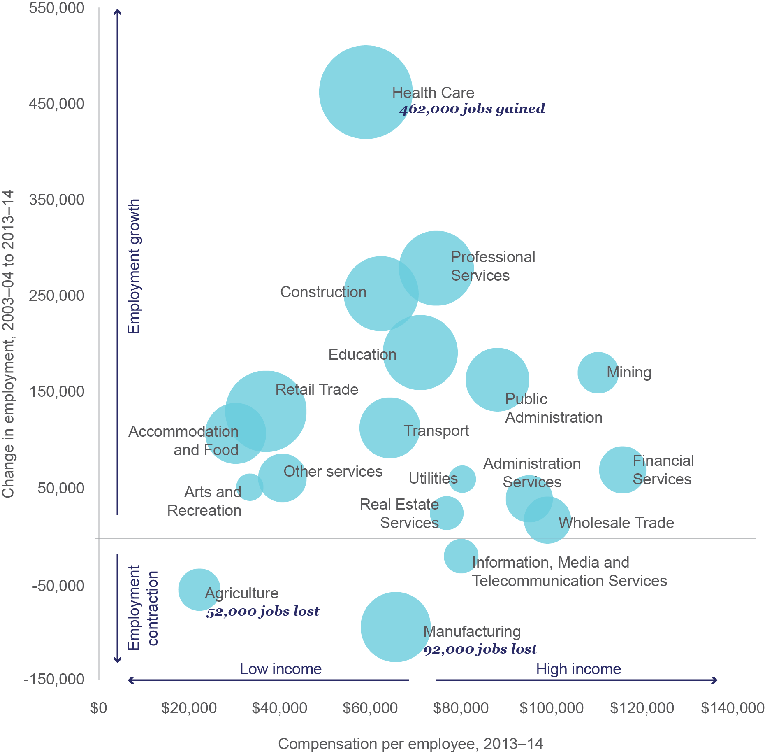

Note: Industry names have been abbreviated

Source: Department of Industry, Innovation and Science (2014), using data from Australian Bureau of Statistics (2014e and 2014f)

These two structural adjustments can be thought of as within-industry changes where individual industries modernise and adapt, and between-industry changes where industries grow and shrink. Understanding the relative impacts of these two effects will help to explain just how transformative technology’s impact on the Australian labour market has been.

The paper draws on a 2013 study by Frey and Osborne on the automation susceptibility of occupations in the United States, and provides new data on the automation susceptibility of occupations in Australia. It considers the relationship between automation and growth in an Australian context, supplemented by correlations with occupation and industry attributes. The paper also analyses change in the automation susceptibility of the Australian workforce over the past decade and provides a decomposition to learn the relative effects of structural change.

# Rise of the machine

The Jacquard loom, introduced in 1801, is often quoted as one of the more meaningful times a piece of machinery threatened a mass number of workers. The artisans and weavers who once manually manned the looms protested against the loom’s introduction by publicly smashing the devices. Many workers became redundant as a result of the development, causing technological unemployment.

The loom is by no means the first piece of machinery to reduce or replace the need for human workers. The steam engine that was patented by James Watt in 1781 meant manufacturing machinery could be created with a fraction of the workers. But the Jacquard loom is unique in its use of a programmable punch card. In what is seen as a first for industry, you could program a machine to create the output you desired — in this case the pattern required for a textile.

Technology is becoming capable of performing the tasks of an increasing number of jobs as it improves exponentially. In many cases, this results in the occupation or industry’s footprint being decreased. In Australia, the share of output from the agriculture sector fell from over a third in the 19th century to just three per cent in the 2000s — in part a result of increased automation of the industry.[2] In some cases, technology’s march has been able to entirely replace an occupation, given sufficient time. Take, for example, a switchboard operator. The last manually operated telephone exchange in Australia — in Wanaaring NSW — closed its operations in 1991, 103 years after the automatic switchboard’s invention in 1888.

There is considerable debate on which workers are most at risk of being displaced by technology. Will automation and its resulting impact on the economy benefit all workers equally like a rising tide with ships? Or will the growing use of automation technologies cause uneven distortions to select areas of the economy?

It was these questions that led Carl Frey and Michael Osborne to attempt to quantify the potential that technology would exist to automate individual occupations in the coming decades. They assessed the tasks performed by 702 US occupations and, with the help of experts in the machine learning and mobile robotics fields, identified the tasks that robots would be unlikely to perform in the coming decades.

Feeding these tasks into a statistical model, the researchers were able to compute a score for each occupation — a score of 0 meant that an occupation’s tasks were incredibly unlikely to be able to be performed by machines; a score of 100 identified that the tasks were highly automatable. This research, which made international headlines, calculated that the technology would be capable of automating 47 per cent of American jobs by 2030. In this paper, the automation susceptibility of Australian occupations has been estimated using data provided in Frey and Osborne.

Granted, just because the technological capacity to automate an occupation’s tasks will exist, does not mean that an occupation will be replaced by a machine. The paper by Frey and Osborne only considered the *technical* automation susceptibility of occupations — could an algorithm be developed to carry out the tasks of the occupation? As they acknowledge in their paper, ‘the actual extent and pace of computerisation will depend on several additional factors which were left unaccounted for’. These factors include access to cheap labour, wage growth, the price of capital, labour shortages, business appetite and risk, consumer appetite, regulatory concerns and political activism. This paper is similarly restricted by those limits, and makes no attempt to predict what jobs will in fact be automated in the future.

As with the Oxford paper, this paper focuses exclusively on automation by means of computer programming, or ‘computerisation’. This distinction separates computerisation from basic mechanical automation seen in the days of the industrial revolution. The main difference is that of the ‘brain’ — computerised automated systems have the significant benefit of the algorithm, a complex set of rules that allow a machine to process information and act according to those inputs. The algorithm has allowed computers to evolve from mere *calculating* and *doing* devices, to *thinking* and even *learning* devices.

In its simplest form, computerised automation simply involves an algorithm making a decision and acting on it — if **a** is greater than **b**, then choose to do **x** over **y**. It is the complex interplay of these decisions and outcomes on a greater scale that frame automation’s true capabilities. Robots are a form of computerised automation, but are only one type. Yes, an algorithm is behind modern industrial and commercial robots. Yet automation doesn’t need to be a robot — an algorithm is equally behind software such as search results and facial recognition. Not only are robots not necessarily humanoid, automation is not necessarily a robot.

Algorithms have not only transformed the ability to automate tasks that were already being undertaken by humans, but also to automate tasks humans will never be able to accomplish.

# How automatable are Australian jobs?

In this paper, the automation susceptibility of Australian occupations has been estimated using data provided in Frey and Osborne.[3] It is based on the extent to which tasks performed in an occupation are able to be mimicked by technology. In this paper, a job is paid position of employment in the labour market. A job, such as chief explosives engineer at Acme Corporation, is an individual position that only one person can occupy. On the other hand, an occupation is a collection of jobs of one type — a sales clerk, a secondary school teach, a dentist for example. Your *job* may be replaced by a machine due to your employer’s decisions, but your *occupation* will continue to exist unless all jobs in that occupation are replaced.

This section outlines the Frey and Osborne methodology and summarises the Australian results. Appendix C provides the automation scores for 435 Australian occupations at the four-digit ANZSCO level.

## Calculating a score

Frey and Osborne used data from O*NET, a database that categorises and evaluates US occupations, to calculate the automation susceptibility for 702 US occupations.

They identified three major engineering bottlenecks that limited the ability of computers to mimic human tasks. These being:

* **Perception and manipulation** — where an occupation’s tasks include working in an unstructured environment, identifying items in that environment, and precisely manipulating those items. Surgeons, for example, must examine a human body to identify abnormalities and make precise alterations, the results on which a life depends. Robots can be programmed to create precise incisions during surgery. However, if a patient should move, or a complication should occur during the incision, robots aren’t generally well equipped to respond.
* **Creative intelligence** — the ability to generate creative products and solutions. Although there exist computer programs which imitate the production of art,[4] there remain significant barriers to robots becoming truly artistic and creative, as opposed to following set scripts and programming. Similarly, while computers are very good at finding solutions, they generally must be told *how*, limiting their ability to be original. Physicists and interior designers alike excel at these tasks.
* **Social intelligence —** the ability to interact with others. The ability of computers to interact socially with humans currently involves voice assistants such as Apple’s Siri responding to questions that meet set formats, to varying degrees of accuracy. A computer holding a two-way conversation is certainly a difficult task. Expecting a computer to do this, as well as negotiate, persuade, upmarket, debate, emote and resolve is simply gargantuan. Occupations which rely heavily on social intelligence, such as solicitors, event organisers and public relations experts are more likely to have high automation susceptibility because of these skills.

The O*NET database ranks tasks (such as ‘typing’, ‘public speaking’, etc.) of occupations out of 100. Using this data, Frey and Osborne were able to categorise these tasks in respect to the three bottleneck skills. An automation score (also out of 100) was then calculated using a function dependent on how strongly each job was associated with the selected O*NET attributes. Examples are provided in Table 3.1.

Table .: Calculating automation scores — example occupations

| Bottleneck | O*NET attributes | Chef | Economist | Librarian |
| --- | --- | --- | --- | --- |
| Perception and manipulation | Cramped work space | 41 | 2 | 17 |
| Finger dexterity | 41 | 23 | 37 |
| Manual dexterity | 43 | 0 | 27 |
|  |  |  |  |  |
| Creative intelligence | Originality | 48 | 46 | 43 |
| Fine arts | 19 | 0 | 21 |
|  |  |  |  |  |
| Social intelligence | Social perceptiveness | 54 | 39 | 50 |
| Negotiation | 50 | 37 | 46 |
| Persuasion | 50 | 50 | 45 |
| Assisting and caring | 44 | 20 | 37 |
|  |  |  |  |  |
|  | **Automation score** | **10** | **43** | **65** |

Source: Department of Industry, Innovation and Science analysis (2015), O*NET (2015)

## Automation susceptibility by occupation

The scope of Frey and Osborne is limited to United States occupations. Although similar in many areas, Australia’s labour market and its industries are sufficiently different to the United States to warrant its own attention. To fully consider automation’s impact on Australian occupations and industry, it is necessary to transfer automation scores for each Australian job using the scores originally compiled by Frey and Osborne.

The results of Frey and Osborne cannot be directly applied to the Australian occupations because of different classification systems. In order bring over scores for Australian occupations it was necessary to undergo a concordance between the two occupational classification systems. This process is outlined in Appendix A.

This approach was used by Deloitte in conjunction with Frey and Osborne to estimate the number of jobs susceptible to automation in the UK.[5] Similar studies have been conducted in Australia by researchers at NICTA as part of CEDA’s *Australia’s Future Workforce?* report. As the NICTA report uses a similar methodology to that outlined below, the headline findings are relatively similar. The findings in this report complement the NICTA research, and provide further detail and analysis on the topic.

The 20 occupations with the highest and lowest automation susceptibility in Australia are listed in Table 3.2.

Table .: Top and bottom 20 occupations by automation susceptibility, 2014

| **20 highest automation scores** | |  | **20 lowest automation scores** | |  |
| --- | --- | --- | --- | --- | --- |
| Occupation | Automation score | | Occupation | Automation score | |
| Telemarketers | 99.0 | | Dietitians | 0.4 | |
| Bank workers | 97.8 | | Hotel managers | 0.4 | |
| Bookkeepers | 97.7 | | Education advisers | 0.4 | |
| Accounting clerks | 97.2 | | Psychologists | 0.5 | |
| Product quality | 97.0 | | Dental practitioners | 0.5 | |
| Payroll clerks | 97.0 | | Speech professionals | 0.6 | |
| Checkout operators | 96.9 | | Education managers | 0.7 | |
| Other clerical workers | 96.7 | | School principals | 0.7 | |
| Insurance investigators | 96.6 | | ICT business analysts | 0.7 | |
| Library assistants | 96.3 | | Secondary teachers | 0.8 | |
| Other sales assistants | 96.2 | | Podiatrists | 0.8 | |
| Switchboard operators | 96.1 | | Occupational therapists | 0.8 | |
| General clerks | 96.0 | | Chiropractors | 0.8 | |
| Inquiry clerks | 95.9 | | Special educ. teachers | 1.1 | |
| Secretaries | 95.4 | | Agricultural scientists | 1.1 | |
| Product assemblers | 95.2 | | Pharmacists | 1.2 | |
| Keyboard operators | 95.1 | | Ministers of religion | 1.3 | |
| Jewellers | 95.0 | | ICT trainers | 1.4 | |
| Debt collectors | 95.0 | | Training professionals | 1.4 | |
| Garden labourers | 95.0 | | Office managers | 1.4 | |

Note: Official occupation names have been condensed in some cases

Source: Department of Industry, Innovation and Science analysis (2015)

On average, employment growth over the past 10 years has been markedly stronger for occupations with lower automation susceptibility. While only 16 low susceptibility occupations have fallen in terms of total employment counts, more than 50 high susceptibility occupations have. The total number of those employed by occupations with high automation susceptibility has grown by only 0.9 per cent per year in the past 10 years; those occupations with low automation susceptibility have grown by a substantially stronger 3.1 per cent per year.

Figure .1: Relationship between automation score and average annual growth (2004 to 2014)

This scatter plot shows the relationship between an occupation's annual average growth and its automation score. A downward sloping trend line through the individual plot points shows that the higher a occupation's automation score, the lower it has grown over the period between 2004 and 2014. Occupations with a low automation score have grown on average by 3.1 per cent per year. Occupations with a high autiomation score have grown on average by only 0.9 per cent.


Note: Department of Industry, Innovation and Science analysis (2015), Australian Bureau of Statistics (2014b)

Source: Department of Industry, Innovation and Science analysis (2015)

Automation susceptibility in Australia follows a similar distribution to that in the United States, albeit with a smaller number of low susceptibility employees and a corresponding larger number of medium susceptibility employees. 43.9 per cent of Australian employment are highly susceptible of being automated. This is nearly identical to 43.4 per cent of US employment.[6] However only 32.7 per cent of jobs have low automation susceptibility — significantly lower than those in the US, where 37.7 per cent of jobs categorised the same.

Figure .2: Distribution of Australian and US jobs by susceptibility of automation capability developing

Source: Department of Industry, Innovation and Science analysis (2015), Australian Bureau of Statistics (2014b)

Frey and Osborne note that the automation score can be seen as a proxy for time — those jobs with a higher score will be automated in the near future, while those with a low automation score will take some time for technology to evolve sufficiently to automate their tasks. This transition period is unspecified in the original research, but Frey and Osborne hypothesise that occupations with high susceptibility to automation will experience significantly increased automation in a decade or two.[7] If so, Australia faces a large number of jobs being able to be automated in the coming years — 22.4 per cent of Australian jobs have very high susceptibility to being automated (a score of 90 to 100).

It seems that those occupations that may experience increased automation in this time are predisposed toward certain worker attributes. Tables 3.3 and 3.4 summarises these correlations and provides a regression the relationships in more detail, while Appendix B examines these relationships in more detail. In general, employees in jobs that involve non-automatable tasks are better off than their automatable colleagues. They are better educated, higher skilled, earn more, are less likely to be unemployed, and are in an occupation that enjoys strong job growth. The results seem to support the ‘skill-biased technology change’ theory, where a shift in production technology favours skills over unskilled labour.[8]

The causality of these attributes are strongly intertwined however — for example, it is broadly acknowledged that tertiary educated workers already enjoy higher pay for several reasons. Whether automation susceptibility in fact causes workers to be paid more, whether automatable professions attract a certain class of worker, or that this is simply a function of tertiary education’s multicollinearity requires further research. Regardless, it is important to note that these attributes are strongly intertwined with automation.

Table .: Occupation automation susceptibility correlation

| Variable | Correlation coefficient |
| --- | --- |
| ANZSCO skill level | + 0.75 |
| Unemployment rate | +0.29 |
| Tertiary education portion | – 0.65 |
| Average weekly earnings | – 0.45 |
| Average annual growth | – 0.34 |

Note: In ANZSCO, skill level is defined as a function of the range and complexity of the set of tasks performed in a particular occupation. Occupations at skill level 1, the highest category, have a level of skill commensurate with a bachelor degree or higher qualification. The unemployment rate, tertiary education and average annual growth variables are percentages between 0 and 100. Average weekly earnings are in dollars.

Source: Department of Industry, Innovation and Science analysis (2015) using Australian Bureau of Statistics (2015), (2014d), (2014c) and (2005)

Table .4: Occupation automation susceptibility regression

| Variable | Coeff | p-value |
| --- | --- | --- |
| Average annual growth | – 0.89 | 0.04 |
| Tertiary education portion | – 0.63 | 0.00 |
| Average weekly earnings | – 0.01 | 0.00 |
| Unemployment rate | + 0.89 | 0.08 |
|  |  |  |
| n | 296 |  |
| R2 | 0.47 |  |

Note: In ANZSCO, skill level is defined as a function of the range and complexity of the set of tasks performed in a particular occupation. Occupations at skill level 1, the highest category, have a level of skill commensurate with a bachelor degree or higher qualification. The unemployment rate, tertiary education and average annual growth variables are percentages between 0 and 100. Average weekly earnings are in dollars.

Source: Department of Industry, Innovation and Science analysis (2015) using Australian Bureau of Statistics (2015), (2014d), (2014c) and (2005)

## Industry automation susceptibility

An automation score can be calculated for each industry using industry occupation employment shares as weights.[9] Weights are calculated as the share of each occupation’s employment in an industry’s employment occupation.

An industry’s automation susceptibility is therefore calculated as:

$$I_{k}= {\sum_{m=1}^{r}{a_{m}O_{km}}}/{\sum_{m=1}^{r}{O_{km}}}$$

$$Occupation m= \left(1,…r\right)$$

Where:

* $I_{k}$ is the mean automation score for the industry $k$
* $a_{m}$ is the automation score for an occupation $m$
* $O_{km}$ is the number of persons employed in industry $k$ and occupation $m$

Industry automation scores are reported in Figure 3.3. The industries with the highest automation susceptibility in 2014 include the retail, transport and the hospitality industries. Those with the most limited susceptibility include education, professional and health care services.

Figure .3: Australian major industries by automation susceptibility, 2004 and 2014

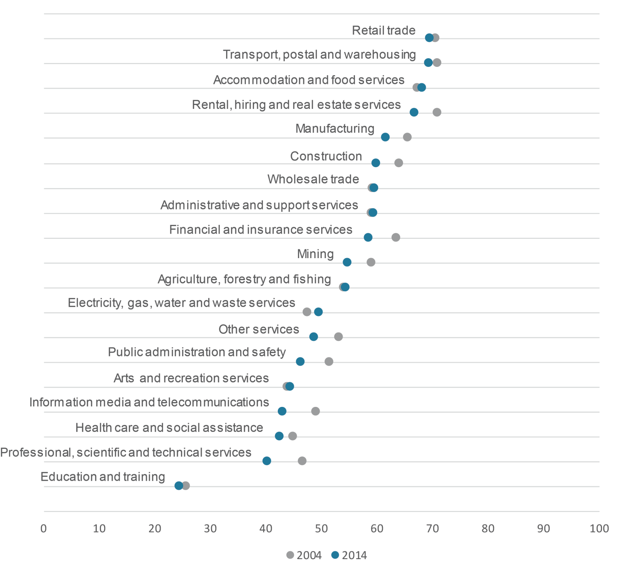

Source: Department of Industry, Innovation and Science analysis (2015)

Figure 3.3 also reports industry automation scores for 2004. This assumes that automation scores have been held constant over the past 10 years (an assumption that is further explored below). The industries that have changed the most over the period include the information media, professional services, and the public administration sectors. The utilities sector was the only industry where the automation score increased by any significant amount.

## Australia’s automation susceptibility

A weighted automation score for the broader economy can be calculated in a similar way. This is a more robust assessment of the automation susceptibility of the economy than simply calculating the portion of workers that are highly susceptible, as identified in section 3.2 earlier.

Let $A$ be the mean automation susceptibility of the economy. This is given by:

$$A= {\sum_{k,m=1}^{p,r}{a_{m}O_{km}}}/{\sum_{k,m=1}^{p,r}{O_{km}}}$$

$$Year j=\left(1,…p\right)$$

$$Occupation m= \left(1,…r\right)$$

Based on Australia’s occupational profile in 2014, the automation susceptibility of the Australian labour force was 54.1. This has progressively fallen over the past decade — the mean automation score for 2004 was 57.3.

Table 3.5 reports this change — for Australia and for the states and territories. The jurisdiction with the highest automation scores in 2014 was Queensland at 56.0, followed by Tasmania at 55.8. The jurisdictions with the lowest automation score was the Australian Capital Territory at 46.8.

Table .5: Automation susceptibility by state, 2004–2014

|  |  |  |
| --- | --- | --- |
| State | 2004 | 2014 |
| NSW | 56.2 | 53.0 |
| Vic | 56.3 | 53.3 |
| Qld | 58.7 | 56.0 |
| WA | 57.6 | 55.3 |
| SA | 57.8 | 54.5 |
| Tas | 56.9 | 55.8 |
| ACT | 50.0 | 46.8 |
| NT | 56.8 | 51.8 |
| **Australia** | **57.3** | **54.1** |

Source: Department of Industry, Innovation and Science analysis (2015) using Australian Bureau of Statistics (2014a)

All states followed the national average and saw a decline in their automation susceptibility. The largest decrease was experienced in the Northern Territory, while Tasmania only marginally improved on its 2004 score.

# Decomposing automation

The decline in the automation susceptibility of the Australian labour market can be divided into a *within-industry* impact and a *between industry* impact.

*Within-industry* impacts relate to changes to an industry’s occupational composition as firms modernise their workforces. Suppose, for example, that changes to an industry’s occupational composition saw occupations with lower automation susceptibility occupy a greater share of industry employment. This would result in a lower automation susceptibility score for that industry. Such is the case of the mining industry, which has seen an increasing number of human resource managers (from 21,800 in 2004 to 267,000 in 2014), ICT trainers (1,200 to 11,600), and safety inspectors (from 9,400 to 98,700).[10] All these occupations have low automation scores, drawing down the average automation susceptibility for the mining industry overall.

*Between-industry* impacts, by contrast, relate to the relative size of industries as the economy changes over time. As industries with high automation susceptibility shrink — and those with limited automation susceptibility grow — the overall automation susceptibility of the economy falls.

This decomposition is important because it allows us to identify the extent to which industry composition versus industry size is driving change. It could be the case that structural change is either accentuating the makeup of industry — or indeed masking how much of an impact industry composition is having. Plainly put, has the fall in Australia’s automation susceptibility been the result of a growing healthcare industry? Or rather, has it been the result of the mining industry employing more ICT trainers?

## Decomposition approach

The approach used to decompose the two effects is the same as that used in the literature to explore similar changes in the labour force regarding skills.[11]

Let the mean automation susceptibility of the economy be given as:

$$A= {\sum_{k,m=1}^{q,r}{a_{m}O_{km}}}/{\sum_{k,m=1}^{q,r}{O_{km}}}$$

$$Industry k=\left(1,…q\right)$$

$$Occupation m= \left(1,…r\right)$$

Where:

* $A$ is the mean automation score for the economy
* $a$ is the automation score for an occupation
* $O$ is the number of persons employed

It follows then that:

$$∆A=s_{m}\sum_{k,m=1}^{q,r}{∆\left({O_{m}}/{\sum_{k,m=1}^{q,r}{O_{km}}}\right)}$$

For simplicity, let the occupational share of industry k be:

$$b_{km}={O_{m}}/{\sum_{m=1}^{r}{O_{m}}}$$

And an industry’s share of total employment be:

$$h_{km}={\sum_{m=1}^{r}{O_{m}}}/{\sum_{k=1}^{q}{O_{k}}}$$

Which gives:

$$∆A=\sum{∆b_{km}{\overline{h}}_{k}}+\sum{∆{\overline{b}}_{km}{∆h}_{k}}$$

Where, $\overline{h}$ and $\overline{b}$ represent the inter-temporal means for each variable.

The first term on the right hand side of the equation denotes the *within-industry* effects. The second term the *between-industry* effect.

## Results

Table 4.1 presents the change in automation susceptibility over the past two decades.

Table .: Decomposition of change in automation susceptibility

| Period | Change in automation susceptibility score |  | Per cent change |  |
| --- | --- | --- | --- | --- |
| Within-industry | Between-industry | Total |
| 2004–2009 | -2.1 | 61.5 | 4.0 | 65.6 |
| 2009–2014 | -1.1 | 19.4 | 15.0 | 34.4 |
| **2004–2014** | **-3.2** | **81.0** | **19.0** | **100.0** |

Source: Department of Industry, Innovation and Science analysis (2015) using Australian Bureau of Statistics (2014b)

Over the period 2004–2014, the automation susceptibility score fell from 57.3 to 54.1. According to the results in Table 4.1, the vast majority (81 per cent) of this change was due to the *within-industry* effects — in short, industries skilling up and evolving.

The contribution of between-industry change has been positive, accentuating the decline. Changes in the relative sizes of industries have seen resources flow to sectors that on average require more creative and social skills.

Table 4.1 also decomposes this change over time. About two thirds of the decline in automation susceptibility occurred in the first half of the decade. The greatest *within-industry* effect occurred during the 2004–2009 period, while the greatest *between-industry* impact occurred in the five years between 2009 and 2014. This is likely influenced by the 2007 financial crisis, the commodities and mining boom, and the resulting impacts on the employment market.

# Sensitivities and limitations

When assessing the impact of innovation, it’s important to acknowledge that technology is notoriously difficult to forecast. In 2004 Levy and Murnane were adamant that computers would not be able to drive a car: ‘But executing a left turn against oncoming traffic involves so many factors that it is hard to imagine discovering the set of rules that can replicate a driver’s behaviour.’ [12] In 2010 Google announced on its official blog that it had ‘developed technology for cars that can drive themselves’, dashing the prediction made by Levy and Murnane only six years earlier.[13]

The key limitation of this paper is the assumption that an occupation’s automation susceptibility remains constant over the decade. This is unlikely to be true for two reasons.

First, occupations evolve over time to adapt to changing circumstances. Adept use of technology has meant that paralegals are now spending less time searching through legal texts and more time applying legal concepts and providing in-depth analysis. Kelly and Lewis show that in Australia occupations have become less focused on motor skills and more focused on interactive and cognitive skills.[14] Similarly, Spitz found that the skill requirement *within* occupations have become more complex over time, which is likely to have made occupations less automatable as a whole.[15]

Second, technology also evolves and becomes better equipped to automate the tasks of professions. A task that technology remained incapable of performing 10 years ago may well be a task that technology approaches confidently today.

Combined, this implies that had an analysis of the automation susceptibility of occupations been conducted in 2004, the automation scores may have been higher or lower than in 2014. Holding technology constant as this paper has does allow a better analysis the underlying impact of structural change, but further analysis on the changing automation scores over time is necessary to get a stronger understanding of the impact of automation in Australia over a larger period of time.

# Conclusion

Over the past decades, technology has had a transformative effect on the Australian economic landscape. It has affected not only what is produced, but also how*.* Coupled with broader economic and demographic forces, the net result is a workforce that is more associated with creativity, social interaction and perception.

This paper has used a measure devised by Frey and Osborne to assess the automation susceptibility of the Australian workforce. It is based on the extent to which tasks performed in an occupation are able to be mimicked by technology. In total, automation scores were calculated for 435 Australian occupations.

Across the workforce, automation susceptibility adopts a bimodal distribution. A large segment of employment (43.9 per cent) is considered to have high automation susceptibility, while a second segment (32.7 per cent) was rated as limited. This distribution is similar to that observed in the United States. In general, employees in jobs that involve non-automatable tasks are better off than their automatable colleagues. They are better educated, higher skilled, earn more, are less likely to be unemployed, and are in an occupation that enjoys strong job growth. This analysis suggests that technology is skill-biased, benefiting higher-skilled workers over their lower-skilled counterparts.

Over time we have seen industries increase their use of automation technologies to replace traditionally routine jobs — labourers, mail sorters and keyboard operators for example. At the same time however these industries have been employing more workers whose skills are less likely to be replicated by machines — web designers, solicitors and advertising managers. In fact, those jobs with low automation susceptibility have grown by nearly three times faster than their automatable counterparts. This can be thought of as the *within-industry* impact of compositional change.

We are also seeing employment move from industries of high automation susceptibility to sectors where technology is less likely to replace workers. For example, the industries with the most limited susceptibility for automation include education, professional and health care services. All three of these industries grew substantially over the past decade, adding hundreds of thousands of workers. This is the effect of the *between-industry* change.

It is thanks to these two forces that automation susceptibility of the Australian labour force has progressively fallen over the past two decades. So how much of this fall was due to movements inside an industry as it modernises, compared to those larger changes of industry sizes? It could be that the growth in certain industries and the decline in others over the past decade has either accentuated or masked the impact industry composition and adaptation is having.

This analysis has shown that these growths and declines has indeed accentuated the decline in automation, but the evolution of the internal composition of Australian industries has been the main driver. A decomposition of these two effects shows that 81 per cent of the decline was due to *within-industry* effects. Australian industries are evidently taking the opportunity to modernise their workforces, hiring workers that have the skills necessary to take advantage of future opportunities.

However, there remain concerns about the displacement effects of automation. In particular, there are concerns that increased automation will lead to greater unemployment, a hollowed middle-class, and increased inequality. It is true that technology will displace some if not many jobs. But this does not mean that new jobs cannot take their places. New jobs that will be more creative, more perceptive, and more social. New jobs that, because of these skills, will be better paid and more stable.

We have a tendency to focus on those occupations and industries that are disappearing. A loss of any job or sector in Australia is unfortunate, but this fails to appreciate the larger picture. The same factors that lead to an industry’s decline present opportunities for other industries, firms and workers to flourish. Despite automation pressures, average job growth over the past ten years has been the same as the ten years before that. As shown in the analysis, structural change and industry composition supports the reduction in Australia’s automation susceptibility. It has freed up resources that were previously required to undertake mundane, routine and often manual tasks, and allowed them to be employed in high value, high skilled and high paid roles.

Higher disposable incomes thanks to the productivity increases of technology have allowed Australians to employ financial advisors, website developers and personal trainers which were not employed only a couple of decades ago. We’re also spending more on our wellbeing, which has seen professions in the healthcare industry increase rapidly in recent years.

Structural change has seen the Australian workforce change markedly in the past few decades, and into the future it will allow workers to better capitalise on the comparative advantages of being human — the ability to solve problems intuitively, improvise spontaneously and act creatively. Consistently workers and industry have embraced and leveraged technological change to ride this wave to prosperity.

###### Concordances

Australia uses a different system of labelling occupations to the US. For example, in the US there are employees with the job title ‘accountants and auditors’. However in Australia these employees could be ‘accountants’ or they could be ‘auditors and company secretaries’. To make the relationships more complex, an Australian ‘auditor and company secretary’ is not necessarily an American ‘accountant and auditor’. They could also be considered in the US to be a ‘budget analyst’, a ‘financial manager’, or a ‘tax preparer’. Figure A1 illustrates the complexity.

Figure 1: US to Australian concordances, accountants

**United States Australia**

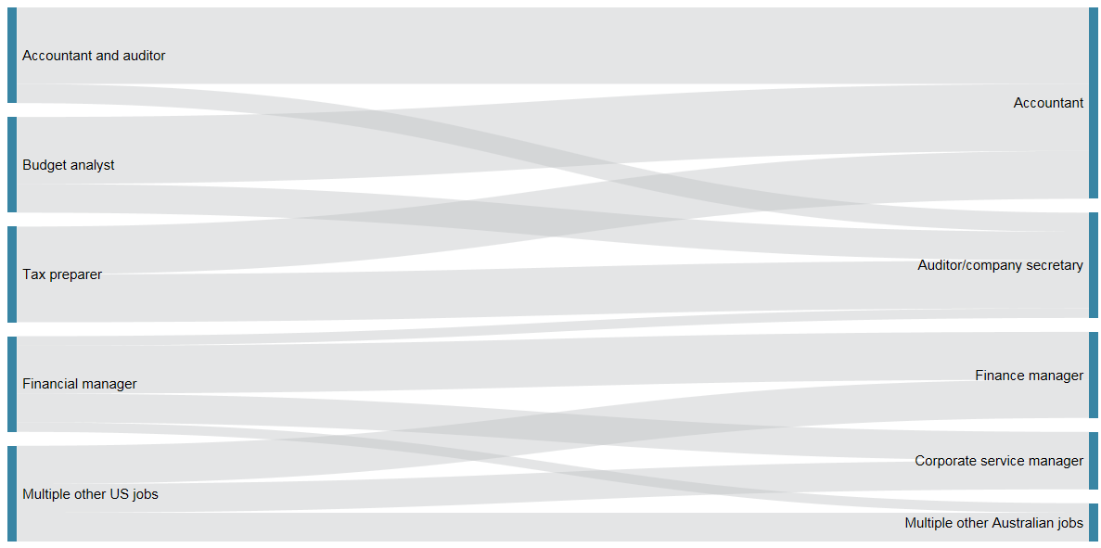

Source: Bureau of Labor Statistics, United States (2012)

Therefore, it is not as simple as taking the score for ‘accountants and auditors’ and applying it to both ‘accountants’ and ‘auditors and company secretaries’, as multiple other US occupations contribute to these Australian occupations. Continuing the above example, Figure A2 details Australian accountants in more detail.

Figure 2: US to Australian concordances, accountants detailed

**SOC ISCO ANZSCO (six-digit) ANZSCO (four-digit)**

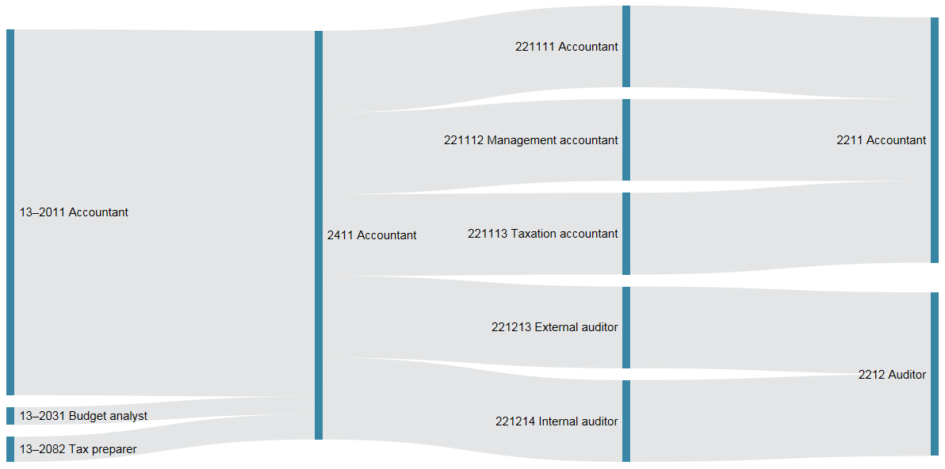

Source: Bureau of Labor Statistics, United States (2012); ABS (2013)

To calculate the automation score for Australian accountants, the automation scores of US occupations analogous to Australian accountants are filtered through crosswalks, or concordances. US job codes (Standard Occupational Classifications, or SOC) must first be converted to international job codes (International Standard Classification of Occupations, or ISCO) using publicly available concordance tables.[16] From here, the Australian Bureau of Statistics produces tables to allow the international job codes to be converted to six-digit Australian job codes (the Australian and New Zealand Standard Classification of Occupations, or ANZSCO) and then on to four-digit Australian job codes.[17]

US job scores cannot simply be divided equally between their international or Australian counterparts. While both US ‘tax preparers’ (with an unfortunate automation score of 99) and ‘accountants and auditors’ (only marginally less automatable at 94) correlate to Australian ‘accountants’, US ‘accountants and auditors’ contribute to a far greater share of the workforce by a factor of almost 15. Treating these occupations equally would distort the Australian automation scores. Therefore, automation scores of US occupations are weighted according to US employment figures[18] for that occupation[19], relative to the total employed that are contributing to the Australian occupation.

Several Australian occupations are missing from the final results. First, due to the nature of concordances not every Australian job has a US counterpart. Second, US employment data is not available for a small number of US occupations[20], and therefore weights cannot be adequately constructed. Lastly, even when an Australian job has a US counterpart with adequate employment data, the original Oxford study did not calculate an automation score for some US jobs due to limitations of data. Therefore, even though Australian anaesthetists (ANZSCO 2532) correlate to US anaesthesiologists (SOC 29–1061), an automation score is not available to be brought across. 23 of 358 four-digit ANZSCO occupations are not included due to the above three limitations, and are found listed at the rear of Appendix C.

The remaining 435[21] four-digit ANZSCO occupations and their automation scores, representing 93.3 per cent of Australian employment,[22] are at  
Appendix C.

###### Occupational characteristics

### Education

There is a strong relationship between a job’s automation score and the number of workers in that job who have tertiary qualifications.

Figure B1: Relationship between tertiary education and automation score, 2014

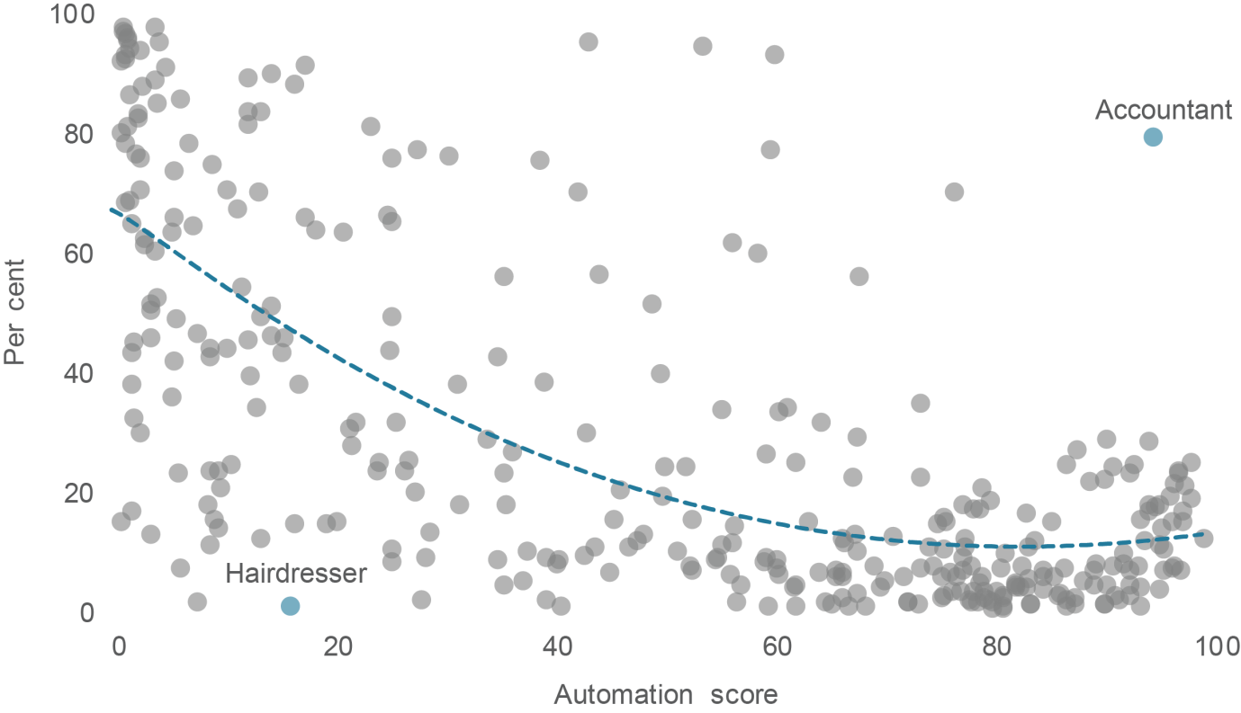

Source: Department of Industry, Innovation and Science analysis (2015), Australian Bureau of Statistics (2014c)

Although there exists a strong relationship between education and automation, there are occupations that do not follow this pattern. For example, while hairdressers are one of the least educated professions in the workforce, their automation score of only 15.8 rivals many. And while accountants have a college degree or higher 80 per cent of the time, their automation score of 94.3 places them in the 25 most automatable occupations.

### Earnings

Earnings also play an important role in the relationship between automation and workers. As shown in Figure B2, the occupations most susceptible to automation receive an average weekly income of $1,042. Those occupations least susceptible to automation receive a substantially larger pay packet — an average of $1,587 a week. Evidently those occupations least likely to be automated — those involving manual dexterity, social perceptiveness and originality for example — allow their workers to demand almost $30,000 extra in earnings per year than their at-risk colleagues.

Figure B2: Relationship between average weekly earnings and automation score, 2014

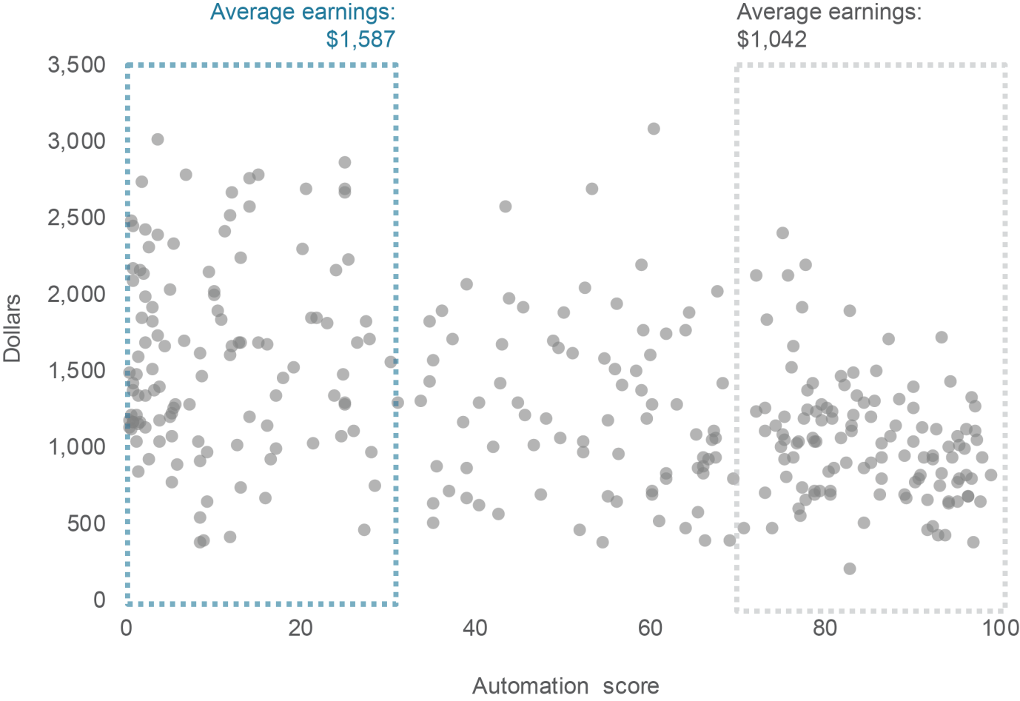

Source: Department of Industry, Innovation and Science analysis (2015), Australian Bureau of Statistics (2015)

### Unemployment

Those occupations where automation capability will likely exist are already experiencing increased unemployment. The one obvious outlier is the stage profession — actors, dancers and other entertainers. Although their automation score is a relatively low 21.4, the occupation experiences over 16 per cent unemployment — the fifth highest on our list.

Figure B3: Relationship between an occupation’s unemployment rate and automation score, 2014

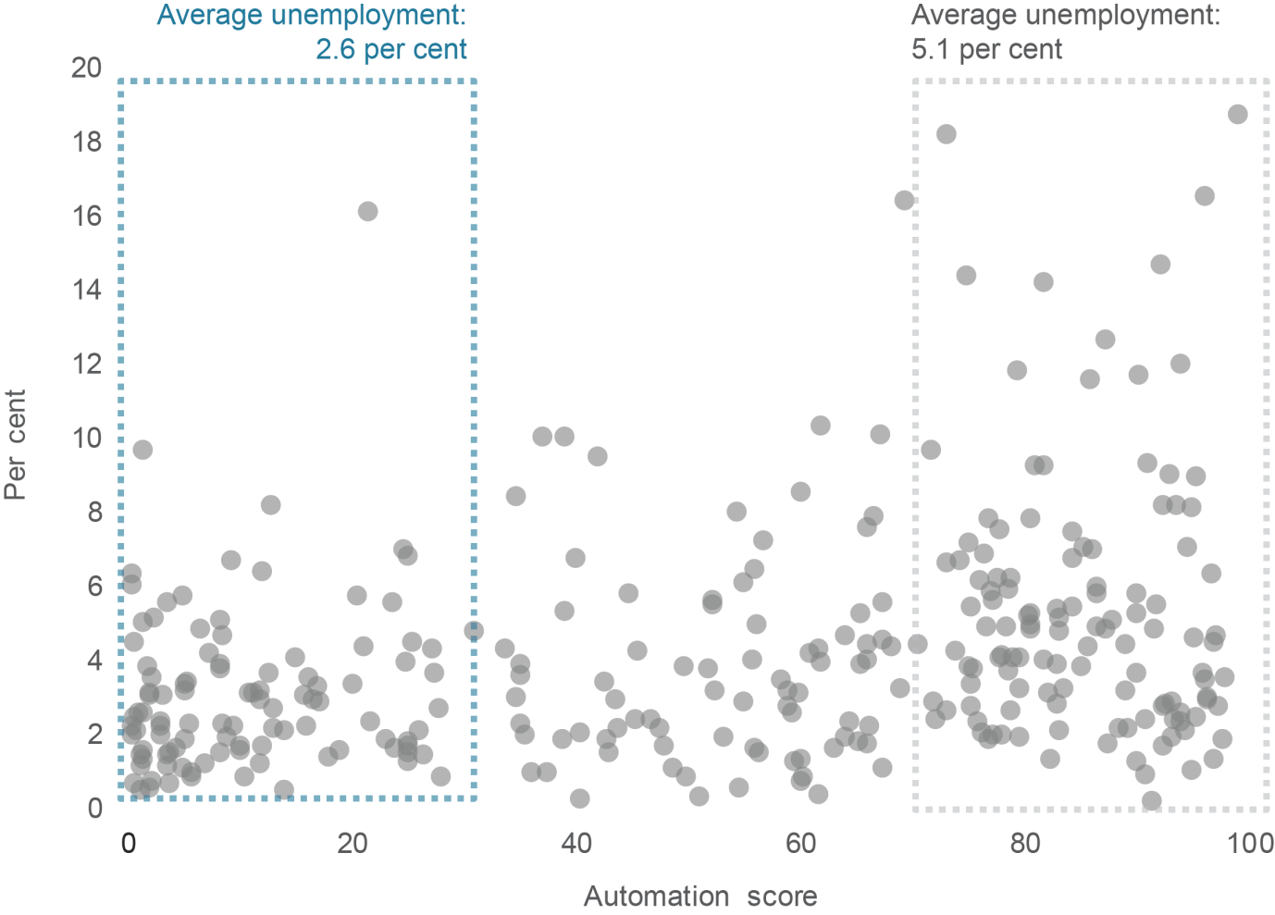

Note: Economy-wide unemployment currently stands at around 6.3 per cent. This figure is larger than the weighted average of the occupation unemployment rate figures (3.7 per cent) as the long-term unemployed are not included in occupation-specific unemployment.

Source: Department of Industry, Innovation and Science analysis (2015), Australian Bureau of Statistics (2014d)

###### Automation scores

Table C: Automation susceptibility of Australian occupations

| ANZSCO | Occupation | Score |
| --- | --- | --- |
| 1111 | Chief executives and managing directors | 14.0 |
| 1112 | General managers | 14.0 |
| 1211 | Aquaculture farmers | 31.2 |
| 1212 | Crop farmers | 51.0 |
| 1213 | Livestock farmers | 37.4 |
| 1214 | Mixed crop and livestock farmers | 59.0 |
| 1311 | Advertising and sales managers | 1.5 |
| 1321 | Corporate services managers | 38.9 |
| 1322 | Finance managers | 6.9 |
| 1323 | Human resource managers | 11.3 |
| 1324 | Policy and planning managers | 25.0 |
| 1325 | Research and development managers | 1.7 |
| 1331 | Construction managers | 9.5 |
| 1332 | Engineering managers | 25.0 |
| 1333 | Importers, exporters and wholesalers | 23.9 |
| 1334 | Manufacturers | 3.0 |
| 1335 | Production managers | 5.5 |
| 1336 | Supply and distribution managers | 59.0 |
| 1341 | Child care centre managers | 1.5 |
| 1342 | Health and welfare services managers | 5.0 |
| 1343 | School principals | 0.7 |
| 1344 | Other education managers | 0.7 |
| 1351 | ICT managers | 3.5 |
| 1391 | Commissioned officers (management) | 25.0 |
| 1399 | Other specialist managers | 13.1 |
| 1411 | Cafe and restaurant managers | 8.3 |
| 1412 | Caravan park and camping ground managers | 25.0 |
| 1413 | Hotel and motel managers | 0.4 |
| 1414 | Licensed club managers | 25.0 |
| 1419 | Other accommodation and hospitality managers | 26.1 |
| 1421 | Retail managers | 16.1 |
| 1491 | Amusement, fitness and sports centre managers | 23.7 |
| 1492 | Call or contact centre and customer service managers | 49.9 |
| 1493 | Conference and event organisers | 4.9 |
| 1494 | Transport services managers | 59.0 |
| 1499 | Other hospitality, retail and service managers | 26.4 |
| 2111 | Actors, dancers and other entertainers | 21.4 |
| 2112 | Music professionals | 5.2 |
| 2113 | Photographers | 2.1 |
| 2114 | Visual arts and crafts professionals | 16.5 |
| 2121 | Artistic directors, and media producers and presenters | 10.0 |
| 2122 | Authors, and book and script editors | 38.5 |
| 2123 | Film, television, radio and stage directors | 8.5 |
| 2124 | Journalists and other writers | 17.0 |
| 2211 | Accountants | 94.3 |
| 2212 | Auditors, company secretaries and corporate treasurers | 76.3 |
| 2221 | Financial brokers | 36.0 |
| 2222 | Financial dealers | 20.5 |
| 2223 | Financial investment advisers and managers | 43.8 |
| 2231 | Human resource professionals | 24.8 |
| 2232 | ICT trainers | 1.4 |
| 2233 | Training and development professionals | 1.4 |
| 2241 | Actuaries, mathematicians and statisticians | 11.9 |
| 2242 | Archivists, curators and records managers | 56.0 |
| 2243 | Economists | 43.0 |
| 2244 | Intelligence and policy analysts | 23.0 |
| 2245 | Land economists and valuers | 67.6 |
| 2246 | Librarians | 59.5 |
| 2247 | Management and organisation analysts | 10.9 |
| 2249 | Other information and organisation professionals | 35.2 |
| 2251 | Advertising and marketing professionals | 58.2 |
| 2252 | ICT sales professionals | 15.1 |
| 2253 | Public relations professionals | 18.0 |
| 2254 | Technical sales representatives | 21.7 |
| 2311 | Air transport professionals | 25.5 |
| 2312 | Marine transport professionals | 20.0 |
| 2321 | Architects and landscape architects | 2.2 |
| 2322 | Cartographers and surveyors | 48.7 |
| 2323 | Fashion, industrial and jewellery designers | 3.1 |
| 2324 | Graphic and web designers, and illustrators | 7.3 |
| 2325 | Interior designers | 15.1 |
| 2326 | Urban and regional planners | 13.0 |
| 2331 | Chemical and materials engineers | 1.8 |
| 2332 | Civil engineering professionals | 1.9 |
| 2333 | Electrical engineers | 10.0 |
| 2334 | Electronics engineers | 12.9 |
| 2335 | Industrial, mechanical and production engineers | 2.1 |
| 2336 | Mining engineers | 12.0 |
| 2339 | Other engineering professionals | 2.2 |
| 2341 | Agricultural and forestry scientists | 1.1 |
| 2342 | Chemists, and food and wine scientists | 6.6 |
| 2343 | Environmental scientists | 8.6 |
| 2344 | Geologists and geophysicists | 53.2 |
| 2345 | Life scientists | 4.3 |
| 2346 | Medical laboratory scientists | 59.8 |
| 2347 | Veterinarians | 3.8 |
| 2349 | Other natural and physical science professionals | 16.1 |
| 2411 | Early childhood (pre-primary school) teachers | 5.1 |
| 2412 | Primary school teachers | 5.7 |
| 2414 | Secondary school teachers | 0.8 |
| 2415 | Special education teachers | 1.1 |
| 2422 | Vocational education teachers | 5.3 |
| 2491 | Education advisers and reviewers | 0.4 |
| 2492 | Private tutors and teachers | 11.9 |
| 2493 | Teachers of English to speakers of other languages | 17.1 |
| 2511 | Dietitians | 0.4 |
| 2512 | Medical imaging professionals | 30.2 |
| 2513 | Occupational and environmental health professionals | 12.0 |
| 2514 | Optometrists and orthoptists | 14.0 |
| 2515 | Pharmacists | 1.2 |
| 2519 | Other health diagnostic and promotion professionals | 41.9 |
| 2521 | Chiropractors and osteopaths | 0.8 |
| 2522 | Complementary health therapists | 2.5 |
| 2523 | Dental practitioners | 0.5 |
| 2524 | Occupational therapists | 0.8 |
| 2525 | Physiotherapists | 2.1 |
| 2526 | Podiatrists | 0.8 |
| 2527 | Speech professionals and audiologists | 0.6 |
| 2611 | ICT business and systems analysts | 0.7 |
| 2613 | Software and applications programmers | 27.3 |
| 2621 | Database and systems administrators, and ict security specialists | 3.0 |
| 2631 | Computer network professionals | 3.0 |
| 2633 | Telecommunications engineering professionals | 2.5 |
| 2711 | Barristers | 3.5 |
| 2712 | Judicial and other legal professionals | 11.8 |
| 2713 | Solicitors | 3.5 |
| 2721 | Counsellors | 5.2 |
| 2722 | Ministers of religion | 1.3 |
| 2723 | Psychologists | 0.5 |
| 2724 | Social professionals | 24.6 |
| 2725 | Social workers | 3.7 |
| 2726 | Welfare, recreation and community arts workers | 3.7 |
| 3111 | Agricultural technicians | 73.1 |
| 3112 | Medical technicians | 61.7 |
| 3113 | Primary products inspectors | 33.7 |
| 3114 | Science technicians | 55.0 |
| 3121 | Architectural, building and surveying technicians | 45.3 |
| 3122 | Civil engineering draftspersons and technicians | 63.0 |
| 3123 | Electrical engineering draftspersons and technicians | 77.3 |
| 3124 | Electronic engineering draftspersons and technicians | 82.8 |
| 3125 | Mechanical engineering draftspersons and technicians | 56.1 |
| 3126 | Safety inspectors | 21.1 |
| 3129 | Other building and engineering technicians | 43.5 |
| 3131 | ICT support technicians | 31.0 |
| 3132 | Telecommunications technical specialists | 73.2 |
| 3211 | Automotive electricians | 59.2 |
| 3212 | Motor mechanics | 65.1 |
| 3221 | Metal casting, forging and finishing trades workers | 92.2 |
| 3222 | Sheetmetal trades workers | 80.7 |
| 3223 | Structural steel and welding trades workers | 83.2 |
| 3231 | Aircraft maintenance engineers | 52.4 |
| 3232 | Metal fitters and machinists | 64.4 |
| 3233 | Precision metal trades workers | 55.8 |
| 3234 | Toolmakers and engineering patternmakers | 79.0 |
| 3241 | Panelbeaters | 80.7 |
| 3242 | Vehicle body builders and trimmers | 68.2 |
| 3243 | Vehicle painters | 79.6 |
| 3311 | Bricklayers and stonemasons | 83.1 |
| 3312 | Carpenters and joiners | 72.0 |
| 3321 | Floor finishers | 80.6 |
| 3322 | Painting trades workers | 75.2 |
| 3331 | Glaziers | 73.0 |
| 3332 | Plasterers | 77.5 |
| 3333 | Roof tilers | 90.0 |
| 3334 | Wall and floor tilers | 80.6 |
| 3341 | Plumbers | 40.3 |
| 3411 | Electricians | 27.7 |
| 3421 | Airconditioning and refrigeration mechanics | 56.3 |
| 3422 | Electrical distribution trades workers | 7.3 |
| 3423 | Electronics trades workers | 47.9 |
| 3424 | Telecommunications trades workers | 44.8 |
| 3511 | Bakers and pastry cooks | 89.0 |
| 3512 | Butchers and smallgoods makers | 86.4 |
| 3513 | Chefs | 52.2 |
| 3514 | Cooks | 86.2 |
| 3611 | Animal attendants and trainers | 73.9 |
| 3612 | Shearers | 61.8 |
| 3613 | Veterinary nurses | 42.6 |
| 3621 | Florists | 40.0 |
| 3622 | Gardeners | 66.0 |
| 3623 | Greenkeepers | 66.0 |
| 3624 | Nurserypersons | 66.0 |
| 3911 | Hairdressers | 15.8 |
| 3921 | Binders, finishers and screen printers | 90.1 |
| 3922 | Graphic pre-press trades workers | 74.8 |
| 3923 | Printers | 83.0 |
| 3931 | Canvas and leather goods makers | 69.9 |
| 3932 | Clothing trades workers | 80.9 |
| 3933 | Upholsterers | 39.0 |
| 3941 | Cabinetmakers | 91.3 |
| 3942 | Wood machinists and other wood trades workers | 90.7 |
| 3991 | Boat builders and shipwrights | 76.0 |
| 3992 | Chemical, gas, petroleum and power generation plant operators | 60.3 |
| 3993 | Gallery, library and museum technicians | 90.7 |
| 3994 | Jewellers | 95.0 |
| 3995 | Performing arts technicians | 49.6 |
| 3996 | Signwriters | 93.3 |
| 3999 | Other miscellaneous technicians and trades workers | 46.6 |
| 4111 | Ambulance officers and paramedics | 49.4 |
| 4112 | Dental hygienists, technicians and therapists | 67.0 |
| 4113 | Diversional therapists | 9.1 |
| 4114 | Enrolled and mothercraft nurses | 5.8 |
| 4116 | Massage therapists | 27.2 |
| 4117 | Welfare support workers | 12.7 |
| 4211 | Child carers | 8.4 |
| 4221 | Education aides | 56.0 |
| 4231 | Aged and disabled carers | 55.0 |
| 4232 | Dental assistants | 60.1 |
| 4233 | Nursing support and personal care workers | 47.4 |
| 4234 | Special care workers | 9.3 |
| 4311 | Bar attendants and baristas | 77.0 |
| 4312 | Cafe workers | 92.9 |
| 4313 | Gaming workers | 76.9 |
| 4314 | Hotel service managers | 94.0 |
| 4315 | Waiters | 93.6 |
| 4319 | Other hospitality workers | 66.2 |
| 4412 | Fire and emergency workers | 19.0 |
| 4413 | Police | 10.4 |
| 4421 | Prison officers | 54.6 |
| 4422 | Security officers and guards | 83.1 |
| 4511 | Beauty therapists | 35.1 |
| 4512 | Driving instructors | 13.0 |
| 4513 | Funeral workers | 39.0 |
| 4514 | Gallery, museum and tour guides | 61.0 |
| 4515 | Personal care consultants | 35.1 |
| 4516 | Tourism and travel advisers | 45.6 |
| 4517 | Travel attendants | 35.4 |
| 4518 | Other personal service workers | 51.8 |
| 4521 | Fitness instructors | 8.3 |
| 4522 | Outdoor adventure guides | 8.3 |
| 4523 | Sports coaches, instructors and officials | 8.9 |
| 4524 | Sportspersons | 40.3 |
| 5111 | Contract, program and project administrators | 34.7 |
| 5121 | Office managers | 1.4 |
| 5122 | Practice managers | 60.2 |
| 5211 | Personal assistants | 85.1 |
| 5212 | Secretaries | 95.4 |
| 5311 | General clerks | 96.0 |
| 5321 | Keyboard operators | 95.1 |
| 5411 | Call or contact centre workers | 52.3 |
| 5412 | Inquiry clerks | 95.9 |
| 5421 | Receptionists | 91.6 |
| 5511 | Accounting clerks | 97.2 |
| 5512 | Bookkeepers | 97.7 |
| 5513 | Payroll clerks | 97.0 |
| 5521 | Bank workers | 97.8 |
| 5522 | Credit and loans officers | 90.1 |
| 5523 | Insurance, money market and statistical clerks | 92.6 |
| 5611 | Betting clerks | 76.9 |
| 5612 | Couriers and postal deliverers | 77.8 |
| 5613 | Filing and registry clerks | 94.5 |
| 5614 | Mail sorters | 77.2 |
| 5615 | Survey interviewers | 94.0 |
| 5616 | Switchboard operators | 96.1 |
| 5619 | Other clerical and office support workers | 96.7 |
| 5911 | Purchasing and supply logistics clerks | 75.3 |
| 5912 | Transport and despatch clerks | 83.5 |
| 5991 | Conveyancers and legal executives | 86.5 |
| 5992 | Court and legal clerks | 87.5 |
| 5993 | Debt collectors | 95.0 |
| 5994 | Human resource clerks | 90.0 |
| 5995 | Inspectors and regulatory officers | 42.8 |
| 5996 | Insurance investigators, loss adjusters and risk surveyors | 96.6 |
| 5997 | Library assistants | 96.3 |
| 5999 | Other miscellaneous clerical and administrative workers | 67.3 |
| 6111 | Auctioneers, and stock and station agents | 34.7 |
| 6112 | Insurance agents | 88.5 |
| 6113 | Sales representatives | 77.9 |
| 6121 | Real estate sales agents | 79.5 |
| 6211 | Sales assistants (general) | 91.7 |
| 6212 | ICT sales assistants | 92.3 |
| 6213 | Motor vehicle and vehicle parts salespersons | 92.3 |
| 6214 | Pharmacy sales assistants | 92.3 |
| 6215 | Retail supervisors | 28.0 |
| 6216 | Service station attendants | 75.5 |
| 6217 | Street vendors and related salespersons | 94.0 |
| 6219 | Other sales assistants and salespersons | 96.2 |
| 6311 | Checkout operators and office cashiers | 96.9 |
| 6391 | Models and sales demonstrators | 54.4 |
| 6392 | Retail and wool buyers | 64.1 |
| 6393 | Telemarketers | 99.0 |
| 6394 | Ticket salespersons | 93.2 |
| 6395 | Visual merchandisers | 28.4 |
| 6399 | Other sales support workers | 78.6 |
| 7111 | Clay, concrete, glass and stone processing machine operators | 84.4 |
| 7112 | Industrial spraypainters | 79.6 |
| 7113 | Paper and wood processing machine operators | 80.1 |
| 7114 | Photographic developers and printers | 67.1 |
| 7115 | Plastics and rubber production machine operators | 87.9 |
| 7116 | Sewing machinists | 89.0 |
| 7117 | Textile and footwear production machine operators | 71.7 |
| 7119 | Other machine operators | 75.2 |
| 7121 | Crane, hoist and lift operators | 72.0 |
| 7122 | Drillers, miners and shot firers | 75.0 |
| 7123 | Engineering production systems workers | 81.8 |
| 7129 | Other stationary plant operators | 61.7 |
| 7211 | Agricultural, forestry and horticultural plant operators | 79.0 |
| 7212 | Earthmoving plant operators | 93.2 |
| 7213 | Forklift drivers | 91.0 |
| 7219 | Other mobile plant operators | 82.1 |
| 7311 | Automobile drivers | 78.7 |
| 7312 | Bus and coach drivers | 82.3 |
| 7313 | Train and tram drivers | 75.8 |
| 7321 | Delivery drivers | 78.7 |
| 7331 | Truck drivers | 78.4 |
| 7411 | Storepersons | 76.4 |
| 8111 | Car detailers | 37.0 |
| 8112 | Commercial cleaners | 65.5 |
| 8113 | Domestic cleaners | 69.0 |
| 8114 | Housekeepers | 70.6 |
| 8115 | Laundry workers | 73.1 |
| 8116 | Other cleaners | 78.5 |
| 8211 | Building and plumbing labourers | 85.8 |
| 8212 | Concreters | 90.0 |
| 8213 | Fencers | 85.6 |
| 8214 | Insulation and home improvement installers | 67.3 |
| 8215 | Paving and surfacing labourers | 87.2 |
| 8216 | Railway track workers | 87.2 |
| 8217 | Structural steel construction workers | 77.7 |
| 8219 | Other construction and mining labourers | 56.7 |
| 8311 | Food and drink factory workers | 74.2 |
| 8312 | Meat boners and slicers, and slaughterers | 86.4 |
| 8313 | Meat, poultry and seafood process workers | 85.2 |
| 8321 | Packers | 60.1 |
| 8322 | Product assemblers | 95.2 |
| 8393 | Product quality controllers | 97.0 |
| 8394 | Timber and wood process workers | 79.4 |
| 8399 | Other factory process workers | 81.8 |
| 8413 | Forestry and logging workers | 81.8 |
| 8414 | Garden and nursery labourers | 95.0 |
| 8415 | Livestock farm workers | 61.8 |
| 8419 | Other farm, forestry and garden workers | 67.5 |
| 8511 | Fast food cooks | 82.8 |
| 8512 | Food trades assistants | 84.3 |
| 8513 | Kitchenhands | 84.3 |
| 8911 | Freight and furniture handlers | 76.7 |
| 8912 | Shelf fillers | 64.0 |
| 8991 | Caretakers | 66.0 |
| 8992 | Deck and fishing hands | 69.4 |
| 8993 | Handypersons | 65.4 |
| 8994 | Motor vehicle parts and accessories fitters | 66.6 |
| 8995 | Printing assistants and table workers | 80.4 |
| 8996 | Recycling and rubbish collectors | 78.0 |
| 8997 | Vending machine attendants | 89.2 |
| 8999 | Other miscellaneous labourers | 75.1 |

Source: Department of Industry, Innovation and Science analysis (2015)

Table C: ANZSCO occupations not included in analysis

|  |  |
| --- | --- |
| ANZSCO | Occupations |
| 1113 | Legislators |
| 1392 | Senior non-commissioned defence force members |
| 2413 | Middle school teachers |
| 2421 | University lecturers and tutors |
| 2531 | Generalist medical practitioners |
| 2532 | Anaesthetists |
| 2533 | Internal medicine specialists |
| 2534 | Psychiatrists |
| 2535 | Surgeons |
| 2539 | Other medical practitioners |
| 2541 | Midwives |
| 2542 | Nurse educators and researchers |
| 2543 | Nurse managers |
| 2544 | Registered nurses |
| 2612 | Multimedia specialists and web developers |
| 2632 | ICT support and test engineers |
| 4115 | Indigenous health workers |
| 4411 | Defence force members - other ranks |
| 8391 | Metal engineering process workers |
| 8392 | Plastics and rubber factory workers |
| 8411 | Aquaculture workers |
| 8412 | Crop farm workers |
| 8416 | Mixed crop and livestock farm workers |

Note: Please see Appendix A for detailed reason behind omission

Source: Department of Industry, Innovation and Science analysis (2015)

###### References

Australian Bureau of Statistics (2005) *Information Paper: ANZSCO - Australian and New Zealand Standard Classification of Occupations*, *2005*, cat. no. 1221.0, <http://www.abs.gov.au/ausstats/abs@.nsf/0/C4BECE1704987586CA257089001A9181?opendocument>

Australian Bureau of Statistics (2013) ANZSCO — *Australian and New Zealand Standard Classification of Occupations, 2013, Version 1.2,* cat. no. 1220.0, [http://www.abs.gov.au/AUSSTATS/abs@.nsf/DetailsPage/  
1220.02013,%20Version%201.2?OpenDocument](http://www.abs.gov.au/AUSSTATS/abs@.nsf/DetailsPage/1220.02013,%20Version%201.2?OpenDocument)

Australian Bureau of Statistics (2014a) *Special Data Request from* *Employment by Occupation Unit Group (four-digit ANZSCO) by state, 1991–92 to 2013–14*

Australian Bureau of Statistics (2014b) *Special Data Request from* *Employment by Occupation Unit Group (four-digit ANZSCO) by industry*, 1991–92 to  
2013–14, based on *Labour Force, Australia, Detailed, Quarterly*, Cat. No. 6291.0.55.003

Australian Bureau of Statistics (2014c) *Special Data Request from* *Education attainment by occupation: Survey of Education and Work*, cat. no. 6227.0 and *Census of Population and Housing*

Australian Bureau of Statistics (2014d) *Special Data Request from* *Unemployment and employment by ANZSCO occupation*

Australian Bureau of Statistics (2014e) *Australian System of National Accounts*, *2013–14*, cat. no. 5204.0

<http://www.abs.gov.au/AUSSTATS/abs@.nsf/MF/5204.0>

Australian Bureau of Statistics (2014f) *Labour Force, Australia, Detailed, Quarterly, Nov 2014,* cat. no. 6291.0.55.003,

[http://www.abs.gov.au/AUSSTATS/abs@.nsf/allprimarymainfeatures/  
2FDAA8C0FE297AD8CA257E0C000F19CF?opendocument](http://www.abs.gov.au/AUSSTATS/abs@.nsf/allprimarymainfeatures/2FDAA8C0FE297AD8CA257E0C000F19CF?opendocument)

Australian Bureau of Statistics (2015) *Employee Earnings and Hours,  
cat. no. 6306, May 2014*, <http://www.abs.gov.au/ausstats/abs@.nsf/mf/6306.0/>

Autor D, Levy F and Murnane R J (2001) The skill content of recent technological change: An empirical exploration, *National Bureau of Economic Research*, <http://www.nber.org/papers/w8337>

Bureau of Labor Statistics, United States (2012) *Crosswalks between the 2010 SOC and systems used by other Federal and international statistical agencies*, <http://www.bls.gov/soc/soccrosswalks.htm>

Bureau of Labor Statistics, United States (2015) *National Occupational Employment and Wage Estimates, May 2014*, <http://www.bls.gov/oes/current/oes_nat.htm>

Connolly E & Lewis C (2010) Structural change in the Australian economy, *RBA Bulletin September 2010*, p1,

<http://www.rba.gov.au/publications/bulletin/2010/sep/1.html>

Deloitte (2014) *One-third of jobs in the UK at risk from automation*, Press Release, 10 November 2014,

<http://www2.deloitte.com/uk/en/pages/press-releases/articles/deloitte-one-third-of-jobs-in-the-uk-at-risk-from-automation.html>

Department of Industry, Innovation and Science (2014) *Australian Industry Report*, figure 2.17, p 98,

<http://industry.gov.au/Office-of-the-Chief-Economist/Publications/Pages/Australian-Industry-Report.aspx>

Frey C B, and Osborne M A (2013) The future of employment: how susceptible are jobs to computerisation, *Oxford Martin School,*

[http://www.oxfordmartin.ox.ac.uk/downloads/academic/  
The_Future_of_Employment.pdf](http://www.oxfordmartin.ox.ac.uk/downloads/academic/The_Future_of_Employment.pdf)

Kelly R and Lewis P (2010) The change in labour skills in Australia over the business cycle, *Australian Bulletin of Labour*, 36(3), p 260, <http://search.proquest.com/docview/763326770/fulltextPDF/CD3F383483244F8DPQ/1?accountid=163701>

Levy F and Murnane R J (2004) The new division of labor: How computers are creating the next job market, *Princeton University Press*. <http://press.princeton.edu/titles/7704.html>

O*NET (2015) *O*NET OnLine*, <https://www.onetonline.org/>

Spitz‐Oener A (2006) Technical change, job tasks, and rising educational demands: looking outside the wage structure, *Journal of Labor Economics*, 24(2), pp 235–270,

[http://www2.wiwi.hu-berlin.de/institute/wt2/sommersemester05/brown_bag/  
task.pdf](http://www2.wiwi.hu-berlin.de/institute/wt2/sommersemester05/brown_bag/task.pdf)

Thrun S (2010) *What we’re driving* *at*, Google Official Blog, web log post, October 9, viewed 9 July 2015,

<http://googleblog.blogspot.com.au/2010/10/what-were-driving-at.html>

1. Foxconn, China’s largest private employer began replacing a million workers with robots in 2013. In the Netherlands, Philips uses 128 robots to produce electric razors, with only nine quality assurance workers at the very end of the production line. Since 2001, Japanese robotics company FANUC has been operating a human less “lights out” factory of robots that manufacture other robots.
2. Connolly E & Lewis C (2010)
3. Frey C B & Osborne M A (2013)
4. Take, for example, *The Painting Fool*, a computer program written by computer scientist Simon Colton, which runs its own web searches and researches a subject before completing an artwork.
5. Deloitte (2014)
6. Frey and Osborne’s original research, which used 2010 US occupational data, estimated that 47 per cent of US employment had high susceptibility of being automated. Any discrepancy is likely because this paper uses the latest available US employment data from 2013 to allow a more consistent comparison between US and Australian automation.
7. Frey C B & Osborne M A (2013) p 38
8. Autor D Levy F & Murnane R J (2001)
9. Calculated using Australian Bureau of Statistics (2014b)
10. Australian Bureau of Statistics (2014b)
11. See Kelly and Lewis (2010) for example
12. Levy F & Murnane R J (2004)
13. Thrun S (2010)
14. Kelly R & Lewis P (2010)
15. Spitz‐Oener A (2006)
16. Bureau of Labor Statistics United States (2012)
17. Australian Bureau of Statistics (2013)
18. Bureau of Labor Statistics United States (2015)
19. That is when two or more occupations are merged in a subsequent job system (such as when multiple US occupations merge to create ISCO 2411 ‘accountant’) the contributing US jobs’ scores are weighted according to the total number employed in that job in the US. However concordance tables do not provide an indication of how occupations are distributed. When one occupation is split into two or more occupations in a subsequent job system (such as ISCO 2411 splitting into several six-digit ANZSCO jobs) the occupation’s employment figure which is then used to create a weighting is split evenly amongst the subsequent occupations.
20. Specifically the US ‘Hunters and Trappers’ occupation
21. 116 jobs are classified as ‘not further defined’ and therefore do not have international concordances. These are not included in this analysis.
22. According to average employment over four quarters, 2013–14; Australian Bureau of Statistics (2014b)