|  |
| --- |
| Office of the Chief Economist logo |
| Research Paper 8/2015 |
| Financing innovative entrepreneurship |
| Mahmoud Alinejad, Antonio Balaguer and  Luke Hendrickson |
| December 2015 |
| Abstract |
| Surveys in Australia and across the OECD suggest that obtaining adequate access to capital is one of the biggest hurdles to growing innovative firms. This paper investigates the likelihood of firms of different age, size and innovation intensity to seek debt or equity finance. Our analysis shows a majority of Australian firms do not tend to seek debt or equity finance in any given year, and that most young SMEs obtain the debt finance they seek. Young innovative firms, particularly the new-to-market innovators, are significantly more likely to seek debt and equity finance than non-innovators. Young innovative SMEs are also significantly more likely to get the equity finance they seek suggesting that there is not an issue with equity finance for young innovative SMEs in Australia. Additional venture capital financing data suggests that fewer high-growth potential, innovative firms are now receiving venture capital despite resurgence in demand. Australia’s venture capital early-stage investments are also very low when compared with OECD countries. This specific equity financing gap may present significant challenges for the diversification and growth of innovative, disruptive firms in Australia. |
| JEL Codes: G24, L26, M13, O16  Keywords: innovation, entrepreneurship, start-up, capital market, debt finance; equity finance; venture capital, high-potential firm |



For further information on this research paper please contact:

Manager

Innovation Research

Department of Industry, Innovation and Science

GPO Box 9839

Canberra ACT 2601

Phone : +61 2 6213 6000

Email: [innovationreport@industry.gov.au](mailto:innovationreport@industry.gov.au)

Disclaimer

The views expressed in this report are those of the author(s) and do not necessarily reflect those of the Australian Government or the Department of Industry, Innovation and Science.

© Commonwealth of Australia 2015.

This work is copyright. Apart from use under Copyright Act 1968, no part may be reproduced or altered by any process without prior written permission from the Australian Government. Requests and inquiries concerning reproduction and rights should be addressed to [chiefeconomist@industry.gov.au](mailto:chiefeconomist@industry.gov.au). For more information on Office of the Chief Economist research papers please access the Department’s website at: [www.industry.gov.au/OCE](http://www.industry.gov.au/OCE)

Creative Commons Licence

With the exception of the Coat of Arms, this publication is licensed under a Creative Commons Attribution 3.0 Australia Licence.

Creative Commons Attribution 3.0 Australia Licence is a standard form license agreement that allows you to copy, distribute, transmit and adapt this publication provided that you attribute the work. A summary of the licence terms is available from <http://creativecommons.org/licenses/by/3.0/au/deed.en>. The full licence terms are available from <http://creativecommons.org/licenses/by/3.0/au/legalcode.>

The Commonwealth’s preference is that you attribute this publication (and any material sourced from it) using the following wording:

Source: Licensed from the Commonwealth of Australia under a Creative Commons Attribution 3.0 Australia Licence. The Commonwealth of Australia does not necessarily endorse the content of this publication.

Acknowledgements

We thank the following colleagues for their comments on the paper: Laurie Hammond, Paul Steffens, Martin Jones, Rhys Hunt, Veronica Heard, Martin Russel, David Thomson, Arthur Lau and Will Hartigan. We also thank Diane Braskic and her team in the Australian Bureau of Statistics for providing the data.

| Key points   * This paper uses Australian Bureau of Statistics (ABS) data to investigate the likelihood of firms of different ages, sizes and innovation status to seek and obtain external (debt and/or equity) finance. * The proportion of young innovative Australian SMEs (less than five years old) that seek external finance is around 25 per cent in any given year. * Innovation-active SMEs of any age and any degree of innovation novelty are more likely to seek and successfully obtain debt or equity financing than non-innovation active firms. * The data suggests that debt finance is not an issue in Australia with success rates in obtaining debt finance at around 90 per cent in 2012–13. * Equity finance success rates are considerably lower than debt finance at around 50 per cent. Approximately 4,500 young SMEs seeking equity finance in 2012–13 were unsuccessful. * Venture capital investment in Australia has declined to 0.017 per cent of GDP ranking it low compared to many competitor countries. Unlike many OECD countries, such as the US and Israel, it has not bounced back to pre-global financial crisis levels. * The success rate of firms applying for venture capital investment has fallen from 3 per cent in 2005-06 to just over 1 per cent in 2013–14. * Australia’s early-stage venture capital investments are relatively low. At 0.007 per cent of GDP, it is half the OECD median (0.015 per cent GDP). Surprisingly, mature firms (5+ years) receive a large share of seed and start-up capital. * The data currently available is insufficient to conclude that there is no systemic issue with equity finance in Australia. We suggest new questions be developed for the ABS Business Characteristics Survey to address major information gaps in debt and equity financing of young firms. |
| --- |

# Introduction

Innovative entrepreneurs can be an important driver of economic growth through the development of new business models, application of new technologies, and creation of new jobs.[1] Access to finance is often necessary for the creation, survival and growth of innovative new ventures. Efficient functioning of capital markets is crucial for entrepreneurs’ access to finance and hence the rates of firm formation.[2] While debt financing by financial institutions plays the most significant role in small firm formation after personal savings,[3] equity finance is also an important source of finance particularly for technology- or knowledge-intensive firms. Muller & Zimmermann’s (2009) study of 6,000 German SMEs showed that companies with high R&D intensities, such as high-tech firms, need more equity capital and are more dependent on a functioning market for external equity.

As a specialised form of private equity finance, venture capital can stimulate innovation, spur entrepreneurship, and enhance productivity growth.[4] The venture capital sector is an important component of national innovation systems, playing an important role in driving innovation and supporting skills development by providing finance and other support to turn novel ideas into innovative outputs.[5]

Australia performs relatively well against other OECD countries in terms of financial market asset and liquidity measures.[6] Although the absolute size of the Australian stock market is small by some international comparisons, its relatively high liquidity provides opportunities for entrepreneurs and innovators to finance their business activities.[7] The stock market capitalisation of listed companies as a percentage of GDP (representing the size of the capital market) was around 84 per cent in Australia in 2012. Although lower than its heights in 2009 and 2010, this was still relatively high, placing Australia in 10th place in the OECD. And in terms of domestic credit provided by the financial sector as a percentage of GDP, Australia ranked 13th in the OECD in 2012. In the total value of stocks traded, which provides a liquidity measure, Australia’s ranking has fallen since 2007; but at USD 1,052 billion Australia still enjoys a high ranking in the OECD (9th in 2012).

In a recent inquiry into firm creation in Australia, the Productivity Commission reviewed access to finance for new firms.[8] The draft report showed that many new firms do not require external financing; that innovation-active firms are more likely to identify access to finance as a barrier to innovation; and that personal finance is the dominant source of finance for micro and small start-up firms. Drawing on a limited body of conflicting evidence the Productivity Commission concluded that equity finance was not an issue for Australian entrepreneurship.

The Treasury’s recent financial inquiry found that new small to medium-sized enterprises (SMEs) have more difficulty accessing bank loans as banks’ business models and expertise are more suited to providing debt finance to established firms, with venture capital more suited to start‑up firms in emerging industries.[9] Often the business concepts and technologies of innovative start-ups that are not yet generating revenue and that have predominantly intangible assets are judged by financial institutions as unviable investments.[10]

Firm external funding as a share of GDP shows a current downward trend.[11] The vast majority of young SMEs do not seek external finance instead drawing on personal savings, personal credit cards, family and friends, and personally secured bank loans.[12]

This paper describes new data on debt and equity financing of young small to medium-sized enterprises (SMEs) in Australia. A particular focus is placed on young innovation-active SMEs and the state of venture capital, using the Business Characteristics Survey (BCS) and Venture Capital and Later Stage Private Equity (VC & LSPE) survey from the ABS (See Appendix A).

Box 1.1: Definition of innovative entrepreneurship

| Innovative entrepreneurial firms are not synonymous either with small and medium enterprises (SMEs) or with early stage firms alone. The OECD locates innovative entrepreneurial firms at the intersection of three areas: (1) innovative firms; (2) young and high-growth firms and (3) SMEs. |
| --- |

Source: OECD and World Bank Group (2013) Innovation Policy Platform <https://www.innovationpolicyplatform.org/content/innovative-entrepreneurship>

Box 1.2: Definitions of new, young and innovation-active firms

| The term ‘start-up’ has many definitions due to the variety of usages in government, industry and academia. In this paper we identify ‘start-ups’ as newly created firms (New firms; less than one year of age) that move from the idea stage to seeking finance in order to lay down the basic structure of the firm and start operations.  A ‘young firm’ is a broader definition encompassing new firms and is defined as firms less than 6 years (0–5 years) of age. In some cases in this paper, due to ABS confidentiality restrictions, we have had to use a definition of young firms as less than 5 years of age. See Table 1.1.  We use the term ‘innovative-active firm’ as used by the [Australian Bureau of Statistics](http://www.abs.gov.au/ausstats/abs@.nsf/mf/8158.0) (ABS) to refer to firms that undertake to develop or introduce new or significantly improved goods, services, processes or methods in a 12 month reference period irrespective of whether the innovation is introduced, still in development or abandoned. All classes of innovation novelty are included in our definition unless noted otherwise. This definition is different from that adopted in the Productivity Commission’s Business set-up, transfers and closure report, where innovative firms are those delivering products, services marketing or organisational processes that are new to Australia or new to the world.  A *New to Market* innovator is one that has introduced an innovation that is either new to the world, new to Australia or new to the industry. A *New to Firm* innovator is one that has introduced an innovation that new to that firm only. |
| --- |

Table .: Defining firms by age and size

| Standard Australian firm employment sizes (ABS definition) | Australian firm ages classes used in this paper |
| --- | --- |
| Micro (0–4 employees) | New (less than 1 year old) |
| Small (5–19 employees) | Young (1–5 years old) |
| Medium (20–199 employees) | Mature (6–9 years old) |
| SMEs (0–199 employees) | Old (10+ years old) |
| Large (200+ employees) |  |

Notes: The young firm age definition may vary from the above to support data confidentialisation by the ABS. See Methodology.

Source: ABS (2001) *Small Business in Australian*, cat. no. 1321.0

Box 1.3: Types of financing defined

| *Debt financing*  Debt financing refers to funds borrowed by a firm for working capital or capital expenditures by selling bonds, bills, or notes to individual and/or institutional investors. The individuals or institutions lending the money thus become creditors of the firm and often receive a security that the principal and interest on the debt will be repaid. Security involves a form of collateral as an assurance the loan will be repaid, to be forfeited to satisfy payment of the debt if the debtor defaults on the loan.  *Equity financing*  Equity financing refers to the sale of an ownership interest (e.g. shares in an enterprise) to raise funds for business purposes. Equity financing spans a wide range of activities in scale and scope, from a few thousand dollars raised by an entrepreneur from friends and family, to initial public offerings (IPOs) running into the billions by companies like Google and Facebook.  *Venture capital*  Venture capital is a specialised form of equity finance used to finance costly, high-risk, high-return technology-based innovative firms at the pre-seed, seed, start-up, and early-expansion stages of commercialisation. The funds are used to develop a company’s ideas to the stage where their commercial potential is sufficiently proven for the venture capitalist to sell its equity in the company to another party. Venture capitalists tend to finance firms during the early stages (when growth is rapid) and cash out of the venture once it is established. Venture capital funds typically operate with a ten year model, where investments and divestments of portfolio companies must occur within that period to generate returns for institutional investors. At that time, the business owner may take the company public, repurchase the investor's stock, merge, be bought by another firm, or in some circumstances liquidates the firm. Most venture capital investment realisations are by way of a trade sale. |
| --- |

Sources: Investopedia <http://www.investopedia.com/terms/d/debtfinancing.asp>; Entrepreneur <http://www.entrepreneur.com/encyclopedia/debt-financing>; Australian Government (2012) Review of Venture Capital and Entrepreneurial Skills- Final report, prepared by the Treasury and the Department of Industry, Innovation, Science, Research and Tertiary Education

# Results

## Firm demand and supply for external finance in Australia

Like many other OECD countries, a majority of SMEs in Australia do not seek external debt or equity financing. Table 2.1 shows the proportion of new SMEs (firms that have 1–199 employees and are less than 1 year old) seeking debt or equity finance between 2006–07 and 2012–13, averaged around 20–25 per cent per year. There was a notable dip in the proportion of firms seeking external finance during the global financial crisis. This decline was not sustained. Disaggregated data by size of the firm for 2012–13 show that these proportions were around 12 per cent for new micro-sized firms (0–4 employees) and 23 per cent for medium-sized firms (20–199 employees).

Table 2.1 also shows that in the period 2006–07 to 2012–13, the proportion of new SMEs seeking debt finance (15–25 per cent) was consistently and substantially higher than firms seeking equity finance (4–8 per cent).

Disaggregated sectoral data shows that the *Mining* sector (38 per cent) had the highest proportion of firms seeking external (debt or equity) finance in 2012-13, followed by *Agriculture, forestry and fishing* at 29 per cent and *Electricity, Gas and Water* at around 22 per cent. *Arts and recreation services* and *Information, media and telecommunication* sectors at around 8 per cent had the lowest proportions of firms seeking debt or equity finance. *Mining*, however, had the lowest proportion of firms seeking debt finance and highest proportion of firms seeking equity finance.[13] Like firm sizes, sectors often sought external finance for different reasons. For example in 2012–13 *Mining* and *Electricity, Gas and Water* firms were most likely to seek debt or equity finance for replacement or purchase of additional equipment or machinery and less likely for the purpose of innovation. While a low proportion of *Information, media and telecommunication* and *Arts and recreation services* firms (both 8 per cent) sought debt or equity finance in 2012–13, when they did they were significantly more likely to be seeking finance for innovation purposes.

Table .: New SMEs seeking debt or equity finance, 2006–07 to 2012–13

|  |  |  |  |  |  |  |  |
| --- | --- | --- | --- | --- | --- | --- | --- |
|  | 2006–07 | 2007–08 | 2008–09 | 2009–10 | 2010–11 | 2011–12 | 2012–13 |
| Businesses that sought debt or equity finance | 20.8 | 25.6 | 26.3 | 18.0 | 23.3 | 26.0 | 24.8 |
| Debt | 19.2 | 23.5 | 24.4 | 15.2 | 20.4 | 23.5 | 21.9 |
| Equity | – | 6.4 | 6.6 | 7.6 | 4.2 | 7.7 | 7.4 |

Notes: Notes: New SMEs are defined here as all firms with 0–199 employees that are less than 1 year old

Source: ABS (various) *Selected Characteristics of Australian Business*, cat. no. 8167.0: Customised Report

Figure 2.1 differentiates between SMEs of different ages seeking debt (panel A) and equity (panel B) finance, as well as showing their success rates in obtaining the finance they seek averaged per year between 2006–07 and 2012–13. This data reveals age and size trends regarding firm demand for external finance. As firms age, their tendency to seek debt or equity finance declines (Figure 2.1) The age effect occurs across all size classes but is most significant for micro-sized or small firms. As firms grow in employment size they also become more likely to seek debt or equity finance (Finance 2.1). This should not be too surprising given the dynamics of employment growth shown in Hendrickson *et al.* (2015) that indicates an increasing demand for resources to sustain growth. Contingent on survival, firms grow as they age, even the ones that don’t move up a size class.

Large firms are twice as likely to be seeking external finance as SMEs but they tend to seek it for different reasons. In 2012–13, large firms seeking finance were often looking to maintain short-term cash flow or liquidity (79 per cent). SMEs on the other hand were most likely to be looking to replace or purchase additional machinery and equipment (50 per cent). However to put this into perspective, in 2012–13 approximately 152,000 and 1,300 SME and large firms, respectively, sought external finance.[14]

Australian SMEs have a high level of success in obtaining the debt finance they seek regardless of firm age or size. In 2012–13, for example, 86–90 per cent of Australian SMEs seeking debt financing obtained the finance they sought (See also Figure 2.1).[15] The success rates for firms seeking debt finance does not vary significantly with firm age but does improve marginally with size. Unfortunately the Business Characteristics Survey does not indicate the sources of debt finance sourced (i.e. personal vs. institutional sources) or the amount of money sought or received. This may vary considerably across firm age and size classes. In spite of this lack of information, it is clear that there is a relatively seamless transition across source types and amounts sought in Australia. This data is consistent with a high degree of business credit in Australia at around 50 per cent of nominal GDP.[16]

The rates of success for those firms seeking equity finance are significantly lower at around 60 per cent (Figure 2.1). This result does not vary significantly by firm age and size. In 2012–13, the success rate of SMEs in obtaining equity finance was around 50 per cent on average.

The scale of the finance issue can be put into clearer perspective by estimating the number of young SMEs seeking finance. Figure 2.2 shows the estimated number of Australian new and young SMEs seeking and obtaining debt or equity finance in 2012–13. The figure also shows the finance gap in terms of the estimated number of firms that did not obtain the finance sought. It shows that around 8,100 start-up SMEs and 20,500 young SMEs sought debt finance, while around 7,300 new SMEs (90 per cent) and 17,600 young SMEs (86 per cent) succeeded to obtain debt finance. Around 3,100 new and 7,500 young firms sought equity finance, while around 1,900 new firms (61 per cent) and 4,200 young firms (56 per cent) managed to obtain the finance they sought. The equity finance gap (~4,500 new and young SMEs) is larger than the debt finance gap (~3,800 ne1w and young SMEs) because of the lower success rate.

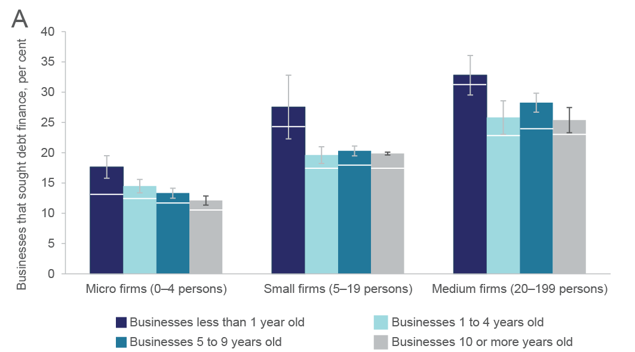Figure .1: SMEs seeking and obtaining debt finance (panel A) or equity finance (panel B), by firm age, size and success rate, 2006–07 to 2012–13

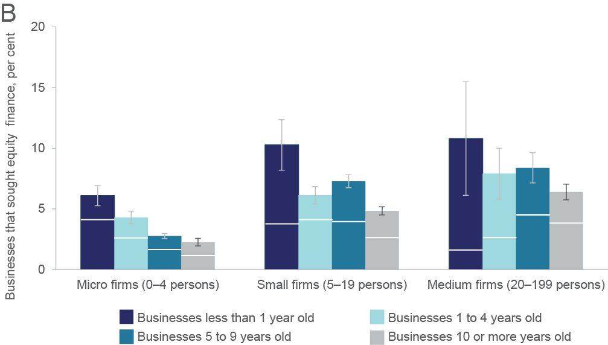

Notes: Values are annual averages ± standard errors. Lower columns represent the proportion of firms seeking finance that are successful in obtaining finance. Note different Y-axis scales in each panel.

Source: ABS (various) *Selected Characteristics of Australian Business*, cat. no. 8167.0: Customised Report

Figure .2: Estimated number of new (less than 1 year old) and young (1–4 years old) SMEs seeking debt or equity finance, by the type of finance obtained, 2012–13

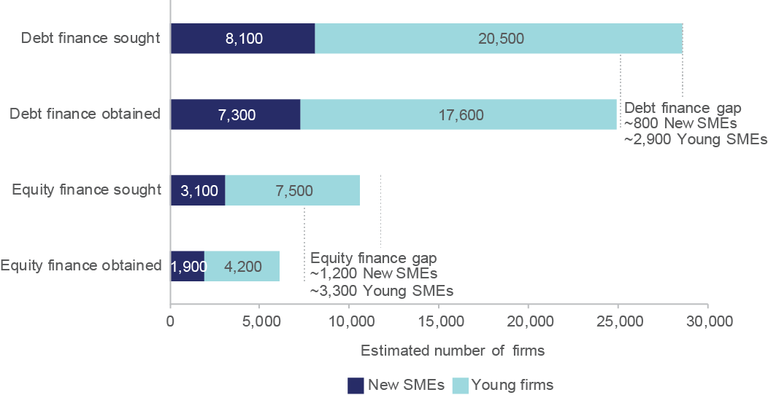

Source: ABS (2014) *Selected Characteristics of Australian Business 2012-13*, cat. no. 8167.0: Customised Report

## Financing of innovative entrepreneurship

Access to finance is one of the highest recorded barriers to innovation in Australia. ABS data shows that in 2012–13 around 30 per cent of innovation-active Australian SMEs identified ‘lack of access to additional funds’ as a barrier to their innovation activities.[17] [18] [19] Figure 2.3 shows that the likelihood of a firm to report a ‘lack of access to additional funds’ as a barrier to innovation declines with age, particularly for micro and small firms.

Figure 2.4 shows that innovation-active SMEs are significantly more likely to seek external finance than their non-innovation-active counterparts. Innovation-active firms are significantly more likely to seek finance for innovation, expansion and acquiring/upgrading ICT (Figure 2.4 B; data not shown for ICT). Other reasons for seeking external finance did not differ by innovation-status (See Box A.1).

The tendency of SMEs to seek equity finance is disproportionately higher for younger or innovative firms. Figure 2.5 looks in more detail at the likelihood and success rate of SMEs seeking equity finance by innovation-status in 2012–13. The data shows that innovation-active SMEs are more likely to seek and also significantly more likely to obtain equity finance compared to their non-innovation-active counterparts. This is even more extreme for firms introducing more novel innovations to a market. Young *New to Market* SME innovators although no more likely to seek equity finance as their *New to Firm* innovator counterparts, are significantly more likely to be successful.

Table B1(Appendix B) shows that only about 25 per cent of young SMEs that introduced *New to Market* innovations sought debt or equity finance in 2012–13. This percentage is only slightly higher than *New to Firm* innovators. The pattern of the type of finance sought is not considerably different, what it is surprising is the rate of success. Young New to Market SME innovators had a 100 per cent success rate in 2012–13 compared to that of New to Firm innovators at 57 per cent.[20]

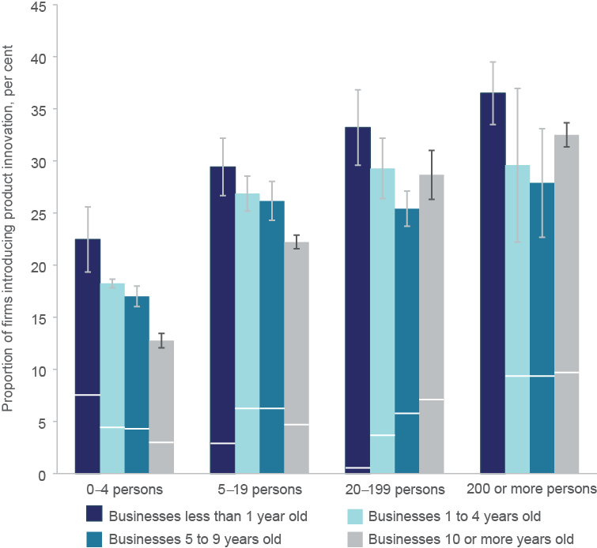Figure .3: SMEs reporting lack of access to finance as a barrier to innovation, by firm age and size, 2006–07 to 2012–13

Notes: Values are annual averages ± standard errors. Large firms are excluded from the analysis.

Source: ABS (various) *Selected Characteristics of Australian Business*, cat. no. 8167.0: Customised Report

## 

Figure .4: SMEs seeking debt or equity finance (panel A) and the percentage of firms specifically seeking finance for expansion and/or innovation (panel B), by age, by innovation status, 2012–13

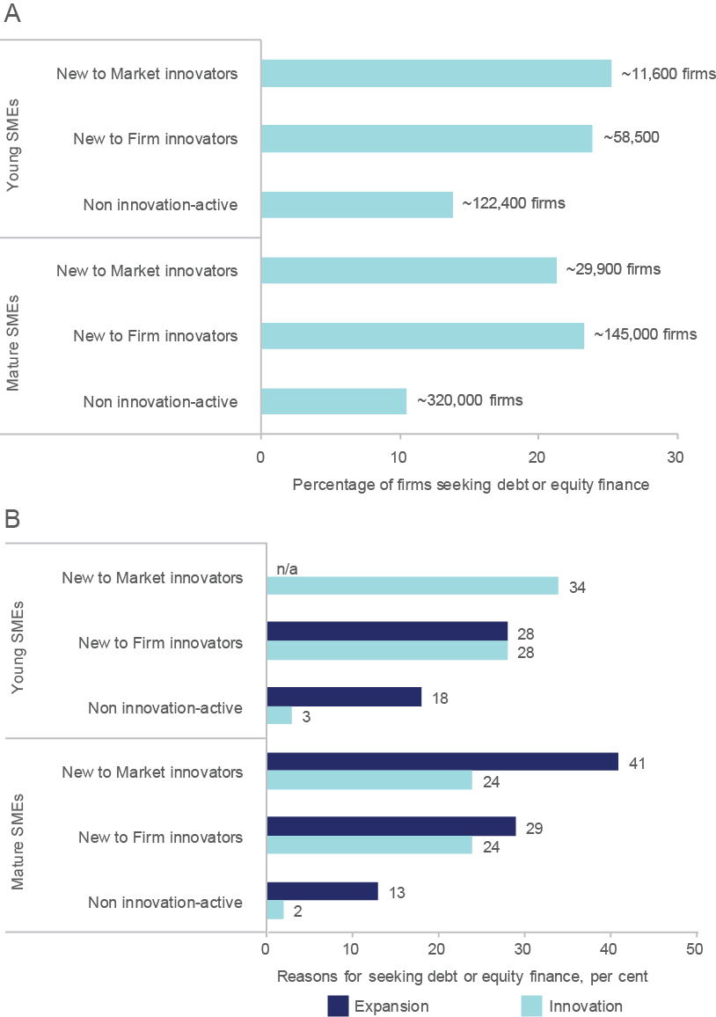

Notes: Young firms are 0–5 years old and Mature firms are 6+ years old. Values are averages ± standard errors. *n/a* indicates that data is not available for confidentiality reasons.

Source: ABS (2014) *Selected Characteristics of Australian Business 2012-13*, cat. no. 8167.0: Customised Report

Figure .5: SMEs seeking equity finance (panel A) and the success rate of these firms (panel B), by age, by innovation status, 2012–13


Based ABS customised data on selected characteristics of Australian business figure 2.5 shows (in the form of two horizontal bar charts (panels A and B) the percentage of SMEs seeking equity finance (panel A) and the success rate of these firms (panel B), by age and by innovation status for the period 2012-13. Panel A shows that a higher percentage of young new-to-firm and new-to-market innovators sought equity finance than mature innovators and non-innovation-active firms. Panel B shows that almost all young new-to-market innovators succeeded in securing finance, whereas the percentage of success rate in other categories of firms was between 40 and 58 per cent. For young and mature new-to-firm innovators the success rate was 57 and 58 per cent respectively. Data for mature new-to-market innovators was not available.


Notes: Young firms are 0–5 years old and mature firms are 6+ years old. Values are averages ± standard errors. *n/a* indicates that data is not available for confidentiality reasons.

Source: ABS (2014) *Selected Characteristics of Australian Business 2012-13*, cat. no. 8167.0: Customised Report

## Venture capital financing

Venture capital is a specialised form of equity capital investment that is in principle meant to target new firms with disruptive or at least *New to Market* innovations.[21]

The global financial crisis suppressed venture capital investment in Australia. Venture capital investment in Australia has declined to 0.017 per cent of GDP ranking it low compared to many competitor countries (Figure B1). While we are performing slightly above the OECD median for later-stage investment as a percentage of GDP Australia, early-stage investments as a percentage of GDP at 0.007 per cent of GDP is just half the OECD median (0.015 per cent GDP).[22] Unlike the US, Israel and many other countries in the OECD Australian venture capital investment has not bounced back to pre-GFC levels. Australian venture capital investment in 2014 is 40 per cent what it was in 2007. Australian data indicates that investment commitments have also fallen almost as sharply as actual investment values over the same period.[23] In particular, there has been a substantial decrease in the amount of VC being invested in new companies, with capital instead being channelled into follow-on investments in existing companies.

The success rate of firms applying for venture capital investment has fallen from 3 per cent in 2005–06 to just over 1 per cent in 2013–14 even though the number of proposals have recovered to pre-GFC levels.[24] In 2013–14, 108 firms were funded out of 8,133 proposals considered. In that same year the ABS estimates there were 94,000 firms seeking equity funding showing that venture capital caters for a small fraction of these firms. The rate of venture backing per thousand firms is on the low side compared with other OECD countries (Figure B2). Although the average investment per firm is moderately ranked at US$1.5 million (Figure B3), it is clear that Australia has the lowest investment in high risk, early stage venture capital (i.e. seed, start-up and other early stage investment) compared with other OECD countries. This is the case both in terms of the number of firms invested in (Figure B4) and the proportion of money invested (Figure B5).

Figure 2.6 shows total venture capital and later stage private equity investment activity in Australia in 2013-14 in various stages of business development in terms of the number of investments (panel A) and the value of investment (panel B). The data shows that the investments are most numerous in start-up and early expansion. However, panel B indicates that in terms of the value of investment, the bulk of investment is made in late expansion and turnaround stages. Table 2.2 shows that the average investment per firm typically increases with the stage of the company. What is surprising is the large number of mature firms that are receiving a large share of start-up and early expansion capital (Figure 2.6). Mature firms generally receive more than twice the investment per firm than young firms at all stages except the start-up phase (Table 2.2).

Table .: Averaged equity investment per firm by firm age and stage, 2013-14

| Stage of firm | Young firms  $ million per firm | Mature firms  $ million per firm |
| --- | --- | --- |
| All seed | 0.29 | 0.71 |
| Start-up | 0.98 | 0.95 |
| Early expansion | 2.34 | 5.16 |
| Late expansion | 13.3 | 37.5 |
| Turnaround/LBO/IPO/listing | 12.7 | 24.8 |

Note: Young firms are less than five years old. Mature firms are five or more years old.

Source: ABS (2015) *Venture Capital and Later Stage Private Equity 2013-14*, cat. no. 5678.0: Customised Report

Figure .6: Total venture capital and later stage private equity investment activity, by firm age, by number of firms (panel A) and value of investments (panel B), 2013–14

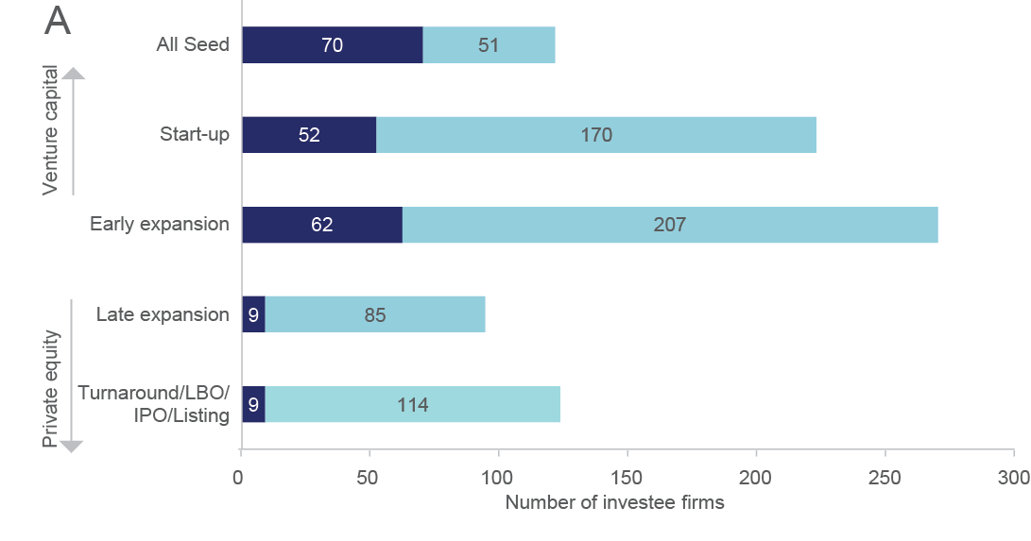

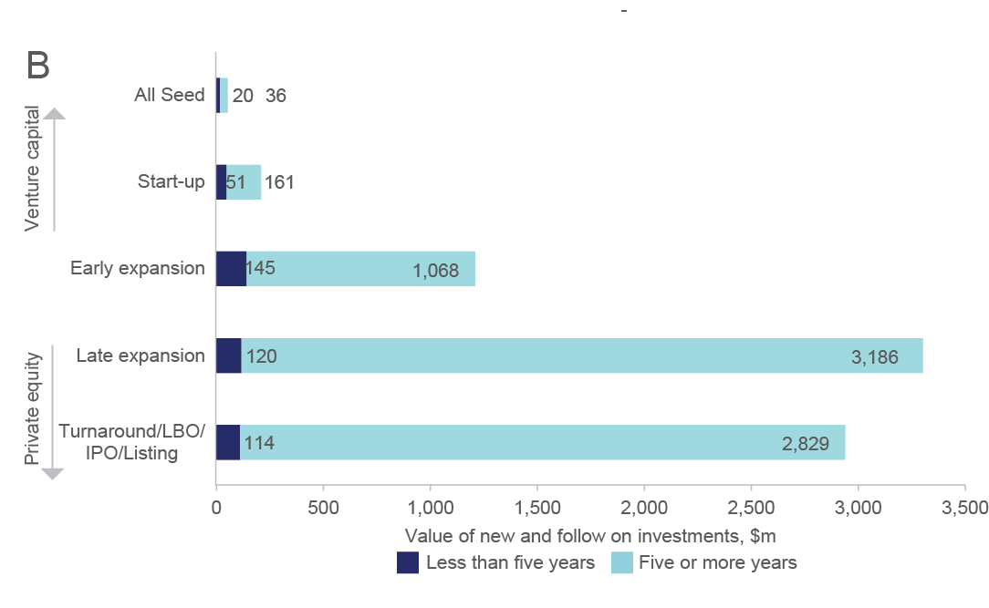

Source: ABS (2015) *Venture Capital and Later Stage Private Equity 2013–14*, cat. no. 5678.0: Customised Report

Box 2.1: Examples of successful venture capital supported firms

| [FIBROTECH THERAPEUTICS](http://www.mrcf.com.au/company/view/fibrotech-therapeutics) is a drug development company sold in one of Australia’s largest biotech deals. Established in 2006, Fibrotech Therapeutics is an Australian biopharmaceutical company developing a new class of drugs to prevent a massive health burden associated with fibrosis. The company was so promising that in May 2014, in one of Australia’s largest ever biotechnology deals, Fibrotech was sold to Irish pharmaceutical company Shire for US$75 million upfront – withfurther milestone payments of US$482.5 million, making the total deal US$557.5 million.  Fibrotech was supported by Brandon Capital Partners through its Brandon & Medical Research Commercialisation Fund (MRCF) funds licensed and registered under two of the Australian Government’s venture capital programs, including the Venture Capital Limited Partnerships (VCLP) programme. The MRCF is a collaboration between the fund manager, investors and over 50 of Australia’s leading medical research institutes and hospitals – investors gain access to cutting edge Australian medical discoveries and the research organisations gain access to capital and professional expertise.  [VAXXAS](http://www.vaxxas.com/) is a venture capital funded technology start-up company developing technology that originated from the research in the Australian Institute of Bioengineering & Nanotechnology at The University of Queensland. Vaxxas was formed in August 2011 by an AUD$15 million syndicate of venture capital funds to commercialise the Nanopatch, which was invented in 2004 by Professor Mark Kendall. The corporate office is in Sydney Australia, but the global partnering and licensing office Vaxxas Inc. is in Cambridge, MA, USA. In February this year Vaxxas raised AUD$25 million in a series B equity round to advance the Nanopatch. The financing brings the total capital raised by Vaxxas to AUD$40.6 million with funding secured well into 2017.  Sydney-based fund manager OneVentures is the lead investor in the syndicate, which also includes Melbourne-based Brandon Capital Partners and the MRCF. US-based HealthCare Ventures is another investor. OneVentures lead both the AUD$15 million Series A round in 2011 and the AUD$25 million capital raising this year. OneVenture’s investors are high net worth individuals and family offices who like the tax benefits associated with its two funds registered under the Australian Government’s Early Stage Venture Capital Limited Partnerships (ESVCLP) programme. Brandon and MRCF benefit from being registered under the Australian Government’s VCLP programme.  [SPINIFEX PHARMACEUTICALS](http://www.spinifexpharma.com/) is the most successful venture capital exit in Australian history. Established in 2005 Spinifex was based exclusively in Australia until 2014 when it also began operations in Stamford, Connecticut USA, Spinifex has received substantial venture capital backing – including from GBS Venture Partners, Brandon Capital Partners, the Medical Research Collaboration Fund, Uniseed and UniQuest (University of Queensland, Australia). Venture capital investment, along with important investments from Uniseed and UniQuest, enabled the company to mount an internationally competitive drug development activity from an Australian base. In June 2015, Australian–US drug developer Spinifex Pharmaceuticals (“Spinifex”) announced that it would be acquired by Swiss pharmaceutical giant Novartis for US$200 million upfront.  It was subsequently confirmed by Spinifex that they were eligible for up to US$500 million in additional milestone payments. The acquisition is centred on Spinifex’s EMA401, a new drug which could offer much-needed relief for millions of people around the world suffering from currently untreatable chronic neuropathic pain. The investors gave Spinifex access to their international network of experts and clinicians.  GBS Venture Partners, Brandon Capital Partners and the Medical Research Collaboration Fund invested in Spinifex through their funds licensed or registered under four of the Australian Government's venture capital programmes – including the VCLP programme. GBS and Brandon’s investors include major Australian superannuation funds. |
| --- |

Box 2.2: Examples of successful venture capital supported firms (continued)

| [SHOES OF PREY](https://www.shoesofprey.com/)  SHOES OF PREY is an Australian brand changing the way women shop for shoes. It is the first company in the world to offer women the opportunity to design and purchase their own custom made shoes online. Using the online Shoes of Prey 3D DESIGNER tool, customers choose the shape, colour and height of their shoes. Designs are handmade within four weeks and delivered worldwide.  As the company grew, the team decided to open design studios in Australia where customers could try on samples for size and view all the textile options in person. In early 2013 Shoes of Prey opened its first physical store inside the David Jones flagship Sydney store in Elizabeth Street. The outlet beat Karl Lagerfeld’s concept store in Paris and the Puma flagship store in Osaka to win the prestigious 2013 World Retail Award.  The company opened its second factory in China in December 2014. Sales have more than doubled in the last year, boosted by the [company's exclusive concession-store deal with US-based luxury goods and fashion retailer, Nordstrom](https://www.google.com.au/url?sa=t&rct=j&q=&esrc=s&source=web&cd=3&cad=rja&uact=8&ved=0CCoQFjACahUKEwiuutzOuO3GAhXCk5QKHYe7Dqs&url=http%3A%2F%2Fwww.afr.com%2Fbusiness%2Fretail%2Fshoes-of-prey-strikes-deal-with-nordstrom-20141105-11gy36&ei=c96uVe60I8Kn0gSH97rYCg&usg=AFQjCNHEUjJb4NmavJ3HvMrAHrdlT3uF6A&sig2=kwYJBP7Z8D6ttgvVKh_rVg&bvm=bv.98197061,d.dGo) in 2014. The US is now the company's largest market. After rolling out interactive design studios across six stores in the US, Shoes of Prey has set up its new headquarters in Los Angeles.  The company has raised a total of $10 million in three funding series over the last three years. It is hoping to raise another AUD$13.5–$20 million to increase capacity by as much as 20 times to meet forecast demand over the next 12 months and build more stores. Its early growth has been backed by venture capital funds Southern Cross VCLP, registered under the Australian Government’s Venture Capital Limited Partnerships programme, and Blackbird Ventures, registered under the Australian Government’s ESVCLP programme.  [COHDA WIRELESS](http://www.cohdawireless.com/)  COHDA WIRELESS is a VC-funded South Australian company investment helping develop safer driving technology. The company is developing life-saving radio communication systems for the automotive industry.  Pioneered by Cohda, V2V technology promises to improve safety by allowing vehicles to ‘talk’ to each other and ultimately avoid crashes by exchanging safety data, such as speed and position, up to ten times per second.  Cohda’s technology allows for communications from vehicle-to-vehicle and vehicle-to-infrastructure and safety warnings such as:   * warning drivers of a potential collision when entering an intersection; * electronic brake light warning if the vehicle ahead is braking; and * rear collision warning of potential impact from a following vehicle.   Cohda designs and produces hardware products with acknowledged best-in-world performance and has developed complete software stacks in-house to run on both Cohda and third party hardware. In November 2015, South Australia will host the first driverless car trials in the Southern Hemisphere, coinciding with an international conference on driverless cars. The driverless vehicle industry is predicted to be worth $90 billion within 15 years. Both Cisco Systems and NXP Semiconductors are strategic investors in Cohda. Today Cohda has 45 employees, and offices in Adelaide, Detroit and Munich. Cohda’s headquarters are in Adelaide, and most of the employees are located there.  Winning major projects in Europe and the USA, Cohda Wireless’ equipment and services have been tested by major organisations around the globe such as GM, Toyota, Honda, Daimler, VW, Hyundai, TomTom, Audi, BMW, and Bosch. In 2014, Cohda won a world-first supply contract with Delphi Corporation to supply vehicle-to-vehicle software to General Motors for the 2016 Cadillac in the USA and 2017 Cadillac in Europe.  Cohda was established by research scientists from the University of South Australia's Institute for Telecommunications Research and is backed by SciVentures Investments, a fund manager licensed under the Australian Government’s Pre-Seed Fund Programme. |
| --- |

# Discussion

This paper shows that an assessment of the demand and supply of external finance for innovative entrepreneurs is not straight forward. We agree with the Productivity Commission (2015) that the data is too limited to make accurate conclusions on access to finance for new or young firms in Australia. The evidence indicates no major impediments to debt financing for innovative entrepreneurs in Australia. Caution should be taken in interpreting this high level data as banks and other institutions are not a major source of debt finance for new or young firms.[25] Rather personal savings and personal credit are a primary source of debt finance which may explain why, despite high start-up activity in Australia, the fear of failure is also high.[26]

The data on the success rate of young SME *New to Market* innovators suggests that equity financing is also not a limiting factor. The low percentage of young, innovative firms seeking equity finance does not necessarily mean that these firms don’t require finance. ABS data indicates that from the 30 per cent of innovation-active firms that reported access to additional funds as a barrier to innovation, only 10 per cent actually sought debt or equity funding. This indicates that innovation-active firms perceive a lack of funding as a barrier for innovation even though a majority of them do not even seek external funding.

Similar to the findings of Gordon & Davidsson (2013) on high potential start-ups the data analysed in this paper indicate that innovation-active firms are more likely to seek equity finance for innovation and expansion and that they are also significantly more likely to get it. Young SME *New to Market* innovators had up to a 100 per cent success rate in 2012–13. This suggests that demand for equity is being effectively met for those firms introducing more disruptive innovations and largely being met for firms that undertake *New to Firm* or incremental innovation. The data seems counter-intuitive in the sense that one might expect high risk investments to be less likely to be financed. The data also contradict anecdotal information from the venture capital industry although that industry supports less than 0.4 per cent of employing firms. Future research should include a longitudinal investigation into the finance of innovative firms and their growth outcomes.

The fact that more than 50 per cent of young, innovative SMEs are successful in obtaining equity financing is insufficient to conclude that there are no systemic issues with equity finance. Equity financing spans a wide range of activities including different levels of risks to cater for firms undertaking innovations of various degrees of novelty. Sources of equity also vary from the personal to the formal or institutional. We don’t know much about the sources of equity or the gaps between what innovative firms seek and what they obtain. Davidsson *et al* (2012) look at all firms and show that personal savings are the major source of funding for both Australian new and young firms. They found that while the reliance of young Australian firms on personal savings amount to around 51 per cent of funds raised, for new firms personal savings accounts for around 72 per cent.[27] Another significant source of finance for Australian start-up and young firms is personal credit cards and other personal credit facilities (nearly 30 per cent for start-up firms and just over 20 per cent for young firms).

A recent survey of 430 self-identified ‘tech’ start-ups indicates that 19 per cent of Australian start-ups are funded by family and friends and 15 per cent by public grants.[28] It also highlights the relatively low levels of funding raised by Australian tech start-ups, with 37 per cent of Australian start-ups raising $50,000 or less in total funding. Based on the same survey, around 10 per cent of start-ups find access to funding in the range $1–4 million and only 3 per cent achieve more than $5 million.[29]

Venture capital in Australia is a form of private equity that caters to a very small fraction of firms numbering in their hundreds, significantly lower than the 6000–8000 high growth firms that are created annually.[30] This paper indicates that not only the success rates of firms applying for venture capital investment are low but also have been falling quite dramatically in the last decade even though the number of proposals have recovered to pre-global financial crisis levels. Moreover Australian early-stage investment as a percentage of GDP is half the OECD median. Australian Private Equity and Venture Capital Association Limited (AVCAL) analysis indicates that there is a persistent gap in equity funding in the range between $2 and 20 million,[31] which may be limiting the growth of high potential firms.

Anecdotal information suggest that there is a growing trend for raising later stage venture capital (more than $5 million) from international investors (mostly in the ICT/digital sector).[32] Many Australian firms with viable value propositions may be finding it difficult to raise equity financing from domestic sources. This would be consistent with the declines in Australian VC investment relative to other countries. It is important to note that some firms undertaking high impact innovation will prefer international investors, as they bring expertise and networks that may not be available from Australian investors.

The fact that mature firms are receiving a large share of seed and start-up capital needs to be further investigated. Mature firms are still receiving the lion’s share (more than twice the investment per firm than young firms) in all stages of venture capital except those in a start-up phase. It is possible that many of these firms are in life sciences, where the life cycle of a typical firm is longer. Many pharma/biotech start-ups’ viability depend on the production of promising clinical trials data and these can take many years. A 6–10 year old pharma/biotech firm may therefore be relatively ‘young’ in terms of their activities and prospect for commercialisation.

Since innovators tend to exhibit superior performance over non-innovators[33] the market is working well in the sense that investment is flowing to more competitive SMEs. The official data that is currently available cannot differentiate between the sources of finance and the amounts sought. We therefore cannot conclude that there is no systemic problem with our financial market’s capacity to support young innovative SMEs in Australia. More detailed information on venture capital suggests that early stage venture capital finance is still an issue for Australia.

More importantly, the focus of VC inquiry needs to shift from the conventional VC model (e.g. 10–year closed-end funds; limited partners/general partners)[34] to a broader range of ‘early stage equity capital market’ models.The conventional VC – particularly since the GFC – has actually amounted to a small part of the early stage equity capital market, which is more diverse in sources, channels and management models than the conventional VC model. It is also subject to rapid evolution. So far, however, only the conventional VC model has been subject to policy intervention by the Australian Government through tax-advantaged structures and co-investment schemes.  Available data are not detailed enough to justify the maintenance of status quo. The new Innovation and Science Agenda of the Australian Government (CSIRO Innovation Fund, Biotechnology Translation Fund, new tax incentives for early stage capital investment, VC, crowd-sourced equity funding and employee share schemes) and other recent private[35] and public sector[36] announcements should in principle inject new sources of capital into the early-stage equity market. However, we do not believe there is sufficient data infrastructure to be able to track these investments or accurately establish whether they are meeting demand.

Government policy should be built upon highly rigorous quantitative evidence. We therefore strongly recommend the finance questions in the ABS’s Selected Characteristics of Australian Business to be supplemented to include the sources of debt and equity finance and the quantum of money sought and received. This will help policy makers better determine the extent to which access to finance is a constraint on growth. Without more extensive data collection on finance it is not possible for policy researchers to determine if the 6,000–8,000 high growth firms per year identified in Hendrickson *et al.* (2015) or firms with high growth potential are actually falling into the equity finance gap identified in this paper, however small that gap might be.

###### Definitions and methodology

This paper is predominantly based on data from the Business Characteristics Survey (BCS), an annual survey administered by the ABS. The BCS is financially supported each year by the Australian Government Department of Industry, Innovation and Science (the department). The department and the ABS work together on the ongoing development and improvement of the BCS.

The BCS is the vehicle for the ABS’s Integrated Business Characteristics Strategy, which is designed to integrate the collection and quality assurance of data required for input into the ABS’s Business Longitudinal Database. It also produces point-in-time estimates for use of information technology, innovation and a broad range of other non-financial characteristics. Firms surveyed for the BCS are sourced from the Australian Business Register, administered by the Australian Taxation Office.

Approximately 6,500 firms are randomly sampled using a mail-out questionnaire. The sample is stratified by industry and an employment-based size indicator. The ABS then uses the sample to estimate the activity of the entire employing business population. The BCS questions on innovation, markets and firm performance allows constructing novel customised data.

There are two caveats to the BCS data used here. Firstly, the sample size is limited and this could affect the quality of data. Secondly, the data are based on firms self-assessment.

Box A.1 shows the finance questions from the BCS.

The Venture Capital and Later Stage Private Equity (VC&LSPE) statistics uses a population of surveyed investment managers from lists of participants in government programs (including Pooled Development Fund, Innovation Investment Fund, Venture Capital Limited Partnerships, Early Stage Venture Capital Limited Partnership), membership of AVCAL, the Australian Venture Capital Guide, business directories and venture capital journals. Venture Capital (VC) is defined as high risk private equity capital for typically new, innovative or fast growing unlisted companies. A venture capital investment is usually a short to medium-term investment with a divestment strategy with the intended return on investment mainly in the form of capital gains (rather than long-term investment involving regular income streams).

Later Stage Private Equity (LSPE) is defined as investment in companies in later stages of development, as well as investment in underperforming companies. These companies are still being established, the risks are high and investors have a divestment strategy with the intended return on investment mainly in the form of capital gains (rather than long-term investment involving regular income streams).

Box A1: Business Characteristics Survey questions on finance

| 1. **Did this business receive any financial assistance from Australian government organisations during the year ended 30 June 2013?** (Tick all that apply)   (a) Grants …  (b) Ongoing funding…  (c) Subsidies …  (d) Tax concessions …  (e) Rebates…  (f) Other (please specify) …  (g) No government financial assistance received…   1. **Did this business seek any debt or equity finance during the year ended 30 June 2013?**   No…  Yes…   1. **Please indicate the type of finance sought and whether it was obtained.** (Tick all that apply) 2. Debt… (Obtained; Not-obtained; In-progress) 3. Equity… (Obtained; Not-obtained; In-progress) 4. **Why did this business seek debt or equity finance during the year ended 30 June 2013? (**Tick all that apply) 5. Ensure survival of business (i.e. to ‘stay afloat’) … 6. Maintain short-term cash flow or liquidity… 7. Replacement of: 8. IT hardware 9. Other equipment or machinery 10. Upgrade of: 11. IT hardware or software 12. Other equipment or machinery   (e) Purchase of additional:   1. IT hardware or software 2. Other equipment or machinery 3. Assets (i.e. to build capital) not related to expansion (e.g. commercial investment properties)   (f) Expand business  (g) To introduce new or improved goods, services, processes or methods  (h) Other (please specify) |
| --- |

Notes: These questions may change from year to year. Notes for each question are not included.

Source: Australian Bureau of Statistics, *Business Characteristics Survey 2012-13*

###### Supplementary data

Table B1: Firm finance sought, by type and status, by innovation status, by employment size, 2012-13

|  |  |  |  |  |  |  |  |  |
| --- | --- | --- | --- | --- | --- | --- | --- | --- |
|  |  |  |  | Type of finance sought by firmsb | | Equity finance obtainedc | Reasons for seeking debt or equity financed | |
| *Firm age and size* | *Innovation status* | *Estimated counts of firms* | *Firms that sought debt or equity finance, per centa* | *Debt, per cent* | *Equity, per cent* | *per cent* | *Expand firm, per cent* | *To introduce new or improved goods, services, processes or methods, per cent* |
| Young SMEs | New to Market innovators | 11,612 | 25.3 | 85.4 | 25.0 | 100.0 | – | 34.1 |
|  | New to Firm innovators | 58,447 | 23.9 | 92.1 | 27.1 | 56.9 | 27.7 | 28.2 |
|  | Non innovation-active | 122,400 | 13.8 | 94.3 | 33.7 | 13.0 | 4.7 | 40.4 |
| Mature SMEs | New to Market innovators | 29,889 | 21.3 | 88.8 | 25.0 | ***48.0 | 41.3 | 24.4 |
|  | New to Firm innovators | 144,937 | 23.3 | 93.0 | 19.5 | 58.1 | 29.2 | 24.0 |
|  | Non innovation-active | 318,800 | 10.5 | 92.4 | 25.1 | 9.7 | 2.6 | 42.4 |

Notes: ***Indicates high relative standard errors greater than 50 per cent. All other relative standard errors less than 10 per cent. aProportions are of all firms in each output category. bProportions are of all firms in each output category. Firms could identify more than one type of finance and more than one status. c Proportions are of all firms that sought equity finance in each output category. dProportions are of all firms that sought finance (either debt or equity) in each output category. Firms could identify more than one reason.

Source: ABS (2014) *Selected Characteristics of Australian Business 2012-13*, cat. no. 8167.0

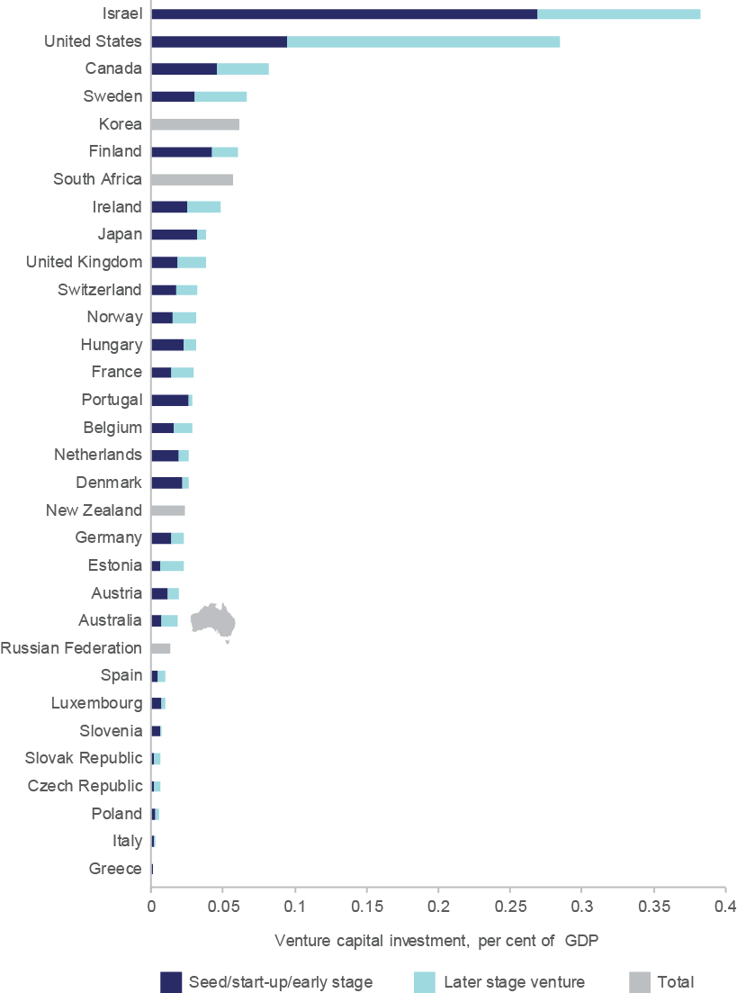Figure B1: Venture capital investments as a percentage of GDP, 2014 or latest available year

Source: OECD (2015) *Entrepreneurship at a Glance 2015*, OECD Paris

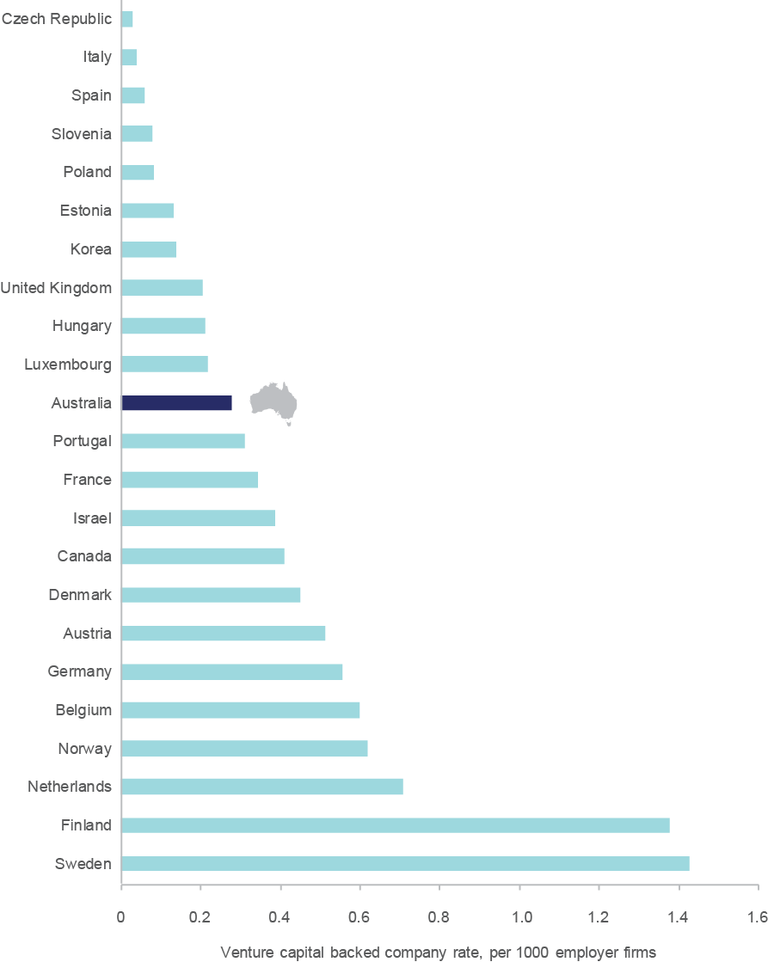Figure B2: Venture capital-backed company rate, by country, 2014

Notes: Employing firms are included only in the analysis. Note that the 2011 rate for the USA was 0.55.

Source: OECD (2015) *Entrepreneurship at a Glance 2015*, OECD Paris

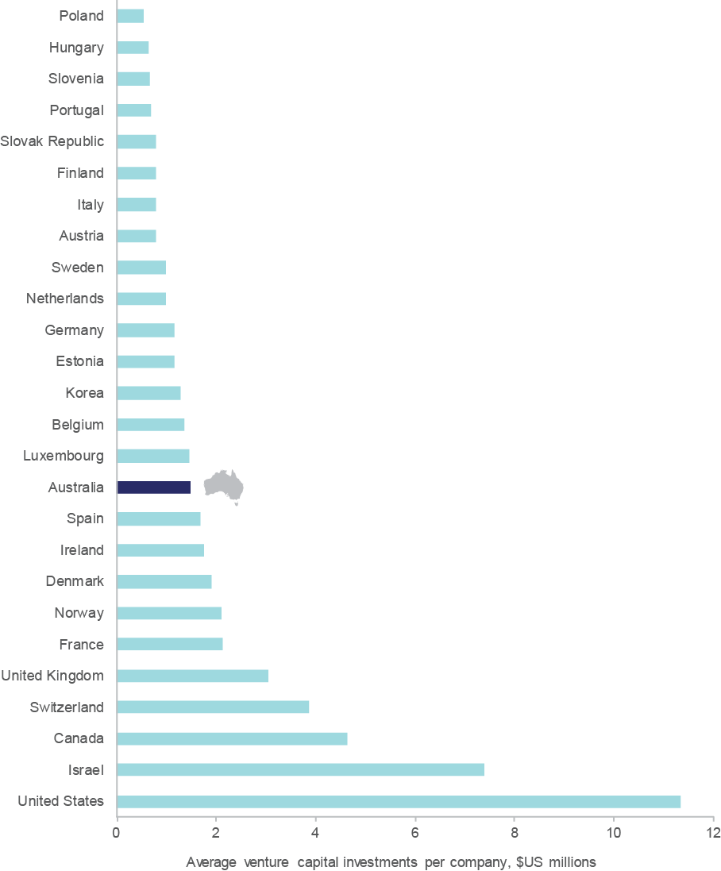Figure B3: Average venture capital investments per company, by country, 2014

Source: OECD (2015) *Entrepreneurship at a Glance 2015*, OECD Paris

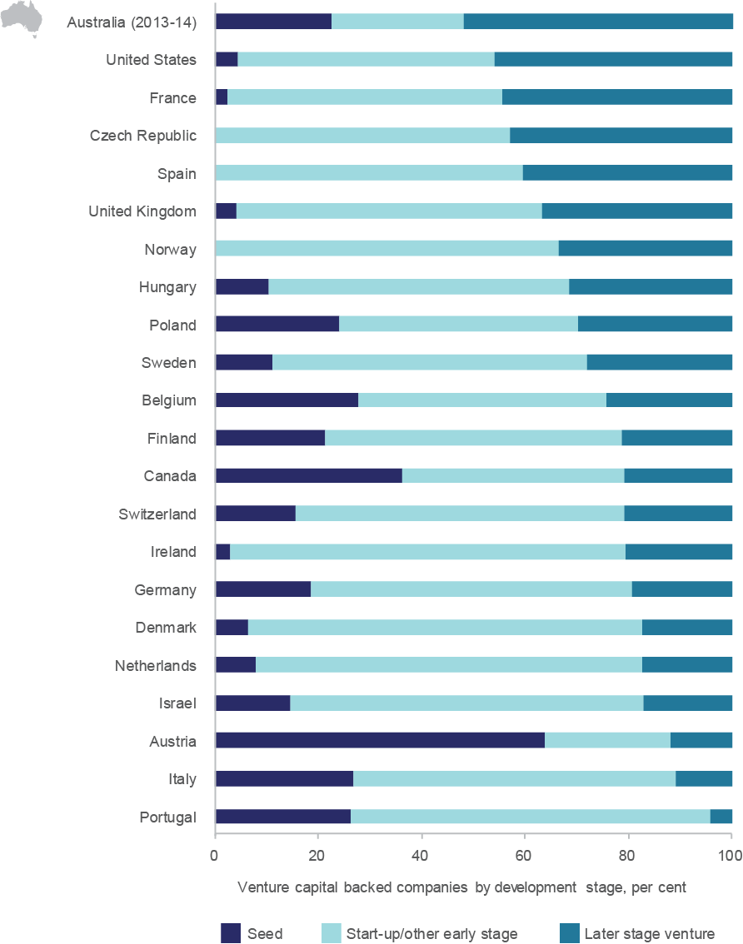Figure B4: Venture capital backed companies by development stage, 2014 or latest available year

Source: OECD (2015) *Entrepreneurship at a Glance 2015*, OECD Paris

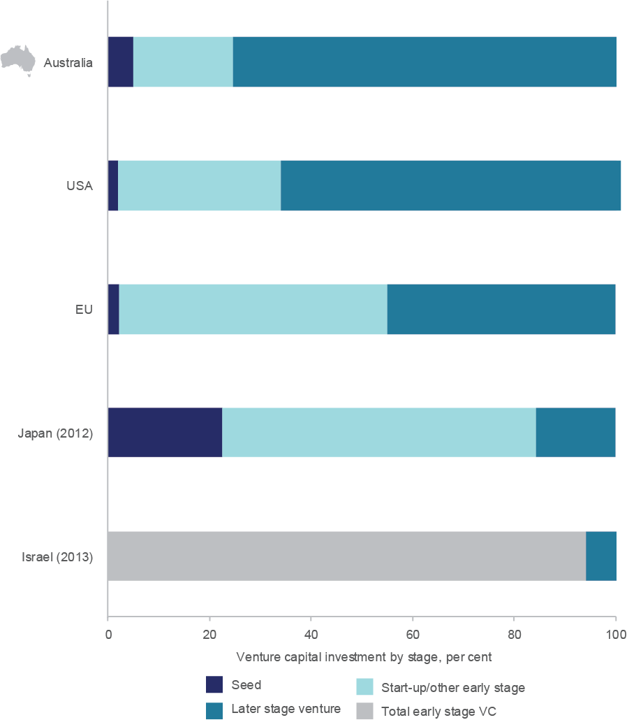Figure B5: Venture capital investment by stage of investment, 2014 or latest available year

Notes: OECD (2015) *Entrepreneurship at a Glance 2015*, OECD Paris was used to harmonise stages of VC investment. Where disaggregated early stage VC was unavailable this was aggregated and named *Total early stage VC*.

Source: ABS (2015) Venture Capital and Later Stage Private Equity, Australia, 2013-14, cat. no. 5678.0; 2015 National Venture Capital Association Yearbook (2015); European Private Equity and Venture Capital Association (2015) EVCA Yearbook - 2014 European Private Equity Activity; Venture Enterprise Center -Japan (2013) Survey on Venture Capital Investment Trends in 2013 – Preliminary Results, PWC Israel (2015) The Money Tree – Israeli Venture Capital Investment data.

**References**

ABS (2014a) Australian National Accounts: National Income, Expenditure and Product, March 2103, Cat. No. 5206.0

ABS (2014b) Innovation in Australian Businesses, 2012–13, Cat. No. 8158.0

ABS (2014c) Selected Characteristics of Australian Businesses 2012–13, Cat. No. 8167.0

ABS (2015a) Counts of Australian Businesses, including Entries and Exits, June 2010 to June 2014, Cat. No. 8165.0

ABS (2015b) Venture capital and later stage private equity, 2013–14 Cat. No. 5678.0

Allman K, Edler J, Georghiou L, Jones B, Miles I, Modivar O, Ramlogan R and Rigby J (2011) *Measuring wider framework conditions for successful innovation: A system’s review of UK and international innovation data*, Index Report, NESTA, UK

Australian Government (2015) Joint media release, the Hon Andrew Robb AO MP, Minister for Trade and Investment, and the Hon Michaelia Cash, Assistant Minister for Immigration and Border Protection, 1 July 2015

Australian Government (2014) Australian Innovation System Report 2014

Australian Government (2011) Australian Innovation Systems Report 2011

Davidsson P, Gordon SR. & Steffens PR (2012) Early stage start-ups: evidence from the Comprehensive Australian Study of Entrepreneurial Emergence (CAUSEE), in Australian Small Business: Key Statistics and Analysis [2012 ed.], Commonwealth of Australia, Canberra, ACT, pp. 4–17 <http://eprints.qut.edu.au/58931/1/EPRINTS_version_-_FINAL_Start-up_chapter_30-10.pdf>

Davis SJ, Haltiwanger J, Lerner J and Miranda J (2008) Private equity and employment, U.S. Census Bureau Center for Economic Studies Paper No. CES-WP-08-07

Gilson RJ (2003) Engineering a venture capital market: lessons from the American experience, *Stanford Law Review*, 55(4)/1067–1103

Gompers PA and Lerner J (1999) *The Venture Capital Cycle*, MIT Press, Cambridge, MA

Gompers PA and Lerner J (2001a) The venture capital revolution. *Journal of Economic Perspectives*, 15 (2)/145–168

Gompers P and Lerner J (2001b) *The Money of Invention: How Venture Capital Creates New Wealt*h, Boston, MA: Harvard Business School Press, p. 35

Gompers PA, Lerner J and Scharfstein D S (2005) Entrepreneurial spawning: public corporations and the formation of new ventures, 1986–1999, *Journal of Finance*, 60(2)/577–614

Gordon SR and Davidsson P (2013) *Capturing gazelles : features of high potential firms and new venture growth*, Business Creation in Australia, 06, Queensland University of Technology Business School, Brisbane, QLD <http://eprints.qut.edu.au/62936/>

Hendrickson L, Bucifal S, Balaguer A and Hansell D (2015) The employment dynamics of Australian entrepreneurship, Office of the Chief Economist, Department of Industry, Innovation and Science

Kerr WR and Nanda R (2009) Financing Constraints and Entrepreneurship Working Paper 10–013, Harvard Business School

Müller E & Zimmermann (2009) The importance of equity finance for R&D activity, *Small Business Economics* 33: 303–318.

Levine R (1997) Financial development and economic growth: Views and agenda, *Journal of Economic Literature*, 35 (2): 688–726

OECD (2014) *Entrepreneurship at a Glance 2014*, OECD publishing <http://dx.doi.org/10.1787/entrepreneur_aag-2014-en>

OECD (2015a) *Financing SMEs and Entrepreneurs 2015: An OECD Scoreboard*, OECD Publishing, Paris

OECD (2015b) *New Approaches to SME and entrepreneurship finance: Broadening the range of instruments-Final Synthesis Report*, Working Party on SMEs and Entrepreneurship (WPSMEE)

Popov A and Roosenboom P (2009) On the real effect of private equity investment: Evidence from new business creation, European Central Bank, Working Paper Series No. 1078, August 2009

PricewaterhouseCoopers (2006) Economic Impact of Private Equity and Venture Capital in Australia

Productivity Commission (2015) *Business Set-up, Transfer and Closure, Draft Report*,  
Canberra

RBA (2015) The Australian Economy and Financial Markets, Chart Pack, Reserve Bank of Australia <http://www.rba.gov.au/chart-pack/pdf/chart-pack.pdf>

Steffens P and Hechavarria D (2015) Global Entrepreneurship Monitor: 2014 Australian National Report for Department of Industry and Science, Australian Centre for Entrepreneurship Research, QUT Business School

The Innovation Policy Platform webpage, OECD and the World Bank Group <https://www.innovationpolicyplatform.org/content/venture-capital?topic-filters=12161>

The Treasury (2014), *Financial System Inquiry Interim Report*, 15 July, Canberra <http://fsi.gov.au/files/2014/07/FSI_Report_Final_Reduced20140715.pdf>

The Treasury (2012) *Review of Venture Capital and Entrepreneurial Skills – Final Report*, a report for the Australian Government, prepared by the Treasury and the Department of Industry, Innovation, Science, Research and Tertiary Education

The World Bank (2008) *Finance for All? Policies and Pitfalls in Expanding Access*, A World Bank Policy Research Report, The World Bank, Washington D.C.

The World Bank (2014) World Development Indicators 2014 <http://data.worldbank.org/sites/default/files/wdi-2014-book.pdf>

1. Hendrickson *et al.* (2015); OECD (2015b)
2. Kerr & Nanda (2009); Allman *et al.*(2011)
3. The World Bank (2008)
4. Popov & Roosenboom ( 2009); Davis et al. (2008); Gompers et al. (2005); Gilson (2003); Gompers & Lerner (2001); Gompers & Lerner (1999)
5. Treasury (2012)
6. The World Bank (2014)
7. In total, 49 companies listed on the Australian Securities Exchange in 2013, a slight increase on the 46 listings of 2012, but substantially less than the 104 new listings completed in 2011 and the 96 new listings in 2010 (partly a reflection of the reduced contribution of small cap listings). There was a shift towards larger IPOs in 2013 compared to 2012, with 96 per cent of all funds raised completed by companies with a market capitalisation of more than $100 million, with the total amount raised from new listings in 2013 just over $8.5 billion (significantly higher than the $2.3 billion average of the past five years). While resource stocks have dominated the statistics in recent years, this was not the case in 2013 (a possible combination of falling commodity prices and reduced investor sentiment). <http://www.hlb.com.au/getattachment/9f37d196-b0b2-4ae4-8f69-7584b9e4f1aa/IPO-Watch-2014;.aspx>
8. Productivity Commission (2015)
9. The Treasury (2014)
10. OECD (2015b)
11. RBA (2015)
12. Davidsson *et al.* (2012)
13. The ABS data on Mining sector having the lowest proportion of businesses seeking debt finance and highest proportion of businesses seeking equity finance have high standard deviations and therefore should be viewed with caution.
14. ABS (2015a)
15. ABS (2014c)
16. RBA (2015)
17. ABS (2014b)
18. According to the Australian Bureau of Statistics (ABS), innovation is considered the development or introduction of new or significantly improved goods, services, processes or methods; and innovation-active businesses include businesses that undertook any innovative activity in a 12 month reference period irrespective of whether the innovation was introduced, still in development or abandoned.
19. ABS data especially provided for the Department indicates that from the 30 per cent of innovation-active firms that report access to additional funding as a barrier to innovation, only 27 per cent actually sought debt or equity funding. This indicates that perception among firms that funding is a barrier for innovation is not always matched by their real actions in seeking funding.
20. The 100 per cent success rate refers to those 700 young SMEs that have introduced new-to-market innovations in the year 2012–13 and have obtained equity finance. This rate seems unlikely and should be interpreted with caution . It also rise issues about the quality of this dataset. However, a high percentage in success rates by new-to-market innovators is still expected as new-to-market innovators have already introduced innovation in the market place, which means, the risk associated with commercialising their innovation has been reduced.
21. Note that our definition of an innovation-active firm differs from that described by the Productivity Commission (see Box 1.2)
22. Australian Bureau of Statistics reports that Australia’s venture capital investment is 0.11 per cent of GDP in its publication Venture Capital and Later Stage Private Equity, Australia, 2013–14 catalogue 5678.0. This is different from the 0.017 per cent of GDP reported by the OECD in the publication Entrepreneurship at a Glance 2014. The large difference between these two figures is due to differences in their respective definitions. ABS definition of venture capital includes pre-seed, seed, start-up and early expansion investments. The OECD includes as venture capital investment pre-seed/seed, start-up/other early stage and later stage venture.
23. For example, the Australian pension fund commitments to equity-based investments (including venture capital and later stage private equity) have fallen by more than 40 per cent. Moreover, the value of funds committed to private equity investment vehicles decreased in 2013–14 compared to a year earlier by 6 per cent. While on 30 June 2013, investors had $19,777 million committed to investment vehicles, on 30 June 2014, these commitments were reduced to $18,514 million.
24. ABS (various) *Venture Capital and Later Stage Private Equity*, cat. no. 5678.0
25. Davidsson *et al.* (2012)
26. Steffens & Hechavarria (2015)
27. Evidence from the US suggests that informal investment accounts for around 99.9 per cent of new businesses and 92 per cent of total venture capital investment. See Bygrave W D (2004) Financing entrepreneurs and their ventures, in, Global Entrepreneurship Monitor’s 2003 Executive Report, Ewing Marion Kauffman Foundation, USA.
28. Startup Muster <https://www.startupmuster.com/>
29. Based on the same data source <https://www.startupmuster.com/>, 13 per cent of start-ups have $50,000–100,000 in funding, another 13 per cent have $100,000–200,000, 20 per cent have $200,000–500,000, 5 per cent have $500,000–1 million, and another 5 per cent have $2–4 million.
30. Hendrickson *et al.* (2015)
31. <https://www.avcal.com.au/stats-research/deal-metrics>
32. A key contributing factor to venture capital activity has been US based VC firms, including the $250m investment from Insight Venture Partners into Campaign Monitors and Technology Crossover Partner’s $30m investment in SiteMinder. In FY2013–14 international VC funds invested $484m into 9 companies across 11 investments with an average of $54m per company and $44m per investment (Source: AVCAL Deal Metrics report 2014 and personal communication). The vast majority of this funding was directed at the ICT/digital sector.
33. Australian Government (2014)
34. A limited partner is a partner in a partnership whose liability is limited to the extent of the partner's share of ownership. Limited partners generally do not have any kind of management responsibility in the partnership in which they invest and are not responsible for its debt obligations. A general partner is a partner in a partnership who have unlimited liability. A general partner is also commonly a managing partner, which means that this person is active in the day-to-day operations of the business.
35. In September 2015, Blackbird Ventures announced that it had teamed up with two superannuation funds, First State Super and HostPLUS, to launch Australia’s largest-ever tech venture capital fund, with more than $200 million raised to support local technology start-ups. See the Australian, 15 September 2015: <http://www.theaustralian.com.au/business/in-depth/blackbird-venture-capital-fund-to-support-local-tech-start-ups/story-fnw66tov-1227527693546>
36. In November 2015, the Group of Eight (Go8), Australia’s leading research intensive universities, released its “Innovation 2016” plan. The broad plan sets out how the Go8 would lead the Government’s economic and productivity push through its industry and innovation actions. According to Go8 Chief Executive Vicki Thomson, with 74 per cent of the university research sector’s patents, the Go8 has much to offer Australia, and with the new Government policy direction this capacity would be harnessed. The Go8 currently produces 62 per cent of the start-ups out of Australia’s university sector and has 80 per cent of the sector’s commercialisation income. Also see <https://go8.edu.au/article/go8-media-release-go8-delivers-industry-and-innovation-work-plan-minister-communique>