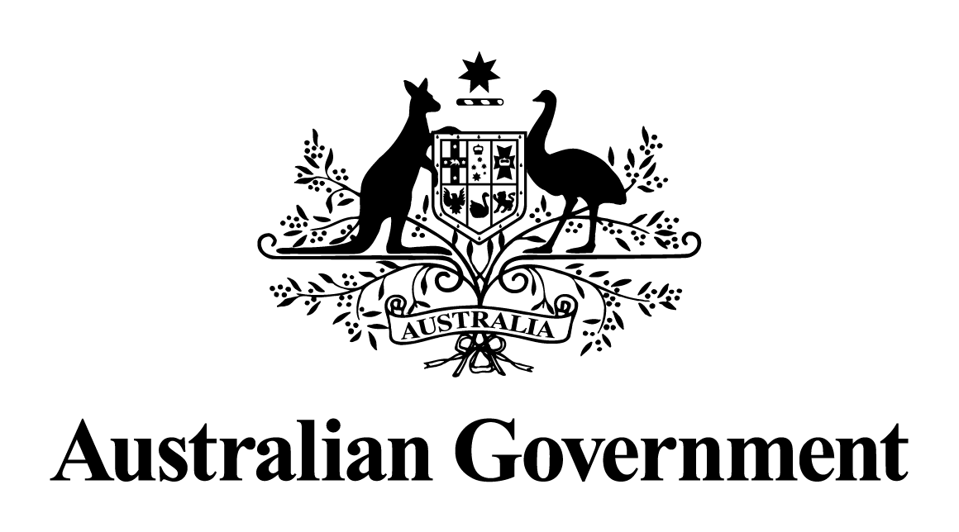

# Australian Government response to the Senate Economics Legislation Committee report:

# Customs Amendment (Anti-Dumping Measures) Bill 2017 [Provisions]

November, 2017

## **Introduction**

On 13 September 2017, the Government introduced a bill into Parliament to address an unintended consequence of Australia’s anti-dumping system that allowed the possibility for foreign exporters subject to duties to subvert the review of measures process to undermine the system’s remedial effects. The bill, the Customs Amendment (Anti-Dumping Measures) Bill 2017 (the Bill), was referred to the Senate Economics Legislation Committee (the Committee) on 14 September 2017. The Committee published its report on the Bill on 6 October 2017. The Government response to the report can be found below.

## **Government response to the Committee’s report**

The Government thanks the Committee for its report and its recommendation that the Bill be passed by the Senate.

The Government is committed to an effective anti-dumping system as an essential component of ensuring free and fair trade, including in the context of Australia’s membership of the World Trade Organization. The Government has implemented several tranches of significant reform to strengthen Australia’s anti-dumping system since 2013. The Government’s reforms have ensured the anti-dumping system provides suitable remedies against unfairly traded goods that cause injury to Australian industry. These reforms have increased the system’s efficiency and transparency, and improved industry access.

The Government considers that engagement with Australian industry and other stakeholders is essential in undertaking ongoing refinement of the operation of Australia’s anti-dumping system to ensure that the system remains contemporary and consistent with international trade rules. Accordingly, the Government is currently engaging with a broad range of anti‑dumping stakeholders to identify opportunities for further improvements to the system. The merits and limitations of any changes to the system will be explored by the Government.

The Government also thanks Senator Xenophon for his recommendation that the Bill be passed by the Senate and notes his suggested improvements to Australia’s anti‑dumping system.

Over the past four years, the Government has implemented a number of policy and operational reforms to the anti‑dumping system to ensure that it continues to provide Australian industry with effective relief from dumped and subsidised goods. These reforms include measures to provide assistance for small and medium enterprises (SMEs) in accessing the anti‑dumping system, such as improving the operation and increasing the resources of the International Trade Remedies Advisory Service. The Government has also implemented changes to improve the efficiency and effectiveness of anti‑dumping and countervailing investigations, including the implementation of a new investigations model, improvements to the conduct of verification, and adding further detail to the subsidies register. The Government also remains committed to the International Trade Remedies Forum (ITRF), the peak industry advisory body for the anti‑dumping system, and is currently considering the recommendations of its sub-committees on SME access, subsidies, and compliance and anti-circumvention. The Government will continue to engage with ITRF members on ways to enhance the system’s operation through the active sub-committees on compliance and anti-circumvention and access to import data.