
OFFSHORE GREENHOUSE GAS STORAGE
ACREAGE RELEASE | AUSTRALIA 2014

Release Areas VIC14-GHG-1, VIC14-GHG-2 and
VIC14-GHG-3, Gippsland Basin, Victoria
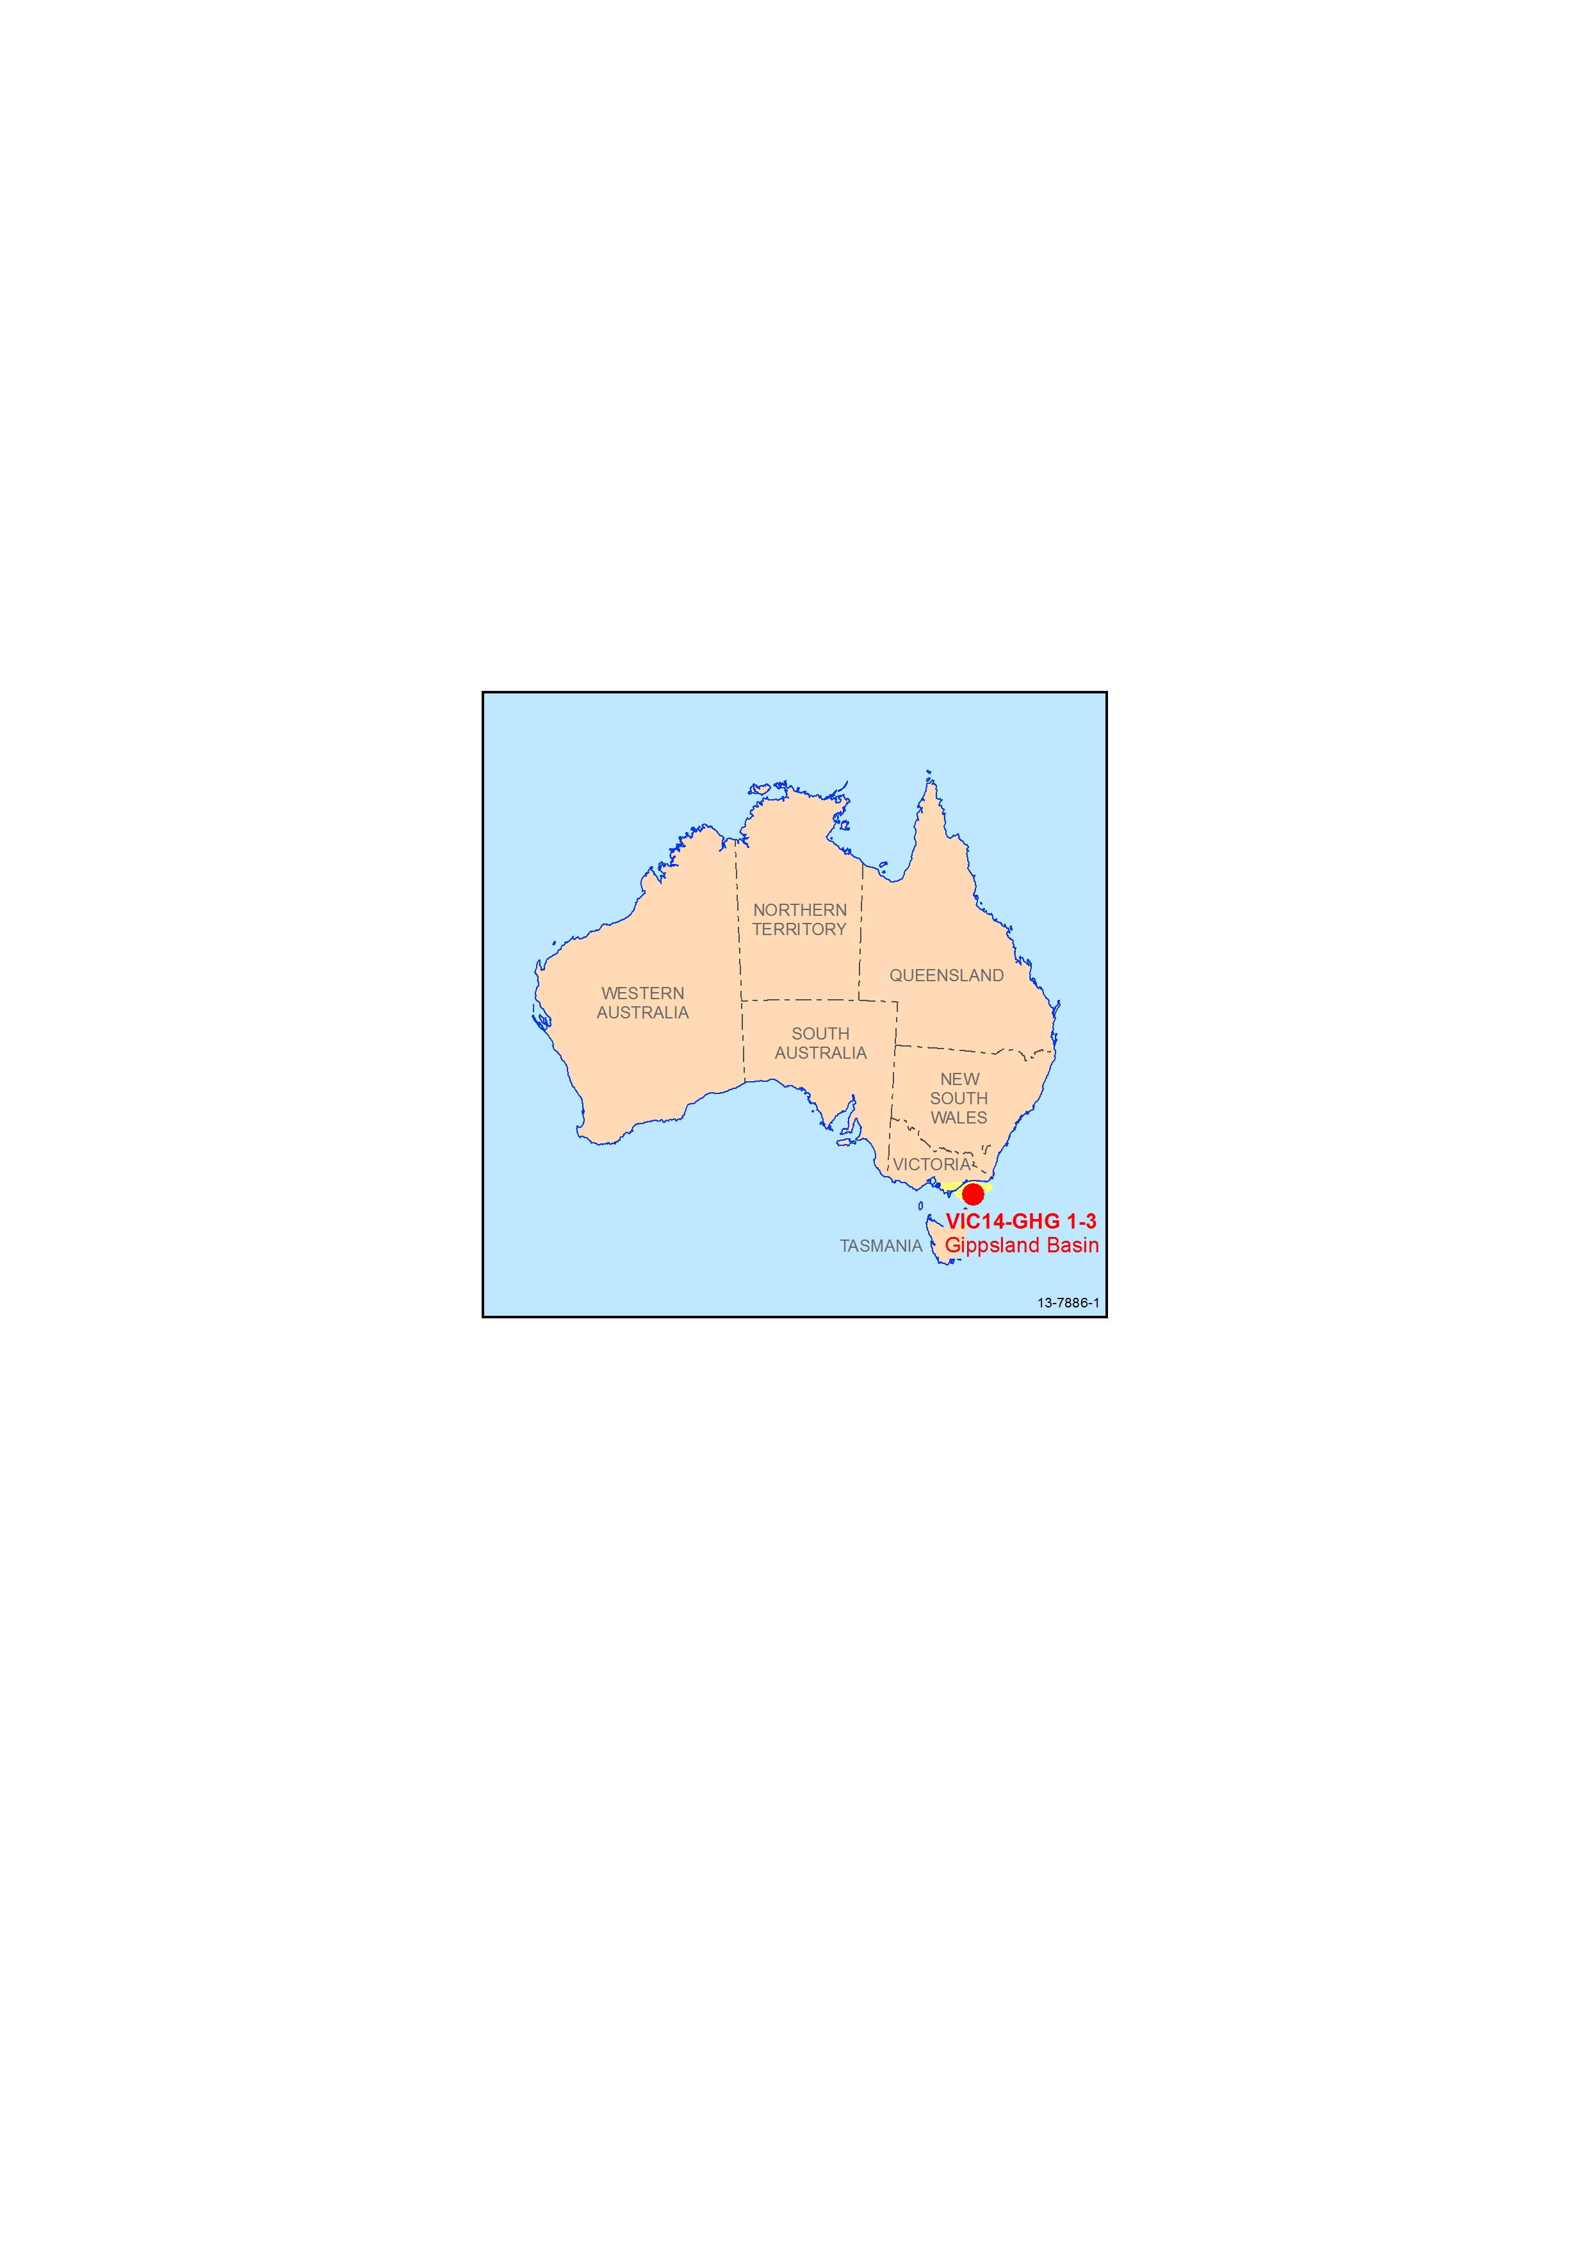
Figure 1 Location of the 2014 Greenhouse Gas Assessment Areas in the Gippsland Basin.

Highlights
- Located in a world-class producing petroleum province
- Shallow water depths (15–50 m)
- Moderate seismic and well coverage
- CO2 storage plays in anticlines, fault sealed anticlines and saline aquifer stratigraphic traps
- Located proximal to CO2 sources and infrastructure
- Special Notices apply, refer to Guidance Notes

The Assessment Areas straddle the shallow shelfal portion of Bass Strait where water depth range from 15 to 50 m. The areas are located in the western Central Deep part of the basin, adjacent to the onshore Seaspray Depression and overlap the western portion of the Southern Terrace (Figure 2). Geological control is provided by exploration wells and seismic surveys of varying quality that have tested top-Latrobe Group and intra-Latrobe Group petroleum targets. Indicative oil and gas discoveries at Barracouta, Dolphin, Golden Beach, Perch, Seahorse, Tarwhine, Mulloway and Whiptail, demonstrate the existence of top-Latrobe and numerous intra-Latrobe reservoir and seal pairs in the Area.
.
The basin developed during the Early Cretaceous as part of the break-up of Gondwana and extension between the Australian and Antarctic continents. Continued rifting into the Late Cretaceous generated a classic extensional geometry comprising a depocentre (the Central Deep) flanked by platforms and terraces. Early to mid-Eocene compression across much of the eastern portion of the southern margin saw reactivation of syn-rift faults and post-rift sediments, creating the present-day inversion structures. Several petroleum systems operate in the basin. The largest oil and gas fields are hosted by top-Latrobe Group (Eocene) shallow marine barrier sandstones with additional discoveries made in intra-Latrobe (Paleocene) coastal plain and deltaic channel sandstones.
The Release Areas offer a range of CO2 storage play types including inversion-related anticlines, fault sealed anticlines and saline aquifer Saline aquifer stratigraphic traps, and migration dissolution/residual traps; stratigraphic traps are represented by pinch-outs and truncations across unconformities.

Reservoir and seal elements

Gippsland Basin
Reservoirs | - Cretaceous–Paleogene marine and non-marine Latrobe Group;  - Eocene–Oligocene lower coastal plain Burong Formation (Cobia Subgroup)  - Paleocene–Eocene Kingfish Formation (Halibut Subgroup)  - Campanian–Maastrichtian Barracouta Formation (Halibut Subgroup)
Seals | Regional seals  - Oligocene–Miocene marine carbonate Early Oligocene Wedge (EOW), Lakes Entrance formation (Seaspray Group)  - Eocene-Oligocene Gurnard Formation  Intra-Latrobe Group seals  - Paleocene marine Kate Shale (Halibut Subgroup)  - Campanian–Paleocene volcanics (several distinct horizons)
Containment targets | - Structural traps (anticlinal closures)  - A variety of fault related traps, including fault seal anticlines  - Saline aquifer stratigraphic traps, and migration dissolution/residual traps

Infrastructure
The Assessment Areas are situated offshore in federal waters at the western extremity of pre-existing petroleum infrastructure in the Central Deep part of the Gippsland Basin. Onshore, brown coal-fired power stations in the Latrobe Valley include the Hazelwood, Loy Yang, Yallourn and Energy Brix power stations. These power stations constitute a large proportion of Victoria’s energy supply and are a major CO2 emission source.
Offshore hydrocarbon production in the basin remains strong, and is being expanded by a new $4.4 billion investment to develop the Kipper Tuna Turrum project. The oil and gas resources are processed at the Longford gas processing facility and made available for the growing SE Australian energy market. The Longford facility is also a CO2 emission source. Despite long term production, the Gippsland Basin is still recognised as a world class petroleum province, with crude oil of 3.34 Gl, condensate production of 1.5 Gl and gas production of 5.5 Gm3 in the 2010/2011 financial year.

Data sets
For the Seismic Surveys and Wells Data Listing go to
http://www.industry.gov.au/energy/clean/ccs/geological/ccs-acreage/Pages/index.aspx
For the Petroleum Wells Database and Seismic Data email requests go to http://dbforms.ga.gov.au/www/npm.well.search, or email: ausgeodata@ga.gov.au
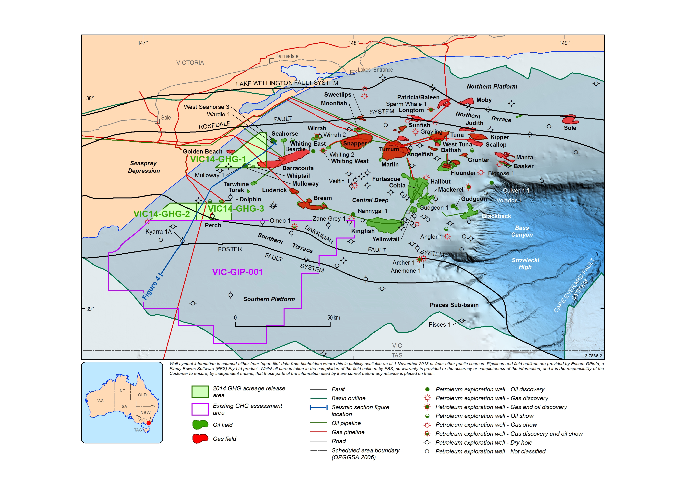
Figure 2 Structural elements of the Gippsland Basin showing petroleum fields and discoveries, the location of regional cross-section and the 2014 GHG Assessment Areas.
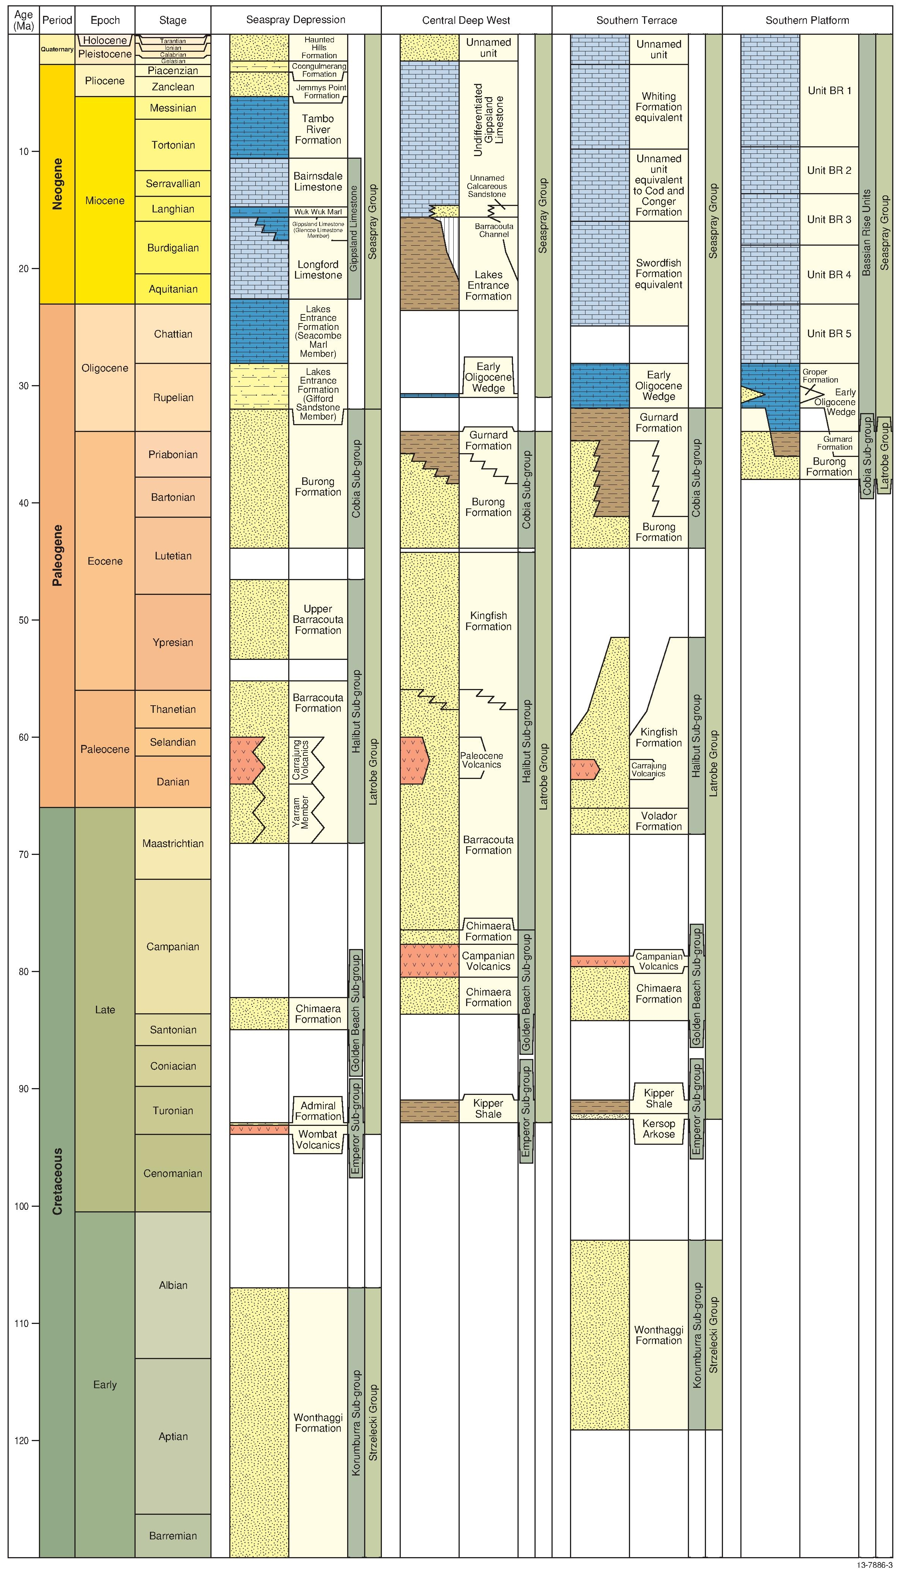
Figure 3 Stratigraphy of the western and southern offshore Gippsland Basin based on the Gippsland Basin Biozonation and Stratigraphy Chart 40 (Partridge et al, 2012). Geologic Time Scale after Gradstein et al (2012)

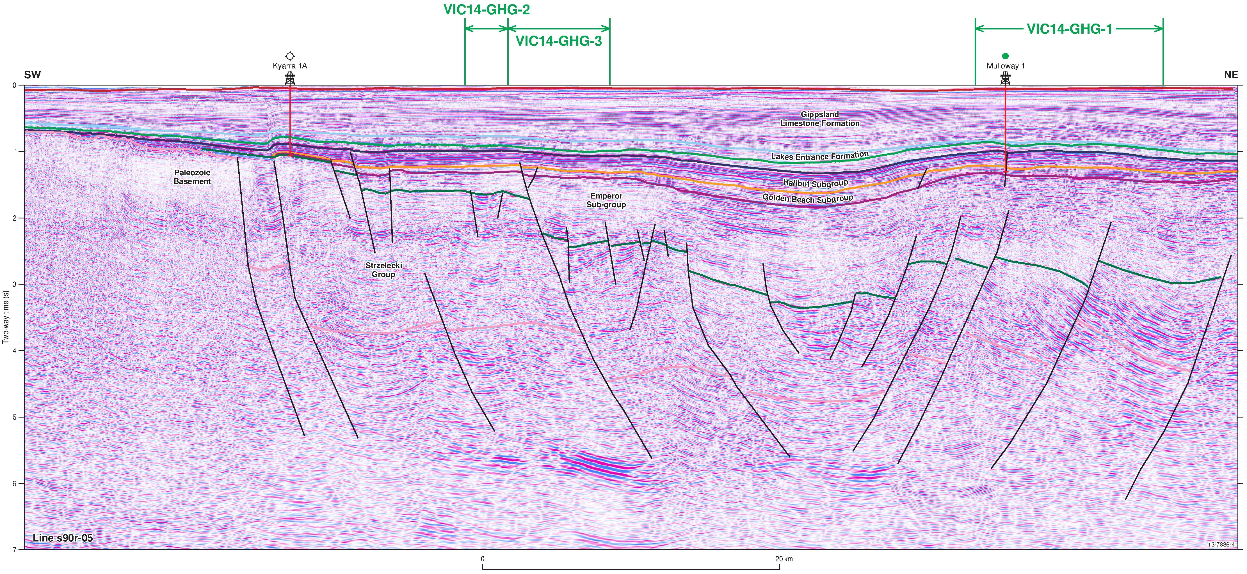
Figure 4 Seismic line s90r-05 across the Southern Terrace and Central Deep West. Location of the line is shown in Figure 2.

Geoscience Australia and Geological Survey of Victoria products

Regional Geology
- Australian Southern Margin Synthesis, Project GA707, Client report to Geoscience Australia by FrOG Tech Pty Ltd., 2009. GEOCAT 68892
- XYZ single and multibeam bathymetry grids of the Gippsland Basin, 2013. GEOCAT 78624
- Colwell, J.B. and Willcox, J.B. 1993. Regional Structure of the Gippsland Basin: Interpretation and Mapping of a Deep Seismic Data Set, Australian Geological Survey Organisation Record 1993/13.
- Maung, T.U. and Nicholas, E., 1990. A Regional Review of the Offshore Gippsland Basin. Bureau of Mineral Resources, Geology and Geophysics Report 297. GEOCAT 15209
- Blevin, J., Cathro, D., Nelson, G., Vizy, J. and Lee, J.D., 2013—Survey GDPI10 Interpretation Project, Southern Flank, Gippsland Basin. VicGCS Report 8, Department of Primary Industries
- Bernecker, T., Thomas, J.H. and Driscoll, J., 2003. Hydrocarbon Prospectivity of Areas V03-1, V03-2, 03-1(v) and 03-2(v), Offshore Gippsland Basin, Victoria, Australia. Victorian Initiative for Minerals and Petroleum Report 79, Department of Primary Industries.
- Chiupka, J.W., 1996. Hydrocarbon play fairway of the onshore Gippsland Basin, Victoria. Victorian Initiative for Minerals and Petroleum Report 30. Department of Natural Resources and Environment.
- Goldie Divko, L.M., O'Brien, G.W., Tingate, P.R. and Harrison, M.L., 2009a. Geological Carbon Storage in the Gippsland Basin, Australia: Containment Potential. GeoScience Victoria VicGCS Report 1. Department of Primary Industries.
- Goldie Divko, L.M., Campi, M.J., Tingate, P.R., O'Brien, G.W. and Harrison, M.L., 2009b. Geological Carbon Storage Potential of the Onshore Gippsland Basin, Victoria, Australia. GeoScience Victoria VicGCS Report 2. Department of Primary Industries.
- Goldie Divko L.M., O'Brien G.W., Harrison M.L. and Hamilton, P.J., 2010. Evaluation of the regional top seal in the Gippsland Basin; implications for geological carbon storage and hydrocarbon prospectivity. The APPEA Journal, 50(1), 463–486.
- Green C., Michael K. and Paterson L., 2012. Reservoir simulation of carbon dioxide geological storage in the Gippsland Basin. GeoScience Victoria VicGCS Report 5. Department of Primary Industries.
- Green C. and Paterson L., 2012. Reservoir simulation screening of the Seaspray Depression. GeoScience Victoria VicGCS Report 4. Department of Primary Industries.
- Miranda J. A., Hall D. L., Phiukhao W., O'Brien, G. W., Goldie Divko, L. M., Campi, M. J. and Tingate, P. R., 2012. Fluid inclusion volatile analysis in the Gippsland Basin: Implications for geological carbon storage. GeoScience Victoria VicGCS Report 6. Department of Primary Industries.
- Wong, D. and Bernecker, T., 2001. Prospectivity and hydrocarbon potential of area V01-4, Central Deep, Gippsland Basin, Victoria, Australia: 2001 Acreage Release. Victorian Initiative for Minerals and Petroleum Report 67. Department of Natural Resources and Environment.
- Woollands, M.A. and Wong, D. (eds), 2001. Petroleum Atlas of Victoria, Australia. Department of Natural Resources and Environment.

Stratigraphy
- Basin Biozonation and Stratigraphy Chart 40 – Gippsland Basin. GEOCAT 76687

Petroleum Systems and Accumulations
- The Oils of Eastern Australia, 2002. GEOCAT 68754
- South-eastern Australia Surface Geochemistry II: Light Hydrocarbon Geochemistry in Bottom-waters of the Gippsland Basin, Eastern Otway Basin, Torquay Sub-Basin and the Durroon Sub-Basin. Volumes 1 and 2. Australian Geological Survey Organisation Record 1992/54. GEOCAT 14562
- Southeast Gippsland Basin Hydrocarbon Prospectivity Package. Bureau of Mineral Resources, Geology and Geophysics Record 1991/09. GEOCAT 14395
- Australian Petroleum Accumulations Report. Gippsland Basin, Victoria, 1987. GEOCAT 37050
For Geoscience Australia products and for further information or to order these reports contact the Sales Centre: phone 61 (0)2 6249 9966, email sales@ga.gov.au
For Geological Survey of Victoria reports access the DSDBI online store at: http://dpistore.efirst.com.au/

