


Northern Endeavour phase 1 decommissioning (EPBC ref 2022/09327)
  - 2025–26 Annual compliance report
1 August 2025 to 31 July 2026
Our purpose is to help the government build a better future for all Australians through enabling a productive, resilient and sustainable economy, enriched by science and technology.
| industry.gov.au



Acknowledgement of Country
Our department recognises the First Peoples of this Nation and their ongoing cultural and spiritual connections to the lands, waters, seas, skies, and communities.
We Acknowledge First Nations Peoples as the Traditional Custodians and Lore Keepers of the oldest living culture and pay respects to their Elders past and present. We extend that respect to all First Nations Peoples.
Artwork credit:
DISR Journey
2024
Chern’ee Sutton

​Copyright
© Commonwealth of Australia 2026
Ownership of intellectual property rights
Unless otherwise noted, copyright (and any other intellectual property rights, if any) in this publication is owned by the Commonwealth of Australia.

Creative Commons Attribution 4.0 International Licence CC BY 4.0
All material in this publication is licensed under a Creative Commons Attribution 4.0 International Licence, with the exception of:
- the Commonwealth Coat of Arms
- content supplied by third parties
- logos
- any material protected by trademark or otherwise noted in this publication.
Creative Commons Attribution 4.0 International Licence is a standard form licence agreement that allows you to copy, distribute, transmit and adapt this publication provided you attribute the work. A summary of the licence terms is available from https://creativecommons.org/licenses/by/4.0/. The full licence terms are available from https://creativecommons.org/licenses/by/4.0/legalcode.
Content contained herein should be attributed as Northern Endeavour phase 1 decommissioning (EPBC ref 2022/09327), 2025/26 Annual compliance report, 1 August 2025 to 31 July 2026, Australian Government Department of Industry, Science and Resources.
This notice excludes the Commonwealth Coat of Arms, any logos and any material protected by trademark or otherwise noted in the publication, from the application of the Creative Commons licence. These are all forms of property which the Commonwealth cannot or usually would not licence others to use.

Disclaimer
The purpose of this publication pursuant to the Environment Protection and Biodiversity Conservation Act 1999 is to provide an Annual Compliance Report regarding Phase 1 decommissioning of the Northern Endeavour floating production, storage and offloading vessel (FPSO) during the reporting period of 1 August 2025 to 31 July 2026 (the Purpose).
The Commonwealth as represented by the Department of Industry, Science and Resources has exercised due care and skill in the preparation and compilation of the information in this publication.
The Commonwealth does not guarantee the accuracy, reliability or completeness of the information contained in this publication other than for the Purpose. Interested parties should make their own independent inquiries and obtain their own independent professional advice prior to relying on, or making any decisions in relation to, the information provided in this publication.
The Commonwealth accepts no responsibility or liability for any damage, loss or expense incurred as a result of the reliance on information contained in this publication. This publication does not indicate commitment by the Commonwealth to a particular course of action.
ISSN: 2982-1851

Figure 1: A tow boat giving a water cannon salute to the Northern Endeavour floating production, storage and offloading (FPSO) vessel. The FPSO was towed from the oilfields where it was moored for 26 years.
Contents
1. Declaration of accuracy 4
2. Approval holder details 5
3. Introduction 6
3.1. Foreword 6
3.2. Purpose 6
3.3. Background and location 7
3.4. Regulatory environment 8
3.5. Description of activities 9
3.6. Variation to conditions and management plans 10
4. Approval conditions 11
4.1. Part A – conditions specific to the action 11
4.2. Part B - Administrative conditions 14
5. Glossary 16
6. Attachment A – Conditions as varied on 13 April 2026 18
6.1. Approved action 18
7. Attachment B – Details of compliance with conditions of approval 19
7.1. Management plans 19
7.2. Discharge management 22
7.3. Invasive marine species management 25
7.4. Well management 27
7.5. Hazardous waste management 30
7.6. Notification of date of commencement of the action 32
7.7. Revision of action management plans 33
7.8. Compliance records 36
7.9. Annual compliance reporting 38
7.10. Reporting non-compliance 40
7.11. Independent audit 41
7.12. Completion of the action 43

Declaration of accuracy
In making this declaration, I am aware that sections 490 and 491 of the Environment Protection and Biodiversity Conservation Act 1999 (Cth) (EPBC Act) make it an offence in certain circumstances to knowingly provide false or misleading information or documents. The offence maybe punishable on conviction by imprisonment or a fine, or both. I declare that, to the best of my knowledge and belief, having made reasonable inquiries, the information and documentation supporting this compliance report is true and correct. I am authorised to bind the approval holder to this declaration, and I have no knowledge of that authorisation being revoked at the time of making this declaration.
Signed: SMcWhinney
Full name: Shane McWhinney
Position: General Manager, Northern Endeavour Branch
Organisation: Department of Industry, Science and Resources
ABN: 74 599 608 295
Date: 8 October 2026

Approval holder details
Approval holder: The Commonwealth of Australia as represented by the Department of Industry, Science and Resources
ABN: 74 599 608 295
Contact email: NEBranch@industry.gov.au
Address: National office: Industry House, 10 Binara Street, Canberra, ACT 2601

Figure 2: The crew of the Northern Endeavour FPSO on the helideck.

Introduction

3.1. Foreword
The Department of Industry, Science and Resources successfully completed phase 1 decommissioning activities during the reporting period of 1 August 2025 to 31 July 2026. This included disconnecting the Northern Endeavour floating production, storage and offloading vessel (FPSO) from the subsea infrastructure and towing to Singapore for additional works. The phase 1 lead contractor continues to monitor the Laminaria and Corallina oil fields for the department.
Phase 1 lead contractor Petrofac Facilities Management Limited appointed administrators on 28 October 2025. Petrofac continued delivering phase 1 decommissioning activities during the entire reporting period. On 9 April 2026, Petrofac’s asset solutions business arm, which was the registered operator of the FPSO, was acquired by Chicago Bridge & Iron Asset Solutions (CB&I). All associated management plans and approvals continue to name Petrofac as the registered operator. For the purposes of this report, Petrofac is referred to as CB&I.
The department was compliant with the Environment Protection and Biodiversity Conservation Act 1999 (EPBC Act) approval EPBC ref 2022/09327 Northern Endeavour Phase 1 Decommissioning (the approval) during the reporting period. CB&I implemented the management plans and complied with the conditions throughout. The department took a proactive approach in maintaining compliance with the approval conditions and met all reporting requirements. The department applied and maintained rigorous internal measures of review to ensure the success of the Northern Endeavour phase 1 decommissioning work.
The department and CB&I maintained a series of detailed management plans to be activated if an incident, non-compliance or emergency occurred. The department maintained a Northern Endeavour crisis management team (CMT), along with CB&I’s incident management team (IMT), to be ready to activate in case of an emergency.

3.2. Purpose
On 1 August 2023, the Department of Climate Change, Energy, the Environment and Water (DCCEEW) gave EPBC Act approval of the ‘Northern Endeavour Phase 1 Decommissioning’ to the department. This was subject to 34 conditions.
Condition 20 of the approval states that the approval holder (the department) must provide an annual compliance report. This report covers the department’s compliance with all conditions of approval for the reporting period. This reporting period runs from 1 August 2025 to 31 July 2026. This report was prepared by the department to meet the Annual Compliance Report Guidelines (DCCEEW 2023), as per condition 21.
On 1 July 2026, the National Environmental Protection Agency (National EPA) was established. EPBC Act responsibilities and reporting requirements have transitioned to National EPA, with these changes reflected within this report.
The Commonwealth of Australia is the approval holder for EPBC ref 2022/09327 as represented by the department (ABN 74 599 608 295).

3.3. Background and location
The Northern Endeavour FPSO was a 274 m long FPSO facility that was permanently moored, approximately 500 km northwest of Darwin in the Timor Sea. The operational area was 5,219 hectares. On 24 September 2025, the FPSO was disconnected from its moorings and towed from the Laminaria and Corallina oil fields to Singapore.
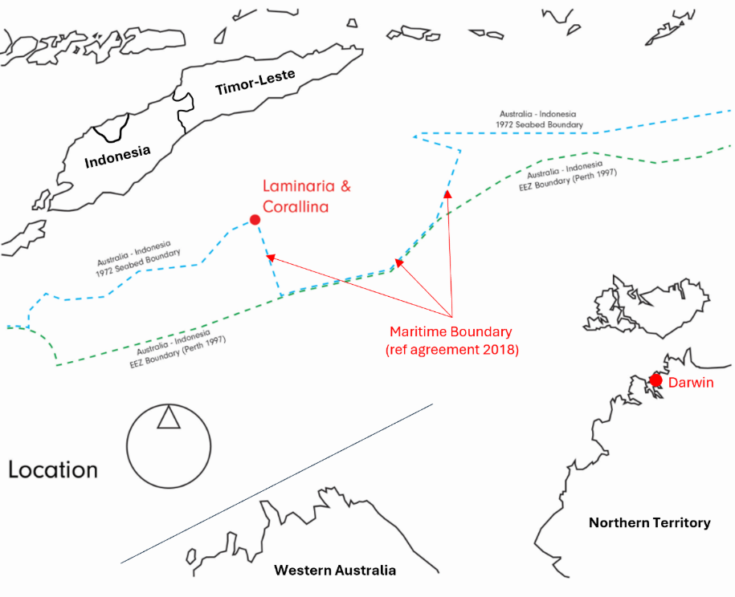
Figure 3: Location of the Laminaria and Corallina oil fields.
The Offshore Petroleum Laminaria and Corallina Decommissioning Cost Recovery Levy recovers the costs of decommissioning and remediation from the oil and gas industry.
Decommissioning is a standard ‘end of life’ practice and legal obligation in the offshore petroleum industry. The Commonwealth took responsibility for the Northern Endeavour in 2020 and began planning its decommissioning. The department aims to complete the decommissioning work efficiently and safely, ensuring value for money while protecting the surrounding environment.
The department is managing the decommissioning program across 3 phases:
- Phase 1: Temporarily suspend the subsea wells, flush subsea infrastructure, disconnect from the subsea equipment, tow and recycle the FPSO.
- Phase 2: Permanently plug and abandon the subsea wells.
- Phase 3: Remove subsea infrastructure and remediate the Laminaria and Corallina oil fields.
The Commonwealth of Australia, represented by the department, submitted a referral under the EPBC Act to DCCEEW on 8 August 2022. The referral was for routine operations and maintenance operations and phase 1 decommissioning activities. The delegate to the Minister for the Environment and Water, the Hon Tanya Plibersek MP, decided that the action was a Controlled Action requiring assessment under the EPBC Act on 24 November 2022.
The following provisions of the EPBC Act were used to determine the action was a controlled action:
- Sections 18 and 18A – listed threatened species and communities
- Sections 20 and 20A – listed migratory species
- Section 28 – Commonwealth actions.
On 1 August 2023, the delegate issued an approval with 34 conditions for the action, under the title ‘Northern Endeavour Phase 1 Decommissioning' (EPBC ref 2022/09327).
The department completed phase 1 decommissioning activities during the reporting period of 1 August 2025 to 31 July 2026. As the program transitions to phase 2, CB&I continues to monitor the Laminaria and Corallina oil fields for the department. Ongoing monitoring ensures well integrity is being maintained after the wells were temporarily suspended during phase 1. This is in accordance with the approval.

3.4. Regulatory environment
The Northern Endeavour decommissioning program is delivered under a different regulatory environment to typical industry decommissioning activities. Normally offshore decommissioning activities are regulated under the Offshore Petroleum and Greenhouse Gas Storage Act 2006 (OPGGS Act). The National Offshore Petroleum Safety and Environmental Management Authority (NOPSEMA) is the regulator under this legislation.
Under the OPGGS Act, oil and gas companies are ‘titleholders’ and are responsible for decommissioning offshore facilities. The Commonwealth is not a titleholder, so environmental approvals for the program come under the National EPA as the current regulator of the EPBC Act. The former regulator, DCCEEW, held this responsibility from the date of approval to 1 July 2026. This change in the regulatory environment means that names, and in some cases content, of reports and management plans are different to standard oil and gas industry practice.

3.5. Description of activities
The EPBC Act approval states that it enables the department:
‘to undertake routine operations and maintenance operations (lighthouse operations and short-term well injections) and Phase 1 decommissioning activities of the Northern Endeavour floating production and storage offtake facility and its associated Laminaria and Corallina resource fields to enable towing.’
The following is an outline of key engineering and operational activities from this reporting period:
- Disconnecting the FPSO from subsea infrastructure –
  - Stage 1 of the disconnection campaign was initiated in the previous reporting period. This included commencement of disconnection of the FPSO from subsea infrastructure, FPSO hull cleaning, surveys and annual inspection, maintenance and repair campaign and emergency management exercises.
  - Stage 2 involved the Skandi Singapore support vessel cutting the 9 mooring chains that anchored the FPSO to the seabed. The FPSO then departed the operational area in September 2025. During this stage, 127 buoyancy modules were recovered, and a general visual survey was conducted of the field. Stage 2 offshore works commenced on 21 July 2025 and were completed on 24 September 2025.
  - Stage 3 involved the Skandi Hercules support vessel removing the final 124 buoyancy modules. Stage 3 offshore works commenced on
20 December 2025 and were completed on 28 December 2025.
- FPSO hull cleaning – this activity commenced in the previous reporting period. The hull cleaning was successfully completed during this reporting period on 7 August 2025.
- Underwater survey – a survey was conducted following the completion of well suspension activities in July 2025 and again in December 2025 specifically for the Corallina-3 well. Regular underwater surveys will be conducted in accordance with the NOPSEMA accepted Well Risk Management Plan to ensure well integrity is maintained.
- FPSO wet tow – The Normand Sirius and the Skandi Emerald towed the FPSO to Singapore for further works before its recycling. The FPSO departed the Laminaria and Corallina oil fields on 24 September 2025.
- Arrival in Singapore – The FPSO arrived in Singapore and was anchored at the mooring on 14 October 2025.

3.6. Variation to conditions and management plans
During the reporting period, the department requested one variation to the approval conditions. Condition 7 was varied to allow greater flexibility in underwater well monitoring.
The previous condition required underwater surveys to be conducted annually following completion of well suspension activities. The variation introduces the flexibility to conduct these surveys either annually or at a frequency based on the results of a risk assessment. This ensures the ongoing integrity of the wells is verified throughout the life of the approval. The EPBC Act approval states:
‘The approval holder must complete an underwater survey after the well suspension activities are completed, and again annually, or as determined by a risk assessment conducted in accordance with the NOPSEMA accepted Well Risk Management Plan (WRMP), thereafter for the duration of this approval, to verify that integrity of the wells is being maintained.’
This variation request was approved by the delegate for the Minister for the Environment on 13 April 2026.

Figure 4: The Normand Sirius towing the Northern Endeavour FPSO to Singapore.

4.6.1 Administrative updates to approved management plans
During the reporting period, the department notified DCCEEW of the following administrative changes to management plans:
- Request to remove reference to the phrase ‘un-crewed’ towing from the Environment Risk Management Plan (ERMP). This request was to align with the correction notice to the approval (as published on the EPBC Public Portal on
12 August 2025). This request was submitted on 20 August 2025 and approved by DCCEEW on 21 August 2025 for implementation of the revision on
29 August 2025.
- Revision of the Source Control Emergency Response Plan (SCERP) to reflect that the source control measures have changed after the FPSO left the field.

Approval conditions
The department was compliant with all the conditions of approval throughout the reporting period. The following sections outline how the department complied with each condition. Additional detail is available in Attachment B.

4.1. Part A – conditions specific to the action

4.1.1. Management plans – condition 1
The department, through its lead contractor CB&I, applied the following management plans during the reporting period.

4.1.1.1. Environment risk management plan
This management plan was revised during the reporting period as detailed in section 3.6.1.
The ERMP describes:
- management controls
- environmental performance standards (EPS)
- environmental performance outcomes (EPO).
These controls reduce environmental impacts and risks to as low as reasonably practicable and ensure no significant environmental impact.
All planned phase 1 operational activities outlined in the ERMP were completed during this reporting period. One exception is the ongoing monitoring of the subsea wells and infrastructure captured by Condition 7. The department will continue ongoing monitoring for the duration of this approval.

4.1.1.2. Waste management plan
The waste management plan (WMP) outlines mandatory waste management requirements based on applicable legislation. It also provides guidance for the crew of the FPSO and support vessels on how to manage waste offshore. The WMP ensures offshore waste is managed in a controlled and appropriate manner to minimise health, safety and environmental impacts.
Once the FPSO arrived in Singapore, the WMP was no longer applicable. All activities covered by the plan have been completed with no further waste to be managed. No ongoing obligations remain.

4.1.1.3. FPSO riser and mooring disconnection methodology
This methodology outlines how lead contractor, CB&I, disconnected the FPSO from the risers and moorings.
The FPSO was disconnected from the subsea infrastructure on 24 September 2025 prior to departing the field. All activities under the FPSO Riser and Mooring Disconnection Methodology have been completed. No ongoing obligations remain.

4.1.1.4. Chemical management procedure
This procedure details the management processes for all chemicals used during regular maintenance and decommissioning of the FPSO. It includes how products are selected, used and managed.
As all operational activities under phase 1 have been completed, the Chemical Management Procedure is no longer applicable. No ongoing obligations remain.

4.1.1.5. Oil pollution emergency plan
The oil pollution emergency plan (OPEP) outlines the department and CB&I’s readiness and response arrangements for worst-case oil spill scenarios.
The OPEP remains current and available for implementation should an oil pollution emergency occur. The risk of an oil pollution event is considered low following completion of the well suspension campaign on 12 February 2025.

4.1.1.6. Three decommissioning project emergency response plans
These 3 decommissioning project emergency response plans are only activated in an incident or emergency.

4.1.1.6.1. Emergency response and communications plan
The emergency response and communications plan (ERCP) supports incident or business interruption management. It gives the lead contractor’s IMT and the department’s CMT the information needed to respond effectively.
The ERCP remains relevant and will be implemented should an incident or business interruption occur.

4.1.1.6.2. Emergency response plan
The emergency response plan (ERP) details procedures for managing and responding to emergencies on the FPSO. The ERP outlines the responsibilities and lines of communication during an incident. As the FPSO has left the operational area, the ERP is no longer applicable. No ongoing obligations remain.

4.1.1.6.3. Source control emergency response plan
This management plan was revised during the reporting period as detailed above in Section 3.6.1.
The SCERP outlines a plan to re-establish well control after an unlikely loss of containment event. The focus is to re-establish control safely and efficiently and to minimise risk to people, environment and assets.
The SCERP remains current and available for implementation in the unlikely event of an emergency.

4.1.2. Discharge management – conditions 2 and 3
During the reporting period, CB&I took samples from different depth horizons in the slops tanks onboard the FPSO. The samples were sent to a National Association of Testing Authorities (NATA) accredited laboratory for testing. The laboratory analysed the samples for toxicant concentrations and radioactivity as outlined in the conditions. An independent and suitably qualified marine environmental water quality expert reviewed the results. CB&I only discharged after receiving notice that the results met the requirements of this condition.
With all operational activities under phase 1 completed, no ongoing obligations remain under conditions 2 and 3.

4.1.3. Invasive marine species management – condition 4

4.1.3.1 FPSO
The FPSO was removed from the operational area during this reporting period. A marine biosecurity risk assessment (MBRA) was prepared by suitably qualified independent environmental consultants. The department submitted the MBRA to DCCEEW during the previous reporting period on 25 July 2025. The department implemented the MBRA during the tow of the FPSO to Singapore.
Prior to the tow of the FPSO, the department consulted with relevant domestic and international regulators regarding invasive marine species biosecurity in relation to the FPSO.
With all operational activities under phase 1 completed, no ongoing obligations remain under condition 4.

4.1.4. Well management – conditions 5–9
A temporary well suspension campaign was successfully completed on 12 February 2025 as outlined in the 2024–25 Annual Compliance Report. The effective barriers will remain in place until the wells are permanently plugged and abandoned. This will occur during phase 2 of the program.
An underwater survey was completed during the previous reporting period in July 2025. The survey verified the integrity of all the wells, confirming they were all successfully suspended.
Condition 7 requires further underwater surveys to be completed. As outlined in
section 3.6, this condition was varied during this reporting period. Surveys after the well suspension activities will be completed annually or as determined by a risk assessment. The risk assessment will be conducted in accordance with the NOPSEMA accepted WRMP.
Well suspension activities were completed in the previous reporting period and were included in the 2024–25 Annual Compliance Report.
Conditions 6 and 9 were closed in the previous reporting period and are no longer applicable. No ongoing obligations remain.
Conditions 5, 7 and 8 remain open, with activities ongoing to meet the relevant requirements.

4.1.5. Hazardous waste management – conditions 10–12
The department developed a draft inventory of hazardous materials (IHM) as outlined in the 2024–25 Annual Compliance Report. The IHM was provided to Seatrium, the designated recipient, prior to the departure of the FPSO from the operational area.
The department obtained relevant permits prior to departure from the operational area.
With all operational activities under phase 1 completed, conditions 10 to 12 were completed and closed during the reporting period. No ongoing obligations remain.

4.2. Part B - Administrative conditions

4.2.1. Notification of date of commencement of the action – conditions 13–14
Conditions 13 and 14 were completed and closed as outlined in the 2023–24 Annual Compliance Report.

4.2.2. Revision of action management plans – conditions
14A–14F
During this reporting period, the department revised 2 approved action management plans as outlined in the requirements of approval conditions 14A to 14F and condition 7. Details can be found above in Section 3.6.1.
Conditions 14A to 14F remain open.

4.2.3. Compliance records – conditions 15–19
The department and lead contractor CB&I kept accurate and complete records of compliance with the conditions of approval for this reporting period. This includes documentation that shows compliance with activities outlined in approved action management plans.
Under the requirements of condition 19, the department notified National EPA on 6 August 2026 that no monitoring data was required to be kept or reported following the end of the reporting period. National EPA confirmed receipt of this notification on 7 August 2026.
With all operational activities under phase 1 completed, conditions 17 to 19 were completed and closed during this reporting period. No ongoing obligations remain.
Conditions 15 and 16 remain open with activities ongoing to meet the relevant requirements.

4.2.4. Annual compliance reporting – conditions 20–23
This report was prepared by the department for the period 1 August 2025 to
31 July 2026. The EPBC approval requires the report to be published on the department’s website by 23 October 2026, 60 days from the end of the reporting period.
All reports were prepared according to the Annual Compliance Report Guidelines (DCCEEW 2023).
Table 1: Dates DCCEEW notified of publication for all reporting periods.
Reporting period | Date DCCEEW notified
1 August 2023 to 31 July 2024 | 23 October 2024
1 August 2024 to 31 July 2025 | 24 October 2025
1 August 2025 to 31 July 2026 | Pending. Approval requires notification within 5 business days of publication.
All notifications to DCCEEW were within 5 business days of publication on the department’s website. The publication of all Annual Compliance Reports was maintained on the department’s website.
Conditions 20 to 23 remain open with activities ongoing to meet the relevant requirements.

4.2.5. Reporting non-compliance – conditions 24–26
There were no events of non-compliance with a condition or a commitment in an approved action management plan during this reporting period. No notifications were made to DCCEEW.

Conditions 24 to 26 remain open, with obligations continuing to be managed and implemented as required.

4.2.6. Independent audit – conditions 27–30
The department did not develop an audit report or engage an independent auditor for this reporting period.
Conditions 27 to 30 remain open with activities ongoing to meet the relevant requirements.

4.2.7. Completion of the action – conditions 31–34
The FPSO completed disconnection activities and departed the operational area during this reporting period. The department notified DCCEEW when:
- CB&I completed the disconnection works
- the designated recipient received the FPSO in Singapore.
With all operational activities under phase 1 completed, conditions 31 and 32 were completed and closed during this reporting period. No ongoing obligations remain.
Conditions 33 and 34 remain open with compliance obligations continuing until expiry of the approval or completion of the action.

Glossary
Abbreviation | Description
AEI | Annual Environmental Inspection
AMMF | Adaptive Monitoring and Management Framework
AMMP | Adaptive Monitoring and Management Plan
CB&I | Chicago Bridge & Iron Company
CMP | Chemical Management Procedure
CMT | Crisis Management Team
Designated recipient | The person, entity or party who receives the FPSO at the agreed location for reuse, recycling, scrapping or other purpose.
DCCEEW | Department of Climate Change, Energy, the Environment and Water
DISR | Department of Industry, Science and Resources
EPBC Act | Environment Protection and Biodiversity Conservation Act 1999
EPO | Environmental Performance Outcome
EPS | Environmental Performance Standard
ERCP | Emergency Response and Communications Plan
ERMP | Environment Risk Management Plan
ERP | Emergency Response Plan
EVR | Environmental Verification Review
FPSO | Floating Production Storage and Offloading vessel
IHM | Inventory of Hazardous Material
IMS | Invasive Marine Species
IMT | Incident Management Team
MBRA | Marine Biosecurity Risk Assessment
NATA | National Association of Testing Authorities
National EPA | National Environmental Protection Agency
NOPSEMA | National Offshore Petroleum Safety and Environmental Management Authority
NORM | Naturally Occurring Radioactive Materials
OPEP | Oil Pollution Emergency Plan
OPGGSA | Offshore Petroleum and Greenhouse Gas Storage Act 2006
RAMP | Revised Action Management Plan
Reporting period | The year beginning from 1 August 2025 to 31 July 2026
ROV | Remotely Operated Vehicle
SCERP | Source Control Emergency Response Plan
SURF | Subsea Umbilical, Riser and Flowline
WMP | Waste Management Plan

Attachment A – Conditions as varied on 13 April 2026
On 13 April 2026, the delegate to the Minister for the Environment and Water at the time, the Hon Tanya Plibersek MP, varied condition 7 of the approval under section 143 of the Environment Protection and Biodiversity Conservation Act 1999 (EPBC Act) for the action under the title ‘Northern Endeavour Phase 1 Decommissioning’ (EPBC ref 2022/09327).

6.1. Approved action
Approval holder | The Commonwealth of Australia as represented by the Department of Industry, Science and Resources.  ABN: 74 599 608 295
Action | To undertake routine operations and maintenance operations (lighthouse operations and short-term well injections) and phase 1 decommissioning activities of the Northern Endeavour floating production and storage offtake facility and its associated Laminaria and Corallina resource fields to enable towing.  See EPBC ref 2022/09327.
Variation of conditions attached to approval | The variations are:  - Revision of condition 7  - Revision of NOPSEMA definition.
Date of effect | These variations have effect on the date this instrument is signed.

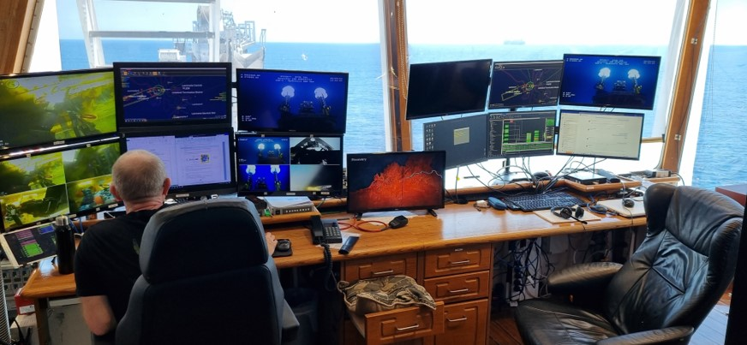
Figure 5: Crew review footage from a remote operated vehicle undertaking inspections.

Attachment B – Details of compliance with conditions of approval

7.1. Management plans
Condition number | Condition | Compliance | Evidence/comments
1) | To prevent, mitigate and manage harm to protected matters, the approval holder must implement the following management plans from the date of this approval notice until the expiry date of this approval, except where the implementation of these plans is superseded by other requirements of this approval.  Note: If there is a contradiction between a requirement in the oil pollution emergency plan or in the 3 decommissioning project emergency response plans and a requirement in any other plan, the requirement of the oil pollution emergency plan and the 3 decommissioning project emergency response plans takes precedence over any contrary requirement of any other plan.
1a) | The environment risk management plan (ERMP) | Compliant | The ERMP remained in effect during the reporting period and was implemented in accordance with the following approved revisions:  - D08 (18 June 2025)  - D09 (29 August 2025).  This compliance assessment is based on the implementation of the relevant approved ERMP for the reporting period.  The department and lead contractor, CB&I, complete a monthly environmental verification review (EVR) of compliance with the environmental performance outcomes (EPOs) and environmental performance standards (EPSs).  This is documented with evidence collected and validated for each open EPO and EPS. CB&I retains this information in compliance records.  Note: All phase 1 operational activities, including those outlined in the ERMP, concluded during this reporting period. Ongoing surveillance and monitoring of the subsea wells and infrastructure continue following the FPSO’s disconnection.
1b) | The waste management plan (WMP) | Compliant | Activities covered by the WMP are captured in a monthly offshore environment inspection form. This information is used as supporting evidence for the EVR. Primary activities are also captured as EPS within the ERMP.  Note: All phase 1 operational activities concluded during this reporting period. This management plan is no longer applicable and no ongoing obligations remain.
1c) | The FPSO riser and mooring disconnection methodology | Compliant | The FPSO was disconnected from the subsea infrastructure on 24 September 2025 prior to departing the field.  The FPSO riser disconnection was undertaken in the previous reporting period and is included in the 2024–25 Annual Compliance Report.  The mooring disconnection was completed in this reporting period.  All activities under the FPSO riser and mooring disconnection methodology have been completed.  Note: All phase 1 operational activities concluded during this reporting period. This methodology is no longer applicable and no ongoing obligations remain.
1d) | The chemical management procedure (CMP) | Compliant | The CMP details the management processes for all chemicals used during regular maintenance and decommissioning of the FPSO. It includes how products are selected, used and managed.  CB&I undertake verification and validation of assessments as part of the EVR for the previous month.  Note: All phase 1 operational activities concluded during this reporting period. This management plan is no longer applicable and no ongoing obligations remain.
1e) | The oil pollution emergency plan (OPEP) | Compliant | The OPEP remains current and available for implementation should an oil pollution emergency occur.  It was not required to be implemented during this reporting period.
1f) | The 3 decommissioning project emergency response plans | Compliant | The 3 decommissioning project emergency response plans remain current and are ready for implementation. There was no requirement to implement any of these plans during this reporting period.  The source control emergency response plan (SCERP) was revised during the reporting period to reflect that the source control measures have changed after the FPSO left the field under the following approved revision:  - D02 (7 July 2026)  There are no specific EPOs or EPSs relating to activities outlined in these plans.

7.2. Discharge management
Condition number | Condition | Compliance | Evidence/comments
2) | To mitigate harm to protected matters from toxicants within the slops tank discharge, the approval holder must, through regular monitoring, ensure: |  | Note: All phase 1 operational activities concluded during this reporting period. All discharges ceased in September 2025, prior to the FPSO disconnection and tow. Condition 2 was closed during the reporting period with no ongoing obligations remaining.
2a) | The slops tank discharge does not exceed a mercury concentration of 0.1 µg/L at the point of discharge at all times. | Compliant | A NATA-accredited laboratory analysed batch samples. An independent, suitably qualified water quality expert reviewed the results and confirmed compliance with this condition before discharge.  The department maintains a log of laboratory reports for each batch.
2b) | The slops tank discharge does not exceed radioactivity levels of 35 Bq/g at all times. | Compliant | An onshore laboratory analysed batch samples for radioactivity levels. An independent, suitably qualified water quality expert reviewed the results and confirmed compliance with this condition before discharge.  The department maintains a log of laboratory reports for each batch.
2c) | Water 100m and beyond from the slops tank discharge point does not exceed the default guideline values for all toxicants. | Compliant | A NATA-accredited laboratory analysed batch samples. An independent, suitably qualified water quality expert reviewed the results and confirmed compliance with this condition before discharge.  The independent water quality expert conducted dispersion modelling to confirm alignment with marine water quality guidelines.  The department maintains a log of laboratory reports for each batch.
2d) | Ensure that representative samples from different depth horizons in the slops tank (near top, middle and near bottom) are obtained and analysed for concentrations of all toxicants that will be discharged, except for NORMs, by a NATA accredited laboratory prior to any batch discharges from the slops tank. | Compliant | CB&I developed and implemented a sampling and analysis process to achieve compliance with this condition.  A NATA-accredited laboratory analysed batch samples. An independent, suitably qualified water quality expert reviewed the results and confirmed compliance with this condition before discharge.  The department maintains a log of laboratory reports for each batch.
3) | To mitigate and remediate harm to protected matters from toxicants within the slops tank discharge, if the slops tank discharge exceeds the allowable toxicant concentrations and radioactivity levels specified in condition 2, then the approval holder must immediately cease all discharges from the slops tank and prepare and submit to the department an adaptive monitoring and management framework (AMMF). The AMMF must: | Not applicable | An AMMF was not required during this reporting period.  Batch sample analysis and an independent review confirmed compliance with the discharge criteria outlined in condition 2. There were no discharges undertaken before these activities confirmed compliance.  Note: All phase 1 operational activities concluded during this reporting period. Condition 3 was closed and is no longer applicable. No ongoing obligations remain.
3a) | Detail the default guideline value exceedance (date, time, measured toxicant concentration, allowable toxicant concentration that was exceeded, distance from the slops tank discharge point and location of the exceedance). | Not applicable | Not applicable
3b) | Specify remediation measures to be implemented to reduce the toxicant concentration and/or radioactivity of slops tank discharges to meet the requirements of condition 2. | Not applicable | Not applicable
3c) | Not be inconsistent with the water quality guidelines. | Not applicable | Not applicable
3d) | Have been reviewed by an independent and suitably qualified marine environmental water quality expert. | Not applicable | Not applicable
3e) | Include an acknowledgement of the independent review and show how any advice from the independent review has been addressed. | Not applicable | Not applicable
3f) | The approval holder must implement the AMMF and ensure that the requirements of condition 2 are being met before allowing any further slops tank water to be discharged. | Not applicable | Not applicable

Figure 6: The Skandi Emerald towing the Northern Endeavour from the operational area to Singapore.

7.3. Invasive marine species management
Condition number | Condition | Compliance | Evidence/comments
4) | To minimise harm to protected matters from the potential introduction of invasive marine species, prior to removing the FPSO, the offtake hose, or any other submerged equipment from the operational area, the approval holder must: |  | Note: All phase 1 operational activities concluded during this reporting period. The FPSO was removed from the operational area on 24 September 2025.  The preparation and submission of the marine biosecurity risk assessment (MBRA) for the FPSO was included in the 2024–25 Annual Compliance Report.  Condition 4 was completed and closed during this reporting period. No ongoing obligations remain.
4a) | Engage an independent suitably qualified marine biosecurity expert to complete a marine biosecurity risk assessment (MBRA) in respect of the FPSO, the offtake hose and any other submerged equipment to be towed from the operational area. | Not applicable | Not applicable
4b) | Submit the MBRA to the department. | Not applicable | Not applicable
4c) | Consult with all relevant authorities and obtain all relevant approvals and permits with respect to invasive marine species biosecurity. | Compliant | The department and CB&I engaged with the Singapore National Environment Agency and the Maritime and Port Authority of Singapore.  The department and CB&I complied with all applicable jurisdictional requirements including:  - maintaining a valid ship sanitation certificate  - implementing a ballast water management plan  - meeting electronic pre-arrival notification (ePAN) obligations.
4d) | The MBRA must specify the measures required to prevent the introduction of invasive marine species to sensitive benthic habitats and marine protected areas as a result of the action. The approval holder must implement the MBRA until the expiry date of this approval. | Compliant | The measures outlined in the MBRA for the FPSO were implemented throughout the tow of the FPSO to Singapore.
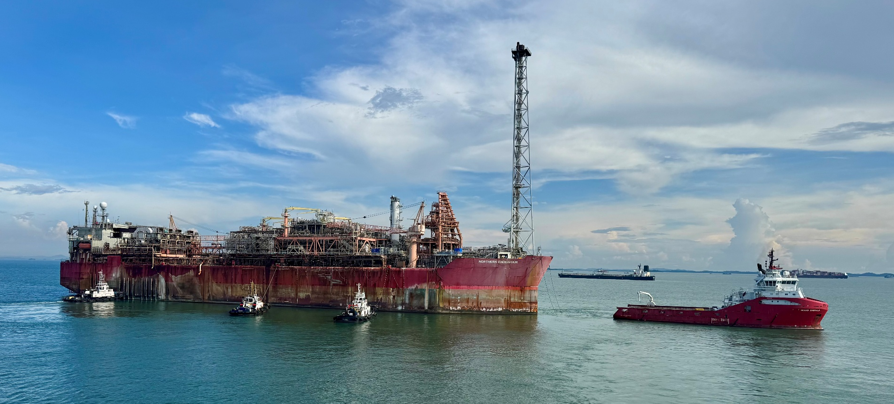
Figure 7: The Skandi Emerald and tugboats anchoring the Northern Endeavour FPSO at the mooring location in Singapore Harbour.

7.4. Well management
Condition number | Condition | Compliance | Evidence/comments
5) | The approval holder must leave all effective barriers in all wells, to prevent the escape of petroleum, water and any other substance from the wells, and ensure integrity is maintained until such time as the department notifies the approval holder in writing that the department is reasonably satisfied that the wells are permanently plugged or closed off. | Compliant | Note: Well suspension activities were completed in the previous reporting period and were included in the 2024–25 Annual Compliance Report.  All effective well barriers have been left in place following the well suspension activities.
6) | Within 5 business days following the completion of well suspension activities, the approval holder must notify the department electronically of the date of completion of well suspension activities. | Not applicable | Note: Well suspension activities were completed in the previous reporting period and were included in the 2024–25 Annual Compliance Report.  Condition 6 was closed in the previous reporting period and is no longer applicable. No ongoing obligations remain.
7) | The approval holder must complete an underwater survey after the well suspension activities are completed, and again annually, or as determined by a risk assessment conducted in accordance with the NOPSEMA accepted well risk management plan, thereafter for the duration of this approval, to verify that integrity of the wells is being maintained.  Condition varied 13 April 2026 | Compliant | Note: Well suspension activities were completed in the previous reporting period and were included in the 2024–25 Annual Compliance Report.  An underwater survey was conducted after the completion of the well suspension activities in July 2025.
8) | Should an underwater survey required by condition 7, or any other observation, show that the well suspension activities have failed, the approval holder must: | Not applicable | Note: Well suspension activities were completed in the previous reporting period and were included in the 2024–25 Annual Compliance Report.  An underwater survey was completed in July 2025 during the previous reporting period. The survey verified the integrity of all the wells, confirming they were all successfully suspended.  Condition 8 is not applicable as there was no failure of the well suspension activities.
8a) | Within one calendar day of discovering that the completed well suspension activity having failed, notify the department that the well suspension activity has failed to prevent the escape of petroleum, water or any other substance (whichever applies). | Not applicable | Not applicable
8b) | Begin implementing an adaptive monitoring and management programme (AMMP) to stop the further failure from the well within one calendar day of the well suspension activity failure having been identified. | Not applicable | Not applicable
8c) | Notify the department electronically when the AMMP was implemented. | Not applicable | Not applicable
8d) | Continue to implement the AMMP at least until no further failure of the well can be detected. | Not applicable | Not applicable
8e) | Within 6 months from the day of identifying that well suspension activities have failed, or a longer period if agreed to by the department in writing, verify that the implemented AMMP has successfully stopped failure. | Not applicable | Not applicable
8f) | Within 5 calendar days of ceasing to implement the AMMP, notify the department in writing of the date on which it ceased implementing the AMMP. | Not applicable | Not applicable
9) | If the approval holder identifies a new risk that could increase the chance of failure of any wells before well suspension activities are completed, the approval holder must implement an AMMP to address the identified risk. The approval holder must implement the AMMP: | Not applicable | Note: Well suspension activities were completed in the previous reporting period and were included in the 2024–25 Annual Compliance Report.  Condition 9 was closed in the previous reporting period and is no longer applicable. No ongoing obligations remain.
9a) | Until the expiry date of this approval. | Not applicable | Not applicable
9b) | Until the approval holder receives written advice from the department that the AMMP no longer needs to be implemented. | Not applicable | Not applicable
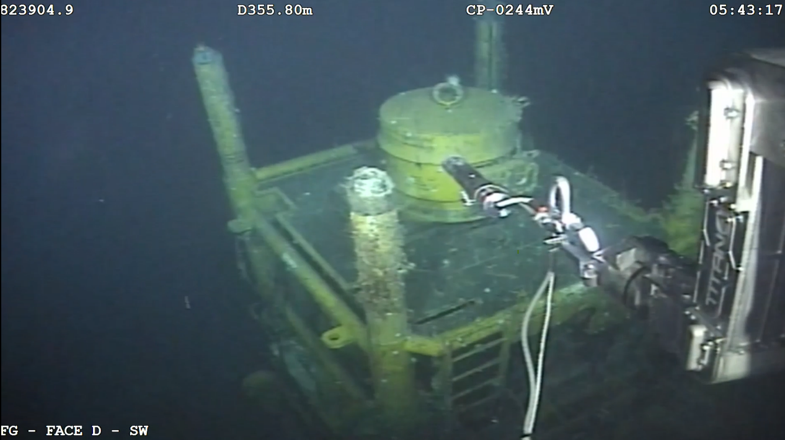
Figure 8: A remote operated vehicle completing a visual inspection of a Corallina wellhead.

7.5. Hazardous waste management
Condition number | Condition | Compliance | Evidence/comments
10) | To minimise harm to protected matters from the potential inadequate management of hazardous wastes, the approval holder must: |  | Note: All phase 1 operational activities concluded during this reporting period. Condition 10 was closed and is no longer applicable. No ongoing obligations remain.
10a) | Have established an inventory of all hazardous waste remaining on the facility, suitably quantified and characterised, prior to the FPSO departing the operational area. this must include, but not be limited to: | Compliant | An inventory of hazardous materials (IHM) report was prepared prior to the FPSO disconnection and tow to Singapore.  The IHM report was updated following the works undertaken in Singapore.
10a) i. | Packaged solid, or liquid waste material (including plastics). | Compliant | As listed in IHM report.
10a) ii. | Any residual process and treatment chemical inventories stored on the facility. | Compliant | As listed in IHM report.
10a) iii. | Solids, liquids and sludges contained in facility piping, vessel and tanks. | Compliant | As listed in IHM report.
10a) iv. | Specifically, material containing mercury, NORM(s), or other hazardous materials identified as part of the proposed activities. | Compliant | As listed in IHM report.
10a) v. | Any material of a category listed in Annex III of the Basel Convention. | Compliant | As listed in IHM report.
10b) | Obtain any necessary permits or approvals for the transportation, import or export of such waste, as required by international or domestic conventions, protocols or legislative instruments, including the Commonwealth Hazardous Waste (Regulation of Exports and Imports) Act 1989 and the Basel Convention, prior to the FPSO departing the Operational Area. | Compliant | The department obtained all relevant permits for transit from the operational area through to Singapore.
11) | The approval holder must inform the designated recipient (at the agreed location) of the FPSO of the quantities and nature of the hazardous waste that will be present on the FPSO, prior to the FPSO departing the operational area. | Compliant | The department and CB&I provided the IHM to Seatrium, the designated recipient, prior to the departure of the FPSO from the operational area.  Note: All phase 1 operational activities concluded during this reporting period. Condition 11 was closed and is no longer applicable. No ongoing obligations remain.
12) | If the approval holder does not deliver the FPSO to the designated recipient (at the agreed location) themselves, and the FPSO is to be delivered to the agreed location by a creditor, then the approval holder must take all reasonable steps to communicate the requirements of this approval notice to the creditor. The requirements of this approval notice must be included in contractual or other handover arrangements between the approval holder and the creditor. | Not applicable | As the approval holder, the department delivered the FPSO to the designated recipient, Seatrium.  Note: All phase 1 operational activities concluded during this reporting period. Condition 12 was closed and is no longer applicable. No ongoing obligations remain.
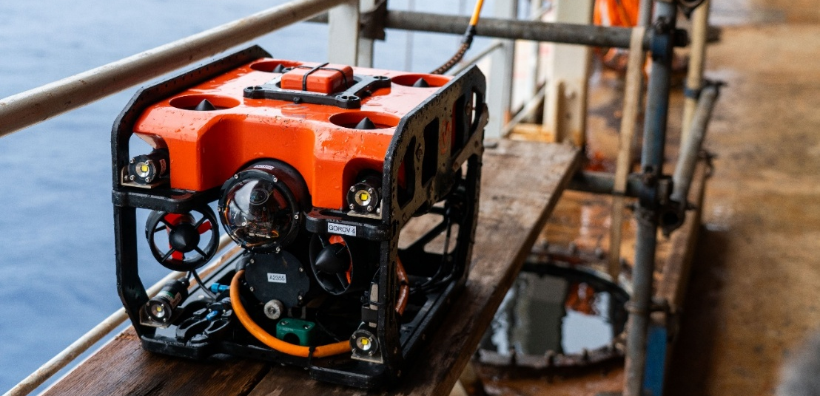
Figure 9: A small remote operated vehicle ready to be lowered into a storage tank onboard the Northern Endeavour FPSO to complete inspections.

7.6. Notification of date of commencement of the action
Condition number | Condition | Compliance | Evidence/comments
13) | The approval holder must notify the department electronically of the date of commencement of the action, within 5 business days following commencement of the action. | Not applicable | Note: The department notified DCCEEW via email on 8 August 2023 that the approved action had commenced.  With the approved action having commenced, condition 13 was completed and closed during the 2023–24 reporting period. It was included in the 2023–24 Annual Compliance Report. No ongoing obligations remain.
14) | If the commencement of the action does not occur within 5 years from the date of this approval, then the approval holder must not commence the Action without the prior written agreement of the Minister. | Not applicable | Note: The department notified DCCEEW via email on 8 August 2023 that the approved action had commenced.  With the approved action having commenced, condition 14 was completed and closed during the 2023–24 reporting period. It was included in the It was included in the 2023–24 Annual Compliance Report. No ongoing obligations remain.

Figure 10: Rope access technicians preparing the Northern Endeavour FPSO hull for departure from the oilfields.

7.7. Revision of action management plans
Condition number | Condition | Compliance | Evidence/comments
14A) | The approval holder may, at any time, apply to the Minister for a variation to an action management plan approved by the Minister by submitting an application in accordance with the requirements of section 143A of the EPBC Act. If the Minister approves a revised action management plan (RAMP) then, from the date specified, the approval holder must implement the RAMP in place of any previous version of the action management plan. | Not applicable | No variation to an action management plan was required to be submitted for approval under condition 14A during this reporting period.
14B) | The approval holder may choose to revise an action management plan specified in condition 1 without submitting it for approval under section 143A of the EPBC Act, if the taking of the Action in accordance with the RAMP would not be likely to have a new or increased impact. | Compliant | - The department implemented a revised ERMP on  29 August 2025 after submitting it to DCCEEW on  20 August 2025, in line with an agreed date confirmed in writing.  - The department submitted a revised SCERP to DCCEEW on 5 June 2026 and implemented it on 7 July 2026.
14C) | If the approval holder makes the choice under condition 14B) to revise an action management plan without submitting it for approval, the approval holder must:
14C a) | Notify the department electronically that the approved action management plan has been revised and provide the department with: | Compliant | All RAMP notifications to DCCEEW included this information.
14C a) i | An electronic copy of the RAMP. | Compliant | All RAMP notifications to DCCEEW included this information.
14C a) ii | An electronic copy of the RAMP marked up with track changes to show the differences between the approved action management plan and the RAMP. | Compliant | All RAMP notifications to DCCEEW included this information.
14C a) iii | An explanation of the differences between the approved action management plan and the RAMP. | Compliant | All RAMP notifications to DCCEEW included this information.
14C a) iv | The reasons the approval holder considers that taking the Action in accordance with the RAMP would not be likely to have a new or increased impact. | Compliant | All RAMP notifications to DCCEEW included this information.
14C a) v | Written notice of the date on which the approval holder will implement the RAMP (RAMP implementation date), being at least 20 business days after the date of providing notice of the revision of the action management plan, or a date agreed to in writing with the department. | Compliant | All RAMP notifications to DCCEEW included this information.
14C b) | Subject to condition 14D, implement the RAMP from the RAMP implementation date. | Compliant | The department implemented all RAMPs either 20 business days after providing notice or on a date agreed in writing with DCCEEW.
14D) | The approval holder may revoke its choice to implement a RAMP under condition 14B at any time by giving written notice to the department. If the approval holder revokes the choice under condition 14B, the approval holder must implement the action management plan in force immediately prior to the revision undertaken under condition 14B. | Not applicable | The department did not revoke the choice to implement a RAMP in this reporting period.
14E) | If the Minister notifies the approval holder that the Minister is satisfied that the taking of the Action in accordance with the RAMP would be likely to have a new or increased impact, then: | Not applicable | No RAMP had a new or increased impact.
14E a) | Condition 14B does not apply, or ceases to apply, in relation to the RAMP. | Not applicable | No RAMP had a new or increased impact.
14E b) | The approval holder must implement the action management plan specified by the Minister in the notice. | Not applicable | No RAMP had a new or increased impact.
14F) | At the time of giving the notice under condition 14E), the Minister may also notify that for a specified period of time, condition 14B does not apply for one or more specified action management plans. | Not applicable | No RAMP had a new or increased impact.
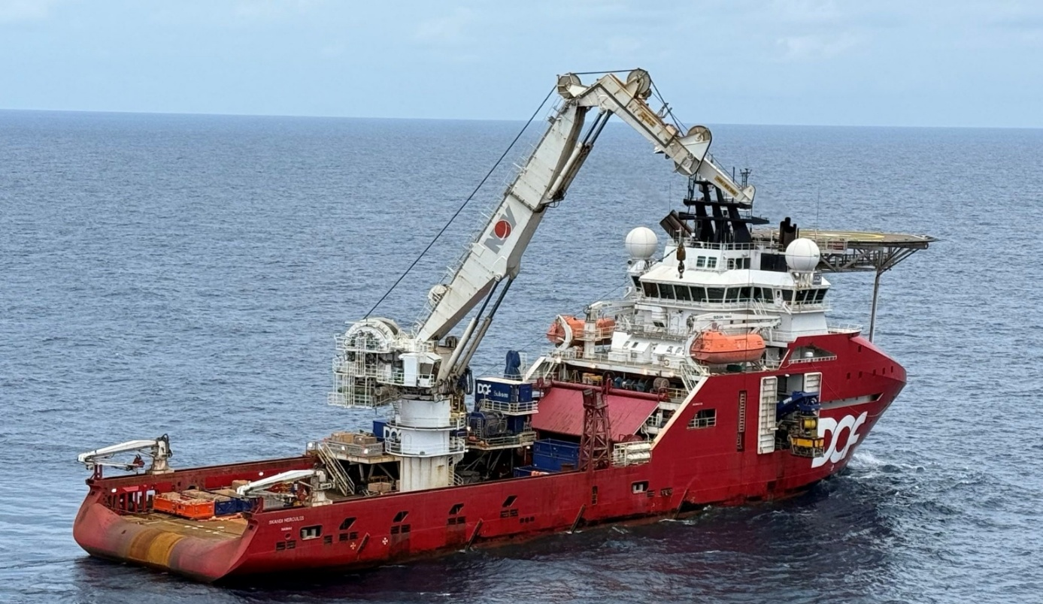
Figure 11: The Skandi Hercules launching a remote operated vehicle to cut the risers connecting the Northern Endeavour FPSO to the subsea infrastructure.

7.8. Compliance records
Condition number | Condition | Compliance | Evidence/comments
15) | The approval holder must maintain accurate and complete compliance records. | Compliant | The department and CB&I maintained accurate and complete compliance records.
16) | If the department makes a request in writing, the approval holder must provide electronic copies of compliance records to the department within the timeframe specified in the request. | Not applicable | There was no request for providing electronic copies of compliance records during this reporting period.
17) | The approval holder must ensure that any monitoring data (including sensitive ecological data), surveys, maps, and other spatial and metadata required under the conditions of this approval are prepared in accordance with the Guidelines for biological survey and mapped data, Commonwealth of Australia 2018, or as otherwise specified by the Minister in writing. | Not applicable | The department and CB&I did not need to prepare or submit any monitoring data, surveys, maps, spatial data, or metadata to DCCEEW during this reporting period.  Note: With all operational activities under phase 1 completed condition 17 was completed and closed during this reporting period. No ongoing obligations remain.
18) | The approval holder must ensure that any monitoring data (including sensitive ecological data), surveys, maps, and other spatial and metadata required under the conditions of this approval are prepared in accordance with the Guide to providing maps and boundary data for EPBC Act projects, Commonwealth of Australia 2021, or as otherwise specified by the Minister in writing. | Not applicable | The department and CB&I did not need to prepare or submit any monitoring data, surveys, maps, spatial data, or metadata to DCCEEW during this reporting period.  Note: With all operational activities under phase 1 completed condition 18 was completed and closed during this reporting period. No ongoing obligations remain.
19) | The approval holder must submit all monitoring data (including sensitive ecological data), surveys, maps, other spatial and metadata and all species occurrence record data (sightings and evidence of presence) electronically to the department within 20 business days of each anniversary of this approval decision. | Compliant | The department notified National EPA on 6 August 2026 that no monitoring data was required to be kept or reported following the end of the reporting period.  Note: With all operational activities under phase 1 completed condition 19 was completed and closed during this reporting period. No ongoing obligations remain.

Figure 12: The Northern Endeavour FPSO lit up at sunset in the Laminaria Corallina oil fields.

7.9. Annual compliance reporting
Condition number | Condition | Compliance | Evidence/comments
20) | The approval holder must prepare a compliance report for each 12-month period following the date of this approval decision, or as otherwise agreed to in writing by the Minister. | Compliant | The department has prepared this compliance report for the period 1 August 2025 to 31 July 2026.
21) | Each compliance report must be consistent with the Annual Compliance Report Guidelines, Commonwealth of Australia 2023. | Compliant | This compliance report has been prepared and published consistent with the Annual Compliance Report Guidelines, (DCCEEW 2023).
22) | Each compliance report must include:
22 a) | Accurate and complete details of compliance and any non-compliance with the conditions and any incidents. | Compliant | This report includes details of any incident and potential non-compliance during the reporting period.
23) | The approval holder must:
23 a) | Publish each compliance report on the website within 60 business days following the end of the 12-month period for which that compliance report is required. | Compliant | The department published this report on its website on 23 October 2026. This was within 60 business days of the end of the reporting period.  This compliance report has been prepared and published consistent with the Annual Compliance Report Guidelines, (DCCEEW 2023).
23 b) | Notify the department electronically, within 5 business days of the date of publication that a compliance report has been published on the website. | Compliant | The department will notify National EPA within 5 business days of publishing the Annual Compliance Report for the 1 August 2025 to 31 July 2026 reporting period.
23 c) | Provide the weblink for the compliance report in the notification to the department. | Compliant | The department will include a weblink to the published report in the notification of publication sent to National EPA.
23 d) | Keep all published compliance reports required by these conditions on the website until the expiry date of this approval | Compliant | All published compliance reports have been maintained on the department’s website.
23 e) | Exclude or redact sensitive ecological data from compliance reports published on the website or otherwise provided to a member of the public. | Not applicable | This compliance report contained no sensitive ecological data that needed exclusion or redaction before publication on the department’s website or provided to a member of the public.
23 f) | If sensitive ecological data is excluded or redacted from the published version, submit the full compliance report to the department within 5 business days of its publication on the website and notify the department in writing what exclusions and redactions have been made in the version published on the website. | Not applicable | This compliance report contained no sensitive ecological data that needed exclusion or redaction before publication on the department’s website or provided to a member of the public.

Figure 13: A crane lifting retrieved buoyancy modules from the cut risers alongside the Northern Endeavour FPSO.

7.10. Reporting non-compliance
Condition number | Condition | Compliance | Evidence/comments
24) | The approval holder must notify the department electronically, within 2 business days of becoming aware of any incident and/or potential non-compliance and/or actual non-compliance with the commitments made in a plan that require reporting, or with any of the conditions of this notice. | Compliant | There have been no notifications of any incidents and/or potential non-compliance and/or actual non-compliance during this reporting period.
25) | The approval holder must specify in the notification:
25 a) | Any condition or commitment made in a plan which has been or may have been breached. | Not applicable | There have been no notifications during the reporting period.
25 b) | A short description of the incident and/or potential non-compliance and/or actual non-compliance. | Not applicable | There have been no notifications during the reporting period.
25 c) | The location (including co-ordinates), date and time of the incident and/or potential non-compliance and/or actual non-compliance. | Not applicable | There have been no notifications during the reporting period.
26 | The approval holder must provide to the department in writing, within 12 business days of becoming aware of any incident and/or potential non-compliance and/or actual non-compliance, the details of that incident and/or potential non-compliance and/or actual non-compliance with the conditions or commitments. The approval holder must specify: | Not applicable | There have been no notifications during the reporting period.
26 a) | Any corrective action or investigation which the approval holder has already taken. | Not applicable | There have been no notifications during the reporting period.
26 b) | The potential impacts of the incident and/or non-compliance. | Not applicable | There have been no notifications during the reporting period.
26 c) | The method and timing of any corrective action that will be undertaken by the approval holder. | Not applicable | There have been no notifications during the reporting period.

7.11. Independent audit
Condition number | Condition | Compliance | Evidence/comments
27) | The approval holder must ensure that an independent audit of compliance with the conditions is conducted for every 5-year period following the commencement of the Action until this approval expires, unless otherwise specified in writing by the Minister. | Not applicable | No audit was required to be conducted during the reporting period.
28) | For each independent audit, the approval holder must:
28 a) | Provide the name and qualifications of the nominated independent auditor, the draft audit criteria, and proposed timeframe for submitting the audit report to the department prior to commencing the independent audit. | Not applicable | No audit was required to be conducted during the reporting period.
28 b) | Only commence the independent audit once the nominated independent auditor, audit criteria and timeframe for submitting the audit report have been approved in writing by the department. | Not applicable | No audit was required to be conducted during the reporting period.
28 c) | Submit the audit report to the department for approval within the timeframe specified and approved in writing by the department. | Not applicable | No audit was required to be conducted during this reporting period.
28 d) | Publish each audit report on the website within 15 business days of the date of the department’s approval of the audit report. | Not applicable | No audit was required to be conducted during this reporting period.
28 e) | Keep every audit report published on the website until this approval expires. | Not applicable | No audit was required to be conducted during this reporting period.
29) | Each audit report must report for the 5-year period preceding that audit report. | Not applicable | No audit was required to be conducted during this reporting period.
30) | Each audit report must be completed to the satisfaction of the Minister and be consistent with the EPBC Act Independent Audit and Audit Report Guidelines, Commonwealth of Australia 2019. | Not applicable | No audit was required to be conducted during this reporting period.

Figure 14: The aft topsides and helideck of the Northern Endeavour FPSO from above.

7.12. Completion of the action
Condition number | Condition | Compliance | Evidence/comments
31) | The approval holder must notify the department in writing the date on which it removed the FPSO from the operational area within 5 business days of having removed the FPSO from the operational area. | Compliant | The FPSO left the operational area on  24 September 2025, and the department notified DCCEEW on 25 September 2025.  Note: With all operational activities under phase 1 completed, condition 31 was completed and closed during this reporting period. No ongoing obligations remain.
32) | The approval holder must notify the department in writing the date on which it delivered the FPSO to the designated recipient within 5 business days of having delivered the FPSO to the designated recipient. | Compliant | The designated recipient received the FPSO in Singapore on 14 October 2025, and the department notified DCCEEW on 16 October 2025.  Note: With all operational activities under phase 1 completed, condition 32 was completed and closed during this reporting period. No ongoing obligations remain.
33) | The approval holder must notify the department electronically 60 business days prior to the expiry date of this approval, that the approval is due to expire. | Not applicable | The approval is not due to expire in this reporting period.
34) | Within 20 business days after the completion of the Action, and, in any event, before this approval expires, the approval holder must notify the department electronically of the date of completion of the Action and provide completion data. The approval holder must submit any spatial data that comprises completion data as a shapefile. | Not applicable | The action has not been completed.

