

How to apply for an anti-circumvention inquiry (excluding avoidance of the intended effect of duty)
  - Instructions and guidelines for applicants
September 2026

| industry.gov.au/ATRC
Contents
Approval and version history 2
Purpose 3
Introduction 4
What is a circumvention activity 5
What is not a circumvention activity 5
Who can apply 6
How to apply 6
Information required by the application form 6
Supporting evidence 6
Guidance to Question 6 7
Assembly of parts in Australia 7
Example 1 – Goods covered by notice are assembled chairs from Country A 8
Assembly of parts in a third country 8
Example 2 – Goods covered by notice are assembled chairs from country A 9
Export of goods through one or more third countries 9
Example 3 – Goods covered by notice are assembled chairs from country A 10
Arrangements between exporters 11
Example 4 – Goods covered by notice are assembled chairs from Country A 12
Slight modification of goods 12
Example 5 – Goods covered by notice are non-alloyed galvanised steel exported from Country A 13
Guidance to Question 7 13
The inquiry process 14
The Act 15
Public record 15
Consideration of application 15
Submissions 15
Verification of information 15
Termination 15
Statement of essential facts 16
Report on anti-circumvention inquiry 16
Minister’s powers 16
Rights of review 16
Find out more 17

Approval and version history
Version | Change | Date | Approver
1.0 | Original version | March 2020 | Paul Sexton – General Manager Anti-Dumping Commission
1.1 | Contact details updated | October 2024 | Isolde Lueckenhausen – Acting Commissioner of the Anti-Dumping Commission
1.2 | Commission - name change update | September 2026 | Alistair McKay – Director, Australian Trade Remedies Commission

Purpose
This guide outlines the steps involved in applying to the Australian Trade Remedies Commission (the Commission) for an anti-circumvention inquiry into avoidance of the intended effect of duty.
Specifically, this guide sets out:
- who can apply
- how to apply
- information required by the application form;
- the inquiry process
- where to find more information.
Related policies and references include:
- How to apply for an anti-circumvention inquiry: avoidance of the intended effect of duty
- Dumping and Subsidy Manual

Introduction
Circumvention is a trade strategy used by exporters and/or importers of products to avoid either:
- the full payment of dumping and/or countervailing duties, or
- the price effect of the dumping and/or countervailing duties in the Australian market.
Circumvention activities take various forms and exploit different aspects of the anti-dumping system, but the outcome of these activities is that either:
- the relevant goods do not attract the intended dumping and/or countervailing duty, or
- the relevant goods attract dumping and/or countervailing duty, which is paid, but the payment of the duty does not have the intended price effect in the market (and therefore does not have the effect of removing the material injury caused by dumped and/or subsidised prices).
This guide outlines the steps involved in applying to the Commission for an anti-circumvention inquiry where the goods do not attract the intended dumping and/or countervailing duty (point (a) above).
For guidance on applying to the Commission for an anti-circumvention inquiry into the avoidance of the intended effect of duty (point (b) above), please refer to ‘How to apply for an anti-circumvention inquiry: avoidance of the intended effect of duty’.

What is a circumvention activity
Section 269ZDBB of the Customs Act 1901 (Cth) (the Act) sets out when circumvention activity, in relation to a notice published following an investigation under sections 269TG(2) or 269TJ(2) of the Act, occurs.

Prescribed circumvention activities are:
- assembly of parts in Australia
- assembly of parts in a third country
- export of goods through one or more third countries
- arrangements between exporters
- avoidance of the intended effect of duty, and
- slight modification of goods exported to Australia.
Greater detail on these activities (excluding avoidance of the intended effect of duty) is in the ‘information required by the application form’ section of these guidelines.

What is not a circumvention activity
Circumvention activities prescribed by the Act only relate to circumvention activities to avoid a dumping or countervailing duty notice and are not illegal or necessarily indicative of criminal behaviour. The Commission would not generally consider the following to be circumvention activities as prescribed under the Act:
- activities that relate to goods that are subject to a notice published under sections 269TG(1) or 269TJ(1) of the Act; and
- goods that have not attracted the intended dumping or countervailing duty due to false and misleading statements provided by importers on Import Declarations (i.e. where incorrect country codes (and country of export), tariff classifications / statistical codes or exemption types are knowingly used by importers).
If you suspect these activities are occurring, you may refer them to the Australian Border Force (ABF). The ABF may subsequently investigate these activities where they involve potential non-compliance with the Act.

Who can apply
A person representing, or representing a portion of, the Australian industry producing like goods can make an application for an anti-circumvention inquiry.

How to apply
You must use the approved application form (Form B1236 available on the Commission’s website). You must lodge the application form, together with the supporting evidence, in an approved manner (by post, email or SIGBOX).
The preferred method of lodging an application is to email applications to clientsupport@atrc.gov.au. Please include all supporting evidence with your application. If file sizes are too large to email, please contact the Commission to arrange access to SIGBOX, our secure online lodgement platform. Alternatively, you can post completed applications to the Commission. Refer to contact details.
You must provide a non-confidential version of the application, including supporting evidence.

Information required by the application form
An application must include a description of the:
- kind of goods that are the subject of the notice
- notice the subject of the application
- circumvention activity in relation to the notice that the applicant considers have occurred
- alterations to the notice that the applicant considers should be made.

Supporting evidence
If you are seeking an anti-circumvention inquiry based on one or more circumvention activities you must indicate this intention in the application form by ticking the relevant box(es).
The application form requires you to provide a statement setting out the reasons for alleging the circumvention activity is occurring, supported by relevant evidence. You should make sure your responses are as accurate and as comprehensive as possible. Simply asserting that circumvention activity has occurred is not sufficient.
Relevant evidence is required to support your claims that one or more circumvention activities has occurred.
Relevant evidence may include market intelligence (not just assertions), commercial documentation (including sales negotiation evidence, quotes, invoices, manufacturing certificates, Bills of Lading) obtained from exporters and importers (and assemblers).
The Commissioner must reject your application if not satisfied that the application contains all the required information, as outlined above, or if there does not appear to be reasonable grounds for your assertions.

Guidance to Question 6
Question 6 requires a description of the circumvention activities in relation to the notice that the applicant considers have occurred.
The following sections examine each of the prescribed circumvention activities (excluding avoidance of the intended effect of duty).

Assembly of parts in Australia
Circumvention activity in the form of ‘assembly of parts in Australia’ occurs if the following apply:
- goods in the form of individual parts (the circumvention goods) are exported to Australia;
- those parts are manufactured in a foreign country in respect of which the notice applies;
- those parts are assembled in Australia, whether or not with other parts, to create goods (the assembled goods) that would be the subject of the notice if they were exported to Australia by an exporter in respect of which the notice applies;
- the total value of the parts manufactured in that foreign country is a significant proportion of the value of the assembled goods;
- section 8 or 10 of the Dumping Duty Act, as the case requires, does not apply to the export of the circumvention goods to Australia.
This activity captures circumstances where parts representing a significant value of the assembled goods are manufactured in a country subject to the notice and exported to Australia as parts, which do not attract interim dumping or countervailing duty. The parts are then used in the manufacture of the assembled goods in Australia that would have been subject to interim dumping or countervailing duty had they been exported to Australia in the assembled state. The parts may be assembled in Australia with or without additional parts (regardless of whether these parts are sourced from Australia or other countries). Example 1 below illustrates this type of circumvention activity.

Example 1 – Goods covered by notice are assembled chairs from Country A
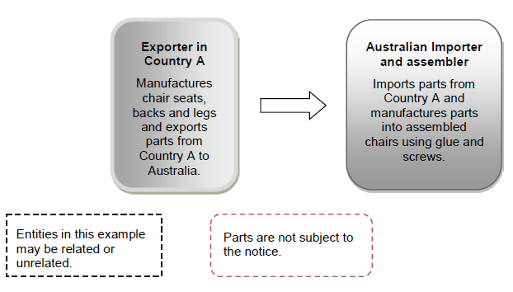
The Australian importer may not be the assembler and may on-sell the imported parts to the Australian assembler. This type of activity may also be considered ‘assembly of parts in Australia’.

Assembly of parts in a third country
Circumvention activity in the form of ‘assembly of parts in a third country’ occurs if the following apply:
- goods in the form of individual parts are manufactured in a foreign country (the original country) in respect of which the notice applies
- those parts are assembled in a foreign country in respect of which the notice does not apply, whether or not with other parts, to create goods (the circumvention goods) that would be the subject of the notice if they were exported to Australia by an exporter in respect of which the notice applies
- the circumvention goods are exported to Australia
- the total value of the parts manufactured in the original country is a significant proportion of the customs value (within the meaning of section 159) of the circumvention goods
- section 8 or 10 of the Dumping Duty Act, as the case requires, does not apply to the export of the circumvention goods to Australia.
This activity is similar to the ‘assembly of parts in Australia’ activity; however for this activity the assembly of the goods that would have been subject to the notice occurs in a third country. This third country is not subject to a dumping or countervailing duty notice. The goods are subsequently exported to Australia from the third country in their assembled state and do not attract interim dumping or countervailing duty. Example 2 below illustrates this type of circumvention activity.

Example 2 – Goods covered by notice are assembled chairs from country A

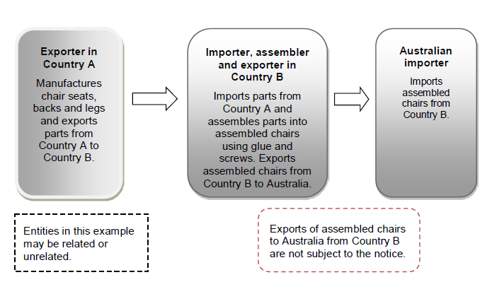

Export of goods through one or more third countries
Circumvention activity in the form of ‘export of goods through one or more third countries’ occurs if the following apply:
- goods (the circumvention goods) are exported to Australia from a foreign country in respect of which the notice does not apply
- before that export, there were one or more other exports of the goods from a foreign country to another foreign country
- the first of those other exports was from a foreign country in respect of which the notice applies
- the circumvention goods would be the subject of the notice if they were exported to Australia by an exporter in respect of which the notice applies
- section 8 or 10 of the Dumping Duty Act, as the case requires, does not apply to the export of the circumvention goods to Australia.
This activity covers circumstances where goods would have been subject to the notice had they been exported directly from their originating country that is subject to a notice. Instead, the goods are exported through one or more third countries that are not subject to the notice. These goods therefore do not attract interim dumping and / or countervailing duties. Example 3 below illustrates this type of circumvention activity.

Example 3 – Goods covered by notice are assembled chairs from country A
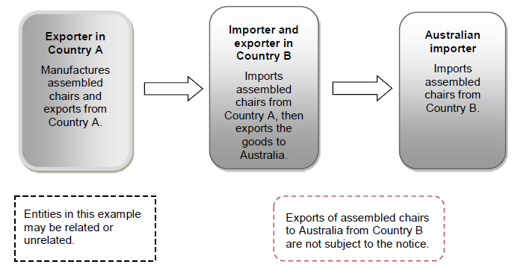

Arrangements between exporters
Circumvention activity in the form of ‘arrangements between exporters’ occurs if the following apply:
- goods (the circumvention goods) are exported to Australia from a foreign country in respect of which the notice applies
- the exporter exported the circumvention goods under an arrangement with another exporter from that foreign country
- the other exporter is an exporter in respect of which the notice applies
- the circumvention goods would be the subject of the notice if they were exported to Australia by the other exporter
either:
    - section 8 or 10 of the Dumping Duty Act, as the case requires, does not apply to the export of the circumvention goods to Australia; or
    - section 8 or 10 of the Dumping Duty Act, as the case requires, applies to the export of the circumvention goods to Australia, but the interim duty payable in relation to that export is less than the interim duty that would have been payable if the other exporter had exported the goods to Australia.
This activity covers circumstances where goods that are the subject of a notice are exported to Australia from the original exporter through another exporter in that originating country that is subject to a lesser rate of duty or is exempt from the notice. In this circumstance, either a lesser amount or no dumping or countervailing duty is applicable to the goods. Example 4 below illustrates this type of circumvention activity.

Example 4 – Goods covered by notice are assembled chairs from Country A
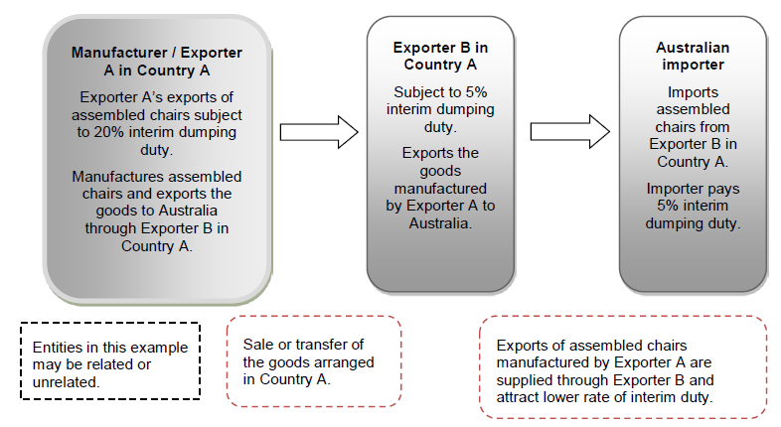

Slight modification of goods
Circumvention activity in the form of ‘slight modification of goods exported to Australia’ occurs if the following apply:
- goods (the circumvention goods) are exported to Australia from a foreign country in respect of which the notice applies;
- before that export, the circumvention goods are slightly modified;
- the use or purpose of the circumvention goods is the same before, and after, they are so slightly modified;
- had the circumvention goods not been so slightly modified, they would have been the subject of the notice;
- section 8 or 10 of the Dumping Duty Act, as the case requires, does not apply to the export of the circumvention goods to Australia.
To determine whether goods have been slightly modified, the circumvention goods must be compared to the goods that are the subject of the notice, by having regard to any relevant factor including the following non-exhaustive factors:
- each good’s general physical characteristics
- each good’s end use
- the interchangeability of each good
- differences in the processes used to produce each good
- differences in the cost to produce each good
- the cost of modification
- customer preferences and expectations relating to each good
- the way in which each good is marketed
- channels of trade and distribution for each good
- patterns of trade for each good
- changes in the pricing of each good
- changes in the export volumes for each good
- tariff classifications and statistical codes for each good

Example 5 – Goods covered by notice are non-alloyed galvanised steel exported from Country A

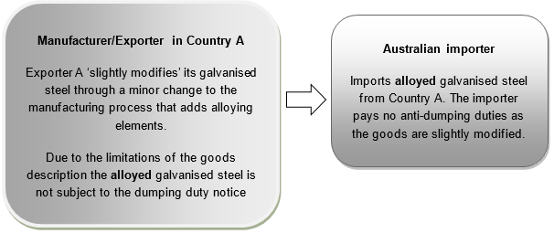

Guidance to Question 7
Question 7 requires a description of the alterations to the notice that the applicant considers should be made.
Section 269ZDBH(2) of the Act outlines the kinds of alterations that may be made to the notice by the Minister including the specification of:
- different goods that are to be the subject of the notice
- different foreign countries that are to be the subject of the notice
- different exporters that are to be the subject of the notice
- different variable factors in respect of existing exporters subject of the notice
- variable factors in relation to the different exporters that are to be the subject of the notice.
Variable factors are export price, normal value, non-injurious price and the countervailable subsidy in respect of the goods (as relevant).
Where relevant, the Commissioner will recommend to the Minister the most appropriate alteration to be made to the notice, and will have regard to the application in making that decision.

The inquiry process

The Act
The anti-circumvention inquiry process is prescribed in Division 5A, Part XVB of the Act.

Public record
The Commission maintains a public record for all anti-circumvention inquiries. A non-confidential version of the application, non-confidential submissions, the statement of essential facts (SEF) and all relevant correspondence will be included on the public record.

Consideration of application
The Commissioner must decide whether or not to reject the application within 20 days of lodgement of an application. The Commissioner must reject the application if not satisfied that:
- the requirements for an application have been met; and/or
- there appear to be reasonable grounds for asserting that one or more circumvention activities in relation to the notice have occurred.
The applicant will be notified of the Commissioner’s decision. If the Commissioner does not reject the application, a notice must be published indicating that an inquiry is to be conducted.

Submissions
Submissions in relation to an inquiry must be received within 37 days of the date of publication of the initiation notice. The Commissioner is not obliged to have regard to a submission received after the deadline, if to do so would prevent the timely placement of the SEF on the public record.
Interested parties must prepare non-confidential versions of submissions for placement on the public record. Information on preparing a submission is available on the Commission’s website.

Verification of information
The Commission may conduct on-site visits to verify information submitted by interested parties. Where on-site visits do not occur, desk audits may also be completed.

Termination
The Commissioner may terminate the inquiry, before publishing a SEF, if satisfied that no circumvention activity in relation to the notice has occurred. The Commissioner must give public notice of a decision to terminate an inquiry.

Statement of essential facts
A SEF must be placed on the public record within 110 days from the initiation of an inquiry. This timeframe can be extended.
The SEF contains the facts on which the Commissioner proposes to base a recommendation to the Minister in relation to the occurrence of a circumvention activity (which will also include recommendations for altering the notice).
Interested parties may lodge responses to the SEF within 20 days from placement of the SEF on the public record. The Commissioner is not obliged to have regard to a submission received after this period, if to do so would prevent the timely preparation of the report to the Minister.

Report on anti-circumvention inquiry
The Commissioner must give the Minister a report within 155 days recommending whether the notice should be altered, and if so, the alterations to be made. This timeframe can be extended.
The report must include a statement of the Commissioner’s reasons for any recommendation contained in the report that:
- sets out the material findings of fact on which that recommendation is based; and
- provides particulars of the evidence relied on to support those findings.

Minister’s powers
The Minister must, within 30 days of receiving the report, declare whether the notice should be altered, and if so, the alterations to be made. Notice of this decision will be published on the public record. If the Minister considers special circumstances exist, a longer period may be taken to make the declaration.

Rights of review
The Minister’s decision to alter or not alter the notice is reviewable by the
Anti-Dumping Review Panel. An interested party can apply for a review within 30 days from the publication of the Minister’s decision.
An applicant may also apply for a review of the Commissioner’s decision to terminate an anti-circumvention inquiry, within 30 days of receiving notice of the termination.
Parties may also be able to apply for review of the decision by the Federal Court of Australia.

Find out more
- Find out about accessing Australia’s trade remedies system
- Research the Dumping Commodity Register
- Small-medium enterprises can seek assistance from the ITRA Service by email itra@industry.gov.au or the ITRA Hotline (02) 6213 7267
- Contact the Anti-Dumping Commission by email clientsupport@atrc.gov.au or by business.gov.au on 13 28 46.

As prescribed in the Customs (International Obligations) Regulation 2015 (Cth).
These notices are dumping duty notices which apply retrospectively by converting dumping securities applicable to the goods the subject of an investigation into interim dumping duty.
Section 269ZDBD of the Act.
As defined under section 269T(1) of the Act.

