
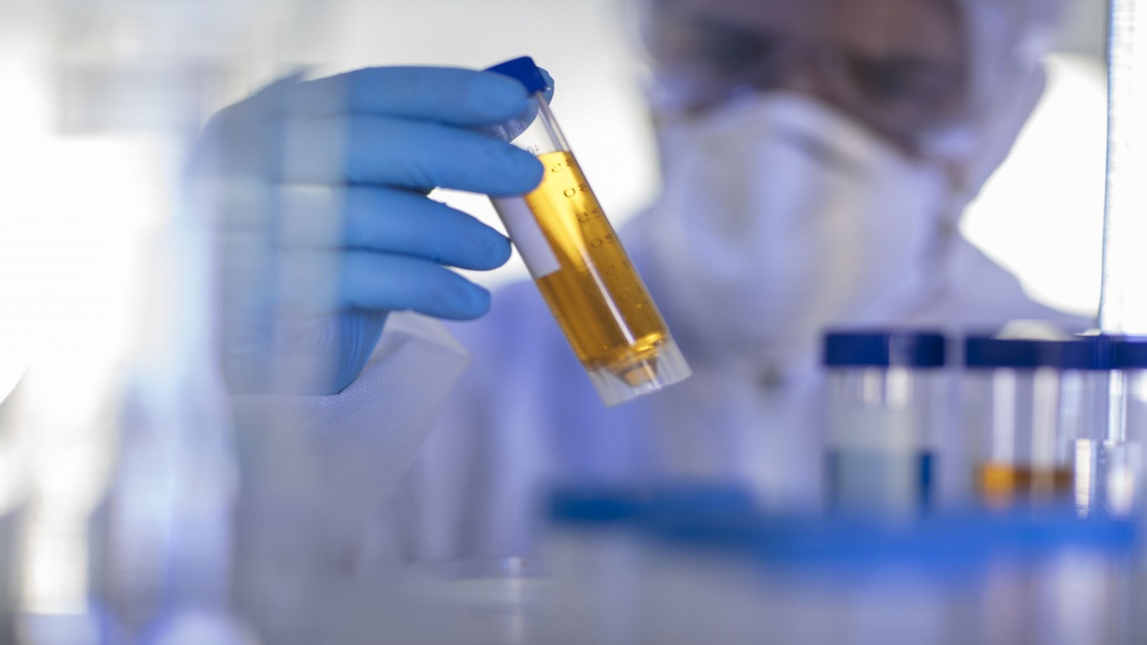

Clinical and Medical Laboratory Testing

Catalogue
January 2026
Quality reference materials for identification and calibration are essential to making accurate chemical measurements in clinical testing.

Category | Description | NMI reference | Unit of issue (mg) | Domestic Cost (A$) (excl GST) | International  Cost (A$)
Testosterone and metabolites | Testosterone | M914c | 10 | 121 | 169
Testosterone and metabolites | Testosterone glucuronic acid | D507d | 1 (ampoule) | 155 | 218
Testosterone and metabolites | Testosterone sulfate (Et₃N salt) | D508 | 1 (ampoule) | 121 | 169
Testosterone and metabolites | Epitestosterone | D547b | 1 (ampoule) | 121 | 169
Testosterone and metabolites | Epitestosterone glucuronide (Na salt) | S035 | 1 | 121 | 169
Testosterone and metabolites | Epitestosterone sulfate | D605 | 1 | 121 | 169
Testosterone and metabolites | 5α-Dihydrotestosterone | D680 | 10 | 121 | 169
Testosterone and metabolites | 5α-Dihydrotestosterone glucuronide free acid | S006 | 1 | 155 | 218
Testosterone and metabolites | 5α-Dihydrotestosterone sulfate | D609 | 1 | 121 | 169
Testosterone and metabolites | Androsterone | D550d | 1 | 121 | 169
Testosterone and metabolites | Androsterone glucuronide | D572b | 1 | 155 | 218
Testosterone and metabolites | Androsterone sulfate (Na⁺ salt) | D610b | 1 | 121 | 169
Testosterone and metabolites | Etiocholanolone | D551c | 1 (ampoule) | 121 | 169
Testosterone and metabolites | Etiocholanolone glucuronide (Na⁺ salt) | D607b | 1 | 155 | 218
Testosterone and metabolites | Etiocholanolone sulfate | D608 | 1 (ampoule) | 121 | 169
Testosterone and metabolites | 5α-Androstane-3α,17β-diol | D634b | 1 | 121 | 169
Testosterone and metabolites | 5α-Androstane-3α,17β-diol-17-β-glucuronic acid | S002 | 1 | 121 | 169
Testosterone and metabolites | 5α-Androstane-3β,17β-diol | D635 | 1 | 155 | 218
Testosterone and metabolites | 5β-Androstane-3α,17β-diol | D636 | 1 | 121 | 169
Testosterone and metabolites | 5β-Androstane-3α,17β-diol-3-β-glucuronic acid | S003c | 1 | 188 | 264
Testosterone and metabolites | 5β-Androstane-3β,17β-diol | D637 | 1 | 155 | 218
Deuterated internal standards of testosterone and metabolites | 16,16,17-d₃-Testosterone | D546 | 1 (ampoule) | 155 | 218
Deuterated internal standards of testosterone and metabolites | 16,16,17-d₃-Testosterone glucuronide (sodium salt) | S036 | 1 (ampoule) | 121 | 169
Deuterated internal standards of testosterone and metabolites | 16,16,17-d₃-Testosterone sulfate (Et₃N salt) | D506b | 1 (ampoule) | 155 | 218
Deuterated internal standards of testosterone and metabolites | d₃-Epitestosterone | D548 | 1 (ampoule) | 155 | 218
Deuterated internal standards of testosterone and metabolites | d₄-Epitestosterone | S001 | 1 (ampoule) | 155 | 218
Deuterated internal standards of testosterone and metabolites | d₃-Epitestosterone glucuronide | D604 | Exhausted | 208 | 319
Deuterated internal standards of testosterone and metabolites | d₃-Epitestosterone sulfate | D591 | 1 | 155 | 218
Deuterated internal standards of testosterone and metabolites | d₃-5α-Dihydrotestosterone | D552 | 1 | 155 | 218
Deuterated internal standards of testosterone and metabolites | d₃-5α-Dihydrotestosterone glucuronide free acid | D573b | 1 | 155 | 218
Deuterated internal standards of testosterone and metabolites | d₃-5α-Dihydrotestosterone sulfate | D590 | 1 | 155 | 218
Deuterated internal standards of testosterone and metabolites | d₄-Androsterone | D549 | 1 | 155 | 218
Deuterated internal standards of testosterone and metabolites | d₄-Androsterone glucuronic acid | D829g | 1 (ampoule) | 155 | 218
Deuterated internal standards of testosterone and metabolites | d₄-Androsterone sulfate | D587 | 1 | 155 | 218
Deuterated internal standards of testosterone and metabolites | d₅-Etiocholanolone | D528d | 1 (ampoule) | 121 | 169
Deuterated internal standards of testosterone and metabolites | d₅-Etiocholanolone sulfate | D606 | 1 | 155 | 218
Deuterated internal standards of testosterone and metabolites | d₃-5α-Androstane-3α,17β-diol | D593 | 1 | 155 | 218
Deuterated internal standards of testosterone and metabolites | d₃-5α-Androstane-3β,17β-diol | D594 | 1 | 155 | 218
Deuterated internal standards of testosterone and metabolites | d₅-5β-Androstane-3α,17β-diol | D580 | 1 | 155 | 218
Deuterated internal standards of testosterone and metabolites | d₅-5β-Androstane-3β,17β-diol | S014 | 1 | 121 | 169
Deuterated internal standards of testosterone and metabolites | 5α-Androstane-3β,17β-diol-3-β-glucuronic acid | D678b | 1 | 155 | 218
Deuterated internal standards of testosterone and metabolites | 5α-Androstane-3β-ol-17-one-3-glucuronide Na⁺ salt | S031 | 1 | 121 | 169
Deuterated internal standards of testosterone and metabolites | 17α-Hydroxyprogesterone | S041 | 20 | 121 | 169
Nandrolone and metabolites | Nandrolone | S038 | 10 | 121 | 169
Nandrolone and metabolites | 17β-Nandrolone glucuronide (K⁺ salt) | D861 | 1 | 228 | 319
Nandrolone and metabolites | 17β-Nandrolone sulfate (Na⁺ salt) | D809b | 1 | 121 | 169
Nandrolone and metabolites | 17α-Nandrolone (epi-nandrolone) | D722e | 1 (ampoule) | 121 | 169
Nandrolone and metabolites | 17α-Nandrolone sulfate | D783b | 5 | 121 | 169
Nandrolone and metabolites | 19-Norandrosterone | D555a | 1 (ampoule) | 121 | 169
Nandrolone and metabolites | 19-Norandrosterone glucuronide (Na⁺ salt) | D596a | 1 (ampoule) | 155 | 218
Nandrolone and metabolites | 19-Norandrosterone sulfate (Et₃N salt) | D841b | 1 (ampoule) | 121 | 169
Nandrolone and metabolites | 19-Noretiocholanolone | D554 | 1 (ampoule) | 121 | 169
Nandrolone and metabolites | 19-Noretiocholanolone glucuronide (Na salt) | D595a | 1 (ampoule) | 155 | 218
Deuterated internal standards of nandrolone and metabolites | d₃-17β-Nandrolone | D583 | 5 | 228 | 319
Deuterated internal standards of nandrolone and metabolites | d₃-17β-Nandrolone sulfate (Et₃N salt) | D782b | 1 (ampoule) | 155 | 218
Deuterated internal standards of nandrolone and metabolites | ¹³C₂-17β-Nandrolone | D679 | 5 | 188 | 264
Deuterated internal standards of nandrolone and metabolites | d₄-19-Norandrosterone | D584c | 1 (ampoule) | 155 | 218
Deuterated internal standards of nandrolone and metabolites | d₄-19-Norandrosterone glucuronide (Na⁺ salt)* | D898b | 1 | 121 | 169
Deuterated internal standards of nandrolone and metabolites | d₄-19-Noretiocholanolone | D742 | 1 (ampoule) | 155 | 218
Amphetamines | (±)-Amphetamine hydrochloride | D736c | 50 | 155 | 218
Amphetamines | (±)-Amphetamine sulfate | D420d | 50 | 121 | 169
Amphetamines | d-(+)-Amphetamine sulfate | D961 | 50 | 155 | 218
Amphetamines | (±)-4-Methylamphetamine hydrochloride | D895b | 10 | 188 | 264
Amphetamines | (±)-4-Methylmethamphetamine hydrochloride | D963 | 20 | 188 | 264
Amphetamines | (±)-Methamphetamine hydrochloride | D816g | 50 | 155 | 218
Amphetamines | S-(+)-Methamphetamine hydrochloride | D830b | 50 | 121 | 169
Amphetamines | (±)-3,4-Methylenedioxyamphetamine hydrochloride (MDA) | D842c | 50 | 121 | 169
Amphetamines | (±)-N-Methyl-3,4-methylenedioxyamphetamine hydrochloride (MDMA) | D792f | 50 | 155 | 218
Cocaine and related compounds | Benzoylecgonine tetrahydrate | D745c | 50 | 155 | 218
Cocaine and related compounds | Cocaine base | D826d | 50 | 155 | 218
Cocaine and related compounds | Cocaine hydrochloride | D747c | 20 | 155 | 218
Cocaine and related compounds | Ecgonine hydrochloride | D746b | 50 | 155 | 218
Cocaine and related compounds | Methyl ecgonine hydrochloride, monohydrate | D452c | 10 | 188 | 264
Ephedrine and related compounds | (+)-Ephedrine hemihydrate | M723 | 100 | 155 | 218
Ephedrine and related compounds | (-)-Ephedrine hydrochloride | M924 | 100 | 155 | 218
Ephedrine and related compounds | (-)-Ephedrine hydrochloride | M924b | 50 | 155 | 218
Ephedrine and related compounds | dl-Norephedrine hydrochloride (Phenylpropanolamine) | M296 | 100 | 121 | 169
Ephedrine and related compounds | (+)-Norpseudoephedrine hydrochloride (Cathine) | M297 | 50 | 121 | 169
Ephedrine and related compounds | p-Hydroxyephedrine hydrochloride (Oxilifrine hydrochloride) | D892b | 5 | 121 | 169
Ephedrine and related compounds | (-)-Methylephedrine hydrochloride | M243b | 20 | 121 | 169
Ephedrine and related compounds | dl-Norephedrine hydrochloride (Phenylpropanolamine) | M296 | 100 | 121 | 169
Ephedrine and related compounds | (+)-Norpseudoephedrine hydrochloride (Cathine) | M297 | 50 | 121 | 169
Ephedrine and related compounds | (-)-Pseudoephedrine base | D397 | 100 | 155 | 218
Ephedrine and related compounds | (+)-Pseudoephedrine hydrochloride | D775b | 50 | 121 | 169
Opiates | Acetylcodeine base | D821c | 50 | 188 | 264
Opiates | Buprenorphine base | D932 | 10 | 121 | 169
Opiates | Codeine base | D671b | 50 | 155 | 218
Opiates | d3-Codeine base | D673 | 1 | 155 | 218
Opiates | Codeine glucuronide | D694 | 0.1 | 155 | 218
Opiates | d3-Codeine glucuronide | D695 | 0.1 (ampoule) | 228 | 319
Opiates | Dihydrocodeine hydrogen tartrate | D823 | 50 | 155 | 218
Opiates | Heroin base | D752d | 50 | 121 | 169
Opiates | Hydrocodone | D988 | 20 | 121 | 169
Opiates | Hydromorphone hydrochloride | D785b | 20 | 121 | 169
Opiates | Methyl codeine | D924 | 10 | 121 | 169
Opiates | 3-Monoacetylmorphine sulfamate | D766c | 20 | 155 | 218
Opiates | 6-Monoacetylmorphine base | D777c | 20 | 121 | 169
Opiates | Morphine base monohydrate | D408e | 50 | 155 | 218
Opiates | d3-Morphine base monohydrate | D709 | 1 | 155 | 218
Opiates | Morphine sulfate | D925 | 50 | 155 | 218
Opiates | Noscapine (Narcotine) base | D831b | 50 | 155 | 218
Opiates | Noscapine (Narcotine) hydrochloride | D791b | 50 | 121 | 169
Opiates | Oxycodone | D987 | 20 | 155 | 218
Opiates | Oxymorphone | D1038 | 10 | 155 | 218
Opiates | Papaverine hydrochloride | D750b | 50 | 121 | 169
Opiates | Pholcodine | D539b | 20 | 155 | 218
Opiates | Thebaine base | D731b | 20 | 121 | 169
Miscellaneous | Caffeine | M724c | 50 | 155 | 218
Miscellaneous | Cannabidiol | D512c | 25 | 121 | 169
Miscellaneous | Ketamine hydrochloride | D686c | 50 | 155 | 218
Miscellaneous | Meperidine hydrochloride (pethidine) | D443b | 20 | 121 | 169
Miscellaneous | Methadone hydrochloride | D425b | 20 | 121 | 169
Miscellaneous | Salbutamol | M898c | 10 | 155 | 218
Miscellaneous | d₃-Salbutamol | D939 | 1 | 155 | 218
Miscellaneous | Selegiline hydrochloride | D822 | 50 | 155 | 218
Selective Androgen Receptor Modulators (SARMs) | Andarine | D1074 | 1 | 121 | 169
Selective Androgen Receptor Modulators (SARMs) | Cardarine | D1077 | 1 | 121 | 169
Selective Androgen Receptor Modulators (SARMs) | Ligandrol (LGD-4033) | D1073 | 1 | 121 | 169
Selective Androgen Receptor Modulators (SARMs) | MK-677 | D1078 | 1 | 121 | 169
Selective Androgen Receptor Modulators (SARMs) | Ostarine | D1075 | 5 | 121 | 169
Selective Androgen Receptor Modulators (SARMs) | RAD 140 | D1076 | 1 | 121 | 169
Synthetic Cannabinoids | AM1220 1-[(1-Methylpiperidin-2-yl)methyl]-3-(1-naphthoyl)-indole | D982 | 20 | 121 | 169
Synthetic Cannabinoids | AM2201 [1-(5-Fluoropentyl)-3-(1-napthoyl)-indole] | D983 | 20 | 121 | 169
Synthetic Cannabinoids | JWH-018 [N-Pentyl-3-(1-naphthoyl)indole] | D955 | 20 | 155 | 218
Synthetic Cannabinoids | JWH-210 [N-Pentyl-3-(4-ethyl-1-naphthoyl)indole] | D984 | 5 | 121 | 169
Synthetic Cannabinoids | XLR-11 [1-(5-Fluoro-pentyl)-3-(2,2,3,3-tetramethylcyclopropoyl)indole] | D1000 | 25 | 121 | 169
*Production funded by the US Anti-Doping Agency.
†Production funded by the Australian Government through the Anti-Doping Research Program.

NMI Reference Materials
Reference Materials (RMs) produced by NMI are NATA accredited to ISO 17034:2016(E) and prepared in accordance with our accreditation.
RMs have demonstrated homogeneity and stability and are supplied with:
- Product information sheet
- Safety Data Sheet (SDS)

NMI Certified Reference Materials
Certified Reference Materials (CRMs) produced by NMI have established metrological traceability to the SI unit for mass (kg).
CRMs have certified purity values, stated as a mass fraction with associated uncertainty and are supplied with:
- Certificate of Analysis (CoA)

Candidate materials
All care is taken in the storage and handling of these materials however they are not independently certified by NMI.
Individual unit issue size varies depending on the amount available and the difficulty of obtaining the replacement compound. They can be provided with the analytical information available.

Ampouled Materials
For each ampouled reference material the product information sheet / certificate of analysis will state the mass of analyte dispensed into each ampoule.

GST charges (Australian customers only)
The prices quoted are EXCLUSIVE of Goods and Services Tax (GST). The current GST rate is 10%. Upon delivery of the requested reference materials NMI will issue valid tax invoices and, if required, adjustment notes as per the requirements of the GST legislation.

Delivery Fee
Delivery and handling fees apply for all orders and vary with destination. Please check the applicable rates when ordering.

For further information
 + (612) 9449 0191
 chemref@measurement.gov.au
www.measurement.gov.au/chemref

NMI reference materials available globally through our international partner:
LGC Standards
Web: www.lgcstandards.com


NATA logo notice: Accredited for compliance with ISO 17034. Accreditation No. 198 / Corporate Site No. 14214.

