
A Marsden Jacob Report
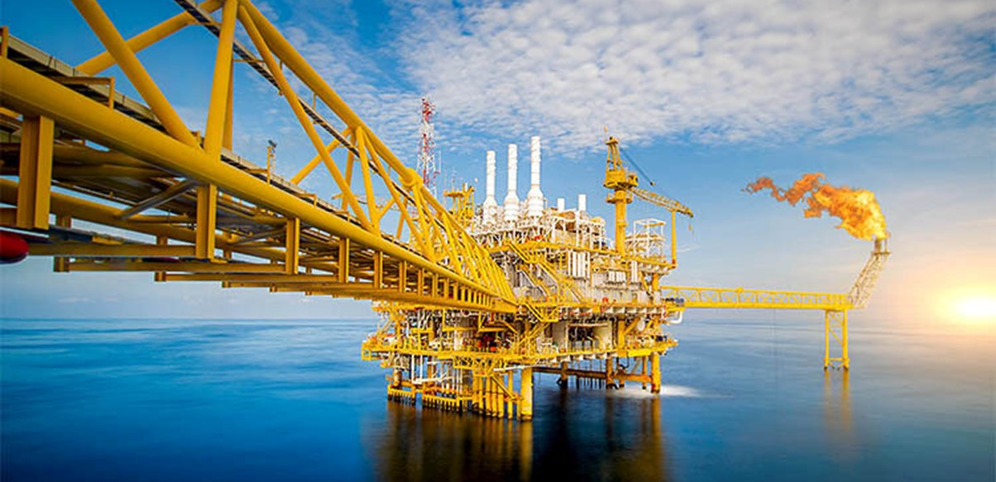

Management of mercury when decommissioning offshore oil and gas infrastructure
Final report for the Department of Industry, Science and Resources
9 February 2026

Prepared for the Department of Industry, Science and Resources
Marsden Jacob Associates Pty Ltd
ABN 66 663 324 657
ACN 072 233 204

e. economists@marsdenjacob.com.au
t. 03 8808 7400

Office locations
Melbourne
Perth
Sydney
Brisbane

Citation:
Marsden Jacob Associates 2026. Management of mercury when decommissioning offshore oil and gas infrastructure, Perth, Marsden Jacob Associates Pty Ltd.

Authors
Alex Marsden | Director – Marsden Jacob Associates
Philippa Short | Principal – Marsden Jacob Associates
Dr Ade Lambo | Principal – Carnax Consulting
Dr Simon Costanzo | Principal – Darwinian Consulting
Ram Chandrasekaran | Senior Consultant – Marsden Jacob Associates

LinkedIn - Marsden Jacob Associates
www.marsdenjacob.com.au

Acknowledgements
Marsden Jacob consulted widely for this report. We would like to acknowledge and thank all the people we engaged with during this project. The report is better for your input. All final recommendations and views in this report are attributable to Marsden Jacob unless otherwise stated.
Statement of Confidentiality
The contents of this report and any attachments are confidential and are intended solely for the addressee. The information may also be legally privileged. If you have received this report in error, any use, reproduction or dissemination is strictly prohibited. If you are not the intended recipient, please immediately notify the sender by reply e-mail or phone and delete this report and its attachments, if any.
Disclaimer
This document has been prepared in accordance with the scope of services described in the contract or agreement between Marsden Jacob Associates Pty Ltd ACN 072 233 204 (Marsden Jacob) and the Client. This document is supplied in good faith and reflects the knowledge, expertise and experience of the advisors involved. The document and findings are subject to assumptions and limitations referred to within the document. Any findings, conclusions or recommendations only apply to the aforementioned circumstances and no greater reliance should be assumed or drawn by the Client. Marsden Jacob accepts no responsibility whatsoever for any loss occasioned by any person acting or refraining from action because of reliance on the document. The document has been prepared solely for use by the Client and Marsden Jacob Associates accepts no responsibility for its use by other parties.

Contents
Acronyms and abbreviations 5
Executive summary 7
Project overview 7
Approach 8
Key findings 8
Recommendations 12
1. Introduction 14
1.1 Background 14
1.2 Project scope 14
2. Decommissioning in Australia and other countries 16
2.1 Australia 16
2.2 International decommissioning frameworks 18
3. Methodology 21
4. Project findings 24
4.1 Levels of contamination 24
4.2 Measurements, standards and thresholds 26
4.3 Handling and transport 35
4.4 Treatment and recycling 47
4.5 Disposal 50
4.6 Emissions 54
4.7 Human and wildlife health 69
4.8 Research 74
5. Next steps 76
Appendix 1. Other information 79
Appendix 2. Analytical methods for analysis of mercury 83
A2.1. In-field analysis 83
A2.2. Laboratory analysis 83

Tables
Table 1 Project questions raised by DISR 15
Table 2 Cross-references between investigation sections and original project questions 22
Table 3 Stakeholders interviewed as part of this report 23
Table 4 Summary of most common methods for analysis of mercury 28
Table 5 Existing standards and guidelines available in Australia for mercury 30
Table 6 Regulatory map for handling, transporting and managing mercury during various stages of decommissioning 36
Table 7 Mercury limits for disposal to landfill in Victoria 40
Table 8 Trigger levels of decontamination of mercury used at CD Dodd—Onslow 55
Table 9 Acceptable levels of mercury post decontamination used at CD Dodd—Onslow 55
Table 10 Operational requirements for mercury decontamination equipment at Contract Resources, Karratha 56
Table 11 Air concentration limits for mercury for discharge points 40, 47, 120 and 108 at Port Kembla Steelworks 59
Table 12 Water concentration limits for mercury for discharge points 82, 87 and 89 59
Table 13 Monitoring requirements for mercury at discharge points 40, 108 and 120 at Port Kembla Steelworks 60
Table 14 Monitoring requirements for mercury at discharge point 87—No. 5 Blast Furnace drain 60
Table 15 Air concentration limits for mercury for Discharge point 1 61
Table 16 Air monitoring requirements for mercury at discharge point 1 61
Table 17 Water and/or land monitoring requirements at discharge points 3, 4, 5, 6, 7 and 8 62
Table 18 Mercury concentration limits for polyethylene use in the electric arc furnace 62
Table 19 Total industry emissions by year, including distribution of emissions by air, land and water 63
Table 20 Suggested delineation of roles for recommendations 77
Table 21 International regulations, advisories and guidelines regarding mercury in air, water and other media 79

Figures
Figure ES 1 Illustration of the two mercury thresholds on steel from decommissioning 9

Figure 1 Assessment framework used for this report 21
Figure 2 Mercuriferous belts and hotspots map 25
Figure 3 Methods available for measurement of mercury in and on decommissioned oil and gas infrastructure, including a summary of strengths and weaknesses for each 28
Figure 4 Illustration of the two mercury thresholds on steel from decommissioning 34
Figure 5 Waste facilities suitable for disposal of waste containing mercury 38
Figure 6 Waste framework in Victoria 39
Figure 7 High-temperature treatment process flowchart 48
Figure 8 BATREC’s solution for converting mercury to mercury sulphide 51
Figure 9 Stabilisation process of metallic mercury to mercury sulphide 52
Figure 10 Class 4 and Class 5 landfills in WA 53
Figure 11 The top 10 industry emitters (point source) to air in Australia for the reporting year 2022–23 64
Figure 12 The top 10 industry emitters to land in Australia for the reporting year 2022–23 65
Figure 13 The top 10 industry emitters to water in Australia for the reporting year 2022–23 66
Figure 14 Estimate of total mercury contamination in steel and removal at various stages of processing 68
Figure 15 Hierarchy of controls to identify and rank safeguards to protect workers 71

Acronyms and abbreviations
ACT | Australian Capital Territory
ANSTO | Australian Nuclear Science and Technology Organisation
BAT | best available technique
CODA | Centre of Decommissioning Australia
COP | conference of parties
CSIRO | Commonwealth Scientific and Industrial Research Organisation
CV-AFS | cold vapour atomic fluorescence spectrometry
DCCEEW | Department of Climate Change, Energy, the Environment and Water
DLGIRS | Department of Local Government, Industry Regulation and Safety
DMPE | Department of Mines, Petroleum, and Exploration
DISR | Department of Industry, Science and Resources
DL | detection limit
DWER | Department of Water and Environmental Regulation
EPA NSW | Environmental Protection Authority, New South Wales
EPA Victoria | Environmental Protection Authority Victoria
ICP-MS | inductively coupled plasma mass spectrometry
IDL | instrument detection limit
IMO | International Maritime Organization
LNG | liquefied natural gas
London Protocol | Protocol to the Convention on the Prevention of Marine Pollution by Dumping of Wastes and Other Matter
NEPM | National Environmental Protection Measure
NOPSEMA | National Offshore Petroleum Safety and Environmental Management Authority
NORM | naturally occurring radioactive material
NPI | National Pollutant Inventory
NSW | New South Wales
NT | Northern Territory
OPGGS Act | Offshore Petroleum and Greenhouse Gas Storage Act 2006
PIG | pipeline inspection gauge
ppm | parts per million
SA | South Australia
Sea Dumping Act | Environment Protection (Sea Dumping) Act 1981
TWA | time weighted average
UK | United Kingdom
UN | United Nations
UNCLOS | UN Convention on the Law of the Sea
UNEP | UN Environment Programme
US | United States
US EPA | US Environment Protection Authority
WA | Western Australia
WHO | World Health Organization
WHS | work, health and safety
XRF | X-ray fluorescence

Executive summary
Australia has a substantial offshore oil and gas production industry. In 2022, Australia ranked as the seventh-largest global gas producer and the world’s second-largest liquefied natural gas (LNG) exporter. As that industry matures, many facilities are nearing the stage when decommissioning is required.
This report investigates the current state of mercury contamination in steel, particularly in the context of Australian offshore oil and gas infrastructure, in line with international best practices. The report does not focus on mercury contamination arising from other areas such as shipping or shipwrecks. The study, commissioned by the Department of Industry, Science and Resources (DISR), aims to evaluate the challenges posed by mercury contamination in steel recycling and its broader environmental and human health implications. This is done with the aim to support responsible recycling and waste management outcomes as identified in Australia’s Offshore Resources Decommissioning Roadmap. The research is informed by interviews with key industry stakeholders and a review of relevant standards, guidelines and best practices globally.

Project overview
The Australian Government has developed a roadmap to establish an Australian offshore decommissioning industry as the country’s oil and gas infrastructure ages. With Australia being a significant player in global gas production and the world’s second-largest LNG exporter, the decommissioning of offshore oil and gas infrastructure presents a unique set of challenges, particularly regarding mercury contamination.
Mercury is naturally present in some oil and gas reservoirs and interacts with the infrastructure used to transport and process production fluids (oil, gas, water). Elemental mercury can adsorb to surfaces, bind to corrosion products (e.g. iron sulphides) and form sulphide species such as metacinnabar, forming a scale on the internal walls of pipelines. ‘Scale’ is a term used to describe solid deposits that grow over time through pipelines, valves, pumps etc. These issues raise concerns over the safe management of mercury during decommissioning. The Minamata Convention on Mercury, which Australia ratified in 2021, has established strict guidelines for reducing mercury emissions and releases into the environment, making this an important issue for the country. Mercury contamination poses significant risks, including health and safety hazards, equipment corrosion, catalyst poisoning and environmental toxicity.
Australia’s decommissioning roadmap places an emphasis on supporting new jobs and investment in responsible recycling and waste management. Decommissioning will produce a significant volume of recyclable and reusable steel. Steel contamination due to the presence of mercury and/or naturally occurring radioactive materials (NORMs) becomes a key barrier to recyclability. Therefore, understanding contamination levels, implications for recyclability and mitigation and disposal strategies becomes a key area. This project specifically focused on mercury contamination in steel.

Approach
The project team, led by Marsden Jacob Associates, undertook a combination of literature review and stakeholder interviews. The review examined existing international and domestic standards, best practices and guidelines concerning the detection, handling, treatment and disposal of mercury-contaminated steel. Interviews were conducted with experts from government, industry and academia, ensuring a comprehensive understanding of the issue from different perspectives.

Key findings
A summary of the key findings is provided below. The findings are based on the research questions provided by DISR, which were used to frame the project methodology and this report.

Standards
There are various standards and thresholds for mercury in Australia for a range of matrices, including air, water and sediments, to protect human and ecological health. However, there is no specific standard for mercury-contaminated steel in Australia—or that were identified overseas through this research. Based on the research undertaken, it was found that there are no generally accepted criteria for mercury decontamination in Australia or internationally. Instead, the industry is utilising thresholds such as 1 mg Hg/kg criteria in whole steel, below which decontamination is not required before release for disposal. However, it would appear that this threshold is utilised because existing measurement techniques and equipment fail to detect mercury below this level. Additionally, it is not clear whether utilisation of 1 mg Hg/kg as a threshold is occurring internationally. This threshold is discussed later in the report.
At the fifth Conference of the Parties for the Minamata Convention (COP-5) a decision was adopted to establish a 15 mg/kg total concentration of mercury as the threshold for mercury-contaminated wastes.
The effect of these two different thresholds is shown in Error! Not a valid bookmark self-reference.. Below the steel recycling threshold (which for example may be set at 1 mg/kg), steel can be recycled without decontamination.
Steel with levels of mercury between the steel recycling threshold (shown as 1 mg/kg) and 15 mg/kg, is not considered to be mercury-contaminated waste—but would require decontamination if it were to be recycled. Steel with levels of mercury above 15 mg/kg is considered to be mercury-contaminated waste. It may be feasible to decontaminate steel to be recycled, or the steel may require specialist disposal.
Figure ES 1 Illustration of the two mercury thresholds on steel from decommissioning

Measurement techniques
In terms of measurement, inductively coupled plasma mass spectrometry (ICP-MS) was identified as the most robust method for detecting elemental mercury in steel, followed by cold vapour atomic fluorescence spectrometry (CV-AFS) for low-level mercury detection.

Mercury levels in decommissioned steel
Based on the information identified through research and consultation undertaken for the project, it is not possible to estimate the total levels of mercury contamination in oil and gas pipelines in Australia. At each site, mercury deposition potential is a function of gas compositions and upstream processing, materials used to construct pipelines (e.g. internal coatings or high chromium steels), mercury deposition rates on steel, and exposure timing. Across Australia, the differences in the gas reserves, pipeline technology and age make a total estimate unreliable at this time.
The recycling of contaminated materials requires proper decontamination to ensure that the process does not pose an unacceptable risk to human health and the ecosystem.

Handling and transport
The Hazardous Wastes (Regulation of Exports and Imports) Act 1989 regulates the export and import of controlled waste at the federal level. The Act aims to give effect to the Basel Convention on the Control of Transboundary Movements of Hazardous Wastes and Their Disposal and utilises the definition of hazardous waste as in that convention. As a result, the export and import of waste contaminated by mercury is regulated under this Act.
The National Environment Protection (Movement of Controlled Waste between States and Territories) Measure 1998 (NEPM) under the National Environment Protection Council Act 1994 (Cwth) ensures that controlled waste that is to be moved between states and territories is properly identified, transported and handled in ways that are consistent with environmentally sound practices.
Under Schedule A of the NEPM, waste streams containing mercury or mercury compounds are classified as controlled waste.
All states and territories in Australia follow the NEPM while transporting controlled waste between states and territories. Further, each individual state and territory has its own controlled-waste tracking system for tracking controlled-waste movements within that jurisdiction.
All states and territories utilise D120 as the controlled-waste tracking code for mercury in line with NEPM.

Treatment and recycling
Based on the consultation and research undertaken for this study, best practices for onshore decontamination involve the following techniques:
- high-temperature treatment and thermal desorption
- high-pressure cleaning
- chemical processes.
However, suitability of these techniques to decontaminate mercury varies depending on the situation. For example, thermal desorption is not easily applicable for large steel; high-pressure cleaning is not well suited to remove elemental mercury in cracks and joints but is well suited to remove non-elemental mercury in the contaminated scale layer. Chemical processes are commonly applied and are well suited for removing mercury when contamination occurs with radioactive materials.
Australia signed the Minamata Convention in October 2013 and ratified the convention in 2021, binding Australia under international law to meet the convention’s obligations.
Article 1 of the convention states:
The objective of this convention is to protect the human health and the environment from anthropogenic emissions and releases of mercury and mercury compounds.
Under Article 1, Australia, as a ratified Party to the convention, has a broad objective to minimise all mercury emissions. Currently, air emissions from steel recycling are not constrained under Article 8 of the Minamata Convention. However, the broad objectives arising from Article 1 still apply. Article 9 provides for the control and reduction of releases of mercury and mercury compounds to land and water. Article 11 provides for the definitions, management, transport and disposal of hazardous mercury waste.

Disposal
Disposal of mercury recovered from decontamination involves:
- extraction of mercury from wastewater, sludges etc.
- safe disposal of elemental mercury
- safe disposal of mercury-contaminated products.
Australia currently lacks a local solution for the disposal of elemental mercury. International best practices suggest stabilising elemental mercury into mercury sulphide, which can be safely disposed of in European salt mines. Domestic facilities, such as Tellus Holdings’ Sandy Ridge facility in Western Australia, can accept solid mercury-contaminated waste but are prohibited by their licence conditions from handling liquid waste contaminated with mercury or elemental mercury. Disposal of mercury-contaminated waste to landfill is largely controlled, as mercury is classified as a controlled waste in all the states and territories.

Emissions and environmental impact
Emissions from mercury-contaminated steel during decommissioning or recycling processes can be a concern, although existing regulations aim to ensure no unacceptable impacts arise. It is difficult to ascertain the impact of mercury emissions from steelmaking on humans and wildlife. This is primarily due to difficulties in accurately estimating the expected levels of emissions.

Human and wildlife health
Global mercury cycling indicates that all worldwide mercury emissions from steelmaking will be deposited in the Southern Hemisphere. Of that deposition, it is estimated that 10% would be deposited within Australia, representing 0.005% to 0.008% of total annual mercury deposition in Australia. While this represents a small fraction of total emissions, mercury’s toxic effects on human health and wildlife remain a significant concern, especially with chronic exposure. This is because mercury undergoes transformation through biological processes, becoming methylmercury, which is a highly toxic form that readily bioaccumulates in organisms. ‘Bioaccumulation’ refers to the gradual build-up of mercury within individual organisms over time, particularly in long-lived species, while biomagnification occurs as mercury concentrations increase at higher trophic levels of the food chain. Additionally, exposure to mercury from utilising scrap steel contaminated with low levels of mercury in electric arc furnaces needs to be studied further.

Research
Throughout the interviews and research undertaken for this project, the following areas emerged as key research priorities.
- Mercury detection and quantification
Ongoing research is needed to improve in situ measurement techniques and understand the long-term impacts of mercury emissions on human health and the environment. Accurately detecting mercury in oil and gas infrastructure is critical in understanding the magnitude and extent of contamination that will require mitigation. Traditional detection techniques, while useful, might not capture the full extent of mercury contamination, especially in complex environments such as pipelines and processing facilities. The development of more sensitive detection tools, including portable mercury analysers (e.g. X-ray fluorescence) and advanced spectroscopy methods, has significantly improved real-time monitoring and will continue to do so.
- Removal of mercury from steel substrates
One of the key challenges in decommissioning oil and gas infrastructure is the removal of mercury that has adsorbed onto steel substrates. Chemical washing involves the use of complexing agents to mobilise and remove mercury from steel surfaces (there are a number on the market), while thermal desorption, when viable to use, applies heat to vaporise mercury for collection. The former method seems to be the preferred method, based on our interviews. However, further research is required in this area to improve the efficiency and effectiveness of the preferred method(s).
- Occupational exposure controls
Occupational exposure to mercury vapour during the melting of contaminated steel is a serious concern for workers within steelmaking facilities that do not have sufficient mitigation measures in place. While engineering controls and personal protective equipment are likely to reduce the risk of worker exposure, research is required to determine the true effectiveness of any measures that will be used.

Recommendations
- Work with industry, such as through workshops, to address the identified areas of further research
Such workshops would facilitate knowledge sharing, drive standardisation efforts and encourage collaboration among stakeholders involved in decommissioning and recycling. Through the workshops, industry professionals can collectively address gaps, such as mercury-contamination management, regulatory harmonisation and best practice approaches to decommissioning, which are crucial for Australia’s emerging offshore resources decommissioning sector.
- Consider developing a national standard for mercury levels in mercury-contaminated steel for recycling
Given the gaps in current legislation, it is recommended that Australia develop a national standard for mercury in steel for recycling. The standard should align with international best practices and take into account relevant thresholds established under the Minamata Convention, and may incorporate specific guidelines for different forms of steel processing.
- Consider opportunities to harmonise the approach and approvals used under different regulatory regimes for decommissioning
For example:
  - an asset operating offshore of Western Australia in Commonwealth waters with onshore processing of the gas may require approvals from the National Offshore Petroleum Safety and Environmental Management Authority (NOPSEMA), the Western Australian Department of Mines, Petroleum and Exploration (DMPE) Pipelines Group and Department of Local Government, Industry Regulation and Safety (DLGIRS) Dangerous Goods Group
  - the onshore decontamination of pipelines also requires approvals from the Western Australian Department of Water and Environmental Regulation (DWER) Industry Licensing, and the transport and disposal of concentrated mercury products requires approvals from Controlled Waste group within DWER.
- Work with industry to refine standard practices for decommissioning, decontamination and emission controls
Decontamination techniques should be standardised across the industry, and steelmaking facilities should implement mercury-abatement measures to minimise emissions. Collaboration with international partners to adopt successful mercury-stabilisation methods, such as conversion to mercury sulphide, is crucial.
- Increase research and monitoring
Ongoing research is needed to improve the safe management and disposal of mercury-contaminated assets. The following areas are identified as current research priorities:
  - mercury detection and quantification—particularly in situ measurement and estimation techniques
  - removal of mercury from steel substrates
  - occupational exposure controls.
It is noted that improved in situ estimation of mercury contamination in offshore production assets will allow the estimates of the total mercury in pipelines and offshore assets to be refined.

- Introduction
  - Background
Australia has a substantial offshore oil and gas production industry. In 2022, Australia ranked as the seventh-largest global gas producer and the world’s second-largest liquefied natural gas (LNG) exporter. As this industry matures, many facilities are nearing the stage when decommissioning is required.
To address this, the Australian Government, through the Department of Industry, Science and Resources (DISR), has developed a roadmap to establish a domestic offshore decommissioning industry. The roadmap outlines a pathway for governments, industry stakeholders, the local workforce and communities to build the capability to decommission offshore oil and gas infrastructure within Australia.
One potential challenge with recycling decommissioned steel is the presence of contaminants such as mercury and naturally occurring radioactive materials (NORMs). Those contaminants occur naturally in oil and gas reserves and contaminate the infrastructure used to transport and process production fluids (oil, gas, water). Mercury contamination poses significant risks during the operation and decommissioning of the infrastructure, including health and safety hazards, equipment corrosion, catalyst poisoning and environmental toxicity.
In 2021, Australia ratified the Minamata Convention on Mercury, committing to protect human health and the environment from anthropogenic emissions and releases of mercury and mercury compounds. In order for Australia to adhere to the Minamata Convention during the decommissioning of oil and gas infrastructure, a number of limitations have been highlighted in the regulatory and technical areas of mercury assessment and management. This forms the basis for this research project.
  - Project scope
A project team led by Marsden Jacob Associates (the project team) was commissioned by DISR to undertake a short research project into mercury contamination in offshore oil and gas infrastructure and to investigate whether that contamination constrains the ability to recycle steel. Research questions for this project are listed in Table 1.
Table 1 Project questions raised by DISR
Number | Questions
1 | Are there existing standards / thresholds for mercury in steel?
2a | What is the most robust method to quantify mercury concentration?
2b | What is the most robust method to quantify mercury risks posed by contaminated steel products?
3 | What are the domestic regulation(s) for handling, transporting and managing mercury?
4a | What are international best practices for mercury-contaminated steel?
4b | What are the best disposal options for mercury removed from steel (local and international options)?
5a | What is the Minamata Convention (COP-5) threshold for Australian smelters?
5b | What are the implications for humans and wildlife from atmospheric emissions releases of mercury at this concentration?
6 | What are the emissions controls in place in Australia to capture any mercury released from steel recycling/smelting?
7 | How does smelting of steel with low levels of mercury contamination add to the cumulative annual emissions of mercury from Australia?
8 | If a mercury in steel standard is to be developed, what would it include and how would it meet human health and environmental protection outcomes?

- Decommissioning in Australia and other countries
A high-level overview of Australia’s decommissioning regulatory environment is presented in this section. Also, two high-level regulatory overviews of the decommissioning frameworks are presented for the United Kingdom and the Netherlands. This is done to highlight the difference in approaches between various countries’ requirements for removal of infrastructure. The UK and the Netherlands were chosen due to their having differing approaches to decommissioning despite being signatories to the Convention for the Protection of the Marine Environment of the North-East Atlantic. One of the decisions under the convention places emphasis on steel recovery and reuse from decommissioning.
  - Australia
The Offshore Petroleum and Greenhouse Gas Storage Act 2006 (OPGGS Act) provides the decommissioning framework in Australia within Commonwealth waters. The key features of the regulatory framework relating to decommissioning in the OPGGS Act are as follows:
- Decommissioning is the responsibility of the titleholders.
- Early planning is encouraged.
- Removal of all property is the ‘base case’:
  - This is consistent with Australia’s commitments under the United Nations Convention on the Law of the Sea (UNCLOS) and the 1996 Protocol to the Convention on the Prevention of Marine Pollution by Dumping of Wastes and Other Matter, 1972 (the London Protocol).
  - The London Protocol is implemented by the Environment Protection (Sea Dumping) Act 1981 (Sea Dumping Act).
- Decommissioning must be completed before the end of the title.
The London Protocol defines dumping as the deliberate disposal at sea of wastes, vessels, aircraft, platforms or other man-made structures. It distinguishes between wastes of which dumping is prohibited and waste of which dumping is possible pursuant to a special or general permit.

The Sea Dumping Act aims to protect Australian waters from wastes and pollution being dumped at sea. It also reflects Australia’s commitments under the London Convention.
An important point to note is that, under the Sea Dumping Act, abandoning in situ an export pipeline or cable (not wholly contained within an oil and gas production field) that will not be moved, modified or augmented in any way is exempt from sea dumping permit requirements. This does not include flowlines, inter- or intra-field pipelines.
UNCLOS provides for the governance of all aspects of the resources of the sea and the uses of the ocean.
Australia ratified UNCLOS on 5 October 1994.
Article 60(3) of UNCLOS states that:
Any installations or structures which are abandoned or disused shall be removed to ensure safety of navigation, taking into account any generally accepted international standards established in this regard by the competent international organization. Such removal shall also have due regard to fishing, the protection of the marine environment and the rights and duties of other States. Appropriate publicity shall be given to the depth, position and dimensions of any installations or structures not entirely removed.
UNCLOS refers to ‘generally accepted international standards’ established by a competent international organisation. This refers to standards developed by the International Maritime Organization (IMO).
In 1989, the IMO produced a set of non-binding guidelines and standards on the decommissioning of offshore installations and structures. Although those guidelines are non-binding, UNCLOS signatories have an obligation to take into consideration their content in accordance with Article 60 of UNCLOS.
The IMO guidelines distinguish between three options:
- entire removal
- partial removal
- non-removal.
The obligation for removal differs based on the weight, location and depth of the installation. Guidelines provide for non-removal only if the remaining parts will not cause unjustifiable interference with other users of the sea.
The removal obligations discussed above refer to abandoned and disused installations and structures. However, neither the Geneva Conventions, UNCLOS nor the IMO guidelines define those terms. Due to the referral to safety of navigation, it is reasonably assumed that installations and structures refer to fixed objects arising above sea level, such as production platforms, and not subsea cables and pipelines.
  - International decommissioning frameworks
The decommissioning frameworks of the UK and the Netherlands have been chosen to highlight the difference in approaches to decommissioning in relation to steel especially. This is because of the Convention for the Protection of the Marine Environment of the North-East Atlantic (the OSPAR Convention). The OSPAR Convention is the current legislative instrument regulating international cooperation on environmental protection in the north-east Atlantic. The convention has been signed and ratified by Belgium, Denmark, the European Community, Finland, France, Germany, Iceland, Ireland, the Netherlands, Norway, Portugal, Spain, Sweden, the UK, Luxembourg and Switzerland.
OSPAR Decision 98/3 prohibits the dumping and the leaving wholly or partly in place of disused offshore installations. The decision also requires that ‘All steel installations with a jacket weight less than 10,000 tonnes in air must be completely removed for re-use, recycling or final disposal on land.’
Under this decision, disposal options are required to be assessed against a comparative framework. One of the assessment factors is the impact on the marine environment due to contaminants, emissions to the atmosphere, leaching to groundwater, discharges to surface fresh waters and effects on the soil.
Despite the UK and the Netherlands both being signatories to the OSPAR convention, they have different decommissioning frameworks, as described.
    - United Kingdom
UK’s guidance notes on the decommissioning of offshore oil and gas installations and pipelines are based on the founding principles enshrined in the UK’s commitment to OSPAR Decision 98/3. Therefore, the default starting point for decommissioning in the UK is complete removal unless an exemption is granted.
Decommissioning of offshore oil and gas installation and pipelines on the United Kingdom Continental Shelf is controlled by the Petroleum Act 1998. Decommissioning is regulated by the Offshore Petroleum Regulator for Environment and Decommissioning. Part 4 of the Act provides for the orderly decommissioning of disused installations and pipelines. Potential exemption cases and pipelines with a potential leave in situ option go through a comparative assessment framework. The comparative assessment framework is provided in the UK’s decommissioning guidance notes.
Within the UK’s comparative assessment framework, impacts on the environment from decommissioning are one of the assessment criteria. Within that criterion, emissions to the atmosphere and cumulative effects on the environment are matters to be considered. An ecological risk assessment framework would be considered to understand the extent of potential risk from contaminants. Annex C of the guideline provides guidance on how to develop a decommissioning program. Decommissioning programs should include an environmental appraisal of the selected decommissioning option that includes potential impacts on the marine environment, including exposure to contaminants.
    - The Netherlands
The exploration and production of hydrocarbons in the Netherlands are governed by the Mining Act. The Act governs the exploration and production of minerals (including oil and gas) onshore and offshore as long as these minerals are located at a depth of at least 100 metres. With regard to decommissioning, the distinction made in international law between installations and pipelines and cables is also found in the Dutch Mining Act.
According to Drankier and Roggenkamp, in international law, removal obligations that are discussed refer to abandoned and disused installations and structures. However, there is a lack of definition for either of those terms in the Geneva Conventions, UNCLOS and the IMO guidelines. Due to the referral to safety of navigation, it is reasonably assumed that installations and structures refer to fixed objects arising above sea level, such as production platforms and not subsea cables and pipelines. As a result of this, removal obligations under the OSPAR Convention are not considered to apply to subsea infrastructure in the Netherlands.
As the OSPAR Convention is not considered to apply to subsea infrastructure in the Netherlands, the requirements for decommissioning arise from the Mining Act. The Act requires the complete removal of disused mining installations as well as materials near the facility—but that obligation is discretionary for disused pipelines and cables. Similarly to UNCLOS and the IMO guidelines, the Mining Act does not contain a removal obligation for disused pipelines and cables but leaves it to the discretion of the responsible minister whether or not to require complete or partial removal. The extent to which disused pipelines and cables need to be removed will be based on assessing the costs and benefits of removal in relation to navigation and the environmental consequences of removal versus non-removal. General cost–benefit analysis guidance published by the Netherlands Environmental Assessment Agency provides guidance on the valuation of environmental effects, including pollution. The guidance provided is quite broad and not specific to mercury.
In addition to the requirements set out above, disused pipelines constructed after 2016 must be removed unless an assessment shows that the social costs of removal outweigh the social benefits. The impact of this approach is that pipelines in the Netherlands are often left in place once they are considered ‘clean and safe’.
- Methodology
The project questions raised by DISR (outlined in Table 1) were organised into eight investigation categories, as shown in Figure 1 and Table 2. The methodology begins by examining measurement techniques, standards and thresholds for detecting mercury contamination, to provide a clear understanding of the issue’s scope. It then reviews the procedures for handling and transporting contaminated steel, focusing on safety measures and relevant regulations. The report explores methods for treating and recycling contaminated steel, as well as proper disposal practices and potential emissions resulting from the handling and processing of mercury-contaminated steel. The information obtained during the project assesses the potential implications for human and wildlife health. Finally, the report outlines identified areas of research required to improve the understanding and management of mercury contamination during decommissioning activities.
Figure 1 Assessment framework used for this report
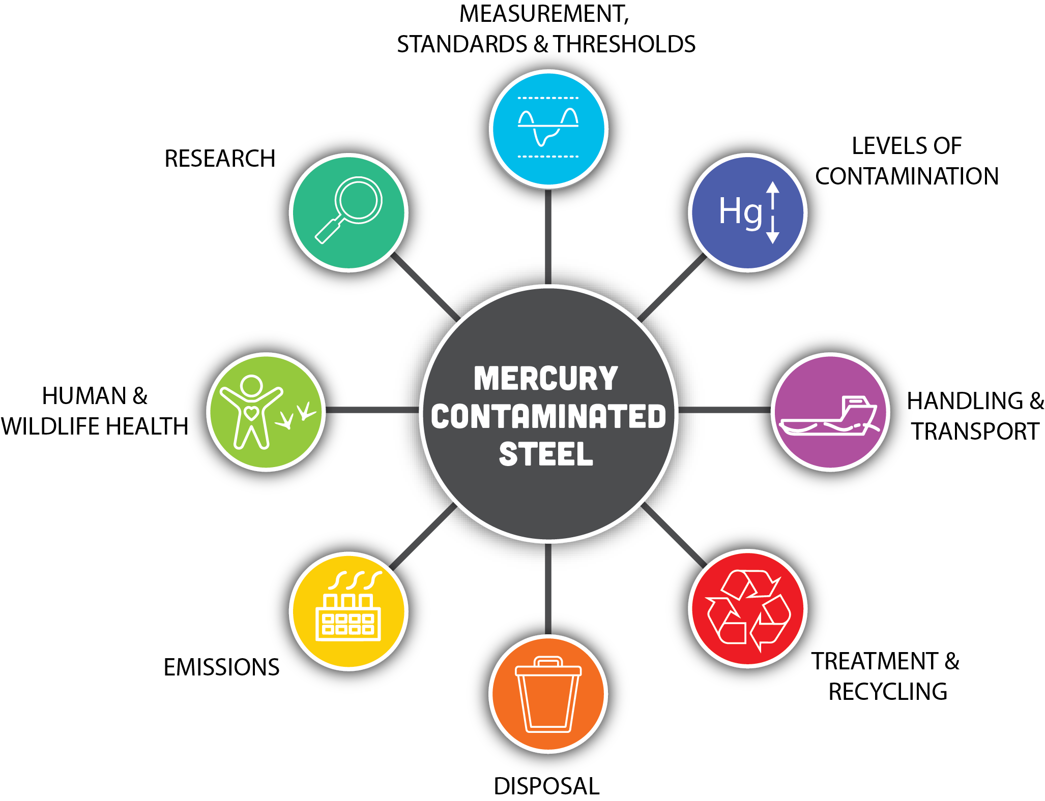

Table 2 Cross-references between investigation sections and original project questions
Section | Project question/s covered in this section
Measurement, standards and thresholds | 1 | Are there existing standards / thresholds for mercury in steel?
Measurement, standards and thresholds | 2a | What is the most robust method to quantify mercury concentration?
Measurement, standards and thresholds | 2b | What is the most robust method to quantify mercury risks posed by contaminated steel products?
Handling and transport | 3 | What are the domestic regulation(s) for handling, transporting and managing mercury?
Treatment and recycling | 4a | What are international best practices for mercury-contaminated steel?
Treatment and recycling | 5a | What is the Minamata Convention (COP-5) threshold for Australian smelters?
Disposal | 4a | International best practices for mercury-contaminated steel
Disposal | 4b | What are the best disposal options for mercury removed from steel (local and international options)?
Emissions | 6 | What are the emissions controls in place in Australia to capture any mercury released from steel recycling/smelting?
Emissions | 7 | How does smelting of steel with low levels of mercury contamination add to the cumulative annual emissions of mercury from Australia?
Human and wildlife health | 5b | What are the implications for humans and wildlife from atmospheric emissions of mercury at this concentration?
Research | 1 | Are there existing standards/thresholds for mercury in steel?
Research | 8 | If a mercury in steel standard is to be developed, what would it include and how would it meet human health and environmental protection outcomes?
Information on those topics was sourced from existing literature and through extensive interviews of practitioners involved in the oil and gas decommissioning process.
Desktop research was undertaken using the following methods:
- Literature review
  - academic journals: search for and review relevant peer-reviewed articles on mercury contamination in steel
  - industry reports: review reports from steel industry associations and environmental organisations
  - government publications: determine the relevant state, federal and international regulations, guidelines and research published by governmental bodies
  - books: use comprehensive sources for background information
  - industry websites: check websites of steel manufacturers, industry associations and environmental groups
  - regulatory bodies: visit websites such as those of the Global Partnership on Mercury set up by the United Nations Environment Programme (UNEP), the World Health Organisation (WHO) and Australian guidelines.
Our approach to interviews, which were conducted over July 2024 – October 2024, was as follows:
- Interviews were held in person and online. A list of experts interviewed is in Table 3.
- Interviews focused on questions specific to the relevant stakeholder.
- Interviews involved the project team providing an overview of the project and then posing the relevant questions to the stakeholders.
Table 3 Stakeholders interviewed as part of this report
Organisation | Groups interviewed
Universities and/or research organisations | Mercury Australia (Australian National University)  Australian Nuclear Science and Technology Organisation  Australian Institute of Marine Science
Commonwealth Government departments/agencies | Department of Climate Change, Energy, the Environment and Water (DCCEEW)  Department of Industry, Science and Resources - Northern Endeavour Branch  National Offshore Petroleum Safety and Environmental Management Authority (NOPSEMA)
State Government departments/agencies | Department of Energy, Mining, Industry Regulation and Safety (Western Australia)  Department of Energy, Environment and Climate Action (Victoria)  Environment Protection Authority Victoria  Department of Energy and Mining (South Australia)
Oil and gas producers | Woodside
Demolition, waste handling, storage and disposal | Tellus  Contract Resources  Cleanaway  Liberty Industrial  CD Dodd  McMahon Services
Smelters | Infrabuild  GreenSteel WA
Independent experts | Two independent experts

- Project findings
  - Levels of contamination
Key points
- Mercury concentrations in oil and gas reserves vary globally but peak in regions of high volcanic activity.
- Oil and gas reserves in Southeast Asia and the northwest of Australia have some of the highest mercury concentrations globally.
- Surface mercury concentrations on the internal surface of pipelines of up to 10 mg/m² have been reported in the literature.
- Industry advises that the total mercury in Australian oil and gas pipelines cannot be estimated based on current data.
Mercury concentrations in oil and gas reserves vary globally, but the highest concentrations are typically reported in regions of high volcanic activity. Mercury’s affinity to organic matter, primarily due to the formation of stable bonds with certain functional groups found in organic compounds (e.g. sulphur), results in its presence in numerous hydrocarbon fields worldwide (Figure 2). Concentrations of mercury have been found up to 20 mg/kg (20 ppm) in crude oil and between 0.05 and 5,000 μg/m³ in natural gas. In comparison, studies show average Australian black coal mercury content of 0.04–0.05 mg/kg (0.04–0.05 ppm; range of 0.01–0.13 mg/kg), with a default global average of 0.15 mg/kg (0.15 ppm).
Several forms of mercury have been identified in gas condensate. They include primarily elemental mercury, inorganic mercury compounds and organic mercury compounds, predominantly mercury thiols. Each of those forms exhibits distinct chemical and physical properties.
Figure 2 Mercuriferous belts and hotspots map
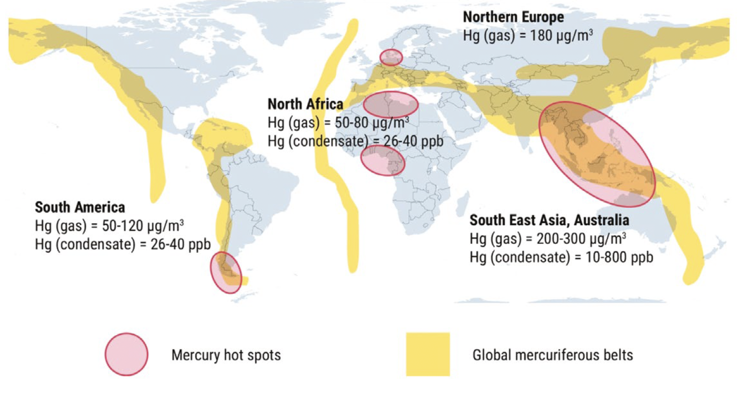
Adapted from A Chalkidis, Mercury in natural gas streams: a review of materials and processes for abatement and remediation, Centre for Advanced Materials & Industrial Chemistry, School of Science, RMIT University, Melbourne, 2020.
Over the operational life of an oil or gas system, different forms of mercury interact uniquely with the infrastructure used to transport and process production fluids. Subsea oil and gas infrastructure includes components such as subsea ‘Christmas trees’ (which act as a pressure-containing barrier between the well and the surrounding environment), wellhead jumpers and spools, flexible and rigid risers and pipelines. In pipelines, particularly gas-export pipelines, elemental mercury can adsorb to surfaces, bind to corrosion products such as iron sulphides and form sulphide species such as metacinnabar, resulting in a scale on the internal walls of the pipelines. ‘Scale’ is a term used to describe solid deposits that grow over time through pipelines, valves, pumps etc. The measured concentration of dissolved Hg⁰ (elemental mercury) typically decreases with distance from the wellhead as a result of adsorption, reaction with iron, conversion to other forms and loss of the suspended fraction. This interaction is commonly seen in gas production and is referred to as the ‘mercury lag effect’, in which mercury that is in gas entering a newly constructed pipeline is not measured at the receiving end for some period of time. An example of this was reported in 2010 by Wilhelm and Nelson at a gas plant located approximately 200 km from offshore producing wells. Mercury was not detected in any significant amounts (< 1 μg/m³) in gas entering the receiving plant over 50 months following production, indicating that the minimum capacity of the pipe surface to retain elemental mercury was between 1.5 and 2 g/m² (which equates to 1.5–2 grams of mercury per metre of a 30-cm diameter pipe). Other studies have reported surface mercury concentrations up to 80 g/m² in tubing and piping used for a natural gas production system, demonstrating the variable capacity of steel piping to be contaminated with mercury.
The project team investigated whether the mercury levels in one particular pipeline with available data could be extrapolated to estimate the total quantity of mercury in Australian oil and gas pipelines. However, industry experts cautioned that this was not appropriate due to the following points of difference with other pipelines:
- Differing hydrocarbon service of the lines - The pipeline in question was a dry gas pipeline and may exhibit different mercury deposition mechanisms to pipelines transporting wet gas or two-phase streams.
- Differing materials of construction – Pipelines manufactured with internal coatings or from high chromium metals will likely exhibit different mercury deposition characteristics in comparison to an uncoated carbon steel pipeline.
- To accurately estimate the levels of mercury, the following information would be required:
  - Complete inventory of the pipelines (materials of construction, size, hydrocarbon service etc.)
  - Compositional information of the extracted product.
  - Measurements, standards and thresholds
Key points
- Accurately quantifying mercury in steel is challenging.
- Inductively coupled plasma mass spectrometry (ICP-MS) is the most suitable method for assessing elemental mercury in steel, followed by cold vapour atomic fluorescence spectrometry (CV-AFS), if very low levels of detection are required.
- Australian standards are lacking for mercury in steel, and industry would welcome guidance on this.
- A value of 1 mg/kg whole steel was mentioned in several interviews with industry experts as an unofficial threshold for international steelmaking facilities.
- At the fifth Conference of the Parties for the Minamata Convention (COP-5), the decision was adopted to establish a 15 mg/kg total concentration of mercury as the threshold for wastes. That value might not be appropriate for mercury-contaminated steel destined for recycling.

Mercury’s toxicity and environmental behaviour depend highly on its chemical speciation, as elemental mercury, inorganic mercury compounds and organic mercury (primarily methylmercury) display varying levels of bioavailability and toxicity. The speciation of mercury influences its persistence, mobility and capacity for bioaccumulation, which is why regulatory standards often differentiate based on the specific form of mercury present. The Minamata Convention, however, does not distinguish between mercury species and addresses the full life cycle of mercury in all its forms and sources, acknowledging that all mercury types pose potential environmental and health risks due to their ability to transform and persist in the environment and therefore should be assessed and managed equally. This is also relevant to this report, as mercury in contaminated steel destined for recycling will volatilise as elemental mercury during melting in the furnace. Hence, the focus of the methods of mercury measurement outlined below is on the accuracy, reliability and ease of total mercury analysis of steel before it is sent to a furnace for recycling, rather than their effectiveness at determining mercury speciation.
    - Methods available for mercury measurement in decommissioned steel
Quantifying mercury concentrations accurately and reproducibly in steel destined for decommissioning can be challenging. Access to the inside of oil and gas infrastructure (e.g. transfer pipes, processing equipment and storage tanks) is required for sampling, which typically includes one or more of:
- ‘coupon’ sampling, or cutting a small piece of steel from the infrastructure being investigated to access the inside surface (usually done at the time of decommissioning and exposes the infrastructure to the outside environment)
- cutting pipework, pipe spool or other infrastructure to access the inside surface (this usually only occurs during decommissioning and often on the seafloor and on barges used to transport decommissioned steel back to land)
- collecting pipe scale from pigging campaigns (this process makes it difficult to determine which part of the pipe network the contamination is coming from).
Anecdotal information on measuring mercury obtained from interviews
- There is an observed loss of mercury from surfaces due to changes in temperature and pressure as infrastructure is brought to the surface
- Hot work, such as cutting steel, volatilises mercury into a vapour, which is lost to the atmosphere and poses a human health risk to workers.
Several methods have been developed to measure mercury in scale and on steel. The most common methods are summarised in Figure 3 and include both ‘in-field’ and ‘laboratory-based analyses’. Each method is described briefly in Table 4 and in more detail in Appendix 2 and can measure potential threshold levels of mercury in steel discussed later in this section.
Figure 3 Methods available for measurement of mercury in and on decommissioned oil and gas infrastructure, including a summary of strengths and weaknesses for each
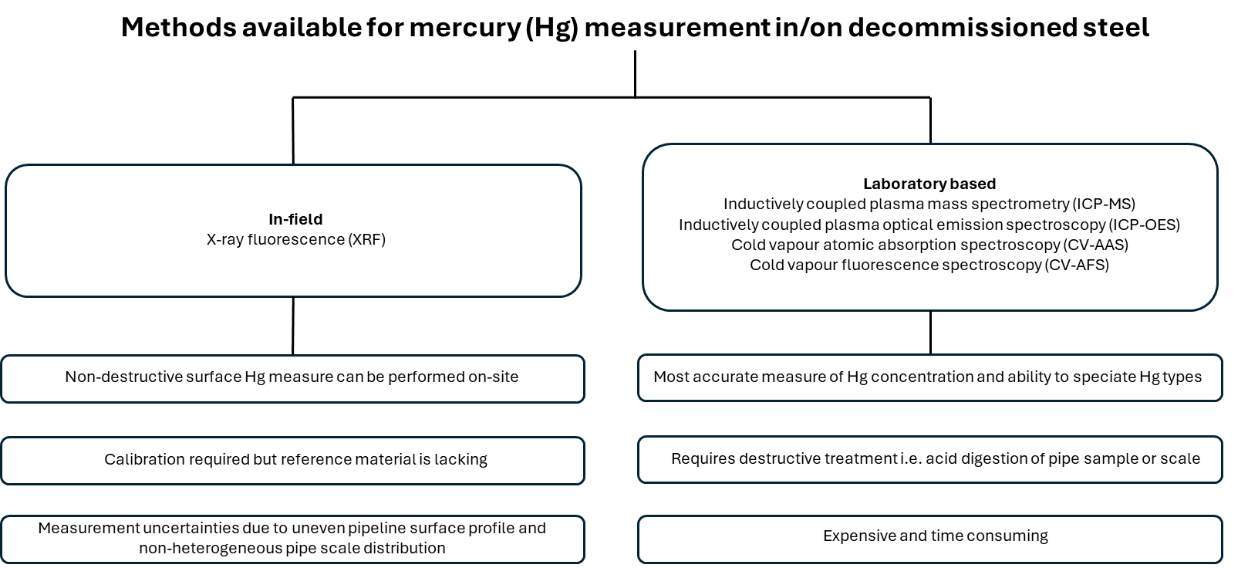
Adapted from F Kho, DJ Koppel, R von Hellfeld, A Hastings, F Gissi, T Cresswell, S Higgins, ‘Current understanding of the ecological risk of mercury from subsea oil and gas infrastructure to marine ecosystems’, Journal of Hazardous Materials, 2022, 438:1–18.

Table 4 Summary of most common methods for analysis of mercury
Method | Overview
X-ray fluorescence (XRF) spectroscopy | XRF provides a non-destructive and semi-quantitative method for measuring mercury in steel, is suitable for on-site analysis and can also be performed in the laboratory. This technique measures mercury exclusively at the contaminated surface and requires conversion from μg/cm² into a ‘semi-quantitative total mercury in steel’ concentration (e.g. mg/kg), which requires consideration of the thickness of mercury contamination (in the scale) and dilution factor of the steel mass. Despite its limitations, XRF remains the only established technique for rapid and cheap testing of mercury contamination in the field and can be useful in assessing the efficacy of decontamination treatments.
Inductively coupled plasma mass spectrometry (ICP-MS) and inductively coupled plasma optical emission spectroscopy (ICP-OES) | ICP-MS and ICP-OES are laboratory-based methods that require the full destruction (digestion) of the steel sample. Experts consulted described ICP-MS as the most suitable method of all for assessing elemental mercury in steel.  Both techniques provide fast analysis of multiple elements in a sample, but ICP-MS provides much lower detection limits than ICP-OES, and so is a better choice for trace element analysis.
Cold vapour atomic absorption spectrometry (CV-AAS) and cold vapour atomic fluorescence spectrometry (CV-AFS) | CV-AAS and CV-AFS are laboratory-based methods that require the full destruction (digestion) of the steel sample. They are widely used to detect mercury in environmental and biological samples. Experts consulted described CV-AFS as the best method of mercury analysis (of all methods) if very low levels of detection are required. CV-AFS requires a specific instrument, which is less commercially available, for the detection of mercury.
    - Standards and thresholds for mercury in steel
In simple terms, steel is an alloy of iron and carbon. Producing steel from raw materials requires iron ore to be reduced and the addition of alloying elements to produce different grades of steel.
In this report, we use the term ‘steelmaking’ to refer to a broad range of processes, including blast furnaces, electric arc furnaces and foundries.
Mercury is a well-understood and studied toxicant. Maximum levels are available in Australia for a range of matrices, including air, water and sediments, to protect human and ecological health (Table 5). However, there is currently a lack of legislated guidance on acceptable levels of mercury in steel in Australia. The current guidelines cover mercury standards for a range of matrices. The implications of exposure are detailed in Section 4.7.1. The guidelines cover a range of issues from environmental safety, human health, workplace exposure etc. Exceeding those thresholds would have impacts on both the environment and ultimately human health.
Table 5 Existing standards and guidelines available in Australia for mercury
Matrix | Mercury standard/guideline | Source | Notes
Air | Maximum eight-hour time weighted average:  0.025 mg/m³ (0.003 ppm) | Safe Work Australia | Workplace exposure standard for mercury, through the workplace exposure standards for airborne contaminants.
Air | 0.05 mg/m³ | DWER, WA | Emission and discharge limits for mercury at Contract Resources heat temperature treatment and thermal desorption unit. This value is set by DWER, accounting for environmental safety and workplace safety.  It is unclear whether the same limits would apply for different facilities or whether the limits are specific to different facilities.
Blood | Blood total mercury:  15 μg Hg/L (0.015 ppm) | Safe Work Australia | Mercury in blood is an indicator of recent exposure to all types of mercury. As inorganic and elemental mercury remains in the bloodstream for only a short time (one to three days), blood levels from elemental or inorganic mercury exposure decrease rapidly and are not useful for estimating cumulative exposure.
Drinking water | Health guideline: 0.001 mg Hg/L (1 ppm) | Australian Drinking Water Guidelines
Fresh and Marine Waters | Freshwater:  0.06 μg Hg t/L (0.00006 ppm)  Marine waters:  0.1 μg Hg t/L (0.0001 ppm) | Australian & New Zealand Guidelines for Fresh & Marine Water Quality | To account for the bioaccumulating nature of this toxicant, the 99% species protection level default guideline value (DGV) is used for slightly to moderately disturbed systems.
Sediment | Fresh and marine sediments  Default guideline value for inorganic mercury:  0.15 mg Hg/kg (0.15 ppm)  Guideline value (high) (GV-high) for inorganic mercury:  1.0 mg Hg/kg (1.0 ppm) | Australian and New Zealand Environment and Conservation Council & Agriculture and Resource Management Council of Australia and New Zealand (2000) | Sediment DGVs have been developed for the fine sediment fraction (grain size less than 2 mm). The DGV and GV-high represent, respectively, the concentration at which 10% and 50% of toxic effects on sediment-dwelling organisms are observed.
Livestock drinking water | Livestock: 0.002 mg Hg/L (0.002 ppm) | Australian & New Zealand Guidelines for Fresh & Marine Water Quality—Livestock drinking water guidelines | Level should not be exceeded. Assessments should be conservative and consider the potential accumulation of mercury in edible tissues.
Irrigation and general water uses | Soil added contaminant loading limit (ACL): 2 kg Hg/ha  Agricultural irrigation water DGV: 0.002 mg Hg/L (0.002 ppm)  Short-term guideline value (SGV): 0.002 mg Hg/L (0.002 ppm) | Australian & New Zealand Guidelines for Fresh & Marine Water Quality—Water quality for irrigation and general water uses | DGV based on 100 years of irrigation; SGV based on 20 years of irrigation at maximum contaminant concentration.
Sewage | Acceptance guideline:  0.05 mg Hg/L (0.05 ppm)  Lower daily mass load:  0.15 g/day | National Water Quality Management Strategy; Guidelines for sewerage systems: acceptance of trade waste | Treatment plant removal typically 65% for primary and secondary treatment.
C1 dry biosolids (sewage sludge) | 1 mg Hg t/kg (1 ppm) | National Water Quality Management Strategy; Guidelines for sewerage systems: biosolids management | Dry solids should not be used for any land application where they exceed 15 mg Hg t/kg (NRMMC, 2004). In line with the National Water Quality Management Strategy (NRMMC, 2004) for grade C1 dry biosolids, South Australia, Queensland and New South Wales have set a maximum permissible concentration of mercury in soils amended with biosolids used for food production of 1 mg Hg/kg.
Waste | Uncontaminated landfill: 0.5 mg/kg dry weight (0.05 μg/L leachable)  Class 1: 75 mg/kg dry weight (0.001 mg/L leachable)  Class 2: 75 mg/kg dry weight (0.001 mg/L leachable)  Class 3: 750 mg/kg dry weight (0.1 mg/L leachable)  Class 4: 3000 mg/kg dry weight (1 mg/L leachable) | DWER, Landfill waste classification and waste  definitions 1996 (as amended 2019)
Waste | Category B: 300 mg/kg (0.4 mg/L leachable)  Category C: 75 mg/kg (0.1 mg/L leachable)  Category D: 75 mg/kg (0.05 mg/L leachable) | EPA Victoria | Parts 6.4 and 6.5 of the Environment Protection Act 2017 (Vic.) provide duties for persons managing industrial and priority waste.
Marsden Jacob analysis
Our research has found that there are no generally accepted criteria for mercury decontamination in Australia or internationally. The value of < 1 mg/kg (< 1 ppm) level of mercury was mentioned in an interview with a demolition provider as an ‘unofficial’ acceptance threshold for international steelmakers. As mentioned, this may have been utilised because existing measurement techniques and equipment might fail to detect mercury below this level.
Guidance for total mercury and a range of mercury species exists internationally (see Table 21 in Appendix 1). However, as per the situation in Australia, there is currently a lack of legislated guidance on acceptable levels of mercury in steel. The US EPA issued guidance regarding the recycling of scrap cars that potentially have mercury-containing electronic switches. Those guidance levels are 0.00026 pounds of mercury per ton of steel (0.13 mg/kg or 0.13 ppm) for existing blast oxygen process furnaces and 0.000081 pounds of mercury per ton of steel (0.041 mg/kg or 0.041 ppm) for new blast oxygen process furnaces.
In November 2023, at the Conference of the Parties to the Minamata Convention on Mercury (fifth meeting), a decision was adopted to establish a 15 mg/kg total concentration of mercury as the threshold for wastes falling under Article 11(2)(c) of the Minamata Convention. That value might not be appropriate for mercury-contaminated steel destined for recycling.
The effect of the 15 mg/kg threshold compared to the steel recycling threshold (which may be set at 1 mg/kg) below which steel can be recycled without decontamination is shown in Error! Not a valid bookmark self-reference..
Steel with levels of mercury between a steel recycling threshold (shown here as 1 mg/kg) and 15 mg/kg, is not considered to be mercury-contaminated waste, but would require decontamination if it were to be recycled. Steel with levels of mercury above 15 mg/kg are considered to be mercury-contaminated waste. It may be feasible to decontaminate steel to be recycled, or the steel may require specialist disposal.
Figure 4 Illustration of the two mercury thresholds on steel from decommissioning

Decision on mercury concentrations in waste adopted at the Conference of the Parties to the Minamata Convention on Mercury (fifth meeting, 30 October – 3 November 2023, Geneva).
At the fifth COP-5, Decision MC-5/10 was adopted to establish a 15 mg/kg total concentration of mercury as the threshold for wastes falling under Article 11(2)(c) of the Minamata Convention.
As an alternative to this threshold, a party may use a ‘different approach’ to determine whether a given waste is ‘mercury waste’ under Article 11(2)(c), provided that the party has documented waste-management measures in place to protect human health and the environment, including:
- measures to ensure that mercury waste is managed pursuant to Article 11(3)
- measures to identify mercury waste using approaches such as those based on national definitions of mercury wastes or hazardous wastes, listing approach, hazardous characteristics or risk considerations, leachate thresholds or total concentration thresholds.
The Australian Government is currently considering implementing mechanisms for this new waste threshold value. Note that the threshold value established by the Minamata Convention is not necessarily sufficiently protective of human health and the environment. Rather, it sets an international basis for identifying mercury-contaminated wastes.

  - Handling and transport
Key points
- Federal guidelines for decommissioning clearly outline that the waste arising as a result of decommissioning processes is primarily the responsibility of the states and territories.
- National Environmental Protection Measure 1998 for the movement of controlled waste between states and territories categorises mercury as a controlled waste.
- All states and territories utilise the same waste code for mercury (D120) as the National Environmental Protection Measure.
- All states and territories have regulatory frameworks under their respective waste-management legislation to ensure the safe management, handling, transport and disposal of waste streams containing mercury and mercury compounds.
This section provides an overview of the domestic regulations that are currently in place for handling, transporting and managing mercury in Australia. The regulatory map of relevant conventions and legislations is shown in Table 9. An important point to note is that current recycling legislation in Australia does not focus on mercury. Mercury management would be focused on safe disposal. State environment legislation provides for the safe handling, transporting and managing of mercury.

Table 6 Regulatory map for handling, transporting and managing mercury during various stages of decommissioning
 | International | Federal | State and federal—work, health and safety | State—environment
Dismantling | Minamata Convention | Offshore Petroleum and Greenhouse Gas Storage Act 2006  Environment Protection (Sea Dumping) Act 1981 | WHS legislation is broadly harmonised across Australia. The legislation covers all aspects of decommissioning. | Environmental Protection Act 2017 (Vic.)  Waste Management and Pollution Control Act 1998 (NT)  National Environment Protection Council Act 1994 (ACT)  Environment Protection Act 1986 (WA)  Environmental Protection Act 1994 (Qld)  Environment Protection Act 1993 (SA)  Environmental Management and Pollution Control Act 1994 (Tas.)  Protection of the Environment Operations Act 1997 (NSW)
Decontamination | Minamata Convention
Disposal | Minamata Convention  Basel Convention | Hazardous Waste (Regulation of Exports and Imports) Act 1989  NEPM 1998
Recycling | Minamata Convention  Basel Convention
Marsden Jacob analysis.

The sections below provide an overview of the regulatory setting at the federal level as well as at the state and territory level.
    - Domestic regulations for handling, transporting and managing mercury

Federal
The Hazardous Wastes (Regulation of Exports and Imports) Act 1989 (Cwth) regulates the export and import of controlled waste at the national level. The Act aims to give effect to the Basel Convention and utilises the definition of hazardous waste as in the convention. As a result, the export and import of mercury waste is regulated under the Act.
The OPGGS Act and the decommissioning guideline state that the management and onshore treatment and disposal of waste arising from decommissioning are primarily the responsibility of the states and territories.
The National Environment Protection (Movement of Controlled Waste between States and Territories) Measure 1998 (NEPM) under the National Environment Protection Council Act 1994 (Cwth) ensures that controlled waste that is to be moved between states and territories is properly identified, transported and handled in ways that are consistent with environmentally sound practices.
Under Schedule A of the NEPM, waste streams containing mercury or mercury compounds are classified as controlled waste.

Western Australia
Decommissioning of subsea infrastructure lying in state coastal waters is regulated by DMPE. Decommissioning in WA is regulated under the state’s Petroleum and Geothermal Energy Resources Act 1967, Petroleum Pipelines Act 1969 and Petroleum (Submerged Lands) Act 1982.
Decommissioning in WA is guided by the following principles, as outlined in the Decommissioning Policy:
- Early planning, continual review and preparation are critical to decommissioning and rehabilitation success.
- Progressive decommissioning and rehabilitation should be undertaken as early as possible in the development phase.
- Case-by-case consideration is appropriate, but the end goal should be the complete removal of property and return of the site to an agreed state.
DWER regulates the transportation of controlled wastes on a road in WA under the Environmental Protection (Controlled Waste) Regulation 2004 under the Environmental Protection Act 1986.
The regulations provide for the licensing of carriers, drivers and vehicles transporting controlled waste on a road in WA. There are obligations under the regulations for waste holders, transit facilities and waste facilities.
The regulations define controlled waste as follows:
Controlled waste means any matter that is within the definition of waste in the NEPM for the movement of controlled waste between States and Territories; and listed in Schedule 1
The controlled-waste category in Schedule 1 of the controlled-waste regulations lists mercury under ‘inorganic chemicals’, and the controlled-waste category list published by DWER assigns a waste code of D120.
Controlled waste, including liquid waste, in WA cannot be disposed of at a Class 1, Class 2 or Class 3 landfill site. Therefore, controlled waste in WA can only be disposed of at a Class 4 or Class 5 facility. Based on DWER’s controlled-waste tracking system, the landfills shown in Figure 5 are suitable for the disposal of waste containing mercury.
Figure 5 Waste facilities suitable for disposal of waste containing mercury
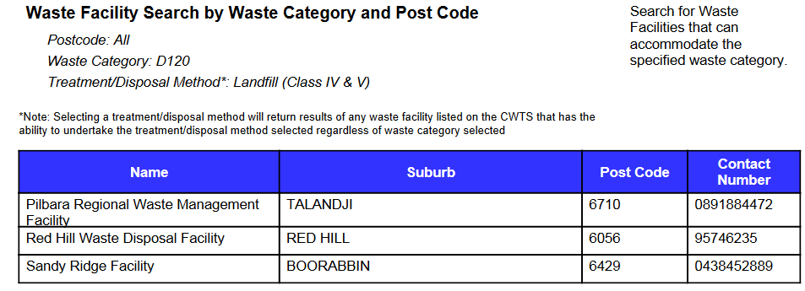
Note: D120 indicates waste code assigned to mercury.
DWER, ‘Controlled Waste Tracking System enhancements update’, Western Australian Government, 1 March 2024.

Victoria
The decommissioning framework in Victoria is regulated by the Department of Energy, Environment and Climate Action under the Victorian Offshore Petroleum and Greenhouse Gas Storage Act 2010. The proponents are required to submit an environment plan for approval under the Act prior to decommissioning.
The Environment Protection Act 2017 (Vic.) came into effect on 1 July 2021. A key feature of the legislation is that it includes environmental obligations and protections for all Victorians and changes Victoria’s focus on environment protection and human health to a prevention-based approach. The legislation includes the general environmental duty provision. The general environmental duty makes it clear that businesses have a responsibility to reduce risks to human health and the environment.
The Environmental Protection Regulations 2021 provide the waste framework in Victoria. The waste regulations set out how the duties in the Environment Protection Act are to be met by duty holders. The aims of the waste regulations are to:
- manage risks to human health and the environment
- support and encourage waste resource recovery and reuse.
The three steps for a duty holder to manage industrial waste under the Act are:
- classification: properly identify and classify waste
- transportation: provide sufficient information about the waste to the transporter; based on the waste classification, follow further containment, isolation and waste-tracking requirements
- lawful place: ensure that the industrial waste goes only to somewhere with lawful authority to receive it.
Figure 6 Waste framework in Victoria
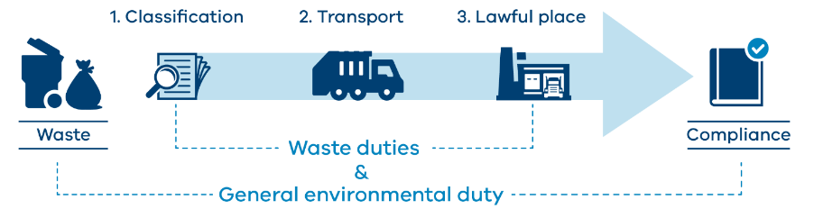
EPA Victoria, publication 1765.2.
The new waste framework in Victoria is shown in Figure 6. The framework outlines three waste types: industrial waste; priority waste; and reportable priority waste. Reportable priority waste is a subset of priority waste that carries the highest level of control. Reportable priority waste is required to be tracked via the Waste Tracker in Victoria.
In Victoria, mercury falls under reportable priority waste.
Therefore, for mercury, the following duties apply to the duty holders.
Duties applicable to mercury waste
- General environmental duty
- Duties of persons depositing industrial waste
- Duties of persons receiving industrial waste
- Duties of persons involved in transporting industrial waste
- Duties of persons managing priority waste (duty to investigate alternatives to waste disposal)
- Duty to notify of transaction in reportable priority waste
- Duties of persons transporting reportable priority waste
Mercury is classified in Schedule 5 of the Environment Protection Regulations 2021 as follows:
Waste code—D120—Reportable priority waste for transactions and transport and priority waste in Victoria.
In Victoria, priority waste category must be identified for priority waste consigned for disposal to landfill or for soil that is priority waste. The categories are:
- Category A waste—prohibited from disposal to landfill
- Category B waste
- Category C waste
- Category D waste—for soil only.
EPA Victoria’s publication 1828.2 provides for waste disposal categories. Table 2 in the publication is used to assign a category of priority waste for disposal. Contaminant concentration thresholds, which are used to determine appropriate disposal means for mercury, are shown in Table 7.
Table 7 Mercury limits for disposal to landfill in Victoria
Category | Category D / Industrial waste upper limit (applicable only to contaminated soil) |  | Category C upper limit |  | Category B upper limit
Contaminant category thresholds as dry weight (units) | Leachable concentration (mg/l) | TC (mg/kg) | Leachable concentration (mg/l) | TC (mg/kg) | Leachable concentration (mg/l) | TC (mg/kg)
Mercury | 0.05 | 75 | 0.1 | 75 | 0.4 | 300
Table 2, EPA Victoria, publication 1828.2.
During consultations, stakeholders from the Department of Energy, Environment and Climate Action and EPA Victoria indicated that mercury waste in Victoria is generated predominantly from old gold mines. As a result, mercury waste from oil and gas decommissioning is currently not an area of major concern.
In Victoria, based on the available information, there are no facilities that are able to store, handle, or dispose of mercury.

Queensland
The object of the Environmental Protection Act 1994 (Qld) is to protect Queensland’s environment while allowing for development that improves the total quality of life, both now and in the future, in a way that maintains the ecological processes on which life depends (ecologically sustainable development). The Act lists obligations and offences to prevent environmental harm, nuisances and contamination. The three primary duties that apply to everyone in Queensland are:
- the general environmental duty
- the duty to notify of environmental harm
- the duty to restore the environment.
The Environmental Protection Regulation 2019 made under the Act includes a risk-based waste classification framework. Under the framework, waste is classified as:
- Category 1: Highest risk
- Category 2: Moderate risk
- Category 3: Lowest risk.
Schedule 9 of the regulation lists regulated wastes and their default categories. Under the schedule, mercury and mercury compounds are given a default category of 1 (highest risk). The schedule also provides for the categorisation thresholds for solid and liquid tested waste.
Waste generators, transporters and receivers have general environmental obligations and duties. To meet those obligations, generators, transporters and receivers must categorise waste and use the waste codes from Schedule 2E of the Environmental Protection Regulation 2019.
Waste-tracking requirements can be fulfilled by utilising Queensland’s Online Services.
Mercury is given a waste code of D120 in Queensland.
Waste generators’ obligations include:
- recording prescribed information about the waste
- giving the prescribed information to the transporter
- giving the prescribed information to the department within seven days
- keeping records of the waste transaction for five years
- giving trackable waste only to authorised waste transporters.
Waste transporters’ tracking obligations include:
- carrying the prescribed information received from the generator
- providing prescribed information to the receiver
- reporting any discrepancy to the regulator
- recording information and keep it for five years.
Waste receivers’ tracking obligations include:
- obtaining the prescribed information about the waste from the transporter
- submitting the prescribed information to the Regulator
- reporting any discrepancy in the information received
- recording and keeping the information for five years.
In Queensland, based on the available information there are no facilities that are able to store, handle, or dispose of mercury.

South Australia
The Environment Protection Act 1993 (SA) provides the regulatory framework to protect South Australia’s environment, including land, air and water. In South Australia, the EPA and other bodies administer the Act through a suite of legislative and non-legislative policies and regulatory tools to address environmental issues.
The following sections of the Act are important for the waste to resource sector in SA:
- section 10: Objects of the Act
- section 25: General environmental duty
- section 36: Requirement for licence
- sections 40 and 48: Grant of licence and annual fee
- section 113: Waste depot levy
- schedule 1: lists the activities or which a licence from the EPA to operate is required; specifically, ‘Activity 3, Waste treatment and disposal’ covers the majority of waste-related activities.
Subsection 3 under Activity 3, Waste treatment and disposal, of the Act covers the following activities that are related to the scope of this study:
- waste-recovery facilities (deport, facility or works) that, during a 12-month period, receive for preliminary treatment or have the capacity for the treatment of more than 100 tonnes of solid waste or matter; or more that 100 kilolitres of liquid waste or matter
- waste-reprocessing facilities—specifically scrap-metal treatment facilities that treat scrap metal by electrically heating it in furnaces or other fuel-burning equipment or by mechanical processes
- waste-disposal facilities (landfill depots, liquid waste depots, incineration depots)
- activities involving listed wastes.
Schedule 1 Part B of the Act provides a detailed list of listed wastes in SA.
Schedule 1 Part B lists mercury compounds and equipment containing mercury as a listed waste.
EPA SA provides detailed guidance on wastes that must be tracked when transporting waste that must be tracked when transported within SA or interstate.
EPA SA’s guidance indicates mercury and mercury compounds as waste that must be tracked. The guidance provides a waste code of D120 for wastes containing mercury or mercury compounds.
EPA SA provides an online tracking system that helps responsible persons meet their obligations under the waste-tracking requirements. The online waste tracking system is to be used by a waste producer, agent, transporter or receiving facility involved in the movement of waste that is tracked.
The SA online waste tracking system can be used to track waste movements both within SA and from interstate to waste facilities in SA.
There are penalties for noncompliance under the Environment Protection Act 1993. Failure to comply with licence conditions is a breach of section 45(5) of the Act, which may result in regulatory actions and a maximum penalty of $120,000. There are also significant penalties for those caught illegally dumping waste. There are also fines for waste producers or transporters who are caught illegally disposing waste. The penalties are provided under clause 10 of the Environment Protection (Waste to Resources) Policy 2010.
Additionally, the Environment Protection (Movement of Controlled Waste) Policy 2014 made under the Environment Protection Act 1993 enables SA to participate in the national tracking of controlled waste and the movement of controlled waste between states and territories.
The policy designates a waste code of D120 for mercury and mercury compounds in South Australia.
In South Australia, based on the available information, there are no facilities that are able to store, handle or dispose of mercury.

New South Wales
In New South Wales, the Protection of the Environment Operations Act 1997 is the key piece of environment protection legislation. The legislation is administered by EPA NSW. The object of the Act is to achieve the protection, restoration and enhancement of the quality of the NSW environment.
The EPA provides guidelines on wastes that need to be tracked and also identifies the list of waste that needs to be tracked. Table 1 in the guidelines provides a list of waste descriptions and codes for waste that must be tracked when transported within NSW or interstate. Additionally, Schedule 1 of the Protection of the Environment (Waste) Regulation 2014 also includes a list of waste that must be tracked.
Mercury is classified as a controlled waste and given a waste code of D120 in New South Wales.
The EPA’s online waste-tracking system helps to track hazardous waste from a producer to a receiving facility. The system is used to track waste movements:
- within NSW
- from interstate to waste facilities in NSW.
Waste producers, transporters, receiving facilities and authorised agents can sign up to the waste-tracking system. Businesses and agents are required to determine their level of access prior to signing up to the system.
There are three levels of access relating to controlled waste:
- View only: applies to producers, transporters, receivers and authorised agents
- Create and update transport certificates: applies to producers, transporters, receivers and authorised agents
- Create and update consignment authorisations and transport certificates: applies to receivers only.
In New South Wales, based on the available information, there are no facilities that are able to store, handle or dispose of mercury.

Tasmania
The ‘Policy Statement—Minamata Convention on Mercury’ document outlines EPA Tasmania’s policy on the implementation of the requirements of the Minamata Convention.
The Environmental Management and Pollution Control Act 1994 (Tas.) addresses the use of mercury in manufacturing processes and other industrial activities. The Environmental Management and Pollution Control (Waste Management) Regulations 2020 are used to define, regulate and manage controlled waste and some aspects of general-waste disposal within Tasmania.
The regulations define mercury as a controlled waste in Tasmania.
Tasmania outlines the controlled-waste category codes based on the 73 controlled-waste categories and codes listed in Appendix F of the Australian Hazardous Waste Data and Reporting Standard 2019.
Mercury is assigned a waste code of D120 in Tasmania.
All stages of mercury disposal (storage, transport and disposal) are covered by these regulations. The regulations provide for:
- the management of controlled waste
- the registration of controlled-waste transporters.
The Environmental Management and Pollution Control Act provides for the creation of instruments called ‘environmental protection policies’. The Environmental Protection Policy (Air Quality) addresses mercury emissions into the air by setting limits on those emissions.
In Tasmania, based on the available information, there are no facilities that are able to store, handle or dispose of mercury.

Northern Territory
The Waste Management and Pollution Control Act 1998 (NT) provides for the protection of the environment through the encouragement of effective waste management and pollution prevention. Prescribed wastes are listed in Schedule 2 of the Waste Management and Pollution Control (Administration) Regulations 1998 made under the Act.
Schedule 2 of the regulations lists mercury and mercury compounds as prescribed waste in the Northern Territory.
Northern Territory EPA provides guidance on tracking listed waste movements via the NT Online Waste Tracking Portal. The guide provides for:
- waste leaving the NT
- waste entering the NT
- waste moving within the NT.
Waste handlers in NT are required to be licensed and hold the required waste-tracking certificates and authorisations.
In the NT, based on the available information, there are no facilities that are able to store, handle or dispose of mercury.

Australian Capital Territory
The ACT Government is required to implement the provisions of the NEPM in the territory. That is done under the National Environment Protection Council Act 1994 (ACT). The conditions of the NEPM relevant to controlled-waste producers are incorporated into the Environment Protection Regulation 2005.
‘Responsibilities of controlled waste producers in the ACT’ outlines the responsibilities of controlled-waste producers in the ACT who wish to transport their waste to another state or territory. It outlines the definition of controlled waste and to whom the guide applies.
The ACT utilises the definition of controlled waste as outlined in NEPM, Schedule A, List 1. In Appendix 1, ‘Responsibilities of controlled waste producers in the ACT’, mercury is given a waste code of D120.
The following are the responsibilities of controlled-waste producers in the ACT if they are transporting controlled waste to another state or territory:
- Waste producers must determine whether the waste is a controlled waste.
- Waste producers must obtain a consignment authorisation prior to dispatching the waste.
- Waste producers must confirm that the controlled-waste transporter is licensed or authorised to transport controlled waste in each state or territory through which the waste will pass:
- Waste producers must obtain the following information, set out at Part 2 of the waste transport certificate, from the controlled-waste transporter:
  - name of transporter(s), address of transporter(s), vehicle registration number(s), name(s) of transit state(s)/territory or territories, transport licence number(s), date of transport, type of transport (e.g. train, truck).
- Waste producers must provide the information set out in Part 1 of the waste transport certificate to the controlled-waste transporter:
  - Information required from the waste producer includes but is not limited to the description and physical nature of waste, waste code, contaminants, UN number and codes, dangerous goods class(es), amount of waste etc.
- Waste producers must report the dispatch of each consignment of controlled waste to the environment agency in the state or territory to which the controlled waste is being transported.
- Waste producers must retain copies of all documentation relevant to the consignment of controlled waste for not less than 12 months.
In the ACT, based on the available information, there are no facilities that are able to store, handle, or dispose of mercury.
  - Treatment and recycling
Key points
- Best practice for onshore decontamination involves high-temperature treatment and thermal desorption, high-pressure cleaning and chemical processes.
- However, suitability of these methods in decontaminating mercury is varied.
- Emissions of mercury from point sources are published annually through the National Pollutant Inventory (NPI).
- National point-source emissions from air, land and water have decreased over the past 20 years, from 15.2 tonnes in 2004–05 to 7.6 tonnes in 2022–23.
- Mercury emissions to air account for the majority of emissions (> 95%).
- Point-source emissions of mercury to air are dominated by non-ferrous metal manufacturing and electricity generation.
- Mercury estimated in oil and gas steel pipelines (~90 tonnes) would result in significant emissions to the atmosphere if not decontaminated first.
    - Best practices for treating mercury-contaminated steel
Based on the consultation and research undertaken for this study, best practices for onshore decontamination involve the following techniques:
- High-temperature treatment and thermal desorption
- high-pressure cleaning
- chemical processes.
However, suitability of these techniques to decontaminate mercury is not clear. For example, thermal desorption is not easily applicable for large steel; high-pressure cleaning is not well suited to remove elemental mercury in cracks and joints. Chemical processes are suited for removing mercury when contamination occurs with radioactive materials.
Disposal of mercury recovered from decontamination involves:
- the extraction of mercury from wastewater, sludges etc.
- the safe disposal of elemental mercury
- the safe disposal of mercury-contaminated products.
Some of the decontamination techniques are described briefly below.

Decontamination by high-temperature treatment and thermal desorption
High-temperature treatment is a continuous process designed to treat catalysts and activated carbon that is contaminated with mercury, mercury sulphide, sulphur and hydrocarbons. Contract Resources’ Gap Ridge processing facility offers this service in Karratha, WA. Contract Resources were involved in developing that facility as a result of a collaborative investigation into dealing with mercury contamination in catalyst beds. A simple flowchart of the high-temperature treatment process is shown in Figure 7.
Figure 7 High-temperature treatment process flowchart
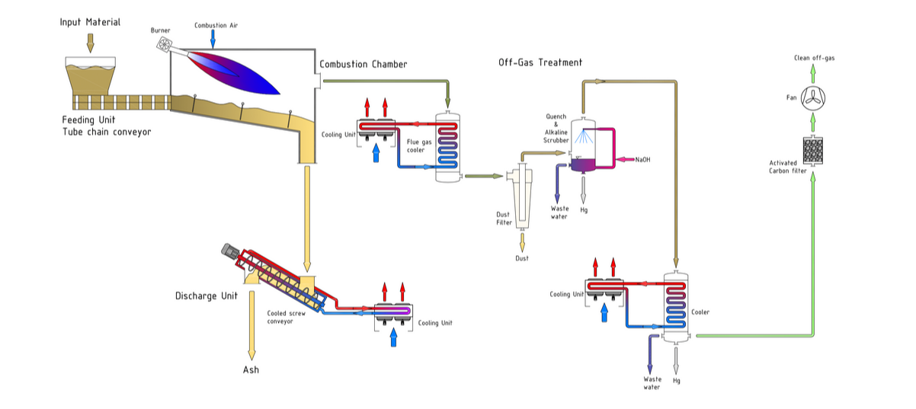
Econ Industries, ‘High temperature treatment’, no date.
The Gap Ridge processing facility also provides a thermal desorption unit that is designed to treat sludge that is contaminated with hydrocarbons and mercury. That process can also be used as a pre-treatment of hydrocarbon–contaminated catalysts, which can then be further treated by the high-temperature treatment unit. As mentioned earlier, thermal desorption is not well-suited to decontaminate large quantities of steel.

Decontamination by high-pressure cleaning
Contract Resources indicated that high-pressure cleaning using water pressure at 15,000 to 20,000 PSI can physically remove the contaminated scale layer from inside the pipeline.
However, this method only works for non-elemental mercury in the contaminated scale layer. It is not well suited for removal of elemental mercury in joints and cracks.

Decontamination via chemical processes
Total Hazardous Integrated Solution (THIS) utilise a proprietary chemical called ‘MerCure’ that can be used on mercury-contaminated metals while suppressing toxic vapours. According to its website, MerCure is:
A synergistic blend of Mercury-specific components in a water-based carrier medium designed to act quickly and effectively on mercury-contaminated metals while suppressing toxic vapours. MerCure has been independently proven to desorb and decontaminate sub-surface bound mercury and mercury compounds from impacted carbon steel prior to waste disposal, hot works and/or decommissioning activities.
Contract Resources indicated that its approach to the decontamination of mercury is similar to its approach to the decontamination of NORMs. Contract Resources deals primarily with parts that are heavily contaminated, such as valves. Its approach to the chemical decontamination of such items involves the creation of a closed-loop system and pumping a fluid through that, which then decontaminates the part. Wastewater generated from that process is then stored in evaporation ponds lined with HDPE liner with a permeability of 2 x 10⁻¹⁰ m/s or less.
Chemical processes are suited for removing mercury when contamination occurs with radioactive materials.
Insight from stakeholder engagement
Contract Resources said that the ownership of mercury-contaminated solid waste remains with the asset owner. The asset owner is then ultimately responsible for the safe disposal of the waste. Currently, the safe disposal of elemental mercury involves shipping it to Europe and creating stable mercury sulphide. That is then disposed of in salt mines. Disposal is further explored in Section 4.5.1.
    - Minamata Convention (COP-5) thresholds for mercury releases and wastes
The Minamata Convention on Mercury is an international environmental agreement that introduces global controls to protect human health and the environment from anthropogenic (human-caused) releases of mercury and mercury compounds.
Australia signed the Minamata Convention in October 2013 and ratified the convention in 2021, binding Australia under international law to meet the convention’s obligations.
Article 1 of the convention states:
The objective of this convention is to protect human health and the environment from anthropogenic emissions and releases of mercury and mercury compounds.
Under Article 1, Australia, as a party to the convention, does have a broader objective to minimise all mercury emissions.
In addition, the convention includes specific controls over various pathways:
- Air emissions—Article 8
- Releases to land and water—Article 9
- Mercury wastes—Article 11
Currently, air emissions from steelmaking are not constrained under Article 8 of the Minamata Convention. However, the broad objectives arising from Article 1 still apply. Article 9 provides for the control and reduction of releases of mercury and mercury compounds to land and water. Article 11 provides for the definition, management, transport and disposal of hazardous mercury waste.
  - Disposal
Key points
- Internationally, best practice for mercury disposal appears to be the extraction of elemental mercury and then stabilisation into mercury sulphide (cinnabar). Cinnabar is disposed of in salt mines. This is the primary method of elemental mercury disposal in Europe.
- Incineration with mercury capture, deep-well injections and permanent storage are also possible means of disposal for mercury-contaminated waste.
- There are currently no facilities in Australia that stabilise elemental mercury into cinnabar. This is currently being investigated, but commercial feasibility would be reliant on a minimum level of mercury requiring stabilisation over the life of the facility.
- In WA, Class 4 and Class 5 landfills can receive solid waste contaminated with mercury or mercury compounds.
    - International options
The best option for disposing of mercury recovered from the decontamination of infrastructure appears to be the conversion of all recovered mercury (elemental or liquid) to mercury sulphide. Internationally this option is provided by the companies listed below.

BATREC in Wimmis, Switzerland
BATREC is under the management of SARP Industries within the Veolia Group. Figure 8 provides a brief overview of its approach to converting mercury into mercury sulphide.
Figure 8 BATREC’s solution for converting mercury to mercury sulphide
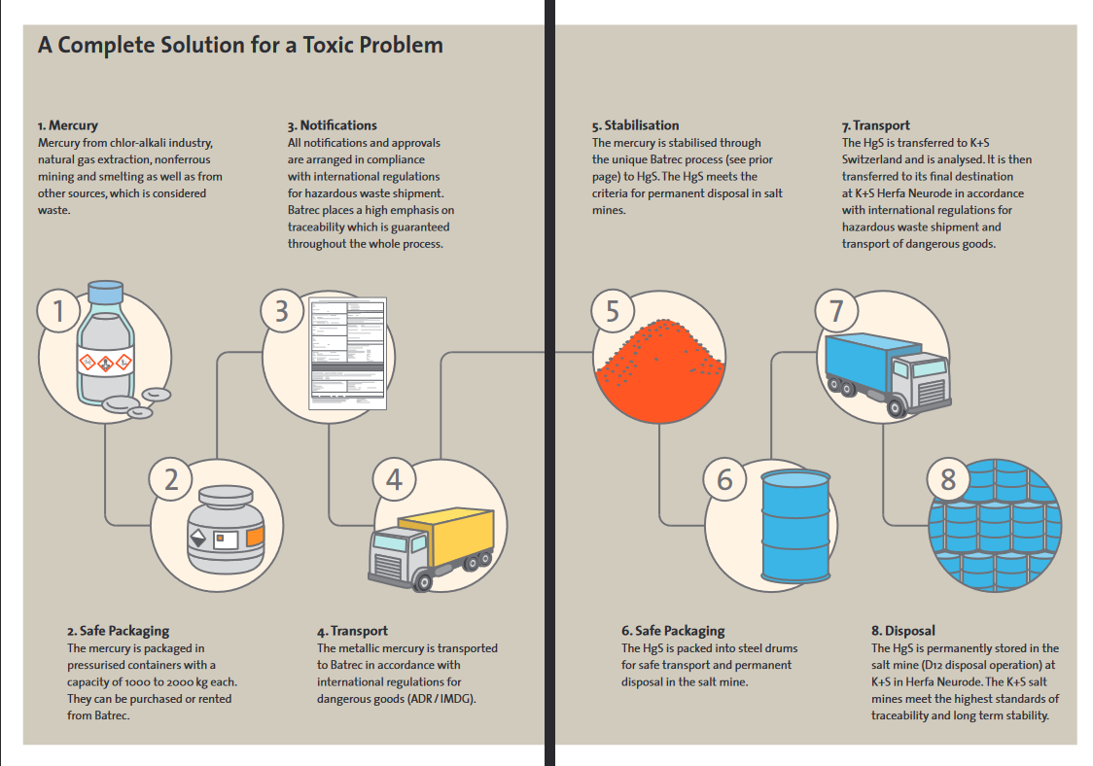
BATREC, ‘Treatment of mercury-contaminated waste’, 2021.
The mercury-sulphide product meets the criteria for permanent disposal in salt mines of K+S Group in Herfa-Neurode, Germany.

ECON Industries
ECON Industries, which is based in Starnberg, Germany, provides an on-site mercury-conversion process that allows mercury conversion and final disposal. The conversion process involves a reaction between elemental mercury and sulphur powder under a nitrogen atmosphere. Continuous, intensive mixing during the process ensures a complete stoichiometric reaction of mercury and sulphur.
Information from ECON Industries indicates the following conditions for the use of its on-site solution:
- minimum 50 tons of metallic mercury
- 200 m² workspace, up to 120 kW electrical power supply
- utilisation of client staff possible
- operating permit, with ECON’s support.
The mercury sulphide produced is packed in certified UN drums and transported to salt mines by ECON Industries, where a final quality check is performed prior to the sulphide being permanently stored in underground disposal sites.

Remondis QR in Dorsten, Germany
Remondis QR’s plant in Lübeck stabilises elemental mercury into mercury sulphide by means of an exothermic reaction. The reaction occurs between mercury and sulphur at a stoichiometric ratio, which ensures that no excess mercury or excess sulphur is in the end product. The end product, which is mercury sulphide or cinnabar, is poured into drums and is then disposed of in German underground salt mines. The stabilisation process is shown in Figure 9.
Figure 9 Stabilisation process of metallic mercury to mercury sulphide
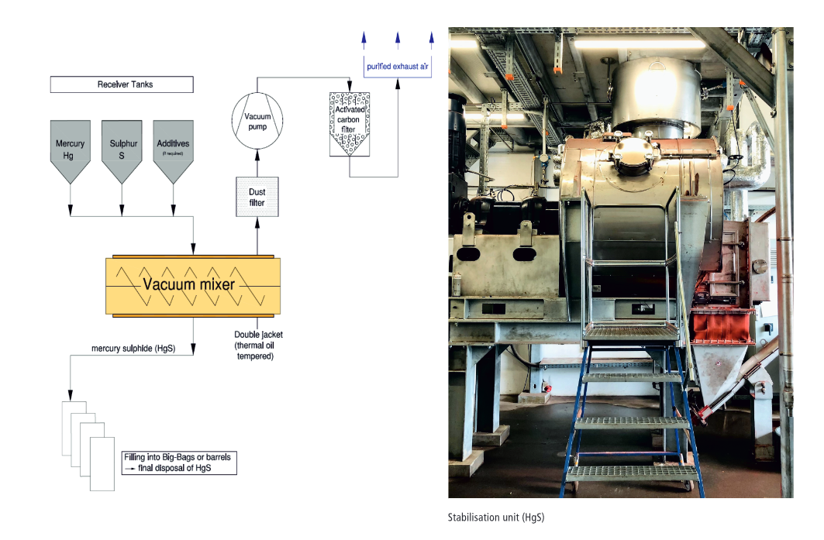
Process description published by Remondis QR.
    - Local options

Disposal of mercury-contaminated waste and mercury-contaminated products
Tellus Holdings operates the Sandy Ridge facility in WA. The facility is located approximately 240 km west-northwest of Kalgoorlie. It has been safely accepting and handling hazardous waste for surface storage. The facility is licensed under Part 5 of the Environmental Protection Act 1986 (WA). It holds approvals to dispose of Class 4 and Class 5 intractable waste inside the waste cell. In consultations undertaken as part of this project, Tellus mentioned the following points:
- Tellus currently receives a significant amount of mercury-contaminated products from mercury beds and catalysts for disposal.
- It does not receive significant quantities of steel contaminated with mercury.
- Currently, liquid disposal in the waste cell is prohibited in Sandy Ridge by the regulator and the facility’s licence conditions. Tellus is unable to receive liquid waste contaminated mercury and elemental mercury for disposal.
Mercury-contaminated solid waste can be safely disposed of in the Sandy Ridge facility.
Additionally, as mentioned in section 4.3.1, the following facilities shown in Figure 10 are also able to receive waste contaminated with mercury within WA. It is currently unknown whether the Pilbara Regional Waste Management Facility or the Red Hill Waste Disposal facility will accept mercury-contaminated waste for storage.
Figure 10 Class 4 and Class 5 landfills in WA
DWER Controlled Waste Tracker.

Disposal of elemental mercury
Currently, there is no local solution for the disposal of elemental mercury by conversion to mercury sulphide in Australia. Stabilisation of elemental mercury to mercury sulphide is currently being investigated by Ecocycle. Ecocycle utilises a mobile encapsulation unit to process elemental mercury into mercury sulphide. That method is similar to the processes used in Europe, as outlined in the previous section. This process would result in the creation of stable mercury sulphide safe for disposal. However, there are two key points to note:
- It is unclear whether this is currently operational. Ecocycle’s website indicates that this technology and the mobile encapsulation unit would be operational in early 2024. However, as of this report, it is unclear whether that time line has been achieved.
- As part of consultations during this project, Contract Resources indicated that this technology requires significant capital investment, and that poses a barrier to entry. Commercial feasibility would be reliant on a minimum level of mercury requiring stabilisation over the life of the facility.
- According to Contract Resources, levels of elemental mercury recovered via decommissioning currently do not justify this investment.
  - Emissions
Key points
- Emissions controls are listed in either the operating licences or works approvals for both decontamination facilities and steel smelters.
- Steel plants utilising electric arc furnaces are the primary destination for scrap steel recovered from decommissioning. blast furnace – basic oxygen furnaces utilise some scrap steel as part of the initial feedstock.
- Emissions from decontamination are captured in stacks of the various treatment units.
- Emissions controls and discharge limits for mercury vary between blast furnace-basic oxygen furnaces and electric arc furnaces.
- Given the uncertainties in estimating the total amount of mercury in decommissioned steel, it is difficult to quantify total mercury emissions to the atmosphere.
During decommissioning, mercury emissions are likely to occur either during the decontamination process or during steelmaking. This section outlines emissions-control technologies that are available for both decontamination and steelmaking facilities and lists the emissions-control limits on the facilities outlined in their respective operating licences for direct comparison of emissions limits between technologies.
    - Emissions controls

Decontamination facilities
Existing decontamination facilities appear to work within the constraints set by regulators on mercury emissions. They would require specialist processes and systems as described below.
CD Dodd owns and operates a scrap-metal processing and salvaging operation at Onslow. The premises are located within the Pilbara Regional Waste Management Facility.
CD Dodd lists the following decontamination infrastructure that is utilised in the facility:
- five fully enclosed high-energy flushing units
- an automatic high-pressure decontamination facility.
The approval specifies the trigger levels shown in Table 8 for mercury, which, if exceeded, will deem the waste item to be contaminated and require processing for decontamination.
Table 8 Trigger levels of decontamination of mercury used at CD Dodd—Onslow
Criteria | Method | Trigger levels
Surface mercury contamination | Olympus Vanta Portable XRF | > 12.5 micrograms/m³
Workplace exposure standards for elemental mercury (vapour) 8-hour exposure | Jerome mercury vapour monitor | > 1 ppm
Figure 5, DWER works approval W6828/2023/1 for CD Dodd—Onslow.
Decontamination acceptance criteria as listed in the works approval are listed in Table 9. The works approval states that waste will be considered adequately decontaminated and suitable for further processing if the contamination is below the clearance criteria.
Table 9 Acceptable levels of mercury post decontamination used at CD Dodd—Onslow
Criteria | Method | Trigger levels
Mercury vapour (elemental) | Mercury vapour monitor | < 0.012 mg/m³
Elemental mercury (liquid) | Visual | None
Table 1, DWER works approval W6828/2023/1 for CD Dodd—Onslow.
Specifically for steel, the approval states that the following steps for steel structures will occur after decontamination:
- Structures will be moved to the scrap-metal processing area, where they will be processed utilising shearing and oxy-cutting.
- Once at an appropriate size, the items will be stored appropriately pending removal.
- Stockpiled scrap metal should not exceed more than 3 m in height and not occupy an area greater than 100 m² at any given time.
The approval states the following for mercury vapour control during decontamination:
- Closed-loop decontamination systems: Use of MerCure within the high-energy flushing units will act to stabilise elemental mercury into an insoluble compound. This method limits vapours emission and any vapours that may be released will be held within the closed-loop system.
- Open decontamination systems: During open decontamination, the facility proposes to manually apply MeDeX 80, which is a non-hazardous mercury-vapour suppression material.
- Mercury wastes will be stored in lined, sealed drums in a lockable container.
Contract Resources operates the Gap Ridge facility, which is a mercury treatment plant in Karratha. DWER granted an operational licence for the facility in 2020. The facility utilises the following units for treating mercury:
- high-temperature treatment unit
- VacuDry Thermal Desorption unit
- mercury purification unit.
The operational requirements for the units, as shown in the licence, are listed in Table 10.
Table 10 Operational requirements for mercury decontamination equipment at Contract Resources, Karratha
Equipment | Operational conditions
High-temperature treatment unit | Dust filter with automatic jet cleaning system  Alkaline scrubber system with automatic pH monitoring and caustic dosing systems  Impact separator  Dual carbon filters consisting of a primary and secondary sulphur-impregnated carbon filter maintained to have a maximum saturation of 80%  The system has interlocks that restrict the use of recycled oil as a burner fuel. The restriction occurs at temperatures over 800°C to ensure combustion efficiency.
VacuDry thermal desorption unit | Vapour filter to treat off-gas from the evaporation chamber  Dual carbon filters consisting of a primary and secondary sulphur-impregnated carbon filter maintained to have a maximum saturation of 80%.
Mercury purification unit | Dual carbon filters consisting of a primary and secondary sulphur-impregnated carbon filter maintained to have a maximum saturation of 80%.
Table 1, from Gap Ridge facility licence issued by DWER.

Emission and discharge limits for mercury at the Contract Resources high-temperature treatment and thermal desorption units’ stack is set at 0.05 mg/m³.

Steel plants
Best available techniques (BATs) for electric arc furnace steelmaking and casting are outlined under Directive 2010/75/EU of the European Parliament. The directive sets out that the BAT for reducing air emissions is:
- Prevent mercury emissions by avoiding, as much as possible, raw materials and auxiliaries that contain mercury.
- For primary and secondary dedusting (including scrap preheating, charging, melting, tapping, ladle furnace and secondary metallurgy), achieve an efficient extraction of all emission sources by using one of the techniques listed below and use subsequent dedusting by means of a bag filter:
  - a combination of direct off-gas extraction (4th or 2nd hole) and hood systems
  - direct gas extraction and doghouse systems
  - direct gas extraction and total building evacuation (low-capacity electric arc furnaces may not require direct gas extraction to achieve the same extraction efficiency).
The overall average collection efficiency associated with BATs is > 98%. The BAT-associated emission level for dust is < 5 mg/m³ (normalised), determined as a daily mean value. The BAT-associated emission level for mercury is < 0.05 mg/m³ (normalised), determined as the average over the sampling period (discontinuous measurement, spot samples for at least four hours).
The sections below outline the emissions controls for two steelmaking facilities located in New South Wales. Port Kembla Steelworks is a blast furnace – basic oxygen furnace steel plant, and OneSteel Sydney Steel Mill is an electric arc furnace steel plant. Port Kembla Steelworks is owned by BlueScope Steel, and OneSteel Sydney Steel Mill is owned by Liberty OneSteel. BlueScope Steel and Liberty OneSteel are the two major integrated steel producers in Australia. They were both formerly part of BHP Limited and currently produce steel domestically as ‘upstream’ manufacturers. It is worth noting that the facilities produce different products from each other.
Port Kembla Steelworks utilises the following technologies for emissions control:
- baghouse/filtration systems
- chemical treatment
- thermal oxidisation
- scrubber systems
- dust suppression.
OneSteel Sydney Steel Mill has the following technology for emissions control:
- bag filtration for emissions from the electric arc furnace baghouse stack
Additionally, the steel mill has standard operating procedures to respond to alarms in the event of elevated opacity levels, audits of scrap quality, and regular dust suppression and sweeping of site roads.
The sections below outline the emissions controls and monitoring limits for mercury as set out in the Environment Protection Licence by the EPA NSW for Port Kembla Steelworks facility and the OneSteel Sydney Steel Mill facility. The impacts of using steel recovered from decommissioning will vary depending on the technology (foundry versus electric arc furnace versus smelter). The suitability of current thresholds and practices to limit mercury emissions would require further research.

Blast furnace – basic oxygen furnace steel plant
EPA NSW has stipulated the following emissions controls for the Port Kembla Steelworks facility in its environment protection licence for the facility. The licence outlines the following types of discharges:
- air emissions via discharges from pollutant stack
- discharges to water and application to land via water quality discharge from the drain.
The licence conditions state no load limit (in kg) for mercury emissions into the air and into estuarine water.
The following discharge points have air emissions limits for mercury:
- Discharge point 40—No. 2 Blower station 24 boiler stack
- Discharge point 47—No. 1 Walking beam furnace stack
- Discharge point 120—No. 2 Walking beam furnace stack
- Discharge point 108—Cold ferrous processing plant scrap cutting dust collector baghouse stack
The concentration limits are summarised in Table 11 for air and Table 12 for water.
Table 11 Air concentration limits for mercury for discharge points 40, 47, 120 and 108 at Port Kembla Steelworks
Discharge points | Pollutant | Units of measure | 100 percentile concentration limit | Reference conditions | Oxygen correction | Averaging period
Point 40—No. 2 Blower station 24 boiler stack | Mercury | Milligrams per cubic metre | 0.1 | Dry, 273, 101.3 kPa | 7% | 1 hour minimum
Point 47—No. 1 Walking beam furnace stack | Mercury | Milligrams per cubic metre | 0.1 | Dry, 273, 101.3 kPa | 7% | 1 hour minimum
Point 120—No. 2 Walking beam furnace stack | Mercury | Milligrams per cubic metre | 0.1 | Dry, 273, 101.3 kPa | 7% | 1 hour minimum
Point 108—Cold ferrous processing plant dust collector baghouse stack | Mercury | Milligrams per cubic metre | 1 | Dry, 273, 101.3 kPa | 7% | 1 hour minimum

The following discharge points have water and/or land concentration limits for mercury:
- Discharge point 82—Flat Products East No. 2 drain
- Discharge point 87—No 5. Blast furnace drain
- Discharge point 89—Ironmaking east drain.

Table 12 Water concentration limits for mercury for discharge points 82, 87 and 89
Discharge points | Pollutant | Units of measure | 100 percentile concentration limit
82—Flat Products East No. 2 drain | Mercury | Micrograms per litre | 1.5
87—Flat Products East No. 2 drain | Mercury (dry) | Micrograms per litre | 1.5
87—No. 5 Blast furnace drain | Mercury (wet) | Micrograms per litre | 1.5
89—Ironmaking east drain | Mercury (dry) | Micrograms per litre | 3
89—Ironmaking east drain | Mercury (wet) | Micrograms per litre | 1.5

Monitoring requirements for concentrations of discharged mercury are outlined in Table 13.

Table 13 Monitoring requirements for mercury at discharge points 40, 108 and 120 at Port Kembla Steelworks
Discharge point | Pollutant | Units of measure | Frequency | Sampling method
Point 40—No. 2 Blower station 24 boiler stack | Mercury | Milligrams per normalised cubic metre | Yearly | TM-12, TM-13 and TM-14
Point 108—Cold ferrous processing plant scrap cutting dust collector baghouse stack | Mercury | Milligrams per cubic metre | Yearly | TM-12, TM-13 and TM-14
Point 120—No. 2 Walking beam furnace stack | Mercury | Milligrams per cubic metre | Yearly | TM-12, TM-13 and TM-14

The sampling methods outlined in the licence conditions are based on the US EPA’s Method 29 (for TM-12, TM-13 and TM-14), Method 102 (for TM-12 and TM-14) and Method 30B (for TM-14).
US EPA Method 29 describes a procedure for determining metal emissions from stationary sources. Method 30B describes a procedure for measuring total vapour phase mercury. Method 102 describes a procedure for measuring particulate and gaseous mercury emissions from chlor-alkali plants (hydrogen streams).
Water and/or land monitoring requirements are outlined in Table 14.
Table 14 Monitoring requirements for mercury at discharge point 87—No. 5 Blast Furnace drain
Discharge point | Pollutant | Units of measure | Frequency | Sampling method
Point 87—No. 5 Blast furnace drain | Mercury | Micrograms per litre | Every 8 days | Grab sample

Electric arc furnace steel plant
EPA NSW has stipulated the following emissions controls for the OneSteel Sydney Steel Mill facility in its environment protection licence for the facility. The licence outlines the following types of discharges:
- air emissions via discharges from electric arc furnace baghouse (Point 1)
- d5ischarges to water and application to land via wet weather discharge at sediment dam (Point 3) and groundwater quality monitoring at wells (5points 4, 5, 6, 7 and 8).
The licence conditions state a 60 kg load limit for mercury emissions into the air for each reporting period (one year).
The following discharge point has air emissions limits for mercury:
- Discharge point 1—Electric arc furnace baghouse
The air concentration limits are summarised in Table 15.
Table 15 Air concentration limits for mercury for Discharge point 1
Discharge point | Pollutant | Units of measure | 100 percentile concentration limit | Reference conditions | Oxygen correction | Averaging period
Point 1—Electric arc furnace baghouse | Mercury | Milligrams per cubic metre | 0.2 | Blank in the licence conditions

The sediment dam and groundwater wells do not have water and/or land concentration limits for mercury.

Licence condition L3.11 states that discharge of biochemical oxygen demand, oil and grease, pH, temperature, total suspended solids, and metals to waters from EPA identification point no. 3 is permitted when the discharge occurs solely as a result of rainfall at the premises exceeding a total of 152 millimetres over any 24-hour period.
Note: ‘Metals’ refers to aluminium, arsenic, cadmium, chromium, cobalt, copper, iron, lead, manganese, mercury, nickel and zinc.

Air-monitoring requirements for the concentration of discharged mercury are outlined in Table 16.
Table 16 Air monitoring requirements for mercury at discharge point 1
Discharge point | Pollutant | Units of measure | Frequency | Sampling method
Point 1—Electric arc furnace baghouse | Mercury | Milligrams per cubic metre | Every 6 months | TM-14

The sampling methods outlined in the licence conditions are based on the US EPA’s Method 29 (for TM-12, TM-13 and TM-14), Method 102 (for TM-12 and TM-14) and Method 30B (for TM-14).
US EPA Method 29 describes a procedure for the determination of metals emissions from stationary sources. Method 30B describes a procedure for measuring total vapour phase mercury. Method 102 describes a procedure for measuring particulate and gaseous mercury emissions from chlor-alkali plants (hydrogen streams).
Water and/or land monitoring requirements are outlined in Table 17.
Table 17 Water and/or land monitoring requirements at discharge points 3, 4, 5, 6, 7 and 8
Discharge point | Pollutant | Units of measure | Frequency | Sampling method
Point 3—Sediment dam | Mercury (dissolved) | Micrograms per litre | Daily during any discharge | Grab sample
Point 3—Sediment dam | Mercury (total) | Micrograms per litre | Daily during any discharge | Grab sample
Points 4, 5, 6, 7, 8—Groundwater wells | Mercury (dissolved) | Micrograms per litre | Yearly | Grab sample
The licence for OneSteel’s Sydney Steel facility lists some special conditions relating to mercury for the use of alternative carbon injectants, specifically polyethylene in the electric arc furnace. The conditions are provided in Table 18.
Table 18 Mercury concentration limits for polyethylene use in the electric arc furnace
Maximum average concentration for characterisation  (mg/kg ‘dry weight’) | Maximum ‘moving’ average concentration for routine testing  (mg/kg ‘dry weight’) | Absolute maximum concentration  (mg/kg ‘dry weight’) | Test method
0.2 | Not required | 0.4 | Particle size reduction and sample splitting may be required. Analysis using US EPA SW-846 Method 7471B Mercury in solid or semisolid waste (manual cold vapour technique), or an equivalent analytical method with a detection limit < 20% of the stated maximum concentration of 0.2 mg/kg

    - Implications for cumulative annual emissions
Emissions of mercury from point and diffuse sources are published annually in Australia through the National Pollutant Inventory (NPI). The thresholds for mercury reporting to the NPI are based on the amount of mercury or mercury compounds a facility uses, handles or emits. The specific thresholds for mercury and its compounds are as follows:
- Facilities must report if they use more than 5 kg of mercury compounds per year.
- Facilities must report if they use more than 2,000 tonnes of fuel/waste or use 60,000 MWh of electricity (for other than lighting or motive purposes).
Table 19 outlines national point-source (facility-based) mercury emissions published by the NPI from 2004–05, including the relative contributions to air, land and water. The data shows that most emissions are to air, followed by water and land, and are approximately half of what they were in 2004–05.
Diffuse-source mercury emissions are also reported by the NPI (reported as 12,024 kg yearly since 1998–99, probably based on initial modelled results that have not been updated). While there are some limitations to the use of this data, it suggests that diffuse sources of mercury to the environment are of a similar magnitude to point sources, if not more significant. Therefore, the proportion of mercury emissions to air from steelmaking is compared to both national emissions (inclusive of diffuse sources but cognisant of limitations with this data) and to national emissions from point sources only.
Table 19 Total industry emissions by year, including distribution of emissions by air, land and water
Year | Total point source emissions (kg) | % air | % land | % water
2022–23 | 7,564 | 96.3 | 0.9 | 2.8
2021–22 | 7,359 | 97.8 | 0.7 | 1.5
2020–21 | 6,576 | 97.5 | 0.7 | 1.8
2019–20 | 6,331 | 97.7 | 0.7 | 1.5
2018–19 | 9,962 | 97.6 | 1.3 | 1.1
2004–05 | 15,184 | 98.6 | 0.3 | 1.1
DCCEEW, National Pollutant Inventory, Australian Government, 2024.

Focusing on the most recently available data from 2022–23 point-source emissions to air are dominated by ‘basic non-ferrous metal manufacturing’ followed by ‘electricity generation’ (Figure 11).
Figure 11 The top 10 industry emitters (point source) to air in Australia for the reporting year 2022–23
National Pollutant Inventory.
Point-source emissions to land are an order of magnitude lower than emissions to air and are dominated across seven industries related to oil and gas, mining, and water and waste management (Figure 12).
Figure 12 The top 10 industry emitters to land in Australia for the reporting year 2022–23
Note: Oil and gas extraction in this graph refers to both onshore and offshore activities. The available data does not distinguish between each. Within the oil and gas extraction and production industry, emissions to land may occur due to drilling fluid / other drilling additive losses and/or spills and leaks. DCCEEW, National Pollutant Inventory: Emission estimation technique manual for oil and gas extraction and production, version 2.0, Australian Government, July 2013.
National Pollutant Inventory.

Point-source emissions to water are also an order of magnitude lower than emissions to air but about 10 times higher than emissions to land and are dominated by urban water management, mining, non-ferrous metal manufacturing and electricity generation (Figure 13).
Figure 13 The top 10 industry emitters to water in Australia for the reporting year 2022–23
National Pollutant Inventory.

Figure 14 conceptually shows steps involved in decommissioning and associated mercury contamination percentages of mercury contamination in steel from decommissioned infrastructure. During decommissioning, 3.5 million tonnes of potentially contaminated steel is expected to be recovered. After recovery, the steel undergoes decontamination, which may result in steel with mercury contamination of up to 1 mg/kg. Note that due to the difficulties in estimating the total contamination of mercury, the figure does not provide any estimates. The decontaminated steel then gets sent to the steelmaker with mercury possibly at a concentration of up to 1 mg/kg. At the steelmaker, a portion of remaining mercury in the steel gets removed and disposed while the remaining mercury would be emitted to air. Once recycled, the steel would be virtually free of any mercury contamination.

Figure 14 Conceptual representation of mercury contamination in steel and removal at various stages of processing
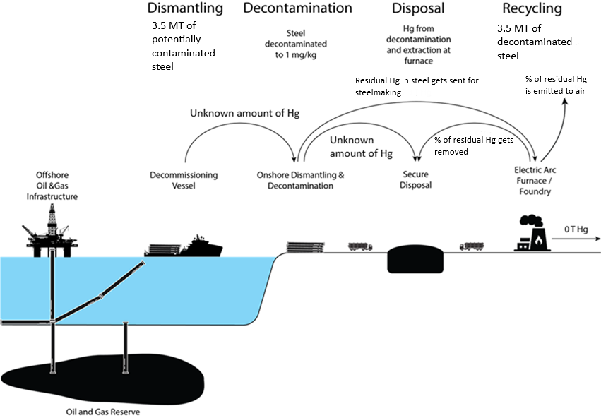
Marsden Jacob analysis.

  - Human and wildlife health
Key points
- It is difficult to ascertain the impact of mercury emissions from steelmaking on humans and wildlife. This is primarily due to difficulties in accurately estimating the expected levels of emissions.
    - Implications for human and wildlife health
This section focuses on the impact of any mercury emissions to the atmosphere from the recycling of mercury-contaminated steel and post-decontamination, and based on the consultation undertaken for this report, it is safe to assume that steelmakers will have mercury-abatement measures to remove a percentage of mercury in emissions to air.
Recent estimates suggest that mercury’s atmospheric lifetime is 3–6 months, implying that mercury is largely a hemispheric pollutant, which indicates that mercury emitted to air in the Southern Hemisphere is likely to be deposited in the Southern Hemisphere. Deposition of atmospheric mercury is one of the most uncertain parts of the global mercury cycle, and those uncertainties are magnified for Australia, where deposition measurements are extremely limited. Estimates of total mercury deposition over Australia range from 23 t/yr to as much as 130 t/yr. Continental-scale modelling finds that only 10% of the mercury emitted in Australia is deposited locally.
It is important to acknowledge that mercury does not remain inert in the environment. Instead, mercury undergoes transformation through biological processes, becoming methylmercury—a highly toxic form that readily bioaccumulates in organisms. ‘Bioaccumulation’ refers to the gradual build-up of mercury within individual organisms over time, particularly in long-lived species, while biomagnification occurs as mercury concentrations increase at higher trophic levels of the food chain.
This is of particular concern in aquatic ecosystems, where mercury can accumulate in fish species. Larger predatory fish, such as tuna or barramundi, can contain significantly higher concentrations of methylmercury due to their position at the top of the food chain. Humans who consume contaminated fish are exposed to those elevated levels, posing serious health risks, particularly to vulnerable populations such as pregnant women and young children, for whom mercury can affect neurological development.
Therefore, any assessment of mercury’s environmental risks should account for those processes, as the initial deposition levels may underestimate the true exposure risk. This link highlights the need for a precautionary approach to mercury management, focusing not only on deposition but also on mercury’s long-term behaviour and potential impact on both ecosystem and human health.

Routes of exposure
Human and wildlife exposure to mercury-contaminated steel begins with the demolition and transport of oil and gas infrastructure. If the material to be demolished is suspected of mercury contamination, techniques that generate heat should be avoided. Adsorbed mercury is rapidly released at high temperatures and may cause high localised mercury concentrations in the atmosphere. Hot work, grinding and blasting on mercury-impacted metals require special attention. Cold-cutting techniques, such as pressurised water and shears, are commonly used in Australia. Limited information is available on how much mercury (if any) is liberated with those techniques.
Decontamination activities on land provide the next mercury-exposure pathway for humans and wildlife. Proper safety protocols must be implemented and followed, including the use of personal protective equipment, air monitoring and containment barriers to prevent waste entering the environment. Waste from decontamination processes, including sludge and mercury-laden residues and personal protective equipment, must be treated as hazardous waste and handled and disposed of in accordance with relevant environmental regulations​. Special disposal methods, such as stabilisation and containment, should be used to prevent environmental contamination.
Depending on the steelmaking process used, steel decontaminated to 1 mg/kg can still pose risks to workers and the environment at the recycling stage (via steelmaking) due to the larger quantities of steel being processed. A paper by Qa³ On-site Chemistry presents estimated prediction of occupational exposure to mercury released during smelting (as distinct from other forms of steelmaking operations) of steel containing 1 mg/kg of mercury. The analysis shows that, for a steel smelter without control measures (as distinct from an electric arc furnace or foundry), the predicted exposure to mercury while smelting would exceed the guidelines.
In Australia, all jurisdictions, except Victoria, operate under harmonised work, health and safety (WHS) legislation. Despite the discrepancy for Victoria, the regulatory approach to ensure worker safety is similar for all jurisdictions:
- Each WHS regulator follows an outcome-based approach to ensure workers’ safety. Therefore, the regulator does not estimate levels of harmful emissions but requires businesses to adequately manage their risks.
- It is up to the person conducting a business or undertaking to ensure that they reduce the risks to as low as is reasonably practicable.
- WHS regulators use a hierarchy of controls to minimise risks, as set out in Figure 15.
- During steelmaking operations, WHS regulators can inspect the facilities and measure mercury levels to ensure compliance.
Figure 15 Hierarchy of controls to identify and rank safeguards to protect workers
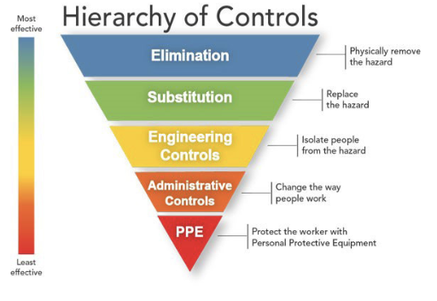
Occupational Safety and Health Administration, ‘Identifying hazard control options: the hierarchy of controls’, Department of Labor, US Government, no date.
Based on the research findings, the following conclusion can be drawn for implications of mercury exposure to human health during steelmaking operations.
- Worker exposure is a key consideration while utilising decommissioned scrap steel during steelmaking.
- Currently, worker exposure limits exist for mercury in Australia.
- Without controls, steelmaking of steel with low levels of mercury may lead to excessive worker exposure.
- Some forms of steelmaking, such as in a modern electric arc furnace, may use engineering controls to minimise the risk (isolating people from the hazard); a secondary form of protection, such as personal protective equipment, may also be required.
- Ideally, mercury controls at steelmaking would require multiple levels of controls and constant monitoring, as outlined in Figure 15.
    - Mercury in steel standard
Based on the research and consultations undertaken in this study, it is reasonable to conclude that mercury included in scrap steel will not be seen in recycled steel products. It is reasonable to assume that all mercury in the scrap after decontamination would be volatilised. Therefore, the most considerable risk arising from mercury in steel would be at the decommissioning and decontamination stages, when workers and the environment are exposed to high levels of mercury. Exposure controls at facilities are addressed via WHS requirements to ensure that they keep to safe exposure levels.
As discussed previously, there is currently no guidance on what level of mercury contamination is deemed small enough to not require decontamination. The development of a ‘clearance standard’—below which the scrap is considered suitable for steelmaking—does require consideration.
The approach to developing a standard for a contaminant in steel, such as mercury, typically follows a structured process involving scientific research, stakeholder consultation and regulatory alignment. The literature review undertaken as part of this project, together with the consensus among industry professionals, is that a standard for mercury in steel does not exist but would be welcomed.
An approach to achieving such a standard would include the following steps:
- Establish a threshold based on risk assessment. An acceptable contamination threshold for mercury should be established based on a detailed risk assessment. The risk assessment aims to quantify the likelihood and severity of adverse effects that could result from exposure to mercury during the various stages of handling, transport, recycling and disposal of steel. The risk assessment should include the following:
  - Hazard identification: Mercury’s toxicity, ability to bioaccumulate in organisms and potential to convert into methylmercury (a more toxic form) are recognised hazards. This step also considers the different forms of the contaminant, as various chemical states of mercury (e.g. elemental, inorganic, or organic mercury) may pose distinct risks.
  - Exposure assessment: This component evaluates how, when and where mercury exposure might occur. In the steel industry, exposure could happen at multiple points, such as during the cutting, decommissioning, transportation and recycling of contaminated steel. The exposure pathways for workers, nearby communities and ecosystems are assessed, considering different scenarios (e.g. accidental spills or volatilisation during steelmaking). Factors such as concentration levels, duration of exposure and environmental persistence are crucial to this assessment.
  - Dose–response assessment: This step examines the relationship between the mercury exposure level and the severity of its potential health effects. Guidelines already exist in Australia for several different areas, including occupational health and ecosystem protection (see Table 5).
  - Characterisation: Based on the findings from the hazard identification, exposure and dose–response assessments, risk characterisation brings everything together to estimate the overall risk posed by mercury. This involves calculating the probability and severity of harmful outcomes under different exposure scenarios. This step provides a clear understanding of the magnitude of the risk, whether it is acceptable and what protective measures or thresholds need to be implemented.
  - Risk-mitigation strategies: Once the risks are characterised, the assessment explores potential strategies to mitigate those risks. This could involve determining acceptable contamination limits, identifying the most effective decontamination methods and identifying existing or new protocols for safe handling and disposal. It also informs the development of engineering controls (e.g. air-filtration systems during steelmaking), operational practices (e.g. worker protective equipment) and environmental monitoring.
Any proposed limits should be benchmarked against international best practices to ensure they are practical and feasible for industry implementation.
- Select measurement and testing methods. Appropriate measurements must be selected to enable confident and reliable mercury measurement to levels below the desired threshold. This could include testing methodologies for both on-site and laboratory-based analysis.
- Engage stakeholders. Once a threshold and suitable testing methods have been identified, consultations should be conducted among industry experts, environmental agencies and health organisations to gather feedback on the practicality of the proposed standard and testing methodologies. Government and regulatory authorities are also involved in ensuring alignment with national laws and international obligations.
- Develop draft standards. Based on the research, risk assessments and stakeholder input, a draft standard is developed. That document outlines contamination limits, testing protocols and guidelines for handling, transport and recycling, along with strategies for managing risks.
- Consult the public for feedback and revisions. The draft standard should then be published for public consultation, allowing stakeholders and the general public to provide feedback. Based on that input, modifications can be made to ensure that the standard is robust and widely supported.
- Implement and monitor standards for compliance. Once finalised, the standard requires adoption by regulatory bodies, and mechanisms are established to monitor compliance, including regular testing and reporting.
- Continuous review. Over time, the standard should be periodically reviewed and updated to reflect new scientific developments, technological advances or changes in industry practices.

  - Research
Key points
- Research is required on estimating levels of mercury contamination from offshore oil and gas infrastructure.
- Research on in situ mercury detection and quantification will help to accurately estimate levels of contamination.
- Understanding how to remove mercury from steel surfaces is another key area to ensure that maximum levels of mercury are removed before recycling.
- The efficiency of occupational exposure controls for mercury during steelmaking is another important area for research.

The presence of mercury in decommissioned oil and gas infrastructure poses significant environmental and health risks if not managed carefully. Areas of research in this sector that are underway or required fall into the following categories.
    - Mercury detection and quantification
The accurate detection of mercury in oil and gas infrastructure is critical in understanding the magnitude and extent of contamination that will require mitigation. Traditional detection techniques, while useful, might not capture the full extent of mercury contamination, especially in complex environments such as pipelines and processing facilities. The development of more sensitive detection tools, including portable mercury analysers (e.g. XRF) and advanced spectroscopy methods, has significantly improved real-time monitoring and will continue to do so.
The use of intelligent PIGs (‘pipeline intervention gadgets’ or ‘pipeline inspection gauges’) is another innovative method that has gained attention for the inspection of decommissioned pipelines. This technology involves the use of instrumented PIGs equipped with sensors capable of detecting internal anomalies and contaminants, including mercury. By providing real-time data on the integrity of pipelines and the presence of mercury deposits, intelligent pigging ensures safer and more efficient decommissioning operations. This approach also enables targeted remediation efforts by identifying specific sections of the pipeline that contain higher concentrations of mercury, allowing for more efficient removal processes.
As mentioned in Section 4.1, the accurate levels of quantification of total mercury in oil and gas pipelines is complicated by the following:
- Differing characteristics amongst oil and gas pipelines across Australia;
- Use of internally flow-coated pipelines and exposure of steel;
- Limited understanding of mercury deposition on steel; and
- Total amount of exposed steel in oil and gas pipelines across Australia with older pipelines having more exposed steel and newer pipelines having less.
Collaboration across industry to develop understanding of the above, could be beneficial in accurately quantifying mercury in steel.
    - Removal of mercury from steel substrates
One of the key challenges in decommissioning oil and gas infrastructure is the removal of mercury that has adsorbed onto steel substrates. Various techniques have been investigated and discussed in this report, including chemical washing, thermal desorption and mercury-specific adsorbents. Chemical washing involves the use of complexing agents to mobilise and remove mercury from steel surfaces (there are a number on the market), while thermal desorption applies heat to vaporise mercury for collection. The former method seems to be the preferred method based on our interviews. Both methods have proven effective in reducing mercury levels on steel substrates, although further optimisation is needed to increase efficiency, minimise waste and improve cost efficiency.
    - Occupational exposure controls
Occupational exposure to mercury vapour during the melting of contaminated steel is a serious concern for workers within steelmaking facilities that do not have sufficient mitigation measures in place. Advice received from Green Steel of WA was that its proposed electric arc furnace and ladle furnace will both be sealed as much as possible for energy-efficiency reasons and that a fume treatment plant will extract directly from the sealed furnaces. That will be complemented with secondary extraction via a suction hood on the roof. In addition, scrap metal will be fed directly into the electric arc furnace on a sealed conveyor, unlike traditional bucket charging, in which a load of steel is dropped into a hot furnace. Such mechanisms are likely to reduce the risk of worker exposure; however, research is required to determine the true efficiency of those measures.

- Next steps
Australia’s Offshore Resources Decommissioning Roadmap clearly outlines the role that the Australian waste and recycling industry can play in decommissioning offshore oil and gas infrastructure. According to ‘Offshore oil and gas decommissioning: Technologies and careers for Australia’s emerging industry’, published by the Australian Academy of Technology and Engineering, there are gaps in our understanding of the impacts of contaminants from decommissioning. The presence of contaminants affects both recycling and the efficiency of cleaning and waste-management processes.
In the roadmap, total ferrous material, predominantly steel, recovered from decommissioning is estimated to be around 3,560 tonnes. Since recovered steel can be predominantly used in electric arc furnaces to produce sustainable steel, there will be a strong demand for scrap steel. Therefore, understanding the impacts of contaminants such as mercury becomes key. Technical learnings from recycling scrap steel from offshore oil and gas projects can be applied to onshore renewable energy infrastructure when those projects are decommissioned.
This report aims to lay the foundation in terms of understanding the impacts of contaminants, specifically mercury, on steel and the implications for possible recycling pathways and technologies. Consultations and research undertaken for this report highlight the uncertainties associated with the estimation of mercury levels in infrastructure, levels of contamination in steel after decontamination and impacts of recycling steel at steel mills.
The points noted in the ‘Executive summary’ are expanded upon here. We recommend that the following activities be undertaken—broadly in this order of importance.
1. Work with industry, such as through workshops, to address the identified areas of further research.
Such workshops would facilitate knowledge sharing, drive standardisation efforts and encourage collaboration among stakeholders involved in decommissioning and recycling. Through the workshops, industry professionals can collectively address gaps, such as mercury contamination management, regulatory harmonisation and best practice approaches to decommissioning, which are crucial for Australia’s emerging offshore resources decommissioning sector. The outcome of the meetings would be an agreement on priorities and a delineation of roles between government and industry—including an agreed project lead and timetable.
As the recommendations cover activities that would be best led by government as well as others that would be best led by industry, a delineation of roles should be agreed, as not all of those activities are within the usual role of government. A suggested delineation of roles for consideration in the workshops is set out in Table 20.
Table 20 Suggested delineation of roles for recommendations
Task | Suggested lead group
Develop a national standard for mercury levels in mercury-contaminated steel for recycling | Steel industry with input from WHS regulators at state and federal levels
Harmonise the approach and approvals used under different regulatory regimes for decommissioning | Decommissioning: state and federal regulators covering industry approvals  Waste management: state and federal environmental regulators
Work with industry to refine standard practices for decommissioning, decontamination and emission controls | Industry led
Increase research and monitoring | Industry led

2. Consider developing a national standard for mercury levels in mercury-contaminated steel for recycling. Given the gaps in current legislation, it is recommended that Australia develop a national standard for mercury in steel for recycling. The standard should align with international best practices and take into account relevant thresholds established under the Minamata Convention and may incorporate specific guidelines for different forms of steel processing.
Currently, some industry groups use 1 mg/kg of steel as a standard, but that is not universally accepted. As a number of the regulators use outcome-focused legislation, a prescriptive threshold (such as 1 mg/kg) will be specific to one end use—such as recycling through an electric arc furnace.
3. Consider opportunities to harmonise the approach and approvals used under different regulatory regimes for decommissioning.
For example, an asset operating offshore of Western Australia in Commonwealth waters with onshore processing of the gas may require approvals from NOPSEMA, DMPE Pipelines Group and DLGIRS Dangerous Goods Group.
Onshore decontamination of pipelines also requires approvals from DWER Industry Licensing, and the transport and disposal of concentrated mercury products requires approvals from DWER Controlled Waste Group.
Harmonisation could follow the example of the controlled-waste management regulatory regime. Controlled-waste movement, transport and tracking between states and territories in Australia is largely harmonised due to the National Environmental Protection Measure.
4. Work with industry to refine standard practices for decommissioning, decontamination and emission controls.
Decontamination techniques need to be standardised across the industry, and steelmaking facilities should implement mercury-abatement measures to minimise emissions. Collaboration with international partners to adopt successful mercury-stabilisation methods, such as conversion to mercury sulphide, is crucial.
5. Increase research and monitoring.
Ongoing research is needed to improve the safe management and disposal of mercury-contaminated assets. The following areas are identified as current research priorities:
  - mercury detection and quantification—particularly in situ measurement and estimation techniques
  - removal of mercury from steel substrates
  - occupational exposure controls.
It is noted that improved in situ estimation of mercury contamination in offshore production assets will allow the estimates of the total mercury in pipelines and offshore assets to be refined.

- Other information
Table 21 International regulations, advisories and guidelines regarding mercury in air, water and other media
Type of mercury | Type of value | Value | Issuing agency | Source of information
Elemental mercury vapour | Acute exposure guideline levels | See US EPA AEGL Program: Mercury vapor results | US EPA | US EPA AEGL Program: Mercury vapor results
Mercuric chloride | Reference dose (RfD) for chronic oral exposure;  no reference concentration (RfC) for inhalation | 3 x10⁻⁴ mg/kg-day  LOAEL: 0.317 mg/kg-day | US EPA | IRIS assessment
Mercuric chloride | Carcinogenicity assessment | possible human carcinogen | US EPA | IRIS assessment
Metallic mercury | RfC for chronic inhalation  (RfD for chronic oral exposure not assessed) | 3x10⁻⁴ mg/m³  LOAEL (ADJ): 0.009 mg/m³ | US EPA | IRIS assessment
Metallic mercury | Carcinogenicity assessment | Not classifiable | US EPA | IRIS assessment
Methylmercury | RfD for chronic oral exposure  (no RfC for inhalation) | 1 x10⁻⁴ mg/kg/day; equivalent to a blood methylmercury concentration of 5.8 micrograms per litre (μg/L) | US EPA | IRIS assessment
Mercuric chloride | Maximum contaminant level goal (MCLG) and maximum contaminant level (MCL) in drinking water | Both the MCLG and the MCL are 0.002 mg/L (2 parts per billion [ppb]) | US EPA | Basic information about mercury (inorganic) in drinking water
Mercuric chloride | Water bodies | Recommends that the level of inorganic mercury in rivers, lakes and streams be no more than 144 parts mercury per trillion [ppt] | Agency for Toxic Substances and Disease Registry (ATDSR) | ATSDR public-health statement on mercury
Methylmercury | Fish-tissue-based water-quality criteria | 0.3 micrograms of mercury per gram (0.3 mg/kg) of fish as an indicator that water bodies should not have higher levels in their fish | US EPA | Human health criteria: methylmercury fish-tissue criterion
Methylmercury | Seafood products sold through interstate commerce. US Food and Drug Administration (US FDA) can seize shipments of these products. Does not apply to in-state shipments or to sport fish caught recreationally. | 1 ppm | US FDA | Guidance for industry: Action levels for poisonous or deleterious substances in human food and animal feed
‘Mercury’ | Allowable levels in bottled water | 0.002 mg/L | US FDA | Code of Federal Regulations
Mercuric chloride | Minimal risk level (MRL): health-based screening level for chronic exposures to airborne mercury; estimate of the daily human exposure to a hazardous substance that is likely to be without appreciable risk of adverse non-cancer health effects over a specified duration of exposure. | Acute:  0.007 mg/kg/day  Intermediate:  0.002 mg/kg/day | ATSDR | List of MRLs for hazardous substances
Metallic mercury | MRL: health-based screening level for chronic exposures to airborne mercury; estimate of the daily human exposure to a hazardous substance that is likely to be without appreciable risk of adverse non-cancer health effects over a specified duration of exposure. | Chronic: 0.0002 mg/m³ | ATSDR | List of MRLs for hazardous substances
Methylmercury | MRL | Chronic: 0.0003 mg/m³ | ATSDR | List of MRLs for hazardous substances
All | Medical management guidelines | n.a. | ATSDR | Medical management guidelines for mercury
Mercury compounds | Workplace exposure limit / REL (health-based screening levels used to identify potentially hazardous situations due to short-term exposures to contaminants in air) | Hg vapour: TWA 0.05 mg/m³ (skin)  Other: no more than 0.1 mg/m³ (skin) | National Institute for Occupational Safety and Health (NIOSH) | Pocket guide to chemical hazards: Mercury compounds
Mercury compounds | Workplace exposure limit / PEL | No more than 0.1 mg/m³ | NIOSH | Pocket guide to chemical hazards: Mercury compounds
Organo-alkyl compounds | Workplace exposure limit / REL (health-based screening levels used to identify potentially hazardous situations due to short-term exposures to contaminants in air) | TWA 0.01 mg/m³ ST 0.03 mg/m³ (skin) | NIOSH | Pocket guide to chemical hazards: Mercury (organo) alkyl compounds (as Hg)
Organo-alkyl compounds | Workplace exposure limit / PEL | TWA 0.01 mg/m, no more than 0.04 mg/m³ | NIOSH | Pocket guide to chemical hazards: Mercury (organo) alkyl compounds (as Hg)
Metallic and inorganic compounds | Industrial workplace PEL | 0.025 mg/m³ | Office of Environmental Health Hazard Assessment, California Environmental Protection Agency | Occupational Health Hazard Risk Assessment Project for California: Identification of chemicals of concern, possible risk assessment methods, and examples of health protective occupational air concentrations (2007)
Mercury and inorganic mercury compounds | Acute, 8-hour and chronic reference exposure levels | Acute: 0.6 micrograms Hg/m³; 8-hour: 0.06 micrograms Hg/m³; Chronic: 0.03 micrograms Hg/m³ | California Office of Environmental Health Hazard Assessment | Acute, 8-hour and chronic reference exposure levels as of August 2020.
Agency for Toxic Substances and Disease Registry, Toxicological profile for mercury, US Government, October 2024.

- Analytical methods for analysis of mercury
  - In-field analysis
X-ray fluorescence (XRF) spectroscopy
XRF spectroscopy provides a non-destructive and semi-quantitative method for measuring mercury in steel, is suitable for on-site analysis and can also be performed in the laboratory. The method requires access to the contaminated surface of steel and uses a hand-held analyser (portable XRF or pXRF) that exposes a steel sample to X-rays that excite atoms in the sample, causing them to emit secondary X-rays. The emitted X-rays are characteristic of the elements present in the sample, including mercury. The intensity of the X-rays can be used to quantify the concentration of mercury. This technique measures mercury exclusively at the contaminated surface. Converting the surface measurement from XRF (μg/cm²) into a ‘semi-quantitative total mercury in steel’ concentration (e.g. mg/kg) necessitates a calculation that considers the thickness of mercury contamination (in the scale) and the dilution factor of the steel mass. In addition, theoretical calculations and assumptions about mercury emission during steelmaking suggest that pXRF instruments might not detect low enough levels to guarantee safety. Therefore, precise measurement through laboratory-based methods is recommended to confirm mercury concentrations prior to steelmaking.
Despite its limitations, XRF spectroscopy remains the only established technique for rapid and cheap testing of mercury contamination in the field and can be useful in assessing the efficacy of decontamination treatments.
  - Laboratory analysis
A variety of laboratory analysis techniques are available to measure mercury in steel. However, they vary in their detection limits, sample preparation requirements, operator skill levels, availability of instrumentation in commercial laboratories and cost. A brief overview of the various methods is outlined below; however, expert consultation described inductively coupled plasma mass spectrometry (ICP-MS) as the most suitable method for assessing elemental mercury in steel, followed by cold vapour atomic fluorescence spectrometry (CV-AFS) if very low levels of detection are required. The latter method requires a specific instrument, which is less commercially available, for the detection of mercury.
Inductively coupled plasma mass spectrometry and inductively coupled plasma optical emission spectroscopy
ICP-MS and inductively coupled plasma optical emission spectroscopy (ICP-OES, or inductively coupled plasma atomic emission spectroscopy ICP-AES) are elemental analysis techniques, meaning they are used to measure elements rather than the molecules and compounds that are measured by liquid or gas chromatography – mass spectrometry (LC-MS and GC-MS, respectively). ICP-MS uses an argon (Ar) plasma (the ICP) to convert the sample into ions that are then measured using a mass spectrometer (the MS). ICP-MS is similar to ICP-OES, but ICP-OES uses an optical spectrometer to measure the light emitted from elements as they pass through the plasma, whereas ICP-MS measures the elements (ions) directly. Both techniques provide fast analysis of multiple elements in a sample, but ICP-MS provides much lower detection limits (DLs) than ICP-OES, so it is a better choice for trace element analysis. Instrument detection limits (IDLs) will vary with the matrices, instrumentation and operating conditions. In relatively simple matrices, IDLs will generally be < 0.1 ppb (< 1 µg/kg or < 0.001 mg/kg) for ICP-MS.
Options for preparing steel samples include full digestion using strong acids (e.g. hydrofluoric acid) to convert all mercury to a soluble form or leaching mercury from the surface of the steel, followed by digestion (the latter requires less prep and access to strong acids). The digested sample is nebulised into a fine aerosol and introduced into the plasma, where mercury atoms are ionised in the plasma prior to detection in the mass spectrometer.
Cold vapour atomic absorption spectrometry and cold vapour atomic fluorescence spectrometry
Cold vapour atomic absorption spectrometry (CV-AAS) and cold vapour atomic fluorescence spectrometry (CV-AFS) are analytical techniques widely used to detect mercury in environmental and biological samples. Both methods are based on mercury’s unique properties, allowing for precise and sensitive measurements.
CV-AAS operates on the principle of atomic absorption, in which mercury atoms in a vapour state absorb light at a specific wavelength, typically around 253.7 nm. The amount of light absorbed correlates directly with the concentration of mercury in the sample. The process begins with the sample being treated with a reducing agent, such as stannous chloride or sodium borohydride, to convert all mercury forms into elemental mercury (Hg⁰). The elemental mercury is then vaporised and carried by an inert gas into a quartz cell within the spectrometer. The decrease in light’s intensity as it passes through the mercury vapour is measured, providing a direct indication of mercury concentration. CV-AAS is commonly used for environmental monitoring, including the analysis of water, soil and air samples, as well as for assessing mercury levels in biological samples such as blood, urine and tissues. Its simplicity, cost-effectiveness and high sensitivity make it a popular choice, although it is mainly limited to mercury detection and can be affected by matrix interferences. This method’s typical IDL is < 0.1 ppb (< 1 µg/kg or < 0.001 mg/kg).
On the other hand, CV-AFS utilises the principle of atomic fluorescence, in which mercury atoms, after being excited by a light source, emit light at a specific wavelength. The intensity of the emitted light is directly proportional to the mercury concentration. The procedure for CV-AFS is similar to that for CV-AAS, involving the reduction of mercury to its elemental form and the generation of mercury vapour. However, instead of measuring absorption, CV-AFS measures the fluorescence emitted by mercury atoms when they return to their ground state after excitation. This technique offers higher sensitivity and lower detection limits compared to CV-AAS, making it particularly useful for detecting trace levels of mercury in complex matrices (< 0.001 ppb with pre-concentration). Despite its advantages, CV-AFS is more complex and expensive, and it can be susceptible to quenching effects and other interferences.
In summary, while both CV-AAS and CV-AFS are highly specific and sensitive methods for mercury detection, the choice between them depends on the required sensitivity, the complexity of the sample matrix and available resources. CV-AAS is generally favoured for its simplicity and cost-effectiveness, whereas CV-AFS is preferred in situations in which higher sensitivity and lower detection limits are essential.
Thermal desorption coupled with various detection methods
Thermal desorption (TD) is a versatile technique used in mercury analysis, in which mercury is released from various matrices by heating the sample, followed by detection using several methods. The primary methods include TD with atomic absorption spectrometry (TD-AAS) and TD with atomic fluorescence spectrometry (TD-AFS), both of which are commonly used for environmental and industrial monitoring. TD-AFS offers higher sensitivity. TD with inductively coupled plasma mass spectrometry (TD-ICP-MS) provides high sensitivity and specificity, making it ideal for trace-level mercury analysis in complex matrices. Additionally, TD with cold vapour techniques, such as TD-CV-AAS and TD-CV-AFS, enhance sensitivity and are particularly useful for air and environmental sample analysis. TD with gas chromatography (TD-GC) coupled with detection methods is employed for mercury speciation, while TD with direct mercury analysers (TD-DMA) offers rapid and automated analysis of mercury in solid and liquid samples.

Geoscience Australia, ‘Australia’s energy commodity resources 2024: gas’, Australian Government, 15 July 2024.
Department of Industry Science and Resources (DISR), Guideline: Offshore petroleum decommissioning, Australian Government, 2 March 2022.
‘Australian waters’, as defined for the purposes of the Sea Dumping Act, cover the territorial seas (other than seas within the limits of a state or the Northern Territory), the exclusive economic zone and waters above the Australian continental shelf. This is broader than the coverage of ‘Commonwealth waters’ under the OPGGS Act, which extends from three nautical miles seaward of the territorial sea baseline.
Department of Climate Change, Energy, the Environment and Water (DCCEEW), ‘Dumping and abandonment of offshore oil and gas platforms and structures at sea’, Australian Government, 2024.
MM Roggenkamp, ‘Petroleum pipelines in the North Sea: question of jurisdiction and practical solutions’, Journal of Energy and Natural Resources Law, 1998, 92–109.
OSPAR Commission, ‘Ministerial meeting of the OSPAR Commission, Sintra, 22–23 July 1998: programmes and measures’.
Department for Business, Energy & Industrial Strategy, Guidance notes: Decommissioning of offshore oil and gas installations and pipelines, UK Government, November 2018.
Department for Business, Energy & Industrial Strategy, Guidance notes: Decommissioning of offshore oil and gas installations and pipelines, Annex A.
Department for Business, Energy & Industrial Strategy, Guidance notes: Decommissioning of offshore oil and gas installations and pipelines, Annex C, p. 96.
Mining Act of the Netherlands 2003, as amended.
Mining Act of the Netherlands 2003, Article 2(1)–(2).
D Drankier, MM Roggenkamp, ‘The regulation of decommissioning in the Netherlands: from removal to reuse’, in MM Roggenkamp, C Banet (eds.), European Energy Law Report, 2020, vol. XIII, pp. 289–306.
MM Roggenkamp, ‘Petroleum pipelines in the North Sea: question of jurisdiction and practical solutions’, Journal of Energy and Natural Resources Law, 1998, pp. 92–109.
Mining Act of the Netherlands 2003, Article 45(1).
Section 3.3.2 of Drankier & Roggenkamp, ‘The regulation of decommissioning in the Netherlands: from removal to reuse’. While there are references to the minister limiting removal obligations, there were no publicly available examples.
Gerbert Romijn, Gusta Renes, General guidance for cost–benefit analysis, Netherlands Bureau for Economic Policy Analysis, Netherlands Environmental Assessment Agency, 2013.
Section 3.3.2 of Drankier & Roggenkamp, ‘The regulation of decommissioning in the Netherlands: from removal to reuse’.
P Crafts, M Williams, ‘Mercury partitioning in oil and gas production systems—design optimisation and risk mitigation through advanced simulation’, The APPEA Journal, 2020, 60(1):97.
D Lang, M Gardner, J Jolmes, Mercury arising from oil and gas production in the United Kingdom and UK continental shelf, IKIMP Mercury Knowledge Exchange, University of Oxford, 2012; United Nations Environment Programme (UNEP), UNEP Global Mercury Partnership Study report on mercury from oil and gas, Geneva, 2022.
JA Fisher, PF Nelson, ‘Atmospheric mercury in Australia: recent findings and future research needs’, Elementa: Science of the Anthropocene, 2020, 8(070).
SM Wilhelm, L Liang, D Cussen, DA Kirchgessner, ‘Mercury in crude oil processed in the United States’, Environmental Science & Technology, 2004, 41(13):4509–4514.
In the oil and gas industry, a Christmas tree is an assembly of valves, casing spools and fittings used to regulate the flow in pipes.
F Gissi, DJ Koppel, A Boyd, F Kho, R von Hellfeld, S Higgins, SC Apte, T Cresswell, ‘A review of the potential risks associated with mercury in subsea oil and gas pipelines in Australia’, Environmental Chemistry, 2022, 19(4):210–227.
SM Wilhelm, Mercury in petroleum and natural gas: estimation of emissions from production, processing, and combustion, EPA/600/R-01/066, Office of Air Quality Planning and Standards, Environmental Protection Agency, US Government, 2001.
SM Wilhelm, M Nelson, ‘Interaction of elemental mercury with steel surfaces’, Journal of Corrosion Science and Engineering, 2010, vol. 13, preprint 38, University of Manchester.
The author does not disclose the location of the facility. This is unlikely to be an Australian example but is considered illustrative of the way mercury affects pipelines.
The author/s do not describe how mercury concentrations increase after initial detection following the first 50 months.
M Zettlitzer, R Scholer, R Falter, ‘Determination of elemental, inorganic and organic mercury in north German gas condensates and formation brines’, SPE International Symposium on Oilfield Chemistry, Houston, Texas, 1997.
Safe Work Australia, Health monitoring: guide for mercury (inorganic), Australian Government, 2002.
Safe Work Australia, Health monitoring: guide for mercury (inorganic).
National Health and Medical Research Council, Australian Drinking Water Guidelines, 2011, updated 2022.
New Zealand Government, Australian state and territory governments, Australian & New Zealand Guidelines for Fresh & Marine Water Quality.
‘Toxicant default guideline values for sediment quality’, Australian & New Zealand guidelines for fresh & marine water quality.
‘Livestock drinking water guidelines’, Australian & New Zealand guidelines for fresh & marine water quality, November 2023.
‘Draft revised Chapter 4.2, Water quality for irrigation and general water uses: guidelines’, Australian & New Zealand guidelines for fresh & marine water quality, January 2024.
Water Quality Australia, Guidelines for sewerage systems: acceptance of trade waste (industrial waste), Australian Government, November 1994.
‘Guidelines for sewerage systems biosolids management’, National Water Quality Management Strategy, Australian Government, November 2004.
Department of Water and Environmental Regulation (DWER), Landfill waste classification and waste definitions 1996 (as amended 2019), Western Australian Government, 2019.
Environmental Protection Agency, National emission standards for hazardous air pollutants: integrated iron and steel manufacturing facilities technology review, US Government, 2024.
DISR, Guideline: Offshore petroleum decommissioning, Australian Government, March 2022.
Department of Mines, Petroleum, and Exploration, Decommissioning of petroleum and geothermal energy property, equipment and infrastructure in Western Australian onshore areas and State coastal waters, Western Australian Government, 15 July 2025.
Environmental Protection Act 1986 (WA). Schedule 1 of the WA Controlled Waste Regulation lists mercury and mercury compounds as controlled waste.
DWER, ‘Controlled waste category list’, Western Australian Government, 2022.
DWER, ‘Controlled Waste Tracking System enhancements update’, Western Australian Government, 1 March 2024.
Environment Protection Authority (EPA) Victoria, ‘Laws and regulations’, Victorian Government, 2024.
EPA Victoria, ‘1756.2: Summary of waste framework’, Victorian Government, 2024.
EPA Victoria, ‘About Waste Tracker’, Victorian Government, 2024.
EPA Victoria, ‘Waste disposal categories - characteristics and thresholds’, Victorian Government, 2024.
Environmental Protection Act 1994 (Qld).
Business Queensland, ‘Meeting environmental obligations and duties’, Queensland Government, 2024.
Environmental Protection Regulation 2019 (Qld).
Business Queensland, ‘List of trackable waste in Queensland’, Queensland Government, 2024.
Business Queensland, ‘Online services (Department of Environment, Science and Innovation)’ Queensland Government, 2024.
Environment Protection Act 1993 (SA).
Environment Protection Authority, ‘Environment protection legislation’, South Australian Government, 2024.
Environment Protection Authority, ‘Table: Waste that must be tracked when transported within SA or interstate’, South Australian Government, 2024.
Environment Protection Authority, ‘About online waste tracking’, South Australian Government, 2024.
South Australian Government, ‘Environment Protection (Waste to Resources) Policy 2010’, 2024.
South Australian Government, ‘Environment Protection (Waste to Resources) Policy 2010’.
Protection of the Environment Operations Act 1997 (NSW).
Environment Protection Authority (EPA NSW), ‘About the Protection of the Environment Operations Act 1997’, NSW Government, 28 June 2024.
EPA NSW, ‘Waste that needs to be tracked’, NSW Government, 8 August 2018.
Protection of the Environment Operations (Waste) Regulation 2014 (NSW).
EPA NSW, ‘Online waste tracking’, NSW Government, 24 October 2023.
EPA Tasmania, ‘Policy statement—Minamata Convention on Mercury’, Tasmanian Government, October 2021.
Environmental Management and Pollution Control Act 1994 (Tas.).
Environmental Management and Pollution Control (Waste Management) Regulations 2020 (Tas.).
EPA Tasmania, ‘Controlled waste category codes’, Tasmanian Government, 2024.
Blue Environment Pty Ltd, Australian Hazardous Waste Data and Reporting Standard, report prepared for the Department of the Environment and Energy, Australian Government, 17 July 2019.
Tasmanian Government, ‘Environment Protection Policy (Air Quality) 2004’.
Waste Management and Pollution Control Act 1998 (NT).
Waste Management and Pollution Control (Administration) Regulations 1998 (NT).
NT EPA, Movement of controlled (listed) waste: Guide to using the NT Online Waste Tracking System, Northern Territory Government, 15 January 2021.
National Environment Protection Council Act 1994 (ACT).
Environment Protection Regulation 2005 (ACT).
Access Canberra, ‘Responsibilities of controlled waste producers in the ACT’, ACT Government, no date.
‘About Gap Ridge processing facility’, Contract Resources, 2022.
As indicated by Contract Resources during stakeholder engagement.
THIS has now been integrated with Radiation Professionals Australia.
‘Chemicals’, www.isthesolution.com, 2016.
As mentioned in Contract Resources’ licence for its Karratha facility issued by DWER.
BATREC, Stabilisation of mercury: mastering a global challenge, Euro Chlor, 2019.
BATREC, ‘Treatment of mercury-contaminated waste’.
Econ Industries, ‘On-site mercury conversion: the traceable and economic solution for mercury disposal’, Euro Chlor, 2019.
Remondis, ‘Process description of the stabilisation facility at the REMONDIS QR site in Dorsten’, no date.
Based on research undertaken for this project and indicated by Contract Resources. As per Australia’s Report on the Minamata Convention on Mercury for the reporting period 1 January 2021 to 31 December 2022, submitted on 14 December 2023.
Ecocycle, ‘Mercury retirement’, 2022.
The facility is operated by the Shire of Ashburton under L9304/2021/1. The premises is leased by CD Dodd from the Shire of Ashburton. DWER granted works approval to the facility on 30 November 2023. The works approval number is W6828/2023/1. DWER, ‘Decision report’, Western Australian Government, 30 November 2023.
Available for download from DWER.
Table 5 in the licence.
‘Commission implementing decision of 28 February 2012 establishing the best available techniques (BAT) conclusions under Directive 2010/75/EU of the European Parliament and of the Council on industrial emissions for iron and steel production’, Official Journal of the European Union, 8 March 2012.
‘Dedusting’ refers to a cleaning process in which dust and other fine impurities are removed.
While this coincides with thresholds set for Contract Resources, that appears to be a coincidence, since Contract Resources is not a steelmaker.
Senate Standing Committees on Economics, ‘Chapter 2: Overview of the steel industry in Australia’, Australia’s steel industry: forging ahead, Australian Parliament, 1 December 2017.
BlueScope, ‘Air quality’, 2012.
OneSteel, Environmental assessment: Proposed production limit increase 500 ktpa rolling mill: Sydney Steel Mill, June 2015.
EPA NSW, environment protection licence, BlueScope Steel (AIS) Pty Ltd, no. 6092, NSW Government.
US EPA, ‘Method 29—Determination of metals emissions from stationary sources’, US Government, 2017.
US EPA, ‘Method 30b—Determination of total vapor phase mercury emissions from coal-fired combustion sources using carbon sorbent traps’, US Government, 2017.
US EPA, ‘Method 102—Determination of particulate and gaseous mercury emissions from chlor-alkali plants (hydrogen streams)’, US Government, 2017.
EPA NSW, Environment protection licence, Infrabuild NSW Pty Ltd, no. 6125, NSW Government.
US EPA, ‘Method 29—Determination of metals emissions from stationary sources’.
US EPA, ‘Method 30b—Determination of total vapor phase mercury emissions from coal-fired combustion sources using carbon sorbent traps’.
US EPA, ‘Method 102—Determination of particulate and gaseous mercury emissions from chlor-alkali plants (hydrogen streams)’.
Section E1.5.
Department of the Environment, National Pollutant Inventory, Australian Government, September 2015.
Department of Industry, Science and Resources (DISR), Roadmap to establish an Australian decommissioning industry: issues paper, Australian Government, 2023.
L Schneider, JA Fisher, AHF del Carmen, J Rémy, J Leaner, RP Mason, ‘A synthesis of mercury research in the Southern Hemisphere, part 1: Natural processes’, AMBIO: A Journal of the Human Environment, 2023, 52(5):897–917.
CT Driscoll, RP Mason, HM Chan, DJ Jacob, N Pirrone, ‘Mercury as a global pollutant: sources, pathways, and effects’, Environmental Science & Technology, 16 April 2013, 47(10); ES Corbitt, DJ Jacob, CD Holmes, DG Streets, EM Sunderland, ‘Global source–receptor relationships for mercury deposition under present-day and 2050 emissions scenarios’, Environmental Science & Technology, 2011, 45:10477–10484.
JA Fisher, PF Nelson, ‘Atmospheric mercury in Australia: recent findings and future research needs’, Elementa: Science of the Anthropocene, 23 December 2020, 8(1).
PF Nelson, H Nguyen, AL Morrison, HJ Malfroy, ME Cope, MF Hibberd, S Lee, JL McGregor, M Meyer, Mercury sources, transportation and fate in Australia, Department of Environment, Water, Heritage and the Arts, Australian Government, 2009.
Arctic Monitoring and Assessment Programme / United Nations Environment Programme, Technical background report to the Global Mercury Assessment 2018, Oslo, Norway, 2019.
UNEP Chemicals Branch, Global Mercury Assessment 2013: sources, emissions, releases and environmental transport, UNEP, Geneva, Switzerland.
TW Clarkson, L Magos, ‘The toxicology of mercury and its chemical compounds’, Critical Reviews in Toxicology, 2006, 36: 609–662.
P Crafts, M Williams, ‘Mercury partitioning in oil and gas production systems—design optimisation and risk mitigation through advanced simulation’, The APPEA Journal, 2020, 60(1):97.
Ipieca, Mercury management in petroleum refining: an Ipieca good practice guide, 2014.
Sourced from interviews.
Qa³ On-site Chemistry, ‘INF-016 information sheet: Mercury contamination in oil and gas infrastructure destined for decommissioning’, no date.
Based on Environmental Protection Agency, ‘Risk assessment guidance: EPA guidance’, US Government, 19 January 2024.
CSIRO, Exploring regional opportunities for onshore resource recovery from offshore oil and gas infrastructure, report to DISR, 2024.
JQ McComb, C Rogers, FX Han FX, PB Tchounwou, ‘Rapid screening of heavy metals and trace elements in environmental samples using portable X-ray fluorescence spectrometer, a comparative study’, Water, Air, and Soil Pollution, 2014, 225(12):2169; Qa³ On-site Chemistry, ‘Information sheet—Mercury contamination in oil and gas infrastructure destined for decommissioning’.
Agilent, ‘ICP-OES frequently asked questions’, no date; Agilent, ‘A beginner’s guide to ICP-MS, mass spectrometry basics’, no date; Environmental Protection Agency, ‘EPA method 6020B: Inductively coupled plasma-mass spectrometry’, US Government, 2014.
Environmental Protection Agency, ‘EPA method 7471B: Mercury in solid or semisolid waste (manual cold-vapour technique), US Government, February 2007.

