Ambitious Australia
Strategic Examination of R&D
  - Summary report
December 2025

Copyright
© Commonwealth of Australia 2025
Ownership of intellectual property rights
Unless otherwise noted, copyright (and any other intellectual property rights, if any) in this publication is owned by the Commonwealth of Australia.

Creative Commons Attribution 4.0 International Licence CC BY 4.0
All material in this publication is licensed under a Creative Commons Attribution 4.0 International Licence, with the exception of:
- the Commonwealth Coat of Arms
- content supplied by third parties
- logos
- any material protected by trademark or otherwise noted in this publication.
Creative Commons Attribution 4.0 International Licence is a standard form licence agreement that allows you to copy, distribute, transmit and adapt this publication provided you attribute the work. A summary of the licence terms is available from https://creativecommons.org/licenses/by/4.0/. The full licence terms are available from https://creativecommons.org/licenses/by/4.0/legalcode.
Content contained herein should be attributed as Ambitious Australia: Strategic Examination of R&D Summary Report, Strategic Examination of R&D independent expert panel.
This notice excludes the Commonwealth Coat of Arms, any logos and any material protected by trademark or otherwise noted in the publication, from the application of the Creative Commons licence. These are all forms of property which the Commonwealth cannot or usually would not licence others to use.

Disclaimer
The purpose of this publication is to identify a package of reforms that the Strategic Examination of R&D independent expert panel recommends for Australia.
The Commonwealth as represented by the Department of Industry, Science and Resources has exercised due care and skill in the preparation and compilation of the information in this publication.
The Commonwealth does not guarantee the accuracy, reliability or completeness of the information contained in this publication. Interested parties should make their own independent inquiries and obtain their own independent professional advice prior to relying on, or making any decisions in relation to, the information provided in this publication.
The Commonwealth accepts no responsibility or liability for any damage, loss or expense incurred as a result of the reliance on information contained in this publication. This publication does not indicate commitment by the Commonwealth to a particular course of action.



Letter to the Ministers
Senator the Hon Tim Ayres | The Hon Dr Jim Chalmers MP | The Hon Jason Clare MP
Minister for Industry & Innovation  Minister for Science | Treasurer | Minister for Education
Dear Ministers
The panel is pleased to present the Final Report of the Strategic Examination of Research and Development (R&D). The report responds to the examination’s terms of reference and the outcomes that were sought on its commissioning. These include: maximising the value of public investment in research across universities, industry and government, harnessing and growing business investment in research and development (R&D), and leveraging our scientific strengths to help address national priorities and foster new industries.
After extensive consultation throughout 2025, the panel concludes that key elements of Australia’s research, development and innovation (RD&I) system need bold reform. Australia is a wealthy nation with substantial opportunities and many successes of which to be proud, yet we are not fully harnessing our success to invest in a better future.
The panel’s recommendations present an integrated package designed to shift Australia’s growth trajectory, which is why we have called this report the Ambitious Australia Report.
The starting point has to be a commitment to bringing the elements of Australia’s RD&I system together under a clear vision. The panel recommends a new governance framework to provide the oversight, coherence, and alignment needed across Australia’s RD&I system (Recommendation 1). Importantly, this framework goes beyond governance – it calls for sustained, purposeful action and collaboration focused on outcomes and impact. International experience shows that scale and focus are essential for competitiveness.
This focus must be matched by sustained support for Australia’s world-class foundational research base (Recommendations 2–4). Without strong and consistent investment in knowledge creation, Australia risks losing its competitive edge in global discovery and eroding the foundation needed to transform innovation into enduring economic prosperity.
A strong research base will only deliver economic and societal results when it is matched to the translation of knowledge into goods and services that transform the lives of our people and the economy that supports them. Tax incentives and deregulation are central to stimulating the private sector in this effort, along with support for partnerships and investments that engage entrepreneurs and innovators in the translation of new knowledge to impact. The panel’s recommended reforms will support businesses that have the ambition to drive the growth and deliver the jobs that will sustain our standard of living (Recommendations 5–7).
These ambitions will stall without better connections to investors and capital. Reforms to unlock angel and venture investment, mobilise superannuation, leverage fund-of-funds mechanisms, and ensure competitive exit pathways for investors are essential to building the mature investment ecosystem that will enable new ideas and new businesses to develop and grow in Australia (Recommendations 8–11).
Talent is critical. Urgent action is needed to develop skills and attract talent across the innovation cycle, with a focus on embedding entrepreneurial and industry pathways for researchers, and aligning migration and education systems so our workforce can power RD&I at scale (Recommendations 12–14).
Government must lead by example to make RD&I a national priority and enable success. This includes leveraging procurement to drive innovation, reducing administrative burden, and signalling long-term commitment through tax competitiveness and a clear national narrative (Recommendations 15–20).
This package will ensure value for every dollar the nation invests and enable the growth to supercharge our economy through innovation.
The imperative for change is clear. Future generations of Australians face a substantial reduction in their standard of living unless there are bold, nation changing reforms. The 2002 Intergenerational Report projected that GDP per person would grow 90% over 40 years. By 2023, the expectation was down to 57% growth over the next 40 years.
The panel shares the ambition expressed by the Treasurer on 18 June 2025 that we have an obligation to future generations to deliver a better standard of living than we enjoy today. In his words: ‘Australia has to recognise that this is genuinely a defining decade… The decisions we make in the 2020s will determine the sort of living standards and intergenerational justice that we have in the decades to come.’
A revitalised RD&I system is the catalyst Australia needs to secure sustainable growth for the next generation.
Yours sincerely,

Robyn Denholm
Chair
Expert Panel for the Strategic Examination of R&D

Summary
This is a summary of the Strategic Examination of R&D Ambitious Australia report which identifies a package of reforms that when implemented will build and sustain Australia’s long-term prosperity. More detail is provided in the Ambitious Australia – Strategic Examination of R&D Final Report.

Our vision
Australia’s research, development and innovation (RD&I) will underpin a knowledge-based, productive and differentiated economy that leads to a more prosperous, healthier, safer and more equitable Australia.
Figure 1: RD&I flywheel
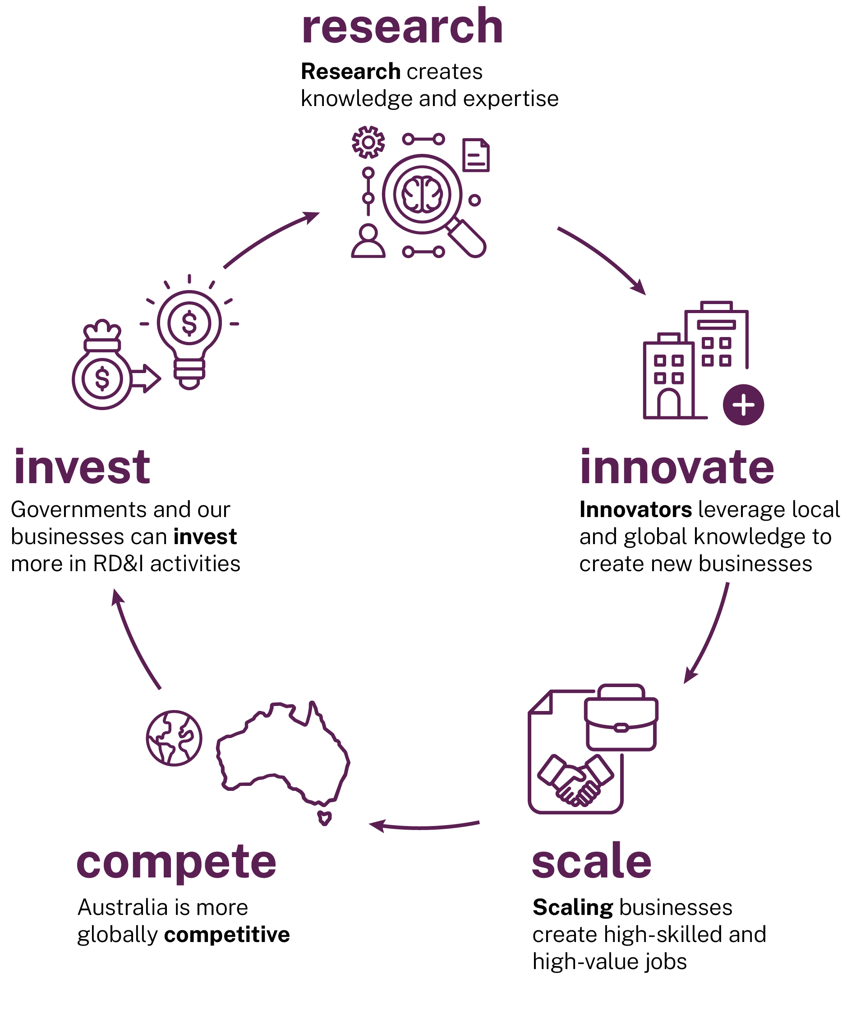
Research creates knowledge and expertise, and when translated builds our economy and society.
Translating knowledge into new Australian products and services creates greater economic impact, new industries and a wide range of high-value jobs across the broader economy. This includes in manufacturing, across supply chains and in supporting services. By building successful RD&I industries, Australia will create wealth and attract more funding by industry and governments into nation-building RD&I investments.
Australia has not fully realised the benefits this flywheel generates: greater productivity, more jobs, higher skills and a stronger economy. We propose a path to change to achieve it.

It’s time to change
The future is in our hands. This panel is unequivocal – the need for strategic, comprehensive and orderly change is inarguable.
This report sets out the panel’s view – to change from a future too dependent on being the ‘lucky country’ to one which, through determined action and investment in Australia’s talent, skills and initiative, will deliver beneficial change widely shared within the community.
We have a once-in-a-generation opportunity to build this future. We must be ambitious and move away from an underperforming system that is the result of often trifling, incremental improvements, risk aversion and band-aid solutions.
The challenge, as Peter Hartcher has written, paraphrasing the Treasurer, is:
‘Can we, as a people, make big reforms to make our country better, even if it’s hard?’
Peter Hartcher (2025)
The panel’s package of recommendations, shaped through extensive consultation, presents a clear plan for a bold new national agenda. We can change the country’s trajectory, and strongly believe the community has the appetite to do so.
The Australian Government’s Intergenerational Report, published every 5 years since 2002, makes clear the probable decline in our circumstances (Department of the Treasury 2023a).
In 2002, the GDP per person was projected to grow 90% over 40 years. By 2023, the predicted growth in GDP per person over the next 40 years had dropped by more than one third to 57%. This signalled a substantial reduction in the standard of living for Australians unless we take decisive steps to change that outcome.
While our luck has given most Australians an enviable quality of life, we need to build a broader base of economic opportunities and growth or risk significant decline in living standards. Australia is ranked 105th of 145 national economies for economic complexity (Growth Lab n.d.). We derive around 50% of export revenue from selling our natural resources like iron ore, gas and coal, and our agricultural products (DFAT 2025a).
We have one of the lowest shares of manufacturing in the Organisation for Economic Co-operation and Development (OECD) (World Bank Group 2024a). And while mining contributes roughly 10% of gross domestic product (GDP) (Reserve Bank of Australia 2025) it directly employs 2% of the workforce (Jobs and Skills Australia 2025).
Simply put, we must do better.
A new RD&I system is the catalyst the country needs to create the sustainable growth for the next generation. New attitudes to RD&I, new businesses, new opportunities, new jobs, a better country.
Although reform can be hard, history has shown that we can make nation defining decisions to secure Australia’s future prosperity. We were once willing to accept change at scale. Nation-changing events in 1906 (the first ever referendum), 1946 (post-war reconstruction), and 1990 (the clever country agenda) all show we could. The next phase in a close to 40-year cycle, 2026, is on our watch. We have an obligation not to flinch.
Slowly, we have shifted away from boldness and towards caution. The instinct to minimise risk to the point of trying to avoid it has led to an RD&I system impacted by rules, regulations, restrictions and atomisation, resulting from a collection of policies and funding programs accumulated and adjusted over years. Incentives and funding are now simply spread too thinly across too many activities.
Our RD&I system is not just atomised. Funding is declining and pressure increasing. There are too many programs, upwards of 150 in the Commonwealth alone (DISR 2025a). Some programs involve multiple grant schemes, few of which fund the actual cost of the research.
This maze has spawned its own industry of navigators because it is unnecessarily cumbersome. It is particularly onerous for small companies and startups with fewer discretionary resources.
There is too much focus on inputs and too little on turning ideas and knowledge into products, products into growth, and growth into jobs and productivity, ultimately leading to a higher standard of living.
It is this generation’s turn to build a sustainable future that can deliver a better standard of living than we enjoy today.
A revitalised RD&I system is key to that future.
This package, when fully implemented, will set us up for prosperity for the next 40 years.

A plan for action
Changing from where we are to where we want to be will require greater focus, a healthy appetite for risk and tough decisions.
There will be stakeholders who are not happy with the changes. But Australia can no longer respond by keeping the status quo and just adding more funding to a broken system.
Change will take time that transcends political cycles. It will require patience and support from all actors in the RD&I community and across political divides, with a focus on intergenerational equity, giving Australians a chance to prosper. Together, we can change Australia’s future.
We present here an action plan that focuses on 6 elements of the package:
- Greater focus and scale for RD&I impact
- A world class foundational research system creating knowledge and expertise
- Incentives to build the RD&I businesses and industries of the future
- Investment and capital to fuel the innovation cycle
- Building workforce capability to power RD&I activities
- Government to lead and champion.
The following summary includes the key recommendations in headline form. They are fully elaborated in the relevant chapters as indicated.

Focus and scale
Australia’s RD&I system has stifled our ability to achieve coordinated, large-scale RD&I impact in areas of national need and global opportunity. Greater focus, simplification and coordination will achieve necessary scale.
Driving focus through defining long-term, national RD&I goals will maximise the value and impact of public investment, attract private investment and foster cross-sector collaboration.
Australia needs the government’s leadership to simplify and coordinate the RD&I system.

Recommendation 1a
Commonwealth Cabinet establish a single National Innovation Council (for example by reforming Industry Innovation and Science Australia) chaired by an eminent Australian, supported by a Statutory Officer, to oversee Commonwealth RD&I funding and reporting directly to the Prime Minister and the Minister for Industry and Innovation / Science.

Figure 2: Establishment and governance of the NIC
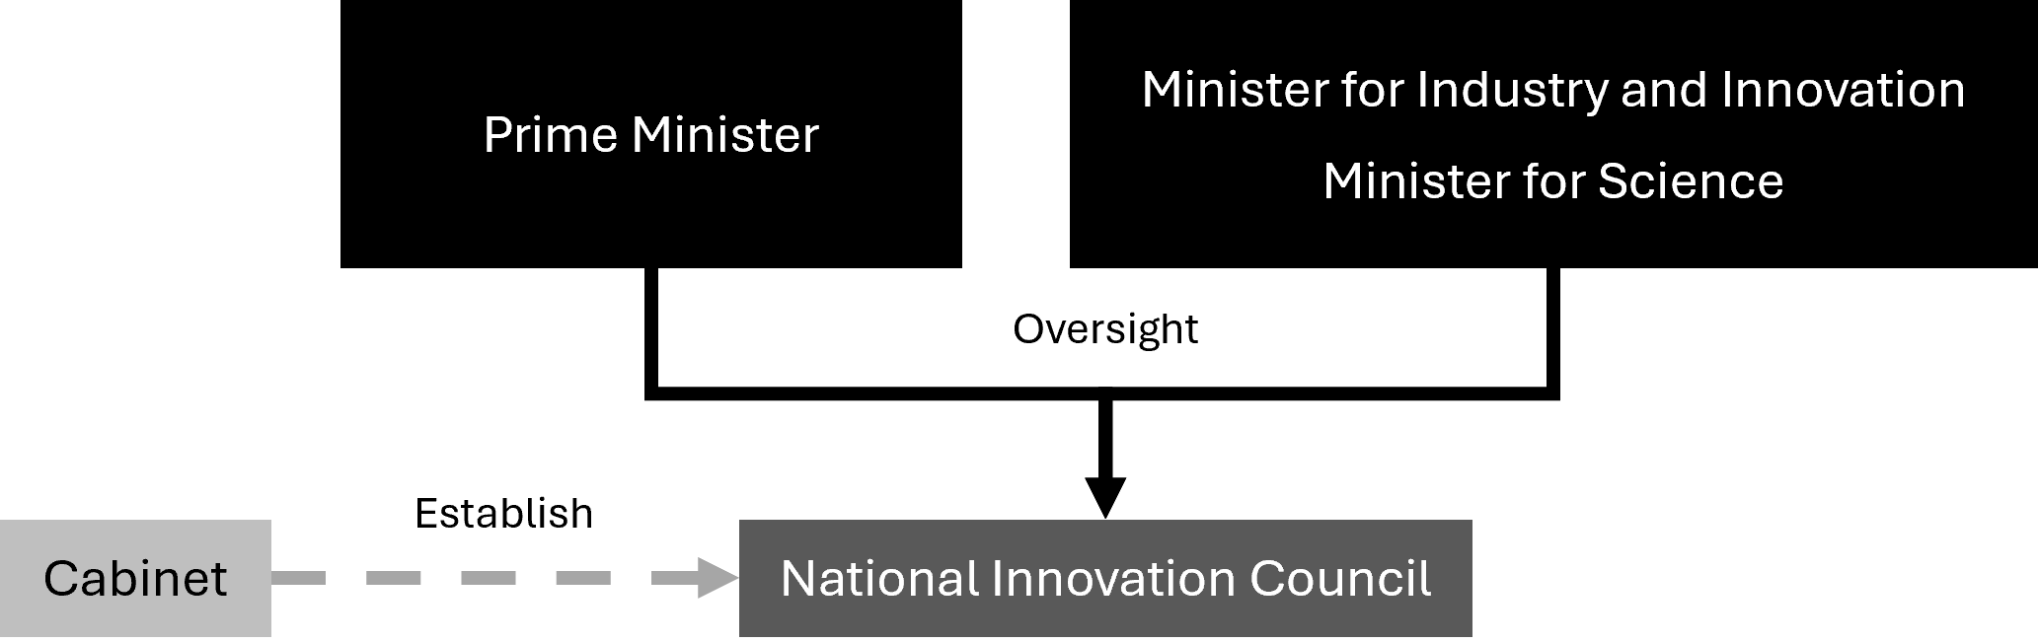
The Commonwealth has long identified where its most substantial focus areas are by virtue of their funding pattern. Areas of focus should be limited to the 6 main areas and drive development and adoption of technology.

Recommendation 1b
Consolidate national RD&I efforts into 6 National Innovation Pillars: (1) Health and medical; (2) Agriculture and food; (3) Defence; (4) Environment and energy; (5) Resources; (6) Technology; each anchored by a long-term and aspirational national goal to guide prioritisation, coordination and strategic focus.

Figure 3: The 6 National Innovation Pillars
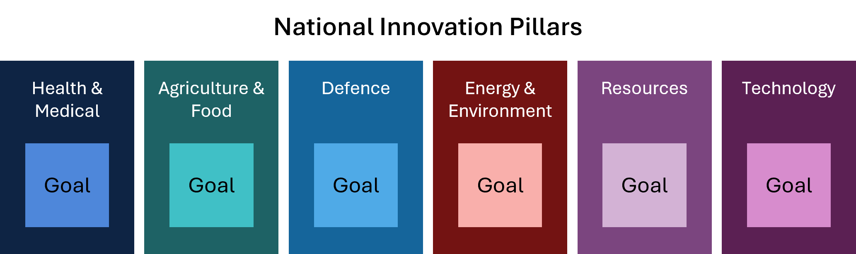
Within each of these National Innovation Pillars, leadership is required to direct RD&I efforts to meet our national goals. Outcomes in each area will be most effective when community implications and expectations are built in from the beginning. This includes supporting diversity across all Australians, including First Nations RD&I activities and supporting women in RD&I.

Recommendation 1c
Establish a National Strategy Advisory Council (NSAC) for each National Innovation Pillar, reporting to portfolio Ministers. NSACs should collaborate with the National Innovation Council and relevant Commonwealth departments to set up to 3 subgoals for each pillar, to focus RD&I activities on high-risk, high-impact challenges.
A core task of the NSACs will be the identification of specific areas where Australia can ‘play to win’.

Recommendation 1d
Public RD&I investment should be consolidated and concentrated to achieve subgoals through National Strategic Initiatives (NSIs) that engage all tiers of government, startups, small to medium enterprises (SMEs), large businesses, investors, and researchers in high-risk, high-impact challenges.

Each NSI will be a partnership between governments, industry and the research sector. It will facilitate public-private partnerships that catalyse investment into the NSI, leveraging Australian Government support to create scale and impact. NSIs will work across the whole of Australia, including in our regions.
Figure 4: ‘Pillars’ model summary
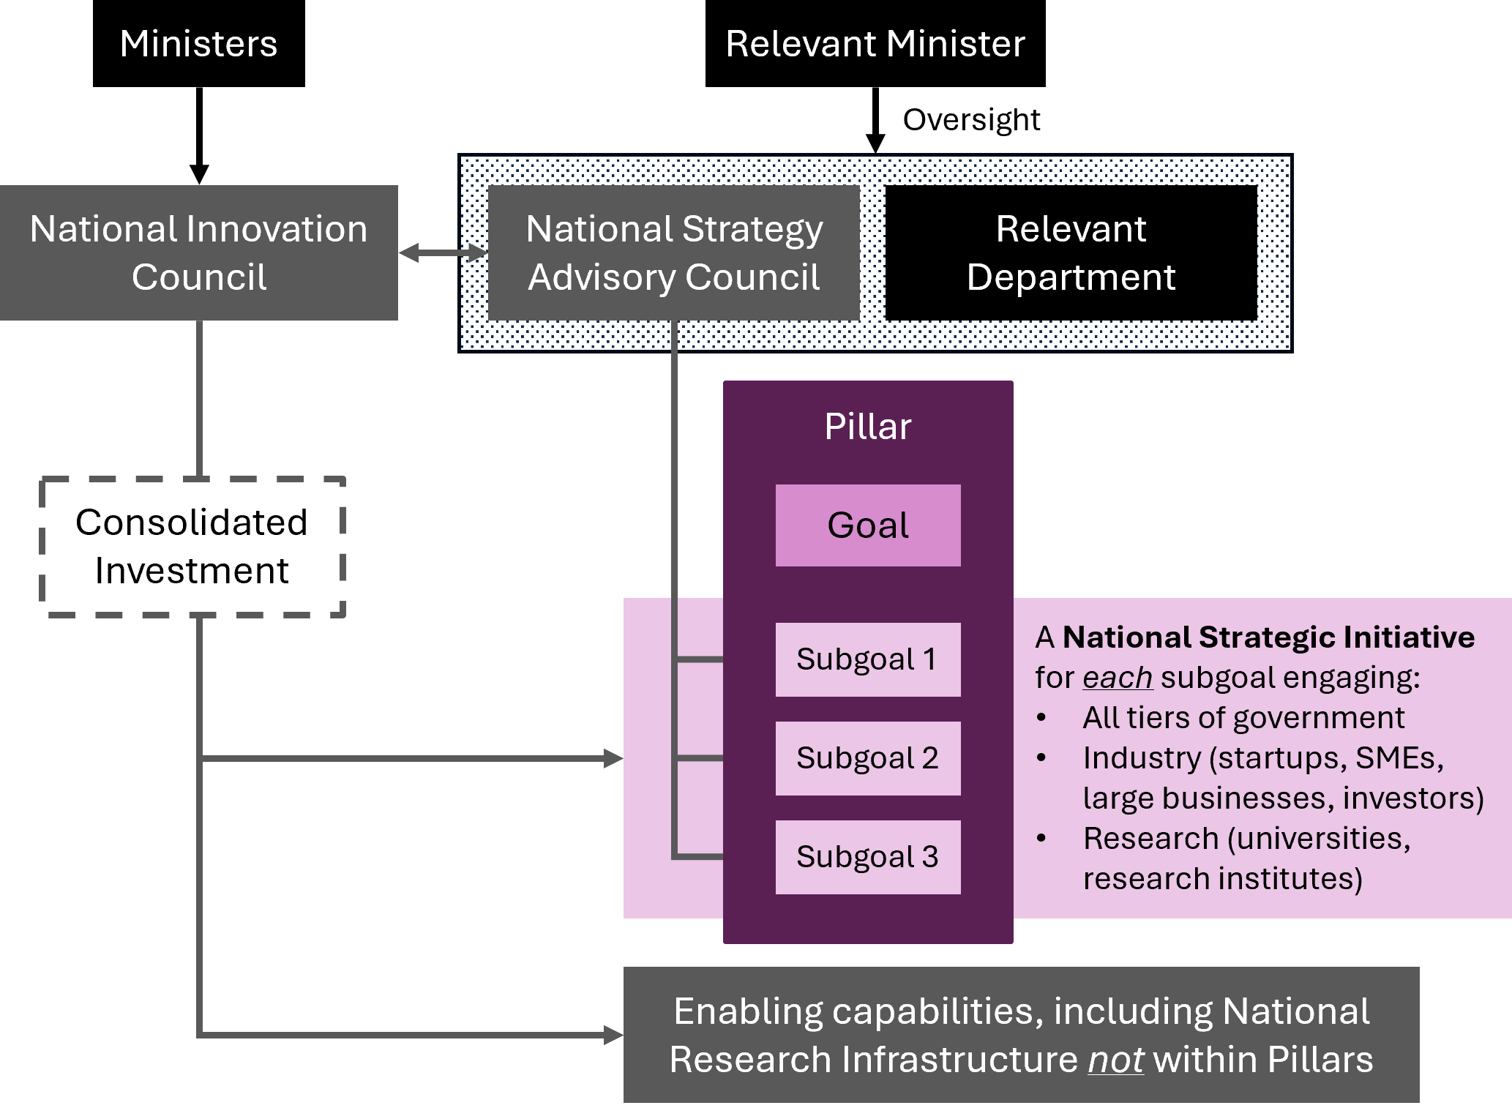
NSIs will be responsible for a seismic change in RD&I activity related to the subgoal. They will accelerate foundational and applied research, as well as translation and development projects, including in ‘cross cutting portfolios’ spanning science, technology, engineering and mathematics (STEM) and humanities and social sciences (HASS), alongside enabling technologies such as artificial intelligence (AI), quantum, robotics and advanced manufacturing technologies.
NSIs will drive startup creation and business growth by managing proof of concept schemes and supporting pre-accelerators, accelerators and incubators.
They will strengthen national coordination by providing a ‘front door’ to industry to engage with the NSI, facilitating collaborations with the research sector and connections with governments. This includes supporting the mobility of talent between business and research sectors, as well as advising on workforce planning.
Ultimately, this approach will position Australia’s RD&I system to grow, lifting our economic complexity, productivity, and global competitiveness.
More detail on these recommendations is provided in Chapter 1.

Creating knowledge
‘Without knowledge no nation can govern its economy, manage its environment, sustain its public health, produce goods or services, understand its own history, or enable its citizens to understand the circumstances in which they live.’
Statement ‘In Defence of Knowledge and Higher Education’
(American Association of University Professors 2017)
The panel recognises the need to focus RD&I activities, as we propose in Recommendation 1. The panel is also aware of the need to create new knowledge, which we do through our foundational research activities. Protecting foundational research across the range of STEM and HASS disciplines is equally important to ensure we create the knowledge an ambitious Australia will need.
Australian researchers create about 3% of the world’s new knowledge each year (Clarivate Analytics 2025). They also provide the expertise to engage with and leverage the 97% of knowledge developed offshore. This research is a critical resource that builds sovereign capability.
The ongoing success of the sector depends on sustained funding. Yet funding for basic research provided through competitive grants has been in real decline for over a decade. Further, most government grants do not cover the full research costs.

Recommendation 2a
Protect and support foundational research by reversing the decline in competitive grants, building investment in the main competitive grant schemes to globally competitive funding levels, and applying appropriate indexation.

Recommendation 2b
Strengthen indirect cost support by reversing recent declines in support rates and tasking the National Innovation Council and the Australian Tertiary Education Commission (ATEC) to implement a mechanism to determine the full cost of delivering high-quality research.

Recommendation 2c
The Australian Research Council (ARC) and the National Health and Medical Research Council (NHMRC) competitive grants programs should balance support directed to the National Innovation Pillars while preserving support for independent research that drives discovery across a broad range of STEM and HASS disciplines.

All universities currently follow a uniform research requirement. This has resulted in thinly spread resources and limited the ability to focus on areas of national needs and global competitiveness.

Recommendation 3
Allow universities to achieve research specialisation by reforming registration requirements to reduce the condition for research breadth and enable each to build scale in areas of their competitive and comparative advantage.

Consistent with Recommendation 1, specialisation can be supported by identifying national priorities and consolidating research support initiatives. The National Competitive Grants Program (NCGP) should balance support for the National Innovation Pillars while preserving opportunity for independent research that drives new discovery across a broad range of STEM and HASS disciplines.
Access to high-quality research infrastructure is also critical for both foundational research and RD&I businesses.
The future of the National Collaborative Research Infrastructure Strategy (NCRIS) is at risk. NCRIS faces a funding cliff in coming years, and many existing arrangements are nearing an end.
To safeguard and strengthen our domestic research, we need a long-term strategy that embeds sustainability and capacity. The National Science and Technology Council (NSTC) has highlighted not only major gaps in system-wide strategic planning but also the lack of investment in research infrastructure as a critical concern for Australia.

Recommendation 4a
Governments commit ongoing funding to ensure sustainability of research infrastructure.

Recommendation 4b
The National Innovation Council be responsible for the oversight, planning and coordination of national research infrastructure.

Recommendation 4c
The National Innovation Council to take on a charter for extending research infrastructure capabilities to include rapid prototyping to accelerate frontier research and foster collaboration with emerging industries.

Recommendation 4d
The National Innovation Council to ensure state of the art capability in high-performance computing and graphics processing unit (GPU) resources to support RD&I activities.
More details on recommendations relating to foundational research are provided in Chapter 2.

RD&I business incentives
Increasing RD&I activity of businesses will create jobs and lift Australia’s productivity growth, sovereign capability, global competitiveness, future economic complexity and long-term prosperity.
Business expenditure on research and development (R&D) is low. Australian industry lacks large RD&I-active businesses, including multinational corporations (with a small number of notable exceptions). Large RD&I businesses anchor RD&I ecosystems and are a critical part of the innovation flywheel. They support a range of activities that spur the sector, including research, and create demand for smaller RD&I firms including through procurement and mergers and acquisitions (M&A). They are a source of mentors, coaches, entrepreneurs and experienced business leaders capable of taking ideas and building them to produce jobs and growth.
Increasing the number of larger RD&I active firms in Australia is an imperative. But it will take time. We can achieve this by ‘home-growing’ new global businesses and attracting global RD&I active firms. Both approaches are needed.
Australia must be a competitive place for larger businesses to conduct RD&I activities.
Efforts to grow new global businesses should focus on supporting ambitious startups, with RD&I embedded in their culture. Without it they wouldn’t exist and with it they prosper. Government support must recognise that most RD&I startups are created by private citizens who indirectly leverage knowledge from decades of research.
Through the NSIs, we expect significant focus on supporting startup creation in areas of national interest, through pre-accelerators and accelerator programs. We also expect a focus on early growth through greater access to a larger number of small grants for proof-of-concept projects.
As we note in Recommendation 1d, NSIs will facilitate broader industry and researcher engagement.
More broadly, support for business RD&I is achieved through the Research and Development Tax Incentive (RDTI) scheme. It needs reform and simplification.
The RDTI is vital to startups. A dedicated stream of the RDTI program should simplify access, providing certainty including through quarterly payments in the early years of a startup’s life.
The majority of companies using the RDTI scheme are SMEs. Many of these are not growing. The RDTI must be reformed to focus on growth-focused businesses only, including scaleups, that reinvest in RD&I activities.
Australia must be an internationally competitive place to conduct high-value RD&I. We must attract and retain RD&I-intensive corporates, including multi-national corporations. The RDTI scheme must be globally competitive and incentivise and reward RD&I activities in Australia including procurement from Australian RD&I firms and industry PhDs.

Recommendation 5a
Reform the R&D Tax Incentive to simplify administration and focus the scheme for greater impact.

Recommendation 5b
Incentivise startups through a premium RDTI segment providing streamlined access to improve benefits for high-potential firms.

Recommendation 5c
Leverage the RDTI to incentivise SME growth and ambition, and increase the thresholds for access and ongoing support.

Recommendation 5d
Increase RDTI incentives for corporates and multi-national corporations to undertake local RD&I activities and to drive partnerships, procurement, investment and M&A.

The panel believes the RDTI scheme is core to incentivising the private sector to invest more in Australian RD&I. The recommendations aim to increase private sector investment, extend eligibility to translation and commercialisation of research into product and services, and reduce the bureaucracy and leakage of funding to administrative activities.
A reformed RDTI scheme will mean some businesses (particularly low growth SMEs) may become ineligible. Those that attempt to innovate should still be supported to lift their RD&I capabilities. A more direct form of support, for example a grant, will reduce the existing barriers.

Recommendation 6
Establish a funding mechanism that enables existing businesses that are ineligible for the RDTI scheme to kick-start their RD&I efforts by accessing Australian research capability in universities, publicly funded research agencies (PFRAs) and innovation intensive corporations.

Building and retaining stronger RD&I activities by Australian businesses will start the flywheel depicted in Figure 1 and change our economy.
Additional dividends will be gained if we retain and grow high-value manufacturing and sovereign production capabilities resulting from local RD&I activities, rather than maintaining the status quo which defaults offshore. In turn this will support advanced manufacturing jobs.

Recommendation 7
The Australian Government provide a production tax credit or subsidy for advanced manufacturing resulting from RD&I activities to remain in Australia.
More details on recommendations relating to RD&I business incentives are provided in Chapter 3.

Investment and capital
Globally competitive RD&I businesses will require greater levels of investment across all stages of growth.
Our capital market must evolve to unlock more investment from angels and institutional investors, including superannuation funds.
The Early Stage Innovation Company (ESIC) incentive scheme has played an important role in unlocking angel investments into young startups. The scheme should be expanded.
Australia’s venture capital (VC) industry is maturing, supported by the Early Stage Venture Capital Limited Partnerships (ESVCLP) scheme. There is significant room for growth and a need for greater diversity of specialist early-stage VC funds, especially in areas aligned to national interest.
Late-stage funding is also a major issue. There is a limited number of Australian funds that make later-stage venture investments (Series B+). Many firms therefore seek international investment and that draws them offshore, taking significant value with them. Attracting and increasing later stage growth funds will fuel investment of maturing local RD&I firms.

Recommendation 8a
Expand the incentives for angel investors to unlock more capital including by reforming ESIC and crowd sourced funding schemes and changing ‘sophisticated investor’ requirements.

Recommendation 8b
Simplify and expand ESVCLP incentives to unlock more capital and support the venture capital industry to scale.

Our long-term investment in superannuation has created a national asset that provides Australia with capacity that is rarely matched globally. Regulatory requirements and the mechanics of managing large asset pools makes investing in Australian high growth RD&I investments difficult.

Recommendation 9
Reform superannuation policy settings under the Australian Securities and Investment Commission (ASIC) Regulatory Guide 97 (RG97) and performance tests, and require superfunds to enable members to elect to invest in Australian high growth RD&I firms.

Enabling pooled investment vehicles across the business lifecycle will mobilise investment, including from superfunds, leading to a more mature venture investment sector in Australia.
Creating the National Reconstruction Fund (NRF) to support Australian projects that drive high-value industry transformation has been an important initiative. The NRF and other policy tools should prioritise crowding-in private capital, including superannuation, to ensure investments are driven by strong business fundamentals.

Recommendation 10
Support the establishment of fund-of-funds (FOF) to grow long-term investment, across different stages, including by providing fee relief for FOF investors and focusing sovereign funds where appropriate.

Regulatory and tax policy have a major impact on the flow of funds for investment in innovation. Policy settings affecting corporate governance, the regulation of competition and capital markets need to prioritise dynamism and avoid unintended consequences that stymie growth.
The panel considers that this balance has not always been achieved in recent regulatory reforms proposals such as the recently developed merger regime. Poorly designed and applied regulations can reduce the attractiveness of investment in Australia and its businesses.
Greater diversity of exit strategies, through initial public offerings (IPOs) or mergers and acquisitions (M&A), are needed for a healthier investment and capital ecosystem.
More effort is needed to overcome the challenges of a capital market defined by the dividend norms of older firms and the dominance of mining and banking stocks. Preferential tax treatment of investor gains from startups that are acquired by another domestic company should be explored as part of broader tax reform processes.

Recommendation 11
Incentivise investment in Australian innovation by ensuring Australian regulatory environments that impact on the exit pathways for RD&I firms, particularly IPOs and M&A, are globally competitive and balance regulatory protections against the need for liquidity to support RD&I businesses.

The RDTI stream for corporates proposed in Recommendation 5 will also incentivise support for exit pathways and liquidity options.
More detail on investment and capital recommendations is provided in Chapter 4.

The workforce
The success of a dynamic RD&I ecosystem depends on a workforce that can adapt to rapid technological and societal change. The development and support of talent is a national imperative. It requires skill sets that are broad – from a basis in fundamental sciences to the humanities and social sciences, to entrepreneurs, to experienced business operators and investment expertise.
Australia’s workforce has significant gaps.
The current pipeline, built largely on the study choices of students, is not aligned with the needs of our workforce. For example, we aren't training enough geoscientists despite our heavy reliance on resources (Australian Academy of Science 2025).
There has been a steady decline in Australian PhD enrolments. We have managed to fill this gap by attracting international PhD students, so the impact on the workforce is not necessarily obvious.
We must be clear: we do not have a system that attracts enough Australians into careers in the right areas. We must ensure a future research workforce has the capacity to meet the aspirations of an ambitious Australia.
A factor affecting Australia’s RD&I performance is the relatively small number of PhD qualified people employed in Australian industry. There is limited mobility of people between academia and industry to encourage this. More needs to be done to support industry PhDs, joint appointments and industry sabbaticals for researchers. This will not only support researchers to build capability to focus research on industry challenges but will provide diverse career pathways.
The NSIs will support PhDs including industry and entrepreneurial programs. In time, these will support expanded career options that help reverse the decline in domestic PhD enrolments and strengthen Australia’s research and innovation capacity in areas of national importance.

Recommendation 12a
Universities, in partnership with industry, be supported to design and deliver inclusive research training programs with a strong industry focus. Universities be encouraged to deliver entrepreneurial research training programs.

Recommendation 12b
Increase the attractiveness of PhD programs for Australian students by lifting the stipend rates in fields aligned with the National Innovation Pillars and making part-time research scholarships tax free.

Until recently, limited focus and support have been given to entrepreneurs. As a country we need to do more to encourage and support them, and so avoid a brain drain whereby our best entrepreneurs are enticed offshore to build their businesses.
When startups do attract capital to grow, they struggle to hire the talent they need to scale their companies. More broadly, Australian RD&I businesses also need to have access to a capable, industry ready workforce with the right skills to hit the ground running.
Gaps also exist in the investment sector. Expertise is especially lacking in specialist RD&I investment and wealth management expertise.
Australia’s labour market must be equipped to address these skills gaps and ensure the full spectrum of RD&I expertise, from research through to business, is available.
Solutions will necessarily focus on both domestic talent development and strategic immigration. Reskilling is key, given the rapid pace of technological change.

Recommendation 13a
The National Innovation Council and the NSACs include skills development as a key element of the investment framework for the pillars in Recommendation 1. Investment in the NSIs should include a requirement to support diverse and inclusive talent and skills development, attraction and mobility.

Recommendation 13b
The National Innovation Council, in consultation with industry and unions, devise an RD&I workforce strategy to leverage funding, migration and education systems to develop, retain and attract the talent Australia needs to make the innovation cycle work.

First Nations researchers, entrepreneurs and RD&I businesses must be supported, including through delivering a network of First Nations pre-accelerators across the country to support early-stage innovation outcomes.

Recommendation 14
The National Innovation Council prioritise First Nations RD&I activities including building the number of First Nations entrepreneurs across the economy.
More details on workforce capability are provided in Chapter 5.

6. Government as an exemplar
Governments should drive RD&I transformation, by setting clear strategic direction through policy and regulatory settings, funding support, and cultural change.
They must lead by example to build confidence by signalling long-term commitment and stability that mobilises resources and encourages private investment.
Yet, over decades, government leadership in RD&I has faltered. Their investment has declined. This trend must be reversed because it is unacceptable to an ambitious Australia.
Procurement is one of the most important levers governments have to drive change.
Widespread views (including in governments) that Australia can simply purchase innovations from overseas will yield a bleak Australian economy: a declining living standard, and greater sovereign risk.
In 1990, the then Prime Minister Bob Hawke said Australia ‘must reduce its reliance on imported technology and borrowed research’ (Hawke 1990). It is more important than ever that governments invest in Australian RD&I capabilities. Over-dependence on international supply chains poses greater long-term risks than carefully backing local initiatives, even if some fail.
Government can encourage large providers, through procurement contracts, to contribute to the national RD&I system: partnering with universities, supporting industry PhDs and sourcing from Australian RD&I active firms.

Recommendation 15
Prioritise procurement of Australian RD&I and implement ‘if not, why not’ as a core tenet of the procurement policies of Australian governments. National Cabinet should provide leadership by setting goals for procurement outcomes and requiring public reporting against those goals.

Governments need to prioritise continuing reform of fundamental economic policy settings to lift RD&I. Australia must compete in a global RD&I market and be seen as an attractive destination to undertake RD&I activities.
Australia’s corporate tax rate has been consistently above the OECD average for over 2 decades. Uncompetitive tax settings are undermining our ability to keep businesses on shore, including the larger firms that anchor RD&I systems. Governments must create an enabling environment for RD&I.

Recommendation 16
Future tax reform should prioritise a competitive effective corporate tax rate for RD&I companies to make Australia an attractive location for investment and innovative business activity.

Over decades the RD&I system has become increasingly complex, bureaucratic and risk averse.

Recommendation 17
Increase the impact of the national RD&I investment by focusing on the effectiveness of grants and funding processes through simplification, standardisation and improved technologies, accompanied by a proportionate appetite for risk.

Australia’s PFRAs have unique capabilities, but they face mounting challenges. These include competing priorities, constrained resources, rising costs, workforce pressures and unstable funding. The Commonwealth Scientific and Industrial Research Organisation (CSIRO), as the largest PFRA and with its focus on industry outcomes, needs sustained funding and a mandate that prioritises support for the National Innovation Pillars. This will enable it to continue to adjust to the exigencies of the moment rather than the priorities of the past.
The 15 rural research and development corporations (RDCs) have played a key role delivering research relevant to the needs of Australia’s important agricultural sectors. To maximise the value these entities provide, there needs to be close integration to the National Innovation Pillar for agriculture.
The pillars model offers an important opportunity for PFRAs and RDCs to be focused on a clear, and targeted set of national goals.

Recommendation 18a
Ensure Australia’s 16 PFRAs and investment in the 15 RDCs align appropriately with National Innovation Pillars, and consolidate where possible.

Recommendation 18b
CSIRO should be positioned as a core contributor to the pillars, supported by sustainable and targeted funding to deliver this role effectively.

We need to change how we measure success, to drive accountability and guide strategic investment. This means shifting from inputs to outcomes and impact, and collecting more relevant and better data.

Recommendation 19
The National Innovation Council should develop an outcome focused RD&I Performance Framework with SMART metrics (specific, measurable, achievable, relevant and timebound) to assess impact and quality at program and system levels.

The panel noted through its extensive consultation that there is an urgent need for cultural change towards RD&I activities. Australians support ambition, engagement with risk, and striving for excellence in many areas of national life, most notably in our sporting endeavours. The Australian Government has a critical role in building confidence and support for Australia’s RD&I system, including attracting foreign investment and industry. It is time to elevate our national dialogue to ‘bring Australians with us’ as we become an ambitious Australia.

Recommendation 20
The Australian Government create a national narrative that persistently demonstrates the benefits and gains of RD&I to the community here and abroad, leveraging the pillars and this reform package to drive investment and opportunity for Australian innovators.
More detail on the recommendations relating to government as a leader are provided in Chapter 6.

Conclusion
Australia faces significant challenges in the years ahead. Without bold reform, our growth in GDP per person will decline (Department of the Treasury 2023a), and future generations will have a lower standard of living than Australia’s potential can deliver.
We have been the lucky country. We’ve been able to rely heavily on abundant natural resources and agriculture to support our quality of life. It is time to transition how we work, live, and see ourselves. It is time to change course and to invest and build an ambitious Australia.
We need our researchers, entrepreneurs and businesses to embrace new opportunities, create high-value jobs, to skill and reskill our workforce and grow an economy that will support the Australia we want it to be. This requires unlocking investment and creating the right environment to ensure Australia’s RD&I system thrives.
We must support the entire innovation system – from the creation of knowledge to the commercial product successful in the marketplace.
This package of reforms, implemented as a whole, is mutually reinforcing. Adopting only parts will be another example of incremental changes and band-aid solutions that will turn the Intergenerational Report’s prediction of a decline in projected living standards into a reality.

Next steps
Australia’s RD&I system needs ambitious, systemic and integrated reform.
The first phase is to fix the system by implementing the reforms in this package. These recommendations will establish the means for clear priority setting, the stimulation of private sector investment through the pillars, and reforms to business incentives while reversing the decline in support for fundamental research. It will make the system ready for further investment from public and private sources.
The successful implementation of the first phase will unlock new revenue streams and pave the way for the second phase – supercharging the system with greater public and private investment. This investment can be strategically directed towards those areas where Australia either has a compelling need or a global competitive advantage.
We need to have passion, patience and persistence with a liberal dose of courage and back ourselves.
Together, we can build an ambitious Australia.

References
American Association of University Professors (2017) In Defense of Knowledge and Higher Education, AAUP website, accessed May 2025.
Australian Academy of Science (2025) Australian science, Australia’s future: Science 2035, AAS website, accessed November 2025.
Clarivate Analytics (2025), InCites [data set], Clarivate website, accessed 20 February 2025.
DFAT (Department of Foreign Affairs and Trade) (2025a) Australia’s goods and services by top 25 exports 2024, DFAT, Australian Government, accessed October 2025.
Department of the Treasury (2023a) Intergenerational Report 2023: Australia’s future to 2063, Department of the Treasury, Australian Government, accessed November 2025.
DISR (Department of Industry, Science and Resources) (2025a) Science, Research and Innovation (SRI) Budget Tables [data set], DISR website, Australian Government.
Growth Lab (n.d.) The Atlas of Economic Complexity, Harvard University.
Hartcher P (21 June 2025) ‘Is this gentle Jim’s JFK moment? If it is, he’s overlooked one thing’, The Sydney Morning Herald.
Hawke B (8 March 1990) ‘Policy Launch by the Prime Minister, Bob Hawke’ [speech transcript], PM Transcripts, Department of the Prime Minister and Cabinet, Australian Government.
Jobs and Skills Australia (2025) Mining, JSA website.
World Bank Group (2024a) Manufacturing, value added [data set], World Bank Group website

