Ambitious Australia
Strategic Examination of R&D
  - Final report
December 2025

Copyright
© Commonwealth of Australia 2025
Ownership of intellectual property rights
Unless otherwise noted, copyright (and any other intellectual property rights, if any) in this publication is owned by the Commonwealth of Australia.

Creative Commons Attribution 4.0 International Licence CC BY 4.0
All material in this publication is licensed under a Creative Commons Attribution 4.0 International Licence, with the exception of:
- the Commonwealth Coat of Arms
- content supplied by third parties
- logos
- any material protected by trademark or otherwise noted in this publication.
Creative Commons Attribution 4.0 International Licence is a standard form licence agreement that allows you to copy, distribute, transmit and adapt this publication provided you attribute the work. A summary of the licence terms is available from https://creativecommons.org/licenses/by/4.0/. The full licence terms are available from https://creativecommons.org/licenses/by/4.0/legalcode.
Content contained herein should be attributed as Ambitious Australia: Strategic Examination of R&D Final Report, Strategic Examination of R&D independent expert panel.
This notice excludes the Commonwealth Coat of Arms, any logos and any material protected by trademark or otherwise noted in the publication, from the application of the Creative Commons licence. These are all forms of property which the Commonwealth cannot or usually would not licence others to use.

Disclaimer
The purpose of this publication is to identify a package of reforms that the Strategic Examination of R&D independent expert panel recommends for Australia.
The Commonwealth as represented by the Department of Industry, Science and Resources has exercised due care and skill in the preparation and compilation of the information in this publication.
The Commonwealth does not guarantee the accuracy, reliability or completeness of the information contained in this publication. Interested parties should make their own independent inquiries and obtain their own independent professional advice prior to relying on, or making any decisions in relation to, the information provided in this publication.
The Commonwealth accepts no responsibility or liability for any damage, loss or expense incurred as a result of the reliance on information contained in this publication. This publication does not indicate commitment by the Commonwealth to a particular course of action.



Letter to the Ministers
Senator the Hon Tim Ayres | The Hon Dr Jim Chalmers MP | The Hon Jason Clare MP
Minister for Industry & Innovation  Minister for Science | Treasurer | Minister for Education
Dear Ministers
The panel is pleased to present the Final Report of the Strategic Examination of Research and Development (R&D). The report responds to the examination’s terms of reference and the outcomes that were sought on its commissioning. These include: maximising the value of public investment in research across universities, industry and government, harnessing and growing business investment in research and development (R&D), and leveraging our scientific strengths to help address national priorities and foster new industries.
After extensive consultation throughout 2025, the panel concludes that key elements of Australia’s research, development and innovation (RD&I) system need bold reform. Australia is a wealthy nation with substantial opportunities and many successes of which to be proud, yet we are not fully harnessing our success to invest in a better future.
The panel’s recommendations present an integrated package designed to shift Australia’s growth trajectory, which is why we have called this report the Ambitious Australia Report.
The starting point has to be a commitment to bringing the elements of Australia’s RD&I system together under a clear vision. The panel recommends a new governance framework to provide the oversight, coherence, and alignment needed across Australia’s RD&I system (Recommendation 1). Importantly, this framework goes beyond governance – it calls for sustained, purposeful action and collaboration focused on outcomes and impact. International experience shows that scale and focus are essential for competitiveness.
This focus must be matched by sustained support for Australia’s world-class foundational research base (Recommendations 2–4). Without strong and consistent investment in knowledge creation, Australia risks losing its competitive edge in global discovery and eroding the foundation needed to transform innovation into enduring economic prosperity.
A strong research base will only deliver economic and societal results when it is matched to the translation of knowledge into goods and services that transform the lives of our people and the economy that supports them. Tax incentives and deregulation are central to stimulating the private sector in this effort, along with support for partnerships and investments that engage entrepreneurs and innovators in the translation of new knowledge to impact. The panel’s recommended reforms will support businesses that have the ambition to drive the growth and deliver the jobs that will sustain our standard of living (Recommendations 5–7).
These ambitions will stall without better connections to investors and capital. Reforms to unlock angel and venture investment, mobilise superannuation, leverage fund-of-funds mechanisms, and ensure competitive exit pathways for investors are essential to building the mature investment ecosystem that will enable new ideas and new businesses to develop and grow in Australia (Recommendations 8–11).
Talent is critical. Urgent action is needed to develop skills and attract talent across the innovation cycle, with a focus on embedding entrepreneurial and industry pathways for researchers, and aligning migration and education systems so our workforce can power RD&I at scale (Recommendations 12–14).
Government must lead by example to make RD&I a national priority and enable success. This includes leveraging procurement to drive innovation, reducing administrative burden, and signalling long-term commitment through tax competitiveness and a clear national narrative (Recommendations 15–20).
This package will ensure value for every dollar the nation invests and enable the growth to supercharge our economy through innovation.
The imperative for change is clear. Future generations of Australians face a substantial reduction in their standard of living unless there are bold, nation changing reforms. The 2002 Intergenerational Report projected that GDP per person would grow 90% over 40 years. By 2023, the expectation was down to 57% growth over the next 40 years.
The panel shares the ambition expressed by the Treasurer on 18 June 2025 that we have an obligation to future generations to deliver a better standard of living than we enjoy today. In his words: ‘Australia has to recognise that this is genuinely a defining decade… The decisions we make in the 2020s will determine the sort of living standards and intergenerational justice that we have in the decades to come.’
A revitalised RD&I system is the catalyst Australia needs to secure sustainable growth for the next generation.
Yours sincerely,

Robyn Denholm
Chair
Expert Panel for the Strategic Examination of R&D

Contents
Letter to the Ministers iv
Summary 1
Our vision 1
It’s time to change 2
A plan for action 4
1. Focus and scale 4
2. Creating knowledge 7
3. RD&I business incentives 9
4. Investment and capital 11
5. The workforce 13
6. Government as an exemplar 15
Conclusion 18
Next steps 19
Introduction 20
Changing the status quo 21
Chapter 1: Focus and scale 24
1.1 A new model for national coordination and impact 24
1.1.1 A National Innovation Council 27
1.1.2 Priorities and impact 29
1.1.3 National Strategy Advisory Councils 31
1.1.4 National Strategic Initiatives 35
1.1.5 An interdependent package of reforms 38
1.2 Other observations 39
1.3 Why this matters 39
Chapter 2: Creating knowledge: Foundational research 40
2.1 Stop the decline in research funding 44
2.2 University research specialisation 49
2.3 Secure and coordinate research infrastructure 49
2.4 Other observations 51
2.5 Why this matters 52
Chapter 3: RD&I business incentives 53
3.1 Growing startups 56
3.1.1 Support for First Nations entrepreneurs 57
3.2 Targeting greater impact for the RDTI 58
3.2.1 R&D Tax Incentive simplification and focus 58
3.2.2 Premium startup stream 59
3.2.3 SMEs and Scaleup Stream 61
3.2.4 RDTI for large firms 63
3.3 Uplift the innovation capacity of SMEs 64
3.4 Incentivise local RD&I production 65
3.5 Other observations 66
3.6 Why this matters 67
Chapter 4: Investment and capital 68
4.1 Strengthening early stage and VC frameworks 72
4.1.1 Driving angel investment for RD&I startups 73
4.1.2 Driving growth of the VC sector to competitive scale 76
4.2 Unlocking superannuation for RD&I 78
4.3 Establishing FOF investment vehicles 82
4.4 Expanding exit and other investment pathways to unlock venture growth 83
4.5 Other observations 85
4.6 Why this matters 85
Chapter 5: The workforce 86
5.1 PhDs, careers and options 89
5.2 Developing, retaining and attracting talent 92
5.2.1 Supporting workforce development through the pillars 92
5.2.2 RD&I workforce strategy and planning 93
5.3 Elevating the role of First Nations people in RD&I 96
5.4 Other observations 97
5.5 Why this matters 98
Chapter 6: Government as an exemplar 99
6.1 Prioritise procurement of Australian RD&I 102
6.2 Future tax reform to make Australia a competitive location for investment 104
6.3 Streamline grants and funding processes 106
6.4 Align research agencies with national goals 107
6.5 Re-focus on outcomes, rather than inputs 109
6.6 Drive cultural change 111
6.7 Why this matters 112
Appendix A: Summary of consultations 113
Appendix B: Panel members 114
Robyn Denholm, Chair 114
Emeritus Professor Ian Chubb AC 114
Winthrop Professor Fiona Wood AO 115
Dr Kate Cornick 115
Appendix C: Terms of reference 116
Purpose 116
Process 116
Scope of the examination 116
Time frame 117
Appendix D: References 118
Appendix E: Acronyms 124

Summary
This report identifies a package of reforms that when implemented will build and sustain Australia’s long-term prosperity.

Our vision
Australia’s research, development and innovation (RD&I) will underpin a knowledge-based, productive and differentiated economy that leads to a more prosperous, healthier, safer and more equitable Australia.
Figure 1: RD&I flywheel
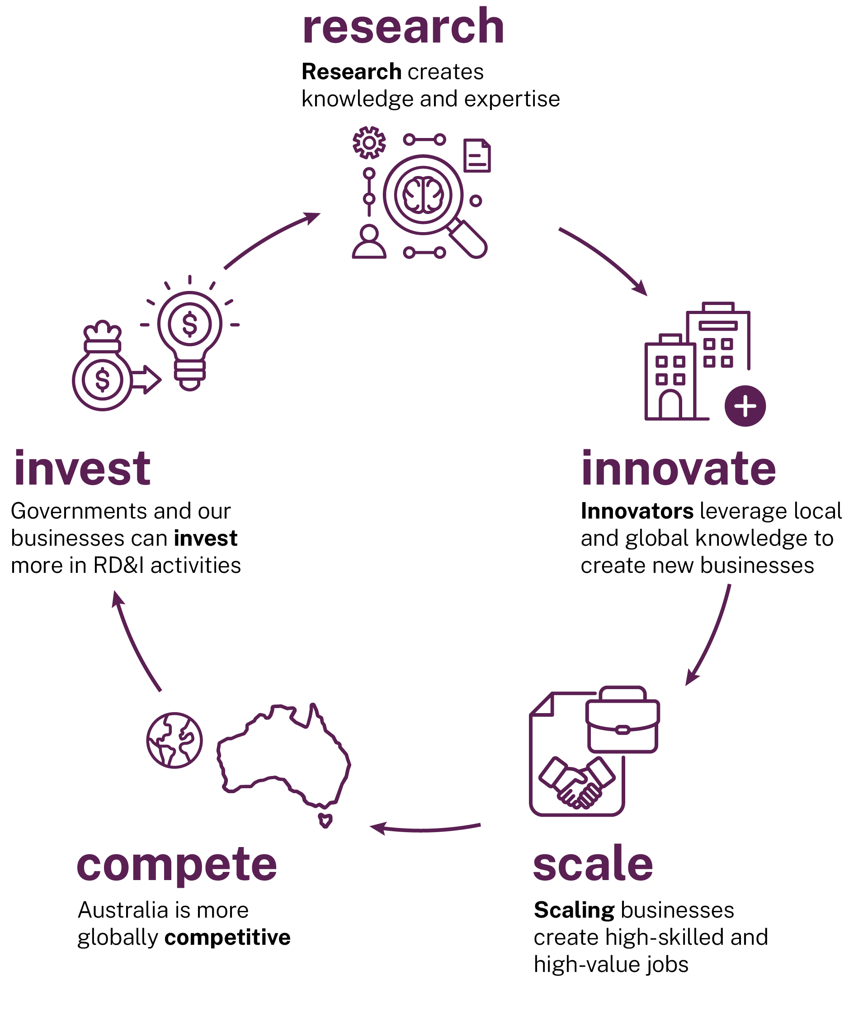
Research creates knowledge and expertise, and when translated builds our economy and society.
Translating knowledge into new Australian products and services creates greater economic impact, new industries and a wide range of high-value jobs across the broader economy. This includes in manufacturing, across supply chains and in supporting services. By building successful RD&I industries, Australia will create wealth and attract more funding by industry and governments into nation-building RD&I investments.
Australia has not fully realised the benefits this flywheel generates: greater productivity, more jobs, higher skills and a stronger economy. We propose a path to change to achieve it.

It’s time to change
The future is in our hands. This panel is unequivocal – the need for strategic, comprehensive and orderly change is inarguable.
This report sets out the panel’s view – to change from a future too dependent on being the ‘lucky country’ to one which, through determined action and investment in Australia’s talent, skills and initiative, will deliver beneficial change widely shared within the community.
We have a once-in-a-generation opportunity to build this future. We must be ambitious and move away from an underperforming system that is the result of often trifling, incremental improvements, risk aversion and band-aid solutions.
The challenge, as Peter Hartcher has written, paraphrasing the Treasurer, is:
‘Can we, as a people, make big reforms to make our country better, even if it’s hard?’
Peter Hartcher (2025)
The panel’s package of recommendations, shaped through extensive consultation, presents a clear plan for a bold new national agenda. We can change the country’s trajectory, and strongly believe the community has the appetite to do so.
The Australian Government’s Intergenerational Report, published every 5 years since 2002, makes clear the probable decline in our circumstances (Department of the Treasury 2023a).
In 2002, the GDP per person was projected to grow 90% over 40 years. By 2023, the predicted growth in GDP per person over the next 40 years had dropped by more than one third to 57%. This signalled a substantial reduction in the standard of living for Australians unless we take decisive steps to change that outcome.
While our luck has given most Australians an enviable quality of life, we need to build a broader base of economic opportunities and growth or risk significant decline in living standards. Australia is ranked 105th of 145 national economies for economic complexity (Growth Lab n.d.). We derive around 50% of export revenue from selling our natural resources like iron ore, gas and coal, and our agricultural products (DFAT 2025a).
We have one of the lowest shares of manufacturing in the Organisation for Economic Co-operation and Development (OECD) (World Bank Group 2024a). And while mining contributes roughly 10% of gross domestic product (GDP) (Reserve Bank of Australia 2025) it directly employs 2% of the workforce (Jobs and Skills Australia 2025).
Simply put, we must do better.
A new RD&I system is the catalyst the country needs to create the sustainable growth for the next generation. New attitudes to RD&I, new businesses, new opportunities, new jobs, a better country.
Although reform can be hard, history has shown that we can make nation defining decisions to secure Australia’s future prosperity. We were once willing to accept change at scale. Nation-changing events in 1906 (the first ever referendum), 1946 (post-war reconstruction), and 1990 (the clever country agenda) all show we could. The next phase in a close to 40-year cycle, 2026, is on our watch. We have an obligation not to flinch.
Slowly, we have shifted away from boldness and towards caution. The instinct to minimise risk to the point of trying to avoid it has led to an RD&I system impacted by rules, regulations, restrictions and atomisation, resulting from a collection of policies and funding programs accumulated and adjusted over years. Incentives and funding are now simply spread too thinly across too many activities.
Our RD&I system is not just atomised. Funding is declining and pressure increasing. There are too many programs, upwards of 150 in the Commonwealth alone (DISR 2025a). Some programs involve multiple grant schemes, few of which fund the actual cost of the research.
This maze has spawned its own industry of navigators because it is unnecessarily cumbersome. It is particularly onerous for small companies and startups with fewer discretionary resources.
There is too much focus on inputs and too little on turning ideas and knowledge into products, products into growth, and growth into jobs and productivity, ultimately leading to a higher standard of living.
It is this generation’s turn to build a sustainable future that can deliver a better standard of living than we enjoy today.
A revitalised RD&I system is key to that future.
This package, when fully implemented, will set us up for prosperity for the next 40 years.

A plan for action
Changing from where we are to where we want to be will require greater focus, a healthy appetite for risk and tough decisions.
There will be stakeholders who are not happy with the changes. But Australia can no longer respond by keeping the status quo and just adding more funding to a broken system.
Change will take time that transcends political cycles. It will require patience and support from all actors in the RD&I community and across political divides, with a focus on intergenerational equity, giving Australians a chance to prosper. Together, we can change Australia’s future.
We present here an action plan that focuses on 6 elements of the package:
- Greater focus and scale for RD&I impact
- A world class foundational research system creating knowledge and expertise
- Incentives to build the RD&I businesses and industries of the future
- Investment and capital to fuel the innovation cycle
- Building workforce capability to power RD&I activities
- Government to lead and champion.
The following summary includes the key recommendations in headline form. They are fully elaborated in the relevant chapters as indicated.

Focus and scale
Australia’s RD&I system has stifled our ability to achieve coordinated, large-scale RD&I impact in areas of national need and global opportunity. Greater focus, simplification and coordination will achieve necessary scale.
Driving focus through defining long-term, national RD&I goals will maximise the value and impact of public investment, attract private investment and foster cross-sector collaboration.
Australia needs the government’s leadership to simplify and coordinate the RD&I system.

Recommendation 1a
Commonwealth Cabinet establish a single National Innovation Council (for example by reforming Industry Innovation and Science Australia) chaired by an eminent Australian, supported by a Statutory Officer, to oversee Commonwealth RD&I funding and reporting directly to the Prime Minister and the Minister for Industry and Innovation / Science.

Figure 2: Establishment and governance of the NIC
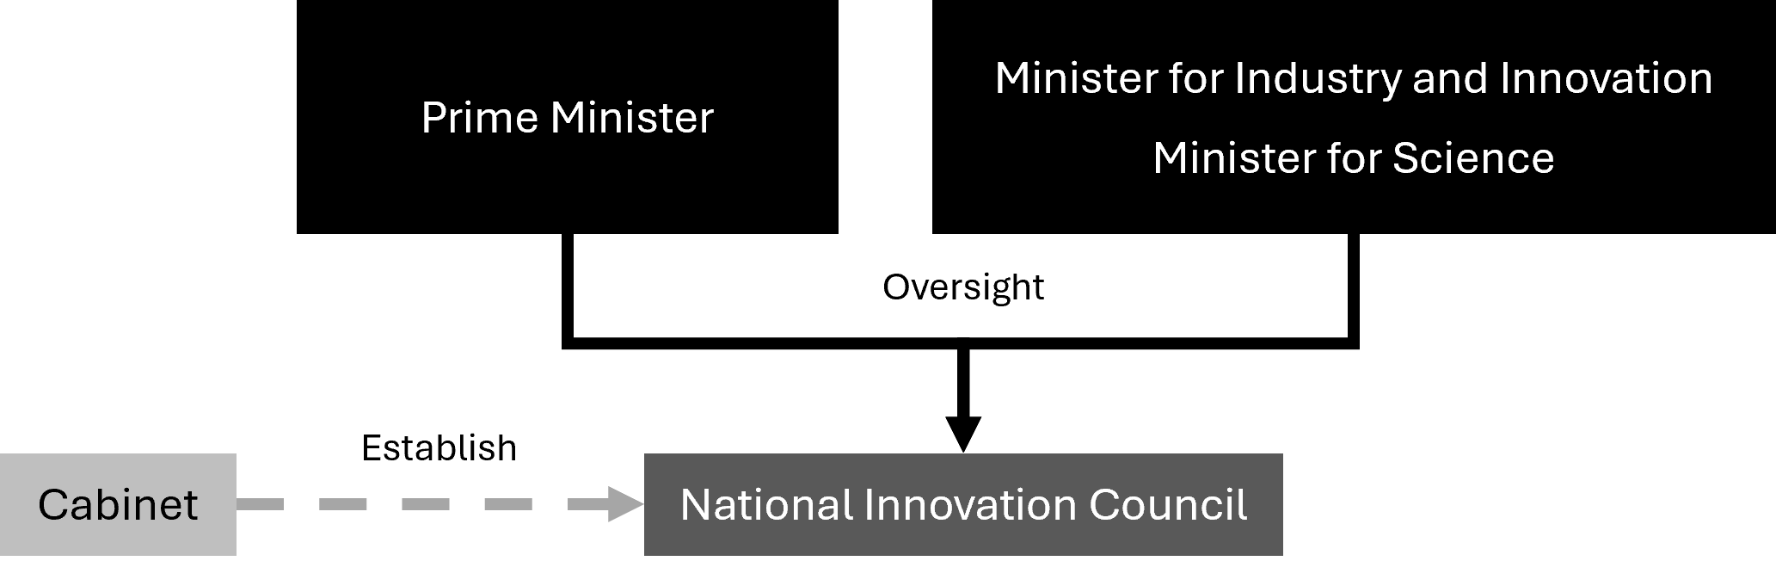
The Commonwealth has long identified where its most substantial focus areas are by virtue of their funding pattern. Areas of focus should be limited to the 6 main areas and drive development and adoption of technology.

Recommendation 1b
Consolidate national RD&I efforts into 6 National Innovation Pillars: (1) Health and medical; (2) Agriculture and food; (3) Defence; (4) Environment and energy; (5) Resources; (6) Technology; each anchored by a long-term and aspirational national goal to guide prioritisation, coordination and strategic focus.

Figure 3: The 6 National Innovation Pillars
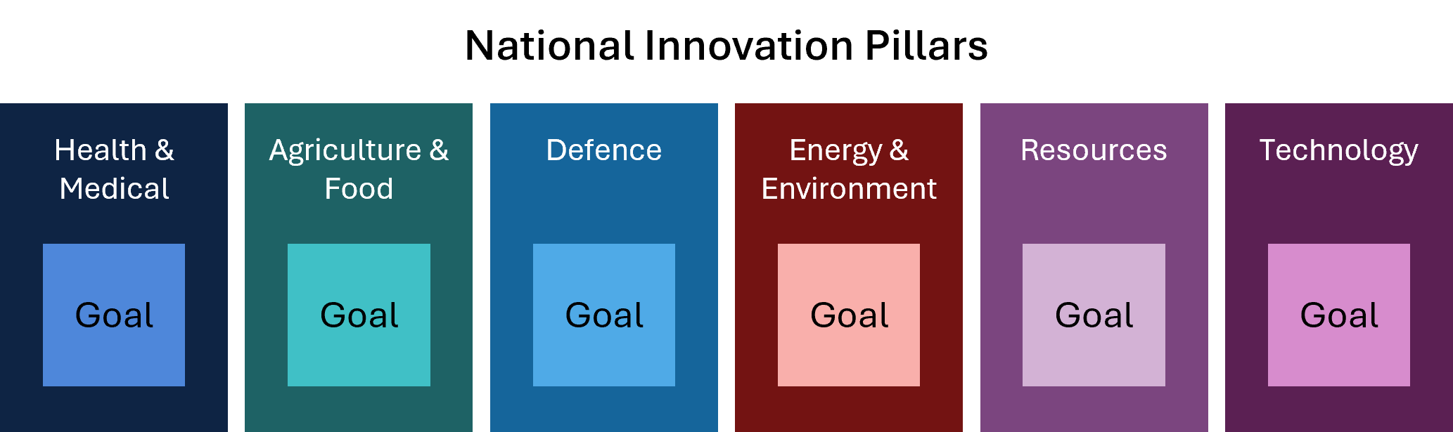
Within each of these National Innovation Pillars, leadership is required to direct RD&I efforts to meet our national goals. Outcomes in each area will be most effective when community implications and expectations are built in from the beginning. This includes supporting diversity across all Australians, including First Nations RD&I activities and supporting women in RD&I.

Recommendation 1c
Establish a National Strategy Advisory Council (NSAC) for each National Innovation Pillar, reporting to portfolio Ministers. NSACs should collaborate with the National Innovation Council and relevant Commonwealth departments to set up to 3 subgoals for each pillar, to focus RD&I activities on high-risk, high-impact challenges.
A core task of the NSACs will be the identification of specific areas where Australia can ‘play to win’.

Recommendation 1d
Public RD&I investment should be consolidated and concentrated to achieve subgoals through National Strategic Initiatives (NSIs) that engage all tiers of government, startups, small to medium enterprises (SMEs), large businesses, investors, and researchers in high-risk, high-impact challenges.

Each NSI will be a partnership between governments, industry and the research sector. It will facilitate public-private partnerships that catalyse investment into the NSI, leveraging Australian Government support to create scale and impact. NSIs will work across the whole of Australia, including in our regions.
Figure 4: ‘Pillars’ model summary
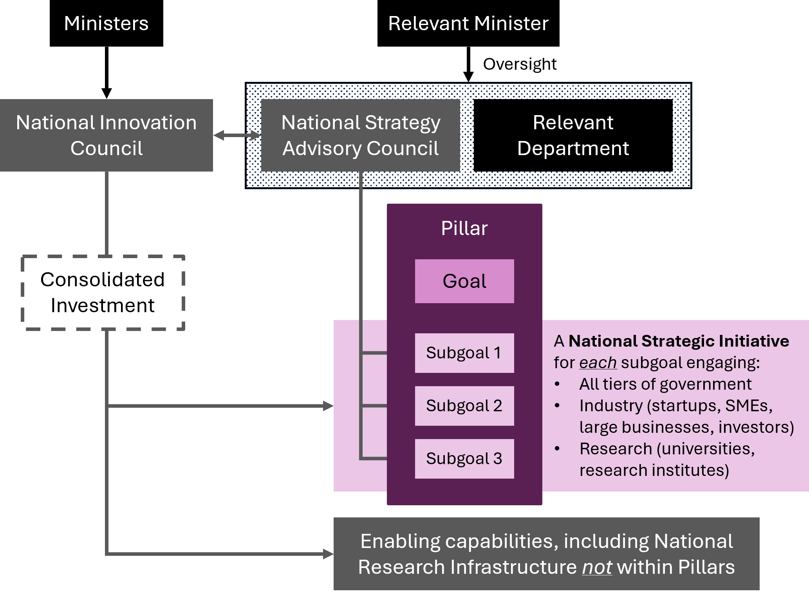
NSIs will be responsible for a seismic change in RD&I activity related to the subgoal. They will accelerate foundational and applied research, as well as translation and development projects, including in ‘cross cutting portfolios’ spanning science, technology, engineering and mathematics (STEM) and humanities and social sciences (HASS), alongside enabling technologies such as artificial intelligence (AI), quantum, robotics and advanced manufacturing technologies.
NSIs will drive startup creation and business growth by managing proof of concept schemes and supporting pre-accelerators, accelerators and incubators.
They will strengthen national coordination by providing a ‘front door’ to industry to engage with the NSI, facilitating collaborations with the research sector and connections with governments. This includes supporting the mobility of talent between business and research sectors, as well as advising on workforce planning.
Ultimately, this approach will position Australia’s RD&I system to grow, lifting our economic complexity, productivity, and global competitiveness.
More detail on these recommendations is provided in Chapter 1.

Creating knowledge
‘Without knowledge no nation can govern its economy, manage its environment, sustain its public health, produce goods or services, understand its own history, or enable its citizens to understand the circumstances in which they live.’
Statement ‘In Defence of Knowledge and Higher Education’
(American Association of University Professors 2017)
The panel recognises the need to focus RD&I activities, as we propose in Recommendation 1. The panel is also aware of the need to create new knowledge, which we do through our foundational research activities. Protecting foundational research across the range of STEM and HASS disciplines is equally important to ensure we create the knowledge an ambitious Australia will need.
Australian researchers create about 3% of the world’s new knowledge each year (Clarivate Analytics 2025). They also provide the expertise to engage with and leverage the 97% of knowledge developed offshore. This research is a critical resource that builds sovereign capability.
The ongoing success of the sector depends on sustained funding. Yet funding for basic research provided through competitive grants has been in real decline for over a decade. Further, most government grants do not cover the full research costs.

Recommendation 2a
Protect and support foundational research by reversing the decline in competitive grants, building investment in the main competitive grant schemes to globally competitive funding levels, and applying appropriate indexation.

Recommendation 2b
Strengthen indirect cost support by reversing recent declines in support rates and tasking the National Innovation Council and the Australian Tertiary Education Commission (ATEC) to implement a mechanism to determine the full cost of delivering high-quality research.

Recommendation 2c
The Australian Research Council (ARC) and the National Health and Medical Research Council (NHMRC) competitive grants programs should balance support directed to the National Innovation Pillars while preserving support for independent research that drives discovery across a broad range of STEM and HASS disciplines.

All universities currently follow a uniform research requirement. This has resulted in thinly spread resources and limited the ability to focus on areas of national needs and global competitiveness.

Recommendation 3
Allow universities to achieve research specialisation by reforming registration requirements to reduce the condition for research breadth and enable each to build scale in areas of their competitive and comparative advantage.

Consistent with Recommendation 1, specialisation can be supported by identifying national priorities and consolidating research support initiatives. The National Competitive Grants Program (NCGP) should balance support for the National Innovation Pillars while preserving opportunity for independent research that drives new discovery across a broad range of STEM and HASS disciplines.
Access to high-quality research infrastructure is also critical for both foundational research and RD&I businesses.
The future of the National Collaborative Research Infrastructure Strategy (NCRIS) is at risk. NCRIS faces a funding cliff in coming years, and many existing arrangements are nearing an end.
To safeguard and strengthen our domestic research, we need a long-term strategy that embeds sustainability and capacity. The National Science and Technology Council (NSTC) has highlighted not only major gaps in system-wide strategic planning but also the lack of investment in research infrastructure as a critical concern for Australia.

Recommendation 4a
Governments commit ongoing funding to ensure sustainability of research infrastructure.

Recommendation 4b
The National Innovation Council be responsible for the oversight, planning and coordination of national research infrastructure.

Recommendation 4c
The National Innovation Council to take on a charter for extending research infrastructure capabilities to include rapid prototyping to accelerate frontier research and foster collaboration with emerging industries.

Recommendation 4d
The National Innovation Council to ensure state of the art capability in high-performance computing and graphics processing unit (GPU) resources to support RD&I activities.
More details on recommendations relating to foundational research are provided in Chapter 2.

RD&I business incentives
Increasing RD&I activity of businesses will create jobs and lift Australia’s productivity growth, sovereign capability, global competitiveness, future economic complexity and long-term prosperity.
Business expenditure on research and development (R&D) is low. Australian industry lacks large RD&I-active businesses, including multinational corporations (with a small number of notable exceptions). Large RD&I businesses anchor RD&I ecosystems and are a critical part of the innovation flywheel. They support a range of activities that spur the sector, including research, and create demand for smaller RD&I firms including through procurement and mergers and acquisitions (M&A). They are a source of mentors, coaches, entrepreneurs and experienced business leaders capable of taking ideas and building them to produce jobs and growth.
Increasing the number of larger RD&I active firms in Australia is an imperative. But it will take time. We can achieve this by ‘home-growing’ new global businesses and attracting global RD&I active firms. Both approaches are needed.
Australia must be a competitive place for larger businesses to conduct RD&I activities.
Efforts to grow new global businesses should focus on supporting ambitious startups, with RD&I embedded in their culture. Without it they wouldn’t exist and with it they prosper. Government support must recognise that most RD&I startups are created by private citizens who indirectly leverage knowledge from decades of research.
Through the NSIs, we expect significant focus on supporting startup creation in areas of national interest, through pre-accelerators and accelerator programs. We also expect a focus on early growth through greater access to a larger number of small grants for proof-of-concept projects.
As we note in Recommendation 1d, NSIs will facilitate broader industry and researcher engagement.
More broadly, support for business RD&I is achieved through the Research and Development Tax Incentive (RDTI) scheme. It needs reform and simplification.
The RDTI is vital to startups. A dedicated stream of the RDTI program should simplify access, providing certainty including through quarterly payments in the early years of a startup’s life.
The majority of companies using the RDTI scheme are SMEs. Many of these are not growing. The RDTI must be reformed to focus on growth-focused businesses only, including scaleups, that reinvest in RD&I activities.
Australia must be an internationally competitive place to conduct high-value RD&I. We must attract and retain RD&I-intensive corporates, including multi-national corporations. The RDTI scheme must be globally competitive and incentivise and reward RD&I activities in Australia including procurement from Australian RD&I firms and industry PhDs.

Recommendation 5a
Reform the R&D Tax Incentive to simplify administration and focus the scheme for greater impact.

Recommendation 5b
Incentivise startups through a premium RDTI segment providing streamlined access to improve benefits for high-potential firms.

Recommendation 5c
Leverage the RDTI to incentivise SME growth and ambition, and increase the thresholds for access and ongoing support.

Recommendation 5d
Increase RDTI incentives for corporates and multi-national corporations to undertake local RD&I activities and to drive partnerships, procurement, investment and M&A.

The panel believes the RDTI scheme is core to incentivising the private sector to invest more in Australian RD&I. The recommendations aim to increase private sector investment, extend eligibility to translation and commercialisation of research into product and services, and reduce the bureaucracy and leakage of funding to administrative activities.
A reformed RDTI scheme will mean some businesses (particularly low growth SMEs) may become ineligible. Those that attempt to innovate should still be supported to lift their RD&I capabilities. A more direct form of support, for example a grant, will reduce the existing barriers.

Recommendation 6
Establish a funding mechanism that enables existing businesses that are ineligible for the RDTI scheme to kick-start their RD&I efforts by accessing Australian research capability in universities, publicly funded research agencies (PFRAs) and innovation intensive corporations.

Building and retaining stronger RD&I activities by Australian businesses will start the flywheel depicted in Figure 1 and change our economy.
Additional dividends will be gained if we retain and grow high-value manufacturing and sovereign production capabilities resulting from local RD&I activities, rather than maintaining the status quo which defaults offshore. In turn this will support advanced manufacturing jobs.

Recommendation 7
The Australian Government provide a production tax credit or subsidy for advanced manufacturing resulting from RD&I activities to remain in Australia.
More details on recommendations relating to RD&I business incentives are provided in Chapter 3.

Investment and capital
Globally competitive RD&I businesses will require greater levels of investment across all stages of growth.
Our capital market must evolve to unlock more investment from angels and institutional investors, including superannuation funds.
The Early Stage Innovation Company (ESIC) incentive scheme has played an important role in unlocking angel investments into young startups. The scheme should be expanded.
Australia’s venture capital (VC) industry is maturing, supported by the Early Stage Venture Capital Limited Partnerships (ESVCLP) scheme. There is significant room for growth and a need for greater diversity of specialist early-stage VC funds, especially in areas aligned to national interest.
Late-stage funding is also a major issue. There is a limited number of Australian funds that make later-stage venture investments (Series B+). Many firms therefore seek international investment and that draws them offshore, taking significant value with them. Attracting and increasing later stage growth funds will fuel investment of maturing local RD&I firms.

Recommendation 8a
Expand the incentives for angel investors to unlock more capital including by reforming ESIC and crowd sourced funding schemes and changing ‘sophisticated investor’ requirements.

Recommendation 8b
Simplify and expand ESVCLP incentives to unlock more capital and support the venture capital industry to scale.

Our long-term investment in superannuation has created a national asset that provides Australia with capacity that is rarely matched globally. Regulatory requirements and the mechanics of managing large asset pools makes investing in Australian high growth RD&I investments difficult.

Recommendation 9
Reform superannuation policy settings under the Australian Securities and Investment Commission (ASIC) Regulatory Guide 97 (RG97) and performance tests, and require superfunds to enable members to elect to invest in Australian high growth RD&I firms.

Enabling pooled investment vehicles across the business lifecycle will mobilise investment, including from superfunds, leading to a more mature venture investment sector in Australia.
Creating the National Reconstruction Fund (NRF) to support Australian projects that drive high-value industry transformation has been an important initiative. The NRF and other policy tools should prioritise crowding-in private capital, including superannuation, to ensure investments are driven by strong business fundamentals.

Recommendation 10
Support the establishment of fund-of-funds (FOF) to grow long-term investment, across different stages, including by providing fee relief for FOF investors and focusing sovereign funds where appropriate.

Regulatory and tax policy have a major impact on the flow of funds for investment in innovation. Policy settings affecting corporate governance, the regulation of competition and capital markets need to prioritise dynamism and avoid unintended consequences that stymie growth.
The panel considers that this balance has not always been achieved in recent regulatory reforms proposals such as the recently developed merger regime. Poorly designed and applied regulations can reduce the attractiveness of investment in Australia and its businesses.
Greater diversity of exit strategies, through initial public offerings (IPOs) or mergers and acquisitions (M&A), are needed for a healthier investment and capital ecosystem.
More effort is needed to overcome the challenges of a capital market defined by the dividend norms of older firms and the dominance of mining and banking stocks. Preferential tax treatment of investor gains from startups that are acquired by another domestic company should be explored as part of broader tax reform processes.

Recommendation 11
Incentivise investment in Australian innovation by ensuring Australian regulatory environments that impact on the exit pathways for RD&I firms, particularly IPOs and M&A, are globally competitive and balance regulatory protections against the need for liquidity to support RD&I businesses.

The RDTI stream for corporates proposed in Recommendation 5 will also incentivise support for exit pathways and liquidity options.
More detail on investment and capital recommendations is provided in Chapter 4.

The workforce
The success of a dynamic RD&I ecosystem depends on a workforce that can adapt to rapid technological and societal change. The development and support of talent is a national imperative. It requires skill sets that are broad – from a basis in fundamental sciences to the humanities and social sciences, to entrepreneurs, to experienced business operators and investment expertise.
Australia’s workforce has significant gaps.
The current pipeline, built largely on the study choices of students, is not aligned with the needs of our workforce. For example, we aren't training enough geoscientists despite our heavy reliance on resources (Australian Academy of Science 2025).
There has been a steady decline in Australian PhD enrolments. We have managed to fill this gap by attracting international PhD students, so the impact on the workforce is not necessarily obvious.
We must be clear: we do not have a system that attracts enough Australians into careers in the right areas. We must ensure a future research workforce has the capacity to meet the aspirations of an ambitious Australia.
A factor affecting Australia’s RD&I performance is the relatively small number of PhD qualified people employed in Australian industry. There is limited mobility of people between academia and industry to encourage this. More needs to be done to support industry PhDs, joint appointments and industry sabbaticals for researchers. This will not only support researchers to build capability to focus research on industry challenges but will provide diverse career pathways.
The NSIs will support PhDs including industry and entrepreneurial programs. In time, these will support expanded career options that help reverse the decline in domestic PhD enrolments and strengthen Australia’s research and innovation capacity in areas of national importance.

Recommendation 12a
Universities, in partnership with industry, be supported to design and deliver inclusive research training programs with a strong industry focus. Universities be encouraged to deliver entrepreneurial research training programs.

Recommendation 12b
Increase the attractiveness of PhD programs for Australian students by lifting the stipend rates in fields aligned with the National Innovation Pillars and making part-time research scholarships tax free.

Until recently, limited focus and support have been given to entrepreneurs. As a country we need to do more to encourage and support them, and so avoid a brain drain whereby our best entrepreneurs are enticed offshore to build their businesses.
When startups do attract capital to grow, they struggle to hire the talent they need to scale their companies. More broadly, Australian RD&I businesses also need to have access to a capable, industry ready workforce with the right skills to hit the ground running.
Gaps also exist in the investment sector. Expertise is especially lacking in specialist RD&I investment and wealth management expertise.
Australia’s labour market must be equipped to address these skills gaps and ensure the full spectrum of RD&I expertise, from research through to business, is available.
Solutions will necessarily focus on both domestic talent development and strategic immigration. Reskilling is key, given the rapid pace of technological change.

Recommendation 13a
The National Innovation Council and the NSACs include skills development as a key element of the investment framework for the pillars in Recommendation 1. Investment in the NSIs should include a requirement to support diverse and inclusive talent and skills development, attraction and mobility.

Recommendation 13b
The National Innovation Council, in consultation with industry and unions, devise an RD&I workforce strategy to leverage funding, migration and education systems to develop, retain and attract the talent Australia needs to make the innovation cycle work.

First Nations researchers, entrepreneurs and RD&I businesses must be supported, including through delivering a network of First Nations pre-accelerators across the country to support early-stage innovation outcomes.

Recommendation 14
The National Innovation Council prioritise First Nations RD&I activities including building the number of First Nations entrepreneurs across the economy.
More details on workforce capability are provided in Chapter 5.

6. Government as an exemplar
Governments should drive RD&I transformation, by setting clear strategic direction through policy and regulatory settings, funding support, and cultural change.
They must lead by example to build confidence by signalling long-term commitment and stability that mobilises resources and encourages private investment.
Yet, over decades, government leadership in RD&I has faltered. Their investment has declined. This trend must be reversed because it is unacceptable to an ambitious Australia.
Procurement is one of the most important levers governments have to drive change.
Widespread views (including in governments) that Australia can simply purchase innovations from overseas will yield a bleak Australian economy: a declining living standard, and greater sovereign risk.
In 1990, the then Prime Minister Bob Hawke said Australia ‘must reduce its reliance on imported technology and borrowed research’ (Hawke 1990). It is more important than ever that governments invest in Australian RD&I capabilities. Over-dependence on international supply chains poses greater long-term risks than carefully backing local initiatives, even if some fail.
Government can encourage large providers, through procurement contracts, to contribute to the national RD&I system: partnering with universities, supporting industry PhDs and sourcing from Australian RD&I active firms.

Recommendation 15
Prioritise procurement of Australian RD&I and implement ‘if not, why not’ as a core tenet of the procurement policies of Australian governments. National Cabinet should provide leadership by setting goals for procurement outcomes and requiring public reporting against those goals.

Governments need to prioritise continuing reform of fundamental economic policy settings to lift RD&I. Australia must compete in a global RD&I market and be seen as an attractive destination to undertake RD&I activities.
Australia’s corporate tax rate has been consistently above the OECD average for over 2 decades. Uncompetitive tax settings are undermining our ability to keep businesses on shore, including the larger firms that anchor RD&I systems. Governments must create an enabling environment for RD&I.

Recommendation 16
Future tax reform should prioritise a competitive effective corporate tax rate for RD&I companies to make Australia an attractive location for investment and innovative business activity.

Over decades the RD&I system has become increasingly complex, bureaucratic and risk averse.

Recommendation 17
Increase the impact of the national RD&I investment by focusing on the effectiveness of grants and funding processes through simplification, standardisation and improved technologies, accompanied by a proportionate appetite for risk.

Australia’s PFRAs have unique capabilities, but they face mounting challenges. These include competing priorities, constrained resources, rising costs, workforce pressures and unstable funding. The Commonwealth Scientific and Industrial Research Organisation (CSIRO), as the largest PFRA and with its focus on industry outcomes, needs sustained funding and a mandate that prioritises support for the National Innovation Pillars. This will enable it to continue to adjust to the exigencies of the moment rather than the priorities of the past.
The 15 rural research and development corporations (RDCs) have played a key role delivering research relevant to the needs of Australia’s important agricultural sectors. To maximise the value these entities provide, there needs to be close integration to the National Innovation Pillar for agriculture.
The pillars model offers an important opportunity for PFRAs and RDCs to be focused on a clear, and targeted set of national goals.

Recommendation 18a
Ensure Australia’s 16 PFRAs and investment in the 15 RDCs align appropriately with National Innovation Pillars, and consolidate where possible.

Recommendation 18b
CSIRO should be positioned as a core contributor to the pillars, supported by sustainable and targeted funding to deliver this role effectively.

We need to change how we measure success, to drive accountability and guide strategic investment. This means shifting from inputs to outcomes and impact, and collecting more relevant and better data.

Recommendation 19
The National Innovation Council should develop an outcome focused RD&I Performance Framework with SMART metrics (specific, measurable, achievable, relevant and timebound) to assess impact and quality at program and system levels.

The panel noted through its extensive consultation that there is an urgent need for cultural change towards RD&I activities. Australians support ambition, engagement with risk, and striving for excellence in many areas of national life, most notably in our sporting endeavours. The Australian Government has a critical role in building confidence and support for Australia’s RD&I system, including attracting foreign investment and industry. It is time to elevate our national dialogue to ‘bring Australians with us’ as we become an ambitious Australia.

Recommendation 20
The Australian Government create a national narrative that persistently demonstrates the benefits and gains of RD&I to the community here and abroad, leveraging the pillars and this reform package to drive investment and opportunity for Australian innovators.
More detail on the recommendations relating to government as a leader are provided in Chapter 6.

Conclusion
Australia faces significant challenges in the years ahead. Without bold reform, our growth in GDP per person will decline (Department of the Treasury 2023a), and future generations will have a lower standard of living than Australia’s potential can deliver.
We have been the lucky country. We’ve been able to rely heavily on abundant natural resources and agriculture to support our quality of life. It is time to transition how we work, live, and see ourselves. It is time to change course and to invest and build an ambitious Australia.
We need our researchers, entrepreneurs and businesses to embrace new opportunities, create high-value jobs, to skill and reskill our workforce and grow an economy that will support the Australia we want it to be. This requires unlocking investment and creating the right environment to ensure Australia’s RD&I system thrives.
We must support the entire innovation system – from the creation of knowledge to the commercial product successful in the marketplace.
This package of reforms, implemented as a whole, is mutually reinforcing. Adopting only parts will be another example of incremental changes and band-aid solutions that will turn the Intergenerational Report’s prediction of a decline in projected living standards into a reality.

Next steps
Australia’s RD&I system needs ambitious, systemic and integrated reform.
The first phase is to fix the system by implementing the reforms in this package. These recommendations will establish the means for clear priority setting, the stimulation of private sector investment through the pillars, and reforms to business incentives while reversing the decline in support for fundamental research. It will make the system ready for further investment from public and private sources.
The successful implementation of the first phase will unlock new revenue streams and pave the way for the second phase – supercharging the system with greater public and private investment. This investment can be strategically directed towards those areas where Australia either has a compelling need or a global competitive advantage.
We need to have passion, patience and persistence with a liberal dose of courage and back ourselves.
Together, we can build an ambitious Australia.

Introduction
Australia stands at a crossroads. The nation’s future prosperity, resilience, and global competitiveness depend on a bold transformation of our research, development and innovation (RD&I) system. Incremental change is not enough.
The Strategic Examination of Research and Development (SERD), established by the Australian Government in December 2024 and led by an expert panel, was tasked with charting a new course. The aim is to move beyond fragmented efforts and declining investment and instead build a system capable of delivering sustained economic impact and societal benefit.
The terms of reference for this review set a clear and ambitious agenda: to identify how a more purposeful, coordinated approach to RD&I can drive economic growth, productivity and national wellbeing.
This called for a fundamental rethink of how Australia invests in and organises research, how knowledge is translated into real-world outcomes, and how the nation can better leverage its strengths across government, industry, universities and the investment community.
The review examined how to maximise the value of existing investment, strengthen connections between research and industry, and ensure that RD&I efforts are focused on areas of national need and global opportunity. A central focus of this is lifting Australia’s RD&I intensity and reversing the decline in business and government investment in RD&I activities.
The review also considered how to make Australia a magnet for global talent and high-value jobs, and how to create the conditions for new industries to emerge and thrive. It also recognised that a modern RD&I system must be inclusive, must support all Australians (including drawing on the knowledge, leadership and aspirations of First Nations peoples), and ensure that the benefits of innovation are shared across all regions and communities.
The review process has been grounded in evidence and shaped by the voices of hundreds of stakeholders. Extensive consultation, through discussion papers, public submissions, roundtables and webinars, revealed a system constrained by complexity, risk aversion, and a lack of strategic focus (DISR 2025b).
The message was clear: with the right reforms, Australia can build an RD&I system that not only generates new knowledge, but also translates it into jobs, industries and solutions to the nation’s most pressing challenges.
The panel recognised that this is not the first time the Australian research and development (R&D) system has been reviewed. Earlier attempts have been less comprehensive and so the outcomes more limited than the package described in this report.
This report sets out a practical pathway for systemic change.
It presents a package of interdependent reforms designed to focus national effort, unlock investment, and build a culture of innovation that is ambitious, inclusive and fit for the future.
The recommendations are grounded in international best practice, robust analysis and the experiences of those who work at the frontiers of research and innovation.
Above all, they reflect a conviction that Australia’s future should be determined by talent, initiative and collective ambition – not by luck or inertia or waiting for others to do what we should do for ourselves.

Changing the status quo
Australia’s economic foundations are shifting. For decades, growth has been dependent on population expansion, and resource and commodity exports. But this approach is no longer delivering the resilience, productivity or complexity needed for sustained prosperity.
Productivity growth has stagnated, and Australia now ranks 105th out of 145 economies for economic complexity (Growth Lab n.d.). Around 43% of our export revenue comes from iron ore, gas and coal, with another 6% from agriculture (DFAT 2025a). In contrast, manufacturing’s share of gross domestic product (GDP) is the lowest in the Organisation for Economic Co-operation and Development (OECD), and while mining contributes about 10% of GDP (Reserve Bank of Australia 2025), it employs 2% of the workforce (Jobs and Skills Australia 2025). While elaborately transformed manufacturers have increased their share of manufacturing exports from 55% in 1989 to 69% in 2024, their contribution to total Australian exports has fallen from 14% to 9% (DFAT 2025b).
Australia’s manufacturing productivity growth has averaged 1.1% since 2000 – lower than in peer economies such as Germany (2.3%), UK (3.6%), US (3.1%) and Norway (1.8%) (OECD 2025a). Although manufacturing’s export orientation has risen modestly from 22% in 2007 to 25% in 2023 (ABS 2025a) the sector remains predominantly domestically focused and constrained in its capacity to scale.
The warning signs are clear. The Intergenerational Report shows that projected growth in GDP per person over the next 40 years has fallen from 90% (projected in 2002) to just 57% in 2023 (Department of the Treasury 2023a). This signals a substantial reduction in living standards for Australians unless determined action is taken.
‘Since 1945, 75% of all global economic growth is derivative of technological advance. And since 1990, 90% of that technical advance is derivative of fundamental scientific understanding, which was never the case before.’
Michael M. Crow and Marcia McNutt (Crow and McNutt 2025)
RD&I should provide a path forward, but Australia’s investment in R&D is falling. R&D spending peaked at 2.24% of GDP in 2008–09 but dropped to 1.69% in 2023–24, well below the OECD average (ABS 2025b). Business expenditure on R&D intensity has fallen by 31% since 2009, now at just 0.9% of GDP, compared to the OECD average of 1.99% and rising (OECD 2025b). Government R&D investment intensity has fallen by 37% over the same period (DISR n.d.).
Figure 5: Comparison of R&D intensity and annual R&D growth rate
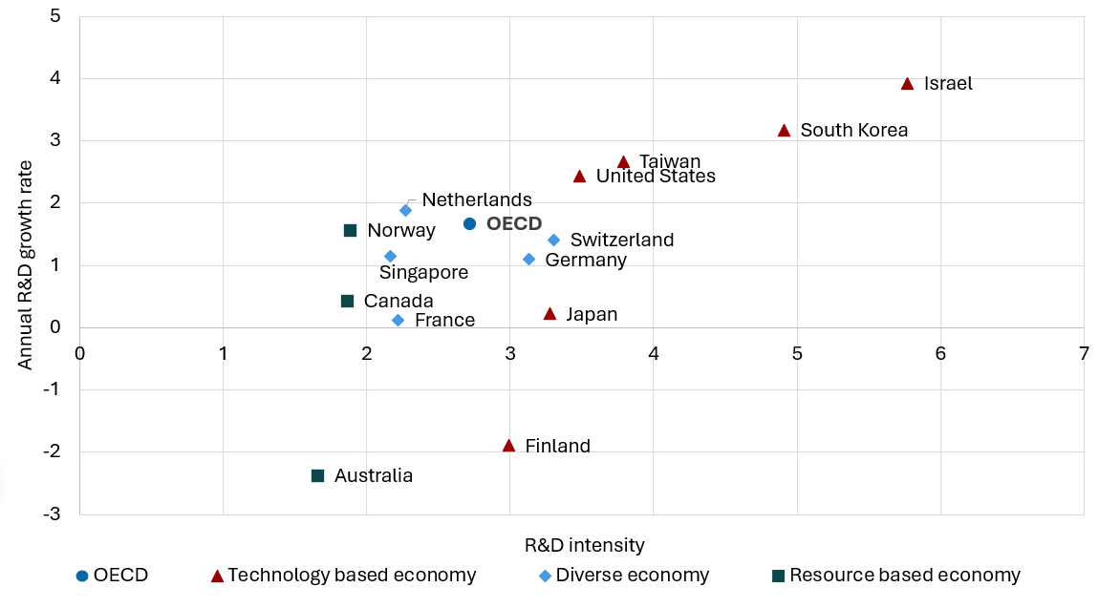
Source: Adapted from OECD main science and technology (MSTI) indicators (OECD 2025b)
The benefits from RD&I investment are clear. Australian firms with more novel innovations have 1.6 times higher labour productivity than those with only incremental innovations, and 1.7 times higher productivity than firms that introduced no innovations (Majeed and Breunig 2022) (Figure 6).
Figure 6: Median labour productivity increases relative to innovation novelty
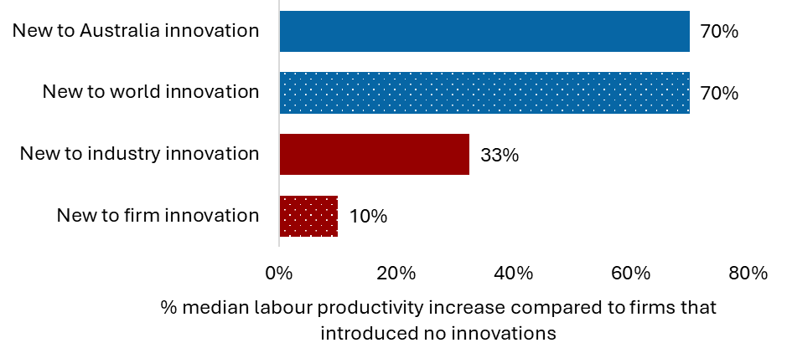
Source: Adapted from Australian National University Centre for Economic Policy Research Discussion Paper (Majeed and Breunig 2022)
The benefits of R&D extend beyond individual firms, generating significant spillovers, with higher returns in high-impact areas like information and communications technology (ICT) and software development. Econometric analysis done for this review shows that firms earn $4.60 for every $1 invested in R&D after 10 years, and the broader economy gains $7.14 per $1 invested in R&D over the same period (Figure 7).
Figure 7: Modelling of social and private return to industry R&D
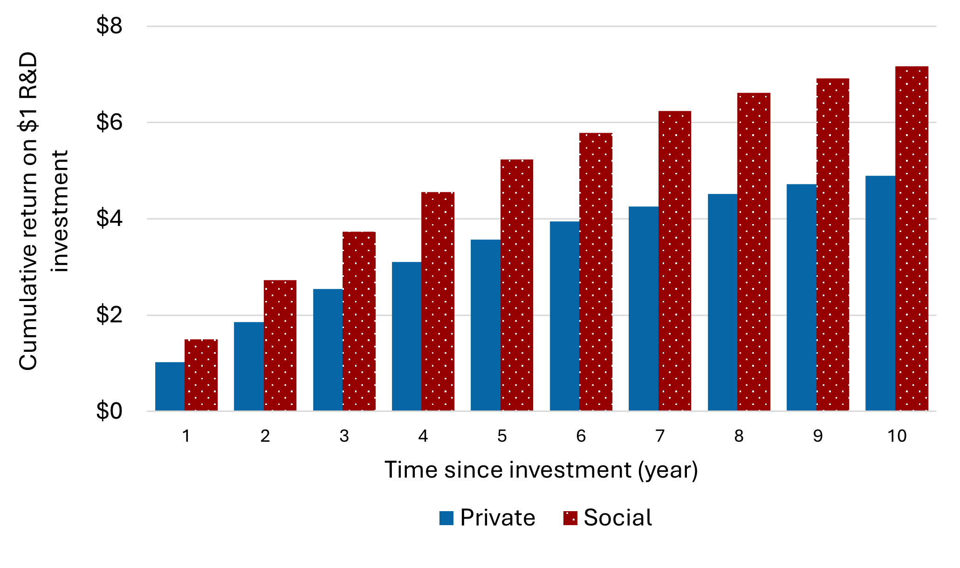
Source: R&D Spillovers, R&D Labour Mobility Effects, and the Effectiveness of R&D Subsidies. Report for the Strategic Examination of R&D (Palangkaraya et al. unpublished)
Higher R&D activity delivers deeper and more enduring benefits than other forms of investment. Evidence shows that R&D has a far stronger impact on productivity. An increase in R&D as a share of GDP lifts total factor productivity in the medium term by around 5 times as much as other types of investment (International Monetary Fund 2024).
Refocusing our economy and RD&I system will also ensure Australia takes advantage of strategic enabling technologies as they develop. The List of Critical Technologies in the National Interest identifies those technologies that are essential to our economic prosperity, national security and social cohesion (DISR 2023). They are integral to our industrial growth, research and manufacturing capabilities, as well as supporting industry transformation – including through clean energy, and national security.
The unfolding artificial intelligence (AI) revolution is a case in point. We need to be able to participate in the RD&I that embeds us as part of the frontier of knowledge generation as well as creating the expertise necessary to apply the new technology to Australian opportunities and circumstances.
Investment in RD&I will equip Australia to adapt to these challenges – and unknown, and others still to emerge – so that we are able to seize new opportunities. Australia will be able to build resilient industries, develop new markets and secure long-term prosperity for future generations.

- Focus and scale
  - A new model for national coordination and impact
Achieving greater focus and scale for Australia’s research, development and innovation (RD&I) system will supercharge the creation of knowledge and expertise. Coordination and prioritisation are needed to get the innovation flywheel moving (Figure 8).
Figure 8: Flywheel coordination
Australia’s RD&I system is fragmented, with uncoordinated programs, duplicated efforts across jurisdictions and inefficient competition for limited resources. This review covered more than 150 Australian Government programs, spread across 13 ministerial portfolios, with a combined annual expenditure of over $14 billion (DISR 2025a). A complex position made worse by the fact that many programs offer multiple grant schemes.
Global experience shows that nations achieving sustained R&D impact do so through focused and cross-sector collaboration. Mission-oriented policies create opportunities to coordinate different approaches to stakeholder engagement, align agencies around shared goals, and mobilise and sustain public and private investment (Larrue 2021). For example, a 2021 study of 7 European Union (EU) countries found that mission-driven R&D boosts both public and private R&D and increases gross domestic product (GDP) (Ziesemer 2021). A 2023 study found that mission-oriented innovation policies deliver stronger long-term growth and resilience, even with equal public resources, because they attract more private investment and generate stronger economic and social outcomes (Dosi et al. 2023).
Driving focus through clearer prioritisation will maximise the impact of public investment and attract private capital. Current Australian Government RD&I priorities are too many and too broad to effectively focus research efforts and achieve outcomes at scale. They include the National Science and Research Priorities, the National Reconstruction Fund (NRF) Priorities and the Future Made in Australia (FMA) Plan, in addition to portfolio-specific plans and priorities.
There is a need to more clearly link science and research priorities to national priorities through specific outcomes-focused, long-term national goals backed by public investment spanning the whole research-to-innovation pipeline.
Stakeholders consulted by the panel broadly agreed. More than 65% of respondents to the discussion paper survey supported a greater focus on prioritisation (Figure 9).
Many countries target specific areas for RD&I investment to boost technological leadership and achieve economic and social benefits. A 2022 survey (National Council for Civilian Research and Development 2022) found that priority areas are typically selected through evaluation processes involving input from government, academia and industry, with criteria including economic potential, national strengths, and major challenges.
Clearer prioritisation requires stronger coordination. This was widely recognised by stakeholders consulted by the panel, with 83% of discussion paper survey respondents agreeing or strongly agreeing that Australia’s RD&I system needs improved coordination (Figure 9).
Figure 9: Stakeholder views on prioritisation and coordination (n=418)
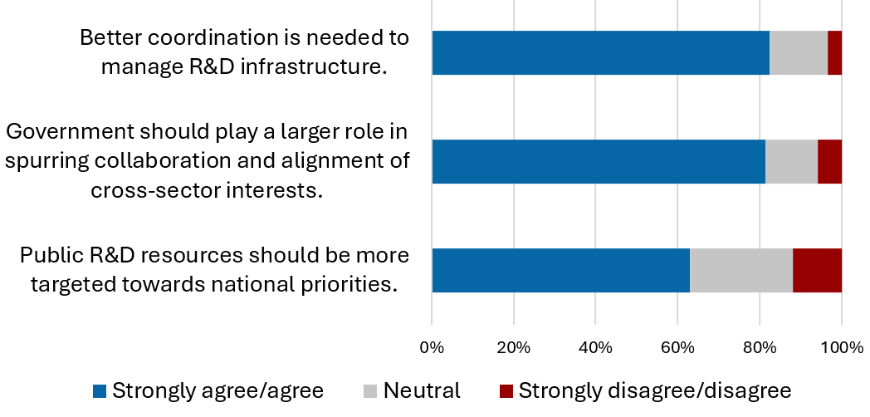
Source: SERD discussion paper survey responses, April 2025
Meaningful coordination and collaboration across disciplines, sectors, institutions and businesses will foster knowledge diffusion and talent mobility. Clear outcomes and timelines matched by essential policy frameworks will increase industry confidence, encouraging investment and partnerships. Economic and societal spillovers and benefits will lead to sustainable growth, lifting Australia’s economic complexity, productivity, and global competitiveness.
The panel proposes a model that will:
- establish a National Innovation Council (NIC) to better coordinate RD&I activities.
- consolidate national RD&I efforts on a limited number of focus areas – National Innovation Pillars – each anchored by a long-term and aspirational national goal to guide prioritisation, coordination, and strategic focus.
- establish a National Strategy Advisory Council (NSAC) for each pillar to provide leadership, governance and support. Each NSAC will work with the NIC to set up to 3 subgoals within each pillar.
- establish a National Strategic Initiative (NSI) for each subgoal – the key delivery mechanism responsible for a step change in Australia’s RD&I activities.
Each of these points are addressed in detail in the following sections.
When implemented, this approach will mobilise the RD&I ecosystem to engage fully from the creation of knowledge to its translation into impact in key areas of national interest.
Figure 10: ‘Pillars’ model summary
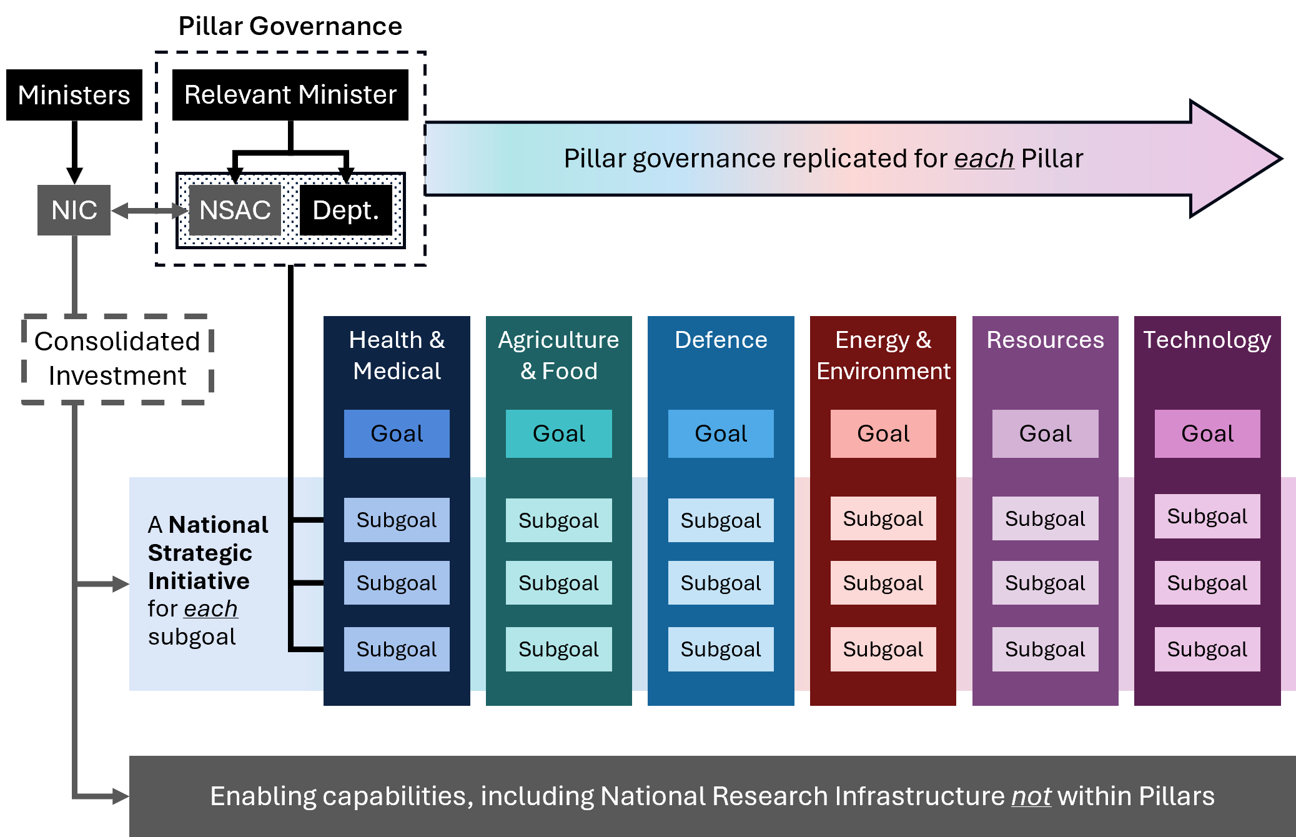
    - A National Innovation Council
The panel proposes the Australian Government establish a NIC with the brief to create a unified and coordinated national RD&I effort encompassing goal setting, strategic planning and evaluation.
Currently, the National Science and Technology Council (NSTC) and Industry Innovation and Science Australia (IISA) play advisory roles within the RD&I system. Many functions could be brought together under the NIC to streamline governance, reduce bureaucracy and enhance coherence. To minimise duplication, the panel recommends leveraging a reformed IISA as the foundation for the NIC.
RD&I must be a national imperative for Australia. The panel strongly recommends that the NIC reports directly to the Prime Minister and the Minister for Industry and Innovation / Science (Figure 11). Given this dual reporting structure, the government could consider the role of the NSTC and whether it should remain as a separate advisory body.

Recommendation 1a
Commonwealth Cabinet establish a single National Innovation Council (for example by reforming Industry Innovation and Science Australia) chaired by an eminent Australian, supported by a Statutory Officer, to oversee Commonwealth RD&I funding and reporting directly to the Prime Minister and the Minister for Industry and Innovation / Science.

Figure 11: Establishment and governance of the National Innovation Council (NIC)
The NIC should be chaired by an eminent Australian with the credibility, integrity and expertise to align stakeholders, advance national goals and champion RD&I for the nation. It should be supported by a statutory officer sufficiently resourced to provide the legal authority, independence and accountability to fulfil its mandate irrespective of political cycles.
Council membership should include experts from academia, industry, investment, and all levels of government. The chairs of the 6 NSACs (addressed in Section 1.1.3 below) should each be represented on the NIC, along with experts from cross-cutting areas including research, investment, RD&I business leadership and governance. This will provide the NIC with the vertical and horizontal expertise needed to coordinate across the pillars.
When established, the NIC will work with the NSACs to set the goals and subgoals for each pillar, which will establish the focus of Australia’s RD&I sector for at least the next decade.
The NIC should also be tasked with developing governance frameworks to facilitate national coordination and improve system performance. These frameworks include:
- An RD&I Investment Framework that outlines principles for public investment in the pillars, ensuring funds target RD&I priorities (e.g., delivering national goals and sub-goals, strengthening the RD&I system, fostering collaboration and building workforce capability), rather than administration. It should promote consistent and transparent decision making across the Australian Government.
- An RD&I Performance Framework centred on RD&I outputs, outcomes and impacts, to support system and program-level evaluations and enable evidence-based, outcome-focused decisions. This will help accountability by linking performance to funding and foster a culture of excellence (detailed further in Chapter 6, Section 6.5).
- A research costing framework, developed in collaboration with the Australian Tertiary Education Commission (ATEC), to support the assessment of the full cost of university research activities (detailed further in Chapter 2, Section 2.2).
Ongoing roles of the NIC include:
- reviewing and endorsing long-term plans for each pillar, developed by NSACs, that set out a roadmap for achieving each pillar’s overarching goal through subgoals and NSIs
- overseeing funding to the NSIs that deliver on subgoals
- coordinating activities across the pillars to ensure alignment, differentiation and strategic direction
- evaluating the progress of the RD&I system, including the development of national dashboards that track progress and hold the system accountable
- undertaking triennial reviews of the system to ensure delivery in the national interest
- ensuring the system responds to any significant developments in the national interest (e.g. pandemics or new technologies)
- integrating skills development into strategic planning and devising a strategy to attract, develop and retain top talent across the innovation cycle by leveraging funding, migration and education systems.
The NIC should also be tasked with developing system-wide strategies for enablers. This includes (but is not limited to) infrastructure and First Nations engagement. To support this, 2 sub-committees are proposed:
- A National Research Infrastructure Investment and Coordination Committee. This is detailed further in Chapter 2 (Section 2.4).
- A First Nations RD&I Committee, to ensure coordination across the First Nations RD&I system and support respectful integration of First Nations knowledge in RD&I policies, programs and activities through the development of frameworks and enabling tools. This is detailed further Chapter 5 (Section 5.3).
Chairs of these committees should also be members of the NIC.
States and territories play an important role in shaping Australia’s RD&I system. They hold jurisdictional levers and capabilities that will need to align with the pillars to ensure success. The NIC will engage with representative bodies for state and territory governments, as well as regional, rural and remote communities, and other groups as required. Broad engagement by the NIC will support an equitable and inclusive RD&I system and ensure that activities are not concentrated in major cities.
    - Priorities and impact
To unlock the full potential of public RD&I investment, clear goals must align efforts with areas of national need and global opportunity. Aligning and consolidating funding will concentrate resources where they matter most, turning national goals into societal and economic outcomes.
Effective prioritisation means pillars must be few and targeted – the panel recommends no more than 6. Each pillar should target a priority area that leverages Australia’s distinctive environmental, agricultural or resource sectors, or builds capacity in critical sectors such as health, defence and national security, and energy (Figure 12).
These areas already receive significant Australian Government investment, and the panel acknowledges it is unlikely that this will change as a consequence of this review. They are therefore accepted as both a starting point and a way to avoid adding more to the over 150 programs that already exist, with one exception.
The technology sector is the exception. It is Australia’s third largest industry by value, contributing $167 billion to GDP in 2021, and it is growing rapidly – up 79% in the preceding 4 years (Tech Council of Australia 2021). Ensuring Australia is conducting RD&I in technology industries, including building future generations of enabling technologies, is fundamental to our future.
The technology industry should be elevated in the national industrial landscape and be recognised as a key focus area. At the same time, we acknowledge that enabling technologies, such as advanced manufacturing technologies and artificial intelligence (AI), must be applied in, and support, progress across all other pillars.

Recommendation 1b
Consolidate national RD&I efforts into 6 National Innovation Pillars, including (1) Health and Medical (2) Agriculture and Food (3) Defence (4) Environment and Energy (5) Resources (6) Technology, each anchored by a long-term and aspirational national goal to guide prioritisation, coordination, and strategic focus.

Figure 12: The 6 National Innovation Pillars
Consolidating existing programs that support translational research is fundamental to freeing up resources to invest into the pillars and build scale. The panel recommends consolidating funding from the following programs to provide the capital needed to invest in the new system under the NIC:
- Cooperative Research Centres (CRC) Program
- Industry Growth Program
- Trailblazer Universities Program
- Australia’s Economic Accelerator Program
- National Collaborative Research Infrastructure Strategy (NCRIS) Program.
Additionally, a proportion of research block grants – the Research Support Program (RSP) and the Research Training Program (RTP) – should be aligned to support the pillars.
Over the past decade, the CRC and Trailblazer Universities programs alone have resulted in the establishment of 38 entities (32 CRCs and 6 Trailblazers). Under the pillars model, these entities will be reduced to no more than 18 NSIs, promoting a leaner and more integrated system.
Within each pillar there already exists a plethora of programs and initiatives. The NSACs would be given a role to consider how consolidation of these programs could occur to further reduce inefficiencies, and focus funding, in the system.
By reducing the number of programs, we will also enable a smaller government, and there will be less need for administration support across the system.
Commitments under existing programs, including CRCs and Trailblazers, should be allowed to continue for the duration of their current funding agreement. Where appropriate, these entities should be aligned with NSIs. Transitional funding may be required for existing programs that are due to end in the short term to ensure that capability and expertise likely to align with NSIs is not lost.
All future funding for programs and projects should be directed into the pillars model to maximise benefit for Australia.
    - National Strategy Advisory Councils
A NSAC will be established for each pillar to ensure deep sector expertise is leveraged and provide governance stability, accountability and oversight of NSIs. They will report to portfolio ministers, ensuring autonomy over portfolios, while facilitating coordination via the NIC. Together the NIC and NSACs should provide strong governance, including by developing long-term plans that clearly articulate overarching pillar goals and sub-goals and encompass all ecosystem participants.

Recommendation 1c
Establish a National Strategy Advisory Council (NSAC) for each National Innovation Pillar, reporting to portfolio ministers. NSACs should collaborate with the National Innovation Council and relevant Commonwealth departments to set up to 3 subgoals for each pillar, to focus RD&I activities on high-risk, high-impact challenges.

Each pillar expert on the NIC will chair the corresponding NSAC, which will have combined expertise spanning industry, academia, research translation, finance and investment, and governance. NSACs should leverage existing structures within pillars where possible, to avoid creating new entities, and ensure clear lines of communication with the NIC and relevant Commonwealth department.
A core task of the NSACs will be to identify specific areas where Australia can ‘play to win’.
Guided by the NIC, each NSAC should set a high-level, long-term goal for its pillar. This goal should be supported by up to 3 subgoals that target the critical capabilities and actions needed to achieve it, and focus RD&I activity on high-risk, high-impact challenges (Figure 13). To ensure focus and targeting of effort, the number of subgoals recommended to government should be limited to no more than 18 across the pillars.
All goals should have a horizon of at least 10 years to rise above short-term pressures and provide the policy certainty industry needs to invest in RD&I. Goals should be specific, measurable, achievable, relevant and time-bound (SMART). They should encompass research across science, technology, engineering and mathematics (STEM) and humanities and social sciences (HASS) disciplines. They should consider potential for growth and jobs. Long-term plans will provide accountability, while triennial reviews will ensure relevance and allow for adjustments in response to global developments.
Selection of pillar goals and subgoals should align with central policy frameworks, such as FMA, and be informed by robust analysis and genuine co-design. Selection should consider Australia’s national challenges, research strengths, industry capabilities, comparative advantage, market opportunities, and potential for social and economic benefit. Early engagement of state and territory governments is critical to ensure goals reflect jurisdictional priorities and regional strengths. Co-design should also involve industry, academia, First Nations peoples, and regional and rural communities to ensure a shared national direction.
Figure 13: Pillar governance structures
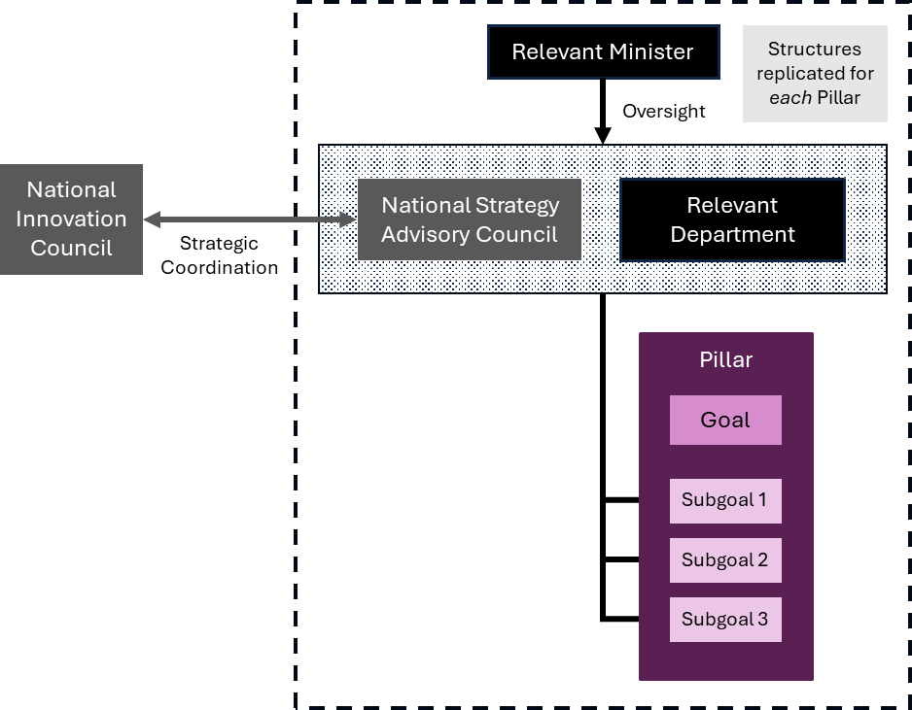
In addition to setting the goals and sub-goals, the NSACs will have the following responsibilities:
- Review existing programs within the pillar, and seek opportunities to reduce the number of programs and initiatives through consolidation, freeing up more capital for investment and further simplifying the system.
- Together with the relevant Commonwealth department, develop a long-term plan for approval by the relevant portfolio minister. The plan should:
  - set out a roadmap for achieving the pillar’s overarching goal through subgoals
  - identify key performance metrics to monitor and evaluate progress
  - ensure efficiency by consolidating and aligning efforts across government and sector participants to maximise impact
  - align to the NIC’s frameworks, government direction, and link to other government strategies.
Once the long-term plan is in place, ongoing responsibilities for each NSAC and relevant Commonwealth department will include:
- recommending proposals for NSIs – the main vehicle through which long-term plans are implemented through RD&I activities – for approval by the relevant portfolio minister.
- overseeing NSI investment, coordination, monitoring, and evaluation, ensuring that funded activities deliver against agreed objectives and contribute to system-wide outcomes.
- collaborating with state and territory governments to resolve barriers to progress in NSIs and strengthen national coordination.
- updating the pillar’s long-term plan as needed, informed by triennial reviews, while maintaining coordination with other portfolios and agencies.

Panel considerations for NSACs leveraging existing efforts
To deliver the goals, pillars will be supported by cross-cutting enablers including national research infrastructure, enabling technologies, Australian Research Council (ARC), and publicly funded research agencies (PFRAs). PFRAs will play a critical role in supporting the delivery of subgoals through NSIs. Their role is explored further in Chapter 6.
The panel recognises that every pillar will be unique and have different requirements for NSACs to effectively implement them.
Australia’s National Health and Medical Research Strategy (NHMRS) is currently being developed. It will establish a 10-year vision to strengthen the health and medical research sector. The panel has worked closely with the chair of the NHMRS. We support the ambitions of the NHMRS and anticipate alignment across our proposed governance structures.
To maximise impact of the model, the Health and Medical Pillar should also leverage National Health and Medical Research Council (NHMRC) and Medical Research Future Fund (MRFF) funding to support the achievement of the goal and subgoals.
The Defence Pillar will involve relevant parts of the Department of Defence. It will require further consideration.
The Agriculture and Food Pillar should support the rural Research and Development Corporation (RDC) model, which has been a successful partnership between the Australian Government and Australia’s agricultural sectors. The panel’s view is that the Australian Government should have greater control about where its funding into the RDC model is spent. The NSI model will support this. The panel is also of the view that consolidation of RDCs should be explored to reduce operational costs across the system and maximise funding directed to RD&I activities. This is addressed further in Recommendation 18.
The Energy and Environment Pillar should leverage the capabilities built by the Australian Renewable Energy Agency (ARENA). The work done to develop the venture capital (VC) industry in this sector, including through the spinout of Virescent Ventures, is something that can be leveraged by other Pillars and NSACs.
The Resources Pillar should be focused and leverage the significant investment by the Australian Government in the Critical Minerals R&D Hub while also drawing from the expertise of the Commonwealth Scientific and Industrial Research Organisation (CSIRO), Australian Nuclear Science and Technology Organisation (ANSTO), and Geoscience Australia.
The Technology Pillar should focus on critical technologies, as defined by Government through the List of Critical Technologies in the National Interest. This includes enabling technologies that support the application of technology across other pillars, such as advanced manufacturing technologies, AI, quantum, robotics and biotechnologies.

    - National Strategic Initiatives
Designed to transform Australia’s RD&I landscape, NSIs will bring together all tiers of government, industry (including startups, small to medium enterprises (SMEs), large enterprises), investors and the research sector to tackle high-risk, high-impact challenges.
NSIs will deliver targeted research translation investments to support the achievement of pillar subgoals, funded through the consolidation of existing research translation programs (see Section 1.1.2). They will also leverage complementary initiatives across levels of government – such as state-based industry development schemes and the NRF – to align efforts and maximise impact.
Complementary funding available to an NSI will vary by pillar and subgoal, and will change over time as RD&I progresses, requiring different types of support. For example, NSIs in the Health and Medical Pillar could draw on NHMRC funding for foundational research, while MRFF funding could support translation and commercialisation.
This coordinated approach will enable large-scale activities spanning foundational research to commercialisation, fostering business startup and growth, creating jobs and accelerating our economic transformation. The panel notes that there is an opportunity to increase the investment in translation and commercialisation research for health and medical purposes through the MRFF, where the maximum annual distribution amount determined by the Future Fund has exceeded the allocations drawn under MRFF investment plans by over $200 million each year since 2023–24. The panel considers that the opportunity provided by the definition of pillar goals, subgoals and NSIs should be taken to increase the MRFF investment plan to apply these additional funds to research translation goals.

Recommendation 1d
Public RD&I investment should be consolidated and concentrated to achieve subgoals through National Strategic Initiatives (NSIs) that engage all tiers of government, startups, Small to Medium Enterprises (SMEs), large businesses, investors, and researchers in high-risk, high-impact challenges.

NSIs should be established through a competitive selection process, with proposals coordinated by and involving at least one state or territory government. Active participation of state and territory governments is essential to align national and jurisdictional priorities, prevent further fragmentation of effort, and reduce unnecessary competition for Commonwealth funding. Proposals must also involve partners from both industry (including startups, SMEs, corporates) and research sectors (universities, research institutes, PFRAs). They must be portfolio (not project) based and focused on achieving research and translation outcomes through tri-sector collaboration.
Each proposal should also show consideration of the key elements for success, including:
- how the NSI subgoal will be delivered
- how the NSI will engage with ‘cross-cutting portfolios’ including research in STEM and HASS, and enabling technologies such as AI, robotics, quantum and advanced manufacturing technologies
- the role of partners, including how state and territory governments can unlock regulation and identify and contribute tangible assets in their local ecosystems, including incentives, infrastructure, facilities and land
- the contribution of partners, with a successful NSI requiring at least a 50% cash investment from the members of the tri-sector partnership.
To avoid duplication of efforts and fragmentation of funding and resources, only one NSI consortium per sub-goal would receive funding.
      - NSI Governance
An NSI will be established as a dedicated, standalone entity. They will be not-for-profit, member-based entities. Members should include, but not be limited to, representatives of the tri-sector consortium.
Each NSI should have a simple governance structure including a board. The board should be chaired by a qualified NSI industry leader and include no more than 5 directors, of whom no more than 2 should represent the members. If not represented on the Board, the lead state or territory government should be entitled to an observer position. This will provide visibility of NSI activities, support effective coordination of jurisdictional contributions, and help minimise duplication and fragmentation.
The board will oversee the management team which in turn will be responsible for the day-to-day operations. This includes performing the NSI roles needed to achieve its goal, ensuring partners meet their commitments, managing the consortium members, and leading broader community outreach and engagement.
      - NSI Principles
Each NSI will need to agree to a set of principles that will support an enhanced RD&I system. These include agreeing to:
- operate as a hub-and-spoke model, ensuring centres of excellence (including in universities, PFRAs and industry precincts) across Australia’s cities and in regions are embedded into the NSI in the most effective and efficient way
- ensure equitable access for business and research leaders, regardless of location. This includes providing grants to non-consortia universities, research organisations, and businesses
- drive a focus on rapid promotion and sharing of intellectual property (IP) across partners and potential adopters, such as through standardised and simple models for IP management
- show fairness and equity in all activities, including promoting both participation in and leadership of RD&I activities by First Nations peoples and other under-represented groups.
Each NSI will be responsible for a seismic change in RD&I activity related to the NSI subgoal (Figure 14).
The role of each NSI should be to:
- determine the foundational research, translation and development projects, including in ‘cross-cutting portfolios’ of HASS and enabling technologies, needed to meet the NSI goal
- administer NSI-specific funding for foundational STEM and HASS research that advance knowledge aligned with the NSI goal
- manage any specialised research infrastructure that is specific to the NSI
- support talent mobility between industry and research, including by funding hundreds of industry PhDs, in addition to joint appointments and industry sabbaticals for researchers
- support the creation and growth of high-quality RD&I startups through proof-of-concept schemes, pre-accelerator, and accelerator programs
- advise the NSAC and the NIC on establishing angel and VC funds to grow NSI startups, noting these may require broader pipeline access and coordination at a sector-wide (NSAC-led) or national (NIC-led) level
- provide a ‘front door’ to industry to engage with the NSI area, including facilitating collaborations with the research sector and coordinating engagement with state, territory and Australian government agencies
- support Austrade to develop a national narrative to attract international partners and investors
- administer other schemes proposed by the consortium, for example any place-based- initiatives proposed by state or territory government partners (e.g. precinct or incubator management, specialised payroll tax schemes)
- monitor and evaluate performance by collecting baseline data and tracking progress through longitudinal studies and triannual reviews, in line with the NIC’s performance framework.
We expect each NSI to create new knowledge that contributes to the achievement of the NSI goal, create hundreds of new NSI-related startups, support the growth of RD&I active firms, create thousands of new high-value jobs and increase GDP.
Figure 14: Implementing pillars through NSIs, using example goals drawn from the Netherlands’ Mission Driven Top-Sector and Innovation Policy
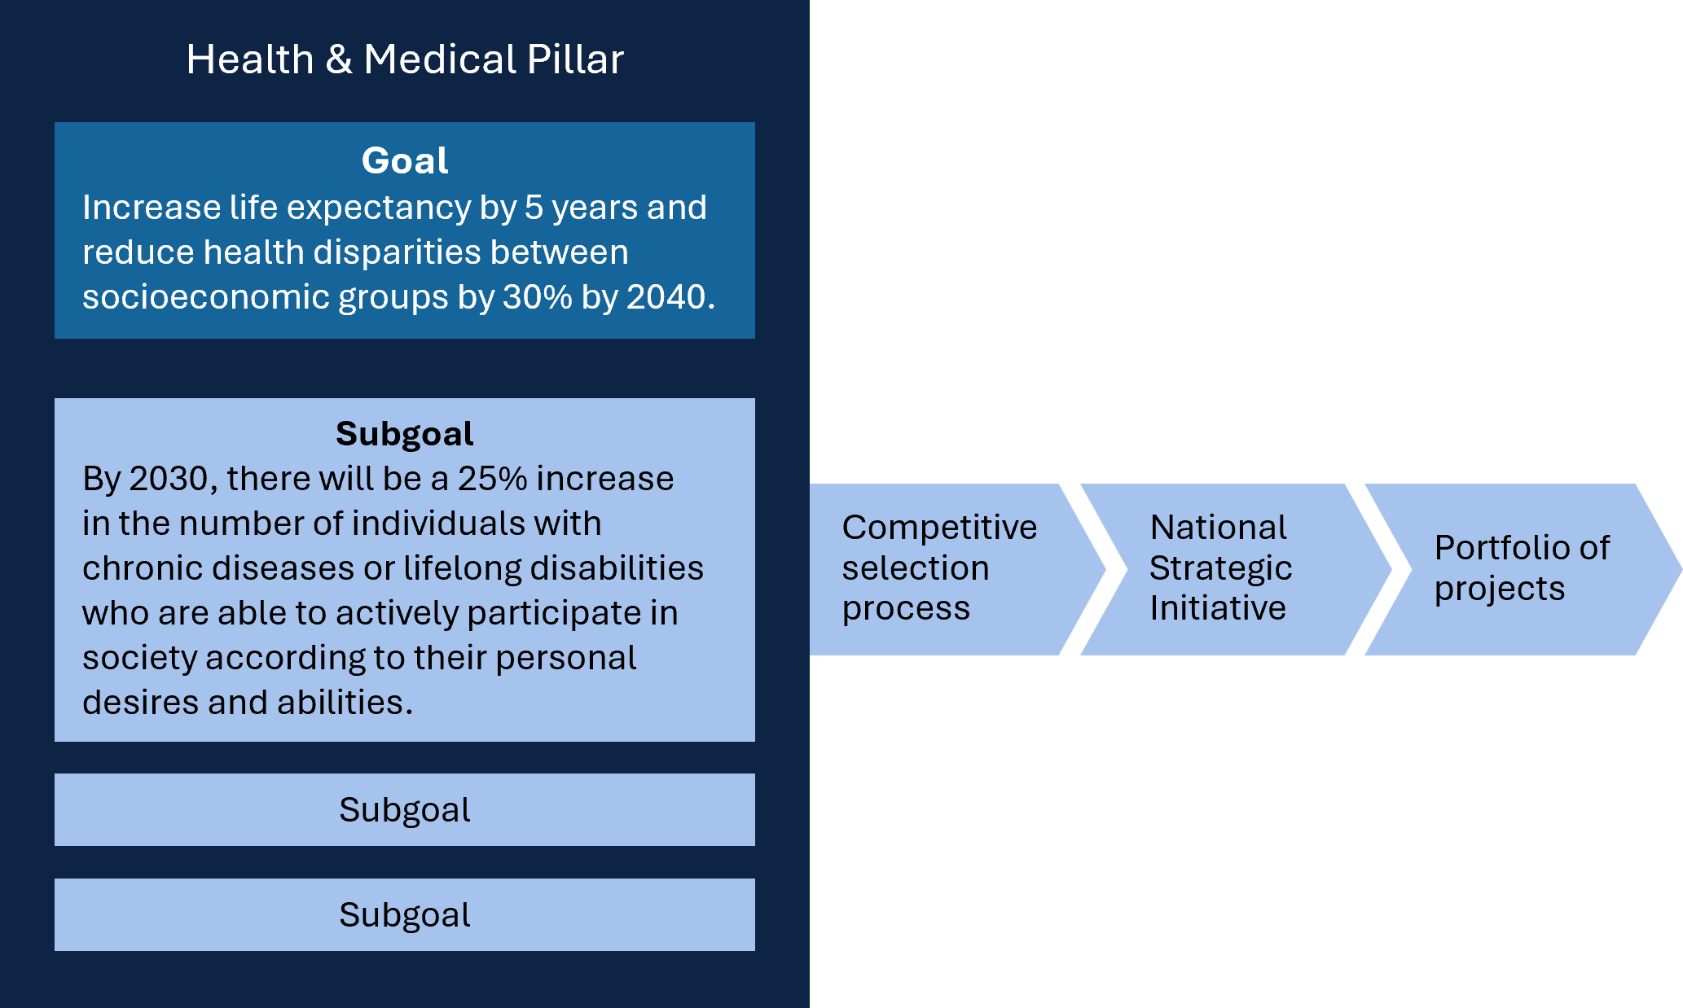
    - An interdependent package of reforms
The proposed pillars model will be the centrepiece of a reformed RD&I system. To achieve focus, scale and impact, the RD&I system must align with this model, building on existing strengths while developing practical incentives and mechanisms to close gaps and address weaknesses.
We also need to address a range of interdependent measures that will support the success of the system.
This includes maintaining support for broad-based, investigator-led foundational research to generate new knowledge and keep Australia at the cutting-edge while building capability as outlined in Chapter 2.
Chapter 3 sets out targeted reforms to stimulate the use of knowledge into startups, and encourage greater participation across businesses of all sizes, including in the pillars.
Australia must also strengthen private investment to grow the businesses supported through Chapter 3. Chapter 4 outlines reforms needed for Australia to expand its angel and VC networks to accelerate success.
To achieve Australia’s aspirations, we need a workforce capability to match our ambitions. Chapter 5 focuses on building the workforce capacity needed to deliver an integrated RD&I system.
And finally, strong government leadership is essential to set the right policies, regulatory and funding environment, and champion RD&I to achieve an ambitious Australia. Chapter 6 sets out reforms, including procurement, aligning Australian PFRAs with the pillars model.
These reforms are an integrated package and are essential to enabling the pillars and their NSIs to succeed, while also strengthening the broader RD&I system.
  - Other observations
The pillars should result in a step change in the profile of Australia's exports. These will need to be marketed. Austrade has a very important role in supporting Australia's global endeavours. This includes supporting exports by Australian firms. The Export Market Development Grants program provides funding to support young firms to export. There would be benefits in focusing this scheme on the high growth RD&I firms, including those aligned to the pillars.
  - Why this matters
Not implementing the NIC, NSACs and NSIs will see the continuation of the status quo. Research will continue to largely respond to the choices of individuals in the RD&I system, rather than to national needs. Funding will remain uncoordinated and divided across too many programs and administrative processes. The system will continue to be overly bureaucratic, and we will not achieve scale and impact, nor change.

- Creating knowledge: Foundational research
‘History has shown it is federally sponsored research that provides the truly “patient” capital needed to carry out basic research and create an environment for the inspired risk-taking that is essential to technological discovery. Often these advances have no immediate practical usability but open “technology windows” that can be pursued until viable applications emerge.’
A Moment of Truth for America:
An open letter to Congress from the executives of some of
America's leading technology companies (Allen et al. 1995)
Foundational research underpins progress. It creates knowledge without which there can be no advancement. Knowledge is the source of every breakthrough, every new industry, and every solution to the challenges we face as communities, as a nation and as a world. Knowledge is therefore the lifeblood of progress and prosperity is the legacy we inherit from foundational research.
As shown in the flywheel (Figure 15), foundational research underpins our vision for a globally competitive Australia.
Figure 15: Flywheel foundational research
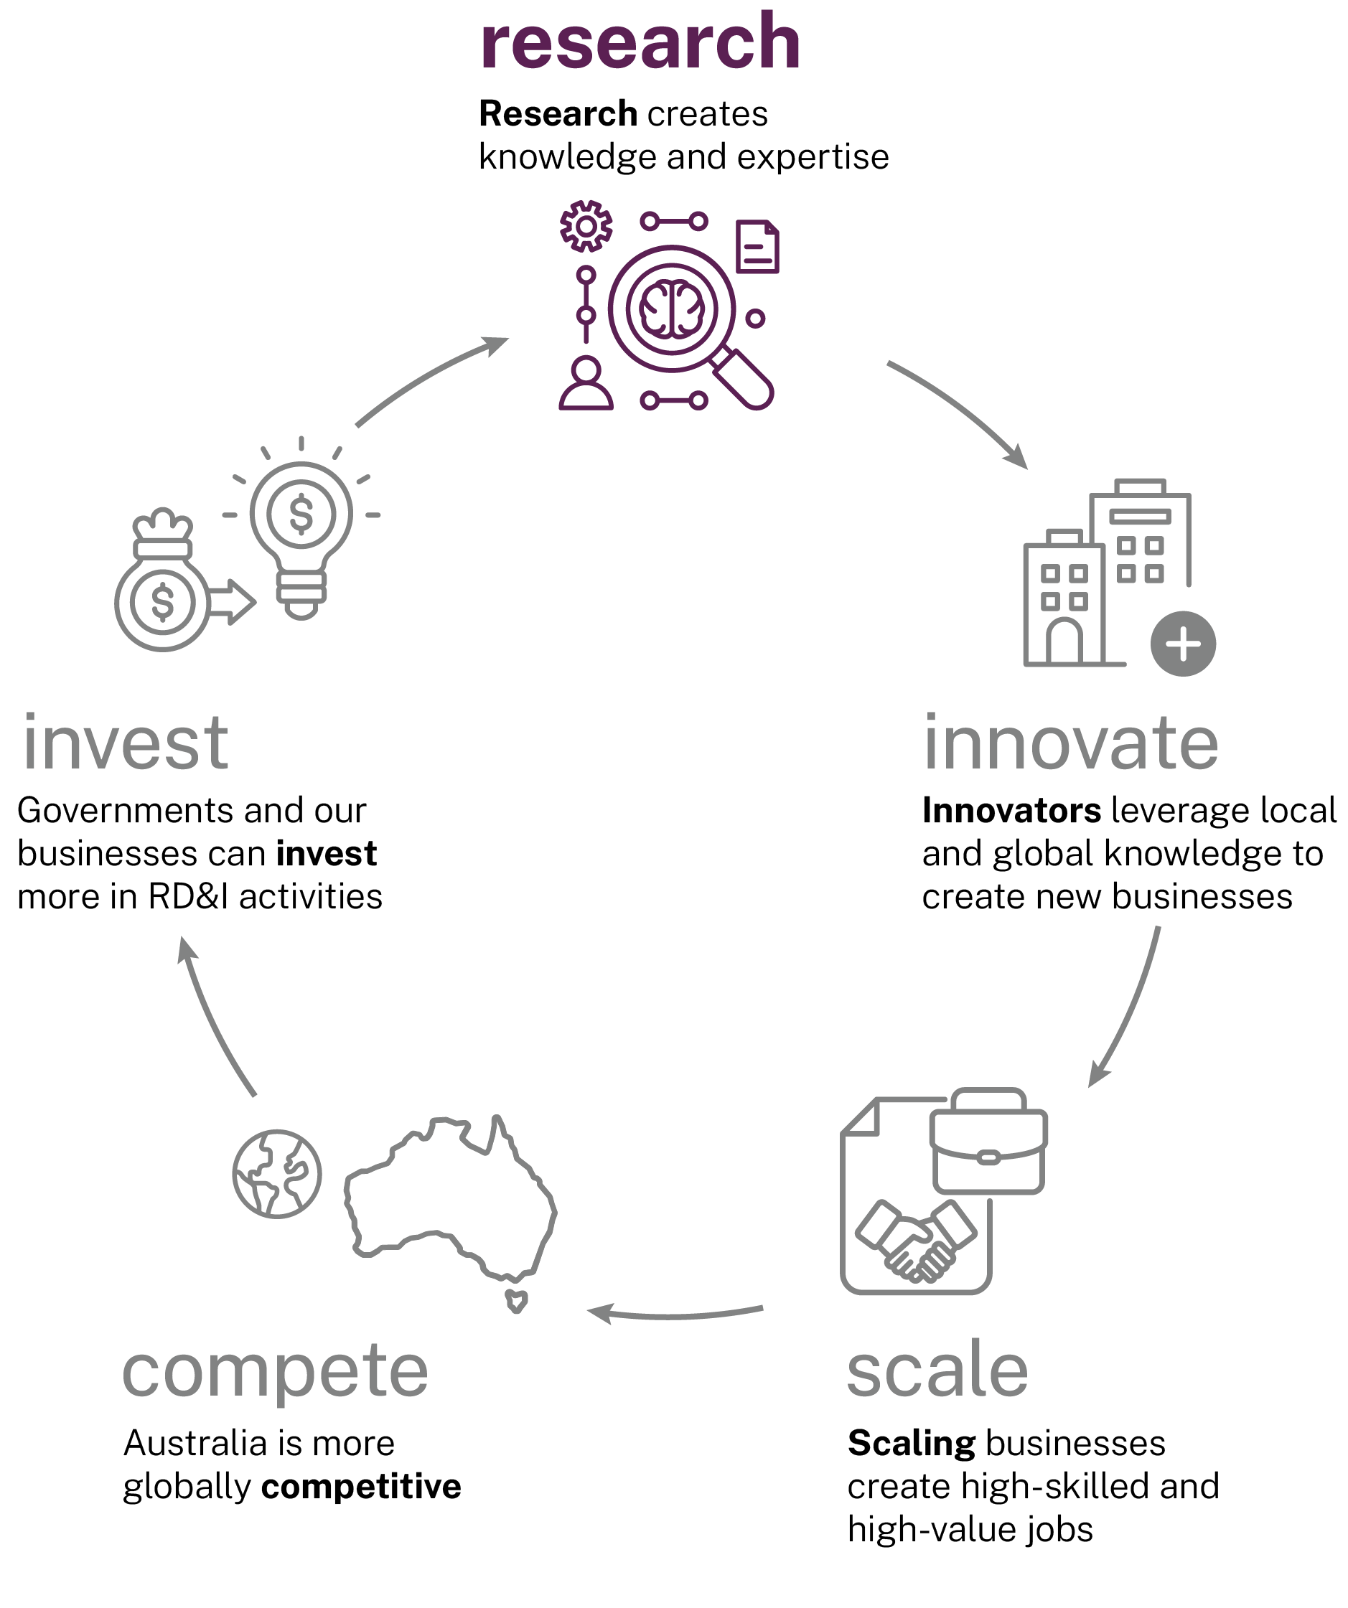
The panel recognises the need to focus on ‘high risk, high reward’ research, development and innovation (RD&I) activities as proposed in Recommendation 1. We also emphasise the importance of protecting foundational research across the range of science, technology, engineering and mathematics (STEM) and humanities and social sciences (HASS) disciplines, both inside and outside the proposed National Innovation Pillars.
Tony Blair, then prime minister of the UK, articulated the importance of such a comprehensive approach by in a speech to The Royal Society of London:
‘[Science] just extends the context of knowledge within which moral judgements are made. It allows us to do more, but it doesn't tell us whether doing more is right or wrong … Science is a central part, not a separate part, of our common culture, together with art, history, the social sciences and the humanities.’
Tony Blair (2001)
In other words, a functioning system values not only the ability to act differently but also respects the type of community we have and want to build.
Australia has a solid foundation. We proudly and frequently assert how we ‘punch above our weight’ by producing 3% of the global knowledge bank from 0.3% of the global population (Clarivate Analytics 2025). We should be prouder of the fact that in 2025, 4.4% of highly cited research was Australian – an indicator of substance, not just weight (Clarivate Analytics 2025). This means we have capability to assess, use and build from the 97% produced elsewhere; it supplies the capacity to build sovereign capability with an impact we largely determine: what, where and how.
Of the respondents to the panel’s survey, 92% agreed that sustained investment in foundational research and development is critical to the health of the system.
Knowledge is a public good and while its translation into goods and services needs to engage suitable private investment, its creation depends on public investment.
Public investment creates the space and time in which curiosity, imagination, and rigorous inquiry can thrive, without having to focus on a presumed product. It is where new knowledge is created and translated into products and services that benefit communities in Australia and globally. The knowledge may have no ‘immediate practical usability’ but without it there are no ‘technological windows’ to open. It has value way beyond cost.
History demonstrates that breakthrough innovations rarely follow a linear and fast trajectory from discovery to commercialisation.

Patient investment opens ‘windows’
Penicillin: The observation of a mould’s antibacterial properties in 1928 to 1929 eventually led to large-scale production, following Howard Florey’s team demonstrating its clinical application nearly 15 years later. Florey said: ‘This was an interesting scientific exercise, and because it was of some use in medicine is very gratifying, but this was not the reason that we started working on it’ (de Burgh 1967). An estimated 200–500 million lives have been saved by the consequences of this ‘interesting scientific exercise’.
Ozempic/Wegovy: Research into the effects of the hormone GLP-1 on duodenal ulcers began in the 1970s. Nearly 40 years later, it is widely used for entirely different conditions – managing diabetes and obesity. Reflecting on this journey, the lead Danish scientist said: ‘I was walking around in the street with signs saying: ‘Research for the people, not for the profit’. We didn’t even think of patenting or getting money out of this… We were interested in publishing, doing something and moving this ahead’ (Reynolds 2023).
mRNA technology: Foundational research into mRNA mechanisms started in the 1960s, and the first mRNA vaccines – initially targeting cancer – were introduced in the early 2000s. While the fundamental discoveries earned Katarina Karikó and her research partner the Nobel prize in 2023, the breakthrough was built on decades of patience and persistence despite repeated grant rejections, publication rejections, ridicule and a demotion. Today, around 275 clinical trials are underway to evaluate the potential of in vitro engineered mRNA related therapies for a wide range of conditions (Beacon RNA 2024).
Touchscreen technology: Capacitive sensing research led to the first finger driven touchscreen by EA Johnson at the Royal Radar Establishment (UK) in 1965. Numerous focussed applications followed, including academic settings, but the technology entered the mainstream in 2007 with its use in the iPhone. In announcing this innovation, Apple CEO Steve Jobs referenced Johnson and other inventors emphasising Apple’s role in ‘[bringing] these things into what you are doing’.
Artificial intelligence (AI): Early ideas for AI emerged in the 1950s, but practical, transformative applications, like generative AI, only became mainstream in the last decade after more than 70 years of research. Now AI is applied across almost every sector, transforming traditional processes and enabling new capabilities. As Gary Kasparov observed: ‘AI won’t replace humans, but those who use AI will replace those who don’t.’ (Kasparov and de Cremer 2021).

Without strong, sustained investment in foundational research, we will know less, have less capacity to benefit from the world of knowledge wherever it is sourced, and will lose our edge, our talent, and hence our capability to shape our own future.
Australia must develop an RD&I ecosystem which values both STEM and HASS contributions. This will ensure discoveries are translated (and translatable) into real-world outcomes through sustained investment and strategic coordination including public acceptance.
The panel proposes a plan that will:
- reverse the decline in competitive grants and indirect costs by growing discovery grant programs incrementally over the next 4 years, by providing more appropriate indexation and resolving how indirect costs for eligible Medical Research Future Fund (MRFF) grants are sourced.
- provide flexibility to enable universities to pursue research specialisation through regulatory reforms
- provide ongoing funding and strategic planning for national research infrastructure through the National Innovation Council (NIC).
Integral to this is an RD&I workforce with the capacity and breadth to engage with knowledge from creation, through application, translation and commercialisation. We address this separately in Chapter 5.
  - Stop the decline in research funding
Australia does not rank well in its support for research.
As shown in Figure 16, Australia invests well below the Organisation for Economic Co-operation and Development (OECD) average. Lifting it to the average (for 2022) would need an increase of 43%.
The UK Government has shown that public investment in R&D generates significant value for the UK, with each pound of public R&D investment estimated to leverage, on average, £2 of private R&D investment and generate £8 of net benefits in the long run (UK Department for Science, Innovation and Technology 2025).
These figures are consistent with CSIRO analysis, which found that each dollar invested in R&D created an average of $3.50 in economy-wide benefits and a 10% average annual return (CSIRO 2021).
Figure 16: Investment in government budget allocations for R&D (GBARD) and government tax relief for R&D expenditures (GTARD) as a % of gross domestic product (GDP) by country (2022)
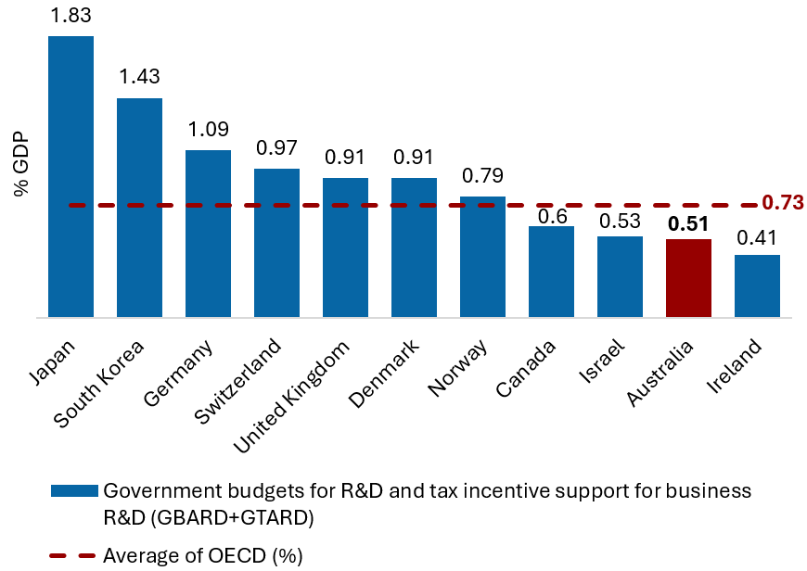
Source: Adapted from SRI budget tables and OECD MSTI (DISR 2025a; OECD 2025b)
‘Foundational research is the precursor to any further research activity within the ecosystem and Australia must ensure it has a consistent, predictable funding mechanism by increasing government funding through the ARC (Australian Research Council) and National Health and Medical Research Council (NHMRC), as well as bolstering funding for indirect costs.’
SERD submission, Research Australia
Investment in ARC and NHMRC funding – the main administrators of competitive grant schemes – has fallen by 15% and 19% respectively compared to 2013–14 and 2014–15 levels (Figure 17) (DISR 2025a).
Immediate action is needed to reverse the fall in support for foundational research. Future funding for foundational research investment should achieve globally competitive funding levels by returning ARC and NHMRC competitive grants to at least the historic levels of investment and indexing at a higher rate going forward.
Figure 17: Investment in ARC and NHMRC grant programs, inflation adjusted 2025
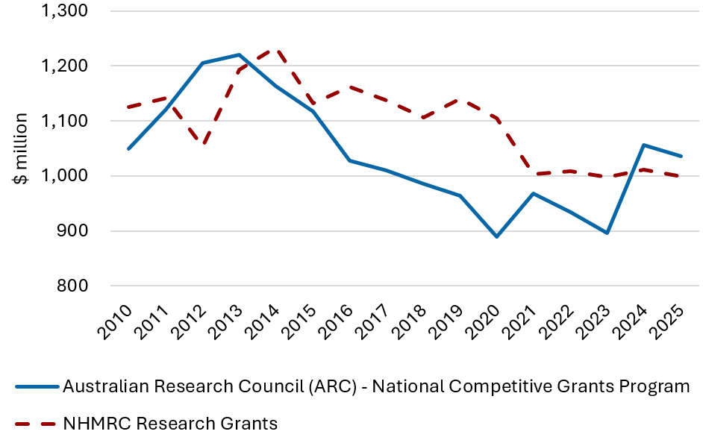
Source: Adapted from SRI budget tables Adapted from SRI budget tables (DISR 2025a)
Grants from these programs support the direct costs of research projects, but they do not cover their full costs – including infrastructure, compliance, and administrative support. The Research Support Program (RSP) is designed to provide flexible funding to universities to support the systemic costs, including some offset for the indirect costs. Under the current RSP formula, this indirect costs component was estimated to be 18.4% of the total value of university competitive research grants in 2023, down from 26% in 2017 (Department of Education 2025a; Department of Education 2025b). Despite its importance to Australian research, the growth of RSP has not kept pace with competitive grant funding.
Similarly, the RSP allocates funding to universities based on research income generated through engagement sources including industry, philanthropic contributions, other government grants, and Cooperative Research Centres (CRCs). This component has also not kept pace with the growth in funding. In 2023, it accounted for an estimated 13.8% of the total value of engagement grants, down from 19.8% in 2017 (Department of Education 2025a; Department of Education 2025b).
RSP funding has grown by 10% in real terms since 2010. Over the same period, competitive R&D grant funding for Australian universities increased by 33%, a trend partly attributable to the establishment of the MRFF.
The panel notes that eligible grants from the MRFF are supplemented from the RSP. However, total RSP funding was not adjusted when the MRFF was introduced. The panel recommends that either the RSP is supplemented accordingly, or the Australian Government develop alternative mechanisms or policy settings for the MRFF indirect costs, noting the MRFF corpus is currently underspent.
Figure 18: University income from competitive grants and funding for systemic costs, inflation adjusted 2025
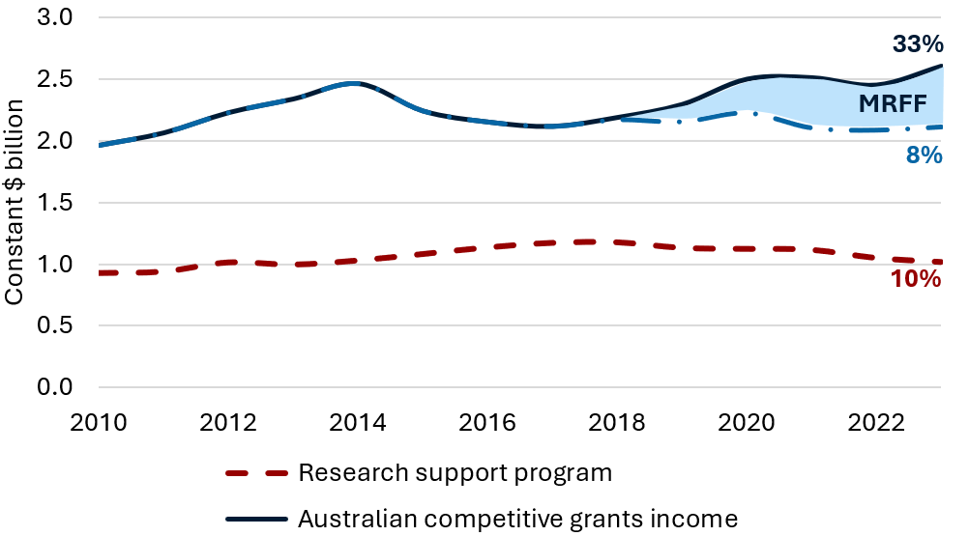
Source: Adapted from research block grant allocations time series (Department of Education 2025a) Funding before 2017 relates to predecessor programs. Additional RSP funding during the COVID-19 pandemic in 2021 is excluded.
‘It is also important that funding keeps pace with the rising costs of research and that both direct and indirect costs are fairly supported, to sustain the quality and impact of Australia’s research system. The gap between what is awarded and what it costs to deliver the research is growing, and this is placing pressure on host institutions.’
SERD submission, Adelaide University
The ARC has proposed significant reforms to the National Competitive Grants Program (NCGP), which aim to improve collaboration, support early-stage research, and better align ARC-funded activities with national priorities. The panel endorses these reforms and recommends that support be strategically directed toward the pillars identified in Chapter 1, ensuring these priorities receive adequate attention by researchers.
While the panel received a wide range of claims regarding the full costs of research, there was limited evidence presented to determine the appropriate rates to charge or receive. A comprehensive R&D costing framework would provide the evidence base for further funding decisions. The UK’s Transparent Approach to Costing – Research (TRAC) offers a strong example of best practice.

Recommendation 2a
Protect and support foundational research by reversing the decline in competitive grants, building investment in the main competitive grant schemes to globally competitive funding levels, and applying appropriate indexation.

Recommendation 2b
Strengthen indirect cost support by reversing recent declines in support rates and tasking the National Innovation Council and the Australian Tertiary Education Commission (ATEC) to implement a mechanism to determine the full cost of delivering high-quality research.

Recommendation 2c
The Australian Research Council (ARC) and the National Health and Medical Research Council (NHMRC) competitive grants programs should balance support directed to the National Innovation Pillars while preserving support for independent research that drives discovery across a broad range of STEM and HASS disciplines.

Recommended implementation pathways to protect and support foundational research include:
- Beginning in 2026 and over the forward estimates, return ARC and NHMRC to at least the historic levels of investment (in real terms) and use it as the basis for indexation.
- Index ARC and NHMRC funding to ensure the investment in basic research is maintained in real terms and reflects the practical cost of research inputs.
- Set long term goals for foundational research investment that would achieve globally competitive funding levels.
- Reform the RSP to:
  - cover the additional costs from increases to competitive grants, notably the introduction of the MRFF
  - provide dedicated funding to support the indirect costs of eligible competitive grants, lifting support from 18.4% to 20% as an initial step towards sustainable funding arrangements over time, and apply indexation in line with ARC and the NHMRC funding
  - provide dedicated funding to incentivise industry grants, with support increasing from 13.8% to 15%, as an initial step towards sustainable funding arrangements over time.
- Task the NIC and the ATEC to develop a comprehensive, internationally benchmarked R&D costing framework to support assessment of high-quality research.
- Match growth in competitive grant allocations with an increase in indirect cost support.
- ARC to align its research priorities to the pillars.
  - University research specialisation
University registration requirements – provider category standards – require a university to conduct research at ‘world standard’ in 50% or at least 3 broad fields of education in which it offers courses. If the regulator is not satisfied a provider is compliant, ‘it may take regulatory action’.
This has limited the ability of universities to focus on areas of comparative strength and reduced the ability to generate scale. Combined with internal cultural practices, this has led to a broadly homogenous approach, resulting in too many -broad-based universities, rather than directing research resources to maximise their unique capabilities and meet community needs.
‘This specialisation must be driven by excellence and responsive to both local and national needs. Achieving this may require changes to the Higher Education Research Threshold Standards to allow some institutions to focus on a narrower, but higher-quality, research profile.’
SERD submission, Group of Eight
Consistent with Recommendation 1, specialisation can be supported by identifying national priorities and consolidating research support initiatives.

Recommendation 3
Allow universities to achieve research specialisation by reforming registration requirements to reduce the condition for research breadth and enable each to build scale in areas of their competitive and comparative advantage.

Recommended implementation pathways to enable institutional research specialisation include:
- Revise the provider category standards to provide universities the flexibility to undertake excellent research in 3 or more 4-digit fields of research and remove the requirement to undertake research at world standard for 50% of the fields they teach in.
  - Secure and coordinate research infrastructure
Access to high-quality research infrastructure is critical for both foundational research and RD&I businesses.
The future of our national research infrastructure and the National Collaborative Research Infrastructure Scheme (NCRIS) is uncertain. It faces a funding cliff, as half of the government’s investment in the program ends in 2028–29. As a result, many existing arrangements are nearing their end, placing this critical capability at risk.
Our broader national research infrastructure investments – outside of NCRIS – lack national coordination and planning, which has undermined efficiency and left research organisations grappling with funding gaps.
Of the respondents to the panel’s survey, 83% called for better coordination of research infrastructure, highlighting concerns about NCRIS funding expiring from 2028‍–‍29, the need for longer funding cycles and an independent oversight body.
‘Stable and predictable infrastructure investment is critical to maintaining Australia’s competitiveness and enabling efficient use of resources. Infrastructure funding should be accompanied by clear planning frameworks that allow for coordinated investment and renewal across institutions and agencies.’
SERD submission, Australasian Research Management Society
To safeguard and strengthen our research ecosystem, we need a long-term strategy that embeds sustainable capacity into the system. The NSTC has highlighted major gaps in system-wide strategic planning, and that enduring funding for research infrastructure is a critical concern for Australia.
A new national research infrastructure oversight model should be implemented under the NIC as set out in Chapter 1 (Section 1.1.1). The National Research Infrastructure Investment and Coordination Sub-Committee of NIC would set strategy and accountability and be supported by a national research infrastructure investment body to coordinate, prioritise, and oversee delivery. Central oversight would streamline investment, reduce duplication, and ensure facilities match sector priorities. This would give researchers, industry, and investors greater confidence and help position Australia to meet future RD&I needs.
Investment in next-generation high-performance computing (HPC) and graphics processing unit (GPU) facilities is essential to ensure scalability, support advanced AI workloads, and enable rapid adaptation to emerging technologies. Early focus should be given to a plan for accessing HPC for research, to support advanced analytical techniques and the application of AI for driving the efficiency of research.
The NIC should ensure that investment in research infrastructure support strategic needs in RD&I, including rapid prototyping for innovative industries, and ensure coordination and alignment with the pillars.

Recommendation 4a
Governments commit ongoing funding to ensure sustainability of research infrastructure.

Recommendation 4b
The National Innovation Council be responsible for the oversight, planning and coordination of national research infrastructure.

Recommendation 4c
The National Innovation Council to take on a charter for extending research infrastructure capabilities to include rapid prototyping to accelerate frontier research and foster collaboration with emerging industries.

Recommendation 4d
The National Innovation Council to ensure state of the art capability in high performance computing and graphics processing unit (GPU) resources to support RD&I activities.

Recommended implementation pathways to support research infrastructure include:
- Ensure ongoing funding for NCRIS at 2028–29 budgeted levels, delivered through the NIC’s coordinated model.
- Consolidate existing planning mechanisms and task the NIC with providing long-term strategic planning and governance for national research infrastructure.
- Commit to investment in next generation HPC, rapid prototyping, GPU facilities and capability for global partnerships.
  - Other observations
The panel recognises that translation of research occurs in multiple ways, including into businesses. Other forms of translation, including into policy and community outcomes, are vital to setting the framework in Australia to enable for an ambitious Australia. Foundational research, particularly in the HASS disciplines, must support this.
Universities play a critical role in creating intellectual property (IP). The panel has repeatedly heard the same concern: current universities’ IP policies are overly complex, risk averse, and disconnected from commercial realities. Despite typically generating modest overall returns, universities and publicly funded research agencies (PFRAs) cling tightly to their IP, and negotiations to extract IP can take a ridiculously long time to resolve. The status quo is unacceptable. Universities and PFRAs need to build better policies and processes for releasing IP, and in many cases, this will require a higher risk appetite as outcomes of commercialisation are rarely known in advance.
The panel also heard that there are significant challenges to protecting First Nations IP with current frameworks and procurement processes. First Nations data sovereignty is often left to individual research projects and is not widely recognised. This is addressed further in Section 5.3.
  - Why this matters
Without action, there is a real risk that investment in foundational research will continue to decline.
Without clear funding pathways, it will be harder to attract Australians into research careers, resulting in a decline in workforce capability.
Without a strong and vibrant research workforce, Australia will lose the competitive advantage of being a knowledge creator. More importantly, we will lose the capability and capacity to assess, engage with and apply the 97% of knowledge created globally. This will affect the entire RD&I system – without knowledge there is no innovation. With diminished capability to use it, there will be less innovation.
Without knowledge, Australia’s RD&I industries will continue to underperform globally and may further decline and the capacity to build new ones will be limited. This will have real impact on our future prosperity, and the projected decline in living standards, as indicated in the 2023 Intergenerational Report, will be realised too late.

- RD&I business incentives
‘Without renewed industry commitment to R&D backed by government support Australia risks missing out on the next wave of opportunity in advanced manufacturing, Al, clean energy and other high growth sectors.’
SERD submission, Business Council of Australia
Increasing research, development and innovation (RD&I) activity of businesses will lift economic growth, create jobs and improve Australia’s productivity growth, sovereign capability, global competitiveness and future economic complexity. RD&I business activity is a cornerstone of the reform package (Figure 19).
Figure 19: Flywheel RD&I business incentives
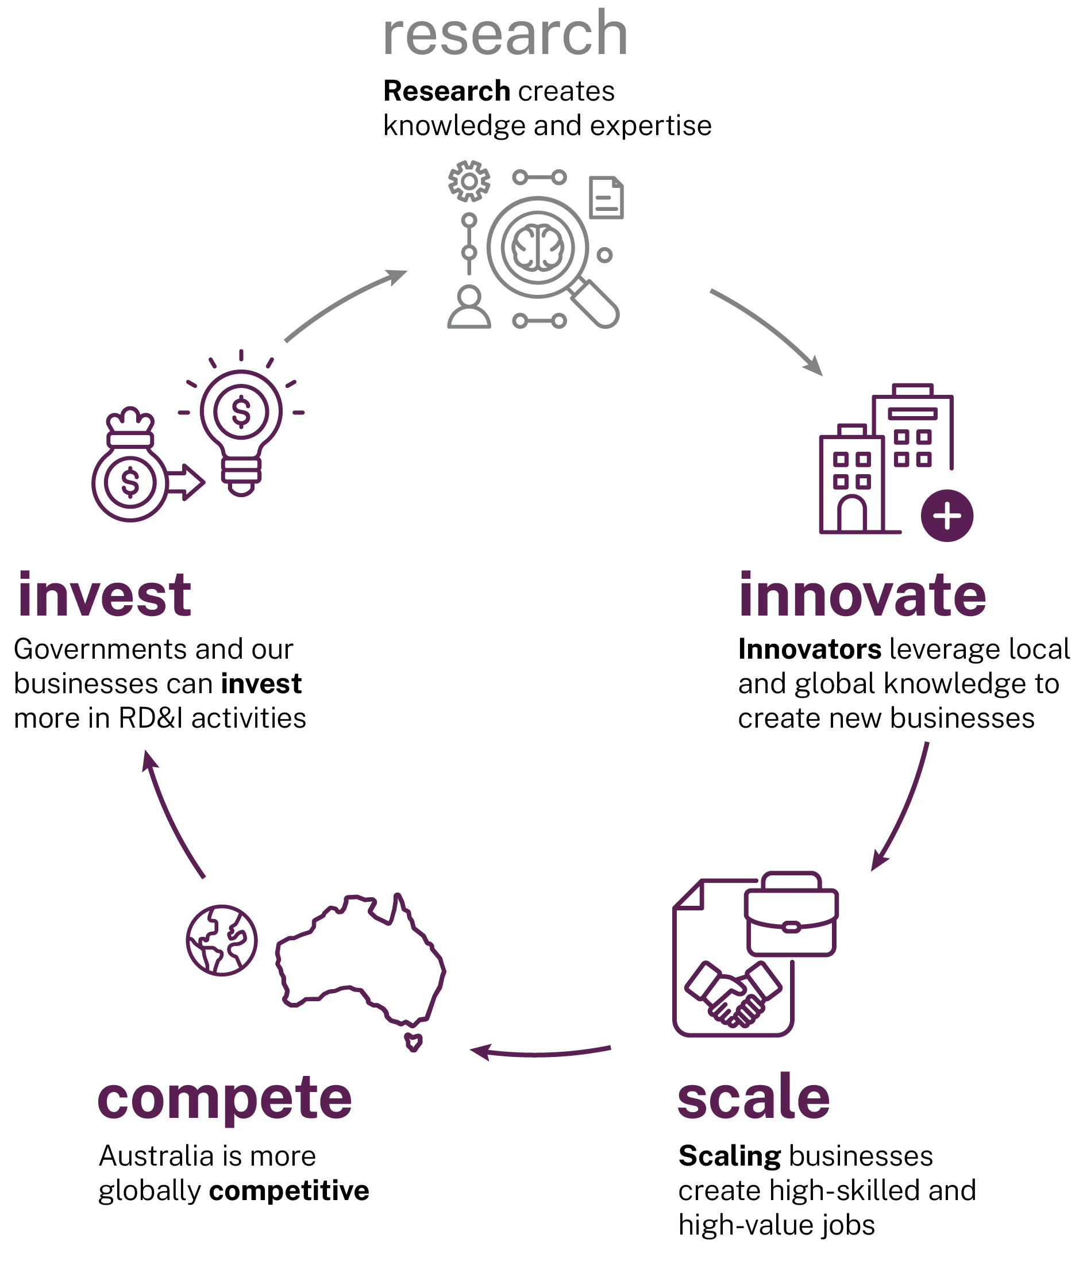
Australia’s business investment in R&D is low, falling to just 0.9% of GDP, well below the OECD’s 1.99% (Figure 20). This persistent decline since 2008 is restricting our ability to apply knowledge to real economic and social benefits.
Figure 20: Business Expenditure on Research and Development (BERD) intensity, Australia vs OECD
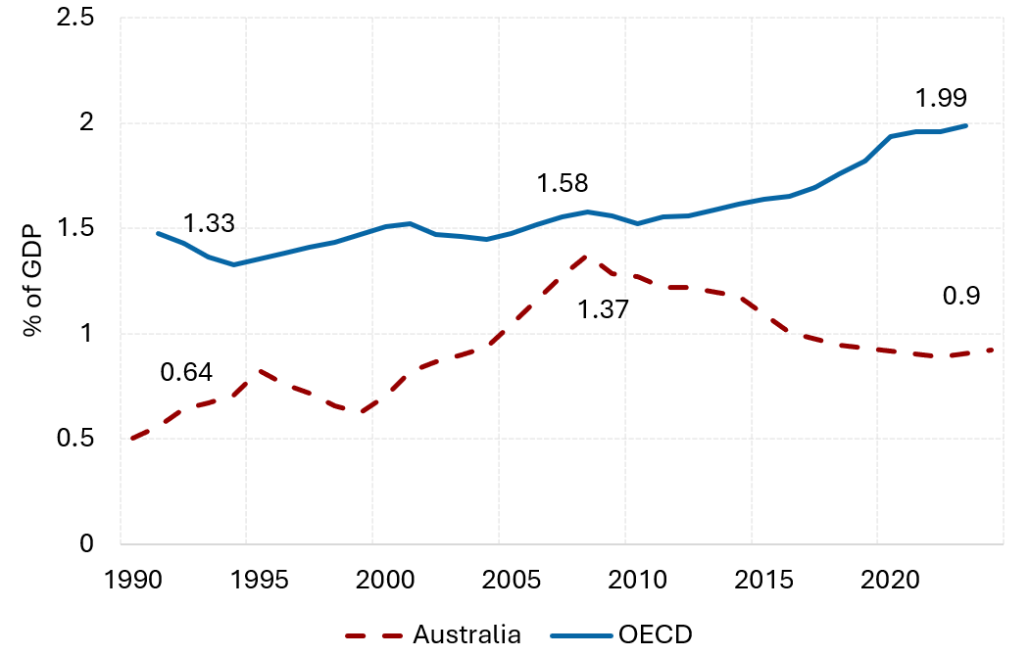
Source: Adapted from ABS and OECD MSTI (ABS 2023–24; OECD 2025b)
Around 46% of Australian businesses reported being innovation active in the 2 years to 2023, yet only about 2% of Australian businesses produced a new-to-the-world innovation (ABS 2022–23). This lack of business innovation reduces the ‘pull through’ of ideas and research knowledge into commercial and community outcomes.
Australian industry also lacks large RD&I active businesses, including multi-national corporations, that undertake significant RD&I activities locally (with a small number of notable exceptions). Figure 21 shows the investment by large businesses has fallen year-on-year over 15 years.
The top 50 R&D firms by expenditure in Australia contribute just 11% of total BERD. By contrast, in China, the US, the UK and South Korea, the top 50 R&D firms contribute between 37% and 56% of their countries total BERD, and in Japan and Germany it is over 80% (DISR 2025a).
Figure 21: Contribution to BERD by large firms is dropping
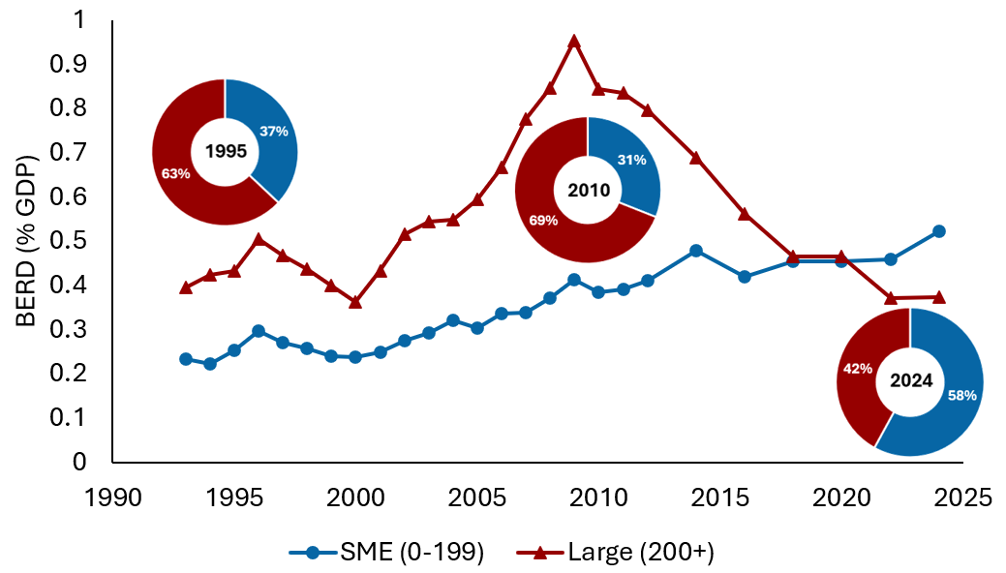
Source: Adapted from ABS Research and experimental development, businesses, Australia (ABS 2025b)
Larger businesses anchor RD&I ecosystems, supporting a range of activities that spur the sector including creating demand for smaller RD&I firms through procurement and mergers and acquisitions (M&A). They also support skills development of the workforce with one analysis suggesting that former employees from major R&D -performing businesses have gone on to lead 1,800 other companies. Collectively, this has generated $77 billion in value added and employed 132,000 R&D workers in Australia between 2014–2025 (Mandala Partners 2025).
Increasing the number of larger RD&I active firms in Australia is an imperative. This can be achieved by actively supporting existing RD&I businesses to scale.
However, ‘home-growing’ new global businesses, by supporting the next generation of ambitious, high-growth startups, will ensure that the culture and energy of these businesses are innately committed to RD&I. It will require patience and determination.
Business growth can also be achieved by attracting and retaining global businesses to undertake RD&I activities locally. Australia must be better positioned as an internationally competitive place to conduct high-value RD&I.
There is no one-size-fits-all solution to growing RD&I businesses. We must develop a tailored system, adapted to the specific needs and characteristics of the different parts of our economy.
This can be achieved through:
- supporting the growth of new startups, including those led by First Nations and female entrepreneurs
- targeting the Research and Development Tax Incentive (RDTI) scheme for greater impact
- uplifting he innovation capabilities of small to medium enterprises (SMEs)
- incentivising local production from RD&I active firms.
These points are addressed in the following sections.
Supporting the growth and retention of RD&I active firms will benefit Australia overall. Businesses that invest more in R&D are more productive, resilient, and globally competitive. This will improve Australia’s economic and productivity growth, capacity to develop sovereign capability, and future economic complexity.
  - Growing startups
Ambitious RD&I startups must be a focus.
Most RD&I companies are created by private citizens who leverage knowledge from decades of research. This knowledge does not need to be a direct outcome of Australian research, but it is dependent on Australian capability to understand knowledge wherever it is created, and to adapt and adopt it.
‘Innovation grows from a foundation of curiosity, creativity and learning – not only in laboratories and boardrooms but in classrooms, workplaces, and communities. It thrives in spaces that foster cross-sector collaboration, encourage risk-taking, and promote continuous learning. That means embracing non-linear innovation processes, tolerating risk and failure as essential to success, and encouraging adaptive thinking across sectors.’
SERD submission,
Commonwealth Scientific and Industrial Research Organisation (CSIRO)
Levels of entrepreneurship in Australia are low relative to comparator economies like Canada and global leaders like the UK and the US, with Australia’s startup ecosystem value being only 5.7% of its GDP (Startup Genome 2024). Amongst G20 nations, the value of startup ecosystems averages 8% of GDP (Figure 22).
Figure 22: Startup ecosystem value relative to GDP
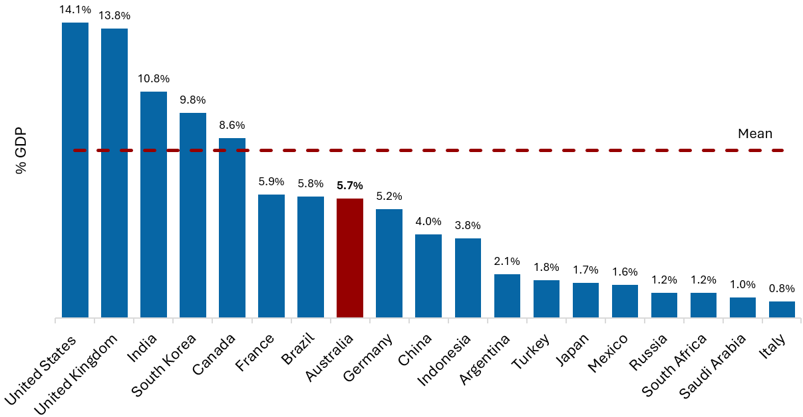
Source: Adapted from Startup Genome 2024 (Startup Genome 2024) Startup ecosystem value averages 8% of G20 GDP
Pre-accelerators and accelerators play vital roles in supporting inexperienced entrepreneurs to establish and grow their businesses. They provide education, mentorship and access to networks, supporting entrepreneurs to test and validate their business model and refine their pitch to investors.
The National Strategic Initiatives (NSIs) will focus on startup creation and will be required to support pre-accelerators and accelerator programs (see Chapter 1, Section 1.1.4.2).
NSIs will also support early growth of startups, for example by offering small proof-of-concept grants, as well as providing access to research and industry partners.
    - Support for First Nations entrepreneurs
The Reserve Bank Bulletin First Nations Businesses: Progress, Challenges and Opportunities highlighted a ‘trust deficit’ impacting First Nations entrepreneurs in many ways, including difficulty in attracting finance, customers, contracts and reliable suppliers (West 2022). Trust issues are exacerbated by broader barriers to human and social capital development, which are multifaceted and rooted in historical inequity.
The First Nations business sector experienced 7.3% annual growth in the 5 years to 2021, far outpacing the average growth rate across all new business entries in Australia (ANZ Banking Group 2025). This indicates that First Nations people are overcoming barriers to establish and scale viable business models.
There are opportunities to assist First Nations-led businesses to uplift innovation activity. Only around 0.2% of businesses registered for the RDTI identify as First Nations owned or controlled (DISR unpublished calculations).
The panel is recommending that a subcommittee of the National Innovation Council (NIC) be established to coordinate First Nations RD&I activities. This committee should also be responsible for delivering and coordinating a network of First Nations pre-accelerators to build the number of First Nations entrepreneurs, including in businesses that are not aligned to the National Innovation Pillars (recommendation 14, see chapters 1 and 5).
This will enhance the positive contributions of Indigenous knowledge and broaden the economic base supporting self-determination of First Nations peoples.
  - Targeting greater impact for the RDTI
The RDTI constitutes the largest portion of federal support for business R&D and represents approximately 30% of all commonwealth R&D funding (DISR 2025b).
Submissions across both industry and research sectors noted that the RDTI is vital to our R&D ecosystem. Most supported simplifying access to the scheme. Despite its national reach, the current RDTI framework was widely regarded as administratively complex, particularly for startups or resource constrained firms.
‘We call for reforms that streamline regulatory obligations and reporting requirements, and for governments to adopt a right-sized approach to regulation that acknowledges that a uniform, one-size-fits-all approach regardless of risk can unfairly disadvantage smaller businesses to the benefit of large, entrenched enterprises.’
SERD submission,
Australian Small Business and Family Enterprise Ombudsman
It is argued that tax incentives for R&D that are market-based and neutral across technologies and industry sectors allow the private sector to determine where R&D effort is best directed (Appelt et al. 2025).
It’s also clear that different business segments contribute uniquely to innovation and the broader economy. For example, the RD&I contributions and needs of a startup are very different from a large multi-national corporation.
Further detail on implementation pathways for how the RDTI should be simplified and reformed to meet needs of startups, scaleups and SMEs, and larger corporates and multi-national corporations are described below.
    - R&D Tax Incentive simplification and focus
Department of Industry, Science and Resources (DISR) analysis reveals that 86% of businesses surveyed rely on R&D tax consultants to access the RDTI (DISR unpublished calculations). Most firms the panel spoke with pass more than 10% of their claims to these consultants as success fees. This high dependence reduces the net benefit to the target company and suggests access to the incentive is complex.
The panel heard that registering R&D activities for the RDTI and maintaining appropriate supporting documentation for a potential audit is onerous. The administrative requirements can be particularly challenging for startups and small enterprises.
Introducing a deemed rate for supporting activities – a fixed offset benefit relative to the amount of core R&D expenditure claimed – would reduce ambiguity in self-assessment of supporting activities, reduce record-keeping obligations, and streamline the assessment process for regulators. It offers a simple and predictable way for applicants to calculate the benefit they can incorporate into business planning.
Raising the minimum R&D project expenditure floor (currently $20k) to a minimum annual R&D project spend of $150k would limit access for companies conducting subscale R&D projects. This will calibrate the program towards encouraging companies to invest in more ambitious, high-impact R&D activities.
The panel recommends existing companies that cannot access the RDTI receive support to lift their R&D capabilities and capacity through direct R&D funding via grants (see Recommendation 6 and Section 3.3).
The withdrawal of an R&D claim after benefits have been received may lead to serious repercussions for a business. Removing clawback rules in the RDTI will reward companies successful in public grant funding, such as funding received via the NSIs (see Recommendation 1d). It will allow the RDTI to back efforts to achieving the outcomes identified by government grant programs.

Recommendation 5a
Reform the R&D Tax Incentive to simplify administration and focus the scheme for greater impact.

Recommended implementation pathways to simplify and focus the RDTI include:
- Introducing a deemed rate for supporting R&D activities.
- Raising the minimum R&D project expenditure floor (currently $20k) to a minimum annual R&D project spend of $150k.
- Removing clawback rules in the RDTI.
These changes would apply to all segments of the RDTI.
    - Premium startup stream
The RDTI is vital to innovative startups with global ambitions. Most startups are extremely resource and cash constrained. Yet they must rely on tax advisers to support RDTI submissions and payday lenders to manage cashflows.
‘Startups, SMEs, and corporates have very different needs, and a one-size-fits-all incentive does not work. A startup-specific RDTI stream with simpler eligibility, advanced payments, and support for development and deployment would make a real difference.’
SERD submission, public anonymous submission
Further simplification of the RDTI scheme for startups will ensure more government support is directed at the right activity – growing RD&I businesses.
The panel recommends a simplified 100-point style test, based on key startup indicators. For example, if the business has already attracted capital via a fund registered through the Early Stage Venture Capital Limited Partnership (ESVCLP) program, then there is a clear indicator that qualified private investors have vetted the company as being innovative and having the potential for high growth.
Aligning points-style tests across programs such as the RDTI, Early Stage Innovation Company (ESIC) and ESVCLP, will create better connections and consistency across government support and reduce regulatory complexity.
A higher refundable tax offset rate will provide additional support for firm growth – but this premium must only be focused on companies with the highest growth potential to provide the best value for public support. This support must also recognise that many startups will fail, and that this is a normal part of the startup creation cycle. The ones that succeed will go on to create the large RD&I businesses of the future.
Other benefits for startups should include access to quarterly cash advances, based on business activity statements.
Eligibility for early commercialisation activities should be included in the premium startup stream (startup stream) to provide these companies an accelerated runway to global viability, profitability, and realisation of growth potential.
Finally, startups need time to grow, but generous government support should not be provided forever. The panel recommends that access to the startup stream should be limited to 3 years for software as a service (SAAS) and artificial intelligence businesses. Deep tech startups have longer development timeframes, so access to the startup stream should be extended for these companies only.
Once startups have achieved the maximum time limit on the scheme, they will become eligible for the SME and scaleup stream.

Recommendation 5b
Incentivise startups through a premium RDTI segment providing streamlined access to improved benefits for high-potential firms.

Recommended implementation pathways for a premium startup and high-growth RDTI stream include:
- To improve simplicity and integrity, eligibility should be based on a 100-point style test reflecting the features of high-potential startups. The test should consider aspects such as:
  - Startup business characteristics to limit access to companies with high growth potential.
  - Secured venture capital investment from a qualified investor.
  - Participation in approved, selective pre-accelerator and accelerator programs.
  - Existence of intellectual property rights.
  - Collaboration with universities.
- Introduce a higher refundable offset rate of corporate income tax +23.5%.
- Enable advanced payments on a quarterly basis, based on quarterly business activity statements.
- Eligible R&D expenditure for the startup stream should be based on R&D projects instead of the core and supporting R&D definitions that still apply to the non-startup RDTI streams. Additionally, eligible expenditure should be extended to include development and deployment, early commercialisation, and allow for user testing and adoption research.
- Access to the startup stream should be limited to 3 years, with a process to reapply every 3 years for a further 3-year period for deep techs such as pharmaceuticals that have longer development timeframes.
    - SMEs and Scaleup Stream
Analysis on R&D spillovers in Australia commissioned for the Strategic Examination of Research and Development (SERD) show that RDTI-induced additionality, the amount of additional R&D investment a firm undertakes for every dollar of tax support, is most significantly observed by medium-sized firms (20–199 employees). In terms of the industry sector, the RDTI induces additionality most effectively in the manufacturing and services industries (Palangkaraya et al. unpublished).
DISR analysis shows that firms claiming the RDTI generally grow faster than those which do not, suggesting innovation active businesses outperform others. However, similar analysis also suggests a large portion of firms accessing the RDTI still have turnover growth below inflation, even many years after claiming the tax offset (DISR unpublished calculations). Many of these businesses are undertaking small scale RD&I activities. Claimants that do not see genuine growth over extended time periods limit the RDTI's economic impact.
Ongoing access to the refundable component of the RDTI scheme should be linked to a company’s revenue growth trajectory. The panel recognises that businesses need certainty, and that market conditions can present challenges to revenue growth year on year. As such, ‘on’ and ‘off’ ramp mechanisms should be carefully implemented to provide certainty for businesses, while linking ongoing access to revenue growth. This could be achieved through:
- An ‘on’ ramp that provides SMEs and scaleups access to the refundable component of the RDTI for 3 years (subject to other RDTI eligibility criteria being met).
- Ongoing eligibility for the next 3 years would require the company demonstrating an average annual revenue growth rate, over the preceding 3-years, of at least 5% above consumer price index (CPI) compared to the year immediately before that period.
- An ‘off ramp’ from offset benefits occurs when businesses fail to meet the ongoing eligibility benchmark for 2 consecutive years.
This approach would give companies graduating from the startup stream, or SMEs already registered for the RDTI, a grace period for their R&D to deliver positive business outcomes. Firms that remain stagnant and rely on the RDTI simply to stay afloat would lose entitlement to support.
Once businesses are scaling, it is critical that they are supported to continue to grow. Currently, the refundable offset benefits only apply to businesses that generate a turnover of less than $20 million. The panel heard from many scaling companies that removal of the refundable offset at a significant growth point can cause real issues.
The Australian Tax Office defines medium businesses as those with an annual turnover between $10 million and $250 million. However, around 80% of these businesses generate turnover of less than $50 million (Australian Taxation Office 2022–23). Extending the refundable RDTI benefit to this group, many of which are manufacturing firms, would support and incentivise their growth and expand the strong contribution by this cohort to the economy and RD&I system.
Once scale-ups and ambitious SMEs achieve this size, they should be migrated to the non-refundable scheme.

Recommendation 5c
Leverage the RDTI to incentivise SME growth and ambition, and increase the thresholds for access and ongoing support.

Recommended implementation pathways to reform the RDTI to better support SMEs focused on growth through R&D include:
- Base ongoing eligibility on outcomes including significant revenue growth and introduce ‘on’ and ‘off’ ramp conditions to ensure support is targeted toward high-growth firms.
- Increase the turnover threshold for the refundable R&D tax offset from $20 million turnover to $50 million.
    - RDTI for large firms
Australia must be an internationally competitive location to conduct high-value RD&I, and we must attract and retain RD&I intensive corporates and multi-national corporations.
The RDTI scheme must be globally competitive for these firms and incentivise and reward a variety of RD&I activities in Australia including: in-house RD&I activities, research partnerships, procurement from Australian RD&I firms, M&A of local RD&I firms, support for industry PhDs, joint appointments for researchers and supporting industry sabbaticals as well as reskilling of current workforces in RD&I related fields.
‘No advanced economy achieves strong R&D performance without large firms operating at scale, they are essential for research translation and ecosystem growth... The fact that large business R&D investment in Australia has dropped by 24% over the past decade while global spend has increased significantly is not a coincidence. Australia is not currently a competitive destination for mobile R&D capital.’
SERD submission, CSL, Atlassian and Cochlear
The RDTI should encourage large businesses to lift their Australian RD&I activities.
There should be no ceiling on R&D expenditure eligible under the RDTI. Access to these benefits should be firmly tied to companies demonstrating significant, measurable contributions to the wider RD&I ecosystem.
Reducing complexity of the RDTI scheme by removing the R&D intensity calculation for large businesses and providing a standard offset rate will help make conducting R&D in Australia cost competitive.
To further incentivise connections between large businesses and smaller local RD&I businesses, the first contract to procure from a new startup participating in the startup stream should qualify as an eligible expense for the RDTI offset.
Additionally, excluding the RDTI offset from the calculation of franking credits would remove a key barrier that limits large corporations from investing in additional Australian R&D as part of their corporate strategy.
Larger firms must be encouraged to be good actors in the RD&I system. This contribution can be assessed with minimal burden through a points-based ‘corporate citizen’ framework. Points would be allocated to activities or investments that strengthen the broader Australian R&D system, weighted by their significance. Examples include:
- collaboration with research institutions
- partnerships with startups and SMEs
- procurements from local RD&I firms
- M&A involving local innovative RD&I firms
- corporate venturing
- precinct development
- upskilling their workforce (e.g. requiring a percentage of employees to receive RD&I training including through -micro credentials)
- research infrastructure investment
- engaging PhDs and researchers.

Recommendation 5d
Increase RDTI incentives for corporates and multi-national corporations to undertake local RD&I activities and to drive partnerships, procurement, investment and M&A.

Recommended implementation pathways include:
- Removing the $150 million R&D expenditure cap.
- Removing the tiered R&D intensity measure aspect of the program and providing a standard offset rate that is globally competitive, such as bringing the rate for large firms in line with that currently provided for SMEs.
- Make the cost of the first contract RDTI eligible to encourage first procurement from new startups.
- Removing the RDTI offset from franking credit calculations.
- Enhanced benefits dependant on qualifying criteria, assessed through a points-based 'corporate citizen' test.
  - Uplift the innovation capacity of SMEs
SMEs often lack the scale, capital and infrastructure to pursue long-term, high-risk research projects independently (Industry Innovation and Science Australia 2023).
A reformed RDTI scheme will mean some businesses (particularly low growth SMEs) may become ineligible for the scheme. These SMEs must be supported to lift their RD&I capabilities and grow if that is their ambition.
Encouraging partnerships between SMEs and research institutions will give businesses access to expertise, facilities, and networks they might not otherwise engage with. Research institutions and universities will benefit and create opportunities for workforce mobility, leading to a more adaptable and diverse skill base. Collaboration will stimulate demand -side pull of research to balance the more traditional supply-side push, common in Australia.
‘No amount of supply side (government and university) ‘push’ can drive increased collaboration without corresponding engagement and capacity ‘pull through’ on the demand side (industry and other end users).’
SERD submission, Australian Research Council
Although research institutions can help SMEs become more innovative, these collaborations can be high cost.
Grants and vouchers are a form of direct support, while tax incentives are a form of indirect support. OECD analysis indicates direct and indirect mechanisms are complementary, with one being more effective in the presence of the other. Introducing a direct funding scheme will balance the Australian Government’s support for business R&D, which is predominately through indirect tax support. Direct forms of support can be designed to uplift capability alongside funding RD&I itself and can supplement the broad-based RDTI.
Providing direct support for RDTI ineligible SMEs will allow them to scale their RD&I activities. This will provide a pathway for SMEs to become eligible for the RDTI scheme in the future.

Recommendation 6
Establish a funding mechanism that enables existing businesses that are ineligible for the RDTI scheme to kick-start their RD&I efforts by accessing Australian research capability in universities, publicly funded research agencies (PFRAs) and innovation intensive corporations.

Recommended implementation pathway includes:
- Introduction of a R&D collaboration voucher program for businesses to conduct R&D projects of value up to $150k. Applications to receive a voucher would require collaboration with a university or research institution.
- Businesses accessing the RDTI should be ineligible for the voucher program.
  - Incentivise local RD&I production
The panel heard that too many Australian businesses were induced offshore to produce, because Australia is cost prohibitive.
The economic benefits to be gained are significant if we focus on attracting, retaining and growing high-value manufacturing and sovereign capabilities resulting from local RD&I activities. This will support economic transformation, complexity, and value-adding in Australia.
Integrating and scaling all phases of research, development, innovation and production will help create and secure well-paying jobs, opportunities and resilience across Australia. Jobs directly associated with exports have a 10% higher average annual income (Austrade 2024).
Incentives to retain and grow high-value manufacturing and sovereign capabilities built upon our local RD&I need to be developed.
The Future Made in Australia (FMA) plan is supporting value -adding and strengthening economic security through attracting investment and domestic manufacturing and backing in Australian ideas, innovation and science.
A production-based incentive or subsidy linked to RD&I is complementary to FMA and would incentivise firms to commercialise R&D and scale manufacturing domestically.
It will alleviate the cost barrier in corporate investment strategies related to manufacturing and will incentivise tangible economic activity such as local fabrication, technology integration, and workforce development. This will allow Australia to maintain and grow manufacturing capabilities needed to seize new opportunities as they arise in an increasingly competitive global market.
By focusing on production, critical stages of the value chain will be better anchored in Australia, ensuring that innovation translates into domestic jobs, supply chain resilience, and higher corporate tax receipts.

Recommendation 7
The Australian Government provide a production tax credit or subsidy for advanced manufacturing resulting from RD&I activities that remain in Australia.

Recommended implementation pathways include:
- The Australian Government design a production and commercialisation tax credit or subsidy that fosters the local advanced manufacturing resulting from domestic RD&I activities.
  - Other observations
The panel received submissions advocating for patent boxes. International evidence on their effectiveness is mixed. These schemes are criticised for encouraging profit shifting with limited additional R&D stimulation (Heckemeyer et al. 2025). More recent evidence highlights that patent boxes using a modified nexus approach link preferential tax treatment to actual R&D activities undertaken by the taxpayer in the jurisdiction. This approach aims to reduce profit shifting behaviour by multinational enterprises (Boie-Wegener 2025).
  - Why this matters
Without encouraging startup creation and RD&I business growth, Australia’s industries are likely to be left behind. Australia will continue to preference imported technologies over stimulating home-grown successes.
Without reform, the RDTI will continue to provide incentives to businesses that fail to demonstrate substantial contributions to the broader Australian R&D ecosystem. Without simplification, the scheme will continue to support third parties, including tax advisers and loan companies, resulting in precious RD&I expenditure being misdirected.
Without production credits, Australia will not stand to fully realise the benefit of a fully functioning RD&I system.

- Investment and capital
Through the package of reforms in Chapters 1, 2 and 3, Australia will foster the creation of many more research, development and innovation (RD&I) businesses. Growing globally competitive RD&I businesses will require greater levels of investment across all stages of growth. The reforms in this chapter build on the previous 2 components to drive this flywheel (Figure 23).
Figure 23: Flywheel investment and capital
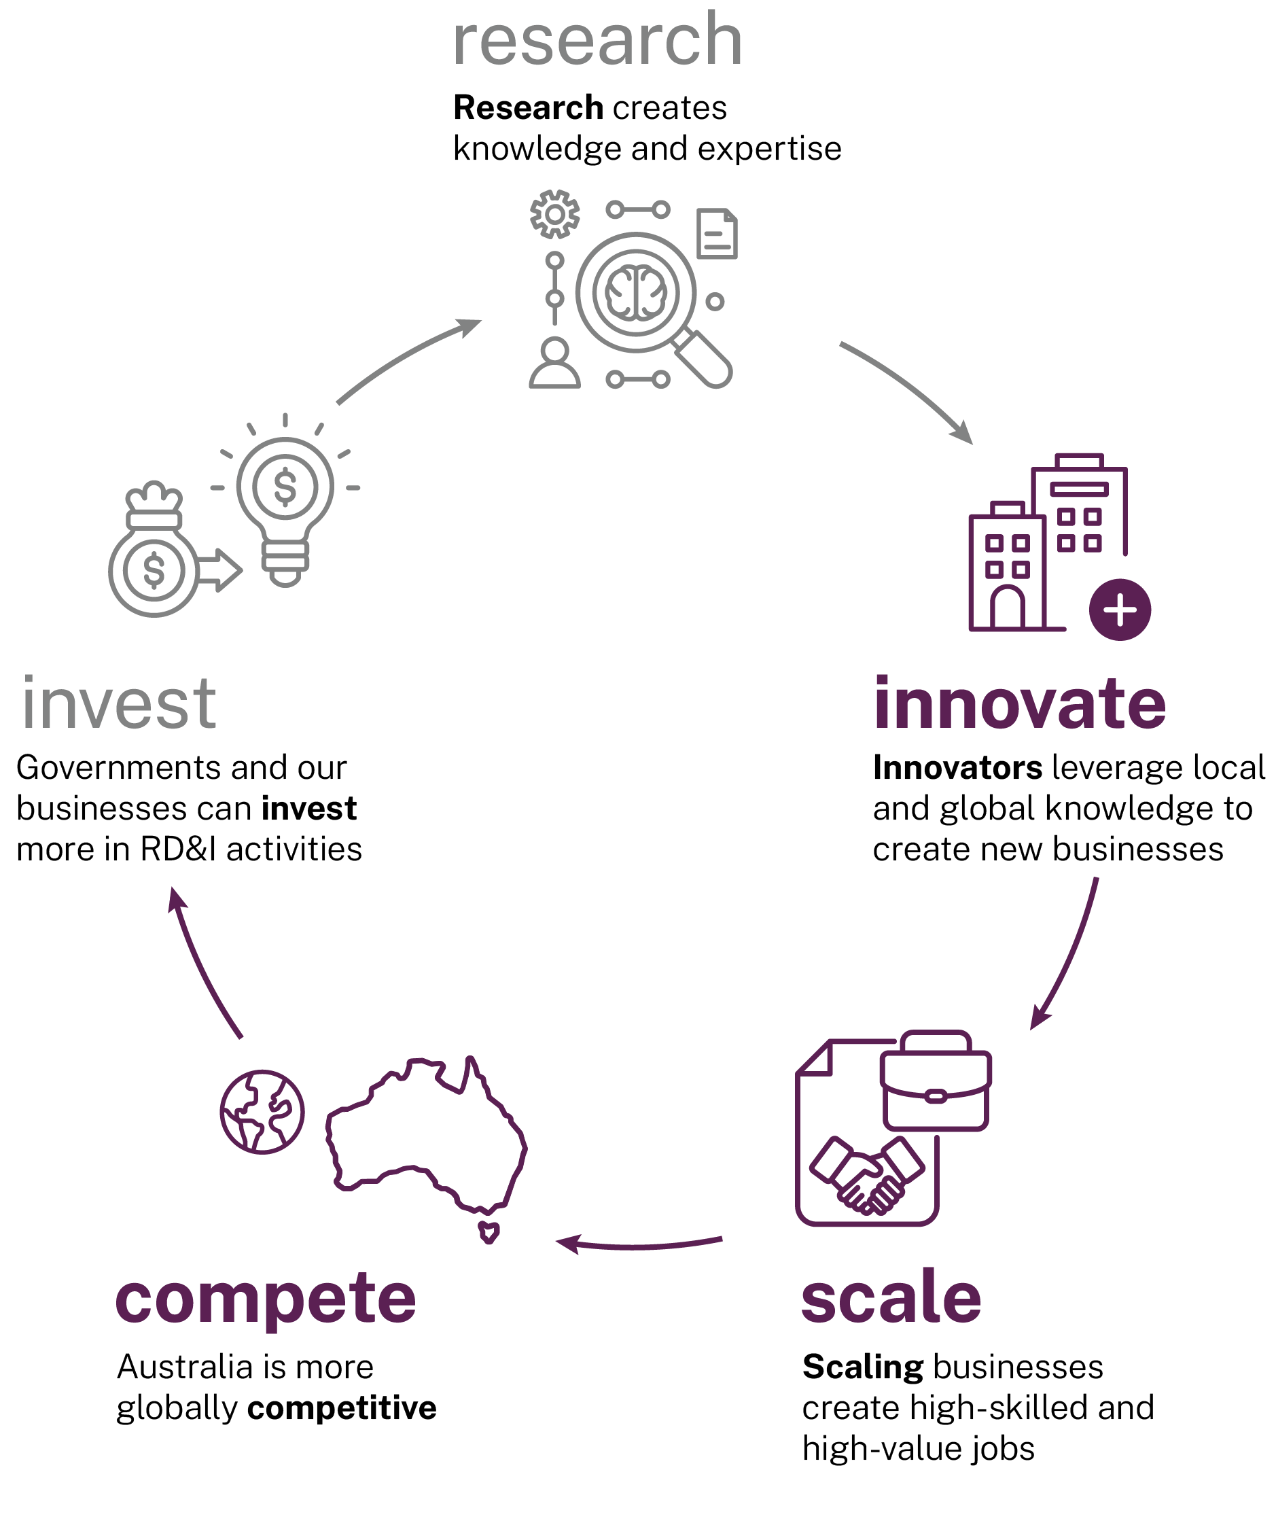
The venture capital (VC) industry plays a vital role in providing investment for RD&I startups, supporting their growth and maximising their impact on the economy, while providing investors with high return opportunities.
Australia’s VC industry lags that of peer nations. In 2024, VC was 0.16% of gross domestic product (GDP) in Australia, compared to 0.88% (Singapore), 0.68% (Israel), 0.67% (US) and 0.49% (UK) (Figure 24).
Figure 24: VC investment in major markets (2024).
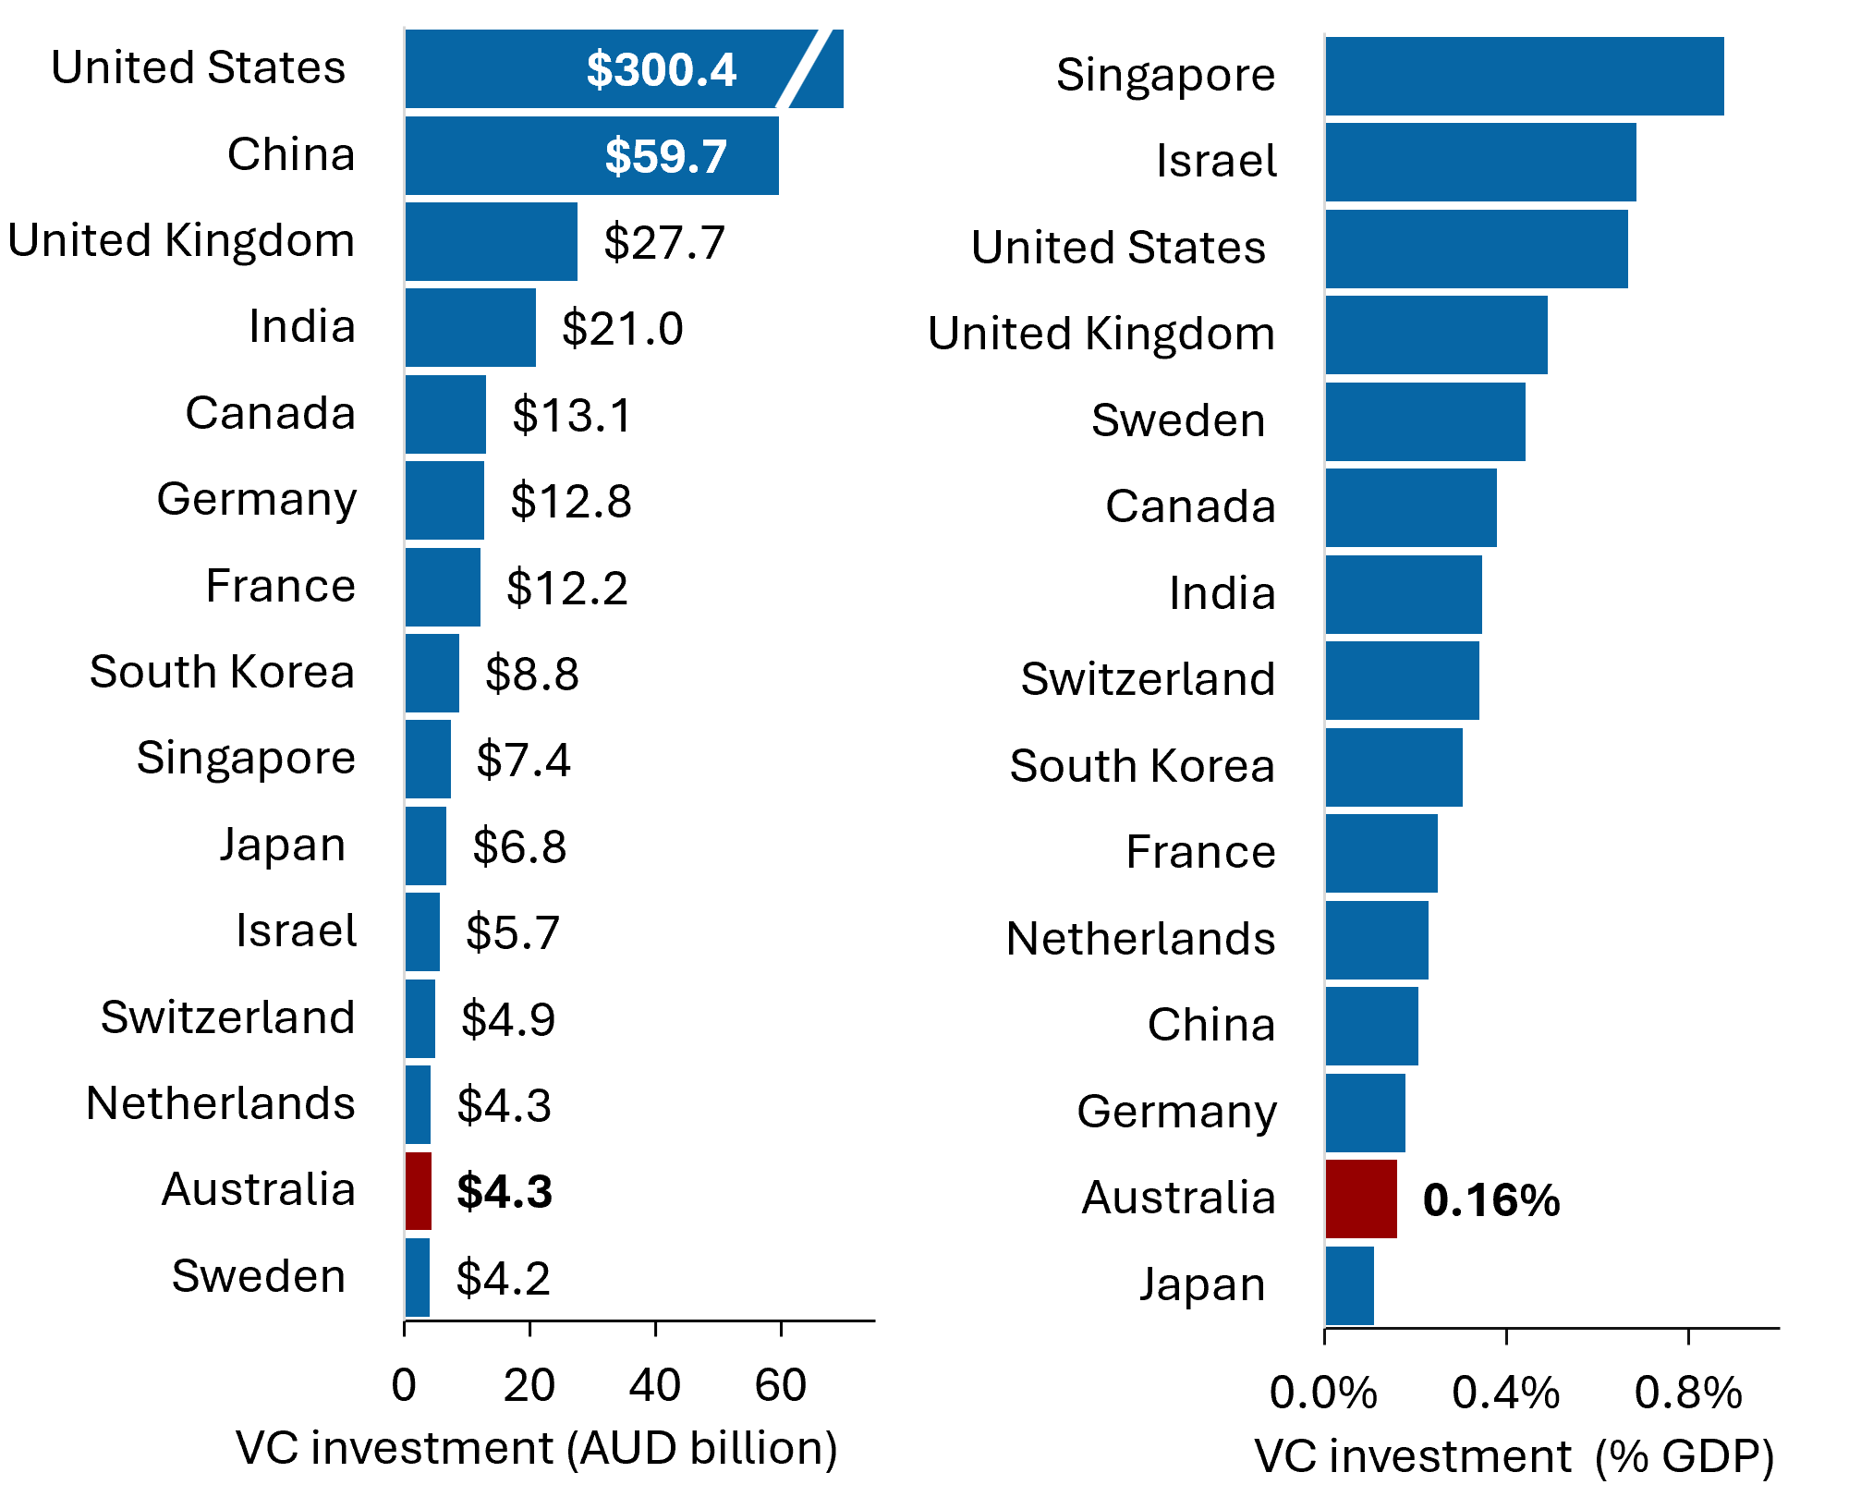
Source: SERD calculations of Dealroom, World Bank Group and country economy data (Dealroom.co 2025a; World Bank Group 2024b; countryeconomy.com 2024). VC investments in AUD (left) and as a proportion of GDP (right). VC investments exclude debt, non-equity funding, lending capital and grants. GDP from World Bank Data, South Korea GDP from Country Economy.
VC applies across different stages of a startup’s trajectory.
Early stage capital and investor engagement help startups determine viability, support growth, and achieve a path to profitability. Early stage investment, while representing a small portion of the investment market, is critical for startups as it provides the most patient capital at the earliest stages of the growth journey. In Australia, early stage VC is still just 0.10% of GDP, compared to 0.21% in the US and 0.18% in the UK (Figure 25).
Figure 25: Early stage VC to GDP, Australia and comparators, 2024
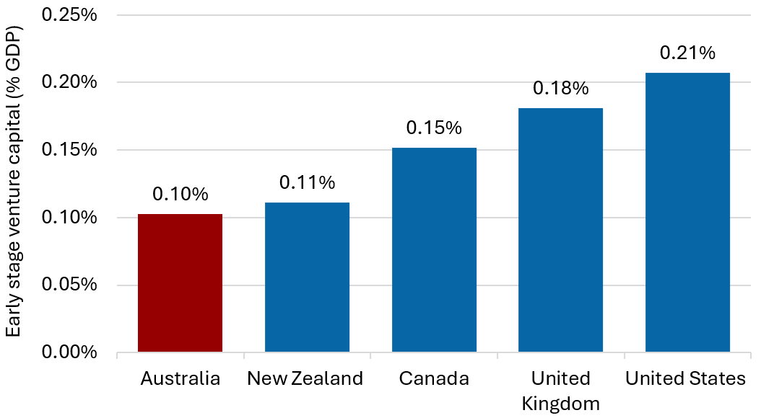
Source: Adapted from Dealroom and World Bank Group (Dealroom.co 2025a; World Bank Group 2024a). Early stage VC in this graph includes angel, seed, Series A, early VC, and grants funding.
Growth capital supports RD&I companies to achieve their full potential, including high-value job creation and global competitiveness.
The lower comparative growth of VC in Australia means scaleups find it more difficult to secure investment than in the US and Canada. For example, Australian businesses show a lower likelihood of securing funding during the early- and mid-scale-up stages compared to the US and Canada (Figure 26). Also, firms founded in the US tend to reach later-stage funding more quickly than Australia (Glasner 2024; Cut Through Venture 2025). The panel heard this has resulted in many founders moving offshore to give their businesses the best chance of success.
Figure 26: Probability of startup achieving subsequent funding round
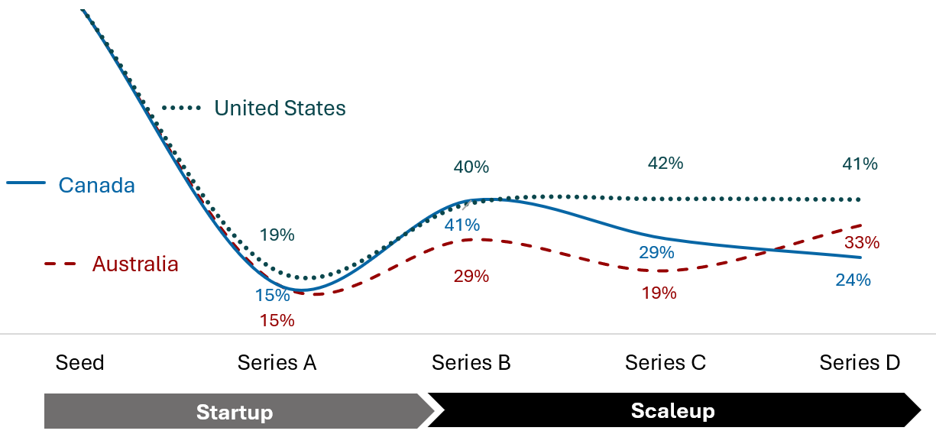
Source: SERD calculations based on Dealroom data for firms founded between 2013 and 2015, accessed Aug 2025 (Dealroom.co 2025a).
The gap in later stage funding (Series B+) when compared to the US is significant. The Tech Council has shown that the gap in late-stage VC funding required to match US per capita funding is $53 billion (Figure 27).
Figure 27: Uplift in VC funding needed to match US per capita funding ($ billion, AUD, 2030)
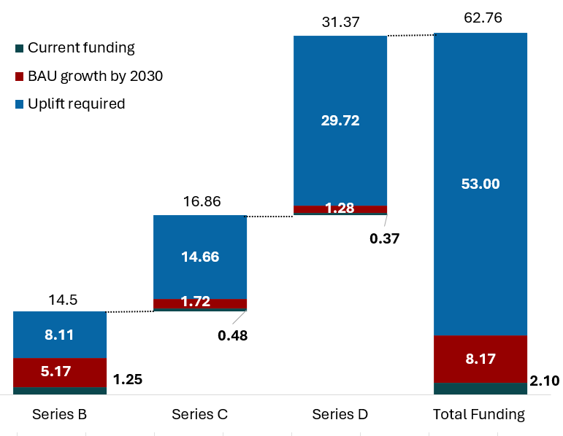
Source: Adapted from Shots on Goal (Tech Council of Australia 2022)
VC exits in Australia remain limited, with many investors unable to realise returns or reinvest. The lack of exit opportunities locks up capital and makes investors more hesitant to commit new funds.
As such, the number of ‘unicorns’ (startups that achieve at least a $1 billion company valuation) originating from Australia remains low compared to other global startup ecosystems (Dealroom.co 2025b). By contrast, Australia creates the most unicorns per dollar of VC invested globally, indicating the quality of the startups we’re producing and highlighting potential undercapitalisation in the ecosystem Dealroom.co 2025b).
Our capital market must evolve to unlock greater levels of investment, and support scale and maturity of the VC sector. The system must also support exit pathways that allow investors to reap returns.
The establishment of the National Reconstruction Fund (NRF) is a significant step in supporting investment into Australia’s RD&I businesses. Complementary policy to further crowd-in private capital, including superannuation, will supercharge the system and enable sustainable growth. This can be achieved through:
- strengthening incentives for angel and VC investment
- reforming superannuation policy settings to encourage investment into VC
- supporting the establishment of fund of fund (FOF) vehicles to unlock capital
- ensuring exit pathways are globally competitive.
These points are addressed in the following sections.
  - Strengthening early stage and VC frameworks
The Early Stage Innovation Company (ESIC) incentive and Early Stage VC Limited Partnerships (ESVCLP) scheme have played a key role in supporting the development of the angel investor and early stage VC sector in Australia.
ESIC tax incentives
ESIC is a tax classification of companies that intends to promote investment in innovative, high-growth potential startups that are less than 3 years old. Investors who purchase new shares in a qualifying ESIC may be eligible for tax incentives in the form of a non-refundable carry forward tax offset equal to 20% of the amount paid and modified capital gains tax treatment. ESIC classification requires the company to pass an early stage test and either a 100-point innovation test or a principles-based innovation test.
ESVCLP scheme
The ESVCLP scheme aims to stimulate the early stage VC sector by providing tax incentives for investing in early stage VC activities. It provides a 10% carry-forward tax credit and tax exceptions for income and capital gains from ESVCLPs. Registering an ESVCLP requires applying to Industry Innovation and Science Australia (IISA). Requirements apply on the amount of capital the partnership has and its investment plan.
Submissions noted that the ESIC incentive and ESVCLP scheme has made investing in innovation and startups significantly more attractive for investors. Many also noted potential improvements to the schemes.
‘The proposal to expand the Early-Stage Innovation Company (ESIC) tax incentive will provide a powerful signal to the market and encourage more investors to back high-growth potential companies. These measures will help to create a more dynamic and entrepreneurial investment culture, where investors are willing to take calculated risks on the next generation of Australian innovators.’
SERD submission, Institute for Photonics and Advanced Sensing

‘Improving access to capital is vital to prevent early-stage companies from moving offshore due to insufficient funding opportunities. Programs like Early-Stage Venture Capital Limited Partnerships (ESVCLP) provide tax benefits for investors and fund managers while supporting startups through pre-seed to early expansion stages. Expanding such initiatives can bolster Australia's startup ecosystem.’
SERD submission, ANDHealth
The panel agrees that reforms are needed, particularly to the ESIC and ESVCLP schemes, to unlock more capital to support more RD&I businesses to scale in Australia.
Further detail on implementation pathways for how incentives for angel investors and early stage VC can be simplified and expanded are described below.
    - Driving angel investment for RD&I startups
Angel investors are an important source of financing for early stage startups, providing high risk and patient capital, along with advice, access to networks and other non-financial support.
Australia has a motivated and active angel investment sector. However, it remains insufficient to fund the level of commercialisation and innovation needed for Australia to remain competitive.
Just 0.8% of companies headquartered in Australia and launched between 2017 and 2025 received angel investment (Dealroom.co 2025a). By comparison, the share of companies receiving angel investment was 40% higher in the United States and 47% higher in Canada (Dealroom.co 2025a).
Growing the angel investor community can be achieved in 2 ways:
- Expand eligibility to the scheme to broaden the number of investors.
- Increase the incentives to encourage further angel investment by eligible investors.
Both approaches are needed.
Expanding the definition of ‘wholesale investor’ to include individuals with demonstrable startup experience will allow more Australians to invest, including via angel investments. Given people with startup experience have a good understanding of the potential of startups, along with the risks, they are well placed to make informed investment decisions.
Changing the requirement for evidence of sophisticated investor status in the form of an accountant certificate dated within the last 6 to12 months will reduce administration for angel investors.
Since its introduction in 2016, the ESIC incentive has helped unlock angel investments into young startups, and expanding the scheme will unlock further capital. This includes addressing developments in the angel investment landscape, such as the rise in the use of simple agreement for future equity (SAFE) notes by Australian startups – up from 8% in 2018 to 44% in 2023 (Cut Through Venture and Folklore Ventures 2024). SAFE notes are currently ineligible under the ESIC scheme.
The ESIC scheme is under-utilised by the deep tech firms market (including biotechs), which have longer pathways to initial investment compared to software companies. When investment is sought by these firms, they are often ineligible for ESIC despite being pre-commercial due to the 3-year company age limit. Dealroom data shows that companies regularly remain early stage for 4 years and longer (Figure 28). Given the focus of the National Innovation Pillars on building new startups in deep tech industries, it is imperative this issue is addressed.
Aligning the ESIC 100-point innovation test with the Research and Development Tax Incentive (RDTI) Premium Startup Stream (see Chapter 3) will create better connections and consistency across government support and reduce regulatory complexity.
Finally, there is an opportunity to expand crowd sourced funding (CSF) in Australia, which provides another pathway for retail and wholesale investors to invest. Shortly after the introduction of the CSF scheme in 2017, 7 crowd funding platforms were launched in Australia (Australian Securities and Investment Commission 2018). CSF activity is currently dominated by the top 3 major CSF platforms, Birchal, OnMarket and Swarmer (Birchal 2024). However, the scheme has not achieved the success of CSF in other nations. In 2024, CSF per capita was just A$2 in Australia, compared to over A$8 in the UK (DISR unpublished calculations). The UK scheme offers advantages over Australia’s CSF scheme as there is no investment cap for wholesale investors, and the scheme allows for different nominee structures that encourages follow-on investment including by VC funds and enables secondary sales of shares. Similarly expanding the Australian CSF scheme could help unlock more angel investment.
Figure 28: Time since founding to last reported seed funding for Australian startups, since 2015
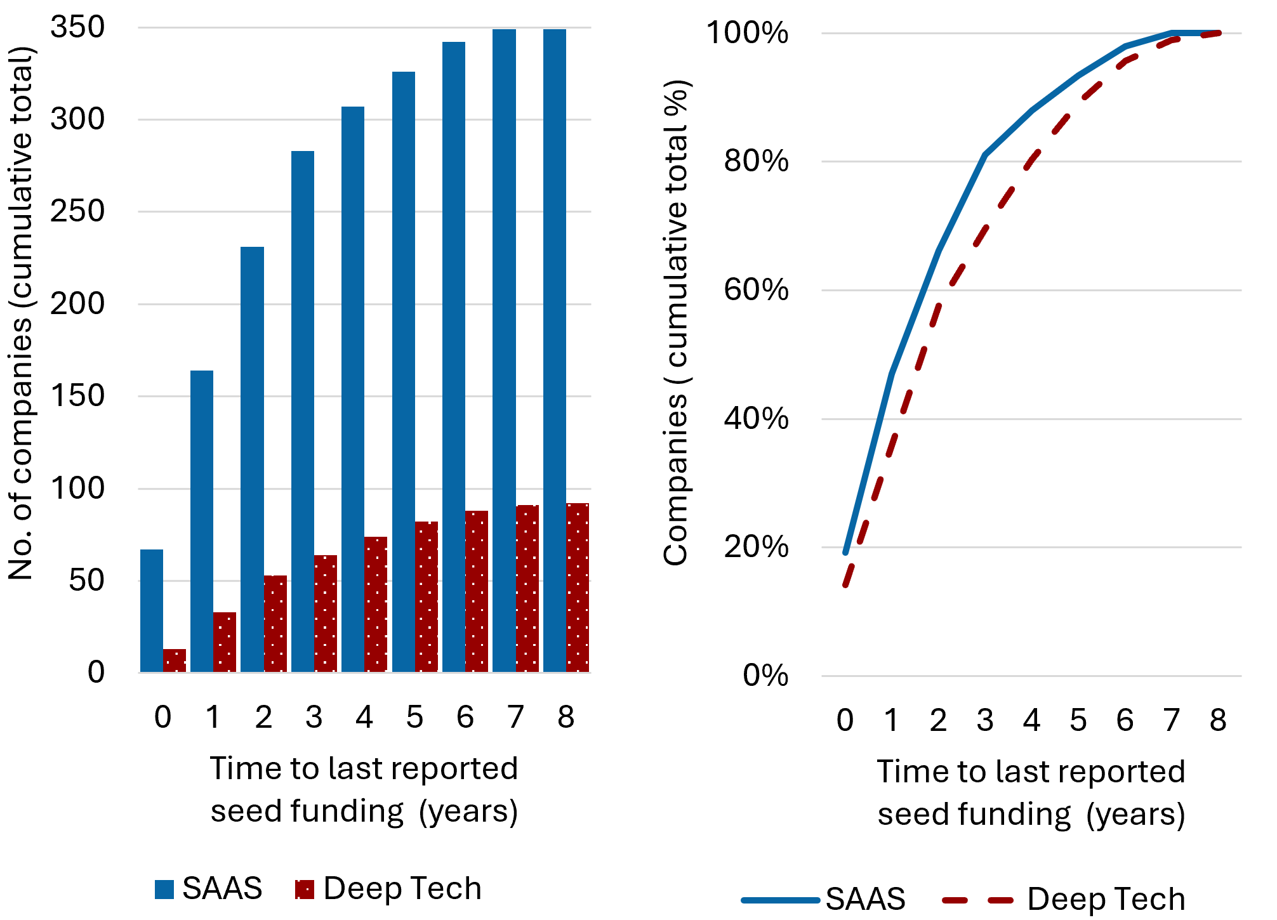
Source: Adapted from Dealroom data (Dealroom.co 2025a). SAAS: Software as a Service. Cumulative count (left) and proportion (right) of Australian companies by time from founding to last reported seed funding since 2015

Recommendation 8a
Expand incentives for angel investors to unlock more capital including by reforming ESIC and crowd sourced funding schemes and changing ‘sophisticated investor’ requirements.

Recommended implementation pathways include:
- The Department of the Treasury to reform investor eligibility definition of ‘wholesale investor’ to include individuals with demonstrable startup experience and only require sophisticated investors to register once per year.
- Enhance ESIC eligibility tests – allow company age of up to 5 years, and/or lift cap on ≤$1 million expenses across last 3 income years.
- Recognise SAFE notes under ESIC framework.
- Expand the CSF scheme by uncapping investments by wholesale investors, allowing different nominee structures, and enabling secondary share sales.
    - Driving growth of the VC sector to competitive scale
Australia’s VC industry is maturing, however there is significant room for growth.
A larger, more diversified VC sector, which has more funding available, particularly for early stage deep tech firms as well as scaleups, would increase the growth of RD&I businesses in Australia.
‘The development of the venture capital industry is considered an important framework condition to stimulate innovative entrepreneurship.’
(Entrepreneurship at a glance 2017, OECD)
There are now many early stage VC funds, focused on seed and Series A investments, including 161 registered under the ESVCLP scheme (DISR 2025c). The vast majority of ESVCLP program supported investments focus on the information media and telecommunications (34%) and services sector (31%) rather than on manufacturing, deep tech and health tech. More broadly, VC accounts for just 17% of deep tech funding (Cicada Innovations 2024). Further, 75% of currently registered ESVCLP partnerships are based in NSW.
There is a need for greater diversity of specialist early stage VC funds, including in locations and focus areas aligned to the pillars. The ESVCLP scheme should continue to play an important role in incentivising this. The National Innovation Council (NIC), National Strategy Advisory Councils (NSACs) and where there is appropriate scale, the National Strategic Initiatives (NSIs), should encourage the establishment of VC funds that support the growth of NSI aligned startups.
Through the consultation, the panel heard from stakeholders about some of the challenges of operating under the ESVCLP scheme.
The current scheme does not allow investors to be excluded from certain investments (such as if investors have restrictions on their investment mandate). Allowing this would align the ESVCLP settings more closely with international VC practices and potentially unlock more investors into VC funds.
International investments in ESVCLPs can currently receive tax concessions for up to 20% of the fund size. This setting is misaligned with trends towards very high valuations following early growth, which can result in an ESVCLP exceeding the 20% cap due to successful international investments and reduced tax concessions for the international portion of ESVCLP investment. Calculating the cap on international exposure based on initial investment instead of the current cumulative book value would incentivise further investment in domestic research and development by providing stronger tax concessions for investing in ESVCLP funds.
Current ESVCLP rules also limit the tax benefits available once a firm has over $250 million in assets. Yet in recent years there has been a shift towards larger deal sizes and valuations (Figure 29). This has resulted in legal complexity and reduced incentives for investors through ESVCLP funds (Sharp et al. 2024). Aligning asset limits with the trajectory of successful high-growth firms would incentivise higher VC investment in early stage firms, simplify regulatory complexity and reduce cost for investors.
The trend towards larger deal sizes and valuations presents opportunities to uplift the ESVCLP program, and to expand support to later funding rounds to introduce new incentives for early scale-up domestic investment, complementing the venture capital limited partnerships (VCLP) incentives for foreign investors which apply at any investment stage (Australian Investment Council and EY 2024).
There is a need to update the assessment of a new ESVCLP’s investment plan to determine if companies are early stage, which includes deal size among other factors in the criteria.
Of greatest concern to the panel is the lack of Series B+ funding provided by Australian VC funds. There are a limited number of Australian VC funds that make later-stage venture investments (Series B+), meaning many firms seek international investment that draws them offshore, taking with them significant value.
Industry stakeholders (including the Australian Investment Council, Tech Council of Australia and Gilbert + Tobin) have called for raising ESVCLP thresholds, which would align the program with larger deal sizes, placing a higher ceiling on new business growth. For example, a $500 million fund size cap would allow an ESVCLP to make more deals at the $25 million to $50 million scale, thereby increasing the amount of Series B+ investment in Australia.
Figure 29: Number of Australian VC deals exceeding $50 million and $100 million since 2018
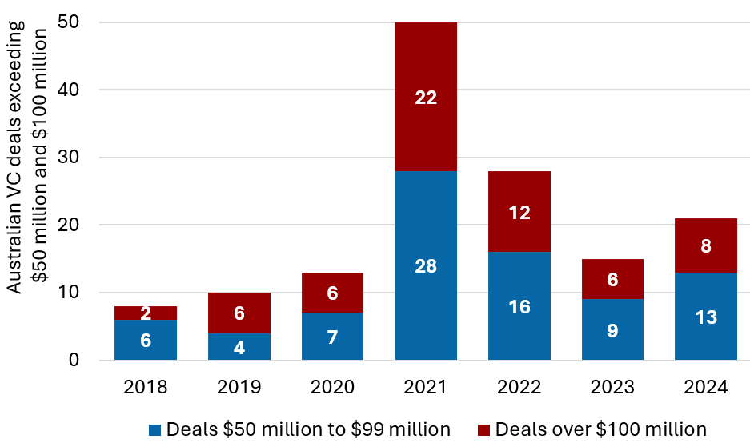
Source: Adapted from the 2024 State of Australian Startup Funding Report (Cut Through Venture and Folklore Ventures 2024)

Recommendation 8b
Simplify and expand ESVCLP incentives to unlock more capital and support the venture capital industry to scale.

Align ESVCLP settings with the current VC market to support high-growth early and scaling innovative firms, including through:
- Lifting the ESVCLP fund size cap from $200 million to $500 million and allow larger early stage investments (including Series B).
- Increasing the asset cap for investee firms for ESVCLP eligibility from $250 million to $500 million.
- NIC to co-design with stakeholders a points-based assessment of investment plans for ESVCLP, which eliminates size of investment as a factor in assessing ‘early stage’ and enables larger first-round investments into startups.
- Basing calculation of the 20% cap on tax benefits for international investment on amounts invested, rather than cumulative book value.
- Enabling fund managers to excuse individual investors from specific investments (within limitations).
  - Unlocking superannuation for RD&I
Superannuation is another potential source of patient VC investment. With the right policy settings, superfunds could take on more long-term, higher-risk investments into Australian RD&I businesses.
Current investment by superfunds into Australian VC funds is limited. A select number of funds have pioneered local VC investments, successfully achieving liquidity that has enabled continued investment. Growing regulatory impediments are preventing others from following.
Figure 30 shows that more investments are made by Australian superfunds into international markets for unlisted entities, compared to local firms.
While superfunds must create a return for their members, it is also in industry superfund members’ interests that they support the prosperity of Australian industries by investing in the very best domestic assets.
Figure 30: Levels of investment in private equity by the Australian superannuation industry
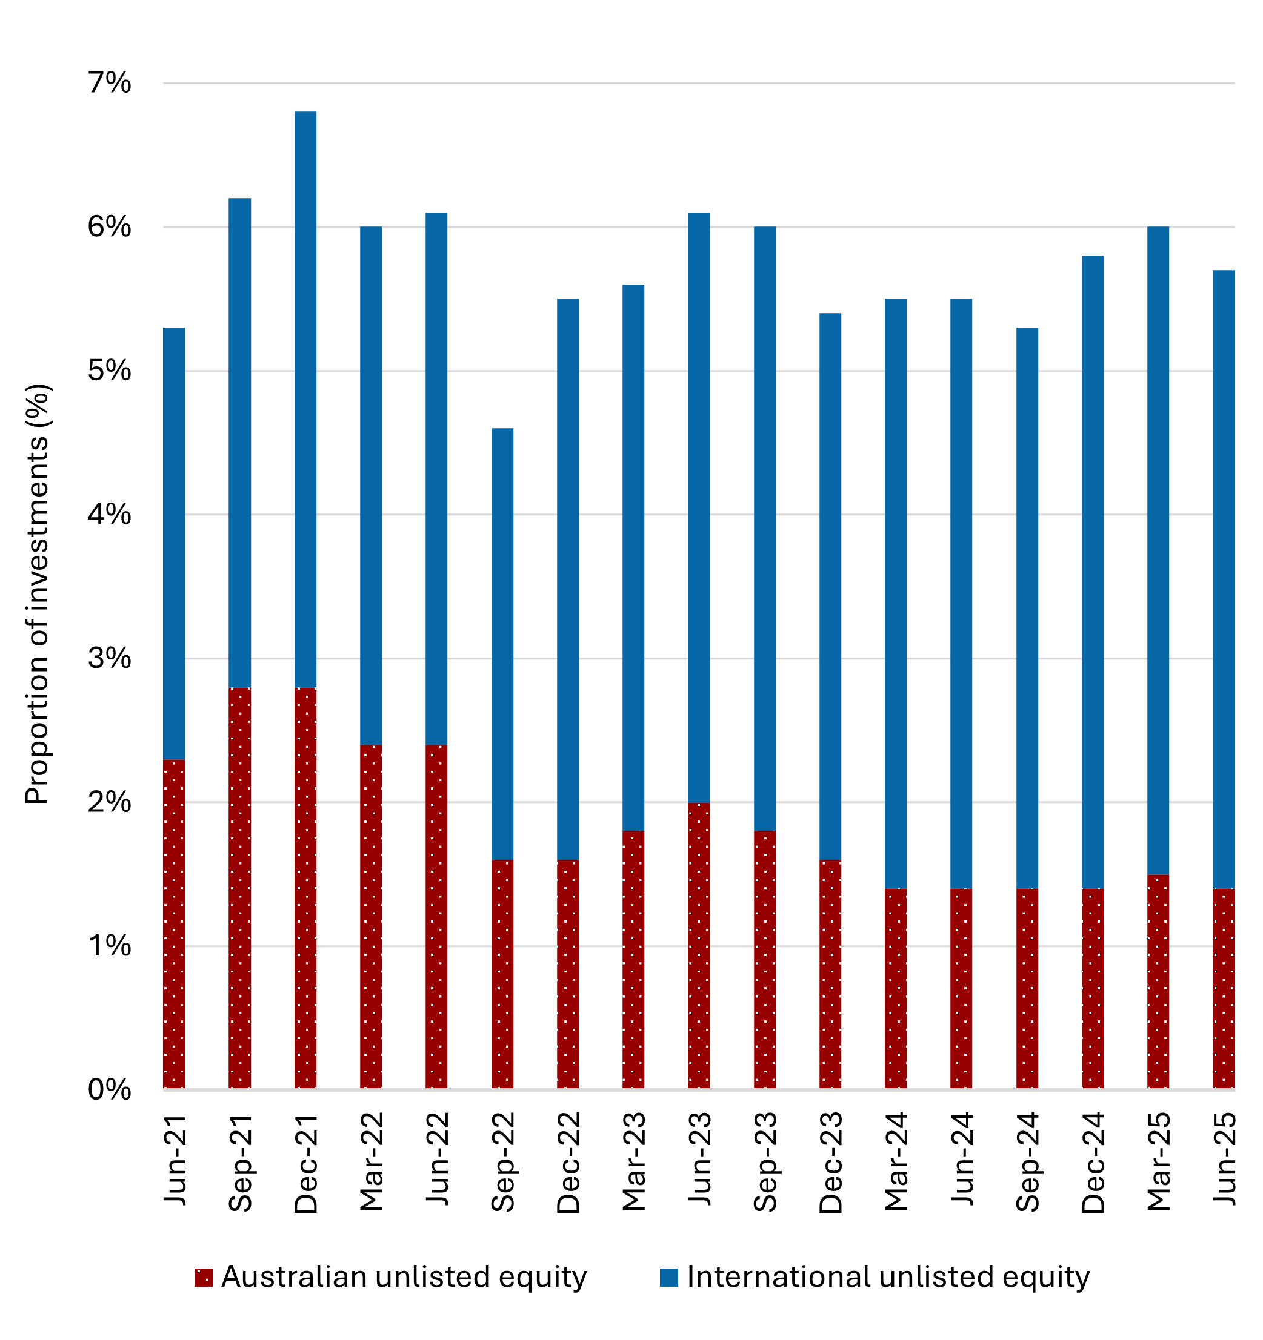
Source: Adapted from the APRA Quarterly Superannuation Industry publication, June 2025 (APRA 2025a)
As the Super Members council has stated, Australia’s $4.2 trillion pool of superannuation savings (equivalent to 153% of GDP) is a ‘long term domestic source of capital to markets that few advanced market economies possess’ (Super Members Council 2025). These assets add stability and depth to Australia’s capital markets while building assets for millions of Australians. On current projections, Australia will overtake Canada by 2030 to become the second largest pool of superannuation savings globally.
A sample of major funds from both countries shows that Canadian pension funds invest more heavily than Australian superfunds across all VC stages – especially break out and late stages (Figure 31).
Figure 31: A sample of major Canadian and Australian retirement fund activity
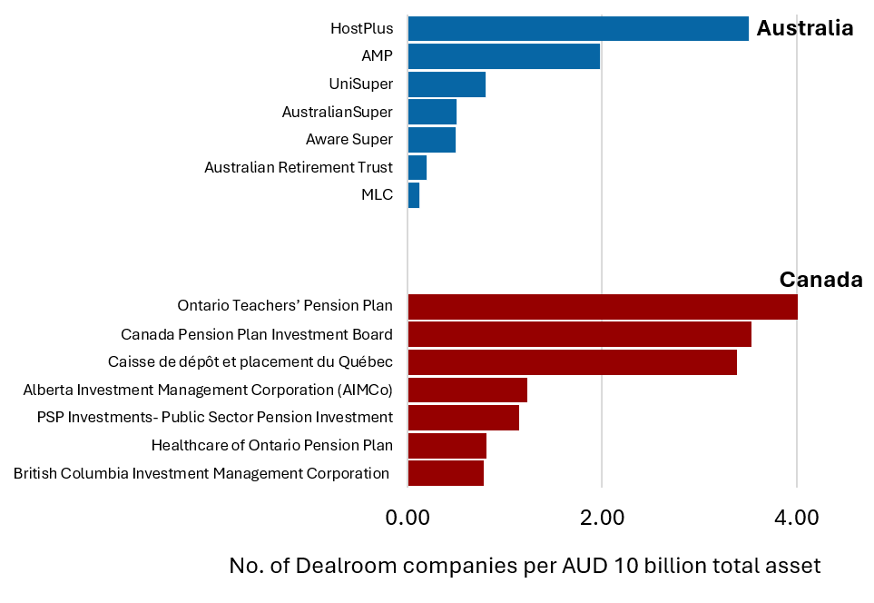
Source: Adapted from Dealroom.co, APRA and various investment and pension organisation reports (Dealroom.co 2025a; APRA 2025b; Alberta Investment Management Corporation 2024; Public Sector Pension Investment Board 2025; HOOPP 2025; BCI 2024-2025; La Caisse n.d.; Ontario Teachers' Pension Plan 2024; CPP Investments 2025).
With targeted reform, superfunds choosing higher exposure to RD&I firms would face fewer impediments and have more viable Australian investment opportunities, resulting in a larger pool of capital available for local innovation active firms and a higher ceiling of returns to members.
The superannuation performance test is a single metric test comparing net investment returns against a benchmark portfolio. Failing the test twice results in an investment product being closed to new members. Stakeholders report that the performance test is a barrier to funds seeking higher long-term returns. Instead, it has led funds to favour established investment strategies and prioritise assets with lower regulatory risk, rather than seeking innovative or higher yielding opportunities.
Similarly, the Australian Securities and Investment Commission (ASIC) Regulatory Guide 97 (RG97) requires product disclosure statements to emphasise fees individually rather than as part of net returns. Investors say funds are aware of how high fees will be framed in disclosure statements and as a result are discouraged from investing in VC funds.
Adjusting the design of the superannuation benchmarking and product disclosure regulatory settings to allow funds to consider VC without regulatory distortion would be an important step towards higher investment in domestic innovation by superannuation, and would allow more effective support for funds choosing higher VC exposure. ASIC committed to a review of RG97 in 2026–27 (Australian Securities and Investments Commission 2025a), and in 2024 the Treasury completed a consultation on the design of the superannuation performance test. In response to these processes, the Australian Government has an opportunity to reframe RG97 guidance on fees and costs so as not to disincentivise long-term high-growth VC and private equity assets, and to redesign the superannuation performance test to remove barriers to higher private equity investment.
‘RG97 requires superannuation fees to be disclosed separately from returns, which has inadvertently disincentivised investments in higher-return asset classes.’
Annual Superannuation Performance Test –
design options submission, Australian Investment Council (2024)
Superfunds have a duty to act in the best financial interests of members and should not be mandated to make specific kinds of investments. Superfunds also provide different investment options to members offering different risk and return profiles, or exposure to certain asset classes such as Environmental, Social and Governance (ESG) investment principles. Offering an investment option to members to preference investment in Australian RD&I firms would provide a pathway to higher domestic VC exposure.
There are also opportunities to enhance public data reporting to more clearly track domestic VC investment by superannuation.

Recommendation 9
Reform superannuation policy settings under the Australian Securities and Investment Commission (ASIC) Regulatory Guide 97 (RG97) and performance tests, and require superfunds to enable members to elect to invest in Australian high growth RD&I firms.

Recommended implementation pathways:
- Reframe RG97 guidance on fees and costs so as not to disincentivise long-term high-growth VC and private equity assets.
- Redesign the superannuation performance test to remove barriers to higher private equity investment.
- Require superfunds to establish a category for Australian innovation firms to allow members to prioritise domestic innovation through member-directed investment options.
- Mandate improved data collection to track VC participation by superfunds, and identify policy gaps.
  - Establishing FOF investment vehicles
Pooled investments such as FOF play important roles in VC sectors. They provide a diversified vehicle for investors whose cheques are too small (e.g. angel investors) or too large (e.g. superfunds) for typical VC funds to accept. They can support investors to access hard to reach funds while providing professional management and regulatory compliance. By pooling capital, FOFs can build diversified, large‑scale funds, attract experienced fund managers and catalyse growth in Australia’s VC sector.
FOFs can also facilitate the development of secondary markets by utilising their specialised expertise to evaluate value and risk in secondary transactions. This enhances deal flow and contributes to greater efficiency and stability within the investment market.
The value of FOF vehicles is supported by research by US research organisation, the National Bureau of Economic Research, which found that a sample of VC FOF’s in the study outperformed direct investment in VC funds when the investor didn’t have an established track record of investing in successful VC funds (Harris et al. 2018). This suggests that well-run FOFs can achieve strong returns while providing added value for investors that face barriers to investing directly in VC such as lack of specialised skills.
‘…strategies for investing in direct funds may be constrained by limits on fund access or manager selection skills. We show that VC FOFs often outperform direct investing handicapped by these limitations.’
Robert S. Harris (Harris et al. 2018)
The panel is of the view that multiple FOFs may be warranted in Australia. Opportunities include FOFs to support university spinouts, diversification of seed and Series A funds (especially into deep tech) as well as supporting emergence of more Series B+ funds.
Enabling public funds like the NRF to leverage FOF investment vehicles will amplify their ability to diversify by providing access to smaller innovation investment opportunities that they might otherwise overlook due to scale or mandate constraints. By acting as an anchor investor in FOF arrangements, the NRF can also crowd-in private capital and accelerate deployment into emerging Australian projects and technologies in NRF priority sectors.
A key challenge of FOFs is higher fees because of layered management costs, which can be a barrier to many investors, particularly those operating in highly regulated environments such as superannuation.
The Australian Government could offset FOF management fees (typically 1–2% of the funds under management (Corporate Finance Institute n.d.)), to attract investment while requiring FOFs to support some investments into VC funds that are in the national interest, for example encouraging the establishment of new investment VC fund partnerships.

Recommendation 10
Support the establishment of fund of funds (FOF) to grow long-term investment, across different stages, including by providing fee relief for FOF investors and focusing sovereign funds where appropriate.

Recommended implementation pathways to support establishment of FOF investment vehicles across the ecosystem:
- Establish a government program that offsets the costs of FOF management fees. Investors in the FOF would still need to cover fees of the underlying VCs.
- Require supported FOFs to support the diversification of the VC sector, through supporting emerging fund managers, as well as funds in key areas of national interest e.g. deep tech or Series B funds.
- Encourage FOFs to invest in secondary funds.
  - Expanding exit and other investment pathways to unlock venture growth
Exits play an incredibly important role in RD&I ecosystems, enabling investors to realise their returns, typically by selling their stake to other investors through an initial public offering (IPO) or through mergers and acquisitions (M&A) processes. Exits also release experienced talent into the market, many of whom will go on to lead other startups – supporting the flywheel depicted in Figure 23.
Exits are challenging for Australian RD&I firms. The Australian IPO market for tech firms is not as mature as international markets, especially in the US. The Australian M&A market is also limited. Few larger businesses, including corporates, have the appetite to invest in young Australian RD&I firms.
These issues are exacerbated by the fact that many RD&I startups and scaleups move offshore in order to attract growth capital to scale. As a result, the value created by growing local RD&I firms is not fully realised – key talent leaves the country and overseas investors stand to benefit from exits.
In recent years, exit activity in Australia has been subdued with 55% of investors reporting no exits during the year 2024, while only 22% achieved more than one (Cut Through Venture and Folklore Ventures 2024). There are also specific challenges for exit types. For example, the IPO window, especially for Australian Securities Exchange (ASX) listings, has narrowed considerably and trade sales have declined sharply – from 50% of exits in 2022 to just 28% in 2024 (Pitcher Partners 2025).
A vibrant investment ecosystem depends on an active secondary investment market (which FOF vehicles will assist in fostering) and an environment that offers multiple exit strategies.
Submissions to the Strategic Examination of Research and Development (SERD) highlighted the need to support a range of viable exit strategies and pathways. Facilitating smoother IPO processes and incentivising corporates and investors to acquire firms through M&A would strengthen exit options for innovative firms.
‘In 2024, 55% of surveyed investors reported no exits, underscoring how fewer distributions have led to more cautious commitments for new funds. This has slowed dealmaking and stifled further investment in earlier-stage companies.’
State of Australian Startup Funding
(Cut Through Venture and Folklore Ventures 2024)
Changing the exit environment in Australia is non-trivial and is driven by a broader need for functional and internationally competitive capital markets that support productive innovative firms. The Australian Government has a key role in ensuring a positive regulatory environment to encourage domestic exit pathways.
New technologies such as tokenisation promise to make it easier for assets to be broken into smaller, more affordable units, reducing barriers to transactions including in private equity and VC (Australian Securities and Investment Commission 2025b). Efforts by the Reserve Bank of Australia, ASIC and others to support innovation in financial markets are an important step towards a financial system where there are fewer barriers to investing in innovative, high-productivity firms. But unintended consequences that stymie the system must be avoided.
While it may be hard for Australia’s ASX to compete against the NASDAQ for tech exits returns, the ASX should be supported to specialise to become a global leading market in applied RD&I technology exits aligned with the pillars, for example in agriculture or health and medical sciences. To achieve this more specialised RD&I wealth management expertise is needed. Attracting skilled talent through migration is a key way to support this, and is addressed in Chapter 5.
Corporates can also be encouraged to consider M&A opportunities, including through the RDTI. This is discussed further in Chapter 3.

Recommendation 11
Incentivise investment in Australian innovation by ensuring Australian regulatory environments that impact on the exit pathways for RD&I firms, particularly IPOs and M&A, are globally competitive and balance regulatory protections against the need for liquidity.

Recommended implementation pathways include:
- Strengthen ASX exit-readiness programs for founders by partnering with successful companies and advisors and focusing on governance, valuation, and capital market engagement.
- Incentivise large business to work with and acquire startups (see Section 3.2.4) and invest in VC funds.
- Australian Competition and Consumer Commission to ease regulatory restrictions on domestic M&A to ensure competition regulation acknowledges the distinct features of tech markets, thereby fostering pathways for successful exits through M&A.
- Consider further action to encourage development of secondary markets.
  - Other observations
To deliver national outcomes and impact wherever RD&I can emerge, we must grow investment in the pillars. The NIC and NSACs will need to play an important role to ensure the VC sector is able to respond to a growing RD&I sector.
Australia’s VC sector is not only undersized but also faces a shortage of skilled fund managers. The specialised skills needed for VC (as opposed to broader wealth management) are difficult and time-consuming to develop, which limits growth and investment potential. Nevertheless, emerging managers must be supported, and Government should avoid backing established funds despite the reduced risk. Attracting international expertise will help develop VC expertise and this is also addressed in Chapter 5.
The VCLP incentive has been credited with strong growth in private equity investment levels, and the panel has heard that the scheme is functioning well. Small improvements, including basing the calculation of the 20% cap on tax concessions for international investment on amounts invested, rather than cumulative book value (similar to the ESVCLP proposal), would be beneficial.
  - Why this matters
Failure to support the development of the RD&I investment system, including VC, will mean Australia will not benefit from investments made into supporting foundational research, and its application into commercial outcomes including through startup creation.
This includes not realising the full potential of the NSIs.
RD&I active firms will struggle to scale without the necessary capital, and Australia will continue to lose RD&I firms offshore.
Without addressing exit pathways, including M&A and IPOs, we will fail to maximize the benefit of scaling RD&I firms, and allow other jurisdictions to benefit from talent and wealth creation.

- The workforce
‘Innovation is fundamentally about people solving problems.’
Catherine Livingstone AC (IMD 2024)
The success of a dynamic research, development and innovation (RD&I) ecosystem depends on a workforce that can adapt to rapid technological and societal change.
Figure 32: Flywheel workforce capability
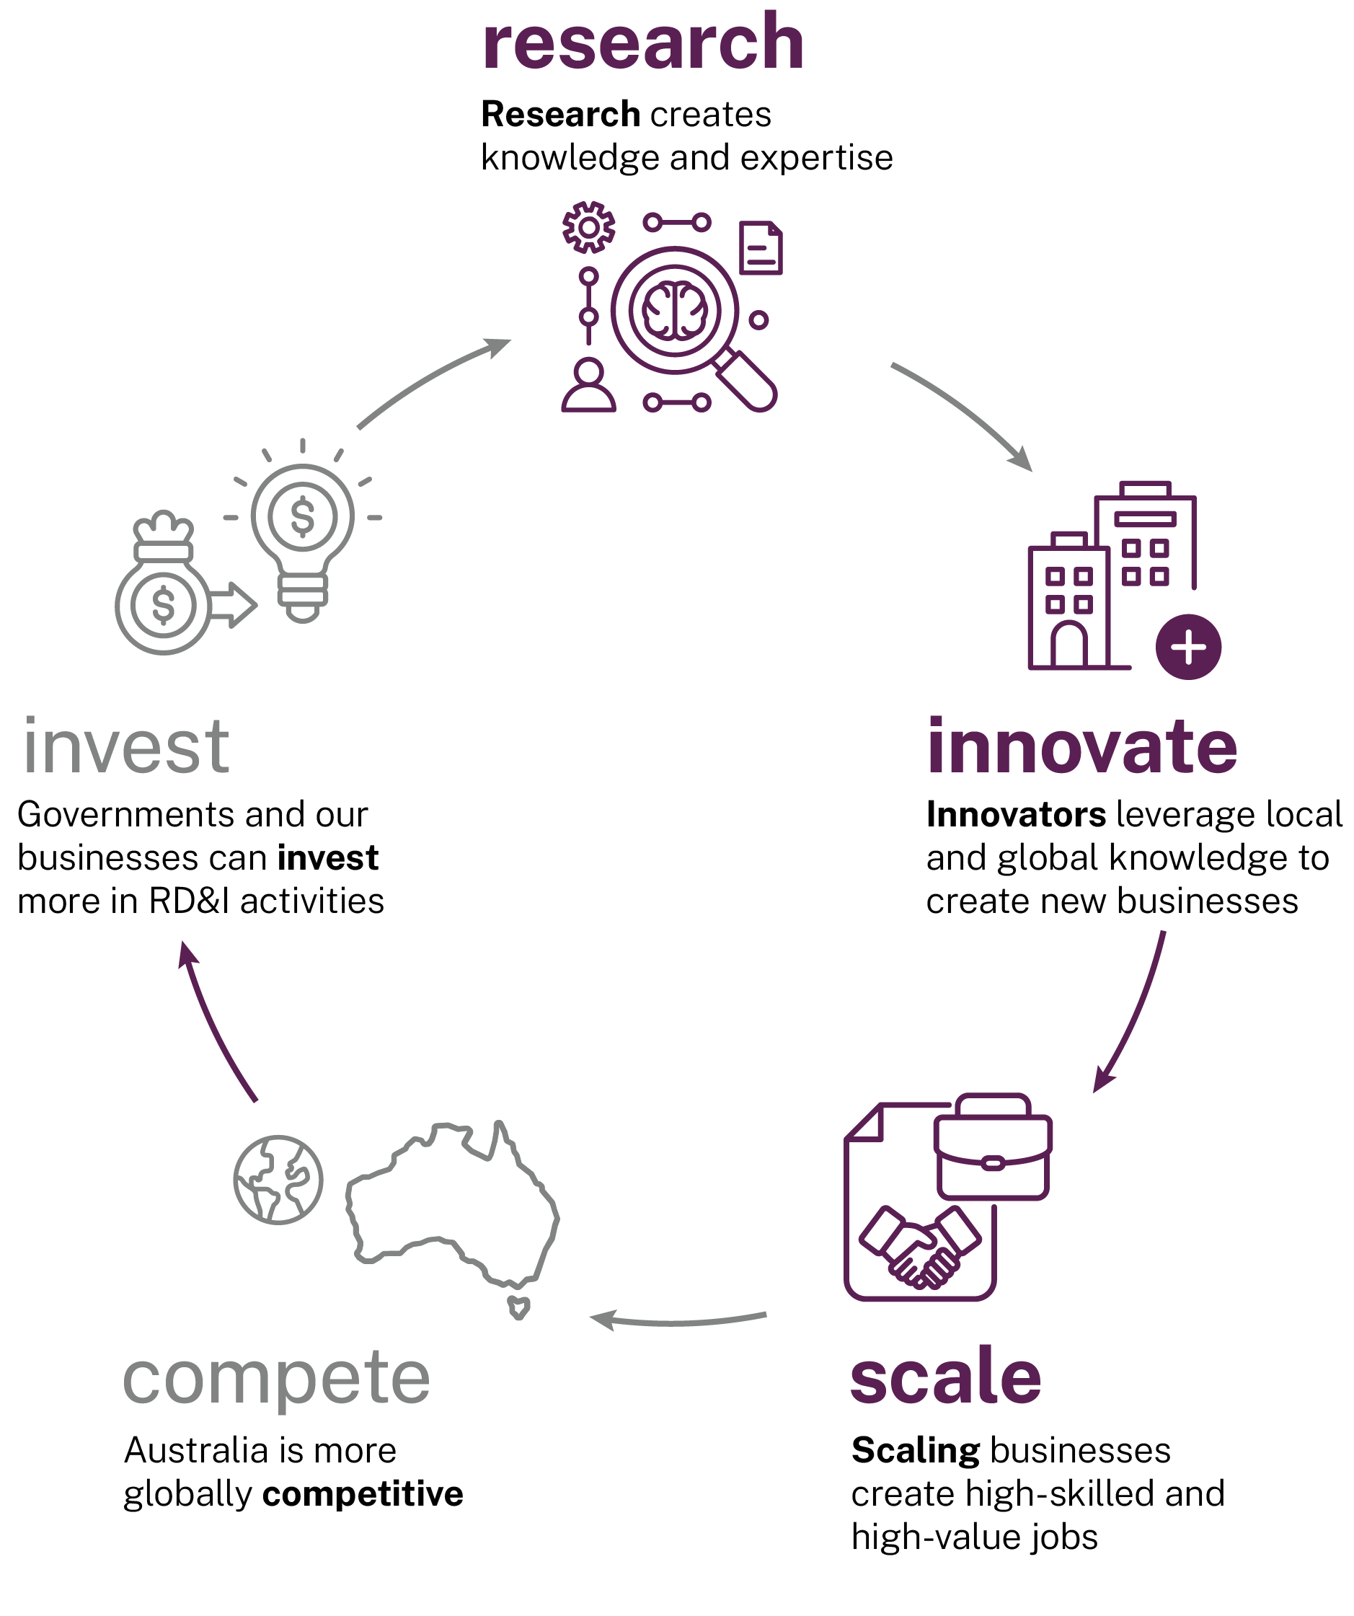
Yet only 16% of submissions expressed confidence that Australia’s current research and development (R&D) workforce is equipped to meet future needs.
The reforms proposed in Chapters 1–4 will develop Australia’s workforce by:
- Reversing the decline in research funding to provide more certainty for researchers and making academia a more attractive career choice, especially for early career researchers.
- The National Strategic Initiatives (NSIs) and reforms to the Research and Development Tax Incentive (RDTI) scheme will support more entrepreneurs to start and grow the next generation of RD&I businesses.
- Investment, regulatory, and tax reforms will make it more attractive for RD&I businesses to stay in Australia, avoiding a brain drain whereby our best companies that are enticed offshore, taking with them significant value.
- Growing more larger RD&I businesses in Australia will create more high-value, high skilled jobs, and provide stable career pathways.
- Requiring large RD&I firms to invest in their employees as part of the RDTI ‘good corporate citizen test’ will support re-skilling of the current workforce.
As the RD&I system grows, there will be an even greater demand for talent. Workforce development will become a national imperative. Given this, Australia must do even more to develop, retain, and attract RD&I talent.
The current pipeline, built largely on the study choices of students, is not well-aligned with the needs of our workforce. For example, we are not training enough geoscientists despite our heavy reliance on resources (Australian Academy of Science 2025). Employers are engaged at the margins, if at all. Given the rate of change of knowledge, re-skilling the workforce, with employers contributing to continuing development is highly desirable.
There has been a steady decline in Australian PhD enrolments (Department of Education 2024). We have managed to fill this gap by attracting international PhD students, so the impact on the workforce is not necessarily obvious.
A factor adversely affecting Australia’s RD&I performance is the relatively small number of PhD qualified people working in Australian industry. There is limited mobility of people between academia and industry to encourage this. For example, nearly half of PhD graduates work as university staff (ABS 2021), while just 45% of the national R&D workforce is employed in business, far below the OECD average of 68% (OECD 2025b). Australia has an estimated 3 business sector researchers per 1,000 employees compared to the OECD average of 6.5 (OECD 2025b), leaving us significantly behind leading nations.
Figure 33: Number of business sector researchers per 1,000 total employees (all sectors), select countries, 2021
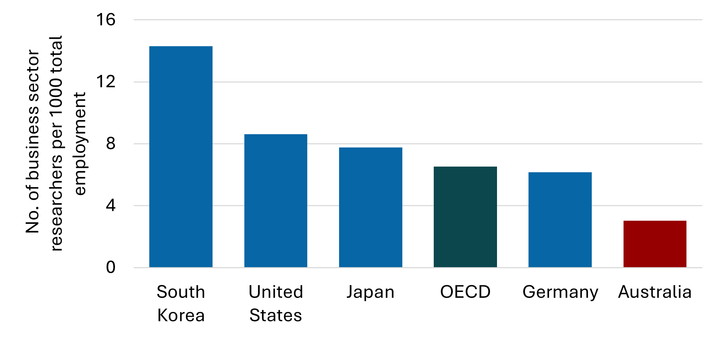
Source: Adapted from OECD MSTI (OECD 2025b). Total employment includes all sectors.
More needs to be done to support industry PhDs, joint appointments, and industry sabbaticals for researchers. This will not only support researchers to build capability to focus research on industry challenges but will also provide diverse career pathways.
As identified in Treasury’s White Paper on Jobs and Opportunities, building a highly skilled workforce will require more collaboration across higher education, vocational education and training, industry and governments, and a culture of lifelong learning (Department of the Treasury 2023b): with a determination from all parties that we have not yet shown.
‘Staff mobility between academia, industry, and government research agencies can help close skill gaps, accelerate technology transfer, and enhance professional development. Encouraging secondments, joint appointments, or sabbatical-like opportunities allows researchers to gain firsthand knowledge of industry needs while enabling companies to tap into the latest academic expertise.’
SERD submission, CropLife
The National Innovation Council (NIC) and NSIs implemented under the pillars model must be tasked with supporting skills development and mobility of people across the RD&I system.
This includes addressing current skills shortages, including through migration. The panel repeatedly heard about challenges faced by businesses in hiring people with advanced technical skills and experience operating in high-growth environments. The panel also identified skills gaps in specialised fund and wealth management.
Finally, the workforce must represent our community, reflecting diversity and inclusion. The underrepresentation of First Nations people in research and business is of great concern. To address these issues, the panel proposes a plan to further strengthen the workforce by:
- Supporting PhDs by raising support levels (including stipends), diversifying the nature of PhD programs, and building strong employer partnerships.
- Developing and training talent across the innovation cycle and attracting top global talent.
- Elevating the role of First Nations people and women in RD&I.
These reforms will accelerate the development of the RD&I sector. It will ensure we have the capability and the investment in our people to avoid the decline in living standards forecast in the Intergenerational Report (Department of the Treasury 2023a).
  - PhDs, careers and options
PhD students play an important role in RD&I systems, building capacity, capability and creating a pipeline of talent for the future academic workforce. In mature RD&I systems, they also provide a workforce for industry while operating as a conduit between business and research institutions.
Yet in recent years, domestic PhD enrolments have fallen to their lowest levels in over 2 decades. International commencements now outpace local commencements (Department of Education 2024).
Submissions to the Strategic Examination of Research and Development (SERD) made clear that, without better financial support and viable career options, Australia will lose the next generation of RD&I leaders.
Figure 34: Postgraduate by research commencements at higher education institutions
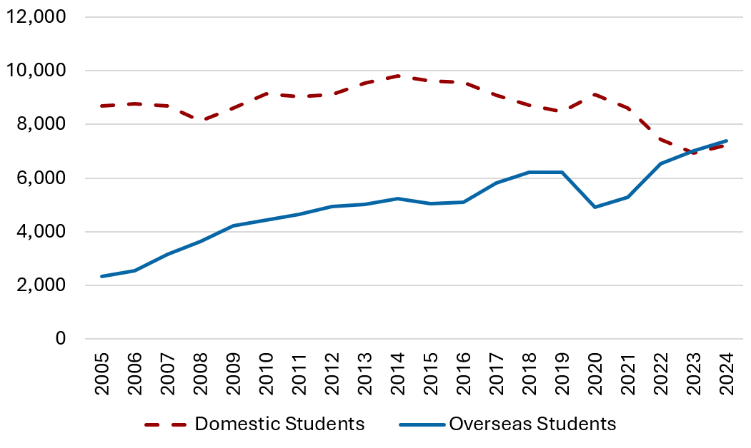
Source: Adapted from Student Data (Department of Education 2024). Students with unknown citizenship are included in the totals.
To help reverse the decline in domestic PhD enrolments, the stipend rate needs to be lifted above the poverty line. As an immediate action, PhDs focused on the National Innovation Pillars should receive a higher stipend rate, as this will help fill workforce gaps in areas of national priority. In the longer term, stipends should be increased for all PhD students.
Financial barriers can be further reduced by extending the tax-free status currently applied to full-time research scholarships to part-time PhD students. This reform would promote equitable treatment across study modes and better reflect the need for flexible training pathways. Increasing the PhD stipend rate and extending tax-free treatment to part-time scholarships will attract more diverse candidates into PhDs, including First Nations people, and reduce barriers for those re-entering education and high-level training while remaining employed in industry.
‘Australia’s sovereign research capability depends on training the domestic Australian workforce. Many aspiring PhD candidates are deterred by financial barriers – stipends are below the poverty line, part-time stipends are taxed, and candidates are excluded from income support.’
SERD submission, Innovative Research Universities
More needs to be done to prepare PhD graduates for careers beyond academia. Yet, as noted in Chapter 3, Australia lacks large RD&I businesses that are employers of researchers. The reforms in Chapter 1–4 help address this, by growing new RD&I-active businesses.
The panel repeatedly heard that businesses hiring PhD graduates find they are not workforce ready – recurring theme expressed over decades. If this is to change, it requires universities to collaborate with business to make PhD programs more flexible, businesses to employ the graduates, and governments to facilitate through policy and focused financial support.
To strengthen these connections, the panel recommends a coordinated strategy for research training, to be led by Universities Australia and the Business Council of Australia. This strategy should embed deeper industry engagement across all disciplines through initiatives such as research cadetships and the broader adoption of industry-aligned PhD and Research Masters models. It should go beyond setting objectives and include practical mechanisms for collaboration, such as joint governance arrangements, shared funding models, and clear performance measures. These actions should be supported by incentives for participation and frameworks that ensure long-term commitment from both universities and businesses.
Universities should also take the lead. They should build and deliver industry and entrepreneurial models at scale, partnering with businesses and accelerators so graduates emerge as both skilled researchers and capable innovators. This will involve incorporating entrepreneurship and commercialisation modules into research curricula, creating opportunities for students to work on industry-defined challenges and providing access to mentors from both academia and business. Expanding industry-aligned research training will enhance employment readiness while embedding cross-sector experience into the research culture, and vice versa, normalising mobility between academia and industry. The NSIs will play a key role supporting the expansion of industry PhD programs.
PhDs programs should accept aspiring founders to enable them to explore ideas in a research setting with the intent of commercialising. In the US, 10% of all startups are spinouts from universities, compared to only 4% in Australia (SERD calculation based on (Knowledge Commercialisation Australasia 2024) and (Dealroom.co 2025a)). This will require greater innovation in PhD programs, including applying different selection criteria, providing entrepreneurial training, and enabling success to be re-defined so universities are not financially penalised if a student fails to graduate but creates an RD&I startup.
TIES
The Technological Innovation, Entrepreneurship, and Strategic Management (TIES) PhD Program at MIT (US) trains scholars capable of advancing the research frontier in the fields of innovation, entrepreneurship, and strategic management. Through a rigorous curriculum, close research collaboration with mentorship by faculty, and an emphasis on questions that have real-world impact, the program trains scholars with an interest in understanding the challenges of innovation and entrepreneurship. It focuses on moving ideas and companies from the earliest stages of basic research to effective products and services with an impact on the world.

Recommendation 12a
Universities, in partnership with industry, be supported to design and deliver inclusive research training programs with a strong industry focus. Universities be encouraged to deliver entrepreneurial research training programs.

Recommendation 12b
Increase the attractiveness of PhD programs for Australian students by lifting the stipend rates in fields aligned with the National Innovation Pillars and making part-time research scholarships tax-free.

Recommended implementation pathways include:
- Increase PhD stipends to $50,000 annually for 1,000 full-time equivalent PhD places in fields related to the pillars.
  - In the longer term, increase stipends for all PhD students.
- Extend the tax-free treatment for research scholarships to part-time recipients.
- Universities and industry (Universities Australia and Business Council of Australia to lead) to develop a strategy for a research training system with a stronger industry component, across all disciplines:
  - Increased engagement of industry in Research Cadetships involving placements and stipend top-ups, working towards a target of 1,500 commencing places per annum.
  - Expand university use of industry-aligned models for PhDs/Research Masters (focused on the pillars), working towards a target of 1,500 commencing places per annum.
- Universities to lead the development and provision of industry and entrepreneurial PhD models and training at scale.
  - Developing, retaining and attracting talent
Ensuring that Australia’s workforce is right sized and skilled for the RD&I system is essential. This will necessarily include workforce development, attraction, and retention. The pillars model, as well as broader workforce strategy and planning will both play a key role.
    - Supporting workforce development through the pillars
The pillars model proposed in Chapter 1 must support workforce development. This should be implemented through the NIC’s investment framework and form a pre-requisite of NSI funding.
Workforce development must include supporting hundreds of industry PhDs across the life of an NSI, including cadetships, where industry supplements PhD stipends and the student commit to a project with the relevant company.
‘Investing in the future workforce includes supporting those who are at the beginning of their career journeys – but also those who will need to accumulate new skills and seek new opportunities as their careers progress.’
SERD Submission, ACTU
NSIs will be well placed to support the mobility of the workforce between industry and academia. This could include industry sabbaticals for PhDs and researchers, like the Mitacs program in Canada, as well as encouraging joint-appointments. NSIs may also support the development and delivery of relevant training programs, as well as the mobility of talent more generally across NSI partners such as research institutions, businesses, infrastructure providers, and governments.
Mitacs
Mitacs (Canada) is a national innovation connector that reduces barriers to research collaboration. Its programs include supporting workforce development by equipping students and postdoctoral researchers with professional skills and research experience. Since 2018, Mitacs has facilitated over 99,000 internships and 35,000 innovation projects involving thousands of businesses – 86% of which are small-to-medium enterprises (SMEs) – resulting in increased R&D investment, revenue growth, productivity gains, and clear career pathways into Canada’s innovation sectors (Mitacs, 2025).
NSIs will play an important role in fostering entrepreneurs, through provision of funding for pre-accelerator and other related programs. Workforce attraction may include attracting relevant leaders from around the world to work in Australia on the NSI sub-goal, including skilled researchers. Monitoring the pillar workforce, and advising on needs, will be a role of National Strategy Advisory Councils (NSACs).

Recommendation 13a
The National Innovation Council and the NSACs include skills development as a key element of the investment framework for the pillars in Recommendation 1. Investment in the NSIs should include a requirement to support diverse and inclusive talent and skills development, attraction and mobility.

Recommended implementation pathways include:
- NIC to include workforce development in the investment framework, including providing clear targets for NSIs where appropriate (e.g. number of industry PhDs and startup creation rates).
- NSIs to develop strategies, as part of their proposal and as well as ongoing planning to support workforce development, retention, and attraction to support the achievement of the subgoal. This should include building a comprehensive program to connect businesses and researchers, drawing on the experience of organisations such as Mitacs.
- NSIs to be tasked with measuring key workforce metrics to support evaluation and inform government policies, as well as NSI strategy.
    - RD&I workforce strategy and planning
The panel heard of numerous and consistent workforce shortages that currently exist.
Startups stressed the need for talent with scaleup experience. Australia’s startup ecosystem is less mature than globally leading hubs and has fewer experienced founders and operators, including product managers. In time this will change as more entrepreneurs successfully grow, scale, and exit businesses, however there is a need to attract global expertise to fill immediate gaps.
‘The government should expand the Core Skills Occupation List to include Product Manager – a key research translation role that is increasingly vital in taking Australian breakthroughs from lab to market.’
SERD submission, Tech Council of Australia
Manufacturing is an enabling capability across the pillars. There is need for a strong pipeline of future advanced manufacturing workers, particularly in rapid prototype manufacturing. Australia’s manufacturing industry faces the critical challenges of an ageing workforce, which limits generational renewal, and skill shortages. STEM skills are essential for enhancing Australia’s manufacturing capability and increasing local manufacturers’ participation in local and global supply chains.
‘Beyond technical skills, an onshore manufacturing innovation ecosystem needs people with production experience. This presents opportunities for re-skilling Australians and attracting skilled immigrants.’
SERD submission, Cicada Innovations
Equipping the workforce with the digital capability skills required to remain relevant in the face of fast-moving fields such as artificial intelligence (AI), quantum, and cyber security are crucial in a highly automated world. Technology is Australia’s fastest growth sector and third-largest industry by economic value. It contributes $167 billion to the economy each year and provides jobs for more than 900,000 people (Tech Council of Australia 2024). Yet we ranked 54th (from 69 countries) on use of digital tools and technologies (CEDA 2025).
‘Without targeted government intervention, this digital divide risks deepening innovation capability gaps and the underutilisation of recent R&D outcomes, stalling entrepreneurial growth, and leaving many small firms behind in an increasingly tech-driven marketplace.’
SERD submission, ACCI
Gaps also exist in the investment community, particularly in specialist RD&I fund and wealth management expertise. According to the CFA Institute, Australia faces a structural shortage of financial advisers and investment managers, driven by regulatory changes, an ageing workforce, and insufficient training pathways. A global survey of investment professionals, including Australia, indicates strong competition for talent and a continual learning curve as new markets, asset classes, and investment strategies emerge – factors that are shaping a very different future of work in investment management (CFA Institute 2022).
Accelerating the development of the RD&I sector will exacerbate workforce challenges if careful planning is not supported. Skills development, migration, and retention strategies will be crucial.
Given the diversity of the workforce capability gaps outlined – spanning technology, engineering, advanced manufacturing, entrepreneurship, and investment – a cross-sector cohesive workforce strategy is needed. There is currently no mechanism for coordinated action.
The NIC, in consultation with industry and unions, is well placed to develop a holistic strategy encompassing workforce planning, talent attraction, and skills development – with a focus on prioritising the skills required for Australia to achieve the goals of the pillars.

Recommendation 13b
The National Innovation Council, in consultation with industry and unions, devise an RD&I workforce strategy to leverage funding, migration and education systems to develop, retain, and attract the talent Australia needs to make the innovation cycle work.

Recommended implementation pathways include:
- NIC as an early priority to develop a comprehensive whole of RD&I system strategy to retain, build and attract the best people across the innovation system.
  - The innovation workforce strategy should include key input from relevant Australian Government portfolios, including the Department of Home Affairs, Jobs and Skills Australia, the Australian Tertiary Education Commission, as well as industry and unions.
- The NIC and the NSACs, as part of the innovation workforce strategy, consider the best mechanisms to address skills deficits and development, to achieve the subgoals. Mechanisms could include:
  - leveraging migration pathways, such as the National Innovation Visa, to attract global investment professionals and fund managers
  - embedding investment and entrepreneurship education into tertiary research training programs to align scientific innovation with commercial readiness
  - establishing a national angel investment board to formalise training, advocacy, and coordination among angel investors, including family offices and experienced founders as mentors and funders
  - developing a national talent narrative to position Australia as a regional hub for RD&I capital expertise.
  - Elevating the role of First Nations people in RD&I
The RD&I ecosystem has an important role to play in making progress towards the objectives of the National Agreement on Closing the Gap and improving the life outcomes of Aboriginal and Torres Strait Islander peoples.
Through its consultation, the panel consistently heard that First Nations people, knowledge, and leadership are underrepresented in a broad range of disciplines, and barriers rooted in historical inequity are preventing the establishment and growth of First Nations RD&I businesses.
As noted in Section 2.5, the panel also heard that there are significant challenges to protecting First Nations intellectual property (IP) with current frameworks and procurement processes. First Nations data sovereignty is often left to individual research projects and is not widely recognised.
First Nations RD&I has the potential to deliver transformative benefits for First Nations People and Australia if it is respectfully connected with the wider system while also prioritising cultural safety, Indigenous leadership, protection of Indigenous cultural and intellectual property (ICIP), data sovereignty, and benefit-sharing.
‘Australia has much to gain by fully embracing First Nations traditional knowledge as part of its science and R&D system. First Nations people are our first researchers and innovators, and the keepers of their knowledge systems and culture. As the keepers of their knowledge systems, any discussions about elevating Indigenous knowledges and leadership within Australia’s R&D system can only be led by First Nations people.’
SERD Submission, AusBiotech
The First Nations RD&I Committee of the NIC in Chapter 1 (Section 1.1.1) should develop a national framework to support the inclusion of First Nations leadership, knowledge and priorities in RD&I policies, programs and activities. This will support First Nations people to have a leading role realising economic, social and cultural benefits made possible by traditional knowledge and knowledge systems, and will help maximise the benefits provided by Australian RD&I.
‘First Nations knowledge and leadership need to be explicitly integrated into all research strategies, plans, and frameworks rather than being confined to separate funding targets. This integration ensures that First Nations perspectives inform and enhance the national R&D agenda.’
SERD Submission, Council of Deans of Nursing
and Midwifery (Australia and New Zealand)
The panel supports reform efforts underway by the Australian Research Council (ARC) to support First Nations researchers.
More needs to be done to support First Nations entrepreneurs to grow the number of innovation-active First Nations businesses, helping address the deficit identified in Chapter 3 (Section 3.1.2).

Recommendation 14
The National Innovation Council prioritise First Nations RD&I activities, including building the number of First Nations entrepreneurs across the economy.

Recommended implementation pathways include:
- Establishing a First Nations RD&I Committee (Chapter 1, Section 1.1.1) to ensure First Nations innovators and entrepreneurs across the system have access to the necessary tools, resources and networks. The role of the First Nations RD&I Committee should be to:
  - Develop a national framework to support the inclusion of First Nations knowledge in RD&I policies, programs and activities. The framework should include principles relating to Indigenous leadership, cultural safety, ethics, data sovereignty, First Nations data ownership consistent with free, prior and informed consent and access and benefit sharing, and ICIP.
  - Advise the NIC on the coordination and integration of First Nations RD&I activities across the broader RD&I system.
  - Improve outcomes and increase the number and representation of First Nations entrepreneurs and RD&I businesses, including through delivering a coordinated network of First Nations pre-accelerators (see Chapter 3).
  - Other observations
Developing talent begins at school – including encouraging quality science, technology, Engineering and mathematics (STEM) education. While outside the scope of this review, it is critical to note that current study choices by secondary school students and at tertiary level largely determine the composition of the future workforce. This can lead to perverse outcomes. For instance, geology programs are closing due to low enrolments despite ongoing national demand for geoscience expertise (Cohen 2022).
According to the Australian Science, Australia’s Future: Science 2035 report (Australian Academy of Science 2025), Australia faces its most significant workforce shortages in geoscience and materials science, with critical gaps also emerging in data science, AI, climate science, and agricultural science.
If these shortages are not addressed, they will jeopardise our nation’s capacity to respond to future challenges in climate adaptation, technological innovation, health, and economic resilience. Strategic investment in these fields is essential to secure Australia’s future prosperity and global competitiveness.
Changing Australian’s cultural attitudes to RD&I will help promote career opportunities, including to school leavers. This is addressed further in Recommendation 20.
Increasing the diversity and presence of company directors with science, technology, and startup experience can help shift organisational culture towards greater risk tolerance and long-term strategy – critical factors for a thriving innovation system (Australian Institute of Company Directors and The University of Sydney 2022).
  - Why this matters
Failing to act on Australia’s RD&I workforce challenges will have profound consequences for national competitiveness, economic resilience, and the long-term living standards of Australians.
Without targeted investment in skills development, industry–academia partnerships, and strategies to attract and retain talent, Australia risks falling further behind global leaders. Inadequate support for entrepreneurs and researchers will continue to push top talent offshore.
Persistent gaps in advanced technical skills, entrepreneurship, and investment expertise will stall innovation, limit technology transfer, and deepen the digital divide, leaving businesses unable to respond to disruption.
A continued lack of mobility between research and industry will stall technology transfer, slow innovation adoption, and reduce opportunities for collaborative problem-solving.

- Government as an exemplar
Governments cannot afford to be passive. They must take a clear leadership role by creating a fair and balanced regulatory environment and investing strategically in domestic research, development and innovation (RD&I). These actions are essential to build confidence, attract private investment, and secure long-term competitiveness. This is reflected in the innovation cycle depicted in the flywheel (Figure 35).
The message should be clear: innovation is a national priority, and Australian, state and territory governments are committed to driving it forward.
Figure 35: Flywheel government as an exemplar
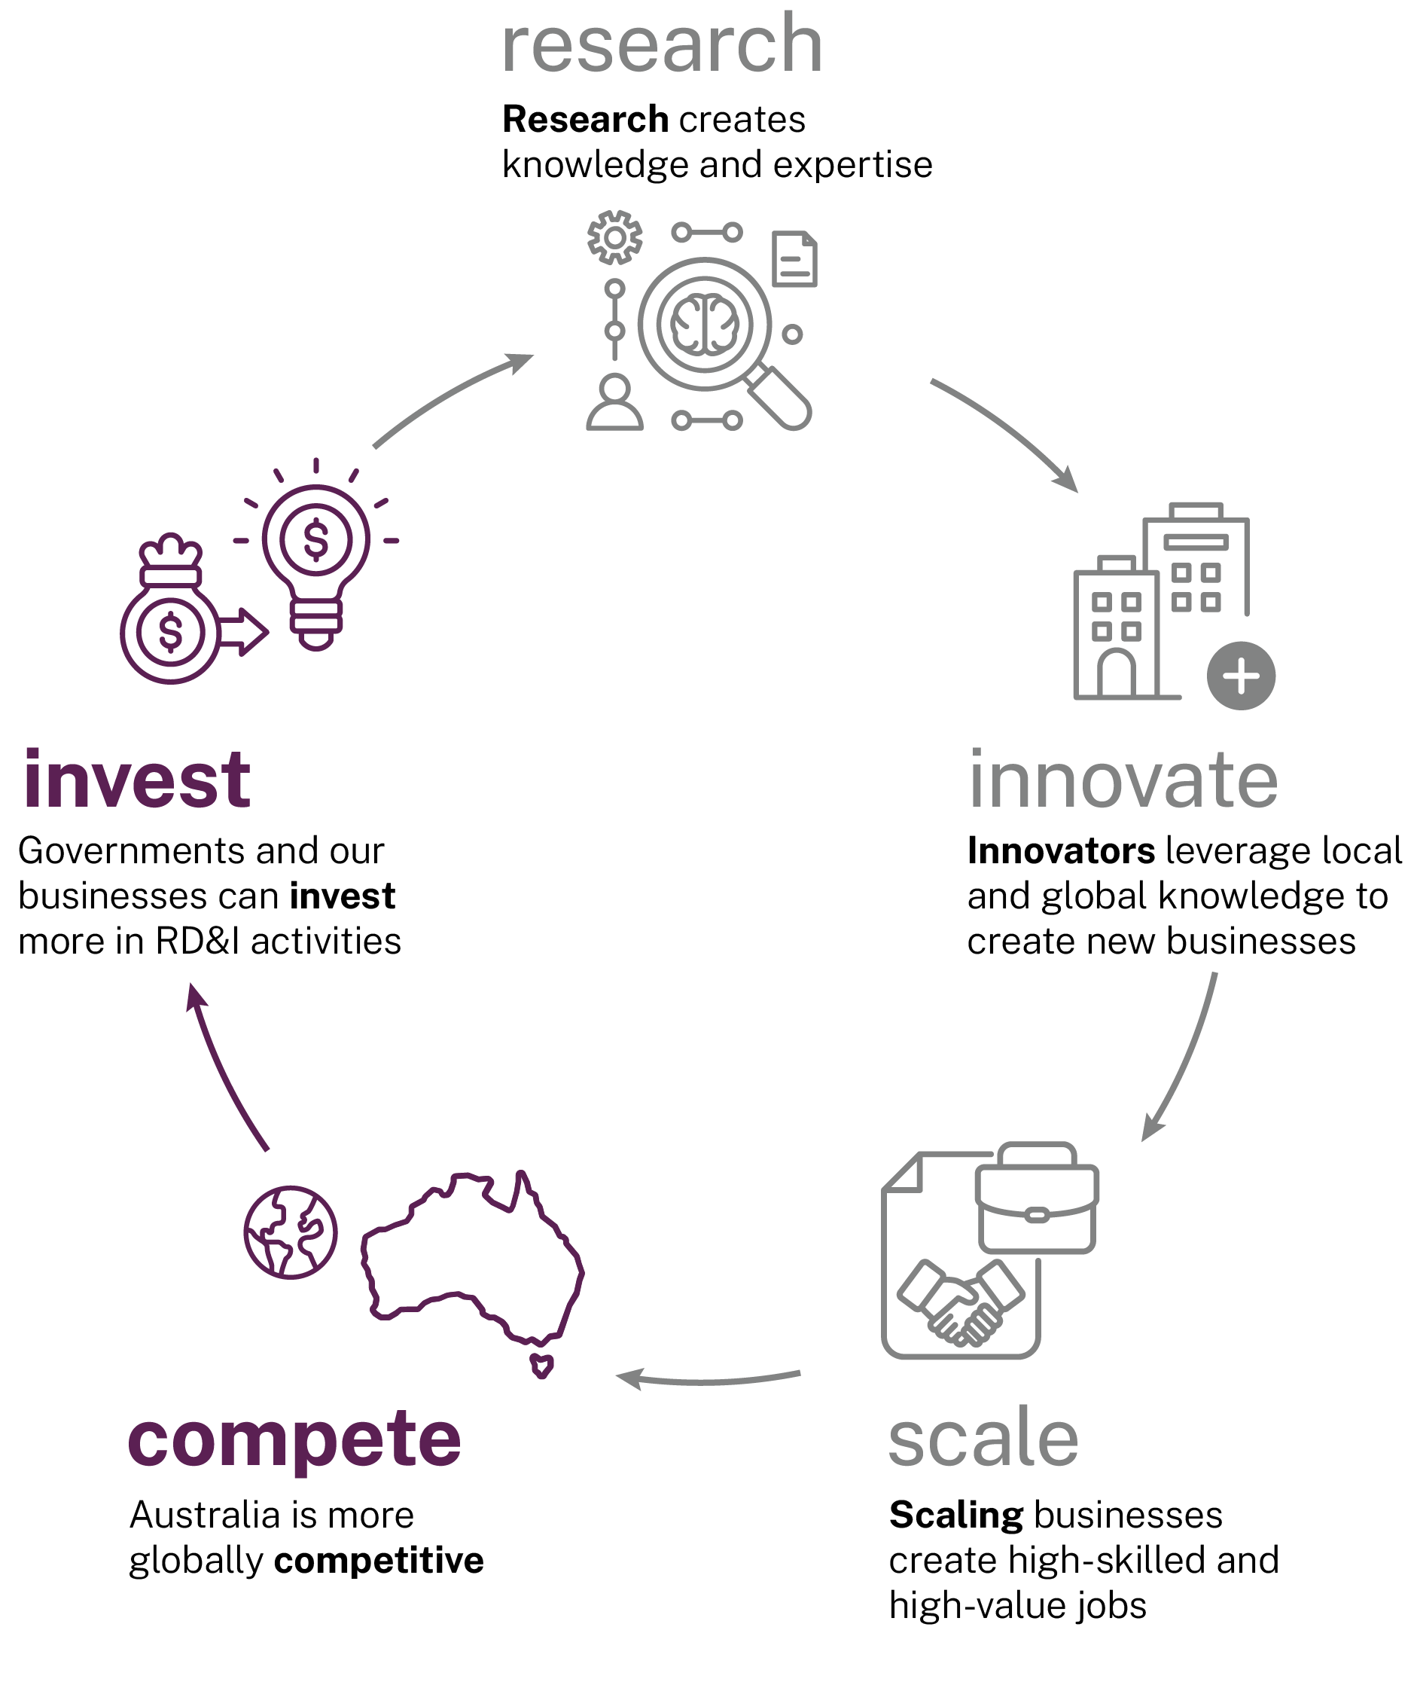
‘What countries spend on generating new knowledge, products, services and processes is important for economic growth and technology innovation, and vital for national security and international competitiveness.’
Darell M West (2022)
At a time when technological capability underpins sovereignty, government’s role in fostering RD&I is not about intervention; it is about creating a deliberate strategy to achieve a national ambition. Government leadership, from funding research to procuring innovation and setting or easing regulatory frameworks, can determine whether breakthroughs from Australian knowledge and capability become enduring national assets – or remain missed opportunities.
Figure 36: Stakeholder views on government playing a larger role in the RD&I system (n=418)
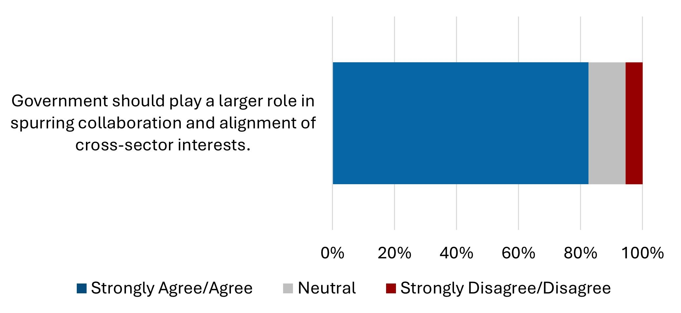
Source: SERD discussion paper survey responses, April 2025
To drive innovation effectively, governments must deploy every tool at their disposal.
‘Governments can foster innovation four basic ways: by buying it, by reducing its risk, by collaborating on it, and by using standards or regulations to encourage it.’
Ashok Boghani and Ronald Jonash (1993)
Public procurement is essential to supporting RD&I in Australia, creating an enabling domestic environment for innovation. Governments in Australia need to invest in local RD&I capabilities through public procurement and reduce our dependence on international supply chains. Current practices are criticised as risk averse, overly complex and lacking the mechanisms to support high-potential firms.
‘Federal and state governments must lead by adopting local innovations and allocating dedicated budgets to support finding solutions to the challenges these departments consistently face.’
SERD submission, Gemaker
We need a tax system that is internationally competitive to support local RD&I businesses and entice innovative overseas companies to establish operations in Australia. Our high corporate tax rates are a barrier to RD&I businesses remaining onshore. For Australia to truly compete in a global RD&I market, our governments must create an enabling environment for innovation.
Australia’s regulatory and grants frameworks are complex, fragmented, and outdated, creating unnecessary barriers for businesses, innovators, and research institutions. Better processes are needed to accelerate innovation across the RD&I system. Without reform, these challenges can slow technology development and adoption, discourage investment, and make it harder for all participants to contribute effectively and respond to national priorities. Along with reforms to the Research and Development Tax Incentive (RDTI) and investment programs to reduce regulatory burden, government must reduce complexity in grant systems. Streamlining and modernising these frameworks will reduce administrative burdens, encourage investment, and help RD&I achieve impact more quickly.
Australia’s publicly funded research agencies (PFRAs) and rural research and development corporations (RDCs) must have clearly defined and distinct roles in the national RD&I system to ensure the value of the Commonwealth’s investment is maximised. Aligning the PFRAs and RDCs with the National Innovation Pillars (pillars) will ensure that they can contribute more effectively to national goals as strategic partners in a coordinated system.
The current focus on inputs, like expenditure, does not provide a clear picture of the real impact of RD&I. This approach makes it difficult to effectively assess outcomes, limits accountability, and weakens alignment with national priorities. Australia needs an outcomes-focused performance measurement framework that tracks the benefits and impacts of RD&I across all sectors, supporting evidence-based decisions and stronger national accountability and alignment.
Australia’s reputation as an innovation nation needs to be strengthened to attract more international investment and talent. By streamlining pathways for global investors and businesses, and promoting national capabilities, governments can position Australia as an innovation nation and support the competitiveness of our ideas and enterprises globally.
The panel proposes a plan that will:
- prioritise Australian RD&I in procurement
- focus future tax reform to make Australia a competitive location for investment
- streamline grants and funding processes
- align research agencies with national goals
- re-focus system measurement on RD&I outcomes, rather than inputs
- drive cultural change for RD&I.
These points are addressed in detail in the following sections.
  - Prioritise procurement of Australian RD&I
Government procurement is a critical lever for economic growth and innovation because of its strategic influence and scale. This purchasing power enables governments not only to deliver essential services but also shape markets, create demand that encourage firms to invest in research and development (R&D), and develop new technologies.
In Australia, government procurement makes up 18.2% of GDP and 47.2% of total government expenditure, above OECD averages (13.2% and 29.9%). Of the Australian Government’s procurement, 23% was awarded to offshore companies (Department of Finance 2023-24). What matters is how and where it is spent. Directing a greater share of public procurement towards domestic RD&I could deliver substantial impact to the system.
Figure 37: General government procurement spending (2023)
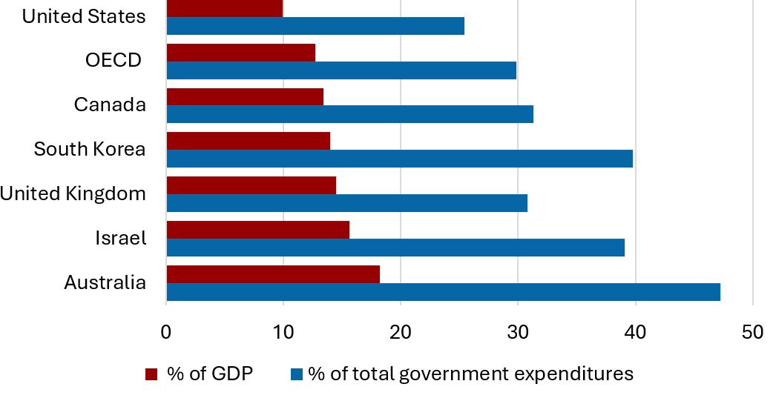
Source: Adapted from Government at a Glance 2025, OECD (OECD 2025c).
Widespread views (including in governments) that Australia can simply purchase innovations from overseas will yield a bleak Australian economy and adversely impact our long-term prosperity and sovereign risk.
‘Australian agencies and its controlled entities do not strongly prioritize purchasing from domestic innovators. Changing procurement rules to favour innovation would send a powerful signal.’
SERD submission, Ziger Energy Systems
Current procurement pathways into Government are a challenge. Submissions criticised current practices for being risk averse, overly complex, slow and costly. They are also seen as favouring short-term cost savings over long-term outcomes. These barriers can make it harder for startups and small-to-medium enterprises (SMEs) to compete for government tenders.
There is untapped flexibility in government procurement frameworks that could be used to better support RD&I. The Commonwealth Department of Finance and Department of Industry, Science and Resources (DISR) have a range of activities underway to actively promote better practice and better use of the current procurement framework. These include addressing capability gaps among procurement professionals through training.
States are also taking positive steps. For example, NSW’s ‘If not, why not’ procurement policy ensures that NSW Government agencies engage with local suppliers before going to tender for projects worth more than $7.5 million (Procurement Board 2024). Agencies must provide justification if a relevant contract is awarded to a supplier outside of NSW.

Recommendation 15
Prioritise procurement of Australian RD&I and implement ‘if not, why not’ as a core tenet of the procurement policies of Australian governments. National Cabinet should provide leadership by setting goals for procurement outcomes and requiring public reporting against those goals.

Recommended implementation pathways include:
- A shared approach to use public procurement to grow local RD&I through:
  - promotion and use of co-creation and challenge-based innovation procurement
  - expanded pathways for RD&I startups and SMEs in procurement
  - creating data-informed targets for local RD&I procurement spend
  - implementing ‘if not, why not’ as a core tenet of procurement policies.
- The Department of Finance, Department of Industry, Science and Resources, and Australian Public Service Commission driving cultural change across the Australian Government by:
  - creating simplified guidance on how the Commonwealth Procurement Framework can support RD&I, including local RD&I weightings and panel flexibility frameworks
  - providing training to embed innovation-friendly procurement practices, including supporting departments to engage with risk and use RD&I-focused assessment criteria in tender evaluations where innovation is key
  - introducing an innovation marker to the supplier panel to better identify RD&I active businesses.
- Governments to leverage procurement contracts with larger providers to encourage procurement from Australia’s RD&I system, including partnering with universities, supporting industry PhDs, and sourcing from Australian RD&I-active firms.
  - Future tax reform to make Australia a competitive location for investment
Governments need to prioritise reform of fundamental policy settings to lift RD&I. Australia must compete in a global RD&I market and be seen as an attractive destination to undertake RD&I activities. Uncompetitive tax settings are undermining our ability to keep businesses in Australia, including larger firms that anchor RD&I systems.
Building and retaining stronger RD&I activities by Australian businesses will help our economy. Additional dividends will be gained if we retain and grow high-value manufacturing and sovereign capabilities, resulting from local RD&I activities. In turn, this will support economic transformation, complexity, and value-adding in Australia. Achieving international cost-competitiveness would significantly improve our strategic positioning and make Australia a more attractive destination for domestic and foreign investment.
Australia’s current full corporate tax rate has been set at 30% since 2002 (Figure 38), the only change being a cut to 25% for businesses with turnovers of less than $50 million (Productivity Commission 2025a). The OECD average has been consistently lower than Australia for over 2 decades, currently sitting at 24.1% (OECD 2025d).
Figure 38: Competitiveness of Australia’s corporate tax rate
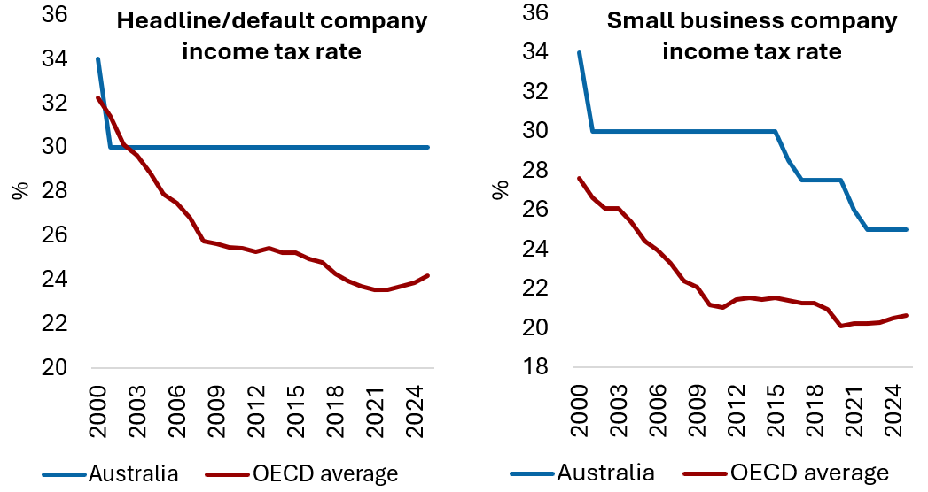
Source: Adapted from Quarterly productivity bulletin – September 2025, Productivity Commission (Productivity Commission 2025b).
Many stakeholders expressed support for a company tax rate reduction by 5–10%, noting that the current rate limits the amount of capital available to companies. These stakeholders suggested that the current rate is a disincentive to investing in RD&I in Australia and a barrier to attracting foreign investors to base their companies here.
'Australia must take decisive steps to reform its tax system to encourage investment in innovation. Currently ranked 32nd in the OECD for tax competitiveness, Australia's corporate tax settings are a significant disincentive to reinvestment in R&D.’
SERD submission, Mitchell, Bu & Gu,
Macquarie Business School
The Productivity Commission (PC) notes that Australia’s corporate tax rate has fallen out of step with other countries, and requires reform to be more competitive (Productivity Commission 2025a). Reforms to tax settings should also consider mechanisms that improve liquidity and simplify RD&I capital deductions, such as instant asset write-offs. This will enable RD&I businesses to re-invest more quickly.
The recommended package of RD&I-specific incentives, including through the pillars model (see Chapter 1), RDTI reform and R&D production subsidies (see Chapter 3), will create a more attractive environment for RD&I businesses in Australia.
The proposals would translate to an effective tax rate on R&D of about 11.5% for large companies. Removing the RDTI offset from franking credit calculations would reinforce the value of RD&I investment with shareholders. R&D-linked production subsidies will support local manufacturing.

Recommendation 16
Future tax reform should prioritise a competitive effective corporate tax rate for RD&I companies to make Australia an attractive location for investment and innovative business activity.

Recommended implementation pathways include:
- The RD&I incentives outlined in this report be adopted alongside any forthcoming tax reforms.
- The Australian Government consider mechanisms that further encourage RD&I reinvestments by business in future tax reform.
  - Streamline grants and funding processes
Over decades the RD&I system has become increasingly complex, bureaucratic, and risk-averse, leading to unproductive processes.
A fragmented and inconsistent approach to grants and funding processes across jurisdictions constrains Australia’s RD&I ecosystem and imposes significant efficiency costs on researchers, businesses and innovators. For example, in 2012, National Health and Medical Research Council (NHMRC) applicants spent an estimated 550 working years preparing submissions, costing approximately $66 million in annual salary costs (Herbert et al. 2013). The panel heard anecdotal evidence that this issue has worsened since.
‘Cumbersome application processes, excessive reporting, and sluggish decision-making bog down government funding schemes. This erodes trust as researchers and smaller players (e.g. startups) lose faith in an inefficient system, while diminishing value for money by diverting time and resources from innovation to administration, delaying outcomes.’
SERD submission, Brett Jackson
Stakeholders noted that government programs impose high administrative burdens, describing them as overly complex, time-consuming, and focused on meeting government priorities over researcher and business needs. These burdens disproportionately affect startups and SMEs, limiting their participation.
Australia has a clear opportunity to modernise its innovation ecosystem through targeted administrative reforms. Streamlining, standardising, and integrating digital systems to create a single access point for all Australian Government RD&I grant processes would substantially reduce administrative burden and improve accessibility for innovators. Efficiency could be further improved by incorporating features such as registration, pre-filled forms, personalised alerts, application tracking, and user support. Encouraging states and territories to adopt unified modernised grant platforms would help extend these benefits.
A 2-stage grant design, including expressions of interest, can reduce administrative burden and response time for high-value grants, as well as reducing the cost to applicants. In the UK, the overall cost per funding round reduced by approximately £43,566 after changing from a one-stage to a 2-stage process (Morgan et al. 2020). Importantly, a 2-stage approach must not extend the total time to decision. Rather, by reducing the number of full applications, it should enable faster funding decisions.
Involving end users, including business leaders, in the grant decision making process will help ensure there is ‘pull through’ of research. It will support Government to accept greater levels of risk.

Recommendation 17
Increase the impact of the national RD&I investment by focusing on the effectiveness of grants and funding processes through simplification, standardisation and improved technologies, accompanied by a proportionate appetite for risk.

Recommended implementation pathways include:
- Unifying and modernising grants management processes through improved technologies, simplification, and standardisation.
- Employing 2-stage application processes for all RD&I grants to improve efficiency and accessibility for applicants and assessors.
  - Align research agencies with national goals
Australia’s 16 PFRAs deliver quality research and operational science services, contributing to Australia’s economic and societal prosperity.
PFRAs face significant challenges including constrained resources, rising operational costs, and workforce pressures. They must balance evolving research priorities with service delivery, maintain public trust amid misinformation, and navigate funding instability while managing critical infrastructure. The number of PFRAs and the breadth of their activities, combined with the absence of clear coordination across agencies, creates a risk of duplication and inefficiency.
Figure 39: Commonwealth science, research and innovation budgets for PFRAs and RDCs
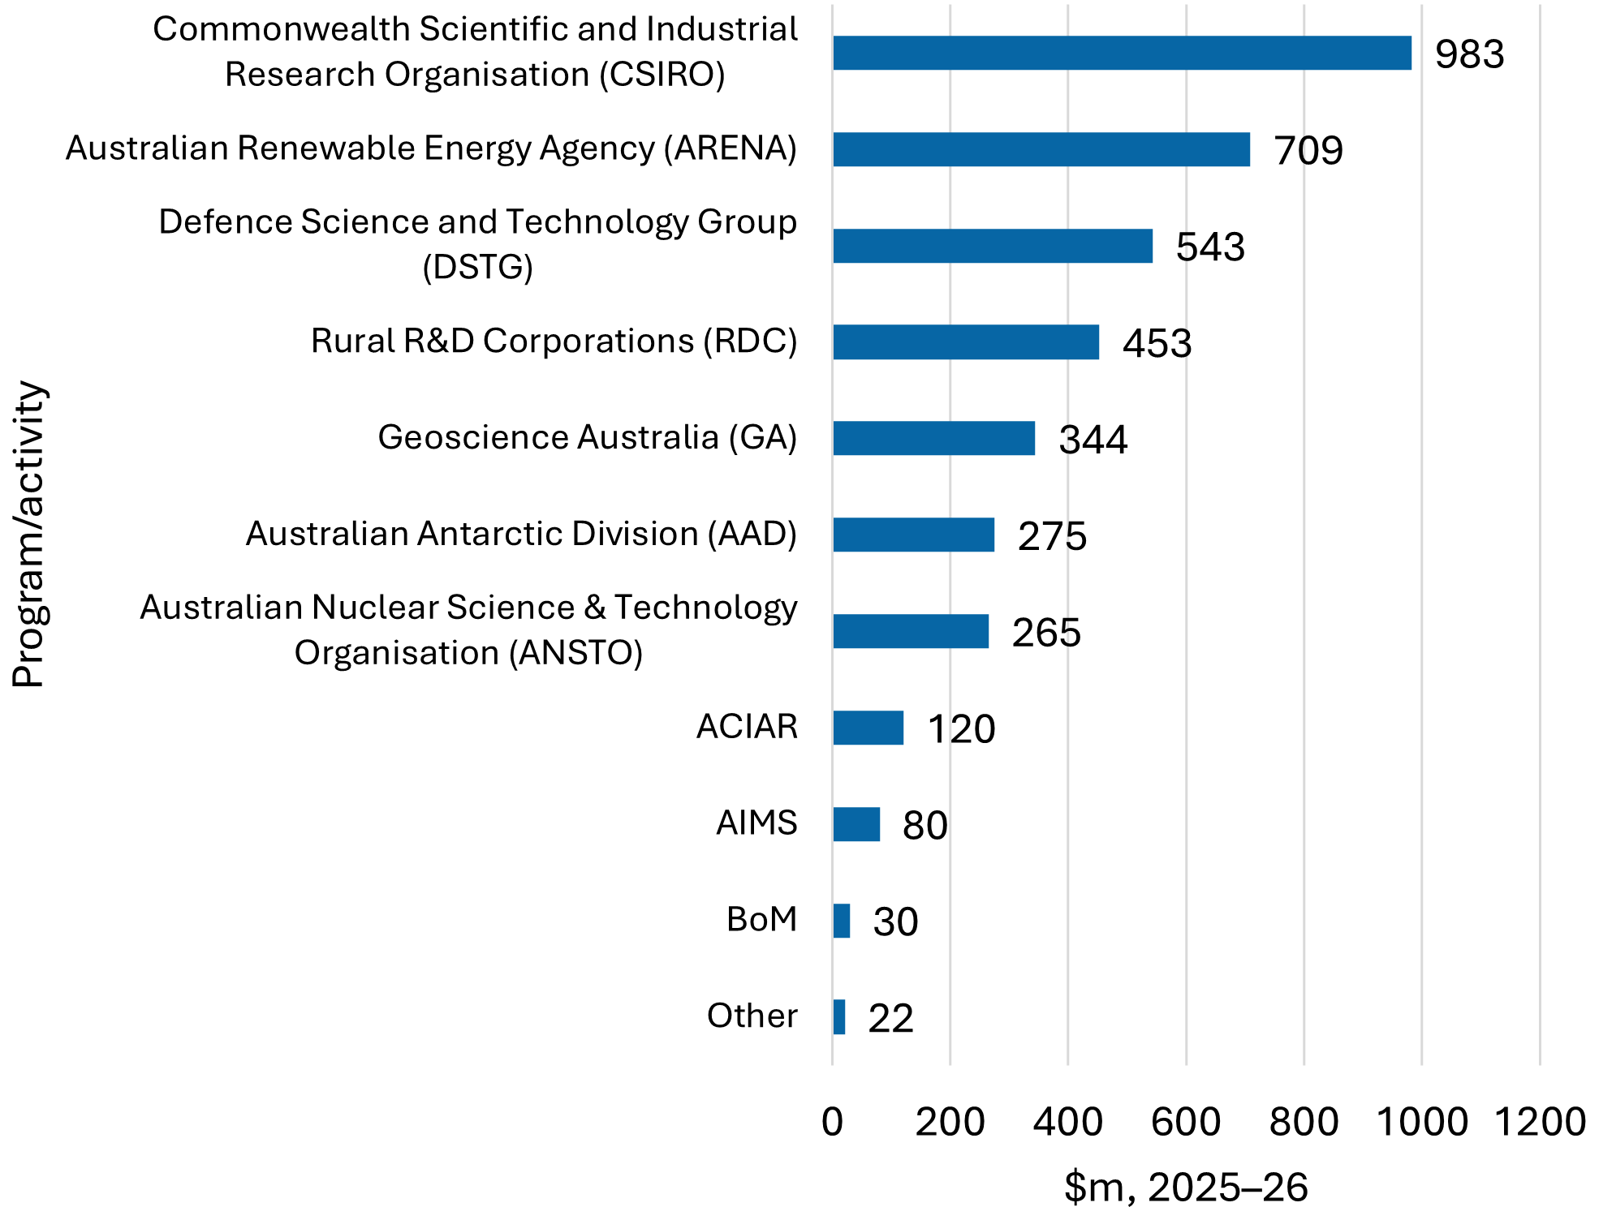
Source: Adapted from SRI budget tables (DISR 2025a). ‘Other’ includes NMI, NAL, AIC, AIATSIS and AIFS; ABARES and CCA are not listed in this publication. Note: this data does not represent the full budget of each agency, only the Commonwealth allocations for science, research and innovation.
As the largest PFRA, the CSIRO is a cornerstone of Australia’s publicly funded research ecosystem. Stakeholders highlighted the need to reassess its strategic role in the broader RD&I system, ensure sustainable funding and prioritise support for the pillars. Collaboration between CSIRO and the university sector was also repeatedly called out as poor by stakeholders with some citing competition between institutions. There is a strong imperative for CSIRO to undertake meaningful reform and concentrate its efforts on a clearly defined set of strategic priorities, rather than clinging to its traditional profile for legacy reasons.
Australia’s RDCs have delivered significant RD&I for our agriculture sectors. RDCs have deep industry and government networks and engagement pathways, making them a powerful mechanism for integrating change in the sector. We must maximise the value provided by these entities. Stakeholders have stated that the commodity-based structure of the RDC framework poses challenges to sector-wide collaboration and transparency and has created barriers for co-investment opportunities.
Given these pressures, affirming the role and value of each PFRA and RDC is essential. To maximise the value of Commonwealth investment, PFRAs and RDCs should align their activities with the pillars and establish themselves as essential partners in a coordinated, impactful RD&I system. Within the pillars, CSIRO, other PFRAs and RDCs should collaborate with National Strategic Initiatives (NSIs) to advance subgoals and foster cross-sector partnerships.
Consideration should also be given to consolidating agencies where appropriate, to reduce overheads and simplify the system.

Recommendation 18a
Ensure Australia’s 16 PFRAs and investment in the 15 RDCs align appropriately with National Innovation Pillars and consolidate where possible.

Recommendation 18b
CSIRO should be positioned as a core contributor to the pillars, supported by sustainable and targeted funding to deliver this role effectively.

Recommended implementation pathways include:
- Aligning the capabilities of PFRAs with the pillars, and leveraging their expertise, infrastructure, and facilities to support NSIs.
- Strengthening the role of PFRAs in network facilitation across academia and industry, including by supporting the proposed national research infrastructure coordination mechanisms under the National Innovation Council (NIC).
- Undertaking an assessment of existing PFRAs and RDCs to determine opportunities for consolidation.
  - Re-focus on outcomes, rather than inputs
Measuring the success of the RD&I system is integral to building confidence and encouraging investment. A clear, intuitive, and robust performance measurement framework is needed to show how RD&I activities contribute to the Australian economy and address social and environmental issues.
Submissions also called for unified, national evaluation frameworks to better measure RD&I outcomes and impacts and promote accountability. They also highlighted the need for improved business R&D reporting and data collection by the Australian Bureau of Statistics (ABS).
‘A missed opportunity of the current system is a lack of clear, consistent, and nationally relevant metrics against which value and impact of R&D may be measured.’
SERD submission, Deakin University
The panel agrees that much of the RD&I system focuses on measuring inputs. For example, the ratio of R&D expenditure to GDP (R&D intensity) is a widely used indicator of a nation's RD&I activity. However, it mainly reflects the intensity of inputs and does not show the impact of these activities.
A framework for measuring RD&I outcomes would enable evidence-based policymaking, promote accountability, and improve the visibility of RD&I activities across sectors. It would also support alignment with national goals for productivity, sustainability, and capability-building. The framework should provide detailed, data-based insights into RD&I participants, activities and outcomes.
There are several options available to improve Australia’s RD&I performance and evaluation methods, and a clear need to shift towards output-based metrics. This could involve one or more of the following:
- Creating an RD&I satellite account in the ABS to chart comprehensive and long-term continuous data on RD&I activities and outcomes in the economy.
- Creating a dashboard of output- and outcome-based metrics as intermediary measurements between inputs and impacts, based on a performance framework to ensure desired results.
- Creating a composite index that could record the economic contributions resulting from RD&I activities or policies.

Recommendation 19
The National Innovation Council to develop an outcome-focused RD&I Performance Framework with SMART metrics (Specific, Measurable, Achievable, Relevant and Timebound) to assess impact and quality at program and system levels, supported by enhanced data collection.

Recommended implementation pathways include:
- NIC to develop the framework, consulting with stakeholders, data custodians and experts regarding the range of reporting metrics that will best assess impacts (economic, social and environmental) and quality.
- ABS data collection to increase for more frequent, comprehensive monitoring of RD&I performance, aligned to the national framework.
- Measure PFRA contributions to national goals and industry engagement as part of annual reporting and evaluation processes.
  - Drive cultural change
RD&I is not currently seen as a national priority in Australia’s culture or identity, and as a result many Australians do not see it as essential to our future. We celebrate our sporting prowess, while failing to value scientists, innovators and entrepreneurs or recognise their achievements and impact on our country to anything like a similar extent.
In order to move from a lucky country to an ambitious country that is purposefully creating its own future, we need to change our cultural attitudes towards RD&I across the community.
Partisanship across political divides about the importance of RD&I to Australia’s future is essential to driving this.
A cultural shift is needed to position Australia as a nation that encourages taking entrepreneurial risks and celebrates business and research success. We must value it as a critical mechanism to secure economic prosperity as it lifts productivity, creates jobs, and strengthens national capability.
Australians must persistently celebrate successes, recognise researchers, back our entrepreneurs and share the stories of breakthroughs. Not just every now and then, but at every available opportunity. This will build confidence in the system that will encourage greater activity and investment.
‘When the public and industry understand how and why R&D investments are allocated, and see evidence of effective stewardship, confidence in the system grows.’
SERD submission, public anonymous submission
Australia also must raise its profile as a leading destination for RD&I investment and activity. While through the reforms in Chapter 4 we seek to change the domestic investment landscape, without Foreign Direct Investment (FDI), RD&I-active businesses may fail to acquire sufficient capital to commercialise. Australia has one of the most restrictive and least efficient FDI review regimes among OECD countries.
Submissions broadly supported a national front door to boost Australia's attractiveness as an RD&I destination by providing clear pathways for international investors and aligning with global best practices. Submissions suggested Austrade could better promote Australian innovations and connect innovators with markets.
The panel heard about duplication and lack of coordination between Austrade and state and territory efforts. A national narrative will support alignment and help ensure greater coordination.
Messaging to promote Australia as an innovation nation that can attract the best talent and businesses from overseas is needed. The Pillars and accompanying NSIs must be used to attract foreign talent, investment and big business to locate in Australia. There is an opportunity to develop long-term international collaborations while ensuring Australian research is commercialised domestically.

Recommendation 20
The Australian Government create a national narrative that persistently demonstrates the benefits of RD&I to the community here and abroad, including leveraging the Pillars and this reform package to drive investment and opportunity for Australian innovators.

Recommended implementation pathways include:
- NIC to develop a national RD&I investment narrative that highlights Australia’s RD&I strengths and priorities.
- Treasury to update the foreign investment framework to include RD&I activity as a priority, especially where aligned to the Pillars and their goals.
- Ensure a Whole of Australian Government access point for investors, leveraging Treasury’s foreign investment portal.
- Leverage Austrade and state trade and investment offices for targeted trade missions and marketing campaigns that link the Pillars with global corporates and investors.
  - Why this matters
Decisive government leadership, strategic investment, and streamlined regulatory and funding frameworks are essential if Australia is to convert local breakthroughs into enduring national assets. Failure to prioritise domestic RD&I, maintain competitive tax and procurement settings, and better utilise PFRAs to advance our national goals will perpetuate lack of scale and impact, and leave us vulnerable to supply chain shocks.
Persistent complexity and inefficiency in grants and funding processes will continue to deter innovative startups and SMEs, constraining our economic diversification and competitiveness.
Similarly, without a shift to outcomes-focused measurement and a culture that values innovation, Australia will struggle to attract international talent and investment, diminishing our global standing.

Appendix A: Summary of consultations
The panel took part in webinars, discussions and roundtables as part of an extensive consultation process through 2025. Additional details are available on the department’s website.

Stage and date | Consultations
Analyse  Jan – Apr 2025   | one webinar delivered (130 attendees)  28 one-on-one discussions with key stakeholders  SERD discussion paper released (12 February)  471 discussion paper responses received  40 roundtables held
Build  May – Jul 2025   | Submissions analysed  Policy reforms taken into consideration  Discussion paper findings and analysis released
Test  Aug – Oct 2025   | one webinar delivered (256 attendees)  6 one-on-one discussions with key stakeholders  6 issues papers released  9 roundtables held with key stakeholders  314 issues paper responses received
Decide  Nov – Dec 2025   | Final consultations with key stakeholders and decision makers  Final report delivered to government

Appendix B: Panel members


Robyn Denholm, Chair
Ms Robyn Denholm is an international executive with extensive experience in technology and advanced manufacturing R&D and innovation.
Ms Denholm is the chair of the board of directors of Tesla, Inc. She is also a board member of Blackbird Ventures and chair of Wollemi Capital Group and served as the inaugural chair of the Technology Council of Australia.
Previously Ms Denholm served as the COO, CFO and Head of Strategy at Telstra and as the Executive Vice President, CFO and COO of Juniper Networks, Inc and held executive roles at Sun Microsystems. Ms Denholm also served on the NSW Government’s Investment Attraction Council.
Ms Denholm was awarded a Doctor of Business (Honoris Causa) from the University of New South Wales in 2019. She also holds a Bachelor of Economics from the University of Sydney, and a Masters in Commerce from the University of New South Wales. Ms Denholm is a Fellow of the Institute of Chartered Accountants of Australia New Zealand, and a member of the Australian Institute of Company Directors.


Emeritus Professor Ian Chubb AC
Emeritus Professor Ian Chubb has had a distinguished career across the university and government sectors.
Professor Chubb is chair of the Inter-Governmental Policy Reform Group, established by the Commonwealth Government to implement policy reform in health and medical research in collaboration with all jurisdictions.
His previous roles include Vice-Chancellor of Flinders University (1996–2000) and the Australian National University (ANU) (2001–2011), Chief Scientist of Australia (2011‍–‍2016) plus numerous boards and committees including the Board of Commonwealth Scientific and Industrial Research Organisation (CSIRO) and the Cooperative Research Centres (CRC) Advisory Committee (2015–2020).
Professor Chubb was elected a Fellow of the Australian Academy of Science (AAS) in 2017. He is a member of the AAS Council, leading the development of Australian Science, Australia’s Future: Science 2035, a 10-year plan to position science in support of our national ambitions. He is also a Fellow of the Academy of Technological Sciences and Engineering (ATSE), the Australian College of Educators and the Royal Society of NSW.


Winthrop Professor Fiona Wood AO
Winthrop Professor Fiona Wood is one of Australia’s most innovative and respected surgeons and researchers.
Professor Wood is the director of the Burns Service of Western Australia, and Winthrop Professor in the School of Surgery at the University of Western Australia.
In October 2002, Professor Wood led the team at Royal Perth Hospital to treat the largest proportion of survivors from the 2002 Bali bombings, saving many lives. Professor Wood pioneered the innovative ‘spray-on skin’ technique (Recell), used worldwide today.
Professor Wood was awarded an Order of Australia Medal in 2003, was named Australian of the Year 2005 and received the Officer of the Order of Australia (AO) in 2024.


Dr Kate Cornick
Dr Kate Cornick has considerable experience in technology and innovation across startups, academia, corporate and government.
Dr Cornick is the Chief Executive Officer of LaunchVic, Victoria’s startup agency. She has held a number of board positions, and is currently chair of the University of Melbourne’s Genesis Pre-Seed Fund Investment Committee, and director and investment committee member of the Alice Anderson Fund. She is also a member of the Charles Sturt University Council.
Previously Dr Cornick developed a human resources technology startup and was CEO of ASX listed Rision Ltd.
Dr Cornick undertook her PhD in optical telecommunications at the University of Melbourne.

Appendix C: Terms of reference
The terms of reference outline the purpose, process, scope and timeline to deliver recommendations for the Strategic Examination of Research and Development.

Purpose
The strategic examination will deliver recommendations to secure Australia’s future prosperity by strengthening Australia’s research and development (R&D) system.
While Australia is a global powerhouse of science and research, more can be done to bolster our national R&D system as an important contributor to economic growth and resilience. Maximising Australia’s attractiveness as a place to undertake R&D, particularly in priority areas of the economy, will create higher value jobs in Australia, attract international talent, and grow businesses that can value-add and compete in global supply chains.
The strategic examination of R&D will consider how Australia can get more value from our investments in research across universities, industry and government, how we can harness and grow business investment in R&D, and how we can leverage our scientific strengths to help address national priorities and foster new industries.

Process
An independent panel will be commissioned to lead the examination.
A dedicated secretariat established jointly by the Department of Industry, Science and Resources and the Department of Education, in consultation with Treasury, will undertake research and analysis, and provide governance of the examination.
The panel will engage widely through public consultation and targeted discussion, including with researchers, businesses, Commonwealth, state and territory governments, in undertaking its examination.
The panel will report to the Minister for Industry and Science, the Treasurer and Minister for Education.

Scope of the examination
The panel should assess the benefits to economic growth and productivity from a more purposeful approach to research and development.
The panel will consider opportunities to:
- maximise the value of existing investment in R&D, across government, universities, philanthropy and industry
- strengthen linkages between research and industry, enabling greater mobility of researchers and innovators between sectors and addressing barriers to meaningful collaboration
- support the achievement of national priorities, including mechanisms to improve coordination and impact of R&D funding and programs across Government and through our science agencies
- drive greater R&D investment by industry, and boost industry adoption of innovation
- uplift Australia’s overall R&D intensity.
In doing so, the panel will examine:
- the current state of Australia’s R&D system, and comparable state of OECD investment in R&D, including levels of investment in R&D, R&D infrastructure and R&D workforce, across sectors
- barriers and risks impacting on Australia’s capacity to maintain R&D competitiveness
- ways to better measure the value and impact of R&D investments, and maximise efficiencies
- ways to ensure R&D benefits are equitably distributed across regions and communities.
The strategic examination should take into consideration recent and ongoing reviews commissioned by Australian Governments relating to Australia’s research, innovation, and productivity performance, including the Australian Universities Accord and the National Science and Research Priorities.
The panel’s recommendations should also consider the contribution of First Nations knowledge, knowledge systems and leadership of research that has impactful, transformative outcomes for all Australians, but especially First Nations peoples.

Time frame
The strategic examination will be conducted until 31 December 2025.

Appendix D: References
ABS (Australian Bureau of Statistics) (2021) Census, ABS website, Australian Government, accessed January 2025.
——(2022–23) Innovation in Australian business, ABS website, Australian Government accessed November 2025.
——(2023–24) Research and experimental development, businesses, Australia, ABS website, Australian Government, accessed 26 March 2025.
——(2025a) Australian National Accounts: Input-Output Tables [data set], ABS website, Australian Government, accessed 26 March 2025.
——(2025b) Research and experimental development, businesses, Australia [data set], ABS website, Australian Government, accessed 26 March 2025.
Alberta Investment Management Corporation (2024) Investing Globally, Rooted in Home: Annual Report [PDF], accessed August 2025.
Allen WW, Augustine NR, Clendenin JL, Eaton RJ, Fisher GMC, Galvin RW, Gerstner LV, Gorman JT, Greenwald G, Heilmeier GH, Junkins JR, McDonnell J, Tobias RL, Vagelos PR, Welch JF, Woolard ES (May 1995) ‘A Moment of Truth for America: An open letter to Congress from the executives of some of America's leading technology companies’, accessed May 2025.
American Association of University Professors (2017) In Defense of Knowledge and Higher Education, AAUP website, accessed May 2025.
ANZ Banking Group (Australia and New Zealand Banking Group Limited) (2025) Australia's $50 billion opportunity [PDF], ANZ Banking Group, accessed October 2025.
Appelt S, Bajgar M, Criscuolo C, and Galindo-Rueda F (2025) How effective are R&D tax incentives? Reconciling the micro and macro evidence, Centre for Economic Performance, accessed November 2025.
Austrade (Australian Trade and Investment Commission) (2024) Austrade’s Trade and Inward Investment Results 2023–2024, Austrade website, Australian Government, accessed February 2025.
Australian Academy of Science (2025) Australian science, Australia’s future: Science 2035, AAS website, accessed November 2025.
Australian Institute of Company Directors and The University of Sydney (2022) Innovation in the Boardroom: Rising to the Challenge? [PDF], Australian Institute of Company Directors, accessed May 2025.
Australian Investment Council (2024) Annual Superannuation Performance Test: AIC Submission, AIC, accessed April 2025.
Australian Investment Council and EY (2024) Funding the Future: Meeting Australia’s investment challenge, boosting jobs and turning ideas into thriving businesses [PDF], accessed 17 April 2025.
APRA (Australian Prudential Regulation Authority) (2025a) Quarterly superannuation industry publication, APRA website, accessed June 2025.
——(2025b) Annual fund-level superannuation statistics [data set], APRA website, accessed 30 January 2025.
Australian Securities and Investments Commission (2018) ASIC licenses first crowd-sourced funding intermediaries [media release], ASIC, accessed 11 January 2025.
——(2025a) ASIC calls for feedback on stamp duty and portfolio holdings disclosure requirements for super funds [media release], ASIC, accessed November 2025.
——(2025b) Advancing Australia’s evolving capital markets: Discussion paper response report, ASIC, accessed November 2025.
Australian Taxation Office (2022–23) Medium Business Income Tax Gap: Latest Estimate and Trends, ATO website, Australian Government, accessed 3 November 2025.
BCI (British Columbia Investment Management Corporation) (2024-2025) Corporate Annual Report, BCI, accessed October 2025.
Beacon RNA (2024) 2024 RNA Landscape Review: Landscape Review Series [PDF], Hanson Wade Group, accessed October 2025.
Birchal (2024) ‘Funded! Crowd-Source Funding (CSF) in Australia’ [PDF], Birchal, accessed 24 November 2025.
Blair T (2001) ‘PM Speech: ‘Science Matters’’, IUMB Life, accessed 23 May 2025, doi:10.1080/15216540214927.
Boghani AB and Jonash RS (1993) ‘The Role of Government in Fostering Innovation’, Arthur Little, accessed June 2025.
Boie-Wegener M (2025) Firms’ Real and Reporting Responses to Tax Policy: Evidence on Investment Incentives, Anti-Avoidance Measures, and Dispute Resolution [cumulative dissertation], University of Göttingen, accessed 31 July 2025.
CFA Institute (2022) The Future of Work in Investment Management: Skills and Learning, CFR Institute, accessed June 2021.
Chalmers J (2025) ‘Address to the National Press Club, Canberra’, Ministers, Treasury Portfolio, accessed June 2025.
Cicada Innovations (2024) Cicada x Tech23 Insights Report, Cicada Innovations, accessed May 2025.
Clarivate Analytics (2025), InCites [data set], Clarivate website, accessed 20 February 2025.
CEDA (Committee for Economic Development of Australia) (2025) IMD World Competitiveness Yearbook 2025: Australia profile, CEDA, accessed August 2025.
Cohen, DR (2022) Australian Geoscience Tertiary Education Profile 2003-2021, Australian Geoscience Council, accessed August 2025.
Corporate Finance Institute (n.d.) Fund of Funds (FOF), CFI website, accessed November 2025.
countryeconomy.com (2024) South Korea GDP - Gross Domestic Product [data set], countryeconomy.com website, accessed August 2025.
CPP Investments (2025) Annual Report 2025, CPP Investments, accessed August 2025.
Crow MM and McNutt M (2025) ‘Universities are the invisible hand’, Issues in Science and Technology, 41(3), 36–39, doi:10.58875/WIAN1772.
CSIRO (Commonwealth Scientific and Industrial Research Organisation) (2021) CSIRO Futures (2021) Quantifying Australia's returns to innovation, CSIRO, accessed September 2025.
Cut Through Venture (2025) ‘Cut Through Venture - Age of Startup at Raise’, LinkedIn, accessed August 2-25.
Cut Through Venture and Folklore Ventures (2024) The State of Australian Startup Funding Report 2024, Cut Through Venture and Folklore Ventures, accessed November 2025.
Dealroom.co (2025a) Company and Transaction Data [data set], Dealroom.co website, accessed August 2025.
——(2025b) Australia Venture & Startup Report, Dealroom.co, accessed August 2025.
de Berg H (5 April 1967) Hazel de Berg interviews Howard Florey: Howard Walter Florey interviewed by Hazel de Berg in the Hazel de Berg collection [interview transcript], National Library of Australia.
Department of Education (2024) Selected Higher Education Statistics – Student data 2005-2024 [data set], Department of Education website, Australian Government, accessed November 2025.
——(2025a) Research block grant allocations time series [data set], Department of Education website, Australian Government, accessed November 2025.
——(2025b) Research and development income time series [data set], Department of Education website, Australian Government, accessed November 2025.
Department of Finance (2023–24) Statistics on Australian Government Procurement Contracts, Department of Finance website, Australian Government, accessed August 2025.
DFAT (Department of Foreign Affairs and Trade) (2025a) Australia’s goods and services by top 25 exports 2024, DFAT, Australian Government, accessed October 2025.
——(2025b) Trade statistical pivot tables, DFAT, Australian Government, accessed November 2025.
Department of the Treasury (2023a) Intergenerational Report 2023: Australia’s future to 2063, Department of the Treasury, Australian Government, accessed November 2025.
Department of the Treasury (2023b) Working Future: The Australian Government’s White Paper on Jobs and Opportunities, Department of the Treasury, Australian Government, accessed May 2025.
DISR (Department of Industry, Science and Resources) (2023) Critical Technologies Statement, DISR, Australian Government.
——(2025a) Science, Research and Innovation (SRI) Budget Tables [data set], DISR website, Australian Government.
——(2025b) Strategic Examination for Research and Development: discussion paper, DISR, Australian Government.
——(2025c) Venture Capital Dashboard, DISR, Australian Government.
——(n.d.) Research and development expenditure, DISR website, Australian Government, accessed November 2025.
——(unpublished calculations) Analysis of crowd sourced funding per capita, DISR, Australian Government.
——(unpublished calculations) Analysis of unpublished RDTI program data, DISR, Australian Government.
Dosi G, Lamperti F, Mazzucato M, Napoletano M, and Roventini A (2023) ‘Mission-oriented policies and the ‘Entrepreneurial State’ at work: An agent-based exploration’, Journal of Economic Dynamics and Control, 151, https://doi.org/10.1016/j.jedc.2023.104650.
Evans M, Polidano C (16 June 2022) ‘First Nations Businesses: Progress, Challenges and Opportunities’, Reserve Bank of Australia.
Glasner J (19 August 2024) ‘Startups Take Longer To Close Rounds, As Funding Cliff Looms’, Crunchbase News, accessed August 2025.
Growth Lab (n.d.) The Atlas of Economic Complexity, Harvard University.
Harris R S, Jenkinson T, Kaplan S N, and Stucke R (2018) ‘Financial intermediation in private equity: how well do funds of funds perform?’, Journal of Financial Economics, 129(2):287-305, https://doi.org/10.1016/j.jfineco.2018.04.013.
Hartcher P (21 June 2025) ‘Is this gentle Jim’s JFK moment? If it is, he’s overlooked one thing’, The Sydney Morning Herald.
Hawke B (8 March 1990) ‘Policy Launch by the Prime Minister, Bob Hawke’ [speech transcript], PM Transcripts, Department of the Prime Minister and Cabinet, Australian Government.
Heckemeyer J H, Nicolay K, Spengel C, Steinbrenner D, and Wickel S (2025) Tax Incentives and Investments in the EU: Best Practices and Ways to Stimulate Private Investments and Prevent Harmful Tax Practices, publication for the Subcommittee on Tax Matters, Policy Department of the Directorate for Economy and Growth, European Parliament.
Herbert D, Barnett A, Clarke P, Graves N (2013) ‘On the time spent preparing grant proposals: an observational study of Australian researchers’ BMJ Open, 3, https://doi.org/10.1136/bmjopen-2013-002800.
HOOPP (2025) Investments: Plan Performance, HOOP website.
IMD (2024) Making the impossible possible: Innovation and its positive impact on business, education, and research, IMD website.
Industry Innovation and Science Australia (2023) Barriers to collaboration and commercialisation, IISA, Australian Government.
International Monetary Fund (2024) ‘Australia: Selected Issues, IMF Staff Country Reports’, IMF Staff Country Reports, 361, IMF.
Jobs and Skills Australia (2025) Mining, JSA website.
Kasparov G and de Cremer D (18 March 2021) ‘AI Should Augment Human Intelligence, Not Replace It’, Harvard Business Review.
Knowledge Commercialisation Australasia (2024) Survey of Commercialisation Outcomes from Public Research [data set], KCA website, accessed September 2025.
La Caisse (n.d.) Our clients, the depositors, La Caisse website, accessed November 2025.
Larrue P (2021) ‘The design and implementation of mission orientated innovation policies: A new systemic policy approach to address societal challenges’, OECD Science, Technology and Industry Policy Papers, No. 100, OECD Publishing.
Majeed O and Breunig R (2022) ‘Determinants of innovation novelty: Evidence from Australian administrative data’, Economics of Innovation and New Technology, 32(8):1249–1273.
Mandala Partners (2025) Unlocking Australia’s R&D potential, Mandala Partners.
Morgan B, Ly-Mee Y, Solomon T and Ziebland S (2020) ‘Assessing health research grant applications: A retrospective comparative review of a one-stage versus a two-stage application assessment process’, PLOS One, 15(3), doi:10.1371/journal.pone.0230118.
National Council for Civilian Research and Development (2022) Recommendation on Israel’s national civilian R&D priority areas, NCCRD, Ministry of Innovation, Science & Technology, State of Israel.
OECD (2017) Entrepreneurship at a Glance 2017, OECD Publishing, accessed August 2025.
OECD (2025a) OECD Dashboard of Productivity Indicators [data set], OECD Data Explorer, accessed August 2025.
——(2025b) Main science and technology indicators [data set], OECD Data Explorer, accessed August 2025.
——(2025c) Government at a Glance 2025, OECD Publishing, accessed August 2025.
——(2025d) Corporate Tax Statistics 2025, OECD Publishing, accessed August 2025.
Ontario Teachers' Pension Plan (2024) 2024 Annual Report, Ontario Teachers’ Pension Plan.
Palangkaraya A, Webster B and Kollmann T (unpublished) R&D Spillovers, R&D Labour Mobility Effects, and the Effectiveness of R&D Subsidies: A Microeconometric Analysis of the Rate of Returns to Australian Business R&D Across Fields of Research and Industry, report for the Strategic Examination of R&D.
Pitcher Partners (9 July 2025) ‘Beyond the boom – The next chapter for Venture Capital investors in Australia’, Pitcher Partners.
Procurement Board (2024) PBD 2024-02 Increasing opportunities for local suppliers to supply to government, Administrative Requirements Portal website, NSW Government, accessed November 2025.
Productivity Commission (2025a) Creating a more dynamic and resilient economy: Interim report, Productivity Commission, Australian Government.
——(2025b) Quarterly productivity bulletin – September 2025, Productivity Commission, Australian Government.
Public Sector Pension Investment Board (2025) Invest PSP [website].
Reserve Bank of Australia (2025) Composition of the Australian Economy, RBA website.
Reynolds M (12 June 2023) ‘What the Scientists Who Pioneered Weight-Loss Drugs Want You to Know’, Wired.
Sharp A, Taylor J, and Fitzimmons M (27 March 2024) ‘Observations on the ESVCLP Regime: A Practitioner’s Perspective’, Alvarez and Marsal.
Startup Genome (2024) Startup Genome [website], accessed September 2025.
Super Members Council (2025) Submission to ASIC Discussion Paper – Australia’s evolving capital, SMC.
Tech Council of Australia (2021) The economic contribution of Australia's tech sector [PDF], TCA.
——(2022) Shots on Goal [PDF], TCA.
—— (2024) About Us, TCA website.
UK Department for Science, Innovation and Technology (2025) DSIT Research and Development (R&D) plans to 2029/2030, UK DSIT, accessed 30 October 2025.
Universities Australia (n.d.) Research & Innovation, Universities Australia website, accessed November 27 2025.
West D (10 October 2022) ‘R&D for the public good: Ways to strengthen societal innovation in the United States’ Brookings.
World Bank Group (2024a) Manufacturing, value added [data set], World Bank Group website.
——(2024b) GDP (Current US$) - Korea, Rep [data set], World Bank Group website.
Ziesemer T (2021) ‘Mission-oriented R&D and growth’, Journal of Applied Economics, 24 (1): 460-477, doi:10.1080/15140326.2021.1963395.

Appendix E: Acronyms
Acronym | Definition
AAS | Australian Academy of Science
ABS | Australian Bureau of Statistics
AI | artificial intelligence
AO | Order of Australia
ARC | Australian Research Council
ARENA | Australian Renewable Energy Agency
ASIC | Australian Securities and Investments Commission
ASX | Australian Securities Exchange
ATEC | Australian Tertiary Education Commission
ATSE | Academy of Technological Sciences and Engineering
BERD | business expenditure on research & development
CPI | consumer price index
CRC | Cooperative Research Centres
CSF | crowd sourced funding
CSIRO | Commonwealth Scientific and Industrial Research Organisation
DISR | Department of Industry, Science and Resources
ESIC | early stage innovation company
ESG | environmental, social and governance
ESVCLP | early stage venture capital limited partnerships
FDI | foreign direct investment
FMA | Future Made in Australia
FOF | fund of funds
GDP | gross domestic product
GPU | graphics processing unit
HASS | humanities and social sciences
HPC | high performance computing
ICIP | Indigenous cultural and intellectual property
ICT | information and communications technology
IISA | Industry Innovation and Science Australia
IP | intellectual property
IPO | initial public offering
M&A | merger and acquisition
m | million
MRFF | Medical Research Future Fund
NCRIS | National Collaborative Research Infrastructure Strategy
NHMRC | National Health and Medical Research Council
NRF | National Reconstruction Fund
NSAC | National Strategy Advisory Council
NSI | National Strategic Initiative
OECD | Organisation for Economic Co-operation and Development
PC | Productivity Commission
PFRAs | publicly funded research agencies
RDC | rural research and development corporation
RDTI | research and development tax incentive
R&D | research and development
RD&I | research, development and innovation
RG97 | Australian Securities and Investment Commission (ASIC) Regulatory Guide 97
RTP | research training program
RSP | research support program
SAAS | software as a service
SAFE | simple agreement for future equity
SMART | specific, measurable, achievable, relevant and timebound
SME | small and medium enterprise
STEM | science, technology, engineering, and mathematics
TRAC | transparent approach to costing – research
VC | venture capital
VCLP | venture capital limited partnerships

