Mobilising Australia's missing middle

Executive summary
Medium-sized enterprises (MSEs) make a significant but often overlooked contribution to the Australian economy. Their combination of small businesses agility, emerging scale, research and development (R&D) intensity, and export potential produce out-sized impacts for economic resilience, productivity, and competitiveness. They play an important role connecting large and small firms by transferring business needs, technologies and solutions. The MSE segment represents a smaller share of Australia’s firms and workers than Organisation for Economic Co-operation and Development (OECD) peers like Canada and Germany. This is sometimes called the ‘missing middle’. In 2023, Industry Innovation and Science Australia (IISA) explored this issue in Barriers to collaboration and commercialisation. It highlighted Australia’s scale-up problem and barriers to MSE growth. But the evidence base on MSEs remains limited and under-explored. Better understanding the role of MSEs in the industrial innovation system could give rise to new policy options to tackle Australia’s long-term economic problems.
Strengthening Australia’s economic middle could help address national challenges. Australia’s declining productivity growth and economic complexity are well-known problems. They have been consistent challenges to successive governments and peer economies as all countries seek to address global headwinds from demographic changes and disruptive technology. Adjusting the share of economic activity from Australia’s MSE segment relative to small and large firms could contribute to reversing these trends. But the nature of being an MSE in Australia comes with challenges – large operating costs, a small domestic market, and export barriers. If MSEs are to make a greater contribution, then policy should explore how best to foster economic conditions and remove barriers to growing the MSE segment in areas of national focus. With productivity and innovation at the centre of the economic agenda, it is timely to consider the missing middle’s role in achieving Australia’s national objectives.
MSEs have several characteristics that benefit our economic system. They serve as connectors between small and large businesses, combining small business agility with capacity and scalability. With appropriate risk appetite, MSEs can use their structure and systems to identify market needs and realise new opportunities. IISA has identified several key attributes of MSEs:
- Innovative: MSEs are strong innovators – a critical lever for long-term productivity.
- Productive, value-adding exporters at scale: Australia’s MSEs are turning points in scale, being more export-oriented, more productive, and adding more value than small firms.
- Competitive: MSEs are supply chain connectors, specialising to be competitive at scale.
- Resilient: MSEs have more resources to withstand and adapt to shocks than smaller firms.
- Agile: MSEs mix small business proximity to customer, with industrial capability at scale.
- Regional: MSEs grow their share of the economy in regional and remote areas, where large companies are few and scale is still essential for communities impacted by distance.
- Growth potential: The highest rate of high-growth manufacturing firms is in the MSE cohort.
- Essential and enabling: MSEs contribute well to priority sectors and essential services.
Recognising MSEs as a distinct cohort is an essential, but not sufficient, first step to realising the segment’s economic potential. MSEs as a group play a valuable role in Australia’s economic mix, greater than their relative segment size and the aggregate contributions of individual firms. But MSEs remain overlooked in our policy landscape, grouped with start-ups and small business for programs and incentives, and lacking a clear voice in policy discussions. Treating MSEs as a distinct cohort is the first step towards improving the conditions for MSEs to scale onshore and strengthen the segment's share of Australia's economic activity. This may lower the risk profile for investment and generate better returns on public funds than broadly focused industry support programs. This does not require creating new programs but rather better leveraging existing levers using a mature understanding of the distinct attributes and role of MSEs in our economic structure.
Mobilising the middle may realise the dividends of innovation and productivity with greater industry-led R&D and domestic industrial capability. By recognising the unique role of the MSE segment in our economic structure, industry and policy leaders can guide the attributes of these mid-sized firms towards supporting national objectives, like the growth of priority sectors and the adoption and diffusion of emerging technologies to lift productivity and build domestic industrial capacity. For industry to lead this mobilisation, it will require cross-sector collaboration with research and government, including co-designing policy that enables the right conditions for growth. Clear policy ownership and measures will also help promote a more integrated role for MSEs in achieving our national objectives.
Future policy must account for variation among the MSE cohort. Sectoral and regional differences, as well as vastly different models for MSEs internationally, underscore the importance of tailored policy approaches that reflect the local context. Effective support may also require targeting different MSE types and motivations. For instance, adapting programs to suit smaller, ambitious MSEs to scale may require different approaches to incentivising R&D from larger MSEs with a lower appetite for risk. Accounting for these variations must balance the use of existing levers to avoid further fragmenting an already complex system.
IISA aims to continue the discussion and grow the evidence base on the missing middle in future analysis, collaborating across government, industry, and research to:
- Explore success stories of thriving MSE segments in Australian regions and overseas. Understand the differences in each case and the role of MSEs in innovation diffusion, industrial precincts and supply chains across sectors and regions to inform program design.
- Highlight MSEs as a distinct cohort in innovation and growth programs. Analyse the MSE cohort’s traits, barriers, outcomes, and use of incentives and programs across portfolios.
- Consider ways to refine programs to uplift MSEs and meet their distinct needs. Analyse the benefits to MSEs from supports given to start-ups or small and medium enterprises (SMEs), including keeping high-potential technology and industrial firms onshore.
- Identify effective levers that reduce barriers to MSE scale and innovation. Prioritise regions undergoing industrial transition, building capability, and reducing fragmentation and duplication across jurisdictions and innovation pipelines while consolidating public funds.
- Explore demand side factors for MSEs to innovate. This includes considering public procurement and large firms as anchor customers for technology, while forging a clear narrative for investment in demand-driven innovation to build globally competitive industries.

Australia’s ‘missing middle’ opportunity
Australia has a relatively small, underappreciated share of medium-sized enterprises (MSEs) in its economy compared to other countries – sometimes referred to as the ‘missing middle’. MSEs have great potential but struggle to grow, reflecting Australia’s scale-up problem.
Industry Innovation and Science Australia (IISA) built on early work about MSEs being ‘stuck in the middle’ in its 2023 report Barriers to Collaboration and Commercialisation, suggesting:
- MSEs may be a small proportion of total businesses in Australia compared to the OECD.
- MSE share of employment and value added in Australia is small compared to the OECD.
- Australia’s MSEs are more likely to shrink to small businesses than grow into large ones.
Its findings focus on barriers to innovation adoption, manufacturing and comparator countries, albeit with different data definitions, business practices and economic conditions. It is clear there are opportunities to explore these early observations further, starting with a deep understanding of Australian MSEs and the role they play in Australia’s economic structure.
This paper revisits the ‘missing middle’ to clarify the problem, explore opportunities and shape solutions. It seeks to stimulate discussions, inform policy and program design, and advocate for treating the MSE segment as a clear and distinct part of our economic structure. More broadly, this paper considers how a thriving MSE segment could support national priorities. It will advocate not simply to grow the middle but foster conditions to mobilise it towards improving issues like low productivity growth and falling economic complexity (Figures 1 and 2).
Figure 1. Labour productivity growth, 20-year average annual growth rate, 2004-24 | Figure 2. Economic complexity index, rank (out of 145 countries), 2004-23
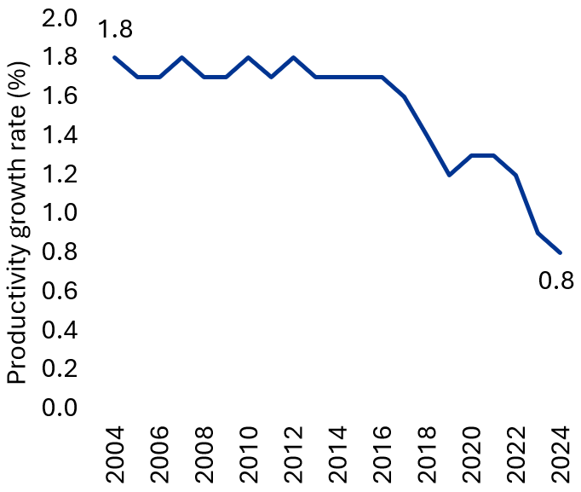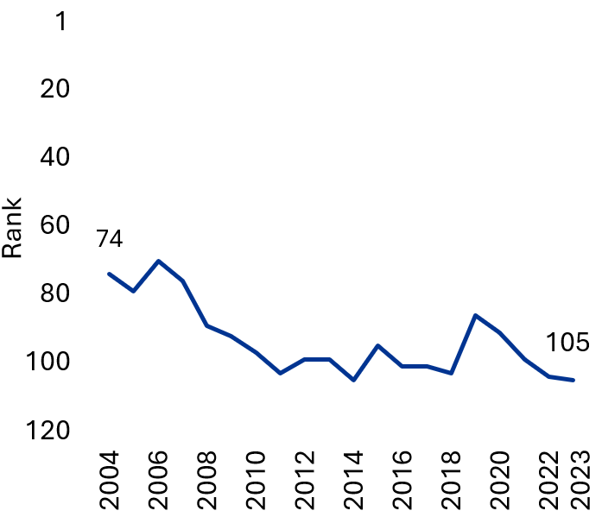

The MSE segment makes an important, but often underappreciated, contribution to tackling Australia’s economic challenges. Australia faces well-known, structural barriers to its long-term prosperity, including low productivity growth and declining economic complexity. There is significant upside to reversing these trends. This includes delivery of a more diverse, resilient and productive economy, and better preparing Australia to navigate global headwinds and disruptive technology. To achieve this, policy will require new approaches in a climate of fiscal constraints, intensifying global competition and rapid change. Refining existing levers to better recognise the distinct traits and needs of MSEs could empower the middle segment to meet these challenges.
A fragmented and opaque evidence base hinders efforts to support Australia’s middle. Current understanding of MSEs only covers isolated attributes or parts of their role in driving innovation and productivity. The ‘missing middle’ also describes issues across housing, commercialisation and energy, which obscures this already limited evidence base. This issue requires a clear understanding to design a coherent strategy, identify effective levers and targets, and argue a need for intervention.
Recent analysis has advanced efforts to clarify issues related to the ‘missing middle’, observing:
- Australia should grow the ‘M’ in its small and medium enterprises (SMEs) to match peers and compete globally, especially in emerging technology like quantum and robotics.
- Scale-ups contribute significantly to the economy by bringing innovation, employment and productivity, with some recommending tailored policy for innovative MSEs to scale.
- MSEs show signs of confidence, improved profitability and growth ambitions, but these insights rely on small sample surveys to isolate the needs of MSEs from small businesses.
- Young, high growth businesses have a greater return on investment for R&D incentives. These firms generate the greatest impact on aggregate growth per dollar of policy support and are more responsive to R&D incentives. With their rapid expansion and increasing market share, young, scale-ups may be better at lifting productivity than other firms.
- Australia’s manufacturing sector has a smaller MSE share of the sector than in other countries, such as Germany, Canada and the US (shown below and in Figure A1).
 |  |  | 
Germany  20.5% | Canada  14.6% | US  8.2% | Australia  7.4%

An economic snapshot of Australia’s MSEs
In Australia, a common definition for MSEs is a public or private enterprise employing between 20 and 199 people. This headcount-based definition is used for demographic and statistical purposes across sectors. Many regulators and policymakers also tailor program design and eligibility around other factors such as turnover and assets (see Technical Note for further discussion). But these elements don’t fully capture the diversity of MSEs and consider their role in the system, nor give rise to programs that treat them as a distinct cohort. An overview of MSEs and their contributions in Australia and the international context is outlined below.
The typical Australian MSE is a significant business operation. In 2023-24, they had sizeable workforces, costs and revenue on average.
 |  |  | 
Employees | Turnover | Wages bill | EBITDA
49.5 | $17.4M | $3.7M | $1.6M
The MSE segment accounts for a significant share of Australia’s economic activity. It contributes 22.9% of industry value added and 25.6% of total employment in the economy. Despite MSEs paying higher wages and being more productive and innovative than small businesses, the segment remains a small share of Australia’s industry structure – 68,214 firms in 2023-24 (2.6% of total). This share has been fairly consistent since at least 2003. MSE contribution to the economy is strong (Table 1) and represented across all jurisdictions (see below and Figure A2).
Table 1. Economic indicators by business size, 2023-24
Economic indicators | Small  (0-19 employees) | Medium  (20-199 employees) | Large  (200+ employees)
Proportion of business numbers by June 2024 (%) | 97.2 | 2.6 | 0.2
Proportion of industry value added (%) | 32.9 | 22.9 | 44.2
Proportion of total employees (%) | 39.1 | 25.6 | 35.3
Industry value added per employee ($’000) | 115.4 | 123.4 | 176.7
Average wages and salaries ($’000) | 43.5 | 73.8 | 82.7
MSEs and MSE workers as share of total in each state | 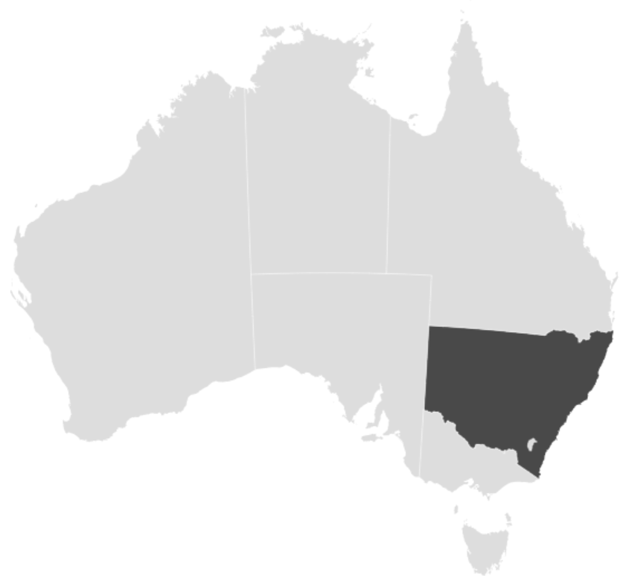 | 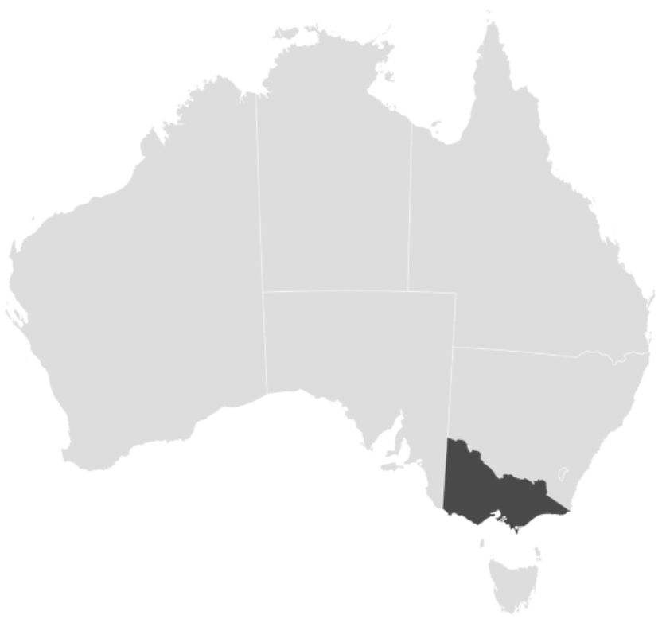 | 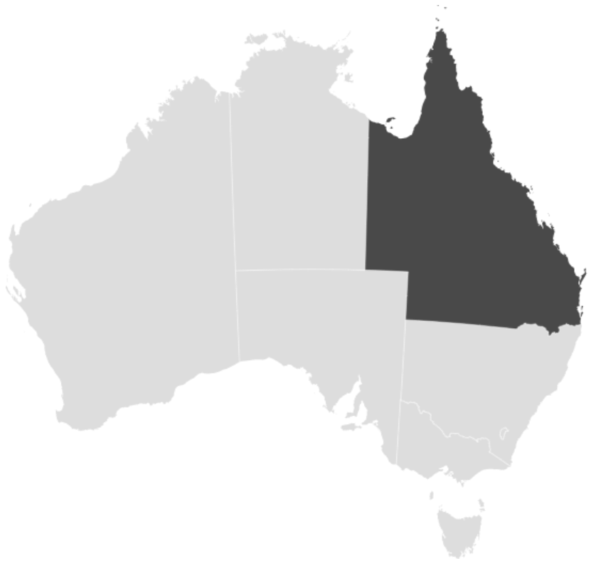 | 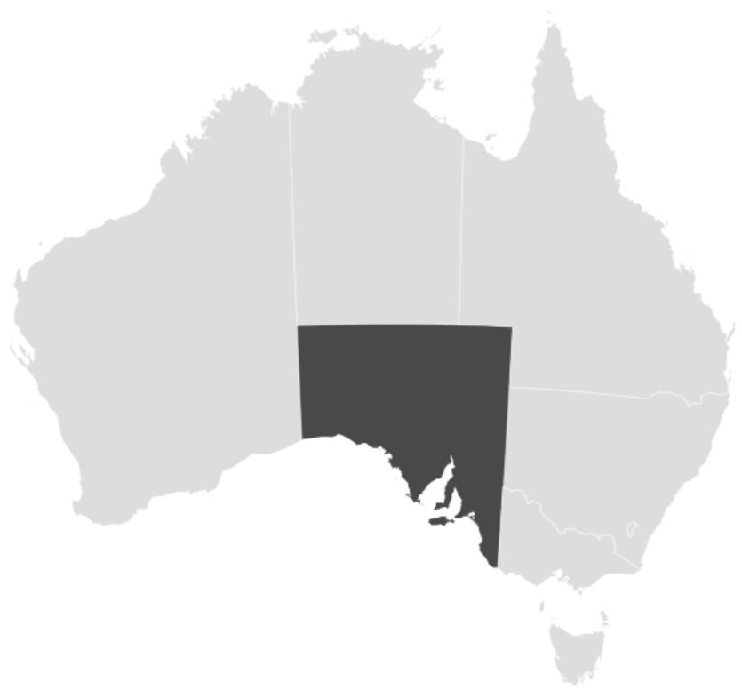 | 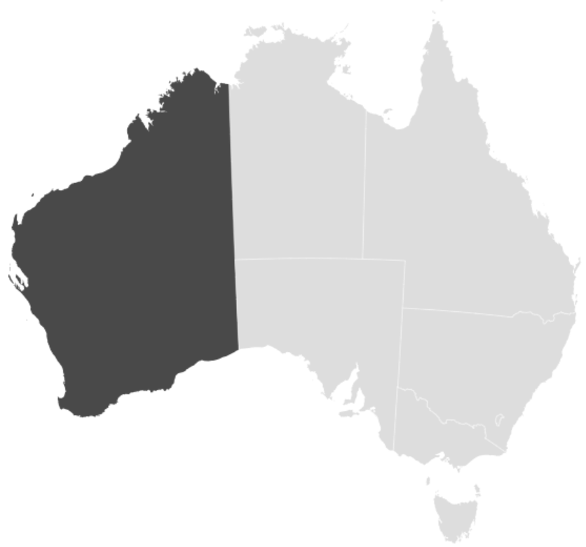 | 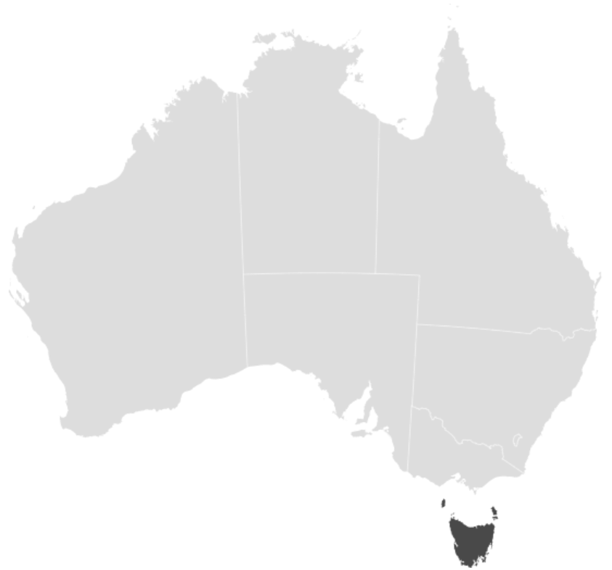 | 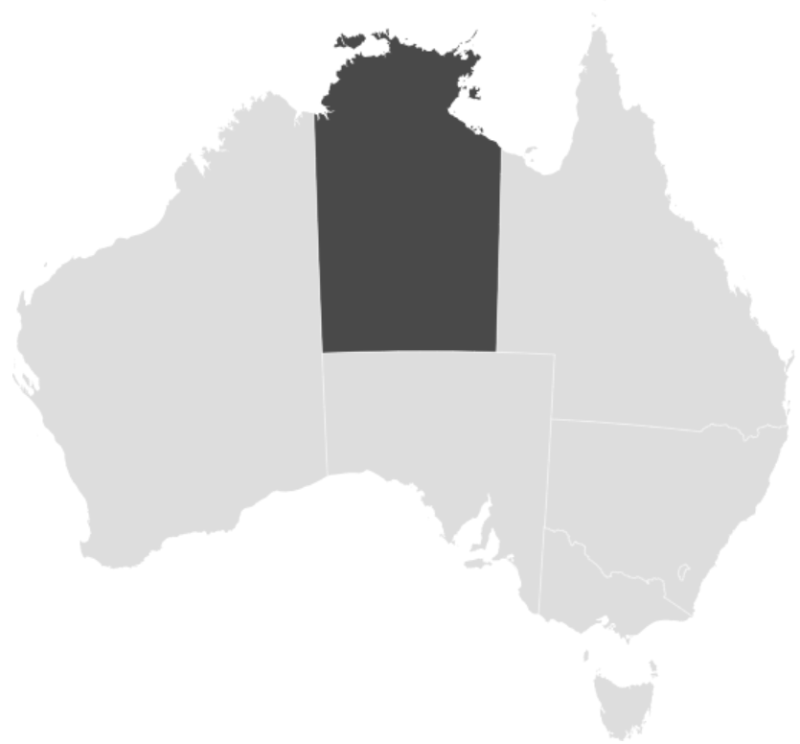 | 
Firms (%)  Workers (%) | NSW  2.4  22.6 | VIC  2.4  24.1 | QLD  2.8  23.9 | SA  2.6  24.3 | WA  3.0  23.4 | TAS  3.1  24.9 | NT  4.3  27.1 | ACT  3.0  20.2
International comparisons offer wider and more diverse interpretations of MSEs and their contributions to economic outcomes. As a cohort, there is little consistency across countries about how to recognise, measure or treat MSEs. Adjusting for population, Australia’s MSE count appears on par with other countries. But business counts do not tell the whole story. Despite mixed signals and data quality, the economic contributions from MSEs in Australia appear lower than some countries such as Germany. Across OECD countries, innovation leaders and the G7, higher MSE share modestly correlates with productivity, economic complexity, innovation, and competitiveness (Figures 3 and A3). Other measures weakly correlated, like GDP growth.

Figure 3. Correlation between MSE share and
economic indicators in OECD countries, 2023
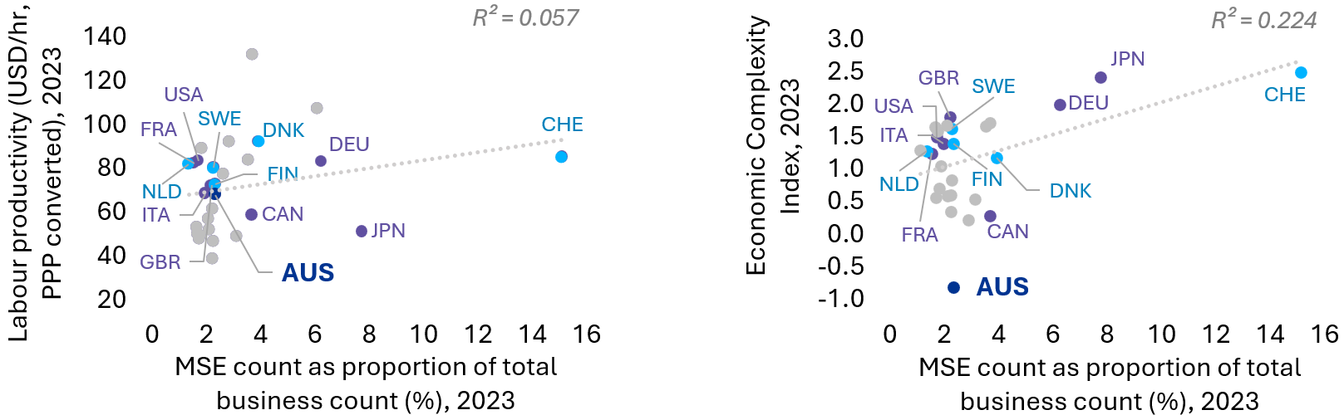
International comparisons are tricky at the best of times – impacted by differences in strategic direction, population density, culture, industry mix, comparative advantages, and business regulation and data practices. Given the mixed evidence on MSEs overseas, it will be important in future to consider global case studies in countries that have successfully mobilised MSEs, such as Germany’s Mittelstand. While there are limits to this paper’s analysis, the variation by country appears to show that not all middle segments are the same. Further investigation of MSE's role in Australia’s industrial system will be needed to test correlations and causality.
This paper’s analysis explores the attributes of MSEs to understand the drivers of the segment’s strong economic contribution. This includes barriers to remove and ways to innovate at scale, generating spillovers that lift productivity and economic complexity.

Characteristics of Australia’s MSEs
Current evidence on the attributes of Australian MSEs suggest that a mobilised MSE segment could help to lift productivity and energise the middle of Australia’s economic structure. With its reach across all industries and regions across the country, the segment drives innovation, connects small and large segments of the supply chain, and adds to competitiveness. Exploring the following MSE attributes may be useful to help shape policy.
Innovative: MSEs are strong innovators – a critical lever for long-term productivity.
- MSEs contribute strongly to Australia’s business expenditure in R&D (BERD). They account for a high proportion of BERD compared to other countries (growing from 21% to 29% between 2012 and 2024, Figure 4), resisting headwinds in Australia’s total BERD decline as a share of GDP.
- MSEs have among the highest R&D intensity of all firm sizes, with R&D expenditure as a share of total spend exceeding the national average (Figure 5). Their R&D expenditure per employee is also higher than small firms and on par with large firms (Figure A4).
- MSEs effectively translate innovation into competitiveness and productivity (Figure A5).
- MSEs have high uptake and optimism for digital technology, including a 68% adoption rate of AI, 28 percentage points higher than that of small businesses. Optimism about AI’s impact on productivity, competitiveness, and revenue is highest among MSEs, with large firms close behind. This suggests a strength of MSEs as vehicles for innovation diffusion.
- MSEs are consistently growing investments in R&D, increasing the segment’s real value and share of BERD. This is despite a small, steady MSE count and segment share (Figure 4).
Figure 4. Australia’s BERD in real terms and as share of GDP by business size, 2012-24
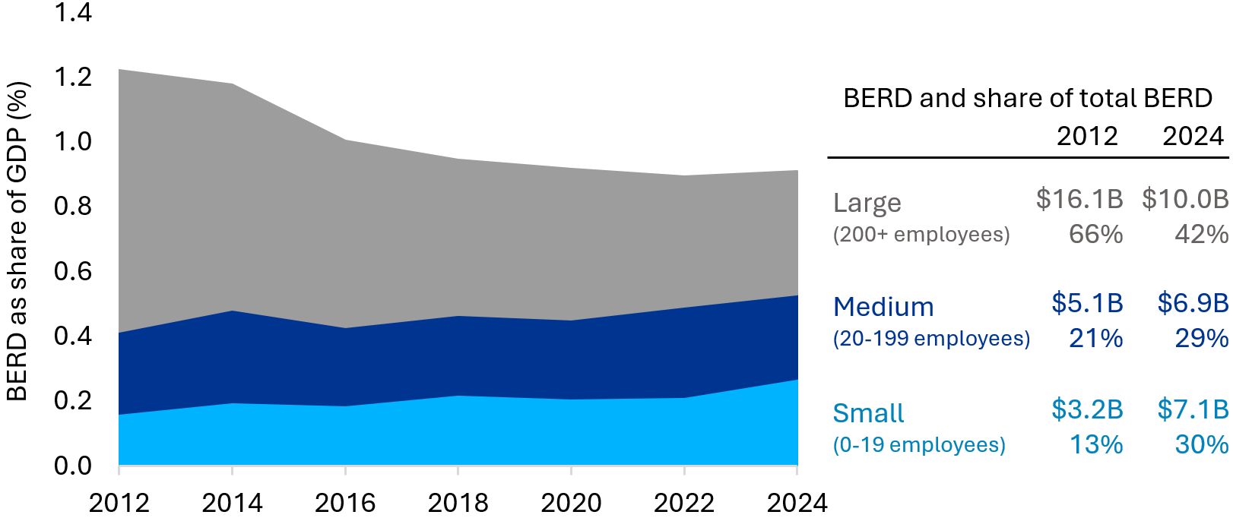
Figure 5. R&D intensity in Australia based on expenditure, by business size, 2012-24

Productive, value-adding exporters at scale: Australia’s MSEs are turning points in scale and productivity, being larger, more productive, and adding more value than small firms.
- MSEs start to develop export market access and international sales. They are more likely to target export markets than small firms. They also record higher annual export value growth rates than small and large firms leading up to COVID-19.
- MSEs adapt to be export-ready. Scale-ups must adapt their business structure to meet the demands of international markets, incubating domestically for speed before building scale to compete globally. They do this by changing operational processes, resourcing and strategy to specialise and tighten integration with the supply chains of larger firms.
- MSEs are more productive than small firms but lag large ones. A better understanding of other MSE attributes (including innovative capacity and agility) could help lift productivity.
Competitive: MSEs are supply chain connectors, specialising to be competitive at scale.
- MSEs face many competitors, with over 70% of MSEs competing with 5 or more firms.
- Small and medium firms start to build competitive advantage and scale by specialising as they grow to match their customer base, capabilities and services. Some even turn into single customer firms serving a few large firms as outsourced parts of its operations. Small firms struggle to navigate the complex requirements and procurement terms of large companies and export markets. MSEs have sufficient scale to better service these needs.
- MSEs have a role as connectors, serving as useful conduits for sales, logistics and outsourcing. MSEs support a seamless supply chain linking small businesses, primarily services local consumers, with large business accessing global markets.
Resilient: MSEs are an important inflection point in enterprise resilience, gaining the resources to withstand and adapt to shocks better than smaller enterprises.
- MSE start to build scale as they accumulate or gain access to sufficient resources and capability to pivot effort, invest in long-term strategies, and weather short-term shocks.
- MSEs show higher export resilience than small businesses because of their size and diverse export markets, but they are still more vulnerable than large businesses.
Agile: MSEs are an ideal mix of small business proximity and care for customer needs, with the scale and industrial capability to deliver significant volume, quality and value.
- MSEs are agile and responsive to customers and the market, with a third of MSEs in 2022 changing the range of goods or services offered, a higher rate than small or large firms.
- MSEs can identify and qualify new market demands quickly, leveraging their structures, systems and appropriate risk appetite to pivot quickly to realise opportunities.
Regional: MSEs tend to grow their firm and employment share in remote communities where large companies are few and scale is essential for communities impacted by distance, concentrating near cost-effective access to supply chains, workforce and industrial scale.
- The share of MSEs increases in more regional and remote areas (Figure 6). This is possibly because large firms give way to MSEs as the ‘larger’ employer to anchor remote economies.
- MSEs concentrate in industrial zones with logistics connectivity and access to skilled labour. They are a higher share of total firms in business districts, airports, seaports and metropolitan areas, likely due to their proximity to infrastructure, services and markets.
Figure 6. MSE share of total firm count and employment, by remoteness, 2024
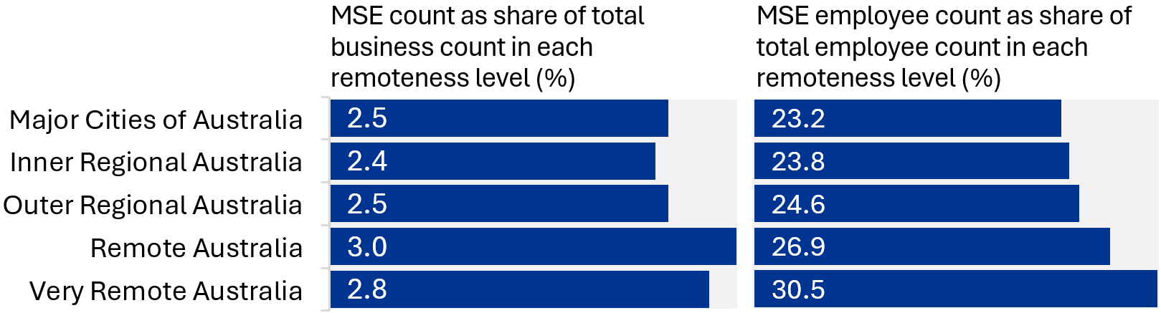

Growth potential: Initial sectoral analysis shows manufacturing MSEs have a higher proportion of high-growth firms (HGFs) than manufacturers of other sizes.
- HGFs are key drivers for Australia’s economy, creating most of the sales and value-add.
- Manufacturing MSEs have maintained the highest proportion of HGFs among all business sizes since 2008, surpassing large manufacturing firms (Figure A6). This is despite the HGF share of total businesses declining post-2008, growing slowly after 2012.
Essential and enabling: MSEs contribute well to priority sectors and essential services.
- MSEs have high segment share in sectors prioritised by policies like the National Reconstruction Fund and Future Made in Australia, such as manufacturing and mining. However, they have lower shares and growth in other sectors like agriculture (Figure 7).
- MSEs in remote areas focus on a few supporting industries, especially essential services like hospitals, accommodation and schools in areas of low industry diversity. In areas with high industry diversity, there are more enabling MSEs such as professional, scientific and technical services. This may show regional priorities such as advanced manufacturing and value-adding primary industry may need MSEs for scaled engineering and scientific support.
Figure 7. MSE’s share of business count and MSE count CAGR, selected sectors, 2015-24
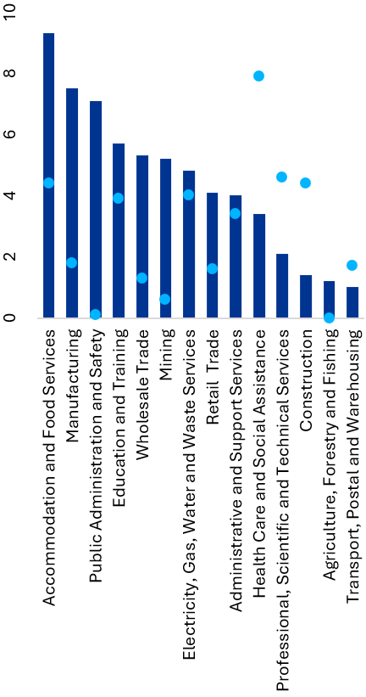
MSEs are a critical part of an economic structure, but further analysis is needed to understand their impact. These mid-sized firms combine small business agility with capacity and potential scalability, as well as being vital connectors in a healthy economic structure between small and large businesses. The attributes of MSEs position them well to contribute to national objectives. Realising this potential is not about simply increasing their share of the economy, but creating conditions that allow them to thrive. The next section will explore how recognising MSEs as a distinct cohort is a prerequisite for designing these enabling conditions. It also sets out considerations for analysis and policy development in the Australian context.

Future considerations for uplifting MSEs in Australia
Recognising MSEs as a distinct cohort is an essential, but not sufficient, first step to realise the benefits of a middle segment mobilised to meet our national objectives. Mobilising the ‘missing middle’ towards achieving national objectives requires a deeper understanding of MSE needs and characteristics, including an appreciation of the diversity in the cohort. To remove entrenched barriers to MSE scale and growth, there needs to be a sustained effort to create an environment for industry-led mobilisation. While current evidence is not definitive, simply increasing the proportion of MSEs in the economy is unlikely to maximise long-term benefits. Instead, there needs to be a holistic and tailored approach to inform effective policy design.
Policy design must consider sectoral and regional differences across Australian MSEs. An understanding of the varying contributions and needs of MSEs by sector is needed to shape policy settings conducive to MSE growth. For instance, MSEs constitute a relatively large share of firms and employment in manufacturing but a small and slow growing segment in agriculture. This highlights differences in MSE performance across different priority sectors. There also needs to be better understanding of how MSEs contribute to regional economies differently to urban ones. Disparities in MSE distribution suggest that regional areas may lack the infrastructure, workforce, or incentives needed to attract and sustain mid-sized firms. Policy should consider these nuances and the role of MSEs in supply chains to design support tailored to local context.
Setting economic conditions that strengthen the MSE segment must target structural barriers. There are many internal and external factors impeding the MSE segment, including constraining the growth of small firms to join the economic middle. Internal barriers to business growth include capability gaps, low risk-appetite, poor absorptive capacity, low perceived need to commercialise new ideas, or a modest desire for growth. Market conditions can also hinder Australian SMEs, including a limited domestic market and export exposure, high costs, poor access to capital, and regulatory burdens. Further analysis should clarify how these barriers affect businesses at different stages, such as small firms transitioning to medium ones as they acquire more complex capability, systems, processes and governance. Analysis should also examine underlying causes of high-potential firms leaving Australia. Effective policy shouldn’t narrow focus by firm size, but instead target the barriers to remove and activities to incentivise.
An industry-led and sustainable mobilisation of the economic middle relies on an enabling environment that allows firms to reach and sustain medium scale. Sustaining the growth of tens of thousands of MSEs requires more than direct, isolated support. A more comprehensive approach would strengthen linkages between MSEs and small and large firms to build mid-stage production capacity, strong supply chains, and effective innovation diffusion. It would also reduce information asymmetry between MSEs to overcome small market challenges. Any solution will require policy to set the enabling conditions for industry to better collaborate and coordinate at a system-level, providing a clear facilitation role for government.

Next steps: What is the middle missing?
An MSE segment mobilised in line with national objectives could support greater productivity, economic diversity, innovation and resilience. This paper has highlighted the need for a more nuanced understanding of MSEs, showing their significant contributions are under-explored and vary by region and sector. International comparisons suggest Australia may have an opportunity to uplift its economic middle to deliver productivity growth and economic complexity. Early insights into the characteristics of MSEs suggest programs and incentives may yield a higher return on investment by addressing the barriers for young, high-growth firms to scale into ambitious, innovative MSEs. This reinforces the urgency and value of the issue in a constrained fiscal and policy environment. Policymakers should treat MSEs as a distinct cohort, identifying the conditions to uplift the segment and incentivise MSEs to support national objectives alongside their own growth ambitions. By partnering across sectors and policy portfolios, further analysis on MSEs could shed light on what the middle is missing.
IISA aims to continue the discussion and grow the evidence base on the missing middle in future analysis, collaborating across government, industry, and research to:
- Explore success stories of thriving MSE segments in Australian regions and overseas. Understand the differences in each case and the role of MSEs in innovation diffusion, industrial precincts and supply chains across sectors and regions to inform program design.
- Highlight MSEs as a distinct cohort in innovation and growth programs. Analyse the MSE cohort’s traits, barriers, outcomes, and use of incentives and programs across portfolios.
- Consider ways to refine programs to uplift MSEs and meet their distinct needs. Analyse the benefits to MSEs from supports given to start-ups or SMEs, including keeping high-potential technology and industrial firms onshore.
- Identify effective levers that reduce barriers to MSE scale and innovation. Prioritise regions undergoing industrial transition, building capability, and reducing fragmentation and duplication across jurisdictions and innovation pipelines while consolidating public funds.
- Explore demand side factors for MSEs to innovate. This includes public procurement and large firms as anchor customers for technology, while forging a clear narrative for investment in demand-driven innovation to build globally competitive industries.

Appendix A. Additional analysis
Figure A1. Business size distribution in manufacturing for selected countries

Figure A2. MSE and MSE employee distribution in Australia and contribution across states and territories, 2024
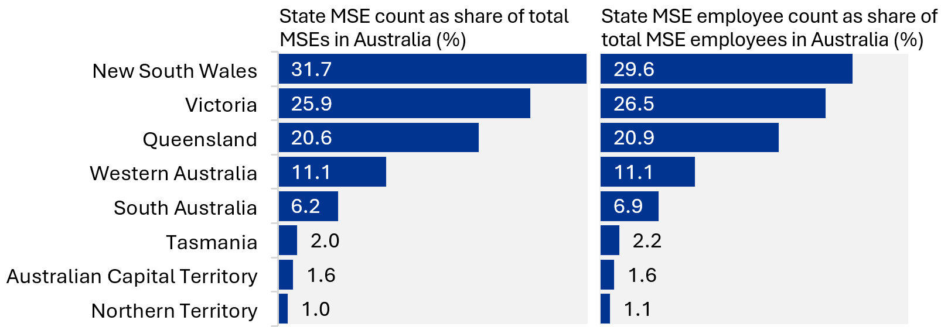
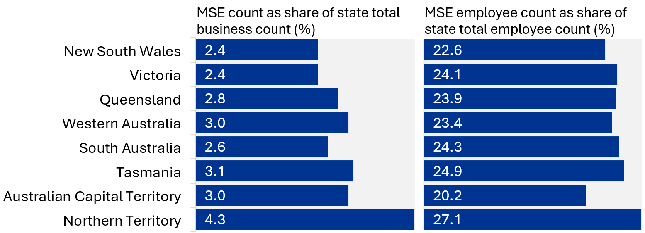
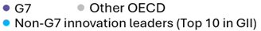
Figure A3. Correlation between MSE share and
economic indicators in OECD countries, 2023
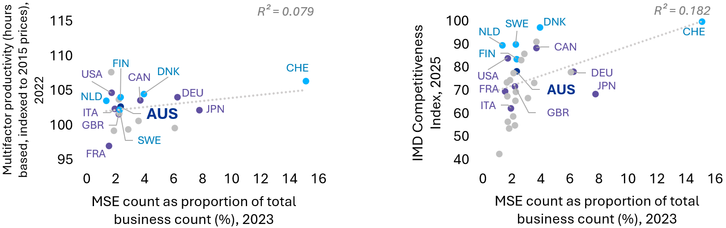
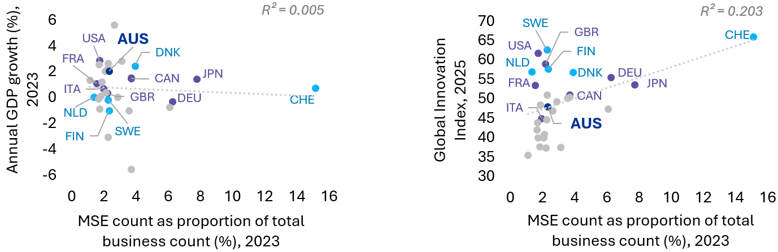

Figure A4. R&D intensity in Australia based on employment, by business size, 2012-24

Figure A5. Business innovation and innovation translation in Australia, by business size, 2023

Figure A6. High-growth manufacturing firms as a share of all manufacturing firms in each business size segment in Australia, 2005–20

Appendix B. Technical notes: Definitions of medium-sized enterprises
The diversity and dispersion of MSEs in Australia’s regions and economic structure complicates the task of providing a clear evidence base for policy and program improvements. This highlights the need for a shared understanding of the segment’s nuances.
As shown in the above analysis of readily available data, variations in the treatment and definitions of MSEs can blur otherwise clear approaches to analysing the segment. There are even fewer datasets on the key attributes of MSEs and the underlying drivers of their success. This paper defers judgement on whether a new definition of MSEs would be more suitable for the modern Australian economic context. Instead, it favours a list of defining characteristics to draw on in developing future fit-for-purpose policy. However, given the limitations of relying on single-measure definitions, this note proposes that a hybrid definition using multiple criteria can help focus future analysis on more established MSEs with potential to scale.
There is a high degree of inconsistency in the definition of MSEs. Both in Australia and globally, different institutions define business sizes using different measures and thresholds. As shown in Table B1, common definitions in Australia use a mix of one or more broad-based measures (for example employee count, turnover and assets) and more specialised measures to suit the program or intended use (for example the number of shareholders, individual loan size and age of the business). Cases where MSEs are not defined as a standalone group, but rather commonly grouped with small businesses as ‘SMEs’ further complicates this. Most importantly, there is a lack of understanding about why these data points are used to identify MSEs.
Employee headcount is widely used to define business sizes, but there is no agreement on thresholds. The Australian Bureau of Statistics (ABS) range of 20 to 199 employees is the most adopted definition of MSEs, but 100 employees is the threshold distinguishing ‘small’ from ‘large’ firms for ASIC and a business with 15 or more employees is no longer ‘small’ under the Fair Work Act 2009 (FWA). These thresholds apply for all firms, but regional and sectoral differences (for example, varying levels of labour intensity) make it unclear if businesses identified as MSEs by headcount truly share similar characteristics. It is worth noting that while this measure is used extensively in business surveys, research and reporting, innovation programs typically use turnover instead to determine eligibility. Programs using employee headcount (for example CRC-P, Made in Queensland) generally do not target MSEs specifically. Instead, they group them with small businesses and cap eligibility at 199 employees. Some analysis breaks this broad range into sub-sets, such as smaller medium (20-109) and larger medium (110-199).
Turnover is another common measure, but its ranges vary significantly by agency and programs – from the Australian Taxation Office’s (ATO) annual turnover value ($10 million to $100 million) to Australian Prudential Regulation Authority (APRA) using a $75m upper bound for MSEs and Australian Securities and Investments Commission (ASIC) using $50m to draw the line between ‘small’ and ‘large’ businesses. While few programs treat MSEs distinctly, many use turnover tests to cap funding, target support and limit eligibility to smaller enterprises. The Research and Development Tax Incentive (RDTI) uses a $20m turnover threshold, limiting access to its more beneficial refundable tax offset to smaller firms. Many of these thresholds have not shifted in decades, despite factors like inflation and the changing nature of our economy.
Definitions based on employment or turnover have limitations when used independently. While a definition based on employment can draw on more readily available data and is easier to apply consistently across industries, it does not clearly reflect a business’s productivity or revenue. On the other hand, a turnover-based definition reflects financial capacity but is often self-reported, less accessible, and can be inconsistent. Given the limitations of single-measure definitions, policies and programs supporting MSEs should draw on multiple dimensions.
Table B1. Examples of definitions of MSEs (adapted from RBA)
Measure | Lower bound (inclusive) | Upper bound (inclusive) | Institution | Purpose
Employee headcount | 20 | 199 | ABS | Business surveys
Employee headcount | 15 | Undefined | FWA | Unfair dismissal laws
Employee headcount | Small: <100  Large: ≥100 |  | ASIC | Annual financial reporting
Turnover  ($M) | 10 | <100 | ATO | Taxation statistics
Turnover  ($M) | 10 | 250 | ATO | Tax gap
Turnover  ($M) | >0.2 | Undefined | ATO | No longer qualify as an Early Stage Innovation Company (ESIC)
Turnover  ($M) | Undefined | 75 | APRA | Prudential supervision (Lower bound defined by liabilities)
Turnover  ($M) | Small: <50  Large: ≥50 |  | ASIC | Annual financial reporting
Liabilities ($M) | 1.5 | Undefined | APRA | Prudential supervision (Upper bound defined by turnover)
Expense ($M) | >1 | Undefined | ATO | No longer qualify as an Early Stage Innovation Company (ESIC)
Assets ($M) | Small: <25  Large: ≥25 |  | ASIC | Annual financial reporting

M. Cully (2017) Stuck in the Middle? Mid-sized enterprises in Australia, Open Forum, accessed 30/10/2025.
Industry Innovation and Science Australia (2023) Barriers to collaboration and commercialisation, IISA, accessed 15/07/2025.
Barriers to collaboration and commercialisation cites SME and Entrepreneurship Outlook Country Profile: Australia (OECD, 2021), which uses 2016 data and excludes non-employing firms. Size classifications vary between countries, limiting comparability. International comparison using case studies, such as those in Barriers to collaboration and commercialisation, may provide clearer insights. | The fact that MSEs are more likely to shrink to small than grow to large is in part explained by the high share of small firms.
Australian Bureau of Statistics (2025) Productivity, ABS, accessed 1/10/2025.
Australian Bureau of Statistics (2025) Economic Resilience, ABS, accessed 1/10/2025.
P. Mares (2024) Australian cities are desperate for the ‘missing middle’ of housing density, The Guardian, accessed 1/10/2025. | J. Riley (2025) A sovereign capability moonshot: Tackling the ‘missing middle’, InnovationAus, accessed 1/10/2025. | Kate B. (2025) Australian battery innovation receives $25M boost from ARENA, Australian Manufacturing, accessed 28/10/2025.
S. Williams (2023) The ‘missing middle’ stopping Australia from being a deep tech force, AFR, accessed 1/10/2025.
NSW Innovation and Productivity Council (2025) Scaling Ambition, NSW Government, accessed 23/09/2025.
MYOB (2024) Mid-Market Report, MYOB, accessed 1/07/2025. | MYOB (2024) MYOB Bi-Annual Business Monitor: June 2024, MYOB, accessed 1/07/2025. | MYOB (2025) How Mid-Sized Businesses Are Powering Our Future Economy, MYOB, accessed 14/07/2025.
M. Ignaszak, D. Robbins, P. Sedláček (2025) Aggregate Impact of Firm-Level R&D Incentives, accessed 15/10/2025.
Note: Includes firms with 20-199 employees in Australia, Canada and US, and firms with 20-249 employees in Germany. | See appendix for data sources.
Australian Bureau of Statistics (2002) Small Business in Australia, 2001. Catalogue No. 1321.0, ABS, accessed 7/08/2025.
Australian Bureau of Statistics (2025) Counts of Australian Businesses, including Entries and Exits, ABS, accessed 15/07/2025. | Australian Bureau of Statistics (2025) Australian Industry, ABS, accessed 15/07/2025.
Australian Bureau of Statistics (2025) Counts of Australian Businesses, including Entries and Exits, ABS, accessed 15/07/2025. | Australian Bureau of Statistics (2025) Australian Industry, ABS, accessed 15/07/2025.
Australian Small Business & Family Enterprise Ombudsman (n.d.) Small businesses in Australia, ASBFEO, accessed 15/07/2025.
Australian Bureau of Statistics (2025) Counts of Australian Businesses, including Entries and Exits, ABS, accessed 15/07/2025. Note: The ABS changed methodology in June 2010 for actively trading businesses, dropping the business count in subsequent years.
Australian Bureau of Statistics (2025) Counts of Australian Businesses, including Entries and Exits, ABS, accessed 15/07/2025. | Australian Bureau of Statistics (2025) Australian Industry, ABS, accessed 15/07/2025.
Our World in Data (2024) Population, 2023, Our World in Data, accessed 14/11/2025. | Various data sources from national statistical offices used for business count. See appendix for details.
See appendix for business count data. | OECD (n.d.) GDP per hour worked, OECD, accessed 28/10/2025. | Harvard Growth Lab (n.d.) Country and Product Complexity Rankings, Harvard Growth Lab, accessed 28/10/2025. | Note: MSE count from 2023 for all countries apart from US (2022) and Japan (2021). Chile, Colombia, Costa Rica, South Korea, Mexico, New Zealand, Israel and Türkiye are not included due to data availability or compatibility issues – the definition of MSEs vary between countries. The range closest to Australia's definition was used – i.e. 20-199 employees for Australia, Japan, UK, US, Canada; 20-200 employees for Israel; 20-249 employees for others. R squared (R²) is an imperfect measure of how well the data points are scattered around the fitted regression line – 1 being perfect fit.
Productivity Commission (2023) 5-year Productivity Inquiry: Innovation for the 98%, PC, accessed 21/07/2025. | AlphaBeta (2020) Australian Business Investment in Innovation: levels, trends, and drivers, AlphaBeta, accessed 21/07/2025.
Department of Industry, Science and Resources (2025) SERD: discussion paper, DISR, accessed 27/07/2025.
AlphaBeta (2020) Australian Business Investment in Innovation: levels, trends, and drivers, AlphaBeta, accessed 21/07/2025.
Australian Bureau of Statistics (2023) Characteristics of Australian Business, ABS, accessed 28/07/2025. | National Artificial Intelligence Centre (2024) AI benefits and challenges data, DISR, accessed 28 July 2025. | National Artificial Intelligence Centre (2025) AI adoption in Australian businesses for 2025 Q1, DISR, accessed 18/11/2025.
National Artificial Intelligence Centre (2024) AI benefits and challenges data, DISR, accessed 28/07/2025.
Australian Bureau of Statistics (2025) Research and Experimental Development, Businesses, Australia, ABS, accessed 01/10/2025. Dollar values deflated by June 2023 price.
Australian Bureau of Statistics (2025) Research and Experimental Development, Businesses, Australia, ABS, accessed 1/10/2025. | Australian Bureau of Statistics (2025) Australian Industry, ABS, accessed 15/07/2025.
Australian Bureau of Statistics (2023) Analysing Australian exporter performance, ABS, accessed 29/07/2025.
NSW Innovation and Productivity Council (2025) Scaling Ambition, NSW Government, accessed 23/09/2025.
Australian Bureau of Statistics (2025) Australian Industry, ABS, accessed 15/07/2025.
Australian Bureau of Statistics (2023) Characteristics of Australian Business, ABS, accessed 28/07/2025.
OECD (2021) Understanding Firm Growth: Helping SMEs Scale Up, OECD, accessed 7/08/2025. | Industry Innovation and Science Australia (2023) Barriers to collaboration and commercialisation, IISA, accessed 15/10/2025.
MYOB (2025) The Bigger Picture: How Mid-Sized Businesses Are Powering Our Future Economy, MYOB, accessed 14/07/2025. | OECD (2019) Strengthening SMEs and Entrepreneurship for Productivity and Inclusive Growth, OECD, accessed 30/07/2025.
Department of Industry, Science and Resources (2023) New insights on barriers to innovation highlight Australia’s missing band of medium-sized businesses, DISR, accessed 16/10/2025. | D. Fajarika, F. Trapsilawati and B. M. Sopha (2024) Influential factors of SME growth across developed and developing countries, International Journal of Engineering Business Management, accessed 16/10/2025.
Australian Bureau of Statistics (2023) Characteristics of Australian Business, ABS, accessed 28/07/2025. | Australian Bureau of Statistics (2024) Innovation in Australian Business, ABS, accessed 15/07/2025. | Brad Jones (2024) Financing SME Innovation in Australia – Challenges and Opportunities, Reserve Bank of Australia, accessed 25/07/2025.
Australian Bureau of Statistics (2023) Analysing Australian exporter performance, ABS, accessed 29/07/2025. Note: Medium exporters are classified as having 20-199 employees, turnover of $2m-$20m, or exports of $2m-$20m during the reference period.
Australian Bureau of Statistics (2023) Characteristics of Australian Business, ABS, accessed 28/07/2025.
Reserve Bank of Australia (2024) Financing SME Innovation in Australia, RBA, accessed 15/07/2025.
Regional Australia Institute (2024) Regionalisation Ambition 2032 - Year 2 Progress Report, RAI, accessed 31/07/2025. | Australian Bureau of Statistics (2024) Counts of Australian Businesses, including Entries and Exits, ABS, accessed 21/07/2025.
Australian Bureau of Statistics (2024) Counts of Australian Businesses, including Entries and Exits, ABS, accessed 21/07/2025. | Australian Bureau of Statistics (n.d.) Jobs and Income of Employed Persons 2021-22, ABS, accessed 21/07/2025. | Note: ABS applies a confidentialisation process where it perturbs data in such a way that component values do not always sum to the published total. Calculations for the graph are based on component values. Australian Bureau of Statistics (2024) Counts of Australian Businesses, including Entries and Exits methodology, ABS, accessed 20/11/2025.
HGFs are defined as those with average annualised turnover growth rates greater than 20 per cent over a three-year period.
Office of the Chief Economist (2018) What Drives High Growth? Characteristics of Australian Firms, DISR, accessed 14/10/2025.
Australian Bureau of Statistics (2024) Business Longitudinal Analysis Data Environment microdata, ABS, accessed 15/12/2024.
Australian Bureau of Statistics (2025) Counts of Australian Businesses, including Entries and Exits, ABS, accessed 15/07/2025. Note: Sectoral differences are also observed in terms of MSE gross value added and employment.
Australian Bureau of Statistics (2025) Counts of Australian Businesses, including Entries and Exits, ABS, accessed 15/07/2025.
Australian Bureau of Statistics (2025) Counts of Australian Businesses, including Entries and Exits, ABS, accessed 15/07/2025.
Australian Bureau of Statistics (2025) Australian Industry, ABS, accessed 15/07/2025. | M. Cully (2017) Stuck in the middle? Mid-sized enterprises in Australia, Open Forum, accessed 31/10/2025.
Regional Australia Institute (2024) Regionalisation Ambition 2032 - Year 2 Progress Report, RAI, accessed 31 July 2025.
IISA (2023) Barriers to collaboration and commercialisation, IISA, accessed 15/07/2025. | Australian Banking Association (2022) SME Lending Report, ABA, accessed 15/07/2025. | The Strategist (2025) Australia can leverage SMEs to build national resilience, ASPI, accessed 15/07/2025. | NSW Innovation and Productivity Council (2025) Scaling Ambition, NSW IPC, accessed 23/09/2025.
NSW Innovation and Productivity Council (2025) Scaling Ambition, NSW IPC, accessed 23/09/2025. | Australian Business Growth Fund (2024) Powering the Growth Economy, ABGF, accessed 28/10/2025.
Note: Includes firms with 20-199 employees in Australia, Canada and US; 20-249 employees in Germany. | Australian Bureau of Statistics (2023) Counts of Australian Businesses, including Entries and Exits, ABS, accessed 15/07/2025. | US Census Bureau (2022) Statistics of U.S. Businesses, US Census Bureau, accessed 15/07/2025. | US Census Bureau (2024) Nonemployer Statistics: 2022, US Census Bureau, accessed 13/11/2025. | Statistics Canada (2024) Canadian Business Counts, with employees, June 2023, Statistics Canada, accessed 15/07/2025. | Statistics Canada (2023) Canadian Business Counts, without employees, June 2023, Statistics Canada, accessed 28/10/2025. | Eurostat (2025), Enterprise statistics by size class and NACE Eurostat, accessed 18/08/2025.
Australian Bureau of Statistics (2024) Counts of Australian Businesses, including Entries and Exits, ABS, accessed 21/07/2025. | Australian Bureau of Statistics (n.d.) Jobs and Income of Employed Persons 2021-22, ABS, accessed 21/07/2025. | Note: ABS applies a confidentialisation process where it perturbs data in such a way that component values do not always sum to the published total. Calculations for the graphs are based on component values. Australian Bureau of Statistics (2024) Counts of Australian Businesses, including Entries and Exits methodology, ABS, accessed 20/11/2025.
Australian Bureau of Statistics (2025) Counts of Australian Businesses, including Entries and Exits, ABS, accessed 15/07/2025. | Eurostat (2025) Enterprise statistics by size class and NACE, Eurostat, accessed 18/08/2025. | US Census Bureau (2022) Statistics of U.S. Businesses, US Census Bureau, accessed 15/07/2025. | US Census Bureau (2024) Nonemployer Statistics: 2022, US Census Bureau, accessed 13/11/2025. | Statistics Canada (2025) Employment for all employees by enterprise size, Statistics Canada, accessed 28/10/2025. | Department for Business and Trade (2024) Business population estimates for the UK and regions 2024: statistical release, Department for Business and Trade, accessed 28/10/2025. | US Census Bureau (2025) 2022 SUSB Annual Data Tables by Establishment Industry, US Census Bureau, accessed 28/10/2025. | e-Stat (2023) Economic Census for Business Activity, Ministry of Internal Affairs and Communications, accessed 28/10/2025. | OECD (n.d.) Productivity Growth Rates – Multifactor productivity (hours based), OECD, accessed 28/10/2025. | World Intellectual Property Organization (2025) GII 2025 results, WIPO, accessed 28/10/2025. | Our World in Data (2025) Annual GDP growth, Our World in Data, accessed 28/10/2025. | IMD (2025) World Competitiveness Ranking, IMD, accessed 28/10/2025. | Note: MSE count from 2023 for all countries apart from US (2022) and Japan (2021). Chile, Colombia, Costa Rica, South Korea, Mexico, New Zealand, Israel and Türkiye are not included due to data availability or compatibility issues – the definition of MSEs vary between countries. The range closest to Australia's definition was used – i.e. 20-199 employees for Australia, Japan, UK, US, Canada; 20-200 employees for Israel; 20-249 employees for others. R squared (R²) is an imperfect measure of how well the data points are scattered around the fitted regression line – 1 being perfect fit.
Australian Bureau of Statistics (2025) Research and Experimental Development, Businesses, Australia, ABS, accessed 1/10/2025. | Australian Bureau of Statistics (2025) Australian Industry, ABS, accessed 15/07/2025.
Australian Bureau of Statistics (2024) Innovation in Australian Business, ABS, accessed 15/07/2025. Note: ‘innovation’ is the ‘introduction of a new or significantly improved good or service; operational process; organisational/managerial process; or marketing method’; ‘innovative activity’ includes ‘any work that was intended to, or did, result in the introduction of an innovation’.
Australian Bureau of Statistics (2024) Business Longitudinal Analysis Data Environment microdata, ABS, accessed 15/12/2024.
Australian Securities & Investments Commission (n.d.) Are you a large or small propriety company, ASIC, accessed 18/07/2025.
Fair Work Ombudsman (2025) Small business and the Fair Work Act, Fair Work Ombudsman, accessed 18/07/2025.
Department of Industry, Science and Resources (2025) Cooperative Research Centres Program: Cooperative Research Centres Projects (CRC-P) Grants Round 17, DISR, accessed 18/07/2025.
Department of Regional Development, Manufacturing and Water (2024) Applicant Guidelines: Made in Queensland Round 7, Department of Regional Development, Manufacturing and Water, Queensland Government, accessed 18/07/2025.
NSW Innovation and Productivity Council (2019) Business size report, NSW Government, accessed 25/07/2025.
Australian Taxation Office (2024) Reference material for Taxation statistics 2022–23, ATO, accessed 21/07/2025.
Australian Prudential Regulation Authority (2025) Size of Business Dimension, APRA, accessed 18/07/2025.
Australian Securities & Investments Commission (n.d.) Are you a large or small propriety company, ASIC, accessed 18/07/2025.
business.gov.au (n.d.) Offset your R&D costs to help innovate and grow your business, Australian Government, accessed 18/07/2025.
Ellis Connolly, David Norman and Tim West (2012) Small Business: An Economic Overview, RBA, accessed 14/07/2025.
Australian Bureau of Statistics (2018) Australian Industry - Business Size, ABS, accessed 14/07/2025.
Fair Work Ombudsman (n.d.) Small business and the Fair Work Act, Fair Work Ombudsman, accessed 14/07/2025.
Australian Securities & Investments Commission (n.d.) Are you a large or small proprietary company, ASIC, accessed 14/07/2025. | Note: ASIC criteria are used in conjunction with each other.
Australian Taxation Office (2025) Reference material for Taxation statistics 2022–23, ATO, accessed 14/07/2025.
Australian Taxation Office (2024) Medium business population, ATO, accessed 14/07/2025.
Australian Taxation Office (2024) Qualifying as an early stage innovation company, ATO, accessed 14/07/2025. | Note: ESIC qualifying criteria are used in conjunction with each other.
Australian Prudential Regulation Authority (2025) Size Of Business Dimension, APRA, accessed 14/07/2025.
Australian Securities & Investments Commission (n.d.) Are you a large or small proprietary company, ASIC, accessed 14/07/2025.
Australian Prudential Regulation Authority (2025) Size Of Business Dimension, APRA, accessed 14/07/2025. Note: This refers to the total exposure of the authorised deposit-taking institution (ADI) or registered financial corporations (RFC) to the business.
Australian Taxation Office (2024) Qualifying as an early stage innovation company, ATO, accessed 14/07/2025.
Australian Securities & Investments Commission (n.d.) Are you a large or small proprietary company, ASIC, accessed 14/07/2025.

