ESG State of play
This report presents findings for 2023 and 2024 from a pilot program conducted in collaboration with a limited number of venture capital (VC) firms across Oceania. The initiative collected Environment, Social, and Governance (ESG) data from portfolio companies ranging from pre-seed to Series C+ stages, using the ESG_VC framework. ESG_VC is administered by UK-based group, Reframe Venture
Ten venture capital firms voluntarily participated in the program, representing a subset of Australia’s broader VC ecosystem. Not all operate an ESVCLP or VCLP. The department oversaw data wrangling and reporting, with the Australian Investment Council playing a coordinating role
ESG considerations remain important in VC as investors seek greater transparency around non-financial performance. The pilot represents efforts to bring greater structure and consistency to ESG measurement within the early-stage investment ecosystem
A considered ESG approach can enhance company valuations, unlock new opportunities, and improve portfolio management. By adopting internationally used frameworks such as ESG_VC, VC firms can help startups build long-term value and remain aligned with evolving global regulatory standards. Early measurement is particularly valuable for startups at the beginning of their ESG journey, providing a foundation for sustainable growthIf you would like assistance with this document please email mailto:venturecapital@industry.gov.au.

ESG in Venture Capital State of play – 2023
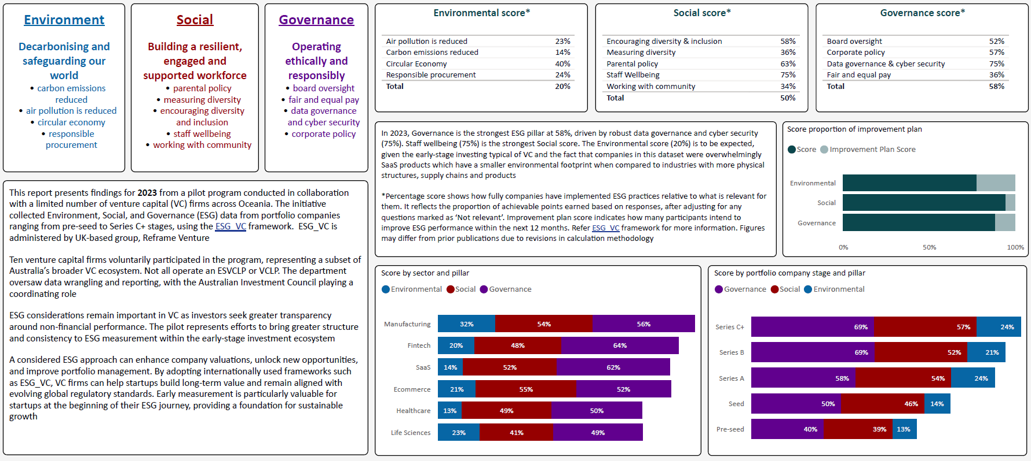

ESG in Venture Capital State of play – 2024
