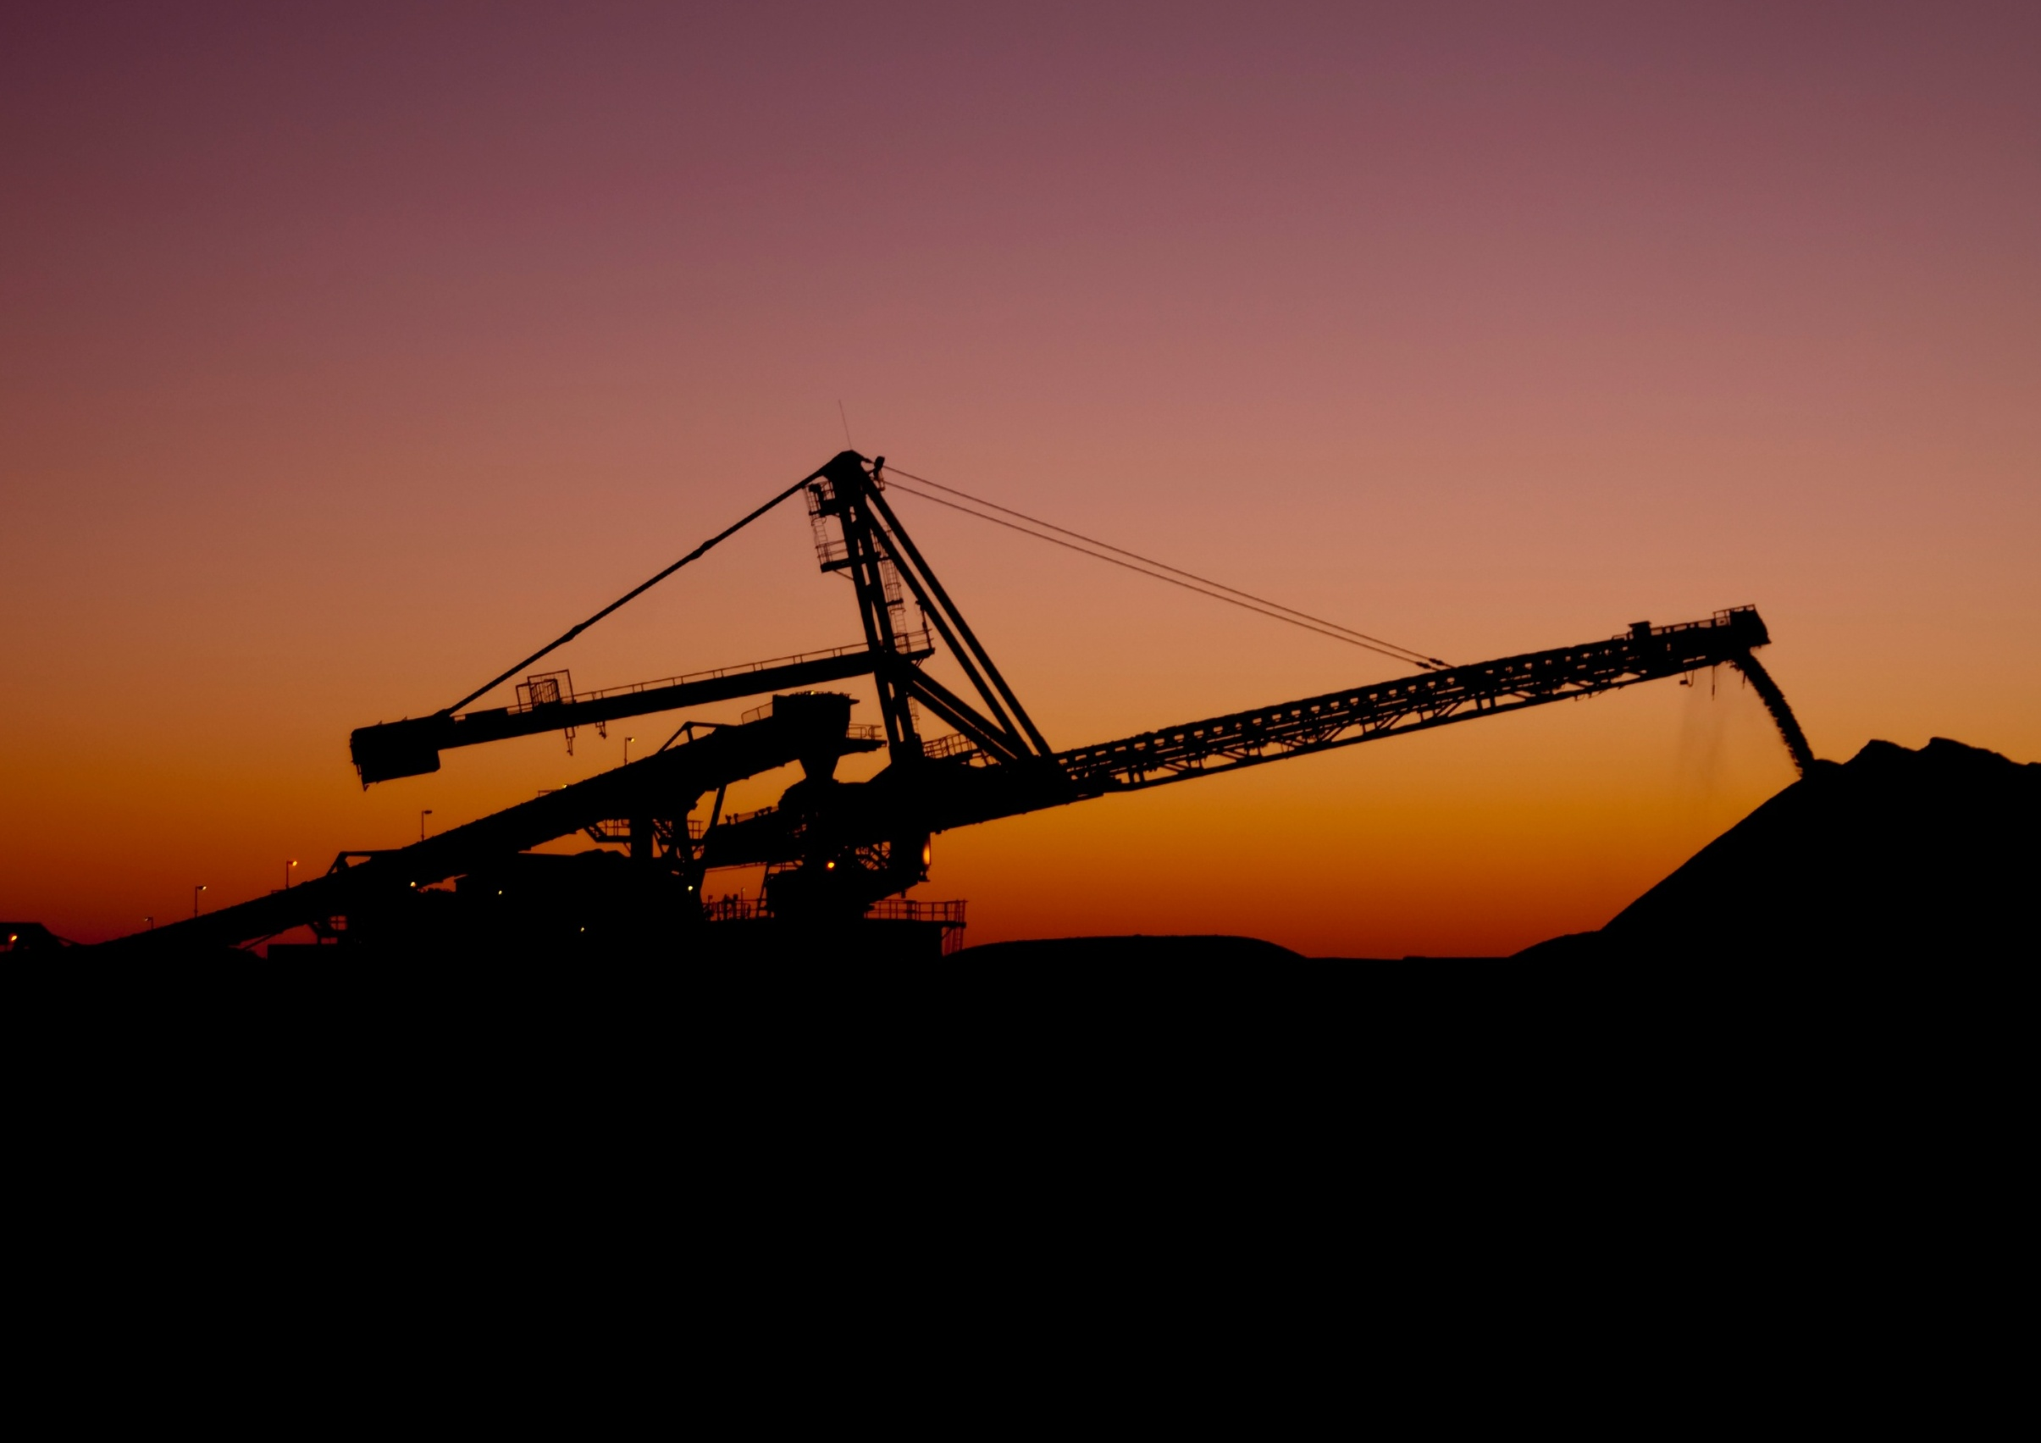

| industry.gov.au/REMP

Resources and Energy Major Projects report
2025

Further information
For more information on data or government initiatives please access the report from the Department’s website at: www.industry.gov.au/oce
Project team
Mark Gibbons, Sufyan Saleem, Andy Lee, Karol Andrzejewski, Colin Clark, Dan Dwyer, Eshaq Farahmand, Ryan Spencer, Tanya Ma, Shuchita Pota, Jacob Rossi, Steve Smith, Kelly Sun, Sabrina Tabassum.
Acknowledgements
The authors would like to acknowledge the contributions of:
David Thurtell, Andrew Nash, Chris Mornement and Ken Colbert
Cover image source: Lynas Rare Earths
ISSN 1839-5007
© Commonwealth of Australia 2025
Ownership of intellectual property rights
Unless otherwise noted, copyright (and any other intellectual property rights, if any) in this publication is owned by the Commonwealth of Australia.
Disclaimer
The views expressed in this report are those of the author(s) and do not necessarily reflect those of the Australian Government or the Department of Industry, Science and Resources.
This publication is not legal or professional advice. The Commonwealth of Australia does not guarantee the accuracy or reliability of the information and data in the publication. Third parties rely upon this publication entirely at their own risk.
Creative Commons license

Attribution 4.0 International License CC BY 4.0
All material in this publication is licensed under a Creative Commons Attribution 4.0 International License, with the exception of:
- the Commonwealth Coat of Arms
- content supplied by third parties
- logos
- any material protected by trademark or otherwise noted in this publication.
Creative Commons Attribution 4.0 International License is a standard form license agreement that allows you to copy, distribute, transmit and adapt this publication provided you attribute the work. A summary of the license terms is available from https://creativecommons.org/licenses/by/4.0/.
Wherever a third party holds copyright in material contained in this publication, the copyright remains with that party. Their permission may be required to use the material. Please contact them directly.
Attribution
Content contained herein should be attributed as follows:
Department of Industry, Science and Resources, Commonwealth of Australia Resources and Energy Major Projects 2025. The Commonwealth of Australia does not necessarily endorse the content of this publication. Requests and inquiries concerning reproduction and rights should be addressed to REQ@industry.gov.au.

Contents
Key statistics 4
Summary 5
1. Overview 5
The value of committed and completed projects declined in 2025 5
Gold, copper, and iron ore accounted for most additions 6
Investment in energy commodities has held up 7
2. Critical minerals 11
Australia’s critical minerals pipeline is driven by early-stage projects 11
Moderate progress in pipeline despite challenging global conditions 11
Rare earths projects lead the later-stage project pipeline amidst investor confidence and government support 12
Project timelines accelerated by global partnerships 12
The battery active materials pipeline remains stable 13
Comparing critical minerals projects to 2024 13
3. Oil and gas 16
Oil and gas dominates projects at the committed stage 16
New project numbers are declining 16
4. Committed and completed projects 18
Committed projects decreased as projects completed 18
5. Publicly announced and advanced feasibility 22
Global net zero plans drove critical minerals projects 22
6. Exploration 23
Lower mineral exploration affected overall capex 23
Gold is drawing the largest interest in mineral exploration 23
7. Methodology 24
1) Publicly announced and under consideration 24
2) Advanced feasibility study completed 25
3) Committed stage 25
4) Completed stage 25
New projects, expansions and reactivations 25
Oil and gas projects 26
Estimated start of commercial operation 26
8. About this report 27
9. Terminology 27

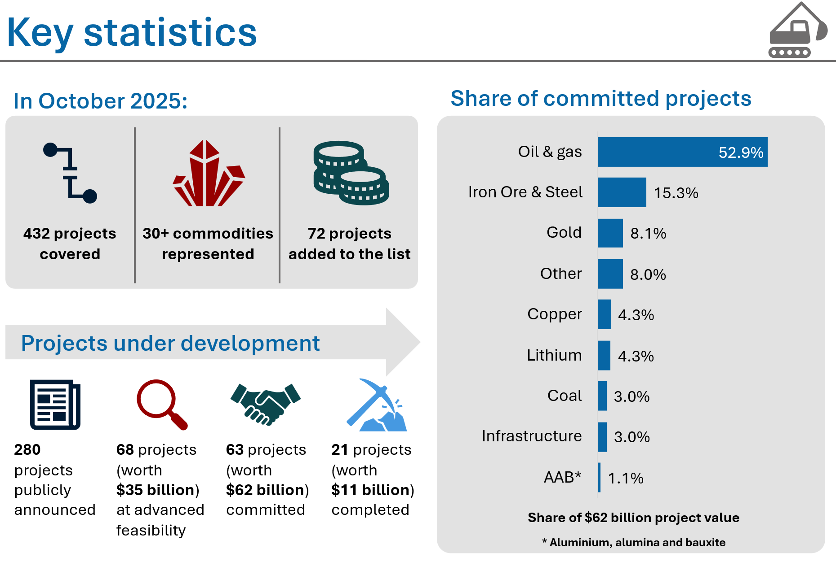
Key statistics

Summary
- The 2025 Resources and Energy Major Projects (REMP) report shows a healthy and relatively stable investment outlook for Australia’s resources and energy sector.
- There were 432 major resource and energy projects under development in Australia as at 31 October 2025, up from 407 projects a year earlier. This includes 63 committed projects – where a final investment decision (FID) has been taken – and 68 projects at the advanced feasibility stage.
- The value of committed projects declined from $65 billion to $62 billion, as some committed projects were completed. Oil and gas projects continue to make up the largest share of committed projects by value.
- Critical minerals projects continue to progress and expand despite sometimes challenging conditions and smaller project sizes. Around a quarter of projects at each stage in this year’s list were critical minerals, with $20 billion of proposed investment for later-stage projects.
- There were $1.9 billion of committed Infrastructure projects in 2025. These projects cover new and expanded gas pipelines, resource processing, port and rail upgrades, and decarbonisation projects.
- Coverage of Australian hydrogen projects will now be through the Department of Climate Change, Energy, Environment and Water’s State of Hydrogen report and CSIRO’s HyResource module to avoid inconsistent methodologies. The next State of the Hydrogen report is due in coming months. Figures and tables throughout this report have been updated to exclude hydrogen from historical series.

Overview

The value of committed and completed projects declined in 2025
The value of committed and completed major projects has declined since 2022, following several years of growth. The rate of decline slowed in 2025, with the value of committed projects falling from $65 billion to $62 billion (Figure 1.1). The number of committed projects rose from 62 to 63 in 2025 after a fall in 2024 (Figure 1.2).
      - Value of committed and completed projects

Source: Department of Industry, Science and Resources (2025)
The value and quantity of committed projects is stabilising following several volatile years (before and during the COVID-19 outbreak). Early-stage announcements fell in 2019 after the completion of many projects in the 2017–18 period. However, early-stage announcements have recovered more recently, creating potential for growth in committed and completed projects over the coming years.
A total of 21 projects worth $11 billion were completed in 2025. Another 14 projects received a FID and progressed to the committed category. This rate of progression is broadly consistent with recent years. It suggests project owners are successfully managing an uncertain global environment, a rapid transition towards emerging commodities, including rare earths, that support the global low-carbon energy transition and other forms of technological change.
A total of 72 projects were added across all stages in 2025, down from the 103 added in 2024. These additions include new projects, expansions and reactivations.
Five projects were reallocated to earlier stages between the 2024 and 2025 REMPs, while 35 projects progressed to more advanced stages. Projects may progress without necessarily moving between stages, since there many steps to be completed within each stage. These steps can include additional exploration, multiple feasibility and scoping/rescoping studies, financing, and contract negotiations with suppliers and service providers.

Gold, copper, and iron ore accounted for most additions
The value of committed and completed projects has held up well across most commodities. Most of Australia’s resources and energy major projects are in Western Australia (Figure 1.4), which now accounts for more than half of all projects at the committed stage, and an even higher share of project value. This trend has been evident for some years, and recent growth in early-stage projects in Western Australia suggests it will continue.
      - Number of projects by stage, 2018–2025

Notes: The 2023 edition replaced the ‘feasibility’ stage with the ‘advanced feasibility’ stage. Projects in the ‘feasibility’ stage are reclassified to either ‘publicly announced’ or ‘advanced feasibility’ stages. Hydrogen projects are not included in the above.
Source: Department of Industry, Science and Resources (2025)
Over the past year, there has been significant growth in project activity in Australia’s iron ore sector. Three iron ore projects advanced to the committed stage and 2 projects were completed in 2025. Capital expenditure for advanced projects (those that have reached advanced feasibility or the committed stages) increased from $8.1 billion in 2024 to $12 billion in 2025.
High gold prices supported strong activity in the gold mining sector in 2025. There were 45 gold projects in 2025, up from 38 in 2024. Projects at the publicly announced and feasibility stages increased from 27 to 29 as new projects were announced, and others reached a final investment decision or were completed. Capital expenditure for projects at advanced stages dropped slightly from $9.6 billion to $9.3 billion in 2025, mainly due to the removal of projects completed in 2024.
Copper project activity remained steady in 2025, with total capital expenditure reaching $16.1 billion, consistent with 2024. Capital expenditure for advanced feasibility and committed projects dropped from $6.1 billion in 2024 to $5.2 billion in 2025, reflecting the transition of one project to the completed stage early in the year. Five new projects were included in 2025, with a mix of expansions and new developments, summing to a total value of $0.7 billion.
Total capital expenditure for zinc, lead and silver projects increased to $2.9 billion in 2025, up from $2.2 billion in 2024. This reflects the addition of 3 new projects in 2025. Capital investment for advanced feasibility and committed projects reached $1.1 billion in 2025, rising from $0.7 billion in 2024.
The investment pipeline for other commodities (non-critical minerals) was largely unchanged in 2025. Out of 30 projects, 15 are publicly announced, 5 are in advanced feasibility, 4 are committed construction, and 4 were completed. Total investment reached $8.4 billion in 2025, with $4.6 billion invested in advanced feasibility and committed projects. The investment pipeline was largely stable, with 2 additional projects in the pipeline compared with last year.
      - Value of new commitments by commodity

Source: Department of Industry, Science and Resources (2025)
      - Number of projects by State/Territory

Source: Department of Industry, Science and Resources (2025)

Investment in energy commodities has held up
Australia’s coal projects remain broadly unchanged, with developments mostly limited to brownfield projects. Three projects were completed, all of which were expansions to existing mines. There were 40 coal projects recorded in 2025, down from 47 in 2024.
Australia has 50 oil and gas projects under development in 2025, with 13 of these (worth $33 billion) at the committed stage. These projects include large investments in Western Australia and the Northern Territory which should help to maintain Australia’s LNG exports for the next 10 years.
Among 8 uranium projects in the list, 7 are publicly announced and one is in the advanced feasibility stage. Uranium projects are generally in a holding pattern. Uranium projects are highly regulated and typically slow to progress, but if current price strength is sustained, pressure to progress uranium projects is likely to grow.

    - Summary of projects as at 31 October 2025
 | Publicly Announced | Advanced Feasibility |  | Committed
 | No. of projects | No. of projects | Value A$b | No. of projects | Value A$b
Aluminium, Alumina, Bauxite | 5 | 2 | 0.5 | 4 | 1.0
Coal | 35 | 3 | 0.8 | 3 | 1.9
Copper | 17 | 7 | 2.5 | 6 | 2.7
Gold | 18 | 11 | 4.2 | 13 | 5.1
Iron Ore | 37 | 5 | 2.4 | 7 | 9.6
Lead, Zinc, Silver | 6 | 4 | 1.0 | 1 | 0.1
Lithium | 9 | 1 | 0.1 | 2 | 1.0
Nickel, Cobalt | 13 | 4 | 5.9
Oil and gas | 29 | 1 | 0.8 | 12 | 33.3
Other Commodities ^{b} | 72 | 27 | 9.9 | 10 | 5.0
Uranium | 7 | 1 | 0.5
Infrastructure ª | 32 | 2 | 5.6 | 5 | 1.9
Total ^{c} | 280 | 68 | 34.0 | 63 | 61.6
Notes: a Infrastructure is limited to resource, energy infrastructure projects including CCS. b Other Commodities is limited to resources and energy commodities not elsewhere identified. c Totals may not add due to rounding at commodity level. Hydrogen projects are not included in the above.
Source: Department of Industry, Science and Resources (2025)

    - New advanced feasibility studies, commitments to projects and projects completed, between 1 Nov 2024 and 31 Oct 2025
 | New advanced feasibility studies |  | New commitments |  | Completed
 | No. of projects | Value A$b | No. of projects | Value A$b | No. of projects | Value A$b
Aluminium, Alumina, Bauxite |  |  | 2 | 0.355
Coal |  |  |  |  | 5 | 1.1
Copper | 1 | 0.5 | 3 | 0.46 | 1 | 0.1
Gold | 2 | 0.2 | 3 | 0.7 | 3 | 0.4
Iron Ore | 1 | 0.5 | 3 | 6.4 | 2 | 3.0
Lead, Zinc, Silver
Lithium |  |  |  |  | 2 | 0.6
Nickel, Cobalt
Oil and gas |  |  | 1 | 0.1 | 3 | 4.3
Other Commodities ^{b} | 2 | 0.7 | 1 | 0.1 | 2 | 0.3
Uranium
Infrastructure ª |  |  | 1 | 0.6 | 3 | 1.0
Total ^{c} | 6 | 1.8 | 14 | 8.8 | 21 | 10.7
Notes: a Infrastructure is limited to resource, energy infrastructure projects including CCS. Several gas pipelines span across more than one state but have been allocated to one state for reporting purposes. b Other Commodities is limited to resources and energy commodities not elsewhere identified. c Totals may not add due to rounding at commodity level.
Source: Department of Industry, Science and Resources (2025)

      - Location of projects at the committed stage, as at 31 October 2025
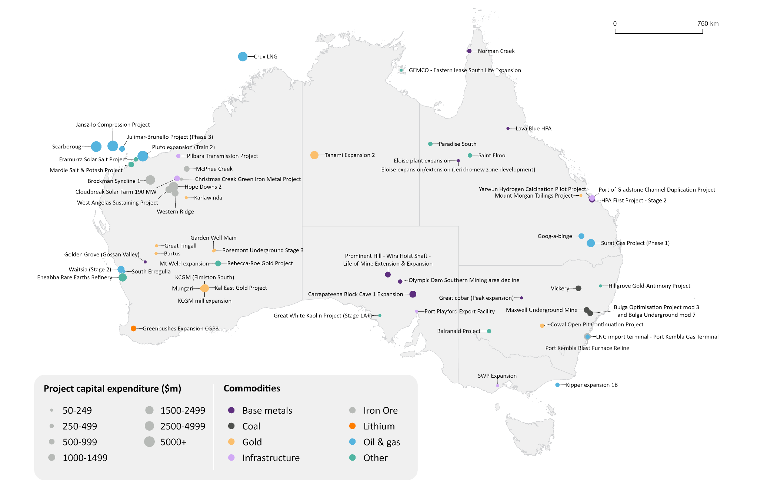
Source: Department of Industry, Science and Resources (2025)

Critical minerals

Australia’s critical minerals pipeline is driven by early-stage projects
Australia’s critical minerals major project list for 2025 features 130 projects, up 11 projects compared with last year. The estimated value of proposed investment for projects at later stages of development was $19 billion as of 31 October 2025 (Table 2.2).
This year’s pipeline continues to be dominated by early-stage projects (publicly announced), which accounted for 70% of the total. Among later stage projects, around 21% of projects had delivered an advanced feasibility study and a further 8% had reached a final investment decision. Two projects were completed in the last 12 months.
Around half of all critical minerals projects (65) were in Western Australia. The remaining projects were distributed across Queensland (22), Northern Territory (11), South Australia (10), New South Wales (10), Victoria (10), and Tasmania (2).

Moderate progress in pipeline despite challenging global conditions
There has been a continued slowdown in expansion and greenfield investment in nickel and lithium projects due to low global prices. Several lithium developments remain delayed, such as Albermarle’s suspension of development of trains 3 and 4 of its Kemerton refinery, while train 2 remains in care and maintenance. The Black Swan Nickel project has been deferred indefinitely due to the weak outlook for nickel prices.
      - Australia’s critical minerals pipeline remains driven by early-stage projects

Source: Department of Industry, Science and Resources (2025)
      - Critical minerals project count by state or territory

Source: Department of Industry, Science and Resources (2025)
      - Investment in later stage critical mineral projects

Notes: Later-stage projects include those that have delivered a Definitive Feasibility Study (or equivalent), and/or have reached a Final Investment Decision (i.e. Committed stage)
Source: Department of Industry, Science and Resources (2025)
Projects that made notable progress include Alliance Nickel’s NiWest Nickel-Cobalt Project, which delivered a definitive feasibility study in November 2024, and Northern Minerals’ Browns Range rare earth project, which delivered a definitive feasibility study in September 2025. Larvotto Resources made a final investment decision on its Hillgrove gold-antimony project in July this year.
The two projects completed in 2025 were the Pilgangoora P1000 expansion ($560 million) and Covalent’s Kwinana Lithium Refinery. The total cost of the Covalent Lithium project (which includes the Mt Holland Mine delivered in 2024, the new Kwinana Refinery and associated infrastructure) is estimated to be $2.6 billion.

Rare earths projects lead the later-stage project pipeline amidst investor confidence and government support
The pipeline of rare earth projects continues to grow steadily, reaching a total of 19 projects in 2025. Rare earths projects accounted for around 32% of the value of later-stage projects, with $6 billion in proposed investment. Nickel-cobalt projects followed with $5.9 billion (Figure 2.3).
Arafura’s $1.8 billion Nolans Project is a key late-stage rare earths project expected to reach FID in Q1 2026. The project has secured more than $1,300 million of funding from the Commonwealth Government, as well as a range of other domestic and international investors. Other late-stage rare earths projects include Northern Minerals’ Browns Range Project and Astron/Energy Fuels’ Donald Rare Earths Project, with FID anticipated by the end of 2025. Construction is underway for several committed projects. Lynas’ Mt Weld Expansion works are close to completion, and Iluka Resources’ $1.8 billion Eneabba rare earths refinery is on track to be commissioned in 2027.
Several high-value nickel projects are in the later-stages of development, including the Sunrise nickel-cobalt project ($2.7 billion) and Sconi ($1.4 billion). However, further advancement is likely to depend on an improving outlook for global nickel prices.

Project timelines accelerated by global partnerships
The rising global appetite to diversify critical minerals supply chains has been driving increased international partnerships in Australia’s critical minerals pipeline. Minerals, including rare earths and gallium, have received substantial funding under the US-Australia Critical Minerals Framework. Numerous rare earth projects – such as the Nolans Project and the Browns Range Project – were recipients of Letter of Interest (LOI) of over $800 million from the Export-Import Bank of the United States (EXIM). Graphinex’s $1.2 billion Esmeralda Graphite project secured an $860 million LOI from EXIM in October 2025 and is expecting first production in 2028.
Australia’s first gallium project was announced by Alcoa Australia in August 2025. The company entered into a Joint Development Agreement with the Japanese Government and Sojitz Corporation to establish the gallium plant at its Wagerup alumina refinery in Western Australia. The Australian and US governments have since partnered to support the project, with all parties to contribute capital to a special purpose vehicle (SPV) and in return for proportional gallium offtake. The plant is targeting a capacity of 60 tonnes a year during the first phase before ramping up to 100 tonnes a year. A final investment decision is expected in 2026.

The battery active materials pipeline remains stable
The battery active materials pipeline was mostly unchanged in 2025, with many projects remaining in early-stage scoping or pre-feasibility phases. No new advanced feasibility studies nor any FIDs were released over the year.
Renascor’s $772 million Siviour purified spherical graphite project, currently at the advanced feasibility stage, is targeting 100,000 tonnes a year across both Stage 1 and Stage 2. In the September quarter 2025, the company commenced construction of a demonstration plant in Adelaide to validate and optimise the purification process ahead of full-scale commercial operations.
International Graphite is advancing a 4 ktpa graphite micronising facility at Collie, Western Australia, following positive results from a Front-End Engineering and Design (FEED) study released in March 2025. The company views the Collie development as a first step in building out its Australian and international downstream processing facilities.
In February 2025, VSPC announced plans for a 250-tonne lithium ferrous phosphate (LFP) cathode powder demonstration plant in Australia, supported by the Australian Renewable Energy Agency (ARENA). The plant will operate for 2 years, during which the company aims to secure binding offtake contracts to enable commercial scale-up.

Comparing critical minerals projects to 2024
The list of critical minerals projects (mining and immediate downstream processing) included in this year’s report is consistent with the Australian Government’s Critical Minerals list as at 31 October 2025. Further information on the current list of Australia’s Critical Minerals can be found on the Department of Industry, Science and Resources’ website.
Table 2.1 shows a comparison between projects on the 2024 and 2025 major projects list. The value of proposed investment includes only projects that have either: (i) delivered a definitive, detailed or bankable feasibility study, or (ii) reached FID.
    - Comparing major critical minerals projects to last year
Category | 2024 | 2025 | Result
Project pipeline ^{b} | $20 billion | $19 billion | Decrease
Total projects | 119 | 130 | Increase
Publicly announced | 79 | 91 | Increase
Advanced feasibility | 25 | 27 | Increase
Committed | 9 | 10 | Increase
Completed | 6 | 2 | Decrease
Note: b Value relates to advanced feasibility and committed projects.
    - Summary of critical mineral projects as at 31 October 2025
 | Publicly Announced | Advanced Feasibility |  | Committed |  | Completed
 | No. of projects | No. of projects | Value A$b | No. of projects | Value A$b | No. of projects | Value A$b
Active materials and electrolytes | 5 | 2 | 0.8
Nickel-cobalt | 13 | 4 | 5.9
Graphite | 5 | 4 | 0.6
High Purity Alumina | 2 | 1 | 0.3 | 2 | 0.6
Lithium | 9 | 1 | 0.1 | 2 | 1.0 | 2 | 0.6 ^{b}
Manganese | 3 | 1 | 0.1 | 1 | 0.1
Magnesium | 6
Rare earths | 10 | 7 | 3.8 | 2 | 2.3
Silica/Silicon | 2 | 2 | 0.3
Titanium and mineral sands | 14 | 3 | 1.1 | 1 | 0.5
Vanadium | 5 | 2 | 0.8 | 1 | 0.4
Other ª | 17 |  |  | 1 | 0.1
Total | 91 | 27 | 13.7 | 10 | 5.0 | 2 | 0.6 ^{b}
Notes: a Other category includes platinum group metals and critical minerals co-located within other metals groups (e.g. copper). Vanadium includes vanadium oxide projects, with outputs including ilmenite, titanium oxide, ferro-vanadium and iron oxides. Heavy mineral sands include zircon, ilmenite, niobium, leucoxene, hafnium, rutile and other heavy mineral concentrates. b Value does not include the value of Covalent’s Kwinana Lithium Refinery as the specific figure is not publicly available.
Source: Department of Industry, Science and Resources (2025)

    - New advanced feasibility studies, commitments to projects and projects completed, between 1 November 2024 and 31 Oct 2025, for critical minerals
 | New advanced feasibility studies |  | New commitments |  | Completed
 | No. of projects | Value A$b | No. of projects | Value A$b | No. of projects | Value A$b
High Purity Alumina |  |  | 1 | 0.1
Lithium |  |  |  |  | 2 | 0.6 ^{b}
Nickel-cobalt | 1 | 1.7
Rare earths | 1 | 0.6
Titanium and mineral sands
Other ª |  |  | 1 | 0.1
Total | 2 | 2.2 | 2 | 0.2 | 2 | 0.6 ^{b}
Notes: a Other category includes platinum group metals and critical minerals co-located within other metals groups (e.g. copper). Vanadium includes vanadium oxide projects, with outputs including ilmenite, titanium oxide, ferro-vanadium and iron oxides. Heavy mineral sands include zircon, ilmenite, niobium, leucoxene, hafnium, rutile and other heavy mineral concentrates. b Value does not include the value of Covalent’s Kwinana Lithium Refinery as the specific figure is not publicly available.
Source: Department of Industry, Science and Resources (2025)

Oil and gas

Oil and gas dominates projects at the committed stage
Oil and gas projects account for a substantial share of overall capital expenditure and most of the value at the committed stage in the 2025 REMP. Oil and gas projects encompass a range of different project types, including oil and gas extraction, projects that produce liquified natural gas (LNG) for export, and LNG receiving terminals. The LNG import terminals included in the 2025 REMP will be Australia’s first, allowing Australia to import LNG for the first time.
The number of oil and gas projects was relatively steady in 2025 (Figure 3.1). In value terms, committed oil and gas projects fell to $33 billion, from $38 billion in 2024 (Figure 3.2). This largely reflects the completion of Santos’ Barossa Backfill project, though the progression of Stike Energy’s South Erregulla project to the committed stage kept the number of committed projects stable in 2025.
LNG remains dominated by large committed projects including Scarborough, the Jansz-Io Compression Project, Crux LNG, and Surat. The completion of these over the next few years should sustain Australia’s gas production and exports into the 2030s.

New project numbers are declining
The number of oil and gas projects at earlier stages of the project pipeline was largely unchanged, with a small decline in publicly announced projects in 2025. More rapid development of LNG has been evident in the Northern Territory where several new projects have been recently announced. Completion of these could add to the Northern Territory’s importance as an energy supplier in the 2030s.
      - Oil and gas pipeline (by project numbers)

Source: Department of Industry, Science and Resources (2025)
      - Oil and gas capex: value of committed projects

Source: Department of Industry, Science and Resources (2025)
    - Oil and gas projects by state, as at 31 October 2025
 |  | NSW | Vic | Qld | SA | WA | Tas | NT
Completed | Number | 1 |  |  |  | 2 |  | 1
 | Value ($m) | 70 |  |  |  | 0 |  | 4300
Committed | Number | 1 | 2 | 2 |  | 7 |  | 1
 | Value ($m) | 250 | 471 | 2500 |  | 30154
Publicly announced and definitive feasibility | Number | 3 | 7 | 10 | 2 | 12 |  | 3
Source: Department of Industry, Science and Resources (2025)

Committed and completed projects

Committed projects decreased as projects completed
Over the year to 31 October 2025, 21 projects worth $11 billion were completed. This largely matches the 21 projects valued at $10 billion completed in 2024 (Figure 4.1). Most projects currently committed are expected to be completed by late 2027.
Five coal projects moved to completed status over the year, with the number of committed projects decreasing from 7 to 3 as a result. One of the 5 projects moved from publicly announced to completed. No coal projects moved to the committed stage in 2025.
Iron ore investment increased significantly in 2025, with steady progress for most projects. In March 2025, Rio Tinto announced its $2.8 billion investment in the Brockman Syncline 1 mine project (BS1), where first production is expected in 2027. In June 2025, Rio Tinto and Hancock Prospecting announced that they have received all necessary approvals for their $2.5 billion Hope Downs 2 project, with expected production in 2027. In October 2025, Rio Tinto announced investment of $1.1 billion to expand the West Angelas mine. The $2.9 billion Western Range project, a collaboration between Rio Tinto and Baowu, commenced commercial production in June 2025. Rio Tinto’s Gudai Darri capacity expansion project was completed in the fourth quarter of 2024.
The net impact of these changes resulted in the total estimated value of iron ore projects in the committed stage increasing from $6.3 billion in 2024 to $9.6 billion in 2025.
      - Expected completion year of projects, for advanced feasibility and committed projects

Notes: Expected completion year of projects are based on either company announcement
Source: Department of Industry, Science and Resources (2025)
      - Number and value of committed projects

Source: Department of Industry, Science and Resources (2025)
      - Value of committed projects by commodity

Notes: Infrastructure is limited to resource and energy infrastructure projects including CCS. Other Commodities is limited to resource and energy commodities not elsewhere identified.
Source: Department of Industry, Science and Resources (2025)
      - Value of completions and new commitments

Notes: Infrastructure is limited to resource, energy infrastructure projects including CCS. Other Commodities is limited to resource and energy commodities not elsewhere identified.
Source: Department of Industry, Science and Resources (2025)

    - Summary of projects at the committed stage by state, as at 31 October 2025
 | NSW |  | Vic |  | Qld |  | SA |  | WA |  | Tas |  | NT |  | Total
 | No. of projects | Value A$b | No. of projects | Value A$b | No. of projects | Value A$b | No. of projects | Value A$b | No. of projects | Value A$b | No. of projects | Value A$b | No. of projects | Value A$b | No. of projects | Value  A$b
Aluminium, Alumina, Bauxite |  |  |  |  | 4 | 1.0 |  |  |  |  |  |  |  |  | 4 | 1.0
Coal | 3 | 1.9 |  |  |  |  |  |  |  |  |  |  |  |  | 3 | 1.9
Copper | 1 | 0.1 |  |  | 2 | 0.2 | 3 | 2.5 |  |  |  |  |  |  | 6 | 2.7
Gold | 1 | 0.4 |  |  | 1 | 0.1 |  |  | 10 | 2.8 |  |  | 1 | 1.8 | 13 | 5.1
Infrastructure |  |  | 1 | 0.1 | 1 | 0.8 | 1 | 0.1 | 2 | 1.0 |  |  |  |  | 5 | 1.9
Iron Ore | 1 | 1.2 |  |  |  |  |  |  | 6 | 8.5 |  |  |  |  | 7 | 9.6
Lead, Zinc, Silver |  |  |  |  |  |  |  |  | 1 | 0.1 |  |  |  |  | 1 | 0.1
Lithium |  |  |  |  |  |  |  |  | 2 | 1.0 |  |  |  |  | 2 | 1.0
Nickel, Cobalt
Oil and gas | 1 | 0.3 | 1 | 0.4 | 2 | 2.5 |  |  | 7 | 30.2 |  |  | 1 | 0.0 | 12 | 33.3
Other Commodities | 2 | 0.6 |  |  | 2 | 0.7 | 1 | 0.1 | 4 | 3.5 |  |  | 1 | 0.1 | 10 | 5.0
Uranium
Total ^{c} | 9 | 4.4 | 2 | 0.5 | 12 | 5.2 | 5 | 2.6 | 32 | 47.1 | 0 | 0 | 3 | 1.8 | 63 | 61.6
Notes: a Infrastructure is limited to resource, energy infrastructure projects including CCS. Several gas pipelines span across more than one state but have been allocated to one state for reporting purposes. b Other Commodities is limited to resource and energy commodities not elsewhere identified. c Totals may not add due to rounding at commodity level.
Source: Department of Industry, Science and Resources (2025)

    - Summary of projects completed by state, between 1 November 2024 and 31 October 2025
 | NSW |  | Vic |  | Qld |  | SA |  | WA |  | Tas |  | NT |  | Total
 | No. of projects | Value A$b | No. of projects | Value A$b | No. of projects | Value A$b | No. of projects | Value A$b | No. of projects | Value A$b | No. of projects | Value A$b | No. of projects | Value A$b | No. of projects | Value  A$b
Aluminium, Alumina, Bauxite
Coal |  |  |  |  | 5 | 1.1 |  |  |  |  |  |  |  |  | 5 | 1.1
Copper | 1 | 0.1
Gold |  |  |  |  | 1 | 0.1 |  |  | 1 | 0.1 |  |  | 1 | 0.1 | 3 | 0.4
Infrastructure | 1 | 0.1 |  |  |  |  |  |  | 2 | 0.9 |  |  |  |  | 3 | 1.0
Iron Ore |  |  |  |  |  |  |  |  | 2 | 3.0 |  |  |  |  | 2 | 3.0
Lead, Zinc, Silver
Lithium |  |  |  |  |  |  |  |  | 2 | 0.6 |  |  |  |  | 2 | 0.6
Nickel, Cobalt
Oil and gas |  |  |  |  |  |  |  |  | 2 | 0 |  |  | 1 | 4.3 | 3 | 4.3
Other Commodities |  |  |  |  | 1 | 0.1 |  |  | 1 | 0.3 |  |  |  |  | 2 | 0.3
Uranium
Total ^{c} | 2 | 0.1 |  |  | 7 | 1.3 |  |  | 10 | 4.9 |  |  | 2 | 4.4 | 21 | 10.7
Notes: a Infrastructure is limited to resource, energy infrastructure projects including CCS. Several gas pipelines span across more than one state but have been allocated to one state for reporting purposes. b Other Commodities is limited to resource and energy commodities not elsewhere identified. c Totals may not add due to rounding at commodity level.
Source: Department of Industry, Science and Resources (2025)

Publicly announced and advanced feasibility

Global net zero plans drove critical minerals projects
The 2025 analysis identified 348 publicly announced and advanced feasibility projects. Of these projects, 68 with an estimated value of $35 billion have an advanced feasibility study. The completion of an advanced study is an indicator that the project may be close to reaching the committed stage. Three projects (with an estimated value of $1.6 billion) progressed to the advanced feasibility stage this year.
Gold projects in the advanced feasibility stage were similar to 2024, with a similar number of projects being completed as progressing to this stage. Some projects moved quickly through the stages with 3 projects that were not previously included already progressing to advanced feasibility in 2025.
A total of 42 iron ore projects are yet to reach the committed stage, with 5 projects reaching advanced feasibility. New projects include the West Angelas Sustaining Project, Mindy South, Ministers North, Lamb Creek, and Mulga Downs. The Mid-West Green Iron Project and NeoSmelt Pilot Plant are new green steel and iron projects. The Collie Green Steel Mill project reached advanced feasibility in 2025.
The number of copper projects rose to 32 this year, from 29 in 2024. Eighteen of these projects are at the publicly announced stage, including the Olympic Dam smelter expansion, which is expected to more than double the site's copper production capacity. Production growth is set to accelerate further with seven projects completing their definitive feasibility study.
Many coal projects remain at the publicly announced stage, likely due to deteriorating market conditions for coal.
      - Projects yet to reach the committed stage

Notes: Infrastructure is limited to resource and energy infrastructure projects including CCS. Other Commodities is limited to resource and energy commodities not elsewhere identified. Oil and gas projects are not separated between publicly announced and advanced feasibility stages.
Source: Department of Industry, Science and Resources (2025)
      - Value of projects at the advanced feasibility stage

Source: Department of Industry, Science and Resources (2024)

Exploration

Lower mineral exploration affected overall capex
Australian mining exploration expenditure declined by 8% year-on-year to $5.1 billion in 2024–25 (Figure 6.1). Non-energy mineral expenditure (which includes minerals such as base metals, gold and iron ore) fell 12% to $3.3 billion. Iron ore exploration expenditure increased by 15% to $0.8 billion, overtaking base metals for the first time since 2016–17. Exploration for base metals declined by 21% in 2024–25.
Energy minerals (thermal and metallurgical coal and uranium) expenditure declined by 15%, although the decline was smaller in absolute value terms (at $0.1 billion). Petroleum exploration increased by 8% over the year to $1.4 billion, but remains below peak levels from 2012 to 2014. Coal exploration expenditure declined 21% over the year.
Exploration expenditure for the ‘other’ minerals category (including lithium) fell sharply in 2024–25 after two exceptionally strong years.

Gold is drawing the largest interest in mineral exploration
For the past ten years, gold has attracted the most mineral exploration expenditure, overtaking iron ore in 2015–16. Gold exploration expenditure increased to $1.3 billion in 2024‍–‍25, closing in on its 2021–22 peak of $1.6 billion. Gold exploration currently contributes 34% of Australia’s total exploration expenditure (Figure 6.2).
      - Mineral and petroleum exploration expenditure

Source: ABS (2024) Mineral and Petroleum Exploration, Australia, 8412.0
      - Annual mineral exploration expenditure by commodity

Notes: Base metals also include silver and cobalt.
Source: ABS (2024) Mineral and Petroleum Exploration, Australia, 8412.0

Methodology
Each year, information is collected about the investment outlook for major resources and energy projects from publicly available resources. Information is gathered from a range of sources, including company websites and media releases, government departments and agencies, industry associations, and Australian Stock Exchange reports.
The focus of this report is on ‘major’ investments – those that can be confidently valued at over $50 million based on publicly available sources. Smaller scale operations are also an important contributor to the sector and the broader Australian economy, but public information – particularly on early-stage projects – can be scarce or difficult to find. These include projects undertaken by private companies who have fewer obligations to report project progress. Bigger operations also make large, but incremental, investments over time replenishing equipment, plant and other property. These investments are unlikely to be characterised as major projects.
For these reasons, this report omits some projects when key parameters cannot be identified. Each year, the Department seeks to improve the coverage and data quality of the report, including by incorporating relevant project information that may not have been identified in previous years.
Resources and energy project proponents often use different planning processes and assessment methods to support their FID. There is no standard project development model – with clearly defined stages and terminology – that can be applied to every resource and energy project.
Projects are grouped into four categories. Earlier stages, such as identifying deposits and exploration activities, are not included in the list. While these activities are important, it is beyond the scope of this report to assess exploration activities on a project-by-project basis. Instead, a summary and analysis of aggregate exploration expenditure is provided.
The 4 stages projects get classified into are:
- Projects publicly announced and under consideration
- Projects that have completed an advanced feasibility study
- Committed projects – which have taken FID
- Completed projects – which have commenced production

  - Publicly announced and under consideration
Projects at the publicly announced stage are usually early in their development and are typically undergoing feasibility studies to assess the commercial aspects of developing an identified resource. For a project to be listed at this stage, there must be publicly available information on the preliminary project schedule, planned output or cost. As they are still in the early planning stage, projects at the publicly announced stage may not have finalised any engineering designs or construction cost estimates.
Projects at this stage may have provisional or outdated cost estimates and will not have received any formal commitment from companies to proceed. Such projects may have been announced 10 or more years ago with no subsequent progress nor any further studies or updates. The available public information on these projects is collected and presented for use as a reference guide, but data is not modified, aggregated or treated as a formal data source for the purposes of the report. Only the total number of projects at this stage is included.
  - Advanced feasibility study completed
Projects at this stage have completed a definitive, detailed or bankable feasibility study and are considered to have a strong business case for further progression. Definitive feasibility studies will have occurred following detailed Front-End Engineering Design (FEED) studies and full development of the final project scope.
Projects that have progressed through the advanced feasibility stage have a higher likelihood of progressing to the committed stage than earlier stage projects. Figures and data on these projects are considered sound enough to use as a leading indicator for future capital investment by the resources sector. However, capital cost estimates on these projects differ from capital costs for projects at the committed stage, since the latter represents fully committed capital investment.
  - Committed stage
Projects at the committed stage have finished all commercial, engineering and environmental studies, received all necessary government regulatory approvals, and finalised the financing of the project to allow construction. Such projects are considered to have received a positive FID from the owner(s). In most cases, projects at this stage of development have already started construction, as there are typically pre-works undertaken as part of exploration and design activities.
Projects at the committed stage typically have cost estimates, schedules, and mine outputs that are well defined and often published. Most projects that progress to the committed stage are likely to commence production. Nevertheless, post-FID, there are still technical and financial risks that, if realised, can result in delays, scope changes and cost overruns, or even affect the commercial viability of a project and possibly lead to its cancellation.
Data on projects at the committed stage is considered of high quality, and is aggregated, compared, and monitored within the report. Newly committed projects (those which have commenced since the prior report) are included as a distinct category in Table 1.2 of this report.
  - Completed stage
As many projects include multiple stages and scope elements that can be independent of each other, the timing around when a project reaches the completed stage can be difficult to assess. Under our framework, a project is considered to have reached the completed stage when all construction and commissioning activities are finished, and the operation has reached commercial production.

New projects, expansions and reactivations
Our framework classifies projects as ‘new’, ‘expansion’ or ‘reactivation’. New projects are those that were not active at the same location before the first announcement recorded in our research. Expansions correspond to those that are already existing and are taking their operations to neighbouring fields. In many cases, the goal of the ‘expansion’ is merely to maintain output. ‘Expansion’ does not imply output will increase. Reactivation indicates a mine is returning to production after care and maintenance, or projects that were announced, then officially abandoned, but have since been returned to the drawing board.

Oil and gas projects
Oil and gas projects are split into three stages – publicly announced, committed, and completed. This is different from the rest of the REMP methodology since it excludes the ‘advanced feasibility’ stage that occurs between publicly announced and committed.
The advanced feasibility stage for non-oil/gas projects is based on projects having completed a ‘definitive feasibility study’ or ‘bankable feasibility study’. These studies are not typically conducted in the oil and gas sector, so the advanced stage has been removed from the oil and gas projects list.

Estimated start of commercial operation
Some projects this year have been designated as ‘other’ rather than providing a date. The ‘other’ category is used in a range of cases, including, but not limited to, when no date is provided publicly by the project proponent, when recent information on the completion date is not publicly available, or if a project has an expected completion date after 2030.

About this report
The Resources and Energy Major Projects publication is an annual review of projects which seek to extend, increase, or improve the quality of mineral commodity output in Australia. These investment projects include greenfield projects, expansions, reactivations, processing facilities, and related infrastructure. Since 1997, the publication has reported the value of current and potential investment in the sector and provided commentary on key development trends.
From 2017 to 2019, Resources and Energy Major Projects was published as a chapter in the Resources and Energy Quarterly. The 2020, 2021, 2022 and 2023 editions, as well as pre-2017 updates, are standalone publications.
This edition of the report presents an update on project developments over the 12 months from the start of November 2024 to the end of October 2025, and is accompanied by a detailed project listing.
Each year, we seek to improve the coverage and quality of the report. Much of the analysis in this edition is directed at projects that have progressed significantly and which have a higher quality of data associated with them.

Terminology
The methodology used in the report is detailed in the Methodology section.
This report and project list is the result of our research on major resources and energy projects under development in Australia. For the purposes of this report, ‘major’ projects are those costed at over $50 million and which have the potential to reach a final investment decision (FID) within the next 5 years.
Projects are classified into four stages: publicly announced, advanced feasibility, committed and completed. Earlier stages of developing mineral projects, such as identifying deposits and exploration activities, are not included in our lists.

