Industry Innovation and Science Australia
  - Annual report
2024–25

Copyright
© Commonwealth of Australia 2025
Ownership of intellectual property rights
Unless otherwise noted, copyright (and any other intellectual property rights, if any) in this publication is owned by the Commonwealth of Australia.

Creative Commons licence Attribution
CC BY 4.0
All material in this publication is licenced under a Creative Commons Attribution
4.0 International Licence, save for content supplied by third parties, logos, any material protected by trademark or otherwise noted in this publication, and the Commonwealth Coat of Arms.
Creative Commons Attribution 4.0 International Licence is a standard form licence agreement that allows you to copy, distribute, transmit and adapt this publication provided you attribute the work. A summary of the licence terms is available from creativecommons.org/licenses/by/4.0/.
The full licence terms are available from creativecommons.org/licenses/by/4.0/ legalcode.
Content contained herein should be attributed as Industry Innovation and Science Australia 2024–25 Annual Report.
Disclaimer
The Commonwealth as represented by the Department of Industry, Science and Resources has exercised due care and skill in the preparation and compilation of the information in this publication.
The Commonwealth does not guarantee the accuracy, reliability or completeness of the information contained in this publication. Interested parties should make their own independent inquiries and obtain their own independent professional advice prior to relying on, or making any decisions in relation to, the information provided in this publication.
The Commonwealth accepts no responsibility or liability for any damage, loss or expense incurred as a result of the reliance on information contained in this publication. This publication does not indicate commitment by the Commonwealth to a particular course of action.
ISSN (Online): 2653-2786
ISSN (Print): 2653-2778

Acknowledgement of Country
Industry Innovation and Science Australia recognises the First Peoples of this Nation and their ongoing cultural and spiritual connections to the lands, waters, seas, skies, and communities.
We Acknowledge First Nations Peoples as the Traditional Custodians and Lore Keepers of the oldest living culture and pay respects to their Elders past and present. We extend that respect to all First Nations Peoples.

Letter of transmittal
Senator the Hon Tim Ayres
Minister for Industry and Innovation
Minister for Science
Parliament House
CANBERRA ACT 2600
Dear Minister,
I am pleased to present the 2024–25 annual report for Industry Innovation and Science Australia (IISA), for the reporting period ending 30 June 2025.
This report has been prepared in accordance with section 46 of the Industry Research and Development Act 1986, which requires that the Board prepare and provide an annual report to you for presentation to the Parliament.
This report covers the IISA Board’s operations during the 2024–25 financial year and the operations of its committees.
Yours sincerely,

Peter Rossdeutscher AM
15/10/2025

Contents
Message from the Chair 1
About IISA 5
IISA functions 5
Financial responsibilities 7
Board meetings 7
IISA committees 7
Program performance 11
Biomedical Translation Fund (BTF) 12
Cooperative Research Centres Advisory Committee (CRCAC) 12
Innovation Investment Committee (IIC) 16
Business Research and Innovation Initiative (BRII) 19
Industry Growth Program Committee (IGPC) 20
Research and Development Incentives Committee (RDIC) 23
Program case studies 26
BTF 26
Case study 26
CRC Grants 28
Case study 28
CRC Projects and VC Programs 31
Case study 31
IGP Commercialisation and Growth grants 35
Case study 35
R&DTI 38
Case study 38
Advice to government 41
National Reconstruction Fund (NRF) Corporation 41
Commercialisation and collaboration 42
Industry innovation for business decarbonisation 42
Strategic Examination of Research and Development 43
IISA oversight of innovation programs 43
Industry Growth Program (IGP) 44
About the Office of Industry Innovation and Science Australia (OIISA) 45
Legal matters and litigation 45
Research and Development Tax Incentive (R&DTI) 46
Venture capital programs 47
Governance 48
Board and committee membership 48
Acronym and abbreviations list 61
Contact 64

Message from the Chair

It is my pleasure to present my first annual report as the Chair of the Industry Innovation and Science Australia (IISA) Board.
This report outlines the important work of the Board and the committees we oversee during the 2024-25 financial year. It showcases the impact of the suite of major national innovation programs IISA and its committees are responsible for and the work IISA committees do alongside the Department of Industry, Science and Resources (the department) to administer these programs.
IISA has a broad legislated remit covering industry, innovation, science and research that is anchored in the Industry Research and Development Act 1986 (IRD Act). The IRD Act provides the basis for its strategic advice, program oversight, investment promotion functions, supporting the Australian Government’s vision for economic growth, productivity and job creation. IISA continues to support the government to deliver coordinated and impactful policies and investment in industry, innovation, science and research. This includes through advice and support for initiatives such as the Strategic Examination of Research and Development (the Examination), economic empowerment for First Nations communities, investment in Future Made in Australia sectors and critical technologies, and the net zero transition.
I commenced as the Chair of the IISA Board on 23 January 2025 following the conclusion of Andrew Stevens’ term as Chair in December 2024. I’d like to thank Andrew for his leadership of the Board and the acumen and passion he provided over his 6 years with IISA. I would also like to thank Dr Cathy Foley who concluded her tenure as the IISA Board Deputy Chair in December 2024 and Dr Doron Samuell who concluded as a member in April 2025.
In December 2024, the former Minister for Industry and Science, the Hon Ed Husic MP, announced the commencement of the Examination and the expert panel that would inform and support this important work.
The IISA Board was pleased to be asked by the Minister to engage closely with the Examination and we continue to work with the Panel and its stakeholders to inform its recommendations. We look forward to the delivery of this work, and the outcomes that may arise from it.
The 2024-25 financial year has seen a lot of change for IISA and its committees.
On 24 February 2025, 4 new members were appointed to the IISA Board:
- Dr Angeline Achariya, who is experienced in scaling innovation from industry, research and entrepreneurial pathways for commercial impact in the agriculture and food industry.
- Ms Petra Andrén, who has expertise in demand-led innovation and commercialisation, including scaling high growth technology ventures and implementing innovation ecosystems. She has advanced sector expertise in life science, digital and agrifood technologies.
- Mr Brodie McCulloch, who is experienced in enabling innovators and entrepreneurs across Australia, from ideation and scaling through to investment. He is an expert in building support systems and organisations.
- Ms Linda Scott, who is an expert at engaging widely with stakeholders to drive innovation outcomes. She brings experience across the finance sector and has worked across all 3 levels of government.
Our members are active local and global champions of innovation and technology development, adoption and diffusion, with expertise spanning industry, entrepreneurship, investment and research.
These new appointments ensure we continue to have a Board with the experience and insights to champion and promote investment in Australia’s innovation, science and research system. The Board’s expertise also supports our role in providing strategic oversight of portfolio innovation programs, to ensure they continue to deliver impactful outcomes against the government’s priorities.
In April, the Entrepreneurs’ Programme Committee (EPC) was dissolved. The IISA Board has delegated responsibility for assessing applications for any remaining rounds of the Business Research and Innovation Initiative (BRII) to the Innovation Investment Committee (IIC).
Throughout the 2024–25 financial year, IISA continued to build upon the program of work outlined in its Statement of Expectations (SOE), as issued by the government. While a number of key projects from the SOE have been delivered, IISA continues its critical role in informing better policy development through program oversight, providing strategic advice to government, and engaging with key stakeholders across the industry, innovation, science and research ecosystem.
The 2024-25 financial year saw IISA implement findings from its internal review of IISA’s governance arrangements, providing an opportunity to streamline operations and provide a clearer line of sight between program delivery and strategic outcomes, enabling IISA to better target its evidence-based advice to government.
We continued to draw on our analyses and insights, such as those outlined in IISA’s Barriers to collaboration and commercialisation report, to advise government on ways to scale businesses, support the development of co-investment plans for the National Reconstruction Fund, and inform its sectoral emissions reductions plans.
In May, we congratulated Senator the Hon Tim Ayres on his appointment as Minister for Industry and Innovation and Minister for Science, and the Hon Dr Andrew Charlton MP in his appointment as Assistant Minister for Science, Technology and the Digital Economy.
When meeting with Minister Ayres, IISA took the opportunity to discuss the unique position it holds as a trusted, credible and independent voice across industry and a valued advisor to government.
We spoke about productivity drivers in the industry, science and research portfolio, with a particular focus on the impact of the major national innovation programs we have oversight of, namely:
- the Cooperative Research Centres (CRC) Program
- the Industry Growth Program (IGP)
- the Research and Development Tax Incentive (R&DTI)
- a range of venture capital programs such as the Venture Capital Limited Partnerships (VCLP), Early Stage Venture Capital Limited Partnerships (ESVCLP), the Australian Venture Capital Fund of Funds (AFOF) and the Pooled Development Funds (PDF).
During the financial year IISA undertook site visits to Lintek, Membrane Transporter Engineers and Vow Foods — 3 innovative businesses in their respective fields. Visits like these deepen our understanding of the real-world impact of investment in Australian research, development and innovation and the barriers being faced by Australian entrepreneurs, researchers and businesses.
These interactions provide insights not visible from a distance, help build trust, inform better decision-making, and ensure our work remains grounded in the lived experiences of Australian businesses. This strengthened connection between policy and advice will help drive Australia’s growth, resilience and technological advances.
In June, IISA welcomed the government’s announcement spotlighting productivity and economic reform as key priorities, and interest in identifying practical ways to build resilience in a rapidly changing global landscape. We’re keen to see what emerges from this focus and stand ready to support the government in turning ideas into action, drawing on our deep industry expertise and nuanced understanding of Australia’s innovation, science and research ecosystem.
In 2025-26, IISA will continue to work to advance innovation as a central pillar of Australia’s prosperity, productivity, and national security. We welcome the opportunity to contribute to long-term strategies that align research and innovation with national priorities, enhance productivity, and strengthen our industrial and innovation capabilities. We look forward to the outcomes of the Treasurer’s Economic Reform Roundtable and the forthcoming recommendations from the Examination. IISA is committed to supporting the government in its implementation of these critical priorities.
I'd like to extend my thanks to the members of the IISA Board, both new and existing, that have supported my transition to IISA Chair, and I appreciate their enthusiasm and experience as we look forward to how IISA can continue to provide value to the Australian Government.
I’d also like to extend my appreciation to the chairs and members of the Cooperative Research Centres Advisory Committee, the Industry Growth Program Committee, the Innovation Investment Committee, and the R&D Incentives Committee. Your dedication and hard work have played a huge role in helping these programs make a real impact for Australian industries.
My sincere thanks also to Ms Mary Jeffries, Executive Director of the Office of Industry Innovation and Science Australia, and her team of expert staff, who supported the Board throughout the year and helped settle me into to my position as Chair.
Peter Rossdeutscher AM
Chair
Industry Innovation and Science Australia

About IISA
Industry Innovation and Science Australia (IISA) is a statutory board established under the Industry Research and Development Act 1986 (the IRD Act) (section 6). Its functions, detailed at section 7 of the IRD Act, fall under 3 main streams:
- Oversee innovation programs delivered by the Department of Industry, Science and Resources (the department). This includes providing strategic advice on their performance and operation and governance; technical, merit and eligibility assessments; evaluations and sharing relevant information with policy and delivery partners.
- Provide independent strategic advice to government in relation to industry, innovation, science and research matters, including undertaking audits, reviewing plans and commissioning research as it relates to this purpose.
- Promote investment in industry, innovation, science and research.
The innovation programs under the IISA Board’s remit are named in the IRD Act or assigned to the IISA Board under ministerial directions. IISA has delegated many of its program responsibilities to IISA committees that are also established under the IRD Act.
Activities under the 3 streams of work during the 2024–25 financial year are covered in the following sections of this report:
- program performance
- advice to government

IISA functions
IISA operates under the authority of the IRD Act. The object of the IRD Act is to position Australia as a leading innovation nation by:
- facilitating the provision of independent strategic advice about investment in industry, innovation, science and research
- supporting and encouraging collaboration in the development and delivery of programs relating to industry, innovation, science and research
- authorising spending on programs relating to industry, innovation, science and research
- promoting the development of, and improving the efficiency and international competitiveness of, Australian industry by encouraging research and development (R&D) activities, innovation and science activities and venture capital (VC) activities.
Through legislation and ministerial directions, IISA has functions relating to the Biomedical Translation Fund (BTF), the Business Research and Innovation Initiative (BRII), the Cooperative Research Centres (CRC) Program, the Industry Growth Program (IGP), the Research and Development Tax Incentive (R&DTI), and a suite of VC programs.
In 2024-25, the IISA Board reported to the Hon Ed Husic MP, Minister for Industry and Science up until 12 May 2025, and to Senator the Hon Tim Ayres, Minister for Industry and Innovation and Minister for Science from 13 May 2025.
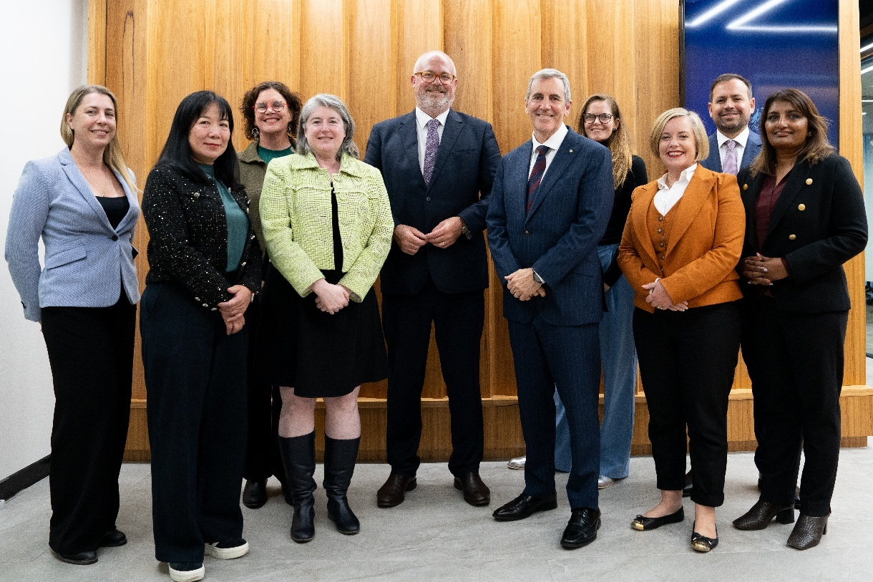
From left to right: Ms Petra Andrén, Professor Fang Chen, Professor Cori Stewart, Ms Meghan Quinn PSM (ex-officio), Minister Tim Ayres, Mr Peter Rossdeutscher AM (Chair), Ms Kate Glazebrook, Ms Linda Scott GAICD, Mr Brodie McCulloch, Dr Angeline Achariya. Not pictured: Ms Lauren Stafford. Image supplied by Department of Industry, Science and Resources.

Financial responsibilities
IISA has no financial responsibility for program-related grants, or loan or licence agreements entered after 10 September 2004. This follows amendments to the IRD Act, which came into effect on 11 September 2004, and removed powers of Innovation Australia (now IISA) to commit, approve or recommend expenditure of government funds and further safeguarded members from any personal liability stemming from Board membership.

Board meetings
The IISA Board met face-to-face 4 times during the financial year. Two of these meetings were chaired by the former Chair, Andrew Stevens, and 2 by the current Chair, Peter Rossdeutscher AM.
At these meetings, the IISA Board reported on progress and outcomes of its projects and engagements and discussed key issues relating to the work of IISA with departmental executives.
The IISA Board held formal meetings on the following dates:
- 15 August 2024 (Sydney)
- 3 December 2024 (Canberra)
- 14 March 2025 (Canberra)
Two Board meetings were preceded by a day of site visits to innovative businesses, Lintek, Membrane Transporter Engineers and Vow Foods
The IISA Board also held a strategy day on 20 May 2025 (Canberra) to set its strategic direction in line with the government’s priorities. Minister Ayres attended a session during the strategy meeting to meet the IISA Board.
In addition, Board members held out-of-session, in-person and virtual targeted discussions with the department and other stakeholders across government, industry and the research sector.

IISA committees
IISA uses a committee structure to support its program oversight function which provides expert advice on innovation and VC programs. Functions are delegated to committees under section 21 of the IRD Act.
As at 1 July 2024, there were 5 active committees under IISA until the Entrepreneurs’ Programme Committee (EPC) was dissolved on 4 April 2025. Details of these 5 committees are as follows:
- Cooperative Research Centres Advisory Committee (CRCAC) – This committee provides advice and recommendations for funding under the CRC Program comprising the CRC and CRC-Projects (CRC-P) programs. The committee also advises on the ongoing progress and performance of individual CRCs and the operation of the CRC and CRC-P programs. The CRCAC met 5 times in 2024–2025.
- Entrepreneurs’ Program Committee (EPC) – This committee provided challenge proposal assessments, and merit assessments of, and advice on, applications for funding under the BRII program. In 2024–25, the EPC met 3 times to assess BRII applications.
In April, the EPC was dissolved. At that time, the IISA Board delegated responsibility for assessing applications for the remaining 2 rounds of the BRII to the Innovation Investment Committee (IIC).
- Industry Growth Program Committee (IGPC) – the IGPC provides advice to the Board and the IGP delegate on matters relating to the operation of IGP grants. The IGPC is primarily responsible for performing merit assessments of eligible grant applications and making recommendations regarding the award of grants to the delegate for their final decision. In 2024–25, the IGPC met 11 times.
- Innovation Investment Committee (IIC) – This committee administers VC programs and provides guidance to the department throughout the programs’ lifecycles. This includes decisions on registration and decisions relating to compliance and legislative interpretation. The IIC met 9 times in 2024–25. The IIC is responsible for assessing applications for the remaining 2 rounds of the BRII, as well as overseeing the following programs which are co-administered with the Australian Taxation Office (ATO):
  - Early Stage Venture Capital Limited Partnerships (ESVCLP)
  - Venture Capital Limited Partnerships (VCLP)
  - Australian Venture Capital Fund of Funds (AFOF).
- Research and Development Incentives Committee (RDIC) – The IRD Act assigns IISA specific functions in the administration of the R&DTI. Other aspects of the program are administered by the ATO. IISA delegates its functions relating to the R&DTI to the RDIC and the department. The committee, in turn, also delegates functions to the department. The committee advises IISA about program operations and operational policy, and it provides certificates to the Commissioner for Taxation about the eligibility of activities registered under the program. The RDIC met 6 times in 2024–25.
IISA’s legislated responsibilities for the BTF were previously supported by the BTF Committee. Since the substantive work of the committee concluded on 29 September 2022, IISA made a resolution to revoke the committee’s delegations and IISA retains direct oversight of the program. The BTF is co-administered by the Department of Industry, Science and Resources and the Department of Health, Disability and Ageing.

IISA committee structure at 30 June 2025

Program performance
The Industry Innovation and Science Australia (IISA) Board supports and promotes the impact of major national innovation programs, overseeing critical programs administered by the Department of Industry, Science and Resources (the department) including the:
- Business Research and Innovation Initiative (BRII)
- Cooperative Research Centres (CRC) Program
- Industry Growth Program (IGP)
- Research and Development Tax Incentive (R&DTI)
- Venture Capital (VC) programs
  - Australian Venture Capital Fund of Funds (AFOF)
  - Early-Stage Venture Capital Limited Partnerships (ESVCLP)
  - Venture Capital Limited Partnerships (VCLP).
IISA also retains the oversight of the Biomedical Translation Fund (BTF), which is currently in the investee company growth stage where fund managers no longer make investments in new companies.
Across the portfolio, programs:
- accelerate commercialisation of research and emerging technologies
- foster collaboration between industry, research organisations, and government
- attract private investment into high-growth startups and scale-ups
- enable demand-driven innovation through public sector partnerships
- support research and development (R&D) activity across diverse sectors with financial incentives.
IISA has no financial responsibility for program-related grants, or loan or license agreements undertaken in 2024–25. The department’s annual report outlines the financial performance for each program.

Biomedical Translation Fund (BTF)
The BTF is an equity co-investment VC program. It combines public and private funds to invest in early-stage companies and support the commercialisation of innovative biomedical research.
Investment funds total more than $500 million. This includes $250 million of Commonwealth capital and $251.25 million of private investor contributions.
The benefits for investing to develop and commercialise biomedical discoveries include:
- translating cutting edge research into products and services that can improve the long-term health of Australians
- supporting companies with high potential to grow the economy.
As of 30 June 2025, there are 28 BTF investee companies. Approximately 93 per cent of capital has been drawn down across the 3 BTF funds. This equates to approximately $465 million for OneVentures Healthcare Fund III, MRCF-BTF Fund and BioScience Managers Translation Fund I.
The 3 BTF funds have now been operating for 9 years. Licenced fund managers are focused on growing the BTF investee companies. There is a shift from making investments in new companies to providing further growth capital to current portfolio companies, in line with the VC model. The funds have several more years to continue the commercialisation journey with their respective investee companies.
The following table shows the committed capital drawn down by BTF funds.
Biomedical Translation Fund (BTF) program performance
Partnership name |  | Total Commonwealth capital drawn as of 30 June 2025 | Total combined capital drawn as of 30 June 2025
 | BioScience Managers Translation Fund I | $48m | $97m
 | MRCF-BTF Fund | $111m | $222m
 | OneVentures Healthcare Fund III | $73m | $146m
Total |  | $232m | $465m

Cooperative Research Centres Advisory Committee (CRCAC)


Message from the Chair
As Chair of the CRCAC, I’m proud to reflect on a year of strong national impact for collaborative research, which continues to expand the pipeline of commercialisation and economic growth opportunities. The committee’s unwavering commitment to excellence continues to shape Australia’s innovation ecosystem, driving alignment to government priorities.
In 2024–25, the CRC Program updated the assessment criteria to ensure the program remained closely aligned with government priorities, including the National Reconstruction Fund priorities and the National Science and Research Priorities, encouraging targeted investment in science, research, technology and innovation across the nation.
Round 25 saw the launch of 3 new CRCs, selected from a highly competitive field and awarded a combined investment of $157.5 million:
- SMART CRC: $65 million to manufacture regenerative therapies for cancer, heart disease and arthritis
- AMCRC: $57.5 million to accelerate adoption of additive manufacturing
- Care Economy CRC: $35 million to commercialise technologies and workforce innovations in the care sector.
The CRC Projects (CRC-P) stream reached record levels of engagement, with 158 applications in Round 16. Twenty-three projects were awarded $55 million to solve industry-identified problems, strengthen small and medium-sized enterprise (SME) capability and create high value jobs.
This year, we sharpened our strategic lens, focussing on program oversight and responsiveness to an evolving policy landscape.
Looking ahead, the CRCAC remains deeply committed to working in close partnership with the IISA Board to ensure the CRC Program continues to deliver transformative research collaborations that drive innovation, economic growth and sustainability.
Denise Goldsworthy
Chair CRCAC

The Cooperative Research Centres (CRC) Program
The CRC Program is a competitive, merit-based grant program that provides funding to support industry-led collaborative research partnerships solving industry-identified problems. The program aims to improve the competitiveness of Australian industries by fostering high quality research and encouraging SMEs to participate in collaborative research.
The CRC Program has 2 streams:
- CRCs undertake medium-to-long-term, industry-led collaborative research for up to 10 years. There is no set limit on grant funding, but it must at least be matched by cash and in-kind contributions from CRC partners. CRCs must have at least one Australian industry entity and one Australian research organisation as partners.
- CRC-Ps undertake short-term, industry-led collaborative research for up to 3 years. Grants have a minimum funding limit of $100,000, are capped at $3 million and must have at least 2 Australian industry entities (lead applicant must be an SME) and one Australian research organisation as partners.

Innovation Investment Committee (IIC)


Message from the Chair
The Australian Government’s VC programs are intended to foster innovation and promote investment in entrepreneurial startups and early stage companies. These initiatives seek to strengthen the Australian VC sector by attracting both domestic and international capital to Australia's venture capital markets.
At the close of 2024–25, 296 limited partnerships were registered under the Venture Capital Act 2002 (VC Act), spanning VCLPs, ESVCLPs, and AFOF.
Despite persistent headwinds in capital raising, the sector maintained its upward trajectory. Total committed capital surpassed $35.09 billion, with over $19.95 billion deployed into innovative Australian businesses over the programs’ lives. This resilience, in the face of ongoing economic uncertainty affecting the market, underscores sustained investor confidence and the enduring appeal of VC as a mechanism for growth and innovation.
The year also marked a significant milestone. Notwithstanding the broad macroeconomic environment, $2.331 billion was invested under the government’s VC programs in 2024-25. This is the second highest annual figure ever recorded, reflecting robust market activity and the successful execution of major transactions. These figures suggest that, while fundraising challenges remain, the sector continues to evolve with purpose and momentum. The scale of investment and breadth of participation signal optimism for further expansion, and a deepening role for VC in shaping Australia’s innovation economy.
The IIC continues to prioritise the integrity and compliance of registered partnerships, ensuring they meet their obligations under the VC Act. In collaboration with the Australian Taxation Office (ATO), the department brings forward for the IIC’s consideration regular compliance activities to uphold the transparency and accountability of the programs.
In parallel, the IIC identified specific areas for improving how stakeholders interact with the programs. Improvements included introducing a customer guide for the AFOF program, and a form to help assess whether investments qualify as eligible VC investments. The IIC also provided input on the annual release of data via the online VC dashboard. These refinements are aimed at streamlining administrative processes and enhancing clarity around program requirements.
Professor Stephen Barkoczy
Chair IIC

Performance of venture capital programs
 | $2.331b | Investments  The deal value of investments in 2024-25 was $2.331 billion.
 | $35.09b | Commitments  Over the lifetime of the programs, partnerships have capital commitments of over $35 billion.
 | 15,400 | Investors  An estimated 15,400 investors may be eligible for tax concessions for investments that realise capital gains.
 | $3.76b | Early stage innovative startups  Within the ESVCLP program, $3.76 billion has been invested into Australian early stage startup and expanding businesses with high growth potential.
 | $16.18b | Innovative businesses  Within the VCLP program, $16.18 billion has been invested into Australian businesses.
 | $39m | Venture capital  Median committed capital in the 2 VC programs in 2024-25:  ESVCLP: $25 million, this has been steadily growing since 2015-16 when the median was $10 million  VCLP: $90 million, which has also been growing steadily since it was $59 million in 2021-22.

Business Research and Innovation Initiative (BRII)
Following the conclusion of the Entrepreneurs’ Programme Committee (EPC) in April 2025, the IISA Board delegated responsibility for assessing applications for the remaining 2 rounds of the BRII to the IIC.
The IIC has embraced this expanded remit, recognising BRII’s unique role in fostering demand-side innovation. BRII provides opportunities for Australian startups and SMEs to work with Australian Public Service (APS) agencies to develop innovative solutions to public policy and service delivery challenges.
In 2024–25, BRII supported innovation across 4 rounds:
- The Renewables and Low Emissions Round supported 15 SMEs to test the feasibility of their proposed solutions to address government challenges in energy efficiency of commercial fishing operations, water purification for remote First Nations communities, and sustainable wine packaging.
- The Regulatory Technology Round supported 5 SMEs to develop prototype solutions to reduce regulatory burden and improve compliance through real-time asbestos detection, autonomous vessel risk assessment, monitoring of animal welfare and anomaly detection in corporate disclosures.
- The Workplace Relations and Usability Round awarded proof-of-concept grants to 2 SMEs to simplify SME engagement with modern awards using AI-driven tools and payroll technology integrated with the Fair Work Commission’s Modern Award Pay Database.
- The Automatic Mutual Recognition (AMR) Round finalised a proof-of-concept prototype for improved information sharing across jurisdictions to support occupational mobility under the AMR scheme.
Since 2016, BRII has supported 28 challenges from 21 APS agencies. Over $42 million in funding has been provided to 99 innovative businesses.

Industry Growth Program Committee (IGPC)


Message from the Chair
In its second year, the IGP continues to see strong demand from small and medium businesses in the government’s priority areas for the National Reconstruction Fund. The program aligns closely with the objectives of the broader Future Made in Australia agenda and is helping to build sovereign manufacturing capability and economic resilience. I am pleased to report that the program is enabling Australian small and medium businesses to scale and compete globally as well as adopt advanced technologies and processes that will help underpin future growth and productivity.
The entry point for program participants is the Advisory Service, where businesses are matched with an Adviser who provides tailored commercialisation and growth advice. This includes a report with recommended actions and priorities, which participants have rated highly for its strategic value. The report helps identify the most impactful ways to commercialise, innovate, and scale up their business. With the report, businesses can apply for matched funding grants ranging from $50,000 to $5 million, assessed on merit.
The IGPC, an independent expert committee under the IISA Board, plays a crucial role in the process of assessing and making recommendations on the operation of the program’s grant element.
The IGPC met for the first time in July 2024. Since then, grant applications sent to the IGPC for assessment have steadily increased, and the IGPC has continued to refine merit assessment processes. It is pleasing to have received many high-quality proposals and exciting to see many projects now funded and operational. We look forward to sharing their outcomes and achievements once they conclude.
Dr John Spoehr
Chair IGPC

Industry Growth Program (IGP)
IGP supports both early stage businesses, and those looking to scale up, through their most challenging development and commercialisation phases and has 3 core elements:
- IGP advisers around Australia provide tailored advice to support innovative commercialisation and growth projects.
- Businesses who receive this advice may be able to apply for matched grant funding opportunities.
- Industry Partner Organisations provide specialist sectorial expertise, advice and support to participating businesses, complementing the role of the advisers.

Grant opportunities
IGP grant funding is designed to help scale up early stage and high growth potential businesses, and better position them to seek future investment and further scaling opportunities, including through the National Reconstruction Fund, where relevant.
IGP grant funding is provided through 2 streams:
- Early Stage Commercialisation grants provide matched grant funding from $50,000 to $250,000 to help establish the commercial viability of an innovative product, process or service.
- Commercialisation and Growth grants provide matched grant funding from $100,000 to $5 million to help push ideas from prototyping through to market readiness stages. Grants help develop and implement strategies for entry to market and scaling up into national and international markets.

Program performance
During 2024-25, over 690 businesses participated in the program, with more than 640 commercialisation and growth reports delivered.
During the year, the program delegate approved 73 grants, totalling $112.43 million, recommended by the IGPC. These grants support businesses with innovative projects like those being undertaken by Gilmour Space Technologies, who is launching Australian made rockets, and Li-S Energy, who has developed a lithium foil manufacturing process for its next-generation batteries.
The grants approved this year included:
- 20 Early Stage Commercialisation grants.
- 53 Commercialisation and Growth grants.

IGP monitoring and evaluation
IGP will be monitored and evaluated to measure how well it meets objectives and intended outcomes. Participating businesses report on their progress and outcomes they have achieved through the program.

Research and Development Incentives Committee (RDIC)


Message from the Chair
The R&DTI Program aims to improve Australia’s economic productivity by encouraging greater business investment in R&D. There are broad spillover effects from business R&D, including fostering new ideas, skills development and knowledge transfers, which contribute to enhancing the nation’s productive capacity.
The number of participating businesses and the value of R&D expenditure continues to grow year-on-year with businesses in various sectors increasingly experimenting with artificial intelligence, machine learning, robotics and quantum computing technologies. We continue to see the Professional, Scientific and Technical Services industry represent the highest number of registrations and R&D expenditure, however from an R&D activities view, R&D in software development and product’s share of total registrations rose from 46% to a new high of 50%.
During 2024-25, RDIC oversaw claimant registrations for R&D activities conducted by businesses in the 2023-24 income year. R&DTI Program received nearly 14,000 registrations, accounting for an estimated $17.7 billion in R&D expenditure. Even though this was the largest year for registrations, the program achieved its performance measure on registration time frames, giving businesses the earliest opportunity to claim the incentive.
There were 215 Advance and Overseas Findings (AOF) sought by businesses during 2024-25. Through continued use of surge capacity in peak assessment periods and business process improvements, the program maintained AOF assessment time frames throughout 2024-25 after the significant reductions achieved in 2023-24.
This year saw an expanded contribution of R&DTI Program data uploaded into the Australian Bureau of Statistics (ABS) Business Longitudinal Analysis Data Environment (BLADE) database. This makes the rich R&DTI dataset available for use by government and authorised researchers performing analysis of Australia’s innovation ecosystem, a key focus with the Examination underway. RDIC looks forward to the analytical insights generated from the data.
The department and the ATO continued to work well jointly administering the R&DTI Program. Program integrity was a focus in 2024-25. The department and the ATO concluded their joint random sample project to inform future risk-based program integrity assurance, and October 2024 saw the first-time publication of R&DTI claimant information as part of the government’s tax transparency measures.
Murray Hurps
Chair RDIC

R&DTI program performance
Key outcomes in relation to the R&DTI Program for the 2023–24 income period, as at 30 June 2025:
 | $17.7b | R&D expenditure  $17.7 billion in registered estimated R&D expenditure
 | 13,901 | Registrations  13,901 registrations, representing 16,478 R&D performing entities
 | 88% | SME participation  Of the 13,901 registrations, the program represents 12,241 small to medium companies (88% of program participation)
 | 21% | New participation  2,914 companies registered that were new to the program (21% of program participation)
Note: Data for the 2023-24 income period is incomplete as at 30 June 2025. Figures provided are subject to change, as they are based on R&DTI’s ongoing administrative data, which is updated when new applications are registered, and previous ones are revoked or withdrawn (including due to compliance checks).
Importantly, the target performance standards for the 2023–24 income year applications were met, with more than 95% of applications being processed within the target time frames. An efficient registration process ensures companies have certainty early.

Program case studies

Biomedical Translation Fund (BTF)

Case study: PolyActiva
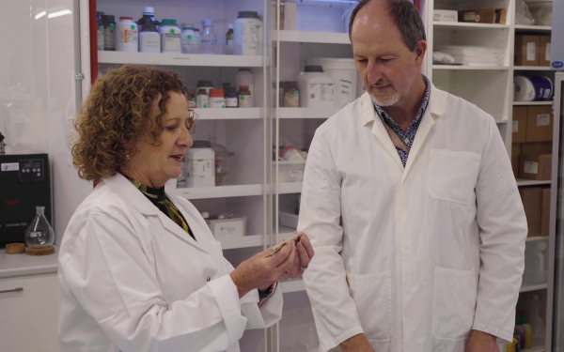
Vanessa Waddell, former Chief Executive Officer and current Chief Strategy Officer at PolyActiva.
Years in business | 16 (founded in 2009)
Employees | 22
Industry sector | Biotechnology and Pharmaceutical
Representatives | Jerry St. Peter, CEO  Vanessa Waddell, former CEO and current Chief Strategy Officer

Project objectives
PolyActiva is an ophthalmology company pioneering polymer technology that delivers medicine directly to the eyes through ocular implants. Its lead product, currently in clinical trials in Australia, New Zealand and the United States, has the potential to treat conditions like glaucoma. Glaucoma is a leading cause of blindness and affects 80 million people worldwide.

Project description
Patients with conditions such as glaucoma often rely on daily eye drops, but adherence to treatment is difficult. PolyActiva is creating small, ocular implants that could replace drop therapy, providing a sustained drug flow to the eye. The implant delivers medication directly to the eye’s internal tissues, targeting affected areas more precisely.
Developing a new drug in the biotech industry usually requires at least 10 years of support, before that drug would be at late-stage clinical development.

Support received
PolyActiva received nearly $23 million from BTF funds over 5 years and $67.8 million from other co-investment funds since 2012.

Impact
If successful, this sustained delivery technology could eliminate the need for daily eye drops, significantly improving patient adherence and outcomes. This technology has the potential to improve quality of life and patient outcomes.
‘Brandon Capital's been an integral part of our story, and then in 2018, the Biomedical Translation Fund invested in our first clinical trial program. We wouldn't have been able to develop our product without the support of that venture capital and in particular Brandon Capital.’
Vanessa Waddell, former CEO and current Chief Strategy Officer of PolyActiva

CRC Grants

Case study: Cooperative Research Centre for Transformations in Mining Economies (CRC TiME)
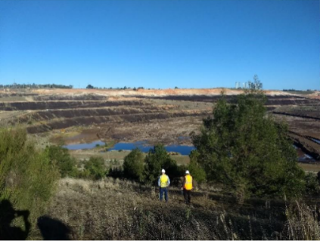
Latrobe Valley inspection at Hazelwood mine, June 2019
Years in Business | 5 (2024–25 was CRC TiME’s fifth year of operation in a 10-year CRC Program funding term)
Partners | 80
Industry sector | Resources
Representative | Dr Guy Boggs, CEO

Project objectives
With 240 Australian mines expected to close between 2021 and 2040, CRC TiME’s research estimates annual mine rehabilitation and closure costs of $4–8 billion. This work will identify and support opportunities for regional, First Nations and other Australian businesses to deliver equipment, technology and services that enhance environmental, social and economic outcomes from mine closures – unlocking significant national value through innovation and inclusive participation.

Project description
CRC TiME’s research has identified 4 key opportunities for Australian businesses in the context of mine closures:
- Engagement and partnership - Supporting collaboration across communities, industry, Indigenous organisations and governments to co-design post-mining futures.
- Waste reduction and recovery - Reducing environmental risks and creating value through mineral recovery, equipment recycling, and innovative reuse of waste materials.
- Mine rehabilitation - Delivering solutions to restore mined land to safe, stable and potentially productive conditions.
- Land use transitions - Developing new uses for post-mining land, such as renewable energy, tourism, agriculture or repurposed infrastructure.
These categories highlight the breadth of opportunities for Australian businesses to contribute to and benefit from mine closure and rehabilitation.

Assistance received
CRC TiME was awarded a $29.5 million CRC Program grant from July 2020 to June 2030 to deliver new research, tools and resources to enable regions and communities to transition to a prosperous and sustainable post-mine future.

Impact
CRC TiME’s work highlights major commercial opportunities for Australian businesses in mine closure solutions, both locally and globally. It empowers regional, Indigenous, and other enterprises to lead in innovative approaches, strengthens Australia’s global leadership in mine rehabilitation, and fosters capabilities and partnerships for sustainable transitions and long-term regional resilience.
‘While land rehabilitation will remain critical, the research shows the diversity, span and scale of technology, services and equipment required in post mine transitions. Of note is how a focus on the circular economy can lead to new commercial opportunities, such as reprocessing mine waste to extract residual minerals or to provide inputs into new processes or industries.’
Dr Guy Boggs, CEO of CRC TiME

CRC Projects and VC Programs

Case study: AMSL Aero Pty Ltd
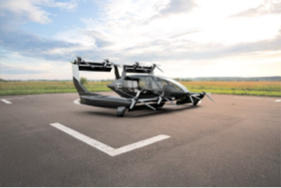
Australian designed Long-range hydrogen-electric vertical take-off and landing (eVTOL) aircraft
Years in Business | 8
Employees | 63
Industry sector | Advanced manufacturing, aerospace and aviation
Representative | Dr Adriano Di Pietro, CEO

Government support and project objectives
AMSL Aero is a Sydney-based company developing world-leading eVTOL aircraft (Vertiia) with zero emissions. AMSL Aero's aircraft range from small uncrewed air systems (UAS) to large passenger carrying advanced air mobility (AAM) aircraft.
AMSL Aero received crucial support through the CRC-Project (CRC-P) and VC programs that helped the aerospace company navigate their eVTOL project through the innovation pipeline from research and development to commercialisation. The CRC-P grant provided $3 million over 3 years to support AMSL Aero and its partners in developing Vertiia, an advanced eVTOL. AMSL Aero has raised more than $50 million from private and government sources, including $9 million through the Venture Capital Limited Partnership (VCLP) program.
This combined government funding was paramount for AMSL Aero’s development of Vertiia. Funding from the CRC-P grant supported AMSL Aero collaboration with the University of Sydney and a number of specialised small and medium-sized enterprises (SMEs) to design and develop the propulsion system of the eVTOL aircraft, whereas the VC program enabled AMSL Aero to secure valuable funding from local and international investors that supported the commercialisation of Vertiia.

Project description
Designed for rapid-response air ambulance and affordable passenger transport in regional and remote Australia, the project focused on optimising and developing a quiet, efficient, and lightweight propulsion system tailored to Vertiia’s unique operational requirements.
Australia’s vast geography demands fast, reliable air transport for emergency medical services and defence operations. This CRC-P supported the development of Vertiia to meet both civilian and Australian Army needs – delivering rapid-response air ambulance services and low-cost passenger and cargo transport across regional and remote areas.
The project’s core objective was to optimise, construct, and certify Vertiia’s full-scale propulsion drive train. This involved refining all propulsion components – propeller, motor, motor speed controller, cooling systems, and power distribution to meet stringent performance and safety requirements. The main challenge was achieving a propulsion system that was quiet, efficient, and lightweight. The team were excited to reach a breakthrough in system optimisation, enabling Vertiia to meet demanding operational profiles while advancing Australia’s position in the emerging global eVTOL industry.

Support received

Cooperative Research Centres Projects
- CRC-P funding: $3 million
- Funding period: 3 years

Venture capital program
- AMSL Aero has raised more than $50 million from private and government sources, including $9 million through the VCLP program.
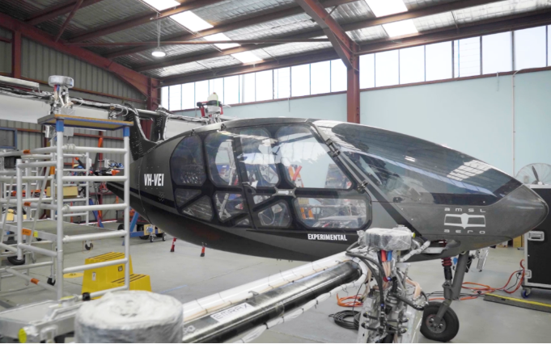
AMSL Aero developing a highly efficient hybrid long-range zero-emissions VTOL aircraft

Impact of programs
The funding from both programs enabled AMSL Aero and partners to develop a unique hybrid architecture hydrogen fuel cell battery for the Vertiia, now protected by a provisional patent.
The CRC-P secured AMSL Aero’s first civil customer, attracted international customers and initiated regulatory engagement to support Vertiia’s global commercial rollout. Capital attracted through the VC Programs allowed AMSL Aero to build on this momentum. The business has already received deposits for 26 Vertiia aircraft orders from civil customers covering passenger services, aircraft charter, air freight and aeromedical flights across Australia.
This work, a product of the CRC-P and VC programs, lays the foundation for safer, more sustainable aviation solutions tailored to Australia’s unique transport needs.
‘The CRC-P’s support has been instrumental in enabling the design and development of a breakthrough eVTOL aircraft propulsion system. Collaborating with leading aerospace researchers at the University of Sydney, and expert organisations in power electronics and advanced safety-critical systems, we’ve set a new global benchmark for sustainable aviation technology.
The VCLP program has been fundamental in enabling AMSL Aero to attract both local and international attention and investment to develop Vertiia. This valuable commitment to Australian innovation has the potential to revolutionise air travel.’
Dr Adriano Di Pietro, CEO of AMSL Aero

Industry Growth Program (IGP) Commercialisation and Growth grants

Case study: EMVision
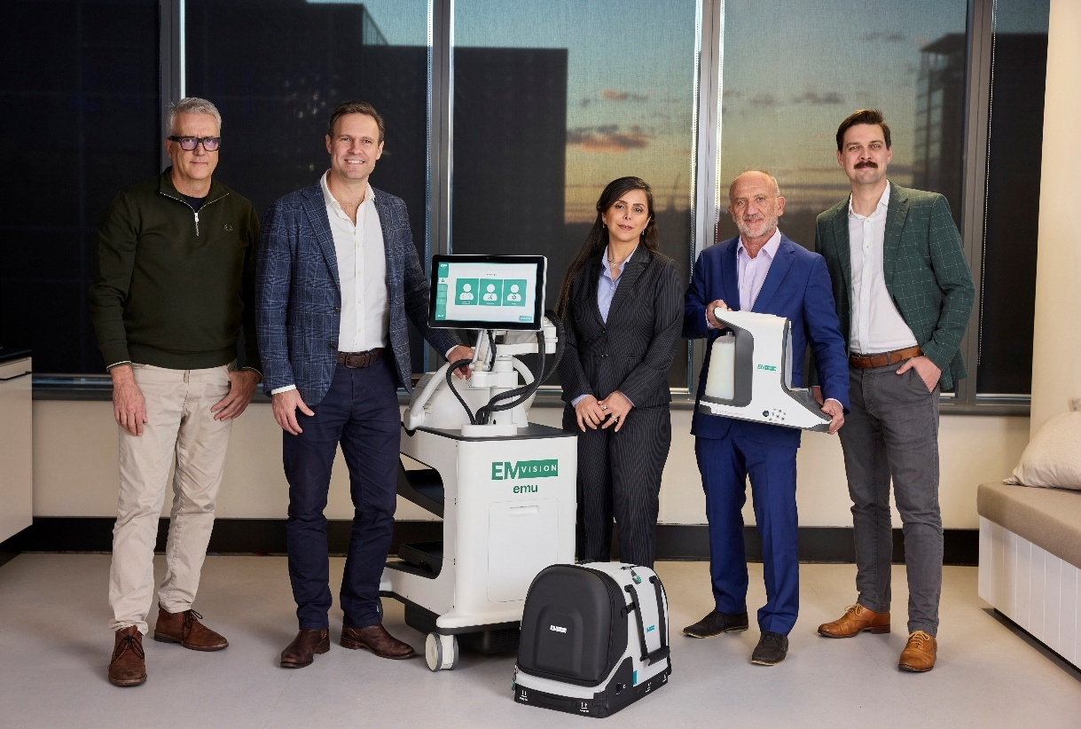
EMVision’s Project29.
Years in business | 8
Employees | 42
Industry sector | Medical Science
Representatives | Scott Kirkland CEO and Managing Director of EMVision

Project objectives
EMVision is on a mission to get their brain scanners into every hospital and ambulance and reduce the burden of stroke and traumatic brain injury.
Strokes are considered a medical emergency where time is everything. One in 4 adults will suffer a stroke at least once in their lifetime and most will result in a permanent disability. All treatment options require urgent identification for the best treatment pathway. Bringing portable brain scanning to the point of care could transform stroke care.

Project description
EMVision’s first commercial product is known as the emu™, a bedside brain scanner for in-hospital use that is currently undergoing a pivotal trial. The second device is the First Responder – a lightweight version of the emu™ which uses the same technology but has been miniaturised into a backpack sized form factor.
The First Responder looks like a motorbike helmet but contains powerful technology under the hood. The device weighs less than 12 kg and is designed for use in road or air ambulances. It can be deployed via backpack to enable paramedics to diagnose stroke and stroke type immediately onsite, wherever the patient is located.
The technology is portable, lightweight, non-ionising and easy to use, making it a differentiated value proposition in neurotechnology.
The IGP $5 million Commercialisation and Growth grant is supporting the EMVision team to commercialise the First Responder, alongside further clinical development.

Support received
EMVision received a $5 million IGP Commercialisation and Growth grant.

Impact
The IGP grant will help EMVision on its journey to take the advanced prototype into commercial production and get the First Responder brain scanner into the back of every ambulance alongside standard equipment like the automated external defibrillator and electrocardiogram.
‘The Industry Growth Program is not only an attractive source of funding, but also a valuable platform for broader opportunities to accelerate commercialisation. Our Adviser understood our roadmap and objectives, enabling effective engagement throughout the process. We are very appreciative of the Industry Growth Program’s support.’
Scott Kirkland CEO and Managing Director of EMVision

Research and Development Tax Incentive (R&DTI)

Case study: Latrobe Magnesium (LMG)
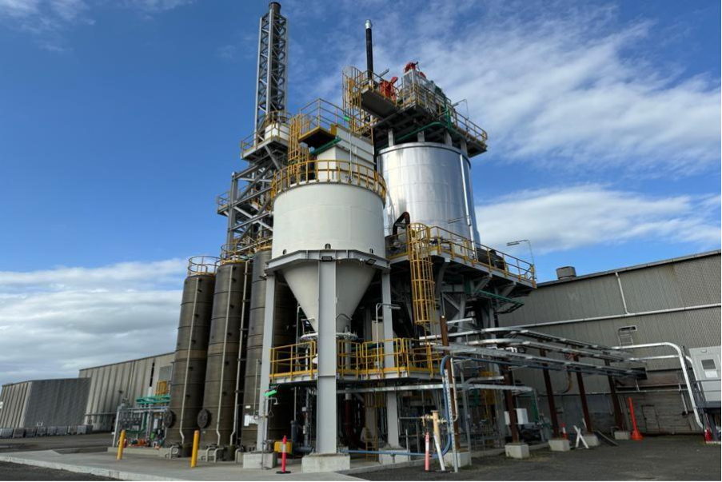
LMG’s demonstration plant in the Latrobe Valley has paved the way for a commercial facility.
Years in Business | 39 years (incorporated in 1986)
Industry sector | Resources
Representative | David Paterson, CEO

Project objectives
LMG is establishing a magnesium production plant in Victoria's Latrobe Valley. Using a patented extraction process, the plant will use brown coal waste to produce magnesium metal and a host of valuable by-products.
Magnesium is a critical input into aluminium alloys for lightweight vehicles, aerospace, defence and other high-performance industries. As nations seek to reduce carbon emissions and diversify supply chains, global demand is increasing.
The company’s CEO David Paterson explains, ‘Our patented process positions Australia as a sovereign supplier of this essential metal, with a far lower environmental impact and a fully circular production model.’

Project description
Using hydrometallurgical and thermal processes, LMG extracts magnesium metal from brown coal ash – an abundant waste product of historical power generation.
The process converts 100% of the input into saleable materials such as concrete additives, iron oxide, char, agricultural lime and silica.

Support received
LMG has claimed the R&DTI since 2008. Over this time, the company has evolved from lab-based R&D to constructing a demonstration plant capable of producing 1,000 tonnes of magnesium metal per annum. The company is now progressing a commercial plant with the aim of upping production tenfold.
The company has used the R&DTI to expand collaborations with leading institutions including the Commonwealth Scientific and Industrial Research Organisation (CSIRO) and Monash University. These partnerships have helped LMG refine its hydrometallurgical process and validate critical steps in its production pathway.

Impact
LMG estimates that its demonstration plant has created more than 50 permanent jobs in the Latrobe Valley, with hundreds of local trades personnel also involved in the construction project. The company forecasts its commercial plant will generate over 100 direct jobs, with hundreds more in logistics, construction, and support industries.​
The company highlights the environmental benefits of its process – recycling problematic coal ash stockpiles to produce magnesium with up to 70% fewer carbon dioxide emissions.
‘The R&D Tax Incentive has been essential for de-risking our early technical trials and continues to support our ongoing commercialisation activities. It makes every R&D dollar go further. That means more engineering hours, more lab validation, and more robust process design.’
David Paterson, CEO of LMG

Advice to government
The Industry Innovation and Science Australia (IISA) Board has a legislated function to provide independent advice to government in relation to industry, innovation, science and research matters. This includes advice on the performance and operation of innovation programs delivered by the Department of Industry, Science and Resources (the department) and the promotion of investment in industry, innovation, science and research.
The objective of this advice is to support the Australian Government’s strategic priorities within IISA’s remit as conferred by the Industry Research and Development Act 1986 (IRD Act), ministerial directions and its Statement of Expectations (SOE).
An overarching theme in IISA’s advice has been to link innovation with industrial policy in an effort to drive broader economic outcomes. This includes advice on how to:
- Grow Australia’s core science and innovation capability, such as in its support of the Strategic Examination of Research and Development (the Examination).
- Strengthen industrial innovation policy, such as placing an industry focus in the revitalisation of National Science and Research Priorities and aligning work to the Future Made in Australia priorities.
- Drive greater outcomes from the government’s investment in research and development (R&D), innovation and commercialisation through its program oversight.
- Support greater industry demand generation, and adoption and diffusion of technology to build industry capability and create the jobs to deliver policy priorities such as the net zero transition.
Select IISA contributions to government, including programs of work outlined in its SOE issued in December 2022, are provided below.

National Reconstruction Fund (NRF) Corporation
In June 2024, the department sought IISA’s advice on Tranche 2 of the NRF Co-Investment Plans relating to Transport and Enabling Capabilities. Aligning with the government’s broader objective to revitalise Australian manufacturing and strengthen sovereign capability through targeted investment, IISA provided advice on these plans early in the 2024-25 financial year.
The NRF Corporation was established as a corporate Commonwealth entity to deliver finance via loans, equity and guarantees to projects that diversify and transform Australia’s industry and economy. IISA’s advice contributed to shaping investment priorities that leverage Australia’s competitive strengths, address supply chain vulnerabilities and support the transition to a net zero economy.
The IISA Board’s input also reinforced the importance of aligning investment decisions with the Future Made in Australia agenda and the NRF Corporation’s investment mandate, which required commercial operation and a positive rate of return.

Commercialisation and collaboration
Commercialisation and collaboration have been a sustained strategic focus for IISA, originating from the SOE issued in 2022. In response, IISA delivered the Barriers to collaboration and commercialisation report in late 2023, which was publicly launched and acknowledged by the Minister in the launch of the Industry Growth Program (IGP). In 2024-25, IISA continued consulting on the findings, recommendations, and next steps of this report, including building on this legacy through its oversight of the IGP and advice to government to integrate commercialisation insights into broader innovation policy initiatives.

Industry innovation for business decarbonisation
In 2023-2024 IISA provided advice to government on how Australian businesses, particularly small and medium-sized enterprises (SMEs), are approaching business decarbonisation, and the roles of technology and business capability. In 2024-2025, IISA has drawn from these insights in its continued engagement with the department to inform ongoing government activities, such as development of sectoral emissions reduction plans.

Strategic Examination of Research and Development (the Examination)
During 2024-25, IISA engaged with the Examination, including working closely with the appointed Expert Panel and the department to provide advice on ways to get more value from Australia’s investment in research, drive more industry engagement and drive innovation outcomes through demand generation.
The Expert Panel also engaged directly with IISA Committees and departmental executives overseeing the venture capital (VC) programs, the Research and Development Tax Incentive (R&DTI) and the Cooperative Research Centres (CRC) Program.

IISA oversight of innovation programs
The Minister asked IISA to ensure its current governance arrangements were fit-for-purpose in relation to its oversight of portfolio innovation programs. Additionally, IISA was asked to consider if the current program oversight arrangements were optimal and whether there were any proposed actions for improvements.
IISA’s Governance and Oversight review (the review) was led by former IISA Member Ms Glenys Beauchamp AO PSM. The review identified 3 key actions for improvement:
- Action 1: To improve governance – Ensure roles and responsibilities for IISA, its committees and the department in relation to IISA’s legislated responsibilities are being supported through clear governance.
- Action 2: To strengthen linkages between IISA and its committees – Improve IISA’s oversight and build stronger working relationships with and between its committees.
- Action 3: Improve IISA’s strategic program oversight – Ensure IISA can report on the programs for which it has legislated responsibility, specifically around program impact and outcomes.
IISA provided the Minister with a summary of the findings of the review in July 2024 and continues to implement activities to support the 3 key actions in collaboration with IISA committees and the department.
Improvements included assigning an IISA Engagement Lead to each IISA committee to improve connections between committees and the IISA Board. In 2024-2025, IISA also commenced work to refine the processes, data and insights for the programs for which it has legislated responsibilities. This allows the IISA Board to better understand the programs' strategic alignment and linkages, and their collective impact on driving commercialisation outcomes.

Industry Growth Program
IISA provided advice to government and the department on the design of the IGP. The advice considered the Australian Government’s overarching policy objectives of industrial and economic transformation, sustainable value creation, and economic diversification, and the role of the IGP in complementing the NRF.

About the Office of Industry Innovation and Science Australia (OIISA)
OIISA is the central point of communication between the Industry Innovation and Science Australia (IISA) Board and the Department of Industry, Science and Resources (the department). It provides secretariat, stakeholder engagement and communications support, as well as policy and research teams who work closely with the IISA Board to support IISA to deliver on its functions and work plan as outlined in its Statement of Expectations (SOE) and legislation. OIISA also has legislative policy responsibility for IISA.
OIISA was established under the Industry Research and Development Act 1986 (IRD Act) (subsection 25(1)) to assist the IISA Board and committees in the performance of their functions.
OIISA staff, including the Executive Director, are employed under the Public Service Act 1999 (Cth).

Legal matters and litigation
IISA, through its delegates, makes decisions under the IRD Act, Venture Capital Act 2002 (Cth) (VC Act) and the Pooled Development Funds Act 1992 (Cth) (PDF Act). These are reviewable decisions, and applicants dissatisfied with a decision may ask for an internal review.
When a decision is confirmed or varied at internal review, the applicant may seek external review by the Administrative Review Tribunal (ART). In some cases, applicants may seek a further review by the Federal Court of Australia (FCA).
This section of the report gives a summary of external review matters that IISA has been a party to during the 2024–25 financial year. They relate to the Research and Development Tax Incentive (R&DTI) and venture capital (VC) programs.

Research and Development Tax Incentive (R&DTI)
In 2024–25, 2 new R&DTI ART applications were made seeking review of IISA’s internal review decision. There was one ART decision involving IISA during the 2024–25 period (this being the ART decision in Body By Michael Pty Ltd v Industry Innovation and Science Australia (2025) ARTA 44). There was one R&DTI matter that proceeded to final ART hearing in the 2024–25 financial year (this being Ultimate Vision Invention Pty Ltd v Industry Innovation and Science Australia, Tribunal no 2017/1319, 2018/6110).
There was one FCA R&DTI decision in the 2024-25 financial year (Active Sports Management Pty Ltd v Industry Innovation and Science Australia (2024) FCA 1346). There were no new R&DTI applications to the FCA during the 2024-25 financial year.
The tables below summarise the status of the ART and court proceedings for R&DTI matters for the 2024–25 financial year.
Matters | High Court of Australia | Federal Court of Australia | Administrative Review Tribunal
Current matters as of 30 June 2025  (IISA as respondent) | 0 | 0 | 4
New matters during 2024–25 (IISA as respondent) | 0 | 0 | 2

Resolution of matters during 2024–25 | High Court of Australia | Federal Court of Australia | Administrative Review Tribunal
Decision | 0 | 1 | 1
Withdrawal | 0 | 0 | 0
Agreement (Consent Orders) | 0 | 0 | 0

Venture capital programs
There has been no litigation or ART reviews of VC program matters during the 2024–25 financial year.

Governance

Board and committee membership

Industry Innovation and Science Australia (IISA) Board
The IISA Board is appointed by and reports to the Minister for Industry and Innovation (who is also the current Minister for Science). Board members are appointed based on their experience, networks in the industry, science and research sectors, and the diversity in skills and expertise they bring to the IISA Board and ongoing IISA work.
Current Board members as of 30 June 2025 are:

Mr Peter Rossdeutscher AM (Chair)
Location: Western Australia
Mr Rossdeutscher AM has been a member of the IISA Board since early 2025. He brings extensive board experience and expertise in Australia's innovation ecosystem. This includes over 2 decades of work in industry and academia across multiple sectors and technologies. He holds expertise in demand-led innovation and commercialisation and in bridging the gap between industry and academia.
He is the Chair/Co-Founder of SG Compute Pty Ltd, a Non-Executive Chair of Quantum Australia, a Non-Executive Chair of Innovative Energy Solutions, Co-Chair of First Nations X Ltd, a Non-Executive Director at Yindjibarndi Wealth Pty Ltd, a Board member of MinEx CRC and a Principal Partner at Atomic Sky Pty Ltd.


Ms Linda Scott GAICD (Acting Deputy Chair)
Location: New South Wales
Ms Scott has been a member of the IISA Board since 2025 and is an experienced chair and board director, bringing expertise in industry superannuation, research commercialisation and government. A former Deputy Lord Mayor of Sydney, she has represented Australian local governments at National Cabinet. She has a demonstrated ability to engage widely with stakeholders to drive investment in innovation outcomes. She is currently Chair and Director at CareSuper, an Independent Non-Executive Director at Clearview, a Chair and Director at the Alcohol and Drug Foundation, a Director at the Australian Council of Superannuation Investors, and a Director at the Powerhouse Museum.


Dr Angeline Achariya (Member)
Location: Victoria
Dr Achariya has been a member of the IISA Board since 2025. She has in-depth experience in scaling innovation from industry, research and entrepreneurial pathways for commercial impact in the agriculture and food industry and sector. She is the CEO of Innovation GameChangers, a Senior Business Advisor at Beanstalk AgTech, the Chair of the Agribusiness and Food Working Group (Victoria), and an Advisory Board Director and Investment Committee Member at Australia’s Economic Accelerator.


Ms Petra Andrén (Member)
Location: New South Wales
Ms Andrén has been a member of the IISA Board since 2025 and has an accomplished track record in demand-led innovation and commercialisation. Her work includes scaling high growth technology ventures and implementing innovation ecosystems, with advanced technology sector expertise in life sciences, digital and agrifood tech. She is the current CEO of Quantum Australia, a mentor and angel investor at Startmate and an Honorary Board Member at the Swedish-Australian Chamber of Commerce.


Professor Fang Chen (Member)
Location: New South Wales
Professor Chen was appointed as a member of the IISA Board in 2023. She has received international recognition for her expertise in ethical and human-centered artificial intelligence and data science. She also has experience in fostering innovation and digital transformation. Professor Chen received the prestigious Australian Museum Eureka Prize for Excellence in Data Science in 2018, and the NSW Premier’s Prize for Science in 2021. Professor Chen has a remarkable track record in research, with over 400 peer-reviewed publications in science and engineering, along with several influential books. She has also filed more than 30 patents across 8 countries, including Australia, the US, Canada, Europe, Japan, Korea, Mexico, and China, showcasing her significant contributions to the field. She is currently Executive Director, Data Science at University of Technology Sydney.


Ms Kate Glazebrook (Member)
Location: New South Wales
Ms Glazebrook was appointed as a member of the IISA Board in 2023. She has strong entrepreneurial experience and engagement with venture capital in the technological sector.
She also has expertise in behavioural economics. Ms Glazebrook is Head of Impact and Operating Principal at Blackbird, leading the fund’s work across impact and Environmental, Social and Governance (ESG). She is a board member of Blackbird Foundation, Cofounder, Director and former CEO at Applied, and an advisory board member at Tripple Ventures.


Mr Brodie McCulloch (Member)
Location: Western Australia
Mr McCulloch has been a member of the IISA Board since 2025 and has deep experience in enabling innovators and entrepreneurs across Australia. He is an expert on building support systems and organisations to progress from ideation to scaling to investment. He is the Founder and Director of Spacecubed, a Venture Partner at Purpose Ventures and an Investment Partner at Plus Eight.


Ms Lauren Stafford (Member)
Location: Western Australia
Ms Stafford has been a member of the IISA Board since 2020 and was appointed for a second term in 2023. She has an extensive background in technology development and commercialisation in global resources market. She has expertise in portfolio strategy, technology and business development, corporate structure, governance and operating models, and intellectual property and data strategies. Ms Stafford is currently Director, Business Development Mining at Amazon Web Services and is also a member of the Industry Advisory Board of Quantum Technology exchange.


Professor Cori Stewart (Member)
Location: Queensland
Professor Stewart was appointed as a member of the IISA Board in 2023. Professor Stewart has advanced manufacturing, artificial intelligence and robotics expertise and has pioneered work in university and industry collaboration and research commercialisation. As the Founder and CEO of the ARM Hub, Professor Stewart has built an Australian-first not-for-profit technology commercialisation company. She has been named one of Australia’s 2023 & 2024 ‘Superstars of STEM’ and won the Asia Pacific 2022 Women in AI award in AI for manufacturing.


Ms Meghan Quinn PSM (Ex-officio member)
Location: Australian Capital Territory
Ms Quinn is the Secretary of the Department of Industry, Science and Resources (the department). Throughout her career she has provided advice on a wide range of economic policy areas including financial markets, superannuation, corporate governance, international relations, structural reform, industry policy, macroeconomics, climate change mitigation, forecasting and modelling.

IISA Board member terms
Member | State | First term | Second term
Chair Mr Peter Rossdeutscher AM | WA | 23 January 2025 to 22 January 2028 | NA
Deputy Chair (a/g) Ms Linda Scott | NSW | 30 June 2025 to  29 September 2025 | NA
Dr Angeline Achariya | VIC | 24 February 2025 to 23 February 2028 | NA
Ms Petra Andrén | NSW | 24 February 2025 to 23 February 2028 | NA
Professor Fang Chen | NSW | 27 November 2023 to  26 November 2026 | NA
Ms Kate Glazebrook | NSW | 27 November 2023 to  26 November 2026 | NA
Mr Brodie McCulloch | WA | 24 February 2025 to 23 February 2028 | NA
Ms Linda Scott | NSW | 24 February 2025 to 23 February 2028  * Includes term as acting Deputy Chair | NA
Ms Lauren Stafford | WA | 7 October 2020 to  6 October 2023 | 27 November 2023 to 26 November 2026
Professor Cori Stewart | QLD | 27 November 2023 to 26 November 2026 | NA
Ms Meghan Quinn PSM | ACT | Ongoing | Ex-officio member

Members who have left the IISA Board in 2024–25
Name | Title | Term/s of appointment
Mr Andrew Stevens  Chair | IISA Chair | 7 February 2022 to  17 December 2024 (Chair)  21 December 2021 to  6 February 2022 (Acting Chair)  21 December 2018 to  19 December 2021 (Chair)
Dr Catherine Foley AO PSM  Deputy Chair | Australia’s Chief Scientist | 1 January 2024 to  31 December 2024  1 January 2021 to  31 December 2023
Dr Doron Samuell  Member | Founder, owner and practice lead at Behaviour | 11 April 2022 to  10 April 2025

Cooperative Research Centres Advisory Committee (CRCAC) members and terms
Name | Title | Term/s of appointment
Ms Denise Goldsworthy AO  Chair | Chancellor, Edith Cowan University | 22 July 2024 to  21 July 2027  (Chair)  17 November 2021 to  21 July 2024 (Member)  8 August 2018 to  7 August 2021 (Member)
Dr Damian Barrett  Member | Research Director, Energy Resources Program, CSIRO  Director, Gas Industry Social & Environment Research Alliance (GISERA), CSIRO | 9 April 2022 to  8 April 2025  9 April 2019 to  8 April 2022
Mr Damien Manuel  Member | Honorary Associate Professor, School of Information Technology, Deakin University | 9 October 2023 to  8 October 2026
Professor Neena Mitter  Member | Centre Director, Centre for Horticultural Science, University of Queensland | 9 October 2023 to  8 October 2026
Ms Jodie Bricout  Member | Principal, Circular Economy, Aurecon | 4 May 2023 to  3 May 2026
Ms Jasmine Chambers  Member | Director, Provenance | 24 September 2024 to  23 September 2027

Members who have left the CRCAC in 2024–25
Name | Title | Term/s of appointment
Dr Damian Barrett  Member | Research Director, Energy Resources Program, CSIRO  Director, Gas Industry Social & Environment Research Alliance (GISERA), CSIRO | 9 April 2022 to  8 April 2025  9 April 2019 to  8 April 2022

Entrepreneurs’ Programme Committee (EPC) members and terms (dissolved)
Name | Title | Term/s of appointment
Mr Anthony Surtees  Chair | Director, Santa Clara Group | 4 April 2022 to  3 April 2025 (Chair)  1 November 2018 to  31 October 2021 (Chair)  19 July 2017 to  31 October 2018 (Member)  1 July 2015 to  30 June 2017 (Member)
Ms Bessi Graham  Member | Co-founder, Benefit Capital | 29 January 2022 to  28 January 2025  29 January 2019 to  28 January 2022
Ms Nicola Hazell  Member | Founder and CEO, The Sunshine Effect | 4 April 2022 to  3 April 2025
Mr Peter Bradd  Member | Partner, Ultimo Ventures | 4 April 2022 to  3 April 2025
Mr Mitchell H Hooke AM  Member |  | 4 April 2022 to  3 April 2025

Industry Growth Program Committee (IGPC) members and terms
Name | Title | Term/s of appointment
Dr John Spoehr  Chair | Chair of Industry Growth Program Committee | 6 May 2024 to  5 May 2027
Ms Tamryn Barker  Member | Co-founder, CORE Innovation Hub and National  Lead, Australian Automation and Robotics Precinct | 6 May 2024 to  5 May 2026
Mr Michael Batko  Member | Chief Executive Officer, Startmate Ops Pty Ltd | 6 May 2024 to  5 May 2026
Dr Amandeep Hansra  Member | Chief Clinical Adviser (Medicine), Australian Digital Health Agency  General Practitioner, Bondi Doctors  Program Director & Clinical Co-Lead, Australian Clinical Entrepreneur Program (AUSCEP) | 6 May 2024 to  5 May 2027
Mr Peter Rowland  Member | Director, Outhink Pty Ltd | 6 May 2024 to  5 May 2027
Mr Murray Saylor  Member | Founder and Managing Director, Tagai Management Consultants Pty Ltd | 6 May 2024 to  5 May 2026
Dr Leonie Walsh  Member | Founder and Director, Productive Management Solutions Pty Ltd | 6 May 2024 to  5 May 2027

Members who have left the IGCP in 2024–25
Name | Title | Term/s of appointment
Mr Murray Saylor  Member | Founder and Managing Director, Tagai Management Consultants Pty Ltd | 6 May 2024 to  11 December 2024 (Resigned)

Innovation Investment Committee (IIC) members and terms
Name | Title | Term/s of appointment
Professor Stephen Barkoczy  Chair | Professor, Faculty of Law, Monash University | 20 April 2025 to 19 April 2028 (Chair)  20 April 2022 to  19 April 2025 (Chair)  20 April 2019 to  19 April 2022 (Member)  20 April 2016 to  19 April 2019 (Member)
Ms Lynda Coker  Member | CEO and Co-Founder, Co-operty Pty Ltd  Advisor, Seed Space Venture Capital | 31 March 2025 to 30 March 2028  31 March 2022 to  30 March 2025
Ms Tara Munro-Mobbs  Member | Special Counsel | 31 March 2025 to 30 March 2028  31 March 2022 to  30 March 2025
Mr Dion Smith  Member | Director, Business Development Health, APM | 7 April 2025 to 6 April 2028  7 April 2022 to  6 April 2025
Ms Judith Smith  Member | Non Executive Director | 13 May 2024 to  12 May 2027

Research and Development Incentives Committee (RDIC) members and terms
Name | Title | Term/s of appointment
Mr Murray Hurps  Member | Director of Entrepreneurship, University of Technology Sydney | 17 February 2025 to 16 February 2028 (Chair)  10 May 2023 to  16 February 2025 (Member)
Mr Clint Collins  Member | General Manager, Global Head of Tax, Orora Limited | 10 May 2023 to  9 May 2026
Mr Sergio Duchini  Member | Chairman, Neurizon Therapeutics Limited  Non-Executive Director, QBiotics Limited  Non-Executive Director, Enlitic Limited  Advisory Committee, Medicines Australia | 10 May 2023 to  9 May 2026

Members who have left the RDIC in 2024–25
Name | Title | Term/s of appointment
Ms Julie Phillips  Chair | CEO, BioDiem Ltd | 15 November 2021 to  14 November 2024 (Chair)  16 August 2019 to  31 October 2021 (Chair)  1 November 2018 to  31 October 2021 (Member)  14 September 2015 to  13 September 2018 (Member)
Ms Geraldine (Gerry) Farrell  Member | General Counsel, Corporate, Orica Limited | 31 March 2022 to  30 March 2025

Acronym and abbreviations list
A
AFOF | Australian Venture Capital Fund of Funds
AI | Artificial Intelligence
AM | Member of the Order of Australia
AO | Officer of the Order of Australia
APS | Australian Public Service
ART | Administrative Review Tribunal
ATO | Australian Taxation Office
B
BRII | Business Research and Innovation Initiative
BTF | Biomedical Translation Fund
C
CEO | Chief Executive Officer
CRCs | Cooperative Research Centres
CRCAC | Cooperative Research Centres Advisory Committee
CRC-Ps | Cooperative Research Centres Projects
CSIRO | Commonwealth Scientific and Industrial Research Organisation

D
the department | Department of Industry, Science and Resources
Dr | Doctor
E
EPC | Entrepreneurs’ Programme Committee
ESG | Environmental, Social and Governance
ESVCLP | Early Stage Venture Capital Limited Partnerships
F
FCA |  | Federal Court of Australia
I
IGP |  | Industry Growth Program
IGPC |  | Industry Growth Program Committee
IIC |  | Innovation Investment Committee
IISA |  | Industry Innovation and Science Australia
IRD Act |  | Industry Research and Development Act 1986 (Cth)
L
LMG |  | Latrobe Magnesium
Ltd |  | Limited

M
MP  MRCF | Member of Parliament  Medical Research Commercialisation Fund
N
NRF | National Reconstruction Fund
O
OIISA | Office of Industry Innovation and Science Australia
P
PDF | Pooled Development Fund
PDF Act | Pooled Development Funds Act 1992
PSM | Public Service Medal
Pty Ltd | Proprietary Limited
R
R&D |  | Research and development
R&DTI |  | Research and Development Tax Incentive
RDIC |  | R&D Incentives Committee

S
SME | Small and medium-sized enterprise
SOE | Statement of Expectations
STEM | Science, technology, engineering and mathematics
T
The department | The Department of Industry, Science and Resources
The Examination | The Strategic Examination of Research and Development
V
VC | Venture capital
VCLP | Venture Capital Limited Partnerships

Contact
industry.gov.au/iisa
secretariat@iisa.gov.au
linkedin.com/company/iisa

1.Section 3 of the IRD Act.
2. Refer to Financial responsibilities section of this report.
Performance measure: 95% of applications processed within: 40 business days for first-time registrants; 20 business days for registrants that have applied within 6 months after the end of the income period; 80 business days for registrations submitted from 6 to 10 months after the end of the income period.
Under the R&DTI Program, businesses must register for the program within 10 months of the end of the income year during which the R&D activities were conducted. Therefore, for the 2024–25 reporting period, most applications processed were for R&D activities conducted in the 2023–24 income period.

