OFFICIAL



Northern Endeavour phase 1 decommissioning (EPBC ref 2022/09327)
  - 2025 Annual compliance report
  - 1 August 2024 to 31 July 2025
Our purpose is to help the government build a better future for all Australians through enabling a productive, resilient and sustainable economy, enriched by science and technology.
| industry.gov.au

Copyright
© Commonwealth of Australia 2025
Ownership of intellectual property rights
Unless otherwise noted, copyright (and any other intellectual property rights, if any) in this publication is owned by the Commonwealth of Australia.

Creative Commons Attribution 4.0 International Licence CC BY 4.0
All material in this publication is licensed under a Creative Commons Attribution 4.0 International Licence, with the exception of:
- the Commonwealth Coat of Arms
- content supplied by third parties
- logos
- any material protected by trademark or otherwise noted in this publication.
Creative Commons Attribution 4.0 International Licence is a standard form licence agreement that allows you to copy, distribute, transmit and adapt this publication provided you attribute the work. A summary of the licence terms is available from https://creativecommons.org/licenses/by/4.0/. The full licence terms are available from https://creativecommons.org/licenses/by/4.0/legalcode.
Content contained herein should be attributed as Northern Endeavour phase 1decommissioning (EPBC ref 2022/09327) 2025 Annual compliance report, 1 August 2024 to 31 July 2025, Australian Government Department of Industry, Science and Resources.
This notice excludes the Commonwealth Coat of Arms, any logos and any material protected by trademark or otherwise noted in the publication, from the application of the Creative Commons licence. These are all forms of property which the Commonwealth cannot or usually would not licence others to use.

Disclaimer
The purpose of this publication is to meet Condition 20 of the Environmental Protection and Biodiversity Conservation Act 1999 approval EPBC ref 2022/09327 Northern Endeavour Phase 1 Decommissioning which requires the approval holder, the Department of Industry, Science and Resources, to provide an Annual Compliance Report.
The Commonwealth as represented by the Department of Industry, Science and Resources has exercised due care and skill in the preparation and compilation of the information in this publication.
The Commonwealth does not guarantee the accuracy, reliability or completeness of the information contained in this publication. Interested parties should make their own independent inquires and obtain their own independent professional advice prior to relying on, or making any decisions in relation to, the information provided in this publication.
The Commonwealth accepts no responsibility or liability for any damage, loss or expense incurred as a result of the reliance on information contained in this publication. This publication does not indicate commitment by the Commonwealth to a particular course of action.
ISSN: 2982-1851

Contents
1. Declaration of accuracy 3
2. Approval holder details 3
3. Glossary 4
4. Introduction 6
4.1. Foreword 6
4.2. Purpose 6
4.3. Background and location 6
4.4. Regulatory environment 8
4.5. Description of activities 8
4.6. Variation to conditions and management plans 10
5. Approval conditions 11
5.1. Part A – conditions specific to the action 11
5.1.1. Management plans – condition 1 11
5.1.2. Discharge management – conditions 2 and 3 13
5.1.3. Invasive marine species management – condition 4 13
5.1.4. Well management – conditions 5 – 9 13
5.1.5. Hazardous waste management – conditions 10 – 12 15
5.2. Part B - Administrative conditions 15
5.2.1. Notification of date of commencement of the Action – conditions 13 and 14 15
5.2.2. Revision of action management plans – conditions 14A – 14F 15
5.2.3. Compliance records – conditions 15 – 19 15
5.2.4. Annual compliance reporting – conditions 20 – 23 15
5.2.5. Reporting non-compliance – conditions 24 – 26 15
5.2.6. Independent audit – conditions 27 – 30 16
5.2.7. Completion of the action – conditions 31 – 34 16
6. Attachment A - Conditions as varied on 20 September 2024 18
6.1. Approved action 18
7. Attachment B – Detail of compliance with conditions of approval 19
7.1. Management plans 19
7.2. Discharge management 22
7.3. Invasive marine species management 25
7.4. Well management 26
7.5. Hazardous waste management 29
7.6. Notification of date of commencement of the Action 31
7.7. Revision of action management plans 32
7.8. Compliance records 35
7.9. Annual compliance reporting 36
7.10. Reporting non-compliance 38
7.11. Independent audit 40
7.12. Completion of the Action 41

Declaration of accuracy
In making this declaration, I am aware that sections 490 and 491 of the Environment Protection and Biodiversity Conservation Act 1999 (Cth) (EPBC Act) makes it an offence in certain circumstances to knowingly provide false or misleading information or documents. The offence is punishable on conviction by imprisonment or a fine, or both. I declare that all the information and documentation supporting this compliance report is true and correct in every particular. I am authorised to bind the approval holder to this declaration, and I have no knowledge of that authorisation being revoked at the time of making this declaration.

Signed: SMcWhinney
Full name: Shane McWhinney
Position: General Manager, Northern Endeavour Branch, Department of Industry, Science and Resources
Organisation: Department of Industry, Science and Resources
ABN: 74 599 608 295
Date: 16/10/2025

Approval holder details
Approval Holder: The Commonwealth of Australia as represented by the Department of Industry, Science and Resources
ABN: 74 599 608 295
Contact email: NEBranch@industry.gov.au
Address: National office: Industry House, 10 Binara Street, Canberra, ACT 2601

Glossary
Abbreviation | Description
AEI | Annual Environmental Inspection
AMMF | Adaptive Monitoring and Management Framework
AMMP | Adaptive Monitoring and Management Plan
CMP | Chemical Management Procedure
CMT | Crisis Management Team
DCCEEW | Department of Climate Change, Energy, the Environment and Water
DISR | Department of Industry, Science and Resources
EPBC Act | Environment Protection and Biodiversity Conservation Act 1999
EPO | Environmental Performance Outcome
EPS | Environmental Performance Standard
ERCP | Emergency Response and Communications Plan
ERMP | Environment Risk Management Plan
ERP | Emergency Response Plan
EVR | Environmental Verification Review
FPSO | floating production storage and offloading vessel
IHM | Inventory of Hazardous Material
IMS | Invasive Marine Species
IMT | Incident Management Team
MBRA | Marine Biosecurity Risk Assessment
NATA | National Association of Testing Authorities
NOPSEMA | National Offshore Petroleum Safety and Environmental Management Authority
NORM | Naturally Occurring Radioactive Materials
OPEP | Oil Pollution Emergency Plan
OPGGSA | Offshore Petroleum and Greenhouse Gas Storage Act 2006
RAMP | Revised Action Management Plan
Reporting period | The year beginning from 1 August 2024 to 31 July 2025
ROV | Remotely Operated Vehicle
SCERP | Source Control Emergency Response Plan
SURF | Subsea umbilical, riser and flowline
WMP | Waste Management Plan
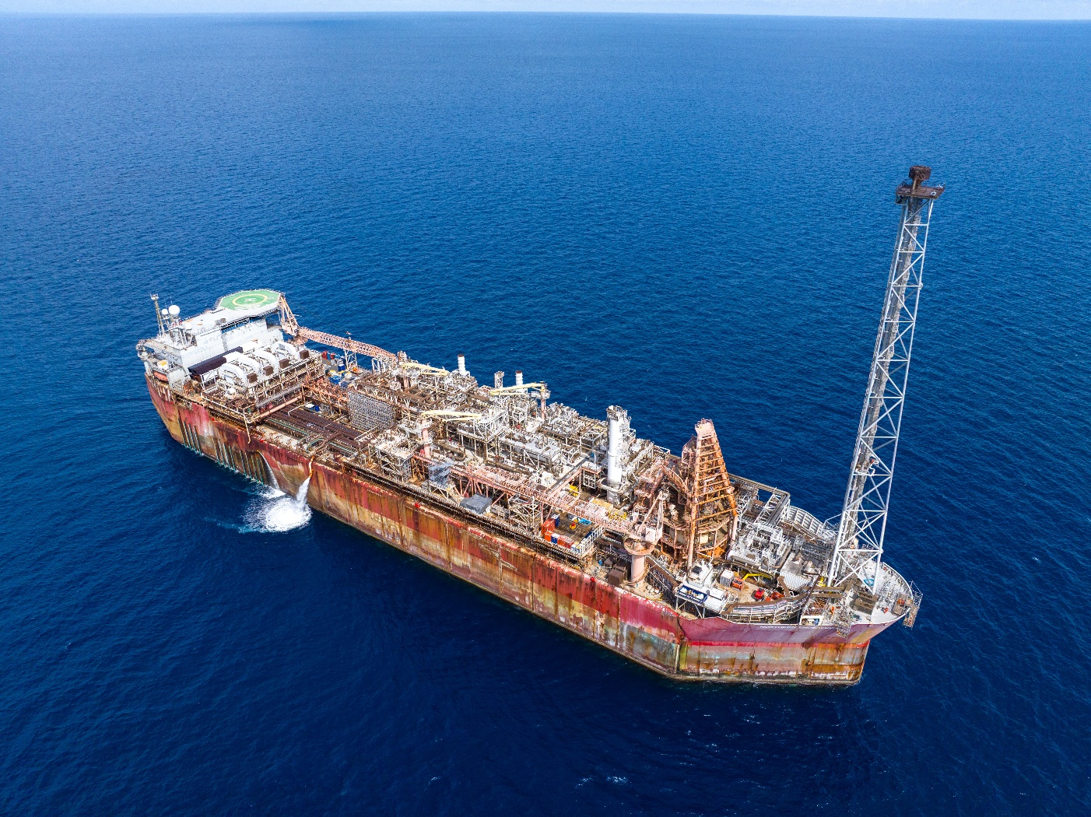
Figure 1 – The Northern Endeavour FPSO from above.

Introduction

Foreword
The Department of Industry, Science and Resources (the department) continued to make significant progress during the reporting period of 1 August 2024 to 31 July 2025. During this time, the department prepared the Northern Endeavour floating production storage and offloading vessel (FPSO) for disconnection from the subsea infrastructure and subsequent disposal. The department maintained and operated the FPSO in non-production mode and undertook work to prepare the FPSO for disconnection and tow. Petrofac Facilities Management Limited (Petrofac) was the registered operator and lead contractor during the reporting period. Petrofac continued to deliver phase 1 decommissioning activities for the department.
The department was compliant with the Environmental Protection and Biodiversity Conservation Act 1999 (EPBC Act) approval EPBC ref 2022/09327 Northern Endeavour Phase 1 Decommissioning (the approval) during the reporting period. Petrofac implemented the management plans and complied with the conditions throughout. The department took a proactive approach in maintaining compliance with the approval conditions and completed all reporting. The department applied and maintained rigorous internal measures of review to ensure the success of the Northern Endeavour phase 1 decommissioning work.
The department and Petrofac developed a series of detailed management plans for activation if an incident, non-compliance, or emergency occurred. The department maintained a Northern Endeavour Crisis Management Team (CMT), along with Petrofac’s Incident Management Team (IMT) to be ready to activate in case of an emergency.

Purpose
On 1 August 2023, the Department of Climate Change, Energy, the Environment and Water (DCCEEW) gave EPBC Act approval of the Northern Endeavour Phase 1 Decommissioning to the department. This was subject to 34 conditions (the conditions).
Condition 20 of the approval states that the approval holder (the department) must provide an Annual Compliance Report. This report covers the department’s compliance with all conditions of approval for the reporting period. This reporting period runs from 1 August 2024 to 31 July 2025. The department has prepared this report to meet the Annual Compliance Report Guidelines (DCCEEW 2023) as per condition 21.
The Commonwealth of Australia is the approval holder for EPBC ref 2022/09327 as represented by the department (ABN 74 599 608 295).

Background and location
The Northern Endeavour FPSO is a 274 m long FPSO facility. During the reporting period the FPSO was permanently moored between the Laminaria and Corallina oil fields. It was approximately 550 km northwest of Darwin in the Timor Sea. The operational area was 5,219 hectares.
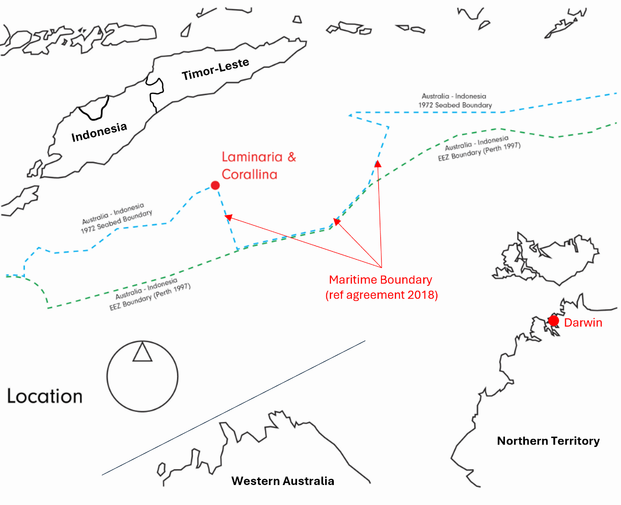
Figure 2 – Location of the Northern Endeavour FPSO and Laminaria and Corallina oil fields.
The Laminaria and Corallina Decommissioning Cost Recovery Levy (the levy) recovers the costs of decommissioning and remediation from the oil and gas industry.
Decommissioning is a standard ‘end of life’ practice and legal obligation in the offshore petroleum industry. The Commonwealth took responsibility for the Northern Endeavour in 2020 and began planning its decommissioning. The department aims to complete the decommissioning work efficiently and safely, ensuring value for money while protecting the surrounding environment.
The department is managing the decommissioning program across 3 phases:
- Phase 1: Temporary suspension of the subsea wells, flushing of subsea infrastructure, hull cleaning and disconnection of the FPSO from the subsea equipment to allow towing.
- Phase 2: Permanently plug and abandon the subsea wells.
- Phase 3: Remove subsea infrastructure and remediate the Laminaria and Corallina oilfields.
Petrofac is the lead contractor undertaking the work on the FPSO that is required for phase 1 of the decommissioning program.
The Commonwealth of Australia, represented by the department, submitted a referral under the EPBC Act to DCCEEW on 8 August 2022. The referral was for routine operations and maintenance operations and phase 1 decommissioning activities. The delegate to the Minister for the Environment and Water, the Hon Tanya Plibersek MP, decided that the action was a Controlled Action requiring assessment under the EPBC Act on 24 November 2022.
The following provisions of the EPBC Act were used to determine the action was a controlled action:
- Sections 18 and 18A – listed threatened species and communities
- Sections 20 and 20A – listed migratory species
- Section 28 – Commonwealth actions.
On 1 August 2023, the delegate issued an approval with 34 conditions for the action, under the title ‘Northern Endeavour Phase 1 Decommissioning' (EPBC ref 2022/09327).

Regulatory environment
The regulatory environment for the Northern Endeavour decommissioning program is different to typical industry decommissioning activities. Oil and gas companies are the titleholders responsible for decommissioning offshore facilities. The titleholders are regulated by the National Offshore Petroleum Safety and Environmental Management Authority (NOPSEMA).
However, as the Commonwealth is not a titleholder, DCCEEW is the regulator of the EPBC Act and environmental approvals for the program. This change in the regulatory environment means that names, and in some cases content, of reports and management plans are different to oil and gas industry norms.

Description of activities
This approval allows the department:
“to undertake routine operations and maintenance operations (lighthouse operations and short-term well injections) and phase 1 decommissioning activities of the Northern Endeavour FPSO and its associated Laminaria and Corallina resource fields to enable un-crewed towing.”
During the reporting period, the department made significant progress decommissioning the Northern Endeavour FPSO and remediating the associated Laminaria-Corallina oil fields. The following is an outline of key engineering and operational activities from this reporting period:
- Well suspension campaign – The light well intervention vessel, the Sapura Constructor, completed a successful well suspension campaign. The campaign started in September 2024 and reached completion in February 2025. The critical part of the works included temporarily suspending 7 of the 9 oil wells in the Laminaria-Corallina oil fields. Two wells were temporarily suspended previously. Temporarily suspending the wells involved:
- closing off the valves that control pressure and flow on the sea floor.
- installing 2 sets of specialised barriers at 2 different sections of the well to ensure fluids cannot escape to the surface.
- Subsea flushing activities – Isolation and cleaning of the subsea infrastructure began in September 2024 and reached completion in April 2025. This involved flushing nearly 30 km of pipelines, including subsea umbilicals, risers and flowlines (SURF). The flushing used over 4,000 m³ of seawater treated to prevent corrosion and biological growth.
- Topsides cleaning and decontamination – Petrofac undertook ongoing cleaning and decontamination of topsides equipment throughout the reporting period.
- Floating offtake hose recovery and disposal – the Skandi Emerald, disconnected the floating offtake hose from the FPSO, towed and disposed of it in Darwin in December 2024.
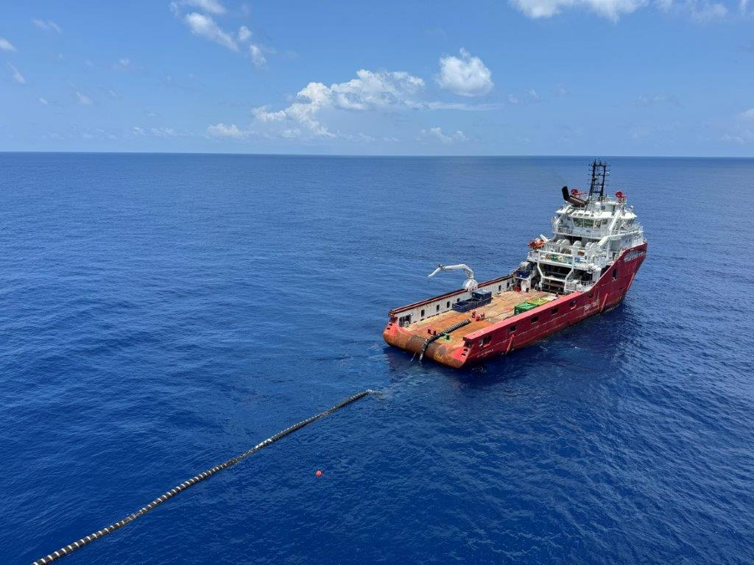
Figure 3 – The floating offtake hose loaded onto the deck of the Skandi Emerald ready to be towed to Darwin for disposal.
- Commencement of disconnection of the FPSO from subsea infrastructure – Stage 1 of the disconnection campaign began in March 2025 and reached completion in April 2025. The Skandi Hercules support vessel disconnected the FPSO from the Corallina and Laminaria oilfields by cutting 8 risers and lowering them to the seabed. Stage 2 began in July 2025 and was due for completion in September 2025, outside of this reporting period. This stage involves cutting the 9 mooring chains that anchor the FPSO to the seabed, ahead of departure of the FPSO from the operational area.
- FPSO hull cleaning – The Bhagwan Dryden successfully cleaned the bottom of the FPSO hull of marine growth between May 2025 and August 2025. The removal of marine growth minimises biosecurity risks posed during the wet tow and arrival in Singapore.
- Surveys and annual inspection, maintenance and repair campaign – Petrofac undertook classification surveys during the reporting period to ensure that structural works achieved compliance with class certificates and rules. Relevant equipment was then successfully repaired, installed or maintained to ensure compliance.
- Emergency management exercises – Petrofac undertook 2 emergency management exercises to test and improve the department’s and Petrofac’s response to any potential oil spill incidents.
- Routine operations and maintenance – Routine services were undertaken throughout the reporting period. These include operational activities, such as:
  - maintenance support and onshore operations
  - waste disposal and miscellaneous project assistance
  - regulatory activities such as implementation and execution of environmental and safety assurance practices.
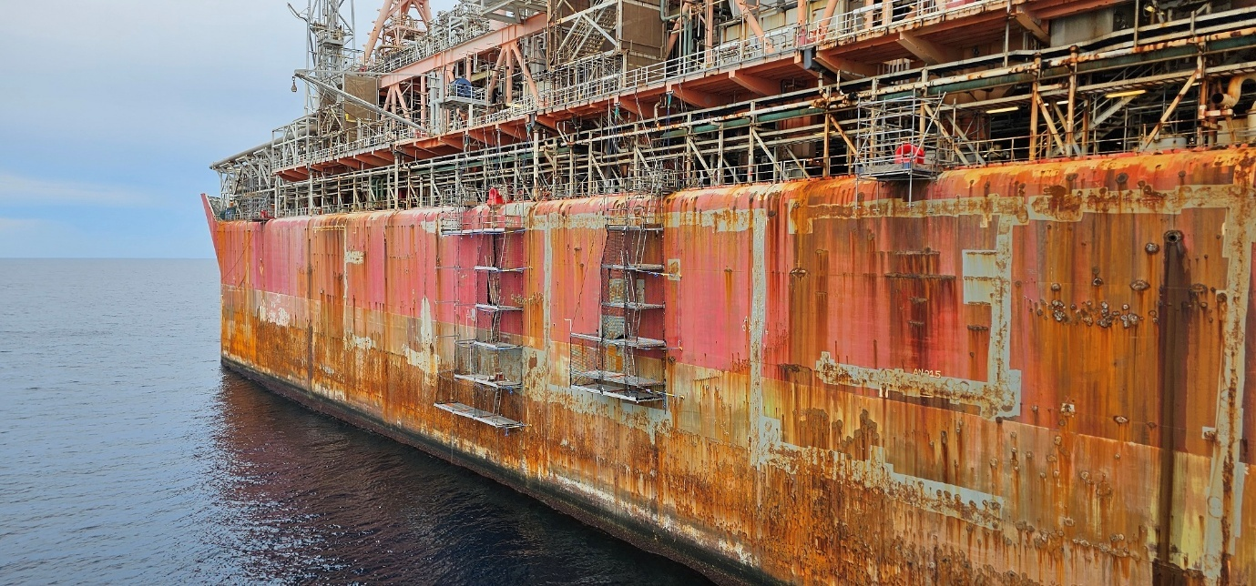
Figure 4 – Temporary scaffolding called ‘V-deck’ in place over the side of the FPSO for crew to complete hull repairs on the Northern Endeavour.

Variation to conditions and management plans
During the reporting period, the department requested the following variations to the approval conditions:
- Allowance for revision and subsequent implementation of management plans that are unlikely to have a new or increased impact on protected matters without requiring formal approval by the Minister for the Environment and Water (or their delegate).
- Update to the definition of ‘slops tank’ to include any tank on the FPSO (relevant to discharge management conditions 2 and 3).
Both proposed variations were approved by DCCEEW and signed by the delegate for the Minister for the Environment on 20 September 2024. This included addition of conditions
14A – 14F and a revised definition for ‘slop tank’.

Approval conditions
The department complied with all the conditions of approval throughout the reporting period. The information below supplements the compliance table in Attachment B, outlining the department’s adherence to each specified condition.

Part A – conditions specific to the action

Management plans – condition 1
The department, through its lead contractor Petrofac, applied the following management plans throughout the reporting period, in compliance with condition 1.

Environment Risk Management Plan
The Environment Risk Management Plan (ERMP) describes the management controls, Environmental Performance Standards (EPS) and Environmental Performance Outcomes (EPO). These controls reduce environmental impacts and risks to ‘as low as reasonably practicable’ and to ‘acceptable levels’.
Prior to the addition of condition 14A – 14F, the department submitted a revision of the ERMP to DCCEEW on 22 May 2024 under s143A of the EPBC Act. This revision to the ERMP was approved and implemented in stages:
- 6 September 2024 – ERMP was updated to include the use of a light well intervention vessel to assist in the SURF flushing campaign.
- 30 September 2024 – ERMP was updated (following an variation to the definition of ‘slops tank’ approved by DCCEEW on 20 September 2024) to allow the segregation of fluids and the use of any FPSO storage tank to hold flushing or slops fluids (See 5.12 Discharge management – conditions 2 and 3).
- 7 November 2024 – ERMP was updated to allow for re-injection of seawater and flushing fluid into the Corallina 3 well.
Following the addition of conditions 14A – 14F, the department submitted two (2) revisions of the ERMP to DCCEEW under Conditions 14B and 14C. The revised action management plans (RAMPs) were implemented following confirmation from the delegate of the Minister for the Environment that undertaking the revised action would not be likely to create a new or increased impact on protected matters.
The department submitted the first of these revised ERMPs to DCCEEW under Conditions 14B and 14C on 14 March 2025 and implemented from 31 March 2025.
This revision allowed for removing marine biofouling from the hull base of the FPSO within the operational area. Removal of the marine biofouling was needed for the FPSO to safely dry dock in Singapore.
The department submitted the second of these revised ERMPs to DCCEEW under Conditions 14B and 14C on 16 May 2025 and implemented from 17 June 2025. This revision allowed a contingency measure for offloading slops onboard the FPSO to an offshore support vessel for disposal.

Waste Management Plan
The Waste Management Plan (WMP) outlines mandatory waste management requirements based on applicable legislation and provides guidance to the FPSO and its support vessels. The WMP ensures offshore waste is managed in a controlled and appropriate manner to minimise health, safety and environmental impacts.

FPSO Riser and Mooring Disconnection Methodology
The FPSO Riser and Mooring Disconnection Methodology outlines the methodology used by Petrofac for disconnecting the FPSO from the risers and moorings.

Chemical Management Procedure
Petrofac’s Chemical Management Procedure (CMP) details the management processes for all chemical products used for regular FPSO maintenance and decommissioning. It includes how products are selected, used and managed.
The department submitted a revised CMP to DCCEEW on 30 October 2024 to incorporate administrative updates. The revision was implemented on 1 November 2024.

Oil Pollution Emergency Plan
In the unlikely event of an oil pollution emergency, the Oil Pollution Emergency Plan (OPEP) supports the first phase of decommissioning the FPSO and Laminaria Corallina oil fields. The OPEP outlines both the department and Petrofac’s readiness and response arrangements for worst-case spill scenarios.

Three decommissioning project emergency response plans
These 3 decommissioning project emergency response plans are only activated by Petrofac and the department in an incident or emergency.

Emergency Response and Communications Plan
The Emergency Response and Communications Plan (ERCP) gives Petrofac’s IMT and the department’s CMT all the information needed for managing incidents or business interruptions.
The department submitted revisions of the ERCP to DCCEEW to include administrative updates on 30 October 2024 and 6 February 2025. These revisions were implemented on
1 November 2024 and 6 March 2025, respectively.

Emergency Response Plan
The Emergency Response Plan (ERP) details facility-specific procedures for managing and responding to emergencies on the Northern Endeavour FPSO. The ERP outlines the responsibilities and lines of communication during an incident on, or in the immediate vicinity, of the FPSO. This includes managing the immediate response and operations of the Northern Endeavour Incident Response Team and all personnel onboard, in responding to any incident or emergency on the FPSO.
The department submitted revisions of the ERP to DCCEEW to include administrative updates on 30 October 2024 and 6 February 2025. These revisions were implemented on
1 November 2024 and 6 March 2025, respectively.

Source Control Emergency Response Plan
The Source Control Emergency Response Plan (SCERP) ensures safe and efficient
re-establishment of well control after a loss of containment event. The focus is to minimise risk to people, environment and assets.

Discharge management – conditions 2 and 3
Petrofac took samples from different depth horizons in the slops tank. They submitted the samples to a National Association of Testing Authorities (NATA) accredited laboratory throughout the reporting period. The laboratory analysed the samples for toxicant concentrations and radioactivity as outlined in the conditions. The results were reviewed by an independent and suitably qualified marine environmental water quality expert. Petrofac did not discharge until they received notice that the results met the requirements of this condition.
On 20 September 2024, the delegate for the Minister of the Environment and Water approved a variation to the definition of ‘slops tank’ within the approval, relevant to conditions 2 and 3. This approved variation broadened the definition of ‘slops tank’ to include any storage tank on the FPSO to comply with the discharge management conditions.

Invasive marine species management – condition 4

Floating offtake hose
The Skandi Emerald removed the floating offtake hose from the operational area on 20 November 2024, during the reporting period. The department submitted a Marine Biosecurity Risk Assessment (MBRA) for the offtake hose to DCCEEW on 7 June 2024. This was reported on in Northern Endeavour phase 1 decommissioning annual compliance report 2024. The department implemented the MBRA during the tow of the floating offtake hose to Darwin for disposal.
Prior to removing the floating offtake hose from the operational area, the department completed consultation on invasive marine species (IMS) biosecurity. Following consultation, the department obtained an Australian Marine Parks permit to the tow of the floating offtake hose to Darwin for disposal. The department maintained compliance with all requirements of the permit.

FPSO
The FPSO was not removed from the operational area during this reporting period. A MBRA was prepared by independent experts and environmental consultants, GHD Group Pty Ltd. The department submitted the MBRA to DCCEEW on 25 July 2025.
The department consulted relevant domestic regulators regarding invasive marine species biosecurity in relation to the FPSO. The department will continue this consultation in the next reporting period.

Well management – conditions 5 – 9
A well suspension campaign began in September 2024 and reached completion on 12 February 2025. The department notified DCCEEW of completion of these activities on 18 February 2025. The effective, temporary well barriers will remain in place until permanent plugging and abandonment of the wells is completed during phase 2 of the program.
The Sapura Constructor conducted an underwater survey following the well suspension activities. The survey verified the integrity of all the wells and that they were all successfully suspended.

Figure 5 – Remote operated vehicle on the Sapura Constructor preparing to do well suspensions.

Corallina-3 ST1 wellhead
Bubbles were first observed at the Corallina-3 ST1 wellhead in December 2021. Following this initial observation, the department notified NOPSEMA in December 2021. NOPSEMA closed an official investigation in March 2022 which included recommendations for the department and Petrofac to:
- continue to monitor annular pressure
- continue to undertake annual surveillance
- attempt to obtain a gas sample at the time of the next inspection.
During the well suspension campaign, the Sapura Constructor surveyed the Corallina-3ST1 wellhead. There was no change to previous observations. As part of the suspension activities, the Sapura Constructor installed and verified barriers prior to the well intervention vessel departing the field.
After the temporary suspension, the Sapura Constructor re-surveyed the wellhead in January 2025, prior to the light well intervention vessel departing the field. Petrofac observed a significant reduction in the bubble rate following reviews of the survey data. This confirmed the success of the temporary well barrier.
Annual underwater surveys of the subsea infrastructure will be undertaken to ensure ongoing monitoring and management of all wells, including the Corallina-3 ST1 wellhead. These annual surveys will be undertaken until all wells have been permanently plugged and the well infrastructure removed. These activities will occur during Phase 2 of the decommissioning program.

Hazardous waste management – conditions 10 – 12
The department developed a draft Inventory of Hazardous Materials (IHM. The FPSO did not depart the operational area during this reporting period.

Part B - Administrative conditions

Notification of date of commencement of the Action – conditions 13 and 14
Conditions 13 and 14 were closed in the previous reporting period as outlined in the Northern Endeavour phase 1 decommissioning annual compliance report 2024.

Revision of action management plans – conditions
14A – 14F
The department revised some of the approved action management plans in accordance with the requirements of conditions 14A–14F during this reporting period. Details can be found above in section 5.1.1.

Compliance records – conditions 15 – 19
The department and Petrofac kept accurate and complete records showing compliance with the conditions of approval for this reporting period. This includes documentation that shows compliance with activities outlined in approved action management plans.
Under the requirements of Condition 19, the department notified DCCEEW on 12 August 2025 that no monitoring data needed to be kept or reported following the end of the reporting period.

Annual compliance reporting – conditions 20 – 23
This report was prepared by the department for the period 1 August 2024 to 31 July 2025. It was published on the department’s website on 24 October 2025. This report was prepared according to the Annual Compliance Report Guidelines (DCCEEW 2023).
The department notified DCCEEW on 23 October 2024 of the publication of the annual compliance report for the 1 August 2023 to 31 July 2024 reporting period. This was within 5 business days of publication on the department’s website. The website publication of all Annual Compliance Reports was maintained.

Reporting non-compliance – conditions 24 – 26
The department submitted 4 notifications of potential non-compliance with a condition or a commitment in an approved action management plan to DCCEEW during this reporting period. It was determined that none of these events amounted to an incident or actual non-compliance.

September 2024 notification
In September 2024, the department made administrative updates to the CMP, ERCP and ERP without prior approval from DCCEEW. The department notified DCCEEW of these updates and provided copies of the updated RAMPs.
DCCEEW agreed with the department’s initial conclusion that there were no changes to the approved commitments in the updated management plans, and therefore, there was no non-compliance.

November 2024 notification
During the well suspension campaign in November 2024, a piece of equipment (an e-line tool string) detached from the Sapura Constructor vessel. Efforts to locate and recover the equipment were unsuccessful. Due to the size, shape and weight of the tool string, it is most likely that it sank into the seabed on impact. This would make it very difficult and unlikely to be recovered. A survey of the area confirmed that no damage occurred to subsea infrastructure.
The event, its reporting and investigation complied with the conditions of approval and commitments within the approved action management plans.

January 2025 notification
During flushing operations in January 2025, the Sapura Constructor detected a hydraulic fluid leak from a sub-surface safety valve (SSSV). When the leak was detected, immediate containment actions were taken by the Sapura Constructor and Petrofac. Follow-up assessments found no harm caused to the marine environment.
The event, its reporting and investigation complied with the conditions of approval and commitments within the approved action management plans.

May 2025 notification
In May 2025, during lifting operations from the Skandi Hercules support vessel, a buoyancy module was accidentally dropped. Efforts to locate and recover the buoyancy module were partially successful, with the clump weight section being recovered to the Skandi Hercules and the remaining section appearing on the surface. However, the remaining section of the buoyancy module was unable to be recovered. This was due to safety considerations of searching the area without adequate visibility as the event occurred at night. Once adequate light had returned, it is most likely that the piece of equipment had drifted a significant distance due to its size and weight, and the currents present in the operational area. This made it very difficult and unlikely to be recovered. The unrecovered section of the buoyancy module is not considered to present a hazard to other marine users or the environment, given the relatively small size of the equipment.
The event, its reporting and investigation complied with the conditions of approval and commitments within the approved action management plans.

Independent audit – conditions 27 – 30
The department did not develop an audit report or engage an independent auditor for this reporting period.

Completion of the action – conditions 31 – 34
The FPSO was not removed from the operational areas during this reporting period, and the action was not completed.
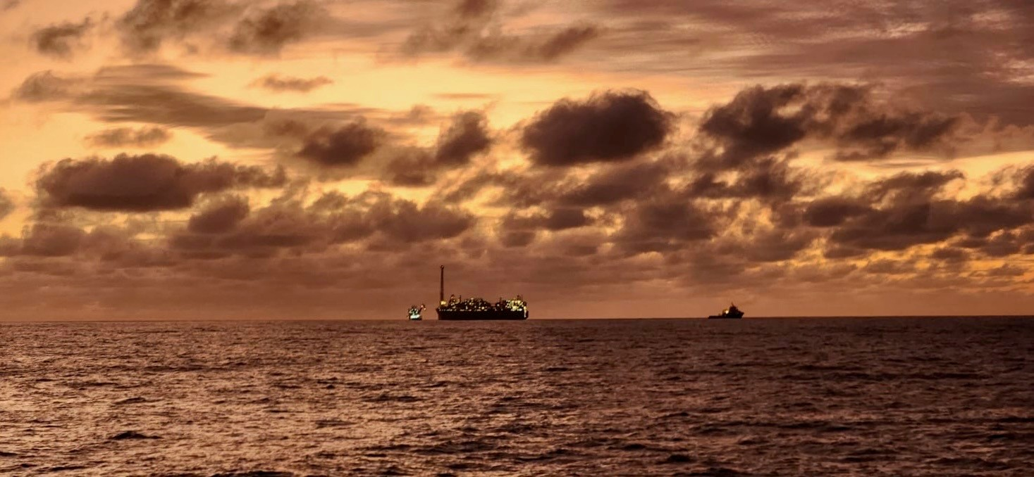
Figure 6 – The Northern Endeavour FPSO at sunset with two support vessels alongside.

Attachment A - Conditions as varied on 20 September 2024
On 20 September 2024, under section 143 of the Environmental Protection and Biodiversity Conservation Act 1999 (EPBC ACT), the delegate to the Minister for the Environment and Water at the time, the Hon Tanya Plibersek MP, issued an approval to vary conditions 1, 2 and 3 of the approval with conditions for the action, under the title ‘Northern Endeavour Phase 1 Decommissioning' (EPBC ref 2022/09327).

Approved action
Approval holder | The Commonwealth of Australia as represented by the Department of Industry, Science and Resources  ABN: 74 599 608 295
Action | To undertake routine operations and maintenance operations (lighthouse operations and short-term well injections) and Phase 1 decommissioning activities of the Northern Endeavour floating production and storage offtake facility and its associated Laminaria and Corallina resource fields to enable un-crewed towing.  See EPBC ref 2022/09327.
Variation of conditions attached to approval | The variations are:  - Revision of management plan definitions.  - Revision of ‘slops tank’ definition.  - Addition of Condition 14A, B, C, D, E and F as specified in the table below.
Date of effect | These variations have effect on the date this instrument is signed.

Attachment B – Detail of compliance with conditions of approval

Management plans
Condition number | Condition | Compliance | Evidence/Comments
1) | To prevent, mitigate and manage harm to protected matters, the approval holder must implement the following management plans from the date of this approval notice until the expiry date of this approval, except where the implementation of these plans is superseded by other requirements of this approval.  Note: If there is a contradiction between a requirement in the Oil Pollution Emergency Plan or in the 3 Decommissioning Project Emergency Response Plans and a requirement in any other plan, the requirement of the Oil Pollution Emergency Plan and the 3 Decommissioning Project Emergency Response Plans takes precedence over any contrary requirement of any other plan. | Compliant | The listed plans have been implemented by Petrofac.
1 a) | The Environment Risk Management Plan (ERMP). | Compliant | During this reporting period the ERMP was approved at revisions:  - D04 (September 2024)  - D05 (September 2024)  - D06 (November 2024)  - D07 (April 2025)  - D08 (June 2025).  This compliance assessment is based on the implementation of the relevant approved ERMP for the reporting period.  A monthly Environmental Verification Review (EVR) of compliance with the Environmental Performance Outcomes (EPOs) and Environmental Performance Standards (EPSs) is undertaken by DISR and Petrofac. This is documented with evidence collected and validated for each EPO and EPS. Petrofac retains this information in compliance records.  An Annual Environmental Inspection (AEI) is also conducted in accordance with the ERMP as a look-back exercise for the reporting period.
1 b) | The Waste Management Plan (WMP). | Compliant | Commitments listed in the WMP are captured in a monthly offshore Environment Inspection form and used as supporting evidence for the EVR. Primary commitments are also captured as EPS within the ERMP.
1 c) | The FPSO Riser and Mooring Disconnection Methodology. | Compliant | This plan was developed in 2022 and remains current. The execution of the FPSO riser disconnection was undertaken in this reporting period, the mooring disconnection had not commenced during the period and is outside of the scope of this report.
1 d) | The Chemical Management Procedure. | Compliant | This procedure is used to guide the assessment of chemicals required for use during the project on an on-going basis.  Verification and validation of evidence is undertaken as part of the EVR for each preceding month.
1 e) | The Oil Pollution Emergency Plan (OPEP). | Compliant | The OPEP remains current and is ready for implementation. It was not required to be implemented during this reporting period.
1 f) | The 3 Decommissioning Project Emergency Response Plans. | Compliant | The 3 Decommissioning Project Emergency Response Plans remain current and are ready for implementation. There was no requirement to implement any of the 3 plans during this reporting period.  There are no specific EPOs or EPSs relating to commitments made in these plans.

Discharge management
Condition number | Condition | Compliance | Evidence/Comments
2) | To mitigate harm to protected matters from toxicants within the slops tank discharge, the approval holder must, through regular monitoring, ensure:
2 a) | The slops tank discharge does not exceed a mercury concentration of 0.1 µg/L at the point of discharge at all times. | Compliant | Batch samples were analysed by a NATA-accredited laboratory. Results were reviewed by an independent and suitably qualified water quality expert to confirm compliance with the requirements of this condition prior to discharge.  DISR maintains a log of laboratory reports for each batch.
2 b) | The slops tank discharge does not exceed radioactivity levels of 35 Bq/g at all times. | Compliant | Batch samples were analysed for radioactivity levels by an onshore laboratory. Results were reviewed by an independent and suitably qualified water quality expert to confirm compliance with the requirements of this condition prior to discharge.  DISR maintains a log of laboratory reports for each batch.
2 c) | Water 100 m and beyond from the slops tank discharge point does not exceed the default guideline values for all toxicants. | Compliant | Batch samples were analysed by a NATA-accredited laboratory. Results were reviewed by an independent and suitably qualified water quality expert to confirm compliance with the requirements of this condition prior to discharge.  Dispersion modelling by the independent water quality expert has been undertaken to ensure consistency with the guidelines for marine water quality.  DISR maintains a log of laboratory reports for each batch.
2 d) | Ensure that representative samples from different depth horizons in the slops tank (near top, middle and near bottom) are obtained and analysed for concentrations of all toxicants that will be discharged, except for NORMs, by a NATA accredited laboratory prior to any batch discharges from the slops tank. | Compliant | The sampling and analysis process to achieve compliance with this condition has been developed and implemented by Petrofac.  Batch samples were analysed by a NATA-accredited laboratory. Results were reviewed by an independent and suitably qualified water quality expert to confirm compliance with the requirements of this condition prior to discharge.  DISR maintains a log of laboratory reports for each batch.
3) | To mitigate and remediate harm to protected matters from toxicants within the slops tank discharge, if the slops tank discharge exceeds the allowable toxicant concentrations and radioactivity levels specified in condition 2, then the approval holder must immediately cease all discharges from the slops tank and prepare and submit to the department an Adaptive Monitoring and Management Framework (AMMF). The AMMF must: | Not applicable | An AMMF was not required during this reporting period – batch sampling analysis and independent review confirmed compliance with discharge criteria outlined under Condition 2 prior to commencement of all discharges conducted.
3 a) | Detail the default guideline value exceedance (date, time, measured toxicant concentration, allowable toxicant concentration that was exceeded, distance from the slops tank discharge point and location of the exceedance). | Not applicable | Not applicable
3 b) | Specify remediation measures to be implemented to reduce the toxicant concentration and/or radioactivity of slops tank discharges to meet the requirements of condition 2. | Not applicable | Not applicable
3 c) | Not be inconsistent with the Water Quality Guidelines. | Not applicable | Not applicable
3 d) | Have been reviewed by an independent and suitably qualified marine environmental water quality expert. | Not applicable | Not applicable
3 e) | Include an acknowledgement of the independent review and show how any advice from the independent review has been addressed. | Not applicable | Not applicable
3 f) | The approval holder must implement the AMMF and ensure that the requirements of condition 2 are being met before allowing any further slops tank water to be discharged. | Not applicable | Not applicable

Invasive marine species management
Condition number | Condition | Compliance | Evidence/Comments
4) | To minimise harm to protected matters from the potential introduction of invasive marine species, prior to removing the FPSO, the offtake hose, or any other submerged equipment from the operational area, the approval holder must: | Compliant | The floating offtake hose was removed from the operational area on 20 November 2024. The preparation and submission of an MBRA for the offtake hose was reported in the previous reporting period.  No other submerged equipment, nor the FPSO, was removed from the operational area during this reporting period.  DISR prepared and submitted a MBRA for the FPSO to DCCEEW during this reporting period.
4 a) | Engage an independent suitably qualified marine biosecurity expert to complete a Marine Biosecurity Risk Assessment (MBRA) in respect of the FPSO, the offtake hose and any other submerged equipment to be towed from the operational area. | Compliant | An MBRA for the FPSO was finalised by consulting firm, GHD, on 22 April 2025. The MBRA was peer reviewed by an independent suitably qualified marine biosecurity expert.
4 b) | Submit the MBRA to the department. | Compliant | The MBRA for the FPSO was submitted to DCCEEW electronically on 25 July 2025.
4 c) | Consult with all relevant authorities and obtain all relevant approvals and permits with respect to invasive marine species biosecurity. | Compliant | DISR has consulted with:  - Department of Agriculture, Fisheries and Forestry Biosecurity team.  - DCCEEW.  - Singapore National Environmental Agency.  - Singapore Marine Port Authority.  Consultation was regarding IMS biosecurity as relevant to the FPSO.  DISR continues to consult with the relevant regulatory authorities to confirm the permitting requirements for the removal of the FPSO from the operational area.
4 d) | The MBRA must specify the measures required to prevent the introduction of invasive marine species to sensitive benthic habitats and marine protected areas as a result of the Action. The approval holder must implement the MBRA until the expiry date of this approval. | Compliant | The measures outlined in the MBRA for the floating offtake hose (the compliance details of which are reported on in the previous reporting period) were implemented throughout tow and disposal of the hose. The scope of this activity was completed in December 2024.  The MBRA for the FPSO contains mitigation measures for the control of risks of IMS. The execution of this scope will take place in the next reporting period.

Well management
Condition number | Condition | Compliance | Evidence/Comments
5) | The approval holder must leave all effective barriers in all wells, to prevent the escape of petroleum, water and any other substance from the wells, and ensure integrity is maintained until such time as the department notifies the approval holder in writing that the department is reasonably satisfied that the wells are permanently plugged or closed off. | Compliant | All effective well barriers have been left in place following the well suspension activities.
6) | Within 5 business days following the completion of well suspension activities, the approval holder must notify the department electronically of the date of completion of well suspension activities. | Compliant | The well suspension campaign was completed on  12 February 2025. DISR notified DCCEEW of the completion of well suspension activities on  18 February 2025.
7) | The approval holder must complete an underwater survey after the well suspension activities are completed, and again annually thereafter for the duration of this approval, to verify that integrity of the wells is being maintained. | Compliant | An underwater survey was conducted on completion of the well suspension activities.
8) | Should an underwater survey required by condition 7, or any other observation, show that the well suspension activities have failed, the approval holder must: |  | NOTE: The approval conditions define ‘failure’ as “being unsuccessful in preventing a new, or being unsuccessful in reducing an existing release of petroleum, water or any other substance (whichever applies) from a well or adjacent seafloor area, such as the release of bubbles.”
8 a) | Within one calendar day of discovering that the completed well suspension activity having failed, notify the department that the well suspension activity has failed to prevent the escape of petroleum, water or any other substance (whichever applies). | Compliant | DISR notified DCCEEW within one calendar day that the existing bubbling from Corallina-3 did not immediately reduce following well suspension.
8 b) | Begin implementing an Adaptive Monitoring and Management Programme (AMMP) to stop the further failure from the well within one calendar day of the well suspension activity failure having been identified. | Compliant | An AMMP was implemented within one calendar day of detection.
8 c) | Notify the department electronically when the AMMP was implemented. | Compliant | DISR notified DCCEEW, via email, in December 2024 of AMMP implementation.
8 d) | Continue to implement the AMMP at least until no further failure of the well can be detected. | Compliant | The AMMP was implemented until the well was resurveyed and it was observed that the existing bubbling had reduced.
8 e) | Within 6 months from the day of identifying that well suspension activities have failed, or a longer period if agreed to by the department in writing, verify that the implemented AMMP has successfully stopped failure. | Compliant | DISR notified DCCEEW in June 2025 that the Corallina-3 bubble rate had reduced since the implementation of the AMMP.
8 f) | Within 5 calendar days of ceasing to implement the AMMP, notify the department in writing of the date on which it ceased implementing the AMMP. | Compliant | DISR notified DCCEEW in June 2025 that the AMMP was no longer being implemented, following the observation that the bubble rate had reduced.
9) | If the approval holder identifies a new risk that could increase the chance of failure of any wells before well suspension activities are completed, the approval holder must implement an AMMP to address the identified risk. The approval holder must implement the AMMP: | Not applicable | No new risks that could increase the chance of well failure prior to completion of well suspension activities were identified.
9 a) | Until the expiry date of this approval. | Not applicable | No new risks that could increase the chance of well failure prior to completion of well suspension activities were identified.
9 b) | Until the approval holder receives written advice from the department that the AMMP no longer needs to be implemented. | Not applicable | No new risks that could increase the chance of well failure prior to completion of well suspension activities were identified.

Hazardous waste management
Condition number | Condition | Compliance | Evidence/Comments
10) | To minimise harm to protected matters from the potential inadequate management of hazardous wastes, the approval holder must:
10 a) | Have established an inventory of all hazardous waste remaining on the facility, suitably quantified and characterised, prior to the FPSO departing the operational area. This must include, but not be limited to: | Compliant | An interim IHM has been finalised for hazardous material onboard the FPSO (under normal operations) with additional IHM reports to be compiled prior to FPSO disconnection and sail away (if required).
10 a) i | Packaged solid, or liquid waste material (including plastics). | Compliant | As listed in the interim IHM.
10 a) ii | Any residual process and treatment chemical inventories stored on the facility. | Compliant | As listed in the interim IHM.
10 a) iii | Solids, liquids and sludges contained in facility piping, vessel and tanks. | Compliant | As listed in the interim IHM.
10 a) iv | Specifically, material containing mercury, NORM(s), or other hazardous material identified as part of the proposed activities. | Compliant | As listed in the interim IHM.
10 a) v | Any material of a category listed in Annex III of the Basel Convention. | Compliant | As listed in the interim IHM.
10 b) | Obtain any necessary permits or approvals for the transportation, import or export of such waste, as required by international or domestic conventions, protocols or legislative instruments, including the Commonwealth Hazardous Waste (Regulation of Exports and Imports) Act 1989 and the Basel Convention, prior to the FPSO departing the operational area. | Not applicable | DISR is in the process of finalising the necessary permits and approvals prior to the FPSO departing the operational area.
11) | The approval holder must inform the designated recipient (at the agreed location) of the FPSO of the quantities and nature of the hazardous waste that will be present on the FPSO, prior to the FPSO departing the operational area. | Not applicable | The FPSO did not depart the operational area during the reporting period.
12) | If the approval holder does not deliver the FPSO to the designated recipient (at the agreed location) themselves, and the FPSO is to be delivered to the agreed location by a creditor, then the approval holder must take all reasonable steps to communicate the requirements of this approval notice to the creditor. The requirements of this approval notice must be included in contractual or other handover arrangements between the approval holder and the creditor. | Not applicable | DISR, as the approval holder, will be delivering the FPSO to the designated recipient.

Notification of date of commencement of the Action
Condition number | Condition | Compliance | Evidence/Comments
13) | The approval holder must notify the department electronically of the date of commencement of the Action, within 5 business days following commencement of the Action. | Not applicable | This condition was closed in the previous reporting period. DISR notified DCCEEW via email on 8 August 2023 that the approved action had commenced.
14) | If the commencement of the Action does not occur within 5 years from the date of this approval, then the approval holder must not commence the Action without the prior written agreement of the Minister. | Not applicable | This condition was closed in the previous reporting period. DISR notified DCCEEW via email on 8 August 2023 that the approved action had commenced.

Revision of action management plans
Condition number | Condition | Compliance | Evidence/Comments
14A) | The approval holder may, at any time, apply to the Minister for a variation to an action management plan approved by the Minister by submitting an application in accordance with the requirements of section 143A of the EPBC Act. If the Minister approves a revised action management plan (RAMP) then, from the date specified, the approval holder must implement the RAMP in place of any previous version of the action management plan. | Not applicable | No variation to an action management plan was required to be submitted for approval under Condition 14A during this reporting period.
14B) | The approval holder may choose to revise an action management plan specified in condition 1 without submitting it for approval under section 143A of the EPBC Act, if the taking of the Action in accordance with the RAMP would not be likely to have a new or increased impact. | Compliant | - Revised versions of the CMP, ERCP and ERP were implemented on 1 November 2024 following submission to DCCEEW on 30 October 2024.  - Revised versions of the ERCP and ERP were implemented on 6 March 2025 following submission to DCCEEW on 6 February 2025.  - A revised version of the ERMP was implemented on 31 March 2025 following submission to DCCEEW on 14 March 2025.  - A revised version of the ERMP was implemented on 17 June 2025 following submission to DCCEEW on 16 May 2025.
14C) | If the approval holder makes the choice under condition 14B) to revise an action management plan without submitting it for approval, the approval holder must:
14C a) | Notify the department electronically that the approved action management plan has been revised and provide the department with: | Compliant | This information was provided to DCCEEW in all notifications of RAMPs.
14C a) i | An electronic copy of the RAMP. | Compliant | This information was provided to DCCEEW in all notifications of RAMPs.
14C a) ii | An electronic copy of the RAMP marked up with track changes to show the differences between the approved action management plan and the RAMP. | Compliant | This information was provided to DCCEEW in all notifications of RAMPs.
14C a) iii | An explanation of the differences between the approved action management plan and the RAMP. | Compliant | This information was provided to DCCEEW in all notifications of RAMPs.
14C a) iv | The reasons the approval holder considers that taking the Action in accordance with the RAMP would not be likely to have a new or increased impact. | Compliant | This information was provided to DCCEEW in all notifications of RAMPs.
14C a) v | Written notice of the date on which the approval holder will implement the RAMP (RAMP implementation date), being at least 20 business days after the date of providing notice of the revision of the action management plan, or a date agreed to in writing with the department. | Compliant | This information was provided to DCCEEW in all notifications of RAMPs.
14C b) | Subject to condition 14D, implement the RAMP from the RAMP implementation date. | Compliant | All RAMPs were implemented either after 20 business days of providing notice or on a date agreed in writing with DCCEEW.
14D) | The approval holder may revoke its choice to implement a RAMP under condition 14B at any time by giving written notice to the department. If the approval holder revokes the choice under condition 14B, the approval holder must implement the action management plan in force immediately prior to the revision undertaken under condition 14B. | Not applicable | DISR did not revoke the choice to implement a RAMP in this reporting period.
14E) | If the Minister notifies the approval holder that the Minister is satisfied that the taking of the Action in accordance with the RAMP would be likely to have a new or increased impact, then: | Not applicable | No RAMP was assessed to have a new or increased impact.
14E a) | Condition 14B does not apply, or ceases to apply, in relation to the RAMP. | Not applicable | No RAMP was assessed to have a new or increased impact.
14E b) | The approval holder must implement the action management plan specified by the Minister in the notice. | Not applicable | No RAMP was assessed to have a new or increased impact.
14F) | At the time of giving the notice under condition 14E, the Minister may also notify that for a specified period of time, condition 14B does not apply for one or more specified action management plans. | Not applicable | No RAMP was assessed to have a new or increased impact.

Compliance records
Condition number | Condition | Compliance | Evidence/Comments
15) | The approval holder must maintain accurate and complete compliance records. | Compliant | DISR and Petrofac maintained accurate and complete compliance records.
16) | If the department makes a request in writing, the approval holder must provide electronic copies of compliance records to the department within the timeframe specified in the request. | Not applicable | There was no request for providing electronic copies of compliance records during this reporting period.
17) | The approval holder must ensure that any monitoring data (including sensitive ecological data), surveys, maps, and other spatial and metadata required under the conditions of this approval are prepared in accordance with the Guidelines for biological survey and mapped data, Commonwealth of Australia 2018, or as otherwise specified by the Minister in writing. | Not applicable | No monitoring data (including sensitive ecological data), surveys, maps, or other spatial and metadata was required to have been prepared or submitted to DCCEEW during this reporting period.
18) | The approval holder must ensure that any monitoring data (including sensitive ecological data), surveys, maps, and other spatial and metadata required under the conditions of this approval are prepared in accordance with the Guide to providing maps and boundary data for EPBC Act projects, Commonwealth of Australia 2021, or as otherwise specified by the Minister in writing. | Not applicable | No monitoring data (including sensitive ecological data), surveys, maps, or other spatial and metadata was required to have been prepared or submitted to DCCEEW during this reporting period.
19) | The approval holder must submit all monitoring data (including sensitive ecological data), surveys, maps, other spatial and metadata and all species occurrence record data (sightings and evidence of presence) electronically to the department within 20 business days of each anniversary of this approval decision. | Compliant | DISR notified DCCEEW on 12 August 2025 that no monitoring data (including sensitive ecological data), surveys, maps, or other spatial and metadata was required during this reporting period.

Annual compliance reporting
Condition number | Condition | Compliance | Evidence/Comments
20) | The approval holder must prepare a compliance report for each 12- month period following the date of this approval decision, or as otherwise agreed to in writing by the Minister. | Compliant | DISR has prepared this compliance report for the period 1 August 2024 – 31 July 2025.
21) | Each compliance report must be consistent with the Annual Compliance Report Guidelines, Commonwealth of Australia 2023. | Compliant | This compliance report has been prepared and published consistent with the Annual Compliance Report Guidelines, Commonwealth of Australia 2023.
22) | Each compliance report must include:
22 a) | Accurate and complete details of compliance and any non-compliance with the conditions and any incidents. | Compliant | This report includes details of any incident and potential non-compliance reported during the period.
23) | The approval holder must:
23 a) | Publish each compliance report on the website within 60 business days following the end of the 12-month period for which that compliance report is required. | Compliant | This report has been prepared for the period 1 August 2024 to 31 July 2025. It was published on DISR’s website on 24 October 2025 within 60 business days of the end of the first reporting period. This report has been prepared in accordance with the DCCEEW Annual Compliance Report Guidelines.
23 b) | Notify the department electronically, within 5 business days of the date of publication that a compliance report has been published on the website. | Compliant | DISR notified DCCEEW within 5 business days from the date of website publication of the Annual Compliance Report for the 1 August 2024 to 31 July 2025 reporting period.
23 c) | Provide the weblink for the compliance report in the notification to the department. | Compliant | The weblink was provided in the notification of publication.
23 d) | Keep all published compliance reports required by these conditions on the website until the expiry date of this approval. | Compliant | All published compliance reports have been maintained on the DISR website.
23 e) | Exclude or redact sensitive ecological data from compliance reports published on the website or otherwise provided to a member of the public. | Not applicable | There was no sensitive ecological data related to this compliance report that was required to be excluded or redacted prior to publication on the DISR website or otherwise provided to a member of the public.
23 f) | If sensitive ecological data is excluded or redacted from the published version, submit the full compliance report to the department within 5 business days of its publication on the website and notify the department in writing what exclusions and redactions have been made in the version published on the website. | Not applicable | There was no sensitive ecological data related to this compliance report that was required to be excluded or redacted prior to publication on the DISR website or otherwise provided to a member of the public.

Reporting non-compliance
Condition number | Condition | Compliance | Evidence/Comments
24) | The approval holder must notify the department electronically, within 2 business days of becoming aware of any incident and/or potential non-compliance and/or actual non-compliance with the commitments made in a plan that require reporting, or with any of the conditions of this notice. | Compliant | - DISR notified DCCEEW within 2 business days, via email, of a potential non-compliance event observed in September 2024. Following investigation, there was no non-compliance with approved management plans or breach to conditions of approval.  - DISR notified DCCEEW within 2 business days, via email, of a potential non-compliance event observed in November 2024. Following investigation, there was no non-compliance with approved management plans or breach to conditions of approval.  - DISR notified DCCEEW within 2 business days, via email, of a potential non-compliance event observed in December 2024. Following investigation, there was no non-compliance with approved management plans or breach to conditions of approval.  - DISR notified DCCEEW within 2 business days, via email, of a potential non-compliance event observed in May 2025. Following investigation, there was no non-compliance with approved management plans or breach to conditions of approval.
25) | The approval holder must specify in the notification:
25 a) | Any condition or commitment made in a plan which has been or may have been breached. | Compliant | All notifications sent to DCCEEW during the reporting period indicated the EPBC conditions and management plan commitments that were relevant to the event.
25 b) | A short description of the incident and/or potential non-compliance and/or actual non-compliance. | Compliant | This information was provided to DCCEEW in all notifications during the reporting period.
25 c) | The location (including co-ordinates), date and time of the incident and/or potential non-compliance and/or actual non-compliance. | Compliant | This information was provided to DCCEEW in all notifications during the reporting period.
26) | The approval holder must provide to the department in writing, within 12 business days of becoming aware of any incident and/or potential non-compliance and/or actual non-compliance, the details of that incident and/or potential non-compliance and/or actual non-compliance with the conditions or commitments. The approval holder must specify: | Compliant | DISR notified DCCEEW within 12 business days, via email, of the conclusion that there was no non-compliance or incident due to the events observed in September 2024, November 2024, December 2024 or May 2025.
26 a) | Any corrective action or investigation which the approval holder has already taken. | Compliant | This information was provided to DCCEEW in all notifications during the reporting period.
26 b) | The potential impacts of the incident and/or non-compliance. | Compliant | This information was provided to DCCEEW in all notifications during the reporting period.
26 c) | The method and timing of any corrective action that will be undertaken by the approval holder. | Compliant | This information was provided to DCCEEW in all notifications during the reporting period.

Independent audit
Condition number | Condition | Compliance | Evidence/Comments
27) | The approval holder must ensure that an independent audit of compliance with the conditions is conducted for every 5 year period following the commencement of the Action until this approval expires, unless otherwise specified in writing by the Minister. | Not applicable | No audit was required to be conducted during this reporting period.
28) | For each independent audit, the approval holder must:
28 a) | Provide the name and qualifications of the nominated independent auditor, the draft audit criteria, and proposed timeframe for submitting the audit report to the department prior to commencing the independent audit. | Not applicable | No audit was required to be conducted during this reporting period.
28 b) | Only commence the independent audit once the nominated independent auditor, audit criteria and timeframe for submitting the audit report have been approved in writing by the department. | Not applicable | No audit was required to be conducted during this reporting period.
28 c) | Submit the audit report to the department for approval within the timeframe specified and approved in writing by the department. | Not applicable | No audit was required to be conducted during this reporting period.
28 d) | Publish each audit report on the website within 15 business days of the date of the department’s approval of the audit report. | Not applicable | No audit was required to be conducted during this reporting period.
28 e) | Keep every audit report published on the website until this approval expires. | Not applicable | No audit was required to be conducted during this reporting period.
29) | Each audit report must report for the 5 year period preceding that audit report. | Not applicable | No audit was required to be conducted during this reporting period.
30) | Each audit report must be completed to the satisfaction of the Minister and be consistent with the EPBC Act Independent Audit and Audit Report Guidelines, Commonwealth of Australia 2019. | Not applicable | No audit was required to be conducted during this reporting period.

Completion of the Action
Condition number | Condition | Compliance | Evidence/Comments
31) | The approval holder must notify the department in writing the date on which it removed the FPSO from the operational area within 5 business days of having removed the FPSO from the operational area | Not applicable | The FPSO has not been removed from the operational area.
32) | The approval holder must notify the department in writing the date on which it delivered the FPSO to the designated recipient within 5 business days of having delivered the FPSO to the designated recipient. | Not applicable | The FPSO has not been delivered to the designated recipient.
33) | The approval holder must notify the department electronically 60 business days prior to the expiry date of this approval, that the approval is due to expire. | Not applicable | The approval is not due to expire in this reporting period.
34) | Within 20 business days after the completion of the Action, and, in any event, before this approval expires, the approval holder must notify the department electronically of the date of completion of the Action and provide completion data. The approval holder must submit any spatial data that comprises completion data as a shapefile. | Not applicable | The action has not been completed.

