# Future Gas Strategy

In brief

May 2024

## Copyright

**© Commonwealth of Australia 2024**

**Ownership of intellectual property rights**

Unless otherwise noted, copyright (and any other intellectual property rights, if any) in this publication is owned by the Commonwealth of Australia.



[**Creative Commons Attribution 4.0 International Licence CC BY 4.0**](http://creativecommons.org/licenses/by/4.0/)

All material in this publication is licensed under a Creative Commons Attribution 4.0 International Licence, with the exception of:

* the Commonwealth Coat of Arms
* content supplied by third parties
* logos
* any material protected by trademark or otherwise noted in this publication.

Creative Commons Attribution 4.0 International Licence is a standard form licence agreement that allows you to copy, distribute, transmit and adapt this publication provided you attribute the work. A summary of the licence terms is available from <https://creativecommons.org/licenses/by/4.0/>. The full licence terms are available from <https://creativecommons.org/licenses/by/4.0/legalcode>.

Content contained herein should be attributed as *Future Gas Strategy – In brief, Australian Government Department of Industry, Science and Resources*.

This notice excludes the Commonwealth Coat of Arms, any logos and any material protected by trademark or otherwise noted in the publication, from the application of the Creative Commons licence. These are all forms of property which the Commonwealth cannot or usually would not licence others to use.

## Acknowledgement of Country

This Strategy was developed on Aboriginal and Torres Strait Islander lands. The government acknowledges and pays respect to all First Nations peoples across Australia, who are the Traditional Custodians of the land and waters and are the oldest continuous living cultures on Earth.

We pay respect to Elders past and present. The government is committed to strengthening First Nations engagement and greatly values the insights and perspectives shared from First Nations peoples during the Future Gas Strategy’s public consultation process.

We thank First Nations people for their continuing custodianship of the Country that we live and work on today.

## Minister’s Message

Gas plays a critical role in Australia’s economy.

Gas is an important part of Australia’s future because it will enable us to successfully compete in the global race for jobs and opportunities in a net zero world. The global shift to clean energy is Australia’s biggest opportunity for growth and prosperity.

Over the past year, my department has rigorously researched, modelled, and analysed the future of gas. This work has been tested through extensive consultation and peer review. I am proud to publish this work alongside the strategy in a comprehensive analytical report.

The findings are clear. Under all credible net zero scenarios, natural gas is needed through to 2050 and beyond, though its production and use will change over this period. Gas will be essential to the transition because our energy system needs gas to achieve net zero. Gas will be a transition fuel that firms renewable power generation and will be required for manufacturing and minerals processing until such time as alternatives are viable. Gas can support our future made in Australia. However, the greenhouse gas emissions associated with gas must sharply decline and where gas use cannot be reduced, emissions must be increasingly abated and offset.

The Future Gas Strategy is the Australian Government’s approach to gas policy. The strategy uses evidence and data to establish six clear and enduring principles that will underpin future the Government’s policies and actions.

We cannot rely on past investments in gas to get us through the next decades. We need continued investment in, and development of, gas supply and transport infrastructure to get us through the energy transition with thriving industries. To secure the clean, affordable, and reliable energy Australia needs to compete in the global race for jobs and opportunities, we need to capitalise on our natural resource endowment.

I want to make a point I have made many times before and will continue to make: Australia is and will remain a reliable and trusted trade and investment partner, including for liquefied natural gas (LNG). Our trade partners have made large investments over decades in Australia’s resources industry and are relying on Australian gas to transition their economies to net zero. Australia is broadening and deepening our existing energy partnerships into emerging industries like critical minerals, hydrogen, carbon capture and storage, and other clean energy exports. The strength of our relationships, based on mutual economic benefit and friendship, will endure.

I would like to thank and acknowledge the significant contribution from all who helped develop this strategy. I look forward to continuing to work closely with industry and communities as we work towards net zero and a future made in Australia.

The road to both runs through the Australian resources sector.

**The Hon Madeleine King MP**

Minister for Resources

Minister for Northern Australia

### Future Gas Strategy at a glance

Securing the clean, affordable, and reliable energy Australia needs to compete in the global race for jobs and opportunities requires us to capitalise on the natural resources we have in the ground and sky.

The Future Gas Strategy is the Australian Government’s policy on the role of gas in our economy.   
It consists of six principles.

Principle 1 – Australia is committed to supporting global emissions reductions to reduce the impacts of climate change and will reach net zero emissions by 2050.

Principle 2 – Gas must remain affordable for Australian users throughout the transition to net zero.

Principle 3 – New sources of gas supply are needed to meet demand during the economy wide transition.

Principle 4 – Reliable gas supply will gradually and inevitably support a shift towards higher-value and non‑substitutable gas uses. Households will continue to have a choice over how their energy needs are met.

Principle 5 – Gas and electricity markets must adapt to remain fit for purpose throughout the energy transformation.

Principle 6 – Australia is, and will remain, a reliable trading partner for energy, including liquefied natural gas (LNG) and low-emissions gases.

The strategy is grounded by rigorous analysis and extensive consultation.

A detailed analytical report and submissions responding to the strategy’s discussion paper are available on the Department of Industry, Science and Resources website.

#### Demand outlook

Natural gas supports our standard of living and Australia’s energy security. How we use gas varies across the country depending on the businesses and households connected to the gas network (Figure 1).

Figure 1: Gas consumption by state/territory and sector, 2021–22

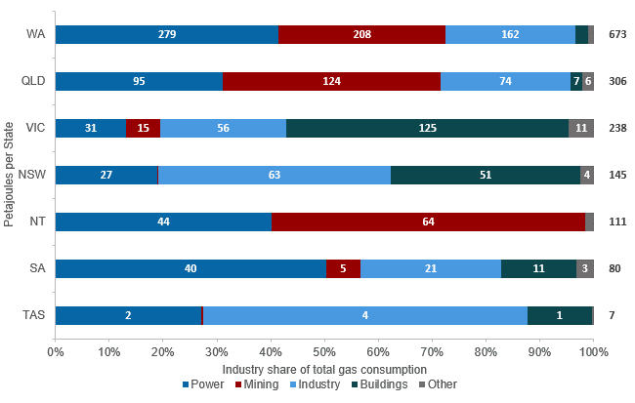

Notes: ACT included in NSW. Power includes on-site electricity generation. Buildings includes commercial and residential gas use. Mining includes gas used to power LNG liquefication. Source: DISR (2024) Fig 3.1; Australian Energy Statistics (2023).

Natural gas is integral to the Australian economy. It meets 27% of our energy needs and represents nearly 20% of our export income. Global and domestic gas demand outlooks are uncertain because they depend on a range of assumptions about how the energy transition progresses. However, under all credible net zero scenarios, natural gas is needed through to 2050 and beyond, albeit to a lesser extent. Australian industry requires a reliable and affordable supply of gas.

Gas is used to process food, to process critical minerals and in the manufacture of cement, bricks, glass, and fertiliser. Demand for gas in these industries will remain until commercially viable alternatives, such as hydrogen or biomethane, become available. Some industries may increase their consumption of gas in the short term ahead of the commercial availability of low-emissions gases, or in response to increased refinery or manufacturing demand related to the energy transformation.

As we transition away from coal, gas will likely play an important role in Australia’s electricity sector. Gas powered generation will continue to maintain grid reliability during periods of low generation from renewable sources, complementing battery storage and pumped hydro generation.

Demand for Australia’s exported LNG will remain strong until 2035 to service existing long-term LNG contracts. Trade partners have indicated their LNG demand will persist beyond 2050, albeit on a reduced scale as gas demand wanes, as they progress along their own decarbonisation pathways.

#### Supply outlook

New sources of natural gas supply are needed to meet demand during the transition. Without continued investment in our gas sector and development of supply sources, Australia faces the risk of annual supply gaps emerging by 2028 on the east coast, and by 2030 on the west coast. Existing policies such as the Gas Market Code, Heads of Agreement, and the Australian Domestic Gas Security Mechanism (ADGSM) remain in place to manage or mitigate shortfall risks.

Developing more flexible gas infrastructure is likely to be part of the solution on the east and west coast and may include infrastructure such as LNG import terminals and gas storage.

To encourage investment in our resources sector and embrace Australia’s natural advantages, the government will continue to invest in precompetitive geoscientific data. Our policies also will focus on optimising existing discoveries and infrastructure in producing basins, prioritise energy security, and align with our net zero emissions targets.

Australia has a strong regulatory framework that aims to avoid adverse environmental, cultural, and social impacts while encouraging investment in resources projects that support our economic prosperity. We must ensure our regulatory settings balance these key priorities and are efficient so Australia can compete for a sustainable, fairer, and prosperous future – made right here in Australia.

#### Emissions reduction

As detailed in the Future Gas Strategy companion analytical report, gas production and domestic use accounted for 24% of total emissions in Australia in 2021–22. These emissions must be minimised and eliminated where possible for us to meet our climate goals. Australia has legislated strong emissions reduction targets and has reformed the Safeguard Mechanism to ensure that our highest greenhouse gas emitting facilities, including those in the gas industry, contribute to achieving those targets. The government is building the infrastructure and clean energy to power new growth, facilitate private sector innovation and catalyse new investment for a prosperous future.

The government is developing six sectoral decarbonisation plans which cover all major components of the economy. The sectoral decarbonisation plans aim to materially reduce emissions associated with gas production and use.

Australia’s gas industry can also help our trade partners to decarbonise. The Asia-Pacific considers Australia a leader in the permanent, safe geological storage of CO2 and wants to invest. Australia will continue to release acreage for offshore greenhouse gas storage and is reviewing its offshore regulatory regime to realise opportunities associated with the geological storage of CO2 for domestic industry and our trade partners. Carbon capture, use and storage (CCUS), if achieved at scale, represents one of the few decarbonisation options for many hard-to-abate industries, such as cement and chemical production. It also underpins technology-based pathways for carbon dioxide removal.

Figure 2: Gas production and use in the Australian economy, including emissions (CO2 equivalent)

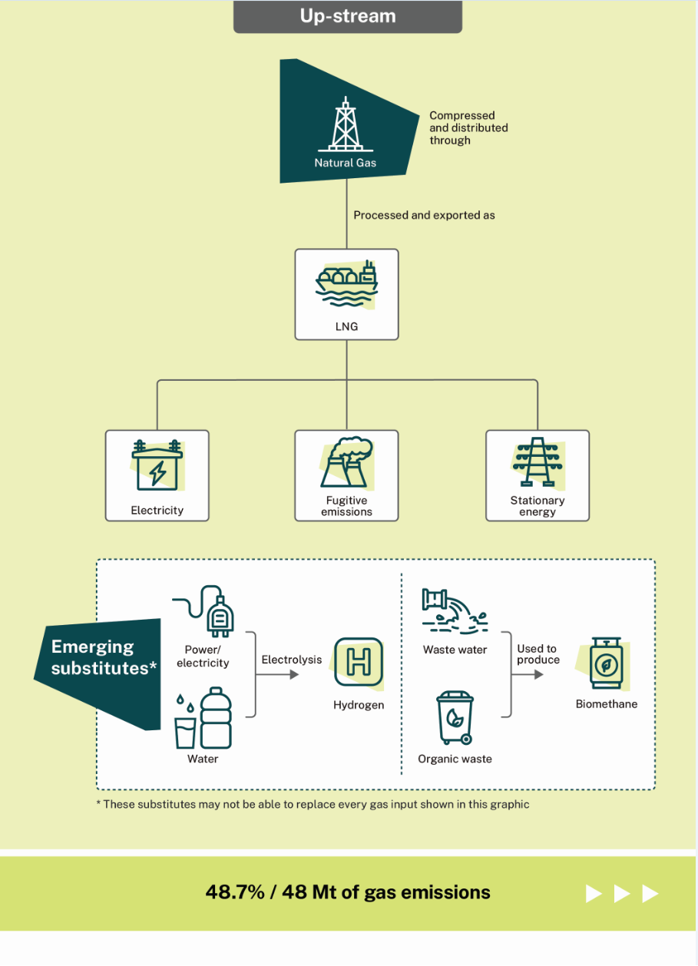

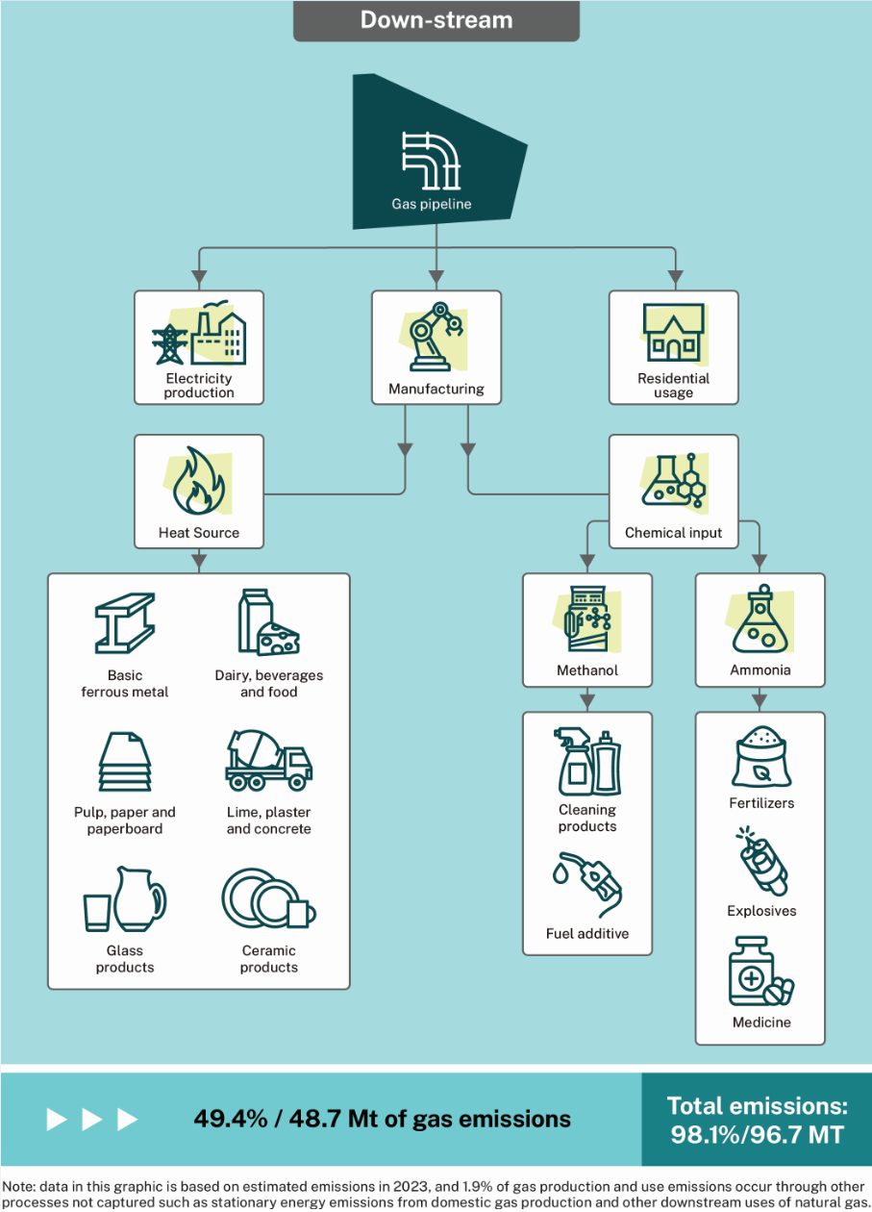

### Action Plan

|  |  |  |
| --- | --- | --- |
| Action 1: Prevent gas shortfalls |  | Action 2: Reduce gas-related emissions |
| **A reliable supply of gas is essential for energy production, and industrial and residential use. Forecast shortfalls are expected to put upward pressure on prices.**  The Government is currently managing shortfall risks through a mix of policy and regulatory settings by:   * utilising the powers of the Australian Energy Market Operator, the supply commitments under the Gas Market Code, and the Heads of Agreement to address forecast shortfalls ahead of time. * using the Australian Domestic Gas Security Mechanism (ADGSM) as a measure of last resort, to limit exports and ensure an adequate and secure supply of gas.   In light of the findings of the analysis supporting the strategy, the government will also:   * continue investing in pre-competitive geoscientific data. * update Commonwealth retention lease policies to encourage more timely development of existing gas discoveries and consider a firmer ‘use it or lose it’ policy. * reframe any future Commonwealth offshore exploration acreage releases to focus on optimising existing discoveries and infrastructure in producing basins, prioritise energy security, and align with our net zero emissions targets. * work with gas producers, under the Gas Market Code exemption framework, to increase gas supply committed for future domestic supply. * continue to work with state and territory governments to improve the efficiency of the regulatory regime. |  | **The Government is committed to reducing greenhouse gas emissions by 43% below 2005 levels by 2030 and achieving net zero by 2050. The Government will accelerate the reduction of gas-related emissions through:**   * the Safeguard Mechanism which obligates Australia’s largest emitters, including gas and LNG producers, to reduce emissions. * the six sectoral decarbonisation plans which cover all major components of the economy to produce decarbonisation pathways that are robust, ambitious and achievable.   In light of the findings of the analysis supporting the strategy, the government will also:   * work with regulators and industry to reduce and where possible eliminate venting and flaring of gas, unless required for safety purposes. * applying a technologically neutral approach to data acquisition in Commonwealth waters to minimise the use of marine seismic surveys where possible. * consider gas demand reduction measures in the government’s six sectoral decarbonisation plans, including the Resources Sector Plan. The Resources Sector Plan is also considering how to promote electrification of gas used in compressors, pumps, and liquefaction in gas production. * the Australian Government’s Future Made in Australia Agenda will help decrease gas emissions in specific sectors over the medium to long-term and contribute to making Australia a renewable energy superpower. |
| Action 3: Support households and businesses through the transition to net zero. |  | Action 4: Empower First Nations people to benefit from the transition to net zero. |
| **Helping Australians with the cost of living is the Government’s number one priority. The cost of living is an important element of community wellbeing and prosperity. Short‑term affordability challenges will be managed through targeted intervention, such as:**   * working closely with states and territories to manage pricing impacts. * the Gas Market Code, including statutory reviews to refine or strengthen aspects.   This is in addition to the existing:   * Energy Price Relief Plan. * $1.3 billion Household Energy Upgrades Fund to provide concessional finance to more than 170,000 households for home upgrades that save energy and contains $300 million to support energy performance retrofits for social housing. |  | **The Government recognises the importance of our First Nations people’s connection to country and is committed to improving social and economic outcomes through future energy projects. To achieve this, the Government will introduce reforms that:**   * clarify consultation requirements for offshore petroleum and greenhouse gas storage activities – this is part of a broader 3-year review of the offshore environmental management regime. * pursue an appropriate level of benefit sharing that ensures First Nations people are partners in the transition to net zero. This includes new job opportunities, improved education programs and direct community investment. |



|  |  |  |
| --- | --- | --- |
| Action 5: Promote geological storage of CO2 and support our region’s transition to net zero. |  | Action 6: Update the strategy |
| **The Australia’s gas industry can assist our region to decarbonise through the permanent, safe geological storage of CO2. To enable this, the government will:**   * continue to release offshore acreage for greenhouse gas storage. * ensure future Commonwealth offshore exploration acreage releases consider the energy security and transition needs of our region. * finalise the review the offshore regulatory regime to realise opportunities associated with the geological storage of CO2for Australian industry and our trade partners. * grow our clean energy exports and connect Australia to new clean energy supply chains through the Hydrogen Headstart and Regional Hydrogen Hubs programs.   In light of the findings of the analysis to support this strategy, the government will also:   * establish a new initiative on regional cooperation on transboundary carbon capture and storage, which will provide options for energy security and carbon management solutions for our regional partners. |  | **The Future Gas Strategy has a long-term outlook. The government is closely monitoring the evolving role of gas as the energy transformation progresses and will update the strategy as needed. This includes:**   * reviewing and, where needed, updating near-term policy levers, such as the Gas Market Code, Heads of Agreement and the ADGSM. * providing tailored policy responses for emerging issues. * ensuring the strategy continues to support Australia’s commitments under the Paris Agreement. |





### 