# Australia 2030 - Prosperity through innovation

## A plan for Australia to thrive in the global innovation race

© Commonwealth of Australia 2017

ISBN-13 978-1-922218-02-5 (print)

978-1-922125-48-4 (online)

**Citation**

Innovation and Science Australia 2017, *Australia 2030: prosperity through innovation*, Australian Government, Canberra.

**Copyright**

With the exception of the Commonwealth Coat of Arms, this work is licensed under a Creative Commons Attribution 4.0 International licence (CC BY 4.0) <http://creativecommons.org/licenses/by/4.0/deed.en>

Wherever a third party holds copyright in this material, the copyright remains with that party. Their permission may be required to use the material. Please contact them directly.

Editing, design and production by Biotext, Canberra.

Contents

Foreword iv

Executive summary 1

Section A: Australia’s innovation opportunity 5

Vision for Australia in 2030 6

Section B: Five imperatives for action 24

Imperative 1 Education: Respond to the changing nature of work by equipping all Australians with skills relevant to 2030 25

Imperative 2 Industry: Ensure Australia’s ongoing prosperity by stimulating high-growth firms and improving productivity 39

Imperative 3 Government: Become a catalyst for innovation and be recognised as a global leader in innovative service delivery 61

Imperative 4 Research and development: Improve research and development effectiveness by increasing translation and commercialisation of research 80

Imperative 5 Culture and ambition: Enhance the national culture of innovation by launching ambitious National Missions 93

Section C: Roadmap for action 102

Funding, implementation and monitoring 103

Summary of recommendations 108

Appendices 114

Appendix A Other National Mission candidates 115

Appendix B Definitions and sources for the scorecard metrics 117

Acronyms, abbreviations and glossary 121

Acknowledgements 124

# Foreword



This year, Australians became world record holders thanks to our 26 years of continuous economic growth.[1]

Much of this growth has been underpinned by two of Australia’s traditional, big export sectors: agriculture and mining. Although a significant natural resources endowment provided the foundations to build on, it was extraordinary innovation, risk-taking and export success that led farmers and miners to their world-leading positions.

Such innovation runs through Australia’s history. Australia's tyranny of distance made inventiveness a necessity for early colonists, inspiring the stump-jump plough, which enabled broad-acre farming, and refrigeration, which allowed meat to be exported. Over the last century, Australia has produced 15 Nobel Prize winners, mostly for knowledge breakthroughs in medicine and physiology.[2] However, Australia has also failed to capture the full value of our many inventions; the black box flight recorder, heart pacemaker, photovoltaic cells, X-ray crystallography and many others were all based on Australian research breakthroughs, but commercialised overseas.

Looking towards 2030, innovation will be integral to the expansion of Australia’s economy, keeping its workforce strong, and addressing societal challenges. Australia will need to be competitive in a global innovation race by scaling up more high-growth industries and companies; commercialising more high-value products and services; fostering great talent; and daring to tackle global challenges.

Yet just at the time when Australia needs to accelerate its innovation performance, we are falling behind our global peers, particularly in student performance in science and mathematics, and in business investment in research and development. **This is more than a canary chirp in our economic mineshaft: it is a clarion call for national action.**

Recognising the importance of innovation for Australia’s future, the Australian Government established the Innovation and Science Australia (ISA) Board in 2016, made up of 15 entrepreneurs, investors, researchers and educators with extensive local and global experience. The board was asked to produce a strategic plan to advise policy makers on how to accelerate innovation and optimise Australia’s innovation system out to 2030.

The ISA Board is confident that Australia can become a top-tier innovation nation by 2030, and retain its record-breaking economic streak. *Australia 2030: prosperity through innovation* (the 2030 Plan) makes 30 recommendations for governments to help achieve this goal, including launching a landmark National Missions program to inspire innovators, progress solutions to big problems, and generate national passion and pride in innovation and science achievements.

Creating the 2030 Plan was only possible with the input of multiple contributors and stakeholders, especially my incredible board of experts, along with our CEO, Dr Charlie Day and his team. I thank them all for the lessons and insights from their own successes and failures, which enabled us to blend our practical experience with the strong evidence base developed for this report.

On behalf of the ISA Board, I present the 2030 Plan and commend its findings and vision for the future.

Bill Ferris AC  
Chair

3 November 2017

ISA Board

Dr Alan Finkel AO (Deputy Chair)

Dr Bronte Adams AM

Dr Michele Allan

Paul Bassat

Dr Rufus Black

Maile Carnegie

Beth Comstock

Scott Farquhar

Professor Bronwyn Harch

Dr Marlene Kanga AM (Special Advisor)

Daniel Petre AO

Dr Christopher Roberts AO

Saul Singer

Dr Heather Smith PSM (Ex Officio)

Supported by Dr Charlie Day, CEO, and the Office of Innovation and Science Australia.

# Executive summary

Australia is in a $1.6 trillion global innovation race,[3] where the prize at stake is a bigger share of global wealth, better jobs, and the best access to the products of innovation, such as new health treatments.

Australia has entered the race from a good position due to our strong economy and established research strengths, but we lag behind our competitor nations in the amount we invest in innovation, and in the level of our ambition. We need to accelerate our pace now to catch the leaders of the innovation pack, or risk falling further behind.

Recognising Australia’s innovation imperative, the Australian Government launched the National Innovation and Science Agenda (NISA) in 2015. It provided an immediate boost to Australia’s innovation capabilities, and created a long-term, strategic investment framework by establishing Innovation and Science Australia (ISA) as an independent and expert board. ISA was tasked with undertaking a performance review of Australia’s innovation system, and developing a strategic plan to 2030 advising policy makers on how to optimise investment in Australian innovation.

ISA’s 2030 Plan is made up of three sections:

**Section A** explains the vision, need and opportunity for Australia to improve its innovation and science performance by 2030.

**Section B** identifies five imperatives for action where governments can catalyse more investment and activity; strategic opportunities and actionable recommendations are discussed for each imperative.

**Section C** proposes a roadmap for action to implement, and measure progress against the 2030 Plan, and includes a complete list of the recommendations.

Innovation will shape opportunity in Australia by 2030

Innovation is essential to create more economic and social opportunities for Australians by 2030. With the resources investment boom easing, and our population ageing, Australia needs to find new sources of growth and improve productivity to maintain our standard of living. The biggest growth opportunities will come from knowledge-intensive companies that innovate and export, as they are the most profitable, competitive and productive. These companies will increasingly need to solve global problems at scale. When they succeed, they will make a substantial contribution to new jobs growth in Australia. This will come through both direct employment and indirect jobs throughout the economy from companies in their supply chain or in the service economy for their workers.

Innovation will also be critical to the employment market in Australia in 2030. Despite present fears about automation eradicating jobs, by 2030 a shortage of workers is a more likely problem than a shortage of jobs. Australia’s ageing population means a retirement boom is looming, which will create a 6 per cent shortfall in the number of workers needed to maintain current gross domestic product (GDP) growth in 2030.[4] Innovation and digital technologies such as automation will help fill Australia’s future labour gap, by improving productivity and performing tasks workers do not want, or need, to do.

In addition, the types of jobs available, the skills needed to do them, and the length of employment will change. Automation will continue to replace some manual, routine tasks performed by workers, disproportionately affecting traditionally strong sources of employment, such as drivers and clerical administrators. Simultaneously, technology will create new roles in fast-growing fields like professional and technical services. The skills people will need to do their jobs will also evolve; 92 per cent of future jobs will need digital skills, and 45 per cent of jobs will need people who can configure and work confidently with digital systems and technology. More jobs will demand   
21st-century skills, such as interpersonal skills, entrepreneurialism and hypothesis-based problem solving.[5] People will also change jobs more frequently. An Australian student leaving school today is likely to have five careers and 17 jobs over their working life.

Education and outlook will determine how well Australians adjust to these new work opportunities. Every Australian child should have access to a world-class education to give them the best start in life. That education must include a foundation of core and 21st-century skills, a progressive accumulation of knowledge in subjects such as maths to maximise the choice of advanced subjects in later study, and a motivated learner’s mindset. Existing workers will depend on the education system to help them retrain and upskill more often to win well-paid jobs and smoothly navigate career transitions.

Innovation will also change Australian’s lives for the better by 2030. Advances in technology – from genomics, to data analytics and materials science – will enable breakthrough discoveries. This will span areas as diverse as personalised health care, disaster management, and energy and transport solutions. Australia is at the forefront globally of many of these opportunities, aided by significant government investment in research and our world-class pool of researchers. This work will have a profound impact on Australian lives. It means by 2030, for example, the 650 Australian children diagnosed with cancer each year are more likely to receive potentially life-saving personalised treatment.[6]

Australia’s innovation imperatives

Australia should be confident, but not complacent, that we can be at the forefront of the global innovation race and reap the opportunities this brings. We have a strong economy, and have shown we can launch globally successful companies in new, high-growth industries. This includes Cochlear Ltd and ResMed in medical devices, CEA Technologies in advanced radar, Austal in high-speed ferries and ships, Marand Precision Engineering in advanced manufacturing, and Atlassian in software. Our services sector, which employs 80 per cent of all Australians, has a robust track record of creating plentiful high-value jobs.[7] And Australia has repeatedly demonstrated we can create game-changing inventions such as the world’s first cancer vaccine, Gardasil.[8]

However, to realise future opportunities in Australia, we need to make Australia one of the best places in the world in which to undertake innovation, science and research, and to maximise the spread of benefits to all Australians.

ISA’s vision, captured in the 2030 Plan, is to help Australia thrive in the global innovation race. This will place Australia within the top tier of innovation nations, and unlock economic and social opportunity.

To frame its strategy, ISA has identified five urgent imperatives for action across the innovation system in Australia (Figure 1).

Figure 1 Five imperatives for the Australian innovation, science and research system

Venn diagram of the five imperatives for the Australian innovation, science and research system. These imperatives are education, research and development, culture and ambition, industry, and government.

R&D = research and development

Source: Design by ISA.

Within these imperatives, the 2030 Plan describes specific opportunities where governments can exercise leadership and influence to accelerate Australia’s performance by 2030 (Figure 2).

Innovation, science and research will offer Australia abundant new economic and social opportunities by 2030, but we are in a global race to realise them. To give Australia the best odds of success, we need to act now to execute a plan to stimulate further investment in Australian inventiveness and ambition, to enable Australia’s creators and risk-takers to thrive, and to ensure all Australians benefit from the best that human ingenuity offers.

Figure 2 Overview of the 2030 PlanTable of an overview of the 2030 Plan. Includes the five imperatives and strategic opportunities for government. They are:
Education: teaching of science, technology, engineering and mathematics; making Australia's vocational education and training system more responsive to new priorities presented by innovation.
Industry: increased business R&D investment; growing export firms; strengthening Australia's digital economy; healthy competition amongst businesses; access to global talent pools.
Government: flexible regulation; encouraging investment; open use of data; using government procurement as a strategic lever; improving government service delivery.
Research and Development: encouraging industry-research collaboration; institutional support for commercialisation; investment in national research infrastructure; utilising the available talent pool; maintain a watching brief on Australia's venture capital.
Culture and ambition: have National Missions and ensure they are effective. Changes to Figure 2:

* Industry section: 5th dot-point now reads “Australia’s innovation investment and talent can be strengthened by improving access to global talent pools and fostering greater gender and ethnic diversity”
* Research and Development section: Removed last dot point as it reiterated the former dot point.

Section A: Australia’s innovation opportunity

# Vision for Australia in 2030

Innovation and Science Australia’s vision for 2030 is that Australia will be counted within the top tier of innovation nations. We will take pride in our global reputation for excellence in science, research and commercialisation. Our world-leading strengths in innovation, science and research will benefit all Australians through:

strong economic growth

competitive industries and companies, and collaborative education and knowledge institutions

plentiful jobs that are meaningful and productive

a fair and inclusive society with a high quality of life.

*Australia 2030: prosperity through innovation* provides the roadmap for governments to accelerate Australia’s innovation system and achieve this vision by 2030.

## Australia in 2017

Australia in 2017 has much to celebrate. We have experienced 26 years of continuous economic growth, and have a high standard of living. Our gross domestic product (GDP) per capita growth over the last 20 years is double the average for the Organisation for Economic Co-operation and Development (OECD).[9] Our economy is diverse, with globally competitive tradeable sectors, especially in traditional industries such as mining,[10] and a thriving domestic economy with almost 80 per cent of jobs in service industries.[11]

We have built this prosperity while remaining a comparatively equitable society. Our strong economy has created good jobs for most Australians. Our unemployment rate has been less than 6.5 per cent for 16 years, and around 1 per cent lower than the OECD average over the last 10 years.[12] There has been consistent growth in high-paid and high-value jobs[13], and we rank well in annual wage levels in comparison to OECD peers.[14] We are second globally on the OECD Better Life Index, and in the top quartile for education, community and jobs.[15]

While our natural resource endowment is widely recognised as a key driver of our prosperity, we have also been steadily building up our innovation and science assets. Our education sector is now a global export leader.[16] Our healthcare system and medical researchers are world class. Our companies and consumers are rapidly adopting digital technology, including in the mining sector, which made a major investment in innovation and automation during the resources investment boom.

This investment in innovation is timely. Australia has moved from a once-in-a-century mining boom to a global innovation race, where intellectual property (IP) is at least as valuable a resource as iron ore. This is a big shift for our country. At the same time, we are navigating a set of social and technological shifts that are reshaping our economy, jobs and quality of life.

Our innovation system has started to adapt to these changes, but we are falling behind our major competitor nations in the amount we invest and the level of our ambition. We need to accelerate our pace now to catch the leaders of the innovation pack, or risk falling behind. Australia can prosper as successfully in this next era as we have done in the past, but we need to plan and act for a new future where we will need to deepen, and draw down on, our innovation, science and research strengths.

## Realising future opportunities

Technology, science and innovation are creating incredible new economic and social opportunities for Australia. These offer a tantalising glimpse of a bright future, but we are in an intense innovation race with other developed and developing countries to realise it. Many of these countries are leveraging digital technologies to build global-scale activities faster than we are.

Australia will need to increasingly look to its innovation system to help navigate this new future. Major economic and social shifts – such as an ageing population, growing demand for health services, and changing employment and skills needs – will challenge us to find new sources of productivity and growth.

A number of themes in particular will shape the future landscape that our innovators will help us to create and to navigate.

### Productivity will determine our future prosperity

Australia has benefited from a favourable move in its terms of trade during an expansionary period in its exports of commodities. However, this contribution to national income growth is now forecast to be –0.5 per cent until 2025 (Figure 3).[17]

Figure 3 Sources of growth in national income, 1960s to 2025 (see changes in graph document)

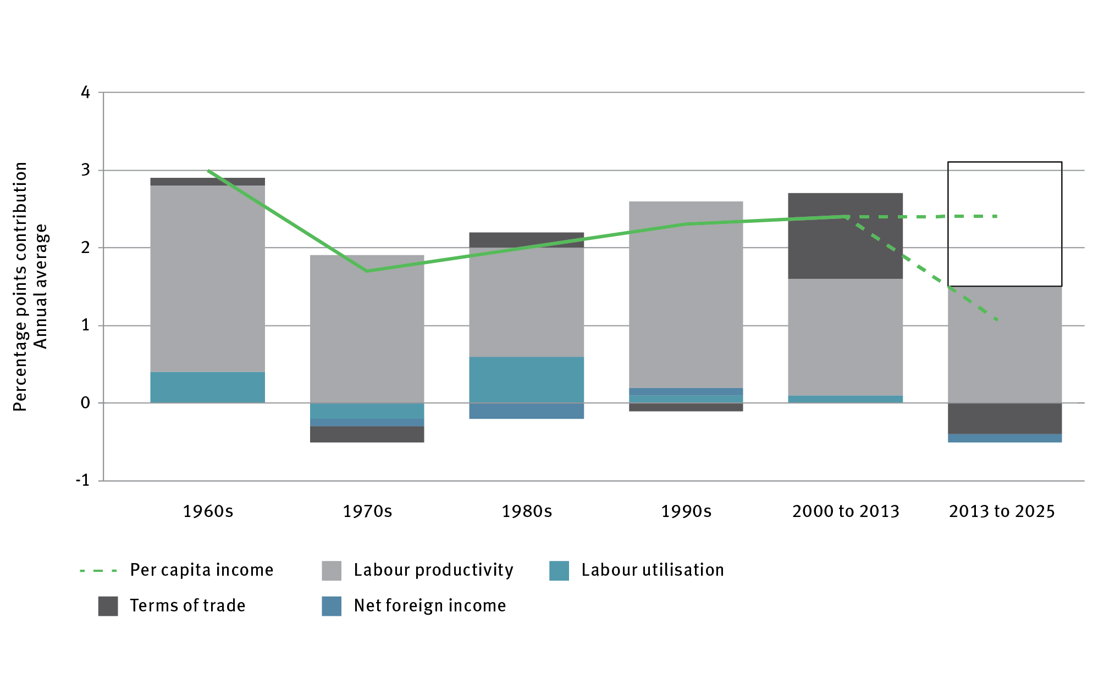

Note: Contributions to income growth 2013–15 are consistent with the forecasts in the Budget statement.

Sources: Australian Government 2014, *Budget Paper no. 1: budget strategy and outlook 2014–15*, Statement 4, Australian Government, Canberra, <http://www.budget.gov.au/2014-15/content/bp1/html/bp1_bst4-03.htm>; Australian Bureau of Statistics 2016, *Australian System of National Accounts, 2015–16*, cat. no. 5204.0, ABS, Canberra, <http://www.abs.gov.au/ausstats/abs@.nsf/mf/5204.0>.

Australia must offset the impact of this expected decline in the terms of trade by developing new sources of export income and improving domestic productivity and growth, to improve GDP per capita by 2025.

Employment growth, which has historically been a major driver of long-run GDP growth, cannot be relied on for future growth. Australia’s workforce size is peaking due to an ageing population and retirement.[18] Australia already takes a high number of migrants, and a higher proportion of skilled workers through immigration programs, compared with other developed nations.[19] Like other developed countries, Australia faces a shortage of full-time workers if we want to maintain per capita GDP at current levels – with a gap of 6 per cent projected by 2030 (Figure 4).[20] Although labour productivity will provide some continuing growth, at current rates it will not make up the shortfall in labour growth from retirement.

Figure 4 Gap between full-time equivalent (FTE) projections and number of FTEs to maintain current gross domestic product per capita in 2030

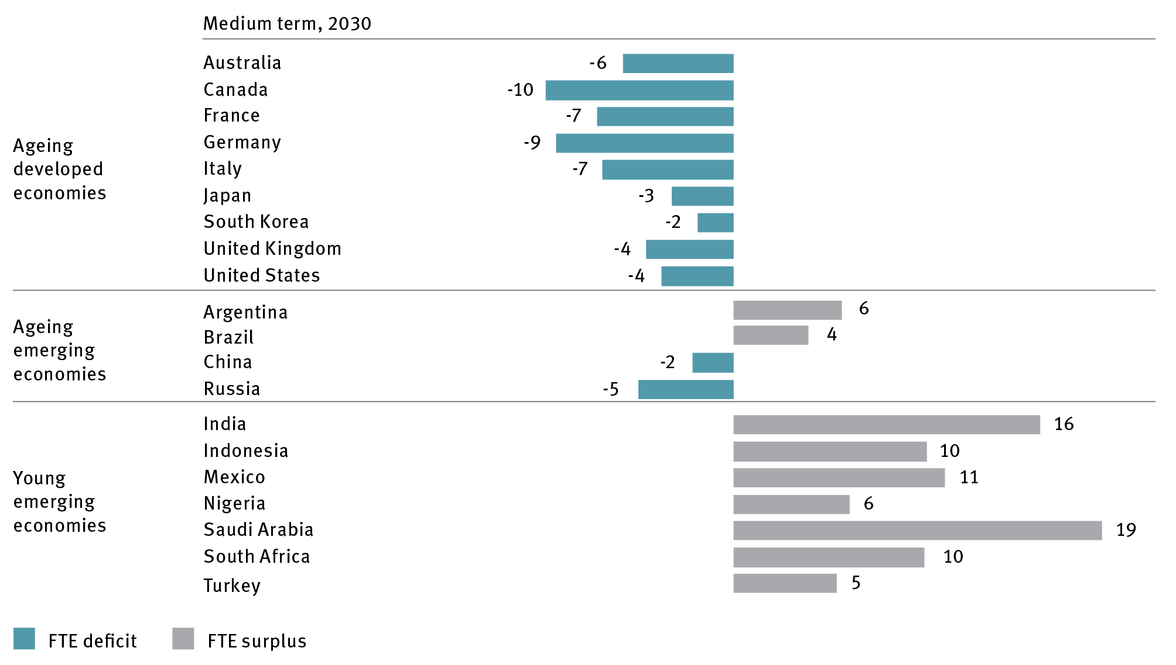

FTE = full-time equivalent

Note: Gap indexed as percentage of number of FTEs in 2014.

Sources: The Conference Board Total Economy Database, *Output, labour, and labour productivity, 1950–2017 <*<https://www.conference-board.org/data/economydatabase/index.cfm?id=27762>; International Labour Organization, United Nations Population Division, Statista, McKinsey Global Institute analysis.

Because improving employment growth and labour productivity alone will not be enough to close the growth gap, Australia will also need to improve capital and multifactor productivity (a change in output per unit of combined inputs; for example, labour and capital). Multifactor productivity reflects innovations that allow more efficient use of labour or capital, such as by improved knowledge or management practices or greater network or spillover effects.

How well we use digital technology will be critical. Digital technology increases the productivity of existing practices and creates new domestic and export markets and services that expand growth. Greater adoption of digital technology could increase Australia’s annual GDP growth rate by 0.7–1.2 per cent.[21] Rather than fearing that digitalisation and automation will erode jobs or opportunity, we should recognise that these changes will be positive for the economy, and are essential to fill the workforce gap left by demographic change, to lift productivity and contribute to GDP growth.

### Many jobs will get better, but we will need different skills to do them

Over the past 70 years, the nature of work in Australia has transformed. The first major shift was a gradual transition in the industries Australians worked in. Jobs in construction, manufacturing, mining and agricultural decreased while service sector jobs increased and now employ 80 per cent of Australians.[22]

A second shift has been an increase in interaction jobs and a decrease in production and transaction jobs. Interaction jobs involve more complex human interactions and judgements. They include roles such as sales account managers, nurses, or construction managers. Production jobs involve making and moving things – such as manufacturing production line workers or construction workers. Transaction jobs involve procedural, rules-based tasks, such as bookkeepers or clerks. Interaction jobs now account for 50 per cent of jobs in Australia, and will account for 60 per cent of the workforce by 2030.[23]

The skills needed to perform jobs are also changing. Digital and science, technology, engineering and mathematics (STEM) skills are increasing in importance. Basic digital literacy skills include the ability to use digital platforms and programs to communicate, market, transact and find information. More advanced digital skills include the ability to design, build, configure and use digital platforms, programs and systems and to develop software and algorithms.[24] Ninety-two per cent of future jobs will require some form of digital skills,[25] making digital literacy an essential foundation workforce skill, in the same league as basic literacy and numeracy today. Australia’s employment mix is also changing to require and favour a higher quotient of STEM jobs and skills. Occupations currently requiring STEM skills are outstripping overall employment growth.[26]

By 2030, jobs across the board will require employees to spend more time using 21st-century skills. These include interpersonal, creative, problem-solving and entrepreneurial skills (Figure 5). Workers will spend less time on predictable physical tasks, such as scanning grocery items at a supermarket check-out, or rote administrative tasks, such as processing expenses, because these functions can be automated. Although the workplaces of the future will still require employees to work with machines, the nature of the relationship with those machines will likely be very different. Success will require workers to have the ability to communicate and empathise with other workers and customers, as well as the skills to use the advanced tools that technology will make available.

These trends mean education needs to develop and support both STEM skills and humanities, arts and social sciences (HASS) skills that nurture interpersonal skills such as empathy and creativity.

Figure 5 Change in time spent on different types of tasks performed by Australian workers, 2000–30

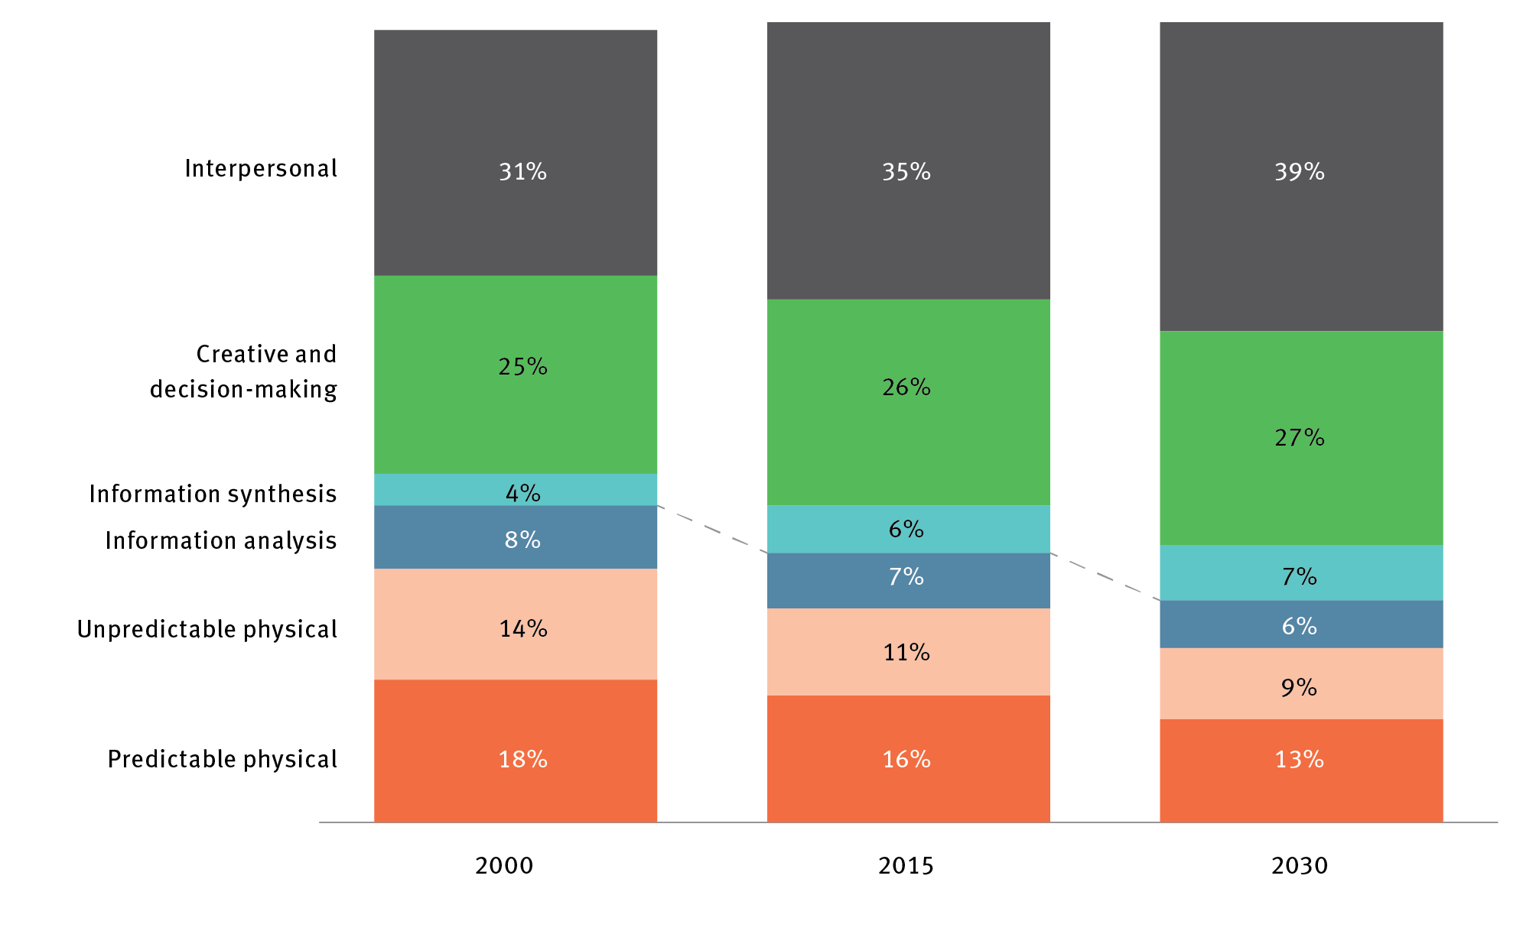

Source: AlphaBeta 2017, *The automation advantage*, AlphaBeta, Sydney, <<http://www.alphabeta.com/the-automation-advantage>>.

These skills are not just a future imperative for workers. Between 2012 and 2015, digital skills were the fastest growing skill set sought by Australian employers in early-career roles (growing at 212 per cent per year), alongside critical thinking (158 per cent), creativity (65 per cent) and presentation skills (25 per cent). Early-career jobs requiring these skills pay around $8000 more per year.[27]

Case study 1 Transforming opportunity in Geelong

Geelong is a city in transition. The city was hard-hit by the decline in manufacturing and closure of iconic factories and large employers, such as the Ford Australia manufacturing plant and Alcoa’s Point Henry smelter. While change has been painful, Geelong is steadily carving out a brighter future, creating new jobs and growth in areas of existing strengths such as engineering, design and materials science, a legacy of its manufacturing base, and in emerging strengths such as information and communications technology and health care.

A central plank in this rebuild strategy was the creation of the Geelong Future Economy Precinct at Deakin University, which aims to better connect education and research with industry, and ensure students have job-ready skills, whether they are setting out on their first career or undertaking a career change.

In five years, the precinct has created over 1000 jobs, which include skilled roles in advanced manufacturing in globally competitive companies, such as Carbon Nexus, LeMond Composites and Carbon Revolution, which have eased the impact of Geelong’s manufacturing transition. To ensure local workers had the right skills for these new jobs, the precinct works with the close-knit education providers in the Geelong region to provide retraining opportunities for people disrupted by Geelong’s changing industrial landscape.

When Evan Llewellyn’s job at Alcoa ended after 16 years, he moved to Carbon Nexus as a technical operator. For Evan, the change resulted in a better job with more variety and problem-solving challenges.

These initiatives are already making a difference to Geelong. By December 2016, the city’s unemployment rate was down to 5.9 per cent – close to the national average, and 21,500 jobs had been created in two years.

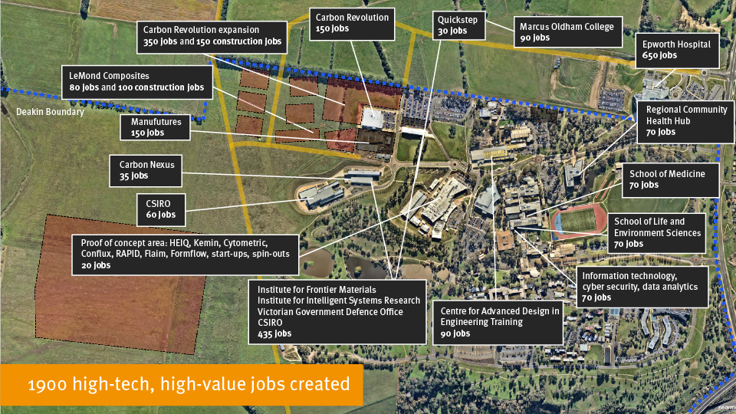

Although there are exciting employment opportunities ahead, they will vary by location and industry. Digital disruption and automation will continue to change the mix of industries and jobs in Australia. The non-linear nature of disruptive technological change will make it challenging to predict the new jobs that will be created, the jobs that will be lost, and the timing of such changes. This uncertainty can be disconcerting, but it does not mean that the net result will be negative for jobs. In the early 1990s, just over 90,000 Australians were employed as bank tellers. By 2014, this figure had almost halved to around 50,000 people as roles were replaced through self-service technologies, such as internet banking and automatic teller machines. However, counterbalancing this decline in tellers was a dramatic increase in the number of finance professionals – a job that requires more specialist advisory skills. These roles grew from just over 30,000 people to around 90,000 people in the same period.[28]

Given the mix of future occupations is uncertain, but the skills needed to perform them are clear, it is important that Australia’s education system provides the right foundation of skills to give every child the best chance in life, and provides the lifelong opportunity to retrain throughout their working life.

### Our companies face greater opportunities, but fiercer competition

Australian companies operate in a fundamentally different business environment to the one they knew at the start of the century. They have a greater ability to seize global market opportunities, enabled by digital technology and the rise of emerging country economies. They also face stiffer competition.

Two trends have reshaped global markets in the last decade: the rise of firms in emerging markets, such as China, and the shift to technology-driven businesses. Emerging-market firms have grown rapidly and became fierce competitors in markets previously dominated by mega companies in developed economies. Since 2000, these new companies have grown from less than 5 per cent of the Global 500 to more than 25 per cent.[29] This shift is being accompanied by a broader rebalancing of economic power to Asian emerging markets. China is expected to have a nominal GDP 50 per cent greater than the United States in 2050 and India is expected to climb from 9th in GDP size in 2014 to 3rd in 2050.[30] The fact that this level of growth is occurring in markets that are largely within Australia’s geographic region makes it a particularly important and novel trend, with significant and positive implications for our economy.

At the same time, technology and tech-enabled firms have gained global scale, changing business models and disrupting traditional markets and profits. This has redefined the global share of profits, shifting them in favour of companies that are ideas-based and can start and scale quickly across multiple markets. Asset-light, idea-intensive sectors in developed economies – for example internet, finance and pharmaceutical companies – have doubled their share of the developed-economy company profits from 17 per cent in 1999 to 31 per cent today.[31]

These trends mean the nature and speed of competition has changed. Australian firms are operating in an environment where companies that can solve a global need using technology can scale fast and generate significant financial value. The countries that generate globally successful firms benefit disproportionately in the global economy because the firms create most jobs in their local market. Facebook, for example, launched in 2004, reached 50 million users in one year, and has a market capitalisation today of over US$500 billion. It employs more than 20,000 workers worldwide,[32] with over a quarter based in Menlo Park, California, where Facebook is headquartered. Facebook estimates it will increase the number of workers at the Menlo Park site to 17,000 by 2018.[33] When Australian companies achieve global scale, they trigger a similar local jobs boom. Software company Atlassian, for example, employs over 2200 people globally and 1000 are based in Australia.

The shift of profits to IP-intensive companies has also ignited a global innovation race. Countries and companies are accelerating their investment in innovation faster than their GDP growth to win a bigger share of the economic prize (Figure 6).

Figure 6 Global research and development expenditures and global gross domestic product growth, 2005–14

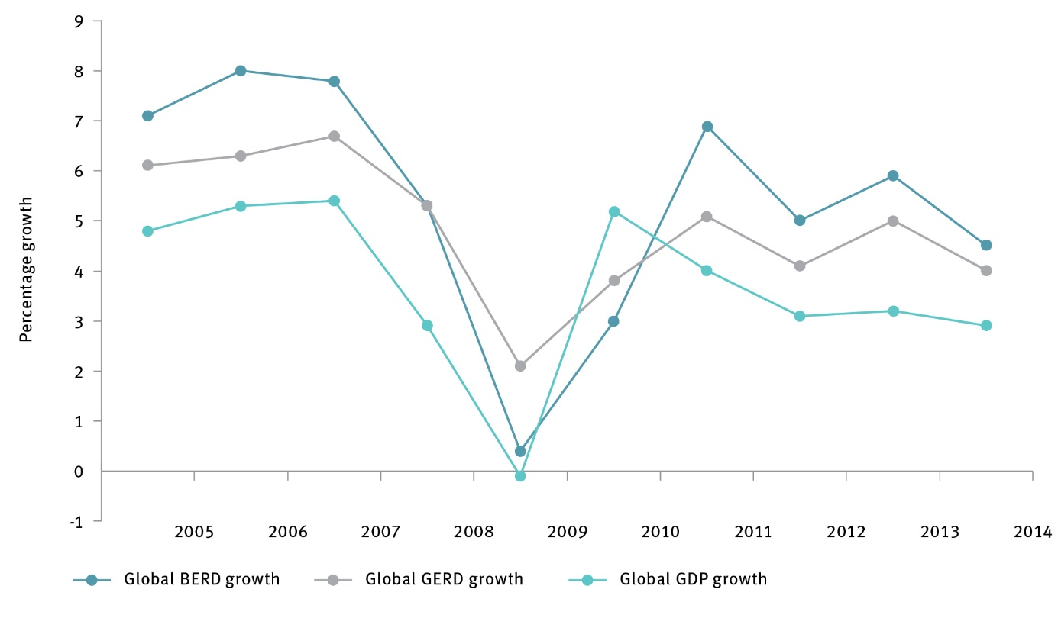

GERD = gross expenditure on R&D; BERD = business expenditure on R&D; GDP gross domestic product

Source: Global Innovation Index 2016; author’s estimate based on the UNESCO Institute for Statistics database and the International Monetary Fund World Economic Outlook database, 2016.

Australia lags behind our global peers in gross expenditure on research and development (GERD) as a percentage of GDP. We rank 20th in the OECD, primarily because business R&D investment is lower relative to other countries (Figure 7).[34]

Figure 7 Australia’s expenditure on research and development compared with peers, 2015

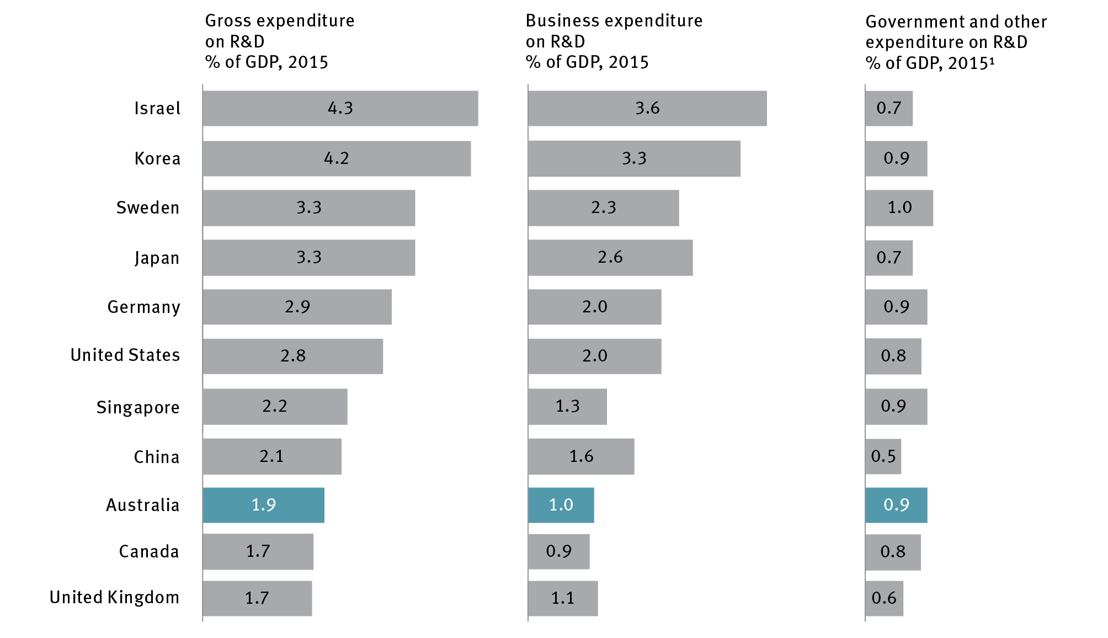

GDP = gross domestic product; R&D = research and development

Notes:

1 Includes higher education expenditure on research and development and government expenditure on research and development 2014 data for public expenditure

Source: Organisation for Economic Co-operation and Development 2017, *Main science and technology indicators*, OECD, Paris, <[http://www.oecd.org/sti/msti.htm>](http://stats.oecd.org/).

Competition is a risk and opportunity for Australian businesses. Australian companies that can solve global problems with new technology and enter confidently into multiple new export markets can grow larger quickly. However, the same forces powering this growth mean more companies can enter and disrupt Australian markets. This dichotomy means that Australian companies will need to scale, innovate and become more productive to thrive. Yet at the same time that domestic industries are exposed to new entrants and global competition, there is emerging evidence that, in some non-tradeable sectors, the Australian economy is experiencing declining competitiveness.[35]

### Technology will continue to transform our world

Technology has always changed the way we do things and created new economic value. However, opportunities in the next decade will be amplified by the sheer ubiquity of technology in our lives, the pace of innovation, and the scale of adoption. Global opportunities will also accelerate as digital technologies combine with asset-intensive domains like healthcare and agriculture to create more value for consumers, and new methods for competing.

Over the past decade, we have experienced a digital communications revolution. The speed of the change is unprecedented: it took radio 38 years to attract an audience of 50 million people; television took 13 years, while the internet took three years.[36]

A suite of new digital technologies, such as machine learning, optimisation, artificial intelligence, sensing, robotics, visualisation and distributed ledgers, are opening new opportunities for innovation.

Exponential increases in computer power, data, algorithm performance and funding are fuelling rapid advances in artificial intelligence (AI) and robotics. Australia punches above its weight in AI research and hosts several industrial labs with solid track records of transitioning AI technologies into practice.[37] The rapidly expanding field of AI is being driven by significant investments which are highly concentrated geographically, focused on established hubs centred around AI research and development work by tech giants, particularly by China and the United States (Figure 8). AI-related patent activity between the big Silicon Valley technology companies indicates that competition is fierce. These developments are opening up new markets for robotics and enabling vast amounts of information in different forms to be rapidly processed and utilised.[38] Computers can now outperform humans at air-to-air combat, diagnosing pulmonary disease and transcribing spoken languages.[39] The upshot is that a new generation of technology is emerging that will have far-reaching impact.

Figure 8 Global investments in artificial intelligence, 2016

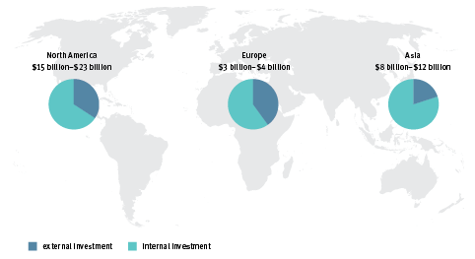

Source: Manyika, J 2017, *10 Imperatives for Europe in the age of AI and automation*, McKinsey&Company, <<https://www.mckinsey.com/global-themes/europe/ten-imperatives-for-europe-in-the-age-of-ai-and-automation>>; Bughin, J, Hazan E, Ramaswamy, S, Chui, M, Allas, T, Dahlström P, Henke, N & Trench, M 2017, *Artificial intelligence: the next digital frontier?,* McKinsey&Company.

Added footnote: “Note ‘External’ and ‘internal’ investments are estimates of annual venture capital and private equity investments by companies in AI and refer to whether the investment originates from within or outside of the region.”

McKinsey and Company have calculated that digitalisation could contribute *‘between AU $140 billion and AU $250 billion to Australia’s GDP by 2025, based on currently available technology alone’*. [40] Across all sectors, Australian companies’ adoption of digital technologies is important for the productivity benefits these technologies generate.

Although Australian companies have generally been ready adopters of digital technology, there is still room for growth. The mining industry is ideally positioned to realise the financial and safety benefits of robotics and automation. Australia’s mining sector led the world in the application of automation to remote sites. Rio Tinto’s Mine of the Future in Western Australia’s Pilbara includes the world’s longest private railroad, much of it automated, and the world’s largest fleet of autonomous trucks. The Perth control room for the mine – 1500 kilometres south of the site – has more than 400 operators tracking 3D visualisations of every piece of capital equipment covering 15 mines, 31 pits and 4 ports.[41] These investments in automation mean that, globally, Australia’s mining industry rates highly for labour digitalisation. However, there is room to improve in the digitalisation of supply chain management and customer service. Our finance sector is also well placed to take advantage of AI developments and Australia has a rich history of market infrastructure innovation. The Australian Securities Exchange leads the world in the exploitation of new technologies like blockchain, and Australian researchers are working on the next disruption to asset trading systems.[42]

Digital technologies are also reshaping markets in Australia. Digital is increasing cross-sector competition, enabling larger technology players with low-cost ways of storing, transporting and replicating data to scale quickly into adjacent businesses and sectors. Apple is becoming a healthcare company and Tesla an energy company. Companies that can achieve scale first typically capture the biggest share of the market value and sector growth – such as Facebook and Twitter in social networking – through effective use of their data assets and through the premium of the network effect, where a product with more users has more value. This means moving quickly, with global ambition, has never been more important for Australian companies.

Around 15 per cent of global goods and services are now traded on e-commerce platforms, such as Alibaba and Amazon.[43] These platforms are also serving as the launch pads for thousands of small-sized and medium-sized enterprises, giving them the reach to challenge larger companies. Although there are significant benefits for businesses who can scale and adapt quickly, there are also risks for incumbents as new business models disrupt traditional markets and services.

The key for Australia to capitalise on these opportunities is to combine our core strengths on asset-intensive physical domains with emerging digital technologies and economic structures.

### We need to use a new toolkit to solve our biggest societal challenges

Science, technology and innovation are instrumental in meeting Australia’s rising demand for public services, and tackling Australia’s biggest societal and environmental challenges, including improving health outcomes, increasing public safety, and decarbonising the economy.

Demand for critical public services is growing at a faster rate than governments can fund them. Australia’s ageing population is increasing demand for health services, which will result in Australian Government health spending per capita approximately doubling by 2054–55.[44] Australian capital cities will be home to 6.4 million additional people by 2031,[45] putting major pressure on transport and infrastructure.

Tackling our national challenges is not the job of governments alone. Australia has a world-class pool of researchers, and an increasingly powerful technological toolkit, created by concurrent improvements in the performance and cost of complementary technologies such as genome sequencing, low-carbon energy, machine learning, AI, optimisation, visualisation, sensors and robotics.

These advances are already changing Australian lives for the better. The Walter and Eliza Hall Institute in Melbourne has developed a pioneering drug, Venetoclax, to treat leukaemia, which has just been approved for use in Australia, the European Union and the United States. Venetoclax builds on decades of research by the Institute. Venetoclax has demonstrated promising results in Australian trials: 20 per cent of patients treated achieved complete clearance of cancer, and 54 per cent showed partial clearance.[46]

CSIRO’s Data61, Australia’s national information and communication technology (ICT) research institute, is also helping to make Australia a safer place to live. They are trialling new optimisation modelling tools with firefighters in Victoria’s Otway region to support real-time evacuation planning along the Great Ocean Road in the event of a bushfire.

The strength of Australia’s local talent – and advances in technology and science – mean we need to raise our aspirations as a nation about what we can achieve. One example is the opportunity to integrate genomics and precision medicine into our healthcare system to ensure that Australia continues to be one of the healthiest countries on Earth. Genomics is the study of genomes, our complete DNA, and it will play an important role in improving health outcomes through early diagnosis, preventative health, and safer and more personalised treatments. Australian researchers can use genomics to build on advances in precision medicine to tackle key causes of death and disability, and to accelerate access to breakthrough treatments to deliver better and more affordable health outcomes.

## Context for the 2030 Plan

Successive governments have demonstrated a long-term commitment to promoting innovation and science in Australia. This commitment has been informed by a series of strategic reviews including *The* *Chance to Change* (2000),[47] which led to the *Backing Australia’s Ability[48]* set of policy initiatives, and *Venturous Australia* (2008),[49] which led to the *Powering Ideas[50]* set of policy initiatives.

The Australian Government renewed its commitment to innovation and science in Australia by releasing the National Innovation and Science Agenda (NISA) in December 2015. NISA provided an immediate boost to Australia’s innovation capability through a $1.1 billion investment in innovation, entrepreneurship and education initiatives. It also set up a long-term, strategic approach to support innovation in Australia by establishing Innovation and Science Australia (ISA).

ISA’s Board was tasked with undertaking a performance review of Australia’s innovation, science and research system, and producing a strategic plan to accelerate innovation in Australia by 2030. The 2030 Plan’s objective is to make long-term recommendations for policy makers to optimise the Australian Government’s $10 billion annual investment in innovation, science and research. This investment includes direct funding for research institutions and research activity, and indirect support through the tax system.

*Australia 2030: prosperity through innovation* will help policy makers at all levels of government to act on the challenges identified in the performance review. It will also help participants in the innovation, science and research system by presenting an integrated perspective on how governments can support their innovation efforts. The 2030 Plan’s development has benefited from extensive input from people and organisations across the country through consultation forums, written submissions, surveys and expert consultation (Figure 9). It also builds on additional analysis undertaken on the strengths and weaknesses of the Australian system as identified in the Program review.

**Figure 9 Innovation and Science Australia’s stakeholder engagement**

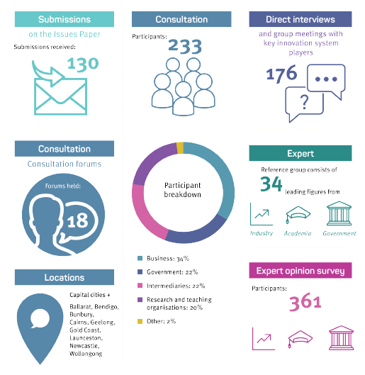

ISA has heard the many passionate and reasoned voices addressing the nation’s roadblocks and enablers to achieving our full innovation potential in the consultations and submissions. These voices provided many great, practical ideas to improve the innovation, science and research system, which have informed the 2030 Plan’s development in several places.

In addition, a number of key issues were raised around enabling infrastructure, including the criticality of affordable, high-speed and reliable internet access; availability of affordable and reliable energy; and sufficient rail and road transport (particularly from the urban periphery into the major cities). Notably, the required performance levels of such infrastructure (whether in terms of baseline broadband access speeds or urban transit times) are only expected to become more demanding over time, so it is important to plan with the future in mind. Although infrastructure issues such as these are beyond the scope of this plan, the 2030 Plan does address many of the industry needs that depend on these infrastructure capabilities.

## Australia’s innovation imperatives

Innovation is critical to Australia’s future opportunity; Australia is part of a global innovation race, and we need to step up our pace to avoid being left behind by other countries.

ISA’s performance review of the Australian innovation, science and research system, published in February 2017, confirmed that Australia had important strengths to build on in each part of our innovation system, such as world-class researchers and a diverse industrial base. It also found uneven performance across the system.[51] It identified critical gaps, such as Australia’s lagging performance relative to its peers in commercialising and exporting ideas, and a tendency towards incremental rather than new-to-world innovation in business. ISA’s review process also identified significant challenges in measuring performance due to limited impact and outcome data for Australian innovation activities.

In considering how to frame its strategy for the future, ISA has recognised that innovation is the product of a collaborative ecosystem and culture. Being a top-tier nation for innovation and science means cultivating a world-class innovation ecosystem in Australia. The innovation ecosystem is complex and dynamic, and hence a degree of simplification is helpful to aid analysis. To frame its planning, ISA has identified five overlapping components that would constitute a thriving innovation and science system in Australia. The five components are:

**1 Education** –the foundation stone of an innovation system because the capability of systems is determined by the ability of the people in them

**2 Industry** – the primary source of innovation investment, implementation, and scale-up, and generator of jobs and growth

**3 Government** – as the largest firm in the economy, and the architect of laws and markets, governments facilitate and exemplify innovation

**4 Research and development (R&D)** – as the engine of new ideas generation and exploitation, R&D fuels innovation in the wider economy

**5 Culture and ambition**– as innovation is a quintessentially human activity, our aspirations and inspiration are shaped by the cultural context in which it occurs.

The 2030 Plan defines five imperatives for action, aligned with the components above, that collectively create a long-term roadmap for increasing innovation performance in Australia. For each imperative, the 2030 Plan highlights strategic opportunities and actionable recommendations for governments to accelerate impact across the innovation system by 2030 (Table 1). It also suggests key metrics to measure success in delivering the ideas in each imperative, and a roadmap to implement them.

Table 1 How *Australia 2030: prosperity through innovation* willimprove the innovation system

| **Innovation system imperative** | **Key findings from the 2016 performance review** | **What the 2030 Plan seeks to achieve** |
| --- | --- | --- |
| 1. Education | Australia has good higher education and school systems based on world rankings, but domestic school student performance is going backwards in the critical disciplines of mathematics and science and vocational education is slipping | Australia’s school, vocational and tertiary education systems are world class and equip all Australians with the skills relevant to 2030 |
| 2. Industry | Australian businesses are applying innovation within their business, but lag counterparts in other countries in introducing new-to-world innovations | Australian jobs and prosperity grow as a result of new industry R&D investment, new-to-world innovation, a stronger base of high-growth firms and exports, and greater competition and productivity |
| 3. Government | Australian governments are keeping pace with other countries in opening up data and supporting digital government, but could increase their use of other levers, such as procurement expenditure | Australian governments catalyse innovation by designing responsive and flexible regulatory frameworks, increase their strategic use of procurement and achieve world-leading service delivery standards |
| 4. Research & development | Australia is above average globally at knowledge creation, with world-class researchers and research infrastructure, but can improve in the commercialisation of research ideas, and the amount invested in research and development; in particular, Australia lags its global peers in its overall expenditure, and rate of growth in spending, on R&D | R&D has increased impact in Australia as a result of increased translation and commercialisation of research, investment in national research infrastructure, and research collaboration across sectors, making Australia a top destination for leading researchers, investors and entrepreneurs |
| 5. Culture & ambition | Australia benefits from being a diverse, multicultural country, but innovation culture too often focuses on short-term objectives rather than longer-term, aspirational goals | Our most talented kids are inspired to be innovators and entrepreneurs and to tackle global challenges, spurred on by National Missions that entrench a strong national culture of ambition and innovation |

Critically, the 2030 Plan recognises that innovation in Australia takes different forms. Regional communities undertake diverse forms of innovation, ranging from businesses and scientific and technical professionals working in competitive tradeable sectors such as agriculture and mining, to entrepreneurs attracted by the lifestyle to working in regional communities such as the Byron Bay hinterland. Large Australian cities attract greater R&D activity and related investment.[52] Some Australians will work directly in knowledge or innovation-intensive jobs, while others will primarily benefit from an education that equips them to find good jobs in their chosen field. The goal of the 2030 Plan is not to pursue a one-size-fits-all approach to innovation, but rather to enable innovation and science to flourish across the system, and throughout the country, for the benefit of all Australians.

Section B: Five imperatives for action

# Imperative 1 Education: Respond to the changing nature of work by equipping all Australians with skills relevant to 2030

ISA’s vision is that Australia has a world-leading education system that equips all Australians with the skills and knowledge relevant to 2030. Realising this vision is the first imperative of this plan because providing a world-class education is fundamental to Australia being an innovative and fair country by 2030. Education determines the capability of workers and entrepreneurs, and therefore the economy’s productivity and innovation capacity. Education also shapes Australians’ life opportunities.

Governments have a key role to play in realising this vision because they design, fund and regulate many aspects of the Australian education system.

## Strategic opportunities for government

There are two strategic opportunities for governments to strengthen Australia’s education system by 2030:

**Strategic opportunity 1.1:** Teaching of science, technology, engineering and mathematics and 21st-century skills can be improved through development for teachers and school leaders, and education inequality can be reduced through targeted interventions

**Strategic opportunity 1.2:** Australia’s vocational education and training system can be made responsive to the new priorities presented by innovation

The 2030 Plan focuses on the school and vocational education and training (VET) system. The quality of the school system determines whether young people receive the relevant foundation of knowledge and skills for future jobs or the option to undertake advanced qualifications.

Vocational education provides initial skilling and helps workers to retrain as jobs and industries evolve, including in response to economic and technological change.

Australia’s university sector is also critical to meeting Australia’s future workforce needs. ISA’s performance review found the university system is already performing well in the education outcomes it is delivering, and the biggest improvement opportunity relates to the sector’s industry linkages and commercialisation activity, which are addressed in Imperative 4.

## Strategic opportunity 1.1: Teaching of science, technology, engineering and mathematics and 21st-century skills can be improved through development for teachers and school leaders, and education inequality can be reduced through targeted interventions

### Rationale

To give every Australian child the best chance in life, Australia’s school system must ensure that young people leave school with the skills and knowledge they need to thrive in the 2030 workforce.

This starts with ensuring that Australian student outcomes in core disciplines are on par with leading countries. It also means equipping students with the skills and knowledge crucial to future jobs, such as STEM skills and 21st-century skills, which include hypothesis-driven problem solving, digital skills, entrepreneurialism, creative thinking and interpersonal skills.

The challenge for this vision is that Australian school system performance has declined in the last decade, both relative to other countries and in real terms (Figure 10). The decline is particularly acute in core STEM subjects, such as science and mathematics.[53]

Figure 10 School education funding and outcomes, 2004–05 to 2015–16

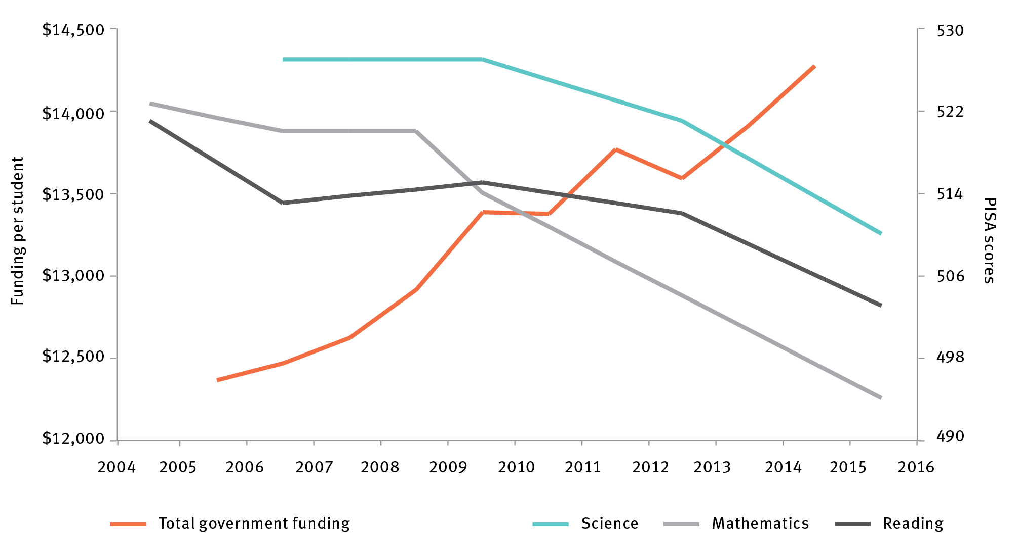

PISA = Programme for International Student Assessment

Note: The left-hand axis refers to total public funding per student, which in constant dollars has increased by 15% over the period. The right-hand axis refers to average PISA scores, which from 2006–07 to 2015–16 have declined by 3% in scientific literacy; and from 2004–05 to 2015–16 have declined by 5% in mathematical literacy and 3.5% in reading.

Source: OECD Programme for International Student Assessments 2015, *Results by country*, <http://www.oecd.org/pisa/>; Productivity Commission Report on Government Services 2017, Chapter 4 School education attachment tables< http://www.pc.gov.au/research/ongoing/report-on-government-services/2017/child-care-education-and-training/school-education>

Not shown in Figure 10 is that Australia has fewer higher achievers and greater numbers of low-achieving students than comparable systems.[54] We significantly lag behind the best education systems in the world, with the average 15-year-old Australian roughly one to two years behind the average 15-year-old in Shanghai, Hong Kong and Singapore in mathematics, and 6–12 months behind in science and reading.[55] For some student cohorts, such as Indigenous Australians, student outcomes are significantly worse than even the average for OECD countries.

Australia’s declining performance has occurred despite significant increases in school funding, suggesting improvements will come from more effective interventions, not more money. International research by McKinsey & Company has examined which interventions have been most effective at driving significant school system improvement based on a system’s starting point. Based on the Australian system’s current performance and its aspirations for improvement, this research suggests there are four interventions that would lift Australian school system performance:

investing in professional development and support for teachers and school leaders, including through keeping the curriculum current

ensuring students are motivated to pursue the skills they need to succeed in the future workforce

investing in targeted interventions for schools or school systems where student learning levels are significantly below the national average

further improving transparency and accountability across school systems.

#### Investing in professional development and support for teachers

The quality of teachers is the single biggest in-school influence on a student’s educational performance.[56] Research shows differences in the level of achievement of two students can diverge by more than 50 percentile points over three years, depending on the teacher they are assigned.

Australian governments have recently undertaken substantial work to improve the quality of initial teacher education through the *Action now: classroom ready teachers* strategy. Measures implemented through the strategy include stronger quality assurance of teacher education courses, more demanding selection requirements for entry to teacher education, and improved and structured practical experience for initial teacher education students.[57]

There are indications of a significant decline in the entry criteria (such as the Australian Tertiary Admission Rank) of teacher education courses following the expansion in enrolments in pre-service courses over the last 10 years. The *Action now: classroom ready teachers r*eport noted that *‘high-performing education systems screen initial teacher education students against criteria they believe will make the best teachers, including academic capability, literacy and numeracy skills and personal characteristics.*’[58] It will be important to monitor the effect of the strategy on the standard of teacher entry requirements.

In addition to these measures, the quality of initial teacher training could be further strengthened by a focus on discipline-specific knowledge, particularly in secondary education. Countries with leading education systems, such as Finland, Singapore and China, require secondary teachers (in STEM subjects) to be fully qualified in their discipline and to teach in that field and no others.[59]

Furthermore, professional development opportunities for working Australian teachers could also be improved. Australian teachers spend less time on professional development activities compared with their international counterparts, with an average of three days a year in training compared with seven days internationally.[60] The quality of these programs is also inconsistent. Only half of Australian teachers attending professional development programs report a moderate or large change in their day-to-day teaching as a result of the programs.[61]

Primary content gaps in professional development include 21st-century skills and pedagogical methods. Only 1 in 10 teachers has recently participated in professional development to help students to develop generic, transferable skills for future work.[62] Teachers also need more support to use mixed pedagogies.[63] The OECD recommends a mix of teacher-directed instruction and inquiry-based learning to deliver 21st-century skills[64] and improve STEM skills.[65] However, use of inquiry-based learning must be carefully selected and appropriate to the subject content, or it can have a negative impact on student scores.[66] Although inquiry-based learning approaches have been used for many years in Australia,[67] teachers report that they have insufficient instruction in how to apply them in the classroom.[68]

Discipline-specific professional development is critical for teaching both in-field (where teachers are teaching within their field of training) and out-of-field (where teachers are teaching outside their field of training). The Council of Australian Governments (COAG) Education Council’s National STEM School Education Strategy noted five areas in which Australia could increase student STEM ability, engagement, participation and completion of higher-level STEM courses in high school by improving the quality of STEM teaching. This included improving the pathway for STEM graduates into teaching to increase the pool of in-field teachers, and supporting schools to access specialist teachers in mathematics, science and technology.

Out-of-field teachers also require support. The Australian Council for Educational Research estimates that around 38 per cent of mathematics teachers are teaching out-of-field.[69] This level of out-of-field teaching cannot be wholly replaced by specialist teachers, which means support for out-of-field teachers is also critical to lifting student outcomes. Teacher professional associations could play a key role in professional development and support for out-of-field teaching and non-teaching staff, such as laboratory technicians.

Teacher development could also be supported through improved performance feedback.[70] Thoughtful and timely feedback improves employee performance in any occupation. However, Australian teachers generally perceive feedback and appraisal as an administrative exercise, rather than a way to identify their strengths and weaknesses and improve performance. In an OECD survey, only 45 per cent of teachers reported that feedback led to positive change in their teaching practices; this was generally because feedback was not actionable or did not motivate them to make the necessary improvements.[71]

#### Investing in professional development and support for school leaders

Principals, lead teachers and mentors play an important role in setting direction and priorities for their schools and positively influencing culture and teaching practice. Top-performing school systems overseas put mechanisms in place for the most capable teachers to become ‘instructional leaders’. Instructional leaders develop and motivate other teachers,[72] including by leading and supporting educational activity and professional development within their school.

#### Keeping the Australian Curriculum current

The content taught in the Australian school system is based on the Australian Curriculum. Teachers and leaders in the school system need to be supported to teach effectively by ensuring that the curriculum reflects future skill needs.

As Section A outlined, the mix of jobs in Australia, and the skills required to perform them, will change by 2030. The Australian Curriculum will need to help students to gain a deep understanding of core subjects, including STEM and HASS, while simultaneously developing cross-cutting skills, such as digital, problem-solving and interpersonal skills, to thrive in further education, training or work.

The Australian Curriculum already includes 21st-century skills or ‘general capabilities’ that can be taught across core subject areas. The general capabilities include critical and creative thinking, ICT capability and ethical and intercultural understanding.[73] However, a 2014 review of the Australian Curriculum found that the general capabilities were not effectively integrated into the curriculum, particularly for primary schools, because of the breadth of content that teachers are already required to absorb and teach across the curriculum.*[74]* The Foundation for Young Australians has found that Australia can improve student performance in 21st-century skills by updating curricula as well as pedagogy.[75]

The next review of the Australian Curriculum will be conducted in 2020; it should have a remit for bold changes based on a review of the lessons from other jurisdictions that have engaged in major curriculum reform to equip students with the capabilities they need to thrive in the 21st century. It will also be an opportunity to seek advice from industry through representative associations and Industry Growth Centres (IGCs).[76]

#### Ensuring students are motivated and pursuing the skills they need to succeed in the future workforce

Low student expectations lead to low outcomes. Recent analysis of individual Programme for International Student Assessment (PISA) scores of 500,000 students across 72 countries found that student mindsets, such as motivation and self-belief, have a greater impact on student performance than any other factor – and double the effect of socioeconomic background. The mindset that was most predictive of performance was the ability to identify what motivation looks like in day-to-day life – including preparing for class, doing more than expected, and working to perfection.

Mindsets made the most difference for students either in low-performing schools or in lower socioeconomic quartiles. For students in schools with low average test scores, a well-calibrated motivation mindset is equivalent to vaulting into a higher socioeconomic quartile.

Increasing the ambition and motivation of students is therefore an important goal for a world-class education system. This is particularly important for STEM subjects, because students perceive them to be difficult and among the hardest subjects in which to achieve high marks.

With universities dropping prerequisite requirements in science and mathematics, one of the key incentives for students to study more challenging subjects in high school and in university has been removed. Between 1994 and 2012, the proportion of students studying advanced mathematics fell from 16 per cent to 9 per cent, replaced with a shift to mid-level and entry-level mathematics. *[77]*

Industry can play a significant role in demonstrating to students the career benefit of a STEM education. Under the National STEM School Education Strategy, the STEM Partnerships Forum has been established to bring together key industry and education leaders and raise awareness of the importance of STEM education in solving real-world problems and the relevance of STEM skills to a range of careers.

#### Investing in targeted interventions

The need to lift student outcomes is most acute for students from socially disadvantaged backgrounds. In both numeracy and literacy results,the difference between advantaged and disadvantaged students is equivalent to around three years of schooling. While the highest socioeconomic quartile of students in Australia performs significantly above the OECD average (approximately one-and-a-half years), results for Australian students in the lowest socioeconomic quartile are significantly lower (approximately one year).’ These gaps have not diminished in over a decade.[78]

There are also significant disparities in the performance of Australian schools and school systems, and an even greater variance in classroom performance. According to the analysis of PISA results conducted by the Australian Council for Educational Research, although Australian students generally perform well in digital literacy, there are clear differences in performance across geographic areas, with 25 per cent of students from remote schools having low proficiency compared with 13 per cent of students from provincial schools and 8 per cent of students in metropolitan schools.[79]

International research on school system improvements emphasises that disparity in school starting points means that a one-size-fits-all model of intervention is ineffective. Instead, each school system needs to target interventions to specific cohorts of schools with different needs. For schools or school subsystems with significantly lower outcomes, this can mean using more structured interventions, such as illustrative class outlines and suggested teaching guides to allow teachers and students to focus on in-classroom learning, and focusing on lifting attendance.

#### Further improving transparency and accountability across school systems

Australia needs to build a strong evidence base to inform education innovations and improvements. The Australian Government has increased transparency and accountability for school outcomes in the last decade through the development of the National Assessment Program – Literacy and Numeracy (NAPLAN) and the creation of the MySchool website.

There is further room to improve the granularity and use of data to drive performance improvement. The National Education Evidence Base Report from the Productivity Commission recommends improving evaluation and dissemination of effective pedagogy. This would allow education systems to quickly implement the best methods of teaching 21st-century skills, and improve monitoring of outcomes.

Two of the most significant evidence gaps identified by the Commission’s report are Australia’s data on student achievement, including measures to track and assess ‘value add’, and data that provide insight on what works best to improve outcomes.[80] Addressing the value-add data recommendations would be a cultural shift in the way we think about student performance. Historically, teachers have focused on a student’s achievement against expectations for that year level. Increasingly, educators are focusing on understanding how much a student has learned, relevant to their individual starting point. Value-add measures support teachers to think about achievement in terms of growth, as well as proficiency.

A second opportunity to improve transparency is to increase the ambition of Australian schools by increasing the level of challenge of performance standards. The current national minimum standards in NAPLAN are very low by international standards. For example, if PISA standards in mathematics for Year 9 and Year 10 students are compared with NAPLAN minimum standards for Year 9 students, there appears to be nearly a two-year differential.[81]

Finally, designing and implementing targeted interventions for teacher professional development could be improved with better national teacher workforce data.

### Recommendations

**Recommendation 1:** Government education policy makers should direct their effort towards:

* investing in quality teaching by improving the quality and content of in-service teacher professional development programs to focus on
* a nationally agreed minimum number of annual hours in discipline-specific training
* the teaching of 21st-century skills
* increasing quality of and emphasis on feedback and appraisal of teacher performance

selecting, developing and effectively resourcing high-performing teachers and school leaders to act as mentors and instructional leaders in their school or area

monitoring the entry standards for initial teacher education courses to ensure that they are sufficiently demanding to select students with the literacy and numeracy skills required for science, technology, engineering and mathematics (STEM) teaching

strengthening the quality of teacher education for secondary STEM teachers through requiring the completion of a discipline-specific, non-teaching degree in addition to a teaching degree

* increasing the system-level focus on targeted interventions to improve outcomes where student learning levels are significantly below our national average through

providing tailored support to teachers in the form of regular tracking of student improvement enabling rapid and evidence-based iteration of teaching practice

* instilling ‘motivation mindsets’ and a culture of high expectations including through
* communicating to secondary students the level of school STEM study needed to enter and successfully complete STEM-related courses at university and in vocational education and training

reinstating prerequisites into those tertiary courses in which discipline skills are necessary

ensuring future reviews of the Australian Curriculum for STEM subjects will continue to meet Australia’s innovation, science and research education needs and be informed of industry expectations through consultation with industry.

**Recommendation 2:** Prepare students for post-school science, technology, engineering and mathematics (STEM) qualifications and occupations, by:

exploring opportunities to encourage participation in higher-level STEM subjects in high school

strengthening education in skills such as hypothesis-driven problem solving, systematic enquiry and logical thinking

improving measurement of the scope of out-of-field teaching in STEM and implementing measures to reduce the level of out-of-field teaching

optimising the interaction of industry with schools through the work of the STEM Partnership Forum.

**Recommendation 3:** Improve transparency and accountability across the system by raising the ambition of the national minimum standards in National Assessment Program – Literacy and Numeracy (NAPLAN) and building on these with new standards focusing on higher levels of achievement.

**Endorsement A:** ISA endorses the priority areas for national collaborative action of the National STEM School Education Strategy.

**Endorsement B:** ISA endorses the findings of the Productivity Commission’s National Education Evidence Base Inquiry Report as an important step in ensuring Australia has the evidence base to innovate and improve in education.

## Strategic opportunity 1.2: Australia’s vocational education and training system can be made responsive to new priorities presented by innovation

### Rationale

Vocational education and training (VET) is a major part of Australia’s education system and it will play a significant role in helping Australians adapt to changing skill needs throughout their careers.

In 2016, there were over 770,000 VET program completions (Certificate I or higher),[82] offered by a diverse mix of training providers. Of the 2016 program completions, 430,000 were delivered through private providers; 215,000 were delivered by technical and further education (TAFE) institutions; 57,000 were delivered by schools; and 73,000 were delivered by other provider types such as community providers.[83]

VET is an important source of skilled workers for Australian businesses and for start-ups, especially in trades and hospitality. In 2016, 53 per cent of employers surveyed by the National Centre for Vocational Education Research used the VET system and 76 per cent were satisfied that VET training fulfilled their skills requirements.[84] VET is particularly important in practical skills-intensive industries such as mining, manufacturing, and property and business services. These industries have higher expenditure on structured training as a share of gross wages and salaries, and provide more training per employee.[85]

The importance of VET-trained workers will increase as industries adapt to new demands and technologies and require higher skills and more frequent skill updates. Demand for VET-level qualifications in New South Wales (NSW) alone is projected to increase from around 30 per cent of workers in 2015 to 45 per cent of workers in 2036.[86]

VET will also be critical to ensuring Australian workers can gain the skills to transition from jobs affected by automation, and take up the new business and work opportunities presented by new technologies. Seventy per cent of young people currently enter the workforce in jobs that will be affected by automation.[87] Displaced and inactive workers represent a clear economic and social cost. Successful transition of workers affected by automation to high value-added work opportunities could cumulatively add an additional $1.2 trillion to GDP between 2015 and 2030 (Figure 11). Access to a highly skilled workforce helps businesses to improve performance and reduces labour market adjustment costs. It also minimises flow-on costs to consumers brought about by skills shortages.[88]

Figure 11 Cumulative economic gain from transitioning workers to new skills, 2015–30

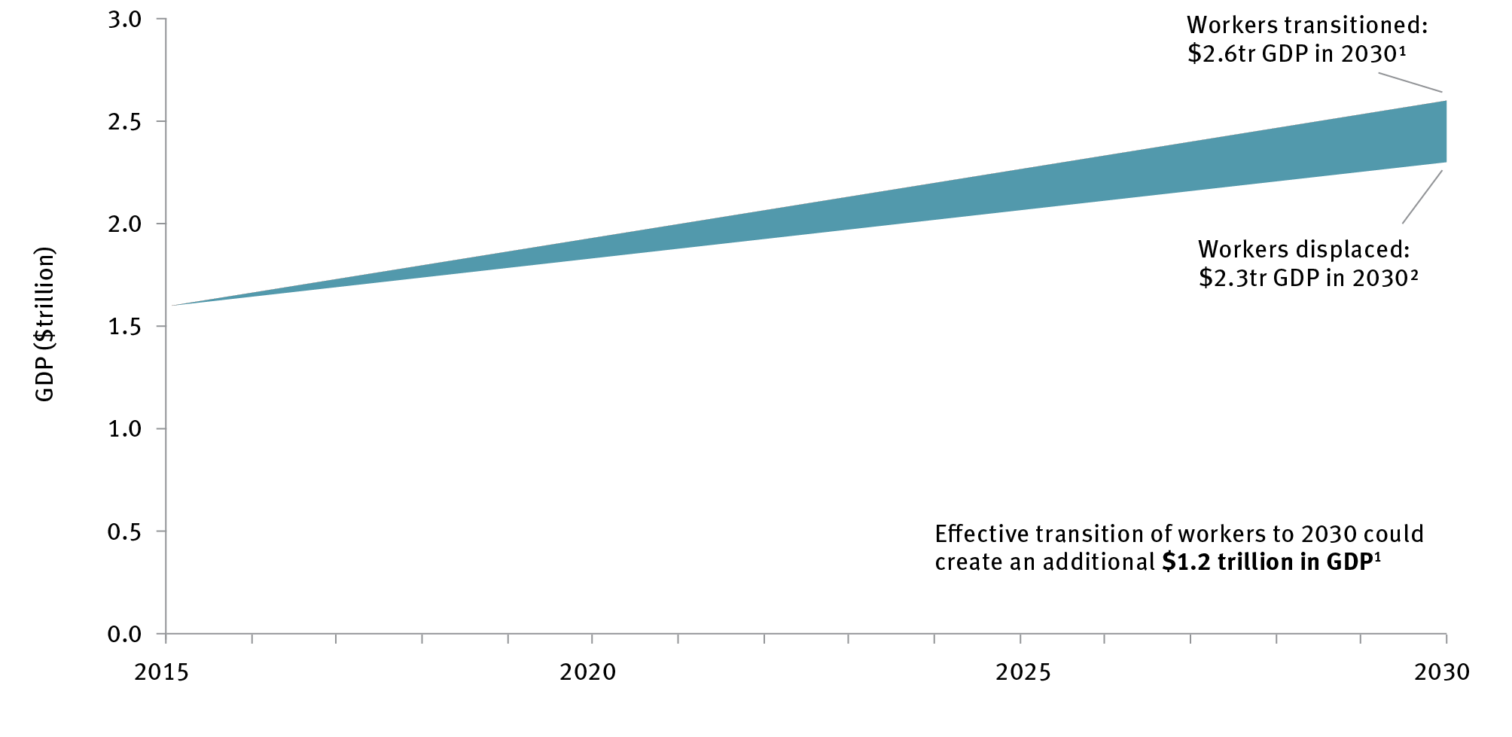

Notes:

1 Cumulative addition GDP calculated assuming all potential productivity savings from automation are reinvested into the workforce with high productivity rate. Hours worked per capita remain unchanged. The green area between the two lines is the $1.2 trillion cumulative addition to GDP.

2 Work hours reduced involuntarily and workers displaced without being absorbed into other jobs.

Source: AlphaBeta 2017, *The automation advantage*, AlphaBeta, Sydney, <http://www.alphabeta.com/the-automation-advantage>, p. 15.**Error! No sequence specified.**

The VET system’s ability to rapidly adapt to these changing skill requirements is critical for industries, occupations and new businesses. Already, the most common cause of employer dissatisfaction is that courses do not sufficiently teach relevant skills.

Commonwealth and state and territory governments will play a key role in ensuring Australia’s VET system adapts to these changes. Although training is delivered by public, private and community providers, governments influence the system through funding, regulation and information provided to the community. How governments strategically engage with industry to ensure training aligns to emerging work and skills demands is also vital.

COAG’s establishment of the Australian Industry and Skills Committee in 2016 put industry at the centre of training package development. This committee is a collaboration of industry and government focused on simplifying and demystifying the VET system, amplifying the voice of industry in skills training development, and building employer confidence in VET qualifications.

Governments could consider funding innovations such as linking pricing of courses to market demand for skills. This could include aligning Higher Education Loan Program (HELP) pricing to employment and wage benefits, and outcomes-based funding similar to the ‘Gainful Employment’ model in the United States.[89]

A pressing priority in recent years has been the reform of the VET-FEE HELP scheme[90] to achieve sufficient protection of students and accountability and compliance monitoring for providers, and to limit cost blowouts.[91] Recent changes made under the new VET student loans scheme are a promising step towards greater accountability for providers, including options for Australian Competition and Consumer Commission intervention to shut down non-compliant providers, reforms to loan issuance, and increased information available for students on course quality through the ‘Myskills’ website.[92]

ISA supports the proposal, currently under review by the Australian Government Department of Education and Training, to issue an ‘approved course list’ for federal loans where the approved course list is linked to employment outcome metrics.[93] There may be further opportunities to improve compliance and quality control by empowering the Australian Skills Quality Authority to more easily shut down non-compliant providers rather than relying on external support from the Australian Competition and Consumer Commission, and expanding the granularity of the Myskills website data on provider quality.

Because the VET sector is focused on preparing people for work, either as employees or employers, it plays a key role in ensuring Australians can harness the opportunities from innovation. A serious examination of how the sector can best play such a role should be undertaken, building on recent research by the National Centre for Vocational Education Research.[94]

### Recommendations

**Recommendation 4:** Task the Australian Government Department of Education and Training to undertake a review of vocational education and training (VET) and report back within 12 months on:

a strategy to make the sector increasingly responsive to new priorities presented by innovation, automation and new technologies

ensuring the Australian VET system will be internationally competitive in the provision of initial skills training, in supporting a life of learning and helping businesses to compete, and ensuring VET interfaces and intersects productively with other parts of the higher education system

recommendations for metrics of VET success to be evaluated by 2022, including via surveys of employers regarding skills relevance, actual completion rates and employment on graduation

increasing the amount and granularity of information made available to students.

**Recommendation 5:** Continue and expand current vocational education and training (VET) reforms to:

optimise the supply-side potential of the Skilling Australia Fund, for example by encouraging industry employers and VET providers to consult with Industry Growth Centres in identifying expected skills shortages in the future work requirements of high-growth sectors

link VET student loan funding to employment outcomes

strengthen the powers of the regulator: Australian Skills Quality Authority

provide improved information to students on provider quality.

Case study 2 Academy Xi and the changing face of education

Digital skills are in high demand by Australian employers, but keeping pace with this dynamically changing area can be challenging for conventional education institutions.

Conventional institutions frequently regulate curricula and have comparatively long lead times to update courses and material.

Recognising this situation as an opportunity, Ben Wong and Charbel Zeaiter founded Academy Xi, an edutech start-up focused exclusively on digital economy skills in areas such as service design, user experience design, augmented and virtual reality design, growth marketing and product management.

Academy Xi offers a wide variety of full-time courses, part-time courses, bootcamps, masterclasses and workshops for individual students and corporate group training. Their agile model means they can rapidly update subjects and course material as learning needs or content changes. Through their social impact arm, Xi Act, the start-up helps to equip non-profit organisations, including UNICEF, Remarkable, Cerebral Palsy Alliance and WWF, with digital skills. Investors agreed the company has strong growth prospects, providing US$1.7 million in funding in 2017 to enable Academy Xi to expand into Singapore in 2018. Academy Xi believes in empowering people with practical, actionable skills that will lead to improving life for others and, as their vision states, hopes to ‘ultimately change the world.’

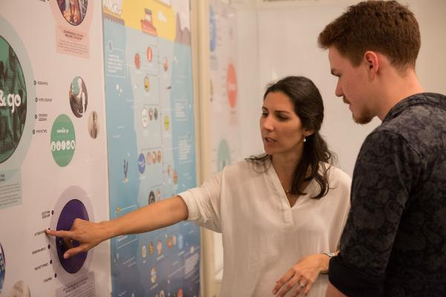

# Imperative 2 Industry: Ensure Australia’s ongoing prosperity by stimulating high-growth firms and improving productivity

ISA’s vision is that by 2030 Australia will accelerate growth and exports by Australian businesses by strengthening a competitive and productive domestic business environment.

## Strategic opportunities for government

There are five strategic opportunities for government to accelerate growth, innovation and exports among Australian companies by 2030:

**Strategic opportunity 2.1:** Business R&D investment can be increased by better targeting the Research and Development Tax Incentive (R&DTI) program, and increasing support for direct grant programs that target national priorities

**Strategic opportunity 2.2:** The growth of export firms, particularly young high-growth firms, can be encouraged by increasing Export Market Development Grants funding, and by expanding and making better use of trade agreements

**Strategic opportunity 2.3:** The opportunities presented by the ‘fourth wave’ of the internet can be captured by strengthening Australia’s digital economy

**Strategic opportunity 2.4:** Business productivity in all sectors can be facilitated by healthy levels of competition

**Strategic opportunity 2.5:** Australia’s innovation investment and talent can be strengthened by improving access to global talent pools and fostering greater gender and ethnic diversity.

Australia needs more innovation-driven productivity to generate GDP growth and keep our economy strong. We need more innovation-active companies because they are more profitable[95] and productive[96], and we need more export-active companies because they are more competitive and more likely to engage in innovation.[97] We also need more high-growth firms because most new jobs in our economy are created by companies that scale fast.[98]

## Strategic opportunity 2.1: Business research and development investment can be increased by better targeting the Research and Development Tax Incentive program, and increasing support for direct grant programs that target national priorities

### Rationale

Despite being in a global innovation race, Australia remains behind our global peers in GERD; we rank 20th in the OECD, with spending of 1.9 per cent of GDP (Figure 7, on page 17).

Australia's shortfall is largely in the private sector, which contributes 1.0 per cent to Australia's GERD spending as a percentage of GDP.[99] Although some of this shortfall reflects a different industrial structure in Australia, the trend over time is of concern. Although business expenditure on research and development (BERD) as a percentage of GDP in Australia increased from 0.64 per cent to 1.37 per cent between 1992 and 2008, it tailed off after the Global Financial Crisis to 1.01 per cent in 2015 (Figure 12). The decline from 2008 was mainly due to reduced mining and manufacturing expenditure. Investment increased in some other sectors, but did not compensate for the decline. As noted in Section A of this report, BERD in Australia went against the global trend,[100] noted in Section A of this report, for growth to exceed GDP growth. Since the turn of the millennium, the average annual growth rate in BERD in absolute terms has been approximately 6 per cent, which ISA believes should set a minimum benchmark for future aspirations.

The volatility of business expenditure has not been matched in the public sector, where Australian Government support for innovation has remained relatively stable. Australian Government R&D expenditure has a medium-term average of 0.63 per cent as a share of GDP, declining from 0.7 per cent of GDP to 0.58 per cent of GDP between 1992 and 2016 (Figure 12).

Figure 12 Australian business and government research and development expenditure, 1992–2016

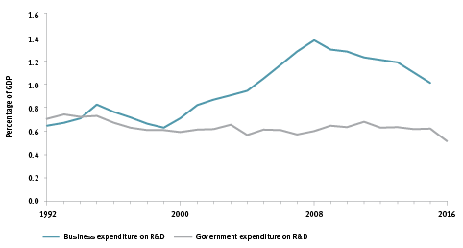

BERD = business expenditure on research and development; R&D = research and development

Note: BERD has only been reported biannually since 2011. Data for missing years are an average of each adjacent year (e.g. BERD for 2012 is the average of 2011 and 2013).

Source: Australian Bureau of Statistics 2017, *Research and experimental development, businesses, Australia, 2015–16*, cat. no. 8104, ABS, Canberra, <<http://www.abs.gov.au/ausstats/abs@.nsf/mf/8104.0>>; Australian Government Department of Industry, Innovation and Science 2017, *Science, research and innovation budget tables,* DIIS, Canberra, <<https://industry.gov.au/innovation/reportsandstudies/Pages/SRIBudget.aspx>>.

In 2016-17, the Australian Government spent $10.1 billion on support of science, research and innovation (Figure 13), directed through:

R&DTI – the largest single innovation support program which provides a tax advantage for businesses undertaking R&D

research block grants – which provide support for university-based R&D activity

competitive investigator-led research grant programs – including the Australian Research Council and the National Health and Medical Research Council

publicly funded research agencies – including CSIRO, Defence Science and Technology Group, and Australian Nuclear Science and Technology Organisation

innovation support programs that are primarily mission-directed – including the Cooperative Research Centres programme, Medical Research Future Fund, Biomedical Translation Fund, Australian Renewable Energy Agency, Entrepreneurs’ Programme, Industry Growth Centres Initiative, and Rural and Regional Development Corporations.

Figure 13 Australian Government science, research and innovation expenditure, 2016–17

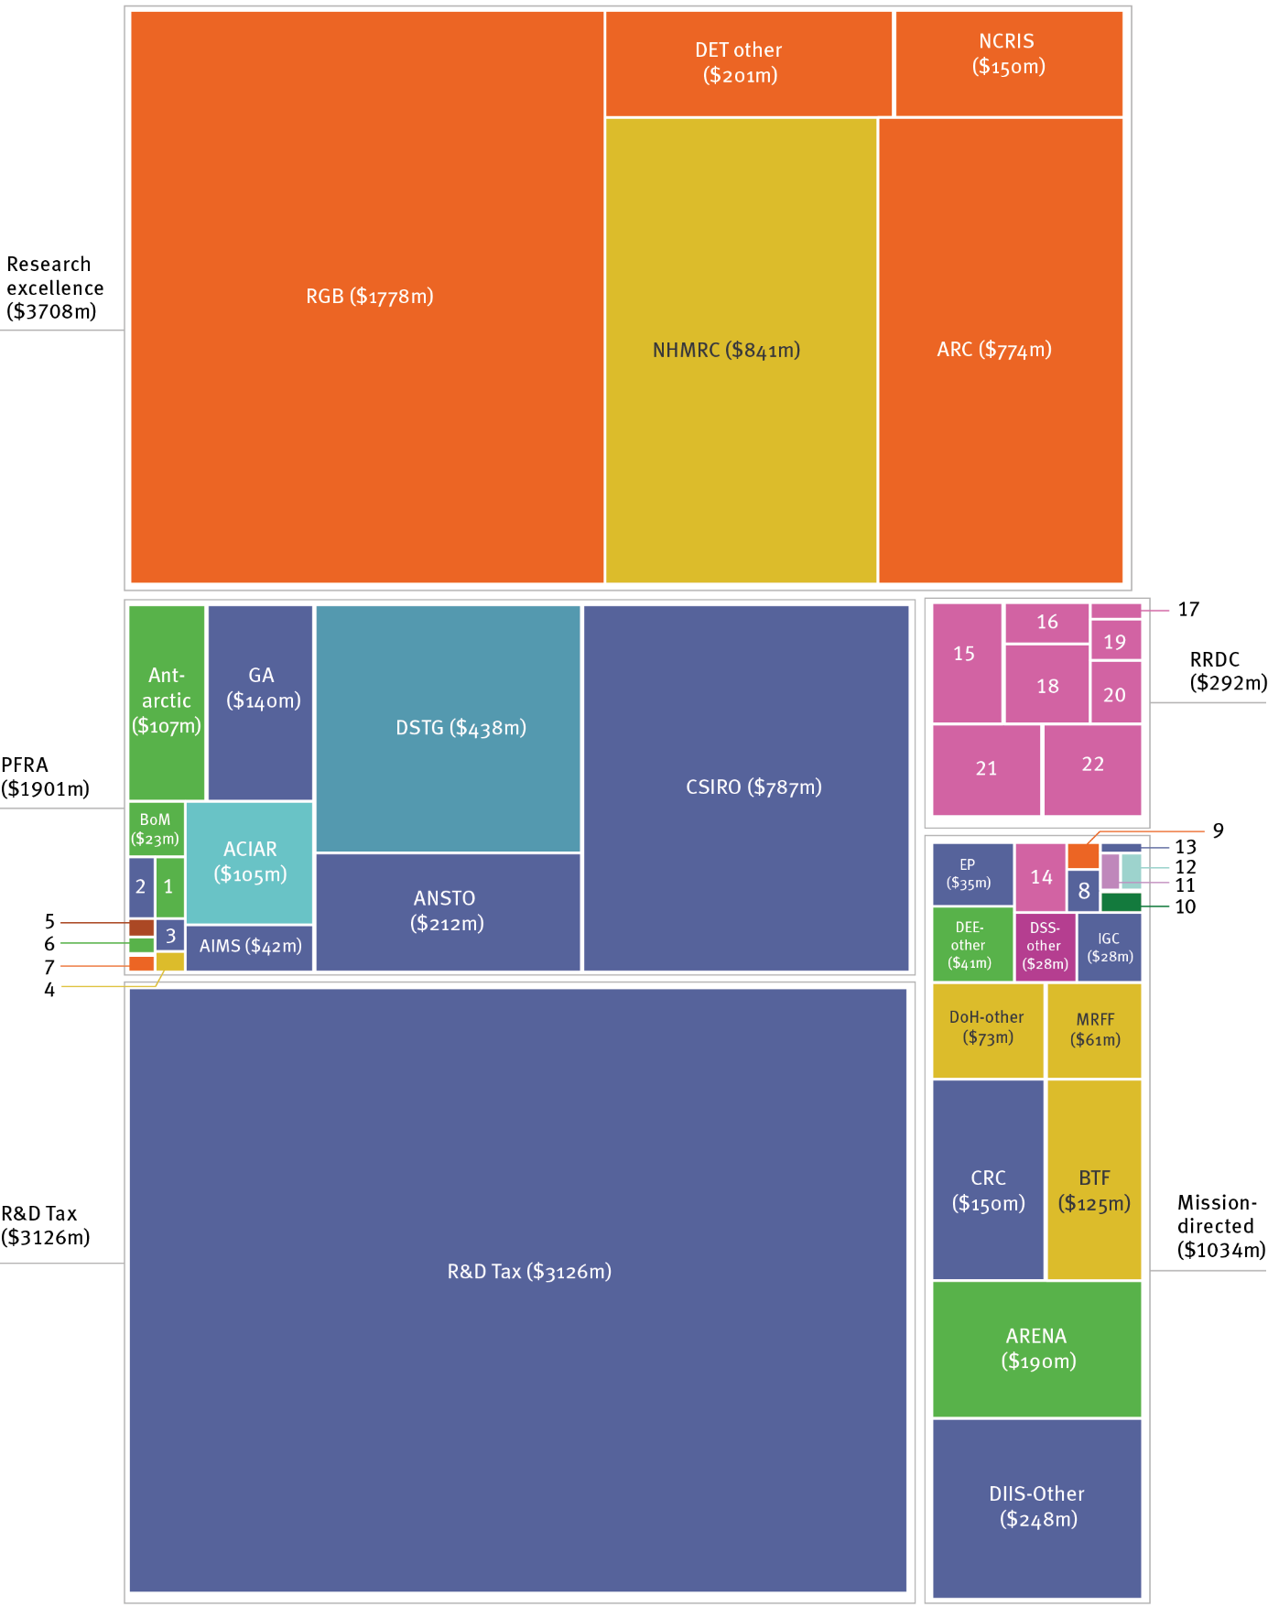

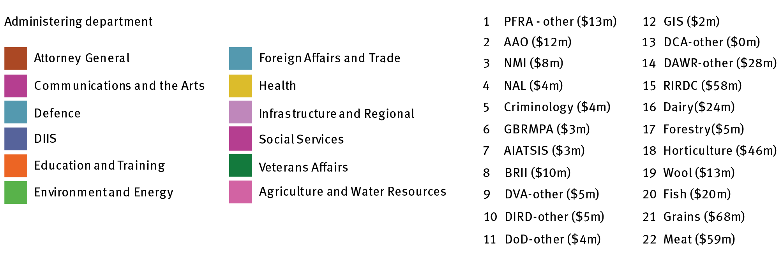

Change to 13 “DCA-other ($0.01m)”

AAO = Australian Astronomical Observatory; AIATSIS = Australian Institute of Aboriginal and Torres Strait Islander Studies; ACIAR = Australian Centre for International Agricultural Research; AIMS = Australian Institute of Marine Science; ANSTO = Australian Nuclear Science and Technology Organisation; ARC = Australian Research Council; ARENA = Australian Renewable Energy Agency; BoM = Bureau of Meteorology; BRII = Business Research Innovation Initiative; BTF = Biomedical Translation Fund; CRC = Cooperative Research Centre; CSIRO = Commonwealth Scientific and Industrial Research Organisation; DAWR = Australian Government Department of Agriculture and Water Resources; DCA = Australian Government Department of Communications and the Arts; DET = Australian Government Department of Education and Training; DIIS = Australian Government Department of Industry, Innovation and Science; DIRD = Australian Government Department of Infrastructure and Regional Development; DOD = Australian Government Department of Defence; DOH = Australian Government Department of Health; DSTG = Defence Science and Technology Group; DVA = Australian Government Department of Veterans’ Affairs; GA = Geoscience Australia; GBRMPA = Great Barrier Reef Marine Park Authority; GIS = Global Innovation Strategy; MRFF = Medical Research Future Fund; NAL = National Acoustic Labratories; NCRIS = National Collaborative Research Infrastructure Strategy; NHMRC = National Health and Medical Research Council; NMI = National Measurement Institute; PFRA = publicly funded research agency; R&D Tax = Research and Development Tax Incentive; RBG = research block grant; RIRDC = Rural Industries Research and Development Corporation; RRDC = Rural Research & Development Corporations

Source: Australian Government Department of Industry, Innovation and Science 2017, *Science, research and innovation budget tables*, DIIS, Canberra, <<https://industry.gov.au/innovation/reportsandstudies/Pages/SRIBudget.aspx>>; design by ISA.

#### Refocusing government support for business research and development

The heavy reliance on ‘indirect’ funding measures, such as the R&DTI, to support business R&D is a characteristic that Australia shares with only a few other nations (Figure 14). Although such schemes have the advantage of being relatively simple to administer, there is concern about the extent to which they generate genuine additionality in R&D activity.[101] Furthermore, there is emerging evidence in the international literature questioning the impact of R&D tax incentives on productivity growth.[102]

Figure 14 Percentage of direct vs indirect government funding for business research and development, as percentage, 2013

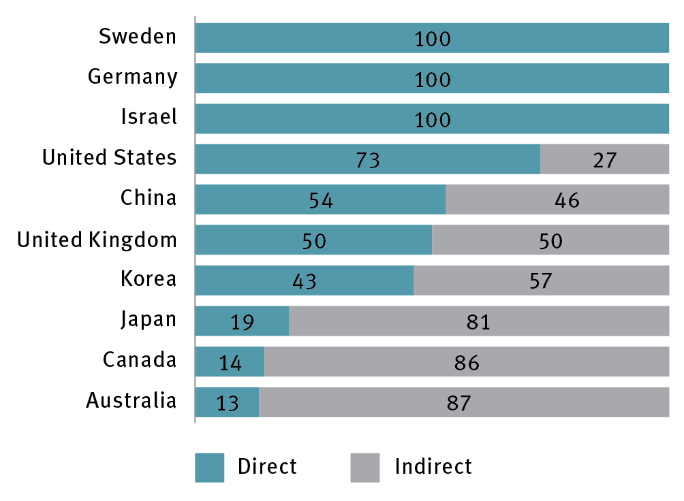

Note: Data on indirect funding for Israel unavailable; data for Australia available from 2011 and United States from 2012.

Source: Organisation for Economic Co-operation and Development 2017, *Measuring tax support for R&D and innovation*, OECD, Paris, <[www.oecd.org/sti/rd-tax-stats.htm](http://www.oecd.org/sti/rd-tax-stats.htm)>; Organisation for Economic Co-operation and Development 2017, *Main science and technology indicators*, OECD, Paris, <[www.oecd.org/sti/msti.htm](http://www.oecd.org/sti/msti.htm)>.

Against this backdrop, the Australian Government commissioned a review of the R&DTI. The review panel was asked to find opportunities to improve the effectiveness and integrity of the R&DTI, including encouraging additionality. The 2016 review found that *‘the programme falls short of meeting its stated objectives of additionality and spillovers’*.[103] It made six recommendations to improve the programme and encourage additional R&D.

The consultations undertaken by ISA to develop this plan confirmed the importance of the R&DTI, particularly for small and medium enterprises (SMEs). SMEs generate greater additionality per dollar spent on R&D tax incentives by governments compared with large businesses; SMEs generate between 0.9 and 1.5 additional dollars per dollar of tax forgone, versus just 0.3 to 1.0 for large firms.[104] In many cases SMEs are also more sensitive to the R&DTI than larger and more established firms: 54 per cent of SMEs’ decisions regarding R&D are influenced by the R&DTI program, versus 34 per cent of decisions for larger entities.[105] ISA consultations reiterated concerns about the additionality generated by the program.

With the benefit of this feedback, and new data gathered as part of the ISA performance review and the development of the 2030 Plan, ISA has identified two opportunities to improve the impact of the recommendations in the *Review of the R&D Tax Incentive*:

The cap referred to in Recommendation 3 of the review of the R&DTI should be set at $4 million per year, and a maximum cumulative refund of $40 million per company should be applied.

The threshold referred to in Recommendation 4 of the review of the R&DTI should be replaced with a trigger set at 1 per cent of total annual expenditure, such that all R&D expenditure is claimable (subject to any other limits) once the trigger level is reached.

Case study 3 Textor Technologies: creating new jobs via innovation

Textor Technologies is proof of the power of a big idea. In 2000, Textor was a small and struggling Victorian manufacturing company, producing limited volumes of textiles for local suppliers in hygiene and car manufacturing.

Phillip Butler, then a director and now company Chair, imagined a different future. He believed that with higher-value products and higher-volume production facilities, the company could be a global exporter.

Butler knew that product and process innovation and an export strategy were critical to a turnaround. Textor Technologies developed innovative textiles designed to control moisture absorption that prevent leakage in products such as nappies, wound pads and other hygiene products, ensuring skin remains dry and in good condition. The company also invested $17 million to upgrade its factory in Tullamarine to a state-of-the-art, automated facility.

Support from government programs incentivising research and collaboration was critical to the company’s improvement journey and growth. The Research and Development (R&D) Tax Incentive enabled Textor to expand its R&D capability, now employing 13 engineers and two PhDs focused on product and process development. Textor also partnered with CSIRO to develop novel three-dimensional moisture-trapping fabric. This new material is used in the millions of nappies produced in Sydney, the United States and Russia by global company Kimberly-Clark.

These innovations have transformed Textor Technologies into a healthcare and hygiene leader exporting across the Asia Pacific. Textor now manufactures 100 million square metres of moisture-trapping fabric each year. The business has grown by 300 per cent, and has opened up a multinational textile value-chain.

[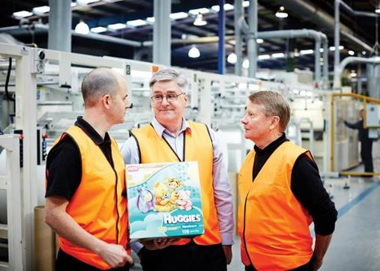](https://www.google.com.au/url?sa=i&rct=j&q=&esrc=s&source=images&cd=&cad=rja&uact=8&ved=0ahUKEwjY09GEqOzWAhXJXLwKHV45A6cQjRwIBw&url=https://csiropedia.csiro.au/3d-ultraabsorb-fabric-technology-for-nappy-liners/&psig=AOvVaw2EZa0gKyOgCaXW8MN-Okgx&ust=1507939655884530)

ISA is also aware that digital transformation projects have resulted in an increasing number of companies making claims for software-related activities under the R&DTI. However, although such software development projects may be innovative, in many cases R&D activities may form only a small part of the overall project. The definition of R&D in the *Industry Research and Development Act 1986* is specific and drawn from the OECD Frascati Manual.[106] Further work is already under way in this important area to provide certainty to companies working with software.

#### Increasing the use of mission-directed support

Several nations are looking anew at the potential for government to stimulate public and private sector innovation through mission-oriented, impact-focused programs.[107] This is supported by a growing body of evidence highlighting the role that governments have historically played in laying the foundations for breakthrough innovations in a range of fields, such as the internet.[108]

Australia currently makes use of a range of mission-driven, directly funded programs to foster business innovation (e.g. the Cooperative Research Centres (CRC) Programme, including CRC Projects, and the Entrepreneurs’ Programme). These currently constitute a comparatively small fraction of total support, but there is evidence they are generating additional, strategically valuable investment in R&D from businesses. For example, one review of CRCs in 2012 calculated that net economic benefit to the Australian community exceeded costs by a factor of 3.1.[109]

**Case study 4 CRC for Sheep Industry Innovation: bringing sheep farming into the technological age.**

Collaboration between industry and research participants of the Cooperative Research Centre for Sheep Industry Innovation (Sheep CRC) is giving farmers new technological tools to aid them in the age-old practice of sheep breeding.

The Sheep CRC counts sheep breeders, producers, processors, retailers, researchers and industry advisors among its 41 participants: Meat and Livestock Australia, Australian Meat Processors, Sheep meat Council of Australia and Wool Producers Australia represent key industry stakeholders; Murdoch University, the University of New England, and the Western Australian, Victorian and New South Wales state governments contribute a wide range of research expertise.

The Sheep CRC combines digital technology with DNA testing, and uses climate information and biophysical models to provide farmers with better access to data to help inform their decision-making around managing healthy and productive sheep.

The first of the digital products released by the CRC was RamSelect. This is a web-based genetic selection app that helps take the guesswork out of selecting rams with the exact genetics that match the breeder’s purpose – whether that be wool production, meat quality or other factors that affect the profitability of a flock. Farmers are able to compare sheep from across Australia via an intuitive and easy-to-use platform to ensure their rams are carrying the right combination of genes.

The real-world usefulness of RamSelect Plus is best demonstrated by the fact that sheep breeders are embracing it in droves. About 14,000 rams from 180 studs were listed on the website within the first five months of its launch. Now in its third year, it is transitioning to a user-pays model to ensure that it can continue to be delivered in a commercially sustainable way beyond the life of the CRC.

The Sheep CRC demonstrates the key role that well-focused collaboration can play in developing complex and innovative technologies with the potential to revolutionise farming practices; all farmers and producers can benefit from access to accurate, reliable and predictive data for decision-making.

 .

More recently, the Australian Government has established independently run IGCs to accelerate growth in promising industry sectors with high strategic, economic and export potential. The IGCs have four areas of focus:

identifying regulations that are unnecessary or over-burdensome for growth sectors and impede their ability to grow, and suggesting possible reforms

improving engagement between research and industry, and within industry, to achieve stronger coordination and collaboration of research and stronger commercialisation outcomes in the key growth sectors

improving the capability of the key growth sectors to engage with international markets and access global supply chains

improving the management and workforce skills of key growth sectors.

IGCs have been established in six areas of competitive strength and strategic priority: advanced manufacturing; cyber security; food and agribusiness; medical technologies and pharmaceuticals; mining equipment, technology and services; and oil, gas and energy resources. While it is too early to fully evaluate the effectiveness of the IGCs, ISA believes that they are already building on their independent status and unique insights to play a key role in directing government support to young firms, SMEs or research-intensive large firms in sectors of competitive strength and strategic priority.

National Missions, discussed in Imperative 5, are another valuable mechanism through which government can drive innovation in priority areas.

### Recommendations

**Recommendation 6:** Adopt as the top priority of innovation policy the reversal of the current decline in business expenditure on research and development, with a headline goal of achieving a medium-term growth rate not less than that seen in 1999–2015. The contribution to this goal made by government support for business R&D should be strengthened by:

ensuring, at a minimum, that total government support for science, research and innovation does not fall below its medium-term average of 0.63 per cent of gross domestic product

* implementing the recommendations of the 2016 Review of the R&D Tax Incentive to improve the effectiveness, integrity and collaboration impact of the program, with the following adjustments
* the cap referred to in Recommendation 3 of the report should be set at $4 million per year, and a maximum cumulative refund of $40 million per company should be applied

the threshold referred to in Recommendation 4 of the report should be replaced with a trigger set at 1 per cent of total annual expenditure, such that all R&D expenditure is claimable (subject to any other limits) once the trigger level is reached

prioritising new and redirected investment in stimulating business R&D to programs that directly support activity in areas of competitive strength and strategic priority (e.g. Cooperative Research Centres – CRCs, CRC Projects, Entrepreneurs’ Programme and Industry Growth Centres).

## Strategic opportunity 2.2: The growth of exporting firms, particularly young high-growth firms, can be encouraged by increasing Export Market Development Grants funding, and by expanding and making better use of trade agreements

### Rationale

Exporting is critical to the national economy. Australia is most globally competitive in export sectors,such asmining, agriculture, tourism and education. Exporting companies expand economic activity by bringing in new income. They are also more likely to be high-performing and innovative and have stronger jobs growth potential.[110]

Australia has significant potential to increase our global export share. This is particularly the case for non-mining sectors and high-growth firms, and in exports to emerging and rapidly growing Asian markets in our region. Governments can enable this growth by expanding free trade agreements and companies’ ability to leverage them. They can also increase access to export programs targeted at high-growth firms, particularly SMEs.

#### Creating the conditions to increase exports

Australia should be ambitious about increasing our share of global exports. The Australian economy is the 14th largest in the world,[111] but ranks only 25th for share of global exports.[112] The mining sector is the exception, in which we rank highly capturing nearly 29 per cent of the world export market for minerals. This has significantly increased from 2000, when we had 12.7 per cent of the world export market.[113] Other sectors do not achieve the same rate of export success. Australia has 2.8 per cent of worldwide market share in agriculture, down from 3.15 per cent in 2000, and only 0.53 per cent of the global manufacturing market, down from 0.64 per cent in 2000.[114]

Australia’s opportunity for improved performance in non-mineral export markets is illustrated by comparison with Canada. Australia has a similar profile to Canada in terms of population size, GDP per capita and annual wages.[115] Yet Canada captures 4.2 per cent of global agricultural market share, even though Canada has less arable land than Australia[116] and agriculture contributes to a higher share of GDP in Australia.[117] Similarly, in manufacturing, Canada outperforms Australia by a factor of four, capturing 2.4 per cent of the global manufacturing export market.[118]

Governments can stimulate export activity by entering into new trade agreements and better capitalising on existing ones. Australia has recently negotiated deals with China, Japan and Korea. This is a promising development with good initial results (e.g. a 12 per cent rise in agriculture exports to Korea).[119] Greater gains are expected to accrue from the China–Australia Free Trade Agreement with scheduled periodic eliminations of tariffs through to 2026.[120] However, Australia has yet to conclude a free trade agreement with India, and will need new agreements with the European Union and the United Kingdom after Brexit.[121]

The Australian Government can also ensure Australian companies are not disadvantaged in the regulatory requirements for exporting. World Bank analysis shows that Australian documentary compliance obligations are heavy, relative to peers, rating Australia 32nd of OECD countries for the efficiency of its processes.[122] This means that Australian businesses face higher average time and costs (Figure 15) for exporting and importing processes. The average time to complete border compliance for exports is 36 hours in Australia compared with less than 15 hours among other OECD countries (Figure 15b).

Figure 15 Costs and time for compliance with Australian import and export regulations

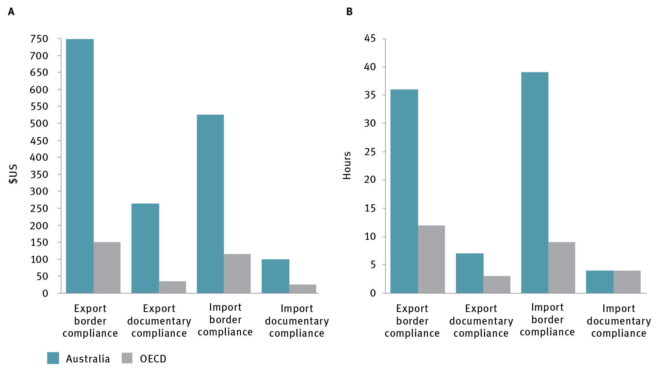

OECD = Organisation for Economic Co-operation and Development  
Source: Organisation for Economic Co-operation and Development 2017, *OECD economic surveys: Australia – March 2017*, OECD, Paris, <<http://dx.doi.org/10.1787/eco_surveys-aus-2017-en>>; The World Bank 2016, *Doing business: Trading across borders*, <<http://www.doingbusiness.org/data/exploretopics/trading-across-borders>>.

#### Accelerating export opportunities for high-growth firms

Increasing the export activity of high-growth firms – in particular, SMEs – poses significant potential upsides for the Australian economy.

High-growth employment firms[123] contributed about 46 per cent of net positive employment growth in 2004–05 to 2011–12, despite representing only 9 per cent of all firms.[124] In particular, SMEs growing to become large firms add many jobs to the economy; 146,000 jobs added by big businesses in Australia’s private sector between 2012 and 2016 were from SMEs scaling to become large businesses (Figure 16).

Figure 16 Employment change of private sector large business in Australia, 2012–16

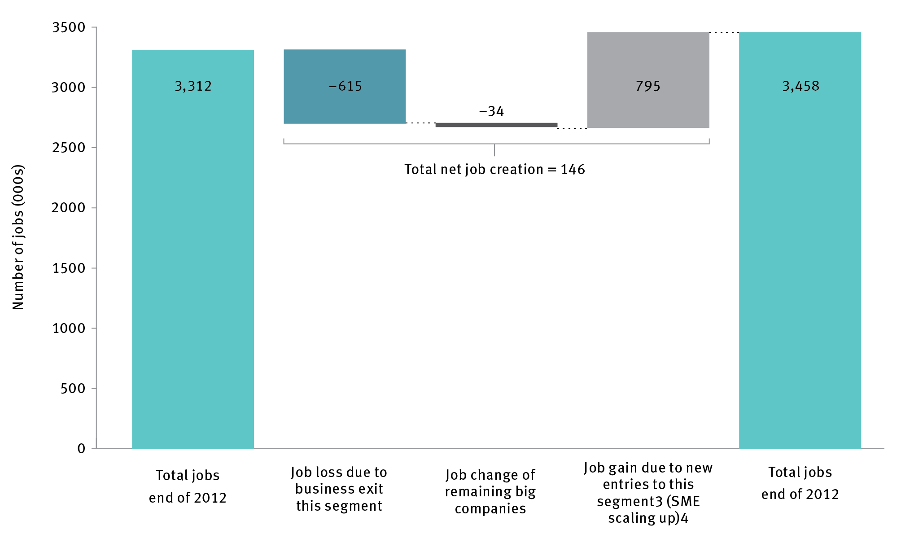

ABS = Australian Bureau of Statistics; SME = small and medium enterprise

a ABS definition: large = 200+ employees, medium = 20–199 employees; small = 1–19 employees

b Excludes financial and insurance services, which are not reported in ABS data, including full-time and part-time

c New entries to the big business segment, including direct entry to big business and SMEs scaling up (over 50 per cent in terms of number of companies)

d Based on McKinsey Global Institute research in the United States, the vast majority of new entries to big business are firms 0–5 years old

Source: Australian Bureau of Statistics, 2016, *8155.0 Australian industry by division, 8165.0 Counts of Australian business, including entries and exits*, June 2012 to June 2016, ABS, Canberra.

Export growth is also largely driven by high-growth firms in Australia (Figure 17).[125]

Figure 17 Contribution of firms to export growth, 2004–05 to 2010–11

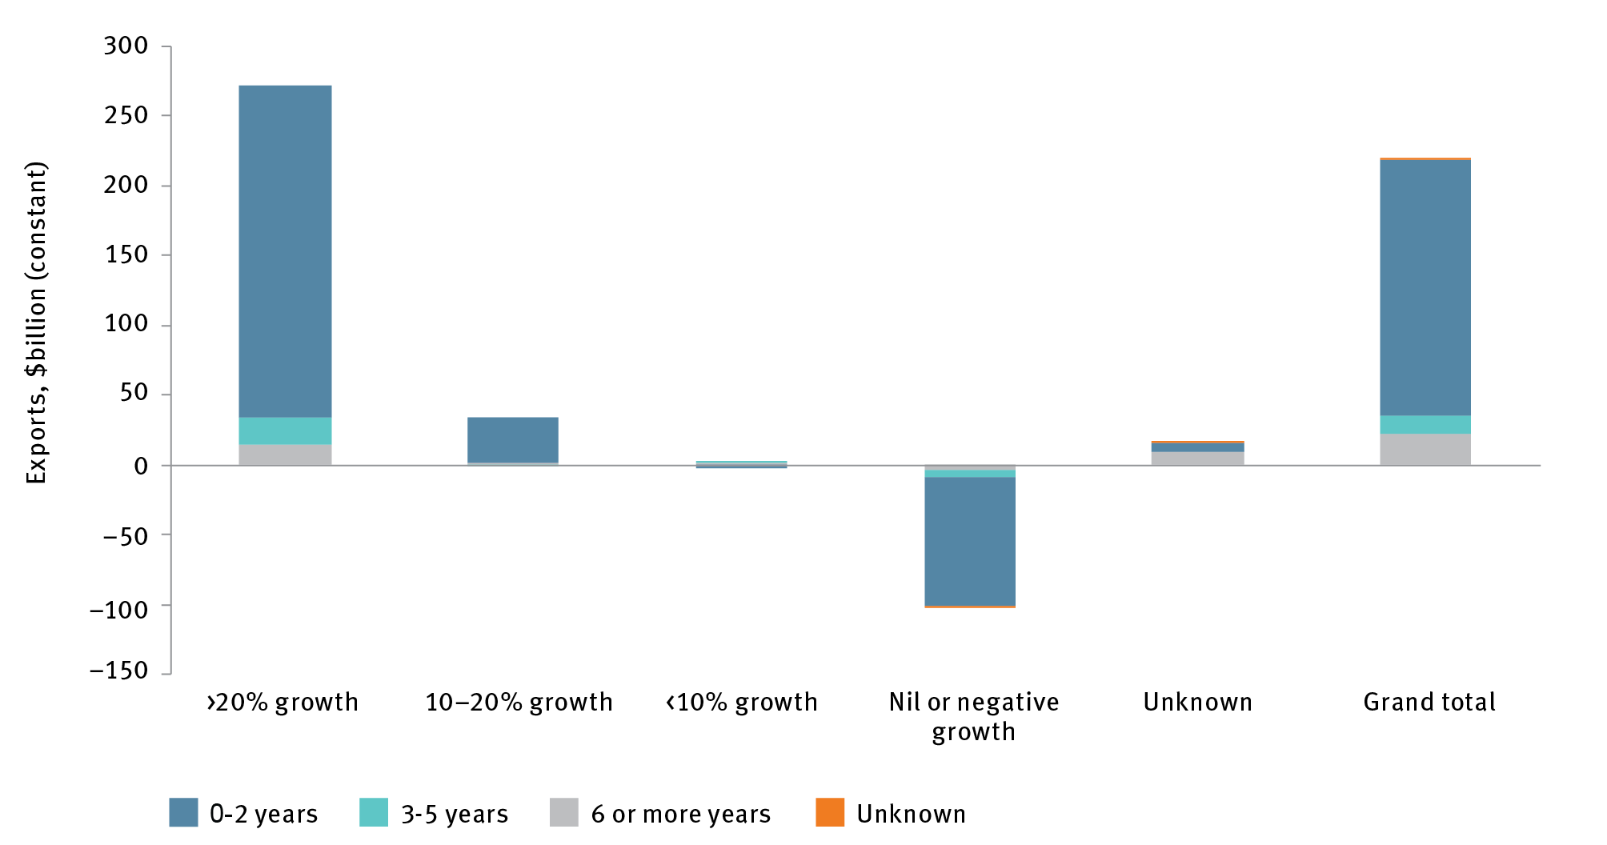

Note: Averages incorporate all industry classes except Standard Institutional Sector Classification of Australia Sector 2 firms. Average annualised growth rates are calculated on a total sales basis over a rolling three-year period.

Source: Australian Bureau of Statistics, 2016, *Business longitudinal analysis data environment*. Customised data report commissioned by the Department of Industry, Innovation and Science, ABS, Canberra.

Given the role of exporting in stimulating innovation,[126] there is clear value in increasing the number of high-growth firms accessing export markets. However, a common barrier to exporting for smaller firms is the knowledge, time and resources involved in developing an export strategy. This will be a more significant issue in future, as both the opportunity and complexity of export markets expands. The rise of Asian economies is creating significant new economic opportunities with the consuming class in Asia forecast to grow from 552 million to 1.2 billion households by 2030.[127] These economies are also urbanising, and in the process creating mega-cities. The McKinsey Global Institute estimates that by 2025, half the world’s economic growth will come from 440 cities, including little-known places such as Kumasi in Ghana and Santa Catarina in Brazil.[128] The complexity of entering emerging markets is that they have distinct cultural, linguistic, business and regulatory environments at the city, regional and country level.

SMEs need increasingly sophisticated and geographically granular strategies to take advantage of these export opportunities. Researching local nuances across markets is difficult for young firms and SMEs with limited resources. There may be economies of scale in addressing common information gaps to help such firms understand the nuances of different markets or cities. Participants in the Bunbury consultation forum conducted as part of the ISA review shared:

We're a start-up and I am flat out trying to get to the bottom line. I don't have the time to reach out and create those networks for myself. It's going to take us a long time to get to the point where we can afford to spend our time doing that rather than spending our time trying to pay the rent. Helping start-ups with export strategy is one of the things that can be an enabler.

Australian governments have multiple program models they can build on to help high-growth SMEs to export, including participating in trade missions and accelerator landing pads, finance for capital goods exports, export market development grants, and IGCs.

Direct government support for participation in trade missions correlates with increased export market participation. A review of the Export Market Development Grants scheme found that the scheme helps to increase the number of businesses that develop into exporters, and has a substantial proportion of high-growth firms in the scheme.[129] ISA’s preliminary analysis of performance by SME participants in the scheme shows that 45 per cent increased their employee numbers by at least 73 per cent (equivalent to a threshold of 20 per cent growth compounded over three years) and 52 per cent increased their turnover in excess of the same threshold.[130] Swinburne University research also found that trade mission participation increased the chance of a company becoming an exporter within 12 months by 26 per cent. On average, missions increased participating firms’ exports by at least 172 per cent within a year.[131]

### Recommendations

**Recommendation 7:** Increase efforts to help young Australian businesses and small and medium enterprises to access export markets by:

increasing funding for Export Market Development Grants and investigating how to target a larger proportion of the funds to high-growth businesses (e.g. consider fostering and identifying them via Industry Growth Centres)

extending funding for international capability promotion through targeted trade missions and trade promotion activities.

## Strategic opportunity 2.3: The opportunities presented by the ‘fourth wave’ of the internet can be captured by strengthening Australia’s digital economy

### Rationale

Adoption and use of digital technologies will be a significant driver of economic growth. Digitally agile businesses tend to be more productive and competitive than others. A key enabler for digital business will be improved availability of high-speed broadband, using both existing and emerging technologies, which is a current area of focus for the government. Digital capability can be a significant source of growth through improved productivity.[132]

A key area of opportunity in the Australian economy that is under-served is the rapidly emerging field of data science and AI. The strategic opportunity for Australia is that cyber–physical systems (including technologies broadly referred to as the ‘internet of things’) are estimated to be a $15 trillion per year economic enabler globally over the next 15 years.[133] As has been seen in previous waves of transformation driven by ICT, the countries who scale their capability fastest in this area are likely to capture the greatest opportunity.

The nation’s research ecosystem is responding to this important opportunity with R&D collaborations, such as the Data to Decision Cooperative Research Centre, bringing together industry, universities and government researchers to tackle ‘big data’ challenges. The national science agency, CSIRO, has also built up impressive capabilities; its data science group, Data61, has the highest concentration of data scientists in Australia and a proven track record for industry engagement and translation of digital and data science-based research.

However, there is a risk Australia will be unable to scale its capability rapidly enough to meet the needs of a transforming economy. Specifically, we must ensure we nurture the skilled workforce and high fixed-cost research and knowledge infrastructure required for Australia to be a leader in the next wave of the internet revolution based on cyber–physical systems.

The Australian Government is developing a Digital Economy Strategy to maximise the potential of digital technology to improve the nation’s productivity and competitiveness, while minimising its negative effects.[134] The Government’s priority should be to position Australia as a leading nation in the research, development and exploitation of AI and machine learning (ML) across the digital economy.

### Recommendations

**Recommendation 8:** The forthcoming Digital Economy Strategy should prioritise the development of advanced capability in artificial intelligence and machine learning in the medium- to long-term to ensure growth of the cyber–physical economy.

## Strategic opportunity 2.4: Business productivity in all sectors can be facilitated by healthy levels of competition

### Rationale

#### Renewing our commitment to competition

Competitive intensity appears to be in decline in some developed economies. This has been most extensively studied in the United States,[135] but there are emerging signs that some of Australia’s domestic industries, such as retail and utilities, are facing long-term competitiveness challenges. Historically shielded from domestic and global competition due to Australia’s geography and small market size, and with growing input costs and inconsistent labour productivity, these industries are less competitive than Australia’s export sectors. More recently, the exit of foreign competitors in some sectors following the Global Financial Crisis may have further reduced competition.[136]

The emergence of global players in some of these sectors, often with business models underpinned by powerful platform economics, means that Australia finds itself an increasingly attractive market for foreign entry. This has been most visible in the retail sector, where international players such as Zara and H&M have set up a physical presence, and Amazon is widely expected to launch a stronger online presence soon. Although the extra efficiency such competition brings may provide some benefit to Australian consumers, the fact that so much of the enabling infrastructure and capability is typically located overseas will limit the value created for Australia.

To respond to this, it will be important that Australian-grown firms improve their global competitiveness. This includes sectors that have traditionally not been exposed to international competition, and especially those sectors where platform economics make global competitors difficult to counter. The past 30 years of prosperity in Australia was, to a significant extent, powered by an opening up of the Australian economy and a commitment to national competition policy. This has shown strong competition is good for the economy and jobs, as it encourages innovation, productivity, jobs and income growth.[137] It is therefore welcome that the Australian Government has renewed its commitment to competition policy through the recent Competition Policy Review

The review, led in 2015 by Professor Ian Harper, identified multiple areas where Australian governments could improve regulatory competitiveness, such as water regulation.[138] Its recommendations provide a good starting point to reduce domestic input costs and ultimately improve productivity. The Australian Government has responded to this review; however, there are outstanding recommended initiatives that require state and territory government actions. These deserve accelerated consideration by state and territory governments working with the Australian Government.

The power of competition to drive innovation makes this an important area for the 2030 Plan, and one which will likely require ongoing attention. It is important that governments ensure relevant agencies such as the Australian Competition and Consumer Commission are resourced and empowered to maintain robust competition across the economy.

#### Maintaining competition and innovation in a data-rich world

Governments can also help to spur innovation by addressing market or information failures. One area of opportunity is facilitating access to data. PwC estimated in 2013 that data-driven activity contributed $67 billion to GDP, but that Australia could realise an additional $48 billion annually from data-driven innovation.[139]

Access to data is emerging as an important barrier to market entry in the digital economy because of the prevalence of powerful network effects. Network effects mean that a first-mover company, which rapidly achieves scale and scope in a product category, gains an ongoing market advantage among consumers who value extra users being added. When network effects are created by such companies, the monopoly or quasi-monopoly situation the company enjoys in its own market can then create a secondary monopoly on user data collection.

Because it is hard for new entrants without equivalent scale to appeal to consumers, these situations may lock up economic value because data sets are not exploited by companies that own them. Other regulators, including those in the United Kingdom and Europe, are currently designing regimes to ensure the potential economic value associated with these data sets is not stranded.

National Australia Bank and Macquarie Bank are transforming banking with the implementation of application programming interfaces that will make it possible for customers to share their data with third-party financial service providers. This open banking initiative is a good first step towards empowering the customer to exploit data.

The Australian Government recognises data access as an important issue. It commissioned the Productivity Commission to conduct a review of data availability and use, which was presented to the Australian Government in March 2017.[140] The review makes welcome recommendations for comprehensive legislative reform to create a system based on transparency and confidence in data processes, treating data as an asset and not a threat. Although the Commission notes that *‘business data use can, by the evidence we have seen, be generally left to market development’*,[141] ISA remains concerned about the potential for inhibition of competition and innovation through concentrated control of data. This should therefore be the subject of ongoing vigilance from government.

### Recommendations

**Recommendation 9**: Establish protocols (including consumer data rights) for maintaining healthy levels of competition in knowledge-intensive industry sectors.

## Strategic opportunity 2.5: Australia’s innovation investment and talent can be strengthened by improving access to global talent pools and fostering greater gender and ethnic diversity

### Rationale

Securing sufficient talent is vital for companies, particularly high-growth, scaling firms. Australia has a strong track record in skilled immigration, and has further opportunities to fine-tune schemes to attract top talent and fill skill shortages.

Immigration is particularly important to make up local shortages in areas of fast-moving, high-demand skills, such as ICT professionals. In 2015–16, the net inflow of ICT workers to Australia was 20,700 people, representing 3 per cent of the overall ICT workforce.[142] Start-up firms, especially in technology, frequently need immigration to access talent. In its 2016 annual report, Start Up Muster recorded that 16 per cent of start-up employees were on a visa, and just over 8 per cent were on temporary work (skilled) visas.[143] In the broader workforce those on temporary work (skilled) visas comprise less than 1 per cent of the total workforce.[144] The Australian Government’s Skilling Australia Fund is a novel and potentially valuable approach to supporting the vocational education and training of Australian workers into the future, and should be seen as part of a portfolio of measures which complement skilled immigration programs.

Australia has also been active in seeking to use immigration to boost innovation and entrepreneurial talent. Australia was the first country in the world to offer an entrepreneur visa, which allows migrants to undertake entrepreneurial activity in Australia, provided they can demonstrate sufficient financial backing from investors for their venture.[145] In 2015–16, 7620 visas offered were in the business innovation and investment stream;[146] this represents 5.65 per cent of all visas awarded in the skilled stream of permanent entrants in that year.[147]

There are opportunities to continue to refine immigration rules to improve access to specialist skilled talent and attract entrepreneurs. The pioneering nature of the entrepreneur visa means some ongoing fine-tuning will be needed. Most business innovation and investment stream visas relate to investment and general business ownership, rather than entrepreneurship, and therefore set minimum investment holding thresholds. This can be an exclusionary requirement for entrepreneurs, especially those at earlier career stages. For example, in 2012– 16, the initial entrepreneur visa (subclass 132) had the demanding requirement of an investment threshold of $1 million; fewer than five visas were awarded during that time.[148] A secondary entrepreneur visa category (188) was added that has a lower investment threshold ($200,000) and a pathway to permanent residency. However, uptake has remained at fewer than five per year since its introduction in October 2016.[149]

Further improvements could be made to the cost and speed of processing these visas. A number of countries have streamlined their processes to increase uptake: for example, the Tech Nation Visa Scheme in the United Kingdom takes a maximum of 16 weeks to process, and costs just under £300.[150] The Australian startup community has observed that the Australian entrepreneur visa requires improvement to address processing times (which can be over a year,)application expense (which can be over $3000), and restrictions on eligibility requirements relative to other countries. [151] It is important that Australia is able to compete for entrepreneurial talent and skills with equivalent countries where visa conditions and application processes are less onerous.

The Australian Government should continue to facilitate Australian business access to top talent by iterating immigration rules to meet changing market needs. ISA has considered multiple methods by which this could be achieved in its submission to the Department of Immigration and Border Protection’s recent public consultation, *Transforming Australia’s Visa System.*[152]Australia can also improve marketing of skilled visas to increase uptake, through better website information on visa types and increased promotion of undersubscribed visa classes. [153]

#### Sustaining Australia’s attractiveness for direct foreign investment in innovation, science and research

A country such as Australia, with a relatively small population and a high demand for capital, could look to direct foreign investment to make up any shortfall between domestic investment and savings and demand. There is ongoing global competition to attract direct, high-quality foreign investment in national economies. Economies that can create the right conditions for economic growth and allow innovation to occur will remain an attractive proposition for foreign investors.

Australian industry and businesses will benefit from foreign investment regardless of whether the foreign entrants conduct their operations in Australian-owned subsidiaries, because of the potential for knowledge spillover. For example, foreign entrants can introduce new knowledge by demonstrating new technologies and training workers who later take employment in local firms. They can also help to develop new infrastructure and expertise and provide access to global supply chains. Greater competition can also force local firms to innovate through improved productivity measures such as the adoption of new management practices and technologies.

#### Fostering greater gender and ethnic diversity

ISA’s performance review found that a weakness of Australia’s Innovation Science and Research system is that, despite substantial improvements in recent decades, it remains part of a gender-unequal society.[154] There is a growing body of literature showing that gender and ethnic diversity is important for innovation performance.

The causes of female under-representation in early-stage and high-growth companies are complex and multi-factorial, and require action from all players in the system. However, in a promising development a number of female-focused incubators and accelerators such as Springboard Enterprises and SheStarts have made good progress in building a stronger cohort of female entrepreneurs. In addition, industry bodies such as LaunchVic have also made gender diversity a priority as they seek to build their local ecosystems, and the Australian Private Equity and Venture Capital Association has recently launched a diversity handbook. These measures are welcome and need to be sustained over time. Government should contribute to these developments by raising awareness of gender diversity in its own programs that target the start-up community.

**Case study 5 Innovation is providing exciting opportunities to Australia’s female entrepreneurs and researchers.**

Australia has a fine tradition of quiet achievers, often better known on the world stage than at home. Dr Deborah Rathjen is one such person. She is an entrepreneur, scientist, innovator, mother and CEO of Bionomics – an Adelaide-based biopharmaceutical company that has gone global.

Dr Rathjen is steering Bionomics through a critical phase in building a portfolio of drug candidates from early to advanced stages of clinical development. Bionomics is developing innovative therapeutics for diseases of the central nervous system (including Alzheimer’s disease) and cancer. She is renowned for her business acumen (including company financing, mergers and acquisitions), and experience in therapeutic product research and development, business development, licensing and commercialisation.

Dr Rathjen was named the BioSingapore Asia Pacific Biotechnology Woman Entrepreneur of the Year in 2009, and 2014 Woman Executive of the Year at the BioPharm Industry Awards. In 2015,   
Dr Rathjen was included in the top 50 most influential Australian businesswomen by The Australian newspaper.



### Recommendations

**Recommendation 10:** Build on strength in accessing overseas talent through continuing and targeted updates to skilled immigration rules and improved marketing to suitable talent, especially through Austrade (with a focus on key target markets).

# Imperative 3 Government: Become a catalyst for innovation and be recognised as a global leader in innovative service delivery

ISA’s vision is that by 2030, Australian governments will facilitate innovation through the regulatory and policy environment; procurement and major programs and projects; and through role modelling innovation in service delivery.

Both Australian and state and territory governments are critical to this imperative. Governments collectively comprise approximately 20–40 per cent of the Australian economy, depending on the measure used.[155] There are about 1.9 million workers in the public sector across the Australian, state and territory governments, making up 16.2 per cent of the nation’s workforce (with the Australian Government public service being 243,000 workers).[156]

## Strategic opportunities for government

Governments have five opportunities to use their strategic market power and position to accelerate jobs, growth and innovation by 2030:

**Strategic opportunity 3.1:** A flexible regulatory environment that supports innovation could be achieved through collaboration between Australian governments

**Strategic opportunity 3.2:** Investors can be encouraged to pursue opportunities that generate both financial and social returns

**Strategic opportunity 3.3:** The use of open data would be accelerated by improving access and usefulness

**Strategic opportunity 3.4:** National innovation can be stimulated by using government procurement as a strategic lever

**Strategic opportunity 3.5:** Government service delivery can be improved through process redesign and digital technology.

The Australian and state and territory governments can use their position as some of Australia’s ‘largest firms’ to foster innovation in the private sector and continuously improve citizen experience through new service delivery models.

To catalyse innovation, the public sector needs to change. As part of the global economy, the private sector has experienced massive disruption of business models, service channels and workforce needs. The public sector has not seen that same disruption. The structure of the Commonwealth public service reflects the needs of government in the 1980s, not the 2000s. Efforts have been made to examine capability and operating models. However, without further change, the public sector will not be well placed to deliver the opportunities in this report or meet the needs of Australian businesses and consumers in the 21st century.

## Strategic opportunity 3.1 A flexible regulatory environment that supports innovation could be achieved through collaboration between Australian governments

### Rationale

There is significant work under way to improve Australia’s legal and regulatory framework to enhance innovative activity. This includes the Productivity Commission’s recent review of Australia’s IP laws,[157] and the passage of legislation implementing the NISA measures to amend insolvencylaws.[158] However, innovation and technical change often have significant impacts on regulation, by challenging or circumventing orthodox approaches and laws. As the Commission notes, *‘getting the most from technological change requires an adaptive regulatory approach. New business models using digital technologies may not fit neatly within existing regulatory regimes and some operate in regulatory grey areas.’*[159]

The National Endowment for Science, Technology and the Arts in the United Kingdom has identified ‘anticipatory regulation’ as an emerging approach that enables regulatory frameworks to be adapt to innovation. It encompasses multiple concepts, including open dialogue with innovators and incumbents, iterative rules, and regulatory testbeds and sandboxes.[160] A number of these methods are already being tested in Australia. The Australian Securities & Investments Commission has created an innovation hub designed to help financial technology (or ‘fintech’) start-ups to navigate Australia’s regulatory system. As part of this initiative, a regulatory sandbox was created, that includes a world-first class waiver to allow eligible fintech businesses to test certain specified services for up to 12 months without an Australian financial services or credit licence.[161]

In the health domain, Australian regulators are reforming processes to strike a balance between maintaining high safety and quality standards for consumers and facilitating health and medical innovation. The Therapeutic Goods Administration (TGA) is decreasing approval times for new medicines and devices and increasing flexibility for industry by enabling several new pathways for registration. The TGA has commenced rolling out regulatory reforms, including increasing the emphasis on international regulatory convergence and providing more flexibility for approval for medicines and medical devices while strengthening post-market monitoring of all therapeutic goods. This risk-based framework provides opportunities for researchers and manufacturers to bring products to the Australian market faster and with less regulatory burden. [162] Similar reforms have been implemented in the Australian Government’s Health Technology Assessment framework. The framework provides an integrated and consistent approach across Australian Government processes to inform which health technologies should be subsidised. The integrated process seeks to facilitate medical innovation without compromising timely and affordable patient access to clinically appropriate and cost-effective medical services and devices.[163]

Australian governments are working together on a streamlined and consistent national approach to clinical trials with the intention of enhancing health outcomes and building Australia’s ability to attract national and international clinical trials. Under COAG, health ministers have agreed to develop approaches to organise sites to better support and streamline clinical trials processes and better engage sponsors and improve trial start-up times and outcomes in Australia.[164]

State and territory governments are also taking an innovative approach towards anticipatory regulation. The NSW Government is trialling the Regulatory Sandbox program to provide a regulatory exemption for innovative solutions that offer clear benefits to the citizens of NSW. The first regulatory sandbox is expected to be announced in mid-2017.[165]

There are also significant opportunities for multiple jurisdictions to collaborate to improve regulatory experiences for businesses. For example, Australian, NSW and local governments collaborated to create a single web interface for all business approvals required for starting a café in Parramatta; it is anticipated that more business types and jurisdictions will be gradually added. Australian governments should also explore specific areas for cross-jurisdictional collaborative regulatory reform.

COAG is pressing to create a more flexible regulatory environment within Australia to foster innovation.[166] ISA supports the COAG Industry and Skills Council aim to adopt an ‘anticipatory regulation’ principles-based approach that guides nationally consistent approaches to regulating technical innovation and disruptive business models.

### Recommendations

**Recommendation 11:** The Australian Government should work with states and territories to lead efforts to create a more flexible regulatory environment within Australia to foster innovation, including exploring specific areas for cross-jurisdictional collaborative regulatory reform.

**Endorsement C:** ISA endorses the Council of Australian Governments’ Industry and Skills Council’s aim to adopt an ‘anticipatory regulation’ principles-based approach that guides nationally consistent approaches to regulating technical innovation and disruptive business models – these principles should be adopted and implemented nationally as a matter of priority, incorporating consultation with Industry Growth Centres in the process.

## Strategic opportunity 3.2: Investors can be encouraged to pursue opportunities that generate both financial and social returns

The Australian Government can ensure that the innovation system delivers social as well as financial returns by addressing specific information failures in the emerging social impact investment (SII) market.

### Rationale

Global innovation strategies are increasingly helping national innovation systems to deliver social and environmental benefits alongside economic benefits.[167] On the whole, Australia performs well compared with other nations in terms of its social outcomes. Australian organisations have been at the forefront of social innovation, with organisations such as the Australian Centre for Social Innovation and Social Ventures Australia introducing a number of new approaches in the social sphere.

Multiple reviews have identified rapidly increasing demand for SII in Australia from corporate and mixed-profit enterprises.[168] Returns on SIIs in Australia generally meet expectations, but a lack of reliable research, information, benchmarks and recognised investment framework, are deterrents to investors (Figure 18).[169] Asset managers are also looking for guidance in assessing impact investment opportunities.[170]

Figure 18 Barriers to impact investing

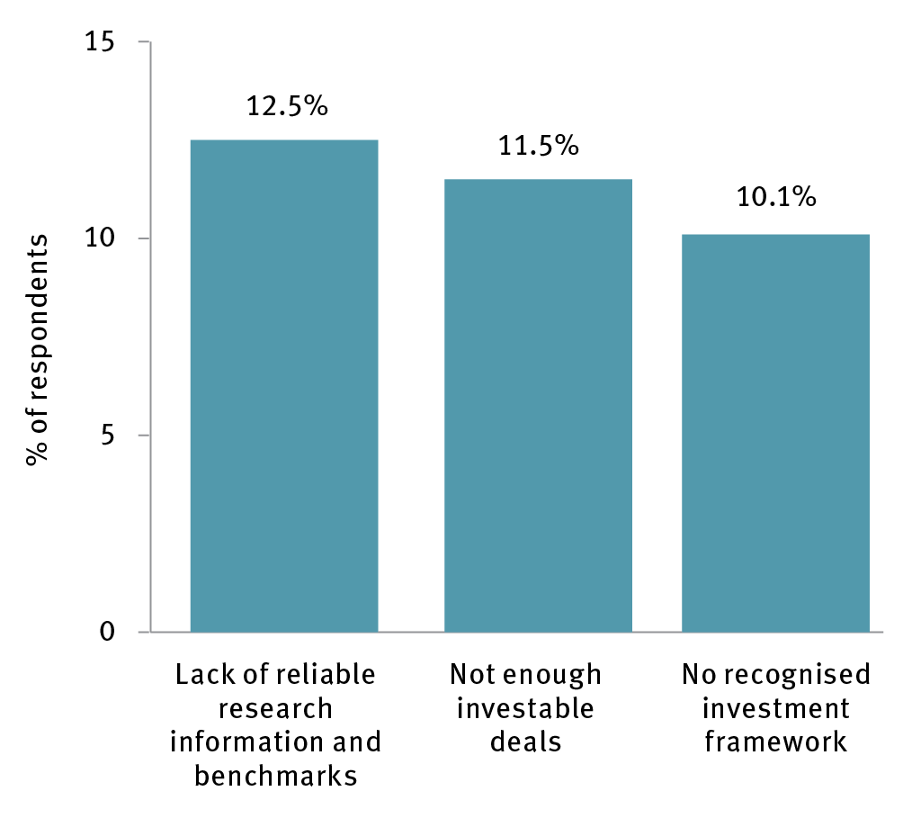

Source: Impact Investing Australia 2016, *2016 investor report*, IIA <<https://impactinvestingaustralia.com/wp-content/uploads/Impact-Investing-Australia-2016-Investor-Report.pdf>>.

Two major reports to government recommended options to improve the impact investment market and encourage innovation in funding social service delivery.[171] The Financial Services Inquiry identified specific impediments to SII, including the absence of guidance on impact investment for superannuation fund trustees and a need to reform laws to re-classify select private ancillary funds.[172] During 2017, the Australian Government responded by producing SII investment principles that guide government involvement in this market.[173] In addition, the Australian Government committed $30.4 million in the 2017–18 Budget to trial the use of SII, including $10.2 million to tackle homelessness in partnership with states and territories.[174] The Australian Government should continue to improve conditions for social impact investing to allow investors to pursue opportunities that generate both financial and social returns.

### Recommendations

**Recommendation 12:**Further strengthen the policy environment to encourage investors to pursue opportunities that provide both social and financial returns.

## Strategic opportunity 3.3: The use of open data would be accelerated by improving access and usefulness

### Rationale

Open public data are an asset that can be used to create financial value for companies and better service and economic outcomes for governments. Australia is above average for the release and use of open data, ranking ninth in the world in the OECD’s OUR (‘open, useful, reusable’) government data index (Figure 19). To date, over 28,000 Australian Government datasets have been made open and accessible,[175] with thousands more released by states and territories.[176]

Figure 19 Open, useful reusable government data by country, 2017

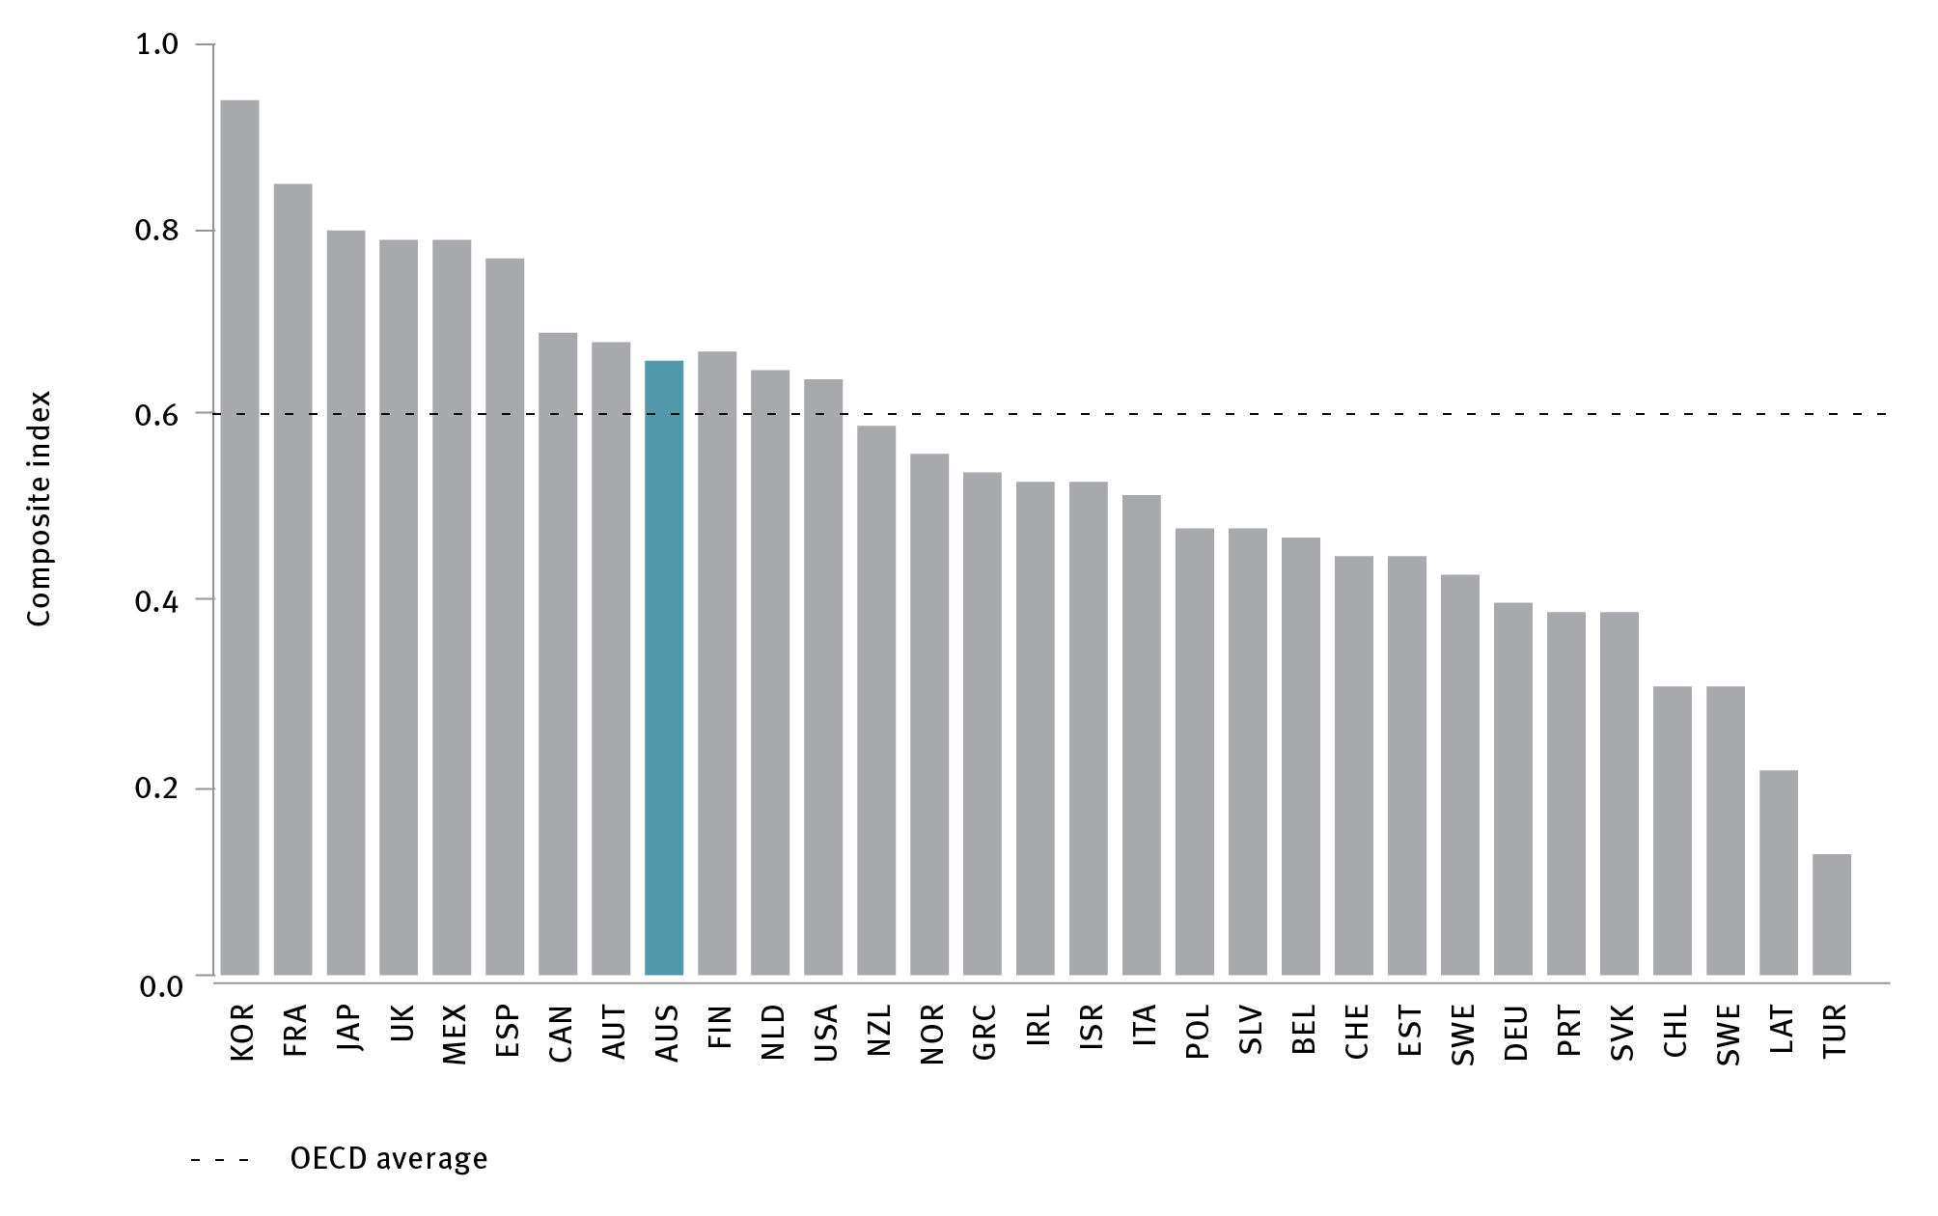

OECD = Organisation for Economic Co-operation and Development

Source: Organisation for Economic Co-operation and Development 2017, *Government at a glance 2017 database*, OECD, Paris, <<http://www.oecd.org/gov/government-at-a-glance-2017-database.htm>>.

Australia is one of only a few countries in the world to make its Geocoded National Address File (G-NAF) open and publicly available.[177] G-NAF and Administrative Boundaries datasets marry precise geographical position (latitude and longitude) with street addresses, allowing businesses to develop useful software products for customers (including emergency service providers and delivery companies). Use of these datasets has increased significantly after being made publicly available, with 73 per cent of users achieving efficiencies or productivity growth through the dataset, and 41 per cent of users reporting development of goods and services through use of the data (Figure 20).

Figure 20 Use (a)

and Impact (b) of selected Australian government datasets

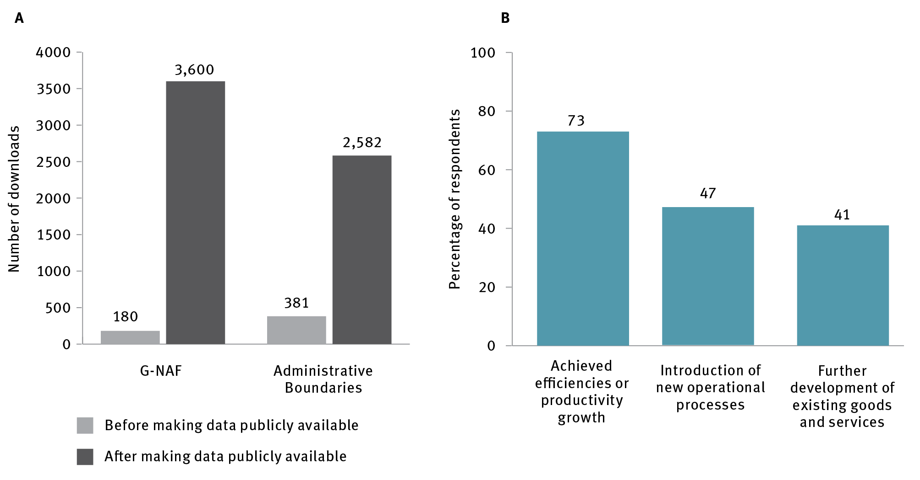

G-NAF = Geocoded National Address File,

Source: Australian Government Department of Prime Minister and Cabinet 2017, *Geocoded national address data*, PM&C, Canberra, <https://www.pmc.gov.au/public-data/geocoded-national-address-data>.

However, there is still significant opportunity to facilitate value creation through open data, with PwC estimating in 2013 that Australia could realise approximately $16 billion of additional economic value through open data.[178]

As mentioned in Imperative 2, the Australian Government has recognised the importance of data to economic activity and commissioned the Productivity Commission to undertake a data availability and use review, which was presented to the Australian Government in March 2017. [179] This review includes a recommendation that a new statutory role of national data custodian be created to guide and monitor new access and use arrangements, including proactively managing risks and broader ethical considerations around data use including providing guidance on privacy, de-identification and security. This recommendation recognised the need to balance the need to instil trust and acceptance of data systems within the community with the need to empower citizens, governments, industries and researchers to use and share data to help boost innovation.

From the specific perspective of innovators, there are two practical issues that governments face in making open data more useful for industry. Firstly, it is costly to update, and can be technically challenging to maintain in a form that is most useful for users outside government. Secondly, there is a persistent question regarding the usefulness of the data that is released. The Open Data Barometer, produced by the World Wide Web Foundation, notes that Australia ranks poorly on machine-readability and reusability of data in important domains, such as health and education sector performance and government spending. Moreover, it notes that governments are generally not publishing data that people *‘really want and need’*.[180] More substantial industry and not-for-profit feedback to originating departments for key datasets would help to improve the usefulness and usability of government data for industry and research purposes.

Creating incubator initiatives focused on government data is one strategy that governments are using to increase dialogue between government and industry to stimulate better use of open data. [SPUR in Western](http://www.spur.wa.gov.au/about-SPUR) Australia is a sector-specific example; it is a hub powered by Landgate, which helps companies and researchers to use location-based information and other government data to solve real-world challenges.[181] Similarly, [ADAX, the Malaysia-based ASEAN Data Analytics eXchange, created by the Malaysia Digital Economy Corporation,](http://adax.asia/) is both an incubator and training hub, providing information to organisations on how to harness the power of big data analytics. Public-private partnerships can also be used to harness the power of open data, such as GovHack, an annual volunteer-run competition, where participants use government data to develop novel applications and solutions.[182]

### Recommendations

**Recommendation 13:** Improve provision and use of open government data by:

developing government capability and capacity to deliver accessible, accurate and detailed public data, balancing release of data with privacy and intellectual property concerns; this will entail sustained investment in data custodianship, maintenance and release

developing improved mechanisms to encourage feedback to originating departments from industry and not-for-profit user groups to ensure that data released by governments is maximally useful.

## Strategic opportunity 3.4: National innovation can be stimulated by using government procurement as a strategic lever

Australian governments’ economic activity generates approximately one-third of the nation’s GDP. There are opportunities to strategically use this expenditure to promote innovation through procurement, and to trigger more economic spillover benefits from existing major projectsthrough strategic policy and project design choices.

### Rationale

Government spending on procurement is a significant market in Australia – for example, Australian Government procurement alone has grown from approximately $26 billion in 2007–08, to nearly $57 billion in 2015–16 (Figure 21).

Figure 21 Australian Government procurement contract expenditure, 2008–16

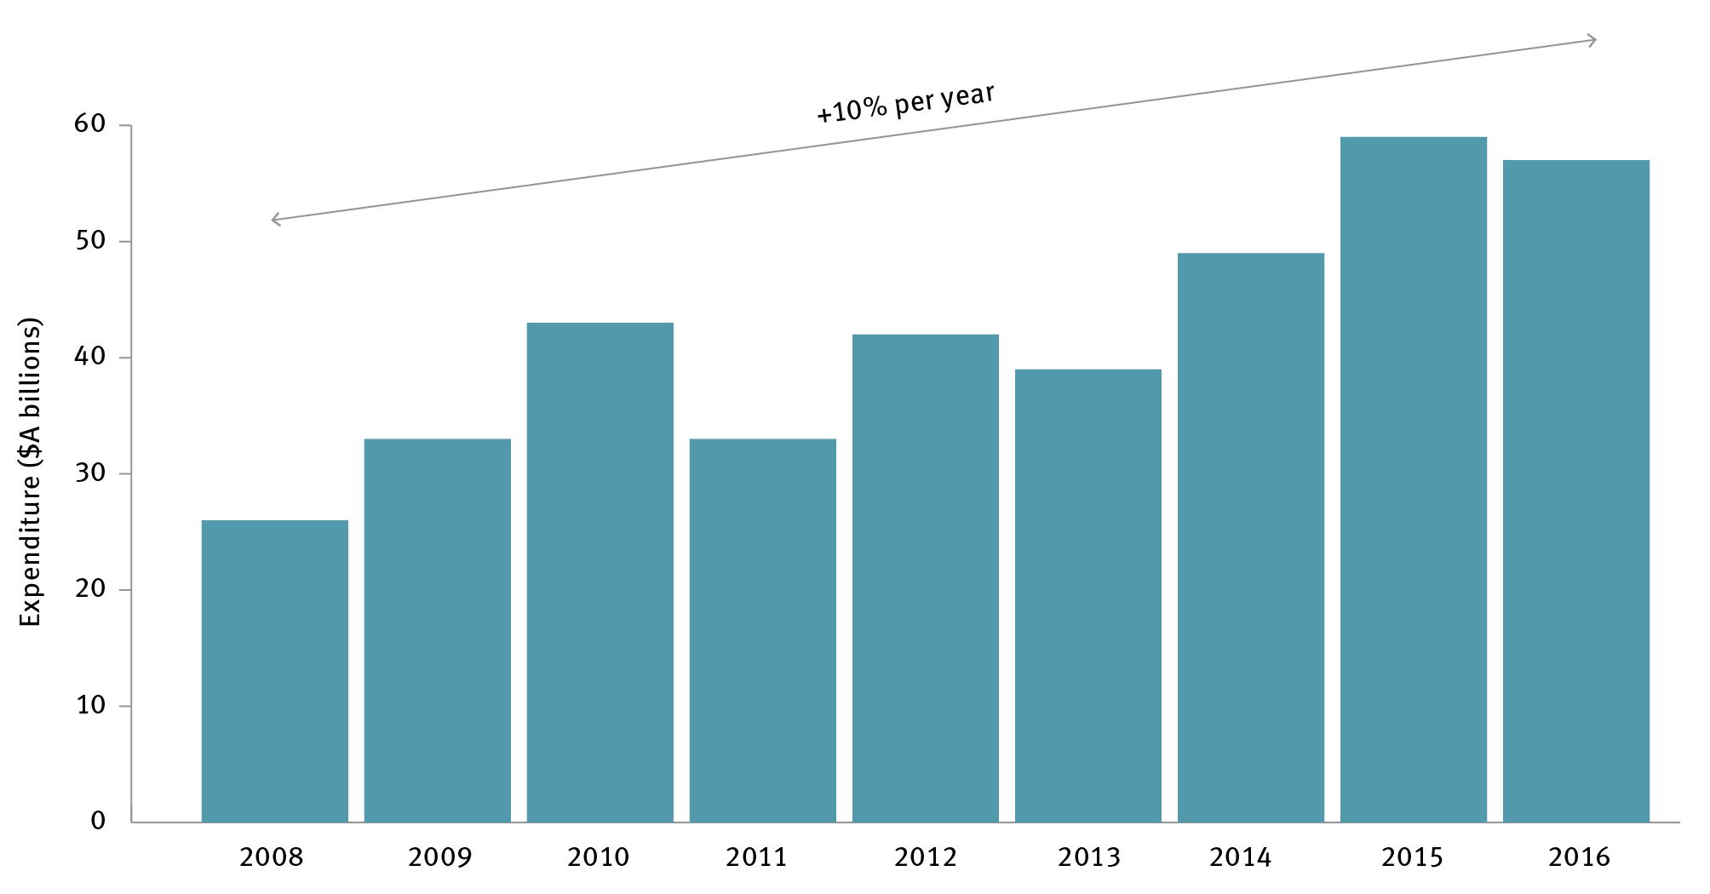

Note: The values reflect the aggregate of all contract values reported in AusTender in each financial year.

Source: Australian Government Department of Finance 2016, *Statistics on Australian Government procurement contracts*, Department of Finance, Canberra, <http://www.finance.gov.au/procurement/statistics-on-commonwealth-purchasing-contracts>.

#### Using government procurement to stimulate innovation

Other jurisdictions use procurement to foster innovation and economic benefits. The United Kingdom and United States governments both run small business research or innovation initiatives as part of their procurement strategies. Through these programs, a government department identifies a specific challenge or problem that is released to the public. Small businesses can then submit an application with their proposed solution, and over the course of multiple phases, the company has the opportunity to prototype and possibly scale their solution.[183] Small Business Innovation Research (SBIR) allocations in the United States have led to the creation of new firms,[184] significantly faster growth and employment, and higher likelihood of attracting venture capital funding.[185] The SBIR has supported the early stages of businesses that have subsequently become global success stories, such as security firm Symantec and telecommunications equipment and semiconductor maker Qualcomm.[186] United Kingdom firms that participate in the Small Business Research Initiative have nearly 10 per cent higher job creation than average, and more than 30 per cent average annual sales growth.[187]

Supporting young, fast-growing firms through procurement is strategic because these firms are outsized contributors to innovation, jobs and growth. As participants in the Melbourne roundtable conducted as part of the ISA review noted:

We need to get to a point where government agencies in particular are not looking at programs any more as just handing out money but actually taking an investor view, investor output in a structured and a framed way.

Australian governments have started trialling new approaches. In August 2016, the Australian Government established the Business Research and Innovation Initiative, based on the SBIR, [188] and in March 2017 Defence announced the Small Business Innovation Research for Defence. More recently, in August 2017, the government announced a new ICT procurement framework aimed at benefiting SMEs.

Similar initiatives are also being, or have been, implemented at state and territory level by the Australian Capital Territory, Victorian and NSW governments. However, Australian governments could do more in this space. They are generally less intent on using their procurement power to foster innovation than other countries; the Australian Government ranks just 70th out of 140 countries on how well its procurement fosters innovation.[189] In addition, SME participation in government tenders, when measured in respect to contract values, is steadily decreasing, from 39 per cent in 2011–12 to 24 per cent in 2015–16.[190] Although there are certain areas within government where procurement practices are constrained by international treaties and agreements (e.g. in aid-related spending), there remain significant opportunities for improvement.

Start-ups cite multiple administrative barriers to engaging with government (Figure 22)including the need to present a financial history to obtain government contracts. United States research echoes results of ISA consultations in Australia that start-ups avoid engaging with government due to complexity and time involved in process.[191] Other countries have recognised the opportunities presented by contracting with start-ups, and are in the process of improving their procurement systems to support start-ups in their engagement with government. For example, the United States Small Business Administration launched RFP (request for proposal)-EZ in January 2013 to make it easier for start-ups to discover and compete for opportunities and for contracting officers to create statements of work.[192]

Figure 22 Barriers to contracting with government reported by start-ups

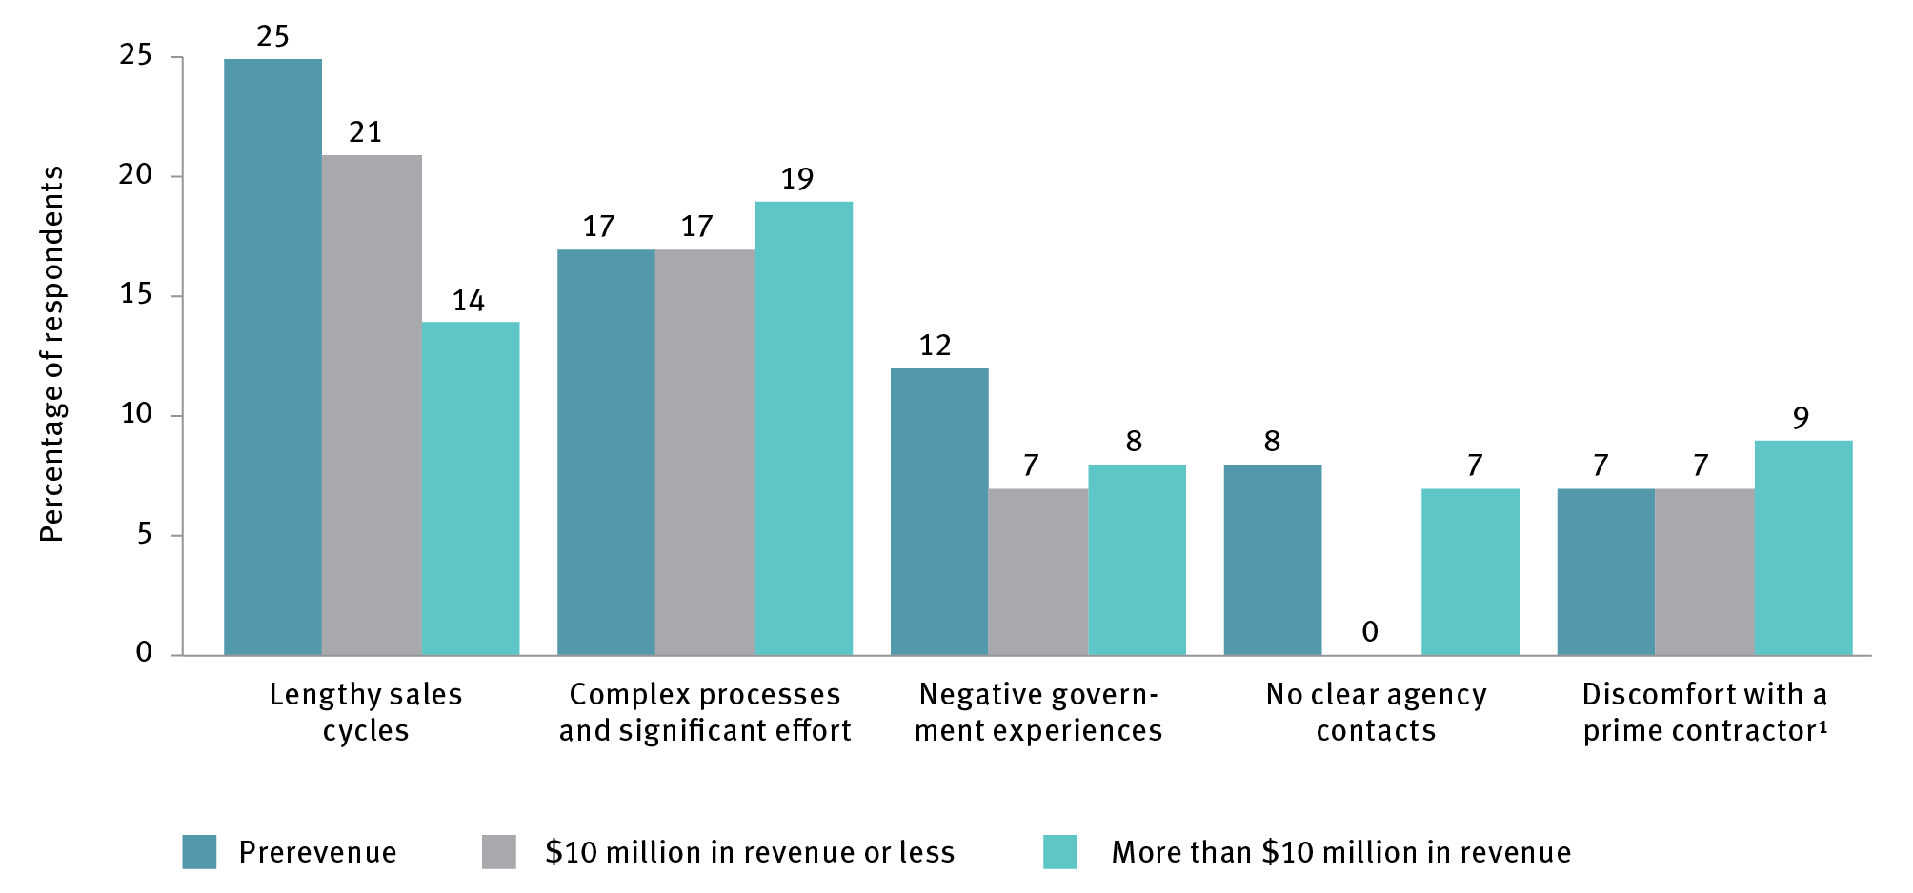

Notes:

1 Fifty-six start-ups answered the survey question ‘What are the top barriers to contracting with the government?’

2 Prime contractors often employ on government contracts

Source: Boston Consulting Group and Eastern Foundry 2017, *Why startups don’t bid on government contracts*, <https://www.bcg.com/en-au/publications/2017/public-sector-agency-transformation-why-startups-dont-bid-government-contracts.aspx>>.

#### Using major government projects that are already in progress to identify, measure and capture spillover effects

Australian governments are engaged in major projects that will have a transformative impact on the nation’s industry and service delivery landscape. These include the National Disability Insurance Scheme;[193] new surface ship and submarine capabilities in Defence;[194] and infrastructure projects at the federal and state and territory level, including the National Broadband Network, and the development of the Fishermans Bend project in Victoria.[195]

Spending on major programs that governments have already decided to pursue can bolster industry capability, productivity and competitiveness. Health care and defence are often singled out as sectors where government can effectively use its leverage, because these markets have government as the principal customer and regulator.

Economic growth and job creation are traditional spillover effects of major projects through multipliers. These are extra economic and jobs activity triggered by the activity that multiply the benefit of each original dollar spent by government. Innovation and skills spillovers are also important, as they build increased capability in the supply chain serving the project, and the employees working on the project, including by exposing them to new technologies and practices. However, it is difficult to forecast spillover benefits from major programs, or even calculate the spillover benefits from past or current programs, because of a lack of suitable data.

Projects involving advanced research and development and technology transfers are used by governments overseas to create new capabilities to expand into new or broader markets beyond the original project. Sweden’s Gripen aircraft building project, for example, had an economic multiplier of 3.6 and generated five new firms and 1200 jobs by 1987 and 3000 jobs at steady-state, mainly through high-technology and R&D activities.[196]

Case study 6 Thales Australia: partners with defence science and technology

During the 1970s and 1980s, the research arm of the Australian Government Department of Defence – known as the Defence Science and Technology Group (DSTG) – pioneered work on sonar sensors used to help detect activity at sea. DSTG recognised they would need a partner to further develop and commercialise their work for it to be deployed in the field, and chose a multinational supplier with an Australian research and manufacturing arm, Thales Australia, who combined the ability to leverage global supply chains and markets with strong local research capability. The Thales sonars, powered by DSTG R&D, continue to provide the Australian Defence Force with regionally superior undersea warfare capability for the nation’s surface ships and submarines.

Subsequent non-military spin-offs have provided sophisticated products for the civilian seismic industry, resulting in $350 million in export revenues for Australia in recent years, and creating new opportunities for local companies in the supply chain. This enduring R&D partnership has underpinned the recent breakthroughs that have resulted in a fibre laser sensor array, a compact and robust sonar that uses micro-lasers to detect activity at sea and can be easily towed behind navy vessels.

DSTG and Thales employ scientists, engineers, and technicians all across Australia, with 2100 employees in DSTG and over 3200 in Thales. The insights from this work are also being shared with the broader Australian manufacturing industry through Thales’ participation in the Advanced Manufacturing Growth Centre, where they link other Australian advanced manufacturers into global supply chains. In 2015, Thales signed a global supply chain agreement with Defence to assist competitive Australian SMEs to grow and enter export markets. This has resulted in 80 contract wins within the first 12 months of operation, and is a great example of how large multinational companies are working with government researchers and policy makers to connect competitive Australian SMEs to export markets.

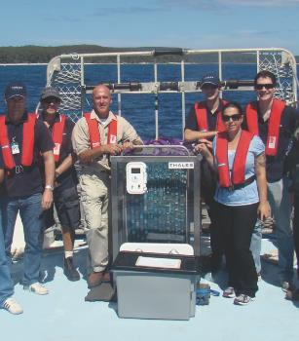

Although Australian governments have used major projects to achieve broader economic benefits, the full potential has not always been realised. The Collins Class Submarines project, for example, produced some innovation benefits. A novel steel technology developed with a number of partners, including BHP and Bisalloy steels,[197] was leveraged in new Defence commercial applications[198]and export market products.[199]However, a review of the economic impact of submarine building in Australia commissioned by the Australian Government Department of Defence reached the conclusion that spillover effects from the Collins Submarines were *‘largely unrealised’*.[200]

The reasons that Australian projects are not triggering the same level of benefits seen in countries such as the United Kingdom include contractual arrangements that result in higher-value activities going offshore, and investment in projects that are unlikely to generate niche advanced manufacturing industry. The Defence industry policy in the United Kingdom does not mandate a fixed offset from major projects, instead opting to focus on strengthening their industry competitiveness. For example, the United Kingdom has committed to increasing the proportion of defence procurements benefiting British SMEs to one-third by 2020,[201] as well as increasing science and research activity through the establishment of a 10-year, £800 million innovation-procurement fund.[202] The Ministry of Defence explicitly supports export activity, with export potential constituting part of the defence equipment procurement decision process.[203]

Australia’s long-held Defence policy (since the 1992 Price Review on Defence Policy and Industry) is that it is more impactful for Australian industry to be encouraged and incentivised to enhance their productivity, skills and innovation to win domestic and export business, than to rely primarily on preferential treatment in procurement processes to support local businesses.

Defence is investing $200 billion over the next 10 years in defence capability, and implementation of the 2016 Defence White Paper.[204] Defence is actively engaged in strengthening local defence industry innovation capability. This includes establishing a 10-year $1.6 billion defence industry and innovation program aimed at boosting Defence’s operational capability and defence industry capability.[205] This includes establishing the Centre for Defence Industry Capability (CDIC), the Defence Innovation Hub for the development of capabilities, and the Next Generation Technologies Fund for the research of capabilities.

Defence and the CDIC is currently developing the defence industrial capability plan, including the sovereign industrial capability assessment framework, and the defence exports strategy. These documents will provide the final pieces of an integrated blueprint that will identify areas of sovereign industrial capability and areas for export potential.[206] Most notably, the Defence Science and Technology Group is pioneering innovative partnership, collaboration and research translation mechanisms, with an explicit spillover benefit of raising knowledge intensity across the innovation supply chain of Defence.

Defence is also working with the Australian Government Department of Industry, Innovation and Science to collect and report on the industry and innovation spillover benefits of some of its major capability programs. These future longitudinal data sets have the potential to inform future spillover forecasting.

### Recommendations

**Recommendation 14**: Establish a small and medium enterprise (SME) procurement target of 33 per cent of contracts (by dollar value) being awarded to Australian SMEs by 2022. The Australian Government Department of Industry, Innovation and Science should report on progress towards this target annually.

**Recommendation 15**: Increase the use of innovative procurement strategies to improve outcomes and optimise government operations by:

establishing programs that promote, track and report on progress towards procurement practices that drive innovation (including identifying impediments raised by industry, and measuring participation of firms by age and stage) across all levels of government

continuing and potentially expanding the challenge-based Business Research and Innovation Initiative and Small Business Innovation Research for Defence program, and managing their evolution to become an Australian Small Business Innovation Research equivalents of the successful United States program

developing contractual frameworks to facilitate procurement from start-ups and young firms

creating a ‘government as first customer’ program designed for high-growth firms, including start-ups, to be trialled by two of the major procurement departments before a roll-out across all government departments.

**Recommendation 16:** Maximise the benefit from nationally significant government programs by establishing a framework to identify, predict, encourage and evaluate spillover benefits by:

using major Defence programs (such as submarine, continuous ship-building and land combat vehicles programs) as ‘pathfinders’ to establish how government can best define, deliver and measure broad national value; the ‘pathfinder’ should plan, collect and report on data and insights that will help future governments and policy makers to calculate and forecast industry and innovation spillover benefits

exploring and reporting on how other major projects and programs (information and communications technology, infrastructure) can be leveraged to deliver increased innovation and spillover returns and reskill the workforce; the Defence Science and Technology Group’s engagement with innovative companies, including the provision of investments for design and prototyping via the Next Generation Technology Fund and the Defence Innovation Hub, provides a potential exemplar.

## Strategic opportunity 3.5: Government service delivery can be improved through process redesign and digital technology

### Rationale

Digital innovation is an existing strength for Australian governments; Australia ranks second in the world in United Nations’ E-Government online index and e-participation index.[207] It is essential, however, for governments to continue to find new ways to deliver better services more cost-effectively, and to improve citizen and business experience. Service digitalisation is vital to meet the demands of Australians, who expect more and better digital services from government, delivered to the same standard as other private sector organisations. It is also critical for governments to meet the challenge of doing more with less. Digitalisation of interactions between government and its citizens has the potential to reduce total departmental expenditureby up to 12 per cent by 2026 (Figure 23).

Figure 23 Potential savings from implementing digital technology, 2026

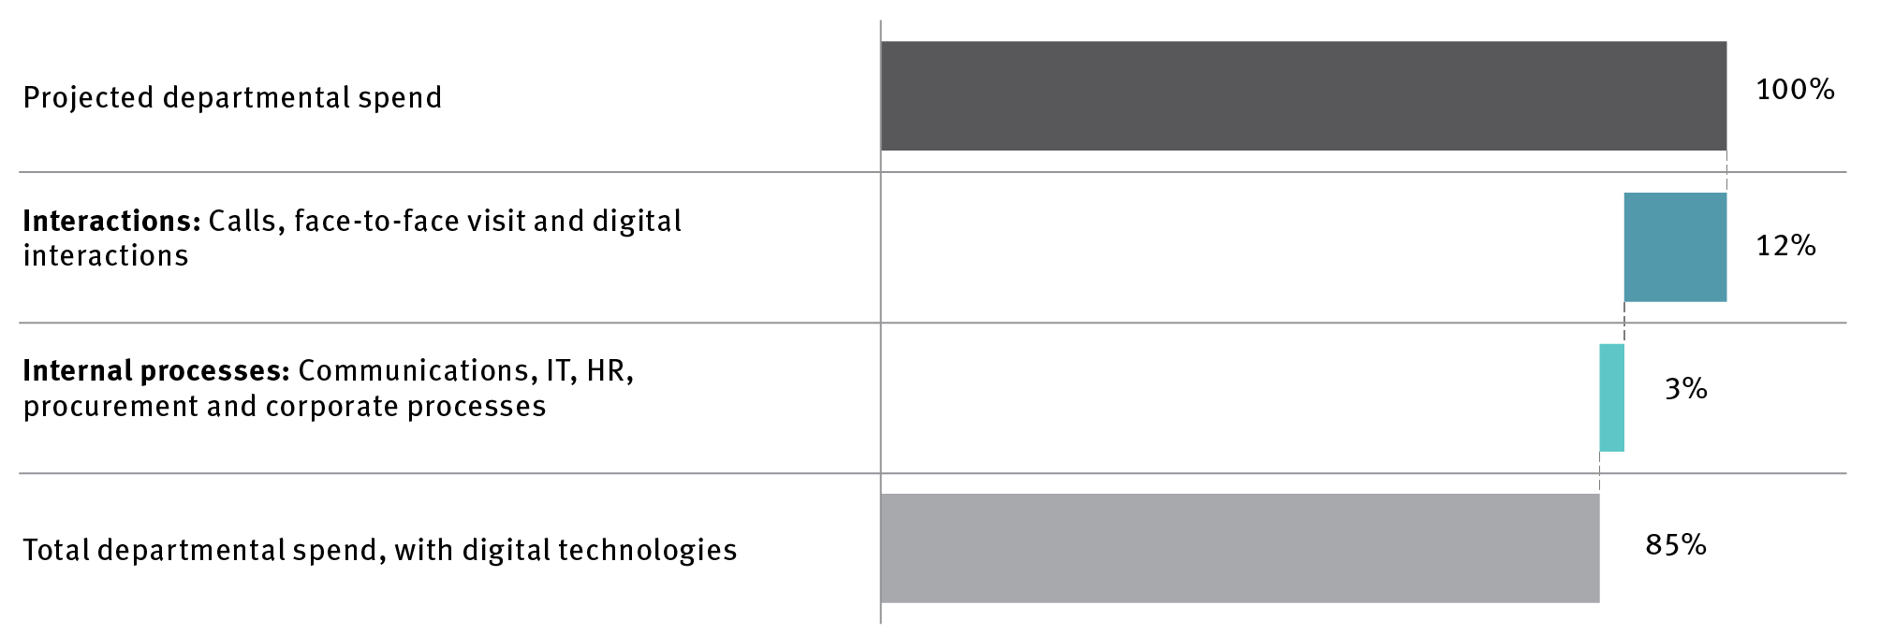

IT = information technology; HR = human resources

Note: Savings shown are the maximum forecast level.

Source: Blackburn, S, Freeland, M & Gärtner, D 2017, *Digital Australia: seizing opportunities from the Fourth Industrial Revolution*, McKinsey&Company, <https://www.mckinsey.com/global-themes/asia-pacific/digital-australia-seizing-opportunity-from-the-fourth-industrial-revolution>.

Australian governments are already making good progress in innovating service delivery. The Australian Government has established the Digital Transformation Agency to lead digital transformation of government services, and implemented a Digital Service Standard to ensure that all services designed or redesigned after May 2016 meet certain criteria in service delivery, for example, understanding user needs.[208] The Australian Taxation Office’s use of chatbots[209] has demonstrated a first-contact resolution rate of 80 per cent, exceeding the industry benchmark of 60–65 per cent.[210] The Taxation Office also accrued $500 million of savings in one year alone through prevention of error and fraud using advanced analytics.[211] There is significant opportunity to leverage analytics for compliance more widely in the Australian Government and state and territory public sectors.

Although Australian governments are rolling out a range of digital services, Australian citizens believe all tiers of government could do better (Figure 24).

Figure 24 (A) Percentage of Australians who strongly agree that governments are using technology well to deliver services; (B) Perceived benefits from government using the latest technology to deliver services

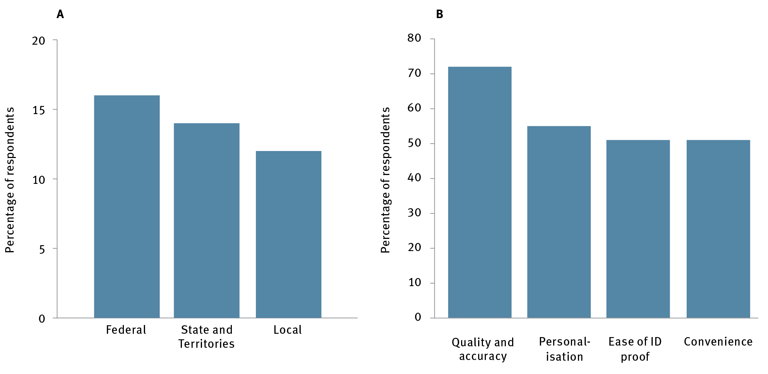

Note: The study was conducted online among a nationally representative sample of Australians 18 years and over. The sample was 1044 respondents, distributed throughout Australia including both capital city and noncapital city areas.

Source: Australian Information Industry Association 2017 Technology and Government Study, AII*A, Canberra <https://www.aiia.com.au/__data/assets/pdf_file/0019/75034/gov-study.pdf>.

Australians are also ambitious about the service experience they believe governments should provide. They want high-quality, easy-to-use, personalised services.[212] They are open to governments introducing new innovations, such as anticipating needs and requirements and actively contacting people and businesses about them, and providing a single set of log-in credentials for all digital services provided by the Australian Government.[213]

International evidence has demonstrated that digital transformation of government service delivery will be unsuccessful if undertaken without regard to citizen needs and desires. Active engagement of citizens with the agencies providing services is vital to those agencies achieving their overarching missions. Improving citizen experience can also increase voluntary compliance and trust in government, in addition to making services more cost-effective.[214] Key elements to improving customer experience include using behavioural psychology to manage expectations; reinventing customer journeys using digital and design thinking; using customer journeys to empower frontline employees; and establishing metrics and a governance system.[215]

In this regard, Service NSW has set the benchmark for digital government customer experience in Australia. Since July 2013, Service NSW has served more than 47 million customers and has maintained a 97 per cent satisfaction rating.[216] Service Tasmania implemented a model with similar objectives as early as 1998.

The Australian Public Service (APS) has a long history of effective operation. The Coombs Royal Commission in the 1970s and the Block Review in the early 1980s helped to establish a public service that was fit for purpose in those times. Consistent with these reviews, the APS is organised, resourced and held accountable on vertical or sectoral lines, and it is internationally regarded as one of the best public services across comparative countries. But our economy and society are being fundamentally disrupted, and we need to ensure that the service remains fit for purpose.

To achieve game-changing innovation in government service delivery, and for government to drive greater innovation in a transformed digital economy, the public sector should be designed to work across portfolios and its processes designed to exploit digital technology (rather than adding digital technology to legacy organisational structures and processes). Like organisations facing — or leading — disruption in the business world, the public sector needs to have the capability skills, culture, technical ability and collaborative methods to work effectively as a whole, and in cooperation with other organisations in the economy, to deliver the innovative services and policy required by business and the public in the 21st century.

The digital economy offers a prime example of how businesses are creating game-changing innovation. Amazon started out as an online bookseller. As it grew, it found that its ICT wasn’t keeping up. To solve the problem, Amazon’s engineers found a way to decouple the ICT infrastructure from the applications that ran on it. Amazon subsequently realised they could offer this infrastructure as a platform for other businesses and private users to build value. Today, Amazon Web Services is the dominant player in the cloud infrastructure market. Amazon’s process and business model transformation is just one example of a company’s capability to continually transform itself. It’s fair to say that the only constant element in Amazon’s more than 20-year history has been its culture of customer-centricity, frugality and innovation; something its founder underlines each year in his letter to shareholders.

Like many companies in disrupted industries, the APS should continually strive to deliver better services, and drive innovation and opportunity in a fundamentally transformed economy. To make game-changing innovation in government service delivery, and for government to drive greater innovation in a transformed digital economy, the public sector needs much more horizontal or cross-sectoral collaboration. It also needs significantly improved policy making and service delivery capability. The capability we need from the APS in 2030 should also be significantly transformed to fully leverage innovation and digital technology.

The recent independent functional and efficiency reviews across major departments and agencies identified the need to build strategic policy and analytical capability within departments and agencies to better meet the future needs of government. Forty-five per cent of the reviews identified the need for strengthened strategic policy and analytical capability.

The reviews may have been valuable for effecting incremental change, but notwithstanding its current strengths the APS should aim for transformative, not iterative, reform to deliver in a new digital economy. Government should consider reviewing the APS to ensure it is ready to lead the transformation out to 2030 and beyond, as envisaged in this plan. For the APS to credibly foster greater innovation and productivity, it will need new mindsets, skills, and capabilities to deliver innovative digital services for businesses and citizens.

### Recommendations

**Recommendation 17**: Instruct the Digital Transformation Agency to explore opportunities to achieve half of the projected 12 per cent of savings from digitising service delivery by 2022 and the balance by 2026, while simultaneously improving citizen satisfaction with government services. The agency should be resourced to also:

benchmark and report on the effectiveness and efficiency of the use of digital technologies and the improvement of service delivery (using automation, advanced analytics and service delivery dashboards to monitor and evaluate the impact of spending)

set a target for citizen satisfaction as part of the planned assessment of performance against key performance indicators, and track the progress of every department delivering citizen-facing services against it; for example, by considering the adoption of the Service NSW approach to benchmarking and measurement of satisfaction.

**Recommendation 18**: Conduct a review of the Australian Government Public Service with the aim of enabling a greater role and capability for innovation in policy development, implementation and service delivery. This work complements, and could be connected with, the work of the Secretaries Australian Public Service Reform Committee.

# Imperative 4 Research and development: Improve research and development effectiveness by increasing translation and commercialisation of research

ISA’s vision for Australia’s R&D sector is to maintain the excellence that has become its hallmark, while increasing the incentives for collaboration and commercialisation.

ISA sees a key role for government in accelerating R&D by providing incentives that increase commercialisation and stimulate jobs growth. Universities, publicly funded research agencies such as CSIRO, research institutions, and industry are also key players – generating high-quality research outputs, training new research talent, actively finding new opportunities to collaborate, and investing financially in R&D activity.

## Strategic opportunities for government

There are five strategic opportunities for governments to accelerate R&D in Australia by 2030:

**Strategic opportunity 4.1:** Industry–research sector collaboration could be increased by introducing a collaboration premium in the Research and Development Tax Incentive program

**Strategic opportunity 4.2:** Institutional support for commercialisation could be increased by establishing a dedicated stream of funding for translational activities

**Strategic opportunity 4.3:** Maintaining Australia’s high-quality research will require continued investment in national research infrastructure, commencing with the nation’s high-performance computing facilities

**Strategic opportunity 4.4**: Making the most of available research talent would be facilitated by promoting greater diversity in the research and innovation workforce

**Strategic opportunity 4.5:** The growing momentum in Australian venture capital would be supported by taking measured and consultative approaches to any intervention.

## Strategic opportunity 4.1: Industry–research sector collaboration could be increased by introducing a collaboration premium in the Research and Development Tax Incentive program

### Rationale

Industry and research collaboration, such as research contracts, consultancies and joint IP filings, is critical to translate knowledge creation to application. It allows universities and industries access to high-cost infrastructure, data and talent that they would not otherwise have. It also benefits industry, with business impacts up to twice as high for projects with academic partners.[217]

Australia has low rates of industry–research collaboration by international standards. Only 5.1 per cent of the expenditure on R&D by the higher education sector is financed by industry, placing Australia 8th of eleven peers for share of higher education revenue derived from industry (Figure 25).[218] Australia is also ranked 27th of 38 OECD countries for proportion of publications with industry co-authors.[219]

Figure 25 Percentage of higher education expenditure on R&D financed by industry, as percentage of GDP, 2014

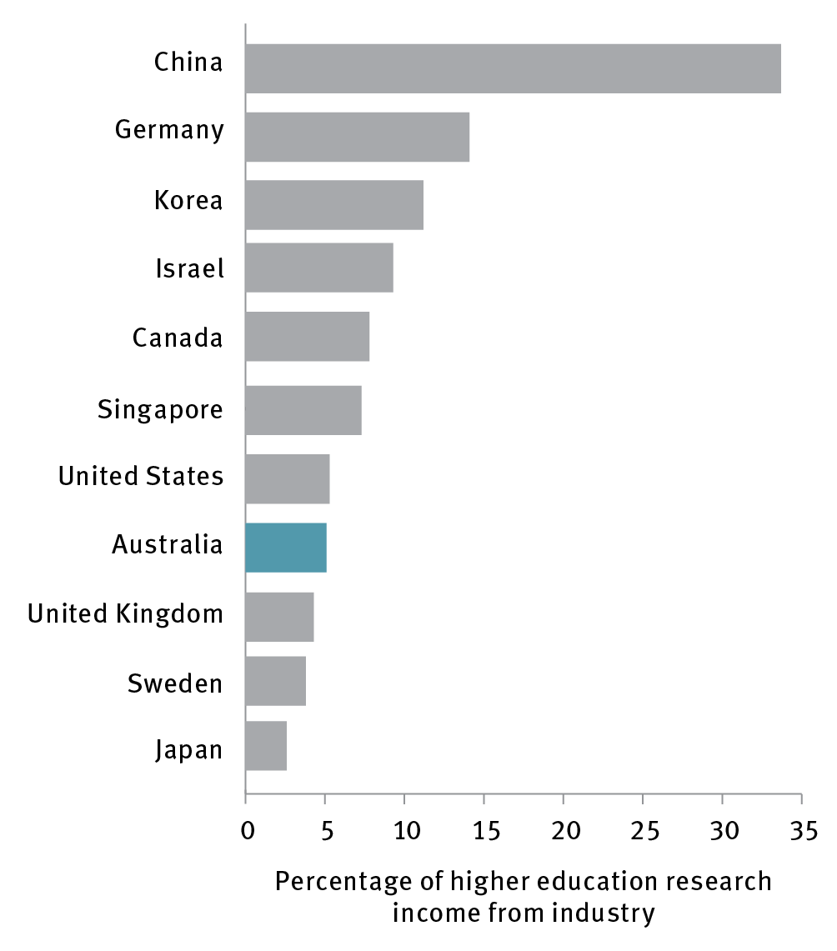

Note: Data for Israel and Sweden from 2013

Source: Organisation for Economic Co-operation and Development 2017, *Main science and technology indicators*, OECD, Paris, <[http://www.oecd.org/sti/msti.htm>](http://stats.oecd.org/).

On the research side, there are two main factors that have contributed to Australia’s lagging performance. The first is that institutional researchers have historically faced disincentives to collaborate with industry or move between industry and academia. This is because institutional promotions and government research funding were allocated based overwhelmingly on academic measures such as peer-reviewed papers, rather than industry collaboration or commercialisation metrics. Although there are funding programs with the express purpose of encouraging such links, such as the CRC programme (where, between 1991 and 2015, 1277 organisations, or 67 per cent of participants were from industry)[220] or the Industrial Transformation Research Program, the overarching structures remained a barrier.

The second factor is the lack of at-scale industry placement programs for higher degree research (HDR) students, most of whom are PhD students. These placement programs build a culture of collaboration from the critical first years of researchers’ careers. Industry placements also increase the collaboration skills of those who enter academia and increase the quality and quantity of researchers who enter private industry. Such programs are a feature of nations that lead in industry–research collaboration. However, imparting broad transferable skills is not currently embedded in HDR programs in Australia as it is in comparable programs around the world.[221]

The Australian Government has recently addressed collaboration incentives. Following the review of research policy and funding arrangements in 2015,[222] the Australian Research Council (ARC) Linkage Projects scheme for competitive funding of projects with an industry partner and the Australian Government Department of Education and Training research block grants were amended to incentivise and facilitate greater collaboration with industry. Changes included revising ARC guidance to prioritise high-quality proposals involving business partner organisations; improving access for SMEs to research collaborations by exempting businesses with up to 20 employees from cash contribution requirements; and improving the incentive for industry collaboration by harmonising three types of block grants and increasing the weighting for industry engagement in the funding formula. NISA also tasked the ARC with developing an assessment system for the engagement and impact of university research. The resulting engagement and impact assessment system was piloted in 2017 and will be rolled out at scale in 2018.

Research institutions and the Australian Government have also begun to address industry placements. In mid-2017, the Australian Government provided support to the Australian Mathematical Sciences Institute to place an additional 1400 PhD interns in industry by the end of 2020 on industry identified and co-funded short student–industry–academia research projects.[223] The government is also responding to the Australian Council of Learned Academies Review of Australia’s Research Training System, which made recommendations in this area.

Broader government and sectoral initiatives are also creating people-to-people connections with industry for PhD students. Good examples include the Innovation Connections element of the Entrepreneurs’ Programme[224] and the Academy of Technology and Engineering’s Industry Mentoring Network in STEM (IMNIS).[225] However, this is an issue that requires ongoing work by all parties at scale to achieve long-term change.

International industry HDR placements programs such as the French CIFRE[226] and the United Kingdom’s Knowledge Transfer Partnerships[227] have influenced Australian approaches. Longevity, stability and scale have been key to these programs’ success, providing industry with a facilitated one-stop shop to access HDR talent. The number of researchers employed in businesses in Australia is low[228], and programs such as these can provide a way to help address this. In the most recent evaluation of the KTP, more than 50 per cent of HDR students who responded to the survey were employed by the KTP partner business immediately after the placement had finished.[229]

Improving incentives for research organisations only addresses half of the research-industry links equation. Building the capability and desire of businesses to collaborate with public research organisations is an area that requires further action. As recommended in the review of the R&DTI, discussed further under Imperative 2, a collaboration premium should be introduced to elicit genuine behavioural change and to incentivise businesses to reach out to the research sector.

### Recommendations

**Recommendation 19:** Introduce a collaboration premium of up to 20 per cent on non-refundable tax offsets to incentivise collaboration (as part of implementing the recommendations of the Review of the R&D Tax Incentive, Recommendation 6 under Imperative 2).

**Recommendation 20:** Evaluate the benefits of introducing an industry higher degree by research placement program at greater scale with long-term support, including assessing the merits of international examples of similar programs.

**Recommendation 21**: Conduct an expert review in 2022 to evaluate the effectiveness of recent changes that incentivise collaboration, and recommend options for further action. The review should cover, at a minimum:

the engagement and impact assessment implemented through the Australian Research Council

funding changes following the Review of Research Policy and Funding Arrangements, including to the Linkage Program and research block grants

progress on addressing the findings and recommendations of the Review of Australia’s Research Training System

progress on ensuring that university career paths allow for mobility between academia and industry

the recommended collaboration premium under the R&D Tax Incentive.

## Strategic opportunity 4.2: Institutional support for commercialisation could be increased by establishing a dedicated stream of funding for translational activities

### Rationale

Australia’s research organisations produce world-class research outputs, and are generally adapting well to changing market conditions. The Australian Government’s assessment of university research through Excellence in Research for Australia found they generally achieve a high level of quality and productivity in research. However, there is room to improve the levels of knowledge translation and commercialisation arising from research activity.

Case study 7 Anatomics: from start-up to international success

Imagine a future where a surgeon needing to replace a patient’s damaged bone or joint takes a scan of the body part and emails it to an onsite manufacturer, who then prints off the customised implant and rapidly delivers it for use in surgery.

Such a scenario is no longer just in the realm of science fiction. Advanced manufacturing techniques and developments in computer sciences, pioneered by the Australian firm Anatomics, are making customised implants a reality.

Anatomics is a Melbourne-based, Australian-owned innovative medical device and software company that pioneered the use of 3D imaging and printing to manufacture surgical implants from advanced composite materials that are revolutionising patient care in a range of applications.

The technology has recently been used to design a world-first 3D-printed titanium and polymer sternum, which was successfully implanted into a British patient who had previously had his sternum removed because of a rare infection. Another was implanted into an American patient after a tumour was removed from her sternum.

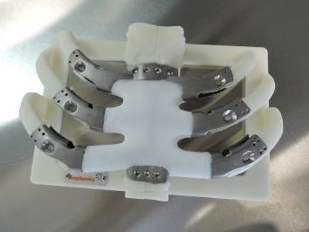

Research and development has been critical to developing Anatomics’ breakthrough technology. Anatomics founder, Mr Paul D’Urso, first began the research that led to the formation of the company in 1995 with a $1200 grant from the hospital he worked in, and support from the Queensland Government.

Later, Anatomics’ research partnerships with Australia’s national science agency CSIRO was also crucial, enabling the company to draw on specialist expertise in disciplines such as material science, and granting them access to cutting-edge infrastructure, such as CSIRO’s Lab 22 facility in Melbourne, which helped to design and print the titanium sternums.

Anatomics is creating social and economic potential. Its technology has the potential to revolutionise the prosthetics industry, as custom-made implants are often more durable, better fitting and cheaper than currently available ‘off-the-shelf’ alternatives. The company exports to around 40 countries and has created highly skilled roles working at the global forefront of medical technology.

Universities and other publicly funded research agencies are increasingly active in translational activities that involve greater industry collaboration. For example, CSIRO’s current strategic focus is on positioning itself as Australia’s ‘innovation catalyst’, which has seen a significant shift in emphasis towards impact and engagement. CSIRO’s ON Accelerator program, which offers a range of accelerator services for researchers seeking to commercialise their research efforts, is creating a more entrepreneurial culture among research staff across the publicly funded research sector. The program is now being piloted with small businesses as part of an ‘ON for SMEs’ program. The Australian Nuclear Science and Technology Organisation is similarly working to engage more with industry. It has announced plans to upgrade its facilities at Lucas Heights to better accommodate a range of industry partners. Universities are increasing their focus on start-up support programs[230]. These are encouraging trends.

The Australian Government is placing greater emphasis on strategic research investment in areas with commercialisation potential. The Medical Research Future Fund will nearly double the government’s investment in medical research over the next decade, with a strong focus on translational and mission-directed activity, such as clinical trials. Investments in Defence R&D through the Next Generation Technology Fund, the Defence Innovation Hub and the Centre for Defence Industry Capability are intended to secure higher levels of innovation and greater sovereign capability. These trends will assist Australian researchers to achieve greater impact, and increasingly require them to work in multidisciplinary teams.

While publicly funded research agencies are improving commercialisation activity,[231] it is clear Australia needs to do more. Australia lags behind its peers for start-up formation (Figure 26) and for the share of higher education revenue derived from industry.

Figure 26 Australian start-ups formed as a result of research and development

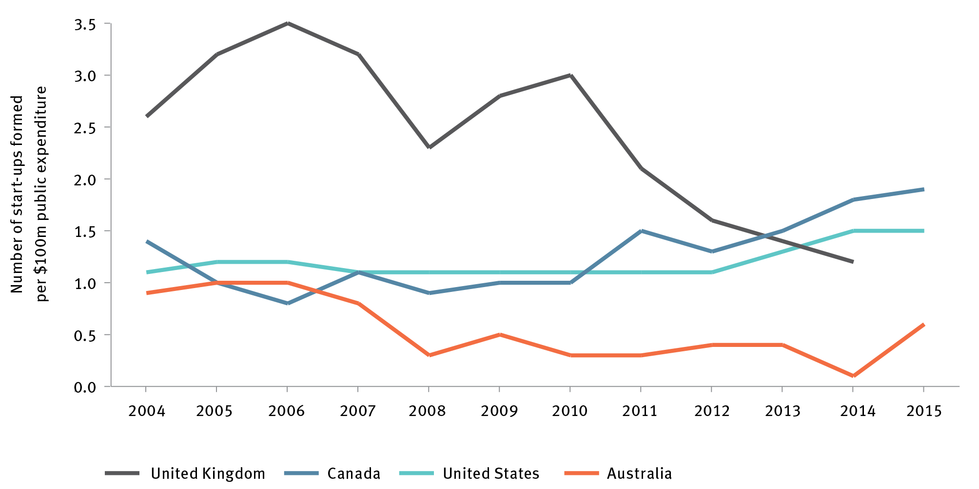

Source: Australian Government Department of Industry, Innovation and Science, *National Survey of Research Commercialisation*, DIIS, Canberra, <https://industry.gov.au/innovation/NSRC/Pages/default.aspx>.

Two barriers to commercialisation of research are competition for staff time and the availability of staff with relevant commercial skills. At present, commercialisation activities must compete within research organisations for resources that could otherwise be spent on core activities. Dedicated funding, appropriately allocated, would ensure that a minimum level of resource is allocated to translational and engagement activities, which have a significant multiplier effect on overall commercialisation activity**.** A study of the United Kingdom’s Higher Education Innovation Fund (HEIF) found a £6.4 return in ‘knowledge exchange’ income for every £1 of HEIF income received.[232]

Importantly, commercialisation activities of not occur in a vacuum – they are a product of, and influenced by, their local context. There is a significant body of evidence that innovation districts can help drive collaboration and commercialisation. When established well, these districts drive disproportionate innovation, employment and economic growth.[233] The clustering of industries and workers that occurs, usually in knowledge-intensive roles, attracts additional entrepreneurs and innovative industries. This in turn drives up average incomes, gross value add (GVA) and exports. This is borne out internationally, including in the United Kingdom where ‘innovation districts’ make up 8 per cent of businesses but contribute 20 per cent of the GVA.[234] Similarly, in NSW, ‘hotspots’ with highly concentrated industries with over 1000 employees registered growth of 2.7 per cent, as opposed to average growth in NSW of 1.2 per cent. Job growth in these 77 hotspots accounted for more than one in four jobs created from 2006 to 2011. [235]

Around Australia, governments at the state, territory and local levels are demonstrating increased interest in fostering innovation precincts in their own jurisdictions.[236] This is a welcome trend, given that most evidence points to the critical role of local leadership in driving successful innovation precincts. However, to fully realise the potential of these developments, it will be important for the Australian Government to work with state and local governments and to outline its role in supporting such precincts. Areas for consideration should include removing regulatory barriers, aligning policy, and capability building through sharing of best practice, skills development and funding support.

### Recommendations

**Recommendation 22:** Increase commercialisation capability in research organisations by establishing a new stream of funding for translational activities.

**Recommendation 23:** Develop and release an Australian Innovation Precincts Statement to shape Australian Government involvement in emerging localised innovation ecosystems in cities and regions.

## Strategic opportunity 4.3: Maintaining Australia’s high-quality research will require continued investment in national research infrastructure, commencing with the nation’s high-performance computing facilities

### Rationale

Investing in world-class national research infrastructure is critical to Australia’s research proposition. Knowledge creation increasingly requires access to large-scale capital equipment, digital technologies and expert operators, particularly in strategic areas such as STEM disciplines. High-quality national research infrastructure also helps attract and nurture top talent, and builds a global reputation for high-impact research.

Recent funding initiatives, including the Medical Research Future Fund and the Biomedical Translation Fund, will increase demand for sophisticated, advanced research infrastructure.

Although national research infrastructure is used by both industry and public researchers, it is commonly provided by government because infrastructure has a high fixed cost, with smaller benefit accruing to each user. International studies have shown high return on investment for research infrastructure. The benefit of the European Bioinformatics Institute is estimated at $1.7 billion – 20 times its operational cost of $79 million per year.[237] The 2014 KPMG report on Australia’s National Collaborative Research Infrastructure Strategy (NCRIS) noted that NCRIS has made a substantial contribution towards scientific research capability as well as research outcomes in Australia.[238]

In December 2015, the Australian Government reaffirmed its commitment to national research infrastructure through NISA. It secured operational funding for the existing facilities and projects of the NCRIS, and funding for the Australian Synchrotron and the Square Kilometre Array. Further, it commissioned the development of the 2016 National Research Infrastructure Roadmap.[239]

The National Research Infrastructure 2016 Roadmap identified nine areas of key national research infrastructure requiring additional investment to maintain a leading edge in research. It also identified two facilities requiring urgent consideration:

Australia’s fastest supercomputer, the National Computational Infrastructure, currently ranks 70th in the world, down from 24th when it was first installed in 2012. The supercomputer will reach the end of its operational life in 2018.[240] Australia’s second supercomputer, Pawsey Supercomputing Centre, will reach the end of its operational life in 2019. Australia’s innovation and research capability and ability to meet international and national obligations depend on these high-performance computers being upgraded.

The Australian Animal Health Laboratory, which supports research in exotic livestock disease and high-risk zoonotic diseases, is a unique national capability that needs to be upgraded to ensure compliance with regulatory requirements.

### Recommendations

**Recommendation 24**: Establish secure, long-term funding for national research infrastructure, in accordance with the recommendations of the 2016 National Research Infrastructure Roadmap.

**Case study 8 Pawsey supercomputer: critical national research infrastructure**

Big science and research problems require big computers with processing ‘grunt’ to model and simulate complex systems that would be too expensive or impossible to physically demonstrate.

Australia is home to two nationally significant research supercomputing facilities: the Pawsey Supercomputing Centre in Perth and the National Computational Infrastructure in Canberra. The Pawsey supercomputing facility supports some 1249 users from across 90 partners and institutions each year.

No-one appreciates a big question like an astronomer. Astronomers working on the Australian Square Kilometre Array Pathfinder (ASKAP) – a precursor to the world’s biggest telescope, the Square Kilometre Array (SKA) – will be investigating around 600,000 galaxies in a bid to gain a better understanding of how galaxies have formed and evolved.

Professor Lisa Harvey-Smith, Group Leader at CSIRO’s Australia Telescope National Facility, appreciates the scale of the challenge.

‘Once we have all 36 of the ASKAP telescopes working, we're going to have about 72 trillion bits per second of information,’ Dr Harvey-Smith said. ‘These supercomputing facilities are essential for us to even use the telescope at all.’

The Australian Government has contributed to Pawsey’s establishment through the Super Science initiative, and provides a level of ongoing operational funding through the National Collaborative Research Infrastructure Strategy. Pawsey attracts significant ongoing co-investment from the CSIRO, the university sector and the Western Australia Government.

The SKA precursor telescopes and supporting research infrastructure have increased Australia’s ability to be an active contributor in the global SKA consortium.

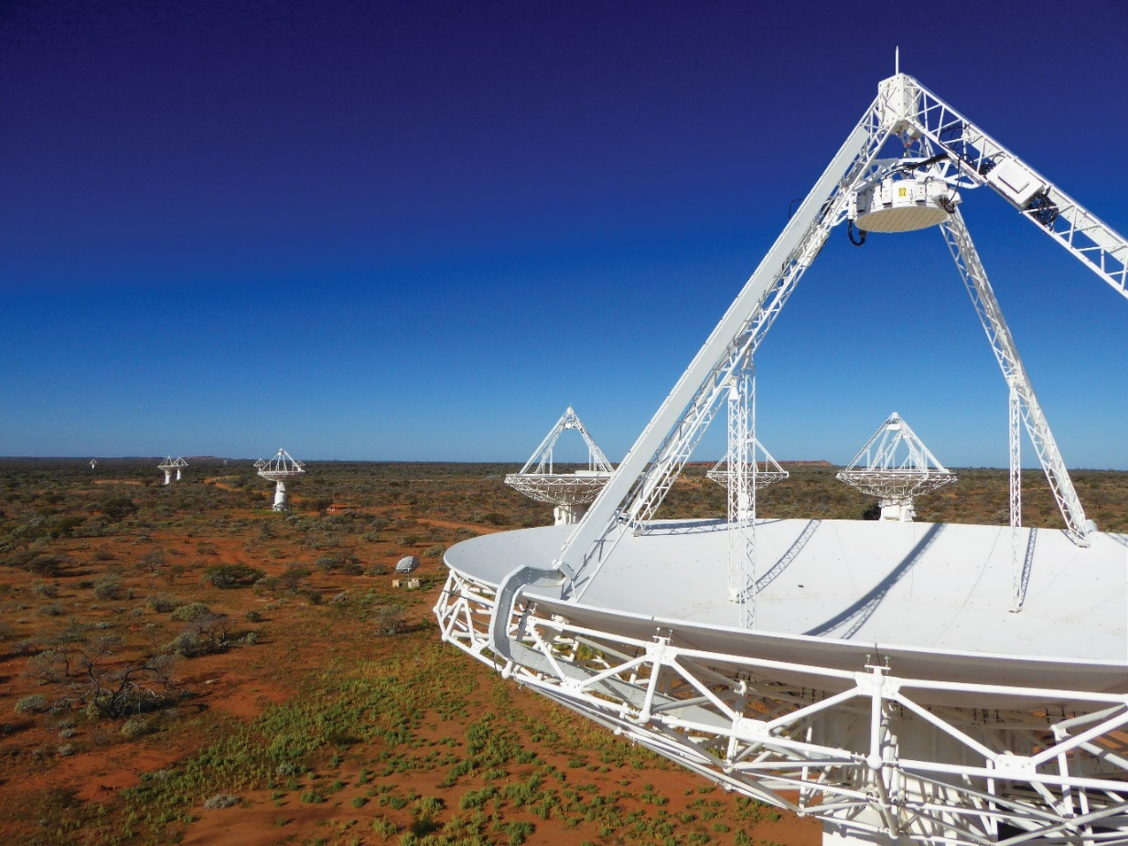

## Strategic opportunity 4.4: Making the most of available research talent would be facilitated by promoting greater diversity in the research and innovation workforce

### Rationale

Studies have found that increased gender diversity in research teams improves innovation.[241] ISA’s performance review found that a weakness of Australia’s Innovation, Science and Research system is that it remains part of a gender-unequal society.[242] Women make up fewer than one-third of STEM academic and research staff and only 17 per cent of STEM professors are female.[243] Women comprise 16 per cent of the STEM workforce.[244]

The Australian Government, through NISA, has supported programs to encourage diversity in STEM, including Science in Australia Gender Equality, Male Champions of Change in STEM, and the Women in STEM and Entrepreneurship grants program.[245] These programs are important and welcomed. They build on and complement initiatives being pursued throughout the sector. However, to achieve meaningful impact they need to be sustained over an extended period of time.

### Recommendations

**Recommendation 25:** Maintain a long-term policy commitment to achieving greater gender diversity in the science, technology, engineering and mathematics workforce, including by raising awareness of gender diversity in government programs.

## Strategic opportunity 4.5: The growing momentum in Australian venture capital would be supported by taking measured and consultative approaches to any intervention

### Rationale

Venture capital is a crucial enabler for spin-off companies from research, and has historically been limited in Australia. The situation is improving rapidly, with Australian venture capital growing from $124 million in funds raised in 2014 to $568 million in 2016. It is expected to top $1 billion in 2017 (Figure 27).[246]

Figure 27 Australian venture capital funds raised per year, 2007–17

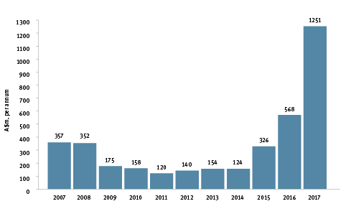

Source: Australian Private Equity & Venture Capital Association 2017, *The venture capital effect: a report on the industry’s impact on the Australian economy*, AVCAL, Sydney, <https://www.avcal.com.au/documents/item/1428>; Date for 2017 is only preliminary

The composition of this increased supply is perhaps more significant than its volume. It is especially encouraging to note the recent engagement by institutional investors as lead funders in a number of the private venture capital funds, including Airtree Ventures, Blackbird Ventures, Square Peg, Carthona Capital, and in each of the Biomedical Translation Funds managed by Brandon Capital, One Ventures and BioScience Managers. Some of our largest superannuation funds, including AusSuper, HostPlus, State Wide Super and First State Super, have now supported a number of these venture capital funds, demonstrating an emerging appetite for the risk–reward profile that is intrinsic to venture capital investing. Longer-term investment periods and illiquidity relative to publicly traded shares and bonds, are some of the characteristics of venture capital investments that have traditionally caused Australian superfunds to avoid their inclusion in asset allocations.

The business community’s interest in corporate venture capital and corporate accelerator programs is also increasing, and international investors have begun to take a greater interest in Australian technology. The IP Group, based in the United Kingdom, has committed to invest at least $200 million in spin-off companies based on the intellectual property developed by the Group of Eight universities in Australia and the University of Auckland in New Zealand.[247]

Recent government interventions following the release of NISA have increased the capital available and should be maintained. These include the newly created $500 million Biomedical Translation Fund and the $200 million CSIRO Main Sequence Ventures fund. Reforms to investment vehicles, including improvements to Early Stage Venture Capital Limited Partnerships, tax incentives for investment in early-stage innovation companies, and the Crowd Sourced Equity Funding legislation *(the Corporations Amendment (Crowd-sourced Funding) Bill 2016)* introduced in 2017, are also expected to improve capital availability. However, government intervention in risk capital markets is notoriously challenging. Therefore, given this vigorous activity, government should take a measured approach to any further intervention, informed by expert advice.

### Recommendations

**Recommendation 26:** Direct Innovation and Science Australia to monitor emerging sectors of high growth in the economy and report annually to the Australian Government on the adequacy of risk capital supply.

# Imperative 5 Culture and ambition: Enhance the national culture of innovation by launching ambitious National Missions

The recommendations in the previous four imperatives focused on specific aspects of the innovation system. Although these are important, they do not operate in a vacuum. Each will play out against the backdrop of the national innovation culture. And for the whole 2030 Plan to be successful, that culture needs to evolve.

Australia’s culture is made up of *‘the stories we tell ourselves about ourselves’*.[248] Our national stories blend pragmatism, egalitarianism, and a streak of irreverence. Importantly, they are not fixed – they evolve slowly over time, as each new generation writes its own chapters. From an innovation perspective, they matter because they shape how we see our world – and what we believe is possible – through the way we view opportunity, failure and risk.

Looking to 2030, ISA sees an opportunity to add a more ambitious chapter on innovation to our evolving national stories. We see a future as an innovation-strong nation that is also innovation proud. We see people and institutions who think differently, collaborate in new ways, and take more calculated risks. We see a nation that is galvanised around significant national challenges, and unafraid to tackle some of our biggest problems.

## Strategic opportunities for government

The Australian Government has a strategic opportunity to use ‘National Missions’ to accelerate Australian innovation and encourage more collaboration across the innovation system.

National Missions are large-scale initiatives, catalysed by governments that are designed to address audacious challenges. They are a powerful means to inspire innovators, develop solutions to big problems, and generate national passion and pride in innovation and science achievements. Australia has a grand tradition of National Mission-style projects, from building the Snowy Mountains Scheme to hosting key components of the international effort to build the Square Kilometre Array. *Australia 2030: prosperity through innovation* can build on this tradition.

National Missions will challenge potential Australian innovators to excel, and demonstrate to the world that Australia can deliver breakthrough innovation. Chosen well, they will catalyse activity around Australia’s comparative advantages, and include the entire community on the journey of creating Australia’s future. The missions will also reinforce and support other imperatives in the 2030 Plan, such as collaboration, talent attraction, and seeding high-growth businesses. As participants in the Parramatta consultation forum conducted as part of the ISA review noted:

We need to make innovation a cultural activity so that it permeates through everything that we do and the way that we think.

National Missions will be large-scale, complex undertakings. They will challenge assumptions of what is possible, and force us to find new ways to deliver outcomes. They will see public and private sectors coming together, and novel methods developed to finance and manage risk. They will need our brightest talents to solve our biggest problems with technological and social solutions.

No mission will be perfect. There will be failures, pivots and public debates. But, as John F Kennedy said of the Apollo program, *‘We choose to go to the moon in this decade and do the other things, not because they are easy, but because they are hard’*.[249]

And therein lies the most important return on investment from this imperative: an Australian nation that can take on National Missions of this scale will proudly make innovation a core part of our national story and culture.

## Strategic opportunity 5.1 A Genomics and Precision Medicine National Mission will be an ideal first mission, delivering health and innovation benefits for all Australians

Consultation during the 2030 Plan’s development identified a strong candidate project to demonstrate the value of National Missions: using genomics and precision medicine to help Australia become the healthiest country on Earth.

Genomics is the study of genomes, the entirety of our DNA. Precision medicine is the application of clinical and laboratory data, including genetic data, gathered in aggregate across a population of healthy and ill people, to better guide the management of an individual patient.

Genomics and precision medicine will play an increasing role in improving health outcomes, drawing on accelerating developments in gene sequencing and data analytics. We see genomics and precision medicine playing a role in:

earlier diagnosis – allowing a greater range of targeted, cost-effective population genome screening programs to identify rare and chronic diseases, especially cancer, earlier than ever before

prevention – enabling targeted public health campaigns, more specific cohort screening, increased awareness of individual susceptibility, and self-management of lifestyle and prevention activities

better and safer treatments – facilitating individual drug and treatment matching, enabled by integration of genetic data with phenotypic data (the observable characteristics of an individual resulting from the interaction of its genotype with the environment), gene therapy and gene editing assisted by AI and ML.

While aspiring to be the healthiest country on Earth sounds ambitious, Australia currently achieves an average life expectancy of 82.5 years – the 6th highest in the world – through health expenditure per person of only US$4493, the 14th highest in the world (Figure 28).

Figure 28 Life expectancy vs health expenditure per person

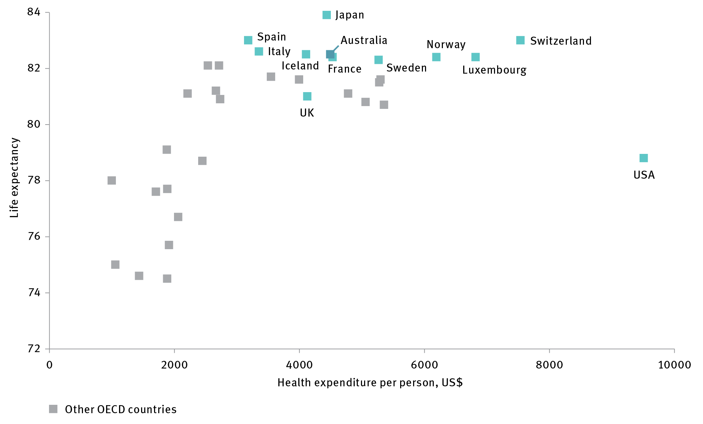

Source: Organisation for Economic Co-operation and Development 2017, *Better life index*, OECD, Paris, <http://stats.oecd.org/Index.aspx?DataSetCode=BLI; OECD Health expenditure and financing data, per capita (current prices) < <https://data.oecd.org/health.htm>>.

Any single international metric of population health has its limitations given the diversity of causes of premature death and disability by disease and country. Nonetheless, it is feasible for Australia to become the number one country for both life expectancy and quality adjusted life years, and in doing so lead the world in intelligent, efficient and cost-effective health delivery.

### Why genomics and precision medicine, and why now

The application of genomics to medicine is a compelling choice to demonstrate the power of a National Mission program. Health outcomes are critically important to Australia’s national interest because we need a healthy and productive population to sustain our nation’s economy. Health outcomes also determine Australians’ quality and length of life; health matters deeply to Australians, making it an inspiring field in which to set high national ambitions for innovation.

Australia starts from a strong position to tackle this mission, with a high-quality healthcare system, a robust medical research community, and strong international linkages to other healthcare systems. We have a strong genomic sequencing capacity, as well as an expanding group of bioinformaticians, geneticists, bioethicists, genetic counsellors, pathologists, and clinicians – all essential for the delivery of this mission.

Australia’s health and medical research community is well connected to the substantial international efforts currently under way in this area. This will enable us to build on and leverage the investments of others, while also contributing to advancing the state of the art. Close international collaboration will serve to both de-risk and accelerate the progress of the mission.

Australia has already made substantial forward commitments to the health sector. The Medical Research Future Fund is forecast to double medical research funding within a decade, while $500 million has already been committed to the Biomedical Translation Fund. This gives us a strong base for the pursuit of major medical research and medical innovation projects.

The possibility of making significant medical discoveries in the areas targeted by the mission are becoming much more feasible. This is due to improvements in the performance and cost of key enabling technologies, such as genome sequencing (Figure 29), computing power, AI and ML. Along with increased access to data and data analysis tools, these technological improvements are increasing our research power, and opening up opportunities for continuing healthcare improvements.

Figure 29 Cost per genome, 2001–15

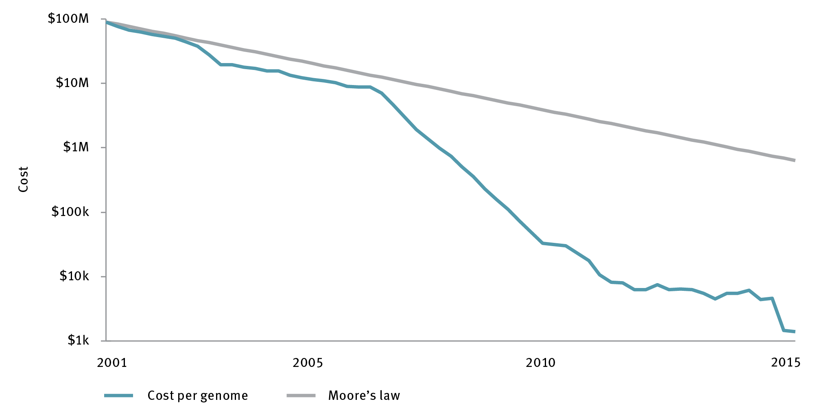

Moore’s law = that the number of transistors in an integrated circuit doubles approximately every two years

Source: National Human Genome Research Institute 2016, *The cost of sequencing a human genome,* NHGRI, Bethesda, <https://www.genome.gov/27565109/the-cost-of-sequencing-a-human-genome/>.

### Program outline

The Genomics and Precision Medicine National Mission would advance genomic research and bioinformatic capability, focused in the first instance, on selected patient cohorts. These cohorts should be selected based on clinical utility, cost effectiveness, and maximising potential translation to clinical practice. Such an approach would build on and leverage major international initiatives. Such cohorts may include:

families with histories of cancer, especially focusing on younger family members

Australians affected by the most common types of cancer, including breast, prostate, lung, bowel and colon, and pancreatic cancer

Australians with serious chronic disease, including cardiovascular, metabolic and inflammatory disorders

children with rare diseases.

Genomic analysis of these and other cohorts will help deliver personalised diagnostics and accelerate the advent of preventative, precision medicine.

### Benefits from the mission

The mission has been chosen partly for its ability to deliver far-reaching benefits over time, such as:

improved health for Australians today, and the next generations of Australian children

better and earlier diagnoses, and the avoidance of unnecessary or erroneous therapeutic interventions

benefits from accelerating the impact of pharmacogenomics (where genomic information is used to predict individual responses to drugs), and a reduction in adverse drug reactions, from the integration of phenotypic and genetic patient information

identification of novel indicators of conditions relevant for development and commercialisation of new medical technology

better and tailored decision-making tools for patients and providers harnessing cutting-edge technology including AI and ML

growth in the size, sophistication and efficacy of health and medical data, supported by increased interoperability across healthcare systems. This will rely on the $374 million commitment in the 2017–18 Budget for the Australian Digital Health Agency to roll out the My Health Record (MHR) to 20 million Australians on an opt-out basis, by the end of 2018. The MHR will provide an essential platform for digital health records and will require interoperability across healthcare systems to drive the access, storage and integration of diverse data systems, including genomics data.

The groundwork for this Genomics and Precision Medicine National Mission has been well prepared by the domain experts and practitioner members of the Australian Genomics Health Alliance. It is a mission that can serve as a foundation for the broader systematic effort to create a more human-centred, wellness-focused healthcare system, driven by data and preventative, diagnostic breakthroughs.

Case study 9 Garvan Institute: genome sequencing: the prospects for genomics and precision medicine

Caring for a loved one with a rare genetic condition can be a frustrating, emotional and lengthy process. Although individual conditions are rare, the aggregate of all rare conditions is significant: conservative estimates are that 6 per cent to 8 per cent of Australians have a rare condition, and 80 per cent of these conditions are genetic in origin.

Recent achievements in genome sequencing by Australian researchers now allow life-changing care for those with rare conditions, often enabling detection of the precise genetic variation causing the disease, and treatment approaches tailored to the individual.

At the age of three, Alan was diagnosed with a rare condition in which his immune system attacked his blood cells. The condition was potentially life-threatening, and his medical specialists did not know what was triggering the immune reaction, and therefore could not treat the underlying cause.

At age seven, Alan was accepted into a research program run by the Garvan Institute of Medical Research in Sydney to sequence the entire genome of individuals in an effort to diagnose their genetic conditions.

The work became urgent when Alan’s health suddenly deteriorated, leaving him critically ill in hospital and facing an uncertain future unless the condition could be treated. The sequencing of Alan’s genome enabled his medical team to quickly pinpoint the genetic variation responsible for the condition. Medical researchers scanned medical literature and discovered that a new drug had been trialled in the United States with patients having the same genetic variation, with promising results. Special access to the drug was rapidly approved for Alan.

The results were life changing. After Alan started the drug, his platelet, neutrophil and red blood cell counts miraculously reached their normal range over time, putting his life out of danger.

Six months later, he was well enough to go to school for the first time, and able to ride a bike and play like other children.

The identification of the gene variant responsible is now also enabling researchers to research new precision treatment options.

[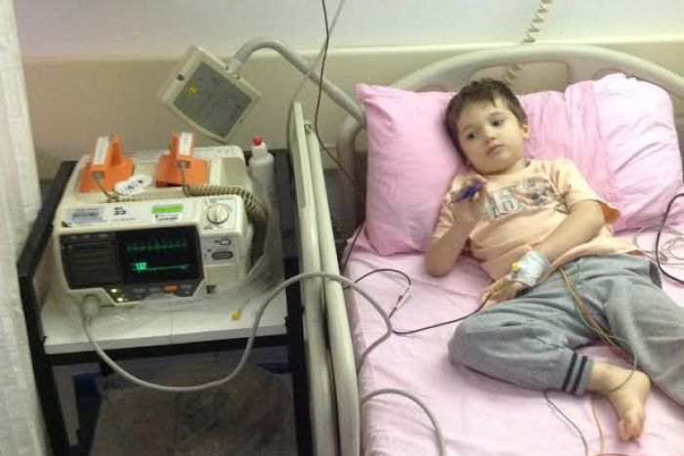](http://www.abc.net.au/news/2016-09-22/alan-in-hospital/7862588)

### Governance and implementation

The lead contribution by the Australian Government to the funding for the research and associated whole-genome sequencing, data storage, analytics, and human capital resourcing will be approximately $200 million during the initial five years. This could possibly be sourced from the Medical Research Future Fund. This core funding is likely to require matching support by participating states and territories, industry and philanthropy, depending on the number of genomes sequenced and interpreted from approved cohorts.

A well-designed, national governance structure will be essential to cover the issues of ethics, privacy, insurance and legal matters, protocols and management of data storage, as well as data access and secondary use for research and commercial development. The governance structure will also need to be designed so that it creates an appropriate platform for private sector engagement with the mission, maximising the potential for creation of new businesses and business models based on the genomic data resource.

Key stakeholders, particularly federal, state and territory health agencies, will need to be involved in the design and establishment of a national structure to provide governance and leadership. The National Health Genomics Policy Framework currently under development will provide a vital mechanism for alignment of these stakeholder groups. The lessons learned from the recent ‘Genome England’ programs may provide valuable guidance.

Mission progress will be aided by the existing capability and capacity in Australia in integrating genomics into clinical care and in sequencing and data analytics.

### Recommendations

**Recommendation 27**: Establish a National Mission to help make Australia the healthiest nation on Earth, with a step-change investment in our national genomics and personalised medicine capability and its integration into our medical research and healthcare system.

## Strategic opportunity 5.2 Ensuring Australia’s National Missions are effective can be achieved through the development of a robust framework to identify and implement missions

To advance the discussion around National Missions, ISA has developed a framework to identify and implement National Missions that are robust, achievable, and in the national interest. This would form the basis for the ongoing development of National Mission opportunities.

Many challenges of scale require sustained and significant investment for many years. They also need a broad base of support to achieve long-term commitment and impact, discipline in selection and development of projects, and a sophisticated approach to managing risk and dealing with failure. A robust framework for identifying, developing and validating missions is essential to ensure those chosen are credible, cost effective and beneficial.

### National Mission identification

National Missions should be chosen because they are bold, inspiring and in the national interest. Before confirming a National Mission, the candidate concept should be assessed against clearly-defined criteria, through an open process that encourages diverse inputs. ISA proposes three criteria for selecting missions. Missions should be:

**robust, credible and in the national interest** – Missions should address a significant threat, gap or opportunity facing Australia that aligns with a current national priority. They should build on an area of existing or potential market advantage with a high possibility of benefits. These could include direct and indirect economic, social or environmental benefits specific to the Australian context, but with potential global impact. Missions should also show potential to build long-lasting Australian capability in the area or advantage they are targeting. Missions should be robust and informed, demonstrating that they are cost-effective and credible through the preliminary design process

**bold and new** – Missions should be imaginative and inspiring, motivating people to identify an ideal future and work back from it. They should focus on paradigm-shifting challenges, to catalyse novel and new, rather than incremental, innovations leading to clear outcomes. Their potential for impact should be ambitious enough for all Australians to see and support the endeavour

**able to bring about a step-change in Australia’s innovation capacity and culture** – Missions need to inspire Australians to aim high and dream big, catalysing lasting shifts towards a culture of innovation and new approaches across the innovation system. They need leaders to sponsor the mission and a narrative that inspires innovators and the community to invest in the mission and the Australian innovation system. They should also show that they can engage a broad base of support, including leading experts, industry, the Australian public and bi-partisan political support.

### National Mission implementation

Missions need to be ambitious, but not improbable. Mission implementation planning should include an assessment of feasibility, based on the potential of the opportunity, the technical and project management capability within Australia to undertake it, and the likelihood of being able to develop a rigorous and flexible approach to execution. The Apollo 11 program, for example, was highly ambitious, but was based on sound science and informed by data on the projected capacity of the American industrial base. The program was also constructed as 23 separate missions and designed to spread risk, with built-in capacity to learn from errors and make improvements along the way.[250] In Australia, CSIRO’s experience with its Flagships program, launched in 2003, can provide useful lessons to inform implementation of National Missions.[251]

ISA proposes that each National Mission is assessed against four factors to ensure that a sound implementation approach is in place. Missions should:

**involve the right people** – National Missions should demonstrate that they will have an independent governance structure that will set strategy, design programs, allocate budgets and coordinate research and innovation to maximise impact. They will need to show involvement of all key players, including identifiable mission ‘champions’, experts across industry, research institutions and government, and the support of government and domain leaders

**be designed for success** – The mission will need to demonstrate thoughtful design, including a clear articulation of the long-term vision, the strategy to achieve it – including credible starting points – and the desired impact of the mission. Validation of design feasibility should also consider technical, economic, social, and political issues that may affect a promising concept. Forecasting techniques could also be used to identify long-term trends and how an issue relevant to the mission may evolve

**have a flexible roadmap** – Breakthrough research is an inherently uncertain endeavour, and National Missions will need to allow for rapid adaptation to new developments throughout their life, and to deliver both short and long-term outputs. This could include identifying early milestones for impact opportunities or ‘low hanging fruit’ to sustain long-term support; constructing mission elements to spread risks across sub-projects; and, supporting the development of ancillary areas and applying mission solutions elsewhere, avoiding reliance on ‘achieving the moonshot’ alone to make progress

**maximise the flow-on benefits of the mission** – National Missions will need to be designed to anticipate and deliver both short and long-term benefits. This includes optimising the design of the project so that potential spillover benefits can be harnessed during implementation. National Missions could be undertaken with other countries or consortia where collaboration is required to achieve scale, international buy-in or to accelerate results.

### Identifying potential future missions

Along with the Genomics and Precision Medicine National Mission, ISA has identified two other promising candidate missions for consideration, as part of a wider process to identify additional future National Missions. These additional candidates are:

**Restore the Reef: Preserving the Great Barrier Reef beyond 2030 –** This mission would build on Australia’s position at the forefront of reef management and marine research to deliver the world’s largest reef re-engineering program to increase its resilience to climate change.

**Hydrogen City –** This mission would lay the groundwork for decarbonisation of direct-combustion sector, currently responsible for 18% of Australia’s greenhouse gas emissions by converting the gas supply of an entire Australian city from natural gas to clean hydrogen.

See Appendix A for further details of these missions.

### Recommendations

**Recommendation 28**: Adopt a framework to continue to identify and implement additional National Missions.

Section C: Roadmap for action

# Funding, implementation and monitoring

Sections A and B of this report define imperatives for action to improve Australia’s innovation capabilities and performance. Governments must act swiftly to consider and act on the recommendations in the 2030 Plan so that Australia can be counted at the top tier of innovation nations and achieve sustainable prosperity for its citizens.

This section examines the way forward in terms of funding implications, implementation, leadership and collaboration, and performance monitoring.

## Funding implications

The recommendations in this plan focus on how governments can contribute to the effective functioning of Australia’s innovation system. This includes actions to regulate and shape the system more effectively, actions to be a stronger customer and catalyst for innovation in the system, and investments that support critical enabling activities that would not occur at all, or as effectively, without government support.

ISA has sought to shape its recommendations in a manner that respects the near-term fiscal challenges enunciated by the Australian Government. In many cases, the funding requirements associated with recommendations are negligible, such as suggested changes to regulatory frameworks or for reviews of current institutions and arrangements. In other cases, we have recommended incremental direct investments in areas such as export facilitation, CRCs, CRC Projects, IGCs and the proposed stream of funding for translational activities for research organisations. These can, to a certain extent, be sized to match broader budgetary constraints. National Missions are expected to draw on a range of funding sources, both at the Australian and state and territory government level, as well as from commercial and philanthropic sources.

Fundamentally, the aim of *Australia 2030: prosperity through innovation* is to use strategic activity and investment by governments to trigger significant increases in funding for R&D from other sources, rather than to significantly increase the investment made by governments. An overarching aim of the 2030 Plan is to return business investment in innovation activities (measured using the proxy of BERD) to a stronger growth rate and to a higher share of GERD by 2030 (Figure 30).

Figure 30 Indicative projections of Research and development expenditure by source, 2016–30

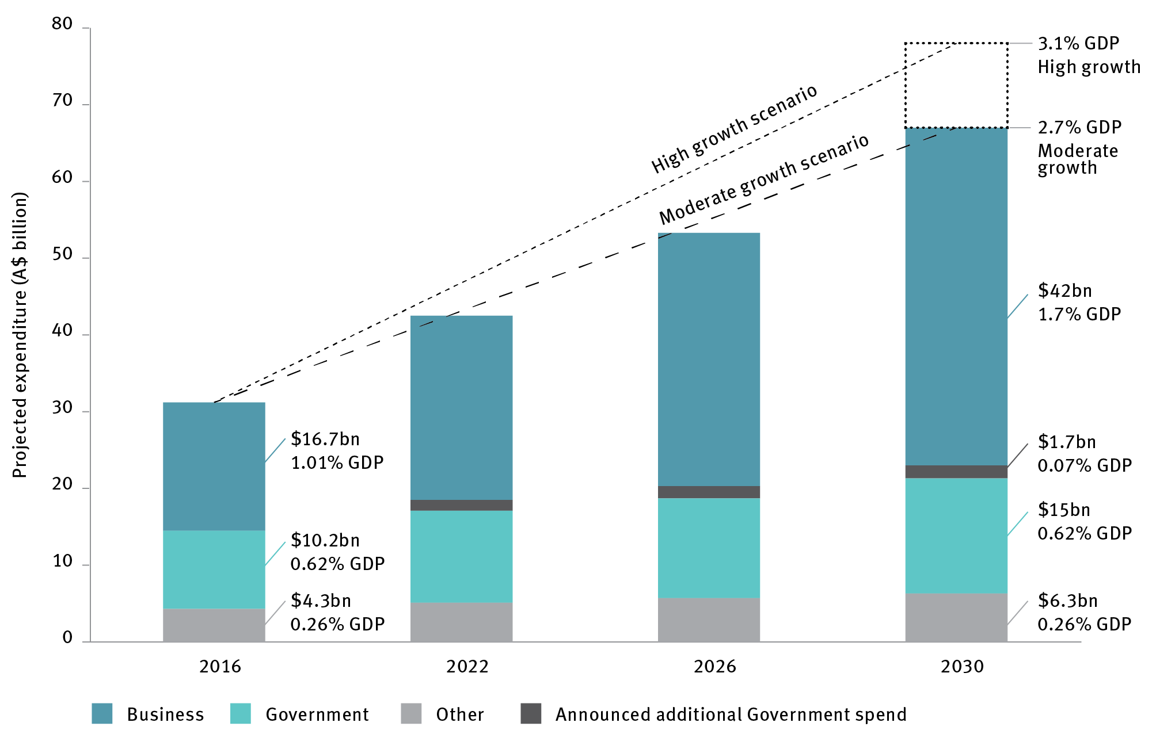

Notes:

Assumptions:

* moderate growth scenario: BERD growth in real terms of 8 per cent p.a. from 2018-2030 (33 per cent premium over historical real growth rate 1999–2015)
* high growth scenario: = BERD growth in real terms of 10 per cent p.a. over 2018–30 (66% premium over historical real growth rate 1999–2015)
* government expenditure, announced additional spend, and Other are assumed to grow in line with GDP, which is forecast to grow at 2.8%/year

Figure 30 shows indicative projections of R&D expenditure on the basis that the 2030 Plan is fully implemented and business expenditure on R&D as a percentage of GDP returns to strong growth. Consistent with our goal of being a top-tier innovation nation, ISA projects:

business expenditure on R&D under the moderate growth scenario could reach 1.7% of GDP by 2030, and return to the previous growth trend of the past two decades, if it could achieve a growth rate of 8 per cent pa in real terms over 2018–30.[252]. However, if the policy mix can be further strengthened by focused iterative improvement, then business expenditure on R&D under the high growth scenario could reach 2.2% of GDP through a real growth rate of 10%, which corresponds approximately to the growth rate seen in the decade prior to 2008 (which was in turn the fastest decade of growth experienced since 1990)

government support for innovation, science and research is assumed to grow to approximately 0.69 per cent of GDP by 2030, with the growth above GDP rate being achieved from already announced additional government R&D expenditure[253]

other sources of R&D expenditure (including state and territory governments, private not-for-profit, and international organisations) are assumed to grow at the GDP real growth average of 2.8 per cent.

BERD increases from just over half of total GERD in 2016 to approximately two-thirds by 2030 because of:

the 2030 Plan’s expected higher additionality flowing from a greater use of direct grant-support programs in preference to current indirect (tax-based) incentives (outlined in Imperative 2)

other measures focused on supporting the growth of knowledge-based and export-oriented businesses (Imperatives 2 and 4)

business’ responses to opportunities for increased participation in government procurement, access to larger and better curated data sets, and benefit from lower cost service delivery (outlined under Imperative 3).

Importantly, the potency of government policy in driving increased investment by business will play a large role in determining whether Australia reaches the upper or lower end of the percentage of GDP range. This is why a strong focus on continuous evaluation and refinement of all support programs is recommended.

## Implementation

Should the government resolve to implement all 30 of the recommendations from the 2030 Plan, these will need to be implemented and delivered across a number of agencies and departments.

An interdepartmental committee of key secretaries or deputy secretaries, similar to that created for the timely roll-out of NISA, could be a suitable implementation control mechanism. The ISA Board, through the Office of Innovation and Science Australia, could be resourced to monitor and evaluate the delivery and impact of the 2030 Plan over time. The ISA Board would report on the outcomes of this work, via the Minister for Industry, Innovation and Science, to the Innovation and Science Committee of Cabinet, chaired by the Prime Minister. This would enable an independent and expert source of review and oversight with a whole-of-government remit. An important feature of this review and advisory role will be ISA’s commitment to report against the innovation performance metrics identified in the 2030 Plan.

It is envisaged that a number of ministers and central agencies will wish to be, and need to be, engaged with specific recommendations that relate to their core portfolio responsibilities. In particular, Departments of Prime Minister and Cabinet; Industry, Innovation and Science; and Health would be partners on all imperatives; the Department of Education would be a partner on Imperatives 1 and 4; and the Department of Defence would be a partner on Imperatives 1, 2 and 3. Other ministers and departments will also have important impact and carriage, including Environment and Energy, Immigration and Border Control, Foreign Affairs and Trade, Attorney General, and of course both Treasury and Finance. ISA looks forward to working across the whole of government in this way to drive a stronger innovation performance for Australia.

## Measuring performance to inform effective investment

ISA recommends implementation of all the 2030 Plan’s 30 recommendations during the period ending 2022. It envisages full strategic reviews of the 2030 Plan in 2022, 2026 and 2030 in addition to annual reporting against progress. Accurate measurement of the innovation system‘s performance is vital to effective investment in innovation. Well-targeted investment will allow Australia to capitalise on our strengths, and continue to build them into the future. Poorly targeted investment risks wasting money and diminishing Australia’s reputation.

Regular reviews based on outcomes that are identified in advance of new investments in government innovation programs will provide an opportunity to review the effectiveness of interventions, iterating them as required based on accumulated evidence, and to respond to any new developments in the system that will undoubtedly occur. These developments should be supported through the accumulation of a longitudinal evidence base to guide policy development and long-term program improvement.

ISA has developed a common set of metrics that could underpin performance reviews in each cycle, and inform decisions about the most effective way to invest in Australia’s innovation, science and research system in the years ahead (Figure 31).

Figure 31 Innovation and Science Australia innovation scorecard (see changes in graph document)

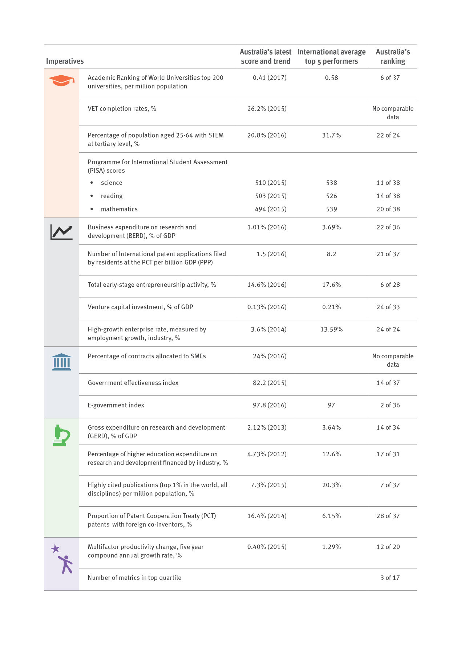

Note: These metrics have been developed based on a range of resources and research; see Appendix B for details.

International comparisons are made between Australia and other OECD+ countries and include all countries in the OECD, as well as China, Taiwan and Singapore (where data is available)

The average for the top 5 OECD+ countries represents the simple average of the top five OECD+ countries in the given metric.

There are multiple indicators and metrics at the global and national level for measuring innovation, including data from the Australian Bureau of Statistics, the Global Innovation Index and OECD statistics. The data are relied upon by policy makers to identify areas where Australia can improve its performance, including through targeted public interventions and investment. However, a growing body of evidence suggests these metrics portray Australia in an overly negative light. This is because they do not fully capture innovation activity, because data are not collected uniformly across nations included in international rankings, or in some cases, because the data collected are flawed. Their utility is also limited because results are too coarse to provide policy insights. ISA is therefore recommending the use of a scorecard containing relevant metrics.

To ensure the reviews of progress against the 2030 Plan draw on robust data, ISA recommends that the Australian Government invest in developing a suite of innovation metrics and methodologies to fully capture innovation and link it to economic, social and environmental benefits.

Continued reliance on unsuitable and inaccurate metrics will drive inappropriate policy development and lead to less-effective decisions on whether and how to intervene to accelerate innovation in Australia.

### Recommendations

**Recommendation 29**: Invest in developing a more effective framework to evaluate the performance of Australia in the innovation race in an effective and timely manner by:

introducing a requirement that new government funding programs and policies aimed at supporting innovation dedicate approximately 2 per cent of their budget for the evaluation of outcomes that should be clearly identified in advance

tasking the Australian Government Department of Industry, Innovation and Science with developing a stronger longitudinal evidence base for program effectiveness, to improve the longevity of high-impact innovation programs, inform cessation of ineffective programs, and underpin iterative improvement of all programs.

**Recommendation 30**: Support the development of a suite of innovation metrics and methodologies to fully capture innovation and link it to economic, social and environmental benefits. In particular:

request the Australian Bureau of Statistics (ABS) and the Department of Industry, Innovation and Science (DIIS) to review business and research and development data collections to ensure they are fit for purpose and take full advantage of all available data sources

commission an independent body, such as the Australian Academy of Technology and Engineering, in consultation with the ABS and DIIS, to review existing innovation metrics and report on a set of recommended metrics within 18 months, including new innovation metrics to track other areas of our innovation economy with a view to promoting these for use by the broader international community.

# Summary of recommendations

Imperative 1 Education: Respond to the changing nature of work by equipping all Australians with skills relevant to 2030

**Recommendation 1:** Government education policy makers should direct their efforts towards:

* investing in quality teaching by improving the quality and content of in-service teacher professional development programs to focus on
* a nationally agreed minimum number of annual hours in discipline-specific training
* the teaching of 21st-century skills
* increasing quality of and emphasis on feedback and appraisal of teacher performance

selecting, developing and effectively resourcing high-performing teachers and school leaders to act as mentors and instructional leaders in their school or area

monitoring the entry standards for initial teacher education courses to ensure that they are sufficiently demanding to select students with the literacy and numeracy skills required for science, technology, engineering and mathematics (STEM) teaching

strengthening the quality of teacher education for secondary STEM teachers through requiring the completion of a discipline-specific, non-teaching degree in addition to a teaching degree

* increasing the system-level focus on targeted interventions to improve outcomes where student learning levels are significantly below our national average through

providing tailored support to teachers in the form of regular tracking of student improvement, enabling rapid and evidence-based iteration of teaching practice

* instilling ‘motivation mindsets’ and a culture of high expectations including through:
* communicating to secondary students the level of school STEM study needed to enter and successfully complete STEM-related courses at university and in vocational education and training

reinstating prerequisites into those tertiary courses in which discipline skills are necessary

ensuring future reviews of the Australian Curriculum for STEM subjects will continue to meet Australia’s innovation, science and research education needs and be informed of industry expectations through consultation with industry.

**Recommendation 2:** Prepare students for post-school science, technology, engineering and mathematics (STEM) qualifications and occupations, by:

exploring opportunities to encourage participation in higher-level STEM subjects in high school

strengthening education in skills such as hypothesis-driven problem solving, systematic enquiry and logical thinking

improving measurement of the scope of out-of-field teaching in STEM and implementing measures to reduce the level

optimising the interaction of industry with schools through the work of the STEM Partnership Forum.

**Recommendation 3:** Improve transparency and accountability across the system by raising the ambition of the national minimum standards in the National Assessment Program – Literacy and Numeracy (NAPLAN) and building on these with new standards focusing on higher levels of achievement.

**Recommendation 4:** Task the Australian Government Department of Education and Training to undertake a review of vocational education and training (VET) and report back within 12 months on:

a strategy to make the sector increasingly responsive to new priorities presented by innovation, automation and new technologies

ensuring the Australian VET system will be internationally competitive in the provision of initial skills training, in supporting a life of learning and helping businesses to compete, and ensuring VET interfaces and intersects productively with other parts of the higher education system

recommendations for metrics of VET success to be evaluated by 2022, including via surveys of employers regarding skills relevance, actual completion rates and employment on graduation

increasing the amount and granularity of information made available to students.

**Recommendation 5:** Continue and expand current VET reforms to:

optimise the supply-side potential of the Skilling Australia Fund, for example by encouraging industry employers and VET providers to consult with Industry Growth Centres in identifying expected skills shortages in the future work requirements of high-growth sectors

link VET student loan funding to employment outcomes

strengthen the powers of the regulator: Australian Skills Quality Authority

provide improved information to students on provider quality.

Imperative 2 Industry: Ensure Australia’s ongoing prosperity by stimulating high-growth firms and improving productivity

**Recommendation 6:** Adopt as the top priority of innovation policy the reversal of the current decline in business expenditure on research and development, with a headline goal of achieving a medium-term growth rate not less than that seen in 1999–2015. The contribution to this goal made by government support for business R&D should be strengthened by:

ensuring, at a minimum, that total government support for science, research and innovation does not fall below its medium-term average of 0.63 per cent of gross domestic product

* implementing the recommendations of the 2016 Review of the R&D Tax Incentive to improve the effectiveness, integrity and collaboration impact of the program, with the following adjustments
* the cap referred to in Recommendation 3 of the report should be set at $4 million per year, and a maximum cumulative refund of $40 million per company should be applied

the threshold referred to in Recommendation 4 of the report should be replaced with a trigger set at 1 per cent of total annual expenditure, such that all R&D expenditure is claimable (subject to any other limits) once the trigger level is reached

prioritising new and redirected investment in stimulating business R&D to programs that directly support activity in areas of competitive strength and strategic priority (e.g. Cooperative Research Centres – CRCs, CRC Projects, Entrepreneurs’ Programme and Industry Growth Centres).

**Recommendation 7:** Increase efforts to help young Australian businesses and small and medium enterprises to access export markets by:

increasing funding for Export Market Development Grants and investigating how to target a larger proportion of the funds to high-growth businesses (e.g. consider fostering and identifying them via Industry Growth Centres)

extending funding for international capability promotion through targeted trade missions and trade promotion activities.

**Recommendation 8:** The forthcoming Digital Economy Strategy should prioritise the development of advanced capability in artificial intelligence and machine learning in the medium- to long-term to ensure growth of the cyber–physical economy.

**Recommendation 9**: Establish protocols (including consumer data rights) for maintaining healthy levels of competition in knowledge-intensive industry sectors.

**Recommendation 10:** Build on strength in accessing overseas talent through continuing and targeted updates to skilled immigration rules and improved marketing to suitable talent, especially through Austrade (with a focus on key target markets).

Imperative 3 Government: Become a catalyst for innovation and be recognised as a global leader in innovative service delivery

**Recommendation 11:** The Australian Government should work with states and territories to lead efforts to create a more flexible regulatory environment within Australia to foster innovation, including exploring specific areas for cross-jurisdictional collaborative regulatory reform.

**Recommendation 12:**Further strengthen the policy environment to encourage investors to pursue opportunities that provide both social and financial returns.

**Recommendation 13:** Improve provision and use of open government data by:

developing government capability and capacity to deliver accessible, accurate and detailed public data, balancing release of data with privacy and intellectual property concerns; this will entail sustained investment in data custodianship, maintenance, and release.

* developing improved mechanisms to encourage feedback to originating departments from industry and not-for-profit user groups to ensure that data released by governments is maximally useful.

**Recommendation 14**: Establish a small and medium enterprise (SME) procurement target of 33 per cent of contracts (by dollar value) being awarded to Australian SMEs by 2022. The Australian Government Department of Industry, Innovation and Science should report on progress towards this target annually.

**Recommendation 15**: Increase the use of innovative procurement strategies to improve outcomes and optimise government operations by:

establishing programs that promote, track and report on progress towards procurement practices that drive innovation (including identifying impediments raised by industry, and measuring participation of firms by age and stage) across all levels of government

continuing and potentially expanding the challenge-based Business Research and Innovation Initiative and Small Business Innovation Research for Defence program, and managing their evolution to become Australian Small Business Innovation Research equivalent of the successful United States program

developing contractual frameworks to facilitate procurement from start-ups and young firms

creating a ‘government as first customer’ program designed for high-growth firms, including start-ups, to be trialled by two of the major procurement departments before a roll-out across all government departments.

**Recommendation 16:** Maximise the benefit from nationally significant government programs by establishing a framework to identify, predict, encourage and evaluate spillover benefits by:

using major Defence programs (such as submarine, continuous ship-building and land combat vehicles programs) as ‘pathfinders’ to establish how government can best define, deliver and measure broad national value; the ‘pathfinder’ should plan, collect and report the data and insights that will help future governments and policy makers to calculate and forecast industry and innovation spillover benefits

exploring and reporting on how other major projects and programs (information and communications technology, infrastructure) can be leveraged to deliver increased innovation and spillover returns and reskill the workforce; the Defence Science and Technology Group’s engagement with innovative companies, including the provision of investments for design and prototyping via the Next Generation Technology Fund and the Defence Innovation Hub, provides a potential exemplar.

**Recommendation 17**: Instruct the Digital Transformation Agency to explore opportunities to achieve half of the projected 12 per cent of savings from digitising service delivery by 2022 and the balance by 2026, while simultaneously improving citizen satisfaction with government services. The agency should be resourced to also:

benchmark and report on the effectiveness and efficiency of the use of digital technologies and the improvement of service delivery (using automation, advanced analytics, service delivery dashboards to monitor and evaluate the impact of spending)

set a target for citizen satisfaction as part of planned assessment of performance against key performance indicators, and track the progress of every department delivering citizen-facing services against it; for example, by considering the adoption of the Service NSW approach to benchmarking and measurement of satisfaction.

**Recommendation 18**: Conduct a review of the Australian Government Public Service with the aim of enabling a greater role and capability for innovation in policy development, implementation and service delivery. This work complements, and could be connected with, the work of the Secretaries APS Reform Committee.

Imperative 4 Research and development: Improve research and development effectiveness by increasing translation and commercialisation of research

**Recommendation 19:** Introduce a collaboration premium of up to 20 per cent on non-refundable tax offset to incentivise collaboration (as part of implementing the recommendations of the Review of the R&D Tax Incentive, Recommendation 6 under Imperative 2).

**Recommendation 20:** Evaluate the benefits of introducing an industry higher degree by research placement program at greater scale with long-term support, including assessing the merits of international examples of similar programs.

**Recommendation 21**: Conduct an expert review in 2022 to evaluate the effectiveness of recent changes to incentivise collaboration, and recommend options for further action. The review should cover, at a minimum:

the engagement and impact assessment implemented through the Australian Research Council

funding changes following the Review of Research Policy and Funding Arrangements, including to the Linkage Program and research block grants

progress on addressing the findings and recommendations of the Review of Australia’s Research Training System

progress on ensuring that university career paths allow for mobility between academia and industry

the recommended collaboration premium under the R&D Tax Incentive.

**Recommendation 22:** Increase commercialisation capability in research organisations by establishing a new stream of funding for translational activities.

**Recommendation 23:** Develop and release an Australian Innovation Precincts Statement to shape Australian Government involvement in emerging localised innovation ecosystems in cities and regions.

**Recommendation 24**: Establish secure, long-term funding for national research infrastructure, in accordance with the recommendations of the 2016 National Research Infrastructure Roadmap.

**Recommendation 25:** Maintain a long-term policy commitment to achieving greater gender diversity in the science, technology, engineering and mathematics workforce, including by raising awareness of gender diversity in government programs.

**Recommendation 26:** Task Innovation and Science Australia to monitor emerging sectors of high growth in the economy and report annually to the Australian Government on the adequacy of risk capital supply.

Imperative 5 Culture and ambition: Enhance the national culture of innovation by launching ambitious National Missions

**Recommendation 27**: Establish a National Mission to help make Australia the healthiest nation on Earth, with a step-change investment in our national genomics and personalised medicine capability and its integration into our medical research and healthcare system.

**Recommendation 28**: Adopt a framework to continue to identify and implement additional National Missions.

Roadmap for action

**Recommendation 29**: Invest in developing a more effective framework to evaluate the performance of Australia in the innovation race in an effective and timely manner by:

introducing a requirement that new government funding programs and policies aimed at supporting innovation dedicate approximately 2 per cent of their budget for the evaluation of outcomes that should be clearly identified in advance

tasking the Australian Government Department of Industry, Innovation and Science with developing a stronger longitudinal evidence base for program effectiveness, to improve the longevity of high-impact innovation programs, inform cessation of ineffective programs, and underpin iterative improvement of all programs.

**Recommendation 30**: Support the development of a suite of innovation metrics and methodologies to fully capture innovation and link it to economic, social and environmental benefits. In particular:

request the Australian Bureau of Statistics (ABS) and the Department of Industry, Innovation and Science (DIIS) to review business and research and development data collections to ensure they are fit for purpose and take full advantage of all available data sources

commission an independent body, such as the Australian Academy of Technology and Engineering, in consultation with the ABS and DIIS, to review existing innovation metrics and report on a set of recommended metrics within 18 months, including new innovation metrics to track other areas of our innovation economy with a view to promoting these for use by the broader international community.

Appendices

# Appendix A Other National Mission candidates

National Mission candidate 2: Restore the Reef

This mission will deliver the world’s largest reef restoration and eco-engineering program to ensure the survival and adaptation of the Great Barrier Reef (GBR) beyond 2030.

The GBR is a global icon and important environmental habitat, bringing in an estimated $6.4 billion each year to the economy and supporting 64,000 full-time jobs.[254] The GBR is under increasing pressure from a range of stressors, including bleaching caused by rising ocean temperatures, poor water quality caused by adjacent land use, marine pollution, crown-of-thorns starfish,   
over-exploitation, cyclone damage and ocean acidification. Recent global bleaching events are estimated to have killed around 50 per cent of coral in the reef.[255]

Australia has made substantial forward commitments to the GBR, including the Reef 2050 Plan, which provides a strong base for this mission. The Reef 2050 Plan is primarily focused on managing direct threats (e.g. crown-of-thorns starfish and land-based run-offs). It does not have an explicit climate adaptation strategy and is therefore insufficient to safeguard the reef beyond 2030. The national mission proposed herein will complement the Reef 2050 Plan’s emphasis on threat reduction by introducing a targeted restoration and adaptation strategy.

This mission’s aim is to develop a capability for cost-effective restoration of the reef in portions at scale. Core areas of focus will be interventions and technologies that can:

reduce exposure to, and impacts of, disturbance, via next-generation corals for tomorrow’s reefs (for example, translocating existing corals with elevated temperature resistance, selective breeding and assisting migration, gene modification, cryo-banking)

increase recovery after disturbance (for example, from coral bleaching, crown-of-thorns starfish outbreaks, or cyclones)

enable an effective ‘toolkit’ to be developed for adaptation and restoration of the reef, and reefs around the world.

This mission will build on Australia’s world-leading science capability and marine research infrastructure, particularly in tropical marine sciences. The program of work will leverage existing and new IP to facilitate the creation of new products, start-ups, and niche industries in areas such as coral nurseries, aquaculture and aquarium technology, bioactive surfaces, bio-materials, 3D printers, autonomous reef inspection devices and sensors.

A full risk assessment of the mission, considering scale, cost, intervention and technology development risks, would be conducted during a 12-month design and validation phase.

Financing may require approximately $500 million over 10 years and require cooperation between Commonwealth and state and territory governments, the private sector and philanthropists.

National Mission candidate 3: Hydrogen City

This mission will demonstrate that an entire city could have its reticulated gas distribution system converted to clean hydrogen by 2030.

The electricity sector is the largest source of greenhouse gas emissions. The next three sectors, of similar size to each other, are direct combustion, transport and agriculture. The hydrogen city mission will demonstrate deep emissions reduction in the direct-combustion sector.

The gas network, all space heating, cooking appliances, and industrial thermal processes will be converted to run on pure hydrogen. Facilities could be provided to supply hydrogen to public transport and other heavy-use vehicle fleets.

The energy used to produce the hydrogen will be electrical energy from zero emissions sources such as solar, wind or hydro. The electricity will be used to split water into hydrogen and oxygen. This has never been done at the scale contemplated in this mission.

The project will test the feasibility of hydrogen as an energy source. The practical challenges around technology deployment, cost reduction, regulation and public engagement at scale in an existing urban environment have never been approached; by taking this project through to full implementation these challenges will be thoroughly addressed.

The project will also consider how innovative technology can be deployed in a standardised way and produced in volume to ensure that energy security and long-term cost competitiveness will not be compromised.

While hydrogen has been safely transported in pipelines across the United States and Europe for decades without incident, evaluating the safety aspects of this proposal will be a critically important early step in the planning of the project. Safety aspects will need to be openly and clearly shared with the local community and confidence earned before the project can proceed.

Technology improvements driven by the large-scale deployment of hydrogen production technologies, gas network upgrades and hydrogen consumption appliances, optimised in collaboration with research organisations, will allow Australia to take a leadership position in the field. This in turn will create export opportunities for both the technology and related expertise.

Financing for the project will be joint between the Australian, state and territory, and local governments and the private sector. Total investment to meet the project scope is estimated to be around $500 million over 10 years combining public and private funding, though given the substantial number of assumptions a more detailed costings exercise and comparison to alternatives, such as full electrification, is needed.

# Appendix B Definitions and sources for the scorecard metrics

Table 2 Sources for Innovation and Science Australia innovation scorecard metrics

| Imperative | Metric | Definition | Source |
| --- | --- | --- | --- |
| Education | Academic Ranking of World Universities s top 200 universities, per million population | The score is calculated by dividing the number of universities in the top 200 of the Academic Ranking of World Universities by the country’s current population. Country populations are obtained from the Global Innovation Index. | Academic Ranking of World Universities <<http://www.shanghairanking.com/ARWU2017.html>>  World Intellectual Property Organization, Cornell University, INSEAD: *Global Innovation Index* <<http://www.wipo.int/publications/en/details.jsp?id=4064>> |
| VET completion rates | This measures the completion rates for government-funded vocational education and training programs at Certificate 1 and above. | National Centre for Vocational Education Research data <<https://www.ncver.edu.au/search-results?collection=ncver-data&scope=all-data/,-fbs&query=&sort=dmetaM&meta_z_sand=true>> |
| Percentage of population aged 25-64 with STEM at tertiary level, % | This is the percentage of STEM fields of study among tertiary-educated 25–64-year-old adults. STEM comprises the ISCED-F 2013 fields of natural sciences, mathematics and statistics, information and communication technologies, and engineering, manufacturing and construction. | OECD Statistics: Education and Training, Education at a glance: *Table Educational attainment and labour-force status* <http://stats.oecd.org/>*;* Education at a Glance2017: OECD INDICATORS <https://www.hm.ee/sites/default/files/eag2017_eng.pdf> |
| Programme for International Student Assessment (PISA) scores in science, reading, mathematics | PISA is a triennial international survey that aims to evaluate education systems worldwide by testing the skills and knowledge of 15-year-old students. The metric highlights current performance in science, mathematics and reading. | OECD: PISA <<http://www.oecd.org/pisa/>> |
| Industry | Business expenditure on research & development (BERD), % of GDP | This is the total intramural expenditure on R&D by businesses, measured as a percentage of national GDP. | ABS Research and Experimental Development, Cat. No. 8104.0 http://abs.gov.au/AUSSTATS/abs@.nsf/allprimarymainfeatures/17EF02A5029649E2CA257F990030EDFE?opendocument >OECD Main Science and Technology Indicators, Table BERD as a percentage of GDP <http://stats.oecd.org/> |
| Number of international patent applications filed by residents at the PCT per billion GDP (PPP) | This shows the number of patents filed by national residents under the the PCT, per billion dollars of GDP adjusted by PPP. The nationality of the first-named applicant on the patent determines the origin of the PCT application. | World Intellectual Property Organization, Cornell University, INSEAD: Global Innovation Index Analysis: https://www.globalinnovationindex.org/analysis-indicator PCT international applications by origin |
| Total early-stage entrepreneurship activity, % | This measures the percentage of the population aged between 18 and 64 who are in the process of starting a venture and those who are running a business that is less than 3.5 years old. | Global Entrepreneurship Monitor: *Adult population survey measures: total early-stage entrepreneurial activity* <http://www.gemconsortium.org/data/key-indicators> |
| Venture capital investment, % GDP | This measures the annual amount of equity investments made to support the pre-seed, seed, start-up and early expansion stages of business development, measured as a percentage of national GDP. | OECD: *Entrepreneurship at a glance* <http://www.oecd.org/std/business-stats/entrepreneurship-at-a-glance-22266941.htm> |
| High-growth enterprise rate, measured by employment growth, % | This shows the percentage of firms that meet the criteria for high growth within the business economy. In this metric, high growth is defined by employment growth. High-growth firms have an average annualised growth of over 20% per year over a 3-year period, and had 10 or more employees at the beginning of the observation period. | OECD Statistics, SDBS Business Demography Indicators (ISIC REV.4): Rate of high-growth enterprise. Data on HE_R-Rate of high-growth enterprises (20% growth based on employment: <<http://stats.oecd.org/>>  ABS 2017: Business longitudinal analysis data environment  (BLADE); Customised data analysis commissioned by the Department of Industry, Innovation and Science. |
| Government | Percentage of contracts allocated to SMEs | This takes data on procurement contracts with SME participation presented and aggregates it with information extracted from AusTender. The metric reflects contractual information reported during the relevant financial year in accordance with entities’ procurement publishing obligations, and does not represent actual expenditure. | Australian Government Department of Finance: *Statistics on Australian Government procurement contracts* <<http://www.finance.gov.au/procurement/statistics-on-commonwealth-purchasing-contracts/>> |
| Government effectiveness index | This is an index that reflects perceptions of the quality of public services, the quality of the civil service and the degree of its independence from political pressures, the quality of policy formulation and implementation, and the credibility of the government’s commitment to such policies. Scores are standardised. | World Intellectual Property Organization, Cornell University, INSEAD: *Section 1.1.2 Government effectiveness* <[https://www.globalinnovationindex.org/analysis-indicator](http://www.globalinnovationindex.org/analysis-indicator)> |
| E-government index | This assesses government online services including the national portal, e-services portal and e-participation portal, as well as the websites of the related ministries of education, labour, social services, health, finance and environment, as applicable. | World Intellectual Property Organization, Cornell University, INSEAD: *Section 3.1.3 Government online services* <[https://www.globalinnovationindex.org/analysis-indicator](http://www.globalinnovationindex.org/analysis-indicator)> |
| R&D | Gross expenditure on research & development (GERD), % of GDP | GERD is the total national intramural expenditure on R&D, as a percentage of GDP. This represents expenditure devoted to R&D by the business, government, private non-profit and higher education sectors. | ABS Research and Experimental Development, *cat. no. 8104.0*  OECD: *Main science and technology indicators* <<https://stats.oecd.org/Index.aspx?DataSetCode=MSTI_PUB>> |
| Percentage of Higher education expenditure on research and development financed by industry, % | This is the proportion of the higher education sector’s total intramural expenditure on R&D which is financed by business. | ABS Research and Experimental Development, *cat. no. 8111.0*  OECD: *Main science and technology indicators* <https://stats.oecd.org/Index.aspx?DataSetCode=MSTI_PUB > |
| Highly cited publications (top 1% in the world, all disciplines) per million population, % | This metric shows the percentage of publications in the world’s top 1% of highly cited publications that have at least one domestic author, measured per million people in the domestic population. | InCites: Thomson Reuters Web of Science database <<https://incites.thomsonreuters.com/>>  OECD: *Main science and technology indicators* <<http://stats.oecd.org/Index.aspx?DatasetCode=PATS_COOP>> |
| Proportion of PCT patents with foreign co-inventors, % | This metric shows the percentage of patents filed at the PCT that have a domestic inventor or inventors and at least one other foreign inventor. | OECD: *International cooperation in patents* <https://stats.oecd.org/Index.aspx?DataSetCode=PATS_COOP> |
| Culture and ambition | Multifactor productivity change, five year compound annual growth rate, % | MFP measures the changes in output per unit of combined inputs of labour and capital. The change or growth in MFP is measured as a 5-year compound annual growth rate. | OECD: *Multifactor productivity* <<https://data.oecd.org/lprdty/multifactor-productivity.htm>> |
| Number of metrics in top quartile | The number of metrics out of the 17 metrics with international comparisons where Australia’s ranking is in the top 25% of the total countries for that metric. |  |

ABS = Australian Bureau of Statistics; BERD= business expenditure on research and development, GDP= gross domestic product, MFP = multifactor productivity; OECD = Organisation for Economic Co-operation and Development, PCT= Patent Cooperation Treaty; PPP = purchasing power parties; PISA = Programme for International Student Assessment; R&D = research and development, STEM = science, technology, engineering and mathematics

Acronyms, abbreviations and glossary

|  |  |
| --- | --- |
| AI | artificial intelligence  Computer systems that are able to perform tasks normally requiring human intelligence |
| BERD | business expenditure on research and development  Intramural expenditure by businesses on creative and systematic work undertaken to increase knowledge or to devise new applications of available knowledge. |
| COAG | Council of Australian Governments |
| CRC | Cooperative Research Centre |
| GDP | gross domestic product |
| GERD | gross expenditure on research and development  Constructed by adding together the research and development expenditures of four sectors: business, government, higher education, and private non-profit |
| GOVERD | government expenditure on research and development  Intramural expenditure towards activities aimed at increasing knowledge or applying knowledge in new ways from all units of the Australian Government (excluding local governments, higher education institutions and government entities involved in market production or financial activities) and all organisations that are mainly financed by and operate for those government units |
| GVA | gross value add |
| HAAS | humanities, arts and social sciences |
| HDR | Higher degree by research |
| HEIF | Higher Education Innovation Fund, United Kingdom |
| HERD | higher education expenditure on research and development  Intramural expenditure on creative and systematic work undertaken to increase knowledge or to devise new applications of available knowledge by universities and other institutions of post-secondary education regardless of their source of finance or legal status |
| ICT | information and communications technology |
| IGC | Industry Growth Centre |
| Incubator | A place where start-up companies share their workspaces to benefit from mentorship and peer learning |
| Innovation | Fresh thinking that creates value |
| IP | intellectual property  Intangible property that is the result of creativity, such as a patent, copyright or trade secret |
| ISA | Innovation and Science Australia |
| ML | machine learning  Where systems can automatically learn and improve from experience without being explicitly programmed |
| NAPLAN | National Assessment Program – Literacy and Numeracy |
| NISA | National Innovation and Science Agenda |
| OECD | Organisation for Economic Co-operation and Development |
| Open data | A philosophy that promotes transparency, accountability and value creation by making data available to all |
| Out-of-field teaching | Education delivered by teachers in an area for which they are not certified or do not possess an academic major at second year level or above |
| PISA | Programme for International Student Assessment  A worldwide study by OECD that measures academic performance |
| R&D | research and development  Creative work undertaken on a systematic basis to increase the stock of knowledge, and subsequently using this stock of knowledge to devise new applications |
| R&DTI | Research and Development Tax Incentive |
| SBIR | Small Business Innovation Research program (United States) |
| SBRI | Small Business Research Initiative (United Kingdom) |
| SII | social impact investment |
| SME | small and medium enterprise |
| STEM | science, technology, engineering and mathematics |
| Venture capital | High-risk private equity capital for typically new, innovative or fast-growing unlisted companies |
| VET | vocational education and training |

Acknowledgements

ISA wishes to thank the hundreds of people who contributed to this process through consultation, submissions and interviews. We acknowledge the support of our consultants and service providers from Howard Partners and McKinsey & Co, and also the provision of a secondee from GE Australia for part of the project.

ISA also wishes to acknowledge the excellent contributions made by the secondees into the ISA Taskforce: Todd Mansell, Pru Glasson, Kristin Milton, Laura Dan, Marty Hazelwood, David Crook, Karen Jackson, Rachel White, Zoe Piper, Bernard Borg-Caruana and Annika Barton. We also thank the team in the Office of Innovation and Science Australia: Mahmoud Alinejad, Clare Barrett, Lisa Blake, Melissa Daniels, Mardi Davis, Michelle Denison-Edson, Rose Filipovic, Julia Freeman, Mark Looney, Dani Polmanteer, Tim Powell, Elice Stanley, Gillian Treloar and Deb Willimott.

We acknowledge the generous time provided by our Expert Reference Group, whose strategic insights have proved invaluable:

**Michael Aitken** (CEO, Capital Markets CRC), **Angus Armour** (CEO of AICD), **Richard Bolt** (Secretary, Department of Economic Development, Jobs, Transport & Resources, Vic Govt), **James Cameron** (Partner, Airtree Ventures), **Georgie Carnegie** (Sentient Group), **Megan Clark** (Bank of America Merrill Lynch), **Jeff Connolly** (CEO, Siemens Pacific), **Kate Cornick** (CEO, LaunchVic), **Geoff Culbert** (President and Chief Executive, GE Australia, New Zealand and Papua New Guinea), **Glyn Davis** (Vice-Chancellor, University of Melbourne), **Nick Davis** (Head of Society and Innovation, World Economic Forum), **Alison Deans** (Director, Westpac), **Jane den Hollander** (Vice-Chancellor, Deakin University), **Maureen Dougherty** (President, Boeing Australia, New Zealand and South Pacific), **Yasser El-Ansary** (Chief Executive, AVCAL), **Jackie Fairley** (CEO, Starpharma), **Roy Green** (former Dean, School of Business, University of Technology, Sydney), **Ken Henry** (Chairman, NAB), **Doug Hilton** (Director, WEHI), **Leigh Jasper** (CEO, Aconex), **Chris Jenkins** (CEO, Thales), **Tim Kelsey** (CEO, Australian Digital Health Agency), **Sally Kift** (former Deputy Vice-Chancellor, James Cook University), **Beau Leese** (Co-founder and Co-CEO, Intersective), **Larry Marshall** (CEO, CSIRO), **Alex McCauley** (CEO, StartupAUS) **Chris Nave** (Managing Director, Brandon Capital), **John Rosenberg** (Box Hill Institute Board), **Niki Scevak** (Partner, Blackbird Ventures), **Anna Skarbek** (CEO, ClimateWorks), **Adrian Turner** (CEO, Data61), **Ian Watt** (former Secretary, PM&C), **Cynthia Whelan** (Chairperson, Foxtel Board), **Innes Willox** (Chief Executive, Australian Industry Group), **Kee Wong** (Managing Director/Principal, e-Centric innovations).

ISA notes that, although we have benefited from the input of many as outlined above, final responsibility for the content of the 2030 Plan rests with the board.

1. Australian Trade and Investment Commission 2017. *Invest in Australia: benchmark report,* ATIC, Canberra*, <*<https://www.austrade.gov.au/International/Invest/Why-Australia/Growth>>.
2. National Library of Australia 2016. *Australian Government Web Archive: Australia's Nobel Laureates and the Nobel Prize*, NLA, Canberra, <<http://webarchive.nla.gov.au/gov/20160615234745/http://www.australia.gov.au/about-australia/australian-story/australias-nobel-laureates>>; Australian National University 2017, ‘Research achievements: Professor John Harsanyi’, ANU, Canberra, <<http://www.anu.edu.au/about/awards-achievements/research-achievements/professor-john-harsanyi>>.
3. 1 Organisation for Economic Co-operation and Development 2015, *Main statistical indicators: gross domestic expenditure on R-D by sector of performance and source of funds*, OECD, Paris, <<http://stats.oecd.org/OECDStat_Metadata/ShowMetadata.ashx?Dataset=GERD_FUNDS&ShowOnWeb=true&Lang=en>>.
4. 1 Organisation for Economic Co-operation and Development 2015, *Main statistical indicators: gross domestic expenditure on R-D by sector of performance and source of funds*, OECD, Paris, <
5. http://stats.oecd.org/OECDStat_Metadata/ShowMetadata.ashx?Dataset=GERD_FUNDS&ShowOnWeb=true&Lang=en>.

   http://mccrindle.com.au/the-mccrindle-blog/job-mobility-in-australia>.
6. Cancer Australia 2016, *About children’s cancer: statistics*, Australian Government, Sydney, <<https://childrenscancer.canceraustralia.gov.au/about-childrens-cancer/statistics>>.
7. Lowe, P 2017, *The labour market and monetary policy*, address to the Anika Foundation luncheon, Reserve Bank of Australia, Canberra, <<http://www.bis.org/review/r170810d.pdf>>.
8. Australian Cancer Research Foundation 2006, *World’s first cervical cancer vaccine becomes available,* ACRF, Sydney, <<https://home.cancerresearch/worlds-first-cervical-cancer-vaccine-becomes-available/>>.
9. World Bank 2016, *GDP (current US$)*, World Bank open data, World Bank, Washington, DC, <<https://data.worldbank.org/indicator/NY.GDP.MKTP.CD?view=chart>>.
10. McKinsey analyses based on Australian Bureaus of Statistics and IHS Markit data.
11. Lowe, P 2017, *The labour market and monetary policy*, address to the Anika Foundation luncheon, Reserve Bank of Australia, Canberra, <<http://www.bis.org/review/r170810d.pdf>>.
12. Organisation for Economic Co-operation and Development 2017, *OECD labour force statistics 2016*, OECD, Paris, <http://dx.doi.org/10.1787/oecd_lfs-2016-en>.
13. Lowe, P 2017, *The labour market and monetary policy*, address to the Anika Foundation luncheon, Reserve Bank of Australia, Canberra, <<http://www.bis.org/review/r170810d.pdf>>.
14. Organisation for Economic Co-operation and Development 2017, *OECD labour force statistics 2016*, OECD, Paris, <http://dx.doi.org/10.1787/oecd_lfs-2016-en>.
15. Organisation for Economic Co-operation and Development 2017, *Better Life Index*, OECD, Paris, <http://www.oecdbetterlifeindex.org/#/11111111111>.
16. Australian Government Department of Foreign Affairs and Trade 2016, *Australia's trade in goods and services*, DFAT, Canberra, <http://dfat.gov.au/about-us/publications/trade-investment/australias-trade-in-goods-and-services/Pages/australias-trade-in-goods-and-services.aspx>.
17. Australian Government 2015, *Budget Paper no. 1: budget strategy and outlook 2014–15*, Statement 4, Australian Government, Canberra.
18. Australian Institute of Health and Welfare 2017, *Older Australia at a glance*, AIHW, Canberra, <<https://www.aihw.gov.au/reports/older-people/older-australia-at-a-glance/contents/demographics-of-older-australians/australia-s-changing-age-and-gender-profile>>.
19. The Economist 2017, *Australia admits more migrants than any other big Western country*, <https://www.economist.com/news/asia/21730004-and-australians-still-them-australia-admits-more-migrants-any-other-big-western-country>.
20. McKinsey Global Institute analysis based on The Conference Board Total Economy database; International Labour Organization; United Nations Population Division.
21. Blackburn, S, Freeland, M & Gärtner, D 2017, *Digital Australia: seizing opportunities from the Fourth Industrial Revolution*, McKinsey&Company, <https://www.mckinsey.com/global-themes/asia-pacific/digital-australia-seizing-opportunity-from-the-fourth-industrial-revolution>.
22. Lowe, P 2017, *The labour market and monetary policy*, address to the Anika Foundation luncheon, Reserve Bank of Australia, Canberra, <<http://www.bis.org/review/r170810d.pdf>>.
23. Jobs for NSW 2016, *Jobs for the future: Adding 1 million rewarding jobs in NSW by 2036*, Jobs for NSW, Sydney, <https://www.jobsfornsw.com.au/__data/assets/pdf_file/0020/90740/Jobs-for-the-future-full-report-August-2016.pdf>, p. 25.
24. AlphaBeta 2017, *The new work order: ensuring young Australian have skills and experience for the jobs of the future, not the past*, Foundation for Young Australians, Melbourne, <https://www.fya.org.au/report/new-work-order>.
25. Stanwick, J, Lu, T, Rittie, T & Circelli, M 2014, *How young people are faring in the transition from school to work*, Foundation for Young Australians, Melbourne, <https://www.fya.org.au/report/how-young-people-are-faring-2014>, p. 30.
26. Australian Government Department of Employment 2017, *Labour Market Information Portal: employment projections*, Department of Employment, Canberra, <<http://lmip.gov.au/default.aspx?LMIP>>. STEM occupations are defined as occupations where a majority of people have a STEM qualification, based on: Australian Bureau of Statistics 2014, *Perspectives on education and training: Australians with qualifications in science, technology, engineering and mathematics (STEM)*, 2010–11, cat. no. 4250.0.55.005, ABS, Canberra, <http://www.abs.gov.au/ausstats/abs@.nsf/Lookup/4250.0.55.005main+features62010%E2%80%9311>.
27. AlphaBeta 2017, *The new basics: big data reveals the skills young people need for the New Work Order*, Foundation for Young Australians, Melbourne, <https://www.fya.org.au/report/the-new-basics>.
28. Hajkowicz, SA, Reeson, A, Rudd, L, Bratanova, A, Hodgers, L, Mason, C & Boughen, N 2016, Tomorrow’s digitally enabled workforce: megatrends and scenarios for jobs and employment in Australia over the coming twenty years, CSIRO, Brisbane, <https://research.csiro.au/lifelong/tomorrows-digitally-enabled-workforce>.
29. Fortune 2017, *Global 500*, <<http://fortune.com/global500/list>>;   
    World Economic Forum 2016, *The new Fortune Global 500 is out. It shows a shift in the world's business landscape*, WEF, Geneva, <https://www.weforum.org/agenda/2016/07/new-fortune-global-500-shift-business-landscape>.
30. The Economist Intelligence Unit 2015, *Long-term macroeconomic forecasts: key trends to 2050*, The Economist, London, <https://www.eiu.com/public/topical_report.aspx?campaignid=ForecastingTo2050>, p. 3.
31. McKinsey&Company 2015, *Playing to win: the new global competition for corporate profits*, McKinsey&Company, <https://www.mckinsey.com/business-functions/strategy-and-corporate-finance/our-insights/the-new-global-competition-for-corporate-profits>, p. 6.
32. Facebook 2017, *Company info*, Facebook, <https://newsroom.fb.com/company-info>.
33. Kelly, K 2017, ‘Facebook leasing more space in Menlo Park for even more employees’, *The Mercury News*, 18 May, <http://www.mercurynews.com/2017/05/18/facebook-leasing-more-space-in-menlo-park-for-even-more-employees>.
34. Organisation for Economic Co-operation and Development 2017, *Main science and technology indicators*, OECD, Paris, <[http://www.oecd.org/sti/msti.htm>](http://stats.oecd.org/); Australian Bureau of Statistics 2017, *Research and experimental development, businesses, Australia, 2015–16*, cat. no. 8104, ABS, Canberra, <http://www.abs.gov.au/ausstats/abs@.nsf/mf/8104.0>.
35. Leigh, A & Triggs, A 2016, ‘Markets, monopolies and moguls: the relationship between inequality and competition’, *Australian Economic Review*, vol. 49, no. 4, pp. 389–412.
36. Dobbs, R, Manyika, J & Woetzel, J (2015). *No ordinary disruption: the four global forces breaking all the trends*, McKinsey Global Institute, <https://www.mckinsey.com/mgi/no-ordinary-disruption>.
37. Walsh, T 2017, *The AI revolution*, Education: Future Frontiers occasional paper series, NSW Department of Education, Sydney.
38. Manyika, J 2017, *10 Imperatives for Europe in the age of AI and automation*, McKinsey&Company, <https://www.mckinsey.com/global-themes/europe/ten-imperatives-for-europe-in-the-age-of-ai-and-automation>.
39. Walsh, T 2017, *The AI revolution*, Education: Future Frontiers occasional paper series, NSW Department of Education, Sydney, <https://education.nsw.gov.au/media/exar/The_AI_Revolution_TobyWalsh.pdf>.
40. Blackburn, S, Freeland, M & Gärtner, D 2017, *Digital Australia: seizing opportunities from the Fourth Industrial Revolution*, McKinsey&Company, <https://www.mckinsey.com/global-themes/asia-pacific/digital-australia-seizing-opportunity-from-the-fourth-industrial-revolution>.
41. Rio Tinto 2017, *Rio Tinto Operations Centre*, Rio Tinto, Perth, <[https://riotintogroundbreakers.com/50-operations-centre>.](https://riotintogroundbreakers.com/50-operations-centre/)
42. Eyers, J 2017, ‘”Better than blockchain” new asset trading system unveiled’, *Australian Financial Review*, 19 September, <http://www.afr.com/technology/better-than-blockchain-new-asset-trading-system-unveiled-20170919-gyk7mb#ixzz4vdz42OSg>.
43. Manyika, J 2017, *10 Imperatives for Europe in the age of AI and automation*, McKinsey&Company, <https://www.mckinsey.com/global-themes/europe/ten-imperatives-for-europe-in-the-age-of-ai-and-automation>.
44. Australian Treasury 2015, *2015 intergenerational report: Australia in 2055*, Australian Treasury, Canberra, <https://static.treasury.gov.au/uploads/sites/1/2017/06/2015_IGR.pdf >, p. 62.
45. Infrastructure Australia 2015, *Population estimates and projections: Australian Infrastructure Audit background paper April 2015*, Infrastructure Australia, Sydney, <<http://infrastructureaustralia.gov.au/policy-publications/publications/files/Background-paper-on-demographic-projections.pdf>>, p. 27.
46. Walter and Eliza Hall Institute of Medical Research 2013, *Trial results bring high hopes for advanced leukaemia*, WEHI, Melbourne, <<https://discovery.wehi.edu.au/timeline/leukaemia-trial>>.
47. http://trove.nla.gov.au/work/33066753?q&sort=holdings+desc&_=1508803244125&versionId=180146693
48. https://industry.gov.au/innovation/reportsandstudies/Documents/InnovationReport2002-03.pdf
49. https://www.industry.nsw.gov.au/__data/assets/pdf_file/0006/55383/NIS_review_Web3.pdf
50. https://www.industry.gov.au/innovation/InnovationPolicy/Pages/PoweringIdeas.aspx
51. Innovation and Science Australia 2016, *Performance review of the Australian innovation, science and research system*, ISA, Canberra, <https://industry.gov.au/Innovation-and-Science-Australia/Pages/default.aspx>.
52. Regional Australia Institute 2017, *[In]Sight – Innovation in regional Australia: spreading the ideas boom*, Regional Australia Institute, Canberra, <http://www.regionalaustralia.org.au/home/innovation-insight-update>.
53. Productivity Commission 2016, *Report on government services 2016*, PC, Canberra, <https://www.pc.gov.au/research/ongoing/report-on-government-services/2016>.
54. Goss, P, Sonnemann, J, Chisholm, C & Nelson, L 2016, *Widening gaps: what NAPLAN tells us about student progress*, Grattan Institute, Melbourne, <http://grattan.edu.au/wp-content/uploads/2016/03/937-Widening-gaps.pdf>, Figure 1.
55. Jensen, B, Hunter, A, Sonnemann, J & Burns, T 2012, *Catching up: learning from the best schools in East Asia*, Grattan Institute, Melbourne, <<http://grattan.edu.au/wp-content/uploads/2014/04/130_report_learning_from_the_best_detail.pdf>>, Figure 2.
56. Sanders, WL & Rivers, JC 1996, *Cumulative and residual effects of teachers on future student academic achievement*, University of Tennessee, Knoxville, <http://www.cgp.upenn.edu/pdf/Sanders_Rivers-TVASS_teacher%20effects.pdf>.
57. Teacher Education Ministerial Advisory Group 2014, *Action now: classroom ready teachers*, Australian Government Department of Education, Canberra, <https://docs.education.gov.au/system/files/doc/other/action_now_classroom_ready_teachers_accessible.pdf>.
58. Teacher Education Ministerial Advisory Group 2014, *Action now: classroom ready teachers*, Australian Government Department of Education, Canberra, <https://docs.education.gov.au/system/files/doc/other/action_now_classroom_ready_teachers_accessible.pdf>.
59. Marginson, S, Tytler, R, Freeman, B & Roberts, K 2013. STEM: Country comparisons – report for the Australian Council of Learned Academies, <http://acola.org.au/wp/project-2>.
60. Organisation for Economic Co-operation and Development 2013, *Results from TALIS 2013: Australia*, OECD, Paris, <https://www.oecd.org/australia/TALIS-2013-country-note-Australia.pdf>, p. 3.
61. Organisation for Economic Co-operation and Development 2013, *Results from TALIS 2013: Australia*, OECD, Paris, <https://www.oecd.org/australia/TALIS-2013-country-note-Australia.pdf>, p. 1.
62. Freeman, C, O’Malley, K & Eveleigh, F (Australian Council for Educational Research) 2014, *Australian teachers and the learning environment: an analysis of teacher response to TALIS 2013*, Australian Government Department of Education, Canberra, <http://research.acer.edu.au/cgi/viewcontent.cgi?article=1001&context=talis>. Teachers were asked whether they have participated in professional development content in the 12 months before the survey that supported ‘approaches to developing cross-occupational competencies for future work or future studies’ and ‘teaching cross-curricular skills (e.g. problem solving, learning-to-learn)’. Responses to both questions were 10–11% positive.
63. Mourshed, M, Krawitz, M & Dorn, E 2017, *How to improve student educational outcomes: new insights from data analytics,* McKinsey&Company, < https://www.mckinsey.com/industries/social-sector/our-insights/how-to-improve-student-educational-outcomes-new-insights-from-data-analytics>.
64. Dumont, H, Istance, D & Benavides, F 2012, *The nature of learning: using research to inspire practice*, OECD, Paris, <http://www.oecd.org/edu/ceri/thenatureoflearningusingresearchtoinspirepractice.htm>.
65. Jobs for NSW 2016, *Jobs for the future: Adding 1 million rewarding jobs in NSW by 2036*, Jobs for NSW, Sydney, <https://www.jobsfornsw.com.au/__data/assets/pdf_file/0020/90740/Jobs-for-the-future-full-report-August-2016.pdf>, p. 55.
66. Mourshed, M, Krawitz, M & Dorn, E 2017, *How to improve student educational outcomes: new insights from data analytics*, McKinsey&Company, <https://www.mckinsey.com/industries/social-sector/our-insights/how-to-improve-student-educational-outcomes-new-insights-from-data-analytics>.
67. See, for example, the STELR program, an inquiry-based curriculum module now used in more than 600 schools: STELR 2016, *About STELR*, STELR, Melbourne, <[http://www.stelr.org.au/aboutstelr>](http://www.stelr.org.au/aboutstelr/).
68. AlphaBeta 2017, *The new basics: big data reveals the skills young people need for the new work order*, Foundation for Young Australians, Melbourne, <https://www.fya.org.au/report/new-work-order>.
69. Weldon, P 2016, *Out-of-field teaching in Australian secondary schools*, Policy Insights, Australian Council for Educational Research, Melbourne, <http://research.acer.edu.au/policyinsights/6/>.
70. 70 Organisation for Economic Co-operation and Development 2009, ‘School Evaluation, Teacher Appraisal and Feedback and the Impact on Schools and Teachers’. In Creating Effective Teaching and Learning Environments: First Results from TALIS, OECD Publishing, Paris. <<http://dx.doi.org/10.1787/9789264068780-7-en>>.

    71 Organisation for Economic Co-operation and Development 2013, *TALIS 2013 Australia country note*, OECD, Paris <<https://www.oecd.org/australia/TALIS-2013-country-note-Australia.pdf>>, p. 3, Organisation for Economic Co-operation and Development 2013, *Results from TALIS 2013*, OECD, Paris, <<http://www.oecd.org/edu/school/talis-2013-results.htm>>.
71.
72. Organisation for Economic Co-operation and Development 2013, *Results from TALIS 2013: Australia*, OECD, Paris, <https://www.oecd.org/australia/TALIS-2013-country-note-Australia.pdf>, p. 3; McKinsey&Company 2007, *How the world’s best-performing school systems come out on top*, McKinsey&Company, <http://mckinseyonsociety.com/downloads/reports/Education/Worlds_School_Systems_Final.pdf>.
73. Australian Curriculum, Assessment and Reporting Authority 2017, *Australian curriculum: general capabilities*, ACER, Camberwell, <https://www.australiancurriculum.edu.au/f-10-curriculum/general-capabilities>.
74. Australian Government Department of Education 2014, *Review of the Australian curriculum: final report*, Department of Education, Canberra, <https://docs.education.gov.au/documents/review-australian-curriculum-final-report>, p. 3.
75. AlphaBeta 2017, *The new basics: big data reveals the skills young people need for the new work order*, Foundation for Young Australians, Melbourne, <https://www.fya.org.au/wp-content/uploads/2016/04/The-New-Basics_Update_Web.pdf>.
76. R. Randall, CEO of ACARA, Personal Communication.
77. Kennedy, J, Lyons, T & Quinn, F 2014, ‘The continuing decline of science and mathematics enrolments in Australian high schools’, *Teaching Science*, vol. 60, no. 2, pp. 34–46, <<https://eprints.qut.edu.au/73153/1/Continuing_decline_of_science_proof.pdf>>.
78. Australian Council for Educational Research 2017, *Australian report card: Time to address disadvantage is now,* ACER, Canberra, <<https://rd.acer.org/article/australian-report-card-time-to-address-disadvantage-is-now>>.
79. Global Entrepreneurship Monitor 2017, *Global report 2016/17*, GEM, London, <http://gemconsortium.org/report/49812>, p. 145; based on comparison of overall satisfaction score for each element of the entrepreneurship system.
80. Productivity Commission 2016, *National education evidence base: overview and recommendations*, PC, Canberra, <https://www.pc.gov.au/inquiries/completed/education-evidence/report/education-evidence-overview.pdf>.
81. Goss, P, Sonnemann, J, Chisholm, C & Nelson, L 2016, *Widening gaps: what NAPLAN tells us about student progress*, Grattan Institute, Melbourne, <http://grattan.edu.au/wp-content/uploads/2016/03/937-Widening-gaps.pdf>, Figure 1.
82. National Centre for Vocational Education Research 2017, *Australian vocational education and training statistics: total VET students and courses 2016*, NCVER, Adelaide, <https://www.ncver.edu.au/publications/publications/all-publications/total-vet-students-and-courses-2016>.
83. National Centre for Vocational Education Research 2017, *Australian vocational education and training statistics: total VET students and courses 2016*, NCVER, Adelaide, <https://www.ncver.edu.au/publications/publications/all-publications/total-vet-students-and-courses-2016>.
84. National Centre for Vocational Education Research 2015, *Employers’ use and views of the VET system 2015 infographic: text only*, NCVER, Adelaide, <http://www.voced.edu.au/content/ngv%3A70414> >.
85. Toner, P, Marceau, J, Hall, R & Considine, G 2004, *Innovation agents: vocational education and training skills and innovation in Australian industries and firms*, NCVER, Adelaide, <https://www.ncver.edu.au/__data/assets/file/0018/5661/nr1011.pdf>.
86. Jobs for NSW 2016, *Jobs for the future: Adding 1 million rewarding jobs in NSW by 2036*, Jobs for NSW, Sydney, <https://www.jobsfornsw.com.au/__data/assets/pdf_file/0020/90740/Jobs-for-the-future-full-report-August-2016.pdf>. Analysis for NSW to 2036.
87. AlphaBeta 2017, *The new work order: ensuring young Australian have skills and experience for the jobs of the future, not the past*, Foundation for Young Australians, Melbourne, < http://www.fya.org.au/wp-content/uploads/2015/08/fya-future-of-work-report-final-lr.pdf>.
88. AlphaBeta 2017, *The automation advantage*, AlphaBeta, Sydney, <http://www.alphabeta.com/the-automation-advantage>, p. 18.
89. Under the Gainful Employment Rule, to be eligible for funding under student assistance programs, an educational program must lead to a degree at a nonprofit or public institution, or must prepare students for ‘gainful employment in a recognized occupation’ <https://studentaid.ed.gov/sa/about/data-center/school/ge>.
90. Government loan scheme that helps eligible students to pay all or part of their tuition fees.
91. Australian National Audit Office 2016, *Administration of the VET FEE-HELP Scheme*, ANAO, Canberra, <https://www.anao.gov.au/work/performance-audit/administration-vet-fee-help-scheme>.
92. Australian Government Department of Education and Training 2016, *VET FEE-HELP reform factsheet*, DET, Canberra, <https://docs.education.gov.au/documents/vet-fee-help-reform-factsheet>.
93. Australian Government Department of Education and Training 2016, *Review of the VET Student Loans course list and loan caps methodology*, discussion paper, DET, Canberra, <<https://docs.education.gov.au/system/files/doc/other/discussion_paper_course_list_loan_cap_methodology_0.pdf>>.
94. Beddie, F & Simon, L 2017, *VET applied research: driving VET’s role in the innovation system*, National Centre for Vocational Education Research, Adelaide, <<https://www.ncver.edu.au/publications/publications/all-publications/vet-applied-research-driving-vets-role-in-the-innovation-system>>.
95. Office of the Chief Economist 2016, *Australian innovation system report*, Australian Government Department of Industry, Innovation and Science, Canberra, <<https://industry.gov.au/Office-of-the-Chief-Economist/Publications/Pages/Australian-Innovation-System.aspx>>.
96. Ernst & Young 2013, Delivering a step change in organisational productivity: findings from the Australian Oil & Gas Productivity and Innovation Survey, Ernst & Young, <<http://www.ey.com/Publication/vwLUAssets/Delivering_a_step_change_in_organisational_productivity/$FILE/Delivering_a_step_change_in_org_prod.pdf>>.
97. Tuhin, R 2016, *Modelling the relationship between innovation and exporting: evidence from Australian SMEs*, Australian Government Department of Industry, Innovation and Science, Canberra, <<https://industry.gov.au/Office-of-the-Chief-Economist/Research-Papers/Documents/2016-Research%20Paper-3-Modelling-the-relationship-between-innovation-and-exporting-Evidence-from-Australian-SMEs.pdf>>.
98. Office of the Chief Economist 2016, *Australian innovation system report*, Australian Government Department of Industry, Innovation and Science, Canberra, <<https://industry.gov.au/Office-of-the-Chief-Economist/Publications/Pages/Australian-Innovation-System.aspx>>.
99. Organisation for Economic Co-operation and Development 2017, *Main science and technology indicators*, OECD, Paris, [<[http://www.oecd.org/sti/msti.htm>](http://stats.oecd.org/)](http://stats.oecd.org/); Australian Bureau of Statistics 2017, *Research and experimental development, businesses, Australia, 2015–16*, cat. no. 8104, ABS, Canberra, <http://www.abs.gov.au/ausstats/abs@.nsf/mf/8104.0>.
100. Based on Australian Bureau of Statistics 2017, *Research and experimental development, businesses, Australia, 2015–16*, cat. no. 8104, ABS, Canberra, <http://www.abs.gov.au/ausstats/abs@.nsf/mf/8104.0>; Innovation and Science Australia 2016, *Performance review of the Australian innovation, science and research system*, ISA, Canberra, <https://industry.gov.au/Innovation-and-Science-Australia/Pages/default.aspx>.
101. Mazzucato. M 2017, *Mission-oriented innovation policy: challenges and opportunities,* Institute for Innovation and Public Purpose, London, <<https://www.ucl.ac.uk/bartlett/public-purpose/sites/public-purpose/files/moip-challenges-and-opportunities-working-paper-2017-1.pdf>>.
102. A summary of the relevant literature can be found in: Organisation for Economic Co-operation and Development 2015, *The future of productivity*, OECD, Paris, <http://www.oecd.org/eco/OECD-2015-The-future-of-productivity-book.pdf>, p. 100.
103. Ferris, B, Finkel, A & Fraser, J 2016, *Review of the R&D Tax Incentive*, Australian Government Department of Industry, Innovation and Science, Canberra, <<https://industry.gov.au/innovation/InnovationPolicy/Research-and-development-tax-incentive/Pages/R-and-D-Tax-Incentive-Review-report-and-submissions.aspx>>.
104. An SME is defined as R&D expenditure of $2 million or less, which is closely aligned with the ABS definition of SMEs (firms with fewer than 200 employees); Ferris, B, Finkel, A & Fraser, J 2016, *Review of the R&D Tax Incentive*, Australian Government Department of Industry, Innovation and Science, Canberra, <https://industry.gov.au/innovation/InnovationPolicy/Research-and-development-tax-incentive/Pages/R-and-D-Tax-Incentive-Review-report-and-submissions.aspx>.
105. Ferris, B, Finkel, A & Fraser, J 2016, *Review of the R&D Tax Incentive*, Australian Government Department of Industry, Innovation and Science, Canberra, <https://industry.gov.au/innovation/InnovationPolicy/Research-and-development-tax-incentive/Pages/R-and-D-Tax-Incentive-Review-report-and-submissions.aspx>.
106. According to the *Industry Research and Development Act 1986*, for software activities to be considered to be R&D, specific requirements need to be met including the objective of a scientific and/or technological advance, and the systematic resolution of a scientific and/or technological uncertainty; Organisation for Economic Co-operation and Development 2015, *Frascati manual 2015: guidelines for collecting and reporting data on research and experimental development*, OECD, Paris, <<http://dx.doi.org/10.1787/9789264239012-en>>.
107. See, for example: High Level Group on maximising the impact of EU Research & Innovation Programmes 2017, *LAB–FAB–APP: investing in the European future we want*, European Commission, Luxembourg, <https://ec.europa.eu/research/evaluations/pdf/archive/other_reports_studies_and_documents/hlg_2017_report.pdf>; or the United Kingdom Government 2017, *Building our industrial strategy: green paper*, <<https://www.gov.uk/government/uploads/system/uploads/attachment_data/file/611705/building-our-industrial-strategy-green-paper.pdf>>.
108. Mazzucato, M & Semieniuk, G 2017, ‘Public financing of innovation: new questions’, *Oxford Review of Economic Policy,* vol. 33, no. 1, pp. 24–48.
109. The Allen Consulting Group 2012, *The economic, social and environmental impacts of the Cooperative Research Centres Program*, report to the Department of Industry, Innovation, Science, Research and Tertiary Education, Allen Consulting Group, <<https://www.business.gov.au/~/media/Business/CRC/Cooperative-Research-Centres-Programme-Economic-Social-and-Environmental-Impacts-2012-PDF.pdf?la=en>>.
110. Tuhin, R 2016, *Modelling the relationship between innovation and exporting: evidence from Australian SMEs*, Australian Government Department of Industry, Innovation and Science, Canberra, <<https://industry.gov.au/Office-of-the-Chief-Economist/Research-Papers/Documents/2016-Research%20Paper-3-Modelling-the-relationship-between-innovation-and-exporting-Evidence-from-Australian-SMEs.pdf>>.
111. World Bank 2017, *GDP ranking*, World Bank, Washington, DC, <<https://data.worldbank.org/data-catalog/GDP-ranking-table>>.
112. Central Intelligence Agency 2017, *The world factbook: exports*, CIA, Washington, DC, <<https://www.cia.gov/library/publications/the-world-factbook/rankorder/2078rank.html>>.
113. Australia’s performance in exports of minerals (non-energy); United Nations 2017, *UN Comtrade*, UN Statistics Division, New York, <<https://comtrade.un.org/data>>.
114. United Nations 2017, *UN Comtrade*, UN Statistics Division, New York, <<https://comtrade.un.org/data>>.
115. Australia: GDP totals US$1.4 trillion, Canada US$1.8 trillion; the population of Australia is 24 million people, Canada 36 million people; GDP per capita in Australia is US$59,477, Canada US$50,151; annual wages in Australia are US$44,000, Canada US$38,000; IHS Markit 2017, *Global economy*, IHS Markit, London, <<http://connect.ihs.com/DataSetBrowser/ShowDataSet?dataset=Global%20Economy>>.
116. Australia’s proportion of arable land is 6.11%; Canada’s is 5.06%; World Bank 2017, *Arable land*, World Bank, Washington, DC, <<https://data.worldbank.org/indicator/AG.LND.ARBL.ZS>>.
117. IHS Markit 2017, *Global economy*, IHS Markit, London, <<http://connect.ihs.com/DataSetBrowser/ShowDataSet?dataset=Global%20Economy>>.
118. United Nations 2017, *UN Comtrade*, UN Statistics Division, New York, <<https://comtrade.un.org/data>>.
119. Worthington, B 2016, *Winners and losers from first years of free trade agreements with China, Japan and Korea*, Australian Broadcasting Corporation, <<http://www.abc.net.au/news/2016-11-28/winners-losers-free-trade-agreements-agriculture/8053336>>.
120. Australian Government Department of Foreign Affairs and Trade 2017, *China–Australia Free Trade Agreement: outcomes at a glance*, DFAT, Canberra, <<http://dfat.gov.au/trade/agreements/chafta/fact-sheets/pages/key-outcomes.aspx>>.
121. Di Lieto, G 2017, ‘Brexit, Trump and the TPP mean Australia should pursue more bilateral trade agreements’, *The Conversation*, 17 January, <<https://theconversation.com/brexit-trump-and-the-tpp-mean-australia-should-pursue-more-bilateral-trade-agreements-71330>>.
122. Organisation for Economic Co-operation and Development 2017, *OECD economic surveys: Australia – March 2017*, OECD, Paris, <https://www.oecd.org/eco/surveys/Australia-2017-OECD-economic-survey-overview.pdf>.
123. Firms with at least five employees and turnover higher than $75,000 that achieve more than 20 per cent average annualised growth in the number of full-time equivalent employees over a three-year period.
124. Office of the Chief Economist 2017, *Australian innovation system report*, Australian Government Department of Industry, Innovation and Science, Canberra, <<https://industry.gov.au/Office-of-the-Chief-Economist/Publications/Pages/Australian-Innovation-System.aspx>>.
125. Hendrickson, L 2016, *The contribution of high-growth firms to the economy*, Australian Government Department of Industry, Innovation and Science, Canberra, <<https://industry.gov.au/Office-of-the-Chief-Economist/Events/Documents/The%20contribution%20of%20high%20growth%20firms%20to%20the%20economy.pdf>>.
126. Tuhin, R 2016, *Modelling the relationship between innovation and exporting: evidence from Australian SMEs*, Australian Government Department of Industry, Innovation and Science, Canberra, <<https://industry.gov.au/Office-of-the-Chief-Economist/Research-Papers/Documents/2016-Research%20Paper-3-Modelling-the-relationship-between-innovation-and-exporting-Evidence-from-Australian-SMEs.pdf>>.
127. Thompson, F, Tonby, O, Sneader, K & Woetzel, J 2015, *No ordinary disruption: the forces reshaping Asia*, McKinsey&Company, <<https://www.mckinsey.com/singapore/our-insights/no-ordinary-disruption-the-forces-reshaping-asia>>.
128. Dobbs, R, Ramaswamy, S, Stephenson, E & Viguerie, SP 2014, *Management intuition for the next 50 years*, McKinsey&Company, <<http://www.mckinsey.com/business-functions/strategy-and-corporate-finance/our-insights/management-intuition-for-the-next-50-years>>.
129. Australian Trade Commission 2015*, Certainty and confidence—exports and jobs for a changing global economy: review of the Export Market Development Grants scheme*, Austrade, Canberra.
130. Analysis performed by Innovation and Science Australia.
131. Milic, J, Palangkaraya, A & Webster, E 2017, *Entering global value chains: do trade missions work?*, Working Paper Series, Centre for Transformative Innovation, Swinburne University of Technology, Melbourne, <<http://www.swinburne.edu.au/media/swinburneeduau/research/research-centres/cti/working-papers/CTI-Working-Paper-1-17-Entering-Global-Production-Chains.pdf>>.
132. Office of the Chief Economist 2016, *Australian industry report*, Australian Government Department of Industry, Innovation and Science, Canberra, <<https://industry.gov.au/industryreport>>.
133. Evans, PC & Annunziata, M 2012, *Industrial internet: pushing the boundaries of minds and machines*, GE, <https://www.ge.com/docs/chapters/Industrial_Internet.pdf>. Estimate is of cumulative benefit assuming a 0.75 percentage point in global productivity due to industrial internet.
134. Australian Government Department of Industry, Innovation and Science 2017, *The digital economy: opening up the conversation*, DIIS, Canberra, <<https://industry.gov.au/innovation/Digital-Economy/Documents/Digital-Economy-Strategy-Consultation-Paper.pdf>>.
135. Economic Innovation Group 2017, *Dynamism in retreat: consequences for regions, markets, and workers*, EIG, Washington, DC, <<http://eig.org/wp-content/uploads/2017/07/Dynamism-in-Retreat-A.pdf>>.
136. Leigh, A & Triggs, A 2016, ‘Markets, monopolies and moguls: the relationship between inequality and competition’, *Australian Economic Review*, vol. 49, no. 4, pp. 389–412.
137. Harper, I, Anderson, P, McCluskey, S & O’Bryan, M 2015, *Competition Policy Review: final report*, Australian Treasury, Canberra, <http://competitionpolicyreview.gov.au/final-report>.
138. Harper, I, Anderson, P, McCluskey, S & O’Bryan, M 2015, *Competition Policy Review: final report*, Australian Treasury, Canberra, <http://competitionpolicyreview.gov.au/final-report>.
139. PricewaterhouseCoopers 2014, *Deciding with data: How data-driven innovation is fuelling Australia’s economic growth*, PricewaterhouseCoopers, <<https://www.pwc.com.au/consulting/assets/publications/data-drive-innovation-sep14.pdf>>.
140. Productivity Commission 2017, *Data availability and use: Productivity Commission inquiry report*, PC, Canberra, <<https://www.pc.gov.au/inquiries/completed/data-access/report>>.
141. Productivity Commission 2017, *Data availability and use: Productivity Commission inquiry report*, PC, Canberra, <<https://www.pc.gov.au/inquiries/completed/data-access/report>>, p. 168.
142. Australian Computer Society 2016, *Australia’s digital pulse: developing the digital workforce to drive growth in the future*, Deloitte Access Economics, <<https://www2.deloitte.com/au/en/pages/economics/articles/australias-digital-pulse.html>>.
143. Startup Muster 2016, *Startup Muster 2016 annual report*, Startup Muster, <<https://www.startupmuster.com/Startup-Muster-2016-Report.pdf>>.
144. Australian Broadcasting Corporation 2016, ‘Fact check: why Michaelia Cash’s claims on 457 visas get mixed verdicts’, *ABC News*, 31 March, <<http://www.abc.net.au/news/factcheck/2016-03-23/fact-check-457-workers/7232258>>.
145. Australian Government Department of Immigration and Border Protection 2017, *Business Innovation and Investment (Provisional) visa (subclass 188)*, DIBP, Canberra, <<http://www.border.gov.au/Trav/Visa-1/188->>.
146. Australian Government Department of Immigration and Border Protection 2016, *Report on Migration Programme 2015–16*, DIBP, Canberra, <<http://www.border.gov.au/about/reports-publications/research-statistics/statistics/live-in-australia/migration-programme>>.
147. This figure does not include temporary work (skilled) visas (subclass 457); Australian Government Department of Immigration and Border Protection 2016, *Report on Migration Programme 2015–16*, DIBP, Canberra, <<http://www.border.gov.au/about/reports-publications/research-statistics/statistics/live-in-australia/migration-programme>>.
148. Statistics supplied by the Australian Government Department of Immigration and Border Protection.
149. Statistics supplied by the Australian Government Department of Immigration and Border Protection.
150. Tech Nation 2017, *Tech Nation Visa Scheme*, Tech Nation, London, <<http://www.techcityuk.com/tech-nation-visa/>
151. McCauley A 2017, ‘Address visa issue to attract the talent’, *The Australian*, 18 July, <<http://www.theaustralian.com.au/business/technology/address-visa-issue-to-attract-the-talent/news-story/f6e3b4d4a7921dd726c9dc96496a02a4>>.
152. Australian Government Department of Immigration and Border Protection 2017, *Visa simplification: transforming Australia’s visa system*, DIBP, Canberra.
153. Methods considered include changes to pathway to permanent residency; recognition of doctoral work experience; regular reviews of skilled occupation lists; consideration of salary threshold as exemption to skilled occupation lists; raising permanent migration program age limit to 50; review of current capping of skilled migration scheme; and harmonisation of visa age requirements.
154. Innovation and Science Australia 2016, *Performance review of the Australian innovation, science and research system*, ISA, Canberra, <https://industry.gov.au/Innovation-and-Science-Australia/Pages/default.aspx>.
155. Australia’s general government spending accounted for 36% of GDP in 2014; Organisation for Economic Co-operation and Development 2017, *General government spending*, OECD, Paris, <<https://data.oecd.org/gga/general-government-spending.htm>>. Australia’s general government final consumption expenditure accounted for 18% of GDP in 2016; World Bank 2017, *General government final consumption expenditure (% of GDP)*, World Bank, Washington, DC, <https://data.worldbank.org/indicator/NE.CON.GOVT.ZS>.
156. Australian Bureau of Statistics 2016, *Employment and earnings, public sector, Australia, 2015–16*, cat. no. 6248.0.55.002, ABS, Canberra, <http://www.abs.gov.au/ausstats/abs@.nsf/mf/6248.0.55.002>.
157. Productivity Commission 2016, *Intellectual property arrangements*, Productivity Commission inquiry report, PC, Canberra, <<https://www.pc.gov.au/inquiries/completed/intellectual-property/report>>.
158. Treasury Laws Amendment (2017 Enterprise Incentives No. 2) Bill 2017, <<http://www.aph.gov.au/Parliamentary_Business/Bills_Legislation/Bills_Search_Results/Result?bId=r5886>>.
159. Productivity Commission 2016, *Digital disruption: what do governments need to do?*, Productivity Commission research paper, PC, Canberra, <<https://www.pc.gov.au/research/completed/digital-disruption/digital-disruption-research-paper.pdf>>.
160. Nesta 2017, *Anticipatory regulation: 10 ways governments can better keep up with fast-changing industries*, Nesta, London, <<http://www.nesta.org.uk/blog/anticipatory-regulation-how-can-regulators-keep-fast-changing-industries>>.
161. Australian Securities and Investment Commission 2017, *Regulatory sandbox*, ASIC, Canberra, <[http://asic.gov.au/for-business/your-business/innovation-hub/regulatory-sandbox>.](http://asic.gov.au/for-business/your-business/innovation-hub/regulatory-sandbox%3e.)
162. , Therapeutic Goods Administration 2016, *Australian Government response to the Review of Medicines and Medical Devices Regulation*, TGA, Australian Government Department of Health, Canberra, <<https://www.tga.gov.au/australian-government-response-review-medicines-and-medical-devices-regulation>>.
163. Australian Government Department of Health 2011, *Health HTA policy framework,* Department of Health, Canberra, <<http://health.gov.au/internet/hta/publishing.nsf/Content/policy-1>>.
164. Australian Government Department of Health, *Clinical trials,* Department of Health, Canberra <<http://www.health.gov.au/internet/main/publishing.nsf/Content/Clinical-Trials>>.
165. New South Wales Government 2017, *Regulatory sandboxes*, New South Wales Government, Sydney, <<https://sandboxes.innovation.nsw.gov.au>>.
166. Council of Australian Governments Industry and Skills Council 2017, *Communiqué for the COAG Industry and Skills Council meeting, 4 August 2017*, COAG Industry and Skills Council, Canberra, <<https://industry.gov.au/AboutUs/Documents/COAG-Industry-and-Skills-Council/4%20August%202017%20-%20COAG%20Industry%20and%20Skills%20Communique.pdf>>.
167. High Level Group on Maximising the Impact of EU Research & Innovation Programmes 2017, *LAB–FAB–APP: investing in the European future we want*, European Commission, Luxembourg, <<https://ec.europa.eu/research/evaluations/pdf/archive/other_reports_studies_and_documents/hlg_2017_report.pdf>>.
168. Impact Investing Australia 2016, *2016 investor report*, IIA <<https://impactinvestingaustralia.com/wp-content/uploads/Impact-Investing-Australia-2016-Investor-Report.pdf>>.
169. Impact Investing Australia 2016, *2016 investor report*, IIA <<https://impactinvestingaustralia.com/wp-content/uploads/Impact-Investing-Australia-2016-Investor-Report.pdf>>
170. Impact Investing Australia 2016, *Benchmarking impact: Australian impact investment activity and performance report 2016*, IIA, <https://impactinvestingaustralia.com/wp-content/uploads/Benchmarking-Impact.pdf>.
171. Australian Treasury 2014, *Financial System Enquiry: final report*, Australian Treasury, Canberra, <<http://fsi.gov.au/files/2014/12/FSI_Final_Report_Consolidated20141210.pdf>>; Australian Government Department of Social Services 2014, *A new system for better employment and social outcomes: full version of the interim report*, DSS, Canberra, <<https://www.dss.gov.au/our-responsibilities/review-of-australia-s-welfare-system/a-new-system-for-better-employment-and-social-outcomes-full-version-of-the-interim-report>>.
172. Australian Treasury 2014, *Financial System Enquiry: final report*, Australian Treasury, Canberra, <<http://fsi.gov.au/files/2014/12/FSI_Final_Report_Consolidated20141210.pdf>>.
173. Australian Treasury 2017, *Australian government principles for social impact investing*, Australian Treasury, Canberra, <https://treasury.gov.au/programs-initiatives-consumers-community/social-impact-investing/australian-government-principles-for-social-impact-investing>.
174. Australian Government 2017, *Reducing pressure on housing affordability: fact sheet 1.9 – encouraging social impact investing*, Australian Government, Canberra, <<http://www.budget.gov.au/2017-18/content/glossies/factsheets/html/HA_19.htm>>.
175. Australian Government 2017, *Data.gov.au*, Australian Government, Canberra, <[https://data.gov.au](https://data.gov.au/dataset)>.
176. See, for example: Victorian Government 2017, *Data.vic.gov.au*, Victorian Government, Melbourne, <<https://www.data.vic.gov.au>>; New South Wales Government 2017, *Data NSW*, New South Wales Government, Sydney, <https://data.nsw.gov.au>.
177. Australian Government Department of Industry, Innovation and Science 2017, *The digital economy: opening up the conversation*, DIIS, Canberra, <<https://industry.gov.au/innovation/Digital-Economy/Documents/Digital-Economy-Strategy-Consultation-Paper.pdf>>.
178. PricewaterhouseCoopers 2014, *Deciding with data: How data-driven innovation is fuelling Australia’s economic growth*, PricewaterhouseCoopers, <<https://www.pwc.com.au/consulting/assets/publications/data-drive-innovation-sep14.pdf>>.
179. Productivity Commission 2017, *Data availability and use: Productivity Commission inquiry report*, PC, Canberra, <<https://www.pc.gov.au/inquiries/completed/data-access/report>>.
180. Open Data Barometer 2016, *Country detail: Australia*, Open Data Barometer, <<http://opendatabarometer.org/4thedition/detail-country/?_year=2016&indicator=ODB&detail=AUS>>;   
     Open Data Barometer 2016, *Global report: findings and recommendations*, Open Data Barometer, <http://opendatabarometer.org/4thedition/report/#findings_recommendations>.
181. SPUR 2017, *About SPUR*, SPUR, Midland, <<http://www.spur.wa.gov.au/about-SPUR>>.
182. GovHack 2017, *About GovHack*, GovHack, <https://govhack.org/about-us>.
183. See, for example: Small Business Research Initiative 2017, *Process*, SBRI, <<https://sbri.innovateuk.org/process>>.
184. National Research Council (US) Committee for Capitalizing on Science, Technology, and Innovation 2008, *An assessment of the Small Business Innovation Research Program*, National Academies Press, Washington, DC.
185. Lerner, J 1999, ‘The government as venture capitalist: the long-run impact of the SBIR Program’, *Journal of Private Equity*, vol. 3, no. 2, pp. 55–78.
186. Australian Government 2017, *Business Research and Innovation Initiative: proof of concept*, Australian Government, Canberra, <<https://www.business.gov.au/assistance/business-research-and-innovation-initiative>>.
187. United Kingdom Government 2017, *SBRI: helping government, helping business*, UK Government, London, <<https://www.gov.uk/government/uploads/system/uploads/attachment_data/file/642084/SBRI_helping_government_helping_business_2017_infographic_04092017.pdf>>.
188. Australian Government 2017, *Business Research and Innovation Initiative: proof of concept*, Australian Government, Canberra, <<https://www.business.gov.au/assistance/business-research-and-innovation-initiative>>.
189. Australian Government 2017, *Business Research and Innovation Initiative: proof of concept*, Australian Government, Canberra, <<https://www.business.gov.au/assistance/business-research-and-innovation-initiative>>.
190. Australian Government Department of Finance internal data.
191. A Tenderer’s Declaration and financial statements for the previous three years should be a minimum requirement for high-risk projects. In assessing profitability of a tenderer, the tenderer should have a track record of profitable operations, as measured by profits generated in at least two out of the three most recent financial years; Australian Government Department of Finance 2014, *Assessing financial viability*, Department of Finance, Canberra, <<https://www.finance.gov.au/procurement/procurement-policy-and-guidance/buying/contract-issues/assessing-financial-viability/practice.html>>.
192. PricewaterhouseCoopers 2014, *The startup economy: how to support tech startups and accelerate Australian innovation*, PricewaterhouseCoopers, <<https://www.digitalpulse.pwc.com.au/wp-content/uploads/2013/04/PwC-Google-The-startup-economy-2013.pdf>>.
193. When the NDIS reaches full scheme in 2019–20, it is estimated that it will cost approximately $21.0 billion, or around 1.1 per cent of GDP. The Australian Government’s contribution will be approximately $10.8 billion; Australian Government 2017, *Budget 2017–18, Budget strategy and outlook, Budget Paper no. 1, 2017–18*, Australian Government, Canberra, <<http://budget.gov.au/2017-18/content/bp1/download/bp1.pdf>>.
194. Naval Shipbuilding program budgeted at $89 billion; Australian Government Department of Defence 2017, *Budget 2017–18: defence budget overview*, Department of Defence, Canberra, <<https://www.minister.defence.gov.au/minister/christopher-pyne/media-releases/budget-2017-18-defence-budget-overview>>.
195. Total of $73.8 billion committed for federal and state infrastructure projects, including the National Broadband Network; ANZ Research 2017, *Australia: major project update*, ANZ Research, <<https://anzlive.secure.force.com/servlet/servlet.FileDownload?file=00P1400000nZLrqEAG>>.
196. Keating, EG, Danescu, I, Jenkins, D, Black, J, Murphy, R, Peetz, D & Bana, SH 2015, *The economic consequences of investing in shipbuilding*, RAND Corporation, Santa Monica, <<https://www.rand.org/pubs/research_reports/RR1036.readonline.html>>.
197. Australian Government Department of Defence 2017, *Collins Class replacement technologies*, Department of Defence, Canberra, <<https://www.dst.defence.gov.au/innovation/collins-class-replacement>>.
198. Bisalloy 2017, *Bisalloy Armour*, Bisalloy, Unanderra, <<https://www.bisalloy.com.au/products/bisalloyarmoursteel.aspx>>.
199. Defence Connect 2017, *Aus armour steel selected by LAND 400 contender*, Defence Connect, North Sydney, <<https://www.defenceconnect.com.au/land-amphibious/1124-aus-armour-steel-selected-by-land-400-contender>>.
200. Australian Government Department of Defence 2015, *Building submarines in Australia: aspects of economic impact*, Department of Defence, Canberra, <http://www.defence.gov.au/FOI/Docs/Disclosures/145_1516_Documents2.pdf>.
201. United Kingdom Ministry of Defence 2016, *MOD SME policy: refreshed post strategic defence and security review*, MOD, London, <<https://www.gov.uk/government/uploads/system/uploads/attachment_data/file/507298/20160311_Refreshed_SME_Policy_-_Final_-_O.pdf>>.
202. United Kingdom Ministry of Defence 2016, *Procurement at MOD*, MOD, London, <https://www.gov.uk/government/organisations/ministry-of-defence/about/procurement>.
203. United Kingdom Government 2017, *National Security Strategy and Strategic Defence and Security Review 2015: a secure and prosperous United Kingdom*, United Kingdom Government, London, <<https://www.gov.uk/government/uploads/system/uploads/attachment_data/file/555607/2015_Strategic_Defence_and_Security_Review.pdf>>.
204. Australian Government Department of Defence 2016, *2016 Defence white paper*, Department of Defence, Canberra, <http://www.defence.gov.au/WhitePaper/Docs/2016-Defence-White-Paper.pdf>.
205. Australian Government Department of Defence 2016, *2016 defence industry policy statement*, Department of Defence, Canberra, <<http://www.defence.gov.au/WhitePaper/Docs/2016-Defence-Industry-Policy-Statement.pdf>>.
206. Australian Government Department of Defence 2017, *Australian industry capability*, Department of Defence, Canberra, <<http://www.defence.gov.au/SPI/Industry/AIC.asp>>.
207. United Nations 2016, *UN E-Government Survey 2016*, UN, <<https://publicadministration.un.org/egovkb/en-us/reports/un-e-government-survey-2016>>.
208. Australian Government Digital Transformation Agency 2017, *Digital Transformation Agency*, DTA, Canberra, <https://www.dta.gov.au>.
209. Virtual assistant that provides tailored responses to customer queries using natural language understanding, conversational dialogue and advanced resolution techniques, to answer hundreds of commonly asked questions across a range of categories; Criterion Conferences 2016, *Are virtual assistants the future of public sector customer service?*, Criterion Conferences, Sydney, <https://www.criterionconferences.com/blog/government/virtual-assistants-future-public-sector-customer-service>.
210. Criterion Conferences 2016, *Are virtual assistants the future of public sector customer service?*, Criterion Conferences, Sydney, <https://www.criterionconferences.com/blog/government/virtual-assistants-future-public-sector-customer-service>.
211. McKinsey Center for Government 2017, *Government productivity: unlocking the $3.5 trillion opportunity*, McKinsey&Company, <<https://www.mckinsey.com/industries/public-sector/our-insights/the-opportunity-in-government-productivity>>.
212. Australian Information Industry Association 2017, *AIIA technology and government study*, AIIA, Canberra, <<https://www.aiia.com.au/__data/assets/pdf_file/0019/75034/gov-study.pdf>>.
213. Dam K 2015, *How do Australians really feel about digital government services?* Australian Government Digital Transformation Agency, Canberra, <<https://www.dta.gov.au/blog/how-do-australians-really-feel-about-digital-government-services/>>.
214. McKinsey&Company 2017, *Improving the customer experience to achieve government-agency goals*, McKinsey&Company, <<http://www.mckinsey.com/industries/public-sector/our-insights/improving-the-customer-experience-to-achieve-government-agency-goals>>.
215. McKinsey&Company 2017, *Improving the customer experience to achieve government-agency goals*, McKinsey&Company, <<http://www.mckinsey.com/industries/public-sector/our-insights/improving-the-customer-experience-to-achieve-government-agency-goals>>.
216. Innovation New South Wales 2017, *Service NSW: making life easier*, NSW Government, Sydney, <<https://www.innovation.nsw.gov.au/whats-happening/service-nsw-making-life-easier>>.
217. Dowling, A 2015, *The Dowling review of business–university research collaborations*, United Kingdom Government, <<http://www.raeng.org.uk/policy/dowling-review/the-dowling-review-of-business-university-research>>, p. 15.
218. Uses 2014 data from: Organisation for Economic Co-operation and Development 2017, *Main science and technology indicators*, OECD, Paris, [<[http://www.oecd.org/sti/msti.htm>](http://stats.oecd.org/)](http://stats.oecd.org/).
219. 219 Innovation and Science Australia 2016, *Performance review of the Australian innovation, science and research system*, ISA, Canberra, <https://industry.gov.au/Innovation-and-Science-Australia/Pages/default.aspx>.
220. Miles, DA 2015, Growth through innovation and collaboration: a review of the Cooperative Research Centres Programme, Australian Government, Canberra, p. 42.
221. Australian Council of Learned Academics 2016, *Review of Australia’s research training system*, ACLA, Melbourne.
222. Watt, I 2015, *Review of Research Policy and Funding Arrangements*, Australian Government, Canberra, https://docs.education.gov.au/system/files/doc/other/main_report_final_20160112.pdf
223. Australian Mathematical Sciences Institute 2017, AMSI Intern: national research internships, AMSI, Parkville, <http://amsiintern.org.au/voucher>.
224. Australian Government 2017, *Innovation Connections*, Australian Government, Canberra, https://www.business.gov.au/assistance/innovation-connections
225. http://imnis.org.au
226. <http://www.anrt.asso.fr/fr/cifre-7843>
227. http://ktp.innovateuk.org
228. Office of the Chief Economist 2016, *Australian innovation system report*, Australian Government Department of Industry, Innovation and Science, Canberra, <<https://industry.gov.au/Office-of-the-Chief-Economist/Publications/Pages/Australian-Innovation-System.aspx>>, p. 64.
229. Warwick Economics & Development 2015, *KTP Programme: the impacts of KTP associates and knowledge base on the UK economy*, WECD, Birmingham, <<https://www.gov.uk/government/uploads/system/uploads/attachment_data/file/467141/KTP_Report_July_2015__1-SEP-15_.pdf>>.
230. Universities Australia, *Universities and the startup economy*, Universities Australia, Canberra, <<https://www.universitiesaustralia.edu.au/australias-universities/Universities-and-the-startup-economy>>.
231. Australian Government Department of Industry, Innovation and Science 2015, *National Survey of Research Commercialisation (NSRC)*, DIIS, Canberra, <<https://industry.gov.au/innovation/NSRC/Data/2015/Documents/Data-Summary-2013-15.pdf>>.
232. Ulrichsen TC 2015, Assessing the economic impacts of the higher education innovation fund: a mixed-method quantitative assessment, report for the Higher Education Funding Council for England, London.
233. Brookings Institute, *Innovation districts*, Brookings Institute, Washington, DC, <https://www.brookings.edu/innovation-districts>.
234. McKinsey&Company 2014, Industrial revolutions: capturing the growth potential, McKinsey&Company.
235. Jobs for NSW 2016, *Jobs for the future: Adding 1 million rewarding jobs in NSW by 2036*, Jobs for NSW, Sydney, <https://www.jobsfornsw.com.au/__data/assets/pdf_file/0020/90740/Jobs-for-the-future-full-report-August-2016.pdf>, pp. 36–37.
236. For example, the Melbourne Innovation Districts initiative: <<https://mid.org.au>>.
237. Australian Government Department of Education and Training 2016, *2016 National Research Infrastructure Roadmap*, DET, Canberra, <https://www.education.gov.au/2016-national-research-infrastructure-roadmap>, p. 9.
238. KPMG 2014, *National Collaborative Research Infrastructure Strategy project reviews: overarching report*, KPMG, <https://docs.education.gov.au/system/files/doc/other/ncris_project_reviews_final_report_web.pdf>.
239. Australian Government 2017, *National Innovation and Science Agenda*, Australian Government, Canberra, <<https://www.innovation.gov.au>>.
240. National Computational Infrastructure 2017, *NCI named Australia’s fastest supercomputer*, NCI, Canberra, <[http://nci.org.au/2017/06/19/nci-named-australias-fastest-supercomputer>](http://nci.org.au/2017/06/19/nci-named-australias-fastest-supercomputer%3e); Australian Government Department of Education and Training 2016, *2016 National Research Infrastructure Roadmap*, DET, Canberra, <https://www.education.gov.au/2016-national-research-infrastructure-roadmap>, p. 9.
241. Díaz-Garcia, C, González-Moreno, A & Sáez-Martínez, FJ 2013, ‘Gender diversity within R&D teams: its impact on radicalness of innovation’, *Innovation: Management, Policy and Practice*, vol. 15, no. 2, pp. 149–60;Schnieder, J & Eckl, V 2016, *The difference makes a difference: team diversity and innovative capacity*, <https://www.oecd.org/sti/015%20-%20SKY_Schneider_Eckl_201607025.pdf>*.*
242. Innovation and Science Australia 2016, *Performance review of the Australian innovation, science and research system*, ISA, Canberra, <https://industry.gov.au/Innovation-and-Science-Australia/Pages/default.aspx>, p. 94.
243. Office of the Chief Scientist 2016, *Women in STEM: a story of attrition*, Datasheet 2, Office of the Chief Scientist, Canberra, <http://www.chiefscientist.gov.au/wp-content/uploads/OCS_Women_in_STEM_datasheet.pdf>.
244. Office of the Chief Scientist 2016, *Australia’s STEM workforce: science, technology, engineering and mathematics*, Office of the Chief Scientist, Canberra, <http://www.chiefscientist.gov.au/wp-content/uploads/Australias-STEM-workforce_full-report.pdf>.
245. Australian Government 2017, *National Innovation and Science Agenda: opportunities for women in science, technology, engineering and maths*, Australian Government, Canberra, <<https://www.innovation.gov.au/page/opportunities-women-stem>>.
246. Australian Private Equity & Venture Capital Association 2017, *The venture capital effect: a report on the industry’s impact on the Australian economy*, AVCAL, Sydney, <https://www.avcal.com.au/documents/item/1428>, p. 72; Baldassarre, G 2017, ‘$1 billion raised in Australian venture capital over the last year’, *Startup Daily*, 14 June, <http://www.startupdaily.net/2017/06/1-billion-raised-australian-venture-capital-last-year-report-finds>.
247. IP Group 2017, IP Group plc: commits A$200m in landmark deal with 9 leading universities in Australia and New Zealand, IP Group, London, <http://www.ipgroupplc.com/media/ip-group-news/2017/2017-05-30>.
248. Geertz, C 1973, *The interpretation of cultures*, Hutchinson, London.
249. National Aeronautics and Space Administration 2017, *Text of President John Kennedy's Rice Stadium moon speech*, NASA, Washington, DC, <<https://er.jsc.nasa.gov/seh/ricetalk.htm>>.
250. Geraci, J 2017, ‘What your moonshot can learn from the Apollo Program’, *Harvard Business Review*, 4 April, <<https://hbr.org/2017/04/what-your-moonshot-can-learn-from-the-apollo-program>>.
251. Australian National Audit Office 2011, *The development and administration of national research flagships, ANAO*, Canberra, <<https://www.anao.gov.au/work/performance-audit/development-and-administration-national-research-flagships>>.
252. The long-term growth trend for business expenditure on R&D in real terms was around 6% per year (1999–2015). ISA analysis.
253. Announced activities include Medical Research Future Fund, Biotechnology Translation Fund, CSIRO Innovation Fund, Defence Next Generation Technologies Fund, andNISA announced investments in research infrastructure.
254. Deloitte Access Economics 2017, *At what price? The economic, social and icon value of the Great Barrier Reef*, Deloitte Access Economics, <<https://www2.deloitte.com/content/dam/Deloitte/au/Documents/Economics/deloitte-au-economics-great-barrier-reef-230617.pdf>>.
255. Deloitte Access Economics 2017, *At what price? The economic, social and icon value of the Great Barrier Reef*, Deloitte Access Economics, <<https://www2.deloitte.com/content/dam/Deloitte/au/Documents/Economics/deloitte-au-economics-great-barrier-reef-230617.pdf>>.