

Innovation and Science Australia

# Stimulating business investment in innovation

**Copyright**

**© Commonwealth of Australia 2020   
Ownership of intellectual property rights**

Unless otherwise noted, copyright (and any other intellectual property rights, if any) in this publication is owned by the Commonwealth of Australia.

Unless otherwise noted, images used in this publication have been sourced from Getty Images, [gettyimages.com.au](http://gettyimages.com.au).

**Creative Commons licence**



**Attribution: CC BY**

All material in this publication is licensed under a Creative Commons Attribution 4.0 International Licence, save for content supplied by third parties, logos, any material protected by trademark or otherwise noted in this publication, and the Commonwealth Coat of Arms.

Creative Commons Attribution 4.0 International Licence is a standard form licence agreement that allows you to copy, distribute, transmit and adapt this publication provided you attribute the work. A summary of the licence terms is available from<https://creativecommons.org/licenses/by/4.0/>

The full licence terms are available from<https://creativecommons.org/licenses/by/4.0/legalcode>

Content contained herein should be attributed as *Stimulating business investment in innovation*, Innovation and Science Australia.

**Disclaimer**

The Australian Government as represented by the Department of Industry, Science, Energy and Resources has exercised due care and skill in the preparation and compilation of the information and data in this publication. Notwithstanding, the Commonwealth of Australia, its officers, employees, or agents disclaim any liability, including liability for negligence, loss howsoever caused, damage, injury, expense or cost incurred by any person as a result of accessing, using or relying upon any of the information or data in this publication to the maximum extent permitted by law. No representation expressed or implied is made as to the currency, accuracy, reliability or completeness of the information contained in this publication. The reader should rely on their own inquiries to independently confirm the information and comment on which they intend to act. This publication does not indicate commitment by the Australian Government to a particular course of action.

2 INNOVATION AND SCIENCE AUSTRALIA

Dear Minister

|  |  |
| --- | --- |
| **The Hon Karen Andrews MP**  Minister for Industry, Science and Technology  Parliament House  Canberra ACT 2600 | Image of Andrew Stevens, Innovation and Science Australia Chair |

I am pleased to present Innovation and Science Australia (ISA)’s report, *Stimulating business investment in innovation*. This is the first of two reports you asked ISA to deliver in your Statement of Expectations, dated 19 February 2019.

ISA believes that this report can advance the objective of increasing business investment in innovation which will contribute to ensuring Australia has a robust and resilient economy where Australian businesses are internationally competitive through their ability to innovate.

ISA consulted with a diverse range of businesses across Australia, and with government departments and agencies, to understand the drivers and barriers to business investment in innovation. This report leverages quantitative and qualitative analyses (see the attached AlphaBeta and Nous Group reports, Appendices A and B respectively) which provide insights into the role of research and development (R&D) and non-R&D innovation in Australia’s economy.

The report makes four strategic recommendations and also provides examples of government and business led initiatives that might be considered to stimulate increased investment in innovation to boost business productivity, increase business revenue and deliver more jobs.

Yours sincerely

**Andrew Stevens**

ISA Board Chair

20 February 2020

**STIMULATING BUSINESS INVESTMENT IN INNOVATION 3**

## Contents

**Executive Summary 5**

**Strategic Recommendations 7**

**Introduction 8**

**Discussion of Strategic Recommendations and supporting findings 11**

**Strategic Recommendation 1:** 11

ISA recommends that Government rebalance its policy mix to support business investment in both non-R&D innovation and R&D, specifically with significant additional support for non-R&D innovation for a defined period, say, 5–10 years.

**Strategic Recommendation 2:** 20

ISA recommends that Government and businesses prioritise the key growth sectors.

**Strategic Recommendation 3:** 26

ISA recommends that Government and businesses develop and encourage a 'growth through innovation' mindset and the business processes required to implement this mindset, among shareholders, directors and managers.

**Strategic Recommendation 4:** 32

ISA recommends that Government facilitate access to, and attraction of, innovation skills and capabilities.

**Conclusion 34**

**Appendices 35**

**APPENDIX A:** 35

Australian business investment in innovation: levels, trends and drivers— the AlphaBeta report

**APPENDIX B:** 35

Policy directions to increase business investment in innovation— the Nous report

4 INNOVATION AND SCIENCE AUSTRALIA

## Executive Summary

Australia’s prosperity rests, to a significant degree, on the global competitiveness of its business sector. Business competitiveness is driven by the rate and type of firm-level innovation. Innovation provides the foundation for new businesses, new jobs and productivity growth. Innovative economies are more productive, resilient, adaptable to change and better able to support higher living standards.1

On a range of measures, Australia’s business sector appears to be falling behind in the global innovation race. This is a concern for business leaders and policy makers alike.

In February 2019, the Minister for Industry, Science and Technology, the Hon Karen Andrews MP, asked Innovation and Science Australia (ISA) to provide advice on opportunities to encourage increased business investment in innovation. ISA has undertaken both quantitative and qualitative analyses, including engaging directly with over 180 firms, to better understand the current levels of business innovation investment and the drivers of, and barriers to, this investment. ISA has used these findings to develop four strategic recommendations to promote change.

ISA has previously highlighted the importance of business investment in research and development (R&D) to the overall innovation system. International evidence continues to support the importance of R&D.2 While business investment in R&D remains important, data shows that Australian businesses, like their international competitors, are investing in innovation activities beyond R&D.3 This has implications for the way government should frame its policy mix.

Innovation (which includes R&D) is defined by the Organisation for Economic Co-operation and Development (OECD) Oslo Manual as “a new or improved product or process that differs significantly from the firm’s previous products or processes and that has been made available to potential users (product/service) or brought into use by the firm (process).”4 We are defining non-R&D innovation as innovation activities that do not stem from a scientific method or involve R&D. Examples include the development of new or improved business models, as well as organisation and marketing practices (refer to Table 1 on page 9 for further examples of non-R&D innovation).

R&D is generally well measured in advanced economies and a well-established target for public policy. Non-R&D innovation, on the other hand, is less well measured and does not have the same track record of established policy interventions. Nonetheless, our quantitative and qualitative findings suggest that attention must be given to non-R&D innovation to obtain a holistic view of how Australian businesses innovate today.

Internationally, ISA has observed that business value is increasingly being created through asset-light, customer-loyalty focused business models, where investment in intangible assets (which includes those developed through R&D) is growing in importance. Firms in global peer economies are innovating to enhance their competitiveness. Investment is shifting from tangible assets such as factories and manufacturing equipment, to intangible assets such as R&D, productivity-enhancing digital technologies (including software and systems), reconfigured business models, branding and marketing, and new staff capabilities.

This has implications for Australian businesses, because the scalability of intangible assets means that businesses can rapidly grow globally and may even create ‘winner takes all’ scenarios. To remain globally competitive, Australian businesses must invest effectively in all aspects of innovation to keep pace with the innovation performance of international peers.

Our analysis indicates that business expenditure on R&D is not a strong predictor of innovation investment. Analysis for this report shows that sectors where many firms are actively innovating are more likely to have greater productivity, whether or not they undertake R&D.5 Australian firms that invested in innovation (of any type) had higher revenue and job growth than those that did not.

1 OECD. (2015). *The innovation imperative – contributing to productivity, growth and well-being*, p. 11.

2 OECD. (2015). *Frascati manual – guidelines for collecting and reporting data on research and experimental development, 6th revision* - research and experimental development comprises the, “creative and systematic work undertaken in order to increase the stock of knowledge... and to devise new applications of available knowledge”.

3 AlphaBeta. (2019). *Australian business investment in innovation: levels, trends, and drivers*, p. 5.

4 OECD. (2018). *Oslo Manual 2018 - guidelines for collecting, reporting and using data on innovation*, 4th edition.

5 AlphaBeta. (2019). *Australian business investment in innovation: levels, trends, and drivers*, p. 39. and Palangkaraya, A., Spurling, T., & Webster, E. (2016). *What drives firm nnovation? A review of the economics literature*.

**STIMULATING BUSINESS INVESTMENT IN INNOVATION 5**

The quantitative analysis found that, on average, large and small firms that invested in innovation outperformed firms that did not.6 ASX200 firms in the top quartile of intangible asset investment grew revenue 1.3 percentage points per year faster than the average ASX200 revenue growth and were more likely to survive over a ten-year period.7

Small and medium enterprises (SMEs) that accelerated their investment in technology and were more sophisticated users of information technology (IT) had higher revenue and employment growth than firms that did not undertake those activities.8

SMEs with high growth in technology spending increased revenue by 3.5 percentage points per year faster and employment by 5.2 percentage points faster than those with low technology spending. Similarly, small firms that adopted at least one business software application in areas such as finance, human resource management, marketing and sales increased employment by 2.2 percentage points faster in that year than others.

Consequently, the traditional focus of business innovation policy on stimulating the supply of R&D should be complemented by measures that stimulate the supply of non-R&D innovation, especially where spillovers are important or systemic impediments exist. Government should also look at demand-side measures (examples include government procurement and missions) to spur greater innovation investment by businesses.

Members of the business community also have a role to play, both through their own investment decisions and through the broader innovation ecosystem they collectively create. ISA’s work has led to four strategic recommendations aimed at stimulating increased business investment in innovation in Australia.



6 AlphaBeta. (2019). *Australian business investment in innovation: levels trends, and drivers*, p. 35.

7 AlphaBeta. (2019). *Australian business investment in innovation: levels trends, and drivers*, pp. 35–36.

8 AlphaBeta. (2019). *Australian business investment in innovation: levels trends, and drivers*, p. 38.

6 INNOVATION AND SCIENCE AUSTRALIA

## Strategic Recommendations

1. **ISA recommends that**

**Government rebalance its policy mix to support business investment in both non-R&D innovation and R&D, specifically with significant additional support for non-R&D innovation for a defined period, say, 5–10 years.**

Australian businesses are increasingly recognising the importance of non-R&D innovation, in addition to more traditional R&D activities. The shift to non-R&D innovation broadens the opportunity for a wider set of firms and industries to grow through innovation. Given the correlations between non-R&D innovation and economic growth and job creation, there is an opportunity for government to rebalance its existing policy mix to support business investment in both non-R&D and R&D innovation. Significant additional support should be targeted at non-R&D innovation (which is predominantly software and digital in nature) for a defined period, say, 5–10 years. The government could encourage and accelerate a shift towards a more balanced approach, rather than focusing predominantly on the supply of R&D activities. This can be achieved by increasing the use of more direct measures (such as innovation grants to high-potential firms) and include approaches that drive demand for innovation (such as procurement and missions).

1. **ISA recommends that Government and businesses prioritise the key growth sectors.**

Australia has already identified sectors of strategic importance where it has or could have a comparative advantage. Key growth sectors such as Advanced Manufacturing, and Food and Agribusiness could be prioritised in line with Strategic Recommendation 1, to build and enhance their competitiveness and scale. These sectors will benefit from and stimulate investment in innovation. They will be important exemplars of the balanced approach to R&D and non-R&D innovation recommended in Strategic Recommendation 1.

1. **ISA recommends that Government and businesses develop and encourage a 'growth through innovation' mindset and the business processes required to implement this mindset among shareholders, directors and managers.**

To enhance growth and job creation,

government and businesses can work together to develop and encourage a 'growth through innovation' mindset among shareholders, directors and managers. This mindset and associated business processes for investment and decision making are key to maximising a firm’s innovation investment. Political leadership across all portfolios will be required, given innovation will be essential to the sustainable provision of at least current levels of services and delivery.

1. **ISA recommends that Government facilitate access to, and attraction of, innovation skills and capabilities.**

Australian businesses often need to support their innovation investments with skills and capabilities in innovation beyond those available in the Australian market. Government can facilitate access to, and attraction of, these innovative skills and capabilities to further fuel business innovation investment. Attracting skills in high demand to Australia will deliver benefits, including increased opportunities for local skills development and enhancing jobs growth. Where appropriate this process should be accelerated.

**STIMULATING BUSINESS INVESTMENT IN INNOVATION 7**

## Introduction

Fostering an environment that enables Australian firms to innovate and be globally competitive is key to a resilient economy, yet Australian business investment in innovation continues to lag leading innovation nations. The gap may widen unless timely action is taken.

Traditionally, business expenditure on R&D activities have been used as a measure of business innovation. However, innovation is broader than R&D. Exhibit 1 provides an overview of the four types of business innovation identified by the OECD.9 AlphaBeta and ABS survey data shows that Business Expenditure on R&D (BERD) is not a strong predictor of business investment in innovation.10 AlphaBeta’s analysis also indicates that sectors where many firms actively innovate are likely to be more productive, whether or not they conduct R&D.11

**Exhibit 1**

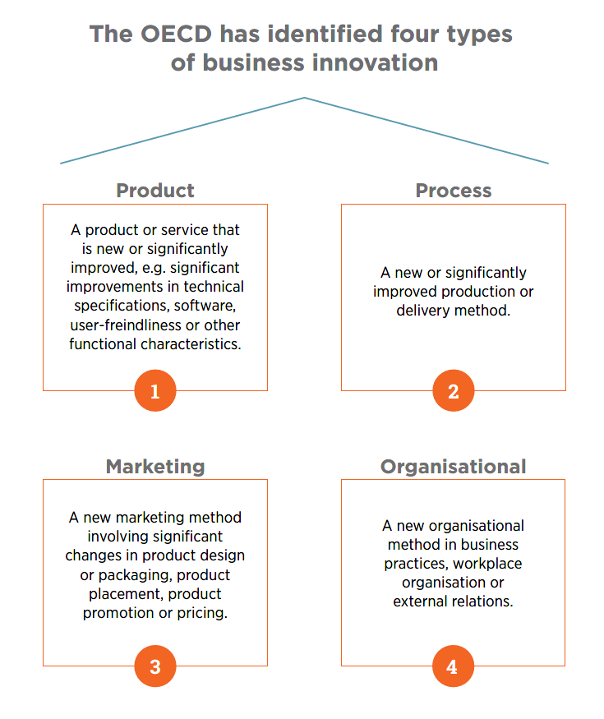

9 OECD. (2005). Oslo Manual - *Guidelines for collecting, reporting and using data on innovation*, 3rd edition.

10 AlphaBeta. (2019). *Australian business investment in innovation: levels, trends, and drivers*, p. 24.

11 AlphaBeta. (2019). *Australian business investment in innovation: levels, trends, and drivers,* p. 39 and Palangkaraya, A., Spurling, T., & Webster, E. (2016). *What drives firm innovation?* A review of the economics literature.

8 INNOVATION AND SCIENCE AUSTRALIA

Table 1 provides a list of non-R&D innovation examples and highlights how intangible asset investments, which are frequently associated with such activities, are being leveraged in each case to drive faster growth.12

**Table 1:** Examples of non-R&D innovation and the types of intangible asset investments made to enact the innovation.

|  |  |  |
| --- | --- | --- |
| **Examples of non-R&D innovation** | **Non-R&D intangible asset investments** | **Mechanisms of growth for the investor in the asset** |
| A car-sharing platform helps people get access to cars without having to cover the up-front costs. | Software (including internally developed and purchased). | Improved process efficiency, ability to spread process innovation more quickly, and improved vertical and horizontal integration. |
| A startup fintech firm delivers financial products to customer segments that are not served by traditional providers. | New or significantly improved product designs. | Access to new/larger markets. Reduced information asymmetry and monitoring costs. |
| A dairy business uses culturally sensitive branding of a new fresh tasting long-life milk product to sell into major supermarket chains in Asia. | Enhanced brand, including positioning and awareness. | Improved consumer trust, enabling innovation, price premium, increased market share and communication of quality. |
| A large, traditional firm adopts a new project management approach across the entire organisation. | New or significantly improved organisational capability. | Internal improvement in decision  making and business processes. |

12 Table 1 is not an exhaustive list of intangible assets investments and often businesses will also invest in more than one type of intangible asset to enact a non-R&D innovation.

**STIMULATING BUSINESS INVESTMENT IN INNOVATION 9**

To examine the critical role innovation plays in driving a productive, resilient and prosperous nation, the Minister for Industry, Science and Technology, the Hon Karen Andrews MP, asked ISA to provide advice on opportunities for increased business investment in innovation. In developing this advice, ISA has:

* undertaken a study of the drivers for, and barriers to, increasing business investment in R&D and emerging technologies, and in other activities that support innovation including systems, processes and skills
* identified the needs and opportunities of firms in existing and emerging areas of the economy, in response to technology disruption
* analysed issues faced by firms that operate predominantly within software environments, and options for addressing them
* considered the role of government, including direct and indirect interventions, and identified opportunities for greater industry-led initiatives.

ISA used both quantitative and qualitative analyses in compiling this report. The quantitative work highlighted the implications of Australia’s industry mix in the economy, the importance of macroeconomic conditions and their impacts on the trends in innovation investment in Australia (see **Appendix A**). The qualitative work used human-centered design methodologies and a collaborative design process involving over 180 business stakeholders from across Australia (see **Appendix B**).

Drawing upon the findings of the quantitative and qualitative analyses and the experience of ISA Board members, this report develops four strategic recommendations for increasing business investment in innovation.

For each recommendation, ISA suggests ways to implement it using examples of government-led and business-led initiatives. These examples are based on insights from the analysis and international best practice and do not constitute a definitive list of potential measures. While consideration of detailed funding arrangements is beyond the scope of this report, these examples could be funded from a combination of savings achieved through streamlining innovation programs and new investment to stimulate greater business innovation.



**10** INNOVATION AND SCIENCE AUSTRALIA

## Discussion of Strategic Recommendations and supporting findings

|  |
| --- |
| Strategic Recommendation 1:ISA recommends that Government rebalance its policy mix to support business investment in both non-R&D innovation and R&D, specifically with significant additional support for non-R&D innovation for a defined period, say, 5–10 years. |

#### Australian businesses are increasingly recognising the importance of non-R&D innovation in addition to more traditional R&D

Innovation is key to business success, but where innovation comes from is changing. Today’s firms are looking beyond R&D to drive innovation.13 While business investment in R&D remains important, Australian data shows our firms are investing in innovation activities beyond R&D.14 These investments are in non-R&D categories such as enhanced business models, marketing and branding, productivity-enhancing technologies (including software and systems) and intellectual property acquisition. Investments are also being made in tangible assets such as innovation-related machinery and equipment. We refer to these as investments in non-R&D innovation.

#### Investment in non-R&D innovation is important

The OECD has found that non-R&D innovation plays a significant role in increasing business value. For example, between 1995 and 2010, United States (US) spending on R&D rose from 2.3 to 2.4 per cent of value-added across the economy. Over the same period, business spending on non-R&D innovation increased from 8.5 to 11.2 per cent of value-added across the economy.15 Similar results were found in many other countries. Overall, private R&D stocks represented no more than 20 to 25 per cent of the total private stocks of business investment in innovation.

Innovation can spur economic growth because the initial cost incurred in developing some types of knowledge does not need to be incurred again when that knowledge is used in production. Once created, some forms of innovation (such as software and some designs) can be replicated at almost zero cost and this can lead to increasing returns to scale in production.

Asset-light, customer-loyalty focused businesses (such as Google and Amazon) are prime examples of the value created by non-R&D innovation, combined with R&D investments. Research suggests that technological progress and the accumulation of intangible capital have accounted for over half of the increase in output, per hour, in the US. Similar findings have been made in comparable economies.16

*‘Innovation is key to business success, but where innovation comes from is changing. Today’s firms are looking beyond R&D to drive innovation’*

13 OECD. (2013). *Supporting investment in knowledge capital, growth and innovation*, p. 17.

14 AlphaBeta. (2019). *Australian business investment in innovation: levels, trends, and drivers*, p. 5.

15 OECD. (2013). *New sources of growth: knowledge-based capital key analyses and policy conclusions synthesis report*, p. 13.

16 Corrado, C., Hulten, C., & Sichel, D. (2009). *Intangible capital and US economic growth. Review of income and wealth, 55(3)*, 661-685. and Corrado, C. A., & Hulten, C. R. (2010). *How do you measure a "technological revolution"? American Economic Review, 100(2)*, pp. 99-104.

**STIMULATING BUSINESS INVESTMENT IN INNOVATION 11**

The European Commission has found that intangible assets are at the heart of firm competitiveness and are vital for productivity and economic growth.17 Firm-level productivity increases as a result of R&D investments were also demonstrated for other intangible assets categories including human capital, organisational capital, customer capital and computerised information (software and databases). The paper notes that there is a need to improve the measurement of intangible assets to capture the ongoing shift from tangible to intangible investments and to ensure evidence-based policy making.18

Non-R&D innovation can also play an important complementary role to R&D investment. R&D may generate significant local process or product innovations. However, non-R&D innovation diffuses global and local innovation through the economy and boosts firm performance through smaller and more continuous innovations.19 A recent OECD report has found robust evidence that digital adoption is associated with productivity gains at the firm level.20



17 Thum, A. E., Voigt, P., Bilbao-Osorio, B., Maier, C., & Ognyanova, D. (2017). *Unlocking Investment in Intangible Assets (No. 047)*.

Directorate General Economic and Financial Affairs (DG ECFIN), European Commission. <https://ec.europa.eu/info/sites/info/files/economy-finance/dp047_en.pdf>

18 Thum, A. E., Voigt, P., Bilbao-Osorio, B., Maier, C., & Ognyanova, D. (2017). *Unlocking Investment in Intangible Assets (No. 047)*.

Directorate General Economic and Financial Affairs (DG ECFIN), European Commission, p. 19. <https://ec.europa.eu/info/sites/info/files/economy-finance/dp047_en.pdf>

19 AlphaBeta. (2019). *Australian business investment in innovation: levels, trends, and drivers*, p. 24.

20 Gal, P., Nicoletti, G., Renault, T., Sorbe, S., & Timiliotis, C. (2019). *Digitalisation and productivity: In search of the holy grail-Firm-level empirical evidence from EU countries*. <http://www.oecd.org/officialdocuments/publicdisplaydocumentpdf/?cote=ECO/WKP(2019)2&docLanguage=En>

**12** INNOVATION AND SCIENCE AUSTRALIA

#### Examples of how Australian business invests in non-R&D innovation

##### RedEye

Australian firm RedEye creates value for its clients through investment in R&D and non-R&D innovation. RedEye was founded in Brisbane in 2012 to improve the way clients manage assets and critical infrastructure. Based on an identified need in the market, the RedEye founders developed cloud-based engineering software that allows secure sharing of engineering data across locations and teams. RedEye also provides training and support services for its clients.21 The company raised $10.4 million from the Queensland Government’s Business Development Fund and US investor Energy Innovation Capital in 2018 to help fund its international expansion. RedEye now employs about 100 people and has clients who manage more than $200 billion worth of critical infrastructure. In 2018–19, RedEye established its third office in North America, opened a new office in New Zealand and is furthering plans to enter Europe.22

##### Abbe Corrugated

Abbe Corrugated manufactures a variety of corrugated packaging, from cardboard packaging for fruit and vegetables to specialised packaging for chemicals and dangerous goods. Abbe recently developed a marketing strategy to support new market growth opportunities. They invested in new technology to support these growth plans, including multi-million dollar specialist printing equipment from Spain – the only equipment of its type in Australia. This technology has allowed Abbe to deliver new products and services, including tailor-made printed packaging for customers’ specific needs. A new digital workspace allows customers to visit the factory and acquire a greater understanding of Abbe’s products and how they can be customised to their needs. Through these non-R&D innovation activities, Abbe has created 23 new jobs. The result has been an increase in revenue, profits and market opportunities.

##### Subcon

Subcon is a market-leading company that provides solutions to some of our most vexing marine challenges. The company draws on expertise in marine engineering, construction and knowledge of the oil and gas industry to create innovative products that meet critical fisheries needs.

Subcon has invested in non-R&D innovation in its innovative business model. Its flexible business model allows the firm to be highly responsive to customer needs. Constant exposure to customer needs has created opportunities for Subcon to improve its current technology. For example, Subcon’s repurposing of oil and gas platforms was an innovative solution to meet customer needs and address an environmental problem.

21 Further information is available at [https://redeye.co/about-us/#](https://redeye.co/about-us/)

22 This information has been taken from the *Trade and Investment Queensland Annual Report 2018–19*.   
<https://www.tiq.qld.gov.au/download/business-interest/about-tiq/annual-reports-strategic-plan/TIQ-Annual-Report-2018-19.pdf>

**STIMULATING BUSINESS INVESTMENT IN INNOVATION 13**

#### BERD is not a strong predictor of innovation investment

AlphaBeta analysis shows sectors where many firms are actively innovating are more likely to have greater productivity, whether or not they conduct R&D.23 Australian firms that invested in innovation (both non-R&D innovation and R&D) had higher revenue and job growth than those that did not.

#### Australian firms invest just as much in non-R&D innovation as they do in R&D

Australian business investment in both R&D and non-R&D innovation is estimated to be two per cent of gross domestic product (GDP) or $32–$36 billion per annum (see Exhibit 2).

Exhibit 2 demonstrates that non-R&D innovation investment is at least as widespread as business investment in R&D.

AlphaBeta analysis also shows only 5.8 per cent of Australian firms reported investing in R&D, while 32 per cent invested in at least some form of innovation (that is R&D, non-R&D innovation or both).24 Also, of those firms that did invest in R&D, four in five spent more than half of their innovation budget on non-R&D activity.

Small firms are more likely to invest in non-R&D innovation than large firms. This is important due to the central role small firms play in Australia’s economy.25 As previously mentioned, international research points to a strong correlation between intangible capital investment and an increase in labour productivity growth, and economic growth.26

**Exhibit 2:** Australian business investment in innovation, 2016–17

Australian business investment in both R&D and non-R&D innovation is estimated to be $32–$36 billion per annum. In 2016-17 this included $17 billion investment in R&D and $15-$19 billion in non-R&D innovation.


***Source:*** *BERD: ABS (2017), 8104.0 (for 2015–16); Total business investment in innovation: ABS (2018) 8158.0 Appendix 1: Explanatory Notes: Innovation Expenditure by Dollar Ranges (for 2016–17); Non-R&D innovation calculated as the difference between BERD and Innovation. (It is likely that the measure of R&D in ABS 8104 is more reliable than any measure that could be inferred from ABS 8159.)*

23 AlphaBeta. (2019). *Australian business investment in innovation: levels, trends, and drivers,* p. 39 and Palangkaraya, A., Spurling, T., & Webster, E. (2016). *What drives firm innovation?* A review of the economics literature.

24 AlphaBeta. (2019). *Australian business investment in innovation: levels, trends, and drivers*, p. 9.

25 Palangkaraya, A., Spurling, T., & Webster, E. (2016). *What drives firm innovation?* A review of the economics literature.

26 Thum-Thysen, A., Voigt, P., Maier, C., Bilbao-Osorio, B., & Ognyanova, D. (2017). *Unlocking investment in intangible assets in Europe*. Quarterly Report on the Euro Area (QREA), 16(1), p. 25. <https://ec.europa.eu/info/sites/info/files/economy-finance/dp047_en.pdf>

**14** INNOVATION AND SCIENCE AUSTRALIA

#### Australian firms that invested in innovation (either non-R&D innovation, R&D or both) had higher revenue and job growth than those that did not

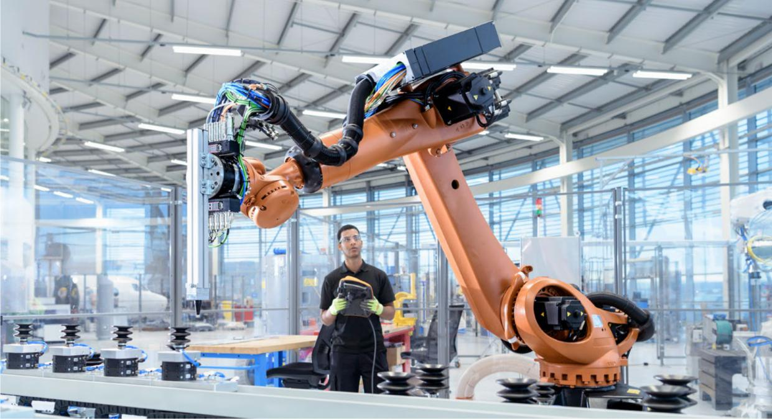

AlphaBeta found that, on average, large and small firms that invested in innovation outperformed firms that did not invest in innovation.27 ASX200 firms in the top quartile, by intangible asset share of total assets, grew revenue 1.3 percentage points per year faster than the average ASX200 firm revenue growth. This analysis also found that large firms that reported spending on intangible assets or spending on R&D activities were more likely to survive than those that reported neither.28

For SMEs, those that accelerated their investment in technology and were more sophisticated users of IT, had higher revenue and employment growth than those that didn’t conduct innovation activity or invest in IT.29 SMEs with high growth in technology spending increased revenue by an additional 3.5 percentage points per year faster and employment by an additional 5.2 percentage points faster than those with low technology spending growth. Similarly, SMEs that adopted at least one business software application, in areas such as finance, human resource management, marketing and sales, increased employment by 2.2 percentage points faster than others.

#### Why should the government support non-R&D innovation?

As businesses are already increasing their investment in non-R&D innovation, the question that could be asked is, “Why should government encourage additional non-R&D business investment? Where is the market failure?” Despite the relative buoyancy in non-R&D innovation, Australian business investment in innovation lags behind developed country averages.30 Australia’s business innovation as a share of GDP is at 1.9 per cent, just two-thirds of the European average of 2.9 per cent.31 Given the revenue and jobs growth correlations with business non-R&D investments, there is a case to encourage and accelerate greater non-R&D innovation.

27 AlphaBeta. (2019). *Australian business investment in innovation: levels trends, and drivers*, p. 35.

28 AlphaBeta. (2019). *Australian business investment in innovation: levels trends, and drivers*, pp. 35-36.

29 AlphaBeta. (2019). *Australian business investment in innovation: levels trends, and drivers*, p. 38.

30 AlphaBeta. (2019). *Australian business investment in innovation: levels trends, and drivers*, p. 24.

31 AlphaBeta. (2019). *Australian business investment in innovation: levels trends, and drivers*, p. 24.

**STIMULATING BUSINESS INVESTMENT IN INNOVATION 15**

Government intervention to accelerate non-R&D innovation investment is appropriate for reasons similar to those that have long underpinned government support of R&D; namely that non-R&D innovation investments produce spillovers and synergies that cannot always be captured by the business investing. Intangible assets, which include R&D and many non-R&D categories, are often especially valuable when combined with other intangibles and human capital.32 For example, a change in business model may trigger additional investment in information and communications technology (ICT) systems and software that is supported by additional training of staff to maximise the benefit from the new investments.

When ISA asked firms about barriers to non-R&D innovation investment, businesses identified information asymmetry challenges such as barriers to enabling greater collaboration, supply chain partnering, and working more closely with customers. There was a lack of understanding of the potential benefits of collaborating, a lack of information about potential partners and high costs to identify them, and a lack of trust in dealing with business partners. Businesses also highlighted the burden of high cost legacy ICT systems and identified access to finance as a key barrier to investing and participating in the ‘new’ economy.

All these market failures impact on the ability of businesses to create thriving industry ecosystems and result in a sub-optimal investment in innovation.

There is a role for government to coordinate, facilitate and act as a catalyst for innovation and develop new markets for businesses.

Given the potential for non-R&D innovation investment to boost productivity, jobs and growth potential, it is imperative that government supports and accelerates business investment in non-R&D innovation to quickly realise these gains.

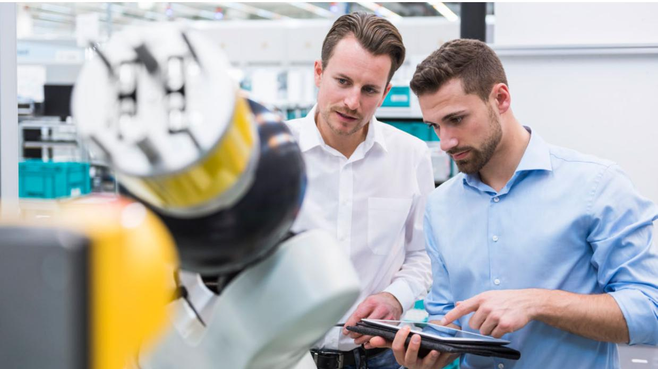

32 Haskel, J., & Westlake, S. (2018). *Capitalism without capital: the rise of the intangible economy*. Princeton University Press.

**16** INNOVATION AND SCIENCE AUSTRALIA

### Strategic Recommendation 1:

### Examples of government-led initiatives

#### **A**. Greater investment in technology

**ISA recommends that Government reduce reliance on the R&D Tax Incentive (R&DTI) as the primary support to businesses and complement support with direct measures (such as grants) to encourage non-R&D innovation investment.**

As a high priority, direct measures need to be used to encourage greater investment in technology and digital innovation. An example of such a support measure could be a business ICT modernisation fund to help businesses move from legacy ICT systems to more modern capabilities.

Over time, government support for business innovation has favoured measures focused on increasing the supply of R&D, rather than support for a range of activities across the innovation spectrum. The Productivity Commission reported that total Commonwealth support for business R&D has remained steady over five years, representing around $4.1 billion.33 The R&DTI accounts for the bulk of the government’s R&D support to industry. The Science, Research and Innovation (SRI) Budget Tables estimate the cost of the R&DTI to the government at $2.06 billion for FY 2019.34

Direct support measures can play an important role in providing targeted support for business investments in general-purpose technologies. They have also been shown to be particularly effective for young firms that lack the upfront funds or collateral to finance an innovative project.35 There is a need to support non-R&D innovation through more direct and targeted support measures.

Government could use a number of different direct mechanisms to rebalance the support between R&D and non-R&D innovation investments. The most appropriate mechanism should be determined through more detailed analysis. However, ISA believes a focus on software, digital transformation and ICT is warranted because these technologies act as enablers of productivity across multiple sectors.

*‘Government intervention to accelerate non-R&D   
innovation investment is appropriate for reasons similar   
to those that have long underpinned government   
support of R&D.’*

33 Australian Productivity Commission. (2017-18). *Trade and assistance review*. pp. 5–6. <https://www.pc.gov.au/research/ongoing/trade-assistance/2017-18>

34 The SRI Budget tables can be found at <https://www.industry.gov.au/data-and-publications/science-research-and-innovation-sri-budget-tables>

35 OECD. (2015). *The innovation imperative – contributing to productivity, growth and well-being*, STI policy note, p. 6.

**STIMULATING BUSINESS INVESTMENT IN INNOVATION 17**

#### **B**. Government procurement



**ISA recommends that, where appropriate, government leverage its procurement of products and services to promote a more innovation-oriented response from business and build business capability. In particular, there needs to be a focus on procurement policy that can deliver innovative solutions for government and growth opportunities for innovative firms.**

Many countries have used government procurement, including challenge-based approaches, to support the development of an innovation ecosystem and drive productivity growth. The US’ Small Business Innovation Research program, the United Kingdom’s (UK) Small Business Research Initiative, and Innovative Solutions Canada are all designed so that government can solve problems with the help of innovative SMEs.

Governments in Australia have been using challenge-based procurement such as the Business Research and Innovation Initiative and Small Business Innovation Research for Defence. However, these are not on a scale to create sufficient demand for innovation from firms and truly move the needle.

Government is a major purchaser and its procurement processes are a training ground for customer engagement.

The use of government procurement to increase business investment in innovation could impact how businesses think about the value of innovation and drive considered risk taking.

There are opportunities across governments in Australia to leverage and coordinate challenge-based procurement programs. This would build scale, provide innovative solutions to governments and generate more customers for innovative firms.

There are examples of the Australian Government creating opportunities for Australian firms using procurement. For example, the digital marketplace channeled $300 million of IT procurement, from a $9 billion budget, to SMEs.

Overall, the government spent $71.1 billion on procurement contracts in 2017–18.36 Some of this expenditure could be used to support the business innovation ecosystem. There is evidence that procurement can significantly boost innovation spillover effects, in particular in social and environmental areas.37

36 Australian Government Department of Finance, Australian Government [Procurement. www.finance.gov.au/procurement](http://Procurement.www.finance.gov.au/procurement)

37 Mazzucato, M. (2015). *The entrepreneurial state: Debunking public vs. private sector myths*. (Vol. 1). Anthem Press.

**18** INNOVATION AND SCIENCE AUSTRALIA

### Case Study 1:

### GreenBe Software

**GreenBe’s innovation journey demonstrates the importance of investing in both non-R&D innovation and R&D, and the critical role government procurement played in the organisation’s success.**

GreenBe Software (GreenBe) is an innovative startup which has thrived by leveraging the opportunities in the regional Australian city of Newcastle. The value it offers customers is bespoke software solutions to difficult problems using a range of innovative technologies.

GreenBe initially developed game-style rewards to create behavioural shifts by measuring the waste in people’s bins and incentivising diversion from landfill. However, without a strong appetite in government for a smart home waste management system there was no market for the product and the company had to look to alternative applications.

At this pivotal point the company decided to invest in non-R&D innovation, shifted its business model and

introduced a service aspect to its business offer—rather than offering a product, it offered solutions. It saw the value in engaging with customers to iterate their offering to individual solutions for clients.

GreenBe’s clients, predominantly local government and the utilities sector, contracted the company to create customer-facing software that encourages positive behavioural shifts. For example, a utility company has employed GreenBe to create a solution that, in real-time, incentivises reduced energy use. This is particularly valuable to electricity retailers as a tool to reduce demand when the grid is under pressure. This type of service offers mutual benefits to customers and the service provider.

GreenBe was founded without assistance from external investors or accelerators. Instead, the company directed its effort towards attracting clients to grow from its core business. The turning point was a local government procurement. This opportunity brought in revenue and enabled GreenBe to develop useful intellectual property and, most importantly, build a positive reputation.

GreenBe is now a strong advocate for the mutual benefits of government procuring from small, local technology start-ups.

#### Key Challenges

* Early opportunities to perform work for government clients were critical to GreenBe’s success. They provided necessary revenue, in addition to a supported opportunity to develop intellectual property and capability.
* The credibility of government clients assisted GreenBe to grow its reputation and provided a valuable springboard for other opportunities. In particular, government experience was a critical gateway to securing opportunities to work in the private sector.

#### Insights

* Government procurement of start-ups and SMEs in the technology space provides a critical opportunity for these businesses to demonstrate and grow their capacity.

**STIMULATING BUSINESS INVESTMENT IN INNOVATION 19**

#### A critical mass of key sectors is important for firms to drive innovation

Businesses are more likely to grow and invest in innovation where they have the support of a thriving industry ecosystem. The bigger the industry ecosystem, the lower the costs for businesses to access resources (including specialist services), the higher the probability of valuable knowledge spillovers, and the lower the risk for businesses to invest in innovation.

Australia’s current approach to allocating resources is to support a broad cross-section of businesses. The Australian Government and business need to focus on achieving a critical mass of sectors where Australia has (or could have) a comparative advantage.

Analysis by AlphaBeta shows the strongest predictor of productivity growth in a sector is the share of innovation-active firms. That is, the scale of innovation within a sector is a key determinant of its success (see Exhibit 3).

Australia has already identified sectors of strategic importance—or where it has or could have a comparative advantage—through its investment in these sectors.38

**Exhibit 3:** Five year multifactor productivity (MFP) growth vs. measures of innovation investment by sector MFP Growth, Annual, 2012–13 to 2017–18, per cent.

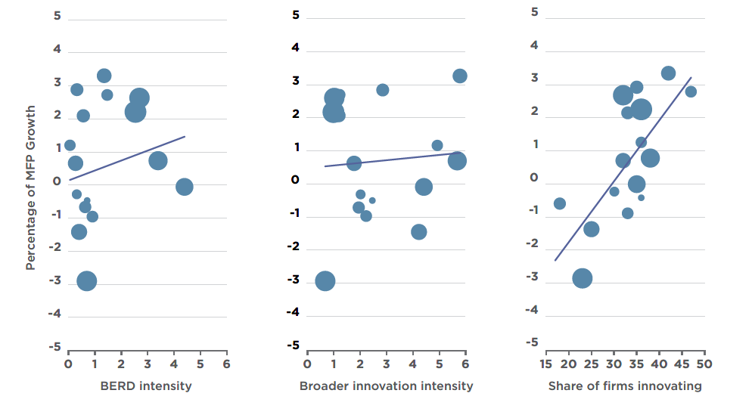

***Source:*** *ABS (2019) 8158.0 and 8104.0 AlphBeta analysis; *BERD intensity is BERD/GVA and is the average for 2011–2016; Broader innovation intensity is a measure of innovation based on the BCS survey, also expressed as a percentage of GVA in 2016–17. This measure is likely to have significant measurement error, as firms only report their expenditure in ranges. Share of firms innovating is the percentage of firms that spent money on innovation in 2016–17.*

### Strategic Recommendation 2:

### ISA recommends that government and businesses prioritise the key growth sectors.

38 Australian Government. (2014). *Industry innovation and competitiveness agenda – an action plan for a stronger Australia*, p. 55. <https://www.pmc.gov.au/sites/default/files/publications/industry_innovation_competitiveness_agenda.pdf>

**20** INNOVATION AND SCIENCE AUSTRALIA

In the near term these key growth sectors (which include Advanced Manufacturing, and Food and Agribusiness) should continue to be the primary focus of the government for encouraging R&D and non-R&D innovation investment, enhancing global competitiveness and ensuring appropriate scale.

In the longer term, the government should develop a rigorous process to review how these sectors are identified and supported. This will ensure they continue to represent suitably prospective sectors, given the inevitable evolution in sector performance.

#### Peer economies are prioritising and fostering innovation in key growth sectors

Many countries are taking an increasingly proactive approach to supporting business innovation. The governments of countries that rank highly in innovation investment commonly have mechanisms to provide funding directly to industry, through either direct co-investment or risk guarantees for private investors.

Funding is typically provided through co-investment programs. The Finnish Innovation Fund II and the Startup SG12 equity fund in Singapore are examples. A key feature of these programs is the targeting of innovative enterprises that operate in a designated sector or meet the strategic needs of the nation.

Although governments in Australia have adopted some of these approaches, fewer resources have been allocated than our international counterparts. Also, the programs have not been sufficiently focused on particular sectors or industries. Australian policies have tended to have broad eligibility, which has not resulted in the appropriate scale to ensure accelerated growth in sectors where Australia has a comparative advantage.

Australian governments must deliver effective policies to help level the international playing field. Without more active, well-targeted engagement to foster business innovation investment, Australian firms risk falling further behind their international competitors. The Australian Government should continue to commit to and concentrate its support for key growth sectors that have built, or are likely to build, our comparative advantage. This could be achieved by expanding the current sectoral policy approach and considering investment in new and emerging growth sectors.

For each of the existing key growth sectors, the government should implement measures that support both non-R&D innovation and R&D. These sectors will be important exemplars of the investment balance established in Strategic Recommendation 1.

#### Australia’s sectoral innovation mix has distinctive characteristics

Using sector-level BERD data, AlphaBeta has highlighted the role of Australia’s industry mix as an important driver of the apparently low aggregate level of R&D investment by Australian firms.39 Much of the gap between Australian and higher international BERD levels could be attributed to the fact that Australian manufacturing and information, media and technology (IMT) sectors account for a smaller share of the economy than peer economies. Furthermore, Australia’s R&D intensity in those sectors is comparatively low (refer to Exhibit 4).

Manufacturing drives 70 per cent of BERD in peer economies (such as Canada, the US, the UK, Korea, Japan and Germany), but accounts for only a quarter of BERD in Australia.

Similarly, the IMT sector accounts for 24 per cent of BERD in the OECD, but just 3.5 per cent in Australia.40

By contrast, Australia’s industry mix and innovation intensity in services—particularly business services—are above

international averages.

*‘Countries are taking an increasingly proactive   
approach to supporting businesses to innovate.’*

39 AlphaBeta. (2019). *Australian business investment in innovation: levels trends, and drivers*, p. 15.

40 AlphaBeta. (2019). *Australian business investment in innovation: levels trends, and drivers*, p. 20.

**STIMULATING BUSINESS INVESTMENT IN INNOVATION 21**

**Exhibit 4** International BERD intensity by sector, 2017–18 or latest

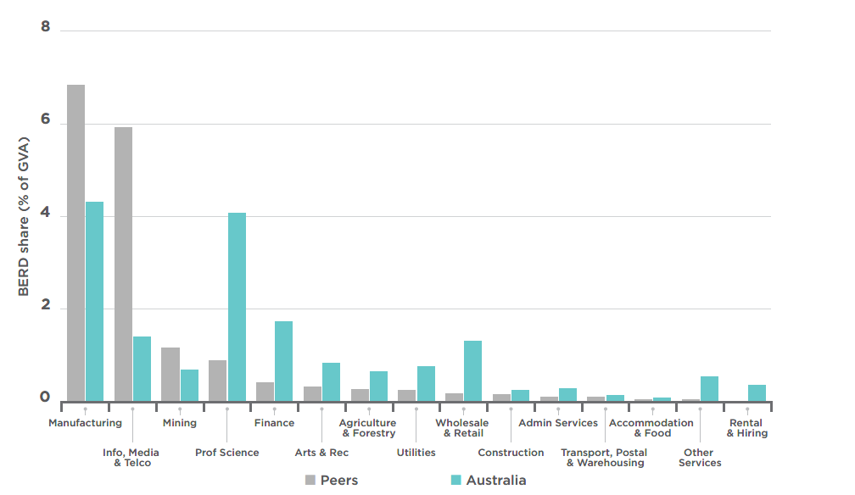

#### While a government focus on prioritised sectors will be a key avenue to grow the Australian economy, broader support for ICT related non-R&D innovation investment will concurrently benefit all sectors

Exhibit 4 indicates Australia’s IMT sector is comparatively small. It is important to note, however, that all sectors use and rely on ICT to some extent, and many have been disrupted by ICT innovations and benefited through innovative technology adoption.

According to the Australian Computer Society publication *Australia’s Digital Pulse 2019*, just under half (49 per cent) of all technology workers are directly employed in ICT-related industries such as computer systems design, telecommunication services and internet service provision.41 The remaining 51 per cent are employed in other industries throughout the Australian economy.42

As such, investments in ICT-based innovation not only support the IMT sector, but more importantly offer revenue and growth spillovers associated with innovation in many other sectors.

Australia already has strong capability in niches within the IMT sector, including business-to-business software. Leveraging this capability across multiple sectors could have significant impact.

Work by Data61, in conjunction with AlphaBeta, has highlighted the opportunity available through ICT-focused investment, in a number of areas of strategic importance to the Australian economy. The work estimates this investment could create a market worth $155 billion in our region over the next decade.43

In targeting key growth sectors, there is therefore an opportunity to demonstrate, in a focused way, the rebalancing of support between R&D and non-R&D innovation. While both are critical to long-term prosperity, in the near term the opportunities from investing in ICT and software appear particularly attractive.

41 Deloitte Access Economics. (2019). *ACS Australia’s digital pulse 2019 – blooming today but how can we sustain digital workforce growth*? <https://www.acs.org.au/content/dam/acs/acs-publications/Digital-Pulse-2019-FINAL-Web.pdf>

42 For example in public administration and safety, financial and insurance services, education and trade, retail trade and manufacturing.

43 Data61 and AlphaBeta. (2018). *Digital Innovation: Australia’s 315B Opportunity*, p. 17.

<https://www.data61.csiro.au/en/Our-Research/Our-Work/Future-Cities/Planning-sustainable-infrastructure/Digital-Innovation>

**22** INNOVATION AND SCIENCE AUSTRALIA

### Strategic Recommendation 2: Examples of government-led initiatives

#### **C.** Mission-oriented policy

**ISA recommends that Government leverage mission-oriented policy levers to solve national problems while stimulating key growth sectors and driving collaborative innovation.**

There is a shift in thinking, both domestically and internationally, about the role of public sector institutions from one that is a passive actor focused on predominantly fixing market failures, to one that leads and sets directions in priority areas.

Mazzucato argues that Market Failure Theory (MFT) is less useful when the policy is required to create and shape new markets dynamically; that is, market 'transformation'. MFT is problematic for addressing innovation and societal challenges because it cannot explain the kinds of transformative, catalytic, public investments required to create new technologies and sectors.44

Internationally, missions are being used as a mechanism to provide global competitiveness across key sectors. For example, the United Kingdom Industrial Strategy sets out four Grand Challenges,45 focused on global trends, to put the UK at the forefront of the industries of the future.46 Each Grand Challenge focuses on a specific problem, bringing government, businesses and organisations together across the UK.

#### **D.** Easier access to innovation capabilities

**ISA recommends that Government explore other models to provide industry with easier access to capabilities within research institutions. For example, consider developing research as a service model, like the Carnot Institutes model in France.**

SMEs are often confronted with challenges such as new technology, security concerns, environmental norms, new materials, or the need to innovate their production processes. Most SMEs lack the financial and personnel resources to perform research that would be necessary to tackle these issues.

A study of 7,000 Australian SMEs found that businesses that collaborated on innovation increased their annual productivity growth by 4.1 percentage points.47 The Office of the Chief Economist also notes that the Australian trend is consistent with international studies that highlight the importance of collaborative R&D on the performance of business.48

Countries have fostered research and industry collaborations in several ways. In Australia, the Cooperative Research Centres (CRC) program has been an effective mechanism. International examples suggest there are additional opportunities to collaboration between industry and researchers. A notable international example t

he Australian Government could consider is the Carnot Institutes in France. Established in 2006, these institutes undertake collaborative research projects and provide SMEs and entrepreneurs with research services through easy-to-use contract models. Their scientific and technological advances enable businesses to innovate and develop their competitive advantage.

For the past ten years the Carnot network, by making strong commitments in favour of the French economy, has more than doubled its turnover with companies.49 The institutes receive €420 million in research contracts directly financed by companies each year, accounting for over 50 per cent of R&D funded by companies for French public research.50 This model focuses on putting the needs of the SME first, is customer service driven and combines the capacity to create scale through a decentralised innovation network. This could provide new competitive opportunities for Australian SMEs to access the expertise and infrastructure they need to grow their businesses.

44 Mazzucato, M. (2016). *From market fixing to market-creating: a new framework for innovation policy*. Industry and Innovation, 23(2), pp. 140–156.

45 The four Grand Challenges are artificial intelligence and data, ageing society, clean growth and future of mobility.

46 More information about the UK Grand Challenges can be found at <https://www.gov.uk/government/publications/industrial-strategy-the-grand-challenges/missions>

47 Palangkaraya A, Spurling T and Webster E. (2015). *Does innovation make (SME) firms more productive?*Paper presented to Reserve Bank of Australia Annual Conference 2015, Sydney, p. 189.

48 Department of Industry, Innovation and Science. (2017). *Australian innovation system report*.

<https://publications.industry.gov.au/publications/australianinnovationsystemreport2017/documents/australian-innovation-system-report-2017.pdf,> p. 15.

49 <https://www.inria.fr/en/innovation/news/carnot-institutes>

50 <https://www.inria.fr/en/innovation/news/carnot-institutes>

**STIMULATING BUSINESS INVESTMENT IN INNOVATION 23**

#### **E.** Align industry skills demand with supply from education institutions

**ISA recommends that Industry Growth Centres and the relevant departments work with businesses to reduce the lag between curriculum development and the skills businesses need. A recent example is AustCyber’s work with the vocational education and training (VET) sector.**

Businesses are more likely to grow where they have the support of a thriving industry ecosystem. Businesses tend to invest in training when they feel comfortable that there is a pipeline of appropriately trained staff or a pool of talent from which they can leverage.

Deloitte Access Economics has highlighted “the highest policy priority for the digital economy is skills development, and that relying on IT graduates and skilled migration alone is unlikely to meet the significant future demand for technology workers.” It adds that “more people need to consider moving from other occupations to take one of the additional 100,000 jobs that will be created in technology by 2024”.51 The Cyber Security Growth Centres’ (AustCyber) collaborations with industry and the VET sector to develop training that meets the needs of industry is a good example of industry demand being met by education institutions. This should be replicated.

### Strategic Recommendation 2: Examples of business-led initiatives

#### **F.** Increase industry and government collaborations

**ISA recommends that businesses work with Industry Growth Centres to further develop sector, cross-sector and export competitiveness plans, articulating how their sector will grow and create jobs and outlining the needs of their sector to government.**

Each of the Australian Government’s six Industry Growth Centres has developed a short-term and long-term strategic vision that identifies challenges and opportunities for growth in their sector. This vision is captured in the Growth Centre’s Sector Competitiveness Plan, a ten-year strategy developed in consultation with stakeholders and updated annually to reflect new sector trends.

There is an opportunity for sectors to identify common issues (e.g. impact of emerging technologies) and to pool resources, establish scale and develop innovative solutions with the help of the Growth Centres.

By identifying cross-sector opportunities, articulating these clearly to government and specifying where government support is needed, there is an opportunity to act quickly, as well as forge stronger industry and government collaborations.

51 Deloitte Access Economics. (2019). *ACS Australia’s digital pulse 2019 – blooming today but how can we sustain digital workforce growth*? <https://www.acs.org.au/content/dam/acs/acs-publications/Digital-Pulse-2019-FINAL-Web.pdf>

**24** INNOVATION AND SCIENCE AUSTRALIA

### Case Study 2: Cohda Wireless

**Cohda Wireless’s innovation journey demonstrates the need for tailored and holistic government assistance to help Australian businesses take an idea all the way through to commercialisation.**

Cohda Wireless was established in 2004 as a spin-off from the University of South Australia. It developed technology to link city-wide Wi-Fi networks that it intended to use as a platform for public safety products (policing, fire and ambulance). The trend towards city-wide Wi-Fi was, however, surpassed by cellular networks, leaving Cohda Wireless searching for a new application for its technology.

The automotive industry proved an ideal fit for its technology with emerging Vehicle-to Vehicle (V2V), Vehicle-to-Infrastructure (V2I), and Vehicle-to-Pedestrian (V2P) technology, collectively known as V2X.

Its ‘big break’ came when it was included in a large trial funded by the German Government, which generated further opportunities to be involved in trials in Australia and abroad. It has been involved in trials supported by the Government of South Australia, including a test of on-the-ground connectivity between cars and roadside infrastructure in challenging locations.

In 2019, Cohda Wireless V2X stacks were used in 60 per cent of all connected vehicle trials worldwide. While the company is based in Adelaide, it operates sales offices in Detroit, Munich and Shanghai.

#### Key Challenges

As an SME, Cohda Wireless was too small for some assistance, and too large for other assistance, without clear support in between. While support was ample when it was ‘on the cusp of growth’, Cohda Wireless found that as it scaled up, it was cut off from certain industry opportunities.

Cohda has also been involved with state-based government programs, including:

* a Victorian Small Business Innovation Research program, and
* the Future Mobility Lab Fund in South Australia.

While each touchpoint has been distinct in purpose, Cohda Wireless has had to (successfully) weave them together to create holistic support for its innovation at various stages in their development.

#### Insights

* SMEs may encounter a funding gap, where they become too large to be eligible for assistance programs, yet remain too small to have full market support. It is also important that SMEs can access support that does not require a significant upfront injection of capital, as this can prohibit their involvement.
* Varied government touchpoints can help support innovation to develop from infancy to successful market entry.

**STIMULATING BUSINESS INVESTMENT IN INNOVATION 25**

|  |
| --- |
| Strategic Recommendation 3:ISA recommends that Government and businesses develop and encourage a 'growth through innovation' mindset and the business processes required to implement this mindset, among shareholders, directors and managers. |

Government and business need to change the way they think about innovation to encourage firms to develop a 'growth through innovation' mindset. Only a third of Australian firms report spending money on some form of innovation.52 This indicates that there is scope for more firms to become innovation active.

Through ISA’s engagement with over 180 Australian firms, we found many firms did not see themselves as innovative, and many focused on R&D as the primary driver of their innovation. Many firms focused predominantly on product innovation but did not see business process innovation, marketing and branding, and creating new business models as part of their innovation strategies. This limited perspective on the scope of innovation activities and lack of a 'growth through innovation' mindset limited their ability to effectively commercialise, scale and grow to be globally competitive.

The global environment has shifted, and highly innovative global firms are already attuned to the critical need to focus on these other innovation activities to successfully capture market share.

Government support is critical for the development of this mindset through proactive industry policy and fostering the industry ecosystem in which firms operate. Through its engagement with firms of all sizes and sectors, ISA identified four key characteristics of firms that are successful innovators.53 These firms:

* take a considered and deliberative approach to decisions about investing in innovation
* have highly engaged staff and investors, supported by their organisational structures and leadership
* know and respond to the needs of their customers and potential customers
* engage extensively with their industry ecosystem of suppliers and potential collaborators.

Firms need all of these characteristics to be consistently successful, so they are useful for understanding why investment in innovation is low in many firms in Australia. The extent to which these characteristics exist or are at a mature level across the Australian business landscape differs considerably between businesses.

*‘Only a third of Australian firms report spending money   
on some form of innovation. This indicates that there is   
plenty of scope for more firms to become innovation   
active.’*

52 AlphaBeta. (2019). *Australian business investment in innovation: levels trends and drivers*, p.9.

53 Nous. (2019). *Policy directions to increase business investment in innovation*, p. 1.

**26** INNOVATION AND SCIENCE AUSTRALIA

#### Firms see the drivers of investment in innovation as internal and acknowledge the importance of a growth mindset to drive investment

Throughout ISA’s engagement, firms acknowledged the importance of a growth mindset. This was acknowledged not only by the leaders and staff within businesses but also by investors and shareholders. A key driver of innovation investment was a desire for business growth and having the skills and capabilities to deliver it.

Export orientation was also considered an activity that focused businesses on a 'growth through innovation' mindset. Global trade has seen an increased emphasis on global value chains, which account for more than two-thirds of world trade, where countries trade not only products, but know-how, as well as collaborate on innovation. There are significant opportunities for countries and firms focused on export and technological advancement.54

The World Bank recommends promoting policies conducive to building the export skills of local manufacturers and nurturing relationships between technology providers. These policies will ensure businesses are prepared for digital exporting, as well as an opportunity to participate in global value chains in the future.

#### Government as an enabler of a 'growth through innovation' mindset

The Nous report (**Appendix B**) provides an insight into businesses’ views on the role of government. Firms saw government as an enabler, coordinating activity in the economy, and acting across state and territory boundaries to ensure a shared and consistent vision of innovation policy.

Firms felt estranged from the government innovation agenda due to the perception that it focused on radical innovation, high-tech sectors and cutting-edge industries, typically located in capital cities. The volume and complexity of government programs increased the cost of engagement and hindered awareness of programs by firms. Also, uncertainty about policy and regulation was found to hinder investment and development of an innovation mindset.

To achieve critical mass in areas of comparative advantage, firms identified an opportunity for government to foster collaboration with business, which would support the development of the 'growth through innovation' mindset. Government should develop a more inclusive innovation narrative, articulate a strong industry policy vision, coordinate with industry to build on Australia’s key growth sectors and achieve scale in those sectors.

Other ways to encourage and accelerate the development of a 'growth through innovation' mindset include working with firms to boost their training in business management skills, connect businesses with export opportunities and build their global networks.

There are limits to how much government can influence internal business mindset, and this needs to be acknowledged. Business-led initiatives are critical to changing the mindset and developing industry ecosystems.There is a substantial opportunity for larger firms to shape their industry innovation mindsets. Goldman Sachs, for example, funds a small business program in the US and UK to provide high-quality, practically focused business and management education to small firms with the potential for high growth.55 The program is delivered over 12 sessions in four months. In Australia, the ANZ Business Growth Program, delivered by the University of South Australia, provides business customers with workshops and seminars to develop the business growth strategies and management skills of its customers.56 These are examples of larger firms building and supporting the SME ecosystem underneath them, behaviour that should be adopted by other large businesses.

54 World Bank. (2019). *Global value chain development report 2019 – technological innovation, supply chain trade, and workers in a globalised world*. <http://documents.worldbank.org/curated/en/384161555079173489/pdf/Global-Value-Chain-Development-Report-2019-Technological-Innovation-Supply-Chain-Trade-and-Workers-in-a-Globalized-World.pd>

55 More information about this program can be found at <https://www.goldmansachs.com/citizenship/10000-small-businesses/UK/about-the-program/>

56 More information about this program can be found at <https://www.anz.com.au/promo/businessgrowth/>

**STIMULATING BUSINESS INVESTMENT IN INNOVATION 27**

### Strategic Recommendation 3:

### Examples of government-led initiatives

#### **G.** Increased training to meet the needs of an innovative economy

**ISA recommends that the government provide businesses with incentives to purchase accredited training focused on growing their business. This training could include topics such as the role and impact of non-R&D investments, how to effectively grow their business, digital and data literacy, and the measurement of innovation.**

Investment in our people is critical to ensure Australian firms can compete against global economies that are increasingly characterised by intangible investments and are more services oriented. A key driver of successful intangible asset investment is the stock of skilled labour with technical or tertiary skills, because most types of intangible assets are human-capital intensive. There is a need to invest in our human capital if we are to achieve a critical mass in certain sectors and be globally competitive.57

#### **H.** Greater alignment and coordination among governments on innovation policy and programs

**ISA recommends that the government review Commonwealth innovation programs and, where possible, align them with state and territory innovation initiatives.**

Apart from the unnecessary duplication of program initiatives, more coordination could improve the quality of program responses and the effectiveness of innovation strategies. Excessive duplication or competition among jurisdictions could undermine the capacity to achieve scale with government interventions. There are also significant opportunities for policy makers to learn from other jurisdictions and to enable greater awareness of innovation programs offered by governments to businesses.



57 Thum-Thysen, A., Voigt, P., Maier, C., Bilbao-Osorio, B., & Ognyanova, D. (2017). *Unlocking investment in intangible assets in Europe*. Quarterly Report on the Euro Area (QREA), 16(1), p. 25. <https://ec.europa.eu/info/sites/info/files/economy-finance/dp047_en.pdf>

**28** INNOVATION AND SCIENCE AUSTRALIA

#### **I.** Optimisation of service delivery and a renewed focus on improved customer experience in navigating the innovation ecosystem

**ISA recommends that the government improve access to information on innovation programs through improved service delivery in areas such as government websites, benchmarking tools and concierge services. Service delivery optimisation could use data across Commonwealth and state jurisdictions to deliver an improved customer-focused experience. In addition, there is scope to showcase innovation case studies relevant to potential customers.**

There is extensive policy and program support for business innovation across Commonwealth, state and territory governments. An audit by a subcommittee of the Council of Australian Governments identified 552 policy and program initiatives at the time of reporting.58

A high proportion of businesses consulted by ISA and the Nous Group were often overwhelmed by the number of government programs available. They were not aware of many of these programs or found the administrative process (specifically significant duplication in applications) burdensome. Businesses were also often unsure how Commonwealth and state grants interacted with one another.

There is a significant opportunity to overcome this information asymmetry, reduce the complexity of applying for innovation support, and leverage the complementarities provided by other governments’ investment in innovation. Addressing these issues will help businesses become more aware of the depth and breadth of support offered by the current innovation ecosystem.

#### **J.** Enhance business export opportunities and capabilities

**ISA recommends that the government works with multinationals to build the export skills and capabilities of Australian SMEs; this could be achieved by facilitating global connections and showcasing potential export opportunities.**

In a globalised world, where firms fiercely compete to buy and sell products and services, Australia needs to ensure our firms, especially our large number of SMEs, are globally competitive.

Australia lacks the scale to support a large number of industries. To date, export-focused industries have predominantly been in the mining, agriculture and tourism sectors. The exception is higher education, where a successful export industry was built on the platform of the large domestic (and largely publicly funded) industry. Exports are key to ensuring Australian businesses develop scale by applying their knowledge and technology to a larger customer base than would be possible in Australia.

Australian firms benefit in other ways from exporting and being globally oriented. Firms that export have a higher probability of survival and greater business performance, employ more people and pay higher wages than those that do not export.59

58 In 2017, a subcommittee of the Council of Australian Governments (COAG) took a snapshot of policy initiatives and programs, across all levels of government, directed at industry innovation, research and development.

59 Tuhin, R., & Swanepoel, J. (2017). *Export behaviour and business performance: Evidence from Australian microdata*. Research Paper, p. 7.

**STIMULATING BUSINESS INVESTMENT IN INNOVATION 29**

### Strategic Recommendation 3: Examples of business-led initiatives

#### **K.** A role for business leaders to boost awareness of the place and importance of innovation in their businesses

**ISA recommends that the Australian Institute of Company Directors (AICD) strengthen their course for company directors by expanding the content on innovation. This could include content aimed at assessing and understanding the value of non-R&D investments. This material could emphasise the importance of innovation, and digital and data opportunities.**

The AICD report, *Driving Innovation: the Boardroom Gap*, identified that innovation was often missing from boardroom agendas and decision-making.60 For example, 57 per cent of directors were not aware of the percentages of their organisations’ total expenditure allocated to R&D and innovation activities. Only three per cent of directors held science and technology expertise, and a similar percentage had international experience.

The AICD, a national organisation with large membership, delivers education to existing and potential directors and executives. The opportunity exists to deliver training content that not only emphasises an understanding of risk and governance but also articulates the importance of innovation and disruption and boosts directors’ technology and digital literacy.

#### **L.** A role for business to build capability and experience to support thriving industry ecosystems

**ISA recommends that key business influencers (e.g. large corporates) be encouraged to mentor and train less experienced businesses (through programs similar to the Goldman Sachs and ANZ Business Growth programs) to build the capabilities of their industry ecosystem.**

Businesses that engage with their ecosystem are more likely to innovate. The challenge for governments is to preserve competition while permitting the type of collaboration that leads to innovation. Individual businesses will underinvest in the common property that defines the industry ecosystem – such as standards, market reputation, the pool of skilled and specialised labour, supporting data and physical infrastructure. This lack of engagement can lead to a zero-sum approach rather than building a thriving industry ecosystem that provides benefit to all businesses.

Key business influencers and stakeholders can play a significant role in creating these ecosystems. A focus on mentoring and training less experienced businesses is relatively low in cost and could lead to spillover benefits for industry.

60 The Australian Institute of Company Directors. (2019). *Driving innovation: the boardroom gap*. <https://aicd.companydirectors.com.au/advocacy/research/driving-innovation-the-boardroom-gap>

**30 INNOVATION AND SCIENCE AUSTRALIA**

### Case Study 3:

### Fastbrick Robotics

**The innovation journey of Fastbrick Robotics (FBR) demonstrates the value of a 'growth through innovation' mindset and the importance of strong leadership and governance in driving innovation.**

In 1993, Mark Pivac came up with a concept to automate time-consuming processes in the marine and mining industries. At the time, the global market was too small to justify the expense of commercialising the technology. Its potential was recognised in 2005 when, amid a building boom in WA, a customer suggested building an automated brick laying machine based on a Computer Numerical Control (CNC) machine.

Bringing such an innovative product to market has proved challenging. FBR experienced significant difficulties in raising capital at various points on its innovation journey. By 2008 FBR had built a prototype however, its investor launch coincided with the global financial crisis. It was unsuccessful in obtaining venture capital and failed to gain entry to the ASX due to its size.

Although work continued, it slowed significantly and staff numbers were reduced. Those involved continued to scope opportunities to accelerate the innovation through investment and this positioned FBR to take advantage of a reverse takeover opportunity during a mining and resources slump in 2015. This made it easier to gain entry to the ASX.

With ASX entry, FBR was able to increase investment, build stronger governance and rapidly accelerate its innovative business. The key technology, called Dynamic Stabilisation Technology (DST), facilitates complete automation of the brick-laying process over large outdoor spaces. FBR has now formed a partnership with the world’s largest brick manufacturer and has a prototype of its signature technology.

FBR could not have undertaken its innovation journey without an initial government research and development grant. The company is pleased to now employ 120 staff.

#### Key Challenges

Access to strong, professional governance support presented an intermittent barrier in FBR’s innovation journey. Although investors look to strong governance to inspire confidence, professional directors were financially out of reach for FBR in its infancy. FBR found that when it shifted from the development to the commercialisation phase, a different skillset was required of their board. FBR now allocates a significant portion of its annual budget to professional directors.

#### Insights

Lack of access to professional governance can hinder an innovative business’ capacity to raise capital, but professional directors can be prohibitively expensive.

**STIMULATING BUSINESS INVESTMENT IN INNOVATION 31**

|  |
| --- |
| Strategic Recommendation 4:ISA recommends that government facilitate access to, and attraction of, innovation skills and capabilities. |

#### Australian firms often need to support their innovation investments with skills and capabilities in innovation beyond those available in the Australian market.

Australian firms need access to the appropriate skills, talents and capabilities to plan for and boost their innovation investment. Australia has, for several years, used a form of temporary skilled migrant visa program to provide Australian firms with access to labour with specialised skill sets deemed to be in short supply.

The reliance of firms on temporary skilled migrants is not unique to Australia. Other advanced economies have used various schemes to source skilled labour from overseas, notably the H1-B visa, a mainstay of the US higher education, software development and IT industries. The UK has used tiered work permit programs; Canadian employers can also temporarily sponsor foreign workers as part of the global talent stream.

Analysis by the Office of the Chief Economist shows skilled migration provides benefits for firm performance through increased sales turnover and employment performance, compared with those firms that did not leverage specific immigration programs.61

Many firms demand certain niche skills and capabilities that simply cannot be found in the domestic market as the industry or ability to gain the experience does not exist in Australia. Facilitating access to these types of skills and capabilities from the global marketplace can assist in not only filling a capability gap within firms, but transferring skills and knowledge to the domestic workforce. More needs to be done to facilitate access to, and attraction of, these innovative skills and capabilities to business and to help build industry ecosystems.

Lessons learnt from early-stage commercialisation venture capital funds, such as Israel’s YOZMA (Hebrew for ‘initiative’), highlight the benefits of importing venture capital (VC) fund management expertise. Israel has managed to leverage overseas fund manager expertise to train and create a thriving domestic VC ecosystem after several failed policy attempts.

*‘Many firms demand certain niche skills and capabilities   
that simply cannot be found in the domestic market.’*

61 Rafi, B., & Talgaswatta, T. (2019). *The characteristics and performance of 457 migrant visa sponsoring business*. Office of the Chief Economist.

**32** INNOVATION AND SCIENCE AUSTRALIA

### Strategic Recommendation 4:



### Examples of government-led initiatives

#### **M**. Access to international talent

**ISA recommends that government continue to reduce barriers for businesses seeking to attract and deploy skills and talent not currently available in Australia. These skills could be easily accessible from international markets and help build domestic capabilities.**

In addition to focusing on skilling our domestic workforce to be future-ready, businesses need to attract skills from overseas to fill shortages where those skills do not exist domestically. Technological advances such as big data, artificial intelligence, and the Internet of Things can enable companies to compete in new and very different ways.

The government has made a good start in this area with the Global Talent Scheme, which was made permanent in 2019 after a pilot phase. For example, Q-CTRL, a company at the forefront of quantum computing in Australia, has leveraged the scheme to secure access to talent in quantum science.62

However, continued vigilance will be necessary to ensure the design of the scheme appropriately balances the need for flexibility in responding to technology developments, with the robust requirements of all visa categories.

This challenge to maintain the appropriate balance is only likely to grow. *Australia’s Digital Pulse 2019* 63 found that the demand for technology workers will grow in Australia by 100,000 workers between 2018 and 2024.64 This demand is likely to come from all sectors. Although the pipeline of technology workers is gradually improving, the report highlights the need for skilled workers from overseas as an important source of technology skills for Australian businesses in the short term. Attracting these business-critical skills to Australia is an important step to developing an effective industry ecosystem.

62 Media releases global talent program:

<https://www.minister.industry.gov.au/ministers/karenandrews/media-releases/government-makes-global-talent-program-permanent-attract>

63 Deloitte Access Economics. (2019). *ACS Australia’s digital pulse 2019 – blooming today but how can we sustain digital workforce growth*?   
<https://www.acs.org.au/content/dam/acs/acs-publications/Digital-Pulse-2019-FINAL-Web.pdf>

64 Over the last seven years, technology workers have had an average of 2.5% growth, which is higher than the 1.7% average for the rest of the labour market.

**STIMULATING BUSINESS INVESTMENT IN INNOVATION 33**

## Conclusion

Innovative economies are made up of businesses which are more productive, resilient, adaptable to change and better able to support higher living standards for their employees. A business must consider many factors in determining what types of investments to make to ensure growth and to boost productivity.

Investment in innovation, whether it be R&D or non-R&D innovation, correlates with improved outcomes for businesses. The challenge for both government and business is how they work together to demonstrate the leadership and 'growth through innovation mindset' to create the environment in which to stimulate business investment in innovation.

Implementing the four strategic recommendations described in this report will stimulate increased investment in innovation that will boost business productivity, increase business revenue and deliver more jobs.

## Acknowledgments

ISA would like to thank the hundreds of businesses that contributed to this report through workshops and the co-design process. We acknowledge the support of our consultants and supporting staff. Specifically, we would like to acknowledge the support from AlphaBeta, led by Dr Jim Minifie; the Nous Group, led by Dr Jenny Gordon; and OISA, led by Dr Charles Day, Dr Kate Cameron, Ms Dharmini Robertson and Mr Joshua Leach.

ISA notes that, although we have benefited from the input of many as outlined above, the final responsibility of the content of this report rests with the ISA Board.

**34** INNOVATION AND SCIENCE AUSTRALIA

## Appendices

### APPENDIX A: Australian business investment in innovation: levels, trends and drivers—the AlphaBeta report

*Australian business investment in innovation: levels, trends, and drivers* forms part of ISA's advice to government on opportunities to increase business investment in innovation.

This report was prepared by AlphaBeta advisors on behalf of ISA and its quantitative analysis and findings form part of the input into ISA’s overarching report outlining key strategic recommendations to increase business investment in innovation.

The AlphaBeta report provides a baseline for Australian business investment in innovation (based on the available data sources) and analyses the key trends, drivers, and the opportunities by sector and firm size.

The report analyses a range of data sources and brings Australia’s innovation challenges into greater focus, asking the following three strategic questions:

* Should policy makers rebalance support for R&D and non-R&D business investment in innovation?
* Should policy focus on growing our activity in the most R&D-intensive sectors, namely manufacturing and IMT, or in other sectors, and if so which ones?
* Should the innovation policy mix be customised based on firm characteristics, capability, and strategy?

View or download **Appendix A**

[https://www.industry.gov.au/](https://www.industry.gov.au/businessinnovation)businessinnovation

### APPENDIX B: Policy directions to increase business investment in innovation—the Nous report

*Policy directions to increase business investment in innovation* forms part of ISA’s advice to government on opportunities to increase business investment in innovation.

This report was prepared by Nous Group on behalf of ISA. Its qualitative analysis and findings, based on engagement with businesses, form part of the input into ISA’s overarching report outlining key strategic recommendations to increase business investment in innovation.

The Nous report was based on findings from workshops held across the country. The workshops adopted a human-centred design approach, involved businesses and sought to understand how Australian businesses in 2019 make decisions about investment in innovation.

View or download **Appendix B**

[https://www.industry.gov.au/](https://www.industry.gov.au/businessinnovation)businessinnovation

**STIMULATING BUSINESS INVESTMENT IN INNOVATION 35**

