Project: How might the APS better use public participation to improve policy development and service delivery?

Discover phase: Report on project’s Problem Identification stage

Working draft

Version 1.0

Disclaimer

The material in this discussion paper is of a general nature and should not be regarded as legal advice or relied on for assistance in any particular circumstance or emergency situation. In any important matter, you should seek appropriate independent professional advice in relation to your own circumstances.

The Commonwealth accepts no responsibility or liability for any damage, loss or expense incurred as a result of the reliance on information contained in this discussion paper.

This discussion paper has been prepared for consultation purposes only and does not indicate the Commonwealth’s commitment to a particular course of action. Additionally, any third party views or recommendations included in this discussion paper do not reflect the views of the Commonwealth, or indicate its commitment to a particular course of action.

Copyright

© Commonwealth of Australia 2017

Creative Commons Attribution 3.0 logo The material in this discussion paper is licensed under a Creative Commons Attribution—3.0 Australia license, with the exception of:

* the Commonwealth Coat of Arms;
* this Department’s logo;
* any third party material;
* any material protected by a trademark; and
* any images and/or photographs.

More information on this CC BY license is set out at the creative commons website: [www.creativecommons.org/licenses/by/3.0/au/](http://www.creativecommons.org/licenses/by/3.0/au/). Enquiries about this license and any use of this discussion paper can be sent to: BizLab, Department of Industry, Innovation and Science, GPO Box 9839 | Canberra ACT 2601.

.

Attribution

Use of all or part of this discussion paper must include the following attribution:

© Commonwealth of Australia 2016

Using the Commonwealth Coat of Arms

The terms of use for the Coat of Arms are available from the *It’s an Honour* website   
(see [www.itsanhonour.gov.au](http://www.itsanhonour.gov.au/) and click ‘Commonwealth Coat of Arms’).

**Note about this draft:**

This document is a draft report on the Problem Identification stage of Australia’s Open Government Partnership Commitment 5.2. The Problem identification stage is part of the Commitment’s Discover phase. There is more detail on the project methodology in the body of the report.

In the interests of co-creation and being open, it is being released to the public despite being incomplete and needing further iteration. We are proud of it. But we acknowledge further iteration of its content is needed. There’s also a few square bracketed sections holding space for new content - most importantly, data from user research with public servants and members of the public.

That said, its structure and the main thrust of its content are solid and will appear (subject to iteration) in the project’s Discover phase’s final report.

We think (and many of our stakeholders have said) that sharing even not quite complete documents and having an ongoing discussion is preferable to dropping final versions of reports and limiting opportunities for co-creation and transparency.

So if you’d like to comment on it, by all means do so. We’re very interested in your views and expertise and nothing is completely set in stone. The content summarises what we’ve discovered through our literature review and initial stakeholder engagement into a narrative with some illustrative examples. It is providing a lens to focus us during the project’s Empathise stage and Create phase. So your input can help us build a richer understanding of the problems we need to solve to improve public participation in Australia.

And of course: We may have quoted some of your work. Obviously we bring our own interpretive lens to it, but if we haven’t perfectly understood work you’ve produced, please let us know and we will correct the record (ogp@industry.gov.au). Any mistakes are totally unintentional and apologies in advance for any misunderstandings.

Contents

Introduction and the Open Government Partnership 3

The problems public servants have to solve are daunting 6

Bringing the community into our work can help 7

Public participation can reduce the complexity: Open Innovation 10

What is engagement and participation? 10

The role of technology 17

The Business Research and Innovation Initiative (BRII) 18

The role of user centred design 19

Others are doing it 20

How are we faring at the Commonwealth level? 21

Advisory Boards/Committees 21

Consulting 21

Stocktake 21

So what is the problem? 21

Process 24

Demographics 25

Insights 25

Themes 25

Platforms 25

Define opportunities for create phase 25

Empathy stage **Error! Bookmark not defined.**

References 26

INTRODUCTION

Public servants want to make a difference through high quality public policy, programmes and services. But we have to navigate increasing complexity to achieve this. Education, health, Indigenous and climate policy, for instance, all require significant expertise and community support to succeed.

Opening up government more effectively to the expertise that exists in civil society is an important way that government can better address complex problems and grow confidence in the work of government. Public participation can get the community involved. It is a source for open innovation that utilises a range of tools that can match the supply of citizen expertise to the demand for it in government.

This Discover report provides an overview of the ways in which the Australian Public Service engages with the broader community. Based upon a stocktake of current practices, an assessment of best practice and extensive user research, this report posits [XX] design questions that create the basis for prototyping an Australian Public Service (APS) wide framework to enhance engagement and participation in policy development and service delivery.

The Open Government Partnership And the National Action Plan

**Exhibits: Australia’s Open Government National Action Plan and the Open Government Partnership**

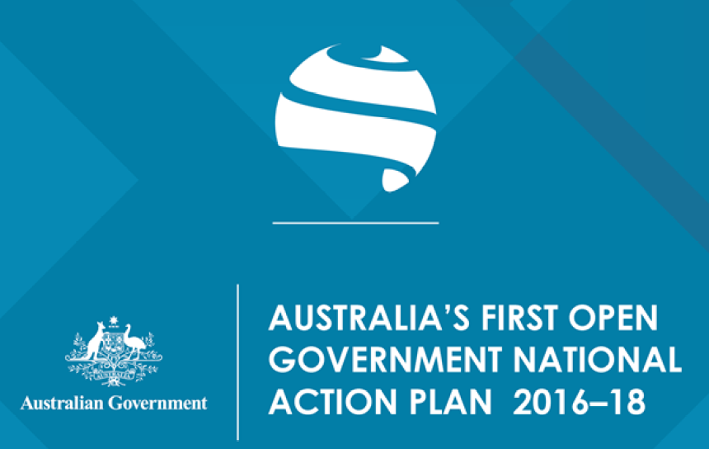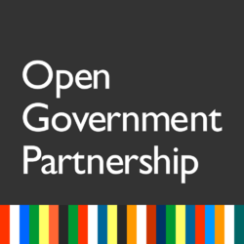

The Open Government Partnership (OGP) is a multi-lateral initiative that aims to secure concrete commitments from governments to advance open government efforts. It has over 70 members including the United States, United Kingdom, Canada and New Zealand.

In November 2015, Australia reaffirmed its commitment to join the OGP. Every two years OGP members must work with the public to transparently and publicly ‘co-create’ a National Action Plan. Actions plans are ‘the driving device’ for the OGP as it is the instrument through which government and civil society develop their ‘commitments’, that is, their agreed reforms.

Australia’s first Open Government National Action Plan (the Plan) was announced in December 2016. The Plan contains 15 commitments that aim to advance transparency, accountability, participation and/or technological innovation.

**SIDEBAR: A Design Thinking Approach**

A user centred design approach is being applied to the development of the framework comprising three phases, Discover, Create and Deliver. This report reflects the Discover phase that has the following three steps:

* **Problem Identification** – where we have identified the real issue we are trying to solve
* **Empathise** - understand end user needs and motivations
* **Define** – we will identify opportunities for design solutions

This methodology is used by Bizlab, the Department of Industry, Innovation and Science’s Innovation Lab. Besides including processes and tools that boost innovation, design thinking ensures that users (i.e., the public) are at the centre of our work through the Commitment’s implementation. This boosts both the quality of our work and its legitimacy.

Commitment 5.2 – Enhancing EnGagement and Participation

This report is part of the first milestone in the delivery of Commitment 5.2 of the National Action Plan. Commitment 5.2 is an undertaking by the Australian Government to work towards improving public participation and engagement to enhance policy and service delivery outcomes for Australians. This will be achieved by establishing a new Australian Government framework for public participation and engagement.  
  
The ambition for Commitment 5.2 is to design and adopt a whole-of-government framework that embeds meaningful, open, public and multi-stakeholder participation into the business of policy development and service delivery.

The Commitment hasthree key milestones

* Milestone 1 - January 2017 - July 2017
* Undertake and publicly release a stocktake of current approaches to public participation to determine best practice activities (including international and domestic examples, user experience research, methodologies to encourage adoption, and relevant standards, such as IAP2 values).
* Milestone 2 - July 2017 - December 2017
* Work with government agencies, the public and organisations outside of government to develop and implement a whole-of-government framework (with guidance / principles and potential public participation initiatives) for improving public participation and engagement across the Commonwealth.
* December 2017 - Mid 2018 (ongoing)
* Undertake pilot public participation initiatives, including working with the Digital Transformation Agency to more effectively use digital channels for engagement.

This report is part of delivering Milestone 1.

**Exhibit: Bizlab’s design thinking project methodology (Discover, Create and Deliver) with Commitment 5.2 milestones mapped to it**

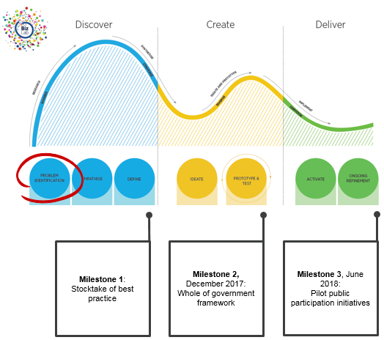

**Milestone 1**, end June 2017:

Stocktake of best practice

**Milestone 2,** December 2017:

Whole of government framework

**Milestone 3**, June 2018:

Pilot public participation initiatives

the problems public servants have to solve are daunting

**SIDEBAR: Quote from Peter Shergold’s Learning from failure report**

“The work of government is hard. Its challenges are wicked. Problems do not always have defined boundaries, solutions can (and should) be contested and authority is ambiguous. Political change can occur unexpectedly and at breakneck speed. Administrative change generally takes place in an almost imperceptible fashion but can be transformative in nature. These challenges are exacerbated by the rapidity and level of scrutiny that is now brought to bear by the 24-hour news cycle, the increasing influence of social media and the 'hyper-connectivity' of community networks enabled by the internet. Both politicians and public servants must grapple with unrealistic citizen expectations and low levels of public trust.”

Public servants want to make a difference through high quality public policy, programmes and services. But as noted in Peter Shergold’s ‘Learning from Failure’ report, we have to navigate a great deal of complexity to achieve this (see box to the right).

The work of the APS is becoming more complex. Government is frequently confronted with so-called ‘wicked problems’— complex policy issues that are highly resistant to resolution. Indigenous disadvantage is a good example of a wicked problem that has proven resistant to solution in spite of ongoing efforts, and requires a concerted effort to identify and address multiple aspects of disadvantage across all levels of government and community. Aspects of health, education, cities and climate change have similar attributes. Obesity provides a good example. If we want to fight obesity, parents must get their children to exercise more. If we want to reduce greenhouse gases, communities must work together to modify local life-styles. And if we want better apprenticeship programmes and schools, community organisations and businesses may need to team up with government to provide them.[1]

Compounding this complexity, Government is often not in a position to exert direct control over how the policy environment operates and needs the help of non-government actors. The world in which public policy is made is an adaptive system with multiple public and private stakeholders. These stakeholders have differing goals and are constantly both acting and reacting to others within overlapping networks.

In the language of Ronald Heifetz, these complex problems are referred to as adaptive challenges which require innovation and learning to address, as opposed to technical problems that can be solved by expertise and good management. [2]

Moreover, recent studies show trust in government at record lows, making it even harder to build public support. For example, a 2016 survey of 1444 Australians reported:

* Satisfaction with democracy at its lowest since 1996

**SIDEBAR: Quote from Peter Shergold’s Learning from failure report**

“Growing citizen expectations of government and the wicked nature of policy and programme problems require different approaches. Orderly, mechanistic approaches to decision-making, as currently configured are not designed to provide flexible, real-time responses to rapidly changing conditions. They are not designed to translate the best technical and academic work into accessible, policy-relevant conclusions. Small groups of professionals, meeting every few months, simply cannot provide quick turnaround in support of immediate needs. They cannot be a source of ongoing conversation and debate. They cannot help vet the resources and research upon which a policymaker must base a decision. They were designed for an earlier, more settled era in which there is belief in the “right” answer. That era has passed… They are especially ill-suited to confronting today’s complex challenges… The new civil servant will be able to co-ordinate multiple channels for dialogue, viewing these processes as core, and not incidental, to the job”.

* Levels of trust in government and politicians in Australia are at their lowest level since 1993, with only 5% of Australians trusting government.[3]

Other studies show similar results. The Edelman Trust Barometer’s Australian Trust findings showed a dip in trust in government in 2016, falling from 45% to 37% among the general population.[4] The Australian National University’s post-election poll found 40% of respondents were not satisfied with democracy in Australia – the lowest level since the dismissal of Gough Whitlam in the 1970s – and only 26% of people thought the government could be trusted, the lowest level since the poll began this measure in 1969.

Lack of trust in government isn’t unique to Australia, either. For example, an OECD study indicates that only four out of ten citizens in OECD countries say they have confidence in their national authorities.

The declining trust in government has implications for both the government’s ability to communicate ideas to the broader public and public confidence in the work of government.

bringing the community into our work can help

Senior public servants and academics argue that we can reduce the complexity of our work by bringing more people and expertise into our work when we need them. Their view is there’s a great deal of untapped information that we miss using current approaches to involving the community in our work.[5] For instance: Reeve Bull in ‘Making the Administrative State Safe for Democracy’ suggests that “to the extent that public input is beneficial to administrative decision making it should be sought and considered and to the extent to which such input is not beneficial administrators should not seek it out of an unnecessary obeisance to the principles of democracy”.

In her book ‘Smart Citizens, Smarter State’, Professor Beth Noveck argues that current approaches to decision making are not well equipped to respond to the increasing complexity and public expectations of public policy. More flexible and responsive approaches that tap into an array of expertise are needed.

|  |  |
| --- | --- |
| CALL OUT BOX: SMART CITIZENS, SMARTER STATE | http://blogs.lse.ac.uk/lsereviewofbooks/files/2016/06/Smarter-Citizens-Smarter-State.jpg |

Academics Tina Nabatchi and Matt Leighninger have a similar view, stating ‘Our current participation infrastructure occupies a great deal of time, money, and political capital, but it is inefficient, ineffective, and outdated. It does not support “good” participation, does not meet the needs of citizens or officials, and does not reflect the way people live today.’[6]

Martin Parkinson, Secretary of the Department of the Prime Minister and Cabinet, has similarly advocated using more community expertise in our work. Noting that ‘no one person or organisation has all the answers’, Parkinson’s view is that ‘creating ‘policy communities’ of those who are making policy, those implementing policy on the ground or those working in think tanks, enables us to be constantly environment scanning, allowing us to see earlier and more clearly the opportunities for better outcomes, as well as identifying the emerging or inherent risks in our approaches. Such communities would allow lessons to feed back into the policy process and create constituencies for positive change.’[7]

|  |  |
| --- | --- |
| **CALL OUT BOX: Peter Shergold’s Learning from Failure** | **Why large government policy initiatives have gone so badly wrong in the past and how the chances of success in the future can be improved** |

Peter Shergold’s ‘Learning from Failure’ review also supports further citizen involvement in policy and programmes. It found that “[t]he APS should promote new forms of civil participation, including digital and deliberative democracy techniques, in order to enhance consumer-directed care, improve customer service, encourage greater citizen engagement and inform the public economy…real solutions to complex issues not only require that stakeholders, citizens and communities be fully involved in the policy process; they require genuine collaboration between governments and the public.”[8]

Other commentators agree involving the public more can improve buy-in to policy and programmes, in particular by improving trust. For example, a 2015 workshop of participation practitioners and experts had the key insight that “[Deliberative democracy] has the potential to restore trust in political decision-making.[9] At the same workshop, Iain Walker, Executive Director of the New Democracy Foundation, argued that “[p]oliticians now see trust as the number one commodity that will give them scope to act. Deliberative processes build trust. They provide circumstances where an average voter, who doesn’t have the time to read in depth about a policy issue, will see a process that involved ‘people like me’ making the decision, and trust it”. These views correlate with OECD behavioural science studies that show that when people feel treated fairly by government their immediate reactions make enforcement of regulations and decisions easier.[10]

Others cite revolutions in ICT technologies as an opportunity that governments simply shouldn’t miss. For instance, Nesta’s recent ‘Digital Democracy: The tools transforming political engagement’ report argues that “[a]lmost every other sphere of life [besides government] finance, tourism, shopping, work and our social relationships - has been dramatically transformed by the rise of new information and communication tools, particularly social media or by the opportunities opened through increased access to and use of data, or novel approaches to solving problems, such as via crowdsourcing or the rise of the sharing economy.”[11]

PUBLIC PARTICIPATION CAN REDUCE THE COMPLEXITY: Open Innovation

Much of public participation is familiar and conventional to public servants. Consultation and sharing information have long been crucial aspects in delivering good policy and programmes. They are means for gathering input and feedback on initiatives and building understanding. More innovative forms of engagement, such as deliberation and collaboration, where the public is invited into the conversation to identify, solve, implement and in some circumstances, decide, are less familiar. Enhanced utilisation of deliberative and collaborative engagement could be argued to be a form of open innovation.

Public participation, particularly deliberation and collaboration, can help public servants overcome the complexity of their work and help government be an exemplar of innovation. As noted in the National Innovation and Science Agenda, the Government’s innovation policy, government needs to be more innovative and back new ways of doing business. Public participation is a new way of doing business that reaps the benefits of open innovation. Henry Chesbrough defines open innovation as ‘a paradigm that assumes that firms can and should use external ideas as well as internal ideas, and internal and external paths to market, as the firms look to advance their technology’. He goes on to explain:

*“Innovators must integrate their ideas, expertise and skills with those of others outside the organisation to deliver the result to the marketplace, using the most effective means possible. In short, firms that can harness outside ideas to advance their own businesses while leveraging their internal ideas outside their current operations will likely thrive in this new era of open innovation.”[12]*

The deliberative and collaborative streams of engagement open government up to a wider array of ideas that otherwise would be untapped and as such can drive innovation, for example, deliberative budgeting for which the South Australian Government’s Fund My Project grants programme is a good example.

What is engagement and participation?

As stated above, engagement and public participation takes many forms, so how can we come to a common understanding on what we mean when we are talking about engagement and participation practices?

The International Association for Public Participation (IAP2) is a body that seeks to promote and improve the practice of public participation in relation to individuals, governments, institutions, and those interested in the public interest. The IAP2 defines public participation as the involvement of those affected by a decision in the decision-making process. Public participation encompasses activities ranging from simply informing people about government's activities to delegating decision-making to the public. The IAP2 have develop Public Participation Spectrum that outlines five forms of engagement: inform; consult; involve; collaborate; and empower. The spectrum outlines the objective of the form of engagement and what the public can expect. The IAP2 approach acknowledges that each form of engagement is legitimate and depends “on the goals, time frames, resources, and levels of concern in the decision to be made”. The spectrum as illustrates that as you move from inform through to empower the engagement has an increasing impact on the decision and gives the impression that engagements at the empower end of the spectrum are of greater value.

**Exhibit: IAP2’s Public Participation spectrum** 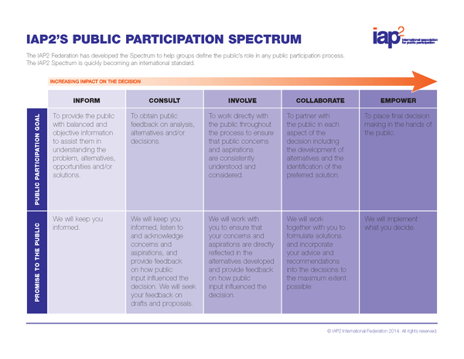

The IAP2 spectrum is widely utilised around the world. In Australia many government departments at both the Commonwealth and state levels have adopted or adapted the spectrum in their stakeholder frameworks (for example, the Commonwealth Department of Health, and the Tasmanian and New South Wales Departments of Premier and Cabinet). Some organisations have taken a different approach.

While the IAP2 spectrum is widely applied there is not universal agreement on the value of the application of the spectrum in its entirety. Carson and Susskind question the value of the inform stream in the context of public participation. Susskind also contends that the ‘empower’ stream is not practical and that government’s will rarely cede authority and in some circumstances they are legislatively prohibited from doing so. [13]

Len Robinson goes as far as to ask “Is the spectrum dead?.” He argues that 3 of the 5 levels in the Spectrum seem to have conceptual or reality problems. He believes they “do not make sense as intellectual categories either because they can’t be implemented or, in the case, of INFORM, aren’t actually a category of consultation”. He argues that a spectrum with only two categories, consult and involve/collaborate would be closer to reality. Importantly he suggests that there is a missing category, listening. Robinson argues that public organisations have lost contact with the public and that there would be value in simply listening without an agenda. He puts forward and alternative spectrum, the Curiosity meter.

*“The idea is: before any community consultation, honestly answer this question: “Where are you on the spectrum between ‘endorsement seeking’ and ‘open-mindedness’?” Being bracingly honest about this might reduce a lot of the wasted effort and conflict around community consultation.”*

**Exhibit: Len Robinson’s curiosity meter**

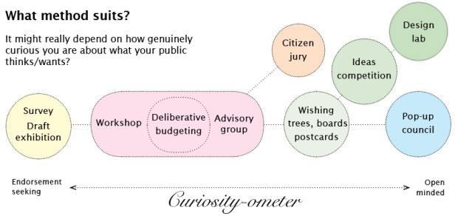

Spectrums or continuums are not the only way to explain engagement. Jenny Stewart notes that “[w]hile it has been traditional to regard engagement as a type of ‘ladder’ or, less metaphorically, as a continuum, contemporary thinking sees engagement in more fluid terms. One possible metaphor is to see engagement as a star-like arrangement of techniques and sites, with each arm of the star corresponding to a particular set of opportunities. From this perspective, types of engagement are strategies corresponding to different kinds of situations and outcomes, rather than indices of power differentials”.[14]

The Ontario Provincial government has adopted a ‘star-like’ framework that outlines four ways of engaging as follows:

* **Share -** Does government need to tell the public about a government initiative? People receive information about a government program or decision in an accessible way. Communication is one-way from the government to the public.
* **Consult** - Does government need to gather feedback from the public about a problem? People have an opportunity to weigh-in and provide their input. Participants advocate for their views on a subject.
* **Deliberate** Does government need help‎ from the public to frame or solve a problem? People help identify the issue and/or develop a strategy that the government commits to deliver. Participants take part in varying degrees to find common ground and collectively arrive at an agreement.
* **Collaborate** Does government ‎need help from the public to find and implement a solution? People work with government to define an issue, develop and deliver solutions. Participants share decision-making and implementation of solutions.

The approach here is to see the ways we can engage as buckets and you draw upon a bucket depending on the need that you have identified. The Ontario framework emphasises the importance of diagnosing the problem and applying the right approach to help you solve the problem. There is no relative value assigned to the different ways to engage, it is very much horses for courses.

Leading digital engagement company Bang the Table has taken a different approach. They believe that community engagement is about decision making, relationship development, or capacity building. They differ from the IAP2 approach and suggest “*This is interesting, because traditionally community engagement training has adopted the* [*International Association for Public Participation*](http://www.iap2.org/) *Spectrum as its starting point. The limitation of the Spectrum is that it is a very useful framework for community engagement around decision-making, but is less useful for relationship development and capacity building*”. [15]

Bang the Table have developed an alternative to the spectrum with what they call “the community engagement triangle”. The triangle reflects the three key objectives as they see them and that projects can move between the three. Importantly, they argue that the triangle “acknowledges explicitly that there is more than one potential objective from a process of community engagement.” More specifically, it positions “decision-making” as just one of (at least) three potential objectives for the organisation. It thus helps to “level” or “democratise” the objectives. Each is valid. Each is actually more than valid. Each is essential and core business for most organisations”.[16]

## **Exhibit: Bang the Table’s Community Engagement Triangle**

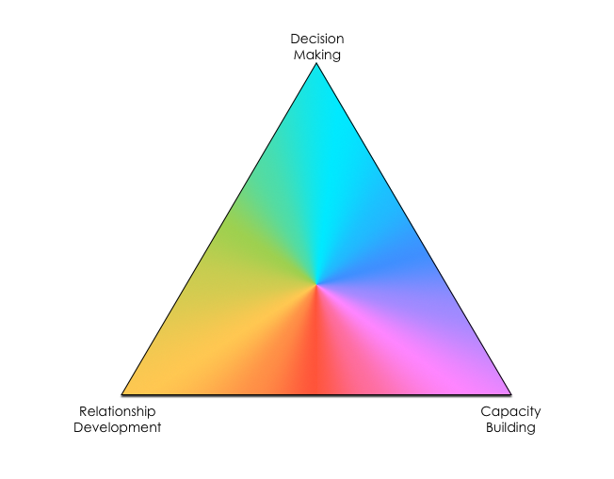

Don Lenihan from Canada 2020 is starting to shift the conversation towards what he calls open dialogue. In his publication “What is open dialogue and is it the answer to post fact populism?” Lenihan writes that:

*‘Open Dialogue fires up a conversation between different people and organisations that gets them doing things together that they could not do alone.*

*Open Dialogue thus is a catalyst for innovation and collaboration on Open Government: If data and information are the primary resources in a knowledge society, dialogue is the refinery that allows*

*governments, businesses, and civil society to find and extract the value’.*



Aligning the Three Principles of Open Government

Lenihan makes a clear distinction between open dialogue and the more traditional form of engagement of consultation, he argues *that Open Dialogue brings participants into the decision-making process — whether a little bit or a lot — and consultation does not*. He outlines the differences as follows:

|  |  |
| --- | --- |
| **Consultation** | **Open Dialogue** |
| * Is guided by basic engagement principles * Gives participants an opportunity to present their views to decision-makers, provide evidence and arguments in support of them, and reply to opposing views * Decision-makers are duty- bound to assess these positions on their merits, but they are not obliged to accept or act on them * Decision-makers are required to provide the rationale for their decisions | * Is guided by basic engagement principles * The engagement plan sets boundaries for how far and in what way citizens and/or stakeholders will participate in decision-making * The process begins by giving participants an opportunity to present their views to decision- makers, provide evidence and arguments in support of them, and reply to opposing views * Once views have been presented, participants engage in deliberative discussions about the best solutions, subject to the boundaries   and rules set by the plan   * These participants are duty- bound to assess different options on their merits and adjust their views accordingly |

## Exhibit: Synonyms for public participation

Public participation lacks a universal definition, and has many synonyms.[17] Our ethnographic research indicates most public servants tend to use the term ‘consultation’ as a catch-all term for the full range of public participation tools. But different countries, organisations and jurisdictions use different terms. Synonyms focussing on engagement include ‘community engagement’; ‘civic engagement’; ‘public involvement’; ‘public engagement’; ‘community consultation’; ‘citizen engagement’; ‘participatory development’; ‘brand engagement’; or simply ‘engagement’ or ‘consultation’.[18] Others refer to public participation models as ‘deliberative democracy’; ‘digital democracy’; ‘collaborative governance’ and ‘participatory governance’. Others define public participation as a spectrum.[19]

**Sidebar: Quote from Beth Novek, author of Smart Citizens, Smarter State**

“Many governments at the federal, state and local level are beginning to use the Internet to engage people from outside by such means as electronic petitions or “suggestion box” websites. The most notable example is the White House’s We the People site. The good side of these petitions websites is that they offer a new way for members of the public to draw attention to an issue. However, there are limits too. Specifically, it is often hard for policymakers to act on these petitions. What they usually provide is a naked demand that the government do something, without any of the necessary evidence, know how or instructions for how to do it. The government really uses these sites to ask people their opinion, rather than to draw on the public’s knowhow. As a result, the petitions usually don’t go anywhere.” Beth Noveck

One common thread is the worldwide move away from talking about ‘consultation’. While consultation is valuable, is it just one part of how public servants can involve people in policy and programmes. ‘Consultation’ may also have fallen from favour due to connotations of being ‘nonsultation’, window dressing or generally lacking sophistication and value.

The role of Technology

A clear barrier to greater engagement and participation is the cost and time required to engage broadly. But new technology may be reducing the transaction cost. Reeve Bull in ‘Making the Administrative State Safe for Democracy’ argues that modern technology has the potential to remove some of the practical barriers to seeking public input.

Offering a far-reaching program for innovation, Beth Noveck in Smart Citizens, Smarter State suggests that public decision making could be more effective and legitimate if government were smarter—if our institutions knew how to use technology to leverage citizens’ expertise. Just as individuals use only part of their brainpower to solve most problems, governing institutions make far too little use of the skills and experience of those inside and outside of government with scientific credentials, practical skills, and ground-level street smarts. New tools—what Beth Simone Noveck calls technologies of expertise—are making it possible to match the supply of citizen expertise to the demand for it in government.

The hope is that matching the right experts to the right opportunities in the right way will lead to faster and better decision making.

There are numerous examples of technology being used to create electronic petitions or “suggestion boxes” such as WethePeople in the United States and ePetition in the UK, which have benefits and drawbacks (see sidebar).

Good examples in the APS include the ATO’s LetsTalk, which provides a space for citizens to have their say and contribute ideas about the tax system as well as facilitating conversations in communities of interest such as superannuation or not for profit. The Department of Social Security has Engage, a digital platform that allows for issues to be presented to the public and feedback sought digitally.

The Digital Transformation Agency has developed a digital marketplace that brings government together with digital specialists. Importantly the marketplace is being utilised by the Smart Cities initiative to allow councils building smart communities and digital services to connect and learn from each other.

These are all good examples of how digital platforms can remove some of the barriers to enhanced engagement and participation but they all fall a little short of being able to identify expertise and bringing that expertise together as envisaged by Noveck. This is where the Business Research and Innovation Initiative may be able to assist.

the Business Research and Innovation Initiative (BRII)

The BRII is a pilot series of ‘challenges’ where the Commonwealth Government is encouraging businesses to develop more innovative solutions to government policy and service delivery problems.

One of the five pilot challenges is to develop a platform that digitally enables community engagement in policy, programme and service design.

The BRII challenge acknowledges that Governments are facing increasing pressure to be more responsive and to accommodate greater citizen and interest group involvement in the policy and programme development process. It acknowledges that co-design and collaboration can lead to better outcomes but that the gap between what governments achieve and what citizens expect continues to grow. Its overview states:

*At the heart of this problem are the current consultation and co-design methods which are time and cost prohibitive for both government agencies and business and community groups … Innovation in the digitisation of communication, information handling, data analytics and social media tools potentially offers the opportunity to develop new co-design and consultation methods.[20]*

The BRII challengers will try and combine the new methods and tools for collaboration and co-design, including social media, into a platform that consistently engages community stakeholders.

The role of user centred design

User Centred Design (UCD) is a creative form of problem solving. As the people at IDEO explain:

*“It’s a process that starts with the people you’re designing for and ends with new solutions that are tailor made to suit their needs. Human-centred design is all about building a deep empathy with the people you’re designing for; generating tons of ideas; building a bunch of prototypes; sharing what you’ve made with the people you’re designing for; and eventually putting your innovative new solution out in the world.’[21]*

So UCD is a form of engagement that could be consultative, deliberative or collaborative depending on how it is applied. If the user is “passive” in the process and is simply used to identify a need or test a prototype the form of engagement would be more akin to consultation. But if the user is involved in the design phase, for example, developing a prototype, then the process can be more deliberative or collaborative.

UCD has been applied in the APS for many years, with the Australian Tax Office and the Department of Human Services being early adopters. It is becoming increasingly utilised across the APS with the drive for innovation. This can be seen in the rise of innovation labs in the APS with 14 dedicated innovation labs operating currently.

This increased emphasis on experimentation and innovation will be critical in addressing the complexity faced by the APS and as a driver for inviting more expertise into the conversation, as Beth Noveck points out *“Closed public institutions are in need of upgrades and improvements, and that means accelerating the pace of research. It will be impossible to convince politicians and policymakers, let alone the public, that the transformation of institutions is imperative without research and experimentation to prove the positive impact of such changes on real people’s lives. We need to follow Mark Moore’s advice to become humble “explorers who, with others, seek to discover, define and produce public value”.*

**Sidebar: Quote from Charles Leadbeater**

Increasingly ‘experimentalism is no longer confined to formal scientific labs’ writes Charles Leadbeater. ‘It has become an organising method for social policy, start businesses, venture capitalists, tech companies and the creative arts. Everyone it seems wants to experiment their way into the future and to do so they want labs, which are proliferating well beyond their traditional habitat in the natural sciences’. There is now a burgeoning movement of so-called public labs – explicitly experimental organisations with ties to government institutions. Though diverse in their approaches, these innovation labs engage primarily in ethnographic processes of engaging citizens through observation and interviews in the design of public services. Most of the public labs are not focused on new technology, nor on comparative testing. But they do bring a spirit of experimentalism to public sector institutions.

OTHERS ARE DOING IT

**Sidebar: Western Australian Partnership Forum**

The Western Australian Partnership Forum brings together leaders from State Government agencies and the not-for-profit community sector, and consumer advocates, to improve outcomes for all Western Australians.

The Partnership Forum has adopted a set of principles and behaviours to govern and facilitate the partnership between the public and not-for-profit community sectors. Some of the important elements of the partnership are a collaborative approach, interdependence, mutual respect, trust and recognising the value and contribution of both sectors

Democratic innovation is burgeoning worldwide. Over 50 examples from Australia alone are now detailed on Participedia, an online global project that documents democratic innovations. In some states, ‘mini-publics’ proliferate at local and state level. Lucy Parry notes in Participedia that South Australia in particular has wholeheartedly embraced the notion of deliberative democracy and has embarked on an ambitious raft of citizen engagement processes including several Citizens’ Juries.[22]

A recent Victorian Auditor General report into public participation in a number of Victorian State Government departments found that unlike the Australian Capital Territory, New South Wales, Queensland, South Australia and Tasmania, Victoria does not have a current whole‑of‑government framework for public participation. The report finds as a result an opportunity is being missed in helping to establish a consistent understanding of public participation responsibilities and priorities as well as contributing to greater consistency “*in activities and terminology across the VPS—for example, the term 'co‑design' is used differently across departments”.[23]*

A 2014 report by the Council for Social Services NSW into participation in NSW found that the NSW State Government “has made a high-level commitment to give the community a say in the State Plan (Goal 32, NSW2021). Recent initiatives have focused on devolved local decision-making, customer service reform, collaboration, and enhanced digital engagement. These are positive steps to improve the way government engages with citizens, particularly in relation to service delivery”.[24]

Some further examples include the Noosa Community Juries, Darebin Participatory Budgeting, City of Melbourne People’s Panel, Geraldton 2029 and Beyond the Western Australian Freight Network Review.

HOW ARE WE FARING AT THE COMMONWEALTH LEVEL?

[Insert text on: Overview of Commonwealth efforts.]

Advisory Boards/Committees

The Commonwealth has numerous advisory boards and committees to help harness public expertise. These include:

* **Primary bodies** - bodies connected with government policies, purposes or services which are prescribed under the *Public Governance, Performance and Accountability Act 2013* and the related rules*.*
* **Secondary bodies** - committees, councils, boards, statutory office holders, consultative bodies and working groups linked to the Australian Government.
* **Other bodies** - Subsidiaries of corporate Commonwealth entities and Commonwealth companies; Joint ventures, partnerships and other companies; National Law bodies; and, Bodies linked to the Australian Government through statutory contracts, agreements and delegations.

There are 177 (15%) secondary bodies, 737 (60%) primary bodies and 306 (25%) others.

Consulting

[Text to be added]

stocktake

* [Text re stocktake to be inserted]
* [Placeholder text: To get a better understanding the depth and breadth of engagement and participation that is currently undertaken in the APS a survey was sent to each Department. The survey adopted the Ontario Provincial government Framework definitions of the streams of engagement: inform, consult, deliberate and collaborate.]
* [The results of the survey found that :]

so what is the problem?

Apart from some notable exceptions such as the first Citizens’ Parliament, the Climate change citizens’ assembly, and Community cabinets, adoption of deliberative process at the Commonwealth level has been relatively low when compared with local and State government.

If greater engagement and participation with the community have been shown to improve both government decision making and the level of confidence in those decisions, why haven’t we adopted it more at the Commonwealth level?

Our initial research suggest that the problem that the framework is to address can be stated as follows:

*The Australian Public Service is missing opportunities to develop more innovative and valued solutions to complex public policy problems due to a lack of effective engagement with the expertise available in the business, academic and the general community. By not engaging more effectively the APS is potentially missing the chance to improve both government decision making and the level of confidence in those decisions.*

*Australia has a strong international reputation for engagement and participation based in large part on the activities undertaken at the state and local levels. Why is the APS less likely to utilise the broader spectrum of engagement activities? What are the barriers to the Commonwealth utilising a broader range of engagement activities and what would be the conditions that would see the Commonwealth better utilise the full range of approaches?*

Our hypothesis is that:

The APS is less active in respect of engagement and participation with the community due to a lack of:

* confidence in the potential benefits to decision making from such activities relative to the time and cost involved;

This has been exacerbated by failures in attempts to do more innovative public participation in the past, examples of this include the 2010 Climate Change Citizen’s Assembly (see sidebar).

**Sidebar: Academic review of the Climate Change Citizens’ Assembly, 2010**

In 2010 the Gillard Government announced a Citizen’s Assembly to address the issue of climate change. The initiative generated significant controversy and criticism, even though there is nothing intrinsically wrong with deliberative citizen assembly models themselves (indeed, they’ve been used successfully in Canada). To understand the backlash, an academic study analysed 200 media articles and summarised criticisms as follows:

* The assembly was a threat to democracy – undermining elected representatives.
* The assembly was an abrogation of duty – a ‘cop out’ or ‘gimmick’ cynically designed to ‘neutralise’ a controversial issue.
* There were procedural objections – how would it work? What information would participants get? Who will appoint them?

The study found most concerns didn’t have a basis in the academic evidence. But they noted that highly politicised and high profile issues might be beyond deliberative democracy and that there needs to be awareness of opposition to deliberative citizen engagement by Australia’s opinion elite.

* a lack of awareness of the practices that are available;

Public participation has been around a long time. Consultation and information sharing tools have been regularly used since the 1970s. While collaboration and deliberation might be relatively less common, they haven’t emerged recently either. Systematic approaches to public participation go back at least to 1969,[25] and deliberation has been a mainstream idea in political science and policy studies since the 1980s.[26] Engagement is becoming increasingly professionalised. For example, there is a public participation association – IAP2 Australasia, which, among other things, advocates on behalf of its members; includes a register of engagement consultancies; and offers training certificate in engagement and participation.

Yet our initial interviews suggests that most public servants have never heard of public participation; and tend to think of engagement as the more formal consultation mechanisms such as traditional green and white paper processes. Where tools such as the IAP2 spectrum are used it tends to be in specific communications and stakeholder engagement teams with little penetration into agencies.

* capability to execute such activities in an effective way.

**Case study: Your SAy / Better Together**

The South Australian Government has established a Strategic Engagement team with 12 staff in the Department of Premier and Cabinet. Among other programmes, the team delivers Better Together and Your Say.

**Better Together** was established in 2013 and is centred on six engagement principles to provide a consistent approach across government and to guide best practice. The Better Together program offers public sector employees practical support through advice, training, events, partnerships to support and deliver innovative engagement techniques and approaches.

**YourSAy** includes a raft of public participation initiatives. The Strategic Engagement team designs and builds the initiatives with line departments. Besides improving policy and programmes, the joint delivery approach boosts public sector capability. YourSAy initiatives include:

* Fund my idea: Incorporating elements of place-based and participatory budgeting approaches, it provides a simple mechanism through which local communities nominate project ideas to benefit the region. Local people are then involved in deciding which projects are funded.
* GOVchat: GOVchat is a community engagement event where we open an 1800 telephone line for two hours so you can phone in at some stage during this two-hour window and chat with senior executives, and the Minister or Premier.
* Simplify: A red tape reduction initiative - shared your ideas via an online forum, emails or written submissions via Service SA centres and also voted on the top ideas through the website.

Like any innovation, culture and capability change will be necessary for enduring change. Our initial stakeholder interviews suggest that some public servants do not see any value in further engagement with the public and have little confidence in the expertise of citizens. Others are more willing but don’t know how. We are investigating examples of how others have built capability and instigated cultural change. Good examples include the Danish Board of Technology Foundation and Involve in the UK.

PRocess

[infographic to be inserted]

demographics

[infographic to be inserted]

insights

[Place for insights text]

themes

[Place for themes text]

platforms

[Place for platforms text]

DEFINE OPPORTUNITIES FOR CREATE PHASE

[Text to be inserted]

References

[Add bibliography of articles in the lit review]

[Add list of stakeholders consulted]

1. Don Lenihan “A case study of Ontario’s Condominium Act Review’, Canada’s Public Policy Forum, 2014.
2. Ronald Heifetz ‘Leadership without easy answers’, Harvard University Press, 1998.
3. Mark Evans, Gerry Stoker, Max Halupka “Now for the big question: who do you trust to run the country?” The Conversation, May 2016
4. Steven Spurr “Trust free-falls in the land down under” Edelman Barometer Research Insight http://www.edelman.com/post/trust-free-falls-in-the-land-down-under/
5. See for example, John Seely Brown, Lang Davison “The power of pull: How small moves, smartly made, can set big things in motion” Basic Books, 2012.
6. Tina Nabatchi and Matt Leighninger “Citizenship outside the public square: Public participation for 21st century democracy” John Wiley & Sons, USA, 2016.
7. Martin Parkinson “Address to the Australasian Implementation Conference”, 2016. https://www.dpmc.gov.au/news-centre/pmc/address-australasian-implementation-conference.
8. Peter Shergold “Learning from failure: Why large government policy initiative have gone so badly wrong in the past and how the chances of success can be improved” http://www.apsc.gov.au/publications-and-media/current-publications/learning-from-failure
9. Wendy Russell and Lucy Parry “Deliberative democracy theory and practice: Crossing the divide”, Workshop Report, University of Canberra, 2015 http://www.governanceinstitute.edu.au/magma/media/upload/ckeditor/files/DD%20Workshop%20report%20(final).pdf
10. E. Allan Lind and Christine Arndt “Perceived fairness and regulatory policy: A behavioural science perspective on government-citizen interactions”, OECD, 2016. https://www.researchgate.net/publication/272415285_Perceived_Fairness_and_Regulatory_Policy_A_behavioral_science_perspective_on_government_-_citizen_interactions
11. Julie Simon, Theo Bass, Victoria Boelman and Geoff Mulgan “Digital democracy” Nesta, 2017.
12. Open Innovation Community “Open innovation”, last accessed 5 July 2017. http://openinnovation.net/about-2/open-innovation-definition/
13. Compiled by Lyn Carson “The IAPS2 Spectrum: Larry Susskind, in conversation with IAP2 members” Active Democracy, 2008, last accessed 5 July 2017. http://www.activedemocracy.net/articles/Journal_08December_Carson.pdf
14. Jenny Stewart “Dilemmas of Engagement” Australian National University, 2009.
15. Crispin Butteriss “What is community engagement, exactly?” Bang the Table, 2016. http://www.bangthetable.com/what-is-community-engagement/
16. Crispin Butteriss “What is community engagement, exactly?” Bang the Table, 2016. http://www.bangthetable.com/what-is-community-engagement/
17. Crispin Butteris ‘What is community engagement, exactly?’ Bang the Table, 2014. Link: http://www.bangthetable.com/what-is-community-engagement/.
18. Bang the Table ‘Community Engagement versus Civic Engagement versus Public Involvement’, 2016. Link: http://www.bangthetable.com/community-engagement-vs-civic-engagement-vs-public-involvement/
19. See for example IAP2 “Iap2’s Public Participation Spectrum’, last accessed 2017. https://www.iap2.org.au/Tenant/C0000004/00000001/images/Resources/IAP2_Public_Participation_Spectrum.pdf
20. Australian Government “Digital enabled community engagement in policy and programme design - Overview”, <https://www.business.gov.au/Assistance/Business-Research-and-Innovation-Initiative/Digitally-enabled-community-engagement-in-policy-and-programme-design>. Last updated 06/06/2017.
21. Ideo “Design Kit”, last accessed 5 July 2017. http://www.designkit.org/human-centered-design
22. Lucy Parry “When is a democratic innovation not a democratic innovation? The populist challenge in Australia”, Participedia, 2016.
23. Victorian Auditor-General “Public participation in government decisionmaking’ Victorian Government Printer, 2017. http://www.audit.vic.gov.au/publications/20170510-PP-Decision-Making/20170510-PP-Decision-Making.html
24. https://www.ncoss.org.au/sites/default/files/141128-participation.pdf
25. Sally Hussey “International public participation models 1969-2016’, Bang the table, 2017. http://www.bangthetable.com/international-public-participation-models-1969-2016
26. Wendy Russell, Lucy Parry “Deliberative democracy theory and practice: Crossing the divide”, University of Canberra, [insert year].