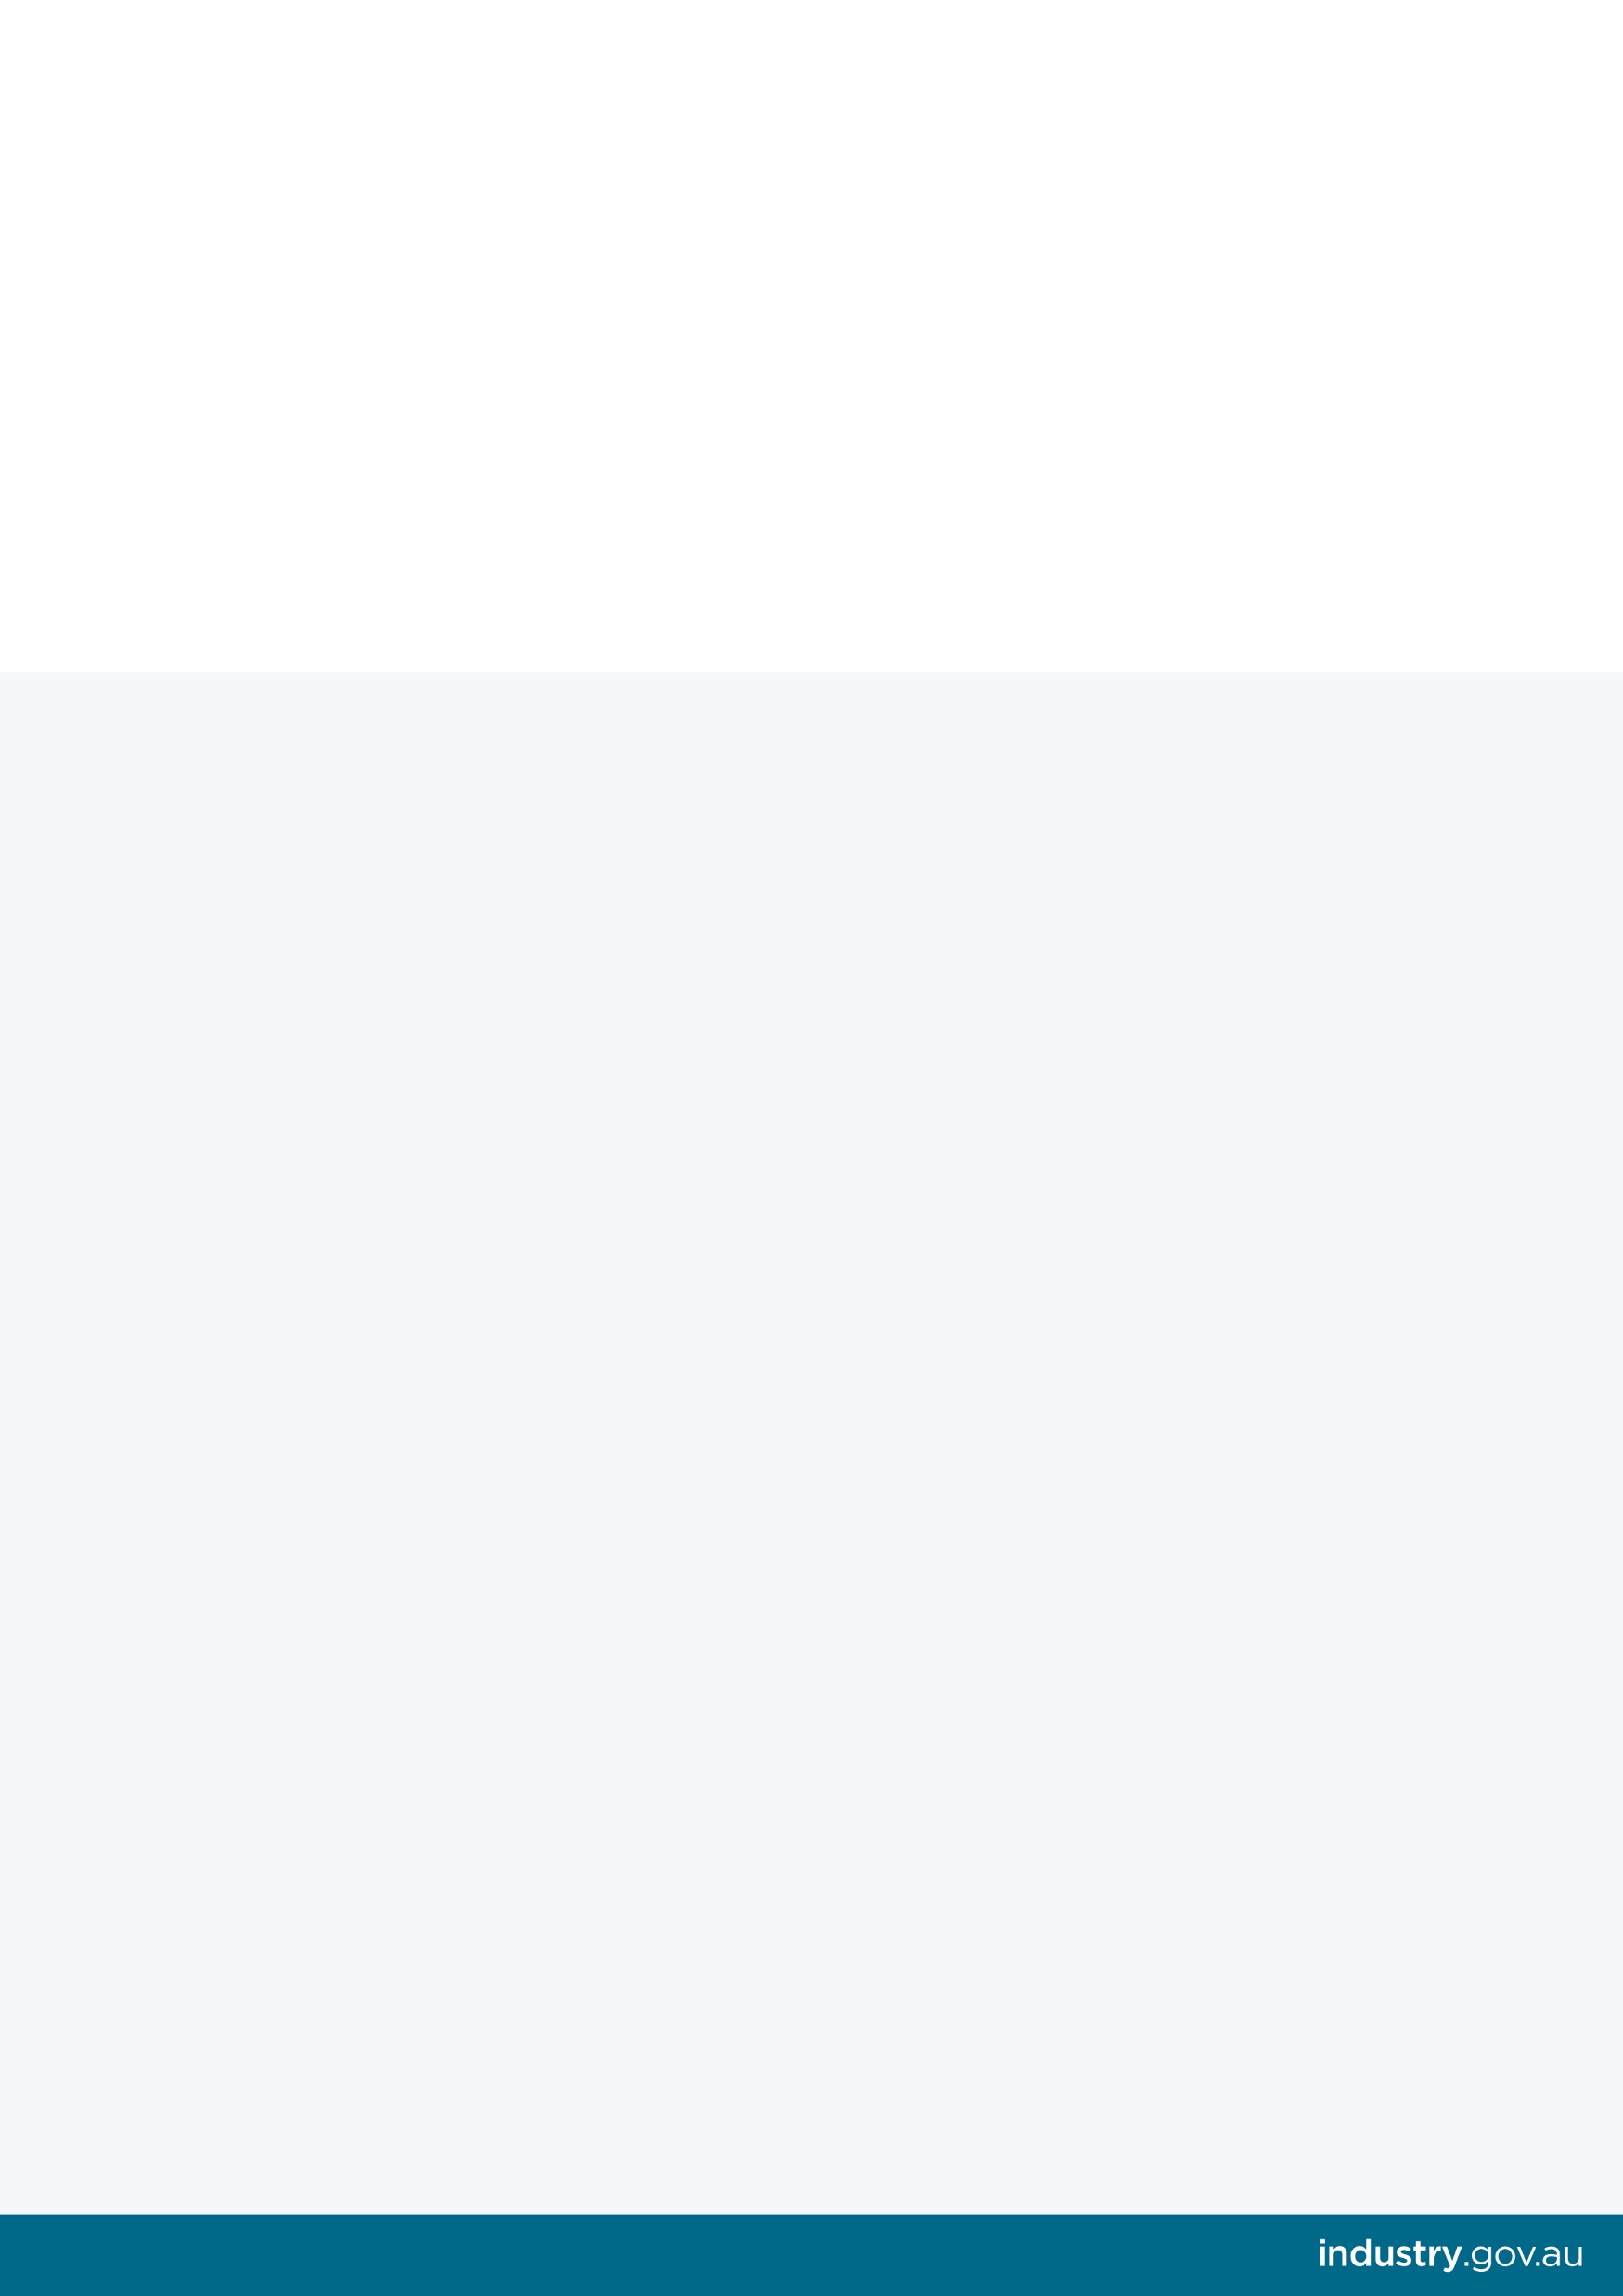Review of the Australian Domestic Gas Security Mechanism

Report by the Department of Industry, Innovation and Science

January 2020

© Commonwealth of Australia 2020

**Ownership of intellectual property rights**

Unless otherwise noted, copyright (and any other intellectual property rights, if any) in this publication is owned by the Commonwealth of Australia.

**Creative Commons licence**

CC-BY logo

All material in this publication is licensed under a Creative Commons Attribution 4.0 International Licence, save for content supplied by third parties, logos, any material protected by trademark or otherwise noted in this publication, and the Commonwealth Coat of Arms. Creative Commons Attribution 4.0 International Licence is a standard form licence agreement that allows you to copy, distribute, transmit and adapt this publication provided you attribute the work. A summary of the licence terms is available from https://creativecommons.org/licenses/by/4.0/

The full licence terms are available from https://creativecommons.org/licenses/ by/4.0/legalcode

Content contained herein should be attributed as Review of the Australian Domestic Gas Security Mechanism.

**Disclaimer:**

The Australian Government as represented by the Department of Industry, Innovation and Science has exercised due care and skill in the preparation and compilation of the information and data in this publication. Notwithstanding, the Commonwealth of Australia, its officers, employees, or agents disclaim any liability, including liability for negligence, loss howsoever caused, damage, injury, expense or cost incurred by any person as a result of accessing, using or relying upon any of the information or data in this publication to the maximum extent permitted by law. No representation expressed or implied is made as to the currency, accuracy, reliability or completeness of the information contained in this publication. The reader should rely on their own inquiries to independently confirm the information and comment on which they intend to act. This publication does not indicate commitment by the Australian Government to a particular course of action.

Contents

Contents 2

Executive Summary 3

1 Introduction 6

1.1 Review purpose 6

1.2 Scope 6

2 Background 6

2.1 Gas market history 6

2.2 Introduction of the ADGSM 7

2.3 Operation of the ADGSM 9

2.4 Complementary gas market measures 10

3 Impacts of the ADGSM 11

3.1 The ADGSM’s effectiveness 11

3.2 Supply-Demand Balance 13

3.2.1 Short-term supply-demand balance 13

3.2.2 Net contribution of LNG exporters 14

3.2.3 Pipeline flows 16

3.3 Domestic prices 19

3.3.1 C&I gas user experience 21

3.3.2 Comparison of global gas prices 23

3.4 Market Function 23

3.4.1 Market Liquidity 23

3.4.2 Market concentration 25

3.5 Long-term supply 26

3.6 LNG sector impacts 28

4 Future of the ADGSM 29

4.1 Total Market Security Obligation 29

4.1.1 Potential change to the TMSO 30

4.2 LNG Netback Price 30

4.3 Price trigger 34

5 Conclusion and Recommendations 36

Executive Summary

The Australian Government introduced the Australian Domestic Gas Security Mechanism (ADGSM) in July 2017 in response to a forecast gas supply shortfall in the eastern domestic gas market. The ADGSM provides the Government with the ability to restrict LNG exports to secure domestic supply.

On 6 August 2019, the Government announced the 2020 statutory review of the ADGSM would be brought forward. Following over two years of operation, it is timely to review the ADGSM. The review assesses the ADGSM’s effectiveness against terms of reference stipulated in the ADGSM’s regulations. Stakeholder consultation has been undertaken largely through a submission process.

The eastern gas market has undergone significant changes in recent years. Most notably, from 2015 the ramp up in exports from Queensland’s LNG industry transformed the market, with domestic gas prices rising to closer align with international prices. Production costs have also risen, reflecting more expensive unconventional coal seam gas production and some declines in offshore production, requiring new and more expensive gas developments.

It is important to note the ADGSM is a temporary supply security measure and not a direct price control mechanism. It aims to ensure there is sufficient gas supply in the domestic market. Increasing domestic gas production remains the most effective method of increasing competition, alleviating market tightness and placing downward pressure on prices.

Since the ADGSM’s introduction in 2017, pressures in the eastern gas market have moderated. The Australian Competition and Consumer Commission’s (ACCC) most recent reporting found that average gas price offers from producers between January and April 2019 were mostly below $10 per gigajoule (GJ). For the same period, average gas price offers from retailers ranged between $10–12/GJ. These prices are significantly lower than the peak-prices reportedly offered in early 2017 which ranged to over $20/GJ. The recent successful negotiation of gas supply contracts between major gas users and producers reinforces this improvement.

However, the gas market and underlying supply chains are complex. A range of factors, both domestically and internationally, influence the supply-demand balance and ultimately prices paid by consumers. These complexities are reflected in Australian governments’ extensive gas market reform agenda. Reforms are being progressed across the gas supply chain, including encouraging more supply and competition, improving regulation, and increasing market transparency.

It is difficult to quantify the impact of specific factors and reforms on market outcomes, including that of the ADGSM. However, the improvement in the domestic supply outlook and subsequent market conditions can in part be attributed to the ADGSM. LNG exporters have increased their supply to the domestic market since the ADGSM was introduced and are currently, in aggregate, net contributors to the domestic market. Australia’s energy market bodies and regulators (Australian Energy Market Operator - AEMO, Australian Energy Regulator – AER, and ACCC) have acknowledged the ADGSM’s contribution in this regard.

Price is an ongoing concern of many gas users, particularly manufacturers and feedstock users. The review found that price formation is complex with numerous influences that vary across domestic markets, including bespoke requirements of individual gas users and the production characteristics and geographic locations of different gas production centres. The review does not therefore recommend adopting a direct price trigger as part of the ADGSM.

Nevertheless, price does serve as a signal of how well a market is functioning and is an important input (along with other signals including production levels and the number of producers, exploration activity, number and range of offers, export levels) in establishing whether there are real supply constraints for Australian gas users. The review recognises that the LNG netback price series released regularly by the ACCC is the most relevant series for Australian gas users, noting the limitations identified by the ACCC on the use of this series.

Submissions to this review have ranged from the general view of gas producers that the ADGSM is no longer required, to calls from gas users for stronger interventions in the gas market. There has been a level of acknowledgement from gas users and producers that the ADGSM has been effective, at least to some extent, in compelling more domestic supply. Stakeholders have also acknowledged that the ADGSM is only one of a suite of reforms and is not in itself a standalone solution to gas market pressures.

Sitting alongside the ADGSM, the review acknowledges the important role the Heads of Agreement between the Government and LNG exporters has played in encouraging more gas into the domestic market and safeguarding against a shortfall. The Heads of Agreement has provided both an incentive and a mechanism for an industry-led initiative to ensure gas is available in the domestic market, with new gas supply agreements being made between exporters and some industrial users.

**Recommendations:**

1. The ADGSM was introduced as a temporary measure alongside a broad suite of gas market reforms aimed at addressing market pressures. While there have been clear improvements in the eastern gas market, the market remains uncertain and persisting pressures still need to be addressed. *As such, the review recommends retaining the ADGSM until its scheduled cessation in 2023.*
2. Whilst the ADGSM has worked well to date, it is important to ensure its effectiveness should it be required. This review has examined the Total Market Security Obligation (TMSO) and found that it may not be able to recover sufficient domestic gas to address a market shortfall. *As such, the review recommends consideration be given to changing the TMSO from the current ‘net-deficit’ test to a ‘50/50’ hybrid model which allocates:* 
   * *half of the identified shortfall volume to applicable LNG projects on a pro-rata basis against LNG production capacity, and*
   * *the remaining half of the shortfall split in a way that is inversely proportional to the domestic gas contributed by each project.*

Any change to the TMSO would be developed in consultation with industry and other affected stakeholders to avoid any unintended consequences. The Government’s intent remains to ensure domestic market security while continuing to attract investment in gas exploration and development and remain a reliable LNG supplier.

1. The review recognises that price is an important indicator in establishing whether the domestic market is functioning effectively and considers that the ACCC’s forward LNG netback price series is the most applicable prices when estimating the likelihood and extent of a potential shortfall. *As such, the review recommends amending the ADGSM’s guidelines to include referencing the ACCC’s LNG netback price series in estimating a potential shortfall.* This amendment clarifies the relevance of the ACCC’s LNG netback price series to considerations under the ADGSM and strengthens the ADGSM’s ability to deliver on its objective of securing domestic gas supply.

# Introduction

## Review purpose

The Australian Government introduced the ADGSM in 2017 to ensure there is sufficient gas supply in the domestic market. As set out in the ADGSM’s regulations - Division 6 of the *Customs (Prohibited Exports) Regulations 1958* - the ADGSM is scheduled to be reviewed in 2020.

On 6 August 2019, the Government announced, as part of a suite of gas market measures, its decision to bring this review forward to 2019. The review is intended to determine whether the ADGSM remains fit for purpose to deliver the desired market and investment outcomes.

## Scope

The review has assessed the ADGSM against the terms of reference stipulated in the ADGSM regulations (Regulation 13.GG). The six terms of reference include:

1. The effectiveness and efficiency of the ADGSM in ensuring a sufficient supply of natural gas for Australian consumers with minimum disruption to Australia’s liquefied natural gas export industry.
2. The impact of the ADGSM on the competiveness of Australia’s LNG export industry, Australia’s investment reputation and Australia’s international reputation for quality and reliability.
3. The impact of the ADGSM on the Australian domestic gas market, including the development of new and additional gas resources and market functions.
4. Whether improvements can be made to the operation of the ADGSM and whether there are appropriate alternative mechanisms to achieve the objectives of the ADGSM.
5. Whether the ADGSM should be amended or repealed before 1 January 2023 and the timing of any such amendment or repeal.
6. The review will examine other relevant considerations, including investigating the ongoing appropriateness of the ADGSM’s Total Market Security Obligation arrangements and the ACCC’s Netback Price series.

Consultation occurred as part of the review with stakeholders invited to provide submissions addressing the terms of reference over the period from 7 to 31 August 2019. A total of 25 submissions were received, around half of which were provided confidentially.

While the ADGSM is applicable nationally, only the eastern gas market has experienced recent supply security concerns. Given the identified pressures, the review focuses mostly on this market.

# Background

## Gas market history

Recent developments have changed dynamics in Australia’s eastern gas market. Historically, most gas has come from conventional sources, which is easier and cheaper to produce. As those more accessible resources are exploited first, remaining resources are more difficult to access, increasing production costs. As such, gas prices in Australia’s eastern market have risen from historical levels of below $4 per gigajoule (GJ) when gas was largely a by-product of oil produced in the Bass Strait and the Cooper Basin. Other constraints, including state and territory restrictions on gas exploration and development have exacerbated tightening supply.

While Australia has substantial developed and undeveloped unconventional gas resources, this has traditionally been an uneconomic alternative to conventional gas. However, advances in technology associated with developing coal seam gas (CSG) and high growth in gas demand in Asia has led to substantial investment in Queensland’s CSG industry, mainly for the purpose of LNG exports.

The development of Queensland’s CSG to LNG industry, with first exports in 2015, transformed the eastern gas market by partially linking domestic and international pricing.[1] While gas reserves are currently substantial and gas production has increased, gas supply on the east coast initially struggled to keep pace with the increase in demand, particularly from the Queensland LNG exporters. As LNG exporters were willing to pay up to the export parity price for gas, it is likely that this required domestic gas buyers to compete with prices that were higher than in previous years. However, the start of Queensland LNG exports is not the only factor behind pressures in the domestic market.

Gas-powered electricity generation (GPG) is increasingly important in balancing the National Electricity Market (NEM). The rapid response of gas-powered generators make them suitable for peak electricity generation capacity and combined cycle intermediate load generation.[2] In particular, gas plays an important role in managing the intermittency of wind and solar electricity generation. Demand for gas from this sector is expected to stabilise in the medium term, with growth forecast in the longer term.

On the supply side, geological challenges in producing gas are increasing costs and lower-cost conventional gas reserves in eastern Australia are in decline.Concurrently, onshore drilling bans and hydraulic fracturing moratoria have limited the supply response of market participants. If additional gas resources are not developed close to major markets, some regions of Australia will increasingly need to source gas from interstate. This increases the cost of supply due to transportation costs and introduces additional risk to supply reliability if there is insufficient pipeline capacity available during peak demand periods.

In 2017, due to these market dynamics, commercial and industrial gas users coming off long-term contracts pricing gas at around $3 to $4 per GJ began receiving offers around three times that amount. Some users were also receiving shorter-term contracts, with less flexible terms making longer-term planning difficult.[3] For some businesses, this was creating uncertainty around their ongoing competitiveness and viability.

## Introduction of the ADGSM

In March 2017, AEMO’s Gas Statement of Opportunities (GSOO) forecast that gas shortfalls could emerge in some states from 2019. These shortfalls were estimated to be between 10 and 54 petajoules (PJ) per year to the end of 2024 (Figure 1).[4] Depending on the year, this represented between 0.5 and 2.7 per cent of expected total gas demand (including LNG exports), or between 1.8 and 10.1 per cent of domestic market demand.

AEMO concluded that the gas shortages had the potential to result in electricity supply shortfalls and impact industrial, commercial and residential customers. AEMO identified the drivers of this potential shortfall to be a reduction in gas production for the domestic market from 600 PJ in 2017 to 478 PJ in 2021, mainly due to a decline from offshore Victoria where production was forecast to reduce by 155 PJ, and an increase in gas for LNG exports to 1,430 PJ per year by 2020.[5]

Figure 1: Forecasts from AEMO’s 2017 GSOO, 2017–2024

Note: Other includes net storage withdrawal and Camden, Cooper/Eromanga, Ironbark and Moranbah gas fields.

Source: AEMO, 2017 GSOO modelling data - Neutral scenario [https://www.aemo.com.au/-/media/Files/Gas/National_Planning_and_Forecasting/GSOO/2017/2017-GSOO-supply-demand-modelling-output-files.zip]

Following the release of AEMO’s report, the then Prime Minister met with east coast gas exporters to seek their commitment to increase supply to the domestic market. Ongoing concerns around Australian consumers’ ability to access suitable gas supply led the Government to consider regulatory measures.

To safeguard domestic gas users against a potential supply shortfall, the Government announced the ADGSM in April 2017, with implementation from July 2017. The ADGSM provides the Minister for Resources with the ability to restrict LNG exports on the basis of insufficient domestic supply.

The mechanism is designed to alleviate domestic shortfalls in a way that doesn’t harm Australia’s reputation as an attractive investment destination. It recognises that ongoing investment in oil and gas exploration and development in Australia is pivotal to unlocking more supply. Throughout the ADGSM’s development, the Government reiterated its preference for an industry-led solution to address any constraints in the domestic gas market.

Under the ADGSM, only those exporters drawing gas out of a market experiencing a shortfall can be subject to restrictions. It requires the Minister for Resources to make decisions according to a timeframe intended to provide the LNG industry with certainty around their licensed volumes for the following year.

In September 2017, AEMO and the ACCC released reports showing that forecast gas shortfalls in the eastern gas market were expected to occur in 2018, rather than 2019. The ACCC’s Gas Inquiry identified a potential supply shortfall of 55 PJ in 2018, while AEMO’s report suggested a shortage of 54 PJ in 2018 and 48 PJ in 2019 — equivalent to 8 per cent of domestic demand in each year.

The deterioration in the outlook for the supply-demand balance in 2018 was due to a downward revision to forecast production and an upward revision to GPG demand of over 50 per cent (around 60 PJ). Figure 2 shows the forecasts from AEMO’s March and September 2017 GSOO, and the upward revision to GPG and downward revision to production that resulted in the projected shortfall being brought forward to 2018.

AEMO emphasised that forecasting GPG demand is complicated by uncertainties such as reduced rainfall impacting hydro generation, reduced wind speeds that affect wind generation output, delays bringing renewables online, and outages at coal-fired power plants. Downward revisions to LNG demand were also substantial, although this did not result in a supply surplus as lower gas demand for LNG flowed through to lower gas production.

Figure 2: AEMO GSOO forecasts for 2018 and actuals

Source: AEMO, Update to Gas Statement of Opportunities, September 2017, p. 8, 9, 11, 13; AEMO, National Electricity Forecasting [http://forecasting.aemo.com.au/]

Following the reports, the Australian Government and east coast LNG exporters signed a Heads of Agreement in October 2017 designed to ensure secure supply for the eastern gas market. Under the agreement LNG exporters committed, in the event of a domestic shortfall, to offer uncontracted gas to the domestic market before selling this gas internationally.

## Operation of the ADGSM

Pursuant to the ADGSM guidelines, the Minister for Resources is able to issue a notification of intent to make a determination of the likelihood of a gas supply shortfall in the domestic market. As part of this notification, the Minister would formally seek information on market participants, including gas producers and large gas users, and market analysts and bodies including AEMO and ACCC.

On the basis of this information, the Minister makes a decision around whether the next calendar year is likely to be a ‘shortfall year’. If the Minister believes there are grounds to consider this, the Minister will calculate the Total Market Security Obligation (TMSO). This is the volume of gas that LNG exporters (in aggregate) are drawing out of a domestic market that is in shortfall and could be subject to export restrictions. Once this total amount has been calculated, the Minister will then determine each project’s contribution - the Exporter Market Security Obligation (EMSO).

The ADGSM has been designed as a measure of last resort in the event of a forecast domestic gas shortage. Its policy rationale is that Australia’s energy security needs are met.

## Complementary gas market measures

The ADGSM is one component of a comprehensive suite of market and regulatory reforms and measures aimed at easing pressures in the domestic gas market. The main objectives are to bring on more supply and improve the function of the gas market. These measures are summarised below.

ACCC gas market inquiry - In April 2017, the Australian Government directed the ACCC to conduct a wide-ranging inquiry into the supply of, and demand for, wholesale gas in Australia over three years to 2020. Through the inquiry, the ACCC is able to use its inquiry powers, including its ability to compulsorily acquire information, to increase transparency in the gas market.

As part of the Inquiry, the ACCC publishes regular interim reports, on the supply and pricing of gas in the eastern gas market. In July 2019, the Australian Government directed the ACCC to extend its inquiry and associated reporting for another five years to 2025.

Gas market transparency measures - Governments are working to increase transparency in the gas market. This includes continuing reforms through the COAG Energy Council requiring improved transparency from gas producers and LNG exporters on prices, reserves and resources.

In August 2019, the COAG Energy Council released a consultation Regulation Impact Statement (RIS) examining options to improve transparency in the eastern and northern Australian gas markets. The RIS focuses on addressing information gaps and asymmetries relating to gas and infrastructure prices, supply and availability of gas, gas demand, and infrastructure used to supply gas to end-markets. Feedback received in response to the consultation RIS is being used to inform a Decision RIS and recommendations to Energy Council on which measures to take forward.

Pipeline regulation - The Government is also supporting the COAG Energy Council’s review of gas pipeline regulation. A consultation RIS on options to improve pipeline regulation was released on 1 November 2019. This review builds on previous reforms to pipeline regulation led by the COAG Energy Council. These past reforms include the introduction of a day-ahead auction of contracted but un-nominated pipeline capacity, standardisation of provisions in gas transportation agreements to make capacity more tradeable, and development of a capacity trading platform to facilitate sales and publication of information on secondary trades.

Gas Acceleration Program - In 2017, the Government announced its $26 million Gas Acceleration Program (GAP) which aims to accelerate the responsible development of onshore gas for domestic consumers. The program encourages direct investment in gas developments. It supports projects with the greatest likelihood of securing new and significant volumes of gas for domestic consumers. GAP has delivered five grants to separate companies to accelerate the development of new gas supplies.

Emergency supply measures - There are other mechanisms that safeguard the domestic gas market against sudden supply shortfalls. For example, the COAG National Gas Emergency Response Advisory Committee responds to gas supply interruptions that affect more than one jurisdiction, managing communication across industry and government during major natural gas supply shortages. AEMO’s Contingency Gas arrangements balance physical supply and demand in short term trading markets in the event that normal market mechanisms are unlikely to achieve this balance.

AEMO Gas Supply Guarantee - In March 2017, production facility operators and pipeline operators made commitments to the Australian Government to make gas available to meet peak demand periods in the National Electricity Market (NEM). The Gas Supply Guarantee is a mechanism developed by the gas industry to facilitate the delivery of these commitments. It comprises new processes to identify, assess and confirm a potential gas supply shortfall as well as processes to communicate with industry and to call for a response to a shortfall.

Additional initiatives – In addition to the ADGSM review, the Government announced a series of additional gas market initiatives on 6 August 2019, including:

* Engaging with LNG plants to explore whether some of their processes could be electrified, to free up more gas for domestic use.
* Engaging with the manufacturing sector to explore opportunities to lower gas costs and reduce demand through increased energy efficiency and electrification measures.
* Undertaking a feasibility study to examine mechanisms to facilitate collective bargaining and improve the negotiating position of Commercial and Industrial customers for gas supply.
* In 2020, the Australian Energy Market Commission will undertake the *2020 Biennial Gas Liquidity Review* that will advise on whether further reforms are required to achieve Energy Council’s vision for a liquid wholesale gas market.
* Considering options to establish a prospective national gas reservation scheme. This will require extensive consultation, including with the states and territories, some of which have their own policies on gas reservation. While some stakeholders have recommended gas reservation in this ADGSM review, it is outside the review’s scope, and will separately be considered by the Government. The Government will seek to conclude its consideration of options by February 2021.

# Impacts of the ADGSM

## The ADGSM’s effectiveness

There has been continuous change in the eastern gas market since the introduction of the ADGSM in mid-2017. Any change will likely reflect the impact of the ADGSM, but there are other contributing factors. The ADGSM was introduced during a period of transition in the eastern gas market, as the effects of the ramp-up of LNG exports flowed through the gas market. There have been a number of substantial changes in industry structure and other government regulations that have also impacted the functioning of the eastern gas market. This section describes the main changes in the eastern gas market since the ADGSM was introduced in June 2017, and points to its likely impacts.

To date, it has not been necessary to restrict exports of LNG. The Heads of Agreements of 2017 and 2018 ensured sufficient gas was supplied to domestic users. In these agreements exporters undertook to provide sufficient gas to meet shortfalls through good faith offers of gas on reasonable terms. This would occur by exporters not offering uncontracted gas for export unless equivalent volumes are first offered on competitive terms to domestic consumers.

A number of industry participants noted that the Heads of Agreement strengthened confidence in the supply of gas to the eastern market. In their submission, APPEA stated, ‘action by the industry, through the Heads of Agreement, together with significant investment in new supply by the industry, has provided confidence in the market that a sufficient supply of gas will be available to domestic consumers for any purposes required, at competitive prices’.

A number of industry stakeholders suggested that since the ADGSM has not been triggered, it cannot have had any effect. However, others contend the ADGSM has helped eliminate local supply shortages and continues to provide an incentive to suppliers to ensure future domestic gas supply. APPEA note that ‘there have been no shortfalls during the period the ADGSM has been in operation’. The Australian Food and Grocery Council state that ‘it is apparent that the implementation of the ADGSM has resulted in local supply shortages being eliminated’. While the ADGSM has not been triggered, it seems likely that its introduction has had an impact on market dynamics and incentives in the eastern gas market, especially for Queensland’s LNG exporters.

Given the aim of the ADGSM is to ensure sufficient supply of gas to domestic markets and that, to date, no gas shortfalls have eventuated, the ADGSM should be considered as largely achieving its objective.

A number of periodical market and regulatory body reports show how the gas market has developed over the last three years. AEMO’s GSOO is an annual publication which forecasts annual gas consumption and maximum gas demand, and reports on the adequacy of Australia’s eastern gas market to supply forecast demand over a 20-year outlook period. The ACCC’s Gas Inquiry 2017-2020 interim reports provide detail on the supply and pricing of gas in eastern Australia. The Australian Energy Regulator’s (AER) annual State of the Energy Market reports cover Australia’s wholesale electricity and gas markets, and the transmission, distribution and retail sectors.

Despite AEMO’s[6] and the ACCC’s[7] reporting in 2017 of potential domestic gas supply shortfalls in 2018 and 2019, their subsequent reporting has forecast adequate domestic supply to meet demand in the near term. As explained in these reports, the changed projections were due in part to the implementation of the ADGSM.

As stated in AEMO’s 2018 GSOO[8], the shortfalls for 2019 that were previously projected in 2018 were eliminated due to changes in the energy markets that included ‘the introduction of the ADGSM, resulting in a Heads of Agreement between the Federal Government and LNG producers for domestic gas supply commitments, and a mechanism to restrict exports if required. This provides an incentive for LNG producers to manage their production and exports to ensure adequate domestic supply’.

In their 2017-2020 Gas Inquiry Interim Report of December 2017, the ACCC found that LNG producers had increased gas supply to the domestic market over the last few months of 2017 and the availability of gas and prices offered to gas users in the eastern gas market had improved. In addition, the ACCC’s July 2018 Gas Inquiry Interim Report[9] found that ‘the LNG producers’ commitment to offer gas to the Australian domestic market at reasonable prices before selling gas in overseas markets is clearly influencing their decisions about supplying gas to domestic customers’.

The AER’s State of the Energy Market 2018, noted that ‘market intervention by the Australian Government in 2017 led LNG producers to commit to increasing gas supplies to the domestic market on reasonable terms’. Additionally, ‘the Government’s threat to activate the ADGSM has contributed to the improved (supply) outlook’.

## Supply-Demand Balance

### Short-term supply-demand balance

Figure 3 shows actual and forecast trends in gas consumption in Australia’s eastern gas market. Over the last five years there has been a substantial increase in LNG exports as the three Queensland LNG projects came online. GPG declined as gas prices rose, and renewables in the NEM increased. Residential, commercial and industrial gas demand levels have been relatively constant.

AEMO in their 2019 GSOO report, forecast moderate consumption growth to 2024 from 1,905 PJ to 2,017 PJ, reflecting modest growth in expected LNG exports and relative stability in residential, commercial, and industrial demand, offsetting reductions from GPG.

Figure 3: Eastern gas consumption, actual and forecast

Source: AEMO, Gas Statement of Opportunities, March 2019, p. 4.

Figure 4, which shows actual and forecast production, indicates that this increased consumption of gas for LNG export has been matched by a commensurate increase in CSG production in Queensland. It also shows that over the near term production in southern gas fields is expected to continue declining from its 2017 peak if new gas fields are not brought into production, while growth in Queensland production is expected to continue.

Figure 4: Eastern gas production, actual and forecast, supply from existing projects and committed developments and LNG consumption (PJ)

Note: Cooper/Eromanga production allocated to South

Source: DIIS analysis of data obtained from AER, Average Daily Production for Production Points, AER reference D11/2298801[V4], [https://www.aer.gov.au/wholesale-markets/wholesale-statistics/average-daily-production-for-production-points]; AEMO, Gas Statement of Opportunities, March 2019, p. 4, 7, 44.

The shortfalls that were initially forecast by AEMO in its 2017 GSOO for 2019 were no longer forecast in its 2018 GSOO due to a reduction in east coast Australian LNG demand estimates, opening of the Northern Gas Pipeline (NGP), fuel substitution away from gas for electricity generation and the introduction of the ADGSM.[10]

AEMO’s latest report forecasts no shortfalls in gas supply until at least 2024.[11] From this point on, AEMO predict gas demand, particularly in the southern states, will be difficult to meet without either development of new southern gas resources or investment in transportation infrastructure allowing increased importation of gas into southern markets.

### Net contribution of LNG exporters

Figure 5 shows the 12-month rolling sum of net domestic gas supplied from Queensland LNG-CSG tenements from July 2016 to October 2019. The contribution made by the LNG exporters has increased substantially since the ADGSM came into effect in mid-2017, despite relatively high Asian spot prices over 2018. Most recently, this increased contribution has coincided with historically low gas prices in north Asian spot markets and a substantially lower number of Australian east coast LNG spot cargo deliveries.

Figure 5: Twelve month rolling sum net contribution of LNG-CSG fields to the eastern gas market

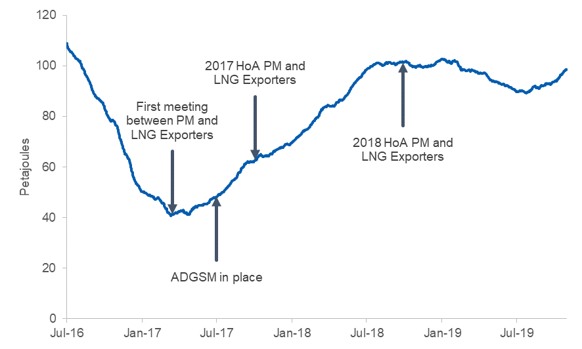

Source: DIIS analysis of data obtained from AEMO via Energy Edge, Gas Market Analysis Tool [www.energyedge.com.au/Products/GasMarketAnalysisTool.aspx]

Figure 6 shows this net contribution by month. Since January 2018, in aggregate, the three LNG export projects have contributed an average of 8.5 PJ per month to the Australian domestic gas market. Figure 6 also shows how the eastern gas market has stabilised over the last 3 years, whereby LNG project contributions to the domestic market are highest during the winter months when southern gas demand is highest.

Figure 6: Monthly net contribution of LNG-CSG fields to the eastern gas market

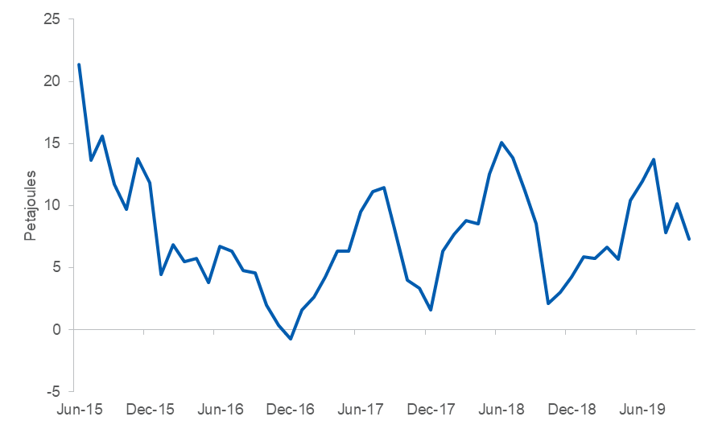

Source: DIIS analysis of data obtained from Energy Edge, Gas Market Analysis Tool [www.energyedge.com.au/Products/GasMarketAnalysisTool.aspx]

### Pipeline flows

The improved supply outlook in Australia’s eastern gas market is reflected in key pipeline gas flows. Before LNG operations, gas flowed from north to south. As shown in Figure 7, in 2014 the LNG operators began to ramp up CSG operations in Queensland in anticipation of the start of LNG operations, leading to increased flows from north to south. However, in 2016 and 2017, instead of an expected large increase in supply of gas to the market, the lower-than-expected flow of gas from CSG fields to LNG export facilities was supplemented by gas from the domestic market. During the establishment phase of the LNG operations, which included contractually-obligated operational testing of plant capabilities, there was substantial disruption in the industry and gas flow reversed to south-north.

As the three LNG facilities have reached a steady rate of production and brought more CSG fields into production, as well as the establishment of the ADGSM, gas flows have reflected more seasonal variation. As shown in Figure 7, over the last three years, gas has flowed from north to south at an increasing rate during the Australian winter when southern gas demand for heating is high. During the Australian summer, gas has flowed south to north as southern gas demand falls.

Figure 7: Average daily flows – Queensland South Australia/New South Wales (QSN) Link

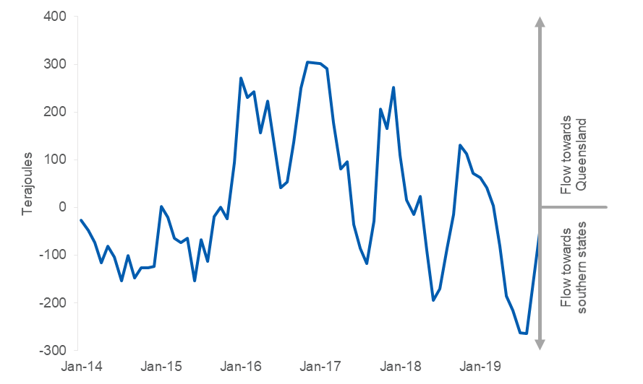

Source: AER, Average daily flows – QSN link and southerly flows towards Victoria (monthly), AER reference D11/2298801[V4], [https://www.aer.gov.au/wholesale-markets/wholesale-statistics/average-daily-flows-%E2%80%93-qsn-link-and-southerly-flows-towards-victoria-monthly]

Figure 8 shows daily flows of the South West Queensland Pipeline (SWQP), ranked from most positive (flow towards Queensland) to most negative (flow towards the southern states) each year since 2016. It highlights the SWQP has been increasingly used to help meet demand in the southern states. In 2016-17, before the introduction of the ADGSM, gas flowed south to north over 80 per cent of the time. In 2018-19, after the ADGSM’s introduction, gas flowed south to north less than 40 per cent of the time.

Figure 8: Daily net flows along the SWQP from 1 July 2014 to 30 June 2019

Source: DIIS analysis of data obtained from AEMO via Energy Edge, Gas Market Analysis Tool [www.energyedge.com.au/Products/GasMarketAnalysisTool.aspx]

Figure 9 shows the average net monthly gas flows on the Queensland to South Australia/NSW (QSN) Link Pipeline over equal time periods before and after the establishment of the ADGSM over three time frames: six months, twelve months and two years. Regardless of time frames, average flows south to north have decreased since the ADGSM was introduced.

Figure 9: Daily net average flows south to north on the QSN

Note: Positive numbers represent net gas flows to Queensland

Source: AER, Average daily flows – QSN link and southerly flows towards Victoria (monthly), AER reference D11/2298801[V4], [https://www.aer.gov.au/wholesale-markets/wholesale-statistics/average-daily-flows-%E2%80%93-qsn-link-and-southerly-flows-towards-victoria-monthly]

## Domestic prices

The establishment of LNG export facilities in Queensland has changed the price dynamics of Australia’s eastern gas market. Gas producers in Victoria and South Australia now have the option of selling gas to LNG export facility operators. As a result, producers can expect to receive at least the export-parity price for their gas.

The ACCC LNG netback price is a measure of an export parity price that a gas supplier located at Wallumbilla can expect to receive for exporting its gas. It is calculated by taking the price that could be received for LNG and subtracting, or ‘netting back’, the costs incurred by the supplier to transport their gas to Gladstone, convert it to LNG and ship it to the destination port. For Australia, the relevant price of LNG is the spot price in geographically close markets, i.e. east Asia. As part of reforms to improve transparency of gas prices in the eastern gas market, the ACCC publishes a monthly LNG netback price series that dates back to 2016.[12] Section 4.2 discusses further issues around the use of the netback price as an indicator of price in the eastern gas market.

Figure 10 shows expected 2019 LNG netback prices compared to different average monthly gas commodity prices from January 2017 to January 2019. As shown, average retailer offers for 2019 to commercial and industrial (C&I) users have declined substantially from their peak in March 2017. Importantly, in the context of this review, domestic gas commodity prices and LNG netback prices at Wallumbilla have converged since the introduction of the ADGSM. Since February 2018, supplier offers for 2019 have tracked closely to the band of expected 2019 LNG netback prices at Wallumbilla plus or minus transport costs to and from Victoria. As stated by the ACCC[13] and explained in Box 3.1, this range reflects prices that would be expected in a well-functioning market.

**Box 3.1: Range of southern state prices that would be expected in a well-functioning market**

In its 2016 inquiry into the eastern gas market, the ACCC set out a bargaining framework to illustrate how gas supply negotiations in the southern states may be influenced by the LNG fundamentals in Queensland. The ACCC observed that, while prices in the southern states were likely to be shaped by LNG netbacks, the cost of transporting gas to, or from, Wallumbilla meant that there was a range of potential pricing outcomes:

* If there is diverse supply and strong competition in the southern states, competition will drive suppliers in the southern states to offer a gas price closer to their next best sales alternative. If this alternative is to sell gas to the LNG projects in Queensland, the price that the supplier in the southern states would receive is the LNG netback price at Wallumbilla less the cost of transporting gas (and processing costs) to Wallumbilla.
* If there is a lack of supply options in the southern states and producers can set prices in the absence of competitive constraints from other producers in the southern states, then these producers in the southern states can charge a price approaching the buyer’s next best alternative. If this alternative is to buy gas from producers in Queensland, the price that a gas buyer would have to pay for this gas is the LNG netback price at Wallumbilla plus transport costs from Wallumbilla to the buyer’s location.

Figure 10: Average of monthly gas commodity prices offered for 2019 supply against contemporaneous expectations of 2019 LNG netback prices (Southern States)

Source: ACCC, Gas Inquiry 2017–2020 Interim Report, April 2019, p. 31.

Figure 11 shows this trend has continued over the last twelve months. From February 2018 to April 2019, the average of prices offered by producers and retailers in southern states tracked closely to the band between the expected 2020 LNG netback price at Wallumbilla and the same price plus transport to Victoria.

Figure 11: Average of monthly gas commodity prices offered for 2020 supply against contemporaneous expectations of 2020 LNG netback prices (Southern States)

Source: ACCC, Gas Inquiry 2017–2020 Interim Report, July 2019, p. 57.

### C&I gas user experience

In September 2017, commercial and industrial (C&I) users told the ACCC that they were experiencing difficulties in securing gas supply offers on competitive terms for 2018 and beyond. Most large C&I users had only one supplier willing to supply them and prices offered in 2017 were considerably higher than 2016 levels, generally ranging from $10 to $16 per GJ. These prices were well in excess of appropriate benchmark prices.[14]

By December 2017, market conditions had improved, particularly for large C&I users who consume more than one PJ per year. Large C&I users reported lower prices than early 2017 and more suppliers making offers, particularly Queensland suppliers. By this time, most large C&I users the ACCC liaised with had secured gas supply agreements (GSAs) for 2018 supply.

These GSAs included substantial supply from LNG projects. In October 2017, Australia Pacific LNG signed a sales agreement with Origin Energy to supply 41 PJ of gas under a 14-month contract starting in November 2017.[15] By December 2017, Santos had pledged to divert over 60 PJ of gas from its Gladstone LNG project into Australia’s eastern gas market over the next two years.[16]

Figure 12 shows offers for supply in the eastern gas market and historical ACCC LNG netback prices. Offers for supply in 2019 were made in 2017, while offers for supply in 2020 have been made since 2018. While prices have largely stabilised since the highs of early 2017, there is potential for them to decrease further. The currently low spot Asia LNG prices[17] will likely exert downward pressure on eastern gas prices in the near term.

Figure 12: Gas commodity price offers for 2019 and 2020 supply in the eastern gas market against expectations of LNG netback prices

**Note:** *Includes arms-length transactions only. Includes offers with a term of at least one year and an annual contract quantity of at least 0.5 PJ. Origin Energy, AGL, Energy Australia, Alinta Energy, Shell Energy Australia and Macquarie Bank are classified as ‘retailers’. The prices of individual transactions are not all directly comparable due to differences in non-price terms and conditions. The ACCC has not sought to adjust for these factors in the chart. Offers for Northern Territory gas were included only if the delivery point for the supply of gas was in the eastern gas market. Offers made in 2017 for the supply of gas in 2019 are priced in 2019 dollars while offers made since 2018 for the supply of gas in 2020 are priced in 2020 dollars. Expected LNG netback prices are contemporaneous with the supply of gas.*

**Source:** ACCC, Gas Inquiry 2017–2020 Interim Report, July 2018, p. 41; ACCC, Gas Inquiry 2017–2020 Interim Report, April 2019, p. 31; ACCC, Gas Inquiry 2017–2020 Interim Report, July 2019, p. 21, 57.

Conditions in the eastern gas market remain tight. In the ACCC’s Gas Inquiry interim report July 2019, C&I gas users were still reporting difficulties in competitive gas supply. A number of C&I gas user businesses have entered administration over the last year with energy costs (both gas and electricity) cited as a contributing factor.

Large C&I gas users and small gas users seeking gas supply report different market experiences. Larger C&I users generally noted a willingness by producers and retailers to engage and negotiate, thereby receiving a number of responses to requests for gas supply. Smaller C&I gas users that have recently been active in the market for 2020 supply reported fewer suppliers making offers. In some cases users received just one offer.

The ACCC reported that increased retail margins may have contributed to the difficulties experienced by C&I users in the eastern gas market, particularly in Victoria and NSW. Average retail margins for C&I customers in NSW have increased, from between 11 and 16 per cent over 2014–16, to between 24 and 27 per cent in 2017 and 2018. Average margins for Victorian C&I customers have risen substantially, from between 15 and 17 per cent over 2014–16 to 31 and 36 per cent in 2017 and 2018, respectively.

The retail gas market is even more concentrated than the retail electricity market. Major retailers supply around 75 per cent of small gas customers across all parts of the eastern market, compared to 68 per cent of electricity customers across the NEM. Gas producer concentration is discussed in section 3.4.2. The ACCC has stated its concern with the level of margins and will further investigate whether they are due to existing low-cost legacy gas contracts, or structural and competition issues in the market.

### Comparison of global gas prices

The public debate on Australia’s domestic gas prices often includes comparisons with prices in other countries. In its July 2019 report, the ACCC engaged S&P Global Platts to prepare a report on delivered gas prices paid by C&I gas users in a range of countries around the world. The Platts report shows that the delivered prices that the C&I gas users in the eastern gas market pay are, broadly speaking, in line with those in several European countries, including Germany, the UK, Spain and Portugal. Average industrial prices in eastern Australia were below those in both China and South Korea. However, the report shows that delivered prices paid by C&I gas users in the east coast are higher than the prices paid by C&I gas users in other gas exporting countries (e.g. US and Canada).[18]

According to the report, the two main factors that impact wholesale gas prices are access to diverse natural gas supply and country-specific tax policy. Countries with varied low-cost supply sources tend to have lower natural gas prices than countries that are dependent on one source.

Consistent with this research, EnergyQuest found that in 2018-19 the average landed price of Australian LNG in our three main export markets, Japan, China and Korea, were all above average Australian eastern wholesale domestic gas prices.[19]

There are a range of factors, which make direct comparisons on gas prices between countries difficult. This includes variations in gas resources, underlying production costs and regulatory and taxation policies across countries. Given the ACCC’s observations on factors that impact gas prices, any steps to reduce supply constraints may help put downward pressure on prices.

## Market Function

### Market Liquidity

There have been a number of reforms in the domestic gas market to improve market liquidity and transparency. In addition to the LNG netback price series, there have been reforms associated with the wholesale gas market and pipeline capacity trading, and a range of measures to enhance market information dissemination. It is expected that these reforms, which are targeted to directly address issues associated with market functionality, could have a greater impact on the market.

As part of the transition to a set of consistent exchange-based trading markets, a northern gas supply hub (GSH) located at Wallumbilla and an additional trading point at Moomba have been established. It is expected that this will concentrate trading liquidity, improve price discovery and reduce barriers to participation in the eastern gas market, where the majority of gas is traded bilaterally. A range of metrics published by the AER demonstrate the improvement in the functioning of the gas market since the introduction of these hubs and other associated reform measures.

Figure 13 shows that monthly traded volumes sold at the Wallumbilla GSH since 2016, its second year of operation, have increased substantially, reaching 3.3 PJ in August 2019. This represents approximately 23 per cent of gross gas flows from the three main transmission pipelines that connect to the Wallumbilla GSH, the South West Queensland Pipeline, the Queensland Gas Pipeline and the Roma to Brisbane Pipeline in August 2019.

Figure 13: Monthly traded volumes on the GSH, Wallumbilla location

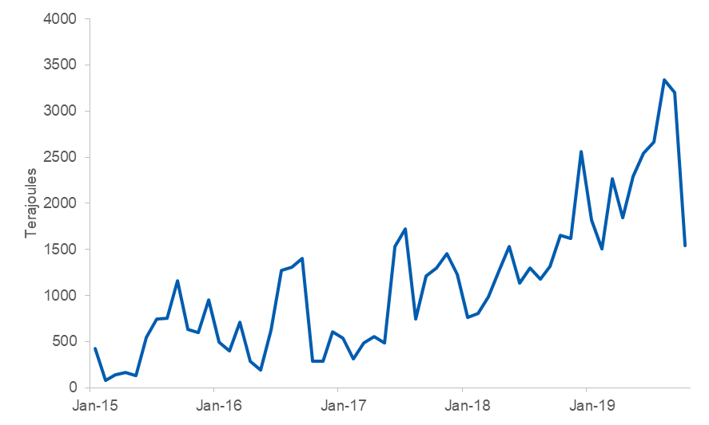

Source: AER, Gas Supply Hub delivered quantities, AER reference AER reference D11/2298801[V4], [https://www.aer.gov.au/wholesale-markets/market-performance/gas-supply-hub-delivered-quantities]

Table 1 shows the number of trades that occurred in each year, at Wallumbilla by product category. Wallumbilla trades have increased significantly over the last three years, across all product categories. Four out of five products set records in the first half of 2019 for the number of trades. Despite this impressive growth in liquidity, bilateral and ‘over-the-counter’ trades still remain the standard method for trading gas in the eastern gas market.[20]

Table 1: Number of trades per product at Wallumbilla

|  |  |  |  |  |  |
| --- | --- | --- | --- | --- | --- |
| **Column1** | **Balance of day** | **Day ahead** | **Daily** | **Weekly** | **Monthly** |
| First half of 2015 | 19 | 152 | 123 | 6 | 0 |
| Second half of 2015 | 45 | 232 | 285 | 13 | 0 |
| First half of 2016 | 102 | 99 | 105 | 10 | 0 |
| Second half of 2016 | 123 | 264 | 81 | 11 | 3 |
| First half of 2017 | 129 | 203 | 221 | 16 | 4 |
| Second half of 2017 | 161 | 267 | 544 | 81 | 10 |
| First half of 2018 | 192 | 256 | 478 | 46 | 14 |
| Second half of 2018 | 245 | 329 | 297 | 23 | 29 |
| First half of 2019 | 547 | 558 | 640 | 63 | 38 |

Source: AER, Gas Supply Hub trade count by product – Wallumbilla, AER reference D11/2298801[V6] [https://www.aer.gov.au/wholesale-markets/wholesale-statistics/gas-supply-hub-trade-count-by-product-%E2%80%93-wallumbilla]

### Market concentration

A number of gas users have expressed concern on the amount of market power suppliers are able to exercise in the eastern gas market. The Herfindahl-Hirschman Index (HHI) is a standard measure of market concentration that is based on the market share of each participant. The HHI can range in value from 0 to 10,000. A lower value represents a less concentrated market. Typically, competition regulators consider that a HHI value below 1500 is indicative of an unconcentrated market.[21], [22]

Industry concentration of gas production and total production for the eastern market is shown in Figure 14. Eastern gas production more than doubled from 2014 to 2019, while the supply-side market concentration of the eastern gas market has remained relatively unchanged. For the June 2019 quarter, the eastern gas production HHI was 1,105.

Figure 14: Quarterly industry concentration (HHI) and total production for the eastern market

Source: DIIS analysis of data obtained from EnergyQuest Energy Quarterly, September 2014 – September 2019.

## Long-term supply

Since the implementation of the ADGSM there have been a number of developments that have improved the long-term outlook for gas supply into the eastern gas market. These investments are reflected in forecasts made by AEMO in its 2019 GSOO report. Eastern production (including NT) is projected to increase from 1,818 PJ in 2018 to 2072 PJ in 2021, an increase of 14 per cent.

In the north, the Northern Gas Pipeline (NGP) started operation in January 2019. The pipeline, which has a capacity of 35 PJ per year, connects the Northern Territory to the eastern gas market. This has led to plans by NT onshore gas producers to increase production to fill the pipeline. For example, Central Petroleum plans to increase gas production in central Australia from 15 terajoules (TJ) per day to more than 60 TJ per day.[23]

The NT Government’s recent removal of a moratorium on exploration and hydraulic fracturing for onshore gas in the Beetaloo Basin and the anticipated successful development of the basin’s shale gas resources could lead to additional gas supply through the NGP. In anticipation of this, the NGP operator, Jemena, is preparing a potential $3 billion to $4 billion expansion and extension of the line to a capacity of 700 TJ per day (an equivalent of 255 PJ per year – this is an almost eight fold expansion from NGP’s current daily capacity of around 32 PJ per year).[24]

The tighter market conditions have also prompted the development of a number of other new pipelines. This includes the Reedy Creek to Wallumbilla Pipeline, which was commissioned in June 2018, the Atlas Gas Pipeline, which opened in December 2019, and the Galilee Gas Pipeline, which is expected to open in 2022.

Over the past two years, the Queensland Government has issued tenements with domestic supply conditions to six different gas producers.[25] Gas produced from each of these tenements must be sold domestically. The first gas from these tenements has come from ‘Project Atlas’ starting in October 2019. Senex estimates that the project has 144 PJ of commercially recoverable reserves.[26]

In the south, Cooper Energy’s Sole project will begin to deliver gas to the Orbost Gas Plant before the end of 2019.[27] Gippsland Basin Joint Venture (GBJV) partners, Esso and BHP, approved investment in the West Barracouta project in December 2018. However, forecast production by the GBJV in 2020 remains significantly lower than its 2017 peak (322 PJ) due to reduced production from its depleting legacy fields.[28] Beach Energy and Cooper Energy have committed over $1 billion to develop gas fields in the Otway Basin.[29]

State moratoria and regulations of onshore unconventional gas in southern markets have limited new gas resource developments. Victoria and Tasmania have state-wide moratoria, South Australia has a moratorium in the south-east of the state. New South Wales has established a number of restrictions on unconventional gas development, including exclusion zones near residential areas and some primary industries. The Narrabri Gas Project, which could supply up to 50 per cent of NSW natural gas needs, is waiting on NSW regulatory approvals.[30]

Supply from existing and committed gas developments is forecast by AEMO to meet gas demand until 2023. However, over this period, production in southern gas fields is expected to decline unless new gas is brought into production. Without new reserves and resources being developed in the south, existing north-south pipeline capacity will become constrained, as southern states source more gas from Queensland. In addition, AEMO has noted that declining Victorian supply will increase reliance on gas storage to meet the state’s winter demand. Should this occur, new infrastructure development will be required to prevent supply gaps.

Ensuring adequate supply to the domestic gas market long term is best achieved by developing gas resources that are close to demand centres. In successive reports, the ACCC has urged state governments to adopt policies that consider and manage the risks of individual gas development projects, rather than implementing blanket moratoria and regulatory restrictions. Support for this position comes from both gas users and producers.

A potential solution to overcome gas pipeline congestion is to establish one or more LNG import terminals in the southern states, as this may be cheaper than investing in expanding pipeline capacity. A number of potential LNG import terminals are at various stages of development. The Port Kembla import terminal proposed by Australian Industrial Energy is the most developed having attained planning approval in April 2019.[31] As noted in AEMO’s 2019 GSOO, ‘these terminals would help relieve pressure on meeting southern gas demand during peak periods and assist in reducing pipeline constraints, but may do little to ease gas pricing pressures’.[32]

## LNG sector impacts

The improved domestic gas market conditions have occurred in tandem with new annual records for east coast LNG projects’ gas consumption and exports since the projects started production. Figure 15 shows monthly east coast LNG exports. Year-to-date LNG exports in October 2019 were approximately 8.6 per cent ahead of year-to-date LNG exports in August 2018 at 18.3 million tonnes. This record production suggests that there has been minimum disruption to Australia’s LNG export industry since the introduction of the ADGSM and that Australia’s LNG industry is highly competitive in global LNG markets.

Figure 15: Monthly east coast LNG exports

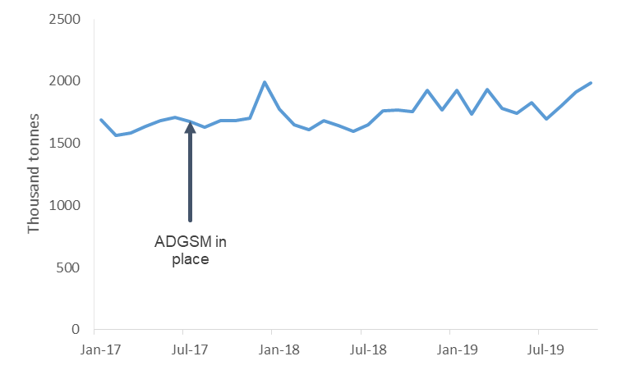

Source: Gladstone Ports Corporation, Cargo Statistics Selections [http://content1.gpcl.com.au/viewcontent/CargoComparisonsSelection/CargoComparisonsSelection.aspx]

Assessing the longer term impact on Australia’s reputation as a reliable LNG supplier and stable investment destination is harder to quantify due to both the inherent uncertainty associated with longer time frames and the number of other factors that influence investment decisions. Stakeholder submissions are varied in their views on the ADGSM’s impacts on Australia’s LNG industry, with gas producers highlighting some concerns while users contending any impacts are negligible.

APPEA’s submission states that the ADGSM is ‘putting at risk Australia’s long-standing reputation as a stable investment destination and reliable supplier to both domestic and global markets’. APPEA does however acknowledge the Australian Government’s efforts to ‘reassure LNG customers in Asia of the value of their partnerships with Australia’. Conversely, the Energy Users Association of Australia state they ‘do not believe the ADGSM has had any material impact on the competitiveness of Australia’s LNG industry or Australia’s investment reputation’.

As highlighted in section 3.5, there is evidence of ongoing investment in the development of Australia’s gas resources for both domestic use and export. A range of factors influence this activity, not the least being prevailing gas market conditions. Investment plans beyond Australia’s new LNG projects, including backfilling existing LNG projects in Australia’s west and north continue to progress. There is no evidence suggesting the ADGSM has had any impact on the prospects for these investments.

When the ADGSM was introduced, Australia’s LNG trading partners expressed concern about the ADGSM’s impact on Australia’s reputation as a reliable LNG supplier and stable investment destination.[33], [34] To date, the ADGSM has not been triggered to restrict LNG exports. As such, this level of concern has largely dissipated and there is a greater understanding around the ADGSM’s objective and operation. The Government is conscious of the potential impact of triggering the ADGSM on certainty for investment and supply.

The ADGSM as currently designed aims to ensure sufficient domestic supply is not compromised by LNG exports. As a ‘backstop’ mechanism, regulatory intervention only occurs in the event of issues with the behaviour of market participants. To date, the ADGSM has been effective in this regard as sufficient domestic supply has negated the need for regulatory intervention. More broadly, the Government, and stakeholders, acknowledge that increasing gas supply is the preferred means of addressing gas market pressures.

# Future of the ADGSM

## Total Market Security Obligation

The Total Market Security Obligation (TMSO) is that part of a gas shortfall the Minister considers attributable to LNG projects in net-deficit. Where the Minister determines a domestic shortfall year, the Minister calculates the TMSO and allocates it to net-deficit LNG projects on a pro-rata basis according to the amount by which they are in net deficit. This determines the Exporter Market Security Obligation (EMSO) that each exporter in net deficit is responsible for, which is the lesser of the pro-rata TMSO allocation and the project’s net deficit amount.

The TMSO is calculated by determining the extent to which an LNG project is drawing from, or adding to, the quantity of gas to the domestic market over the forthcoming calendar year. This net market position of an LNG project will be calculated by reference to that project’s tenements, including all tenements considered ‘own gas’ or ‘third party export compatible gas’.

Own gas can come from tenements that are wholly or partly owned by one or more entities of the LNG project, where the gas is contracted directly to supply the project and was developed primarily for export. Third party export compatible gas is produced from tenements owned by a third party where the gas is contracted directly to supply the LNG project and the gas was either: primarily developed for the purpose of supplying the export market; or, the contract for gas supply was entered into for the purpose of supplying the LNG project before a final investment decision was made on the project.

The inclusion of own gas and third party export compatible gas in the consideration of the LNG project’s net market position aims to recognise that some exported gas is sourced from gas fields developed specifically for export, and ensure development of such fields is not disadvantaged. An LNG Project is regarded as being in net-deficit in the forthcoming calendar year if its total gas used is greater than the sum of its own gas and third party export compatible gas.

LNG exporters, in aggregate, are currently net suppliers to the domestic gas market (see Figure 5). If all LNG exporters are net suppliers to the domestic market, an expected shortfall cannot be recovered under the TMSO’s existing arrangements.

### Potential change to the TMSO

The review has examined the TMSO and found that as currently designed, it may not be able to recover sufficient domestic gas to address a potential market shortfall. This is due to the ‘net deficit’ component only enabling export restrictions on volumes of gas where exporters are drawing more gas from the domestic market than they are putting in.

To address this, the review recommends consideration be given to changing the TMSO in a way that enables the recovery of gas beyond that currently permitted under the ‘net-deficit’ test. This change would be based on a requirement for applicable LNG projects to meet a shortfall in the domestic gas market while recognising their gas contribution to that market. As such, the mechanism would be a ‘50/50’ hybrid which allocates:

* half of the identified shortfall volume to applicable LNG projects on a pro-rata basis against LNG production capacity, and
* the remaining half of the shortfall, split in a way that is inversely proportional to the domestic gas contributed by each project.

Only those LNG projects exporting gas from a market that is in shortfall would be subject to export restrictions.

This change could be effected by revisions to the ADGSM’s guidelines. Therefore, in the unlikely event of a shortfall that could not be addressed by the Heads of Agreement or other measures (as outlined in section 2.4), the Minister for Resources would be able to take action to secure domestic gas supply.

As per current arrangements, during a shortfall year LNG producers who are exporting from a shortfall market would be issued with an Allowable Volume export permission equivalent to their planned export volume minus their share of the TMSO. For the purposes of determining a project’s contribution to the domestic market, the ADGSM would retain the existing definitions of ‘own’ and ‘third party export compatible’ gas.

Importantly, this review does not consider it likely that there will be a domestic gas shortfall over the life of the ADGSM - based on reporting by AEMO and the ACCC. As such, export restrictions are not envisaged particularly if LNG projects continue their contributions to domestic supply.

Any change to the TMSO would be developed in consultation with industry and other affected stakeholders to avoid any unintended consequences. The Government’s intent remains to ensure domestic market security while continuing to attract investment in gas exploration and development and remain a reliable LNG supplier.

## LNG Netback Price

#### ACCC LNG netback price

The ACCC commenced publishing its LNG netback price series on 2 October 2018 as one of the measures to improve transparency of gas prices in the eastern market. The ACCC’s LNG netback series is calculated by taking the Asian LNG spot price and subtracting, or ‘netting back’, the costs of getting the gas from Australia (specifically, from the Wallumbilla GSH) to its destination. These costs include pipeline transportation to the LNG plant, liquefaction (i.e. conversion of the gas to LNG) and shipping to the destination port.

The ACCC’s LNG netback price represents the theoretical price at which a gas supplier should be indifferent between exporting gas and supplying that gas to a domestic customer. Effectively, it is the ‘opportunity cost’ to a gas supplier of choosing to sell gas into the domestic market, i.e. the revenue foregone as a result of selling gas domestically.

The ACCC has acknowledged the limitations of its LNG netback price series. It notes that the publication of the price series does not represent the ACCC setting gas prices in the eastern gas market, nor the ACCC forecast of international or domestic gas prices. It notes that the LNG netback price is not the sole factor that influences gas prices in the eastern gas market and that different pricing dynamics apply in states and territories outside Queensland. [35]

Figure 16 shows the difference between the historical LNG netback price as observed by the ACCC and the Wallumbilla spot price. As shown there is limited correlation between these two prices. However, it is important to note that the gas price traded at Wallumbilla represents a small proportion of domestic gas sales and is not yet accompanied by the range and diversity of financial products and hedging opportunities that is seen at somewhere like the Henry Hub in the United States.

**Figure 16: Comparison between ACCC’s historical LNG netback price and Wallumbilla gas supply hub spot price July 2017- January 2020**

Note: The January 2020 average Wallumbilla spot price is calculated to 15 January 2020.

Source: DIIS analysis of data obtained from AEMO via Energy Edge, Gas Market Analysis Tool [www.energyedge.com.au/Products/GasMarketAnalysisTool.aspx] and ACCC LNG netback price series [www.accc.gov.au/regulated-infrastructure/energy/gas-inquiry-2017-2025/lng-netback-price-series]

There were some common views expressed across the submissions on the utility of the ACCC’s LNG netback price series. APPEA stated that the series ‘provides useful information’, while Origin noted that it ‘provides an indicator of the opportunity cost to LNG producers for making domestic sales’. Manufacturing Australia applauded ‘the valuable work of the ACCC to establish a benchmark price series for domestic gas’. A number of other limitations were also identified with the LNG netback price series, with producers and consumers expressing differing views on how it could be improved.

Forward LNG netback prices in the ACCC’s price series are derived using prices for JKM futures contracts quoted by Intercontinental Exchange, as at the time of publication. The average of forward LNG netback prices over a given period of future gas supply can be used by gas buyers (such as C&I users) in negotiations with suppliers. For example, if a gas user was seeking gas supply over the next full calendar year, the LNG netback price series would allow them to calculate the average of forward LNG netback prices over that year. The user would then be able to use this average to, for example, assess price offers made by suppliers for that same period of supply - noting that other factors such as transportation costs, the terms and conditions of gas supply, and retailer charges may be relevant.

This review considers that the ACCC’s forward LNG netback prices are the most applicable prices when estimating the likelihood and extent of a potential shortfall. As such, the review recommends amending the ADGSM’s guidelines to include a reference to the ACCC’s LNG netback price series in estimating a potential shortfall. The guidelines currently reference LNG netback prices in general, without specifying the ACCC’s LNG netback price series as it had not commenced when the guidelines were developed and introduced. This amendment clarifies the relevance of the ACCC’s LNG netback price series to considerations under the ADGSM. It will also strengthen the ADGSM’s ability to deliver on its overall objective of securing domestic gas supply.

While the ADGSM is not a mechanism to control price, if prices paid by Australian gas users are significantly higher than the ACCC’s netback price, this would serve as an indication that the domestic gas market is not operating efficiently. For this reason, a comparison of an average domestic price with the ACCC’s netback price should be a factor for consideration in assessing the likelihood of a supply shortfall in the Australian domestic gas market. While comparing the ACCC’s average LNG netback price and the Wallumbilla gas supply hub price are an imperfect representation of market activities, such a comparison would still stand as an indication of the operation of the domestic gas market.

#### Other LNG netback prices

As outlined above, the ACCC uses an Asian LNG spot price as the basis for its LNG netback price series, noting that the Asian LNG spot price represents the opportunity cost for suppliers of selling gas to domestic consumers. The relationship between domestic gas prices, LNG spot prices and LNG contract prices in the eastern gas market is complicated. Given this complexity in price formation processes, the eastern gas market may benefit from the development of other price benchmarks.

It is possible, for example, that oil-linked LNG contract prices may influence the opportunity cost for gas suppliers of selling domestically, and thus exert some influence over domestic gas prices. The fact that pricing arrangements in the eastern gas market have changed quickly, and may continue to change in the future, points to the need for ongoing monitoring and consideration of measures to assist with price transparency.

There are a number of issues to consider when assessing the utility of alternative LNG netback benchmarks. These include the transmission mechanisms between international and domestic prices, and how a price benchmark would affect the efficiency of the market and the behaviour of market participants.

The publication of an oil-linked contract netback price may provide additional information to buyers, and a number of oil-linked netback price series are available through private/commercial providers. APPEA states, ‘a better way to inform all market participants would be for the ACCC to publish in future editions other LNG price markers, including prices based on short-term multi-cargo LNG contracts and prices based on long-term LNG contracts’.[36] However, these potential benefits would need to be weighed against a variety of other factors.

The ACCC has stated: ‘To be of most use to domestic gas buyers under current market conditions, the prices published by the ACCC in the LNG netback price series are short-run LNG netback prices based on measures of Asian LNG spot prices. Over the course of its Gas Inquiry 2017-2020, the ACCC will consider whether to also publish LNG netback prices based on other LNG price markers.’[37]

Figure shows an indicative oil-linked contract price for LNG exports from Gladstone, versus an Asian LNG spot price. LNG spot prices and oil-linked contract prices have diverged over the past year, with oil-linked contract prices substantially higher than LNG spot prices.

Figure 17: Oil-linked LNG contract price versus LNG spot price

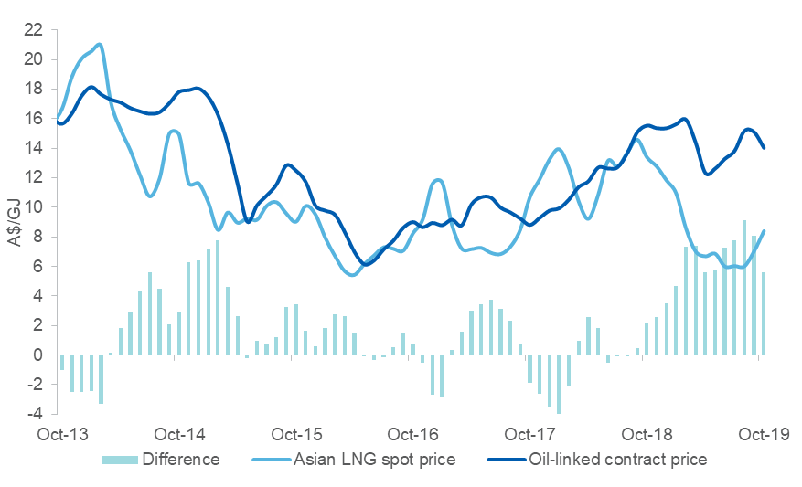

Note: The Argus Northeast Asian spot price is shown. LNG prices are DES (Delivered Ex Ship). DES prices include shipping and insurance. The long-term oil-linked contract price is indicative only, and is estimated at 14 per cent of the 3-month lagged Japan Customs-cleared crude oil price plus shipping.

Source: Argus Media, LNG des Northeast Asia (ANEA) half-month 1 [https://direct.argusmedia.com]; Bloomberg, Japan Customs-cleared crude oil price [https://www.bloomberg.com/professional/solution/bloomberg-terminal/]

Some submissions from gas users suggested the use of a long-run LNG netback as a benchmark price for triggering the ADGSM. However, a long-run LNG netback is best seen as a tool that gas producers might use to: determine which long-term commercial decision is most profitable; enter a long-term domestic gas supply agreement; enter a long-term LNG export agreement; and, invest in LNG export facilities or delay production.

## Price trigger

A key theme in the submissions related to the potential use of a price trigger in the ADGSM. Currently, the ADGSM can only be activated if a gas shortfall is forecast for the forthcoming calendar year. A number of submissions from gas users called for a price trigger to be adopted, although they differed on how it should be implemented.

Manufacturing Australia’s submission noted that a price trigger could be based on an LNG netback price that, unlike the ACCC’s current netback price series, subtracts the cost of LNG capital investment. The submission noted that ‘it is not reasonable to expect the domestic market to subsidise investments in LNG export infrastructure’. Calls for a price trigger are generally based on using either a set price or a price reflecting the relationship between domestic and international prices.

A number of other submissions, typically from gas producers, made the case that the incorporation of a price trigger into the ADGSM would be problematic. These submissions emphasised the limitations of LNG netback calculations for determining an appropriate price for domestic gas. They argued that non-price terms vary substantially between LNG spot sales and the domestic sales – therefore, LNG spot price netbacks and domestic prices are not directly comparable in a well-functioning market.

For instance, Origin noted that an LNG netback price does not account for factors such as ‘take-or-pay’ percentages, load factors, transportation arrangements and contract length. Similarly, APPEA noted that ‘LNG netback prices should not be viewed as a benchmark for domestic gas prices’ and ‘contract prices vary according to many factors, such as the duration of the contract and the ways risks are shared by buyer and seller’. The submissions noted that other factors, such as the seasonal movements in Asian LNG spot prices, also limit the comparability of domestic and international prices.

There are a number of issues with incorporating a price trigger into the ADGSM. Prices would still be determined by market forces in the event the ADGSM is triggered, and its activation may not deliver a targeted price level. Also, the ADGSM can restrict exports but it does not require LNG exporters to increase sales to the domestic market, nor at a specified price. It is possible that only a small proportion of any ADGSM-triggered reduction in exports would flow to the domestic market as high-cost production may be cancelled or delayed. Further, it does not address other factors affecting prices, such as developments in the electricity market, retailers’ margins, or constraints around pipeline transportation and capacity.

Also, there are a variety of factors that make precise comparisons between international LNG prices and domestic gas prices difficult. This would complicate the operation of a price trigger in the ADGSM and may introduce additional uncertainty about the direction of future domestic gas prices, even if the ADGSM were not activated.

A price trigger may also impact Australia’s high standing as a reliable LNG supplier and a stable and attractive investment destination. Companies that invest in long term projects will seek a level of certainty and stability that there will not be changes to regulatory or operating frameworks which could undermine their investments.

More generally, the introduction of a price trigger has the potential to cause unintended consequences. In a market economy, prices play a crucial role. They indicate relative commodity values, transmit information about market conditions and help match supply to demand. The introduction of a price trigger could impede these functions. Limiting prices in the short-term has the potential to stifle incentives to invest in new production longer term.

# Conclusion and Recommendations

Since the ADGSM’s introduction in 2017, pressures in the eastern gas market have moderated. It is important to note the ADGSM is not a price control mechanism, but rather aims to ensure domestic supply is not compromised by LNG exports. Increasing domestic gas production remains the most effective means of increasing competition, alleviating market tightness and placing downward pressure on prices.

The gas market and underlying supply chains are complex with a range of factors affecting market outcomes. These complexities are reflected in Australian governments’ extensive gas market reform agenda. It is difficult to quantify the impact of specific factors and reforms on the market, including for the ADGSM. However, the improvement in the domestic supply outlook and subsequent market conditions is at least partly credited to the ADGSM – this has been acknowledged by energy market bodies and regulators (AEMO, AER and ACCC).

Submissions to this review have ranged from the general view of gas producers that the ADGSM is no longer required, to calls from gas users for stronger interventions in the gas market. Both gas users and producers have acknowledged the ADGSM’s effectiveness in encouraging more domestic supply and recognised that it is only one of a suite of reforms aimed at addressing gas market pressures.

**Recommendations:**

1. The ADGSM was introduced as a temporary measure alongside a broad suite of gas market reforms aimed at addressing market pressures. While there have been clear improvements in the eastern gas market, the market remains uncertain and persisting pressures still need to be addressed. *As such, the review recommends retaining the ADGSM until its scheduled cessation in 2023.*
2. Whilst the ADGSM has worked well to date, it is important to ensure its effectiveness should it be required. This review has examined the Total Market Security Obligation (TMSO) and found that it may not be able to recover sufficient domestic gas to address a market shortfall. *As such, the review recommends consideration be given to changing the TMSO from the current ‘net-deficit’ test to a ‘50/50’ hybrid model which allocates:* 
   * *half of the identified shortfall volume to applicable LNG projects on a pro-rata basis against LNG production capacity, and*
   * *the remaining half of the shortfall split in a way that is inversely proportional to the domestic gas contributed by each project.*

Any change to the TMSO would be developed in consultation with industry and other affected stakeholders to avoid any unintended consequences. The Government’s intent remains to ensure domestic market security while continuing to attract investment in gas exploration and development and remain a reliable LNG supplier.

1. The review recognises that price is an important indicator in establishing whether the domestic market is functioning effectively and considers that the ACCC’s forward LNG netback price series is the most applicable prices when estimating the likelihood and extent of a potential shortfall. *As such, the review recommends amending the ADGSM’s guidelines to include referencing the ACCC’s LNG netback price series in estimating a potential shortfall.* This amendment clarifies the relevance of the ACCC’s LNG netback price series to considerations under the ADGSM and strengthens the ADGSM’s ability to deliver on its objective of securing domestic gas supply.

1. ACCC, *Gas Inquiry 2017–2020 Interim Report*, September 2017, p. 66.
2. AER, *State of the Energy Market 2018*, December 2018, p. 180.
3. ACCC, *Gas Inquiry 2017-2020 Interim Report,* September 2017, p. 19.
4. AEMO, *Gas Statement of Opportunities for Eastern and South Eastern Australia*, March 2017, p. 13.
5. AEMO, Gas Statement of Opportunities for Eastern and South Eastern Australia, March 2017, p. 2.
6. AEMO, Update to Gas Statement of Opportunities, September 2017, p. 3.
7. ACCC, Gas Inquiry 2017-2020 Interim Report, September 2017, p. 10.
8. AEMO, 2018 Gas Statement of Opportunities, June 2018, p. 3.
9. ACCC, Gas inquiry 2017–2020, July 2018 interim report, p. 19.
10. AEMO, 2018 Gas Statement of Opportunities, June 2018, p. 3.
11. AEMO, Gas Statement of Opportunities, March 2019, p. 3.
12. A full discussion of how the netback price should be interpreted and the underlying methodologies associated with calculation of the netback price can be found in ACCC, *Gas Inquiry 2017—2020: Guide to the LNG netback price series*, October 2018, [<https://www.accc.gov.au/system/files/Guide%20to%20the%20LNG%20netback%20price%20series%20-%20October%202018.pdf>]
13. ACCC, Gas Inquiry 2017-2020 Interim Report, July 2018.
14. ACCC, Gas Inquiry 2017–2020 Interim Report, September 2017, p. 7.
15. APLNG, ‘Australia Pacific LNG sells additional 41 PJ of gas to domestic market’, 26 October 2017 [<http://www.aplng.com.au/content/dam/aplng/media-release/2017/APLNG%20domestic%20gas%20sale%2041%20PJ%20-%20media%20release%20-%2020171026%20-%20FINAL.pdf>]
16. Santos, ‘Santos and GLNG partners deliver another 15PJ into Australian domestic gas market’, 20 December 2017 [<https://www.santos.com/media-centre/announcements/santos-and-glng-partners-deliver-another-15pj-into-australian-domestic-gas-market/>]
17. Reuters, ‘LNG prices seen wallowing at 10-year seasonal lows by year end: traders’, 23 September 2019.
18. S&P Global Platts *Study on Global Natural Gas Prices to End-users for ACCC*, June 2019, p. 4.
19. EnergyQuest, ‘FACT CHECK: do Australians pay more for Australian gas than LNG buyers?’, 14 August 2019 [https://www.energyquest.com.au/fact-check-do-australians-pay-more-for-australian-gas-than-lng-buyers/]
20. AEMC, Gas Markets [https://www.aemc.gov.au/energy-system/gas/gas-markets]
21. US Department of Justice, *Horizontal Merger Guidelines*, August 2010, p. 19.
22. ACCC, *Merger Guidelines*, November 2008, p. 35,
23. Central Petroleum, Northern Territory's largest onshore gas producer to increase exploration, 26 February 2018, [<http://centralpetroleum.com.au/wp-content/uploads/2018/03/20180225-ABC-Northern-Territorys-largest-onshore-gas-producer-to-increase-exploration.pdf.pdf>]
24. Jemena, Missing Gas Pipeline Link Complete [http://jemena.com.au/about/newsroom/media-release/2018/missing-gas-pipeline-link-complete]
25. ACCC, *Gas Inquiry 2017–2020 Interim Report*, July 2019, p. 37.
26. Senex, 2018 Annual Reserves Statement, 31 July 2018, [https://www.senexenergy.com.au/wp-content/uploads/2018/07/2018.07.31-2018-Annual-Reserves-Statement.pdf]
27. Cooper Energy, Sole Gas Project Update, 17 July 2019, [<https://www.cooperenergy.com.au/Upload/2019.06.17-Sole-Pipeline-update.pdf>]
28. ACCC, *Gas Inquiry 2017–2020 Interim Report*, July 2019, p. 36.
29. The Standard, *’Onshore and offshore gas wells to be drilled off Great Ocean Road in $1 billion search for gas’*, 31 May 2019 [https://www.standard.net.au/story/6192202/1b-in-gas-projects-in-the-pipeline-for-south-west/]
30. Santos, Narrabri Gas Project, [https://www.santos.com/what-we-do/activities/new-south-wales/gunnedah-basin/narrabri-gas-project](https://www.santos.com/what-we-do/activities/new-south-wales/gunnedah-basin/narrabri-gas-project/)]
31. NSW Government, ‘Port Kembla gas terminal gets planning approval’, 29 April 2019, [https://www.nsw.gov.au/news-and-events/news/port-kembla-gas-terminal-gets-planning-approval]
32. AEMO, *Gas Statement of Opportunities*, March 2019, p. 3.
33. The Courier-Mail, ‘Korean giant Kogas warns Australia’s reputation is at risk because of plan to restrict gas exports‘, 14 November 2017.
34. Australian Financial Review, ‘Federal Resources Minister Matt Canavan dashes to Asia to calm anxious LNG investors’, 23 January 2018.
35. ACCC, *Gas Inquiry 2017–2020 Guide to the LNG netback price series*, October 2018, p. 6-7.
36. APPEA, Understanding LNG netback prices [https://www.appea.com.au/wp-content/uploads/2018/10/Fact-Sheet-Understanding-LNG-netback-prices-1.pdf]
37. ACCC, *Gas Inquiry 2017–2020 Guide to the LNG netback price series*, October 2018, p. 21.