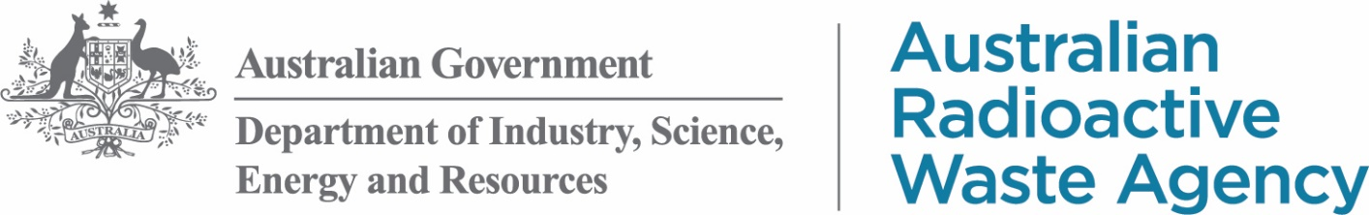

Kimba Consultative Committee and   
Kimba Economic Working Group Meeting

**Date:** Thursday 14 October 2021

**Time:** 9:00am-1:00pm (local time)

**Location:** Kimba Gateway Hotel, 40 High Street, Kimba

**MINUTES**

**KCC Independent Convener:** Allan Suter

**KCC Deputy Convener:** Dean Johnson

**KEWG Chair:** David Schmidt

| **Item** | **Lead** | **Key points** |
| --- | --- | --- |
| 1. **Welcome** | Allan Suter | * Housekeeping |
| 1. **ARWA update** | David Osborn + Shane Holland | * Acknowledgement of Country * Intention to declare * Staffing and recruitment * Community conversations * Cultural Heritage Assessment process * Concept design video |
| 1. **Regional Consultative Committee** | Nic Crowther | * Review and discussion |
| 1. **Community Skills and Development Program** | Nic Crowther | * Review and discussion |
| 1. **NCE transition** | Nic Crowther | * Progress and consultation |
| 1. **RDA-EP visitor centre presentation** | RDA-EP | * Presentation on their report |
| 1. **Agricultural Research and Development Zone** | David Osborn | * Initial discussions |
| 1. **Other business** | Allan Suter |  |

| **Committee Member** | **Attendance** |
| --- | --- |
| Allan Suter (Convener) | Accepted |
| Dean Johnson (Deputy Convener) | Accepted |
| Symon Allen | Accepted |
| Jeff Baldock | Accepted |
| Heather Baldock | Accepted |
| Pat Beinke | Accepted |
| Randall Cliff | Accepted |
| Kellie Hunt | Accepted |
| Sally Inglis | Accepted |
| Jeff Koch | Accepted |
| Meagan Lienert | Accepted |
| Kerri Rayson | Accepted |
| Toni Scott | Accepted |
| Peta Willmott | Accepted |
| Peter Woolford | Accepted |
| Amy Wright | Apology |
| David Schmidt (Chair KEWG) | Accepted |
| Laura Fitzgerald | Accepted |
| Debra Larwood | Accepted |
| Christine Lehmann | Accepted |
| Charlie Milton |  |

Australian Radioactive Waste Agency

Staff attending:

* David Osborn, General Manager, Safety and Technical
* Shane Holland, Manager, Indigenous Engagement
* Megan Rusk, Media Officer, Community Engagement
* Jim Haskett, Site Supervisor
* Deborah Francis, Community Liaison Officer
* Elise Hearnshaw, Executive Assistant to David Osborn, Safety and Technical

Staff attending via VC:

* Sam Chard, A/g Head of Division
* Nicholas Crowther, Manager, Community Engagement
* Clare Butterfield, Assistant Manager, Community Engagement

## Outstanding action items

| **Item number** | **Detail** | **Status** |
| --- | --- | --- |
| **KCC20210826/A02** | Where possible, provide detailed radionuclide descriptions for the ILW coming to Kimba. | **PENDING** |
| **KCC20210826/A05** | Look into getting UQ to update the social impact of the facility aspect of their report. | **PENDING** |

## New action items

| **Item number** | **Detail** |
| --- | --- |
| **KCC20211114/A01** | Circulate the cultural heritage assessment process slide to the committee. |
| **KCC20211114/A02** | Provide a written response to members regarding nuclear submarines, high and low level waste questions. |
| **KCC20211114/A03** | Circulate CSDP information provided at the meeting – prior to the minutes being made available. |
| **KCC20211114/A04** | Work to further develop the CSDP, including whether Tier 1 projects for the CSDP can be used to attract skills, such as health services and what the definition of regional is. |
| **KCC20211114/A05** | Add visitor information centre to the agenda for the November meeting. |

1. **Welcome and Acknowledgement of Country**

The Convener, Mr Allan Suter, opened the meeting at 9:00am (local time). Mr Suter outlined housekeeping arrangements and proposed breaks throughout the day. Members agreed to have photographs taken during the meeting. Mr Suter invited Mr David Osborn, General Manager – Safety and Technical, to deliver an Acknowledgement of Country.

Mr Osborn thanked members for their continued engagement and introduced colleagues Nicholas Crowther and Clare Butterfield joining the meeting via Skype, and the ARWA team members in the room: Shane Holland, Megan Rusk, and Jim Haskett. Mr Osborn also introduced new team members Deb Francis, Community Liaison Officer, and Elise Hearnshaw, Executive Assistant to Mr Osborn.

Mr Osborn discussed the expansion of ARWA in Adelaide, with seven new employees starting in the Safety and Technical branch in recent weeks. Mr Osborn introduced Deb Francis to the members as the new CLO and Elise Hearnshaw as his EA and spoke to the committee about the expansion of the Adelaide team with seven new employees starting in the Safety and Technical branch in the past three weeks.

The technical team, as it has previously been known is no more, and in its place, ARWA has the following teams: Design and Site; Radiation Safety; Waste Management Function; Security, Transport and Occupational Safety. This reflects the considerable ramping up of activities as they progress the facility.

Mr Osborn introduced Trevor Smith, Economic Development Officer for Regional Development Australia – Eyre Peninsula (RDA-EP).

1. **ARWA update**

**Intention to declare**

Mr Osborn discussed the upcoming closing date for the public consultation period for the Minister for Resources and Water’s intention to declare Napandee as the site for the National Radioactive Waste Management Facility. Mr Osborn reminded the members that comments must be received by 22 October 2021, via the Department’s Consultation Hub or by downloading a form from ARWA’s website and posting it.

**Community conversations**

Mr Osborn summarised the recent community conversation held within the community. The conversation was had with representatives from the Kimba Men’s Shed, Senior Citizen’s Club, Probus Club, and Lions Club of Kimba, and focussed on health, the health care system in Kimba and the group’s thoughts for the future.

Key themes that emerged from the conversation were:

* the need for doctors and nurses to be retained permanently in Kimba,
* changes needed to country health policy, particularly around not disadvantaging regional areas, and
* continuity of care.

The summary was circulated as part of the meeting papers and will be published on ARWA’s website shortly.

Mr Osborn noted that ARWA and the facility won’t be able to ‘fix’ all the issues raised in these conversations, but the issues raised will inform ARWA’s thinking as the facility develops.

A member asked if the community conversations were open to anyone to attend or is by invite only?

Mr Nic Crowther, Manager, Community Engagement, advised that community groups are invited, and it’s up to them to decide who represents them at the conversation.

**Community Benefit Program (CBP)**

Mr Osborn outlined the anticipated timeframes for the next round of CBP funding, as advised by Business Grants Hub (BGH). BGH are hoping to make the draft grant guidelines available ASAP – before the applications open – to give people as much time as possible to consider and prepare applications. ARWA are unable to give more detailed timeline for the funding round at this stage.

It’s likely that the assessment workshop with the KCC and KEWG where committee members have an input into CBP applications will be held in the first quarter of 2022.

BGH will circulate information about conflicts of interest, and the rules relating to them, prior to the assessment workshop, as they did last time. There will also be an opportunity to declare any conflicts of interest, prior to the assessment workshop.

The Minister will be the decision maker this round, but the department – through BGH, and in consultation with the KCC and KEWG – will provide advice to assist the Minister in his decision making.

A member asked if completion dates for projects funded in this round were known, and Mr Osborn advised that at this stage there are no firm dates.

**Cultural heritage assessment process**

Mr Shane Holland, Manager, Indigenous Engagement, provided an outline of the process of undertaking a cultural heritage assessment, as seen below: 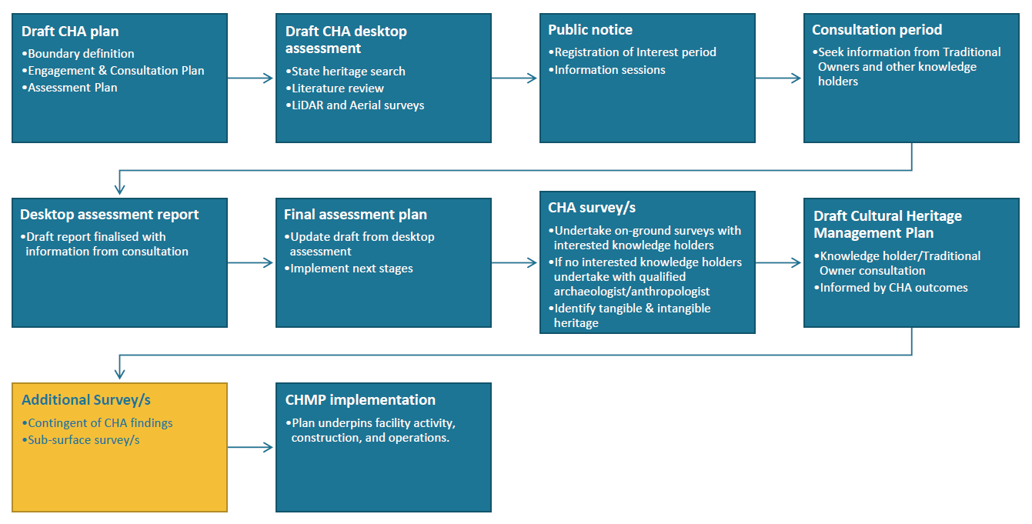

Mr Holland also discussed the difference between tangible and intangible heritage items. Tangible items include physical artefacts, like bones, whereas intangible items are those non-physical items, such as songlines.

| **Action item** | **Details** |
| --- | --- |
| KCC20211014/A01 | Circulate the cultural heritage assessment process slide to the committee. |

A member asked when the cultural heritage assessment process would start, and how long it would take. Mr Holland advised that the process will start after a site for the facility is acquired, and it will take approximately six months.

**Kimba Show**

Mr Osborn spoke about Kimba’s successful Agricultural, Horticultural and Floricultural Show and thanked the team for their efforts on the ARWA stand. He shared how pleased ARWA was to be part of the show, and with the level of interest and engagement from the community at the ARWA stand.

**Facility concept design**

Mr Osborn presented the updated version of the facility concept design video, and discussed the location of four malleefowl nests that were found during a recent survey of the Pinkawillinie Conservation Park, before opening the floor to questions.

Members sought clarification regarding the amount of land being acquired, and how it had increased – in particular asking for details about the additional 50 hectares listed in the intention to declare notice. Mr Osborn advised that initial concept designs identified a need for approximately 100 hectares, but during planning additional land was proposed for extra operational plant works and the recommended agricultural research and development zone. In the original nomination of the land, 211 hectares was nominated, so ARWA have decided it would be best to acquire all 211 hectares (should the Minister decide to declare Napandee as the site for the facility), as this would provide flexibility regarding the way in which the facility sits on the site.

A member asked whether the concept design video just shown reflected the original 160 hectares or the larger 211 hectares. Mr Osborn advised the video shows the 160 hectare footprint of the facility, but noted there is no intention to change the scope of the facility, and no decision had yet been made on site fencing or which operational areas will have the highest level of security.

A member questioned whether there are plans for high level waste to be stored in the increased footprint and high security level area of the facility. Mr Osborn advised that was not the case, and reiterated that there is no intention to expand the scope of the facility.

A member raised a community concern that high level waste will eventually be brought to the site – whether there is an increased footprint or not. Mr Osborn advised that was not the case, and reiterated that there is no intention to expand the scope of the site. Members requested an assurance in writing that high level waste would not be brought to the facility.

Discussion ensued regarding hazard reduction measures at the site, including soil management and fire hazard reduction around solar panels. Mr Osborn advised that at this stage of planning, there will be a 100 metre ring around the storage site or low grasses, and manicured grass under the solar panels. The highest fire risk is likely to come from the solar panel batteries, which will be taken into consideration during detailed site design works. Mr Osborn acknowledged that dust is also a concern on site, and the site design team will look into vegetation cover options to assist with dust suppression.

A member raised questions that had been brought to his attention by the community regarding the recent nuclear submarines announcement. In particular, what the plan is for the waste from the nuclear submarines, and whether ARWA can provide a written guarantee it won’t be brought to Kimba? Mr Osborn advised that ARWA is building a facility for the disposal of low level radioactive waste and the temporary storage of intermediate level waste, with no changes to this scope as a result of the announcement regarding nuclear submarines. Mr Osborn reiterated that legislation prevents high level waste being brought to the National Radioactive Waste Management Facility.

A member asked what happens if there is a change in government, and what happens to the Community Fund if intermediate level waste doesn’t end up being brought to Kimba. Mr Osborn advised that while we cannot speak for the decisions of future governments, the planned facility will only be able to accept waste that meets strict waste acceptance criteria agreed to by the regulators. Mr Osborn also advised that the Community Fund is tied to the facility receiving its operational licence, not to the type of waste that is stored there.

Further discussion ensued regarding the nuclear submarines program and its implications for radioactive waste management in Australia. Mr Osborn advised that at this stage of the process, the by-products of these submarines is unknown, however the Department of Defence has committed to the safe management of these materials, and ARWA will assist where appropriate.

Discussion turned to the planned expansion of intermediate level waste facilities at ANSTO. Mr Osborn advised that part of ARWA’s remit is to progress plans for permanent disposal for intermediate level waste, and that the current scope of the NRWMF is to temporarily store intermediate level waste until a permanent disposal solution is achieved.

| **Action item** | **Details** |
| --- | --- |
| KCC20211014/A02 | Provide a written response to members regarding nuclear submarines, high and low level waste questions. |

# Regional Consultative Committee

Mr Crowther provided an update on the establishment of the Regional Consultative Committee (RCC), which will be stood up as soon as possible following the declaration of a site for the facility.

The RCC’s main role will be to facilitate information provision between the Commonwealth, ARWA, and people living near the specified site. The RCC’s focus will be on representing the views of the residents of the Kimba region.

* There are a number of steps involved in setting up the committee, including making regulations and appointing the members and the Chair.
* ARWA anticipates having the draft regulations available before the end of the year, for the KCC and KEWG’s consideration. ARWA hopes to provide at least a week for consideration of the regulations and to provide comment on them, and endeavours to have this to the committee prior to the next meeting.

Members asked questions about the makeup of the RCC and timeframes – particularly with regard to how many people from Kimba and how many from other areas will be on the committee. Mr Crowther confirmed this information will be outlined in the draft regulations. Mr Crowther advised that it is likely the KCC + KEWG would wrap-up and RCC commence in the middle of 2022, and took the opportunity to thank the KCC + KEWG members for their efforts and commitment.

# Community Skills and Development Program

Mr Crowther recapped the objective of the Community Skills and Development Program (CSDP), being to build economic resilience, capacity and skills for the purposes of:

* realising benefits from the construction of the facility; or
* supporting the facility’s long term operation.

Mr Crowther advised that ARWA is working towards a roll out of the CSDP grants to start in the 2022-23 financial year, pending the outcome of a Ministerial site declaration, and as with previous grant processes, the department will work with the KCC on development of the guidelines. He noted that the CSDP program will work alongside prior grant funding, like the Community Benefit Program, however it will focus on areas that have not been funded to prepare the community to make the most of the opportunities to come with the build and operation of the facility.

Mr Crowther talked through ARWA’s preliminary policy thinking to get the committee’s thoughts before guidelines are settled. He advised that current thinking is there will be key priority areas, split into three tiers:

* Tier 1: skills development, training support, scholarships and cadetships, and education outreach.
* Tier 2: local business and community resilience endeavours.
* Tier 3: tourism, some aspects of economic diversification, and some types of infrastructure (such as telecommunications outside the immediate area of the facility).

The aim of the tiers is to ensure funding is allocated in order of preference as recommended by the policy outcomes for this program, which is a focus on education and training.

| **Action item** | **Details** |
| --- | --- |
| KCC20211014/A03 | Circulate CSDP information provided at the meeting – prior to the minutes being made available. |

Discussion ensued about the CSDP funding, guidelines, and priority areas. Mr Crowther advised that Tier 1 priority areas could take precedence over Tiers 2 and 3, and confirmed that the onus would not be on the community to ensure appropriate accommodation or support would be available for contractors coming to the area for the construction phase of the facility.

Members asked whether Tier 1 priority areas can be used to attract skills, such as health services, and how regional is defined when it comes to this funding. Mr Crowther took these questions on notice and will respond when able to.

| **Action item** | **Details** |
| --- | --- |
| KCC20211014/A04 | Work to further develop the CSDP, including whether Tier 1 projects for the CSDP can be used to attract skills, such as health services and what the definition of regional is. |

# NCE Transition

Mr Osborn spoke to members about two key pieces of work currently being progressed for the transition of ARWA to a non-corporate Commonwealth entity (NCE): development of relevant legislation, and appointment of a Chief Executive Officer.

Mr Osborn advised that a suitable candidate for the CEO position had been identified, and a Ministerial announcement is expected shortly. Mr Osborn advised members that the CEO is expected to commence in January 2022, in the Adelaide office, and following a handover period, Ms Sam Chard, A/g Head of Division for ARWA, will move to another senior leadership role within the Australian Public Service.

Mr Osborn discussed the work undertaken to date on legislation in order to facilitate transition to an NCE by mid-2022. The legislation will establish the governance and administrative provisions required to establish the Agency, including (but not limited to) activities required for ARWA to operate as the Commonwealth agency responsible for siting, construction and operation of the new facility, and the agency responsible for progressing the broader National Radioactive Waste Management Function program. Mr Osborn reminded members that ARWA is a separate entity from the facility, and will be looking at all radioactive waste management matters in Australia.

Mr Osborn noted that the bill is expected to be introduced during the spring parliamentary sitting period and ARWA will keep you updated on the proposed timings. If introduced in the spring sitting period, passage of the legislation would not be expected until the next sitting period which is from February to April 2022.

# RDA-EP Presentation

Mr Trevor Smith, Economic Development Officer from Regional Development Association – Eyre Peninsula (RDA-EP), presented RDA-EP’s initial findings regarding a visitor information centre for the facility.

Mr Smith outlined the scenarios assessed: a centre on site at the NRWMF; a centre within the Kimba Township; and a hybrid model of a centre within the Kimba Township with tours to the NRWMF.

Mr Smith noted that RDA-EP undertook considerable research – including evaluation of visitor information centre insights; examination of relevant case studies; overview and assessment of the tourism industry in the Eyre Peninsula; and a cost benefit analysis of each assessed scenario.

Mr Smith advised members of the initial findings, which found that locating a visitor information centre within Kimba Township will provide the greatest economic benefit to the community, and a greenfield site near the highway would be the best location.

Mr Osborn advised that since this report was commissioned, the scope had changed slightly, and ARWA sees a need to co-locate a functioning office with a visitor information centre. He also advised that further analysis will be done regarding different operating models, whether a non-accredited visitor centre that is specific to the facility is a viable option, and appropriate spending of public monies.

Considerable discussion ensued about an appropriate site for the visitor information centre, how it would be funded, liaison with the District Council of Kimba, and the viability of centres run by volunteers. Mr Osborn undertook to ensure the visitor information centre would be added to the agenda for the next meeting, to continue discussions.

| **Action item** | **Details** |
| --- | --- |
| KCC20211014/A05 | Add visitor information centre to the agenda for the November meeting. |

**At this point, Ms Sam Chard joined the meeting via video conference**

Ms Chard greeted members, thanked them for their continued engagement, and called for any questions members may have for her.

Members advised Ms Chard that they had raised some community concerns earlier in the meeting – particularly around intermediate level waste, nuclear submarines, and ANSTO’s increased storage plans – and re-requested they receive a response in writing. Ms Chard confirmed that this information would be provided in writing.

Ms Chard provided an overview of the NCE process, reiterating what Mr Osborn had advised members.

Members asked about the status of planned waste acceptance criteria, and Mr Osborn advised it is being progressed. Ms Chard advised that letters of comfort will be provided to ANSTO, meaning they may be able to start pre-conditioning their waste holdings, which will ease the pressure on storage levels.

Questions were also raised about ANSTO’s synroc technology and its status. Mr Osborn advised that he has had casual conversations with ANSTO about it, and they’ve advised they would like it to be operational within 12-18 months.

With no further questions for her, Ms Chard left the meeting.

# Agricultural research and development zone

Mr Osborn advised the committee that ARWA intends to hold an agricultural roundtable in February 2022 (after the harvest is finished). The event will bring together representatives from a range of agriculture organisations to discuss a number of topics, including the agricultural research and development zone at the facility.

Mr Osborn invited members to provide their initial thoughts on the agricultural research and development zone. Members noted that February is a busy time of the year – particularly for agricultural development groups and meetings – and the second half of February 2022 is already fully booked.

Key issues raised by members regarding the agricultural research and development zone were: who would manage the site; the need for baseline data prior to any trials; the need to ensure trials are relevant; the need to establish what research and development is already being undertaken in the region; funding for research trials; and how publicly available the data would be, following trials.

# Other business

Mr Suter called for any other business.

Members questioned how the economic training and skills were going to be directed through the CSDP, with another member noting the District Council of Kimba is developing a workforce training plan that may assist in identifying appropriate avenues.

Discussion turned to the status of ARWA’s Economic Development Officer position, and Mr Crowther advised that discussions are ongoing to appoint someone to this role.

Members asked whether anyone will be able to access the agricultural research and development area of the facility prior to construction, and Mr Osborn advised this will be determined by site testing requirements and the outcome of the cultural heritage assessment.

# Meeting close

Mr Suter closed the meeting at 1:00pm (local time), thanking members for their attendance.