Industry Innovation and Science Australia Annual Report 2020-21

# Letter of Transmittal

# 

**Chair**

The Hon Christian Porter MP

Minister for Industry, Science and Technology

Parliament House

CANBERRA ACT 2600

Dear Minister

I am pleased to present the Industry Innovation and Science Australia Annual Report on its activities for the financial year ended 30 June 2021, prepared in accordance with section 46 of the *Industry Research and Development Act 1986*.

Innovation and Science Australia (ISA) was established on 20 October 2016.   
On 1 October 2020 the Government announced that ISA would be renamed Industry Innovation and Science Australia and would provide industry advice to Government throughout the implementation of the Modern Manufacturing Strategy. The 2020-21 Annual Report covers activities undertaken by ISA, IISA and their committees throughout the financial year.

.

Sincerely,

PDF copy signed

Andrew Stevens

29 September 2021

Contents

Letter of Transmittal 2

Welcome from the Chair 7

Welcome from the Office of Industry Innovation and Science Australia 10

Section 1 - REVIEW OF 2020-21 12

Overview of Industry Innovation and Science Australia 13

Informing policy through strategic Advice 14

Whole of Government engagement 14

Core projects 14

Venture Capital Tax Concession Programs Review 14

Cross-Cutting Issues from the National manufacturing Priority Road Maps 15

Investment Characteristics of Successful Innovative Businesses 16

Advocacy 16

Program oversight 17

Program Overview – Research and Development Incentives Committee 19

Research and Development Tax Incentive Program 19

Case study - Vaxxas – Needle-Free Vaccines 22

Case Study - Biarri Networks: making high-speed internet a global reality 24

Program Overview – Cooperative Research Centres 26

Cooperative Research Centres Program 26

Case study - Food Agility CRC – technical solution to oyster harvesting hassles 29

Case study - PEGRAS Asia Pacific - Treating label contamination to increase plastics recycling 31

Program Overview – Venture Capital programs 33

Venture Capital programs 33

Case study - Blackbird Ventures partners with Morse Micro to deliver next generation Wi-Fi. 37

Program Overview – Biomedical Translation Fund 40

The Biomedical Translation Fund 40

Case study – Brandon Capital Partners and Ena Respiratory investing in Australia’s health and wellbeing 42

Program Overview – Entrepreneurs’ Programme 45

Entrepreneurs’ Programme 46

Case study - Life Cell 48

Case Study - Solcast 50

Program Overview – Business Research Innovation Initiative 52

Case study - Trellis Data 53

Case study - Hemishpere Digital formerly known as Wejugo 56

Legacy programs 59

Section Two – Governance 60

Innovation and Science Australia 61

Legislation 61

The Industry Research & Development Act 1986 61

IISA functions and powers 61

Financial responsibilities of IISA under the IR&D Act 62

Organisation and Management 62

Board and committee membership in 2020-21 63

Meetings of Industry Innovation and Science Australia in 2020-21 71

Structure of Industry Innovation and Science Australia as at 30 June 2021 72

Legal matters and litigation 73

Acronym and abbreviations list 75

Innovation and Science Australia’s strategic objectives

Objective 1: Inform Australian Government policy on Australian innovation, science research.

Objective 2: Advocate and champion for Australia’s innovation, science and research system.

Objective 3: Oversee innovation programs to ensure effectiveness and efficiency of delivery.

# Welcome from the Chair



It is with great pleasure that I present to you the 2020-21 Industry Innovation and Science Australia (IISA) Annual Report.

For the second year running, IISA has acknowledged the impact of the COVID-19 pandemic on Australian industries, businesses and citizens. It has been another tough year for all Australians.

Despite the challenges that the COVID-19 pandemic has presented, we have seen some positive trends emerge. IISA has been in a unique position to witness the way Australian businesses have changed and adapted to this ongoing volatility. We have been analysing what has helped businesses remain resilient such as the adoption of technology, adaptation of business models, diversification of service and product offerings, and a renewed focus on human capital. These investments have enabled many of our businesses to survive and can be a catalyst for increased value and growth.

Many Australian businesses were quick to respond to the changing environment. According to the Australian Bureau of Statistics (ABS), within a month of COVID-19 being declared a pandemic, 38% of businesses had already altered their business models to change the method of delivery of products or services, including a shift to online services. By June 2020, ABS data revealed that large percentages of Australian businesses reported that they had introduced innovation into their operations. Seventy eight per cent of accommodation and food services businesses, 70% of health care and social assistance businesses, 64% of education and training businesses, and 58% of arts and recreation services reported changing the types and range of products and services offered or the way they were delivered to customers.

By September 2020, the ABS reported that the most common form of modifications that Australian businesses had in place to combat the effects of the pandemic were changes to the way products or services were provided to customers (36%). The ABS also reported that 19% of business had changed the types and ranges of products they offered. Those business leaders who saw an opportunity (and also those driven by necessity) acted for resilience. There will, however, remain challenges for all, no matter how they have fared during the financial year.

Addressing these challenges has formed a strong focus for IISA. On 1 October 2020, the Prime Minister announced that Innovation and Science Australia would be renamed to Industry Innovation and Science Australia with a refreshed focus on providing strong industry advice to Government. This change builds on work across Government to improve economic conditions for Australian businesses. As a result of this renewed focus, five new members were appointed to our Board. New members include   
Mr Patrick Houlihan, Ms Lauren Stafford, Mr Scott Farrell, Dr Alex Grant and   
Ms Sarah Nolet. In early 2021 we also saw Ms Glenys Beauchamp PSM join the Board and Australia’s Chief Scientist, Dr Catherine Foley AO PSM FAA FTSE began her role as our Deputy Chair. I have valued the perspectives which these new members have brought to the Board, and want to thank all existing and new members for their dedication, expert advice and professionalism in the work we have carried out together to date.

IISA is supported by the Office of Industry Innovation and Science Australia (OIISA) which is led by Dr Kate Cameron in her role as acting CEO. Kate has led OIISA diligently during the recent refresh and has assisted the Board to provide impactful advice in policy and advocacy matters.

A focus of IISA this year has been providing advice to Government on the implementation of the Modern Manufacturing Strategy (MMS). Through the MMS, the Government is focussing investment to foster manufacturing strength and capability in areas of comparative advantage and strategic interest.

In 2020-21, roadmaps were developed for the six MMS National Manufacturing Priority (NMP) areas, to guide future investment and action from both government and industry over 10 years. The roadmaps cover Australia’s six NMPs: Medical Products, Recycling and Clean Energy, Defence, Space, Food and Beverage and Resources Technology and Critical Minerals Processing. IISA provided expert advice to Government on the development of these roadmaps and continues to assist with their implementation..

Furthering our independent work on manufacturing, we have commenced a project to examine key cross-cutting issues affecting Australian manufacturing businesses. In this project we are analysing challenges manufacturers face to build scale, adopt technologies, and increase their competitiveness by competing on value rather than cost alone.

In separate work, we are also analysing how all Australian businesses create and sustain value, along with the lessons that can be learned from their investment characteristics. We are doing this with a view to provide advice on possible policy approaches to support firm growth. This will include in-depth analysis of the role of different types of intangible assets in value creation.

We have also commenced work with Treasury to review Venture Capital (VC) Tax Concession Programs to ensure these concessions are fit-for-purpose and support genuine early stage Australian startups. The review will evaluate the impact of the Early Stage Venture Capital Limited Partnership (ESVCLP) program, the Venture Capital Limited Partnership (VCLP) program, and the Australian Fund of Funds (AFOFs) program. The review will progress into next financial year.

In early 2021, IISA released our report, *Driving effective Government investment in innovation, science and research*. Within this report we recommended an increased focus on research commercialisation. In November 2020, myself and Dr Foley, were appointed to an expert panel for the University Research Commercialisation Scheme, which is being developed by the Department of Education, Skills and Employment. Announced as part of the 2020-21 Budget, the intent of the scheme is better translation and commercialisation of university research outputs. Dr Foley and I have continued to be involved in this work during 2021.

I would like to take this opportunity to thank our Board members whose tenures concluded during the year. Dr Alan Finkel AO, Dr Bronte Adams AM,   
Professor Bronwyn Harch and Dr Christopher Roberts AO all concluded with the board during the financial year. It has been a pleasure to work with you all. Your commitment and contributions have been invaluable and to extend my gratitude to the OIISA staff for their continuous efforts and ongoing support of the IISA Board. The quality of their work does not go unnoticed and ensures the Board are able to confidently proceed with our work in an effective and efficient manner.

I would like to also recognise the ongoing efforts of the IISA Committees throughout the year. IISA oversees a number of innovation programs via the Research and Development Incentives Committee, the Entrepreneurs' Programme Committee, the Cooperative Research Centres Advisory Committee, the Innovation Investment Committee, and the Biomedical Translation Fund Committee. These committees play a vital governance role for key government programs in support of the Australian innovation system.

I invite you to read this report to get a full understanding of the crucial work IISA and OIISA have conducted through the financial year to assist businesses and industry in difficult times. I am very proud of our achievements throughout the year and the progress we have made on a number of projects. We have provided expert advice to Government, advocated and championed for the Modern Manufacturing Initiative, the innovation, science and research system, and informed and guided policy which will aid in Australia’s ongoing response to and recovery from the COVID-19 pandemic.

Mr Andrew Stevens  
Chair

# Welcome from the Office of Industry Innovation and Science Australia



The 2020-21 financial year has been another incredibly challenging year for Australia and Australians. As the year drew to a close, the country was facing a rise in the virulent Delta COVID-19 variant and we were once again adapting to an ever-changing environment, both personally and professionally.

While COVID-19 continues to present challenges for us all, the Office of Industry Innovation and Science Australia (OIISA) team has been assisting the IISA Board to analyse the way our businesses have reacted, so as to provide expert strategic advice to Government. While many businesses have made innovative gains in work practices through the disruption of the pandemic, many have also found the conditions challenging. As our country begins to return to business as usual, it will be important to build on the experiences of our businesses to help them to grow both in the aftermath of the current crisis and beyond.

I have particularly welcomed the support of the OIISA team during the pandemic.   
We have moved, as the rest of the country has, to the adoption of virtual working environments for staff and the IISA Board – assisting them to meet and collaborate virtually despite being located across many states and territories. We have been able to gather and achieve efficiencies, whilst also progressing our care and protection of our staff and their families in what has been both a physically and mentally challenging time. These new approaches will pave the way for greater efficiencies that I am sure will carry on for OIISA and IISA, well past the end of the pandemic.

Continuing the trend from the previous two years, we have seen a number of new board members and new responsibilities for the Board in 2020-21. This year we have undergone a change in name, a refocus of our responsibilities to assist with the implementation of the Modern Manufacturing Strategy, have farewelled some

Industry Innovation and Science Australia Annual Report 2020-21 8

Board members, and have welcomed a number of new Board members. It has been a valuable experience leading the office through these changes and witnessing the agility of the team and their skills as they support the Board to provide expert advice to Government.

This was evidenced by the work OIISA conducted to support the IISA Board deliver the *Driving effective Government investment in innovation, science and research* report in early 2021. The report analyses the effectiveness of the Commonwealth Government's investment in, and system performance of, innovation, science and research (ISR). It provides recommended actions which can guide the most effective use of government investments, including the development of whole-of-government ISR priorities and an investment plan which aligns with these priorities, coordinated at the whole-of-government level.

I would like to thank the Board for their work in delivering this report and the other important pieces of work they have contributed to throughout the financial year.   
Your unwavering commitment to positive outcomes for industry and the ISR system has been invaluable, especially as needs have shifted. In particular, I would like to acknowledge the experience and support of the IISA Chair, Mr Andrew Stevens.   
His guidance, experience, and knowledge of the challenges and opportunities that businesses face every day has ensured that OIISA has been able to effectively support the Board in its advice to Government.

The OIISA team would also like to thank both our current and previous Minister for Industry, Science and Technology, the Hon Christian Porter MP and the   
Hon Karen Andrews MP, and their respective staff for their keen interest in our work. We also thank all our colleagues in the Department of Industry, Science, Energy and Resources, and the Australian Public Service more broadly, for their collaborative and constructive engagement.

Dr Kate Cameron, acting CEO

# Section 1 - REVIEW OF 2020-21

Overview of Industry Innovation and Science Australia

Informing policy through strategic advice

Advocacy

Program oversight

# Overview of Industry Innovation and Science Australia

IISA is an independent Board that provides strategic advice to Government on industry innovation, science and research matters. IISA also monitors and oversees a number of innovation programs through five committees.

IISA was originally announced as part of the Australian Government’s National Innovation and Science Agenda in December 2015, and formally established on   
20 October 2016 through amendments to the *Industry Research and Development Act 1986* (IR&D Act).

On its formation, the Board inherited the roles of the body formerly known as Innovation Australia which had been established under the IR&D Act to assist with the administration and oversight of the Government’s industry, innovation and venture capital programs.

IISA’s role and responsibilities are defined by the IR&D Act, the Government’s Statement of Expectations (SOE) and any directions issued by the Minister for Industry, Science and Technology. The Government’s most recent SOE, and ISA’s Statement of Intent (SOI) in response are published on [https://www.industry.gov.au/policies-andinitiatives/industry innovation-and-science-australia](https://www.industry.gov.au/policies-andinitiatives/industry%20innovation-and-science-australia).

In the 2020-21 financial year, IISA released our report, *Driving effective Government investment in innovation, science and research*. The report reviews the effectiveness of the Government’s innovation science and research (ISR) investments across all portfolios. It looks at the overall mix of investments to identify:

* duplications
* gaps
* alignment of policies across the system.

It includes three recommended actions to guide the most effective use of government investments. If adopted these recommended actions can ensure high-impact ISR outcomes both now and in the future.

The recommended actions include the development of:

* whole-of-government ISR priorities that are used to drive investment decisions
* a 10-year investment plan that is aligned with ISR priorities, coordinated at the whole-of-government level, and has effective evaluation processes
* an investment plan that is strategically balanced across the government’s portfolio of investments to ensure returns over the short, medium and long term.

IISA continues to play a key advisory role in the development and implementation of the Modern Manufacturing Strategy and has also continued to work across many areas of government to inform the development and delivery of stronger policies to support science, research and innovation.

## Informing policy through strategic Advice

IISA’s first strategic objective is to ‘Inform policy through strategic advice”. IISA’s achievements against this objective in 2020-21 are summarised below.

### Whole of Government engagement

IISA is uniquely positioned to act as an integrator and connector in the Australian innovation ecosystem. As a diverse, experienced and highly influential board, IISA can approach innovation in Australia through a strategic, whole of systems lens. This has facilitated meaningful engagement with a broad stakeholder group on a number of cross-cutting areas and initiatives.

### Core projects

IISA’s strategic advisory role during 2020-21 focused on key programs of work. These pieces of work meet IISA’s unique mandate to take a strategic, whole‑of‑innovation system view that is supported by a diverse, experienced and influential group of Board Members. You can read about these projects in the coming pages.

### Venture Capital Tax Concession Programs Review

Announced as part of the Government’s Digital Economy Strategy in the 2021–22 budget[1],[2] IISA, in conjunction with the Department of the Treasury, will complete a Review of in-scope Venture Capital Tax Concession programs. This Review will also meet the legislative requirement for an impact assessment to be conducted of the venture capital tax concession programs[3], and is also part of IISA’s SOE.

The Terms of Reference planned for release in early July 2021, outline the purpose of the Review as follows:

* to consider how the concessions operate in practice and whether they are achieving their intended objectives
* to satisfy the legislative requirement outlined in Section 118-455 of *Income Tax Assessment Act 1997*
* to consider the recommendations of other relevant reviews, to which the Government has not yet responded, that examine the venture capital tax concessions

The Review scope includes the Venture Capital Limited Partnership (VCLP), Early Stage Venture Capital Limited Partnership (ESVCLP), and Australian Venture Capital Fund of Funds (AFOF) tax concession programs. Investments made directly by foreign residents registered under Part 3 of the *Venture Capital Act 2002* are also in scope. It is a legislated requirement that a public consultation is undertaken as part of the Review, and this is planned to commence in the second half of 2021.

### Cross-Cutting Issues from the National manufacturing Priority Road Maps

Another project IISA is undertaking is an analysis of three key cross-cutting challenges and opportunities for Australian manufacturing businesses. Specifically, IISA is examining the ability of Australian manufacturing businesses to:

* grow and build scale
* successfully adopt and implement technologies that lead to better business outcomes
* increase their competitiveness by competing on value rather than solely on cost.

This work builds on the insights provided in the Government’s Modern Manufacturing Strategy (MMS) industry-led National Manufacturing Priority (NMP) Road Maps, and explores how the cross-cutting issues affect Australian manufacturing businesses.   
How these inter-linked pathways to growth might be better exploited by businesses, and supported by government, will also be considered through analysis of cross-cutting enablers, including skills, regulation and digital and technological capability.

IISA will review existing domestic and international literature, engage and consult with businesses, and analyse available quantitative and qualitative data, to gain

Industry Innovation and Science Australia Annual Report 2020-21 13

insights about three cross-cutting issues. A report articulating IISA’s evaluation of, and proposed actions for, these cross-cutting issues will be delivered to the Minister in October 2021.

### Investment Characteristics of Successful Innovative Businesses

IISA is building on the Board’s previous report, *Stimulating business investment in innovation*, to undertake further analysis of the investment characteristics of successful innovative businesses and advise on possible policy approaches to support business growth.

The work is employing a mix of quantitative and qualitative research to explore how Australian businesses of varying sizes and ages create and sustain value and remain resilient. It will also involve be informed by engagement with a range of Australian businesses and stakeholders to identify the lessons that can be learned from successful businesses.

This work is focusing on various aspects of value creation, including the role of intangible (non-physical) assets and executive decision-making capability in firm performance.

A final report will be delivered to the Minister in the 2021-22 financial year.

## Advocacy

IISA’s second strategic objective is to ‘advocate and champion for Australia’s innovation, science and research system’.

This objective encompasses a range of activities for IISA, from speeches and presentations at conferences and public events, to participation in roundtable forums and meetings with stakeholder groups from industry and government. IISA is represented by a number of spokespeople in public engagement activities and advocacy work, including the IISA Board Chair, Board members, the Acting CEO and OIISA staff members.

During 2020-21 IISA has worked directly with stakeholder groups to better understand the barriers to, and characteristics of, success within their industries, with particular attention paid to assisting rapid economic and industry recovery from the COVID-19 pandemic. We have provided expert advice to the Minister for Industry, Science and Technology on the implementation of the MMS.

IISA’s broad engagement strategy ensures that we can proactively target messages to industry and ISR communities, as well as the wider Australian public.

In 2020-21 we continued our use of social media to engage with the public, industry and ISR stakeholders. In our second year of using LinkedIn, we continue to reach out to the Australian business community and those with an interest in the innovation.   
We reached just under 500 followers on our LinkedIn account by the end of the financial year, joining our more than 2,750 Twitter followers.

Some highlights from IISA’s public engagement activities over the year included:

* The Public Sector Network Innovate Australia Conference and Expo   
  16 June 2021 (Dr Kate Cameron)
* IP Group Australia Showcase 27 October 2020 (Mr Andrew Stevens, Chair)
* MTP Connect Board Meeting 21 October 2020 (Mr Andrew Stevens, Chair)
* The Interview with the Australian 20 October 2020 (Mr Patrick Houlihan:, Board Member)
* The Western Sydney Business Chamber Webinar – Using Research and Development and Innovation to Kickstart the Economy 14 September 2020 (Mr Andrew Stevens, Chair)
* The UniQuest Board Meeting 23 July 2020 (Mr Andrew Stevens, Chair)

A number of additional speaking engagements/events were cancelled or postponed due to COVID-19 and have not been rescheduled to date.

## Program oversight

IISA’s third strategic objective is to ‘oversee innovation programs to ensure effectiveness and efficiency of delivery’. As at 30 June 2021, the IISA Board, through regular engagement with IISA committee chairs, provided oversight to, and support for, the administration of the following programs[4]:

1. **Research and Development Tax Incentive Program**
2. **Cooperative Research Centres Program**

* Cooperative Research Centres (CRCs)
* Cooperative Research Centres Projects (CRC-Ps)

1. **Venture Capital Programs**

* Early Stage Venture Capital Limited Partnerships (ESVCLPs)
* Venture Capital Limited Partnerships (VCLPs)

1. **Biomedical Translation Fund** (delivered by AusIndustry on behalf of the Department of Health)
2. **Entrepreneurs’ Programme[5]**

* Accelerating Commercialisation (AC)
* Incubator Support (IS)

1. **Business Research Innovation Initiative[6]**

The IISA Committees and the Department of Industry, Science, Energy and Resources (DISER) assisted the Board to oversee these programs in 2020-21.. The programs were delivered by DISER. The Australian Taxation Office (ATO) also assists DISER with the administration of the Research and Development Tax Incentive and Venture Capital programs.

## Program Overview – Research and Development Incentives Committee

*“The October 2020 Federal budget saw enhancements to the RDTI program which were in most cases beneficial to applicant companies. During the year significant work was undertaken by the DISER on a refreshed Guide to Interpretation and a new Registration Form. Both have been well-received”.*

*“In response to COVID, extensions for submission deadlines were introduced impacting program metrics for the year. While the inability to engage with companies face-to-face reduced the understanding of compliance levels, overall the introduction of departmental initiatives which promote early engagement with applicants has been successful”.*

Ms Julie Phillips *–* Chair, R&D Tax Incentive Committee

## Research and Development Tax Incentive Program

The R&D Tax Incentive (RDTI) program is the Australian Government’s principal measure to encourage industry investment in R&D. It is a broad-based, market-driven program that is accessible to all industry sectors. The program provides benefits in the form of tax offsets to eligible entities undertaking eligible R&D activities. To access the incentive, companies self-assess the eligibility of their R&D activities, register them with DISER, and then claim a tax offset in their company tax return with the ATO.

The objective of the incentive is to encourage industry to conduct R&D activities that might otherwise not be conducted. The incentive addresses a market failure whereby businesses under-invest in R&D due to uncertain outcomes and the inability to capture all the benefits of their R&D.

2020-21 has seen some big changes for the RDTI. Enhanced reforms announced in the 2020-21 Budget apply from 1 July 2021. Under these reforms, annual R&D expenditure up to $150 million per annum (up from $100 million per annum in previous years) will receive:

* a tax offset of 18.5% above the 25% tax rate for eligible companies with an aggregated turnover of less than $20 million per annum, which can be taken as a cash refund
* a two-tiered non-refundable tax offset for eligible companies with an aggregated turnover of $20 million or more per annum, depending on a company’s R&D intensity (R&D expenditure as a proportion of total expenditure):
  + a tax offset of 8.5% above a company’s prevailing tax rate (25% or 30%) for expenditure up to 2% R&D intensity
  + a tax offset of 16.5% above a company’s prevailing tax rate (25% or 30%) for expenditure above 2%.

Administrative reforms, include a three month time limit on time extensions and new powers for IISA to publish determinations, apply from 1 January 2021.

Key outcomes in relation to the RDTI for the 2019-20 income year, as at end-June 2021, include:[7]

* $12,698,224,308 in registered R&D expenditure
* 12,330 registrations, representing 14,040 R&D performing entities
* 10,821 registrations, representing 11,462 small to medium companies (81% of program participation)
* 2,265 companies registered that were new to the program (16.1% of program participation).

DISER has continued to support companies throughout the COVID-19 pandemic.   
In response to the pandemic, DISER allowed an extension of time for the registration of 2018-19 activities to 30 September 2020.

Looking ahead – Clarifying eligibility of software development activities

Eligibility of software development activities continues to be an issue for some program applicants and has been raised in the media, with inaccurate assertions that software development activities are ineligible under the program.

However, software R&D activities have always been a major part of the RDTI. In recent years information and communications technology (ICT) projects across all industry sectors have comprised more than 40% of total registrations and more than 30% of total R&D expenditure.

To provide greater clarity around the eligibility of software development activities going forward, AusIndustry continues to work with program applicants and other industry stakeholders to update existing guidance material.

Guidance products entitled “Software activities in the R&D Tax Incentive” and “Guide to common errors”, originally released on 21 February 2019, were updated in October 2020.These guidance products are being refreshed in response to feedback received from the software industry. A draft of the software guidance was released for public comment between 17 May 2021 and 18 June 2021. Work with industry to finalise this guidance product is ongoing. DISER continues to collaborate with the software sector to improve understanding of eligibility for the RDTI.

Advice on software R&D eligibility was also provided in the refreshed Guide to Interpretation, released on 4 November 2020.

Looking ahead – Customer Portal

The RDTI is developing a new application process. From 17 May 2021, RDTI applicants are able to view a preview version of the customer portal and prepare their applications ready for submission when the portal goes live on 5 July 2021. The new customer portal will provide:

* improved security
* revised application form questions
* ability to view the status of applications in real time
* indicators of approaching deadlines.

Further information and details on the RDTI program are available on DISER’s website www.industry.gov.au. Find out more information on the RDTI or if you are eligible for the RDTI program and apply via the customer portal at [www.business.gov.au/RDTI](http://www.business.gov.au/RDTI) or call 13 28 46.

## Case study - Vaxxas – Needle-Free Vaccines

## *Vaccinations have historically been given using syringes and needles. Vaxxas is working on a new, less invasive vaccine delivery technology that creates a more potent immune response. The company’s flagship product, the Nanopatch, encompasses an array of micro needles that collectively deliver vaccines and immuno-therapeutics into the skin.*

Vaxxas is a medical technology company, revolutionizing the way vaccines are delivered. Vaxxas has grown from a small startup to a company with 60 full time employees based at the Translational Research Institute in Brisbane.[8]

Vaxxas came out of the University of Queensland and is commercialising novel technology that dramatically enhances the performance of existing and next-generation vaccines. The company has developed novel technologies that enable vaccines to be applied to the tips of the micro-projections under sterile conditions.

The High Density Microarray Patch delivers the vaccine on its micro-projections efficiently to the high density populations of immune cells directly beneath the surface of the skin. The micro-projections also trigger natural immuno-cellular alarms that cause vaccine components to be rapidly trafficked to lymph nodes eliciting a robust immune response.

Vaxxas Chief Executive, David Hoey, says the technology is likely to play an important role in future pandemics because it allows vaccines to be quickly and easily deployed to people.

Vaxxas demonstrated in recent clinical trials that vaccine delivered through its patch can produce six times the response from antibodies, in a much shorter timeframe, as the same amount of vaccine delivered into the muscle via needle and syringe.[9]

Mr Hoey explains that the technology was an early idea that needed to be transformed into a commercial reality and to do that requires a considerable R&D effort across all areas of the technology. The RDTI has helped to build the required data that Vaxxas can take to partners to encourage further investment into the company and open up more opportunities for collaboration with large pharmaceutical, universities and philanthropic organisations around the world.

The RDTI also allowed Vaxxas to get quickly into their first time in-human study and do that work within Australia. Mr Hoey stated that this was an opportunity to demonstrate that the technology was safe and potentially effective prior to moving onto larger clinical studies. He believes that the RDTI is massively important for R&D in Australia, and enables companies to take risks and perform experiments where the outcome of that work is uncertain. There is also a significant positive impact on the local and Australian economy due to the company’s location in Brisbane.

Vaxxas’ R&D pipeline has included several large R&D programs underway funded by the Bill & Melinda Gates Foundation, the World Health Organisation, global pharmaceutical companies and Australian universities.[10]

“The R&D Tax Incentive helped attract further investment in our company and open up more chances for collaboration with large pharma companies, universities and philanthropic organisations around the world”.

Angus Foster, Chief Development and Operations Manager, Vaxxas

## Case Study - Biarri Networks: making high-speed internet a global reality

## *Biarri Networks uses theoretical mathematics to design optimal routes of fibre connections, in building national fibre networks and bringing the world closer to accessible and affordable high-quality internet. This dramatically reduces the cost and time involved.*

Creating new fiber network designs using FOND software | Biarri Networks

Pulled from: https://biarrinetworks.com/creating-new-fiber-network-designs/ 

Quality of internet connection is important. A recent global ranking of internet speed revealed Australia’s fixed broadband speed currently ranks at number 55.[11] Australia is addressing these issues via the roll-out of the National Broadband Network. Yet, a nationwide fibre network poses many challenges, particularly financial. In remote areas the cost of connecting a single premise can be higher than in city areas.

Algorithm-based software developed by Biarri Networks plays an important role in realising the roll-out of a fibre networks – in Australia, and globally.

The company’s software is based on geographical databases that contain layers of infrastructure information. Through extensive R&D, Biarri Networks has achieved computations for 40,000 homes in a single run – the world’s only software capable of delivering to this scale. The company is working towards increasing the computational capacity to 60,000 homes. This would make it possible to design a network for a suburb in one run.

CEO Bernard Blake stresses that for a small business like Biarri Networks, the RDTI plays an important role in supporting the development of first-to-market, innovative products. He explains that the additional funding that comes with RDTI enabled the company to pursue more opportunities with high return prospects.

Support from the RDTI allows Biarri Networks to undertake more projects. The added financial security also helped the company hire 50 highly specialist employees. Mr Blake says there is a direct link between the RDTI program and taking some of the commercial and technical risks that are needed for the long-term success of the business. Investing in new talent also means more employment opportunities in science, technology, engineering and mathematics (STEM) graduates. The RDTI also helped Biarri Networks to invest in their relationship with universities and they have been able to offer sponsorships and internships to support STEM-related employment.

Mr Blake is also convinced that the software developed by Biarri Networks will make internet access cheaper for the end-user, thanks to savings during the design and construction process. The software would also support more companies to build fibre networks — which creates competition and ultimately saves costs for consumers.

“The R&DTI is a wonderful program that supports Australian technology and innovation. It’s an important part of our economic development going forward”. Bernard Blake, CEO, Biarri Networks

## C:\Users\DWillimott1\AppData\Local\Microsoft\Windows\INetCache\Content.Word\KS Photo.jpgProgram Overview – Cooperative Research Centres

“The Cooperative Research Centres Advisory Committee (CRCAC) has been pleased to see continued stakeholder support for both the CRC and CRC-P streams, across industry, academia and government. It is encouraging to see the quality of applications continue to increase across the rounds and the variety of applications spread across a broad range of sectors seeking to solve important industry problems. The CRC Program continues to be a highly competitive process demonstrated by an abundance of high quality applications.  With the uncertainties of COVID across the country, we have all had to adjust our ways of working. For the CRCAC, this has meant moving to a virtual environment for our meetings. The large number of applications have added to the experience, including conducting the CRC Round 22 Stage 2 interviews remotely, which lead to a very different dynamic. Nonetheless, the Committee was impressed with the quality of the applications and pleased with the outcomes, including the recently announced Round 22 CRCs: Digital Finance CRC; Marine Bioproducts CRC; and Heavy Industry Low-carbon Transition CRC”.

“The CRC Advisory Committee has been pleased to see the successful end-of-term transition of a number of CRCs, which have delivered significant outcomes across a range of measures.  Equally, many of the earliest CRC-Ps have now concluded, similarly delivering a steady stream of technology development milestones.  Furthermore, the Committee is pleased to note the continuing involvement of many stakeholders in the innovation ecosystem, demonstrating expansion of business investment in R&D within CRC and CRC-P partners and deepening collaborative relationships between industry, academia and government research organisations”.

Ms Kylie Sproston – Chair, CRC Advisory Committee.

## Cooperative Research Centres Program

The CRC Program is a competitive, merit-based grant program that provides funding to support industry-led collaborative research partnerships solving industry-identified problems. The program aims to improve competitiveness of Australian industries by fostering high quality research and encourage SME participation in collaborative research.

The CRC Program has two streams:

1. **CRCs**, which undertake medium to long term, industry-led collaborative research for up to 10 years. CRCs must have at least one Australian industry entity and one Australian research organisation as partners
2. **CRC Projects (CRC-Ps)** undertake short term, industry-led collaborative research for up to three years with grants capped at $3 million. CRC-Ps must have at least two Australian industry entities (one must be a small or medium enterprise) and one Australian research organisation as partners.

Over the life of the program (since 1990), $5.2 billion of Australian Government funding has supported the establishment of 233 CRCs and 154 CRCPs. Partners have committed a further $16.2 billion in cash and in-kind contributions.

During 2020-21, CRCs and CRC-Ps operated across a variety of sectors, including manufacturing, mining, healthcare, agriculture and the environment.

The total Government commitment for new CRCs (3) and CRC-Ps (19) in 2020-21 was $198.4 million, which leveraged over $590.5 million in partner cash and in-kind contributions.

In June 2021, Round 22 CRC outcomes were announced, with funding totalling   
$158 million for three new CRCs to improve industry outcomes in fintech, heavy industry and the marine bio-industry.

Round 9 and Round 10 CRC-P funding outcomes were announced on 14 July 2020 and 2 January 2021 respectively. Nineteen projects were supported across both rounds, with grant funding totalling $40.4 million. Round 10 was opened to projects that had a specific focus on waste and recycling, and supported nine projects through $14.9 million in grant funding.

The CRC Program is well placed to support the Government’s objectives of helping Australian manufacturers scale-up, become more competitive and build more resilient supply chains. Round 11 of CRC-Ps included a focus on the Government’s NMPs, and saw a wide range of applications submitted that aligned to the six NMPS. Round 23 of the CRC Grants stream, which opened in June 2021, also encourages applications that contribute to the NMPs.

Looking ahead, the CRC Program will continue to develop important, real world, solutions to improve the competitiveness, productivity and sustainability of Australian industries, strengthen the economy and create jobs. As COVID-19 continues to create uncertainty for businesses and the research sector, the CRC Program will continue to support businesses innovate, collaborate and capture new market opportunities.

A CRC Program impact evaluation is due to be completed in 2021. This evaluation will provide a cost-benefit analysis of the Program’s impact and explore the Program’s contribution to improving industry-research collaboration and commercialisation.

For more information on the CRC Program, visit [www.business.gov.au](http://www.business.gov.au), or call 13 28 46.

## Infographic data Active CRC-Ps and CRCs 2020-21

|  |  |  |  |  |
| --- | --- | --- | --- | --- |
| STATE | NUMBER OF CRC-PS (LOCATION OF LEAD PARTNER) | TOTAL CRC-P GRANT FUNDING (GST EXCL) | NUMBER OF CRCS (LOCATION OF HEADQUARTERS) | TOTAL CRC GRANT FUNDING (GST EXCL) |
| ACT | 3 | $8,354,179 | 1 | $19,839,000 |
| NSW | 37 | $87,910,948 | 8 | $324,350,000 |
| NT | 3 | $4,018,297 | 0 | $0 |
| QLD | 21 | $43,163,487 | 3 | $140,451,000 |
| SA | 5 | $8,977,679 | 2 | $85,000,000 |
| TAS | 1 | $2,385,067 | 1 | $70,000,000 |
| VIC | 30 | $64,559,702 | 7 | $236,013,000 |
| WA | 14 | $26,258,024 | 6 | $201,500,000 |
| Total | 114 | $245,627,383 | 28 | $1,077,153,000 |

## Case study - Food Agility CRC – technical solution to oyster harvesting hassles

## *The New South Wales oyster industry produces some of the tastiest and safest oysters in the world. The industry abides by strict standards to ensure that oysters in the marketplace are safe to consume, but harvesting is often unnecessarily shut down due to lengthy water quality testing. The Food Agility CRC wants to fix that.*

Heavy rain and subsequent run-off, or waterway exposure to contaminants, may affect water quality. At these times authorities are forced to have producers close their harvesting while the regulator conducts testing.

This adherence to safety comes at a cost. Testing for microbial contaminants, many of which come back clear, is done at off-site laboratories and can take up to seven days.

This means that every year, oyster farmers close harvesting for up to 82 days more than is necessary, with closures during key sales periods costing the industry up to $100,000 a day.

Food Agility CRC will improve the profitability of the NSW oyster industry by reducing harvest closures while still maintaining strict safety standards.

More accurate and faster testing of water quality could save oyster farmers millions of dollars.

The first stage of this project was a series of farmer engagement workshops and sensor installations, which took place between in June 2018.

Food Agility is working with the NSW Department of Primary Industries, (regulator of the NSW oyster industry), agtech company The Yield and researchers at the University of Technology Sydney.

Together, they are focusing on digital technology and innovation – including the development of new, real-time tests for water quality using sensing technology to establish indicative measures of water quality, such as water temperature, pH and salinity.

The data collected from The Yield’s sensors will create more accurate predictive models for oyster production, and will be the trigger for further research and innovations.

This project is one of the first on the agenda for the Food Agility CRC, which is receiving $50 million in Australian Government funding under the CRC Program.

The Food Agility CRC brings together 54 participants from food, technology and research sectors to solve issues so the Australian agri-food industry is more globally competitive and sustainable.

*“It’s an industry led combination of partners that bring the technology smarts, the research smarts, all those elements together beautifully”.* Dr Mike Briers AO, CEO, Food Agility

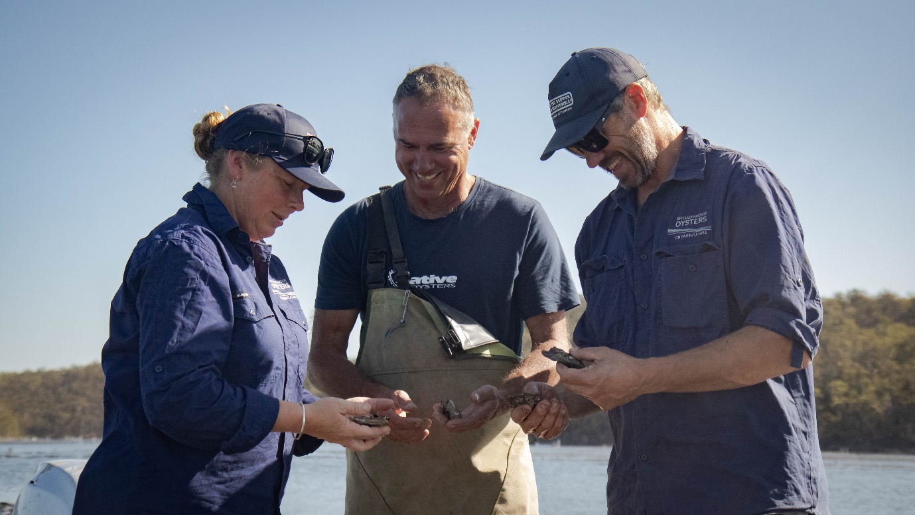

A woman and two men inspecting oysters in shells. Pambula Lake, NSW. Photo Attribution – Department of Industry, Science, Energy and Resources

## Case study - PEGRAS Asia Pacific - Treating label contamination to increase plastics recycling

*A $650,000 CRC-P grant has helped PEGRAS Asia Pacific and its CRC-P partners devise a world-first technological solution for addressing the removal of adhesive residue on plastic bottles, a key barrier to the recycling of high-value high-density polyethylene (HDPE) materials worldwide.*

The technology combines an impact delamination process to remove labels and glue from a commercial HDPE feed with a new chemical washing technology. The project partners are contributing a further $850,000 to support the CRC-P’s work.

HDPE is a high quality material that is in demand for re-use, but current recycling technology is unable to effectively remove contaminants such as labels and adhesives, resulting in hundreds of thousands of tonnes of HDPE waste going to landfill. Recent changes to the export of waste materials from Australia make it even more important for the recycling industry to find a solution to this problem.

The project’s objective is to produce 100% recycled HDPE for remanufacture in Australia, with the solution anticipated to be applicable to a range of polymer and plastic recycling practices around the world.

PEGRAS Asia Pacific is the lead partner. They are a technical solutions consulting company operating in the associated fields of chemistry, print and packaging media, industrial equipment, and related manufacturing sectors. They are collaborating with the University of Technology Sydney, University of Sydney, The University of New South Wales, NSW Smart Sensing Network, Labelmakers Group and Visypet. The CRC-P partnership provides a unique opportunity to bring together leading experts to find a solution to this worldwide industry problem.

Whilst reducing the impact of plastics on our environment and meeting the demands of a global market, the CRC-P will also open up greater economic opportunities in waste recycling and technology for Australians and create new job opportunities.

*‘PEGRAS believes in the circular economy. The CRC-P grant has helped us to develop solutions to clean labels and adhesive off HDPE milk bottles which increases its recyclability.’ (Dr. Stephanus Peters, Managing Consultant of PEGRAS)*

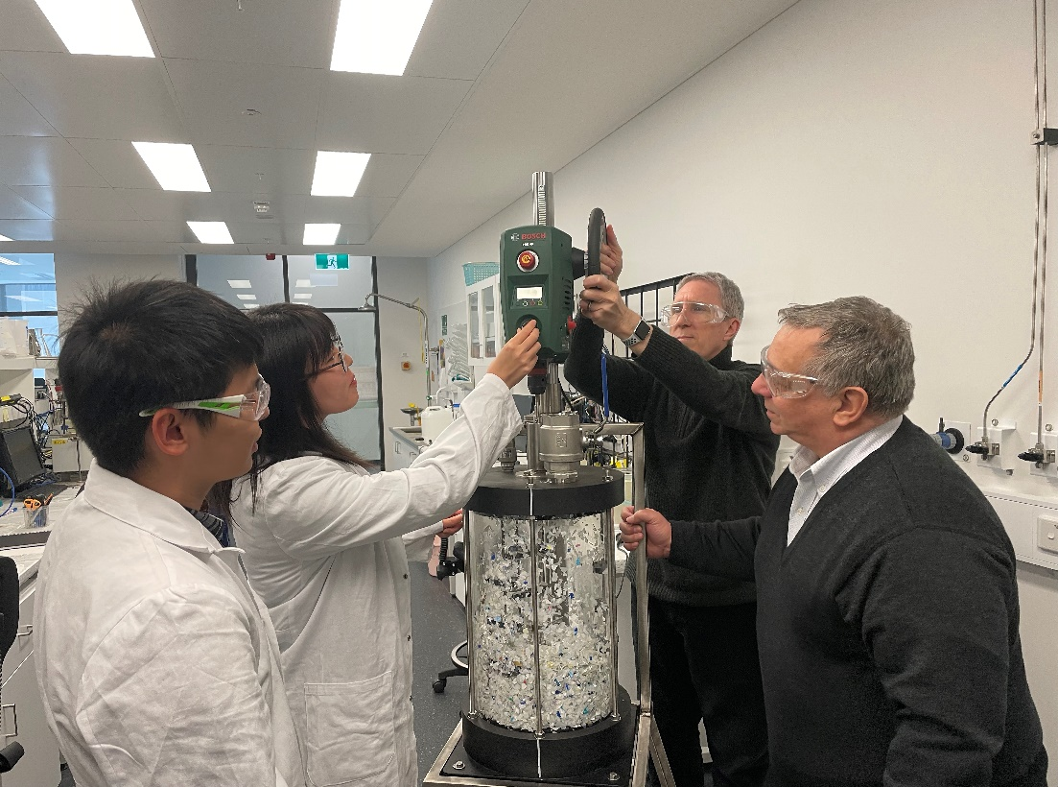*Recycling ‘wash reactor' mini-rig, tests label and glue variations to improve recyclability (UNSW)*

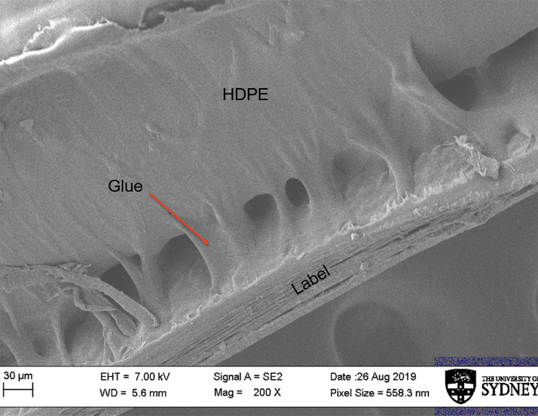

*Label glue is thinner than a human hair but very difficult to remove in the recycling process.*

## Program Overview – Venture Capital programs

“*A highlight for the committee and the VC programs this year has been the continued strong growth in both fund numbers and capital committed.  While there will be challenges ahead, we consider the sector is in a strong position”.*

*“The committee has, together with DISER, made great progress on a comprehensive education and compliance program. While this will deliver benefits over time the additional workload has been a challenge both for the Committee and DISER”.*

Mr Marty Gauvin – Chair, Innovation Investment Committee

## Venture Capital programs

The Australian Government has a suite of programs designed to cultivate innovation and encourage VC investment in entrepreneurial start-up and early stage companies. These programs are designed to stimulate the Australian VC sector by attracting both domestic and foreign capital into Australian VC markets.

The Venture Capital Limited Partnerships (VCLPs) Program aims to stimulate Australia's VC sector by attracting foreign investors. A VCLP is entitled to flow through tax treatment and its foreign investors do not pay capital gains tax on their share of returns the VCLP makes from eligible VC investments. The program is also open to domestic investors. VCLPs benefit Australian businesses as they increase the level of foreign investment available in the Australian VC sector.

The Early Stage Venture Capital Limited Partnerships (ESVCLP) Program aims to increase VC investment in start-ups and early stage companies. ESVCLPs offer flow-through tax concessions to investors on their share of returns, assisting fund managers to attract pooled capital. In addition, investors in ESVCLPs receive a 10% investor tax offset on capital invested during the year. ESVCLPs encourage investment in startup enterprises with a view to commercialisation of activity and company growth.

Australian Venture Capital Fund of Funds (AFOFs) are available to Australian resident general partners to pool capital from limited partners for investment into VCLPs and ESVCLPs.

Eligible Venture Capital Investor (EVCI) registration is available for tax-exempt foreign residents under the *Venture Capital Act 2002*. Under the incentive, EVCIs disregard their capital gains or capital losses from eligible investments they have held for at least   
12 months.

Program statistics

Over their lifetime, the total capital committed by registered partnerships is   
$19.86 billion with over $10.7 billion invested into an estimated 1800businesses.

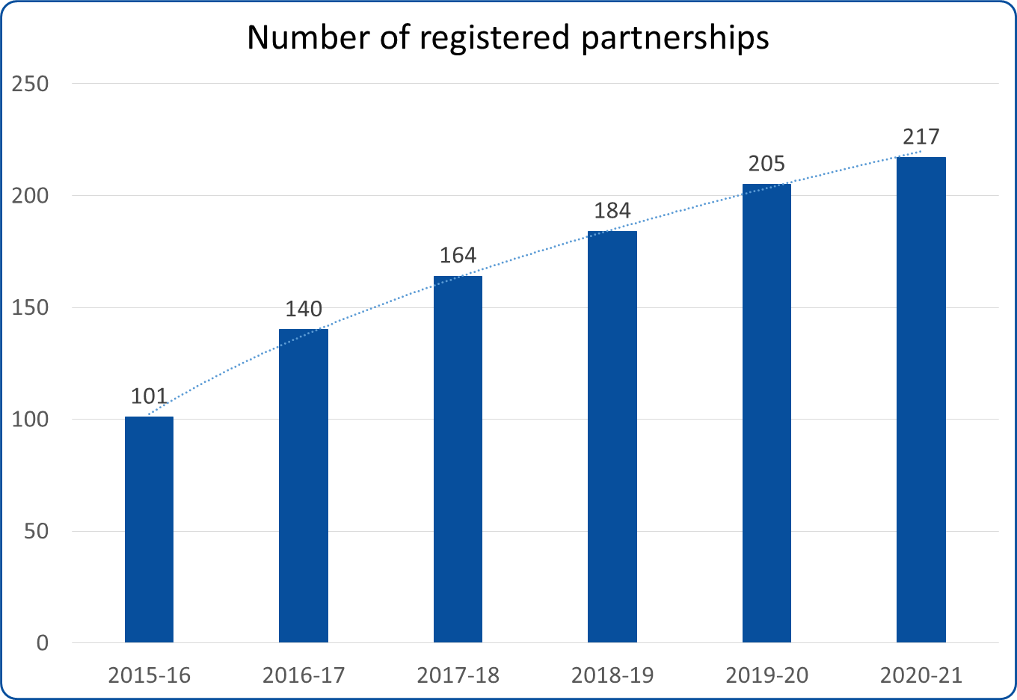  
*Growth of participation in VCLP, ESVLP and AFOF programs*

**VCLP outcomes**

There has been steady increase of investments over time, demonstrating the continued positive impact of the VCLP program in attracting foreign investment into Australian businesses.

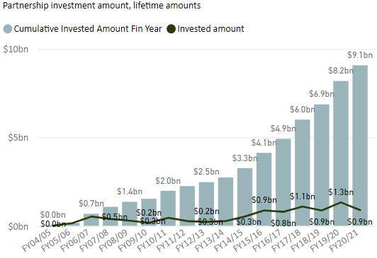

*Graph: Growth of VCLP partnership investments over time*

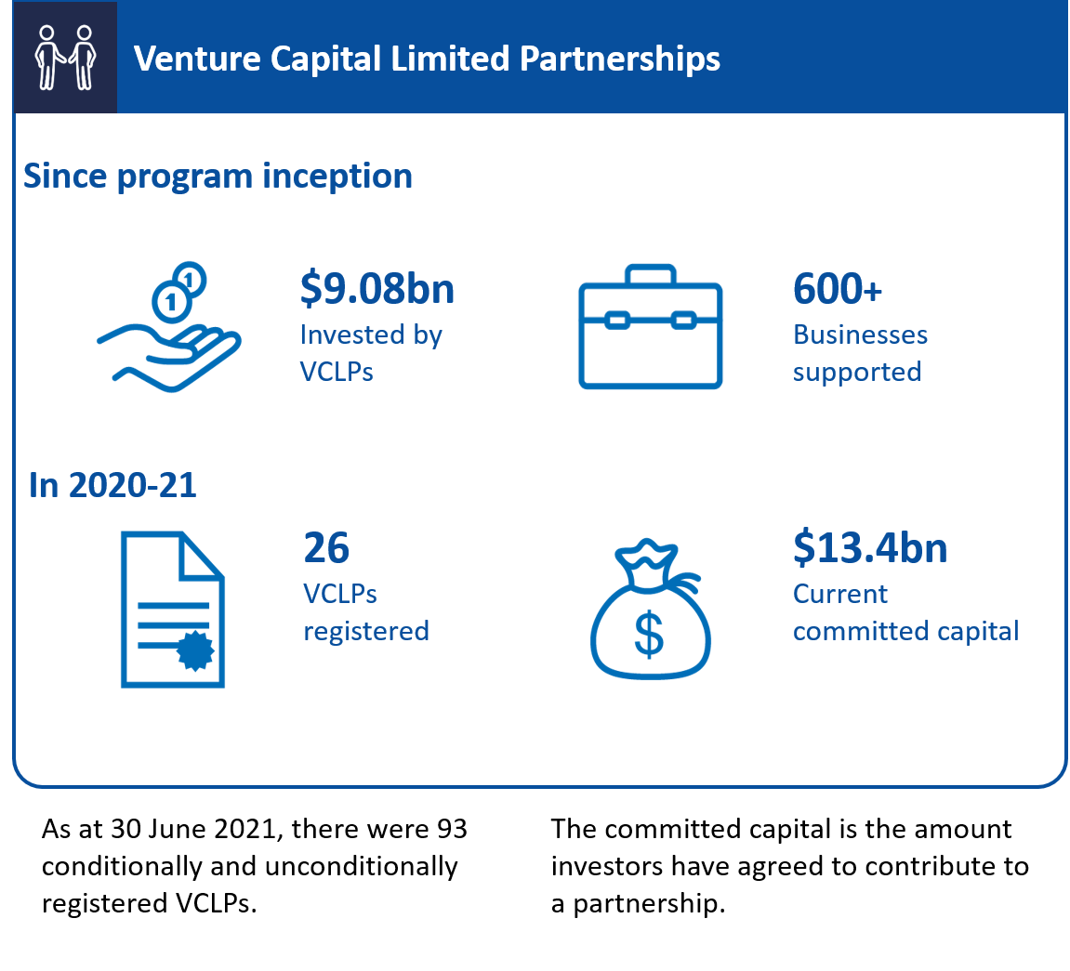

**ESVCLP outcomes**

Boosting investment in Australian businesses is critical for commercialising new ideas and encouraging new startups.

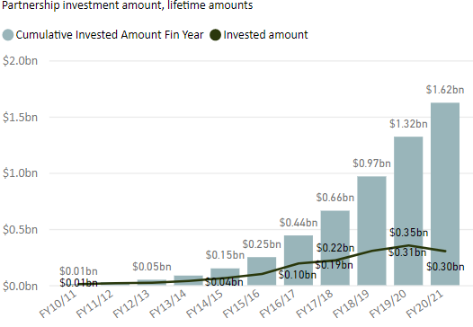

*Graph: Growth of ESVCLP partnership investments over time*

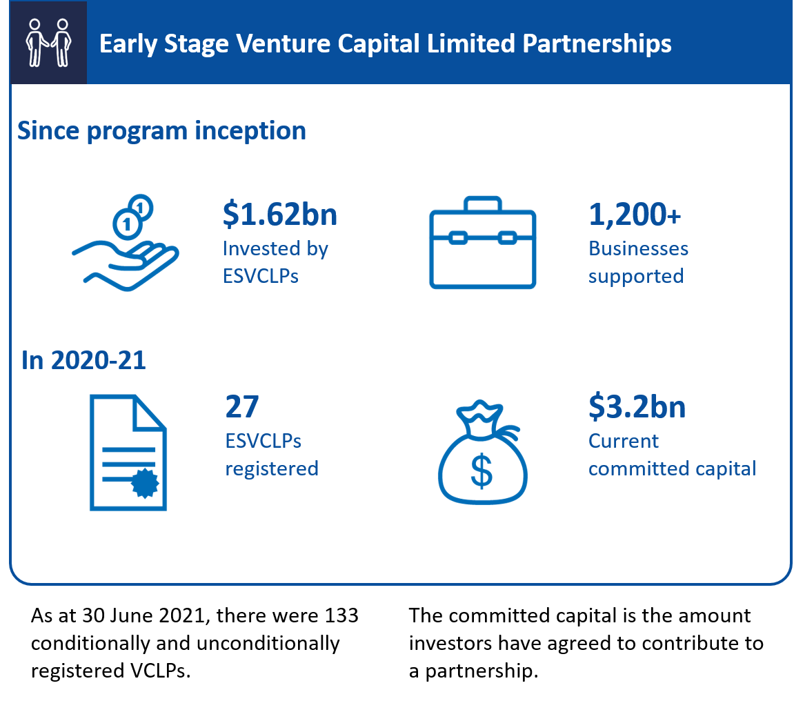

Disclaimer:

*All figures are current according to latest data. This may vary from previously published data for the same time period due to additional information supplied by customers. Committed capital and investment data is based on preliminary financial year figures, current as at 30 June 2020.*

For more information, detailed guidelines are available online for fund managers interested in establishing and registering VC partnerships.

Companies seeking private investment to commercialise ideas and scale their businesses are encouraged to view the lists of registered partnerships and approach fund managers directly. [business.gov.au/venture-capital](https://business.gov.au/venture-capital)

## Case study - Blackbird Ventures partners with Morse Micro to deliver next generation Wi-Fi.

*Reinventing global Wi-Fi through the production of a new generation of chips is an ambitious idea. Turning their brilliant idea into a commercial product was where the challenge started for Morse Micro.*

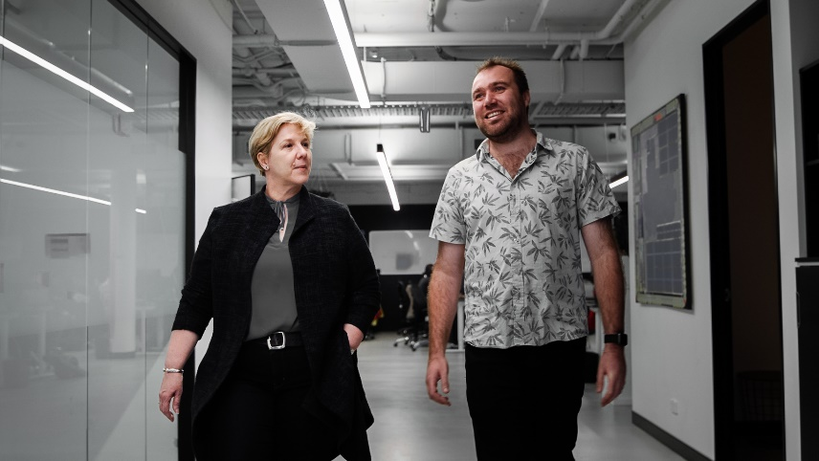

*Robyn Denholm, Blackbird Ventures and Michael De Nil, Morse Micro*

Morse Micro has developed a new generation of ultra-long range Wi-Fi chips that reach 10 times farther than conventional Wi-Fi, with better penetration through walls and a much lower power consumption. It is an innovation that could revolutionise wireless connectivity in a world where everything from your phone to your fridge is increasingly online.

For Morse Micro, seeking help from a VC firm early on in their journey means they are on their way to realising their dream.

"When looking for investors, we looked for partners who are as ambitious as we are," says Michael De Nil, CEO and co-founder at Morse Micro.

"It's a big change, evolving from a pre-revenue start-up, into a successful, multinational company. It's been really great having the Blackbird partners along the journey with us. They've taught us a lot about fundraising, about scaling the company, about growing into a multinational company."

Blackbird Ventures has a track record of investing in some of the most exciting   
startups in Australia and New Zealand, including the wildly successful Canva.

More than just money, Blackbird Ventures invest in people. "It's about the idea and it's about the founders. It's about the team they assemble to actually realise that vision," says Robyn Denholm, Operating Partner at Blackbird Ventures.

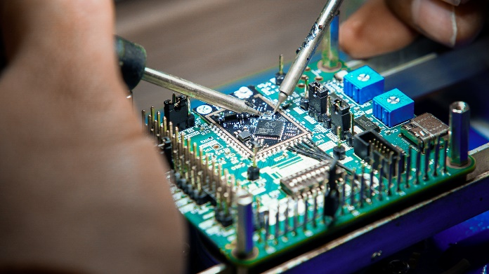

Morse Micro Wi-Fi chip.

"What we do is create a network of ambitious founders across the country that mentor and coach each other. The Blackbird team actually help in their journey as well.

"It's been phenomenal in terms of creating this cohort of founders that support each other, help each other through the peaks and valleys – and they're able to learn from each other in terms of successes. That's a very important ingredient.”

Establishing solid relationships early in the start-up journey can also help when it comes to scaling and success.

“Like any deep tech start up, there is a long period of time spent on research and development. Morse Micro was no different. They've had an amazing journey. They have assembled a world class team," Robyn says.

Since the first Blackbird investment of $25,000 in 2016, new and existing investors have raised almost $50 million more, enabling Morse Micro to become Australia's largest semiconductor employer, hiring over 100 people.

"The advice I'd give to other companies is that venture capital is for the brave of heart. It allows you to either grow and scale aggressively, or die quickly," says Michael.

"You can shoot for the stars. You can recruit the best talent, and you can build an extremely valuable company in a very short time."

Blackbird Ventures has four early stage venture capital limited partnerships registered under the Venture Capital Act 2002, investing into innovative early stage businesses and helping them grow.

*“It's been really great having the Blackbird partners along the journey with us. They've taught us a lot about fundraising, about scaling the company, about growing into a multinational company."*  Michael De Nil, CEO and co-founder, Morse Micro

## Program Overview – Biomedical Translation Fund

*“The past financial year saw the Biomedical Translation Fund (BTF) progress with all three fund managers making   
$46.4 million of commitments and investments made up of:*

1. *Kira Biotech, $9.5 million (OneVentures)*
2. *Closed Loop Medical $10 million (BioScience Managers)*
3. *PolyActiva Pty Ltd $5.08 million (Brandon Capital Partners)*
4. *Adherium Ltd $10 million (BioScience Managers)*
5. *Ena Therapeutics $11.9 million )Brandon Capital Partners)*

*Most significant was the BTF investment in Australian biotech company Ena Respiratory and their innovative nasal treatment deployed to fight COVID-19, common colds and the flu. INNA-051 works by stimulating the innate immune system the first line of defence against the invasion of pathogens into the body”.*

“*The BTF Committee could not convene in person during the year and received written briefing. More flexible communications have become extremely valuable for us and businesses in general in the context of this infectious COVID-19 outbreak”.*

Mr Peter Wills AC – Chair, BTF Committee

## The Biomedical Translation Fund

BTF is an equity co-investment VC program. It combines public and private funds to invest in early stage companies and support the commercialisation of innovative biomedical research.

Funds for investment total more than $500 million, made up of $250 million of Commonwealth capital and $251.25 million contributed by private investors.

Investing to develop and commercialise biomedical discoveries has twin benefits:

1. Translating cutting edge research into products and services that can improve the long term health of Australians
2. Supporting companies with high potential to grow the economy and create skilled employment opportunities.

**Key outcomes**

As at 30 June 2021, the BTF fund managers have publicly announced 22 investments totalling $247.8 million into innovative biomedical companies.

Funding has been used to support the development of a range of biomedical discoveries, from new treatments of food allergies, autoimmune disease and women’s health, to smart and robotic medical devices, artificial hearts and vaccines.

**How the BTF works**

Three fund managers partner with the Commonwealth and private investors to foster game-changing breakthroughs: Brandon Capital Partners, OneVentures Management and BioScience Managers. They demonstrate expertise in identifying high-potential companies, finding gaps in the market and growing concepts from seed to fruition.

Biomedical discoveries include: therapeutic, medical or pharmaceutical products, processes, services (including digital health services), technologies or procedures that represent the application and commercialisation of the outcomes of research that serve to improve health and wellbeing. It does not include alternative or complementary medicine, or traditional medicine.

BTF fund managers not only invest in promising biomedical discoveries, they encourage the growth of companies developing products by providing guidance, skills, resources and expertise.

All BTF investment decisions are made by the selected fund managers. The Government has no role in selecting investments, technologies or markets, but ensures all investments are consistent with the requirements of the program guidelines.   
This approach has been taken to ensure the venture capital expertise required to invest in commercialisation opportunities is provided by those most qualified.

Announced in December 2015, the BTF was as a key initiative under the National Innovation and Science Agenda. The Department of Health has policy responsibility, while the Department of Industry, Science, Energy and Resources administers the program.

Following a competitive, merit-based selection process, the three private sector BTF fund managers were licensed in December 2016. This process was conducted by the BTF Committee under the auspices of the then Innovation and Science Australia Board, (now industry Innovation and Science Australia).

Support is available for early stage companies with intriguing ideas to pitch their proposal to the fund managers for a share in the dedicated VC on offer.

Find out more about the BTF fund managers and current investments via: [business.gov.au/BTF](https://business.gov.au/grants-and-programs/biomedical-translation-fund)

### Case study – Brandon Capital Partners and Ena Respiratory investing in Australia’s health and wellbeing

*Ena Respiratory is developing a potential game-changer in how we deal with the treatment and prevention of viral respiratory infections, from COVID-19 to the common cold.*

Photo.

*Caption Bio21 Molecular Science and Biotechnology Institute, Melbourne. Image credit: Screencraft Media*

Viral respiratory infections are among the most common causes of sickness and death, inflicting epidemics and pandemics and creating ongoing health and economic concerns worldwide.

Ena Respiratory has developed the INNA-051 treatment, which targets the primary site of most respiratory infections, such as SARS-CoV-2 (the strain of coronavirus that causes COVID-19) and influenza. Applied with a nasal spray, the treatment activates the body’s immune defence mechanisms in the respiratory tract.

Developing the research from an academic paper to a product on the pharmacy shelf takes time, money and the right people.

Brandon Capital Partners is focussed on commercialising some of the most promising biomedical innovations in Australia. Through the BTF, they have committed   
$11.9 million to Ena Respiratory to test the concept and bring it to reality.

Chris Smith is one of the investment directors at Brandon Capital Partners, responsible for finding ideas and investing in new companies that will hopefully change the world for the better.

“Biomedical science is not the same as other investment spaces. Fundamentally, it relies on biology, usually human biology – and that is complicated and unpredictable.”

“It takes a long time, sometimes five to ten years, just to get to human proof of concept, the point at which large pharmaceutical companies usually get involved in

Christophe Demaison, Managing Director and CEO of Ena Respiratory, sees venture capital investment as crucial to bridge the gap.

“If we didn't manage to get the venture capital funding, I don't think the research would have been developed into a product that could ultimately be made available to patients. “

“It has taken five years to translate the product concept that came out of the University of Melbourne to start the phase one clinical trial.”

“Investment from the Commonwealth has been used to support the research & development activities of the company, including clinical trial in Australia.”

“Investments in life sciences companies are long-term and rely on a combination of strong relationships, commitment and commercialisation expertise.”

“Over the last five years that I've been working with Brandon Capital it has been really important to work together and listen to their goals and make sure our goals are aligned”, Christophe says.

Chris agrees, offering some salient advice for biomedical companies seeking venture capital investment.

“Do your due diligence on the people you're speaking to. Know who you're coming to speak to and what their strategic interest is so that you can really have a good conversation with them. Come with the idea and take them along the journey with you.”

“This business is a lot about trust and relationships - establish that connection as early as you can. It takes time.”

*Brandon Capital Partners is a licensed Biomedical Translation Fund (BTF) fund manager. The BTF is an Australian government co-investment venture capital program, combining public and private capital to support the commercialisation of biomedical research to achieve significant national economic and health outcomes.*

***“****If we didn't manage to get the venture capital funding, I don't think the research would have been developed into a product that could ultimately be made available to patients****.”*** Christophe Demaison, Managing Director and CEO, Ena Respiratory.

## Program Overview – Entrepreneurs’ Programme

*“The Entrepreneurs’ Programme Committee (EPC) has been at full strength during the 2020-21 financial year.   
In February 2021, the Committee held its biggest single meeting to consider 16 Accelerating Commercialisation (AC) grant applications worth almost $10.5 million”.*

*“AC, Incubator Support Initiative (ISI) and the Business Research and Innovation Initiative (BRII) represent key elements within the national innovation ecosystem that have the capacity to help drive growth and create other national benefits”.*

*“BRII continues to support startup opportunities while effectively providing solutions to public sector challenges.  As an example, in response to the BRII Round 2 challenges, the technology developed to detect biosecurity risks of hitchhiking pests and contaminants on shipping containers with hyperspectral cameras from ship to shore along with a handheld devices is not only ground breaking but could be a world first in the biosecurity field.  The Department of Agriculture, Water and the Environment has teamed up with the two successful applicants to further develop this work”.*

*“A key challenge has been shifting Committee meetings online in light of COVID-19, as well as engaging with a new cohort of Commercialisation Facilitators (CFs). These meetings have continued to be both productive and successful through the ability of Committee members to draw on their real world insights and experiences. They have mentored and assisted CFs in understanding role expectations, and the structure of meetings supported by a clear agenda and revisiting meeting procedures and protocols to suit an online environment”.*

**Committee highlight during the year**

*“Commercialisation is the key process that drives returns to R&D investment and innovation in the economy. The work of the Committee is to apply commercial experience across key sectors and independence to the merit assessment process.   
This year the transformation of the applicant management process introduced a new community of facilitators which proved to be a successful input to our Committee’s work.  As at the end of May 2021 the Committee made approval recommendations for 75% of applicants to the Minister”.*

**Challenges the Committee faced during the year**

*“2020/21 represented a year of unique challenges as the early stage commercialisation sector diverged into those projects where COVID 19 stimulated some applicant’s growth to become a great accelerator, those whose supply chains, distribution partners and availability to financial resources were somewhat disrupted and those whose plans needed to dramatically change. The Committee’s merit assessment process took these changed circumstances into account to provide recommendations that were appropriate in these challenging and rapidly changing circumstances”.*

Mr Anthony Surtees – Chair, Entrepreneurs’ Programme Committee.

## Entrepreneurs’ Programme

The Entrepreneurs’ Programme (EP) delivers advice and grants to enable high potential businesses to strengthen, grow, innovate and commercialise nationally and globally.   
In addition to improving outcomes for clients, it also improves outcomes for the broader economy, regions, industry sectors and communities. EP is delivered through a suite of unique offerings:

* *Accelerating Commercialisation* works with businesses, entrepreneurs and researchers to develop novel products, processes or services through to production and on to the market
* *Growth* works with businesses to help them grow by improving their management capability, capacity to trade and export in global markets, and their supply chain performance
* *Incubator Support Initiative* provides new and existing incubators with funding to help start-ups develop the capabilities to succeed in international markets. As part of the 2020-21 Federal Budget the funding for Incubator Support was reduced and as a result no new Incubator Support applications have been accepted from   
  May 2021.
* *Innovation Connections* connects businesses with the research sector and supports them to undertake collaborative research projects to develop innovative solutions
* *Strengthening Business* works with bushfire-affected businesses to help them recover and strengthen their business systems, operations and strategies into the future.

In 2020-21, EP supported 4,719 businesses.

In 2020-21, a total of 3,310 EP services were approved, with a total of 1,737 matched grants worth $78,590,454 including:

* Accelerating Commercialisation: 65 grants worth a total of $35,787,908
* Growth: 1,332 grants worth a total of $26,583,437
* Incubator Support: 27 grants worth a total of $2,756,104[12].
* Innovation Connections: 313 grants worth a total of $13,463,005.

The program is delivering results. A 2021 survey of EP businesses (EP clients) shows that, on average, EP clients increase their annual turnover by $1.57 million and create 4.3 new jobs a year after leaving the program.

For each $1 of grant funding awarded, AC clients have been able to raise on average $3.75 in new capital.

As at 30 June 2021, the ISI has invested in 65 incubator projects, which deliver services to over 1,500 startups, helping these businesses to build skills to commercialise overseas.

As of January 2021, data from 152 Graduate Placement Final Project Reports indicate that 90% of graduates were offered employment by the business at the end of an Innovation Connections project. This is equivalent to 130 early-stage researchers securing positions in industry as a result of these Innovation Connection projects.

In its first year, Strengthening Business has provided tailored support to more than 400 bushfire-affected regional businesses in New South Wales, South Australia and Victoria. This is a terminating measure to 30 June 2022.

During the first wave of lockdowns in March-June 2020, the program responded rapidly to its businesses, pivoting to digital and remote delivery of services, and focusing advice on helping businesses to bridge the crisis. From 1 March to 30 June 2020, over 2,500 EP businesses received an especially targeted one-on-one advisory service.   
For context, in an average year, EP provides approximately 3,500 tailored services.   
This approach has since been incorporated into business as usual engagement model.

EP will deliver targeted procurement Learning Events for SMEs, focusing on how businesses can access supply chains (including with government buyers) and work in major project environments over four years from 2021-22. This initiative forms part of the 2021-2022 Budget measure Supporting Small and Medium Enterprise Participation in Commonwealth Procurement.

Through Growth the Cold Chain Optimisation SMART project there will be a number of workshops and peer group sessions commencing in August that will focus on challenges faced in Western Australia and the gains from improving cold chain practices and upskilling of workforces.

From October 2021, the program will commence its impact evaluation.

For more information on how the Entrepreneurs’ Programme can transform your business, visit www.business.gov.au/EP or call 13 28 46.

InfoGraphics

* 170+ independent business and industry experts
* 1,294 learning events delivered to 15,773 participants to date
* 20,934 individual businesses received tailored services to date

According to client survey data, business experience the following on average, 12-18 months after accessing EP services:

* The creation of 4.3 new jobs (FTE) (EP Growth clients)
* An increased turnover of $1.57 million. (EP Growth clients)
* An additional $3.75 in new capital for every single $1 of government investment (Accelerating Commercialisation clients)

## Case study - Life Cell

*A harrowing sea experience was the catalyst for a couple of mates to create their Life Cell marine safety invention. The Life Cell is a high-visibility buoyancy device that stores essential safety equipment and is mounted in a handy position, but with the ability to float free of its bracket if submerged.*

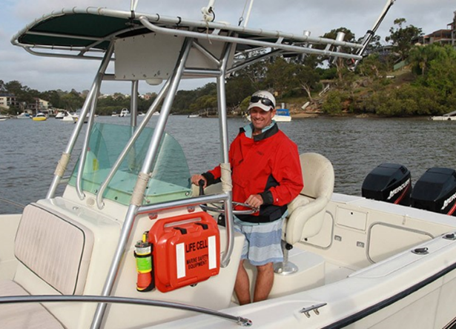

Life Cell Marine Safety received an Acceleration Commercialisation grant to break into the US market.

Early 2021, Life Cell hit the news when 4 spear-fishermen were rescued off the coast of Port Stevens after finding themselves in trouble after their boat capsized. Grabbing Eskys, lifejackets and their trusty Life Cell, they floated for 45 minutes before being rescued.

An eerily similar situation inspired co-founders Scott Smiles and Jenny Aiken to redefine how safety equipment is stored and used on boats.

Scott, his friend and their 2 young sons were stranded at sea after their boat sank   
10 years ago. Left clinging to an Esky, and thankfully with a safety beacon in hand, they were rescued. This ordeal lead to the creation of Life Cell. Part floatation device and part container to store safety equipment, including emergency beacons and flares.

Bringing to life a genius idea is one thing, being able to commercialise it is another. Attending 6 trade shows in the US, providing samples, modifying packaging and websites and training sales reps is a very expensive process, so Life Cell Marine Safety turned to the AusIndustry Entrepreneurs’ Programme for help. Life Cell Marine Safety was awarded a $370,000 Accelerating Commercialisation grant to develop their marine safety device to reduce the number of people losing their lives at sea.

As well as international exports, The Life Cell is also being sold all over Australia and New Zealand, and is used on vessels operated by NSW Roads and Maritime Services and Department of Primary Industries. Life Cell is also endorsed by Westpac Life Saver Rescue Helicopter, who rescued the business partners on that fateful day.

Not content to simply enjoy their success, Life Cell has given back to the community by participating in a marine safety program which has helped to save lives in Torres Strait and was funded by the Australian High Commission.

Coming full circle, Jenny Aiken has since joined the program as a commercialisation facilitator to help other business owners achieve their commercial success.

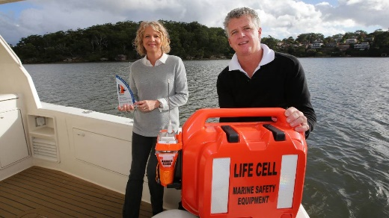

Life style CEO Jenny Aiken and Director Scott Smiles, with their award winning marine safety device.

“The grant provided us with much needed financial assistance to allow us to gain traction in the US market. I am not sure that we could have achieved this without the grant. We are incredibly grateful for [AusIndustry’s] support at this critical time for our company.” Jenny Aikin, CEO, Life Cell Marine Safety

## Case Study - Solcast

*In 2016 James Luffman and Doctor Nick Engerer decided to apply complex science to real world problems. With a background in and a passion for meteorology, the duo seized the opportunity to gather and produce solar radiation data to enable networks to better predict their solar modelling and forecasting. This data has revolutionised weather forecasting for the renewable energy sector by predicting 600 million solar forecasts around the world every hour.*

 Dr Nick Engerer, Director, CTO and Co-founder of Solcast, accessed AusIndustry to help commercialise their weather forecasting prototype.

Nick has always been fascinated with the weather–in fact, he once contemplated life as a TV weatherman back in his college days in Ohio. Thankfully, he instead formed Solcast in 2016 with friend Dr Nick Engerer and created the prototype for NowCasting, a cost-effective forecasting tool which can track and predict renewable energy output in real time.

Traditional weather radars are expensive and not available in every location. To be able to take their NowCasting prototype to market, Solcast needed a little extra support, so they sought the help of AusIndustry through the Entrepreneurs’ Programme.

Solcast have been awarded in total $880,000 from two Accelerating Commercialisation grants to commercialise the NowCasting prototype and progress to the next stage of applying the systems to rainfall and storms.

Doctor Engerer explains that the most advantageous thing about this opportunity is the ability to see rainfall where there is not weather radar coverage.

With help from AusIndustry, Solcast’s clients range from Weatherzone to big solar farms to energy companies and they are well on their quest to revolutionise weather forecasting by enabling them with the facilities to launch their prototype to market. Nick jokes the ‘sky’s the limit’ for the growth of Solcast.

‘We now have the technology for precipitation, operational around the world and Accelerating Commercilisation was a big part of that’. Dr. Nick Engerer, CTO, Solcast

## Program Overview – Business Research Innovation Initiative

The Business Research and Innovation Initiative (BRII) aims to drive innovation within small and medium enterprises (SMEs) and government by encouraging SMEs to develop innovative solutions to public policy and service delivery challenges. SMEs with the best proposals to solve each policy challenge receive grants of up to $100,000 to test the feasibility of their ideas over three months. Successful SMEs are then eligible for up to $1 million to build on their feasibility studies and develop a working prototype or proof of concept.

Australian Government agencies work closely with SMEs to develop the solutions, and at the conclusion of the project, potentially procure the solutions. SMEs retain intellectual property rights, and the right to sell in domestic and global markets allowing them to commercialise their solutions.

To date, the BRII has supported 58 innovative SMEs, providing 73 grants over four rounds and 19 challenges. In excess of $20 million in grant funding has been provided to Australian SMEs to bring new products and technologies to market.

Over the financial year:

* Proof of concept prototypes have been completed to demonstrate solutions to challenges relating to tourism, biosecurity and national archives. The 6 SMEs involved are now exploring commercialisation opportunities
* A total of 23 SMEs completed feasibility studies for challenges focused on oceans, soil and water quality and technologies advancing recycling. Successful recipients of the proof of concept grants are scheduled to be announced in September 2021
* A Regulatory Technology (RegTech) round of the BRII, launched in April 2021, focused on decreasing regulatory burden, reducing unnecessary regulatory compliance and streamlining regulatory processes. Successful recipients of the feasibility grants are scheduled to be announced in October 2021.

The BRII will continue as a demand-side innovation policy leaver for government agencies, to help stimulate SME research and development and deliver novel solutions to government challenges. Ongoing rounds of the BRII will be shaped by the outcomes of a program evaluation that is underway.

For more information on the BRII and previous grant recipients, refer to business.gov.au/BRII.

## Case study - Trellis Data

*Utilising BRII funding and working with the Department of Agriculture, Water and Environment (DAWE) has enabled Canberra-based AI company, Trellis Data, to develop a new Biosecurity Automated Threat Detection System. This project was in response to DAWE’s challenge, managing the biosecurity risks of hitchhiker pests and contaminants on shipping containers.*

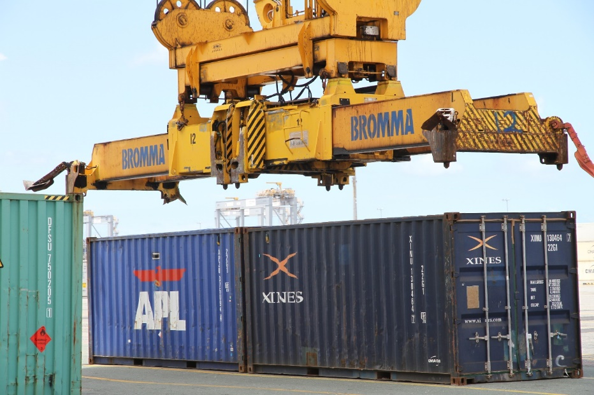

*Image courtesy Trellis. Trellis Data’s new Biosecurity Automated Threat Detection System (BATDS) inspecting shipping containers.*

Incoming shipping or sea containers are a pathway for hitchhiking pests, organisms, diseases, weeds and contaminants to enter Australia and create biosecurity risks to Australia’s $60 billion agriculture industry. DAWE manages the biosecurity risks associated with shipping containers, however manually inspecting containers can be challenging, time-consuming and costly. This is predicted to become more challenging as trade volumes and container arrivals increase. DAWE required a solution which provided an alternative to human inspection. The solution needed to consider: efficient movement of containers; aptitude for use by a wide range of staff; remote sampling and diagnosis; real time data capture and results; operation in future environments; and scalability.

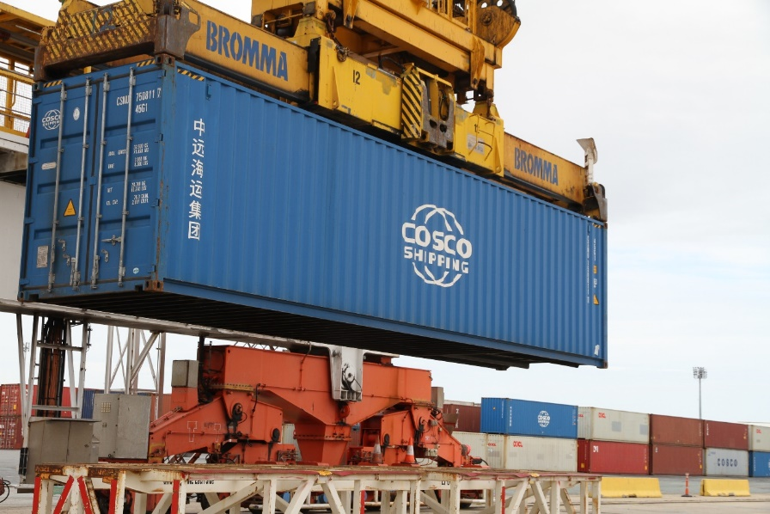

*Image courtesy trellis. Trellis Data’s new Biosecurity Automated Threat Detection System (BATDS) inspecting shipping containers.*

Trellis Data was able to develop a real-time AI-supported sensor system to address this challenge. Cameras were mounted on platforms at wharfs and ports – the live feed from the cameras were sent through to Trellis Data’s pest detection platform, which could identify pests as small as 5 mm in length. The benefit of this system is that it enables the identification of pests in real time, without slowing down the container movements from international ships to Australia’s borders. The developed solution is able to check 100% of the containers coming into Australia, and has demonstrated the ability to detect pests above the current inspection rates of biosecurity teams. Not only does this provide enhanced biosecurity for Australia’s agriculture sector, it is a fully automated system. This system could be rolled out nationally, and to other countries globally.

Trellis Data’s ground breaking technology is trained to detect many different types of pests and contaminants, and is additionally capable of detecting new pests or contaminants. Trellis was able to refine their machine learning models through research and development at the Port of Brisbane, while working with the private sector and Government.

*“Solving this problem for the Australian Agriculture industry has been a challenge, but we couldn’t be prouder of the accuracy of our results”.* Michael Gately, CEO, Trellis Data

## Case study - Hemishpere Digital formerly known as Wejugo

*Utilising BRII funding and working with Austrade has enabled Wejugo to develop the Hemisphere Digital platform, which generates accessible, ready-made insights on how Australians travel and spend money. By combining digitally sourced data into a comprehensive set of tourism benchmarks, Hemisphere Digital opened up the potential for users to quickly identify the impact of tourism and population movements across a number of key metrics, in near real time. This was in response to Austrade’s challenge focused on intelligent data to transform tourism service delivery.*



Mike Welling, founder of Wejugo

Tourism cuts across many economic segments with widespread benefits. The industry’s fragmented and diversified nature creates an environment that is difficult to measure in statistically valid ways, particularly when sharing economic impacts. Austrade required a solution to identify, unlock, integrate and leverage new data sources. The solution would enable government and business to support tourism, promote tourism outwardly and complement work underway to measure the demand side of tourism.

The BRII grant enabled the team at Wejugo to develop a visitation and tourism insights platform that has wide application across the tourism sector – from quantifying the success of tourism recovery efforts at a policy level, right down to the hyperlocal impact of adventure tourism activities to natural areas.



Image courtesy Wejugo. Hemisphere Digital Platform

The Hemisphere Digital platform combines data from transactional, telecommunications, social media and other digitally sourced data into a 360 degree view of tourism impacts across economic, environmental and cultural performance metrics.

The platform has since been used and tested by a number of large organisations during the pre-commercial launch phase, including by government institutions, state tourism agencies and other partners. It has seen the transformational impact that having access to real data insights can have on businesses looking to access population movements, spend patterns and shifting visitor behaviours.

The Hemisphere Digital platform demystifies data and supports businesses of all sizes to glean the information they need to drive innovation and sustainable outcomes for businesses and society. The platform has attracted investment internationally due to its global potential.

*“It is our hope that access to affordable and insightful data can become a transformative vehicle for economic and social benefit right when it is needed most in a heavily disrupted tourism sector.”* Image courtesy Wejugo. Mike Welling, Founder/CEO, Hemisphere Digital.



Image courtesy Wejugo. Hemisphere Digital Platform

# Legacy programs

As at 30 June 2021 IISA continues to monitor the following programs which are closed to applications:

* Innovation Investment Follow-on Fund
* Innovation Investment Fund
* Pooled Development Funds
* Pre-Seed Fund.

DISER will continue to work with legacy program customers.

## Section Two – Governance

Industry Innovation and Science Australia

Legislation

Organisation and Management

Board and Committee Membership in 2020-21

Meetings of Industry Innovation and Science Australia in 2020-21

Structure of Industry Innovation and Science Australia

Legal Matters/Litigation

## Innovation and Science Australia

Through IISA’s partnership and administration of the Government’s industry research and development, innovation and venture capital programs, it seeks to encourage a more entrepreneurial Australian innovation, science and research system.

In 2020-21, IISA reported to the Minister for Industry, Science and Technology,   
The Hon Karen Andrews MP and subsequently The Hon Christian Porter MP in accordance with the Board’s legislative requirements as described below.

## Legislation

### The Industry Research & Development Act 1986

IISA operates under the authority of the *Industry Research and Development Act 1986* (IR&D Act). The aims of the IR&D Act are to:

* facilitate the provision of independent strategic advice about industry, innovation, science and research
* promote the development of, and improve the efficiency and international competitiveness of, Australian industry by encouraging research and development, innovation and venture capital activities.

### IISA functions and powers

IISA’s functions are set out in the IR&D Act and associated Ministerial Directions.   
The Board’s responsibilities include:

* provision of independent strategic whole-of-government advice to government in relation to industry, innovation, science and research matters
* promotion of investment in industry and Australia’s innovation, science and research system
* co-administration, monitoring and operation of the R&D Tax Incentive
* registering, monitoring and revoking the registrations of Venture Capital Limited Partnerships and Early Stage Venture Capital Partnerships
* co-administration and oversight of the Cooperative Research Centres Program
* strategic oversight of the Entrepreneurs’ Programme, which includes administration and monitoring of Accelerating Commercialisation and Incubator Support Initiative
* monitoring ongoing projects under programs which are now closed to applications (see list of legacy programs on page; 52_
* advising the Minister about the operation of the IR&D Act, the *Pooled Development Funds Act 1992*, the *Venture Capital Act 2002*, and the Commonwealth’s *Income Tax Assessment Act 1997* as they operate in relation to those Acts.

Ministerial Directions issued to the former Innovation and Science Australia Board and the IISA Board also provided additional functions for IISA, which were undertaken in the   
2020-21 reporting period.

In December 2020, the Government provided IISA with a Statement of Expectations (SOE) outlining IISA’s core objectives and activities. These objectives and activities support the Government to transform Australia into a leading innovation nation that is capable of continued economic prosperity and creation of new job opportunities. IISA is working on three priority tasks set out in the SOE: an impact assessment of Venture Capital Tax Concessions, a report on investment characteristics of successful innovative businesses and an evaluation of cross-cutting issues arising from the national manufacturing priority road maps. Further information on these pieces of work can be found in the Strategic Advice section of this report.

### Financial responsibilities of IISA under the IR&D Act

IISA has no financial responsibility for program-related grants, loan or licence agreements entered into after 10 September 2004. This follows amendments to the IR&D Act which came into effect on 11 September 2004, and removed powers of the former Innovation Australia to commit, approve or recommend expenditure of government funds and further safeguard members from any personal liability stemming from board membership.

### Organisation and Management

IISA uses a committee structure to support administration and provide expert advice on innovation and venture capital programs. As at 30 June 2021 five committees reported to IISA; each committee has the following specific functions:

* **Research and Development Incentives Committee** – This committee is responsible for advising the Board about the operations of the R&D Tax Concession program for income years commencing before 1 July 2011 and the R&D Tax Incentive program for income years commencing on or after 1 July 2011.   
  The Committee advises on operational policy as well as providing certificates to the Commissioner for Taxation about the eligibility of activities registered for the concession and the incentive. The R&D Incentives Committee met eight times in 2020-21
* **Cooperative Research Centres Advisory Committee** – This committee has an ongoing role to provide advice and recommendations on applications for funding, the progress and performance of individual Cooperative Research Centres (CRC), and the operation of the CRC program. The CRC Advisory Committee met four times in 2020-21
* **Innovation Investment Committee** – This committee is responsible for administering the venture capital programs and providing guidance to the DISER throughout the programs’ lifecycles. This includes decisions on registration and decisions relating to compliance and interpretation. The IIC Committee met ten times in 2020-21
* **Biomedical Translation Fund Committee** – This committee administers the Biomedical Translation Fund (BTF) program and guides DISER throughout the lifecycle of the program. The BTF Committee did not meet in 2020-21
* **Entrepreneurs’ Programme Committee** – This committee is responsible for providing merit assessments and merit ranking recommendations on applications under the Accelerating Commercialisation and the Incubator Support Initiatives.   
  The Committee also provides merit assessments for the Business Research Innovation Initiative which supports Australian businesses to develop innovative solutions that address persistent government challenges. The EP Committee meet nine times in 2021-21.

## Board and committee membership in 2020-21

Membership

Members of the IISA Board are appointed by the portfolio Minister, in writing.   
The IR&D Act provides for a maximum of 15 members, including the Chair, Deputy Chair and an ex-officio member. Four members of the IISA Board constitute a quorum.

IISA committee members are appointed by the portfolio Minister and operate under delegation from the IISA Board. Committees comprise a chair and up to six members, with three committee members constituting a quorum. These committees also include Departmental members.

IISA (Board and committee) members are individuals with an appropriate mix of professional and technical expertise across a broad section of industries, technologies and capital markets, as well as experience in commercialisation of industry innovation, corporate governance and business finance.

The IISA Board and its committee members, other than the Departmental members, are remunerated in accordance with determinations set by the Remuneration Tribunal.

Conduct

As statutory office holders, Board and committee members are bound by the Australian Public Service Code of Conduct as per sections 13 and 14 of the *Public Service Act 1999*.

Office of Industry Innovation and Science Australia

Whilst IISA is independent of government by virtue of its founding statute, it is supported by the Office of Industry Innovation and Science Australia (OIISA), which is located within, and supported by the DISER. As part of the development of its advice to Government, IISA (through OIISA), undertakes consultation with relevant government portfolios, industry, the innovation community, and the research and science communities.

OIISA is headed by a CEO who is appointed by the Portfolio Minister and engaged through DISER. Dr Kate Cameron is currently acting in the role of CEO. The process to fill this role permanently is underway. OIISA also has a dedicated Board Manager. OIISA staff as at 30 June 2021 included nine full time staff and a part time Soldier on Intern of three days per week.

Partners in delivery

DISER staff in the national, state, territory and regional offices provide project reporting services, technical assessment and promotional services for the programs that IISA oversees. DISER officers also advise customers about the range of government industry support programs.

DISER (on behalf of IISA) and the Australian Taxation Office (ATO) jointly administer the Research and Development (R&D) Tax Incentive, the R&D Tax Concession, the Venture Capital Tax Programs and Pooled Development Fund. DISER manages the registration of research and development activities and conducts compliance reviews related to the eligibility of these activities. The ATO determines if the research and development expenditure claimed in a tax return is eligible.

The Department of Health has policy responsibility for the Biomedical Translation Fund, DISER administers the Fund.

Board members as at 30 June 2021

|  |  |  |  |
| --- | --- | --- | --- |
| NAME | TITLE | Photo | TERM/S OF APPOINTMENT |
| Mr Andrew Stevens  CHAIR |  |  | 20 December 2018 to  19 December 2021 |
| Dr Cathy Foley AO  DEPUTY CHAIR | Australia’s Chief Scientist |  | 1 January 2021 to 31 December 2023 |
| Ms Lauren Stafford | Manager, Open Innovation at Woodside Energy Limited |  | 7 October 2020 to 6 October 2023 |
| Mr Patrick Houlihan | Chairman and CEO, DuluxGroup Limited |  | 7 October 2020 to 6 October 2023 |
| Mr Scott Farrell | Partner, King & Wood Mallesons |  | 7 October 2020 to 6 October 2023 |
| Ms Sarah Nolet | CEO, AgThentic |  | 7 October 2020 to  6 October 2023 |
| Dr Alexander Grant | CEO, Myriota Pty Ltd |  | 7 October 2020 to 6 October 2023 |
| Ms Glenys Beauchamp | Chair, Health Industry Co-ordination Group |  | 1 January 2021 to 31 December 2023 |
| Professor Elanor Huntington | Dean of Engineering and Computer Science at the Australian National University |  | 20 December 2018 to 19 December 2021 |
| Professor Raoul Mortley AO | Principal, Raoul Mortley Consulting Chairman Spee3D |  | 20 December 2018 to 19 December 2021 |
| The Secretary, (Mr David Fredericks, PSM) | Department of Industry, Science, Energy and Resources |  | 3 February 2020  Ongoing |

Members who retired from the Board in 2019-20

|  |  |  |  |
| --- | --- | --- | --- |
| Dr Alan Finkel AO  DEPUTY CHAIR | Australia’s Chief Scientist | Please use same as last year’s | 25 January 2019 to  31 December 2020  10 March 2016 to  24 January 2019 |
| Dr Bronte Adams AM | Managing Director, Dandolo Partners International | Please use same as last year’s | 17 August 2019 to  16 August 2020  24 October 2016 to  16 August 2019 |
| Professor Bronwyn Harch | Executive Director, Institute for Future Environments, QUT | Please use same as last year’s | 17 August 2019 to  16 August 2020  24 October 2016 to  16 August 2019 |
| Dr Christopher Roberts AO | Chair, OncoSil Medical Limited | Please use same as last year’s | 13 March 2019 to 12 March 2021  10 March 2016 to 24 January 2019 |

*Including acting Chair of Innovation Australia from 19 September 2014 to 18 September 2015

Committee Tables

R&D Incentives Committee

R&D Incentives Committee Members Term of Appointment

|  |  |  |
| --- | --- | --- |
| Ms Julie Phillips  Chair | CEO, BioDiem Ltd | 16 August 2019 to  31 October 2021 (Chair)  1 November 2018 to  31 October 2021 (member)  14 September 2015 to  13 September 2018 (member) |
| Mr Lachlan James | Executive Director of Frontier Fund Management & ITP renewables and CEO of Haystack HQ | 4 April 2019 to  3 April 2022 |
| Dr Michelle Perugini | Co-Founder and CEO at Presagen and Life Whisperer | 11 September 2019 to  10 September 2022 |
| Ms Julia Sloman | Company Secretary, Big 4 Transactions and listed company CEO | 1 March 2019 to  28 February 2022 |
| Mr Mark Stevens | Managing Director, ActionTech | 11 September 2019 to  10 September 2022 |
| Ms Joanne Mulder | Department of Industry, Science, Energy and Resources | 11 September 2019 to 10 September 2022 |

Cooperative Research Centres (CRC) Advisory Committee

CRC Advisory Committee Members Term of Appointment

|  |  |  |
| --- | --- | --- |
| Ms Kylie Sproston  Chair | CEO, Bellberry Ltd | 18 June 2018 to  17 June 2021 (Chair)    18 June 2021 to  17 June 2024 (Chair)  20 October 2016 to  17 June 2018 (member) |
| Dr Damian Barrett | Research Director, Onshore Gas Program | 9 April 2019 to  8 April 2022 |
| Mr Douglas Stuart | Chief Marketing Officer, Instaclustr | 20 June 2020 to 19 June 2023  20 June 2017 to  19 June 2020 |
| Professor Wendy Erber | Professor of Pathology and Laboratory Medicine, The University of Western Australia | 18 November 2020 to  23 August 2023 |
| Professor Bronwyn Harch | Executive Director, Institute for Future Environments, QUT | 24 August 2020 to  23 August 2023 |
| Mr David Williamson | Department of Industry, Science, Energy and Resources | 11 September 2019 to 10 September 2022 |

Innovation Investment Committee

Innovation Investment Committee Members Term of Appointment

|  |  |  |
| --- | --- | --- |
| Mr Marty Gauvin  Chair | President and CEO, Virtual Ark Pty Ltd | 20 April 2019 to  19 April 2022  20 April 2016 to  19 April 2019 |
| Professor Stephen Barkoczy | Professor, Faculty of Law, Monash University | 20 April 2019 to  19 April 2022  20 April 2016 to  19 April 2019 |
| Ms Amanda Heyworth | Non-executive Director | 12 March 2019 to  11 March 2022  20 April 2016 to  19 November 2018 |
| Ms Leonie Horrocks | Department of Industry, Science, Energy and Resources | 11 September 2019 to  10 September 2022 |

Biomedical Translation Fund Committee

Biomedical Translation Fund Committee Members Term of Appointment

|  |  |  |
| --- | --- | --- |
| Mr Peter Wills AC  CHAIR | Deputy Chair, Research Australia | 2 May 2019 to  1 May 2022  2 May 2016 to  1 May 2019 |
| Ms Fiona Pak-Poy | Non-executive Director, Securities Industry Research Centre of Asia | 2 May 2019 to  1 May 2022  2 May 2016 to  1 May 2019 |
| Dr Deborah Rathjen | Chief Executive Officer & Managing Director, Bionomics Ltd | 2 May 2019 to  28 February 2021  4 April 2016 to  1 May 2019 |
| Dr Leanna Read | Chief Scientist for South Australia | 4 April 2019 to  3 April 2022  2 May 2016 to  24 January 2019 |
| Mr Jeremy Samuel | Founder & Managing Director, Anacacia Capital | 4 April 2019 to  3 April 2022  2 May 2016 to  24 January 2019 |
| Ms Leonie Horrocks | Department of Industry, Science, Energy and Resources | 11 September 2019 to  10 September 2022 |

Entrepreneurs’ Programme Committee

Entrepreneurs’ Programme Committee Members Term of Appointment

|  |  |  |
| --- | --- | --- |
| Mr Anthony Surtees  Chair | Co-founder and Director of Marketing and Strategy, Zeetings Pty Ltd | 1 November 2018 to  31 October 2021 (Chair)  19 July 2017 to  31 October 2018 (member)  1 July 2015 to 30 June 2017 (member) |
| Ms Jan Bingley | Founder & Principal, UCX Consulting Pty Ltd | 28 November 2018 to  27 November 2021 |
| Ms Bessi Graham | Co-Founder, Benefit Capital | 29 January 2019 to  28 January 2022 |
| Ms Rachael Neumann | Netherless Tach Pty Ltd | 28 November 2018 to  27 November 2021 |
| Dr Carrie Hillyard AM | Co-Founder CM Capital Investments Pty Ltd | 1 July 2018 to 30 June 2021  1 July 2015 to 30 June 2018 |
| Dr James Williams | Investment Director Yuuwa Capital | 19 July 2020 to 30 June 2023  18 July 2017 to  17 July 2020 |
| Mr Steve Telburn | Managing Director, Secret Sauce IP Ventures | 1 July 2018 – 30 June 2021  1 July 2015 to 30 June 2018 |

## Meetings of Industry Innovation and Science Australia in 2020-21

During the 2020-21 financial year four formal IISA meetings were scheduled, however due to restrictions caused by COVID-19, only three meetings were held. Travel restrictions varied in each state, meaning that members attended either in person (when possible) or virtually (if restricted), depending on the nature of restrictions at the time of each meeting.

23 October 2020 Canberra

26 November 2020 Sydney

4 March 2021 Sydney

IISA also held a number of out of session meetings via teleconference to consider a number of matters.

## Structure of Industry Innovation and Science Australia as at 30 June 2021

Minister for Industry’ Science and Technology

Industry Innovation and Science Australia

Chair: Mr Andrew Stevens

Innovation Investment Committee

Chair: Mr Marty Gauvin

Entrepreneurs’ Programme Committee

Chair: Mr Anthony Surtees

Cooperative Research Centres Advisory Committee

Chair: Ms Kylie Sproston

Biomedical Translation Fund Committee

Chair: Mr Peter Wills AC

R&D Tax Incentive (RDTI)

Early Stage Venture Capital Limited Partnerships (ESVCLP)*

Venture Capital Limited Partnerships (VCLP)

Pooled Development Funds

Australian Venture Funds of Funds

Entrepreneurs’ Programme (EP)

* Accelerating Commercialisation (AC)
* Incubator Support Initiative (ISI)

Business Research & Innovation Initiative (BRII)

Cooperative Research Centres (CRC)

Cooperative Research Centres – Projects (CRC-P)

Biomedical Translation Fund (BTF)

**Committees**

**Programs**

R&D Incentives Committee

Chair: Ms Julie Phillips

**Decision maker / financial delegation^**

 AusIndustry SES

Minister

Minister

Minister

Minister

AusIndustry SES

## Legal matters and litigation

### Research & Development Tax Incentive

In 2020-21, nine new applications were made seeking review of IISA’s internal review decision in the Administrative Appeals Tribunal (AAT) and one new application seeking review of a Full Court of the Federal Court of Australia (FCA) decision to the High Court of Australia (HCA). Seventeen matters were resolved (four decided at final hearing, eight withdrawn by applicants and five resolved by consent orders).

IISA was the respondent in three matters that went to final hearing in the AAT:   
Absolute Vision Technologies v IISA; Lakes Oil v IISA; and Moreton Resources v IISA.    
All three matters are awaiting final AAT decision.

The  AAT made 2 decisions on RDTI matters involving IISA decisions during the 2020-21 period. In the matter of *Royal Wins v IISA*, the AAT affirmed IISA’s decision.  In the matter of *PKWK v IISA*, the AAT overturned IISA’s decision and found the claimed activities to be eligible R&D activities.

IISA was also the respondent in three matters in the FCA involving an appeal of a decision of the AAT.  In two of the matters (*Coal of Queensland* *v IISA* and *H2O Exchange v IISA),* the FCA affirmed the decision of the AAT (in favour of IISA). In the third FCA matter (*Ultimate Vision v IISA*), the FCA is yet to hand down its decision.

Following the decision of the FCA in Coal of Queensland, the applicant applied for special leave to appeal the decision of the FCA to the HCA. This is the first time there has been an application for special leave to the HCA concerning an  R&DTI decision of the IISA. The HCA is yet to decide whether to decide the application on the papers or via a hearing.

The was one further application to the AAT in relation to a matter in which there were existing AAT proceedings for the same activities in a prior income year. That further application was consolidated with the earlier related AAT proceedings and has not been included as a separate application for the purposes of this report.

Status of the AAT and court proceedings for R&DTI matters for the 2020-21 year.

|  |  |  |  |
| --- | --- | --- | --- |
|  | **High Court of Australia** | **Federal Court of Australia** | **Administrative Appeals Tribunal** |
| **Current matters as at 30 June 2021 (IISA as respondent)** | 1 | 1 | 20 |
| **New matters during 2020-21 (IISA as respondent)** | 1 |  | 9 |
|  | | | |
| **Resolution of matters during 2020-21** | **High Court of Australia** | **Federal Court of Australia** | **Administrative Appeals Tribunal** |
| Decision |  | 2 | 2 |
| Withdrawal |  |  | 8 |
| Agreement (Consent Orders) |  |  | 5 |

Venture Capital Program

In 2020-21, MEC Resources Ltd (MEC) made an application to the AAT for review of IISA’s internal review decision. The internal review affirmed the initial decision to revoke MEC’s registration declaration under paragraph 47(1)(a) of the *Pooled Development Funds Act 1992.* The matter will be likely be heard between November 2021 and March 2022.

## Acronym and abbreviations list

**A**

AAT Administrative Appeals Tribunal

ABS Australian Bureau of Statistics

AC Accelerating Commercialisation

AFOF Australian Venture Capital Fund of Funds

AM Member of Order

AO Officer of the Order

APS Australian Public Service

ATO Australian Taxation Office

**B**

BATDS Biosecurity Automated Threat Detection System

Board Industry Innovation and Science Australia Board

BRII Business Research Innovation Initiative

BTF Biomedical Translation Fund

**C**

CEO Chief Executive Officer

CF Commercialisation Facilitators

CRC Cooperative Research Centres

CRC-P Cooperative Research Centres-Projects

CSIRO Commonwealth Scientific and Industrial Research Organisation

**D**

DAWE Department of Agriculture, Water and the Environment

DISER Department of Industry, Science, Energy and Resources

**E**

EP Entrepreneurs’ Programme

EPC Entrepreneurs’ Programme Committee

ESVCLP Early Stage Venture Capital Limited Partnerships

EVCI Eligible Venture Capital Investor

**F**

FAA Fellow of the Australian Academy of Science

FCA Federal Court of Australia

FTE Full Time Equivalent

**H**

HCA High Court of Australa

HD-MAP High Density Microarray patch

HDPE High Density Polyethylene

**I**

ICT Information and Communication Technology

ICC Innovation Investment Committee

IISA Industry Innovation and Science Australia

IR&D Industry Research and Development

IR&D Act Industry Research and Development Act 1986

ISA Innovation and Science Australia

IS Incubator Support

ISI Incubator Support Initiative

ISR Innovation, Science and Research

**L**

**Ltd** Limited

**M**

MEC MEC Resources Ltd

MMP Modern Manufacturing Priority

MMS Modern Manufacturing Strategy

MP Member of Parliament

**N**

NMP National Manufacturing Priority

**O**

OIISA Office of Industry Innovation and Science Australia

**P**

PSM The Public Service Medal

**Q**

QUT Queensland University of Technology

**R**

R&D Research and Development

RDTI Research and Development Tax Incentive

Regtech Regulatory Technology

**S**

SAP Substituted Accounting Period

SME Small and Medium Enterprise

SOE Statement of Expectations

SOI Statement of Intent

STEM Science, Technology, Engineering and Mathematics

**T**

The Board Industry Innovation and Science Australia Board

**U**

UNSW University of New South Wales

**V**

VC Act Venture Capital Act 2002

VCLP Venture Capital Limited Partnerships

1. Prime Minister of Australia, ‘[A modern digital economy to secure Australia's future](https://www.pm.gov.au/media/modern-digital-economy-secure-australias-future)’, press release 6 May 2021.
2. Commonwealth of Australia, ‘[Digital Economy Strategy: Tax incentives](https://digitaleconomy.pmc.gov.au/fact-sheets/investment-incentives)’, 2021.
3. Subsection 118-455 of the Income Tax Assessment Act 1997.
4. Legacy programs which are no longer open to new applicants and of which Innovation and Science Australia maintains oversight are listed at page 54.
5. Note that there are two other components of the Entrepreneurs’ Programme, the Business Management component and the Innovation Connections component, which are not included here as ISA does not have a formal oversight role of these components.
6. Note that the Business Research Innovation Initiative does not have its own committee, but instead is overseen by the Entrepreneurs’ Programme Committee.
7. Please note that income year 2019-20 is incomplete. Companies with a substituted accounting period (SAP), ending after 30 June 2020 (but before 31 December 2020) may continue to register for the RDTI until 30 September 2021.
8. <https://www.csiro.au/en/work-with-us/funding-programs/programs/stem-plus-business/vaxxas>
9. <https://www.tri.edu.au/Vaxxas>
10. <https://www.tri.edu.au/Vaxxas>
11. <https://finance.nine.com.au/personal-finance/australias-fixed-internet-speed-ranking-falls-two-places-to-55th/032cc5f5-0466-4067-b4fa-93eb34ff290e>
12. New applications for the Incubator Support Initiative were not accepted after 1 May 2021.