# *Australian Jobs Act 2013*

# User Guide for SmartForm Compliance Reports

**August 2024**

|  |
| --- |
| **This user guide is for project proponents and facility operators preparing their SmartForm Compliance Reports under the *Australian Jobs Act 2013* (Jobs Act)*\**** |

AIP Plan

Compliance Reports

AIP Notification

I want to:

Get a quick overview of the Jobs Act compliance report p.2

Understand the compliance report submission process p.3

Navigate through the SmartForm compliance report p.8

Find out how to answer each question in the report p.14

Get an answer to my query about compliance reports p.20

Preview the SmartForm Jobs Act compliance report p.22

*Important note: this User Guide does not apply to Commonwealth procurements or Commonwealth funded projects under $500 million.

Overview of Compliance Reports

Compliance reports describe how proponents and operators of eligible major projects ($500 million and above) have implemented their approved Australian Industry Participation (AIP) plan to give full, fair and reasonable opportunity to Australian entities to bid for the supply of key goods and services ($1 million and more) for the project or new facility.

AIP plans are specific to each major project and apply to the design, procurement and construction phase of the project. If the project establishes a new facility, the AIP plan also applies to the procurement for the operational phase of the new facility and the first two years of operations.

AIP plans do not mandate the award of contracts to Australian entities (defined as an entity with an ABN or ACN) but do require proponents and operators to give equal consideration to capable Australian suppliers alongside any existing suppliers they may have.

It is a requirement of the Jobs Act that for as long as the approved AIP plan is in force, the project proponents must comply with Part B of the AIP plan and facility operators must comply with Part C of the AIP plan.

The SmartForm Compliance Reports have been developed in accordance with the Australian Jobs (Australian Industry Participation) Rule 2014and must be used to complete the compliance reports for SmartForm AIP plans.

The nominated project proponent completes the Project Compliance Reports and the nominated facility operator completes the Operations Compliance Reports.

Australian Industry Participation Authority

The Australian Industry Participation Authority (AIP Authority) is responsible for ensuring project proponents and facility operators comply with the requirement to effectively implement their AIP plans. The AIP Authority will assess compliance reports to ensure they meet the required standard.

There are penalties the AIP Authority may impose on proponents and operators for non-compliance with the Jobs Act, including non-compliance with their approved AIP plan. As detailed in the [GUIDELINES FOR AUSTRALIAN JOBS ACT 2013 COMPLIANCE MONITORING AND ENFORCEMENT](https://www.industry.gov.au/sites/default/files/guidelines-for-jobs-act-compliance-monitoring-and-enforcement.pdf) available on the AIP website, penalties may include naming the responsible entity, adverse publicity notices and seeking restraining or performance injunctions.

Under the Jobs Act sections 25(6) and 26(3) respectively, project proponents and operators must submit six-monthly compliance reports within 3 months after the end of each reporting period. Additionally, as specified under Jobs Act sections 25(7) and 26(4), compliance reports must be accompanied by information as specified in the legislative rules. The SmartForm Compliance Reports have been developed to allow proponents and operators to upload the information and supporting evidence required under the Australian Jobs (Australian Industry Participation) Rule 2014.

SmartForm Compliance Reports

The SmartForm Compliance Reports allow proponents and operators to develop and submit their compliance reports online. They have a number of features that make it easier to complete the reports. The actions from Parts B and C of the approved AIP plan will be pre-populated with response boxes to describe how they have been implemented. Evidence of implementation actions can be uploaded to the report. Changes to proponent, operator, project and contact details in the approved AIP plan can be made in the compliance reports.

Compliance reports should be completed by one person within the proponent or operator but can be sent to other staff for review and approval. Proponents and operators can also print a copy of the reports for distribution at any stage.

Compliance report submission

The nominated project proponent must submit a Compliance Report for each six-month period (or part thereof) commencing on the day that the AIP plan is approved until the project is completed. Compliance Reports are due following the end of each six-month reporting period and **must be submitted to the AIP Authority** no later than the last day at the end of the **three months following the end of each six-month reporting period**. This timeframe is legislated under the Jobs Act and cannot be extended. Reports received after this date are recorded as non-compliant under the Jobs Act and the AIP Authority will request a rationale for the late submission, before considering if any penalties such as administrative consequences will be applied. The table below illustrates this for a project where the AIP plan was approved on 10 January 2019 and the project was completed on 30 May 2020:

|  |  |  |  |
| --- | --- | --- | --- |
| **AIP plan approved** | **Start first reporting period** | **End first reporting period** | **First report must be submitted by** |
| 10 January 2019 | 10 January 2019 | 9 July 2019 | 9 October 2019 |
|  | **Start second reporting period** | **End second reporting period** | **Second report must be submitted by** |
|  | 10 July 2019 | 9 January 2020 | 9 April 2020 |
| **Project completed** | **Start third reporting period** | **End third reporting period** | **Third report must be submitted by** |
| 30 May 2020 | 10 January 2020 | 30 May 2020 | 30 August 2020 |

Where a project will establish a new eligible facility, the nominated facility operator must submit a Compliance Report for each six-month period commencing on the day procurement activity for the initial operations of the facility commences. Compliance Reports are due following the end of each six-month reporting period and must be given to the AIP Authority no later the last day at the end the three months following each six-month reporting period. Reports received after this date are recorded as non-compliant under the Jobs Act and the AIP Authority will request a rationale for the late submission, before considering if any penalties such as administrative consequences will be applied. A facility operator must continue to provide Compliance Reports up to and during the two-year initial operational period in which an AIP plan remains in force. Compliance reporting is not required after the expiry of the two-year period. The table below illustrates this where the AIP plan for the project was approved on 10 January 2019, operations procurement activity started on 1 January 2020 and the new facility commenced operations on 1 June 2020:

|  |  |  |  |
| --- | --- | --- | --- |
| **Operations procurement activity starts** | **Start first operations reporting period** | **End first operations reporting period** | **First operations report must be submitted by** |
| 1 January 2020 | 1 January 2020 | 30 June 2020 | 30 September 2020 |
| **New facility commences operations** | **Start second operations reporting period** | **End second reporting period** | **Second report must be submitted by** |
| 1 June 2020 | 1 July 2020 | 31 December 2020 | 31 March 2021 |
|  | **Start third operations reporting period** | **End third reporting period** | **Third report must be submitted by** |
|  | 1 January 2021 | 30 June 2021 | 30 September 2021 |
|  | **Start fourth operations reporting period** | **End fourth reporting period** | **Fourth report must be submitted by** |
|  | 1 July 2021 | 31 December 2021 | 31 March 2022 |
|  | **Start fifth operations reporting period** | **End fifth reporting period** | **Fifth report must be submitted by** |
|  | 1 January 2022 | 30 May 2022* | 30 August 2022 |

* Two years after facility commenced operations

As project proponents and facility operators report separately there may be an overlapping period when project phase and operations phase compliance reports are both required.

Compliance reports assessed as not meeting requirements submitted t0 the AIP Authority shortly after the end of each reporting period will be returned with advice on outlining the non-compliance to allow proponents time to revise reports, if required, for resubmission before the latest submission date. The AIP Authority is unable to provide extensions to compliance report submission dates and reports submitted after the last due date will be recorded in the register of major projects as being non-compliant with the requirement under the Jobs Act.

Completing the compliance reports

The Project Compliance Reports should be completed and submitted by the nominated proponent for the project. The Operations Compliance Reports should be completed and submitted by the nominated facility operator.

The nominated project proponent’s contact person must complete the Project Compliance Report by opening the link to the SmartForm report in the AIP Authority’s approval email for the AIP plan. The nominated facility operator’s contact person must complete the Operations Compliance Report by opening the link to the report in the AIP Authority’s approval email for the AIP plan. Ensure the correct link is used. If a proponent or operator has multiple AIP plans, ensure the correct project approval email is used. If the links are not able to be found contact the AIP Authority. Do not use the paper-based compliance report templates as they do not match the SmartForm AIP plan.

Only use the AIP plan approval email links for the first Project Compliance Report and the first Operations Compliance Report. Subsequent reports must be completed using the links from the email from the AIP Authority confirming that the most recent compliance report has met the requirements under the Jobs Act. If an approved AIP plan is replaced with a new AIP plan, use the links from the replacement AIP plan approval email for the next compliance reports.

The contact person should read all information and each question, select from the available options and provide more information where indicated. All required questions must be answered and the use of “TBA” or “TBC” is not acceptable. Provide evidence of implementation actions where indicated. If a required question has not been answered the SmartForm will prompt an answer before the report can be completed. The report should be saved regularly during completion. Refer to the SmartForm Compliance Reports Navigation section for more information on SmartForm features.

The compliance reports describe the actions that the project proponent or operator have taken to ensure that their procurement entities also provide Australian entities with full, fair and reasonable opportunity to participate in the project. Procurement entities are those entities responsible for acquiring key goods and services ($1 million and above) for the project or facility. They include entities engaged by the project proponent or facility operator to provide engineering, procurement and construction/management (EPC/M) services or tier one contractors for the project or facility.

Where a project proponent and/or operator is also a procurement entity for the project or facility, the actions relating to procurement entities in the AIP plan also apply to the proponent or operator.

At any stage of completion, the report can be sent to another internal person for review and/or approval. This is optional and the AIP Authority does not require reports to be sent for internal review. Note that any person with access to the link will be able to open the report and make changes to it. It is recommended therefore that only the contact person should complete and update the report using feedback from others. Reviewers can enter feedback comments against each response by clicking on the comment’s icons. These comments will then be visible to the contact person when the report is returned to them. Proponents and operators can also print a PDF copy of the report for distribution.

Note that if you do not access and save your report within 90 calendar days of your last save, it will expire, and the report will be deleted. You will not be able to retrieve it and will need to start a new report.

Submitting compliance reports

Project proponents and facility operators must submit each compliance report to the AIP Authority as soon as possible after the end of each reporting period and within three months of that date. If a compliance report is not received within three months of the end of the reporting period, the proponent or operator will be recorded as non-compliant under Sections 25(6) or 26(3) of the Jobs Act, respectively.

After completing the compliance report, the declaration should be read and confirmed by the nominated project proponent contact person on behalf of any other project proponents or the nominated facility operator on behalf of any other operators if applicable. It is not necessary to provide separate confirmations of acceptance from other proponents or operators.

The contact person should submit the compliance report from within the SmartForm to the AIP Authority for consideration. Do not email the report to the AIP Authority. Proponents and operators cannot retrieve or edit the report after it has been submitted.

It is important that the nominated project proponent or facility operator contact person’s details in Part A of the report are correct as their email address will be the only notification point from the AIP Authority for the report. Their details can be updated in the report. If the email address changes after the report is submitted contact the AIP Authority on (02) 6213 6404.

Compliance report assessment and acceptance

Upon receipt of a compliance report, an AIP Authority Case Manager will review it and make a recommendation to the AIP Authority to either accept the report or return the SmartForm to the contact person with feedback or a request for additional information, usually within 10 business days. The proponent or operator should consider the feedback, make any changes required to the report and return it within 14 calendar days in the SmartForm to the AIP Authority.

A compliance report will not be accepted if it does not comply with the Rule’s requirements including required supporting evidence. Adequately addressing all actions and questions in the report will assist project proponents and operators with complying with the Rule.

When a compliance report is accepted by the AIP Authority, the nominated project proponent or facility operator contact person will receive a SmartForm email notification of acceptance and a copy of the compliance report. The AIP Authority will also provide a SmartForm link to enable proponents and operators to complete the next report.

AIP plan summary

The AIP Authority is required to publish a summary of each draft AIP plan when it is first submitted for assessment. It is a Jobs Act requirement that summaries are published within one business day of receipt of the draft AIP plan. Summaries are published on the AIP Authority website [www.industry.gov.au/aip](http://www.industry.gov.au/aip).

Privacy and confidentiality

Information collected by, or provided to, the AIP Authority in SmartForm compliance reports is “protected information” as defined under the Jobs Act. The use and disclosure by the AIP Authority of protected information is governed by Part 9 of the Jobs Act. The AIP Authority is also required to comply with the *Privacy Act 1988* and the Department of Industry, Science and Resources Privacy Policy.

Part 9 of the Jobs Act allows the AIP Authority to disclose compliance report information to third parties such as the Minister with responsibility for AIP, certain government agencies and with the consent of the proponent, to any other party. Proponents acknowledge in the compliance report declaration that these disclosures may occur.

The SmartForm service is hosted by an external provider Avoka, part of the Temenos Infinity group. Avoka does not have permission to access protected information, but the AIP Authority may allow it to access data in the SmartForm for incident diagnosis only.

Proponents are responsible for ensuring the confidentiality of their SmartForm compliance reports during completion. Proponents should put in place arrangements to control internal access to the SmartForm to prevent unauthorised editing and printing of the report. Note that if SmartForm emails are forwarded by their recipient, the next recipient will be able to use the link to access and edit the report. It is recommended that only the nominated project proponent or facility operator contact person be authorised to make changes to the report. The AIP Authority can cancel a report if the proponent or operator believes the report’s confidentiality has been breached.

Duration of approved AIP plans

The AIP plan comes into force when the AIP Authority approves the AIP plan and continues throughout construction until project completion. For projects that establish new facilities, it continues until the end of the first two years of operations of the new facility.

Record keeping

The nominated project proponent and nominated facility operator must keep such records as are reasonably necessary to enable the AIP Authority to ascertain compliance at any time with Part B and/or Part C of the AIP plan and retain those records for five years after project completion or the initial operational period.

Changes to approved AIP plans

There may be changes to the information provided in an AIP plan after it is approved. This could include changes to the project proponent or operator details, project details, contact person details or website addresses. Proponents and operators can change these details in the compliance report.

Where a project has not yet been completed, the nominated project proponent may submit another draft AIP plan with the intention of replacing the approved AIP plan. This may occur where the project has materially changed so that the approved AIP plan is no longer suitable or where there are changes to the AIP activities. The replacement AIP plan must be completed in SmartForm using the link sent by the AIP Authority when the original plan was approved.

For a project that establishes a new facility, the nominated operator of the new facility may submit another draft AIP plan in replacement of Part C of the AIP plan approved by the AIP Authority. Replacement of an approved AIP plan may be required if the operator has different procurement practices and is unable to fulfil the steps in Part C of the original AIP plan. The operator will need to obtain the SmartForm link held by the nominated project proponent contact person to start the replacement AIP plan or contact the AIP Authority for the link.

The link will open an editable version of the original AIP plan. Proponents and operators should amend the plan and submit it to the AIP Authority. A replacement AIP plan will undergo the same review and approval process as a draft AIP plan. Before replacing an approved AIP plan, proponents and operators should contact the AIP Authority to confirm that a replacement AIP plan is required.

Cancellation of projects

If a project is abandoned or cancelled, the nominated project proponent contact person must advise the AIP Authority of the cancellation within 60 days. The AIP Authority may ask for evidence of the cancellation such as media or ASX releases. Once cancellation is confirmed, the approved AIP plan ceases to be in force. Compliance reporting will be required for the period up until the date of cancellation.

If a project with an approved AIP plan is placed on hold or delayed the AIP plan will remain in force. Proponents should advise the AIP Authority of any significant delays to projects as it may be possible to extend compliance reporting periods.

SmartForm Compliance Reports Navigation

The SmartForm compliance reports have been designed to streamline the completion process for proponents and operators. The information from the approved AIP plan for the project is reproduced in the report. For each action from the AIP plan there is a text box to provide information on how it has been implemented.

It is important to start at the first tab and enter information progressively through the tabs in order. This will ensure you get the maximum benefit from the SmartForm features. Once you have completed all the tabs you can go back and make edits to earlier responses if required.

Most questions are mandatory. The SmartForm will prompt you if a question is unanswered or you don’t select an option. Text boxes allow you to provide more information on an AIP plan action. These have character limits and the counter at the bottom of the text box shows how many characters are remaining.

Each SmartForm compliance report has a reference code. This code is unique and can be used to access the report up until it is accepted. You should not share the code outside your organisation. If you think the confidentiality of the code has been breached, you should contact the AIP Authority. Note if you print the compliance report the code will be included in the copy of the report.

SmartForm allows you to send the completed report to another person in your organisation for review and/or approval. However, the SmartForm does not support multiple users completing or editing the report at the same time. The AIP Authority therefore strongly recommends that completion, editing and submission of the report is carried out by one person only. This will avoid issues with multiple people trying to change the report at the same time.

The nominated project proponent or facility operator contact person should be the person to complete, edit and submit the report. This person’s email address will also be the only form of communication from the AIP Authority on the submitted report, including if there is feedback on the report and when the report is accepted. If the person or their email address changes after submission, contact the AIP Authority.

Opening the SmartForm compliance report

To open your SmartForm compliance report for the first time you will need your specific project link sent via email by the AIP Authority when the AIP plan was approved for your project:

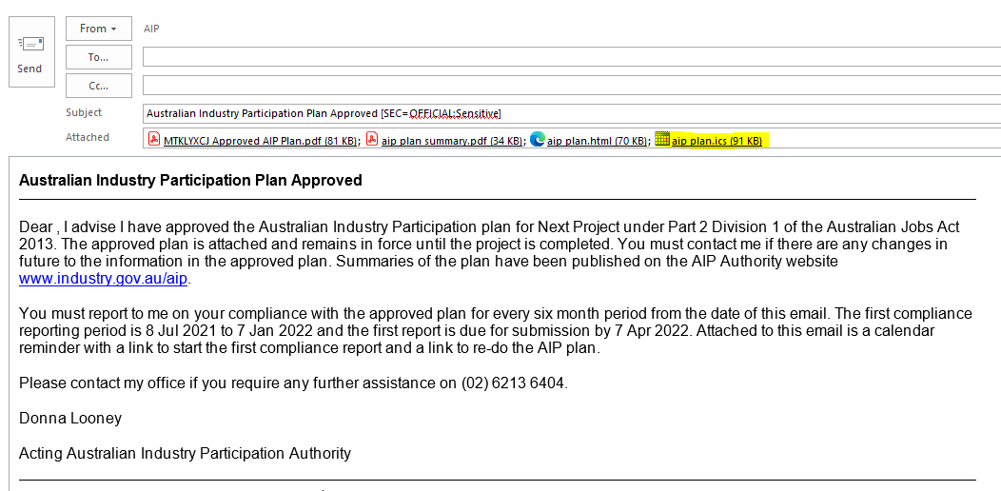

Click on the link within the calendar reminder:

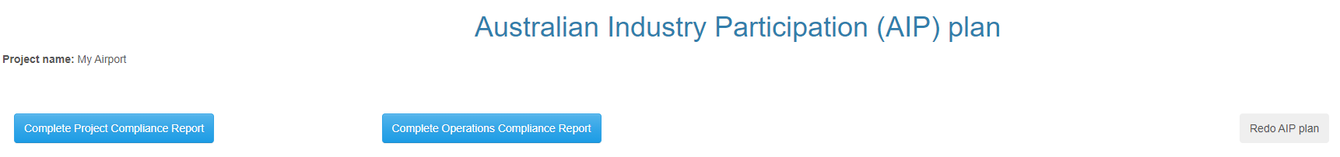

If you are the nominated project proponent reporting on Part B of the approved AIP plan, select ‘Complete Project Compliance Report’. If you are the nominated facility operator reporting on Part C of the approved AIP plan, select ‘Complete Operations Compliance Report’. This will open the report for completion:

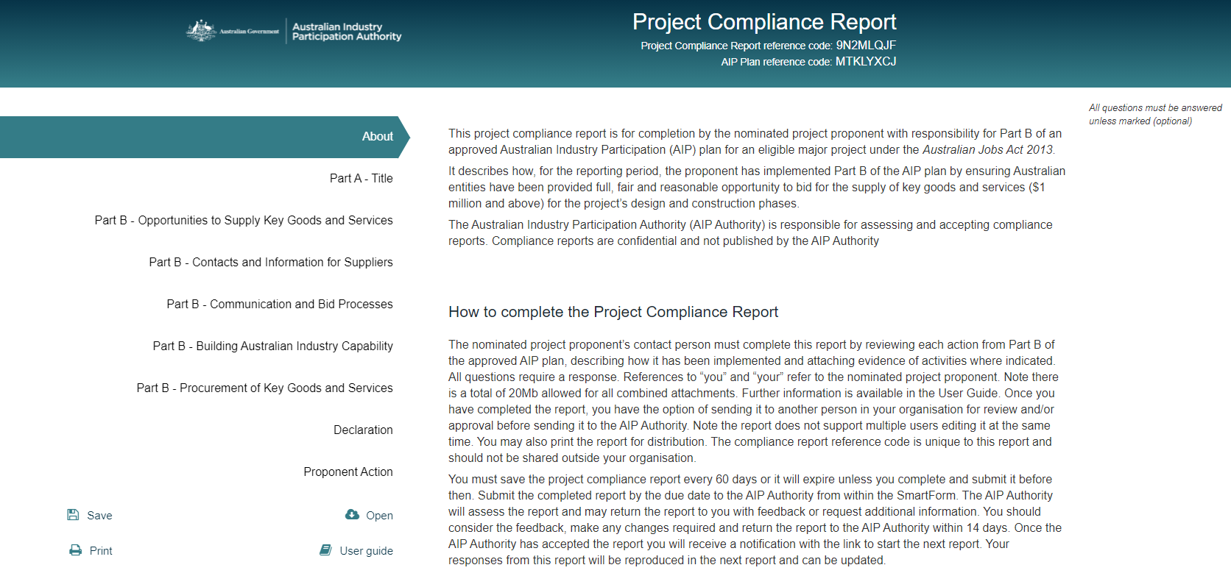

Once you have opened the report it will be assigned a report reference code and can be saved for later editing. Use the link that SmartForm sends you when you save the report to open it again. Do not click on the original link from the AIP plan approval email as a new report will then be generated. You must only submit one report for each reporting period. Do not use the original link for the subsequent compliance reports. These should be opened using the link sent by the AIP Authority when the previous compliance report was accepted.

The About page has important information about the SmartForm compliance report. The tabs on the left-hand side represent each of the sections of the report that you need to complete. A tick next to each tab indicates it has been completed successfully. Important information about the AIP plan and the report are available by hovering over the information symbols .

See the next section of this User Guide for information on how to respond to each of the questions.

Underneath the tabs are the SmartForm icons:

Save – whenever you have finished editing the report save it by clicking on the Save icon. Note that if you do not access and save your report within 90 calendar days of your last save, it will expire, and the report will be deleted. You will not be able to retrieve it and will need to start a new report.

Open – this allows you to re-enter your report using your reference code.

Print – this generates a PDF copy of your report which you can print and distribute.

User guide – this opens the Compliance Reports User Guide which is this document.

In addition, there will be a comments icon when you hover to the right of fields as below:

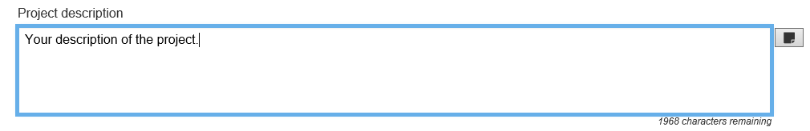

If you click on the icon it opens up a text box where you can add comments relating to the response:

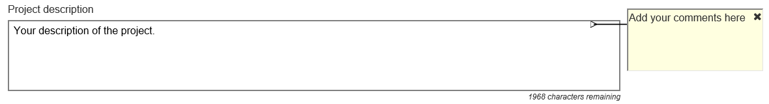

You can use it to leave reminders to yourself or make notes which can be read by other people that you send the report to (see below). You can add to, edit or delete comments you or anyone else have made in the report. If you send the report to the AIP Authority the comments will be visible to the AIP Authority, so make sure you delete any internal comments before sending it. Do not use the comments boxes to report on implementation of your AIP plan.

After completion of the compliance report

The last tab is the Proponent Action tab which requires you to select one of the following options after you have completed the report:

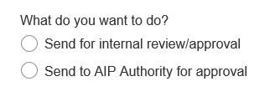

**Send for internal review/approval**

This option allows you to send the SmartForm compliance report to another person in your organisation for review and/or approval. You will need to enter the person’s email address and include a message instructing them on what to do with the report. You can only send the report to one email address at a time:

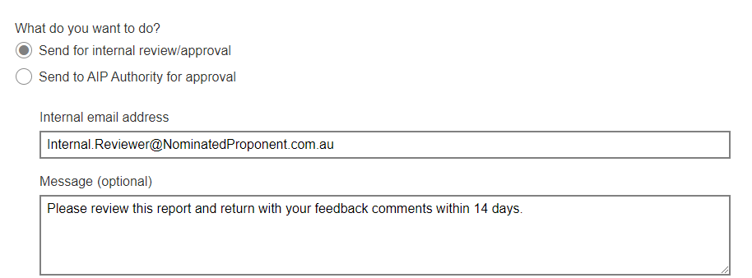

The reviewer will receive an email from SmartForm with the link to open the report like this:

**Project Compliance Report (Jobs Act)**

You have been sent a Project Compliance Report (Jobs Act) for Next Project for review/approval.

<Your message>

Your reference code is **672KQXWD**.

**This saved version will expire on: Thu Oct 22 19:29:52 AEDT 2020.** If it is not saved or submitted before this date and time it will be permanently deleted. The above reference code may be required to open your report. Use the following url, https://forms.test.business.gov.au/smartforms/servlet/SmartForm.html?formCode=australianindustryp2&saveChallenge=true&referenceNumber=672KQXWD to open this report.

Note there is no email address checker in the SmartForm so ensure the email entered is correct. You will not receive bounce-back emails for incorrect email addresses or out-of-office messages. Check with the reviewer that they received the report. If you send the report to an incorrect or dormant email address you cannot recall the send. Anyone receiving the link will be able to open, edit and print the report. You can, however, still access the report from your last saved email and re-send it. This will not cancel the access to the report for the original email address you sent it to. If you believe the incorrect address you sent the report to will breach the confidentiality of the report, contact the AIP Authority to have the report cancelled. You can start a new version of the report by clicking on the original link sent by the AIP Authority.

Once you send the report to the reviewer, they will be able to edit it. It is recommended, however, that only the nominated project proponent or facility operator contact person makes changes to the report. Any reviewers can provide their feedback against each response by clicking on the comments icons and entering their feedback in the comments text boxes. When they return the report to you their feedback comments will be visible to you. Note they must return the report to you from the Proponent Internal Review/Approval Action tab by clicking Send:

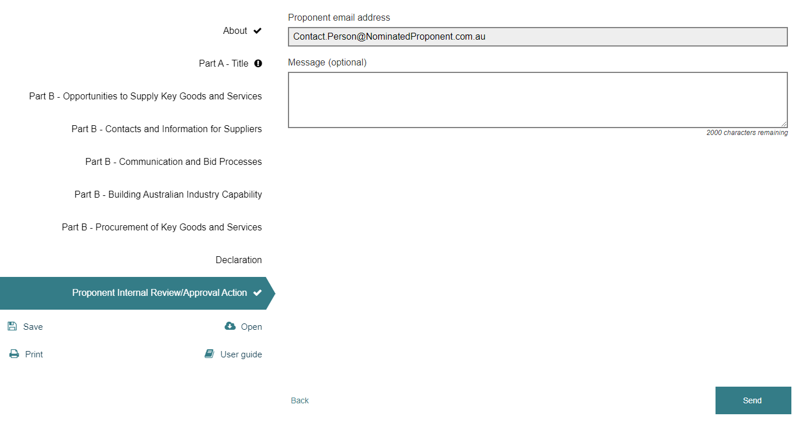

The SmartForm will always return the report to the email address in Part A – Nominated Project Proponent or Facility Operator Contact Person. The reviewer is not able to send the report to a different person or to the AIP Authority. You will receive an email from SmartForm with the link to open the report when it is returned by the reviewer. You may then send the report to another person for review or approval.

While another person in your organisation can approve the report, the Declaration page should only be confirmed by the nominated project proponent or facility operator contact person. Their name appears at the start of the declaration and cannot be changed. The AIP Authority will take it that this person has confirmed the declaration and no other person has confirmed it.

Note the SmartForm compliance report will expire if it is not accessed and saved within 90 days of you sending it to another person. Either the reviewer or you should save the report regularly by clicking on the Save icon and then clicking Confirm in the pop-up box. You will receive an email from SmartForm with the link to re-open your report:

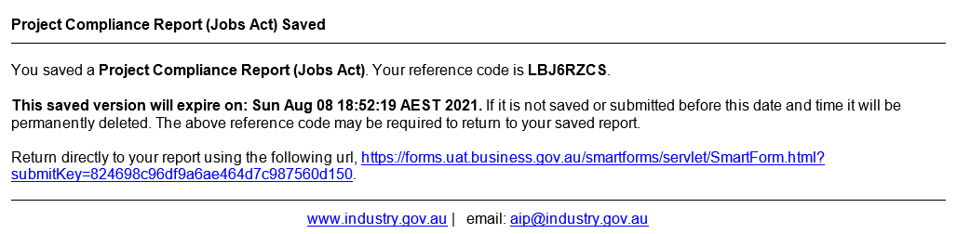

**Send to AIP Authority for consideration**

This option is used to submit the report to the AIP Authority. All reports must be sent to the AIP Authority for consideration. The nominated proponent or facility operator contact person will need to fully complete the report and confirm the Declaration before they can submit it from within the SmartForm by clicking Send. If there is information missing in any part of the report the SmartForm will advise you which questions require completion before you can submit it. Any comments left in the report will be visible to the AIP Authority. Once you submit the report you will not be able to retrieve it. From the Proponent Action tab, select ‘Send to AIP Authority for approval’ and click Send.

SmartForm will send an email to the AIP Authority ([aip@industry.gov.au](mailto:aip@industry.gov.au)) advising the report has been submitted. You will receive a copy of the email from SmartForm as confirmation it has been sent.

Once received, your AIP Authority Case Manager will review the report and provide a recommendation to the AIP Authority. The AIP Authority will consider the report and notify you if the report has met the requirements of the Jobs Act via the SmartForm workflow providing a copy of the compliance report and a link to start the next compliance report.

If the report has not met the requirements under the Jobs Act, the AIP Authority will return the SmartForm to you with feedback on required information or supporting evidence to assist you in updating the report If the report is returned you will receive an email from SmartForm like this:

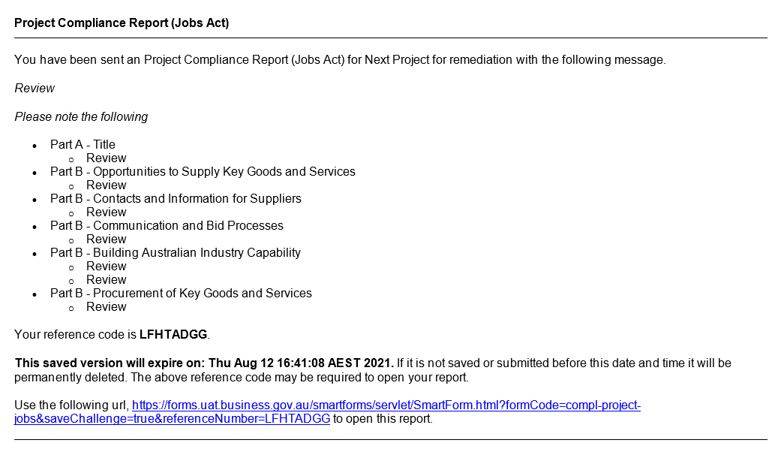

You should consider any feedback, update the report, send it for internal review or approval and return it within 14 calendar days to the AIP Authority in the SmartForm. Delays in returning the updated report could result in non-compliance. Your case manager will consider the report and forward it with their recommendation to the AIP Authority for consideration.

If the AIP Authority determines that the report meets the requirements of the Jobs Act, you will receive an email from SmartForm providing a copy of the compliance report and a link to start the next compliance report. This email is the formal notice from the AIP Authority that the report meets the requirements of the Jobs Act.

If the AIP Authority determines the report has still not met the requirements under the Jobs Act, you will receive an email from SmartForm with feedback to assist you in updating the report. You must update the report and return it to the AIP Authority within 14 calendar days.

Compliance reports that have not met the requirements of sections 25(7) and 26(4) under the Jobs Act before the due date for submission of the next compliance report, will be recorded as non-compliant in the register of major projects and administrative consequences may be applied. The AIP Authority will request from the proponent or operator a rationale for any matters of non‑compliance, before considering if any penalties such as administrative consequences will be applied.

How to answer each question in the compliance reports

This section describes how to complete the questions in both the Project and Operations Compliance Reports. The information on questions is from the Project Compliance Report but the questions in the Operations Compliance Report are the same.

The compliance reports have the same format as the AIP plan. Each question has the action from the approved AIP plan followed by a text box in which proponents and operators should describe how the action has been implemented during the reporting period. This is followed by a function that enables evidence of the implementation to be uploaded to the report. There are also comments icons next to each question. These are for reviewers of the report and the AIP Authority to provide feedback. Do not use these comments boxes to report on implementation of the AIP plan. If there is insufficient space in a text box attach the additional information using the upload evidence function for that question.

Some of the questions allow proponents and operators to modify the information from the approved AIP plan. This is the preferred method for advising the AIP Authority of changes to information in the AIP plan such as proponent, project and contact details. If information that is not amendable in the reports needs to be changed a replacement AIP plan will be required.

All references to “you” and “your” in the compliance reports refers to the nominated project proponent for Project Compliance Reports and the nominated facility operator for Operations Compliance Reports.

It is important to provide information on how the AIP plan was implemented during the reporting period only. SmartForm will include your responses from the previous report if applicable and these should be updated by you. If there was no implementation activity during the reporting period for an action state this and provide an explanation. Do not provide information on future activities in the report.

A copy of the SmartForm Project Compliance Report is at the end of this User Guide. The following provides more information on how to answer each question in the reports.

### **Part A – Title**

**Project/Operations Compliance Report**

Select the Project or Operations Compliance Report number from the list.

Select the Compliance reporting period start date by clicking on the date symbol and selecting the first day of the reporting period. If you are completing the first Project Compliance Report for the project this will be the date when the AIP plan was approved. For all subsequent Project Compliance Reports this will be the day after the end date of the last compliance reporting period. For the first Operations Compliance Report this will be the date when procurement for the initial operations phase of the new facility commenced. For subsequent Operations Compliance Reports this will be the day after the end date of the last compliance reporting period.

The SmartForm will populate the Compliance reporting period end date. Do not change this date unless you have been advised by the AIP Authority of a different end date for the reporting period. If the project was completed during the reporting period select the date of completion. Your report is due after the end of the reporting period and must be received by the AIP Authority within three months of this date.

The SmartForm will populate the Compliance report due date. Do not change this date unless you have been advised by the AIP Authority of a different due date. You must submit the report to the AIP Authority by the due date. Reports received after this due date will be recorded as non-compliant under the Jobs Act and administrative consequences may be applied.

**Nominated Project Proponent Details**

Check the nominated project proponent details are correct. If not, enter the ABN, ACN or name of the nominated project proponent in the Search field. The SmartForm will search for the entity matching those details. Select the correct entity.

Check the contact person details are correct. If not, enter the name, position title, phone number and email address of the nominated project proponent’s contact person for the AIP Authority. This person will be the point of contact between the nominated proponent and the AIP Authority and will be responsible for completing the SmartForm compliance report and submitting it to the AIP Authority. SmartForm will send all communications on the report from the AIP Authority to this person’s email address only. The details of this contact person will not be published and are for the AIP Authority’s use only. The nominated proponent’s contact person must be a director or employee of the nominated project proponent or its holding entity and not an external person or agent.

**Postal Address**

Check the postal address is correct. If not, enter the nominated project proponent’s postal address in the Search field. The SmartForm will search for the address. Select the correct address.

Check the proponent type is correct. If not, select the nominated project proponent’s proponent type from the available options: Single Company, Joint Venture, Public Private Partnership or Government Agency.

**Other Project Proponent Details**

Check the other project proponent details are correct if applicable. If not, provide details for all other project proponents involved in the project which have discharged their AIP plan responsibilities to the nominated project proponent. Enter the details for each other project proponent(s) by selecting ‘Add project proponent’ and searching for the correct entity. Add each other proponent in another row.

**Project Details**

**Project name**

Check the project name is correct. If not, enter the name of the project.

**Project location**

Check the project location is correct. If not, enter the physical location of the project. This should be the street address (if applicable), suburb or other location and the state or territory. If there are multiple locations, enter the principal location.

**Project type**

Check the project type is correct. If not, select the type of facility being established/upgraded by the project from the available options:

|  |  |  |
| --- | --- | --- |
| Airport | Electricity facility | Factory |
| Land transport facility | Mine or quarry | Passenger terminal |
| Petroleum facility | Sewage or wastewater facility | Telecommunications network |
| Water supply facility | Wharf or other port facility | Other productive facility |

If more than one type of facility is being established/upgraded, select the principal type of facility for the project. If selecting ‘Other productive facility’ provide a description of the facility being established or upgraded.

**Project purpose**

The Project purpose describes the principal purpose of the project as either to upgrade an existing eligible facility or establish a new eligible facility. It will have been pre-populated from the AIP Notification or by the AIP Authority and cannot be amended by the proponent in SmartForm. If the Project Purpose needs to be changed contact the AIP Authority.

**Project capital expenditure**

Check the estimate of the total expenditure of a capital nature for the project in Australian dollars (AUD). If it needs to be updated enter the new total estimated capital expenditure value.

**Project description**

Check the project description. If it needs to be updated enter a full description of the project including principal activities and components, timelines and procurement strategy. This description should provide enough information for Australian entities to determine if they are suitable to provide goods and services to the project.

**Project completion date**

Check the project completion date. If it needs to be updated select the estimated date for completion of the construction phase of the project by clicking on the calendar icon. If the exact date is not determined, enter the last day of the month of completion.

**Project update**

Provide a project update for the reporting period, including an overview of the procurement and work undertaken or completed for the project, in the text box and an explanation for any changes you have made to the proponent or project details.

**Part B – Opportunities to supply key goods and services**

Select Yes or No to the question on have you or your procurement entities conducted any AIP plan implementation activities during the reporting period. This refers to any of the actions from Part B of the AIP plan such as maintaining a project opportunities website. If you select No provide an explanation such as project delays. You will still be required to complete and submit the report.

**Indicative List of Key Goods and Services for the Project**

**Select Yes or No to the question on is the indicative list of key goods and services from the AIP plan still current. Refer to your AIP plan for the list. If you select No provide an explanation of the changes.**

**Maintain Understanding of Australian Industry Capability**

The actions from your approved AIP plan are reproduced in the report. Enter information in the text box on how you implemented these actions to ensure your procurement entities maintained a current understanding of Australian industry capability. Upload evidence of implementation, such as market research for potential suppliers, Industry Capability Network (ICN) engagement or a supplier database.

**Project Standards**

The standards information from your approved AIP plan is reproduced in the report. Enter information in the text box on how you ensured the project standards were implemented on the project. Upload evidence of implementation, such as the design standards specified in requests for tender.

**Part B - Contacts and Information for Suppliers**

**Project Proponent Contact Person**

Check the details of the contact person for supplier enquiries. If they need to be updated enter the new details.

**Procurement Entity Contact Person**

The confirmation from your approved AIP plan is reproduced in the report. Enter information in the text box on how you ensured your procurement entities had a procurement contact person for the project. If you are the sole procurement entity for the project confirm this in the text box.

**Project Proponent Website**

Check the project proponent website details. If they need to be updated enter the new details. Upload evidence of the website, such as a copy of the web page with details of the project.

**Project Opportunities Website**

Check the project opportunities website details. If they need to be updated enter the new details. Upload evidence of the website, such as a copy, or screenshot, of the web page/s displaying the opportunities, along with any pre-qualification requirements, standards and the contact person’s details.

**Procurement Entity Website**

The actions from your approved AIP plan are reproduced in the report. Enter information in the text box on how you ensured your procurement entities published the required information. If you are the sole procurement entity for the project describe how you have published this information. Upload evidence of implementation, such as the web page that displays the details.

**Part B - Communication and Bid Processes**

**Engagement and Communication**

The actions from your approved AIP plan are reproduced in the report. Enter information in the text boxes on how you implemented these actions during the reporting period. Upload evidence of implementation, such as engagement with industry associations and vendor identification agencies, supplier briefing presentations and media releases.

**AIP Training**

The actions from your approved AIP plan are reproduced in the report. Enter information in the text box on how you implemented these actions during the reporting period. Upload evidence of implementation, such as AIP policies, AIP training materials and workshops with procurement staff.

**Equal Bid Timeframes**

The confirmation from your approved AIP plan is reproduced in the report. Enter information in the text box on how you ensured your procurement entities provided equal bid timeframes. If you are the sole procurement entity for the project enter information on how you provided equal bid timeframes. Upload evidence of implementation, such as web pages or tender documents that specify the closing date for expressions of interest or bids.

**Part B - Building Australian Industry Capability**

**Capability Development**

The actions from your approved AIP plan are reproduced in the report. Enter information in the text boxes on how you implemented these actions during the reporting period. Upload evidence of implementation, such as support for suppliers to become accredited, supplier development workshops and examples of technology transfer and alliance building.

**Global Supply Chain Integration**

The actions from your approved AIP plan are reproduced in the report. Enter information in the text boxes on how you implemented these actions during the reporting period. Upload evidence of implementation, such as introductions to global suppliers, support to register with databases and facilitating supplier accreditations.

**Feedback**

The actions from your approved AIP plan are reproduced in the report. Enter information in the text box on how you implemented these actions at each stage of the procurement, i.e.: after shortlisting of expressions of interest, after any subsequent pre-qualification and after award of contracts during the reporting period. Upload evidence of implementation, such as deidentified emails offering feedback to unsuccessful suppliers, written records of oral feedback and referrals to training programs.

**Supplier Performance**

Provide any details or observations you have in the text box of the capability, capacity and competitiveness of Australian suppliers, including manufacturers, to the project. This information will help the AIP Authority to work with government agencies to improve the capability of Australian suppliers.

**AIP Plan Effectiveness**

Rate the effectiveness of your AIP plan actions to date against the four criteria and provide any supporting comments in the text boxes. This information will help the AIP Authority to determine the outcomes of AIP plans.

**Part B – Procurement of Key Goods and Services**

**Sourcing Decisions**

Select Yes or No to the question on were any contracts awarded for key goods and services ($1 million and above) by you or your procurement entities during the reporting period. If you select Yes complete the Sourcing Decisions table available from the link and upload it to the report. Only include details of contracts awarded by you or your procurement entities during the reporting period. Estimate the percentage of Australian content for each contract. This should be the value of work to be performed in Australia under the contract (manufacture of goods and services performed by Australian employees). It does not mean a contract has been awarded to an Australian entity (ABN holder). Estimate the percentage for contract awards to both Australian and non-Australian entities. Enter data into the template and do not modify the template’s wording or layout.

**Ongoing Commitment Summary**

Provide the cumulative commitments you have made to Australian and non-Australian entities for the project in Australian dollars (millions). Cumulative commitment figures should be rounded up or down to the nearest whole number of millions of dollars. In the first row enter in the cumulative commitments up to the day before the reporting period. In the second row enter in the commitments (value of contracts awarded) for the reporting period (start date to end date). Include all contracts including those below $1 million. Do not include subcontracts awarded by your procurement entities that they will fund.

**Adjustments to previously reported commitments**

Describe any adjustments made to commitments previously reported in the Ongoing Commitment Summary. This could be due to variations in awarded contracts.

**Forecast Major Contracts**

List any $1 million and above contracts likely to be awarded by you or your procurement entities during the next reporting period. For each contract, provide a description and then select the contract value and the contractor type.

Frequently asked questions about Jobs Act compliance reports

**Q: Can we defer completing the reports until we are certain our project is going ahead?**

A: Once the AIP plan is approved for a project you must report on its implementation even if there has been minimal activity on the project.

**Q. Should we wait until we select our procurement entities before completing the reports?**

A. There is no need to wait until you select your procurement entities. You must report on implementation of the AIP plan from the date it is approved.

**Q. Are there any examples of good compliance reports the AIP Authority can share with us?**

A. There are many variations in reports due to project scope, size and sector so it is difficult to provide an example of a report that would cover all these variations. This user guide includes examples of the evidence that proponents should provide with their reports.

**Q. Can we develop our compliance report on our own template?**

A. Proponents must use the SmartForm compliance reports if their AIP plan was done in SmartForm. This ensures you address all the requirements of the Jobs Act compliance report rules. The SmartForm has features to make it easier for you to complete and submit the report. Reports submitted on different templates will not be accepted.

**Q. Do we need to report if we are required to develop a state or territory industry plan?**

A. If you are required to develop a state or territory industry participation plan you may get an exception from doing the Jobs Act AIP plan and compliance reports. Contact the AIP Authority for more details.

**Q. We have several Jobs Act AIP plans for other projects and would like to do one report.**

A. AIP plans and compliance reports are specific to each project you are developing so they cannot be combined into one report.

**Q. Can we submit the draft report without confirming the declaration seeking feedback?**

A. No. The SmartForm requires you to confirm the declaration before you can send the report to the AIP Authority. The AIP Authority will consider your report and either find it meets the requirements of the Jobs Act or return it to you for updating if it does not meet the requirements of the Jobs Act.

**Q. How can we get the other project proponent(s) and facility operator(s) to sign off the report?**

A. You may circulate the PDF copy of the draft report to the other parties for their agreement prior to submission. The AIP Authority does not need to see confirmation from any other project proponents or other operators that they agree to the report. It is taken that the person confirming the declaration in the plan has the authority to do so on behalf of all parties and all parties have been made aware of and accept the report.

**Q. Will the AIP Authority acknowledge receipt of our report submission?**

A. SmartForm will cc you into the email we receive alerting us to your submission so you know it has reached us. If you haven’t heard from the AIP Authority after 30 calendar days contact us on (02) 6213 6404.

**Q. Should we email a copy of the report to the AIP Authority?**

A. It is not necessary to email copies of the report at any stage to the AIP Authority, including your early drafts for review. SmartForm is the platform for submitting and receiving acceptance of reports.

**Q. Can the AIP Authority modify the content of our report after we submit it?**

A. The only fields the AIP Authority can modify in a submitted report are in Part A - Nominated Project Proponent details. This allows the AIP Authority to update the email address so the report can be returned to the correct person. Any other changes to the report can only be done by the proponent or operator after the report is returned to them by the AIP Authority.

**Q. Will the AIP Authority send a formal letter of approval for our report?**

A. SmartForm will send an email notification to the nominated project proponent or facility operator contact person when the report has been found to meet the requirements of the Jobs Act. This is the formal notification from the AIP Authority and letters will not be sent.

The Jobs Act SmartForm Project Compliance Report*



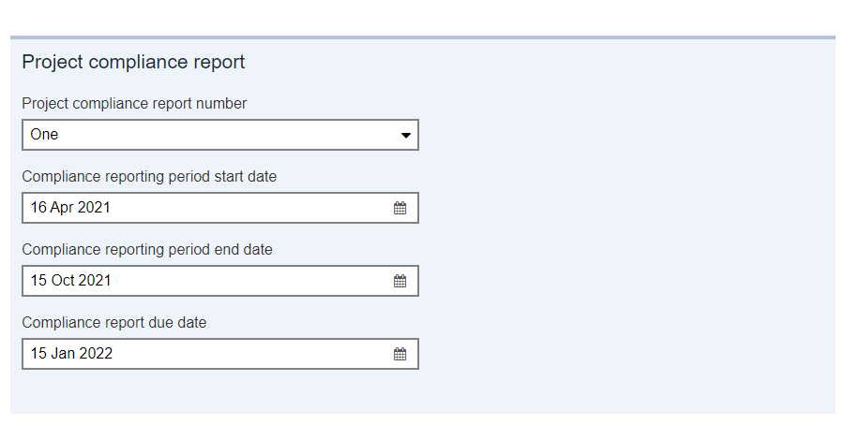

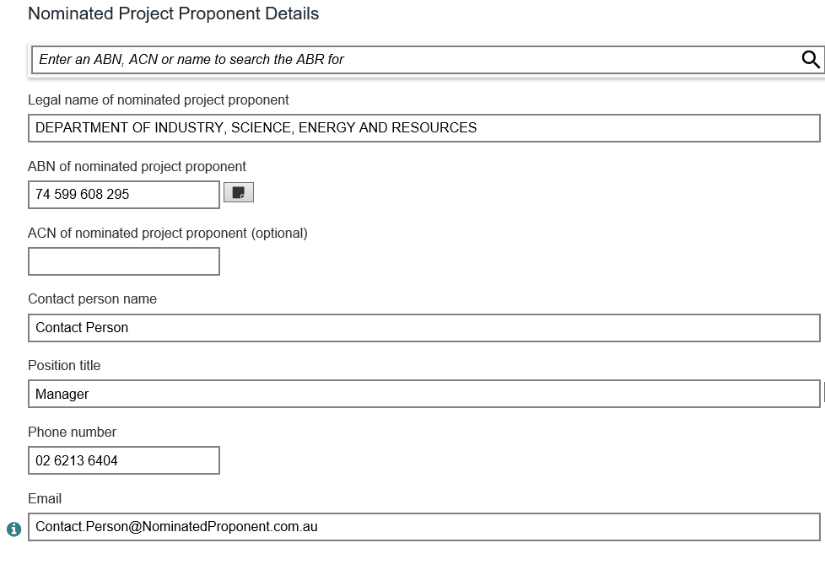

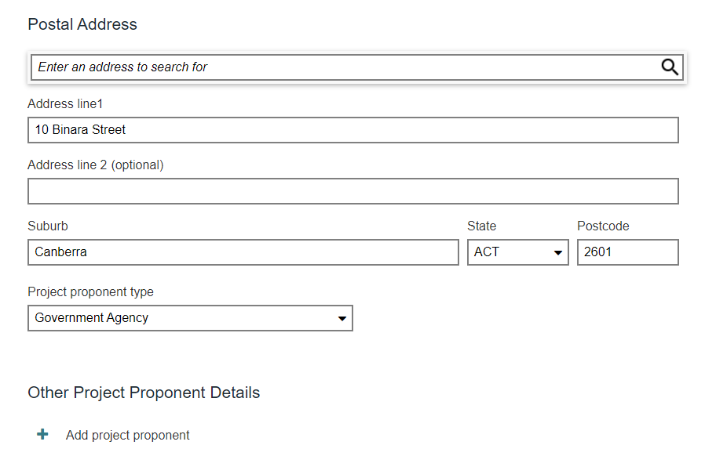

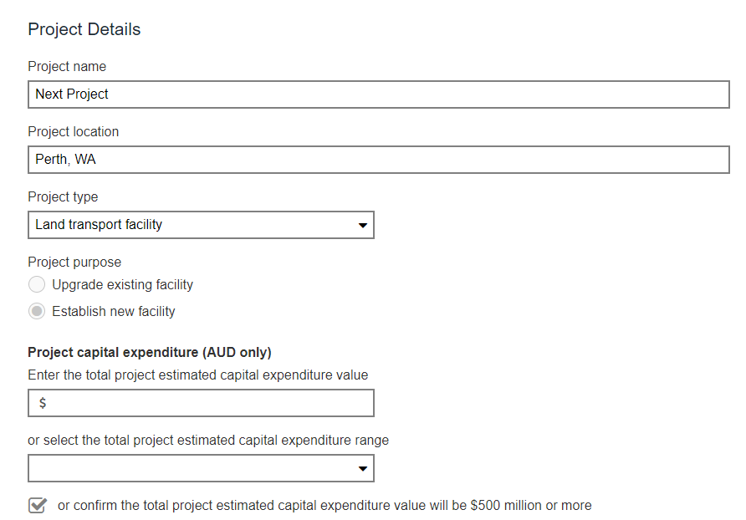

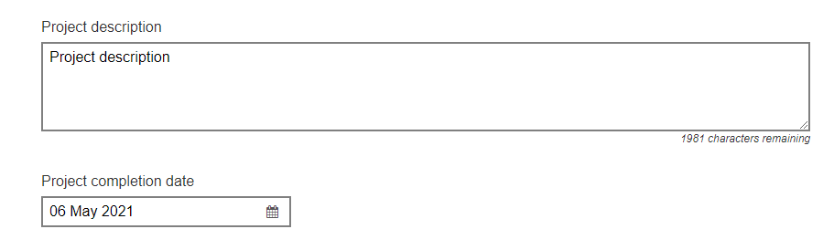

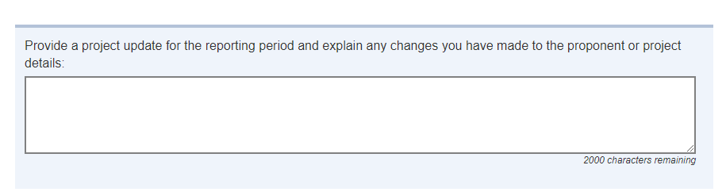

SAMPLE ONLY – DO NOT COMPLETE



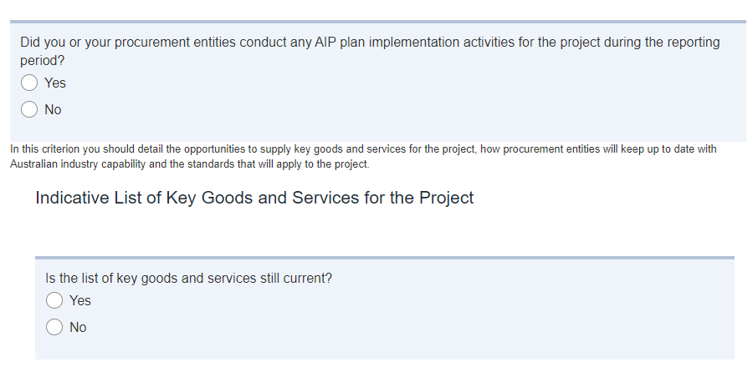

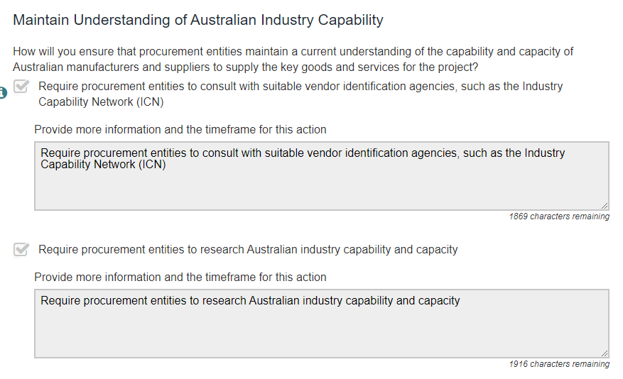

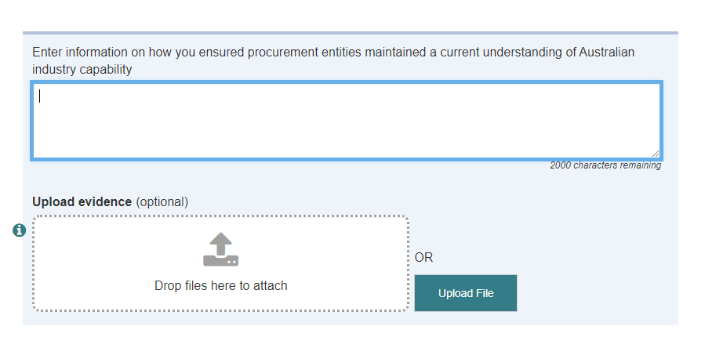

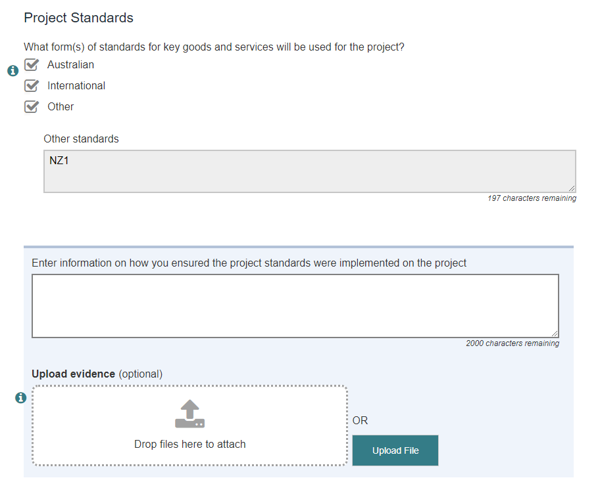

SAMPLE ONLY – DO NOT COMPLETE

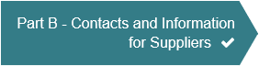

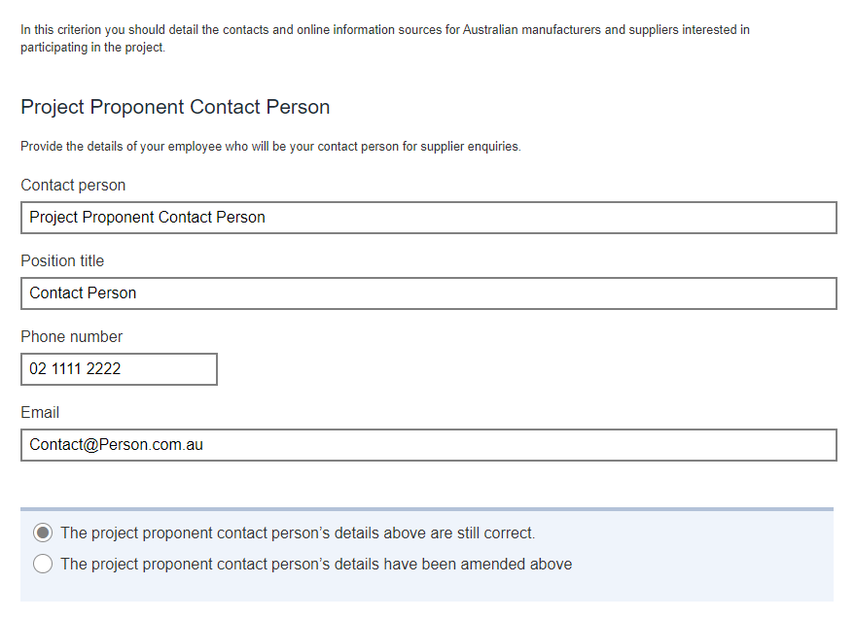

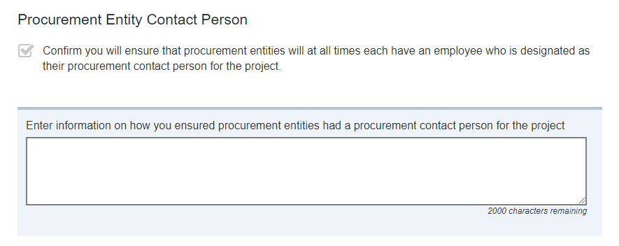

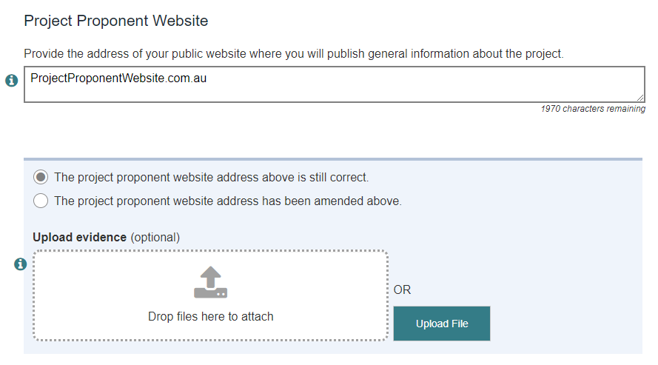

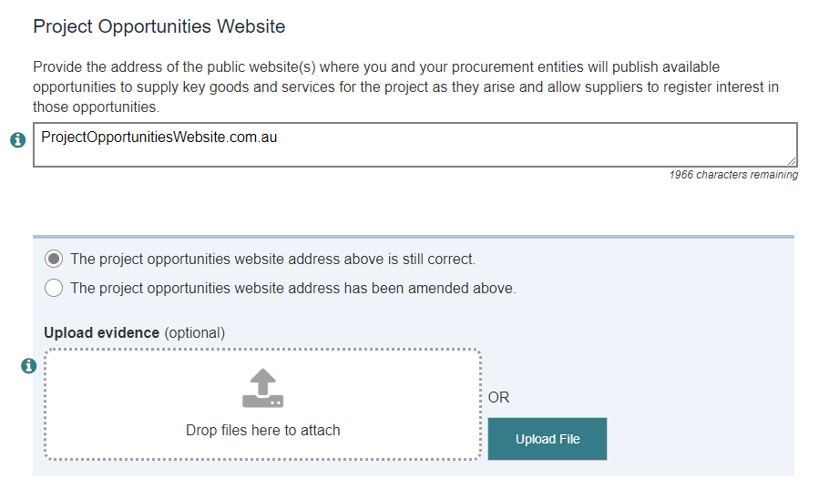

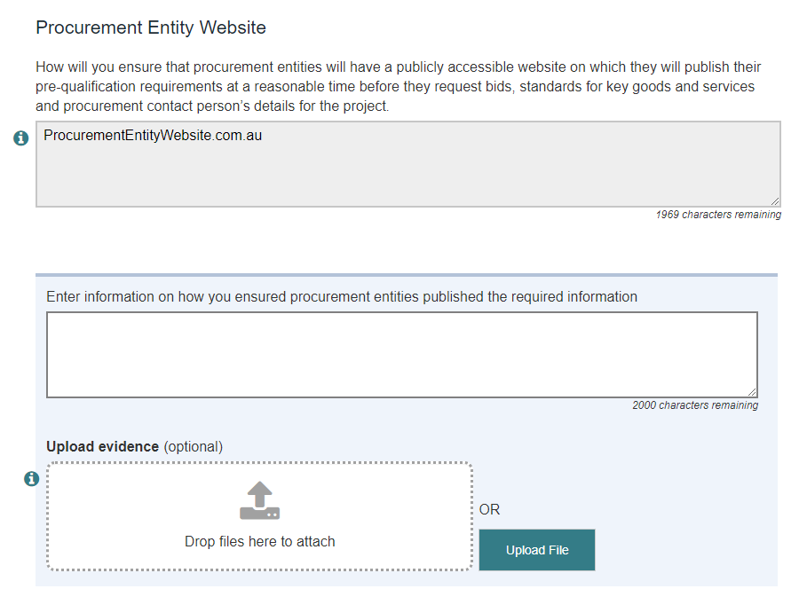

SAMPLE ONLY – DO NOT COMPLETE



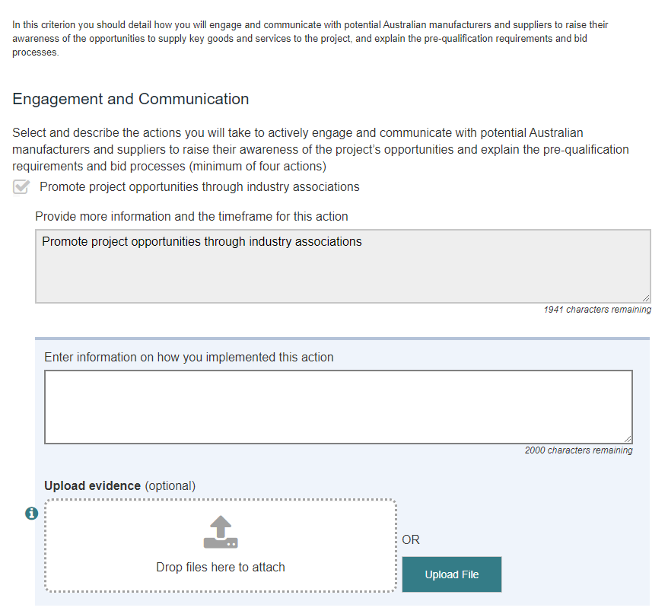

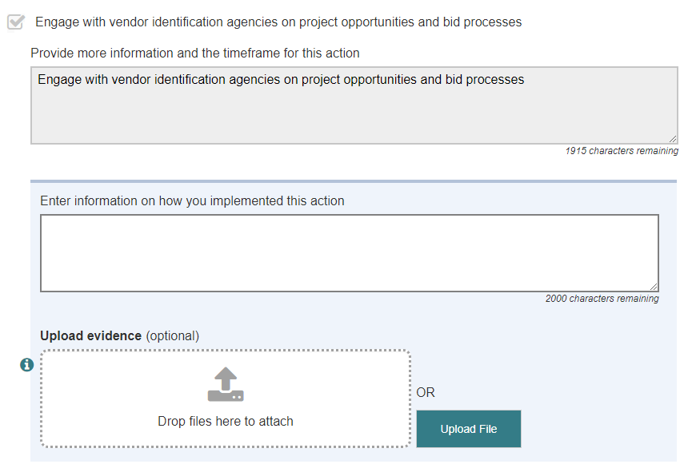

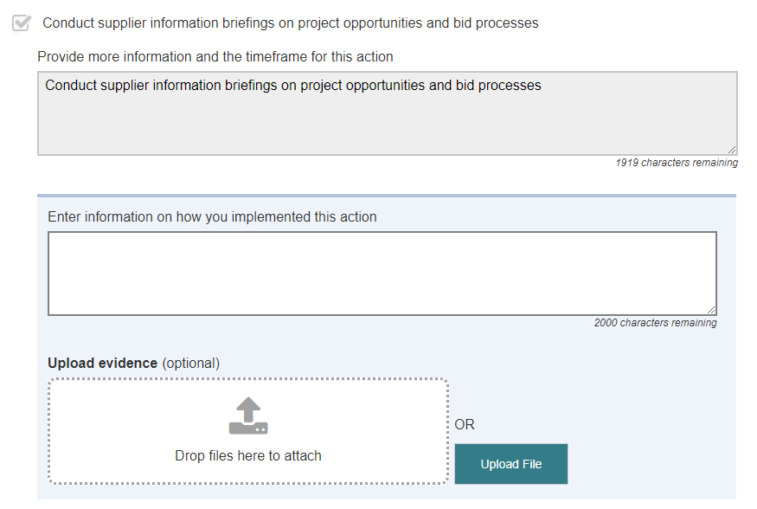

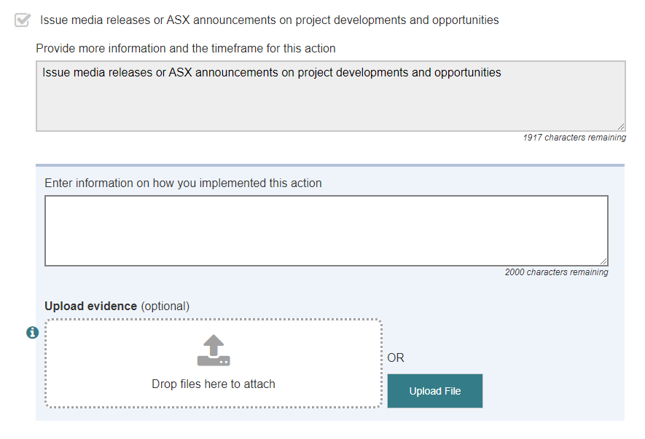

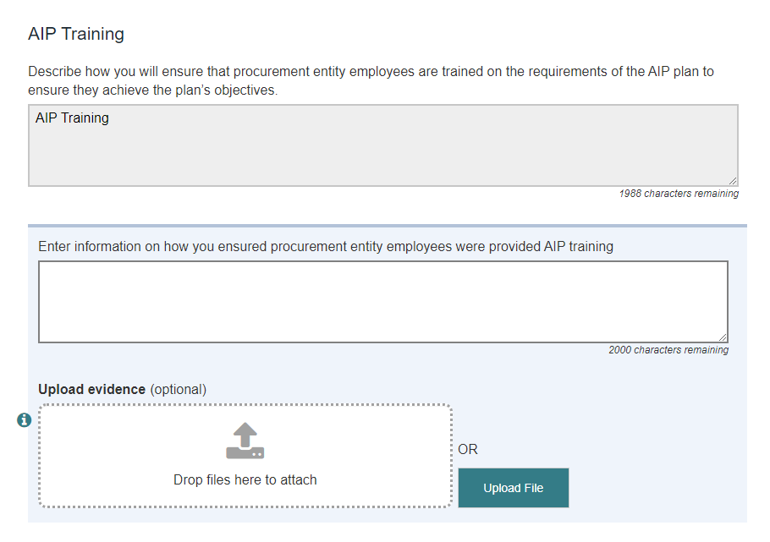

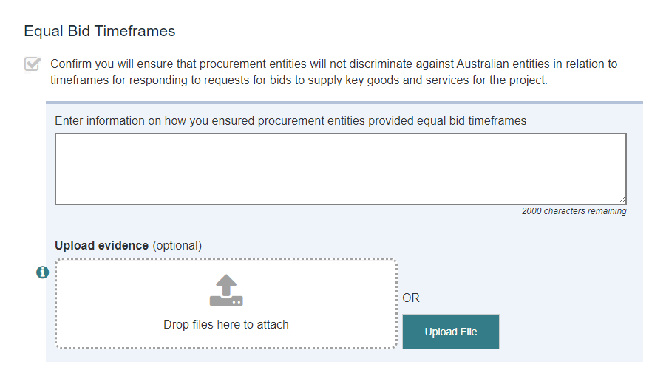

SAMPLE ONLY – DO NOT COMPLETE



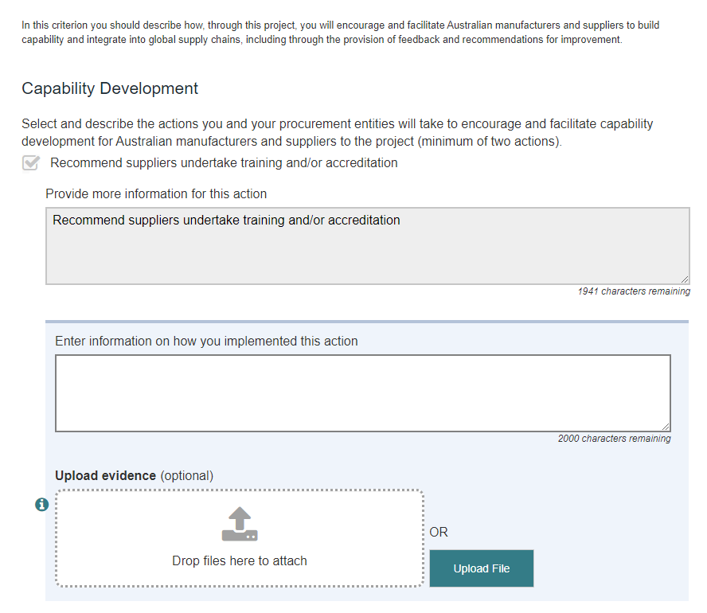

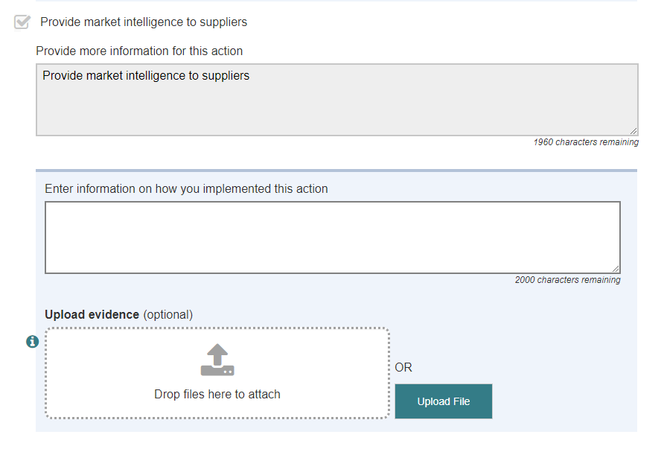

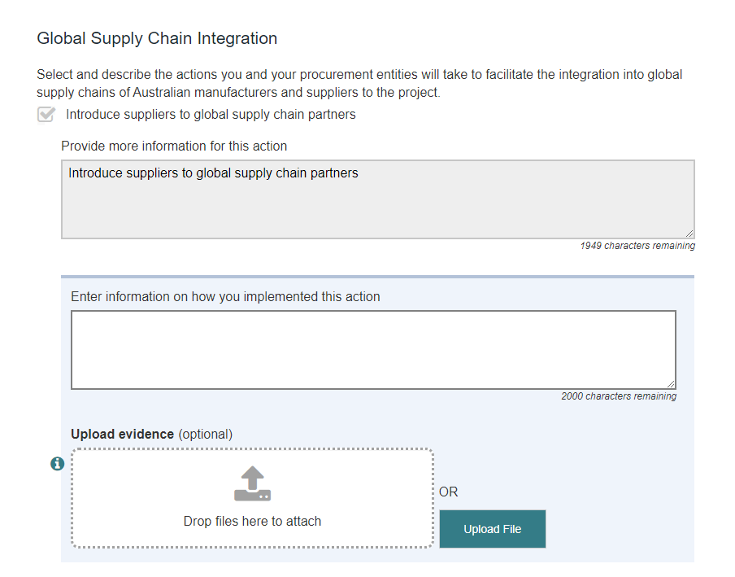

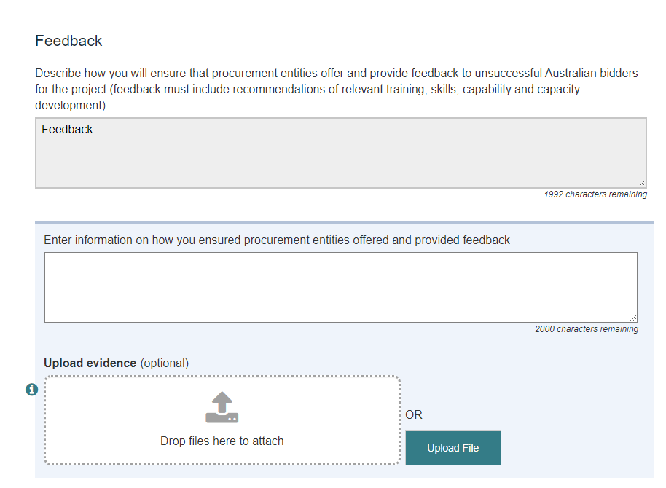

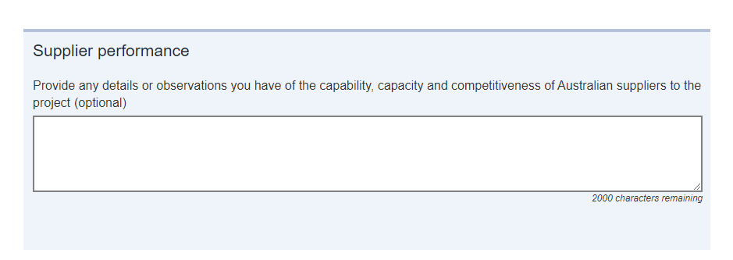

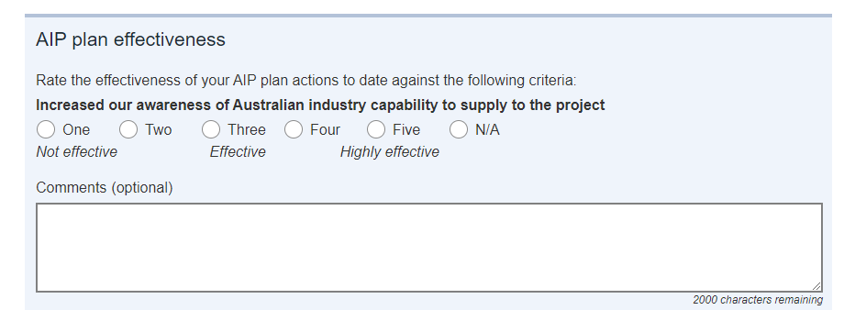

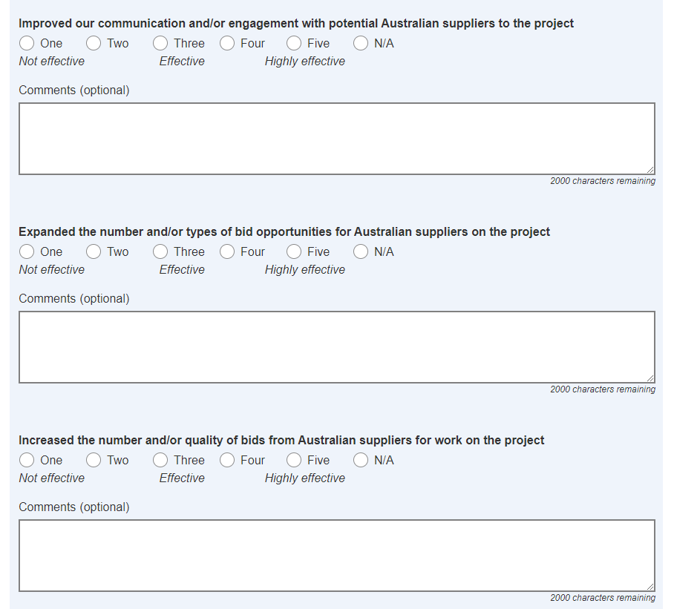



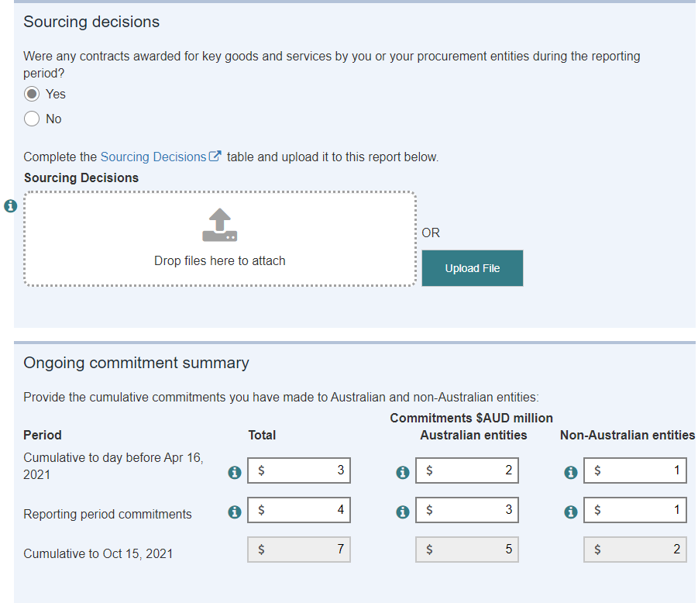

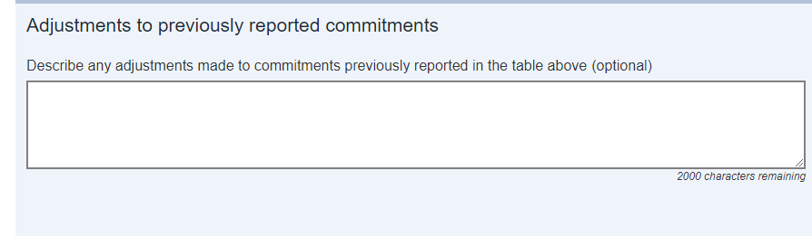

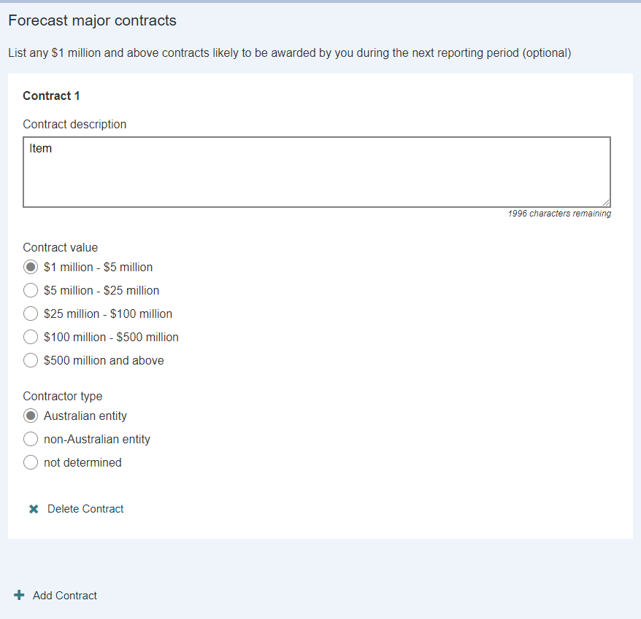

SAMPLE ONLY – DO NOT COMPLETE



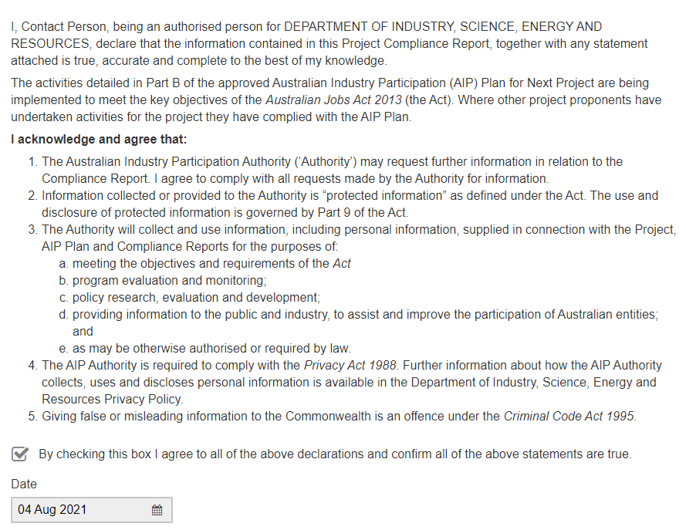

SAMPLE ONLY – DO NOT COMPLETE