*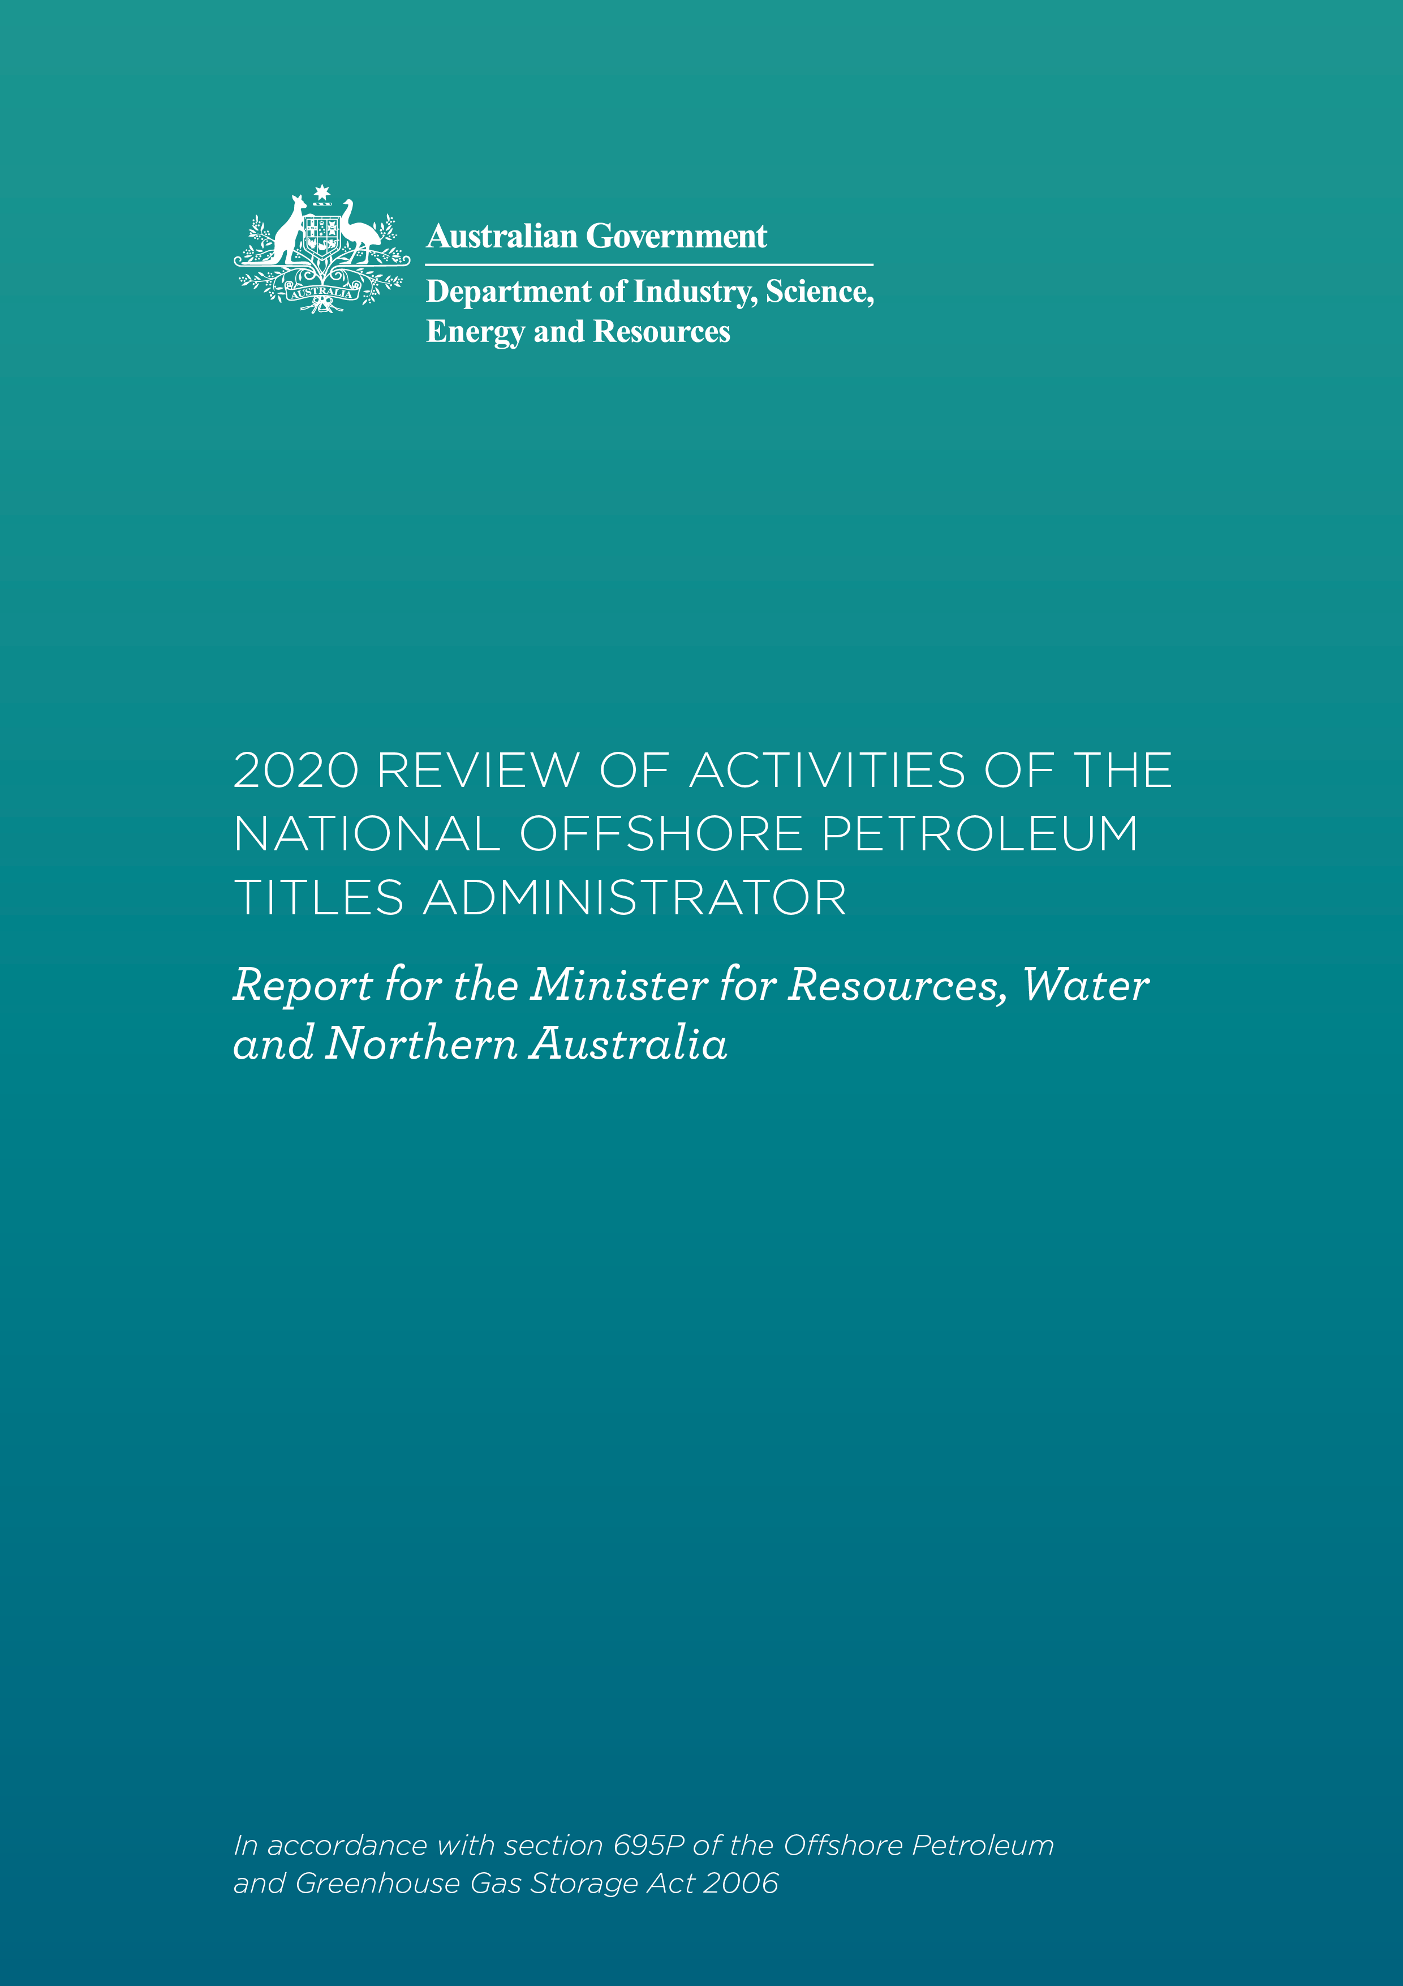*

D:\Tortoise\DeloitteAU\Templafy\Graphics\White_Logo_Access_Economics.emf

Contents

[Summary 5](#_Toc59629263)

[1 Executive summary 6](#_Toc59629264)

[2 Our recommendations and identified opportunities 11](#_Toc59629265)

[3 Review approach and method 16](#_Toc59629266)

[4 Understanding the current industry landscape 19](#_Toc59629267)

[Detailed findings 25](#_Toc59629268)

[5 How does NOPTA effectively administrate and advise on the use of powers? 26](#_Toc59629269)

[6 How does NOPTA enable timely and effective information to be provided to responsible decision-makers? 40](#_Toc59629270)

[7 How does NOPTA administrate and respond to industry through its capability and capacity? 50](#_Toc59629271)

[8 How does NOPTA manage data and information? 64](#_Toc59629272)

[9 How does NOPTA effectively engage with external parties to improve regulatory outcomes and build community confidence? 74](#_Toc59629273)

[10 How does NOPTA reduce the burden for industry and recover costs? 84](#_Toc59629274)

[11 Strategic matters: Looking to the future industry 99](#_Toc59629275)

[Appendices 108](#_Toc59629276)

[Appendix A: Terms of Reference 109](#_Toc59629277)

[Appendix B: NOPTA personnel interviewed 110](#_Toc59629278)

[Appendix C: External parties consulted 111](#_Toc59629279)

[Appendix D: Key NOPTA documentation examined 112](#_Toc59629280)

[Appendix E: Status of NOPTA’s 2015 statutory review recommendations 114](#_Toc59629281)

[Appendix F: Fees and Levies 120](#_Toc59629282)

[Appendix G: Summary of stakeholder feedback 122](#_Toc59629283)

**Inherent Limitations**

The Services provided are advisory in nature and have not been conducted in accordance with the standards issued by the Australian Auditing and Assurance Standards Board and consequently no opinions or conclusions under these standards are expressed.

Because of the inherent limitations of any internal control structure, it is possible that errors or irregularities may occur and not be detected. The matters raised in this report are only those which came to our attention during the course of performing our procedures and are not necessarily a comprehensive statement of all the weaknesses that exist or improvements that might be made.

Our work is performed on a sample basis; we cannot, in practice, examine every activity and procedure, nor can we be a substitute for management’s responsibility to maintain adequate controls over all levels of operations and their responsibility to prevent and detect irregularities, including fraud.

Any projection of the evaluation of the control procedures to future periods is subject to the risk that the systems may become inadequate because of changes in conditions, or that the degree of compliance with them may deteriorate.

Recommendations and suggestions for improvement should be assessed by management for their full commercial impact before they are implemented.

The statements made in this document are accurate, but no warranty of completeness, accuracy, or reliability is given in relation to the statements and representations made by, and the information and documentation provided by the Department’s personnel. We have not attempted to verify these sources independently unless otherwise noted within the document.

**Limitation of Use**

This document is intended solely for the information and use of the Department in accordance with our Contract for Provision of Services 018862 dated 29 June 2020, and is not intended to be and should not be used by any other person or entity. No other person or entity is entitled to rely, in any manner, or for any purpose, on this document. We do not accept or assume responsibility to anyone other than the Department for our work, for this document, or for any reliance which may be placed on this document by any party other than the Department.

**About Deloitte**

Deloitte refers to one or more of Deloitte Touche Tohmatsu Limited (“DTTL”), its global network of member firms, and their related entities (collectively, the “Deloitte organisation”). DTTL (also referred to as “Deloitte Global”) and each of its member firms and related entities are legally separate and independent entities, which cannot obligate or bind each other in respect of third parties. DTTL and each DTTL member firm and related entity is liable only for its own acts and omissions, and not those of each other. DTTL does not provide services to clients. Please see www.deloitte.com/about to learn more.

Liability limited by a scheme approved under Professional Standards Legislation.

Member of Deloitte Asia Pacific Limited and the Deloitte organisation

© 2020 Deloitte Touche Tohmatsu.

Summary

# Executive summary

## Background

The National Offshore Petroleum Titles Administrator (**NOPTA**) was established under the *Offshore Petroleum and Greenhouse Gas Storage Act 2006* (**OPGGS Act** or **the Act**) as Australia’s title administrator for offshore petroleum and greenhouse gas (**GHG**) activities in Commonwealth waters. NOPTA is responsible for supporting effective regulation of Australia’s offshore oil and gas (**petroleum**) resources consistent with good oil field practice and optimum resource recovery.

In 2009, the Productivity Commission *Review of the Regulatory Burden on the Upstream Petroleum (Oil and Gas) Sector* (the **2009 Productivity Commission Review**) was published and identified duplication, overlap, and inconsistencies in the governance of Australia’s petroleum sector. Further impetus from the findings of the *2010 Report of the Montara Commission of Inquiry*, resulted in a decision by the Australian Government to centralise the regulation and administration of the offshore petroleum industry operating in Commonwealth waters.

In 2012, NOPTA was established as a branch within the now Department of Industry, Science, Energy, and Resources (**DISER**) and sits alongside the policy branch, the Offshore Resources Branch, bringing together the administration and policy areas of Australia’s offshore petroleum and greenhouse gas regime into the Resources Division of DISER. NOPTA is responsible for the day-to-day administration of all petroleum and GHG injection and storage titles (referred to collectively as **GHG storage titles**) in Commonwealth waters on behalf of the Joint Authorities. Prior to 2012, the administration of Australia’s offshore petroleum legislative titles framework was overseen by the relevant state/territory governments for each of the seven offshore areas, known as the Designated Authorities. NOPTA’s establishment, effective 1 January 2012, abolished the Designated Authorities. At this time, environmental powers previously held under the Designated Authorities were transferred to the National Offshore Petroleum Safety and Environmental Management Authority (**NOPSEMA**), formerly, the National Offshore Petroleum Safety Authority (**NOPSA**).

As such, there are four parties responsible for delivering the OPGGS Act and its associated regulations (the **offshore legislative framework**[[1]](#footnote-2)). These are:

* DISER Offshore Resources Branch – responsible for the development of government policy in relation to the OPGGS Act (the ‘policy development’ arm)
* NOPTA, a branch of DISER – responsible for the administration and assessment of title applications, with specified functions under section 695B of the OPGGS Act (the ‘administrative’ arm)
* NOPSEMA – responsible for the regulation of safety, well integrity, and environment matters as specified under section 646 of the OPGGS Act (the ‘regulatory’ arm)
* The Joint Authorities – responsible for decision-making as defined in Part 1.3 of the OPGGS Act (the ‘decision-making’ arm).

In accordance with section 695P(1) of the OPGGS Act, NOPTA is subject to a review (the **review**[[2]](#footnote-3)or **the report**) of its activities every five-years following the first review. This is the second review, with the last being undertaken in 2015. The *2015 Operational Review of the National Offshore Petroleum Titles Administrator* (the **2015 Operational Review**) found NOPTA to be *“effective in contributing to the efficiency of the decision making by a Joint Authority for a State or the Northern Territory”* and identified 12 recommendations. Five of these were accepted, one agreed in principle, and six noted by the Government.

## Objective of the independent review

Deloitte (“we”, “our”, or “the review team”) were engaged in July 2020 by DISER to undertake an independent assessment of NOPTA’s role as an administrator in accordance with the terms of reference (**TOR**) prepared by DISER, attached at **Appendix A** for the period of 1 January 2015 to 31 December 2019.

We conducted this review at an extraordinary moment in time – one significantly shaped by the COVID-19 pandemic, global uncertainty, energy demand destruction and oil price collapse. We see NOPTA at an inflection point – it must continue to support a productive offshore petroleum industry that optimises resource recovery in accordance with good oil field practices while also preparing to take on the additional challenges of increased future GHG storage-related activities.

The review’s objective was to determine whether NOPTA has been effective in contributing to the efficiency of decision-making by a Joint Authority for a State or the Northern Territory and the Commonwealth Government (collectively referred to as the **Joint Authorities**).

In writing our report, we have given consideration to the period up to October 2020, where necessary. Importantly, we have also considered future directions of the industry and the associated implications for NOPTA.

## Our findings

Our review has found NOPTA to have generally been effective and efficient across the review period in carrying out its functions under section 695B of the OPGGS Act and effective in contributing to the efficiency of the decision making by a Joint Authority for a state or the Northern Territory. In our review, we assessed that NOPTA’s provision of advice to the Joint Authorities to be timely but do note that focusing on the timeliness and transparency of the end-to-end titles administration process would be of additional benefit for both industry and government.

The Australian offshore petroleum industry will face many challenges and threats over the coming decades, including declining fields, increasing asset transition activity, aging assets, decommissioning and intensifying pressure to reduce emissions. Looking to the future, there will also be many new opportunities to help the industry transition to a more diverse energy mix. NOPTA’s ability to anticipate and respond with agility to challenges and to collaborate and coordinate with the various state, territory, and Commonwealth government partners will be of paramount importance to ensure it can continue to be effective and efficient in future. NOPTA will need to evolve to take an even more influential and proactive role to support the industry with the optimum recovery of resources in accordance with good oil field practice. Underpinning this is the need for a ‘One Government’ approach to the delivery of the offshore legislative framework.

In support of our findings we offer **17 recommendations** for consideration and have identified **9 opportunities**, which are outlined in **Table 2.1** and **Table 2.2**, respectively, in **Section 2**. Collectively, these recommendations and opportunities seek to prepare NOPTA, and the associated components of the offshore legislative framework, to respond to emergent challenges facing the offshore industry in a decisive and effective manner.

### NOPTA: An effective and efficient administrator within its current focus

Based on the evidence we have seen, we believe NOPTA is a competent administrator of offshore petroleum and GHG storage titles in Commonwealth waters. That said, we do identify a number of areas where effectiveness and efficiency could be further improved.

**NOPTA’s processes and procedures are adequate for their purpose. There is benefit from a more proactive consideration of available enforcement options considering the full scope of powers available to it under the OPGGS Act**

From our examination, the titles assessment process is adequate and relies on appropriate operating documents and procedures. NOPTA has established a well-defined compliance process and procedure for receiving information on a titleholder’s progress against committed activities and schedule. For example, the Annual Title Assessment Reports (**ATARs**) submission process enables NOPTA to oversee compliance with a titleholder’s committed development timetable.

With respect to enforcement, NOPTA has outlined high-level guidance of potential enforcement activities within its *Compliance and Enforcement Policy* and the *Compliance Procedure*. NOPTA has not established suitably clear protocols for taking enforcement action. We consider NOPTA to have access, under the various provisions of the OPGGS Act, to a sufficient suite of enforcement powers, although highlight that NOPTA is an administrator and so is limited to advising on enforcement actions to either the Joint Authorities or NOPSEMA. We recommend NOPTA establish set timeframes within a compliance protocol to ensure it has a clearer view over what it will and will not accept from a non-compliance perspective. Where non-compliance is identified, we encourage NOPTA to ensure it proactively considers the full suite of options available to it under the provisions of the OPGGS Act. This should consider enforcement options available through NOPSEMA as the offshore legislative framework’s regulator to ensure an appropriately graduated set of powers may be applied before cancellation of a title is sought.

**NOPTA has built a trusted relationship with Joint Authority delegates and is generally timely in its advice, but timeliness and transparency will remain a topical issue moving forward**

NOPTA’s primary function is the support of Joint Authorities in making their decisions through the provision of high-quality technical advice. We believe NOPTA is effective in this role. It was apparent from our consultation that NOPTA has built trusted relationships with the Joint Authorities and their delegates. In particular, significant improvements have been made with respect to state/territory delegate relationships over the review period. NOPTA is seen by delegates to be providing thorough and high-quality technical advice that is succinct and clear, which is reflected in the relatively low rates of deviation by Joint Authorities from NOPTA advice, as noted by several delegates we consulted with.

Delegates provided feedback that NOPTA should give greater consideration to policy or strategic impacts on its technical advice and that NOPTA did not always appear to demonstrate sufficient ‘situational awareness’ of these broader issues. We observed that the roles and responsibilities as outlined in the *Operating Protocols for Offshore Petroleum Joint Authorities and Supporting Institutions* (the **Operating Protocols**) may contribute to misalignment in NOPTA’s responsibilities in this regard between NOPTA and the Joint Authorities. In our view, as members of the Australian Public Service (**APS**), NOPTA should ensure it displays the appropriate cognisance of strategic and policy considerations in its advice and be enabled by its state/territory and Commonwealth counterparts to do so.

NOPTA is generally timely in providing advice to Joint Authorities and in making Titles Administrator decisions. Specifically, based on data we analysed, NOPTA has tended to meet the indicative timeframes specified in the Operating Protocols across the review period for Titles Administrator-related titles application assessments and decisions and Joint Authority-related application assessments.

Moving forward, as the industry matures, the timeliness of the overall titles administration process will become increasingly important. We also note, while out of direct scope of our review, strong and near unanimous feedback from industry that the decision-making portion of certain titles applications would benefit from improved timeliness and transparency, particularly where decisions are ‘critical path’ for a titleholder’s project. NOPTA is encouraged to explore further digitisation of the titles process (including Joint Authority elements) to provide greater transparency over decision-making to titleholders and progress of applications.

**NOPTA has sufficient capability and capacity for undertaking its current activities but will need to evolve in future to respond to the industry**

We did not identify areas of sustained over or under capacity. NOPTA’s capacity has increased due to the recruitment of four additional technical staff following a key recommendation from the 2015 Operational Review.

NOPTA’s capacity must be viewed relative to industry activity, both in terms of volume and complexity. As industry activity volumes have fallen, the complexity of activities have increased. This complexity has been observed by NOPTA and is consistent with what we would expect from a maturing industry (e.g. more complex operations and challenges from managing declining and marginal fields). This trend is expected to continue. Although some instances of capacity challenges were raised by NOPTA, we would expect this given the volatility and cyclicality of industry activity.

Some stakeholders suggested NOPTA is “top heavy”. We believe there are opportunities for realignment of NOPTA’s operating model and a consolidation of the management layer to better support cross-functional ways of working and to further increase operational efficiency. As NOPTA evolves, its leadership approach and culture will be required to evolve with it.

NOPTA is to be commended for the depth of the technical skillsets it has developed, particularly in geotechnical areas. We do identify capability gaps in commercial and financial analysis (particularly in transaction due diligence given the predicted increase in transfers and dealings) as they relate to decommissioning. With increasingly complex titles transactions likely, NOPTA will need to ensure it has access to the right depth of capabilities to undertake these activities. The development of these capabilities could be explored in concert with NOPSEMA to avoid duplication wherever possible.

We consider NOPTA to be reasonably efficient within its current remit and cost recovering in an effective manner. Further improvements to operational efficiency may be achieved through the aforementioned operating model realignment. Across the review period, NOPTA made a number of enhancements to the National Electronic Approvals Tracking System (**NEATS**), transitioned internal systems to the cloud, and improved integration of databases to create a more streamlined titles administration process. There are opportunities in enhanced digitisation of the titles process, and supporting digitisation of transactions for titleholders, NOPTA, and the Joint Authorities. NOPTA should explore these in collaboration with industry. Several of our associated recommendations would require amendment to either legislation or regulation. In general, we encourage the movement towards outcome-based data management legislation and regulation.

|  |
| --- |
| The following recommendations apply to section 1.3.1: 2, 4, 5, 6, 7, 8, 9, 17 |

* + 1. An influential and proactive NOPTA is required to meet the challenges of a maturing industry

**NOPTA needs to evolve to be more influential and proactive in supporting the various arms of the offshore legislative framework and, where appropriate, the industry**

Australia’s offshore petroleum industry is at a critical juncture, and therefore, so too is NOPTA as the titles administrator. The industry trajectory is clear and the events surrounding the Northern Endeavour Floating Production and Storage Offtake facility and the broader Laminaria-Corallina fields are an early indicator of the challenges ahead. A more mature industry will see increased transaction activity (with larger operators selling declining and marginal fields to smaller, lower cost operators with the agility to manage these fields economically), fragmentation of asset ownership, increased volume of decommissioning activities, a greater focus by industry on reducing costs, and a general increase in industry complexity.

These trends and risks require an administrator that takes a more proactive and influential role in supporting the various arms of the offshore legislative framework and, where appropriate, the industry, particularly in resource management, optimum recovery, and adherence to good oil field practice. It is critical that NOPTA makes sufficient use of its privileged position to generate strategic intelligence, undertakes proactive stakeholder engagement activities, is further empowered to make straightforward titles administration decisions, and makes use of the full suite of enforcement powers to support decision-makers in acting quickly and decisively to a maturing industry. These are key learnings from international peers who oversee more mature offshore industries.

Our observations on this matter should not be construed as discounting NOPTA’s efforts in applying a greater focus on resource management to date. It is our view that there is a need for NOPTA to *do more* in this space – curating and publishing strategic intelligence. We have made a number of recommendations to the Government covering NOPTA’s proactive and influencing approach to stakeholder engagement and making enforcement recommendations, greater decision-making delegations where appropriate, and a greater focus on strategic matters. These recommendations should be considered together.

|  |
| --- |
| The following recommendations apply to section 1.3.2: 2, 3, 10, 13, 14, 15, 17 |

* + 1. Adopting a ‘One Government’ approach

**The various role and functions of the different facets of the offshore legislative framework are not well understood**

Through our stakeholder consultation with industry, we identified a lack of understanding of the various roles and responsibilities of the administrative, policy development, regulatory and decision-making arms of the offshore legislative framework. This is a common finding in legislative frameworks, particularly where there is a relatively complex legislative delivery model encompassing multiple entities. Further exacerbating this is misalignment and sometimes contradictory understanding of the respective parties’ roles under the offshore legislative framework by other members of the framework. A lack of clarity over NOPTA’s role can create confusion, inefficiency in processes, and misalignment in expectations between stakeholders and NOPTA over NOPTA’s purview. As a result, we suggest that the Government take a more active approach to communicating the respective roles and functions of the arms of the regime to its stakeholders and the public.

**A ‘One Government’ approach is required**

All arms of the offshore legislative framework (administrative, policy, regulatory, and decision-making) must work in unison to address the challenges ahead – even where elements remain independent of one another. A cohesive approach and independence are not mutually exclusive outcomes.

Positively, we have seen evidence of NOPTA frequently engaging with the Offshore Resources Branch of DISER, although alignment on priorities and addressing of information and data sharing barriers, discussed below, remain an area for improvement.

There have been improvements to NOPTA’s and NOPSEMA’s collaboration and coordination across the review period. Example actions implemented by NOPTA and NOPSEMA include joint meetings with titleholders on areas of regulatory overlap, co-location of personnel, sharing of capabilities, and seconding staff where appropriate. NOPTA and NOPSEMA could work together more effectively to share knowledge, coordinate on strategic matters of industry significance, and break down information silos.

We have observed a degree of deviation between the various arms over understanding in roles and responsibilities and, in some instances, interpretations of the OPGGS Act. These inconsistencies within the framework do not support effective and efficient outcomes and may serve to perpetuate misconceptions by stakeholders in the various roles of each party. We recommend the pursuit of greater alignment between the facets of the offshore legislative framework.

A clear theme emerged that NOPTA holds information and data of value to others in the offshore legislative framework but that it is unable or perceived to be unwilling to share this data. The data and information NOPTA can exchange is limited by legislative and regulatory barriers and confidentiality requirements. We see this as a broader issue than just pertaining to the information NOPTA holds and is not for NOPTA alone to address. Current settings are too conservative, and not pragmatic or supportive of a cohesive application of policy or regulation. There is a risk of disconnect of regulatory and policy application, missed policy improvement benefits, and inefficiencies with the current siloed approach. Exchange of data and information is the foundation of any successful partnership. We recommend that the Government identify and address these barriers, applying an outcome-based approach in determining the scope of data to be exchanged, whilst still protecting mandatory privacy and commercial sensitivity requirements.

|  |
| --- |
| The following recommendations apply to section 1.3.3: 1, 8, 11, 12 |

* + 1. Exploration of a unified offshore resources regulator and administrator

**Exploration of a unified model could be given but governance challenges in managing conflicting regulatory purviews must be addressed**

An obvious question is whether the current offshore model that separates the administrative functions of NOPTA from the regulatory functions of NOPSEMA, remains fit-for-purpose in responding to change and delivering the collaboration and coordination required for the industry. The establishment of a unified offshore resources model by moving NOPTA from the Department into NOPSEMA would align to the recommendation for a single national offshore regulator made by the 2009 Productivity Commission Review and result in a more cohesive regulatory landscape.

Conversely, there are strong arguments as to why NOPTA and NOPSEMA were established as separate entities. The primary reason being to avoid actual or perceived conflicts of interest and ensure there is a distinct separation between the administration and assessment of titles applications (NOPTA), the decision makers (the Joint Authorities) and the regulatory objectives for safety, well integrity and the environment (NOPSEMA). This argument is in line with the Hon Lord Cullen’s report into the 1988 Piper Alpha Disaster. International precedent for offshore petroleum regulatory frameworks is generally to have separate administration and licencing from health, safety, and environmental matters (e.g. the United Kingdom and Norway) but this is not universal (e.g. in the case of the Canada-Newfoundland & Labrador Offshore Petroleum Board (**C-NLOPB**)).

A unified offshore resources model would need to establish appropriate mechanisms for addressing such concerns. That said, should NOPTA take a more influential and proactive role in relation to resource management, the need for clear delineation of functions will become more, not less, important.

While we have not taken a position on the question of whether a unified offshore resources model should be established by moving NOPTA from DISER into NOPSEMA – as it requires analysis beyond the scope of the current report – we do see merit in the concept being explored further and recommend the Government considers the appropriateness of this. We also note that the balance of our recommendations are made on the assumption that the status quo model remains in place. Should the Government ultimately decide to integrate NOPTA within NOPSEMA, the appropriateness of NOPTA’s functions, as they relate to resource management, would require revision to ensure such functions do not introduce additional risk in relation to actual or perceived conflicts of interest.

|  |
| --- |
| The following recommendations apply to section 1.3.4: 16 |

# Our recommendations and identified opportunities

Our recommendations and opportunities are consolidated in **Table 2.1** and **Table 2.2**

**Table 2.2**, respectively. Additional considerations and detail relating to recommendations and opportunities are contained within the respective sections where they are raised.

We distinguish between opportunities and recommendations. Opportunities are improvements or enhancements that are tactical in nature and, while important, do not reach the threshold for a formal recommendation. In contrast, recommendations are strategic in nature or are critical improvement areas that exceed the threshold for an opportunity.

**Table 2.1: Consolidated list of recommendations for consideration by Government**

| Report section | Recommendation | |
| --- | --- | --- |
| Effective regulation and use of powers | 1 | The Government should engage with industry and adjacent stakeholders to build a clear and common understanding among these groups of the various roles, powers, and functions of the administrative, regulatory, policy, and decision-making facets of the offshore legislative framework. |
| Effective regulation and use of powers | 2 | NOPTA should, where there is non-compliance identified, seek to proactively make appropriate enforcement recommendations to NOPSEMA or the Joint Authorities through the application of a graduated enforcement approach.  Specifically, NOPTA should:   * Consider the severity of non-compliance it is willing to tolerate for each of its compliance requirements and expectations * Review and refine its compliance process to ensure identified timeframes for compliance action and enforcement recommendations are clear and adhered to * Proactively consider the full scope of enforcement powers available to it across all provisions of the OPGGS Act:   + Considering, in conjunction with NOPSEMA, how NOPTA enforcement recommendations may be actioned or assisted by the regulator (NOPSEMA) under the relevant provisions of the OPGGS Act. |
| Effective regulation and use of powers | 3 | NOPTA should take a more proactive approach to contributing to the management of industry risk by:   * Engaging with industry on identifying areas of highest risk and impacts to titles administration * Focusing resourcing on areas of assessed highest industry risk * The use of data in identifying, monitoring, and managing risks. |
| Timely and effective information provided to responsible decision-makers | 4 | The parties to the Operating Protocols should clarify the expectations of NOPTA giving consideration to strategic and/or policy matters in its technical advice and the parties enablement of this outcome through providing access to or visibility of pertinent matters to NOPTA. |
| Timely and effective information provided to responsible decision-makers | 5 | The Government should consider further mechanisms and opportunities for improving the decision-making timeliness and transparency across the titles administration process where areas of inefficiency are identified ensuring such actions are not to the detriment of the quality of decision-making outcomes. |
| Capability and capacity to regulate and respond to industry | 6 | NOPTA, in collaboration with DISER executives, should realign its operating model to better enable cross-functional ways of working and to reduce the cost to industry where appropriate. This alignment should consider:   * Changes to processes to enable new ways of working and increased digital fluency, ensuring talent processes support the attraction and retention of diverse talent that brings a new and wide range of thinking and experience * Consolidation of management positions within NOPTA to reduce the number of direct reports to the Titles Administrator * Any required changes to support other recommendations accepted by the Government in relation to this review. |
| Capability and capacity to regulate and respond to industry | 7 | NOPTA and NOPSEMA should, once the policy framework for offshore decommissioning has been developed and agreed by the Government, coordinate on the building of capability and capacity for decommissioning and aging asset management (including facilities engineering) and financial/commercial analysis (including transaction analysis and financial capacity). NOPTA and NOPSEMA may consider engaging with peers in more mature jurisdictions to identify the specific capability skillsets required. NOPTA and NOPSEMA should consider opportunities for building a shared capability that can be accessed by both parties to avoid duplication of capabilities and capacity. |
| Managing data and information | 8 | NOPTA should continue to extend NEATS functionality to incorporate:   * Digitisation of the titles assessment process, including digitising of the initiating of the assessment process for a title application (i.e. so that emails are not required to be generated manually) * Industry portal functionality for digital transacting, including data submissions, digital signatures, visibility over decision-making (both NOPTA and Joint Authority elements of the process), digital reporting submission, and access to resource and data submission benchmarking dashboards * Where appropriate, develop functionality within NEATS to incorporate GHG storage titles * A portal for NOPSEMA and NOPTA to interact through to flag titleholder-specific issues and enable greater collaboration and coordination on matters of shared interest (e.g. transfers and dealings) * A portal for Joint Authority delegates to reduce manual handling of approvals. Importantly, this functionality should support digital signatures, notifications to be sent to the delegates, a dashboard view of pending approvals for delegates, and visibility over the status of delegate decisions for titleholders. This will need to consider the risks associated with different processes for decision makers i.e. between delegates and ministers and how these will be mitigated and assured against.   We highlight that a number of these functions will require amendment to either legislation or regulation. |
| Managing data and information | 9 | NOPTA and Geoscience Australia should collaborate with industry to identify and prioritise enhancements to the National Offshore Petroleum Information Management System (**NOPIMS**). Enhancements, some of which are underway, to consider including are:   * Greater integration between NOPIMS and other NOPTA systems, such as NEATS. In particular, this could consider improved linkages between titles information and data management records * Integration between NOPIMS and NOPTA’s online submissions portal to enable data to be received directly from titleholders to the cloud, streamlining submissions (with an eventual aim to enable to ‘cloud to cloud’ data transfers) * Greater data searching/querying capabilities and ability to manipulate and transform information within the system. For example, enabling searching by different data types or keywords e.g. petrography or core porosity.   We highlight that a number of these functions will require amendment to either legislation or regulation. |
| Effective engagement with external parties | 10 | NOPTA should evolve beyond a transactional “title-by-title” approach to stakeholder engagement to become more strategic and proactive in its engagements across stakeholder groups. |
| Effective engagement with external parties | 11 | The administrative (NOPTA), regulatory (NOPSEMA), and policy development (DISER Offshore Resources Branch) arms of the offshore legislative framework should seek to improve their alignment, coordination and collaboration on matters such as policy development, interpretations of the OPGGS Act, exchange of data and information, and shared priorities to deliver a more cohesive ‘One Government’ approach. |
| Effective engagement with external parties | 12 | DISER, NOPSEMA, NOPTA, and relevant state/territory government departments should examine and address barriers inhibiting the secure, seamless, and sensible exchange of information and data between parties to deliver a more cohesive ‘One Government’ approach. |
| Strategic matters: Looking to the future industry | 13 | NOPTA, in consultation with the DISER executive, should seek to continuously improve/update its Strategic Plan document/approach to focus on:   * Reflecting the broader risks and trends of the industry and how these apply to its roles in ‘analysing’, ‘influencing’, and ‘regulating’ the offshore industry * Placing greater emphasis on how it could deliver proactive influencing resource management activities to the benefit of the offshore legislative framework and, where appropriate, the industry * Placing greater emphasis on GHG storage-related activities.   Supporting strategic performance measures should be ‘SMART’ (Specific, Measurable, Achievable, Relevant, Time-bound) and aligned to the desired outcome(s) of NOPTA. |
| Strategic matters: Looking to the future industry | 14 | NOPTA should, with access to industry intelligence and within the overarching policy framework set by the Government, take a more influential and proactive role in supporting the facets of the offshore legislative framework (and, where appropriate, the industry) in regards to resource management in accordance with its broad advisory functions outlined in section 695B of the OPGGS Act. |
| Strategic matters: Looking to the future industry | 15 | DISER Offshore Resources Branch and NOPTA, in collaboration with the states/territory governments, should investigate the feasibility of delegating straightforward decisions (i.e. those that do not bestow resource access rights) to the Titles Administrator supported by an appropriate governance and escalation framework.  This is a modification to a recommendation made as part of the 2015 Operational Review. |
| Strategic matters: Looking to the future industry | 16 | The Government should, in consultation with other stakeholders as appropriate, consider if there should be a single offshore resources regulator covering:   * Offshore petroleum, GHG storage, and titles administration * Regulation of safety and environmental matters for offshore petroleum, GHG storage.   In undertaking this recommendation, there should be regard for:   * The relative merits of alternative options, such as retaining the current model * Governance models for such an entity, with reference to how governance structures can ensure the appropriate involvement of the Joint Authorities, maintenance of regulatory independence by NOPSEMA, and independence between titles administration activities and safety and environmental management regulation. |
| Strategic matters: Looking to the future industry | 17 | NOPTA, in collaboration with other stakeholders, is encouraged to identify areas where advanced technologies (such as predictive analytics) could be applied, particularly with respect to NOPTA’s cross-industry datasets. |

**Table 2.2: Consolidated list of opportunities for consideration by Government**

| Report section | Opportunity | |
| --- | --- | --- |
| Effective regulation and use of powers | 1 | NOPTA is encouraged to evaluate its *Annual* *Assurance Review Plan* to ensure it adequately targets NOPTA’s key areas of risk. At a minimum, NOPTA should consider:   * A range of review activities that cover NOPTA’s key internal risks * Flexibility in the plan to changes in risk ratings (i.e. risk trending) * Any required updates following risk register and hazard control register reviews * Required timeframes for delivery to ensure reviews are conducted in a timely manner * Strategic forward forecasting of the required skillsets, and resource mix to ensure specialists are engaged as required. |
| Capability and capacity to regulate and respond to industry | 2 | NOPTA is encouraged to provide greater clarity over performance expectations to its personnel. As part of this, NOPTA should look to further foster a culture which welcomes open and constructive performance feedback. Importantly, the development of this culture must be ‘leader led’ and modelled by NOPTA’s senior management. |
| Managing data and information | 3 | NOPTA is encouraged to track, manage and report on benefit realisation from its investments in digital initiatives, communicating these benefits in a transparent fashion to stakeholders. This could include reporting on benefits realisation through the *Annual Report of Activities*. |
| Managing data and information | 4 | NOPTA is encouraged to review its quality control (**QC**) procedures with a focus on: identifying root causes of data quality issues; undertaking of spot checks; application of internal consistency checks or other automated detection of data submission issues (where possible); application of set margins or tolerance levels to detect instances where submissions may have erroneous data; and identification and monitoring of potential lead indicators of data submission quality. |
| Managing data and information | 5 | NOPTA is encouraged to assess the feasibility of analysing NOPIMS search meta-data (i.e. to see which searches users make) and, if viable, use this data to strategically prioritise acreage release and pre-competitive work programs accordingly. |
| Managing data and information | 6 | NOPTA is encouraged to develop advanced data management and analytics capabilities to make more effective use of its integrated data sets. |
| Effective engagement with external parties | 7 | NOPTA and NOPSEMA are encouraged to identify further opportunities for building and delivering joint guidance, briefings, or information packages for industry on issues of strategic importance or regulatory overlap, such as decommissioning. |
| Efficient, reducing regulatory burden and recovering costs fairly and equitably | 8 | NOPTA is encouraged to take a more frequent, proactive and structured approach to engagement with stakeholders on its cost recovery process. This could occur via its stakeholder survey conducted once every two years.  As part of implementing this opportunity, NOPTA could improve the level of transparency in relation to the information provided to stakeholders about how fees and levies are developed and expended. |
| Efficient, reducing regulatory burden and recovering costs fairly and equitably | 9 | NOPTA is encouraged to continue, as part of its scenario modelling process, forecast its financial sustainability under different industry activity levels (e.g. an accelerated decline of petroleum industry activity) and with the deferral of major discretionary spend (e.g. office fit out). As part of this, NOPTA should continue to specifically examine how different cost recovery levy and fee structures may offset lower revenue from petroleum titles and how volatility can be managed through different fee and levy structures. This should be factored into NOPTA’s next CRIS process. |

# Review approach and method

## Review approach

To guide our review, we have utilised Deloitte’s Regulatory Assessment Model. Our model has been informed by:

* Our expertise in regulation across a wide-ranging number of industries – from objective and risk-based regulation models to compliance, enforcement-based regulation
* Better practice guides (e.g. Australian National Audit Office’s (**ANAO**) Better Practice Guide for Managing Regulatory Performance)
* Learnings from the Banking Royal Commission, including how the Australian Prudential Regulation Authority (**APRA**) has altered its approach to regulatory oversight and involvement – resulting in the Governance, Culture, Remuneration, and Accountability framework.

**Figure 3.1: Deloitte’s Regulatory Assessment Model**

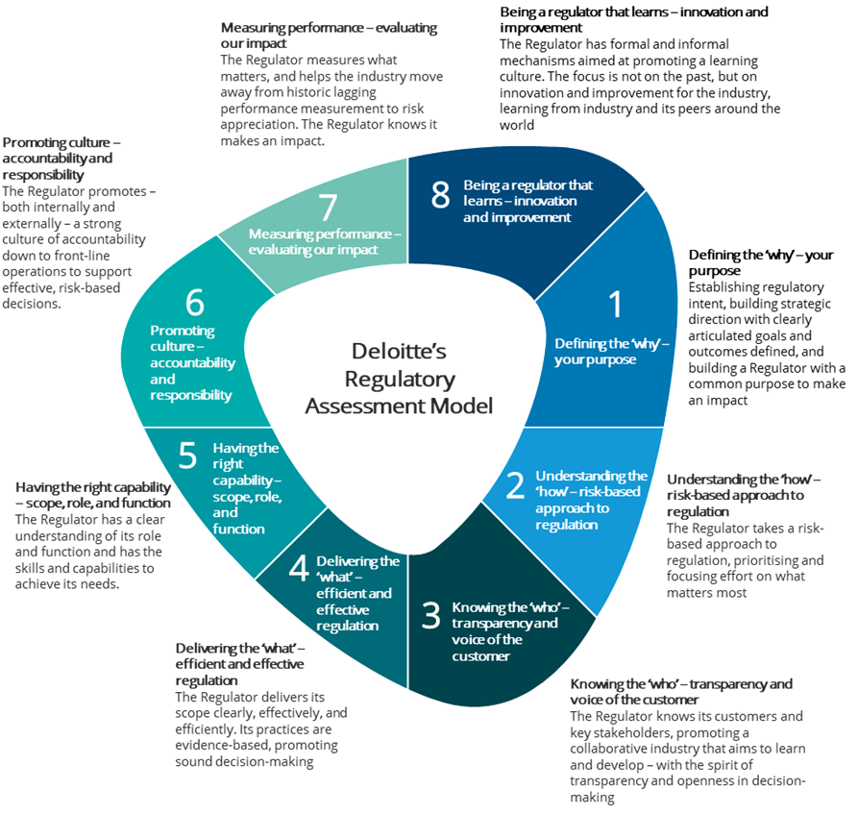

Source: Deloitte

The review approach centred on the following key activities:

* Interviews with key NOPTA personnel, including the Titles Administrator, Strategy & Governance Manager, and Operations Manager. Refer to **Appendix B** for NOPTA personnel interviewed during this review
* Examination of NOPTA-provided documentation, including policies, procedures, corporate plans, performance reports, financial modelling workbooks, and other materials. Refer to **Appendix D** for a list of key documentation and materials examined
* Detailed walkthrough sessions with NOPTA personnel to understand current processes and systems used to discharge its functions
* Consultation with industry stakeholders, including international regulators, titleholders, Joint Authority delegates, Government stakeholders, and industry bodies. Our approach to consultation included a detailed industry survey, structured interviews, and an industry workshop with participants invited to discuss the current risks and trends facing the industry. Please refer to **Appendix C** for a listing of industry stakeholders engaged through our consultation process
* Independent research and analysis of other jurisdictional approaches to regulation of offshore petroleum and GHG storage titles administration.

## Reflecting on past reviews

We recognise there are a number of completed reviews or reviews that are currently in progress that have had or will have an impact on the way NOPTA operates. Of note are the 2015 Operational Review, the *Independent review into the circumstances leading to the administration and liquidation of Northern Oil and Gas Australia (NOGA)* (the **Walker Review**) undertaken by Mr Steve Walker, and the review underway on Parts 7 – 10 and Schedules 1 – 5 of the OPGGS Resource Management and Administration Regulations (**RMA Regulations**).

Our review does not look to duplicate recommendations from the above reviews. Where relevant, we have referenced the previous review and an applicable finding we may agree with, providing endorsement for the direction of the recommendation proposed.

## How to read this report

Our report has been structured into various sections, which are interrelated – with specific details, findings, and suggestions for the Government’s consideration throughout. To achieve the review objectives as set out in the TOR[[3]](#footnote-4), the detailed findings section of our report has been structured to align to the following format:

| **Section** | **Heading** | **Description** |
| --- | --- | --- |
| 2 | Our recommendations and identified opportunities | A consolidated list of our recommendations and identified opportunities |
| 3 | Review approach and method | An overview of the review process we undertook to develop our report |
| 4 | Understanding the current industry landscape | Identifying the future direction of the offshore industry in Australia, including key implications for NOPTA |
| 5 | How does NOPTA effectively administrate and advise on the use of powers? | TOR 1, TOR 4, and TOR 5 |
| 6 | How does NOPTA enable timely and effective information to be provided to responsible decision-makers? | TOR 1, TOR 3, and TOR 8 |
| 7 | How does NOPTA administrate and respond to industry through its capability and capacity? | TOR 11 |
| 8 | How does NOPTA manage data and information? | TOR 2 |
| 9 | How does NOPTA effectively engage with external parties to improve administrative outcomes and build community confidence? | TOR 6, TOR 8, and TOR 9 |
| 10 | How does NOPTA reduce the burden for industry and recover costs? | TOR 10 and 12 |
| 11 | Strategic matters: Looking to the future industry | A look ahead to addressing key industry trends and shifts and the potential impacts of the offshore legislative framework |

TOR 7 has been examined as part of all relevant sections. We have collated the status of progress against recommendations made in the 2015 Operational Review recommendations in **Appendix E**.

All charts, tables and figures with the source listed as *“Deloitte analysis adapted from NOPTA data”* are a reproduction of information using data from NOPTA provided to Deloitte as part of this review.

All monetary figures contained within this report are in Australian Dollars unless otherwise specified.

# Understanding the current industry landscape

Key points

|  |  |
| --- | --- |
| **The Australian offshore industry is maturing and will become increasingly complex**  The report must be read in conjunction with the future direction of the industry. Whilst the review is necessarily ‘backwards looking,’ the recommendations we make and our observations have been informed by where we think the industry, and therefore NOPTA, will shift to in future.  Within the industry, cost pressures, economic uncertainty, and a decommissioning ‘wave’ all serve to create a challenging environment for operators and the government bodies with responsibility for overseeing the industry. These challenges occur against the backdrop of pressures to decarbonise and the energy transition.  As the industry matures, we expect to see increased divestments from Australia by larger operators and the subsequent entry of smaller operators looking to manage increasingly marginal fields. There will be an increase in transaction and decommissioning activity. As a consequence, there will also be new risks for industry and the Government to oversee. The expertise and knowledge required to manage many of these risks may not currently reside in Australia.  As the result of a myriad of factors, each interconnected, we expect the industry activities and titles administration activities to increase in complexity.  **There are clear implications of the future industry for NOPTA to consider now**  Implications we have identified include:   * Importance of reducing regulatory burden and streamlining regulatory processes to support an industry facing cost pressures from economic headwinds balanced with a need for the right processes to enable greater focus on the areas of higher risk * Ability to be agile and adaptable to changing industry characteristics, policy, legislation | * Ability to influence and promote an industry that will become more diverse, fragmented and cost-focused over time * Need for greater collaboration and integration across the Government to address strategic industry challenges in relation to supporting the prudent and efficient management of decommissioning * Ability to rapidly develop new or enhance existing capabilities, people, systems and processes to support changes noted above * A sustainable way to manage regulation of a maturing industry (petroleum) and emerging industry (GHG), particularly where cost recovered revenue may come under pressure * A sustainable and transparent approach to engaging with a diverse and increasingly complex stakeholder ecosystem.   **Offshore GHG functions overseen by NOPTA are an emergent industry**  NOPTA also oversee an emergent industry in offshore GHG storage. At this stage, only 4 GHG storage titles have been awarded, all in the state of Victoria. Demand from industry and therefore NOPTA’s capability and capacity requirements in this space are not fully known. The aforementioned drive to decarbonise and shift to cleaner forms of energy production may stimulate future demand for GHG storage activities and titles applications.  **Recommendations: No recommendations are made in this section.**  **Opportunities: No opportunities are made in this section.** |

## The industry landscape moving forward

**Our report is anchored on key implications from broader industry strategic shifts**

We open this report with a discussion of the offshore industry’s landscape and an identification of the key challenges it faces in future as it matures. This reflects our view that Australia’s offshore petroleum industry is at a critical juncture, and therefore, so too is NOPTA as the titles administrator. It is our fundamental belief that for this report to be effective, its findings must reflect and be cognisant of the industry, as well as advancements in practices more broadly as, increasingly, the industry’s future is intertwined with adjacent developments.

Australia has a significant geographic spread of assets. For example, the marine area under title that NOPTA administers is approximately 552,383km2 [[4]](#footnote-5) Referring to **Figure 4.1**, the majority of titles under issuance are concentrated in Western Australia and Victoria. The number of title applications has varied year-on-year, which presents challenges for NOPTA’s operational capacity management, although the general trend has remained relatively static across the review period (see **Figure 4.2**).

**Figure 4.1: Total number of offshore petroleum and greenhouse gas titles as at 30 June 2020**

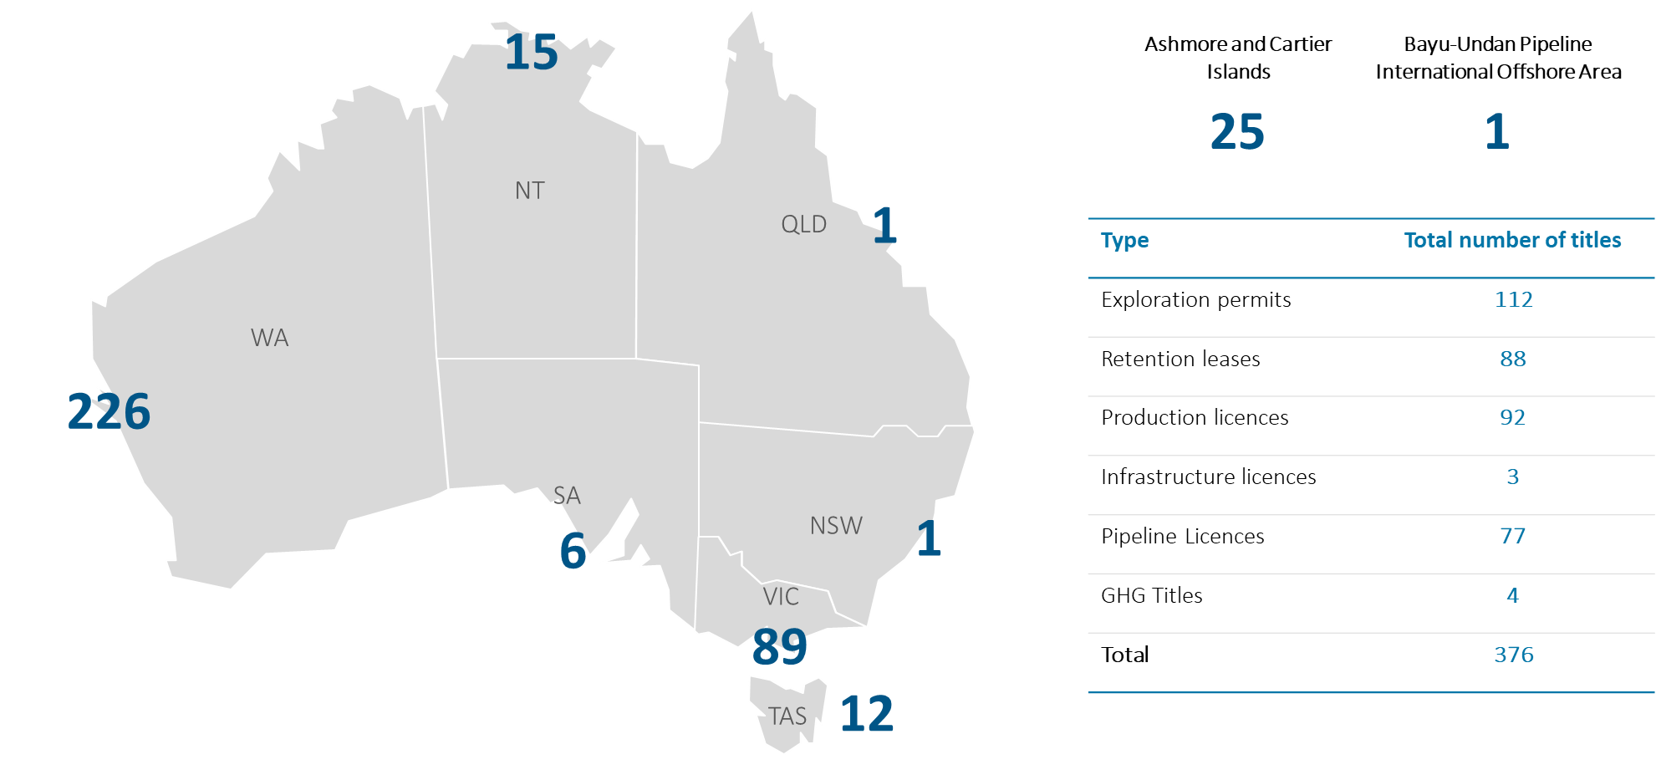

*Source: Deloitte analysis adapted from NOPTA data*

**Figure 4.2: Titles applications submitted by financial year**

Source: Deloitte analysis adapted from NOPTA data

In the short term, the industry will need to manage significant cost pressures and economic uncertainty, which are in part the result of COVID-19, recent and repeated oil price shocks, and existing pressures to reduce emissions. Over the medium term, a maturing industry and an aging asset base create challenges for administrators, policymakers, regulators, and industry alike through a need to prudently and efficiently manage decommissioning. Maintaining community confidence in the offshore legislative framework to manage decommissioning will be essential. Furthermore, the energy transition to a lower carbon future is a key issue for the industry and the Government to manage. Underpinning each of these, there are heightened demands from stakeholders for transparency, engagement, and accountability by the industry and government bodies who oversee it.

As part of our review process we undertook a horizon-scanning workshop with industry stakeholders to identify key risks and trends. A summary of these risks and trends, as well as several we have identified, are outlined in **Figure 4.3** below. This is not an exhaustive list but does serve to underscore the array of risks and trends facing the industry.

**Figure 4.3: Summary of key risks and trends impacting NOPTA**

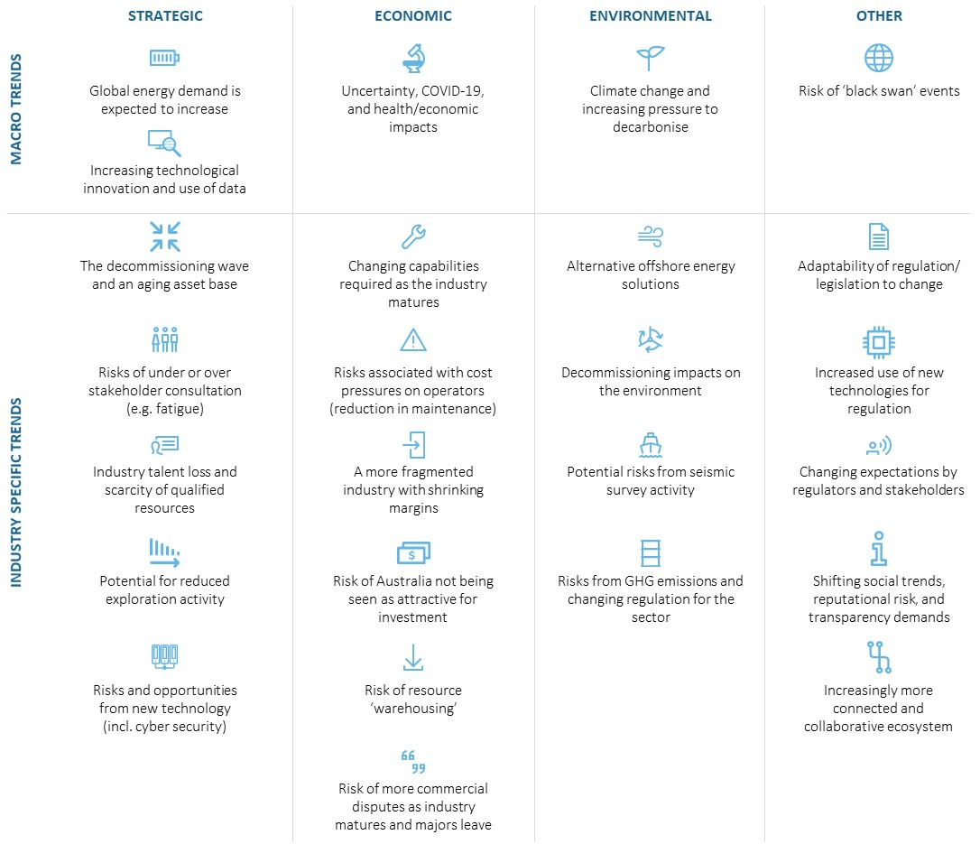

Source: Industry Workshop, Deloitte analysis

**The Australian offshore industry is maturing and will become increasingly complex**

Australia’s petroleum industry is now well established. Moving forward, it is unlikely there will be the same scale of greenfield investment in offshore petroleum activities seen over the past two decades. What does a maturing industry practically mean for Australia’s offshore petroleum industry and the Government? To help answer this, we have looked to markets that are at more advanced stages of the industry lifecycle, specifically the United Kingdom and Norway.

Through our discussions with NOPTA’s international peers, it was identified that in a more mature industry:

* Large offshore operators tend to divest aged assets as their cost structures best align to long-lived, highly productive assets that can be operated to take advantage of significant economies of scale
* The exit of larger operators will stimulate the entry of smaller operators looking to manage late-life marginal production assets. These smaller operators will typically have lower overheads, but also smaller balance sheets, and so will likely have less financial capacity to fund investment associated with ongoing asset maintenance and decommissioning
* The entry of smaller operators into the industry and the stimulation of an active mergers and acquisitions (**M&A**) environment is necessary to foster the ongoing optimal recovery of assets. The clarity, consistency and timing of approval processes underpinning M&A activities will also become increasingly important
* As the assets age, there is a need for greater government-led industry coordination in order to optimally recover resources in accordance with good oil field practice. The offshore legislative framework needs to place greater emphasis (and therefore resourcing) on activities that proactively influence industry to meet this aim. There may be significant lost economic value for Australia should resources not be optimally recovered through the industry’s full lifecycle
* With more offshore assets reaching the end of their economic life, there will be a sharp increase in both transaction and decommissioning activity. For example, **Figure 4.4** illustrates one estimate that the total forecast decommissioning liability for all offshore facilities is expected to exceed $11 billion by 2050. We consider this to be a highly conservative estimate. The industry will need to build the capability and capacity to manage this end of life phase and the Government will need to ensure this is undertaken in a prudently and efficient manner. The importance of ensuring compliance with good oil field practice will also increase as, in our view, good oil field practice includes the prudent provisioning for – and effective undertaking of – decommissioning activities
* Asset ownership is likely to fragment and with increasing fragmentation comes a more complex stakeholder ecosystem to manage
* As average margins narrow on late life assets, the industry’s focus will become increasingly ‘commercial’ in an effort to profitably recover resources from declining and marginal operations. Operators run increasingly lean maintenance schedules and may look to defer maintenance, which can have associated health and safety risks. In addition, price volatility and cyclicality can see target timing for truncation and commencement of decommissioning timetables shift significantly for operators
* Reducing regulatory burden has a proportionately larger financial impact on operators’ profitability and, therefore, has a greater relative importance for these operators
* As a result of the above factors, there is a general increase in the complexity of titles administration activities. While industry production levels decline, there may not be a corresponding immediate reduction in titles administration activities (and therefore NOPTA’s operational resourcing)
* Importantly, regardless of the stage in the industry lifecycle, safety and environment outcomes remain critical.

However, Australia’s offshore industry, while maturing, still operates a number of early-to-midlife assets. Therefore, NOPTA and NOPSEMA oversee an industry which could be described as a ‘two-stage’ industry.

**Figure 4.4: Forecast decommissioning liability for offshore facilities in Australia between 2020 and 2025**

*Includes all facilities ‘offshore’ (i.e. inclusive of facilities within three nautical miles of the Australian coastline) and includes all includes subsea tieback, floater and fixed facilities; based on an exchange rate of AUD to USD of 1.416:1*

Source: Rystad Energy, Deloitte analysis

The factors outlined above present challenges for industry and the Government alike. We are already seeing a number of large operators seeking to exit mature areas (e.g. ExxonMobil and BHP in the Bass Strait and ENI looking to divest its Northern Australia assets[[5]](#footnote-6)). Moreover, the events surrounding the Northern Endeavour Floating Production and Storage Offtake facility and the broader Laminaria-Corallina fields are an early indicator of the challenges ahead. The Government has begun developing a draft decommissioning framework for consultation with industry. At the time of writing this report, the draft framework has not been released. The need for a cohesive administrative, policy, decision-making, and regulatory approach is an imperative.

## Implications for NOPTA

**There are clear implications of the future industry for NOPTA to consider now**

At some level, each factor mentioned above has ramifications for the future of NOPTA. We briefly outline key implications below. Our report must be read with these factors and their implications in mind – they underpin many of our observations and recommendations. We dedicate the final section of our report to examining strategic issues in greater detail.

Key implications for NOPTA include:

* Importance of reducing regulatory burden and streamlining regulatory processes to support an industry facing cost pressures from economic headwinds balanced with a need for the right processes to enable greater focus on the areas of higher risk
* Ability to be agile and adaptable to changing industry characteristics, policy, and legislation
* Ability to proactively influence an industry that will become more diverse, fragmented, and cost-focused over time
* Increased complexity of titles administration activities
* Need for greater collaboration and integration across Government to address strategic industry challenges in relation to supporting the prudent and efficient management of decommissioning
* Ability to rapidly develop new or enhance existing capabilities, people, systems and processes to support changes noted above
* A sustainable way to manage regulation of a maturing industry (petroleum) and emerging industry (GHG storage), particularly where cost recovered revenue may come under pressure
* A sustainable and transparent approach to engaging with a diverse and increasingly complex stakeholder ecosystem.

## Offshore GHG storage

**Offshore GHG functions overseen by NOPTA are an emergent industry**

NOPTA oversees what might be described as a second or adjacent industry: the GHG/Carbon Capture and Storage (**CCS**) emergent industry. Referring to **Figure 4.1**, NOPTA oversee 4 GHG storage titles. At this stage, Australia’s offshore CCS/GHG storage industry is in the early stages of progressing commercial scale applications as a key climate change mitigation strategy. The CarbonNet Project, which aims to establish a commercial-scale CCS network in Victoria, Australia, has an approved environment plan in place with NOPSEMA (approved in April 2019) to drill an offshore appraisal well. Overall, it is unclear of the extent or timing of future demand for CCS/GHG storage and therefore the volume of administrative or regulatory oversight required. Demand will be dictated by a number of factors including the ability to commercialise technologies and government policy.



Detailed findings

# How does NOPTA effectively administrate and advise on the use of powers?

Key points

|  |  |
| --- | --- |
| **NOPTA’s role is not well understood by stakeholders**  Through our stakeholder consultation, we identified a lack of understanding of the roles, responsibilities, and functions of the various arms of the offshore legislative framework by stakeholders. This is a common finding in regulatory frameworks. A misunderstanding of NOPTA’s role may serve to create expectations of its functions that it simply cannot meet. More active communication of all parties’ roles, responsibilities, and functions are required.  **Within its current remit, NOPTA’s processes and practices for supporting titles administration are generally adequate for their purposes**  Through our interactions with NOPTA and stakeholders, we believe NOPTA is a competent administrator of offshore petroleum and GHG storage titles in Commonwealth waters. The titles assessment process is adequate and relies on appropriate operating documents and procedures for guiding the key steps of the titles administration process. Digitisation should be pursued further to deliver further efficiencies.  From a compliance perspective, NOPTA has established a well-defined process for receiving information on a titleholder’s progress against agreed activities. This enables NOPTA to have oversight of compliance issues where the process is not adhered to by titleholders. NOPTA has also developed and implemented robust procedures for guiding its compliance processes.  **NOPTA has robust procedures for guiding its compliance processes. NOPTA’s approach to taking enforcement action is not always sufficiently proactive or timely and could make further use of additional enforcement channels through NOPSEMA in future**  With respect to enforcement, NOPTA has outlined high-level guidance of potential enforcement activities within its Compliance and Enforcement Policy and the Compliance Procedure. Through our interviews and | walkthroughs, we observed instances where NOPTA’s enforcement actions were not, in our view, sufficiently timely.  NOPSEMA offers a further channel for accessing enforcement powers, whereby the Titles Administrator has the ability, among others, to provide direction to[[6]](#footnote-7) a NOPSEMA inspector to exercise entry, monitoring and investigation powers. NOPTA advised they had not been required to draw on the NOPSEMA enforcement powers during the review period as all compliance outcomes during the period were achieved and met without the need to rely upon those powers. However, NOPTA acknowledged they may need to rely upon the powers at some time in the future and are ready, willing and able to do so. NOPTA and NOPSEMA are encouraged to further collaborate on areas where the regulator might assist the administrator in rectifying non-compliance to ensure an appropriately graduated enforcement approach is applied.  **NOPTA does not take a sufficiently proactive approach to contributing to the management of industry risk**  Based on our examination, we believe NOPTA’s current processes are not established with the view to engage with and influence industry risks and issues. Our view is that all arms of the offshore legislative framework must engage in supporting effective external risk management.  **Recommendations: 1, 2, 3**  **Opportunities: 1** |

## NOPTA’s functions and powers

The OPGGS Act establishes a statutory office holder[[7]](#footnote-8) within the Department to perform the functions of the ‘National Offshore Petroleum Titles Administrator’ as outlined in section 695B of the Act.

The Titles Administrator must be a Senior Executive Service (**SES**) employee in the Department who is then specified in a written instrument made by the Secretary. As the Titles Administrator resides within the Resources Division, the position reports directly to the Head of Division. The position is supported by departmental employees, made available by the DISER Secretary to assist the Titles Administrator in the performance of its functions. NOPTA has two offices in Perth and Melbourne, with the majority of personnel based in Perth. There are also a small number of remote workers located in Brisbane and Adelaide. NOPTA’s organisational chart is outlined in **Section 7**.

Part 1.3 of the OPGGS Actestablishes the Joint Authority for each offshore area. NOPTA advises the Joint Authorities and the Responsible Commonwealth Minister (collectively referred to as the Joint Authorities for the purposes of our review) on titles administration decisions relating to offshore petroleum and GHG storage activities. The Joint Authority for the offshore area for each state (except Tasmania) and the Northern Territory is constituted by the responsible Commonwealth Minister and the relevant state or Northern Territory Minister. The Joint Authority for the Eastern Greater Sunrise offshore area, the offshore area of each external territory i.e. the Territory of Ashmore and Cartier Islands and for the Tasmanian offshore area, is the responsible Commonwealth Minister only.

The quality of NOPTA’s advice, and its timeliness, underpin effective and efficient decision-making by the Joint Authorities. Joint Authority decision-making is integral to the functioning of the offshore legislative framework.

**NOPTA’s role is not well understood by all stakeholders**

NOPTA’s activities are driven by its functions specified by section 695B of the OPGGS Act. The *Statement of Expectations* issued by the Commonwealth Minister in October 2019 (the **Minister’s Statement of Expectations**) summarises NOPTA’s legislated functions as outlined by the OPGGS Act to include:

* Advising the responsible Commonwealth Minister (both as a member of the Joint Authority and otherwise) and state and Northern Territory Ministers of the Joint Authority and their delegates
* The day-to-day administration of offshore petroleum titles in Commonwealth waters in accordance with the OPGGS Act and associated regulations
* Decisions in relation to the approval and registration of transfers and dealings, including consideration of the technical and financial capacity of prospective titleholders
* Maintaining a public register of Commonwealth offshore petroleum and GHG storage titles
* Cooperating with NOPSEMA on matters relating to the administration and enforcement of the OPGGS Act and regulations
* Ensuring petroleum resource management is undertaken in accordance with the principles of good oil field practice
* Implementing effective field performance monitoring strategies in order to secure optimum petroleum recovery for the benefit of the Australian community
* Engaging with titleholders on their performance in meeting regulator obligations and expectations
* In partnership with Geoscience Australia and the Western Australian Geological Survey, maintaining the National Offshore Petroleum Data and Core Repository (**NOPDCR**)
* Collecting levies and fees in accordance with government policy and NOPTA’s approved Cost Recovery Implementation Statement (**CRIS**)
* Maintaining a special account consistent with the requirements of the *Public Governance, Performance, and Accountability Act 2013* (**PGPA Act**).

As part of our consultation and through a survey of 33 stakeholders[[8]](#footnote-9), we identified a lack of understanding of NOPTA’s role as the Titles Administrator. In responding to multiple choice questions on their understanding of NOPTA’s role, none of the survey respondents correctly selected all of NOPTA’s functions. There are misconceptions relating to NOPTA’s role in data management and policy setting, with almost 50% of respondents incorrectly stating that NOPTA manages government-related offshore petroleum data and 36% of respondents incorrectly stating that NOPTA develops and maintains government policies on titles administration.

Further to this, referring to Table 5.1 below, less than half (48.5%) of respondents indicated NOPTA was responsible for ensuring petroleum resources are managed in accordance with the principles of good oil field practice, a key aspect of NOPTA’s role. Respondents also indicated NOPTA strongly delivers in the areas it is required to or chooses to focus on, but that it could be more outward facing and agile in its approach.

**Table 5.1: Survey responses to NOPTA’s functions and role**

| **NOPTA has a defined set of functions as specified in the OPGGS Act (section 695B)** | **% of stakeholders who selected the item as a legislated role of NOPTA** | **NOPTA’s functions as defined by the OPGGS Act?** |
| --- | --- | --- |
| Provide advice and recommendations to the Joint Authorities and the responsible Commonwealth Minister | **69.7%** | **Yes** |
| Provide information, assessments, analysis and reports to the Joint Authorities and the responsible Commonwealth Minister | **69.7%** | **Yes** |
| Maintaining records of all petroleum and GHG storage titles | **69.7%** | **Yes** |
| Facilitating the titles administration lifecycle, including reviewing and issuing titles | **63.6%** | **Yes** |
| Conducting compliance monitoring activities relating to titles management | **54.5%** | **Yes** |
| Managing the collection, management and release of government-related offshore petroleum data | **54.5%** | **No** |
| Ensuring petroleum resources are managed in accordance with the principles of good oil field practice | **48.5%** | **Yes** |
| Developing and maintaining government policies and procedures on titles administration | **36.4%** | **No** |

Source: Deloitte Stakeholder Survey, Deloitte analysis

There is a lack of publicly available information to guide stakeholder understanding of NOPTA’s role in the broader offshore legislative framework and how it intersects with the policy development, decision-making, and regulatory arms of the regime. We note this finding is not isolated to NOPTA – we found a similar finding across all arms of the offshore legislative framework – and the Government should seek to address gaps in understanding across the regime to ensure clear and achievable expectations are set.

|  |
| --- |
| Recommendation #1 |
| The Government should engage with industry and adjacent stakeholders to build a clear and common understanding among these groups of the various roles, powers, and functions of the administrative, regulatory, policy, and decision-making facets of the offshore legislative framework. |

In addition to implementing this recommendation, the Government could develop and disseminate information that clarifies what NOPTA does not do (e.g. development of policy). Some factors to consider include:

* The role NOPTA plays in policy decisions
* The role NOPTA plays in acreage release and titles administration
* How overlapping powers with the regulator and policy bodies (e.g. DISER and NOPSEMA) work and who is responsible for what
* How the various parties and stakeholders in industry work together to achieve desired and planned outcomes
* NOPTA’s role in stewardship, education and awareness.

## Titles management

### Purpose of titles

Under the OPGGS Act, a valid title is required before any petroleum or GHG activity can be undertaken in offshore Australia. A range of titles are defined in the OPGGS Act that cover the complete lifecycle of a petroleum or GHG related activity. Six examples of petroleum titles administered by NOPTA are depicted in **Figure 5.1**, although there are a range of titles application types across petroleum or GHG storage activities.

**Figure 5.1: Example** **of six titles administered by NOPTA**

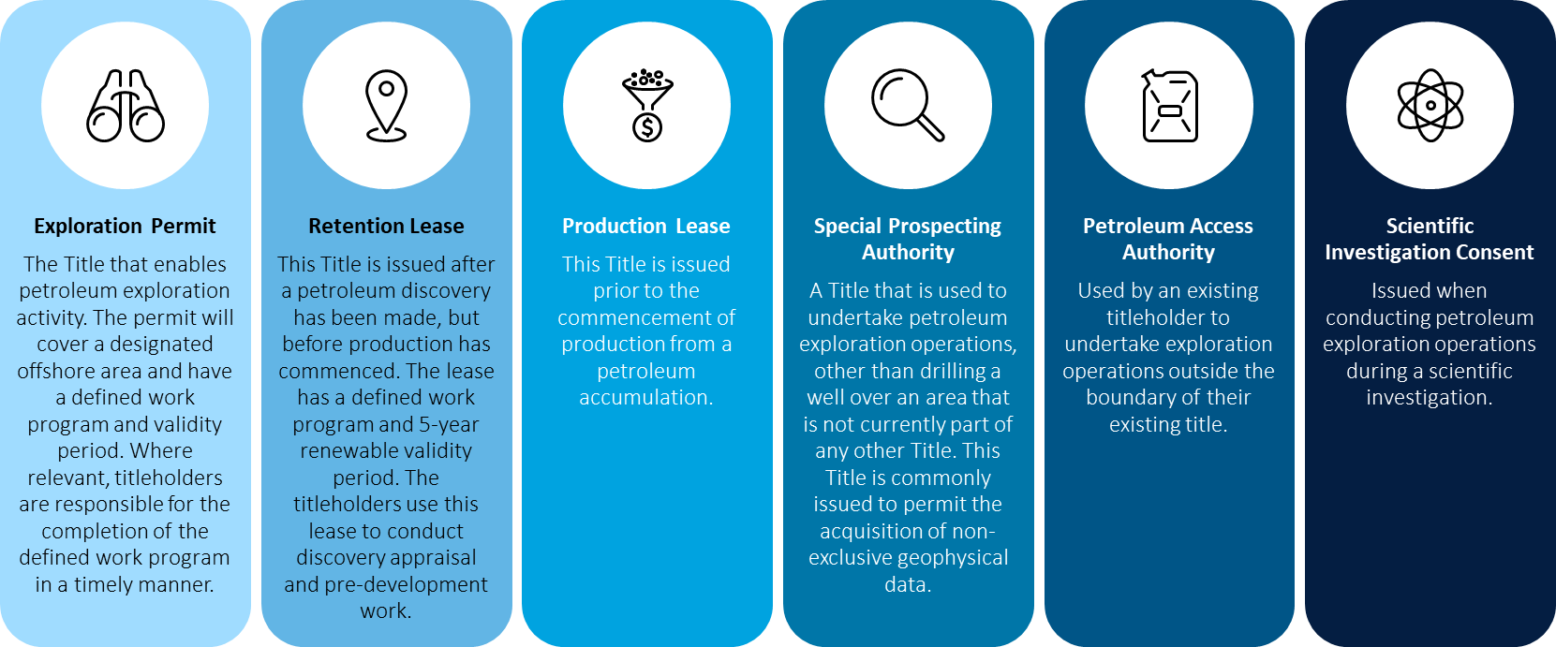

Source: Deloitte analysis adapted from NOPTA data

### Titles framework and approach

**Figure 5.2** outlines the Government’s process for offshore petroleum exploration and development. The titles framework applied by NOPTA (the **framework**) is robust and follows NOPTA operating documents (**NODs**), including the *Procedural Fairness Guide*. NOPTA assesses applications under Chapter 2 of the OPGGS Act and the relevant guideline(s).**Figure 5.2: Overview of the offshore petroleum exploration and development process**

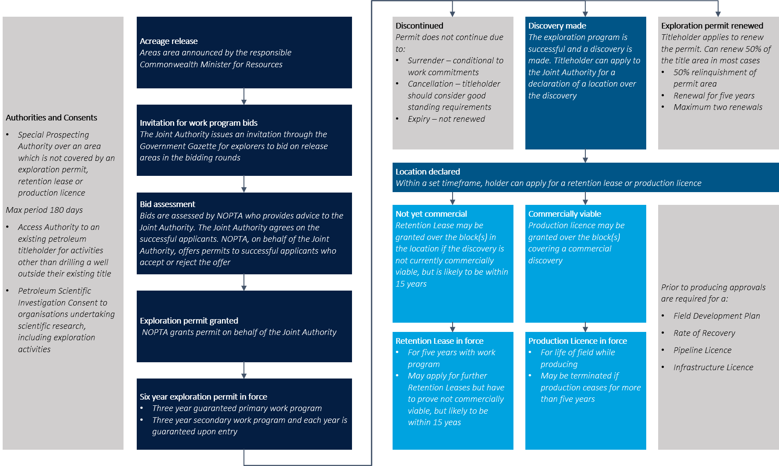

Source: Deloitte analysis adapted from NOPTA data (NOPTA Annual Report of Activities)

#### The titles application process

As part of the annual Offshore Petroleum Exploration Acreage Release[[9]](#footnote-10), applicants are invited by the Joint Authority for specific offshore areas to apply for a work program or cash bid exploration permit. Successful applicants are granted a six-year exploration permit. During this time, primary and secondary work programs, a condition of the title, requires the titleholder to commence and complete key activities agreed.

Following the exploration permit, there are three potential pathways for the titleholder. The titleholder can apply to renew their exploration permit for up to 50% of the initial title area. The remaining 50% of the permit area is relinquished and the renewal of the permit is for five years with a maximum of two renewals.

Alternatively, the permit may be discontinued due to surrender, cancellation, or expiry.

Where a discovery is made (i.e. the locating of offshore resources), the titleholder can submit a declaration of location[[10]](#footnote-11) to the Joint Authority for consideration. The block(s) identified as part of the declaration of location will form the basis for an application for a production licence or retention lease. The titleholder is able to apply for a production license where the declared location is commercially viable. Conversely, the titleholder can apply for a retention lease where the declared location is not yet commercially viable.

#### The titles assessment process

**NOPTA’s processes and practices for supporting titles administration are generally adequate for their purposes**

NOPTA receipts and records all titles applications through its Titles Electronic Register Interface (**TERI**) system, the internal interface of the NEATS system. Upon receiving and recording a titles application, NOPTA is required to manually generate emails to initiate the assessment process.

NOPTA assesses titles applications in alignment with the process illustrated in **Figure 5.3** below. Upon receiving an application, NOPTA assesses the validity of the application and identifies whether there is a need for further information. NOPTA commences the assessment of the application once it has sufficient information. NOPTA is required to manually update the status of each titles application as it moves from across the stages of an assessment.

Upon completion of the assessment, NOPTA prepares its technical advice which is sent to the relevant Joint Authority via email. Once a decision has been made by a Joint Authority, NOPTA then advises the respective titleholder of the decision.

**Figure 5.3: NOPTA’s titles application assessment process**

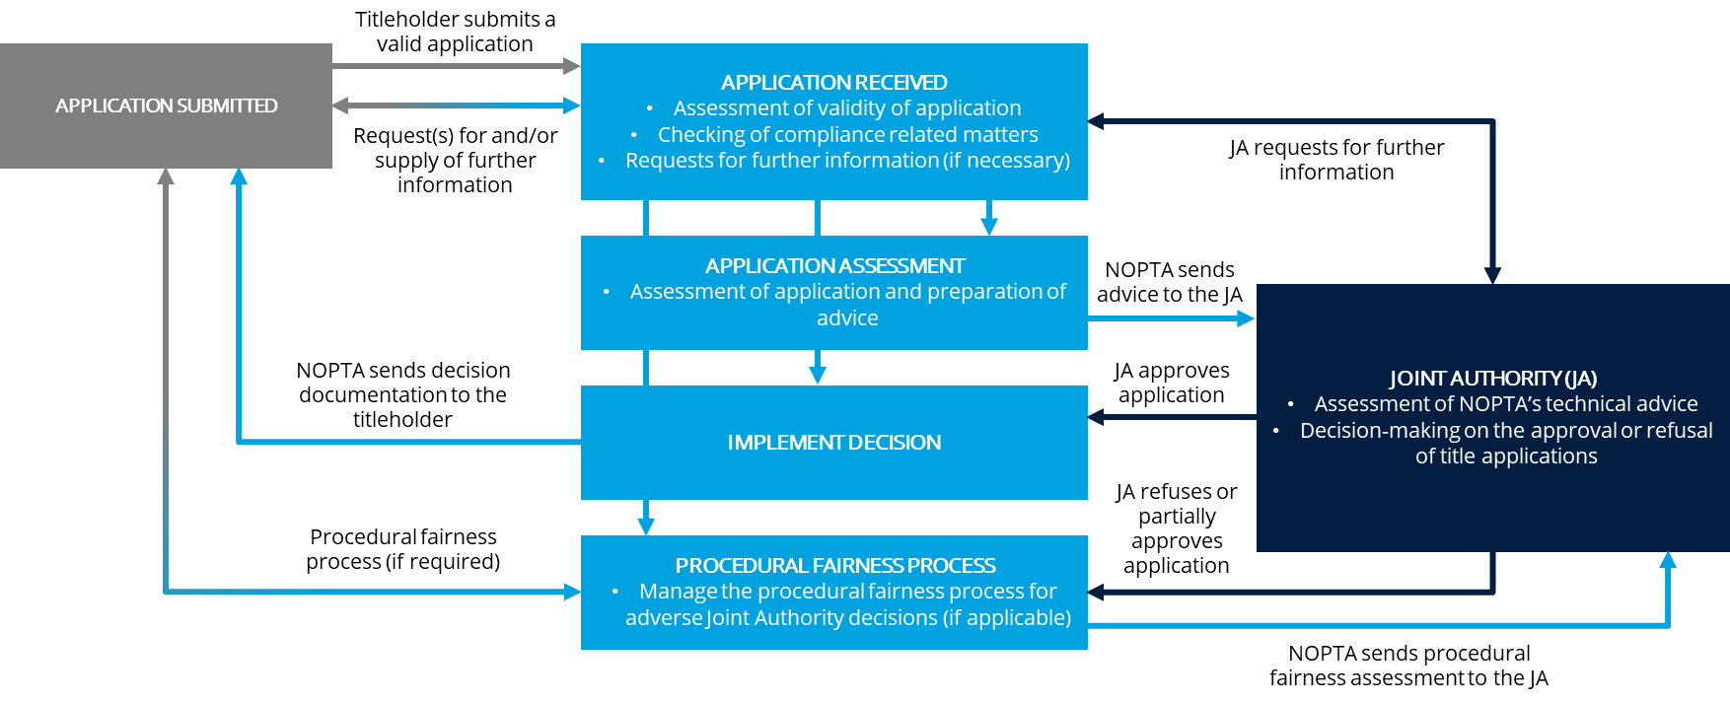

Source: Deloitte analysis adapted from NOPTA data

Based on our examination, the titles assessment process is adequate and relies on appropriately specific NODs to guide the key steps of the process. However, the process relies on manual input at the point of initiating the assessment, updating the status of the assessment, and communication back and forth between NOPTA and the Joint Authorities. We discuss further opportunities for digitisation of the process through our report.

#### The titles recommendation process

At a high level, the Joint Authorities are able to approve, refuse or request further information from the applicant. Where an adverse decision is reached by the Joint Authorities (i.e. refusal or partial refusal), the Joint Authority, via NOPTA, initiates and manages the procedural fairness process. As defined by NOPTA in its Procedural Fairness Guide:

*“the fair hearing rule of procedural fairness requires that persons who may be affected by an administrative decision be provided with:*

* *Notice that a decision will be made*
* *Disclosure of an outline of the substance of the information or ‘critical issues’ on which the proposed decision will be based*
* *An opportunity to comment on that information, and to present submissions to the decision maker.”*

NOPTA prepares the procedural fairness assessment to clearly outline the adverse findings and proposed decision. The procedural fairness assessment is sent to the Joint Authorities for decision and the same information is presented to the applicant in the form of a *Notice of Intent* letter, providing the applicant with an opportunity to comment and/or present submissions to the Joint Authorities.

Overall, we assessed NOPTA’s titles recommendation process to be well defined – albeit manual – and demonstrating clarity between NOPTA’s role in providing technical advice and the Joint Authorities’ role as the decision-maker.

## Compliance monitoring and enforcement

NOPTA (in its capacity as an administrator and adviser) notifies the Joint Authorities (in their capacity as decision-maker) of non-compliance items and makes recommendation for enforcement action to be taken.

### NOPTA’s compliance and enforcement approach and underpinning principles

***NOPTA has a defined framework for managing compliance and enforcement***

NOPTA’s *Compliance and Enforcement Policy* provides high-level guidance to titleholders on NOPTA’s role in compliance and enforcement. The policy is publicly available and outlines:

* The role of NOPTA in compliance monitoring and enforcement
* The role of the Joint Authority in decision-making
* NOPTA’s principles of compliance
* NOPTA’s compliance and enforcement strategy and options
* NOPTA’s role in education and awareness
* Early engagement, title conditions / directions
* Title cancellations and prosecutions.

**Figure 5.4: Graduated compliance and enforcement options**

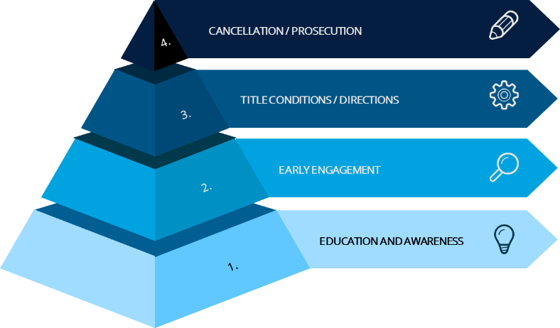

Source: Adapted from NOPTA Compliance and Enforcement Policy

NOPTA’s internal *Compliance Procedure* outlines the process for identifying actual or potential compliance issues, and steps for managing escalated compliance issues. Each NOPTA team is responsible for monitoring and reporting compliance issues as relevant to their processes as defined within the *Compliance Register Guide*. Compliance issues are recorded within the *Compliance Register*, which includes the key details of the compliance issue (e.g. description, date), relevant legislation and regulation, and severity and initial risk rating.

Each new compliance issue is screened by the relevant NOPTA team. At the point of screening, the relevant NOPTA team has the ability to resolve the matter or escalate the matter to the Legislative Compliance Team (**LCT**), where required. Any compliance issue with a ‘high’ risk rating (as verified by the relevant NOPTA team) will also be automatically escalated to the LCT. Where a compliance issue is resolved, the relevant NOPTA team will document key actions and evidence appropriately within the *Compliance Register*. Where an issue is not immediately resolved and is not escalated to the LCT, the relevant NOPTA team is responsible for ensuring resolution of the matter, including monitoring, reviewing and updating the record within the *Compliance Register.*

Where the relevant NOPTA team escalates the matter to the LCT, the LCT may accept or reject the escalation request. Where a request is rejected, a notification is sent to the relevant NOPTA team outlining the reasons for rejection. Conversely, where an escalation request is accepted, the LCT review the matter and provide advice on the required steps to move towards resolution. This includes notifying the Joint Authority on the issue of non-compliance. The LCT will work with the relevant NOPTA team to resolve the issue.

### NOPTA’s compliance process and powers

NOPTA as an administrator has limited enforcement powers directly. Instead, NOPTA has two channels through which it can advise on the use of enforcement action:

* Through the Joint Authorities, who as decision-makers under the offshore legislative framework can make a number of decisions relating to titles, including cancellation or refusal of renewal for a title
* Via NOPSEMA, as the offshore legislative framework’s regulator.

From our conversations with NOPTA, we understand NOPTA views the powers under the OPGGS Act as they relate to titles administration to be sufficient for incentivising compliance. Through the Joint Authorities, NOPTA can advise, for example, the cancellation of a title or refusal of renewal for a title in situations where a titleholder is in breach of a title’s conditions and/or work program. Under the OPGGS Act, NOPTA has the ability to seek a civil penalty, give an infringement notice, or apply for an injunction in relation to non-compliance with specified provisions. However, we observe that provisions of the regulations currently are restricted to criminal penalties and/or administrative responses to non-compliance.

NOPSEMA offers a further channel for NOPTA to address non-compliance. NOPTA may, under section 601 of the OPGGS Act (‘NOPSEMA Laws’), call on NOPSEMA’s enforcement powers as the single offshore regulator who is, among other things, responsible for the compliance and enforcement activities for Australia’s offshore regime under the OPGGS Act.[[11]](#footnote-12) By way of example only, specific laws that could be viewed as being beyond the scope of NOPSEMA’s current regulatory focus (i.e. safety, well integrity, or environment) include:

* 1: Chapter 2 of the Act – regulation of activities related to petroleum
* 2: Chapter 4 of the Act – registration of transfers of, and dealings in, petroleum titles
* 3: Sections 568 and 569 of the Act – works and operations obligation of petroleum titleholders
* 9: Part 6.7 – collection of fees and royalties payable to the Titles Administrator or the Commonwealth
* 11: Division 4 of Part 6.10 – collection of fees and levies payable to the Titles Administrator.

Additionally, the NOPSEMA CEO may, under section 602(1)(b) of the OPGGS Act, appoint as a NOPSEMA inspector *“an employee of the Commonwealth or of a Commonwealth authority”* (of which NOPTA staff fall under).

NOPTA and NOPSEMA have established the Determination No. 2019/1 *Payments for NOPSEMA inspectors*, which outlines the amount to be paid by NOPTA to NOPSEMA if the services of NOPSEMA inspectors are required for the exercise of powers relating to the Titles Administrator, as described above. The document also details an understanding by both parties that the Titles Administrator may give written directions to a NOPSEMA inspector to exercise powers of entry, monitoring and investigation for the purposes of the OPGGS Act[[12]](#footnote-13).

#### Work program

The Government’s offshore petroleum exploration and development framework imposes a primary and secondary work program on titleholders granted work bid exploration permits. The first three years of a work program are referred to as the primary term. The first three years of the permit term are generally combined, and the minimum work program commitments must commence and be completed within the primary term. Permit years 4 and 5 are referred to as the secondary term. Each year’s work program commitment becomes guaranteed upon entry and the minimum work requirements must commence and be completed within the permit year. In addition to this, 5-year work programs are also required for titleholders granted retention leases.

#### Annual title assessment report

Where relevant[[13]](#footnote-14), titleholders are required by regulation to report on their progress against the agreed work program and other requirements specified by the Joint Authorities within their ATAR.

Titleholders are required to submit their ATAR within 30 days after the anniversary date of the grant of the title unless otherwise approved by NOPTA. NOPTA provides titleholders with ATAR templates relevant to each title.

Based on our examination of NOPTA’s compliance process, we believe NOPTA has established a well-defined process for receiving information on a titleholder’s progress against agreed activities. This enables NOPTA to have oversight of compliance and to identify compliance issues where the process is not adhered to by titleholders.

In addition to the above items, NOPTA also monitors compliance against matters such as data submissions.

### NOPTA’s enforcement process

**NOPTA has robust procedures for guiding its compliance processes. NOPTA’s approach to taking enforcement action is not always sufficiently proactive or timely and could make further use of additional enforcement channels through NOPSEMA in future**

Within the review period, the Joint Authority has taken a number of enforcement actions against titleholders, as depicted in **Figure 5.5**.In total, the Joint Authorities, acting on NOPTA’s recommendation, cancelled 23 titles during this time.

**Figure 5.5: Joint Authority’s enforcement action within the review period**

Source: Deloitte analysis of NOPTA internal document

Referring to **Table 5.2**, NOPTA advised the Joint Authorities of the majority of work program compliance matters and in all instances where a Joint Authority’s expectation was unmet. However, we note there are significantly more compliance issues identified than the number escalated to the Joint Authority. Following discussions with NOPTA, we understand the majority of compliance issues are rectified through discussions with titleholders or internal discussions. Refer to **Section 5.3.1** for further details on NOPTA’s escalation of compliance issues.

**Table 5.2: Compliance matters recorded and compliance matters for which the Joint Authority was advised.**

|  | **Year** | | | | | **Totals** | |
| --- | --- | --- | --- | --- | --- | --- | --- |
|  | **2015** | **2016** | **2017** | **2018** | **2019** | |  |
| **Compliance Matters recorded** |  |  |  |  |  | |  |
| **Work Program Compliance/Title conditions** | 7 | 7 | 6 | 3 | 7 | | **30** |
| **Reporting/data submission (Monthly reports, ATARS, Well Documentation - Part 5 RMA Regulations, notifications)** | Unknown | 47 | 43 | 19 | 22 | | **131** |
| **Petroleum Recovery** |  | 3 |  |  |  | | **3** |
| **Joint Authority Expectation - Unmet** |  |  | 1 |  | 2 | | **3** |
| **Overdue Annual Levy** |  |  |  |  | 4 | | **4** |
| **Other** |  | 6 | 1 | 1 |  | | **8** |
| **Overall Total** | **7** | **63** | **51** | **23** | **35** | | **179** |
| **Joint Authority Advised** |  |  |  |  |  | |  |
| **Work Program Compliance/Title conditions** | 7 | 4 | 6 | 3 | 6 | | 26 |
| **Joint Authority Expectation - Unmet** |  |  | 1 |  | 2 | | 3 |
| **Other** |  |  |  | 1 |  | | 1 |
| **Joint Authority Advised Total** | **7** | **4** | **7** | **4** | **8** | | **30** |

Source: Deloitte analysis adapted from NOPTA data

Based on our examination, NOPTA has developed and implemented robust procedures for guiding its compliance processes. This is reflected within its titles assessment process, *Compliance Procedure* and *Compliance Register Guide*. With respect to enforcement, NOPTA has outlined high-level guidance of potential enforcement activities within the *Compliance and Enforcement Policy* and the *Compliance Procedure*.

However, it appears NOPTA has not clearly defined timelines for notifying the relevant Joint Authorities of non-compliance. For example, NOPTA has not clearly defined time period in which it is willing to accept late submissions of ATARs. Through our interviews and walkthroughs, we observed NOPTA permitting titleholders multiple opportunities to rectify compliance issues. In an example, we saw multiple compliance issues by one titleholder, which were associated with a late ATAR where NOPTA provided advice to the Joint Authority almost three months after the non-compliance. Four months after the due date, the titleholder submitted their ATAR to NOPTA. At this time, no decision had been made by the Joint Authority and grounds for cancellation were removed. Based on our examination, we note titleholders must be awarded procedural fairness, which in some cases may contribute to the delay in enforcement action. Consideration of appropriate penalties for non-compliance need to focus on the outcome to be achieved. For example, in the case of non-compliance with work program commitments, the desired outcome would be to ensure either the titleholder does the work or to enable the Australian Government to award title over the area to another entity who will undertake the work.

Based on our examination of NOPTA’s processes, we support NOPTA providing a degree of discretion in enforcement and adoption of an educational approach is appropriate and an application of a graduated enforcement approach (as shown in **Figure 5.4**). Yet we saw the above-mentioned example where we consider NOPTA not to have undertaken timely notification to the Joint Authority, which may have led to untimely enforcement action. Without taking timely action on compliance issues, NOPTA may appear to take on unnecessary risk or appear to be overly tolerant to non-compliance.

While non-compliance relating to ATARs or work programs are not always perceived to be significant issues in isolation, we believe there can be potential risk where there are unknowns and it can contribute to the perception of insufficient oversight – whether true or not. Further to this, there is the potential for the quality of NOPTA’s data – its biggest asset – to be compromised (e.g. as in the case of late or missing ATAR submissions).

In relation to utilising NOPSEMA’s powers under the relevant provisions of the OPGGS Act, NOPTA and NOPSEMA have administrative arrangements in place to utilise these mechanisms where NOPTA deems it appropriate. NOPTA advised they had not been required to draw on the NOPSEMA enforcement powers during the review period as all compliance outcomes during the period were achieved and met without the need to rely upon those powers. However, NOPTA acknowledged they may need to rely upon the powers at some time in the future and are ready, willing, and able to do so. We encourage NOPTA and NOPSEMA to ensure opportunities are identified where the regulator could assist the administrator with applying a graduated enforcement approach. That is, ensuring consideration for NOPSEMA’s involvement is not only limited to situations where a serious breach or prosecutable offence may have occurred.

In the event NOPTA is required to rely upon NOPSEMA’s enforcement powers in the future, clarity would need to be provided to industry as a whole as to NOPSEMA’s involvement and their role (on behalf of NOPTA) in taking enforcement actions for titles administration-related matters. Based on our stakeholder consultation, we believe stakeholders in the industry are likely unaware that NOPSEMA inspectors may be requested to exercise their regulatory powers on behalf of the Titles Administrator for the purposes of the OPGGS Act. This matter could be addressed as part of our earlier recommendation on bringing additional clarity on the roles and responsibilities within the offshore legislative framework.

Based on our examination, we believe that NOPTA has access to sufficient powers under the provisions set out across the OPGGS Act. However, the provisions relating to NOPSEMA have not been utilised in relation to non-compliance. We see benefit in future from NOPTA examining the full breadth of powers accessible under the OPGGS Act in making recommendations for enforcement action.

|  |
| --- |
| Recommendation #2 |
| NOPTA should, where there is non-compliance identified, seek to proactively make appropriate enforcement recommendations to NOPSEMA or the Joint Authorities through the application of a graduated enforcement approach.  Specifically, NOPTA should:   * Consider the severity of non-compliance it is willing to tolerate for each of its compliance requirements and expectations * Review and refine its compliance process to ensure identified timeframes for compliance action and enforcement recommendations are clear and adhered to * Proactively consider the full scope of enforcement powers available to it across all provisions of the OPGGS Act:   + Considering, in conjunction with NOPSEMA, how NOPTA enforcement recommendations may be actioned or assisted by the regulator (NOPSEMA) under the relevant provisions of the OPGGS Act. |

Beyond the implementation of this recommendation, both NOPTA and NOPSEMA should ensure they have appropriate policies, processes, and procedures in place to support the operationalisation of this recommendation.

### Stakeholder feedback on enforcement and compliance

Through the stakeholder consultation process, we heard mixed views from stakeholders on the effectiveness of NOPTA’s compliance and enforcement processes. Stakeholders broadly agreed that NOPTA has access to sufficient powers to drive compliance and enforcement (see **Figure 5.6** below). However, stakeholders were less positive that NOPTA transparently advises on the use of powers it has access to.

**Figure 5.6: Survey responses to the sufficiency of enforcement powers in relation to titles administration**

\*NOTE: ‘Right people’ refers to capability such as skillset, experience, qualifications

Source: Deloitte Stakeholder Survey, Deloitte analysis

Specifically, of stakeholders surveyed:

* 85.7% ‘strongly agreed’ or ‘agreed’ that NOPTA has access to sufficient powers to enforce effective titles administration
* 71.5% ‘strongly agreed’ or ‘agreed’ that NOPTA has the right people to drive titles administration practices and regulation for the industry.

Stakeholders also rated their perception of NOPTA’s advisement of the use of its enforcement powers (see **Figure 5.7**), which was less favourably viewed compared to stakeholders’ perception of the sufficiency of powers available. Consistent with our observations, stakeholders identified timeliness to be an area for relative improvement. Stakeholders also provided consistent feedback that they were typically unaware of NOPTA’s recommended enforcement actions.

**Figure 5.7: Survey responses to NOPTA’s advisement of the use of its enforcement powers**

\*Justified, with appropriate reference to the appropriate legislation and guidelines

Source: Deloitte Stakeholder Survey, Deloitte analysis

## NOPTA’s approach to risk management

### NOPTA’s internal risk management process and underpinning principles

**NOPTA has a defined risk process and has identified key operational risks relating to titles administration**

NOPTA’s (internal) risk management process (the **risk** **process**) is made up of the *NOPTA Risk Register* (the **risk** **register**) and the *NOPTA Hazard Controls Register* (the **hazards** **register**). There are appropriate references to DISER’s *Risk Management Plan (2018-2020)*, which is in turn aligned to the *Commonwealth Risk Management Policy*.

Within the register, NOPTA has identified 23 key risks mapping to the below categories:

* People (e.g. workplace health and safety, skills and qualifications, recruitment and retention)
* Process (e.g. errors in titles instruments, failure to comply with legislation, unauthorised release of data, inability to recover costs)
* Technology (e.g. failure of ICT systems, security breaches).

NOPTA has adapted the Department’s risk matrix and corresponding ‘likelihood’ and ‘consequence’ descriptors to ensure appropriateness and relevancy to NOPTA’s operations (as opposed to the broader Department).

Based on our examination, we believe NOPTA has adequately identified its key operational risks relating to titles administration. NOPTA has considered the potential implications of its risks occurring (e.g. financial, reputation, legislative non-compliance), and has identified appropriate controls for mitigating these risks, with a significant focus on NODs.

### NOPTA’s internal risk monitoring and review process

#### Reviews of the risk register

Through the risk register, NOPTA has identified monitoring and review processes for updating the risk register, including scheduled quarterly reviews conducted through the Business Support Unit (**BSU**)[[14]](#footnote-15) as well as ad hoc reviews where trigger events occur. NOPTA has defined trigger events as:

* The allocation of new functions or powers to NOPTA
* Legislative changes of current functions and powers
* Staffing changes
* Change of delegate.

NOPTA has also defined a process for monitoring and updating risk ratings, whereby the effectiveness of controls is required to be tested and validated. This process demonstrates NOPTA’s understanding that risk ratings can only be lowered once controls are designed, implemented and tested for their effectiveness. Further to this, NOPTA also considers its dependency on controls uses this to determine whether the effectiveness of the control can be assessed internally or whether a third-party assessment is required.

In addition to the risk register, NOPTA has established the hazards register in reference to the *Work Health and Safety Act 2011* (the **WHS Act**), which complements the register and providers further detail on NOPTA’s workplace health and safety risk.

#### NOPTA’s Annual Assurance Review Plan

**NOPTA has an established Annual Assurance Review Plan. Greater clarity and specificity is needed over how the assurance plan targets key areas of risk**

NOPTA has recently established an *Annual* *Assurance Review Plan* (the **assurance** **plan**), which includes the evaluation of the controls listed in the risk register.

The assurance plan details the following components:

* Review subject / process (e.g. transfer transactions, regulatory submissions, ATAR)
* Review purpose
* Risk description / analysis
* Suggested review method
* Review execution
* Review and recommended action plan.

The establishment of the assurance plan demonstrates NOPTA’s consideration of the need to mature its internal risk processes. The plan enables NOPTA to gain assurance that its controls are operating effectively given NOPTA’s important role in Australia’s offshore industry. Since the plan has been implemented, NOPTA has completed two of its five scheduled reviews.

However, the assurance plan currently lacks clarity in the process used to identify the assurance review subject and the specific risks being targeted. Based on our examination, all five reviews as part of the first twelve months of the plan test the same six risks. As a result, there is a need to mature NOPTA’s assurance plan.

|  |
| --- |
| Opportunity #1 |
| NOPTA is encouraged to continue to[[15]](#footnote-16) evaluate its *Annual Assurance Review Plan* to ensure it adequately targets NOPTA’s key areas of risk. At a minimum, NOPTA should consider:   * A range of review activities that cover NOPTA’s key internal risks * Flexibility in the plan to changes in risk ratings (i.e. risk trending) * Any required updates following risk register and hazard control register reviews * Required timeframes for delivery to ensure reviews are conducted in a timely manner * Strategic forward forecasting of the required skillsets, and resource mix to ensure specialists are engaged as required. |

#### Other reviews

NOPTA is also subject to audits and operational assurance reviews as determined by DISER. Within the last five years, NOPTA has been subject to the following reviews, led by DISER:

* Internal Audit of legislative compliance (2015)
* ICT compliance management (2017)
* Third-party relationships (2018)
* ICT governance and risk management with business units (2018-19)
* Assurance (compliance) review of NOPTA’s administrative practices relating to procurement, recruitment and legal services (2019).

### NOPTA’s role in contributing to the management of industry risk

**NOPTA does not take a sufficiently proactive approach to contribute to the management of industry risk**

NOPTA plays an important role in the overall risk framework for the offshore petroleum industry, including the optimum use of Australia’s natural resources. As described under NOPTA’s role and function (refer to **Section 5.1**), we understand that NOPTA’s role as a Titles Administrator is to *“advise on and administer the OPGGS Act in support of the effective regulation and management of… offshore petroleum resources, consistent with good oil field practice and optimum recovery”*[[16]](#footnote-17).

Based on our examination, we believe NOPTA’s current processes are not established with the view to engage with and influence industry risks and issues. This is further supported by the outcomes of our stakeholder consultation, which highlighted perception among stakeholders that NOPTA does not sufficiently consult or engage externally to positively influence risk management. Only 28% of stakeholders ‘agreed’ or ‘strongly agreed’ that NOPTA adopts a proactive approach towards risk management (see **Figure 5.8**). Stakeholders called for NOPTA to use its unique position to identify and engage with industry on key risks, and to act more proactively and be more timely in responding to risks it identifies. Our view is that all arms of the offshore legislative framework must engage in supporting effective external risk management.

**Figure 5.8: Survey responses to NOPTA’s management of and approach to risk**

*\*NOTE: independence means that NOPTA conducts itself free of any undue external bias or influence*

*\*\*NOTE: Stakeholder consultation may include workshops, industry forums, surveys*

Source: Deloitte Stakeholder Survey, Deloitte analysis

|  |
| --- |
| Recommendation #3 |
| NOPTA should take a more proactive approach to contributing to the management of industry risk by:   * Engaging with industry on identifying areas of highest risk and impacts to titles administration * Focusing resourcing on areas of assessed highest industry risk * The use of data in identifying, monitoring, and managing risks. |

Proportion of ‘strongly agree’ and ‘agree’ responses

# How does NOPTA enable timely and effective information to be provided to responsible decision-makers?

Key points

|  |  |
| --- | --- |
| **NOPTA has built a trusted relationship with Joint Authorities and their delegates**  We consider NOPTA to be effective in supporting the Joint Authorities in making decisions. NOPTA has built trusted relationships with the Joint Authorities. The quality of NOPTA’s technical advice and changes made to advice templates were favourably viewed by Joint Authority delegates we consulted with.  For some high-risk or complex applications, delegates noted that NOPTA did not always provide a single, clear recommendation (instead providing a range of recommendations). In other situations, feedback was that NOPTA did not always consider a broad enough range of options in reaching a recommendation.  Some delegates also provided feedback that NOPTA should give greater consideration to policy or strategic impacts on its technical advice. We observed that greater clarity over roles and responsibilities contained within the Joint Authority Operating Protocols is required, particularly with respect to the delineation between policy and technical advice. We see the current articulation of roles and responsibilities, specifically that NOPTA’s role is not to duplicate policy advice functions within the Joint Authority departments, may contribute to the perception that NOPTA does not sufficiently consider these aspects. In our view, as members of the APS, NOPTA should display the appropriate cognisance of strategic and policy considerations in its advice and be enabled by its state/territory and Commonwealth counterparts in this matter. Any misconceptions or lack of clarity in roles and responsibilities should be addressed.  **NOPTA is generally timely in providing advice to Joint Authorities but timeliness and transparency over the titles administration process as a whole should remain a focus**  NOPTA is generally timely in providing advice to Joint Authorities and in making Titles Administrator decisions.  There is an opportunity for NOPTA to further curate and publish strategic intelligence, particularly with respect to advising the Joint Authorities and their delegates of trends | **Specifically, based on data we analysed, NOPTA has tended to meet the indicative timeframes specified in the Operating Protocols across the review period for:**   * Titles Administrator-related titles application assessments and decisions * Joint Authority-related application assessments.   We make the following observations:   * As complexity in titles applications increases, it is reasonable to assume that application assessments may proportionately increase in ‘time-to-decision’ to address the increase in complexity. Focus should be given to clarifying application requirements with titleholders ‘up front’ to reduce the number and extent of requests for further information requiring issuance by NOPTA * The current reporting outputs of titles administration activities are not sufficiently visible to industry. Although NOPTA provide an annual summary of application decision-making statistics as part of its annual report of activities, we consider there would be benefit of integrating reporting and decision-making timeframes as part of future NEATS improvements.   Moving forward, as the industry matures, the timeliness of the overall titles administration process will become increasingly important. We also note, while out of direct scope of our review, strong and near unanimous feedback from industry that the overall decision-making portion of certain titles applications would benefit from improved timeliness and transparency.  **Recommendations: 4, 5**  **Opportunities: No opportunities were identified in this section** |

## Overview of the current arrangements to support Joint Authorities decision-making

### Joint Authorities model

As outlined earlier, NOPTA advises the Joint Authorities on titles administration decisions relating to offshore petroleum and GHG storage activities.

A Joint Authority’s key functions are typically, but not always, strategic in nature and likely to have long term implications and, therefore, generally require consideration of a broad range of policy considerations when making a decision. **Table 6.1** provides a summary of the Joint Authorities decision-making powers relating to petroleum titles applications. Decisions relating to GHG assessment permits are made, through NOPTA, by the responsible Commonwealth Minister.

To exercise its functions and powers for decisions, the Joint Authorities:

* Rely on technical assessments and advice from NOPTA
* Consider policy advice on an application from their respective department.

A Joint Authority can delegate any or all of its functions to its respective state/territory or Commonwealth Department officials under section 66(1) of the OPGGS Act. Typically, delegations are subject to conditions, such as the referral to members of the Joint Authority by delegates for sensitive, contentious, or strategic decisions. In addition to the Joint Authority delegating its powers to department officials, a number of straightforward titles administration decisions are conferred through legislation on the Titles Administrator to facilitate more efficient titles administration for offshore petroleum activities. Within this model, the delegates each wear “multiple hats”. For example, DISER’s General Manager (Offshore Resources Branch) undertakes two roles – that of General Manager overseeing the development of offshore resources policy and a second role as the delegate for the responsible Commonwealth Minister, the Commonwealth Joint Authority representative.

**Table 6.1: Summary of decisions by decision-maker for petroleum titles applications[[17]](#footnote-18)**

| Decision-maker | Joint Authorities | Titles Administrator |
| --- | --- | --- |
| **Decisions relating to petroleum titles applications** | * Grant and renewal of an exploration permit * Declaration, variation or revocation of a location * Grant and renewal of a retention lease * Variation, suspension, extension or exemption of a condition of a title * Grant of a production licence (including to which the Royalty Act applies) * Renewal of a fixed term production licence * Field development plan (**FDP**) (including variation) * Set the rate of recovery * Grant and variation of a pipeline licence and consent to cease to operate a pipeline licence * Grant of an infrastructure licence (including variation) * Scientific investigation consents * Surrender, cancellation, termination and revocation of titles. | * Transfers and dealings * Change of company name * Credits (work program) * Special prospecting authorities (**SPA**) (including variation) * Access authorities (**AA**) (including variation and extension) * Extension of the application period (location) * Approval to undertake recovery without an accepted FDP * Request for extension of time to lodge an application for the renewal of a title. |

Source: Adapted from NOPTA internal document

### NOPTA’s arrangements for supporting the Joint Authorities

NOPTA has developed a number of processes and procedures to enable its support of the Joint Authorities.

The Operating Protocols (which incorporated comments from jurisdictions, NOPTA and NOPSEMA), sets out the broad framework for Joint Authority decision-making and seeks to clarify the respective roles and responsibilities of the various parties in Joint Authority decision-making. Notably, the Operating Protocols outlines, among other matters:

* The OPGGS Act does not intend that the Joint Authority or their delegates duplicate the technical advisory functions of NOPTA
* NOPTA is expected to develop a collaborative working relationship with each of the Joint Authority delegates and their respective Departments
* Commonwealth and state/territory Joint Authority delegates and their Departments will be responsible for providing any relevant policy or local advice to their respective members comprising the Joint Authority
* The Joint Authorities and their delegates will seek to make decisions on a consensus basis and within a reasonable timeframe
* The Joint Authority delegates will use best endeavours to finalise consideration of NOPTA’s advice within 10 business days or 15 business days for more complex matters or where the Joint Authority delegates seek further advice or clarification from NOPTA
* The Joint Authority or their delegate are not compelled to accept NOPTA’s advice or recommendations and may seek additional information and/or clarification from or through NOPTA where necessary
* Indicative maximum timeframes for NOPTA to undertake various titles administration activities in support of the Joint Authorities or their delegates.

NOPTA has a range of supporting documents to support the Joint Authority decision-making process. NOPTA has a suite of templates and forms, which were updated at various points across the review period based on feedback from a sample of Joint Authority delegates. NOPTA has a comprehensive operating procedure outlining the process, controls, roles and responsibilities, and timelines for providing advice to the Joint Authorities. The procedure was developed in June 2019 and last updated in August 2020. Based on our examination of these documents, we believe NOPTA’s operating procedure and templates for supporting Joint Authority decision-making are adequate for their purposes.

## NOPTA’s support of Joint Authority decision-making

### NOPTA’s relationship with the Joint Authorities

**NOPTA is generally well-regarded by the delegates of the Joint Authorities, with excellence of technical advice cited as a key factor in building trust**

NOPTA is seen to be providing thorough and high-quality technical advice. The delegates we consulted with provided positive feedback on NOPTA’s support of the Joint Authority decision-making process. Delegates noted that the quality of NOPTA’s advice is reflected in the relatively low rates of deviation by Joint Authorities from NOPTA advice (and where deviations have occurred, these were stated to be due to policy consideration rather than limitations with the supportability of technical advice). These findings are reinforced by the positive perceptions expressed by delegates we surveyed (referring to **Figure 6.1**).

**Figure 6.1: Survey responses to NOPTA’s support of Joint Authority decisions**

*\* Justified, with appropriate reference to the appropriate legislation and guidelines*

Source: Deloitte Stakeholder Survey, Deloitte analysis

In addition, there are several other factors contributing to the largely positive view of NOPTA’s support of the Joint Authorities:

* Building on the findings from the 2015 Operational Review, delegates consulted with provided near universal acknowledgement of the quality of NOPTA’s technical advice. For instance:
  + Strong positive ratings across all survey questions relating to technical capability
  + The 2019 and 2017 NOPTA stakeholder surveys identified that Joint Authority delegates largely had positive views of NOPTA advice with the consistency and supportability of advice improving between 2017 and 2019 (with ‘very satisfied’ ratings increasing from 43% to 54% and 29% to 54%, respectively).[[18]](#footnote-19)
* NOPTA’s relatively low turnover of senior level staff (as shown in **Figure 7.9** in **Section 7.4.1**) has helped build continuity in relationships within delegate departments.

Based on our examinations, we believe NOPTA has dedicated an appropriate level of effort to improve the quality of its advice. During the review period, NOPTA consulted with a selection of Joint Authority delegates on enhancements to the presentation of its advice, which we understand to have been well received by the Joint Authorities. We also note that delegates were complimentary of NOPTA’s integration of complex technical matters into succinct and clear advice. Furthermore, NOPTA is looking to develop a ‘Joint Authority portal’ within NEATS to systematise currently manual processes. We see the digitisation of the Joint Authority process as having potential benefits for the transparency and timeliness of the overall titles administration process.

Industry raised no material concerns regarding NOPTA’s support of the Joint Authorities’ decision-making. Several titleholders reinforced the findings from the 2015 Operational Review that industry positively regard NOPTA as a technical advisor to the Joint Authorities.

**Delegates saw an opportunity to improve the quality of recommendations received**

Delegates noted that for some high-risk and complex applications, NOPTA appeared not to provide a single, clear recommendation and instead provided a range of recommendations. This may reflect a lower risk appetite from NOPTA in providing its advice or making recommendations. Additional feedback was that NOPTA did not always consider a broad enough range of options in arriving at its recommendations. Outside of situations where NOPTA recommendations are binary (i.e. to approve or decline an application), we encourage NOPTA to ensure it canvasses available options in its advice and establishes a clear ‘NOPTA position’ in relation to these options.

The scope of NOPTA’s advice and processes were identified challenges. We received feedback from some delegates during our consultations that NOPTA can be seen to:

* Focus on technical and legislative/regulatory perspectives when providing advice and, by extension, may not be fully cognisant of policy or other strategic matters when making its recommendations
* Focus on meeting timeframes to the detriment of considering the full implications of the decision
* Be insufficiently involved once advice has been given to the Joint Authorities.

NOPTA’s agreed role under the Operating Protocols is not to apply local policy considerations in its advice (with this being the responsibility of the respective state/territory and Commonwealth departments). NOPTA noted the challenge of being abreast of each jurisdiction’s nuanced policy and strategic landscape as it often does not have visibility over these aspects. As a consequence of the above factors, NOPTA recommendations are not always perceived to align with state/territory and Commonwealth Government needs.

We observed that:

* There is a lack of clarity over roles and responsibilities with regards to NOPTA’s role in the consideration of policy and strategic matters. We heard conflicting viewpoints on this from stakeholders. In our view, NOPTA, as a branch of DISER and a member of the APS, could reasonably be expected to remain abreast of the policy and strategic landscape. Importantly, it must be enabled to achieve this by its respective state, territory and Commonwealth Government peers. The roles and responsibilities as written in the Operating Protocols may have the unintended consequence of creating confusion in this regard. Clarification and agreement should be reached on this by the relevant parties to the Operating Protocols
* At times, the NOPTA advice-giving process, delegate analysis, and Joint Authority processes can appear disparate in their execution and there is an opportunity to improve the handoffs and engagement of the parties across these processes.

|  |
| --- |
| Recommendation #4 |
| The parties to the Operating Protocols should clarify the expectations of NOPTA giving consideration to strategic and/or policy matters in its technical advice and the parties enablement of this outcome through providing access to or visibility of pertinent matters to NOPTA. |

### ‘Transactional Titles advice’ versus ‘strategic advice’

**NOPTA is generally timely in providing advice to Joint Authorities, but timeliness and transparency over the titles administration process should remain a focus**

NOPTA makes a number of decisions directly (referred to as Titles Administrator decisions/applications) and supports the Joint Authorities in reaching their decisions (referred to as Joint Authority decisions/applications) through the provision of advice and recommendations.

Over the review period, for both Titles Administrator and Joint Authority applications, NOPTA tended to meet its indicative application assessment timeframes (see **Figure 6.2**). This data aligns with responses to our survey, where delegates tended to see NOPTA as timely in its provision of advice (see **Figure 6.1** above). Indicative application assessment and decision timeframes are as specified by the Operating Protocols or, where the Operating Protocols do not establish an indicative timeframe for assessment, as set by NOPTA.

**Figure 6.2: All decision-types – NOPTA’s percentage of applications assessed within indicative assessment timeframes from 2015 to 2019**

Source: Deloitte analysis adapted from NOPTA data

#### Titles Administrator-related assessments and decisions

Examining Titles Administrator applications in greater detail, NOPTA received 894 applications across the review period (see **Table 6.2**). The majority of applications related to transfers and dealings (approximately 83% in total).

**Table 6.2: Titles Administrator Decisions – Application Assessments from 2015 to 2019**

| Decision Type | # of Applications | % of Titles Administrator Decisions |
| --- | --- | --- |
| Credits (work program) | 13 | 1.5% |
| Extension of the application period (renewal) | 49 | 5.5% |
| Extension of the application period (location) | 14 | 1.6% |
| Special prospecting authorities | 23 | 2.6% |
| Access Authorities | 34 | 3.8% |
| Dealings | 577 | 64.5% |
| Transfers | 162 | 18.1% |
| Change of company name | 22 | 2.5% |
| TOTAL | **894** | **100%** |

Source: Deloitte analysis adapted from NOPTA data

**Figure 6.3** shows that for the majority of applications, NOPTA met their indicative assessment timeframes. The weighted average percentage of applications meeting the indicative assessment timeframes was 89.8% for the period.[[19]](#footnote-20) Conversely and referring to **Figure 6.4**, we observed that it appears that the average number of business days for the time for NOPTA to assess Titles Administrator decisions has increased across the review period. This has been driven by an increase in the number of requests for further information (**RFIs**) by NOPTA of titleholders. The indicative assessment timeframes are applicable only once all information on an application has been received.

**Figure 6.3: Titles administrator decisions – average days for application assessments versus NOPTA assessment timeframes by application type from 2015 to 2019**

*\*The indicative assessment timeframe for assessing each application means target assessment timeframe, once all information relating to the application is received*

Source: Deloitte analysis adapted from NOPTA data

**Figure 6.4: Titles administrator decisions – average days for application assessments by processing stage from 2015 to 2019**

Source: Deloitte analysis adapted from NOPTA data

In terms of its decision-making timeliness for Titles Administrator decisions, NOPTA met the indicative decision-making timeframes in all cases (see **Figure 6.5**) for 2018-19 and we observe that in many cases the average time for a decision was one business day.

**Figure 6.5: Titles administrator decisions – average days for decision-making by the Titles Administrator by application type for 2018-19[[20]](#footnote-21)**

Source: Deloitte analysis adapted from NOPTA data

#### Supporting Joint Authority decisions

**Figure 6.6** shows the percentage time spent at each major stage of application processing for Joint Authority-related applications. Approximately 60% of an application’s processing time is spent with the prospective titleholder and NOPTA and approximately 40% with the Joint Authorities for consideration.

**Figure 6.6: Percentage of time spent at each stage of application process for completed Joint Authority applications for 2019-20**

Source: Deloitte analysis adapted from NOPTA data

Examining Joint Authorities applications in greater detail, NOPTA received 969 applications across the review period (see **Table 6.3**). The majority of applications related to suspensions, extensions, variations, and exemption (**SEVE**) (approximately 52% in total). For applications relating to Joint Authority decisions across the review period, NOPTA tended to meet the indicative assessment timeframes as set out in the Operating Protocols (see **Figure 6.7**). For the same period, the weighted average percentage of applications meeting the indicative assessment timeframes was 82.9%.[[21]](#footnote-22) The lower weighted average for this category of applications (than for Titles Administrator decisions) is reflective of the generally greater complexity of Joint Authority decisions. That said, there are instances where assessments exceeded the indicative assessment timeframe specified by the Operating Protocols, such as rate of recovery and equipment and procedures applications. We note the inherent limitations with using averages as an assessment of NOPTA’s timeliness but highlight that the data we have examined aligns to industry stakeholder feedback we received.

**Table 6.3: Joint Authority decisions – application assessments from 2015 to 2019**

| Decision Type\* | # of applications | % of Joint Authority Decisions |
| --- | --- | --- |
| Initial Exploration Permit | 88 | 9.1% |
| Renew Exploration Permit | 32 | 3.3% |
| Declaration of Location | 39 | 4.0% |
| Variation Location | 3 | 0.3% |
| Revocation Location | 9 | 0.9% |
| Initial Retention Lease | 46 | 4.7% |
| Renew Retention Lease | 44 | 4.5% |
| Pipeline Licence | 3 | 0.3% |
| Initial Production Licence | 6 | 0.6% |
| Renew Production Licence | 11 | 1.1% |
| Field Development Plan | 6 | 0.6% |
| Field Development Plan variation | 10 | 1.0% |
| Equipment & procedures | 14 | 1.4% |
| Rate of recovery | 47 | 4.9% |
| Cancellation | 27 | 2.8% |
| Surrender | 75 | 7.7% |
| SEVE | 501 | 51.7% |
| Variation Pipeline Licence | 8 | 0.8% |
| **TOTAL** | **969** | **100%** |

*\*No infrastructure licence was granted or varied in 2015-2019. SEVE data includes all title types*

Source: Deloitte analysis adapted from NOPTA data

**Figure 6.7: Joint Authority decisions – average days for application assessments versus indicative assessment timeframes by application type from 2015 to 2019**

*\*The indicative assessment timeframe for assessing each application means target assessment timeframe, once all information relating to the application is received*

Source: Deloitte analysis adapted from NOPTA data

Based on the data we have analysed and in light of the trajectory of the industry, we make the following observations:

* As complexity in titles applications increases, it is reasonable to assume that application assessments may proportionately increase in ‘time-to-decision’ to address the increase in complexity. This will come at a time when timeliness of decision-making for titles will be increasingly important for titleholders due to profitability pressures from marginal, late-life fields
* To reduce burden on titleholders and titles application decision-makers, focus should be given to clarifying application requirements with titleholders to reduce the number and extent of RFI’s requiring issuance by NOPTA to titleholders after an application has been submitted
* Where there are demonstrated patterns of certain application types not consistently being processed within the indicative timeframes set out in the Operating Protocols, attention should be given by NOPTA and the respective parties to identifying root causes of these delays and addressing these accordingly[[22]](#footnote-23)
* We support NOPTA’s intentions to improve transparency over the Joint Authority process through the planned establishment of a Joint Authority portal in NEATS, which will provide visibility over application progress. The current end-to-end reporting outputs of titles administration activities are not sufficiently visible to industry. Although NOPTA provide an annual summary of application decision-making statistics as part of its annual report of activities, we consider there would be benefit of integrating reporting and decision-making timeframes as part of future NEATS improvements. We make an associated recommendation to this effect in **Section 8.**

Therefore, we see a further need for NOPTA and the component parts of the titles administration process to place renewed focus on the timeliness and further increase transparency over the end-to-end titles administration process. It is stressed that timeliness must not come at the expense of the quality of assessments or decision-making.

|  |
| --- |
| Recommendation #5 |
| The Government should consider further mechanisms and opportunities for improving the decision-making timeliness and transparency across the titles administration process where areas of inefficiency are identified ensuring such actions are not to the detriment of the quality of decision-making outcomes. |

In addition, while out of scope of our review, we did observe strong and near unanimous feedback from industry stakeholders for the opportunity to further improve the transparency and timeliness of the Joint Authority decision-making process (that is, the decision-making process once NOPTA has provided its assessment advice to the Joint Authorities for decision). The consequence for industry may be a lack of certainty and large variability over titles application approvals timelines, impacting the ability to plan and adhere to critical path on development schedules. We observe that stakeholders are monitoring decision-making timeframes across the end-to-end titles administration process, and not just its component parts. Given the Joint Authority decision-making process was out of scope of the review, we do not make formal recommendations to address these points but encourage the Government, as part of a continual focus on reducing regulatory burden, to consider mechanisms for improving timeliness and transparency accordingly.

NOPTA is required to keep applicants informed of decision-making progress during the Joint Authority decision-making process, but often themselves lack visibility over the status of a particular application. We note several stakeholders mention that on occasion, NOPTA avoids providing certainty or clarity over titles applications (e.g. timeframes or application outcomes). Greater digitisation of the titles administration process may help address this, as would proactive engagement with the Joint Authorities on application status and communication of this to titleholders.

# How does NOPTA administrate and respond to industry through its capability and capacity?

Key points

|  |  |
| --- | --- |
| **NOPTA has sufficient capability and capacity for its current activities as Titles Administrator**  We consider NOPTA to have sufficient capability and capacity to undertake its current remit and functions under the OPGGS Act.  We did not identify areas of sustained over or under capacity. Stakeholders tended to view NOPTA as having sufficient capacity, but some stakeholders stated that NOPTA had excess capacity. NOPTA’s capacity must be viewed relative to industry activity, both in terms of volume and complexity. While industry activity volumes have fallen, complexity of activities has increased. This trend is expected to continue.  In light of increasingly complex work, the use of cross-functional teams that bring multi-disciplinary capabilities will continue to be essential. NOPTA adopts a matrix style of working whereby temporary ‘project teams’ can be formed to address complex applications or issues.  The Titles Administrator has thirteen direct reports. Leading practice organisation design principles typically recommend a managerial span of control between five to eight direct reports, depending on factors such as the complexity and risk of the work activities. If, as we recommend, further decision-making delegations are provided to NOPTA, it will be important to ensure the Titles Administrator has bandwidth to effectively and efficiently undertake its expanded decision-making role. Some consolidation of the senior leadership team may be appropriate. Consolidation opportunities may include grouping like functions (such as titles areas) under a single direct report. | **While NOPTA’s technical capabilities are strong, there are a number of emerging capability gaps for NOPTA to address**  NOPTA’s technical capabilities were well regarded by the majority of stakeholders. NOPTA is to be commended for the depth of its technical skillsets, particularly in geotechnical areas. Stakeholders also broadly agree NOPTA personnel behaviours reflected NOPTA’s values, particularly the respect, integrity, and professionalism of personnel.  We do see emerging capability gaps, from now, in facilities engineering, commercial and financial analysis (particularly in transaction due diligence), and decommissioning – capabilities necessary to support a maturing offshore industry. We note that these are within NOPTA’s purview but highlight their increased importance moving forward. NOPTA is aware of these potential gaps and should actively pursue the development of capabilities as a priority.  **Expansion of NOPTA’s activities to be more proactive and influential in approach may require additional capacity**  Should NOPTA’s remit be further expanded to take on a more proactive and influential role in supporting the other arms of the offshore legislative framework and, where appropriate, the industry, there may be associated additional resourcing requirements. We have not undertaken a capacity modelling exercise to determine the extent, if any, of future capacity constraints. NOPTA may also consider conducting rolling forecasts of capacity requirements based on capability gap assessment outcomes. The benefit to Australia and the industry from the effective application of a more proactive and influential titles administrator will likely exceed the incremental costs added.  **Recommendation: 6, 7**  **Opportunities: 2** |

## NOPTA’s structure and ways of working

NOPTA has made structural changes across the review period

Underpinning NOPTA’s ability to effectively and efficiently administer titles in the offshore petroleum industry is ensuring that it has the right number of capable personnel. As part of the review, an assessment of the capacity and capability of NOPTA has been undertaken, including examining whether current personnel arrangements, capability requirements, and operating model design enable NOPTA to carry out its functions under the OPGGS Act. Consideration is also given to future industry activity and emerging issues.

NOPTA’s organisational structure is aligned to its functions. Referring to **Figure 7.1**, as of 30 June 2020 NOPTA’s structure had 10 teams which align to seven areas of operation. An Operations Manager and Strategy & Governance Manager provide cross-functional oversight and leadership, reporting directly to the Titles Administrator. Both the Offshore Resources Branch (policy development) and NOPTA (titles administration) report to the Head of the Resources Division.

As of 31 December 2019, NOPTA had 58.1 FTEs, of which 4 positions were vacant (due to parental leave and secondments). 7.3 FTEs are currently filled by contractors.

NOPTA personnel can operate remotely across geographies, with work allocation primarily based upon capability and capacity considerations rather than geographic or proximity to industry. NOPTA is accustomed to collaborating remotely and has the IT infrastructure in place to do so effectively, prior to 2020.

There have been a number of structural changes throughout the review period. Of note:

* In October 2015, the Legislative Compliance Team was established to ensure continued compliance with and to meet obligations under the Government’s *Regulator Performance Framework*
* In February 2017, an organisational restructure was undertaken which:
  + Introduced two streams within the Titles and Technical teams; Exploration and Development
  + Merged the Commercial and Operations Support team with the Technical Development team. This restructure was driven by senior personnel departures and a need to build knowledge across NOPTA, to reduce key person and knowledge retention risks
  + Established the roles of Operations Manager and Strategy & Governance Manager to provide strategic oversight for functional and operational delivery.
* In early 2018, the Commercial function was moved from the Technical Development stream to form the Technical Commercial stream. This was to address the increased focus by the Government on commercial reviews at that time.

**Figure 7.1: NOPTA’s organisation chart (as at 30 June 2020)**

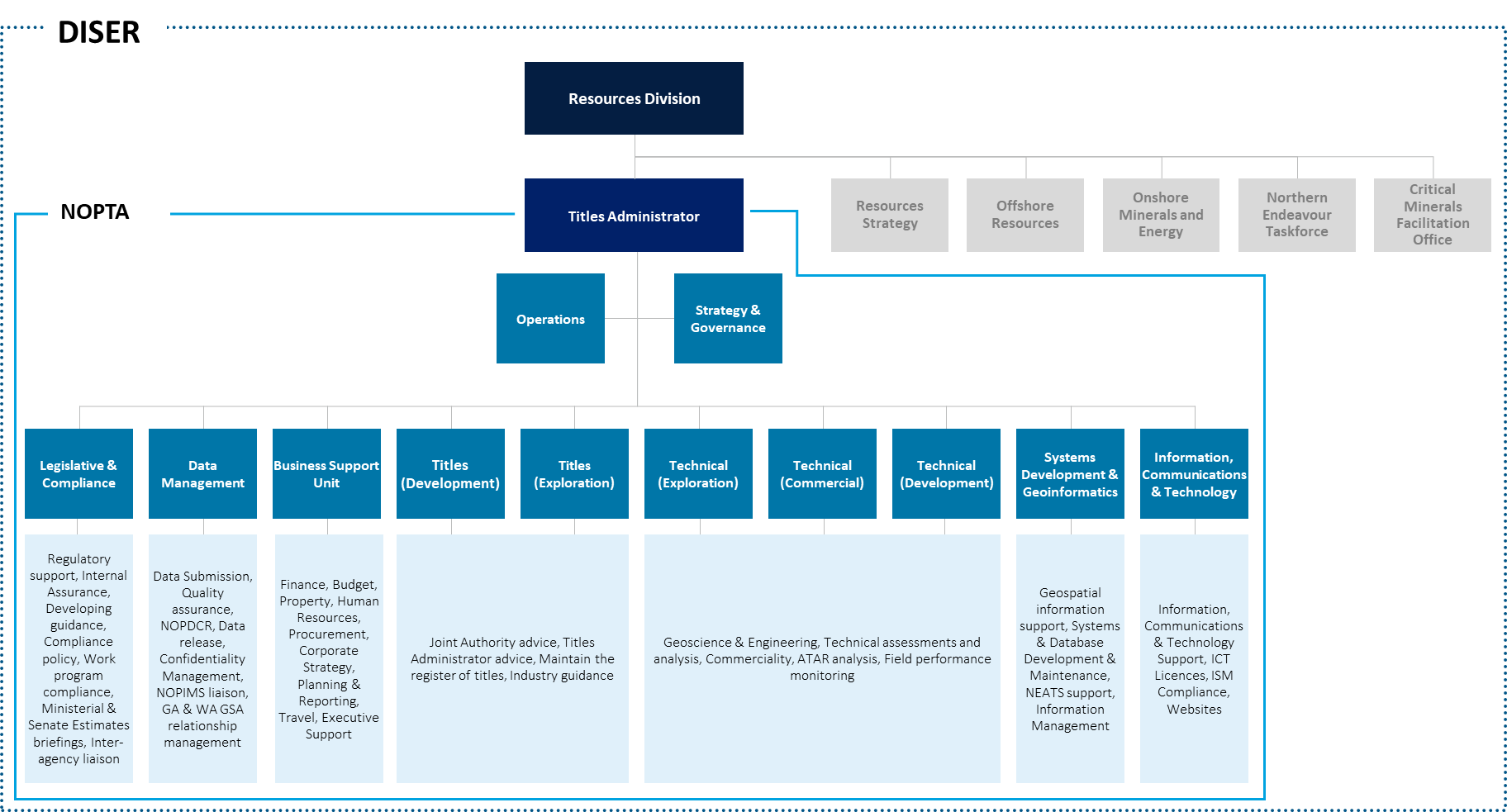

Source: Adapted from NOPTA internal document

### Operating Model

**NOPTA is adopting a matrix-style approach to operational delivery**

The changes in structure and the implementation of a matrix-style organisation (refer to **Figure 7.2**) over the review period have led to teams working together more cross-functionally. This appears suitable given the increasing requirements for multidisciplinary teams to address increasingly complex industry requirements and titles applications. As an example, when working on a renewal application, nominated representatives from the Titles and Technical teams will prepare the application assessment documentation. They will obtain maps from the Geospatial team, confirm with the BSU that an application payment has been made and then consult the Data Management team to ensure that all data submissions/reports relating to the current permit term have been submitted within the regulatory timeframes. Over the past 18 months, both the Titles and Technical teams have moved away from working within their distinct streams and instead now work within a pooled resource model.

These changes in structure and ways of working have provided greater flexibility in resource allocation and a more balanced distribution of work in the Titles and Technical functions. It has also allowed for more breadth in role for staff members which has contributed positively to development and technical upskilling.

Given the introduction of a pooled resource model, NOPTA should consider the need to maintain separate Managers per stream within the Titles and Technical operations, as outlined above.

**Figure 7.2: The NOPTA matrix organisation model**



Source: Adapted from NOPTA internal document

#### Collaboration internally

There are a number of formal routines in place at NOPTA to promote discussion and collaboration across the functions (see **Table 7.1**). In addition to this, there are frequent informal discussions that occur between Managers as well as Assistant Managers to provide updates and feedback on work and staff members. However, there is a need to ensure processes and systems fully support a matrix-style of working. A unified operating model is required to successfully execute a matrix-style way of working.

**Table 7.1: Internal collaboration and governance arrangements**

| Meeting | Role | Attendees | Frequency |
| --- | --- | --- | --- |
| **Quality Assurance Committee** | Governance – oversee arrangements in relation to risk, reporting and quality assurance | Titles Administrator, Strategy & Governance Manager, Operations Manager | Quarterly |
| **ICT Board** | Governance – strategic direction and advice on ICT technology and capability. | Titles Administrator, Strategy & Governance Manager, Operations Manager, BSU Manager, ICT Manager, SDG Manager | Monthly |
| **Senior Leadership Group** | Strategic planning, resourcing & organisation priorities | Titles Administrator, Strategy & Governance Manager, Operations Manager | Fortnightly |
| **Management** | Discuss Human Resource, NOPTA-internal Health, Safety & Environment and team priorities/strategic discussions | All managers and above | Fortnightly |
| **Operations** | Discuss priorities for the week and track applications against timeframes | All managers and above (except ICT and BSU managers) | Weekly |

Source: Adapted from NOPTA internal document

### Span of control of the Titles Administrator

**There is an opportunity to consolidate the management layer**

NOPTA has a flat organisational structure, with three layers and the Titles Administrator having a total of thirteen[[23]](#footnote-24) direct reports (see **Figure 7.1**). Some stakeholders raised that NOPTA appears “top heavy”. Leading practice organisation design principles typically recommend a managerial span of control between five to eight direct reports, depending on factors such as the complexity and risk of the work activities. If, as we recommend, further decision-making delegations are provided to NOPTA, it will be important to ensure the Titles Administrator has the appropriate number of direct reports so the Titles Administrator can effectively and efficiently undertake its expanded decision-making role.

Some consolidation of the senior leadership team may be appropriate and may further improve NOPTA’s operational efficiency. Consolidation opportunities may include:

* Grouping like functions such as Information, Communications & Technology and Systems Development & Geoinformatics under a single direct report[[24]](#footnote-25)
* Reviewing the management structure of the Titles and Technical teams. Aligning the Technical and Titles teams by discipline (i.e. Development, Exploration and Commercial).

|  |
| --- |
| Recommendation #6 |
| NOPTA, in collaboration with DISER executives, should realign its operating model to better enable cross-functional ways of working and to reduce the cost to industry where appropriate. This alignment should consider:   * Changes to processes to enable new ways of working and increased digital fluency, ensuring talent processes support the attraction and retention of diverse talent that brings a new and wide range of thinking and experience * Consolidation of management positions within NOPTA to reduce the number of direct reports to the Titles Administrator * Any required changes to support other recommendations accepted by the Government in relation to this review. |

## NOPTA’s capacity

### NOPTA’s current capacity

**NOPTA’s capacity is considered sufficient for its current remit, although acute capacity constraints were noted**

NOPTA’s personnel levels have increased from 51.3 FTEs in 2015-16 to 58.1 FTEs in 2019-20[[25]](#footnote-26) (see **Figure 7.3**). The increase was predominantly due to the recruitment of four additional technical staff following a key recommendation from the 2015 Operational Review. Technical specialists were recruited in the areas of commercial analysis, geology, reservoir engineering and geophysics.

**Figure 7.3: FTE by functional area from 2015 to 2019**

Source: Deloitte analysis adapted from NOPTA data

We have observed the following:

* Feedback from discussions with the Technical Managers is that the current staffing levels of the Technical team is deemed appropriate discharging NOPTA’s current functions and remit. Since 2015-16, the number of technical staff has remained steady (fluctuating between 12 and 14 FTEs), despite an increased focus on Resource Management and Commercial Reviews across the review period
* Over the five-year period, the Titles team staffing has increased marginally from 11 to 13 FTEs. Over the review period, the Titles team have experienced difficulty in balancing their day to day applications workload and maintaining registers. Manual processes, and NOPTA’s requirement in some cases to maintain hard copies of titles, have reduced efficiency of the Titles teams, and further digitisation is required
* NOPTA faces a challenge in addressing acute capacity constraints using more flexible resourcing models, such as fixed-term or contractors
* There has been an increase in staff in the Data Management team (from 6 to 9 FTEs over 2014-15 to 2018-19), which is consistent with an increase in the transactional workload of the Data Management team as well as an increased focus on Regulatory compliance and data quality improvements. The revised Minister’s Statement of Expectations for NOPTA is to take an active role in improving data outcomes for industry and other stakeholders
* The staffing levels of the Legislative Compliance team has seen a gradual increase (from 4 to 7 FTEs over 2014-15[[26]](#footnote-27) to 2018-19). This was to increase internal compliance capacity and to assist with technical input and operational advice for policy work in progress in the Offshore Resources Branch. Other responsibilities of the team include (but are not limited to) providing regulatory support, preparing guidance, performing assurance reviews and managing escalated compliance.

There are frequent ad hoc requests from other branches of DISER and government departments for information or advice related to offshore petroleum or GHG storage. At times requests are outside of NOPTA’s core mandate but considered to be ‘for the public good’ and therefore are fulfilled. We do note that NOPTA is part of the broader APS and therefore would reasonably be expected to contribute to such activities and requests as appropriate.

#### Stakeholder perceptions of NOPTA’s capacity

**Stakeholders tended to view NOPTA as having sufficient capacity, but some stakeholders stated that NOPTA had excess capacity**

Stakeholders tended to view NOPTA’s capacity as being sufficient (refer to **Figure 7.4**). Positive sentiments (‘slightly agree’ or better responses) of 94% or higher were recorded across all questions by external stakeholders surveyed (results below).

In general, we did not identify areas of sustained over or under capacity through our analysis. NOPTA’s capacity appears sufficient within its current remit. Insofar as capacity challenges were noted, NOPTA should consider process efficiency before increasing personnel levels. Furthermore, there will be benefit from greater digital enablement of data submission processes in helping to streamline NOPTA’s Data Management functions over the longer-term. Although acute instances of capacity challenges were raised by NOPTA, we would expect this given the unpredictability of industry activity.

NOPTA’s capacity must be viewed relative to industry activity, both in terms of volume and complexity. Multiple stakeholder groups questioned the size and structure of NOPTA, with some feeling NOPTA was top heavy and its capacity too high. While industry activity volumes have fallen or remained flat (e.g. see **Figure 7.5** for the number of titles applications), complexity of activities has increased. For example, referring to **Figure 7.5**, Transfers and Dealings make up the largest portion of applications from July 2019-June 2020, which, relative to some titles activities, are more time consuming and of higher complexity to assess. This trend is expected to continue. As such, care must be given not to determine NOPTA’s resourcing requirements on a volume basis only.

We do not see an immediate need to rationalise roles across NOPTA per se. However, as discussed above and in consideration of the evidence examined, we support efforts to consolidate NOPTA’s management layer (which may further improve NOPTA’s operational efficiency) and to improve process efficiency across NOPTA prior to rationalisation of roles.

**Figure 7.4: Survey responses to NOPTA’s capacity**

Source: Deloitte Stakeholder Survey, Deloitte analysis

**Figure 7.5: Applications submitted in 2019-20**

*\*Location includes declaration, extension and revocation*

*\*\*Other includes credit, extension renewal, rate of recovery and cancellations*

*\*\*\*Transfer and Dealings includes change of company name*

Source: Deloitte analysis adapted from NOPTA data

### NOPTA’s future capacity

**A more proactive and influential approach may require additional capacity**

Based on our understanding of NOPTA’s potential future capacity, we believe NOPTA should take on a more proactive and influential role in shepherding the petroleum industry as it matures. There will likely be greater resourcing requirements to successfully deliver this expanded role, as this represents a change in the way NOPTA engages with the industry. Relevant examples of regulators internationally have shown that resourcing, particularly in support of stakeholder engagement activities, is required. There may also be a need to build new capabilities for this more active role.

We do not, however, expect NOPTA’s resource profile to substantially increase, nor would the increase be expected to occur as a step change. Rather, NOPTA’s resource profile should continue to mirror the needs of the industries it oversees. In relation to GHG matters, NOPTA’s capacity reflects the current levels of industry activity and demand, with only 4 active GHG titles.

The timing and quantum of resourcing requirements will depend on a multitude of factors, including the rate of petroleum industry decline, complexity of outstanding titles-related activities, and NOPTA’s improvements to operating efficiency through technology-driven improvements. The benefit to Australia and the industry from the effective application of an expanded remit will likely exceed the incremental costs from greater resourcing.

## Performance and accountability

**NOPTA manages personnel performance but should foster an open culture which welcomes constructive feedback**

As part of DISER, NOPTA utilises DISER’s performance management system, MyPlan. Individual performance objectives and goals are linked to both Team Plans and the overall NOPTA Strategic Plan, applying a cascading approach to objectives. Individual development plans are also captured in MyPlan. Formal performance check-ins between staff members and leadership are formally required on a quarterly basis with informal feedback encouraged regularly. Personnel and leaders are able and encouraged to record feedback more frequently. An end of year performance review is completed, and personnel are allocated are a performance rating. There appears to be high engagement with Performance Management. For instance, NOPTA’s MyPlan submission rate is 100%[[27]](#footnote-28) as per DISER’s mandate that all employees are to have a MyPlan in place however, this is not necessarily indicative of the quality of submissions.

In 2019, NOPTA leadership distributed a questionnaire to all NOPTA personnel asking a series of questions on culture and team effectiveness. NOPTA leadership identified a gap in the comfort and accountability for providing performance or behavioural feedback among staff. This feedback was reinforced through the 2019 APS Census[[28]](#footnote-29), which highlighted a perception from many NOPTA staff members that the current levels of performance management by leadership may require improvement (see **Figure 7.6**). NOPTA leadership also identified a potential cultural barrier to providing open and honest feedback. This could include both peer to peer and upwards feedback. Positively, in 2019, as an outcome of these results and feedback, NOPTA held training for all Executive Level 1 (**EL1**) and Executive Level 2 (**EL2**) staff on ‘how to have difficult conversations’. In 2018, NOPTA also held an all staff event on giving and receiving feedback.

**Figure 7.6: 2019 APS census data for NOPTA**

55% favourable

50% favourable

47% favourable

62% favourable

To what extent do you agree that in the past 12 months, the performance expectations of your job were clear and unambiguous

To what extent do you agree that the support by your supervisor has helped to improve your performance

My overall experience of performance management in my agency has been useful for my development

My supervisor openly demonstrates commitment to performance management

Source: 2019 APS Census data

There is further opportunity for managers to provide ongoing feedback outside of technical areas and to build a culture which welcomes and is open to constructive feedback.

Through discussions with NOPTA leadership, there were no concerns highlighted in relation to poor performance. Aligned to this, NOPTA staff members reported high performance of their peers through the 2019 APS Census, with 94% providing favourable sentiments to the statement ‘The people in my workgroup complete work to a high standard’.

|  |
| --- |
| Opportunity #2 |
| NOPTA is encouraged to provide greater clarity over performance expectations to its personnel. As part of this, NOPTA should look to further foster a culture which welcomes open and constructive performance feedback. Importantly, the development of this culture must be ‘leader led’ and modelled by NOPTA’s senior management. |

### Learning and development

**NOPTA demonstrates a focus on learning and development**

There is a strong focus on Learning and Development at NOPTA which is encouraged at all levels of the organisation. The NOPTA Learning and Development Plan is reviewed annually and ensures alignment to DISER’s Capability Development Strategy and relevant APS Frameworks. The current Learning and Development Plan (2020-2023) is focused on two strategic priorities: Strong Leadership and Advancing Capability. The Learning and Development Plan does not include Technical/Specialist training, which is addressed through functional areas of NOPTA between individuals and their managers. As outlined in **Figure 7.7**, NOPTA applies a structured approach to Learning and Development, covering three levels: APS General Training, NOPTA Training, and Professional/Technical Training.

Much of the Technical training undertaken by NOPTA staff members is centred around attendance at seminars/conferences/workshops as well as holding professional memberships that require a certain number of continued professional development (**CPD**) hours per year.

**Figure 7.7: NOPTA’s three levels of training**

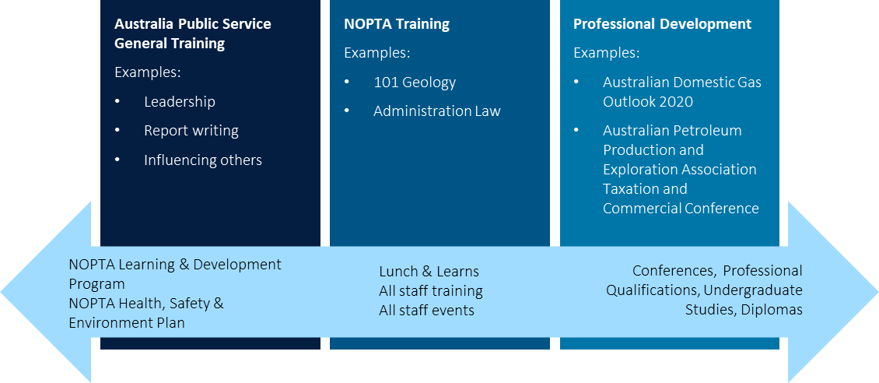

Source: Adapted from NOPTA internal document

In 2018, NOPTA commenced a skills exchange program with regulators in the UK and Norway. We discuss this further in **Section 9**. The intent of the program is to discuss and share best practice and innovation in resource and data management. The program has been positively received to date, with a view to expand it to other areas in the future. We see value in international exchanges as a means for developing staff whilst also identifying relevant lessons for application to NOPTA’s approach to titles administration.

There was evidence of a continued focus on learning and development of personnel and evidence of learning and development being embedded across talent processes.

### Embodiment of values

**Stakeholders broadly agree NOPTA personnel behaviours reflected NOPTA’s values, particularly the professionalism of personnel**

Referring to **Figure 7.8**,NOPTA personnel were generally seen to exhibit NOPTA’s values. Specifically:

* Integrity and respect were most favourably rated, with 100% of stakeholders surveyed selecting ‘strongly agree’ or ‘agree’ to these question
* Openness received the lowest rating, with 70% of stakeholders surveyed selecting ‘strongly agree’ or ‘agree’ to this question
* Over 90% of stakeholders surveyed indicated positive sentiments (‘slightly agree’ or better responses) to all questions.

**Figure 7.8: Survey responses to NOPTA’s adherence to its values**

Source: Deloitte Stakeholder Survey, Deloitte analysis

## Capability and workforce planning

### NOPTA’s current capability

**NOPTA’s technical capabilities are strong**

From our discussions with NOPTA and our review of NOPTA’s strategic documentation, including its Strategic Plan, there was evidence of a focus on building current and sensing future capability requirements. For example, in developing the Strategic Plan, NOPTA’s senior leadership considered likely capability requirements for the next three years and what additional skill sets may be required. Furthermore, NOPTA’s Human Resources Manager holds annual discussions with Managers to discuss team structure, succession planning and Learning and Development requirements.

NOPTA manages two somewhat competing personnel risks:

* **Key person risk:** The scale of NOPTA’s operations means that, for several roles, there is a single individual with a given skillset. This was realised to an extent in 2016-17 when three key senior staff members departed the organisation. NOPTA’s deliberate move to a cross-functional way of working is part of its strategy to manage its key person risk by cross-fertilising skills across the organisation.
* **Risk of stagnation from low turnover (see Figure 7.9):** Whilst there are many benefits to having a consistent workforce, this must be balanced with the need for ‘fresh ideas’ and the most relevant industry and APS experience. External feedback did not indicate any concerns on a lack of industry understanding or relevance, but it is something that NOPTA should continue to monitor.

**Figure 7.9: Annual turnover rate (percent) from 2014-15 to 2018-19**

Source: Deloitte analysis adapted from NOPTA data (Part 1 2020 Operational Review (NOPTA Overview))

The majority of NOPTA’s technical roles are sourced from industry. Availability of these technical capabilities is dependent on market conditions. In line with leading practice talent models, NOPTA look to engage specific capabilities for a period of time rather than establishing full-time permanent capability, as can be seen through its use of contractors and consultants.

NOPTA does not currently perform proactive recruitment activities, due to cited constraints with APS recruitment processes. However, an opportunity exists to commence a level of informal proactive resourcing through market mapping activities and building relationships within the market with those who may be a potential fit for future required skill sets.

NOPTA’s technical capabilities were well regarded by the majority of stakeholders (see **Figure 7.10**). NOPTA is to be commended for the depth of its technical skillsets, particularly in geotechnical areas (which includes experience in GHG storage). This feedback was near universal through our engagements with stakeholders. These impressions are also reinforced through NOPTA’s stakeholder surveys, which has consistently shown high degrees of satisfaction with NOPTA’s technical capabilities.

**Figure 7.10: Survey response to NOPTA staff technical capabilities**

Source: Deloitte Stakeholder Survey, Deloitte analysis

### Remuneration and career progression

**NOPTA align to DISER and APS guidelines. Remuneration is typically lower than industry as a result**

NOPTA’s recruitment processes and salary structures are in line with the APS Recruitment Procedure and DISER’s Enterprise Agreement (2019-2022) as NOPTA is a branch within DISER. As a result, industry salaries are typically higher vis-à-vis NOPTA salaries for equivalent roles.

Remuneration appears to have a moderate impact on attraction of talent. There is a gap between industry remuneration and NOPTA remuneration levels. Remuneration appears to have a moderate impact on talent retention at junior levels, as junior talent is observed to be more likely to leave to take up industry roles. Feedback from discussions with NOPTA personnel is that role stability within NOPTA is likely to contribute to higher retention at more senior levels, versus greater volatility experienced within industry.

The 2019 APS Census for NOPTA outlined largely favourable results, although the item on intention to stay with NOPTA was less favourable:

* 70% of NOPTA personnel indicated favourable responses to the statement ‘I am fairly remunerated e.g. salary, super for the work that I do’
* 92% of NOPTA personnel indicated favourable responses to the statement ‘I am satisfied with my non-monetary employment conditions (e.g. leave, flexible work arrangements, other benefits)’
* Only 53% of NOPTA personnel indicated favourable responses to the statement ‘I want to stay working for my agency for at least the next three years.’

There is a strong perception amongst NOPTA personnel that opportunities for career progression and mobility are limited. For instance, only 44% of NOPTA personnel indicated in the 2019 APS Census that they are satisfied with the opportunities for career progression. There is a natural limit to career progression opportunities within a small organisation with a defined set of functions. This is acknowledged by NOPTA leadership. NOPTA seek to provide opportunities for individuals to ‘act’ in roles that are of a higher designation, offer secondments (e.g. to NOPSEMA), and provide staff members with learning and development opportunities in line with career desires.

### NOPTA’s future capabilities

**There are a number of areas where capability should be further enhanced**

To define future required capabilities, the Technical team at NOPTA undertakes a ‘horizon scanning’ exercise, considering what might be of interest to the Joint Authorities in future, where the legislation and policy is heading and industry trends. NOPTA also benchmarks itself against its peer administrators (including some regulators) globally to gain a better understanding of their capability and remit.

We have identified, as part of our review and in relation to industry trends, a number of personnel capability areas that will likely require further development. The drivers for these capability requirements are discussed further in **Section 4**, where we outline the future direction of the industry and the associated implications for NOPTA. Each of the capability areas will have a differing level of relative urgency and criticality to supporting the effective and efficient administration of offshore petroleum titles (see **Figure 7.11**).

Specific capability requirements we have identified include:

* **Commercial** and **financial analysis:** While a core function of NOPTA’s existing role, greater emphasis and depth of capability will be required to support the increase in the number of transactions expected with a maturing industry
* **Decommissioning** and **facilities engineering:** Capabilities to address the technical elements of industry activities in relation to late life/maturing assets
* **Risk management:** As we have discussed in **Section 5.4.3**, NOPTA plays a critical role in risk management within the offshore legislative framework. Risk management was highlighted as an area for growth through results from the 2019 APS Census where only 52% of NOPTA personnel answered favourably to the statement ‘My agency provides me with opportunities to develop and enhance my skills to manage risk effectively’. NOPTA has taken steps to address this by engaging an external provider to deliver risk management training sessions (which was compulsory for staff) and also holding an internal ‘lunch and learn’ training session, where an ex-industry staff in the Technical team provided an overview of risk management tools used in the oil and gas sector[[29]](#footnote-30)
* **Industry leadership:** This is the capability to help shape the industry’s strategic direction in relation to resource management and demonstrate leadership through interactions with titleholders to support policy development by the policy areas within the Department. We consider the ability to demonstrate administrative leadership as underpinning a successful move to a more proactive and influential role
* **Communications** and **stakeholder engagement:** NOPTA will need to be able to clearly and confidently communicate its position to stakeholders as it takes on a more influential and proactive role. Moreover, the ability to effectively engage with stakeholders will underpin efforts to shape industry activity in relation to resource management
* **Offshore GHG storage:** The particular capabilities required will depend, to a degree, on industry demand (i.e. the type of offshore investments made). NOPTA may not be required to ramp up this capability at present but should have plans in place to scale accordingly should industry demand for GHG storage titles increase in future.

There is a risk that NOPTA will be in competition with the industry for what will likely be scarce skillsets, particularly with respect to decommissioning. With respect to financial analysis and decommissioning capabilities, there may be benefits in exploring the development of shared capabilities in this regard with NOPSEMA to avoid duplication, gain better access scarce skillsets, and improve coordination on the associated matters.

**Figure 7.11: Potential required future capabilities**

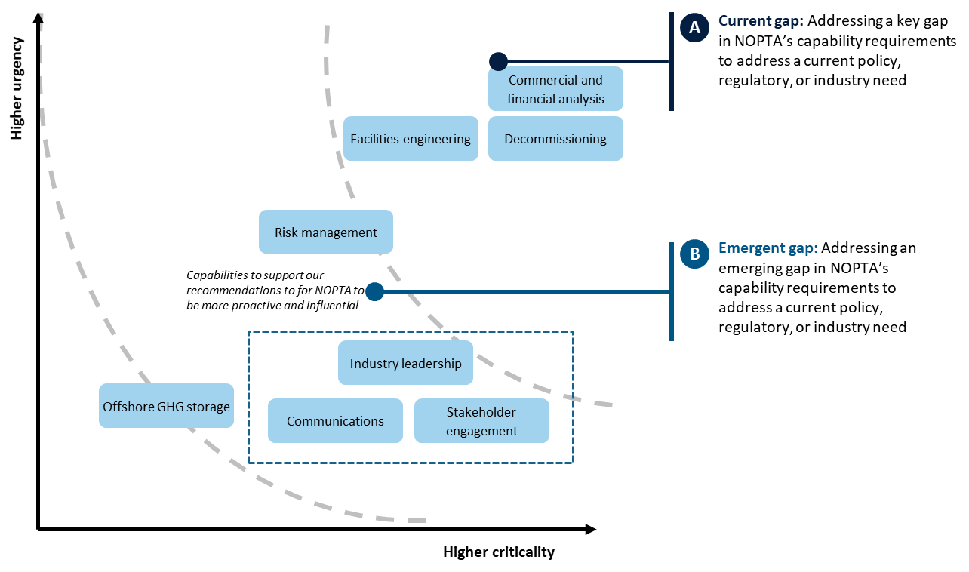

Criticality refers to the degree to which a capability supports the mitigation of a risk, supports the fulfilment of NOPTA’s functions, or supports the fulfilment of other relevant strategic objectives; urgency refers to the relative timeframe when the capability is required

Source: Deloitte analysis

|  |
| --- |
| Recommendation #7 |
| NOPTA and NOPSEMA should, once the policy framework for offshore decommissioning has been developed and agreed by the Government, coordinate on the building of capability and capacity for decommissioning and aging asset management (including facilities engineering) and financial/commercial analysis (including transaction analysis and financial capacity). NOPTA and NOPSEMA may consider engaging with peers in more mature jurisdictions to identify the specific capability skillsets required. NOPTA and NOPSEMA should consider opportunities for building a shared capability that can be accessed by both parties to avoid duplication of capabilities and capacity. |

# How does NOPTA manage data and information?

Key points

|  |  |
| --- | --- |
| **NOPTA has an established set of strategic documents outlining its data and information management priorities**  NOPTA has an established set of strategic documents outlining its data and information management priorities. NOPTA uses an outsourced model for delivering ICT systems and core data management system capabilities, has established assurance and governance arrangements, and seeks to align to Australian Government Cyber Security standards and are actively seeking to improve maturity relative to cyber security better practice.  **NOPTA’s pursuit of a ‘digital agenda’ is encouraged**  NOPTA has made progress with its digital agenda over the review period. NOPTA’s digital focus aligns with broader trends in regulation to employ digital technologies to effectively and efficiently deliver regulatory services. Our analysis supports NOPTA’s digital focus and the trend of digitisation as a means to improve efficiency of internal processes, reduce regulatory burden for titleholders, and provide the means for delivering strategic intelligence to drive performance. These factors will be increasingly important as the industry matures and faces increasing challenges in achieving the optimum recovery of resources. | **NOPTA’s digital capabilities are, in the main, well-regarded and have improved significantly**  NOPTA’s data and information management capabilities are, in the main, robust and well-regarded internationally by other peer regulators and domestically by industry. NOPTA’s digital capabilities will underpin its ability to successfully influence the industry and uplift industry performance.  While some enhancement opportunities are noted, the NEATS system received strong positive feedback for providing accurate titles information. Enhancements should broaden NEATS functionality with a view to digitise the end-to-end titles management process to the extent possible, enable greater visibility over titles decision-making, and support NEATS being a ‘one stop shop’ for titleholders on titles applications (e.g. for transacting, data submissions, and fulfilling reporting requirements).  NOPTA has invested significantly in integrating datasets across its various systems. Its use of this data to support more strategic decisions is essential. To achieve this, NOPTA will need to invest in the appropriate analytical capabilities and tools to extract insights from large, unstructured datasets.  NOPTA’s partnership with Geoscience Australia and WA DMIRS is an efficient model for managing offshore petroleum data. However, to build confidence in the data held by NOPTA, further focus is needed on improving the quality of data submissions and NOPTA’s QC process.  There is a need to modernise the regulations relating to data to support many of our recommendations. This is outside the scope of this review; however, a review is underway by DISER into these components of the offshore regulations.  **NOPTA’s use of benchmarking is a step change in capability and should be built on further**  NOPTA has developed a set of quality criteria to quantitatively assess data submissions, enabling comparator analyses between titleholders. NOPTA’s use of data submission benchmarking is an example of leading practice globally.  **Recommendations: 8, 9**  **Opportunities: 3, 4, 5, 6** |



The quality of NOPTA’s management of industry data and information underpin the confidence of the Joint Authorities in the advice they receive for decision-making and confidence of titleholders in the offshore legislative framework. Ultimately, the effective and efficient use of data and information helps enable a vibrant offshore petroleum industry.

In the context of titles administration, data refers to technical petroleum data such as survey, well, or sample data. Data can be digital (captured in electronic systems) or physical samples held in sample repositories.

## NOPTA’s arrangements for data and information management

NOPTA is pursuing what we would describe as a digital transformation agenda, aligned with government priorities, and has invested significantly in enhancing its data and information management capabilities. It is essential that NOPTA has the right strategic documents, delivery model, governance, cyber security, and assurance practices in place to support this journey

### Strategic management of data and information

**NOPTA has an established set of strategic documents outlining its data and information management priorities**

NOPTA’s Strategic Plan sets out NOPTA’s key priorities. Effective data and information management is an important enabler for each of the Strategic Plan’s priorities:

* Integrating data and technology
* Resource management in accordance with optimum recovery and good oil field practice
* Collaboration and engagement with stakeholders
* Building internal NOPTA capability to support the fulfilment of other priorities
* Supporting external compliance by titleholders
* Optimising NOPTA’s operational performance.

NOPTA has a *2020-23 ICT Strategic Plan* (**ICT Strategic Plan**) which outlines how, from a data and information management perspective, NOPTA will support its priorities set out in the Strategic Plan. NOPTA’s ICT Strategic Plan sets out a high-level program (the **program**) of work to deliver the ICT strategic priorities. In addition to NOPTA’s ICT Strategic Plan, there are a range of policies, procedures, and guidelines and governance arrangements which collectively operationalise the ICT Strategic Plan. To date, NOPTA’s ICT priorities have centred on moving to the cloud and integrating key databases.

For the current ICT Strategic Plan, NOPTA’s ICT priorities are to:

* Create and maintain a single source of the truth for data and information held by NOPTA
* Support improved business processes by enhancing/developing innovative ICT solutions
* Provide continuous training opportunities for all NOPTA staff in respect of ICT
* Ensure continuous improvement of ICT processes and infrastructure.

Based on our analysis, NOPTA appears to have suitable strategic documents in place that set clear ICT priorities. However, the period for the program contained within the ICT Strategic Plan concludes in 2020[[30]](#footnote-31). We consider there is an opportunity to take a longer-term view of the ICT work program, including the identification of barriers or enablers for initiatives within the program. We discuss further focus areas for NOPTA’s future ICT strategic direction below.

### NOPTA’s data and information management delivery model

#### Information management

**NOPTA uses an outsourced model for delivering ICT systems**

Referring to **Figure 8.1**, NOPTA operates a primarily outsourced model for the delivery of information management systems:

* NOPTA corporate systems, such as the Finance Management System, Payroll, and Human Resources system are hosted by DISER. As NOPTA is fully cost recovered, NOPTA pays a ‘corporate fee’ for the use of these systems to DISER’s corporate shared services
* NOPTA’s systems for supporting the delivery of titles administration activities are primarily delivered through outsourcing arrangements with service providers, covering for applications managed services and infrastructure managed services.

Oversight of outsourced arrangements is provided through NOPTA’s ICT governance framework (discussed below). NOPTA’s ICT capabilities are delivered across two teams, with the support of NOPTA’s BSU team:

* The Information, Communications, and Technology team (responsible for supporting infrastructure and software-as-a-service (**SaaS**) applications)
* System Development and Geoinformatics team (responsible for supporting bespoke ICT applications and ensuring NOPTA has up-to-date geospatial data).

Given NOPTA’s size, we are of the belief that current outsourced arrangements for ICT capabilities are appropriate. We examine further centralisation opportunities with DISER’s corporate shared services in **Section 10.1.2.**

**Figure 8.1: NOPTA’s information management delivery model**

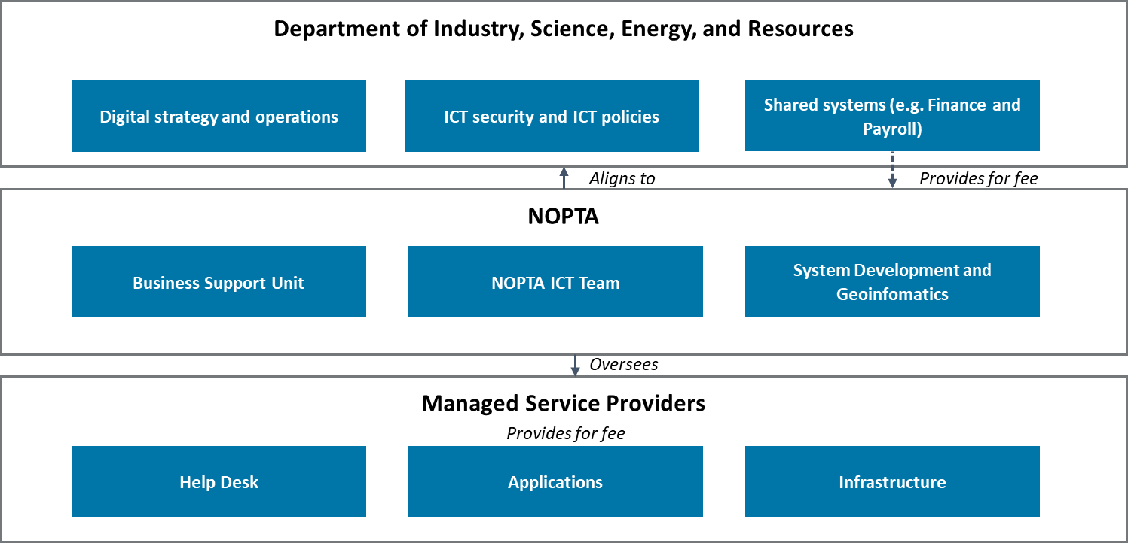

Source: Adapted from NOPTA internal document

#### Data management

**NOPTA uses an outsourced model to deliver its core data management system capabilities**

NOPDCR houses all offshore petroleum data and is a partnership between NOPTA, Geoscience Australia and the Western Australia Department of Mines, Industry, Regulation and Safety (**WA DMIRS**). There are two physical repository sites, one managed by Geoscience Australia and the other by WA DMIRS. There is a services agreement in place between the parties, whereby Geoscience Australia and WA DMIRS provide a service to NOPTA on a fixed fee-for-service basis.[[31]](#footnote-32) The agreement specifies service levels, roles and responsibilities, treatment and usage of confidential data, commercial arrangements, and governance requirements.

Under the agreement, NOPTA has formal custodianship of the data and physical samples from the point of submission until the expiration of the specified confidentiality period for that data (each data item has a specified confidentiality period as specified by the RMA Regulations. Geoscience Australia has formal custodianship of the data and physical samples once they have been authorised for release as per the RMA regulations. WA DMIRS provides data management services to NOPTA and Geoscience Australia prior to and after public release.

Data received in NOPDCR is compliance and quality checked, consolidated, and uploaded to the National Offshore Petroleum Information Management System (**NOPIMS**), where it is managed and authorised for release[[32]](#footnote-33). NOPIMS is hosted by Geoscience Australia and provides the primary digital channel for accessing offshore petroleum data held in NOPDCR. Geoscience Australia and WA DIMRS also enable access to NOPDCR data through other public-facing distribution channels. NOPIMS is administered collaboratively by the parties and is subject to a separate agreement.

NOPTA’s data management capabilities are primarily managed through its Data Management team, who also manage the relationship with Geoscience Australia and WA DMIRS in relation to NOPDCR and NOPIMS.

**NOPTA’s partnership with Geoscience Australia and WA DMIRS is an efficient model for managing offshore petroleum data**

International regulators we consulted with noted that NOPTA’s arrangements with Geoscience Australia and WA DMIRS are leading practice globally for the management of offshore petroleum data. We support this perspective. The current arrangements represent an efficient delivery model due to the avoidance of capability duplication (e.g. as would be the case if NOPTA was required to store and catalogue samples) and the significant experience Geoscience Australia and WA DMIRS have in managing physical samples. It is likely due to their experience and relative scale; Geoscience Australia and WA DMIRS can render these services at a lower cost than NOPTA would be able to.

As noted above, the formal mechanism governing the relationship between NOPTA and Geoscience Australia and WA DMIRS is a services agreement. However, given the strategic, long-standing, and close nature of the relationship between NOPTA, Geoscience Australia, and WA DMIRS, we encourage the parties to view the relationship as a strategic partnership, as opposed to a ‘transactional’ services arrangement. Practically, this means setting shared objectives for mutual benefit, establishing principles for managing the partnership, and ensure a suitably long-term view to co-development of initiatives is applied.

#### Assurance and governance arrangements

**NOPTA has established assurance and governance arrangements**

NOPTA has a Strategic Management Framework for managing the integration of strategic requirements (e.g. from legislation or DISER’s corporate policies), NOPTA’s strategic documents (e.g. the Strategic Plan, risk register, and ICT Strategic Plan), NOPTA’s operational practices (e.g. NOPTA ICT Board, Team Plans, and operating documents), and NOPTA’s assurance framework. Governance and assurance arrangements are discussed further below. NOPTA undertakes assurance reviews, which feed into its Quality Assurance Committee (**QAC**). NOPTA is also subject to internal audits as part of DISER.

As part of the Strategic Management Framework, NOPTA’s ICT Board is responsible for the strategic direction, risk management, and prioritisation of ICT initiatives. The ICT Board was formed in 2019 in response to the need to maintain greater visibility and control over NOPTA’s ICT journey and is comprised of NOPTA senior management[[33]](#footnote-34)[[34]](#footnote-35). Sponsorship of an initiative is by the relevant NOPTA Manager or Titles Administrator (depending on the scope and complexity of the initiative). NOPTA requires business cases for initiatives before funding is granted.

NOPTA stated that the ICT Board manages investment decision-making in accordance with applicable delegations of authority and procurement is undertaken in accordance with the PGPA Act and DISER policy.

A key element of governance over initiatives is benefits management. However, there is currently limited visibility over the achievement of the benefits for many of NOPTA’s digital initiatives. NOPTA needs to track and manage realised benefits and communicate benefit realisation outcomes to key stakeholders. This will be essential for securing ongoing support from industry for future investment.

|  |
| --- |
| Opportunity #3 |
| NOPTA is encouraged to track, manage and report on benefit realisation from its investments in digital initiatives, communicating these benefits in a transparent fashion to stakeholders. This could include reporting on benefits realisation through the *Annual Report of Activities*. |

#### Cyber security arrangements

**NOPTA seeks to align to Australian Government Cyber Security standards and are actively seeking to improve maturity relative to cyber security better practice**

NOPTA seeks to align to the *Australian Government Information Security Manual* (**ISM**) and have a suite of documents outlining its cyber and information security practices. For instance, NOPTA has an Information Security Strategy/Roadmap, a range of security policies, security plans/processes, and security operational procedures. NOPTA is currently reviewing these documents to align with the latest version of the ISM, where relevant. We saw evidence of NOPTA seeking to refresh existing policies to align, wherever practicable, to the ISM. NOPTA also seek to align to ‘The Essential Eight’ cyber security practices.[[35]](#footnote-36)

## NOPTA’s system capabilities and its digital journey

NOPTA has signalled a clear intent to pursue a digital agenda through investment in key technology improvements, including the integration of key systems and migration to a cloud-based system. Broadly NOPTA’s digital journey can be summarised in the following phases:

* **Phase 1 (completed)**: The establishment of base capability following NOPTA’s inception. Largely spreadsheet based and physical (on-premise) infrastructure and data centres developed.
* **Phase 2 (completed)**: Migration to the cloud in 2019 and the building of core systems. For example, NOPTA’s development of capabilities such as NEATS, GIS/spatial data presentation, and NOPIMS. A key focus of NOPTA’s early phases was on ensuring it had a complete historic dataset for titles activities prior to its establishment in 2012
* **Phase 3 (current and future focus)**: The enhancement of system functionality and integration of systems. This includes the streamlining of titles administration activities, digitisation of data, and leveraging cross-system dataset to derive insights to support decision-makers and industry.

A high-level view NOPTA’s technology landscape is shown in **Figure 8.2**. Systems can be broadly classified as internal-facing or external-facing. For the purposes of this section, we have not included systems provided to NOPTA by DISER’s corporate shared services. Additionally, NOPDCR has not been classified as a technology system for the purposes of this diagram.

**Figure 8.2: NOPTA’s technology landscape**

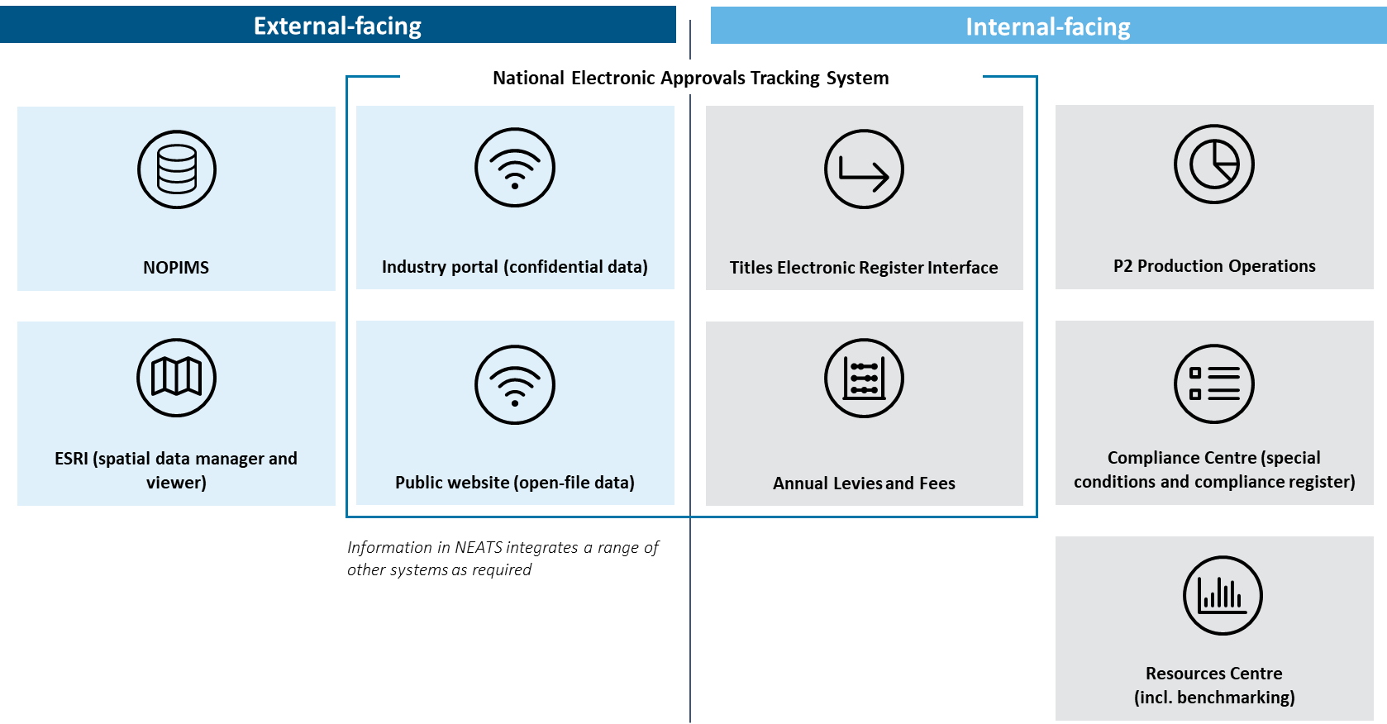

Source: Adapted from NOPTA internal document

### Key NOPTA systems

#### Internal-facing systems

Referring to **Figure 8.2**, NOPTA has a range of internal systems supporting the administration of titles. NOPTA is currently engaged in a range of initiatives to integrate these systems. Based on the evidence we examined, these systems appear to effectively support NOPTA in discharging its duties.

#### National Electronic Approvals Tracking System

**NEATS is a ‘top tier’ system by international standards**

NEATS provides information on Commonwealth petroleum titles across Australia’s offshore areas. NEATS has two main interfaces:

* **External interface:** Accessed through the NEATS external website. Within the external interface there is publicly available information and an industry portal where titleholders can access their confidential data
* **Internal interface:** Where NOPTA manages the titles administration process in alignment with its procedures, policies, and processes. NEATS acts as a workflow management tool and has links to NOPTA’s document management system. The internal NOPTA interface is called the TERI. In addition, the Annual Levies and Fees (**ALF**) interfaces is used to manage cost recovery from titleholders in relation to titles applications. There are also links to other NOPTA systems as required.

The genesis for NEATS was the 2009 Productivity Commission Reviewwhich recommended the introduction of an electronic approvals tracking system to improve the timeliness, accountability and transparency of approval processes. Work begun on previous models over 2010-11 and this was transitioned to NOPTA on its establishment.

The 2015 Operational Review recommended that *“NOPTA, in conjunction with stakeholders, develop and implement short and long term plans to enhance the NEATS system to improve the efficiency and access to titles information.”* NOPTA has subsequently engaged with stakeholders to identify improvement opportunities for NEATS.[[36]](#footnote-37) NOPTA’s overall vision for NEATS is to be a ‘one stop shop’ for centralised and secure interactions for titleholders covering titles applications, data submissions, and fulfilment of reporting requirements. NOPTA’s vision aligns to the 2009 Productivity Commission Review’s full recommendation that the Commonwealth Government consider whether additional features could be included as part of the system (e.g. licence payments and data submission).

Referring to **Figure 8.3**, NEATS was viewed favourably by stakeholders surveyed. This observation echoes findings from NOPTA’s stakeholder surveys where stakeholders tended to view NEATS favourably. Specifically, stakeholders on our survey commented that NEATS is a leading capability that is up-to-date, clear, and easy to use but should be expanded in its scope to enable digital submissions of data. Stakeholders also noted that NEATS does not currently cover GHG storage titles.

**Figure 8.3: Stakeholder perceptions of information in NEATS**

Source: Deloitte stakeholder survey, Deloitte analysis

**Enhancements should broaden NEATS functionality with a view to digitise the titles management process and support NEATS being a ‘one stop shop’ for titleholders on titles applications[[37]](#footnote-38)**

Key enhancement opportunities for NEATS, identified by NOPTA and aligning to stakeholder feedback from the *NEATS 2020 summary report*, include:

* Improving the industry portal to support digital data submissions, payment functionality, notifications, and reporting
* Administrative automation and streamlining (including reporting and data submissions)
* Incorporation of the GHG register and related functionality
* Development of portals for Joint Authority delegates and NOPSEMA.

Our analysis supports these enhancements as a means for improving the efficiency of the titles administration process and, in the case of the latter point, improving collaboration and coordination between NOPTA and NOPSEMA. In particular, digitisation of the Joint Authority decision-making process would help to streamline the overall process and centralise communications. We also suggest NOPTA investigate the incorporation of a benchmarking dashboard as part of the industry portal, within the bounds of confidentiality of information.

|  |
| --- |
| Recommendation #8 |
| NOPTA should continue to extend NEATS functionality to incorporate:   * Digitisation of the titles assessment process, including digitising of the initiating of the assessment process for a title application (i.e. so that emails are not required to be generated manually) * Industry portal functionality for digital transacting, including data submissions, digital signatures, visibility over decision-making (both NOPTA and Joint Authority elements of the process), digital reporting submission, and access to resource and data submission benchmarking dashboards * Where appropriate, develop functionality within NEATS to incorporate GHG storage titles * A portal for NOPSEMA and NOPTA to interact through to flag titleholder-specific issues and enable greater collaboration and coordination on matters of shared interest (e.g. transfers and dealings) * A portal for Joint Authority delegates to reduce manual handling of approvals. Importantly, this functionality should support digital signatures, notifications to be sent to the delegates, a dashboard view of pending approvals for delegates, and visibility over the status of delegate decisions for titleholders. This will need to consider the risks associated with different processes for decision makers i.e. between delegates and ministers and how these will be mitigated and assured against.   We highlight that a number of these functions will require amendment to either legislation or regulation. |

#### National Offshore Petroleum Information Management System (NOPIMS)

Geoscience Australia, upon authorisation of release by NOPTA, provide open-file access to digitised offshore petroleum data through NOPIMS. This helps deliver a competitive edge for Australia as an investment destination for offshore petroleum and supports cost-effective access to offshore subsurface data.

During 2016, an agreement was reached with WA DMIRS to develop NOPIMS, based in part on an existing system developed internally by WA DMIRS. In 2017, NOPIMS went live. Total costs for NOPIMS development over the four years to financial year 2019-20 was approximately $2.5M. This cost was shared between Geoscience Australia and NOPTA, and with WA DMIRS contributing in-kind.[[38]](#footnote-39) NOPTA’s initial focus was on establishing base internal functionality such as developing a tool for managing the data lifecycle, data discoverability by name and geographical area, and undertaking compliance and data modelling.

Key features of NOPIMS includes:

* Access to metadata on new and legacy well, survey, and titles activities
* Downloadable data and ability to request sample access and loan from NOPDCR
* Ability to request larger datasets
* Spatial representation of acreage release areas and other marine areas.

**Feedback on NOPIMS from stakeholders was mixed**

Referring to **Figure 8.4**, stakeholder perception of NOPIMS was mixed. Specifically:

* Positives included, the consistency and accessibility of NOPIMS data, with 64% of stakeholders surveyed selecting ‘strongly agree’ or ‘agree’ responses to these questions
* The accuracy, completeness, and fitness-for-use of NOPIMS information were identified as improvement opportunities, with only 43%, 50%, and 43% of stakeholders surveyed selecting ‘strongly agree’ or ‘agree’ responses to these questions, respectively.

Stakeholder’s noted that historic information in NOPIMS was not always accurate or complete (particularly for information pertaining to wells), had a lack of consistency in the quality of the data, and challenges searching and locating data within NOPIMS. Feedback also highlighted that data downloaded from NOPIMS was not always in a useful configuration and often requires effort to transform into a state that is fit-for-use.

**Figure 8.4: Survey perceptions of information in NOPIMS**

*\*NOTE: ‘Fit-for-use’ means the data is presented in a format that can be readily used (i.e. does not require additional time or resources to reformat)*

Source: Deloitte stakeholder survey, Deloitte analysis

**Through future enhancements, greater automation and streamlining of data transfers are encouraged**

NOPTA is undertaking a development program to enable the majority of its data management tasks to be performed in NOPIMS. We see an opportunity for NOPIMS to be further integrated with other NOPTA systems, such as NEATS for the association of titles and data management records. We encourage NOPTA to formally engage with industry on the identification and prioritisation of development opportunities for NOPIMS. The reduction in manual processing and transacting of data should be a priority for NOPTA.

|  |
| --- |
| Recommendation #9 |
| NOPTA and Geoscience Australia should collaborate with industry to identify and prioritise enhancements to the NOPIMS. Enhancements, some of which are underway, to consider including are:   * Greater integration between NOPIMS and other NOPTA systems, such as NEATS. In particular, this could consider improved linkages between titles information and data management records * Integration between NOPIMS and NOPTA’s online submissions portal to enable data to be received directly from titleholders to the cloud, streamlining submissions (with an eventual aim to enable to ‘cloud to cloud’ data transfers) * Greater data searching/querying capabilities and ability to manipulate and transform information within the system. For example, enabling searching by different data types or keywords e.g. petrography or core porosity.   We highlight that a number of these functions will require amendment to either legislation or regulation. |

Addressing data quality issues relating to accuracy and completeness should be a further priority. Currently, perceptions of accuracy and completeness issues are undermining the confidence in NOPIMS as a reliable source of information to support industry decision-making. NOPTA, Geoscience Australia, and WA DMIRS currently undertake a multistep process for QC, including checking data submissions against regulatory requirements, identifying data corruption issues, and checking the metadata applied where applicable. Benchmarking of data submission quality (discussed further below) is expected to improve data completeness and accuracy. Notwithstanding benchmarking, further investment in QC is required.

|  |
| --- |
| Opportunity #4 |
| NOPTA is encouraged to review its QC procedures with a focus on: identifying root causes of data quality issues; undertaking of spot checks; application of internal consistency checks or other automated detection of data submission issues (where possible); application of set margins or tolerance levels to detect instances where submissions may have erroneous data; and identification and monitoring of potential lead indicators of data submission quality. |

A further opportunity is to utilise meta-data from NOPIMS (such as meta-data derived from searches made by users) to provide a forward view over areas of exploration focus of persons or organisations interested in exploration in offshore Australia. Analysing of meta-data and sharing with Geoscience Australia, state/territory departments, and DISER could provide information for use to identify priority areas for acreage release, Commonwealth Government to produce pre-competitive studies and data packages[[39]](#footnote-40), and, if published publicly, industry and consultants to create additional value-added products to meet the need of explorers.

|  |
| --- |
| Opportunity #5 |
| NOPTA is encouraged to assess the feasibility of analysing NOPIMS search meta-data (i.e. to see which searches users make) and, if viable, use this data to strategically prioritise acreage release and pre-competitive work programs accordingly. |

#### National Offshore Petroleum Data and Core Repository

**NOPDCR is a well-regarded repository for offshore petroleum physical samples**

NOPDCR is perceived by stakeholders as a leading practice repository for the storage of physical samples such as core, cuttings and petroleum samples. Stakeholders acknowledged the continued development of NOPDCR since the 2015 NOPTA Operational Review and the efficient access to data that the repository provides.

We make the following observations:

* Under the current regulations, physical samples are required to be retained by titleholders, even after titles are relinquished. This can result in significant storage costs to titleholders
* Samples, wherever possible, should be digitised for more efficient storage and to enable data analysis. The core scanning and digitisation program undertaken by WA DMIRS is an example of how digitisation could progress.

Given the review on Parts 7 – 10 and Schedules 1 – 5 of the RMG Regulations is currently underway, we do not make formal recommendations in relation to these observations. However, our observations support the recommendations made through the RMA Regulations review which seek to modernise the regulations to support digital forms of transacting and more streamlined data retention arrangements.

### Benchmarking and analytics

**NOPTA’s use of benchmarking is a step change in capability and should be built on further**

NOPTA’s development of benchmarking capabilities across data submission quality and resource management represent a step change in capability. In our experience, benchmarking in this manner is a clear example of better practice and is supportive of NOPTA’s purpose to support the effective regulation and management of Australia’s offshore resources in accordance with optimum recovery and good oil field practice. NOPTA’s benchmarking initiatives have been enabled, in part, through its investment in integration of its various databases and application of learnings gained from international peers.

#### Resource management

NOPTA has developed a set of production monitoring capabilities that enable titleholders’ production performance to be benchmarked versus peers within the industry. Example benchmark metrics include reservoir, field, and cost efficiency. NOPTA has begun sharing insights with industry during the 2019-20 period.[[40]](#footnote-41) Due to the recency of the benchmarking initiative, many industry stakeholders remain largely unaware of NOPTA’s development of benchmarking capabilities. Our view is that NOPTA should monitor benchmarking performance and proactively engage with titleholders and other stakeholders where improvement opportunities are identified.

As the industry matures and assets move towards the end of their economic lives, the optimum recovery of resources will become an increasing challenge for industry. NOPTA should make use of its privileged position to raise the performance of industry through sharing performance intelligence widely, whilst maintaining the appropriate level of confidentiality.

#### Data submission quality

NOPTA has developed a set of quality criteria to quantitatively assess data submissions, enabling comparator analyses between titleholders. Metrics include timeliness, compliance effort, usability of the data, and completeness. It is expected that benchmarking in this fashion will improve the quality of data submissions, reduce errors, and reduce the reworking of data submissions by titleholders.

NOPTA’s use of data submission benchmarking is an example of leading practice globally, and NOPTA’s international peers have expressed interest in NOPTA’s application of benchmarking beyond resource management. Our analysis supports NOPTA’s use of benchmarking to support efficient and quality compliance activities and would encourage its application beyond data submission to other compliance areas where relevant.

#### From data to insights

**Extracting further insights from data should be a next step in NOPTA’s digital journey**

It is appropriate that NOPTA’s focus, to date, has been on establishing base capabilities in the cloud and improving the integration of key databases. NOPTA now needs to make effective use of integrated datasets. As NOPTA transitions to the next phase of its digital journey, it should investigate the application of advanced analytics to derive insights, and other technology advances including machine learning, in support of the industry’s optimum recovery of resources.

|  |
| --- |
| Opportunity #6 |
| NOPTA is encouraged to develop advanced data management and analytics capabilities to make more effective use of its integrated data sets. |

# How does NOPTA effectively engage with external parties to improve regulatory outcomes and build community confidence?

Key points

|  |  |
| --- | --- |
| **In general, NOPTA is well-regarded by stakeholders but needs to ensure it is proactive and visible in its engagements, particularly as the industry matures**  Our engagement with stakeholders found NOPTA to be generally well-regarded with respect to stakeholder engagement, particularly regarding NOPTA’s collaboration, cooperation, and inclusiveness. However, stakeholders tended to view NOPTA as not being adequately transparent, responsive, or proactive in their approach to stakeholder engagement.  Our impression is that NOPTA’s relationships with industry are largely transactional in nature. The next step in NOPTA’s evolution will be developing relationships with titleholders, particularly at executive levels, and being more purposeful in the proactive cultivation of interactions outside of titles processes.  **A ‘One Government’ approach is required**  Based on feedback gathered from NOPTA and stakeholders, we have observed frequent and appropriate levels of engagement between NOPTA and other members of DISER, particularly with the Offshore Resources Branch. There are limitations regarding the degree and type of information NOPTA is able or perceived to be willing to share under its interpretations of the OPGGS Act and its associated regulations and there are observed instances of differing perceptions of NOPTA’s independence and priorities to address, which can impact the degree of collaboration and coordination present. Greater clarity could be achieved through alignment on priorities that are consistent with government and departmental priorities. | There have been improvements to NOPTA’s and NOPSEMA’s collaboration and coordination across the review period. Example steps undertaken by NOPTA and NOPSEMA include joint meetings with titleholders on areas of activity overlap, co-locating of personnel, leveraging one another’s capabilities, and seconding staff where appropriate. NOPTA and NOPSEMA could work together more effectively to share knowledge, coordinate on strategic matters of industry significance, and break down information silos.  A key question is whether the degree of collaboration and coordination required to support a maturing industry is possible under the current offshore model – this is examined further in Section 11.  All components of the offshore legislative framework (administrative, policy, regulatory, and decision-making) must work in unison to address the challenges ahead. We have observed a degree of deviation between the various components over clarity in roles and responsibilities and, in some instances, interpretations of the OPGGS Act. Furthermore, data and information sharing – a key pillar of a cohesive delivery of the legislation and regulations – must be improved and barriers to this outcome addressed.  **Recommendations: 10, 11, 12**  **Opportunities: 7** |

## Overview of NOPTA’s approach to stakeholder engagement

A key aspect of NOPTA’s role in the administration of titles is collaborating and engaging with stakeholders. A robust and scalable approach to stakeholder engagement is important for fostering understanding in and transparency over the offshore petroleum and GHG storage titles administration process.

### NOPTA’s stakeholder ecosystem

NOPTA engages with four key stakeholder segments. These segments are outlined with stakeholder organisation examples listed in **Figure 9.1**. NOPTA’s primary stakeholder groups are industry and state/territory and Commonwealth Government stakeholders. Although Environmental Non-Government Organisations and community groups have an interest in the broader acreage release process and the ultimate outcomes of titles administration activities, these groups are not direct stakeholders of NOPTA but rather the policy area within DISER and are, therefore, not discussed below.

**Figure 9.1: NOPTA stakeholder ecosystem**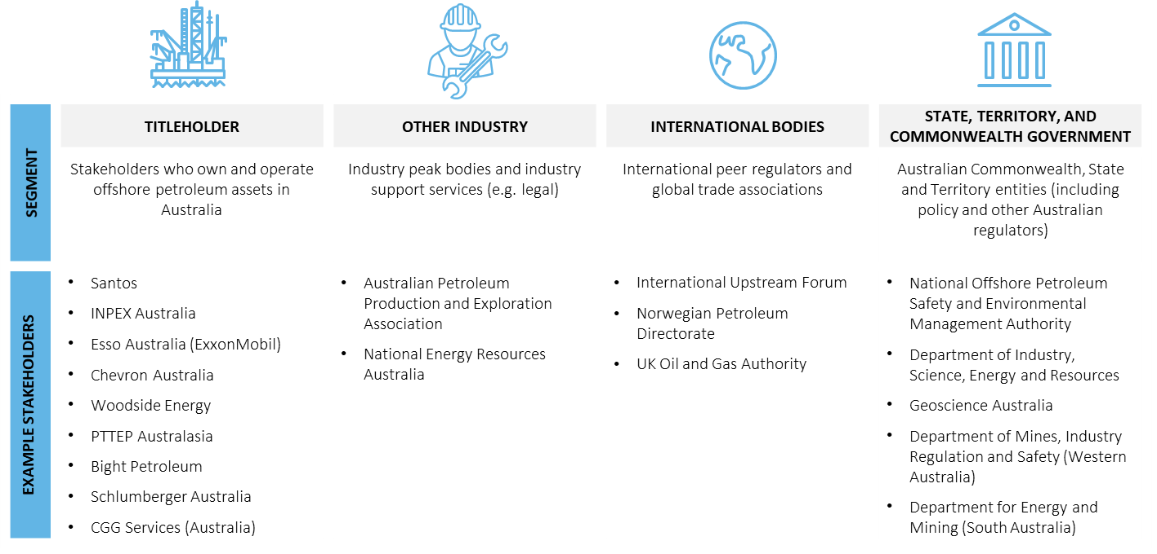

Source: Deloitte

### NOPTA’s engagement approach

During the review process NOPTA has since put in place a *Communications Strategy* and is in the process of developing a *Communications Plan*. For the review period, NOPTA did not have a *Communications Strategy* in place. The *Communications Strategy* is linked to NOPTA’s Strategic Plan, in particular the Strategic Plan’s priority ‘Collaboration & Engagement’. The intent of the *Communications Strategy* and *Communications Plan* will be to provide structure and consistency in NOPTA’s messages and engagements with stakeholders. The *Communications Strategy* outlines NOPTA’s key stakeholder segments, its communications objectives, channels of communications, roles and responsibilities, measurement of engagement success, and key messages. The *Communications Plan* will outline NOPTA’s high level schedule of stakeholder engagement activities. NOPTA currently does not formally track and monitor stakeholder engagement activities. Therefore, NOPTA is currently unable to analyse its stakeholder engagement activities.

NOPTA conducts an annual self-assessment against the Commonwealth Government’s *Regulator Performance Framework* as a means to improve transparency over its activities. The self-assessment examines NOPTA’s performance against the six KPIs specified under the framework, covering reducing regulatory burden, communications, risk-based and proportionate approaches, efficient and coordinated monitoring, transparency, and continuous improvement. Two are most relevant here:

* *“KPI #2: Communication with regulated entities is clear, targeted and effective.*
* *KPI #5: Regulators are open and transparent in their dealings with regulated entities.”*

We see benefits in NOPTA undertaking a self-assessment of this manner, but NOPTA need to be clear in its messaging around its role as a titles administrator (and not as the regulator) within the offshore legislative framework.

### NOPTA’s primary stakeholder engagement channels

NOPTA engages with stakeholders through a variety of channels. Key engagement channels include:

* Attendance at or hosting of events (e.g. workshops, forums, conferences, presentations, working groups)
* Face-to-face interactions (e.g. meetings, calls)
* Media requests which is generally centrally coordinated through DISER (e.g. briefings, interviews, press conferences, media releases)
* Website/online media (e.g. guidance and policies, website contact information)
* Publications (e.g. NOPTA Annual Activities Report, NOPTA’s Regulator Performance Framework Self-Assessments)*.*

### Summary of NOPTA’s stakeholder engagements across categories

Since 2015, NOPTA has undertaken a number of stakeholder engagement activities outside of those relating to specific titles processes. We have provided a brief, non-exhaustive summary of engagement activities undertaken by NOPTA during the review period in **Table 9.1**. Note that many of these activities are currently ongoing.

**Table 9.1: Summary of NOPTA’s stakeholder engagement activities**

| **Stakeholder category** | **Summary of engagement activities** |
| --- | --- |
| Titleholders | * Established the NEATS working group to gather feedback on the development of NEATS in 2017 * Produced tutorial videos to assist NEATS users in navigating and using the public portal, with a focus on highlighting the system’s key features and tips for effective use. NOPTA developed the videos following stakeholder feedback obtained from the NEATS 2020 report[[41]](#footnote-42) published in April 2017 * Consulted on the review of NOPTA’s cost recovery arrangements from December 2015 to February 2016[[42]](#footnote-43) * Consulted on introducing model templates for ATARs in September 2015[[43]](#footnote-44) * Participated in the National Energy and Resources Australia Oil and Gas Future Resources Workshop in April 2016[[44]](#footnote-45) * Presented to the 2015 Professional Petroleum Data Management (**PPDM**) symposium and hosting the 2016 PPDM 1st quarter luncheon.[[45]](#footnote-46) |
| Other industry and trade associations | * Participated in the 2017, 2018, and 2019 APPEA conference (The Australian Government has a booth where NOPTA staff were present to answer questions)[[46]](#footnote-47) * Attended the 2018 South East Asia Australia Offshore Conference.[[47]](#footnote-48) |
| State, Territory, and Commonwealth Government (incl. Ministers) | * Collaborated with the Offshore Resources Branch within DISER to inform the Offshore Resources Branch’s update to various guidelines (e.g. Offshore Petroleum Exploration Guideline: Work-bid[[48]](#footnote-49)) across 2015 to 2019 * Held frequent structured and unstructured engagements with peers within DISER * Participated in community sessions in South Australia and Newcastle, NSW regarding the Government’s role in regulating offshore petroleum activities[[49]](#footnote-50) during 2018 to 2019. |
| International engagement | * Developed and executed of a skills exchange program with the United Kingdom’s Oil and Gas Authority (**OGA**) and the Norwegian Petroleum Directorate (**NPD**), including the development of a confidentiality agreement with the OGA * Participated in the International Upstream Forum (**IUF**) and contributed to the IUF’s agenda, including hosting the IUF in Melbourne, and participated as an observer at the International Regulators Forum * Contributed to PPDM initiatives through membership of the Regulatory Standards Committee * Conducted various ad hoc engagements and relationship building activities with OGA, NPD, and Canadian counterparts (e.g. the C-NLOPB). |
| Other | * Implemented and undertook stakeholder surveys in 2015, 2016, 2017, and 2019 * Published an Annual Report of Activities from 2014/15 * Launched a refreshed website in late 2017.[[50]](#footnote-51) |

Source: Deloitte analysis adapted from NOPTA data

## NOPTA’s stakeholder engagement approach

**In general, NOPTA is well-regarded by stakeholders but needs to ensure it is proactive and visible in its engagements, particularly as the industry matures**

Echoing findings from the 2015 Operational Review of NOPTA and NOPTA’s annual stakeholder surveys from 2015 to 2019, our engagement with stakeholders found NOPTA to be generally well-regarded with regards to stakeholder engagement activities. For instance:

* Stakeholders surveyed were largely positive about NOPTA’s collaboration, cooperation, and inclusiveness (with 67%, 76%, and 71% of stakeholders selecting ‘agreed’ or ‘strongly agreed’ to these items, respectively) (see **Figure 9.2**)
* Stakeholders surveyed were largely positive about the relevance, clarity, usefulness, and accuracy of NOPTA’s communications (with 76%, 71%, 75%, and 85% of stakeholders selecting ‘agreed’ or ‘strongly agreed’ to these items, respectively) (see **Figure 9.3**)
* Stakeholders surveyed broadly agree NOPTA is aware of its key stakeholders and is aware of the relevant industry trends (79% and 74% of stakeholders selected ‘agree’ or ‘strongly agree’ to these questions, respectively).

**Figure 9.2: Survey responses to NOPTA’s approach to stakeholder engagement**

|  |
| --- |
| Source: Deloitte Stakeholder Survey, Deloitte analysis |

Conversely, identified areas of improvement for NOPTA’s stakeholder engagement activities were its transparency, responsiveness, and proactiveness (with only 52%, 52%, and 43% of stakeholders surveyed selecting ‘agreed’ or ‘strongly agreed’ to these items, respectively) (see **Figure 9.2**). With regards to stakeholder communications, timeliness was an identified area of relative improvement (see **Figure 9.3**).

**Figure 9.3: Survey responses to NOPTA’s communications**

|  |
| --- |
|  |
| Source: Deloitte Stakeholder Survey, Deloitte analysis |

These survey results confirm our impression that NOPTA, while well regarded, needs to more actively engage with industry outside of titles applications processes. As Australia’s industry matures, we expect the stakeholder ecosystem to fragment. To help enable NOPTA to effectively fulfil its role and meet the Minister’s expectations as outlined in the Minister’s Statement of Expectations, NOPTA will need to have a more influential and proactive role in supporting the industry’s performance in relation to resource management.

**To date, NOPTA’s stakeholder engagement approach has been ad hoc – a strategic approach is needed**

An additional consequence of a more mature and fragmented offshore petroleum industry is that NOPTA’s stakeholder ecosystem is likely to become more complex due to the entry of smaller operators seeking to manage late-life assets. This will require a greater level of planning and a more strategic approach to stakeholder engagement than has been applied by NOPTA to date. The development of the *Communications Plan* to align to the recently developed *Communications Strategy* is a necessary first step. NOPTA need to ensure stakeholder engagements and their efficacy can be monitored and analysed. It will be important for NOPTA to be able to view a single stakeholder’s needs and concerns across the portfolio as the ownership of assets are likely to fragment in future. Currently, NOPTA lacks the full capability to do this.

A more strategic approach to stakeholder engagements would focus on the desired outcomes from engagement activities and ‘work backwards’ to identify what stakeholder engagements are required to best deliver these outcomes. Such an approach asks the question of ‘where are the risks and the opportunities? And how can we best address these through our engagements?’ This contrasts a more traditional approach to stakeholder engagement planning which focuses on stakeholder engagement outputs.

Our impression is that NOPTA’s relationships with industry are largely transactional in nature. The next step in NOPTA’s evolution will be developing less transactional relationships with titleholders, particularly at executive levels, and being more purposeful in the proactive cultivation of interactions outside of titles processes.

|  |
| --- |
| Recommendation #10 |
| NOPTA should evolve beyond a transactional “title-by-title” approach to stakeholder engagement to become more strategic and proactive in its engagements across stakeholder groups. |

Elements to consider in implementing this recommendation include:

* Greater connection and engagement with DISER Offshore Resources Branch (discussed below)
* Applying an ‘outcome focus’ to stakeholder engagement activities, identifying where the likely risks and opportunities are and targeting engagement activities accordingly
* Including ‘outside-in’ engagement activities, which seek to elicit feedback and input from stakeholders in balance with ‘inside-out’ communication activities that seek to inform stakeholders
* Playing a proactive role in engaging with industry on strategic risks and issues that have a shared impact. NOPTA should explore the appropriate forums and/or channels to engage with industry on these matters
* Undertaking further engagements with the industry body, APPEA
* Undertake regular engagement with Geoscience Australia at a strategic level (discussed below)
* Undertake regular engagement with each state/territory department at the operational level (discussed below)
* Identifying opportunities to more proactively influence the industry in the pursuit of improving industry performance, particularly through the utilisation of international peer regulator relationships.

**Figure 9.4** below outlines NOPTA’s volume of stakeholder engagements from 2018-18 to 2019-20. We note a step change in the level of activity between 2018-19 and 2019-20 (a 161% change). We were unable to conduct a full trend analysis of NOPTA’s stakeholder engagements over the review period as NOPTA only began capturing data on stakeholder engagement activities from 2018-19.

**Figure 9.4: NOPTA’s stakeholder engagement activities across 2018-19 and 2019-20**

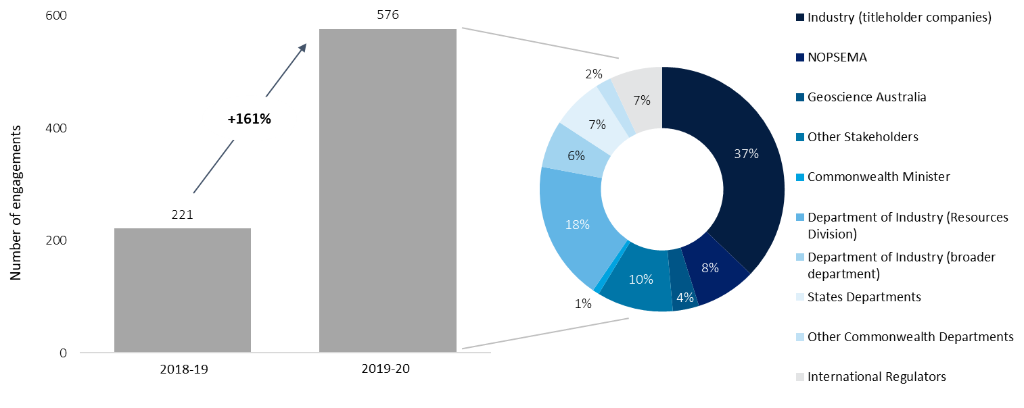*Source: Deloitte analysis adapted from NOPTA data*

To support the successful execution of the *Communications Strategy*, *Communications Plan* and the increasing importance of active and proactive stakeholder engagement, NOPTA will need to build its internal capabilities in stakeholder engagement. This is discussed further in **Section 7**.

## NOPTA’s relationship with titleholders and industry

**NOPTA’s approach to stakeholder engagement was positively viewed by industry, although some opportunities for developing a closer relationship outside of titles administration processes remain**

NOPTA’s approach to stakeholder engagement tended to be positively viewed. Several stakeholders perceived NOPTA to be transparent and cooperative in its approach to titles administration. For instance, stakeholders indicated positive sentiments regarding their involvement in the development of NEATS.

There was general sentiment that NOPTA needs to be more visible and proactive in its engagement, aligning to the discussion above. We observed a gap in engagement between NOPTA senior management and senior members of titleholders in relation to title administration and strategic resource management. Where practical, NOPTA could look to proactively hold annual meetings with senior industry stakeholders or look to leverage existing relationships/interactions held between DISER Offshore Resources Branch and industry. There would also be benefit from NOPTA engaging more closely with APPEA, as the industry’s peak body, on matters such as strategic risks and trends. Again, this could be achieved through greater use of joint engagements with the DISER Offshore Resources Branch. This approach has worked well in other jurisdictions, such as the United Kingdom, to address emerging issues like strategic resource management, renewable energy development, and the impacts of climate policy on the offshore petroleum industry.

Lastly, it was the view of some stakeholders that NOPTA is becoming more involved in commercial matters between titleholders and this was unwelcomed. While we agree that NOPTA must remain impartial and avoid being seen to inappropriately involve itself in commercial matters, we do see an increased need for NOPTA to take a more influential role in engaging with stakeholders on development of investments in line with good oil field practice and optimum recovery.

## NOPTA’s engagement with international stakeholders

**NOPTA’s relationships with its international peers are effective**

NOPTA regulates an industry that is globally connected. Therefore, we view it as essential that NOPTA continue to engage with international peers to identify and apply learnings to the Australian context.

NOPTA has further cultivated relationships with international peer regulators during the review period (referring to **Table 9.1**). Of note is the establishment of a confidentiality agreement and skills exchange program with the United Kingdom’s OGA. While the benefits of international engagements are often difficult to quantify, we have seen evidence of NOPTA applying global learnings across its resource management approach, with the introduction of resource benchmarking, and more broadly to data management practices. A willingness to learn is the hallmark of an effective administrator and encourage NOPTA to further develop these relationships.

There are two further opportunities that NOPTA should continue to drive:

* For NOPTA to further facilitate, where relevant, working level relationships below the Manager (i.e. EL2) layer to ensure learnings and discussions can filter between the organisations at the appropriate level
* Include members from DISER responsible for developing offshore resources policy in relevant discussions, leveraging NOPTA’s established networks with international regulators. We acknowledge that on occasion policy personnel have been invited but see benefit in this being extended further. This will become increasingly important as the Australian Government looks to more advanced jurisdictions for learnings on managing a multi-use marine environment.

## NOPTA’s engagement with Commonwealth Government and state/territory government

### NOPTA’s engagement with Commonwealth Government

#### NOPTA’s relationship with Geoscience Australia

**NOPTA and Geoscience Australia have a strong operational relationship but should engage further at the strategic level to ensure ongoing alignment on objectives and priorities**

Geoscience Australia is a key service provider to NOPTA for the provision of NOPDCR and hosting of NOPIMS (discussed further in **Section 8**). We consider the relationship between NOPTA and Geoscience Australia to be effective. It was noted to us by international peer regulators we engaged with that NOPTA’s arrangements with Geoscience Australia are considered world-leading with respect to the sharing and accessibility of technical information and data.

We did observe a gap in strategic engagement between NOPTA and Geoscience Australia. Geoscience Australia and NOPTA have an effective operational relationship (e.g. hosting regular meetings and various ad hoc engagements across both organisations) but do not formally engage at an executive or senior management level on strategic objectives and priorities, particularly with regards to how these may influence decisions over NOPIMS and NOPDCR developments. We see benefit in the establishment of a regular engagement between both organisations at this level (e.g. on a quarterly or biannual basis). We have captured these points in **recommendation #10** above.

#### NOPTA’s relationship with other elements of DISER

**There is opportunity for greater alignment on priorities between NOPTA and other branches of DISER**

NOPTA interacts with DISER across three main areas:

* As the technical advisor to the Commonwealth member of the Joint Authority
* As a branch of DISER, contributing to wider departmental corporate processes, aligning where relevant to DISER’s policies and procedures, and as a user of DISER’s shared services functions and IT environment
* As a colleague of the Offshore Resources Branch, who are responsible for the policy and legislative frameworks for Australia’s offshore minerals, petroleum and greenhouse gas sectors.

Based on feedback gathered from NOPTA and stakeholders, we have observed that:

* There are frequent and appropriate levels of engagement between NOPTA and other members of DISER, particularly with the Offshore Resources Branch. For example, NOPTA is called on by the Offshore Resources Branch to review policy papers, proposed legislative amendments and guidance material. NOPTA also holds monthly meetings with the Offshore Resources Branch and NOPSEMA to discuss legislative and policy matters
* There are opportunities for DISER and NOPTA to establish mechanisms for the sharing of data and information within regulatory parameters (e.g. to ensure confidentiality of data and information). We consider that the use of data and information gathered through titles administration activities, with the right controls in place, should be used more fully to inform policy development
* There would be greater benefit in NOPTA and the Offshore Resources branch collaborating on stakeholder engagements with senior/executive titleholder stakeholders. This could be achieved through development of shared agendas and greater use of joint meetings with titleholders where deemed appropriate
* There are observed instances of differing perceptions of NOPTA’s independence among branches of DISER and differing perspectives on priorities, which can impact the degree of collaboration and coordination present. Greater clarity could be achieved through a shared set of priorities that are consistent with government and departmental priorities, for example in relation to the legislative or regulatory improvement forward work program.

**Recommendation #11** seeks to address these observations.

#### NOPTA’s relationship with NOPSEMA

**NOPTA and NOPSEMA are working closer together but improvements to collaboration and coordination will be required**

A legislated function for both NOPTA (see section 695B(e)) and NOPSEMA (see section 646(gr)) is to cooperate with one another in relation to the administration and enforcement of the OPGGS Act and its regulations. We have assessed the effectiveness and efficiency of NOPTA and NOPSEMA’s relationship through an examination of examples of collaboration and whether:

* Effective communication and consultation mechanisms have been established
* Cross border coordination and collaboration mechanisms are in place
* Formal mechanisms are in place to share learnings and promote a collegiate approach to regulating the industry.

The 2015 Operational Review recommended that NOPSEMA and NOPTA *“develop an appropriate mechanism (for example an MOU or charter of engagement) to identify the interfacing points and areas of cooperation between the agencies and their respective responsibilities”*.

We heard from NOPTA and NOPSEMA that generally over the review period, cooperation and coordination has improved. Examples cited by NOPTA and NOPSEMA as evidence of improved cooperation and coordination include personnel secondments in the environment, communications, legal and human resources areas within both organisations. Furthermore, NOPTA and NOPSEMA have co-located offices in Perth and Melbourne, which has been beneficial to formal and informal resolution of issues and knowledge sharing between the entities. We understand that there is now a good level of interaction at all levels of the organisations, with regular meetings between the NOPSEMA CEO and the Titles Administrator, members of the senior leadership teams, and operational personnel. Positively, we also heard from industry stakeholders that the adoption of joint meetings by NOPTA and NOPSEMA where there may be areas of overlap was positively received. This is an area we encourage NOPTA and NOPSEMA to continue to pursue. There may also be an opportunity to conduct more strategic, joint training or presentations to industry on emerging issues of overlap into the future.

|  |
| --- |
| Opportunity #7 |
| NOPTA and NOPSEMA are encouraged to identify further opportunities for building and delivering joint guidance, briefings, or information packages for industry on issues of strategic importance or regulatory overlap, such as decommissioning. |

We do not seek to re-review the events that the Walker Review examined. However, we do refer to this event to demonstrate how the NOPSEMA – NOPTA relationship may continue to be improved. Stakeholder feedback from the Government and industry indicated that collaboration between NOPTA and NOPSEMA is still, in their view, siloed. Feedback was that NOPSEMA and NOPTA could work together more effectively, to continue to share knowledge and break down information silos. The Walker Review demonstrated that both agencies need to have a clear and consistent interpretation of the OPGGS Act and hold the ability to compel information to ensure the financial capability of titleholders. It is not enough to hold a regulatory power; it must be exercised where necessary and in a timely manner. NOPSEMA and NOPTA must be willing to coordinate and collaborate where such powers may be exercised, engage on difficult cases or issues, and be proactive in doing so. The reports of increased interaction between NOPTA and NOPSEMA are positive but must be extended further to help manage the significant risks from the maturing of the industry.

We have made three relevant recommendations: the first is to continue investigating greater functionality, as part of NOPTA’s planned development of the ‘NOPSEMA NEATS portal’ to digitally transact on items of shared interest (see **recommendation #8** in **Section 8**). The second is for the various arms of the offshore legislative framework to align on roles and responsibilities. The third is the requirement to break down information and data sharing barriers. These latter two points are discussed further below.

A key and unresolved question is whether the degree of collaboration and coordination required to support a maturing industry is possible under the current offshore model where administrative and regulatory arms of the framework remain separate. We discuss this further in **Section 11.**

### NOPTA’s engagement with state/territory governments

**NOPTA’s relationship with state/territory government is strong, but engagement outside of titles applications can be infrequent**

During our consultation with state/territory government stakeholders through our survey and interviews, many described having trust in NOPTA’s advice and having positive relationships with NOPTA. It is our view that, given the majority of NOPTA’s interactions with state/territory government stakeholders are in reference to titles applications, the development of trust in technical advice has been important to strengthening the overall relationship – even for engagements outside of titles-related matters.

It was observed over the review period that there is relatively infrequent engagement between state/territory departments and NOPTA outside of titles applications and this has, on some occasions, led to unfamiliarity with NOPTA processes when titles applications do arise. This is particularly the case for states/territories where there are relatively few titles applications and, therefore, interactions with NOPTA. Furthermore, NOPTA noted that when it consulted with state/territory government stakeholders, it often received relatively little feedback from these engagements.

Positively, we saw evidence of some improvements to NOPTA’s interactions with state/territory counterparts outside of titles applications across the review period. For example, NOPTA:

* Has provided presentations to jurisdictions on relevant applications and issues particularly relevant to retention leases and production licences
* Holds a quarterly meeting with WA DMIRS to share information on industry insights/trends, operational matters, policy issues, and relevant applications
* Meets with the relevant departments in Victoria and the Northern Territory to discuss, among other matters, non-title specific technical matters.

We encourage more frequent engagement between NOPTA and its state/territory department counterparts to build and maintain familiarity with NOPTA processes. NOPTA could also look to utilise these interactions to further its understanding of the specific issues (policy or strategic) of state/territory importance to ensure its advice can, where possible, factor these considerations in. In combination, the above points may help serve to improve the overall cohesiveness of the delivery of the offshore legislative framework.

## A ‘One Government’ approach to the delivery of the offshore legislative framework

**Alignment between the administrative, policy, and regulatory arms of the offshore legislative framework should be improved**

We have observed that the delivery model of the offshore legislative framework is complex, with multiple parties responsible for respective elements across the administration (NOPTA), decision-making (the Joint Authorities), policy development (DISER Offshore Resources Branch), and regulation (NOPSEMA). The delivery complexity is compounded by the length and structure of the legislation itself, which spans three volumes and associated regulations. The outcome sought should be a cohesive and consistent 'One Government' approach to the industry and its risks in the delivery of legislative and regulatory instruments. The criticality of a ‘One Government’ approach (be it across state, territory, or Commonwealth Government) has been starkly highlighted by the events surrounding the Northern Endeavour Floating Production and Storage Offtake facility and the broader Laminaria-Corallina fields.

As outlined in the discussion above, there are positive indications of a more cohesive approach being taken in some cases, particularly during the latter part of the review period. Nevertheless, it is our view that further work needs to be done to properly connect processes across the parties.

At the core of a coordinated and collaborative approach is gaining further alignment between the expectations, roles, and responsibilities of the administrative, policy, and regulatory facets of the offshore legislative framework. We have observed, through our interactions between NOPTA, NOPSEMA, and the DISER Offshore Resources Branch, deviations in the understanding of roles and responsibilities of each party and, in some cases, interpretations of the OPGGS Act. This fact and the general complexity of the offshore legislative framework itself may further contribute to a misunderstanding of the various roles and responsibilities by external stakeholders. We see benefit in closer alignment on these areas while also respecting the independence of each arm.

|  |
| --- |
| Recommendation #11 |
| The administrative (NOPTA), regulatory (NOPSEMA), and policy development (DISER Offshore Resources Branch) arms of the offshore legislative framework should seek to improve their alignment, coordination and collaboration on matters such as policy development, interpretations of the OPGGS Act, exchange of data and information, and shared priorities to deliver a more cohesive ‘One Government’ approach. |

**Effective and efficient relationships across the regulatory landscape will be essential to managing a maturing industry**

While a significant and understandable focus has been placed on the effectiveness NOPTA’s and NOPSEMA’s interactions, of importance will also be NOPTA’s and NOPSEMA’s interactions with various state and territory policy developers and regulators who oversee assets within state and territory waters. A number of assets, particularly pipelines, traverse Commonwealth and state/territory waters. Therefore, collaboration on the decommissioning and managing of risk for these assets will be essential. Should conferral of state/territory powers not be pursued, significant improvements to the ability for collaboration and coordination between parties will be required.

The ability to exchange data and information in a secure, seamless, and prudent manner will underpin the ability for NOPTA and NOPSEMA, and their state and territory counterparts to coordinate and collaborate effectively. Through our consultation with stakeholders, it was outlined to us that a number of legislative and/or regulatory barriers currently inhibit the seamless sharing of data and information between NOPTA, NOPSEMA and their state/territory counterparts outside of titles-specific Joint Authority interactions. This needs to be addressed and will help improve the effectiveness of interactions beyond the decommissioning of assets.

|  |
| --- |
| Recommendation #12 |
| DISER, NOPSEMA, NOPTA, and relevant state/territory government departments should examine and address barriers inhibiting the secure, seamless, and sensible exchange of information and data between parties to deliver a more cohesive ‘One Government’ approach. |

In implementing the above recommendation, consideration could be given to:

* Identifying and addressing any potential regulatory or legislative barriers, prioritising those jurisdictions that have the greatest volume of offshore activity and/or where the risks are highest
* Applying an outcome, rather than prescriptive, approach to setting which data and information could and should be exchanged
* Developing protocols for securely and efficiently exchanging information and data in a structured way.

Beyond this recommendation, all parties involved in the delivery of the offshore legislative framework will need to coordinate on risks and issues arising across jurisdictions, particularly where activity overlap is greatest.

# How does NOPTA reduce the burden for industry and recover costs?

Key points

|  |  |
| --- | --- |
| **NOPTA is operationally efficient and its cost recovery model effective, although transparency could be improved**  Based on our analysis, we consider NOPTA’s costs appear to be reasonable and its cost recovery model to be effective. NOPTA is operationally efficient in delivering its current activities. NOPTA’s costs have risen due to investments in digital capabilities and increased complexity of titles administration activities. There may be further efficiency improvements gained with a consolidation of management positions within NOPTA’s structure. The titles assessment process is partly systematised but further work is needed to remove manual elements of the process.  Our view is there is likely limited value in further centralisation of NOPTA’s functions with DISER’s shared services functions as there is a need for organisational agility, ability to interact with industry, and likely limited financial benefits from centralisation. We expect NOPTA will continue pursuing further operational efficiency improvements but note the most meaningful and substantial benefit for industry will be through reducing burden with improvements to administrative processes. This could be achieved through greater digital enablement of processes such as data submissions, amending the periods for data retention, and reducing ‘time-to-decision’ across the titles administration process (although we make no formal recommendations on these points as they are beyond the scope of this review). | We observed the following for NOPTA’s cost recovery scheme:   * NOPTA’s fees and levies have been developed in line with the Australian Government Cost Recovery Guidelines. The adoption of a standard application fee has improved clarity and understanding of cost recovery * There is a degree of under/over recovery across levy categories, which is considered appropriate to foster desired industry outcomes. That said, there is a need to further explore whether cross-subsidisation between titleholders is occurring * Affordability and ability to pay have not been raised as concerns by industry. Stakeholders generally had positive perceptions of the fairness and equity of the levy and fee regime * There is an opportunity to improve transparency of the information provided to stakeholders regarding how fees and levies are developed and NOPTA could consult more frequently with stakeholders on satisfaction with its cost recovery arrangements * Financial sustainability will remain a key focus for NOPTA moving forward, particularly as overall activities in the industry are expected to decline in the long-term. NOPTA is encouraged to continue to undertake appropriate scenario modelling in support of this   **Recommendations: No recommendations were made in this section**  **Opportunities: 8, 9** |

## Reducing burden on industry and streamlining operational expenditure

A key objective of the 2009 Productivity Commission Review was streamlining regulatory processes for the industry. Pursuit of this objective remains relevant and is a focus of NOPTA. Ultimately a reduction in burden on the industry will help stimulate a productive and vibrant offshore resources sector in Australia. In this section we consider two main levers for reducing regulatory burden:

* Improving the efficiency of NOPTA’s administrative processes for industry and NOPTA
* Improving NOPTA’s operational efficiency across its staffing, ICT, and process models.

### Analysis of the efficiency of regulatory processes

#### Completed or underway initiatives

**NOPTA maintain focus on the reduction of burden on industry and have made tactical improvements with the aim of improving administrative process efficiency**

Based on the evidence we have examined and interactions with NOPTA, our view is that NOPTA gives sufficient regard to reducing administrative burden within the current legislative framework. NOPTA has completed or initiated a number of activities across the review period that are aimed (at least in part) at reducing burden for industry (see **Table 10.1**).

**Table 10.1: Example initiatives NOPTA has undertaken or has planned to reduce administrative burden on industry**

|  |  |
| --- | --- |
| **Initiatives** | **Detail** |
| **NOPTA’s pursuit of digital** | * NOPTA is investing in improvements to its core systems. There will be likely benefits in terms of reducing administrative burden for titleholders (e.g. improved efficiency engaging with NOPTA’s compliance processes) and for NOPTA’s internal processes. |
| **Titles administration process improvements** | * During the review period, NOPTA examined its internal process for the assessment of retention leases due to identified inefficiencies and complexities with the process * NOPTA reviewed and simplified its advice formats (moving from formal letters to table structure) which has reduced the number of errors and appears to have improved the understandability of advice * Removed credit card surcharges for payments made through NEATS.[[51]](#footnote-52) |
| **Submission data benchmarking** | * NOPTA has begun benchmarking data submissions and sharing benchmarking information with titleholders to improve submission quality. This reduces rework for titleholders and errors in submission content. |
| **Provision of geographic information systems to NOPSEMA** | * NOPTA provide, at no additional cost to industry, geographic information systems information to NOPSEMA which serves to improve the efficiency of NOPSEMA’s operations. This has an estimated annual cost of between $30,000 to 40,000 and initial set up cost of $50,000.[[52]](#footnote-53) |

Source: NOPTA

#### Benchmarking against international peer cohort

***NOPTA is relatively efficient compared to peer regulators based on its own benchmarking analysis***

Benchmarking can serve as an additional datapoint for examining NOPTA’s administrative burden. For instance, a measure of efficiency is NOPTA’s operational expenditure and headcount relative to the activities undertaken.

During 2019-20, NOPTA undertook a benchmarking study (using 2018-19 data) relative to peer regulators globally and found it outperformed these peers on its benchmark metrics (we have highlighted the study’s results in **Figure 10.1** and **Figure 10.2**). Specifically, NOPTA had a lower operating expenditure per title and fewer headcount per total titles than its peers. The peer group for the comparison was the United Kingdom’s OGA, Norway’s NPD, the U.S.A’s Bureau of Ocean Energy Management (**BOEM**) and Canada’s C-NLOPB. NOPTA noted to us that as part of its methodology, it sought to limit comparisons to activities for petroleum titles applications only (i.e. petroleum titles administration activities).

Although it serves as an additional datapoint in our assessment, benchmarking results must be appropriately caveated:

* The scope of functions carried out by NOPTA versus its peers (who have wider scope of functions) may skew the outcomes of the benchmarking to presenting NOPTA more favourably as its overheads will be comparatively lower. That is, care must be taken when interpreting comparisons between an administrator (NOPTA) and regulators (such as its peer comparators)
* Each regulator’s jurisdiction and industry context is unique and therefore costs and activities are not always directly comparable. NOPTA was conscious of this and proactively removed any distortions (as far as practicable) to enable a more accurate and like-for-like comparison as part of the benchmarking analysis
* While similar, each jurisdiction’s processes and requirements of titleholders varies, which can have a direct impact on the effort required by both the regulator and titleholder
* The benchmarks assume a proportionate relationship between the number of titles and effort to administer those titles (which may not always be the case where factors such as title complexity may impact costs per title)
* Benchmarking can only provide a reference as to the relative (as opposed to absolute) efficiency of NOPTA.

**Figure 10.1: NOPTA’s relative efficiency to peer regulators globally – operational expenditure per title (using 2018-19 data)**

Source: NOPTA analysis

**Figure 10.2: NOPTA’s relative efficiency to peer regulators globally – headcount (using 2018-19 data)**

Source: NOPTA analysis

#### Further improvement opportunities

**The modernisation of data management regulations will support a more efficient titles administration process**

Industry are currently required to retain physical samples for significant periods, even once digitised and well beyond what would be described as a useful retention period. This requires costly long-term storage of samples by titleholders. As a further example, the current regulations specify data to be submitted in certain media formats, many of which are outdated. The inability to submit data digitally (e.g. removing the requirements of physical signatures) adds complexity and burden on industry with little or no regulatory benefit. As discussed in **Section 5**, the review on Parts 7 – 10 and Schedules 1 – 5 of the RMA Regulations is currently underway. We are hopeful this review will address many of these issues. Our observations support the recommendations from this review that seek to address the reasonableness of sample retention, reduce prescription in the regulations, and drive towards ‘technology agnostic’ regulation.

We also refer to our earlier recommendations relating to the efficiency of the titles administration process and the benefits to industry of a more timely and transparent process.

### Analysis of NOPTA’s operational efficiency

Based on our analysis and the evidence we have reviewed, we consider NOPTA to be reasonably efficient in delivering its current activities. Whilst costs have risen in some cases, increases can be attributed to investment in digital capabilities and increasing complexity in titles applications.

#### NOPTA’s historic expenditure versus activity levels

NOPTA is required to comply with all the requirements of the PGPA Act. This is the cornerstone of the Commonwealth Resource Management Framework and governs the use and management of public resources. NOPTA is also required to comply with the Commonwealth’s *Procurement Rules* and DISER’s *Accountable Authority Instructions*, policies and procedures.

***NOPTA’s operational expenditure has tended to increase since 2014-15 while NOPTA regulatory activities have marginally decreased, driven by NOPTA’s investment in its digital agenda***

NOPTA’s costs predominantly consist of employee benefits (inclusive of salary costs) and ICT system related costs (captured across supplier costs, due to outsourcing arrangements with NOPTA’s IT functions, and systems-related maintenance and development) (see **Figure 10.3**). NOPTA’s costs have tended to increase since 2014-15. Key drivers for this trend are:

* Increased investment in ICT, including system development costs, system maintenance and outsourcing costs to suppliers
* Increased costs of employee benefits (inclusive of salary costs). While the costs of employee benefits increased 34% overall between 2014-15 and 2019-20, they have decreased since 2016-17 (both in absolute terms and as a proportion of NOPTA’s total costs). There was a marginal increase in employee costs partially driven by an update to DISER’s Enterprise Agreement during the review period.

**Figure 10.3: NOPTA’s expenditure by category from 2014-15 to 2019-2020**

Source: Deloitte analysis adapted from NOPTA data (NOPTA Annual Report of Activities)

We have not examined NOPTA’s commercial contracts with suppliers but note that NOPTA has established governance arrangements with these suppliers to manage service levels and track performance.

Referring to **Figure 10.4**, NOPTA’s expenses appear to marginally deviate from activities undertaken.[[53]](#footnote-54) While expenses have tended to increase in aggregate, the count of NOPTA’s titles application activities have tended to decrease. Two factors are driving this. First, there is an observed increase in the complexity of titles administration activities, particularly for petroleum activities as the industry matures. Second, given NOPTA’s investment in pursuit of its digital agenda, there is a corresponding increase in expense categories relating to outsourced suppliers and system maintenance.

**Figure 10.4: Trend analysis of NOPTA’s expenses versus regulatory activities from 2014-15 to 2019-20**

Source: Deloitte analysis adapted from NOPTA data (NOPTA Annual Report of Activities)

#### Completed or underway initiatives

***NOPTA is seeking to improve its operating efficiency through improvements to ICT capabilities***

NOPTA has completed or initiated a number of activities across the review period that are aimed (at least in part) to improve operating efficiency (see **Table 10.2**).

**Table 10.2: Example initiatives NOPTA has undertaken or has planned to improve operational efficiency**

| **Initiatives** | **Detail** |
| --- | --- |
| Office space relinquishment | Relinquished Perth office in 2015-16, which resulted in an approximate saving of $600,000. |
| Management of staff | Referring to **Section 7** and *NOPTA’s Annual Reports of Activities* from 2015-16 to 2019-20, NOPTA use a range of mechanisms to manage staff costs, including the use of:   * Fixed term contracts to help manage fluctuations in industry activity * Flexible and part-time working arrangements * Fixed term secondments from within Government * Department of Finance salary guidelines. |
| Supplier management | * Use of competitive tendering processes as required under APS procurement guidelines, including the establishment of a deed of standing offer for technical advice * Renegotiation of the NOPDCR/NOPIMS agreements with Geoscience Australia (see **Section 8**, for further details). Based on NOPTA estimates the expected savings in the current financial year from the renegotiated agreement are approximately $330,000[[54]](#footnote-55). |
| NOPTA’s digital agenda | * Migration to the Cloud of major systems in 2017-18, reducing downtime costs and establishing the enabling capabilities for other digital initiatives * Increased data connectivity between key systems and centralisation of operational elements of key systems, which appears to have reduced risks associated with manual data management and improved overall process efficiency * A number of planned enhancements to core digital capability (see **Section 8** for further details). |

Source: NOPTA

#### Further opportunities including consideration of centralisation of NOPTA’s corporate functions with DISER’s corporate functions

**There is unlikely to be a net benefit (financial or otherwise) from greater centralisation of NOPTA’s corporate functions with DISER**

The Terms of Reference required us to identify opportunities where NOPTA can reduce operating costs and streamline cooperate functions to reduce the financial and regulatory burden on industry. In identifying these opportunities, we were asked to consider if there should be greater alignment with DISER’s functions.

We gave consideration for efficiency improvements through greater centralisation of NOPTA’s corporate shared services with DISER’s shared services functions.

NOPTA has three corporate shared services functions as part of its BSU:

* Human Resources (mainly to support recruitment and general human resources advice)
* Finance
* Information Technology.

NOPTA operates a hybrid centralised-decentralised model for these functions. That is, NOPTA utilises aspects of DISER’s shared service capabilities (such as payroll, finance systems, email system), seeks to align to all relevant Department policies, and feeds into DISER’s planning processes. In return, NOPTA pays a reimbursement to DISER, which across the review period accounted for between 2-4% of NOPTA’s total expenditure.[[55]](#footnote-56) Similarly, NOPTA’s corporate shared service functions account for approximately 4% of NOPTA’s total expenditure.[[56]](#footnote-57)

Based on our assessment, we currently do not believe that there would be benefit in pursuing further centralisation with DISER at this time for the following reasons:

* **A need to be close to the ‘customer’:**
  1. Centralisation is typically applied in situations where the proposed centralised activities are transactional in nature and do not require a high degree of input from the ‘customer’. However, NOPTA engage closely with industry on the development of systems, such as NEATS. We see benefit in this close engagement continuing and do not see a centralised model supporting this
  2. NOPTA’s Finance function interacts with industry and NOPTA’s Titles teams to support financial transactions. We see risks of inefficiencies in these interactions if the NOPTA Finance function were centralised.
* **Likely limited cost-savings from greater alignment:** 
  1. There would likely be minimal financial benefit (i.e. cost savings achieved through economies of scale, reduction in duplication of functions (like a help desk), or synergy efficiencies) as many of the costs would simply be substituted from NOPTA to DISER’s corporate shared services functions. Based on our examination, NOPTA do not appear to duplicate DISER’s core systems, and thus any incremental financial benefit from centralisation is likely to be related to staff costs and, therefore, relatively minor
  2. There would be moderate implementation costs incurred from undertaking an alignment program and risks to disruptions to NOPTA’s titles administration processes.
* **Stakeholder perceptions and independence of appearance:**
  1. Stakeholders may perceive conflicts over the independence of NOPTA’s systems if the data is centralised within DISER’s corporate shared services functions
* **Other risks:**
  1. There are risks in centralising the management of NOPTA’s special account to DISER’s corporate functions. NOPTA’s special account requires close and careful management and we believe NOPTA is best placed, given its proximity to industry trends in activity, to manage this risk.

Should further alignment/centralisation be pursued in future, NOPTA in conjunction with the broader elements of DISER will need to consider the costs, benefits, and risks involved with both a ‘do nothing’ and ‘greater centralisation’ option. At this time, DISER could consider delivery models which align to other industry-facing branches within its portfolio. We also note that any further decisions for centralisation should only be pursued after a decision is made on the future model of NOPTA and NOPSEMA either being retained as separate entities or being combined into a single entity (discussed further in **Section 11**). Should the latter option be agreed by the Government, there would be little value in further centralising NOPTA’s corporate functions as it is assumed they would be integrated into the new combined model.

### NOPTA’s cost profile moving forward

**NOPTA faces an uncertain operating environment over the next 12 to 18 months, which may impact costs**

As has been discussed across a number of sections, NOPTA’s operating environment is continuing to evolve. We have outlined some areas of uncertainty and their potential cost implications (see **Table 10.3** below). These will require careful management by NOPTA to ensure it maintains efficiency.

**Table 10.3: Potential cost implications of key uncertainties in NOPTA’s environment**

| **Uncertainty** | **Potential cost implication** |
| --- | --- |
| Legislative changes | * The impact is unknown at this stage and will depend on any legislative or regulatory changes the parliament makes either in relation to this or other related reviews * NOPTA could explore a supplier panel arrangement that could offer surge capacity for talent in the short-medium term as a means of sourcing capabilities and to manage fluctuations in resource requirements depending on future legislative changes. As the industry trends towards a greater number of transactions, NOPTA could explore increasing its in-house capabilities in this area. |
| Impacts of COVID-19 and oil price collapse | * Likely a near-term impact as operators look to reshape their portfolios (e.g. increase in applications), increasing operating activity for NOPTA * Medium-term impact may be a reduction in exploration activities and so a reduction in titles applications while uncertainty and unfavourable commercial conditions remain * Recurring compliance obligations for active operations are unlikely to materially alter (e.g. ATARs). |
| Increasing industry transactions | * This is part of the longer-term trend of industry maturing, which will likely see an increase in asset sales (i.e. transactions) as larger operators look to exit the market * Transactions will require close scrutiny by NOPTA and NOPSEMA, which may have implications for staffing levels. |

Source: Deloitte

## Cost recovery

### Australian Government and NOPTA cost recovery framework

The Australian Cost Recovery Guidelines (**CRGs**) set out the overarching framework for government entities to design, implement and review cost recovered activities provided on behalf of the Australian Government. The cost recovery framework is underpinned by three principles that must be applied across all stages of the cost recovery process: efficiency and effectiveness, transparency and accountability, and stakeholder engagement.

For each cost recovered activity, the responsible government entity must:

* Obtain policy approval from the Australian Government to cost recover
* Hold the statutory authority to charge
* Ensure alignment between expenses and revenue
* Maintain up-to-date, publicly available documentation and reporting.

Additionally, each Department of State (in this case, Department of Finance) must conduct a portfolio review at least every 5 years.

NOPTA was established to operate on a full cost recovery basis, to be funded by industry fees. The OPGGS Act associated Acts provide the legal authority for NOPTA to charge application or nomination fees on a range of matters and annual titles administration levies. The legal authority to impose the Annual Titles Administration Levy is contained in Part 4C of the *Offshore Petroleum and Greenhouse Gas Storage (Regulatory Levies) Act 2003*. The amounts are prescribed in the *Offshore Petroleum and Greenhouse Gas Storage (Regulatory Levies) Regulations 2004*.

The legal authority to prescribe application fees can be found in Part 2, Part 4, Part 6 and Part 7 of the OPGGS Act. The fees are prescribed in the Offshore Petroleum and Greenhouse Gas Storage (Resource Management and Administration) Regulations 2011. Following NOPTA’s 2016-17 CRIS, these regulations have been updated (commencing 1 July 2016) as follows:

* *Offshore Petroleum and Greenhouse Gas Storage (Regulatory Levies) Amendment (Annual Titles Administration Levy) Regulation 2016*
* *Offshore Petroleum and Greenhouse Gas Storage (Resource Management and Administration) Amendment (Fees) Regulation 2016.*

Under the CRGs, it is a requirement that each cost recovered activity be documented in a CRIS prior to the commencement of charging. The CRIS is an explanatory document that provides key information on how cost recovery for a specific government activity is implemented.

On 1 January 2012, NOPTA began operations on a full cost recovery basis. A CRIS for the interim period and establishment costs for NOPTA was developed in July 2011. The levy and fee structure were maintained in a similar form to what was in place previously when the offshore legislative framework was predominantly administered through the Designated Authorities. NOPTA’s CRIS has since been updated in 2013-14, 2015-16 (updated in line with revised *Australian Government Cost Recovery Guidelines*) and in 2016-17, when the current CRIS was published (**2016-17 CRIS**).

The 2016-17 CRIS was proposed to remain in force for a period of at least three years from 1 July 2016 in order to provide a stable fiscal regime to titleholders. While it has been over three years since the 2016-17 CRIS was introduced and no timeframes have been set for the development of the next CRIS, NOPTA’s rationale is to minimise the need to adjust charges in light of the strained current economic climate.

### Current levy and fee structure

An Annual Titles Administration Levy is charged to titleholders. The levy is payable upon the grant of a title and annually thereafter within 30 days of the anniversary of the title. Where a title is in force for less than twelve months, the levy is calculated pro rata.

Application fees are payable at the time that an application is submitted for approval to enable titleholders to undertake certain regulated activities. Over the past five years, levies have accounted for approximately 80% of revenue.

The 2016-17 CRIS introduced a standard application fee of $7,500, increased annual levy amounts, and aligned the annual levy for retention leases to production licences at $20,000 per block (see **Table 10.4** for changes to annual levies). **Appendix F** outlines the levies and fees that have applied from 1 July 2016.

**Table 10.4: Changes to annual title administration levies, 2016-17**

| **Annual title levy** | **Previous levy amount** | **New levy amount** |
| --- | --- | --- |
| Work-bid petroleum exploration permit or special exploration permit | $9,781 | $10,000 |
| Cash-bid petroleum exploration permit | $9,781 | $10,000 |
| Boundary-change petroleum exploration permit | $9,781 | $10,000 |
| Petroleum retention lease | $7,755 | $20,000 |
| Petroleum production licence | $15,500 | $20,000 |
| Infrastructure licence | $22,500 | $25,000 |
| Pipeline licence[[57]](#footnote-58) | $52 | $100 |
| Work-bid greenhouse gas assessment permit | Zero | $10,000 |
| Greenhouse gas holding lease | $6,820 | $20,000 |
| Greenhouse gas injection licence | $20,460 | $20,000 |

Source: OPGGS (Regulatory Levies) Amendment (Annual Titles Administration Levy) Regulation 2016

### Cost Recovery Implementation Statement

For the purpose of cost recovery, NOPTA allocates direct and indirect costs to each key activity output based on management estimates of effort required.

The following steps are involved in estimating levies and fees:

* Estimate direct costs to key activity outputs (i.e. by categories of titles) by estimating the total percentage of time that staff in each of the technical teams spend on key activity outputs on an annual basis, then estimating costs by applying a wage rate to time. Direct costs consist of:
  + Employee and associated expenses of the five technical teams
  + Employee and associated expenses of the Executive team
  + Maintenance and support of NEATS
  + NOPDCR expenses required for the management of petroleum mining sample data
* Allocate indirect costs to technical teams
* Determine fees and levies based on estimated cost.

A review of the level of effort required for each output was undertaken in December 2015 for input to the 2016-17 CRIS, following NOPTA’s first three financial years of operation.

Indirect costs comprise employee and associated costs of support staff, overheads[[58]](#footnote-59), ICT desktop services, office accommodation and utilities, travel, and legal costs. Indirect costs allocated to technical teams using cost drivers outlined in **Table 10.5**.

In 2018-19, direct costs represented approximately 68% of total costs. This is in comparison to 2016-17, where direct costs represented 76% of total costs. The increase is partly driven by investment in ICT.

**Table 10.5: Indirect cost drivers**

| **Indirect Cost** | **Cost drivers** |
| --- | --- |
| Support Staff and Overheads | % of Total Direct Costs |
| ICT – Desktop services | Headcount (as each person having a PC) |
| Office accommodation and utilities | Headcount (as a proxy of consumption of office-related expenses) |
| Travel[[59]](#footnote-60) | Headcount |
| Legal[[60]](#footnote-61) | % of Total Direct Costs |

Source: NOPTA data

NOPTA aims to retain a reserve of 10% of its annual budget at the end of each financial year to ensure it was able to manage its cashflow and mitigate exposure to potential industry fluctuations.

As part of this analysis, NOPTA’s cost recovery spreadsheet modelling for its 2016-17 CRIS process was reviewed. NOPTA’s CRIS modelling is detailed, transparent and consistent with its principles and methodology for cost recovery as set out in its 2016-17 CRIS. It reflects the information that is conveyed to industry.

### Analysis

#### Consistency with Australian Government Cost Recovery Guidelines

**NOPTA’s fees and levies have been developed in line with the Australian Government Cost Recovery Guidelines**

#### Efficiency and effectiveness

**NOPTA’s cost recovery arrangements are considered to be efficient and effective**

Within the context of cost recovery, efficiency and effectiveness involves making proper use of available resources (people, money and other supplies) to achieve government policy outcomes. Government activities should meet quantity, quality and other targets, be undertaken at minimum cost, and be conducted in accordance with applicable policy and legislative requirements. Under the CRGs, efficiency also relates to whether it is efficient to provide the activity on a cost recovery basis and considers the balance between developing a more precise, but more complex and hence more expensive costing model, and developing a simpler and less expensive, but less precise, costing model.

The effectiveness of cost recovery involves the reliability and accuracy of the cost recovery model and related processes in measuring costs and reflecting those costs in the related charges. Effective cost recovery includes appropriate revenue management.

Since its inception in 2012, NOPTA has minimised the need to adjust charges (including both levies and fees) in order to provide long term certainty to industry. NOPTA has managed costs internally to avoid increases in fees and levies (see examples in **Table 10.2**).

As shown in **Figure 10.5**, it appears that NOPTA’s activity as measured by number of titles and applications assessed has slightly decreased or remained stable over the past five years, while costs have been increasing. NOPTA has advised that its level of activity has been increasing due to a greater focus on resource management and increased complexity of titles applications.

**Figure 10.5: NOPTA volume of levies and fees, 2014-15 to 2018-19**

|  |
| --- |
|  |
| Source: Deloitte analysis adapted from NOPTA data |

Our assessment has also considered NOPTA’s cost recovery arrangements in relation to the balance it strikes between developing a more precise, but more complex and hence more expensive costing model, and developing a simpler and less expensive, but less precise, costing model. Under the CRGs, cost recovery charges should be:

* Clear and easy to understand
* Closely linked to the specific activity
* Set to recover the full efficient costs of the specific activity[[61]](#footnote-62)
* Efficient to determine, collect and enforce
* Set to avoid volatility, while still being flexible enough to allow for changes based on fluctuations in demand or costs.

As noted in **Section 10.2.2**, NOPTA’s current CRIS increased annual levy amounts, introduced a standard application fee of $7,500, and aligned the annual levy for retention leases to production licences at $20,000 per block.

The $7,500 flat fee is an average cost of assessing each application type and reflects that similar amounts of effort are required to assess the different types of applications. The standard flat rate fee is clear and easy to understand, and consistent for all titleholders. The alignment of the annual levy for retention leases and production leases also makes the levy clear and easy to understand.

In 2019, NOPTA conducted a detailed review of the costs of undertaking key output activities against revenue collected. The review, which is intended to occur annually, was to inform more frequent analysis of its cost recovery arrangements than is provided by the timing of the formal CRIS processes. The analysis reviewed revenue and expenditure from 2016-17 to 2018-19 and the effort required for each output activity. This process was informed by each technical team reviewing time spent on key activity outputs.

NOPTA’s analysis shows that there is a degree of over/under recovery across levy categories. The revenue collected from retention leases and production licence titles is greater than estimated costs for these activities, while the revenue collected for exploration permit activities is less than estimated costs (see **Figure 10.6**). Annual levies for exploration-based titles are $10,000 and $20,000 for retention leases and production licences. The figure also illustrates that revenue from exploration permits and acreage release bids is substantially lower than the revenue generated from these activity outputs. NOPTA has advised that this is due to a range of factors, including longer initial assessment timeframes for work-bid applications and the relative complexity of some application types.

**Figure 10.6: NOPTA revenue verse cost allocation, 2018-19**

Source: Deloitte analysis adapted from NOPTA data

NOPTA has advised that:

* The imbalance between costs and revenue for the declaration of location is due to this activity being a complex process with no associated levy prior to approval, other than the underlying exploration permit
* Levy amounts are established taking into consideration the objective of encouraging exploration and innovation within the industry. It is noted that under the CRGs, the effect of cost recovery on competition, innovation and the financial viability of the directly affected individuals and organisations should be analysed.[[62]](#footnote-63) There may therefore be justification for this over/under recovery
* It intends to continue reviewing levy amounts and over/under recoveries and will consider these matters as part of its next CRIS process.

We see an opportunity that as part of the next CRIS process, NOPTA ensure that the information provided in the CRIS on how fees and levies are set, and any over/under recovery, is made as transparent as possible for stakeholders to understand and provide comment on.

The annual levy accounts for over 80% of NOPTA’s revenue, providing a stable revenue stream and avoiding short-term volatility from industry activity. This helps ensure that NOPTA can fund operating and capital expenditure while minimising the need to adjust charges too frequently.

The fee and levy arrangements that are in place appear to be simple and easy to administer. The costs of administering the cost recovery arrangements appear to be proportionate to the charges for and potential revenue from the activity. NOPTA takes these principles into account when considering changes to levies and fees, for example streamlining of fee amounts to a single flat fee amount for different types of applications instead of charging different fee amounts to reflect small cost differences (which are more costly to administer).

Under the CRGs, the effectiveness of cost recovery also involves the reliability and accuracy of the cost recovery model and related processes in measuring costs and reflecting those costs in the related charges. NOPTA developed a detailed and transparent cost recovery model for its 2016-17 CRIS process and has undertaken recent detailed modelling of costs and revenues to inform its understanding of costs and revenues.

#### Transparency and accountability

***NOPTA provide transparency over cost recovery mechanisms but there is an opportunity for further visibility over fee and levy calculation to be provided***

In a cost recovery context, transparency can be achieved through documenting key information about the activity, such as policy approval, statutory authority to charge and the cost recovery model, in an accessible way for those who pay charges. Transparency can also be achieved through frequent reporting on performance. Accountability refers to entities, staff and responsible Ministers being answerable for their actions and decisions in relation to cost recovery.

In relation to transparency, NOPTA publishes its annual report of activities and CRIS on its website. We observe that there is additional information that is not provided publicly which may assist stakeholders in understanding how fees and levies are being developed and how they align to costs being incurred for key activities. For instance, detailed information relating to cross subsidisation which is not clearly documented in their current reports. We note that approximately 20% of respondents to our survey indicated that NOPTA’s levy and fee structure was not transparent in its calculation.

Our view is that, while NOPTA is transparent with the majority of details relating to its cost recovery arrangement, it could improve the level of transparency in relation to the information provided to stakeholders about how fees and levies are developed.

In relation to accountability, we found no evidence to suggest that NOPTA is not accountable for its actions in relation to cost recovery.

#### Stakeholder engagement in relation to cost recovery

Further engagement with stakeholders on cost recovery is suggested

As per the CRGs, NOPTA should actively engage with stakeholders throughout all stages of the cost recovery process, from policy development through to implementation and review.

NOPTA engages with stakeholders prior to the implementation of its CRIS by providing it to stakeholders for comment and by publishing it on its website and asking for comment. This provides stakeholders the opportunity to provide input, comments and feedback into the detailed design of the cost recovery model. To inform the 2016-17 CRIS process a report titled “*NOPTA* *Review of Cost Recovery Arrangements – For Consultation by 29 February 2016*” was also provided to titleholders and key stakeholders. However, the CRIS process is not frequent, with it being over three years since the last CRIS review was undertaken. Additionally, NOPTA does not engage with stakeholders on cost recovery through its stakeholder survey process.

We note in identifying this opportunity that stability in the level of fees and levies is important for providing consistency for industry, supporting a more predictable investment environment. Nevertheless, we see value in NOPTA regularly seeking feedback from stakeholders regarding satisfaction with various elements of the cost recovery scheme.

|  |
| --- |
| Opportunity #8 |
| NOPTA is encouraged to take a more frequent, proactive and structured approach to engagement with stakeholders on its cost recovery process. This could occur via its stakeholder survey conducted once every two years.  As part of implementing this opportunity, NOPTA could improve the level of transparency in relation to the information provided to stakeholders about how fees and levies are developed and expended. |

### Impact of levies and fees on titleholders

**Affordability and ability to pay have not been raised as concerns**

Under NOPTA’s cost recovery model, small industry players pay the same as large industry participants for a given activity, regardless of the size of their business. It is possible this may cause problems with ability to pay, although this has not been raised as a significant issue via stakeholder consultation on NOPTA’s CRIS processes or as part of consultation undertaken for this project.

We observe that a relatively small number of titleholders are responsible for paying a relatively large proportion of revenue collected by NOPTA. For instance, in 2018-19, six titleholders paid 64% of NOPTA’s revenue with the largest contributor representing 20% of NOPTA’s revenue stream (refer **Figure 10.7**). There are 68 other titleholders who paid approximately 36% of NOPTA’s revenue.

**There is a need to further explore whether cross-subsidisation between titleholders is occurring**

In considering whether the proportion of fees paid across titleholders is reasonable, a key factor to consider is the degree of alignment between the costs of the activity and the revenue. As noted in **Section 10.2.4.2**, there is some over/under recovery between the exploration levies and the production and retention lease levies. If smaller participants are relatively more involved in exploration than production and retention, this could lead to larger participants paying relatively more in levies than the cost they impose. This is a matter that NOPTA should address transparently via the CRIS process and seek feedback on.

**Figure 10.7: NOPTA revenue, by industry player, 2018-19**

|  |
| --- |
|  |
| Source: Deloitte analysis adapted from NOPTA data |

### Perceptions as to the fairness and equity of the current levy and fee regime

**Stakeholders generally had positive perceptions of the fairness and equity of the levy and fee regime**

NOPTA put to us that the industry appears comfortable with the current levy and fee regime. NOPTA has received limited feedback from stakeholders regarding the fairness and equity of the levy and fee regime. For example, NOPTA’s consultation with stakeholders during the last CRIS process did not generate significant interest or identify contentious points. **Figure 10.8** shows the findings of the industry survey undertaken for this review, which asked for feedback on NOPTA’s cost recovery arrangements. The results show at least 80% of respondents had favourable sentiments to the five statements about NOPTA’s levies and fees. In general, stakeholders were satisfied with NOPTA’s levy and fee regime.

**Figure 10.8: Survey responses to NOPTA’s levy and fee structure**

|  |
| --- |
|  |
| Source: Deloitte Stakeholder Survey, Deloitte analysis |

### Scenario modelling

**NOPTA is encouraged to review its CRIS in early 2021 and ensure financial sustainability under a range of conservative scenarios is examined**

As part of the cost recovery analysis modelling undertaken by NOPTA in 2019, NOPTA has undertaken detailed scenario modelling to inform its next understanding of revenue and costs and its next CRIS process.

The most likely scenario modelled represents a medium risk to NOPTA. The analysis assumed the continuation of the current levy and fee arrangements. In this scenario, NOPTA’s cash reserve is forecast to decline to zero in 2021-22. To maintain a cash reserve would require a new levy and fee arrangements to apply from 2021-22 with a formal CRIS process commencing in 2020. This scenario reflects the following assumptions:

* Known and likely upcoming volume of title grants
* Impact of transitioning titles from exploration permits to retention leases
* Volume of known and likely expiries, surrenders and cancellations
* Known increases in salaries and rent
* Capital expenditure of $1.5 million per year and $2.0 million for a full Perth fit out in 2021-22.

The scenario also assumed no unforeseen additional expenses.

NOPTA’s intention is to undertake this modelling process annually to continue to inform its revenue and cost management, and its cost recovery process. We do see emergent challenges for NOPTA’s financial sustainability as industry activity levels decline.

|  |
| --- |
| Opportunity #9 |
| NOPTA is encouraged to continue, as part of its scenario modelling process, forecast its financial sustainability under different industry activity levels (e.g. an accelerated decline of petroleum industry activity) and with the deferral of major discretionary spend (e.g. office fit out). As part of this, NOPTA should continue to specifically examine how different cost recovery levy and fee structures may offset lower revenue from petroleum titles and how volatility can be managed through different fee and levy structures. This should be factored into NOPTA’s next CRIS process. |

# Strategic matters: Looking to the future industry

Key points

|  |  |
| --- | --- |
| **NOPTA’s role needs to change to be more proactive and influential**  NOPTA’s Strategic Plan focuses on delivering its purpose through the roles of analyse, influence, and regulate. We are pleased to see that NOPTA recognises its role in influencing industry but consider further focus must be given in this regard. NOPTA should also consider how it more fully integrates the administration of GHG matters into its Strategic Plan.  Industry trends and risks require an administrator that take a proactive and influential role in supporting the various arms of the offshore legislative framework and, where appropriate, the industry, particularly in relation to resource management and optimum recovery matters in adherence to good oil field practice. In future there will be increased transaction activity (with larger operators selling marginal fields to smaller, lower cost operators with the capability to manage marginal fields), fragmentation of asset ownership, increased volume of decommissioning activities, a greater focus by industry on reducing costs, and a general increase in industry complexity.  In response, it is important for NOPTA to make sufficient use of its privileged position to generate strategic intelligence, undertake proactive stakeholder engagement activities, be empowered to make further straightforward titles administration decisions, and make use of enforcement powers to support decision-makers in acting quickly and decisively to a mature industry. | **Exploration of a unified model could be given but governance challenges in managing these purviews must be addressed**  To manage an increasingly complex and maturing industry, greater collaboration and coordination across the regulatory system is required – as we discuss in relation to the concept of a ‘One Government’ approach earlier in our report. A natural question is whether the current offshore model (i.e. NOPTA and NOPSEMA as separate entities) remains fit-for-purpose to deliver a cohesive approach to regulation and administration. We have not taken a position on the answer to this question – as it is beyond the scope of our review and requires further analysis – but there is merit in the concept being explored further.  NOPTA and NOPSEMA were established as separate entities to avoid actual or perceived conflicts of interest and to ensure there is a distinct separation between the administration and assessment of titles applications (NOPTA), the decision makers (the Joint Authorities), and the regulatory objectives for safety, well integrity and the environment (NOPSEMA). Among other matters, a unified model would need to determine how the independence of regulatory functions from titles administration functions would be maintained.  **The future of NOPTA’s activities should be underpinned by access to and use of data to drive decisions**  There are further opportunities for NOPTA to make use of advanced technologies to the benefit of the Government and industry, for instance in predictive analytics and legislation-as-a-code. In general, there are three areas where technological advancements could be applied:   * Reducing regulatory burden, particularly in the area of administrative compliance * Increasing internal efficiency to improve administrative throughput and decision-making speed * Improving administrative effectiveness through data-driven decision-making.   **Recommendations: 13, 14, 15, 16, 17**  **Opportunities: No opportunities were identified in this section** |



## NOPTA’s strategic approach – shifting to being more proactive and influential

In this section we look to the future and seek to answer the question of how the facets of Australia’s offshore legislative framework might best position themselves to respond to the key risks and trends we have observed. We draw on our experience, industry knowledge, and findings and observations made across the review to inform these views.

### NOPTA’s strategic management framework and strategic plan

**NOPTA’s strategic management framework and strategic plan provides a strong foundation for NOPTA to continuously improve and respond to industry changes**

Developed in 2019, NOPTA’s Strategic Management Framework (shown in **Figure 11.1**) outlines the linkages of key documents and the information flow from legislation to strategy to operations. NOPTA’s Quality Assurance Committee (**QAC**), made up of NOPTA’s leadership team, provides oversight and governance to the Strategic Management Framework.

NOPTA’s Strategic Plan is important in linking the direction and priorities of the Government and Department to NOPTA’s management and operational activities. The Minister’s Statement of Expectations and DISER’s corporate plan are key inputs into the development of NOPTA’s Strategic Plan, which articulates its priorities for the corresponding period.

**Figure 11.1: Simplified view of NOPTA’s strategic management framework**

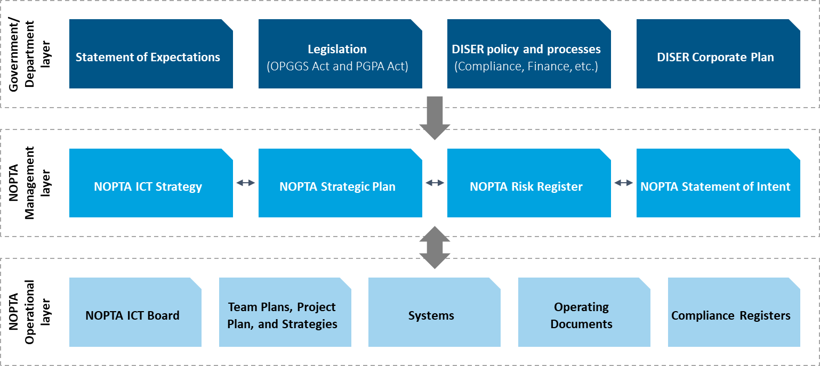

*Source: Deloitte adaptation from NOPTA Annual Report of Activities 2019-20*

NOPTA’s vision is to contribute to national prosperity through administering the development of Australia’s offshore petroleum industry. This vision is supported by its purpose to *“perform its role as stipulated in the OPGGS Act to support of the effective regulation and management of our offshore petroleum resources consistent with good oil field practice and optimum recovery”*.

NOPTA outlines three roles that it fulfils in delivering its purpose:

* **Analyse** – analyse data and information to inform resource management considerations and decision-making
* **Influence** – encourage greater collaboration and efficiency within industry to drive timely development and optimum recovery
* **Regulate** – efficiently administer offshore titles in accordance with the OPGGS Act and associated regulations.

Upon review and considering feedback from stakeholders, we believe NOPTA and its Strategic Plan:

* Appropriately recognises the importance of influencing industry (which is discussed further below)
* While clear and relevant to the industry (i.e. NOPTA’s strategic direction), there is a counter perception that NOPTA is inward-looking, not adaptable or agile (see **Figure 11.2**), and not placing sufficient weight on helping steward Australia’s offshore natural resources
* Does not place sufficient emphasis on how NOPTA will administer titles in relation to GHG storage activities. We received commentary from titleholders that the NOPTA Strategic Plan and the Minister’s Statement of Intent does not sufficiently call out offshore GHG storage-related activities for which NOPTA has a role in administering
* Must be cautious in how it positions its ‘regulate’ role. Given there is a degree of existing misunderstanding of roles and responsibilities within the offshore legislative framework which may be exacerbated if NOPTA is described as a regulator (when it is an administrator and an advisor). We might suggest the term ‘administrate’ be applied to this role.

**Figure 11.2: Survey responses to NOPTA’s strategic direction**

Source: Deloitte Stakeholder Survey, Deloitte analysis

NOPTA has a suite of metrics and Key Performance Indicators (**KPIs**) linked to the *Australian Government’s Regulator Performance Framework* KPIs in its Strategic Implementation Plan and team plans[[63]](#footnote-64). These are internally tracked and reported on a quarterly basis and discussed by NOPTA’s QAC.

NOPTA does report externally on a number of output measures as part of its annual report of activities process. This is a strong foundation; however, output measures should be broadened to align to the outcomes desired. Therefore, outside of the KPIs outlined in the *Australian Government’s Regulator Performance Framework* (against which NOPTA performs an annual self-assessment), there is no established definition of success for ‘administration’ specific to NOPTA’s context.

|  |
| --- |
| Recommendation #13 |
| NOPTA, in consultation with the DISER executive, should seek to continuously improve/update its Strategic Plan document/approach to focus on:   * Reflecting the broader risks and trends of the industry and how these apply to its roles in ‘analysing’, ‘influencing’, and ‘regulating’ the offshore industry * Placing greater emphasis on how it could deliver proactive influencing resource management activities to the benefit of the offshore legislative framework and, where appropriate, the industry * Placing greater emphasis on GHG storage-related activities.   Supporting strategic performance measures should be ‘SMART’ (Specific, Measurable, Achievable, Relevant, Time-bound) and aligned to the desired outcome(s) of NOPTA. |

### An influential and proactive NOPTA

**A more proactive and influential NOPTA is required**

As we established in **Section 4**, the industry is becoming more complex and will require greater oversight by the Government to steward effectively and support a vibrant offshore industry. The following discussion explores the concept of a more influential and proactive NOPTA within the overarching policy framework set by the Government. We recognise at the outset that some of the points we raise are at the boundary of the responsibilities between NOPTA (the administrative arm), the Offshore Resources Branch (the policy development arm)[[64]](#footnote-65), and NOPSEMA (the regulatory arm). Our discussion centres on NOPTA’s roles in resource management (e.g. supporting industry’s optimum recovery of resources in accordance with good oil field practice) and as an advisor to the other arms of the offshore legislative framework and, where appropriate, to the industry (e.g. in support of achieving desired outcomes). We see NOPTA as well positioned to undertake these activities under its broad advice-giving functions and its privileged position as a recipient of broad sets of industry data.

NOPTA’s ability to influence the industry to achieve the objective of ‘optimal recovery of resources in accordance with good oil field practice’ (among other aims) will become more important as total industry production levels decrease over the coming decades. Learnings from international jurisdictions with more mature industries have highlighted the importance of having the administrative and advice-giving arm of a framework that is able to be influential and proactive in the activities it undertakes in support of the policy framework it operates within. These activities should work in concert with the promotional and strategic direction-setting aspects of the regime undertaken by DISER’s Offshore Resources Branch and the regulatory activities delivered through NOPSEMA.

In our view and by way of example only, an influential NOPTA could be characterised by:

* Readily providing insights and intelligence to industry and its stakeholders that support resource recovery performance uplift. Regulation sets the minimum standard but the data NOPTA has access to provides the opportunity to drive improved industry performance to the benefit of a more productive industry. NOPTA do this to a degree currently with its newly developed benchmarking capabilities and has undertaken commerciality reviews
* Taking a more proactive approach to identifying and managing risks arising from the industry in relation to resource management and providing input on these risks to those developing policy
* In collaboration with the Offshore Resources Branch, bringing various elements of the stakeholder ecosystem together, as needed, to address issues of strategic consequence in respect to resource management
* Being more active in examining titleholder activities, particularly with regards to transfers and dealings, titleholder governance arrangements, and holding effective and prudent relationships with senior titleholder executives
* Visible leadership in the industry, for example in the provision of best practice guidance on relevant industry topics, such as on GHG and CCS matters
* Advising decision makers on compliance and enforcement actions through having access to a graduated set of enforcement powers to incentivise industry to achieve desired outcomes.

In support of a more proactive and influential NOPTA, we make the following interrelated observations, drawing from discussions across our report. There is benefit:

* From greater application of proactive stakeholder engagement approaches by NOPTA (see **Section 9** and **recommendation #12**)
* For the overall offshore legislative framework in making more fulsome usage of NOPTA’s privileged position to generate insights from the data it receives from industry
* In further exploration of delegations of straightforward decisions from the Joint Authorities to the Titles Administrator where decisions do not require significant levels of policy input or the bestowal of resource access rights.

We examine the latter two points in further detail below.

|  |
| --- |
| Recommendation #14 |
| NOPTA should, with access to industry intelligence and within the overarching policy framework set by the Government, take a more influential and proactive role in supporting the facets of the offshore legislative framework (and, where appropriate, the industry) in regards to resource management in accordance with its broad advisory functions outlined in section 695B of the OPGGS Act. |

#### Making full use of a privileged position

**NOPTA needs to leverage its ‘privileged position’ to provide more strategic portfolio-wide intelligence**

NOPTA has a privileged position as a recipient of pan-industry datasets. Significant value could be extracted by utilising this information more comprehensively. NOPTA’s leveraging of its privileged position to provide more strategic advice will help improve its ability to influence.

NOPTA has made progress in taking a more strategic approach in managing resources by looking beyond title-by-title applications (e.g. in relation to resource benchmarking, skills exchanges with international regulators, use of outcome-focused annual field performance reviews, undertaking commerciality reviews, and regional views of titles). We support this and our observations on this matter should not be construed as discounting NOPTA’s efforts to date. It is our view that there is a need for NOPTA to *do more* in this space – curating and publishing strategic intelligence, particularly with respect to advising the Joint Authorities of trends and cross-cutting industry issues.

This opportunity is raised in the context of the likely industry trend towards a more fragmented and complex offshore resource landscape. These factors drive a greater need for a more coordinated and strategic approach to resource management of marginal fields, which we believe will be supported by better use of industry data.

Some examples of strategic advice, analysis, and insight include:

* Publishing insight report(s) on the Australian basins to support industry decision-making
* Providing data and information to support the development of government policy
* Ensuring NOPTA continues the strategic focus on advice to the Joint Authorities by evaluating titles administration decisions on a more holistic basis (rather than title-by-title), such as basin views
* Consulting with the Joint Authorities and their delegates on providing strategic reporting outside of titles applications, including identifying delegate reporting requirements.

The execution of a privileged position should be undertaken as part of **recommendation #14** above.

#### Delegation of decisions to the Titles Administrator

**NOPTA should be empowered to make straightforward titles administration decisions**

The 2015 Operational Review identified the following relevant recommendation:

* *“Recommendation 3: That the feasibility of delegating simple decisions to the Titles Administrator is investigated.”*

Limited progress has been made in implementing this recommendation. Discussions between NOPTA and DISER’s Offshore Resources Branch have identified several potential areas where decisions might be delegated to NOPTA. However, as of writing this report, no decisions have been taken by the Government.

We concur with the previous Operational Review’s view that, where there are further opportunities to delegate straightforward administrative decisions to the Titles Administrator, this should be pursued. In instances where decisions are highly technical in nature, do not require highly nuanced policy advice, and do not relate to decisions over rights to resource access, these could be delegated to the Titles Administrator. Examples of decisions which may be suitable for delegation could include suspension, extensions and variations for exploration permits, changes to rates of recovery including equipment and procedures (with the exception of titles subject to the *Offshore Petroleum (Royalty) Act 2006*), variation of pipeline licences and consent to cease to operations of a pipeline, and FDP acceptance or rejection and FDP variations. The delegation of straightforward decisions from the Joint Authority to NOPTA may help streamline the titles administration process and reduce regulatory burden on industry. In addition, it would better allow Joint Authority decision-makers to place further focus on more complex, strategic titles decisions.

Concern has been raised by some government stakeholders that industry changes, changes in government priorities, and increasing complexity of some decisions has resulted in a need for retaining decision-making functions with the Joint Authorities. We are confident an appropriate escalation framework, outlining the criteria for where decisions require escalation to the Joint Authorities (such as where nuanced state or Commonwealth policy considerations are required), could be developed to address these concerns. For this recommendation to be most effective, NOPTA will be required to remain suitably abreast of key policy issues to identify where further policy input will be required. We see this as an integral role for NOPTA regardless of whether further delegations of decisions are made.

|  |
| --- |
| Recommendation #15 |
| DISER Offshore Resources Branch and NOPTA, in collaboration with the states/territory governments, should investigate the feasibility of delegating straightforward decisions (i.e. those that do not bestow resource access rights) to the Titles Administrator supported by an appropriate governance and escalation framework.  This is a modification to a recommendation made as part of the 2015 Operational Review**.** |

## Considerations for a unified offshore resources regulator and administrator

The optimal structure of the offshore legislative framework was raised as an open question through the review process. Specifically, we heard concerns regarding the fitness-for-purpose of the separation of administrative (NOPTA) and regulatory functions (NOPSEMA)[[65]](#footnote-66) of the regime with the respect to the ability for NOPTA and NOPSEMA to effectively and efficiently meet the needs of a more mature industry.

**Delineation of safety and environment regulation and titles administration considerations is a well-established precedent**

There were strong arguments as to why NOPTA and NOPSEMA were established as separate entities. The primary reason being to avoid actual or perceived conflicts of interest and ensure there is a distinct separation between the administration and assessment of titles applications (NOPTA), the decision makers (the Joint Authorities), and the regulatory objectives for safety, well integrity and the environment (NOPSEMA). These arguments are in line with the Hon Lord Cullen’s recommendations from the United Kingdom’s *1990 Public Inquiry into the Piper Alpha Disaster*.

We observe the general international precedent for offshore petroleum regulatory frameworks to separate administration/licencing from health, safety, and environmental regulation (e.g. as in the United Kingdom and Norway). However, there are jurisdictions which operate what might be described as a ‘unified model’ (e.g. the Canadian C-NLOPB).

As an administrative and advice-giving arm of the offshore legislative framework, NOPTA is not a truly an independent entity, existing as a branch of DISER. Should it be accepted that NOPTA further pursue influential and proactive activities in relation to resource management, there will be a need to ensure appropriate levels of independence of these functions from regulatory functions.

**There are drivers for revisiting whether the two-entity model remains fit-for-purpose**

Drivers for bringing together the administrative and regulatory arms of the offshore legislative framework include:[[66]](#footnote-67)

* Minimising the regulatory burden on industry through more efficient and connected regulatory processes – better facilitating a ‘One Government’ approach to administration and regulation and ensuring clearer arrangements where multiple parties are involved
* Avoidance of duplication or the risk of conflicting decision-making by administration (NOPTA) and regulation (NOPSEMA) facets of the offshore legislative framework
* A likely increase in the number of industry transactions and areas of ‘regulatory’ overlap between NOPTA and NOPSEMA (both in relation to decommissioning and outside of decommissioning activities)
* Minimising inconsistencies in legislative requirements and decision-making
* Economic efficiency from making better use of scarce skillsets and specialist expertise and an opportunity to better share capabilities and learnings between regulators, including, for example, leveraging data and systems capabilities
* Greater coordination with regards to GHG storage and petroleum activities.

There are a number of options to consider when examining how greater collaboration and coordination might be achieved. Example options to consider include:

* **Option 1: Improved operational interaction.** Under this option,NOPTA and NOPSEMA would remain separate entities but with more formalised mechanisms for increasing the proximity and interaction of staff and processes. This most closely resembles the current state and the current legislative requirement that the entities cooperate. This ensures a seamless regime and is aimed at minimising ‘silos’.
* **Option 2: Applying a partnership approach.** Under this option, NOPTA and NOPSEMA would remain separate entities but have integrated project governance processes[[67]](#footnote-68) on key issues, such as decommissioning. In practice this could result in the formation of cross-organisational teams tasked with addressing and coordinating on particular issues
* **Option 3: Establishment of a single independent offshore resources model.** Under this option, NOPTA would be moved from DISER and formally integrated into NOPSEMA, thus forming a single independent entity with the remit for the administration and regulation of offshore petroleum and GHG storage matters.

The question is whether the degree of coordination, cooperation, and collaboration required to support the next phase of Australia’s offshore industry can be achieved through the current model (Options 1 and 2), particularly in light of as-yet unaddressed challenges in the effective and efficient sharing of information and data, as discussed in **Section 9**. It is noted that the establishment of a unified offshore regulatory model (Option 3) would align to the 2009 Productivity Commission Review, which recommended the establishment of a single national regulator for the offshore oil and gas industry in Commonwealth waters.

In developing our report, we have not taken a position on the question of whether a unified offshore resources model should be established – it requires analysis outside the scope of the current report. However, there is merit in the concept of NOPTA being moved into NOPSEMA being explored further. We also note that the balance of our recommendations have been made on the assumption that the status quo model remains in place. Should the Government ultimately decide to integrate NOPTA within NOPSEMA, the appropriateness of NOPTA’s functions, as they relate to resource management and potentially the delegation of Joint Authority powers to NOPTA, would require revision to ensure such functions do not introduce additional risk in relation to conflicts of interest.

For a unified model to be successful, at minimum, the following considerations or questions need to be satisfactorily addressed:

* **Independence and governance.** A unified model would need to determine how independence of safety, well integrity, and environmental regulatory functions from administrative functions would be maintained. A governance model in this context would need to maintain separation of these duties (e.g. through mechanisms such as ‘ring-fencing’ and appropriate internal controls)
* **Coordination and collaboration with the policy arm.** As we have outlined above, the ability for the administrative and policy arms of the offshore legislative framework to collaborate and coordinate effectively will remain essential. A unified model must consider how these outcomes will be achieved
* **Dual focus.** Assurance must be gained that a unified model is able to give sufficient focus to both NOPTA’s and NOPSEMA’s respective functions – that is, the fulfilment of the regulatory role, does not detract from the fulfilment of the administrative role and vice versa
* **Degree of actual conflicts of interest present.** Consideration should be given to the degree of actual conflict of interest present between NOPTA’s objectives and NOPSEMA’s safety and environmental objectives. Consideration needs to be given as to whether, should NOPTA take a more proactive and influential role in industry (with greater decision-making powers as we recommend), this would exacerbate any actual or perceived conflicts of interest if a unified model were established
* **Stakeholder perceptions.** Community and industry confidence in the offshore legislative framework is paramount for retaining a ‘social licence to regulate’. A unified model would need to be able to transparently demonstrate independence of mind and appearance of its functions and not detract from stakeholder confidence
* **Joint Authority decision-making.** Understanding the role and functions of the Joint Authorities under such an arrangement to ensure oversight and policy input by ministerial decision-makers as appropriate
* **Impact assessment for policy, legislation, regulations, and operating documents.** Consideration would need to be given to the degree of change (if any) to the existing legislative and regulatory framework to establish a unified model. The costs and timescale to effect this change would also need to be examined
* **Reducing regulatory burden: areas of synergy and cost efficiencies.** An evaluation of the actual areas of capability overlap (either in people, processes, or technology) to determine cost saving efficiencies (if present)
* **Strategic benefits**. Consider if there are other strategic benefits from a unified model, such as greater coordination and collaboration helping enable a ‘One Government’ approach to offshore resource regulation or benefits in making shared use of scarce technical capabilities or sharing of data to inform regulatory activities.

|  |
| --- |
| Recommendation #16 |
| The Government should, in consultation with other stakeholders as appropriate, consider if there should be a single offshore resources regulator covering:   * Offshore petroleum, GHG storage, and titles administration * Regulation of safety and environmental matters for offshore petroleum, GHG storage.   In undertaking this recommendation, there should be regard for:   * The relative merits of alternative options, such as retaining the current model * Governance models for such an entity, with reference to how governance structures can ensure the appropriate involvement of the Joint Authorities, maintenance of regulatory independence by NOPSEMA, and independence between titles administration activities and safety and environmental management regulation. |

## Adapting to the future of regulation

A key aspect of reducing regulatory burden on industry and operating effectively is having a culture and organisational focus on improving current practices and seeking appropriate ways to innovate.

### Stakeholder perceptions of NOPTA’s continuous improvement

***NOPTA’s stakeholders have mixed views over its focus and commitment to continuous improvement***

International regulators we consulted with stated that NOPTA was world leading in ‘regulatory process excellence’. Despite this perspective, a portion of NOPTA’s domestic stakeholders do not perceive NOPTA to be sufficiently utilising leading practice, regularly seeking feedback and input from industry, or demonstrating innovation (see **Figure 11.3**).

**Figure 11.3: Survey responses to NOPTA’s innovation and continuous improvement**

*\*NOTE: leading practice could refer to utilising a new technology, technique, process, practice, or other innovation*

*\*\*NOTE: feedback could be through a survey, meeting, or other form of interaction*

Source: Deloitte Stakeholder Survey, Deloitte analysis

Currently, NOPTA’s Annual Report of Activities serves as the primary conduit for communicating improvements made. As part of our recommended shift for NOPTA towards a more proactive engagement model (see **Section 9**), we encourage NOPTA to continue seeking feedback on improvement areas and communicating steps it is taking to implement industry best practice.

### Future opportunities

**The future of NOPTA’s activities should be underpinned by access to and use of data to drive decisions**

Technological advancements are resulting in change for the administrative environment and are posing significant challenges for those who strive to maintain a balance between achieving objectives, fostering innovation, and addressing the potential unintended consequences of disruption. A key focus of NOPTA should be on identifying opportunities to more effectively and efficiently deliver its functions through more powerful digital capabilities.

There are three areas where technological advancements could be applied:

* Reducing regulatory burden, particularly in the area of administrative compliance
* Increasing internal efficiency to improve administrative throughput and decision-making speed
* Improving administrative effectiveness through data-driven decision-making.

Example technologies being applied by regulators internationally and across other industries are shown in **Figure 11.4**. Other industry applications have been included given the transferability, in many cases, to the petroleum context. We have outlined several case studies of successful applications of these technologies by regulators globally below:[[68]](#footnote-69)

* **Analytics.** New York City has made its fire risk inspections about 20% more accurate by using a regression analysis tool to determine which buildings are most vulnerable. The tool assesses more than 7,500 risk factors – including a building’s tax status, construction materials and location – using data from 17 agencies and calls to municipal services
* **AI.** A New Zealand government unit has pioneered “legislation by code” by taking the “rules” or components of legislation – its logic, requirements, and exemptions – and rewriting them as software code. When legislation changes, a machine can automatically understand the changes, with no need for a human expert or lawyer to complete the job
* **AI.** The US Food and Drug Administration is using AI and analytics to expedite the approval process for trusted companies with an excellent track record of compliance.

**Figure 11.4: Summary of key risks and trends impacting NOPTA**

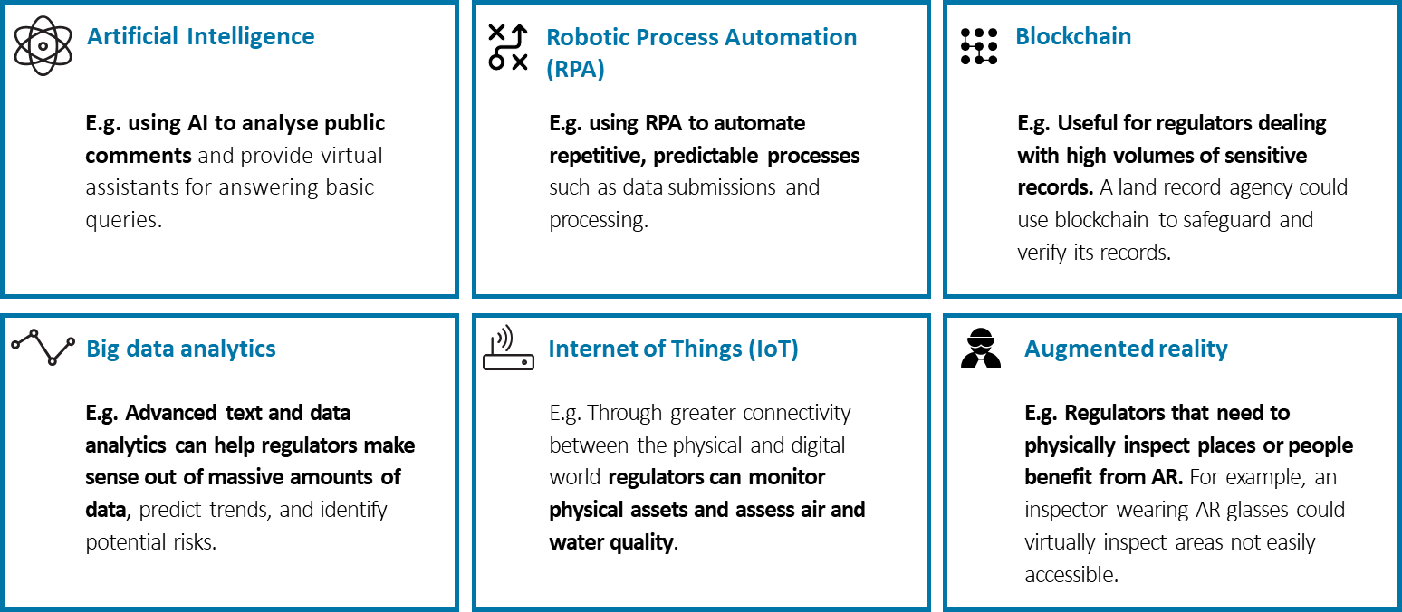

Source: Deloitte Regulator’s New Toolkit

|  |
| --- |
| Recommendation #17 |
| NOPTA, in collaboration with other stakeholders, is encouraged to identify areas where advanced technologies (such as predictive analytics) could be applied, particularly with respect to NOPTA’s cross-industry datasets**.** |

In considering this recommendation, NOPTA may wish to identify and prioritise specific use cases that present an optimal balance between value delivered and ease of implementation. Example use cases for NOPTA to consider may include:

* Predictive analytics – examining the statistical predictors of field performance
* Legislation as a code – examining opportunities where compliance activities required of titleholders under the OPGGS Act could be codified into logical rules for automated compliance checks, such as with data submissions.



Appendices

1. Terms of Reference

In accordance with section 695P(1) of the *Offshore Petroleum and Greenhouse Gas Storage Act 2006* (the Act), the 2020 review of activities of the National Offshore Petroleum Titles Administrator (NOPTA) will:

1. Make an assessment of the effectiveness of the Titles Administrator in contributing to the efficiency of decision-making by a Joint Authority for a state or the Northern Territory.

In the context of the Act and regulations, including the legislated functions of the Titles Administrator, this review will consider, assess and provide recommendations in relation to:

1. The arrangements for data and information management, including the National Offshore Petroleum Data and Core Repository (NOPDCR).
2. The provision of information, assessments, analysis, reports, advice and recommendations to Joint Authorities and the Responsible Commonwealth Minister on titles, compliance and other related matters.
3. NOPTA’s level of engagement with risk and the appropriateness of current risk mitigation strategies.
4. The effectiveness of the compliance, monitoring and enforcement activities of the Titles Administrator.
   1. This should consider the process for reporting of related matters to the Responsible Commonwealth Minister (where relevant) and the Joint Authorities (where relevant).
   2. The appropriateness and effectiveness of NOPTA’s internal arrangements concerning compliance.
5. The effectiveness of NOPTA in co-operating with NOPSEMA in matters relating to the administration and enforcement of the Act and its associated regulations.
6. The effectiveness of the Australian Government’s accepted and implemented recommendations from the 2015 review of NOPTA’s activities.
7. The effectiveness, management and performance of NOPTA in:
   1. making information publicly available on the register of petroleum and greenhouse gas titles to meet community expectations and the ease of use and access to the information
   2. meeting its obligations under section 469 of the Act to keep a register for each offshore area
   3. contributing to and maintaining community confidence that appropriate administrative oversight is in place through transparent assessment and compliance activities
   4. providing timely information and advice to the Minister in responding to community concerns and other matters as they arise.
8. NOPTA’s engagement and relationships with external parties, including federal, state and territory governments, industry, Geoscience Australia and other stakeholders in contributing to the efficiency of the Titles Administrator in performing its functions.
9. This should also consider the level of international engagement by NOPTA, including the appropriateness and its effectiveness.
10. The current cost recovery arrangements, commensurate with the functions of NOPTA and the size of industry.
11. An assessment of the capacity and capability of NOPTA, including current staffing arrangements and its structure, commensurate with its functions, to respond to varying levels of industry activity and to new technologies and other emerging issues.
12. Identify potential opportunities where NOPTA can reduce operating costs and streamline corporate functions, to reduce the financial and regulatory burden on industry.
13. This should consider a greater alignment with the Department of Industry, Science, Energy and Resources corporate functions.
14. NOPTA personnel interviewed

|  |  |
| --- | --- |
| **#** | **Role** |
|  | A/g Assistant Manager, Titles Team |
|  | A/g Manager, ICT |
|  | Assistant Manager Business Support Unit |
|  | Assistant Manager Finance |
|  | Assistant Manager, Data Management Team |
|  | Assistant Manager, Titles Team |
|  | Manager, Business Support Unit |
|  | Manager, Data Management Team |
|  | Manager, Legislative Compliance Team |
|  | Manager, Operations |
|  | Manager, Strategy & Governance |
|  | Manager, Systems Development Group |
|  | Technical Manager, Commercial |
|  | Technical Manager, Development |
|  | Technical Manager, Exploration |
|  | Titles Administrator |
|  | Titles Manager, Development |
|  | Titles Manager, Exploration |
|  | Titles Officer(s) |

\*For several of the NOPTA personnel interviewed, multiple interviews were held across various terms of reference areas.

1. External parties consulted

|  |  |  |  |
| --- | --- | --- | --- |
| **Organisation\*** | **Survey** | **Interview** | **Workshop** |
| Australian Maritime Safety Authority |  |  | ✔ |
| Australian Petroleum Production and Exploration Association | ✔ | ✔ | ✔ |
| Beach Energy Limited |  |  | ✔ |
| BHP Petroleum | ✔ |  |  |
| Bight Petroleum | ✔ |  |  |
| CGG | ✔ |  |  |
| Chevron Australia | ✔ | ✔ | ✔ |
| CO2CRC | ✔ |  |  |
| Cue Energy Resources | ✔ |  |  |
| Department for Energy and Mining (South Australia) | ✔ |  |  |
| Department of Industry, Science, Energy and Resources | ✔ | ✔ |  |
| Department of Mines, Industry Regulation and Safety (Western Australia) | ✔ | ✔ |  |
| Equinor Australia | ✔ |  |  |
| Esso Australia (ExxonMobil) |  | ✔ |  |
| FAR Ltd | ✔ |  |  |
| Geoscience Australia |  | ✔ |  |
| INPEX Australia |  |  | ✔ |
| Jadestone Energy |  |  | ✔ |
| Mitsui E&P Australia | ✔ |  |  |
| Molyneux Advisors | ✔ |  | ✔ |
| National Energy Resources Australia | ✔ |  | ✔ |
| NOPSEMA | ✔ |  |  |
| Norwegian Petroleum Directorate |  | ✔ |  |
| Oil and Gas Authority (UK) |  | ✔ |  |
| PTTEP Australia | ✔ |  |  |
| Santos Limited |  | ✔ | ✔ |
| Sapura Energy – OMV |  |  | ✔ |
| Schlumberger Australia | ✔ | ✔ | ✔ |
| SGH Energy | ✔ |  |  |
| The CarbonNet Project, Victorian Department of Jobs, Precincts & Regions | ✔ |  |  |
| Woodside Energy | ✔ | ✔ | ✔ |

*\***Organisations ordered alphabetically. Note some organisation include multiple participants.*

*\*\* Responses include partially completed surveys. The representation of stakeholders consulted by category excludes all ‘NA’ responses*

*\*\*\* Some stakeholders were unable to stay for the full workshop. We have included all stakeholders who attended the workshop in full or in part.*

1. Key NOPTA documentation examined

| **#** | **Document** |
| --- | --- |
|  | 2020 Operational Review presentation (NOPTA Overview) |
|  | NOPTA Strategic Plan 2020-2023 |
|  | DISER Enterprise Agreement 2019 |
|  | Procedural Fairness Guide June 2018 |
|  | NOPTA Assurance Review Plan 2020 |
|  | Titles administration process walkthrough material |
|  | NOPTA Risk Register (July 2020) and Hazard Control Register |
|  | Compliance and Enforcement – policy, procedure and Compliance Register guide |
|  | HR Strategic Plan 2020-2022 |
|  | NOPTA Learning & Development Plan 2020–2023 and NOPTA’s 3 levels of training and development |
|  | 2019 APS Census – National Offshore Petroleum Titles Administrator (NOPTA) |
|  | NOPTA workshop series – debrief and All Staff Event Sessions – day 1 and 2 (HR) |
|  | NOPTA Information, Communications & Technology Strategy 2017-2019 and 2020-2023 |
|  | Management of Information/Data Management presentation material and team plan (2020) |
|  | NOPTA systems overview, NEATS presentation material and system screenshots (NEATS and TERI) |
|  | Agreement for the Provision of Services relating to the National Offshore Petroleum Data and Core Repository (Confidential Data) |
|  | NOPDCR Usage Statistics (Calendar Year 2016 – June 2020) |
|  | DIIS - Assurance Advisory Service - NOPTA Administrative Compliance Review - Draft Report January 2020 |
|  | Internal Audit - ICT Governance and Risk Management with Business Units - Draft Report 2018-19 |
|  | NOPTA ICT Board Meeting Minutes - September 2020 |
|  | Operating Protocols for Offshore Petroleum Joint Authorities & Supporting Institutions (July 2015) |
|  | Operating Protocols for Offshore Petroleum Joint Authorities (December 2011) |
|  | Procedure Joint Authority Applications and JA Advice Assessment Template |
|  | Joint Authority Decision Process Walkthrough and procedural Fairness in Joint Authority decision making |
|  | NOPTA Joint Authority and Titles Administrator Application Statistics |
|  | NOPTA Stakeholder Relationship Map and List of stakeholder engagement activities for 2019-20 |
|  | NOPTA Lunch & Learn – Communications and Engagement Strategy presentation |
|  | NOPTA – Cost Recovery Arrangements and Schedule of fees (from 1 October 2020) |
|  | Financial transaction volume chart BSU |
|  | 2015-2019 NOPTA Application Stats and Ledger Print Revenue 2018-19 |
|  | CRIS Activity based summary 2016 and 2018 Activity Based Summary of Costs – Estimate of effort with Actuals |
|  | Brief NOPTA CRIS analysis 2019 |
|  | Current cost recovery implementation statement (CRIS) 2016-17 and CRIS 2015-16 |
|  | Business Support Unit Team Task List and DISER Interactions (internal) |
|  | Internal Review – Detailed Observations on NOPTA (draft report) |
|  | NOPTA Annual report of activities for the periods 2014-15 to 2019-20 |
|  | NOPTA stakeholder surveys 2015 to 2019 |
|  | NOPTA 2015–16 to 2018-19 self-assessment against the Government’s Regulator Performance Framework |
|  | Determination No. 2019/1 Payments for NOPSEMA inspectors |

**Note:** This should not be considered an exhaustive list of materials reviewed. There are other materials considered and referenced throughout the report as appropriate. We also considered a range of publicly available information on the NOPTA, NOPSEMA, and DISER websites where relevant.

1. Status of NOPTA’s 2015 statutory review recommendations

As part of the assessment, we have assessed the current status taken by NOPTA and DISER to address recommendations identified in the 2015 operational review conducted by Noetic. In summary, NOPTA and DISER have largely addressed the recommendations, with some actions still pending.

| **#** | **2015 recommendation** | **Australian Government response** | **Current status** |
| --- | --- | --- | --- |
| 1 | That timeframes for the consideration of, and decision making for, all titles related matters by Joint Authorities is agreed with jurisdictions and implemented. | **Noted**  The Australian Government notes the Review comments that some titleholders raised concerns regarding transparency and timeliness of decision-making by Joint Authorities and recognises that clarity on these issues contributes to project certainty and risk management. The OPGGS Act does not preclude statutory timeframes being provided. A protocol has been established that provides an agreed framework for decision making by the Joint Authority. The ‘Operating Protocol for Offshore Petroleum Joint Authorities and Supporting Institutions’ (the Protocol) provides indicative timeframes for NOPTA assessment and Joint Authority decisions (which differs if the decision is taken by members or by their delegates). A protocol has been in place since the establishment of NOPTA. The Protocol requires every jurisdiction to use ‘best endeavours’ to meet these timelines. A revised Protocol was agreed by all members of the Joint Authority in July 2015. NOPTA has amended its performance measures under the Government’s Regulators’ Performance Framework to reflect these indicative timeframes. The Protocol is an internal guidance document for governments. The Government notes that the Offshore Petroleum Resource Management Review has proposed an Action that agreement be obtained from the Joint Authorities to make public the indicative timeframes for title decisions as provided in the Protocol on the NOPTA website. To satisfy the recommendations of both reviews, the Government will seek agreement from all jurisdictions through the Upstream Petroleum Resources Working Group (UPR), a sub-committee of the Council of Australian Governments (COAG) Energy Council, to make the Protocol publicly available to increase transparency and support timely decisions. Implementation of this recommendation is the responsibility of the Department of Industry, Innovation and Science. | **DISER status:**  The protocol was updated in 2015 by the Department in consultation with states/Northern Territory and published on NOPTA’s website. It continues to undergo reviews and refreshes as required.  **Deloitte comments:**  A detailed assessment of Joint Authority decision-making timeliness is out of scope of our review and so we do not make further recommendations in direct relation to this matter. However, we note strong industry feedback that further consideration could be given to the timeliness and transparency across the end-to-end titles administration process. |
| 2 | The adherence of the Titles Administrator and Joint Authorities against the agreed timeframes is reported as part of NOPTA’s annual report. | **Agreed in principle**  The Government agrees that timeliness in decision making delivers improved certainty for titleholders. While existing guidelines available on NOPTA’s website include indicative timing for some Joint Authority decisions, such as retention lease applications, the Government considers that making public the indicative timeframes in the Protocol will further encourage timely decision making. In addition, NOPTA currently provides dashboard reports on the NOPTA website which provides aggregated information on the status of applications. This recommendation is agreed in principle, as any decisions to make Protocols and or performance against indicative timeframes public must be agreed by the Upstream Petroleum Resources Working Group (UPR). The reporting mechanism will be considered following discussion with the UPR. Implementation of this recommendation is the responsibility of the Department of Industry, Innovation and Science. | **DISER status:**  Complete.  **Deloitte comments:**  As Per #1. |
| 3 | That the feasibility of delegating simple decisions to the Titles Administrator is investigated. | **Accepted**  The Government notes that this recommendation is consistent with an action proposed in the Offshore Petroleum Resource Management Review. The Resource Management Review recommends that the Offshore Petroleum Joint Authorities consider options for further streamlining decision points across the offshore petroleum regime, including devolving some decisions to the Titles Administrator and/or the responsible Commonwealth Minister. Implementation will be informed by the areas identified and agreed to by the members of the Joint Authorities and is the responsibility of the Department of Industry, Innovation and Science. | **DISER status:**  The Department continues to pursue the exploration of opportunities to streamline decision-making where it aligns with priorities and resourcing.  **Deloitte comments:**  We make further recommendations in relation to the delegation of straightforward decisions to the Titles Administrator. |
| 4 | That NOPTA, in conjunction with stakeholders, develop and implement short and long term plans to enhance the NEATS system to improve the efficiency and access to titles information. | **Accepted**  The National Electronic Approvals Tracking System (NEATS) was established by NOPTA and provides access to publicly available information concerning offshore petroleum titles and applications. NEATS has a level of access for both industry and the public, and is a single source of up to date information on offshore petroleum titles and applications. NEATS can be accessed through NEATS online (www.neats.nopta.gov.au). The public portal in NEATS provides access to information held within the titles register, application tracking and the electronic lodgement of applications. It also enables titleholder specific (confidential) information to be viewed by Titleholders through an industry portal. In this regard, a Titleholder is able to have a consolidated view of the titles in which they participate and is able to lodge selected applications, including payment of fees. The key features included in NEATS are:  • the ability to search the title register using a range of criteria  • the ability to view details of a title, including relevant title instruments  • a geospatial view of titles providing summary details and interactive maps to identify surrounding titles.  The key features of the NEATS Industry Portal are:  • application tracking and search facilities  • online fee payment facilities  • online lodgement of selected applications  • industry log-on with roles based user management  • application tracking in greater detail for applicants  • company based task lists of applications in progress and actions required  • the ability to produce reports from the title register using a range of criteria.  The Government notes that the current development cycle of NEATS is due to conclude in October 2015 with the last major upgrade/roll out. The next phase of development for NEATS will consider increased functionality in respect of the titles activities and useability in relation to the information that can be accessed through the geospatial/mapping capability, such as Special Prospecting and Access Authorities, and titles register, further contributing to transparency of offshore petroleum titles. Consideration of the development requirements will commence in early 2016 and will include providing higher levels of automation and increased use of on-line submission of applications, and related workflows. It is estimated that the planning and development program will be over three years (12 months planning/scoping followed by specification and design followed by up to two years development, testing and implementation). Implementation of this recommendation is the responsibility of the Department of Industry, Innovation and Science. | **DISER status:**  Complete.  **Deloitte comments:**  No specific issues noted with progress against this recommendation.  Please refer to **Section 8** for further detail on Deloitte’s assessment of NOPTA’s data and information management processes and specific enhancement opportunities for NEATS in future, including greater digitisation of the end-to-end titles administration process. |
| 5 | That NEATS functionality is extended to include more information on the progress of applications through the Joint Authority process. | **Accepted**  NEATS has a proven and established platform and framework for titleholders to be able to track their individual title applications through the confidential industry portal. The publicly visible Approvals Tracking page on NEATS provides aggregated information on total numbers of applications at milestone stages. NEATS also offers an additional, confidential level of detail for registered titleholders to log-in and see what stage their individual application is up to, including which member of the Joint Authority is currently considering the matter. The Government notes that this function of NEATS does not appear to be known broadly, and as such NOPTA will further communicate and promote this function with titleholders to ensure its effective utilisation. In addition, the further development and implementation of electronic workflows by NOPTA will contribute to increasing the timeliness of information that can be made available to applicants, particularly in relation to the progress of applications. Implementation of this recommendation is the responsibility of the Department of Industry, Innovation and Science. | **DISER status:**  Complete.  **Deloitte comments:**  As per #4. |
| 6 | That, depending on the outcomes of the Department of Industry and Science’s (now the Department of Industry, Innovation and Science) report on the Management of Offshore Resources, the Minister consider an enhancement to NOPTA’s capability and capacity to enable it to more effectively contribute to the management of Australia’s offshore resources. | **Noted**  The Government acknowledges the 2015 Review’s finding that NOPTA has developed the necessary skills and capability to deliver high quality advice to the Joint Authorities and to meet its legislative functions. However, in relation to resource management, the Report has noted that NOPTA requires staff with the technical skills, knowledge and experience to undertake review of development plans and the ongoing implementation of these plans to ensure the exploitation of the resource is in the national interest. The Review recommends an increase in NOPTA’s technical capabilities whilst noting the difficulties in attracting and retaining these staff in a competitive market. The Government notes that consistent with this recommendation, the Offshore Petroleum Resource Management Review identified the need to have the right skill sets and technical capacity in the administration and management of Australia’s offshore petroleum resources. The Offshore Petroleum Resource Management Review acknowledged that there could be improvements in some of NOPTA’s technical capacity with an Action for NOPTA to work with relevant government agencies and industry to assess its technical needs against identified resource management requirements and develop a medium term plan to address any deficiencies or areas of new capacity. Implementation of this recommendation is the responsibility of the Department of Industry, Innovation and Science. | **DISER status:**  Recommendation was noted by the Government.  NOPTA has undertaken recruitment activities over the last five years and in doing so has sought to align its current and future capability requirements through its recruitment activities.  **Deloitte comments:**  No specific issues noted, we consider NOPTA to have demonstrated progress in implementing this recommendation. Refer to **Section 7** for Deloitte’s review of NOPTA’s capability and capacity.  We do make further recommendations in relation to NOPTA assuming a more proactive and influential role in relation to resource management. Our commentary and associated recommendations should not be construed as NOPTA not having made progress in this regard. |
| 7 | That NOPTA develop and implement plans to facilitate Recommendations 3 and 6 (if accepted). | **Noted**  The Government notes that implementation of recommendation 3 will be informed by the areas identified and agreed to for streamlining by the Joint Authorities. Any legislative changes that may be required to the OPGGS Act and its supporting regulations will be made in accordance with the Australian Government’s legislative timetable. Implementation of this recommendation is the responsibility of the Department of Industry, Innovation and Science. | **DISER status:**  Recommendation was noted by the Government.  **Deloitte comments:**  No issues noted. |
| 8 | That NOPTA prepare and issue its own annual report. | **Noted**  The 2015 Review considered the case for NOPTA to operate as a standalone statutory authority. The rationale for this was the need to be, and be perceived to be, impartial or independent. In its consideration the 2015 Review did not find any compelling evidence that NOPTA’s functions would best be performed outside of the Department of Industry, Innovation and Science. Further as an administrator and in some cases the administrative decision maker, NOPTA’s position in the Department further supports its independence from industry. The Titles Administrator has a statutory responsibility to “prepare and give to the responsible Commonwealth Minister, for presentation to the Parliament, a report on the Titles Administrator’s activities during that year. (s695N (1) of the OPGGS Act). In the 2013-14 reporting period the Title Administrator discharged this responsibility as part of the then 2013-14 Department of Industry and Science Annual Report. However, the Government notes that NOPTA intends to provide a separate report detailing the title administration, management and advisory activities it undertook for the Joint Authority and as the Title Administrator. This will also be consistent with the reporting requirements of the Australian Government’s Regulator Performance Framework which came into effect on 1 July 2015. The Regulator Performance Framework is an important part of the Australian Government’s commitment to reducing the cost of unnecessary or inefficient regulation imposed on individuals, business and community organisations. This report will also be published on NOPTA’s web site in the fourth quarter of 2016 in relation to the 2015-16 reporting period. Implementation of this recommendation is the responsibility of the Titles Administrator. | **NOPTA status:**  Complete.  **Deloitte comments:**  No issues noted. |
| 9 | That NOPTA and NOPSEMA should establish an instrument (such as a Memorandum of Understanding or Charter of Engagement) to clarify the interaction between the agencies. | **Noted**  The Government notes that the 2015 Review highlighted the relationship between NOPTA and NOPSEMA as being pivotal in the effective oversight of the offshore petroleum sector and that this relationship could be made more effective through a formal agreement. NOPSEMA and NOPTA have improved their inter-agency cooperation since the initial period of operations when engagement was almost by necessity focused on discharging their new responsibilities. Legislative change has since enabled better sharing of information which provides opportunities for further cooperation. Both organisations have demonstrated the capacity to work cooperatively on matters relating to the regulation of offshore petroleum titles and greenhouse gas operations. As such, the Government does not consider a formal instrument of engagement between NOPSEMA and NOPTA is necessary provided the areas of co-operation and consultation are documented and updated to ensure currency. Implementation of this recommendation is the responsibility of the National Offshore Petroleum Titles Administrator and the Chief Executive Officer of NOPSEMA. | **NOPTA/NOPSEMA status:**  Complete.  **Deloitte comments:**  For areas of progress and further enhancement, please refer to **Sections 5**(in relation to enforcement), **9** (in general for their collaboration and coordination), and **11** (in relation to future directions for coordination and coordination). |
| 10 | That NOPTA investigate the implications of a growth in applications for greenhouse gas storage titles. This should be undertaken in conjunction with the Department of Industry and Science (now the Department of Industry, Innovation and Science), and NOPSEMA. | **Accepted**  Australia was one of the first countries in the world to have a comprehensive legislative framework to regulate offshore greenhouse gas injection and storage. The creation of NOPTA occurred after the commencement of the greenhouse gas legislative framework so there is merit in NOPTA and the Department to continue to work together to better understand the resourcing and other implications of a growth in greenhouse gas titles. Implementation of this recommendation is the responsibility of the Department of Industry, Innovation and Science | **DISER status:**  Complete.  **Deloitte comments:**  No specific issues noted. We do make further comment on NOPTA’s integration of GHG storage matters in its strategic planning processes in **Section 11**. |
| 11 | That NOPTA provide its insights on the offshore petroleum and greenhouse gas storage industries to jurisdictions to assist with policy development. | **Accepted**  The 2015 Review notes NOPTA is now at a point in its development where it has a range of analytical skills and industry expertise gained through its administrative function that would benefit the policy decision making of the jurisdictions. These skills and knowledge would provide insights into the exploration, development and production phases, based on trend analysis and on industry knowledge, rather than providing policy advice per se. The Titles Administrator is able to exercise this expertise as there is a clear and broad advice function under s695B of the OPGGS Act in relation to advice to the jurisdictions and relevant State/Northern Territory Petroleum Ministers. NOPTA already employs its recognised technical expertise and analytical skills in the insights provided to the jurisdictions through its participation in the meetings of the Upstream Petroleum Resources Working Group, which reports to the COAG Energy Council. NOPTA has developed extensive data holdings, captured as part of the functions of the Title Administrator. NOPTA will consider aggregating confidential data to develop trend analysis including projections, to inform policy development for both the Commonwealth and the states/ Northern Territory. Furthermore, the Offshore Petroleum Resource Management Review has an Action for NOPTA to establish an annual public reporting framework that provides a holistic assessment of the state-of-play of Australia’s offshore petroleum resources and associated infrastructure in producing and prospective regions. The intent of this report is to provide the community and the offshore petroleum industry with a high-level comprehensive picture of Australia’s offshore petroleum resource base and associated development/production infrastructure at the regional and/or basin level and to highlight current and emerging resource management issues. It will also provide the public with a transparent understanding of the management regime and will be used by NOPTA and the Joint Authorities as a basis for engagement with industry on the issues identified. Implementation of this recommendation is the responsibility of the Titles Administrator. | **DISER status:**  Complete.  **Deloitte comments:**  Refer to **Section 11** for our perspective on NOPTA’s provision of insights in support of the offshore legislative framework.  We do make further recommendations in relation to NOPTA making further usage of its privileged position. Our commentary and associated recommendations should not be construed as NOPTA not having made progress in this regard. |
| 12 | That the Commonwealth Minister considers the conduct of a feasibility study for the creation of a single offshore titles administrative framework for both Commonwealth waters and State/Northern Territory waters through the conferral of powers under State and Northern Territory legislation. | **Noted**  The Australian Government is committed to a regulation reform agenda that will drive productivity and efficiency gains within the economy. A key feature of the agenda includes reducing the regulatory burden, as a means of unlocking productivity and competitiveness gains for industry. For the purpose of the Government’s activities in this area, regulation is considered broadly in this context. This includes, legislation, programs, administrative processes and guidelines and any other aspect of government or regulator behaviour that can influence actions. Responsibility for the management and regulation of offshore petroleum activities in coastal waters is a matter for the states and the Northern Territory. The Government notes that this recommendation is in response to the Terms of Reference which stated that “the review should have regard to opportunities consistent with the Government’s deregulation agenda”. While the Commonwealth does not intend to pursue this option at this time, it notes that s695B of the OPGGS Act does provide limited authority for NOPTA to exercise functions and powers conferred upon it under a state/Northern Territory Petroleum (Submerged Lands) Act, so long as those functions and powers are substantially similar to those conferred upon NOPTA by the operation of the OPGGS Act and associated regulations. This authority requires an agreement between the Titles Administrator on behalf of the Commonwealth and the relevant State or Northern Territory Petroleum Minister, and approved by the responsible Commonwealth Minister (see s695 B(2) and (3)). There are thus provisions for the states and the Territory to authorise NOPTA to undertake title administrative functions in coastal waters, on a fee for service basis. This option continues to be available to jurisdictions to utilise as considered appropriate. | **NOPTA status:**  Recommendation was noted by the Government.  **Deloitte comments:**  Refer to **Section 11** for our observations on a more unified offshore legislative framework. |

1. Fees and Levies
   1. NOPTA’s fees and levies, 1 July 2016

| **Levy or Fee** | **Act / Regulation** | **Amount (AUD)** |
| --- | --- | --- |
| *Offshore Petroleum and Greenhouse Gas Storage (Regulatory Levies) Regulations 2004* Annual Titles Administration Levy | | |
| Work-bid petroleum exploration permit or special exploration permit | Part 11A-59A (2) | $10,000 per title |
| Petroleum retention lease | Part 11A-59A (3) | $20,000 per block |
| Petroleum production licence | Part 11A-59A (4) | $20,000 per block |
| Infrastructure Licence | Part 11A-59A (5) | $25,000 per title |
| Pipeline licence | Part 11A-59A (6) | $100 per km or part thereof |
| Work-bid greenhouse gas assessment permit | Part 11A-59A (7) | $10,000 per title |
| Greenhouse gas holding lease | Part 11A-59A (8) | $20,000 per block |
| Greenhouse gas injection licence | Part 11A-59A (9) | $20,000 per block |
| Cash-bid petroleum exploration permit | Part 11A – 59A (2A) | $10,000 per title |
| Boundary-change petroleum exploration permit | Part 11A – 59A (2B) | $10,000 per title |
| *Offshore Petroleum and Greenhouse Gas Storage (Resource Management and Administration) Regulations 2011* Schedule 6: Part 1 Fees in relation to applications  Division 1 – Fees payable under section 256 of the Act | | |
| Work-bid petroleum exploration permit | (s104) | $7,500 |
| Special petroleum exploration permit | s115 | $7,500 |
| Cash-bid petroleum exploration permit | s110 (refers to prequalification) | $7,500 |
| Renewal of petroleum exploration permit (all types) | s119 | $7,500 |
| Petroleum retention lease (all types) | s141 or s147 | $7,500 |
| Renewal of petroleum retention lease (all types) | s153 | $7,500 |
| Petroleum production licence over a surrendered block | s178 | $7,500 |
| Petroleum production licence over an individual block | s182 | $7,500 |
| Petroleum production licence | Other than in s178 and s182 | $7,500 |
| Renewal of petroleum production licence (all types) | s184 | $7,500 |
| Infrastructure licence | s198 | $7,500 |
| Variation of infrastructure licence | s198 | $7,500 |
| Pipeline licence | s217 | $7,500 |
| Variation of pipeline licence | s226 | $7,500 |
| Petroleum special prospecting authority | s234 | $7,500 |
| *Offshore Petroleum and Greenhouse Gas Storage (Resource Management and Administration) Regulations 2011* Schedule 6: Part 1 Fees in relation to applications  Division 2 – Fees payable under section 516A of the Act | | |
| Approval of transfer of petroleum title | S473 | $7,500 |
| Approval of dealing relating to petroleum title | S488 | $7,500 |
| *Offshore Petroleum and Greenhouse Gas Storage (Resource Management and Administration) Regulations 2011* Schedule 6: Part 1 Fees in relation to applications Division 3 – Fees payable under section 695L of the Act | | |
| Request for a variation of a declaration of location | s133(1) | $7,500 |
| Application for a petroleum access authority | s242 | $7,500 |
| Application for one or more of the following:  (a) variation of conditions of permit, lease or licence;  (b) suspension of conditions and extension of the term of permit or lease;  (c) exemption from conditions of permit, lease or licence;  (d) suspension of conditions of licence, permit or lease. | s264 | $7,500 |
| Nomination by permitee for declaration of a location in relation to a petroleum title | s129 | $7,500 |
| Application for a consent to surrender a title | s269 | $7,500 |
| Application for a declaration of a part of a geological formation as an identified greenhouse gas storage formation | s312 | $7,500 |
| Application for variation of a declaration of an identified greenhouse gas storage formation | s313 | $7,500 |
| Application for a greenhouse gas special authority | s415 | $7,500 |
| Application for one or more of the following in relation to a greenhouse gas assessment permit, greenhouse gas holding lease or greenhouse gas injection licence:  (a) variation or suspension of any of the conditions to which the permit, lease or licence is subject;  (b) exemption from compliance with any of the conditions to which the permit, lease or licence is subject. | s436(1) | $7,500 |
| Application for acceptance of a field development plan | r4.04 | $7,500 |
| Application for variation of a field development plan | r4.08 | $7,500 |
| Application for permission to undertake recovery of petroleum from a petroleum pool in a licence area | r4.14 | $7,500 |
| Application for approval of the rate of recovery of petroleum from a petroleum pool in a licence area | r4.18 | $7,500 |
| *Offshore Petroleum and Greenhouse Gas Storage (Resource Management and Administration) Regulations 2011* Schedule 6: Part 2 Fees for greenhouse gas applications Application fees payable under section 427 of the Act | | |
| Work-bid greenhouse gas assessment permit | s427 | $7,500 |
| Cash-bid greenhouse gas assessment permit | s427 | $7,500 |
| Renewal of greenhouse gas assessment permit | s427 | $7,500 |
| Greenhouse gas holding lease (all types) | s427 | $7,500 |
| Renewal of greenhouse gas holding lease | s427 | $7,500 |
| Greenhouse gas injection licence | s427 | $7,500 |
| Greenhouse gas search authority | s427 | $7,500 |
| Greenhouse gas site closing certificate | s427 | $7,500 |

1. Summary of stakeholder feedback

As part of our review, we undertook an extensive stakeholder engagement programme which has been used to inform our findings.

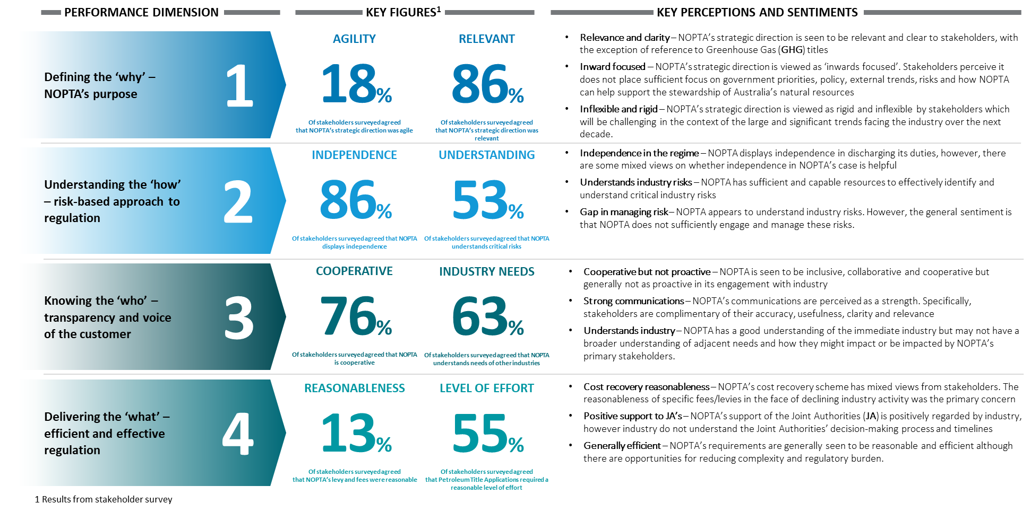

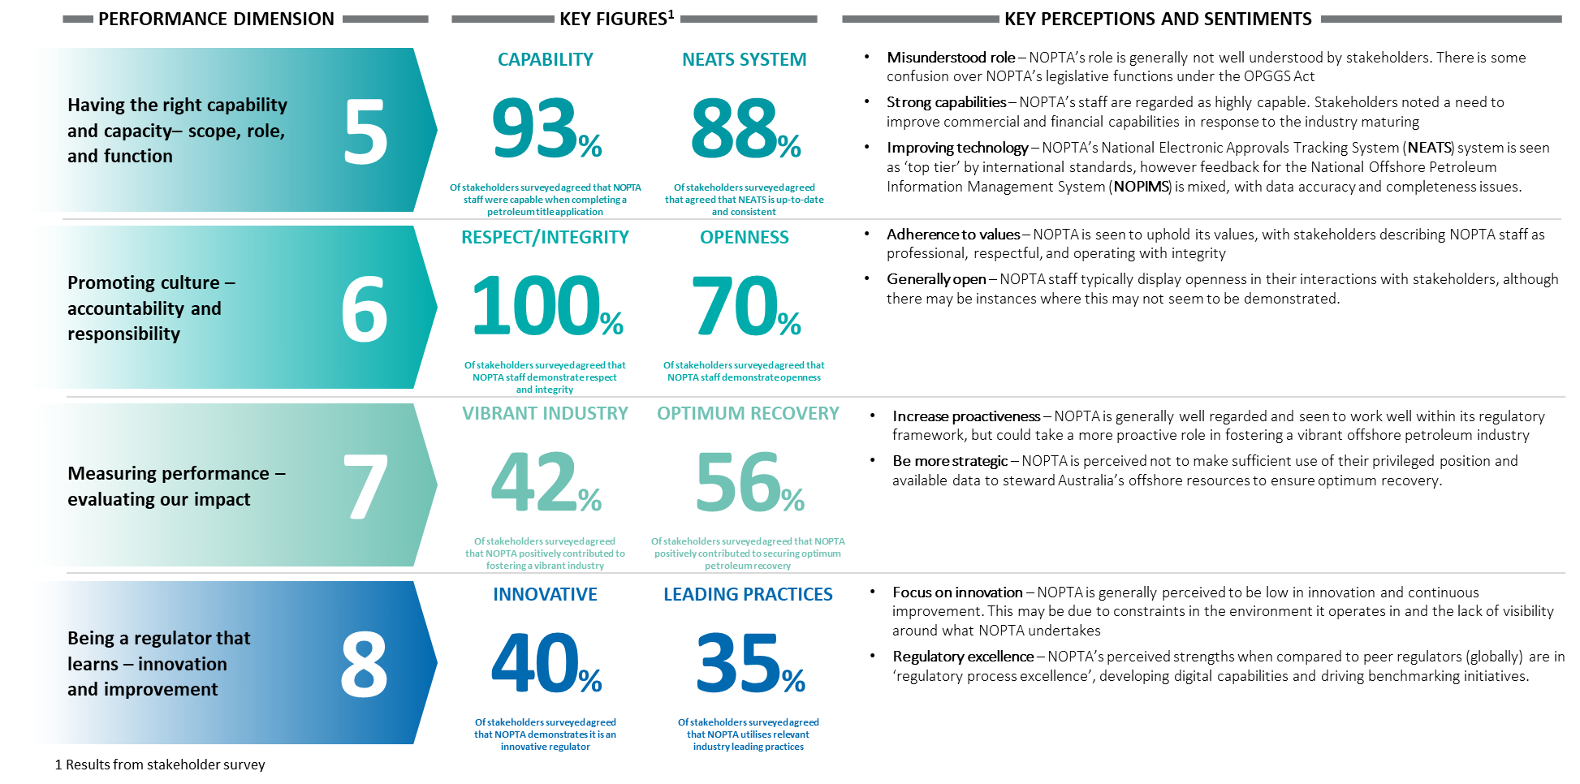

Source: Deloitte analysis

1. For the purposes of our report, we use the term ‘offshore legislative framework’ to refer to the collective relevant legislation, regulation, policies, regulators, and government departments (state, territory and Commonwealth) that collectively enable offshore resource exploration. [↑](#footnote-ref-2)
2. The review of NOPTA’s activities is not designed to provide assurance as defined by the Australian Auditing Standards Board. [↑](#footnote-ref-3)
3. The full Terms of Reference can be found in Appendix A. [↑](#footnote-ref-4)
4. NOPTA, 2020. [↑](#footnote-ref-5)
5. This is at the time of writing the report. [↑](#footnote-ref-6)
6. As defined under s707A of the OPGGS Act (i.e. s707A(1) – The Titles Administrator may give written directions to a NOPSEMA inspector as to the exercise of the inspector’s powers under this Division) [↑](#footnote-ref-7)
7. https://www.finance.gov.au/government/managing-commonwealth-resources/structure-australian-government-public-sector/types-australian-government-bodies [↑](#footnote-ref-8)
8. Individual responses, inclusive of partially completed surveys. [↑](#footnote-ref-9)
9. Source: Department of Industry, Science, Energy and Resources (2020) - The annual offshore petroleum exploration acreage release is part of the government’s strategy to promote offshore oil and gas exploration. Each year, the government invites companies to bid for the opportunity to invest in oil and gas exploration in Australian waters. [↑](#footnote-ref-10)
10. Declaration of location identifies the block or blocks within an exploration permit necessary to cover a petroleum discovery. [↑](#footnote-ref-11)
11. Section 602B has provisions for NOPTA to reimburse NOPSEMA if a NOPSEMA inspector exercises and/or prepares to exercise powers for a purpose that relates to the functions of NOPTA. [↑](#footnote-ref-12)
12. Also see section 707A of the OPGGS Act – *Directions by Titles Administrator*. [↑](#footnote-ref-13)
13. For Exploration permits, retention leases and production licences [↑](#footnote-ref-14)
14. The Business Support Unit is responsible for corporate-related activities at NOPTA, which relies on the Department’s corporate function for procurement, recruitment and human resources, finance and property-related matters. [↑](#footnote-ref-15)
15. Through our analysis, we note NOPTA is currently undertaking a review of its Assurance Review processes [↑](#footnote-ref-16)
16. Source: NOPTA website. [↑](#footnote-ref-17)
17. Chapter 3 of the OPGGS Act outlines the various titles applications types for GHG injection and storage matters. [↑](#footnote-ref-18)
18. KPMG, 2019. See: https://www.nopta.gov.au/\_documents/Stakeholder-Survey-Report-2019.pdf [↑](#footnote-ref-19)
19. Computed using the number of applications per category and the percentage of applications meeting the timeframes per category. [↑](#footnote-ref-20)
20. Note: This data relates to 2018-19 completed applications only. Prior to this the decision timeframe was incorporated into the assessment timeframe. [↑](#footnote-ref-21)
21. Computed using the number of applications per category and the percentage of applications meeting the timeframes per category. [↑](#footnote-ref-22)
22. NOPTA reviews the statistics on a monthly basis and determines if continuous improvement discussions are required in relation to a particular application or process. [↑](#footnote-ref-23)
23. As at 30 June 2020, including secondments. [↑](#footnote-ref-24)
24. The Technology, Information & Geospatial Support team is an example of like functions being merged (https://www.nopta.gov.au/\_documents/nopta-org-chart-20201130.pdf) [↑](#footnote-ref-25)
25. As at December 2019. [↑](#footnote-ref-26)
26. The Legislative Compliance Team was established in October 2015, splitting from Compliance and Operations. [↑](#footnote-ref-27)
27. As at 8 September 2020. [↑](#footnote-ref-28)
28. The APS census is an annual employee perception survey. The survey captures attitude and opinion data on important issues such as wellbeing, innovation, leadership, learning and development, and engagement of the APS workforce. It provides an opportunity for all APS employees to have their say about their workplace and help make the public sector a better place to work. For further details see: https://www.apsc.gov.au/aps-employee-census-2019 [↑](#footnote-ref-29)
29. NOPTA, 2020. [↑](#footnote-ref-30)
30. NOPTA has developed its ICT Strategy for 2020 – 2023 and are currently preparing a three-year development plan for NEATS and other system enhancements. [↑](#footnote-ref-31)
31. The fee is based on an agreed estimate of staff, operations, and infrastructure costs incurred by Geoscience Australia. [↑](#footnote-ref-32)
32. Data is authorised for release by NOPTA (outside of NOPIMS), and is then ‘made available’ by Geoscience Australia via NOPIMS. [↑](#footnote-ref-33)
33. A Terms of Reference for the NOPTA ICT Board was developed and effective from February 2020. [↑](#footnote-ref-34)
34. A Terms of Reference for the NOPTA ICT Board was developed and effective from February 2020. [↑](#footnote-ref-35)
35. For further details, please refer to: https://www.cyber.gov.au/acsc/view-all-content/essential-eight/essential-eight-explained [↑](#footnote-ref-36)
36. See NOPTA’s stakeholder engagement surveys and the *NEATS 2020 summary report* [↑](#footnote-ref-37)
37. NOPTA is currently working on the identified initiatives to enhance NEATS. This is in the *ICT Strategy 2020 – 2023* and being incorporated as part of a three-year plan for future development work. [↑](#footnote-ref-38)
38. NOPTA, 2020. [↑](#footnote-ref-39)
39. Pre-competitive work refers to activities (e.g. by Geoscience Australia or another technical body) ahead of an exploration acreage release to promote work in a particular area. [↑](#footnote-ref-40)
40. NOPTA maintain confidentiality by providing a view of titleholder performance relative to deidentified peers. [↑](#footnote-ref-41)
41. NOPTA, 2018. See: https://www.nopta.gov.au/\_documents/NOPTA-Self-Assessment-2017-18.pdf [↑](#footnote-ref-42)
42. NOPTA, 2016. See: https://www.nopta.gov.au/\_documents/NOPTA-Self-Assessment-2015-16.pdf [↑](#footnote-ref-43)
43. Ibid. [↑](#footnote-ref-44)
44. Ibid. [↑](#footnote-ref-45)
45. Ibid. [↑](#footnote-ref-46)
46. NOPTA, 2019. See https://www.nopta.gov.au/\_documents/NOPTA-Self-Assessment-2018-19.pdf [↑](#footnote-ref-47)
47. Ibid. [↑](#footnote-ref-48)
48. NOPTA, 2020. See: https://www.nopta.gov.au/guidelines-and-factsheets/offshore-petroleum-guidelines.html [↑](#footnote-ref-49)
49. NOPTA, 2019. See: https://www.nopta.gov.au/\_documents/NOPTA-Self-Assessment-2018-19.pdf [↑](#footnote-ref-50)
50. NOPTA, 2018. See: https://www.nopta.gov.au/\_documents/NOPTA-Self-Assessment-2017-18.pdf [↑](#footnote-ref-51)
51. Credit card surcharges will be reintroduced from 11 January 2021 to address issues of cross-subsidisation between titleholders. [↑](#footnote-ref-52)
52. NOPTA, 2020. [↑](#footnote-ref-53)
53. There will not be a perfect correlation between all expense categories and activities undertaken, for example due to lags between activity reductions and any associated resourcing reductions. In addition, the activities listed here are only a proxy for all of NOPTA’s activities and exclude items such as system development initiatives and engagements with stakeholders outside of regulatory processes. [↑](#footnote-ref-54)
54. NOPTA, 2020. [↑](#footnote-ref-55)
55. Ibid. [↑](#footnote-ref-56)
56. Ibid. [↑](#footnote-ref-57)
57. Per km or part thereof. [↑](#footnote-ref-58)
58. Including costs that are allocated to NOPTA from the Department for providing; governance structure, access to corporate support and systems, workers compensation, other insurance coverage and shared accommodation expenses. [↑](#footnote-ref-59)
59. Travel is shown as an indirect cost as staff often travel for general NOPTA business, across projects, general oil and gas industry conferences etc. It is difficult to assign these costs directly to outputs. [↑](#footnote-ref-60)
60. Legal advice may be sought on OPGGS Act matters. [↑](#footnote-ref-61)
61. Or the level set by the Australian Government if partial cost recovery has been agreed. [↑](#footnote-ref-62)
62. Australian Cost Recovery Guidelines, p.17. [↑](#footnote-ref-63)
63. NOPTA, 2020. [↑](#footnote-ref-64)
64. An examination of the Offshore Resources Branch is out of scope of our review and so we do not make recommendations with reference to the policy development arm of the regime. [↑](#footnote-ref-65)
65. Although we discuss NOPTA as an ‘entity’ here, it is important to reinforce that NOPTA exists as a branch of DISER. [↑](#footnote-ref-66)
66. Productivity Commission Review. [↑](#footnote-ref-67)
67. For the avoidance of doubt, this is not referring to the sharing of organisational governance models. [↑](#footnote-ref-68)
68. Deloitte, Regulator’s New Toolkit, 2020. [↑](#footnote-ref-69)