

Regulator Performance Framework
  - Self-Assessment Report
Submitted by: The Anti-Dumping Commission
5 November 2020

www.adcommission.gov.au

Contents
1 Certification by the Accountable Authority 3
2 One page snapshot 4
3 Introduction 6
3.1 About the Anti-Dumping Commission 6
3.2 The Australian Government Regulator Performance Framework 7
3.3 Our approach to implementing the RPF 8
4 Assessment 9
KPI 1 - Regulators do not unnecessarily impede the efficient operation of regulated entities 9
KPI 2 - Communication with regulated entities is clear, targeted and effective 13
KPI 3 - Actions undertaken by regulators are proportionate to the regulatory risk being managed 18
KPI 4 - Compliance and monitoring approaches are streamlined and co-ordinated 21
KPI 5 - Regulators are open and transparent in their dealings with regulated entities 22
KPI 6 - Regulators actively contribute to the continuous improvement of regulatory frameworks 24

Certification by the Accountable Authority

“The regulator’s Accountable Authority under the PGPA Act, if applicable, must certify the self-assessment report and provide it to the MAC or other stakeholder consultation mechanism approved by the responsible Minister”.
The Secretary of the Department of Industry, Science, Energy and Resources is the Accountable Authority for the Anti-Dumping Commission.
The stakeholder consultation mechanism is the International Trade Remedies Forum.

One page snapshot

Summary of achievement
During 2019-20, the Anti-Dumping Commission’s (the Commission’s) performance as a regulator was self-assessed against the six key performance indicators (KPI) of the Australian Government Regulator Performance Framework (RPF). The Commission, similar to 2018-19, had its strongest performance in the areas of communication and transparency.

Specifically, during 2019-20, the Commission:
- engaged with members of the International Trade Remedies Forum (ITRF) and trade remedy consultants to better understand their needs and how their experience with the Commission might be improved through digital technologies.
- convened three meetings of the ITRF and four meetings of ITRF subcommittees to facilitate ongoing dialogue with stakeholders.
- continued to refine its quality assurance framework to document the policies, attitudes, actions and procedures necessary to ensure that quality is being maintained and enhanced across the range of the Commission’s operational activities.
- implemented a new workforce coordination tool within the current Case Management System (CMS) for efficient and risk-based allocation of resources to operational activities.
- worked to minimise the potential for unintended negative impacts of regulatory activities by improving knowledge about the Commission’s processes using website alerts and by offering pre-lodgement checks for Australian industry applicants. These initiatives assist businesses, in particular small-medium enterprises access the Australian anti-dumping system.
- demonstrated our open and transparent dealings by:
  - publishing 151 Anti-Dumping Notices and 170 reports explaining decisions.
  - publishing a case status report every month to provide stakeholders with a holistic picture of the Commission’s overall case load and the commodities involved.
  - considering 342 submissions from Australian industry, exporters, importers, foreign governments and others.
- effectively managed a heavy workload initiating 134 cases in 2019–20 (a 17.5 per cent increase on 2018–19). The number of investigations initiated from applications for dumping or countervailing notices from Australian industry increased by 155 per cent compared to 2018–19.
- assisted stakeholders with 1,472 enquiries by phone or email with 99 per cent of those resolved in two business days.
- enhanced the Trade Remedy Index, which tracks the trade flows of certain goods subject to anti-dumping measures on a monthly basis.

Continuous improvement
The first RPF self-assessment report was used to set performance benchmarks and identify suitable metrics. This report is used to further self-assess against those benchmarks. For the 2019-20 period, the Commission continued to focus on effectively utilising data collected for other reporting and business improvement processes for self-assessment. The Commission will continue to work on ensuring the metrics are effective indicators of performance.

Introduction

About the Anti-Dumping Commission
Australia’s trade remedies system operates within the framework established by the World Trade Organization (WTO). This framework forms an integral element of a free and open global trading system. Most developed countries and many developing countries also operate trade remedies regimes. The purpose of Australia’s trade remedies system is to remedy material injury caused to Australian industries by dumped and subsidised imports and give Australian industries the opportunity to compete with imports on a level playing field.

The Commission administers Australia’s anti-dumping system under the Customs Act 1901 (the Act). The Commission sits within the Department of Industry, Science, Energy and Resources and the Commissioner of the Anti-Dumping Commission is an independent statutory office holder. The Commission investigates the dumping and subsidy claims that are voluntarily lodged by an Australian industry applicant.

An investigation includes examination of alleged dumping and/or subsidies, any injury suffered by the Australian industry concerned, and any causal link between the dumping or subsidy and the injury found. The Commission collects and verifies data from Australian manufacturers and importers, and overseas exporters and governments, to determine if the dumping/subsidisation of imports has injured the Australian industry and recommends to the relevant Minister whether duties should be imposed. Duties imposed are collected by the Department of Home Affairs. Australian Industry can lodge applications for investigations into alleged dumping, subsidisation or circumvention of duties. Industry can also lodge an application for a continuation, review or revocation of measures.

The Act also contains provisions for importers and exporters to apply to the Commission. Exporters are able to lodge applications for exemptions to measures, reviews of measures or revocation of measures. Importers can lodge applications for exemptions to measures, reviews of measures, revocation of measures and assessments of duty paid. These applications are a significant area of work for the Commission and represent 66 per cent of the completed cases for the 2019-20 financial year.

During 2019-20, the Commission effectively managed a heavy workload initiating 134 cases (a 17.5 per cent increase on 2018–19). The number of investigations initiated from applications for dumping or countervailing notices from Australian industry increased by 155 per cent compared to 2018–2019. The Commission completed 101 cases in 2019-20 (based on the World Trade Organization count) relating to applications from Australian Industry, importers and exporters. The completed cases are broken down into each case type in Table 1.

Table 1
Case type | Number of cases completed in 2019-20
Dumping and/or subsidy investigations (incl. Resumptions) | 9
Anti-circumvention inquiries | 1
Accelerated reviews | 21
Review of measures | 10
Continuation inquiries | 14
Exemptions | 10
Duty assessments | 31
Reinvestigations | 5
Total | 101

The Australian Government Regulator Performance Framework
As part of the Australian Government’s regulation reform agenda, the RPF has been established to measure and assess the efficiency and effectiveness with which regulators undertake their roles and interact with regulated entities. The objective of the RPF is to improve the way regulators operate, reduce the costs incurred by regulated entities, and to increase the public accountability and transparency of regulators.

The RPF consists of six key KPIs, which outline the government’s expectations of regulator performance.
- KPI 1—Regulators do not unnecessarily impede the efficient operation of regulated entities.
- KPI 2—Communication with regulated entities is clear, targeted and effective.
- KPI 3—Actions undertaken by regulators are proportionate to the risk being managed.
- KPI 4—Compliance and monitoring approaches are streamlined and co-ordinated.
- KPI 5—Regulators are open and transparent in their dealings with regulated entities.
- KPI 6—Regulators actively contribute to the continuous improvement of regulatory frameworks.

The RPF requires regulators to establish their own performance assessment framework and annually self-assess their performance against these KPIs in consultation with stakeholders. The Commission is considered a regulator for the purposes of the RPF because it has a statutory responsibility to administer, monitor, or enforce regulation by undertaking some or all of the following activities:
- licensing and/or approvals processes, including registration/accreditation, that control entry to or participation in a market;
- monitoring and compliance activities, including imposing and collecting fees;
- enforcement actions for non-compliance and complaints resolution; or
- providing advice and guidance regarding compliance with regulation, including education around compliance.

These responsibilities were identified by the Productivity Commission as the primary activities undertaken by regulators.

Our approach to implementing the RPF
For 2019-20, the Commission has used the same self-assessment methodology as previously designed in consultation with the Department of Industry, Innovation and Science Regulation Reform Unit and material drawn from:
- the OECD guidance on developing frameworks for regulatory policy evaluation
- the Department of Finance Resource Management Guidance on Performance
- the Department of the Prime Minister and Cabinet RPF and guidance material on reviewing performance
- the Productivity Commission Regulator Audit Framework.

Consistent with this methodology, the Commission made use of existing reporting streams, where possible, to ensure no additional burden was created for industry. The Commission’s evidence for performance against a number of the RPF measures is drawn from existing internal reporting and data collection processes because this is also a cost effective approach. The Commission considers this data a meaningful indicator of performance against the KPIs, and will consult with stakeholders to refine them. Quantitative data will be complemented with relevant output or activity-based evidence specific to the Commission’s circumstances.

This methodology and the relevant measures and examples of evidence were tested with the Commission’s key stakeholder body, the ITRF. The ITRF membership includes representatives from Australian manufacturers and producers, peak bodies, importers, customs brokers, unions and government.

This self-assessment report provides an assessment of the Commission’s performance against each of the six RPF KPIs and sets the performance benchmarks to measure future performance improvement. The full set of performance measures for each of the KPIs is provided at Attachment A.

Assessment

KPI 1 - Regulators do not unnecessarily impede the efficient operation of regulated entities
Summary of achievement
During 2019-20, the Commission:
- received generally positive responses on its operations in a survey of ITRF members;
- held three meetings of the ITRF to facilitate consultation with members, and four meetings of the ITRF sub-committees;
- facilitated engagement in the system by completing pre-lodgement checks as requested by Australian Industry;
- commenced a review of the application form and associated materials;
- engaged with members of the ITRF and trade remedy consultants to better understand their needs and how their experience with the Commission might be improved through digital technologies;
- improved information on the system through a new guidance document on anti-circumvention; and
- continued to engage with other anti-dumping agencies to learn from international practices and ensure consistency with Australia’s international obligations.

Expectations for KPI 1
As articulated in the RPF, the government’s expectation for this KPI is for regulators to be striving towards better regulatory practice by implementing regulation in a manner that does not unnecessarily impede the efficient operations of regulated entities. They seek to achieve a balance between the responsibility to deliver protection to the community and the burden imposed by external intervention.

The objectives against this KPI are to show that the Commission meets government’s expectations by demonstrating that we:
- understand the relevant industry sectors impacted by anti-dumping and the current and emerging issues that affect them
- take action to minimise the potential for unintended negative impacts of regulatory activities on applicants
- take action to learn from experiences and better practices from equivalent international organisations and other anti-dumping administrations to improve administrative efficiencies.

Our approach for KPI 1
To measure stakeholder satisfaction with the Commission’s administration of the anti-dumping system, the Commission undertook a survey of ITRF members. Of the 24 members of the ITRF (other than the Commissioner), 11 members responded to the survey. Of the 11 respondents, 36 per cent were manufacturers or producers, 27 per cent represented peak bodies and unions, 18 per cent were from Australian Government agencies and the balance of respondents reflected importers and unions.
Results KPI 1
Measure: understand the relevant industry sectors impacted by anti-dumping and the current and emerging issues that affect them
- Metric: Evidence of appropriate feedback channels to measure stakeholder satisfaction with the anti-dumping system and documenting responsiveness to feedback from regulated entities on internal improvements
The survey of ITRF members found:
- 80 per cent of applicable respondents agreed or strongly agreed that Commission staff regularly sought views from stakeholders and made themselves available to discuss both the anti-dumping system and specific case matters.
- 80 per cent of applicable respondents were very satisfied, satisfied or somewhat satisfied with the information and support available to access Australia’s anti-dumping system.
- 70 per cent of applicable respondents considered the Commission’s understanding of the relevant industry sectors and the current and emerging issues that affect them was very strong, strong or sound.
- 80 per cent of applicable respondents were very satisfied, satisfied or somewhat satisfied that the Commission effectively communicates the evidence base and approach used in investigations.
- 90 per cent of applicable respondents were very satisfied, satisfied or somewhat satisfied with the Commission’s commitment to continuous improvement.
- 91 per of all respondents were very satisfied, or satisfied that the Commission was taking action to enhance whole-of-government collaboration to strengthen the anti-circumvention and compliance framework. Stakeholders have consistently raised compliance and circumvention as important issues.

Respondents to the 2015-16 survey suggested that the ITRF meet on a more regular basis. Three ITRF meetings were convened in 2019-20:
- on 9 July 2019 on the Gold Coast
- on 5 December 2019 in Melbourne; and
- on 26 May 2020 as on online ‘virtual’ meeting due to COVID-19.
These meetings included: updates from the Commission on casework, updates on verification and compliance activities; updates from other government members on relevant matters; presentations by the Commission on its review of the application form and digitalisation initiative; updates from the Commission on the Trade Remedy Index; and updates from sub-committee Chairs.

In 2019-20, the ITRF sub-committees on compliance and anti-circumvention and access to import data also each met twice to enable in-depth discussions on matters of particular interest to members.

- Metric: Number of appealed findings not overturned by external review bodies
Certain decisions of the Minister and the Commissioner may be reviewed by the Anti-Dumping Review Panel (ADRP) and the Federal Court of Australia. These include decisions to impose anti-dumping measures or terminate investigations, outcomes of continuation inquiries and reviews of measures, and outcomes of duty assessments. ADRP decisions provide the Commission with valuable opportunities to identify areas where operational improvements can be made. In addition, the outcomes of merits review can provide guidance on the correct or preferable approach where there is ambiguity or uncertainty (for example, in how to interpret complex legislative provisions).
To make best use of these opportunities, the Commission carefully considers the outcomes from merits and judicial reviews to identify where it can improve its decision-making processes and investigation practices.

In the 2019-20 financial year the ADRP issued 7 reports. Of these decisions 57 per cent affirmed the original decision, 14 per cent affirmed the original decision in part and 28 per cent revoked the decision in full.

The amount of reports issued by the ADRP were down, in comparison to 2018-19 where 13 reports were issued. The affirmed cases were consistent with the previous year where 52 per cent of cases resulted in the original decision being affirmed. The remaining reports of the previous year found 31 per cent affirmed in part and 17 per cent revoked in full.

There were also five Federal Court cases under consideration during 2019-20. Of these, two remain ongoing, one was determined against the Commission’s original decision, with the remaining two cases resolved by both parties agreeing to have the matters remitted back for reconsideration.

Measure: Take action to minimise the potential for unintended negative impacts of regulatory activities on applicants
- Metric: Examples of actions taken to minimise any unnecessary impacts of the Commission’s activities on applicants
The Commission takes action to minimise unnecessary regulatory impacts on applicants during the anti-dumping and countervailing application process by offering a series of services and some flexibility in how information is provided and presented.

The Act requires that applications must be made in writing and in an approved form. The Commission acknowledges that the information required to support an application can be onerous to obtain. However, this information is an important element of ensuring that the Commissioner’s decisions and recommendations to the Minister are evidence based, objective and factual in order to meet legislative requirements and to be consistent with international obligations. These requirements also assist to reduce the likelihood of an application being rejected due to insufficient information or evidence. To ensure the information requirements are clear, there is a comprehensive set of guidelines on the Commission’s website with instructions on how to complete an application.

Furthermore, in 2019-20, the Commission commenced a review of the application form and associated materials. Key priorities for the review include ensuring: purposive content that is not duplicative; clear and targeted questions, limiting the need for excessive guidance materials; consistency among documents and compliance with existing legislative requirements; and fit for purpose subsidy questions. The Commission plans to undertake consultations with stakeholders as part of this review in 2020-21.

In addition, in 2019-20, the Commission published a new guidance document for applicants seeking an anti-circumvention inquiry, and improved its Electronic Public Record and dumping commodity register to make it easier for applicants and other interested parties to find relevant case documents.

In 2019-20, the Commission conducted four pre-lodgement checks. A pre-lodgement check of applications is offered to all applicants prior to lodgement. Working with the applicant, the Commission will provide detailed advice on what is required to best support the application. A pre-lodgement check can take anywhere between two and ten days to complete depending on the complexity of the application.

Measure: Demonstrated efforts to learn from experiences and better practices from equivalent international organisations and other Anti-Dumping administrations to improve administrative efficiencies.
- Metric: Implementation of the Commission’s International Engagement Plan
- Metric: Use of technical exchanges and knowledge sharing with comparable jurisdictions
The Commission recognises how important it is to learn from the experiences and better practices of other comparable jurisdictions. As a key component of the International Engagement Plan, the Commission met Australia’s international trade obligations by participating in the November 2019 meetings of the WTO Anti-Dumping Practices Committee and the Subsidies and Countervailing Measures Committee with the Department of Foreign Affairs and Trade (DFAT). These meetings help to ensure that the Commission is aware of trends and issues in trade remedies practices internationally. It also ensures Australia’s anti-dumping system is consistent with the relevant WTO agreements.

The Commissioner and Commission staff also attended a number of international trade remedies forums in 2019-20, including the International Trade Update in Washington and the Seminar on Trade Remedies Investigations in Tokyo.

In addition to these events, the Commission participated in bilateral exchanges with six other anti-dumping jurisdictions to share information on best practice. These included virtual workshops with the Canada Border Services Agency to share information about our respective systems and practices, exchanges with the new UK authority on investigative systems and processes, and a visit to New Zealand for discussions with their investigative authority.

Discussion KPI 1
The Commission notes the generally positive feedback from ITRF members in the survey responses. Based on the survey feedback, the Commission will focus on continuing to strengthen its understanding of relevant industry sectors and how to effectively explain the evidence base and approach used in investigations.

The Commission seeks to explain the approach used in investigations in a number of ways. It maintains a comprehensive policy and practice guide, the Dumping and Subsidy Manual (Manual), to explain the practices of the Commission. In the prior financial year, the Commission published an update of the Manual to clarify the Commission’s current practices. The Commission also publishes detailed reports on the Electronic Public Record in relation to investigations that explain the approach used in developing recommendations. The Commission will continue to work on enhancing its communication of the approach used in investigations.

The ITRF plays an important role as the primary forum advising on the operation of, and reforms to, Australia’s anti-dumping legislation. The establishment of ITRF sub-committees created a valuable forum for more regular and detailed discussion of issues of interest to stakeholders in between ITRF meetings. While two of the sub-committees established in 2016 have completed their work, the two current sub-committees are continuing to provide a valuable forum for detailed discussions with stakeholders.

In a highly contested system that is open to legal interpretation, a robust review process is a positive attribute of the system. Quality investigative learnings come from analysis of the review findings and the Commission will continue to carefully consider the outcomes of merits and judicial reviews to identify ways to improve its decision making and investigative processes.

The Commission considers that its engagement with international organisations and other jurisdictions is supporting continuous improvement of its practices.

Stakeholder Validation
ITRF members were surveyed in September 2020 and the results are reported above.

A draft of this report was circulated to ITRF members for their consideration and comment in October 2020.

KPI 2 - Communication with regulated entities is clear, targeted and effective
Summary of achievement
As noted in the discussion under KPI 1, the survey results generally indicate satisfaction with the Commission’s communications with regulated entities, with some areas for further improvement. In 2019-20, the Commission:
- assisted stakeholders with 1,472 enquiries by phone or email with 99 per cent of those resolved in two business days; and
- considered 342 submissions from Australian industry, exporters, importers, foreign governments and others.

Expectations for KPI 2
Effective communication is vital for the efficient delivery of regulatory services and the achievement of positive regulatory outcomes. Best practice regulators communicate in such a way that regulated entities clearly understand what they need to do in order to comply with regulation. The reasons for regulatory decisions are clearly communicated and communication with regulated entities is consistent.

The objectives against this KPI are to show that Commission meets government’s expectations by demonstrating that:
- guidance and information is up-to-date, clear, accessible and concise;
- industry groups and representatives of affected stakeholders are adequately consulted before changing policies, practices or service standards;
- decisions, reasons for decisions and advice provided by the Commission to affected entities are readable and understandable; and
- information requests are tailored, coordinated with other regulators (such as the Department of Home Affairs), only made when necessary, and in a way that minimises impact.

Our approach for KPI 2
For this KPI, the Commission has assessed its communication practices and outcomes by using quantitative information collected for other reporting and continual improvement processes. The survey supplemented this approach with questions on communication, which will be used to identify opportunities for strengthening performance further.

During 2018-19, the Commission engaged PwC to conduct a functional review of the client support function. The review identified several recommendations to improve the services provided to stakeholders. Work has commenced on implementing the recommendations of the review.

Results KPI 2
Measure: Demonstrated provision of guidance and information that is up-to-date, clear, accessible and concise.
- Metric: The Commission’s response rates to stakeholder enquiries/complaints including: the number of queries, type of query and response/resolution times for stakeholder to acknowledge matter resolved.
During 2019-20 the Commission received 1,472 enquiries via its website, email or by phone referral from the business.gov.au hotline. Contacts are down on the previous two financial years by an average 28 per cent, which could be partly attributed to Covid-19 as we see consistently lower contacts in the later part of the financial year, which is consistent with a decline in Australian imports for that period. It is expected that the decline can also be attributable to improved accessibility of anti-dumping information for importer and brokers on the department’s website particularly the information provided in the Dumping Commodity Registers. The monthly trends are depicted in Figure 1.
Figure 1
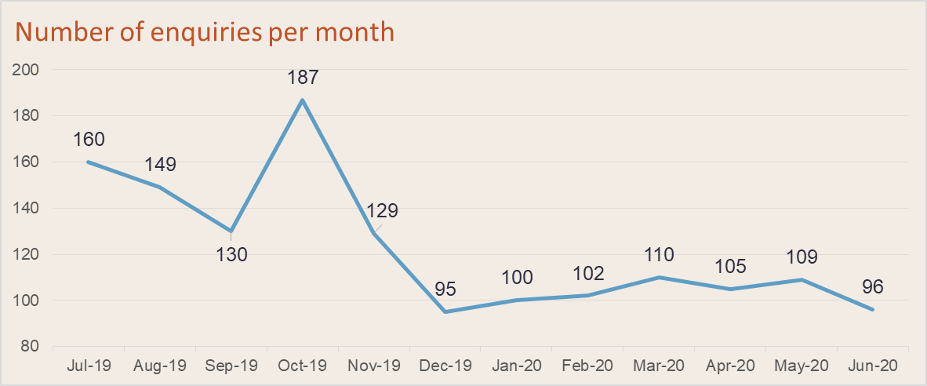

From 1 July 2019 to 30 June 2020, 99 per cent of enquiries were resolved within two business days. Enquiries resolved in 2019-20 are categorised by enquiry type in Figure 2 with the most frequent enquiries being requests for detailed duty rates (19 per cent). The second and third highest enquires were questioning if specific goods were subject to measures (18 per cent) and guidance on calculating duties (17 per cent).

Figure 2
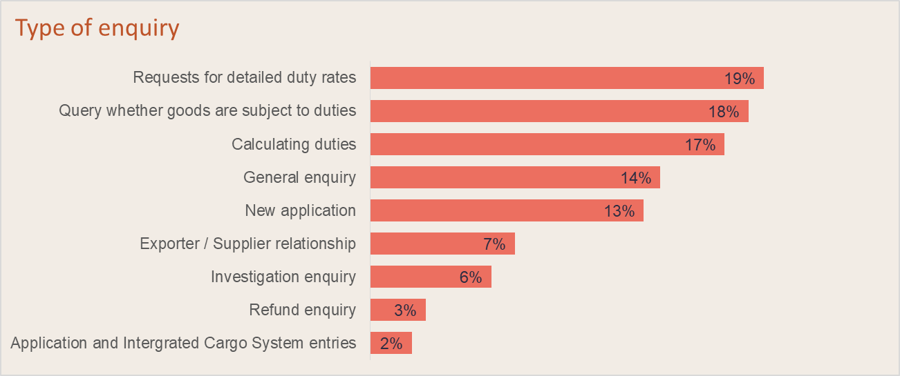

Figure 3 represents the enquiries received during 2019-20 that have been grouped by commodity type. Steel and aluminium enquiries representing 74 per cent of all enquires, which is consistent with last year. Food or chemicals represented 6 per cent, with electrical or glass and making up a combined 4 per cent. The balance of enquires (16 per cent) were not in relation to a specific good or related to other goods that Australia doesn’t have measures against.

Figure 3
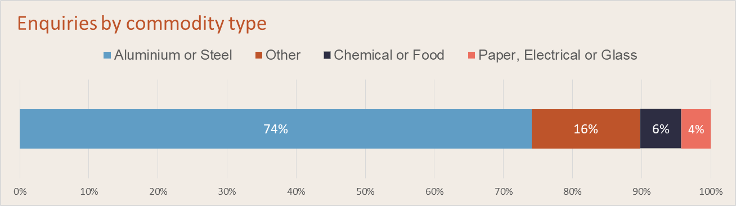

In July 2017, the Commission introduced website alerts, following stakeholder feedback, including responses to a survey of website users conducted at the time. As at 30 June 2020, more than 800 subscribers had signed up to receive alerts. The website alerts assist stakeholders in keeping up-to-date with developments in the Commission’s cases, initiation of new investigations and reviews, and publication of general information on the anti-dumping system.

Measure: The Commission adequately consults with industry group representatives of affected stakeholders before changing policies, practices or service standards.
- Metric: Number and type of consultation opportunities given to regulated entities and industry group representatives.
Australia’s anti-dumping system offers many formal and informal opportunities for consultation on policy and practice development. As noted in relation to KPI 1, the ITRF and ITRF sub-committees met regularly throughout 2019-20 and provided numerous opportunities for consultation with stakeholders on specific policy and practice issues. For example (and as discussed further below in relation to KPI 6), the Commission consulted ITRF members on operational matters of the Commission, and enhanced approaches to trade flow tracking and potential improvements through digital technology. In addition, the Commissioner and Commission staff continued to meet regularly with stakeholders across a range of sectors to discuss operational policy and practice matters.

At the operational level, interested parties are able to make submissions throughout an investigation and there are certain periods of time open to make formal submissions in response to specific investigation reports such as the Statement of Essential Facts (SEF). Consultation is an integral part of the inquiry process and the SEF in particular is an opportunity for regulated entities to have access to, and comment on, the facts on which the Commissioner will base his recommendations to the Minister. In 2019-20, 342 submissions were received on 64 separate cases. Public versions of these submissions were published on the Commission’s website and included submissions from Australian manufacturers and producers, exporters, importers, foreign governments and others. (See Figure 4 for a breakdown of submissions.)
Figure 4
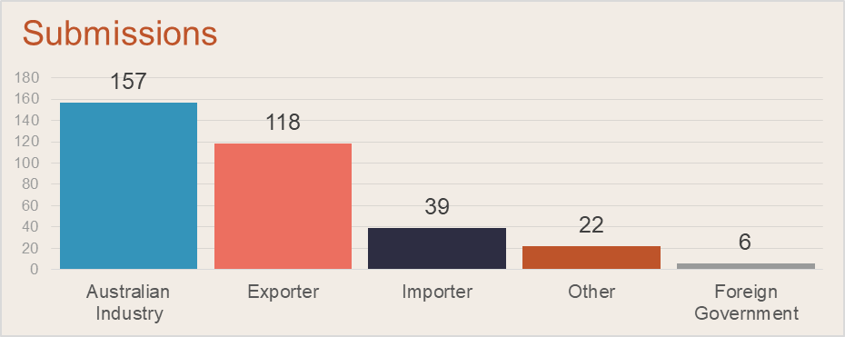
*The “other” category relates to submissions from associations, unions, traders and unaffiliated interested parties.

Measure: Decisions, reasons for decisions and advice provided by the Commission to affected entities are readable and understandable
- Metric: Information provided to entities will be readable and consistent with Anti-Dumping legislation, policies and guidelines, and/or decisions made by the Commission, via merits or judicial reviews
Australia’s anti-dumping legislation requires a certain level of transparency throughout an investigation. In 2019-20, 151 Anti-Dumping Notices were published on the Commission’s website notifying decisions and 170 investigation reports were published explaining the evidence, analysis and decisions (Figure 5). Some of these investigation reports are not required by legislation but are published by the Commission to improve transparency and facilitate stakeholder engagement in investigations.

The Commission works to ensure that information provided to entities including decisions and reasoning are readable, timely and consistent with legislation, policies and guidelines. The Commission has worked to improve the readability of its reports, an example of this is including executive summaries to assist with the understanding of decisions. In the survey conducted for this report, 80 per cent of applicable respondents were very satisfied, satisfied or somewhat satisfied that the Commission’s communication is appropriately targeted and clearly explains the evidence-based approach used in investigations.

Figure 5
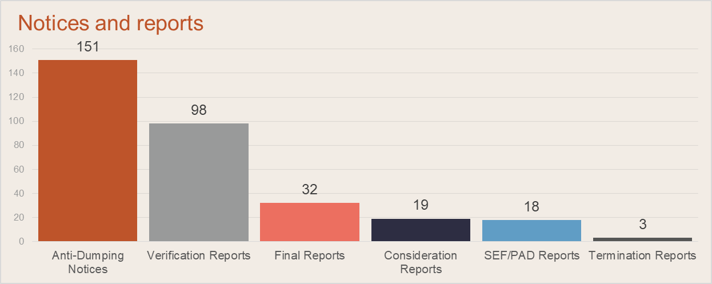

- Metric: The Dumping and Subsidy Manual and subsidy register will be readable and will be regularly updated to assist stakeholders understand the legislative, policy and guidelines
The Commission maintains a Dumping and Subsidy Manual and a subsidies register to assist stakeholders understand the practices used by the Commission in administering the anti-dumping and countervailing system. The Manual is a public document outlining the Commission’s established policies and practices. The Manual provides guidance to regulated entities on the Commission’s approach to investigations and its interpretation of legislative provisions and aims to promote a consistent approach in investigations undertaken by the Commission. The subsidies register is a further resource for stakeholders that provides a summary of subsidy programs that have been investigated by the Commission by country and includes references to relevant Commission reports.

Measure: Information requests are tailored, coordinated with other regulators (such as the Department of Home Affairs), only made when necessary, and in a way that minimises impact
In conducting investigations, the Commission makes every attempt to ensure that information requests are tailored, coordinated with other regulators, only made when necessary, and made in a way that minimises impact. Nonetheless, the Commission is required to make significant information requests, because the Commission’s assessments of dumping, subsidies, injury and causation must be objective and evidence-based.

For example, verifying exporter financial data can place a significant impost on exporters’ time and resources, but on-site exporter verification is a core investigative tool and Australian industry expects exporter data to be thoroughly examined and verified on-site. The Commission’s preference is to conduct as much on-site verification as possible, but to balance this with effective alternatives when possible. It has not been possible for the Commission to undertake on site verification exercises since March 2020 due to COVID-19 international travel restrictions. While COVID-19 has affected the ability for the Commission to conduct on-site verification resulting in more exporters having their data verified using desktop methods. The Commission plans to return to on-site verification as soon as practicable.

For verification of exporter and importer data, the Commission will sometimes use alternative verification methodologies to on-site verification, where this is appropriate. An example might be a duty assessment where the entities involved were subject to satisfactory verification by the Commission in a recently completed investigation or review. The Commission takes a risk based approach to making these decisions.

The Department of Home Affairs (Home Affairs), including the Australian Border Force (ABF), is responsible for collecting dumping and countervailing duties. To ensure that regulated entities are receiving consistent and seamless advice and streamlined information requests, the Commission and Home Affairs work closely together to promote a coordinated whole-of-government approach. An example is the process of applying provisional measures to certain imports during an investigation and then cancelling them or converting them to interim measures at the end of an investigation. The Commission and Home Affairs work together to ensure that customs brokers have a single point of contact during the conversion or cancellation period. Both organisations work together to respond to enquiries and provide a single source of advice back to the broker.

Discussion KPI 2
The opportunities for regulated entities to participate in the anti-dumping system on an investigation level or at a broader system level are extensive. The Commission has improved the opportunities for engagement with ITRF members on policy and practice issues by establishing sub-committees.

The survey results confirm that the opportunities for communication are sufficient and the Commission’s communications with stakeholders are generally effective. The Commission will continue to look for ways to improve its communications with stakeholders.

Minimising information requests will always be an area that the Commission will find challenging due to the evidence-based nature of investigation, inquiry and review processes, consistent with Australia’s international obligations under the WTO agreements.

Stakeholder Validation
As noted above, the survey of ITRF members indicated that members are satisfied with the Commission’s performance for KPI 2.

KPI 3 - Actions undertaken by regulators are proportionate to the regulatory risk being managed
Summary of achievement
During 2019-20 the Commission:
- continued to refine its quality assurance framework to document the policies, attitudes, actions and procedures necessary to ensure that quality is being maintained and enhanced across the range of the Commission’s operational activities; and
- implemented a new workforce coordination tool within the current Case Management System (CMS) for efficient and risk-based allocation of resources to operational activities.

Expectations for KPI 3
Comprehensive risk assessment processes are essential to ensuring that resources are targeted to the areas requiring the most attention. A risk-based approach promotes the most efficient use of resources and improves the effectiveness of the regulatory framework through minimising burden on those who are voluntarily compliant and ensuring that verification activity is proportionate and undertaken where assessed as necessary.

Efficient regulatory risk assessment takes account of the regulated activity, the nature of the regulated cohort, including its compliance history, and other external factors affecting risk. Risk assessments are balanced and implemented uniformly and impartially, while also being dynamic and open to scrutiny. They are based on the recognition that not all risk can be eliminated and not all risk can be effectively mitigated by government.

The objectives against this KPI are to show that the Commission meets government’s expectations by demonstrating that:
- the preferred approach to regulatory risk is regularly assessed; and
- a risk-based approach to its investigations is adopted, evidence gathering and decision-making based on the regulatory risks being managed.

Our approach for KPI 3
For this KPI, the Commission has demonstrated its approach to assessing and managing risk. In relation to its verification activities, it has reported data on its on-site verification activity and the percentages of export volumes subject to on-site verification.

Results KPI 3
Measure: The Commission’s preferred approach to regulatory risk is regularly assessed.
- Metric: Development and implementation of guidelines to inform all of the Commission’s investigations.

The implementation of a comprehensive Quality Assurance (QA) Framework reflects the Commission’s commitment to strengthening both the quality and consistency of case findings, reports and recommendations across the full remit of the Commission’s functions.
It was designed to complement the implementation of the new investigations model. The QA Framework provides for quality assurance processes that are embedded into the case planning and investigations process to ensure risks are identified and managed as early as possible in an investigation. The key enabler in this regard is the series of quality control point (QCP) meetings that are scheduled to take place at key milestones during each case. Those QCP meetings are an opportunity for the case management team and our key advisory teams (e.g. policy, legal and quality assurance) to consider risks and risk treatments.

The Commission has a dedicated Quality and Assurance team to provide expert quality assurance over all exporter verification activities to reduce the risk of incorrect outcomes from the verification process. This team is responsible for providing advice regarding the application of Commission policy and practice at a highly detailed level, while improving the quality and presentation of the dumping margin calculations. .

To complement the QA Framework, a Risk Management Framework provides guidance to manage the core operations capability in relation to risk.

The Commission has continued to improve its capability and capacity in verification activities. In particular, it has developed and delivered a Verification Capability Framework, which includes multiple training and development modules aimed at increasing the efficiency and effectiveness of its verification activities. Currently, the Commission has 19 competent lead verifiers. The Commission is in the process of conducting quality control checks on current leaders to ensure the standard of verification is maintained.

Measure: The Commission adopts a risk-based approach to its investigations, evidence gathering and decision-making based on the regulatory risks being managed.
- Metric: Evidence of data being collected during investigations being based on a risk-based approach.
- Metric: Annual statistics of numbers of exporters that are verified in-country, by desktop audit, or other method.
As discussed under KPI 2 and KPI 3, a key area of managing regulatory risk for the Commission is the verification of financial data, in particular, exporters’ data. During an investigation, the Commission is required to establish that data provided by an exporter is complete, relevant and accurate and therefore suitable for evidence-based calculations of dumping and subsidy margins and injury assessments. On-site verification is one means to establish the suitability of the information provided and is an important part of the Commission’s strategy in conducting investigations.

It is not possible for the Commission to undertake on-site verification exercises in relation to all parties in all types of investigations, reviews and other inquiries. Therefore, the Commission applies a risk management approach to its investigations when selecting the method of verification for a particular investigation. The Commission can only verify an exporter’s data if it has completed an exporter questionnaire and agrees to a verification visit.

In 2019-20 the Commission undertook 20 onsite exporter verification visits, a decrease of 8 from the previous financial year. In addition to these 20 onsite verifications, a further 39 (up from 22) other exporters had their data verified using desktop methods. The Commission measures the coverage of onsite verifications as the proportion of Free on Board (FOB) value of cooperating exporters visiting onsite, compared to the total FOB value of cooperating exporters. In 2018-19 the coverage value was 84 per cent and in 2019-20 this was 44 per cent. The Commission notes that this metric can change from year to year depending on the relative value of the goods under investigation each year.

The number of onsite verifications conducted in 2019-20 was impacted by the COVID-19 pandemic and related travel restrictions. On 20 March 2020 the Commission suspended all onsite exporter verification activities due to the global pandemic. The Commission has undertaken desktop verification of exporters during this period, consistent with the practice of other Anti-Dumping administrations such as Canada and the United Kingdom. The Commission plans to resume onsite verification as soon as practical.

Following the completion of exporter verification visits in 2019-20, the Commission’s exporter verification reports were published (on average) within 75 days after commencing the verification. This is a decrease of 8 days from 2018-19. The Commission notes that from March 2020, the start of several verifications was delayed due to COVID related travel restrictions. This resulted in the average number of days a verification being completed after case initiation being 182 days, an increase of 28 from 2018-19.

Discussion KPI 3
The implementation of the suite of frameworks and the new Verification and Data Assurance (VADA) team has strengthened the Commission’s performance against this KPI. By improving its approach to assessing risks and adopting a more efficient and effective approach to workforce coordination, while applying more detailed scrutiny to the results of verification activities, the Commission ensures that it focuses its resources on the areas of highest risk.

Implementing enhanced quality assurance processes and improving its capability and capacity in verification have further supported the Commission in taking a risk-based approach and ensuring that decisions and recommendations are based on reliable evidence and facts. In addition, by maintaining its timely publication of exporter verification reports, the Commission facilitates submissions by interested parties on the evidence.

Stakeholder Validation
In the stakeholder survey, 80 per cent of applicable respondents were somewhat satisfied, to very satisfied, with the Commission’s performance for KPI 3. The Commission’s approach to continuous operational improvement will support its focus on the quality, evidence base and timeliness of its investigations.

KPI 4 - Compliance and monitoring approaches are streamlined and co-ordinated
Summary of achievement
During this reporting period, the Commission continued to work with Home Affairs, including the ABF, to further enhance, and improve the effectiveness of the whole-of-government approach to anti-circumvention and compliance relating to trade remedies.

Expectations for KPI 4
Compliance and monitoring are an essential part of regulatory frameworks. Monitoring allows regulators to determine the level of compliance with regulation. Effective regulators do not seek information from regulated entities unless the information is required to achieve the regulatory outcome sought. Regulators minimise duplicative information requests, including between regulators where possible, and consider whether the information sought is available from alternative means.

The Commission does not have a compliance role once duties are applied to imports of certain goods. The ABF, as an operationally independent body within the Home Affairs portfolio, is the regulator responsible for compliance. The Commission uses Home Affairs import data to monitor the effectiveness of measures and to identify evidence of potential circumvention. The Commission works with Home Affairs to adopt a whole-of-government approach to strengthening the anti-circumvention and compliance framework, including sharing information and market intelligence as appropriate.

Our approach for KPI 4
The methodology for this KPI is to demonstrate the effort by describing examples of collaboration.

Results KPI 4
Measure: The Commission does not have a compliance role once duties are applied on imports of certain goods. The ABF monitors compliance; however, the Commission will adopt a whole of government approach.
- Metric: The Commission will put in place enhanced arrangements to continually promote robust whole-of-government collaboration to strengthen the anti-circumvention and compliance framework.
The Commission has continued to work with Home Affairs, including the ABF on monitoring compliance with anti-dumping measures. This includes through Commission referrals of potential non-compliance with measures to the ABF, conducting joint site visits, and timely communication about potential circumvention matters.

During 2019-20, Home Affairs again provided the Commission with access to its import database and information requested by the Commission on trade flows, to assist the Commission in monitoring the effectiveness of measures. In addition, the ABF has supported a number of anti-dumping investigations by providing targeted import data and advice (for example, on tariff classifications) early in the investigation process.

The Commission and the ABF continue to develop their working relationship and streamline interactions pursuant to a protocol which sets out the agreed working arrangements between the two agencies for ensuring an effective collaborative approach to monitoring potential non-compliance and circumvention of measures. The protocol is available on the Commission’s website.
The Commission has further developed the Trade Remedy Index to analyse the trade flow of certain products subject to anti-dumping measures. An interactive version is now published on the website and updated monthly.

The Commission and the ABF have also continued a data analytics exchange arrangement where certain Commission staff members have access to ABF data extraction and analytics capabilities.

The Commission continues to facilitate discussion with stakeholders and the ABF on compliance and anti-circumvention issues through the ITRF sub-committee, which met twice in 2019-20.

Discussion KPI 4
Whilst the Commission is not directly responsible for compliance activities once duties are applied, the Commission continues its commitment to work with Home Affairs and the ABF towards strengthening compliance monitoring and improving the Commission’s trade flow analysis capability. The Commission considers that effective whole-of-government collaboration has occurred during this reporting period.

Stakeholder Validation
In the stakeholder survey reported under KPI 1, 75 per cent of respondents were very satisfied or satisfied that the Commission was taking action to enhance whole-of-government collaboration to strengthen the anti-circumvention and compliance framework.

KPI 5 - Regulators are open and transparent in their dealings with regulated entities
Summary of achievement
In 2019-20, the Commission published:
- 170 reports setting out its recommendations or decisions and explaining the evidence base and reasoning for those recommendations and decisions;
- monthly status reports on its current cases and measures; and
- quarterly performance indicators.

Expectations for KPI 5
It is important that regulators are open and transparent in the way they regulate to ensure the confidence of those being regulated and the wider community. If regulated entities understand how and why they are being regulated, regulatory outcomes are more likely to be achieved. Transparency also contributes to a greater understanding of the regulator’s role by both the regulated cohort and the broader community.

Open and transparent dealings with regulated entities increase the accountability of both regulators and government. Increased accountability, to both regulated entities and the wider community, improves the overall performance of regulators. Where possible, better practice regulators clearly communicate to regulated entities the evidence base and approach used in the regulatory decision-making process. Results from performance measurement against this framework are also made public in a timely way to ensure an open and transparent relationship with regulated entities.

The objectives against this KPI are to show that Commission meets government’s expectations by demonstrating that:
- the evidence-base and approach used in the regulatory decision-making process is communicated to regulated entities
- performance measurement results are published in a timely manner to ensure accountability to the public.

Our approach for KPI 5
For this KPI, the Commission has demonstrated the transparency of dealings with regulated entities by describing the range of information that is published.

Results KPI 5
Measure: The Commission communicates the evidence base and approach used in the regulatory decision-making process to regulated entities.
- Metric: Publication of all decisions and reasoning
The Commission communicates its investigative approach, the evidence base and its reasoning to stakeholders in its investigation reports. In 2019-20, 170 reports were published on the Commission’s website. These reports resulted in over 340 submissions. The submissions received from stakeholders in relation to reports open new lines of inquiry, test the evidence used, and challenge the legal reasoning behind a particular decision taken, creating a high level of openness and transparency in Australia’s anti-dumping system.
Measure: The Commission’s performance measurement results are published in a timely manner to ensure accountability to the public.
- Metric: Publication of a regular status report that is accessible and useful to a variety of audiences.
The Commission publishes a monthly status report on its website to give stakeholders a holistic picture of the Commission’s overall case load and the commodities, companies and industries involved. The average time taken from the end of the month to publish a monthly status report was 11.5 days in 2019-20, which was consistent with the previous year. In addition to complementing this monthly status report the Commission also produced monthly updates to the WTO along with is the publication of semi-annual case reports. Australia’s semi-annual reports are publicly available on the WTO website under notifications.

The Commission has also developed a set of performance indicators for investigations, reviews and revocations, and continuation and exemption inquiries that allow the Commission to monitor the achievement of objectives, support operational improvements and increase transparency. These performance indicators are published quarterly on the Commission’s website. The Commission has invited comments on the value of these indicators from ITRF members; responses to date have been positive.

Discussion KPI 5
The Commission is satisfied with its performance against KPI 5 and that the metrics are a good indicator of the transparency of the anti-dumping system. The Commission has responded to feedback from stakeholders by developing the quarterly performance indicators and publishing the monthly status report more quickly. The Commission will continue to make improvements in 2019-20.

Stakeholder Validation
Feedback from stakeholders on this KPI was generally positive regarding information available from the Commission.

KPI 6 - Regulators actively contribute to the continuous improvement of regulatory frameworks
Summary of achievement
Over 2019-20, the Commission has continued to implement improvements to its operations. The Commission is committed to continuous improvement and will look for further ways to improve its efficiency and effectiveness. In addition, the Commission contributed to the policy development process led by the Department of Industry, Science, Energy and Resources including through its role in providing secretariat support for the ITRF.

The Commission has enhanced the Trade Remedy Index which tracks on a monthly basis the volume and pricing movements of products subject to anti-dumping measures. The Trade Remedy Index provides information to industry members on developments affecting their industries and helps the Commission assess how anti-dumping measures may be impacting on the volumes, pricing and source of imports. It is now published in an interactive format on the website and updated monthly.

Expectations for KPI 6
Better practice regulators actively contribute to the continuous improvement of regulatory frameworks. No service remains the same over time, and continuous improvement ensures a regulatory framework has the flexibility to adjust to changing circumstances.

Better practice regulators follow the principles identified in KPI 2, building appropriate communication channels to promote a regular feedback cycle with peers and regulated entities. Information collected as part of monitoring and compliance approaches is used by these regulators to inform improvements in the authorising legislation and achieve reductions in compliance costs. Stakeholder feedback informs the development of any proposed change to management activities, to ensure the proposed actions are appropriately targeted. This process maintains the cycle of continuous improvement, and provides the flexibility for regulatory frameworks to adapt to changes in the external environment.

The objectives against this KPI are to show that Commission meets the government’s expectations by demonstrating that we:
- establish and maintain cooperative and collaborative relationships with stakeholders to promote trust and improve the efficacy and effectiveness of the regulatory framework
- regularly share feedback from stakeholders and performance information with policy areas to improve the operation of the regulatory framework.

Our approach for KPI 6
The Commission has described its activities in developing and implementing operational reforms and its actions in collaborating with stakeholders and policymakers to demonstrate its commitment to continuous improvement of the anti-dumping system.

Results KPI 6
Measure: Establish and maintain cooperative and collaborative relationships with stakeholders to promote trust and improve the efficacy and effectiveness of the regulatory framework.
- Metric: Implementing recent reforms and contributing to the development of new reforms.
The Commission has continued to actively contribute to the policy development process being led by the Anti-Dumping Policy Section of the Department of Industry, Science, Energy and Resources. The Commission provided information and feedback on implementation issues in 2019-20 to assist the Anti-Dumping Policy Section in developing policy options for consideration by Government. In addition, the recommendations of the ITRF sub-committees convened by the Commission have been incorporated into the policy development process.

The Commission has continued to strengthen and embed the investigations model implemented in late 2016 into its high caseload. Ongoing monitoring and evaluation has been important to the development and implementation of these vital reform initiatives. These reforms are ensuring the Commission completes cases and allocates resources as efficiently as possible. These efficiencies have meant that timeframes have not increased significantly for complex cases, with the financial years of 2018-19 and 2019-20 delivering consistent complex case lengths.

A collaborative relationship with stakeholders enabled the ongoing publication of and improvement to the Trade Remedy Index, which provides better information earlier on the trade flow of products subject to anti-dumping measures.

Measure: The Commission regularly shares feedback from stakeholders and performance information with policy areas to improve the operation of the regulatory framework.
- Metric: Procedures are in place to facilitate the flow of information between policy areas and the Commission regarding stakeholder feedback and performance through joint Ministerial briefings, policy development and reforms.
To effectively undertake its responsibilities as a regulator, the Commission has in place procedures and processes to facilitate the regular flow of information to departmental policy areas and key Australian Government partners such as Home Affairs and DFAT. These procedures involve designating responsibility for managing a relationship to a specific team within the Commission. The Commission has specific relationship managers with the International Trade Remedies Advisory Service, the Anti-Dumping Review Panel secretariat and the Anti-Dumping Policy Section within the Department of Industry, Science, Energy and Resources. The aim is to ensure consistent, considered and timely whole-of-department engagement. A similar approach applies to Home Affairs and DFAT, with whom the Commission works together formally and informally on a daily basis.

The Commission also facilitates the communication of feedback to policy areas through the involvement of relevant government agencies in meetings of the ITRF and ITRF sub-committees. Forums such as these provide an opportunity for policy areas to engage directly and regularly with the Commission’s stakeholders about operational and policy issues relating to the Commission’s regulatory framework.

Discussion KPI 6
The results against this KPI demonstrate that the Commission works closely with departmental colleagues to ensure that the administration of the trade remedies system is consistent with the Government’s policy on anti-dumping and with its broader industry policy and regulation reform agendas.

Stakeholder Validation
The survey results reported under KPI 1 indicated that 90 per cent of applicable respondents were very satisfied, satisfied or somewhat satisfied with the Commission’s commitment to continuous improvement.

The reports include Consideration Reports, Verification Reports, Statements of Essential Facts, Preliminary Affirmative Determinations, Day 60 Status Reports and Final Reports.
World Trade Organization (WTO) method of case counting is used where each country and each type (dumping and/or countervailing) is counted as one. For example an investigation into two countries each with dumping and countervailing considered will be counted as four cases.
OECD (2014), OECD Framework for Regulatory Policy Evaluation, OECD publishing, http://dx.doi.org/10.1787/9789264214453-en
Australian Government Department of Finance (2015), Resource Management Guide no.131: Developing good performance information, http://www.finance.gov.au/resource-management/performance/
Australian Government Department of the Prime Minister and Cabinet (2014), Cutting Red Tape, http://www.cuttingredtape.gov.au/resources/rpf
Australian Government Productivity Commission (2014), Regulator Audit Framework, http://www.pc.gov.au/research/supporting/regulator-audit-framework
The government’s expectations for each KPI are explained in full in the Regulator Performance Framework. Australian Government Department of the Prime Minister and Cabinet (2014), Cutting Red Tape, http://www.cuttingredtape.gov.au/resources/rpf.

