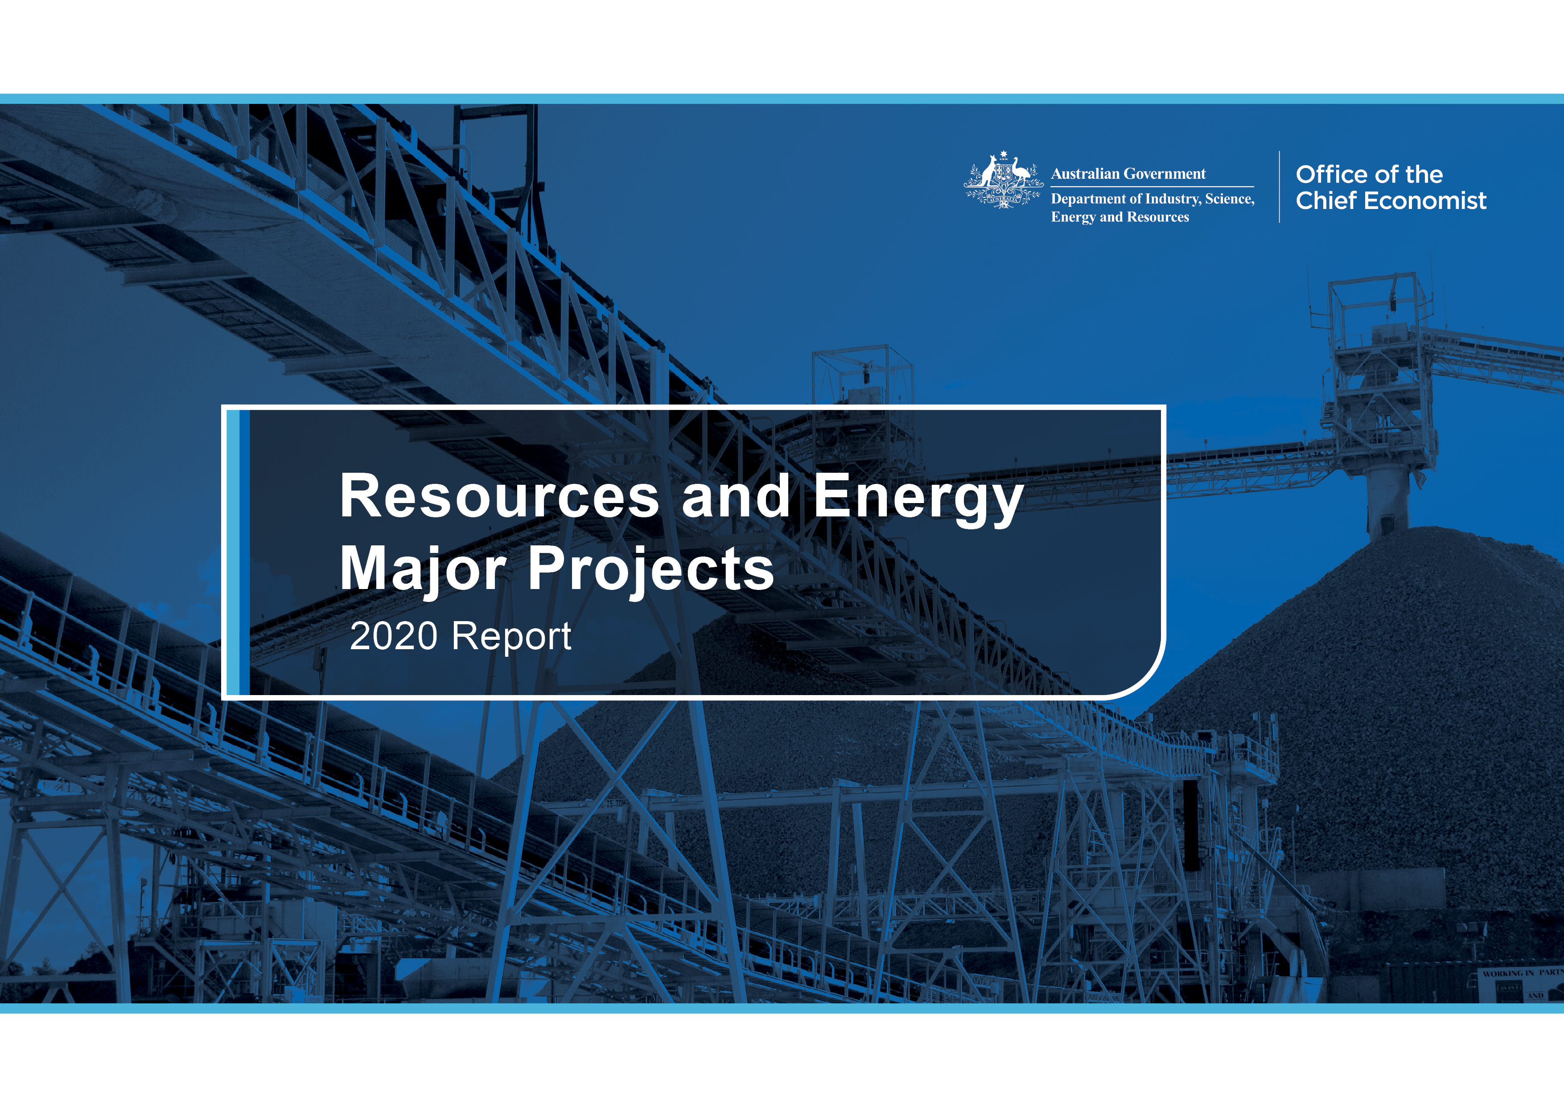

Further information
For more information on data or government initiatives please access the report from the Department’s website at: www.industry.gov.au/oce

Project lead
Caroline Lewis

Project team
Jeremy Coghlan, Mark Gibbons, Kate Martin, Thuong Nguyen, Monica Philalay and Nathan Pitts

Acknowledgements
The authors would like to acknowledge the contributions of:
David Thurtell, Allison Ball, Lou Brooks, Kelly O’Brien and Ken Colbert.
Cover image source: Shutterstock
ISSN 1839-5007
© Commonwealth of Australia 2020

Ownership of intellectual property rights
Unless otherwise noted, copyright (and any other intellectual property rights, if any) in this publication is owned by the Commonwealth of Australia.

Disclaimer
The views expressed in this report are those of the author(s) and do not necessarily reflect those of the Australian Government or the Department of Industry, Science, Energy and Resources.
This publication is not legal or professional advice. The Commonwealth of Australia does not guarantee the accuracy or reliability of the information and data in the publication. Third parties rely upon this publication entirely at their own risk.

Creative Commons licence
 | Attribution 4.0 International Licence  CC BY 4.0
All material in this publication is licensed under a Creative Commons Attribution 4.0 International Licence, with the exception of:
- the Commonwealth Coat of Arms;
- content supplied by third parties;
- logos; and
- any material protected by trademark or otherwise noted in this publication.
Creative Commons Attribution 4.0 International Licence is a standard form licence agreement that allows you to copy, distribute, transmit and adapt this publication provided you attribute the work. A summary of the licence terms is available from https://creativecommons.org/licenses/by/4.0/.
Wherever a third party holds copyright in material contained in this publication, the copyright remains with that party. Their permission may be required to use the material. Please contact them directly.

Attribution
Content contained herein should be attributed as follows:
Department of Industry, Science, Energy and Resources, Commonwealth of Australia Resources and Energy Major Projects 2020. The Commonwealth of Australia does not necessarily endorse the content of this publication.
Requests and inquiries concerning reproduction and rights should be addressed to REQ@industry.gov.au

About this report
The Resources and Energy Major Projects publication is an annual review of projects which seek to extend, increase, or improve the quality of mineral commodity output in Australia. These investment projects include greenfield projects, expansions, reactivations, processing facilities, and related infrastructure. Since 1997 the publication has measured the value of current and potential investment in the sector and provided commentary on key development trends.
From 2017 to 2019, Resources and Energy Major Projects was published as a chapter in the Resources and Energy Quarterly. The 2020 edition and pre-2017 updates are standalone publications.
This edition of the report presents an update on project developments over the twelve months from the start of November 2019 to the end of October 2020, and is accompanied by a detailed project listing. This year the list of major resources and energy projects in Australia features 335 projects.
Terminology
The full methodology is detailed in Section 8.
This report and project list is the result of a census on major resources and energy projects under development in Australia. For the purposes of this report, ‘major’ projects are those valued at over $50 million, and which have the potential to reach a final investment decision within the next five years.
Projects are classified into four stages of an investment pipeline model: publicly announced, feasibility, committed and completed. Earlier stages of developing mineral projects, such as identifying deposits and exploration activities, are not included in the assessment.
Projects at the feasibility and publicly announced stages are rated as either ‘unlikely’ (0 – 20% probability), ‘possible’ (20 – 60%) or ‘likely’
(60 – 100%) to progress to the committed stage.
Contents

1. Overview 5

2. Outlook for project investment 8

3. Exploration 10

4. Projects at the publicly announced stage 13

5. Projects at the feasibility stage 15

6. Projects at the committed stage 18

7. Projects at the completed stage 22

8. Methodology 27

9. Further information and resources 29

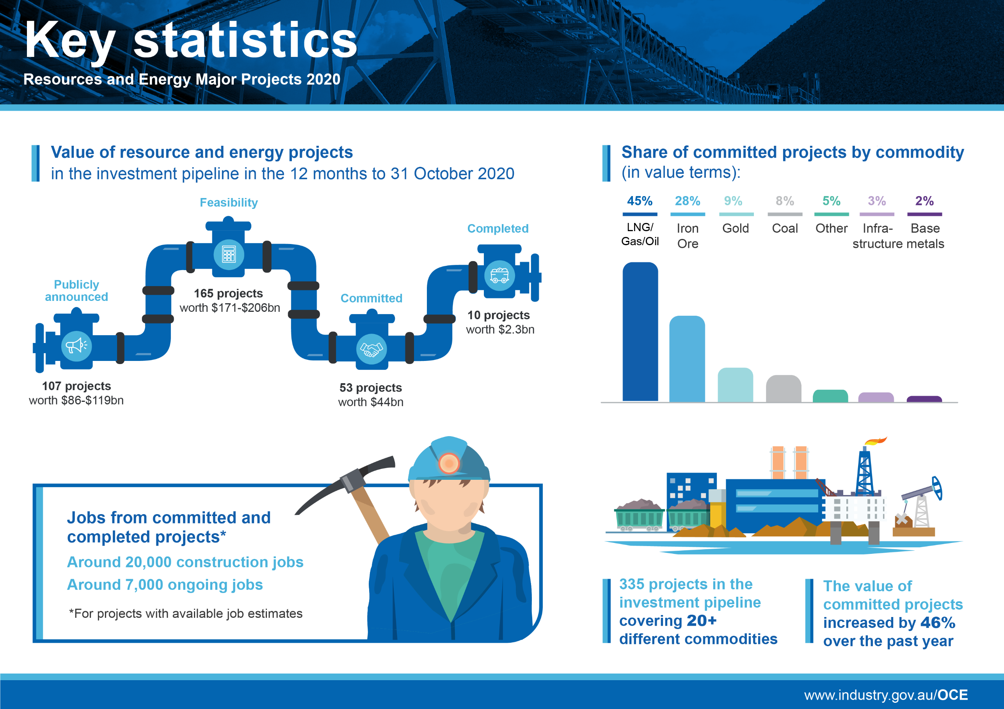

Infographic

Summary
- While it is unlikely that investment will return to the levels seen last decade, there are significant opportunities emerging for Australia's resources and energy sector.
- Over the 12 months from the start of November 2019 to the end of October 2020, the number of resources and energy major development projects increased by 19 per cent to 335 projects, and the value of projects in the investment pipeline increased by 4 per cent to $334 billion.
- The value of gold and battery/electric vehicle related projects rose by 35 per cent and 6 per cent, respectively, reflecting strong gold demand and expectations of strong growth for electric vehicles.
- The value of committed projects rose by 46 per cent to $44 billion, marking a turning point in the cycle and a change in investment style.
- Committed and completed resources projects are expected to create around 20,000 construction jobs and 7,000 ongoing jobs.

Overview
The value of committed projects grew by 46 per cent
Our outlook for resources and energy investment suggests that 2019 represented an inflection point in the mining investment cycle. The value of ‘committed’ resource and energy projects — those where a final investment decision (FID) has been taken — increased by 46 per cent over the past year to $44 billion (Figure 1.1). This growth in value follows six years of decline — as a result of the completion of several large LNG projects — before levelling out last year.
Ten resources and energy projects were completed in the year to October 2020 (Figure 1.2). These include the Gwalia gold expansion project, the Tropicana gold expansion project and the Carrapateena copper project. The value of completed projects declined 73 per cent to $2.3 billion, as a number of gas, oil and metals projects moved off the pipeline.
Figure 1.1: Value of projects in the investment pipeline, 2013 to 2020
Notes: Value of publicly announced and feasible projects estimated as the range mid-point.
Source: Department of Industry, Science, Energy and Resources (2020)
Figure 1.2: Number of projects in the investment pipeline, 2013 to 2020
Source: Department of Industry, Science, Energy and Resources (2020)

Gold mines are being reactivated, but coal and gas investment is slow
The past year has also seen a surge in reactivated gold mines, as higher prices draw previously closed operations out for development. Ausgold’s $102 million Katanning gold project in Western Australia (WA) is expected to be reactivated in the near term, after production ceased in May 1997. Operations at Horizon Gold’s Gum Creek gold project in WA ended in 2005, and are expected to be reactivated in 2023, as high gold prices outweigh the cost of reactivation (estimated at $55 million). Heritage Minerals’ $60 million Mount Morgan project in Queensland is expected to be reactivated at the end of 2021, after production ceased in 1990.
There are $3.9 billion of gold projects at the ‘committed’ stage this year, likely propelled by record high gold prices. There are 17 gold projects at the ‘feasibility’ stage which represent new capacity of almost 76 tonnes per annum. If all gold projects were realised over the time frame of this report, Australia’s gold production would increase by about one-third.
While some projects have progressed, the flow of projects from the ‘feasibility’ to the ‘committed’ stage remains slow in some areas, particularly coal and gas.
There are 45 coal projects at the feasibility stage, but many of these have been delayed (Table 1.1). There is a growing preference for coal expansions over new project investments. There appears to be a growing reluctance to commit to greenfield coal projects, and an expanding list of lenders/investors have announced plans to no longer finance thermal coal projects. Some pension and equity funds are also divesting from, or limiting their exposure to thermal coal, narrowing the range of investment financing options available to coal projects.
There are also 19 gas/LNG projects that remain at the feasibility stage. The impact of the COVID-19 pandemic on oil and LNG prices has occurred against a backdrop of an existing global LNG supply glut, which has led to the deferral of FIDs for several large offshore projects that were originally expected in 2020 or 2021.

Employment outlook
Of the projects for which job estimates are made, committed and completed resources projects are expected to create around 20,000 construction jobs and 7,000 ongoing jobs.

Exploration is rising, but early-stage investment is changing
There has been an increase in activity at the early stages of the investment pipeline, with the value and number of projects at the ‘publicly announced’ stage increasing from 2019 (Figures 1.1 and 1.2). The value of projects at the ‘feasibility’ stage decreased slightly. Part of the decline can be attributed to some substantial projects at the feasibility stage progressing to the committed stage. However, a large share of the decline has also been driven by the scaling back of the size and scope of projects (to reduce capital expenditure), project cancellations, and projects moving backwards in the pipeline — with thirteen projects regressed from the ‘feasibility’ stage to the ‘publicly announced’ stage due to a lack of progress.
This decline in investment activity likely partly reflects the impact of global uncertainties due to the COVID-19 pandemic, with particularly challenging market conditions for energy commodities. However, the impacts of the COVID-19 pandemic have been partially offset by a strong gold price and the consequent reactivation of a number of gold mines.
Record gold prices have driven an increase in exploration expenditure, particularly across precious and base metals (copper, zinc/lead projects with gold by-products). Australia’s gold exploration expenditure reached a record high of nearly $1.2 billion in 2019–20, accounting for 42 per cent of Australia’s total mineral exploration expenditure.
Project proponents are increasingly willing to tackle more difficult deposits across a range of mineral commodities. The lift in development activity represents a marked turnaround from the period of 2015 and 2016, when low commodity prices forced companies to delay exploration and new projects and instead focus on cost cutting.
Table 1.1: Summary of projects in the investment pipeline as at 31 October 2020
 | Publicly Announced |  | Feasibility |  | Committed |  | Completed |  | Total
 | No. of projects | Value A$b | No. of projects | Value A$b | No. of projects | Value A$b | No. of projects | Value A$b | No. of projects | Value  A$b
Aluminium, Alumina, Bauxite | 2 | 1.5 |  |  |  |  |  |  | 2 | 1.5
Coal | 21 | 17-20+ | 45 | 57-65+ | 6 | 3.4 |  |  | 72 | 77-89+
Copper | 10 | 4.2-4.6+ | 4 | 1.4-1.7 |  |  | 1 | 0.9 | 15 | 6.5-7.2+
Gold | 7 | 0.6-1.1+ | 16 | 3.4 | 12 | 3.9 | 4 | 0.3 | 39 | 8.2-8.7+
Infrastructure a | 16 | 10-16+ | 8 | 4.4-5.3 | 6 | 1.3 | 1 | 0.1 | 31 | 15-23+
Iron ore | 15 | 14-18+ | 10 | 14-20+ | 6 | 12.4 | 1 | 0.1 | 32 | 41-51+
Lead, Zinc, Silver |  |  | 4 | 0.2-0.9+ | 1 | 0.3 |  |  | 5 | 0.5-1.2+
LNG, Gas, Petroleum | 14 | 33-48+ | 19 | 71-77+ | 10 | 20 | 1 | 0.8 | 44 | 124-146+
Nickel, Cobalt | 6 | 2.6-3.9+ | 4 | 3.4-4.9+ | 5 | 0.6 | 1 | 0.1 | 16 | 6.7-9.5+
Other Commodities  b | 14 | 0.7 | 50 | 13-25+ | 7 | 2.0 | 1 | 0.1 | 72 | 17-33+
Uranium | 2 | 2.1-5.9+ | 5 | 2.3+ |  |  |  |  | 7 | 3.0+
Total | 107 | 86-119+ | 165 | 171-206+ | 53 | 44 | 10 | 2.3 | 335 | 300-373+

Notes: a Infrastructure is limited to resource and energy related infrastructure projects. b Other commodities is limited to resource and energy commodities not elsewhere identified. c Totals may not add due to rounding at commodity level.
Source: Department of Industry, Science, Energy and Resources (2020)

Outlook for project investment
This section discusses the outlook for future investment in the resources and energy sector. Not all projects on the list will proceed through to an FID and construction, so projects at the ‘publicly announced’ and ‘feasibility’ stages are assigned a rating of the likelihood (likely, possible or unlikely) they will proceed (see Section 8 for the methodology). The projects included in the profile of future investment over the next five years are limited to projects that have been rated as committed, likely or possible.

Project development more uncertain but companies increasing efforts
‘Possible projects’ accounted for the largest share of overall projects in 2019–20, with 167 projects out of 335. There were also 58 likely projects and 46 unlikely projects across all stages of the investment cycle.
A marked increase in committed projects, up by 46 per cent to $44 billion, may reflect the increase in expansions and reactivations in the project listing (Table 2.1). Expansions and reactivations require lower capital investment, potentially fewer approvals and have less technical risk. The number of completed projects fell sharply (Table 2.2).
‘Unlikely’ or ‘possible’ projects account for 64 per cent of the project list, and just over a third of the list are rated as ‘likely’ and ‘committed’ (Table 2.2). This may reflect recent rising uncertainty over global economic conditions following the COVID-19 pandemic.

Mega projects and bulk commodities dominate the project pipeline
A modest uptick in resources and energy investment in 2020 is expected, with potential for a further recovery in the subsequent few years (Figure 2.1). There are over $217 billion of projects at the ‘publicly announced’ and ‘feasibility’ stages that we consider ‘possible’ or ‘likely’ to receive an FID, a decline from $244 billion in the previous year. The bulk of this potential investment comes from projects at the feasibility stage (Table 2.2).
This potential investment depends heavily on the progression of just 12 ‘mega projects’ (projects involving over $5 billion of investment), which account for half of the value of projects in the investment pipeline. By far the largest of these mega projects is the ‘Browse to North West Shelf’ project. Other mega projects include the ‘Scarborough to Pluto’ project on the west coast, the Surat gas project on the east coast, and the West Pilbara iron ore project.
Figure 2.1: Outlook for project investment
Notes: Due to the nature of project development and information release, the decrease in investment value towards the end of the outlook period reflects a lack of information rather than a reduction in investment.
Source: Department of Industry, Science, Energy and Resources (2020)
Iron ore, coal and gas/LNG projects and related infrastructure — Australia’s three largest export commodities — account for over 80 per cent of projected investment.
LNG/gas projects are the largest of these. The majority of the large gas projects at the feasibility stage are backfill projects that utilise existing LNG export infrastructure — rather than greenfield developments of the type seen over the past decade (which formed the bulk of Australia’s $230 billion LNG investment boom between 2009 and 2012).
Progress on most iron ore projects has been steady, with some acceleration among projects in the Pilbara region in recent months, as high iron prices improved their potential profitability. Some iron ore projects in South Australia (SA) and New South Wales (NSW) continue to face challenges, with slower progress over the past year.
Coal projects account for almost $40 billion of project investment. However, the recent downturn in both metallurgical and thermal coal prices is expected to weigh on future investment decisions. Consequently, a number of coal projects were downgraded to ‘unlikely’.

The project pipeline for battery and precious metals is growing
There are around $33 billion of precious metal, base metal and other commodity projects at the ‘publicly announced’ and ‘feasible’ stages that are rated as ‘likely’ or ‘possible’ to receive an FID. This is up from $28 billion in 2019. Developments in battery technology and expectations of growing electric vehicle manufacturing continue to spur investment in Australia’s nickel, cobalt, rare earths and lithium resources, with 34 projects likely or better now publicly announced, feasible or above with a combined value of over$17 billion. A number of development projects are investing in processing facilities to produce battery cathode precursors in the form of lithium hydroxide. Key battery and critical minerals projects are presented in Tables 7.2 – 7.4 with Figure 7.3 showing steady growth in this area.
Overall, our outlook for mining investment suggests that, while we will not see a return to the levels seen during the last investment phase (which peaked in 2012 with $268 billion in committed projects), there are some significant opportunities emerging for Australia’s resources and energy sector.

Table 2.1: New and expansion projects by rating, as at 31 October 2020
 | Unlikely | Possible | Likely | Committed | Completed
New project
A$ billion | 70.1 | 94.0 | 76.3 | 14.7 | 2.0
Number | 41 | 131 | 37 | 19 | 6
Expansion
A$ billion | 1.8 | 25.1 | 20.8 | 28.9 | 0.4
Number | 4 | 33 | 18 | 32 | 4
Reactivation
A$ billion | 0.1 | 0.4 | 0.2 | 0.1 | 0
Number | 1 | 4 | 3 | 2 | 0
Source: Department of Industry, Science, Energy and Resources (2020)

Table 2.2: Number of projects by stage of investment and rating, as at 31 October 2020
 | Unlikely | Possible | Likely | Committed | Completed
Publicly announced | 19 | 77 | 11 | 0 | 0
Feasible | 27 | 91 | 47 | 0 | 0
Committed | 0 | 0 | 0 | 53 | 0
Completed | 0 | 0 | 0 | 0 | 10
Total | 46 | 168 | 58 | 53 | 10
Notes: Projects at the publicly announced and feasibility stages are rated as either ‘unlikely’ (0 – 20%), ‘possible’ (20 – 60%) or ‘likely’ (60 – 100%) to progress to the committed stage.
Source: Department of Industry, Science, Energy and Resources (2020)

Exploration
Exploration encompasses expenditure aimed at improving knowledge about the location, type, quantity and quality of deposits. This spending helps inform future development. Before making a decision to undertake exploration, companies balance the benefits of exploration with a range of factors, including: commodity prices, the regulatory environment, geological prospects and tax/royalty arrangements.

Exploration expenditure increased in 2019–20
Australian exploration expenditure increased by 12 per cent in 2019–20 to $4.0 billion (Figure 3.1). This growth was driven by mineral exploration, a trend consistent with previous years. Mineral exploration expanded by 18 per cent to $2.5 billion in 2019–20. While petroleum exploration was stable over the year (at $1.2 billion), exploration in energy commodities increased, due to higher coal exploration.

Growth driven by minerals exploration
In 2019–20, mineral exploration expenditure was primarily on existing deposits. However, expenditure on new deposits has picked up in recent years and accounted for more than a third of mineral exploration expenditure in 2019–20. This share was consistent with 2018–19 levels, but at $1.1 billion in 2019–20, makes it the highest since 2011–12 (Figure 3.2). Minerals exploration expenditure represented almost 70 per cent of total exploration expenditure, a rise from five years prior, when it represented about 30 per cent of total exploration expenditure.

Gold continues to draw the largest interest in mineral exploration
For the last five years, gold has attracted the most mineral exploration expenditure, having overtaken iron ore in 2015–16. In 2019–20, gold expenditure increased to $1.2 billion, up 20 per cent, accounting for almost half of Australia’s minerals exploration expenditure (Figure 3.3). Exploration activity has been encouraged by record high Australian dollar gold prices amidst economic and political uncertainty.
Figure 3.1: Mineral and energy exploration expenditure
Source: ABS (2020) Mineral and Petroleum Exploration, Australia, 8412.0
Figure 3.2: Mineral exploration by deposit type

Source: ABS (2020) Mineral and Petroleum Exploration, Australia, 8412.0

Significant growth in coal exploration expenditure

Coal exploration expenditure increased for the third year in a row in 2019–20, rising by 66 per cent to $303 million. This was its highest value since 2013–14, and brings coal exploration expenditure back to levels broadly consistent with the ten year average (Figure 3.3).

Iron ore prices continue to incentivise exploration
Iron ore expenditure expanded by 12 per cent in 2019–20 to $361 million, a growth rate similar to the previous year. While far from the peak of $1.2 billion attained in 2011–12, this is the highest level of exploration expenditure since 2014–15. High iron ore prices — supported by constrained Brazilian supply and robust demand from China — continue to encourage exploration in some mineral-rich areas of WA (Figure 3.3).

Modest increase in base metals expenditure, driven by copper
Base metals exploration expenditure rose by 10 per cent to $681 million in 2019–20, driven primarily by increases in copper exploration. Nickel and cobalt expenditure was stable, while silver, lead and zinc exploration expenditure declined. This marked the fourth year of increase in base metals exploration expenditure (Figure 3.3). Copper exploration increased by 28 per cent over the year to $420 million, possibly stimulated by record high gold prices — and thus the potential for co-production. (Copper and gold are commonly found in the same ore body).
Nickel and cobalt expenditure remained around $200 million in 2019–20 — consistent with the last three years — as expectations of future market shortages were balanced with low prices. On a world scale, Australia accounts for the largest share of exploration activity, with over a third of total nickel exploration spending.
Silver, lead and zinc expenditure fell by 34 per cent to $59 million, due to a steady decline in zinc prices.
Figure 3.3: Recent annual exploration expenditure by commodity
Notes: Base metals also include silver and cobalt.
Source: ABS (2020) Mineral and Petroleum Exploration, Australia, 8412.0

Petroleum exploration supported by onshore activity
Petroleum (oil or gas in solution) expenditure remained close to decade lows in 2019–20, holding steady at $1.3 billion (Figure 3.4). A 52 per cent increase in onshore exploration expenditure outweighed a 27 per cent decrease in offshore expenditure. For the first time in more than three decades, onshore exploration expenditure was higher than offshore expenditure in 2019–20.
Global oil and gas prices fell dramatically in the first half of 2020, due to the impacts of COVID-19. These price declines drove significant cost cutting in the petroleum industry, including the deferral of exploration spending. Offshore exploration expenditure consequently fell to a two decade low in 2019–20. Over the same period, onshore petroleum exploration grew modestly to reach a five-year high. A tighter domestic gas market could support ongoing growth in onshore petroleum exploration, with the Australian Energy Market Operator (AEMO) forecasting a possible shortfall of natural gas on the Australian east coast market by 2024.
Figure 3.4: Petroleum exploration expenditure, quarterly
Source: ABS (2020) Mineral and Petroleum Exploration, Australia, 8412.0
Figure 3.5: Exploration expenditure by state and territory
Source: ABS (2020) Mineral and Petroleum Exploration, Australia, 8412.0

WA leads exploration expenditure
Exploration in WA accounts for 60 per cent of total exploration, which has steadily recovered from a relative low in 2015–16 (Figure 3.5). In recent years, the growth in WA exploration has been related to copper, nickel and lithium exploration, however, the increase in 2019–20 is solely due to gold exploration. In 2019–20, exploration in Queensland lifted, predominantly reflecting higher coal exploration; exploration also rose in NSW, driven by coal and gold exploration.

Market conditions lead to stronger drilling results
A total of 10 million metres was drilled in 2019–20, a level consistent with the previous year. The share of drilling on new deposits has increased modestly in recent years, which may have been incentivised by higher commodity prices (Figure 3.6).
Figure 3.6: Drilling on new deposits versus commodity prices

Source: ABS (2020) Mineral and Petroleum Exploration, Australia, 8412.0; Department of Industry, Science, Energy and Resources (2020)

Projects at the publicly announced stage

Over a quarter of all projects are at the ‘publicly announced’ stage
Of the 335 projects on this year’s list, around 107 were at the ‘publicly announced’ stage. The value of the 107 projects at the publicly announced stage in October 2020 is estimated to be between $86 billion and $119 billion. Around 38 per cent of these projects are in WA, and are largely LNG/gas projects or iron ore projects. Queensland had almost 30 per cent of projects, with the majority being coal projects (Table 4.1).

Almost 60 per cent of projects are aimed at our largest commodity exports
Many projects at the publicly announced stage remain uncertain, and are unlikely to progress in the near term. This is the case for a number of infrastructure projects and large LNG/gas, iron ore, coal projects — the predominant commodities classified as being at this stage (Figure 4.1). The lack of movement in projects at this stage of the investment pipeline may partly reflect the low costs associated with taking a project to this stage of development.
Almost two thirds of the infrastructure projects are gas pipelines, with seven of these new to the list. Several of these pipelines aim to connect proposed LNG import terminals and new basins to the east coast gas market, or to extend existing infrastructure in the east coast gas market.
There is one new oil project at the publicly announced stage. Santos’ Dorado project has an estimated new capacity of 85,000 barrels a day —around a quarter of 2019–20 Australian crude oil and condensate production. Although progress has been slowed by current low oil prices, Santos is expected to make progress on the front-end engineering design (FEED) decision in late 2020.

The development of gold projects will depend on market conditions
Seven gold projects at the publicly announced stage, with a combined value of around $1 billion, could progress if gold prices remain strong.
Figure 4.1: Number of projects at the publicly announced stage
Notes: a Infrastructure is limited to resource and energy related infrastructure projects. b Other Commodities is limited to resource and energy commodities not elsewhere identified.
Source: Department of Industry, Science, Energy and Resources (2020)

Battery minerals activity is growing
The majority of the copper projects on this year’s list are at the publicly announced stage. Of the ten publicly announced projects, most are new projects, with one expansion (Oz Mineral’s Carrapateena mine) and one reactivation (Metals X’s Nifty mine). Most are under active development, and are dependent on improvements in copper prices. With supportive market conditions, a number of new mines could be online by 2023.
The number of projects in ‘other commodities’ more than doubled, with growth primarily from WA. The commodities in these areas are predominantly rare earths and lithium.
Finally, there are two bauxite and alumina projects at the publicly announced stage, including Glencore Bauxite Resources’ $1.3 billion Aurukun bauxite project in Queensland and Alcoa’s $150 million Wagerup and Pinjarra alumina expansion project in WA. These could reach an FID when the market conditions improve.

Table 4.1: Summary of projects at the publicly announced stage, as at 31 October 2020
 | NSW |  | Qld |  | WA |  | NT |  | SA |  | Vic |  | Tas |  | Total
 | No. of projects | Value A$b | No. of projects | Value A$b | No. of projects | Value A$b | No. of projects | Value A$b | No. of projects | Value A$b | No. of projects | Value A$b | No. of projects | Value A$b | No. of projects | Value  A$b
Aluminium, Alumina, Bauxite |  |  | 1 | 1.3 | 1 | 0.2 |  |  |  |  |  |  |  |  | 2 | 1.5
Coal | 7 | 2-3+ | 13 | 16-17 |  |  |  |  | 1 | 0.2 |  |  |  |  | 21 | 17-20+
Copper | 1 | 0-0.2 | 1 | 0.3+ | 5 | 2-2.3+ | 1 | 0.2+ | 2 | 1.6 |  |  |  |  | 10 | 4.1-4.6+
Gold |  |  | 1 | 0.2 | 5 | 0.2-1+ | 1 | 0.1 |  |  |  |  |  |  | 7 | 0.6-1.1+
Infrastructure a | 4 | 1-1.2+ | 8 | 3-4+ | 2 | 4-7 | 1 | 1-2+ |  |  | 1 | 0.2 |  |  | 16 | 10-16+
Iron ore |  |  |  |  | 10 | 10-14+ | 1 | 0.1 | 3 | 3.8 |  |  | 1 | 0.1 | 15 | 14-18+
Lead, Zinc, Silver |  |  |  |  |  |  |  |  |  |  |  |  |  |  | 0 | 0
LNG, Gas, Petroleum |  |  | 4 | 2-4+ | 8 | 27-38+ | 1 | 2-5+ |  |  | 1 | 0.2-0.5 |  |  | 14 | 33-48+
Nickel, Cobalt | 2 | 0.6-1+ |  |  | 4 | 2-3 |  |  |  |  |  |  |  |  | 6 | 3-4+
Other Commodities  b | 1 | 0.1+ | 2 | 0.5-1+ | 7 | 1-3+ | 2 | 0.3-1+ |  |  | 1 | 0-0.2 | 1 | 0.2+ | 14 | 2-6+
Uranium |  |  | 1 | 0.6 |  |  |  |  | 1 | 0.1 |  |  |  |  | 2 | 0.7
Total | 15 | 3-5+ | 31 | 24-29+ | 42 | 47-69+ | 7 | 5-9+ | 7 | 5-6 | 3 | 0.4-0.9 | 2 | 0-0.3+ | 107 | 86-119+
Notes: a Infrastructure is limited to resource and energy related infrastructure projects. A number of gas pipelines span across more than one state but have been allocated to one state for reporting purposes. Please refer to the detailed project listing for more details on the locations of these pipelines. b Other Commodities is limited to resource and energy commodities not elsewhere identified. c Totals may not add due to rounding at commodity level.
Source: Department of Industry, Science, Energy and Resources (2020)

Projects at the feasibility stage

Around 50 per cent of projects are at the feasibility stage
The value of projects at the feasibility stage decreased by around 5 per cent to an estimated $186 billion in the 12 months to October 2020. Port, rail and pipeline infrastructure projects grew in Queensland, despite 13 projects regressing from the feasibility stage to publicly announced, and 19 other projects taking FIDs and moving to the committed stage on a national basis. Over 160 projects are listed at the feasibility stage — around 50 per cent of our Major Projects list this year (Table 5.1). Coal projects account for 27 per cent of the number of projects at the feasibility stage, while LNG/gas/petroleum projects account for over 11 per cent. ‘Other commodities’ contributed 30 per cent (Figure 5.1).

Just under 50 per cent of all projects are in our largest commodity exports
The number of coal projects at the feasibility stage was steady over the 12 months to October 2020, with 45 projects listed worth an estimated $59 billion in total (Table 5.1). The elevated number of coal projects currently at the feasibility stage is likely to reflect FIDs being delayed by low prices, with some financial institutions seeking to reduce their involvement in coal projects. A number of the mines listed as feasible also have proponents announcing they are transitioning out of coal — notably BHP — raising doubts about some coal projects advancing to the committed stage.
Weak oil and LNG prices in 2020 have resulted in the deferral of FIDs for several gas and LNG projects. An FID for Woodside’s Browse to North West Shelf project — the largest project on the list at over $30 billion — has been delayed from 2020 to 2023. FIDs for Santos’ Barossa gas project (which looks likely to provide backfill for Darwin LNG), Shell’s Crux project (slated for backfill to the Prelude FLNG facility) and Woodside’s Scarborough to Pluto LNG project have all been delayed from 2020 to 2021. The proposed Pluto LNG expansion (where a 5 mtpa train would be added) is the only substantial expansion to Australia’s LNG capacity currently in the investment pipeline.
Figure 5.1: Number of projects at the feasibility stage
Notes: a Other Commodities is limited to resource and energy commodities not elsewhere identified. b Infrastructure is limited to resource and energy related infrastructure projects.
Source: Department of Industry, Science, Energy and Resources (2020)
Figure 5.2: Projects at the feasibility stage, by State and Territory
Source: Department of Industry, Science, Energy and Resources (2020)
There are five proposed LNG import terminals on the major projects list, with four at the feasibility stage. These projects are aiming to start commercial operations by 2022 or 2023, in order to meet an anticipated gas shortage on the east coast market — although it is unlikely that all five projects will go ahead.

Around 10 per cent of all projects are in gold, as price drives development
There are seventeen gold projects at the feasibility stage, with a combined capital expenditure of around $3.4 billion. Of those, around five projects have the potential to progress to ‘committed’ in the near term, provided there are supportive market conditions. This includes Evolution Mining’s $319 million Cowal expansion project in NSW (under review by the NSW government), Heritage Minerals’ $60 million Mount Morgan project in Queensland (recently completed positive definitive feasibility study), Red 5’s $226 million King of the Hills project in WA (an FID is expected before the end of 2020), and ACH Minerals’ $85 million Ravensthorpe project in WA (which received environmental approval from the WA government in May 2020).

Around 20 per cent of projects at the feasible stage are driven by demand for commodities used in rechargeable batteries
The largest proportion of projects at the feasibility stage are in WA, including a number of prospective nickel-cobalt projects (Figure 5.2, Table 5.1). Expectations of higher demand — propelled by growing battery manufacturing — are driving investment in mine capacity and processing facilities. There are four nickel/cobalt projects at the feasibility stage, worth around than $5 billion combined. These projects are expected to take advantage of Australia’s high quality nickel sulphide resources, and to allow access to secure cobalt supplies. The largest of these is Clean TeQ’s Sunrise project in NSW, which is expected to produce battery grade refined products, including nickel for 1 million electric vehicles.
The number of projects in ‘other commodities’ decreased from 55 to 50, as projects progressed towards the committed stage (potash, tin, tungsten and manganese); the value of projects decreased marginally to $17.9 billion. Trial mining has commenced at the Balranald minerals sands project in NSW. Rare earth production at Yangibana in WA has progressed, with offtake agreements now in place and an application for funding placed through the Northern Australian Infrastructure Fund. Nolans’ rare earths project in the Northern Territory has progressed, with a FID possible in 2021 after environmental approvals were received.
The Gabanintha project in WA has progressed, with an agreement for offtake of vanadium dependent on making the FID by mid-2021. The demand for vanadium has increased, due to its use in certain rechargeable batteries. The Australian Vanadium project in WA is progressing, with ‘Major Project’ status granted by the Australian Government. The Siviour graphite project in SA (north-east of Port Lincoln) has progressed, with financing from Australia and the Netherlands. Graphite is used as an anode in rechargeable battery production.
Pilbara Minerals has plans for an expansion of the Pilgangoora mine in WA, dependent on market conditions for lithium. The Greenbushes mine in WA also has expansion plans and the Wodgina mine may also restart. However, poor market conditions late last year led to significantly curtailed development.
Table 5.1: Summary of projects at the feasibility stage, as at 31 October 2020
 | NSW |  | Qld |  | WA |  | NT |  | SA |  | Vic |  | Tas |  | Total
 | No. of projects | Value A$b | No. of projects | Value A$b | No. of projects | Value A$b | No. of projects | Value A$b | No. of projects | Value A$b | No. of projects | Value A$b | No. of projects | Value A$b | No. of projects | Value  A$b
Aluminium, Alumina, Bauxite |  |  |  |  |  |  |  |  |  |  |  |  |  |  | 0 | 0
Coal | 13 | 7-10+ | 32 | 50-55+ |  |  |  |  |  |  |  |  |  |  | 45 | 57-65+
Copper |  |  | 1 | 0.6 | 1 | 0-0.2 |  |  | 1 | 0.6 | 1 | 0.3 |  |  | 4 | 1.4-1.7
Gold | 2 | 0.6 | 1 | 0.1 | 9 | 1.2 | 2 | 1.4 | 2 | 0.2 |  |  |  |  | 16 | 3.4
Infrastructure a | 1 | 1.2 | 4 | 1.4-2 |  |  | 1 | 1.2 | 1 | 0.5-1 | 1 | 0.2 |  |  | 8 | 4.3-5.3
Iron ore | 1 | 2.5-5 |  |  | 7 | 8-11+ |  |  | 2 | 4-4.3+ |  |  |  |  | 10 | 14-20+
Lead, Zinc, Silver | 1 | 0-0.2 |  |  | 2 | 0-0.4+ | 1 | 0.2 |  |  |  |  |  |  | 4 | 0.2-0.9+
LNG, Gas, Petroleum | 3 | 2-3.4 | 2 | 8.3+ | 7 | 55-58+ | 1 | 5-5.8 | 2 | 0-0.5 | 4 | 1-1.5+ |  |  | 19 | 71-77+
Nickel, Cobalt | 1 | 1.5-2.5 | 2 | 1.5-2.1 | 1 | 0.4+ |  |  |  |  |  |  |  |  | 4 | 3.4-4.9+
Other Commodities b | 5 | 1-2.5+ | 3 | 0.4-1+ | 25 | 7-14+ | 7 | 3-4+ | 2 | 0-0.5+ | 5 | 1.3-3+ | 3 | 0.1-1+ | 50 | 13-25+
Uranium |  |  | 1 | 0.4 | 4 | 2.0+ |  |  |  |  |  |  |  |  | 5 | 2.3+
Total | 27 | 16-26+ | 46 | 63-69+ | 58 | 74-87+ | 12 | 10-12+ | 10 | 5-7+ | 11 | 2-5+ | 3 | 0.1-1+ | 165 | 170-206+
Notes: a Infrastructure is limited to resource and energy related infrastructure projects. b Other Commodities is limited to resource and energy commodities not elsewhere identified. c Totals may not add due to rounding at commodity level.
Source: Department of Industry, Science, Energy and Resources (2020)

Projects at the committed stage

The value of ‘committed’ projects increased by 46 per cent
The value of projects at the ‘committed’ stage increased over the year to October 2020, from $30 billion to $44 billion (Figure 6.1). Australia’s three largest export commodities — iron ore, coal and gas — account for around 80 per cent of investment at the committed stage, although ‘other commodities’ has more than doubled from its low base (Figure 6.2, Table 6.2). The location and value of projects at the committed stage is shown in Image 6.1.

Our largest commodity exports dominate the ‘committed’ stage
Gas and LNG projects accounted for the largest share of committed projects by value (Figure 6.2). Despite challenging market conditions, three gas projects progressed to the committed stage in the 12 months to October 2020. The first phase of Arrow Energy’s $10 billion Surat Gas Project was sanctioned in 2020. Gas from the project will be sold domestically and exported through the QCLNG plant at Gladstone. Other gas projects new to the committed stage will also sustain production at existing LNG facilities: Julimar-Brunello Project Phase 2 will support LNG production at Wheatstone, and Greater Western Flank Phase-3 will support LNG production at North West Shelf.
Iron ore development projects account for the second largest share of committed projects by value. Several large iron ore projects are moving closer to completion: Fortescue’s Eliwana, which is set to commence production in December 2020 and produce 30 million tonnes per year, and BHP’s South Flank, set to produce 80 million tonnes annually and replace existing production from the Yandi operations from 2021. Rio Tinto’s Koodaideri is also progressing, and is expected to commence in late 2021 and produce 43 million tonnes per year.
There are six coal mines at the committed stage, with two new additions in the past year. Both the Mandalong Southern Extension project and United-Wambo are expansions designed to extend the life of existing mines and/or improve the productivity of existing operations.
Figure 6.1: Number and value of committed projects
Notes: The Major Projects was formerly a biannual publication released in April and October, but became an annual report in 2016.
Source: Department of Industry, Science, Energy and Resources (2020)

Figure 6.2: Value of committed projects by commodity
Notes: a Other Commodities is limited to resource and energy commodities not elsewhere identified. b Infrastructure is limited to resource and energy related infrastructure projects.
Source: Department of Industry, Science, Energy and Resources (2020)

Gold contributed significantly to growth of projects in the ‘committed’ stage
Overall, gold, nickel and other commodities grew substantially in percentage terms from 2019 to 2020. This was largely due to high gold prices as well as anticipated growth in electric vehicles (Table 6.1).
Twelve gold projects, worth $3.9 billion, have progressed to the committed stage over the past year. Together, these committed gold projects are expected to contribute 182 tonnes per annum of gold of capacity to Australia’s gold mine potential production. These projects include both expansions and greenfield developments. The largest of these is Newcrest’s $685 million and $175 million Cadia Stage 1 and Stage 2 Expansion projects in NSW, and Newmont Mining’s $750 million Tanami Expansion 2 project in WA.
The number of committed ‘other commodities’ projects increased from three to seven, with the combined value more than doubling to $1.7 billion. New committed projects include the Kwinana Lithium Refinery (Tianqi), where progress was previously stalled by a protracted commissioning process. The Kemerton Lithium Refinery (Albemarle/Mineral Resources) in WA is progressing with construction, and is due to be completed late in 2021, though complexities linked to COVID-19 may affect the timetable.
Kalgoorlie Crack and Leach facility (Lynas) plans to provide preliminary processing of rare earths ore from the Mt Weld mine. The proposed facility gained ‘Major Project’ status from the Australian Government, with long lead items already ordered. An FID is imminent, with construction potentially starting in 2021, and the facility aiming to be operational in 2023. Capital costs are estimated to be in the order of $500 million.
The Butcherbird manganese project has significantly changed its scope. Project capital has decreased by an order of magnitude, to $25 million, in order to initiate a quick start up and take advantage of market conditions arising from manganese’s use in rechargeable lithium batteries.
Two WA potash projects have reached the committed stage, with construction underway at Beyondie and Lake Way totalling around $500 million. Production from these operations could commence in 2021.
The Renison tin mine in Tasmania is expanding, as part of its life of mine planning process, with ‘Area 5’ of the mine requiring an investment of $55 million. Mt Carbine tungsten is also in the process of commissioning its pilot plant for the processing of tungsten tailings. The expansion of Sun Metals’ Zinc Refinery in Townsville is also now committed, with future output from the facility set to increase as a result.
Table 6.1: Change in value of committed projects between 2019 and 2020
Commodity | Change in value 2019-2020
Aluminium, alumina, bauxite |  | 0%
Coal |  | 37%
Copper |  | -100%
Gold |  | 26%
Infrastructure |  | 279%
Iron ore |  | 67%
Lead, zinc, silver |  | 76%
LNG, gas, petroleum |  | 40%
Nickel, Cobalt a |  | 41%
Uranium |  | 0%
Other commodities |  | 139%
Total |  | 46%
Notes: a Nickel increase is partly due to cobalt reclassification.
Source: Department of Industry, Science, Energy and Resources (2020)

Table 6.2: Summary of projects at the committed stage, as at 31 October 2020
 | NSW |  | Qld |  | WA |  | NT |  | SA |  | Vic |  | Tas |  | Total
 | No. of projects | Value A$b | No. of projects | Value A$b | No. of projects | Value A$b | No. of projects | Value A$b | No. of projects | Value A$b | No. of projects | Value A$b | No. of projects | Value A$b | No. of projects | Value  A$b
Aluminium, Alumina, Bauxite |  |  |  |  |  |  |  |  |  |  |  |  |  |  | 0 | 0
Coal | 4 | 0.9 | 1 | 2 |  |  |  |  |  |  | 1 | 0.5 |  |  | 6 | 3.4
Copper |  |  |  |  |  |  |  |  |  |  |  |  |  |  | 0 | 0
Gold | 2 | 0.9 | 1 | 0.1 | 8 | 2.1 | 1 | 0.8 |  |  |  |  |  |  | 12 | 3.9
Infrastructure a |  |  | 1 | 0.2 | 5 | 1.1 |  |  |  |  |  |  |  |  | 6 | 1.3
Iron ore |  |  |  |  | 6 | 12.4 |  |  |  |  |  |  |  |  | 6 | 12.4
Lead, Zinc, Silver |  |  | 1 | 0.3 |  |  |  |  |  |  |  |  |  |  | 1 | 0.3
LNG, Gas, Petroleum |  |  | 4 | 10.2 | 5 | 9.4 |  |  |  |  | 1 | 0.2 |  |  | 10 | 19.8
Nickel, Cobalt |  |  |  |  | 5 | 0.6 |  |  |  |  |  |  |  |  | 5 | 0.6
Other Commodities b |  |  | 1 | 0.1 | 5 | 1.9 |  |  |  |  |  |  | 1 | 0.1 | 7 | 2.0
Uranium |  |  |  |  |  |  |  |  |  |  |  |  |  |  | 0 | 0
Total | 6 | 1.8 | 9 | 12.9 | 34 | 27.5 | 1 | 0.8 | 0 | 0 | 2 | 0.7 | 1 | 0.1 | 53 | 43.7
Notes: a Infrastructure is limited to resource and energy related infrastructure projects. b Other Commodities is limited to resource and energy commodities not elsewhere identified. c Totals may not add due to rounding at commodity level.
Source: Department of Industry, Science, Energy and Resources (2020)
Image 6.1: Location of projects at the committed stage, as at 31 October 2020
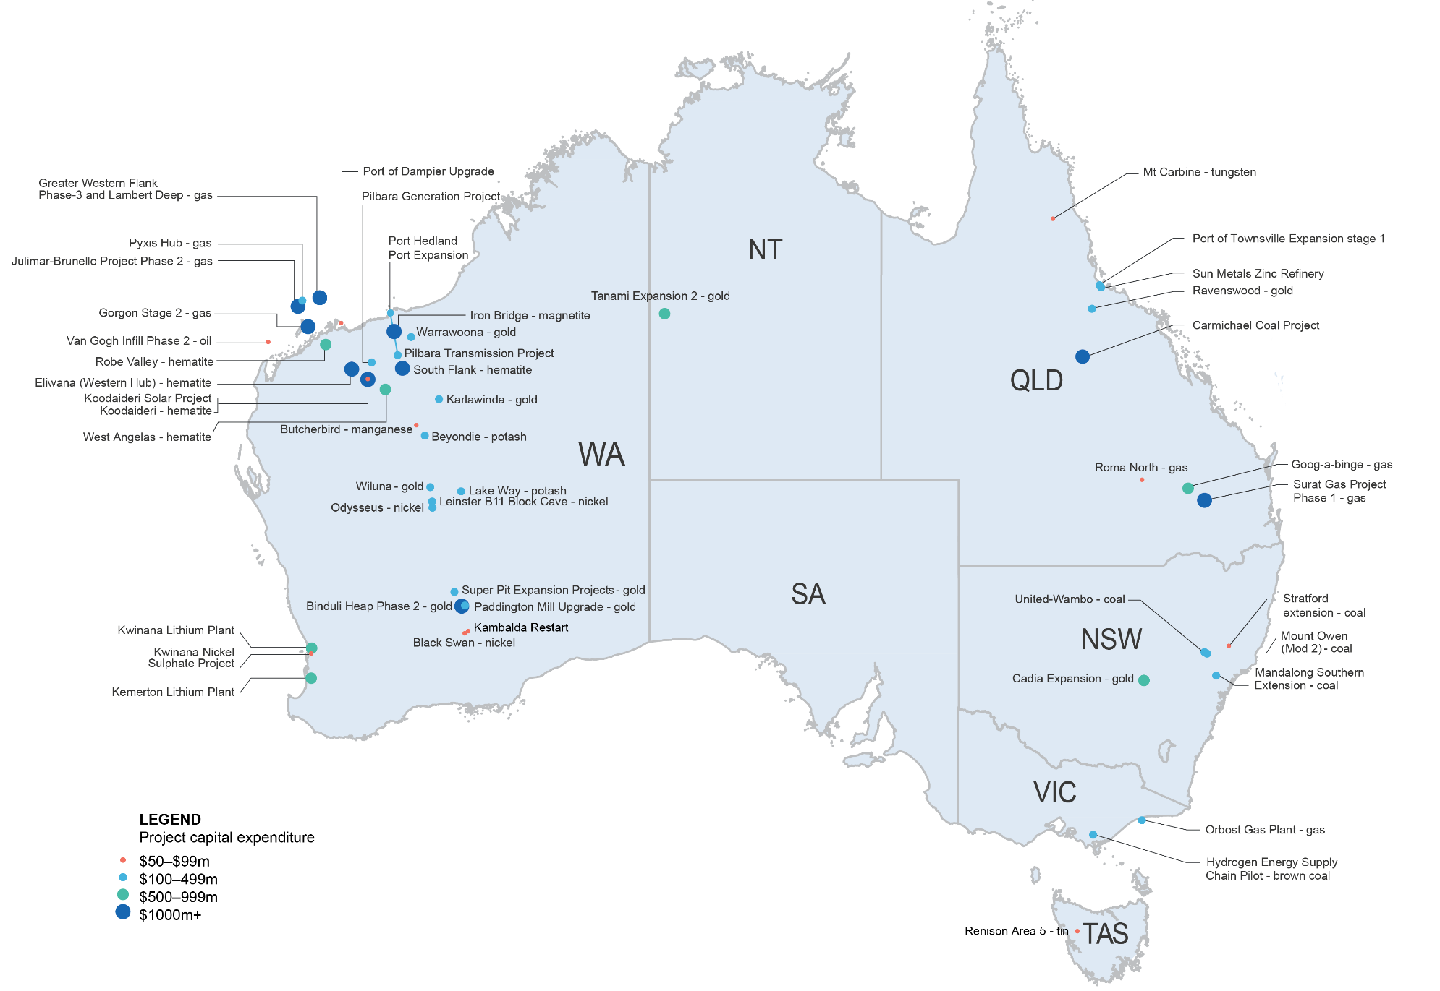
Source: Department of Industry, Science, Energy and Resources (2020)

Projects at the completed stage
Number of completed projects declined sharply in 2020
The value of projects at the ‘completed’ stage fell, from $8.8 billion to just $2.3 billion over the year to October 2020 (Figure 7.1). Completed projects by state and commodity type are shown in Table 7.1. The recent sharp fall in completed projects value reflects the completion of a number of LNG mega-projects in 2019. Other non-LNG projects have accounted for more than half of the value of completed projects since 2019.
Ten resource and energy major projects were completed over the past 12 months in a variety of commodities (Figure 7.2).
In late 2019, Oz Mineral’s Carrapateena copper gold mine in SA was completed. Project ramp-up has been successful, and output is expected to reach target throughput rates of 4.25 million tonnes a year by the end of 2020.
Gas production at Santos GLNG’s Roma East project has continued to rise, with drilling complete and all 424 wells connected and on-line.
The Atlas Gas Pipeline began commercial operations in 2019, and is now delivering gas from the Atlas Gas Field — the first domestic gas acreage from the Queensland Government — to the east coast gas market.
Four gold projects were completed over the year including St Barbara’s 7.9 tonnes a year Gwalia Expansion in WA and the Tropicana Expansion project — a joint-venture between AngloGold Ashanti and Independence Group, with an estimated capacity of 3.1 tonnes a year.
A large proportion of BHP’s Nickel West expansion projects have been completed over the last year, including the Venus and Yakabindie deposits at Mt Keith.
The Sandy Ridge kaolin and storage facility in WA was also completed, with $62 million invested.
Figure 7.1: Value of completed projects
Source: Department of Industry, Science, Energy and Resources (2020)
Figure 7.2: Value of completed projects by commodity
Notes: a Infrastructure is limited to resource and energy related infrastructure projects. b Other Commodities is limited to resource and energy commodities not elsewhere identified.
Source: Department of Industry, Science, Energy and Resources (2020)

Table 7.1: Summary of projects at the completed stage, as at 31 October 2020
 | NSW |  | Qld |  | WA |  | NT |  | SA |  | Vic |  | Tas |  | Total
 | No. of projects | Value A$b | No. of projects | Value A$b | No. of projects | Value A$b | No. of projects | Value A$b | No. of projects | Value A$b | No. of projects | Value A$b | No. of projects | Value A$b | No. of projects | Value  A$b
Aluminium, Alumina, Bauxite |  |  |  |  |  |  |  |  |  |  |  |  |  |  | 0 | 0
Coal |  |  |  |  |  |  |  |  |  |  |  |  |  |  | 0 | 0
Copper |  |  |  |  |  |  |  |  | 1 | 0.9 |  |  |  |  | 1 | 0.9
Gold | 1 | 0.1 | 1 | 0.1 | 2 | 0.2 |  |  |  |  |  |  |  |  | 4 | 0.3
Infrastructure a |  |  | 1 | 0.1 |  |  |  |  |  |  |  |  |  |  | 1 | 0.1
Iron ore |  |  |  |  | 1 | 0.1 |  |  |  |  |  |  |  |  | 1 | 0.1
Lead, Zinc, Silver |  |  |  |  |  |  |  |  |  |  |  |  |  |  | 0 | 0
LNG, Gas, Petroleum |  |  | 1 | 0.8 |  |  |  |  |  |  |  |  |  |  | 1 | 0.8
Nickel, Cobalt |  |  |  |  | 1 | 0.1 |  |  |  |  |  |  |  |  | 1 | 0.1
Other Commodities b |  |  |  |  | 1 | 0.1 |  |  |  |  |  |  |  |  | 1 | 0.1
Uranium |  |  |  |  |  |  |  |  |  |  |  |  |  |  | 0 | 0
Total | 1 | 0.1 | 3 | 1.0 | 5 | 0.4 | 0 | 0 | 1 | 0.9 |  |  |  |  | 10 | 2.3
Notes: a Infrastructure is limited to resource and energy related infrastructure projects. b Other Commodities is limited to resource and energy commodities not elsewhere identified. c Totals may not add due to rounding at commodity level.
Source: Department of Industry, Science, Energy and Resources (2020)
Table 7.2: Recent developments in critical minerals projects
Project | Company | State | Cost estimate $m | Status in 2020 | Comments
Critical Minerals Developments
Rare Earths
Browns Range (Stages 2 & 3) | Northern Minerals | WA | 250–499+ | Publicly announced | Pilot plant (Stage 1) completed with rare earth products being evaluated in anticipation of expansion. Stages 2 and 3 are now being evaluated.
Nolans | Arafura Resources | NT | 1006 | Feasible | FID possible in 2021 after environmental approvals were completed
Yangibana | Hastings Technology Metals Limited | WA | 519+ | Feasible | Offtake agreements now firm as well as debt from Germany and an application for funding through the Northern Australian Infrastructure Fund
Tin
Renison (Area 5) | Metals X | TAS | 55 | Committed | Life of mine extension and expansion based on Area 5
Renison (Rentails) | Metals X | TAS | 0–249+ | Feasible | Environmental permitting underway
Tungsten
Mt Carbine (Stage 1) | Specialty Minerals International Limited | QLD | 55 | Committed | Commissioning of pilot plant for the processing of tungsten tailings. Pilot plant has started production.
Mt Carbine (Stage 2) | Specialty Minerals International Limited | QLD | 0–249 | Publicly announced | Company has developed a new X Ray sorting technique for separate scheelite and wolframite concentrates.
Value Adding - Rare Earths
Dubbo Zirconia | Australian Strategic Minerals | NSW | 1000–1499+ | Feasible | Hatch combining ‘metallisation’ to produce rare earth metals and 2018 feasibility study with results due in early 2021. Metallisation of rare earth metals comes from their recent Korean transaction and is not included in the capital cost.
Kalgoorlie Crack & Leach (Mt Weld Rare Earths) | Lynas | WA | 250–499+ | Feasible | Crack and leach of rare earth products from Mt Weld be done on site expected by mid-2023.

Table 7.3: Recent developments in battery minerals projects
Project | Company |  | State |  | Cost estimate $m |  | Status in 2020 |  | Comments
Battery Minerals Developments
Cobalt
Sunrise Project |  | Clean TeQ | NSW | 1500-2499 |  | Feasible |  | Project execution plan delivered in Sept 2020, highlighting potential for low-cost nickel, cobalt and scandium production.
Vanadium
The Australian Vanadium project | Australian Vanadium Ltd |  | WA |  | 500–999 |  | Feasible |  | The Australian Vanadium project is progressing with its feasibility studies and offtake agreements. Received ‘Major Project’ status from Australian Government.
Gabanintha | Technology Metals AU Ltd |  | WA |  | 518 |  | Feasible |  | Gabanintha vanadium progressed with an agreement for offtake dependent on making FID by mid-2021
Graphite
Siviour | Renascor |  | SA |  | 0–249+ |  | Feasible |  | Progressed with import and export financing in train from Australia and the Netherlands. Debt financing progressing with Nordic Bank
Manganese
Butcherbird | Element 25 Limited |  | WA |  | 25 |  | Committed |  | Project capital has decreased by an order of magnitude to $25 million in order to initiate a quick start-up and take advantage of market conditions arising from manganese’s use in rechargeable lithium batteries.
Lithium - mining
Greenbushes Expansion beyond 1.9-2.3mtpa | Talison (51 Tianqi / 49 Albemarle) |  | WA |  | 500–999+ |  | Feasible |  | As market conditions dictate
Kathleen Valley | Liontown Resources Limited |  | WA |  | 250–499+ |  | Publicly announced |  | Prefeasibility study completed
Pilgangoora (Stage 2) | Pilbara Minerals |  | WA |  | 0–249+ |  | Feasible |  | As market conditions dictate
Pilgangoora (Stage 2) | Altura Mining |  | WA |  | 0–249+ |  | Feasible |  | As market conditions dictate
Mt Holland | Covalent Lithium (50/50 Wesfarmers / SQM) |  | WA |  | 500–999+ |  | Feasible |  | FID possible 2021
Finnis | Core Exploration Limited |  | NT |  | 0–249+ |  | Feasible |  | 85 per cent offtake for production of spodumene concentrate by European and Chinese buyers
Table 7.4: Recent developments in lithium refining projects
Project | Company | State | Cost estimate $m | Status in 2020 | Comments
Lithium - refining
Kemerton | Albemarle | WA | 560+ | Committed | Progressing with construction and is due to be completed late in 2021 but did suffer some COVID related delays that might extend the timetable
Kwinana | Tianqi | WA | 770 | Committed | Commissioning currently stalled but likely to resume in 2021
Kwinana | Covalent Lithium (50/50 Wesfarmers / SQM) | WA | 500–999+ | Feasible | FID possible in 2021
Notes: Critical minerals refers to commodities that have important economic functions, can’t be easily substituted and which face some degree of supply risk. Lithium may be considered a critical mineral but is listed separately in this table.
Source: Department of Industry, Science, Energy and Resources (2020)
Figure 7.3: Value of battery and electric vehicle related mineral projects by stage

Notes: Battery and electric vehicle related minerals refers to commodities that have important inputs into rechargeable batteries and rare earth permanent magnets that are part of electric motors.
Source: Department of Industry, Science, Energy and Resources (2020)

Methodology
Each year, we collect information about the investment pipeline for major resource and energy projects. Information is gathered from a number of sources, including company websites, Australian Stock Exchange reports, media releases, and from direct contact with company representatives. Although there is substantial investment by mining and energy companies in replenishing equipment, plant and other property, the focus of this report is on ‘major’ investments — those valued at over $50 million. Smaller scale operations are also an important contributor to the sector and the broader Australian economy, however gathering data on such projects is challenging, as many are undertaken by private companies, which have fewer obligations to report progress.
Developers of resources and energy projects often use different planning processes and assessment methods to support an FID. Thus, there is no standard project development model with clearly defined stages and terminology that can be applied to every resource and energy project.
To broadly represent the general life-cycle of a project, we use a four-stage model of the investment pipeline to measure the potential investment in Australia’s resource and energy sectors. Earlier stages of developing mining and energy projects, such as identifying deposits and exploration activities, are not included in the assessment. While these activities remain important, it is beyond the scope of this report to assess exploration activities on a project-by-project basis. Instead, a summary and analysis of aggregate exploration expenditure is provided. To qualify for the major projects list that accompanies this report, there must be evidence of project activities that support the likelihood that the project will progress to an FID within the next five years.
The four stages in our investment pipeline model are:
- Publicly announced
- Feasibility
- Committed
- Completed

(1) Publicly announced stage
Projects at the publicly announced stage are usually very early in their development, and are typically undergoing an initial feasibility study to assess the commercial aspects of developing an identified resource. To have a project on the list at this stage, preliminary information on the project schedule, planned output or cost must be publicly available. Projects that have stalled in progressing towards an FID, and which are investigating alternative development options, are also classified as Publicly Announced to reflect their longer planning times.
As they are still in the early planning stage, projects at the publicly announced stage may not have finalised the engineering designs or estimates of construction costs. To reflect this uncertainty, project costs are quoted as a cost band in the Major Projects list. In most cases, this is based upon an estimate we developed using industry averages for similar construction activities. The cost bands we use in this report for publicly announced projects are:
- $0 – $249m | - $1,500m – $2,499m
- $250m – $499m | - $2,500m – $4,999m
- $500m – $999m | - $5,000m+
- $1,000m – $1,499m

(2) Feasibility stage
This stage of the project development cycle is when the initial feasibility study for a project has been completed and the results support further development. Projects that have progressed to the feasibility stage have undertaken initial project definition studies and commenced more detailed planning work. This work includes Front-End Engineering Design (FEED) studies, Bankable Feasibility Studies, developing the final project scope, commercial plans and environmental surveys (in support of finalising an Environmental Impact Statement).
While there is an opportunity to progress projects at the feasibility stage to the committed stage, this is not guaranteed to occur, as the evaluation of commercial prospects has not yet been finalised and all regulatory approvals are yet to be received. Projects at the feasibility stage have not been committed to, and are only potential investments that may occur under the appropriate conditions. Therefore, the total value of projects at the feasibility stage cannot be directly compared to the value of the projects at the committed stage in order to forecast the future of capital investment in Australia’s resources and energy sectors.

(3) Committed stage
Projects at the committed stage have completed all commercial, engineering and environmental studies, received all necessary government regulatory approvals, and finalised the financing of the project to allow construction. Such projects are considered to have received a positive FID from the owner(s). In most cases, projects at this stage of development have already started construction, as there are typically pre-works undertaken as part of exploration and design activities.
Projects at the committed stage typically have cost estimates, schedules, and mine outputs that are well defined and often publicly released. Most projects that progress to the committed stage will eventually commence production. Nevertheless, post-FID, there are still technical and financial risks that, if realised, can result in delays, scope changes and cost overruns, or even affect the commercial viability of a project and possibly lead to its cancellation.
In 2019, we introduced a change to our methodology for tracking capital expenditure associated with Queensland’s three LNG projects based around coal seam gas (CSG). Each year, hundreds of CSG wells are drilled in order to sustain gas production to support LNG exports — sometimes this drilling activity is announced as a specific project, but other times it is not. We therefore estimate a level of ‘sustaining capex’ associated with Queensland’s LNG facilities that can be considered ‘committed’ by virtue of being required to maintain LNG production. This estimate accounts for capital expenditure associated with CSG production that is not already covered by specific projects, such as Arrow’s Surat Gas Project.

(4) Completed stage
A project reaches the completed stage when construction and commissioning activities are completed. As many projects include multiple stages and scope elements that can be independent of each other, the timing around when a project reaches the completed stage can be difficult to assess.

Project ratings and the outlook for project investment
While the resources boom over the past decade stimulated considerable investment in Australia’s resources and energy sector, not all projects that were initiated progressed through to construction. Accordingly, projects at the publicly announced and feasibility stages can only be viewed as potential investment.
Resources and Energy Major Projects employs a project-level analysis to provide a profile of future investment. Projects at the feasibility and publicly announced stages are rated as either ‘unlikely’ (0 – 20%), ‘possible’ (20 – 60%) or ‘likely’ (60 – 100%) to progress to the committed stage.
This assessment is based on a range of internal and external factors, as well as market and company commentary. Where data is available, projects are assessed based on their position on the relevant commodity’s production cost curve. The timing of when projects are likely to progress to the committed stage is based on schedules announced by the project’s developers. Projects that have been assessed as ‘unlikely’ to proceed are not included in the forward projection of the value of committed investment.
Although assessments are made at a project level, these are not made public in the Resources and Energy Major Projects data set, because some of the information used is treated as commercial-in-confidence.

Further information and resources

Department of Industry, Science, Energy and Resources
Office of the Chief Economist publications

Resources and Energy Major Projects
Resources and Energy Major Projects provides a review of the mining, infrastructure and processing facilities projects that increase, extend or improve the output of mineral and energy commodities in Australia.
https://www.industry.gov.au/remp

Resources and Energy Quarterly
The Resources and Energy Quarterly contains the latest data, analysis and forecasts for the value, volume and price of Australia’s major resources and energy commodity exports.
https://www.industry.gov.au/data-and-publications/resources-and-energy-quarterly-all

Geoscience Australia publications and resources

Australia’s Identified Mineral Resources
Australia’s Identified Mineral Resources is an annual assessment of Australia’s mineral reserves and resources for all major, and some minor, commodities. It provides useful indicators of potential resource life and future supply capability, comparisons of world rankings, and insights into the distribution of Australia's resources and industry developments.
https://www.ga.gov.au/scientific-topics/minerals/mineral-resources-and-advice/aimr

Geoscience Australia Portal
This provides users with a single point to access Australia’s geoscience data, including a range of assessment tools such as Economic Fairways.
https://portal.ga.gov.au/

Minerals and Mines Maps
Geoscience Australia produces a number of annual maps on resources and industry activity across the country. They include the operating status of the different mines and deposits, along with major infrastructure. The most recent versions of these maps can be accessed via these links:
Australian Operating Mines Map 2019: https://d28rz98at9flks.cloudfront.net/133033/133033_00_0.pdf
Australian Critical Minerals Map 2020 - link: https://d28rz98at9flks.cloudfront.net/144155/144155_00_0.pdf
Australian Mineral Exploration Review 2018-19: https://d28rz98at9flks.cloudfront.net/133031/133031_00_0.pdf

Australia’s Energy and Mineral Resources Investor Guide 2020
The Australia’s Energy and Mineral Resources Investor Guide 2020 is a guide for investors interested in Australian resources opportunities.
http://d28rz98at9flks.cloudfront.net/133857/133857_00_0.pdf

Australian Critical Minerals Prospectus 2020
The prospectus includes technical, commercial and geological data to help facilitate investment in Australian critical minerals projects and greenfield opportunities. The 2020 prospectus details over 200 potential investments in a wide range of critical minerals.
https://www.austrade.gov.au/ArticleDocuments/5572/Australian_Critical_Minerals_Prospectus.pdf.aspx

