|  |
| --- |
| Image shows a logo with the Australian Government Department of Industry, Science, Energy and Resources alongside the logo of the Office of the Chief EconomistImage shows the Australian Government logo alongside the Economic Data and Analysis Network Logo |
| Research Paper 2/2020 |
| Market Power and Entrepreneurship Change: the Case for Australia |
| Sasan Bakhtiari |
| July 2020 |
| Abstract |
| It has been suggested that the increasing market power of large firms is behind the entrepreneurship decline in several advanced economies. With a focus on Australia, this paper studies whether this has been the case. It uses an index, extracted from Hirschman-Herfindahl and the business counts of industries, to rank industries based on their supposed market power. Using this index, the impact of market power on firm entry is estimated through the application of parametric and semi-parametric methods. The results suggest that changes to market power are unlikely to be the reason behind the observed historical decline in entrepreneurship. The decline seems to have a secular nature or to be driven by factors other than changes in market power. |
| JEL Codes: D43, L13, L26, M13  Keywords: Market Concentration, Market Power, Competition, Entrepreneurship, Exporting |

For further information on this research paper please contact:

Name: Sasan Bakhtiari

Section: Firm Analysis

Department of Industry, Science, Energy and Resources

GPO Box 9839

Canberra ACT 2601

Phone : +61 2 9397 1639

Email: sasan.bakhtiari@industry.gov.au

Creative Commons Licence

© Commonwealth of Australia 2020

Creative Commons   
Attribution 4.0 International Licence  
CC BY 4.0

All material in this publication is licensed under a Creative Commons Attribution 4.0 International Licence, with the exception of:

* the Commonwealth Coat of Arms;
* content supplied by third parties;
* logos; and
* any material protected by trademark or otherwise noted in this publication.

Creative Commons Attribution 4.0 International Licence is a standard form licence agreement that allows you to copy, distribute, transmit and adapt this publication provided you attribute the work. A summary of the licence terms is available from <https://creativecommons.org/licenses/by/4.0/>

Wherever a third party holds copyright in material contained in this publication, the copyright remains with that party. Their permission may be required to use the material. Please contact them directly.

Attribution

Content contained herein should be attributed as follows:

Department of Industry, Science, Energy and Resources, Commonwealth of Australia,  
Market Power and Entrepreneurship Change: the Case for Australia. The Commonwealth of Australia does not necessarily endorse the content of this publication.

Requests and inquiries concerning reproduction and rights should be addressed to [chiefeconomist@industry.gov.au](mailto:chiefeconomist@industry.gov.au).

Disclaimer

The views expressed in this report are those of the author(s) and do not necessarily reflect those of the Australian Government or the Department of Industry, Innovation and Science.

This publication is not legal or professional advice. The Commonwealth of Australia does not guarantee the accuracy or reliability of the information and data in the publication. Third parties rely upon this publication entirely at their own risk.

For more information on Office of the Chief Economist research papers please access the Department’s website at: [www.industry.gov.au/OCE](http://www.industry.gov.au/OCE)

|  |
| --- |
| Key points   * The evidence shows that increasing market power in individual industries causes firm entry in that industry to drop. * However, on aggregate level, the observed decline in entrepreneurship in Australia from 2002 to 2013 had very little to do with the increasing market power. * The reason is that market power mostly increased where firm entry was very low. Its overall effect in the aggregate statistics was negligible. * The decline in entrepreneurship seems to have been driven by a secular trend or by other factors such as credit tightening. |

# Introduction

Across many countries and continents, the market concentration of industries has been increasing. The increasing concentration has been recorded in several countries belonging to the Organisation for Economic Cooperation and Development (OECD) (Guschanski & Onaran, 2018), across Europe and North America (Bajgar et al., 2019), and especially in the United States (Autor et al., 2017; Shambaugh et al., 2018).

This trend is on the back of the evidence showing that entrepreneurship and business dynamism has also been on the decline in several countries including the United States (Decker et al., 2014), Canada (MacDonald, 2014), the United Kingdom (Ugur et al., 2016), and across most high-income countries (Naudé, 2019). Entrepreneurs, and young firms in general, contribute disproportionately to job creation in the economy (Haltiwanger et al., 2013; Bakhtiari, 2019a); therefore, a declining entrepreneurship especially raises concerns about a slowdown in employment growth.

Australia has had a somewhat similar experience. Entrepreneurship in Australia has been on the decline over the decade following 2002 (Bakhtiari, 2019a). In tandem, the concentration of economic activity – measured by the Herfindahl–Hirschman Index (HHI) – has been increasing across some Australian industries (Bakhtiari, 2019b). The simultaneity of the two trends hints at the possibility that the increasing market power – or monopolistic power to be precise – of large firms is acting to the detriment of competition and firm entry across the industries. If confirmed, it could warrant a policy response to regulate markets in the interest of entrepreneurship. However, as the analysis will show, the evidence is inconclusive and does not call for drastic action.

In this paper, I explore the case for market power as a driver of the entrepreneurship decline. The first challenge is forming a proper measure of industry-level market power. The indexes of market concentration – the HHI specifically – are easy to construct from observable data, but are imperfect

indicators of market power. Another observable variable that holds information about market power is the number of incumbent firms. The premise is that where markets are concentrated, but the industry is populated by a large number of firms, the largest firms are not wielding much market power.

Using the two variables, I extract an index of market power as the principal component of the HHI and the log of firm population in the industry. I then explore the properties of the constructed index and show that they are consistent with what one would expect from an indicator of market power. For one, firm population monotonically falls with the index, whereas its relation with the HHI was piecewise and at points non-monotonic.

The principal and the secondary component thus derived constitute the key variables in the analysis. A series of parametric tests in the form of negative binomial regressions show a falling number of firm entries with a higher level of market power (the principal component) even when controlling for other effects.

Once the negative relationship is established, I use a semi-parametric relationship to estimate changes in entrepreneurship due to changes in market power. In particular, this relation will be non-parametric in market power in order to include as much detail about the effect of market power in the estimates as possible. The methodology is that of Yatchew (1998) which helps to filter out additional effects, such as time effects common to all industries. Then, using the filtered data, I estimate the non-parametric relationship between firm entry and market power. This relation serves as the basis for studying the aggregate changes in entrepreneurship directly tracked to changes in market concentration, keeping all else fixed.

I especially focus on the period from 2007 to 2012, during which the Australian economy sees the steepest increase in market power matched with a steep fall in firm entry. However, the estimates from the semi-parametric model during this period suggest a slight increase in the number of entries, whereas the actual numbers point to a large drop. During other periods, the explanatory role of market power is more inconsistent with the actual changes observed in firm entry. The main reason for the discrepancies is that market power is mostly increasing among the already concentrated industries, with higher market powers, and falling or unchanged among the others (Bakhtiari, 2019b). The increase in the number of entries in the latter industries, keeping all else fixed, completely overshadows the drops predicted in industries with high market powers.

The remainder of the paper is composed as follows: The next section describes the data used in the study. Section 3 details the construction of market power and a secondary index that constitute the key variables for the study. The properties of the two indexes are also demonstrated. The impact of market power on firm entry is estimated parametrically in Section 4 and semi-parametrically in Section 5. The semi-parametric estimation, as the more detailed approach, is then used to quantify the change in entrepreneurship caused by the changes in market power. The paper is concluded in Section 6.

# Data

The study relies on the Business Longitudinal Analysis Data Environment (BLADE) provided by the Australian Bureau of Statistics (ABS). Hansell & Rafi (2018) describe the production and composition of the data in full details. The available version of the BLADE covers fiscal years 2002 to 2016, and the universe spans all firms that have been registered for the Goods and Services Tax (GST) at some point in time.[1]

The unit of observation in the BLADE is Type-of-Activity-Unit (TAU), which pertains to “a producing unit comprising one or more legal entities, sub-entities or branches of a legal entity that can report productive and employment activities via a minimum set of data items” (ABS Cat.No.1292.0). In particular, some firms hold multiple Australian Business Numbers (ABNs) or are part of a larger enterprise. These firms are termed as *profiled* firms. The ABS assigns one unique TAU to such firms accounting for the collection of ABNs. For holding enterprises, a TAU covers the operation of each subsidiary firm under the same parenthood. Each TAU uniquely identifies a firm and is invariant over time for the firm.

The data provides information on firms’ income statement and balance sheets (from Business Income Tax reports and Business Activity Statements), and also on wages and employment (from Pay-As-You-Go reports). Some of the variables in the BLADE that are utilised in this study are the employment, turnover, export values, and the Australia and New Zealand Standard Industry Classification (ANZSIC).

The BLADE does not explicitly identify entry and exit of firms. Therefore, the definition of entrepreneurship using the BLADE poses certain challenges. I use the same definition as in Bakhtiari (2019a, Section 3). Specifically, entry of an entrepreneur is defined as the first ever appearance of a firm in the BLADE within the observed window of years.

Some firms have time gaps in their data, either because they did not have to report or their data is missing. I take care not to count the re-entry of these firms after a period of invisibility as new entries. The ABS identifies some entering firms as belonging to a larger enterprise. I also do not consider these latter entries as entrepreneurs.

I am also dropping Financial Asset Investing (ANZSIC 6240) and Superannuation Funds (ANZSIC 6330) from the data, as entries and exits in these sub-sectors is mostly about investment portfolios maturing and being repackaged. Moreover, I drop sectors related to the operation of government as they are not meant to be competitive. These sectors are Public Administration and Safety (ANZSIC 751–772) which encompass the operation of federal, state and local governments, and that of the defense forces. I also drop Central Banking (ANZSIC 621) for the same reason.

Finally, I only include operational firms by dropping all firms reporting zero or missing turnover.

In the end, I maintain close to two million firms a year from the BLADE (Figure 2.1). The number of firms in the data slowly grows during the first years until 2007, but is rather stable for the years that follow.

Figure 2.1: The count of firms in the analysis data by year.

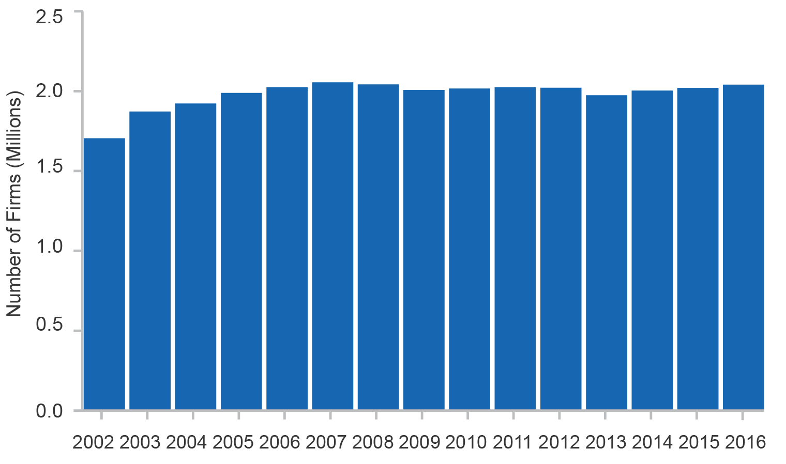

Source: BLADE

The firm entry rate for the industries in the analysis sample is illustrated in Figure 2.2. The entry rate is define as the number of new entries divided by the total number of firms expressed in percentage terms. These rates are plotted alongside the rates reported by the ABS Count of Businesses (Cat.No.8165). The entry rates from the two sources are somewhat different; they are generally lower for the analysis sample from the BLADE owing to the application of the filters mentioned above. Still, the movements of the two series are very much in parallel.

Figure 2.2: The rate of firm entry as percentage of all firms.

| The firm entry rate falls from 17 per cent in 2003 to about 11 per cent in 2013, then rises to about 15 per cent in 2016. The numbers reported by the ABS are slightly higher and also cover the year 2017, where the netry rate is about 16 per cent. |
| --- |

Source: BLADE and ABS Cat.No.8165

Bakhtiari (2019a) describes falling entrepreneurship during the decade following 2002. This trend is also evident in Figure 2.2 for both series, where the entry rate is falling for most parts. However, the trend switches direction after 2013 in both series and recovers some of the ground lost. Still, the firm entry rate in 2016 is below that in 2002, which is the starting year of the series.

# Measuring market power

## Market concentration to market power

Most often, market power and competition in an industry are measured by the concentration of its market. A common measure of market concentration is the HHI and has the advantage that it can easily be constructed using information that are readily observable in most surveys or administrative records. Formally, the HHI is formed as

${HHI}_{it}=\sum_{j}{s_{jit}^{2}}$ (1)

In (1), $s_{jit}$ is the share of turnover by firm *j* from the total in industry *i* at time *t*. An industry is defined as a 3-digit ANZSIC. However, at least as early as Lerner (1934), it has been debated whether market concentration, *per se*, is a sufficient statistic for market power (also see Donismoni et al., 1984). The partial disconnect between the HHI and market power is in fact evident in the data. Figure 3.1 shows the average number of incumbent firms (*N*) as a function of the HHI by applying a kernel regression. Each point in the plot corresponds to the HHI of an observation, where an observation is an industry–year. The denser parts of the plot, hence, represent the denser parts of the data.

Figure 3.1: The average number of incumbent firms as a function of the industry’s HHI.

| The average number of firms falls steeply as HHI increases from zero to almost 0.1. After that it stays low but goes up ad down as HHI increases. |
| --- |

Notes: A kernel regression and a bandwidth of 0.05 is used. Industries with the HHI higher than 0.8 are censored for confidentiality protection.

Source: Department of Industry, Innovation and Science (2019)

In this picture, firm population is falling monotonically with the HHI as long as the HHI is smaller than 0.1. When the HHI is larger than 0.1, however, the monotonicity is not as strong. In particular, there are industries with quite concentrated markets that are also inhabited by a large number of firms. This situation does not fully conform to a position of dominance where large firms are controlling the market.

Understanding that the HHI and firm population in an industry, jointly, are a better indication of market power, I propose to use both variables to construct an index of market power that mimics the essence of high concentration and low firm population. The premise is where the market is concentrated but the industry is also populated by a large number of firms, the largest firms are not wielding much market power. This situation is possible, for instance, where the supply elasticity of the fringe competition is high (Donismoni et al., 1984). In such cases, the index of market power should assign a lower rank to these industries compared to a similar industry with the same concentration but few incumbent firms.

I need to emphasise that market power here refers to the monopolistic or horizontal power of a firm to influence other firms in the same industry. Another source of market power is monopsonistic or vertical power, where a dominant client increases its markup by pushing down on the supply price of the input. The latter is out of focus in this study.

The second point is that with this definition, natural monopolies, where there are large natural barriers to entry, are going to be branded as wielding market power. In that sense, the computed market power is accounting for any type of monopolistic power, whether acquired or natural.

## Index of Market Power

In the description provided, the interconnection between the HHI and firm population determines the market power. It happens that the principal component computed from the HHI and the log of firm population exhibits properties that closely mimic that of the market power. For this reason, I will refer to the principal component as the *Market Power* index henceforth.

Table 3.1 reports a series of descriptive statistics for Market Power and also for the other industry-level key variables. One of these variables is the number of incumbent firms (*N*) and the other is the number of firm entries (*E*). The Market Power index (the principal component) is capturing about 75 per cent of the total variations in HHI and *log*(*N*).

Table 3.1: Descriptive statistics for the key and constructed variables.

| Statistic | *HHI* | *N* | *E* | Market Power |
| --- | --- | --- | --- | --- |
| Mean | 0.087 | 9,760.4 | 1,301.1 | 0 |
| Std.Dev. | 0.134 | 19,438.7 | 2,645.6 | 1.222 |
| 10th Pctl. | 0.003 | 245 | 7 | -1.304 |
| 1st Qrtl. | 0.009 | 641 | 44 | -0.868 |
| Median | 0.036 | 2,615 | 253 | -0.182 |
| 3rd Qrtl. | 0.102 | 9,339 | 1,050 | 0.669 |
| 90th Pctl. | 0.227 | 27,120 | 4,191 | 1.487 |
| #Obs | 3,045 | | |

Source: Department of Industry, Innovation and Science (2019)

The simple statistics for the HHI confirm that most industries in Australia are not dominated by large firms. Moreover, most industries are populated by a number of firms ranging from hundreds to thousands. The number of incumbent firms is equally matched by a fair number of firm entries in each year.

The Market Power index, by construction, is centred around zero. The index also shows substantial variation across industries.

The way these variables relate to each other is, however, not apparent from the numbers in Table 3.1. Some inference can be made from the correlation coefficients that are reported in Table 3.2.

Table 3.2: Correlation coefficients between the key variables.

|  | *HHI* | *N* | *E* | *ExpInt* |
| --- | --- | --- | --- | --- |
| *N* | -0.226 |  |  |  |
| *E* | -0.220 | 0.885 |  |
| *ExpInt* | 0.047 | -0.176 | -0.174 |  |
| Market Power | 0.864 | -0.519 | -0.505 | 0.159 |

Source: Department of Industry, Innovation and Science (2019)

The correlation coefficients with the export intensity of industries (ExpInt) are additionally reported in Table 3.2, where export intensity is defined as the total amount of exports in an industry in a year as the proportion of its total income. De Loecker & Warzynski (2012) find a strong association between market power and exporting activity, where exporting firms are wielding higher market powers. Inspecting the correlations with export intensity could particularly test the properties of Market Power along this line.

Foremost, Market Power is positively correlated with the HHI but has a negative correlation with *N*. That is, the index is the highest where markets are concentrated and barely populated by firms. Besides, the constructed Market Power index correlates positively with export intensity, another indicator of industries where market power reigns.

The HHI shows similar properties, too, except that the magnitude of correlations is weaker than those observed for Market Power.

As another sign that the constructed Market Power index is properly sorting the data, I illustrate the relationship between Market Power and firm population in Figure 3.2 using a kernel regression. Again, each point in the plot corresponds to the Market Power of an observation.

Figure 3.2: The average number of firms as a function of Market Power.

| The average number of firms falls monotonically with increasing Market Power index. The average number of firms is very small for indexe values above zero. |
| --- |

Notes: A kernel regression with a Gaussian kernel and a bandwidth of 0.1 is used.

Source: Department of Industry, Innovation and Science (2019)

As one can see, the relationship in this picture is practically monotonic. There is no sign of the non-monotonicities observed in the upper tail of the relation in Figure 3.1. Market Power effectively reorders observations to eliminate those non-monotonicities.

For some specifics, in Table 3.3, I report a few industries that have the lowest and the highest values for the derived index of Market Power. As the table shows, those industries with the highest Market Power are both concentrated and have a very small firm population.

Table 3.3: Industries with lowest and highest Market Power.

| ANZSIC | Division | Description | Market Power | HHI | $$N$$ | $$E$$ | | Secondary |
| --- | --- | --- | --- | --- | --- | --- | --- | --- |
| **Panel A: Lowest Market Power** | | | | | | | | |
| 671 | L | Property Operators | -1.989 | 0.011 | 152,584 | 15,708 | 1.193 | |
| 14 | A | Cattle and Grain Farming | -1.875 | 0.011 | 112,058 | 5,679 | 1.073 | |
| 324 | E | Building Completion Services | -1.856 | 0.009 | 104,243 | 14,416 | 1.036 | |
| 323 | E | Building Installation Services | -1.757 | 0.001 | 72,797 | 9,003 | 0.858 | |
| 692 | M | Architectural and Engineering Serv. | -1.714 | 0.003 | 66,743 | 8,701 | 0.837 | |
| **Panel B: Highest Market Power** | | | | | | | | |
| ANZSIC | Division | Description | Market Power | HHI | $$N$$ | $$E$$ | Secondary | |
| 189 | C | Other Basic Chemical Products | 2.468 | 0.350 | 145 | 16 | 0.303 | |
| 822 | P | Educational Support Services | 2.498 | 0.491 | 930 | 193 | 1.758 | |
| 472 | I | Rail Passenger Transport | 2.615 | 0.304 | 54 | 2 | -0.328 | |
| 221 | C | Iron and Steel Forging | 3.012 | 0.435 | 114 | 12 | 0.653 | |
| 262 | D | Electricity Transmission | 4.214 | 0.568 | 31 | 4 | 0.853 | |

Notes: Industries with fewer than 10 firms are dropped for confidentiality protection.

Source: Department of Industry, Innovation and Science (2019)

For comparison, Table A1 in the appendix lists industries with the highest HHI. Industries in Table A1 that have very concentrated markets but also a large population of firms are absent from panel (B) of Table 3.3; Market Power is assigning a lower score to these industries for not having the power to curb a build-up of firm population.

## The Secondary Index

The derivation process for Market Power also involves the creation of a secondary component that embodies the remaining variations not captured by the principal component. A set of descriptive statistics for this index is listed in Table 3.4.

Table 3.4: Descriptive statistics for the Secondary Index.

| Panel A: Descriptive Statistics | | | |  |  |
| --- | --- | --- | --- | --- | --- |
|  | Mean | Std.Dev. | 10th Pctl. | 1st Qrtl. | Median |
| Secondary | 0 | 0.712 | -0.744 | -0.422 | -0.080 |
|  |  |  | 3rd Qrtl. | 90th Pctl. | #Obs |
|  |  |  | 0.301 | 0.793 | 3,045 |
|  |  |  |  |  |  |
| Panel B: Correlations | | | |  |  |
|  | *H* | *N* | *E* | *ExpInt* | Market Power |
| Secondary | 0.504 | 0.442 | 0.430 | -0.179 | 0 |

Source: Department of Industry, Innovation and Science (2019)

From the statistics, it appears that the Secondary index has some properties of its own. The correlation coefficients, in particular, reveal that this index is positively correlated with both the HHI and firm population. In essence, it represents those industries that are concentrated but still populated by a large number of firms.

Figure 3.3 shows the average number of firms as a function of the Secondary index using a kernel regression. Each point in the plot represents the Secondary index of an observation in the data. The relationship is mostly monotonic and increasing: a higher Secondary index corresponds to a larger firm population. Only for a handful of observations with very concentrated markets, the number of firms falls with the index.

Figure 3.3: The average number of firms as a function of the Secondary Index.

| The average number of firms increases with secondary index up the index value of one. Above index value of one it falls . |
| --- |

Notes: A kernel regression with a Gaussian kernel and a bandwidth of 0.1 is used. Observations in top percentile are dropped for confidentiality protection.

Source: Department of Industry, Innovation and Science (2019)

Overall, the index appears to have elements representing the attractiveness of an industry to firms. Such attractiveness could, for example, stem from low entry barriers or the size and the profitability of the market. As a result, more firms will enter, and the firm population of the industry could grow even in the face of dominating contender.

## Time trends

The HHI has not stayed the same in Australia over the years. The changes that took place from 2002 to 2016 are illustrated in Figure 3.4(a), where the coordinates of every point is the HHI of 3-digit industries in 2002 then in 2016. As the plot shows, despite staying almost the same for most industries, the HHI has also changed, either increased or decreased, in several others.

Figure 3.4: The index value in 2016 versus the value in 2002 by industry‒year.

**(a)**

| HHI in 2002 is on x-axis and HHI in 2016 is on y-axis. The points are scattered both above and below the 45 degree line. The deviations from 45 degree line increase with HHI. |
| --- |

**(b)**

| Market power index in 2002 is on x-axis and market power index in 2016 is on y-axis. The points are scattered both above and below the 45 degree line, but the deviations are smaller than tose with HHI. The deviations from 45 degree line increase with market power index. |
| --- |

**(c)**

| Secondary index in 2002 is on x-axis and secondary index in 2016 is on y-axis. The points are scattered mostly above the 45 degree line, but rather close to it. There are still a few points both above and below the 45 degree line that have large deviations from the line. |
| --- |

Notes: In (a), industries with the HHI above 0.8 are dropped for confidentiality protection.

Source: Department of Industry, Innovation and Science.

Panels (b) and (c) in Figure 3.4 illustrate the same trend but for Market Power and Secondary indexes. These two indexes also show some change at industry level. However, they are more stable in the sense that the industries, especially with Market Power, are more clustered along the 45 degree line than with the HHI.

The other interesting observation from panel (b) of Figure 3.4 is that, when it comes to the changes in market power, most of the action is taking place for industries who’s Market Power are above the value zero. For most industries whose Market Power are below zero, Market Power appears to be dropping over the years but not by a great amount. As will become clear in the next sections, this observation bears important implications for whether the changes in market power are the driving force behind declining entrepreneurship.

In more details, Bakhtiari (2019b) shows that the average HHI across industries falls prior to 2007 and then starts increasing up to 2012 and stays rather steady since. These movements are depicted in Figure 3.5 alongside those for Market Power and Secondary indexes. All indexes are transformed to start from zero and have a maximum magnitude of one, so that the co-movements of the series can be more easily detected.

Figure 3.5: The time trend of the HHI, Market Power, and the Secondary Index.

| HHI falls a bit from 2002 to 2005, but then increases rather steeply from 2005 to 2012. After that there is no celar trend. Market pwoer index follows very much the same trend as HHI. Secondary index rises all the way from 2002 to 2012 but has no clear trend afterwards. |
| --- |

Notes: Time series are transformed to start from zero and have a maximum magnitude of one.

Source: Department of Industry, Innovation and Science (2019)

Some elements of the observed trend in the HHI is reflected in time movements of Market Power and Secondary indexes. Market power behaves very much in line with the changes in the HHI: it mostly falls prior to 2007, then rises up until 2012, and then has a rather flat trend.

The Secondary index is increasing over the early years up until 2012. After 2012, the index lacks any specific direction.

# Firm entry: parametric approach

From a theoretical point of view, where large firms have market power, they will use their power to curb the entry of potential rival firms. As a result, firm entry should fall with increasing market power. On its face, the correlations from Table 3.2 do point out that firm entry falls with market power (and also with the HHI).

A more detailed indication is evident from Figure 4.1. In this picture, I estimate the average number of firm entries as a function of Market Power using kernel regression. Again, each point in the plot corresponds to the Market Power of an observation.

Figure 4.1: Average number of firm entries as a function of Market Power.

| Average number bof firm entries falls steeply with increasing market power index. For index values larger than zero, firm entry is almost zero. |
| --- |

Notes: A kernel regression with a Gaussian kernel and a bandwidth of 0.1 is used.

Source: Department of Industry, Innovation and Science (2019)

As the figure shows, the number of firm entries falls steeply with Market Power for values from -2 towards zero. When Market Power is about zero, the number of firm entries hits the bottom; thereafter, the number of firm entries practically remains close to zero.

For a more rigorous statistical analysis of the relation, I apply a Negative Binomial Regression (NBR). In the NBR specification, the expected number of firm entries is modelled as:

(2)

In the specification above, the key covariates are Market Power and Secondary indexes. The economy-wide effects are absorbed by the set of year dummies, . The estimated results appear in Table 4.1.

Table 4.1: Negative binomial regression models of firm entry as a function of market power.

|  | Dependent: Number of firm entries | | |
| --- | --- | --- | --- |
| Variable | (1) | (2) | (3) |
| Market Power | −1.310 | −1.306 | −1.288 |
|  | (0.009) | (0.009) | (0.020) |
| Secondary | 1.397 | 1.419 | 1.426 |
|  | (0.014) | (0.015) | (0.017) |
| ΔMarket Power |  | −0.114 | −0.116 |
|  |  | (0.033) | (0.033) |
| Market Power×|Market Power| |  |  | −0.009 |
|  |  |  | (0.009) |
| Log Likelihood | -18,361.3 | -17,008.1 | -17,007.6 |
| Wald | 4.10 | 3.78 | 3.78 |
| #Obs | 2,842 | 2,639 | 2,639 |

Notes: Numbers in parenthesis are standard deviation. *** indicates significance at 1 per cent level. Unit of observation is industry–year

Source: Department of Industry, Innovation and Science (2019)

In column (1) of the table, a higher Market Power pushes down the average number of firm entries. The model is predicting that for every 0.1 point increase in Market Power – rather a small increase compared to the full range of the index – the average number of firm entries falls by about 14 per cent.[2] On the other hand, a higher Secondary value – already interpreted as industry’s attractiveness to potential entrepreneurs – coincides with a higher number of firm entries. Both effects are statistically significant.

In column (2), I add the year-on-year change in Market Power to investigate the more immediate impact of a change in Market Power on firm entry, where differencing is defined as

(3)

This effect is meant to test whether increasing market power in an industry has any effect on the number of firm entries in the same industry. I refrain from including the change in Secondary index, as it almost perfectly correlates with the change in Market Power.

The estimated coefficient shows that an increase in Market Power of an industry also has a negative and statistically significant effect on the average number of firm entries in that industry. This evidence on top of the previous findings further cements the detrimental effect of Market Power on firm entry.

In column (3), I add a quadratic term for Market Power to test whether a more detailed parametric model of Market Power is warranted. Note the peculiar way the quadratic term is added; it is because Market Power can assume both positive and negative values, and this quadratic term is preserving the sign. The estimated coefficient for the quadratic term is very small in magnitude and statistically insignificant. A likelihood ratio test between columns (2) and (3) also confirms that the quadratic term is adding very little to the quality of the estimates.

The parametric models estimated so far show that Market Power acts against firm entry. Moreover, the effect spreads fast: increasing Market Power in an industry causes firm entry to drop in that industry over the following year. In the next section, I will use a semi-parametric approach to make quantitative predictions about the scale of the drop.

# From market power to entrepreneurship decline

The number of firm entries in the analysis sample falls from 316,000 in 2003 to about 301,000 in 2016, a drop of almost 15,000 firm entries. In the interim, the Market Power index shows a period of sharp increase (Figure 3.5). In this section, I mainly address the question of whether Market Power played a major role in the observed decline of firm entry and how much of the drop in entrepreneurship can be directly associated with the increasing market power.

Figure 5.1 illustrates the general idea. If an industry has a Market Power of *MP*1 in 2003, for instance, and a Market Power of *MP*2 in 2016, then using the relationship it is possible to deduce that firm entry should fall by *E*2-*E*1 over the period. The industry-level changes can then be aggregated to yield the total change in firm entry of the economy associated with the changes in Market Power alone.

Figure 5.1: Estimating the change in the number of entries as a result of change in Market Power index using the non-parametric relationship.

| A hypothetical downward curve that describes the negative relation between market power and firm entry. As market power increases from MP1 to MP2, firm entry will fall from E1 to E2. |
| --- |

Source: Department of Industry, Innovation and Science (2019)

The non-parametric relationship in Figure 4.1 sets a starting point. However, as Table 4.1 shows, average firm entry is also affected by the Secondary and time effects. These effects need to be factored out of the relationship so that what remains is basically the direct effect of Market Power on firm entry.

For this purpose, I apply the two-step methodology of Yatchew (1998). Let the number of firm entries in a 3-digit industry be governed by the following semi-parametric model:

$E_{+1,k',}=G({Market Power}_{k^{'}})×exp\left(α_{A}{Secondary}_{k'}+\sum_{s=2002}^{2015}{α_{s}T_{k^{'},s}}\right)$ (4)

where *k*’ indexes industry-year observations in no particular order. *E*+1,k’ is the number of firm entry for an observation over the following year (in *t*+1 as before but for the same industry). In this model, *Tk*’,*s* is a dummy that indicates whether observation *k*' belongs to year *s*. *G*(.) is a smooth function with bounded derivatives.

The particular functional form chosen in (4) is essential as it constrains all predicted values to be feasible (no negative number of entries). It further conforms to the functional form in (2) and makes the estimated results for the parametric parts comparable.

In the first step, all observations are sorted in ascending order by their Market Power. Let the ordering be indicated by *k* such that

${Market Power}_{k}≥{Market Power}_{k-1}, ∀k$.

Taking logs from both sides of (4) and differencing gives

$$\log\left(E_{+1,k}\right)-\log\left(E_{+1,k-1}\right)=log\left(G\left({Market Power}_{k}\right)\right)-log\left(G\left({Market Power}_{k-1}\right)\right)$$ $+α_{A}\left({Secondary}_{k}-{Secondary}_{k-1}\right)$ (5)

$$+\sum_{s=2002}^{2015}{α_{s}\left(T_{k,s}-T_{k-1,s}\right)}$$

Yatchew (1998) posits that the smoothness assumption on *G*(.) implies that

(6)

if *Market Powerk* and *Market Powerk-1* are sufficiently close. Applying this simplification to (5) generates a linear equation for which or $α_{A}$ and or $α_{s}$ s can be consistently estimated using Ordinary Least Squares (OLS). Note that the differenced time dummies in (5s) sum to zero, hence, it is necessary to enforce to avoid collinearity.

In the second step, the estimated effects are deducted from (4) to yield ${\tilde{E}}_{+1,k}=G({Market Power}_{k})$. At this point, function *G*(.) can be estimated using a kernel regression, yielding the non-parametric estimate Ĝ(.).

The estimated value for $α_{A}$ along with some model statistics from the first step are listed in Table 5.1. The estimated time effects and the associated 90 per cent confidence intervals are shown in Figure 5.2.

Table 5.2: The first step estimation of Yatchew (1998) method.

| Variable | Coefficient | Std.Err. |
| --- | --- | --- |
| Secondary | 1.420*** | (0.020) |
|  | 0.662 |  |
| *F* | 424.4*** |  |
| #Obs | 2,831 |  |

Source: Department of Industry, Innovation and Science (2019)

Figure 5.2: The estimated time effects in the first stage.

| The estimated time effects show a fall from 2002 to 2012 and then a slight increase afterwards. The confidence intervals show that most estimates are statistically significant. |
| --- |

Source: Department of Industry, Innovation and Science (2019)

The time effects, in particular, suggest a secular decline in entrepreneurship that affected all industries and goes on for most of the early years in the data and hits its nadir in 2012. The trend somewhat recovers after 2012; still, it remains in the negative territory.

The estimated non-parametric function Ĝ(*H*) from the second step is illustrated in Figure 5.3 alongside with the original non-parametric relationship that was first observed in Figure 5.3. The filtering of the first step takes out the Secondary and time effects. As a result, the relationship appears to have become smoother, especially in the upper tail.

Figure 5.3: The non-parametric relationship between firm entry and Herfindahl-Hirschman index.

| The estijmated non-parametric relationship is super imposed on the previosuly estimated falling firm entry by market power index. The non-paramnteric estimate shows a unimodal relationship that hits the maximum around index value of 0.5 and then falls monotonically afterwards. |
| --- |

Notes: A kernel regression with the bandwidth of 0.1 is used.

Source: Department of Industry, Innovation and Science (2019)

Ĝ(.) can be used in the same conceptual framework as in Figure 5.1. The goal is to compute change in firm entry of industry *i* from year *t*1 to year *t*2 (>*t*1) as Market Power changes, keeping all else fixed at *t*1. Based on (4), it is possible to show that the estimated change is

(7)

In (7), embodies all the industry conditions in $t_{1}$. The economy-wide changes will be the aggregation of the industry-level changes computed from (7).

Using (7), the changes predicted in the number of firm entries from 2002 to 2015 is reported in Table 5.2. In this table, the average ΔMarket Power is the simple mean of all changes in Market Power at 3-digit level industries. $∆E_{+1}$ in Table 5.2 is the actual change in the number of firm entries for the following year over the period from *t*1 to *t*2. is the predicted part associated with the change in Market Power, keeping all else fixed at their value.

Table 5.3: Changes in the number of entry and the predicted change associated with change in market power.

| Years | | Average |  |  |
| --- | --- | --- | --- | --- |
| From | To | ΔMarket Power |  |  |
| 2002 | 2015 | 0.046 | -14953 | 93,544.6 |
| 2002 | 2007 | -0.116 | -31698 | 107,371.0 |
| 2007 | 2012 | 0.101 | -73786 | 3,908.8 |
| 2012 | 2015 | 0.062 | 90532 | 321,903.9 |

Source: Department of Industry, Innovation and Science

As mentioned above, the first row in the table pertains to the choice of $t_{1}=2002$ and $t_{2}=2015$. The results indicate that the average market power increased by a small amount from 2002 to 2015, matched by a drop of about 15,000 entries. However, the predicted value for the estimated relationship suggests that the number of firm entries over the same period must have increased by about 93,500. In this case, Market Power does not seem to offer any clues as to why firm entry should fall over the period.

Figure 3.5 points to a changing pattern in Market Power time trend. Market Power mostly falls prior to 2007 and then steeply rises up until 2012. Thereafter, the trend is much flatter. To test the predictive power of the model during the middle period when Market Power is fast increasing, I split the sample into three subsamples that span years 2002–2007, 2007–2012 and 2012–2015.

The predicted changes in firm entry for each sub-period are listed in the last three rows of Table 5.2. None of the estimated number of entries is close to the actual changes that took place.

For the 2002 to 2007 period, the computed value predicts that firm entry should have increased by about 107,000 in line with a drop in the average Market Power. The actual number is a drop of almost 32,000 in firm entries.

During 2007 to 2012 that market power is growing, the predicted number of firm entries drops to its lowest, but still predicts an increase of about 4,000 firm entries over the period. In reality, the number of entries fell by a massive 74,000 firms.

In the last period from 2012 to 2015, both the predicted and actual numbers point to an increase in firm entry. However, there is still a wide wedge between the two numbers which points to other factors besides market power that are moderating the rate of firm entry.

Within 3-digit ANZSIC codes, the picture is almost identical. Figure 5.4 shows the actual change in firm entry for each 3-digit industry and also the predicted change by each industry’s market power in the beginning year.

Figure 5.4: Actual versus predicted change in the number of firm entries by 3-digit industries and by the industry’s market power in the beginning year .

**(a)**

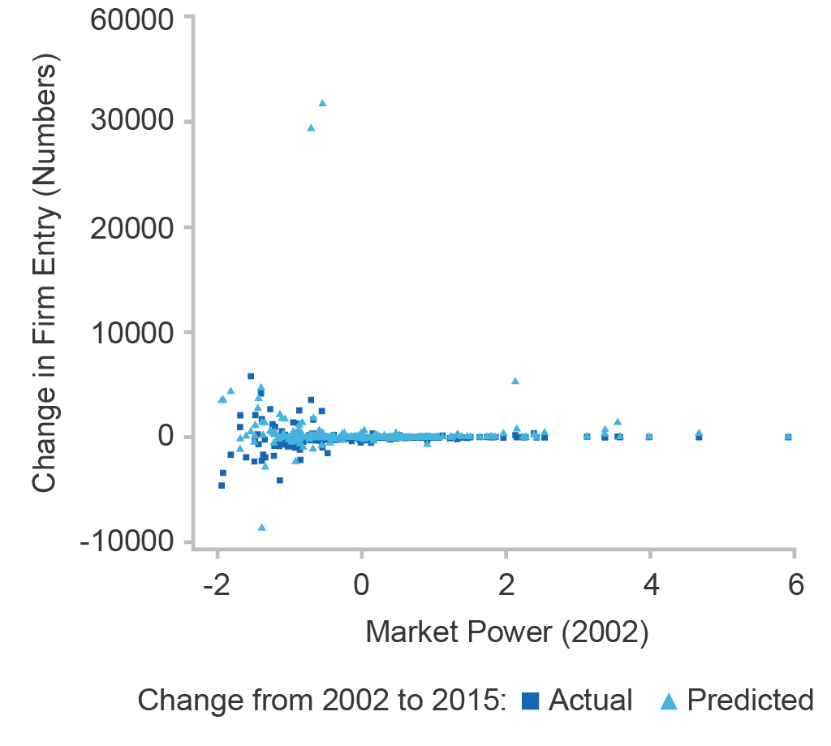

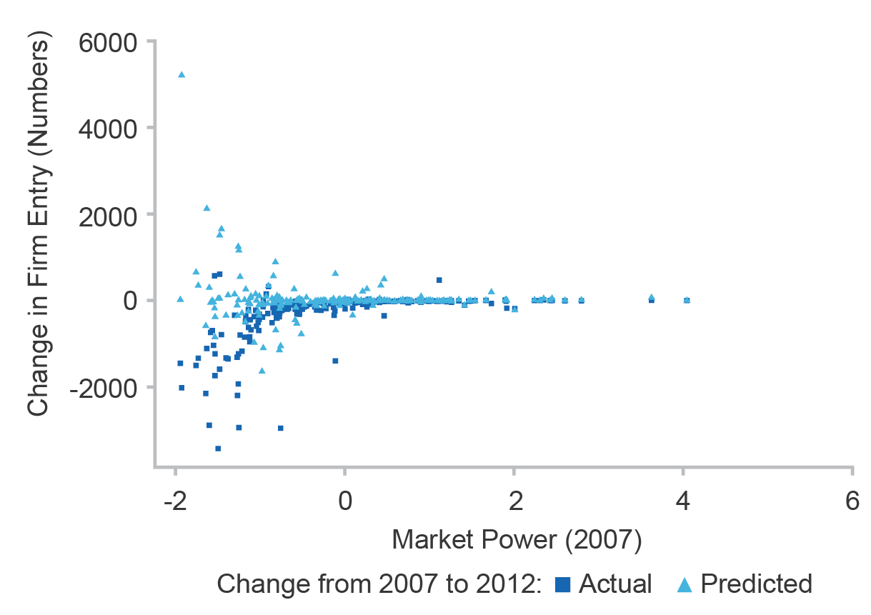**(b)**

Source: Department of Industry, Innovation and Science (2019)

Even at industry level, most industries show a drop in the actual number of firm entries. This trend is especially visible in panel (b) where the data is narrowed to the 2007–2012 period. This is the period that, again, market power was on the rise.

The predicted values, on the other hand, show increases in firm entry across most industries. This is particularly true for industries whose Market Power index is below zero, that is, the already competitive industries.

Industries with high market power are the ones experiencing an increase in market power. They do not show much increase or decrease in firm entry; firm entry in those industries is already too low.

To sum up, the unexpected results are due to the peculiar way market power interacts with firm entry. As is evident from Figure 5.3, the upper tail of the relationship almost touches the zero line when Market Power is larger than zero. That is, any change in Market Power will generate negligible results in the aggregate statistics as long as the index of Market Power stays above zero.

On the other hand, a slight change in Market Power of industries that lie to the left of zero has substantial impact. As it turns out, most of the increase in Market Power happened among industries whose index of Market Power was above zero (Bakhtiari, 2019a). In the process of aggregation, any drop in firm entry of these industries will be ultimately masked by the increases predicted in the more competitive industries.

To this end, increasing Market Power does not seem to be the driving force behind the fall in entrepreneurship. The omnipresence of the fall in firm entry across all industries, even where Market Power is not increasing, points to other factors or a secular trend being behind the trend.

# Conclusion

The evidence supports the notion that the increasing market power of a few firms can threaten entrepreneurship in an industry. A series of parametric estimations provide support that increasing market power is detrimental to firm entry. This situation is certainly undesirable from a social and economic point of view. Weak entrepreneurship hinders innovative young firms from entering and getting a foothold. The process of resources reallocation towards more productive and innovative firms will also be stalled. In turn, productivity and economic growth would slow down.

Market power in Australia has been increasing among some industries, with the fastest trend happening during the 2007 to 2012 period. One would think that the drop in the number of entrepreneurs is a side effect of this increasing market power. However, estimates do not substantiate any role for market power as the main cause of the entrepreneurship decline. A secular trend common to all industries or some other factor appears to be the main driving force behind the entrepreneurship decline. For instance, Bakhtiari (2019a) contemplates a few other factors such as tightening credit or international competition as alternative explanations.

###### Concentrated industries

Industries with the highest level of concentration, according to their HHI, are listed in Table A1 for comparison to those with the highest market power. For confidentiality protection, industries with fewer than 10 firms are dropped.

Table A1: The most concentrated industries.

| ANZSIC | Division | Description | Average HHI | Average *N* |
| --- | --- | --- | --- | --- |
| 580 | J | Telecommunication Services | 0.389 | 1,252 |
| 161 | C | Printing and Support Services | 0.421 | 7,042 |
| 221 | C | Iron and Steel Forging | 0.435 | 114 |
| 822 | P | Educational Support Services | 0.491 | 930 |
| 262 | D | Electricity Transmission | 0.568 | 31 |

Notes: Industries with fewer than 10 firms are excluded for confidentiality protection.

Source: Department of Industry, Innovation and Science (2019)

I am also replicating the parametric estimates in Section 4 using the HHI instead of Market Power with the intention of showing how relying on the HHI leads to weaker and sometimes inconsistent results. The main parametric specification has a very similar composition and has the form:

(8)

In the specification above, the key covariates are the HHI and the log of firm population. The economy-wide effects are, again, absorbed by the set of year dummies, .

The estimated coefficients in (8) are listed in Table A2. In column (1) of the table, I am looking at the generic relationship between firm entry and the HHI and, as expected, find a negative and statistically significant relationship.

Table A2: Negative binomial regression models of firm entry as a function of the HHI.

|  | Dependent: Number of firm entries | | |
| --- | --- | --- | --- |
| Variable | (1) | (2) | (3) |
| HHI | −4.533 | 0.455 | 0.533 |
|  | (0.211) | (0.088) | (0.097) |
| log(*N*) |  | 1.040 | 1.045 |
|  |  | (0.006) | (0.007) |
| ΔHHI |  |  | −0.286 |
|  |  |  | (0.175) |
| Log Likelihood | −22,117.200 | −18,361.250 | −17,012.780 |
| Wald | 64,046.4*** | 409,748.3*** | 376,208.9*** |
| #Obs | 2,842 | 2,842 | 2,639 |

Notes: Numbers in parenthesis are standard deviation. *** indicates significance at 1 per cent level. Unit of observation is industry–year.

Source: Department of Industry, Innovation and Science (2019)

In column (2) of the table, both the HHI and firm population are included and the results are unexpected. Using both variables simultaneously implies that firm entry increases with both the HHI and firm population of the industry. However, as indicated by the correlations in Table 3.2, there is a lot of overlap between the two variables. This overlap was reduced when the two variables are converted into Market Power and Secondary indexes.

In column (3), I add the year-on-year change in HHI to investigate the real-time effect of the changes in HHI on firm entry, where differencing is defined as

(9)

The estimated coefficient suggests a fall in the firm entry of an industry as the industry becomes more concentrated. However, the estimated effect is not statistically significant, again, leading to a weaker result than those observed in Table 4.1.

Disclaimer

The results of these studies are based, in part, on ABR data supplied by the Registrar to the ABS under A New Tax System (Australian Business Number) Act 1999 and tax data supplied by the ATO to the ABS under the Taxation Administration Act 1953. These require that such data is only used for the purpose of carrying out functions of the ABS. No individual information collected under the Census and Statistics Act 1905 is provided back to the Registrar or ATO for administrative or regulatory purposes. Any discussion of data limitations or weaknesses is in the context of using the data for statistical purposes, and is not related to the ability of the data to support the ABR or ATO’s core operational requirements. Legislative requirements to ensure privacy and secrecy of this data have been followed. Only people authorised under the Australian Bureau of Statistics Act 1975 have been allowed to view data about any particular firm in conducting these analyses. In accordance with the Census and Statistics Act 1905, results have been confidentialised to ensure that they are not likely to enable identification of a particular person or organisation. Views expressed in this paper are those of the author and not necessarily those of the Department of Industry, Innovation and Science or the Australian government.

References

Aghion P, Bloom N, Blundell R, Griffith R & Howitt P (2005) [Competition and Innovation: an Inverted-U Relationship](https://doi.org/10.1093/qje/120.2.701%20), Quarterly Journal of Economics, 120(2), pp.701–728.

Aghion P, Fally T. & Scarpetta S (2007) [Credit Constraints as a Barrier to the Entry and Post-entry Growth of Firms](https://doi.org/10.1111/j.1468-0327.2007.00190.x%20), Economic Policy, 22(52), pp.732–779.

Autor D, Dorn D, Katz LF, Patterson C & Van Reenen J (2017) [Concentrating on the Fall of the Labor Share](https://doi.org/10.1257/aer.p20171102), American Economic Review, 107(5), pp.180–185.

Bajgar M, Berlingieri G, Calligaris S, Criscuolo C & Timmis J (2019) [Industry Concentration in Europe and North America](https://doi.org/10.1787/2ff98246-en), OECD, Productivity Working Paper, No.18.

Bakhtiari S (2019a) [Entrepreneurship Dynamics in Australia: Lessons from Micro-data](https://doi.org/10.1111/1475-4932.12460), Economic Record, 95(308), pp.114‒140.

Bakhtiari S (2019b) [Trend in Market Concentration of Australian Industries](https://www.industry.gov.au/data-and-publications/trends-in-the-market-concentration-of-australian-industries), Australia Dept. of Industry, Innovation and Science, Working Paper 8/2019.

Decker RA, Haltiwanger JC, Jarmin RS & Miranda J (2014), [The role of entrepreneurship in U.S. job creation and economic dynamism](http://doi.org/10.1257/jep.28.3.3), Journal of Economic Perspectives, 28(3), pp.3–24.

De Loecker J & Warzynski F (2012) [Markups and Firm-Level Export Status](https://doi.org/10.1257/aer.102.6.2437), American Economic Review, 102(6), pp.2437–2471.

Donismoni MP, Geroski P & Jacquemin A (1984) [Concentration Indices and Market Power: Two Views](https://doi.org/10.2307/2098227), Journal of Industrial Economics, 32(4), pp.419–434.

Elzinga KG & Mills DE (2011) [The Lerner Index of Monopoly Power, Origins and Uses](https://doi.org/10.1257/aer.101.3.558), American Economic Review, 101(3), pp.558–564.

Guschanski A & Onaran O (2018) [The Labour Share and Financialisation: Evidence from Publicly Listed Firms](http://gala.gre.ac.uk/19371/), Greenwich Papers in Political Economy, University of Greenwich, Paper No. GPERC59.

Haltiwanger JC, Jarmin RS & Miranda J (2013) [Who Creates Jobs? Small vs. Large vs. Young](http://doi.org/10.1162/REST_a_00288%20), Review of Economics and Statistics, 95(2), pp.347–361.

Hansell D & Rafi B (2018) [Firm-Level Analysis Using the ABS’ Business Longitudinal Analysis Data Environment (BLADE)](https://doi.org/10.1111/1467-8462.12253), Australian Economic Review, 51(1), pp.132–138.

Landes WM & Posner RA (1981) [Market Power in Antitrust Cases](https://doi.org/10.2307/1340687), Harvard Law Review, 94(5), pp.937–996.

Lerner AP (1934) [The Concept of Monopoly and the Measurement of Monopoly Power](https://doi.org/10.2307/2967480), Review of Economic Studies, 1(3), pp.157–175.

MacDonald R (2014) [Business Entry and Exit Rates in Canada: A 30-year Perspective](http://www.statcan.gc.ca/pub/11-626-x/11-626-x2014038-eng.pdf), Statistics Canada, Cat.No.11-626-X, No.038.

Naudé W (2019) [The Decline Entrepreneurship in the West: Is Complexity Ossifying the Economy?](http://ftp.iza.org/dp12602.pdf) IZA Discussion Paper, No.12602.

Orr D (1974) [The Determinants of Entry: A Study of the Canadian Manufacturing Industries](https://doi.org/10.2307/1927527%20), Review of Economics and Statistics, 56(1), pp.58–66.

Shambaugh J, Nunn R, Breitwieser A & Liu P (2018) [The State of Competition and Dynamism: Facts about Concentration, Start-ups, and Related Policies](https://www.brookings.edu/research/the-state-of-competition-and-dynamism-facts-about-concentration-start-ups-and-related-policies/), Brookings Institution, Economic Facts Report, June.

Siegfried JJ & Evans LB (1994) [Empirical Studies of Entry and Exit: A Survey of the Evidence](https://doi.org/10.1007/BF01035654), Review of Industrial Organization, 9(2), pp.121–155.

Ugur M, Trushin E, Solomon E (2016) [A Firm-level Dataset for Analyzing Entry, Exit, Employment and R\&D Expenditures in the UK: 1997--2012](https://doi.org/10.1016/j.dib.2016.05.028), Data in Brief, 8, 153--157.

Yatchew A (1990) [Nonparametric Regression Techniques in Economics](http://www.jstor.org/stable/2565120), Journal of Economic Literature, 36(2), pp.669–721.

1. Fiscal years in Australia begin on July 1st and end on 30th June the next year. Throughout the paper, I refer to fiscal years by the ending year, so that fiscal year 2002-03 is referred to as the year 2003.
2. Considering the form of the model in (2), the percentage change in firm entry for a 0.1 increase in Market Power is