How to apply for an  
anti-circumvention inquiry: avoidance of the intended effect of duty

Instructions and guidelines for applicants

March 2020

Contents

Contents 2

Purpose 4

Introduction 4

What is a circumvention activity that avoids the intended effect of duty 5

What is not a circumvention activity that avoids the intended effect of duty 5

Who can apply 5

How to apply 6

Information required by the application form 6

Supporting evidence 6

Guidance to Question 6 7

Example 1 8

Reasonable period 9

Guidance to Question 7 9

The inquiry process 10

The Act 10

Public record 10

Consideration of application 10

Submissions 10

Verification of information 10

Termination 11

Report on anti-circumvention inquiry 11

Minister’s powers 11

Rights of review 11

Find out more 12

#### **Approval and version history**

|  |  |  |  |
| --- | --- | --- | --- |
| **Version** | **Change** | **Date** | **Approver** |
| 1.0 | Original version | March 2020 | Paul Sexton - General Manager Anti-Dumping Commission |
| 1.1 | Contact details updated | October 2024 | Isolde Lueckenhausen – Acting Commissioner of the Anti-Dumping Commission |

# Purpose

This guide outlines the steps involved in applying to the [Anti-Dumping Commission](https://www.industry.gov.au/about-us/our-structure/anti-dumping-commission) (the Commission) for an anti-circumvention inquiry into avoidance of the intended effect of duty.

Specifically, this guide sets out:

* who can apply
* how to apply
* information required by the application form;
* the inquiry process
* where to find more information.

Related policies and references include:

* [How to apply for an anti-circumvention inquiry](https://www.industry.gov.au/regulations-and-standards/anti-dumping-and-countervailing-system/applying-for-an-anti-circumvention-inquiry) (excluding avoidance of the intended effect of duty)
* [Dumping and Subsidy Manual](https://www.industry.gov.au/data-and-publications/dumping-and-subsidy-manual)

Introduction

Circumvention is a trade strategy used by exporters and/or importers of products to avoid either:

1. the full payment of dumping and/or countervailing duties; or
2. the price effect of the dumping and/or countervailing duties in the Australian market.

Circumvention activities take various forms and exploit different aspects of the anti-dumping system, but the outcome of these activities is that either:

1. the relevant goods do not attract the intended dumping and/or countervailing duty; or
2. the relevant goods attract dumping and/or countervailing duty, which is paid, but the payment of the duty does not have the intended price effect in the market (and therefore does not have the effect of removing the material injury caused by dumped and/or subsidised prices).

This guide outlines the steps involved in applying to the Commission for an anti‑circumvention inquiry into the avoidance of the intended effect of duty (point b above).

For guidance on applying to the Commission for an anti-circumvention inquiry into all other types of circumvention activity (points a above), please refer to [*‘How to apply for an anti‑circumvention inquiry (excluding avoidance of the intended effect of duty)’*](https://www.industry.gov.au/regulations-and-standards/anti-dumping-and-countervailing-system/applying-for-an-anti-circumvention-inquiry).

A circumvention activity in the form of avoidance of the intended effect of duty may take place where goods which incur dumping or countervailing duties are exported to Australia, and the importer, whether directly or through an associate, sells those goods in Australia without increasing the price commensurate with the total amount of duty payable on the goods.

## What is a circumvention activity that avoids the intended effect of duty

Section 269ZDBB(5A) of the [*Customs Act 1901*](https://www.legislation.gov.au/Details/C2019C00314) (the Act) sets out when a circumvention activity avoiding the intended effect of duty occurs (in relation to a notice published following an investigation, under sections 269TG(2) or 269TJ(2) of the Act).

Further detail is in the ‘information required by the application form’ section of these guidelines.

## What is not a circumvention activity that avoids the intended effect of duty

It is not a circumvention activity if external factors (such as currency fluctuation or reduction in other selling and general expenses) have caused the circumstance where the selling price of the goods by the importer has not increased in accordance with the imposition of duties.

Further, recognising that profit reduction can be a legitimate business practice, it may not be a circumvention activity if an importer, who is truly independent of the exporter from whom it purchases its goods, is absorbing the payment of the dumping and/or countervailing duty through a partial reduction in profit.

An applicant may not be aware of the circumstances that result in the commercial effect of the imposition of duties not being reflected in the Australian market for the goods the subject of measures. As such, an applicant may need only provide evidence to support a prima facie case that the selling prices of goods subject to measures have failed to increase in line with the anticipated effect of duties payable.

Who can apply

A person representing, or representing a portion of, the Australian industry producing like goods can make an application for an anti-circumvention inquiry.

If the Commissioner has previously published a notice indicating that such an inquiry would be undertaken following an application, the same applicant cannot lodge another application for an avoidance of the intended effect of duty inquiry until 12 months after the publication of the Commissioner’s notice.

How to apply

You must use the approved application form (Form B1257 available on the Commission’s [website](https://www.industry.gov.au/regulations-and-standards/anti-dumping-and-countervailing-system/applying-for-an-anti-circumvention-inquiry)). You must lodge the application form, together with the supporting evidence, in an approved manner (by post, email or SIGBOX).

The preferred method of lodging an application is to email applications to [clientsupport@adcommission.gov.au](mailto:clientsupport@adcommission.gov.au). Please include all supporting evidence with your application. If file sizes are too large to email, please contact the [Commission](https://www.industry.gov.au/about-us/our-structure/anti-dumping-commission) to arrange access to SIGBOX, our secure online lodgement platform. Alternatively, you can post completed applications to the Commission. Refer to [contact](https://www.industry.gov.au/about-us/our-structure/anti-dumping-commission) details.

You must provide a non-confidential version of the application, including supporting evidence.

Information required by the application form

An application must include a description of the:

* kind of goods that are the subject of the notice
* notice the subject of the application
* circumvention activity in relation to the notice that the applicant considers have occurred
* alterations to the notice that the applicant considers should be made.

An application alleging the avoidance of the intended effect of duty must **not** include any other kind of circumvention activity.[1] A separate application form (Form B1236) and related guidelines exist for the other circumvention activities prescribed in the Act.

## Supporting evidence

The application form requires you to provide a statement setting out the reasons for alleging the circumvention activity is occurring, supported by relevant evidence. You should make sure your responses are as accurate and as comprehensive as possible. Simply asserting that circumvention activity has occurred is not sufficient.

Relevant evidence is required to support your claims that avoidance of the intended effect of duty circumvention activity has occurred.

Relevant evidence may include quotes/price lists to customers of importers that, over a reasonable period, show that prices have not increased commensurate with the imposition of duties. Other relevant evidence may include market intelligence (not just assertions), commercial documentation (including sales negotiation evidence, quotes, invoices, manufacturing certificates, Bills of Lading) obtained from exporters and importers (and assemblers).

The Commissioner must reject your application if not satisfied that the application contains all the required information, as outlined above, or if there does not appear to be reasonable grounds for your assertions.

## Guidance to Question 6

Question 6 requires a detailed statement regarding the circumvention activity that you consider has occurred and which is resulting in avoidance of the intended effect of duty in relation to the notice.

Avoidance of the intended effect of duty occurs if the following apply:

1. goods (the circumvention goods) are exported to Australia from a foreign country in respect of which the notice applies;
2. the exporter is an exporter in respect of which the notice applies;
3. either or both of sections 8 or 10 of the [Dumping Duty Act](https://www.legislation.gov.au/Details/C2016C00716), as the case requires, apply to the export of the circumvention goods to Australia;
4. the importer of the circumvention goods, whether directly or through an associate or associates, sells those goods in Australia without increasing the price commensurate with the total amount payable[2] on the circumvention goods under the [Dumping Duty Act](https://www.legislation.gov.au/Details/C2016C00716);
5. the above circumstances occur over a reasonable period.

In the usual course of trade, the price of dumped goods increases in the Australian marketplace when anti-dumping duty is collected at the border. The additional dumping or countervailing duty paid by the importer for the goods is generally passed on to the client or consumer in the form of increased prices in the Australian market.

Avoidance of the intended effect of duty circumvention activity captures circumstances where dumping and/or countervailing duty is being paid, but there is little or no effect, over a reasonable period, on the price at which the goods are sold. For example, the price of the goods has not increased in line with the duty payable.

Example 1 below illustrates this type of circumvention activity.

### Example 1

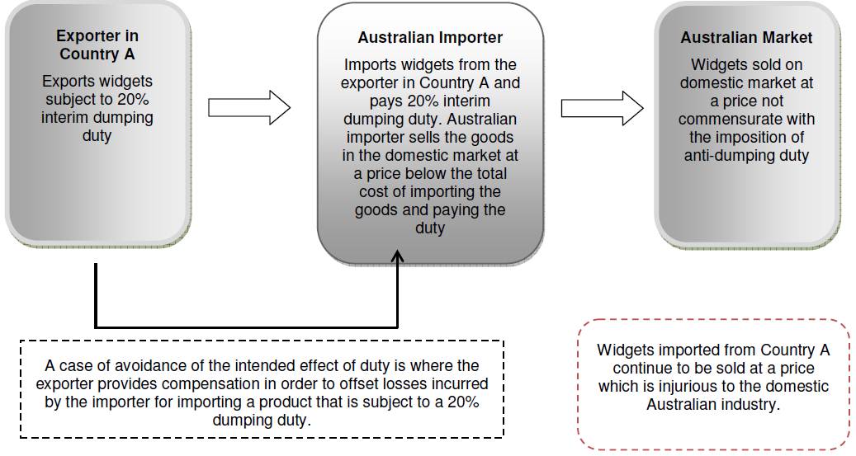

In Example 1, there is a dumping and/or countervailing duty notice in relation to widgets exported from Country A to Australia. An exporter in Country A is undertaking the circumvention activity. The Australian importer – or their associate – is likely to be aware of the circumvention activity as it is benefitting from financial compensation offered by the exporter for continuing to sell the circumvention goods at a price which would not recover the cost of the payment of dumping duty.

This type of activity would be considered ‘sales at a loss’ (and fall within the description of the circumvention activity). In these circumstances, the Minister may consider it is reasonable to alter the notice as it applies to that exporter to adjust the export price to reflect the compensation arrangement between the exporter and importer.

In contrast to Example 1, it would generally not be avoidance of the intended effect of duty if the importer had reduced its profit margin on the sale of widgets without a compensatory arrangement with the exporter. This may be considered a legitimate business decision on behalf of the importer.

A further example of the circumvention activity might be where an importer is selling the goods subject to measures at a loss, without any compensation from the exporter, because it is selling those goods in conjunction (i.e. bundled with) other goods in the transaction which are sold at a profit. This may be considered as avoidance of the intended effect of duty.

## Reasonable period

A key aspect of the circumvention activity is that it must occur over “a reasonable period”. This reflects that there will likely be a period of adjustment in the market to account for the imposition of duties (which, in practical terms, represents an additional cost to the importer). In the period following the imposition of measures, an importer may continue to sell at a price not reflective of the payment of duties as the importer may be drawing down on stocks purchased and entered prior to the imposition of duties, or the importer may be locked into contractual obligations preventing the increase of prices for a certain period. What is a “reasonable period” will vary depending on the type of goods subject to measures and the selling arrangements in respect of those goods.

An application should address this element of “reasonable period” to explain why the selling prices of goods should be expected to have adjusted to account for the duties paid. Relevant assertions would generally detail the structure and operation of the market and the selling arrangements under which the goods are commonly sold. Generally, the Commission will not consider a period of less than three months to be a reasonable period.

## Guidance to Question 7

Question 7 requires a description of the alterations to the notice that you consider should be made.

Section 269ZDBH(2) of the Act outlines the kinds of alterations that may be made to the notice by the Minister including the specification of:

* different goods that are to be the subject of the notice
* different foreign countries that are to be the subject of the notice
* different exporters that are to be the subject of the notice
* different variable factors in respect of existing exporters subject of the notice
* variable factors in relation to the different exporters that are to be the subject of the notice.

The most relevant alteration in respect of the circumvention activity relating to the avoidance of the intended effect of the duty is the specification of variable factors different to those which form the basis for the notice. Variable factors are export price, normal value, non-injurious price and the countervailable subsidy in respect of the goods (as relevant).

In relation to Example 1 above, a possible outcome would be to specify a different variable factor (export price) in respect of the exporter to account for the fact that a compensatory arrangement was in operation which affected the export price otherwise shown on the commercial documentation relating to the importation of the goods.

Where relevant, the Commissioner will recommend to the Minister the most appropriate alteration to the notice, and will have regard to the application in making that decision.

The inquiry process

## The Act

The anti-circumvention inquiry process is prescribed in Division 5A, Part XVB of the Act.

## Public record

The Commission maintains a public record for all anti-circumvention inquiries. A non-confidential version of the application, non-confidential submissions and all relevant correspondence will be included on the public record.

## Consideration of application

The Commissioner must decide whether or not to reject the application within 20 days of lodgement of an application. The Commissioner must reject the application if not satisfied that:

* the requirements for an application have been met;[3] and/or
* there appear to be reasonable grounds for asserting that one or more circumvention activities in relation to the notice have occurred.

The applicant will be notified of the Commissioner‘s decision. If the Commissioner does not reject the application, a notice must be published indicating that an inquiry is to be conducted.

## Submissions

Submissions in relation to an inquiry must be received within 37 days of the date of publication of the initiation notice. The Commissioner is not obliged to have regard to a submission received after the deadline, if to do so would prevent the timely preparation of the final report to the Minister.

Interested parties must prepare non-confidential versions of submissions for placement on the public record. Information on preparing a submission is available on the Commission’s [website](https://www.industry.gov.au/regulations-and-standards/anti-dumping-and-countervailing-system/submissions-to-an-anti-dumping-or-countervailing-case).

## Verification of information

The Commission may conduct on-site visits to verify information submitted by interested parties. Where on-site visits do not occur, desk audits may also be completed.

## Termination

The Commissioner may terminate the inquiry if satisfied that no circumvention activity in relation to the notice has occurred. The Commissioner must give public notice of a decision to terminate an inquiry.

## Report on anti-circumvention inquiry

The Commissioner must give the Minister a report within 100 days recommending whether the notice should be altered, and if so, the alterations to be made. This timeframe can be extended.

Unlike the inquiry process relating to other forms of circumvention activities, an inquiry concerning the alleged avoidance of the intended effect of duty does not require the Commissioner to publish a statement of essential facts during the inquiry process.

The report must include a statement of the Commissioner’s reasons for any recommendation contained in the report that:

* sets out the material findings of fact on which that recommendation is based; and
* provides particulars of the evidence relied on to support those findings.

## Minister’s powers

The Minister must, within 30 days of receiving the report, declare whether the notice should be altered, and if so, the alterations to be made. Notice of this decision will be published on the public record. If the Minister considers special circumstances exist, a longer period may be taken to make the declaration.

Rights of review

The Minister’s decision to alter or not alter the notice is reviewable by the  
[Anti-Dumping Review Panel](https://www.industry.gov.au/about-us/our-structure/anti-dumping-review-panel). An interested party[4] can apply for a review within 30 days from the publication of the Minister’s decision.

An applicant may also apply for a review of the Commissioner’s decision to terminate an anti‑circumvention inquiry, within 30 days of receiving notice of the termination.

Parties may also be able to apply for review of the decision by the Federal Court of Australia.

Find out more

* Find out about accessing Australia’s [anti-dumping system](https://www.industry.gov.au/regulations-and-standards/anti-dumping-and-countervailing-system)
* Research the [Dumping Commodity Register](https://www.industry.gov.au/data-and-publications/anti-dumping-commission-measures)
* Small-medium enterprises can seek assistance from the [ITRA Service](https://www.business.gov.au/advisory-services/international-trade-remedies-advisory-service) by email [itra@industry.gov.au](mailto:itra@industry.gov.au) or the ITRA Hotline (02) 6213 7267
* Contact the Anti-Dumping Commission by email [clientsupport@adcommission.gov.au](mailto:clientsupport@adcommission.gov.au) or by business.gov.au on 13 28 46

1. Section 269ZDBD(2A)
2. Amount payable refers to final duties and may be subject to the completion of any duty assessment of interim duties.
3. Section 269ZDBD of the Act.
4. As defined under section 269T(1) of the Act.