Small Business Advisory Group Report

UNLOCKING THE POTENTIAL OF BUSINESS.GOV.AU

## Copyright

**© Commonwealth of Australia 2019**

**Ownership of intellectual property rights**

Unless otherwise noted, copyright (and any other intellectual property rights, if any) in this publication is owned by the Commonwealth of Australia.

**Creative Commons licence**



**Attribution**

**CC BY**

All material in this publication is licensed under a Creative Commons Attribution 4.0 International Licence, save for content supplied by third parties, logos, any material protected by trademark or otherwise noted in this publication, and the Commonwealth Coat of Arms.

Creative Commons Attribution 4.0 International Licence is a standard form licence agreement that allows you to copy, distribute, transmit and adapt this publication provided you attribute the work. A summary of the licence terms is available from <https://creativecommons.org/licenses/by/4.0/>

The full licence terms are available from <https://creativecommons.org/licenses/by/4.0/legalcode>

Content contained herein should be attributed as *Report title, Australian Government Department of Industry, Innovation and Science*.

## Disclaimer

The Australian Government as represented by the Department of Industry, Innovation and Science has exercised due care and skill in the preparation and compilation of the information and data in this publication. Notwithstanding, the Commonwealth of Australia, its officers, employees, or agents disclaim any liability, including liability for negligence, loss howsoever caused, damage, injury, expense or cost incurred by any person as a result of accessing, using or relying upon any of the information or data in this publication to the maximum extent permitted by law. No representation expressed or implied is made as to the currency, accuracy, reliability or completeness of the information contained in this publication. The reader should rely on their own inquiries to independently confirm the information and comment on which they intend to act. This publication does not indicate commitment by the Australian Government to a particular course of action.

Contents

Executive Summary 4

Our purpose 4

Findings 4

Introduction 5

Background on business.gov.au 5

Project aims 5

Structure of this report 6

PART ONE: Project design 7

PART TWO: Stakeholder perspectives 8

Awareness of business.gov.au 8

Perceptions of the quality of business.gov.au 8

Vision and scope of the site 9

Functionality 10

Content 11

Channels of communication 11

Mobile application (app) 13

PART THREE: Recommendations 14

1. A clear vision and scope for business.gov.au 15

2. Functionality – improving how business.gov.au works and how information is found 15

3. Content – improving the relevance and quality of information 16

4. Channels of communication 16

5. Mobile application (app) 17

PART FOUR: Capability and roadmap alignment 18

References 19

Appendix 1. The Small Business Advisory Group 20

Appendix 2. Stakeholder awareness and knowledge of business.gov.au 21

Appendix 3. Recommendations from Winning Moves (2017) 23

Appendix 4. Recommendations from the Small Business Digital Taskforce (2018) 24

# Executive Summary

## Our purpose

The purpose of this review is to assess whether the needs and aspirations of small and family business owners are being supported effectively by [business.gov.au](http://www.business.gov.au/) and to provide recommendations on how the website could be enhanced.

This report presents a synthesis of stakeholder perspectives on the strengths, weaknesses and emerging digital opportunities for enhancing the quality of business.gov.au and enriching the service experience of small and family business owners.

The recommendations draw on analysis of three data sets, which focus on user and stakeholder perspectives on the quality of the business.gov.au experience:

1. a survey of the views of the Small Business Advisory Group;
2. quantitative surveys of small business users conducted by the Department of Industry, Innovation and Science in 2013, 2015 and 2017 (Winning Moves, 2017); and
3. the outcomes of two co-design workshops conducted with members of the Advisory Group.

The data and insights generated from these sources provide the Minister for Industry, Science and Technology and Minister for Small and Family Business, Skills and Vocational Education with a robust evidence base to support the recommendations outlined in this report.

## Findings

The findings from the analysis of these three data sets suggest that there are four key areas of focussed improvement for business.gov.au. The recommendations include:

1. clarifying the vision and scope of business.gov.au;
2. improving the functionality of the site and how information is found;
3. enhancing the relevance and quality of its content; and
4. heightening stakeholder awareness of the site through strategic channels of communication.

It is recognised that over the past five years capability has been built within the Department of Industry, Innovation and Science to meet the challenges of user centred design, personalisation and digital innovation. We believe that these recommendations will go a long way towards unlocking the potential of business.gov.au – noting that some of this work is already in progress or planned by the Department of Industry, Innovation and Science in the site’s current roadmap.

# Introduction

## Background on business.gov.au

business.gov.au is an online government resource for the Australian business community which has been operational for 20 years. business.gov.au is designed as a one-stop shop for businesses, providing access to government information and assistance to plan, start and grow a business.

In 2018, business.gov.au recorded 9.7 million web sessions and 6.5 million website users. In 2017, research revealed that 60 per cent of businesses were aware of the site, 81 per cent of the businesses aware of the site identified as small businesses (0-19 employees) and 30 per cent of businesses had saved money due to free information and advice received from business.gov.au.

The team behind business.gov.au conducts frequent research with real businesses to test concepts and hypotheses. In 2018, user research and testing was conducted with 1,812 participants from a range of industries, locations and business sizes. Insights about business.gov.au were gathered on a range of topics including the labels used on menus and navigational elements, the structure and categorisation of information, the ability to find government support on the site, and information to help start a business. The frequency of testing ensures that future enhancements to both content and functionality reflect and keep pace with the changing business landscape and emerging technologies that can enable an improved user experience.

## Project aims

The Small Business Advisory Group was established in February 2019 to advise the Minister for Industry, Science and Technology and Minister for Small and Family Business, Skills and Vocational Education on the role of business.gov.au in supporting small and family businesses.[1]

The purpose of the Advisory Group is to:

“ensure [business.gov.au](http://www.business.gov.au/) continues to fulfil its objectives as a whole-of-government one-stop-shop to support Australian businesses, with a stronger focus on small and family businesses”.

The Advisory Group members have been tasked with sharing insights and data about the needs of small business owners and the role that business.gov.au can play in supporting those needs.

Members have been asked to specifically consider:

* the vision for the site and changes required to deliver on this;
* identifying key information that is not included on the site and whether any existing information should be removed;
* improvements to the site for both functionality and useability;
* whether an application for small and family businesses should be developed; and
* the capabilities required to deliver the site’s objectives on an ongoing basis.

## Structure of this report

This report is organised into four parts:

* **PART ONE: Project design** provides an overview of the research design informing the development of this project.
* **PART TWO: Stakeholder perspectives** presents stakeholder perspectives on the awareness and quality of the business.gov.au, focusing on the vision and scope of the site, its functionality, content and channels of communication.
* **PART THREE: Recommendations** presents a set of recommendations for enhancing the quality of the business.gov.au user experience.
* **PART FOUR: Capability and roadmap alignment** includes an assessment of the Department of Industry, Innovation and Science’s ability to deliver on the key recommendations of this report.

# PART ONE: Project design

The design of this project is outlined in Figure 1.

A diagram depicting the phases, stages, outcomes and deliverables of the project. The Project Initiation phase is made up of 1) Inception, 2) Information gathering, 3) Core stakeholder survey, 4) Conduct co-design workshops and 5) Draft report. The outcomes of this phase were: An understanding of the strengths, weaknesses and opportunities for enhancing business.gov.au, validated against existing survey data; identification of the current design and potential future design focusing on awareness, functionality, content and channels of communication; and identification of recommendations for achieving the future state, validated with core stakeholders. A Draft Report was delivered at the end of Phase 1.
The Finalisation and Dissemination phase is made up of 6) Analyse stakeholder feedback, 7) Integrate with the Roadmap and 8) Final report. The outcomes of this phase were: Assessment against the existing business.gov.au roadmap and developing capabilities; and A recommended future state, the rationale for its selection, and how to proceed in implementing it. The Final Report was delivered at the end of Phase 2.

Figure 1. Project design

A mixed methods approach to data collection was used including:

* analysis of existing departmental data on user and stakeholder perspectives on the quality of the business.gov.au service experience;
* a survey of the awareness of Advisory Group members of business.gov.au and an assessment of their perceptions of its utility in supporting the needs of small and family business owners;
* two co-design workshops were held with members of the Small Business Advisory Group and the Minister for Industry, Science and Technology and Minister for Small and Family Business, Skills and Vocational Education to review the evidence and craft a set of recommendations for enhancing the quality of the business.gov.au service experience; and
* out-of-session consultations with members on the recommendations and draft report.

This project is designed to enable the Advisory Group to assess and provide recommendations on the current and future design of business.gov.au focusing on issues of vision and scope, functionality, content and channels of communication.

# PART TWO: Stakeholder perspectives

## Awareness of business.gov.au

General user awareness of business.gov.au is increasing. Figure 2 shows that in 2017, 60 per cent of all businesses were aware of the site: 44 per cent without prompting and a further 16 per cent following a description of the site. This marks a clear increase from previous evaluations (50 per cent in 2015; 40 per cent in 2013; 41 per cent in 2011 (Winning Moves, 2017)).

Generally members of the Advisory Group do not use business.gov.au often, however some members had more knowledge and awareness of the site (see Advisory Group survey results in Appendix 2, Charts 1 and 2). Members use the site to find out: “how to register a business name”; retrieve “information about grants and government programs”; access “HR-oriented information”; and access “tools and templates”. This suggests the need to work on ways to enhance stakeholder awareness of business.gov.au. Advisory Group perceptions of the quality of business.gov.au are encapsulated in a quotation from the Advisory Group survey: “a great but largely unknown resource”.

Figure 2. User awareness of business.gov.au (Winning Moves, 2017)

## Perceptions of the quality of business.gov.au

Four measures were used to assess Advisory Group members’ perceptions of the quality of business.gov.au through our survey instrument. We asked the Group to: 1) assess ease of access; 2) capture in one word how they would describe business.gov.au; 3) identify its strengths and, 4) its weaknesses (frustrations). No significant access barriers were identified and only two members out of ten were unlikely “to recommend business.gov.au to a colleague or friend”. It is evident, however, that once the resource was brought to the attention of group members the feedback was much more positive – “useful”, “informative”, “comprehensive”, “helpful”, “potential”, and “seems simple”.

This is consistent with user perspectives where satisfaction with business.gov.au is high (93 per cent) (Winning Moves, 2017). In this research, to further gauge satisfaction, users were asked to what extent they agreed or disagreed with a series of prompted statements regarding site content relevance, reliability, clarity and access (see Figure 3). In the main, responses were very positive with some concerns over navigation, access to a comprehensive information base and interaction with government through a single business service.

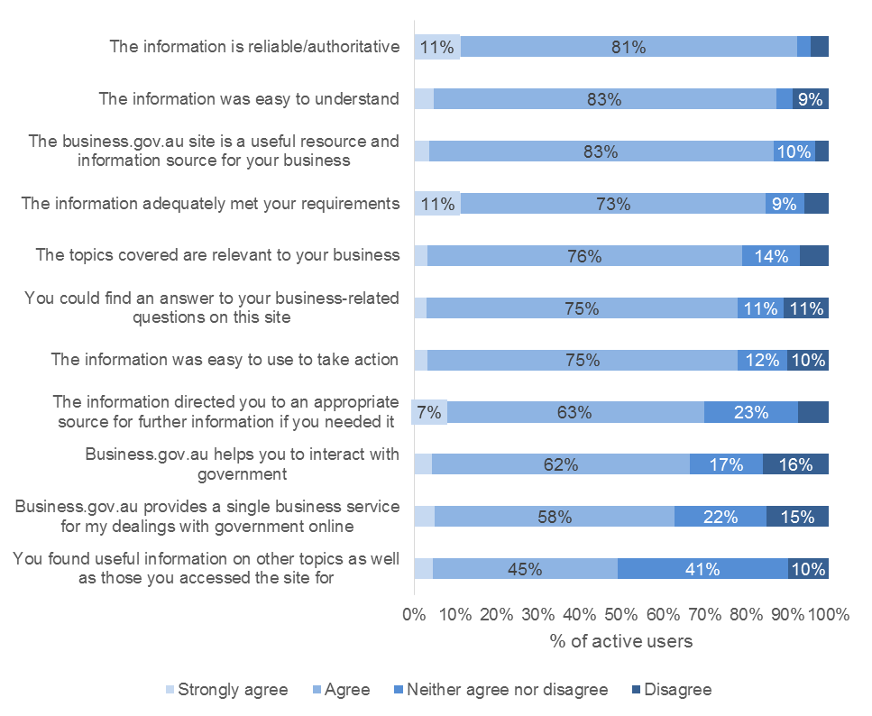

Figure 3 Error! No sequence specified.User perceptions about business.gov.au's quality (Winning Moves, 2017)

## Vision and scope of the site

The Advisory Group agreed that further work is required to clarify the vision and scope for the site. business.gov.au’s vision is to offer simple and convenient access to government information, assistance, forms and services businesses need. Members agreed with this vision, but noted that its current impact is diluted due to multiple government agencies and technologies targeting the same audience with similar content.

Clarity of content ownership and links with other government agencies’ content, would improve the concentration of relevant information for small business. This requires a more coordinated approach across government to enhance the experience of users and to maximise the investment by government. This is supported by the Digital Transformation Agency’s recommendations for agencies’ digital platforms to “break down silos and remove duplication, resulting in a unified, seamless experience for people and businesses” (Digital Transformation Agency, 2018) and the Winning Moves Stakeholder Research report, which was “supportive of the amalgamation of content and ‘one stop shop’” noting the “time saving this brings” (Winning Moves, 2017).

Members also noted that the site needs to present “hot-topic” or timely content in a more integrated and dynamic way to align with the site’s vision as a one-stop shop.

## Functionality

The Advisory Group survey findings suggest that recent improvements made to business.gov.au have improved the functionality of the site but need to be better promoted. In particular, there is strong endorsement of the step-by-step guide to starting a business in Australia and the revised homepage, menu and ways to categorise information. However, certain navigation problems were identified suggesting the need to work on the linear flow of content, signposting and the simplification of content. This observation was also in keeping with user perspectives (Winning Moves, 2017).

business.gov.au regularly conducts research with businesses to find out how they use the website and what other features they’d like to see developed. In the Advisory Group survey, the members were presented with a list of user challenges and potential improvements to the website, drawn from previous user research. Members were asked to rank these user challenges and the results demonstrated the importance of improving website navigation, the capacity for users to “save” business information, updating users on legislative changes and the personalisation and targeting of grants information to specific users.

In the first co-design workshop, group members drilled down in more detail to generate ideas for enhancing the functionality of the site. A key theme emerged during discussion around the importance of early identification of what users are looking for:

* the site should identify different user types (personas) and different needs (user journeys). These could be related to the business life cycle or key business problems (e.g. I need to hire staff) and should be based on user research.
* the site needs some method of triaging what people are looking for – this may be a more sophisticated search capability, or a series of quick questions or options to point users to particular information. This could be associated with the business growth journey map which identifies key business growth stages and possible pain points, questions and information sources.
* the aim is to direct users quickly to relevant content, pertinent to their current needs.

A particular concern was also flagged with respect to identifying possible grant opportunities. It was suggested that grant searching and associated metadata was not fit for purpose – “it is very difficult to identify a grant that could be beneficial”, “it is difficult to know what is available for a particular type of business and for a particular purpose”. In the second co-design workshop, members suggested that search results could be segmented to more clearly identify grants and other types of assistance that directly match search criteria, and ones that are less relevant but potentially related.

Members further explored options to present relevant information for a user’s current needs in the second co-design workshop. This included a detailed discussion of whether any existing datasets (such as Australian Business Number) could be used for a login to tailor a user’s experience on the site.

The personalisation features and content redesign project in progress by the Department of Industry, Innovation and Science was presented to members at the second co-design workshop. The business.gov.au site has traditionally focussed on providing static or ‘evergreen’ content, such as information about starting a business. The proposed personalisation changes to the site focus on providing timely and relevant information to users while they are browsing through the site’s static content offering. The content redesign project will enable the system to better package a piece of content so that it can be reused across the site in multiple places, increasing a business’s chance of coming across relevant information. This is a move away from the reliance on users finding information in a traditional ‘newsroom’, and instead will enable the site to present relevant information to a user at opportune times during their browsing experience.

Members agreed that the personalisation features that are in progress and planned under the Department’s roadmap would be sufficient to tailor content for users while they are browsing the site. However, members felt that there would be value in an email-based subscription service to proactively advise users of relevant information and support offerings after they leave the site.

The Advisory Group’s findings are supported by the Department’s user research with businesses (Department of Industry, Innovation and Science, 2017). This research shows that users want to be notified about time-sensitive content that might be relevant to them, including changes in legislation and new areas of interest. They also want the ability to save or flag information in some way, and return to it later.

## Content

In the Advisory Group member survey, the majority of members endorsed the existing portfolio of topics supported by business.gov.au (see Appendix 2, Chart 3). This observation was consistent with user perspectives (Winning Moves, 2017). Unsurprisingly, we discovered that “starting a small business”, “closing a business”, “registration and licenses”, “tax and superannuation”, and recruitment are considered the most important topics for small business. When we asked the Advisory Group to identify topics that they believed were missing from the service offering, an emphasis was placed on the provision of information to ensure that the business has problem-specific advice when things go wrong, and information to improve business leadership.

Three key observations on site content emerged in the first co-design workshop: the importance of back of house linkages between business.gov.au with the broader government ecosystem (federal, state and territory, local); the provision of business success information (benchmarking, cases and curated content form other authoritative sources); and, the inclusion of “must do, should do” critical information for “time poor” business owners.

## Channels of communication

In the Advisory Group member survey, a broad range of suggestions were made for improving audience awareness of business.gov.au through identification of new and more traditional channels of communication (see Table 1). These largely focussed on methodologies to target specific audiences such as: influencer marketing through professional intermediaries (accountants, bookkeepers, solicitors), targeted social media and traditional advertising; working collaboratively with business, community and industry associations[2], chambers of commerce and whole of government; and, promoting knowledge and peer group learning through webinars and vox pop case studies.

Table 1. Advisory Group responses to question: What are your top three suggestions for improving awareness of business.gov.au for small businesses?

| **First** | **Second** | **Third** |
| --- | --- | --- |
| Referral via intermediaries such as accountants, or solicitors | Influencer marketing (Instagram, Facebook, LinkedIn & blogging) - successful Australian business people sharing their experiences using [business.gov.au](https://www.business.gov.au/) | Case studies showing how [business.gov.au](https://www.business.gov.au/) helped a certain business then running social media ads or google retargeting |
| Industry associations | More social media | Pay money |
| Make all areas of government promote the site rather than their own – Australian Taxation Office, Australian Securities and Investments Commission, Fair Work Ombudsman, Australian Competition and Consumer Commission | Consistent targeted advertising | Use industry associations to promote and train people in its use |
| Social Media | Regular print advertising | Promotion through industry associations |
| Cross reference with organisations | Stop selling that government is the only answer | Resource production |
| Chamber of Commerce | At the point of Business Registration | Referral via intermediaries such as accountants |
| The traditional awareness channels, like TV & radio, are going to attract an audience that will be unlikely to find the site through digital channels | Supporting business advisors, accountants and similar professional services, as well as business networking groups, chambers of commerce etc with on-boarding material to promote [business.gov.au](https://www.business.gov.au/) | Encouraging more prominent support from related Government websites to refer visitors to [business.gov.au](https://www.business.gov.au/) |
| Industry associations | Peer channels on social media | Personal peer recommendations |
| Work with tax/BAS agents to promote. We are always looking for ways to inform our clients. Saves us having to teach them. | Work with the Australian Taxation Office. People who register an Australian Business Number, have a debt, etc should get directed to the site | Webinars (recorded for later view) are a great way to show the information on the site. |

In the first co-design workshop, group members examined these suggestions in more detail. Three key themes emerged. Firstly, traditional channels of communication (e.g. print, TV and radio advertising) have limited impact. Secondly, once again a greater emphasis was placed on engaging the business advisory eco-system, and greater cross government, university and TAFE collaboration. There was also strong advocacy of the need to continue to embrace the opportunities afforded by advances in digital technology such as: greater search engine optimisation and use of Google Analytics to analyse and track traffic and usage; the use of various media to convey business success stories, inform user about grant opportunities, and increase compliance; the development of a subscriber model to sign up for a personalised information feed; and more active use of social media to promote business success stories and networking.

In the second co-design workshop members discussed the challenges of reaching users who would benefit from the site but do not currently engage with it. Members reiterated the need to use strategic communication channels, such as connecting with intermediaries with greater coverage of the broader small business community. In addition, the use of more contemporary communication mediums such as podcasts was suggested as another avenue to refer potential users to [business.gov.au](http://www.business.gov.au/).

## Mobile application (app)

In the Advisory Group member survey, a narrow majority of respondents believed that an application “would provide additional benefits to small and family businesses”. Some of the reasons given in support of its development tended to focus on generalities rather than specific requirements: “[T]here are lots of apps around across government”, or “[I]t’s the way of the world”. On closer inspection during our first co-design workshop, strong doubts emerged about the benefits of an application over a mobile responsive website particularly given the site takes a “mobile first”[3] approach. Members noted that apps are more suited to repetitive, transactional processing (e.g. banking) than providing information and resources like those on business.gov.au.

# PART THREE: Recommendations

1. A clear vision and scope for business.gov.au

Small businesses want a trusted, one-stop shop to access the government information and assistance that they need. It should not mirror government internal structures (federal, state, local) and content should not be dispersed across multiple agencies, platforms and technologies (various applications and websites).

1. Functionality – improving how business.gov.au works and how information is found

Small businesses are seeking content that is tailored for their personal and user journey.

1. Content – improving the relevance and quality of information

Small businesses need access to information that is practical, in plain English and presented via a range of content mediums.

1. Channels of communication

Intermediaries (such as accountants, bookkeepers, business advisers, and industry and professional associations) are key points of contact for small business. These established relationships can be better leveraged to encourage intermediaries to refer small businesses to business.gov.au and push out relevant information that meets their members’ and clients’ needs.

1. Mobile application (app)

The Advisory Group considered the issue of developing new applications. It decided that given that small businesses want easy access to government information from any device, at any time, the business.gov.au website should continue to be developed with a “mobile-first” approach, meaning the website and its key features are easily accessible from all devices, at all times. This would negate the need for the development of applications at this time.

## A clear vision and scope for business.gov.au

Small businesses want a trusted, one-stop shop to access the government information and assistance that they need. It should not mirror government internal structures (federal, state, local) and content should not be dispersed across multiple agencies, platforms and technologies (various applications and websites). To achieve this aim:

* 1. A more coordinated approach across government should be taken to improve the concentration of relevant content for small business. The website’s current impact is diluted due to similar content targeting the same audience dispersed across multiple government agencies and technologies. This requires a clear and agreed understanding about the scope of [business.gov.au](http://www.business.gov.au/)’s remit, including content ownership and where to leverage from other agencies.
  2. Ongoing consultation with relevant stakeholders is required for the site to continue delivering outcomes for the benefit of small business. This includes state and territory government representatives, who should have responsibility for keeping their content on business.gov.au current and relevant, and proactively informing the business.gov.au team about current topics of interest. There should also be regular consultation by the Department of Industry, Innovation and Science with industry associations and professional bodies to ensure what is being delivered meets the needs of business.
  3. To realise the vision of business.gov.au as a one-stop shop, the site needs an increased focus on presenting timely or ‘hot-topic’ content in a more dynamic way. In addition to the personalisation and content rewrite and redesign work already underway by the Department, the site should leverage existing intelligence to provide content on current issues of relevance to small business. Options could include information and data from sources such as the Department’s Contact Centre’s phone and webchat interactions, key contacts within industry, or linking existing information from other government sites.

## Functionality – improving how business.gov.au works and how information is found

Small businesses are seeking content that is tailored for their personal and user journey. To achieve this aim:

* 1. Web design must be based on principles of user centred design, such as the “mobile first” approach currently applied to the site. The site must be intuitive, accessible in multiple ways (via search engines or while browsing through the website), reflecting different user journeys at different entry and exit points with information communicated in plain English.
  2. User journeys and personas have been developed to help drive personalisation of the site. These should be reviewed and refined over time. In the future, the site could surface relevant content, such as grants or other important business information to users based on their persona, browsing behaviour and other relevant information such as location. The recently improved grants search functionality provides users with the ability to find grants and support options through a manually filtered search journey. This should be improved and have the information reused to drive personalisation across the site.
  3. Machine learning and analytic capability should be used to define these user journeys and identify new ones as the system reaches maturity over time.
  4. One of the user journeys should lead to the user not setting up a business and this should be designed in such a way to ensure that this is not a negative outcome for the user.
  5. Landing page design must be easily navigable with clear pathways of content, and sign-posting to guide users to the next piece of content to read.
  6. The site should better detect and react when a user is having difficulty finding information on the site. This could include identifying when the user displays certain behaviours that indicate a “struggle pattern” – for example viewing the same page multiple times, indicating that they are stuck in a navigational loop. When a user displays these behaviours, the site should intercept them and provide a waypoint to assist them in finding information, or a seamless referral so they can speak to an adviser (such as the webchat facility or contact centre).

## Content – improving the relevance and quality of information

Small businesses want access to information that is practical, in plain English and presented via a range of content mediums. To achieve this aim:

* 1. Small businesses should not need to understand agency or government structures in order to access information and services that are relevant to their small business operations.
  2. Small businesses want the language and tone of the content to connect at the individual level – “talk to me as a person not a business”. Content should be communicated in plain English and not bureaucratic speak, including consideration of users from a non-English speaking background. Nor should it be assumed that the user has even a basic knowledge of running a business – there is a very broad spectrum of small business owners with varying depth and breadth of expertise.
  3. Information must be practical and address key threshold questions such as – ”What is the essential information I need to know to comply?” but also aspirational questions such as “[W]here do I want my business to be in the future and how do I get there?”.
  4. Designers should be encouraged to think differently about how they can use content and different mediums to encourage engagement. For example: compelling real life case studies that illustrate how successful small businesses have met certain challenges or cautionary case studies that illustrate what not to do; business leadership webinars; partnering with relevant podcasts; tool kits – fast facts on key areas of practical interest; benchmarking the performance standards of different industries to act as a source of lesson-drawing.

## Channels of communication

Intermediaries (such as accountants, bookkeepers, business advisers, and industry and professional associations) are key points of contact for small business. These established relationships can be better leveraged to encourage intermediaries to refer small businesses to business.gov.au and push out relevant information that meets their members’ and clients’ needs. To achieve this aim:

* 1. Develop “packaged content” relevant to intermediary members’ user journeys and personas in a format they can easily be disseminated (both individually and collectively).
  2. The website should allow users to register or subscribe to receive notifications through business.gov.au. This would allow users to nominate their information preferences, so they could be proactively alerted – for example if there is a change in relevant compliance obligations, or when a particular grant program opens for applications.
  3. The website and its content needs to be promoted through a targeted and integrated marketing strategy which includes: relevant social media channels, including paid content; email marketing; referrals from intermediaries; and, referrals in the form of direct links on other government websites (e.g. Australian Taxation Office, Australian Securities and Investment Commission) to business.gov.au.
  4. Potential collaborations include educational and research institutions, industry associations, professional registration bodies (e.g. Certified Practicing Accountant) and leveraging off existing networks from state government and the private sector.
  5. The website needs to continue to monitor and optimise its search ranking so that it can easily be found in search engines such as Google. Businesses “don’t know what they don’t know” and often turn to Google first, when searching for answers. The business.gov.au website is ranked highly in all major search engines, often appearing on the first page of Google search results. Attracting users to the site through search engines is an excellent way to attract small businesses searching for information. The content on the website needs to be continually monitored and optimised, to ensure it is keeping up with search engine algorithm changes.

## Mobile application (app)

* 1. The Advisory Group considered the issue of developing new applications. Members agreed that given that small businesses want easy access to government information from any device, at any time, the business.gov.au website should continue to be developed with a “mobile-first” approach, meaning the website and its key features are easily accessible from all devices, at all times. This would negate the need for the development of applications at this time.

It is important to note that these recommendations significantly align with those made by Winning Moves (2017) and recommendations 4, 5, 6 and 7 advocated by the Small Business Digital Taskforce (2018). See Appendix 3 and 4.

# PART FOUR: Capability and roadmap alignment

Capability has been built within the Department of Industry, Innovation and Science over the past five years to enable the design and delivery of high quality digital products.

The teams working on business.gov.au operate using an Agile approach to system development. Fundamental to this methodology is user-centred design and working within a multi-disciplinary team to ensure a balance of skills and that subject matter experts work directly with technology development teams. The team behind the website development includes: content writers, business analysts, subject matter experts, user experience experts, service designers and developers. The Department of Industry, Innovation and Science also has partnerships with third party agencies to leverage private sector capabilities to complement its internal skill base.

All business.gov.au products are developed using the Digital Transformation Agency’s Digital Service Standard Framework.

The recommendations outlined in the report materially align with the Department of Industry, Innovation and Science’s business.gov.au roadmap of planned work. The roadmap provides an overarching vision for the site and sets the direction for addressing the current user challenges. All bodies of work set out in the roadmap are based on evidence and research with users, and prioritised based on the item of work that will deliver the highest business value first.

The business.gov.au roadmap program of work is in progress and aligns to the Advisory Group’s recommendations about user-centred content design, providing information in plain English and improving the pathways to timely information. However, some further thought will need to be given to how [business.gov.au](http://www.business.gov.au/) can more effectively harness the support and resources of the broader business intermediary ecosystem.

In summary, the Department of Industry, Innovation and Science possesses the institutional capacity and capabilities to deliver on this program of change for supporting the needs and aspirations of small business in Australia.

# References

Department of Industry, Innovation and Science. (2017). *Connecting Business to Government Support - Research Report.*

Digital Transformation Agency. (2018). *Corporate Plan 2018-22.* Retrieved from https://www.dta.gov.au/about-us/reporting-and-plans/corporate-plans/corporate-plan-2018-22

Productivity Commission. (2019). *Productivity Commission Issues Paper: The Social and Economic Benefit of Improving Mental Health.* Retrieved from https://www.pc.gov.au/inquiries/current/mental-health/issues/mental-health-issues.pdf

Small Business Digital Taskforce. (2018, March). *Report to Government.* Retrieved from https://www.industry.gov.au/data-and-publications/small-business-digital-taskforce-report-to-government

Winning Moves. (2017). *Final Report: stakeholder research.* prepared for the Department of Industry, Innovation and Science.

# Appendix 1. The Small Business Advisory Group

The Advisory Group is composed of 10 members who are representative of the broader business sector, including the small and family business sector. The Group also includes at least one representative of the business sector with experience in web design and user experience.

Members are appointed by the Minister for Industry, Science and Technology, in consultation with the Minister for Small and Family Business, Skills and Vocational Education, the Australian Small Business and Family Enterprise Ombudsman (ASBFEO) and Council of Small Business Organisations Australia (COSBOA).

The membership includes:

| Co-Chair | Minister for Industry, Science and Technology |
| --- | --- |
| Co-Chair | Minister for Small and Family Business, Skills and Vocational Education |
| Member | Matthew Addison – Executive Director, Institute of Certified Bookkeepers |
| Member | Kate Carnell – Australian Small Business and Family Enterprise Ombudsman |
| Member | John Chapman – South Australian Small Business Commissioner |
| Member | Kym Clark – Founder and Owner, She’s Empowered |
| Member | Paul Meissner – Founder and Managing Director, 5ways Accounting |
| Member | Michelle Melbourne – Executive Director, Intelledox |
| Member | Dominic Ooi – Director, South West Sydney Business Enterprise Centre |
| Member | Juliana Payne – CEO, Restaurants and Catering Australia |
| Member | Peter Strong – CEO, Council of Small Business Organisations Australia |
| Member | Russell Zimmerman – Executive Director, Australian Retailers Association |

# Appendix 2. Stakeholder awareness and knowledge of business.gov.au

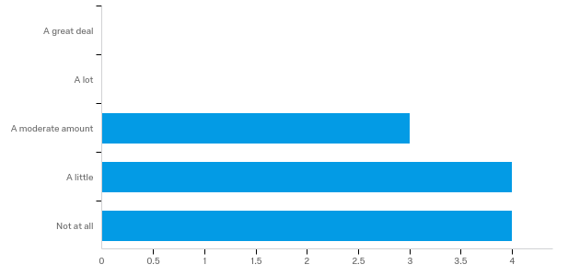

Chart 1. How frequently do you use business.gov.au?

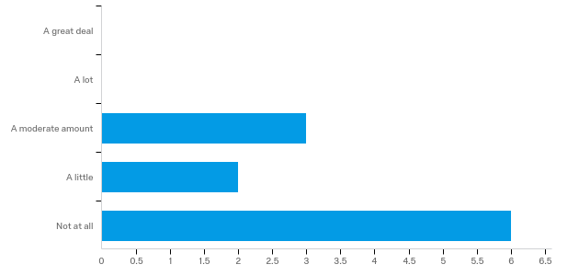

Chart 2. How frequently do you direct others to the website?

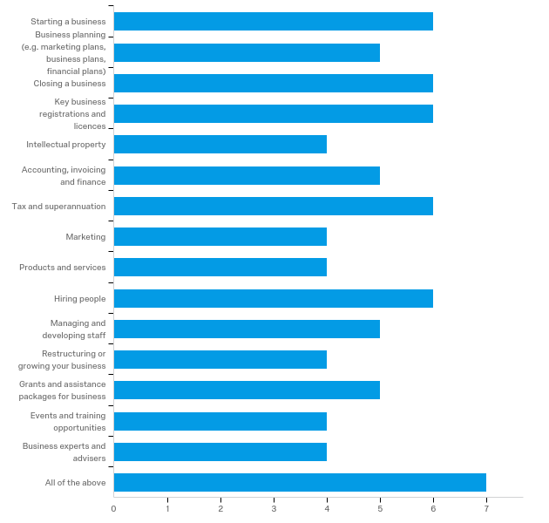

Chart 3. Are any of the following topics useful to small business?

# Appendix 3. Recommendations from Winning Moves (2017)

The study has highlighted opportunities to further enhance business.gov.au marketing and delivery:

* Increased marketing – and especially cross-promotion – of the site and its content. This could include advertising through individuals’ personal social media use.
* There continue to be opportunities to refine the in-site customer experience and off-site marketing activities, built around key customer journeys and opportunities to cross-promote appropriate complementary services, but also on sectors.
* Business.gov.au should continuing expanding its approach of migrating content to the site instead of signposting. This should focus on high demand and valued business content and engaged stakeholders.
* Based upon reticence amongst some non-users to switch from current sources, business.gov.au content and services could be more readily packaged for delivery by others (including accountants, industry associations and business advisors).

# Appendix 4. Recommendations from the Small Business Digital Taskforce (2018)

**Taskforce Recommendation 1: A non-government organisation (NGO)**

A central, national point for information and advice on digital opportunities for small businesses and their advisors. The NGO would:

* consolidate, disseminate and simplify information and advice on digital options provided by the public and private sector
* establish a two-way flow of information between the NGO and industry associations and Small Business Commissioners
* provide a multi-channel approach to address diversity of small business digital needs
* be the main vehicle through which the federal government will promote awareness of the benefits of digital adoption for small business
* establish and enhance business-to-business information sharing and best practice
* develop and deliver business benchmarking tools to assess the ‘digital health’ of a business
* promote and coordinate awareness campaigns on digital issues of concern to small business.

The Government supports this recommendation. The NGO will be expected to leverage business.gov.au as the well-established, trusted point of information for Australian business.

**Taskforce Recommendation 2: Annual event for small business**

To highlight and explore emerging digital technology developments and issues impacting small businesses. The event would include a marketplace to enable vendors and suppliers to showcase new applications and services.

The Government supports in principle this recommendation.

**Taskforce Recommendation 3: Small Business Awards program**

Sponsored by industry to complement existing business awards. Would highlight ‘unsung’ small business owners who are loved by their customers or those that use technology to enhance their customer experience. The awards would form part of the annual event.

The Government supports in principle this recommendation.

**Taskforce Recommendation 4: Video and audio case studies**

Develop and distribute case studies and success stories of small businesses that have gone digital. Work with digital platforms and peer-to-peer services to identify small businesses using these services to grow and scale their business.

The Government supports this recommendation.

**Taskforce Recommendation 5: University student-based connection**

Utilise university students studying IT, marketing, business and related fields for short term and project work to help raise the digital capability of businesses and make students more job ready.

The Government supports this recommendation.

**Taskforce Recommendation 6: Awareness and communications campaign tools**

Leverage trusted advisors of small business (accountants, industry associations, banks). Provide a digital health check tool to assess the level of digital maturity of a business, where they rank among peers, and receive advice and resources to raise their digital sophistication.

The Government supports in principle this recommendation.

**Taskforce Recommendation 7: Digital capability of industry associations**

Work with industry associations to develop specific digital playbooks or best practice guides for their specific business sector. Initially pilot industries with low levels of digital uptake.

The Government supports in principle this recommendation.

**Taskforce Recommendation 8: Exploring scaling the Queensland Local Digital Champions program**

Establish and promote local digital champions as a touchpoint for information and advice to help local businesses use digital technologies more effectively.

The Government supports this recommendation.

**Taskforce Recommendation 9: Digital roadshows for regional communities**

Explore existing roadshow models and public-private partnerships to create ‘pop-ups’, travelling ‘fix-it’ squads and digital business experts to travel where businesses are.

The Government supports in principle this recommendation.

1. See Appendix 1 for a list of members.
2. It is also worth noting the Productivity Commission’s (2019) recent observation that small businesses have limited resources to implement mental health initiatives and recommend greater collaboration with industry associations and other professional groups to assist them.
3. A mobile first approach ensures that a website can be effectively used regardless of a user’s device size, type, processing power, or browser. This differs from an application (app), which is a program that must be downloaded on a user’s device for them to access it.