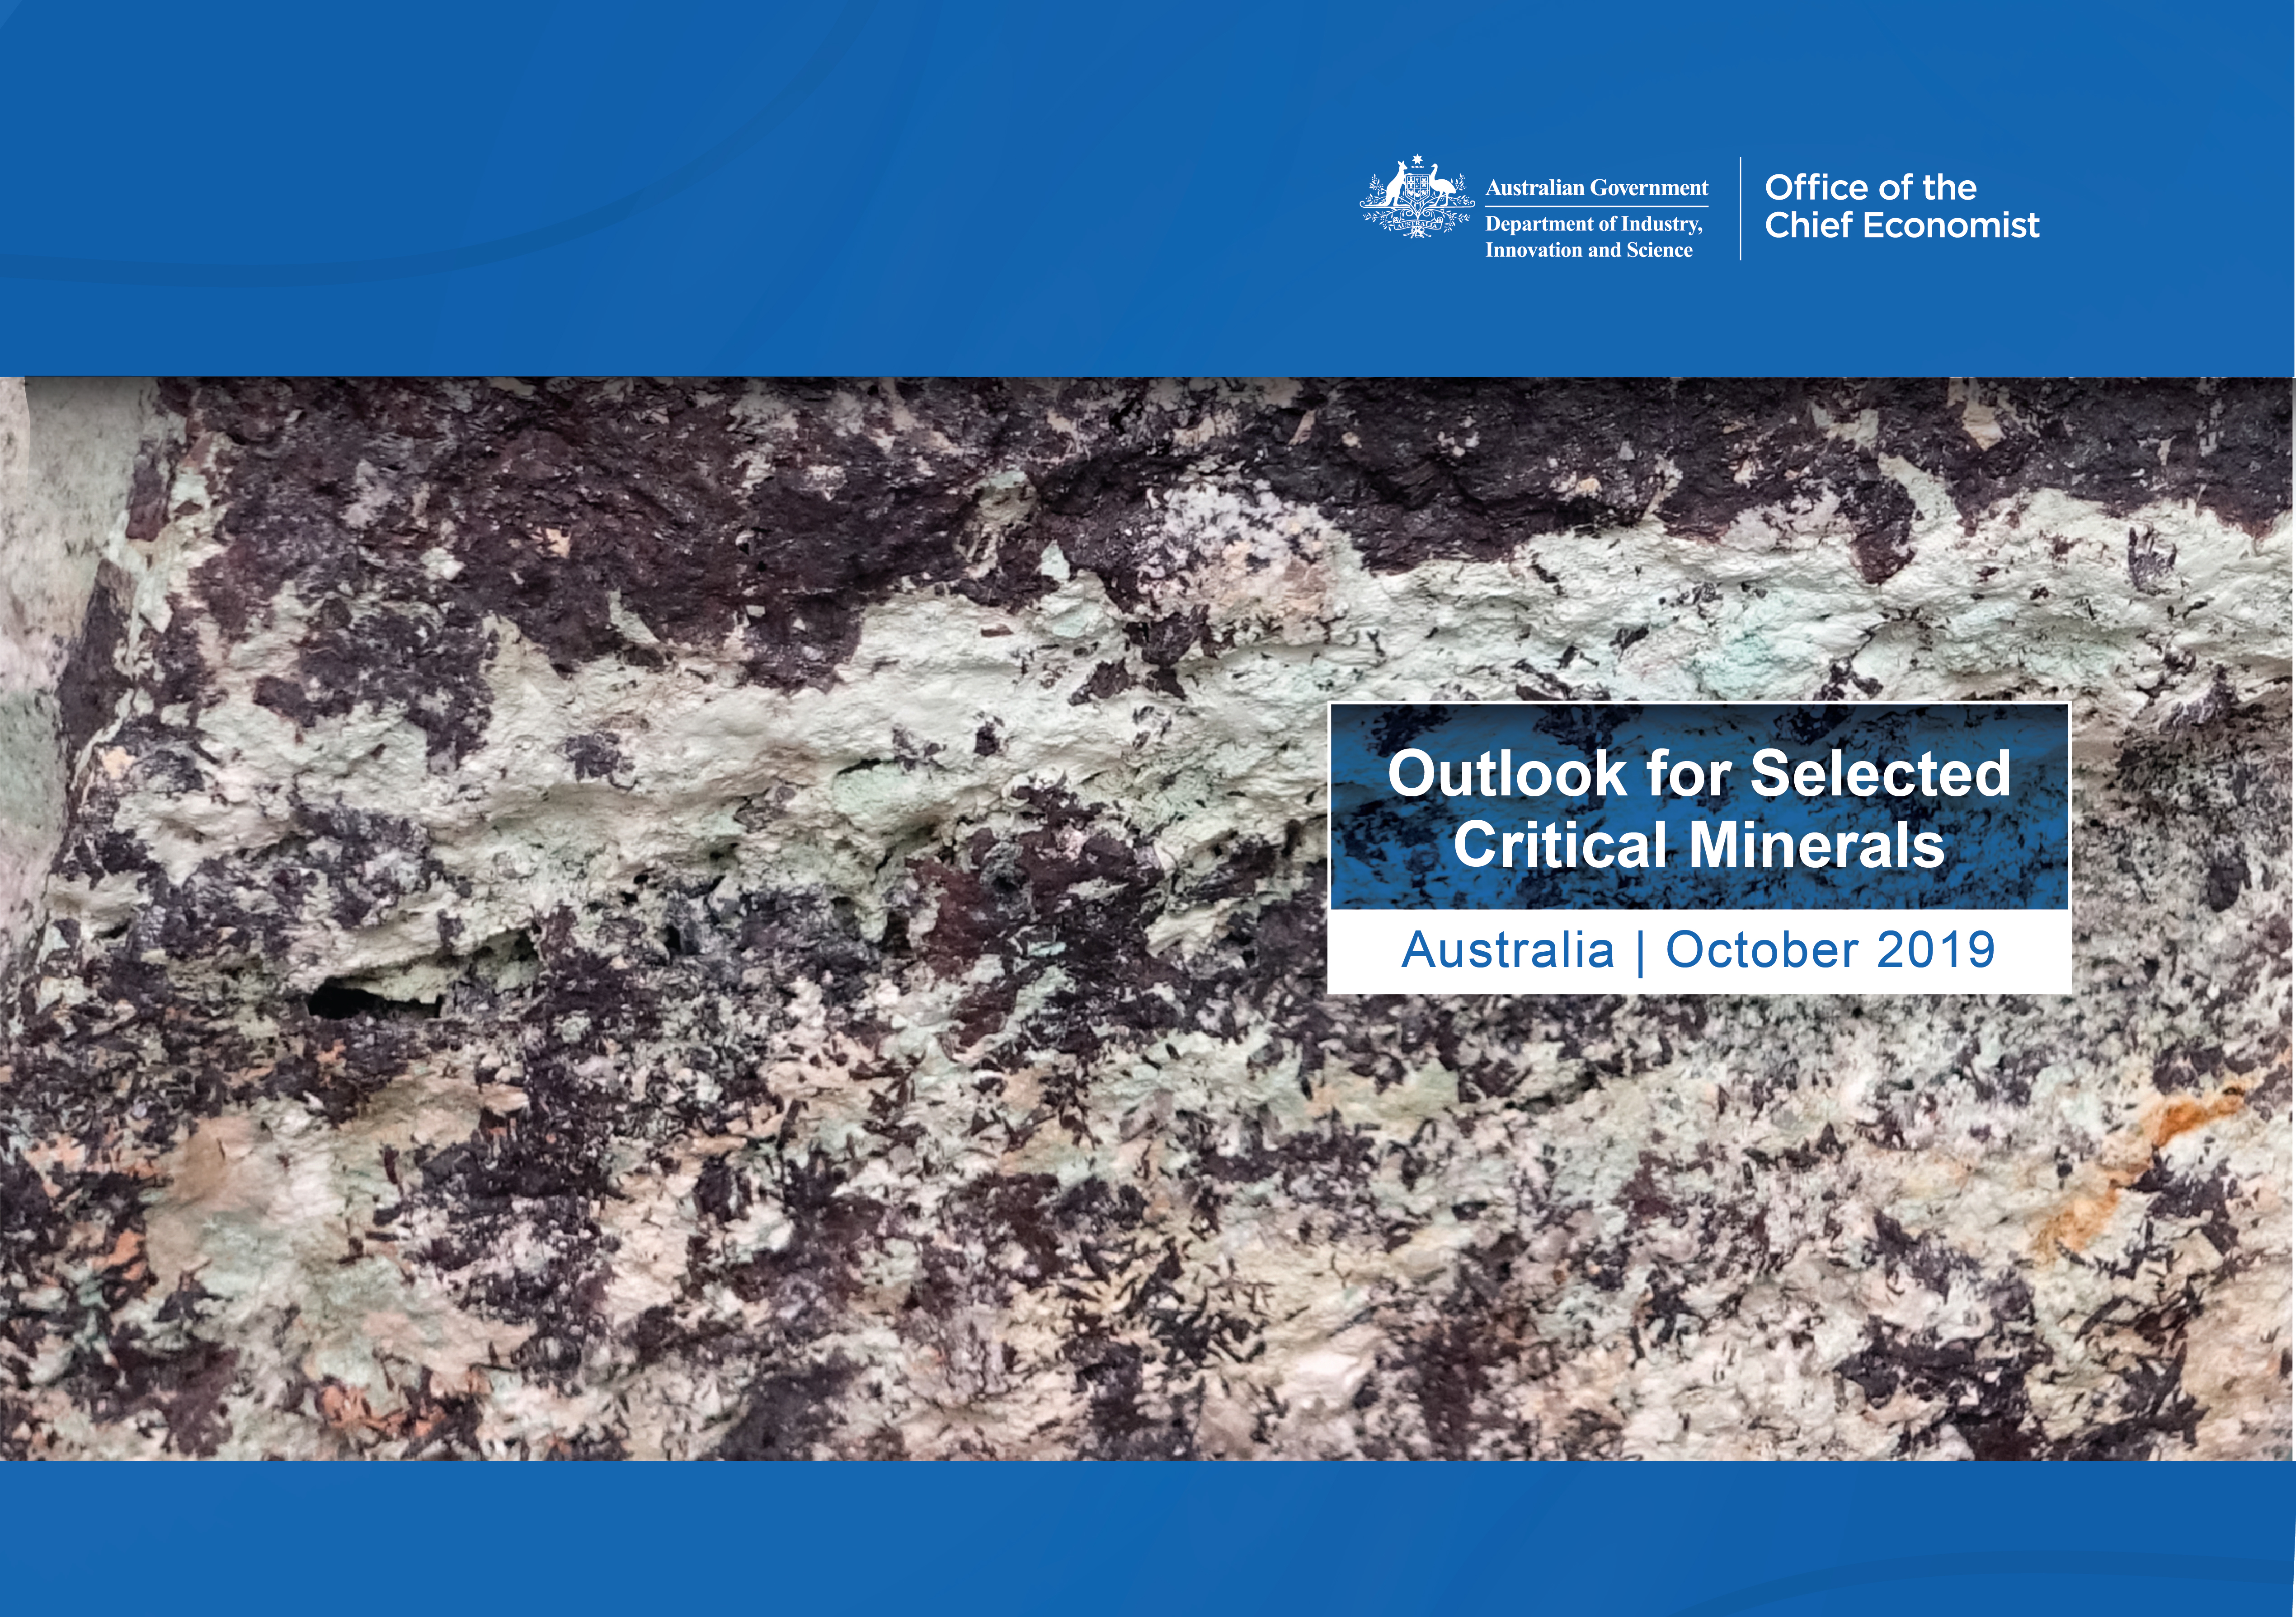
Contents
Why critical minerals matter – new technologies and growing markets 1
Focus of this report 2
What Australia has to offer 3
Development projects in Australia 6
Australia’s Critical Minerals Strategy 8
Niobium 10
Rare Earth Elements 13
Cobalt 22
Antimony 28
Magnesium 33
Tungsten 37

Why critical minerals matter – new technologies and growing markets
Critical minerals are metals and non-metals that have important economic functions, cannot be easily substituted and which face some degree of supply risk. Supply risks can stem from geological scarcity, geopolitical issues, trade policy or other factors. What constitutes as ‘critical’ differs between countries, depending on essential demand applications, productive capacity and import dependence.
Critical minerals are important for industrial progress and emerging technologies. They are used for renewable energy systems, electric vehicles, rechargeable batteries, consumer electronics, telecommunications, specialty alloys, and defence technologies.
Growth in these markets is expected to boost world demand for critical minerals. Australia’s resource endowment, mining capability and existing processing infrastructure mean it is well placed to support this demand.

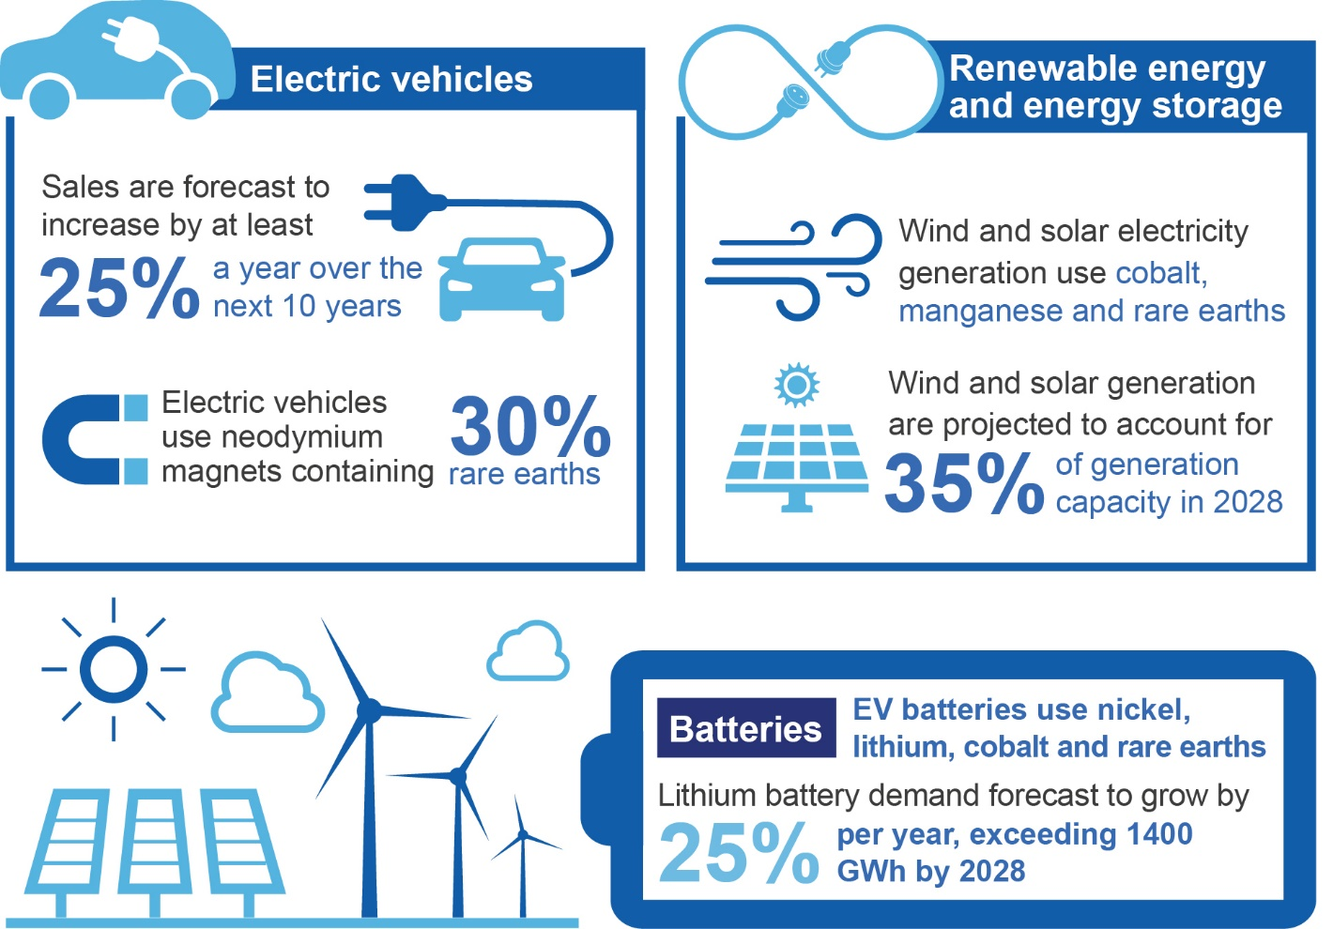

Focus of this report
Australia is home to a large array of critical minerals. Some, such as lithium, have already attracted significant investment, with mines opening rapidly and refineries under construction across Western Australia. Others, such as bauxite, have been well developed for many years.
Among the less developed minerals, some remain uneconomic, while others have not yet been found in sufficient quantities to be viable.
This publication focuses on six critical minerals that hold significant potential. These minerals have important uses in energy supply and technology, and are projected to be in strong demand across the globe for a number of decades to come. Mine and/or refined output for these minerals is often dominated by two or three countries, and world markets are mostly nascent and under-developed.
In all cases, Australia has been identified as one of the top six resource holders of each commodity, meaning there is potential for additional production and investment.
The six critical minerals covered in this publication are:
- Niobium
- Rare earth elements
- Cobalt
- Antimony
- Magnesium
- Tungsten

Australia’s potential as a supplier of critical minerals is not limited to these minerals, and many others also have significant prospects for the future. However, it is likely that early success will depend to a significant degree on whether these prospects prove fruitful, and on our ability to co-operatively harness the opportunities they represent.

What Australia has to offer
Australia has a large natural resource endowment and one of the most diversified commodity export portfolios in the world. This endowment includes a number of critical minerals.
Australia has been a reliable, cost-competitive supplier of resource and energy commodities to the world for many decades. These commodities are exported in raw form (e.g. iron ore), semi-processed (e.g. gold doré) or refined forms (e.g. aluminium).
Australia is a key producer of critical minerals, with potential to grow
- Australia has the world’s largest resources of rutile (titanium), zirconium (zircon) and tantalum, as well as non-critical minerals such as lead, nickel, uranium, gold and iron ore.
- Australia’s resources of critical minerals such as antimony, cobalt, lithium, magnesite, manganese ore, niobium, tungsten and vanadium, all rank in the top five globally.
- Australia is the world’s top producer of spodumene (lithium), rutile and zirconium.
- Australia has potential for more undiscovered resources. Well-established mining regions cover just 20 per cent of Australia, with the remaining 80 per cent of the continent largely unexplored.
Australia offers a strong and supportive investment climate
- Australia has a stable investment environment, good infrastructure for road, rail and seaborne trade, and no significant security issues that could threaten supplies. Human capital is high, with key strengths in project management, skilled trades, engineering and other professions. It is ranked second in the world by the Fraser Institute (2018) for most attractive jurisdiction for mining investment, based on its policies and mineral potential.
- High construction, environmental and safety standards apply to mining projects across Australia’s thousands of mines, protecting the industry’s social licence to operate.
- Australia’s strengths are also reflected in its huge mining equipment, technology and services (METS) sector. The METS sector was responsible for $92 billion in gross value-added in 2017-18 and employs an estimated half a million Australians. Australian capital cities have creative METS hubs supporting the mining industry, with 201 METS companies’ head offices being located in Sydney, 186 in Perth and 149 in Brisbane.
- Australia’s Federal and State governments have dedicated resources ministers and a range of policies, incentives and programs support mining investment. These include:
  - The Australian Government’s Major Projects Facilitation Agency, which provides a single entry point for major project proponents seeking tailored information and facilitation of their regulatory approval requirements.
  - A total of 15 Research and Development (R&D) facilities focusing on the resource sector. Through its Growth Centres Initiative, the Australian Government supports an industry-led plan for the Australian METS sector.
  - The R&D Tax Incentive, which provides a national platform of support for R&D in Australia.
  - A Critical Minerals Strategy (see table 1.4 below)

Figure 1.1 shows Australia’s mineral deposits, including the major critical minerals, and major mines.
Figure 1.1: Critical mineral deposits and major mines in Australia
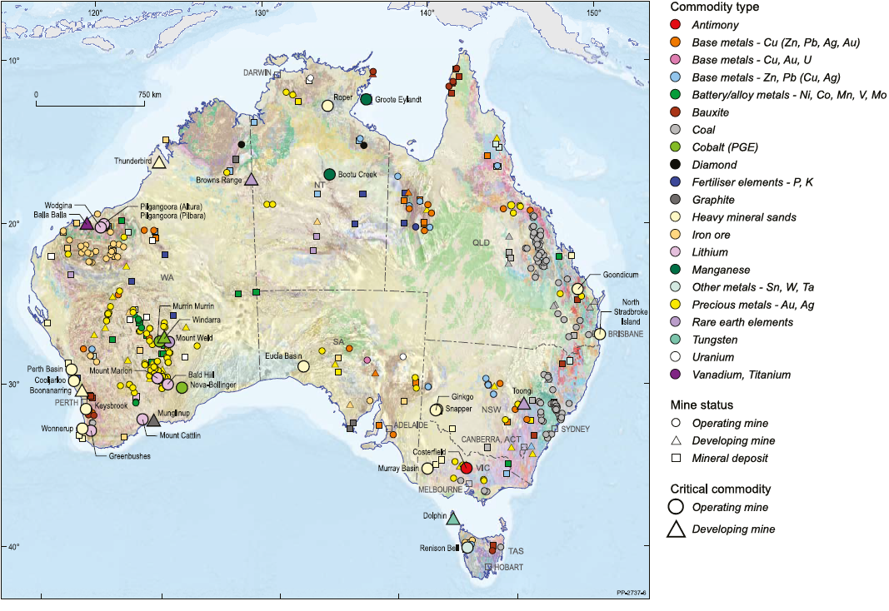
Source: Geoscience Australia (2019)

Table 1.1: Australia’s critical minerals share and ranking, 2018
Commodity | Australia’s Geological Potential | Australia’s ranking for resources | Share of world resources | Australia’s ranking for production | Share of world production
Antimony | Moderate | 4 | 9% | 4 | 4%
Beryllium | Moderate | - | - | - | -
Bismuth | Moderate | - | - | - | -
Chromium | High | - | - | - | -
Cobalt | High | 2 | 17% | 3 | 3%
Gallium | High | - | - | - | -
Germanium | High | - | - | - | -
Graphite | Moderate | - | 3% | - | -
Hafnium | High | - | - | - | -
Helium | Moderate | - | - | - | 3%
Indium | High | - | - | - | -
Lithium | High | 3 | 17% | 1 | 33%
Magnesium | Moderate | 5 | - | 4 | -
Manganese | High | 3 | 32% | 3 | 20%
Niobium | High | 2 | 7% | - | -
Platinum-group elements | High | Minor | 8% | Minor | 1.3%
Rare-earth elements | High | 6 | 3% | 2 | 11%
Rhenium | Moderate | - | - | - | -
Scandium | High | - | - | - | -
Tantalum* | High | 1 | 69% | - | -
Titanium | High | Ilmenite 1  Rutile 1 | Ilmenite 30%  Rutile 50% | Ilmenite 1  Rutile 1 | Ilmenite 22%  Rutile 40%
Tungsten | Moderate | 2 | 12% | Minor | 0.12%
Vanadium | Moderate | 4 | 11% | 0 | -
Zirconium | High | 1 | 17% | 1 | 38%
Notes: This list is not representative of a national critical minerals list for Australia. *Tantalum ranking based on available reports of economic resources and does not include African resources.
Source: Department of Industry, Innovation and Science (2019) Critical Minerals Strategy, Geoscience Australia (2019)

Table 1.2: Supply chain analysis — major player in aspects of critical mineral supply chain (2018)
 | Primary production  (mining) | Processing | Refining
Rare earths | China 77% | China | China
Cobalt | Democratic Republic of the Congo 70% | Democratic Republic of the Congo 43% | China 61%
Niobium | Brazil | Brazil | Brazil
Antimony | China 48% | China 85% | China 42%
Magnesium | China | China | China
Tungsten | China 79% | China | China 75%
Notes: Primary production refers to mine production of ores. To get to saleable production a commodity goes through processing, which includes intermediate oxides.
Source: Roskill (2019), Department of Industry Innovation and Science (2019).

Development projects in Australia
Australia’s large resource endowment and supportive operations environment has facilitated a number of development projects. Some of these projects will create new mines and bring new critical minerals into production. Others will potentially lift critical minerals exports and production up the value chain through the development of refinery capacity. Lithium provides a notable recent example of this, with six mines having recently opened, and a range of refineries now under construction. Expanded output, in conjunction with gradual progress up the value chain, could make Australia a significant global source of high quality refined critical minerals.
Some prominent projects are highlighted below.
Table 1.3: Select critical minerals development projects in Australia
Project | Company | Mining product | Project details | Status
Browns Range | Northern Minerals | Rare earths including dysprosium, terbium, lanthanum | Capacity: 585 kt/year ore.  Capex: $329m | Pilot operating, stage 2 and 3 under feasibility
Dubbo Project | Alkane Resources | Rare earths including hafnium, zirconium, niobium, yttrium | Capacity: 1.0 mt/year  Capex: $1.3b | Feasibility
Nolans | Arafura Resources Limited | Rare earths including lanthanum, cerium and neodymium and praseodymium oxides | Capacity: 13.4 kt/year  Capex: US$730m | Feasibility
Yangibana | Hastings Technology Metals | Rare earths including neodymium and praseodymium | Capacity: 3.4 kt/year NdPr  Capex: $427m | Feasibility
Goongarrie | Ardea Resources | Nickel and cobalt | Capacity: 5.5 kt/year cobalt sulphate  Capex: na | Publically announced
NiWest | GME Resources | Nickel and cobalt | Capacity: 2.4 mt/year  Capex: na | Publically announced
Sconi | Australian Mines | Cobalt, nickel and scandium | Capacity: 1.8 kt/year cobalt  Capex: US$974m | Feasibility
Sunrise | Clean TeQ | Nickel, cobalt and scandium | Capacity: 3.2 kt/year cobalt  Capex: US$1.5 billion | Feasibility
Wingellina | Metals X | Nickel and cobalt | Capacity: 3 kt/year cobalt  Capex: na | Feasibility
Dolphin | King Island Scheelite | Tungsten | Capacity: 1.6 kt  Capex: $65m | Feasibility
Molyhil | Thor Mining | Tungsten, molybdenum | Capacity: 1.25 kt  Capex: $69m | Feasibility
Mt Carbine | Speciality Metals International | Tungsten | Capacity: 0.3 kt  Capex: $55m | Feasibility
Mt Lindsay | Venture Minerals | Tin and tungsten | Capacity: 1.6 kt  Capex: $198m | Feasibility
Mulgine Hill | Tungsten Mining NL | Tungsten | Capacity: 0.5 kt  Capex: na | Feasibility
Watershed | Tungsten Mining NL | Tungsten | Capacity: 1.5 kt  Capex: $100m | Feasibility
Notes: kt/year – thousand tonnes per year; mt – million tonnes; m – million; NdPr - neodymium and praseodymium; Capex – capital expenditure.
This is a selection of current development projects in Australia and not intended to be an exhaustive list. Projects at feasibility status have undertaken initial project definition work, which can include engineering design, environmental impact studies and regulatory approval, but have not reached the financial investment decision.
Source: Austrade (2019), Roskill (2018), company reports

Australia’s Critical Minerals Strategy
Launched in March 2019, Australia’s Critical Minerals Strategy aims to position Australia as a world leader in the exploration, extraction, production and processing of critical minerals.
It targets actions in three areas:
- promoting investment in Australia’s critical minerals sector and downstream processing
- providing incentives for innovation to lower costs and increase competitiveness
- connecting critical minerals projects with infrastructure development
Table 1.4: Australia’s Critical Minerals Strategy Actions
Investment
Australian Critical Minerals Prospectus | Austrade, with support from Geoscience Australia, has developed a report of Australia’s potential for critical minerals mining projects and investment.
Investment roadshows | Austrade delivers international roadshows promoting investment in critical minerals and the potential for more lithium-ion battery manufacturing in Australia.
Export Finance Australia | Export Finance Australia helps finance the expansion by Australian businesses into international markets, within WTO guidelines.
Exploring for the Future | The $100.5 million Exploring for the Future initiative (2016-2020) helps explorers target new mineralisation by imaging from the deepest roots of mineral systems all the way through to the surface, and is employing many world-first techniques.
MinEx Cooperative Research Centre | The $218 million MinEx Cooperative Research Centre is the world’s largest mineral exploration collaboration bringing together industry, government and research organisations. Its 10-year research program will develop and deploy the next generation of drilling technology.
Australia Minerals | Australia Minerals is increasing investment in exploration, especially in greenfield areas. This group is unique world-wide, as it brings together all of the country’s chief geologists. This group regularly visits major investors.
Major Projects Facilitation Agency | The Major Projects Facilitation Agency provides a single entry point for major project proponents seeking tailored information and facilitation of their regulatory approval requirements.
Innovation
Cooperative Research Centre Projects | $20 million of Cooperative Research Centre Projects funding has been prioritised for projects with a specific focus on critical minerals.
Cooperative Research Centre for Optimising Resource Extraction | The CRC for Optimising Resource Extraction will receive $34.45 million from 2016‑2021 to develop energy-saving and resource-expanding technology that will allow lower‑grade ores to be economically and eco‑efficiently mined.
Infrastructure
Northern Australia Infrastructure Facility | The $5 billion Northern Australia Infrastructure Facility can provide concessional loans to eligible infrastructure projects in Northern Australia.
Other Commonwealth infrastructure investment | Investment in transport infrastructure through the Infrastructure Investment Program, including the $3.5 billion Roads of Strategic Importance initiative.
Source: Department of Industry, Innovation and Science (2019) Australia’s Critical Minerals Strategy

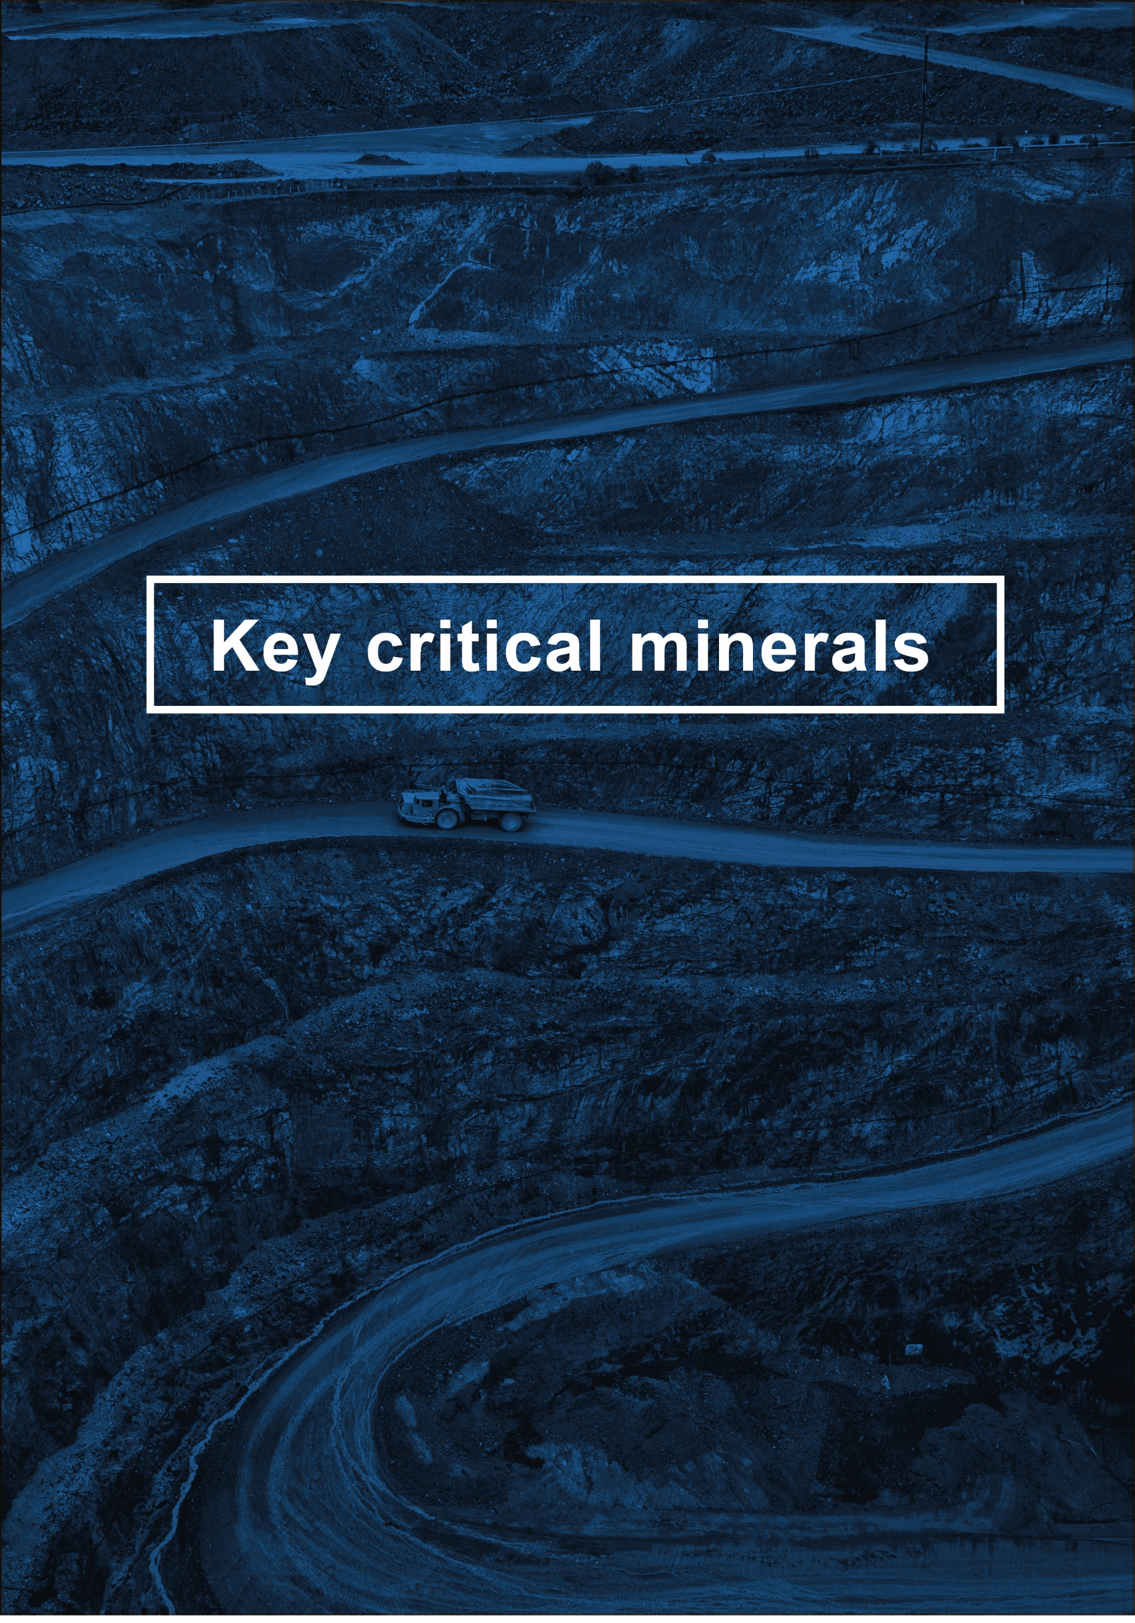

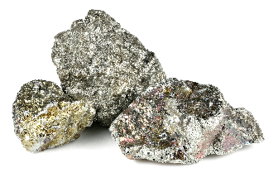
Niobium

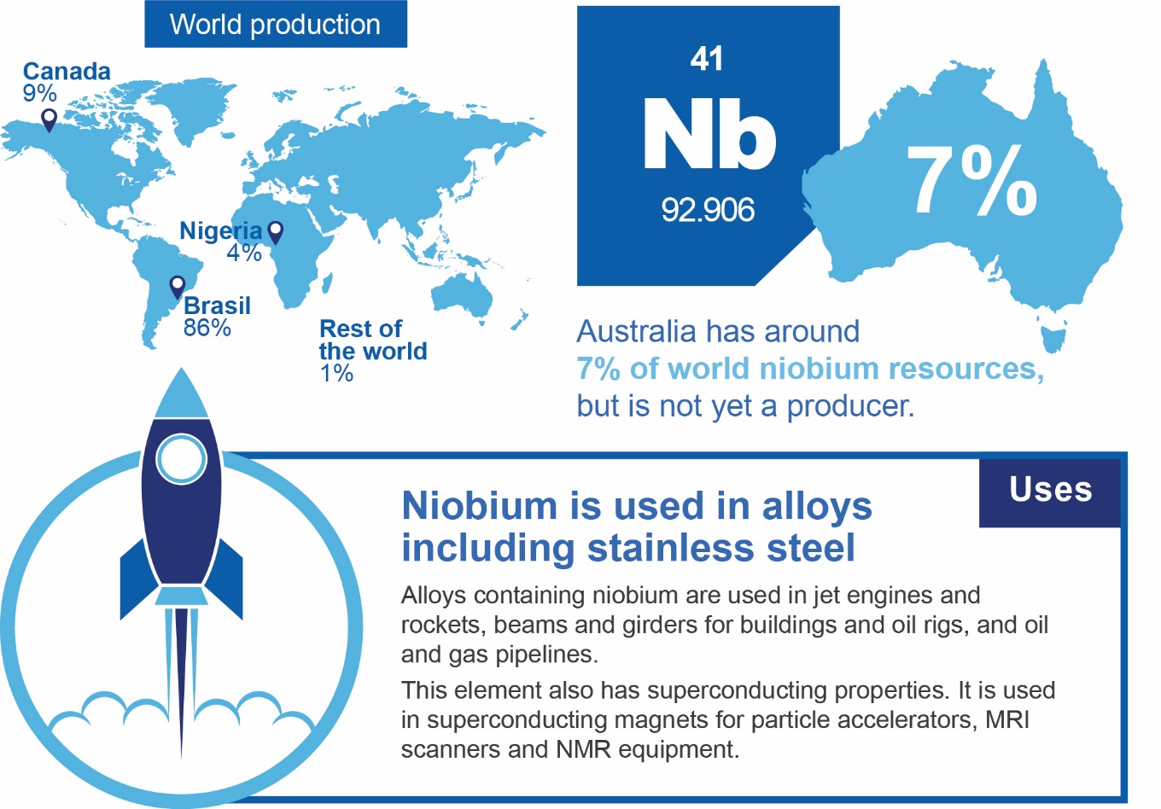

Key properties and uses
Niobium is a soft and ductile metal with a notable resistance to organic and inorganic acids. It is used primarily to produce micro capacitors (used for smoothing power output and storing energy in electronic equipment), steel, and ferroalloys. Niobium occurs as a minor element in minerals such as columbite, pyrochlore and euxenite, and is largely extracted as a co-product or by-product.

Substitution
Niobium can be substituted by molybdenum and vanadium in high-strength, low-alloy steel, and by tantalum and titanium in stainless and high-strength steels. However, substitution may add to costs and lead to a loss in performance.

World consumption
Globally, the niobium market is worth more than US$2 billion. The top five niobium importers are:
- China (US$901 million)
- US (US$483 million)
- Germany (US$192 million)
- United Kingdom (US$68 million)
- France (US$66 million)
Demand is likely to rise steadily over the next few years. This is in part due to China’s switch towards higher quality steel, which will likely require more niobium alloys. Niobium and vanadium can be substituted for each other, and higher vanadium prices may create more demand for niobium — at least in the short-term. At present, Europe and China account for the bulk of niobium imports, though China accounts for a large share of recent growth in global demand.
Niobium precursors, such as pyrochlore, are not typically sold as concentrates, and little price data is available for them. However, tantalite concentrates — which typically contain both tantalum and niobium — are an exception. It is likely that niobium prices are influenced by tantalum prices, and both appear to be correlated over time. Prices for niobium and tantalum concentrates peaked in 2011 and then declined steadily for six years, recovering in 2017 as demand began to pick up. Prices grew strongly in 2017, but are expected to ease slightly over the next few years, as European and Chinese companies slow the rate of inventory accumulation.
The United States is entirely import reliant, with most imported niobium used in the US steel industry, which utilises ferroniobium to strengthen steel for use in gas pipelines. Some niobium is also used in the US aerospace industry, which incorporates niobium alloys into a range of products.

World production

Inventory build suggests markets expect growth in the future
Niobium production has risen by around a quarter over the past seven years, with the rate of growth picking up recently. Much of the recent growth was diverted to inventories, suggesting that users are anticipating rapid growth in demand in the years ahead.
Brazil currently accounts for more than 85 per cent of all output, with Canada accounting for around 10 per cent. Companies such as Companhia Brasileira de Metalurgia e Mineração (CBMM), which mine the bulk of niobium, also have significant resources dedicated to refining, though refinery capacity also exists to some degree in China (which has the largest imports of concentrates), India, the US, Thailand, Estonia, and Kazakhstan.

Market outlook

Niobium is a ‘growth’ commodity with potential supply pressures emerging
Niobium is a rapidly growing market, with production expected to reach record levels in 2019. Significant spare capacity is still available at the CBMM facilities in Brazil. The company is currently the largest niobium producer, dominating global supply. Most other mines and facilities are at or near full capacity, and the reliance on a single dominant company for future expansions in capacity creates a market risk for niobium which would be alleviated by Australian supply.
Niobium prices are currently around US$33 a kilo, and rising margins and prices (see Figure 2.1) may attract more production over time. Markets are expected to remain approximately in balance over the next five years, with high inventories and unused capacity expected to prevent any significant supply deficit and check any rapid growth in prices. The long-term picture suggests niobium use will grow by around 2-3 per cent annually over the next 10 years. Significant volatility is unlikely, since the commodity is used primarily in circuitry and steel, which are not typically subject to large swings in production.
Figure 2.1: Ferroniobium supply, use, and price
Source Department of Industry, Innovation and Science (2019) forecasts, Australia

Australia has very limited production, but high potential
Niobium is not currently mined to any significant degree in Australia. It is co-located with lithium and tantalum at the Greenbushes mine, but it is likely that most of the output ends up in mine tailings.
A future Australian production model would likely involve extraction as a by-product of rare-earth element mining in alkaline intrusion-related systems, and also from pegmatites from granite-related mineral systems. Up to 20 per cent of output could be recycled from scrap niobium-bearing steel and superalloys.
Several significant deposits exist which could provide the raw materials. A deposit of around 75 million tonnes exists at Alkane Resources’ Dubbo project in New South Wales — this is large enough to supply current levels of global demand for up to 70 years. The project has received state and federal government clearances, and the company is now engaged in the market to refine the project specifications. Previous announcements suggest production could commence by 2020.
Hastings Technology also has a nascent rare earth/zirconium/niobium project near Hall’s Creek in Western Australia. However, the company is currently focused on its rare earth project at Yangibana.
Table 2.1: Australia’s niobium resources and production
Australia’s reserves |  |  |  | Australia’s production
Geological potential | Economic Demonstrated Resource | Share world resources | World ranking resources | 2018 production | Share of world production | World ranking production
High | 286kt | 7% | 2nd | N/A | N/A | N/A
Source: Australian Trade and Investment Commission (2019) Critical Minerals Prospectus, Geoscience Australia (2019) Critical Minerals in Australia

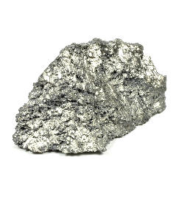
Rare Earth Elements
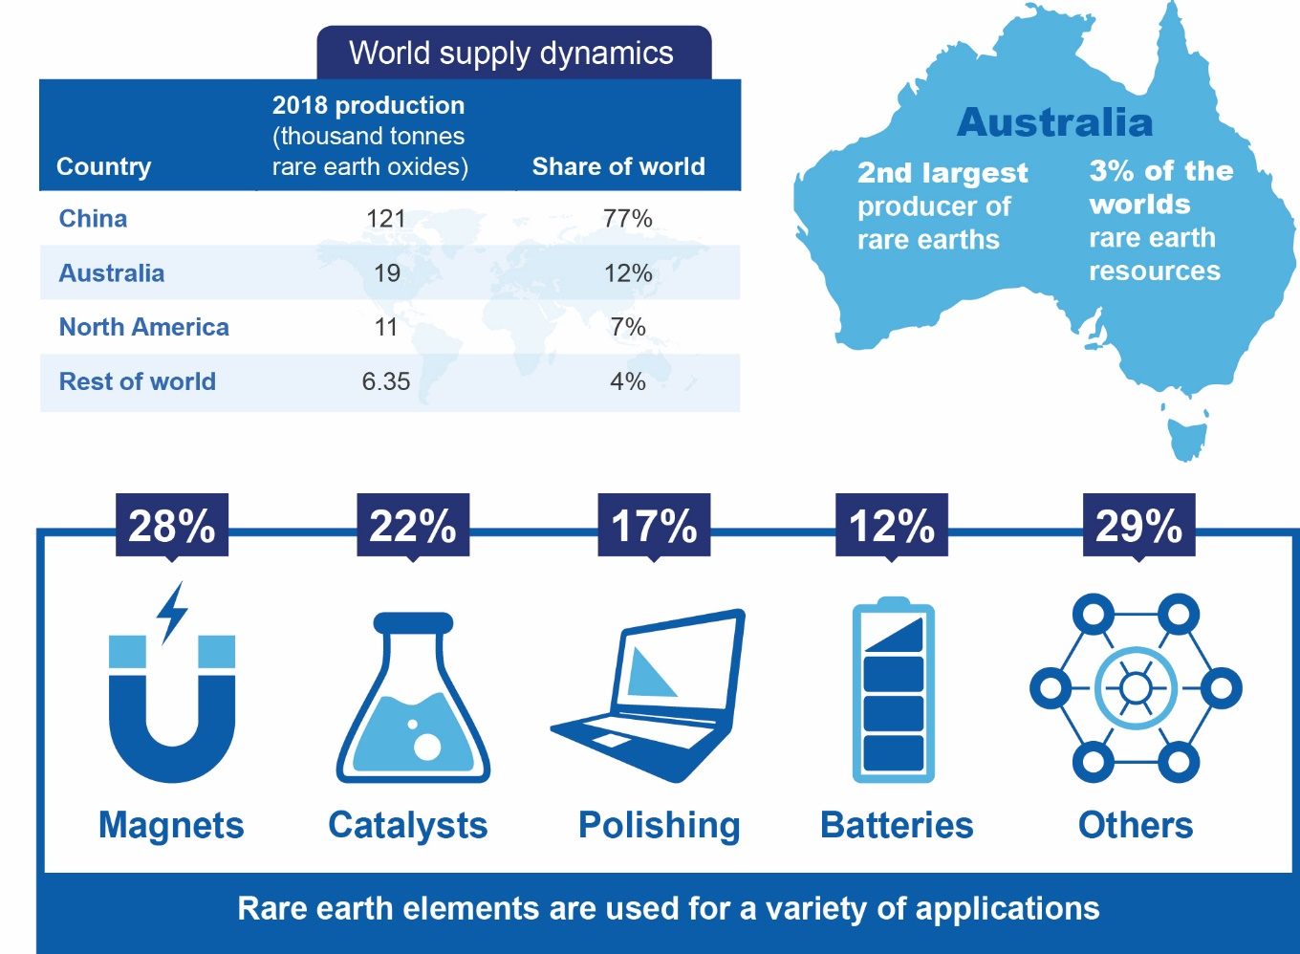

Key properties and uses
Rare earth elements (rare earths) are a group of 15 lanthanide elements plus yttrium and sometimes scandium. These elements are common in the earth’s crust, but complex to extract and exist only in limited concentrated deposits around the world. Light rare earths are more abundant and are produced in a number of countries. The most commonly produced are lanthanum and cerium, used in batteries and catalysts. In comparison, heavy rare earths are more valuable, and include dysprosium, used in permanent magnets. In the first half of 2019, lanthanum and cerium averaged US$2 per kilogram (China FOB), whereas dysprosium averaged US$212 per kilogram (China FOB).
Rare earths have unique catalytic, metallurgical, nuclear, electrical, magnetic, and luminescent properties. They are used for a variety of applications, ranging from routine to emerging technologies. They have strategic importance, due to their vital role in a variety of applications and growing end-use markets.
Table 3.1: Rare earth elements and uses
Rare earth | Uses
Light rare earths
Lanthanum | Rechargeable batteries, automotive catalysts, television and computer screens
Cerium | Automotive catalysts, glass, polishing powders
Praseodymium | Permanent magnets for EVs and wind turbines, computers, consumer electronic screens
Neodymium | Permanent magnets for EVs and wind turbines, computers, consumer electronic screens
Promethium | Thickness gauges and atomic batteries for spacecraft and guided missiles
Samarium | Magnets for small motors, cancer treatment and nuclear reactors
Europium | Red and blue colours in LCD screens, anti-forgery marks on banknotes
Heavy rare earths
Gadolinium | LCD screens, in steel to improve resistance to high temperatures
Terbium | LCD screens and magnets for electric cars and turbines
Dysprosium | Permanent magnets for electric vehicles and wind turbines,
Holmium | Nuclear control rods, sonar systems, data storage and laser materials
Erbium | Nuclear control rods, lasers
Thulium | Lasers, as a radiation source in x-ray machines and anti-forgery marks on banknotes
Ytterbium | Portable X-ray machines, lasers, earthquake monitors, strengthening stainless steel
Lutetium | Positron Emission Tomography (PET) scanners for 3D images of cellular activity
Other rare earths
Yttrium | Consumer electronics, energy efficient lighting, satellites and superconductors
Notes: Scandium is not included in this list of rare earth elements.
Source: Austrade (2019), Geoscience Australia (2013)

Substitution
Rare earth substitutes are available in some applications, but they tend to be less effective. Users of rare earths have responded to supply issues and price spikes by reducing use in non-essential applications.

World consumption
Consumption of all rare earths grew by around 5 per cent a year in the five years to 2018, driven primarily by higher use in magnet manufacturing. China is the largest user of rare earths, accounting for 69 per cent of world end-use consumption, followed by Japan and the US (Figure 3.1). The US depends heavily on imports of processed rare earths, although there is some domestic mine capacity.
Major importers of rare earths are:
- China (56 per cent of world imports)
- Japan (22 per cent of world imports)
- US (17 per cent of world imports)
China’s rare earths consumption is mostly used in magnet manufacturing — China produces around 90 per cent of the world’s permanent magnets — however battery and other manufacturing is significant. As such, China’s rare earths consumption is expected to continue growing in-line with manufacturing activity, while consumption growth in other countries is expected to be more stagnant.
Figure 3.1: Rare earths consumption 2018, by type and region

Source: Roskill (2018), Department of Industry, Innovation and Science (2019)

Magnet manufacturing to push up rare earths consumption
Rare earths are primarily used in magnet manufacturing (28 per cent of world consumption), catalysts (22 per cent), polishing (13 per cent) and batteries (9 per cent). Growing markets and technological changes, particularly in magnet and battery use, are expected to drive future consumption growth of more than 5 per cent a year over the next five years.
Rare earths used in magnet manufacturing — primarily praseodymium, neodymium, dysprosium and lanthanum — are expected to see double digit consumption growth as magnet manufacturing grows to support electric vehicle growth, as well as other applications like wind turbines and electric bikes.
Expanding battery manufacturing will support consumption growth in lanthanum and cerium, outweighing the reduction in cerium used in the catalysts of internal combustion engines.

World production

China accounts for 77 per cent of the world’s rare earths production, followed by Australia
Low prices and production quotas in China have curbed rare earths production growth; world production fell for six consecutive years before rebounding in 2018, to reach an estimated 170 thousand tonnes of rare earth elements. In 2018, China accounted for around 77 per cent of rare earth mine production, well ahead of Australia (12 per cent) and North America (7.1 per cent). Australia’s production has increased steadily, due to Lynas’ Mount Weld operation, which exports rare earth oxides for processing in Malaysia. MP Materials’ Mountain Pass operation in the US reopened in 2018, and exports bastnasite concentrate to China.
Within China, production is highly concentrated, with six state-owned entities controlling 75 per cent of mine production. In the past, China’s production quotas, export restrictions, environmental controls and efforts to address illegal production have caused sharp price spikes. Tighter environmental controls were introduced in 2016, and environmental inspections in subsequent years have resulted in capacity closures and the reallocation of productive capacity across the border to Myanmar. The increased focus on illegal production has also led to decreases in output.
Processing and separation of rare earths predominately occurs in China. Processing requires specific technology for different applications, and there are significant waste processes to manage.
Production of rare earths is projected to increase at around 5 per cent a year over the next five years, reaching 222 thousand tonnes in 2023 (Figure 3.2). New and expanding production from Australia is expected to contribute the biggest share of this growth.
Figure 3.2: World production of rare earth oxides
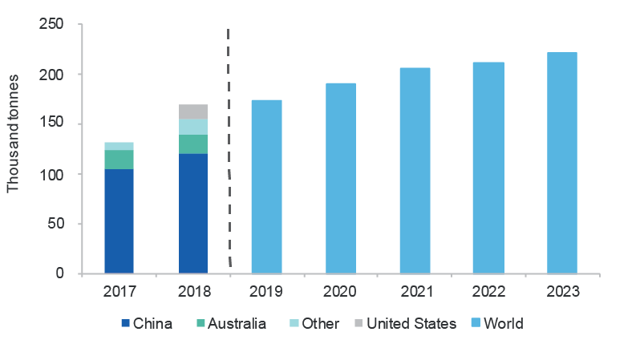
Source: United States Geological Survey (2019), Department of Industry, Innovation and Science (2019)

Market outlook
The outlook for individual rare earths varies; oversupply is expected in some rare earth element markets, like lanthanum, whereas the market for neodymium is expected to remain tight. In the past, oversupply has led to low prices and stockpiling. Consumption is expected to increase, particularly in magnet and battery end use markets (Figure 3.3). Prices for rare earths used in magnet production grew steadily in mid-2019, due to fears of undersupply relating to US-China trade tensions. Prices of heavy rare earths (including dysprosium and terbium) have seen high volatility in 2019, due to supply constraints — including the closure of the trade port between at the China-Myanmar border in May and other closures for environmental purposes.
In mid-2019, China imposed a 25 per cent tariff on rare earth imports from the US, which makes US-produced rare earth oxides more expensive when imported for processing in China. The outlook for rare earths depends, in part, on whether there are further tariffs applied or export controls introduced.
Figure 3.3: Forecast rare earth consumption, by usage type
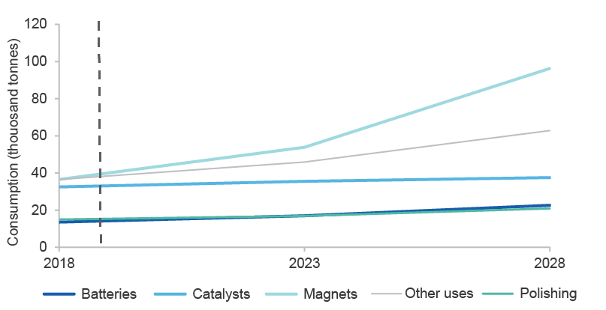
Source: Roskill (2018), United States Geological Survey (2019), Department of Industry, Innovation and Science (2019)
Prices for rare earths used in magnets and batteries are expected to grow substantially over the medium term, while markets for other elements are expected to be more balanced. Praseodymium and neodymium prices are forecast to increase by 5-10 per cent over the next five years. (Figure 3.4).
Figure 3.4: Price outlook for select rare earths, China FOB
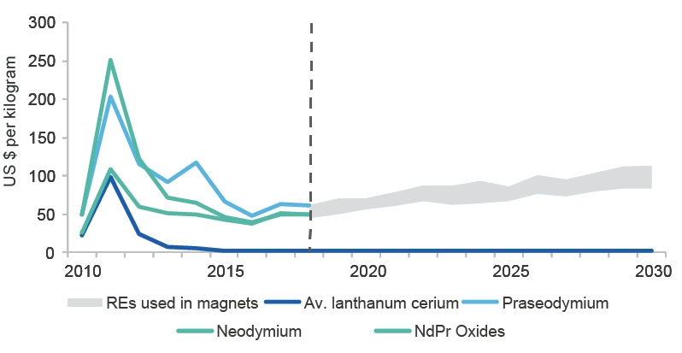
Notes: NdPr -oxides neodymium and praseodymium oxides, lanthanum and cerium prices are represented as an average
Source: Roskill (2018), Department of Industry, Innovation and Science (2019)
Prices for heavy rare earths are expected to increase; consumption is expected to grow and the issues constraining current production are not likely to be resolved in the near-term. Near term price increases are expected to be maintained over the outlook period; however growth in electric vehicles, magnet manufacturing and production constraints influence the variability in this forecast (Figure 3.5).
Figure 3.5: Price outlook for dysprosium
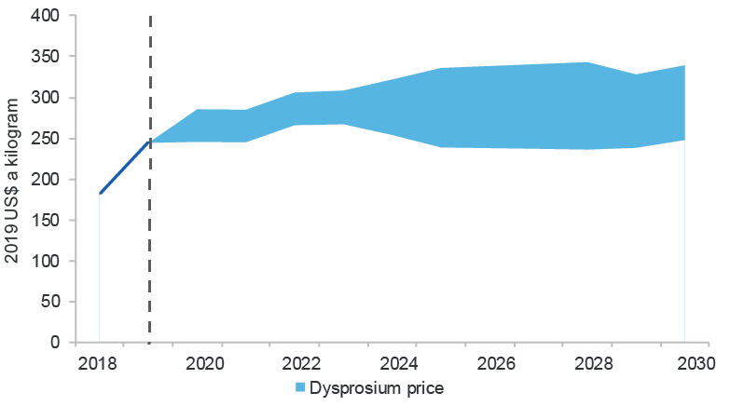
Source: Roskill (2019), Department of Industry, Innovation and Science (2019)

Australia

Australia has high quality deposits and the potential to increase production
Australia’s rare earth deposits are distributed across the country, and Australia has the potential to supply both light and heavy rare earths. Historically, production was mostly sourced from mineral sands; however rare earths deposits have now been discovered in a greater range of geological settings, and there are projects operating or developing in most states.
Table 3.2: Australia’s rare earth resources and production
Australia’s resources |  |  |  | Australia’s production
Geological potential | Economic Demonstrated Resource | Share world resources | World ranking resources | 2018 production | Share of world production | World ranking production
High | 3430kt | 3% | 6th | 19kt | 12% | 2nd
Source: Roskill (2018), Australian Trade and Investment Commission (2019) Critical Minerals Prospectus, Geoscience Australia (2019) Critical Minerals in Australia
There are currently two projects producing rare earths, with a number of projects in the development pipeline. Australia’s production, primarily from Lynas’ Mt Weld project, has grown at an average of 38 per cent a year over the last five years, to reach 20 thousand tonnes in 2018-19. The pilot stage of Northern Minerals’ Brown Range project commenced exporting in December 2018.
Australia’s resource richness is highlighted by Hasting Technology Metal’s Yangibana project, which has higher praseodymium and neodymium resource concentrate than is available in comparable projects in China. With significant resource capacity and a positive operating environment, there is scope to establish the domestic processing of rare earths, as is being examined as part of Alkane’s Dubbo Project. Australia’s development projects also have positive project economics — Arafura’s Nolans project, is expected to have operating costs of around half of current prices and is targeting start-up in 2022.
There is also potential in rare earths that are currently co-produced with other commodities but not accounted for in product sales, or content that may remain in tailings. Rare earths content may be exported in unprocessed ores, potentially incurring a penalty as it incurs processing costs. The value of these resources is currently being explored by Geoscience Australia. Significant progress in processing technology and changes in world markets would be required to make the development of these resources economically viable.

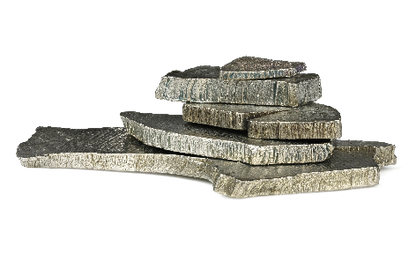
Cobalt
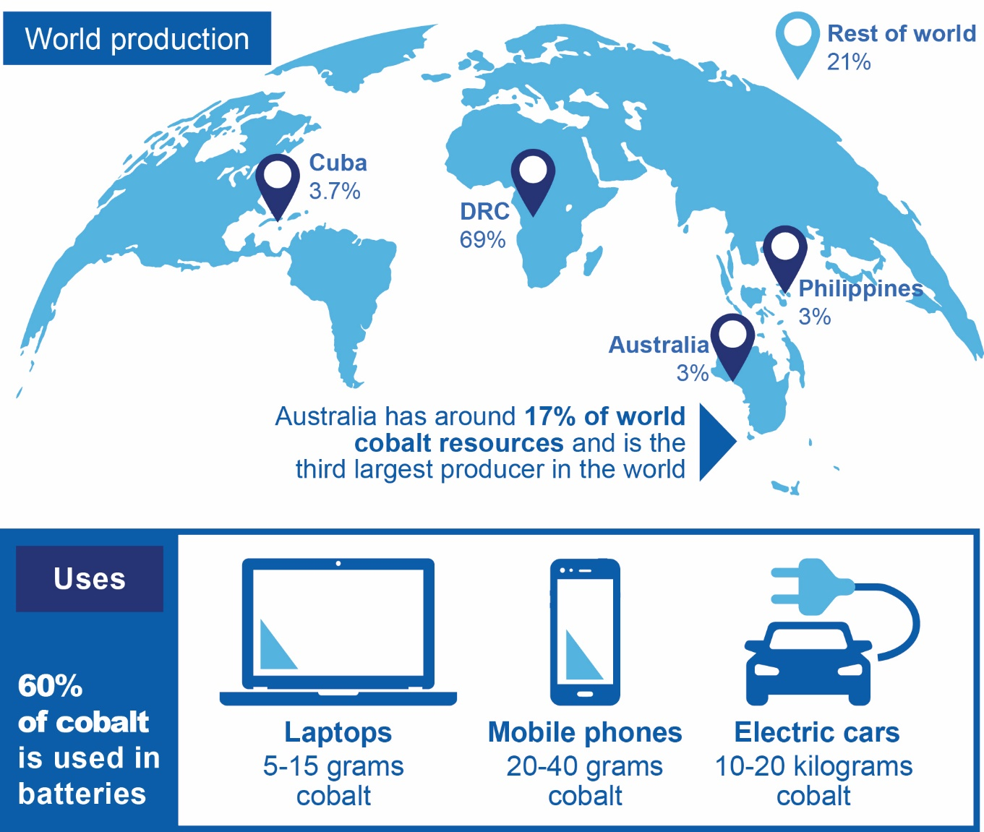

Key properties and uses
Cobalt is a ferromagnetic metal that is known for being hard and lustrous. Cobalt is mainly used in batteries (57 per cent of consumption total), nickel-based alloys (14 per cent) and for tool manufacturing (9 per cent).

Substitution
Currently available cobalt substitutes are higher cost and result in lower performance. Supply issues are prompting investment into developing alternatives, including using other materials to reduce the cobalt content of batteries.

World consumption

Cobalt consumption has increased with broader applications and expanding markets
Cobalt consumption has grown with battery use, as it provides a fundamental component to the booming consumer electronics market. Since 2010, world consumption has grown at 24 per cent a year to reach 131,000 tonnes in 2018. As battery manufacturing and, to a lesser extent, the manufacture of nickel-based alloys, continue to grow, world cobalt consumption is projected to grow by around 7 per cent year, to reach a 310,000 tonnes in 2030 (Figure 4.1).
In 2018, the largest importers of cobalt ores and concentrates were:
- China (66 per cent of world total)
- Zambia (27 per cent)
- Morocco (3 per cent)
Figure 4.1: Forecast cobalt consumption
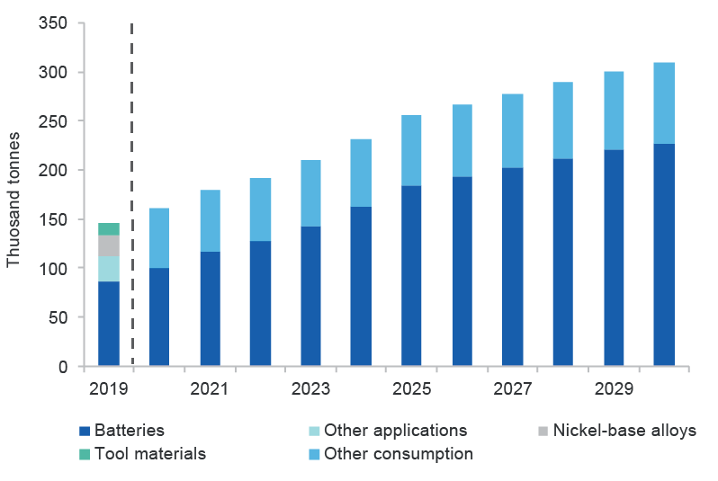
Source: Bloomberg New Energy Finance (2019), Department of Industry, Innovation and Science (2019), Roskill (2019).
Refined cobalt consumption is closely tied to battery manufacturing activities. China is the largest consumer of refined cobalt, accounting for around 40 per cent of the world’s refined consumption, followed by Japan and South Korea.

World production

Mined and refined production of cobalt is highly concentrated
The Democratic Republic of the Congo (DRC) accounts for around 65 per cent of world mined cobalt production, while Australia accounts for around 3 per cent (Figure 4.2). In the DRC, cobalt is co-produced with copper, and faces significant social and environmental issues, which are a major risk to supply. This supply risk is making cobalt, and cobalt sourced in the DRC, increasingly unattractive to consumers. Despite this, in the future, the highest production growth is expected to come from the DRC.
Figure 4.2: World production of mined cobalt
Notes: DRC is the Democratic Republic of the Congo.
Source: Bloomberg (2019)
Cobalt mined in the DRC is almost exclusively exported to China for further refining. China accounts for around 66 per cent of refined cobalt production (Figure 4.3). In terms of refining capacity, Australia accounts for around 3 per cent of world capacity and is ranked 5th in world.
Figure 4.3: World production of refined cobalt
Source: Bloomberg (2019)

Market outlook

Growing metal consumption may tighten the market balance and increase prices
Prior to 2017, the cobalt market was well supplied. However, in 2017 and 2018 cobalt prices spiked, exceeding US$94,000 a tonne — double the average of the previous five years. Prices have since declined steadily; in the first half of 2019, the cobalt LME spot price averaged US$33,500 a tonne. Recent low prices and expectations about demand growth, have prompted the temporary closure of Glencore’s Mutanda mine in the DRC, the largest cobalt mine in the world.
Cobalt prices are expected to rise as battery production increases. However, the market is expected to be adequately supplied until around 2025, as new production enters the market and the output of recycled production increases. Cobalt used in batteries is projected to grow by 9 per cent a year to 2030. Cobalt used in nickel alloys, pigments and permanent magnets is also set to grow. This growth is expected to support modest price increases in the medium term, although uncertainty around trends in battery manufacturing could lead to price volatility (Figure 4.4).
Issues in the DRC, including heightened political instability and a new tax treatment on critical minerals mining, also pose a risk to world production. These supply-side issues and fear of price spikes, are prompting investment into alternatives, including substitution of cobalt in batteries. The market outlook is dependent on these factors, as well as on the take-up of electric vehicles.
Figure 4.4: Cobalt price outlook

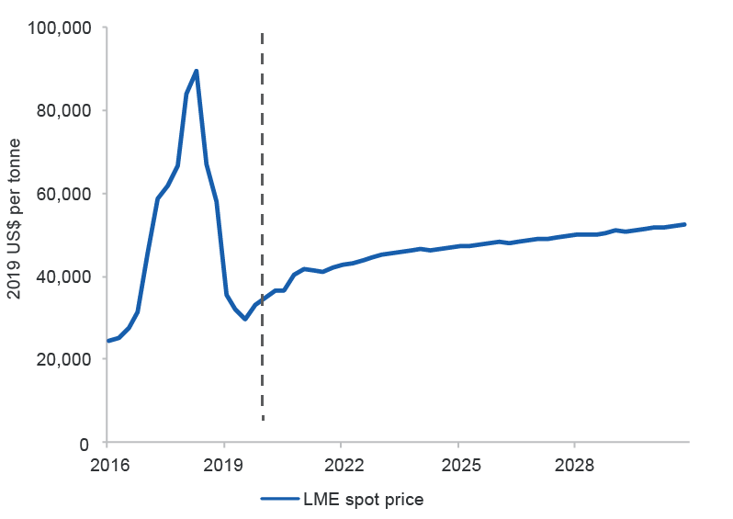
Source: Bloomberg (2019), Department of Industry, Innovation and Science (2019)

Australia

Australia has strong cobalt prospects
Australia’s cobalt is expected to be in high demand going forward, as consumers increasingly seek secure and ethical supply sources. Australia’s cobalt is primarily found in nickel laterite resources, and has also been extracted from copper deposits. With Australia holding an estimated one-sixth of the world's known cobalt reserves (Table 4.1), there are significant opportunities for cobalt extraction from existing mines, the development of known deposits and the discovery of new deposits.
Table 4.1: Australia’s cobalt resources and production
Australia’s resources |  |  |  | Australia’s production
Geological potential | Economic Demonstrated Resource | Share world resources | World ranking resources | 2018 production | Share of world production | World ranking production
High | 3,430kt | 17% | 2nd | 5kt | 4% | 3rd
Source: Australian Trade and Investment Commission (2019) Critical Minerals Prospectus, Geoscience Australia (2019) Critical Minerals in Australia
In 2019, Australia’s production of mined cobalt is estimated to be 5,500 tonnes, and refined metal production is estimated to be 3,200 tonnes. After some consolidation in recent years, there is strong potential in Australia’s cobalt production, with a number of cobalt projects under development and positive price expectations in associated copper and nickel markets.
There are a number of cobalt projects under development in Australia, including pure cobalt projects and cobalt-nickel-scandium projects. Australia Mine’s Sconi project in Queensland (annual cobalt capacity 1.8 thousand tonnes) and Clean TeQ’s Sunrise project in NSW (annual cobalt capacity 3.2 thousand tonnes) are both being assessed for feasibility. Both projects have associated nickel production, which is expected to support project financing and development.

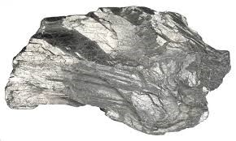
Antimony

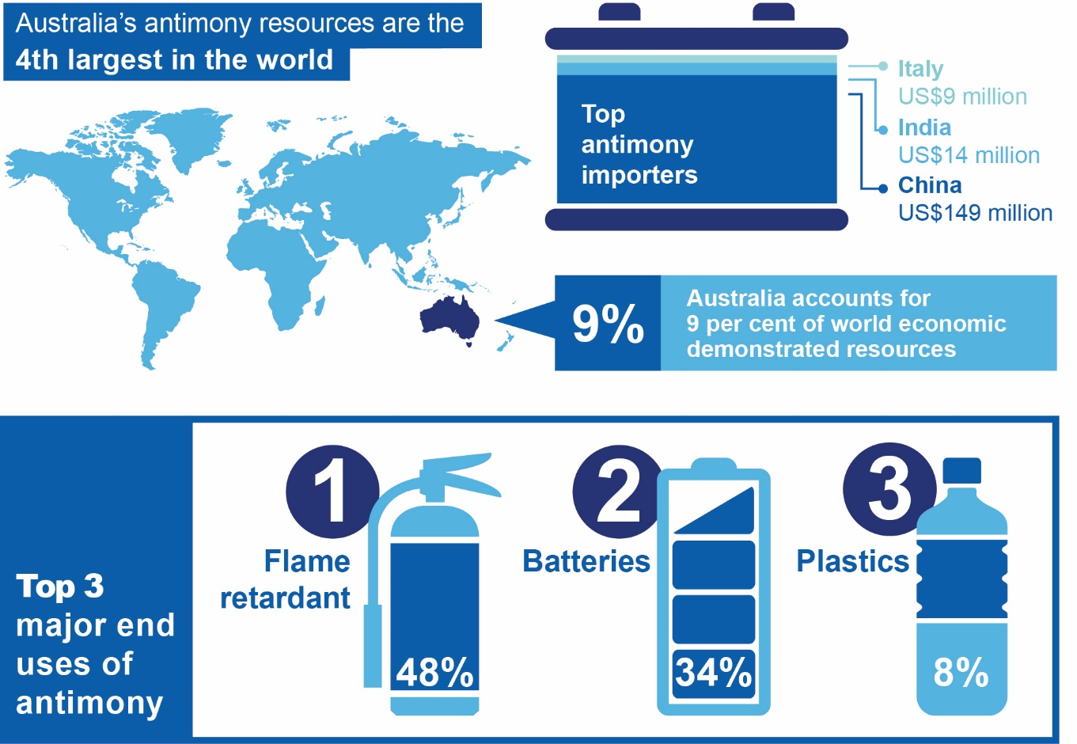

Key properties and uses
Antimony generally occurs along with lead, copper and silver in complex polymetallic ores that also contain molybdenum, tungsten, zinc, indium and bismuth. It is a silvery-white brittle metal known to be semi-conductive and resistant to acids.
Antimony is mostly used in lead acid batteries and as a flame retardant in other materials such as plastics. Smaller quantities are used in niche applications such as to improve the performance of glass in photovoltaic solar panels. The metallurgical antimony required for batteries is sourced from either mining or from the secondary recovery of antimonial lead, such as the recycling of lead acid batteries. Antimony for non-metallurgical applications is generally sourced from mining.

Substitution
Antimony has cost-effective substitutes in flame-retardant applications, although some can have undesirable consequences like weakening the polymer being treated. In automotive lead-acid batteries, lead-calcium-tin alloys can be substituted for antimonial lead. Additionally, technological developments in lead acid batteries have progressively reduced the amount of antimony required for alloying with lead, with modern car batteries containing a fraction of the antimony they once did.

World Consumption

Consumption of antimony is in decline
China is both the main consumer and the largest supplier of antimony. The US, by contrast, relies on imports for 85 per cent of its antimony requirements, primarily from China, Bolivia and Belgium.
The top antimony importers are:
- China (US$149 million)
- India (US$14 million)
- Italy (US$9 million)
Antimony consumption has been in decline (Figure 5.1), led by falling flame retardant and battery use. The role of antimony has continued to grow in plastics production, where it’s used, for example, as a heat stabiliser in PVC. The use of antimony in plastics, while relatively small in volumes, has been growing at an annual rate of over 4 per cent since 2010, and this is expected to continue.
The volume of antimony consumed for battery production has fallen by an average 1 per cent a year since 2010 due to decreasing intensity of use, despite growth in the volume of lead acid battery production overall.
Figure 5.1: World antimony consumption
Source: Roskill (2019)

World production
China has dominated global antimony supply for over a decade. However, increasing enforcement of environmental regulations has seen its production falling recently, causing its share of world production to drop from 80 per cent in 2010 to 48 per cent in 2018. By contrast, Russia’s production of mined antimony is growing strongly, reaching 29 per cent of global supply in 2018, and bringing the country into second place — displacing Tajikistan (Figure 5.2).
Figure 5.2: World mine production of antimony, major producers and Australia
Source: Roskill (2019)
Australia has the fourth largest reserves of antimony in the world, and was the sixth largest supplier of mined antimony in 2018, accounting for 2 per cent of global mine production. Australia’s production fluctuates with market conditions, with at least one mine suspending production in recent years, due to lower prices.
Processing of antimony is complex, and differs according to the particulars of the ore in which it is contained. Australian antimony is currently associated with gold, so alkaline sulphide leaching of the ore is a preferred pre-treatment method to isolate antimony. A number of pyro- or hydro-metallurgical processing techniques can then be applied for antimony recovery.
China has capabilities for processing most ore types. It processes all of its own mine output, all of Australia’s mine output, and the majority of ores and concentrates mined elsewhere. China therefore dominates the world’s supply of antimony metal and antimony oxide. By contrast, Europe (led by Germany) is the leading supplier of antimonial lead which is sourced from lead acid battery recycling rather than mining.

Market Outlook

A slowly-growing market, with some additional mines needed
Consumption of antimony is forecast to grow slowly — at under 1 per cent a year over the next 10 years— and a change in the composition of consumption will support growth in mining.
The market for metallurgical antimony is expected to contract over the outlook period as the intensity of use in batteries continues to decline. Longer term, lead acid batteries themselves may give way to lithium-based and other battery technologies. Increasing battery recycling activity, particularly in China, is forecast to fully meet metallurgical demand for antimonial lead in the mid-2020s.
Steady growth in non-metallurgical uses of antimony is likely to offset the metallurgical decline over the outlook period to 2028, led by increasing consumption in flame retardants and plastics.
The US National Toxicology Program has recently confirmed that antimony trioxide is ‘reasonably anticipated to be a human carcinogen’. It is likely that subsequent policy decisions will limit its application in some uses, such as in flame retardants, to minimise the risks of human exposure. Even with regulatory limits on some uses of antimony trioxide flame retardants, the expected growth in flame retardant demand overall is likely to support continued growth in antimony use.
Over the outlook period, non-metallurgical uses will support growth in antimony mining, averaging around 1.5 per cent a year. Some investment in additional low-cost mining capacity is expected to be needed to meet expected consumption volumes. With output capacity growing faster than antimony use, a modest decline in the price of mining output is expected (Figure 5.3).
Figure 5.3: Antimony price outlook (2017 US dollars)
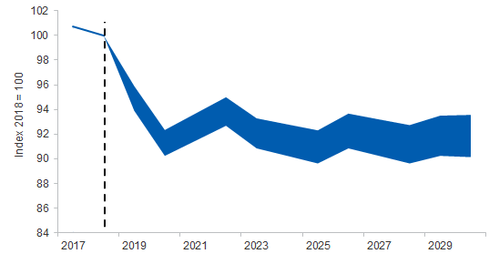
Source: Roskill (2019), Department of Industry, Innovation and Science (2019)

Australia

Australia’s production has been in decline, but has potential to grow again
Australia has large economic demonstrated reserves of antinomy, but only one currently-operating mine at Costerfield in Victoria. Mandalay Resources, which owns the mine, extracts both gold and antimony. Low antimony prices have seen a similarly-sized producer, Hillgrove in New South Wales (Hillgrove Mines), held in a state of ‘care and maintenance’ since 2016. Australian antimony ore has relatively strong market value, due to both high ore grades and the presence of gold.
Another source of Australian antimony is the recycling of lead acid batteries, such as car batteries. Three facilities perform this: Enirgi in Wagga Wagga NSW; HydroMet in Laverton Victoria; and HydroMet in Unanderra NSW. This recycling process produces antimonial lead, and the outlook for Australian output of this type is expected to be stable since recycling rates are already high.
Table 5.1: Australia’s antimony resources and production
Table 5.1: Australia’s antimony resources and productionAustralia’s resources |  |  |  | Australia’s production
Geological potential | Economic Demonstrated Resource | Share world resources | World ranking resources | 2018 production | Share of world production | World ranking production
Moderate | 138kt | 9 per cent | 4th | 3.4kt | <1% | Minor
Source: Roskill (2018), Australian Trade and Investment Commission (2019) Critical Minerals Prospectus, Geoscience Australia (2019) Critical Minerals in Australia

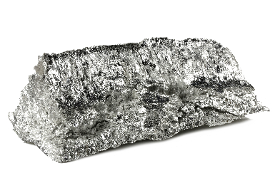
Magnesium
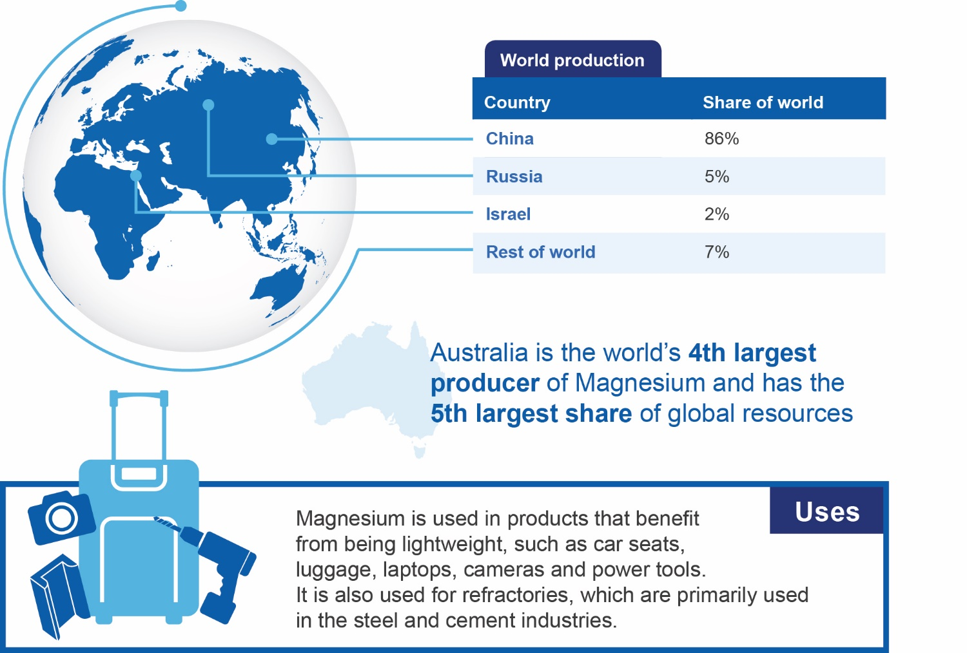

Key properties and uses
Magnesium is a shiny-grey, light metal produced from precursors including magnesite.
Magnesium and its precursors have a range of industrial uses. Magnesia is used in large amounts for refractories, which are primarily used in the steel and cement industries. Steel production has risen by more than 2 per cent each year on average over the past five years, but technological improvements and efficiency gains have nonetheless led to steadily declines in demand for refractor materials. Demand for magnesia and related products remains robust in agriculture and construction.

Substitution
Aluminium and zinc may substitute for magnesium in castings and wrought products, but the light weight of magnesium provides an advantage.

World consumption

Magnesium is increasingly important for industrial and chemical markets
Magnesium markets were worth more than US$750 million in 2018, with the top magnesium importers being:
- Germany (US$204 million)
- Canada (US$195 million)
- US (US$159 million)
- Japan (US$100 million)
- Republic of Korea (US$58 million)
The US imports around half of its magnesium, making it relatively import reliant. More than half of magnesium used in the US is directed to agricultural, chemical, construction, environmental, and industrial applications. A substantial amount is also used for refractories in the form of dead-burned magnesia, fused magnesia, and olivine.

World production

China dominates magnesium production, but the market is starting to diversify
At present, magnesium production is heavily dominated by China, which accounts for 86 per cent of all refined output. Russia accounts for 5 per cent, with Israel accounting for a further 2 per cent.
China dominates every stage of the magnesium supply chain, with production concentrated in the Liaoning province, which has two primary production hubs: Dashiqiao (which includes the bulk of processing) and Haicheng (which holds large deposits and primary production facilities).
In recent years, Chinese refined production has been constrained by the closure of some facilities on environmental grounds. This comes alongside new restrictions on access to mining explosives. By late 2017, cuts in Chinese mine output had led to significant global supply shortfalls, and windfalls for suppliers outside China. As Chinese production costs rise, countries including Australia will have more opportunities to enter the market, and supply sources are expected to diversify.
Most magnesia trade occurs through contracts between producers and consumers, with little trading at exchange markets. This means there is little transparency and minimal information on prices for magnesium and its precursors. However, it is clear that prices for products such as magnesite are virtually set by China due to its dominant position, and the prices for these minerals have risen sharply following environmental closures among Chinese facilities.

Market outlook

Magnesium use is growing slowly, with new projects emerging
Magnesite use is expected to grow slowly over time. A gradual decline in use of gypsum and fibre cement in the construction industry, and their replacement with magboard (which includes magnesium content) is one potential growth source. Demand for magnesium-based fertilisers — which are soluble and quick-acting — is also set to rise, and the ubiquity of global agriculture means this could create many new opportunities around the world. Global demand is expected to grow by around 2.5 per cent per year out to 2030, with the Chinese construction sector set to make the largest contribution. Prices for magnesium precursors are expected to ease back from recent peaks, before rising slowly over the medium term.
Most magnesite is processed into magnesia in the country where it is extracted. This would likely be the case for Australia too, meaning that expansion of supply here would potentially entail a full production chain growing up over time. Only a very small number of new magnesium projects have been commissioned since 2010, but production has the potential to grow, as new mineral projects emerge in Australia, Russia, Turkey, and Spain.

Australia

Australia has potential to be leading supplier of magnesium precursors
Australia extracts approximately 500,000 tonnes of magnesite each year, or around 2 per cent of global output (Figure 6.1). More than 90 per cent of Australian magnesite output is produced by QMAG, which is owned by Sibelco. The company holds a deposit at Kunwarara in Queensland, and produces fine-grained monocrystalline nodular magnesite. In Victoria, Calix produces magnesium hydroxide using magnesite raw materials mined in South Australia. Causmag also produces high-purity magnesium oxide powder using output mined at Thuddungra in NSW.
Australian output could potentially quadruple as new projects commence. Possible projects include:
- Archer Exploration’s Leigh Creek deposit in South Australia
- Thesally’s Huandot project in the Northern Territory
- Jindalee Resources’ Prospect Ridge project in Tasmania
- BMAG’s Ravensthorpe project, in Western Australia
- Korab Reosurces’ Winchester project in the Northern Territory
Opportunities also exist in the Pilbara region of Western Australia, where salt producers generate large quantities of magnesium in their waste streams.
Figure 6.1: Australia’s share of global magnesite production

Source: Department of Industry, Innovation and Science (2019), Roskill (2018)
Table 6.1: Australia’s magnesium resources and production
Australia’s reserves |  |  |  | Australia’s production
Geological potential | Economic Demonstrated Resource | Share world resources | World ranking resources | 2018 production | Share of world production | World ranking production
Moderate | 1.17mt | N/A | 5th | N/A | N/A | 4th
Source: Australian Trade and Investment Commission (2019) Critical Minerals Prospectus, Geoscience Australia (2019)

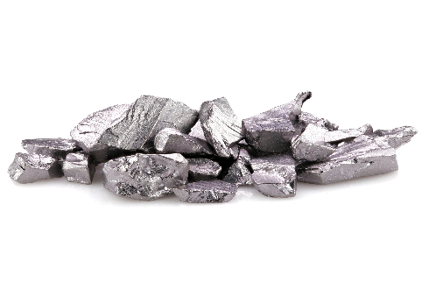
Tungsten

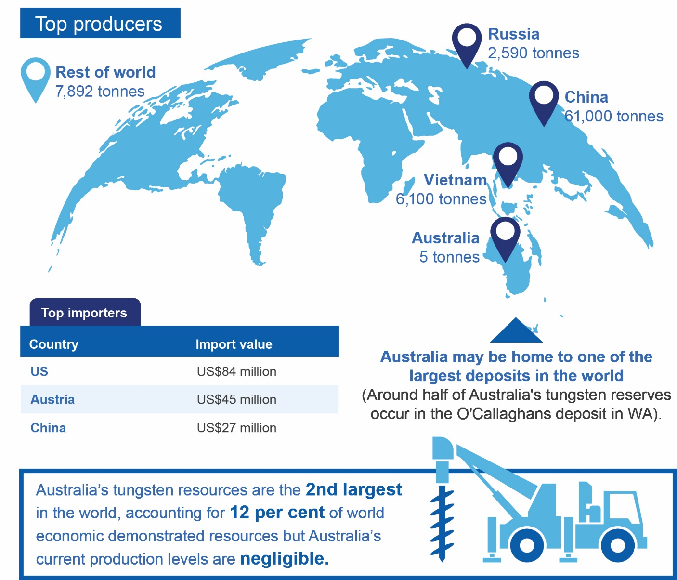

Key properties and uses
In mineral deposits, tungsten is commonly found in association with molybdenum or tin.
Tungsten is a steel-grey, brittle metal with a high melting point, very high tensile strength, and the lowest coefficient of thermal expansion of any metal. These qualities are useful in tool making.
Tungsten is used to make alloys and specialty steels, as well as electrodes, filaments, wires, and other components for electrical, electronic, heating, lighting and welding applications. Cemented carbide parts are important for cutting and wear-resistant applications, primarily in the construction, metalworking, mining, and oil and gas drilling industries. It is also used to produce chemicals.

Substitution
Substitutes for tungsten carbide include molybdenum carbide, titanium carbide, ceramics, ceramic-metal composites, and tool steel. Molybdenum steel can substitute for tungsten steel, and there are several substitutes for tungsten in lighting. These tend to be less cost effective than tungsten or face performance limitations. Depleted uranium can be substituted in munitions, is cheaper than tungsten, but has been associated with health concerns for people handling it.
Figure 7.1: World consumption of tungsten by use
Xx Paste figure
Source: Roskill (2019)

World consumption
The top tungsten importers are:
- US (US$84 million)
- Austria (US$45 million)
- China (US$27 million)
Since tungsten’s main uses are in industry, its consumption tends to grow in line with the world economy, and particularly in line with the manufacturing sector. Tungsten has seen steady growth in both demand and supply over the past decade. With strong world economic growth from 2011 to 2018, tungsten consumption rose 2.1 per cent a year on average (Figure 7.1). Current weakness in the global economy and manufacturing sector has contributed to prices falling to two-year lows of around US$270 per metric tonne unit (mtu).
Tungsten has long been considered strategically important, and the US has maintained a defence national stockpile of tungsten ores and concentrates since the 1940s.

World production
Over the past 20 years, China has been the dominant producer of primary (mining) and secondary (recycling) tungsten. In 2018, China accounted for 79 per cent of all mining output, Vietnam accounted for 8 per cent, and Russia for a further 3 per cent (Figure 7.2). While Australia has produced modest volumes of tungsten in the past, 2018 Australian output was negligible. A number of tungsten mines remain uneconomic at prevailing prices.
Figure 7.2: Mine production of tungsten concentrates, major producers and Australia
Pa
Source: Roskill (2018)
High prices from 2011 to 2014 stimulated investment around the world. This investment caused world mining output to surge in 2015, resulting in production exceeding consumption by around 10 per cent in that year. Prices have declined since then, and mine closures have reduced primary supply, albeit with some offset from secondary sources. Higher environmental standards for Chinese producers have also reduced output more recently, with compliance action in 2017 and 2018 suspending operations at some mines.
China dominates the ore processing and chemical production aspects of the tungsten supply chain. Newly-mined tungsten ores and concentrates are typically processed into ammonium paratungstate (APT) or (to a smaller extent) ferrotungsten as the initial refined tungsten production steps. Most APT is then transformed into tungsten oxides, tungsten metal powders and, finally, tungsten carbide. Most production capacity (three-quarters) for these processes is located in China, and much capacity is unused — with worldwide current facilities capable of processing around double the current levels of output.

Market Outlook

Solid market growth expected
While some uses of tungsten — such as filament light bulbs — may experience decline over the longer term, overall tungsten demand is expected to grow at around 1 per cent per year on average over the period to 2030. Prices are expected to recover from 2019 levels and to remain at levels which support steady growth in world mining output (Figure 7.3).
Figure 7.3: World refined tungsten production/consumption, price outlook
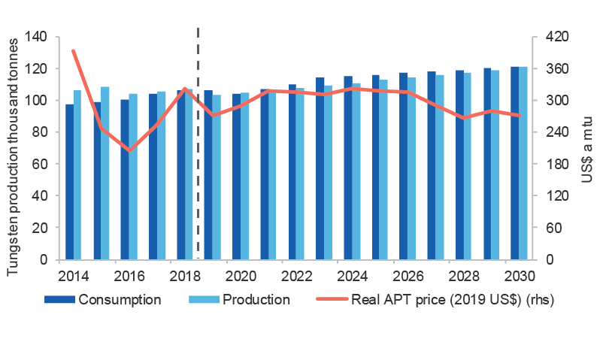 Xx Paste figure x
Notes: APT is ammonium paratungstate. A Metric Tonne Unit ("mtu") is equal to ten kilograms per metric tonne and is the standard weight measure of tungsten.
Source: Bloomberg (2019), Roskill (2019), Department of Industry, Innovation and Science (2019) estimates

Australia

Australia’s production has been in decline, but prospects for the future are bright
Australia’s tungsten production is currently negligible, as the major ongoing producer — Wolfram Camp mine in Dimbulah, Queensland — ceased active production in recent years, due to weak market conditions. The company is now in voluntary administration.
Australia holds one-eighth of total global economic demonstrated resources, and has the potential to increase tungsten production significantly. Around half of Australia's tungsten reserves occur in the O'Callaghans deposit in WA, and this may be one of the largest deposits in the world. In coming years, up to 19 tungsten mine projects have some prospects for development. If all these projects come online, production of up to 15kt a year (equivalent to 17 per cent of projected world mine output in 2028) would be possible. There is further potential for new discoveries and redevelopment of historic mines/districts, particularly in the Tasmanides Belt of Eastern Australia. Tungsten projects at feasibility stage are shown in the Development Projects Table 1.3 above.
Table 7.1: Australia’s tungsten resources and production
Australia’s resources |  |  |  | Australia’s production
Geological potential | Economic Demonstrated Resource | Share world resources | World ranking resources | 2018 production | Share of world production | World ranking production
Moderate | 386kt | 12% | 2nd | Negligible | Negligible | Minor
Source: Roskill (2018), Australian Trade and Investment Commission (2019) Critical Minerals Prospectus, Geoscience Australia (2019) Critical Minerals in Australia

