|  |
| --- |
| Picture contains the Office of the Chief Economist logoEDAN is the Economic data and analysis network. |
| Research Paper 8/2019 |
| Trends in Market Concentration of Australian Industries |
| Sasan Bakhtiari |
| September 2019 |
| Abstract |
| Market concentration has been increasing in many industrialised countries raising concerns about falling competition. This paper explores how market concentration has evolved across Australian industries from 2002 to 2016. The results show that market concentration is on average increasing. However, most of the increase is happening within industries that are already more concentrated. This is especially true if the industry is export oriented. Digital maturity and the presence of high-performing firms in addition to export intensity accelerate the pace of concentration. Importantly, productivity is growing within export intensive industries that are getting more concentrated, hinting that a fall in competition may not be the cause. The same thing cannot be said about the other concentrating industries. |
| JEL Codes: K21, L13, L5  Keywords: Market Concentration, Competition, Digital Maturity, Exporting, Productivity |

  


For further information on this research paper please contact:

Sasan Bakhtiari  
Industry and Firm Analysis  
Department of Industry, Innovation and Science  
GPO Box 9839  
Canberra ACT 2601  
Phone : +61 2 9397 1639  
Email: sasab.bakhtiari@industry.gov.au

Disclaimer

The views expressed in this report are those of the author(s) and do not necessarily reflect those of the Australian Government or the Department of Industry, Innovation and Science.

© Commonwealth of Australia 2019.

This work is copyright. Apart from use under Copyright Act 1968, no part may be reproduced or altered by any process without prior written permission from the Australian Government. Requests and inquiries concerning reproduction and rights should be addressed to [chiefeconomist@industry.gov.au](mailto:chiefeconomist@industry.gov.au). For more information on Office of the Chief Economist research papers please access the Department’s website at: [www.industry.gov.au/OCE](http://www.industry.gov.au/OCE)



Creative Commons Licence

With the exception of the Coat of Arms, this publication is licensed under a Creative Commons Attribution 3.0 Australia Licence.

Creative Commons Attribution 3.0 Australia Licence is a standard form license agreement that allows you to copy, distribute, transmit and adapt this publication provided that you attribute the work. A summary of the licence terms is available from http://creativecommons.org/licenses/by/3.0/au/deed.en. The full licence terms are available from http://creativecommons.org/licenses/by/3.0/au/legalcode.

The Commonwealth’s preference is that you attribute this publication (and any material sourced from it) using the following wording:

Source: Licensed from the Commonwealth of Australia under a Creative Commons Attribution 3.0 Australia Licence. The Commonwealth of Australia does not necessarily endorse the content of this publication.

|  |
| --- |
| Key points   * Market concentration is increasing, but mostly among industries that are already more concentrated. * Export intensive industries are one group where market concentration is increasing fast. * If export intensive industries are digitally mature or have skewed productivity dispersion, their concentration is increasing faster. * Labour productivity is also increasing in export intensive industries, suggesting that the increasing market concentration is not caused by a fall in competition. |

# Introduction

Business dynamics in the form of entry, exit and the reallocation of resources from large incumbents to younger and more productive firms has been shown to play a significant role in the aggregate productivity growth (See Bartelsman & Doms, 2000, for a survey). These growing young firms are also a major contributor to net job creation (Haltiwanger et al., 2013). Bakhtiari (2017) shows that about 80 per cent of jobs added to the Australian economy over the period from 2002 to 2014 have been created by small young firms. As such, any change to the detriment of competition and firm entry raises concern for the future of growth and job creation in the economy.

Accordingly, much concern has been raised over the recent evidence showing that industries in many industrialised countries are becoming more concentrated in the hands of fewer firms. Autor et al. (2017) show an increasing trend in market concentration in the United States and use it to explain the falling labour share of production. Their argument centres around the rise of *superstar* firms – firms characterised by high productivity and innovation activity. These firms can grow fast and dominate markets. Other works have also documented increases in market concentration in the United States (Shambaugh et al., 2018), North America and Europe (Bajgar et al., 2019) and across the OECD countries (Guschanski & Onaran, 2018).

In this study, I focus on the trends in market concentration in Australia using an Australian micro-dataset on firms and their operation. Using the Hirschman–Herfindahl Index (HHI), I find that market concentration in Australia has on average been falling before 2007. However, from 2007 or thereabouts the average market concentration shows an increasing trend. Further scrutiny shows that almost all of the increase in concentration has happened among the industries whose HHI is above the median. For industries with HHI below the median there has not been any noticeable change in concentration.

I further explore these dynamics by trying to characterise industries that experience an increase in their HHI. I use digital maturity, productivity dispersion, the skewness of productivity distribution, and export intensity – all within the industries – as indicators of the potential for *star* or apt firms driving the increase in market concentration.

Overall, the results suggest very little role for innovation and stellar performance contributing to the increasing market concentration. The only exception is when the industry is export intensive. The evidence suggests that export intensive industries are more concentrated and also one group where market concentration is increasing. The effect becomes even stronger when the industry is additionally characterized as being digitally mature or as having a skewed productivity distribution.

Further, it is possible to show that the industry's average productivity is also increasing within this group, where productivity is unchanged or falling elsewhere that concentration is rising. The findings put the onus for the increasing market concentration in export intensive industries on the more productive, or star, firms and not on falling competition.

The last results confirm that the domestic market in Australia is comparably small. For productive and innovative firms to thrive and grow to dominant levels, a larger market is required (Bakhtiari, 2012). Access to export markets is the crucial element. The findings are also in line with the argument by De Loecker & Warzynski (2012) that exporting firms in general have higher market powers than other firms.

The remainder of the paper is composed as follows: The next section describes the data used for the study. Sections 3 and 4 illustrate the distribution and dynamics of market concentration. A taxonomy of industries experiencing changes to their market concentration is offered in Section 5. In Section 6, I show that average productivity is increasing where star firms are supposed to be driving the increase in market concentration. Some robustness tests follow in Section 7. The paper is concluded in Section 8.

# Data

The study relies on the Business Longitudinal Analysis Data Environment (BLADE) from the Australian Bureau of Statistics (ABS). Hansell & Rafi (2018) describe the production and composition of the data in full details. The most recent version of the BLADE covers fiscal years 2001–02 to 2015–16 and the universe spans all firms that have been registered for the Goods and Services Tax (GST) at some point in time.

The data provides information on firms’ income statement and balance sheet (from Business Income Tax reports and Business Activity Statements), and also on wages and employment (from Pay-As-You-Go reports). In particular, I use the provided information on turnover, exports income, Australia and New Zealand Standard Industry Classification (ANZSIC), and employment.

Using wage reports and other supplementary data, the ABS also estimates and adds Full-Time equivalent Employment (FTE) to the BLADE. I will use the reported FTE in the computing of labour productivity. The FTE estimate is missing for a number of firms either because they are non-employers or because the data is missing. I impute those missing values using the methodology described in Bakhtiari (2017, Section 2). Specifically, where wages are zero, I set FTE to zero too. Elsewhere, I estimate a linear regression of the log of FTE on the log of wages and year and industry dummies. The of the estimated model is close to 0.9. I then use the estimated model to predict FTE where it is missing but wages are reported.

There are still observations that report non-zero turnover but have missing FTE. To account for these firms when computing aggregate employment, I further weight the observations with non-missing FTE, including the imputed ones, with an inverse propensity weight computed in the same way as in Bakhtiari (2017, Section 2). The method estimates the probability that the FTE is known, including the imputed ones, by estimating a Probit function with log of turnover, whether the firm is three years or younger and year and industry dummies as explanatory variables. The inverse of predicted probabilities are then used to weight observations where FTE is known.

The unit of observation in the BLADE is Type-of-Activity-Unit (TAU) which pertains to “a producing unit comprising one or more legal entities, sub-entities or branches of a legal entity that can report productive and employment activities via a minimum set of data items” (ABS Cat.No.1292.0). For the majority of firms in the BLADE, TAU and the Australian Business Number (ABN) are the same. For firms with complex structures and multiple ABNs, a TAU covers the operation of firm comprising of all the related ABNs. In the case of holding companies, a TAU signifies the operation of each subsidiary firm under the same parenthood. Consequently, a firm is uniquely identified by its TAU, which is invariant over time for a firm.

To properly focus on market-based industries, I drop sectors related to the operation of government. Specifically, I am dropping sectors in Public Administration and Safety (ANZSIC 751–772) which encompass the operation of federal, state and local governments, and that of the defence forces. I am also dropping Central Banking (ANZSIC 621).

# Industry Concentration

I investigate the extent to which large firms are dominant in various industries in Australia using HHI. Formally, the index is defined as

(1)

In (), *sijt* is the share of turnover by firm *j* from the total in industry *i* at time *t*. An industry is defined as a 3-digit ANZSIC.

The distribution of HHI when pooling all industry–years is illustrated in Figure 3.1. The bulk of observations have an index of 0.3 and lower. There are a few industry–years with HHI higher than 0.5. Only a handful of observations have HHI larger than 0.8. The skewness of this distribution confirms that very few Australian industries are dominated and controlled by a small number of large firms.

Figure 3.1: The distribution of HHI.

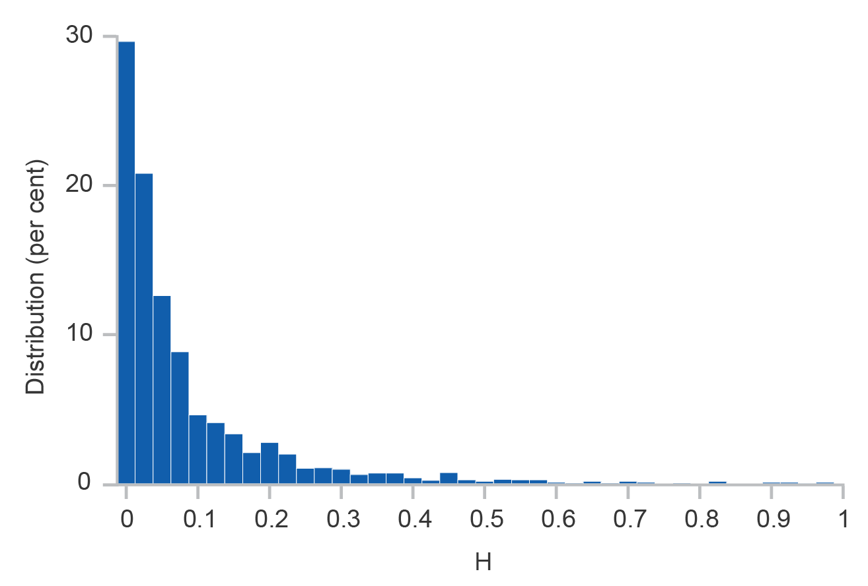

Notes: Pooling all industry–years

Source: Department of Industry, Innovation and Science (2019)

These features also show up in the descriptive statistics of HHI, which are reported in Table 3.1. The table, additionally, reports the descriptive statistics for the firm population of the industry (*N*) as in most cases HHI and firm population go hand-in-hand.

Table 3.1: The descriptive statistics for HHI and firm population.

| Statistic | *H* | *N* |
| --- | --- | --- |
| Mean | 0.087 | 10,006.8 |
| Std.Dev. | 0.134 | 19,525.3 |
| 10th Percentile | 0.003 | 247 |
| 1st Quartile | 0.009 | 660.5 |
| Median | 0.036 | 2,682.0 |
| 3rd Quartile | 0.103 | 9,569.0 |
| 90th Percentile | 0.226 | 30,825.2 |
| #Obs | 3,075 | 3,075 |

Notes: Statistics pool over all industry–years

Source: Department of Industry, Innovation and Science (2019)

As these statistics show, HHI is smaller than 0.23 for more than 90 per cent of industry–years in the data. HHI is lower than 0.04 for more than half of the industry–years. The statistics point to some disparity across industries in terms of market concentration. Still, as noted before, there is no indication of oligopolistic dominance as a common feature of Australian industries.

The last column in Table 3.1 further confirms that most industries in Australia are populated by a fair number of firms ranging from hundreds to thousands of firms – with industry defined as 3-digit ANZSIC. However, the relationship between HHI and firm population is negative: more concentrated industries tend to be populated by a smaller number of firms and vice versa. This inverse relationship especially manifests itself in the correlation coefficient between the two variables which is -0.224.

The inverse relation is generally associated with large firms in concentrated industries using their market power to prevent the entry and survival of rival firms, thus, keeping competition at bay. There are exceptions too; not every concentrated industry is populated by a small number of firms. This imperfect relationship follows a related line of debate that argue that a larger market is not synonymous with market power (Donismoni et al., 1984).

It is also helpful to put a few names behind the industries that create the observed picture above for further quality check. In Table 3.2, I am listing industries with the lowest and the highest average HHI along with the average number of firms populating each industry, where industry averages are taken over the years. Note that, for confidentiality protection, all industries with fewer than 10 firms are dropped from the listing.

Table 3.2: The least and most concentrated industries.

| Panel A: Least Concentrated | | | | |
| --- | --- | --- | --- | --- |
| ANZSIC | Division | Description | Average *H* | Average *N* | |
| 16 | A | Dairy Cattle Farming | 0.001 | 13,323 | |
| 323 | E | Building Installation Services | 0.001 | 72,797 | |
| 851 | Q | Medical Services | 0.001 | 44,160 | |
| 941 | S | Automotive Repair and Maintenance | 0.001 | 38,254 | |
| 951 | S | Personal Care Services | 0.001 | 21,524 | |
|  |  |  |  |  | |
| Panel B: Most Concentrated | | | | |
| ANZSIC | Division | Description | Average *H* | Average *N* | |
| 580 | J | Telecommunication Services | 0.389 | 1,252 | |
| 161 | C | Printing and Support Services | 0.421 | 7,042 | |
| 221 | C | Iron and Steel Forging | 0.435 | 114 | |
| 822 | P | Educational Support Services | 0.491 | 930 | |
| 262 | D | Electricity Transmission | 0.568 | 31 | |

Notes: Industries with fewer than 10 firms are excluded for confidentiality protection. Averages are taken for each industry over the years.

Source: Department of Industry, Innovation and Science (2019)

In both groups, a mix of major divisions such as Manufacturing, Telecommunication, Education, and Health Care Services can be observed. However, the least concentrated industries are mostly in the services area.

On the other hand, Gas, Electricity, and Utilities (Division D), Manufacturing (Division C), and Information Media and Telecommunication (Division J) constitute the bulk of the most concentrated industries. See Appendix A for a longer list of industries with concentrated markets, including a few industries that have taken the spotlight for the lack of competition.

The number of firms listed for each industry further affirms that the least concentrated industries tend to be populated by a larger number of firms, whereas the most concentrated industries generally have a smaller number of firms. Printing and Support services, however, is one exception related to the earlier discussed: despite the industry being concentrated, it is populated by a fairly large number of firms.

# Changing Market Concentration

## Time Trend

The overview of the previous section underlines the fact that, apart from a few exceptions, the majority of industries in Australia are quite competitive and large firms do not generally dominate industries. However, as shown in other industrialised countries, this situation need not hold over time and could gradually degenerate owing to various reasons. The increasing concentration could, in turn, spill into competition and firm entry with detrimental impact.

One way to test whether there has been a long-term shift in the distribution of HHI is to compare the empirical Cumulative Distribution Function (CDF) of HHI in 2002 and 2016. An order of stochastic dominance determines whether the distribution has been shifting in any particular direction.

These CDFs are illustrated in Figure 4.1. The CDFs in the picture cross at multiple points and do not exhibit any order of stochastic dominance of the CDF in one year over that of the other. On its face, the evidence points to a mixed pattern where, moving from 2002 to 2016, some industries have become more concentrated, whereas some other have done the opposite.

Figure 4.1: The cumulative distribution function of HHI in 2003 and in 2016.

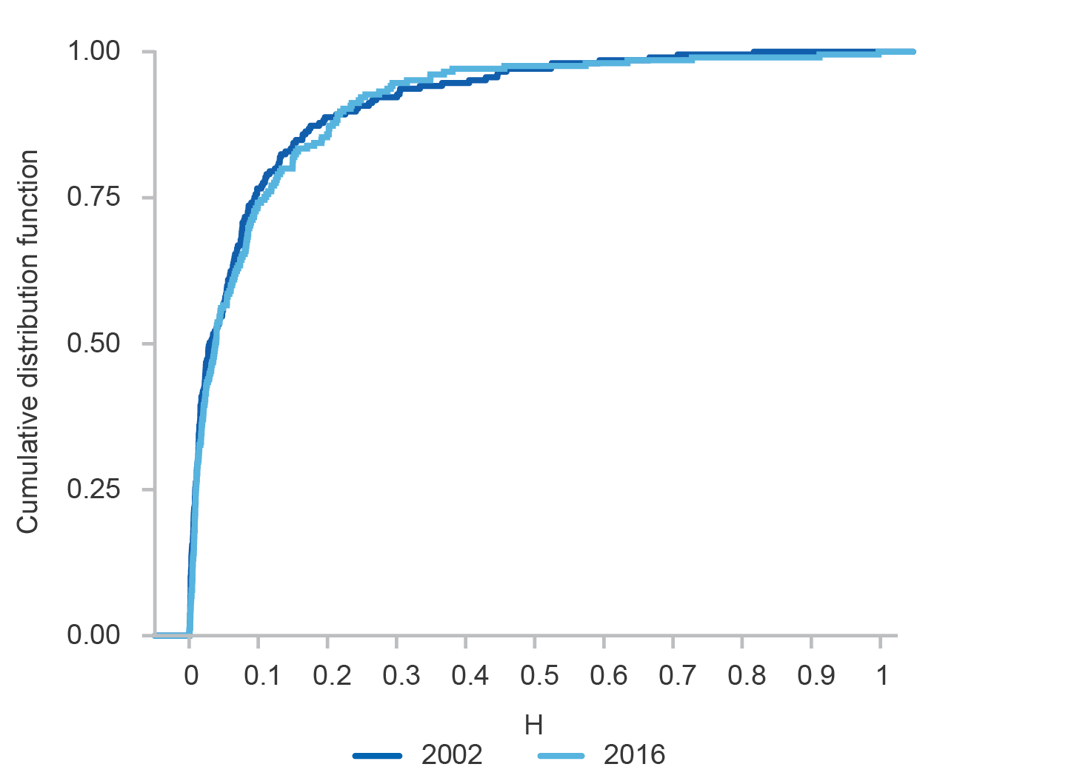

Source: Department of Industry, Innovation and Science (2019)

To check this trend in more details, I illustrate a few descriptive statistics of HHI by year in Figure 4.2. The statistics include the mean, median, and quartiles of HHI by year. Together, these statistics track how the distribution of HHI has shifted over time and which part of the distribution has shifted the most.

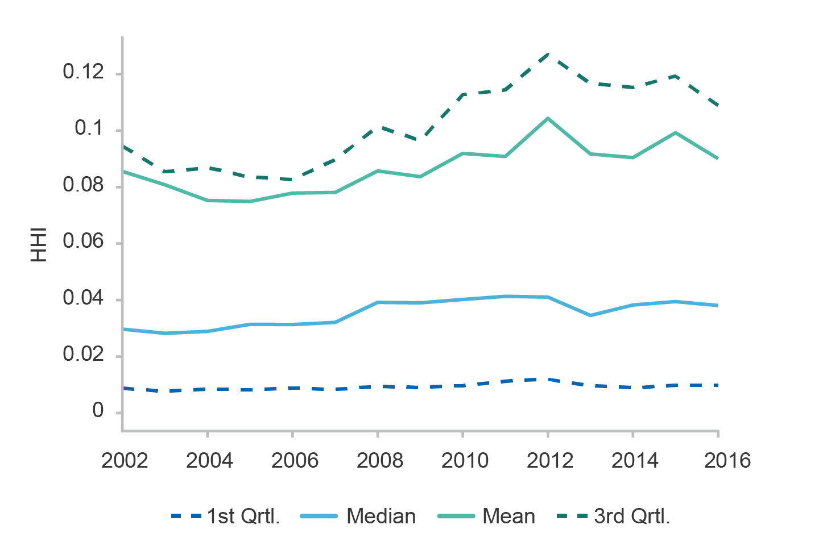Figure 4.2: The time trend for HHI across 3-digit ANZSICs.

Source: Department of Industry, Innovation and Science (2019)

Looking at the average HHI, one distinguishes three episodes. First, the average HHI slightly drops over the years prior to 2007. Around 2007 the trend reverses and the average HHI starts increasing. The increasing trend continues until 2012. After 2012, the average HHI is by and large stable.

Comparing the trends in average HHI to those in HHI quartiles reveals that the changes observed in the mean are not uniformly taking place across all industries. The movements of the average HHI are mostly in line with that of the third quartile.

The median HHI is also increasing but much more slowly than the third quartile. The first quartile of HHI barely changes from 2002 to 2016. These movements suggest that most of the increase in HHI over the last years took place within industries that are in the upper tail of the HHI distribution. Industries in the lower tail of the HHI distribution experienced little if any change in their concentration.

This conjecture is further corroborated by Figure 4.3. This figure illustrates the average change in HHI from 2002 to 2016 as a function of the HHI in 2002. The picture also shows the 90 per cent confidence interval for the averages. One observes that the average change for industries whose HHI in 2002 is below the median is very small. The average change rises almost monotonically for the deciles above the median. The main exception is the top two deciles where market concentration falls by a substantial amount. These are Australia’s most concentrated industries, almost monopolies.

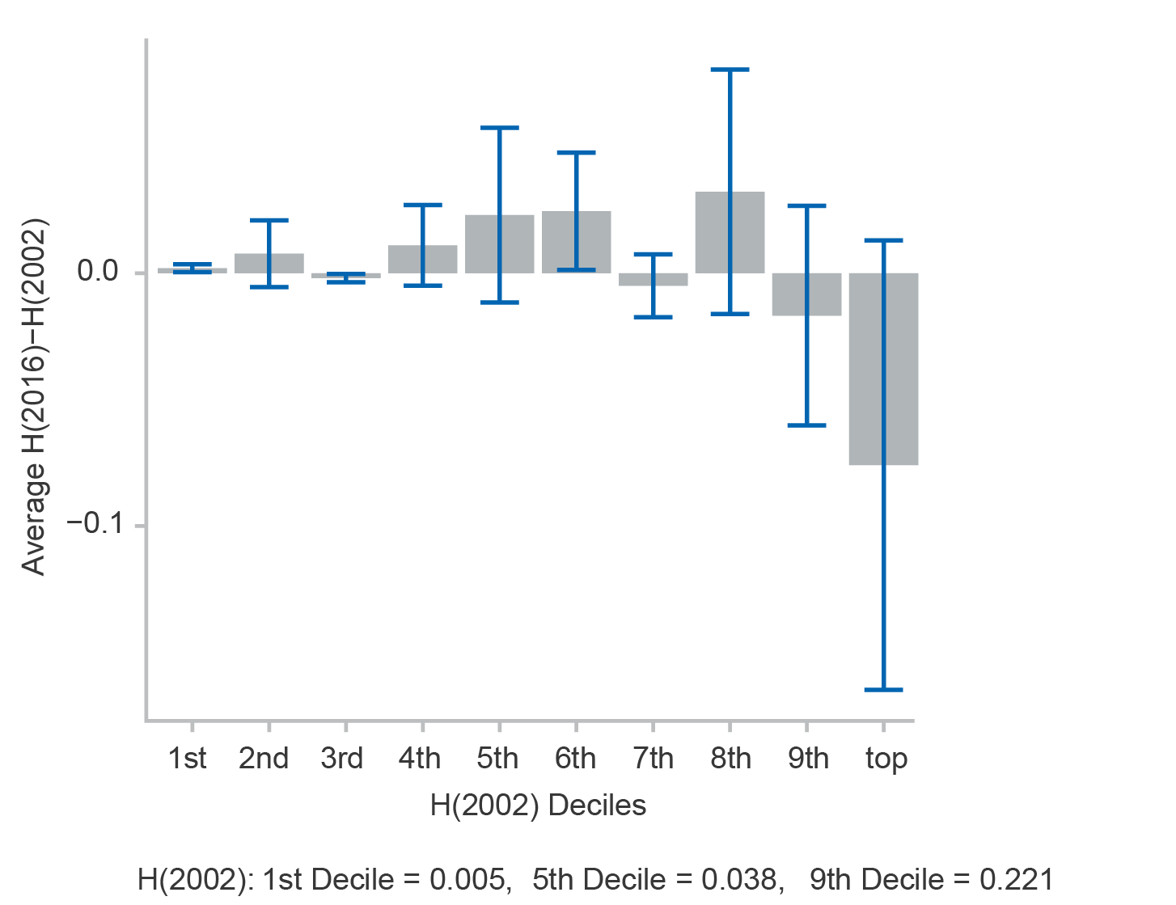Figure 4.3: Average change in HHI for each decile of HHI in 2002.

Source: Department of Industry, Innovation and Science (2019)

## Trends by Industry

Market concentration did not increase uniformly across all industries; most of the increase happened in the upper median. Table 3.2 suggests that industries that make up the upper and the lower median of the HHI distribution can be from different ANZSIC divisions. It is likely that the change in the concentration is linked to the industrial composition of the ANZSIC division.

Figure 4.4 shows the HHI of an ANZSIC division in 2016 versus that of the same division in 2002. In each year, the HHI is averaged over all 3-digit ANZSICs belonging to the same division. The position of each point in the graph relative to the 45 degree line indicates whether HHI for that division increased or dropped (or did not change) from 2002 to 2016.

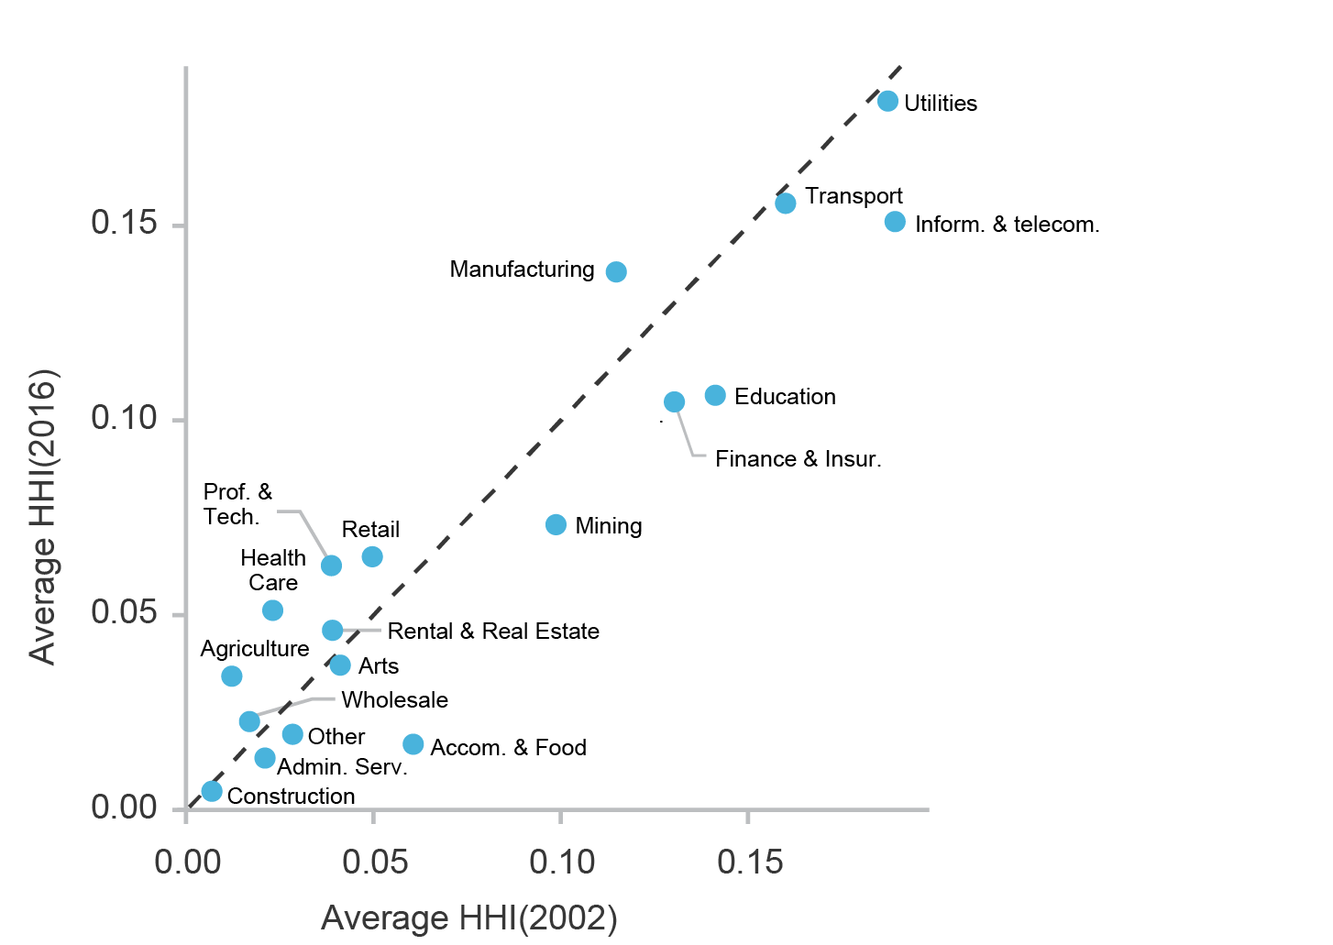Figure 4.4: The change in HHI from 2202 to 2016 by ANZSIC divisions.

Notes: Indexes in each division are the averages over all 3-digit ANZSICs belonging to the division.

Source: Department of Industry, Innovation and Science (2019)

A few industry divisions fall above the 45 degree line, that is, concentration in those industries increased. Manufacturing is the most notable one. The market concentration of Manufacturing also starts with quite high concentration in 2002 as compared to most other industries. Health Care and Professional, Scientific and Technical Services are two other examples; however, they are much less concentrated overall than Manufacturing.

On the other hand, several divisions are positioned below the 45 degree line, which means they experience a drop in market concentration. Information Media and Telecommunication is one notable case. This division is host to a few of the most concentrated industries in Australia including Telecommunication Services (for instance, ANZSIC 580 in Table 3.2). Accommodation and Food Services, Education, Mining, and Finance and Insurance are also experiencing a sizable drop in market concentration.

Market concentration in most other divisions does not change by much from 2002 to 2016.

For more specifics, I list industries that experienced the largest or smallest change in their HHI in Table 4.1. Note that industries with fewer than 10 firms are, again, excluded from the listing for confidentiality protection.

Table 4.1: Industries that experienced the largest increase or drop in concentration and those that had the smallest change.

| Panel A: Largest drop in concentration | | | |  |
| --- | --- | --- | --- | --- |
| ANZSIC | Division | Description | *H*(2002) | *H*(2016) |
| 472 | I | Rail Passenger Transport | 0.707 | 0.234 |
| 631 | K | Life Insurance | 0.594 | 0.128 |
| 592 | J | Data Processing and Storage Services | 0.446 | 0.036 |
| 602 | J | Other Information Services | 0.459 | 0.132 |
| 822 | P | Educational Support Services | 0.666 | 0.349 |
|  |  |  |  |  |
| Panel B: Largest increase in concentration | | | |  |
| ANZSIC | Division | Description | *H*(2002) | *H*(2016) |
| 562 | J | Television Broadcasting | 0.124 | 0.369 |
| 530 | I | Warehousing and Storage Services | 0.055 | 0.315 |
| 259 | C | Other Manufacturing | 0.301 | 0.727 |
| 694 | M | Advertising Services | 0.012 | 0.456 |
| 161 | C | Printing and Support Services | 0.016 | 0.912 |
|  |  |  |  |  |
| Panel C: Smallest change in concentration | | | |  |
| ANZSIC | Division | Description | *H*(2002) | *H*(2016) |
| 301 | E | Residential Building Construction | 0.002 | 0.002 |
| 329 | E | Other Construction Services | 0.001 | 0.001 |
| 322 | E | Building Structure Services | 0.001 | 0.001 |
| 462 | I | Road Passenger Transport | 0.013 | 0.014 |
| 113 | A | Dairy Product Manufacturing | 0.093 | 0.094 |

Notes: Industries with fewer than 10 firms are excluded for confidentiality protection.

Source: Department of Industry, Innovation and Science (2019)

Each panel in the table includes a variety of industry divisions. Most industries that experienced a very small change in HHI are from Construction (Division E). The same observation can be made in Figure 4.4 where Construction practically lies on the 45 degree line.

Two of the industries with the largest drop in HHI are from Information Media and Telecommunication (Division J). Conversely, two of the industries with the largest increase in HHI are from Manufacturing (Division C). These movements are also in line with the observations made in Figure 4.4.

# Concentrating Industries

So far, it is established that market concentration is mainly increasing among industries that are already more concentrated than the others. The changes are also more nuanced in certain industry divisions. It is instructive to explore whether there is some connection between certain industry characteristics and the increase in market concentration.

First of all, the increasing market concentration is not necessarily caused by shrinking demand. Most of the increase in market concentration is actually happening where the demand market is expanding (Figure 5.1). This is important, because it shows that most of the increase in demand is already being absorbed by a few firms.

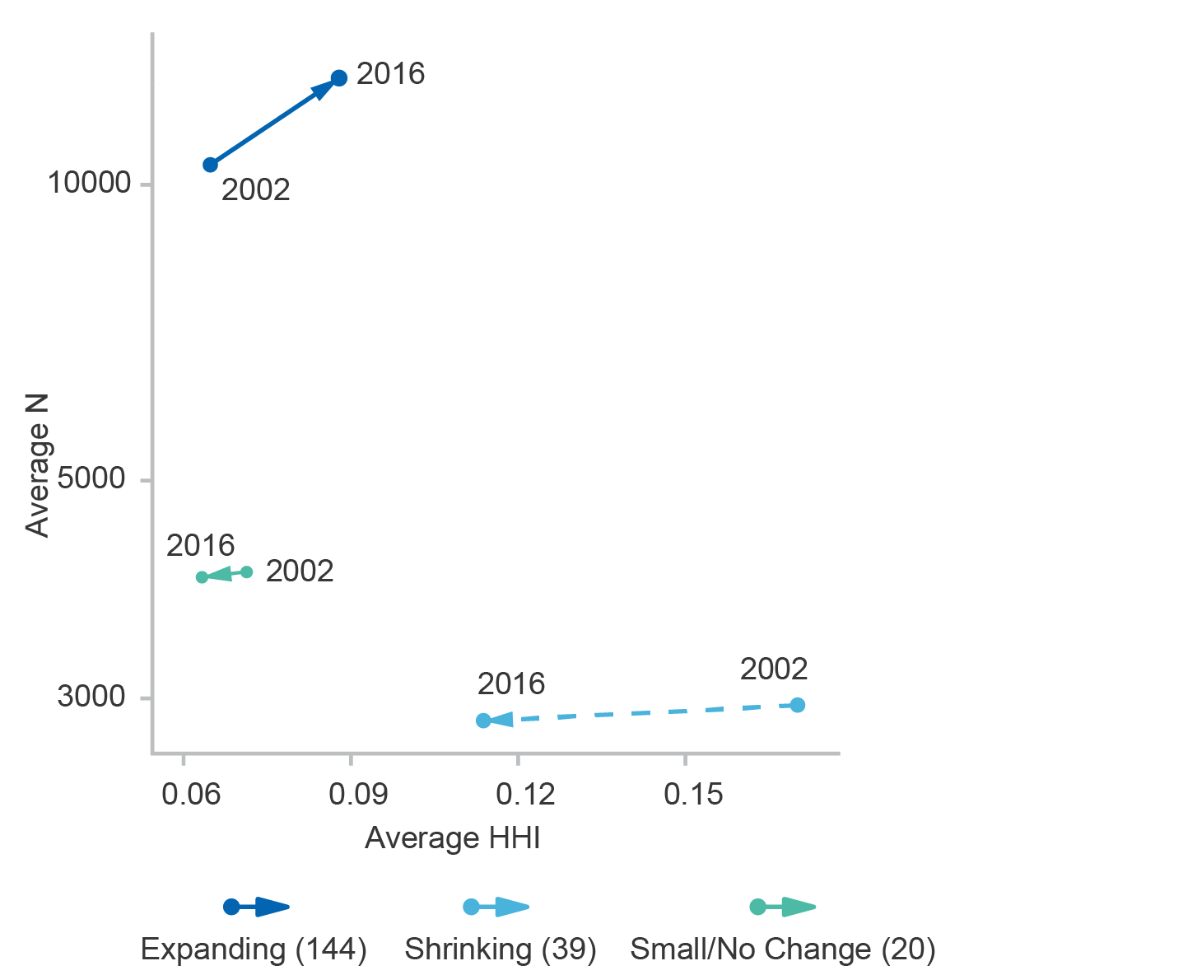Figure 5.1: Averaged HHI and firm population classified by the direction of change in total sales from 2002 to 2016.

Notes: Numbers in parentheses are the industry population for each category. Small/No change is defined as the change in sales staying within ±10 per cent.

Source: Department of Industry. Innovation and Science (2019)

In the remainder, I investigate whether digital maturity, shape of productivity distribution, and export possibilities are enablers of the observed increase in concentration. Each of these features can provide opportunities for the apt firms, or stars, to break away from the rest, to grow, and to dominate the industry.

## Role of Digital Maturity

Innovation is one driver of productivity and growth. In industries with abundant innovation possibilities, firms with better innovation outcomes can jump ahead, grow rapidly, and dominate the market. In the United States, especially, there are examples such as Google, Apple, and Uber. The innovation tide is nowadays mostly riding on digital technologies, hence, digitally mature industries are potential candidates for increasing market concentration.

The tax data in the BLADE lack any indication of whether an industry or a firm is oriented towards digital technology. For this reason, I supplement the data with the indexes of digital maturity reported by the Organization for Economic Cooperation and Development (OECD, 2017). The OECD measures the engagement of industries over seven dimensions (with possible overlaps). One shortcoming of these indicators is that they are specific to the years 2011 to 2013. The other is that they are not specific to Australia and represent the OECD average.

Four of the indexes in the OECD report have a complete set of information for all industries listed. These indexes pertain to software investment, ICT tangible investment, intermediate ICT service purchases, and the number of ICT experts. The three other indexes are intermediate ICT good purchases, robot use, and online sales. I am not using these last indexes as they are incomplete and are only reported for a subset of industries.

For my application, I first correspond each industry specification in the OECD’s list as closely as possible with the ANZSIC codes. Some industry specifications in the OECD report correspond to 3-digit ANZSICs. Others correspond to 2-digit ANZSICs. In the latter case, I assume that all 3-digit sub-sectors in that industry have the same indexes of digital maturity.

In applying the indexes, I also find that there is a good degree of overlap between the four indexes to be used. The amount of overlap is demonstrated by the correlation coefficients listed in Table 5.1. For instance, software expenditures and investments in ICT are tightly related. There is also a strong relationship between software expenditures and expenditures on ICT services.

To construct one index of digital maturity that captures the essence of the four indexes, I introduce the index which is the principal component of the four indexes (Hotelling, 1933). This index captures about 72 per cent of the full variations by the four indexes and has very strong correlations to each of the indexes (Table 5.1, last row).

Table 5.1: Correlation between different indexes of digital maturity.

|  |  | ICT | ICT | ICT |
| --- | --- | --- | --- | --- |
|  | Software | Investment | Services | Experts |
| ICT Investment | 0.907 |  |  |  |
| ICT Services | 0.795 | 0.694 |  |  |
| ICT Experts | 0.449 | 0.290 | 0.725 |  |
| Digital | 0.964 | 0.920 | 0.897 | 0.578 |

Source: Department of Industry, Innovation and Science (2019)

The level of variation in each of the indexes discussed can be observed in Table 5.2 where a set of descriptive statistics are reported for each. The statistics show that every industry has some exposure to digital technology, but different industries have different levels of exposure.

Table 5.2: Descriptive statistics for the indexes of digital maturity.

|  |  | ICT | ICT | ICT |  |
| --- | --- | --- | --- | --- | --- |
|  | Software | Investment | Services | Experts | Digital |
| Mean | -0.012 | -0.041 | -0.145 | -0.167 | 0.000 |
| Std.Dev | 1.030 | 0.866 | 0.661 | 0.601 | 1.691 |
| Qrtl1 | -0.600 | -0.600 | -0.400 | -0.300 | -0.875 |
| Median | -0.400 | -0.350 | -0.300 | -0.300 | -0.548 |
| Qrtl3 | 0.600 | 0.400 | -0.100 | -0.200 | 0.492 |
| #Obs | 214 | 214 | 214 | 214 | 214 |

Source: Department of Industry, Innovation and Science (2019)

The least digitally mature industries, by their *Digital* score, tend to be in Agriculture. The most digitally mature industries are from Professional, Scientific and Technical Services, Telecommunication (ANZSIC 580), and Internet Providers and Data Processing (ANZSIC 59).

On another front, the derived digital index correlates positively with the HHI index. The correlation between the two indexes stands at 0.065 (with a p-value of almost zero) which is rather small but statistically significant. In other words, digitally mature industries tend to be more concentrated and, as suggested by Figure 4.2, could potentially be the driving force behind the increasing market concentration.

I formally test this hypothesis using the following model:

(2)

in which the dependent is a two-period change in HHI or

(3)

Model () basically tests the effect of digital maturity on the change in HHI. In this model is a set of year dummies that absorb macroeconomic movements irrelevant to digital orientation of industries.

The use of a two-year differencing in () is meant to smooth the dependent variable so that the estimated coefficients are less affected by short term noises.[1] I will also conduct a few robustness tests in Section 7 using one-period changes in HHI.

The estimated coefficients for model () are listed in Table 5.3. In column (1), I use all years for estimation. The coefficients suggest that market concentration is on average increasing within industries that are more digitally mature. However, the negative coefficient for the interaction term means that the trend is reversed where the industry is both digitally mature and also more concentrated.

Table 5.3: The estimated effect of digital maturity on the change in HHI.

| Dependent: | | |
| --- | --- | --- |
| Variable | (1) | (2) |
| *H* | −0.154*** | −0.157*** |
|  | (0.011) | (0.020) |
| *Digital* | 0.003*** | 0.003 |
|  | (0.001) | (0.002) |
| *H*×*Digital* | −0.030*** | −0.040*** |
|  | (0.006) | (0.012) |
| Years: | All | 2010–2014 |
| Adjusted R | 0.075 | 0.076 |
| F Statistic | 76.6*** | 30.4*** |
| #Obs | 2,665 | 1,025 |

Notes: Numbers in parentheses are standard errors. *** indicates significance at 1% level.

Source: Department of Industry, Innovation and Science (2019)

In column (2) of the table, I restrict the years used for estimation to 2010–2014. This sample restriction follows the fact that the index of digital maturity is the most accurate around the years 2011 to 2013. In this case, the only change is that the estimated coefficient for *Digital* is not statistically significant anymore. The estimate for the interaction term is still negative and statistically significant.

At this point, it does not appear that digital maturity explains much about the increasing average HHI post 2007.

The *Digital* index used in () is a combination of four indexes. Some of those indexes might be playing a larger role in the closing of the gap than the others. To investigate this possibility, I replace *Digital* in () with each of the underlying indexes and conduct a separate estimation. These results are listed in Table 5.4.

Table 5.4: The estimated effect of various digital indexes on the change in HHI.

| Dependent: | | | | |
| --- | --- | --- | --- | --- |
| Variable | (1) | (2) | (3) | (4) |
| *H* | −0.153*** | −0.160*** | −0.191*** | −0.211*** |
|  | (0.021) | (0.021) | (0.020) | (0.024) |
| *Index* | 0.004 | 0.003 | 0.012** | 0.015** |
|  | (0.003) | (0.004) | (0.005) | (0.007) |
| *H*×*Index* | −0.047*** | −0.049** | −0.160*** | −0.200** |
|  | (0.016) | (0.020) | (0.041) | (0.079) |
| Digital Index: | Software | ICT Invest. | ICT Services | ICT Experts |
| Adjusted R | 0.074 | 0.072 | 0.079 | 0.072 |
| F Statistic | 29.728*** | 28.793*** | 31.790*** | 28.751*** |
| Observations | 1,025 | 1,025 | 1,025 | 1,025 |

Notes: Numbers in parentheses are standard errors. *** and ** indicate significances at 1% and 5% levels. Only years 2010–2014 are used for estimation.

Source: Department of Industry, Innovation and Science (2019)

Each column in this table by and large mirrors the result from Table 5.3. There are also some differences. The strongest effects, in terms of magnitude and the significance of coefficients, pertain to industries that rely on ICT services and have a larger number of ICT experts. In these estimates, industries with more reliance on ICT services and experts are getting more concentrated. However, the trend is again reversed if the industry is also more concentrated (the interaction term).

In brief, digital maturity seems to suggest a trend that is contrary to the one observed in Figure 4.2. Consequently, digital maturity is unlikely to be behind the observed pattern.

It is also remarkable that the coefficients for digital maturity and its interaction with HHI have opposite signs whether in Table 5.3 or in Table 5.4. Together, they suggest a convergence in HHI and the existence of an equilibrium for digitally mature industries which is around *H*=0.075. With the convergence fully taking place, digitally mature industries will still be more concentrated than the median industry but will stay below the 3rd quartile of HHI (Table 3.1).

## Role of Productivity Distribution

Industries with highly dispersed and skewed productivity distributions are also potential candidates for increasing market concentration. In theory, if resources reallocate from the least to the most productive units in these industries, one may see an increase in the dominance of the more productive units leading to more market concentration. A larger productivity dispersion generates space for resources reallocation. Alternatively, a higher skewness in productivity distribution – since almost all productivity distributions have a long upper tail – suggests the presence of *star* firms that are poised to dominate the industry.

To study the impact of productivity dispersion, I define the following measure:

(4)

where quartiles are taken over firms *j* in industry *i* at time *t*. Productivity is the labour productivity of firms and is computed as

(5)

in which *FTE* is the full-time equivalent employment in the firm reported in the BLADE.

To test for the second notion, I simply use the skewness of productivity distribution across firms in an industry–year (*LP* *Skew*). A set of descriptive statistics for the two productivity-related covariates are reported in Table 5.5. Most industries exhibit a fair amount of productivity dispersion where units at the top quartile are about three times more productive than the units at the bottom quartile. Productivity skewness has more variation across industries.

Table 5.5: The descriptive statistics for the productivity dispersion and skewness.

| Statistic |  | *LP* *Skew* |
| --- | --- | --- |
| Mean | 3.510 | 31.52 |
| Std.Dev. | 2.423 | 29.17 |
| 1st Qrtl. | 2.533 | 9.619 |
| Median | 2.943 | 21.64 |
| 3rd Qrtl. | 3.650 | 45.72 |
| #Obs | 3,075 | 3,075 |

Notes: Statistics pool over all industry–years.

Source: Department of Industry, Innovation and Science (2019)

Again, as was the case with the digital index, the HHI has a positive correlation with productivity dispersion. The correlation between the two variable is 0.059, which is again not very large but statistically significant. In other words, industries with more dispersed productivity distributions tend to be more concentrated too.

On the contrary, the correlation between the HHI and productivity skewness is negative and is equal to -0.315. These are the industries that supposedly have a few star firms. The correlation suggests that many industries in this category are not very concentrated.

To formalise the role of productivity distribution on the changes in HHI, I estimate a model of the form:

(6)

where is defined as in (). I separately estimate a similar model using *LP* *Skew* instead of . The estimated results for both models are reported in Table 5.6.

Table 5.6: The estimated effect of productivity dispersion on the change in HHI.

|  | Dependent: | | | | | | | |
| --- | --- | --- | --- | --- | --- | --- | --- | --- |
| Variable | (1) | (2) | (3) | (4) | (5) | | (6) | |
| *H* | -0.155*** | -0.256*** | -0.046* | -0.128*** | −0.100*** | | −0.141* | |
|  | (0.020) | (0.023) | (0.028) | (0.015) | (0.017) | | (0.021) | |
|  | -0.0002 | -0.002** | 0.002** |  |
|  | (0.001) | (0.001) | (0.001) |  |  |  | |
|  | -0.002 | 0.027*** | -0.039*** |
|  | (0.004) | (0.004) | (0.007) |  |  |  | |
| *LP* *Skew* |  |  |  | -0.0001** | -0.0001* | | -0.0001* | |
|  |  |  |  | (0.0001) | (0.0001) | | (0.0001) | |
| *H*×*LP* *Skew* |  |  |  | -0.003*** | -0.005*** | | -0.003*** | |
|  |  |  |  | (0.001) | (0.001) | | (0.001) | |
| Years: | All | 2002– | 2006– | All | 2002– | | 2006– | |
|  |  | 2005 | 2014 |  | 2005 | | 2014 | |
| Adjusted R | 0.067 | 0.134 | 0.082 | 0.085 | 0.120 | | 0.080 | |
| F Statistic | 68.5*** | 44.1*** | 58.7*** | 87.1*** | 39.2*** | | 57.1*** | |
| #Obs | 2,665 | 820 | 1,845 | 2,665 | 820 | | 1,845 | |

Notes: Numbers in parentheses are standard errors. ***, **, and * indicate significances at 1%, 5% and 10% levels, respectively.

Source: Department of Industry, Innovation and Science (2019)

In column (1), the key industry feature is . The estimated coefficients do not reveal any significant effect. On the other hand, the average HHI goes through two phases: it falls prior to 2007 and then mostly increases over the years 2007 to 2014 (Figure 4.2). It is possible that the underlying industry-level movements are different during each episode.

To consider this possibility, I split the time period into 2002–2005 and 2006–2014. The dependent in the first subset mostly reflects the falling average HHI, whereas it captures the increasing average HHI in the second subset. A separate estimation is done using each subset of years and the results appear in columns (2) to (3) of Table 5.6.

These results reveal a changing pattern between the phases. On average, industries with dispersed productivity have their market concentration fall during the first phase and increase during the second phase. Both effects are very small.

More concentrated industries with dispersed productivity distribution (the interaction term) show a larger impact. In these industries, market concentration increases during the first phase and falls during the second phase.

Despite having an effect, the impacts from the interaction terms do not align with the changes in average HHI observed in Figure **Error! Reference source not found.**. In fact, they are the opposite of what one would want to see. By this token, productivity dispersion is not contributing to the increasing average HHI.

In column (4) I consider the role of productivity skewness. The effects are much weaker in this case and all point to a dropping concentration. Splitting the time period in columns (5) and (6) does not change that picture. Based on this, the productivity skewness of an industry does not seem to support the increasing average HHI either.

## Role of Exporting

Export orientation can be one factor behind the increase in market concentration. De Loecker & Warzynski (2012) and a series of follow-up works document higher market power among the exporting firms. They argue that, being more productive, exporting firms are able to undercut other firms’ prices while still charging substantial markups. With higher market power, exporting firms are in a position to drive out competition and grow to dominate the market.

Another argument in favour of exporting firms is that market size does matter when it comes to the size of the most productive firms in an industry (Bakhtiari, 2012). Productive firms can grow large and dominate markets only in the presence of sufficient demand. Due to its population size, Australia is traditionally a small market. In the absence of exporting possibilities, productive firms do not have much incentive to grow beyond serving the domestic market. Limited demand is one explanation why industries with more innovative or productive firms in Australia are not getting more concentrated as is the case in the United States. Exporting possibilities can remedy this situation.

I distinguish export-oriented industries by their export intensities defined as

(7)

A set of simple statistics describing the distribution of export intensity across industry–years is listed in Table 5.7.

Table 5.7: Descriptive statistics for export intensity.

|  | Mean | Std.Dev. | 1st Qrtl. | Median | 3rd Qrtl. |
| --- | --- | --- | --- | --- | --- |
| *ExpInt* | 0.070 | 0.116 | 0.007 | 0.028 | 0.080 |
|  |  |  |  | #Obs=3,075 | |

Notes: Statistics pool over all industry–years.

Source: Department of Industry, Innovation and Science (2019)

As the numbers in Table 5.7 show, most industries export only a small fraction of their output. However, there are also a few industries that export a large proportion of their output. Table 5.8 lists a few industries with the lowest and highest export intensities to provide more details on each group of industries. The reported export intensities are the averages for the industry over all years.

Table 5.8: Least and most export intensive industries.

| Panel A: Least export intensive | | |  | | |
| --- | --- | --- | --- | --- | --- |
|  |  |  | | Average |  |
| ANZSIC | Division | Description | | *ExpInt* | *N* |
| 453 | H | Clubs (Hospitality) | | 0.000 | 3,842 |
| 324 | E | Building Completion Services | | 0.001 | 104,243 |
| 391 | G | Motor Vehicle Retailing | | 0.001 | 6,127 |
| 952 | S | Funeral and Cemetery Services | | 0.001 | 919 |
| 301 | E | Residential Building Construction | | 0.002 | 49,843 |
|  |  |  | |
| Panel B: Most export intensive | | | | |  |
|  |  |  | | Average |  |
| ANZSIC | Division | Description | | *ExpInt* | *N* |
| 132 | C | Leather and Fur Product Manufacturing | | 0.495 | 572 |
| 99 | B | Other Non-metallic Mineral Mining | | 0.600 | 689 |
| 80 | B | Metal Ore Mining | | 0.609 | 828 |
| 60 | B | Coal Mining | | 0.634 | 319 |
| 213 | C | Basic Non-ferrous Metal Manufacturing | | 0.640 | 302 |

Source: Department of Industry, Innovation and Science (2019)

The most export intensive industries in Table 5.8 are dominated by those from Manufacturing (Division C) and Mining (Division B). The mining sectors in panel (B) are exporting more than 60 per cent of their output on average. The manufacturing sectors in the same panel are also exporting at least 50 per cent of their output on average. It is also notable that these industries are not particularly associated with advanced or digital technologies.

The correlation coefficients in Table 5.9 corroborate the fact that export intensive industries in Australia tend to be less digitally mature, though there is a positive correlation between export intensity and productivity dispersion.

Table 5.9: The correlation between export intensity and other industry measures.

|  | *ExpInt* | *Digital* |  | *LP* *Skew* |
| --- | --- | --- | --- | --- |
| *Digital* | -0.129 |  |  |  |
|  | 0.379 | -0.059 |  |  |
| *LP* *Skew* | -0.241 | 0.084 | -0.140 |  |
| *HHI* | 0.047 | 0.065 | 0.059 | -0.315 |

Source: Department of Industry, Innovation and Science (2019)

Besides, export intensity and the HHI exhibit a positive correlation which is also statistically significant. On its face, the positive correlation underlines De Loecker & Warzynski (2012) case that exporting firms have market power and can use it to dominate markets. For a more rigorous analysis, I estimate a model of the form:

$∆_{2}H_{it}=a_{0}+a_{1}H_{it}+a_{2}{ExpInt}_{it}+a_{3}H_{it}×{ExpInt}_{it}$ (8)

The estimated coefficients are listed in Table 5.10. Column (1) uses all years. In this column, export intensity is associated with a drop in market concentration. However, market concentration is increasing where the industry is more concentrated and export intensive (the interaction term).

Table 5.10: The estimated effect of export intensity on the change in HHI.

| Dependent: | | | |
| --- | --- | --- | --- |
| Variable | (1) | (2) | (3) |
| *H* | −0.184*** | −0.112*** | −0.205*** |
|  | (0.012) | (0.016) | (0.016) |
| *ExpInt* | −0.048** | 0.039 | −0.073*** |
|  | (0.020) | (0.025) | (0.027) |
| *H*×*ExpInt* | 0.554*** | −0.281 | 0.703*** |
|  | (0.120) | (0.216) | (0.148) |
| Years: | All | 2002–2005 | 2006–2014 |
| Adjusted R | 0.075 | 0.082 | 0.078 |
| F Statistic | 76.917*** | 26.403*** | 56.024*** |
| #Obs | 2,665 | 820 | 1,845 |

Notes: Numbers in parentheses are standard errors. *** and ** indicate significances at 1% and 5% levels, respectively.

Source: Department of Industry, Innovation and Science (2019)

Once splitting the years into 2002–2005 and 2006–2014 phases, it becomes apparent that most of the impact of export intensity on market concentration happened during the later years (Table 5.10 columns (2) and (3)). During the earlier years, when the average HHI is falling, export intensive industries do not seem to be playing any important role. On the other hand, export intensive industries experience an increase in market concentration during the later years.

Incidentally, this last episode coincides with the resources boom that took place in Australia from 2005 to circa 2014 (Bakhtiari, 2019 Section 7.1). A few of the most export intensive industries are in the mining industry. Together, they suggest that the rapid expansion of the export market for mining ‒ especially the growing demand from China ‒ could be one of the triggers for the increasing concentration among this particular group of industries.

The next test explores whether digitally mature or more dispersed industries are the ones being the most affected by export intensity. The test is carried out through the following model:

$∆_{2}H_{it}=a_{0}+a_{1}H_{it}+a_{2}{ExpInt}_{it}+a_{3}H_{it}×{ExpInt}_{it}$ (9) $$+b_{1}{Type}_{it}+b_{2}H_{it}×{Type}_{it} \\ +c_{1}{ExpInt}_{it}×{Type}_{it}+c_{2}H_{it}×{ExpInt}_{it}×{Type}_{it}+τ_{t}+ϵ_{it}$$

The variable *Type* is a generic variable that can be replaced by either of *Digital*, or *LP* *Skew*. In this model, I am adding all the interaction terms that test whether export intensity facilitates market domination within industries characterised by digital maturity or having dispersed or skewed productivity distributions. The estimated results for each case are reported in Table 5.11.

Table 5.11: The estimated effect of export intensity joint with other covariates on the change in HHI.

| Dependent: | | | | | | | |
| --- | --- | --- | --- | --- | --- | --- | --- |
| Variable | (1) | (2) |  | (3) | (4) |  | (5) |
| *H* | −0.256*** | −0.073** |  | −0.110*** | −0.150*** |  | −0.187*** |
|  | (0.028) | (0.030) |  | (0.019) | (0.023) |  | (0.022) |
| *ExpInt* | 0.023 | −0.100** |  | −0.014 | −0.005 |  | −0.081* |
|  | (0.049) | (0.045) |  | (0.034) | (0.040) |  | (0.044) |
| *H*×*ExpInt* | −0.052 | 0.868*** |  | 0.757** | −0.675** |  | 1.060*** |
|  | (0.537) | (0.264) |  | (0.304) | (0.297) |  | (0.220) |
| *Type* | −0.003** | 0.002 |  | −0.0002** | −0.0001 |  | 0.004 |
|  | (0.001) | (0.002) |  | (0.0001) | (0.0001) |  | (0.003) |
| *H*×*Type* | 0.028*** | −0.039*** |  | −0.003** | −0.003*** |  | −0.042*** |
|  | (0.005) | (0.008) |  | (0.001) | (0.001) |  | (0.013) |
| *ExpInt*×*Type* | 0.002 | 0.005 |  | 0.005*** | −0.004** |  | −0.058 |
|  | (0.009) | (0.007) |  | (0.002) | (0.002) |  | (0.039) |
| *H*×*ExpInt* | −0.017 | −0.030 |  | −0.117*** | 0.104*** |  | 0.801*** |
| ×*Type* | (0.115) | (0.057) |  | (0.024) | (0.019) |  | (0.290) |
| Years: | 2002–2005 | 2006–2014 |  | 2002–2005 | 2006–2014 |  | 2010–2014 |
| Type: | *LP*(*Q*3/*Q*1) | *LP*(*Q*3/*Q*1) |  | *LP* *Skew* | *LP* *Skew* |  | *Digital* |
| Adjusted R | 0.132 | 0.094 |  | 0.143 | 0.104 |  | 0.095 |
| F Statistic | 19.192*** | 29.607*** |  | 21.030*** | 32.566*** |  | 16.938*** |
| #Obs | 820 | 1,845 |  | 820 | 1,845 |  | 1,025 |

Notes: *** and ** indicate significances at 1% and 5% levels, respectively.

Source: Department of Industry, Innovation and Science (2019)

The results in columns (1) and (2), where industries are featured by their productivity dispersion, do not reveal much beyond what was found in the previous sections. In particular, during the second phase, where average HHI is increasing, the increase is driven by export intensive industries and not by industries with dispersed productivity distribution. The trends with productivity dispersion seem to be counter to those observed in Figure 4.2.

Columns (3) and (4) feature industries by their skewness of productivity distribution. The results in these columns evince that productivity skewness combined with export intensity and higher concentration accelerate further market concentration. These factors are, again, taking effect during the second phase and in tandem with the increase in average HHI.

In column (5) of the table, industries are featured by their digital maturity. Since the relevant index is the most accurate during the later years of the data, I restrict this particular estimation to the years 2010 to 2014. Again, one observes that digitally mature industries that are both export intensive and more concentrated are also more likely to experience an increasing concentration.

In the last two columns, the coefficient for the interaction between the HHI and export intensity is positive as before. The possible role of the mining sector was discussed in this regard. However, the coefficient for the interaction between the HHI, export intensity and the industry type (productivity skewness or digital maturity) is positive too. This second part suggests that mining firms are probably not the only export intensive sectors experiencing a rising concentration and some other high-technology sectors might also be partaking.

# Productivity Implication

The findings from the previous sections imply that in most industries the increase in the HHI is about a fall in competition. There is, however, an exception: where the industry is export intensive and digitally mature or has skewed productivity distribution, it appears that the increase in market concentration is driven by innovative or productive firms growing and dominating.

If the latter is true, then one should detect an increase in the overall productivity of the relevant industries in tandem with the increasing market concentration. Besides, productivity should fall or stay unchanged elsewhere that concentration is increasing. In this section, I explore this hypothesis.

First, I define the average productivity of an industry as

(10)

In the above, *w* is the inverse propensity weights mentioned in Section 2. The average productivity computed here is somewhat different from the more conventional approach where weighted average of individual productivities is used (Baily et al., 1992). The estimates computed from () are, however, less noisy and more stable over time.

The computed productivity indexes have very different scales across industries due to differences in the level of output and labour usage. To harmonise the indexes, productivity for each industry is scaled so that average productivity of each industry in 2002 is equal to one. In this way, the emphasis will shift to the changes in productivity and not to levels.

The impact of the presence of star firms in an industry on its productivity is explored through the following linear model:

$∆_{2}{\overline{LP}}_{it}=α_{0}+α_{1}{\overline{LP}}_{it}+α_{2}H_{it}+α_{3}H_{it}×{ExpInt}_{it}$ (11)

$$+β_{1}{Type}_{it}+β_{2}H_{it}×{Type}_{it}$$

$$+γ_{1}{ExpInt}_{it}×{Type}_{it}+γ_{2}H_{it}×{ExpInt}_{it}×{Type}_{it}+τ_{t}+ε_{it}$$

In this model, $∆_{2}{\overline{LP}}_{it}$ is defined in the same way as in () and is a two-year change in the overall productivity of the industry. The estimated coefficients are reported in Table 6.1.

Table 6.1: The estimated effect of export intensity joint with other covariates on the industry’s productivity.

|  | Dependent: $∆_{2}{\overline{LP}}_{it}$ | | | |
| --- | --- | --- | --- | --- |
| Variable | (1) | (2) |  | (3) |
|  | 0.349*** | −0.0004 |  | −0.002 |
|  | (0.055) | (0.012) |  | (0.013) |
| *H* | 0.242** | −0.263** |  | −0.284** |
|  | (0.108) | (0.120) |  | (0.134) |
| *ExpInt* | −0.215 | −0.162 |  | −0.206 |
|  | (0.194) | (0.196) |  | (0.209) |
| *H*×*ExpInt* | 2.858* | −0.668 |  | 4.779*** |
|  | (1.708) | (1.450) |  | (1.050) |
| *Star* | −0.001 | −0.0001 |  | 0.007 |
|  | (0.0005) | (0.0004) |  | (0.014) |
| *H*×*Star* | −0.009 | −0.010** |  | −0.155 |
|  | (0.006) | (0.005) |  | (0.097) |
| *Star*×*ExpInt* | 0.025*** | −0.007 |  | −0.105 |
|  | (0.009) | (0.009) |  | (0.189) |
| *H*×*Star*×*ExpInt* | −0.327** | 0.246*** |  | 4.460*** |
|  | (0.133) | (0.094) |  | (1.405) |
| Years: | 2002–2005 | 2006–2014 |  | 2010–2014 |
| Star: | *LP* *Skew* | *LP* *Skew* |  | *Digital* |
| Adjusted R | 0.062 | 0.011 |  | 0.020 |
| F Statistic | 8.105*** | 4.399*** |  | 4.055*** |
| #Obs | 811 | 1,787 |  | 987 |

Notes: Numbers in parentheses are standard errors. ***, **, and * indicate significances at 1%, 5% and 10% levels, respectively.

Source: Department of Industry, Innovation and Science (2019)

The estimated results reveal two things. First, market concentration and productivity change in the opposite directions (*H* coefficient). During periods of increasing market concentration, the average productivity falls. When market concentration is falling, on the other hand, average productivity rises. This part of the results corroborates the fact that most of the increase in market concentration has been to the detriment of the competition.

Second, where star performance and export intensity combine with already higher market concentration, average productivity is increasing (The last interaction term). In previous section, the increase in the market concentration of these industries was attributed to the presence of stellar performance of the firms. The simultaneous increase in market concentration and productivity of these industries lends support to the theory.

# Robustness Test

In this section, I carry out a robustness test using an alternative definitions of change in HHI. Specifically, I use $∆H_{it}=H_{i,t+1}-H_{it}$ as the dependent variable. This variable is a one-period change in HHI as opposed to () which covers two periods to reduce the effect of short-term noises.

The estimated results using the newly define dependent variable are reported in Table 7.1. Overall, the results have the same qualitative features observed in Table 5.11. The difference is that the estimated coefficients in this case are smaller in magnitude. The statistical significance have also suffered.

Table 7.1: Testing robustness of the findings when using one-period change in HHI instead of the two-period change.

| Dependent: | | | | | | | |
| --- | --- | --- | --- | --- | --- | --- | --- |
| Variable | (1) | (2) |  | (3) | (4) |  | (5) |
| *H* | -0.140*** | -0.096*** |  | -0.059*** | -0.079*** |  | -0.144*** |
|  | (0.022) | (0.024) |  | (0.015) | (0.018) |  | (0.019) |
| *ExpInt* | 0.023 | -0.072** |  | -0.011 | -0.0004 |  | -0.044 |
|  | (0.038) | (0.037) |  | (0.026) | (0.033) |  | (0.038) |
| *H*×*ExpInt* | -0.253 | 0.608*** |  | 0.418* | -0.406* |  | 0.529*** |
|  | (0.414) | (0.214) |  | (0.234) | (0.240) |  | (0.188) |
| *Type* | -0.002* | 0.0001 |  | -0.0001** | -0.00001 |  | -0.001 |
|  | (0.001) | (0.001) |  | (0.0001) | (0.0001) |  | (0.002) |
| *H*×*Type* | 0.016*** | -0.009 |  | -0.002** | -0.003*** |  | 0.008 |
|  | (0.004) | (0.006) |  | (0.001) | (0.001) |  | (0.011) |
| *ExpInt*×*Type* | -0.001 | 0.006 |  | 0.003** | -0.003* |  | 0.001 |
|  | (0.007) | (0.006) |  | (0.001) | (0.001) |  | (0.033) |
| *H*×*ExpInt* | 0.032 | -0.049 |  | -0.070*** | 0.059*** |  | 0.120 |
| ×*Type* | (0.088) | (0.046) |  | (0.018) | (0.016) |  | (0.248) |
| Years: | 2002–2005 | 2006–2014 |  | 2002–2005 | 2006–2014 |  | 2010–2014 |
| Type: | *LP*(*Q*3/*Q*1) | *LP*(*Q*3/*Q*1) |  | *LPSkew* | *LPSkew* |  | *Digital* |
| Adjusted R | 0.072 | 0.046 |  | 0.087 | 0.060 |  | 0.050 |
| F Statistic | 10.440*** | 14.861*** |  | 12.528*** | 19.096*** |  | 9.278*** |
| #Obs | 820 | 1,845 |  | 820 | 1,845 |  | 1,025 |

Notes: Numbers in parentheses are standard errors. ***, ** and * indicate significances at 1%, 5% and 10% levels, respectively.

Source: Department of Industry, Innovation and Science (2019)

# Conclusion

Market concentration is increasing in many advanced economies. Australia has also been experiencing a rise in market concentration since 2007. However, most of the increase in concentration has taken place in industries that are more concentrated than others. The evidence points to the industry’s export intensity as one factor behind the increase. Where the industry is also digitally mature or inhabited by a few top performers, in addition to being export oriented, the increase in market concentration accelerates.

The evidence suggests that in most cases market power and falling competition go hand-in-hand with the increasing market concentration. However, for exporting industries the increase in market concentration appears to be in tandem with an increase in productivity, suggesting that productive or innovative firms are driving the trend. Average productivity falls elsewhere with an increase in market concentration.

In either case, the increasing concentration of the markets is not especially to be celebrated. There are great concerns that when firms get large beyond certain scales, whether they are productive or otherwise, they will unequivocally use their size advantage to bend the rules and gain advantage through influencing the political process (Stiglitz, 2019). To stay on top of the ladder, large firms have the option to innovate or lobby (Zingales, 2017). As the cheaper and more effective option with proven outcomes, lobbying is increasingly becoming the preferred strategy.

Any policy wishing to address the issue should take note of these views. For one thing, it needs to distinguish that the increasing market concentration might not necessarily be a result of anti-competitive actions. An industry-by-industry approach might be better suited for such policies. Second, it needs to be aware that there is a critical size for firms beyond which they become too powerful to tolerate competition. An antitrust approach might be required when dealing with firms who have reached that point.

###### Concentrated Industries

A few industries in Australia are in the spotlight as being too concentrated or lacking competition. In this part, I will briefly look at these industries and show how concentrated they are compared to the other industries. Minifie (2017) especially names a few: Supermarkets, domestic air transportation, fuel retail, and liqueur retail. To that I will also add the banking sector. Table 8.1 puts these industries within the context based on their HHI.

Table 8.1: The most concentrated industries; a longer list.

| Rank | ANZSIC | Division | Description | Average *H* | Average *N* |
| --- | --- | --- | --- | --- | --- |
| 77 | 400 | G | Fuel Retailing | 0.072 | 4,070 |
| ⋮ | ⋮ | ⋮ | ⋮ | ⋮ | ⋮ |
| 17 | 411 | G | Supermarkets and Groceries | 0.252 | 9,635 |
| ⋮ | ⋮ | ⋮ | ⋮ | ⋮ | ⋮ |
| 13 | 490 | I | Air Transportation | 0.278 | 1,142 |
| 12 | 622 | K | Depository Banking | 0.287 | 907 |
| ⋮ | ⋮ | ⋮ | ⋮ | ⋮ | ⋮ |
| 5 | 580 | J | Telecommunication Services | 0.389 | 1,252 |
| 4 | 161 | C | Printing and Support Services | 0.421 | 7,042 |
| 3 | 221 | C | Iron and Steel Forging | 0.435 | 114 |
| 2 | 822 | P | Educational Support Services | 0.491 | 930 |
| 1 | 262 | D | Electricity Transmission | 0.568 | 31 |
|  |  |  | #Industries = 203 | | |

Notes: Industries with fewer than 10 firms are excluded for confidentiality protection. Averages are taken by industry over the years.

Source: Department of Industry, Innovation and Science (2019)

Australia’s banking industry, though populated by several institutions, is dominated by four major banks, often dubbed as the [*Big4*](https://en.wikipedia.org/wiki/Big_Four_(banking)). These four banks are: Commonwealth Bank of Australia (CBA), Westpac, National Australia Bank (NAB), and Australia and New Zealand Bank (ANZ). Together, they control about 80 per cent of the home loan market in Australia. In Table 8.1, the sector Depository Banking (ANZSIC 622) is positioned as the 12th most concentrated industry. Note that a few very concentrated industries populated by fewer than 10 firms are dropped for confidentiality protection.

When it comes to domestic air transport, the Australian market is practically served by two carriers: Qantas and Virgin Australia. In the associated ANZSIC, air transportation includes both domestic and international operators, hence, the sheer concentration of the industry is not as evident when using the data for this ANZSIC. In Table 8.1, this industry is positioned as the 13th most concentrated industry and just behind the banking sector.

The supermarket industry in Australia is also considered [very concentrated](https://retailworldmagazine.com.au/spotlight-australias-supermarkets-grocery-industry/), though competition is rife in the industry. The two largest supermarket chains, Coles and Woolworths, together hold a commanding share of the market. However, in the recent years, their control has loosened with the entry and the expansion of the German chain, Aldi. In Table 8.1, this industry is positioned as the 17th most concentrated industry.

Fuel retail industry in Australia is often associated with the dominance of a few [large players](https://www.accc.gov.au/system/files/Petrol-market-shares-report.pdf). The industry is practically dominated by four suppliers: Caltex, BP, Coles and Woolworths. There are also several independent suppliers; however, their individual share of the market is not very sizable. In Table 8.1, this industry stands at the 77th position. The industry is probably not as concentrated and not with so much market power as many people would like to believe.

Disclaimer

The results of these studies are based, in part, on ABR data supplied by the Registrar to the ABS under A New Tax System (Australian Business Number) Act 1999 and tax data supplied by the ATO to the ABS under the Taxation Administration Act 1953. These require that such data is only used for the purpose of carrying out functions of the ABS. No individual information collected under the Census and Statistics Act 1905 is provided back to the Registrar or ATO for administrative or regulatory purposes. Any discussion of data limitations or weaknesses is in the context of using the data for statistical purposes, and is not related to the ability of the data to support the ABR or ATO’s core operational requirements. Legislative requirements to ensure privacy and secrecy of this data have been followed. Only people authorised under the Australian Bureau of Statistics Act 1975 have been allowed to view data about any particular firm in conducting these analyses. In accordance with the Census and Statistics Act 1905, results have been confidentialised to ensure that they are not likely to enable identification of a particular person or organisation.

References

Aghion P, Fally T & Scarpetta S (2007) [Credit Constraints as a Barrier to the Entry and Post-entry Growth of Firms](https://doi.org/10.1111/j.1468-0327.2007.00190.x%20), Economic Policy, 22(52), pp. 732–779.

Autor D, Dorn D, Katz LF, Patterson C & Van Reenen J (2017) [Concentrating on the Fall of the Labor Share](https://doi.org/10.1257/aer.p20171102), American Economic Review, 107(5), 180–185.

Baily MN, Hulten C & Campbell D (1992) Productivity Dynamics in Manufacturing Plants, Brookings Papers on Economic Activity, 187–249.

Bajgar M, Berlingieri G, Calligaris S, Criscuolo C & Timmis J (2019) [Industry Concentration in Europe and North America](https://doi.org/10.1787/2ff98246-en), OECD, Productivity Working Paper, No.18.

Bakhtiari S (2012) [Markets and the Non-monotonic Relation between Productivity and Establishment Size](https://doi.org/10.1111/j.1540-5982.2011.01698.x), Canadian Journal of Economics, 45(1), 345–372.

Bakhtiari S (2019) [Entrepreneurship Dynamics in Australia: Lessons from Micro-data](https://industry.gov.au/Office-of-the-Chief-Economist/Research-Papers/Pages/Entrepreneurship-Dynamics-in-Australia-Lessons-from-Micro-data.aspx), Economic Record, 95(308), 114‒140.

Bartelsman EJ & Doms M (2000) [Understanding Productivity: Lessons from Longitudinal Microdata](https://doi.org/10.1257/jel.38.3.569), Journal of Economic Literature, 38(3), 569–594.

De Loecker J & Warzynski F (2012) [Markups and Firm-Level Export Status](https://doi.org/10.1257/aer.102.6.2437), American Economic Review, 102(6), 2437–2471.

Donismoni MP, Geroski P & Jacquemin A (1984) [Concentration Indices and Market Power: Two Views](https://doi.org/10.2307/2098227), Journal of Industrial Economics, 32(4), 419–434.

Guschanski A & Onaran O (2018) [The Labour Share and Financialisation: Evidence from Publicly Listed Firms](http://gala.gre.ac.uk/19371/), Greenwich Papers in Political Economy, University of Greenwich, Paper No. GPERC59.

Haltiwanger JC, Jarmin RS & Miranda J (2013) [Who Creates Jobs? Small vs. Large vs. Young](http://doi.org/10.1162/REST_a_00288%20), Review of Economics and Statistics, 95(2), 347–361.

Hansell D. & Rafi B. (2018) [Firm-Level Analysis Using the ABS’ Business Longitudinal Analysis Data Environment (BLADE)](https://doi.org/10.1111/1467-8462.12253), Australian Economic Review, 51(1), 132–138.

Hotelling H (1933) [Analysis of a Complex of Statistical Variables into Principal Components](http://dx.doi.org/10.1037/h0071325), Journal of Educational Psychology, 24(6), 417–441.

Minifie J (2017) [Competition in Australia: Too Much of a Good Thing?](https://grattan.edu.au/report/competition-in-the-australian-economy/) Grattan Institute, December 3rd.

OECD (2017) [*Science, Technology and Industry Scoreboard 2017*](http://dx.doi.org/10.1787/888933617434), Organisation of Economic Cooperation and Development, Chp.1, Graph 1.31.

Shambaugh J, Nunn R., Breitwieser A & Liu P (2018) [The State of Competition and Dynamism: Facts about Concentration, Start-ups, and Related Policies](https://www.brookings.edu/research/the-state-of-competition-and-dynamism-facts-about-concentration-start-ups-and-related-policies/), Brookings Institution, Economic Facts Report, June.

Stiglitz JE (2019) [Market Concentration is Threatening the US Economy](https://www.project-syndicate.org/commentary/united-states-economy-rising-market-power-by-joseph-e-stiglitz-2019-03), Project Syndicate, March 11.

Zingales L (2017) [Towards a Political Theory of the Firm](https://doi.org/10.1257/jep.31.3.113), Journal of Economic Perspectives, 31(3), 113–130.

1. Note that

   and applies a smoothing filter in the form of averaging.