Image shows an illustration of people running up a stair case.

Image also shows a logo with the Australian Government Department of Industry, Innovation and Science
alongside the logo of the Office of the Chief Economist

Title of the document reads, Program Insights, what do we know about government assistance for firms?
2019



Foreword

This report presents vignettes on Australian businesses[1], the economic environment in which they operate and the cohort of businesses that participate in departmental programs. From these, a number of interesting stories emerge that help us to better understand the performance and characteristics of Australian businesses, and departmental program participants.

My Office has conducted various studies over the years that shed new light on business characteristics, business performance and the impact of government assistance. Our investment in a new firm-level database in collaboration with the ABS, namely the Business Longitudinal Analysis Data Environment (BLADE), has facilitated more detailed analysis that can answer complex policy questions. This has also allowed us to collaborate on a number of important firm-level cross-country studies such as on employment dynamics and productivity.

Our efforts gained further momentum through the recently announced Data Integration Partnership for Australia (DIPA). Funding for the associated economy, industry and business analytical unit (named the Economic Data and Analysis Network or EDAN) – one of five analytical units under DIPA – will drive new evidence about the Australian economy and appropriate policies over the next few years.

This report showcases some of these insights including some lessons learnt. It also includes a chapter on a challenging conceptual issue, namely return on government investment as we continue to strive to improve on our evaluation efforts. In an attempt to increase transparency, we are also releasing a new tool – the Program Analytics Tool or (PAT) – which enables users to explore key attributes and performance metrics of cohorts of firms that participate in Department of Industry, Innovation and Science (DIIS) programs. I trust that the compendium of findings, tools and methodologies contained in this report will further the policy and academic discussion around Australian businesses and the assessment of government programs.



Mark Cully

Chief Economist

Department of Industry, Innovation and Science

Executive summary

As the engine room of the economy, firms create employment, they innovate and help sustain the momentum of economic growth.

The composition of firms in the Australian economy, and the goods and services they provide, is constantly changing in response to shifting consumer preferences and new technologies. This report builds a picture of the diversity of Australian firms, and the characteristics of those firms that participate in departmental programs. This adds to the evidence base for the Department of Industry, Innovation and Science (DIIS) to draw on when realising its vision to enable the growth and productivity for globally competitive industries.

Chapter 1 of this report outlines the characteristics of Australian firms and how they are performing, using data from the Australian Bureau of Statistics (ABS), the Organisation of Economic Co-Operation and Development (OECD) and findings from the Business Longitudinal Analysis Data Environment (BLADE). In this chapter notable sources of innovation and superior firm growth are identified, including: international trade, investment in research and development, and managerial ability. Additionally, young, entrepreneurial high-growth firms have emerged as star performers in the Australian economy. Mitigating better firm performance are factors such as increasing input costs, regulatory barriers, and access to finance.

Chapter 2 describes the department’s approach to using administrative data such as BLADE to better understand salient characteristics of the industries and firms DIIS supports. The department has developed an interactive Program Analytics Tool (PAT) that can be used to provide a clearer picture of the attributes and performance of cohorts of firms that participate in portfolio programs. This chapter includes an example of how the PAT can be used to describe the attributes of firms in the Enterprise Connect Program. The chapter also investigates the extent to which some firms are being assisted multiple times by the department, either through the same program/scheme across multiple financial years (persistent participation) or across multiple programs/schemes (multiple program participation). Chapter 2 concludes with an assessment of the client base of the National Measurement Institute (NMI). NMI’s metrology services enable its clients to innovate more effectively and reduce transaction costs and market failures.

The value of administrative data is further illustrated in Chapter 3 which presents findings from firm-level program impact assessments of recently concluded departmental programs. The findings suggest that firms that participated in departmental programs achieved better performance relative to a counterfactual when assessed against metrics such as turnover, employment, and export performance. The chapter also discusses the department’s approach to quantitative impact assessments and more holistic mixed-methods evaluations. In guiding these impact assessments and evaluations the Evaluation Unit of the department plays a key role. The capture, analysis and reporting of relevant data and intelligence on program and policy performance are critical to maintaining a high-performing organisation. Within the department, embedded processes in data management and evaluation are contributing solid evidence to underpin better policy and program design and implementation which in turn achieve better outcomes for Australians. The discussion of methodologies in this chapter reveals that there is no one size fits all approach to evaluation.

While administrative data has afforded additional insights on the characteristics and performance of participant firms and departmental programs, it is not a silver bullet that can address all policy questions. Of note are the lags inherent in receiving, cleaning, matching and integrating administrative data. This makes the use of administrative data less feasible for an impact analysis of newer programs compared to programs that are mature or have already concluded. Impact analyses of concluded programs can still provide valuable lessons for new or current programs with similar policy motivations. As highlighted in the Department’s *Evaluation Strategy 2017-2021*, there are also other types of evaluation activities that inform decisions around newer programs. These include post-commencement evaluations (focused on the initial implementation, design and delivery of a program) and monitoring evaluations (that test the program’s data sources to see whether they are providing the required performance information).

Theoretical and methodological challenges also remain, particularly in terms of assessing the wider social impacts of government programs. Chapter 4 of this report considers these challenges in more detail and features a guest contribution from Dr Leo Dobes, a noted academic expert from the Australian National University. He discusses the mechanics of two viable alternatives to the department’s current evaluation approach, namely, social cost-benefit analysis (CBA), and social return on investment (SROI). Both these approaches allow for wider program impacts to be measured, valued and compared. A key point made by Dr Dobes is that social CBA examines all the material effects of a policy or program on all members of Australian society. He argues that even non-marketed outcomes such as social or environmental effects are amenable to measurement, and should be included as a matter of course if relevant causal evidence exists. As part of the Data Integration Partnership for Australia (DIPA), and one of its analytical hubs, the Economic Data and Analysis Network (EDAN), the department will endeavour to stay at the forefront of debate, original research and capability building in this space.

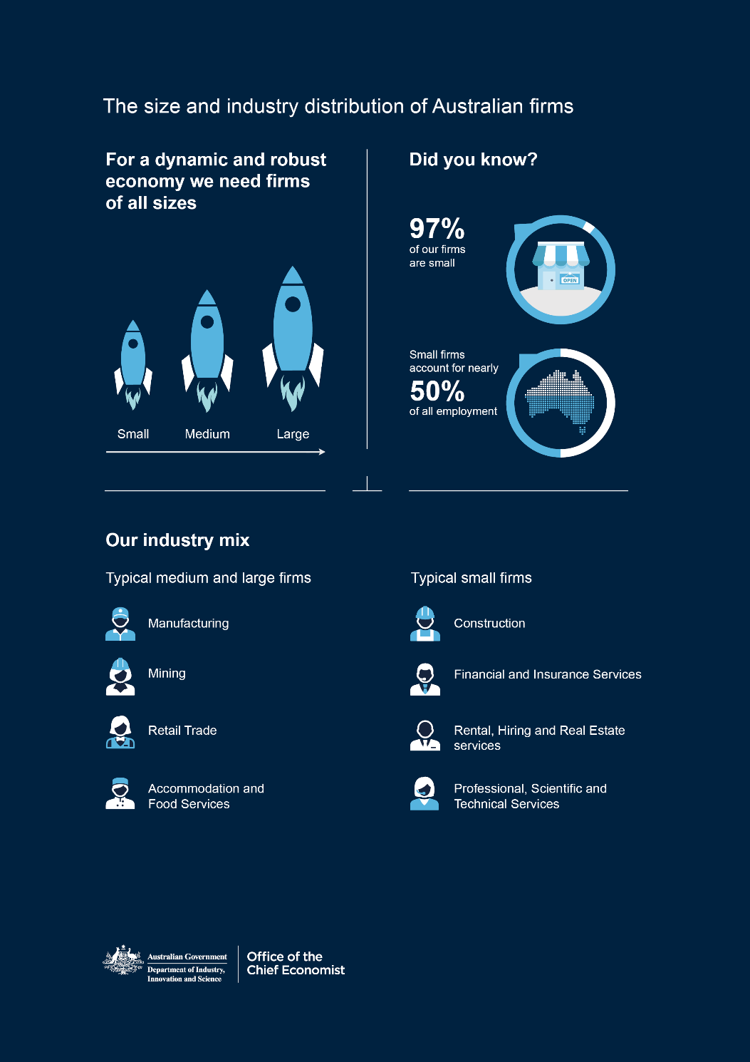

Insights into the role, distribution and performance of firms

Economies are characterised by a collection of sectors that each have their distinguishing features and also intersect with other economic activity. For example, the household sector provides an important input — labour — and creates demand for goods and services. It is also a source of savings which, in turn, are channelled through the financial sector to facilitate investment elsewhere in the economy. The government sector ensures rule of law, provides public goods, like education and health, and corrects for market failures.

This publication focuses on the production or supply side of the economy where firms that are classified and organised within various industries act as an engine room. Firms account for the bulk of economic activity in a market economy. They contribute to the creation of employment, output and capital investment. Firms compete within and across markets, leading to innovation and productivity growth. They also contribute to the demand side of the economy via participation in supply chains and demand for intermediate goods. Over time, consumer preferences change and evolve in response to new products and services introduced by firms. This encourages more innovation and efficiency as has been seen over the past two decades, during which the Australian economy has evolved into a highly skilled, services-based economy.

The Department of Industry, Innovation and Science (DIIS) supports globally competitive industries in their efforts to grow and become more productive. The department depends on solid evidence, quality data and robust analytics to better understand the diversity of Australian firms and to inform the programs it administers.

This chapter outlines the characteristics of Australian firms and how they are performing. It uses statistics from the Australian Bureau of Statistics (ABS), the Organisation for Economic Co-operation and Development (OECD) and findings from the Business Longitudinal Analysis Data Environment (BLADE). This gives readers the context for later discussion on government support provided to Australian firms and how the administrative data the department collects is used to build an evidence base for policies.

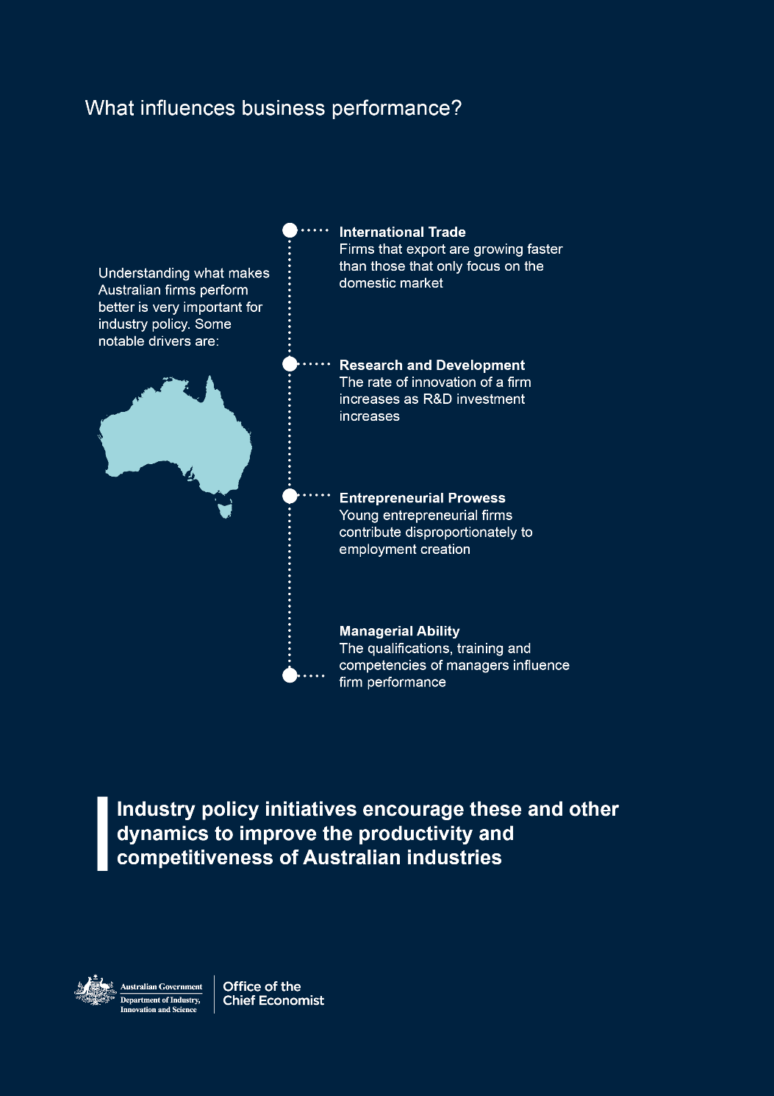

Snapshot of Australian firms

## The contribution of firms of various sizes to the economy

OECD data collected in recent years on developed economies shows the correlation between firm size, rates of innovation, exporting and labour productivity. While size is not the only determinant of productivity, innovation and trade — the influence of technology, market competition, regulation, and financial markets is also critical — it is helpful to understand the way different sized firms operate.

Australia has 2.2 million actively trading firms. Figure 1.1 illustrates that 61 per cent of these do not employ any workers. The next largest cohort is small firms, classified as firms that employ between 1 and 19 employees. Of these, a significant proportion (27 per cent) are micro-firms that employ between 1 and 4 employees.

Figure 1.1: Distribution of Australian firms by size and employment share, June 2017

Notes: Employment shares are only for employing firms

Source: ABS cat. no. 8165.0, table 13, and ABS cat. no. 8155.0, table 05

Medium firms, those with 20–199 employees, and large firms, employing more than 200 employees, constitute only a tiny proportion of all firms in Australia, but employ 56 per cent of all workers. Small firms account for the remainder of employment in Australia.

Firms of all sizes contribute to the Australian economy. While departmental programs predominantly target employing firms, non-employing firms are an avenue for entrepreneurs to start and subsequently grow their business. Medium and large businesses remain important but in years it is younger and smaller Australian firms that have been responsible for the majority of employment growth in Australia.[2] It is also worth mentioning that most employing small and medium firms in Australia are classified as mature firms — those that have been in operation for six years or longer.[3] The proportion of young firms in Australia has been in decline in recent years. Given the contribution of young firms to employment creation, this aspect of Australia’s firm distribution needs to be considered in more detail in the future. It is important to ascertain policy questions such as; why are there fewer younger firms? What can be done to encourage their entry?

The size distribution of firms in all industries is shown in Table 1.1. Non-employing and small firms are most concentrated in Construction, Financial and Insurance Services, Rental, Hiring and Real Estate Services, and Professional, Scientific and Technical Services. Medium and large firms are most likely to be in Manufacturing, Mining, Retail Trade, Accommodation and Food Services, Administrative and Support Services, and Health Care and Social Assistance.

Table 1.1: Firm size distribution across industry (per cent of total firms), June 2018

|  |  |  |  |  |
| --- | --- | --- | --- | --- |
|  | Non-employing | Small | Medium | Large |
| Agriculture, Forestry and Fishing | 8.7 | 6.0 | 4.7 | 2.2 |
| Mining | 0.3 | 0.3 | 0.7 | 3.8 |
| Manufacturing | 2.6 | 5.1 | 11.1 | 12.5 |
| Electricity, Gas, Water and Waste Services | 0.3 | 0.3 | 0.6 | 2.0 |
| Construction | 15.9 | 18.7 | 8.2 | 5.0 |
| Wholesale Trade | 2.7 | 4.6 | 7.5 | 7.9 |
| Retail Trade | 3.9 | 8.4 | 10.3 | 7.8 |
| Accommodation and Food Services | 1.9 | 7.4 | 14.2 | 8.5 |
| Transport, Postal and Warehousing | 9.5 | 4.7 | 3.7 | 5.7 |
| Information Media and Telecommunications | 0.9 | 0.9 | 1.3 | 1.8 |
| Financial and Insurance Services | 12.2 | 4.2 | 2.1 | 5.0 |
| Rental, Hiring and Real Estate Services | 15.2 | 4.2 | 3.2 | 2.2 |
| Professional, Scientific and Technical Services | 11.1 | 14.3 | 10.1 | 7.5 |
| Administrative and Support Services | 3.6 | 4.4 | 7.1 | 11.5 |
| Public Administration and Safety | 0.3 | 0.4 | 0.9 | 0.9 |
| Education and Training | 1.2 | 1.6 | 3.4 | 4.0 |
| Health Care and Social Assistance | 5.3 | 6.8 | 6.8 | 8.3 |
| Arts and Recreation Services | 1.3 | 1.2 | 1.7 | 2.6 |
| Other Services | 3.1 | 6.4 | 2.5 | 1.0 |
| Total | 100 | 100 | 100 | 100 |

Source: ABS cat.no. 8165.0, Businesses by main state by industry class by employment size ranges, February 2019

The contribution that firms of different sizes make across industries is shown in more detail in Table 1.2 and 1.3. Small firms are the main contributors to employment and turnover in the Agriculture, Forestry and Fishing, Construction, Professional, Scientific and Technical Services, and Rental, Hiring and Real Estate Services industries. The contribution of medium and large firms is most significant in the Mining, Electricity and Gas, Water and Waste Services, Information Media and Telecommunications, and the Education and Training Services industries.

Structural shifts in the economy over the past decades have changed our industrial base. The contribution of primary industries — in terms of employment and sales — has diminished relative to the secondary and tertiary sectors. Expansion has been most significant in Professional, Scientific and Technical Services and Health Care and Social Assistance. However, firms in secondary industries such as Manufacturing and Construction remain important for sustainable future growth and job creation.

Table 1.2: Total Industry employment share by firm size (per cent), June 2017

|  | Small | Medium | Large | Total |
| --- | --- | --- | --- | --- |
| Agriculture, Forestry and Fishing | 77.7 | 17.9 | 4.3 | 100 |
| Mining | 8.9 | 14.0 | 76.4 | 100 |
| Manufacturing | 31.0 | 31.7 | 37.3 | 100 |
| Electricity, Gas, Water and Waste Services | 12.5 | 18.3 | 69.2 | 100 |
| Construction | 71.1 | 16.3 | 12.6 | 100 |
| Wholesale Trade | 33.8 | 39.1 | 27.1 | 100 |
| Retail Trade | 33.3 | 18.9 | 47.8 | 100 |
| Accommodation and Food Services | 45.9 | 31.3 | 22.7 | 100 |
| Transport, Postal and Warehousing | 43.5 | 15.7 | 40.8 | 100 |
| Information Media and Telecommunications | 23.4 | 18.1 | 57.9 | 100 |
| Rental, Hiring and Real Estate Services | 76.1 | 13.8 | 10.1 | 100 |
| Professional, Scientific and Technical Services | 52.4 | 26.1 | 21.5 | 100 |
| Administrative and Support Services | 30.0 | 27.6 | 42.3 | 100 |
| Public Administration and Safety (private) | 23.1 | 28.2 | 47.4 | 100 |
| Education and Training (private) | 22.2 | 35.6 | 42.1 | 100 |
| Health Care and Social Assistance (private) | 30.0 | 23.4 | 46.7 | 100 |
| Arts and Recreation Services | 38.8 | 25.2 | 35.9 | 100 |
| Other Services | 68.2 | 20.2 | 11.8 | 100 |

Source: ABS cat.no. 8155.0, Australian Industry by division, May 2018

Table 1.3: Total Industry turnover share by firm size (per cent), June 2017

|  | Small | Medium | Large | Total |
| --- | --- | --- | --- | --- |
| Agriculture, Forestry and Fishing | 75.2 | 19.8 | 5.0 | 100 |
| Mining | 12.1 | 15.3 | 72.6 | 100 |
| Manufacturing | 16.4 | 30.2 | 53.4 | 100 |
| Electricity, Gas, Water and Waste Services | 9.3 | 15.3 | 75.4 | 100 |
| Construction | 58.7 | 19.4 | 21.9 | 100 |
| Wholesale Trade | 23.8 | 37.3 | 38.9 | 100 |
| Retail Trade | 26.8 | 26.6 | 46.6 | 100 |
| Accommodation and Food Services | 42.1 | 34.6 | 23.3 | 100 |
| Transport, Postal and Warehousing | 27.8 | 17.0 | 55.2 | 100 |
| Information Media and Telecommunications | 11.0 | 12.0 | 77.0 | 100 |
| Rental, Hiring and Real Estate Services | 76.2 | 10.4 | 13.3 | 100 |
| Professional, Scientific and Technical Services | 44.0 | 28.6 | 27.4 | 100 |
| Administrative and Support Services | 33.4 | 29.5 | 37.1 | 100 |
| Public Administration and Safety (Private) | 30.4 | 29.2 | 40.4 | 100 |
| Education and Training (Private) | 28.8 | 30.8 | 40.4 | 100 |
| Health Care and Social Assistance (Private) | 51.7 | 13.0 | 35.3 | 100 |
| Arts and Recreation Services | 24.9 | 27.6 | 47.5 | 100 |
| Other Services | 66.0 | 22.2 | 11.8 | 100 |

Source: ABS cat.no. 8155.0, Australian Industry by division, May 2018

A diverse industry base will ensure a dynamic Australian economy that is capable of sustainable growth through productivity improvements. Recent evidence from BLADE analysis suggests that the size of Australian firms has an influence on their chances and prospects of expansion (upscaling), survival, and productivity. Recent statistics from the ABS also reveal that firms of different sizes have differing perceptions of the barriers to their performance. These dynamics are highlighted in the next section.

## Exit rates and firm size transitions

Business entries and exits reflect a healthy economy where entrepreneurship is encouraged and opportunities are provided to small businesses to enter and exit relatively easily. Figure 1.2 reveals that, irrespective of profitability in recent financial years, small businesses have been more likely to cease operation[4] (exit) than medium and large businesses. There is little difference in the exit rate between profitable medium and large businesses, where the tendency is for more loss-making firms to close down.

Figure 1.2: Exit rates by firm size, all industries, 2009–10 to 2013–14

Notes: OCE analysis using data from the ABS BLADE from 2009–10 to 2013–14

Source: Department of Industry, Innovation and Science (2018)

Table 1.4 presents Office of the Chief Economist (OCE) analysis of the size transitions of Australian firms before and after the Global Financial Crisis (GFC). Similar to other economies, most Australian firms are small in size. Some generalisations from the analysis of the data — stylised facts —are:

* the majority of businesses do not change their size category.[5] In recent years (2010–2014):
  + 63.7 per cent of small firms remained small, while 0.6 per cent became medium-sized firms. The remaining 35.7 per cent of firms are associated with exits
  + 64.6 per cent of medium firms remained medium, while 1.8 per cent became large firms and 19.5 per cent became small firms
  + 75.3 per cent of large firms remained large, while 8.9 per cent became medium firms and 4.4 per cent became small firms
    - while there is some evidence of lower upscaling, and higher downscaling rates post-GFC, the GFC did not have a persistent impact on exit rates for Australian firms. Post-GFC exit rates have fallen for medium and large firms, suggesting increased survivability
    - most new entrant firms start off small and are likely to remain small
    - Medium-sized firms show the greatest propensity to downscale. They were approximately ten times more likely to downscale to a small firm (1–19 employees) than they were to upscale to a large firm (200 or more employees).

Table 1.4: Size transition matrices by firm size

|  | Small | Medium | Large | Exit |
| --- | --- | --- | --- | --- |
| **2002–2006** | | | | |
| **Entrants** | 98.8 | 1.1 | 0.1 | 0.0 |
| **Small** | 63.8 | 0.7 | 0.0 | 35.5 |
| **Medium** | 20.1 | 58.7 | 2.1 | 19.1 |
| **Large** | 7.1 | 8.3 | 60.6 | 24.1 |
| **2006–2010** | | | | |
| **Entrants** | 98.8 | 1.1 | 0.1 | 0.0 |
| **Small** | 63.5 | 0.6 | 0.0 | 35.9 |
| **Medium** | 21.3 | 59.0 | 1.9 | 17.9 |
| **Large** | 5.8 | 8.7 | 71.7 | 13.8 |
| **2010–2014** | | | | |
| **Entrants** | 98.6 | 1.3 | 0.1 | 0.0 |
| **Small** | 63.7 | 0.6 | 0.0 | 35.7 |
| **Medium** | 19.5 | 64.6 | 1.8 | 14.0 |
| **Large** | 4.4 | 8.9 | 75.3 | 11.4 |

Notes: OCE Markov chain analysis using the ABS BLADE. Table rows denote transitions for all entrants, as well as entrants by firm size. Table columns denote firm size at the end of the three time intervals.

Source: Department of Industry, Innovation and Science (2018)

## Barriers to business growth

What explains these firm-size patterns? Beyond the preferences and ability of the owners and managers of Australian firms and the overall macroeconomic conditions, it is possible that these patterns of entry, survivability and exit by firm-size are influenced by barriers to business performance.

Results from the ABS *Business Characteristics Survey* (BCS) provide insight into these barriers — the type and magnitude of which greatly depends on firm size. Figure 1.3 shows that relative to larger firms, medium, small and micro firms reported greater constraints relating to accounts receivables and cash flow. Micro firms and SMEs also face challenges accessing skills.

While relatively larger firms appear to be better equipped to deal with compliance costs and other regulatory burdens firms of all sizes perceive regulation and associated compliance costs as a greater impediment to their performance and potential expansion than larger firms.

Skills constraints remain a barrier to performance for Australian firms of all sizes but more so for small and medium firms.

By far the most commonly reported factor hampering business activities or performance was lower profit margins making it difficult to remain competitive. Again, medium, small and micro firms alike, are more likely to report this as a constraint than large firms.

Australian businesses of all sizes perceive the input costs for intermediate goods or factors of production, such as raw materials and energy, as a major barrier to operation. This aligns with the views held by industry bodies that input costs have the potential to curtail the performance of Australian business across the economy.

Facilitating and enabling government policies that help mitigate the constraints imposed by some of these barriers is important. Emerging data and empirical evidence increases the knowledge base and awareness of these issues. Policies in response to these issues need to be firm size-contingent and hopefully motivate business decisions in the interest of achieving a firm’s optimal scale of operation — the minimum efficient scale. This is an important consideration in the context of cost competitiveness and productive efficiency.

Figure 1.4 shows the correlation between firm size and productivity measures. As stated earlier, while size is not the only determinant of productivity, in general, particularly for manufacturing firms, larger firms tend to be more productive. Forthcoming research by the Treasury using the BLADE will shed further light on the productivity dispersion of Australian firms.

Figure 1.3: Barriers to performance by firm size, 2017

|  |
| --- |

Source: ABS Business Characteristics Survey, cat.no. 8167

Figure 1.4: Labour productivity by firm size, 2016

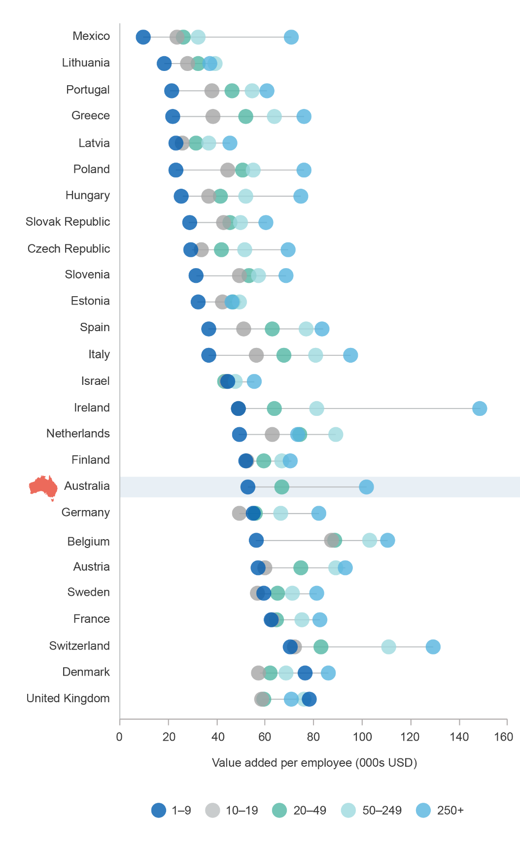

Notes: For Australia the OECD 1–9 firm size category is equivalent to the ABS 1–19 size category; the OECD 20–49 category is equivalent to the ABS 20–199 size category; and the OECD 250+ category is equivalent to the ABS 200+ category

Source: OECD Entrepreneurship at a glance, 2016

## Does Australia have an optimal number of firms across the business size distribution?

Compared to other OECD economies, Australia has an above-average stock of businesses per capita (Figure 1.5). This is true even by size group, that is, small, medium, or large.

Figure 1.5: Business counts by population

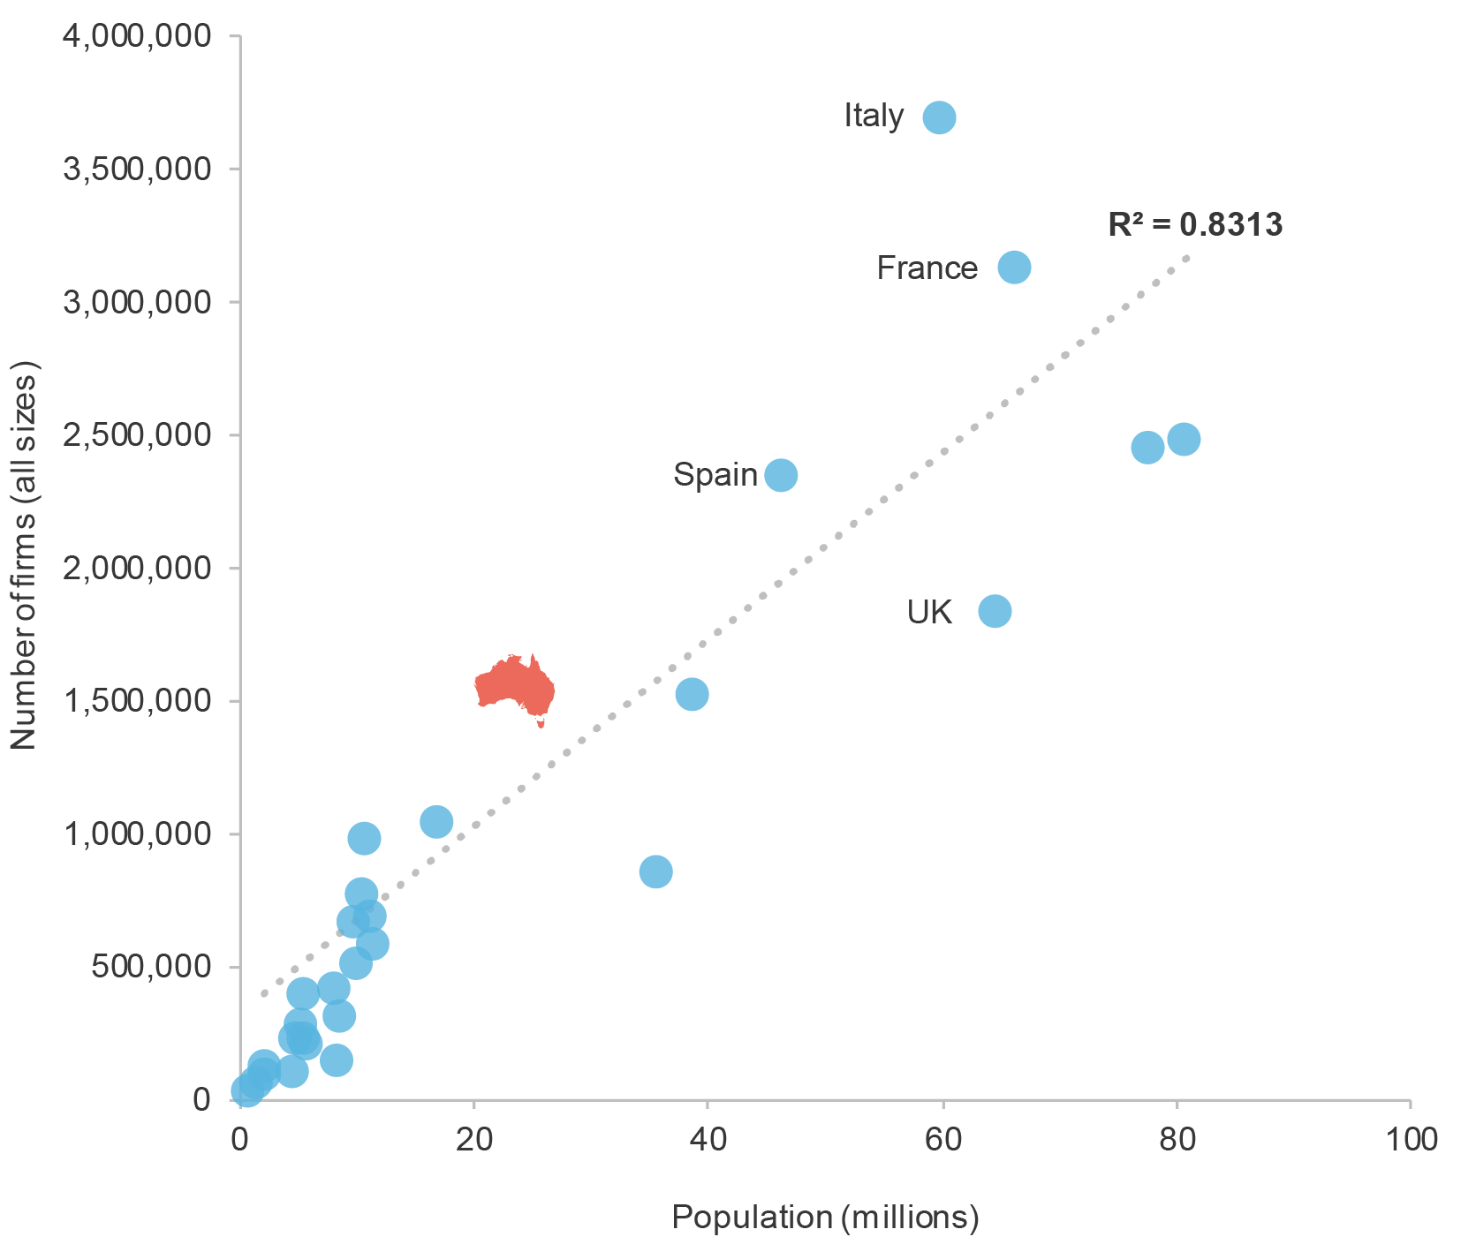

Notes: 2014 or most recent year available

Source: OECD SBDS Structural Business Statistics (ISIC Rev.4) and Penn World Tables

To answer the question of optimal scale and scope of operations, two perspectives need to be considered. First are the preferences and motivations of owners and managers of firms. Second is, how barriers and impediments to performance and expansion constrain the scale of Australian businesses (Figure 1.3). Here, the policy and regulatory context needs to help firms that wish to become larger to start growing. Before governments can assist, policy makers need to understand the factors and dynamics that shape firm performance. The OCE has done research in this area to inform policy. Recent findings on firm dynamics are discussed in the following section.

# Business dynamics and drivers of performance

A dynamic business environment is important for ensuring job creation and productivity growth. The formation of new businesses and the decline of less competitive businesses are the key to long-term economic growth and structural change.[6] New businesses are the building blocks of ‘creative destruction, a term coined by the Austrian economist Joseph Schumpeter in 1942. Schumpeter argued that capitalism exists in a state of ferment, with spurts of innovation destroying established enterprises and creating new ones. Today, creative destruction is thought to be conducive to long-term economic growth. In the Australian context, while there has been substantial economic research and subsequent policy debate on studying the determinants of aggregate economic growth, the factors influencing the creation, growth and destruction of businesses in the economy have received less attention. Limited availability of firm-level data has been one reason for a lack of research in this area. BLADE is now opening up firm-level research possibilities.

## What are business dynamics and why are they important?

Business dynamism refers to the entry and exit of firms from the market. Over the last four years, around 36 businesses were born every hour in Australia. This equates to 1,275 new businesses for every 100,000 people each year.[7] To illustrate the state of flux in the business population, there were 354,520 business entries and 279,528 business exits in 2017–18. As shown above, the number of business entries varies by business size and industry. Location also matters.

Business formation and scaling up are complex issues given the diversity of the business population, with its differences between start-ups and established businesses; employing and non-employing businesses; businesses with or without growth ambitions; and businesses in different sectors, of different sizes and in different locations. These all affect the dynamism of the economy.

The rates of firm entry and exits mirror the economy’s ability to spur new ideas, transform itself and reallocate resources from less productive firms to more productive ones. This process is an important contributor to productivity growth, particularly in the long term. Figure 1.6 shows that productivity growth is higher in general in OECD countries where business dynamism is higher. Part b) of Figure 1.6 shows this is also the case for Australian industries with higher business dynamism.

Various studies have empirically investigated this relationship by decomposing measures of productivity into components that represent the impact of resource allocation across surviving firms as well the impact on productivity of the entry and exit of firms.[8] The pace of this reallocation will vary over time, across sectors and across countries. Reallocation of resources is not always a smooth or immediate process and as such there might be significant adjustment costs involved with an excessive level of churn. Official data for Australia, however, do not point   
to excessive levels of churn. Entry and exit rates by industry over the period   
2013–14 to 2016–17 remained relatively stable and varied between 8.5 to 26.8 per cent and 8.4 to 16.9 per cent respectively.

Figure 1.6: Average entry rate and productivity growth

| Panel A of Figure 1.6 shows the positive relationship between labour productivity growth of firms in selected OECD countries and the countries’ firm entry rate from 2010 to 2014. The line of best fit for this relationship has an R squared value of 0.5926. According this relationship, Australia has a slightly higher labour productivity growth rate than its entry rate predicts, along with the US, Canada, South Korea and Brazil. The New Zealand and Israel have labour productivity growth than their entry rate predicts.  Panel B of Figure 1.6 shows this relationship for selected industries within Australia from 2012 to 2016. The line of best fit for this relationship has an R squared value of 0.6683. Information, media and telecommunications, Financial and insurance services, and Wholesale trade have higher labour productivity than their entry rate predicts, while Administrative and support services, and Accommodation and food services have lower labour productivity than their entry rate predicts. |
| --- |
|  |

Source: ABS cat. no. 8165.0 and 5260.0.55.002, *Entrepreneurship at a Glance* (2016), Conference Board *Total Economy Database*

The constant influx and exit of businesses generates a churning business population. But what drives these changes in business entries and exits and why are they important? Changes in the business demography cast light on how firms get access to markets and the barriers to entry and exit. Changes in these demographics also have implications for competition policy and employment creation.

With the creation of BLADE we can now get a more complete understanding of the contribution of businesses of various size and age to employment and productivity growth. Access to linked microdata on firms has the potential to transform our understanding of the economy by moving beyond the ‘average firm paradigm’ that masks the differences between firms’ levels of performance. With the growing availability of firm-level microdata, there are increasing opportunities to use empirical economic research to improve policy.

Microdata can paint a clearer picture about the behaviour and performance of businesses. For example, on the topic of reallocation (movement of resources between firms), advances in the availability and analysis of business microdata has shed new light on the process whereby lagging firms catch up to domestic and global productivity frontiers.[9] The diffusion of technology, knowledge and practices (driven by competitive pressures) plays a key role in this convergence process that is narrowing productivity gaps in the economy. This process of creation and diffusion of new products or processes provides the foundation for new industries, businesses and jobs.

DIIS, in collaboration with the ABS, is working to better understand business dynamics and productivity by participating in multi-country projects such as MultiProd, DynEMP and CompNet.[10] Each of these collaborations involves using representative firm-level data to conduct comparable cross-country analysis of employment dynamics and productivity.

Under the Government’s Data Integration Partnership for Australia Initiative (DIPA), the Economic Data and Analysis Network (EDAN) analytical unit is currently investigating questions on the extent of productivity dispersion in Australia and the driving forces behind it, as well as a number of factors that are linked to national productivity growth such as innovation, management capability of firms and entrepreneurship dynamics.

In the following article Sasan Bakhtiari, a senior economist from the OCE, illustrates how he used BLADE to assess Australia’s rates of entrepreneurship. His work showcases new Australian evidence on business dynamism, particularly the long-term entry rate — entrepreneurship rate — in Australia. The article also makes international comparisons and discusses the implications for employment and productivity growth.

# Dynamic entrepreneurship boosts the economy

By Sasan Bakhtiari**[11]**

Entrepreneurship is an important driver of job creation and long-term economic growth. The more productive and innovative entrepreneurs displace less productive firms, thus improving aggregate productivity. As they grow, these new firms create jobs. In the process, they also transform markets and drive out firms that are inflexible or slow to adjust. An economy with dynamic entrepreneurship is more progressive and adaptable.

For these reasons, economists and policy makers consider the rate of entrepreneurship as one barometer of the economy’s health. For example, part of the recent slowdown in productivity growth in North America can be explained by the gradual decline in the rate of firm entry in the United States and Canada over the past three decades. In addition, the rate of job creation among the US entrepreneurs is also falling. With the Business Longitudinal Analysis Data Environment (BLADE) becoming available in Australia, it was prudent to ask whether Australia is facing the same problem. Three measures of entrepreneurial dynamism are of special interest: rate of entry, probability of exit, and job creation and destruction rates.

On the firm entry rates, the BLADE reveals a declining trend. Specifically, the entry rate falls from 15 per cent of all firms in 2005 to about 9 per cent in 2015.

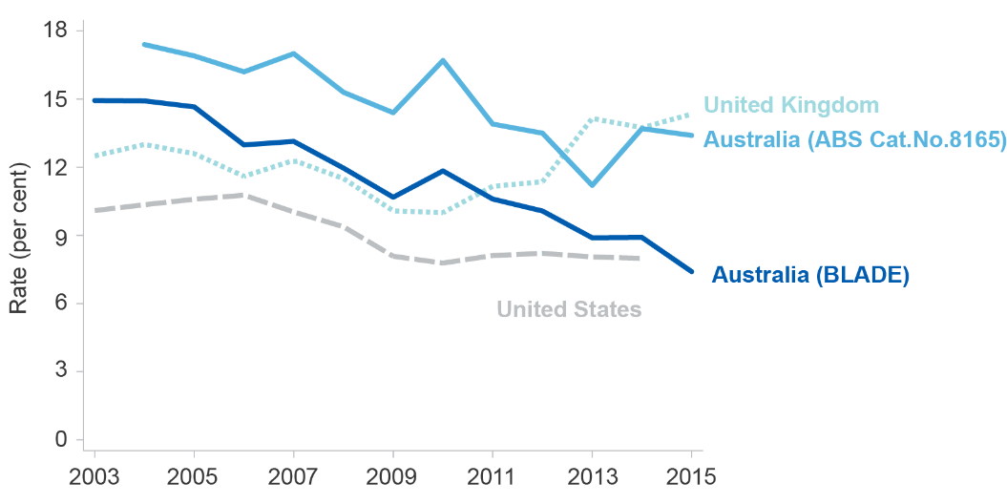Figure 1.7: Firm entry rates, selected countries, 2003 to 2015

Notes: The entry rates computed from the BLADE do not include re-entries and certain sectors where entry is not entrepreneurial. Hence, the entry rates from the BLADE are lower than those from the ABS reported numbers.

Source: Bakhtiari, S. (2017) Entrepreneurship Dynamics in Australia: Lessons from Micro-data

Figure 1.7 also shows the fall in Australia has been steeper than in the US. To emphasise that not all countries are going through the same decline, the figure also shows the entry rates for the UK, which have been increasing post   
the GFC.

Analysing the likelihood of exit among young firms in Australia, as an indicator of risks, further reveals that cohorts of entrepreneurs that enter in 2005 or later are more likely to exit during their early years. The probability of exit is 10 per cent higher for these cohorts compared to those that entered prior to 2005. There is also a temporary jump following the GFC.

Interestingly, there is one important exception to this rule. The level of risk in the mining sector dropped while it was increasing elsewhere. The period in discussion coincides with the resources boom in Australia, which could explain why mining entrepreneurs would have behaved differently from others.

With a lower number of entrepreneurs entering and even a lower number surviving, it is natural to expect job creation in Australia to be affected. Indeed, the job creation rate (as a percentage of all jobs) in Australia has been constantly falling at the same time that job destruction has held steady. This has led to diminishing net job creation (Figure 1.8).

Figure 1.8 Australian job creation and destruction rates, 2004 to 2014

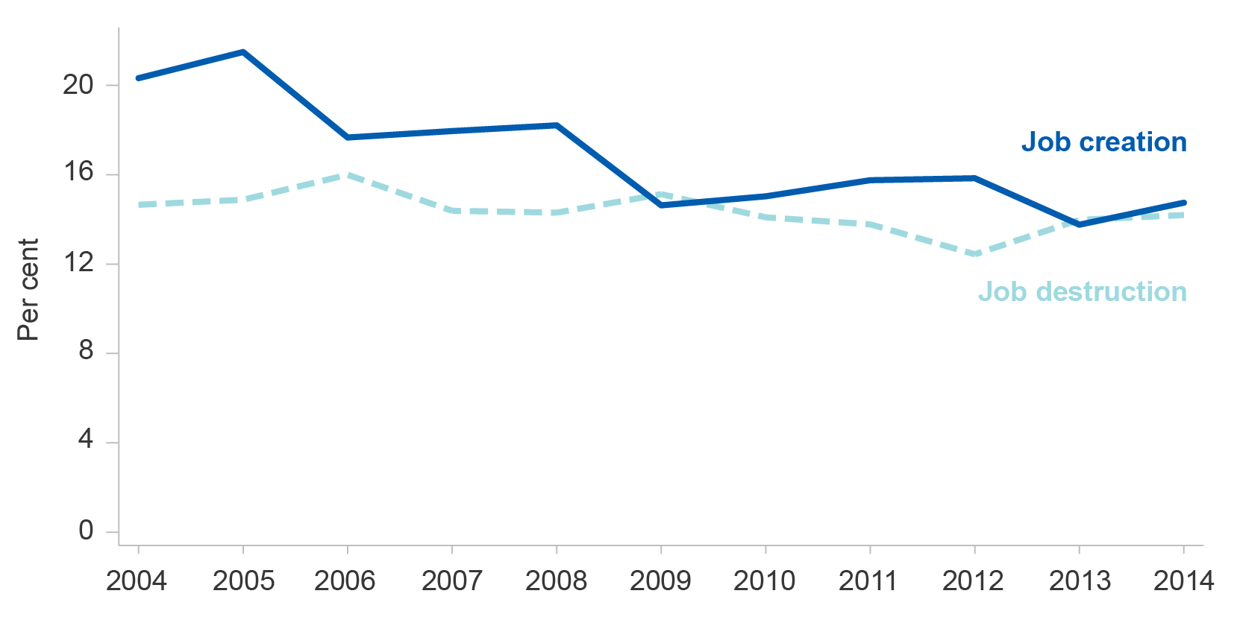

Source: Bakhtiari, S. (2017) Entrepreneurship Dynamics in Australia: Lessons from Micro-data

Was the drop in job creation further accelerated by the surviving entrepreneurs also creating fewer jobs? BLADE analysis shows the job creation prowess of the surviving entrepreneurs has not subsided and is in fact increasing.

This analysis raises further questions. What are the reasons behind the riskier environment for entrepreneurs? Industry booms, the rising cost of borrowing for small firms, and increasing globalisation are a few candidates worthy of consideration. Understanding the causes and how policy can help to mitigate these is one way to improve the entrepreneurial experience in Australia.

# Notable drivers of firm-performance

BLADE has also opened the door to firm-level analysis of factors that facilitate the growth of businesses. Some of these factors revealed by recent OCE research are discussed below.

## The importance of international trade

Businesses of all sizes are active in global markets. The OCE conducted research in 2016[12] to shed more light on the characteristics and performance of exporters versus non-exporters. The findings show that firms that export are growing faster than those that only focus on the domestic market.

Exporters are generally larger than non-exporters. And, based on key business performance metrics such as value-added, labour productivity, employment and wage levels, persistent exporters consistently outperform non-exporters and intermittent exporters. Most importantly, exporting is associated with a higher probability of business survival. Earlier work also looked at the innovation-trade nexus, illustrating that trade drives innovation and *vice versa*.[13] Exporters were found to be 7 to10 per cent more likely to be innovators.

OCE research also points to signs of Australian manufacturing reaping gains from global production sharing (also referred to as international production fragmentation or vertical specialisation).[14] The study shows that the ongoing process of global production sharing has opened up opportunities for Australia to specialise in parts and components, and final assembly, which are not subject to the tyranny of distance in world trade. Preliminary results indicate that industries in which Australia has a revealed comparative advantage in global production networks have a higher degree of export orientation, research and development (R&D) intensity, real wages and labour productivity compared to other industries.

## The direct and indirect benefits of R&D

Innovation is a key source of competitive advantage and can provide innovative firms with a productivity advantage. R&D is a key input to innovation, particularly in the development of new products and technologies. Moreover, R&D activity within the business increases absorptive capacity (the rate of adoption of existing technologies and ideas). Networks allow businesses to collaborate and share ideas, resources, and risks for innovation. Previous OCE research reveals that collaboration between businesses and researchers is associated with better business performance.[15] As such, a culture of both innovation and collaboration (joint R&D activities, informal and personal networks, joint publications etc.) are associated with compounding benefits for firms and the economy more broadly.

New or significantly improved products and services can be sources of increased profits for innovating firms, while process innovation can lead to productivity improvements. Both types of innovation often arise out of R&D. OCE research shows that R&D expenditure tends to have a positive effect on business performance (turnover, labour productivity and wages) across all industries, and that these effects are more pronounced over time, demonstrating the relatively long-term impact of R&D.[16]

## The benefits of high-growth

High-growth firms (firms that achieve at least 20 per cent average annualised growth in either turnover or employment over three consecutive years) are very important contributors to economic growth.[17] In any given year, there are more than 10,000 high growth firms in Australia. With the advent of the GFC the number of high-growth firms declined between 2005 and 2014. [18]These firms are not of any specific type, rather they are in a temporary growth phase of their lifecycle. OCE research reveals that these firms tend to be younger; achieve higher labour productivity; are better able to maintain their performance when the macroeconomic environment is conducive; and that their performance is characterised by innovation in both goods and services. The international empirical evidence points to some notable determinants to high growth such as international exposure, management capability, entrepreneurship and institutional factors such as the IP rights, and the quality of legal, political and academic systems.

## Learning more about management as a driver of firm performance

There is evidence that the quality of management plays an important role in maximising organisational performance. Managers’ qualifications, continuing training and development, and competencies relate to firm performance. This is substantiated by the Australian Securities and Investments Commission’s (ASIC’s) detailed findings from initial external administrators’ reports lodged electronically, which reveal that a significant proportion of Australian firms cite poor strategic management as the reason for their failure (Figure 1.9).

Figure 1.9: Poor strategic management of business as cause of business failure, proportion of all nominated causes, 2009–10 to 2016–17

|  |
| --- |

Source: ASIC and DIIS calculations

There is a growing international literature that examines the link between management capability and business performance.[19] The contribution of management capability has also been considered in Australia, notably by the Karpin Report[20] and Roy Green who established the positive contribution of good management practices to labour productivity, sales performance and employment growth within firms.[21] Australia will contribute further to this literature through the management capability survey (MCS) administered by the ABS. The MCS is a significant improvement on current existing sources of Australian data on managerial ability.

In August 2017, the ABS released the first official data from the MCS. Notable results show that:

* only one in ten businesses had a written strategic plan in place
* half of all businesses did not monitor any aspect of their performance
* just over 10 per cent of businesses agreed that they embarked on high-risk and high-reward ventures in their business
* a third of the principal managers had a degree or similar higher qualification, which is broadly in line with the workforce at large.

These initial findings reveal significant gaps and potential areas of improvement in regards to Australian management practices. The OCE has already integrated the 2015–16 MCS survey data into BLADE and is planning to publish research outputs based on the matched dataset. The results will be useful in informing policy on the role management plays in the survival and growth of firms.

# The role of industrial policy and assistance in enabling businesses

The drivers and dynamics discussed above identify aspects of market and firm behaviour that can lead to superior business and economic performance. Industry policy complements these firm-level dynamics and drivers by attempting to correct market failures and removing other impediments to superior industry and firm performance. Industry policy can focus on specific industry sectors, firms, or regions, or on specific technologies, programs and policies, independent of industry. Both approaches are common.

As illustrated in the *Australian Industry Report 2016*, industry policy aims to facilitate growth through competitive markets, a properly functioning innovation system and effective regulation.[22] Well-designed industry policy complements other economic and social policies. The latter are explored from the perspective of the social returns on government investment in more detail in Chapter 4.

Table 1.5 gives a snapshot of notable departmental programs that enable Australian industries, firms and regions to meet their full potential. Further details of these and other departmental initiatives and programs are available on the department’s online portal, [www.business.gov.au](http://www.business.gov.au). Some of these programs, their objectives and impacts are also discussed in the following chapters.

One of the key priorities for departmental programs and initiatives is to address market failures that inhibit productivity and competitiveness. This occurs when markets do not invest at socially optimal levels because the benefits from such investments cannot be fully captured by an investor. Market failures can arise for many reasons. For instance, asymmetric (imperfect) information constrains the ability of businesses to respond to incentives or make appropriate investments. Market failure can also arise from the presence of externalities, which are the good or bad consequences of an economic activity experienced by unrelated third parties. This occurs when the true cost of a good or service is not captured by the market. In the case of negative externalities this leads to over-production by the market, for example, of pollution. Positive externalities result in under-production of socially desirable goods and services, as businesses do not factor in social benefits in their production decisions. This includes things like investing in basic R&D where the investment benefits (skilled workers and knowledge) can be used by multiple companies.

The ongoing process of structural change — medium to long-term shifts in the distribution of output, investment and employment across industries and regions— also creates an impetus for industrial policy and government action. In the long run, structural change results in an economy that is continually evolving and adapting to newer more efficient technologies and economic dynamics. However, rapid structural change such as the closure of a key regional industry or employer, can leave regional economies vulnerable. Industry policy has a role to play in this scenario by facilitating the adjustment process and helping those affected to transition.

The initiatives highlighted in Table 1.5 reflect the government’s endeavours to overcome some of these issues and provides a taxonomy of departmental initiatives that aim to support business growth and performance. Some seek to reduce the costs of getting information and of making transactions. Others subsidise the cost of investment in critical infrastructure and knowledge goods or increase the rate of collaboration between Australian businesses and experts from academia, industry and beyond. The goal of these and other departmental programs is to foster greater levels of entrepreneurship, trade, innovation, productivity and business performance to enhance the global competitiveness of the Australian economy.

Table 1.5 – Examples of DIIS programs and initiatives

| Initiative(s) | Objective(s) | Desired outcome |
| --- | --- | --- |
| Online industry  assistance portal,  [*www.business.gov.au*](http://www.business.gov.au/) | A one-stop shop for current and potential business owners that provides guidance on available industry assistance | Reduction of asymmetric information and search costs |
| Global Innovation Strategy,  Australia-India Strategic Research Fund,  Square Kilometre Array Radio Telescope Project | Science awareness, infrastructure and international engagement | Provision of public goods, increasing rates of investment, addressing positive externalities and spill-overs |
| Cooperative Research Centres (CRC) Program,  Research and Development Tax Incentive,  Entrepreneurs’ Programme: Accelerating Commercialisation,  Innovation and Investment Funds | Business research, development and commercialisation | Increasing rates of investment in the knowledge economy, addressing positive externalities and spill-overs, reducing information and transaction costs |
| Entrepreneurs’ Programme: Business growth grants,  Industry Growth Centres Initiative,  Tradex | Business and market development, increasing competitiveness | Increasing business dynamism, reducing transaction and information costs in terms of financing, identifying and developing competitive advantage |
| Northern Australia Infrastructure Facility,  Automotive Transformation Scheme (ATS),  Next Generation Manufacturing Investment Program | Economic transitioning, growing business investment in strategic regions | Managing structural change, reducing skewed economic growth and investment |

Notes: Not an exhaustive list. Refer to [www.business.gov.au](http://www.business.gov.au) for more specific details on these and other DIIS programs

Source: Table based on DIIS (2017) Budget 2016–17 Portfolio Budget Statements 2016–17, Budget Related Paper No.1.12, Commonwealth of Australia, Canberra

Of particular significance is the Research and Development Tax Incentive, which provides support for companies undertaking eligible R&D. The RDTIis the largest DIIS program in terms of budgetary outlay; 30.5 per cent of all federal government budgetary assistance to industry is provided through the program.[23]   
The importance of R&D to the Australian economy and the firm-level impacts in terms of benefits and spill overs are discussed in Chapters 2 and 3.

Figure 1.10 further illustrates the diversity of departmental programs and initiatives not only in terms of their objectives but also in terms of their relevance and influence on Australian businesses at nearly all stages of the business life cycle.

Figure 1.10 describes how the department assists firms throughout their lifecycle: at the start (Australian Small Business Advisory Services, Venture Capital Programs, Business.gov.au); as firms develop (Entrepreneurs’ Programme, tailored advice and financial grants, advise on complying with regulation, encouraging employment); as firms expand (Industry Growth Centres, R&D Tax Incentive, Cooperative Research Centres, TRADEX); and during restructure (selling/merging/transferring, repurposing, closing).
Figure 1.10: Business life cycle and departmental programs

# Conclusion: firms of all sizes drive the economy

This chapter highlighted the diversity and distribution of Australian businesses and pointed out the contribution that firms of all sizes make to the Australian economy. As the engine room of the economy, firms create employment, they innovate and help sustain the momentum of economic growth. Therefore, understanding firm dynamics and drivers of performance is critical for ensuring a vibrant industrial base and a prosperous Australian economy.

Notable sources of innovation and superior firm performance have been identified in this introductory chapter: OCE research has identified international trade, investment in research and development and managerial ability as notable sources of superior firm performance. Additionally, young, entrepreneurial high-growth firms have emerged as star performers in the Australian economy. Mitigating better firm performance are factors such as increasing input costs, regulatory barriers, and access to finance.

Designing and implementing sound industrial policy needs to start by investigating the facilitators of, and impediments to, business performance. Once that context is understood targeted industry policy can assist firms to unlock their full potential where there is under investment. This is the rationale for the departmental programs and initiatives highlighted in this chapter.

DIIS and the OCE are leveraging administrative data to better understand their client base of supported firms, thus providing the theoretical underpinnings and empirical evidence for government initiatives. However, more can be done. How to strengthen the policy rationale further via the use of administrative data is discussed in the next chapter.

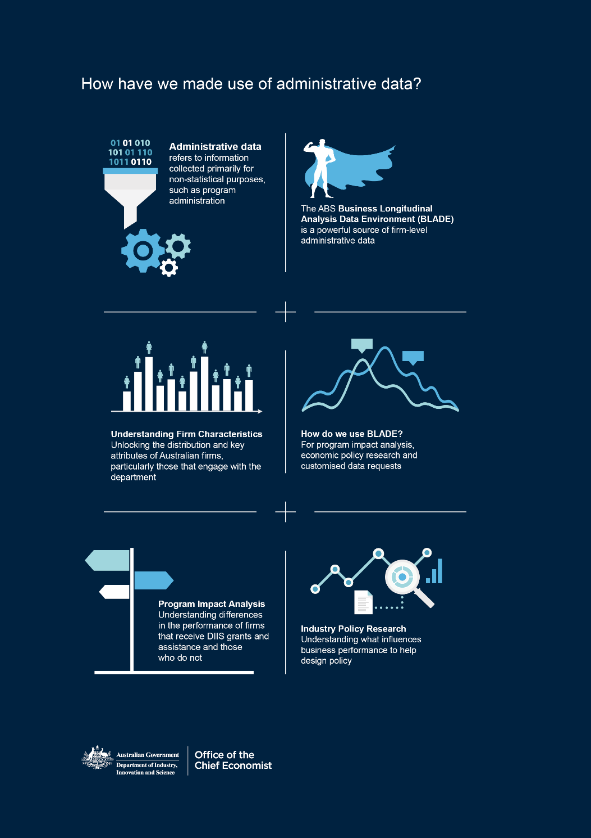

Characteristics of firms that engage with departmental programs

Creating industry policy that offers the right incentives and support to the right firms requires a thorough understanding of firm dynamics and drivers of performance, such as those discussed in Chapter 1. The goal of these policies is to promote the growth and prosperity of Australian industries and the economy, and to correct for market and system failure.

While this may sound intuitive, implementation, monitoring and refinement of industry policy is not simple. Economies and economic systems are dynamic; government interaction with the system needs to be dynamic as well. General principles like minimising costs or encouraging innovation can act as a guiding light for policy development. But variations in circumstances mean a one-size-fits-all approach is rarely useful.

Industry policy has vacillated in individual countries and regional and global institutions. Like many developed countries, the focus in Australia has changed from sustaining and protecting industries to establishing productive and internationally competitive industries. This is in contrast to certain East Asian countries such as Malaysia, which typically still employ higher levels of state intervention in the economy.

Noted Harvard economist Dani Rodrik elaborates on the diverse choices that are available for the structure of industry policy.[24] These depend on a society’s prevailing political ideologies and their interaction with social and economic considerations. In all but the rarest of exceptions, this requires governments to work in concert with market forces when designing industry policy.

Economic theory and past experiences of encouraging the development and growth of sectors of the economy — whether domestic or international — is instructive when designing policies. Also useful is the increasing body of firm-level economic research and analysis that is bolstering the evidence base underpinning the government’s industry initiatives.

This chapter highlights the department’s approach to using administrative data to better understand salient characteristics of the industries and firms DIIS supports. Many of these statistical insights will be available via the Program Analytics Tool — a customisable user interface for reporting key performance indicators for firms that participate in DIIS programs.

Current industry policy in Australia aims to facilitate the growth and productivity of globally competitive industries. The policy’s three touchstones are: simplifying the act of doing business; growing business investment and improving business capability; and supporting science and commercialisation.

There is scope to influence the economy in multiple beneficial ways. The Australian Government’s largest program, in terms of finance and reach, is the R&D Tax Incentive (RDTI). Complementing the RDTI are the Entrepreneurs’ Programme (which includes Accelerating Commercialisation), which aim to help Australian businesses succeed. Via the Cooperative Research Centres (CRC) Program and the Australian Research Council (ARC), the government also supports collaborations between industry and professional researchers to improve the competitiveness, productivity and sustainability of Australian industries. Innovation is also broadly promoted via the research activities of the Commonwealth Scientific and Industrial Research Organisation (CSIRO).

Even when all support is tallied, the scale of departmental programs is quite small. Industry support is a complement to market opportunities and dynamics rather than a substitute for it. Most Australian businesses do not receive government funding or support. Even fewer receive direct support from departmental programs (as opposed to other forms of state and federal government support). There are, however, other ways for the department to influence the business environment in a positive way. Its ability to harness new ideas, collect and analyse data and employ robust evaluation techniques informs decisions about when to continue providing assistance, when it’s appropriate to change the scale and scope of assistance, or to discontinue assistance and identify new support opportunities.

# Increasing our understanding of DIIS initiatives by analysing administrative data

Policy makers and analysts require access to accurate and timely data on businesses to inform and refine industry policy. The data itself comes from several sources. Statistical data is generated via periodic surveys and censuses. Qualitative and quantitative data can also be collected via interviews and forums.

Administrative data, while not as timely[25], can nevertheless help. Administrative data refers to information collected primarily for non-statistical purposes. This type of data is collected by government departments and other organisations for the purposes of registration, administration and record keeping — usually during the delivery of a service or a program.

To unlock the potential of administrative data DIIS has established the Data Management and Analytics Taskforce (DatMAT). DatMAT collects, manages and disseminates data and analytics. The taskforce is tackling the challenges of how to build the necessary IT infrastructures, store data in one place, overcome legal obstacles related to data sharing and design training modules for public sector researchers to improve data usability and access.

## BLADE - a valuable data asset to inform policy

Since 2016, the department has been integrating its program participant data into BLADE.[26] The creation of this firm-level linked data asset is highly valuable for generating statistics on the characteristics of firms and to assess program impacts and performance. Data from 20 departmental programs has already been linked to BLADE and data from additional programs is being prepared for linking. The departmental data captured from program administrators includes elements such as the Australian Business Number (ABN), industry classification codes, program enrolment start and end dates, and if applicable the dollar amount granted to firms. This information is linked to additional financial variables on these firms from BLADE data, such as turnover, the wage bill and capital expenditure.

As part of the *Data Integration Partnership for Australia* (DIPA) initiative, the department has a leadership role in the Economic Data and Analysis Network (EDAN), which focuses on using government data assets, such as BLADE to address economic, business and industry policy questions. EDAN’s initial focus is on improving analysis of the drivers of productivity and assessing the effectiveness of government support for business.

Linking program participant data within BLADE has enabled the department to extract de-identified information to facilitate analysis of participant firms. The expanded dataset has generated insights and determined participant firm performance attributes that were unavailable before. These program-related statistics also allow for assessment of departmental initiatives.

Box 2.1: How the OCE uses BLADE

| *Program impact analysis* — Studies already completed include the impact of Industry Innovation Funds on business performance in South Australia and the impact of the Clean-Technology program on emissions reductions and business dynamism (see next chapter for more detail).  *Economic policy research* — DIIS has looked into the drivers of productivity and growth; the dynamics of employment, the characteristics and performance of high growth firms; and export behaviour and business performance. Our research findings have stimulated policy debate and contributed to a solid evidence base for the department’s programs. The results also feature in the department’s flagship publications, the *Australian Industry Report* and the *Australian Innovation System Report*.  *Customised data requests* — From time to time the department extracts customised data that assists policy development or analysis requirements (e.g. firm size distributions, industry and geographic distributions, business age distribution, etc.) |
| --- |

Growth and productivity can now be assessed using performance indicators such as value added (the difference between the final price of a good or a service and the cost of intermediate inputs, essentially the economic contribution of a firm), turnover, exports, employment, wages, productivity and business survival. These variables were not available exclusively through departmental program data, but are now all available via linked BLADE datasets that combine DIIS data with data from other sources such as the ATO. Analysis of this linked data on program participant attributes can also shed light on the distribution of firms by business size, industry, business age, foreign ownership and export status.

The longitudinal — available over time — nature of the linked data in BLADE enables departmental to assess the performance of program participants at different points in time. For example, business performance can be examined during and after participation in DIIS programs. It also makes it possible to compare cohorts of firms that participate in departmental programs within and across programs as well as with non-participant firms, including from other countries. It must be acknowledged that there are lags inherent in collecting, accessing, combining and analysing administrative data. This makes the use of administrative data less feasible for assessing the impact of newer programs. An impact analysis of concluded programs can still produce valuable insights and policy lessons that can inform decisions around current programs with similar policy motivations. There are other types of evaluation activities that also inform decisions around newer programs as highlighted in the Department’s *Evaluation Strategy 2017–2021*. This include post-commencement evaluations (that focus on the initial implementation, design and delivery of programs) and monitoring evaluations (that test data sources to see whether they are providing the required performance information).

While BLADE contains a large volume of administrative tax data on individual firms, this data is not used for compliance or program management purposes. Rather BLADE facilitates statistical analyses of cohorts of firms and industries that are of policy interest. Analysis of individual firms for any reason is specifically prohibited under ABS’ safeguards such as their adoption of the *Five Safes Framework*.[27]

The remainder of this chapter showcases some recent insights generated from departmental administrative data. The department is creating PAT to allow users to interactively explore program participant firm attributes and key performance metrics. PAT will also assist in enhancing the transparency of DIIS programs by sharing more insights from them.



# The Program Analytics Tool (PAT)

A large volume of data — millions of records over more than 10 financial years — is available in the linked BLADE datasets. Presenting important findings from this quantity of data in a manner accessible to a wide variety of stakeholders proved to be a challenge. To address this challenge, the department has developed an interactive Program Analytics Tool (PAT) that can be used to display the attributes of cohorts of firms that participate in portfolio programs. The web-based tool contains information items such as program descriptions, program coverage and a data dictionary. It will allow users to generate interactive charts and tables that display participant firm characteristics.

PAT serves two primary functions. First, it allows policy makers and other users to understand the patterns of departmental assistance, and the characteristics of assisted firms. This will facilitate the refinement of current programs and the design and delivery of future programs. Gaining a better understanding of participant firm characteristics is the first step in performing robust empirical analysis of aspects of program and firm performance — PAT helps lay the ground work for this. Second, PAT increases the accessibility and transparency of departmental programs by making more data insights available to a wider audience. For example, PAT has the potential to deepen the analysis of government assistance for business presented in the Productivity Commission’s annual *Trade and Assistance Review*.

Statistics from seven programs are available within PAT: the R&D Tax Concession, the R&D Tax Incentive, Enterprise Connect, Commercialisation Australia, Clean Technology Innovation, and Textile, Clothing and Footwear Strategic Investment programs, and the Entrepreneurs’ Programme. These programs include some of the biggest departmental programs[28] and align with the government’s strategic priorities set out in the *National Innovation and Science Agenda* (NISA). PAT will be updated annually as new financial data become available and additional program data are integrated into BLADE.

## Scope and limitations of PAT

As pointed out in Chapter 1, non-employing firms account for the majority of businesses in Australia. The scope of the PAT is limited to employing businesses. This aligns PAT more closely with the motivations of departmental programs, which are predominantly targeted at employing firms. Statistics within PAT are generated by cohort. Cohorts are determined by the financial year the participant firm joins a program.

PAT also generates all industry benchmark statistics based on all employing firms in BLADE — as opposed to statistics on just program participant firms. These benchmarks are useful for comparative purposes.

Future releases of the PAT will also include data on the performance of program participants. This data will also be presented alongside a benchmark, however the benchmark is not analogous to a counterfactual. A perfect counterfactual would compare assisted firms with similar firms (in terms of business size, industry etc.) that did not receive assistance from a DIIS program. The construction of a counterfactual is a more complex process. It involves the use of a randomised control trial or a quasi-experimental technique such as a matching estimator. The OCE is progressing work in this area as shown in Chapter 3.

A final limitation arises due to the need for data confidentiality. Statistics cannot be produced if the sample sizes in BLADE are too small.

Despite these limitations, PAT provides an accessible and customisable mechanism to quickly and consistently interrogate statistics on program participant firms, produce charts and benchmark statistics.

The following section illustrates the range of statistics and insights that can be generated via PAT. For the sake of brevity the example concentrates on a particular program — the Enterprise Connect (EC) program. The following section presents some stylised facts from the PAT analysis of firms that received a business review and grant under the EC program. A specific cohort of EC firms — 2009–10 — is then selected to illustrate the selection of charts and statistics that can be generated within PAT.

Box 2.2: An example of output available in PAT – The Enterprise Connect program

| The Enterprise Connect (EC) program was launched in 2007–08 with the overarching objective to provide small and medium sized enterprises with better access to new ideas, knowledge and technologies, to enable businesses to become more innovative, efficient and competitive and to lift productivity across Australian industry. The EC program consisted of several grants programs and reviews: Researchers in Business (RIB), Tailored Advisory Services (EC-TAS), Continuous Improvement Tailored Advisory Services (CITA) and Business Reviews (BR). Businesses in the manufacturing industry; manufacturing related services; resources technology; defence; clean energy; creative industries and remote Australia received these grants and services. Firms with turnover between $1.5m and $100m ($1m for creative/clean tech industries; $750,000 in regional areas) and that have been trading for three years and had an ABN were eligible. The closure of EC program was announced in May 2014 with the majority of program activities concluded by December 2014. The new Entrepreneurs’ Program was announced in May 2014. |
| --- |

Key points on EC participant firms:

* + *Business size distribution —* Most EC participants are small firms, similar to the general business population.
  + *Industry distribution —* A relatively large proportion of EC participant firms are in Manufacturing and Professional, scientific & technical services industries.
  + *Exporting* — Around one third of EC participants are involved in exporting.

The program participant firms’ characteristics show that there are some important differences between the EC participants and the all-firm benchmark. This is because the all-firm benchmark includes all active, employing firms in the Australian economy rather than a subset of firms that are equivalent to the group of treated firms. Chapter 3 showcases the results of a study that analyses the impact of the Enterprise Connect program where a robust counterfactual was developed.

Figure 2.1: Characteristics of firms who joined Enterprise Connect in 2013–14, compared to a benchmark of employing firms.

|  |
| --- |
|  |

Notes: PST stands for Professional, Scientific and Technical Services

Source: DIIS Program Analytics Tool

In addition to statistics and analysis which rely on BLADE the department is pursuing other sources and uses of administrative data. Given the diversity of administrative data there is no one-size-fits-all approach or methodology to this. The remainder of the chapter illustrates two additional ways the department is using administrative data, namely to consider the incidence of firm participation in multiple departmental programs, and investigating which firms engage with the National Measurement Institute.

# Firms that interact with DIIS programs multiple times

According to the ABS, only one in ten of all Australian businesses receive government financial assistance.[29] This statistic captures assistance from all levels of government and is comprised of grants, ongoing funding arrangements, subsidies, tax concessions and rebates. What stands out is that government assistance is the exception rather than the rule.

Within this exception, there is much to explore about assisted firms. One interesting question concerns the extent to which some firms are being assisted multiple times, either through the same program/scheme across multiple financial years (persistent participation) or across multiple programs/schemes (multiple program participation).

There is currently no consolidated data source that covers assistance provided by all levels of government. So determining the true extent of assistance provided to each firm is not an easy task. As an initial step, the department has undertaken exploratory analysis of assistance provided through departmental programs. The intention is to determine the length of time that firms are being assisted, as well as the number of different programs providing assistance to each assisted firm. For the full analysis, see Horne (2018).[30]

The analysis is of 23 departmental programs which offered financial grants and tax concessions/offsets to firms since 1997. They are categorised under nine broad program groups based on logical groupings and historical links. They are:

1. R&D tax programs (RDTC and RDTI)
2. Enterprise Connect and Entrepreneurs’ Programme (excluding Accelerating Commercialisation)
3. Textiles, Clothing and Footwear Programs
4. Venture Capital
5. Commercialisation Australia and Accelerating Commercialisation (within the Entrepreneurs’ Programme)
6. Green Building Fund
7. The Industry and Innovation Funds that are typically offered to specific geographic areas
8. Clean Technology Innovation and Investment Program
9. Automotive New Markets Program.

In all, 137,000 instances of firm assistance are captured. Each instance of assistance is for a distinct financial year, as shown in Figure 2.2.

Figure 2.2: Instances of assistance in a financial year by DIIS program group for financial years 1997–98 to 2017–18

|  |
| --- |

Notes: Program groups are R&D: R&D Tax Concession/Incentive; EC & EP: Enterprise Connect & Entrepreneurs’ Programme (excluding Accelerating Commercialisation); TCF: Textiles, Clothing & Footwear; VC: Venture Capital; AC & CA: Accelerating Commercialisation (EP) and Commercialisation Australia; GBF: Green Building Fund; IIF: Industry & Innovation Funds; CT: CleanTech; ANMP: Automotive New Markets Program

Not all program data is available for the most recent years

Source: Department of Industry, Innovation and Science (2018)

The R&D Tax Incentive (formerly the R&D Tax Concession) is the largest program administered by the DIIS (jointly with the ATO) by a long way. The next most prominent program is the Entrepreneurs’ Programme and its predecessor, Enterprise Connect.

The 137,000 instances of assistance captured are provided to approximately 37,000 firms: the typical firm is being assisted between three to four times. This is most often assistance provided by the same program over multiple financial years (persistent participation), though can also be individual firms receiving assistance from multiple programs (multiple program participation), as shown in Figure 2.3.

Figure 2.3: Unique ABNs and instances of assistance

| Instances of assistance in a financial year by Department of Industry, Innovation and Science program group for financial years 1997–98 to 2017–18. |
| --- |

Source: Department of Industry, Innovation and Science

The Department of Industry, Innovation and Science mainly provides assistance to Manufacturing firms, as shown in Figure 2.4. In contrast, the ABS estimates of overall government financial assistance show that Agriculture, Forestry and Fishing, Health Care and Social Assistance, Arts and Recreation Services and then Mining, were the most assisted industries.[31] This contrast is not as marked if tariff assistance is included. The Productivity Commission’s *Trade and Assistance Review* finds that Manufacturing receives the largest amount of net assistance from government (largely due to tariff protection).[32]

The industry distribution of assistance shown in Figure 2.4 covers a time period from 1997–98 to 2017–18 for a select group of departmental programs. For more recent years, Manufacturing’s dominance begins to wane.

Figure 2.4: Instances of assistance by industry breakdown within DIIS grant and concession programs

| Figure 2.4 shows instances of assistance by the department in grant and concession programs by industry. The four industries with the most instances of assistance are Manufacturing; Professional, scientific and technical services; Information media and telecommunications; and Mining. |
| --- |

Source: Department of Industry, Innovation and Science (2018)

The 37,000 firms that the department has assisted works out to be roughly four per cent of the total number of employing businesses in Australia.[33] But for any one year, this proportion is smaller. For 2014–15, department-assisted firms are 1.7 per cent of the total number of employing businesses.

Roughly 30 per cent of departmental assisted firms are assisted by only one program for one financial year. It is possible that these firms have been financially assisted by other federal, state or local assistance schemes. But this is something this analysis is unable to uncover.

The remaining 26,000 firms are assisted over multiple financial years and/or by multiple departmental programs. For the R&D tax programs there is a small group of firms assisted for each of the 15 years captured by the data set. But in general, program particip­ation is most likely for fewer rather than more financial years.

For grant-based programs, persistence is closely associated with the design of the program and the type of projects delivered by the program. Observed persistence is also dependent on time horizons for research and/or program projects that target distinct industry sectors. For example, medical, health and life sciences projects may involve ongoing research that can last for more than 10 years.

OCE research has shown that persistence is important for firm performance in terms of innovation and exporting.[34] But it is not yet known whether persistent participation in departmental programs has an impact on firm performance. Ongoing evaluation work of departmental programs will be able to answer this at a later date.

Persistence is not mutually exclusive from the other main type of multiple assistance: multiple program participation. The extent to which firms participate in one program or in multiple programs is influenced by the program from which they receive assistance. Figure 2.5 provides a breakdown of this likelihood.

Figure 2.5: Multiple program participation proportions by program groups

|  |
| --- |

Notes: R&D: R&D Tax Concession/Incentive; EC: Enterprise Connect; TCF: Textiles, Clothing and Footwear; EP: Entrepreneurs’ Programme (excluding Accelerating Commercialisation (AC)); CA: Commercialisation Australia; VC: Venture Capital; GBF: Green Building Fund; IIF: Industry and Innovation Funds; CT: CleanTech; ANMP: Automotive New Markets Program

Source: DIIS

For the R&D tax programs, most assisted firms only participate in one or both of the R&D tax programs (the RDTI and its predecessor the RDTC) and no other. The RDTI has rules that prevent a company gaining an additional government benefit on top of the one already being provided. This may limit the appeal of additional support measures, or reduce the incentive to seek assistance from an additional grant-based program.

In contrast to the R&D tax program assisted firms, many firms that received departmental grant were assisted by another departmental program. For instance, almost all *CleanTech* assisted firms are multiple DIIS program participants. *Venture Capital* and *Accelerating Commercialisation/ Commercialisation* *Australia* grant recipients were also very likely to receive assistance from another departmental program. For these firms, it was most likely that they were also assisted by one or both R&D tax programs.

For the 2,222 firms assisted by multiple programs, most are assisted by two programs. There is a very large drop to firms assisted by three programs (138 firms) and only a handful of firms assisted by four distinct program groups. It is worth noting that the identification of these firms is time static. Multiple program participation as defined in this analysis can occur in the same financial year, consecutive financial years or financial years separated by long periods of time.

To see how these interactions are occurring with respect to time, firm participation in two distinct program groups is classified based on the number of years that elapse between the initial and subsequent interactions. This is able to show whether participation in certain programs is likely to lead to participation in another program soon after. Each pale red and blue dot in Figure 2.6 identifies a program pairing of a multiple program assisted firm.

Figure 2.6: Multiple program participant program pairings

| Figure 2.6 shows the pattern of multiple program participation among departmental program groups. Rows indicate the first program that assisted the firm, columns represent the program that follows, and the colour of the dot indicates the number of financial years between the instances of assistance (red for within two financial years, blue for more than two years). For example, the dots on the R&D row are denser than other rows, indicating that most multiple program participants begin in the R&D program group. |
| --- |

Notes: Program groups are R&D: R&D Tax Concession/Incentive; EC & EP: Enterprise Connect & Entrepreneur’s Programme (excluding Accelerating Commercialisation); TCF: Textiles, Clothing & Footwear; VC: Venture Capital; AC & CA: Accelerating Commercialisation (EP) and Commercialisation Australia; GBF: Green Building Fund; IIF: Industry & Innovation Funds; CT: CleanTech; ANMP: Automotive New Markets Program

Source: DIIS

For portions of the graph that have more red dots, the interaction between the initial program and the subsequent program occurred within two financial years. This might indicate that the initial program is more likely to lead to participation in the subsequent program. For portions of the chart that appear bluer, this is less likely to be the case.

Firms that were assisted by one of the R&D tax programs subsequent to receiving assistance from a departmental grant program were most likely to receive the R&D tax program assistance within two years. It is more likely that the initial interaction with a departmental grant program leads to assistance through one of the R&D tax programs soon after. This was the case for 380 of 561 firms (68 per cent).

All up, 12 per cent of two program interactions for a firm occurred in the same financial year. And 34 per cent received assistance from the subsequent assistance program within two financial years. This means that slightly more than half (54 per cent) of these pair interactions occurred three or more financial years apart. For these interactions, it is less likely that the initial participation acted as an impetus for the subsequent interaction.

Firm performance may be impacted by the length of time that a firm receives assistance from a program and/or by the number of programs that are providing assistance. It is important to know this to better understand the impact of government assistance programs.

The department not only interacts with firms through its diverse range of programs; its reach extends to firms accessing other services from the broader departmental portfolio. Box 2.3 highlights the characteristics of fee-for-service clients of the National Measurement Institute (NMI) — a division of DIIS. These NMI clients are found to share characteristics of highly innovative firms.

Box 2.3: Sizing up the National Measurement Institute’s client base

| The National Measurement Institute was created in 2004 as a division of the DIIS. It is the peak body responsible for maintaining Australia’s units and standards of measurement. The NMI issues over 100,000 test and measurement reports to approximately 3,000 organisations[35] spanning federal, State and local governments; multinationals; calibration and analytical laboratories; environmental consultants; and other small-medium enterprises.[36] The NMI provides services such as determination of food contaminants, chemical analyses for organic and inorganic pollutants to meet statutory requirements and development of new measuring instruments, systems and solutions to meet industrial and scientific needs.[37]  Metrology (the science of measurement) improves the effectiveness of the R&D process, making it easier for innovative producers to demonstrate to customers that an innovative product is indeed superior to the competition.[38] This reduces transaction costs and limits market failure.[39] Australia’s standards and conformance system relies on the NMI’s measurement capabilities to support the adoption of overseas-made technologies and processes, which are often drivers of technological change. The NMI is a foundation element of publicly funded innovation in Australia, which includes research organisations, research grant providers, and the patent system.  A forthcoming OCE paper, *An analysis of the National Measurement Institute’s client base*, explores characteristics of clients of the NMI’s broad range of services. The paper makes use of administrative data from the Department of Industry, Innovation and Science and the NMI. |
| --- |

Key Findings

| * In 2015‒16, the majority of NMI’s client base were in Manufacturing, Wholesale Trade or Professional, Scientific & Technical (PST) Services. * One quarter of all NMI clients are in industry growth sectors, in contrast to just 9 per cent of firms in the total employing firm population. The five growth sectors include Advanced Manufacturing, Food and Agribusiness, Medical Technologies and Pharmaceuticals, Mining Equipment, Technology and Services and Oil, Gas and Energy Resources.**[40]** * NMI Sample Manager clients are more likely to file for patents and trademarks than other firms in similar industries. In 2014–15, 15 per cent of NMI clients filed trade mark registrations, and 2.2 per cent filed patent registrations. These rates are similar to the rates of IP filing activity of innovation-active firms in Australia. **[41]** * NMI clients are more likely to be R&D-active**[42]** than other firms in similar industries. In 2014–15, 9.0 per cent of NMI clients filed for the RDTI. In contrast**[43]**, only 4.9 per cent of Manufacturing firms, 1.1 per cent of PST firms and 0.2 per cent of Whole Sale Trade firms were R&D-active in 2014–15. * All NMI clients consistently spend more (around four times) on R&D than the average firm registered in the RDTI. * NMI Sample Manager clients who are IP-active and/or R&D-active generally spend more on NMI services than other clients. In 2014–15, the average NMI expenditure by Sample Manager clients was $14,800. R&D-active clients spent an average of $37,300 on NMI services, and IP-active clients spent an average of $14,800 in 2014–15. * NMI firms participated in four departmental programs: the RDTI/RDTC, Commercialisation Australia, Enterprise Connect and the Entrepreneurs’ Programme. |
| --- |

# Conclusion

By leveraging administrative data, the department is getting a better understanding of the firms that it supports, their characteristics, and the patterns and frequency of interactions between the department and firms. The core motivation behind this is to be more attuned to the needs of our client base by building a more complete profile of their activity. Beyond gaining insights into the client base the department is also using administrative data to assess the impact its programs have on participant firms. The next chapter presents recently completed and ongoing departmental program impact assessments and evaluations.

Recent evidence on the impact of departmental programs

The previous chapter highlighted the utility of administrative data to gain further insights on the patterns and characteristics of supported firms. This improved understanding of the departmental client base assists in fine tuning current programs as well as planned policy initiatives. Additionally, administrative data, notably from BLADE, has enabled the department to understand the impact that its programs has on participant firms. Such impact assessments form one pillar of the department’s evaluation strategy.

To facilitate the integration of administrative data from multiple agencies and to encourage greater inter-agency co-ordination of research, the Australian Government established the Data Integration Partnership for Australia (DIPA) initiative in 2017. DIPA is increasing the richness of administrative data to enable whole-of-government program impact assessments and evaluations.

This chapter outlines the department’s approach to impact assessments and evaluations. It also presents findings from empirical work on program impacts, conducted as part of the department’s participation in the Economic Data and Analysis Network (EDAN) within DIPA.

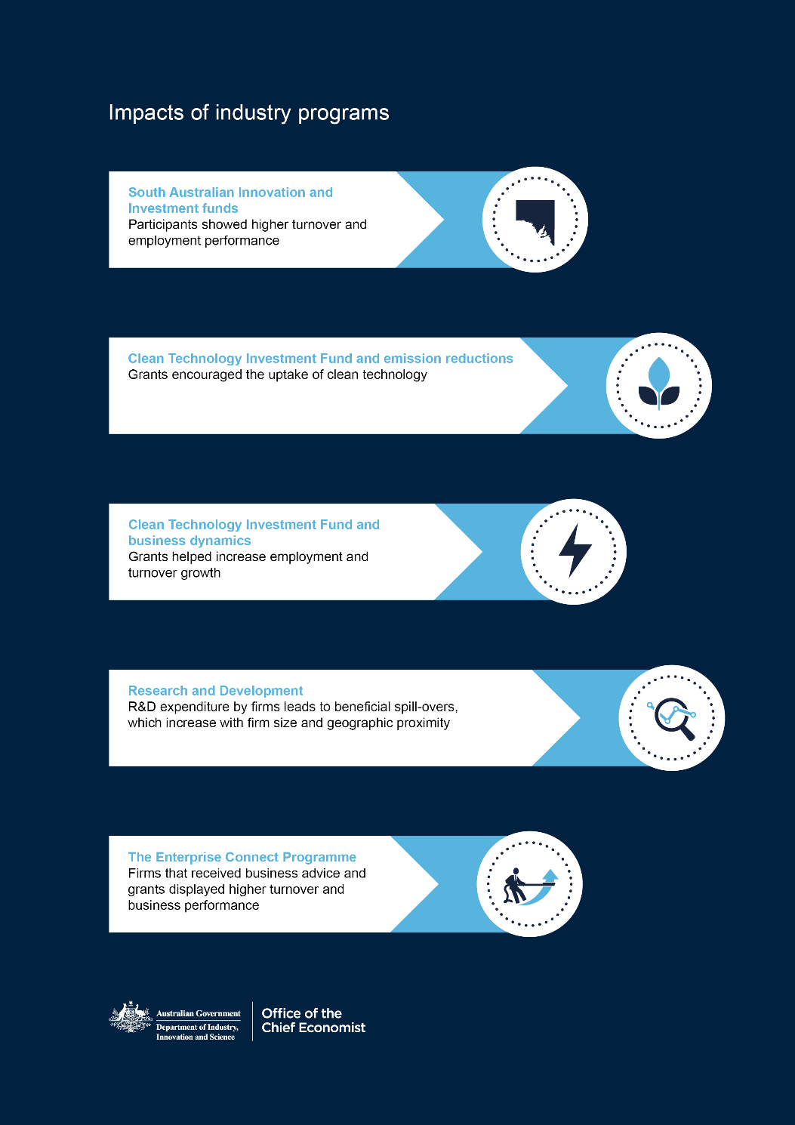

# The importance of impact assessments and evaluations

The OCE’s teams of evaluators, economists and researchers conduct program evaluation and research. The department’s approach to evaluation is guided by its *Evaluation Strategy 2017–21*, and two key approaches:[44]

* impact **assessments** — quantitative research to identify the extent of change in selected variables — measuring *specific program impacts (primary impacts)*
* mixed methods **evaluations** — quantitative and qualitative research to identify *wider impacts (such as externalities)*, and illustrate how and why the impacts occurred.

These approaches complement each other in the department’s effort to measure program performance. An appropriate methodology is selected to suit the program being evaluated, the nature of the evaluation, and available resources or constraints.[45] Quantitative research is often narrow in scope, though provides a more definitive assessment on a specific question backed by data. Impacts we analyse include revenue, jobs, exports, capital expenditure, innovation in specific industrial sectors, and positive or negative externalities.

# The use of impact assessments and evaluations

Consistent with best practices, impact assessments and evaluations should be published externally to strengthen public confidence and support public debate on government initiatives and use of public funds.

As argued by Jones et.al. (2013)[46] Irrespective of whether an impact assessment or a full-blown evaluation is carried out, this form of analysis is useful for:

* **Advocacy** — demonstrating the value, or otherwise, of programs
* **Allocation** —of investment funding, staff and other public resources
* **Analysis** —to inform continuous improvement, including future   
  program design.
* **Accountability** — as required under legislation and better practice performance management guidelines.

The following pages explain the department’s research and program evaluation activities, starting with the role of the Evaluation Unit. This chapter also identifies viable impact assessment techniques and shows how we have used these in recent work.

Box 3.1: The department’s evaluation activities

| The Evaluation Plan  The department has a strategic, risk-based, whole-of-department approach to prioritising evaluation effort. The scale of an evaluation should be proportionate to the size, significance and risk profile of the program (sometimes referred to as ‘fit for purpose’). Evaluative effort and resources should not be expended beyond what is required to satisfy public accountability and the needs of decision-makers.  The department’s Evaluation Plan covers a four-year period (over the forward estimates) and uses a tiered system to identify evaluations of highest priority and strategic importance. Prioritisation of evaluations is based on a program’s strategic importance, budgetary outlay and data availability.  The Evaluation Unit  The department’s Evaluation Unit is located in the Insights and Evaluation Branch of the Office of the Chief Economist in order to ensure independence from policy and program management areas of the department.  The Insights and Evaluation Branch specialises in econometric analysis of various dynamics of industry and firm performance. The Evaluation Unit applies a mixed-methods approach, combining quantitative and qualitative research methods. The Unit also draws upon general and sector-specific expertise from other areas of the department.  The Evaluation Unit is responsible for:   * conducting or contributing to evaluations of departmental programs * providing evaluation related advice and guidance to program and  policy areas * strengthening the department’s capability for evaluative thinking * supporting programs to be prepared for future evaluations * maintaining a repository of completed evaluations and sharing report findings to inform future policy and program design. |
| --- |

# Common approaches to impact assessments

Several viable techniques and methodologies can be used to analyse the impacts of a government program or intervention. This section outlines these approaches and their relative strengths and limitations. As illustrated in Figure 3.1 and discussed in Stern et al. (2012)[47] the choice of a methodology depends on:

* the nature of the features of the project, program or organisation being assessed or evaluated; whether the features are simple, complicated or complex; and the stage of the policy or program in its lifecycle
* the purpose of the assessment or evaluation, that is both the key questions it is intended to answer and the requirements of key stakeholders
* the available resources and constraints — including timing, expertise and existing data — as well as organisational standards and definitions for assessment and evaluation.

Figure 3.1 highlights the interplay between factors that impact on methodological choice. It is not an exhaustive list of considerations. For some impact assessments or evaluations — particularly those that are retrospective — there is likely to be a gap between what is deemed optimal and what is possible. In the presence of data gaps, a pragmatic approach to the assessment and evaluation of government programs is advisable, using the framework outlined in Figure 3.1 and one or more of the methodologies outlined below.

Figure 3.1: Choosing an appropriate methodology

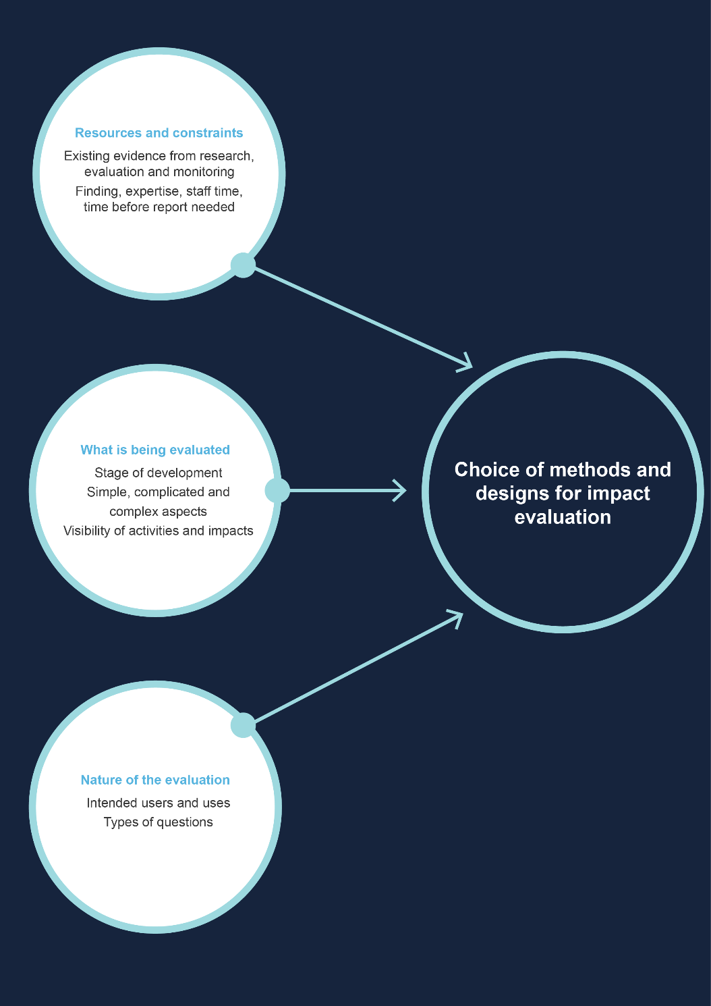

Source: DIIS (2015) Choosing appropriate designs and methods for impact evaluation, Office of the Chief Economist

## Experimental methods: randomised controlled trials

Randomised control trials (RCTs) are an experimental technique, often referred to as the ‘gold standard’ in research because they can isolate the causality and attribution of a program or intervention. To eliminate selection bias, two similar groups of firms, individuals or organisations are randomly assigned to a treatment (for example, an enrolment into a program, a clinical drug trial, or some other intervention). The remaining participants receive no treatment or intervention or in some cases receive a placebo. These latter groups of participants are referred to as the counterfactual or the control.

Due to random assignment, any difference between the performance or outcomes (the treatment effect) of the treated and control groups is then deemed to be caused by the treatment or intervention. RCTs are common in the medical sciences and within that context are also referred to as ‘clinical trials’. The elimination of selection bias and spurious correlation is advantageous.

It is not always viable to run a RCT. When looking at a government program, particularly those in the industry policy space, firms involved are not usually a random group. For example more motivated and successful firms, or firms with prior experience with government programs may have self-selected into a program. Moreover, a counterfactual or control group is often missing.

For new programs this is less of a concern as the methodological and data considerations for investigating impact can be incorporated into the program logic and design. Even then, implementation of an RCT can be time consuming and costly: once random allocation occurs, it needs to be maintained and the two groups have to be monitored over a sufficiently long time to ascertain the effect of the intervention. In the context of an impact assessment of a government program this could take decades.

The use of RCTs also requires adequate sample sizes for the treated and counterfactual (control) groups. For government programs that assist Australian firms, very large sample sizes would be required, leading to an increase in program administration and monitoring costs. There is also the related issue of attrition because firms enter and leave the market and thus the sample.

Finally, purely random assignment of similar firms to a government program may result in some firms that needed government assistance or funding being passed over (not assigned the treatment). This would be akin to treating government funding as a lottery.

In a wider context of government activity, there are a multitude of interesting applications of RCTs. Some recent uses of RCTs in public policy are showcased on the website for the Behavioural Economics Team of the Australian Government (BETA).[48]

## Quasi-experimental methods

Like RCTs, quasi-experimental methods aim to establish a reliable counterfactual to assess the effect of a treatment or intervention. Instead of random assignment of participants into a treatment group and a control group, quasi-experimental methods attempt to establish a synthetic counterfactual by accounting and modelling for non-random assignment. This overcomes the missing data problem that occurs because a treated firm cannot simultaneously be observed receiving a treatment and not receiving treatment.

A multitude of techniques are available to deal with the missing data problem, including the use of matching estimators such as propensity scores. Here treated participants are paired with similar firms or individuals that do not receive the treatment or intervention. Similarity is determined by:

* *Nearest-neighbour matching (NNM)*. This method matches treated firms with similar non-treated ‘neighbour’ firms. The selection of neighbour firms is based on firm characteristics such as turnover performance, profits, exporting status, employment size and firm age. The difference in the outcome for the treated firms and their close neighbours then gives us the average treatment effect that can be attributed to the intervention. NNM is viable when the number of predictive covariates (firm characteristics) to be matched is low, and there are not many continuous variables —such as profits or loss — for matching.
* *Propensity score matching (PSM)*. This method first estimates the probability of being assigned to the treatment (the propensity score) based on observable characteristics for both the firms that received treatments and non-treated firms drawn from the population. The outcomes for the treated and non-treated firms that have similar propensity scores are then compared to derive the average treatment effect. PSM is easy to implement and is more appealing to use when the number of covariates to be matched is large.
* *Regression discontinuity design (RDD).* Among other quasi-experimental techniques such as inverse probability weighting (IPW), regression adjustment (RA), it is RDD that has gained traction in recent years. RDD is suitable when the likelihood of assignment to an intervention is based on surpassing a cut-off or a threshold. For example, firms often apply to participate in government programs that provide funding and other forms of assistance. The suitability of applicants is assessed against some eligibility criteria — in most cases by allocating them a score, or using a threshold such as a minimum amount of turnover, the level of R&D expenditure or employment. Suppose that successful participation in a government program requires an eligibility score of at least 75 per cent or requires annual R&D expenditure of more than $1 million. Firms that score more than 75 per cent or conduct R&D worth more than $1 million a year will receive the intervention (participate in the program) and those below will not. The intuition behind RDD is that the outcomes for firms on either side of the eligibility criteria or threshold can be compared to infer an average treatment effect — the characteristics of a non-participant firm with an eligibility score of 74 per cent are likely to be very similar to that of a participant firm with an eligibility score of 76 per cent. The use of RDD therefore hinges on there being some sort of ranking, eligibility criteria or threshold, and a sufficient number of observations on either side of this threshold.

The choice of which quasi-experimental technique to use depends on the nature of the data and its availability, as well as the research and policy questions. While these methods attempt to minimise selection bias, they may not be able to do so to the same extent as RCTs. But quasi-experimental methods offer some desirable benefits relative to RCTs:

* They can be used for retrospective analysis
* They can allow for more cost-effective and timely analysis
* They can rely on existing sources of data such as existing survey, census or financial data
* They are relatively straightforward to implement using most statistical programming languages.

While these techniques can help assess impacts by establishing causality and attribution, they are less suitable for determining the net benefit to stakeholders and society. Here other methods such as non-experimental or mixed method approaches, and/or cost-benefit analysis (CBA) and social return on investment (SROI) might be more suitable. Non-experimental approaches are briefly outlined below. Chapter 4 discusses the use of CBA and SROI in further detail.

## Non-experimental methods

These methods attempt to add value and insights to an assessment or evaluation. They are used to complement experimental and quasi-experimental methods and are suitable if the intervention is new and the expected outcomes are unclear or if it is complex to observe results from existing data. Examples of such methods are: forms of qualitative analysis such as structured and semi-structured interviews and surveys; contribution analysis; an approach for assessing causal questions and inferring causality; case study analysis; multiple linear regression analysis; input-output analysis and computable general equilibrium analysis.

**Recently published impact assessments of DIIS programs**

When we talk about impact, we are referring to the result, influence or consequence of a public policy or program. These effects usually occur in conjunction with activities and influences of other agencies and stakeholders.[49] Impacts can be broader than the stated goals of a program or policy and are not always positive — when assessing government programs it is prudent to consider both positive and negative results.

Impacts can be diverse. Primary impacts only affect program participants or direct stakeholders, whereas secondary impacts such as externalities can affect the wider community. Impacts can be financial or non-financial. Some examples of impacts include the effect of a government program on a firm’s financial performance, commercialisation prospects, R&D activities, employment creation or survivability.

This section presents notable findings from recent OCE impact assessments and evaluations. Readers who are interested in further details on these projects are encouraged to refer to the full papers and reports available on the OCE website.[50]

# Business performance of Enterprise Connect participants

Angelina Bruno — Office of the Chief Economist

The Enterprise Connect (EC) program, active between 2007–08 and 2013–14, played a key role in providing advisory services via a network of technical, scientific and industry experts to assist small and medium sized enterprises (SMEs) to improve productivity, increase competitiveness and capitalise on potential growth. EC also facilitated linkages to research institutes and complementary businesses that could lead to new business opportunities. Matched grants were also provided to assist participants to implement the advice received. The EC program was created to address the failure of SME’s to seek professional advisory services to address strategic management issues in their businesses. There were two types of EC participants:

* *Review only* - These firms received reviews carried out by business advisors to identify their business’s strengths and weaknesses, strategic issues, areas for improvement and potential growth
* *Review & grant* - Once the review was complete, firms could apply for a grant of up to $20,000 to implement recommendations from the review.

This analysis was restricted to program participants that received both a business review and a subsequent grant. It assesses the impact of participation in the EC program on business performance including turnover growth, employment growth, capital expenditure growth, and survival rates.[51] A counterfactual (non-treated) set of firms was constructed using observable characteristics in the Business Longitudinal Analysis Data Environment (BLADE). Average treatment on the treated effects (ATT) using propensity score matching was estimated to compare the outcome of treated firms to that of the counterfactuals and obtain a reliable estimate of the average ‘additional’ impact of the EC program. Firm characteristics in the propensity score model included factors influencing both a firm’s likelihood to be treated and its outcomes post treatment. In addition to including observable characteristics such as size, industry, R&D status, exporter status, location and legal type of organisation, variables that captured past firm performance were also included in the model to minimise selection bias. While the EC program has concluded, findings from this analysis inform decisions around the future evaluation and design of the *Entrepreneurs’ Programme*, which shares the same broad motivations as EC.

# Key findings

* EC participant firms had higher performance than non-participants firms, in terms of growth in turnover, employment, capital expenditure and survival rates.
* Micro and other small employing participant firms were driving the growth in turnover, employment and capital expenditure.
* Manufacturing firms and firms in the ‘Other Services’ industry sector were contributing more to growth in turnover, employment and capital expenditure.
* Firms participating in both the EC and the R&D Tax Incentive (RDTI) programs outperformed firms only participating in the RDTI program in terms of turnover growth.

Figure 3.2 reports the ATT for the two year, three year and four year change in turnover growth by industry sector. Results show that EC participants across all industries experienced positive and statistically significant gains to turnover growth. Notably, it was micro and other small employing firms (between 1 and 19 employees) that were driving the change in turnover growth.

The EC firms in Manufacturing experienced on average an additional $94,000 growth in turnover within two years, an additional $178,000 growth in turnover within three years and an additional $273,000 growth in turnover within four years. Firms in the ‘Other Services’ industries and in the Professional, Scientific, and Technical Services (PST) industry experienced similarly positive gains to turnover growth as a result of participating in the EC program.

Figure 3.2: Growth in turnover ($, 000), average treatment effect, pooled across cohorts, by industry sector

Notes: Length of the bars depicts the growth premium in turnover change relative to the counterfactual. A missing bar signifies the lack of a statistically significant result.

Source: BLADE (2001–02 to 2014–15) and Bruno, A (2018) Business performance of Enterprise Connect participants, Office of the Chief Economist Research Paper

# Impact of Commercialisation Australia on Business Performance

Sasan Bakhtiari and Angelina Bruno

Commercialisation Australia (CA) was a government grant program that ran from 2009 to 2014. The objective of CA was to build the capacity of, and opportunities for, Australia’s researchers, entrepreneurs and innovative small and medium size firms to convert ideas into successful commercial ventures. CA had a focus on applicants that lack financing for the proposed project and were unable to obtain the required financing through alternative sources. Empirical evidence has shown these latter firms have difficulty attracting financing from private sources for innovation, hence, the program was addressing a niche in the financing market.

The analysis undertaken in this paper uses the Business Longitudinal Analysis Data Environment (BLADE) provided by the Australian Bureau of Statistics (ABS) to compare the performance of CA participants against a comparison group of equivalent firms. While the CA program has concluded, findings from this analysis have policy lessons for the *Accelerating Commercialisation* program, which shares the same broad motivations as CA.

We construct the comparison group using observable characteristics including industry classification, turnover, export status, R&D-activity and firm age. Using R&D-activity to construct a comparison group is particularly useful, as R&D is a leading indicator of product innovation and commercialisation intent, which are the key characteristics of the program’s target market.

As measures of program success we look at:

growth in turnover,

investments in capital and R&D, and

exporting and IP activity.

We use inverse propensity weighting to estimate the average treatment effect for the CA participants. Compared to other methods such as nearest neighbour or propensity score matching, this approach has the advantage of being less computationally intensive yet offering the same degree of consistency.

## Key findings

Small and young firms received the majority of Commercialisation Australia (CA) grants.

Most recipient firms are from Manufacturing and Professional, Scientific and Technical Services industries, and from sub-divisions associated with advanced technology.

CA participants had higher R&D and capital expenditures than the comparison group.

CA participants had larger increases in their rates of turnover growth than the comparison group.

Overall, there is an increase in exporting activity, and patents and trademark applications among the CA participants compared to the comparison group.

# Participation in South Australian Innovation and Investment Funds: impact on firm performance

Bilal Rafi — Office of the Chief Economist

Government assistance that allows vulnerable regions to cope with and adjust to structural change is a feature of industry policy in many economies around the world. In Australia the *Innovation and Investment Funds* (IIFs) aim to create sustainable and durable employment opportunities, encourage private investment in structurally vulnerable regions, and diversify the regional industrial base. This research focused on South Australia where there were several completed IIFs to study.

Meaningful econometric assessment of the impact of IIFs has proven challenging given data limitations in establishing the counterfactual — how would firms that received assistance as part of IIFs have performed if such assistance was not offered?

With BLADE, we now have a powerful microeconomic data source that can overcome some of these limitations. We used a quasi-experimental technique (known as the nearest-neighbour estimator) to establish a counterfactual. Each IIF participant firm was matched with at least three similar firms from the pool of non-participant firms within BLADE. The analysis was conducted separately for firms with a single Australian Business Number (ABN) (‘simple’ firms) and firms that were part of multi ABN enterprise groups (‘complex’ firms).

These techniques allowed us to determine whether the South Australian IIFs had a positive additional impact on aspects of participant firm performance. The IIFs can help to drive productivity in the economy by reallocating resources across firms, contributing to employment and business dynamism, and encouraging innovation.

## Key findings

* The estimated average treatment effects (the difference in performance between matched firms) suggest that participation in the South Australian IIFs provided additional benefits to firms in terms of higher employment and turnover.
* Overall these additional impacts were modest in magnitude, although they were suggestive of persistence of additional benefits over time. Many benefits such as increased turnover and employment are larger after the first year.
* For simple firms, on average, each participant firm created four additional full-time equivalent (FTE) employment opportunities and had turnover that was $500,000 higher than non-participant firms.

# Clean technology, regulation and government intervention: the Australian experience

Sasan Bakhtiari – Office of the Chief Economist

From 2012 to 2014, the Australian Government ran a *Clean Technology Investment Fund (CleanTech)* that offered financial grants to manufacturing facilities to switch to cleaner technologies. It was intended to help facilities remain competitive relative to their international competitors who might not be burdened by climate-related regulations.

This study used a production function approach to examine whether the recipients of *CleanTech* grants reduced their emissions more than the average firm.

Reduction in emissions can be achieved by cutting business activity (producing less) or by adopting cleaner technology. The former is a myopic strategy and has adverse economic consequences. The latter is a long-term and desirable outcome. It is important to know what portion of emissions reduction by *CleanTech* firms was achieved with cleaner technology.

The *CleanTech* program cost almost half a billion dollars. The magnitude of the program demands some justification in terms of added benefits and was the motivation behind this impact assessment. The following key points summarise the findings on the impact of the program.

## Key findings

* *CleanTech* grants encouraged innovation by enabling firms to employ new methods so they could comply with climate-related regulations.
* From 2011 to 2014, there was a 10 per cent drop in manufacturing emissions in Australia as a result of facilities switching to cleaner technologies.
* Simultaneously, due to an increase in the size of the manufacturing industry, the sector’s emissions increased by about 6 per cent as energy consumption increased. The net reduction in manufacturing emissions was 4 per cent.
* Facilities that benefited from the *CleanTech* program also reduced their emissions substantially, but not necessarily through technology adoption.
* The technological effect of *CleanTech* was size-dependent, with size measured in energy consumption. Small and large energy consuming facilities made larger investments in clean technology. A larger number of mid-range *CleanTech* facilities invested in reducing energy intensity.
* Exposure to *CleanTech* projects mostly affected facilities belonging to firms whose operation was geographically concentrated. However, there was no evidence of extra spill-overs across firms.

# Business dynamics of a clean energy policy

Sasan Bakhtiari – Office of the Chief Economist

This analysis focused on aspects of business operation other than energy and emissions reduction to see whether receiving *CleanTech* grants had any broader implications in terms of business strategy and operations. Hypothetically, it is through these broader implications that *CleanTech* can contribute to the growth and productivity of globally competitive industries, alongside its primary aim of assisting businesses to comply with emissions regulations. This analysis investigated whether receiving *CleanTech* grants had any impact on participating firms in terms of growth in employment, turnover and exports. It then compared them to firms that were also subject to the carbon pricing scheme but did not receive grants from the *CleanTech* Investment programme.

The study used BLADE to compare the performance of participants and non-participants. The participating firms in the data were identified using the ABNs provided by the DIIS. Comparison was made using nearest-neighbour matching and computing the average treatment effects.

## Key findings

* Firms that received *CleanTech* grants showed a higher rate of employment and turnover growth during the projects compared to similar firms without the grants.
* Exporting firms with *CleanTech* grants also showed a higher rate of growth in exports value compared to similar firms with no grants. However, there was no evidence that *CleanTech* helped firms to commence exporting.
* The positive effects on firm performance were mostly concentrated among those firms that were contracting in size before they received *CleanTech* grants.
* The performance differential was more nuanced among large and medium-sized firms.
* The analysis was firm-level. It is important to note that the facility (plant) that used *CleanTech* could have contracted at the same time that the parent firm was growing.

# The role of spillovers in R&D expenditure in Australian industries

Sasan Bakhtiari — Office of the Chief Economist Robert Breunig — Australian National University

* Research and development play a central role in long-run productivity and economic growth. Spillovers from R&D between firms can extend the benefits of R&D and accelerate growth and the pace of innovation. Spillovers from other firms can also complement a firm’s own R&D efforts, increasing the value of their R&D and their incentive to invest in R&D. However, the chance of competitors benefiting from spillovers has the potential to disincentivise firms from investing in R&D in the first place. These two opposing forces leave the overall impact of spillovers ambiguous. The presence of spillovers indicate that firms may invest less in R&D than would be efficient for the economy as a whole, given individual firms do not reap all the benefits of their R&D investments. This suggests a role for government to correct this market failure and increase R&D expenditure to the efficient level. This is particularly true where disincentives dominate.
* This research focused on the R&D expenditure decisions of individual firms and on how these decisions were affected by the R&D activity of other firms. The analysis used a departmental dataset that holds information on the firms that received R&D tax concessions from the financial year 2000−01 to 2010−11.

## Key findings

* Disincentives dominate — the presence of spillovers resulted in firms making less R&D investment than they otherwise would.
* R&D spillovers were the strongest between geographically proximate firms.
* The results also pointed to a positive influence from academic research on private R&D likely attributed to its higher composition of basic research.
* R&D expenditures were higher in industrial clusters. However, there was no evidence of any extra spillovers within industrial clusters.

## A mixed-methods approach

While useful, impact assessments, particularly those conducted using administrative data, have a number of limitations. Departmental impact assessments broadly make use of quasi-experimental techniques, which helps minimise selection bias. However, bias can still remain due to the non-random selection of program participants and other data limitations. Quantitative impact assessments using BLADE, can provide detailed insights into the financial performance of firms that participate in departmental programs relative to a counter factual. However BLADE is not suitable for more qualitative analysis of firm’s performance, and the analysis of secondary impacts of departmental programs on wider communities.

To answer these questions, a mixed methods-approach which is broader than a purely quantitative assessment can be used. Through a variety of research designs[52], mixed methods approaches can be used to:[53]

* test evidence from different sources
* elaborate on results from different sources
* develop or inform results and methods
* extend the breadth and range of inquiry through different methods.

Evaluations within the department use a mixed-method research approach to find objectively verifiable results and contribute to the measurement of an organisation’s strategic objectives. Within the department, these evaluations commonly occur three years after the program implementation. They measure the medium-term and long-term outcomes of programs and initiatives. The department also uses a number of lead indicators to assess its programs in the short-term prior to evaluations. The following pages highlight a recently completed departmental evaluation. The Evaluations Unit adopts a holistic approach to such evaluations in order to address conceptual and methodological challenges.

Particularly, ascertaining the impact of a program on participating stakeholders — often primary stakeholders — may determine the program’s social return. As discussed in Chapter 4, this is not always straight forward.

# Impact Evaluation: the Community Energy Efficiency Program

Bridgette Hargreave, Jamos McAlester, Niki Walters, Elize Wium and Kevin Yao – Office of the Chief Economist

* The Australian Government introduced the *Community Energy Efficiency Program* in 2012 as part of the Low Carbon Communities initiative. This competitive merit-based grants program provided co-funding to local governments and non-profit community organisations to help them improve their energy efficiency and reduce their energy use. The program was intended to mitigate the financial impact of the planned *Emissions Trading Scheme* (ETS).
* The Evaluation Unit in the OCE conducted an impact evaluation of the program in 2016. Though the program was not related to the competitiveness of businesses, the evaluation measured the impact of the program on participating community groups. The evaluation considered the energy savings data and final reports provided by grant recipients (including the spillover benefits to the community), and interviews with energy industry stakeholders.
* Under the program, a total of $96.3 million was paid in grant funding for 153 projects. It resulted in participants being able to reduce costs and provide improved services.   
  All but two projects achieved energy efficiency improvements, resulting in a combined total saving of approximately 350 terajoules[54] (TJ) of energy per annum. This is equivalent to the energy used by over 6,800 Australian homes.
* Assuming each project initiated by the program lasts fifteen years, the program has cost the Australian Government approximately $19,000 to reduce one TJ of energy.   
  The total cost (including co-contributions from grant recipients) equates to approximately $38,000 to reduce one TJ of energy.
* Although there were some data limitations in terms of data collection and collation, the evaluation found the projects with the highest return on investment involved upgrading space and street lighting.
* Qualitative evidence provided in the final reports of grant recipients suggested the program produced a wide range of co-benefits including: improved facility amenities; reduced maintenance costs; increased operating hours; improved employee/client health and safety; increased sales; and increased services available to the community.
* Grant recipients suggested there had been a significant improvement in energy efficiency by households who participated in the direct engagement activities (public workshops and seminars) they conducted.
* In many cases, the program enabled technology upgrades that may not have otherwise occurred. Grant recipients commonly reported that the grant allowed projects to be brought forward by many years, or to fund upgrades that were not planned at all due to financial constraints.
* The evaluation found that although the ETS was not implemented, these projects are expected to continue benefiting the communities in the longer term through reduced energy costs. The projects will also continue to improve energy efficiency in Australia more broadly by demonstrating the financial savings that can be achieved in the community, and by helping Australia to reach its carbon emissions reduction target.

# Conclusion

Administrative data has proven to be an invaluable source of information on Australian firms. It has complemented traditional survey data and helped fill data gaps. As shown by the research in this chapter, this has allowed the department to gain better insights into the impact that department programs and initiatives have on supported firms. Such endeavours strengthen the evidence base for policy design and add to transparency surrounding the use of public funds.

The department is continuing to make strides in this area, for example by integrating more program data into administrative data assets such as BLADE. The increasing experience of departmental researchers with administrative data sources and program impact assessments and evaluations is helping to refine newer waves of analysis.

However, there is room for further improvement. Administrative data is not a silver bullet. It can be useful in some ways yet deficient in others — for example, data available within BLADE is rich in financial variables but lacking in other dimensions such as labour market variables, ICT use, managerial ability etc. for the majority of firms.[55] Theoretical and methodological challenges in terms of assessments and evaluations also remain. Defining the scope of assessments and evaluations, establishing the base case scenario, and consistently measuring the costs and the benefits of programs remains challenging. There is also a need to move away from primary firm-level impacts and to start considering the broader social impact of government programs and policies.

In addition to building its own analytical capabilities to address these issues and challenges, the OCE has sought advice and feedback from subject matter experts. The following chapter discusses these aspects in more detail.



Can we improve the evaluation of government programs?

Evaluations can tell us what is working and what is not. The lessons learnt can then be disseminated to improve the evaluated program (or related programs) and foster new understandings for policymakers, academics and business people. For these reasons, the department strives to have good evaluation practices that help to make it more accountable and transparent with its public spending. This in turn leads to an evidence-base on programs that deliver value, helping improve subsequent funding decisions.[56]

As the previous chapters have shown, the department has made a significant start on program evaluation. It is also aware that its approach can be further improved. The department is conscious that program evaluations can be myopic if their outcomes are measured only from the perspective of specific stakeholders. This can occur in the absence of adequate stakeholder engagement and/or a lack of appropriate and objective assessment of outcome metrics. For example, a program that aims to increase jobs in one region might achieve this at the expense of jobs in other regions. Hence, unintended consequences uncovered during an evaluation should be explored and valued.

Evaluations can lack credibility for other reasons. For instance, current quantitative approaches used by the department do not consider broader social and environmental impacts. And while mixed methods approaches often do identify unintended consequences, there are difficulties in valuing these consequences. Furthermore, narrowly defined indicators of success are less likely to show whether programs result in outcomes that benefit the whole of Australian society.

Predominantly, the current DIIS approach has been to evaluate and assess the impact of departmental programs retrospectively. This may not always be ideal. Given the size and scope of many government programs it is also prudent to consider their likely impact on stakeholders *before* implementation. Particularly in the case of new and or pilot programs, that do not have insights from previous similar programs that can guide policy makers.

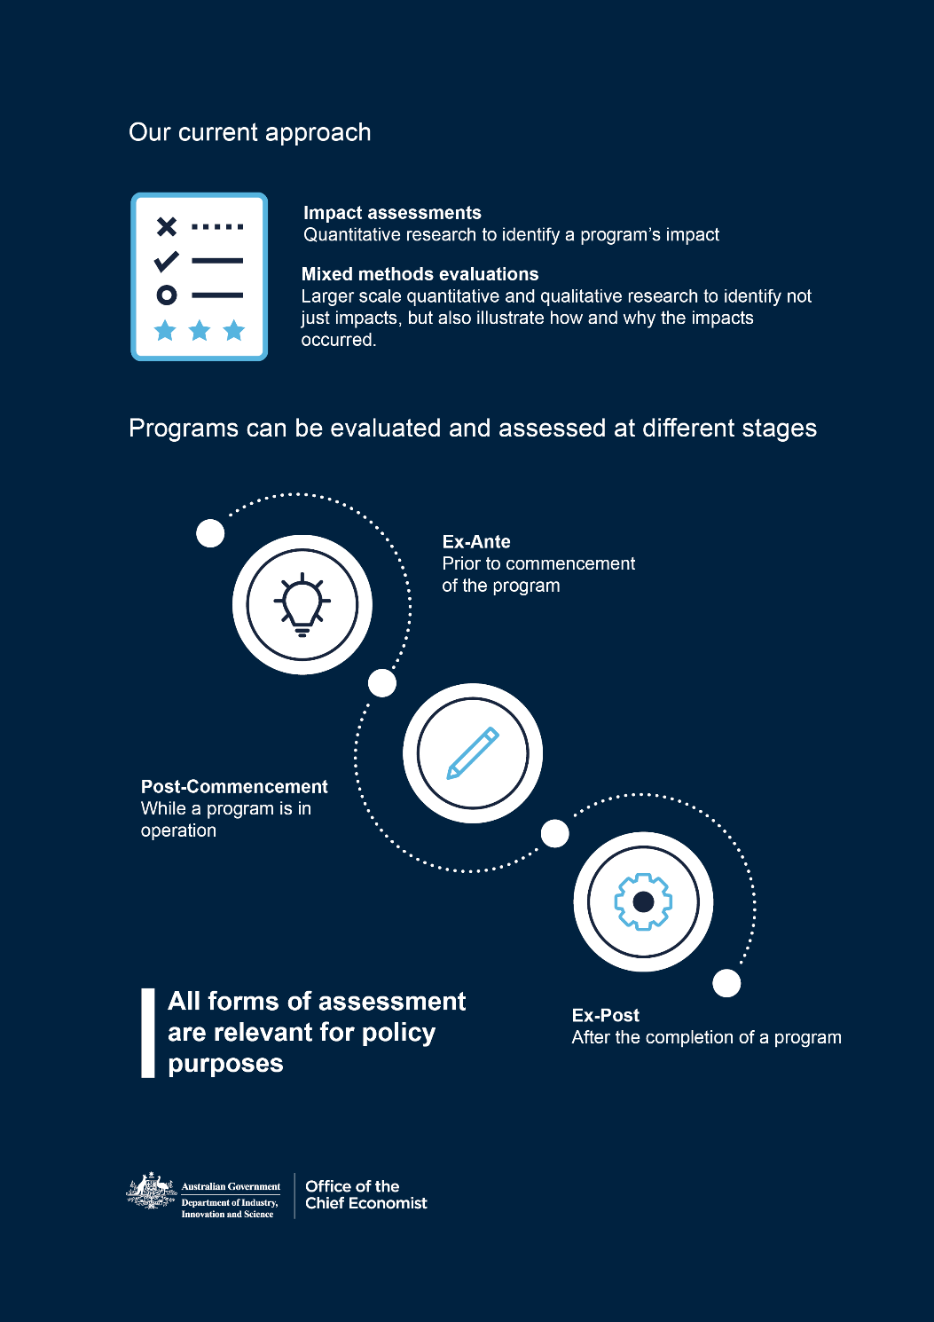

Some of the areas where improvements can be made to ensure more comprehensive evaluation are suggested in this chapter by Dr Leo Dobes, Honorary Associate Professor at the Crawford School of Public Policy, Australian National University. Dr Dobes explores social cost-benefit analysis (CBA), and compares it to techniques measuring the social return on investment (SROI). Both these approaches allow for wider program impacts to be measured, valued and compared.

Box 4.1: Selected cost analysis approaches

| **Cost-benefit analysis**  Cost-benefit analysis is often misconstrued to mean a purely financial analysis. To economists, CBA is identical to the less-commonly used term ‘social cost-benefit analysis’.  **Social cost-benefit analysis**  Social CBA (or, more commonly, just cost-benefit analysis) is an economic methodology. Economic analysis automatically considers all resource costs and benefits, including social and environmental aspects. It therefore monetises as far as practicable intangible environmental and social costs and benefits.  **Social return on investment**  A stakeholder-driven approach to measure additional social, environmental and other values in evaluation. |
| --- |

A key point made by Dr Dobes is that social CBA examines all the material effects of a policy or program on all members of Australian society. He argues that even non-marketed outcomes such as social or environmental effects are amenable to measurement, and should be included as a matter of course if relevant causal evidence exists.

# Evaluating use of public funds: SROI, CBA, or neither?

### Leo Dobes, Australian National University

### Introduction

Because a country’s resources are limited, their use in one project or policy means they are unavailable for use in other projects. Because a key role of government is to direct social resources to where they will most benefit the community as a whole, evaluation and comparison of the relative merits of competing projects can help governments make more informed decisions.

Evaluation of projects is particularly pertinent before decisions are taken   
(*ex ante*). However, evaluations during implementation (*in media res*) can be useful if improvements or alterations remain feasible. And *ex post* evaluations can provide valuable learning experiences after project completion.

The fact that there is no uniquely prescribed or orthodox approach to evaluation is reflected in the range of enthusiasms that have swept the Australian Public Service over the years: balanced scorecards, fuzzy logic, triple bottom line, value for money, cost-effectiveness analysis, gap analysis, triangulation, cost-benefit analysis, multi-criteria analysis, social return on investment, SWOT (strength, weakness, opportunity, threat) analysis, simply second-guessing ministers, traffic light reporting, citizens’ juries, scenario analysis, and so on.

It is increasingly common for decision-makers to refer to ‘economic, social and environmental’ effects of a program or policy. They are interested in the costs and benefits and in the social return on the government’s investment. In terms of evaluation, it is not immediately clear what the differences in approach of cost-benefit analysis (CBA) and society’s return on investment (SROI) might be. A major purpose of this article is therefore to ask: ‘How does SROI differ from CBA, and why?’

Here, use of the term CBA is taken to mean ‘social cost-benefit analysis’ in the sense of an economic analysis that accounts for the social and environmental, as well as the financial, costs and benefits. It therefore automatically considers the full range of impacts of a program or policy from the perspective of society as a whole. Most economists readily understand this, because the framework and methodology of CBA has been assiduously debated and refined by their trenchant peers for well over a century. Despite polemical detractors like Pusey[57], CBA is probably the most developed and rigorous of all the evaluation tools available at present. Nevertheless, the term ‘economic’ is sometimes decoupled in more general usage of the term from the social and environmental aspects, referring purely to financial or commercial aspects of projects.

Work on the social return on investment (SROI) was pioneered in California by the Roberts Enterprise Development Fund almost two decades ago in order to assist philanthropists who wished to assess the social impact of projects funded to benefit individuals and society (Faivel et al., 2012, p. 8).[58]

Faivel et al.,[59] claim that the SROI approach is based on CBA. The UK Government’s Cabinet Office (Office of the Third Sector) *A guide to Social Return on Investment*[60] borrows heavily from standard economic concepts prevalent in CBA, albeit using newly-minted terminology.

Box 4.2: When should government invest according to Net Present Value?

| It has become a commonplace that governments should fund projects that generate a net present value (NPV) greater than zero. While generally correct, this maxim is subject to qualification. In particular, a necessary justification for a government investment or regulation is the need to address a case of genuine market failure.  The NPV rule is sometimes expressed in terms of funding projects that achieve a benefit cost ratio (BCR) greater than one.  The commonly accepted decision rule of NPV > 0 can be simplistic and open to misinterpretation. It is certainly a necessary condition to justify a government investment but is not in itself sufficient. Government policies or programs should only be implemented if genuine market failure can be demonstrated as well. Otherwise, government intervention in markets is likely to introduce economic distortions that may diminish the wellbeing of society.  Even if it is found that the NPV is greater than zero, the project should not necessarily go ahead. If other possible projects have a higher NPV — a potentially greater contribution to the wellbeing of society — then they should be given precedence. Caution is required if two projects of differing time horizons are being compared. A longer time period generally means that more benefits are accrued, especially if most of the costs are incurred up front. To compare the NPVs of a five- and an eight-year project, for example, would not compare like with like. In such cases, equivalent annual values (essentially annuities) should be calculated.[61]  It may be that a budget constraint is highly likely to occur in one of the out-years. A project would risk becoming non-viable in such circumstances. Again, a simplistic acceptance of the NPV > 0 decision rule would not be warranted.  The embedding of ‘real options’[62] in a project may mean that the standard calculation of NPV results in an underestimate of the overall value of the project. Addition of the option value may take a project across the line, even if NPV is slightly negative or close to zero. This is a specialised area of analysis, but an introduction to the topic is provided by Brealey et al. (2006); Dixit & Pindyck (1994); Borison (2005); and others. |
| --- |

# Cost-Benefit Analysis

There is no cookbook for CBA. Every issue or project needs to be examined on the facts.

The basic decision rule in CBA is that a project is potentially worthwhile if the additional social benefits it is expected to generate are greater than the additional social costs incurred. In principle, CBA can be used to evaluate a wide range of projects and policies. Some Australian examples include health warnings on tobacco products[63], phasing out lightweight plastic bags[64], assessing the costs of gambling addiction[65], climate change mitigation[66], assistance to regional towns[67], and preservation of river red gum forests through improved environmental water flows.[68]

While there is no standardised template for carrying out a CBA, following a general framework of sequential steps can help ensure that the key aspects are addressed in the evaluation. The following ten-step list is taken from Dobes et al.;[69] most textbooks adopt a similar pattern:

1. Specify the objective of the project or policy, as well as the feasible alternatives for achieving it, taking into account any physical or legal constraints
2. Define ‘standing’: whose costs and benefits are to be counted. (This concept is discussed below.) The default position is generally a national standing
3. Define the base case scenario (the status quo, no change)
4. Predict the impacts of the policy or project over its life-cycle
5. Estimate the economic value of the relevant costs and benefits
6. Calculate the net present value of the benefits and costs
7. Adjust cost and benefit estimates for risk: e.g. using the Monte Carlo technique[70]
8. Conduct a sensitivity analysis
9. Determine the distributional consequences: who gains, and who loses
10. Arrive at a conclusion and recommendation.

Failure to follow the analytical sequence of the framework can result in serious methodological and estimation errors. For example, not taking into account the physical constraint of limited water resources in western New South Wales might lead to an overestimation of increased crop production and the volume to be transported on the proposed inland rail project. Not specifying the ‘standing’ of the analysis can also result in errors: the analysis of Canberra’s light rail project is a case in point. Capital Metro Agency[71] implicitly carried out the study from the perspective of the Australian Capital Territory but wrongly claimed as a benefit the additional revenue from income taxes which are the prerogative of the Commonwealth.

Only a number of the ten steps are discussed below, on the basis that they are the ones more often misapplied. More comprehensive explanations are available in texts such as Boardman et al.[72] and Dobes.[73]

# Constraints and feasible alternatives for achieving government objectives

A common error in government policy formulation is to consider only a specific proposal, without full consideration of alternatives that could achieve the same objective. Objectives set by government are likely to be achievable in more than one way. Reducing traffic congestion, for example, might be achieved by banning vehicles altogether from some streets; imposing congestion or cordon charges in certain areas of a city; or subsidising public transport.

By examining only a single course of action, the analysis is compromised. If the estimated benefits exceed the costs, then it is likely to be adopted. If this is the case, then the result is based on partial evidence. Consideration of the excluded alternatives may have revealed an approach that would generate even greater net social benefits.

A corollary is that it is necessary to consider likely constraints. Subsidising public transport, for example, may not be possible if capacity limits on existing railways have already been reached. Similarly, denying vehicular access to some streets to reduce congestion may be socially unacceptable if those streets are the only possible means of accessing hospitals, or other emergency services.

An instructive historical example of failure to consider constraints to a favoured policy solution occurred during debates held soon after Federation regarding the advantages of standardising rail gauges.[74] The then Prime Minster Billy Hughes argued during the May 1920 Premiers’ Conference that a unified rail system would permit feed to be shipped easily to drought-affected areas in other states — a significant benefit during severe drought years such as 1920. NSW Treasurer Jack Lang retorted by pointing out that the lack of water in drought-affected areas would also limit the ability of steam locomotives to distribute the feed.

Having clearly stated the objective of a proposal, a credible CBA analysis should begin by listing all the alternative means of achieving it, and then give reasons for rejecting those not to be considered further. Unless a full justification is provided, there is a risk that a favoured policy approach will only be compared to versions easily refuted as inferior.

# Standing: whose benefits and costs are to be counted?

One of the most common omissions in CBAs is specification of whose costs and benefits will be counted. Even the handbook on CBA[75] from the former Australian Government Department of Finance and Administration does not deal explicitly with the concept of standing. This concept is analogous to the recognition by a court that a particular party has a sufficiently valid interest in the matter on which they are seeking to be heard or represented in court. (Whittington & MacRae[76] appear to have first coined the term ‘standing’ in an analogy to the legal concept of *locus standi*.)

Discussion of the issue of ‘standing’ has also been relatively sparse in the academic literature, save for a brief debate in the late 1980s and early 1990s about the principles that underlie the concept. Zerbe’s[77] dictum that legal rights should form the basis for determining standing has remained unchallenged. Although not stated explicitly, the rationale is likely to be that only those paying taxes to the government – and hence those who fund projects – should have their benefits and costs counted.

It is not uncommon in CBAs to take a national approach to ‘standing’. The costs and benefits accruing to the citizens of a country are included in the calculus of the analysis. This is sometimes expressed as a need to include the costs and benefits affecting ‘the whole of society’. In the case of a national approach, any costs or benefits accruing to foreigners or non-citizens may not be counted, although this can raise ethical issues with respect to refugees or residents who are not (yet) citizens.

It is also possible to take a sub-national approach: the Australian states, for example, claim to adopt a purely state-based standing that ignores externalities imposed on other states and only includes benefits to its own residents. Proximate towns in border areas, like Albury and Wodonga, can thus pose a conundrum. An orthodox approach to a NSW-based CBA would avoid counting any benefits to Wodonga residents of a project in Albury. However, little or no distinction on the basis of residency is made in Australia for use of public roads, parks, access to emergency services, disposal of rubbish in street bins, etc. Income taxes and GST – important sources of state government revenue – are also collected on a non-residency basis. It is therefore at least arguable that state-based projects should adopt a national perspective in evaluating social costs and benefits. The NSW government is currently considering such cross-border issues.[78]

Despite relative neglect of the concept, ‘standing’ is particularly important from the perspective of shared resources. Although the Australian states contend that they count only benefits and costs accruing to their residents, the principle is often ignored in traffic counts, ostensibly because it is not possible to distinguish between residents and others who use local roads.[79] The result is to inflate estimates of benefits for road projects evaluated by the states.

Another common but incongruous result due to lack of clarity about ‘standing’ is the attribution of the costs of greenhouse gas emissions. Even where the ‘standing’ of a CBA is implicitly taken to be a national perspective, damage costs (or the ‘price’ of carbon) are generally estimated with reference to a global perspective. The incongruity is highlighted where both state-based and national analyses in Australia adopt identical values for ‘carbon prices’ even though different climate change effects may be experienced in different locations.

# Transfer payments and double-counting

A project that merely redistributes income, costs or benefits within society is a transfer payment not an impact. If it does not change the overall level of wellbeing of society, it can be ignored when aggregating costs and benefits. Nevertheless, it can be useful to record such effects as part of a distributional presentation that is likely to be of interest to decision-makers.

An example of a transfer payment is the provision of pocket money to a child by a parent. A redistribution of wealth occurs, but the family’s overall wellbeing is not changed (assuming that each family member values an additional dollar equally). On a broader social scale, examples of common transfer payments include taxes, fines, tariffs, pensions, foreign aid, unemployment benefits, drought subsidies to farmers, insurance premiums. Their key characteristic is that one section of society transfers income to another group without directly obtaining goods or services in return.

CBA should avoid double-counting. For example, by not counting increases in the value of land in evaluating a new road or rail project. The benefit of a new road or railway typically lies in the travel time saved by those with access to it. Reflecting the benefit of faster travel, property prices near the road or railway are likely to rise. To count both the benefit of faster travel and the consequential increase in property prices is to count the same effect twice. Put differently, property prices rise only because travel is faster, so the increase reflects the saving in travel time.

If information were unavailable on the value of travel time saved, it would be valid to use the change in property prices as a secondary or proxy method of estimating the benefit of the new road or railway. This ‘hedonic pricing approach’ (see below) is often useful for estimating the benefit of variables that have no readily discoverable market value.

# Measurement of benefits and costs: some economic principles

The iconic Australian film, *The Castle*, exposed the common misconception that economic benefits can be measured as market values. Offers by the airport developers of the market price for their house were rightly rejected by the fictitious Kerrigan family because the offers did not reflect the true economic value of their home. The emblematic ‘pool room’ was full of family memories that could not be traded away for an outsider’s willingness to pay for the land plus a rundown dwelling only yards away from an airport runway.

The demand curve in Figure 4.1 represents the conceptual minimum willingness to accept (WTA) compensation for losing their homes by the Kerrigan family and their neighbours. From another perspective, it shows their willingness to pay (WTP) to retain their homes if they were under threat of compulsory acquisition by a government agency. The area under the demand curve (A+B) represents the neighbourhood’s total WTP to retain homes. The Kerrigans and their neighbours are being offered only area B, the market value of the houses. If they were to accept the offer of market value, they would lose area A, their ‘consumer surplus’. Governments sometimes offer an amount a little above market value for compulsory acquisitions: owners may find this more palatable because they do not lose their entire consumer surplus.

Consumer surplus is the difference between a market price and the maximum WTP (alternatively, minimum WTA) for a good or service: it reflects the psychic value to a consumer over and above market price. After subtracting the opportunity cost of a good of service from a consumer’s total WTP or WTA, it is the residual — the ‘consumer surplus’ — which is the true economic benefit of the good or service. If the consumer surplus were zero, the consumer would be indifferent about acquiring the good or service because the amount paid would just equal the value obtained, so there would be no gain from the purchase.

Figure 4.1: ‘a house is not a home’

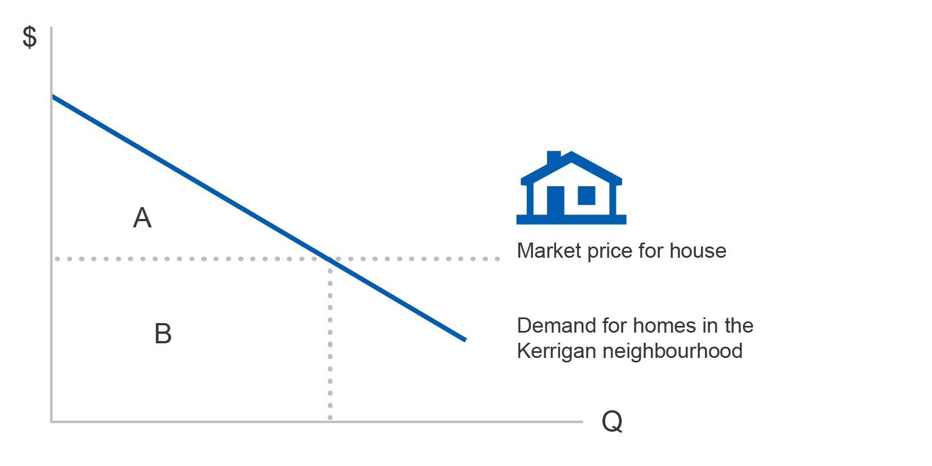

Source: Author’s illustration

A surplus obtained by a producer of goods or services can be thought of as profit: the ‘producer surplus’ is the difference between the market price received by producers and their cost of producing the items (area A in Figure 4.2). Factors of production can also be thought of as producers of services, with the difference between market value and cost of supply being the economic rent earned. For suppliers of labour, it would be the difference between their wage and their loss of leisure as well as any other costs of employment.

Figure 4.2 illustration of producer or factor surplus

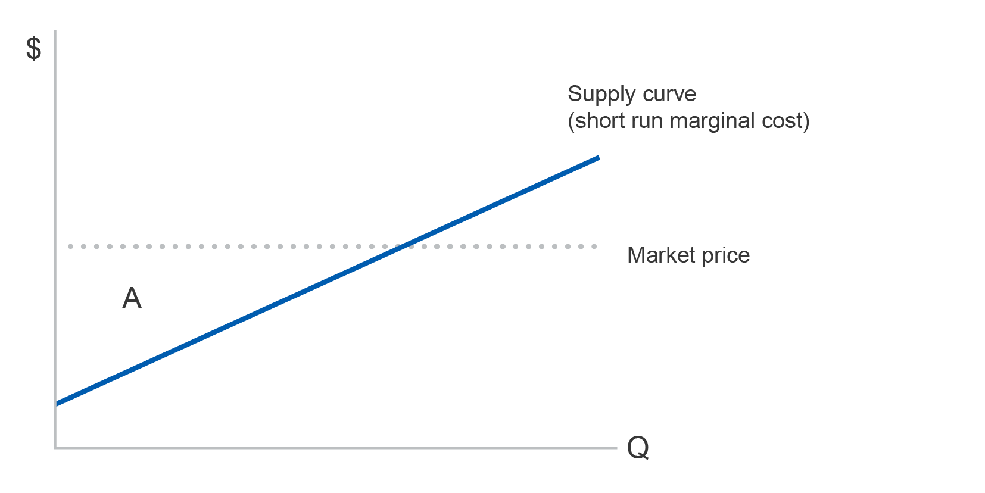

Source: Author’s illustration

In practice, the demand curve for goods and services is unlikely to be as well defined as that shown in Figure 4.1. It is therefore standard practice in CBA to estimate the *change* in social surplus (essentially consumer, producer and government surplus). The change is a comparison between a base-case scenario and the expected outcomes of a project or policy. Base-case scenarios are variously described as ‘nothing changes’, ‘the status quo’, ‘do minimum’, ‘the hypothetical’, the ‘reference case’, and are intended to reflect a situation that evolves more or less naturally into the future, without the implementation of the project or policy in question.

Figure 4.3 illustrates a change in consumer surplus. The trapezium is composed of two parts. Rectangular area A reflects the gain from a decrease in cost[80] of goods or services to existing users. The triangular area B shows the gain in consumer surplus accruing to new users, or from increased demand by existing users.

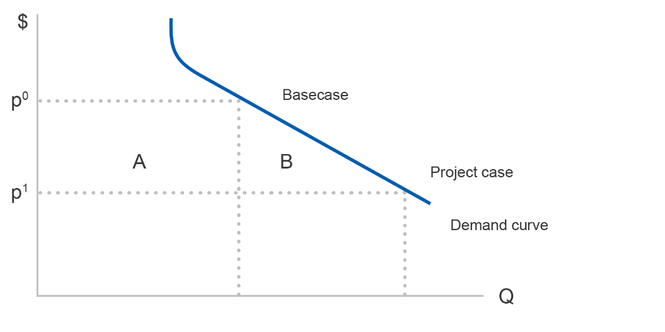Figure 4.3: measuring change in consumer surplus

Source: Author’s illustration

Figure 4.3 shows only the increase in benefit if the cost of the goods or services falls from p0 (the base case) to p1 (the project case). It does not show the cost of implementing or operating the project, a variable that needs to be estimated separately.

# Measurement of benefits and costs: the practice

Various methods of estimating demand curves can be used in practice. Depending on the context, each has some disadvantages and some advantages and positive aspects. The approaches used fall into two main categories: ‘revealed preference’ and ‘stated preference’ methods.

Revealed preference methods are based on market data such as the econometric estimation of demand curves. But historical data on which the curves are based may not be a reliable means of estimating future demand over a long-time horizon.

One method of estimating the value of reasonably isolated locations using available data is the Travel Cost Method. For example, by surveying arriving tourists at Kakadu national park, for instance, it is possible to ascertain how far people have come and from where, by what form of transport, how long it took to get there, and any entry fee to the park. The total cost provides an estimate of a tourist’s willingness to pay to visit Kakadu, and hence the benefit value they attach to the park. A disadvantage of the method is that trip-linking may have occurred, with a stop *en route* to Uluru, for example, so that it will be difficult to determine how much of the total travel cost to attribute to Kakadu alone. Nevertheless, this method is used for projects such as gauging the benefits from recreational fishing, and the cleaning up of polluted waterways.

Hedonic pricing is a common method for estimating non-market values by using two contrasting situations: one with a particular characteristic, and one without. The nuisance value of noise can be estimated by comparing the prices of similar houses in noisy and not noisy suburbs. The value placed on a risky job can be estimated by comparing the wage of a window cleaner outside a tall building with that of a colleague who only cleans windows inside the building. The value of travel time can be estimated by comparing fares for the Manly ferry in Sydney with the faster but more expensive hydrofoil service. And the sale prices of farms that have access to irrigation channels, compared to those that do not, can reveal information about the value that farmers place on water. The key disadvantage of this method is that it requires comparable ‘with and without’ situations and avoidance of any confounding factors.

It has become common to rely on a ‘cost avoided’ approach, especially in the health sector, disaster situations and in the climate change literature. For example, the benefit of building a sea wall may be estimated by the damage avoided to dwellings in the area, particularly of furniture and soiled carpets. But this is a conceptually incorrect comparison of costs: the cost of a sea wall versus the damage costs of inundation. Benefits to individuals and society – as measured by willingness to pay to avoid flood damage – are also likely to include less tangible attributes such as the desire to avoid losing cherished family memorabilia and the inconvenience of an uninhabitable home. Similarly, the benefit of controlling or eradicating dengue fever — a painful and potentially fatal illness — should be assessed in terms of individuals’ willingness to pay to avoid its consequences, rather than the cost of hospital bills, lost wages, etc.

When market data are unavailable or cannot be used to estimate willingness to pay for a particular project or policy, recourse can be had to two of the major ‘stated preference’ methods. A manual by Bateman et al.[81] provides an authoritative and readable exposition of stated preference techniques. Pearce et al.,[82] Hanley & Barbier[83] and Baker & Ruting[84] review stated preference methods with a focus on environmental values, as well as examining the debate about the realism of stated preference approaches compared with revealed preference.

Contingent valuation methods (CVM) involve surveys that elicit the maximum willingness to pay or willingness to accept compensation for non-market goods such as saving a threatened species of flora or fauna. Early formats of this method simply asked respondents to state a value. While straightforward, such open-ended approaches can result in large non-response rates. They can also lead to overestimation of the value as the people surveyed do not actually have to pay, particularly if respondents have not been given enough contextual information, or time to consider the issue at hand.

Dichotomous choice approaches to CVM, on the other hand, present respondents with a value and ask if they would pay that amount, or more, or less. The initial amount is decreased or increased until the respondent states that it represents their maximum willingness to pay, or their minimum willingness accept compensation. However, starting with a specific value is likely to generate anchoring bias, because respondents may not feel confident straying too far from the suggested initial value, especially if they believe that it has some social validity.

Some examples of the use of the CVM approach for estimating non-market values include willingness to pay for more effective treatment of rheumatoid arthritis,[85] Australian households’ willingness to pay to mitigate climate change,[86] nature conservation in the Australian Alps,[87] and the preservation of Kakadu National Park if uranium mining were not permitted.[88] Bennett[89] argues that the heated debate that followed the Kakadu study discouraged the use of the technique in Australia, although it continued to be widely used in the United States despite the controversy there over valuations of damage costs resulting from the Exxon Valdez oil spill on the Alaskan coast in 1989.

A more sophisticated stated preference method is choice modelling, originally developed by Louviere & Hensher[90] on the basis of Lancaster’s[91] characteristics theory of value and random utility theory.[92] Choice modelling is similar to conjoint valuation techniques used by the marketing industry to set prices for new goods that do not yet have established market values.

Choice modelling posits that any good or service can be described in terms of a bundle of characteristics, and the quantities (levels) of those characteristics. An apple, for instance, can be portrayed in terms of its colour, taste, size and cost. Each of the characteristics can be specified with different levels. Colour could be specified in terms of degree of redness, or as red, green, yellow. Taste could be specified as an index and size in terms of weight or volume. More desirable characteristics are associated with higher costs (the price of acquisition). By choosing between many different combinations (bundles) of these characteristics and levels, including cost, respondents provide the analyst with data that allows econometric estimation of the marginal value of each characteristic: that is, a consumer’s willingness to pay. The key to understanding the technique is that it represents consumer choice as a trade-off: in the real world a consumer may be willing to buy an apple that is slightly less red than desired but is larger or less costly so that the overall level of satisfaction remains the same.

Environmental goods and services can be similarly described in terms of bundles of characteristics. Figure 4.4 illustrates a choice modelling survey card (one of many presented to respondents) similar to one that would have been used in a survey to gauge the value of allocating environmental water flows in the Murray River.[93] Respondents were asked to consider trade-offs between bundles. For example, the area of river red gums varied from 54,000 hectares to 80,000 hectares, and the number of campsites with facilities ranged from 6 to 12. The cost (a compulsory annual payment) ranging from zero (the status quo) to $100 per annum for 20 years.

Figure 4.4: illustration of a survey card for choice modelling of willingness to pay for environmental flows in the Murray River

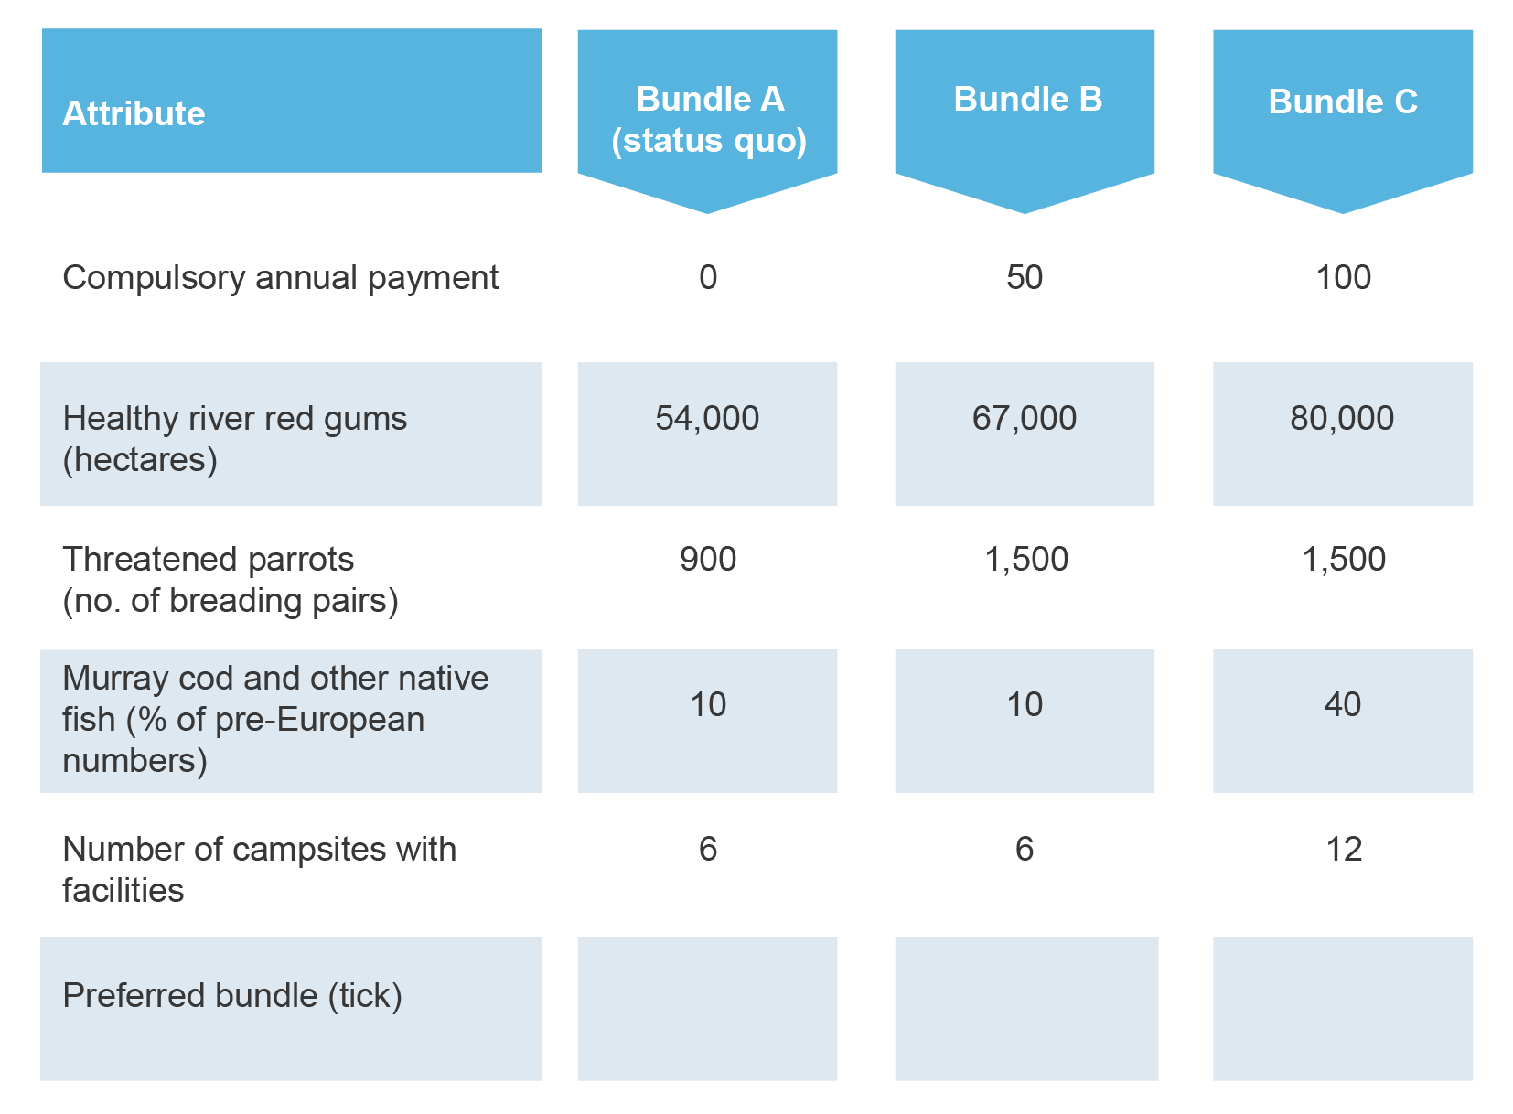

Note: a selection of cards with different combinations of levels would be presented to each respondent.

Source: Bennett (2008)

It is important in both the CVM and CM approaches to present respondents with as much realism as possible. For example, the cost (the payment vehicle) of each bundle option may be described as additional income tax or a levy on superannuation. For example, Dobes et al.[94] specified a household electricity levy because an ‘ambulance’ levy on electricity had been discontinued the year before in Queensland, so respondents were familiar with the possibility.

# Job creation is not a social benefit

Politicians and the public typically focus on the single aspect of job creation. This can distort decision-making.

French economist Frederic Bastiat[95] lampooned a proposal to create a break in gauge at Bordeaux on the railway line from Paris to Bayonne. The proponent had claimed that a break in the tracks would create jobs for porters as well as increasing the profits of hotel owners and cartage firms.

In response, Bastiat recommended breaks in gauge at all the other towns along the route as well, in order to create even more employment and thereby increase national economic growth. Like many other proposals that are claimed to serve the public interest, consumers would have been sacrificed to the narrow interests of producers.

CBA treats the employment of a worker as a cost to a project, rather than a benefit.[96] Like other resources, labour is scarce. Employment of a worker on one project denies society the opportunity to use that worker to produce goods and services elsewhere in the economy.

In a situation of structural unemployment, the social cost of drawing on unemployed labour is actually less than the nominal wage paid, because there is no opportunity cost due to lost production elsewhere in the economy. However, previously unemployed workers still forgo the value of their leisure and may incur additional work-related costs like child-minding, relocation expenses, or commuting, all of which constitute the social cost of employing them. Further, it is important to avoid ascribing a permanent benefit to creating more jobs during a situation of less than full employment: because employment levels are typically cyclical, a base-case scenario that assumed permanent unemployment would be unrealistic and would overestimate benefits.

There is evidence that unemployment is associated with impaired mental health.[97] But there is also evidence that poor quality jobs (perceived job insecurity, low marketability and job strain) are associated with mental health problems as bad as those associated with unemployment.[98] Analysis of job creation programs would ideally take all such factors into account, but it is unlikely that data would normally be available at an appropriate level of detail.

Increased employment should not enter into the calculus of the benefits of a project, any more than the additional use of other resources like land or machines. Given that decision-makers consider job creation to be important, a more sensible approach may be to present any employment effects separately from the CBA proper.

# The Net Present Value (NPV) decision rule: several common furphies

An enduring public service furphy[99] is that the purpose of discounting costs and benefits is ‘to allow for inflation’.[100] Discounting can be carried out with either nominal values (no adjustment for inflation), or with real values (adjusted for inflation) provided that nominal or real discount rates respectively are applied. The confusion is to some extent understandable, because the arithmetic of converting ‘nominal’ values to ‘real’ quantities is similar to that used for discounting future values to the present. Brealey[101] provide a comprehensive exposition of relevant calculations.

A dollar today is worth more than a dollar tomorrow. From an investor’s perspective, a dollar today can be invested to start earning a market return immediately, so receipt of a dollar in the future would forgo that opportunity. From a consumer’s perspective, receiving a dollar in the future means forgoing consumption in the present, so the consumer will need to be rewarded for their abstinence. If a consumer’s personal rate of discount is 15 per cent per annum, then forgoing a dollar today will result in a demand for receipt of $1.15 in a year’s time.

Another furphy — that it is not worth discounting beyond a period of 30 years because values fall away to zero — can be dispelled with a glance at a table of discount factors. Even after 50 years at 5 per cent per annum discount rate, for example, a dollar of future value is still worth almost 10 cents in present value terms because the discount factor is 0.0872.

A social rate of discount differs from a private rate of discount because it reflects the overall rate at which society as a whole trades off present and future consumption. Individuals are mortal, and their private discount rate is likely to be influenced by knowledge of their limited time to engage in consumption of goods and services. Despite producing an enormous number of learned articles, the search for the Holy Grail of “the” social discount rate has been unproductive to date, and may well remain so. As illustration, Infrastructure Australia[102] inexplicably requires the use of three different rates: 4, 7, and 10 per cent per annum. A readable introduction to social discount rates is available in Zhuang et al.,[103] and in Pearce et al.[104]

A third, seductive furphy is that a CBA result where Net Present Value (NPV) is greater than zero indicates that the government should proceed with the proposed project or policy. The conclusion is obviously wrong if other available projects yield a higher NPV. A government should proceed with caution before committing to a project if it is likely to encounter a serious budget constraint in one or more out-years. Projects of different time periods cannot be compared using NPV; they need to be converted to Equivalent Annual Values (i.e. annuities) to provide validly comparable data. Where real options exist in a project, calculation of the NPV alone may underestimate the benefits.[105] Finally, an oft-forgotten but necessary condition for government investment is that it should occur only to overcome genuine market failure.

Discount rates are certainly important in estimating NPV. But they are not the only consideration in CBA. Errors and uncertainties in estimating costs and benefits can easily swamp any difference in choice of discount rate.

# Adjusting for risk versus sensitivity analysis: two different animals

It is not uncommon to find a consultant’s report that includes a matrix of alternative NPVs for different levels of selected variables, and headed ‘sensitivity analysis’. It is rarely clear what one should do with the table; particularly which NPV is to be used in any recommendation to decision-makers.

Sensitivity analysis involves changing the absolute value of a variable used in the CBA by a marginal amount: both higher and lower. If a marginal change to a variable results in a disproportionately large change in NPV, then prudence is required in using the estimated value of the variable.[106] The role of sensitivity analysis is to signal to the analyst which variables require more careful checking for accuracy.

It is another furphy that sensitivity analysis represents risk analysis. Risk refers to the likely variation of a variable from its expected value and is typically measured as the variance of a probability distribution. It can be incorporated into CBA using decision-trees or by applying Monte Carlo analysis. Use of Monte Carlo analysis produces a probability distribution of NPVs, rather than a single, deterministic estimate. A practical explanation of the technique is accessible at a variety of websites, including <http://www.palisade.com/risk/> or <http://www.minitab.com>.

# Social return on investment (SROI): an incomplete methodology

Use of the social return on investment (SROI) measure has been promoted for almost two decades as a means of evaluating investments in the not-for profit sector. Pioneered by the Roberts Enterprise Development Fund in California, its objective is to assist practitioners and their philanthropist sponsors to assess the impact and effectiveness of their social investments.[107]

It is difficult to provide a precise explanation of SROI methodology, let alone a clear definition of the ratio itself. As Faivel et al. point out, ‘SROI is not yet a comprehensive evaluation framework’, and ‘a range of approaches to SROI have emerged’. They elaborate as follows:

In its current form, the SROI approach is neither a comprehensive evaluation framework, and nor is it intended to be. Rather, SROI complements, and in some cases borrows from, existing tools and methods such as the Balanced Scorecard, the Australian Business Excellence Framework, the European Framework for Quality Management, Social Auditing/Social Accounting, Risk Management, and the plethora of accountability frameworks established by funding programs. That said, there is a long-standing literature on cost-benefit analysis, on which SROI is based.

Providing a definitive exegesis from the smorgasbord of possible methodologies is therefore not a task for the faint-hearted.

The UK Cabinet Office (Office of the Third Sector) published a *Guide* to SROI. The *Guide* appears to be accepted as the ‘predominant’ exposition of the SROI approach to evaluation, but its contents are largely focused on process issues, rather than concepts or methodology. For example, the seven ‘principles’ of SROI are in fact tasks: ‘involve stakeholders, understand what changes, value the things that matter, only include what is material, do not over-claim, be transparent, verify the result’.

Nicholls et al., also point out that ‘an SROI analysis can take many different forms’. They present two alternative forms of the SROI ratio, but do not explain in any detail the precise definition of terms such as ‘value of inputs’, which is also referred to as ‘the total investment’. It is therefore not clear, for example, whether the term includes both operating and capital costs. At a relatively superficial level, the SROI appears to resemble a Benefit Cost Ratio (BCR), and a ‘net SROI’ resembles one form of a Return on Investment (ROI) ratio.

SROI = $\frac{Present Value of benefits}{Value of total inputs}$

Net SROI = $\frac{Present Value of benefits-total inputs}{Value of total inputs}$

Faivel et al., extol the virtues of the SROI approach as ‘a form of stakeholder-driven evaluation blended with cost-benefit analysis tailored to social purposes’. Indeed, there is a degree of concordance in the concepts used in SROI and CBA. For example, Nicholls et al. warn against double-counting impacts and employ terminology like ‘financial proxies’ in the sense of estimating economic values (shadow pricing), ‘deadweight’ to mean base-case values, ‘displacement’ to mean offsetting effects and transfer payments, and ‘drop-off’ to mean a decline in impact of a variable. It is not clear why this new terminology has been introduced, given that conventional terms such as ‘revealed preference’ and ‘travel cost method’ are also employed.

On the other hand, SROI does not appear to be entirely consistent with basic CBA principles. Use of the formulation ‘social, environmental and economic costs and benefits’ indicates lack of understanding that economic values automatically take into account social and environmental effects. Valuation of the time of volunteer labour, for example, is proposed as the median hourly wage, but there is no reference to the opportunity cost of loss of the volunteer’s leisure.

Of greatest concern is the apparently narrow focus on a project’s impact on ‘stakeholders’ (see Box 4.3), rather than the whole of society. Although clarity is lacking, there appears to be an implicit supposition that only the costs and benefits of those directly affected by the project need to be counted (see for example, Faivel et al.) Because the ‘standing’ in a CBA is defined as ‘the whole of society’, it would automatically include proximate ‘stakeholders’. But CBA would also include other members of society, because they may experience costs (e.g. payment of taxes to fund social projects) or non-market benefits such as bequest or option values.

Box 4.3: Stakeholders are not society

| Use of the term ‘social’ in SROI is misleading.  Cost-benefit analysis (CBA) requires estimation of the effect of a project or policy on society as a whole. Society is typically defined to include all the inhabitants of a country, including all producers, consumers and government. It automatically includes, but is not limited to ‘stakeholders’.  The perspective of the social return on investment (SROI) method, on the other hand, is selectively limited to stakeholders: ‘staff, management, investors and others’. Because stakeholders are essentially vested interests who are affected by, or who influence a policy, program or project, the specification of costs or benefits will be narrower than those of society at large.  A government subsidy to a particular industry facing difficult commercial circumstances, for example, will typically ignore the countervailing effect on taxpayers. If additional taxation is required to fund the subsidy, taxpayers will suffer a loss in wellbeing due to lower levels of disposable income and consumption. Activity in other, non-subsidised industries will be affected adversely.  Unless the costs and benefits to all of society are considered, any evaluation will be arbitrary and biased. |
| --- |

# Ratio metrics: why they aren’t enough

Some analysts and decision-makers prefer to assess projects in terms of a benefit cost ratio (BCR) rather than a NPV. Both the SROI and BCR metrics are a ratio of two variables and therefore suffer from the problem of not measuring scale.

Table 4.1 illustrates the issue by comparing BCRs for three different projects. The example highlights the BCR because the problem is more striking when net present values are compared with the ratio value. But the SROI is equally susceptible to misleading evaluation results if only the ratios are used without separate examination of the total value of the numerator and of the denominator.

Table 4.1 illustration of the scale problem for evaluation metrics based on ratios, using BCR as an example

|  | Project 1 | Project 2 | Project 3 |
| --- | --- | --- | --- |
| PV benefits | 11 | 1100 | 11 |
| PV costs | 10 | 1000 | 9 |
| Benefit Cost Ratio | 1.1 | 1.1 | 1.2 |
| Net present value | 1 | 100 | 2 |

Source: Author’s illustration

Basing a decision solely on a BCR, a decision-maker may well agree to proceed with an investment in Project 1. However, Project 2, which has the same BCR of 1.1, has an overall net present value (NPV) that is larger than the one for Project 1. Project 2 therefore contributes more net benefit to society than does Project 1 and should be preferred. Project 2 should also be preferred over Project 3, despite Project 3’s higher BCR.

# What are the implications for government?

Should the department decide to develop expertise in the technique of social CBA, it could enhance the quality of evaluations while reducing the effort and resources required. The following suggestions are made on the basis of many years’ experience in fielding requests for assistance by public servants:

* Adopt a harmonised approach to the presentation of CBA in order to facilitate reading or review of reports. At present, consultants are free to draft reports in their own style, making it difficult and time-consuming to locate specific information. The approach suggested by Dobes et al.[108] would not only rationalise the presentation of information, but would also simplify procurement processes
* Secure inter-departmental agreement on the specification and use of key variables. Commonwealth portfolios currently use differing values of statistical life, for example, when estimating the benefit of safety or health programs. Use of different parameters reduces the comparability of competing policies or projects being considered by Ministers
* Establish a central, easily accessible database of peer-reviewed CBA commissioned or undertaken by government portfolio agencies. Apart from the increased accountability and improved quality of reports, significant benefit would be reaped by public servants who want to undertake a CBA. A readily-accessible database would also minimise duplication of effort in analysing similar issues
* Ensure that program or project managers collect relevant data before beginning, and during implementation. The corollary is that managers should ensure that their program or project budget includes sufficient funds for data collection and post-completion evaluation
  + Provide staff with executive-level training courses in CBA. Some Commonwealth and state government agencies have produced handbooks and manuals to assist their staff in undertaking CBA. While laudable in intent, such undertakings suffer from a major drawback because manuals need to be concise in order to avoid replicating textbooks. But concise publications will tend to exclude the level of detail necessary to inform those who do not possess sufficient training in economic analysis. A more effective approach would be to provide staff with training courses in order to provide a basic grounding that enables them to pursue more detailed knowledge from existing textbooks.

## The next steps

The Department of Industry, Innovation and Science’s leadership of the Economic Data and Analysis Network (EDAN) — one of five Australian Government analytical units under the Data Integration Partnership for Australia initiative — is enabling the department to further refine its approach to evaluation by seeking out expert advice and considering best practice in government, academia and the private sector. Through EDAN, the department plans to commission and publish more of its research and evaluation on the OCE website. Internally, the department is developing a library of completed evaluations. The EDAN will also support capacity building to develop the evaluation skills of staff within partner agencies by offering training, sharing lessons learnt from part experiences, and facilitating and encouraging greater collaboration between government researchers and evaluators.

1. Unless otherwise stated, the terms ‘business’ and ‘firm’ are treated as synonyms in this report and used interchangeably.
2. Bakhtiari, S (2017) Entrepreneurship Dynamics in Australia: Lessons from Micro-data, OCE staff research paper 5/2017, Department of Industry, Innovation and Science
3. Hendrickson et al. (2015) The employment dynamics of Australian entrepreneurship, OCE staff research paper 4/2015, Department of Industry, Innovation and Science
4. It needs to be acknowledged that beyond an outright exit, a firm may cease to operate due to mergers and acquisitions.
5. For additional information on the Australian business size distribution see Swanepoel, J.A. and Harrison, A.W. (2015) The business size distribution in Australia, Office of the Chief Economist Research Paper, no. 5
6. Structural change broadly refers to the evolving patterns of economic activity, employment, and investment in an economy.
7. Calculations are based on ABS cat. no. 8165.0 and ABS cat. no. 3101.0.
8. For a review of the literature, see for example Foster, L., Haltiwanger, J. and Krizan, C.J. (1998) Aggregate productivity growth: lessons from microeconomic evidence, NBER Working Paper no. 6803; Melitz, M. J., & Polanec, S. (2015) Dynamic Olley‐Pakes productivity decomposition with entry and exit, The Rand journal of economics, 46(2), 362-375; and Jaef, F., & Roberto, N. (2018) Entry and Exit, Multiproduct Firms, and Allocative Distortions, American Economic Journal: Macroeconomics, 10(2), 86-112
9. For example see Berlingieri, G., P. Blanchenay and C. Criscuolo (2017a) The Great Divergence(s), OECD Science, Technology and Industry Policy Papers, No. 39, OECD Publishing, Paris, <http://dx.doi.org/10.1787/953f3853-en>
10. The OECD’s 'DynEmp' (Dynamics of Employment) project utilises harmonised micro-aggregated data to analyse employment dynamics in OECD countries, while the MultiProd project provides cross-country harmonised micro-aggregated data for understanding productivity dynamics. COMPNet (The Competitiveness Research Network) is a project initiated by the European Central Bank that operates as an international hub for research and policy analysis on competitiveness and productivity.
11. This feature article is based on the findings of a 2017 OCE staff research paper entitled Entrepreneurship Dynamics in Australia: Lessons from Micro-data
12. Tuhin, R & Swanepoel, J.A. (2016) Export behaviour and business performance: evidence from Australian microdata, Staff research paper 7/2016, Office of the Chief Economist, Department of Industry, Innovation and Science <https://industry.gov.au/Office-of-the-Chief-Economist/Research-Papers/Pages/Export-behaviour-and-business-performance-evidence-from-Australian-microdata.aspx>
13. Tuhin, R. (2016) Modelling the relationship between innovation and exporting: Evidence from Australian SMEs, Staff research paper 3/2016, Office of the Chief Economist, Department of Industry, Innovation and Science <https://industry.gov.au/Office-of-the-Chief-Economist/Research-Papers/Pages/Modelling-the-relationship-between-innovation-and-exporting-Evidence-from-Australian-SMEs.aspx>
14. Athukorala, P & Talgaswatta, T. (2016) Global production sharing and Australian manufacturing, Office of the Chief Economist, Department of Industry, Innovation and Science <https://industry.gov.au/Office-of-the-Chief-Economist/Publications/Documents/other/Global-production-sharing-and-Australian-manufacturing.pdf>
15. See for example OCE (2017) Business Research Collaboration (BRC) Discovery Project Report, Office of the Chief Economist, Department of Industry, Innovation and Science, Canberra <https://www.industry.gov.au/innovation/reportsandstudies/Pages/BRC-Discovery-Project-Report.aspx>, and Palangkaraya, A., Spurling, T., & Webster, E. (2015) Does Innovation make (SME) firms more productive?, Reserve Bank of Australia, <https://www.rba.gov.au/publications/confs/2015/pdf/palangkaraya-spurling-webster.pdf>
16. See Australian Innovation System Report 2017 Chapter 5.
17. Refer to the Australian Innovation System Report 2017 for more details.
18. Cully, M (2017) Bursting out of the growth blocks, Op-Ed InnovationAus.com: Public policy and business innovation <https://www.innovationaus.com/2017/12/Bursting-out-of-the-growth-blocks>
19. See for example Lucas Jr, R. E. (1978) On the size distribution of business firms, The Bell Journal of Economics, 508-523; Bloom, N., & Van Reenen, J. (2007) Measuring and explaining management practices across firms and countries, The Quarterly Journal of Economics, 122(4), 1351-1408; Agarwal, R., & Green, R. (2011) The role of education and skills in Australian management practice and productivity, Fostering Enterprise: The Innovation and Skills Nexus–Research Readings, Adelaide, National Centre for Vocational Education Research (NCVER), 79-102; and Dowdy, J. & Van Reenan, J. (2014) Why management matters for productivity, McKinsey&Company <https://www.mckinsey.com/global-themes/china/why-management-matters-for-productivity>
20. Karpin, D, Australia Industry Task Force on Leadership and Management Skills (1995) Enterprising nation: renewing Australia’s managers to meet the challenges of the Asia-Pacific century [Karpin report], Australian Government Publishing Service, Canberra
21. Green, R., et.al (2009) Management Matters in Australia: Just how productive are we? Findings from the Australian Management Practices and Productivity global benchmarking project, Report commissioned by Department of Innovation, Industry, Science and Research <http://worldmanagementsurvey.org/wp-content/images/2010/07/Report_Management-Matters-in-Australia-just-how-productive-are-we.pdf>
22. Baily, M. (2016) Principles for industry policy in a modern economy, in Australian Industry Report, 2016, Office of the Chief Economist, Department of Industry, Innovation and Science
23. As outlined in the 2017-18 Science, Research and Innovation Budget Tables, <https://industry.gov.au/innovation/reportsandstudies/Pages/SRIBudget.aspx>
24. Rodrik, D. (2004) Industrial policy for the twenty-first century, Harvard University, John F. Kennedy School of Government
25. As administrative data is not originally collected for statistical analysis, there are inherent time lags while the data is collected, cleaned and integrated to other data sources.
26. For further information on BLADE and its construction refer to, Hansell, D. and Rafi, B. (2018)   
    Firm-Level Analysis Using the ABS’ Business Longitudinal Analysis Data Environment (BLADE), Australian Economic Review, 51: 132–138
27. For further details on the Five Safes Framework and ABS safeguards refer to ABS (2017) Managing the risk of disclosure: the five safes framework, cat.no. 1160.0 - ABS Confidentiality Series, Aug 2017, Australian Bureau of Statistics, Canberra <http://www.abs.gov.au/ausstats/abs@.nsf/Latestproducts/1160.0Main%20Features4Aug%202017?opendocument&tabname=Summary&prodno=1160.0&issue=Aug%202017&num=&view=>
28. The R&D Tax Incentive and the Entrepreneurs’ Programme are the only of these programs that are currently operational.
29. ABS cat. no. 8167, Selected Characteristics of Australian Businesses, 2015–16
30. Horne, M. (2018) Firms that receive multiple instances of assistance from DIIS programs, Department of Industry, Innovation and Science, Office of the Chief Economist Research Paper (forthcoming)
31. ABS cat. no. 8167, Selected characteristics of Australian businesses, 2016–17
32. Productivity Commission (2017) Trade and Assistance Review, 2015–16
33. ABS cat. no. 8165.0, Counts of Australian businesses, including entries and exits, Jun 2013 to June 2017
34. Tuhin, R & Swanepoel, J.A. (2016) Export behaviour and business performance: evidence from Australian microdata, Staff research paper 7/2016, Office of the Chief Economist, Department of Industry, Innovation and Science <https://industry.gov.au/Office-of-the-Chief-Economist/Research-Papers/Pages/Export-behaviour-and-business-performance-evidence-from-Australian-microdata.aspx>; and OCE(2016) Australian Innovation System Report 2016, Office of the Chief Economist, Department of Industry, Innovation and Science, Canberra
35. The National Measurement Institute, viewed 25 May, http://www.measurement.gov.au/Documents/NMIbrochure.pdf
36. Williamson S (2003) National analytical labs to merge, Australian Life Scientist, viewed 25 May, http://www.labonline.com.au/content/life-scientist/news/national-analytical-labs-to-merge-556570644
37. To read more about the diverse range of services NMI provides, see <http://www.measurement.gov.au/Documents/NMIbrochure.pdf>
38. Swann, P. (2009) The Economics of Metrology and Measurement, Report for National Measurement Office, Department of Business, Innovation and Skills
39. For further discussion on the economic benefits of measurement, see Robertson, K & Swanepoel, J. (2015) The economics of metrology, Canberra, Department of Industry, Innovation and Science
40. Australian Bureau of Statistics cat. no. 8170.0, Characteristics of Businesses in Selected Growth   
    Centres, Australia, 2013-14, <http://www.abs.gov.au/AUSSTATS/abs@.nsf/DetailsPage/8170.02013-14?OpenDocument>
41. As defined by the Business Characteristics Survey. ABS cat. no. 8158.0, Innovation in Australian   
    Business, 2014–15
42. A firm is R&D active if they have registered for the R&D Tax Incentive*.*
43. Only employing firms are used in comparisons with NMI client outcomes.
44. Department of Industry, Innovation and Science (2017), Evaluation Strategy 2017-21, Office of the Chief Economist, Canberra
45. Stern, E., Stame, N., Mayne, J., Forss, K., Davies, R. & Befani, B. (2012) Broadening the range of designs and methods for impact evaluations, Working Paper 38, Department for International Development, London
46. Morgan Jones, M., Castle-Clarke, S., Manville, C., Gunashekar, S., & Grant, J. (2013) Assessing research impact: An international review of the Excellence in Innovation for Australia Trial. Santa Monica, CA: RAND Corporation
47. Stern, E., Stame, N., Mayne, J., Forss, K., Davies, R., & Befani, B. (2012) Broadening the range of designs and methods for impact evaluations. Report of a study commissioned by the Department for International Development, London, UK
48. Department of Prime Minister and Cabinet (2018) Behavioural Economics, [https://www.pmc.gov.au/domestic- policy/behavioural-economics](https://www.pmc.gov.au/domestic-%20policy/behavioural-economics)
49. Rogers, P., Hawkins, A., McDonald, B., Macfarlane, A., & Milne, C. (2015) Choosing appropriate designs and methods for impact evaluation. Office of the Chief Economist, Department of Industry, Innovation and Science, Australian Government
50. Office of the Chief Economist (2018) Staff research papers, Department of Industry, Innovation and Science,<https://industry.gov.au/Office-of-the-Chief-Economist/Research-Papers/Pages/default.aspx>
51. Data on review only program participants are dropped from the analysis at this time due to concerns over data quality for this group.
52.
53. Jones, M, Castle-Clarke, S, Manville, C, Gunashekar, S & Grant, J (2013) Assessing research impact: An international review of the Excellence in Innovation for Australia Trial, RAND Europe, Cambridge
54. A terajoule is equivalent to one trillion joules or approximately 0.278 gigawatt hours. A joule is defined as the energy transferred to an object when a force of one newton exerts on the object in the same direction of motion over a distance of one metre. One terajoule is sufficient energy to power 17,000 homes for one hour.
55. There is some information on these variables for a small subset of firms from the ABS Business Characteristics Survey.
56. Jones, M, Castle-Clarke, S, Manville, C, Gunashekar, S & Grant, J (2013) Assessing research impact:   
    An international review of the Excellence in Innovation for Australia Trial, RAND Europe, Cambridge
57. Pusey, M. (1991) Economic rationalism in Canberra, A nation-building state changes its mind, CUP, Melbourne
58. Faivel, S., Ghosh, S., Hilton, O., James, D., and D. Peppercorn (2012) Social Return on Investment, Lessons learned in Australia, Social Ventures Australia Consulting, [www.socialventures.com.au](http://www.socialventures.com.au)
59. Ibid
60. Nicholls, J., Lawlor, E., Neitzert, E. and T. Goodspeed (2009) *A guide to Social Return on Investment*, Office of the Third Sector, UK Cabinet Office, published by Society Media, UK
61. Brealey, R.A., Myers, S.C. and F. Allen (2006) *Principles of Corporate Finance*, 8th edition, McGrawHill-Irwin, NY
62. Real options’ valuation methodology may increase the conventional net present value (NPV) estimate by including the value of flexibility and greater information due to delaying a decision to invest. Borison (2005) outlines various methods that are commonly used.
63. Abelson, P. (2003) Cost-Benefit Analysis of Proposed New Health Warnings on Tobacco Products, Report prepared for the Commonwealth Department of Health and Ageing, Applied Economics, Sydney
64. Allen Consulting Group (2006) Phasing out Lightweight Plastic Bags: Costs and Benefits of Alternative Approaches, Report to the Environment Protection and Heritage Council, Canberra
65. Productivity Commission (1999) Australia’s Gambling Industries, Inquiry Report no. 10. Ausinfo, Canberra
66. Garnaut, R. (2008) The Garnaut Climate Change Review: Final Report, Cambridge University Press, Melbourne
67. Dobes, L. (2007) Turning isolation to advantage in regional cost-benefit analysis, Economic Papers 26(1): 17-28
68. Bennett, J. (2008) Defining and managing environmental flows: inputs from society, Economic Papers 27(2): 167–83
69. Dobes, L., Leung, J., & G. Argyrous (2016) Social Cost-Benefit Analysis in Australia and New Zealand,The state of current practice and what needs to be done, ANU Press, Canberra. Freely downloadable at <http://press.anu.edu.au/titles/australia-and-new-zealand-school-of-government-anzsog-2/social-cost-benefit-analysis-in-australia-and-new-zealand/>
70. A Monte Carlo simulation is a computer-based technique that uses statistical sampling and probability distributions to provide a systematic assessment of the combined effects of multiple sources of risk. Campbell & Brown (2016) explain the method using an Excel spreadsheet.
71. Capital Metro Agency (2014) Full Business Case, Capital Metro, Canberra
72. Boardman, A.E., Greenberg, D.H., Vining, A. & D.L. Weimer (2011) Cost-Benefit Analysis: Concepts and practice, 4th edition, Pearson Prentice Hall, NJ
73. Dobes, L. (2009) A practical guide to cost-benefit analysis, in Argyrous, A. (ed.) Evidence for policy and decision-making: a practical guide, University of New South Wales Press, Sydney
74. Dobes, L. (2008) A century of Australian cost-benefit analysis, Working Paper 2008-01, Office of Best Practice Regulation, Department of Finance and Deregulation, <https://www.pmc.gov.au/resource-centre/regulation/century-australian-cost-benefit-analysis-working-paper>
75. Department of Finance and Administration (2006) Handbook of Cost-Benefit Analysis, Financial Management Reference Material no. 6, Australian Government, Canberra
76. Whittington, D and MacRae, D. (1986) [The issue of standing in cost-benefit analysis](https://ideas.repec.org/a/wly/jpamgt/v5y1986i4p665-682.html), [Journal of Policy Analysis and Management](https://ideas.repec.org/s/wly/jpamgt.html), John Wiley & Sons, Ltd., vol. 5(4), pages 665-682
77. Zerbe, R. (1991) Does benefit cost analysis stand alone? Journal of Policy Analysis and Management, vol. 10(1), pages 96-105
78. See for example, Dobes,L (2017) A cross-border perspective on ‘standing’ in cost-benefit analysis, Crawford School Working Paper 1711, Australian National University <https://crawford.anu.edu.au/publication/crawford-school-working-papers/12019/cross-border-perspective-standing-cost-benefit>
79. Dobes, L., Leung, J., & G. Argyrous (2016) Social Cost-Benefit Analysis in Australia and New Zealand, The state of current practice and what needs to be done, ANU Press, Canberra. Freely downloadable at <http://press.anu.edu.au/titles/australia-and-new-zealand-school-of-government-anzsog-2/social-cost-benefit-analysis-in-australia-and-new-zealand/>
80. Note that a fall in price is not sufficient. In order to reflect resource savings by society, the cost of providing the goods or services must be reduced as a consequence of the project.
81. Bateman, I., Carson, R., Day, B., Hanemann, M., Hett, T., Hanley, N., Jones-Lee, M., Loomes, G., Mourato, S., and E. Ozdemiroglu (2002) Economic valuation with stated preference techniques: a manual, Edward Elgar, Cheltenham, UK
82. Pearce, D., Atkinson, G., and Mourato, S. (2006) Cost-benefit analysis and the environment: Recent developments, OECD
83. Hanley, N. and E.B. Barbier (2009) Pricing nature: Cost-Benefit Analysis and environmental policy, Edward Elgar, UK
84. Baker, R. and B. Ruting (2014) Environmental policy analysis: A guide to non-market valuation, Productivity Commission Staff Working Paper, Canberra
85. Slothuus, U. and R.G. Brooks (2000) Willingness to pay in arthritis: a Danish contribution, Rheumatology 39: 791-799
86. Akter, S. and J. Bennett (2011) Household perceptions of climate change and preferences for mitigation action: the case of the Carbon Pollution Reduction Scheme in Australia, Climatic Change 109(3-4): 417-436
87. Lockwood, M. (1996) Analysing conflict between cultural heritage and nature conservation in the Australian Alps: a CVM approach, Journal of Environmental Planning and Management vol. 39, issue 3
88. Imber, D., Stevenson, G. and L. Wilks (1991) A Contingent Valuation survey of the Kakadu conservation zone: final report, Resource Assessment Commission, Australian Government Publishing Service, Canberra
89. Bennett, J. (1996) The contingent valuation method: a post-Kakadu assessment, Agenda 3(2): 185-194
90. Louviere, J. and D.A. Hensher (1983) Using discrete choice models with experimental design data to forecast consumer demand for a unique cultural event, Journal of Consumer Research 10(3): 348-361
91. Lancaster, K. (1966) A new approach to consumer theory, Journal of Political Economy 84: 132-157
92. Luce, R.D. (1959) Individual choice behaviour: a theoretical analysis, Wiley, New York; and McFadden, D. (1973) Conditional logit analysis of qualitative choice behaviour, Frontiers in Econometrics, Academic Press, New York
93. Bennett, J. (2008) Defining and managing environmental flows: inputs from society, *Economic Papers* 27(2): 167–83
94. [Dobes, L., Scheufele, G., and Bennett, J. (2015) Post-cyclone emergency services: a cost-benefit analysis for Cairns, Australia, Natural Hazards, 75(1): 869-886](https://researchers.anu.edu.au/publications/97873)
95. Bastiat, F. c. (1848) Economic sophisms, collection of Bastiat’s articles published in 1996 by the Foundation for Economic Education, New York
96. Portney (1994, p. 13) further argues that any policy that destroys jobs will create disutility for people who gain satisfaction from knowing that hard-working people are gainfully employed, so CVM should be used to estimate the cost of job losses in the same way as environmental losses.
97. Paul, K.I. & K. Moser (2009) Unemployment impairs mental health: Meta-analyses, Journal of Vocational Behavior 74(3): 264-282
98. Broom, D.H., D’Souza, R.M., Strazdins, L., Butterworth, P., Parslow, R. & B. Rodgers (2006) The lesser evil: Bad jobs or unemployment? A survey of mid-aged Australians, Social Science & Medicine 63(3): 575-586; and Butterworth, P, Leach, L, Rodgers, B et.al (2011) Psychosocial job adversity and health in Australia: Analysis of data from the HILDA Survey, Australian and New Zealand Journal of Public Health, vol. 35, no. 6, pp. 564-571
99. A furphy is Australian slang for a false report or rumour. It is ‘thought to have arisen in gossip around the water-cart in World War I’ (Wilkes, 1978) and refers to water carts with the logo of the manufacturer, Joseph Furphy, from Shepparton, Victoria.
100. Even the Guidance note on cost-benefit analysis issued by the Department of the Prime Minister and Cabinet in February (2016 p. 6) confusingly discusses discounting under the heading ‘Accounting for inflation’ <https://www.dpmc.gov.au/sites/default/files/publications/006-Cost-benefit-analysis.pdf> viewed 19 Dec 2016
101. Brealey, R.A., Myers, S.C. and F. Allen (2006) Principles of Corporate Finance, 8th edition, McGrawHill-Irwin, NY
102. Infrastructure Australia (2013) Reform and investment framework templates for use by proponents, Template for stage 7: solution evaluation (transport infrastructure), Infrastructure Australia, Sydney
103. Zhuang, J., Liang, Z., Lin, T., and F. De Guzman (2007) Theory and practice in the choice of social discount rate for cost-benefit analysis: a survey, ERD Working Paper, Asian Development Bank, Manila
104. Pearce, D., Atkinson, G., and Mourato, S. (2006) Cost-benefit analysis and the environment: Recent developments, OECD
105. See for example Dixit AK, Pindyck RS (1994) Investment and uncertainty, Princeton University Press, NJ; Brealey, R.A., Myers, S.C. and F. Allen (2006) Principles of Corporate Finance, 8th edition, McGrawHill-Irwin, NY; and Brealey, R.A., Myers, S.C. and F. Allen (2006) Principles of Corporate Finance, 8th edition, McGrawHill-Irwin, NY
106. Abelson (2012), Boardman et al. (2011) and other texts indicate that discount rates are subject to sensitivity analysis. However, Dobes et al. (2016, appendix 6) argue that it is inappropriate to carry out sensitivity analysis on parameters like social discount rates. Market interest rates in an investment analysis, on the other hand, are variables that might validly be subject to sensitivity analysis. In their section on sensitivity analysis, Brealey et al. (2006, pp. 245-56) refer to a number of variables, but do not suggest the discount rate as one of them.
107. This section draws on the work of Faivel, S., Ghosh, S., Hilton, O., James, D., and D. Peppercorn (2012) Social Return on Investment. Lessons learned in Australia, Social Ventures Australia Consulting, [www.socialventures.com.au](http://www.socialventures.com.au); and Nicholls, J., Lawlor, E., Neitzert, E. and T. Goodspeed (2009) A guide to Social Return on Investment, Office of the Third Sector, UK Cabinet Office, published by Society Media, UK
108. Dobes, L., Leung, J., & G. Argyrous (2016) Social Cost-Benefit Analysis in Australia and New Zealand. The state of current practice and what needs to be done, ANU Press, Canberra. Freely downloadable at <http://press.anu.edu.au/titles/australia-and-new-zealand-school-of-government-anzsog-2/social-cost-benefit-analysis-in-australia-and-new-zealand/>