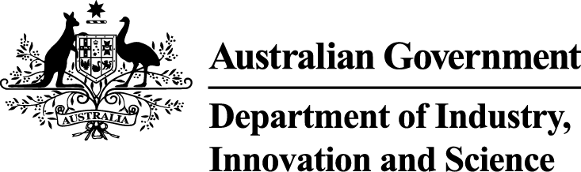
Meeting notes

safety stakeholder group
meeting 3
8 MArch 2019

Level 25 St Martins Tower
44 St Georges Terrace
Perth, Western Australia
10:00 – 12:00 AWST

When | What | Who
10:00 – 10:15 | - Welcome and SSG Updates  - Meeting notes from second meeting  - Senate Inquiry into WHS of Offshore Workers – Australian Government Response | Chair
10:15 – 11:00 | - Draft Part 5 Objects, Safety Cases and Diving Safety Management Systems Discussion Paper  Discussion on the Draft Discussion Paper on Objects, Safety Cases and Diving Safety Management Systems | SSG members
11:00 – 11:45 | - Draft Part 6 Compliance and Enforcement Discussion Paper  Discussion on the Draft Discussion Paper on Compliance and Enforcement | SSG members
11:45 – 12:00 | - Next Steps and Next Meeting  Any other business, next steps in the review process and timing of next meeting | Chair

Welcome and SSG Updates
- The Chair welcomed attendees to the third Safety Stakeholder Group (SSG) meeting, provided membership updates, confirmed the SSG 2 meeting notes are available online, and outlined the agenda for the meeting.
  - Attendees included: DIIS (Chair), APPEA, Santos, IADC, AMWU (on behalf of the ACTU), Health and Safety Representative, WorkSafe Victoria, NSW Resources Regulator, WA Department of Mines, Industry Regulation and Safety, NOPSEMA and the Department of Jobs and Small Business.
  - Apologies from: ACTU, AMSA.
- The Chair updated the SSG on the status of the Australian Government Response on the Senate Inquiry into work health and safety of workers in the offshore petroleum industry.
  - The Government Response was tabled in the Senate on 8 January 2019 and is available on both the Senate Committee website and department’s website. The link was sent to SSG members in early January.
  - The Government Response noted all recommendations made in the report, and these issues are all under consideration as part of this Safety Review.
Update on Discussion Paper development
- The Chair reiterated that the purpose of the discussion paper is to provide information on the current offshore petroleum safety regime and outline issues, challenges and views that have been identified by stakeholders to date.
- The Chair thanked members for their feedback on Parts 3 and 4 of the discussion paper, which has been incorporated into the final paper.
- The Chair introduced Parts 5 and 6 for discussion (Objects, Safety Cases and Diving Safety Management Systems; Compliance and Enforcement), and advised that Part 7: Jurisdictional Coverage will be provided to members for comment out of session.
Draft Parts 5 and 6 Discussion Paper
- Draft Part 5 on Objects, Safety Cases and Diving Safety Management Systems and Draft Part 6 on Compliance and Enforcement were provided to the SSG to seek feedback, including their views on whether these parts sufficiently and accurately capture the issues and concerns of their stakeholder groups and organisations.
- Part 5 looks at the overarching principles and purposes of the safety regime that underpin the requirements of OPGGS regime, and examines the use of safety systems, through the safety case, diving safety management system and diving project plan.
- Part 6 examines compliance and enforcement provisions under the OPGGS regime, and specifically outlines the occupational health and safety functions of NOPSEMA, the compliance and enforcement regulatory framework, including inspections and inspector powers, and provisions for notification and reporting.
- Both parts pose questions and invite stakeholders to consider their experience in relation to these issues and provide views supported by evidence.
- The SSG provided overall support for the content contained in the drafts, and indicated that the papers describe the issues accurately. The meeting discussed the need for the discussion questions in the paper to elicit useful submissions, and the Chair confirmed that the department is seeking examples through consultation on the discussion paper, to inform the evidence-based review.
- The SSG discussed the preventative rather than punitive nature of the regulatory regime, and the need to differentiate between the legislation and/or regulations versus their implementation.
- Members noted the final report of the review of the WHS model laws, conducted by Marie Boland, was recently published and recommendations should be incorporated in to the discussion paper as appropriate.
  - SSG members to provide DIIS with any additional comments or feedback on Parts 5 and 6.
  - DIIS to include references to the Boland Review in the safety review discussion paper.
Stakeholder engagement
- SSG members discussed the importance of consulting with health and safety representatives (HSRs), and the opportunity of using the upcoming HSR Forum for that purpose.
- SSG members discussed and supported the use of an online survey to seek views from the workforce, noting that the workforce should receive notice in advance of the survey.
  - DIIS to consult the offshore workforce through an online survey.
Meeting close and next meeting
- The Chair thanked members for attending the third SSG meeting and sharing their views on the draft papers.
- The Chair proposed that the fourth SSG meeting be held in mid-2019 in Melbourne or Canberra.

