

Offshore Petroleum Incident Coordination Framework

##### March 2019

Revision History

| VERSION | RELEASE DATE | CHANGE HISTORY | AUTHORISATION |
| --- | --- | --- | --- |
| 1.1 | August 2017 | Draft update replaced Offshore Petroleum Incident Coordination Framework (January 2015) | Department of Industry, Innovation and Science |
| 2.0 | March 2019 | Framework finalised incorporating lessons from Exercise Ningaloo Challenge | Department of Industry, Innovation and Science |

Contents

PART 1: SCOPE AND GOVERNANCE 4

1.1 Purpose 4

1.2 Objectives 4

1.3 Scope 4

1.3.1 Offshore petroleum activities 4

1.3.2 Responsibility for operational response 5

1.3.3 Geographic scope 6

1.3.4 Timor Sea Joint Petroleum Development Area 7

1.3.5 Exclusions 8

1.4 Australian Government Crisis Management Framework 8

1.5 Commonwealth response 9

1.5.1 Minor incident 10

1.5.2 Significant incident 10

1.5.3 Crisis 11

1.6 Coordination with other agencies and jurisdictions 12

1.6.1 Maritime incidents 13

1.6.2 Maritime counter-terrorism incidents 14

1.6.3 Cross-jurisdictional incidents 14

1.7 Liaison Officers 16

1.7.1 Commonwealth Government Liaison Officers 16

1.7.2 State/Territory Government Liaison Officer 17

PART 2: SIGNIFICANT INCIDENT ARRANGEMENTS 18

1.7.3 Titleholder Liaison Officer 17

2.1 Purpose of the OPICC 18

2.2 Responsibilities of the OPICC 18

2.3 Out of scope 18

2.4 Committee operation 19

2.4.1 Activation 19

2.4.2 Notification 19

2.4.3 Format 19

2.4.4 Documentation 19

2.5 OPICC Membership 19

2.5.1 OPICC Agency Responsibilities 20

2.5.2 State and Territory Involvement 20

2.6 Communications 21

PART 3: CRISIS ARRANGEMENTS 22

3.1 Role of the Department of Industry, Innovation and Science 22

3.2 Role of the Department of Home Affairs 22

3.3 Role of other Commonwealth agencies 23

3.4 Whole-of-government crisis committee 23

3.4.1 Purpose 23

3.4.2 Responsibilities 23

3.4.3 Out of scope 23

3.4.4 Committee operation 23

PART 4: REVIEW, EXERCISE AND DEVELOPMENT 25

4.1 Review 25

4.2 Exercise and development 25

Appendix A: Stakeholder List 26

Appendix B: Capabilities of Commonwealth Government Agencies 29

Appendix C: Legislation and Policy Responsibilities 31

Appendix D: Terminology and Acronyms 34

# **PART 1: SCOPE AND GOVERNANCE**

## 1.1 Purpose

The purpose of the Offshore Petroleum Incident Coordination Framework(theFramework) is to provide overarching guidance on the Commonwealth Government’s role and responsibilities in the event of an offshore petroleum incident in Commonwealth waters. The Framework provides a mechanism, through the establishment of the Offshore Petroleum Incident Coordination Committee (OPICC), for interdepartmental coordination in the event of a significant offshore petroleum incident, and provides an overview of the Commonwealth Government arrangements for addressing crises arising from offshore petroleum incidents. These arrangements form part of the Commonwealth Government’s ‘all hazards’ crisis management approach, with offshore petroleum incidents identified as one possible hazard in the Australian Government Crisis Management Framework (AGCMF).

## 1.2 Objectives

The objectives of the Framework are to:

* guide the Commonwealth Government’s actions during and following offshore petroleum incidents, and ensure these actions align with the Australian Government Crisis Management Framework
* set out the Commonwealth Government coordination arrangements
* outline the roles and responsibilities of Commonwealth Government agencies
* reinforce the Commonwealth Government’s role in providing strategic leadership
* establish mechanisms to ensure reliable and consistent information, timely reporting and effective communication and engagement across the Commonwealth Government, and with state and territory governments and the public.

## 1.3 Scope

### 1.3.1 Offshore petroleum activities

The Framework applies to all offshore petroleum incidents that occur in Commonwealth waters. Offshore petroleum incidents are those which relate to any or all of the following operations in an offshore area:

1. petroleum exploration operations
2. petroleum recovery operations
3. operations relating to the processing or storage of petroleum
4. operations relating to the preparation of petroleum for transport
5. operations connected with the construction or operation of a pipeline
6. operations relating to the decommissioning or removal of structures, equipment or other items of property that have been brought into an offshore area for or in connection with any of the operations mentioned in paragraph (a), (b), (c), (d) or (e) (Section 576A, *Offshore Petroleum and Greenhouse Gas Storage Act 2006*).

While the Framework currently focuses on offshore petroleum activities, it may also be applied to offshore greenhouse gas (GHG) storage activities, as regulated by the *Offshore Petroleum and Greenhouse Gas Storage Act 2006* (OPGGS Act) and its associated regulations. Future revisions of the Framework may be made to specifically accommodate GHG activities as required.

### 1.3.2 Responsibility for operational response

Oil and gas companies that have been awarded offshore title areas are referred to as titleholders in the OPGGS Act and in the Framework.The OPGGS Act and the OPGGS Environment Regulations assign responsibility for responding to and monitoring oil pollution to the titleholder.

This responsibility requires the titleholder to take all reasonably practicable steps to eliminate or control the escape of petroleum; clean up the escaped petroleum; remediate any resulting damage to the environment; and carry out environmental monitoring of the impact of the escape of petroleum on the environment[1]. Further, titleholders are required to maintain financial assurance sufficient to give them the capacity to meet costs, expenses and liabilities arising in connection, or as a result of, complying with this duty.

The OPGGS Safety Regulations require the facility operator to demonstrate through their safety case how they will take all reasonably practicable steps to ensure a facility is safe, and plan for evacuation, escape and rescue in the event of an incident. The OPGGS Resource Management and Administration Regulations require that oil and gas wells within Commonwealth waters must have a well operations management plan (WOMP). A WOMP must show how the risks to the integrity of the well will be reduced to as low as reasonably practicable, and describe the measures and arrangements that will be used to regain control of the well if there is a loss of integrity.

The preparation for, and implementation of, these responsibilities is regulated by the National Offshore Petroleum Safety and Environmental Management Authority (NOPSEMA). NOPSEMA, as the regulator, is provided with specific provisions for monitoring and securing compliance. In addition to its assessment and inspection functions, NOPSEMA has a range of powers it may choose to use in the event of an offshore petroleum incident, including powers to issue environmental and occupational health and safety prohibition notices. NOPSEMA also has a general power to give directions to a registered titleholder and to give remedial directions to titleholders in relation to restoration of the environment (similar powers are also available to the responsible Commonwealth Minister).

NOPSEMA also has a power to give directions to a titleholder in the event of a significant offshore petroleum incident. Directions for significant offshore petroleum incidents may require the titleholder to prevent, eliminate, mitigate, manage and/or remediate the effects of the escape of petroleum. These significant incident directions can also require that the titleholder take any other action, or not to take an action, relating to the escape of petroleum and its effects.

### 1.3.3 Geographic scope

The geographic scope of the Framework applies to Commonwealth waters extending from three nautical miles from the territorial sea baseline and not within the constitutional limits of a state or the Northern Territory (refer Figure 1).

Where there is an offshore petroleum incident in Commonwealth waters that impacts upon coastal waters, coordination of the response will be informed by the legislative arrangements in place for that jurisdiction and other intergovernmental arrangements as appropriate. Refer to section 1.6.3 of this Framework for further information on cross jurisdictional incidents.

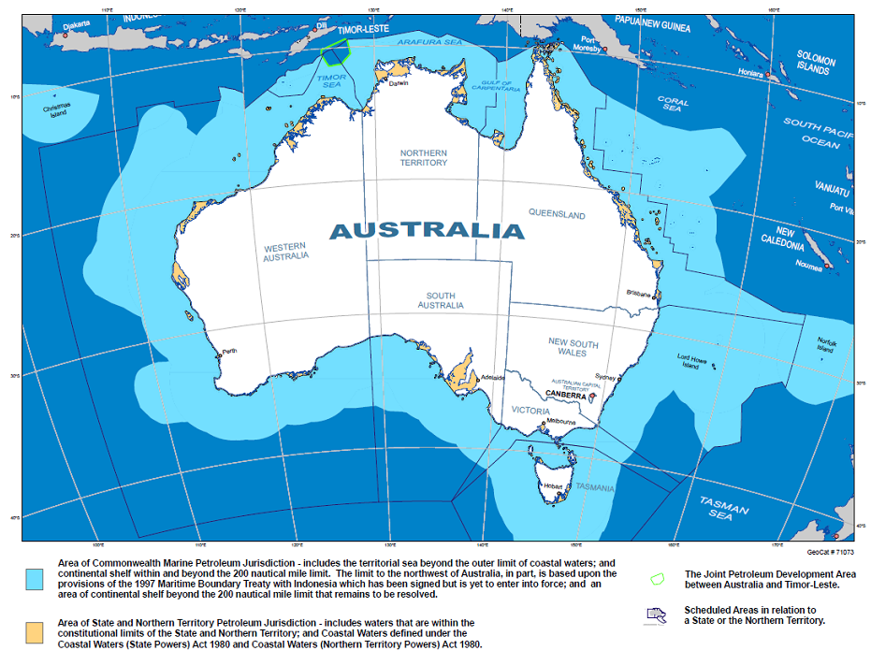

Figure 1 Commonwealth Offshore Jurisdictional Boundaries

### 1.3.4 Timor Sea Joint Petroleum Development Area

On 6 March 2018, Australia and Timor Leste signed the [*Treaty Between Australia and the Democratic Republic of Timor-Leste Establishing Their Maritime Boundaries in the Timor Sea*](http://dfat.gov.au/geo/timor-leste/Pages/timor-leste.aspx)*[2]*. Pending the new Treaty entering into force, the Parties have agreed that the Timor Sea Treaty (2002) and the regulatory framework that it established for the joint management and development of hydrocarbon resources within the Joint Petroleum Development Area (JPDA) will continue to apply.

Australia and Timor-Leste will continue to jointly manage and regulate the JPDA, and cooperate to protect the marine environment of the JPDA so as to prevent and minimise pollution and other environmental harm from petroleum activities. The Timor Sea Designated Authority, known as the Autoridade Nacional do Petróleo e Minerais (ANPM), has responsibility for the day‑to-day regulatory administration of offshore petroleum activities in the JPDA. This includes issuing regulations to protect the marine environment and approving operator plans for emergency response arrangements.

The Timor Sea Treaty, provides for the sharing of the proceeds of petroleum found in the JPDA and establishes the Joint Commission, consisting of Commissioners appointed by Australia and Timor-Leste. Specifically, under the Timor Sea Treaty, the ANPM is responsible for establishing a contingency plan for combating pollution from petroleum activities in the JPDA.

The contingency plan, as agreed by the Joint Commission, states that:

* in a situation where a pollution incident could be contained by the operator, under arrangements approved by the ANPM, the operator has responsibility for responding to the incident. The operator would normally inform the ANPM of the incident and continuously update the ANPM on progress.
* in situations where the pollution incident is beyond the capability of the operator, the ANPM/Timor-Leste Government or the operator may contact the Australian Maritime Safety Authority (AMSA) to seek assistance from Australia.

Where there is an incident in Commonwealth waters that crosses into the Timor Sea JPDA, the Framework will apply, in addition to the National Plan *Guideline for Coordination of International Incidents: Notification Arrangements*.[3]

### 1.3.5 Exclusions

The Framework does not apply to:

* onshore incidents (incidents occurring on land and under state or territory jurisdiction)
* offshore petroleum incidents wholly occurring in coastal waters
* liquid transport fuel incidents
* liquid fuel supply crises
* natural gas supply shortages affecting jurisdictions with interconnected gas supply networks
* national security incidents, unless they involve an offshore petroleum incident
* ports, maritime, and shipping incidents that do not include an offshore facility.

If an offshore petroleum incident does not trigger activation of the OPICC or a whole-of-government crisis committee, normal regulatory processes will be implemented by NOPSEMA. This type of incident is further described in section 1.5.1 Minor incident.

## 1.4 Australian Government Crisis Management Framework

The Framework forms part of the Commonwealth Government’s ’all hazards’ crisis management approach, as outlined in the AGCMF. This Framework supports the objectives of the AGCMF through its aim to protect human life, support continuity of everyday activity, and as far as possible, to protect critical infrastructure and property.

The AGCMF designates the lead ministers for the Commonwealth Government’s response to, and recovery from, a crisis. The Minister for Resources and Northern Australia is the lead Commonwealth Minister in the event of an incident involving an offshore petroleum facility in Commonwealth waters and has the following responsibilities:

* oversee the delivery of the Commonwealth Government response
* exercise executive responsibilities in consultation with ministers who have relevant portfolio interests
* represent the Commonwealth Government as the key spokesperson (or appoint a delegate as required).

The lead minister’s agency is responsible for:

* leading the Commonwealth Government response in cases that have not triggered a whole-of-government crisis committee
* where a whole-of-government crisis committee is convened – providing subject matter expertise and advice; and implementing key elements of the Commonwealth response. This may include coordinating briefings, situational reports and public messaging.

Certain circumstances may require two or more ministers to co-lead the Australian Government response to a crisis. This depends on the effects of the crisis and the respective Ministers’ responsibilities. Where there is no clear ministerial lead on a domestic crisis, the Minister for Home Affairs is the default lead minister.

Depending on the nature and scale of the crisis, the Prime Minister may decide to lead some or all elements of the Commonwealth Government response. In the event the Prime Minister decides to lead the Commonwealth Government response to, and/or recovery from, a crisis, the Prime Minister:

* will oversee the delivery of the Commonwealth Government response
* will determine which ministers should continue to support that response, and how
* may represent the Commonwealth Government as the key spokesperson
* may consult with leaders of the affected states and/or territories
* may engage with foreign leaders as appropriate.

Within the AGCMF, the Commonwealth Government has two crisis committees comprised of senior officials to facilitate whole-of-government coordination of domestic crises:

* the Australian Government Crisis Committee (AGCC) – for the coordination of the Australian Government response
* the National Crisis Committee (NCC) – to facilitate cooperation and coordination between the Australian Government and the relevant state and territory government(s).

The Interdepartmental Emergency Task Force (IDETF) may be formed to coordinate the Commonwealth Government response to overseas crises or incidents, particularly in relation to crises that affect, or are threatening to affect, Australians or Australian interests overseas. The IDETF is led by the Department of Foreign Affairs and Trade.

## 1.5 Commonwealth response

In recognition that the response required from the Commonwealth will vary in size, complexity and duration, this Framework describes escalating categories, ‘minor incident’, ‘significant incident’ and ‘crisis’, and provides direction as to the appropriate Commonwealth Government actions proportional to the assessed severity of the situation.

This approach provides for escalation and de-escalation of the various strategic arrangements as necessary.

These classifications are for guidance only. The response undertaken and strategic arrangements enacted will be chosen based on the individual incident and will be determined by the responsible lead Commonwealth Government agency (refer Figure 2).

The three response classifications described in this framework are analogous but not directly equivalent to the incident classifications described in National Plan for Maritime Environmental Emergencies (the National Plan)[4], which are primarily related to operational rather than strategic implications.

### 1.5.1 Minor incident

A minor incident is an incident that can be managed by the titleholder and/or facility operator primarily through first-strike operational response actions with no lasting impacts on the environment or human health and safety. In this situation, normal regulatory and enforcement processes will be implemented by NOPSEMA. The OPICC and whole-of-government crisis committees will not be required and are not activated.

### 1.5.2 Significant incident

A significant incident has wider implications than a minor incident and may involve a greater impact to the surrounding environment and wildlife, and/or to human health and safety. The operational response will often extend beyond the titleholder or operator’s first strike capability and will likely need to draw upon domestic contracts and capability, or even capability that exists beyond Australia. The titleholder will be expected to work with the relevant state/territory jurisdictions and the Commonwealth to share information, and, where necessary, coordinate response activities.

The Commonwealth Government’s involvement and coordination will be managed by the OPICC, an interdepartmental committee chaired by the Department of Industry, Innovation and Science (DIIS).

Factors in the decision to activate the OPICC include, but are not limited to:

* the scale and nature of the incident and its actual or potential impacts
* if casualties or loss of life have occurred
* if the incident is likely to continue beyond 24 hours
* if the incident requires a coordinated clean-up response effort
* if the incident has had multiple significant outcomes and/or consequences, such as a collision
* if there are cross-jurisdictional impacts from an incident originating in Commonwealth waters
* if the cause of the incident is not known
* if the incident has received media attention.

Refer to Part 2 for further details regarding the OPICC, including its establishment, responsibilities and member agencies.

### 1.5.3 Crisis

A crisis will have wider ramifications for Australia beyond the area surrounding the incident, such as one or more of the following: impacts on multiple jurisdictions; implications for other nations; multiple casualties; ecological impacts; and economic impacts (possible or known) on other industry sectors such as fisheries and tourism. While a crisis may see the titleholder or operator leading a large operational response, the hallmarks of a crisis will be the broader social, economic and political impacts.

The Commonwealth Government will provide all feasible assistance, and coordination of these efforts will require the activation of a whole-of-government crisis committee chaired by the Department of Home Affairs or the Department of the Prime Minister and Cabinet (PM&C) and supported by the Australian Government Crisis Coordination Centre (CCC).

Some triggers for activating whole-of-government coordination arrangements under the AGCMF may include:

* the scale of the crisis and its potential or actual impact on Australia, Australians or Australian national interests
* formal ministerial consideration of the crisis
* a crisis affecting multiple jurisdictions or industry sectors
* a request from an affected nation, state and/or territory for Commonwealth Government capabilities or assistance
* a crisis that has both domestic and international components
* a crisis resulting in a large number of casualties
* community expectation of national leadership
* multiple crises occurring simultaneously.

If a whole-of-government crisis committee is activated, the OPICC will not be convened. Refer to Part 3 for further details regarding activation of a whole-of-government crisis committee.

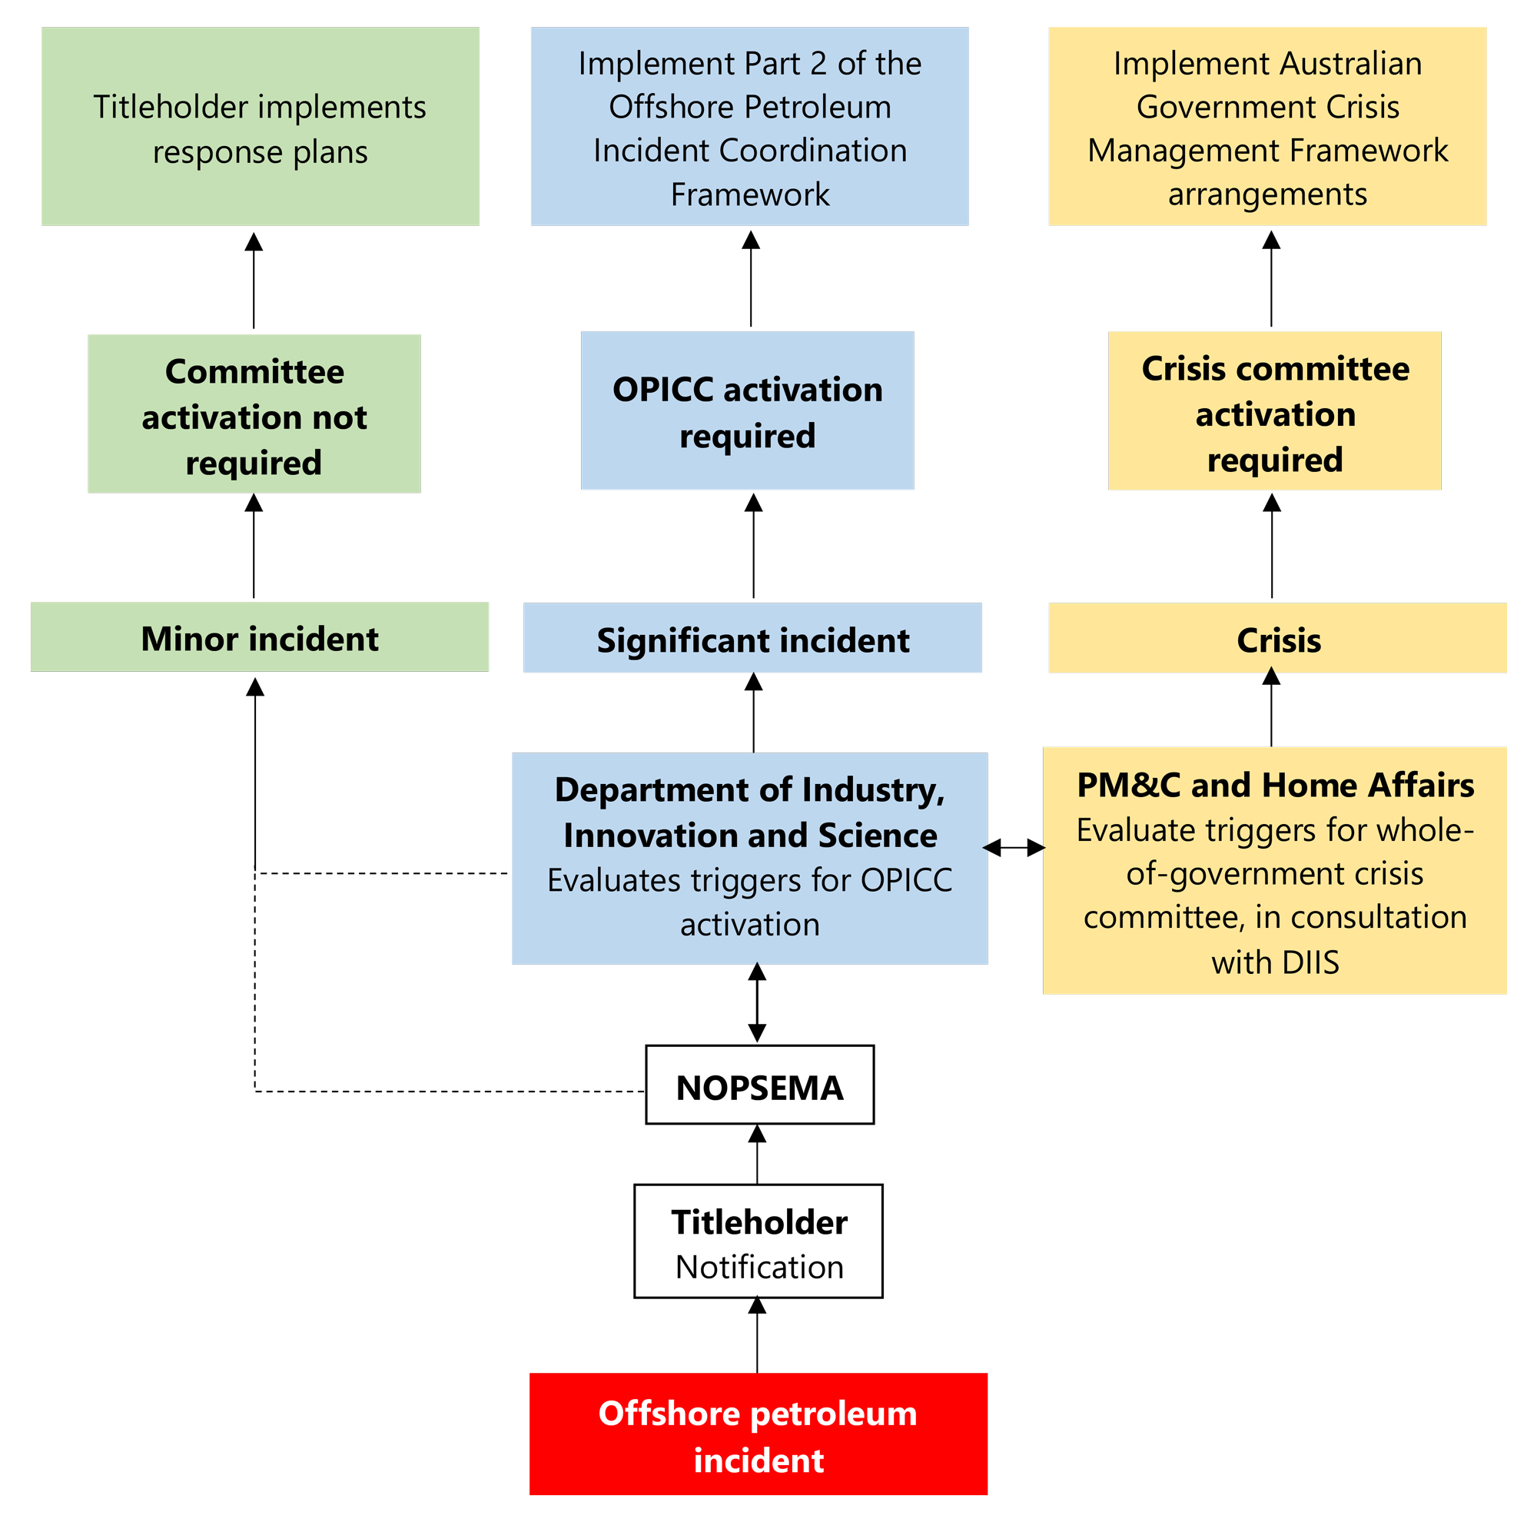

**Figure 2 Process for activation of OPICC or whole-of-government crisis committee**

## 1.6 Coordination with other agencies and jurisdictions

It is possible that various aspects of an offshore petroleum incident may cut across the jurisdictional and legislative authority of multiple agencies and/or governments. This section identifies the primary ways in which this Framework can interface with the arrangements of other agencies and jurisdictions, including titleholders’ Oil Pollution Emergency Plans (OPEP), the National Plan, other whole-of-government crisis management plans, and state or Northern Territory marine pollution contingency plans as appropriate.

### 1.6.1 Maritime incidents

In the event of an offshore petroleum incident, the titleholder has responsibility for the operational response. In the event of a maritime environmental emergency (such as pollution from a vessel), AMSA has responsibility for the operational response. It is important that the Framework takes into consideration areas in which the offshore petroleum and maritime regimes may intersect, and provides guidance on the steps to be taken to ensure a seamless interface between relevant Commonwealth Government agencies.

Throughout an offshore petroleum project, there are points at which the offshore petroleum and maritime regimes interface. For example, seismic surveys are undertaken by vessels for the purposes of petroleum exploration operations, and petroleum production activities are undertaken by facilities such as floating production storage and offloading (FPSO) units that can, in some circumstances, meet the definition of a ship.

Furthermore, in the event of an offshore petroleum incident, a situation may arise where AMSA’s assistance is required for search and rescue services, or where the titleholder requests the services of AMSA to assist in its operational response under the cooperative arrangements of the National Plan.

In the event of an incident in Commonwealth waters incorporating both an offshore petroleum incident and a maritime environmental emergency involving a ship, one strategic committee will be formed to coordinate the actions of the Commonwealth Government. The Department of Infrastructure, Regional Development and Cities, DIIS, NOPSEMA, AMSA, PM&C and Home Affairs (through Emergency Management Australia) will liaise at the earliest opportunity to determine which committee (the OPICC, the Maritime Emergency Strategic Coordination Committee, or a whole-of-government crisis committee) is most appropriate to manage the incident and to agree on a delineation of responsibilities.

A Maritime Emergency Strategic Coordination Committee (MESCC) led by AMSA, is formed in the event of a significant maritime environmental emergency involving a ship within the Commonwealth marine area, or where the Commonwealth Government is supporting a state or Northern Territory under the National Plan arrangements. More information on the MESCC can be found in the Australian Government Coordination Arrangements for Maritime Environmental Emergencies[5].

Where responsibility for strategic management of the incident must transition from one committee or agency to another, this will occur gradually with full communication and agreement between the agencies involved.

### 1.6.2 Maritime counter-terrorism incidents

Where it is evident that the cause of the incident is an act of terrorism, the National Counter-Terrorism Plan assigns Maritime Border Command responsibility for coordinating the whole-of-government response to an offshore incident. The Minister for Home Affairs is the responsible Minister under the AGCMF. If the act of terrorism involves an offshore petroleum incident, the Department of Home Affairs will activate the Australian Maritime Counter Terrorism Response Concept 2019. DIIS may assist with the coordination of activities relating specifically to the offshore petroleum-related aspects of the event.

In the event that a terrorism-related incident results in an ongoing offshore petroleum incident, such as an uncontrolled release of hydrocarbons, arrangements described in this Framework will apply when the terrorism-related threat has been resolved.

### 1.6.3 Cross-jurisdictional incidents

The OPGGS Act requires titleholders to remediate all impacts on the environment, including where those impacts cross jurisdictional boundaries from Commonwealth waters into coastal waters and impacts onshore areas and the shoreline. The OPGGS Environment Regulations require that a titleholder consult with relevant persons, including relevant states and territory governments, in the preparation of its environment plan and OPEP. States and territory governments should advise titleholders of their expectations for incident response arrangements during this consultation phase.

As described in the National Plan, the Control Agency is the agency or company assigned by legislation, administrative arrangements or within the relevant contingency plan to control response activities to a maritime environmental emergency. For oil and gas activities taking place in Commonwealth waters, the titleholder is the responsible Control Agency for all operational aspects of oil spill response. NOPSEMA is the jurisdictional authority with responsibility for regulating the titleholder’s response to the incident.

Where an incident impacts upon coastal waters, the relevant state or territory government may decide to assume the role of Control Agency for the elements of the response that take place within coastal waters and on the shoreline. Should this occur, there will be two Control Agencies, with the titleholder being the Control Agency for the response taking place in Commonwealth waters and the state or territory government the Control Agency for the response taking place in coastal waters.

In addition to the requirements under the OPGGS Act to clean up escaped petroleum and remediate the environment, the titleholder is required to submit an OPEP to NOPSEMA. The OPEP must describe the titleholder’s arrangements for responding to and monitoring oil pollution, and the titleholder is required to carry out this plan in the event of an environmental incident. The elements of the operational response carried out in coastal waters and onshore may be under the control of the relevant state or territory government should they assume the role of the Control Agency.

Figure 3 depicts the strategic response structure for offshore petroleum incidents in Commonwealth waters (3a) and how coordination between the Commonwealth and a state or territory jurisdiction may operate in the event of a cross jurisdictional incident (3b). The Commonwealth strategic coordination group referenced in 3a will change depending on the severity of the incident, as described in section 1.4.

In accordance with both the National Plan and the Inter-Governmental Agreement on the National Plan to Combat Pollution of the Sea by Oil and other Noxious and Hazardous Substances[6], jurisdictions appoint a State Marine Pollution Controller/Coordinator with overall responsibility for ensuring that a response to marine pollution incidents within their relevant jurisdiction is managed and coordinated appropriately. This includes providing strategic management of the response, including provision of support to the Incident Controller in coordinating the delivery of all available combat resources both in Australia and, where necessary, from overseas.

The nominated State Marine Pollution Controller/Coordinator has authority to direct response and clean up arrangements at a management level and will be responsible for high level liaison with state or territory ministers as well as senior government and industry representatives.

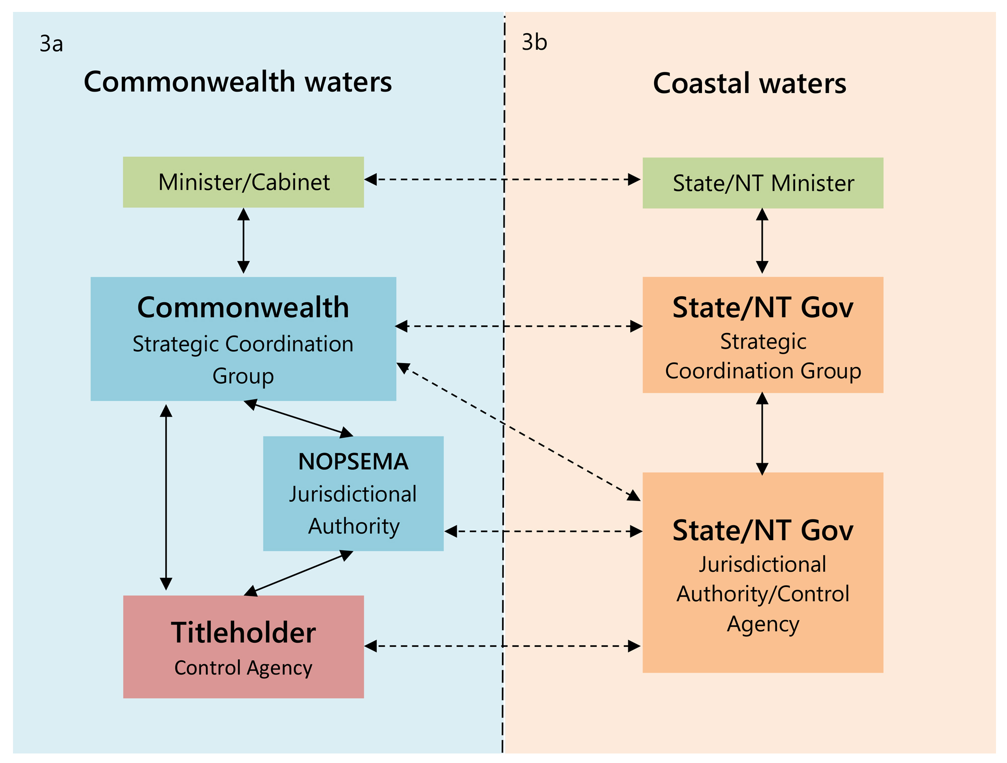

Figure 3 Offshore Petroleum Strategic Response Structure

## 1.7 Liaison Officers

Liaison Officers are responsible for communicating and coordinating activities between relevant parties. In contrast with OPICC and whole-of-government crisis committee members, Liaison Officers will be officers at the working level, expected to be readily available and capable of providing information and advice.

### 1.7.1 Commonwealth Government Liaison Officers

To ensure the timely and effective flow of information between Commonwealth Government agencies, Liaison Officers from relevant agencies may be requested to work with DIIS or the CCC to:

* contribute to situational awareness
* provide information held by the Liaison Officer’s home agency
* provide advice based on their area of subject matter expertise
* facilitate communication and cooperation
* identify and correct problems in inter-agency communication.

A Commonwealth Government Liaison Officer must be authorised to represent their agency’s views, but should not replace their agency’s representative on the OPICC or whole-of-government crisis committee.

NOPSEMA will gather information about the incident and operational response through a range of regulatory activities and direct liaison with the titleholder, making NOPSEMA’s role crucial in establishing situational awareness. In the event of a significant incident or crisis, NOPSEMA will be requested to designate a Liaison Officer to provide situational awareness and regulatory advice to inform briefing and planning activities. The NOPSEMA Liaison Officer must be in addition to the NOPSEMA OPICC or whole-of-government crisis committee member(s).

### 1.7.2 State/Territory Government Liaison Officer

To facilitate communication between the OPICC or whole-of-government crisis committee and the state or territory government(s) involved in the incident response, the relevant state/territory government agency may be requested to appoint a Liaison Officer. Dependent on available state/territory staffing resources and the nature and severity of the incident, a Commonwealth Liaison Officer may instead be appointed to the state or territory’s relevant coordination group.

DIIS will also appoint a Liaison Officer to the state/territory, who may be deployed to the state or territory’s relevant coordination group depending on the severity of the incident.

### 1.7.3 Titleholder Liaison Officer

In order to gain and maintain situational awareness, DIIS will request frequent situation reports from the titleholder. The titleholder may be asked to appoint a Liaison Officer to the Commonwealth Government from the work area the titleholder deems most appropriate, to provide detailed updates on the incident.

DIIS may make a request to deploy a Liaison Officer to the titleholder, especially during a crisis, to support the efficient and rapid exchange of information.

# PART 2: SIGNIFICANT INCIDENT ARRANGEMENTS

A significant incident may have an impact on human health and safety and on the environment and wildlife surrounding the incident, but the scope of the incident does not constitute a crisis. In the event of a significant incident, the Minister for Resources and Northern Australia is the lead Commonwealth Minister and the Department of Industry, Innovation and Science is the lead Commonwealth agency. The OPICC, supported by DIIS, will be used as the primary mechanism through which to facilitate coordinated strategic leadership.

## 2.1 Purpose of the OPICC

The purpose of the OPICC is to draw together expertise and capability from across government to guide a coordinated Commonwealth Government response to an offshore petroleum incident in Commonwealth waters deemed to be a significant incident.

## 2.2 Responsibilities of the OPICC

The OPICC has the following responsibilities:

* *Situational awareness:* provide an accurate and unified picture of the significant incident and the Commonwealth Government’s, state and territory governments’ and industry’s capacity to respond
* *Advice:* inform and align advice to ministers, through portfolio agencies, on the status of the incident and possible response options
* *Public information*: ensure a coordinated approach to communications management to support consistent messaging
* *Leadership*: provide strategic direction from the Commonwealth Government during and following an incident
* *Assistance:* liaise with the titleholder to provide advice on Commonwealth Government capabilities and regulatory processes
* *Evaluation:* to monitor and evaluate the effectiveness of the OPICC’s activities in relation to public and ministerial expectations.

## 2.3 Out of scope

The OPICC does not take responsibility for leading the operational response to an incident. Incident control and deploying operational resources is the responsibility of the Control Agency (which will be the titleholder in Commonwealth waters and may be the titleholder or the relevant state or territory government within coastal waters) and shall be coordinated in accordance with the titleholder’s OPEP and other regulatory documents.

The OPICC cannot assume any regulatory responsibilities, which remain at all times with the relevant regulatory agencies.

The OPICC does not have decision-making powers to allocate funding to any activities occurring as a result of a significant incident.

## 2.4 Committee operation

### 2.4.1 Activation

DIIS is responsible for activating the OPICC. The decision to activate will be made by the General Manager, Offshore Resources Branch, in consultation with other relevant agencies and regulators. The Environment, Safety and Security Team within Offshore Resources Branch will act as the central point of working-level contact once the OPICC has been convened.

### 2.4.2 Notification

Member agencies will be notified about OPICC activation via email, telephone and/or text message according to the OPICC contact details provided to DIIS.

### 2.4.3 Format

Meetings will run in a similar style to other Commonwealth Government interdepartmental committees.

The OPICC will meet as frequently as deemed necessary to provide the most effective coordination. The OPICC Chair will determine the frequency of meetings in consultation with OPICC members. It is anticipated that on initial activation the OPICC will meet daily.

The OPICC will remain active during the recovery phase through to the return of Commonwealth Government agencies to normal business, including debriefing and reporting.

### 2.4.4 Documentation

DIIS is responsible for circulating relevant OPICC documentation, including meeting agendas prior to the OPICC meetings, minutes and actions arising.

## 2.5 OPICC Membership

The OPICC is chaired by DIIS. Membership of the OPICC includes senior representatives from relevant government agencies and industry representatives where appropriate. The exact OPICC composition will be determined by the Chair depending on the nature of the significant incident.

OPICC members should be at the Assistant Secretary/General Manager level (SES Band 1). Where agencies nominate an alternative member of a lower level, these members must be able to make decisions on behalf of their agency.

OPICC members are asked to bring only those staff critical to the proper functioning of the committee meetings. Each agency will be restricted to a maximum of three attendees, unless otherwise agreed with DIIS.

Attendance via videoconference or teleconference will be facilitated for interstate members. As the significant incident develops, its nature, scale and predicted duration will assist in determining whether meeting attendance in person is required.

OPICC member agencies may include:

* Department of Industry, Innovation and Science (Chair)
* National Offshore Petroleum Safety and Environmental Management Authority
* Department of the Prime Minister and Cabinet
* Australian Maritime Safety Authority
* Department of Home Affairs (specifically the Australian Government Crisis Coordination Centre)
* Department of the Environment and Energy
* State/Territory Government(s) impacted or potentially impacted by the significant incident.

As the significant incident progresses, the membership may change to meet the specific demands that arise, including the addition of members to address specific issues; or standing down of members who do not have a direct interest or role in the significant incident.

The responsible Titleholder may also be invited to attend OPICC meetings.

Summaries of relevant Commonwealth Government agencies’ roles and functions during an offshore petroleum incident are outlined at Appendix B: Capabilities of Commonwealth Government Agencies. Relevant Commonwealth legislation underpinning the functions of these agencies is at Appendix C: Legislation and Policy Responsibilities.

### 2.5.1 OPICC Agency Responsibilities

OPICC members are primarily responsible for providing information and advice in support of the OPICC’s roles and responsibilities. Each member will provide advice to the OPICC based on their function, area of expertise and legislative powers. OPICC agencies with regulatory powers may provide advice to the OPICC and to the titleholder on how to most effectively and expediently navigate regulatory processes.

Members are the primary conduit between the OPICC and their agencies and are responsible for disseminating information and coordinating activities within their own agency on an as-needed basis. This includes the implementation of actions arising from OPICC meetings.

Agencies will meet the cost of their attendance at meetings and involvement with the OPICC.

### 2.5.2 State and Territory Involvement

Relevant state or territory governments will be invited to join the OPICC based on the impacts or potential impacts that the incident may have on that jurisdiction. Jurisdictions will be responsible for nominating an appropriate representative to the OPICC who is able to carry out the responsibilities described above. The OPICC will liaise with equivalent arrangements in the relevant jurisdiction as appropriate (refer section 1.6.3 for further information on cross jurisdictional incidents).

State and territory government members may be asked to provide regular situational updates to ensure that the OPICC has an accurate understanding of the significant incident and its impacts on the state/territory jurisdiction. In turn the OPICC will ensure that the state/territory jurisdiction receives accurate and up-to-date information on Commonwealth Government activities.

## 2.6 Communications

During an offshore petroleum incident, the Commonwealth Government will be expected to provide reliable and up-to-date information about the situation to the public and all relevant stakeholders. This will include providing information on what is happening, why it is happening, what can be done and what is being done to address the situation. Coordination across government and a genuine and transparent approach will be crucial to effectively communicating this information and building public confidence in the response.

It is the role of the Commonwealth Government to coordinate and distribute reliable and consistent information regarding the incident and response activities taking place in Commonwealth waters to ensure the public is informed. During a significant incident, DIIS will take the lead for the Commonwealth Government in coordinating communications activities.

DIIS will not provide public safety warnings or supersede the responsibilities of state/territory or local government jurisdictions. DIIS will, on behalf of the Commonwealth Government, seek to coordinate messages with other jurisdictions so that public messaging does not contradict or cause confusion.

Where a state or territory government has assumed the role of Control Agency within coastal waters, that jurisdiction will be expected to provide updates to the public on the status of operational response activities within its span of control.

If a significant incident occurs, DIIS will implement a pre-prepared communications strategy on behalf of the Commonwealth Government to ensure that agencies coordinate and harmonise their public information activities, without impeding, duplicating or complicating the work of immediate response agencies.

The communications strategy will identify:

* objectives for the communications strategy
* primary and secondary audiences for communication activities
* key messages for those audiences
* communication methods and platforms
* media handling strategy
* government spokespeople
* processes and protocols governing the strategy’s implementation
* timeline of communication activities
* tactics required to support the communications strategy
* key communications contacts in the event of an incident.

Other jurisdictions retain responsibility for their own communication plans, products, activities and stakeholder liaison.

# PART 3: CRISIS ARRANGEMENTS

A crisis will have wide ramifications for Australia which may include impacting both Commonwealth and state or territory jurisdictions, implications for other nations, human casualties, or a severe impact on other industry sectors.

In the event of a crisis, the coordination of the Commonwealth response will be escalated to whole-of-government crisis committee arrangements, and the OPICC will not be convened. However, DIIS will remain the lead agency as defined by the AGCMF, and play a key role in supporting the whole-of-government crisis committee and the CCC.

## 3.1 Role of the Department of Industry, Innovation and Science

In the event of a crisis, DIIS will take the lead role in establishing situational awareness for the Commonwealth, through close liaison with the titleholder, relevant Commonwealth agencies including NOPSEMA in particular, and the relevant state or territory jurisdiction. This will be undertaken by a working-level team within DIIS. This team may include Liaison Officers from other relevant government agencies if required. The team will work closely with the CCC to support the whole-of-government crisis committee and ensure the efficient flow of information between relevant stakeholders.

The Minister for Resources and Northern Australia or the Prime Minister, as appropriate, will remain the lead Commonwealth spokesperson for the crisis.

## 3.2 Role of the Department of Home Affairs

Home Affairs, through the CCC, will take the lead for coordinating information, activities and communications across the Commonwealth Government during a crisis, with support from DIIS.

Planning will be led by the CCC’s Crisis Coordination Team (CCT), which will include staff from Home Affairs, and seconded staff from DIIS, NOPSEMA, AMSA, and other agencies as required. The CCT will identify where Commonwealth resources and capability should be directed to achieve the best possible results in addressing the crisis.

Where the public information response is broader than responsibilities managed by DIIS, the Home Affairs Media and Engagement Branch (Crisis Communications) will coordinate the Commonwealth Government’s whole-of-government public communications response. The Home Affairs team will be supported and augmented by DIIS and other agencies in the whole-of-government crisis committee. This coordinating role will not require the Home Affairs Crisis Communications team to take responsibility for responding to media enquiries on behalf of other agencies.

It will not be the responsibility of the CCC to provide public safety warnings or supersede the responsibilities of state/territory or local government jurisdictions.

## 3.3 Role of other Commonwealth agencies

Subject matter and procedural expertise from other Commonwealth agencies will be crucial to the effective management of situational awareness, planning and communications. Commonwealth agencies may be requested to provide staff to these functions within DIIS and the CCC, where the issues being raised and considered through those functions is relevant to that agency’s responsibilities.

## 3.4 Whole-of-government crisis committee

### 3.4.1 Purpose

The purpose of the whole-of-government crisis committee will be to guide a coordinated Commonwealth Government response to crisis arising from an offshore petroleum incident. This committee will be the AGCC for crises involving only the Commonwealth Government, or the NCC for crises where coordination and cooperation between the Commonwealth and the relevant state(s) and territory government(s) is required.

### 3.4.2 Responsibilities

As outlined in the AGCMF, the whole-of-government crisis committee will provide:

* *Situational awareness:* supports information sharing and provides senior officials with an accurate and unified picture of the crisis and response activities
* *Advice and support:* enables senior officials to provide ministers and key decision making bodies with status updates and resources to support ministerial decision making
* *Communication strategy:* supports consistent messaging and information sharing; execute crisis plans; and support and maintain public safety and confidence
* *Strategic coordination:* provides high level linkage; and ensures that ministerial directions are effectively implemented across government, including with the states and territories, and with affected industry and the community, where required.

### 3.4.3 Out of scope

Similar to the OPICC (refer section 2.3), the AGCC or NCC will not take the lead for operational response, cannot assume regulatory responsibilities and do not have decision-making powers to allocate funding to any activities occurring. However, agencies that comprise the committee will report on and coordinate their operational and regulatory activities.

### 3.4.4 Committee operation

*Activation*

The decision to convene the AGCC or NCC in the event of an offshore petroleum incident will be made by the agencies that chair those committees, Home Affairs and PM&C, with advice from DIIS. Triggers for activating a whole-of-government crisis committee are discussed in section 1.5.3 of this Framework. Home Affairs will provide secretariat support to the whole-of-government crisis committee.

To avoid duplication of effort, when a whole-of-government crisis committee is activated, the OPICC will not be convened. In the event that the whole-of-government crisis committee is stood down as the crisis de-escalates, the OPICC may be convened to coordinate government actions and communications during ongoing recovery efforts.

*Notification*

The CCC will be responsible for notifying relevant Commonwealth Government agencies if a whole-of-government committee is activated.

*Format*

The composition of the whole-of-government crisis committee will be determined by the Chair depending on the nature of the incident. The whole-of-government crisis committee will meet as frequently as deemed necessary.

*Documentation*

The CCC is responsible for circulating relevant documentation prior to whole-of-government crisis committee meetings. The CCC will be supported by Liaison Officers from DIIS in addition to Liaison Officers from other relevant agencies as required.

# PART 4: REVIEW, EXERCISE AND DEVELOPMENT

## 4.1 Review

The Framework will undergo a desktop review following the activation of the OPICC or whole-of-government crisis committee but not less frequently than every 24 months. This process will be overseen by DIIS in consultation with relevant agencies.

The list of relevant Commonwealth Government agencies at Appendix A will be updated annually by DIIS in consultation with these agencies.

DIIS will contact OPICC member agencies biannually requesting any updates for the contact list. Where there has been a change of staff within OPICC member agencies, notification of the new incumbent and their contact details should be provided as soon as possible to ensure an accurate, up-to-date contact list is available in the event of an offshore petroleum incident.Updated contact details can be emailed to [opicc@industry.gov.au](mailto:opicc@industry.gov.au).

## 4.2 Exercise and development

The arrangements in this Framework will be exercised with participants from key agencies at least every two years. DIIS will coordinate these exercises with other government or industry exercises where possible.

DIIS will also undertake small-scale exercises on a regular basis to practice and validate the critical components of the Framework and associated crisis management system.

In order to build and maintain the capability of the OPICC and relevant DIIS staff to manage the strategic response to a significant incident and contribute to the management of a crisis, DIIS will participate in training and development activities which may include but are not limited to:

* workshops or seminars on strategic issues related to managing crises such as offshore petroleum incidents
* workshops for relevant DIIS staff on topics related to implementing a Commonwealth Government response to an offshore petroleum incident.

# Appendix A: Stakeholder List

Offshore Petroleum Incident Coordination Framework stakeholders.

| **Agency** | **Stakeholders** |
| --- | --- |
| Minister for Resources and Northern Australia | Minister  Chief of Staff and Advisors  Departmental Liaison Officer  Media Adviser |
| Department of Industry, Innovation and Science | Secretary  Deputy Secretary  Chief Operating Officer  Chief Financial Officer  General Counsel  General Manager, Communications Branch |
| Department of Industry, Innovation and Science – Resources Division | Head of Division  General Manager, Offshore Resources Branch  Manager, Environment, Safety and Security Section |
| Department of Industry, Innovation and Science – National Offshore Petroleum Titles Administrator (NOPTA) | Titles Administrator |
| National Offshore Petroleum Safety and Environmental Management Authority (NOPSEMA) | Chief Executive Officer  Head of Division, Environment  Head of Division, Safety and Integrity  Head of Division, Regulatory Support |
| Australian Maritime Safety Authority (AMSA) | Chief Executive Officer  Deputy Chief Executive Officer  General Manager, Response Division |
| Geoscience Australia | Chief Executive Officer  Chief, Environmental Geoscience Division  Branch Head, National Earth and Marine Observations  Branch Head, Resources Advice and Promotion |
| Department of the Environment and Energy | Deputy Secretary, Environment Protection  First Assistant Secretary, Corporate Strategies Division, and Chief Operating Officer  Assistant Secretary, Communications & Engagement Branch |
| Department of Home Affairs | Director General, Emergency Management Australia  Assistant Secretary, Crisis Management Branch  Deputy Commissioner, Support  Deputy Commissioner, Operations  Deputy Secretary, Visa and Citizenship Services |
| Department of the Prime Minister and Cabinet | Deputy Secretary, Economic & Strategy  Deputy Secretary, National Security  First Assistant Secretary, Industry, Infrastructure and Environment  First Assistant Secretary, National Security Division  Assistant Secretary, Environment, Energy and Climate Change  Assistant Secretary, National Security Division |
| Department of Infrastructure, Regional Development and Cities | Deputy Secretary  Executive Director, Surface Transport Policy  General Manager, Maritime and Shipping Branch (STP) |
| Department of Foreign Affairs and Trade | Deputy Secretary  First Assistant Secretary, South-East Asia Maritime Division  Assistant Secretary, Papua New Guinea and Fiji Branch  Assistant Secretary, International Legal Branch |
| Australian Fisheries Management Authority | Chief Executive Officer |

# Appendix B: Capabilities of Commonwealth Government Agencies

| **Agency** | **Resource** |
| --- | --- |
| Australian Border Force (ABF) | The ABF provides maritime and aviation search and surveillance support to AMSA as requested and within Maritime Border Command (MBC) operational capabilities, and border facilitation of international assistance (resources and equipment). The 24/7 Border Operations Centre in Canberra can expedite entry of overseas personnel and equipment, if required. |
| Australian Fisheries Management Authority (AFMA) | AFMA manages and monitors commercial fishing in Commonwealth waters, and has the power to close fisheries within Commonwealth jurisdiction that may be threatened by pollution, such as that resulting from an offshore petroleum incident. |
| Australian Maritime Safety Authority (AMSA) | AMSA maintains a 24/7 Rescue Coordination Centre with an aviation and maritime communication capability and picture for search and rescue planning and response. This includes air drop capability over land and sea and Distress Beacon locating over land, sea, ice and air. AMSA also provides marine pollution identification, monitoring and dispersal, maritime ship casualty response and emergency towage and the promulgation of Maritime Safety Information.  AMSA holds memoranda of understanding with most offshore petroleum titleholders within Commonwealth waters to provide operational assistance in the event of an offshore petroleum incident. |
| Department of the Environment and Energy (DoEE) | The roles of the department in maritime environmental emergencies flow from the legislation it administers, notably the *Environment Protection and Biodiversity Conservation Act 1999* (EPBC Act) and the *Environment Protection (Sea Dumping) Act 1981* (Sea Dumping Act).  DoEE can provide information on environmental and heritage values in the marine environment, including Australian Marine Parks and World Heritage Areas. |
| Department of Home Affairs | The Department of Home Affairs chairs the Australian Government Crisis Committee and the National Crisis Committee (note, the Deputy Secretary of the Department of the Prime Minister and Cabinet may chair or co-chair these committees). In the event of an offshore petroleum incident, the department may also be involved in advising on visa matters.  Within Home Affairs, Emergency Management Australia (EMA) maintains 24/7 all-hazards situational awareness and monitoring through the Australian Government Crisis Coordination Centre (CCC). This includes the coordination of physical assistance as well as briefing and support to executive decision-makers in the Australian Government, the state and territory governments and non-government agencies.  In the event of a crisis, the CCC will provide support to a whole-of-government crisis committee and lead the planning and communications activities for the Commonwealth Government.  Within Home Affairs, Aviation and Maritime Security is the Australian Government’s preventive security regulator for the aviation and maritime sectors, and its primary adviser on transport security. Aviation and Maritime Security works with the states and territories; other government agencies; international governments and bodies; and the aviation and maritime industry to improve security and prevent transport security incidents. |
| Department of Industry, Innovation and Science (DIIS) | DIIS is responsible for convening the OPICC in the event of an offshore petroleum significant incident in Commonwealth waters. Within the department, the National Offshore Petroleum Titles Administrator (NOPTA) may provide advice relating to titles, resource management issues, and technical matters to the OPICC. |
| Department of the Prime Minister and Cabinet (PM&C) | In the event of an offshore petroleum incident, PM&C will coordinate the Prime Minister’s involvement (if any) in communications relating to the incident. In the case of escalation to a whole-of-government crisis response, PM&C may chair the relevant whole-of-government crisis committee. |
| Geoscience Australia (GA) | Upon activation of the OPICC, GA, as Australia’s national geoscience agency, will make best efforts to provide resources, technical advice and expertise relating to satellite imagery, mapping capabilities, and biogeochemical and other geoscientific information. |
| National Offshore Petroleum Safety and Environmental Management Authority (NOPSEMA) | Under the OPGGS Act and regulations, NOPSEMA is the regulator for occupational health and safety, structural integrity and environmental management of offshore petroleum facilities in Commonwealth waters, and in coastal waters where state and Northern Territory powers have been conferred.  NOPSEMA is responsible for monitoring and securing compliance of a duty holder’s response to an incident. In addition to its assessment and inspection functions, NOPSEMA has a range of powers it may choose to use in the event of an offshore petroleum incident, including powers to issue environmental and occupational health and safety prohibition notices and a general power to give directions to a registered titleholder and to give remedial directions to titleholders in relation to restoration of the environment (powers also available to the responsible Commonwealth Minister). NOPSEMA also has a power to give directions to a titleholder in the event of an offshore petroleum incident to prevent, eliminate, mitigate, manage and remediate the effects of the escape of petroleum. |

# Appendix C: Legislation and Policy Responsibilities

The implementation of this plan is consistent with the following Commonwealth legislation:

|  |
| --- |
| *Offshore Petroleum and Greenhouse Gas Storage Act 2006*  (and regulations) |
| Responsibility |
| DIIS as the policy holder and responsible for administering the Act.  NOPSEMA as responsible for the administration of provisions governing OH&S, well operations and environmental management.  NOPTA as responsible for assisting and advising the Joint Authority and the responsible Commonwealth Minister, keeping registers of titles and data and information management. |
| Description |
| Sets up a regulatory framework for:   1. petroleum exploration and recovery 2. the injection and storage of greenhouse gas substances in offshore areas under Commonwealth jurisdiction   The OPGGS Act provides for the granting of specific licences to titleholders and the monitoring and enforcement of licence provisions by the relevant authorities. The OPGGS Act is supported by regulations covering safety, petroleum resource management, well operations and environmental management.  It also provides for the Commonwealth to direct titleholders to take specific actions in response to incidents of pollution, such as remedial actions (i.e. clean‑up), monitoring of impacts and reimbursement of costs to NOPSEMA or the Commonwealth. |
|  |
| *Environment Protection and Biodiversity Conservation Act 1999* (EPBC Act) |
| Responsibility |
| Department of the Environment and Energy as the policy holder.  NOPSEMA as responsible for the administration and regulation of offshore petroleum activities. |
| Description |
| Regulates activities impacting on defined matters of national environmental significance (MNES), Commonwealth marine reserves and species listed under the Act. Offshore petroleum activities that are likely to significantly impact MNES require assessment under the EPBC Act.  As part of this approval process conditions may be attached to an approval requiring the titleholder/operator to protect, repair or mitigate damage to MNES. Previously, an exemption has been granted for oil spill response activities undertaken in accordance with the National Plan for Maritime Environmental Emergencies.  The EPBC Act also includes a range of coercive powers as well as criminal, civil and administrative sanctions for breaches of the Act. |
|  |
| *Australian Maritime Safety Authority Act 1990* |
| Responsibility |
| Department of Infrastructure, Regional Development and Cities as the policy holder, AMSA as the regulator. |
| Description |
| Sets out AMSA’s powers and responsibilities. |
|  |
| *Environment Protection (Sea Dumping) Act 1981 (Sea Dumping Act)* |
| Responsibility |
| Department of the Environment and Energy  In February 2014, following a strategic assessment under Part 10 of the EPBC Act, the Commonwealth Environment Minister handed responsibility for environmental regulation of offshore petroleum activities to NOPSEMA. |
| Description |
| Aims to minimise marine pollution threats by prohibiting ocean disposal of waste considered too harmful to be released in the marine environment and regulating permitted waste disposal to ensure environmental impacts are minimised. The Act also fulfils Australia's obligations under the Protocol to the Convention on the Prevention of Marine Pollution by Dumping of Wastes and Other Matter. |
|  |
| *Maritime Powers Act 2013* (MP Act) |
| Responsibility |
| Department of Home Affairs |
| Description |
| The MP Act establishes a system of authorisations under which a maritime officer may exercise enforcement powers in the maritime domain. The comprehensive powers are available to enforce a diverse range of Australia’s maritime laws, including in relation to illegal foreign fishing, customs, migration, quarantine and drug trafficking, as well as international agreements and arrangements at sea.  Assets assigned to Maritime Border Command conduct law enforcement activities on behalf of other Australian Government agencies exercising powers under this Act. |
|  |
| *Fisheries Management Act 1991* |
| Responsibility |
| Department of Agriculture and Water Resources |
| Description |
| Assets assigned to Maritime Border Command conduct law enforcement activities on behalf of other Australian Government agencies exercising powers under this Act. |
|  |
| *Customs Act 1901* |
| Responsibility |
| Australian Border Force |
| Description |
| The Customs Act establishes authorisations under which a Border Force officer is able to aid the lawful passage of goods, vessels, aircraft and people to and from the response area. |
|  |
| *Migration Act 1958* |
| Responsibility |
| Department of Home Affairs |
| Description |
| The Migration Act establishes authorisations under which a Border Protection officer is able to aid the lawful passage of people to and from Australia. |

## 

# Appendix D: Terminology and Acronyms

## Terminology

| **Term** | **Description** |
| --- | --- |
| Incidents | |
| Minor incident | A minor incident is an incident that can be managed by the titleholder through first-strike operational response actions with no lasting impacts on the environment or human health and safety. In this situation, normal regulatory and enforcement processes will be implemented by NOPSEMA. The OPICC and whole-of-government crisis committees will not be required and are not activated. |
| Significant incident | A significant incident has wider implications than an incident and may involve a greater impact to the surrounding environment and wildlife, and/or to human health and safety. The operational response will extend beyond the titleholder’s first strike capability and will likely need to draw upon domestic contracts and capability. The titleholder will be expected to work with the relevant state/territory jurisdictions and the Commonwealth to share information, and, where necessary, coordinate response activities.  Commonwealth activities led by the Offshore Petroleum Incident Coordination Committee. |
| Crisis | A crisis has wider ramifications for Australia beyond the area surrounding the incident, such as impacts on multiple jurisdictions, implications for other nations, multiple casualties, ecological impacts and economic impacts such as a possible or known severe impact on other industry sectors such as fisheries and tourism.  Commonwealth activities led by a whole-of-government crisis committee. |
| Plans | |
| Environment Plan | A petroleum or greenhouse gas activity cannot commence before NOPSEMA has assessed and accepted an environment plan for that activity. The purpose of an environment plan is for the titleholder to identify the proposed petroleum activity’s potential impacts on and risks to the environment. The titleholder must set out control measures to reduce the identified environmental impacts and risks of the activity and describe how and to what standard of performance will those measures will be implemented and throughout the life of the activity including emergency situations. |
| Oil Pollution  Emergency Plan | An oil pollution emergency plan (OPEP) is prepared by titleholders and must include adequate arrangements to ensure that oil pollution response control measures can be implemented in a timely manner. Titleholders must have the capacity to meet obligations to clean up potential oil pollution and monitor oil pollution to inform response activities and environmental monitoring. The OPEP must also be consistent with the national system for oil pollution preparedness and response. |
| Safety Case | A safety case is a document produced by the facility operator to describe the facility, identify the hazards and risks, the risk controls and the safety management system which provides for the continual identification and assessment of hazards and how risks will be minimised10. A safety case is a sophisticated, comprehensive, integrated risk management system which must identify the safety-critical aspects of the facility, both technical and managerial, and defines appropriate performance standards for the operation of the safety-critical aspects. |
| Well Operations Management Plan | A well operations management plan (WOMP) must identify the technical and managerial aspects of managing the risks to integrity of wells, and must describe the well integrity control measures for any particular identified risk to collectively eliminate, or reduce the risk, to a level that is as low as is reasonably practicable. |
| Responders | |
| Control Agency | Agency or company assigned by legislation or within the relevant contingency plan to control response activities to a maritime environmental emergency. |
| Titleholder | A company that has been awarded an offshore title area under the *Offshore Petroleum and Greenhouse Gas Storage Act 2006.* |
| Committees | |
| Agency-led coordination committees | Agency-led coordination committees, such as the Offshore Petroleum Incident Coordination Committee (OPICC), are convened as a mechanism for a single Commonwealth agency (or agencies if a co-lead situation is necessary) to coordinate a response on behalf on the Commonwealth Government. Incidents that exceed these arrangements are escalated to a whole-of-government crisis committee. |
| Whole-of-government crisis committees | The three whole-of-government crisis response committees established by the Australian Government Crisis Management Framework are the Australian Government Crisis Committee (AGCC), Inter-Departmental Emergency Taskforce (IDETF) and National Crisis Committee (NCC). These committees provide situational awareness, advice and support, communication strategy and strategic coordination. |

## Acronyms

| Acronym | Description |
| --- | --- |
| ABF | Australian Border Force |
| AFMA | Australian Fisheries Management Authority |
| AGCC | Australian Government Crisis Committee |
| AGCMF | Australian Government Crisis Management Framework |
| AMSA | Australian Maritime Safety Authority |
| ANPM | Autoridade Nacional do Petróleo e Minerais |
| CCC | Australian Government Crisis Coordination Centre |
| DFAT | Department of Foreign Affairs and Trade |
| DIIS | Department of Industry, Innovation and Science |
| DoEE | Department of the Environment and Energy |
| EPBC Act | Environment Protection and Biodiversity Conservation Act 1999 |
| EMA | Emergency Management Australia |
| FPSO | Floating production storage and offloading |
| GA | Geoscience Australia |
| GHG | Greenhouse gas |
| JPDA | Joint Petroleum Development Area |
| MESCC | Maritime Emergency Strategic Coordination Committee |
| MBC | Maritime Border Command |
| NCC | National Crisis Committee |
| NOPSEMA | National Offshore Petroleum Safety and Environmental Management Authority |
| NOPTA | National Offshore Petroleum Titles Administrator |
| OPEP | Oil Pollution Emergency Plan |
| OPGGS Act | Offshore Petroleum and Greenhouse Gas Storage Act 2006 |
| OPICC | Offshore Petroleum Incident Coordination Committee |
| OPICF | Offshore Petroleum Incident Coordination Framework |
| PM&C | Department of the Prime Minister and Cabinet |

1. OPGGS Act 2006, Chapter 6, Part 6.1A – Polluter pays
2. Department of Foreign Affairs and Trade website, URL: <http://dfat.gov.au/geo/timor-leste/Pages/timor-leste.aspx>
3. National Plan supporting document NP-GUI-007, <https://www.amsa.gov.au/environment/national-plan/Supporting-Documents/>
4. Available at [www.amsa.gov.au](http://www.amsa.gov.au/)
5. Available at [www.amsa.gov.au](http://www.amsa.gov.au/)
6. <https://www.amsa.gov.au/forms-and-publications/MOUs/Nat-Plan/index.asp>