**NMI R 80-1 Road and rail tankers with level gauging**

Part 1: Metrological and technical requirements

May 2021

[www.measurement.gov.au](http://www.measurement.gov.au)

© Commonwealth of Australia (2014)

**NMI R 80-1**

First edition ­— November 2014

Second edition — May 2021

National Measurement Institute

Bradfield Road, Lindfield, NSW 2070

T: +61 2 8467 3600

F: +61 2 8467 3610

W: www.measurement.gov.au

1. **Scope**

NMI R 80-1 specifies the metrological and technical requirements for the pattern approval of road and rail tankers with level gauging.

1. **Contents**

NMI R 80-1:2021 is considered to be a **modified** adoption of OIML R 80-1:2009 *Road and rail tankers with level gauging. Part 1: Metrological and Technical Requirements* published by the International Organisation of Legal Metrology (OIML).

OIML’s international recommendation is published in three parts and the second and third parts have been adopted as the national standards NMI R 80-2 *Road and rail tankers with level gauging. Part 2: Metrological controls and tests* and NMI R 80-3 *Road and rail tankers with level gauging. Part 3: Report Format for type evaluation* respectively.

1. **Amendments and Interpretations**

Amendments and interpretations have been made to the 2009 version of OIML R 80-1. These are described in the table below. Substantive amendments to OIML R 80-1 have been made in blue text.

|  |  |
| --- | --- |
| Clause | Details |
| General | All references in this document to ‘this Recommendation’ shall be taken to refer to NMI R 80-1. |
| General | In Australia ‘type’ approval (or examination) is referred to as ‘pattern’ approval (or examination. The two terms refer to the same concept. This has not been marked as an amendment. |
| General | All references in this document to the ‘issuing authority’, ‘the approval body’, ‘the pattern evaluation body’ or ‘the body responsible for pattern evaluation’ shall be taken to refer to the Chief Metrologist. |
| General | All references in this document to the ‘verification authority’ shall be taken to be NMI, Trade Measurement Inspectors, Servicing Licensees and/or their employees. |
| General | Date references have been changed throughout the document as relevant. This has not been marked as an amendment. |
| 1.5 | The following text deleted “At the date of Part 1 publication, Part 2 and Part 3 are not available.” |
| 1.7 | The metrological and technical requirements specified in the NMI General Certificates of Approval for vehicle tanks may be applied as part of the pattern evaluation of systems approved in accordance with this Recommendation. |
| 5.1.1 | Inclusion of an alternative rated operating conditions with a temperature range of:  -10 °C to +55 °C |
| 5.1.5.a | For the purposes of pattern evaluation and approval in accordance with NMI R 80-1, the presence and use of temperature sensors and volume conversions are not considered mandatory requirements for the level gauging system.  Pattern approval applications **may** include temperature sensors and volume conversion functions within the scope of the pattern evaluation process. In this case, the requirements specified below shall be applied.  Certificates of Approval shall indicate whether or not volume conversion forms part of the approved pattern of the level gauging system.  Where volume conversions are required for the trade of certain products, they shall be calculated and applied appropriately. |
| 5.4.1.5 | The pattern evaluation of the level gauging system shall include an assessment of the sensitivity of measurement performance with respect to inclination. |

|  |  |
| --- | --- |
| International | **OIML R 80-1** |
| Recommendation | Edition 2009 (E) |

|  |
| --- |
| Road and rail tankers with level gauging |
| Part 1: Metrological and technical requirements |
|  |
| Camions et wagons citernes avec mesurage de niveau |
| Partie 1: Exigences métrologiques et techniques |

|  |  |  |  |
| --- | --- | --- | --- |
| OIML R 80-1 Edition 2009 (E) |  |  |  |
| "" |  | Organisation Internationale  de Métrologie Légale |
| International Organization  of Legal Metrology |

**Contents**

*Foreword* 4

1 Scope 5

2 Terminology 5

3 Classification and description 14

3.1 General 14

3.2 Construction of tanks 15

4 Units of measurement 17

5 Technical and metrological requirements 17

5.1 General 17

5.2 Container of the measuring tank 20

5.3 Additional devices 23

5.4 Level gauging system 25

5.5 Tank capacity table 28

5.6 Metrological requirements for indicating and ancillary devices 29

5.7 Additional requirements for measuring systems with electronics parts 32

6 Plates, documents and sealing 36

6.1 Identification plate 36

6.2 Measuring system document 36

6.3 Tank capacity plate on tanks with dispsticks scaled in non-volumetric units 37

6.4 Verification certificate 37

6.5 Seals 38

7 Bibliography 40

8 Index 41

Annex A Example for tankers with mechanical sensors (Informative) 45

Annex B Example for automatic measuring systems with electronic level gauging (Informative) 54

Annex C Examples for volume conversion – petroleum products and lubricants (Informative) 58

Annex D Examples for volume conversion - Liquefied petroleum gas (Informative) 60

Annex E Density and volume (of 1 kg) of distilled water (Informative) 61

**Foreword**

The International Organization of Legal Metrology (OIML) is a worldwide, intergovernmental organization whose primary aim is to harmonize the regulations and metrological controls applied by the national metrological services, or related organizations, of its Member States. The main categories of OIML publications are:

* **International Recommendations (OIML R),** which are model regulations that establish the metrological characteristics required of certain measuring instruments and which specify methods and equipment for checking their conformity. OIML Member States shall implement these Recommendations to the greatest possible extent;
* **International Documents (OIML D),** which are informative in nature and which are intended to harmonize and improve work in the field of legal metrology;
* **International Guides (OIML G),** which are also informative in nature and which are intended to give guidelines for the application of certain requirements to legal metrology; and
* **International Basic Publications (OIML B),** which define the operating rules of the various OIML structures and systems.

OIML Draft Recommendations, Documents and Guides are developed by Technical Committees or Subcommittees which comprise representatives from the Member States. Certain international and regional institutions also participate on a consultation basis. Cooperative agreements have been established between the OIML and certain institutions, such as ISO and the IEC, with the objective of avoiding contradictory requirements. Consequently, manufacturers and users of measuring instruments, test laboratories, etc. may simultaneously apply OIML publications and those of other institutions.

International Recommendations, Documents, Guides and Basic Publications are published in English (E) and translated into French (F) and are subject to periodic revision.

Additionally, the OIML publishes or participates in the publication of **Vocabularies (OIML V)** and periodically commissions legal metrology experts to write **Expert Reports (OIML E)**. Expert Reports are intended to provide information and advice, and are written solely from the viewpoint of their author, without the involvement of a Technical Committee or Subcommittee, nor that of the CIML. Thus, they do not necessarily represent the views of the OIML.

This publication - reference OIML R 80-1, edition 2009 (E) - was developed by the OIML Technical Subcommittee TC 8/SC 1 *Static volume and mass measurement*. It was approved for final publication by the International Committee of Legal Metrology in 2009 and will be submitted to the International Conference of Legal Metrology in 2012 for formal sanction. This Edition supersedes the previous edition of OIML R 80 (Edition 1989).

OIML Publications may be downloaded from the OIML web site in the form of PDF files. Additional information on OIML Publications may be obtained from the Organization’s headquarters:

Bureau International de Métrologie Légale

11, rue Turgot - 75009 Paris - France

Telephone: 33 (0)1 48 78 12 82

Fax: 33 (0)1 42 82 17 27

E-mail: biml@oiml.org

Internet: www.oiml.org

**Road and rail tankers with level gauging**

**Part 1: Metrological and technical requirements**

## 1 Scope

**1.1** This Recommendation specifies the metrological and technical requirements applicable to static measuring systems for volume of liquids subject to legal metrological controls. It also provides requirements for the approval of parts of the measuring systems.

It applies to tankers for the transport of liquid products by road and rail and used, in addition to their functions as carriers, as transportable measuring tanks. Examples are given in Annexes A and B.

**1.2** Tankers may be considered as measuring instruments for liquids of which the viscosity does not exceed 20 mPa.s at working temperature.

**1.3** This Recommendation is also applicable for measuring partial volume received or delivered.

**1.4** Essential metrological requirements of this Recommendation are in accordance with the relevant requirements of OIML R 117 *Measuring systems for liquids other than water* [3] referring to measuring systems with liquid meters used for the same purpose.

**1.5** In addition to the metrological and technical requirements included in this Part 1 (R 80-1) the methods of metrological controls and tests are given in Part 2 (R 80-2) and the test report formats in Part 3 (R 80-3).

**1.6** This Recommendation does not include any aspects with respect to safety (see also 5.2.1).

**1.7** The metrological and technical requirements specified in the NMI General Certificates of Approval for vehicle tanks may be applied as part of the pattern evaluation of systems approved in accordance with this Recommendation.

## 2 Terminology

The terminology used in this Recommendation conforms to the *International Vocabulary of basic and general terms in metrology* [1] and the *International Vocabulary of terms in legal metrology* [2]. In addition, for the purposes of this Recommendation, the following definitions apply.

**2.1 Transportable measuring tank**

Container, suitable for use as a volume measuring device for liquids, fixed on a truck (or on a railcar) or detachably connected to it, which may be subdivided into several measuring compartments.

*Note:* Hereafter referred to as measuring tank or tank.

**2.2 Static measuring system**

System that comprises a measuring tank, fitted with its ancillary and additional devices. Static measuring systems can also be utilized for measuring the quantity of the liquid in the tank such as the volume at working conditions or at base conditions.

*Note:* Hereafter referred to as measuring system.

**2.3 Ancillary device**

Device intended to perform a particular function, directly involved in elaborating, transmitting or displaying measurement results.

Examples of ancillary devices:

* zero setting device;
* repeating indicating device;
* printing device;
* memory device;
* price indicating device;
* conversion device.

**2.4 Additional device**

Part or device, other than an ancillary device, required to ensure correct measurement or intended to facilitate the measuring operations, or which could in any way affect the measurement.

Examples of additional devices:

* manifold;
* sampling device;
* gas indicator;
* sight glass;
* filter, pump;
* gas elimination device;
* device used for the transfer point;
* anti-swirl device;
* branches or bypasses;
* valves, hoses.

**2.5 Electronic part**

Any device, component or measuring element containing electronics.

## 

## 2.6 Nominal capacity (of the tank or compartment) (*V*n)

Volume indicated (marked) on the tank or its compartment.

*Notes:* 1. The nominal capacity value usually corresponds to the volume of liquid which a tank or compartment contains at reference temperature when filled up to the maximum permissible level or volume mark.

2. The nominal capacity value can be limited by safety regulations.

**2.7 Total capacity**

Maximum volume of liquid which a tank or compartment may contain up to overflowing, under rated operating conditions and at reference temperature.

**2.8 Expansion volume**

Difference between total and nominal capacity.

## 2.9 True volume (*V*t)

Conventional true value of volume of liquid in a tank or compartment at working temperature *t*.

**2.10 Indicated volume (*V*i)**

Value of volume provided by the volume measuring system.

**2.11 Error of indicated volume**

Difference between the indicated volume (*V*i) of the tank or compartment and the true volume (*V*t).

**2.12 Tank or compartment calibration (tank calibration)**

Set of operations to determine the capacity of a tank or compartment, using methods satisfying the technical and metrological requirements, such as measurement at one or several filling levels by means of geometric size measurement, gravimetric, or volumetric method.

The gravimetric method determines the volume of liquid in the tank by means of weighing; the volumetric method determines the volume of liquid in the tank by means of measuring the volume of liquid entered in or emptied from the tank.

**2.13 Liquid level**

Level of the surface of the liquid, or the vapor/liquid interface in the tank.

**2.14 Reference point**

Point clearly identified on the vertical measurement axis, with reference to which the liquid level is measured.

## 2.15 Reference point top (RPT)

Reference point in the upper part of the tank, under normal operating conditions above the liquid level.

## 2.16 Reference point bottom (RPB)

Reference point in the lower part of the tank, under normal operating conditions below the liquid level.

## 2.17 Reference height (*H*)

Distance, measured along the vertical measurement axis, between the reference point top and the reference point bottom.

## 2.18 Ullage height (*C*)

Distance between the free surface of the liquid and the reference point top, measured along the vertical measurement axis.

## 2.19 Liquid height (*h*)

Distance between the free surface of the liquid and the reference point bottom, measured along the vertical measurement axis.

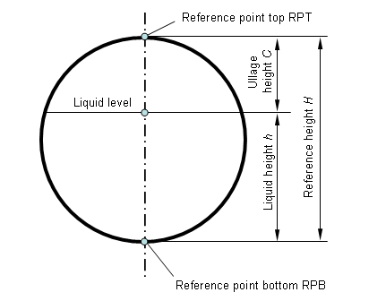

Fig. 1 Schematic view of a tank to determine 2.15 – 2.19

**2.20 Sensitivity of a tank**

Change in the level of liquid Δ*h* divided by the corresponding relative change in volume Δ*V*/*V* for the contained volume *V* at the level *h*.

**2.21 Tank capacity table**

Table which shows the relation between the liquid level and the volume contained in the tank (compartment) at that level under reference conditions (including the position of the tank).

**2.22 Baffle**

Internal device of the tank or compartment, e.g. a partition wall or obstacle inside the tank, intended to damp the movement of liquid during transport and to increase the mechanical stability of the tank.

**2.23 Level sensor**

Measuring device for the level of a liquid in a tank or compartment.

**2.24 Measuring range of the level sensor**

Range between the minimum and maximum possible indications of the level sensor. The lower limit is type and system dependent and shall be significantly less than the liquid level corresponding to the minimum measured quantity of the tank or compartment. The upper limit depends on the tank height and shall be above the maximum permissible filling height of the tank or compartment.

**2.25 Temperature sensor**

Measuring device for the temperature of the liquid.

**2.26 Inclination sensor**

Measuring device for the pitch and roll angles.

**2.27 Longitudinal axis and pitch angle**

Symmetry axis of the tank parallel to the main direction of travel, when the tank is in normal position. The vertical angle by which this axis is rotated is referred to as the pitch angle. It is positive if the front part of the tank is lifted.

**2.28 Transverse axis and roll angle**

Horizontal axis of the tank perpendicular to the longitudinal axis, when the tank is in its normal position. The vertical angle by which this axis is rotated is referred to as the roll angle. It is positive if the right part of the tank (in relation to the direction of travel) is lifted.

**2.29 Damping tube**

Mechanical device (usually in the form of a tube with holes) intended to minimize or eliminate the effect of surface waves on the level measurement and to protect the level sensor against mechanical damage.

**2.30 Transfer point**

Point at which the liquid is defined as being delivered or received.

**2.31 Empty hose (Dry hose)**

Hose and/or pipework containing liquid products only during a transaction and usually being completely evacuated before the transaction is terminated. It is connected downstream of the transfer point (the transfer point is located upstream of the delivery hose or downstream of the receiving hose).

**2.32 Full hose (Wet hose)**

Hose and/or pipework filled with liquid product prior to and after a transaction. In this case the transfer point is located close to the outlet of the full hose (the transfer point consists of a closing device located in the delivery or receiving line).

**2.33 Collector (Manifold)**

Collecting line connected via valves to the outlets of the measuring compartments and allowing delivery from any one or several compartments via common pipework.

**2.34 Built-in manifold**

Collecting line connected via diverting valves to the discharge pipes of the measuring compartments and allowing delivery from any one or several compartments via a common pipework. A compartment connected to a built-in manifold has two possible outlets: its own outlet valve and its own diverting valve.

**2.35 Direct discharger**

Tanker discharged by gravity, each individual measuring compartment having its own outlet. Frequently, the loading adapter is used as the outlet.

**2.36 Top loading**

Loading of a measuring compartment from the top through the fill hole cover opened for this purpose.

**2.37 Bottom loading**

Loading of a measuring compartment from the bottom through a standardized dry adapter (e.g. an API adapter) and the bottom valve that is integrated into the bottom of the measuring compartment and opened for this purpose.

**2.38 Transaction**

Delivery of liquid products from one or several measuring compartments to a recipient.

*Note:* The transaction can also be a receipt (e.g. a milk collecting truck). A transaction is settled when the parties interested in the transaction have made their agreement known (explicitly or implicitly) as regards the amount of the transaction. This may be a payment, signing a credit card voucher, signing a delivery order, etc.

The parties interested in a transaction may be the parties themselves or their representatives (for example: the employee in a filling station, the driver of a tanker).

**2.39 Reference position**

Position for the discharge (or loading) of the measuring tank in accordance with the design drawing. It is the basis for the inclination correction function. The zero point of the inclination represents the zero point for both (longitudinal and transversal) inclinations.

**2.40 Working conditions**

Conditions under which the volume of liquid is to be measured, at the point of measurement (example: temperature, viscosity, position of the tank).

**2.41 Base conditions**

Specified conditions under which the measured volume of liquid is converted (example: temperature, density, pressure).

**2.42 Liquid detector**

Device intended to detect the presence of liquid in the pipework or the tank and to check, before start-up and after stopping, that all or part of the measuring system is either filled completely with liquid (full hose measuring systems) or completely empty of liquid (empty hose measuring system).

*Note:* A liquid detector may also be used for high level detection.

**2.43 Liquid indicator**

Device to indicate the presence of liquid in the pipework (e.g. sight glass).

## 2.44 Minimum measured quantity MMQ (*V*min)

Smallest volume of liquid for which the measurement is metrologically acceptable for the tank or individually for each of its compartments. It shall be specified only for measuring systems suitable for measuring partial volumes.

Alternatively, the terms “minimum delivery” or “minimum receipt” may be used.

## 2.45 Minimum specified volume deviation (*E*min)

Twice the absolute value of the maximum permissible error for the minimum measured quantity of a tank or compartment.

**2.46 Influence quantity**

Quantity which is not the object of the measurement but which influences the value of the measurand or the indication of the tank.

**2.47 Disturbance**

Influence quantity whose value lies within the limits defined by the relevant requirements, but outside the established rated operating conditions for the tank.

**2.48 Fault**

Difference between the error of indication and the intrinsic error of a measuring instrument.

*Notes:* 1. Principally, a fault is the result of an undesired change of data contained in or flowing through an electronic measuring instrument.

2. From the definition it follows that in this Recommendation, a "fault" is a numerical value which is expressed either in a unit of measurement or as a relative value, for instance in %.

**2.49 Significant fault**

Fault greater than the value specified in 5.7.1.4.

**2.50 Rated operating conditions**

Conditions of use giving the range of values of influence quantities for which the specified metrological characteristics of a measuring instrument are intended to lie within given limits.

### 2.51 Reference conditions

Conditions of use prescribed for testing the performance of a measuring instrument or for inter-comparison of results of measurements.

*Note:* The reference conditions generally include reference values or reference ranges for the influence quantities affecting the measuring instrument.

### 2.52 Influence factor

Influence quantity having a value within the rated operating conditions specified in 5.1.1.

### 2.53 Durability

Ability of a measuring instrument to maintain its performance characteristics over a period of use.

### 2.54 Intrinsic error

Error (of the indicated volume) of a measuring system used under reference conditions.

### 2.55 Initial intrinsic error

Intrinsic error as determined prior to each performance tests.

### 2.56 Checking facility

Facility that is incorporated in a measuring instrument and which enables significant faults to be detected and acted upon.

*Note:* "Acted upon" refers to any adequate response by the measuring instrument (luminous signal, acoustic signal, prevention of the measurement process, etc.).

### 2.57 Automatic checking facility

Checking facility that operates without the intervention of an operator.

### 2.58 Permanent automatic checking facility (type P)

Automatic checking facility that operates at each measurement cycle.

### 2.59 Intermittent automatic checking facility (type I)

Automatic checking facility that operates at certain time intervals or per fixed number of measurement cycles.

### 2.60 Symbols and abbreviations

*V*n nominal capacity (of the tank or compartment)

*V*t total volume at working conditions

*V*i indicated volume

*H* reference height

*C* ullage height

*h* liquid height

*V*min minimum measured quantity

*E*min minimum specified volume deviation

*U*x expanded uncertainty of level measurement

Δ*V*t,*i*partial volume at working temperature *t*

*t* working temperature

*t*0 base temperature

Δ*V*0,*i* partial volume at base conditions

*V*0 total volume at base conditions

*φ*(*V*t,*t*) conversion function

*α*0 thermal expansion coefficient

*ρ*0 density at base conditions

RPT reference point top

RPB reference point bottom

MMQ minimum measured quantity

## 3 Classification and Descriptions

### 3.1 General

3.1.1 Determination of the quantity in a road tanker or rail car involves:

* the method of measurement to derive the volume;
* ancillary devices;
* operating conditions (influence factors);
* tank capacity and its calibration table;
* the method of mounting of the tank.

3.1.2 Measurement methods:

* level measurement:
  + by a manual or visual (mechanical) level gauge, or an electronic level gauge;
* temperature measurement:
* in the case of the measurement of a volume transferred (delivered/received), by an electrical temperature sensor located on the discharge/inlet line (pipe); or
* in the case of inventory measurement, by one or more temperature sensors/thermometers located in such a way that they allow the mean temperature of the liquid volume in the tank or in each compartment to be determined, respectively;
* volume measurement at working or base conditions (delivered/received including partial deliveries):
  + by an electronic computing device or controller, or by manual calculation using data from the tank calibration table and the volume correction table.

The manual or visual gauging method may be based on:

* a single or more volumetric marks;
* a graduated window in the dome;
* another measuring device with a graduated scale (with a viewing window or an external gauge tube or with any means of transferring the level position outside the tank);
* a dipstick or a dip tape.

Electronic level gauging method may be based on:

* floats/displacers with electronic detection (magnetic or magneto-strictive);
* ultrasonic level gauge;
* radar (microwave) level gauge;
* other non-contact level gauges such as electrical capacitance.

Automatic volume measurements are achieved by the electronic computing device or controller, and characterized by automatic volume determination.

*Note:* This may include:

* complete automatic control and supervision of the deliveries/receipts;
* automatic taking into account of the influence of inclination, stage of emptying and/or waves.

3.1.3 Regarding the kind of delivery/receipt that the tank may be designed for:

* delivery/receipt of full compartment only;
* delivery/receipt of partial volume of a compartment;
* automatic measurement of the average temperature of the delivered/received volume;
* automatic volume conversion.

3.1.4 For the ancillary devices, tanks may be fitted with or without:

* installations for measuring partial volumes received or delivered;
* internal pumps;
* collectors;
* full hose installations.

3.1.5 The main influence factors that can have a major effect during calibration and use of tankers are pressure and temperature.

1. regarding the pressure, the tanks may be:

* at atmospheric pressure;
* under pressure (e.g. for liquefied gases or beer).

1. regarding the temperature, the tanks may be:

* without means for heating and with or without thermal insulation of the contents;
* with means for heating and with or without thermal insulation of the contents.

3.1.6 Regarding the capacity of the tank, road tankers are usually between 0.5 m3 and 50 m3 and rail tankers between 10 m3 and 120 m3.

3.1.7 Regarding the method of mounting, the tanks of road tankers may be:

* mounted directly and permanently on the chassis of a vehicle, trailer, or semi-articulated trailer, or be self-propelled, detachable;
* mounted temporarily on the vehicle by means of devices that ensure that the position of the tank when mounted on the vehicle remains unchanged.

### 3.2 Construction of tanks

3.2.1 If a tank is divided into compartments, each shall be considered as a separate tank and shall be subject to the requirements of this Recommendation.

3.2.2 Each tank shall comprise a shell and ends and discharge devices.

3.2.3 The shape and the mounting of the tank as well as the installation of the discharge device shall be such that the tank drains completely.

3.2.4 The discharge device shall comprise one or two discharge pipe(s) (allowing offloading on either side of the tanker), each equipped with a stop valve. The flow of liquid between the tank and the discharge pipe(s) may be stopped by a foot valve.

If the tank is equipped with two discharge pipes, suitable interlock facilities shall prevent the use of both discharge pipes together.

If necessary, a tank may incorporate devices fitted at the lowest point for water separation.

*Note:* A tank may be equipped with a third discharge pipe (on its rear side) fulfilling all the requirements of 3.2.4.

3.2.5 Tanks fitted with level gauges

Tanks fitted with level gauges shall comprise:

3.2.5.1 A dome with reinforcing elements serving as a manhole and as an expansion space and in some (non-fuel) applications to increase the sensitivity of the tank. It is located on the top of the tank.

The dome may incorporate the following:

* a filling aperture, fitted with a leak-proof cover;
* an orifice to observe the filling;
* a venting device or double-acting safety valve.

The level index may be in the dome or in the upper part of the shell, provided that the sensitivity requirements are met.

3.2.5.2 For tanks fitted with mechanical level gauges, a ladder shall be installed giving access to the dome and the platform, thus allowing the operator to perform the measurement or to check the tank.

3.2.5.3 For tanks fitted with electronic level gauging:

* access to the interior of the tank shall either be prevented by sealing or other means; or
* a visual checking of the interior shall easily be possible according to 3.2.5.2 (for instance in the case of top loading).

3.2.6 Tankers for liquefied gases shall not have domes and are subject to regulations covering the construction of pressure vessels.

3.2.7 Where appropriate, tanks shall be fitted with breather valves and flame arresters.

3.2.8 Examples for tankers with mechanical and electronic level gauging are given in informative Annexes A and B.

## 4 Units of measurement

The authorized units of measurement are those of the International System of Units (SI). Lengths shall be given in mm, volumes in litres.

If units of measurement other than those of the SI are authorized by the state, these legal units of measurement may be used. In international trade, the officially agreed equivalences between these units of measurement and those of the SI shall be applied.

## 5 Technical and metrological requirements

### 5.1 General

5.1.1 Rated operating conditions

Measuring systems according to this Recommendation shall be designed and manufactured such that their errors do not exceed the maximum permissible errors given in Table 2 under the following rated operating conditions:

|  |  |  |  |
| --- | --- | --- | --- |
| **Rated operating conditions** | | | |
| a) Environmental temperature | low | – 25 °C or – 10 °C (1) | |
| high | + 55 °C (1) | |
| b) Humidity | Up to condensing | | |
| c) Vibration less than | 10 Hz – 150 Hz, 7 ms-2, 1 m2s-3,  –3 dB/octave | | |
| d) AC mains voltage (2), (3) | *U*nom – 15 % to *U*nom + 10 % | | |
| e) AC mains frequency (2) | *f*nom – 2 % to *f*nom + 2 % | | |
| f) Voltage of internal battery (2) | The lowest voltage at which the instrument functions properly according to the specifications up to the voltage of a new battery. | | |
| g) Voltage of a road vehicle battery (2) | 12 V battery | | 9 V – 16 V |
| 24 V battery | | 16 V – 32 V |
| h) Inclination | To be specified by the manufacturer | | |
| (1) This value is to be decided by the national authority as it depends on the climatic conditions and the expected conditions of application (indoors, outdoors, etc.) that are different in different countries.  (2) Whatever is applicable.  (3) The values of *U*nomare those marked on the measuring instrument.  In case a range is specified, the “– 15 %” relates to the lowest value and the “+ 10 %” to the highest value of the range. | | | |

5.1.2 Accuracy classification and maximum permissible errors

Depending on the field of application the static measuring systems mounted on the road or rail tankers are classified into four accuracy classes according to Table 1. The corresponding maximum permissible errors on quantity indications are specified in Table 2.

Table 1 Accuracy classes depending on the field of application

|  |  |
| --- | --- |
| Accuracy class | Type of measuring system |
| 0.5 | * Measuring systems for liquids of which the viscosity does not exceed 20 mPa⋅s at working temperature; * Measuring systems for milk, beer, and other foaming liquids; * Measuring systems for refueling aircraft. |
| 1.0 | * Measuring systems for liquefied gases under pressure measured at a temperature equal or above –10 °C. |
| 1. 5 | * Measuring systems for liquefied carbon dioxide; * Measuring systems for liquefied gases under pressure measured at a temperature below –10 °C. |
| 2.5 | * Measuring systems for cryogenic liquids. |

Table 2 Accuracy classes and maximum permissible errors

|  |  |  |  |  |
| --- | --- | --- | --- | --- |
|  | Accuracy class | | | |
| 0.5 | 1.0 | 1.5 | 2.5 |
| Static measuring system (A) | 0.5 % | 1.0 % | 1.5 % | 2.5 % |
| Transportable measuring tank (B) | 0.3 % | 0.5 % | 1.0 % | 1.5 % |

5.1.3 Conditions for applying maximum permissible error

5.1.3.1 Maximum permissible errors in line A of Table 2 apply to complete measuring systems, under rated operating conditions, without any adjustment between the various tests, for:

* type approval;
* initial verification;
* subsequent verifications.

5.1.3.2 Maximum permissible errors in line B of Table 2 apply to:

* type approval of a measuring tank, under rated operating conditions; and
* verification of the tank as a preliminary stage of the initial verification of the measuring system.

5.1.3.3 For measured volumes greater than the minimum measured quantity up to twice the minimum measured quantity, the absolute value of the maximum permissible error shall not be less than *E*min.

5.1.4 Base conditions

Recommended base temperature is 15 °C. Other base temperatures such as 20 °C and 27 °C may be used if established by the national metrology body in the country. Recommended base pressure is normal atmospheric pressure (0.1 Mpa).

The use of other values for justified reasons is allowed.

5.1.5 Requirements on temperature measurement

5.1.5.a For the purposes of pattern evaluation and approval in accordance with NMI R 80-1, the presence and use of temperature sensors and volume conversions are not considered mandatory requirements for the level gauging system.

Pattern approval applications **may** include temperature sensors and volume conversion functions within the scope of the pattern evaluation process. In this case, the requirements specified below shall be applied.

Certificates of Approval shall indicate whether or not volume conversion forms part of the approved pattern of the level gauging system.

Where volume conversions are required for the trade of certain products, they shall be calculated and applied appropriately.

5.1.5.1 For the purpose of volume conversion, the maximum permissible error for the determination of the temperature is ± 1 °C for accuracy class 2.5 and ± 0.5 °C for other accuracy classes.

*Note*: These maximum permissible errors apply to the indication by the corresponding calculator with its indicating device and include the errors due to rounding if using digital inputs.

5.1.5.2 For the measurement of a volume transferred (received or discharged), the temperature element (sensor) shall be installed in the inlet/discharge line beneath the tank at a location where under all discharge or loading modes the liquid flow passes by the sensor. In the case of separate liquid paths, additional sensor(s) shall be installed.

5.1.5.3 If the road or rail tanker is used for static volume measurement of the inventory, the temperature sensor(s) shall be installed inside the tank/each compartment in such a way that they give the mean temperature of the liquid volume in the tank/compartment in accordance with the requirements of 5.1.5.1.

5.1.5.4 The measuring system shall allow the read-out of the actual temperature value. A permanent indication is not necessary.

5.1.6 Nominal capacity

Nominal capacity of a measuring tank or of its compartment shall be at least 500 L unless stated otherwise in the type approval certificate.

5.1.7 Minimum measured quantity

5.1.7.1 The minimum measured quantity shall be specified for each compartment of a tank and shall not exceed a quarter (1/4) of its nominal capacity.

5.1.7.2 The minimum measured quantity shall be equal to or greater than the larger of the two following values:

* the volume corresponding to the level difference given in Table 3, according to the accuracy class and with the smallest sensitivity;
* the volume which corresponds to the manufacturing tolerance on the volume (differences between the actual tank geometry and the design specifications) and which does not exceed three-fifths (3/5) of the maximum permissible error specified in line A of Table 2 for each permitted inclination.

Table 3 Minimum level difference corresponding to MMQ (*V*min)

|  |  |  |  |  |
| --- | --- | --- | --- | --- |
|  | Accuracy class | | | |
| 0.5 | 1.0 | 1.5 | 2.5 |
| Level difference | 200 mm | 171 mm | 190 mm | 200 mm |

*Note*: The given level differences are based on an expanded uncertainty *Ux* for the corresponding accuracy classes given in 5.4.3.1 Table 6.

5.1.7.3 The minimum measured quantity of a measuring system shall be given by one of the following forms:

* 1 × 10*n*, 2 × 10*n* or 5 × 10*n* litres, where *n* is a whole number;
* entire multiples of 100 litres.

### 5.2 Container of the measuring tank

5.2.1 Safety and other non-metrological requirements

5.2.1.1 National and international organizations, official services concerned with the transport of dangerous goods, and authorities responsible for the supervision of the production of pressured vessels lay down conditions for the construction of road and rail tankers intended for the transport of liquids contained in tanks, without overload and free from danger. Additional regulations for safety at work and protection against fire and explosion may exist. These conditions shall be observed.

5.2.1.2 In the case of tankers for potable liquids, the structural characteristics of the tank (shape, material, etc.) shall have no adverse effect on the quality of the liquid transported; the advice of the health authorities in this regard shall be sought.

The application of the above-mentioned requirements shall be compatible with the measuring function of the tank.

5.2.1.3 The specification of the nominal capacity shall take into account the national or international regulations prescribing the maximum filling volume of tanks.

5.2.2 General requirements on the construction of the container

5.2.2.1 Shapes, materials, reinforcing elements and methods of shaping or assembly shall be chosen so that the containers are sufficiently unaffected by atmospheric agents and the liquids they contain, and are practically not subject to distortion under rated operating conditions.

5.2.2.2 The container shall be tight. Proof by the safety tests carried out is generally sufficient.

5.2.2.3 The reference height *H* of a tank or each compartment shall not vary during filling more than the greater of the two values given in Table 4.

Table 4 Maximum permissible variation of the reference height in dependence of the accuracy class

|  |  |  |  |  |
| --- | --- | --- | --- | --- |
|  | Accuracy class | | | |
| 0.5 | 1.0 | 1.5 | 2.5 |
| Maximum permissible variation of the reference height *H* (mm) | 2 mm or *H*/1000 | 4 mm or *H*/500 | | |

5.2.2.4 The capacity of a compartment shall not change by more than one-third (1/3) of the maximum permissible error specified in line B of Table 2 when the neighboring compartment or compartments are filled or emptied.

5.2.2.5 The material of the tank shall be chosen so that the capacity of the tank shall not change more than one-third (1/3) of the maximum permissible error specified in line B of Table 2 when the temperature of the tank changes in the range of ± 10 °C from the reference temperature.

*Note:* This condition is fulfilled if the linear expansion coefficient of the tank material is less than 33·10-6 K-1.

5.2.2.6 Tanks for liquids which are not measured at atmospheric pressure shall be designed in such a way that their capacity in the whole admissible pressure range does not change more than one-fifth (1/5) of the maximum permissible error specified in line B of Table 2.

5.2.2.7 Every tank or compartment shall be of such a shape that no air is trapped during the filling and no liquid is retained during the emptying in any admissible position of use of the equipment.

5.2.2.8 Spouts, mouldings or vent pipes and valves may be utilized in order to comply with the above requirements.

5.2.2.9 The complete drainage shall be ensured:

* by an adequate shape of the tank;
* by a slope of at least 2 % (1.2°) of the tank bottom with the vehicle on horizontal ground; or
* by other means.

All road measuring tanks shall be designed to discharge within an inclination of at least ± 2 % of the reference position.

If complete drainage is not possible in all positions that may be expected during use, monitoring/indicating facilities shall be provided to ensure complete emptying (for example, by additional liquid sensors in the compartment, or by monitoring the inclination).

5.2.2.10 The volume of liquid remaining in the tank or compartment after its complete draining shall not be greater than one-tenth (1/10) of the absolute value of the maximum permissible error given in line B of Table 2 applied to the capacity of the tank or compartment. This volume may remain in the tank for reasons of conditions of construction or mounting (for example, at the joints).

5.2.2.11 Baffles and reinforcing elements that may be fitted in the tank shall have a shape and shall be provided with appropriate orifices such that filling, draining and checking the emptiness of the tank are not impeded.

5.2.2.12 The introduction of dead wood inside the tank for the purpose of adjusting the capacity to a given value, or any other body which when removed or changed could modify the capacity of the tanks, is prohibited.

5.2.2.13 Fixed internal elements in the measuring compartments (e.g. heating coils) are permitted if they have been present during the calibration and cannot be modified or dismounted.

5.2.2.14 The tank or compartment geometry should be such that waves at the liquid surface are adequately damped.

5.2.2.15 To minimize inclination effects, the measuring tanks should be symmetrical both in the longitudinal and in the transverse direction and the level sensors should be installed centrally. Other constructions are permitted if correct volume measurement is ensured.

5.2.2.16 If correct measurement is not possible under all inclinations, which may be expected during use, the tank shall be equipped with a device that indicates the actual inclination with respect to the range of inclinations required for a correct measurement.

5.2.2.17 The interior of the measuring tank shall be accessible for inspection purposes via a manhole, provided that safety or other regulations do not exclude this. In conformity with 3.2.5.3 it shall be sealed to prevent manipulations.

5.2.2.18 The capacity of a measuring tank shall not deviate by more than 10 % from that specified in the design documents.

5.2.2.19 The dome, when fitted, shall be on the upper part of the body and shall be welded to the latter. In general, the mechanical level gauging device shall be inside the dome.

5.2.2.20 The dome may have a cylindrical or parallelepipedic form, with vertical side-walls. If the dome is parallelepipedic in form it may be of the same length as the tank itself.

5.2.2.21 If the sidewalls of the dome are mounted so that they penetrate the tank shell, in such a way that air pockets could form when filling at the maximum permitted filling level, orifices or cut-outs of appropriate dimensions and at high enough positions to avoid such pockets shall be provided.

5.2.2.22 The transverse section of the shell and dome shall have a vertical axis of symmetry. Other constructions are permitted if correct volume measurement is ensured.

5.2.2.23 The dimensions of the horizontal section of the dome shall be such as to allow inspection of the interior of the tank. A diameter of at least 500 mm is recommended.

### 5.3 Additional devices

5.3.1 Discharge device

5.3.1.1 The discharge device shall ensure complete and rapid discharge of the liquid contained in the tank. For this purpose, the discharge device shall be connected to the lowest part of the tank shell.

5.3.1.2 For tanks of special construction dedicated to airports, the fitting of a device to collect water and impurities precipitated by a liquid contained in the tank is permitted. This device shall have a separate drain pipe, of small diameter, when the normal discharge pipe is not connected to the lowest part of the tank.

The collecting device may be mounted:

* over the whole of the lower part of the tank; or
* over a reduced area of the lower part.

5.3.1.3 The discharge pipe shall be as short as possible and have an adequate slope towards the stop valve. A resulting slope of at least 2° is recommended.

5.3.1.4 Each compartment shall have means for being discharged independently. A discharge manifold is permitted under the following conditions:

Manifolds should have suitable control facilities that prevent the flowing back from one compartment to another or provide evidence of such a situation.

However, when the conditions of exploitation render it necessary, the legal metrology authority may accept the use of non secured manifolds provided that appropriate information is easily legible and readable close to the delivering points.

This information may consist of a label providing one of the following appropriate texts:

* “The presence of the collector is not allowed during the delivery from the measuring tank”, when the collector is easily removable;
* “Check the liquid level before and after each delivery from a compartment”, when it may be acceptable that the collector is not easily removable.

5.3.1.5 The existence of a manifold shall be indicated in the verification certificate.

5.3.1.6 Stop valves shall be readily accessible and shall be at the rear or on the appropriate side of the tank.

5.3.1.7 If a tank consists of more than one measuring compartment, each compartment shall be provided with a separate (manual or automatic) shutoff device in each delivery line. Unwanted mixtures of the products from different compartments shall be prevented by constructive or control devices.

5.3.1.8 In the vicinity of the lowest point of each delivery line, liquid detectors or sight glasses (excepted for automatic measuring systems) shall be installed, if necessary, for checking emptiness.

5.3.1.9 Pipework, whose filling quantity has an effect on the measurement result, shall not be flexible and shall be rigidly laid.

5.3.1.10 For full hose delivery, it shall be ensured by a separate gas separator, or an equivalent function of existing parts, that the full hose is completely filled at the time of level gauging.

5.3.1.11 Control lines and control devices whose manipulation might falsify the measurement result shall be protected against tampering.

5.3.1.12 During a transaction, the change from full to empty hose and vice versa as well as the change between the full hose systems are admissible only when the filling levels are monitored in all measuring compartments so that manipulations are evident.

5.3.1.13 Venting devices on the measuring system shall be protected against dismounting and removal as well as against manipulations from the outside.

5.3.1.14 The measuring tank shall have supports in the longitudinal and in the transverse directions. Their length shall be greater than 500 mm to accommodate an electronic water-level to mark the reference plane for the normal position of the measuring tank.

5.3.2 Installations for external measurement and pumping

5.3.2.1 If it is intended to connect the tank to separate pumping or measuring devices, it should be provided with the appropriate detachable coupling devices which shall be as short as possible and easy to connect and disconnect.

5.3.2.2 Pumping installations shall comprise, in addition to the pump itself, no more than one filter and very short pipes (no valves or branch connections). The installation shall be constructed so that it can be drained completely, each time the tank is emptied, without the need for any special measures.

5.3.2.3 For tanks equipped with a built-in manifold for measuring partial volumes delivered, the fitting of a diverting valve on each discharge pipe is permitted provided that:

* any leakage of liquid through the diverting valve can be detected (for example: the built-in manifold ensures complete and rapid discharge of the liquid that it contains. A sight glass or monitoring device at its bottom end shall allow the checking of its emptiness); and
* the installation and the control of the diverting valves is such that the product cannot flow back from one compartment to another.

5.3.2.4 Sampling device

The measuring system may include a sampling device intended to determine the properties of the liquid to be measured.

Obtaining a representative sample is usually needed for the following reasons:

* to calculate the standard volume (i.e. volume at defined base conditions);
* to determine the density of the liquid for conversion;
* to determine if the liquid transferred is within the quality specification, and its properties.

The quantity of a sample taken from the tank does not need to be accounted for if the quantity of the sample is less than one-third (1/3) of the absolute value of the maximum permissible error given in line B of Table 2 applied to the capacity of the tank or compartment.

5.3.2.5 Additivation systems

The measuring system may include an injection device that injects additives to the delivered product. If the additivation ratio is not higher than 1:500 there is no need to measure the additive quantity.

5.3.3 Other devices

5.3.3.1 Tank may be fitted with:

* level switch;
* level detectors;
* high level shutoff devices;
* etc.

5.3.3.2 The use of devices to facilitate reading of the index, or to stop the flow automatically when the level of the liquid reaches the index, are permitted, provided that no additional measurement errors are introduced.

### 5.4 Level gauging system

5.4.1 General requirements

5.4.1.1 The level gauging device shall ensure a safe, easy and unambiguous readout, practically independent of tank tilt under rated operating conditions.

5.4.1.2 The index (e.g. volumetric marks, scales), or the vertical measurement axis, shall be as near as possible to the center of the horizontal sections of the tank.

5.4.1.3 The level gauging system shall perform a valid height measurement only when the liquid surface has calmed down so that the result is reproducible.

5.4.1.4 When the measuring range of the level sensor is reached, a visual and/or audible indication shall automatically occur.

5.4.1.5 The pattern evaluation of the level gauging system shall include an assessment of the sensitivity of measurement performance with respect to inclination.

5.4.2 Requirements on level gauging for full compartment delivery

5.4.2.1 The shape of the tank shall be such that, in the zone where the levels are gauged, a sensitivity equal to or greater than the values given in Table 5 is attained.

Table 5 Sensitivity of the tank depending on the accuracy class of the measuring system   
for full compartment delivery

|  |  |  |  |  |
| --- | --- | --- | --- | --- |
|  | Accuracy classes | | | |
| 0.5 | 1.0 | 1.5 | 2.5 |
| Minimum sensitivity of tank Δ*h* per Δ*V*/*V* in mm / ‰  (i.e. in mm for 1/1000 of measured volume) | 1.5 | 1.0 | 0.5 | 0.3 |

5.4.2.2 For non-pressurized tanks, it shall be possible to gauge the level of the contained liquid manually. The gauging device shall be positioned as close as possible to the curve connecting the centers of gravity of the horizontal cross sections of the compartment in the level measuring range.

When the lower end of the gauging device is close to the bottom of the tank, its axis should intersect the lower tank bottom at a point having no orifice or obstacle within a radius of 100 mm. If this is not the case, there shall be a horizontal and non removable plate of 100 mm × 100 mm in order to ensure repeatability of measurements.

5.4.2.3 The reference points RPB and RPT shall be clearly defined and realized.

5.4.2.4 The joint between the shell and the dome shall be such that the gauging device can be held in a vertical position during measurement.

5.4.3 Requirements on level gauging for partial delivery

5.4.3.1 The expanded uncertainty of the level measurement shall not exceed the values given in Table 6.

Table 6 Level measurement uncertainty for partial delivery

|  |  |  |  |  |
| --- | --- | --- | --- | --- |
|  | Accuracy classes | | | |
| 0.5 | 1.0 | 1.5 | 2.5 |
| Level measurement uncertainty *U*x in mm | 0.7 | 1.2 | 2 | 3.5 |

The expanded uncertainty of measurement, *U*x, is stated in accordance with the *Guide to the expression of uncertainty in measurement* (GUM) [4] as the standard uncertainty of measurement multiplied by the coverage factor *k*=2 which for a normal distribution corresponds to a coverage probability of approximately 95 %.

Other values of expanded uncertainties *U*x may be fixed in the type approval certificate of the measuring system.

5.4.3.2 The resolution of the level indication shall be in accordance with the values in Table 7.

Table 7 Resolution of the level indication

|  |  |  |  |  |
| --- | --- | --- | --- | --- |
|  | Accuracy classes | | | |
| 0.5 | 1.0 | 1.5 | 2.5 |
| Maximum value of the resolution for the level indication in mm | 0.1 | 0.2 | 0.5 | 1.0 |

5.4.3.3 To dampen the surface waves, the level sensor may be fitted in a damping tube. In the area of the tank bottom, of the tank roof and in-between, this tube shall be provided with openings for liquid exchange. The tube shall not affect the measurement (e.g. dirt or sedimentation occurring under regular operation).

5.4.4 Specific requirements for level gauging systems with float

5.4.4.1 The float shall not change its mass and volume due to the influence of the product measured. Neither pressure shall lead to a change in its volume.

5.4.4.2 The cross-section of float in the range of immersion depth change shall be well known.

5.4.4.3 The shape of the float shall be designed so that it does not retain liquid except the liquid layer caused by capillary effects. Additionally, no gas or air cushion shall be formed under the float.

5.4.4.4 Within the permissible density range of the measured liquid at base conditions, the immersion depth of the float shall not change by more than the value given in Table 8. The permissible density range shall be specified in the type approval certificate. For measuring systems not fitted with the corresponding correction, the influence on the immersion depth that results from variation in the liquid density should be included in the uncertainty evaluation of the level measurement.

Table 8 Change of float immersion depth

|  |  |  |  |  |
| --- | --- | --- | --- | --- |
| Maximal change of immersion depth in mm for | Accuracy classes | | | |
| 0.5 | 1.0 | 1.5 | 2.5 |
| - partial deliveries | 0.5 | 0.8 | 1.6 | 2.5 |
| - full compartment deliveries | 1.5 | 2.4 | 4.8 | 7.5 |

5.4.5 Specific requirements for level gauging systems based on the ultrasound transit time measurements

5.4.5.1 Within the permissible product parameters range (mainly density and modulus of elasticity), the measured height shall not change by more than the values given in Table 6. The permissible ranges of product parameters shall be specified in the type approval certificate.

5.4.5.2 The effects of the product parameters on the transit time of the ultrasound signal may be compensated by suitable methods (e.g. by reference marks).

### 5.5 Tank capacity table

5.5.1 For the conversion of the result of the level gauging into volume, the electronic data processing system shall store a tank capacity table with pairs of level/volume values for each measuring compartment. The number and distance of these value pairs are selected according to the real tank geometry. Intermediate values are calculated by suitable interpolation. Extrapolation is not admissible.

5.5.2 The tank capacity table shall be determined for each compartment of the measuring tank by volumetric, gravimetric or geometric methods.

*Note:* A calculation of the tank capacity table only based on the construction documents is not permitted.

5.5.3 The level range of the tank capacity table shall encompass all filling states occurring in practical operation. Filling of a measuring compartment to a level beyond the maximum permissible point of the tank capacity table shall be prevented or shall be detected by means and a visual and/or audible indication shall occur.

5.5.4 Volume effects of the inclination in the range specified for a given system (pitch and roll angles) shall not exceed the minimum specified volume deviation for partial delivery or the value given in line B of Table 2 of nominal compartment volume for full compartment delivery.

5.5.5 If compliance with the requirements of 5.1.5.2 and 5.1.5.3, respectively, requires that a correction for inclination should be made, the inclined position of the measuring tank shall be measured during level detection using inclination sensors rigidly fixed to the tank. The inclination data are utilized to correct the measurement using a suitable algorithm.

5.5.6 The tank capacity table compiled during the calibration as well as the inclination correction data, when relevant, shall be stored in the system so that they are protected from manipulation.

5.6 Metrological requirements for indicating and ancillary devices

5.6.1 Volume conversion

5.6.1.1 The maximum permissible error for the conversion of the measured volume into a volume at base conditions or a mass is equal to ± (A – B), A and B being the values specified in Table 2. However, the magnitude of the maximum permissible error shall not be less than the greater of the two following values:

* one-half (1/2) scale interval of the indicating device for converted indications;
* half of the value corresponding to the minimum specified volume deviation *E*min.

5.6.1.2 The total volume at base conditions may be determined using either of the following two methods:

Method A: The conversion is performed during the measurement. Each partial volume Δ*V*t,*i*at working temperature *t* is converted to the partial   
volume Δ*V*0,*i* at base temperature *t*0

****

The total volume*V*0 at base conditions is:

****

Method B: The conversion is done at the end of the measurement,using the weighted average temperature, which is calculated from the working temperatures *ti*of the partial volumes Δ*V*t,*i*:

****

The total volume *V*0 at base conditions is:

****

5.6.1.3 The utilized conversion function *φ*(*V*t,*t*) shall be in accordance with the applicable International Recommendation or Standards (in particular, OIML R 63 [5]), or other methods accepted for national use. Annexes C and D (informative) give two examples of the use of such conversion functions.

5.6.1.4 During a transaction, the temperatures of the liquid flowing through the particular delivery line shall be measured in proportion to the volume or the time.

5.6.1.5 If a volume proportional average is used, the partial volumes shall not be greater than one fifth of the minimum measured quantity:

****

5.6.1.6 If a time proportional average is used, the time intervals shall not be greater than the time needed to measure one fifth of the smallest measured quantity at maximum flow.

5.6.1.7 The total volume at working conditions is:

****

5.6.1.8 The maximum permissible error for the determination of the weighted average temperature is ± 1 °C for accuracy class 2.5 and ± 0.5 °C for the other accuracy classes.

*Note:* In the case of a static volume measurement of the inventory in accordance with 5.1.5.3, the corresponding mean temperature of the liquid volume in the tank/compartment has to be used for the conversion.

5.6.1.9 The data underlying the conversion (for instance the density *ρ*o at base conditions or the thermal expansion coefficient *α*o) can be either firmly set or be adjustable depending on the product. They shall be protected against manipulations.

5.6.1.10 If the data according to 5.6.1.9 underlying the conversion can be adjusted depending on the product, the indication and, where appropriate, the printout shall unambiguously indicate which values have been used or which liquid has been measured.

5.6.1.11 The measuring method - with temperature conversion of the volume or without conversion - for a given product shall be selected once at the time of verification. This selection may not be changed later. Similarly, for a given product, only one set of conversion data may be entered.

The volume correction factor calculation method utilized when determining the standard volume of a given product, shall not be changed unless the relevant standard is modified.

5.6.2 Indicating device

5.6.2.1 The reading of the indication shall be precise, easy and non-ambiguous. The customer shall be able to inspect it without particular measures.

5.6.2.2 The required resolution of indication should be based on the unit of measure in the form 1, 2 or 5 ×10*n* and shall not exceed one tenth of *E*min, *n* being a whole positive or negative number or zero.

5.6.2.3 The continuous display of the quantity during the period of measurement is only mandatory in the case of direct sale to the public.

5.6.2.4 The output of all measured and calculated values shall be possible. Additionally, when the volume of a product at base conditions is indicated, it shall be possible to access all the values underlying the conversion. However, it is not required to permanently indicate all values.

5.6.2.5 The nature of the indicated quantity (metering or base condition) shall be unequivocal.

5.6.2.6 The measuring system may have several units for indicating the same measuring quantity. Each of these indications shall satisfy all the specified requirements.

5.6.2.7 Other information, not subject to legal metrological control, may be additionally indicated. In such a case, it shall be clearly identified and shall not give rise to false interpretation.

5.6.2.8 In case of correction of a quantity, the non‑corrected quantity shall not be displayed during normal operation. The non-corrected quantity shall, however, be available for test purposes.

5.6.3 Price calculation

Optionally, before or after the delivery, a unit price for a delivered product may be entered. The unit price is used to calculate the total price, which may be printed on the delivery note or invoice.

5.6.4 Printing device

5.6.4.1 Printing devices are mandatory only for measuring systems for direct sales to the public. In this case, the system shall check before the delivery or receipt starts, that a printer is connected (even temporarily) and ready for this transaction.

5.6.4.2 Data to be printed

If a delivery/receipt document is generated, it shall contain at least the following data:

* an identifier for the measuring system (e.g. serial number, number plate of the semi-trailer, or number of the compartment);
* the product name or product group name;
* a unique number, which shall be incremented for each transaction;
* the volume *V*t at working conditions with the remark “at delivery/receipt temperature” and/or the volume *V*0 “at base conditions”.

5.6.4.3 Printing of multiple results

If during a transaction more than one compartment is used for delivery/receipt, all the results may be printed on the same delivery/receipt document. If more than one result is available for the same product, these results may be summed up.

5.6.4.4 Marking of data

Verified data shall be enclosed by special characters (e.g. an asterisk “🟏”). It is not allowed to enclose non-verified data by such special characters.

The delivery document shall contain the following explanatory note:

“Data from verified devices are enclosed in 🟏asterisks🟏”.

The remark may either be printed at the time the document is generated, or pre-printed on the paper or the rear side of the paper being used for the printout.

5.6.5 Memory device

5.6.5.1 Measuring systems may be fitted with a memory device to store measurement results until their use, or to keep a record of commercial transactions, providing proof in the event of a dispute. Devices used to read stored information are considered as included in the memory devices.

5.6.5.2 In the case of measuring systems not used for direct sales to the public, the printing device may be replaced by a memory device. In this case, all data necessary for the printout shall be stored.

5.6.5.3 The medium on which the data are stored shall have sufficient permanency to ensure that the data are not corrupted under normal storage conditions.

5.6.5.4 There shall be sufficient memory storage for any particular application for which the measuring system is used.

5.6.5.5 Unless otherwise specified, the measured data shall be stored for at least the billing period and the period for objection before being erased. If the capacity of the data memory is exhausted and if stored data cannot be erased because the periods specified have not yet elapsed, it shall not be possible to start a new measurement.

5.6.5.6 If the measured data have been printed or transferred out at least once in an acceptable way for verification, they may be erased.

5.6.6 Automatic stop

If the system is able to stop the delivery or the loading, it is admissible to automatically terminate the delivery or the loading after a given difference, or final quantity, has been reached.

*Note:* This option is not a volume pre-setting as described in OIML R 117 and shall therefore not be used for prepaid transactions. It is not necessary to reach the given quantity exactly.

### 5.7 Additional requirements for measuring systems with electronic parts

5.7.1 General requirements

5.7.1.1 The electronic parts of the measuring system shall be designed and manufactured such that their errors do not exceed the maximum permissible errors (see 5.1.2) under the rated operating conditions specified (see 5.1.1).

5.7.1.2 Disturbances

Measuring instruments shall be designed and manufactured such that when they are exposed to the following disturbances (5.7.1.2.1 and 5.7.1.2.2), either:

* 1. Significant faults do not occur; or
  2. Significant faults are detected and acted upon by means of a checking facility:

5.7.1.2.1 During the following disturbances

|  |
| --- |
| a) Radiated, radio-frequency, electromagnetic fields |
| b) Conducted radio-frequency fields |
| c) Electrostatic discharge |
| d) Power frequency magnetic field |
| e) Bursts (transients) on power, signal, data and control lines |
| f) Surges on signal, data and control lines |
| g) AC mains voltage dips, short interruptions and voltage variations |

5.7.1.2.2 After the following disturbances

|  |
| --- |
| a) Damp heat, cyclic (condensing) |
| b) Surges on AC mains power |
| c) In the case of a measuring instrument powered by a road vehicle battery via the main ignition switch   of the car:  Transients from DC motors acting as generators after the ignition is switched off. |

*Note:* A fault equal to or smaller than the significant fault is allowed irrespective of the value of the error of indication.

5.7.1.2.3 Application

The provisions in 5.7.1.2 (a) and 5.7.1.2 (b) may be applied separately to:

1. Each individual cause of significant fault; and/or
2. Each part of the measuring instrument.

The choice of whether 5.7.1.2 (a) or 5.7.1.2 (b) is applied, is left to the manufacturer.

5.7.1.2.4 Durability

The provisions in 5.1.3 and 5.7.1.2 shall be met durably.

Measuring instruments shall be designed and manufactured such that either:

1. Significant durability errors do not occur; or
2. Significant durability errors are detected and acted upon by means of a durability protection facility.

The provisions in (a) and (b) may be applied separately to each part of the measuring instrument (for example: analogue and digital parts).

## The choice of whether (a) or (b) is applied is left to the manufacturer.

5.7.1.3 Presumption of compliance

The type of a measuring instrument is presumed to comply with the provisions in 5.1.3 and 5.7.1.2 if it passes the examination and tests specified in Part 2 of this Recommendation.

5.7.1.4 The significant fault is the greater of the following two values for the measured volume of liquid:

* 1/5 of the maximum permissible error of the relevant measured quantity; or
* the minimum specified volume deviation *E*min defined according to 2.45.

5.7.1.5 The following faults are not significant faults, even when they exceed the value defined in 5.7.1.4:

* 1. faults arising from simultaneous and mutually independent causes (e.g. electromagnetic fields and discharges) originating in the measuring instrument or in its checking facilities;
  2. faults implying the impossibility to perform any measurement;
  3. transitory faults being momentary variations in the indication, which cannot be interpreted, memorized or transmitted as a measurement result;
  4. faults giving rise to variations in the measurement result that are serious enough to be noticed by all those interested in the measurement result; the relevant Recommendation may specify the nature of these variations.

5.7.2 Power supply device

## 5.7.2.1 If the transaction is not interrupted in case the power supply fails, the measuring system shall be provided with an emergency power supply device to safeguard all measuring and control functions during the failure.

## 5.7.2.2 If the transaction is interrupted in case the power supply fails, the requirements of 5.7.2.1 shall be met, or the data contained at the time of the failure shall be saved and shall remain displayable for a sufficiently long time on an indicating device subject to legal control so that the current transaction can be completed. The absolute value of the maximum permissible error for the indicated volume in this case is increased to 5 % of the minimum measured quantity.

## 5.7.2.3 In the case 5.7.2.2, it is also sufficient to indicate the result of the measurement after re-establishing the power supply.

## 5.7.2.4 Alternatively, in the case of 5.7.2.2, the transaction may be terminated properly after re-establishing the power supply. In such a case the maximum permissible errors according to 5.1.2 apply.

5.7.3 Checking facilities

5.7.3.1 The checking facilities serve to detect a disturbance whose effects on the measured volume exceed the significant fault according to 5.7.1.4 and shall have the following effect:

* automatic correction of the change in volume; or
* stopping only the faulty device when the measuring system continues to comply with the regulations without this device being in operation; or
* stopping the transaction.

5.7.3.2 During type approval and initial verification it shall be possible to check that the checking facilities function correctly, e.g.:

* by disconnecting the sensor; or
* by interrupting the signaling circuit; or
* by interrupting the power supply.

## 5.7.3.3 The checking facility for the functioning of the calculator checks the values of all permanently stored instructions and data as well as all procedures for the internal transmission and storage of the data relevant to the measurement result and shall be of type I or P.

## 5.7.3.4 The checking facility for the correctness of the calculations carried out by the computer shall be of type P. This check can be carried out, for example, with the aid of a parity bit, a checksum or double storage.

## 5.7.3.5 The checking facility for the indicating device shall ensure that a failure or mal-operation of individual elements is detected visually and/or automatically or cannot lead to erroneous interpretation. The automatic detection can, for example, take place by monitoring the current between the segments of LED displays or by measuring the grid voltage of fluorescent displays. The visual check can, for example, be carried out by redundant LC segments (graphics LCD) or a black-and-white test.

## 5.7.3.6 It shall be possible during initial verification to check the checking facility for the indicating device, for example, by disconnecting the whole or part of the indicating device (in the case of an automatic checking facility) or by a visual check of a manually or automatically triggered black-and-white test.

## 5.7.3.7 Checking facilities for ancillary devices (e.g. according to 5.6.2 to 5.6.5) shall ensure that the particular ancillary device is available, if necessary, and that the transmission of the data is valid.

## 5.7.3.8 The checking facility for a printing device shall also monitor the presence of paper.

## 

## 6 Plates, documents and sealing

### 6.1 Identification plate

## 6.1.1 Each tank shall be provided with an identification plate, which is clearly visible and easily legible. The plate shall not be of a material that deteriorates under the rated operating conditions of the tank and should allow the data to be easily inscribed. The plates shall be fixed in such a way that they cannot be removed without breaking the seals of the Legal Metrology Service.

6.1.2 The following information shall be inscribed on the plate:

* name or trademark of the manufacturer;
* type and year of manufacture (year may be given as part of a serial number);
* serial number of the tank;
* serial number of the level gauging system, if appropriate;
* type approval number, if appropriate;
* nominal capacity of the tank or of each compartment;
* accuracy class if other than 0.5;
* minimum measured quantity of the tank or of each compartment;
* base temperature;
* range of specified inclination, if it differs from 2 %.

6.1.3 A free area shall be left on the plate for the verification marks, according to national regulations.

### 6.2 Measuring system document

6.2.1 Upon initial verification of a measuring system, a measuring system document shall be drawn up. This document shall contain at least:

* sealing plan;
* pipework diagram;
* pneumatics diagram with the metrologically significant control lines marked;
* calibration parameter printout and calibration tables, if applicable;
* extra sheets with descriptions of changes to the measuring system, repairs as well as any breaking of official seals including their confirmations;
* signatures for the software relevant to verification and its parameters, if applicable.

6.2.2 The measuring system document is part of the measuring system and shall be kept on the tanker.

### 6.3 Tank capacity plate on tanks with dipsticks scaled in non-volumetric units

The measuring system document may be replaced by a tank capacity plate for the tank or for each compartment. In such a case, the tank capacity plate shall be fixed on the tank and bear the following information:

* institution which calibrated the tank and prepared the tank capacity table;
* calibration certificate number;
* base temperature;
* number of heating coils, if appropriate;
* tank capacity table (as a function of *V*(*h*) or *V*(*C*)).

### 6.4 Verification certificate

6.4.1 In conformity with national regulations a verification certificate may be required.

6.4.2 In the case of road tankers, the verification certificate shall include the following information:

* issuing authority and certificate number;
* name and, if appropriate, address of holder;
* manufacturer’s name or trademark, type, year of manufacture and serial number;
* vehicle registration number, if appropriate;
* number of compartments and heating coils, if appropriate;
* identification of the reference point and the vertical measurement axis, if appropriate;
* method of calibration used, number of the calibration certificate for the standard installation used;
* convention relating to the filling of the discharge pipes, and if appropriate, indication of the presence of a manifold;
* uncertainty of the determination of the values of volume indicated in the certificate;
* date of issue and limit of validity of the verification certificate, if a limit is set (*Note*: a period of validity of 2 to 5 years is recommended);
* title, name and signature of the person responsible for the verification;
* sketch indicating the meaning of the symbols used;
* height of coupling during verification (for semi trailers only);
* number and positions of the applied verification marks.

For each compartment, the verification certificate shall indicate:

* nominal capacity;
* total capacity;
* ullage height corresponding to the nominal capacity, in mm;
* reference height, in mm;
* sensitivity of the tank at the level of the nominal capacity or tank capacity table, in legal units of measurement.

6.4.3 In the case of rail tankers, the calibration certificate shall include the following information:

* issuing authority and certificate number;
* registration number of rail tanker;
* name and, if appropriate, address of owner and manufacturer;
* method of calibration, if appropriate, and date and place of the tests;
* identification of the reference point and the vertical measurement axis;
* conventions concerning filling of the tank and discharging pipework;
* reference height, in mm;
* total contents and corresponding ullage height;
* capacity of the tank body, up to the upper internal generator, and corresponding ullage height;
* reference temperature (on which the table is based);
* uncertainty of the determination of the values indicated in the certificate;
* limit of validity of the certificate as regards the use of the tank as a measuring instrument (*Note*: a period of validity of 4 to 5 years is recommended);
* date of issue of the verification certificate;
* title, name and signature of the person responsible for the verification;
* sketch indicating the meaning of the symbols used;
* tank capacity table giving, in legal units, the volume of the liquid contained in the tank against the ullage height or the liquid height expressed in mm, within the range of level gauging;
* number and positions of the applied verification marks.

### 6.5 Seals

6.5.1 All measuring systems shall be sealed in such a way that manipulations can be prevented and/or detected. The following locations for seals are recommended:

* indicating devices of the level gauging system;
* controller and interface units;
* terminal boxes with cables relevant to the measurements (e.g. for temperature and liquid detector);
* inclination sensors;
* temperature sensors;
* liquid detectors, except those requiring removal for cleaning;
* dipsticks on the upper and lower fastenings, where relevant;
* identification plate of the measuring system, operating instructions and pneumatic and pipework diagram, if applicable;
* dome cover and man holes of tank compartments in measuring systems which can be filled from the bottom only.

Heating coils, if provided, shall be sealed at their points of junction with the tank body.

6.5.2 Seals are not applied to the pipework system.

6.5.3 The locations for seals shall be arranged such that the sealing and the external administrative examination are possible without hindrance. They are fixed individually for each type of measuring system within the type approval certificate.

## 7 Bibliography

[1] *International Vocabulary of Basic and General Terms in Metrology* (VIM). BIPM, IEC, IFCC, ISO, IUPAC, IUPAP and OIML. International Organization for Standardization, Geneva, 1993;

[2] *International vocabulary of terms in legal metrology* (VIML). OIML, Paris, 2000;

[3] OIML International Recommendation R 117 *Measuring systems for liquids other than water*. OIML, Paris, 1995 (Revised in 2007);

[4] *Guide to the expression of uncertainty in measurement*. BIPM, IEC, IFCC, ISO, IUPAC, IUPAP and OIML. International Organization for Standardization, Geneva,1995;

[5] OIML International Recommendation R 63 *Petroleum measurement tables* (with reference to the ISO International Standard 91-1:1982 & 91-2:1991). OIML, Paris, 1994;

[6] OIML International Document D 11 *General Requirements for electronic measuring instruments*. OIML, Paris, 2004.

## 8 Index

## A

2.4 Additional device

2.3 Ancillary device

2.4 Anti-swirl device

2.57 Automatic checking facility

## B

2.22 Baffle

2.41 Base conditions

2.36 Bottom loading

2.4 Branches or bypasses

2.34 Built-in manifold

## C

2.56 Checking facility

2.33 Collector (manifold)

2.3 Conversion device

## D

2.29 Damping tube

2.35 Direct discharger

2.47 Disturbance

2.31 Dry hose

2.53 Durability

## E

2.5 Electronic part

2.31 Empty hose

2.11 Error of indicated volume

2.8 Expansion volume

## F

2.48 Fault

2.4 Filter

2. 32 Full hose

## G

2.4 Gas elimination device

2.4 Gas indicator

## H

2.4 Hoses

## I

2.26 Inclination sensor

2.10 Indicated volume (Vi)

2.52 Influence factor

2.46 Influence quantity

2.55 Initial intrinsic error

2.59 Intermittent automatic checking facility (type I)

2.54 Intrinsic error

## L

2.23 Level sensor

2.42 Liquid detector

2.19 Liquid height (h)

2.43 Liquid indicator

2.13 Liquid level

2.27 Longitudinal axis and pitch angle

## M

2.4 Manifold

2.24 Measuring range of the level sensor

2.3 Memory device

2.44 Minimum measured quantity MMQ (*V*min)

## 2.45 Minimum specified volume deviation (*E*min)

## N

## 2.6 Nominal capacity (of the tank or compartment) (*V*n)

## P

2.58 Permanent automatic checking facility (type P)

2.3 Price indicating device

2.3 Printing device

## 2.4 Pump

## R

2.50 Rated operating conditions

2.51 Reference conditions

2.17 Reference height (*H*)

2.14 Reference point

2.16 Reference point bottom (RPB)

2.13 Reference point top (RPT)

2.39 Reference position

2.3 Repeating indicating device

## 2.28 Roll angle

## S

2.4 Sampling device

2.20 Sensitivity of a tank

2.4 Sight glass

2.49 Significant fault

## 2.2 Static measuring system

## T

2.21 Tank capacity table

2.12 Tank or compartment calibration (Tank calibration)

2.25 Temperature sensor

2.36 Top loading

2.7 Total capacity

2.38 Transaction

2.30 Transfer point

2.1 Transportable measuring tank

2.28 Transverse axis and roll angle

2.9 True volume (*V*t)

## U

2.18 Ullage height (*C*)

## V

## 2.4 Valves

## W

2.32 Wet hose

## 2.40 Working conditions

## Z

## 2.3 Zero-setting device

**Annex A**

**Examples for tankers with mechanical sensors**

**(Informative)**

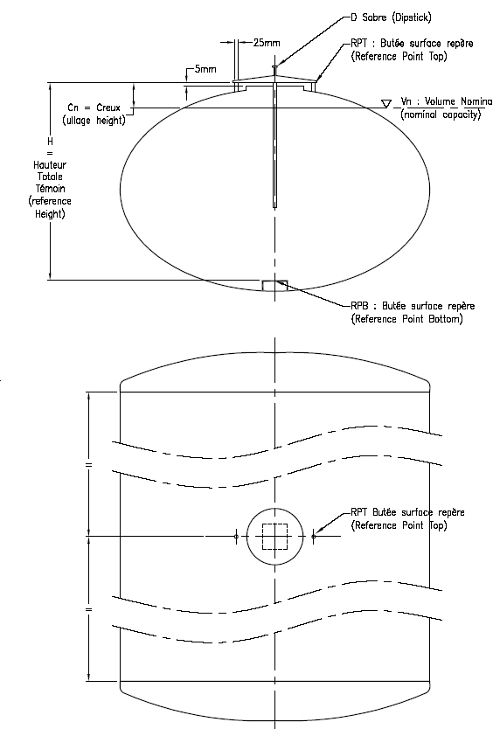







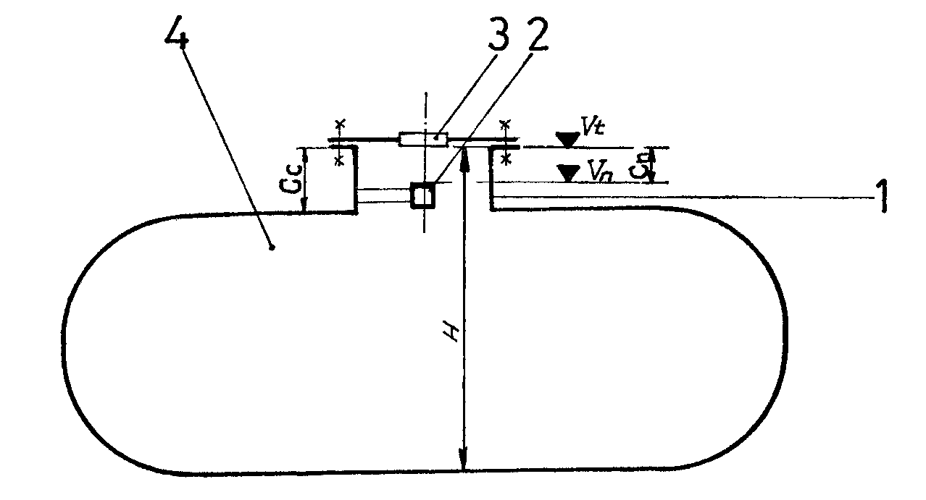

Fig. A.1 Single or two (opposite) volumetric marks or indexes in the dome

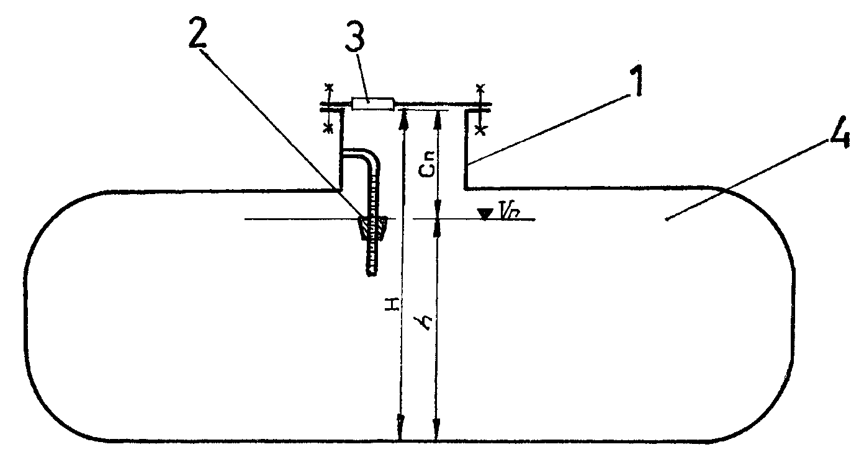

Fig. A.2 Top edge of the index fixed on holder (one-mark dipstick)

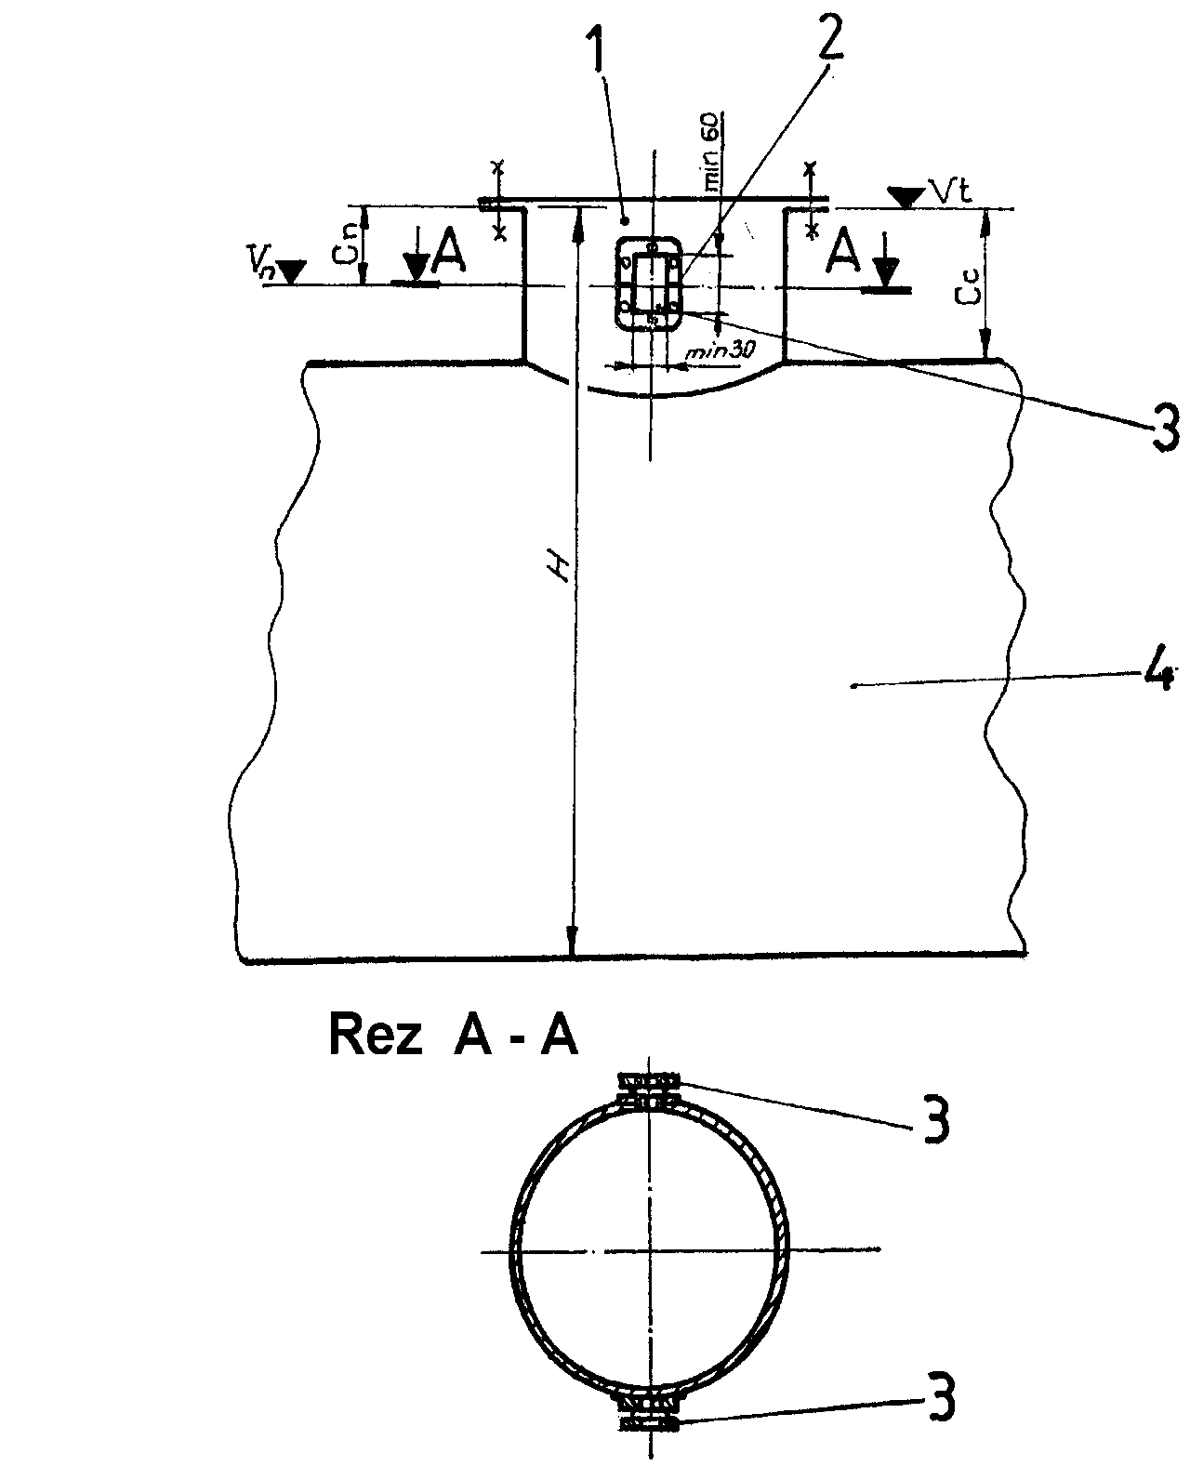

**Section A-A**

Fig. A.3 Single mark or graduated window in dome

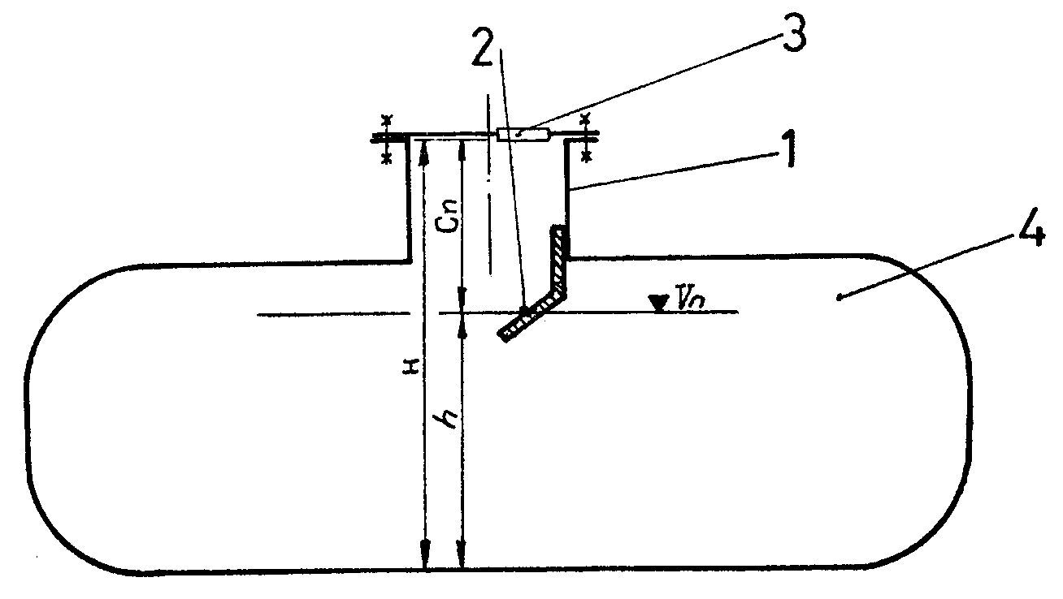

Fig. A.4 Single volumetric mark in tank (on console fixed to dome)

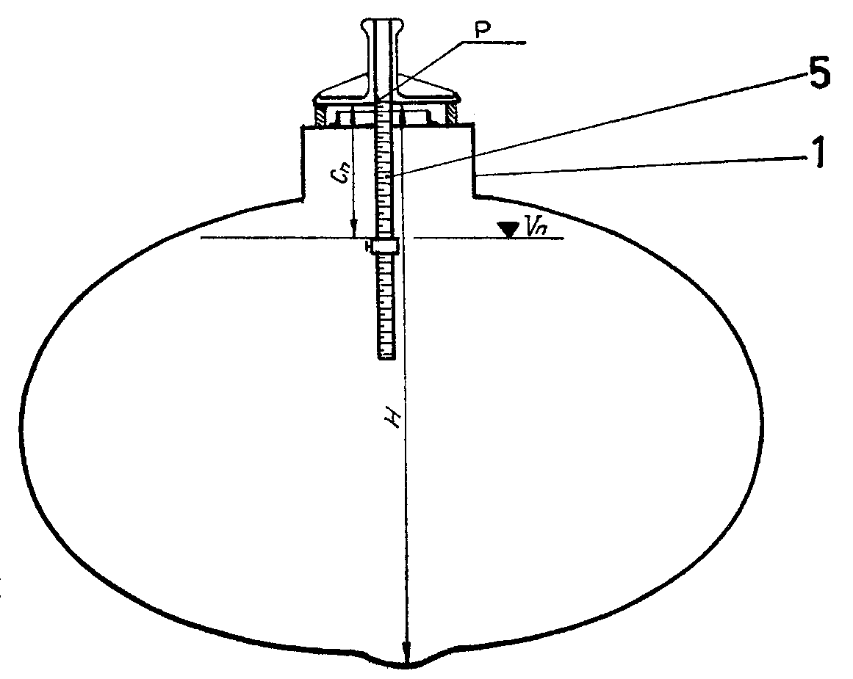

Fig. A.5 Mechanical dipstick with sliding index

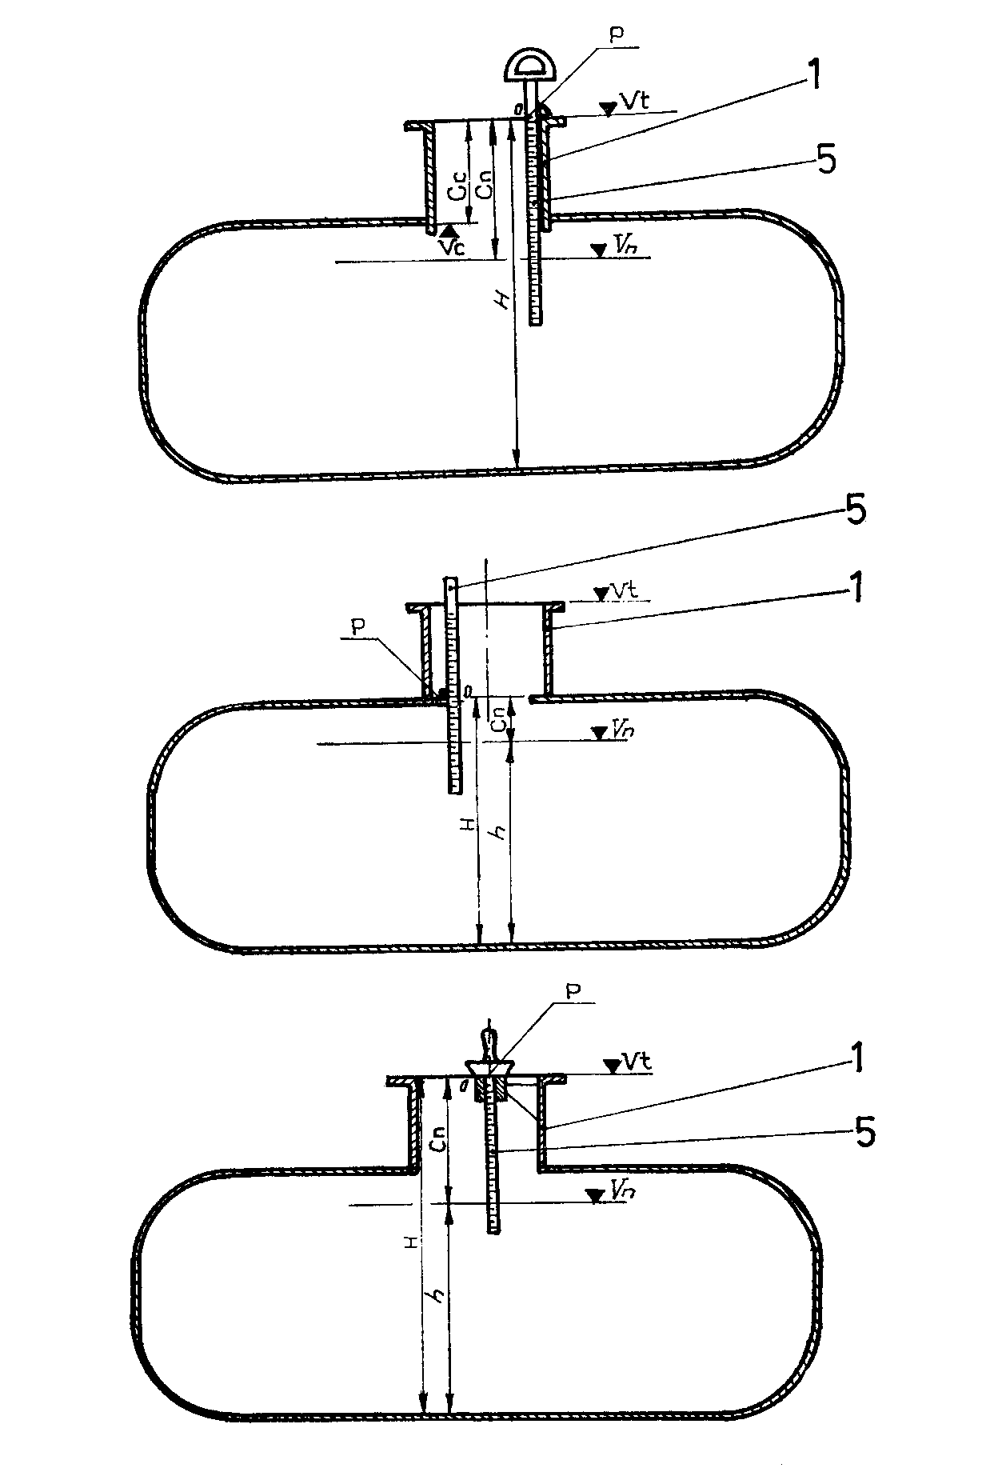

Fig. A.6 Examples of mechanical dipsticks and placement of RPT (Ullage height measurement)

Fig.A.7 Examples of mechanical dipsticks and placement of RPT
(Liquid height measurement)


1

5

*V*t

*Vn*

*h*

*H*

RPT

Manhole cover Cover

Fig.A.7 Examples of mechanical dipsticks and placement of RPT  
(Liquid height measurement)

Fig. A.8 Slip gauge (overflow mark) for a beer transport tank

Fig. A.8 Slip gauge (overflow mark) for a beer transport tank

**Annex B**

**Examples for automatic measuring systems  
with electronic level gauging**

**(Informative)**

BILD2

Fig. B.1 Schematic setup of the measuring system of a tanker for oils in its maximum version   
(for explaining the basic components and functions)

1. level sensor
2. measuring tank/measuring compartment
3. float, if appropriate
4. product
5. bottom valve
6. discharge line
7. dry coupler (API)
8. liquid detector (if appropriate, in collector line and downstream of pump)
9. collector vent valve
10. collector line (shown with valve function)
11. filter system
12. pump
13. level sensor for pipe system, alternatively: gas separator
14. draining, if appropriate
15. valve of empty hose
16. coupler of empty hose with filter and inspection glass (alternative positions)
17. hose reel with full hose
18. valve of full hose 2
19. valve of full hose 2 (reduced delivery without shutdown valve)
20. valve of full hose 1
21. non-return valve
22. temperature sensor
23. ventilation, if appropriate
24. electronic measuring and control unit
25. control apparatus for pump motor, if necessary
26. delivery line to the right, if appropriate

Fig. B.2 Schematic setup of the measuring system of a road tanker for milk in   
its maximum version (for explaining the basic components and functions)

sch0282_milk

1. level sensor
2. measuring tank/measuring compartment
3. float, if appropriate
4. valve for compartment 1
5. pipe empty sensor
6. valve for pumping to the trailer
7. valve for compartment 2…n
8. valve for pumping to the trailer
9. valve for pumping to the trailer
10. non-return valve
11. transfer point sensor
12. transfer point with inspection glass
13. pump with control apparatus for pump motor, if necessary
14. suck bottle
15. pressure air valve
16. suck bottle level sensor
17. vacuum valve
18. suck bottle clearing valve
19. milk sampling system
20. pressure air valve
21. mainstream suck valve
22. temperature sensor
23. vacuum sensor
24. suction hose
25. suction lance
26. electronic measuring and control unit

**Annex C**

**Examples for volume conversion from   
observed temperature to 15 °C (from working to base conditions) – petroleum products and lubricants**

**(Informative)**

The volume conversion of mineral oils is based on the following rules:

|  |  |  |  |
| --- | --- | --- | --- |
|  | Product group | Tables | Conversion equation |
| Generalized petroleum products  Correction of volume to 15 °C against density at 15 °C | B | Manual of petroleum  measurement standards  Chapter 11.1.54.4 – Volume correction factors  ASTM D 1250-80 Volume VIII, Table 54B | Chapter 11.1.54.4 – 6  ASTM D 1250-80 Volume X |
| Generalized lubricating oils  Correction of volume to 15 °C against density at 15 °C | D | Manual of petroleum measurement standards  Chapter 11.1.54.10 – Volume Correction Factors  ASTM D 1250-82 Volume XIV, Table 54D | Chapter 11.1.54.10  ASTM D 1250-82 Volume XIV |

The conversion (volume correction factor) is based on the following constants:

|  |  |  |  |  |  |  |
| --- | --- | --- | --- | --- | --- | --- |
|  | **Product group** | **Oil group** | **Range of density** [kg/m³] | **K0**  [(kg/m³)²/°C] | **K1**  [(kg/m³)/°C] | **Function** |
| Generalized petroleum products | B | Petrol  Naphtha | 60.,0 – 770.4  770.5 – 787.5 | 346.4228  – 0.00336312 | 0.4388  2680.3206 | 2.2  2.3 |
| Jet-A-1 Kerosene | 787.6 – 83.,5 | 594.5418 | 0.0 | 2.2 |
| Fuel oil | 838.6 – 1200.0 | 186.9696 | 0.4862 | 2.2 |
| Generalized lubricating oils | D | Lubricants | 750.0 – 1164.0 | 0.0 | 0.6278 | 2.2 |

The volume correction factor (VCF) for product group B and D:



where



or



**Annex D**

**Examples for volume conversion from observed temperature to 15 °C (from working to base conditions) – Liquefied petroleum gas (LPG)**

**(Informative)**

The volume conversion of liquefied petroleum gas is based on the following rules:

|  |  |  |  |
| --- | --- | --- | --- |
|  | Product group | Tables | Conversion function |
| Generalized light products (LPG)  Correction of volume to 15 °C against density at 15 °C | X | Density determination  (54 X) | DIN 51 757 Annex B and Annex G |

The constants P1, P2 and P3 used to calculate the volume correction factor (VCF) are:

|  |  |  |  |  |
| --- | --- | --- | --- | --- |
| **Range of density** kg/m³ | **P1** | **P2** | **P3** | **P4** |
| 500 to 600 | 4075.0 × 10-3 | 5050.0 × 10-6 | 27.5 × 10-3 | 45.0 × 10-6 |
| > 600 to 620 | 2448.9 × 10-3 | 2340.9 × 10-6 | 1.589 × 10-3 | 1.947 × 10-6 |
| > 620 to 640 | 2225.1 × 10-3 | 1980.0 × 10-6 | 1.588 × 10-3 | 1.946 × 10-6 |
| > 640 to 650 | 1936.6 × 10-3 | 1529.1 × 10-6 | 1.588 × 10-3 | 1.946 × 10-6 |

The volume correction factor (VCF) for product group X:



where

*t* = *t* – 15

**Annex E**

**Density and volume (of 1 kg) of distilled water (Informative)**

|  |  |  |
| --- | --- | --- |
| **Temperature** | **Density** | **Volume of 1 kg** |
| °C | kg/m3 | L |
| 0 | 999.8428 | 1.00016 |
| 1 | 999.9017 | 1.00010 |
| 2 | 999.9429 | 1.00006 |
| 3 | 999.9672 | 1.00003 |
| 4 | 999.9749 | 1.00003 |
| 5 | 999.9668 | 1.00003 |
| 6 | 999.9431 | 1.00006 |
| 7 | 999.9045 | 1.00010 |
| 8 | 999.8513 | 1.00015 |
| 9 | 999.7839 | 1.00022 |
| 10 | 999.7027 | 1.00030 |
| 11 | 999.6081 | 1.00039 |
| 12 | 999.5005 | 1.00050 |
| 13 | 999.3801 | 1.00062 |
| 14 | 999.2474 | 1.00075 |
| 15 | 999.1026 | 1.00090 |
| 16 | 998.9459 | 1.00106 |
| 17 | 998.7778 | 1.00122 |
| 18 | 998.5984 | 1.00140 |
| 19 | 998.4079 | 1.00159 |
| 20 | 998.2067 | 1.00180 |
| 21 | 997.9950 | 1.00201 |
| 22 | 997.7730 | 1.00223 |
| 23 | 997.5408 | 1.00247 |
| 24 | 997.2988 | 1.00271 |
| 25 | 997.0470 | 1.00296 |
| 26 | 996.7857 | 1.00322 |
| 27 | 996.5151 | 1.00350 |
| 28 | 996.2353 | 1.00378 |
| 29 | 995.9465 | 1.00407 |
| 30 | 995.6488 | 1.00437 |
| 31 | 995.3424 | 1.00468 |
| 32 | 995.0275 | 1.00500 |
| 33 | 994.7041 | 1.00532 |
| 34 | 994.3724 | 1.00566 |
| 35 | 994.0326 | 1.00600 |
| 36 | 993.6847 | 1.00636 |
| 37 | 993.3290 | 1.00672 |
| 38 | 992.9654 | 1.00708 |
| 39 | 992.5941 | 1.00746 |
| 40 | 992.2152 | 1.00785 |

*Tanaka, M.; Girard, G.; Davis, R.; Peuto, A.; Bignel, N.:* Recommended table for the density of water between   
0 °C and 40 °C based on recent experimental reports. Metrologia, 2001, **38**, 301-309