NMI P 107 Calculations for suitability of load cells fitted to belt weighers

September 2020
www.measurement.gov.au

© Commonwealth of Australia (1996)
NMI P 107
First edition — August 1996 (Document 133)
First edition, first revision — June 2001 (renamed NSC P 107)
First edition, second revision — July 2004 (renamed NMI P 107)
Second edition — September 2020 (Document NMI P 107)

National Measurement Institute
Bradfield Road, Lindfield, NSW 2070
T: +61 2 8467 3600
F: +61 2 8467 3610
W: www.measurement.gov.au

Foreword
This edition has been produced to align this document with NMI R 50:2020, Continuous totalising automatic weighing instruments (belt weighers) and NMI R 60 Metrological Regulation for Load Cells. It includes calculations for class 0.2 belt weighers.

Contents
Foreword ii
1. Scope 1
2. Load Cells 1
3. Belt Weighers 1
4. Calculations 1
4.1 Load Cell Capacity 1
4.2 Minimum number of scale intervals 2
4.3 Minimum verification scale interval 2
Appendix A Calculations 3
A.1 Calculations for minimum number of scale intervals 3

- Scope
This document is to be used in conjunction with certificates of approval of belt weighers which permit a range of approved load cells to be used in the various installations covered by the approval. The calculations included in this document will be applied to each installation to ensure that the approved specifications of the load cells are not exceeded for the specifications of the belt weigher installation.
The belt weigher will have been approved to comply with the requirements of NMI R 50-1:2020 Continuous totalising automatic weighing instruments (belt weighers). Part 1: Metrological and technical requirements.
The load cells will have been approved to comply with the requirements of NMI R 60 Metrological Regulation for Load Cells.
- Load Cells
The following specifications characterise the performance of load cells in accordance with NMI R 60 Metrological Regulation for Load Cells:
- maximum capacity (E_{max});
- maximum number of load cell verification intervals (n_{max}); and
- minimum load cell verification interval (v_{min}).
These figures are based on the required performance for fitting the load cells to non-automatic weighing instruments on the basis that the load cell contributes no more than 70% of the total weighing instrument errors.
Although the maximum permissible errors for automatic weighing instruments such as belt weighers are different to non-automatic weighing instruments the performance specifications given in the load cell recommendation can be applied to belt weigher installations.
- Belt Weighers
Belt weigher installations are characterised by the following specifications in accordance with NMI R 50-1:2020 Continuous totalising automatic weighing instruments (belt weighers). Part 1: Metrological and technical requirements:
- maximum capacity (of the weighing instrument) (Max);
- maximum flow rate (Q_{max});
- minimum flow rate (Q_{min});
- weigh length (L); and
- belt speed (V).
The total maximum load on the load cells supporting the weighing unit is made up of the maximum capacity (live load) and the weight of the weighing unit (dead load).
- Calculations
The following calculations are based on knowing the characteristics of the belt weigher installation and from these determining the required performance of each load cell. If the calculated performance is equal to, or less than, the performance of the load cell then the load cell selected is satisfactory for that installation.

4.1 Load Cell Capacity
Total maximum load on load cells (W_{c}) = Max + dead load, where Max = Q_{max} × L / V.
The maximum load on each load cell (W_{L}) is the above divided by the number of load cells (N), and the lever ratio (R), if applicable, namely W_{L} = W_{c} / N × R.
If W_{L} ≤ E_{max} the load cells are satisfactory, namely if E_{max} ≥ (Max + dead load) / N × R.

4.2 Minimum number of scale intervals
Table 1 gives the satisfactory values for the minimum number of scale intervals for class C load cells.
Any load cell with a minimum number of scale intervals equal to, or greater than, the value given in Table 1 will be satisfactory for use in the corresponding class of belt weigher. Refer to Appendix A.1 for calculations.
Alternatively, the replacement of a load cell with one that has less than the minimum number of scale intervals listed in Table 1 will require retesting and the issuing of a variant.
NMI reserves the right to vary and interpret requirements.
Table 1 Satisfactory values for the minimum number of scale intervals for class C load cells
Belt weigher class | 2 | 1 | 0.5 | 0.2
Minimum number of scale intervals for class C load cell | 500 | 1 000 | 1 500 | 7500

4.3 Minimum verification scale interval
Table 2 gives the satisfactory values for the minimum verification scale interval (v_{min}) for analogue strain gauge load cells and Table 3 gives the satisfactory values for the minimum verification scale interval (v_{min}) for digital load cells.
Any load cell with a minimum verification scale interval less than or equal to the value given in Tables 2 and 3 will be satisfactory for use in the corresponding class of belt weigher.
Table 2 Satisfactory values for the minimum verification scale intervals for analogue strain gauge load cells
Belt weigher class | Minimum verification scale intervals for analogue strain gauge load cells
2 | v_{min} ≤ (Max × R × $\sqrt{N}$) / 1 500
1 | v_{min} ≤ (Max × R × $\sqrt{N}$) / 3 000
0.5 | v_{min} ≤ (Max × R × $\sqrt{N}$) / 6 000
0.2 | v_{min} ≤ (Max × R × $\sqrt{N}$) / 15 000

Table 3 Satisfactory values for the minimum verification scale intervals for digital load cells
Belt weigher class | Minimum verification scale intervals for digital load cells
2 | v_{min} ≤ (Max × R × $\sqrt{N}$) / 1 000
1 | v_{min} ≤ (Max × R × $\sqrt{N}$) / 2 000
0.5 | v_{min} ≤ (Max × R × $\sqrt{N}$) / 4 000
0.2 | v_{min} ≤ (Max × R × $\sqrt{N}$) / 10 000

Appendix A Calculations

A.1 Calculations for minimum number of scale intervals
The relative maximum permissible errors (MPE) for a belt weigher tested under simulated conditions for influence factors (NMI R 50-1, clause 3.2.2) are given in Table 3.
The load cells are also tested under simulated conditions for influence factors. Using an apportioning factor of 0.7, the relative errors for the load cell shall not exceed 0.7 (or 70%) of the relative MPE for the belt weigher (NMI R 50-1, clause 3.2.2). The relative MPE for load cells are also given in Table 3.
Table 3 Relative MPE for belt weighers and load cells
Class | 2 | 1 | 0.5 | 0.2
Relative MPE for belt weigher | ±0.7% | ±0.35% | ±0.175% | ±0.07%
Relative MPE for load cell | ±0.49% | ±0.245% | ±0.1225% | ±0.049%
The suitability of a load cells is determined based on the worst possible errors, the MPE, for the class of load cell. Using the apportioning factor of 0.7 (70%), the MPE for class C load cells are given in Table 4, where v is the verification scale interval.
Table 4 Absolute MPE for class C load cells over different ranges
Absolute MPE | Class C
±0.35 v | 0 to 500 v
±0.7 v | 501 to 2 000 v
±1.05 v | 2001 to 10 000 v
The relative error decreases as the load increases in each range.
The relative error for a load is given by:
Relative error (%) = Absolute MPE × 100 / load
So, the limiting load, for each MPE range, is given by:
Limiting load = Absolute MPE × 100 / Relative MPE.
The limiting loads (rounded up) for class C load cells are given in Table 5.
Table 5 Limiting loads for class C load cells
Limiting loads for belt weigher class |  |  |  | MPE range
2 | 1 | 0.5 | 0.2 | MPE range
72 v | 143 v | 286 v | 500 v | 0 to 500 v
– | – | 572 v | 1429 v | 501 to 2 000 v
– | – | – | 2143 v | 2001 to 10 000 v
A load cell is satisfactory for use in a specified class of belt weigher if the load always exceeds the limiting load.
For a belt weigher that operates down to 20% of the maximum flow rate, the limiting load must be no more than 20% of the maximum load.
Therefore, the maximum flow rate must correspond to at least five times the limiting loads; see Table 6.
Table 6 Limiting loads corresponding to max flow rates for belt weighers
Limiting loads for belt weigher class
2 | 1 | 0.5 | 0.2
358 v | 715 v | 1 429 v | –
– | – | 2 858 v | 7 143 v
– | – | – | –
By convention, load cells have scale intervals in units of 500 or more.
Putting this together, Table 7 gives the satisfactory values of n_{max} for class C load cells.
Table 7 Satisfactory values of n_{max} for class C load cells
Belt weigher class | 2 | 1 | 0.5* | 0.2
n_{max} for class C load cells | 500 v | 1 000 v | 1 500 v | 7500 v
*Selection of n_{max} for class 0.5 belt weighers: For class 0.5 belt weighers, there is a region between 501 v and 571 v that would theoretically exceed the MPE requirements. It is not expected that any load cell would exhibit sudden ‘steps’ in the relative error that theoretically exceed the permitted MPE requirements in the region between 501 v and 571 v as this is an artefact of the load cell MPE step function.
Any cells with n_{max} equal to, or more than, the value given in Table 7, will be satisfactory for use in the corresponding class of belt weigher.
A plot of the errors is shown in Figure 1. The curved line illustrates the relative errors of class C load cells. The horizontal lines show the required MPE for different classes of belt weigher.
Figure 1 Plot of relative error (%) for load cells and MPE for load cells for all classes of belt weighers
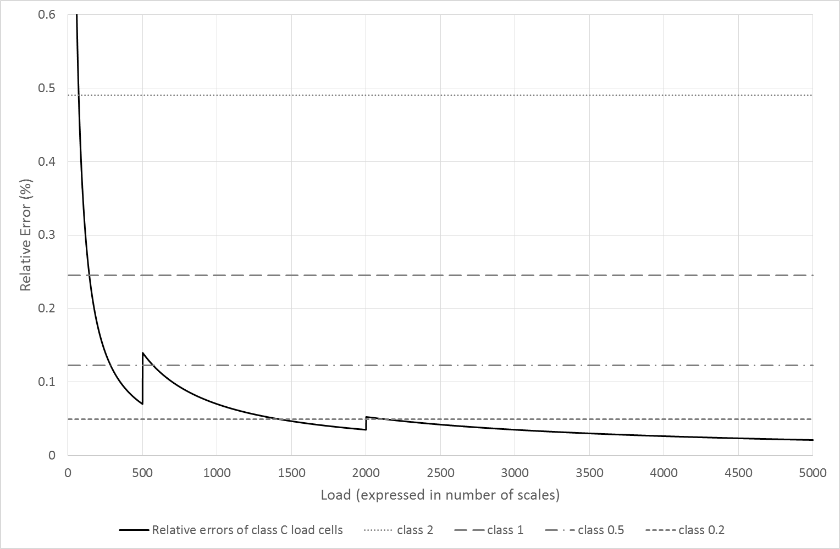

If a calculated limiting load is greater than the upper MPE range, the limiting load is the upper MPE range. If a calculated limiting load is less than the lower MPE range, there is no limiting load for that MPE range; this is indicated with ‘–‘.

